What is radium?

Radium is a radioactive element, formed through the decay of uranium that emits alpha, beta and gamma ionising radiation. Radium is found naturally in the environment in trace quantities in rocks, soil, and water. When radium emits radiation, some of the atoms decay and produce radon, a radioactive gas. Radium was discovered in 1898 by Marie and Pierre Curie, and was widely used between 1900 and the 1960s.

What were the uses of radium?
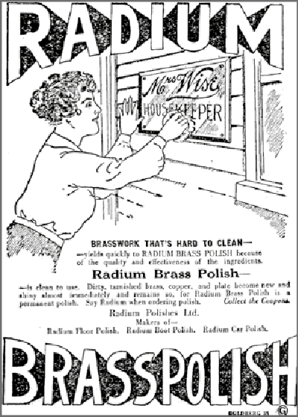  Source: Christchurch Sun | Historically, radium was commonly used in radio-luminescent paint, which continuously produces visible light. Such paint was used before 1960 in clocks and watches, aircraft switches and dials, military vehicle gauges (for example, those used in World War Two), communication equipment, compasses, and emergency exit signs. Military-issued wrist watches and pocket watches typically have higher levels of radium. Many devices containing radium no longer glow in the dark because the radium has degraded the phosphorus in the paint. However, these devices remain radioactive.  Previously, radium was also added to products claimed to have various curative properties, including toothpaste, hair and face creams and food products.
The image above, from an advertisement in a 1920 edition of the Christchurch Sun, shows that certain cleaning products also included radium, which manufacturers claimed improved the effectiveness of the product.
Radium used to be used for medical treatments in an early from of radiation therapy. Radium salts were used to treat cancers, skin legions and lung diseases. Radon gas was also used in treatments for lung diseases. Today medical treatments have evolved to no longer involve the direct use of radium.

What are the health risks associated with radium exposure?
Radium can damage cells within the human body. Long- term exposure increases people’s risk of developing several diseases. Exposure to radium can occur in three different ways:
- external exposure to gamma radiation
- internal exposure, from ingesting radium, breathing in particles of radium or absorbing radium through the skin
- lung exposure from breathing in radon
Internal exposure increases a person’s risk of developing bone diseases such as lymphoma and bone cancer and blood diseases such as leukaemia. This is because radium is a bone seeker (an element that tends to accumulate in bones when it is introduced into the body); it primarily irradiates bone tissue. It usually takes years for effects to develop after a significant intake of radium.
External exposure to gamma radiation increases a person’s risk of cancer in all parts of the body, to varying degrees.
The probability of a person developing cancer increases with their level of exposure. Exposure of the lungs to radon increases a person’s chance of lung cancer, and is the second highest cause of that cancer after smoking. Radon can escape devices containing radium. If such devices are stored in closed environments, such as safes or rooms with poor airflow, radon will build up over time, increasing the risk of exposure.

How long does radium remain radioactive?
Nuclear physicists use the term ‘half-life’ to describe how quickly
unstable atoms undergo radioactive decay. Radium has a half-life of 1,600 years, which means that any device containing radium will be radioactive for thousands of years.

How can I tell if a device has radium in it?
Radium paint is typically white at first but fades to yellow over time; eventually, the paint no longer glows in the dark. Most luminous devices containing radium are not labelled with radiation warning symbols. It might only be possible to tell that there is radioactivity present by using a radiation meter.

What should I do if I have a radium luminous device in my possession?
Because radium is a radioactive element, and has the potential to damage human cells, you should take care when handling devices containing radium.
Over time, radium paint breaks down and becomes brittle, and flakes can come off. Care should be taken to avoid contamination from this paint. Bearing in mind that the amount of radium a device contains will be highly variable, if the device is in good condition and the glass is intact, you can manage the risk by taking some precautions.
- The Ministry of Health advises adhering to the following guidelines.
- Store the device in a sealable plastic bag.
- Wear disposable gloves when handling the device.
- Never open the device.
- Do not eat, drink, or smoke in areas where the device is stored or handled.
- Store the device in a secure location away from occupied areas.
- Minimise the number of devices stored in one location.
- Ensure the rooms where the device is stored is well ventilated.
If the device is damaged or the glass is cracked, seal it within a plastic bag and contact the Office of Radiation Safety for further advice.
Radon build-up is of particular concern in the case of military-issue watches. In rooms with poor ventilation, levels of radium in these devices can reach up to 3,000 Bq/m3, which is 30 times the World Health Organization’s recommended maximum.
Take additional precautions in dealing with radium luminous watches and time pieces, as follows.
- Do not keep watches and time pieces in bedrooms.
- Minimise the amount of time you spend wearing these devices: do not wear them continuously.
- Do not disassemble the devices.
Having a collection of radium devices increases your risk of exposure: gamma dose rates and radon levels will be higher. If you have a collection, you should undertake an assessment of the radon levels, to determine whether active ventilation
is required. In any case, you should store your collection in a secure low-occupancy area.
For more information on assessment of radiation risks, contact the Office of Radiation Safety.
If you wish to service a radium luminous device, or to dispose of it, you will need approval from the Office of Radiation Safety. Do not put the device in landfill.

Contact information
Office of Radiation Safety
- orsenquiries@health.govt.nz
- www.health.govt.nz/our-work/ionising-radiation-safety
For radiation emergencies such as transportation accidents involving the movement of radioactive materials the radiation emergency number is 021 393 632.

Further information
For radiation safety awareness guidance for museum staff, see the Government of Canada’s webpage ‘Radiation safety awareness guidance for museum staff’
- www.canada.ca/en/department-national-defence/services/military-history/radiation-safety- awareness-museums.html
For guidance on determining whether a collectible item contains radium, see the Canadian Nuclear Safety Commission’s webpage ‘Could your collectible item contain radium?’
- nuclearsafety.gc.ca/eng/resources/radiation/could-your-collectible-item-contain-radium.cfm#radiation-hazards
For information on radium in general and in the health context, see the United States Environmental Protection Agency’s webpage ‘Radionuclide Basics: Radium’:
- www.epa.gov/radiation/radionuclide-basics-radium
For information on radioactivity in antiques, see the United States Environmental Protection Agency’s webpage ‘Radioactivity in Antiques’:
- www.epa.gov/radtown/radioactivity-antiques
October 2023
HP 8746

