Whakamaua 2020-2025
Te mahere whakatutuki whāinga hauora Māori

Whakamaua
He whakahau te kupu whakamaua ki te kapo ake, ki te pupuri, ki te whakamau i ngā āhuatanga katoa e hāpai ana i te hauora o te tangata.
Arā hoki te kōrero e mea ana ‘Ko te pae tawhiti, whāia kia tata. Ko te pae tata, whakamaua kia tīna’. Me whakamau tātou i ngā pae tata, me whakapau kaha hoki ki te whakamau i ngā pae ora. Koia hoki te whāinga nui o He Korowai Oranga:Te Rautaki Hauora Māori, otirā, ko Whakamaua te whakatinanatanga o tērā rautaki.
Hei tāpiri atu anō, he kākahu te korowai hei mau mā te tangata. Ko te tūmanako, ka whakamaua te kākahu o He Korowai Oranga e ngā whānau, ngā hapū, ngā iwi me ngā hapori Māori kia uhia rātou e te hauora me te oranga nui.

Nā: Manatū Hauora. 2020. Whakamaua 2020–2025. Te Whanganui-a-Tara: Manatū Hauora.
He mea whakaputa i te Hereturikōkā nā te Manatū Hauora PO Poutāpeta 5013, Te Whanganui-a-Tara 6140, Aotearoa ISBN 978-1-99-002927-1 (online)
ISBN 978-1-99-002928-8 (print)
HP 7449

Tīkina atu tēnei tuhinga ki health.govt.nz

E mana ana tēnei tuhinga i raro i te raihana whenua o Creative Commons Attribution 4.0. E mea ana, ka pai noa: te tuari, arā, te tāruarua me te tuku atu anō i ngā kōrero, ahakoa te momo rawa, te hanga rānei; pērā i te whakahoutanga anō, i te huringa anō, i te tāpiringa anō rānei nō te putanga taketake. Me tika te whakamihi, me whai hononga
ā-ipurangi ki te raihana, me āta tautohu ngā raweketanga

Ngā mihi
E rere ana ngā kupu whakamānawa me ngā mihi mō ngā kōrero urupare, ngā kitenga me ngā kupu ārahi i tukuna mai e ngā whānau, ngā hapū me ngā whakahaere ā-iwi, ngā whakahaere Māori ā-motu, ngā rōpū kiritaki, ngā kaikerēme o Wai 2575, ngā whakahaere hauora matua (PHO), te Māori Expert Advisory Group for the Health and Disability System Review, ngā whare whakahaere o Whānau Ora, ngā whakahaere hua-kore (NGO), ngā umanga mātanga Māori, ngā
kairangahau mātauranga, ngā tari kāwanatanga me ngā whare hauora o te Karauna me ngā kaimahi o ngā poari hauora ā-rohe (DHB) i te whakawhanaketanga mai o te mahere whakatutuki whāinga hauora Māori, arā, o Whakamaua 2020–2025.
Kei te mihi hoki ki a Tā Mason Durie nāna tōna wā, tōna mātauranga hoki i tuku noa mai i runga i te ngākau makuru, waihoki, ko te tohungatanga me ngā kupu ārahi a te Māori Health Action Plan Expert Advisory Group me Te Tumu Whakarae ( arā, ko te kāhui a te DHB General Manager Māori Health).
E kore e mutu ngā mihi ki ngā tāngata takitahi, ki ngā rōpū, ki ngā whakahaere me ngā momo whakarōpūtanga i whai wāhi mai ki tēnei kaupapa.

E hara taku toa i te toa takitahi engari he toa takitini.
He tohu ngā tauira hukahuka ki roto i He Korowai Oranga o te kaha, o te mana me te rerehua o te korowai.
Ka oreore ngā hukahukao te korowai, ka rangona te ihi o te kākahu. He tohu tērā o te mana o ngā tāngata, o ngā whānau me ngā hapori kua uhia e te korowai,arā, kua kākahuria ki te hauora, te waiora me te oranga o te whānau.
He tohu hoki te tauira o te mana motuhake o ia hapū, o ia iwi anō ki te takahi i ō rātou ake ara, ki te whakatū i ā rātou ake anga e tutuki ai ō rātou anō hiahia. Waihoki, ko te tūranga o te Manatū Hauora hei hoamahi pono i raro i te tikanga o te mana whakahaere.

Nō reira, he korowai oranga mō
ngā iwi katoa, kia tū hauora
ai tātou katoa

He kupu whakataki nā te Minita Tuarua o ngā Take Hauora
Kua tawhiti kē tō hāerenga mai kia kore e hāere tonu;
he nui rawa ōu mahi kia kore e mahi tonu.
TĀ HĒMI HENARE

E ngā iwi, e ngā mana, e ngā karangatanga maha huri noa o Aoteraoa nei, tēnā koutou, tēnā koutou, tēnā koutou katoa! Kei te rere taiāwhiowhio tonu te mihi aroha ki ō tātou tini aituā; rātou ki a rātou o te tai awatea, ā, ko tātou ki a tātou kei te whai muri i te tai ahiahi. Nā reira tēnā anō tātou katoa!
Ko Whakamaua 2020–2025 te ara e tohu ana i ngā tino mahi e tutuki ai te whāinga nui o pae ora mā te iwi Māori. Nō te whakarewatanga ake o tēnei mahere e ārahi ana i te whakatinanatanga o He Korowai Oranga, ka whakakīia te āputa i puta mai i te whakatutukinga o Whakatātaka Tuarua 2006–2011, arā, ko te mahere whakatutuki whāinga hauora Māori o mua.
He whakahau tēnei mahere, nā te kāwanatanga ki te Manatū, ki te tū hei kaiārahi o te rāngai hauora me te hunga whaikaha. Nō te kawenga ake o tēnei tūranga, me whakapau kaha mātou ki te kōkiri i te kaupapa mā te iwi Māori. Mā tēnei mahere mahi, arā, mā Whakamaua 2020–2025, ka puare mai ai ngā ara hou hei whai mā te Manatū, mā te rāngai o te hauora me te hunga whaikaha me te rāngai kāwanatanga whānui, e tino koke whakamua ai ngā whakatutukinga tautika mō te hauora o te Māori. E tautokona ana tēnei whāinga e te pūrongo whakamutunga o te Health and Disability System Review.
Ko pae ora te whāinga whānui o He Korowai Oranga, ā, e toru ngā wāhanga matua o te kaupapa, arā, ko te whānau ora, ko te mauri ora me te wai ora. Kei te kaha tautokona tonu a He Korowai Oranga huri noa i te rāngai hauora me te hunga whaikaha, i te mea kei te whakamana taua tuhinga i ngā hononga matua me ngā momo tuituinga i waenga i ngā tāngata, i ō rātou whānau, i roto hoki i ngā horopaki maha a te pāpori whānui.
He mea nui kia rangona ngā reo o te iwi Māori i roto i te whakawhanaketanga mai o tēnei mahere. Kua puta mai ngā whāinga tōmua me ngā mahi a tēnei mahere i ngā tini whakawhitinga kōrero a te Manatū me te rāngai kāwanatanga ki ngā kaiwhaipānga matua, pērā i ngā whānau, ngā hapū me ngā iwi. Ko te tuhinga matua tēnei e ārahi ana i te ahunga whakamua o ngā wawata mō te hauora o te Māori hei ngā tau e 5 e haere mai ana, waihoki, ko Whakamaua te ara e whai mana ai ngā reo o te whānau, e huraina mai ai ngā mateā hauora o te Māori, e whakamarumarutia ai hoki te hauora o ngā iwi, ngā hapū, ngā whānau me ngā hapori Māori e te pūnaha o te hauora me te hunga whaikaha, e whakarauoratia ai hoki rātou i te mate urutā o COVID-19.
Mā te mahere o Whakamaua hoki, ka whakamanatia Te Tiriti o Waitangi hei tūāpapa o ngā kaupapa here o te kāwanatanga. Ko ngā tānga a Te Tiriti, arā, ko te kupu takamua, ko ngā wāhanga e toru me te whakaputanga o ngā Ritenga Māori ngā pou matua o Whakamaua 2020–2025.
He koanga ngākau, he hikinga manawa anō te huranga mai o ngā ara hou i roto i tēnei mahere mahi. Mā tēnei mahere mahi, ka whiwhi ō tātou whānau, hapū, iwi me te hāpori whānui i te oranga nui, ka eke hoki ki ngā taumata tiketike, hei Māori. Ka manawanui au ki te mahitahi ki ōku hoamahi, arā, ki ngā Minita huri noa i te kāwanatanga, hei hāpai ake i ngā wawata o te tangata whenua, te ao Māori hoki, hei whakaea i ngā mateā hauora o te Māori, hei whakapiki ake i te oranga o ngāi Māori, huri noa i Aotearoa.
Tēnā koutou te hunga i kaha nei, e kaha tonu nei, ki te hāpai i te whanaketanga mai, i te whakatinanatanga mai o te Whakamaua 2020–2025.
Mā tini, mā mano, ka rapa te whai!

Hon Peeni Henare
Associate Minister of Health

He kupu whakataki nā te Kaiwhakahaere - Matua o te Hauora
E ngā mana, e ngā reo, e ngā karangatanga maha, tēnā koutou katoa E tika ana, ka mihi hoki au ki a rātou kua wehe atu ki te pō.
Nō reira, tēnā anō koutou katoa.
Ka whakapau kaha te Manatū Hauora (te Manatū) me te pūnaha o te hauora me te hunga whaikaha ki te tāpae pūtea haumi ki te hauora me te oranga nui o te Māori, otirā, mā konā, ka ea ngā wawata o te rāngai hauora me te hunga whaikaha, me te noho taurite o te hauora o te Māori. Kei te mōhio mātou ki ngā take e pā kino ana ki te hauora o te Māori, he take ērā e taea ana hoki te karo, ā, i runga i tō mātou tūranga hei kaitiaki, me āta whakahaere te Manatū Hauora i ngā whakapaunga kaha o te kāwanatanga ki te whakaū i te hauora me te oranga hākoakoa o ngāi Māori. Ka mātua whai mātou kia tino whaihua te tangata whenua i te whakatinanatanga o Whakamaua 2020–2025, ā, ka āta kōkirihia hoki te whakatutukinga o te whāinga nui o pae ora.
Ko pae ora te whāinga nui o He Korowai Oranga, ā, e toru ōna wāhanga matua, ko te mauri ora, ko te whānau ora, me te wai ora. E ai ki ngā tini kōrero urupare a ngā kaiwhaipānga, kei te kaha tautoko tonu te rāngai hauora me te hunga whaikaha i ngā mātāpono o He Korowai Oranga, i te mea, kei te whakamana taua tuhinga i ngā tini hononga whaitake me ngā momo tuituinga i waenga i ngā tāngata, i ngā whānau me ngā horopaki maha o te pāpori whānui.
He ara a Whakamaua 2020–2025 hei whai mā te Manatū, ngā poari hauora ā-rohe, ngā whānau, ngā hapū, ngā iwi me ngā kaiwhaipānga matua, ki te whakapiki ake i te hauora o te Māori mā roto mai i ētahi mahinga tūturu tonu. Kei ēnei rōpū katoa te mana whakahaere o te whakatinanatanga o te mahere, arā, kei ngā tāngata katoa o Aotearoa te haepapa ki te whakapiki ake i te hauora o ngāi Māori i Aotearoa.
Ka taka te wā, ka whakahoutia a Whakamaua hei whakaea i ngā take o te Health and Disability System Review, hei whakatikatika hoki i a mātou anō e puta atu ai tātou i te mate urutā COVID-19.
Kua ū te Manatū ki ōna kawenga i raro i Te Tiriti o Waitangi i roto i te whanaketanga mai o Whakamaua 2020–2025, ā, ka ū tonu mātou ki tērā i roto i te whakatinanatanga o te kaupapa ā ngā tau e heke mai ana. Me toro atu tonu ki ngā whānau, ngā hapū, ngā iwi me ngā hapori Māori, arā, me whai wāhi tonu rātou ki te ahunga whakamua o tēnei kaupapa.
Kei te koa katoa ahau ki te mahitahi ki ētahi atu i raro i te kaupapa o Whakamaua 2020–2025, ki te whakapiki ake i ngā putanga hauora o te Māori, ki te whakatutuki hoki i ngā whāinga o pae ora.

Dr Ashley Bloomfield
Director-General of Health

Te whatunga o He Korowai Oranga
Mai anō i te tau 2002, he mea whakataki te ahunga whakamua o te rautaki mō te whakawhanaketanga o te hauora o te Māori e He Korowai Oranga: te Rautaki Hauora Māori. Kua arahi ngā mahere whakatutuki whāinga hauora Māori i te pūnaha o te hauora me te hunga whaikaha ki te whakatutuki i ngā whāinga matua o He Korowai Oranga. Ko te whāinga whānui o He Korowai Oranga me ngā mahere mahi, kia eke te hauora me te oranga o te iwi Māori ki ngā taumata tiketike.
Kei te Āpitihanga 1 ētahi atu kōrero mō te whatunga o He Korowai Oranga me ngā whakatutukinga tae noa ki tēnei wā.

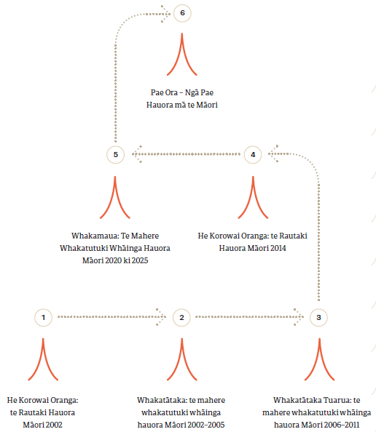

Ihirangi
Whakamaua i
Ngā mihi iii
He kupu whakataki nā te Minita Tuarua o ngā Take Hauora iv
He kupu whakataki nā te Kaiwhakahaere - Matua o te Hauora vi
Te whatunga o He Korowai Oranga viii
E whakatakoto ana i te ara o te rautaki hauora Māori 1
Te noho pūmau ki Te Tiriti o Waitangi 1
Tō mātou whakaahuatanga o te Tiriti 1
Te whakatinanatanga o ngā mātāpono o Te Tiriti 2
E whakatutuki ana i ngā whāinga matua o He Korowai Oranga 4
Ngā whānga matua o He Korowai Oranga 5
Whakamaua 2020-2025: te Mahere Whakatutuki Whāinga Hauora Māori 7
Ngā putanga e hiahiatia ana 8
Ngā whāinga e ārahi ana I ā mātou mahi 9
Ngā whāinga tōmua hei whakatutuki 10
Te hāpai tahi i te hauora o te Māori 11
Ngā putanga e hiahia ana 12
Putanga 1 12
Putanga 2 12
Putanga 3 13
Putanga 4 14
Ngā whāinga tōmua hei whakatutuki 15
Te Whāinga Tōmua 1 15
Te Whāinga Tōmua 2 18
Te Whāinga Tōmua 3 22
Te Whāinga Tōmua 4 25
Te Whāinga Tōmua 5 28
Te Whāinga Tōmua 6 31
Te Whāinga Tōmua 7 34
Te Whāinga Tōmua 8 37
Te aroturuki 40
E arotūruki ana i ngā mahi i ngā tau e rima 40
Te mahi arotake arotutuki 45
Āpitihanga 1 46
Ko ngā taipitopito o te whatunga o He Korowai Oranga 46
Āpitihanga 2 49
E Whakawhanake ana i te Mahere Whakatutuki Whāinga Hauora Māori 49
Āpitihanga 3 50
Ngā mema o te Expert Advisory Group mō te Mahere Whakatutuki Whāinga Hauora Māori 50
Āpitihanga 4 52
Whakamaua: the Māori Health Action Plan 2020–2025 52
Āpitihanga 5 54
Te Tiriti o Waitangi and the health and disability system 55
Our Te Tiriti o Waitangi Framework 56
Ngā tohutoro 57

E whakatakoto ana i te ara o te rautaki hauora Māori

Te noho pūmau ki Te Tiriti o Waitangi
Ka pono te pūnaha o te hauora me te hunga whaikaha ki te whakatutukinga o te hononga motuhake i waenga i te Māori me te Karauna i raro i Te Tiriti o Waitangi (te Tiriti). I raro i te Tiriti me ngā whakaputanga i te wā o te hainatanga, kei te Manatū Hauora, i roto i tana tūnga hei kaitiaki o te pūnaha o te hauora me te hunga whaikaha (te wāhanga 1 o te Tiriti), te haepapa ki te hāpai i te tino rangatiratanga o te Māori e pā ana ki tō rātou hauora, ki tō rātou oranga anō (te wāhanga 2), e hua mai ai ngā putanga hauora taurite mā te Māori (te wāhanga 3), kia noho, kia whai oranga nui, kia puāwai te Māori, hei Māori anō (te whakaputanga o te Ritenga Māori).
He mea nui te whakatutukinga o ngā kawenga i raro i te Tiriti, i roto i te whakatinanatanga o ngā whāinga whānui o He Korowai Oranga: te Rautaki Hauora Māori me te putanga mai o ngā hua mā te katoa o te pūnaha o te hauora me te hunga whaikaha. E kapi ana tēnei whāinga i te hiahia kia whiwhi ngā tāngata katoa o Aotearoa ki te ora roa, ki te ora nui, kia noho hoki rātou i raro i tō rātou ake mana motuhake.

Tō mātou whakaahuatanga o te Tiriti
Ka noho pūmau ngā kupu a te Tiriti, arā, ko te kupu takamua, ko ngā wāhanga e toru me te whakaputanga o te Ritenga Māori, hei pou e tū ai tō mātou whare hauora me te mana motuhake. E whā ngā whāinga e whakaahua ana i te mana o te Tiriti i raro i ēnei pou.

Mana whakahaere
Me whaitake, me tōtika te tū hei kaitiaki o te pūnaha o te hauora me te hunga whaikaha. Me whai i ngā tikanga, i ngā kaupapa me te kawa o te Māori. Kei tua atu tēnei kaupapa i ngā momo whakahaere e pā ana ki ngā rawa me ngā rauemi, me whakamana hoki i ngā wawata o te Māori e pā ana ki te hauora me tō rātou mana motuhake.

Mana motuhake
Me whakamana i te tū o te Māori, hei Māori (te tino rangatiratanga); e taea ai e te Māori tōna anō mana motuhake te pupuri e pā ana ki tōna noho, ki te noho hei Māori, e whai ana i te mātauranga, i ngā tikanga me ngā tūmomo mahi Māori.

Mana tangata
Me kite i ngā putanga taurite mā te Māori i te ao hauora me te hunga whaikaha. Me hāpai i te mana o te tangata i te roanga o tōna oranga, me whakapau kaha hoki ki te hauora whānui me te oranga o ngāi Māori.

Mana Māori
Me hāpai i ngā ritenga Māori nō te ao Māori me te whakatinanatanga o ngā tikanga Māori i raro i te mātauranga Māori.

Te whakatinanatanga o ngā mātāpono o Te Tiriti
Ko ngā mātāpono o te Tiriti, i whakaputaina e ngā kōti me Te Rōpū Whakamana i te Tiriti o Waitangi, ngā kōrero matua o te Tiriti e whāia ana e te Manatū, koia hoki ngā kōrero e ārahi ana i ngā mahi i roto i tēnei mahere. Kua whakatakotohia e te pūrongo o Hauora, nō te tau 2019, ngā mātāpono hei whakauru atu ki te pūnaha o ngā whare tiaki hauora matua. E whai pānga ana ēnei mātāpono ki te pūnaha whānui o te hauora me te hunga whaikaha. Koia nei ngā mātāpono e hāngai ana ki ā mātou mahi i te pūnaha o te hauora me te hunga whaikaha:

Tino rangatiratanga
Me hāpai te tino rangatiratanga me te mana motuhake o te Māori i roto
i te waihangatanga, te whakaratonga me te aroturukitanga o ngā ratonga o te rāngai hauora me te hunga whaikaha.

Te noho taurite
Me ū ki te whakatutukinga o ngā putanga taurite mā te Māori i te rāngai hauora.

Te kaitiakitanga
Me whakapau kaha ki te whakatutukinga o ngā putanga taurite mā te Māori i te rāngai hauora. Kei raro i tēnei take, me mātua mōhio te Karauna, āna tari me tōna hoa i raro i te Tiriti, ki te whānui me te hōhonu o ngā putanga hauora o te Māori me ngā kaupapa mahi e whai ana kia rite tahi ngā hua o te ao hauora mā te Māori.

Ngā kōwhiringa whaihua
Me tika te whāngai i ngā rauemi tōtika ki ngā kaupapa hauora Māori me ngā ratonga mō te hunga whaikaha. Waihoki, me kaha te Karauna ki te whai, ki te tautoko hoki i ngā tikanga a te Māori i roto i ngā kaupapa hauora me ngā ratonga o te hunga whaikaha. Me whakamana, me tautoko i ngā momo tauira hauora Māori.

Te pātuitanga
I roto i te pātuitanga ki a ngāi Māori, me noho te Māori hei kaihoahoa, i te taha o te Karauna, arā, mō ngā take whakahaere, ngā hoahoatanga, te whakaratonga me te aroturukitanga o ngā kaupapa hauora me ngā ratonga a te hunga whaikaha.

E whakatutuki ana i ngā whāinga matua o He Korowai Oranga
I whakarewaina tuatahitia a He Korowai Oranga i te tau 2002, e tiro whakamua ana ki te ngahuru tau whai muri atu. Ko te whāinga matua ko
te hauora o te whānau (whānau ora).
Nō te whakahoutanga i te tau 2014, ko te whāinga matua o He Korowai Oranga ko pae ora, arā, kia whakamaua te pae o te oranga nui o te iwi Māori. He kaupapa whānui a pae ora, e toru ōna wāhanga: ko mauri ora (kia ora te tangata), whānau ora (kia ora te whānau), me te wai ora (kia ora te taiao). Ko pae ora te whāriki e pai ai te noho o te Māori, arā, ko ngā āhuatanga o tōna hauora me tōna oranga, i roto i tētahi taiao e tautoko ana i te puāwaitanga me te oranga nui, hei Māori.
Kua whakatakotoria e He Korowai Oranga te ara mō te whakawhanaketanga mai o te hauora o te Māori, e ārahi ana hoki i te rautaki a te pūnaha hauora me te hunga whaikaha mō te whakatutukinga o ngā wawata o te Māori me te whiwhinga o ngā hua rite tahi i te ao hauora.

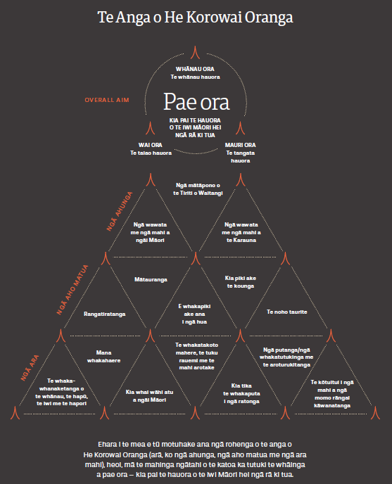

Ngā whānga matua o He Korowai Oranga
Ko te whāinga matua o He Korowai Oranga ko Pae ora – kia pai te hauora o te iwi Māori hei ngā rā ki tua

Pae ora  KIA PAI TE HAUORA O TE MĀORI Ā NGĀ RĀ KI TUA | Ko tā pae ora, he akiaki i ngā tāngata katoa o te pūnaha hauora me te hunga whaikaha, arā, ko te hunga e whakapau kaha ana ki te hauora o te Māori, ki te mahi ngātahi, ki te titiro ki tua atu i ngā whakamārama whāiti e pā ana ki te hauora, ki te tuku atu i ngā ratonga whai kounga, whai take hoki. Kei te whakamana a pae ora i te hauora Māori – kei te kaha tautokona ngā otinga e arahina ana e te Māori me ngā momo tauira Māori e pā ana ki te hauora me te oranga tangata. Kei te hāpai a pae ora i te hiahia o te Māori ki te whakahaere i tōna anō hauora me tōna anō oranga ā ngā rā ki tua.
Whānau ora  TE WHĀNAU HAUORA | Ko Whānau Ora te ariā matua e puāwai mai ai te kaha, te hauora me te mana o te whānau. He hua nui tō te whānau whai kaha, te whānau hauora me te whakamanatanga o te whānau mō te hauora me te oranga o te Māori. Ka ahua mai te kaha o te whānau i tōna āhei ki te tiki atu i ngā pārongo me ngā kōrero whai kounga, i ngā rauemi tōtika, i te hauora o tōna noho, i tōna āhei ki te whakahaere i tōna anō ao me tōna rangatiratanga, me te whakapono ka taea e ia tōna anō ao te waihanga, ehara i te mea me pīkau noa ia i ngā taumahatanga o te wā.
Mauri ora  TE TANGATA HAUORA | Ko tā te whāinga o mauri ora, he whakapiki ake i te mauri o te tangata mai i te ngoikore ki te mauri ora. Ka ora nui te mauri i ngā momo āwhina, i ngā ratonga me ngā rongoā e hāpai ana i te noho hauora; me whakapiki ake i te mātauranga me te mana whakahaere; me whakapūmau i te tuakiri; me hāpai i te tangata ki te whakahaere i a ia anō, me whakahoki atu i te mana whakahaere ki te tangata tonu. He taha wairua tō te mauri ora e whakatairanga ana i te wāhi ki te ahurea e pai ai te hauora o te tangata.
Wai ora  TE TAIAO HAUORA | Ko tā te wai ora, he whakaū i te hiranga o ngā hononga o te Māori ki te whenua, hei tauira mō ngā tūmomo taiao e nōhia ana e tātou me te pānga nui o tēnei āhuatanga ki te hauora me te oranga o te tangata takitahi, o te whānau, o te hapū, o te iwi me ngā hapori Māori.  Kei te taiao hauora ngā rauemi tōtika (arā, he whare pai, he wai māori, te hau ora me te kai ora), ka tautokona, ka whakapūmautia hoki te ora o te mauri, te hauora me te mana o te whānau.

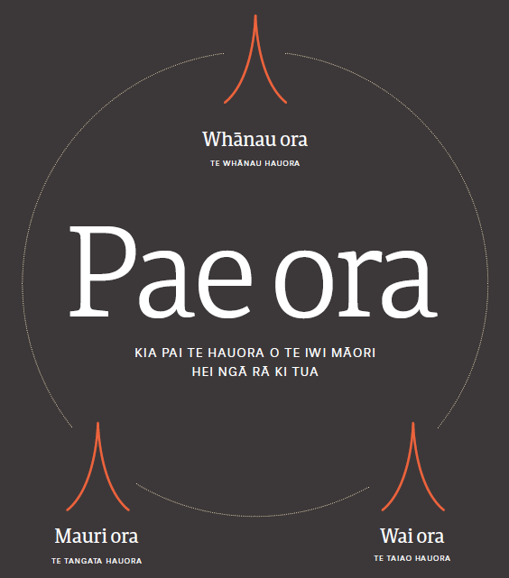

Whakamaua 2020-2025:
te Mahere Whakatutuki Whāinga Hauora Māori
Kei te whakatakoto a Whakamaua 2020–2025 i te koronga o te kāwanatanga mō te ahunga whakamua o te hauora o te Māori ā ngā tau e rima e heke mai ana. Kei te mahere nei ngā whāinga, ngā whāinga tōmua me ngā tūmahi tūturu e puta mai ai ngā hua tiketike e mau ai te pae ora i te iwi Māori. Ka whakainea,
ka whakatakoto pūrongo te Manatū mō te ahunga whakamua o te kaupapa i roto i te takanga o te wā.
Kei te ārahi te mahere i te Manatū, rātou ko te rāngai hauora me te hunga whaikaha, ki te whakatinana i te kaupapa o He Korowai Oranga.
E hāpaitia ana te pūnaha hauora me te hunga whaikaha ki te whakaū i ngā mahi e tutuki ai ngā kawenga o te Karauna ki raro i te Tiriti me te United Nations Declaration on the Rights of Indigenous Peoples.
Mā te whakatutukinga o ngā mahi e rārangi ana i roto i tēnei mahere, ka tutuki hoki ngā mahi a Hāpaitia te Oranga Tangata, nā te Kāwanatanga, me ngā whāinga tōmua o te pūnaha hauora me te hunga whaikaha, pērā i te whakapikinga ake o te hauora o te tamaiti, o te hauora ā-hinengaro me te oranga whānui mā te whakawhanaketanga mai o tētahi pūnaha māia, o tētahi pūnaha e pono ana ki ngā putanga taurite i roto i te rāngai hauora tūmatanui me te hunga whaikaha.
He kaupapa ora hoki tēnei mahere whakatutuki whāinga hauora, ka whanake tonu mai i roto i ngā mahinga ngātahi ki ngā kaiwhaipānga hei whakatutuki i ngā hiahia o tēnei wā, me ērā e puta tonu mai ana. Kei te ara tika tēnei mahere ki te whakapiki ake i ngā putanga hauora o ngāi Māori.

Ngā putanga e hiahiatia ana
He putanga whānui ngā putanga o Whakamaua 2020–2025, e tohu ana i te aronga matua o ngā tūmomo kaupapa mahi mā te katoa, hei ngā tau e rima e heke mai ana.
E whā ngā putanga matua e whakautu ana i ngā tino wero e pā ana ki ngā take ahurea, ngā take pāpori, ngā take ōhanga me ngā take ā-taupori e whai pānga ana ki te hauora o Aotearoa.
E tino hāngai ana ēnei putanga ki ngā kōrero a ngāi Māori me ngā taunakitanga e mea ana, me tahuri te pūnaha o te hauora me te hunga whaikaha ki te whakaea i ngā wawata o ngāi Māori me te whāinga nui o pae ora.

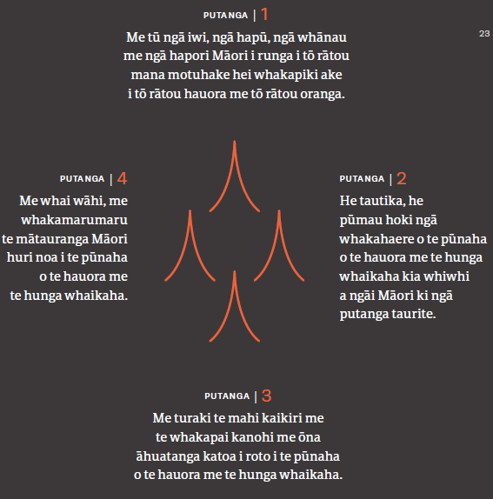

Ngā whāinga e ārahi ana I ā mātou mahi
E whā ngā whāinga e ārahi ana i te whakahāngaitanga o ngā mahi me ngā rauemi i roto i ngā whāinga tōmua.
Ko ngā whāinga nei, te taumata mō te inenga me te aroturukinga o ngā mahi i roto i te mahere i ngā tau e rima, e tutuki ai ngā putanga whānui e whā kua whakaahuatia ki runga ake rā.
Me wawe te tuku pūtea haumi, me tika hoki ngā kaupapa e whāia ana, kia eke ai ngā āhuatanga e mau ana ki roto i te mahere. Me kuhu atu hoki ngā momo wāhi e hāpai ana i ngā tāngata, i ngā whānau, i ngā hapū me ngā iwi Māori; me arotahi te pūtea haumi ki te whakamarumarutanga o te hauora me te oranga o te hapori; me whānui hoki te āhei ki te toro atu ki ngā ratonga whai tikanga, ngā ratonga torowhānui anō, e hāngai ana ki ngā mateā me ngā ratonga whai hononga i roto i te rāngai hauora me te hunga whaikaha. Me whakawhiwhia ēnei ratonga i te wā e tika ana, me tū pātata ki ngā kāinga, ki ngā wāhi mahi me ngā papa kāinga o te Māori. Mēnā ka nui ake te pūtea haumi ki ngā whare hauora Māori me ngā whare manaaki o te hapori, ka piki ake te oranga tangata, ka heke iho ngā take hauora o te tangata takitahi me ngā whānau, me ngā nama hei utu mā te pūnaha o te hauora me te hunga whaikaha. Me turaki ngā whakapae ā-ahurea, ā-pāpori anō, kua whakatōkia noatia huri noa i te rāngai hauora me te hunga whaikaha, me te pāpori whānui, e ea ai, e kauparehia atu ai ngā take kaikiri me te whakapai kanohi.

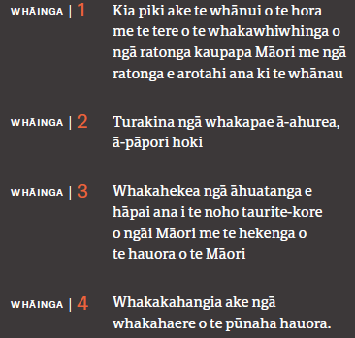

Ngā whāinga tōmua hei whakatutuki
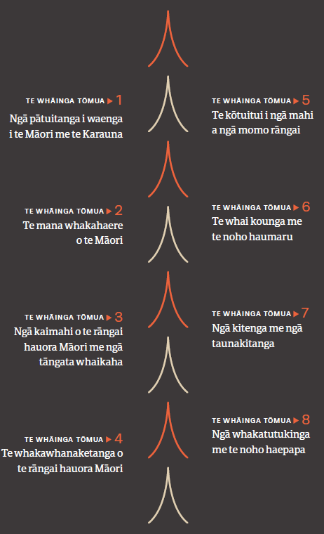
Kua whiwhi te Manatū i ngā tāpaenga kōrero mai i te pūnaha o te hauora me te hunga whaikaha, i ngā tangata takitahi, ngā whānau, ngā hapū, ngā iwi me ētahi atu whakahaere i roto i te whakawhanaketanga mai o ngā whāinga tōmua e waru a Whakamaua 2020–2025.

Kua tuituia ngā wāhanga katoa o ngā whāinga tōmua. Kua tohua e ngāi Māori me te pūnaha whānui ngā wāhi me mātua whakatikatika e puta mai ai ngā hua rerekē, e tū pakari ai te ao hauora ā ngā tau e heke mai ana.
Kua ahu mai ngā tino mahi ki raro i ia whāinga tōmua, i te hiahia kia hāngai, kia whaihua te whakapaunga o ngā rauemi. Ehara i te mea e kapi ana tēnei mahere i te katoa o ngā mahi e tutuki ai ngā whāinga huri noa i tēnei taiao motuhake, taiao matatini hoki. Heoi, ko ngā mahi i roto i tēnei mahere, ngā mahinga matua, e taea ai, mēnā ka ū te katoa, te whakatō i ngā āhuatanga e tika ana ki te whakatakahuri i te pūnaha hauora i roto i te wā poto, i te wā āhua poto rānei.
E mārama ana ki a mātou, ka whai pānga ngā hua o ngā tino mahi ki raro i tētahi whāinga tōmua, ki ētahi atu whāinga tōmua. Ka kitea ngā putanga e whāia ana mēnā e hāngai ana ngā mahi i raro i ngā whāinga tōmua katoa, waihoki, mēnā ka mātua whāia ēnei putanga e te katoa o te pūnaha hauora.

Te hāpai tahi i te hauora o te Māori
Hei tāpiri atu ki ngā kōrero a Whakamaua, ka ea hoki , ka ea ngā whāinga matua o He Korowai Oranga mā ngā rautaki whānui a te kāwanatanga rātou ko te pūnaha o te hauora me te hunga whaikaha, mā ngā rautaki a ngā poari hauora ā-rohe takitahi, me ētahi atu mahere mahi, korero ārahi, arotakenga me ngā tūhuratanga, pērā i ēnei e rārangi mai nei, me ētahi atu:
- Wai 2575 Health Services and Outcomes Kaupapa Inquiry
- Health and Disability System Review
- New Zealand Disability Strategy
- Whāia Te Ao Marama 2018 to 2022: The Māori Disability Action Plan
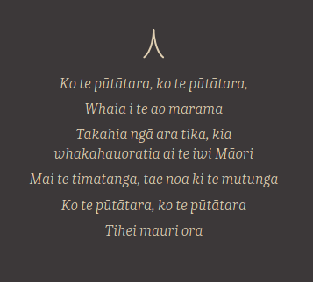
- Response to He Ara Oranga: the report on the Government Inquiry into Mental Health and Addiction
- Every Life Matters: He Tapu te Oranga o ia Tangata: Suicide
- Prevention Strategy 2019–2029
- New Zealand Cancer Action Plan 2019–2029
- Child and Youth Wellbeing Strategy.

He whāinga tōmua te whakatutukinga o ngā wawata o te Māori me ngā whāinga mō te hauora me te oranga tangata, huri noa i te pūnaha hauora me te hunga whaikaha, waihoki, i roto i te rāngai pāpori, te rāngai ture, te ao ōhanga me te rāngai taiao.

Ngā putanga e hiahia ana

Putanga 1
Me tū ngā iwi, ngā hapū, ngā whānau me ngā hapori Māori i runga i tō rātou mana motuhake hei whakapiki ake i tō rātou hauora me tō rātou oranga.
E mea ana tēnei whāinga, kei te Māori tōnā anō mana motuhake e pā ana ki tōna hauora me ōna wawata mō tōna oranga. Me tahuri kē ngā mana whakahaere ki te hāpai i ngā iwi, ngā hapū me ngā whānau ki te kimi oranga nui mō rātou anō, hei Māori, ki te whakapūmau hoki i te hauora, i ngā āhuatanga o te taiao me te hapori, e noho pai ai, e tipu pai ake ai ngā tamariki.
E hāngai ana tēnei whāinga ki te wāhanga 1 me te wāhanga 2 o te Tiriti, waihoki, e whakatinana ana tēnei whāinga i ngā mātāpono o te pātuitanga, o te tino rangatiratanga me te whakatuwheratanga o ngā ara hei whai mā ngāi Māori.
Ko te whakatutukinga o ngā wawata o te Māori e pā ana ki te hauora me te oranga tētahi o ngā āhuatanga e whāia ana ki raro i te whāinga nui o pae ora, arā, kia ora te taiao (wai ora), kia ora te whānau (whānau ora), kia ora hoki te tangata (mauri ora).

Putanga 2
He tautika, he pūmau hoki ngā whakahaere o te pūnaha o te hauora me te hunga whaikaha kia whiwhi a ngāi Māori ki ngā putanga taurite.
E whai ana tēnei putanga i te noho taurite o te Māori i roto i ngā whakahaere o te pūnaha o te hauora me te hunga whaikaha o Aotearoa. Me whakaae ngā kaituku katoa o te pūnaha o te hauora me te hunga whaikaha e takatahi ana ngā hua o te rāngai hauora, waihoki, he āhuatanga taurite-kore tērā, he kino, heoi, he āhuatanga hoki e taea te karo. Ka tutuki tēnei putanga i runga i te kaha o ngā mana whakahaere ki te tuku i ngā momo rauemi tōtika, ki te kimi hoki i ngā ara mahi e arotahi ana, e hāngai ana hoki ki ngā wawata o te Māori mō te hauora me ngā momo mateā kāore anō kia whakatutukihia.
Kei te kawe a ngāi Māori i te nuinga o ngā taumahatanga o te ao hauora, arā, ko te kino o te hauora, ko te pānga o ngā mate whaikaha, me te nui o ngā matenga tōmua. E whāngaihia ana tēnei āhuatanga taurite-kore e ngā rerekētanga, nō te pāpori, nō te ao ōhanga me
ngā momo whanonga o te tangata e whakaawe ana i te hauora me te oranga. Hei tāpiri atu, ko te āhei o te tangata ki te toro atu ki ngā whare tiaki hauora me te kounga o ngā mahi a ērā whare.
E hāngai ana tēnei putanga ki ngā wāhanga 2 me te 3 o te Tiriti, otirā, e whakatutuki ana tēnei putanga i ngā mātāpono o te tino rangatiratanga, o te noho taurite me te kaitiakitanga. He mea nui te noho taurite i roto i He Korowai Oranga, he whāinga tōmua hoki tērā a te Kāwanatanga e tū ai tētahi pūnaha kaha, tētahi pūnaha e hāpai ana i ngā putanga taurite i te pūnaha hauora me te hunga whaikaha.

Putanga 3
Me turaki te mahi kaikiri me te whakapai kanohi me ōna āhuatanga katoa i roto i te pūnaha o te hauora me te hunga whaikaha.
Ko te whāinga o tēnei putanga ko te whakakorenga o ngā momo mahi kaikiri me ngā momo whakapai kanohi katoa e rangona ana e ngāi Māori. He wāhi nui tēnei o te whakamanatanga o te Tiriti. He mea nui kia whakahēngia te mahi kaikiri me te whakapai kanohi i ōna āhuatanga katoa e tutuki ai te whāinga nui o pae ora mā ngāi Māori. Otirā, me whakaū i ngā tikanga o te manaaki, me te hiahia o ngā tāngata me ngā whakahaere katoa e mahi ana huri noa i te rāngi hauora me te hunga whaikaha ki te kite, ki te whakatikatika hoki i ō rātou ake ngākau kino, waiaro, whakapae, whakaaro horapa, whakawātanga, ngā momo hanganga me ngā āhuatanga e whai pānga ana ki te whakawhiwhinga o ngā momo mahinga hauora e tika ana me te kounga o aua mahi.
Kei te kitea te mahi kaikiri i roto i ngā tirohanga tikanga tōtahi o te pūnaha e whai painga ai tētahi wāhi kotahi o te taupori, e mahue ana tētahi atu. Ko te mahi kaikiri tētahi āhuatanga o te ao hauora e taea ana te karo.
He pānga tōna ki te hauora ā-hinengaro me te hauora ā-tinana hoki, ā, ko te hekenga o ngā putanga hauora o te Māori te otinga atu.
E hāngai ana tēnei putanga ki te wāhanga 3 o te Tiriti me te whakaputanga e pā ana ki ngā Ritenga Māori. Ko te whakatinanatanga tēnei o ngā mātāpono o te kaitiakitanga, o te noho taurite me te whakatuwheratanga o ngā kōwhiringa whaihua.

Putanga 4
Me whai wāhi, me whakamarumaru te mātauranga Māori huri noa i te pūnaha o te hauora me te hunga whaikaha.
Mā tēnei putanga ka whakaūngia te mātauranga Māori huri noa i te pūnaha o te hauora me te hunga whai kaha, hei hāpai i te hauora me te oranga o te Māori. E whakamana ana tēnei putanga i te hāngai me te wāriu o te mātauranga motuhake o te Māori, me te mōhiotanga, te mahi, me te oranga o ngā iwi taketake kei roto i ngā tauira hauora Māori, kei ngā taumata katoa o te pūnaha o te hauora me te hunga whaikaha.
Ko ngā ratonga rongoā Māori ērā me ngā whare hauora o te hapori e arotahi ana ki te whānau. He mea nui te whakapakari i te mōhiotanga me te māramatanga ki te mātauranga Māori, mā te rangahau me ngā arotakenga o ngā kaupapa hauora Māori. Me mahi ngātahi ki te waihanga i ngā ratonga me ngā tūmomo kaupapa e whakatere ana i te putanga mai o ngā hua mō te hauora o te Māori. Me whai wāhi hoki te mātauranga Māori e eke ai ēnei kaupapa ki te taumata e tika ana.
E hāngai ana tēnei putanga ki te wāhanga 2 o te Tiriti me te whakaputanga o te Ritenga Māori. Kei te whakatinanatia ngā mātāpono o te tino rangatiratanga, o ngā kōwhiringa whaihua me te kaitiakitanga.
E whakaahua ana tēnei putanga i ngā āhuatanga katoa e hāngai ana ki ngā wawata me ngā mahinga a te Maori i roto i te rautaki o He Korowai Oranga. E tautoko ana hoki te pūrongo whakamutunga o te Halth and Disability System Review i te whakaurunga o te mātauranga Māori ki te pūnaha o te hauora me te hunga whaikaha.

Ngā whāinga tōmua hei whakatutuki

Te Whāinga Tōmua 1

Ngā pātuitanga i waenga i te Māori me te Karauna

He whakamārama
- E whakaata ana ngā hononga whaikiko i waenga i te Māori me te Karauna i te hōhonutanga o ngā pātuitanga ki ngā taumata katoa o te pūnaha o te hauora me te hunga whaikaha.
Whakataukī
Mā tini, mā mano,
ka rapa te whai
- E piki ake ana te nui o ngā iwi me ngā hapū e ārahi ana i te whanaketanga mai o te hauora o te Māori.
- E pūmau ana ngā hononga i waenga i te Māori me te Karauna, i runga i te pono o tētahi ki tētahi, me te māia o te pūnaha o te hauora me te hunga whaikaha.

Te kaupapa
Ki te whakapiki ake i ngā ara whaihua me te kounga o ngā pātuitanga i waenga i te Māori me te Karauna me te whakatairangatanga o ngā hononga pai i waenga i te Māori me te Karauna

Ngā tino mahi
- Whakatūria ngā pātuitanga ki ngā iwi, kia hāpaitia te whanaketanga ā-rohe o ngāi Māori me ngā ratonga kaupapa Māori.
- Arotakengia, whakahoahoatia, whakawhānuihia ngā momo pātuitanga i waenga i te Māori me te Karauna 1.3 huri noa i ngā Poari Hauora ā-Rohe ki ngā taumata katoa o te pūnaha o te hauora me te hunga whaikaha.
- Arahina, whakatutukihia ngā whakahau o te pūrongo Hauora mai i te wāhanga tuatahi o Wai 2575. Me tautoko hoki ngā wāhanga e puta tonu atu ana.
- Me whakapā atu ngā DHB ki ngā iwi o tō rātou rohe, me whai hoki i te anga me te puka ārahi mō ngā whakapāpātanga, i a rātou e whakawhanake ana i ngā kaupapa pakihi nunui.

He aha te take he mea nui tēnei whāinga tōmua?
Ko te kāwanatanga (arā, ko te mana o te Manatū ki te whakahaere i te pūnaha o te hauora me te hunga whaikaha i runga i te pono me te tika) me te tino rangatiratanga o te iwi Māori ki runga i ngā āhuatanga o tō rātou noho, i raro anō i ā rātou ake tikanga Māori te tūāpapa o te tūhonotanga o te Māori me te Karauna. Me whakatō i ngā kākano o te pono ki roto i te pātuitanga i waenga i te Māori me te Karauna i raro i te pūnaha o te hauora me te hunga whaikaha kia puāwai ai taua hononga ā ngā tau e heke mai ana. Me āta arotake ngā whakaritenga o tēnei pātuitanga kia ea ai ngā whāinga o te Tiriti.
“Me whakatū i ngā hononga whaitake i waenga i te Māori me te Karauna, arā, me mārama ki ngā mōtika, ki ngā painga me ngā tirohanga o te Māori; me āta whakatū i ngā hononga whaitake ki ngā iwi, ngā hapū me ngā hapori Māori; me whakatō i ngā tirohanga o te Māori me te Tiriti ki roto i ngā kaupapa here, ngā hōtaka me ngā ratonga.”

He korero urupare a tētahi Kaiwhaipānga
E hāngai ana te nuinga o ēnei mahi ki te putanga 1 – me tū ngā iwi, ngā hapū, ngā whānau me ngā hapori Māori i runga i tō rātou mana motuhake hei whakapiki ake i tō rātou hauora me tō rātou oranga.

He aha rā te whakatinanatanga o tēnei whāinga tōmua?
He mārō, he whaihua ngā hononga a te Manatū, ngā DHB me ētahi atu whakahaere o te Karauna, ki te Māori, i roto i te waihangatanga, i te whakatinanatanga me te aroturukinga o ngā ratonga hauora me ngā ratonga mō te hunga whaikaha. I roto i te wā, ka inea te kounga o ngā hononga i waenga i te Māori me te Karauna ki ngā taumata katoa o te pūnaha o te hauora me te hunga whaikaha, e ngā rōpū e rua, hei ārahi i ngā whakapaitanga me te noho haepapa. Kei ngā iwi me ngā hapū ngā rauemi me ngā momo āwhina hei whakawhanake i ngā ratonga kaupapa Māori me ngā ratonga e arotahi ana ki te whānau, e whakatutuki ana i ngā wawata o ō rātou ake hapori mō te hauora. Ka hīkina ake ngā mahi a te rāngai hauora me te hunga whaikaha ki te whakaea i ngā take hauora o ngāi Māori, ki te whakatutuki hoki i ngā whāinga o te Tiriti.
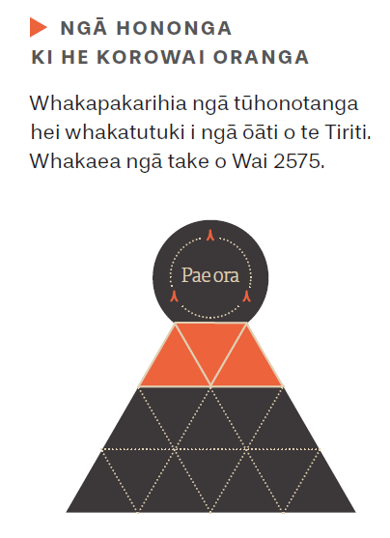

Te Whāinga Tōmua 2

Te mana whakahaere o te Māori

He whakamārama
- Kua whakapūmauhia te mana whakahaere o te Māori i raro i te Tiriti o Waitangi. Koia hoki te ngako o te whakatutukinga o ngā kaupapa ‘a te Māori, mā te Māori, i te taha hoki o te Māori’.
Whakataukī
He rātā whakamarumaru
- Kia nui ake ngā momo tautoko, ngā whakangungu hoki mā ngā kaiārahi Māori o nāianei me ērā e piki ake ana i roto i te rāngai o te hauora me te hunga whaikaha.
- Kia nui ake ngā ara e whai wāhi atu ai ngā kaiārahi Māori o te rāngai hauora me te hunga whaikaha ki te ārahi i ngā whakataunga, ki te whai tūhonotanga, ki te tuari me te mahi ngātahi.

Te kaupapa
Ki te whakapiki ake, ki te tautoko hoki i te tū o te Māori i roto i ngā rōpū whakahaere, i ngā tūranga rangatira me ngā whakataunga a ngā kaiwhakahaere i ngā taumata katoa o te pūnaha o te hauora me te hunga whaikaha

Ngā tino mahi
- Whakatakotohia ngā ara whaihua e tūhono atu ana i ngā mema Māori o ngā DHB, ngā mema o ngā poari tautoko me ngā Māori kei roto i ērā atu whakahaere o te rāngai hauora me te hunga whaikaha.
- Whakawhanakehia tētahi anga rautaki hei ārahi i te huringa o te pūnaha whakahaere, hei whakapiki ake hoki i ngā putanga mō te hauora ā-hinengaro me ngā momo waranga o te Māori.
- Whakahoahoatia, whakaratoa hoki ngā kaupapa whakawhanake ngaiotanga me ngā ra whakangungu mā ngā mema Māori o ngā DHB me ngā mema o ngā poari tautoko o ngā DHB/Iwi/Māori.
- Me tāpae kōrero te Manatū Hauora e pā ana ki te whakawhanaketanga o ngā mema Māori i roto i ngā rōpū whakahaere huri noa i te pūnaha o te hauora me te hunga whaikaha.
- Arotakengia He Korowai Oranga, hei whakapūmau i te koronga o te rautaki kia tutuki pai ai ngā wawata me ngā hiahia o āpōpō, hei whai i ngā putanga o te arotakenga o te pūnaha o te rāngai hauora me te hunga whaikaha.

He aha te take he mea nui tēnei whāinga tōmua?
Ka eke te hauora me te oranga o te Māori ki tōna taumata tiketike mēnā ka whai wāhi mai hoki te mātauranga me te mana whakahaere o te Māori. Ka kitea ngā mana whakahaere ki waenga i ngā iwi, ngā marae, ngā hapori, ngā ratonga hauora me ngā ratonga ā-pāpori, kei ngā whare rangahau, kei ngā pūkenga mātauranga, kei ngā kaituhi o ngā kaupapa here me ngā kaiwhakahaere. Ka eke te mahi a tētahi pūnaha ki te taumata tiketike mēnā ka reira hoki ngā ara whakangungu mō ngā kaiārahi Māori i raro i ngā wāhanga katoa o te rāngai hauora me te hunga whaikaha, hei whakawhanake i te āheitanga o te tangata ki te tū hei kaiārahi.
Ko te whaihua o ngā pūtea haumi tētahi o ngā kawenga matua o te whakawhanaketanga mai o ngā kaiārahi Māori. Koia hoki tētahi o ngā pou o te whakatutukinga o ngā whāinga matua a He Korowai Oranga. Kei raro i te New Zealand Public Health and Disability Act 2000 me whakatū ngā DHB ētahi momo hanganga e taea ai e te Māori te kuhu atu ki ngā whakataunga me te whakaratonga o ngā kaupapa mō te hauora me te hunga whaikaha. He take matua tonu te whakatūnga me te whakapūmautanga o ngā tūru Māori ki te taumata o te poari. Me āta whai wāhi atu te Māori ki ngā whakahaere matua me ngā whakataunga whaikiko ki ngā taumata katoa o te pūnaha o te hauora me te hunga whaikaha.
E hāngai ana tēnei whāinga tōmua me āna tino mahi ki te putanga 1: Me tū ngā iwi, ngā hapū, ngā whānau me ngā hapori Māori i runga i tō rātou mana motuhake hei whakapiki ake i tō rātou hauora me tō rātou oranga me te putanga 2: he tautika, he pūmau hoki ngā whakahaere o te pūnaha o te hauora me te hunga whaikaha kia whiwhi a ngāi Māori ki ngā putanga taurite.

He aha rā te whakatinanatanga o tēnei whāinga tōmua?
“Me kite ngā kanohi Māori i ngā taumata katoa o ngā rōpū whakaputa whakatau. Ehara i te mea, me noho ngā kaiārahi Māori ki te poari whakahaere anake; me whai i ngā tūranga mahi kei ngā wāhi katoa o te pūnaha hauora, arā, ko te kaiwhakahaere, ko te takawaenga whakahaere, ko
te kaiārahi o ngā rōpū, waihoki ko ngā mana whakahaere me ngā kaiārahi o ngā tari hauora.”

“Ko te mana whakahaere
o te Māori te ngako o ngā otinga e ahu mai ana i te Māori, mā te Māori; me tautoko tēnei āhuatanga kia taea ai e te Māori te poipoi me te tohutohu i ngā
kaiārahi o āpōpō.”

HE KŌRERO URUPARE A TĒTAHI KAIWHAIPĀNGA

.”

STAKEHOLDER ENGAGEMENT FEEDBACK
Kua piki ake te tatau me te āheitanga o ngā kaiārahi Māori i ngā taumata katoa o te rāngai hauora. Ko te mātauranga Māori te tūāpapa, waihoki, ko ngā kitenga o te mātauranga hauora me ngā mātauranga o ngā iwi taketake o te ao. He pūkenga ngā kaimahi, he mātau ki te mahitahi ki ngā tūmomo whakahaere, mai i ngā rāngai maha, i ngā hapori me ngā iwi Māori. He whānui te hora o ngā kaiārahi Māori huri noa i te rāngai hauora, kua tuia ngā muka tāngata, e noho haepapa ana rātou ki a ngāi Māori, ki ngā whakahaere o te kāwanatanga hoki.
He ngākaunui, he whai pūkenga ngā kaiārahi Māori o te rāngai hauora o nāianei, o āpōpō anō, e taea ai e rātou te tino kuhu atu, te whai wāhi atu, te whakaaweawe hoki i ngā tukanga whakaputa whakatau o te pūnaha hauora me te hunga whaikaha, inā koa ko ngā DHB. Mā te whakapikinga ake o te tatau o ngā kaiārahi Māori, ka āta kitea ngā hua i roto i te hoahoatanga me te whakaratonga o ngā ratonga hauora e whakaataata ana i ngā mateā hauora ā-rohe o ngāi Māori. Ka whakatikaina te hora o ngā rawa, ka pai ake ai ngā putanga hauora o ngā hapū, ngā iwi, ngā whānau me ngā hapori Māori. Ka tautokona ngā kaiārahi hauora Māori ki te mahi ngātahi i roto i tētahi akomanga kotahi, e tipu ake ai te whanaungatanga i waenga i ngā rohe Māori me te taura here tangata i waenga i ngā kaiārahi o te rohe, kia āhei rātou ki te whai i ō rātou ake
tino rangatiratanga.
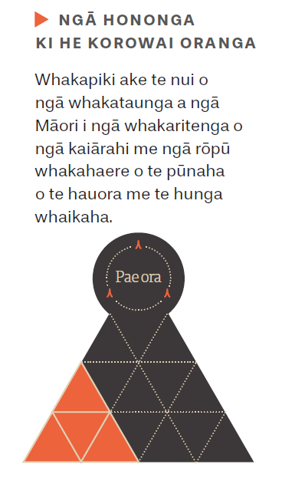

Te Whāinga Tōmua 3

Ngā kaimahi o te rāngai hauora Māori me ngā tāngata whaikaha Māori

He whakamārama
- Ka piki ake te tatau me te āheinga o ngā kaimahi o te rāngai hauora Māori me te hunga whaikaha.
Whakataukī
Mā whero, mā pango ka oti te mahi.
- Pūkenga rua – ka whakaūngia te mana Māori me te mātauranga Māori hei pūkenga whaitake
- E hāngai ana ngā pūkenga o ngā kaimahi o te rāngai hauora Māori me te hunga whaikaha ki ngā mateā hauora o ngāi Māori

Te kaupapa
Ki te whakapiki ake i te tatau me te āheitanga o ngā kaimahi o te rāngai hauora Māori me te hunga whaikaha ki ngā taumata katoa o te pūnaha hauora me te hunga whaikaha.

Ngā tino mahi
- Whakawhānuihia ngā kaupapa o nāianei e akiaki ana i te Māori ki te whai i ngā tūranga mahi i roto i te ao hauora.
- Tautokona te whakawhanaketanga mai o tētahi ohu matua Māori mō te hauora ā-hinengaro.
- Tautokona ngā DHB me te rāngai hauora Māori ki te whakapoapoa, ki te mau, ki te whakawhanake, ki te āta whakamahi hoki i ā rātou kaimahi Māori, arā, i roto i ngā mahi a ngā kaiārahi me ngā kaiwhakahaere hoki.
- Whakawhanakehia tētahi anga rautaki hei ārahi i te whakawhanaketanga o ngā kaimahi o te rāngai hauora Māori me te hunga whaikaha i ngā 10 tau e haere mai ana.

He aha te take he mea nui tēnei whāinga tōmua?
Ko ngā kaimahi o te rāngai hauora me te hunga whaikaha ngā kaikōkiri o te whakapikinga ake o ngā putanga mō te hauora me te noho taurite o te Māori. Mēnā e hāngai ana ngā kaimahi hauora Māori ki ngā mateā o te hapori, ka tino tāmia ngā mahi kaikiri i roto i te pūnaha hauora, i te mea ka manaakihia ngā tikanga Māori, ka whakahāngaitia ngā mahi tiaki tangata.
Huri noa i te pūnaha o te rāngai hauora me te hunga whaikaha, he tokoiti tonu ngā kaimahi Māori. Mēnā ka mātua hāpaitia ake te tatau me ngā āheinga o ngā kaimahi o te rāngai hauora me te hunga whaikaha, ka hāngai ake ngā ratonga mō te hauora me te hunga whaikaha, ka āta whakaataatahia hoki te hapori e whakawhiwhia ana ki ngā ratonga. He mea nui anō, te āta tautoko i te mahi ngātahi i waenga i ngā kaimahi Māori huri noa i te rāngai mahi. I roto i ngā tini āhuatanga e pā ana ki ngā kaiārahi me ngā kaimahi Māori, me whakapiki ake hoki te pūtea haumi huri noa i te rāngai mahi hei whakaea i ngā mateā e puta mai ana, me ērā e haere tonu mai ana kia whānui te hora o ngā ngā mahi papai me ngā mahi auaha.
“Me whai wāhi mai te Māori ki te whakaratonga o ngā mahi tiaki tangata, kia noho haumaru, kia tiakina tōtika ngā tūroro Māori. Mā konā, ka pai ake ō rātou whakapātanga atu ki te pūnaha hauora, ka pai ake hoki ngā putanga hauora.”

He kōrero urupare a tētahi Kaiwhaipānga
E hāngai ana tēnei whāinga tōmua me ngā tino mahi ki te putanga 2: he tautika, he pūmau hoki ngā whakahaere o te pūnaha o te hauora me te hunga whaikaha kia whiwhi a ngāi Māori ki ngā putanga taurite me te putanga 3: me turaki te mahi kaikiri me te whakapai kanohi me ōna āhuatanga katoa i roto i te pūnaha o te hauora me te hunga whaikaha.

He aha rā te whakatinanatanga o tēnei whāinga tōmua?
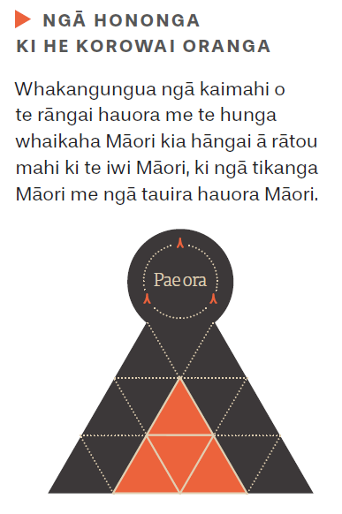
Ka tū tētahi ara rautaki e āta māramahia ana me tētahi mahere roa mō te whakangungutanga o ngā kaimahi Māori o te rāngai hauora me te hunga whaikaha. Ka piki ake te tatau me ngā āheinga o ngā kaimahi Māori o te rāngai hauora me te hunga whaikaha. E whakatata atu ana te tatau o ngā kaimahi hauora Māori ki ngā kaiwhiwhi ratonga, otirā, e hāngai ana ngā ratonga ki ngā mateā hauora. Kua piki ake te nui o ngā Māori e whai ana, e puta atu ana, e whai mahi ana i roto i te mātauranga hauora me te hunga whaikaha, kua piki ake hoki te nui o ngā mātanga hauora Māori. E whakaata ana ngā kaimahi o te rāngai hauora Māori me te hunga whaikaha i ngā tikanga me ngā tauira hauora Māori – e whakamana ana, e whakaū ana i te mātauranga Māori hei pūkenga whaitake.

Te Whāinga Tōmua 4

Te whakawhanaketanga o te rāngai hauora Māori

He whakamārama
- Whakaterehia ake, whakawhānuitia ake te hora o ngā ratonga kaupapa Māori me ngā ratonga e arotahi ana ki te whānau.
Whakataukī
Ko te pae tawhiti, whāia kia tata. Ko te pae tata, whakamaua kia tina.
- Whāia ngā ara tautika me ngā ara pūmau ki te kimi i ngā rōpū hei whakahaere i kaupapa Māori me ngā ratonga e arotahi ana ki te whānau.
- Hāpaitia te āhei me te nui o ngā rāngai hauora Māori e tuku atu ana i ngā ratonga whaihua ki ngā hapori Māori.

Te kaupapa
Me whakawhānui ake te hora, me whakapakari, me whakapūmau, me tautoko i ngā whakangungutanga whai kounga i roto i te rāngai hauora me te hunga whaikaha me ōna kaiwhakarato.

Ngā tino mahi
“… ko te whakatūnga o tētahi huarahi, e riro mai ai mā te Māori ngā ratonga hauora e tuku atu ki te Māori, koia tētahi take matua i roto i te whakapikinga ake o te hauora o te Māori, waihoki, he huarahi tēnei e ea ai ngā kawenga o
te Tiriti o Waitangi.”

“Aronui atu ki ngā ara e hāpai ana e riro mai ai mā te Māori ngā ratonga hauora e tuku atu ki te Māori, koia tētahi take matua i roto i te whakapikinga ake o te hauora o te Māori, waihoki, he huarahi tēnei e
ea ai ngā kawenga o
te Tiriti o Waitangi.”

He kōrero urupare a tētahi Kaiwhaipānga
- Me whakapiki ake te tatau me te āhei o ngā tāngata o te rāngai hauora Māori mā te Māori Provider Development Scheme, mā te pūtea o Te Ao Auahatanga Hauora Māori me ētahi atu tahua pūtea.
- Whakapakarihia ngā taunakitanga, whakawhānuitia ake te āhei ki te toro atu ki ngā ratonga rongoā Māori, me whakapakari ngātahi hoki i ngā kaimahi e whai ana i te rongoā Māori.
- Me whakapiki ake ngā anga tono pūtea me ngā tohutohu hei whakapiki ake i te auahatanga o ngā kaiwhakarato Māori hei whakawhanake, hei whakawhānui hoki i ngā kaupapa Māori whaihua me ngā ratonga e arotahi ana ki te whānau.
- Me whakapiki ake te āhei ki te toro atu ki ngā ratonga kaupapa Māori matua e pā ana ki te hauora ā-hinengaro me ngā momo waranga. Me nui ake hoki ngā kōwhiringa mā tēnei hunga.
- Whakarewaina te Hui Taumata Whakaoranga ā-tau mō te tau 2020–2025. Tonoa ngā rōpū katoa ki te whakatakoto tahi me te hāpai ngātahi i ngā mahere me ngā haepapatanga e pā ana ki te hauora Māori. Whakatakotohia tētahi rārangi take whai rautaki mō te roanga o te mahere o Whakamaua 2020–2025.
- Whāia tētahi mahere mahi hei aukati, hei kaupare atu hoki i ngā mate tūroa, pērā i te mate porohau me te mate huka mā tētahi kaupapa e kapi ana i te katoa o te pūnaha hauora. Me whakatū tētahi kaupapa pāpāho ā-motu, me whakawhānui hoki i ngā tauira tiaki hauora matua me ngā tauira tiaki hauora ā-hāpori e tino whaihua ana.
- Me tuku pūtea haumi ki ngā kaupapa auaha e hāpai ana i te whakatepe kaipaipa me ngā kaupapa ārai mate hei whakapiki ake i ngā putanga hauora o ngāi Māori.
- Me whakahou te kaupapa o Well Child Tamariki Ora kia āhei te katoa ki te uru atu, me whakaū hoki, kia pai ake ngā putanga mā ngā tamariki me ngā whānau Māori.
- Me tuku pūtea haumi kia tipu ake te āhei o ngā iwi me te rāngai hauora Māori ki te tuku i ngā ratonga e arotahi ana ki te whānau me ngā kaupapa Māori, kia hauora, kia whai tuituinga, kia tautokona ngā mahi tiaki tangata me te hunga whaikaha.

He aha te take he mea nui tēnei whāinga tōmua?
Ka whakatūria tētahi kaupapa e tuku atu ana i ngā ratonga hauora e te Māori, mā te Māori, i roto tonu i ō rātou ake hapori. He mea nui ngā ratonga e whai ana i ngā tikanga Māori, e hāngai ana hoki ki te tangata, hei whakapiki ake i te hauora o ngāi Māori, hei whakaea hoki i ngā kawenga a te Karauna i raro i te Tiriti. Me pono ki ngā kaiwhakarato Māori, me whai rātou i ngā rauemi tōtika ki te tuku atu i ngā ratonga whai tikanga Māori, i ngā ratonga e kapi ana i
te whānuitanga o tēnei mea te hauora e whai hononga anō hoki ki ētahi atu ratonga. Me mahi ngātahi rātou ki te whānau me ngā rāngai mahi, hei whakaea i ngā tūtohu whānui o te hauora, mō te roanga o te oranga o te tangata, me ngā tini āhuatanga e tāmi ana i te hauora o te Māori.
Mā te tuku pūtea haumi hei whakatere ake i te hora o ngā kaupapa Māori me ngā ratonga e arotahi ana ki te whānau, ka tipu hoki te hauora me te oranga, ka haukotia hoki ngā take tautika-kore e mau roa ana ki te hauora o te tangata. Mā ngā ara mahi kōtui, e hāngai ana ki te whānuitanga o te hauora, ka noho ngā mateā o te Māori me ō rātou whānau ki te pūtake o ngā ratonga tino whai kounga i te ao o te hauora me te hunga whaikaha.
E hāngai ana tēnei whāinga tōmua me ngā tino mahi ki te putanga 1: me tū ngā iwi, ngā hapū, ngā whānau me ngā hapori Māori i runga i tō rātou mana motuhake hei whakapiki ake i tō rātou hauora me tō rātou oranga, te putanga 2: he tautika, he pūmau hoki ngā whakahaere o te pūnaha o te hauora me te hunga whaikaha kia whiwhi a ngāi Māori ki ngā putanga taurite, me te putanga 4: me whai wāhi, me whakamarumaru te mātauranga Māori huri noa i te pūnaha o te hauora me te hunga whaikaha.

He aha rā te whakatinanatanga mai o tēnei whāinga tōmua?
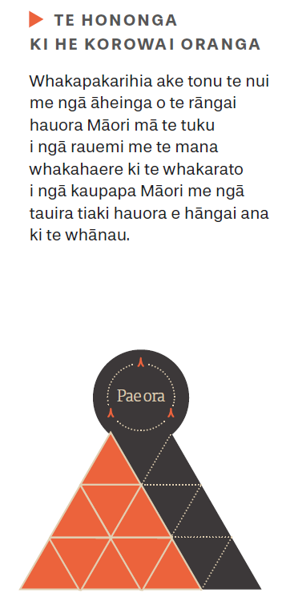
E whiwi ana te rāngai hauora Māori me ngā hapori Māori i ngā tautoko tōtika ki te tuku atu i ngā ratonga whai kounga mō te hauora me te hunga whaikaha, e whai ana i ā rātou tikanga tuku iho; i ō rātou mōhiotanga, i ā rātou mahi, i tō rātou mana Māori; me tō rātou tirohanga ki te ao. Mā te whakawhiwhinga tōtika o te pūtea ki ngā whare whakahaere hauora Māori, ka poipoia ngā mahi auaha, ka hua mai ngā otinga kaupapa Māori e arahina ana e ngā rohe. E wātea ana ngā ratonga ki ngā tangata takitahi, ki ngā whānau, ngā hapū me ngā iwi i te wā tika, e whai ana i ngā tikanga Māori me ngā mahi tiaki tōtika. E whakamanahia ana te mātauranga Māori hei puna mātauranga tūturu i roto i ngā tukanga tuku pūtea me te mahi kimi whare whakahaere ratonga a te Manatū me te DHB. E wātea ana ngā taunakitanga whai mana, ngā kitenga me ngā raraunga ki ngā kaiwhakarato Māori hei takahuri, hei kōkiri i te hauora me te oranga o te Māori.

Te Whāinga Tōmua 5

Te kōtuitui i ngā mahi a ngā momo rāngai

He whakamārama
- Me mātua whakaea ngā tūtohu whānui o te hauora e tutuki ai te whāinga o pae ora.
Whakataukī
Nā tou rourou. Nā taku rourou. Ka ora ai te iwi.
- E tuaritia ana ngā mahi mahere, te pūtea haumi me te noho haepapa e pā ana ki te hauora o te Māori e ngā momo rāngai mahi rerekē.
- E kōkirihia ana ngā kōtuinga mahi a ngā momo rāngai e ngā rohe, hei tautoko i te tuituinga, i te whakatutukinga wawe, me te whānui o ngā ratonga e arotahi ana ki te whānau.

Te kaupapa
Ki te hāpai i te mahi tahi me ngā whakaritenga tōtika, huri noa i ngā tari kāwanatanga kia eke te hauora me te oranga o te Māori ki tōna taumata tiketike.

Ngā tino mahi
- Tautokona te kaupapa mahi a TPK me Te Tari Taiwhenua e mahi tahi ana ki ngā marae ki tuawhenua me ngā papa kāinga kia whai hauora, kia whai oranga rātou i te wai māori.
- Me whakapau kaha kia rite tahi te toro atu a ngā tamariki e tiakina ana i raro i te marumaru o te kāwanatanga, e pā tata ana rānei ki te kuhu atu ki tētahi whare tiaki, ki ngā ratonga me ngā putanga whaihua mā roto
- i tētahi kaupapa mahi i raro i te Manatū Hauora me Oranga Tamariki.
- Hāpaitia ngā mahi huri noa i te rāngai kāwanatanga ki te kaupare atu i te pānga o te COVID-19 ki runga i ngā whānau, ngā hapū, ngā iwi me ngā hapori Māori.
- Whakawhānuitia ngā kaupapa e arahina ana e ngā rohe mā ngā hōtaka o Healthy Families New Zealand me He Kāinga Ora.
- Me noho tōmua te whakamarumarutanga, te whakatutukinga hoki o te noho taurite, o te hauora anō o te Māori i roto i ngā rautaki me ngā kaupapa mahi ā-tari (arā, ko te Child and Youth Wellbeing Strategy me te Homelessness Action Plan hoki) mō te Joint Venture on Family Violence and Sexual Violence.
- Ka tautoko te Manatū Hauora i ngā mahi aroturuki a Te Puni Kōkiri (TPK). Ko te rāngai hauora Māori te aronga tuatahi. Tautokona te whakatinanatanga o Whāia Te Ao Mārama 2018 ki 2022: The Māori Disability Action Plan.

He aha te take he mea nui tēnei whāinga tōmua?
“Kāore he tino kiko o ngā hua e taka atu ana ki te Māori i te pāpori me te ao ōhanga nā te mahi tāmi a tauiwi; ko te kino o te hauora o te Māori te hua o ngā tini āhuatanga taurite-kore i pā ki a rātou i roto i ngā tau maha.”

“Me mātua whai wāhi ngā momo mahi whaikiko, whai hononga hoki hei whakaea i ngā tūtohu e pā ana ki ngā āhuatanga taurite-kore i te ao hauora. Me āta tohu ngā tūranga mahi me ngā kawenga o tēnā me tēnā, i roto i ngā mahinga ā-rāngai. He mahi tōmua katoa ēnei ki raro i tēnei mahere mahi.”

He kōrero urupare a tētahi Kaiwhaipānga
E whakatairanga ana te kaupapa o wai ora (he oranga taiao) i te hiranga o te whakatūnga o ngā whare me ngā taiao māori e hāpai ana i te hauora o te Māori. He mea nui kia mahi ngātahi ngā tari kāwanatanga katoa hei whakaea i ngā ārai matua kia ngāwari ake ai te toronga atu me te noho āhuru o ngā whānau me ngā hapori ki ngā taiao hauora. Me āhei hoki rātou ki te nanao atu ki ngā momo āwhina e tika ana kia hoki atu te mana whakahaere e pā ana ki tō rātou hauora me tō rātou oranga ki a rātou anō. Me āta whakarite, me whaikiko hoki ngā mahi māherehere, ngā whakapaunga pūteā haumi, ngā rauemi me te noho haepapa huri
noa i ngā rāngai mahi, kia whiwhi a ngāi Māori ki ngā ratonga i te wā tika, kia rite tahi te āhei ki te toro atu ki ngā rauemi me ngā ratonga.
E hāngai ana tēnei whāinga tōmua me ngā tino mahi ki te putanga 2: he tautika, he pūmau hoki ngā whakahaere o te pūnaha o te hauora me te hunga whaikaha kia whiwhi a ngāi Māori ki ngā putanga taurite.

He aha rā te whakatinanatanga o tēnei whāinga tōmua?
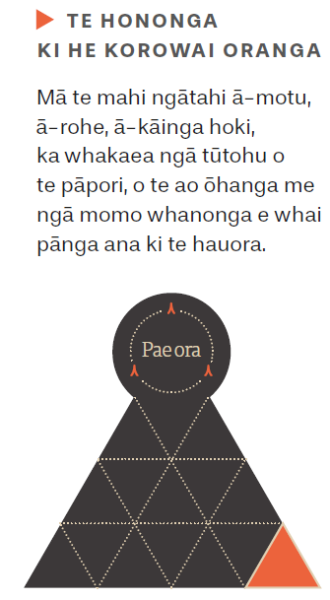
E pūmau ana ngā tūhonontanga kei ngā taumata katoa o te pūnaha, mai i ngā kaiwhakarato, ki ngā DHB, tae atu ki te Manatū, huri noa i ngā momo rāngai mahi, kia pai ake ai te kōtui ratonga, te whakatakoto mahere me te tautoko ki a ngāi Māori rātou ko ō rātou whānau. He tūranga nui tō te Māori i te whakawhanaketanga mai me te whakaratonga o ngā kaupapa o ngā tari kāwanatanga. Ko te tangata takitahi me ngā whānau te pūtake o ngā mahi a ngā kaiwhakarato – ka whakahāngaitia ngā mahi ki te tatau o ngā tāngata, ka whakahāngaitia hoki ngā mahi a ngā ratonga hauora me ngā ratonga pāpori. E tino whaihua ana te kōtuinga o ngā ratonga, he whai tikanga Māori, he pai ake te mahi tiaki i te roanga o te wā, he pai ake hoki ngā taiao me ngā putanga o ngāi Māori, huri noa i ngā rāngai maha.

Te Whāinga Tōmua 6

Te whai kounga me te noho haumaru

He whakamārama
- Me āta tirotiro i ngā raraunga hei kimi māramatanga e pā ana ki ngā rerekēnga i waenga i ngā putanga, hei whakapai ake i ngā mahi a te pūnaha hoki.
Whakataukī
Whāia te iti kahurangi; ki te tuohu koe, me he maunga teitei.
- Whakatūria ngā anga me ngā paerewa e pā ana ki te kounga me te noho haumaru.
- Whakatūria ngā taiao ratonga hauora e kaha ana ki te manaaki i ngā tikanga ā-iwi, e mātau ana hoki ki aua tikanga.

Te kaupapa
Ki te whakapiki ake i te kounga, te noho haumaru me ngā āhuatanga e rangona ana e tangata Māori takitahi me ō rātou whānau e pā ana ki ngā ratonga hauora me te hunga whaikaha.

Ngā tino mahi
- Nanao atu ki ngā rawa hangarau auaha hei whakahāngai i te ara hauora mā te tūroro, hei whakaū hoki i ngā mahi tiaki tōtika i te roanga o te wā, mā ngā tāngata Māori takitahi me ō rātou whānau.
- Me mahitahi ki ngā rōpū ngaio ki te kōkiri i te whakapikinga ake o te tatau o ngā kaimahi ngaio e eke ana ki ngā paearu tōtika e pā ana ki tō rātou mōhioranga ki ngā tikanga Māori me te noho haumaru.
- Whakatutukihia te arotakenga o ngā paetae a ngā kaiwhakarato o ngā mahi hauora me te hunga whaikaha i raro i te ture. Whakatinanahia hoki aua paetae i te taha o Te Apārangi: Māori Partnership Alliance.
- Arotakengia, whakatinanahia te whakahoutanga o te Health Equity Assessment Tool (HEAT).
- Waihangatia, whakatutukihia tētahi hōtaka mahi hei kaupare atu i te mahi kaikiri me te whakapae kanohi i roto i te pūnaha o te hauora me te hunga whaikaha.
- Hāpaitia ngā mahinga ngātahi i waenga i te pūnaha hauora me te hunga whaikaha mō te waihangatanga me te whakaūnga o tētahi anga nō te ao Māori hei whakapiki ake i te kounga o ngā mahi.

He aha te take he mea nui tēnei whāinga tōmua?
Me whiwhi a ngāi Māori i ngā putanga hauora taurite mā roto i tōna āhei ki te tiki atu i ngā ratonga hauora me ngā ratonga whaikaha e tōtika ana i raro i ngā tikanga Māori, e hāngai ana ki ō rātou wawata me ō rātou mateā. E ai ki ngā taunakitanga, ahakoa he ōrite pea te āhei o te iwi Māori ki te toro atu ki ngā ratonga, he iti ake te kounga o ngā mahi tiaki hauora e whakaratoa ana ki a ngāi Māori. Ko te noho taurite te ngako o tēnei mea te kounga o ngā mahi. Mēnā e taurite ana ngā mahi tiaki hauora, ko ngā putanga tōtika te hua mā ngā tūroro e tino mate ana, ahakoa te āhua o tōna noho me ētahi atu āhuatanga. Me whai kounga ngā raraunga hauora e kohikohia ana, e tātarihia ana, e whakamahia ana e te Manatū, e ngā DHB, e ngā kaituku ratonga huri noa i ngā rāngai mahi, e noho taurite ai te taumata o ngā putanga hauora o ngāi Māori. Hei tāpiri atu, me whakatū ētahi paerewa e whakatakoto ana i te kounga o ngā mahi me te noho haumaru o te tangata, hei ārahi i te pūnaha me ngā kaimahi ki te mahi māherehere, ki te whāngai atu me te aromatawai i te kounga o ngā mahi e eke ai ngā putanga hauora ki ngā tauamta tautika.
“Me whai wāhi ngā tikanga me te mātauranga Māori ki ngā paerewa mahi i ngā wā e tika ana. Pērā i ngā ratonga e kaha whakamahia ana e te Māori, he tokomaha rānei ngā Māori me ngā ratonga me whiwhi a ngāi Māori, engari kāore e whakawhiwhia ana i tēnei wā.”

“Mā te raraunga e puta ai ngā taunakitanga me te māramatanga e pā ana ki te whaihua, kāore rānei o te pūnaha me ngā ratonga.”

He kōrero urupare a tētahi Kaiwhaipānga
E hāngai ana tēnei whāinga tōmua me ngā tino mahi ki te putanga 2: he tautika, he pūmau hoki ngā whakahaere o te pūnaha o te hauora me te hunga whaikaha kia whiwhi a ngāi Māori ki ngā putanga taurite me te putanga 3: me turaki te mahi kaikiri me te whakapai kanohi me ōna āhuatanga katoa i roto i te pūnaha o te hauora me te hunga whaikaha.

He aha rā te whakatinanatanga o tēnei whāinga tōmua?
Ka whakawhiwhia ngā tāngata Māori takitahi me ngā whānau ki ngā ratonga whai kounga, arā, e haumaru ana te tangata, e whaihua ana, e arotahi ana ngā mahi ki te whānau, i te wā tōtika, waihoki, e hāngai ana ngā whakahaere. E hāpaitia ana ērā āhuatanga, e tētahi pūnaha o te hauora me te hunga whaikaha, e kohikohi ana, e whakamahi ana i ngā raraunga, kua wāwāhia i runga i te iwi o te tangata me ētahi atu āhuatanga, kia tino kitea ai ngā rerekētanga hei kōkiri tonu i te whakapikinga o te kounga o ngā mahi e noho taurite ai te tangata. Ka whakatūria, ka āta aroturukihia ngā paerewa whai kounga me ngā tikanga mahi e whakaataata ana i ngā kawenga o te Tiriti, i ngā tirohanga o te Māori, mā ngā ara mahi e arotahi ana ki te whānau. Ka whakapūmautia ngā tikanga mahi e aroturuki ana i te noho taurite o ngāi Māori, i ētahi atu mahi e kitea ai te kounga me te noho haumaru, e heke iho ai ngā rerekētanga i waenga i te kounga o ngā paerewa, ngā mahi me ngā putanga. E aronui ana ngā mahi whakangungu ki te hauora tautika, ki te Tiriti, ki ngā tikanga Māori me te mātau ki ngā take hauora. E tino whaihua ana ngā mahi whakangungu me ngā kaupapa whakawhanake hei whakapiki ake i te noho haumaru i raro i ngā tikanga Māori me te mātauranga hauora, hei whakaū i ngā putanga hauora tautika mā ngāi Māori.
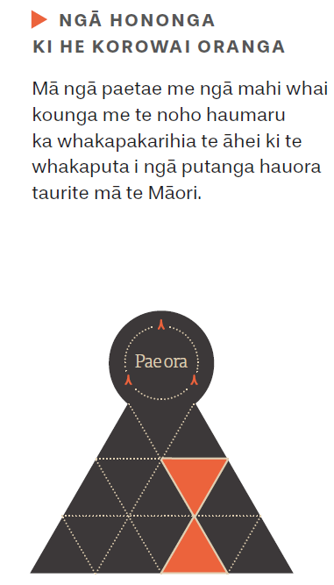

Te Whāinga Tōmua 7

Ngā kitenga me ngā taunakitangau

He whakamārama
- Me whai i ngā kitenga me ngā taunakitanga nō te ao Māori hei whakaū, hei whakaawe i ngā tukanga whakaputa whakataunga.
Whakataukī
Whāia te mātauranga hei oranga mō koutou

- Me whakamana, me whakaae ki ngā whakautu a ngāi Māori me te mātauranga Māori.
- Me whakawātea ngā kitenga, ngā taunakitanga me ngā raraunga ki ngā iwi me te rāngai hauora Māori.

Te kaupapa
Ki te whakapakari i ngā taunakitanga e pā ana ki te hauora Māori me te hunga whaikaha, hei whakapai ake i te hauora me te oranga o ngāi Māori.

Ngā tino mahi
- Whakatakotoria, ā, whāia tētahi rārangi kaupapa rangahau mō te hauora Māori me te hunga whaikaha, hei hāpai i te whakatutukinga o pae ora i te taha o ngāi Māori.
- Whakawhanakehia ngā paearu e hāngai ana ki ngā putanga me te oranga o te hauora Māori me te hunga whaikaha, hei whakaine i te whakatutukinga o te whāinga nui o pae ora i te taha o ngāi Māori.
- Kohia, ā, whakawāteahia ki te motu whānui ngā putanga e pā ana ki te hauora Māori me te hunga whaikaha, me ngā pārongo e pā ana ki te oranga tangata. Me arotahi ki te noho tautika, me te ahunga whakamua o ngā whāinga o pae ora. Me whai wāhi hoki te whakahoutanga o Tatau Kahukura.
- Whakatakotoria, whāia tētahi kaupapa mā te pūnaha hauora me te hunga whaikaha e hāpai ana i te mana whakahaere o te Māori ki runga i āna anō raraunga.

He aha te take he mea nui tēnei whāinga tōmua?
Ko ngā kitenga me ngā taunakitanga nō te ao Māori te ngako o te whakatutukinga o te mana motuhake hei whakamarumaru, hei whakamana hoki i te tangata Māori, hei whakatairanga ake anō i ngā tikanga o te ao Māori me ōna tini hua. Ka whakamana, ka whakaū ngā kitenga me ngā taunakitanga nō te ao Māori i ngā whakautu a te Māori, ōna mōhioranga, āna mahi me tōna mātauranga tuku iho. Ka whakanuia hoki te tōtika me te angitu o ngā otinga me ngā ara mahi e arahina ana e te Māori hei whakatutuki i te oranga nui o te Māori.
Me tāpae hoki i te tahua pūtea haumi hei tautoko i ngā kitenga me ngā taunakitanga nō te ao Māori. Me whakawhiti noa i ngā kitenga me ngā taunakitanga ki ngā kaupapa here, ki te whanaketanga mai o ngā ratonga, ki ngā mahi māherehere me ngā tukanga e pā ana ki te noho haepapa. Ko te tino pūtake tonu o tēnei whāinga tōmua, ko te whakatūnga o ngā hononga whaikiko ki ngā iwi me ngā whakahaere Māori e hura mai ai ngā ara hei whakaea i ngā hiahia o ngā iwi me ngāi Māori e pā ana ki ngā kitenga, ngā taunakitanga me ngā momo raraunga.
E hāngai ana tēnei whāinga tōmua me ngā tino mahi ki te putanga 1: me tū ngā iwi, ngā hapū, ngā whānau me ngā hapori Māori i runga i tō rātou mana motuhake hei whakapiki ake i tō rātou hauora me tō rātou oranga, te putanga 2: he tautika, he pūmau hoki ngā whakahaere o te pūnaha o te hauora me te hunga whaikaha kia whiwhi a ngāi Māori ki ngā putanga taurite me te putanga 4: me whai wāhi, me whakamarumaru te mātauranga Māori huri noa i te pūnaha o te hauora me te hunga whaikaha.
“He rerekē ngā otinga o ngā raraunga a te Karauna me ērā e whakahaerehia ana e te Māori mā ngā momo whakataunga, mā te whanaketanga o ngā kaupapa here, mā te aromatawai o ngā putanga me te noho haepapa.”

“Me tautoko ngā Māori ki te kuhu atu ki ngā rangahau nō te ao Māori, hei hāpai i ngā mahi whai taunakitanga, e whai ana i ngā kaupapa here o te ao hauora.”

He kōrero urupare a tētahi Kaiwhaipānga

He aha rā te whakatinanatanga mai o tēnei whāinga tōmua?
Mā te pūnaha o te hauora me te hunga whaikaha, rātou ko ngā rōpū Māori, ko ētahi atu whakahaere, hei tuku noa i ngā pūtea haumi ki ngā momo taunakitanga me ngā momo kitenga e hāpai ana i ngā whakautu a ngāi Māori, e whakapiki ake ana hoki i te hauora me te oranga o te Māori. Mā ngā paearu e hāngai ana ki te oranga o te Māori, ka mātua kitea ngā āhuatanga hei whakarerekē e tutuki ai te whāinga nui o pae ora. Mā ngā taunakitanga me ngā kitenga, ka āta kitea ngā hua o ngā mahi a te pūnaha hauora ki te Māori. E wātea noa ana ngā pārongo, e kaha whakamahia ana hoki, hei āwhina i ngā mahinga auaha, i ngā kaupapa here, i ngā ratonga me ngā tauira o ngā mahi tiaki tūroro a te pūnaha o te hauora me te hunga whaikaha. E whai ana ngā taunakitanga ki ngā mahi māherehere me te whakatutukinga o ngā haepapa – e whakaataata ana i ngā wawata o ngāi Māori. E wātea ana ngā kitenga whaikiko, ngā taunakitanga me ngā raraunga ki ngā whānau, ngā hapū, ngā iwi me ngā whakahaere Māori. Kei a rātou ngā tāngata me te āheitanga ki te tahuri i ngā ratonga, ki te whakapai ake i te oranga o te tangata takitahi, o te whānau me ngā hapori.

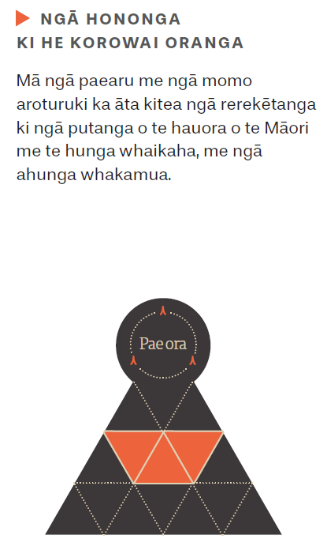

Te Whāinga Tōmua 8

Ngā whakatutukinga me te noho haepapa

He whakamārama
- Kua āta whakatakotohia ngā hiahia e pā ana ki te whakatutukinga o ngā kawenga o te Tiriti me te noho haepapa ki aua kawenga.
Whakataukī
Hāpaitia te ara tika pūmau ai te rangatiratanga mo ngā uri whakatipu.

- E pono ana, e tautika ana te tuku pūtea haumi ki te whakawhanaketanga o te hauora Māori me te aroturukinga o ngā putanga.
- Mā ngā pūrongo pono e pā ana ki ngā ahunga whakamua, ka hua mai ngā putanga hauora tautika mā te iwi Māori

Te kaupapa
Ki te whakatutuki i ngā kawenga o te Tiriti me te noho taurite o ngā putanga hauora mā te whakapakaritanga ake o ngā mahi me te noho haepapa.

Ngā tino mahi
- Whakatinanahia ngā whakahoutanga ki ngā anga haepapa, hei āta tautohu i te hunga e noho haepapa ana ki ngā kawenga o te Tiriti me te whakawhiwhinga o ngā otinga hauora taurite ki te iwi Māori.
- Tonoa ngā whakahaere o te Karauna me ngā whakahaere hauora nunui here-kore ki te whakaputa i ā rātou mahere me ngā ahunga whakamua e pā ana ki te whakatutukinga o ngā putanga hauora taurite mā te Māori.
- Whakawhanakehia, whakamahia hoki ngā rawa me ngā rauemi tōtika e pā ana ki te noho taurite o te hauora o te Māori me te Tiriti, hei ārahi i te tānga o ngā rautaki, ngā mahi māherehere ngā mahi aroturuki me ngā tuhinga e pā ana ki te noho haepapa.
- Whakatinanahia ngā whakahoutanga i raro i te ture kia āta kitea te ngākau tapatahi ki te Tiriti, ki te noho taurite o te hauora o te Māori hoki.
- Me whai whakaaro ngā anga tono pūtea nunui ki ngā mateā kāore anō kia whakatutukihia me te tuaritanga tōtika o ngā rauemi ki a ngāi Māori.

He aha te take he mea nui tēnei whāinga tōmua?
E takatahi ana te nuinga o ngā āhuatanga taurite-kore o te ao hauora, kei te hē tēnei, otirā, he āhuatanga tēnā e taea te karo. Kua taka iho ēnei āhuatanga ki runga i te Māori nā te rerekē o tō rātou whai wāhitanga atu ki ngā rauemi e hāpai ana i te noho hauora me tō rātou noho i runga i tō rātou ake mana motuhake. Ka tutuki ngā wawata mō te hauora me te oranga o te Māori mēnā ka mātua whai ngā kaiwhakaputa whakatau ki te turaki i ngā āhuatanga taurite-kore o te ao hauora e pā kino ana ki te Māori, ki te whakawhanake hoki i ngā kaupapa e tino whaihua ana ki a ngāi Māori. Ki raro i te New Zealand Public Health and Disability Act 2000 me whakapai ake ngā DHB i te hauora o te Māori. Me mātua kite i ngā mahi hei whakatikatika i ngā āhuatanga taurite-kore i roto i ngā mahere rautaki a ngā whare whakahaere, i ngā tuhinga e pā ana ki te noho haepapa, waihoki, i ngā whakataunga pūtea, me ngā whakatau e pā ana ki te whakawhanaketanga, te whakatinanatanga me te aroturukitanga o ngā hōtaka me ngā pūrongo.
“…He mea nui tēnei whāinga tōmua i te whakatutukinga tōtika o te noho haepapa o te hunga e mahi ana i roto i te pūnaha i tēnei wā tonu. Mā rātou tēnei e kawe i te mea kei a rātou te mana whakahaere, te mana whakatau hoki i roto i te pūnaha i tēnei wā.”

He korero urupare nā tētahi Kaiwhaipānga
E hāngai ana tēnei whāinga tōmua me ngā tino mahi ki te putanga 2: he tautika, he pūmau hoki ngā whakahaere o te pūnaha o te hauora me te hunga whaikaha kia whiwhi a ngāi Māori ki ngā putanga taurite.

He aha rā te whakatinanatanga o tēnei whāinga tōmua?
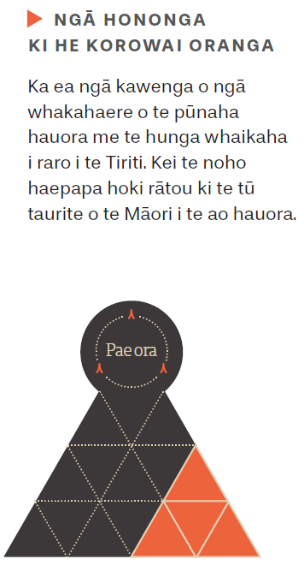
E tino mārama ana ki te Manatū me ngā whare whakahaere pūtea, ngā whāinga mō te whakatutukinga o ngā kawenga o te Tiriti me ngā putanga hauora tautika mā te iwi Māori. E whai ana te Manatū me ngā DHB i ngā kōrero o te wātū hei whakaine i ngā mahi, hei whakaputa hoki i ngā whakataunga e tautoko ana i te whakawhanaketanga o ngā ratonga pūmau, whai kounga hoki ki te iwi Māori. Ka piki ake te nui o te pūtea haumi e tukuna atu ana ki te whakawhanaketanga o te rāngai hauora Māori me ōna kaupapa, kia wawe te whakaea o ngā take hauora Māori. Kia rite tonu te tuku pūrongo e pā ana ki te nui o te katoa o te pūtea haumi e tukuna ana ki te hauora Māori me ngā kokenga whakamua e pā ana ki te whakatutukinga o ngā kawenga o te Tiriti, ki te whakahekenga o ngā tahumaero me ngā momo mate pūmau, me te whakapikinga ake o ngā āhuatanga katoa o te hauora me te oranga o te Māori.

Te aroturuki

E arotūruki ana i ngā mahi i ngā tau e rima

Te aroturuki i ngā tatauranga
Kua āta tohua ngā pae mahi e whai ake nei hei tātaitai i te ahunga whakamua o ngā mahi i raro i nga whāinga e whā (kua rarangihia ki te whārangi 25). Mēnā ka tutuki ēnei whāinga, ka ea hoki tētahi wāhi nui o ngā putanga matua o te mahere mō te hauora me te oranga o te iwi Māori. Inā kē pea te nui o ngā momo mahi hei ine me ngā ara hei rangahau, i konei, kua āta tohua tētahi huinga pae mahi tuatahi hei aromātai i te roanga o tēnei mahere.
Me tautohu, me arotahi ki ngā momo inenga e hāngai ana ki te kaupapa, e puta atu ana i ngā hangarau tōtika, e noho pai ana i te taha o ngā raraunga e wātea kē ana i roto i te pūnaha o te hauora me te hunga whaikaha. Mā ēnei mahi ka āta kitea te pae tuatahi, ka taea hoki te ine i ngā huringa i roto i te wā. I te roanga o te mahere, ka ara mai ngā raraunga, ngā ara tātaitai me ngā kitenga hou, pērā i ngā kōrero mai i ngā rangahau tūroa o te NZ General Social Survey o Tatauranga Aotearoa me te rangahau o Te Kupenga. Ka whai pānga ngā mahinga ngātahi ki a ngāi Māori, arā, ki ngā kaikerēme o Wai 2575 me ētahi atu kaiwhaipānga, ki ngā otinga e hua tonu mai ana ā ngā tau e heke mai ana.
I raro i ētahi o ngā pae mahi, me whakataurite i te noho tōkeke, me aroturuki hoki i ngā āhuatanga taurite-kore i waenga i te Māori me ētahi atu tāngata. I raro i tēnei mahere, ka whakatauritehia a ngāi Māori ki a tauiwi, arā, ki te hunga ehara i te Maori, ehara hoki i te tangata nō tētahi o ngā motu o Te Moananui-a-Kiwa. Kua ahu mai tēnei whakataunga i te kōrero urupare e mea ana mēnā ka whakatauritehia te Māori ki te katoa o tauiwi, e kore pea e āta kitea ētahi o ngā āhuatanga taurite-kore e pā kino ana ki te Māori. Me noho motuhake ngā kōrero mō ngāi Māori, mō ngā iwi o Te Moananui-a-Kiwa me ngāi Tauiwi e āta kitea ai ngā āhuatanga katoa o te pae mahi e inea ana.
Kua rārangi mai i konei ngā pae mahi e hāngai ana ki ngā whāinga.

Whāinga 1
Whakaterehia ake, whakawhānuitia ake te hora o ngā kaupapa Māori me ngā ratonga e arotahi ana kit e whānau.

Ngā pae mahi tuatahi | Te ngako o tēnei pae mahi
- Kua whiwhi pūtea ngā kaituku ratonga kaupapa Māori o te rāngai hauora me te hunga whaikaha. | Ka kitea te mana whakahaere o ngā iwi, ngā hapū, ngā whānau me ngā hapori Māori mēnā e wātea ana ngā rauemi tōtika ki a rātou. Ki te āta tātaihia te ia o te tahua pūtea o Pōti:Hauora e whakawhiwhia ana ki ngā kaituku kaupapa Māori, ka kitea ngā rerekētanga i roto i te wā.  Ka ea tēnei pae mahi mēnā ka nui ake te pūtea e whakawhiwhia ana ki ngā kaituku ratonga kaupapa Māori o te rāngai hauora me te hunga whaikaha.
- E whāia ana ngā ratonga rongoā Māori huri noa i te motu. | ‘Ko te pūtake o te rongoā Māori ko te oranga o te tangata. He kaupapa hōhonu tēnei e whai ana i ngā mātauranga o ngā mātua tīpuna Māori. Ko te whakatinanatanga o tēnei kaupapa ko te hauora, ā-tinana, ā-hinengaro, ā-whatumanawa, ā-wairua, ā-ngao, ā-pāpori, ā-iwi, otirā, he pānga anō ki ngā hononga tāngata me te taiao.’ He kaupapa matua tēnei, e āta kitea ai te mātauranga Māori i roto te pūnaha o te hauora me te hunga whaikaha.  Ka ea tēnei pae mahi mēnā ka nui ake ngā ratonga rongoā Māori e wātea ana ki te tangata.
- Ko te ōrau o ngā Māori kāore anō kia kite i tētahi ara e ea ai tōna mateā i raro i ngā whakahaere o ngā whare tiaki hauora matua. Me whakataurite i tēnei āhuatanga ki ngā putanga mō tauiwi. | He mea nui te āheitanga ki te toro atu ki ngā whare tiaki hauora matua, e pai ai te hauora me te oranga o te whānau. Ka whai tēnei pae mahi i ngā āhuatanga e aukati ana i te toronga atu o te Māori ki ngā whare tiaki tōtika i te wā e tika ana.  Ka ea tēnei pae mahi mēnā ka heke; te nui o ngā Māori kāore e whakawhiwhia ana ki ngā mahi tiaki tōtika i ngā whare tiaki hauora matua, te nui o te āputa i waenga i a ngāi Māori me tauiwi e pā ana ki ngā mateā hauora kāore anō kia ea i raro i ngā whare tiaki hauora matua.

Whāinga 2
Turakina ngā whakapae ā-ahurea, ā-pāpori hoki
Ngā pae mahi tuatahi | Te ngako o tēnei pae mahi
- Ngā wheako e pā ana ki ngā ratonga hauora, mai i ngā rangahau o ngā whare tiaki hauora matua me ngā whare tiaki tūroro pakeke. | These surveys, administered by the Health Quality and Safety Commission, directly measure whether patients and their whānau are treated with respect and understanding.  An improvement in this measure will see improved experiences for Māori across the domains covered by the surveys.
- Te tatau o ngā Māori ‘kāore i tae atu’, ‘kāore rānei i tatari’ i ngā tari ratonga haora o ngā DHB. Me whakataurite ngā tatauranga o ngāi Māori ki ērā o ngāi tauiwi. | Me haumaru, me tika ngā ratonga o ngā tari ratonga hauora mā ngā tūroro Māori rātou ko ō rātou whānau e piki ake ai ngā putanga hauora o ngāi Māori. E whai ana tēnei pae mahi kia tika te mahi whakahaere a te DHB e whakawhiwhia ai a ngāi Māori ki ngā ratonga i te wā tika, i te wāhi tika, waihoki e manaakihia ana rātou, e whaihua ana hoki ngā ratonga hauora.  Ka ea tēnei pae mahi mēnā ka heke te nui o ngā Māori ‘kāore i tae atu’, ‘kāore hoki i tatari’ i ngā tari ratonga hauora, mēnā ka heke hoki te āputa i waenga i te Māori me tauiwi.
- Whakatauritehia te ōrau o ngā Māori e mahi ana i te rāngai hauora ōkawa ki te tatau o ngā Māori katoa o Aotearoa. | Mēnā ka whakaatahia te hora o ngā iwi o te motu ki waenga i ngā kaimahi hauora, ka manaakihia ngā tikanga Māori, ka tuituia hoki te mātauranga Māori ki ngā wāhi katoa o te pūnaha o te hauora me te hunga whaikaha.  Ka ea tēnei pae mahi mēnā ka piki ake te ōrau o ngā Māori kei ngā tūranga hauora i raro i te Ture hauora.

Whāinga 3
Whakahekea ngā āhuatanga e hāpai ana i ten oho taurite-kore o ngāi Māori me te hekenga o te hauora o te Māori
Ngā pae mahi tuatahi | Te ngako o tēnei pae mahi
3.1 Te tatau o ngā kuhunga noa ki te hōhipera e taea te karo (arā, ngā kuhunga  ASH) mā ngā kōhungahunga Māori e 0-4 tau te pakeke. Me whakataurite ngā tatauranga o ngāi Māori ki ērā o ngāi tauiwi/ehara nō Te Moananui-a-Kiwa. | E meatia ana, ko ngā kuhunga ASH, he momo kuhunga ki te hōhipera e taea ai te whakaheke mā ngā mahi a ngā whare tiaki hauora matua. He tohu nui ēnei tatau mō te pai, te koretake rānei o te pūnaha o ngā whare tiaki hauora matua mā ngā kōhungahunga Māori.  Ka ea tēnei pae mahi mēnā ka heke te tatau o ngā kuhunga ASH o ngāi Māori, mēnā ka heke hoki te āputa i waenga i te Māori me tauiwi.
3.2 Me whiwhi ngā rangatahi Māori ki ngā ratonga hauora ā-hinengaro, ngā ratonga mate waranga rānei i te wā tōtika (arā, kia kaua e nui ake i te 3 wiki i muri atu i te tono).  Me whakataurite ngā tatauranga o ngāi Māori ki ērā o ngāi tauiwi/ehara nō Te Moananui-a-Kiwa. | He nui ake te pānga o ngā momo mate ā-hinengaro me ngā mate waranga ki a ngāi Māori. He tokomaha te hunga rangatahi i waenga i te iwi Māori, ā, nō te tamarikitanga rā anō, ka whanake mai ngā mate ā-hinengaro me ngā mate waranga.  Ka ea tēnei pae mahi mēnā ka piki ake te ōrau o ngā Māori e whakawhiwhia ana ki ngā ratonga tōtika i mua i te paunga o te toru wiki, mēnā ka heke hoki te āputa i waenga i te Māori me tauiwi.
3.3 Me whakataurite te tatau o te pānga o ngā mate e  hāngai ana ki te mate huka ki te Māori ki ērā o tauiwi. | He mate nui, he mate tūroa te mate huka. He nui ake te pānga kino ki te Māori. Ka piki ake ngā pānga kino o tēnei mate i roto i takanga o te wā. He nui te utu ki ngā whānau Māori, ki te pūnaha o te hauora me te hunga whaikaha hoki.  Ka ea tēnei pae mahi mēnā ka heke te nui o ngā pānga kino o te mate huka ki te Māori, mēnā ka heke hoki te āputa i waenga i te Māori me tauiwi.

Whāinga 4
Whakapakarihia ake ngā whakahaere o te pūnaha hauora
Ngā pae mahi tuatahi | Te ngako o tēnei pae mahi
4.1 Mā ngā paearu e pā ana ki te kaha o ngā pātuinga i waenga i te Māori me te Karauna, e whakawhanakehia ana e  Te Arawhiti, hei taunaki i ngā mahi a te pūnaha o te hauora me te hunga whaikaha. | Ka arotahi ēnei paearu ki te tika o te whakatinanatanga o ngā whakapāpātanga a te Karauna ki ngā anga Māori, te hora o ngā pātuinga, ngā momo pātuinga me te whakatinanatanga o ngā mātāpono o ngā pātuinga ki waenga i te Māori me te Karauna.  Ka ea tēnei pae mahi mēnā ka piki ake te hora o ngā pātuinga me ngā momo pātuinga e kapi ana i ngā kaupapa o te rāngai hauora me te hunga whaikaha.
4.2 Te nui o ngā kaupapa rangahau Māori e whakaaetia ana e ngā rōpū matatika e hāngai ana ki te hauora me te hunga whaikaha Māori. | Ko te Mahi 2 o te whāinga tōmua 1 o te New Zealand Health Research Strategy (2017–2027) he tāpae pūtea haumi ki ngā mahi rangahau e tutuki ai te pae ora a te Māori. He tohu te kokenga whakamua o tēnei mahi o te ahunga whakamua o te mātauranga Māori.  Ka ea tēnei pae mahi mēnā ka piki ake te nui o ngā kairangahau e whai ana i te kaupapa Māori hei tikanga rangahau.
4.3 Te nui o ngā Māori kei ngā tūranga o te kaiārahi, kei ngā tūranga whakahaere rānei huri noa i te Manatū, i ngā DHB me ngā hinonga Karauna o te rāngai hauora. | I raro i tēnei mahere, he mahi tōmua te whakapikinga ake me te whakawhanaketanga ake o te mana whakahaere o te Māori. I te wāhanga tuatahi nei (2020–2025), ka kimi mōhiotanga mātou, ka whai hoki i te pikinga ake o te nui o ngā Māori kei roto i ngā whakahaere matua o te Karauna. Whai muri atu, ka whakapakarihia ake ngā pūkenga kaiārahi o ngāi Māori, ka whakawhānuihia hoki te titiro ki ngā rāngai ki waho atu o te ao hauora.  Ka ea tēnei pae mahi mēnā ka piki ake te nui o ngā Māori ki roto i ngā tūranga whakahaere me ngā tūranga kaiārahi huri noa i ngā whare whakahaere hauora o te kāwanatanga.
4.4 Te tatau o ngā Māori e kuhu noa atu ana ki te hōhipera mō ngā mate kino hei wāhi o te katoa o te tatau o ngāi Māori. Me whakataurite ngā tatauranga o ngāi Māori ki ērā o ngāi tauiwi/ehara nō Te Moananui-a-Kiwa. | Ko te whakamahinga o ngā ratonga mō ngā tūroro e pāngia ana e ngā mate kino tētahi tohu o te pai o te pūnaha o te hauora me te hunga whaikaha. He nui ake te whakamahinga o ēnei rātonga e te Māori i ērā o tauiwi. He tohu tēnei me pai ake ngā ratonga me ngā mahi tautoko a te pūnaha hauora ki a ngāi Māori.  Ka ea tēnei pae mahi mēnā ka heke te tatau o ngā kuhunga noa o te Māori ki te hōhipera mō ngā mate kino i te wātū tonu, mēnā ka heke hoki te āputa ki waenga i te Māori me tauiwi.

Te mahi arotake arotutuki
Hei tāpiri atu ki ngā tatau aroturuki, ka tautokona ngā inenga tatau, ka whakaūngia te māramatanga e pā ana ki ngā rerekētanga e haere ana i waenga i te pūnaha mā te mahi arotake. Ka arotakengia ngā tino mahi i raro i te mahere i ngā wā e tika ana. Ka arotakengia hoki te whakaratonga o te katoa o te mahere.
Mā te anga arotake ka kitea ngā mahi whaihua, te iwi e whaihua ana me ngā akoranga hei whai tonu. Ka whāngai ēnei korero i te whanaketanga mai o te mahere me te ahunga o te rautaki.

Āpitihanga 1

Ko ngā taipitopito o te whatunga o He Korowai Oranga

He Korowai Oranga: te Rautaki Hauora Māori 2002

Te kaupapa o He Korowai Oranga 2002
Ko te whakatūnga o tētahi ahunga hou mō te whakawhanaketanga o te hauora Māori i roto i te pūnaha hauora me te hunga whaikaha. Ko te whāinga matua tuatahi o He Korowai Oranga, ko whānau ora (arā, kia tautokona ngā whānau Māori ki whakaū i tō rātou hauora me tō rātou oranga nui).

Mā wai te rautaki
- Te Manatū Hauora me ngā DHBs
- Ngā iwi, ngā kaituku ratonga hauora Māori, ngā hapori Māori
- Ētahi atu kaituku ratonga.

Whakatātaka: te mahere whakatutui whāinga hauora Māori 2002–2005

Te kaupapa o Whakatātaka 2002–2005
He putanga pātui ki He Korowai Oranga, e ārahi ana i ngā kaupapa here me ngā hōtaka o ngā DHB i a rātou e takatū ana ki te whakatutuki i ō rātou kawenga e ea ai ngā whāinga matua o whānau ora.

Ngā whakatutukinga
- I piki ake te pūtea haumi e whai pānga ana ki te whakawhanaketanga ake me te whakapikinga ake o te hauora Māori
- Ko te hauora Māori me te whānau ora tētahi o ngā paearu matua i te whakaraupapatanga me te whakaratonga o ngā rawa o ngā DHB
- Ka mahi ngātahi ngā DHB ki ngā whare hauora Māori ā-rohe me ngā hapori Māori ki te waihanga i ngā rauemi aroturuki me ngā rauemi arotake.

Ngā wero
- He mea nui ngā raraunga me ngā mōhiotanga whai kounga hei aromatawai i ngā mahi a te Manatū me ngā DHB.
- He wero nui te āta whakatutuki i ngā mahi e hāngai ana ki ngā wātaka i whakatakotohia.
- Kāore anō te kaupapa o whānau ora kia puāwai.
- Kāore anō kia āta tautohua ngā wāhi tōmua hei whakatutuki.

Whakatātaka Tuarua: te mahere whakatutuki whāinga hauora Māori 2006–2011

Te kaupapa o Whakatātaka 2006–2011
He putanga pātui ki He Korowai Oranga, e whakapiki ake ana i ngā hua o Whakatātaka 2002–2005.

Ngā whakatutukinga
- Kua nui ake ngā tamariki ki raro iho i te 6 tau e kuhu atu ana, e whakamahi ana i ngā ratonga o ngā whare tiaki hauora matua, ka pai ake hoki ngā ara e whai oranga ai ngā tūroro kua pāngia e ngā mate tūroa
- Ka whakatinanahia ngā kaupapa e pā ana ki ngā kaimahi o te hauora Māori me te hunga whaikaha
- Ka tautokona ngā tini kaupapa e whakapakari ana i te nui o te hunga e mahi ana i te mahi nēhi, i te mahi tapuhi, i roto i te rāngai hauora tūmatanui me ngā mahi rata Māori
- Ka tautohua, ka whakatairangahia ngā momo kōtuinga e whakahaere ana i ngā tauira ratonga e tino whaihua ana ki ngā Māori me ō rātou whānau.
- Ka pai ake te kounga o ngā raraunga me ngā mōhiotanga, pērā i te whanaketanga mai o te puka tātai hauora o Tatau Kahukura Māori.

Ngā wero
- Nā te tini o ngā huringa ki ngā whāinga tōmua me ngā kaupapa here i te takanga o te wā, kāore i rite te whaipānga o ngā mahi ki te wā i puta tuatahi atu tēnei kaupapa.

Te whakahoutanga o He Korowai Oranga: te Rautaki Hauora Māori 2014

Te kaupapa o He Korowai Oranga 2014
I whakahoungia te putanga taketake o He Korowai Oranga i te tau 2014, hei whakapūmau i te whaipānga o tēnei kaupapa mō āpōpō.
Ko pae ora te kitenga matua o te kāwanatanga me te whāinga nui mō te whakahoutanga o te rautaki. Kei te whakatenatena a pae ora i te katoa o te pūnaha o te hauora me te hunga whaikaha ki te mahi ngātahi, ki te whakaaro ki tua atu i ngā whakamārama whāiti mō te hauora, kia tino whai kounga, kia tino whaihua ngā ratonga.
Kei te whakapakarihia te tūāpapa o te whānau ora (kia ora te whānau), arā, ko te mauri ora (kia ora te tangata) me te wai ora (kia ora te taiao).

Mā wai tēnei kaupapa
- Te Manatū Hauora, ngā DHB
- Ngā iwi, ngā kaituku ratonga Māori m ngā hapori Māori
- Ētahi atu tari kāwanatanga (āra, ko Te Puni Kōkiri, ko Oranga Tamariki, ko Te Arawhiti)

Whakamaua 2020–2025

Te kaupapa o Whakamaua 2020–2025
Kei te mahere o Whakamaua 2020–2025 ngā kōrero mō te whakatinanatanga o He Korowai Oranga 2014.
Ko te Tiriti me ngā mātāpono o te tino rangatiranga, o te noho taurite, o te kaitiakinga, o ngā kōwhiringa whaihua me te pātuitanga te tūāpapa o te mahere.
Kua whakatakotohia ki te mahere ngā putanga matua, ngā whāinga, ngā whāinga tōmua, ngā tino mahi me ngā pae mahi hei aroturuki i te ahunga whakamua o te mahere ā ngā tau e rima e heke mai ana.
Koia tētahi o ngā pou o te whakawhanaketanga mai o te hauora Māori. He kaupapa ora tēnei, ka whanake tonu mai hei whakatutuki i ngā hiahia o tēnei wā, me ērā e puta tonu mai ana i te ao hauora mō ngā mateā o te oranga tangata, hei whakaea hoki i ngā whāinga matua o He Korowai Oranga.

Āpitihanga 2

E Whakawhanake ana i te Mahere Whakatutuki Whāinga Hauora Māori
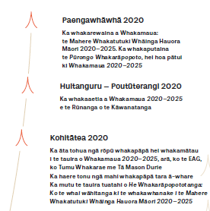
He tukanga tāruarua, he mahinga ngātahi hoki te whanaketanga mai o te mahere mahi. Kei te hoahoa ki raro iho nei, tētahi tirohanga whānui ki te whanaketanga mai o te kaupapa.
Ka whakaputaina ngātahitia tētahi whakarāpototanga o ngā kōrero urupare a ngā kaiwhaipānga.
Kei te whakarāpopototanga ngā taipitopito kōrero e pā ana ki te tukanga whakapāpā tāngata.
Tikina ake te puka whakarāpopoto ki te pae tukutuku o te Manatū Hauora.

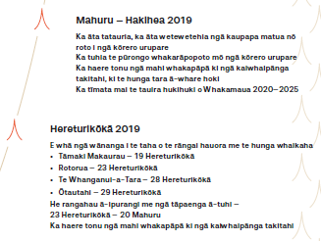
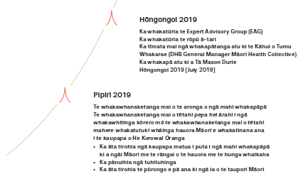

Āpitihanga 3

Ngā mema o te Expert Advisory Group mō te Mahere Whakatutuki Whāinga Hauora Māori
Ingoa | Haurongo
Hingatu Thompson (Heamana) | He nui ngā wheako mahi a Hingatu Thompson i roto i te rāngai hauora. Nō nātata nei ka whakatūria ia hei CEO o Manaaki Ora Trust. I mua i tērā, he kaiwhakahaere a Hingatu i te Manatū Hauora, ka āwhina hoki ia i te whanaketanga mai o He Korowai Oranga. I a ia e mahi ana i te Manatū, ka tonoa a Hingatu e te tari o te Minita Tuarua o te Hauora, e Mita Ririnui.  Nā tōna āhei ki te tūhono atu ki ngā hapori me tōna kaha ki te whakaea i ngā take i roto i ngā hapori, he mana nui tō Hingatu i te rāngai hauora me te ao Māori. E tū māia ana te rōpū o ngā mātanga hauora i runga i tōna kaha ki te ārahi i a rātou.
Lance Norman | E mātau ana a Lance Norman ki ngā mahi a te kaiwhakahaere matua. He mārō ōna here ki te ao Māori. Kua tū ia hei CEO o Hāpai Te Hauora Tapui me te National Urban Māori Authority (NUMA). Kua mahi ia hei kaituku moni, hei kaituku ratonga hoki i roto i te rāngai hauora, te rāngai whare me te rāngai moni. He mōhio hoki nōna ki ngā tikanga Māori.  He nui ōna wheako mahi i te rāngai hauora Māori. Kātahi anō ia ka whakatūria hei Head of Equity and Māori Health Outcomes ki ProCare Health (PHO) Limited.
Tristram Ingham | Kua roa a Dr Tristram Ingham e mahi ana i te rāngai hauora. I tēnei wā, kei te mahi ia hei kairangahau matua ki Te Whare Wānanga o Otāgo. Ko tōna aronga matua ko ngā mate tūroa o te Māori me te hunga whaikaha.  He nui ngā tūranga whakahaere o Tristam, arā, ko te Heamana o te rōpū mātanga e tautoko ana i te whakatinanatanga o Whāia Te Ao Mārama me te Heamana Tuarua o Muscular Dystrophy New Zealand.  E whitu tau ia e tū ana i te Māori Partnership Board a te Ūpoko ki te Uru Hauora. Ināianei, kua whakatūria ia hei mema o te poari o te Ūpoko ki te Uru Hauora.
Te Pora Thompson-Evans | E mātau ana a Te Pora Thompson-Evans ki ngā mahi whakahaere me te mahi kaitohutohu. Ko te hauora Māori tōna kaupapa matua. I tēnei wā, kei te tū ia hei Heamana o te Iwi Māori Council o te DHB o Waikato, hei Heamana pātui hoki mō Te Manawa Taki Iwi Relationship Board.  He nui ngā mahi a Te Pora i te rāngai hauora tūmatanui, e pā ana ki ngā mahi whakahaere hauora me te whakawhanaketanga ake o ngāi Māori. Ko Te Pora tētahi o te tokorima tuatahi i whakatūria anō hei Māngai Māori ki Te Kaunihera o Kirikiriroa. Kei te tū a Te Pora ki te Community and Economic Development Committee hei kanohi mō ngā iwi me te mana whenua. He tini hoki ngā momo kaupapa rangahau Māori me ngā arotakenga e arahina ana, e whāia ana e ia.
Ezekiel Raui | I whakawhiwhia a Ezekiel Raui ki tōna Tohu Paetahi mō te Mahi Pakihi/Mātauranga Tauhokohoko i te tau 2018. Ahakoa he rangatahi tonu a Ezekiel, he nui ōna wheako i te rāngai hauora Māori me ōna whakatutukinga. Kua mahi ia hei perehītini o Te Waka o ngā Ākonga Māori, ko ia hoki tētahi o ngā Kaiwhakatū me te Kaiwhakahaere o te hōtaka o TūKotahi.  I whakawhiwhia a Ezekiel ki tētahi o ngā tohu o Ngā Whetū o Matariki, arā, ko Te Whetū Maiangi i te tau 2016. I tapaina hoki ia ki te rārangi o Forbes 30 Under 30 mō te rohe o Āhia/Te Ao o Kiwa. Ko ia hoki tētahi o ngā māngai Māori tokowhā nō Aotearoa i tonoa ki te White House Tribal Nations Conference Tribal Youth Gathering i te tau 2015. He mea whakatū nā te Perehītini, nā Barack Obama.
Suzanne Pitama | He kaimātai hinengaro rēhita a Pūkenga Suzanne Pitama mō te ao mātauranga. He tino mātau ia ki te mahi rangahau e pā ana ki te hauora Māori me te mātauranga hauora. Kei te arotahi a Suzanne ki ngā take e whakaū ana i te noho taurite kore o te Māori i te rāngai hauora, mā te mahi rangahau e pā ana ki te hauora, (arā, ko te hauora ā-hinengaro me te hauora ā-manawa) me tana tū ki runga i ngā kōmiti me ngā poari (arā, ko te HRC Board me te Australian Medical Council). Ko Suzanne te kanohi mō te kura o te Otago Medical School Hauora Māori, he mema o te kōmiti marautanga o te MBChB, ko ia anō te Heamana o te rōpū whāiti o te Hauora Māori. E whai wāhi ana hoki a Suzanne ki ngā akoranga poto o MIHI mō te Hui Process me te Meihana Model, e hāpai ana i ngā mahi whakangungu o ngā kaimahi hauora e whai ana i ngā tohu paerua.

Āpitihanga 4

Whakamaua: the Māori Health Action Plan 2020–2025
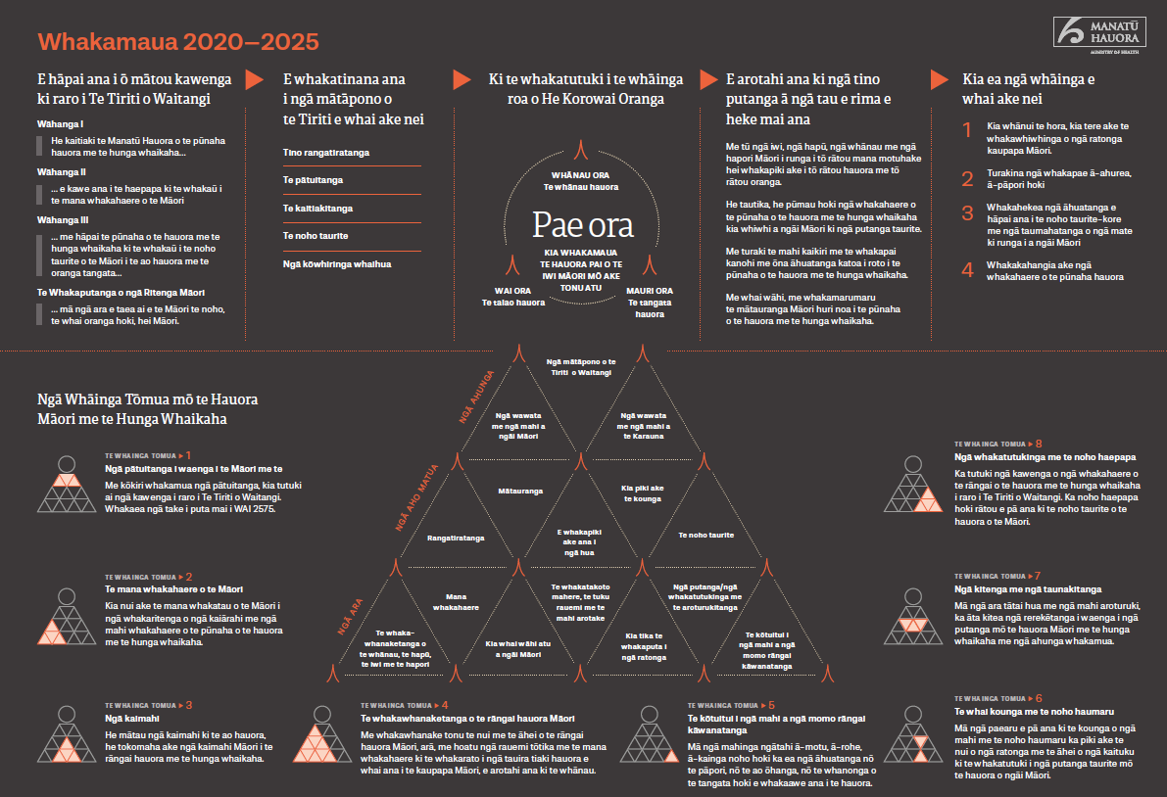
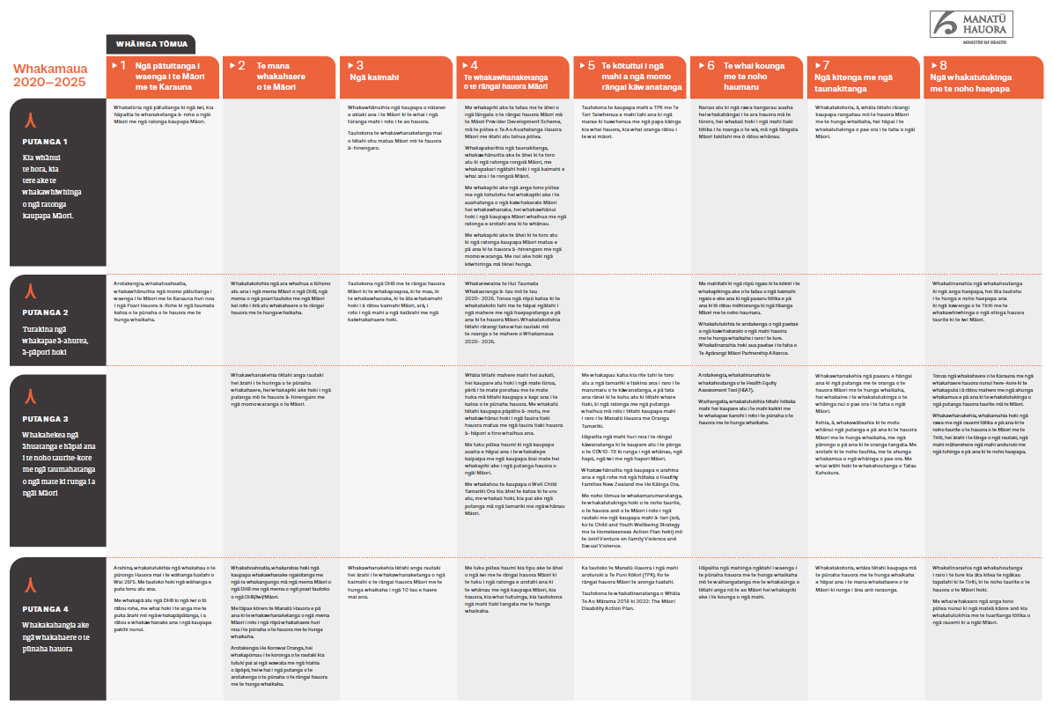

Āpitihanga 5

Te Tiriti o Waitangi and the health and disability system
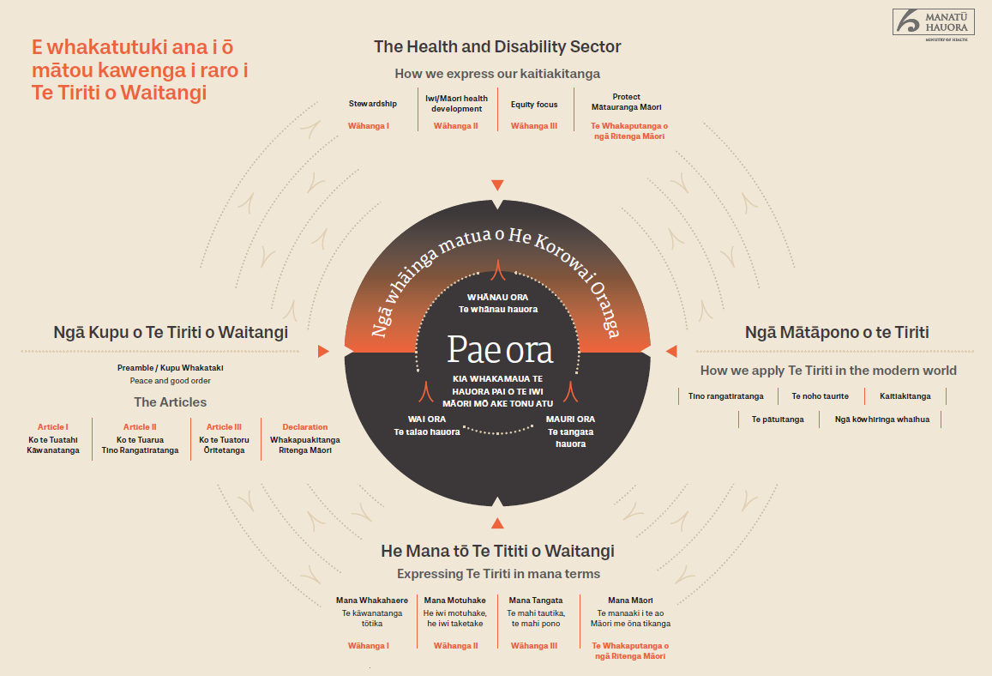

Our Te Tiriti o Waitangi Framework
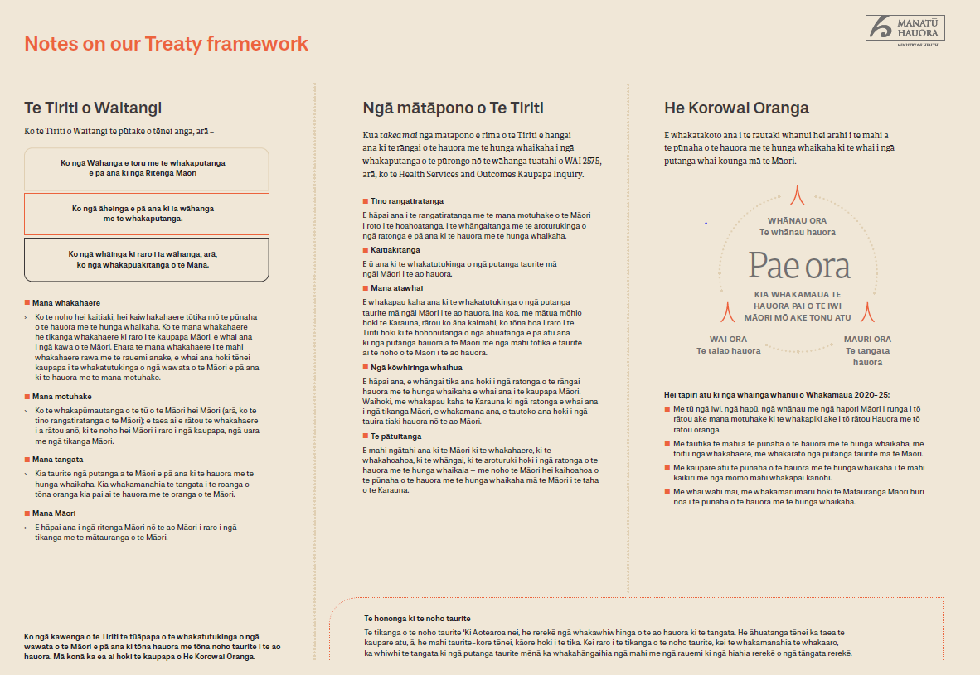

Ngā tohutoro
Broughton D. McBreen K. 2014. Mātauranga Māori, tino rangatiratanga and the future of New Zealand science. Journal of the Royal Society of New Zealand 45: 2, 83–88.
Came H. 2012. Institutional Racism and the Dynamics of Privilege in Public Health (Thesis, Doctor of Philosophy (PhD)). Hamilton: University of Waikato. URL: https://hdl.handle.net/10289/6397 (accessed 10 February 2020).
Chin MH, Clarke AR, Nocon RS, et al. 2012. A roadmap and best practices for organizations to reduce racial and ethnic disparities in health care. Journal of General Internal Medicine 27: 8, 992–1000. URL: www.ncbi.nlm.nih.gov/pubmed/22798211/ (accessed 10 February 2020).
Cram F. 2010. Shifting Māori Health Needs – Māori population trends, health service needs, and medical workforce requirements – issues arising. Ministry of Health: Wellington.
Department of the Prime Minister and Cabinet. 2019. Child and Youth Wellbeing Strategy. Wellington: Department of the Prime Minister and Cabinet.
Harris R, Cormack D, Tobias M, et al. 2012. The pervasive effects of racism: experiences of racial discrimination in New Zealand over time and associations with multiple health domains. Social Science & Medicine 74(3), 408–15.
HDSR. 2019. Health and Disability System Review – Interim Report. Hauora Manaaki ki Aotearoa Whānui – Pūrongo mō Tēnei Wā. Wellington: Health and Disability System Review (HDSR).
Health Quality & Safety Commission New Zealand. 2019. He Matapihi ki te Kounga o ngā Manaakitanga ā-Hauora o Aotearoa 2019: A
Window on the Quality of Aotearoa New Zealand’s Health Care 2019.
Wellington: Health Quality & Safety Commission New Zealand.
Maxwell-Crawford K. 2011. Indigenous workforce development in Aotearoa. Pimatisiwin: A journal of aboriginal and indigenous community health 9(1), 53–64.
Mead HM. 2003. Tikanga Māori: Living by Māori values. Wellington: Huia Publishers. pp 29–30, 51–52.
Minister of Health and Associate Minister of Health. 2002. Whakatātaka: Māori Health Action Plan 2002–2005. Wellington: Ministry of Health.
Minister of Health and Associate Minister of Health. 2006. Whakatātaka Tuarua: Māori Health Action Plan 2006–2011. Wellington: Ministry of Health.
Ministry of Business, Innovation and Employment and Ministry of Health. 2017. New Zealand Health Research Strategy 2017–2027. Wellington:
Ministry of Business, Innovation and Employment and Ministry of Health. URL: www.health.govt.nz/publication/new-zealand- health-research-strategy-2017-2027 (accessed 10 February 2020).
Ministry of Health. 2002. He Korowai Oranga: Māori Health Strategy.
Wellington: Ministry of Health. URL: www.health.govt.nz/system/ files/documents/publications/mhs-english.pdf (accessed 24
January 2020).
Ministry of Health. 2014a. Equity of Health Care for Māori: A framework.
Wellington: Ministry of Health.
Ministry of Health. 2014b. He Korowai Oranga. Wellington: Ministry of Health. URL: www.health.govt.nz/our-work/populations/maori- health/he-korowai-oranga (accessed 29 January 2020).
Ministry of Health. 2014c. Tikanga ā-Rongoā. Wellington: Ministry of Health.
Ministry of Health. 2015. Tatau Kahukura: Māori Health Chart Book 2015 (3rd edition). Wellington: Ministry of Health.
Ministry of Health. 2018a. Achieving Equity in Health Outcomes: Highlights of important national and international papers. Wellington: Ministry of Health.
Ministry of Health. 2018b. Whāia Te Ao Mārama 2018 to 2022: The Māori Disability Action Plan. Wellington: Ministry of Health. URL: www. health.govt.nz/publication/whaia-te-ao-marama-2018-2022- maori-disability-action-plan (accessed 10 February 2020).
Ministry of Health. 2019a. Achieving Equity in Health Outcomes: Summary of a Discovery Process. Wellington: Ministry of Health.
Ministry of Health. 2019b. Annual Update of Key Results 2017/18: New Zealand Health Survey. Wellington: Ministry of Health.
Ministry of Health. 2019c. Every Life Matters – He Tapu te Oranga o ia Tangata: Suicide Prevention Strategy 2019–2029 and Suicide Prevention Action Plan 2019–2024 for Aotearoa New Zealand. Wellington: Ministry of Health.
Ministry of Health. 2019d. New Zealand Cancer Action Plan 2019–2029 –
Te Mahere mō te Mate Pukupuku o Aotearoa 2019–2029. Wellington: Ministry of Health.
Ministry of Health. 2019e. Wai 2575 Māori Health Trends Report.
Wellington: Ministry of Health.
Ministry of Health. 2020. Summary Report: Engagement on the development of the Māori Health Action Plan 2020–2025. Wellington: Ministry of Health.
New Zealand Government. 2017. The New Zealand Health and Disability System: Handbook of Organisations and Responsibilities.
Wellington: New Zealand Government.
New Zealand Maori Council v Attorney-General [1987] 1 NZLR 641. New Zealand Maori Council v Attorney-General [1989] 2 NZLR 142. New Zealand Maori Council v Attorney-General [1991] WL 12012744. New Zealand Maori Council v Attorney-General [1992] 2 NZLR 576. New Zealand Maori Council v Attorney-General [2013] NZSC 6.
NZQA. 2012. Conversations on Mātauranga Māori. Wellington: New Zealand Qualifications Authority (NZQA).
Office for Disability Issues. 2016. New Zealand Disability Strategy 2016– 2026. Wellington: Ministry of Social Development.
Paradies Y, Ben J, Denson N, et al. 2015. Racism as a determinant of health: a systematic review and meta-analysis. PLoS One 10(9): e0138511.
Pescud M, Sargent G, Kelly P, et al. 2019. How does whole of government action address inequities in obesity? A case study from Australia. International Journal for Equity in Health 18: 8.
Te Puni Kōkiri. 2001. A Guide to the Principles of the Treaty of Waitangi, as expressed by the Courts & the Waitangi Tribunal. Wellington: Te Puni Kōkiri. pp 40–41.
Waitangi Tribunal. 1987. Report of the Waitangi Tribunal on the Orakei claim. Wellington: Brooker and Friend.
Waitangi Tribunal. 1988. Report of the Waitangi Tribunal on the Muriwhenua fishing claim. Wellington: Department of Justice.
Waitangi Tribunal. 1991. The Ngai Tahu Report 1991. Vol. 1. Wellington: Brooker and Friend.
Waitangi Tribunal. 2019. Hauora: Report on Stage One of the Health Services and Outcomes Kaupapa Inquiry. Wellington: Waitangi Tribunal. pp. 163–164.
Walsh M, Grey C. 2019. The contribution of avoidable mortality to the life expectancy gap in Māori and Pacific populations in New Zealand – a decomposition analysis. New Zealand Medical Journal 132(1492): 46–60.

I tāia te whakaputanga o te Ritenga Māori (e kīia ana ko te ‘wāhanga tuawhā’) ki te reo Māori, ka pānuihia i te wā o ngā whakawhitinga kōrero ki ngā rangatira mō te Tiriti. Ko tā te whakaputanga rā, ka tiakina ngātahitia ngā momo whakapono me ngā ritenga Māori tuku iho. (Te Puni Kōkiri, 2001)
He tikanga Māori motuhake te ‘mana’ he matatini, he whānui ngā kōrero (Mead 2003).
New Zealand Maori Council v Attorney-General [1987] 1 NZLR 641; New Zealand Maori Council v Attorney-General [1989] 2 NZLR 142; New Zealand Maori Council v Attorney-General [1991] WL 12012744; New Zealand Maori Council v Attorney-General [1992] 2 NZLR 576; New Zealand Maori Council v Attorney-General [2013] NZSC 6; The Ngai Tahu report 1991 (Te Rōpū Whakamana i te Tiriti o Waitangi 1991); Report of the Waitangi Tribunal on the Orakei claim (Te Rōpū Whakamana i te Tiriti o Waitangi 1987); Report of the Waitangi Tribunal on the Muriwhenua fishing claim (Te Rōpū Whakamana i te Tiriti o Waitangi 1988).
Hauora: Report on Stage One of the Health Services and Outcomes Kaupapa Inquiry (Te Rōpū Whakamana i te Tiriti o Waitangi 2019).
Manatū Hauora, 2002.
Manatū Hauora 2002.
Manatū Hauora 2002.
. Tirohia United Nations Declaration on the Rights of Indigenous People ki: www.un.org/development/desa/indigenouspeoples/declaration-on-the-rights-of-indigenous- peoples.html
Manatū Hauora 2020.
Manatū Hauora 2019e.
Manatū Hauora 2019a.
Te Rōpū Whakamana i te Tiriti o Waitangi 2019.
HDSR 2019.
Te Tari mō ngā Take Hauātanga 2016.
Manatū Hauora 2018b.
Tirohia Government Inquiry into Mental Health and Addiction kei te paetukutuku o te Manatū, kei: www.health.govt.nz/our-work/mental-health-and-addictions/government-inquiry-men-tal-health-and-addiction
Manatū Hauora 2019c.
Manatū Hauora 2019d.
Te Tari o te Pirimia me te Komiti Matua 2019.
Manatū Hauora 2019e
Walsh rāua ko Grey 2019.
Came 2012.
Paradies et al 2015.
Harris et al 2012.
HDSR 2020
Te Rōpū Whakamana i te Tiriti o Waitangi 2019.
Public Health and Disability Act 200, ngā wāhanga 3(a), te 4 me te 23(1)(d) me te (e). Tirohia hoki Te Kāwanatanga o Aotearoa 2017.
Maxwell-Crawford K. 2011.
Cram F. 2010.
HDSR. 2019.
Manatū Hauora 2018b.
Manatū Hauora 2002.
Pescud M et al. 2019
Manatū Hauora 2014a.
Manatū Hauora 2019b.
Chin et al. 2012.
Tatau Kahukura: Māori Health Chart Book (putanga 3) he karapatanga poto e whakataurite ana i te hauora o te Māori ki tērā o tauiwi (tirohia te Manatū Hauora 2015).
Broughton rāua ko McBreen 2014
NZQA 2012.
Manatū Hauora 2018a.
Kupu Taurangi Hauora o Aotearoa 2019.
Public Health and Disability Act 200, wahanga 22(1)(e).
Tirohia Tatauranga Aotearoa, General Social Survey 2018 mō te roanga o ngā kōrero. Kei www. stats.govt.nz/methods/general-social-survey-2018-final-content te tānga whakamutunga.
Tirohia Tatauranga Aotearoa, Te Kupenga 2013 (reo Ingarihi) ki: www.stats.govt.nz/ information-releases/te-kupenga-2013-english?gclid=CjwKCAiAg9rxBRADEiwAxKDTulDULh5 uC-qEsx4ody5JQHzik4oNAxgsdlU_rvYT4b3S_WWqUE3d1xoCOHEQAvD_BwE
Manatū Hauora 2014c.
Hīkina, whakatutuki me te Manatū Hauora 2017.
Minita o ngā Take Hauora me te Minita Tuarua o ngā Take Hauora 2002.
Manatū Hauora 2014b.
Hei tauira, tirohia te Manatū Hauora 2015.
Manatū Hauora 2018b.

