Whakamaua
Māori Health
Action Plan
2020–2025

Whakamaua
Whakamaua means ‘to secure, to grasp, to take hold of, to wear’. It also widely associated with the whakataukī ‘Ko te pae tawhiti, whāia kia tata. Ko te pae tata, whakamaua kia tīna.’ – ‘Seek out the distant horizons, while cherishing those achievements at hand.’

Its use conveys a sense of acting to take hold of the pae tata, those goals within our reach, as well as working to secure pae ora, healthy futures for Māori – that is the vision of He Korowai Oranga: Māori Health Strategy, which Whakamaua will help give effect to.

Whakamaua also alludes to the idea that a korowai is intended to be worn. Whakamaua will bring completion and form to He Korowai Oranga so that all whānau, hapū, iwi and Māori communities can experience health and vitality under its covering.

Citation: Ministry of Health. 2020. Whakamaua: Māori Health Action Plan 2020–2025.
Wellington: Ministry of Health.

Published in July 2020 by the Ministry of Health
PO Box 5013, Wellington 6140, New Zealand

ISSN 978-1-99-002918-9 (online)
HP 7429

This document is available at health.govt.nz
This work is licensed under the Creative Commons Attribution 4.0 International licence. In essence, you are free to: share ie, copy and redistribute the material in any medium or format; adapt ie, remix, transform and build upon the material. You must give appropriate credit, provide a link to the licence and indicate if changes were made.

Ngā mihi Acknowledgements
Our thanks and acknowledgement for the feedback from and insights and guidance provided by whānau, hapū and iwi organisations, national Māori organisations, consumer groups, the claimants for Wai 2575, primary health organisations (PHOs), the Māori Expert Advisory Group for the Health and Disability System Review, Whānau Ora commissioning agencies, the COVID-19 Māori Monitoring Group, non-government organisations (NGOs), Māori professional associations, academic researchers, government and Crown-Health agencies, and staff from district health boards (DHBs) in the development of Whakamaua: Māori Health Action Plan 2020–2025.

The Ministry of Health would especially like to acknowledge Tā Mason Durie for his generosity of time and wisdom and the expertise and guidance provided by the Māori Health Action Plan
Expert Advisory Group and Te Tumu Whakarae (the DHB General Manager Māori Health collective).

The contribution of each individual, group, organisation and association in this process is very much appreciated.

E hara taku toa i te toa takitahi engari he toa takitini.
Success is not the work of one but the work of many.
The tohu woven through
He Korowai Oranga expresses the strength,
character and beauty of a woven cloak.
The korowai is a style of cloak with hukahuka,
or tassels, that add an energising sense of movement
and life to the cloak. This represents the mana of each
person, whānau and community embraced within the korowai,
enrobed in a fulness of hauora, waiora and whānau ora.
The design system also represents the mana motuhake of
each hapū and iwi to define pathways and frameworks that
meet their unique needs and the Ministry of Health’s role
in being a genuine partner in this process through
the principle of mana whakahaere.–

Nō reira, he korowai oranga mō
ngā iwi katoa, kia tū hauora
ai tātou katoa

He kupu whakataki nā te Minita Tuarua o ngā Take Hauora
Associate Minister of Health’s foreword
Kua tawhiti kē tō hāerenga mai kia kore e hāere tonu;
he nui rawa ōu mahi kia kore e mahi tonu.
TĀ HĒMI HENARE

E ngā iwi, e ngā mana, e ngā kārangatanga maha huri noa o Aotearoa nei, tēnā koutou, tēnā koutou, tēnā koutou katoa! Kei te rere taiāwhiowhio tonu te mihi aroha ki ō tatou tini aituā; rātou ki a rātou o te tai awatea, ā, ko tātou ki a tatou kei te whaimuri i te tai ahiahi. Nā reira, tēnā anō tatou katoa!

Whakamaua: Māori Health Action Plan 2020–2025 (Whakamaua) provides a roadmap of tangible actions that contribute to achieving the vision of pae ora for Māori. The release of Whakamaua, which will guide the implementation of He Korowai Oranga, bridges a gap that has existed since
the completion of Whakatātaka Tuarua 2006–2011, the Ministry’s previous Māori health action plan.

With this plan, the government has tasked the Ministry to provide leadership of the health and disability sector. Owning that leadership role means we must be unapologetic in taking action for Māori.

Whakamaua presents new opportunities for the Ministry, the health and disability system, and the wider government to make considerable progress in achieving Māori health equity. This direction is supported by the final report of the Health and Disability System Review.

Pae ora is the overarching aim of He Korowai Oranga and is underpinned by the three key elements of whānau ora, mauri ora, and wai ora. He Korowai Oranga is still strongly supported
throughout the health and disability system, as it recognises the intricate, important and interdependent relationships that exist between people, their whānau, and their wider social contexts.
Ensuring that the voices of Māori are captured in this plan has been an integral part of its development. The priorities and actions outlined are born out of the myriad conversations the
Ministry and wider government had with key stakeholders including whānau, hapū, and iwi. As well as being the guiding document to progress Māori health aspirations for the next five
years, Whakamaua is a conduit to empowering the voices of whānau, lifting the visibility of Māori health needs, and positions the health and disability system to protect the health of iwi, hapū,
whānau and Māori communities and respond and recover from the COVID-19 pandemic.

Whakamaua emphasises the significance of Te Tiriti o Waitangi as a foundational document for public policy. The text of Te Tiriti, including the preamble and three articles, along with the Ritenga Māori declaration, are the enduring pillars of Whakamaua.

I am excited and hopeful for the opportunity this action plan presents. The action plan enables our whānau, hapū, iwi, and wider hāpori to thrive and succeed as Māori. I am committed to
working with my Ministerial colleagues across the government to elevate tangata whenua aspirations, te ao Māori, and respond to Māori health needs to improve the lives of Māori across Aotearoa.

Thank you to all of those that have been and continue to be involved in the development and implementation of Whakamaua: Māori Health Action Plan 2020–2025.

Mā tini, mā mano, ka rapa te whai!

Hon Peeni Henare
Associate Minister of Health

He kupu whakataki nā te Kaiwhakahaere - Matua o te Hauora
Director-General of Health’s foreword
E ngā mana, e ngā reo, e ngā karangatanga maha, tēnā koutou katoa

E tika ana, ka mihi hoki au ki a rātou kua wehe atu ki te pō

Nō reira, tēnā anō koutou katoa

The Ministry of Health (the Ministry) and wider health and disability system are committed to investing in Māori health and wellbeing and by doing so achieving Māori health and disability aspirations and health equity for Māori. We know there are unfair and avoidable deficits in Māori health and, as the system steward, the Ministry of Health has an important leadership role for the government’s efforts to enable Māori to live healthier, happier lives. We are committed to
ensuring that the implementation of Whakamaua serves tangata whenua and actively works towards achieving the overall goal of pae ora (healthy futures).

Whakamaua: Māori Health Action Plan 2020–2025 provides a clear direction for the Ministry, district health boards, whānau, hapū, iwi, and other key stakeholders to improve Māori health.
The implementation of the plan will be shared and owned across these groups, reflecting the responsibility of all New Zealanders to improve Māori health in Aotearoa.

The Ministry will progressively update Whakamaua to respond to the outcomes of the Health and Disability System Review, and ensure we are well positioned for recovery from the COVID-19 pandemic.

Our commitment to the Ministry’s obligations under Te Tiriti o Waitangi has fully informed the development of Whakamaua and will continue to inform its implementation over the coming years. Progressing work in this kaupapa needs to involve ongoing engagement with and participation by whānau, hapū, iwi, and Māori communities.

I look forward to working together with others to ensure that Whakamaua: Māori Health Action Plan 2020–2025 improves Māori health outcomes and contributes to achieving pae ora –
healthy futures.

Dr Ashley Bloomfield
Director-General of Health

Te Whakapapa O He Korowai Oranga
Whakapapa of He Korowai Oranga
Since 2002, He Korowai Oranga: Māori Health Strategy (He Korowai Oranga) has set the strategic direction for Māori health development (Ministry of Health 2002). The Māori health action plans have guided the health and disability system to implement the aims of He Korowai Oranga.
The overall aim of He Korowai Oranga and the action plans is to ensure that Māori enjoy high standards of health and wellbeing.

More information on the whakapapa of He Korowai Oranga and the progress made is detailed in Appendix 1.

Contents
Ngā mihi Acknowledgements ii
He kupu whakataki nā te Minita Tuarua o ngā Take Hauora
Associate Minister of Health’s foreword iii
He kupu whakataki nā te Kaiwhakahaere - Matua o te Hauora
Director-General of Health’s foreword v
Te Whakapapa O He Korowai Oranga
Whakapapa of He Korowai Oranga vii
E whakatakoto ana i te ara o te rautaki hauora Māori
Setting the strategic direction for Māori health 1
A commitment to Te Tiriti o Waitangi 1
Our expression of Te Tiriti o Waitangi 1
Applying the principles of Te Tiriti o Waitangi 2
Achieving the aims of He Korowai Oranga 4
Aims of He Korowai Oranga 5
Whakamaua Māori Health Action Plan 2020–2025 6
Intended outcomes 7
Objectives to guide our work 8
Priority areas for action 9
Shared responsibility for Māori health 10
Intended outcomes 11
Outcome 1 11
Outcome 2 11
Outcome 3 12
Outcome 4 12
Priority areas for action 13
Te Whāinga Tōmua 1 Priority Area 1 13
Te Whāinga Tōmua 2 Priority Area 2 15
Te Whāinga Tōmua 3 Priority Area 3 17
Te Whāinga Tōmua 4 Priority Area 4 19
Te Whāinga Tōmua 5 Priority Area 5 21
Te Whāinga Tōmua 6 Priority Area 6 23
Te Whāinga Tōmua 7 Priority Area 7 25
Te Whāinga Tōmua 8 Priority Area 8 27
Monitoring 29
E arotūruki ana i ngā mahi i ngā tau e rima 29
Monitoring progress over the five-year period 29
Evaluative monitoring 33
Āpitihanga 1 Appendix 1 34
Detailed whakapapa of He Korowai Oranga 34
Āpitihanga 2 Appendix 2 37
Developing Whakamaua: Māori Health Action Plan 37
Āpitihanga 3 Appendix 3 38
Members of the Maori Health Action Plan Expert Advisory Group 38
Āpitihanga 4 Appendix 4 40
Whakamaua: the Māori Health Action Plan 2020–2025 40
Āpitihanga 5 Appendix 5 42
Te Tiriti o Waitangi and the health and disability system 42
Our Te Tiriti o Waitangi Framework 43
Ngā tohutoro References 44

E whakatakoto ana i te ara o te rautaki hauora Māori
Setting the strategic direction for Māori health

A commitment to Te Tiriti o Waitangi
The health and disability system is committed to fulfilling the special relationship between Māori and the Crown under Te Tiriti o Waitangi (Te Tiriti). With regard to the text of Te Tiriti and declarations made during its signing – the Ministry of Health (the Ministry), as the kaitiaki
and steward of the health and disability system (under article 1 of Te Tiriti), has the responsibility to enable Māori to exercise authority over their health and wellbeing (under article 2) and achieve equitable health outcomes for Māori (under article 3) in ways that enable Māori to live,
thrive and flourish as Māori (Ritenga Māori declaration).

Meeting our obligations under Te Tiriti is necessary if we are to realise the overall aims of He Korowai Oranga: Māori Health Strategy (He Korowai Oranga) and achieve outcomes for the health and disability system as a whole. This includes a desire to see all New Zealanders living longer, healthier and more independent lives.

Our expression of Te Tiriti o Waitangi
The text of Te Tiriti, including the preamble and the three articles, along with the Ritenga Māori declaration, are the enduring foundation of our approach to achieving health and independence.
Based on these foundations, we will strive to achieve the following four goals, each expressed in terms of mana.

Mana whakahaere
Effective and appropriate kaitiakitanga and stewardship over the health and disability system. Mana whakahaere is the exercise of control in accordance with tikanga, kaupapa and kawa Māori. This goes beyond the management of assets and resources and towards enabling Māori aspirations for health and independence.

Mana motuhake
Enabling the right for Māori to be Māori (Māori self-determination); to exercise their authority over their lives and to live on Māori terms and according to Māori philosophies, values and practices, including tikanga Māori.

Mana tangata
Achieving equity in health and disability outcomes for Māori, enhancing the mana of people across their life course and contributing to the overall health and wellbeing of Māori.

Mana Māori
Enabling Ritenga Māori (Māori customary rituals), which are framed by te ao Māori (the Māori world), enacted through tikanga Māori (Māori philosophy and customary practices) and encapsulated within mātauranga Māori (Māori knowledge).

Applying the principles of Te Tiriti o Waitangi
The principles of Te Tiriti, as articulated by the courts and the Waitangi Tribunal, underpin the Ministry’s commitment to Te Tiriti, and guide the actions outlined in this action plan. The 2019 Hauora report4 recommends a series of principles be applied to the primary health care system.
These principles are applicable to the wider health and disability system as a whole. The principles that apply to our work across the health and disability system are:

Tino rangatiratanga
Providing for Māori self-determination and mana motuhake in the design, delivery and monitoring of health and disability services.

Equity
Being committed to achieving equitable health outcomes for Māori.

Active protection
Acting to the fullest extent practicable to achieve equitable health outcomes for Māori. This includes ensuring that the Crown, its agents and its Treaty partner under Te Tiriti are well informed on the extent, and nature, of both Māori health outcomes and efforts to achieve Māori health equity.

Options
Providing for and properly resourcing kaupapa Māori health and disability services. Furthermore, the Crown is obliged to ensure that all health and disability services are provided in a culturally appropriate way that recognises and supports the expression of hauora Māori models of care.

Partnership
Working in partnership with Māori in the governance, design, delivery and monitoring of health and disability services – Māori must be co-designers, with the Crown, of the primary health system for Māori.

Achieving the aims of He Korowai Oranga
He Korowai Oranga was originally launched in 2002,5 providing a 10-year outlook with an overall aim of whānau ora (healthy families). Refreshed in 2014, the overall aim of He Korowai Oranga is pae ora: healthy futures for Māori.6

Pae ora is a holistic concept that includes three interconnected elements: mauri ora (healthy individuals), whānau ora (healthy families) and wai ora (healthy environments). Pae ora provides
a platform for Māori to live with good health and wellbeing in an environment that supports Māori to flourish and thrive as Māori.

He Korowai Oranga continues to set a direction for Māori health development and provides guidance at a strategic level on how the health and disability system can support Māori health
aspirations and health equity.

Aims of He Korowai Oranga
The overall aim of He Korowai Oranga is Pae ora – healthy futures for Māori.

Pae ora  HEALTHY FUTURES FOR MĀORI | Pae ora encourages everyone in the health and disability system, as contributors to Māori wellbeing, to work collaboratively, to think beyond narrow definitions of health and to provide high-quality and effective health services. Pae ora affirms holistic Māori approaches – strongly supporting Māori-led solutions and Māori models of health and wellness. Pae ora recognises the desire for Māori to have control over their future health and wellbeing.
Whānau ora  HEALTHY FAMILIES | Whānau ora is a fundamental philosophy for creating strong, healthy and empowered whānau. A strong healthy and empowered whānau can make the most significant difference to Māori health and wellbeing. Whānau empowerment will be shaped by access to quality information and advice, necessary resources, healthy living, a sense of agency and self-determination, and a conviction that the future can be created, not simply endured.
Mauri ora  HEALTHY INDIVIDUALS | Mauri ora seeks to shift the mauri (or life force) of a person from one that is languishing to one that is flourishing. A strong, flourishing mauri requires interventions, services and treatment that foster healthy lifestyles; increase knowledge and power; strengthen identity; encourage self-management and restore dignity. Mauri ora has a spiritual dimension that recognises culture as a determinant of good health.
Wai ora  HEALTHY ENVIRONMENT | Wai ora acknowledges the importance of Māori connections to whenua as part of the environments in which we live and belong – and the significant impact this has on the health and wellbeing of individuals, whānau, hapū, iwi and Māori communities. An environment that is compatible with good health reflects the need for Māori to have access to resources (ie, good housing, safe drinking water, clean air, healthy food) and to live in environments that support and sustain a strong flourishing mauri and a healthy and empowered whānau

Whakamaua
Māori Health Action Plan 2020–2025
Whakamaua: Māori Health Action Plan 2020–2025 sets the government’s direction for Māori health advancement over the next five years. It outlines a suite of objectives and priority areas with tangible actions that can be implemented to achieve high-level outcomes that will contribute to pae ora (healthy futures) for Māori. The Ministry will measure and report progress regularly as the plan moves forward.

The plan guides the Ministry and the whole health and disability system to give practical effect to He Korowai Oranga. It enables the health and disability system to implement actions that can contribute to the Crown meeting its obligations under Te Tiriti and the United Nations Declaration on the Rights of Indigenous Peoples.7

Achieving the actions listed in this plan will contribute to the Government’s wellbeing agenda and priorities for the health and disability system, including improving child, mental and general wellbeing by developing a strong and equitable public health and disability system.

This health action plan is a living document with the ability to evolve in collaboration with stakeholders to ensure it meets existing and emerging needs and is well placed to achieve better health outcomes for Māori.

Intended outcomes
The outcomes of Whakamaua: Māori Health Action Plan 2020–2025 are high level and provide an important focus for collective action over the five-year period.

There are four main outcomes, and they respond to important cultural, social, economic and population health challenges present in Aotearoa New Zealand. They align closely with what Māori have said and what the evidence indicates is necessary to shift the health and disability
system towards achieving Māori aspirations and pae ora.

Objectives to guide our work
Four objectives guide the coordination of action and resources within and across priority areas.

The objectives are the basis for measuring and monitoring the progress of the plan over the
five-year period towards achieving the four high-level outcomes.

Investing early and in the right things will be necessary to deliver the changes set out in the
plan. This will include settings that enable Māori individuals, whānau, hapū and iwi; focusing
investment in protecting community health and wellbeing; and spreading access to and benefit
from culturally safe, holistic, responsive and joined up health and disability services. Services need
to be provided in a timely way and close to where Māori live, work and belong. An investment in
more Māori and community-based health care along with a change in how the whole health and
disability system provides services to and supports Māori will increase wellness and reduce health
loss for individuals and whānau and costs for the health and disability system. Shifting the cultural and social norms embedded across the health and disability system, and society more broadly, will be critical to addressing and eliminating racism and discrimination.

For more information measuring the progress against these objectives, see page 29.

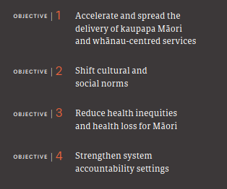

Priority areas for action
The Ministry has drawn guidance from the health and disability system, Māori individuals, whānau, hapū and iwi and other agencies to develop eight priority areas for Whakamaua: Māori Health Action Plan 2020–2025.

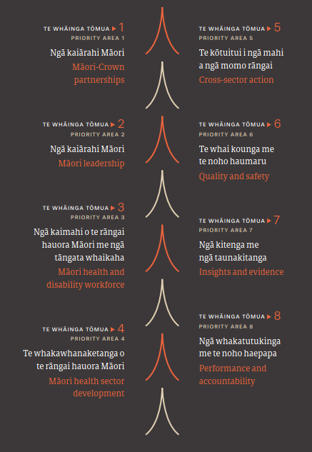
These priority areas are highly interdependent. They are where Māori and the wider system said action is most needed in the next five years to enable change and set a strong foundation for the future.

The actions for each priority area are designed to ensure that available resources will be used efficiently and effectively. This plan does not include all actions that are necessary across a complex ecosystem to achieve the outcomes sought. The actions in this plan are the critical few, that, in combination, can create the conditions necessary for a system shift in the short to medium term. This includes ensuring the health and disability system is well positioned for recovery from COVID-19.

We recognise that changes as a result of actions in one priority area will impact on other priority areas. Achieving desired outcomes will be contingent on synergies across all priority areas and taking a whole-of-system approach.

Shared responsibility for Māori health
In addition to Whakamaua, the aims of He Korowai Oranga will also be achieved through broader
government strategies and health and disability system strategies, individual district health board
(DHB) strategies, other action plans, guidance, reviews and inquiries, including but not limited to:
- Wai 2575 Health Services and Outcomes Kaupapa Inquiry
- the Health and Disability System Review
- the New Zealand Disability Strategy
- Whāia Te Ao Marama 2018 to 2022: The Māori Disability Action Plan
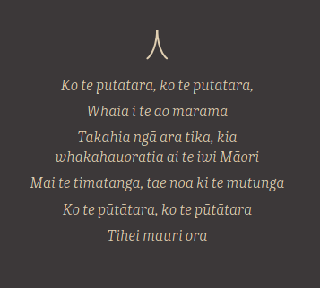
- Response to He Ara Oranga: the report on the Government Inquiry into Mental Health and Addiction
- Every Life Matters: He Tapu te Oranga o ia Tangata: Suicide
- Prevention Strategy 2019–2029
- New Zealand Cancer Action Plan 2019–2029
- Child and Youth Wellbeing Strategy.

Achieving Māori aspirations, wellness and wellbeing goals are priorities across the whole health and disability system as well as the social, justice, economic and environmental sectors.

Intended outcomes

Outcome 1
Iwi, hapū, whānau and Māori communities can exercise their authority to improve their health and wellbeing.

This outcome acknowledges that Māori have the right to manage their own health and wellbeing aspirations. It requires system shifts that better enable iwi, hapū and whānau to thrive as Māori,
create healthy and sustainable environments and communities in which to live and raise children.

This outcome links to articles 1 and 2 of Te Tiriti and gives effect to the principles of partnership, tino rangatiratanga and providing options for Māori. Enabling Māori health and wellbeing aspirations remains a condition for achieving pae ora (healthy futures) – wai ora (healthy environments), whānau ora (healthy families) and mauri ora (healthy individuals).

Outcome 2
The health and disability system is fair and sustainable and delivers more equitable
outcomes for Māori.

This outcome aims to ensure that Māori health equity is at the heart of the way New Zealand’s health and disability system operates. Achieving equity for Māori will require all contributors to the health and disability system to acknowledge inequitable health outcomes for Māori as not only unfair and unjust but also avoidable. A key part of achieving this outcome will be the extent to which a range of resources are prioritised and approaches are targeted and tailored to meet Māori aspirations for wellbeing and unmet need.

The burden of health loss falls inequitably on Māori, in terms of poor health, disability and premature death. Differences in the social, economic and behavioural determinants of health
and wellbeing, differential access to health care and differences in the quality of care in health outcomes for Māori contribute to this inequity.

This outcome links to articles 2 and 3 of Te Tiriti and gives effect to the principles of tino rangatiratanga, equity and active protection. Equity is a key element of He Korowai Oranga and
is a Government priority for achieving a strong and equitable health and disability system.

Outcome 3
The health and disability system addresses racism and discrimination in all its forms.

This outcome aims to eliminate all forms of racism and discrimination against Māori as a critical part of upholding Te Tiriti. Addressing racism and discrimination in all its forms is necessary if we are to achieve pae ora for Māori. This will involve embedding cultural safety and a commitment by all individuals and organisations working across the health and disability system to acknowledge and address their own biases, attitudes, assumptions, stereotypes, prejudices, structures and characteristics that may affect access to adequate health care and the quality of the care provided.

Racism can present as systemic monocultural perspectives and advantages one sector of the population while disadvantaging another. Racism is a modifiable determinant of health that can impact mental and physical health and lead to poorer health outcomes for Māori.

This outcome links to article 3 of Te Tiriti and the Ritenga Māori declaration and gives effect to the principles of active protection, equity and options.

Outcome 4
The inclusion and protection of mātauranga Māori throughout the health and disability system.

This outcome is about strengthening mātauranga Māori across the health and disability system as an important enabler of Māori health and wellbeing. This outcome acknowledges the relevance and value of distinctive Māori knowledge systems and indigenous ways of knowing,
doing and being that are embedded in kaupapa Māori models of care at all levels of the health and disability system. This includes rongoā Māori (traditional Māori medicine) services and whānau-centred community health care. Building knowledge and understanding of mātauranga
Māori through research and evaluation in Māori health settings will be important. Co-constructing services and interventions that accelerate improved Māori health outcomes will need to incorporate mātauranga Māori in order to be successful. The integration of mātauranga Māori into the health and disability system is supported by the final report of the Health and Disability System Review.

This outcome links to article 2 of Te Tiriti and the Ritenga Māori declaration. It gives effect to the principles of tino rangatiratanga, options and active protection. In He Korowai Oranga, it speaks to all aspects linked with Māori aspirations and contributions.

Priority areas for action

Te Whāinga Tōmua 1
Priority Area 1

Ngā pātuitanga i waenga i te Māori me te Karauna
Māori-Crown partnerships

Overview
- Meaningful Māori-Crown relationships reflect true partnership at all levels of the health and disability system.
Whakataukī
Ma tini, ma mano,
ka rapa te whai
(Many hands make light work
/ unity is strength.)
- Māori health development is increasingly led by iwi and hapū.
- Māori-Crown relationships are built on mutual trust and confidence in the health and disability system.

Purpose
To increase opportunities for, and quality of, Māori-Crown partnerships and promote good Māori-Crown relationships.

Actions
  - Develop iwi partnerships that support local level Māori development and kaupapa Māori service solutions.
  - Review, design and expand effective Māori-Crown partnership arrangements across DHBs and all levels of the health and disability system.
  - Lead and respond to the recommendations of the Hauora report from stage one of Wai 2575 and continue to support subsequent stages.
  - DHBs will engage with local Iwi, using the engagement framework and guidelines, when developing major capital business cases.

Why is this important

The Māori-Crown relationship is based on the fundamental exchange of kāwanatanga (the right of the Ministry to govern the health and disability system in a fair and just way) and the right of Māori to exercise tino rangatiratanga over their lives in a way that aligns with Māori customs and values. There is a need to build a meaningful Māori-Crown partnership in the health and disability system to reflect more future-orientated relationships. The practical arrangements to implement a meaningful partnership require constant evaluation to ensure that the partnership fulfils its purpose in meeting Tiriti commitments.
“[Developing] effective Māori-Crown relationships, including understanding the rights, interests and perspectives of Māori; meaningfully engaging and building relationships with iwi, hapū and Māori communities; and embedding Māori and Te Tiriti perspectives into policy, programmes and services.”

STAKEHOLDER ENGAGEMENT FEEDBACK

These actions contribute most to outcome 1 – iwi, hapū, whānau, and Māori communities can exercise their authority to improve Māori health and wellbeing.

What does it look like in practice?
The Ministry, DHBs and other health Crown entities have strong active relationships with Māori in designing, implementing and monitoring
health and disability services. The quality of Māori-Crown relationships at all levels of the health disability system are measured over time by both
parties to drive improvements and accountability. Iwi and hapū have the resources and support to develop kaupapa Māori and whānau-centred
services that meet the health aspirations of their own communities. The Ministry lifts health and disability system performance to better respond
to Māori health issues and ensures that Tiriti commitments are upheld.

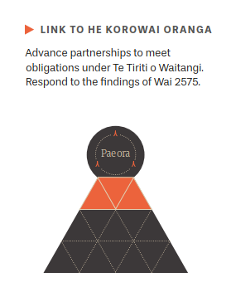

Te Whāinga Tōmua 2
Priority Area 2

Ngā kaiārahi Māori
Māori leadership

Overview
- Māori leadership is a significant enabler for achieving Māori health equity and wellbeing.
Whakataukī
He rātā whakamarumaru
(relates to a formidable chief or leader who shelters and protects the people)
- There is greater support and training for current and aspiring Māori health and disability leaders.
- Māori health and disability leaders have more opportunities to guide decision-making, network, share and collaborate.

Purpose

To increase and support Māori participation in governance, leadership and management decision-making at all levels of the health and disability system.

Actions
  - Deliver leadership networking opportunities for Māori DHB board members, members of the DHB/iwi/Māori partnership boards and Māori in other health and disability organisations.
  - Develop a Māori mental health and addiction strategic leadership framework to guide system transformation and decision making to improve mental health and addiction outcomes for Māori.
  - Design and deliver professional development and training opportunities for Māori DHB board members and members of the DHB/Iwi/Māori partnership boards.
  - Have the Ministry of Health provide strategic advice on developing Māori governance throughout the health and disability system.
  - Review He Korowai Oranga to ensure its strategic direction meets the future aspirations and needs, including the outcomes of the Health and Disability System Review.

Why is this important

Achieving optimal health and wellbeing for Māori requires Māori knowledge and leadership. That leadership is to be found within iwi, on marae, in communities, within health, disability and social services, within research centres, in academia, in policy making and in management. Ongoing Māori leadership development across the health and disability workforce is needed in order to develop the leadership capacity that underpins a high-performing system.
“We need Māori at all levels of decision making. Māori leadership is not just confined
to the board level; it must be throughout the health system, including executive management, middle management and team leader levels as well as clinical
directorships and clinical leaders.”

“Māori leadership is crucial to Māori-led solutions for Māori; this capability needs to be supported so Māori can nurture and mentor future leaders.”

STAKEHOLDER ENGAGEMENT FEEDBACK

Effective investment in Māori leadership development is a key responsibility and central to realising the aims of He Korowai Oranga. The New Zealand Public Health and Disability Act 2000 requires DHBs to provide mechanisms that enable Māori to contribute to decision-making and participate in the delivery of health and disability services. There is an ongoing need to ensure Māori are, and remain, adequately represented at the board level and are actively involved in key leadership and strategic decision-making at all levels of the health and disability system.

This priority area and associated actions contribute most to outcome 1: iwi, hapū, whānau and Māori communities can exercise their authority to improve their health and wellbeing and outcome 2: the health and disability system is fair and sustainable and delivers more equitable outcomes for Māori.

What does it look like in practice?
Māori health leadership at all levels of the health and disability system has increased in capacity and capability. It is based on mātauranga Māori as well as insights from health sciences and
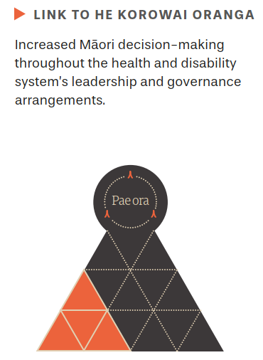
global indigenous knowledge. It has an accomplished workforce that is able to collaborate with a wide range of agencies across sectors and equally across Māori communities and iwi. Māori
health leadership is distributed, networked and has dual accountability to Māori and to government.

Current and aspiring Māori health leaders are equipped with the confidence and skill set necessary to actively engage, participate and influence health and disability system decision-making processes, particularly in DHBs. Increased Māori leadership contributes to health service design and delivery reflecting more of the local Māori population’s needs, leading to improved
prioritisation of resources and better health outcomes for hapū, iwi, whānau and Māori communities. Māori health leaders are supported to collaborate in a shared learning environment, building regional Māori health whanaungatanga and local leadership networks, and can progress towards more autonomous arrangements.

Te Whāinga Tōmua 3
Priority Area 3

Ngā kaimahi o te rāngai hauora Māori me ngā tāngata whaikaha
Māori health and disability workforce

Overview
- The capacity and capability of the Māori health and disability workforce is increased.
Whakataukī
Mā whero, mā pango ka oti te mahi.
(By red, by black, together we will get the work done.)
- Dual competence – mana Māori and mātauranga Māori is acknowledged as a professional skill set.
- A Māori health and disability workforce is equitably matched to the health needs of the Māori population.

Purpose

To increase the capacity and capability of the Māori health and disability workforce at all levels of the health and disability system.

Actions
  - Expand existing Māori health workforce initiatives aimed at encouraging Māori to enter health careers.
  - Support the development of a Māori primary mental health workforce.
  - Support DHBs and the Māori health sector to attract, retain, develop and utilise their Māori health workforce effectively, including in leadership and management.
  - Develop a strategic framework and plan to guide the development of the Māori health and disability workforce over the next 10 years.

Why is this important

The Māori health and disability workforce is a key enabler for improved health outcomes and equity for Māori. A Māori health workforce matched to its community’s needs can make a significant contribution to addressing racism in the health system by providing culturally safe and responsive care.

Māori continue to be under-represented in the health and disability workforce in almost all areas of the system. For health and disability services to better reflect and service the communities they serve, the Māori health and disability workforce needs a substantial uplift in capacity and capability. Supporting collaborative work across Māori workforce sectors is also important. In the evolving Māori leadership and workforce landscape, comprehensive investment will be required across the workforce to meet emerging and future needs and spread best and innovative practices.
“It is vital to the safety of and care for Māori patients and whānau that we have
Māori involved in the delivery of care – this will lead to improved
engagement with the health system and better health outcomes.”

STAKEHOLDER ENGAGEMENT FEEDBACK

This priority area and associated actions contribute most to outcome 2: the health and disability system is fair and sustainable and delivers more equitable outcomes for Māori and outcome 3: the health and disability system addresses racism and discrimination in all its forms.

What does it look like in practice?
There is a clear strategic direction and long-term plan for developing the Māori health and disability workforce. The Māori health and disability workforce has increased in capacity and capability, with progress made towards achieving Māori population parity and matching
services to need. Most health and disability disciplines have experienced an uplift in the number of Māori studying, graduating and entering paid employment, as well as, an increase in Māori health practitioners in leadership roles. The Māori health and disability workforce reflects Māori values and Māori models of practice – recognising and acknowledging mātauranga Māori as a professional skill.
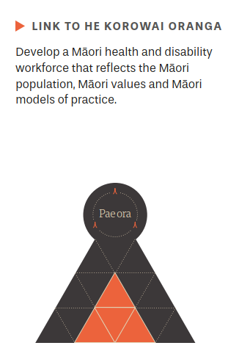

Te Whāinga Tōmua 4
Priority Area 4

Te whakawhanaketanga o te rāngai hauora
Māori health sector development

Overview
Whakataukī
Ko te pae tawhiti, whāia kia tata. Ko te pae tata, whakamaua kia tina.
(Seek out the distant horizons so that they may become close, bringing that vision to realisation.)
- Accelerate and spread the delivery of kaupapa Māori and whānau-centred services.
- Follow equitable and sustainable approaches to commissioning kaupapa Māori and whānau-centred services.
- Support Māori health sector capability and capacity to innovate and deliver effective services for Māori communities.

Purpose

To spread, strengthen, sustain and support high-quality Māori health and disability sector and provider development.

Actions
  - Increase the capacity and capability of the Māori health sector through the Māori Provider Development Scheme, the Te Ao Auahatanga Hauora Māori funding and other funds.
  - Strengthen evidence and expand access to rongoā Māori services in parallel with developing the rongoā Māori workforce.
  - Strengthen commissioning frameworks and guidance to increase Māori provider innovation and develop and spread effective kaupapa Māori and whānau-centred services.
  - Increase access to and choice of kaupapa Māori primary mental health and addiction services.
  - Launch the annual Hui Taumata Whakaoranga 2020–2025 to invite shared planning and accountability for Māori health and set a strategic agenda for the period of Whakamaua: Māori Health Action Plan 2020–2025.
  - Implement an action plan to prevent and manage long term conditions, including gout and diabetes, through a cross-health system approach, including a national communication campaign and extending effective primary health and community models of care.
  - Invest in innovative tobacco control, immunisation and screening programmes to increase equitable access and outcomes for Māori.
  - Complete and implement the redesign of the Well Child Tamariki Ora programme to ensure equitable access to the programme and improved outcomes for tamariki and whānau Māori.
“…providing a platform where health services are delivered by Māori for Māori is integral to improving Māori health and honouring the Crown’s obligations under Te Tiriti o Waitangi.”

“Focus on approaches that use Māori strengths and assets to develop Māori-led initiatives tailored to meet Māori needs (includes Māori models of health, rongoā and innovation).”

STAKEHOLDER ENGAGEMENT FEEDBACK
  - Invest in growing the capacity of iwi and the Māori health sector as a connected network of providers to deliver whānau-centred and kaupapa Māori services to provide holistic, locally led, integrated care and disability support.

Why is this important

Providing a platform where health services are delivered by Māori for Māori in their communities and are culturally safe and responsive is integral to improving Māori health and honouring the Crowns obligations under Te Tiriti. There is a need to ensure Māori providers are fairly treated and adequately resourced to provide timely outreach to whānau and culturally safe, holistic and integrated services – working with whānau and across sectors in ways that address the broader determinants and whole-of-life health and wellbeing challenges that Māori face.

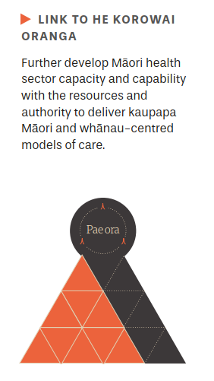
An investment in accelerating the spread of kaupapa Māori and whānau-centred services is an investment in wellness, wellbeing and preventing longer-term health inequities. Integrated holistic approaches place the needs of Māori and their whānau at the centre of quality health and disability services.

This priority area and associated actions contribute most to outcome 1: iwi, hapū, whānau and Māori communities can exercise their authority to improve their health and wellbeing, outcome 2: the health and disability system is fair and sustainable and delivers more equitable outcomes for Māori and outcome 4: the inclusion and protection of mātauranga Māori throughout the health and disability system.

What does it look like in practice?
The Māori health sector and Māori communities are adequately supported to deliver high-quality health and disability services according to their indigenous traditions; ways of knowing, doing and being; and world view. The equitable commissioning of the Māori health sector fosters innovation and locally led kaupapa Māori solutions. Māori individuals, whānau, hapū and iwi have access to services that are timely, culturally safe and responsive. Mātauranga Māori is recognised as a legitimate source of knowledge in Ministry and DHB funding and commissioning processes. Māori providers have access to powerful evidence, insights and data to transform and advance Māori health and wellbeing.

Te Whāinga Tōmua 5
Priority Area 5

Te kōtuitui i ngā mahi a ngā momo rāngai
Cross-sector action

Overview
- Addressing the broader determinants of health is key to achieving pae ora.
Whakataukī
Nā tou rourou. Nā taku rourou. Ka ora ai te iwi.
(With your food basket and my food basket the people will thrive)
- Planning, investment and accountability for Māori wellbeing is shared across sectors.
- Cross-sector action is locally driven to support integrated, timely, holistic whānau-centred services

Purpose

To foster collaboration and coordination across government agencies to maximise Māori health and wellbeing.

Actions
  - Support the joint work with Te Puni Kōkiri and the Department of Internal Affairs to work with rural marae and papa kāinga to enable health and wellbeing as a result of access to safe drinking water.
  - Prioritise equitable access to services and outcomes for tamariki in care or at risk of entering care, through a joint Ministry of Health and Oranga Tamariki work programme.
  - Support the cross-government COVID-19 response to mitigate the impacts of COVID-19 on whānau, hapū, iwi and Māori communities.
  - Expand innovative locally led initiatives through the Healthy Families New Zealand and Healthy Housing programmes.
  - Prioritise the active protection and achievement of health equity and wellbeing for Māori in cross-sector strategies and work programmes (including the Child and Youth Wellbeing Strategy and the Homelessness Action Plan) and participation on the Joint Venture on Family Violence and Sexual Violence.
  - The Ministry of Health supports Te Puni Kōkiri in its monitoring function, with an initial focus on Māori health sector development.
  - Support the delivery of Whāia Te Ao Mārama 2018 to 2022: The Māori Disability Action Plan.

Why is this important
“Addressing Māori health without addressing the root causes of poor health narrows the capacity of the system to respond to Māori illnesses and limits
the effect the health and disability system can have on improving health equity for Māori.”

“Māori are disadvantaged socially and economically as a result of colonisation; their poor health status reflects cumulative multifactorial inequities.”

“Comprehensive, joined-up action to address the determinants of health inequities, with clarity around roles and responsibilities when working across sectors must be a priority under the action plan.”

STAKEHOLDER ENGAGEMENT FEEDBACK

Wai ora (healthy environments) acknowledges the importance of creating built and natural environments that supports Māori wellbeing. A whole-of-government approach is critical to addressing the broader determinants of health to ensure individuals, whānau and communities are better able to access and enjoy healthy environments and get the help they need to take control of the circumstances affecting their health and wellbeing. Coordinated and effective planning, investment, resources and accountability across all sectors must be in place to ensure Māori receive timely, equitable access, resources and services.

This priority area and associated actions contribute most to outcome 2: the health and disability system is fair and sustainable and delivers more equitable outcomes for Māori.

What does it look like in practice?
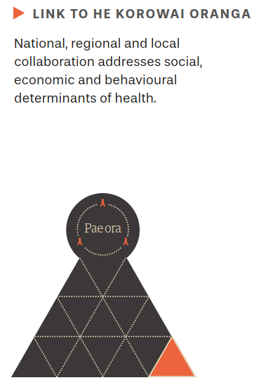
The different levels of the system, from providers to DHBs to the Ministry, have established partnerships across a range of sectors to allow for better service integration, planning and support for Māori and their whānau. Māori play a central role in developing and delivering cross-sector initiatives. Services place individuals and whānau at the centre – adapting to get efficiencies of scale and closer alignment between health and social services. Integrated services are delivered more effectively and are culturally safe, with improved continuity of care and improved environments and outcomes for Māori across a range of areas.

Te Whāinga Tōmua 6
Priority Area 6

Te whai kounga me te noho haumaru
Quality and safety

Overview
Whakataukī
Whāia te iti kahurangi; ki te tuohu koe, me he maunga teitei.
(Pursue excellence; should you bow your head, let it be to a lofty mountain.)
- Better understand differences in outcomes and improve system performance.
- Form consistent quality and safety standards and frameworks.
- Create culturally safe and culturally competent health service environments.

Purpose

To improve the quality, safety and experience of health and disability services received by Māori individuals and their whānau.

Actions
  - Adopt innovative technologies and increase access to telehealth services that streamline patient pathways and provide continuity of care for Māori individuals and their whānau.
  - Work with professional councils to drive sustained improvement in the number of professionals meeting standards of cultural competence and safety.
  - Design and implement a programme of work to address racism and discrimination in the health and disability system.
  - Review and implement the refreshed Health Equity Assessment Tool (HEAT).
  - Manage the protection of Māori health through the COVID-19 Ministry work programme.
  - Complete the review of and implement the health and disability service standards for regulated health and disability providers, with input from Te Apārangi: Māori Partnership Alliance.
  - Enable cross health and disability system collaboration to create and implement a te ao Māori quality improvement framework.

Why is this important

Māori have the right to experience equitable health outcomes through access to high-quality health and disability services that are timely, safe and culturally responsive to their aspirations and needs. Evidence shows that even when access to services is equal, Māori tend to receive lower-quality care. Equity is an integral component of quality. Equitable care ensures optimal outcomes for those patients who most need it, regardless of their background or circumstances. Quality health data, including ethnicity data, must be collected, analysed and utilised by the Ministry, DHBs and providers and across sectors to achieve equitable health outcomes for Māori. In addition, quality and safety standards, measures and procedures are needed to better guide the system and workforce to plan for, deliver and mitigate variation in access and treatment, and assess quality to deliver equitable health outcomes for Māori.
“Quality standards need to recognise, where appropriate, tikanga Māori and mātauranga Māori.
Particularly services with high numbers of Māori users and engagement or services where the engagement should be high but is not.”

“Data provides the evidence and understanding around whether the system and services are working or not.”

STAKEHOLDER ENGAGEMENT FEEDBACK

This priority area and associated actions contribute most to outcome 2: the health and disability system is fair and sustainable and delivers more equitable outcomes for Māori and outcome 3: the health and disability system addresses racism and discrimination in all its forms.

What does it look like in practice?
Māori individuals and whānau receive quality services that are safe, effective, whānau centred, timely and efficient. This is supported by a health and disability system that collects and uses data, disaggregated by ethnicity and other variables, to understand differences and drive continuous quality improvement to achieve equity. The system sets and monitors quality standards and practice requirements reflective of Tiriti obligations, Māori perspectives and
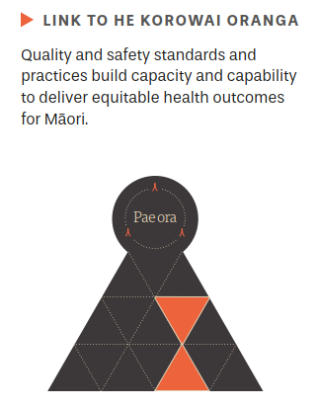
whānau-centred approaches. Routine monitoring of Māori equity and other quality and safety improvement approaches are embedded to reduce variation in the quality of standards, practices and outcomes. Vocational training has a robust focus on health equity, Te Tiriti, cultural safety
and health literacy. Training and development initiatives are successful in increasing cultural safety and competency to contribute to equitable health outcomes for Māori.

Te Whāinga Tōmua 7
Priority Area 7

Ngā kitenga me ngā taunakitangau
Insights and evidence

Overview
- Use kaupapa Māori insights and evidence to inform and influence decision-making processes.
Whakataukī
Whāia te mātauranga hei oranga mō koutou
(Seek knowledge for the sake of your wellbeing.)
- Validate and affirm Māori solutions and mātauranga Māori.
- Enable iwi and the Māori health sector to access insights, evidence and data.

Purpose

To advance the Māori health and disability evidence base that contributes to improved Māori health and wellbeing.

Actions
  - Design and implement a Māori health and disability research agenda that contributes to achieving pae ora in partnership with Māori.
  - Develop measures of Māori health and disability outcomes and wellbeing to measure pae ora in partnership with Māori stakeholders.
  - Collect and make publicly available timely Māori health and disability outcomes and wellbeing information, with a focus on equity and progress towards pae ora, including updating Tatau Kahukura.
  - Design and implement a Māori data sovereignty approach for the health and disability system in partnership with Māori.
  - Monitor and evaluate the impact on Māori health outcomes of other health and disability strategies and plans, such as the New Zealand Cancer Action Plan and Smokefree Aotearoa 2025.

Why is this important

Kaupapa Māori insights and evidence are essential for enabling mana motuhake, ensuring the protection and improvement of mana tangata and elevating the values and benefit of mātauranga Māori. Kaupapa Māori insights and evidence validate and affirm Māori solutions and Māori ways of knowing, doing and understanding the world. They acknowledge the relevance and success that Māori-led solutions and approaches have played in achieving wellbeing for Māori. The validation of kaupapa Māori insights and evidence should be supported by a commitment of investment and routine translation of insights and evidence into policy, service development, planning and accountability processes. At the heart of this priority area is the need to develop active partnerships with iwi and Māori organisations to explore different ways of meeting iwi and Māori insights, evidence and data needs.
“Crown data and data over which Māori have sovereignty can inform very
different results in decision-making, policy development,
outcome assessment and accountability.”

“Support Māori to participate in research underpinned by te ao Māori to contribute to evidence-based practice that is recognised in health policy.”

STAKEHOLDER ENGAGEMENT FEEDBACK

This priority area and associated actions contribute most to outcome 1: iwi, hapū, whānau and Māori communities can exercise their authority to improve their health and wellbeing, outcome 2: the health and disability system is fair and sustainable and delivers more equitable outcomes for Māori and outcome 4: the inclusion and protection of mātauranga Māori throughout the health and disability system.

What does it look like in practice?
The health and disability system, in partnership with Māori and other agencies, routinely invests in kaupapa Māori evidence and insights that advance Māori-led solutions and elevate Māori health and wellbeing. Measures of Māori wellbeing create a greater understanding of system change requirements towards pae ora. Evidence and insights provide
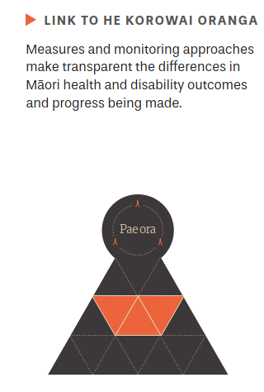
a clearer understanding of system performance for Māori. Information is readily available and consistently utilised to inform health and disability system innovation, policy, services and models of care. Planning and accountability is evidence informed – reflecting Māori aspirations. Whānau, hapū, iwi and Māori organisations have access to and the capacity and capability to utilise powerful insights, evidence and data to transform services and wellbeing for individuals, whānau and communities.

Te Whāinga Tōmua 8
Priority Area 8

Ngā whakatutukinga me te noho haepapa
Performance and accountability

Overview
Whakataukī
Hāpaitia te ara tika pūmau ai te rangatiratanga mo ngā uri whakatipu.
((Foster the pathway of knowledge to strength, independence and growth for future generations.)
- There are clear performance and accountability expectations for meeting Tiriti obligations to Māori.
- There is fair and equitable investment in Māori health development and monitoring of outcomes.
- Transparent reporting of progress ensures equitable health outcomes for Māori.

Purpose

To enable Tiriti compliance and the achievement of equitable health outcomes through strengthened performance and accountability arrangements

Actions
  - Implement changes to system accountability frameworks that assures ownership of Tiriti obligations and accountability for Māori health equity.
  - Require Crown health and disability organisations and larger non-governmental organisations in the health and disability system to publish their plans and progress in achieving equitable health outcomes for Māori.
  - Develop and implement Māori health equity and Tiriti tools and resources to guide the health and disability system in its strategies, planning, monitoring and accountability documents.
  - Implement legislative changes to reflect a commitment to Te Tiriti and Māori health equity across the health and disability system.
  - Ensure that major system funding frameworks consider and adjust for unmet need and the equitable distribution of resources to Māori.

Why is this important

Most inequities in health are unfair, unjust and avoidable. For Māori, they are the result of differential access to resources necessary for people to lead healthy and independent lives. Māori health and wellbeing aspirations are more likely to be achieved if all decision-makers make it a priority to address health inequities that affect Māori and develop initiatives that work effectively for Māori. The New Zealand Public Health and Disability Act 2000 requires DHBs to improve the health of Māori. Addressing inequities must be reflected in commissioning agencies’ strategic planning and accountability documents, as well as in decisions about funding, programme development, implementation, monitoring and reporting.
“…this priority area is key to achieving a high level of accountability from those within the current system who are responsible as they are controllers and decision-makers within the current system.”

STAKEHOLDER ENGAGEMENT FEEDBACK

This priority area and associated actions contribute most to outcome 2: the health and disability system is fair and sustainable and delivers more equitable outcome for Māori.

What does it look like in practice?
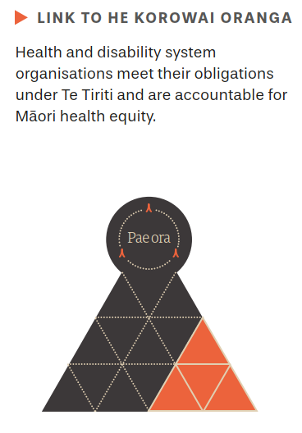
Expectations for the Ministry and commissioning agencies to meet Tiriti obligations and achieve equitable health outcomes for Māori are clear. The Ministry and DHBs are using real-time information to measure performance and openly drive decisions that support the development and sustainability of quality health services for Māori. There is greater investment in Māori health sector development and initiatives to respond earlier to Māori health need. There is routine reporting of the total investment in Māori health and progress being made to meet Tiriti obligations, reduce disease and long-term conditions, and improve overall Māori health and wellbeing.

Monitoring

E arotūruki ana i ngā mahi i ngā tau e rima

Monitoring progress over the five-year period

Quantitative monitoring
The following measures have been selected to track progress on a regular basis and provide a broad view of system performance against our four objectives (see page 25). Achieving these objectives will make a significant contribution to realising the plan’s high-level outcomes for Māori health and wellbeing. While there are many measures that could be assessed and there are significant opportunities for research and insights, it is important to identify an initial set that can be reported on regularly over the period of the plan.

It is important to identify and focus on measures that are relevant and technically reliable, with data already available in the health and disability system. This allows baselines to be set and changes to be measured over time. Over the period of the plan, new data, measures and insights will become available, including from longer-term surveys, like Stats NZ’s General Social Survey and Te Kupenga survey. Collaboration with Māori, including Wai 2575 claimants and other stakeholders, will impact future reporting against the outcomes.

Several of the measures call for an equity comparison and monitoring inequities between Māori and other people. For the purposes of this plan, the comparator group will be people who do not identify as either Māori or Pacific peoples (non-Māori/non-Pacific). This comparator has been
chosen in response to feedback that the usual approach of comparing Māori with all non-Māori can underestimate the inequities faced by Māori. To provide a complete view of the measure, it will be usual to display the information for Māori, Pacific people and non-Māori/non-Pacific.

The measures for the objectives are as follows.

Objective 1
Accelerate the spread and delivery of kaupapa Māori and whānau-centred services

Initial measures | Why this measure matters
- Funding received by kaupapa Māori health and disability service providers | For iwi, hapū, whānau and Māori communities to exercise their authority, they need to have access to fair levels of resourcing. Measuring the trend in Vote: Health funding received by kaupapa Māori providers will enable us to track changes in this area.  An improvement in this measure will see more funding directed to kaupapa Māori health and disability service providers.
- Geographical coverage and utilisation of rongoā Māori services | ‘Rongoā Māori is a wellbeing-oriented practice. It is a specialty based on a body of knowledge accumulated by tipuna Māori that is applied in totality to bring about wholeness or interconnectedness of body, mind, emotions, spirituality, energy, society, culture, relationships and environment.’ This is a key application of mātauranga Māori in the health and disability system.  An improvement in this measure will see increased accessibility to rongoā Māori services.
- The percentage of Māori reporting unmet need for primary health care, including a comparison between Māori and non-Māori/non-Pacific | Being able to access primary health care is important to maintaining whānau health and wellbeing. This measure will track Māori experiences of barriers to accessing the right care at the right time.  An improvement in this measure will see both a decrease in the percentage of Māori reporting unmet need for primary health care and a reduction in the gap between Māori and non-Māori/non-Pacific reporting unmet need for primary health care.

Objective 2
Shift cultural and social norms
Initial measures | Why this measure matters
- Experience of health services as measured by the primary health care and adult inpatient patient experience surveys | These surveys, administered by the Health Quality and Safety Commission, directly measure whether patients and their whānau are treated with respect and understanding.  An improvement in this measure will see improved experiences for Māori across the domains covered by the surveys.
- ‘Did Not Attend’ (DNA) and ‘Did Not Wait’ (DNW) percentages for Māori at outpatient services at DHBs, including a comparison between percentages for Māori and percentages for non-Māori/non-Pacific | Outpatient services that are safe and appropriate for Māori patients and their whānau are essential to improving health outcomes for Māori. This measure places responsibility on DHBs to offer services at times, in settings and in ways that build trust and work for Māori.  An improvement in this measure will see a reduction in DNA and DNW rates for Māori and a reduction in the gap between Māori and non-Māori/non-Pacific.
- Percentage of Māori in the regulated workforce compared with the percentage of Māori in the population | A health workforce that reflects the ethnic distribution of the population is essential in providing culturally safe care, enabling mātauranga Māori to be interwoven throughout the health and disability system.  An improvement in this measure will see an increase in the percentage of Māori in each of the regulated professions.

Objective 3
Reduce health inequities and health loss for Māori
Initial measures | Why this measure matters
- Rates of ambulatory sensitive hospitalisations (ASH) for Māori aged 0–4-years, including a comparison with rates for non-Māori/non-Pacific | ASH are admissions that are considered potentially reducible through interventions provided at the primary health care level. This is a key multi-morbidity measure of how well the primary health care system is working for young Māori tamariki.  An improvement in this measure will see a reduction in the ASH rates for Māori and a reduction in the gap between Māori and non-Māori/non-Pacific.
- Māori young people able to access specialist mental health or addiction services in a timely manner (within three weeks from referral), including a comparison between access for Māori and access for non-Māori/non-Pacific | Māori are disproportionately affected by a range of mental health and addiction problems. Māori are a youthful population, and mental health and addiction problems develop at an early age.  An improvement in this measure will see an increase in the percentage of Māori being seen within the three-week timeframe and a reduction in any gap between Māori and non-Māori/non-Pacific.
- Rate of diabetes complications for Māori compared with non-Māori/non-Pacific | Diabetes is a major long-term condition that disproportionately impacts Māori, and it is a condition that has significant downstream impacts and costs for Māori whānau and the health and disability system.  An improvement in this measure will see a reduction in both the rates of diabetes complications for Māori and the gap between Māori and non-Māori/non-Pacific.

Objective 4
Reduce health inequities and health loss for Māori
Initial measures | Why this measure matters
- Measures of the health of Māori/Crown partnerships, being developed by Te Arawhiti (The Office of Māori Crown Relations), as evidenced in the health and disability system | These measures will focus on the appropriate application of the Crown engagement with Māori framework, the breadth and types of partnerships and the implementation of the Māori/Crown partnership principles.  An improvement in this measure will see an increase in the breadth and type of partnerships that include health and disability as part of their scope.
- Number of kaupapa Māori research proposals receiving ethics approval that focus on Māori health and disability | Action 2 of strategic priority 1 of the New Zealand Health Research Strategy (2017–2027) is to invest in research for healthy futures for Māori. Progress against this action is an indicator of progressing mātauranga Māori.  An improvement in this measure will see an increase in the number of researchers reporting the use of kaupapa Māori research methods.
- Number of Māori leadership and governance roles across the Ministry DHBs and health sector Crown entities | Increasing and developing Māori leadership is a priority under this plan. In this initial phase (2020–2025), the focus will be on developing a baseline understanding and tracking an increase in Māori representation across key Crown organisations. Future plans will look to build in aspects of Māori leadership development and look wider than just the state health sector.  An improvement in this measure will see an increase in the number of Māori in governance and leadership roles across state health organisations.
- Standardised acute bed days per capita for Māori, including a comparison between Māori rates and rates for non-Māori/non-Pacific | The utilisation of acute inpatient services is an indicator of how the overall health and disability system is operating. Utilisation rates for Māori are significantly higher than those for non-Māori/non-Pacific, indicating that the system can improve how it provides services and support to Māori.  An improvement in this measure will see a reduction in the acute bed days per capita for Māori and a reduction in the gap between Māori and non-Māori/non-Pacific rates.

Evaluative monitoring
In addition to the quantitative monitoring, evaluation will complement the quantitative measures and strengthen understanding of the system change that is occurring. Evaluation will occur as part of the delivery of individual actions under the plan where appropriate. The plan’s delivery overall will also be evaluated.

The evaluation framework will create opportunities to better understand what works, for whom, and provide opportunities for continuous learning, which will inform the further development of
this plan and its strategic direction.

Āpitihanga 1
Appendix 1

Detailed whakapapa of He Korowai Oranga

He Korowai Oranga: Māori Health Strategy 2002

The role of He Korowai Oranga 2002
To establish a new direction for Māori health development in the health and disability system. The initial aim of He Korowai Oranga was whānau ora (Māori families supported to achieve their maximum health and wellbeing).

Audience
- Mostly Ministry and DHBs
- Iwi, Māori providers and Māori communities
- Other providers.

Whakatātaka: Māori Health Action Plan 2002–2005

The role of Whakatātaka 2002–2005
A companion publication to He Korowai Oranga, framing DHB policies and programmes as they set out to fulfil their responsibilities in relation to achieving the aims of whānau ora.

Achievements
- Increased relative investment in Māori health development and Māori health improvement
- Māori health and whānau ora included as key criteria in DHB prioritisation and resource allocation
- DHBs working with local Māori health partners and Māori communities to design monitoring and audit tools.

Challenges
- Quality data and information are essential for assessing performance of the Ministry and DHBs.
- Timelines for actions were challenging and difficult to achieve.
- The concept of whānau ora had not yet been realised.
- A more focused approach on prioritising areas for attention was needed.

Whakatātaka Tuarua: Māori Health Action Plan 2006–2011

The role of Whakatātaka 2006–2011
A companion publication to He Korowai Oranga, building on the gains from Whakatātaka 2002–2005.

Achievements
- Increased enrolment and uptake of primary health care services for children under the age of 6 years and improved patient pathways for long-term conditions
- Implementation of Māori health and disability workforce initiatives
- Supporting a range of initiatives to grow the Māori nursing, midwifery, public health and medical workforces
- Identifying and promoting successful integrated service delivery models that showed real improvement for Māori and their whānau
- Improved data and information, such as the development of the Tātau Kahukura Māori health chart book.

Challenges
- Frequent changes to priorities and policy settings over time meant actions didn’t have the same relevance that they did at time of publication.

The refresh of He Korowai Oranga: Māori Health Strategy 2014

The role of He Korowai Oranga 2014
The original He Korowai Oranga was refreshed in 2014 to ensure its relevance for the future.

Pae ora (health futures for Māori) is the government’s vision and aim for the refreshed strategy. Pae ora encourages everyone in the health and disability system to work collaboratively, to think beyond narrow definitions of health and to provide high-quality and effective services.

It builds on the initial foundation of whānau ora (healthy Māori families) to include mauri ora (healthy Māori individuals) and wai ora (healthy environments).

Audience
- Ministry, DHBs
- Iwi, Māori providers and Māori communities
- Other government agencies (such as Te Puni Kōkiri, Oranga Tamariki, Te Arawhiti).

Whakamaua: Māori Health Action Plan 2020–2025

The role of Māori Health Action Plan 2020–2025
Whakamaua: Māori Health Action Plan 2020–2025 gives practical effect to He Korowai Oranga 2014.

The plan is underpinned by Te Tiriti and the principles of tino rangatiratanga, equity, active protection, options and partnership.

The plan outlines a suite of high-level outcomes, objectives, priority areas, actions and measures to monitor progress over a five-year period.

It provides an important focus for Māori health development. It is a living document with the ability to evolve to meet existing and emerging health and wellbeing needs and achieve the aims of He Korowai Oranga.

Āpitihanga 2
Appendix 2

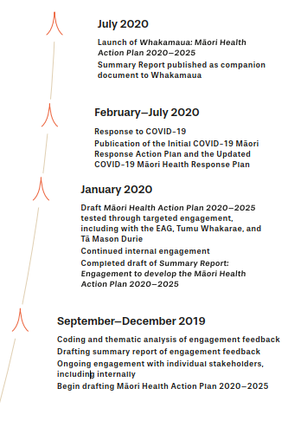
Developing Whakamaua: Māori Health Action Plan 2020-2025
The development of the action plan has been an iterative and collaborative process. This diagram provides a high-level overview of this development process. A summary of stakeholder engagement feedback has been published as a companion document to this action plan.
This summary report provides a detailed overview of the engagement process and is available on the Ministry of Health website.
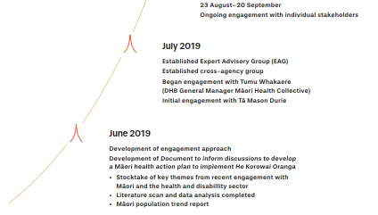
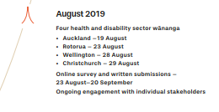

Āpitihanga 3
Appendix 3

Members of the Maori Health Action Plan Expert Advisory Group
Name | Profile
Hingatu Thompson (Chair) | Hingatu Thompson has a wealth of experience in the health sector, most recently as the CEO of Manaaki Ora Trust. Before this, Hingatu was a manager at the Ministry of Health and assisted with the development of He Korowai Oranga. During his time at the Ministry, Hingatu was also seconded to the office of the Associate Minister of Health, Mita Ririnui.  Hingatu is well respected within the health sector and within te ao Māori for his ability to connect with local communities and directly address the problems within hapori. His leadership skills have provided a firm foundation for the expert advisory group.
Lance Norman | Lance Norman is an experienced senior executive leader with strong connections to te ao Māori. His previous roles include being CEO of both Hāpai Te Hauora Tapui and the National Urban Māori Authority (NUMA). His vocational experience has covered areas such as health, housing, finance and tikanga Māori – at both the funding and provider levels.  Lance’s experience in Māori health is considerable, recently being appointed as the Head of Equity and Māori Health Outcomes at ProCare Health (PHO) Limited.
Tristram Ingham | Dr Tristram Ingham has an extensive career in the health sector. He currently works as a senior research fellow for University of Otago, with a specific focus on Māori health long-term conditions and disability.  Tristram’s extensive governance experience includes being the Chair of the external advisory group supporting the implementation of Whāia Te Ao Mārama and Vice Chair of Muscular Dystrophy New Zealand. He was also a member of the Māori Partnership Board for Capital and Coast DHB for nearly seven years and has been appointed as a member of the Capital and Coast DHB board.
Te Pora Thompson-Evans | Te Pora Thompson-Evans is an experienced governance executive and consultant specialising in hauora Māori. She is the current Chair for the Iwi Māori Council of Waikato DHB and Co-Chair for Te Manawa Taki (Midlands) Iwi Relationship Board.  Te Pora has a strong background in public health, hauora governance and Māori development. She has been reappointed as one of five Māngai Māori (Voice of Māori) to the Hamilton City Council. She also leads and contributes to various kaupapa Māori research and evaluation projects.
Ezekiel Raui | Ezekiel Raui graduated from university in 2018 with a Bachelor’s degree in Business/Commerce. Ezekiel has already developed considerable experience in Māori health and has several notable achievements to his name. His work experience includes being president of Te Waka o ngā Akonga Māori (Māori students association of Massey University) and the TūKotahi Programme Manager and Co-Founder.  Ezekiel’s achievements include being awarded the inaugural Matariki Awards, Te Whetū Maiangi Award for Young Achievers in 2016, being named as one of Forbes 30 Under 30 for the Asia/Pacific region and being selected as one of four New Zealand Māori ambassadors to attend the 2015 inaugural White House Tribal Nations Conference, Tribal Youth Gathering, hosted by President Barack Obama.
Suzanne Pitama | Professor Suzanne Pitama is a registered educational psychologist. She has extensive experience in Māori health research and health education. Suzanne is focussed on addressing Māori health inequities through medical education, health research, including mental health and heart health, and through membership on appropriate committees and boards, including the Health Research Council and Australian Medical Council.  Suzanne is the Otago Medical School Hauora Māori faculty representative, is a member of the Bachelor of Medicine and Bachelor of Surgery curriculum committee and chairs the Hauora Māori sub-committee. Suzanne also contributes to the Māori/Indigenous Health Institute (MIHI) post-graduate short courses that support the professional development of health professionals in the Hui Process and Meihana Model.

Āpitihanga 4 Appendix 4

Whakamaua: the Māori Health Action Plan 2020–2025
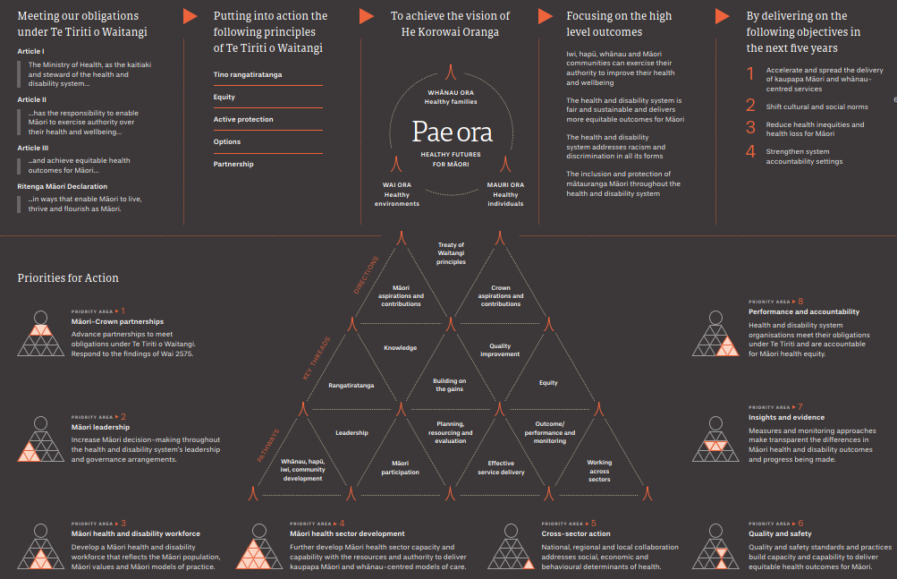
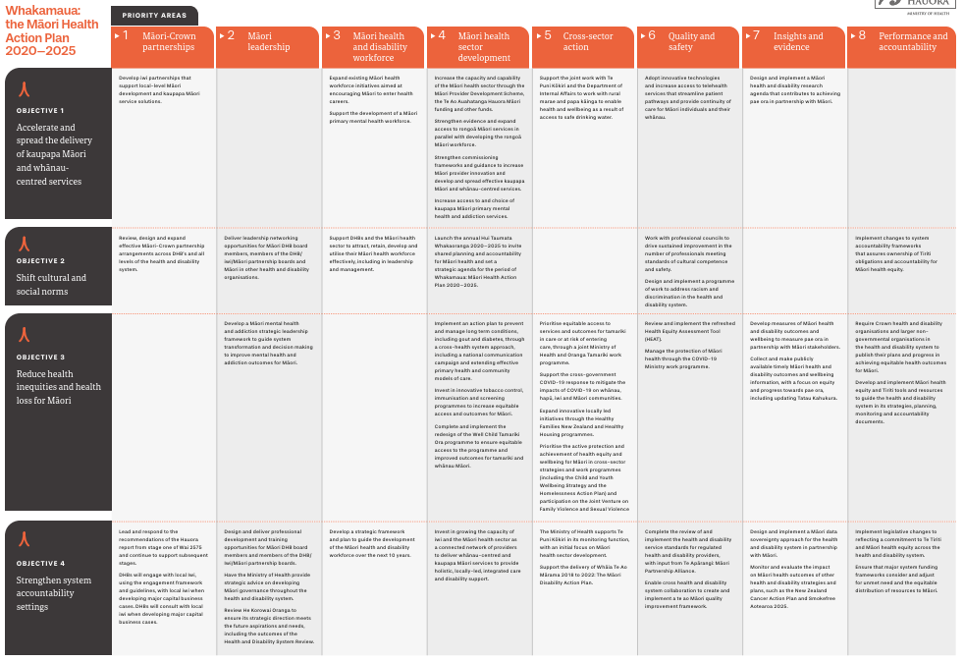

Āpitihanga 5 Appendix 5

Te Tiriti o Waitangi and the health and disability system
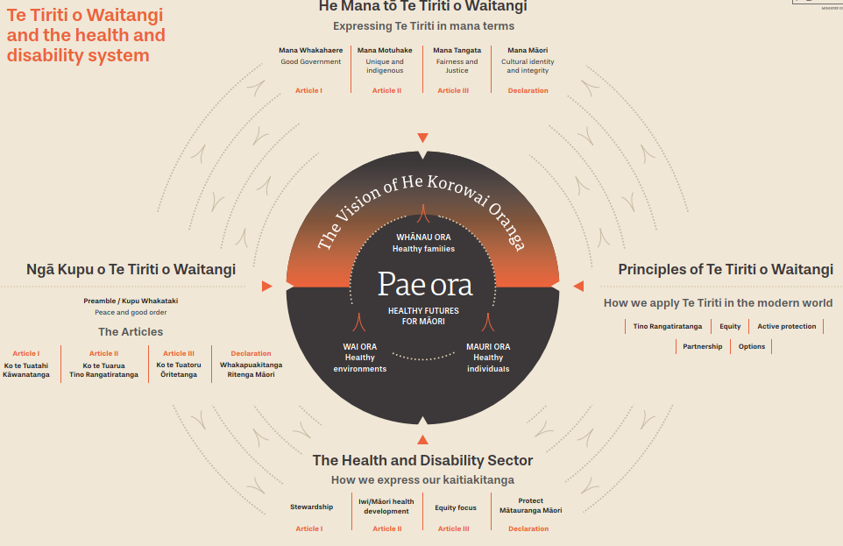

Our Te Tiriti o Waitangi Framework
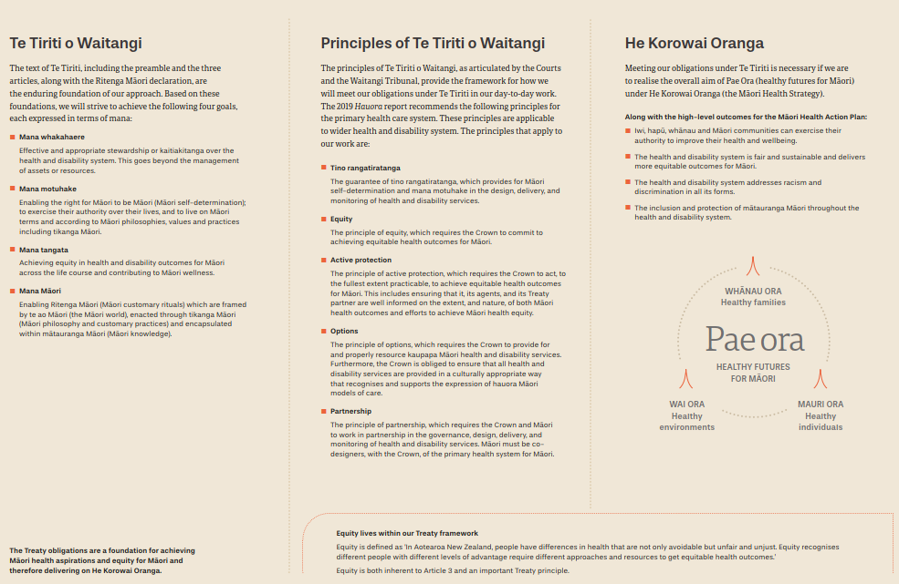

Ngā tohutoro
References
Broughton D. McBreen K. 2014. Mātauranga Māori, tino rangatiratanga and the future of New Zealand science. Journal of the Royal Society of New Zealand 45: 2, 83–88.

Came H. 2012. Institutional Racism and the Dynamics of Privilege in Public Health (Thesis, Doctor of Philosophy (PhD)). Hamilton: University of Waikato. URL: https://hdl.handle.net/10289/6397 (accessed 10 February 2020)

Chin MH, Clarke AR, Nocon RS, et al. 2012. A roadmap and best practices for organizations to reduce racial and ethnic disparities in health care. Journal of General Internal Medicine 27: 8, 992–1000. URL: www.ncbi.nlm.nih.gov/pubmed/22798211/ (accessed 10 February 2020)

Cram F. 2010. Shifting Māori Health Needs – Māori population trends, health service needs, and medical workforce requirements – issues arising. Ministry of Health: Wellington.

Department of the Prime Minister and Cabinet. 2019. Child and Youth Wellbeing Strategy. Wellington: Department of the Prime Minister and Cabinet.

Harris R, Cormack D, Tobias M, et al. 2012. The pervasive effects of racism: experiences of racial discrimination in New Zealand over time and associations with multiple health domains. Social Science & Medicine 74(3), 408–15.

HDSR. 2019. Health and Disability System Review – Interim Report. Hauora Manaaki ki Aotearoa Whānui – Pūrongo mō Tēnei Wā. Wellington: Health and Disability System Review (HDSR).

HDSR. 2020. Health and Disability System Review – Final Report – Pūrongo Whakamutunga. Wellington: Health and Disability System Review (HDSR).

Health Quality & Safety Commission New Zealand. 2019. He Matapihi ki te Kounga o ngā Manaakitanga ā-Hauora o Aotearoa 2019: A Window on the Quality of Aotearoa New Zealand’s Health Care 2019. Wellington: Health Quality & Safety Commission New Zealand.

Maxwell-Crawford K. 2011. Indigenous workforce development in Aotearoa. Pimatisiwin: A journal of aboriginal and indigenous community health 9(1), 53–64.

Mead HM. 2003. Tikanga Māori: Living by Māori values. Wellington: Huia Publishers. pp 29–30, 51–52.

Minister of Health and Associate Minister of Health. 2002. Whakatātaka: Māori Health Action Plan 2002–2005. Wellington: Ministry of Health.

Minister of Health and Associate Minister of Health. 2006. Whakatātaka Tuarua: Māori Health Action Plan 2006–2011. Wellington: Ministry of Health.

Ministry of Business, Innovation and Employment and Ministry of Health. 2017. New Zealand Health Research Strategy 2017–2027. Wellington: Ministry of Business, Innovation and Employment and Ministry of Health. URL: www.health.govt.nz/publication/new-zealand-health-research-strategy-2017-2027 (accessed 10 February 2020).

Ministry of Health. 2002. He Korowai Oranga: Māori Health Strategy. Wellington: Ministry of Health. URL: www.health.govt.nz/system/files/documents/publications/mhs-english.pdf (accessed 24 January 2020).

Ministry of Health. 2014a. Equity of Health Care for Māori: A framework. Wellington: Ministry of Health.

Ministry of Health. 2014b. He Korowai Oranga. Wellington: Ministry of Health. URL: www.health.govt.nz/our-work/populations/maori- health/he-korowai-oranga (accessed 29 January 2020).

Ministry of Health. 2014c. Tikanga ā-Rongoā. Wellington: Ministry of Health.

Ministry of Health. 2015. Tatau Kahukura: Māori Health Chart Book 2015 (3rd edition). Wellington: Ministry of Health.

Ministry of Health. 2018a. Achieving Equity in Health Outcomes: Highlights of important national and international papers. Wellington: Ministry of Health.

Ministry of Health. 2018b. Whāia Te Ao Mārama 2018 to 2022: The Māori Disability Action Plan. Wellington: Ministry of Health. URL: www. health.govt.nz/publication/whaia-te-ao-marama-2018-2022-maori-disability-action-plan (accessed 10 February 2020).

Ministry of Health. 2019a. Achieving Equity in Health Outcomes: Summary of a Discovery Process. Wellington: Ministry of Health.

Ministry of Health. 2019b. Annual Update of Key Results 2017/18: New Zealand Health Survey. Wellington: Ministry of Health.

Ministry of Health. 2019c. Every Life Matters – He Tapu te Oranga o ia Tangata: Suicide Prevention Strategy 2019–2029 and Suicide Prevention Action Plan 2019–2024 for Aotearoa New Zealand. Wellington: Ministry of Health.

Ministry of Health. 2019d. New Zealand Cancer Action Plan 2019–2029 – e Mahere mō te Mate Pukupuku o Aotearoa 2019–2029. Wellington: Ministry of Health.

Ministry of Health. 2019e. Wai 2575 Māori Health Trends Report. Wellington: Ministry of Health.
Ministry of Health. 2020. Summary Report: Engagement on the development of the Māori Health Action Plan 2020–2025. Wellington: Ministry of Health.

New Zealand Government. 2017. The New Zealand Health and Disability System: Handbook of Organisations and Responsibilities. Wellington: New Zealand Government.

New Zealand Maori Council v Attorney-General [1987] 1 NZLR 641.

New Zealand Maori Council v Attorney-General [1989] 2 NZLR 142.

New Zealand Maori Council v Attorney-General [1991] WL 12012744.

New Zealand Maori Council v Attorney-General [1992] 2 NZLR 576.

New Zealand Maori Council v Attorney-General [2013] NZSC 6.

NZQA. 2012. Conversations on Mātauranga Māori. Wellington: New Zealand Qualifications Authority (NZQA).

Office for Disability Issues. 2016. New Zealand Disability Strategy 2016–2026. Wellington: Ministry of Social Development.

Paradies Y, Ben J, Denson N, et al. 2015. Racism as a determinant of health: a systematic review and meta-analysis. PLoS One 10(9): e0138511.

Pescud M, Sargent G, Kelly P, et al. 2019. How does whole of government action address inequities in obesity? A case study from Australia. International Journal for Equity in Health 18: 8.

Te Puni Kōkiri. 2001. A Guide to the Principles of the Treaty of Waitangi, as expressed by the Courts & the Waitangi Tribunal. Wellington: Te Puni Kōkiri. pp 40–41.

Waitangi Tribunal. 1987. Report of the Waitangi Tribunal on the Orakei claim. Wellington: Brooker and Friend.

Waitangi Tribunal. 1988. Report of the Waitangi Tribunal on the Muriwhenua fishing claim. Wellington: Department of Justice.

Waitangi Tribunal. 1991. The Ngai Tahu Report 1991. Vol. 1. Wellington: Brooker and Friend.

Waitangi Tribunal. 2019. Hauora: Report on Stage One of the Health Services and Outcomes Kaupapa Inquiry. Wellington: Waitangi Tribunal. pp. 163–164.

Walsh M, Grey C. 2019. The contribution of avoidable mortality to the life expectancy gap in Māori and Pacific populations in New Zealand – a decomposition analysis. New Zealand Medical Journal 132(1492): 46–60.

Ritenga Māori declaration (often commonly referred to as the ‘fourth article’) was drafted in te reo Māori and read out during discussions with rangatira about Te Tiriti. The Ritenga Māori declaration provides for the protection of both religious freedom and traditional spirituality and knowledge (Te Puni Kokiri 2001).
‘Mana’ is a uniquely Māori concept that is complex and covers multiple dimensions (Mead 2003).
New Zealand Maori Council v Attorney-General [1987] 1 NZLR 641; New Zealand Maori Council v Attorney-General [1989] 2 NZLR 142; New Zealand Maori Council v Attorney-General [1991] WL 12012744; New Zealand Maori Council v Attorney-General [1992] 2 NZLR 576; New Zealand Maori Council v Attorney-General [2013] NZSC 6; The Ngai Tahu report 1991 (Waitangi Tribunal 1991); Report of the Waitangi Tribunal on the Orakei claim (Waitangi Tribunal 1987); Report of the Waitangi Tribunal on the Muriwhenua fishing claim (Waitangi Tribunal 1988).
Hauora: Report on Stage One of the Health Services and Outcomes Kaupapa Inquiry (Waitangi Tribunal 2019).
Ministry of Health 2002.
Ministry of Health 2014b.
See United Nations Declaration on the Rights of Indigenous People at: www.un.org/development/desa/indigenouspeoples/declaration-on-the-rights-of-indigenous-peoples.html
Ministry of Health 2020
Ministry of Health 2019e
Ministry of Health 2019a.
Waitangi Tribunal 2019.
HDSR 2019.
HDSR 2020.
Office for Disability Issues 2016.
Ministry of Health 2018b.
See Government Inquiry into Mental Health and Addiction on the Ministry’s website at: www.health.govt.nz/our-work/mental-health-and-addictions/government-inquiry-men-tal-health-and-addiction
Ministry of Health 2019c.
Ministry of Health 2019d.
Department of the Prime Minister and Cabinet 2019.
Ministry of Health 2019e.
Walsh and Grey 2019.
Came 2012.
Paradies et al 2015.
Harris et al 2012.
HDSR 2020.
Waitangi Tribunal 2019
Public Health and Disability Act 2000, sections 3(a), 4 and 23(1)(d) and (e). Also see New Zealand Government 2017.
Maxwell-Crawford K 2011.
Cram F. 2010.
HDSR. 2019.
Ministry of Health 2002.
Pescud M et al. 2019.
Ministry of Health 2014a.
Ministry of Health 2019b.
Chin et al. 2012.
Broughton and McBreen 2014.
NZQA 2012.
Ministry of Health 2018a.
Health Quality & Safety Commission New Zealand 2019.
Public Health and Disability Act 2000, section 22(1)(e).
For more details, see Stats NZ, General Social Survey 2018: Final content at: www.stats.govt.nz/methods/general-social-survey-2018-final-content
For more details, see Stats NZ, Te Kupenga 2013 (English) at: www.stats.govt.nz/informa-tion-releases/te-kupenga-2013-english?gclid=CjwKCAiAg9rxBRADEiwAxKDTulDULh5uC-qEsx-4ody5JQHzik4oNAxgsdlU_rvYT4b3S_WWqUE3d1xoCOHEQAvD_BwE
Minister of Health and Associate Minister of Health 2002.
For example, see Ministry of Health 2015.
Ministry of Health 2014b.
Ministry of Health 2020
Advice and guidance was also provided by the COVID-19 Māori Monitoring Group as Whakamaua was finalised

