UPDATED COVID-19 MĀORI HEALTH RESPONSE PLAN

Ministry of Health

Updated COVID-19 Māori Health Response Plan

July 2020

Acknowledgements
Our thanks and acknowledgement for the feedback, insights and guidance provided by a range of individuals, groups, and organisations during the COVID-19 response. This includes the Māori Reference Group, Māori Monitoring Group, Tumu Whakarae (DHB General Managers, Māori Health), the Technical Advisory Group, and iwi and Māori organisations. We will continue to work with these groups and others as we respond to COVID-19. We also recognise the significant and huge collective effort made by iwi, hapū, whānau and Māori communities across the COVID-19 response to date.

Citation: Ministry of Health. 2020. Updated COVID-19 Māori Response Action Plan. Wellington: Ministry of Health.
Published in July 2020 by the Ministry of Health
PO Box 5013, Wellington 6140, New Zealand
ISBN 978-1-99-002915-8 (online)
HP 7427
This document is available at health.govt.nz
This work is licensed under the Creative Commons Attribution 4.0 International licence. In essence, you are free to: share ie, copy and redistribute the material in any medium or format; adapt ie, remix, transform and build upon the material. You must give appropriate credit, provide a link to the licence and indicate if changes were made.

Contents
Executive summary 5
Contact details and further information 5
Introduction 6
Indigenous health inequities in New Zealand 6
A commitment to Te Tiriti o Waitangi and health equity 6
Shared responsibility for Māori health 6
The Government’s approach to the COVID-19 response 7
COVID-19 Alert System 8
Objectives of the updated Plan 9
Progress so far 11
Summary 11
Confirmed and probable cases 11
Transmission sources 12
Addressing equity in testing approaches 13
Protective measures – increased access to the influenza vaccination 14
COVID-19 health and wellbeing survey 15
Māori health and disability provider sector in Alert Level 4 16
Investment to support Māori health 17
Support the delivery of care packages by Whānau Ora agencies 18
Support Māori health providers to continue providing services 18
Increase outreach services for Māori 19
Whānau-centred communications 19
Actions to support whānau, hapū, iwi and Māori communities 20
Section 1: Actions as part of the Initial COVID-19 Māori Response Action Plan and Māori Health Funding Package 21
Section 2: Contributory actions across the health and disability system 24
Section 3: Contributory actions to Māori health across government 29
Māori governance 32
Monitoring progress 33
Communications approach 34
Strategic communications 34
Media 34
External communications 34
Internal communications 34
National-level communications approach 35
Regionalised communications approach 35
Appendix 1: A commitment to Te Tiriti o Waitangi and equity 36
Our expression of Te Tiriti 36
Our approach to achieving these goals 36
Positioning equity at the centre of the pandemic response 37
Integrating equity into decision-making 38
Appendix 2: Ministry of Health’s draft Te Tiriti o Waitangi framework 39

Executive summary
The Updated COVID-19 Māori Health Response Plan (the Plan) builds on the progress made by the Initial COVID-19 Māori Response Action Plan and provides an updated framework to protect, prevent, and mitigate the impacts of COVID-19 within whānau, hapū, iwi and Māori communities. This Plan responds to a range of feedback received since the release of the initial plan and adjusts the strategic approach against the Government’s evolving approach to COVID-19. The Plan is aligned with and contributes to the broader health and disability COVID-19 response. This ensures that the COVID-19 response for Māori health remains strategically focused and is integrated across the broader health and disability system response. This Plan also makes an important contribution to the all-of-government response to COVID-19 in mitigating the social impact of COVID-19 on whānau, hapū, iwi and Māori communities.
The updated Plan will guide health and disability system action throughout the COVID-19 response – building on the activity to fight the virus and cushioning the blow, while beginning to position for longer-term recovery. In addition to this Plan, Māori health COVID-19 activity will be supported by Whakamaua: the Māori Health Action Plan 2020–2025 (Whakamaua). Whakamaua has been developed through an extensive consultation process and will guide Māori health action over the next five years, with implementation beginning over the next few months. Whakamaua gives practical effect to He Korowai Oranga: the Māori Health Strategy and its overarching vision of Pae Ora – healthy futures for Māori. Further updates on the process to implement Whakamaua can be found at www.health.govt.nz/MHAP.
An overview of the Ministry’s Te Tiriti o Waitangi and equity statements are attached as Appendix 1, and the Ministry of Health’s draft Te Tiriti o Waitangi framework is attached as Appendix 2.

Contact details and further information
If you have any issues and queries, please contact maorihealth@health.govt.nz.
For more information about the Māori health COVID-19 response, please go to https://www.health.govt.nz/. For the latest updates and information on the COVID-19 response, please go to https://covid19.govt.nz/.

Introduction
This Plan sets out objectives and actions that the health and disability system and broader government will implement to ensure the health and wellbeing of iwi, hapū, whānau and Māori communities is protected during the COVID-19 response. This updated Plan responds to a range of feedback that we received since the release of the Initial COVID-19 Māori Response Action Plan.
This Plan remains a living document that will continue to adapt and evolve alongside the fast-evolving COVID-19 context. The actions in this Plan will evolve as we progress through the immediate response phase and alert levels to longer-term recovery. This will require the Ministry and its partners involved in this Plan to be flexible and agile to meet the changing needs of the communities we serve. We recognise that further input is always required, so we welcome ongoing feedback.

Indigenous health inequities in New Zealand
Indigenous ethnic inequities in infectious diseases are clear. Māori experience higher rates of infectious diseases than other New Zealanders. The severe impact of the 1918–19 influenza pandemic on Māori and the increased susceptibility of Māori to the 2009 H1N1 influenza A pandemic provide rationale to strengthen the Māori-specific response to COVID-19. Māori generally have higher rates of chronic conditions and comorbidities and, following international trends, are likely to have an increased risk of infection should a community outbreak occur. The unequal distribution and exposure to the determinants of health further increases the risk for Māori. This requires equity to be a central feature to the health and disability system’s COVID-19 response, ensuring the active protection of the health and wellbeing of whānau, hapū, iwi and Māori communities.

A commitment to Te Tiriti o Waitangi and health equity
Demonstrating a commitment to Te Tiriti o Waitangi and the achievement of Māori health equity is a critical component of this Plan. Meeting these obligations requires collective effort across the health and disability system and the application of Te Tiriti articles and principles at every level of the response. Equity considerations should continue to be integrated across the response.
More detailed statements on the Ministry’s approach to meeting these obligations are provided in Appendix 1. The Ministry’s draft Tiriti o Waitangi Framework, which helps to guide this Plan, is attached as Appendix 2.

Shared responsibility for Māori health
This Plan emphasises the responsibilities of the whole health and disability system and broader government to drive Māori health improvement towards the achievement of health equity. This requires a collective and integrated approach across the COVID-19 response. Achieving the objectives in this Plan will require input from plans and strategies from across the all-of-government COVID-19 response.

The Government’s approach to the COVID-19 response
The Government, the health and disability system, and communities have had to respond swiftly, as demanded by the COVID-19 response. The Ministry has played an important stewardship role across this process by guiding an extensive public health response. As the pandemic unfolds, the focus is turning to mitigation of its effects, acknowledging that the potential for longer-term impacts is still emerging.
The Government has announced its plan to respond and recover from COVID-19. This includes the continuation of an elimination strategy that seeks to eradicate or minimise cases of COVID-19 from New Zealand to a level that is manageable by the health system, until a vaccine becomes available to achieve population-level immunity. The Ministry’s focus continues to be on Response, Recovery, and Redesign.
Though the Ministry is moving towards the recovery and redesign phases, the threat of a community outbreak of COVID-19 remains. This risk requires the health and disability system to maintain its responsiveness and its ability to shift focus according to need. This may mean some parts of the system will be required to focus on response activities, and others on recovery and redesign.
Recovery – ensuring the health and disability system is positioned for recovery
Response – leading the health sector’s COVID-19 response by fighting the virus and cushioning the blow

Redesign – capturing the positive changes made to the way health care is delivered during the COVID-19 response while supporting significant and long-term recovery.

While New Zealand is on track for elimination, the risk of further cases (particularly among arriving travellers) potentially seeding further clusters and community transmission remains. The Ministry is currently drafting a COVID-19 Health and Disability Sector Resurgence Action Plan, which provides an overview of the Ministry’s readiness and response activities for any future waves of COVID-19 cases. This is aligned with an all-of-government approach to re-escalation or resurgence. The activity outlined in this Plan therefore remains flexible enough to respond as the risk of an outbreak changes over time, according to the COVID-19 alert levels.

COVID-19 Alert System
The COVID-19 Alert System guides the types of public health and social measures needed to be taken to respond to COVID-19. Although New Zealand shifted into Alert Level 1 at 11.59 pm on Monday 8 June 2020, the Ministry will remain prepared to move up and down alert levels as the risk of a COVID-19 outbreak changes over time. This Plan acknowledges the impact of different alert levels on the delivery of health and disability services, and on the health and wellbeing of communities more generally, including psychosocial impacts.

Objectives of the updated Plan
The overarching goal of the updated Plan is to protect, prevent and mitigate the impacts of COVID-19 within whānau, hapū, iwi and Māori communities. This Plan also supports the Crown in meeting its obligations under Te Tiriti o Waitangi in the COVID-19 response, including the protection of Māori health and wellbeing and the achievement of equity. To achieve this goal, the Plan outlines three objectives (outlined in the diagram below) which are guided by the principles of Te Tiriti o Waitangi and based on insights about where action is needed most. These objectives build on the Initial COVID-19 Māori Response Action Plan and provide clear direction for the COVID-19 Māori health response over the next four months. An overview of the framework of this updated Plan is provided on the following page.

Objective 1: Ensure iwi, hapū, whānau and Māori communities can exercise their authority to respond directly to the health and wellbeing challenges across the COVID-19 response.
Objective 2: Ensure the health and disability system delivers equitable outcomes for Māori across the COVID-19 response.
Objective 3: Ensure Te Tiriti and Māori health equity responsibilities are met in the exercise of kaitiakitanga and stewardship over the COVID-19 response.

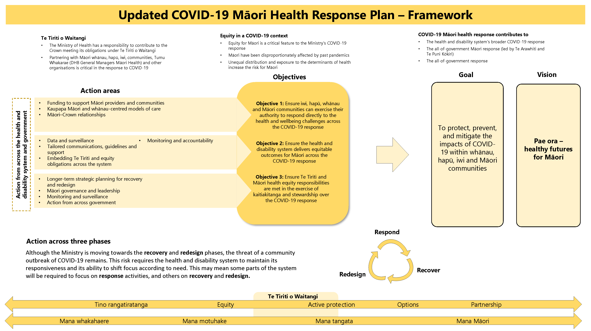

Progress so far

Summary
The COVID-19 Māori response has been a collective effort involving iwi, hapū, Māori communities, and the wider Māori health and disability provider network along with the wider health and disability system and broader government. The achievements and progress made are the result of collaboration and kotahitanga; it is imperative the Ministry continues to encourage and enable this unified effort.
The rate of confirmed and probable COVID-19 cases for Māori, as at 17 June 2020, is 15.7 per 100,000 people. This rate is less than half of the non-Māori rate of 33.1 per 100,000 people. This achievement is significant and important given the negative experience of Māori in previous epidemics.
Most confirmed and probable cases of COVID-19 have been either directly imported (22 percent) or directly related to an imported case (52 percent). Community transmission has been avoided, with only 7 percent of cases caused by an unknown local source. Working together to prevent widespread community transmission has avoided the negative outcomes experienced by Māori in previous epidemics.

Confirmed and probable cases
As at 17 June 2020, 130 Māori have been diagnosed with COVID-19, or 8.6 percent of the total confirmed and probable cases. Of these, 127 have recovered and three people have died.
Count of confirmed and probable cases  for Māori by DHB | Rate of confirmed and probable cases for Māori by DHB (rate per 100,000)
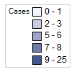  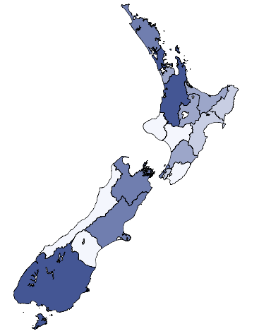 | 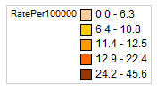  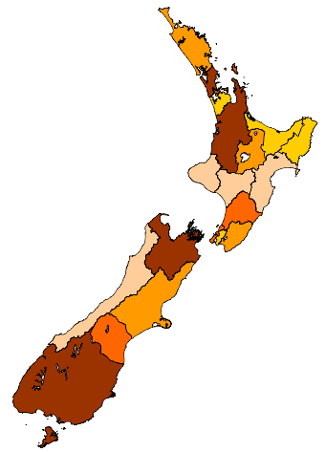

Transmission sources
Most cases amongst Māori have been directly related to people coming from overseas, either from people who have come from overseas themselves (imported cases, 22 percent) or people who have been exposed to infected people who have come from overseas (import-related cases, 52 percent). Another 19 percent can be linked back to other infected people (locally acquired, epidemiologically linked). This leaves only 7 percent of cases either from community transmission or from an unknown source.

Source of transmission by ethnicity
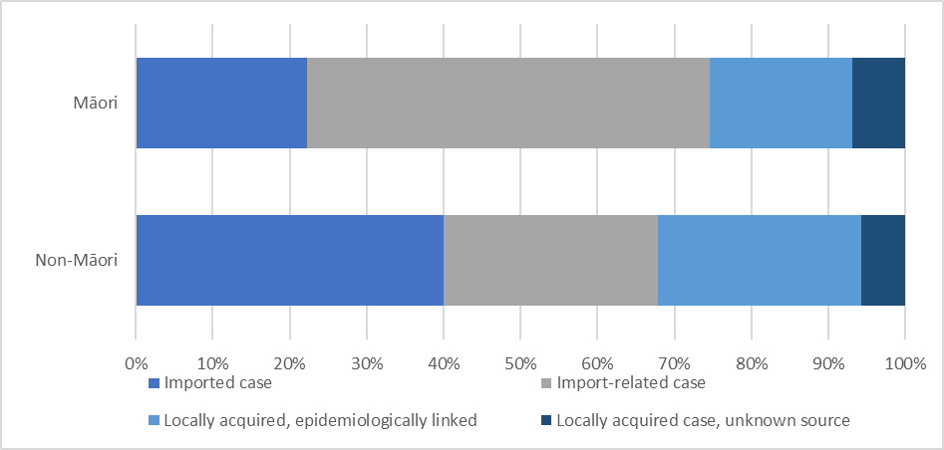

Addressing equity in testing approaches
Testing has been an important aspect in understanding the characteristics of COVID-19 in Aotearoa and the likelihood of undetected disease. As at 15 June 2020, 65.7 per 1,000 Māori had been tested for COVID-19 compared to 54.9 per 1,000 non-Māori. This indicates for every 1,000 people an additional 10.8 Māori are tested compared to non-Māori.
Tairāwhiti DHB has the highest proportion of Māori tested, with 87.6 per 1,000 Māori tested compared to 60.9 per 1,000 non-Māori within the region as at 15 June 2020. This is a difference of 26.7 per 1,000 people.

COVID-19 testing rates per 1,000 population by ethnicity and DHB
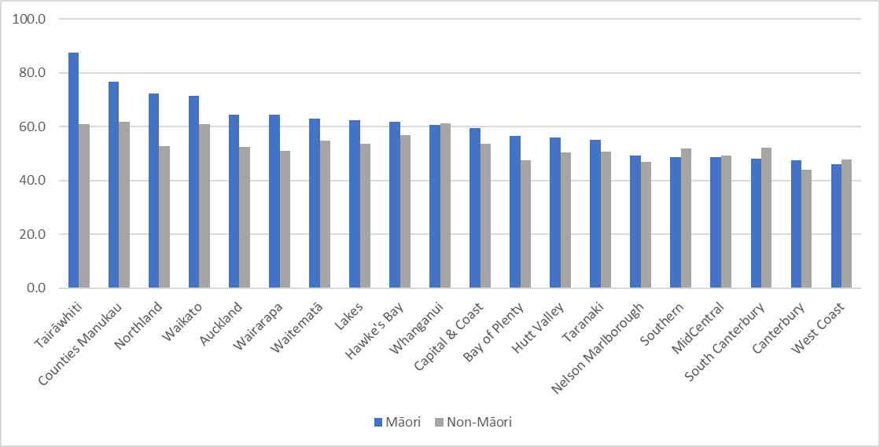

Protective measures – increased access to the influenza vaccination
To improve wellbeing and minimise the pressure on secondary care in the 2020 winter season, the Ministry established an influenza vaccination strategy to protect the most vulnerable. This strategy included a proactive flu vaccination programme that targeted previously identified vulnerable groups, including Māori and Pacific who are aged 65 years or above or have a pre-existing chronic condition, including respiratory conditions.
Additionally, a Māori influenza vaccination programme was established, drawing from the $9.5 million funding pool committed through the COVID-19 health package for DHBs and Māori health providers to work collaboratively together to implement outreach vaccination initiatives. The funding pool significantly boosted opportunities for more Māori to receive the flu vaccination through innovative, coordinated DHB and Māori provider led services.
Already, the system is well above the usual rates of immunisation for Māori, with 56 percent of Māori aged 65 and above vaccinated. This is 1.4 times the proportion of Māori aged 65 and above vaccinated at the same time last year (12 June 2019). Further work is underway to continue this increase.

Percentage of the Māori population aged 65 and above who received the
influenza immunisation, by week of the year for the last six years
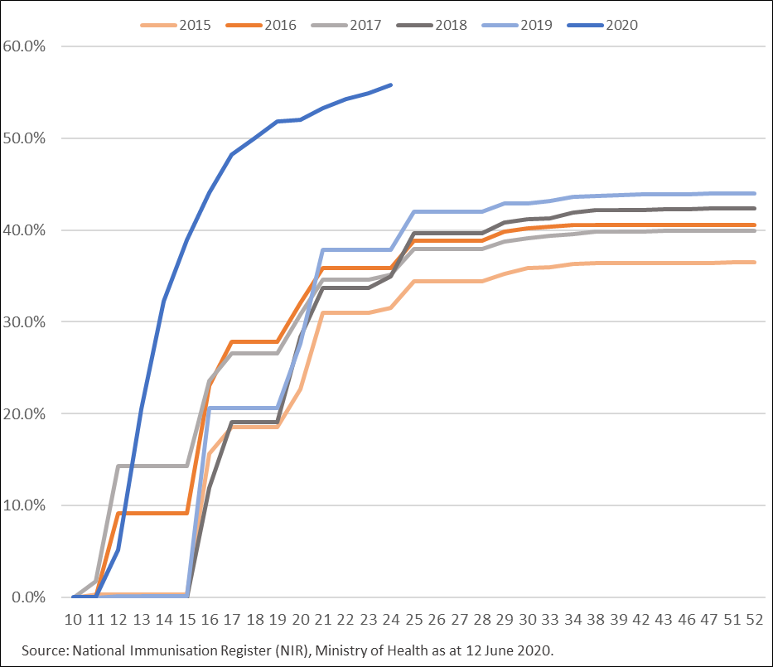

COVID-19 health and wellbeing survey
This survey has been developed by the Ministry of Health and collects information about how New Zealanders are being impacted by COVID-19. About 300 people (aged 15 years+) who previously took part in the New Zealand Health Survey and at the time agreed they could be contacted in future for further research are interviewed each day. Interviewing began on 30 March 2020. The following table shows key results for Māori and non-Māori from the week of 8 to 14 June 2020.

Indicator – Percentage of respondents… | Māori | Non-Māori
Who have felt lonely or isolated in the past week | 17% | 17%
With a household size greater than one | 84% | 78%
Reporting good or excellent general health | 84% | 88%
Who think the rules around the alert level are clear | 96% | 98%
And are finding the rules easy to follow | 100% | 99%
Who have lost their main source of income due to COVID-19 | 4% | 5%
Who are struggling to pay for basic living costs | 10% | 5%
Experiencing symptoms of anxiety or depression | 10% | 11%

The information above included a sample size of 251 Māori and 1,469 non-Māori. All results are indicative only as data analysis methods are being constantly improved, therefore results may change. None of the differences between Māori and non-Māori are statistically significant.

Māori health and disability provider sector in Alert Level 4
The Ministry also conducted a survey from 9 to 19 April 2020 (during Alert Level 4) to understand how providers were still operating and to what extent. The survey responses from 84 providers receiving Māori Provider Development Scheme (MPDS) funding, Te Ao Auahatanga Hauora Māori funding, and rongoā funding gave the following insights.

Number of providers and the proportion of services maintained during Alert Level 4
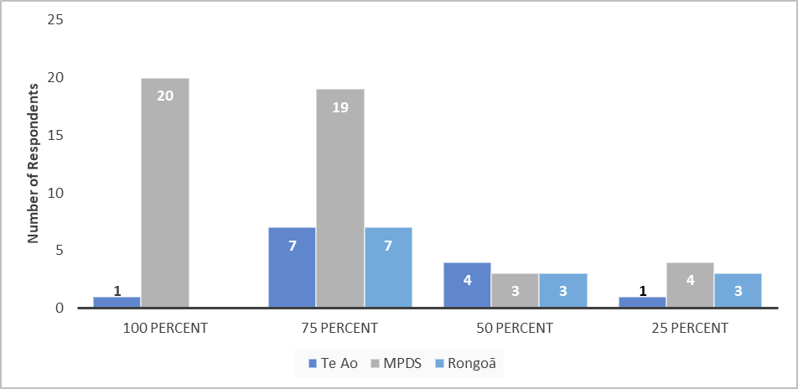
Methods providers used for contacting clients during Alert Level 4
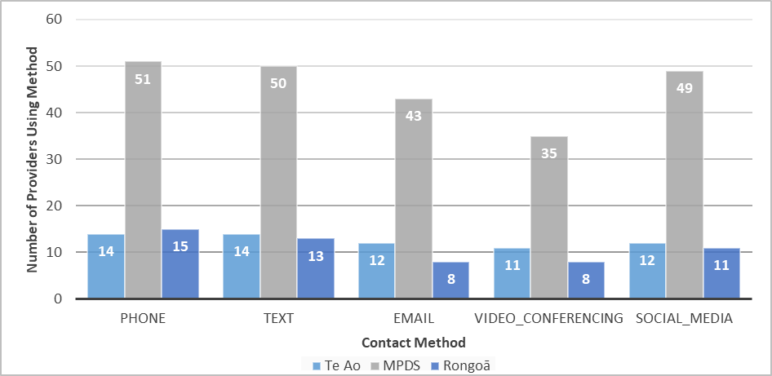

Investment to support Māori health
Māori health and wellbeing has been prioritised through targeted funding for a Māori COVID-19 response. The Ministry has worked closely with DHBs – in particular, Tumu Whakarae (DHB General Managers, Māori Health) – to establish outreach support and resources to protect the health and wellbeing of iwi, hapū, whānau and wider Māori communities. An overview of the funding package is provided below.

COVID-19 Māori-focused funding ($M)

Support the delivery of care packages by Whānau Ora agencies
Whānau Ora commissioning agencies have been key to increasing outreach to Māori communities and ensuring equitable and holistic care. The Ministry provided $4.3 million to the Whānau Ora commissioning agencies to further support their work. A key initiative from this funding is the provision of 80,000 hygiene packages to whānau across the country, ensuring those who need them have appropriate cleaning materials to practice good hygiene. Whānau Ora also provided over 2,500 Whānau Direct grants averaging over $400 per whānau to support them through a ‘moment that matters’ and have built community resilience through recovery planning and planning for future adverse events. Additionally, 7,898 whānau received Manaaki Support packages, which included kai, data support, and other material means of support via Whānau Ora Navigators. | Care/hygiene packages delivered through Whānau Ora  80,000

Support Māori health providers to continue providing services
All providers, including Māori health and disability providers, have been granted extensions to their contracts and/or have been guaranteed funding at existing levels. This includes Ministry contracts under Te Ao Auahatanga Hauora Māori: Māori Health Innovation Fund, rongoā Māori service providers and the MPDS. These extensions are intended to provide Māori health and disability providers with security of funding and enable them to focus on what they need to do to support the COVID-19 response.  In addition to this, approximately 125 Māori health and disability providers received additional funding from a dedicated support fund of $5 million. This funding helps to support providers to tailor their services so they can continue to provide essential health and disability services through the pandemic. | Māori health and disability providers supported with additional funding  125

Increase outreach services for Māori
Ensuring adequate access to health care is imperative, especially when considered in the context of a pandemic. To enable better community outreach during the COVID-19 response, the Ministry committed $8 million to increasing outreach services for vulnerable Māori – in particular, kaumātua, hapū māmā, and whānau without access to care.  The funding is being tailored at the regional level by Tumu Whakarae to target Māori communities with the greatest need for services. Local initiatives will increase digital outreach to support isolated individuals and communities; lessen costs of prescriptions, general practice and other co-payments; and assist with travel to and from essential health services. These services enable accessible health care and are provided in the community, close to those in need. | Committed to increasing outreach services for vulnerable Māori  $8 million

Whānau-centred communications
As part of the Ministry’s COVID-19 response, $1.75 million was committed to a Māori-focused communications campaign to provide iwi, hapū, whānau and wider Māori stakeholders with relevant, useful and up-to-date information on protecting their wellbeing throughout the pandemic response.  The communications strategy included a national approach and four regional approaches (Northland, Midland, Central and Southland). The national Māori health communications campaign is linked with the all-of-government COVID-19 communications campaign to deliver consistent messages around what alert levels mean for whānau. A key part of the national communications response is centred on a social media campaign, run primarily through the Ministry’s social media to provide informational videos targeted at whānau Māori. The videos centre around important and topical health issues such as mental health and wellbeing and good hygiene practices. As of 6 May 2020, the videos have been viewed over 1.94 million times. The regional approaches have been designed in collaboration with Tumu Whakarae to extend the key messages into communities in a way that resonates with whānau at a local level.  Moving forward, the Ministry will work with other health agencies, iwi, and stakeholders to develop targeted communications for whānau, particularly for rangatahi, kaumātua and psychosocial wellbeing. | Views on Māori-focused social media campaign  1.94 million

Actions to support whānau, hapū, iwi and Māori communities
This Plan sits under the responsibility of the Māori Health Directorate, which is one of several directorates involved in the Ministry’s response to COVID-19. This Plan acknowledges that Māori are a priority population group for the COVID-19 response and that actions specific to supporting whānau, hapū, iwi and Māori communities will also be delivered through other COVID-19 operational workstreams.
The actions outlined in this Plan are organised into three main sections:
- Section 1: Actions as part of the Māori Health Funding Package
- Section 2: Contributory actions across the health and disability system
- Section 3: Contributory actions across government
Each action is tracked against three phases (response, recovery, redesign) of the Ministry’s approach to COVID-19.
The actions outlined within each section meet one or more of the principles of Te Tiriti o Waitangi and contribute to one or more of the three objectives for this Plan. The actions have been drawn from a range of sources, including:
- the New Zealand Influenza Pandemic Plan
- insights and evidence drawn from the draft Whakamaua: Māori Health Action Plan 2020–2025
- an external Māori Touchstone Group (established to advise on the COVID-19 response)
- a range of Māori stakeholders and Māori commentary on COVID-19 to date.
This Plan and the actions outlined will be revised and updated as new information is available. This Plan is to be read in conjunction with:
- The Guide to He Korowai Oranga: Māori Health Strategy (2014)
- New Zealand Influenza Pandemic Plan: A framework for action (2017)
- COVID-19 Health and Disability System Response Plan (2020).

Section 1: Actions as part of the Initial COVID-19 Māori Response Action Plan and Māori Health Funding Package
This section consists of actions included as part of the Initial COVID-19 Māori Response Action Plan and Māori Health Funding Package to support whānau, hapū, iwi and Māori communities. This also includes support to Māori providers and organisations. Delivery of these actions is primarily coordinated by the Māori Health Directorate within the Ministry of Health and delivered in partnership with DHBs and the Māori health and disability provider sector. These actions build on the activity from the Initial COVID-19 Māori Response Action Plan and will continue to evolve to respond to emerging need.
Action | Progress Update | Phase
 |  | Respond | Recover | Redesign
- Provide financial assistance for Māori provider networks to enable providers to meet increased demand, including through Tumu Whakarae (DHB General Managers, Māori Health). Support the backfilling and additional workforce capacity arrangements for Māori providers. | Approximately 125 Māori health and disability providers received additional funding to support tailoring of their services in the face of the COVID-19 outbreak. This funding supports them to backfill/hire additional staff as well as tailor services as appropriate to ensure they can meet demand for services during the COVID-19 pandemic. | X | X
- Establish and maintain appropriate Māori governance groups to provide advice and guidance on the Government’s response to COVID-19. | A Māori Reference Group was established, which includes membership from a range of providers, community members, experts and iwi. This group continues to provide advice on emerging challenges and operational considerations that inform the Māori health COVID-19 response. A Māori Monitoring Group has been established as part of the next phase of the COVID-19 Māori health response (see ‘Māori governance’ section). | X | X
- Support the Whānau Ora commissioning agencies to respond to the increased need in the community as a result of COVID-19 to provide packages of care, including hygiene and sanitation packs, access to food, essential supplies, warm clothing and access to quality health information. | Funding provided to Whānau Ora commissioning agencies provided a range of services, including:  - over 80,000 hygiene and additional care packages for whānau who need them to practise good hygiene and keep themselves healthy  - grants to over 2,500 whānau who needed the financial support in their ‘moment that matters’, which is about addressing specific issues for whānau  - navigation support, which ensures whānau can access a range of support such as food services (eg, meals on wheels). | X
- Ensure actions are supported by tailored Māori communications and guidelines through appropriate and trusted channels – expanding the reach and coverage of communications. | The Ministry has undertaken a Māori-focused communication campaign to provide iwi, hapū, whānau and wider Māori stakeholders with relevant, useful, and up-to-date information on protecting their wellbeing throughout the pandemic response.  In addition, Māori-specific guidance has been developed and disseminated, including tangihanga guidelines and marae guidelines.  A total of $1.15 million has been allocated to the four DHB regions to support them to localise communications products and collateral produced by central government. The northern DHBs, for example, have established a weekly ‘Whaanau Guide Show’. They have established Paerangi, a website for tangata whaikaha, and are regularly communicating with registered whānau in their rohe.  Funding has also been set aside to support iwi and hapū to deliver health and wellbeing campaigns that resonate with their whānau.  The Ministry continues to influence the development of communication content across various cross-government groups to ensure it is appropriate for whānau Māori. | X | X | X
- Provide support to Māori providers and communities to provide locally specific assistance, eliminate barriers to health care, and provide continuity of care and support for kuia and koroua. | The Ministry supported DHBs to partner with their local network of Māori providers with $8 million of funding to increase outreach services for vulnerable Māori as part of the COVID-19 response, particularly to kaumātua, hapū māmā, and whānau with limited access to care. The intent of this holistic service model in line with kaupapa Māori principles is centred upon meeting the health and wellbeing needs of the individual and whānau. Services focus on reducing two of the biggest barriers to accessing health care – co-payments and transport – as well as providing a range of wrap-around support where needed. Services are being developed regionally with the input of local hapū and iwi authorities to identify where and what type of services are required for their people in the context of COVID-19. | X | X
- Ensure DHBs are partnering with iwi and Māori organisations in the development and delivery of COVID-19 response strategies. | The Ministry has engaged with the National Iwi Leaders Forum throughout the response. Tumu Whakarae worked in collaboration with iwi in their regions across the 20 DHBs to look at how they can best deliver the COVID-19 response strategies. Te Arawhiti is providing financial support to assist iwi with their COVID-19 response planning. | X
- Conduct active surveillance and monitoring of COVID-19 outcomes for Māori across DHB regions. | The Ministry embedded solutions to enable accurate ethnicity reporting of COVID-19 cases and active surveillance of the pandemic’s impact on Māori whānau, hapū and iwi. This includes surveillance of emerging trends in service access and providing advice to influence the delivery of services. This has contributed to the strong results achieved to date for Māori regarding the number of confirmed cases, access to testing/swabbing and uptake of influenza immunisations. | X | X | X
- Design, develop and test an integrated public health model of care for Māori underpinned by the concept of whānau ora. | The Ministry will work, as needed, with whānau, hapū, iwi and Māori communities, PHUs, DHBs, Whānau Ora commissioning agencies, and government agencies (including the Ministry of Education, the Ministry of Social Development, and Te Puni Kōkiri) to develop a public health model of care for Māori that integrates health and social services around the public health needs of whānau.  In particular, the model of care will ensure whānau, hapū, iwi and Māori communities are partners in the planning, design and delivery of public health services and will inform future service development for public health. |  | X | X
- Implement a Māori-led influenza vaccination programme to protect those most at risk, including kuia and koroua aged 65 and above. | An influenza vaccination strategy was created to ensure the most vulnerable populations have been protected through the pandemic. The strategy included:  - a proactive vaccination period for vulnerable populations  - a more equitable distribution process  - the establishment of a Māori influenza vaccination programme.  The Māori influenza vaccination programme utilised the funding dedicated through this Plan to enable DHBs and Māori health providers to work collaboratively together to implement outreach vaccination initiatives. Initiatives included pop-up vaccination stations, drive-through clinics and door-to-door vaccinations.  An external evaluation of the programme is being commissioned to review what worked and what could be strengthened if the programme were to be replicated in future years. | X | X

Section 2: Contributory actions across the health and disability system
This section consists of actions designed to specifically target support to whānau, hapū, iwi and Māori communities. Delivery of these actions is primarily coordinated and led by other directorates within the Ministry of Health and delivered in partnership with DHBs, PHUs, Māori health and disability providers and other providers of services. This is not an exhaustive list of actions that impact on Māori – this list will evolve as Māori-specific actions are identified across other workstreams. The actions outlined in this section are intended to be high-level and indicative. All COVID-19 actions must consider Te Tiriti and equity implications and, where there are Māori-specific actions, that they contribute to the objectives of this Plan.
Work stream/  Directorate | Actions |  |  | Phase
 |  |  |  | Respond | Recover | Redesign
Mental Health & Psychosocial Recovery | Focus area 1: Collectively build the social and economic foundations for psychosocial wellbeing |  | Prioritise support for interventions that meet the wellbeing needs of Māori and other groups who have been disadvantaged and experience inequitable wellbeing outcomes, including support to maintain whānau engagement. | X | X
 |  |  | Measure and track mental health and wellbeing in the population and share data with policymakers across government and other agencies. | X | X
 | Focus area 2: Empower community-led response and recovery |  | Provide support for community-led initiatives that enhance whānau, hapū and community wellbeing and resilience, including:  - creating innovative local responses that help build mental and social wellbeing,  - enabling community-based mental health organisations to adapt service delivery during lockdown and post-lockdown  - supporting and strengthening community leadership  - supporting populations with specific mental wellbeing needs. | X | X | X
 | Focus area 3: Equip people to look after their own mental wellbeing |  | Fund and monitor public communication campaigns to support mental wellbeing, in alignment with the general communications approach that focuses on Māori.  Ensure groups with specific needs are reached (eg, rangatahi, kuia/ kaumātua, parents, unemployed, rural communities and people with disabilities). | X | X | X
 | Focus area 4: Strengthen primary mental health and addiction support in communities |  | Support the expansion of primary services by and for Māori, including through:  - investing in kaupapa Māori primary mental health and addiction services  - supporting kaupapa Māori services to explore and implement new forms of service delivery to meet the needs of tangata whaiora  - ensuring access to tikanga-based interventions is supported alongside Māori clinical interventions.
Disability | Develop COVID-19 communications for tangata whaikaha to ensure graphics, imaging, symbolism and messaging are representative, easily understood and embrace te ao Māori. |  |  | X | X
 | Develop specific COVID-19 health equity measures and monitoring frameworks for people with disabilities that can support improved performance. |  |  | X | X
 | Partner with government welfare teams to ensure tangata whaikaha are well cared for throughout the COVID-19 response. |  |  | X
 | Invest in partnerships with tangata whaikaha community leaders to address the disparities Māori experience in health outcomes that have been further exacerbated by COVID-19, moving towards a more equitable partnership that upholds the Ministry’s obligations under Te Tiriti o Waitangi. |  |  |  | X | X
Care in the Community (Health System Improvement and Innovation) | Primary care | Target Māori and Pacific peoples as vulnerable population groups and make sure they receive appropriate services to manage COVID-19 and reduce inequities.  Prioritise access to rural general practice, urgent care and after-hours services, particularly for vulnerable population groups, including Māori, Pacific peoples and people with disabilities.  Implement new models of care across primary care to embed the positive changes and learnings from COVID-19. Equity is a central consideration to this work to address issues such as access, any digital divide and so on. |  | X | X
 | Pharmacy | Support essential pharmacies that service local populations, including Māori, rural and vulnerable populations, to stay open. |  | X
 |  | Support new models of care, including the active outreach to vulnerable populations in their homes, with medicine repeat reminders, medicines advice, medicines reviews and adherence support, and telehealth modalities. |  |  |  | X
 | Supporting older people at home | Support Māori communities (marae, hapū, iwi and Māori organisations) to provide whānau-based support for those who are self-isolating, unwell or are generally in need of additional assistance. |  | X
 | Maternity | Provide targeted maternity support to Māori and Pacific peoples to manage COVID-19.  Ensure rural communities, particularly Māori and Pacific communities, have access to maternity services (eg, through virtual consults).  Monitor access and birthing statistics to ensure inequities for Māori are addressed, including ensuring registration with a community midwife and tracking length of stay in hospital following birth. |  | X | X | X
 | Healthline | Analyse Māori utilisation of telehealth services to understand the opportunities and impacts across the broader health and social systems. |  | X | X
 |  | Focus telehealth on improving access, choice and health outcomes for Māori and Pacific by increasing the cultural diversity and cultural competency of its stakeholders.
Public Health (Population Health & Prevention) | Work with DHBs, PHUs and service providers to ensure continuity of service delivery for Māori over the period of the COVID-19 response, particularly through the Alert Level System, and beyond in the recovery stage. Actively support flexibility and agility of providers to be responsive to the needs of Māori and the most vulnerable communities. |  |  | X
 | Support the immunisation team to provide targeted influenza vaccinations for Māori and their whānau. |  |  | X
 | Support DHBs and PHUs where needed to strengthen relationships and coordination of collective action between whānau, hapū, iwi and the Māori sector to deliver culturally appropriate services and their Te Tiriti commitments for COVID-19 response and recovery. |  |  | X | X
 | Work with the Māori Health Directorate to involve Māori in planning, design and delivery of COVID-19 end-to-end public health responses to our elimination strategy, including the:  - testing plan  - national close contact tracing service  - managed isolation and quarantine. |  |  | X
 | Measure the impact of COVID-19 on local communities, with a focus on Māori, to respond quickly where further testing, contact tracing, public messaging and support services need to be scaled. |  |  | X
 | Support DHBs where appropriate to have collaborative relationships and involvement with iwi, hapū, whānau and Māori communities in planning, implementation and resourcing of wrap-around services for cases and their close contacts at a local level. |  |  | X
 | Detect and rapidly mitigate inequities, including access to health services, especially for Māori. |  |  | X | X
 | Establish and maintain a kaitiakitanga working relationship with the Māori Health Directorate to receive guidance, support and advice and ensure alignment to the COVID-19 Māori Health Action Plan and Whakamaua: Māori Health Action Plan 2020–2025.  Work with the Māori Health directorate to ensure COVID-19 public health messaging for Māori across the public health response where appropriate. |  |  | X
Hospitals (DHB Support and Infrastructure) | Establish an initiative to capture the disruption to planned care resulting from COVID-19, including for Māori, and implement necessary responses to mitigate disruption. |  |  | X | X
 | Ensure that all improvement initiatives established as part of the Planned Care Improvement Plan impact positively on equity. |  |  |  | X | X
Cancer Control Agency | Develop diagnostic and treatment guidelines for cancer services and ensure an equity statement has been applied across these guidance documents to mitigate potential negative impacts for people with cancer and their whānau. |  |  | X
 | Complete a stocktake of travel and accommodation options for access cancer treatment and distributed with regional cancer networks for communication and dissemination. This will help to mitigate existing access issues for Māori, which have been exacerbated by the COVID-19 response. |  |  | X
 | Continue to work with Hei Āhuru Mōwai (the Māori Cancer Network) to develop Māori-specific communication during COVID-19 across a range of channels – for example, providing advice to Māori cancer patients through video format. |  |  | X
 | Continue to work closely with Hei Āhuru Mōwai and other Māori clinicians and stakeholders throughout our response. |  |  | X
 | Develop an equity action plan that outlines the evidence on known inequity in cancer diagnosis and treatment, how these inequities could be exacerbated by COVID-19, and what actions need to be taken to mitigate them. |  |  | X
 | Develop a monitoring framework to assess the impact of COVID-19 on cancer treatments during lockdown, with a specific focus on identifying impacts on equity of access to treatment for Māori. |  |  | X | X
Health Workforce | The Ministry has developed a database of health and disability workers available for the surge workforce. This will include a focus on capturing available Māori health and disability workers. |  |  | X
 | Prioritise surge workforce requests from Māori health providers and/or providers who deliver services to vulnerable communities. |  |  | X
 | Deliver a suite of culturally appropriate online training modules for carers and community workers, in partnership with Careerforce. |  |  | X
 | Deliver funded temporary accommodation for the health and disability workforce, with a focus on workers in DHBs, Māori health providers, Pacific providers and community providers. |  |  | X
Health Crown Entities
Health Promotion Agency | The Health Promotion Agency has been contracted by the Ministry of Health to target psychosocial support messaging to key target groups, one of which is Māori. |  |  |  | X
 | Support the Northland Iwi Collective to engage the Northland Māori community on health and wellbeing messages, including alcohol harm prevention and linking whānau with the services that they need. |  |  |  | X
Health Quality & Safety Commission | Partner with Māori health providers to showcase the responses taken and recovery phase experiences, including enablers and disablers, and their understanding of how Māori health inequities have been impacted, sharing best practice, good stories, and other aspects. |  |  | X
PHARMAC | Provide one-off funding to Whānau Ora commissioning agencies to enable whānau to access medicines. |  |  | X
 | Temporarily easy restrictions on already funded medicines to reduce to reduce hospital visits and risk of highly vulnerable patients catching COVID-19. |  |  | X
 | Limit dispensing to one month’s supply at a time following stockpiling behaviour that did not abate. This is to ensure that all New Zealanders, especially vulnerable communities, continue to be able to access the medicines they need. Pharmacists are authorised to dispense three months’ supply all at once to people who had mobility issues, lived far from the pharmacy, were immunocompromised or elderly. |  |  | X | X

Section 3: Contributory actions to Māori health across government
This section consists of actions being led by other government agencies across the COVID-19 response that impact on Māori health and wellbeing. An all-of-government approach is critical to addressing the broader determinants of health to ensure individuals, whānau and communities are better able to access and enjoy healthy environments and get the help they need to take control of the circumstances affecting their health and wellbeing. This is an important part of the long-term planning of the COVID-19 response as its impacts on Māori extend into socio-economic and other domains.
Agency | Actions | Phase
 |  | Respond | Recover | Redesign
Te Puni Kōkiri | Economic resilience strategy  To maximise strategic impact for Māori wellbeing outcomes, including economic wealth as a driver of wellbeing, in the context of COVID-19, Te Puni Kōkiri is developing an economic resilience strategy for Māori focused on opportunities to lift outcomes in community resilience, workforce and skills, and Māori enterprise through wave 3. | X | X | X
 | Addressing family violence  Eliminate the harm of family violence and sexual violence using whānau-centred approaches. Specifically, in the short term, this has meant re-orienting funding to respond to the impacts of COVID-19. | X | X
 | Whānau Māori Community Outreach Fund  Support community resilience and economic sustainability by funding a range of initiatives across Māori communities. |  | X | X
 | Regional intelligence, advocacy and coordination  In addition to direct investment, Te Puni Kōkiri continues to collate intelligence and provide advocacy across the COVID-19 response, ensuring iwi, hapū, whānau and hapori are able to leverage off opportunities that will benefit their communities. | X | X | X
Te Arawhiti | Support iwi COVID-19 responses  Te Arawhiti has administered funding to assist iwi with their COVID-19 response planning. Information on this work can be found at https://www.tearawhiti.govt.nz/support-for-iwi-on-covid-19/ | X
Whānau Ora commissioning agencies | Whānau Ora leads the way across agencies on brokering opportunities and developing policy and strategy that builds the capability and readiness of whānau and Māori communities. It utilises existing specialist advice from the insights driven and reported by whānau on what works.  The three Whānau Ora commissioning agencies moved quickly to provide rapid, wrap-around support, particularly as whānau presented with multiple, complex issues exacerbated by the impact of COVID-19 response and recovery.  The commissioning agencies have spent most of their COVID-19 response funding and are working through the next phase of recovery response plans to support whānau during the alert levels restrictions and recovery. They are now putting in place a range of initiatives to support the post COVID-19 response and recovery. More detail can be found in the following links:  - Whānau Ora Commissioning Agency  - Te Pūtahitanga o Te Waipounamu  - Pasifika Futures | X | X | X
Oranga Tamariki | Oranga Tamariki invested in the Whānau Ora Commissioning Agency and Te Pūtahitanga o Te Waipounamu to procure and distribute hygiene kits to whānau Māori across Aotearoa. | X
 | Invest in a partnership with community leaders on COVID-19 solutions to ensure concomitant disparities in health care for Māori are expressed in associated policies, strategies and plans. | X | X | X
Ministry of Social Development | Provide support through the E Tū Whānau initiative  The E Tū Whānau framework for change is based on tikanga and Māori values and focuses on mobilising communities to address violence within whānau. The Ministry of Social Development has leveraged this initiative across the COVID-19 response, including through:  - ensuring whānau are receiving good, clear and timely messaging and guidance  - targeted funding to keep vulnerable whānau safe and well supported, and strengthening their resilience in the face of heightened anxiety, stress and emergent need  - targeted funding towards community activity supporting and sustaining wellbeing for vulnerable Māori communities. | X | X | X
 | Work with Te Hiku o Te Ika  The Ministry of Social Development is continuing to work with Te Hiku Iwi to support the immediate needs of whānau impacted by COVID-19 in the Te Hiku Region as well as the ongoing implementation of the Te Hiku Iwi–Crown Joint Work Programme. | X | X | X
Ministry of Housing and Urban Development | Respond to homelessness issues through a range of initiatives  The Ministry of Housing and Urban Development has utilised a range of initiatives to address Māori homelessness issues compounded by the COVID-19 response. These include:  - Homelessness Action Plan – kaupapa Māori approaches to support those who were rough sleeping, homeless or living in housing insecurity.  - Māori and Iwi Housing Innovation Framework for Action (MAIHI) – responding to homelessness, emergency accommodation and housing needs due to COVID-19. Kaupapa Māori approaches and projects have been funded through MAIHI to address homelessness through wrap-around support, building provider capability to improve the delivery of services that attend to homelessness and increasing housing supply.  - Working with community housing providers and Housing First providers.  - Te Matapihi – coordination to support community engagement, relationships and networks in line with kaupapa Māori, the Homelessness Action Plan and MAIHI.  - MAIHI Partnership Programme – cross-agency collaboration Mobile housing – working with the Ministry of Business, Innovation and Employment (MBIE) and Māori community housing providers and iwi organisations to secure mobile homes to reduce risk of infection and provide security from homelessness for the short term. | X | X | X

Māori governance
Māori leadership is a significant enabler for achieving Māori health equity and wellbeing. Māori leadership in governance arrangements across the COVID-19 response is essential to guide decision-making, networking, sharing and collaboration. It also gives practical effect to fulfilling obligations under Te Tiriti o Waitangi, especially the principle of partnership.
The COVID-19 response requires multi-level governance and leadership arrangements, including input from a broad range of stakeholder perspectives. Additional representation is sought from iwi, hapū, Māori organisations, and Māori experts and clinicians from across the health and disability sector and other sectors.
This Plan formalises the governance arrangements for the COVID-19 Māori health response. The governance approach is outlined below.

Proposed Māori governance framework
Governance group | Engagement touchpoint | Purpose
Māori Reference Group (MRG) | Ministry of Health – Māori Health Directorate | To provide intel and insights on the COVID-19 Māori health response to inform decision-making and deployment of resources.
Māori Monitoring Group (MMG) | Ministry of Health –  Māori Health Directorate | To provide analysis and advice to guide the COVID-19 Māori response and monitoring approach, alongside the refresh of Whakamaua.
Iwi Chairs Forum | Te Arawhiti | To provide advice and guidance to the broader all-of-government Māori COVID-19 response.
Te Tumu Whakarae | Ministry of Health – Māori Health Directorate | To provide coordination of the Tumu Whakarae led response to COVID-19 across DHBs in partnership with the Māori Health Directorate.
Interagency Caring for Communities – Māori responsiveness sub-group | Te Arawhiti | To provide coordination on the all-of-government Māori COVID-19 response.

Monitoring progress
Monitoring the progress of the Plan and the impact of the broader COVID-19 response on Māori health is important to ensure we focus on the right things and do them well. An initial monitoring framework has been developed (see table below) as a foundation to build on over the next four months. The monitoring of three main components – surveillance, system performance, and actions – will ensure a clear line of sight over the progress and impact of the COVID-19 Māori health response, as well as the broader impacts on Māori health.
A Māori Monitoring Group (MMG) has been established as part of the governance framework for this Plan. This group will provide insights and advice to inform the Ministry’s response to COVID-19, acting as an accountability and monitoring mechanism to track the progress of the COVID-19 Māori health response. The COVID-19 Māori health monitoring framework will be incorporated over time into the broader monitoring framework of Whakamaua, ensuring COVID-19 activity operates in the broader context of Māori health.

Monitoring framework
Monitoring component | Sources and type of data | Why this is important?
Surveillance | Ethnicity and geography data across:  - confirmed and probable cases  - testing – positive and negative  - close contact tracing  - support for people in self-isolation and quarantine  - COVID-19 specific hospitalisations  - influenza vaccination access coverage | - To maintain close oversight of the impact of COVID-19 on Māori communities  - To inform internal strategy and planning of the COVID-19 Māori health response
Monitoring of system performance | Ethnicity and geography data across:  - utilisation of inpatient and outpatient services, including:  - ambulatory sensitive hospitalisations  - attendances at emergency departments  - utilisation of outpatient services  - ‘did not attend’ rates for outpatient services  - utilisation of community care services (eg, pharmaceuticals, childhood immunisations)  - psychosocial survey insights | - To maintain oversight of potential impact of COVID-19 on Māori access to services  - To inform internal strategy and planning of Whakamaua and to reflect some of the measures in the monitoring section of Whakamaua
Māori-specific COVID-19 actions | - Insights from contracts, including outcomes and outputs  - Qualitative insights from Māori communities and Māori health and disability service providers | - To track the progress and impact of investment  - To enable accountability to the Ministry for delivering on COVID-19 response actions

Communications approach
The Ministry’s communications approach is two-fold: our national approach is to deliver tailored messaging to stakeholders using the Ministry’s existing channels; our regional approach is to partner with DHBs enabling them to deliver localised communications to Māori communities. The Ministry also partners with iwi to co-design communications campaigns and strategies that support the holistic health of hapū and whānau.
The all-of-government key messages will be our ‘source of truth’ from which we will draw content and, if necessary, repackage it to be more relatable to our stakeholders and partners.
Our communications approach is strengthened by five Māori communications principles:
- Kanohi ki te kanohi: It is important that, wherever possible, engagement must include kanohi-ki-te-kanohi (face-to-face) communication.
- Kanohi kitea: Establish a relationship during engagement.
- He ngākau Māori: An authentic Māori ‘heart’ or approach.
- He ngākau hūmārie: Being humble during engagement.
- Te mita o te reo: Placing value on te reo by using it in writing and speaking.

Strategic communications
We will influence the development of Māori-focused communications internally and externally through sharing our own key messages and providing strategic communications advice.

Media
We will remain responsive to media and proactive in setting up media operations as we see fit. We also partner with Māori media where possible to deliver television and radio campaigns that communicate the Māori response and its efficacy at a national, regional and local level.

External communications
We will utilise the following external channels to communicate with our audiences:
- Social media (Facebook)
- Television and radio
- Email
- Website

Internal communications
We will work with the national office communications and media teams. We utilise the internal channels to share relevant messaging with Ministry of Health colleagues. We also influence the development of communications products in other directorates to ensure the messaging will also resonate with whānau Māori.

National-level communications approach
At a national level, we distribute communications through our primary channels – email, Facebook, television, radio, and the website. We are responsive to media and regularly seek out opportunities to front-foot announcements and update stakeholders on our work programme. We are also strategic in how we influence wider government and our internal colleagues to shape their messaging in a way that is relevant to Māori.
Our mahi includes:
- a social media campaign via the Ministry’s Facebook page
- tailoring all-of-government key messages for Māori audiences
- regular TV and radio interview opportunities
- weekly pānui
- a psychosocial communications campaign
- development of digital and print collateral for whānau
- sharing good news stories with Māori media
- influencing all-of-government communications
- influencing internal communications
- influencing iwi communications.

Regionalised communications approach
Our regional approach is to partner with Tumu Whakarae and iwi to deliver communications that are relevant and suitable to whānau Māori in their rohe. Messaging created at a national level will be distributed throughout the regions and then tailored to suit the communications needs of local communities. Tumu Whakarae will largely have freedom (within service specifications) to develop and implement their own communications strategies. We will work with iwi to co-design communications campaigns targeted towards their own hapū and whānau.
Our mahi includes:
- strengthening existing communications work
- social media campaigns
- regular print and digital pānui to whānau within regions
- regular TV and radio opportunities with iwi radio and/or regional news services
- regular pānui to whānau within region
- development of digital and print collateral for whānau
- a text messaging campaign.

Appendix 1: A commitment to Te Tiriti o Waitangi and equity
As a public service department, the Ministry of Health has a responsibility to contribute to the Crown meeting its obligations under Te Tiriti o Waitangi. This statement confirms our commitment and provides high-level direction for how we will go about delivering on it. Additional detail on this approach is summarised in the Ministry of Health’s draft Te Tiriti o Waitangi framework, attached as Appendix 2. This position on Te Tiriti o Waitangi was endorsed by the Director-General of Health on 9 January 2020.

Our expression of Te Tiriti
The text of Te Tiriti, including the preamble and the three articles, along with the Ritenga Māori declaration, are the enduring foundation of our approach. Based on these foundations, we will strive to achieve the following four goals, each expressed in terms of mana.
- Mana whakahaere: effective and appropriate stewardship or kaitiakitanga over the health and disability system. This goes beyond the management of assets or resources.
- Mana motuhake: enabling the right for Māori to be Māori (Māori self-determination), to exercise their authority over their lives, and to live on Māori terms and according to Māori philosophies, values and practices, including tikanga Māori.
- Mana tangata: achieving equity in health and disability outcomes for Māori across the life course and contributing to Māori wellness.
- Mana Māori: enabling ritenga Māori (Māori customary rituals), which are framed by te ao Māori (the Māori world), enacted through tikanga Māori (Māori philosophy and customary practices) and encapsulated within mātauranga Māori (Māori knowledge).

Our approach to achieving these goals
The principles of Te Tiriti o Waitangi, as articulated by the Courts and the Waitangi Tribunal, provide the framework for how we will meet our obligations. These principles are applicable to the wider health and disability system, including the response to COVID-19. The principles include:
- Tino rangatiratanga, which provides for Māori self-determination and mana motuhake. This means that Māori are key decision-makers in the design, delivery, and monitoring of health and disability services and the response to COVID-19.
- Equity, which requires the Crown to commit to achieving equitable health outcomes for Māori and to eliminate health disparities resulting from COVID-19. This includes the active surveillance and monitoring of Māori health to ensure a proportionate and coordinated response to health need.
- Active protection, which requires the Crown to act, to the fullest extent practicable, to protect Māori health and achieve equitable health outcomes for Māori in the response to COVID-19. This requires the Crown to implement measures to equip whānau, hapū, iwi and Māori communities with the resources to undertake and respond to public health measures to prevent and/or manage the spread of COVID-19.
- Options, which requires the Crown to provide for and properly resource kaupapa Māori health and disability services in the response to COVID-19. Furthermore, the Crown is obliged to ensure that all health and disability services are provided in a culturally appropriate way that recognises and supports the expression of hauora Māori models of care.
- Partnership, which requires the Crown and Māori to work in partnership in the governance, design, delivery, and monitoring of the response to COVID-19. This contributes to a shared responsibility for achieving health equity for Māori.
Meeting our obligations under Te Tiriti o Waitangi is necessary if we are to ensure iwi, hapū, whānau, and Māori communities and organisations are active partners in preventing and addressing the potential impacts of COVID-19. This is crucial to realising the overall aim of Pae Ora (healthy futures for Māori) under He Korowai Oranga (the Māori Health Strategy). These principles underpin all actions outlined in this Plan.

Positioning equity at the centre of the pandemic response
The Ministry of Health’s definition of equity is:
In Aotearoa New Zealand, people have differences in health that are not only avoidable but unfair and unjust. Equity recognises different people with different levels of advantage require different approaches and resources to get equitable health outcomes.
A fair health and disability system prioritises equity. The key drivers of health inequity are differential access to resources, services and opportunities on the basis of ethnicity and social positioning (eg, age, gender, able-ness) and inaction or inappropriate action in response to health need. To mitigate against inequity, the National Ethics Advisory Committee’s Getting through Together: Ethical values for a pandemic outlines two equity principles – fairness and respect.
Fairness:
- supports individuals, whānau, hapū, iwi and Māori communities to get what they are entitled to
- ensures that individuals, whānau, hapū, iwi and Māori communities get treated in an equitable manner
- minimises health and disability inequities for individuals, whānau, hapū, iwi and Māori communities
- prioritises fairly when there are limited resources for all to get the services they seek.
Respect:
- supports individuals, whānau, hapū, iwi and Māori communities to make their own decisions wherever possible
- supports those who make decisions on behalf of individuals who can’t make their own decisions
- restricts freedom as little as possible, if freedom must be restricted for the public good.

Integrating equity into decision-making
Applying an equity analysis to planning and operational activities requires the following actions:
- Identify which of the priority populations are relevant to the specified action.
- Decide on the actions to meet the needs of the identified priority populations.
- Resource and implement the actions, focusing on tailored and appropriate delivery.
- Monitor and track the results for the identified priority population group.
In addition to Te Tiriti o Waitangi principles, this approach will help us to:
- prioritise resources to improve access
- improve pathways of care
- address structural inequities for priority population groups
- ensure the active protection of priority population groups
- ensure the provision of options for priority population groups
- partner with communities to make their own decisions.

Appendix 2: Ministry of Health’s draft Te Tiriti o Waitangi framework

A detailed description of these inequities, including examples, is included in the Initial COVID-19 Māori Response Action Plan.
Data as at 17 June 2020. Ethnicity as collected by public health units (PHUs) and recorded in Environmental Science and Research’s (ESR’s) EpiServ system. Population data as per Stats NZ’s 2020 population projections.
Data as at 17 June 2020. Ethnicity as collected by PHUs and recorded in ESR’s EpiServ system.
Data as at 17 June 2020. Ethnicity as collected by PHUs and recorded in ESR’s EpiServ system. Non-Māori includes cases with an unknown ethnicity.
Combined laboratory testing information as at 15 June 2020. Ethnicity information based on the patient’s National Health Index record.
Influenza immunisation data and population data as recorded in the National Immunisation Register as at 12 June 2020. Note that the population data used in the National Immunisation Register is not the latest 2020 StatsNZ predictions, so it differs from the population data used elsewhere in this report.
Further detail can be found in the Cabinet Office circular CO (19) 5: Te Tiriti o Waitangi/Treaty of Waitangi Guidance 22 October 2019.
Often referred to as the ‘fourth article’ or the ‘verbal article’.
Mana is a uniquely Māori concept that is complex and covers multiple dimensions.
This definition of equity was signed-off by the Director-General of Health, Dr Ashley Bloomfield, in March 2019.

