Update on Polyp surveillance guidelines
2020

Citation: Te Aho O Te Kahu. 2020. Update on Polyp Surveillance Guidelines. Wellington: Te Aho o Te Kahu.
Published in December 2020 by Te Aho o Te Kahu in partnership with the Ministry of Health, PO Box 5013, Wellington 6140, New Zealand
ISBN 978-1-99-002973-8 (online)
HP 7539
This document is available at teaho.govt.nz and health.govt.nz
This work is licensed under the Creative Commons Attribution 4.0 International licence. In essence, you are free to: share ie, copy and redistribute the material in any medium or format; adapt ie, remix, transform and build upon the material. You must give appropriate credit, provide a link to the licence and indicate if changes were made.

Contents
Introduction 1
Purpose of this advice 3
Audience for these guidelines 3
Associated documents 4
Equity 4
Notes on clinical context 5
Polyp risk categories 5
Polyp Surveillance Guidance 2020 6
Definitions 8
High-quality colonoscopy 8
High-quality polypectomy 8
Boston Bowel Preparation Scale 8
Serrated Polyposis Syndrome 9
Referral criteria to the New Zealand Familial Gastrointestinal Cancer Service 10
Serrated Polyposis Syndrome 10
Multiple adenoma 10
References 11

List of Tables
Table 1: Associated documents 4
Table 2: Polyp risk categories 5

List of Figures
Figure 1: Surveillance intervals based on findings at high-quality colonoscopy 6

Introduction
Te Aho o Te Kahu, the Cancer Control Agency (TAoTK) in partnership with the National Screening Unit, Ministry of Health (the Ministry) endorses this advice on surveillance colonoscopy for follow-up after removal of polyps. This advice sets out appropriate practice for clinicians to follow subject to their own judgement. It has been developed to help them make decisions in this area.

The advice was developed to align with recent publications from the United Kingdom, the United States, Australia and Europe (Cancer Council Australia Surveillance Colonoscopy Guidelines Working Party 2019; Gupta, Lieberman et al 2020; Hassan, Antonelli et al 2020; Rutter, East et al 2020). These publications, based on updated available evidence up to June 2019, indicated that previous guidelines would now recommend over surveillance for some groups.

A technical advisory group with the required expertise was established and has undertaken a systematic review of recent literature. Members of the group included a range of clinicians and some members of the National Bowel Cancer Working Group (NBCWG). Their role was to review the evidence and consider implementation of a similar polyp follow-up approach in New Zealand.

The New Zealand specialists in the technical advisory group are routinely involved in the diagnosis, management and surveillance of patients identified to have bowel polyps.

Acknowledgements go to:
- Ian Bissett, Chair of NBCWG, Colorectal surgeon, Department of Surgery, University of Auckland
- Susan Parry, Gastroenterologist, Clinical Lead of National Bowel Screening Programme, Ministry of Health
- Campbell White, Physician, Taranaki Base Hospital
- Chris Hemmings, Pathologist, Clinical Director of Anatomic Pathology, Canterbury Health Laboratories; University of Otago
- David Vernon, General surgeon, Lakes District Health Board (DHB)
- Marianne Lill, General surgeon, Whanganui DHB
- Masato Yozu, Pathologist, Counties Manukau DHB
- Russell Walmsley, Gastroenterologist, Waitematā DHB, University of Auckland
- Siraj Rajaratnam, Colorectal surgeon, Waitematā DHB
- Teresa Chalmers-Watson, Gastroenterologist, Canterbury DHB, University of Otago.

For New Zealand’s previous Guidance on Surveillance for People at Increased Risk of Colorectal Cancer, published in February 2012, go to www.health.govt.nz/publications.

Ensuring an equity focus is a priority for TAoTK and the Ministry. Evidence indicates that Māori are less likely to have access to early diagnosis for some cancers, including colorectal cancers, than non-Māori. Breaking down barriers for Māori to access surveillance colonoscopy will allow a greater proportion of cancers to be detected early and managed well, leading to more curative treatment and subsequent improvements in survival for Māori patients.

Note: This document is updating only the polyp surveillance section of the previous guidelines. An update on other aspects will also be developed. New Zealand colonoscopy capacity is constrained, and we anticipate that these guidelines will reduce demand.

Professor Diana Sarfati
Chief Executive
Te Aho o Te Kahu

Professor Ian Bissett
Chair
National Bowel Cancer Working Group

Dr Susan Parry
Clinical Lead
National Bowel Cancer Screening Programme

Purpose of this advice
The main purpose of this document is to provide recommendations for surveillance after colonoscopy and complete removal of adenomas and serrated polyps. The recommendations are the same for initial and subsequent procedures and may, if appropriate, be applied to colonoscopy procedures that have been completed before we released this guidance.

Patients outside the scope of this advice are those with hereditary colorectal cancer syndromes (for example, Lynch syndrome or Familial Adenomatous Polyposis), inflammatory bowel disease, personal history of colorectal cancer, and family history that warrants investigation for hereditary colorectal cancer syndromes (Ministry of Health 2012).

Audience for these guidelines
This advice is relevant to clinicians providing colorectal polyp surveillance. All district health boards, whether or not they have begun to participate in the National Bowel Screening Programme, are expected to offer colonoscopic polyp surveillance in line with this advice.

Associated documents
Table 1: Associated documents
Ministry of Health. 2012. Guidance on Surveillance for People at Increased Risk of Colorectal Cancer. Retrieved 13 August 2020, from https://www.health.govt.nz/system/files/documents/publications/colorectal-cancer-surveillance-guidance.pdf
Rutter MD, et al. 2020. British Society of Gastroenterology/Association of Coloproctology of Great Britain and Ireland/Public Health England post-polypectomy and post-colorectal cancer resection surveillance guidelines. Gut 69(2): 201–23.
Gupta S, et al. 2020. Recommendations for follow-up after colonoscopy and polypectomy: a consensus update by the US Multi-Society Task Force on Colorectal Cancer. Gastrointestinal Endoscopy 91(3): 463–85. e465.

Equity
Survival outcomes for colorectal cancer are significantly poorer for Māori than for non-Māori. Comorbidity and difficulties with accessing health services for colon cancer account for about 30 percent of excess mortality among Māori (Hill, Sarfati, et al 2010). Māori and Pacific peoples are also more likely to be diagnosed with advanced disease at diagnosis of colorectal cancer and, significantly, are more likely to be diagnosed after they present at an emergency department, which may reflect poorer access to primary and secondary services (Health Quality & Safety Commission New Zealand 2017). For this reason, it is important that clinicians make decisions that contribute to equitable outcomes for Māori and Pacific peoples in particular. However, surveillance intervals are determined by the biology of premalignant polyps. There is no evidence that adenomas and serrated polyps grow faster in Māori and Pacific peoples.

Notes on clinical context
High-quality colonoscopy is the prerequisite for these recommendations. To be of high quality, the colonoscopy must involve verified and documented caecal intubation, good colonoscopy technique and adequate bowel preparation (see ‘Definitions’ below). Surveillance should be adjusted for suboptimal colonoscopy.

Recommended techniques for polypectomy should be followed and complete polyp excision should be performed (see ‘Definitions’ below).

Polyp risk categories
Table 2: Polyp risk categories
 | Conventional adenomas | Serrated polyps
Average-risk polyps | Tubular adenomas < 10 mm | Sessile serrated lesion (SSA/P) < 10 mm  Hyperplastic polyp ≥ 10 mm*
High-risk polyps | Adenoma ≥ 10 mm**  Adenoma with tubulovillous or villous histology**  Adenoma with high-grade dysplasia** | Sessile serrated lesion (SSA/P) ≥ 10 mm  Sessile serrated lesion (SSA/P) with dysplasia  Traditional serrated adenoma  Serrated adenoma, unclassified (unclassified serrated polyp with dysplasia)
* Follow up as a high-risk polyp if concern exists about consistency in distinction between sessile serrated lesion and hyperplastic polyp locally.
** Advanced adenoma defined as: 10 mm or larger in size or 25% or greater villous histology (that is, tubulovillous or villous adenoma) or high-grade dysplasia.

After piecemeal resection of polyps equal to or greater than 20 mm in size, the site should be checked within two to six months and then a further full colonoscopy performed after an additional 12 months. Once no recurrence is confirmed patients should undergo post polypectomy surveillance after a further interval of three years. The need for further surveillance should then be determined in accordance with this update and individual risk factors.

No surveillance is required for anyone who has only hyperplastic polyps smaller than 10 mm, unless the person meets the criteria for Serrated Polyposis Syndrome.

Polyp Surveillance Guidance 2020
Figure 1 summarises the new guidance after complete removal of adenomas and serrated polyps. This advice was developed in recognition of the:
      - low risk of future colorectal cancer for some groups of patients identified as having adenomas
      - colorectal cancer risk associated with some serrated polyps.

Figure 1: Surveillance intervals based on findings at high-quality colonoscopy
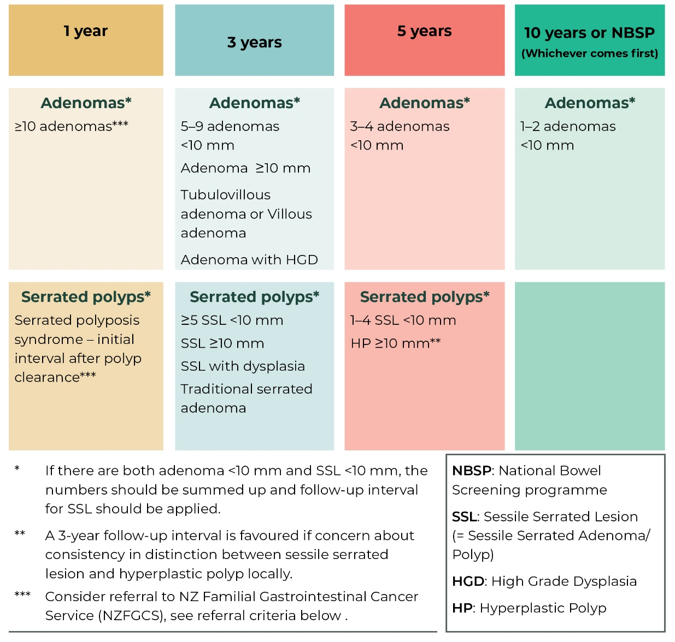
* If there are both adenoma <10mm and SSL <10 mm, sum up the numbers and apply follow-up interval for SSL.
** A three-year follow-up interval is favoured if concern about consistency in distinction between sessile serrated lesion and hyperplastic polyp locally.
*** Consider referral to the NZ Familial Gastrointestinal Cancer Service (NZFGCS). Referral criteria for multiple adenoma and Serrated Polyposis Syndrome to NZFGCS are provided below.

NBSP: National Bowel Screening Programme
SSL: Sessile serrated lesion (=sessile serrated adenoma/polyp)
HGD: High grade dysplasia
HP: Hyperplastic polyp

For people older than age 75 years or with significant comorbidities, carefully consider potential benefits and risks before offering any routine surveillance.

This advice needs to be interpreted taking the patient’s family history of bowel cancer into account.

Surveillance colonoscopy should only be performed in people whose life expectancy is > 10 years and therefore generally not in people older than 75 years.

Definitions

High-quality colonoscopy
The decision on future surveillance can only be made if the colonoscopy was of sufficient quality.

A full description of what constitutes the expected good practice is described in the Standards for Individuals Performing BSP colonoscopy (Endoscopy Governance Group for New Zealand 2017).

The basic principles include:
      - The colonoscopy is performed by a credentialed colonoscopist, as defined by the Endoscopy Guidance Group for New Zealand (Endoscopy Guidance Group for New Zealand 2018).
        - The bowel preparation is sufficiently clear, defined as both a; Boston Bowel Preparation Score (BBPS) on withdrawal of 6 or higher, with no single segment score under 2.
        - Subjective rating of Excellent or Adequate (the top two categories on the drop-down menu from Provation).
      - There is photo documentation of caecal intubation and retro flexion in the rectum.

High-quality polypectomy
Endoscopic polypectomy should ensure complete removal of all neoplastic tissue.

Polyp size should be measured using the width of a snare (Gupta, Lieberman, et al 2020).

Morphology of the polyp should be assessed using the PARIS classification and the pit pattern interpreted using virtual or chromoendoscopy.

Removal of polyps assessed to be difficult (e.g. by the Size, Morphology, Site and Access criteria) which includes those larger than 2cm should be considered for deferring for an appropriately experienced and skilled (Level 4) endoscopist.

The European Society of Gastrointestinal Endoscopy’s 2017 clinical guideline is the current best-practice guideline for performing colonoscopic polypectomy of different morphology, size and location (Endoscopy Governance Group for New Zealand 2017; Ferlitsch, Moss, et al 2017; Sidhu, Tate, et al 2018).

Boston Bowel Preparation Scale
The Boston Bowel Preparation Scale (BBPS) is a scale that describes the quality of bowel preparation at colonoscopy. The large bowel is divided into three sections: the right colon, the transverse colon (including flexures) and the left colon with rectum. Each section is scored individually from 0–3 (Rosty, Brosens et al 2019).
- 0 = Unprepared colon segment with mucosa not seen due to solid stool that cannot be cleared.
- 1 = Portion of mucosa of the colon segment seen, but other areas of the colon segment not well seen due to staining, residual stool and/or opaque liquid.
- 2 = Minor amount of residual staining, small fragments of stool and/or opaque liquid, but mucosa of colon segment seen well.
- 3 = Entire mucosa of colon segment seen well with no residual staining, small fragments of stool or opaque liquid.

These segment scores are summed for a total BBPS score ranging from 0–9.

Serrated Polyposis Syndrome
The updated World Health Organization criteria for diagnosis are:
- Criterion 1: At least 5 serrated polyps proximal to the rectum all ≥5 mm, with at least two ≥10 mm.
- Criterion 2: More than 20 serrated polyps of any size but distributed throughout the large bowel, with at least 5 proximal to the rectum (Dekker, Bleijenberg, et al 2020).

Any histologic subtype of serrated polyp is included in the final count. The diagnosis may require more than one colonoscopy and the polyp count is cumulative over time.

Referral criteria to the New Zealand Familial Gastrointestinal Cancer Service

Serrated Polyposis Syndrome
Refer a patient to the New Zealand Familial Gastrointestinal Cancer Service where they meet the World Health Organisation (WHO) criteria for a diagnosis of SPS and have one of the below features:
- Age < 50 years
- Personal history colorectal cancer (CRC)
- First degree relative with CRC or SPS diagnosed at age <50 years
- > 20 polyps and 2 > 10mm (meet both WHO 2019 SPS criteria 1 and 2)
- Presence serrated lesions with dysplasia.

Multiple adenoma
Refer a patient to the New Zealand Familial Gastrointestinal Cancer Service where they have:
- 10 or more adenomas at one time (if aged over 70 years, patient must have at least one advanced adenoma), or
- 5 or more advanced adenomas at one time, or
- 20 cumulative adenomas, or
- 10 cumulative adenomas if the patient is aged 30 years or younger.

References
Cancer Council Australia Surveillance Colonoscopy Guidelines Working Party. 2019. Clinical Practice Guidelines for Surveillance Colonoscopy. Retrieved 13 August 2020, from https://wiki.cancer.org.au/australia/Guidelines:Colorectal_cancer/Colonoscopy_surveillance.
Dekker E, et al. 2020. Update on the World Health Organization Criteria for Diagnosis of Serrated Polyposis Syndrome. Gastroenterology 158(6): 1520–3.
Endoscopy Governance Group for New Zealand. 2017. Endoscopy Standards for Individual Colonoscopists Performing Bowel Cancer Screening in New Zealand. Retrieved 13 August 2020, from https://endoscopyquality.co.nz/assets/Uploads/EGGNZ-Endoscopy-Standards-for-Individual-Colonoscopists-Performing-Bowel-Cancer-Screening-in-New-Zealand-Final-v3.0.pdf.
Endoscopy Guidance Group for New Zealand. 2018. Guidelines for Local Credentialing in Adult Endoscopy. Retrieved 13 August 2020.
Ferlitsch M, et al. 2017. Colorectal polypectomy and endoscopic mucosal resection (EMR): European Society of Gastrointestinal Endoscopy (ESGE) clinical guideline. Endoscopy 49(3): 270–97.
Gupta S, et al. 2020. Recommendations for follow-up after colonoscopy and polypectomy: a consensus update by the US Multi-Society Task Force on Colorectal Cancer. Gastrointestinal Endoscopy 91(3): 463–85. e465.
Hassan C, et al. 2020. Post-polypectomy colonoscopy surveillance: European Society of Gastrointestinal Endoscopy (ESGE) Guideline – Update 2020. Endoscopy 52(08): 687–700.
Health Quality & Safety Commission New Zealand. 19 July 2017. Bowel Cancer. Retrieved 23 November 2020, from https://www.hqsc.govt.nz/our-programmes/health-quality-evaluation/projects/atlas-of-healthcare-variation/bowel-cancer/.
Hill S, et al. 2010. Survival disparities in indigenous and non-indigenous New Zealanders with colon cancer: the role of patient comorbidity, treatment and health service factors. Journal of Epidemiology & Community Health 64(2): 117–23.
Ministry of Health. 2012. Guidance on Surveillance for People at Increased Risk of Colorectal Cancer. Retrieved 13 August 2020, from https://www.health.govt.nz/system/files/documents/publications/colorectal-cancer-surveillance-guidance.pdf.
Rosty C, et al. 2019. Serrated polyposis. WHO Classification of Tumours Editorial Board Digestive System Tumours. WHO Classification of Tumours series (5th edition). Lyon, France: IARC.
Rutter MD, et al. 2020. British Society of Gastroenterology/Association of Coloproctology of Great Britain and Ireland/Public Health England post-polypectomy and post-colorectal cancer resection surveillance guidelines. Gut 69(2): 201–23.
Sidhu M, et al. 2018. The size, morphology, site, and access score predicts critical outcomes of endoscopic mucosal resection in the colon. Endoscopy 50(07): 684–92.

