The New Zealand Guidelines for Helping People to Stop Smoking
2021 Update

Citation: Ministry of Health. 2021. The New Zealand Guidelines for Helping People to Stop Smoking: 2021 Update. Wellington: Ministry of Health.
Published in August 2021 by the Ministry of Health
PO Box 5013, Wellington 6140, New Zealand
ISBN 978-1-99-100741-4 (online)
HP 7806
This document is available at health.govt.nz
This work is licensed under the Creative Commons Attribution 4.0 International licence. In essence, you are free to: share ie, copy and redistribute the material in any medium or format; adapt ie, remix, transform and build upon the material. You must give appropriate credit, provide a link to the licence and indicate if changes were made.

Contents
Introduction 1
Part 1: The ABC pathway 3
The ABC pathway for helping people to stop smoking 3
Stop-smoking services 4
Making an offer of cessation support 5
Part 2: Smoking cessation interventions 6
Providing behavioural support 6
Providing stop-smoking medicines 6
Providing stop-smoking support to Māori 7
Providing stop-smoking support to Pacific peoples 7
Providing stop-smoking support to pregnant women 8
Providing stop-smoking support to children and young people (under 18 years old) 8
Providing stop-smoking support to people who use mental health and addiction treatment services 9
Stop-smoking medicines 9
Documentation 11
Part 3: Barriers and facilitators to implementing the ABC pathway 12
Barriers to implementing the ABC pathway 12
Facilitators for implementing the ABC pathway 13

Introduction
The New Zealand Guidelines for Helping People to Stop Smoking (the Guidelines) provide health workers with updated guidance for use during their contacts with people who smoke.

Smoking kills many people prematurely and is a significant cause of health inequities. Around 4,500 New Zealanders die each year from a smoking-related disease, with 350 of those dying from exposure to second-hand smoke and the remainder dying from the direct effects of smoking. In 2020, 12 percent of all New Zealanders smoked tobacco every day, with rates higher for Māori (29 percent), Pacific peoples (18 percent), people with mental health and addictions and people living in the most socioeconomically deprived areas compared with the population as a whole.

In 2011, the New Zealand Government set a goal of reducing smoking prevalence and tobacco availability to below minimal levels (below 5 percent) by 2025 (the Smokefree 2025 goal). New Zealand is not on track to meet the Smokefree 2025 goal at the current rate of decline, especially in Māori and Pacific peoples.

The Guidelines are one way of tackling our Smokefree 2025 challenge. They aim to empower health workers, providing up-to-date knowledge about the evidence for effective smoking cessation interventions available in New Zealand. Health workers see many people who smoke and are uniquely placed to provide expert advice and support to help those people stop smoking. Health workers have an obligation to help New Zealand to become smokefree.

These Guidelines replace the 2007 and 2014 New Zealand smoking cessation guidelines. They remain structured around the ABC pathway introduced in the 2007 guidelines. However, the definitions of A, B and C (see below) have been expanded to emphasise the importance of making an offer of cessation support and referring people who smoke to a stop-smoking service.

The Guidelines have also been condensed into a new format suitable for health workers in different health or tobacco control work areas. They include an overview of the ABC pathway for all health workers, more detailed information about smoking cessation interventions relevant to specialist smoking cessation practitioners and information about the barriers and facilitators to implementing the ABCs in health settings.

Smoking cessation is a crucial tool for improving health equity in New Zealand. Systematic and structural factors – colonisation, the Crown’s failure to meet obligations under Te Tiriti o Waitangi, institutional racism, limited access to health services and adequate quality of care, and inequalities in the broader determinants of health – have all contributed to the high prevalence of smoking and lower rates of successful smoking cessation among Māori compared with non-Māori. Health workers, services and organisations must identify and address these barriers to equitable care for Māori and other priority population groups in order to improve health equity.

Further information on the evidence and recommendations included in these Guidelines is available in Background and Recommendations of The New Zealand Guidelines for Helping People to Stop Smoking 2021 (the background and recommendations document), downloadable from The New Zealand Guidelines for Helping People to Stop Smoking webpage of the Ministry of Health’s website at: www.health.govt.nz/publication/new-zealand-guidelines-helping-people-stop-smoking.

The ABC pathway
- Ask about and document every person’s smoking status.
- Give brief advice to stop smoking to every person who smokes.
- Strongly encourage every person who smokes to use cessation support (a combination of behavioural support and smoking cessation medicine works best) and offer them help to access it. Refer to, or provide cessation support to everyone who accepts your offer.

Part 1:
The ABC pathway
As a health worker, your role is to create the opportunity for people to make a quit-smoking attempt and help them access cessation support. This section provides guidance on how to do this.

The ABC pathway for helping people to stop smoking
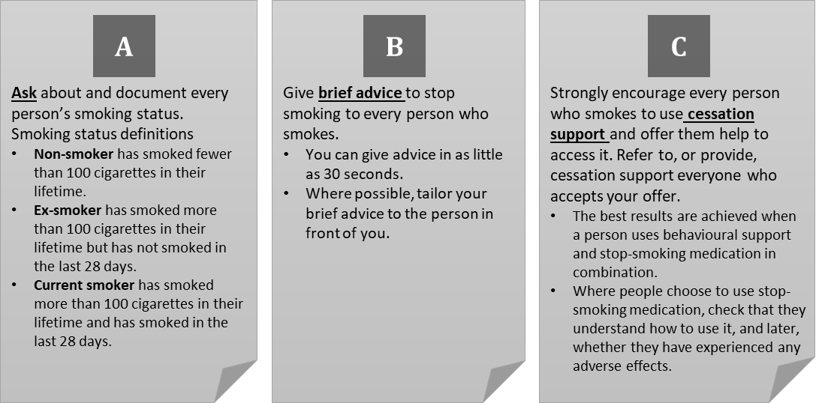

Stop-smoking services
Service | What is provided? | How do you refer?
Quitline | Telephone, text and online support – go to www.quit.org.nz for more information. Quitline also provides subsidised nicotine replacement therapy (NRT). | 1. Advise the person to call 0800 778 778 or visit www.quit.org.nz to register.  2. Refer directly from your practice management system (PMS).  3. Email (referrals@quit.org.nz) a referral form.*  4. Midwives and Plunket nurses can also make text referrals. Text the following information to 021 784 866: type of referrer (MW for midwife, PN for Plunket nurse), referrer’s name, client’s name, client’s phone number and client’s date of birth.
Māori services | Face-to-face support for Māori** in an individual, whānau and/or group setting. | See Stop smoking services on the Smokefree website at: https://www.smokefree.org.nz/help-advice/stop-smoking-services
Pacific services | Face-to-face support for Pacific peoples* in an individual, fānau, and/or group setting. | See Stop smoking services on the Smokefree website at: https://www.smokefree.org.nz/help-advice/stop-smoking-services
Pregnancy services | Face-to-face support for pregnant women in an individual and/or family/partner setting. | See Stop smoking services on the Smokefree website at: https://www.smokefree.org.nz/help-advice/stop-smoking-services
Other services | There may be other stop smoking services in your area. These services will typically provide a combination of stop smoking medicines and face-to-face support in an individual or group setting. | See Stop smoking services on the Smokefree website at: https://www.smokefree.org.nz/help-advice/stop-smoking-services
* Download referral forms from the Quitline website at: https://quit.org.nz/helping-others-quit#midwives-plunket-other-referrers; https://quit.org.nz/helping-others-quit#secondary-care---dhbs; https://quit.org.nz/helping-others-quit#primary-care---phos and e-mail the completed form to referrals@quit.org.nz. Alternatively, your PMS may be able to you refer patients directly. Quitline advisors will acknowledge and process your referral, and the stop-smoking support provider will contact the client within three working days of receiving the referral. The provider will make two separate attempts to contact the person. If they are still unable to contact them, they will send a letter encouraging the person to get in touch, accompanied by quit smoking information (provided you have supplied the person’s address with your referral).
** These services also provide support to non-Māori and non-Pacific peoples who want help to quit smoking. All services provide multi-session support. To find contact details for your local services, call a Quit Advisor on 0800 778 778 (or text 4006).

Making an offer of cessation support
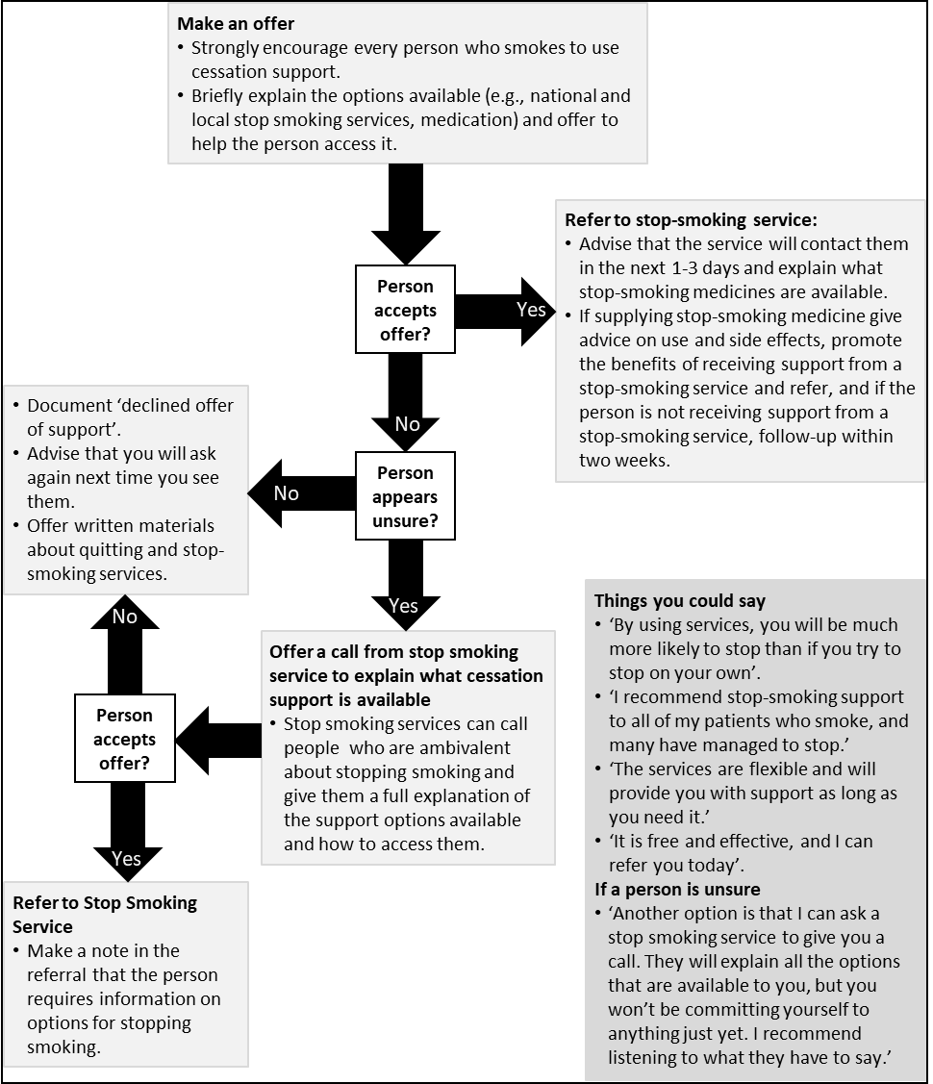

Part 2: Smoking cessation interventions
This section outlines the different intervention strategies that you can use to help people stop smoking.

Providing behavioural support
- Behavioural support involves advice, discussion, encouragement and other targeted activities designed to:
- maximise motivation to remain smokefree
- minimise motivation to smoke
- enhance the skills and capacity needed to avoid and resist urges to smoke
- optimise effective use of stop-smoking medication.
- When delivering behavioural support, evidence suggests that people need at least four follow-up contacts to have their best chance of stopping smoking.
- Priority population groups include Māori, Pacific peoples, pregnant women and users of mental health services due to their high smoking rates or the substantial benefits they will obtain from stopping smoking. The recommendations in these Guidelines apply to all these groups, but a more tailored approach may be required in some cases. There may also be specific support available in your area – see part 3 of the background and recommendations document for more information.

Providing stop-smoking medicines
- Give information about effective stop-smoking medicines to everyone who wants help to stop.
- The approved stop-smoking medicines that are available in New Zealand are:
- nicotine replacement therapy (NRT)
- varenicline
- bupropion
- nortriptyline.
- These medicines all help reduce unpleasant withdrawal symptoms, which makes stopping smoking easier. See below for specific information about each type of medication.
- Check that people understand how to use each of the stop-smoking medicines.
- NRT can be used to relieve tobacco withdrawal symptoms in settings where people cannot smoke (for example, hospitals), even if they do not intend to stop smoking long term.
- Monitor people who are using stop-smoking medication to see whether they develop any side effects.
- Stopping smoking can affect the metabolism of other drugs (for example, selective serotonin reuptake inhibitors (SSRIs), clozapine and warfarin) regardless of the type of stop-smoking medication being used. People trying to quit smoking and taking these medications should see their doctor about adjusting their medication dose.
- Vaping products, especially those that contain nicotine, may help some people to stop smoking or cut down as they can address both the nicotine dependence and behavioural aspects of smoking.

Providing stop-smoking support to Māori
- Although the evidence is limited to a relatively small number of studies in New Zealand that included Māori participants, interventions that work in the general population (for example, behavioural support and stop-smoking medicines) are at least as effective for Māori.
- Offer Māori smokers support that incorporates components known to be effective (such as stop-smoking medication).
- Where available, offer kaupapa Māori services as well as generic stop-smoking services to Māori wanting support to stop smoking.
- Stop-smoking practitioners who provide support to Māori smokers should be trained to ensure they are both technically and culturally safe in this role.
- Services and organisations should ensure that health workers understand the systematic and structural factors contributing to the high prevalence of smoking in Māori compared with non-Māori and identify and address barriers to equitable care for Māori and other priority groups to improve health equity.

Providing stop-smoking support to Pacific peoples
- There are relatively few studies focused on helping Pacific peoples to quit smoking, but in general, the interventions that work in the general population (for example, behavioural support and stop-smoking medicines) appear to be just as effective for Pacific peoples.
- Stop-smoking interventions for Pacific peoples need to address cigarette dependence, provide support and be delivered in a way that reflects an understanding of the cultural values that underlie Pacific people’s lives, such as including the wider family and spiritual dimension in any discussion.
- It is essential to give Pacific smokers a choice of different treatment options.
- Providers should offer culturally and language-appropriate services where available.
- Stop-smoking practitioners who provide support to Pacific smokers should seek training to ensure they are both technically and culturally safe in this role.

Providing stop-smoking support to pregnant women
- Pregnant women expect clear, honest and non-judgmental communication about smoking.
- Behavioural interventions and NRT are effective in supporting pregnant women to abstain from smoking during pregnancy. Women can use NRT during pregnancy and breastfeeding – practitioners should discuss the risks versus benefits of using NRT during pregnancy.
- Vaping products may be considered for pregnant women who have been unable to quit using other methods, but only after the women have been informed of and have weighed up the risks and benefits.
- Strongly recommend that all pregnant women who smoke use a stop-smoking service to help them stop and make a referral as appropriate.
- Continue to offer cessation support throughout the pregnancy to all pregnant women who continue to smoke.
- Postnatal relapse back to smoking is common in women who stop smoking during pregnancy. These women may benefit from referral to a stop-smoking service around the time of birth to help them remain smokefree.

Providing stop-smoking support to children and young people (under 18 years old)
- There is very limited evidence of effective interventions to help children and adolescents stop smoking. The only known effective intervention for quitting smoking is group counselling. Other effective interventions for adults are likely to be as effective for younger people, but the evidence base is lacking to confirm this.

Providing stop-smoking support to people who use mental health and addiction treatment services
- People with mental health disorders have particularly high smoking rates, but most want to stop smoking.
- Brief advice should be offered to all users of mental health and addiction treatment services who smoke.
- Effective interventions, such as behavioural interventions and pharmacological interventions, should be offered to people with mental health disorders and addictions.
- It is essential to monitor people with mental health disorders who stop smoking while still using medication for their mental health disorder as their medication dosage may need to be adjusted.

Stop-smoking medicines

Nicotine replacement therapy
- NRT provides some of the nicotine that a person would have otherwise received from tobacco and, in doing so, reduces the person’s urge to smoke.
- There are five different NRT products available over the counter in New Zealand: patches, gum, lozenges, inhalators and mouth spray.
- The patches, gum and lozenges are subsidised if supplied on prescription or via the Quit Card programme. Community pharmacists can also provide NRT without a prescription. NRT products are available for free from stop-smoking services.
- Regardless of the product used, NRT can improve long-term abstinence rates by more than 50 percent.
- Using two NRT products (for example, patches and gum) is more effective than using one.
- People should use NRT for at least eight weeks. People who need NRT for longer than 12 weeks can continue to use it.
- If the person is not ready to stop smoking straight away, NRT can help reduce their smoking before they stop.

Varenicline
- Varenicline reduces a person’s urge to smoke and the ‘reward’ they get from smoking. It can more than double a person’s chance of stopping smoking.
- Varenicline is fully funded (subject to special authority criteria) for people who have tried to stop twice with NRT or once with bupropion or nortriptyline.
- People should start varenicline at least one week before their quit date and use it for a full 12 weeks.
- Before prescribing or recommending varenicline, check the contraindications and cautions that apply.
- There is insufficient evidence to recommend varenicline for smoking cessation in pregnant or breastfeeding women and people under the age of 18 years.

Bupropion
- Bupropion is an atypical antidepressant that reduces the severity of tobacco withdrawal and can increase a person’s chance of stopping smoking.
- Bupropion is a fully-funded stop-smoking medicine and is available on prescription without special authority.
- People should start bupropion at least one week before their quit date and use it for at least seven weeks.
- Before prescribing or recommending bupropion, check the contraindications and cautions that apply. Seizures have been reported, so the medication should not be used in people with a history of seizures.
- Pregnant or breastfeeding women and those under the age of 18 years must not use bupropion.

Nortriptyline
- Nortriptyline is an antidepressant medicine that also helps people stop smoking.
- Nortriptyline reduces the severity of tobacco withdrawal symptoms and can improve a person’s chance of stopping smoking long term.
- Nortriptyline is a fully-funded stop-smoking medicine and is available on prescription without special authority.
- People should start nortriptyline at least one week before their quit date and use it for 12 weeks. The dose should be tapered at the end of treatment to avoid withdrawal symptoms.
- Before prescribing or recommending nortriptyline, check the contraindications and cautions that apply. People with cardiovascular disease should use nortriptyline with caution.
- Pregnant or breastfeeding women and those under the age of 18 years must not use nortriptyline.

Documentation
- Always record when you have given brief advice or referred a person to support services, if possible, using a referral form. Sending letters or text messages cannot be counted as an offer of treatment unless the patient replies and either:
- declines the offer of support or
- seeks further information or accepts the offer (can be coded as brief advice).
- All patients who fall into the second category should be followed up and then coded according to the follow-up call/visit outcome.
- Text-message recipients who reply with an indication of interest in cessation support but who cannot then be re-contacted should be sent a reminder/prompt.

Part 3:
Barriers and facilitators to implementing the ABC pathway
This section identifies some of the common barriers and facilitators to implementing ABC into your organisation or clinic. It also suggests how you might overcome some of the barriers. Services and organisations should identify and address barriers to equitable care for Māori and other priority groups as part of their obligation to improve health equity.

Barriers to implementing the ABC pathway
- Health workers who smoke: Health workers who smoke may have different attitudes towards smoking than non-smoking colleagues and are less likely to provide stop-smoking advice to the people they see. Health services should offer cessation support to all employees who smoke and remind them that most people expect health workers to discuss their smoking.
- Lack of time, knowledge and skills: Lack of time is one of the most common reasons given for health workers not discussing people’s smoking with them. The ABCs can be delivered in a busy clinic in as little as a few minutes. Perceived lack of knowledge or skills may also be a barrier to providing smoking cessation support. For example, health workers may not feel confident in delivering the information to their patients and be reluctant to provide support in case they ‘get it wrong’.
- Health workers who see ABC as beyond their remit: Some health workers still believe that helping people stop smoking is outside their job description. Providing health workers with a rationale specific to their area of work may help change such a view. Key messages for health workers are available from The New Zealand Guidelines for Helping People to Stop Smoking webpage of the Ministry of Health’s website at: www.health.govt.nz/publication/new-zealand-guidelines-helping-people-stop-smoking.

Facilitators for implementing the ABC pathway
- Training: Health workers are more likely to provide patients with advice and support to stop smoking when they have been trained to do so. Therefore, staff induction should include brief stop-smoking training, with instructions on what health workers must do. Cultural safety training is also vital to ensure equitable quality of care. Refresher training (in ABCs and cultural safety) should be offered regularly (ideally, annually).
- System prompts: All health settings should use tools and systems that prompt health workers to provide and record the different elements of the ABC pathway.
- Audit and feedback: Auditing health workers’ performance and providing them with regular feedback are effective ways of changing clinical behaviour. All health settings should use automated feedback systems where possible.
- Leadership: Leadership is essential in achieving and maintaining any change. Health workers should foster, advocate for and maintain clinical leadership for stopping smoking at all levels in their organisations.

