Technical Guidelines for Tuberculin Skin Test

Acknowledgements
The Ministry of Health would like to acknowledge all those who have contributed to the development of these guidelines.
Citation: Ministry of Health. 2018. Technical Guidelines for Tuberculin Skin Test. Wellington: Ministry of Health.
Published in August 2018
by the Ministry of Health
PO Box 5013, Wellington 6140, New Zealand
ISBN 978-1-98-853986-7 (online)
HP 6918
This document is available at health.govt.nz
This work is licensed under the Creative Commons Attribution 4.0 International licence. In essence, you are free to: share ie, copy and redistribute the material in any medium or format; adapt ie, remix, transform and build upon the material. You must give appropriate credit, provide a link to the licence and indicate if changes were made.

Contents
Recommended reading iv
Introduction 1
Tuberculosis control in New Zealand 1
Tuberculin skin test (Mantoux) and interferon gamma release assays 1
Mantoux before BCG vaccination 2
Storage and disposal of the tuberculin solution 2
Contraindications for Mantoux testing 2
Administering the test 4
Measuring and recording reactions 6
Interpreting the results 7
Mantoux cutting points 7
Notes on cutting points 8
Mantoux conversion 8
Adverse reactions following testing 9
Circumstances that do not prevent a Mantoux test? 9
Post-Mantoux test 10
References 11

List of Tables
Table 1: Definition of a positive Mantoux test in New Zealand (cutting points) 7

List of Figures
Figure 1: Administering the Mantoux test 5
Figure 2: Mantoux reactions showing induration 6

Recommended reading
These guidelines can be read as a stand-alone document, but it is recommended that you refer to chapters in the Guidelines for Tuberculosis Control in New Zealand 2019 (Ministry of Health 2019) at: www.health.govt.nz/publication/guidelines-tuberculosis-control-new-zealand-2019.

For information on the BCG vaccine, please refer to the latest edition of the Immunisation Handbook (sections 2.2.3 and A 4.1.3 and chapter 20; Ministry of Health 2018) at: www.health.govt.nz/publication/immunisation-handbook-2017

The Tuberculosis Act 1948 was repealed on 4 January 2017 by section 15 of Health (Protection) Amendment Act 2016 (no. 35). See: www.legislation.govt.nz/act/public/2016/0035/latest/DLM6223006.html

Introduction

Tuberculosis control in New Zealand
The principal control measures for tuberculosis (TB) in New Zealand are case finding, treatment of active and latent TB infection, contact tracing and selective screening. For more detail on these control measures, see the Ministry of Health’s (2019) Guidelines for Tuberculosis Control in New Zealand 2019 (www.health.govt.nz/publication/guidelines-tuberculosis-control-new-zealand-2019).

Bacillus Calmette-Guèrin (BCG) is offered to groups or individuals who are at increased risk of contracting TB. For the current recommendations for BCG use in New Zealand, see the most recent edition of the Ministry of Health’s (2018) Immunisation Handbook (www.health.govt.nz/publication/immunisation-handbook-2017 ).

Tuberculin skin test (Mantoux) and interferon gamma release assays
Current or previous TB infection and previous BCG immunisation lead the body to develop a cellular immune response.

The immune response can be detected by measuring dermal induration after the injection of tuberculin puriﬁed protein derivative, termed a tuberculin skin test (TST). The Mantoux test is the preferred tuberculin skin test in New Zealand. (For its purposes, this document will use the term Mantoux to describe tuberculin skin testing.)

Alternatively the immune response can be measured by detecting interferon gamma released by T-lymphocytes when exposed to specific TB antigens, more formally known as interferon gamma release assays (IGRA). IGRA testing can detect current or previous TB infection, but not previous BCG immunisation. (See chapter 2 of the Guidelines for Tuberculosis Control in New Zealand 2019, Ministry of Health 2019.)

While New Zealand has used the Mantoux test for many years, IGRA is a much newer test and researchers are still gathering evidence for its use. Either pre-vaccination test can be used for people aged over seven years. See the Guidelines for Tuberculosis Control in New Zealand 2019 (Ministry of Health 2019) for further information on IGRA testing (including the underlying principle, administration, interpretation and selected literature findings).

Most BCG vaccinations are given to infants under six months of age. These infants do not require pre-vaccination testing if they have no identifiable risk factors.

The Mantoux test is recommended for children aged seven years and under.

Note that, following review of the available literature and local data, the age cut-off for pre-vaccination Mantoux has changed from older than 12 weeks to older than six months in children with no identifiable risk factors.¹

All people over six months of age, and infants under six months of age who have been exposed to active TB, require pre-vaccination testing with either a Mantoux test or (if over seven years of age) an IGRA test. Perform the pre-vaccination test no more than four weeks before the intended vaccination. (See chapter 5 of the Guidelines for Tuberculosis Control in New Zealand 2019, Ministry of Health 2019.)

Mantoux before BCG vaccination
The person who performs Mantoux testing should be proficient with the procedure and have experience in reading the results. Authorised vaccinators must have BCG endorsement to be able to administer BCG vaccine. It is recommended that public health units establish their own process for ensuring proficiency. A Mantoux test is usually given in the right arm. (If a second test is necessary, do it in the opposite arm.)

Storage and disposal of the tuberculin solution
- Store the tuberculin solution at a temperature between 2°C and 8°C.
- Protect it from light.
- Once you have opened a vial, date it and discard it after one month.

Contraindications for Mantoux testing
Do not perform a Mantoux test with people who have:
- documented Mantoux reactions >15 mm in the past; repeating the test will not provide any new diagnostic information and will create discomfort
- previously had TB disease or have a latent TB infection; useful diagnostic information will not be gained and significant discomfort is likely
- previously had severe blistering or other hypersensitivity reactions following Mantoux testing, or have extensive burns or eczema over Mantoux testing sites; these people are more likely to have adverse reactions or severe reactions
- major viral infections
- received measles vaccination within the past four weeks; evidence shows that this makes false-negative Mantoux results more likely. While no data are available on how other live virus vaccinations affect Mantoux results, it would seem prudent to follow the same guidance for them as well. However, if it means that you might miss the opportunity to perform the Mantoux test, do not delay the test because of live virus vaccines, as these are theoretical considerations. Note that you may administer a Mantoux test before or on the same day as live virus vaccinations, but at a different site.

Administering the test
See Figure 1 for photos of the key steps in administering the test.

Public health units should have a locally agreed policy on who can administer a Mantoux test. The previous recommendation was that staff who administer BCG vaccine are best placed to administer the test.

The Mantoux test involves injecting 0.1 mL 5TU PPD (5 tuberculin units purified protein derivative) intradermally into the flexor surface of the mid-forearm.

Use either an insulin syringe or a tuberculin syringe with a 20-gauge (G) needle. If the vial has been previously opened, swab the vial with an alcohol swab and allow it to dry before use.
- With an insulin syringe, you do not need to change the needle. The needle is very fine and does not become blunt or dislodged.
- With a tuberculin syringe, you need to change the needle to a new 26G or 27G needle because:
- they are the correct size for administration
- penetrating the bung may blunt the needle.

Follow these steps in administering the test.
- Gather all necessary equipment. Perform hand hygiene in line with the 5 moments for hand hygiene.
- Expel any air from the syringe and then draw 0.1 mL of tuberculin into the syringe Insert the needle into the most superficial layers of the skin (on the inside of forearm) with the bevel of the needle upward, until the bevel is just covered, and slowly inject the solution.
- If you have carried out the intradermal injection correctly, a definite white bleb of at least 6 mm in diameter will appear at the needle point. This will soon disappear. You do not need to apply dressing or use alcohol swabs on the site.
- If the bleb is less than 6 mm in diameter, then administer the test again. The first dose may have been inadequate because the needle bevel was inserted too deeply or some tuberculin has leaked out. If leakage occurs at the insertion site, you may not have inserted the needle bevel far enough for the bevel to be covered by the skin.
- If the tuberculin test must be repeated, use another site at least 50 mm from the original site.
- Dispose of used equipment safely and clean your hands.

See the Medsafe data sheet (Sanofi Pasteur Limited 2007) for further information on the tuberculin solution: www.medsafe.govt.nz/profs/Datasheet/t/Tubersolinj.pdf

Figure 1: Administering the Mantoux test
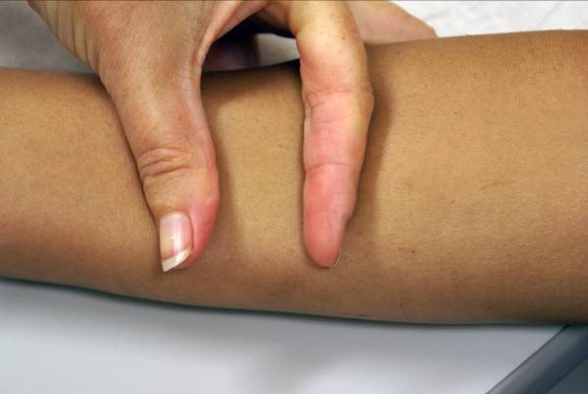 | 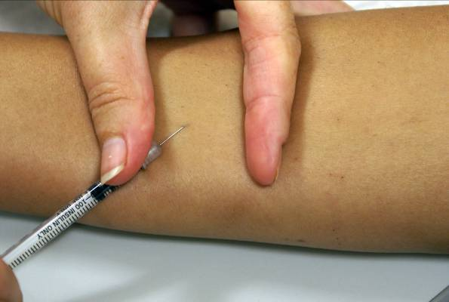
1. Draw 0.1 mL of tuberculin into the syringe and remove any air bubbles. Hold the skin taut. | 2. Insert the needle into the most superficial layers of the skin with the bevel of the needle upward, until the bevel is just covered, and slowly inject the solution.
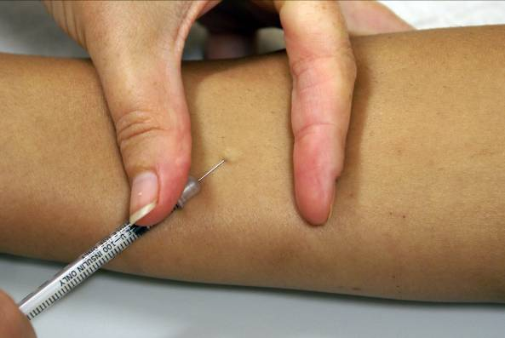 | 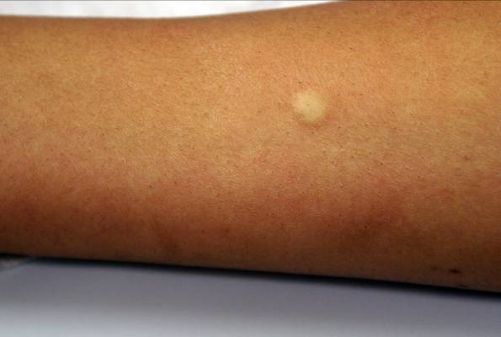
3. A definite white bleb or weal will appear at the needle point. This will soon disappear.
Source: Auckland Regional Public Health Service

Measuring and recording reactions
Read the Mantoux reaction 48–72 hours after administration. If this timeframe is not possible, you may read it after 72 hours and up to seven days later. However, as all the literature on the risk of developing TB is based on reading Mantoux tests at 48–72 hours, the reliability of the interpretation of Mantoux tests that are read after 72 hours and up to seven days later is uncertain (Menzies and Doherty 2006).

The exception is when you conduct the two-step Mantoux to identify the booster effect. In this case, read the reaction at 48 hours.

You read the Mantoux test by observing the presence or absence of induration (the area of raised tissue that can be felt and seen), not redness. You may determine the induration by inspection and palpation. It is important to carry out readings in good light.

Most people find it easier to identify the edge of the induration on each side by drawing a line on the skin with a ballpoint pen, advancing the tip towards the induration until they feel the edge of the induration (as in Figure 2).

Use a transparent ruler that is marked in millimetres (and that you clean, according to local policy, between uses) to measure the induration (and only the induration – not the entire area of redness). Measure transversely to the long axis of the forearm (ie, across the width of the forearm) and record the result in millimetres. This is the method recommended by the American Thoracic Society (2000) and produces data that are internationally comparable. See Figure 2 for photos of Mantoux reactions.

Figure 2: Mantoux reactions showing induration
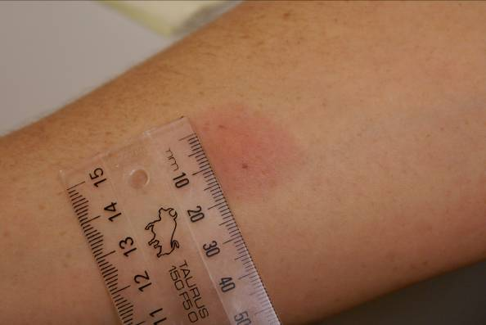 | 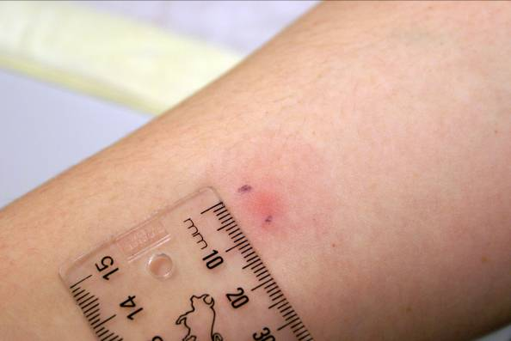
Photos show Mantoux reactions at (a) 15 mm and (b) 9 mm.
Source: Auckland Regional Public Health Service

Interpreting the results

Mantoux cutting points
Factors other than TB infection can increase the Mantoux response. These factors include boosting by tuberculin, exposure to environmental non-tuberculosis mycobacteria, and BCG vaccination. You need to consider them when interpreting a Mantoux response. The larger the Mantoux response, the more likely it is that it represents a previous infection with Mycobacterium tuberculosis. Some positive tests will blister. As noted above, however, the reading is determined by the area of induration.

Table 1 shows the Mantoux ‘cutting points’ that are considered measurements of a positive Mantoux result. Mantoux measurements lower than those outlined in the table are considered to be negative Mantoux results.

Note: If the Mantoux test is:
- positive, refer the patient to a respiratory physician, tuberculosis specialist or paediatrician
- negative, discuss with an expert in this field for advice.

Table 1: Definition of a positive Mantoux test in New Zealand (cutting points)
Category | Adults  (> 15 years) | Older children  (5–14 years) | Younger children  (< 5 years)
New Zealand born
- No BCG vaccination | > 10 mm | > 10 mm | > 5 mm
- Previous BCG vaccination | > 15 mm | > 10 mm | >10 mm
Following residence in a high-incidence country*
- No BCG vaccination | >10 mm | > 10 mm | > 5 mm
- Previous BCG vaccination | > 10 mm | >10 mm | >10 mm
With immunosuppressive illness or taking immunosuppressive drugs (with or without BCG vaccination) | 5–10 mm | > 5 mm | > 5 mm
HIV/AIDS (with or without BCG vaccination) | > 5 mm | > 5 mm | > 5 mm
Close contacts of smear-positive cases (any origin) (with or without BCG vaccination) | >10 mm | > 5 mm | >5 mm
* See notes on cutting points below.

Notes on cutting points
- Because children are at greater risk of developing severe and life-threatening TB disease if untreated, cutting points for children are conservative. Children younger than 12 weeks may be unable to produce an immunologic response (ie, may have a false negative Mantoux test).
- Consider the actual risk and level of exposure for people from a high-incidence country on an individual basis.
- Where adults have immunosuppressive illness or are taking immunosuppressive drugs, document the degree and duration of immune suppression and identify the appropriate cutting point, as described here.
- The 5 mm cutting point is appropriate for people with:
- immunosuppressive treatment for organ transplantation
- aggressive immunosuppressive cancer treatment
- cytotoxic immunosuppressive agents such as cyclophosphamide or methotrexate
- systemic corticosteroid treatment that is prolonged (eg, for more than six weeks) and in a dose of prednisone equal to or greater than 15 mg/day (or equivalent with another steroid); the higher the dose, the greater the risk of reactivating TB
- a combination of other immunosuppressive conditions (eg, prednisone less than 15 mg/day plus diabetes mellitus (on treatment) and moderately or severely advanced malignancy. (This advice is empirical, not evidence based.)
- end-stage renal failure.
- The 10 mm cutting point is appropriate for people who:
- are on long-term doses of prednisone less than 15 mg/day
- have diabetes mellitus (including insulin dependent)
- have alcoholism, malnutrition or disseminated malignancy.

Mantoux conversion
Mantoux conversion is relevant for repeat testing of contacts. Repeated Mantoux tests can result in larger reaction sizes, which can be due to non-specific variation, boosting or true Mantoux conversion (Menzies and Doherty 2006). Non-specific increases occur because of differences in administration or reading, as well as because of minor variation in the individual’s response. Increases due to non-specific variation are small, between 2 and 3 mm.

Definition: Mantoux conversion is an increase in reaction size of 10 mm or more within a two-year period (American Thoracic Society 2000).

People who have a Mantoux conversion should be investigated for TB disease. The Mantoux reaction takes up to eight weeks to convert after exposure (Menzies 1999). If eight weeks have passed since a contact was last exposed to the case, a single Mantoux test is all that is required. If you give the first test less than eight weeks after last exposure and it is negative, then repeat the test eight weeks after last exposure.

Adverse reactions following testing
Adverse reactions are unusual. In rare cases, people may experience a sore arm or mild flu-like symptoms for a few days. Severe systemic hypersensitivity reactions (anaphylactic or anaphylactoid reactions) following administration of the Mantoux test are also rare (Sanofi Pasteur Limited 2007). Where hypersensitivity has occurred, reactions have resulted in angioedema, upper respiratory stridor, dyspnoea, skin rash, generalised rash and/or urticaria within 24 hours of administering Mantoux.

Continue to observe people for 20 minutes after administering a Mantoux test so that any immediate adverse reaction can be appropriately treated. Standard vaccination practice of not giving vaccines alone and having an emergency resuscitation equipment in the room is recommended when administering Mantoux.

For further information on anaphylaxis and reporting adverse events to the Centre for Adverse Reactions Monitoring, see the latest edition of the Immunisation Handbook (Ministry of Health 2018).

Circumstances that do not prevent a Mantoux test?
Unless contraindicated, people can receive a Mantoux test if they:
- have a common cold
- are pregnant or who are breastfeeding
- are immunised with any other vaccine on the same day
- have immunised in the past four weeks with inactivated vaccines
- give a history of a positive Mantoux reaction (other than blistering) that is not documented
- are taking low doses of systemic corticosteroids (<15 mg prednisone (or equivalent) daily (as long as they are not also diabetic); it generally takes a steroid dose equivalent to >15 mg prednisone daily for two to four weeks to suppress Mantoux reactivity.

Post-Mantoux test
There is no evidence relating to the degree of protection to either size of any subsequent Mantoux reaction or to the presence or absence of any scar formation. For this reason, follow-up Mantoux tests after vaccination are not recommended (Al-Kassimi et al 1995).

References
Al-Kassimi F, Al-Hajjaj M, al-Orainey IO, et al. 1995. Does the protective effect of neonatal BCG correlate with vaccine-induced tuberculin reaction? American Journal of Respiratory and Critical Care Medicine 152: 575–8.
American Thoracic Society. 2000. Diagnostic standards and classification of tuberculosis in adults and children. Am Journal of Respiratory and Critical Care Medicine 161: 1376–95.
Menzies D. 1999. Interpretation of repeated tuberculin tests. Boosting, conversion, and reversion. American Journal of Respiratory and Critical Care Medicine 159: 15–21.
Menzies D, Doherty T. 2006. Diagnosis of latent tuberculosis infection. In: MC Raviglione (ed), Reichman and Herschfield’s Tuberculosis: A comprehensive international approach (pp 215–63). New York: Informa Healthcare.
Ministry of Health. 2019. Guidelines for Tuberculosis Control in New Zealand 2019. Wellington: Ministry of Health.
Ministry of Health. 2018. Immunisation Handbook 2017. Wellington: Ministry of Health.
Sanofi Pasteur Limited. 2007. Data Sheet Tubersol: Tuberculin purified protein derivative (Mantoux) diagnostic antigen. Wellington: Medsafe.

Risk factors include exposure to TB cases, travel to high-incidence countries and having visits from relatives who live in high-incidence countries. You must assess these risk factors thoroughly for each child pre-vaccination, as part of the informed consent process.
Tuberculin skin testing (Mantoux) before BCG vaccination (Immunisation Handbook, section 20.5.1, Ministry of Health 2018). You do not need to perform tuberculin skin testing if you are giving BCG to an infant under the age of six months unless they have a history of contact with a known or possible case of TB. Although the tuberculin skin test is usually positive in the year following BCG vaccination, at least 50 percent of children will be negative beyond that time, so tuberculin skin testing is still a useful way of diagnosing TB infection.
www.handhygiene.org.nz/index.php?option=com_content&view=category&id=9&Itemid=107
The two-step Mantoux is when you give a second TST after an initial negative TST reaction. See www.cdc.gov/tb/publications/factsheets/testing/skintesting.htm
Boosting is a recall of the hypersensitivity response in the absence of new infection.
Mantoux conversion is the development of new or enhanced hypersensitivity due to infection with tuberculous or non-tuberculous mycobacteria, including BCG vaccination.

