Tatau Kahukura
Māori Health Chart Book 2015

3rd edition

The title of this publication, Tatau Kahukura, refers to valuable, high-quality information that has been woven and gathered from a variety of sources to be presented as a whole. Many different people can use this knowledge and these tools to work towards the achievement of whānau ora: Māori families supported to achieve their maximum health and wellbeing.
Acknowledgement: Our thanks and acknowledgements to Erenora Puketapu-Hetet for permission to use her creation of a korowai taonga on the cover.
Citation: Ministry of Health. 2015. Tatau Kahukura: Māori Health Chart Book 2015 (3rd edition). Wellington: Ministry of Health.
Published in October 2015
by the Ministry of Health
PO Box 5013, Wellington 6145, New Zealand
ISBN 978-0-478-44863-4 (print)
ISBN 978-0-478-44862-7 (online)
HP 6243
This document is available at health.govt.nz
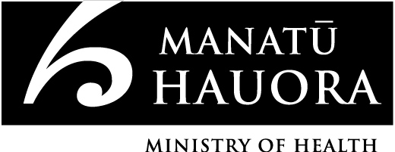

This work is licensed under the Creative Commons Attribution 4.0 International licence. In essence, you are free to: share, ie, copy and redistribute the material in any medium or format; adapt, ie, remix, transform and build upon the material. You must give appropriate credit, provide a link to the licence and indicate if changes were made.

Manakotanga: Acknowledgements
The authors of this report were from the Māori Health Research team (Li-Chia Yeh, Roimata Timutimu, Peter Himona, Natalie Talamaivao and Paula Searle) and from Health and Disability Intelligence (Deepa Weerasekera) within the Ministry of Health. Maree Martinuseen (of Māori Health Research) assisted with the preparation of the report and the online data tables.

The authors would like to acknowledge the numerous people who provided data and advice throughout the development of the report, and the assistance of John McCarthy (of Health and Disability Intelligence) in creating the map.

The authors also gratefully acknowledge the peer reviewers of this report: Gabrielle Baker, Christopher Carroll, Donna Cormack, Ash Dovey, Sarah Fraei, Helen Gower, Robyn Haisman-Welch, Ricci Harris, Anthea Hewitt, Michelle Hooper, Rayoni Keith, Chris Lewis, Andrea Mill, Anne O’Connel, Diana O’Neill, Saburo Omura, Bridget Robson, Salli Rowe, Janine Ryland, Hilary Sharpe, Niki Stefanogiannis, Martin Tobias and Pat Tuohy.

Ihirangi: Contents
Manakotanga: Acknowledgements iii
Whakamōhiotanga: Introduction 1
Ngā tapuae me ngā raraunga: Methods and data sources 2
How to interpret results: tables 4
How to interpret results: figures 5
Tatauranga taupori: Demographics 6
Age structure 6
Population projections 8
Ngā awe o te hauora: Socioeconomic determinants of health 11
Neighbourhood deprivation 11
Socioeconomic indicators 13
Racial discrimination 14
Ngā tauwehe tūpono me te marumaru: Risk and protective factors 16
Tobacco smoking 16
Alcohol use 17
Nutrition 18
Body size 19
Physical activity 21
Ngā mana hauora tūtohu: Health status indicators 22
Life expectancy 22
Disability 24
Major causes of death 28
Cardiovascular disease 30
Cancer 32
Respiratory disease 37
Diabetes 38
Infectious disease 40
Immunisation 41
Suicide and intentional self-harm 42
Interpersonal violence 44
Oral health 45
Mental health 47
Infant health 48
Unintentional injury 50
Ngā ratonga hauora kua mahia: Health service use 52
Primary health care 52
Prescriptions 56
Ngā pūnaha hauora tūtohu: Health system indicators 57
Tāpiritanga: Appendices 58
Appendix 1: Data sources and ICD-10-AM codes 58
Appendix 2: 2001 Census total Māori population 62
Appendix 3: Years of life lost 63
Appendix 4: Ethnicity data in the cancer registration and public hospital event records 64
Pūtea kōrero: References 67

Rārangi kauwhata toro: List of tables
Table 1: Population by age group and gender, Māori and non-Māori, 2013 6
Table 2: Projected populations by gender, Māori and non-Māori, 2015–2030 8
Table 3: DHB populations by life-cycle age group, Māori and non-Māori, 2013 9
Table 4: Populations by neighbourhood deprivation decile (NZDep 2013) and by gender, Māori and non-Māori, 2013 11
Table 5: Socioeconomic indicators, by gender, Māori and non-Māori, 2013 13
Table 6: Self-reported experience of any racial discrimination, by gender, Māori and non-Māori, 2011/12 14
Table 7: Self-reported experience of ethnically motivated personal attack, by gender, Māori and non-Māori, 2011/12 14
Table 8: Self-reported experience of unfair treatment on the basis of ethnicity, by gender, Māori and non-Māori, 2011/12 15
Table 9: Daily smoking in people aged 14–15 years, by gender, Māori and non-Māori, 2014 16
Table 10: Current smoking in people aged 15 and over, by gender, Māori and non-Māori, 2013/14 16
Table 11: Alcohol use indicators, by gender, Māori and non-Māori, 2013/14 17
Table 12: Nutrition indicators, by gender, Māori and non-Māori, 2013/14 18
Table 13: International BMI cut-off points for adults aged 18 years and over 19
Table 14: Body size indicators, children aged 5–14 years, by gender, Māori and non-Māori, 2013/14 20
Table 15: Body size indicators, adults aged 15 and over, by gender, Māori and non-Māori, 2013/14 20
Table 16: Physical activity indicators, by gender, Māori and non-Māori, 2013/14 21
Table 17: Disability prevalence, by age group and gender, Māori and non-Māori, 2013 24
Table 18: Prevalence of unmet need for special equipment among total disabled population, by age group and gender, Māori and non-Māori, 2013 26
Table 19: Prevalence of unmet need for health professional among total disabled population, by age group and gender, Māori and non-Māori, 2013 26
Table 20: Major causes of death, ranked by age-standardised mortality rates, by gender, Māori and non-Māori, 2010–12 28
Table 21: Major causes of death, ranked by YLL, by gender, Māori and non-Māori, 2010–12 29
Table 22: Cardiovascular disease indicators, by gender, Māori and non-Māori 30
Table 23: Ischaemic heart disease indicators, by gender, Māori and non-Māori 31
Table 24: Cancer indicators, by gender, Māori and non-Māori, 2010–12 32
Table 25: Female cancer screening indicators, Māori and non-Māori 36
Table 26: Asthma indicators, by gender, Māori and non-Māori 37
Table 27: Chronic obstructive pulmonary disease indicators, by gender, Māori and non-Māori 37
Table 28: Diabetes indicators, by gender, Māori and non-Māori 38
Table 29: Type 2 diabetes (diagnosed after 25 years of age) prevalence, by gender, Māori and non-Māori, 2013/14 39
Table 30: Meningococcal disease notification rates, Māori and total New Zealand population, 2013 40
Table 31: Tuberculosis notification rates, Māori and total New Zealand population, 2014 40
Table 32: Acute rheumatic fever initial hospitalisation rates, by gender, Māori and non-Māori, 2012–14 40
Table 33: Suicide rates, by age group and gender, Māori and non-Māori, 2010–12 42
Table 34: Intentional self-harm indicators, by age group and gender, Māori and non-Māori, 2012–14 43
Table 35: Interpersonal violence indicators, by gender, Māori and non-Māori 44
Table 36: Dental status for age 5 years and year 8 children, Māori and total New Zealand population, 2013 45
Table 37: Dental visit and dental treatment indicators, by gender, Māori and non-Māori, 2013/14 46
Table 38: High or very high probability of anxiety or depressive disorder, by gender, Māori and non-Māori, 2013/14 47
Table 39: Infant health indicators, by gender, Māori and non-Māori, 2010–12 48
Table 40: Breastfeeding indicators, by gender, Māori and non-Māori, 2013/14 49
Table 41: Unintentional injury indicators, by age group and gender, Māori and non-Māori 50
Table 42: Top three unintentional injury mortality categories, ranked by counts, by age group and gender, Māori and non-Māori, 2010–12 51
Table 43: Primary health care access indicators, by gender, Māori and non-Māori, 2013/14 52
Table 44: Unmet need for primary health care indicators for children aged 0–14 years, by gender, Māori and non-Māori, 2013/14 53
Table 45: Unmet need for primary health care indicators for adults aged 15 and over, by gender, Māori and non-Māori, 2013/14 54
Table 46: Prescription indicators, by gender, Māori and non-Māori, 2013/14 56
Table 47: Health system indicators, by gender, Māori and non-Māori, 0–74-year-olds 57
Table A1.1: Data sources for numerators 58
Table A1.2: Amenable mortality codes 59
Table A1.3: Ambulatory-sensitive hospitalisation codes 60
Table A1.4: ICD-10-AM codes used in this report 61
Table A2.1: 2001 Census total Māori population 62
Table A4.1: Final ethnicity adjusters (gender combined) 65

Rārangi tatau: List of figures
Figure 1: Age distribution of the Māori population, males and females, 2013 7
Figure 2: Age distribution of the non-Māori population, males and females, 2013 7
Figure 3: Proportion of DHB population that is Māori, 2013 10
Figure 4: Neighbourhood deprivation distribution (NZDep 2013), Māori and non-Māori, 2013 12
Figure 5: Life expectancy at birth, by gender, Māori and non-Māori, 1951–2013 22
Figure 6: Prevalence of single or multiple impairments among Māori, by age group and gender, 2013 25
Figure 7: Prevalence of single or multiple impairments among non-Māori, by age group and gender, 2013 25
Figure 8: Female cancer registration rates, by site, 25+ years, Māori and non-Māori, 2010–12 33
Figure 9: Female cancer mortality rates, by site, 25+ years, Māori and non-Māori, 2010–12 33
Figure 10: Male cancer registration rates, by site, 25+ years, Māori and non-Māori, 2010–12 35
Figure 11: Male cancer mortality rates, by site, 25+ years, Māori and non-Māori,
2010–12 35

Whakamōhiotanga: Introduction
Tatau Kahukura: Māori Health Chart Book 2015, 3rd Edition presents a snapshot of Māori health in the early 2010s. Like the previous editions (Ministry of Health 2006 and 2010b) this chart book presents key indicators relating to the socioeconomic determinants of health, risk and protective factors for health, health status, health service use and the health system. It uses the most recent data available for each indicator. The indicators were selected based on their ability to signal wider health concerns, focus on salient health issues, represent quality (reliability and validity), be monitored and respond to change. The indicators align to those used in more general annual monitoring at a national level.

The chart book shows that Māori have higher rates than non-Māori for many health conditions and chronic diseases, including cancer, diabetes, cardiovascular disease and asthma. Māori also experience higher disability rates.

As the Government’s advisor for health and disability, the Ministry of Health is charged with setting the direction for Māori health and guiding the sector as it works to increase access, achieve equity and improve outcomes for Māori.

He Korowai Oranga: Māori Health Strategy sets the overarching framework to guide the Government and the health and disability sector to achieve the best health outcomes for Māori. He Korowai Oranga supports the Ministry of Health and District Health Boards (DHBs) to improve Māori health, in alignment with the New Zealand Health Strategy, the New Zealand Disability Strategy and the New Zealand Public Health and Disability Act 2000.

The Ministry is currently updating the New Zealand Health Strategy to provide a roadmap for the sector’s priorities over the next three–five years; this will be relevant to the goal of achieving better health outcomes for Māori.

The chart book, along with the full suite of data tables supporting the figures and text, is available on the Ministry of Health website (www.health.govt.nz) and the Māori Health website (www.health.govt.nz/our-work/populations/maori-health).

The Ministry intends to continue to update this profile of Māori health regularly (every three to five years).

Ngā tapuae me ngā raraunga: Methods and data sources

Numerators
Data in this chart book were sourced from the Ministry of Health (including the New Zealand Health Survey (NZHS)), Statistics New Zealand (SNZ), the Institute of Environmental Science and Research Ltd (ESR), the Action on Smoking and Health (ASH) Year 10 Snapshot Survey and the Community Oral Health Service.
Where administrative data (ie, national collections and notifications) were used, the most recent three years of data were aggregated to provide stable rate estimates. For survey data, the most recent survey year was used.
Where the NZHS was used, the numerator was the sum of the weights for the respondents in the relevant subgroup (eg, Māori who had diabetes). Further information about survey weights for the NZHS can be found in Methodology Report 2013/14: New Zealand Health Survey (Ministry of Health 2014c).
Appendix 1 gives full details of the data sources and the International Statistical Classification of Diseases and Related Health Problems, Tenth Revision, Australian Modification (ICD-10-AM) codes used for data from national collections.

Denominator
SNZ’s mid-year (at 30 June) estimated resident population were used as denominator data in the calculation of population rates for deaths, hospitalisations and cancer registrations. Live births, sourced from SNZ, were used as denominators for rates of infant death and low birthweight.
For NZHS data, the denominator was the sum of the weights for the respondents in the relevant population group (eg, Māori) (Ministry of Health 2014c).

Ethnicity classification
Most indicators compare Māori with non-Māori. The method of ethnicity classification is noted under each table or figure in this chart book. In general, prioritised ethnicity classification was used when people identified with more than one ethnic group. A person was classified as Māori if one of their recorded ethnicities as Māori; all other people were recorded as non-Māori, and represent a comparative or reference group. (For example, a person recorded as both Māori and New Zealand European was counted as Māori.) Unknown or missing ethnicity was counted as non-Māori.
Unless otherwise stated, all indicators used ethnicity as recorded on the relevant collection or survey. Recent research has shown that there is no net undercount of Māori deaths and while hospitalisations have been shown to undercount Māori in the past, an assessment of this by the authors of this chart book has shown that when compared with Māori deaths, Māori hospitalisations show no undercount. However, Māori cancer registration rates in this chart book may still be underestimated because the impact of the method used to assign ethnicity in the cancer registration is not well understood (see Appendix 4 for more detail).

Age-standardised and crude rates
Age-standardised rates account for differences in population structure, and can be used to compare groups with different age structures, such as Māori and non-Māori. This chart book uses direct age-standardisation; most rates (unless noted otherwise) are standardised to the 2001 Census Māori population (see Appendix 2). Most of the indicators are expressed as an age-standardised rate per 100 (ie, a percentage), per 1000 or per 100,000. Age-standardisation is noted under the relevant tables or figures.

Standardising to the 2001 Census Māori population provides rates that more closely approximate the crude Māori rates (ie, the actual rates among the Māori population) than could be provided by other standard populations (eg, the World Health Organization (WHO) World Standard Population), while also allowing comparisons with the non-Māori population. Caution should be taken when comparing data in this chart book with data in reports that use a different population standard.

Where Census data, infectious disease notifications or data for a specific age were presented, crude rates were calculated. Crude rates are the number of events (eg, infant deaths) divided by the population of that age and multiplied by 1000. In this case, caution should be taken when comparing Māori with non-Māori results. Crude rates accurately portray a situation in each population, but make comparisons difficult, because they do not take into account different age distributions in each of the populations (eg, the Māori population is much younger than the non-Māori population).

Rates were not calculated for counts fewer than five in data from national collections, or where the population group being analysed (denominator) comprised fewer than 30 in data from surveys.

Confidence intervals
A confidence interval (CI) gives an indication of uncertainty around a single value (such as an age-standardised rate). CIs are calculated with a stated probability; in the case of this chart book, 95 percent (ie, each CI in this chart book has a 95 percent probability of enclosing the true value).

The CI is influenced by the sample size of the group. As the sample size becomes smaller, the CI becomes wider, and there is less certainty about the rate.

Rate ratios
Age-standardised rate ratios are used in this chart book to compare age-standardised rates between Māori and non-Māori. The rate ratio (RR) is equal to the age-standardised Māori rate divided by the age-standardised non-Māori rate. Thus the non-Māori population is used as the reference population. For example, an age-standardised RR of 1.5 means that the rate is 50 percent higher (or 1.5 times as high) in Māori than in non-Māori, after taking into account the different age structures of these two populations.

The main text of this chart book gives rate ratios and their 95 percent CIs. In this chart book, if the CI of the rate ratio does not include the number 1, the ratio is said to be statistically significant.

Unless otherwise stated, all differences presented in this chart book are statistically significant.

How to interpret results: tables
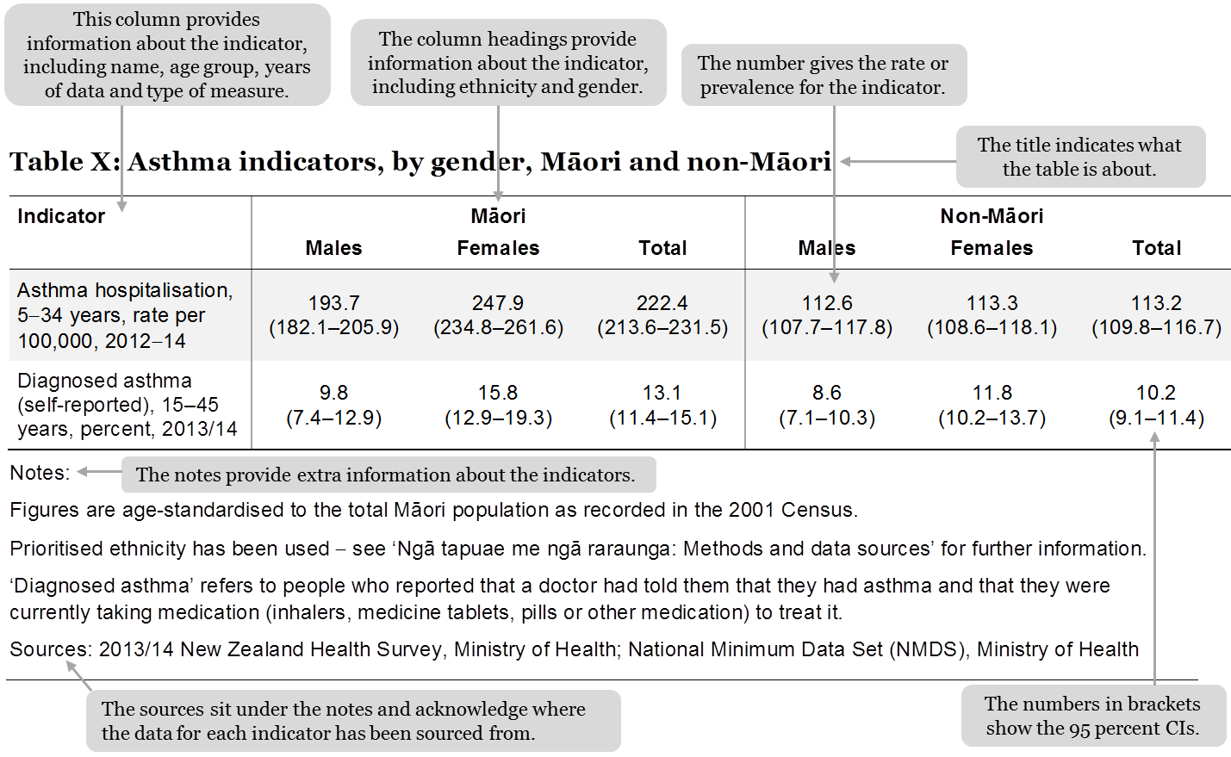

How to interpret results: figures
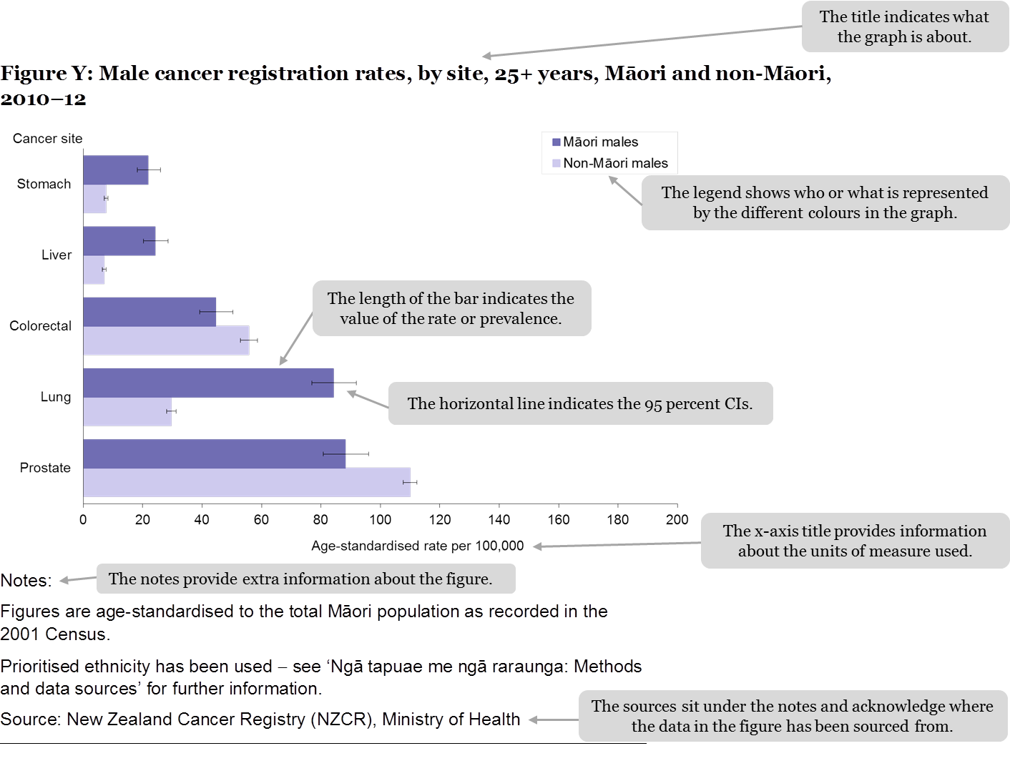

Tatauranga taupori: Demographics

Age structure
Table 1: Population by age group and gender, Māori and non-Māori, 2013
Age group (years) | Māori |  |  | Non-Māori
 | Males | Females | Total | Males | Females | Total
0–14 | 119,790 | 113,200 | 232,980 | 346,110 | 329,640 | 675,790
15–24 | 63,550 | 64,210 | 127,760 | 255,780 | 243,860 | 499,640
25–44 | 77,180 | 90,420 | 167,600 | 469,330 | 504,590 | 973,910
45–64 | 59,870 | 67,590 | 127,460 | 491,980 | 518,990 | 1,010,970
65+ | 16,560 | 19,900 | 36,460 | 272,000 | 317,530 | 589,520
Total | 337,000 | 355,300 | 692,300 | 1,835,200 | 1,914,600 | 3,749,800
Notes:
Due to rounding, individual figures in this table do not add to give the stated totals.
Prioritised ethnicity has been used − see ‘Ngā tapuae me ngā raraunga: Methods and data sources’ for further information.
Source: Statistics New Zealand

In 2013, Māori comprised 15.6 percent of the New Zealand population. Females made up 51.3 percent of the Māori population, and males 48.7 percent.

Figures 1 and 2 show that the Māori population is younger overall than the non-Māori population; 33.7 percent of Māori were aged less than 15 years, compared with only 18.0 percent of non-Māori.

Figure 1: Age distribution of the Māori population, males and females, 2013
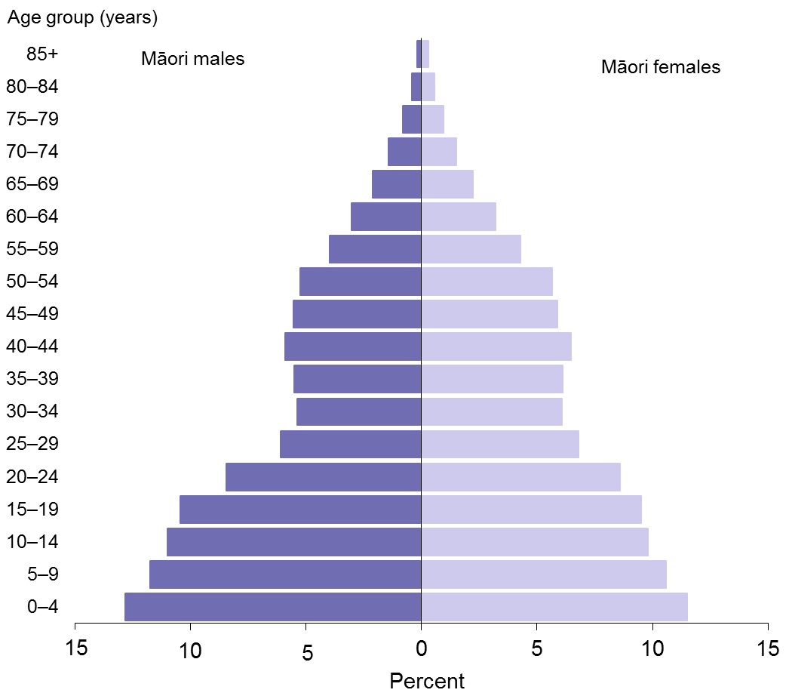
Note: Prioritised ethnicity has been used − see ‘Ngā tapuae me ngā raraunga: Methods and data sources’ for further information.
Source: Statistics New Zealand

Figure 2: Age distribution of the non-Māori population, males and females, 2013
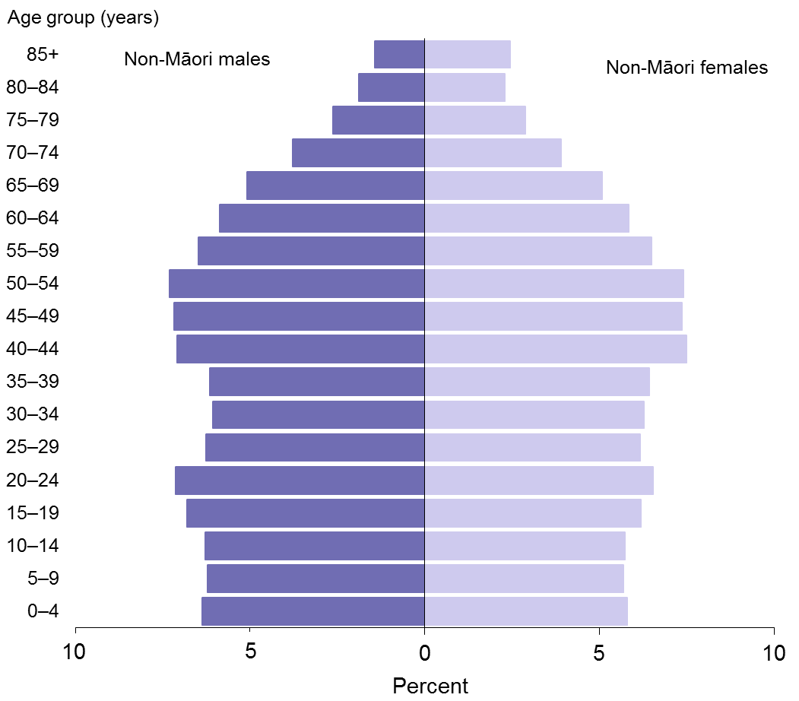
Note: Prioritised ethnicity has been used − see ‘Ngā tapuae me ngā raraunga: Methods and data sources’ for further information.
Source: Statistics New Zealand

Population projections
Table 2: Projected populations by gender, Māori and non-Māori, 2015–2030
Year | Māori |  |  | Non-Māori
 | Males | Females | Total | Males | Females | Total
2015 | 346,850 | 365,110 | 711,960 | 1,895,375 | 1,972,195 | 3,867,570
2020 | 366,360 | 383,720 | 750,080 | 1,993,685 | 2,065,760 | 4,059,445
2025 | 386,210 | 402,780 | 788,990 | 2,079,415 | 2,149,520 | 4,228,935
2030 | 405,900 | 421,330 | 827,230 | 2,160,355 | 2,229,015 | 4,389,370
Notes:
Due to rounding, individual figures in this table do not add to give the stated totals.
Prioritised ethnicity has been used − see ‘Ngā tapuae me ngā raraunga: Methods and data sources’ for further information.
Māori figures are series 6 projections based on the 2013 Census, and assume medium fertility, medium mortality, medium annual net migration and medium inter-ethnic mobility. Non-Māori figures are derived from national series 5 projections based on the 2013 Census, and assume medium fertility, medium mortality and long-term annual net migration of 10,000. The two series are designed to be directly comparable.
Source: Statistics New Zealand

Table 2 shows that between 2015 and 2030, the Māori population is projected to grow by 16.2 percent, whereas the non-Māori population is projected to grow by only 13.5 percent. The Māori projected population has a slightly higher growth rate (an average annual increase of 1.0 percent) compared with the non-Māori projected population (an average annual increase of 0.8 percent).

There are a number of drivers of this higher population growth rate for Māori, including a higher fertility rate for Māori females. In 2014 the Māori total fertility rate was 2.34 in 2014, compared with 1.92 for New Zealand (Statistics New Zealand 2015a).

Another factor is that the Māori population has a younger age structure, with a relatively large proportion in the main reproductive ages (15–44 years; see Figure 1). This provides built-in momentum for future population growth (Statistics New Zealand 2005).

Population by DHB
Table 3 presents the Māori and non-Māori populations of each DHB, by life-cycle age group. A map showing the proportion of each DHB’s population that is Māori follows as Figure 3.

Table 3: DHB populations by life-cycle age group, Māori and non-Māori, 2013
DHB | 0–14 years |  | 15–14 years |  | 25–44 years |  | 45–64 years |  | 65+ years |  | Total
 | Māori | Non-Māori | Māori | Non-Māori | Māori | Non-Māori | Māori | Non-Māori | Māori | Non-Māori | Māori | Non-Māori
Northland | 15,138 | 17,610 | 6888 | 9795 | 9723 | 21,258 | 9738 | 33,774 | 3441 | 24,324 | 44,928 | 106,764
Waitemata | 15,942 | 92,049 | 8634 | 63,111 | 11,613 | 130,923 | 8238 | 126,564 | 1875 | 66,609 | 46,302 | 479,256
Auckland | 8820 | 70,182 | 6255 | 64,059 | 8751 | 129,363 | 6159 | 96,465 | 1554 | 44,736 | 31,542 | 404,802
Counties Manukau | 24,408 | 88,698 | 12,399 | 58,455 | 16,317 | 107,019 | 11,799 | 99,945 | 3009 | 47,235 | 67,944 | 401,349
Waikato | 25,374 | 52,212 | 13,530 | 36,879 | 17,850 | 69,822 | 13,446 | 77,178 | 3855 | 49,167 | 74,049 | 285,261
Lakes | 10,455 | 11,727 | 5298 | 6942 | 7488 | 16,035 | 6270 | 19,422 | 1932 | 12,624 | 31,440 | 66,747
Bay of Plenty | 16,011 | 27,513 | 7584 | 15,870 | 11,100 | 34,908 | 9456 | 45,414 | 3126 | 35,025 | 47,277 | 158,718
Tairāwhiti | 6429 | 4302 | 3114 | 2439 | 4545 | 5442 | 4146 | 7113 | 1446 | 4680 | 19,683 | 23,970
Taranaki | 6447 | 16,722 | 3015 | 9918 | 4416 | 22,212 | 3282 | 25,929 | 1005 | 16,812 | 18,165 | 91,590
Hawke’s Bay | 12,144 | 20,862 | 5808 | 12,255 | 8154 | 25,764 | 6765 | 34,410 | 2106 | 23,421 | 34,977 | 116,718
Whanganui | 4641 | 7782 | 2436 | 4863 | 3291 | 9597 | 2889 | 13,680 | 900 | 10,038 | 14,151 | 45,969
MidCentral | 9876 | 22,956 | 5379 | 18,330 | 6678 | 30,849 | 4977 | 36,630 | 1425 | 25,464 | 28,347 | 134,217
Hutt Valley | 7140 | 22,011 | 3717 | 14,331 | 5532 | 31,161 | 3960 | 32,103 | 861 | 17,562 | 21,213 | 117,165
Capital & Coast | 8943 | 44,193 | 5910 | 39,069 | 7671 | 74,793 | 5013 | 64,062 | 1215 | 32,838 | 28,749 | 254,955
Wairarapa | 2223 | 5928 | 1155 | 3387 | 1416 | 7224 | 1197 | 10,719 | 375 | 7485 | 6360 | 34,752
Nelson Marlborough | 4263 | 21,663 | 2085 | 11,943 | 2919 | 27,993 | 2430 | 38,226 | 687 | 24,789 | 12,384 | 124,611
West Coast | 1053 | 5097 | 531 | 2976 | 729 | 6714 | 672 | 9195 | 189 | 4992 | 3171 | 28,977
Canterbury | 12,705 | 77,562 | 7377 | 59,268 | 9660 | 114,753 | 6597 | 122,061 | 1635 | 70,557 | 37,971 | 444,207
South Canterbury | 1416 | 8718 | 648 | 5415 | 894 | 10,977 | 672 | 15,531 | 213 | 11,130 | 3843 | 51,783
Southern | 8889 | 45,510 | 5244 | 40,113 | 6192 | 66,177 | 4440 | 74,241 | 1323 | 45,300 | 26,085 | 271,338
Notes:
Due to rounding, individual figures in this table do not add to give the stated totals.
Prioritised ethnicity has been used − see ‘Ngā tapuae me ngā raraunga: Methods and data sources’ for further information.
Source: Statistics New Zealand

Figure 3: Proportion of DHB population that is Māori, 2013
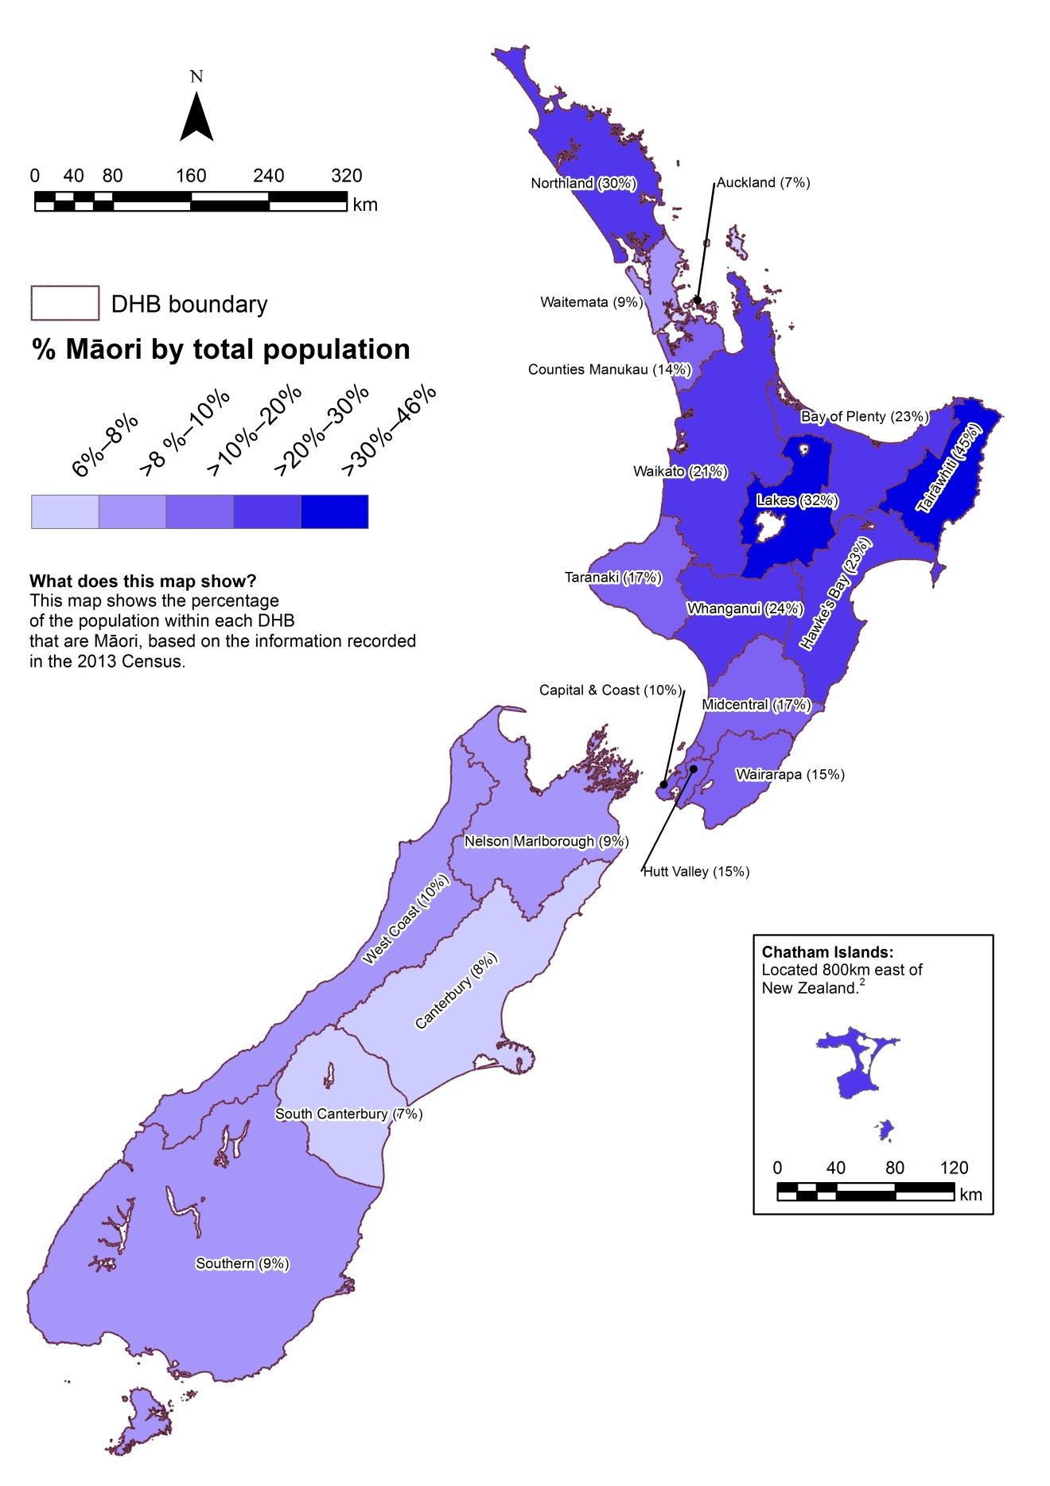
Note: Prioritised ethnicity has been used − see ‘Ngā tapuae me ngā raraunga: Methods and data sources’ for further information.
Source: Ministry of Health

Ngā awe o te hauora: Socioeconomic determinants of health
Socioeconomic position is regarded as a major determinant of health. Factors such as income, employment status, housing and education can have both direct and indirect impacts on health. These impacts can be cumulative over lifetimes (Robson et al 2007, p 21). This section presents measures for neighbourhood deprivation experienced by Māori, followed by socioeconomic indicators and racial discrimination.

Neighbourhood deprivation
NZDep2013 is a small-area-based index providing a measure of neighbourhood deprivation, by looking at the comparative socioeconomic positions of small areas and assigning them decile numbers from 1 (least deprived) to 10 (most deprived). The index is based on nine socioeconomic variables from the 2013 Census. It describes the general socioeconomic deprivation of an area. An area’s decile score does not necessarily mean all individuals living in that area experience an equivalent level of deprivation. Table 4 presents Māori and non-Māori populations in 2013 by deprivation decile.

Table 4: Populations by neighbourhood deprivation decile (NZDep 2013) and by gender, Māori and non-Māori, 2013
NZDep2013 decile | Māori |  |  | Non-Māori
 | Males | Females | Total | Males | Females | Total
1 (least deprived) | 11,457 | 11,385 | 22,845 | 194,241 | 202,266 | 396,504
2 | 14,346 | 14,424 | 28,773 | 193,155 | 202,428 | 395,583
3 | 16,047 | 15,957 | 32,004 | 186,231 | 195,495 | 381,726
4 | 18,345 | 18,825 | 37,173 | 178,188 | 187,359 | 365,547
5 | 22,002 | 22,704 | 44,706 | 173,019 | 182,469 | 355,488
6 | 25,911 | 26,937 | 52,848 | 166,347 | 176,040 | 342,387
7 | 30,252 | 31,575 | 61,827 | 159,444 | 170,121 | 329,565
8 | 36,840 | 39,594 | 76,434 | 150,816 | 161,703 | 312,522
9 | 47,565 | 53,163 | 100,728 | 139,296 | 148,344 | 287,640
10 (most deprived) | 65,712 | 75,177 | 140,886 | 114,054 | 118,725 | 232,779
Unknown | 159 | 222 | 381 | 4512 | 8553 | 13,068
Notes:
Due to rounding, individual figures in this table do not add to give the stated totals.
Prioritised ethnicity has been used − see ‘Ngā tapuae me ngā raraunga: Methods and data sources’ for further information.
‘Unknown’ refers to the population for whom an NZDep2013 score was not ascertained.
Source: Atkinson et al 2014

Figure 4 shows that higher proportions of Māori live in areas with higher NZDep2013 scores; that is, in more deprived areas. In 2013, 23.5 percent of Māori lived in decile 10 areas (compared with 6.8 percent of non-Māori), while only 3.8 percent lived in decile 1 areas (compared with 11.6 percent of non-Māori).

Figure 4: Neighbourhood deprivation distribution (NZDep 2013), Māori and non-Māori, 2013
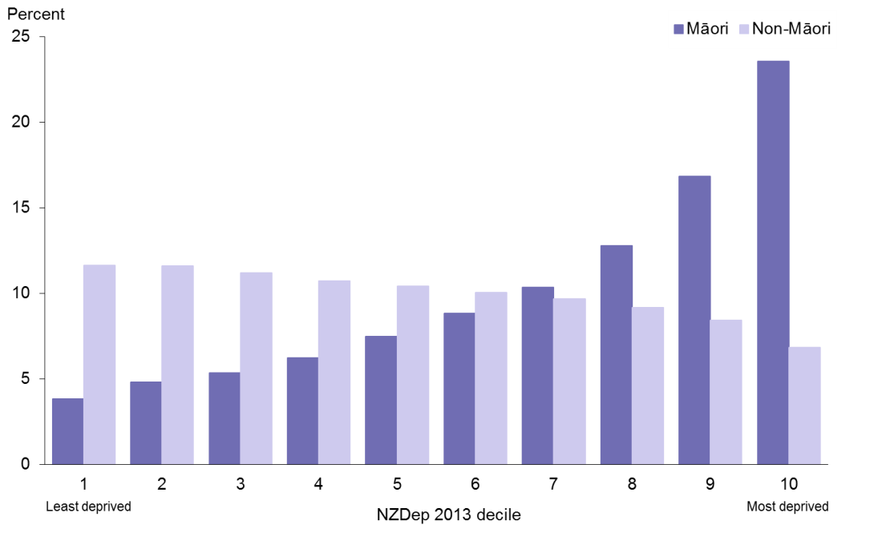
Note: Crude rates and prioritised ethnicity have been used − see ‘Ngā tapuae me ngā raraunga: Methods and data sources’ for further information.
Source: Atkinson et al 2014

Socioeconomic indicators
Table 5 shows that, in 2013, non-Māori were more advantaged than Māori across all socioeconomic indicators presented. Māori adults had lower rates of school completion and much higher rates of unemployment. More Māori adults had personal income less than $10,000, and more Māori adults received income support. Māori were more likely to live in households without any telecommunications (including internet access) and without motor vehicle access. More Māori lived in rented accommodation and lived in crowded households.

Table 5: Socioeconomic indicators, by gender, Māori and non-Māori, 2013
Indicator | Māori |  |  | Non-Māori
 | Males | Females | Total | Males | Females | Total
School completion (Level 2 Certificate or higher), 15+ years, percent, 2013 | 42.1 | 47.8 | 45.1 | 65.2 | 63.4 | 64.3
Unemployed, 15+ years, percent, 2013 | 9.8 | 10.9 | 10.4 | 3.9 | 4.1 | 4.0
Total personal income less than $10,000, 15+ years, percent, 2013 | 23.0 | 25.0 | 24.1 | 14.8 | 21.7 | 18.4
Receiving income support, 15+ years, percent, 2013 | 23.1 | 36.7 | 30.4 | 10.9 | 16.4 | 13.8
Living in household without any telecommunications, all age groups, percent, 2013 | 3.1 | 2.9 | 3.0 | 1.0 | 0.8 | 0.9
Living in household with internet access, all age groups, percent, 2013 | 69.4 | 68.6 | 69.0 | 84.3 | 83.2 | 83.8
Living in household without motor vehicle access, all age groups, percent, 2013 | 8.1 | 9.3 | 8.7 | 3.7 | 5.0 | 4.4
Living in rented accommodation, all age groups, percent, 2013 | 48.3 | 50.5 | 49.5 | 27.7 | 27.3 | 27.5
Household crowding, all age groups, percent, 2013 | 18.3 | 18.8 | 18.6 | 7.8 | 7.6 | 7.7
Notes:
Crude rates and prioritised ethnicity have been used − see ‘Ngā tapuae me ngā raraunga: Methods and data sources’ for further information.
Telecommunications include telephone, cell/mobile phone, facsimile and internet.
The household crowding measure is based on the Canadian National Crowding Index. This calculates a required number of bedrooms for each household (based on the age, sex and number of people living in the dwelling), then compares it with the actual number of bedrooms. A household is considered crowded when there are fewer bedrooms than required.
Source: Statistics New Zealand

Racial discrimination
Previous analyses, in the 2002/03 and 2006/07 NZHS, have showed that experience of racial discrimination is associated with poor health outcomes and has impact on a wide range of risk factors (Harris et al 2012). This section presents the prevalence of self-reported experience of racial discrimination ‘ever’ in a person’s lifetime using data from the 2011/12 NZHS. ‘Racial discrimination’ refers to experience of ethnically motivated personal attack (physical or verbal) and experience of unfair treatment on the basis of ethnicity in any of three situations: health care, housing or work.

Table 6: Self-reported experience of any racial discrimination, by gender, Māori and non-Māori, 2011/12
Indicator | Māori |  |  | Non-Māori
 | Males | Females | Total | Males | Females | Total
Self-reported experience of any ethnically motivated personal attack or any unfair treatment on the basis of ethnicity (ever), 15+ years, percent, 2011/12 | 30.8  (26.9–35.1) | 24.9  (22.1–28.0) | 27.5  (25.2–30.0) | 16.0  (14.4–17.9) | 13.4  (12.1–15.0) | 14.7  (13.6–15.9)
Notes:
Figures are age-standardised to the total Māori population as recorded in the 2001 Census.
Prioritised ethnicity has been used − see ‘Ngā tapuae me ngā raraunga: Methods and data sources’ for further information.
Source: 2011/12 New Zealand Health Survey, Ministry of Health

Overall, Māori adults were almost twice as likely as non-Māori adults to have experienced any type of racial discrimination (RR 1.87, CI 1.67–2.10).

Table 7: Self-reported experience of ethnically motivated personal attack, by gender, Māori and non-Māori, 2011/12
Indicator | Māori |  |  | Non-Māori
 | Males | Females | Total | Males | Females | Total
Self-reported experience of ethnically motivated physical attack (ever), 15+ years, percent, 2011/12 | 12.4  (9.5–15.9) | 3.9  (2.7–5.4) | 7.8  (6.2–9.6) | 4.4  (3.6–5.3) | 2.1  (1.6–2.6) | 3.2  (2.8–3.7)
Self-reported experience of ethnically motivated verbal attack (ever), 15+ years, percent, 2011/12 | 24.6  (20.8–28.8) | 17.9  (15.4–20.7) | 20.8  (18.6–23.3) | 12.7  (11.1–14.5) | 10.6  (9.4–11.9) | 11.7  (10.6–12.8)
Self-reported experience of any ethnically motivated personal (physical or verbal) attack (ever), 15+ years, percent, 2011/12 | 26.9  (22.9–31.3) | 18.4  (15.9–21.2) | 22.2  (19.9–24.7) | 13.9  (12.3–15.7) | 11.3  (10.1–12.7) | 12.6  (11.5–13.8)
Notes:
Figures are age-standardised to the total Māori population as recorded in the 2001 Census.
Prioritised ethnicity has been used − see ‘Ngā tapuae me ngā raraunga: Methods and data sources’ for further information.
Source: 2011/12 New Zealand Health Survey, Ministry of Health

Māori adults were more than one-and-a-half times as likely as non-Māori adults to have experienced any ethnically motivated personal (physical or verbal) attack (RR 1.78,
CI 1.57–2.01). The disparity was greater for rates of experience of physical attack: Māori adults were more than twice as likely as non-Māori adults to have experienced physical attack (RR 2.35, CI 1.78–3.09).

Table 8: Self-reported experience of unfair treatment on the basis of ethnicity, by gender, Māori and non-Māori, 2011/12
Indicator | Māori |  |  | Non-Māori
 | Males | Females | Total | Males | Females | Total
Self-reported experience of unfair treatment by a health professional on the basis of ethnicity (ever), 15+ years, percent, 2011/12 | 3.7  (2.2–5.9) | 4.8  (3.7–6.1) | 4.2  (3.4–5.3) | 0.9  (0.6–1.3) | 1.6  (1.3–2.1) | 1.3  (1.0–1.5)
Self-reported experience of unfair treatment at work or being refused a job unfairly because of ethnicity (ever), 15+ years, percent, 2011/12 | 8.1  (6.1–10.7) | 5.1  (3.8–6.8) | 6.5  (5.2–8.0) | 2.8  (2.3–3.5) | 3.0  (2.4–3.7) | 2.9  (2.5–3.4)
Self-reported experience of unfair treatment when renting or buying a house on the basis of ethnicity (ever), 15+ years, percent, 2011/12 | 3.9  (2.4–6.0) | 6.3  (5.0–8.0) | 5.1  (4.1–6.4) | 0.9  (0.6–1.2) | 0.8  (0.6–1.1) | 0.9  (0.7–1.0)
Self-reported experience of any unfair treatment on the basis of ethnicity (ever), 15+ years, percent, 2011/12 | 12.6  (9.8–16.0) | 12.4  (10.3–14.8) | 12.4  (10.7–14.4) | 4.0  (3.3–4.7) | 4.5  (3.9–5.3) | 4.2  (3.8–4.7)
Notes:
Figures are age-standardised to the total Māori population as recorded in the 2001 Census.
Prioritised ethnicity has been used − see ‘Ngā tapuae me ngā raraunga: Methods and data sources’ for further information.
Source: 2011/12 New Zealand Health Survey, Ministry of Health

Māori adults were almost three times as likely as non-Māori adults to have experienced any unfair treatment on the basis of ethnicity (RR 2.95, CI 2.43–3.58). The disparity was greater for rates of experience of unfair treatment in housing among females: Māori females were more than seven times as likely as non-Māori females to have experienced unfair treatment in renting or buying houses because of ethnicity (RR 7.35, CI 5.02–10.76).

Ngā tauwehe tūpono me te marumaru: Risk and protective factors
Differences in socioeconomic position between Māori and non-Māori are likely to contribute to differences in individual risk and protective factors, which in turn impact on health outcomes.

This section presents data on individual risk and protective factors comprising tobacco smoking, alcohol use, nutrition, body size and physical activity.

Tobacco smoking
Table 9: Daily smoking in people aged 14–15 years, by gender, Māori and non-Māori, 2014
Indicator | Māori |  |  | Non-Māori
 | Males | Females | Total | Males | Females | Total
Daily smoking (self-reported),  14−15 years, percent, 2014 | 5.4  (4.8–6.1) | 8.8  (7.9–9.8) | 7.2  (6.4–8.0) | 1.7  (1.5–2.0) | 1.7  (1.5–1.9) | 1.7  (1.5–1.9)
Notes:
Crude rates and prioritised ethnicity have been used − see ‘Ngā tapuae me ngā raraunga: Methods and data sources’ for further information.
‘Daily smoking’ refers to smoking at least once a day.
Source: ASH Year 10 Snapshot Survey 2014

Young Māori (aged 14–15 years) had a much higher prevalence of tobacco smoking than non-Māori in the same age group.

Table 10: Current smoking in people aged 15 and over, by gender, Māori and non-Māori, 2013/14
Indicator | Māori |  |  | Non-Māori
 | Males | Females | Total | Males | Females | Total
Current smoking (self-reported), 15+ years, percent, 2013/14 | 41.1  (36.4–45.9) | 42.7  (39.5–46.0) | 42.0  (39.2–44.9) | 17.9  (16.2–19.8) | 13.2  (12.0–14.5) | 15.5  (14.5–16.6)
Notes:
Figures are age-standardised to the total Māori population as recorded in the 2001 Census.
Prioritised ethnicity has been used − see ‘Ngā tapuae me ngā raraunga: Methods and data sources’ for further information.
‘Current smoking’ refers to having smoked more than 100 cigarettes in a lifetime and currently smoking at least monthly.
Source: 2013/14 New Zealand Health Survey, Ministry of Health

Māori adults were almost three times as likely as non-Māori adults to smoke (RR 2.71,
CI 2.47–2.97). The disparity was greater for females: Māori females were more than three times as likely as non-Māori females to smoke (RR 3.23, CI 2.89–3.60).

Alcohol use
Table 11: Alcohol use indicators, by gender, Māori and non-Māori, 2013/14
Indicator | Māori |  |  | Non-Māori
 | Males | Females | Total | Males | Females | Total
Consumed alcohol in the past 12 months, 15+ years, percent, 2013/14 | 83.1  (80.2–85.6) | 79.4  (76.9–81.7) | 80.9  (79.0–82.7) | 83.4  (81.8–85.0) | 76.1  (74.5–77.7) | 79.6  (78.5–80.7)
Drank alcohol 4 or more times a week in the past 12 months (among past year drinkers), 15+ years, percent, 2013/14 | 11.9  (9.1–15.3) | 8.1  (6.0–10.8) | 9.9  (8.1–12.2) | 20.4  (18.8–22.1) | 13.0  (11.7–14.4) | 16.9  (15.7–18.1)
Drank large amounts of alcohol at least weekly in the past 12 months (among past year drinkers), 15+ years, percent, 2013/14 | 22.7  (19.3–26.5) | 16.9  (14.7–19.4) | 19.7  (17.5–22.0) | 15.1  (13.3–17.1) | 7.6  (6.4–8.9) | 11.5  (10.4–12.6)
Notes:
Figures are age-standardised to the total Māori population as recorded in the 2001 Census.
Prioritised ethnicity has been used − see ‘Ngā tapuae me ngā raraunga: Methods and data sources’ for further information.
‘A large amount of alcohol’ is defined as more than six (for men) or four (for women) standard drinks on one drinking occasion.
Source: 2013/14 New Zealand Health Survey, Ministry of Health

Māori and non-Māori adults were equally likely to have consumed alcohol in the past year (RR 1.02, CI 0.99–1.05). Māori adult drinkers were less likely than non-Māori adult drinkers to have drunk alcohol four or more times a week in the past year (RR 0.60, CI 0.50–0.72). However, of those who had drunk in the past year, Māori were about twice as likely as non-Māori to have consumed a large amount of alcohol at least weekly (RR 1.75, CI 1.54–1.99).

Nutrition
Table 12: Nutrition indicators, by gender, Māori and non-Māori, 2013/14
Indicator | Māori |  |  | Non-Māori
 | Males | Females | Total | Males | Females | Total
3 or more servings of vegetables per day (self-reported), 15+ years, percent, 2013/14 | 58.4  (53.4–63.2) | 63.5  (60.1–66.7) | 60.8  (57.5–64.0) | 56.6  (53.7–59.5) | 63.3  (60.8–65.6) | 60.1  (58.0–62.1)
2 or more servings of fruit per day (self-reported), 15+ years, percent, 2013/14 | 45.2  (41.2–49.2) | 48.5  (45.2–51.8) | 47.0  (44.3–49.8) | 50.5  (48.2–52.9) | 60.3  (58.2–62.3) | 55.5  (53.8–57.2)
3 or more servings of vegetables and 2 or more servings of fruit per day (self-reported), 15+ years, percent, 2013/14 | 31.2  (27.3–35.5) | 35.8  (32.9–38.8) | 33.5  (31.0–36.1) | 33.3  (31.1–35.6) | 43.0  (40.8–45.3) | 38.3  (36.5–40.1)
Notes:
Figures are age-standardised to the total Māori population as recorded in the 2001 Census.
Prioritised ethnicity has been used − see ‘Ngā tapuae me ngā raraunga: Methods and data sources’ for further information.
Source: 2013/14 New Zealand Health Survey, Ministry of Health

The Ministry of Health recommends that New Zealanders eat at least three servings of vegetables and at least two servings of fruit per day (Ministry of Health 2003).

Table 12 shows that a substantial proportion of both Māori and non-Māori adults did not meet this recommended intake in 2013/14. About two-thirds of Māori adults did not meet the recommended intake. Māori adults were less likely than non-Māori adults to meet the recommended daily intake of three or more servings of vegetables and two or more servings of fruit per day (RR 0.86, CI 0.80–0.93).

Females were more likely than males to eat the recommended number of servings of vegetables and fruit servings.

Body size
A healthy body size is recognised as important for good health and wellbeing. Evidence shows that obese children and adults are at greater risk of short- and long-term health consequences (Ministry of Health 2014a).

Body mass index (BMI) provides a useful population-level indicator of excess body weight. It is a measure of weight adjusted for height, and is calculated by dividing weight in kilograms by the square of height in metres (kg/m²). This measure is used internationally to classify underweight, overweight and obesity. It should be noted that BMI is a crude measure, and does not distinguish between weight associated with muscle and weight associated with fat. However, it is considered to be a good estimate of increased risk of health conditions associated with obesity (WHO 2007).

From July 2012, the NZHS measured height using a laser meter, replacing the stadiometers used in the 2006/07 and 2011/12 NZHSs. Refer to the Indicator Interpretation Guide 2013/14: New Zealand Health Survey for more details (Ministry of Health 2014b).

Table 13: International BMI cut-off points for adults aged 18 years and over
Classification | BMI score (kg/m²) | Risk of health conditions
Underweight | <18.50 | Low risk
Normal range | 18.50–24.99 | Average risk
Overweight | 25.00–29.99 | Increased risk
Obese | ≥ 30.00 | Substantially increased risk
Note: Risk only includes health conditions associated with increasing BMI.
Source: WHO 2007

Details on the classification of overweight and obesity in children under 18 years can be found in Cole et al (2000, 2007).

There is an association between BMI and health risk (Asia Pacific Cohort Studies Collaboration 2004), and therefore data on BMI distribution, as well as BMI cut-offs, is useful. For this reason, this chart book presents data on mean BMI and mean waist measurement (cm) as well as the prevalence of overweight and obesity.

Table 14: Body size indicators, children aged 5–14 years, by gender, Māori and non-Māori, 2013/14
Indicator | Māori |  |  | Non-Māori
 | Males | Females | Total | Males | Females | Total
Overweight, 5−14 years, percent, 2013/14 | 28.8  (24.0–34.1) | 29.2  (24.6–34.3) | 29.0  (25.3–33.0) | 18.9  (16.1–22.1) | 23.4  (19.7–27.5) | 21.1  (18.7–23.7)
Obese, 5−14 years, percent, 2013/14 | 18.1  (14.0–23.1) | 17.7  (13.1–23.4) | 17.9  (14.5–21.9) | 7.8  (5.8–10.4) | 9.1  (7.0–11.7) | 8.4  (6.8–10.4)
Mean BMI score, 5–14 years, 2013/14 | 19.5  (19.1–20.0) | 19.3  (18.9–19.7) | 19.4  (19.1–19.7) | 18.3  (18.0–18.5) | 18.4  (18.1–18.6) | 18.3  (18.1–18.5)
Notes:
Figures are age-standardised to the total Māori population as recorded in the 2001 Census.
Prioritised ethnicity has been used − see ‘Ngā tapuae me ngā raraunga: Methods and data sources’ for further information.
Source: 2013/14 New Zealand Health Survey, Ministry of Health

Māori children were more likely to be overweight than non-Māori children (RR 1.38,
CI 1.15–1.65). Māori children were more than twice as likely to be obese as non-Māori children (RR 2.13, CI 1.58–2.87). Māori children had a slightly higher mean BMI score than non-Māori children (RR 1.06, CI 1.04–1.09).

Table 15: Body size indicators, adults aged 15 and over, by gender, Māori and non-Māori, 2013/14
Indicator | Māori |  |  | Non-Māori
 | Males | Females | Total | Males | Females | Total
Overweight, 15+ years, percent, 2013/14 | 33.4  (30.0–37.0) | 27.6  (24.0–31.4) | 30.4  (27.8–33.0) | 39.2  (37.3–41.3) | 28.2  (26.6–29.9) | 33.6  (32.3–34.9)
Obese, 15+ years, percent, 2013/14 | 42.0  (38.2–45.8) | 47.2  (43.8–50.6) | 44.7  (42.1–47.3) | 24.7  (22.8–26.6) | 24.7  (23.0–26.6) | 24.7  (23.6–25.9)
Mean BMI score,15+ years, 2013/14 | 29.8  (29.2–30.3) | 30.6  (30.1–31.1) | 30.2  (29.8–30.6) | 27.2  (27.0–27.5) | 26.9  (26.6–27.2) | 27.1  (26.9–27.2)
Mean waist measurement (cm), 15+ years, 2013/14 | 99.1  (97.7–100.5) | 94.0  (92.7–95.4) | 96.4  (95.4–97.4) | 93.7  (93.0–94.4) | 84.4  (83.7–85.0) | 88.9  (88.5–89.4)
Notes:
Figures are age-standardised to the total Māori population as recorded in the 2001 Census.
Prioritised ethnicity has been used − see ‘Ngā tapuae me ngā raraunga: Methods and data sources’ for further information.
Source: 2013/14 New Zealand Health Survey, Ministry of Health

Māori adults were less likely than non-Māori adults to be overweight (RR 0.89, CI 0.82–0.96). However, Māori adults were more than one-and-a-half times as likely to be obese as non-Māori adults (RR 1.76, CI 1.65–1.87). Māori adults had higher mean BMI scores (RR 1.11, CI 1.10–1.13) and mean waist measurements (RR 1.08, CI 1.07–1.09) than non-Māori adults.

Physical activity
Table 16: Physical activity indicators, by gender, Māori and non-Māori, 2013/14
Indicator | Māori |  |  | Non-Māori
 | Males | Females | Total | Males | Females | Total
Regular physical activity (self-reported), 15+ years, percent, 2013/14 | 57.7  (53.7–61.5) | 45.2  (41.4–49.0) | 51.1  (48.3–53.9) | 55.1  (52.5–57.6) | 48.7  (45.7–51.8) | 51.9  (49.5–54.2)
Notes:
Figures are age-standardised to the total Māori population as recorded in the 2001 Census.
Prioritised ethnicity has been used − see ‘Ngā tapuae me ngā raraunga: Methods and data sources’ for further information.
‘Regular physical activity’ is defined as at least 30 minutes of physical activity per day on five or more days of the week.
Source: 2013/14 New Zealand Health Survey, Ministry of Health

Māori and non-Māori adults, regardless of gender, reported similar levels of physical activity in the 2013/14 NZHS (RR 0.96, CI 0.91–1.02).

In 2013/14, Sport and Recreation New Zealand (SPARC) ran its fifth national Active New Zealand Survey, which provided new benchmarks for monitoring physical activity.

Sport and Recreation New Zealand’s physical activity guidelines state that adults should participate in at least 30 minutes of moderate-intensity physical activity on most (at least five), if not all, days of the week. This is referred to as the 30 x 5 recommendation.

Results from the 2013/14 Active New Zealand Survey showed that 38.5 percent of Māori met the 30 x 5 recommendation, compared with 34.7 percent of the total New Zealand population. For further information, see
www.sportnz.org.nz/managing-sport/research/201314-active-nz-survey-2

Ngā mana hauora tūtohu: Health status indicators
This section presents a range of indicators relating to health status, including life expectancy, disability, major causes of death, cardiovascular disease, cancer, respiratory disease, diabetes, infectious disease, immunisation, suicide and intentional self-harm, interpersonal violence, oral health, mental health, infant health and unintentional injury.

Life expectancy
Figure 5: Life expectancy at birth, by gender, Māori and non-Māori, 1951–2013
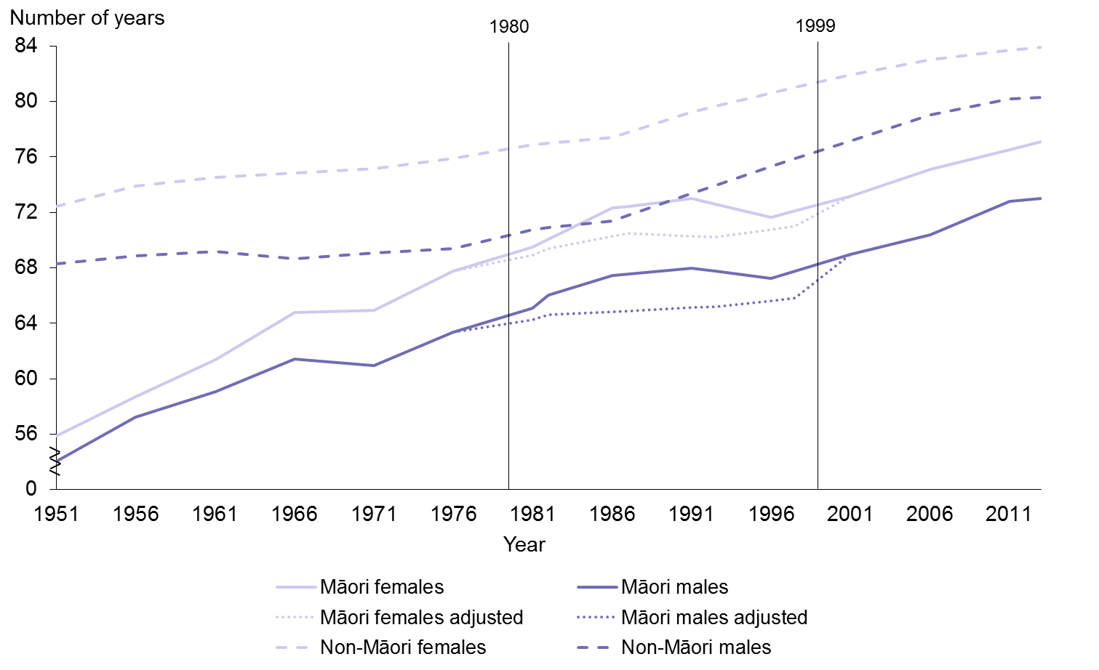
Notes:
Adjusted life expectancy estimates for Māori 1980−1999 use estimates from the New Zealand Census − Mortality Study (NZCMS) graphed at the mid-point of each time period. From 2001, adjusted estimates are close to unadjusted.
Prioritised ethnicity has been used − see ‘Ngā tapuae me ngā raraunga: Methods and data sources’ for further information.
Sources: Blakely et al 2007; Statistics New Zealand

In 2013, life expectancy at birth was 73.0 years for Māori males and 77.1 years for Māori females; it was 80.3 years for non-Māori males and 83.9 years for non-Māori females.

During the 1980s and early 1990s, Māori mortality was seriously undercounted due to the different definitions of ethnicity on death registration, birth registration and census forms. The dotted lines on Figure 5 for Māori males and females represent adjusted, more reliable life expectancy figures for this period, calculated from data in the NZCMS (Ajwani et al 2003; Blakely et al 2007).

Figure 5 shows that Māori life expectancy rapidly increased up until the late 1970s or early 1980s, after which it was (mostly) static, while non-Māori life expectancy continued to increase. Since the late 1990s, Māori life expectancy has been increasing at about the same rate as non-Māori, or even slightly faster (Blakely et al 2007). The gap between Māori and non-Māori life expectancy at birth had narrowed to 7.1 years by 2012–14. This continues the trend of a narrowing gap, from 9.1 years in 1995–97 to 8.5 years in 2000–02, and to 8.2 years in 2005–07 (Statistics New Zealand 2015b).

Statistics New Zealand changed the methods it uses to derive life tables in 2012–14. This new modelling technique was used to help with the estimation of death rates for small populations. For further details on the method, see www.stats.govt.nz/browse_for_stats/health/life_expectancy/NZLifeTables_HOTP12-14.aspx

Disability
The 2013 New Zealand Disability Survey estimated that a total of 1.1 million (24 percent) New Zealanders were disabled (Statistics New Zealand 2014). Disability was defined in the survey as any self-perceived limitation in activity resulting from a long-term condition or health problem lasting or expected to last six months or more and not completely eliminated by an assistive device. People were not considered to have a disability if an assistive device such as glasses or crutches eliminated their impairment.

Table 17: Disability prevalence, by age group and gender, Māori and non-Māori, 2013
Indicator | Māori |  |  | Non-Māori
 | Males | Females | Total | Males | Females | Total
Total disabled (of total population), 0–14 years, percent, 2013 | 19.0 | 10.6 | 14.9 | 11.0 | 7.2 | 9.2
Total disabled (of total population), 15–24 years, percent, 2013 | 20.3 | 23.5 | 20.9 | 14.0 | 13.8 | 13.9
Total disabled (of total population), 25–44 years, percent, 2013 | 24.7 | 22.2 | 23.3 | 14.0 | 15.3 | 14.7
Total disabled (of total population), 45–64 years, percent, 2013 | 39.6 | 45.3 | 43.6 | 26.0 | 26.1 | 26.1
Total disabled (of total population), 65+ years, percent, 2013 | 73.7 | 50.0 | 62.2 | 55.1 | 57.0 | 55.9
Note: Crude rates and prioritised ethnicity have been used − see ‘Ngā tapuae me ngā raraunga: Methods and data sources’ for further information.
Source: 2013 New Zealand Disability Survey, Statistics New Zealand

Table 17 shows that Māori had a higher disability rate than non-Māori, regardless of age, in 2013. Older people had higher disability rates generally.

Figures 6 and 7 show that, for both Māori and non-Māori, more than half of disabled children and young adults (aged under 44 years) had a single impairment, but more than 60 percent of disabled adults aged 45 years and over had multiple impairment.

The top three impairment types for both Māori and non-Māori children were: difficulty with learning, psychiatric or psychological impairments, and difficulty with speaking. The top three impairment types for adults were: mobility impairment, hearing impairment and agility impairment (data not shown here).

Common causes of impairment for children, regardless of ethnicity, were conditions that existed at birth or due to disease or illness. For adults, common causes were accident or injury (especially for males), disease or illness, and ageing (data not shown here).

Figure 6: Prevalence of single or multiple impairments among Māori, by age group and gender, 2013
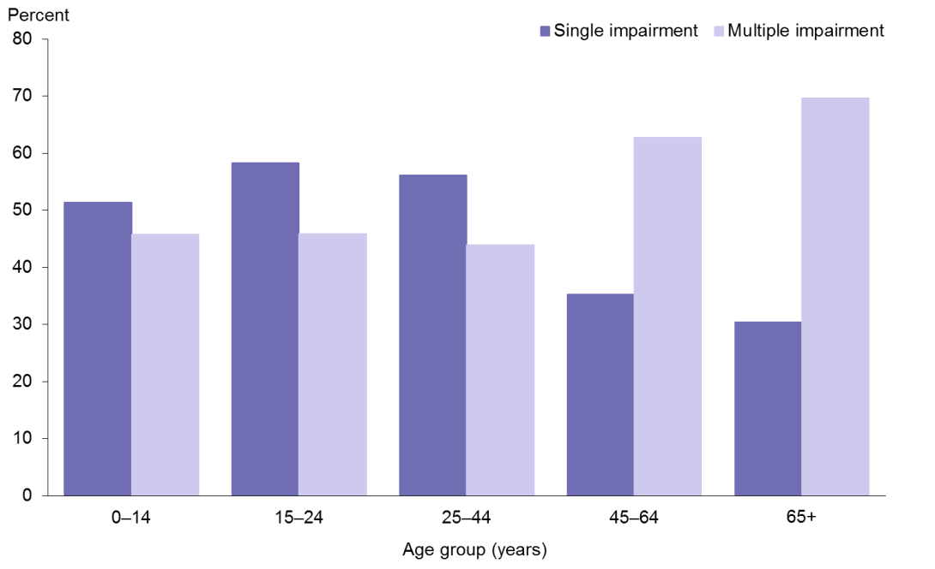
Note: Crude rates and prioritised ethnicity have been used − see ‘Ngā tapuae me ngā raraunga: Methods and data sources’ for further information.
Source: 2013 New Zealand Disability Survey, Statistics New Zealand

Figure 7: Prevalence of single or multiple impairments among non-Māori, by age group and gender, 2013
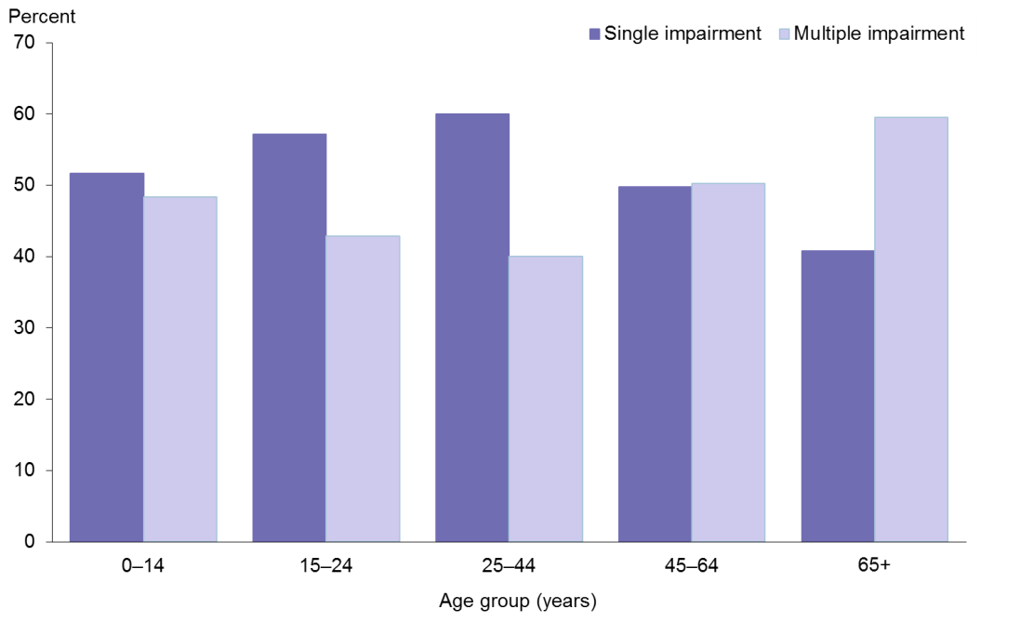
Note: Crude rates and prioritised ethnicity have been used − see ‘Ngā tapuae me ngā raraunga: Methods and data sources’ for further information.
Source: 2013 New Zealand Disability Survey, Statistics New Zealand

Table 18: Prevalence of unmet need for special equipment among total disabled population, by age group and gender, Māori and non-Māori, 2013
Indicator | Māori |  |  | Non-Māori
 | Males | Females | Total | Males | Females | Total
Unmet need for special equipment  (of total disabled), 0–14 years, percent, 2013 | 21.7 | 16.7 | 20.0 | 27.0 | 17.4 | 23.3
Unmet need for special equipment  (of total disabled), 15–24 years, percent, 2013 | 7.7 | 16.7 | 12.5 | 5.4 | 6.1 | 5.7
Unmet need for special equipment  (of total disabled), 25–44 years, percent, 2013 | 10.5 | 18.2 | 17.1 | 9.0 | 10.3 | 9.7
Unmet need for special equipment  (of total disabled), 45–64 years, percent, 2013 | 23.8 | 20.7 | 21.6 | 17.6 | 14.2 | 15.8
Unmet need for special equipment  (of total disabled), 65+ years, percent, 2013 | 28.6 | 33.3 | 30.4 | 18.6 | 16.2 | 17.4
Note: Crude rates and prioritised ethnicity have been used − see ‘Ngā tapuae me ngā raraunga: Methods and data sources’ for further information.
Source: 2013 New Zealand Disability Survey, Statistics New Zealand

Table 18 shows that Māori disabled children were less likely than non-Māori disabled children to have an unmet need for special equipment, but for all other groups unmet need was higher in Māori.

Table 19: Prevalence of unmet need for health professional among total disabled population, by age group and gender, Māori and non-Māori, 2013
Indicator | Māori |  |  | Non-Māori
 | Males | Females | Total | Males | Females | Total
Unmet need to see a health professional (of total disabled),  0–14 years, percent, 2013 | 17.4 | 16.7 | 17.1 | 10.8 | 17.4 | 15.0
Unmet need to see a health professional (of total disabled),  15–24 years, percent, 2013 | 15.4 | 25.0 | 20.8 | 10.8 | 12.1 | 11.4
Unmet need to see a health professional (of total disabled),  25–44 years, percent, 2013 | 21.1 | 40.9 | 31.7 | 20.9 | 21.8 | 21.4
Unmet need to see a health professional (of total disabled),  45–64 years, percent, 2013 | 19.0 | 24.1 | 21.6 | 12.0 | 13.4 | 13.1
Unmet need to see a health professional (of total disabled),  65+ years, percent, 2013 | 7.1 | Data not available | 4.3 | 4.8 | 4.8 | 4.8
Notes:
Crude rates and prioritised ethnicity have been used − see ‘Ngā tapuae me ngā raraunga: Methods and data sources’ for further information.
Data was not available where Statistics New Zealand suppressed estimates less than 1000 (they are subject to sampling errors too high for most practical purposes).
Source: 2013 New Zealand Disability Survey, Statistics New Zealand

Table 19 shows that Māori adults aged 65 years and over with a disability were less likely to have an unmet need to consult with a health professional than non-Māori disabled adults in the same age group, but for all other age groups unmet need was higher in Māori.

Disabled children, regardless of ethnicity, attended appointments with their doctors or their dentists most commonly, out of all health professionals. Disabled adults consulted most commonly with doctors, followed by nurses and pharmacists (data not shown here).

About 10 percent of carers of both Māori and non-Māori disabled children received help with personal care for the child. The top three types of help young disabled adults (aged 15–24 years) received were help with doing paperwork, help with making decisions and help with communicating with other people. The top three types of help disabled adults aged 25 years and over received were help with heavy chores, help with normal household chores and help with shopping (data not shown here).

Major causes of death
Causes of death have been ranked in two different ways in this chart book: first by age-standardised mortality rates (Table 20) and then by years of life lost (YLL) (Table 21).

Table 20: Major causes of death, ranked by age-standardised mortality rates, by gender, Māori and non-Māori, 2010–12
 | Males | Females
Māori | Ischaemic heart disease | Lung cancer
 | Lung cancer | Ischaemic heart disease
 | Suicide | Chronic obstructive pulmonary disease
 | Diabetes | Cerebrovascular disease (stroke)
 | Motor vehicle accidents | Diabetes
Non-Māori | Ischaemic heart disease | Ischaemic heart disease
 | Suicide | Breast cancer
 | Lung cancer | Cerebrovascular disease (stroke)
 | Cerebrovascular disease (stroke) | Lung cancer
 | Motor vehicle accidents | Colorectal cancer
Notes:
Figures are age-standardised to the total Māori population as recorded in the 2001 Census.
Prioritised ethnicity has been used − see ‘Ngā tapuae me ngā raraunga: Methods and data sources’ for further information.
Source: Mortality Collection Data Set (MORT), Ministry of Health

Table 20 shows that ischaemic heart disease was the leading cause of death for Māori males and both non-Māori males and females, and the second leading cause of death for Māori females.

Lung cancer was the leading cause of death for Māori females and the second leading cause of death for Māori males. It was also in the top five causes of death for non-Māori.

Suicide was the third leading cause of death for Māori males and the second leading cause of death for non-Māori males.

Diabetes featured in the top five causes of death for Māori but did not feature in the top five for non-Māori.

Motor vehicle accidents were the fifth leading cause of death for both Māori and non-Māori males, but not for either Māori or non-Māori females.

Apart from suicide and motor vehicle accidents for males, the major causes of death were all chronic diseases, regardless of gender or ethnicity.

Growing old is a natural biological process, and death, being inevitable, reflects population health status only to a limited extent. Therefore, YLL is used in this chart book to provide a measure of the social burden of premature mortality across the life span, including deaths in old age. See Appendix 3 for further information about YLL.

Table 21: Major causes of death, ranked by YLL, by gender, Māori and non-Māori, 2010–12
 | Males | Females
Māori | Ischaemic heart disease | Lung cancer
 | Suicide | Ischaemic heart disease
 | Lung cancer | Breast cancer
 | Motor vehicle accidents | Chronic obstructive pulmonary disease
 | Diabetes | Cerebrovascular disease (stroke)
Non-Māori | Ischaemic heart disease | Ischaemic heart disease
 | Lung cancer | Cerebrovascular disease (stroke)
 | Cerebrovascular disease (stroke) | Breast cancer
 | Suicide | Lung cancer
 | Colorectal cancer | Colorectal cancer
Note: Prioritised ethnicity has been used − see ‘Ngā tapuae me ngā raraunga: Methods and data sources’ for further information.
Source: Mortality Collection Data Set (MORT), Ministry of Health

When considering cause of death by YLL, Table 21 shows that the major causes of premature death were still dominated by chronic diseases.

Ischaemic heart disease was the leading cause of premature death for Māori males and both non-Māori males and females, and it was the second leading cause of premature death for Māori females.

Lung cancer was the leading cause of premature death for Māori females and it was in the top five leading causes of premature death for Māori male and non-Māori.

Suicide was the second leading cause of premature death for Māori male and it was the fourth leading cause of premature death for non-Māori males.

Motor vehicle accidents were the fourth leading cause of premature death for Māori males, but were not in the top five for Māori females, or for non-Māori of either gender.

Diabetes was the fifth leading cause of premature death for Māori males but not for non-Māori males, neither for Māori or non-Māori females.

Breast cancer was the third leading cause of premature death for both Māori and non-Māori females.

Cardiovascular disease
Table 22: Cardiovascular disease indicators, by gender, Māori and non-Māori
Indicator | Māori |  |  | Non-Māori
 | Males | Females | Total | Males | Females | Total
Total cardiovascular disease mortality, 35+ years, rate per 100,000, 2010–12 | 346.9  (328.6–365.9) | 232.3  (219.2–246.1) | 286.8  (275.7–298.3) | 168.2  (165.3–171.0) | 99.2  (97.6–100.8) | 132.4  (130.8–133.9)
Total cardiovascular disease hospitalisation, 35+ years, rate per 100,000, 2012–14 | 3725.6  (3660.3–3791.8) | 2710.2  (2658.6–2762.6) | 3186.4  (3145.3–3228.0) | 2537.2  (2522.1–2552.3) | 1376.0  (1366.5–1385.7) | 1938.6  (1926.9–1947.4)
Stroke mortality, 35+ years, rate per 100,000, 2010–12 | 44.7  (38.3–51.9) | 50.6  (44.5–57.3) | 48.2  (43.7–53.0) | 30.9  (29.8–32.1) | 30.2  (29.3–31.0) | 30.9  (30.2–31.6)
Stroke hospitalisation, 35+ years, rate per 100,000, 2012–14 | 355.1  (335.3–375.8) | 374.2  (355.4–393.6) | 365.7  (352.1–379.8) | 245.1  (240.8–249.5) | 172.3  (169.2–175.4) | 207.6  (205.0–210.3)
Heart failure mortality, 35+ years, rate per 100,000, 2010–12 | 5.4  (3.3–8.3) | 4.9  (3.3–7.0) | 5.2  (3.9–6.9) | 2.2  (2.0–2.5) | 2.2  (2.0–2.4) | 2.2  (2.1–2.4)
Heart failure hospitalisation, 35+ years, rate per 100,000, 2012–14 | 676.1  (648.7–704.3) | 434.8  (414.3–456.0) | 547.5  (530.6–564.7) | 179.7  (176.4–183.0) | 96.8  (94.9–98.8) | 136.4  (134.6–138.2)
Rheumatic heart disease mortality, 15+ years, rate per 100,000, 2010–12 | 5.0  (3.6–6.9) | 5.7  (4.3–7.5) | 5.4  (4.4–6.7) | 0.9  (0.7–1.1) | 1.1  (1.0–1.3) | 1.0  (0.9–1.2)
Rheumatic heart disease hospitalisation, 15+ years, rate per 100,000, 2012–14 | 27.6  (23.8–31.8) | 48.6  (43.4–54.1) | 38.7  (35.4–42.2) | 6.8  (6.2–7.4) | 9.2  (8.5–9.9) | 8.0  (7.6–8.5)
Notes:
Figures are age-standardised to the total Māori population as recorded in the 2001 Census.
Prioritised ethnicity has been used − see ‘Ngā tapuae me ngā raraunga: Methods and data sources’ for further information.
Sources: Mortality Collection Data Set (MORT), Ministry of Health; National Minimum Data Set (NMDS), Ministry of Health

Table 22 shows that in 2010–12 the total cardiovascular disease mortality rate among Māori was more than twice as high as that among non-Māori (RR 2.17, CI 2.08–2.26). In 2012–14, Māori were more than one-and-a-half times as likely as non-Māori to be hospitalised for cardiovascular disease (RR 1.64, CI 1.61–1.67).

In the equivalent time periods, the stroke mortality rate among Māori were about one-and-a-half times as high as that of non-Māori (RR 1.56, CI 1.41–1.73), and the stroke hospitalisation rate among Māori were more than one-and-a-half times as high as that of non-Māori (RR 1.76, CI 1.67–1.86). The disparity was greater for females: the stroke hospitalisation rate among Māori females was more than twice as high as that among non-Māori females (RR 2.17, CI 2.02–2.34).

The heart failure mortality rate among Māori was more than twice as high as that of non-Māori (RR 2.36, CI 1.76–3.17), and Māori were about four times as likely as non-Māori to be hospitalised for heart failure (RR 4.01, CI 3.83–4.21). The disparity was greater for females: the heart failure hospitalisation rate among Māori females was about four-and-a-half times as high as that among non-Māori females (RR 4.49, CI 4.16–4.85).

The rheumatic heart disease mortality rate among Māori was over five times as high as that of non-Māori (RR 5.23, CI 3.99–6.87), and the rheumatic heart disease hospitalisation rate among Māori was almost five times as high as that of non-Māori (RR 4.82, CI 4.23–5.51). The disparity was greater for females: the rheumatic heart disease hospitalisation rate among Māori females was more than five times as high as that among non-Māori females (RR 5.30, CI 4.47–6.29).

Table 23: Ischaemic heart disease indicators, by gender, Māori and non-Māori
Indicator | Māori |  |  | Non-Māori
 | Males | Females | Total | Males | Females | Total
Ischaemic heart disease mortality, 35+ years, rate per 100,000, 2010–12 | 205.5  (191.6–220.3) | 109.5  (100.6–119.0) | 154.6  (146.5–163.0) | 103.3  (101.0–105.6) | 44.0  (43.0–45.1) | 72.1  (71.0–73.3)
Ischaemic heart disease hospitalisation, 35+ years, rate per 100,000, 2012–14 | 1095.7  (1060.0–1132.3) | 676.3  (650.4–702.9) | 872.7  (851.0–894.8) | 982.8  (973.1–992.6) | 369.5  (364.4–374.6) | 667.0  (661.7–672.4)
All re-vascularisation (coronary artery bypass graft and angioplasty) heart disease procedures, 35+ years, rate per 100,000,  2012–14 | 95.2  (84.9–106.3) | 37.0  (30.9–44.0) | 64.3  (58.4–70.6) | 91.6  (88.5–94.9) | 18.6  (17.3–19.9) | 54.1  (52.5–55.8)
Notes:
Figures are age-standardised to the total Māori population as recorded in the 2001 Census.
Prioritised ethnicity has been used − see ‘Ngā tapuae me ngā raraunga: Methods and data sources’ for further information.
Sources: Mortality Collection Data Set (MORT), Ministry of Health; National Minimum Data Set (NMDS), Ministry of Health

Ischaemic heart disease accounts for over half of all cardiovascular disease mortality. Table 23 shows that the ischaemic heart disease mortality rate among Māori was more than twice as high as that among non-Māori (RR 2.14, CI 2.02–2.27), and Māori were 1.3 times as likely as non-Māori to be hospitalised for ischaemic heart disease (RR 1.31, CI 1.26–1.36). The disparity was greater for females: the ischaemic heart disease hospitalisation rate among Māori females was almost twice as high as that among non-Māori females (RR 1.83, CI 1.73–1.94).

Māori were significantly more likely than non-Māori to have experienced a re-vascularisation heart disease procedure (coronary artery bypass graft (CABG) and angioplasty) (RR 1.19, CI 1.04–1.36). The disparity was greater for females: the CABG and angioplasty procedure rate among Māori females was almost twice as high as that among non-Māori females (RR 1.99, CI 1.55–2.57).

The risk of ischaemic heart disease and cardiovascular disease (mortality and hospitalisation) was higher among males than females. The relative differences were greater between Māori and non-Māori females than between Māori and non-Māori males.

Cancer
Table 24: Cancer indicators, by gender, Māori and non-Māori, 2010–12
Indicator | Māori |  |  | Non-Māori
 | Males | Females | Total | Males | Females | Total
Total cancer registrations, 25+ years, rate per 100,000,  2010–12 | 455.5  (438.1–473.5) | 552.5  (534.4–571.1) | 506.3  (493.6–519.1) | 419.2  (414.6–423.9) | 394.7  (390.1–399.3) | 405.8  (402.6–409.1)
Total cancer mortality, 25+ years, rate per 100,000, 2010–12 | 218.4  (206.5–230.7) | 214.5  (203.6–225.9) | 215.6  (207.6–223.9) | 133.0  (130.6–135.3) | 110.0  (108.0–112.1) | 120.3  (118.8–121.9)
Notes:
Figures are age-standardised to the total Māori population as recorded in the 2001 Census.
Prioritised ethnicity has been used − see ‘Ngā tapuae me ngā raraunga: Methods and data sources’ for further information.
Sources: Mortality Collection Data Set (MORT), Ministry of Health; New Zealand Cancer Registry (NZCR), Ministry of Health

Māori adults aged 25 and over had significantly higher cancer registration rates than non-Māori adults for total cancers in 2010–12 (RR 1.25, CI 1.21–1.28). The total-cancer mortality rate among Māori adults was more than one-and-a-half times as high as that among non-Māori adults (RR 1.79, CI 1.72–1.87).

Figure 8 shows that the most common cancers registered for Māori females over this time period were breast cancer, lung cancer, colorectal cancer, uterine cancer and cervical cancer. Figure 9 shows that the leading causes of cancer death for Māori females were lung cancer, breast cancer, colorectal cancer, stomach cancer and uterine cancer.

Māori females had a breast cancer registration rate 1.4 times that of non-Māori females (RR 1.40, CI 1.32–1.50). Māori females were around one-and-a-half times as likely to die from breast cancer as non-Māori females (RR 1.59, CI 1.37–1.83).

For cervical cancer, Māori females had a registration rate twice that of non-Māori females (RR 2.06, CI 1.64–2.58), and the mortality rate for Māori females was about two-and-a-half times that of non-Māori females (RR 2.57, CI 1.70–3.90).

Māori females had a lung cancer registration rate over four times that of non-Māori females (RR 4.26, CI 3.89–4.66). This disparity was similar in terms of mortality; Māori female lung cancer mortality was over four times that of non-Māori females (RR 4.30, CI 3.88–4.77).

Although Māori females had a significantly lower colorectal cancer registration rate than non-Māori females (RR 0.80, CI 0.70–0.92), there was no significant difference for colorectal cancer mortality rates between Māori females and non-Māori females (RR 0.84, CI 0.67–1.05).

Figure 8: Female cancer registration rates, by site, 25+ years, Māori and non-Māori,
2010–12
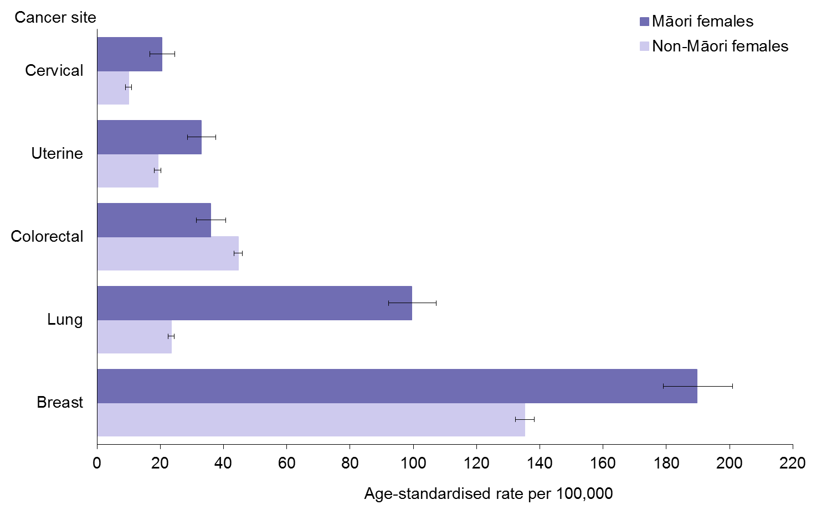
Notes:
Figures are age-standardised to the total Māori population as recorded in the 2001 Census.
Prioritised ethnicity has been used − see ‘Ngā tapuae me ngā raraunga: Methods and data sources’ for further information.
Source: New Zealand Cancer Registry (NZCR), Ministry of Health

Figure 9: Female cancer mortality rates, by site, 25+ years, Māori and non-Māori, 2010–12
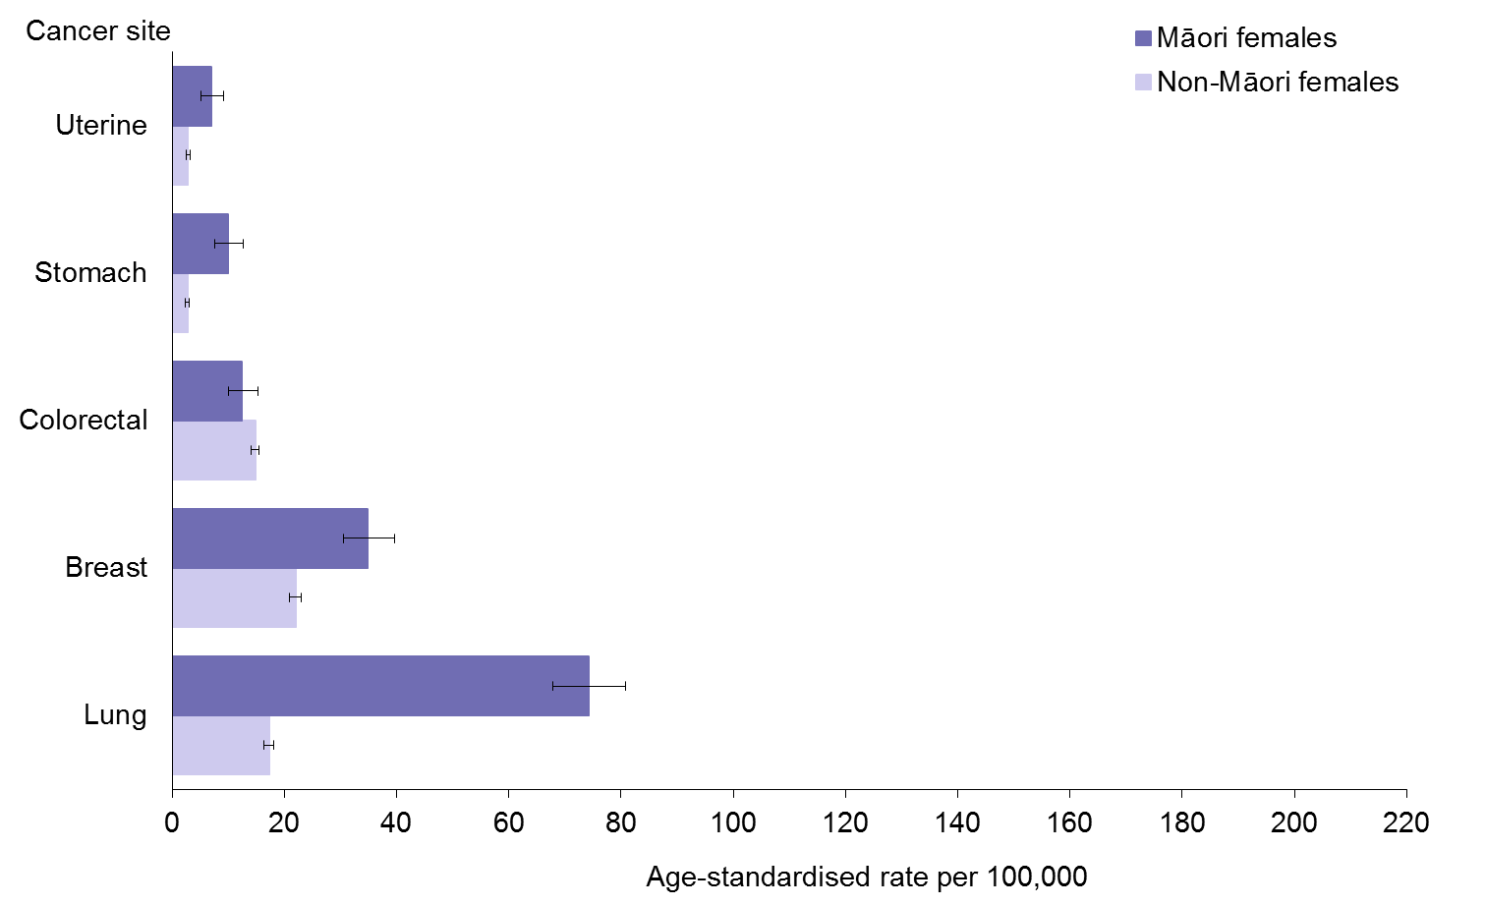
Notes:
Figures are age-standardised to the total Māori population as recorded in the 2001 Census.
Prioritised ethnicity has been used − see ‘Ngā tapuae me ngā raraunga: Methods and data sources’ for further information.
Source: Mortality Collection Data Set (MORT), Ministry of Health

The most common cancer registration sites for Māori males were prostate cancer, lung cancer, colorectal cancer, liver cancer and stomach cancer (Figure 10). The leading causes of cancer mortality for Māori males were lung cancer, colorectal cancer, prostate cancer, liver cancer and stomach cancer (Figure 11).

Māori male lung cancer registration and mortality rates were nearly three times those of non-Māori males (RR 2.84, CI 2.58–3.13 for registration; RR 2.78, CI 2.50–3.10 for mortality).

Colorectal cancer registration rates were significantly lower for Māori males than for non-Māori males (RR 0.80, CI 0.70–0.91). However, there was no significant difference in rates of colorectal cancer mortality between Māori and non-Māori males (RR 1.06, CI 0.87–1.28).

For Māori males, liver cancer registration and mortality rates were almost three-and-a-half times those of non-Māori males (RR 3.43, CI 2.83–4.17 for registration; RR 3.43, CI 2.71–4.33 for mortality).

Prostate cancer registration was significantly lower for Māori males than for non-Māori males (RR 0.80, CI 0.73– 0.88). However, Māori males had a prostate cancer mortality rate over one-and-a-half times that of non-Māori males (RR 1.51, CI 1.25–1.83).

The rate of stomach cancer registration was almost three times as high for Māori males than that for non-Māori males (RR 2.84, CI 2.32–3.49). The rate of stomach cancer mortality for Māori males was more than two-and-a-half times that for non-Māori males (RR 2.53,
CI 1.97–3.26).

For many cancers, the cancer registration rates for Māori were less than or similar to the cancer registration rates for non-Māori; however, the mortality rates were higher for Māori than for non-Māori. This suggests that Māori with cancer have a higher risk of dying from their cancer than non-Māori.

Figure 10: Male cancer registration rates, by site, 25+ years, Māori and non-Māori,
2010–12
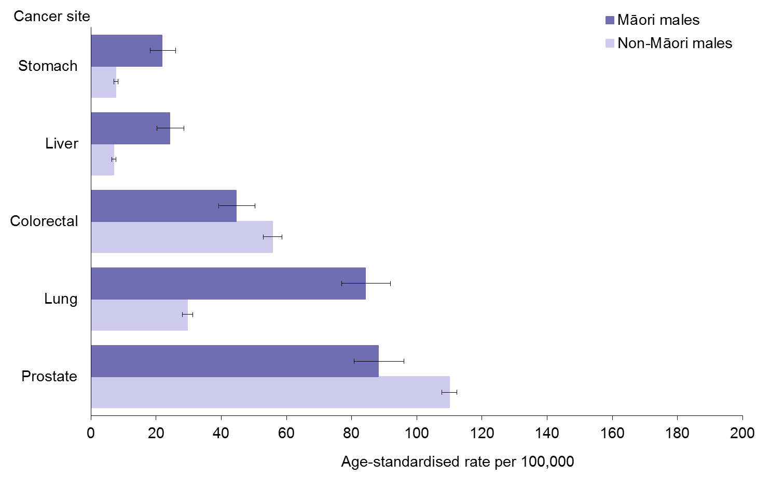
Notes:
Figures are age-standardised to the total Māori population as recorded in the 2001 Census.
Prioritised ethnicity has been used − see ‘Ngā tapuae me ngā raraunga: Methods and data sources’ for further information.
Source: New Zealand Cancer Registry (NZCR), Ministry of Health

Figure 11: Male cancer mortality rates, by site, 25+ years, Māori and non-Māori, 2010–12
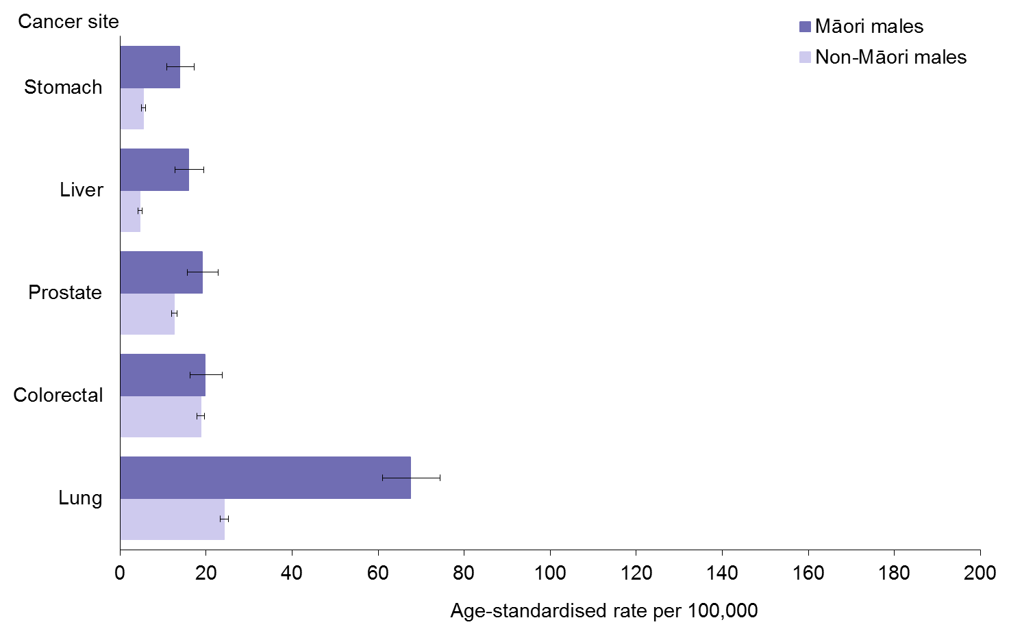
Notes:
Figures are age-standardised to the total Māori population as recorded in the 2001 Census.
Prioritised ethnicity has been used − see ‘Ngā tapuae me ngā raraunga: Methods and data sources’ for further information.
Source: Mortality Collection Data Set (MORT), Ministry of Health

Table 25: Female cancer screening indicators, Māori and non-Māori
Indicator | Māori | Non-Māori
BreastScreen Aotearoa coverage for 24 months to 31 March 2015, females aged 45–69 years, percent | 64.4 | 73.8
BreastScreen Aotearoa coverage for 24 months to 31 March 2015, females aged 50–69 years, percent | 64.6 | 73.4
National Cervical Screening Programme three-year coverage to 31 March 2015, females aged 25–69 years, percent | 62.6 | 78.4
National Cervical Screening Programme three-year coverage to 31 March 2015, females aged 20–69 years, percent | 60.2 | 75.6
Note: Crude rates and prioritised ethnicity have been used − see ‘Ngā tapuae me ngā raraunga: Methods and data sources’ for further information.
Source: National Screening Unit, Ministry of Health

There are screening programmes for both breast and cervical cancer in New Zealand. Table 25 shows that for both these programmes, coverage rates were lower for Māori than for non-Māori.

The BreastScreen Aotearoa (BSA) programme is a free national breast X-ray (mammography) service offered two-yearly to women aged between 45 and 69 years. The most recent two-year screening coverage rate represents a full screening round with two-yearly two-view mammographic screening. More information about the BSA programme can be found at: www.nsu.govt.nz/health-professionals/breastscreen-aotearoa/breast-screening-coverage

The National Cervical Screening Programme (NCSP) coverage percentage represents the proportion of women aged 20–69 years who enrolled on the NCSP register had had a cervical smear in the 36 months prior to the reporting period. A 36-month interval was used because this is the recommended cervical screening interval. More information about the NCSP programme can be found at: www.nsu.govt.nz/health-professionals/national-cervical-screening-programme/cervical-screening-coverage

Respiratory disease
Table 26: Asthma indicators, by gender, Māori and non-Māori
Indicator | Māori |  |  | Non-Māori
 | Males | Females | Total | Males | Females | Total
Asthma hospitalisation, 5−34 years, rate per 100,000, 2012−14 | 193.7  (182.1–205.9) | 247.9  (234.8–261.6) | 222.4  (213.6–231.5) | 112.6  (107.7–117.8) | 113.3  (108.6–118.1) | 113.2  (109.8–116.7)
Diagnosed asthma (self-reported), 15–45 years, percent, 2013/14 | 9.8  (7.4–12.9) | 15.8  (12.9–19.3) | 13.1  (11.4–15.1) | 8.6  (7.1–10.3) | 11.8  (10.2–13.7) | 10.2  (9.1–11.4)
Notes:
Figures are age-standardised to the total Māori population as recorded in the 2001 Census.
Prioritised ethnicity has been used − see ‘Ngā tapuae me ngā raraunga: Methods and data sources’ for further information.
‘Diagnosed asthma’ refers to people who reported that a doctor had told them that they had asthma and that they were currently taking medication (inhalers, medicine tablets, pills or other medication) to treat it.
Sources: 2013/14 New Zealand Health Survey, Ministry of Health; National Minimum Data Set (NMDS), Ministry of Health

Table 26 shows that Māori aged 5–34 years were almost twice as likely as non-Māori in the same age group to have been hospitalised for asthma (RR 1.96, CI 1.87–2.07).

In 2013/14, Māori aged 15–45 years were more likely than non-Māori in the same age group to report being diagnosed with asthma (RR 1.27, CI 1.06–1.52).

Table 27: Chronic obstructive pulmonary disease indicators, by gender, Māori and non-Māori
Indicator | Māori |  |  | Non-Māori
 | Males | Females | Total | Males | Females | Total
Chronic obstructive pulmonary disease mortality, 45+ years, rate per 100,000, 2010–12 | 106.9  (93.7–121.3) | 110.6  (98.5–123.8) | 108.5  (99.6–118.1) | 43.7  (41.9–45.5) | 32.1  (30.7–33.6) | 37.0  (35.9–38.1)
Chronic obstructive pulmonary disease hospitalisation, 45+ years, rate per 100,000, 2012–14 | 1157.0  (1110.4–1205.1) | 1804.5  (1747.0–1863.4) | 1498.9  (1461.3–1537.2) | 447.2  (439.7–454.8) | 391.3  (384.5–398.2) | 417.0  (412.0–422.1)
Notes:
Figures are age-standardised to the total Māori population as recorded in the 2001 Census.
Prioritised ethnicity has been used − see ‘Ngā tapuae me ngā raraunga: Methods and data sources’ for further information.
Sources: Mortality Collection Data Set (MORT), Ministry of Health; National Minimum Data Set (NMDS), Ministry of Health

The chronic obstructive pulmonary disease (COPD) mortality rate among Māori aged 45 and over in 2010–12 was almost three times that of non-Māori in the same age group (RR 2.94, CI 2.68–3.22). The disparity was greater for females: Māori females had a COPD mortality rate almost three-and-a-half times that of non-Māori females (RR 3.44, CI 3.03–3.91).

Māori aged 45 and over had a COPD hospitalisation rate over three-and-a-half times that of non-Māori at the same age group in 2012–14 (RR 3.59, CI 3.46–3.74). Again, the relative disparity was greater for females: Māori females had a COPD hospitalisation rate more than four-and-a-half times that of non-Māori females (RR 4.61, CI 4.38–4.85).

Diabetes
Table 28: Diabetes indicators, by gender, Māori and non-Māori
Indicator | Māori |  |  | Non-Māori
 | Males | Females | Total | Males | Females | Total
Diagnosed diabetes prevalence (self-reported), 15+ years, percent, 2013/14 | 6.0  (4.7–7.5) | 5.3  (4.1–6.7) | 5.6  (4.7–6.6) | 3.5  (2.9–4.1) | 2.1  (1.6–2.6) | 2.8  (2.4–3.1)
Diabetes complications – renal failure with concurrent diabetes (type 1 and type 2 diabetes), 15+ years, rate per 100,000, 2012−14 | 115.1  (106.5–124.1) | 81.1  (74.5–88.1) | 97.1  (91.7–102.7) | 20.7  (19.7–21.8) | 14.5  (13.7–15.3) | 17.5  (16.9–18.2)
Diabetes complications – lower limb amputation with concurrent diabetes (type 1 and type 2 diabetes), 15+ years, rate per 100,000, 2012−14 | 41.8  (36.7–47.3) | 22.3  (18.9–26.2) | 31.4  (28.4–34.6) | 13.3  (12.5–14.1) | 5.3  (4.8–5.8) | 9.1  (8.7–9.6)
Notes:
Figures are age-standardised to the total Māori population as recorded in the 2001 Census.
Prioritised ethnicity has been used − see ‘Ngā tapuae me ngā raraunga: Methods and data sources’ for further information.
Sources: 2013/14 New Zealand Health Survey, Ministry of Health; National Minimum Data Set (NMDS), Ministry of Health

Table 28 shows that the self-reported prevalence of diabetes among Māori was about twice that of non-Māori in 2013/14 (RR 1.99, CI 1.65–2.40). It also shows that there are much higher disparities between Māori and non-Māori for diabetes complications.

Renal failure is one of the complications of diabetes. Rates of renal failure with concurrent diabetes for Māori aged 15 and over were more than five times that of non-Māori at the same age group in 2012–14 (RR 5.55, CI 5.07–6.07). While some of this difference can be attributed to the higher prevalence of diabetes among Māori, the disproportionately higher rate suggests that Māori with diabetes are more likely to have renal failure than non-Māori with diabetes. The extent of the disparity can be estimated by dividing the relative risk of renal failure by the relative risk of prevalence (ie, 5.55 ÷ 1.99), which suggests that among people with diabetes, Māori are 2.8 times as likely as non-Māori to have renal failure.

Lower limb amputation is another complication of diabetes. Similarly, rates of lower limb amputation with concurrent diabetes for Māori were over three times that of non-Māori in
2012–14 (RR 3.44, CI 2.96–3.99). Therefore, among people with diabetes, lower limb amputations among Māori can be estimated as 1.7 times that of non-Māori (ie, 3.44 ÷ 1.99).

Table 29: Type 2 diabetes (diagnosed after 25 years of age) prevalence, by gender, Māori and non-Māori, 2013/14
Indicator | Māori |  |  | Non-Māori
 | Males | Females | Total | Males | Females | Total
Type 2 diabetes (diagnosed after 25 years of age) prevalence (self-reported), 15+ years, percent, 2013/14 | 5.2  (4.1–6.7) | 4.3  (3.1–5.7) | 4.7  (3.9–5.6) | 3.1  (2.5–3.7) | 1.7  (1.3–2.1) | 2.4  (2.0–2.7)
Notes:
Figures are age-standardised to the total Māori population as recorded in the 2001 Census.
Prioritised ethnicity has been used − see ‘Ngā tapuae me ngā raraunga: Methods and data sources’ for further information.
Source: 2013/14 New Zealand Health Survey, Ministry of Health

Māori adults were about one-and-a-half times as likely as non-Māori adults to have been diagnosed with diabetes after 25 years of age in 2013/14; that is, the self-reported prevalence of type 2 diabetes for Māori was about 50 percent higher than that for non-Māori (RR 1.49, CI 1.32–1.69).

Infectious disease
Table 30: Meningococcal disease notification rates, Māori and total New Zealand population, 2013
Indicator | Māori | Total New Zealand population
Meningococcal disease notifications, all age groups, rate per 100,000, 2013 | 3.4 | 1.5
Meningococcal disease notifications, less than one year old, rate per 100,000, 2013 | 32.3 | 18.4
Meningococcal disease notifications, 1–4 years, rate per 100,000, 2013 | 15.7 | 5.2
Note: Crude rates and prioritised ethnicity have been used − see ‘Ngā tapuae me ngā raraunga: Methods and data sources’ for further information.
Source: Institute of Environmental Science and Research Limited (ESR)

The frequency of meningococcal disease notifications was higher for Māori than for the total New Zealand population in 2013 for all age groups. The meningococcal disease notification rate for Māori infants aged less than one year old was 1.8 times as high as that of the total New Zealand rate. For toddlers aged 1–4 years, the meningococcal disease notifications for Māori were about three times as high as for the total New Zealand population.

Table 31: Tuberculosis notification rates, Māori and total New Zealand population, 2014
Indicator | Māori | Total New Zealand population
Tuberculosis notifications, all age groups, rate per 100,000, 2014 | 5.8 | 6.8
Note: Crude rates and prioritised ethnicity have been used − see ‘Ngā tapuae me ngā raraunga: Methods and data sources’ for further information.
Source: Institute of Environmental Science and Research Limited (ESR)

Māori had a lower rate of tuberculosis notifications than the total New Zealand population in 2014 for all age groups.

Table 32: Acute rheumatic fever initial hospitalisation rates, by gender, Māori and non-Māori, 2012–14
Indicator | Māori |  |  | Non-Māori
 | Males | Females | Total | Males | Females | Total
Acute rheumatic fever initial hospitalisation (exclude recurrences), all ages, rate per 100,000, 2012−14 | 16.1  (13.6–18.8) | 10.4  (8.4–12.7) | 13.3  (11.7–15.1) | 4.6  (3.9–5.4) | 3.8  (3.1–4.5) | 4.2  (3.7–4.7)
Notes:
Figures are age-standardised to the total Māori population as recorded in the 2001 Census.
Prioritised ethnicity has been used − see ‘Ngā tapuae me ngā raraunga: Methods and data sources’ for further information.
Source: National Minimum Data Set (NMDS), Ministry of Health

The initial hospitalisation rate for acute rheumatic fever among Māori was more than three times as high as that for non-Māori in 2012–14 (RR 3.16, CI 2.66–3.77). As noted previously, hospitalisations and mortality for rheumatic heart disease were also higher for Māori than for non-Māori (see the ‘Cardiovascular disease’ section).

Immunisation
Childhood immunisation coverage information from the National Immunisation Register (NIR) shows that in 2014, at the age of eight months, 88.9 percent of Māori children had completed age-appropriate immunisations, compared with 91.9 percent of total New Zealand children. By two years of age, the coverage rates were 91.9 percent for Māori children and 92.8 percent for total New Zealand children. Further data are available from the NIR:
www.health.govt.nz/our-work/preventative-health-wellness/immunisation/immunisation-coverage/national-and-dhb-immunisation-data

The human papillomavirus (HPV) immunisation is free for all girls and young women up to their 20th birthday living in New Zealand. It protects young women from HPV infection and the risk of developing cervical cancer and a range of other HPV-related diseases later in life. The average HPV immunisation coverage rate (for completion of all three doses) for all girls born between 1997 and 2001 was 57.5 percent; the coverage rate was higher for Māori girls (63.4%). More information about the HPV immunisation programme can be found at: www.health.govt.nz/our-work/preventative-health-wellness/immunisation/hpv-immunisation-programme

Suicide and intentional self-harm
Table 33: Suicide rates, by age group and gender, Māori and non-Māori, 2010–12
Indicator | Māori |  |  | Non-Māori
 | Males | Females | Total | Males | Females | Total
Suicide mortality, all age groups, rate per 100,000, 2010−12 | 24.7  (21.6–28.0) | 9.8  (8.0–12.0) | 16.9  (15.1–18.8) | 14.0  (13.1–14.9) | 4.4  (4.0–5.0) | 9.1  (8.6–9.6)
Suicide mortality, 15−24 years, rate per 100,000, 2010−12 | 52.4  (42.5–63.9) | 29.2  (22.0–38.0) | 40.7  (34.5–47.7) | 23.5  (20.2–27.2) | 7.4  (5.6–9.6) | 15.6  (13.7–17.7)
Suicide mortality, 25−44 years, rate per 100,000, 2010−12 | 41.1  (33.3–50.2) | 11.1  (7.4–15.9) | 25.1  (20.9–29.9) | 22.3  (19.9–24.9) | 6.6  (5.4–8.0) | 14.2  (12.8–15.6)
Suicide mortality, 45−64 years, rate per 100,000, 2010−12 | 20.6  (14.2–28.7) | 4.2  (1.8–8.3) | 11.9  (8.6–16.1) | 21.6  (19.3–24.2) | 7.4  (6.1–8.9) | 14.4  (13.0–15.8)
Notes:
Figures are age-standardised to the total Māori population as recorded in the 2001 Census.
Prioritised ethnicity has been used − see ‘Ngā tapuae me ngā raraunga: Methods and data sources’ for further information.
Source: Mortality Collection Data Set (MORT), Ministry of Health

Māori suicide rates were near twice as high as those of non-Māori in 2010–12 (RR 1.85,
CI 1.64–2.10). The disparity was greater for females: Māori females were more than twice as likely as non-Māori females to commit suicide (RR 2.22, CI 1.76–2.81).

Males overall had significantly higher suicide mortality rates than females.

Young adults aged 15–24 years had the highest suicide rate.

Table 34: Intentional self-harm indicators, by age group and gender, Māori and non-Māori, 2012–14
Indicator | Māori |  |  | Non-Māori
 | Males | Females | Total | Males | Females | Total
Intentional self-harm hospitalisation, all age groups, rate per 100,000, 2012−14 | 76.3  (70.8–82.1) | 129.9  (123.1–137.0) | 103.0  (98.6–107.5) | 51.6  (49.7–53.4) | 122.2  (119.2–125.2) | 86.6  (84.8–88.4)
Intentional self-harm hospitalisation, 15−24 years, rate per 100,000, 2012−14 | 135.5  (119.4–153.0) | 293.3  (269.5–318.7) | 213.5  (119.2–228.7) | 107.6  (100.5–115.2) | 323.9  (310.8–337.3) | 212.9  (205.6–220.5)
Intentional self-harm hospitalisation, 25−44 years, rate per 100,000, 2012−14 | 131.2  (116.8–146.8) | 148.5  (134.4–163.7) | 140.5  (130.3–151.2) | 72.2  (67.8–76.7) | 133.1  (127.4–139.0) | 103.6  (100.0–107.3)
Intentional self-harm hospitalisation, 45−64 years, rate per 100,000, 2012−14 | 72.0  (60.0–85.8) | 98.0  (84.7–112.9) | 85.8  (76.6–95.8) | 63.5  (59.4–67.8) | 85.0  (80.4–89.8) | 74.6  (71.5–77.8)
Notes:
Figures are age-standardised to the total Māori population as recorded in the 2001 Census.
Prioritised ethnicity has been used − see ‘Ngā tapuae me ngā raraunga: Methods and data sources’ for further information.
Source: National Minimum Data Set (NMDS), Ministry of Health

Māori overall were significantly more likely than non-Māori to be hospitalised for intentional self-harm in 2012–14 (RR 1.19, CI 1.13–1.25).

The hospitalisation rates for intentional self-harm for women were twice as high as for men. Māori males were about one-and-a-half times as likely as non-Māori males to be hospitalised for intentional self-harm (RR 1.48, CI 1.36–1.61).

Young people in the 15–24 years age group had the highest rate of hospitalisation for intentional self-harm. Māori males in the 15–24 years and 25–44 years age groups had significantly higher rates of hospitalisation for intentional self-harm than non-Māori males in the same age groups.

Interpersonal violence
Table 35: Interpersonal violence indicators, by gender, Māori and non-Māori
Indicator | Māori |  |  | Non-Māori
 | Males | Females | Total | Males | Females | Total
Assault and homicide mortality, 15+ years, rate per 100,000, 2010−12 | 4.9  (3.3–7.0) | 1.6  (0.8–2.8) | 3.1  (2.3–4.2) | 1.3  (1.0–1.7) | 1.0  (0.7–1.4) | 1.2  (1.0–1.4)
Assault and attempted homicide hospitalisations, 15+ years, rate per 100,000, 2012−14 | 294.5  (281.5–307.9) | 109.6  (102.0–117.5) | 197.2  (189.9–204.8) | 98.4  (95.2–101.7) | 18.7  (17.4–20.1) | 58.4  (56.7–60.2)
Notes:
Figures are age-standardised to the total Māori population as recorded in the 2001 Census.
Prioritised ethnicity has been used − see ‘Ngā tapuae me ngā raraunga: Methods and data sources’ for further information.
Sources: Mortality Collection Data Set (MORT), Ministry of Health; National Minimum Data Set (NMDS), Ministry of Health

Māori adults were more likely than non-Māori adults to suffer adverse health effects as the victims of violence. Māori adults were more than two-and-a-half times as likely as non-Māori to die from assault and homicide (RR 2.67, CI 1.83–3.90). The disparity was greater for males: the Māori male rate was nearly four times as high as that of non-Māori males (RR 3.66,
CI 2.31–5.80).

Māori rates of hospitalisation as the result of assault or attempted homicide were also significantly higher than those for non-Māori (RR 3.38, CI 3.21–3.55). The disparity was greater for females: the Māori female rate was nearly six times as high as that of non-Māori females (RR 5.87, CI 5.28–6.52).

Oral health
Table 36: Dental status for age 5 years and year 8 children, Māori and total New Zealand population, 2013
Indicator | Māori |  | Total New Zealand population
 | Fluoridated supply | Non-fluoridated supply | Fluoridated supply | Non-fluoridated supply
Mean number of missing or filled teeth at 5 years of age, 2013 | 2.5 | 3.7 | 1.7 | 2.1
Mean number of missing or filled teeth at school year 8, 2013 | 1.4 | 2.0 | 1.0 | 1.3
Caries-free at 5 years of age, percent, 2013 | 42.5 | 32.3 | 59.5 | 55.2
Caries-free at school year 8, percent, 2013 | 47.0 | 38.8 | 56.2 | 51.7
Note: Crude rates and prioritised ethnicity have been used − see ‘Ngā tapuae me ngā raraunga: Methods and data sources’ for further information.
Source: Community Oral Health Services

At school entry (5 years of age), Māori children had a higher mean number of missing or filled teeth than non-Māori children in 2013, and were less likely to be caries-free. This was the case for people living in areas with both fluoridated and non-fluoridated water supplies.

There was some reduction in the disparity by school year 8, although Māori children still had a higher mean number of missing and filled teeth than non-Māori and were less likely to be caries-free.

Table 37: Dental visit and dental treatment indicators, by gender, Māori and non-Māori, 2013/14
Indicator | Māori |  |  | Non-Māori
 | Males | Females | Total | Males | Females | Total
Visited a dental health care worker in previous year (self-reported), 1–14 years, percent, 2013/14 | 82.2  (78.8–85.2) | 82.6  (79.0–85.7) | 82.4  (79.9–84.7) | 83.6  (80.8–86.0) | 84.8  (82.7–86.8) | 84.2  (82.4–85.9)
Visited a dental health care worker in previous year (self-reported), 15+ years, percent, 2013/14 | 33.6  (30.2–37.1) | 42.0  (38.5–45.6) | 38.3  (35.7–41.0) | 45.0  (42.9–47.1) | 51.5  (49.3–53.7) | 48.3  (46.7–49.8)
Usually only visits a dental health care worker for dental problems, or never visits, among adults with natural teeth (self-reported), 15+ years, percent, 2013/14 | 75.8  (72.0–79.2) | 71.3  (67.8–74.6) | 73.4  (70.8–75.8) | 53.6  (51.2–56.0) | 48.3  (45.7–51.0) | 50.9  (48.7–53.0)
Had any teeth extracted due to decay, abscess or infection in previous year (self-reported), 1–14 years, percent, 2013/14 | 7.1  (5.0–10.1) | 4.0  (2.7–5.8) | 5.6  (4.3–7.3) | 2.9  (2.0–4.0) | 4.2  (2.8–6.1) | 3.5  (2.7–4.6)
Had any teeth extracted due to decay, abscess, infection or gum disease in previous year (self-reported), 15+ years, percent, 2013/14 | 8.2  (6.4–10.4) | 10.3  (8.5–12.6) | 9.4  (8.0–11.0) | 6.0  (5.2–6.9) | 5.6  (4.8–6.5) | 5.8  (5.2–6.4)
Notes:
Figures are age-standardised to the total Māori population as recorded in the 2001 Census.
Prioritised ethnicity has been used − see ‘Ngā tapuae me ngā raraunga: Methods and data sources’ for further information.
Source: 2013/14 New Zealand Health Survey, Ministry of Health

There was no significant difference between Māori and non-Māori children (RR 0.98,
CI 0.95–1.01) in terms of the frequency of their having visited a dentist in the past 12 months, in 2013/14. However, Māori adults were less likely than non-Māori adults to have visited a dentist in the past 12 months (RR 0.77, CI 0.72–0.83).

Among adults with natural teeth, Māori adults were more likely than non-Māori to report that they had never visited a dental health care worker at all, or usually only visited a dental health care worker for dental problems (RR 1.44, CI 1.38–1.51).

Māori children were more than one-and-a-half times as likely as non-Māori children to have had any teeth extracted due to decay, abscess or infection in the past 12 months (RR 1.60,
CI 1.08–2.37). Similarly, Māori adults were about one-and-a-half times as likely as non-Māori adults to have had any teeth extracted due to decay, abscess, infection or gum disease in the past 12 months (RR 1.49, CI 1.25–1.77).

Mental health
Table 38: High or very high probability of anxiety or depressive disorder, by gender, Māori and non-Māori, 2013/14
Indicator | Māori |  |  | Non-Māori
 | Males | Females | Total | Males | Females | Total
High or very high probability of anxiety or depressive disorder, 15+ years, percent, 2013/14 | 9.6  (7.1–13.0) | 9.5  (7.5–11.8) | 9.4  (7.7–11.4) | 4.5  (3.6–5.6) | 7.6  (6.4–9.0) | 6.0  (5.2–7.0)
Notes:
Figures are age-standardised to the total Māori population as recorded in the 2001 Census.
Prioritised ethnicity has been used − see ‘Ngā tapuae me ngā raraunga: Methods and data sources’ for further information.
‘High or very high probability of anxiety or depressive disorder’ refers to a K10 score of 12 or more. The Kessler 10-item scale (K10) is a set of questions used internationally to screen populations for non-specific psychological distress and serious mental illness (Kessler et al 2003).
Source: 2013/14 New Zealand Health Survey, Ministry of Health

Māori adults were about one-and-a-half times as likely as non-Māori adults to report a high or very high probability of having an anxiety or depressive disorder (RR 1.56, CI 1.24–1.97). The difference was higher for males: Māori males were twice as likely as non-Māori males to report a high or very high probability of having an anxiety or depressive disorder (RR 2.04,
CI 1.36–3.04).

Infant health
Table 39: Infant health indicators, by gender, Māori and non-Māori, 2010–12
Indicator | Māori |  |  | Non-Māori
 | Males | Females | Total | Males | Females | Total
Low birthweight, rate per 1000 live births, 2010−12 | 67.5  (64.5–70.6) | 79.9  (76.6–83.4) | 73.6  (71.3–75.9) | 59.6  (57.8–61.5) | 63.3  (61.4–65.3) | 61.4  (60.1–62.8)
Infant mortality, rate per 1000 live births, 2010−12 | 7.6  (6.6–8.7) | 5.9  (5.0–6.9) | 6.8  (6.1–7.5) | 4.9  (4.4–5.4) | 4.0  (3.5–4.5) | 4.5  (4.1–4.8)
Sudden unexpected death in infancy (SUDI), rate per 1000 live births, 2010−12 | 2.1  (1.6–2.7) | 1.5  (1.0–2.0) | 1.8  (1.4–2.2) | 0.5  (0.3–0.7) | 0.3  (0.2–0.4) | 0.4  (0.3–0.5)
Sudden infant death syndrome (SIDS), rate per 1000 live births, 2010−12 | 0.9  (0.6–1.3) | 0.4  (0.2–0.8) | 0.7  (0.5–0.9) | 0.2  (0.1–0.4) | 0.2  (0.1–0.3) | 0.2  (0.1–0.3)
Notes:
Crude rates and prioritised ethnicity have been used − see ‘Ngā tapuae me ngā raraunga: Methods and data sources’ for further information.
‘Low birthweight’ is defined as a birthweight of less than 2500 grams.
‘Infant mortality’ includes early neonatal deaths, late neonatal deaths and post-neonatal deaths.
‘Sudden unexpected death in infancy (SUDI)’ includes sudden infant death syndrome (SIDS), unintentional suffocation, and other unspecified sudden deaths or unattended deaths from unknown causes. More information can be found at www.whakawhetu.co.nz/what-sudi
‘Sudden infant death syndrome (SIDS)’ refers to deaths for which no identifiable cause can be found following autopsy, clinical history and scene examination. Babies who die from SIDS usually die in their sleep. More information can be found at www.whakawhetu.co.nz/what-sudi
Sources: Mortality Collection Data Set (MORT), Ministry of Health; Statistics New Zealand
The prevalence of low birthweight was slightly higher for Māori than non-Māori in 2010–12 (RR 1.20, CI 1.15–1.24). The Māori infant mortality rate was about one-and-a-half times as high as that of non-Māori (RR 1.52, CI 1.33–1.73).

The SUDI rate among Māori infants was nearly five times as high as that among non-Māori infants (RR 4.70, CI 3.35–6.59). This disparity was greater for females: SUDI was more than five-and-a-half times as likely in Māori baby girls as it was in non-Māori baby girls (RR 5.63, CI 3.18–9.95).

The SIDS rate for Māori infants was about three times that of non-Māori infants (RR 3.12, CI 1.92–5.07). This disparity was greater for males: SIDS was nearly four times as likely in Māori baby boys as it was in non-Māori baby boys (RR 3.80, CI 2.03–7.13).

Table 40: Breastfeeding indicators, by gender, Māori and non-Māori, 2013/14
Indicator | Māori |  |  | Non-Māori
 | Males | Females | Total | Males | Females | Total
Exclusively breastfed at 13 weeks (among children aged 13 weeks–4 years), percent, 2013/14 | 57.9  (49.7–65.6) | 69.0  (63.2–74.3) | 63.2  (58.1–68.1) | 72.5  (66.7–77.6) | 71.8  (66.6–76.5) | 72.2  (68.2–75.8)
Exclusively breastfed at 26 weeks (among children aged 26 weeks–4 years), percent, 2013/14 | 43.2  (36.7–49.9) | 51.8  (44.3–59.1) | 47.3  (42.5–52.2) | 56.0  (49.8–62.0) | 55.2  (49.4–60.8) | 55.6  (51.2–59.9)
Notes:
Figures are age-standardised to the total Māori population as recorded in the 2001 Census.
Prioritised ethnicity has been used − see ‘Ngā tapuae me ngā raraunga: Methods and data sources’ for further information.
‘Exclusively breastfed’ means the infant has not been given any liquids or solids (other than prescription medicines) other than breast milk.
Source: 2013/14 New Zealand Health Survey, Ministry of Health

Māori babies were significantly less likely than non-Māori babies to have been exclusively breastfed when they were three months (13 weeks) old (RR 0.88, CI 0.80–0.96) and six months (26 weeks) old (RR 0.85, CI 0.75–0.96).

Unintentional injury
Table 41: Unintentional injury indicators, by age group and gender, Māori and non-Māori
Indicator | Māori |  |  | Non-Māori
 | Males | Females | Total | Males | Females | Total
All unintentional injury mortality, 0−14 years, rate per 100,000, 2010−12 | 18.5  (14.4–23.5) | 11.1  (7.9–15.2) | 14.9  (12.2–18.0) | 5.7  (4.4–7.4) | 2.7  (1.7–3.9) | 4.2  (3.4–5.2)
All unintentional injury mortality, 15−64 years, rate per 100,000, 2010−12 | 53.9  (48.2–60.1) | 13.7  (11.0–16.9) | 32.8  (29.7–36.1) | 27.1  (25.4–28.8) | 11.0  (10.0–12.1) | 18.9  (18.0–19.9)
All unintentional injury mortality, 65+ years, rate per 100,000, 2010−12 | 97.0  (70.2–130.7) | 59.3  (41.7–81.7) | 75.5  (59.8–93.9) | 69.8  (65.0–74.8) | 53.4  (50.1–56.8) | 61.0  (58.1–63.9)
All unintentional injury hospitalisations, 0−14 years, rate per 100,000, 2012−14 | 1534.7  (1494.6–1575.7) | 1105.7  (1070.8–1141.4) | 1326.2  (1299.5–1353.4) | 1380.6  (1358.1–1403.3) | 968.4  (949.1–988.0) | 1179.5  (1164.6–1194.5)
All unintentional injury hospitalisations, 15−64 years, rate per 100,000, 2012−14 | 2021.2  (1958.2–2057.7) | 890.0  (867.7–912.7) | 1427.6  (1406.9–1448.6) | 1487.1  (1474.5–1499.8) | 682.5  (674.5–690.6) | 1080.8  (1073.4–1088.3)
All unintentional injury hospitalisations, 65+ years, rate per 100,000, 2012−14 | 2214.4  (2104.3–2328.8) | 2045.4  (1951.7–2142.4) | 2124.8  (2053.0–2198.5) | 2145.7  (2122.1–2169.4) | 2225.3  (2206.3–2244.5) | 2196.6  (2181.8–2211.5)
Notes:
Figures are age-standardised to the total Māori population as recorded in the 2001 Census.
Prioritised ethnicity has been used − see ‘Ngā tapuae me ngā raraunga: Methods and data sources’ for further information.
Sources: Mortality Collection Data Set (MORT), Ministry of Health; National Minimum Data Set (NMDS), Ministry of Health

Māori children aged 0–14 years had an unintentional injury mortality rate three-and-a-half times that of non-Māori children in the same age group in 2010–12 (RR 3.53, CI 2.66–4.70). Māori children had a significantly higher unintentional injury hospitalisation rate than that of non-Māori children in 2012–14 (RR 1.12, CI 1.10–1.15).

In the equivalent time periods, Māori adults aged 15–64 years had an unintentional injury mortality rate more than one-and-a-half times that for non-Māori adults in the same age group (RR 1.73, CI 1.55–1.94), and the unintentional injury hospitalisation rate for Māori was about 30 percent higher than that of non-Māori adults (RR 1.32, CI 1.30–1.34).

Māori adults aged 65 years or over had a similar unintentional injury mortality rate and hospitalisation rate as that of non-Māori (RR 1.24, CI 0.99–1.55 for mortality; RR 0.97, CI 0.92–1.02 for hospitalisation). However, Māori females in this age group had significantly lower unintentional injury hospitalisation rates than non-Māori females (RR 0.92, CI 0.86–0.98).

Table 42: Top three unintentional injury mortality categories, ranked by counts, by age group and gender, Māori and non-Māori, 2010–12
 | Māori | Non-Māori
Males | 0–14 years  Suffocation/accidental threats to breathing  Motor vehicle accidents  Accidental drowning and submersion | 0–14 years  Motor vehicle accidents  Suffocation/accidental threats to breathing  Accidental drowning and submersion
 | 15–64 years  Motor vehicle accidents  Accidental poisoning by exposure to noxious substances  Falls | 15–64 years  Motor vehicle accidents  Accidental poisoning by exposure to noxious substances  Falls
 | 65+ years  Falls  Motor vehicle accidents  Accidental poisoning by exposure to noxious substances | 65+ years  Falls  Motor vehicle accidents  Suffocation/accidental threats to breathing
Females | 0–14 years  Suffocation/accidental threats to breathing  Motor vehicle accidents  Accidental drowning and submersion | 0–14 years  Motor vehicle accidents  Accidental drowning and submersion  Suffocation/accidental threats to breathing
 | 15–64 years  Motor vehicle accidents  Accidental poisoning by exposure to noxious substances  Falls | 15–64 years  Motor vehicle accidents  Accidental poisoning by exposure to noxious substances  Falls
 | 65+ years  Falls  Motor vehicle accidents  Suffocation/accidental threats to breathing | 65+ years  Falls  Motor vehicle accidents  Suffocation/accidental threats to breathing
Note: Prioritised ethnicity has been used − see ‘Ngā tapuae me ngā raraunga: Methods and data sources’ for further information.
Source: Mortality Collection Data Set (MORT), Ministry of Health

Table 42 shows that the three most common causes of unintentional injury mortality differed by age group, gender and ethnicity in 2010–12. Motor vehicle traffic was a common cause of unintentional injury causing death for all groups. For older people aged 65 years and over, falls were the most common cause of death by unintentional injury.

Ngā ratonga hauora kua mahia: Health service use
This section presents indicators that look at use of health services, with a focus on primary health care providers. Primary health care providers are a person’s first point of contact with the health system: they include general practice teams, after-hours clinics and some community health services. This section also includes indicators on prescriptions and unmet need for health care.

Primary health care
Table 43: Primary health care access indicators, by gender, Māori and non-Māori, 2013/14
Indicator | Māori |  |  | Non-Māori
 | Males | Females | Total | Males | Females | Total
Has a GP clinic or medical centre that usually goes to when unwell or injured (self-reported), 0–14 years, percent, 2013/14 | 97.6  (95.4–98.9) | 97.7  (95.7–98.9) | 97.6  (96.3–98.6) | 97.8  (96.7–98.6) | 97.2  (95.7–98.3) | 97.5  (96.8–98.1)
Has a GP clinic or medical centre that usually goes to when unwell or injured (self-reported), 15+ years, percent, 2013/14 | 90.4  (87.3–92.9) | 96.2  (94.8–97.4) | 93.5  (91.8–94.9) | 88.8  (86.8–90.5) | 95.4  (94.4–96.3) | 92.1  (90.9–93.2)
Visited a GP in the last 12 months (self-reported), 15+ years, percent, 2013/14 | 64.4  (59.8–68.7) | 75.6  (71.6–79.1) | 70.3  (67.4–73.0) | 67.6  (65.2–69.8) | 81.5  (79.7–83.1) | 74.5  (73.0–76.0)
Visited a practice nurse (without seeing a GP at the same visit) in the last 12 months (self-reported), 15+ years, percent, 2013/14 | 21.3  (18.3–24.6) | 34.6  (31.3–38.1) | 28.5  (26.1–31.1) | 17.6  (16.4–18.9) | 32.5  (30.3–34.8) | 25.1  (23.8–26.5)
Visited an after-hours medical centre in the last 12 months (self-reported), 15+ years, percent, 2013/14 | 8.4  (6.5–10.8) | 12.0  (9.7–14.8) | 10.3  (8.7–12.1) | 10.6  (9.2–12.3) | 14.5  (12.8–16.3) | 12.5  (11.3–13.9)
Notes:
Figures are age-standardised to the total Māori population as recorded in the 2001 Census.
Prioritised ethnicity has been used − see ‘Ngā tapuae me ngā raraunga: Methods and data sources’ for further information.
Source: 2013/14 New Zealand Health Survey, Ministry of Health

Māori were equally as likely as non-Māori to report having a GP clinic or medical centre that they usually went to when unwell or injured in 2013/14 (RR 1.00, CI 0.99–1.01 for children; RR 1.01, CI 0.99–1.03 for adults).

Males were less likely to have seen any primary health workers in the past 12 months than females.

Table 43 shows that Māori adults were less likely than non-Māori adults to report having seen a GP in the last 12 months (RR 0.96, CI 0.92–0.99). Māori adults were equally as likely as non-Māori adults to have seen a nurse without seeing a GP in the same visit (RR 1.09, CI 1.00–1.19) or to have visited an after-hours medical centre in the past 12 months (RR 0.84, CI 0.69–1.02).

Table 44: Unmet need for primary health care indicators for children aged 0–14 years, by gender, Māori and non-Māori, 2013/14
Indicator | Māori |  |  | Non-Māori
 | Males | Females | Total | Males | Females | Total
Experienced one or more types of unmet need for primary health care (self-reported), 0–14 years, percent, 2013/14 | 25.0  (21.1–29.4) | 29.9  (25.9–34.2) | 27.4  (24.6–30.3) | 17.8  (15.1–20.8) | 21.1  (17.9–24.5) | 19.4  (17.4–21.6)
Unable to get appointment at usual medical centre within 24 hours (self-reported),  0–14 years, percent, 2013/14 | 14.0  (10.9–17.7) | 17.4  (14.3–21.0) | 15.6  (13.5–18.1) | 10.8  (8.5–13.6) | 12.0  (9.7–14.6) | 11.4  (9.8–13.2)
Unmet need for GP services due to cost (self-reported),  0–14 years, percent, 2013/14 | 7.7  (5.5–10.7) | 5.7  (4.1–7.7) | 6.7  (5.4–8.4) | 4.3  (3.0–5.9) | 5.1  (3.6–7.0) | 4.7  (3.6–5.9)
Unmet need for GP services due to lack of transport (self-reported), 0–14 years, percent, 2013/14 | 4.9  (3.2–7.0) | 4.2  (2.6–6.2) | 4.5  (3.3–6.0) | 1.6  (0.9–2.6) | 1.3  (0.7–2.1) | 1.4  (1.0–2.1)
Unmet need for GP services due to lack of child care (self-reported), 0–14 years, percent, 2013/14 | 3.5  (2.0–5.6) | 3.0  (1.8–4.8) | 3.3  (2.3–4.5) | 1.3  (0.6–2.6) | 1.9  (1.1–3.0) | 1.6  (1.0–2.4)
Unmet need for after-hours services due to cost (self-reported), 0–14 years, percent, 2013/14 | 5.4  (3.9–7.6) | 4.2  (2.8–6.1) | 4.9  (3.7–6.2) | 3.2  (1.9–5.0) | 3.2  (1.8–5.1) | 3.2  (2.2–4.5)
Unmet need for after-hours services due to lack of transport (self-reported),  0–14 years, percent, 2013/14 | 1.8  (0.9–3.1) | 2.4  (1.2–4.3) | 2.1  (1.3–3.1) | 0.6  (0.2–1.1) | 0.2  (0.0–0.4) | 0.4  (0.2–0.7)
Notes:
Figures are age-standardised to the total Māori population as recorded in the 2001 Census.
Prioritised ethnicity has been used − see ‘Ngā tapuae me ngā raraunga: Methods and data sources’ for further information.
Unmet need for primary health indicator investigates whether people had experienced any of the following barriers to accessing primary health care in the last 12 months: unmet need for a GP due to cost, unmet need for after-hours services due to cost, unmet need for a GP due to lack of transport, unmet need for after-hours services due to lack of transport, inability to get an appointment at their usual medical centre within 24 hours and lack of childcare for other children.
Source: 2013/14 New Zealand Health Survey, Ministry of Health

Māori children were more likely than non-Māori children to have experienced one or more types of unmet need for primary health care in 2013/14 (RR 1.41, CI 1.21–1.65).

Māori children were more likely than non-Māori children to have experienced an unmet need due to an appointment at their usual medical centre not being available within 24 hours (RR 1.38, CI 1.10–1.72).

Māori children were more likely than non-Māori children have experienced an unmet need for a GP due to cost (RR 1.45, CI 1.06–1.96).

Lack of child care was about twice as likely to be a barrier that prevented Māori parents taking their children to a GP as it was for non-Māori parents (RR 2.03, CI 1.23–3.36).

Māori children were more than three times as likely as non-Māori children to have experienced an unmet need for a GP due to lack of transportation (RR 3.12, CI 1.95–5.00).

Similarly, Māori children were more than five times as likely as non-Māori children to have experienced an unmet need for after-hours services due to a lack of transportation (RR 5.54, CI 2.48–12.34). The disparity was greater for Māori girls compared with non-Māori girls (RR 14.94, CI 3.50–63.70).

Table 45: Unmet need for primary health care indicators for adults aged 15 and over, by gender, Māori and non-Māori, 2013/14
Indicator | Māori |  |  | Non-Māori
 | Males | Females | Total | Males | Females | Total
Experienced one or more types of unmet need for primary health care (self-reported), 15+ years, percent, 2013/14 | 30.0  (26.7–33.6) | 45.3  (41.9–48.8) | 38.0  (35.5–40.7) | 21.6  (19.7–23.6) | 33.1  (30.9–35.4) | 27.4  (25.9–28.9)
Unable to get appointment at usual medical centre within 24 hours (self-reported), 15+ years, percent, 2013/14 | 15.4  (12.8–18.5) | 25.1  (22.0–28.5) | 20.7  (18.5–23.2) | 12.9  (11.3–14.7) | 18.8  (17.2–20.5) | 16.0  (14.8–17.3)
Unmet need for GP services due to cost (self-reported), 15+ years, percent, 2013/14 | 18.8  (16.0–22.0) | 25.8  (22.8–29.1) | 22.4  (20.3–24.7) | 11.4  (10.0–13.0) | 18.6  (16.9–20.5) | 15.1  (14.0–16.2)
Unmet need for GP services due to lack of transport (self-reported), 15+ years, percent, 2013/14 | 4.7  (3.2–6.5) | 6.7  (5.2–8.4) | 5.8  (4.8–7.0) | 1.7  (1.2–2.3) | 3.5  (2.9–4.1) | 2.6  (2.2–3.0)
Unmet need for after-hours services due to cost (self-reported), 15+ years, percent, 2013/14 | 8.9  (6.8–11.5) | 16.8  (14.5–19.3) | 12.9  (11.3–14.8) | 4.5  (3.7–5.5) | 8.6  (7.5–9.9) | 6.6  (5.8–7.5)
Unmet need for after-hours services due to lack of transport (self-reported), 15+ years, percent, 2013/14 | 2.0  (1.2–3.2) | 3.2  (2.3–4.4) | 2.7  (2.1–3.5) | 0.5  (0.3–0.8) | 1.5  (1.1–1.9) | 1.0  (0.8–1.2)
Notes:
Figures are age-standardised to the total Māori population as recorded in the 2001 Census.
Prioritised ethnicity has been used − see ‘Ngā tapuae me ngā raraunga: Methods and data sources’ for further information.
Unmet need for primary health indicator investigates whether people had experienced any of the following barriers to accessing primary health care in the last 12 months: unmet need for a GP due to cost, unmet need for after-hours services due to cost, unmet need for a GP due to lack of transport, unmet need for after-hours services due to lack of transport, inability to get an appointment at their usual medical centre within 24 hours and lack of childcare for other children (for the 0–14 years indicator only).
Source: 2013/14 New Zealand Health Survey, Ministry of Health
Māori adults were more likely than non-Māori adults to have experienced one or more types of unmet need for primary health care in 2013/14 (RR 1.37, CI 1.27–1.48).

Māori adults were more likely than non-Māori adults to have reported an unmet need due to being unable to get an appointment at their usual medical centre within 24 hours (RR 1.27, CI 1.15–1.41).

Māori adults were more than one-and-a-half times as likely as non-Māori adults to have experienced an unmet need for a GP due to cost (RR 1.51, CI 1.34–1.69).

Lack of transport was more than twice as likely to be a barrier to accessing GP services for Māori adults as it was for non-Māori adults (RR 2.30, CI 1.81–2.93).

Cost was almost twice as likely to be a barrier to accessing after-hours services for Māori adults as it was for non-Māori adults (RR 1.95, CI 1.65–2.30).

Lack of transport was nearly three times as likely to be a barrier to accessing after-hours services for Māori adults as it was for non-Māori adults (RR 2.83, CI 2.08–3.84). The disparity was greater for Māori males compared with non-Māori males (RR 4.56, CI 2.31–9.03).

Prescriptions
Table 46: Prescription indicators, by gender, Māori and non-Māori, 2013/14
Indicator | Māori |  |  | Non-Māori
 | Males | Females | Total | Males | Females | Total
Uncollected prescriptions due to cost in past 12 months (self-reported), 0–14 years, percent, 2013/14 | 7.7  (5.5–10.6) | 6.4  (4.7–8.7) | 7.1  (5.6–8.9) | 2.8  (1.8–4.2) | 3.2  (2.1–4.6) | 3.0  (2.2–4.1)
Uncollected prescriptions due to cost in past 12 months (self-reported), 15+ years, percent, 2013/14 | 10.8  (8.3–13.9) | 15.0  (12.6–17.8) | 13.0  (11.2–15.0) | 3.7  (3.1–4.4) | 7.1  (6.1–8.2) | 5.4  (4.8–6.1)
Notes:
Figures are age-standardised to the total Māori population as recorded in the 2001 Census.
Prioritised ethnicity has been used − see ‘Ngā tapuae me ngā raraunga: Methods and data sources’ for further information.
Source: 2013/14 New Zealand Health Survey, Ministry of Health

In 2013/14, Māori children were more than twice as likely as non-Māori children to have reported not collecting prescriptions due to cost at any time in the last 12 months (RR 2.35, CI 1.65–3.33).

Māori adults were more than twice as likely as non-Māori adults to have reported not collecting prescriptions due to cost at any time in the last 12 months (RR 2.38, CI 2.01–2.82).

Females were more likely to have not collected a prescription due to cost than males.

Ngā pūnaha hauora tūtohu: Health system indicators
The indicators in this section measure the performance of the health system, and include amenable mortality and ambulatory-sensitive hospitalisation (ASH).

The Ministry of Health defines amenable mortality as ‘deaths from those conditions for which variation in mortality rates (over time and across populations) reflects variation in the coverage and quality of health care (preventive or therapeutic services) delivered to individuals’ (Ministry of Health 2010a). Amenable mortality only includes deaths as defined above occurring in those less than 75 years of age.

The Ministry defines ASH as hospitalisations of people less than 75 years old resulting from diseases sensitive to prophylactic or therapeutic interventions that are deliverable in a primary health care setting.

Appendix 1 provides ICD-10-AM code lists for these categories.

Table 47: Health system indicators, by gender, Māori and non-Māori, 0–74-year-olds
Indicator | Māori |  |  | Non-Māori
 | Males | Females | Total | Males | Females | Total
Amenable mortality,  0–74 years, rate per 100,000, 2010–12 | 172.1  (164.6–179.8) | 116.4  (110.6–122.4) | 142.8  (138.1–147.7) | 75.2  (73.5–76.8) | 45.1  (43.8–46.3) | 59.8  (58.8–60.9)
Ambulatory-sensitive hospitalisation, 0–74 years, rate per 100,000, 2012–14 | 3013.4  (2978.9–3048.2) | 2987.7  (2954.3–3021.5) | 3001.6  (2977.5–3025.8) | 1874.7  (1863.1–1886.4) | 1776.8  (1765.4–1788.2) | 1824.8  (1813.9–1833.0)
Notes:
Figures are age-standardised to the total Māori population as recorded in the 2001 Census.
Prioritised ethnicity has been used − see ‘Ngā tapuae me ngā raraunga: Methods and data sources’ for further information.
Sources: Mortality Collection Data Set (MORT), Ministry of Health; National Minimum Data Set (NMDS), Ministry of Health

Amenable mortality rates among Māori were almost two-and-a-half times as high as those among non-Māori in 2010–12 (RR 2.39, CI 2.29–2.48).

ASH rates among Māori were more than one-and-a-half times as high as those of non-Māori in 2012–14 (RR 1.64, CI 1.63–1.66).

Saving Lives: Amenable mortality in New Zealand, 1996–2006 (Ministry of Health 2010a) contains further analyses comparing Māori with non-Māori: www.health.govt.nz/publication/saving-lives-amenable-mortality-new-zealand-1996-2006

Tāpiritanga: Appendices

Appendix 1: Data sources and ICD-10-AM codes
Table A1.1: Data sources for numerators
Source  (agency or collection) | Data | Period | Type of data
Ministry of Health | Mortality Collection Data Set (MORT) – mortality | 2010−12 | National collection
 | National Minimum Data Set (NMDS) – hospitalisations* | 2012−14 | National collection
 | New Zealand Cancer Registry (NZCR) – cancer registrations | 2010−12 | National collection
Statistics New Zealand | Low birthweight, live births | 2010−12 | Birth registration
 | Life expectancy | 1951−2013 | Life tables
 | Disability | 2013 | Survey
 | Demographics | 2013 | Census
 | Population projections | 2015−30 | Official estimates
 | Socioeconomic indicators | 2013 | Census
Institute of Environmental Science and Research Limited (ESR) | Meningococcal disease notifications | 2013 | Notifications
 | Tuberculosis notification | 2014 | Notifications
New Zealand Health Survey (NZHS) | Risk and protective factors, disease prevalence, health service use and self-rated health | 2013/14 | Survey
 | Racism | 2011/12 | Survey
Action on Smoking and Health (ASH) Snapshot Survey | Smoking prevalence for youth | 2014 | Survey
Community Oral Health Service | Oral health data for age 5 and year 8 | 2013 | Administrative
* Short stay Emergency Department (ED) events were excluded.

Table A1.2: Amenable mortality codes
Condition | ICD-10-AM code
Pulmonary tuberculosis | A15–A16
Meningococcal disease | A39
Pneumococcal disease | A40.3, G00.1, J13
HIV/AIDS | B20–B24
Cancers
Stomach | C16
Rectal | C19–C21
Bone and cartilage | C40–C41
Melanoma of skin | C43
Female breast | C50
Cervical | C53
Prostate | C61
Testis | C62
Thyroid | C73
Hodgkin lymphoma | C81
Acute lymphoblastic leukaemia* | C91.0
Complications of pregnancy | O00–O96, O98–O99
Complications of the perinatal period | P01–P03, P05–P94
Cardiac septal defect | Q21
Diabetes | E10–E14
Valvular heart disease | I01, I05–I09, I33–I37
Hypertensive diseases | I10–I13
Coronary disease | I20–I25
Pulmonary embolism | I26
Heart failure | I50
Cerebrovascular diseases | I60–I69
COPD | J40–J44
Asthma | J45–J46
Peptic ulcer disease | K25–K27
Cholelithiasis | K80
Renal failure | N17–N19
Land transport accidents excluding trains | V00**, V01–V04, V06–V14, V16–V24, V26–V34, V36–V44,  V46–V54, V56–V64, V66–V74, V76–V79, V80.0–V80.5,  V80.7–V80.9, V82–V86, V87.0–V87.5, V87.7–V87.9,  V88.0–V88.5, V88.7–V88.9, V89, V98–V99
Accidental falls on same level | W00–W08, W18
Fire | X00–X09
Suicide | X60–X84
Treatment injury | Y60–Y82
* Age 0–44 years.
** Includes V00 as used version VI of ICD-10-AM.

Table A1.3: Ambulatory-sensitive hospitalisation codes
Condition | ICD-10-AM code
Angina and chest pain* ^ | I20, R07.2–R07.4
Asthma | J45–J46
Bronchiectasis* | J47
Cellulitis | H00.0, H01.0, J34.0, L01–L04, L08, L98.0
Cervical cancer* | C53
Congestive heart failure* | I50, J81
Constipation | K59.0
Dental conditions& | K02, K04–K05
Dermatitis and eczema | L20–L30
Diabetes* | E10–E14, E16.2
Epilepsy* | G40–G41, O15, R56.0, R56.8
Gastroenteritis/dehydration | A02–A09, R11, K52.9
Gastro-oesphageal reflux disease (GORD) | K21
Hypertensive disease* | I10–I15, I67.4
Kidney/urinary infection** | N10, N12, N13.6, N30.9, N39.0
Myocardial infarction* ^ | I21–I23, I24.1
Nutrition deficiency and anaemia | D50–D53, E40–E46, E50–E64, M83.3*
Other ischaemic heart disease* ^ | I24.0, I24.8–I24.9, I25
Peptic ulcer* | K25–K28
Respiratory infections – pneumonia | J13–J16, J18
Rheumatic fever/heart disease | I00–I02, I05–I09
Sexually transmitted infections* | A50–A60, A63–A64, I98.0, M02.3, M03.1,  M73.0–M73.1, N29.0, N34.1
Stroke* ^ | I61, I63–I66
Upper respiratory tract and ENT infections | J00–J04, J06, H65–H67
Vaccine-preventable disease – meningitis, whooping cough, hepatitis B, pneumococcal disease, other*** | A33–A37, A40.3, A80, B16, B18
Vaccine-preventable disease – MMR**** | B05, B06, B26, M01.4, P35.0*
* Applicable ages ≥ 15 years.
** Applicable ages ≥ 5 years.
*** Applicable ages = 6 months to 15 years.
**** Applicable ages = 15 months to 15 years.
^ Weight = 0.5.
& Includes elective events.

Table A1.4: ICD-10-AM codes used in this report
Condition | ICD-10-AM code
Diseases of the circulatory system (total cardiovascular disease) | I00–I99
Acute rheumatic fever | I00–I02
Chronic rheumatic heart disease | I05–I09
Ischaemic heart disease | I20–I25
Heart failure | I50
Cerebrovascular disease (stroke) | I60–I69
Chronic obstructive pulmonary disease (COPD) | J40–J44
Asthma | J45–J46
All revascularisation (CABG and angioplasty) heart disease procedures | 3530400, 3850500, 9022100, 3530500, 3531000, 3531002, 3849700, 3849701, 3849702, 3849703, 3850000, 3850300, 3849704
Diabetes | E10–E14
Diabetes complications with renal failure | E10.2, E11.2, E12.2, E13.2, E14.2
Lower limb amputation with concurrent diabetes | E10–E14 together with 4433800, 4435800, 9055700, 4436100, 4436400, 4436401, 4436101, 4437000, 5023600, 4437300, 5023300, 4436700, 5023602, 4436701, 4436702
Total cancers | C00–C96, D45–D47
Stomach cancer | C16
Colorectal cancer | C18–C21
Liver cancer | C22
Lung cancer | C33–C34
Prostate cancer | C61
Breast cancer (female only) | C50
Cervical cancer | C53
Uterine (uterus) cancer | C54–C55
Sudden unexpected death in infancy (SUDI) | R95–R96, R98–R99, W75, W78–W79
Sudden infant death syndrome (SIDS) | R95
Unintentional injuries (accidents) | V00–X59
Motor vehicle accidents | V02–V04, V09.0–V09.3, V12–V14, V19.0–V19.6,  V20–V79, V80.3–V80.5, V81.0–V81.1, V82.0–V82.1, V83.0–V83.3, V84.0–V84.3, V85.0–V85.3,  V86.0–V87.8, V88.0–V88.8, V89.0, V89.2, V89.9
Falls | W00–W19
Drownings and submersions | W65–W74
Suffocation | W75–W84
Poisonings | X40–X49
Suicide and self-harm | X60–X84
Assault and homicide | X85–Y09

Appendix 2: 2001 Census total Māori population
Table A2.1: 2001 Census total Māori population
Age group  (years) | 2001 Census total Māori population | Weighting
0–4 | 67,404 | 12.81
5–9 | 66,186 | 12.58
10–14 | 62,838 | 11.94
15–19 | 49,587 | 9.42
20–24 | 42,153 | 8.01
25–29 | 40,218 | 7.64
30–34 | 39,231 | 7.46
35–39 | 38,412 | 7.30
40–44 | 32,832 | 6.24
45–49 | 25,101 | 4.77
50–54 | 19,335 | 3.67
55–59 | 13,740 | 2.61
60–64 | 11,424 | 2.17
65–69 | 8043 | 1.53
70–74 | 5046 | 0.96
75–79 | 2736 | 0.52
80–84 | 1251 | 0.24
85+ | 699 | 0.13

Appendix 3: Years of life lost
Years of life lost (YLL) measures health loss from early death, taking into account the age that death occurred. A death that occurs at a young age has a higher weighting than a death that occurs in old age. YLLs are calculated with reference to a standard life expectancy at each age (Ministry of Health 2012).

All YLL are valued equally, and life expectancy does not decline to zero at any age. However, to reflect society’s preference for present benefits, health losses that occur in the future have been discounted (3 percent discount rate) relative to those that occur in the past. The model life table West level 26 (female), selected for monitoring life expectancy in New Zealand, provides a life expectancy at birth of 82.5 years. The same standard is used for all population groups, regardless of gender and ethnicity, in order to enhance comparability. In addition, using different standard life tables on the basis of gender and ethnicity would imply different goals for different population groups, and so would be incompatible with the values of most New Zealanders (Ministry of Health 1999).

Appendix 4: Ethnicity data in the cancer registration and public hospital event records

Background
High-quality ethnicity data is essential for monitoring health trends by ethnicity. It is also needed to obtain quality information about Māori health and disparities to inform planning, development and evaluation of policies and interventions (Cormack and Harris 2009).

The Ministry publishes ethnicity data protocols for the health and disability sector that outline procedures to be used for the standardised collection, recording and output of ethnicity data for the sector (see Ministry of Health 2004).

Ethnicity classification in the cancer registration
According to previous research findings from the New Zealand Census Mortality Study (NZCMS), the ethnicity records in the death registrations for the years 2001–2004 showed no net undercount of Māori deaths (Fawcett 2008). However, cancer registration data sets in the years 1981–2004 have been shown to undercount Māori cancer registrations (Harris et al 2007, Shaw et al 2009).

Since 2009, the methodology used to assign ethnicity to a cancer registration examines the ethnicity recorded on the corresponding death registration, national health index (NHI) and hospitalisation record(s). A cancer registration is automatically assigned the ethnicity on a death registration and NHI (unless the ethnicity is not stated, or identified as ‘Other’). The ethnicity recorded on the hospital records is assigned to the cancer registration only if this particular ethnicity has been recorded on at least 20 percent of an all hospitalisation records for this person. For example, if a person is recorded as Māori on nine hospitalisation records and is recorded as Samoan on one hospitalisation record it is likely that the recording of Samoan is incorrect, therefore Samoan would not be recorded as an ethnicity on the person’s cancer registration.

This chart book does not adjust for an undercount, so cancer registration rates for Māori could still be underestimated.

Using this methodology means that when there are different ethnic groups recorded for an individual on different source data sets, multiple ethnicities are recorded on the cancer register. Further information about the current methodology used to assign ethnicity to cancer registrations can be requested from the Ministry of Health: email data-enquiries@moh.govt.nz

Ethnicity classification in the public hospital event records
Hospitalisation statistics have been shown to undercount Māori (Ministry of Health 2011, Ministry of Health 2013). To examine whether the quality of ethnicity data has improved in hospital event records, the hospital data set was linked to mortality data.

For the purposes of this chart book, death registration ethnicity was assumed to be a reliable count of Māori ethnicity data. Using encrypted NHIs, public hospital event records were linked to death registrations for those people who had both been admitted to hospital and died in the period 2008–12. Death records were only available up to 2012, whereas hospitalisation data was available up to 2014. The time period 2008–12 was chosen because it was the closest period to the period of interest for hospitalisations (2012–14), and it was wide enough to provide enough data to calculate reliable adjusters. The number of Māori hospitalisations using hospital event ethnicity was compared with the number of Māori hospitalisations using death registration ethnicity. Anyone recorded as Māori (either alone or in combination with another ethnic group or groups) was classified as Māori. Everyone else was classified as non-Māori.

Table A4.1: Linked hospital and mortality data 2008–12 (gender combined)
Age group (in years) | Māori recorded at 2008–12 death registration | Māori recorded at 2008–12 public hospital admission* | Ratio (death/  hospital) | Smoothed ratio** | Linked hospital and mortality data 2000–2004 (from Hauora IV)***
0–4 | 1680 | 1636 | 1.027 | 0.990 | 1.144
5–9 | 307 | 268 | 1.146 | 0.990 | 1.084
10–14 | 332 | 437 | 0.760 | 0.991 | 1.309
15–19 | 701 | 777 | 0.902 | 0.991 | 1.192
20–24 | 950 | 916 | 1.037 | 0.991 | 1.132
25–29 | 841 | 759 | 1.108 | 0.991 | 1.167
30–34 | 716 | 760 | 0.942 | 0.990 | 1.059
35–39 | 1571 | 1533 | 1.025 | 0.992 | 0.999
40–44 | 2147 | 2190 | 0.980 | 0.993 | 1.009
45–49 | 3975 | 4024 | 0.988 | 0.999 | 1.084
50–54 | 5520 | 5481 | 1.007 | 1.005 | 1.068
55–59 | 8241 | 8425 | 0.978 | 1.011 | 1.048
60–64 | 11,599 | 11,772 | 0.985 | 1.018 | 1.046
65–69 | 9017 | 8972 | 1.005 | 1.025 | 1.040
70–74 | 10,047 | 10,170 | 0.988 | 1.033 | 1.125
75–79 | 8598 | 8110 | 1.060 | 1.040 | 1.137
80–84 | 4901 | 4652 | 1.054 | 1.048 | 1.153
85+ | 2938 | 2635 | 1.115 | 1.056 | 1.161
Notes:
* Short stay Emergency Department (ED) events were excluded.
** The ratios were smoothed using local regression with LOESS procedure in SAS.
*** Harris et al 2007, p 249.

Table A4.1 presents linked hospital and mortality data for the time period 2008–12. The ratios (death registration ethnicity/hospital event ethnicity) are all very close to 1, and increase with age. A ratio greater than 1 indicates more Māori hospitalisations using death registration ethnicity for that age group compared with Māori hospitalisations using hospital event ethnicity, and therefore suggests an undercount of Māori in the hospitalisation data. Undercounting of Māori is more likely to be seen among older age groups.

The data in younger age groups may be less reliable, due to the smaller numbers of deaths and the fact that there are therefore fewer linkages. Age-specific ratios were smoothed to account for the effect of low numbers in younger age groups and potential unreliability. Smoothing ratios were created using local regression with the LOESS procedure in SAS (version 9.1, SAS Institute Inc, Cary NC).

Table A4.1 shows the ratios developed for Hauora IV for comparison. The ratios of this chart book are generally closer to 1 than those found in Hauora IV, this is an indication of improved data quality for ethnicity records in the hospital data set.

Summary
For the purposes of this chart book, and assuming the death registration data records ethnicity data accurately, there is no undercount of Māori in the public hospital event records. Therefore, there is no need to adjust for hospitalisations. However, cancer registration rates for Māori could still be underestimated since this chart book does not adjust for an undercount.

Pūtea kōrero: References
Ajwani S, Blakely T, Robson B, et al. 2003. Decades of Disparity: Ethnic mortality trends in New Zealand 1980–1999. Wellington: Ministry of Health and University of Otago.
Asia Pacific Cohort Studies Collaboration. 2004. Body mass index and cardiovascular disease in the Asia-Pacific Region: an overview of 33 cohorts involving 310,000 participants. International Journal of Epidemiology 33: 751–8.
Atkinson J, Salmond C, Crampton P. 2014. NZDep2013 Index of Deprivation. Wellington: Department of Public Health, University of Otago.
Blakely T, Tobias M, Atkinson J, et al. 2007. Tracking Disparity: Trends in ethnic and socioeconomic inequalities in mortality, 1981–2004. Wellington: Ministry of Health.
Cole TJ, Bellizzi MC, Flegal KM, et al. 2000. Establishing a standard definition for child overweight and obesity worldwide: international survey. British Medical Journal 320: 1−6.
Cole TJ, Flegal KM, Nicholls D, et al. 2007. Body mass index cut offs to define thinness in children and adolescents: international survey. British Medical Journal 335(7612): 194.
Cormack D, Harris R. 2009. Issues in Monitoring Māori Health and Ethnic Disparities: An update. Wellington: Te Rōpū Rangahau Hauora a Eru Pōmare.
Fawcett J, Atkinson J, Herd P, et al. 2008. Record Linkage of Census and Mortality 2001–04 Records: New Zealand Census-Mortality Technical Report No. 6. Wellington: Department of Public Health, University of Otago.
Harris R, Cormack D, Tobias M, et al. 2012. The pervasive effects of racism: Experience of racial discrimination in New Zealand over time and associations with multiple health domains. Social Science & Medicine 74(3): 408–15.
Harris R, Purdie G, Robson B, et al. 2007. Appendix 3: Estimating Māori Hospitalisation and Cancer Registrations. In Robson B and Harris R (eds). Hauora: Māori Standards of Health IV. A study of the years 2000–2005. Wellington: Te Rōpū Rangahau Hauora a Eru Pōmare.
Kessler RC, Barker PR, Colpe LJ, et al. 2003. Screening for serious mental illness in the general population. Archives of General Psychiatry 60(2): 184−9.
Ministry of Health. 1999. Our Health, Our Future: Hauora Pakari, Koiora Roa. Wellington: Ministry of Health.
Ministry of Health. 2003. Food and Nutrition Guidelines for Healthy Adults: A background paper. Wellington: Ministry of Health.
Ministry of Health. 2004. Ethnicity Data Protocols for the Health and Disability Sector. Wellington: Ministry of Health.
Ministry of Health. 2006. Tatau Kahukura: Māori Health Chart Book, Public Health Intelligence Monitoring Report No.5. Wellington: Ministry of Health.
Ministry of Health. 2010a. Saving Lives: Amenable Mortality in New Zealand, 1996–2006. Wellington: Ministry of Health.
Ministry of Health. 2010b. Tatau Kahukura: Māori Health Chart Book 2010, 2nd Edition. Wellington: Ministry of Health.
Ministry of Health. 2011. Tatau Kura Tangata: Health of Older Māori Chart Book 2011. Wellington: Ministry of Health.
Ministry of Health. 2012. Ways and Means: A report on methodology from the New Zealand Burden of Diseases, Injuries and Risk Factors Study, 2006–2016. Wellington: Ministry of Health.
Ministry of Health. 2013. Mātātuhi Tuawhenua: Rural Hospitalisations 2007 to 2011. Wellington: Ministry of Health.
Ministry of Health. 2014a. Annual Update of Key Results 2013/14: New Zealand Health Survey. Wellington: Ministry of Health.
Ministry of Health. 2014b. Indicator Interpretation Guide 2013/14: New Zealand Health Survey. Wellington: Ministry of Health.
Ministry of Health. 2014c. Methodology Report 2013/14: New Zealand Health Survey. Wellington: Ministry of Health.
Robson B, Cormack D, Cram F. 2007. Chapter 3: Social and Economic Indicators. In Robson B and Harris R (eds). Hauora: Māori Standards of Health IV. A study of the years 2000–2005. Wellington: Te Rōpū Rangahau Hauora a Eru Pōmare.
Robson B, Harris R (eds). 2007. Hauora: Māori Standards of Health IV. A study of the years 2000–2005. Wellington: Te Rōpū Rangahau Hauora a Eru Pōmare.
Shaw C, Atkinson J, Blakely T. 2009. (Mis)classification of ethnicity on the New Zealand Cancer Registry: 1981–2004. New Zealand Medical Journal 122(1294): 10–22.
Statistics New Zealand. 2005. Māori Population: Looking out to 2021. Hui Taumata 2005. Wellington: Statistics New Zealand.
Statistics New Zealand. 2014. Disability Survey: 2013. Wellington: Statistics New Zealand.
Statistics New Zealand. 2015a. Births and Deaths: Year ended December 2014. Wellington: Statistics New Zealand.
Statistics New Zealand. 2015b. New Zealand Period Life Tables: 2012–14. Wellington: Statistics New Zealand.
WHO. 2007. Global Database on Body Mass Index. Geneva: World Health Organization.

The total fertility rate is the average number of live births that a women would have during her life if she experienced the age-specific fertility rates of a given period (usually a year). It excludes the effect of mortality.
Since 1 July 2015, Canterbury DHB has been responsible for providing health care services to the Chatham Islands. Prior to this the Chatham Islands were part of the Hawke’s Bay DHB. The proportions presented in this map are based on DHB populations from the 2013 Census therefore, while services are currently provided by Canterbury DHB, the percentage of Māori in the Chatham Islands presented here reflects the percentage of Māori in the Hawke’s Bay DHB (23%) rather than Canterbury DHB (8%).
Note that using self-reported diabetes as a measure underestimates the true prevalence, because some people living with type 2 diabetes have not yet been diagnosed.
The linkage method described here was developed in Hauora: Māori Standards of Health IV: A study of the years 2000–2005 (Robson and Harris 2007); the authors would like to acknowledge those authors’ contribution to this report.

