|  |
| --- |
| Cover page image of plants and tools for preparing herbal remedies. |
| Rongoā  Summary of Māori feedback on the inclusion of rongoā in the Therapeutic Products Bill (201-4) to the Ministry of Health. |
| |  |  |  | | --- | --- | --- | | Weaving Insights |  | March 2023 | |

### Report Information

|  |  |
| --- | --- |
| Prepared for | The Ministry of Health |
| Prepared by | Ben Scully, Kahiwa Sebire, Nan Wehipeihana and Kellie Spee.  Weaving Insights logo |

### Acknowledgement

Tuku mihi ki a koutou katoa mō to koutou whakaaro, wawata hoki mō tēnei taonga tuku iho, arā, rongoā. Tēnā koutou, tēnā koutou, tēnā koutou katoa.

Thank you to those who shared their thoughts and aspirations for rongoā. From the communities in Te Tai Tokerau the members of Te Kāhui Rongoā Trust, tohunga, practitioners, and recipients of rongoā treatment. We are grateful for your time, honesty, insight and deep concern for rongoā.

We also want to acknowledge Te Pou Hauora Māori Manatū Hauora (the Māori Health Directorate of the Ministry of Health), who engaged with the community while also beholden to parliamentary process.

### Citation

Scully, B., Sebire, K.W., Wehipeihana, N., Spee, K. (2022). *Rongoā: Summary of Māori feedback on the inclusion of rongoā in the Therapeutic Products Bill (201-4) to the Ministry of Health.* Wellington: Ministry of Health.

Published in March 2023 by the Ministry of Health  
PO Box 5013, Wellington 6140, New Zealand

ISBN 978-1-991075-52-9 (online)

This document is available at health.govt.nz

### Disclaimer

We developed this report in good faith using the information available to us at the time. We provide it on the basis that the authors of the report are not liable to any person or organisation for any damage or loss that may occur from acting or not acting with respect to any information or advice within this report.

### Table of contents

Executive Summary 4

Introduction 4

Report purpose 4

What is rongoā? 4

1. Introduction 7

The Therapeutic Products Bill 7

Rongoā 9

Report purpose 10

Report structure 10

2. What we heard 11

Defining rongoā 11

The perceived purpose of the Bill 13

Protection of rongoā and the Bill, and access to the export market 15

Patient safety and the Bill 22

Reactions to the proposed Regulator 24

Miscellaneous but direct issues with clauses or concepts under the Bill 25

About the licensing approach 26

About qualifications for rongoā 26

3. Context of feedback 28

He Whakaputanga 28

Te Tiriti o Waitangi 28

The Tohunga Suppression Act 1907 31

Modern history of rongoā and the relationship with Manatū Hauora 33

Engagement with Māori 34

Appendix 1 – Approach to collecting feedback 38

Kaupapa Māori approach 38

Survey 39

Appendix 2 – Survey results summary 40

Respondent profile 40

The current law and proposed Bill overall 41

Legal protection for rongoā – basis 44

Response to proposed Bill core purposes 45

Products under the Bill 47

Training, reputation, endorsement 50

Licensing 51

Health benefit claims 52

Search and entry 53

Overall 53

# Executive Summary

## Introduction

The Therapeutic Products Bill (the Bill) replaces the Medicines Act 1981 and the Dietary Supplements Regulations 1985. It aims to provide comprehensive, risk-proportionate regulation of therapeutic products - medicines, medical devices, natural health products, and active pharmaceutical ingredients.

## Report purpose

The purpose of this report is to share feedback from Māori on whether the Bill protects rongoā[1], will help assure patient safety and will help ensure access to the export market for rongoā. There was also scope to report additional Māori views and perspectives. Weaving Insights documented the feedback at two in-person hui, two online hui and developed an online survey. In total, 295 Māori, provided feedback on the Bill from 17 January to 13 February 2023.[2]

## What is rongoā?

Rongoā is a traditional Māori health and wellbeing system.[3] Participants describe rongoā as a holistic wellbeing methodology, shaped by unique hapū, iwi, hapū and tupuna tikanga and mātauranga. Rongoā is not a homogenous practice and the Bill does not allow for this diversity of practice, nor does it allow for hapū to express their rangatiratanga or kaitiakitanga.

Rongoā has also been described as mātauranga Māori wellbeing, a holistic system connected to whenua, taiao and wairua, shaped by unique iwi, hapū and whānau tikanga.[4] The Ministry of health describe rongoā as a traditional healing system, that is formulated in a Māori cultural context, and delivered through a range of culturally grounded responses including rongoā rākau (preparations of native plant and trees), mirimiri and romiromi (massage and bodywork) and karakia (prayer).[5]

Rongoā practices are underpinned by mātauranga Māori (Māori knowledge systems) tikanga Māori (Māori cultural practices) and whakapapa (the enduring link to shared history, connections to people, place and the environment). Rongoā differs according to whānau, hapū and iwi and evolved alongside and in response to the flora and fauna available to Māori in different geographic climates. The underpinning tikanga that regulates rongoā are often unique to the whakapapa and tupuna of the practitioner and the mātauranga that embodies rongoā is therefore not homogenous. This mātauranga holds deep spiritual and cultural value to practitioners. Elements of rongoā also cross between practices. This means that the inclusion of rongoā within the Bill occurs at multiple stages, and in different domains.

The Bill does not specifically refer to rongoā. Some products used in the practice of rongoā or made by rongoā practitioners will be captured under the Bill as NHPs depending on the ingredients and whether they are on a list of recognised NHP ingredients that is set out in secondary legislation. Types of rongoā rākau are likely to be classified as a NHP.

### § Does the Bill protect rongoā?

**No, the Bill does not protect rongoā Māori.** This was a strong and consistent response by participants.

Three quarters of survey respondent (79/104) feel the Bill provides little or no protection for rongoā or rongoā practitioners.

Participants agreed rongoā needs to be protected. They view rongoā as a taonga and protecting rongoā as an expression of rangatiratanga consistent with Article 2 of Te Tiriti o Waitangi (Te Tiriti). What the Bill aims to protect is in stark contrast to what participants feel is needed to protect rongoā. They want the Crown to endorse Māori to exercise their rangatiratanga over rongoā in Aotearoa and to support Māori to actively protect rongoā globally.

Participants feel there are significant threats to rongoā: commodification (domestically and internationally) and exploitation of rongoā products. These threats are accompanied by risks to taonga species and to Māori intellectual property and cultural identity. To protect rongoā against these risks requires a view of rongoā as holistic - connected to whenua, taiao and wairua. They do not view the Bill as achieving this because of the focus on product and export.

### § Does the Bill help to assure patient safety?

**No, the Bill does not help to assure patient safety.** The safety purposes of the Bill were rejected by participants. They did not agree that there were existing harms sufficient to justify the Bill regulating practice and did not think that the regulatory process had established evidence of this harm.

Approximately three quarters of survey respondents (76/103) feel the Bill will improve safety, a little or not at all, of whānau and the people they serve.

For participants, patient safety was inherent within tikanga. Cultural mechanisms in the context of rongoā were referred to as the basis of patient safety: hapū and iwi tikanga and tohunga and practitioner mātauranga and whakapapa. Participants referred to having practice oversight from tohunga and more experienced practitioner as a safety mechanism.

### § Does the Bill help to ensure access to the export market for rongoā

**Yes, to some extent, the Bill helps to ensure access to the export market for rongoā.** However, there is a difference between access and being able to compete effectively and equitably. The Bill was seen to favour large corporate entities with access to capital to engage with the regulator, obtain licences, manufacture product, and undertake marketing.

Most survey respondents (61/103) feel the Bill will make it easier, a little or not at all, for rongoā products to be exported.

The Bill helps to ensure access to the export market by creating a series of mechanisms[6] for the Regulator to facilitate access. Participants expressed concern about the role and powers of the proposed Regulator and secondary regulation not being consistent with Te Tiriti, particularly as the regulations have not yet been developed. Other concerns included whether the Regulator would be Māori, their technical and cultural competency, the involvement of hapū and iwi and “the Regulator being given the mana to decide the lens that will be cast over mātauranga Māori.”

The Bill has a clear focus on export. A consistent and strong view expressed by participants is that one of the underlying purposes of the Bill is to exploit rongoā and traditional and native taonga for commercialisation and industry, despite the claims around safety.

While export is not viewed as inherently bad, the risks associated with export of rongoā have yet to be worked through by Māori and are not addressed in the Bill. They include depleting traditional and native taonga due to production demands, diminishing the mana of rongoā by reducing it to a product, non-Māori or overseas interests producing and selling products they claim to be rongoā and Māori names being misused or appropriated.

The sentiment expressed by participants, is not anti-export, but pro protection of rongoā. Yes, export could be facilitated, but this will pose considerable risk to rongoā. If export of rongoā is to occur, it requires the active involvement and oversight by Māori. They have the cultural knowledge and expertise to navigate hapū and iwi complexities, practitioner networks with mātauranga and whakapapa to explore practice and production and acknowledge a kaitiaki responsibility with respect to rongoā (and taonga species).

Conclusion

Rongoā is a taonga tuku iho and the Bill is inconsistent with Article 2 of Te Tiriti and the tino rangatiratanga held by hapū Māori.

Rongoā is a holistic Māori wellbeing system and the Bill through its product approach fails to account for rongoā as a wellness and healing system.

Rongoā is shaped by unique iwi, hapū and whānau tikanga and mātauranga and is not a homogenous practice. The Bill does not allow for this diversity of practice, nor does it allow for hapū to express their rangatiratanga or kaitiakitanga.

Rongoā encompasses te ao Māori ways of being, spirituality, and wellness and connections to whenua, taiao and wairua. The Bill disconnects rongoā from this context and this was viewed as antithetical to rongoā, setting the wrong foundation for regulation and engagement.

Rongoā has inherent safety systems and protocols, and patient safety is assured using hapū, tohunga and practitioner tikanga. The patient safety purposes of the Bill are rejected as unwarranted and unnecessary.

Rongoā is not protected by the Bill. This Bill denies Māori their tino rangatiratanga over rongoā and their ability to

Rongoā is placed at greater risk with the focus on commercialisation, the export market, and Regulator with sweeping powers and no guaranteed place for Māori in the regulatory framework and decision-making.

This Bill attempts to regulate “everything” under a handful of "one size fits all" rules. The Bill overreaches its powers, trying to effectively control every aspect of rongoā particularly where Māori did not ask for a Crown-led approach to protect rongoā. How much harm does the Bill alleviate or fix, compared to the obscured future costs for all New Zealanders not having ease of access to alternative treatment options. Participants feel this Bill needs to exempt rongoā as it does a poor job including it, or a purpose designed Bill for rongoā developed.

**Ka mate kāinga tahi, ka ora kāinga rua: There is more than one way to achieve an objective.**

# 1. Introduction

**Mā te aha i te whakarongo pīkari : The main thing is we should listen attentively.**

The purpose of this report is to record the voices of Māori about the Therapeutic Products Bill (the Bill) where the Bill impacts rongoā. It contributes to the rongoā workstream led by Manatū Hauora │ Ministry of Health (the Ministry) to identify any gaps and opportunities in the Bill to protect rongoā Māori, assure patient and whānau safety, and ensure access to the export market for rongoā practitioners.

As part of their role as steward and kaitiaki of the health system, the Ministry bought together groups of Māori to express their views and concerns about the Bill with respect to rongoā.

Weaving Insights documented feedback at the in-person and online hui and developed an online survey. Across feedback channels, 295 people provided feedback on the Bill as part of this process from 17 January to 13 February 2023:[7]

|  |  |  |
| --- | --- | --- |
| Type | Date | Participant Numbers[8] |
| Online webinar | 17 January | 48 |
| Parawhenua Marae, Te Tai Tokerau | 23 January | 60[9] |
| Te Kahui Rongoā Trust, Rotorua | 25-26 January | 10 |
| Online hui with rongoā researchers | 31 January | 7 |
| Online Survey | 31 January - 13 February | 170 |
| Total | 17 January – 13 February | 295 |

## The Therapeutic Products Bill

The Bill replaces the Medicines Act 1981 and the Dietary Supplements Regulations 1985. The Bill is intended to provide comprehensive, risk-proportionate regulation of therapeutic products, such as medicines, medical devices, natural health products, and active pharmaceutical ingredients.

### The purpose of the Bill

The purposes of the Bill (per version 201-4) are

* to protect, promote, and improve the health of all New Zealanders by providing for acceptable safety, quality, and efficacy or performance of medicines, medical devices, and active pharmaceutical ingredients across their life-cycle; and acceptable safety and quality of natural health products across their life-cycle; (and)
* support timely access to products, open and well-functioning markets, and innovation. Regulation should also support choice of, and equity of access to, therapeutic products.

The Bill also envisages co-operation with overseas regulators and, where appropriate, alignment with international standards and practice.

### Natural Health Products and rongoā rākau

Therapeutic products include Natural Health Products (NHPs). NHPs are traditional and herbal medicines, and vitamin and mineral supplements. In summary: rongoā rākau may be NHPs.

In the Bill, the interplay of [sections 29 - 31](https://www.legislation.govt.nz/bill/government/2022/0204/latest/LMS706605.html) defines an NHP and ties NHPs back to their therapeutic purpose [(section 15)](https://www.legislation.govt.nz/bill/government/2022/0204/latest/DLM6914613.html). If something meets a therapeutic purpose and is intended for use in, on, or in relation to humans it will be therapeutic product [(section 16)](https://www.legislation.govt.nz/bill/government/2022/0204/latest/DLM7377500.html).

While the Bill does not specifically refer to rongoā, some products used in the practice of rongoā or made by rongoā practitioners may be captured under the Bill as NHPs (or in rare cases possibly as medicines or medical devices). Whether a rongoā product is an NHP under the Bill will depend on the ingredients of the product: that is, whether they are on a list of recognised NHP ingredients that is to be set out in secondary legislation. This list and the secondary legislation that facilitates it would be determined following enactment of the Bill and with public consultation.

It is important to note, that more than a few respondents commented that the use of the term “product” to describe rongoā was inappropriate. For the purposes of this report, “product” is used to describe a physical output of rongoā, such as a balm or tincture, in line with the definitions used in the Bill.

### Regulation under the Bill

The Bill creates a Therapeutic Products Regulator (the Regulator) who will be a public servant, appointed by the Director-General of Health. They will exercise their powers under the Bill as an independent regulator but will be subject to several policy directions issued by the Minister.

Per version 201-4, the Bill provides for:

* regulation of controlled activities on manufacturing, supply, export, conducting clinical trials. Manufacturing and exporting NHPs will be controlled activities if they are in the course of business
* market authorisation: products must receive market authorisation following evaluation by the Regulator before they can be imported, exported or supplied in New Zealand (with penalties for breaching this). For NHPs, this evaluation standard will be different to medicines and medical devices
* restrictions on product claims in advertising a product, so that people aren’t misled.
* broad cost recovery power with regulations able to impose fees and levies to fund the costs of administering the Bill
* a range of compliance and enforcement powers
* a suite of offences and civil penalties that (depending on the nature of the breach of the Bill) could result in infringement notices, fines, or imprisonment
* secondary matters to respond to offending – injunctions, enforceable undertakings
* the ability to issue orders under the bill, including recall orders for products, advertising remediation orders, directions orders, or product prohibition orders

The Bill is technical and comprehensive, and a full copy of the Bill is available [here](https://www.legislation.govt.nz/bill/government/2022/0204/latest/whole.html#DLM6914502). Decisions, Regulatory Impact Statements, Cabinet Minutes and Cabinet Papers are available [here](https://www.health.govt.nz/our-work/regulation-health-and-disability-system/therapeutic-products-regulatory-regime) and [here](https://www.health.govt.nz/our-work/regulation-health-and-disability-system/natural-health-products).

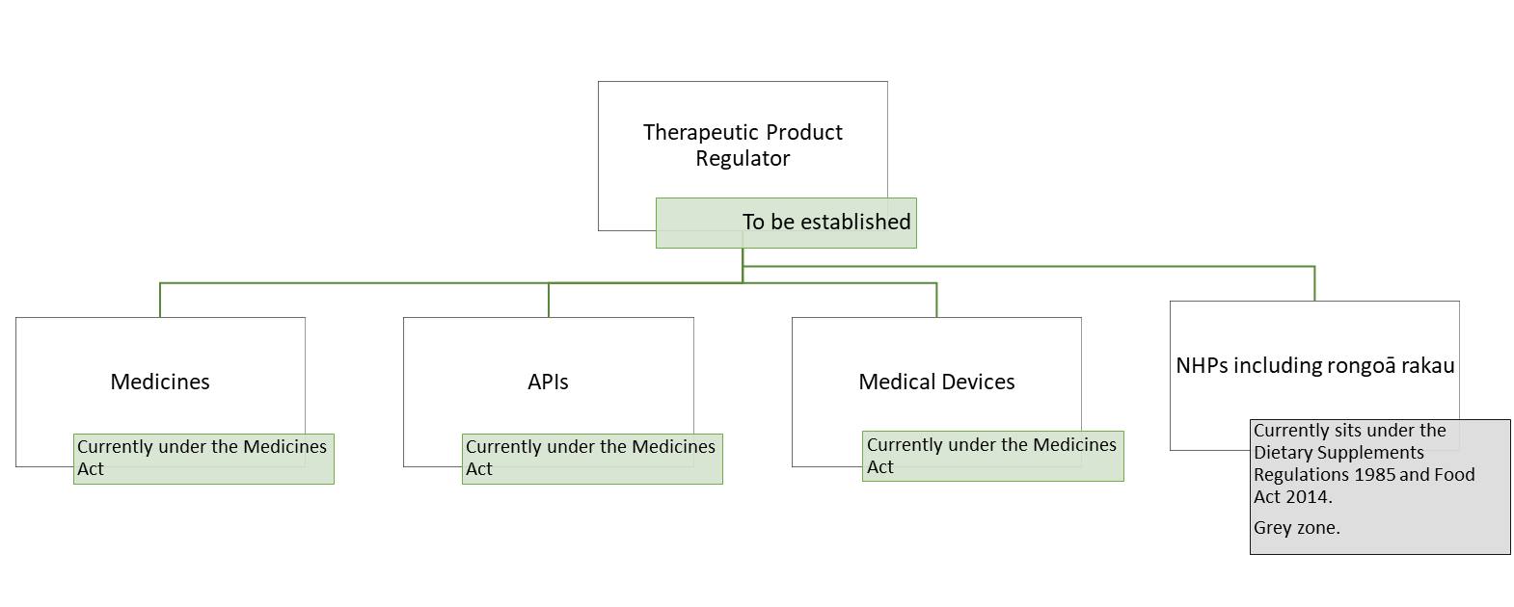

Figure1: Diagram of intersection of current and proposed relevant legislation

## Rongoā

Rongoā Māori was the health and wellbeing system for Māori pre-colonisation.[10] With the advent of Western medicine, it was discounted by mainstream health systems in New Zealand.

A recent review of the Ministry of Health funded rongoā sector described rongoā Māori “as mātauranga Māori wellbeing and as holistic and whānau-centred, shaped by unique iwi, hapū, and whānau tikanga.”[11]

“Rongoā is not about products - rongoā is traditional healing.”

The Ministry of Health described rongoā Māori as traditional healing that is formulated in a Māori cultural context, in which the understanding of events leading to ill health and its impacts are addressed through a range of culturally bounded responses.[12] These responses include distinct and diverse mātauranga, including:

* Rongoā rākau (native floral herbal preparations)
* Mirimiri and romiromi (massage and bodywork)
* Karakia (prayer).

These rongoā practices are underpinned by mātauranga, tikanga, kawa, and taonga tuku iho. In this way, rongoā practices have their own mana (jurisdiction) that is sourced from te ao Māori and a deep underpinning philosophy. These connections enrich the value of rongoā and provide connections for practitioners and recipients of services that can promote overall wellbeing. One tohunga commented:

“If we want wairua and health, we need those connections.”

Rongoā differs according to whānau, hapū, and iwi. It is a diverse practice that is anchored to whenua. Rongoā evolved alongside and in response to the flora and fauna resources available to Māori in different climates geographically – so practical manifestations of rongoā are different in different rohe and engage with the natural environment differently. Further, the underpinning tikanga and kawa that regulate rongoā are often unique to the whakapapa and tūpuna of the practitioner. Each practitioner inherits carefully developed and valuable knowledge as a kaitiaki for the next generation of practitioners. The mātauranga that surround rongoā, contextualise it, and tie it to te ao Māori are not homogenous. This mātauranga is of deep spiritual and cultural value to practitioners and are one of the reasons that rongoā can help Māori effectively.

For example, a rongoā practitioner from Ngāti Whātua therefore will have a different tikanga and different mātauranga than one from Kāi Tahu.[13] This was a strongly recurring theme from participants where, for example, a Ngāti Whātua practitioner was unlikely to comment on or look to regulate the practices (the tikanga and mātauranga) of a practitioner from Kāi Tahu, as this would not be their mātauranga nor their role to regulate rongoā outside of their own tribal territory.

The practice of rongoā is fluid. For example, rongoā rākau might be used as a balm by a rongoā practitioner providing mirimiri. The restriction, control, or regulation of rongoā rakau therefore impacts or could impact or change other rongoā practices. This means that the inclusion of rongoā within the Bill occurs at multiple stages and in different domains. Practitioners of rongoā might make their own products, might purchase them commercially or from a friend, might sell them, or koha them to others.

Surveying the rongoā community, of those who indicated they identified as a Practitioner of rongoā (70/133), most (44/70) also identified they did product preparation and about a third also identified as a purchaser of rongoā products. It is not necessary to be (or have been) a practitioner to prepare and sell rongoā products. Someone may be producing products called rongoā with no knowledge of rongoā and no connection to the iho (essential quality) of rongoā.

As a result, this report captures a very diverse range of feedback. One core aspect that we consistently heard was that rongoā is much broader and deeper than being a product or even being a medicine: it is a holistic methodology that encompasses te ao Māori ways of being, spirituality, and wellness with connectivity to whenua, whānau and atua and tūpuna. The disaggregation and disconnection of rongoā from this context was overwhelmingly viewed as antithetical to rongoā and as setting the wrong foundation for regulation and engagement.

## Report purpose

This report captures feedback on three specific areas as requested by the Ministry of Health. These include:

1. Feedback from Māori on whether the Bill protects rongoā.
2. Feedback from Māori on whether the Bill will help assure patient safety
3. Feedback from Māori on whether the Bill will help ensure access to the export market for rongoā.

There was also scope to capture additional Māori views and perspectives on rongoā and other relevant factors.

## Report structure

The report is structured in three sections, two of which are the heart of the report:

1. Section one introduces the report.
2. Section two is titled ‘what we heard.’ It sets out the feedback on the three core areas (noted in the report purpose above), and additional thoughts and aspirations shared by Māori participants.
3. Section three is titled ‘context of feedback.’ It sets out feedback on the engagement process and historical context as these experiences and perspectives provide context and further depth to the feedback we received.
4. Appendices (one, two and three) explain the engagement approach, provide a selection of quotes not used in the body of the report, and a summary of results from the online survey.

# 2. What we heard

Section two contains six sub-sections:

1. Defining rongoā
2. The perceived purpose of the Bill
3. Protection of rongoā and access to the export market under the Bill
4. Patient safety and the Bill
5. Reactions to the proposed Regulator
6. Miscellaneous but direct issues with clauses or concepts under the Bill.

Sub-sections three and four directly respond to the three areas of interest set out in the Ministry’s *Report Brief*. The remaining sections document participant views, experiences, and aspirations for rongoā.

## Defining rongoā

|  |
| --- |
| Participants commented that philosophically the Bill started from the wrong conceptual point: the underlying purposes of the Bill (safety, protection and export markets) reflected a misunderstanding of rongoā and a cultural dissonance about rongoā as a holistic methodology.  This was exacerbated by rongoā not being defined. Rongoā not being defined meant that participants were unclear of the Bills scope, but also that the entry point of regulation for rongoā being through product reinforced the feeling that the Crown doesn’t understand what it is doing. |

“The Crown doesn’t even have the respect to reference rongoā Māori in the Bill… It’s insidious that the Crown could write a Bill to try to overlay law over rongoā without referencing it.”

A consistent theme from participants was the absence of a definition of rongoā in the Bill. Further, as the Bill appeared deliberately structured to catch products (“a wide net” as one participant put it), that rongoā is not explicitly referred to was seen as assimilating rongoā into a Pākehā or Western colonial framework. One participant commented that this creates a false equivalence, where synthetic products not provided by nature would be NHPs like rongoā, despite distinct conceptual differences.

### Ambiguity of capture

The Bill not referring to rongoā also exacerbated confusion for participants about whether it was included or intended to be included. This led to further examination of specific sub-elements around:

* therapeutic products
* products derived from taonga
* synthetic compounds mimicking compounds in rongoā
* compounds used by rongoā practitioners
* what type of rongoā practice would be covered – for example, whether products made at home would be covered
* ambiguity between whether a rongoā rākau would be an ingredient or a product
* workarounds and ambiguity between rongoā, NHPs and food products like medicinal teas.

Participants commented that the Bill would reform something that hasn’t been deliberately included. This was received poorly by participants and increased ambiguity for participants about the scope of the Bill:

“(1) They are not products: they are rongoā. (2) The Bill does NOT mention rongoā.”

### Philosophy of Rongoā – the Bill gets it wrong

“Rongoā is about wellness, not sickness. It’s about using rongoā to improve the health of the people.”

The lack of a definition of rongoā as well as rongoā rākau being captured incidentally led to significant discussion that Manatū Hauora fundamentally misunderstand rongoā. One practitioner simply commented that “it’s broader than just plants”

And another that:

“Products are but a small part of rongoā Māori. To have an understanding of rongoā Māori and delivery is not only "products" that are used but a way of life that only rongoā practitioners would be able to "formalise" in a Pākehā whakaaro. Using the Bill and lumping rongoā Māori in the bill demonstrates the misunderstanding of this taonga tuku iho handed down from our tūpuna.”

Participants perceived the Ministry as having misunderstood rongoā at a fundamental, philosophical level:

“Rongoā Māori isn’t just a medicine. There is no consideration or respect for the whole process of rongoā. It’s like a catchment. What is required is full consideration of rongoā. It sits with wairua and atua. And those things need to be balanced. This is captured by kaitiakitanga.”

This point was reiterated across responses to the Bill.

Responding to protection under the Bill, participants stated that holisticprotection of the rongoā ecosystem was required – not protection of products. In response to patient safety aims, participants commented that rongoā has cultural systems of protection built into it as a methodology and that patient safety would not be improved by a focus on products. Participants were critical about the aim of supporting export markets, noting that export markets themselves were a threat to rongoā (and taonga species that are used for rongoā rākau) when considered from a holistic lens.

Practitioners commented that fundamentally the ‘entry’ point for regulating rongoā should not be through a Bill focussed on rongoā products. This presents a challenge for the Ministry as there are no singular frameworks or methodologies that engages with rongoā. One participant commented that meaningful engagement with rongoā would require:

“...an improvement in government documentation that encapsulates the entire system of rongoā and all of the things that it involves.”

To participants, the current Bill repeatedly treats rongoā solely as a product without its broader context. Participants noted that starting a regulatory approach to rongoā that focuses on product and separates the product from its use is difficult and complex. A practitioner might make a ‘product’ but then provide a treatment alongside it. For them, the whole treatment or session would be the rongoā. As such, the Bill, through its product-focussed approach, fails to account for rongoā as a holistic wellness and healing system.

It is:

“… taking something and looking at it in isolation – but that thing has huge impacts that speak to the system [of rongoā]. It’s holistic, so it must have connections to the other parts of that system and to mauri.”

To participants this starting point reinforced the absence of a Māori perspective in the Bill – that the Bill had a Western medical perception, treating practice and therapeutic separately, and that rongoā will be difficult to “formalise” from a Pākehā perspective:

"I think when you look at a kaupapa it only makes sense in the cultural context in which it was created – without that we can’t take snapshots and have it resonate. One of the issues of engaging with the crown is that they don’t understand that taking a balm and rubbing it on a sore limb isn’t the end of treatment – it’s about healing them holistically."

Alongside several comments that this was the wrong starting point, one tohunga commented that the starting point philosophically reflected a legislative drive from a sterile spirit disconnected from whenua and ngahere.

This reflects the distinction between a ‘product’ and a holistic methodology. Another described the Bill as:

“Taking something and looking at it in isolation – but that thing has huge impacts that speak to the system. It’s holistic. So, it must have connections to the other parts of that ecosystem and mauri and living philosophy.”

Overall, this line of commentary also reflects the whakapapa of the Bill – the underlying history of rongoā being suppressed and operating in a fragile resurgence, and participant distrust and fear about this happening again. This distrust and fear were elevated further due to participant feelings about the engagement process, described above.

### Opportunity going forward

Implicitly from the comments above, practitioners feel that any regulatory approach to rongoā needs to be holistic.

Participants commented explicitly that they felt there had been a lack of creative options explored. This reinforced comments about the whakapapa of the Bill – that inclusion of rongoā was an afterthought, reflected in part by the lack of adequate engagement with Māori.

One participant asked what consideration had been given to a more deliberate approach recognising rongoā explicitly as a taonga under Te Tiriti and exempting rongoā from regulation when used in the context of traditional indigenous use. They perceived this as an option to address some of the issues relating to Te Tiriti under the current Bill. Other discussions in hui centred around applying the model of customary and traditional harvest rights. These discussions in part reiterate the complaint that engagement occurred too late for Māori to be heard. Instead, participants wanted to be involved in the design phase, not approached with a final product.

## The perceived purpose of the Bill

|  |
| --- |
| Overall, participants roundly critiqued the purpose of the legislation. The stated purposes were rejected or criticised, and many participants perceived the purpose of the Bill as being driven by power, money and exploitation.  This perception is partially driven by the whakapapa of the Bill and a lack of trust in the Crown and partially driven by worldviews that are distinct from the one that structured and is carried by the Bill. This issue is exacerbated by the philosophical origin of the Bill described above. |

“We never asked for your help. Never sought it. Yet here you are, offering it. It’s another initiative forced upon us where the least, worst thing is to do nothing.”

The purposes of the legislation for rongoā were summarised by the Ministry as: protecting rongoā, ensuring patient safety and ensuring an adequate export market. Participant views on how the Bill achieves (or does not achieve) these goals are discussed below at the sections *Protection of rongoā, the Bill and access to the export market*, and *Patient safety and the Bill*.

Participants questioned the rationale of the Bill and the purported benefits it could bring. They voiced significant concern about their view of the underlying purposes of the Bill that led to these goals, the focus areas of the Bill being developed, and the purposes for including rongoā within its scope.

Overall, participants viewed the stated purposes as disingenuous. Many said the true objectives of the Bill reflected corporate interests, including the exploitation of taonga species and development of a rongoā export market, and usurping tino rangatiratanga over rongoā in favour of government control. They view the Bill as “just more regulation, more limiting, more oppression.”

### Exploitation not protection or wellbeing

“I feel that it is the Tohunga Suppression Act 1907 renamed. I also feel it is a serious breach of articles 2 and 4 of Te Tiriti o Waitangi. It’s only another income creation strategy, by government for government.”

Participants perceived the underlying agenda of the Bill is to facilitate the commercialisation of rongoā (and traditional and native taonga) for industry and for money, and to give government greater control of rongoā. Participants believe the Bill does not achieve a more equitable health system or improve access to rongoā. One participant commented that the Bill “isn’t concerned with wellness” and another said that the Bill does not even allude to wellbeing, that:

“There are claims around concerns for safety, but the whole Bill is designed to support international exporters.”

One participant said they understood historically there was work to recognise and protect rongoā but that the scope of the Bill has changed into “safety and perpetuating trade” and that this could be seen in references in Cabinet Papers and Regulatory Impact Statements.

The view that exploitation is the core underlying function of the Bill was the strongest sentiment participants voiced across all feedback channels. A series of comments reflect the perspectives of participants:

“The other agenda that the government has had for a long time, and has invested heavily in, and is very quick to respond to, is the commercialization of rongoā and traditional and native taonga. And so, this Bill continues that agenda, this Bill is very clearly written for the benefit of non-Māori who would like to seek to gain profit and commercialise and appropriate our taonga further.”

That:

“We all know the purpose of this legislation is ki te whai mana [to acquire mana].”

And:

“The purpose of this Bill is just to get Money.”

Moreover, participants commented that the Bill felt dishonest; that the Crown should have “been honest about the agendas driving it.” With another participant stating, “you haven’t been subtle or sneaky. We see you.”

### Perspectives and power dynamics

The Ministry’s core areas of interests, and the core concerns of Māori who gave feedback, are distinct and disconnected. Participants simply did not feel that the issues the Bill put forth were their issues, and that the concerns they have are not addressed by the Bill:

“Māori were doing fine without them. They are mana motuhake. Where are we being equally represented in this Bill?”

To participants these perspectives are entirely different, but only one perspective is represented in the Bill: that of the Crown. Participants signalled that the decisions about what the Bill addresses reflects power dynamics between Māori and the Crown.

Participants repeatedly asked why the Ministry was getting involved. The comment above that “[w]e never asked for your help. Never sought it. Yet here you are, offering it. It’s another initiative forced upon us” was a consistent theme. Participants felt the Crown “spasmodically” makes decisions that impact Māori severely, in a way that is inconsistent with Te Tiriti and instead demonstrates that the power dynamic between the two is not an authentic partnership:

“I think the relationship with the Crown has always been power based and I believe that they were deaf and blind and that many still are. It’s really important to remember in a modern context that Māori are a minority in their own country – and that under political power, the majority win.”

This dynamic is sensitive due to the historical examples of its manifestations – the legacy of colonisation, He Whakaputanga, Te Tiriti, and the Tohunga Suppression Act. In recent memory, participants commented on the Medicines Act 1981 suppressing rongoā and on the lack of authentic consultation for this Bill reinforcing the feeling that the Crown can, and will, do what it wants.

Participants questioned what it means for tuku iho protected under tino rangatiratanga going forward and that this power dynamic generates further issues systemically for other engagements and would set the tone for engaging with the Regulator under this Bill: if the power dynamic is unfair, it will generate further distrust, fear, disengagement, and disenfranchisement.

“They need to understand that they’ve built a lot of their models around flawed foundations: signing reconciliation treatise with people who are in duress…. We are like prisoners within our own lands, and in our own jurisdictions.”

## Protection of rongoā and the Bill, and access to the export market

|  |
| --- |
| Rongoā is a taonga. For participants, protecting rongoā is an expression of rangatiratanga consistent with article 2 of Te Tiriti. They want the Crown to endorse Māori to exercise their rangatiratanga over rongoā and to support Māori to actively protect rongoā globally.  Participants feel there are significant threats to rongoā: commodification (domestically and internationally) and exploitation of rongoā products. These threats are accompanied by risks to taonga species and to Māori intellectual property and cultural identity. To protect rongoā against these risks requires a view of rongoā as holistic – connected to whenua, taiao and wairua. They do not believe the Bill achieves this because of the focus on product and export. |

“The protection is rangatiratanga. Not something in a process.”

The concept of the Bill providing protection of rongoā sparked several strong reactions from participants Overwhelmingly survey respondents indicated that they feel the Bill provides little or no protection for rongoā or rongoā practitioners (79/104).

First, participants feel that protection needs to start by purposely engaging with rongoā. Second, it is hard to protect something without having an in-depth understanding of it, and third, protection is also aligned to views about the purpose of the legislation. The Bill does not specifically mention rongoā. For participants, this felt like rongoā is an afterthought and any claims of protection appear to lack integrity. Participants questioned the authenticity of the Government’s desire to protect rongoā.

These critiques rolled into discussion about what protection should look like, and the need for it to be consistent with Māori aspirations for rongoā. Participants agreed protection over rongoā is needed; however, the challenge is who should protect it, and how.

Subsequently participants talked about two primary concerns for protecting rongoā. The first being commodifying rongoā and the risks therein. The second was demonstrating the authenticity of rongoā.

Overall, to participants, the world view represented by what the Bill aims to protect contrasts starkly with their own world view about what needs to be protected and how this should be achieved. Participants expressed their concern that the world view represented by the Bill will come to dominate or destroy the world view that rongoā is currently enshrined within. Participants fear that because of the focus on products, the underlying spiritual dimensions that make rongoā an asset to Māori wellness and health will be destroyed:

“We will lose the values and connectivity – it will all be about money. It removes the connection to atua and tikanga.”

### Deep cultural knowledge is needed to protect rongoā

Rongoā is a holistic, inter-connected, wellbeing system. Change in one area can change or impact rongoā in other areas. Deep hapū and iwi knowledge is needed therefore to protect rongoā. One participant commented on the challenge for non-Māori institutions to protect rongoā, given the culturally anchored understanding needed:

“I believe something should be in place to protect rongoā. But it’s a really hard thing to protect… It’s hard to govern. It just is.”

Most survey respondents (58/103) indicated they believe that rongoā (including rongoā practitioners and whānau accessing rongoā services) does not require legal protection. Rongoā is consistently viewed as a taonga tuku iho, protected under tino rangatiratanga a-hapū, a-iwi:

“We require lawful protection which is not the same as legal protection. We have hapū that can and will protect our rongoā.”

This distinction between the underlying jurisdiction was raised repeatedly:

“Because rongoā belongs to iwi Māori and not the crown. There is kawa and tikanga behind it. The phrase legal protection is a Pākehā kōrero that belongs to the Crown.”

And:

“This taonga tuku iho from our tūpuna has been practiced by rongoā Māori practitioners since time began. To wrap legislation and legal protection around a taonga tuku iho is using a Pākehā whakaaro yet again to restrain our practice of healing our people and community at large. This Pākehā whakaaro is not always the answer. The answer lies within te ao Māori who have practiced rongoā Māori since time began.”

As an extension of this, for many, the notion of legal protection is not seen as necessary when it comes to Māori practising rongoā for Māori:

“Tautoko having quality controls on large corporations taking selling native rongoā nationally, global, however I support the same controls for individual and small whānau, hapū, iwi enterprises and hauora whose main objectives are supporting the well-being and overall health of ngā tangata.”

And consistent with this is the distinction around the *purpose* for which rongoā is being used:

“Rongoā needs protection from non-Māori practitioners and large businesses whose intention is to make a profit and mass produce rongoā for sale.”

Therefore, participants see the need for protection of rongoā against exploitation but not within te ao Māori:

“[Protection] from what? The mauri is that we are dangerous, and we need to protect public from our practitioners and rongoā. Listen to the kōrero. We have successfully kept our mātauranga to ourselves and we need to protect ourselves from non-Māori who exploit our rongoā rakau, whakaaro, mātauranga and kupu. Check out how many non-Māori are exporting our rākau and kōrero and they aren’t Māori. That’s where the protection needs to be.”

Of the survey respondents who indicated they believe that rongoā (including rongoā practitioners and whānau accessing rongoā services) requires legal protection (29/103), most (17/28) indicated they believe that legal protection for rongoā is best placed in a separate Bill specifically focused on rongoā rather than in this Bill (5/28).

“Rongoā and Māori practices do need protection but not in the from proposed rongoā and the practices should be under the control of, with accountability to te ao Māori tohunga practitioners.”

The challenge in the view of the participant sat with the breadth of rongoā; that it encompasses a lot more than rongoā rākau, but even protecting native flora and fauna was a daunting job. That each iwi, hapū, and whānau have their own relationship to rongoā. The scope of protection is enormous, and participants felt the difficulty of adequately protecting rongoā strongly.

Participants talked about two core elements of protection philosophically.

The first is that the core of protecting rongoā is tino rangatiratanga and the recognition that rongoā is a taonga. The second is that systemic protection of rongoā requires more than focussing on product or even practice; that rongoā is tied to wellbeing of people and of land.

Discussing tino rangatiratanga, one tohunga commented:

“Every rohe has their own tikanga and their own kawa inside their own rohe. The tikanga they practice through kaitiakitanga and with manaakitanga, and the teachings of their kuia and koro.”

This provides a framework around what needs to be protected.

In summary, participants felt a series of obligations to protect mātauranga rongoā: firstly, to protect the knowledge of their whānau, then their hapū, then their iwi. This reflects the ‘tightness’ of their belief in their right to control the space in which they practice and the degree of agency they can exert without their mana or jurisdiction clashing with another person’s.

This balance of right and responsibility over protection of rongoā illustrates the difficulty regulating te ao Māori and partially explains why so many participants commented on the jarring quality of protection being offered. Māori are not homogenous, and the domains of protection are tightly bound in a relational world. As one participant commented:

“Hapū rangatiratanga is what happens in the rongoā world now!”

One participant explained that this feeling of protection is bound deeply to the concept of rongoā being a form of mātauranga. One explanation of mātauranga being:

“Mātauranga Māori is the knowledge of the land from the people who belong to the land. It is the result of their interaction with the whenua over many generations. It is the knowledge they have accumulated by living on the land, working with the land, harvesting from the land, all the time listening, watching, caring, to ensure that they can continue to survive.”

Another participant added to this view where mātauranga is the embodiment of *practical* knowledge, tied deeply to a broader connected world. Because rongoā is a class of knowledge that is inherited from atua, and practiced alongside tikanga, rongoā needs to be protected in *that* context:

“What they are about to do is pull the rug out on us with regards to mātauranga and thereby the core underlying fundamental of rongoā – and all our atua… and make something very sacred into something very common.”

This point reinforces the difficulty of starting to protect rongoā by protecting a *product*; even if rongoā products on a technical level were perfectly ‘protected’, without the mātauranga, tikanga, and connection to iho, the core of rongoā as a taonga would be lost:

“I feel it’s taking the mana Motuhake of rongoā Māori away from the tangata whenua that use and need it the most. It is minimising the cultural element of natural health.”

Another philosophical starting point for rongoā protection raised by participants focuses on rongoā within an environmental ecosystem. Participants commented that rongoā is not a therapeutic, it’s about living. Rongoā is not about sickness, it’s about health, and connection and caring for oneself with sensible living. This is deeply tied to the taiao and the wellbeing of whenua(land) and of the ngahere (forests).

In line with this, participants expressed the need for protection to extend beyond product. That to protect rongoā requires the protection of the earth. Participants acknowledged that the Bill was never designed to achieve this but stated that there needs to be something to protect the connectivity to the living and natural systems, and that the largest threat to rongoā is ecological change. One participant commented:

“There will be no point having the most robust legal system in the world if it is protecting photos of things that no longer exist.”

Overall, when discussing the protection of rongoā, the core aspirations of participants were that the Bill should not affect the ability of Māori to practice rongoā as Māori:

“What I’d like to see in there is that nothing in this Bill affects the practice of Rongoā Māori where it is being practised within the jurisdiction of Māori, and it doesn’t stop anyone entering into that practice.”

And the second, no further loss of knowledge and practice:

“Zero knowledge loss and zero practice loss.”

More generally one participant said:

“My aspiration is for Rongoā Māori to be accessible for every single person in Aotearoa so they can lift themselves into hauora. This isn’t something that people can do now in their own iwi, in their own hapū.”

That’s my aspiration;that the mana of rongoā is respected as Māori understand it to be.”

### Self-regulation – by Māori for Māori

“This taonga should be left to be regulated by the people who hold the knowledge and skills. Rongoā Māori does not need to be overseen and have its various facets turned into legalese. This is yet another assault on the credibility and ability of Māori to operate in the natural world in a time-honoured manner.”

Participants consistently expressed a desire for “by Māori for Māori” regulation; a feeling that Māori should be the overarching authority over rongoā to work in Māori interests and protect against improper use or exploitation of rongoā. Sub-themes within this included:

* Māori already are regulators of rongoā within their own hapū and iwi.
* A series of proposed mechanisms to involve Māori in ongoing regulation of rongoā.
* Tensions of self-regulation for Māori.

Participants view Māori as regulating rongoā already within their own whānau, hapū and iwi and commented that tohunga are the regulators; that when they needed to know about those regulations they go to their own:

“We are the regulators: mātauranga a hapū.”

To participants, self-regulation is an extension of tino rangatiratanga:

“Definitely we must be sovereign owners over what is ours, as Māori. And nobody can tell us what to do, except ourselves, in our rohe, with our tikanga - hapū specific.”

This is viewed as an extension of kaitiaki and tino rangatiratanga; that Māori have mana motuhake, whakapapa and mātauranga and these components enable appropriate regulation.

Participants questioned appropriate forms of regulator; whether there could be an independent rongoā and mātauranga regulator to protect the holistic rongoā system, whether some form of co-regulation could be designed so that:

“Māori will have sovereignty over rongoā Māori definitions, regulation, use, development of international regulations, rongoā rākau, as determined by Māori - some Māori regulating body that anything rongoā Māori is discussed and regulated.”

However, many participants also noted the tension of cross-iwi regulation.

This point is relevant for the proposed Regulator as participants stated even if there were a Māori regulator, no iwi will tell another what to do, and as it stands the proposed Regulator will still need spokespeople for iwi and hapū (who won’t necessarily agree with each other) to facilitate compliance with Te Tiriti. One participant commented that Regulator success:

“Comes down to the model. Recognising each tino rangatiratanga in each rohe.”

### Commodification of rongoā domestically and internationally is a concern

“The question is driven by the commercialisation of rongoā practice.”

Concerns about the commodification of rongoā were consistent, and deeply held. Participants were concerned about several aspects of commodification. Firstly, that it would remove the wairua of rongoā thereby harming the cultural values rongoā offers. Secondly, there is a distinction between domestic and international commodification, so concerns are distinct for these markets. Thirdly, that taonga Māori could be exploited in the commodification process.

Overall, participants fear the Bill will make rongoā more of a commodity for sale at the expense of the core elements that make rongoā an effective tool for helping an individual – reconnecting with land, with family and whakapapa, and with the spirit of rongoā. This is consistent with Participant comments around the purpose of the Bill. One participant called this a:

“decoupling of the fundamentals that make rongoā what it is and make it functional.”

Almost half (14/29) of practitioners responding to our survey identified their marae or a local marae as a place they practice rongoā reinforcing the deep community ties rongoā has as a practice.

Participants note there are already individuals and companies, both Māori and non-Māori, who produce and sell rongoā or products branded as rongoā, leveraging a connection with te ao Māori. Some do this on a small-scale offering product as part of their service. In this context, there is a relationship between the practitioner and the patient, and this maintains the link to the practical and spiritual dimensions of rongoā. Even in this space however there is tension. One participant commented they feel “overloaded by products” and that “the developing market for rongoā is “taking the mauri of rongoā Māori” and they are “feeling forced to engage because of the dilution of the product.” The practitioner is considering making rongoā products themselves to respond to this dilution by trying to provide an authentic and quality product for their patients.

Production and sale of rongoā products nationally and internationally was discussed. One example shared was the marketing of a rongoā product as ‘niche’ or bespoke, drawing on the brand value (whakapapa and a perception of trust) of rongoā. Participants were concerned that the ‘seller’ was not a rongoā practitioner, and any claims about the product its authenticity were questionable. Another series of examples came up in an exchange between hui participants:

A: I have a cousin who has never touched rongoā and is now exporting a Kawakawa balm – as a ‘bespoke product.’ She sells overseas. She sells it at pop up markets. She sells it everywhere. It’s flooding the market.

B: Same as my niece. She had the gumption to say ‘but it’s in my whakapapa’ but I never see her at events to protect taonga tuku iho, or at rongoā events…

Combined: we can’t say the exporters aren’t rongoā practitioners, but…

C: there are a high percentage who are not.

The example illustrates the tension some practitioners feel: whether they let the commodification continue unchallenged or intervene. If they decide to intervene, how, and in what way? Letting commodification of rongoā continue could be viewed as endorsement, and participant concerns about the wairua and mana of rongoā could worsen. However, intervention risks conflict in a complex relational world – practitioners were clear that they won’t comment on another iwi or practitioners kawa, tikanga and practice unless they have a very strong relationship: they won’t risk injury to the mana of that person. Intervention could also occur by way of competition – intervening by producing rongoā of a higher quality or with demonstrable integrity and authenticity within te ao Māori. At the same time economic incentives and profit motives are likely to result in rongoā branded products with a weak or no rongoā provenance.

Holistically, this tension is viewed by participants as the Crown forcing the issue to a head before it is ready: extractive economics focussed on product regulation and export exacerbating a risk to their taonga tuku iho.

Participants did comment on the distinction between domestic and international sales. Domestically, rongoā is mostly still tied to te ao Māori, therefore practitioners can still rely on whakapapa and relational knowledge to engage with their patients, and patients can do the same when engaging with a practitioner. Export can mean looking after whānau overseas and is tentatively viewed as an economic benefit.

Practitioners raised concerns about products being duplicated or replicated, defrauded, and reproduced in an anti-competitive manner. Notable concern surrounded rongoā produced with an emphasis on economies of scale in a manner that undermines small businesses and sole practitioners, drives prices down and incentivises a low-value economy for rongoā products. This concern is seen to inherently favour large companies that aren’t necessarily Māori or aren’t even necessarily based in New Zealand:

"This Bill gives competitive advantage to the larger players in the natural health products industry through their ability to more easily afford compliance costs imposed on rongoā practitioners under this Bill. The likely consequence of this is reduced consumer access to authentic rongoā Māori products and service and more costly rongoā."

Participants view this as risking diminishing the value of rongoā to a cheap product, harming its mana.

Of survey respondents, only a few felt the Bill would make it either a lot or a moderate amount easier to manufacture rongoā products (16/103), and about a quarter felt the same way about improving export opportunities for rongoā (27/103). This indicates a gap between the intent of the Bill and its perception by the community who are meant to be served by these opportunities.

Overall, to participants the benefits of the proposed approach seemed unclear against the risks of commodification:

"The burden of these costs will be felt disproportionately by those who rely on traditional Māori healing methods and result in a further erosion of access to these valuable practices. Furthermore, the regulation of natural health products is likely to favour large pharmaceutical companies who have the resources to conduct the necessary testing and meet regulatory requirements. This has the potential to create an uneven playing field and further marginalize traditional Māori healers."

### Product authenticity

“...there are a lot of people out there making crap.”

Alongside the difficulties described about protecting rongoā from commodification, there are difficulties about what would be protected. Part of the exploitation issue many participants raised was around illegitimate products being sold – domestically or internationally.

These issues are synergistic to many participants as the more of a market there is for rongoā the more inauthentic product will creep in, which inherently is a risk to rongoā. Simultaneously, if inauthentic product is regulated effectively this would be a form of protection for rongoā that may prevent commodification being done by non-Māori, thereby leaving money in the Māori community.

Core issues around authenticity for participants include:

* non-Māori owned commercial operations extracting native taonga and whether this would be allowed.
* non-Māori owned commercial operations producing NHPs from native taonga species.
* Non-Māori owned commercial operations selling product called rongoā.
* Non-Māori individuals claiming to practice or produce rongoā for sale.
* Overseas interests sponsoring product under the Bill and exporting rongoā overseas.
* Indigenous names being misused (by Māori or non-Māori). Examples included the word rongoā, or a Māori name for a product implying it is rongoā.

Significantly, the ongoing issue around mānuka and kānuka honey came up a lot. There was a strong concern around industry harm due to brand recognition – this was expressed specifically in terms of the integrity of the brand (and mana) of rongoā being maintained, but also at a national level: how does Brand New Zealand manage reputational control.

Several thematic responses to authenticity came up.

There were discussions around having some form of Māori workstream to assess product authenticity. Participants repeatedly shared the feeling that a product was not rongoā if it was not produced by Māori – without that whakapapa, a product would be an NHP. Adding further complexity, questioned whether non-Māori should be allowed to produce a product that was copying a rongoā, or even use traditional ingredients.

There were also ideas around creating some form of brand control over the word rongoā like an authenticity checkmark. One discussion centred around requiring a Māori lens in marketing and the law to give some comfort over branding. Participants also discussed mechanisms to control the lifecycle of rongoā based around traditional rights to cultivate, harvest and produce products.

## Patient safety and the Bill

|  |
| --- |
| Participants did not agree that there were existing harms sufficient to justify the Bill regulating practice and did not think that the regulatory process had established evidence of this harm. This led to pointed criticism of what was viewed as ‘safe’ by the Ministry and under a Western perspective of medicine.  Cultural safety mechanisms in the context of rongoā were referred to as the basis of patient safety: mātauranga, atua, tikanga, kawa, tūpuna. Participants referred to having practice oversight from more experienced practitioner as a safety mechanism**.** |

“This Bill assumes the premise that rongoā presents a risk to the New Zealand public that warrants legislative protection. Despite producing no evidence to the support this notion and contrary to lived experience and lack of statistical evidence of actual harm. The greatest risk to the health and safety of rongoā consumers is Crown intervention in a practice that they have no knowledge, experience, or appreciation for.”

Participants said this oppression of rongoā Māori is manifested in the Bill through the safety lens which places Western-centric standards at the heart of the regulatory scheme. This is expanded upon below at the section Patient safety and the Bill.

### The safety purposes of the Bill were rejected

Participants commented on this topic feeling like it prompted an inorganic discussion – that there was extremely limited harm presented by rongoā rākau and rongoā products, and limited evidence of harm being relied on to justify the regulation.

There were several comments about a lack of substantiated evidence for harm in the associated cabinet papers and therefore, the patient safety and product safety goals didn’t make sense. One participant commented the rationale felt poorly prepared:

“There is no evidence, that I have been able to find, or is presented in the Cabinet Papers, of natural health products causing harm. The other thing that is fails to present, is evidence of natural health products causing benefit to wellbeing, of which there is a lot.”

Another participant asked for evidence of harm under the existing regime to justify replacing the existing regulations and stated there does not seem to be a legitimate safety concern to address. The Bill was viewed as biased and coming from a strongly Western position by several participants. This relates back to the overarching philosophical issue discussed above, and to whakapapa of the issue.

Participants critiqued the prompt of safety as coming from the wrong perspective. One said:

“So, for me, as a starting point, when you're starting to develop this Bill and your rational is around ‘the safety of rongoā’, that to me speaks loud and clear, that this is coming from a colonial agenda. And so, I will just elaborate on that, the argument around safety of rongoā Māori, and the need to proof its effectiveness or its safety using scientific evidence, has long been a tool of colonisation. It's been an excuse and argument that Western medicine and Pākehā have used to oppress and marginalise and undermine, rongoā.”

Participants also said that the question implied that mainstream medicine is safe or provided an implicit benchmarking for safety and noted that this stems from a Western-centric philosophical basis of safety being found in government regulation. Participants rejected the implication that rongoā is dangerous, pointing out the danger associated with Western medicines in comparison to rongoā rākau. One participant commented that the safety question is:

“Ridiculous. It’s crazy. They’ve allowed red food dyes and colouring known to cause neurological issues and are going to regulate Kawakawa.”

Another commented on drug dependency and side effects from allopathic medicine[14] and another commented on the irony of being able to add toxic chemicals as preservatives to rongoā products that were safe prior.

### Safety for rongoā is located in te ao Māori

For Māori (and rongoā) safety was inherent within tikanga a hapū, tohunga and practitioner whakapapa, and te ao Māori. These inherent qualities manifest in a practical knowledge of safety. Further, safety evolves with the times and so practitioners maintain awareness of new developments:

“The practitioner takes practice from the past and evolves it for the future – the mātauranga evolves.”

Rongoā practitioners also talked about many of their patients not feeling safe in the mainstream medical system. By comparison, practitioners discussed the safety of rongoā being contextualised within the service, and being located within tikanga:

“Tikanga is first and foremost about safety. There are other elements, but first and foremost, it’s about safety.”

As a result, the practitioner is answerable to a cultural system of safety expressed through common sense, kawa, tikanga and learned from atua and tūpuna:

“As a practitioner there is a requirement to sit inside a Western philosophy and government system. When we step back into our own world… we are answerable to a greater jurisdiction: to our mokopuna.”

Practitioners feel deeply accountable to their communities. Alongside a sense of primary accountability to whānau and hapū, many practitioners are also managed and monitored through their own tohunga until they are experienced enough to step up into that tohunga role themselves.

Participants noted that that rongoā has a historic track record that doesn’t appear to have been acknowledged in the Bill. One participant commented:

“I think individual hapū, whānau, have managed rongoā adequately for hundreds of years. Our tikanga, as different and diverse as it is, has managed the safety of rongoā Māori, and I would argue that with anyone. We are second to none, and everybody has heard me say it before, but we have the stats to prove it, we are second to none, in terms of safety, of any other practice in this country. Why the hell are we messing with it, it works, the way hapū and iwi have done it, although not perfect, I’m not blind to what's happening out there, but we are not killing people, we are not maiming people, and we are trying our best to balance economy with protection of the taiao.”

Participants were also concerned that this topic needs more time to be discussed. As:

“...these safety measures haven’t been fully explored… we don’t have the opportunity to wananga and agree.”

Despite this, most survey respondents feel the proposed Bill will either not improve the safety of whānau and the community being served at all or will only improve the safety a little (76/103). Only 17 (17/103) indicated that they feel the proposed Bill will improve safety a lot or a moderate amount.

## Reactions to the proposed Regulator

|  |
| --- |
| Overall participants are concerned by the role of the proposed Regulator. Participants were concerned by the dynamic of a sole Regulator who isn’t independent and are concerned that Māori won’t be sufficiently involved.  These concerns have practical and philosophical / legal elements. Practically, participants were concerned around regulator knowledge and sufficiently engaging with a variety of iwi and hapū. Philosophically and legally participants raised concerns around a regulator and secondary regulation not being consistent with Te Tiriti and a te ao Māori world view.  Some participants advocated a ‘by Māori for Māori’ regulatory approach, but also acknowledged the difficulties of regulating within te ao Māori. |

One subject that prompted discussion was the proposal in the Bill to introduce a Therapeutic Product Regulator (the Regulator). Reactions were mixed. Participants expressed a philosophical critique of the structure of the proposed Regulator, raised a series of clarifications or anxieties, and discussed how Māori could and should be involved.

### Concern about the powers of the Regulator

"The Regulator is going to be given the mana to decide the lens that will be cast over mātauranga Māori."

Participants raised concerns around the jurisdiction of the proposed Regulator – that having a sole Regulator sets the wrong engagement dynamic for regulating rongoā. This concern is consistent with issues raised about tino rangatiratanga and ongoing informed engagement under Te Tiriti.

Participants commented:

“The Regulator is empowered by this regulation. Then they sit on their own. They are not informed by us. Not empowered by us. Therefore, they have the iron rod, but nothing else – they don’t have mātauranga, and they don’t need to take account of it. The jurisdiction is reversed: they have the power, but we are the ones using and producing rongoā Māori.”

And that

“… the design of having one Regulator and then that person being responsive to the Director General of Health, is really inconsistent with a te ao Māori way of being and doing. In a te ao Māori way of being and doing we don't respond to one person, there are many iwi and hapū and whānau and each of those have their own tino rangatiratanga and so this Bill is failing to acknowledge the diversity of te ao Māori.”

Several sub-themes were raised, that can be summarised as jurisdiction and design issues. Examples of these issues include whether the Regulator will be Māori (an ongoing theme), how the Regulator can themselves be regulated “to ensure their exercise of power is justified, appropriate and unbiased” and concerns around the technical and cultural competency of the Regulator:

“I do not trust policy or the majority of the people monitoring rongoā to understand the culture in which it comes from, let alone the taonga that it is, to be able to provide protection for our rongoā.”

A consistent comment was around refusing to work with the Regulator – participants either explicitly stating they wouldn’t engage with the Regulator, or raising their concern that some practitioners wouldn’t. An element of this was that participants were concerned about providers or practitioners being deemed unfit to provide service, and around the Regulator therefore suppressing practice.

Participants also raised concern consistent with Te Tiriti issues – around exercising rights over taonga in an ongoing fashion; how could they engage with regulations and the development of regulation. This was framed as a recurring theme:

“Our taonga is already exploited under all legislation. Our tīpuna missed out and again we keep engaging with the same process. Give effect part is about obligation, adhere to is the other part.”

Explicit concerns in line with this are around standards and rules being managed in an ongoing fashion, and whether they can be changed without Māori involvement – contrary to Te Tiriti. Of respondents who indicated that rongoā requires legal protection, very few (3/28) indicated they believe that legal protection for rongoā is best placed in secondary legislation under this Bill – indicating the structural concerns of participants with the use of regulations to flesh out the practicalities of the Bill.

## Miscellaneous but direct issues with clauses or concepts under the Bill

### Labelling

One ongoing series of questions was around labelling. These were tied in part to the brand recognition element (Brand New Zealand, and rongoā having its own brand), and the perceived need for some form of Māori input into advertising.

Participants questioned whether people would potentially misuse any exceptions developed for rongoā, and how labelling controls and classifications could prevent this.

Another line of enquiry was around whether workarounds would be used in general – similar to the current tension between supplements and food, whereby some medicinal teas are just called ‘tea’ rather than a natural health product.

### Fees

“Looking forward, there will be costs. Licensing costs. Regulator costs. Compliance costs. Something that was a customary right will become a compliance regime.”

Fees and the proposed regulatory costs were another area that caused debate.

Participants questioned the distinction between commercial practice and individuals, how costs would be managed for smaller providers so that it didn’t wipe them out, commented the costs risk eliminating small Māori businesses, and on the levies not being currently clear.

This last point tied back to frustration about consulting on a Bill with so much impending secondary legislation; participants keenly felt the financial ambiguity of what they were engaging on.

Another element here was around long-term practice – questioning what has functionally changed to justify fees being charged. Thematically, comments focussed on the fact that they had been practicing long term, and practice has not changed, and yet new financial stresses were being added to Māori practitioners and rongoā providers.

### Fit and proper person

An area of discussion was around the prerequisite to be a ‘fit and proper person’ to engage with further elements under the Bill:

“That’s going to be a hard thing to govern. Do the mana whenua get to govern that? Currently it’s the Regulator… proves the problem… how would mātāwaka prove it?”

On the one hand, participants noted that the idea of assuring someone is fit to work with whānau and provide services is important. They see this process as reducing the risk of harm from, for example, sexual assault.

On the other hand, participants returned to the theme of tino rangatiratanga, noting that the appropriate people to make that judgement call are the local whānau, hapū and iwi, and tohunga from the rohe. They also raised concerns about the criteria used to determine "fit" and "proper". For some, bankruptcy was not important, because of the challenges Māori face accessing funding and financial support. For others, bankruptcy was a risk factor for financial abuse. More broadly, a "fit and proper" person in relation to rongoā practice and products needed to include aspects specific to rongoā, such as connection to local tohunga, and the right motivation.

Overall, most survey respondents (71/87) indicated the definition of “fit and proper person” makes little or no sense in a mātauranga Māori context. Participants commented on a couple of considerations around this:

“You have too many things to consider. Someone needs to hold a status. I get the bankrupt thing because of potential to take bribes or to defraud the system… to be tika and pono and trustworthy are the most important things to us. To be connected to your tohunga and atua and the wairua, and to have the mātauranga. It’s a lot and it’s a lot for one person. And, once again you are going to need capability to interact with different iwi. And all this while being non-judgmental across all the mahi – but you are always going to be judgmental when you pick a Regulator. The bias is huge.”

## About the licensing approach

“Traditional practices can’t be licensed by Western practices.”

Licensing also prompted feedback and was received poorly. The reasons for this poor receipt sit in the feeling that Manatū Hauora and the Crown don’t have the jurisdiction to intervene into an issue protected under Te Tiriti.

As a result, licensing is seen as symptomatic of government overreach and colonialisation, and “impedes on the sacredness and expression of how our ancestors gave life to rongoā Māori.”

The practical outworking of concerns around licensing came down to costs and the burden of establishing proof. In the words of one participant:

“I think this will become similar to the Food Act. You will need to pay lots of money to get a licence. If you want to make products and sell them, it will cost thousands to verify what we use in a rongoā clinic. Do we need to pay thousands to verify what we know works and how it works?”

Overall, participants felt the efforts required to participate in the new systems under the Bill could be cumbersome barriers and could exacerbate pre-existing inequities and either drive them out of business or into the grey-market. Survey respondents had a mixed understanding of what they would need a license for if the Bill passes at it currently stands. Just under a quarter of respondents indicated they understood very well what they would need a license for (8/22). Similarly, respondents were divided on whether they think they’ll need one – indicating they have mixed awareness of how the licensing regime would operate. These responses support the concerns raised more broadly.

## About qualifications for rongoā

“The intellectual property I retain comes from the whakapapa of the healers who taught me.”

One theme throughout discussion was the variety of pathways that practitioners had taken to become rongoā practitioners, and the crossover here with the perception the Bill might impose qualification requirements on rongoā practitioners. This is relevant as most respondents indicated they came to practice rongoā through pathways outside formal accreditation.

* The majority of respondents (43/61) indicated they came to rongoā through their whakapapa.
* Almost half of respondents (26/61) indicated they studied alongside a tohunga.
* More than a few respondents indicated they completed some kind training, including a training course at a wananga or educational institution (19/61), a workshop or wananga with a tohunga from their iwi or rohe (19/61), or a workshop or wananga with someone else (17/61).

Generally, there was a view around qualifications being established by qualities outside of formal education institutions: that formal courses supplement learning from tohunga, and handed down through whānau, hapū and iwi.

“Rongoā Māori is passed down through generations, each iwi and whānau have their own methods on how rongoā Māori is delivered and made.”

This is important because the connection back to whānau, hapū and iwi is an intrinsic tie to land and community – the wider net that makes rongoā a holistic methodology is made up of these connections.

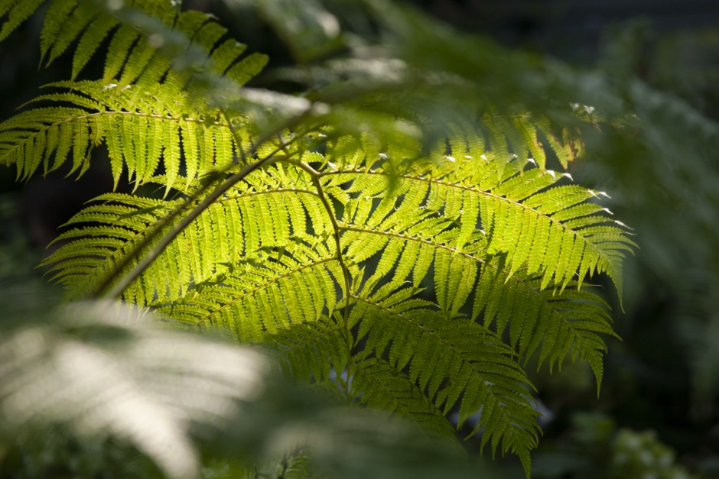

# 3. Context of feedback

Section three is divided into five thematically grouped sub-sections.

* He Whakaputanga
* Te Tiriti o Waitangi (Te Tiriti)
* The Tohunga Suppression Act
* Modern history of rongoā and the relationship with Manatū Hauora
* Engagement with Māori.

## He Whakaputanga

|  |
| --- |
| For Māori, engaging with the Crown requires a mutual understanding of the foundation for the discussion. For Māori who assert their tino rangatiratanga on He Whakaputanga, this relationship can be opaque or uncertain. The implications of this flow into issues around engagement, export, and sovereignty. |

He Whakaputanga (the Declaration of Independence of 1835) was a theme that came up throughout engagement.

“It didn’t take many Bills to take away what Māori had 150 years ago.”

Primarily He Whakaputanga came up as a question around the appropriate basis for engagement on the Bill between Manatū Hauora and Māori. The practical elements of this line of enquiry were twofold.

1. Firstly, will Manatū Hauora support submissions that are based on He Whakaputanga? Implicitly asking the question how?
2. Secondly, how can the Bill accommodate or exempt those tribal confederations who are actively working through constitutional matters around sovereignty.

These two lines of enquiry are of relevance to Māori who whakapapa to hapū that acknowledge He Whakaputanga and who do not accept Te Tiriti as the foundation of the relationship between themselves and the Crown.

For these participants, to exercise their mana and engage in a way they felt was fair requires a mutual understanding of the basis from which they engage: a confirmation that they possess tino rangatiratanga and that the Crown understands where they are arguing from.

He Whakaputanga also came up explicitly regarding export:

“A ship was locked up because it didn’t have a trading flag. But it did have a trading flag: He Whakaputanga. It’s still an international flag and an international agreement. We have rights. Export here, however, is subject to the approval and exploitation of the ruling government.”

## Te Tiriti o Waitangi

|  |
| --- |
| Overwhelmingly, participants viewed the Bill as inconsistent with Te Tiriti o Waitangi. In particular, participants felt the Bill did not satisfy article 2 (tino rangatiratanga) and that engagement was insufficient to meet the principles of partnership and informed decision-making established by the Courts and Waitangi Tribunal. There was also curiosity about the WAI 262 claim, and cautious optimism that it might pave a way forward. |

“The disconnect between the Crowns role as a Tiriti partner to enable us as Māori to live in the way that we want to live as Māori, and this. Those two positions are completely disconnected and dissonant and they can’t operate together.”

During engagement activities (and particularly at the in person and online hui), participants distinguished between articles and the principles of Te Tiriti o Waitangi (Te Tiriti). For these participants, articles confer rights unequivocally and principles are interpretable and procedural, and seen as secondary:

“… the principles of the Treaty are **not** the Treaty we signed; they are different. The Articles are what are binding.”

This distinction is drawn for completeness and to advise the reader: in the sub-sections below, the section on Article 2 will use the term ‘article’, and the section on engagement will use the term ‘principles’ to refer to Te Tiriti. This is consistent with the reaction of participants and consistent with the distinction between Te Tiriti itself, and the interpretation of Te Tiriti by the Courts and Waitangi Tribunal.

### Tino rangatiratanga and taonga

Many participants commented that the Bill in its current form does not adequately reflect Article 2 of Te Tiriti.

“Rongoā Māori is a taonga tuku iho, so under article 2 of Te Tiriti that would mean that rongoā comes under Tino rangatiratanga, that is held by Māori hapū. The role of the Ministry of Health is as representative of the Crown, and what that means to me is that the role of the Ministry of Health is not to regulate rongoā Māori, and is not to control rongoā Māori, and is not to exercise any authority over rongoā Māori other than to protect it and to ensure that Māori have access to our traditional medicines.”

Participants communicated several themes that the Bill could:

“Encroach into Māori indigenous autonomy of taonga and tikanga.”

Firstly, that rongoā needs to be explicitly recognised as a taonga, and then explicitly recognised as falling under article 2 of Te Tiriti whereby Māori have tino rangatiratanga over it. This theme is expanded upon more at *Defining Rongoā*. One participant stated:

“We need the Crown to restate our right to tino rangatiratanga over our taonga tuku iho. To recognise, protect and empower the practice of rongoā Māori.”

To participants, the starting point for discussion must establish tino rangatiratanga over rongoā. This thread is drawn out further below in the section *Systemic issues and engagement*, as it has consequences for engagement as well as for tino rangatiratanga, but the basic principle is:

“First you need to sit with those who have tino rangatiratanga.”

Participants talked about the breadth of mātauranga that could be affected by the Bill:

“I look at te kupu o te rangatiratanga. Every rohe has their own tikanga and their own kawa inside their own rohe. The tikanga they practice through kaitiakitanga and with manaakitanga, and the teachings of their kuia and koro.”

Rongoā is a taonga tuku iho*,* something handed down from generation to generation. As a result, every whānau, hapū and iwi have unique taonga that they exercise tino rangatiratanga over and feel is guaranteed to them under Article 2 of Te Tiriti. Participants stated that due to this, the Bill fails to acknowledge the diversity of te ao Māori as it treats rongoā in a way that defers to homogeneity as a default due to broad categorisations and broad definitions of capture.

Participants were clear that they have mana motuhake (mana through self-determination) and tino rangatiratanga over rongoā as a taonga. Despite this, several participants commented that the Bill in its current form and recognising long-term decisions under the Bill to be made by the Regulator, appears to favour the Crown and not acknowledge tino rangatiratanga held by Māori. One participant stated this was the Crown not giving appropriate power to Māori as Tiriti partners and not allowing Māori to exercise tino rangatiratanga.

Participants questioned how the regime proposed by the Bill would facilitate Māori tino rangatiratanga when the decisions and enforcements over rongoā would be enforced by the Crown. This line of questioning was accompanied by the feeling that:

“Taonga is already being exploited under rules and legislation.”

This represents a lack of trust in continuity; a feeling that things chop and change with different governments and different attitudes of the day.

Several participants discussed the merits of a Tribunal claim based on the Bill not upholding Article 2 of Te Tiriti. This itself was a point of discussion due to the diverse nature of rongoā as a taonga tuku iho – one participant commented that each individual hapū nationwide would have a separate entitlement to claim.

### Te Tiriti, consultation, and engagement

Participants questioned whether engagement for the Bill upheld the principles of Te Tiriti. The principles raised by participants explicitly were partnership, and informed decisions.[15] It is noteworthy that several participants felt that if the Select Committee doesn’t hear their voice, the only recourse they have is a Tribunal claim.

Participants pointed out that despite the principles, they did not view the Crown as meeting partnership in practice for this engagement due to the time limits they were operating under, the lack of forewarning, and the stage at which engagement was occurring (once the Bill was before the Select Committee).

One comment was that this engagement approach set the tone for the Bill: how could the Crown uphold Te Tiriti going forward when they haven’t shown this in the past and haven’t met partnership in this instance?

Several questions were raised around what engagement had taken place, and who was responsible for ensuring that Te Tiriti was being upheld with a sense that there needed to be a watchdog.[16] Practical considerations participants raised were:

* Who is responsible internally?
* Who is responsible externally (holding Manatū Hauora to account)?
* How can Māori follow this easily?
* Are there tools to make it easier?

These questions provide a roadmap for ways to improve engagement in the future. One participant commented that if these safeguards were more explicit and more visible to Māori:

“Maybe we wouldn’t be so hōhā with it.”

### Rongoā and WAI 262

Participants asked for explicit clarification of the relationship between Te Pae Tawhiti[17] and where WAI 262 and the *Ko Aotearoa Tēnei* report fits in to the Bill. Several participants view the WAI 262 claim as deeply related to the issues surround rongoā:

“To me, the issue is about the role of health in the colonisation problem. Wai 262 holds a key because basically what it gives is a map and blueprint of the way forward.”

On one level, participants stated the synthesis between WAI 262 and rongoā under this Bill as being clear: taonga needs to be protected. However, a few broader, complex, and interwoven issues also came up.

The first of these issues was around intellectual property, research, and protection. Participants wanted to understand how the proposed Bill would operate in the research-ecosystem. Questions included:

* How taonga species of rākau could be looked after.
* Whether and how therapeutics derived from taonga rākau would be protected.
* How rākau could be protected from commercialisation and protected in research.
* The role of mana whenua in this ecosystem.
* Whether there could be revenue sharing from taonga-species based products.

Philosophically these questions are consistent with the view of WAI 262 as being a step forward – to a future that tūpuna could not have imagined, but that still needs to have the right foundation.

These questions were aligned to anxieties of participants about international plant registration. For example, rākau used by tangata whenua as rongoā are, or could be, restricted. This issue needs to be addressed but has not been acknowledged as a risk. Participants raised concern around ingredients being trademarked or controlled in a way that exclude Māori or prevent Māori using traditional ingredients.

The second issue that participants stressed was that rongoā rākau is intrinsically tied to the ngahere (the forest) and whenua (the land). Under Te Pae Tawhiti and aligned to WAI 262, there is work around environmental kaitiaki relationships with taonga species such as rākau that are used for rongoā, and around taonga taiao (the natural world) including wai (water).

Two participants reinforced the centrality of ngahere and whenua to rongoā:

“I see nothing here about protecting the connectivity to the ngahere, to rongoā.”

And:

“My tohunga told me ‘How can we teach rongoā to someone who doesn’t know the ngahere and the whenua?”

To many participants, protecting rongoā requires protecting the taiao and the cultural systems in which rongoā exists. This is reinforced and expanded upon below at the section *Definition of rongoā*.

## The Tohunga Suppression Act 1907

|  |
| --- |
| Participants explicitly stated that the Bill echoed the Tohunga Suppression Act 1907, which suppressed tohunga and pushed the practice of rongoā underground. That this echo is one of colonial control and paternalism, and a risk to the fragile resurgence of rongoā. |

“Looks like it will go the same way as the Tohunga suppression Act.”

Participants commented the Bill had a similar tone to the Act of 1907[18] that sought to address ‘charlatans’ but had the effect of driving legitimate practice underground. Participants noted that there seems to be an underlying assumption in the Bill that rongoā products, and therefore rongoā practice, is harmful and the public need protection, despite the lack of evidence for this claim:

“The mauri is not tika. It is a Western construct over the top of mātauranga rongoā because of the narrow product brief… The Tohunga Suppression Act of 1907 is a clear example of legislation for the perceived protection of others which sent an entire healing system underground because of judgements and perceptions that were incorrect. That legislation was repealed 55 years later yet 116 years on we are still living with the repercussions of the intergenerational trauma that our whakapapa experienced.”

Participants questioned the assumption that the only or ‘best’ way to provide protection is through legislation and regulation. Two threads emerged here.

Participants acknowledged that there are:

"…people making shit up. This gets licensed and sent overseas and then it becomes ‘rongoā Māori.’ But there are people making crap. Get rid of the crap stuff. Will this Bill even achieve that?”

But stated that they are concerned regulation will suppress legitimate practice.

“I don't think this Bill will do it, and my disquiet is that actually what could happen is that our healers and practitioners will go underground again.”

This reflects the inherent tension in rongoā being regulated as a product rather than as a system of practice. Participants highlighted the concern that the parties who are making product purely for financial gain, but without a deeper or spiritual connection to rongoā, will continue to do so legitimately under the Bill, and will exploit rongoā for commercial gain. Meanwhile, practitioners who are focussed on healing roles but who don’t make significant (or any) income from their product and practice will be driven to a grey (or black) market role and there is the subsequent risk of knowledge loss:

“History has shown what has been taken, stolen, or stripped from our people, including my own whānau and past rongoā practitioners. My great-grandmother was a rongoā practitioner but practised in secret and didn't share her knowledge with her tamariki or mokopuna.”

As a result, many participants view the Bill as primarily benefitting non-Māori commercial interests. This is expanded upon below at the section *The Perceived Purpose of the Bill*.

The second thread was that the rationale of the Bill echoes the same reasoning that drove the Tohunga Suppression Act 1907: regulation for safety and legitimacy’s sake. This was viewed as coming from a Western colonial agenda:

“The argument around safety of rongoā Māori, and the need to prove its effectiveness or its safety using scientific evidence, has long been a tool of colonisation. It's been an excuse and argument that Western medicine and Pākehā have used to oppress and marginalise and undermine, rongoā.”

Thematically this was viewed as a modern extension of past modalities and mentalities control mechanisms – the need to impose control on Māori for their own good – and of class, whereby tohunga had their mana destroyed to retain control once it had been imposed.

## Modern history of rongoā and the relationship with Manatū Hauora

|  |
| --- |
| Participants voiced their view that modern treatment of rongoā by government has been overwhelmingly negative. That rongoā has been marginalised within the health system and by government, that funding has been tokenistic, and that this Bill feels like a repetition of an ongoing discussion anchored in deeper issues of tino rangatiratanga. |

“We don’t trust the Crown and it’s ture (laws).”

“I’m reminded that those who went before me had a much harder path. With the mātauranga and the knowledge left to us, we couldn’t bury it because we are kaitiaki of that knowledge.”

The first theme that emerged was the marginalisation of rongoā.

Participants talked about ‘denial’ of indigenous health systems by government and, consequently, that rongoā has not been accessible in New Zealand and therefore has not been able to establish itself and provide a broad benefit:

“…in terms of whakapapa, we need to remember that there have been hundreds of years of oppression of rongoā Māori and mātauranga Māori.”

One participant commented that as recently as the Medicines Act 1981:

“Early engagements with the Crown displayed the power differential. Public servants felt encouraged to dissuade rongoā Māori.”

Participants said this oppression of rongoā Māori is manifested in the Bill through the safety lens which places Western-centric standards at the heart of the regulatory scheme. This is expanded upon below at the section *Patient safety and the Bill*.Another example raised was that support for rongoā in the form of Ministry-funded contracts have been [19]limited to karakia and mirimiri. This was described as ‘tokenistic.’ The broadest example, was that tohunga aren’t respected and treated as equals to Pākehā doctors or paid like doctors, are not able to engage more systematically in treating their patients (such as by prescribing medication), and that this contributes to health system inequity:

“People can’t pay. Where is the equal representation and the equity under the treaty? Our people are poor! Poor people die!”

It is noteworthy that, in terms of the marginalisation of rongoā, strong patterns emerged around connection to rongoā. Most survey respondents (83/137) identified a connection to rongoā of over 21 years. A quarter (41/137) identified themselves as having 2 – 10 years connection and only a few respondents (10/137) identified their connection as being less than a year old. While these figures have limitations, there is a notable absence of Māori with new connections to rongoā. Further, of survey respondents only a few (15/104) indicated they feel the proposed Bill will make it easier for rongoā to be practiced.

A second pattern emerged around repeated consultations around the same issue, and participants repeatedly not feeling heard.

Generally, Māori believe that when they are asserting their rights to control over taonga, this has always included rongoā. As a result, to some participants this feels like the latest instance of telling the government what they want, with consistent messaging, but not being listened to:

“Anything I have ever seen out of WAI 262, what I’ve seen out of Tairāwhiti what I’ve seen out of the Whakamaua Māori Action Plan,[20] what I’ve seen out of Pae Ora, they are all consistent. They are all consistent, they are not conflicting, so I’m not sure what the hold-up is.”

Moreover, for practitioners, the centrality of rongoā to their life means that several of them have been engaged in specific discussion about rongoā for many years. Working in the relationship space and engaging on past versions of equivalent regulations means that they view this Bill as having distinct provenance (particularly when compared to the governmental view). Namely that this discussion has been happening, and that they feel limited progress has been made on being heard by government:

“What I did see was a repeated affirmation that Māori wanted access to, and adequate funding for, and resourcing for, Rongoā. So as a starting point when you’re starting to develop this Bill and your rationale is around ‘the safety of rongoā’ that to me speaks loud and clear that this is coming from a colonial agenda.”

Participants also commented on work that has occurred in the past to develop rongoā standards and questioned what happened to these.[21]

## Engagement with Māori

|  |
| --- |
| Participants overwhelmingly viewed the engagement by the Ministry as poor. This is tied to issues around tino rangatiratanga, participation and informed decision-making and increases the risk of non-compliance with Te Tiriti.  Moreover, it perpetuates a low-trust relationship. This low-trust dynamic can be seen below in the perceived purpose of the Bill, the lack of faith in a Regulator, and a lack of faith that the Bill will be positive for Māori. |

“This is another fast and furious process that has captured Māori to time limits once again.”

Participants critiqued the communication and engagement by the Crown. This reflected a participant view that systemic issues in engagement weren’t adequately addressed and instead contributed to issues around Te Tiriti compliance, that Māori were not sufficiently involved, and that the engagement window was too short.

“There has been a lack of consultation with tangata whenua, and this is inconsistent with the protections of taonga Māori and mātauranga Māori and the protection of the health and wellbeing of whānau Māori.”

There was a sense that this reflects a power imbalance:

“There needs to be more communication. Government always asks for full transparency but then there isn’t that same courtesy back… The process needs to be clearer; the communication needs to be clearer.”

Participants were sceptical that they had all the facts. One participant pointed out extensive redactions in public facing documents. Tying into the principle of informed decision-making, participants felt it was hard to engage without all the facts being available.

### Engagement

The overall position that participants communicated was that partnership and acknowledgement of Māori tino rangatiratanga was insufficient. This is expanded upon more below in the *Engagement with Māori* section of the Report. Participants also commented on the complexity of the Bill and the informed decisionsprinciple:

“How are we to give feedback if we don’t have all the information and detail?”

Overall, there was a broad spread of the extent to which participants felt informed about the Bill and the engagement process.

About half of survey respondents (55/109) indicated they feel moderately or very informed about the proposed Bill. However, those who indicated a connection to rongoā through being a practitioner, product preparation, manager, or kaiako, had a higher proportion of people who indicated they felt moderately or very informed about the proposed Bill (40/66). By comparison, of the people who indicated a client connection to rongoā (as a recipient or product purchaser only), most respondents (25/43) indicated they felt a little or not at all informed or not sure about how informed they are about the proposed Bill.

Most survey respondents sourced information from the Bill itself (57/107) and their community, including rongoā groups (56/107), friends and whānau (49/107) and social media (44/107). They also said that they found these sources the most useful. By contrast, about a third of survey respondents indicated they had been getting information about the proposed Bill from Manatū Hauora (34/107) and Te Aka Whai Ora (32/107).

Two structural elements exacerbated the complexity of the Bill and the engagement process for participants. Firstly, the stage of the Bill meant that parliamentary rules changed the nature of their engagement with Manatū Hauora. Secondly, a considerable amount of the practicalities under the Bill will be in regulations and therefore were not outlined in the Bill.

In addition, participants broadly expressed fatigue at trying to keep up with the number of engagements they were across, noting that not all engagement about the Bill involved Manatū Hauora.

### Systemic issues in engagement

There were several enquiries that indicated the Māori community and practitioners may not have been aware of the Bill and of their engagement options. Examples included “are there going to be more hui” and “how do we become involved with all the workstreams proposed”, indicating a potential need to improve the diversity and timing of communications from the Ministry. One participant commented that:

“Manatū Hauora must be seen to consult Māori community through all mediums of communication, emails, social media, Zoom due to time limits.

One explanation offered by participants is that engagement started from the wrong conceptual place as a symptom of structural processes not engaging with te ao Māori adequately, and is a consequence of the Crown not sufficiently acknowledging tino rangatiratanga over taonga tuku iho:

“All other authority and rights to do, and to bring about change, and resolve and practice, it begins with engagement. First you need to sit with those who have tino rangatiratanga.”

This reflects the view of participants that rongoā is a taonga under Te Tiriti, and thereby is protected by Māori. To give effect to this would have required engagement on those grounds. Moreover, participants were concerned about the role of Māori in the design of the Bill:

“In my view the drafting of this Bill, if upholding Te Tiriti, would have included Māori leadership from the start, and Māori leadership on the drafting of the Bill.”

The perception that the Bill was based on superseding or ignoring tino rangatiratanga created a negative feedback loop.

Firstly, there was a sense amongst participants that the policy position had already been settled before engagement started and discussing the detail was therefore pointless. As a result, attendees raised that fewer people were likely to engage than might have if they felt that they would be listened to, or that the Bill would respond to their concerns. In turn, this leads to less representative and less reliable feedback and, importantly, increases the risk of lower awareness amongst Māori of the substance of the proposed legislative changes. This has potential far-reaching impacts to the Crown-Māori relationship.

Secondly, it shifts engagement from the content of the Bill onto Te Tiriti issues, as the process was viewed as inconsistent with the principle of engagement under Te Tiriti. This in turn exacerbated the feeling that the Bill breaches article 2 of Te Tiriti, closing off the negative feedback loop.

One participant’s view on the process was that:

“The process used to develop and inform the drafting of the Bill is dishonest and circumvents the Parliamentary Select Committee submission process.”

“Ministry of Health advice to the Select Committee on how the Bill should recognise and protect rongoā will not be available for public comment through the Select Committee submission process as a result of Ministry advice not being supplied until the opportunity for public submissions close.”

Participants raised two accompanying themes around engagement that reflect and compound the systemic issues further: that there was insufficient Māori engagement, and a lack of submission time once Māori were involved.

### Lack of genuine Māori engagement and consultation

“Consultation process was not followed or performed legally, where was the panui (notice) to our marae, hapū, iwi partners, rural whānau? You can't create a piece of legislation without the proper consultation process with tangata whenua, community practitioners, iwi, hapū - it’s a breach of Te Tiriti o Waitangi!”

Overall, participants commented that engagement was not sufficient, did not include enough Māori, and that this is inconsistent with Te Tiriti. Participants wished to know who in te ao Māori was consulted and engaged in developing the Bill, both within Manatū Hauora and externally about “who is providing the wero, the kaha that the Bill needs?”

This is partially discussed above at the section *Te Tiriti, consultation, and engagement*. One participant commented that:

“The Cabinet Paper also refers to consultation prior consultation in the development of the Bill, it fails to acknowledge that that consultation has not included Māori.”

A number referred to iwi they whakapapa back to or engage with, not being sufficiently consulted – and either having strong feelings about the Bill or simply not knowing about it:[22]

“My brief from that hui, is that it’s a reflection on their engagement; they only engaged with one iwi. There are eighteen iwi in the area.”

And:

“I’ve just come out of a hui with [iwi] and they are very against the Bill.”

And:

“In [a rohe] of eight iwi, none had heard of it.”

### Lack of submission time

“Now you’ve given us 23 days plus weekends. It is a short time to respond, there has been a lack of consultation. So as far as I see it, it’s about you can tick that box.”

Generally, participants viewed the timing of engagement around the Bill as undermining the principle of consultation under Te Tiriti itself in several ways. At the time of hui and the survey being published, public submissions to the Select Committee were going to close on the 15th of February 2023. This was subsequently extended to the 5th of March 2023.

Participants talked about the short period of time to review the Bill and provide feedback, particularly given the length and complexity of the Bill. This denied them the opportunity to fully consider the Bill and its implications – this point is also addressed above *at Te Tiriti, consultation, and engagement* as being a risk to the principles of partnership and informed decision-making.

Without reaching an in-depth knowledge of the Bill, engagement is compromised and the risk to tino rangatiratanga being exercised is exacerbated. This point is also discussed above at *Tino rangatiratanga and taonga*.

One participant commented that in engagement Māori needed:

“…the time and space to exercise, tino rangatiratanga over rongoā and to discuss and formulate solutions to nuances, in a timely way, that would be helpful, this process and all of the legislative jargon, not helpful… not helpful to Māori, the timeline, that's very rushed, not helpful…”



# Appendix 1 – Approach to collecting feedback

## Kaupapa Māori approach

Weaving Insights, a Māori owned and managed company was commissioned to document Māori feedback and engagement on the Therapeutic Products Bill. When needed we also facilitated conversations and engagement.

Kaupapa Māori research principles guided our approach. At its essence, Kaupapa Māori means a ‘Māori way’ of doing things. The concept of kaupapa implies a framing and superstructure that guides how to think about, design and undertake research and engagement with Māori. The Kaupapa Māori principles we followed:

* Manaakitanga, an ethic of care: Invitational, relational and light touch approach to data collection and providing koha.
* Āheitanga, opportunity, access, choice: Provide a mix of engagement options including kanohi-ki-te-kanohi (face-to-face).
* Te reo Māori, providing Māori speaking interviewers/group facilitators.
* Aroha-ki-te-tangata, a respect for people and their time: maintain oversight of the data collected to ensure that sufficient data is collected, but no more than enough, to reduce the participation burden on providers and whānau.
* Whakarongo, titiro, korero. To listen, look and then speak
* Kaua e takahia te mana o te tangata, don’t trample on the mana of the people, ensuring we give voice to and honour Māori perspective and experience.

This research employed a mixed methods approach including two in person hui and, two online question and answer style webinars hosted by the Ministry of health. Weaving Insights hosted one online hui and the online survey.

We gathered feedback on the Bill from 17 January to 13 February. This time frame was tied to the original 7 February closing date for submissions which was extended to 15 February and then to 5 March.

|  |  |  |
| --- | --- | --- |
| Type | Date | Participant Numbers[23] |
| Online webinar | 17 January 2023 | 48 |
| Parawhenua Marae, Te Tai Tokerau | 23 January 2023 | 60[24] |
| Te Kahui Rongoā Trust, Rotorua | 25-26 January 2023 | 10 |
| Online hui with rongoā researchers | 31 January 2023 | 7 |
| Online Survey | 31 January - 13 February | 170 |
| Total | 17 January – 13 February | 295 |

## Survey

An online survey was developed with Manatū Hauora. It was hosted on Weaving Insights Qualtrics instance, and a link to the survey was accessible through the Ministry’s rongoā workstream public engagement page between 31 January and 13 February 2023.

A total of 175 participants responded to the survey during this time., including 7 responses received prior to the webpage being published, by people from the rongoā community who agreed to complete ‘beta’ testing of the survey. Of these, 170 respondents agreed to the terms and continued and completed the survey. Five respondents did not agree and were routed to the survey end page.

Due to the complexity of the Bill, the survey took between 15 to 25 minutes to complete. The survey asked a combination of purely qualitative questions, and some discrete questions to get quantitative indicators and qualitative feelings from participants on each sub-issue within the survey. An example would be to ask, “How comfortable are you with X” and offer a spectrum of discrete answers, and then secondly ask “Is there anything else you would like to say about X.”

See Appendix 2 for a summary of survey results.



# Appendix 2 – Survey results summary

The survey was made available on the Manatū Hauora / Ministry of Health’s workstream website https://www.health.govt.nz/our-work/populations/Māori-health/rongoā-workstream.

The webpage was published on 31 January 2023. However, 7 responses were received prior to the webpage being published, by people completing ‘beta’ testing of the survey. The survey closed on Monday 13 February 2023.

A total of 175 responses were received; noting that skip and display logics were in place to automatically route respondents away from sections that would be irrelevant based on their previous answers.

Of these, 170 responses agreed to the terms and continued to the first question; 5 responses did not agree and were routed to the survey end page.

This summary is based on the 170 responses.

## Respondent profile

### Connection to Rongoā

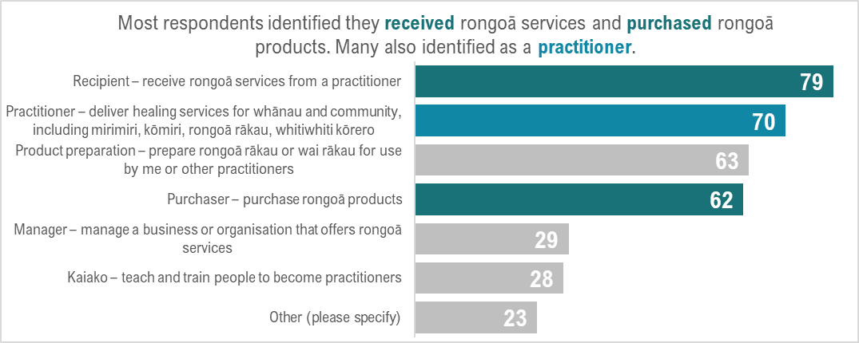

* Most of respondents (79/133) identified as a Recipient – receive rongoā services from a practitioner and about half of respondents (62/133) identified as a Purchaser – purchase rongoā products.
* Most respondents (70/133) identified as a Practitioner – deliver healing services for whānau and community, including mirimiri, kōmiri, rongoā rākau, whitiwhiti kōrero.
* About half of respondents (63/133) indicated they did Product preparation – prepare rongoā rākau or wai rākau for use by me or other practitioners.
* About a quarter respondents identified as a manager (29/133) – manage a business or organisation that offers rongoā services or as a Kaiako (28/132) – teach and train people to become practitioners.
* Note: 22 respondents chose not to answer this question.
* Of those who indicated they identified as a Practitioner (70/133), most (44/70) also identified they did Product preparation and about a third also identified as a Purchaser of rongoā products.

### Length of connection

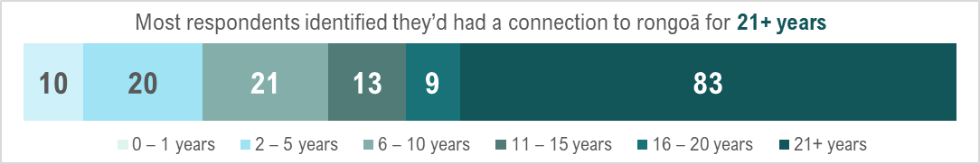

* Most respondents (83/137) identified they’d had a connection to rongoā for 21+ years.
* A quarter of respondents (41/137) identified they’d had a connection to rongoā for 2-10 years.
* A few of respondents (10/137) identified they’d had a connection to rongoā for a year or less.
* Note: 19 respondents chose not to answer this question.

### Practice location

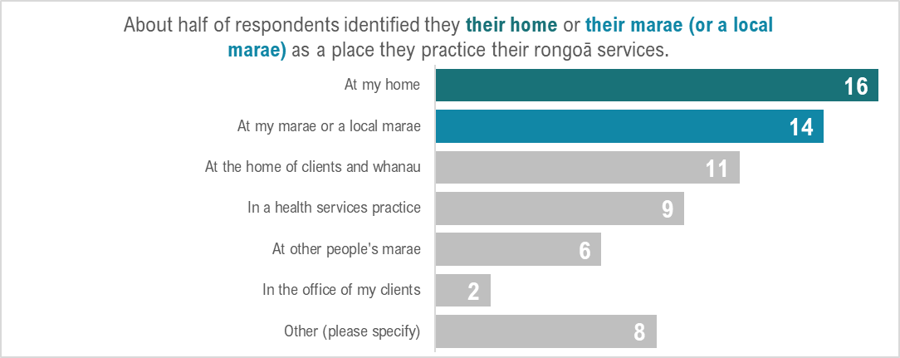

* About half of respondents (16/29) identified their home as a place they practice their rongoā.
* Almost half of respondents (14/29) identified their marae or a local marae as a place they practice their rongoā.
* Overall, respondents identified their home, their client’s home or their marae (or a local marae) as the top three places they practice their rongoā.

## The current law and proposed Bill overall

### The current law

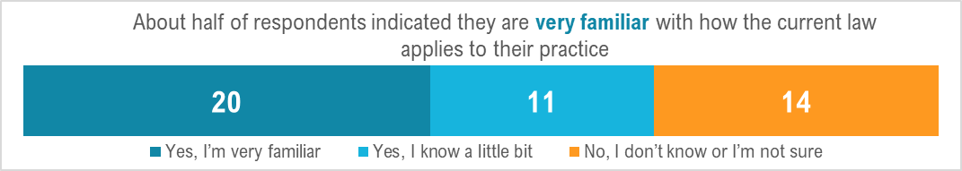

* About half of respondents (20/45) indicated they are very familiar with how the current law applies to their practice.
* About a third of respondents (14/45) indicated they don’t know or unsure how the current law applies to their practice.

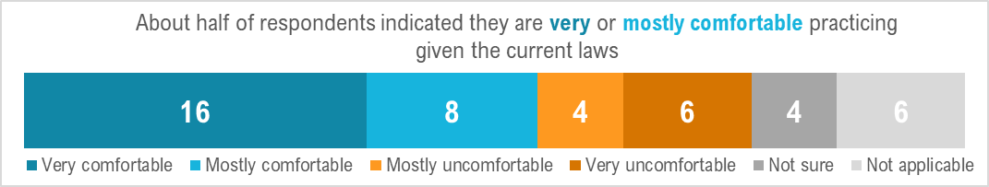

* About half of respondents (24/44) indicated they are very or mostly comfortable practicing given the current laws.
* About a quarter of respondents (10/44) indicated they are mostly or very uncomfortable practicing given the current laws.

### Understanding of the proposed Bill

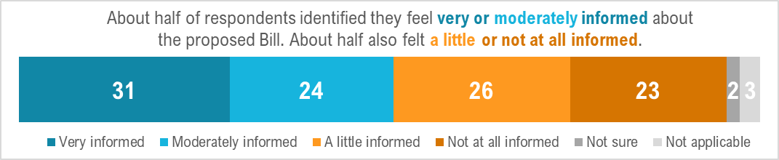

Overall, there was a very even spread from respondents about how informed they feel about the proposed Bill.

* About half of respondents (55/109) indicated they feel moderately or very informed about the proposed Therapeutic Products Bill.
* However, almost half of respondents (49/109) indicated they feel a little or not at all informed about the proposed Therapeutic Products Bill.
* Very few respondents (2/109) indicated they are unsure how informed they are about the proposed Therapeutic Products Bill.
* Of the people who indicated a practitioner-adjacent connection to rongoā (a practitioner, product preparation, manager, or kaiako), most respondents (40/66) indicated they feel moderately or very informed about the proposed Therapeutic Products Bill.
* Of the people who indicated a client-adjacent connection to rongoā (a recipient or product purchaser only), most respondents (25/43) indicated they feel a little or not at all informed or not sure about how informed they are about the proposed Therapeutic Products Bill.

Overall, of the people who indicated a connection to rongoā more than just a recipient or purchaser, many of them feel they understand reasonably well how the proposed Bill will affect their practice.

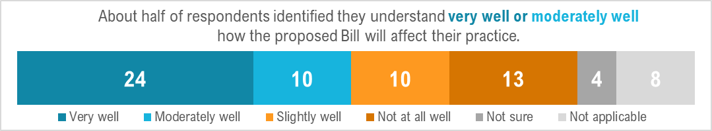

* About half of respondents (34/66) indicated they feel they understand moderately well or very well how the proposed Bill will affect their practice.
* Some respondents (24/66) indicated they feel they understand very well how the proposed Bill will affect their practice.
* However, about a quarter respondents (13/66) indicated they feel they understand how the proposed Bill will affect their practice slightly well or not at all well.

Overall, most respondents have sourced information from the Bill itself and their community. They found these sources the most useful.

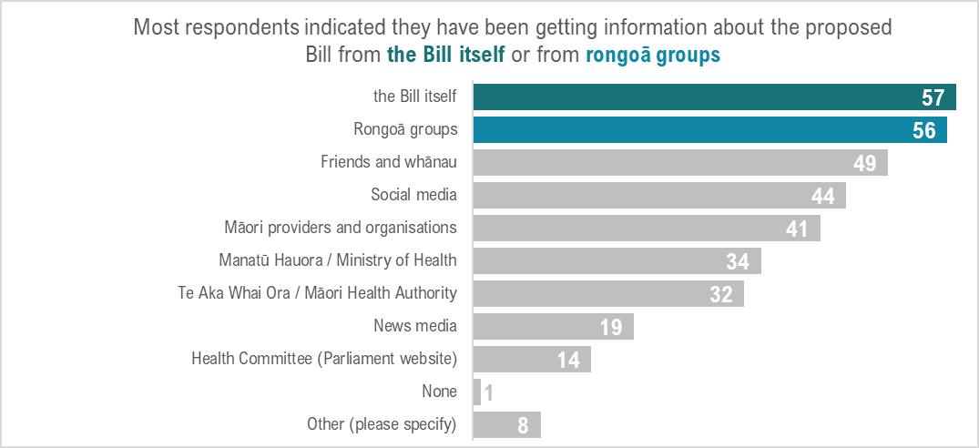

* Most respondents (57/107) indicated they have been getting information about the proposed Bill from the Bill itself.
* Most respondents (56/107) indicated they have been getting information about the proposed Bill from rongoā groups.
* Almost half of respondents indicated they have been getting information about the proposed Bill from friends and whānau (49/107) and social media (44/107).
* More than a quarter of respondents indicated they have been getting information about the proposed Bill from Manatū Hauora (34/107) and Te Aka Whai Ora (32/107).

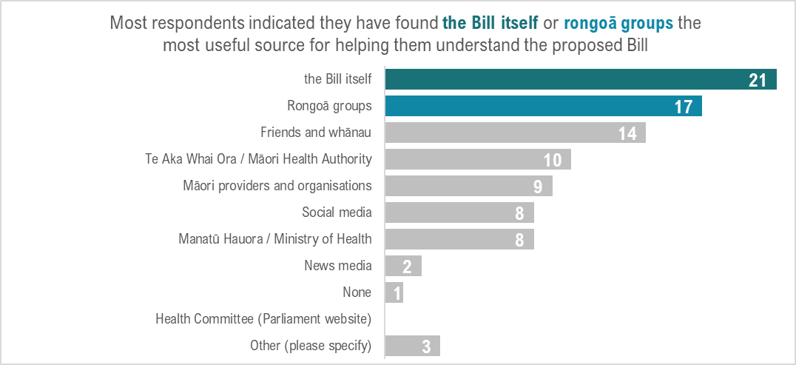

* About a quarter of respondents (21/93) indicated they have found the Bill itself the most useful source for helping them understand the proposed Bill.
* About a quarter of respondents indicated they have found rongoā groups (17/93) and friends and whānau (14/93) the most useful source for helping them understand the proposed Bill.

## Legal protection for rongoā – basis

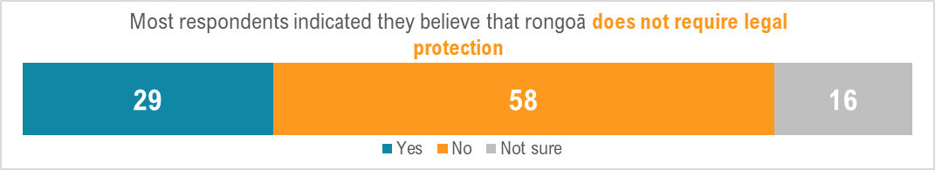

* Most respondents (58/103) indicated they believe that rongoā (including rongoā practitioners and whānau accessing rongoā services) does not require legal protection.
* About a quarter of respondents (29/103) indicated they believe that rongoā (including rongoā practitioners and whānau accessing rongoā services) requires legal protection.

Of the respondents that indicated Yes, rongoā requires legal protection:

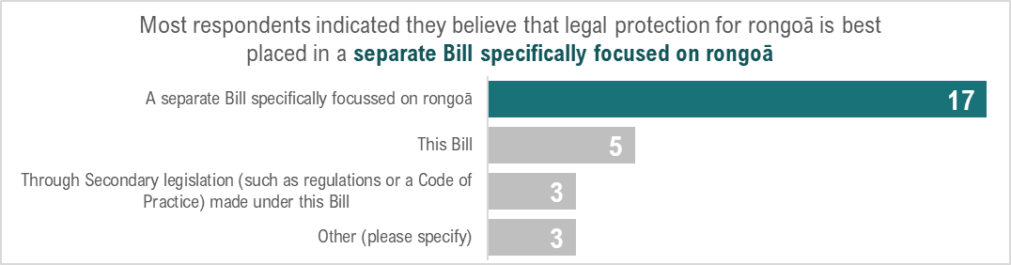

* Most respondents (17/28) indicated they believe that legal protection for rongoā is best placed in a separate Bill specifically focused on rongoā
* Few respondents (5/28) indicated they believe that legal protection for rongoā is best placed in this Bill.
* Very few respondents (3/28) indicated they believe that legal protection for rongoā is best placed in secondary legislation (such as regulations or a Code of Practice) made under this Bill.

## Response to proposed Bill core purposes

### Protection of rongoā

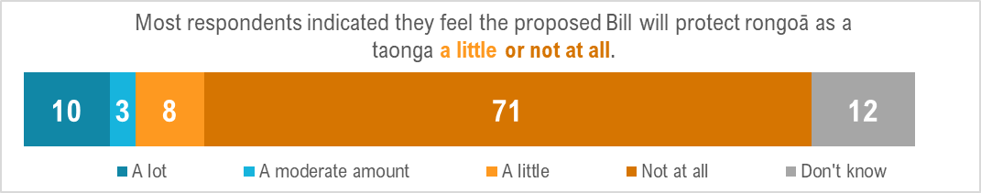

* Few respondents (13/104) indicated they feel the proposed Bill will protect rongoā as a taonga a lot or a moderate amount.
* Most respondents (79/104) indicated they feel the proposed Bill will protect rongoā as a taonga a little or not at all.

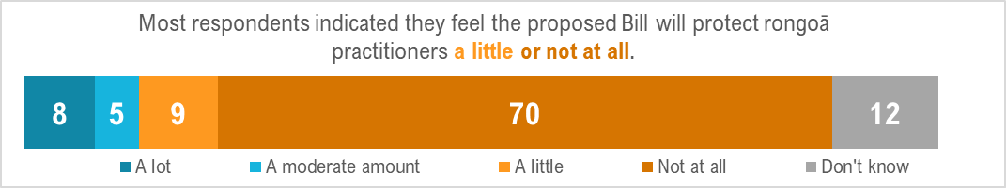

* Few respondents (13/104) indicated they feel the proposed Bill will protect rongoā practitioners a lot or a moderate amount.
* Most respondents (79/104) indicated they feel the proposed Bill will protect rongoā practitioners a little or not at all.

### Patient safety

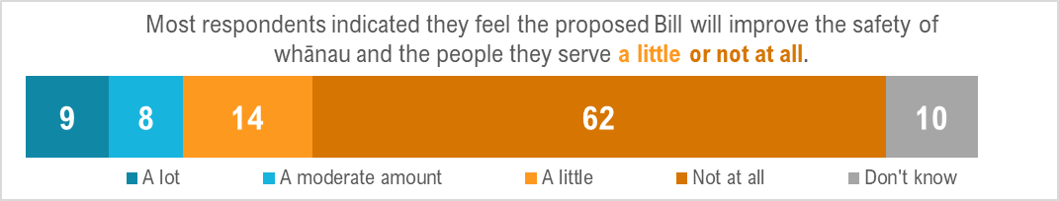

* Few respondents (17/103) indicated they feel the proposed Bill will improve the safety of whānau and the people I serve a lot or a moderate amount.
* Most respondents (76/103) indicated they feel the proposed Bill will improve the safety of whānau and the people I serve a little or not at all.

### Ease of practice continuity

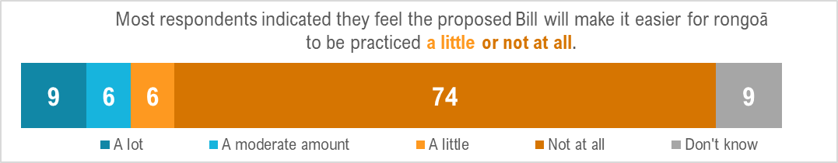

* Few respondents (15/104) indicated they feel the proposed Bill will make it easier for rongoā to be practiced a lot or a moderate amount.
* Most respondents (80/104) indicated they feel the proposed Bill will make it easier for rongoā to be practiced a little or not at all.

### Ease of product manufacturing

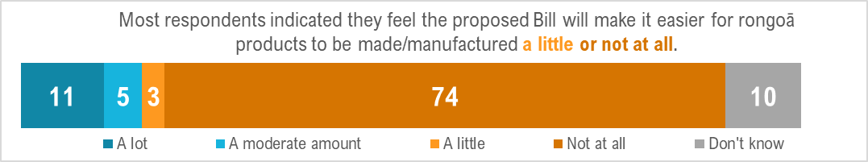

* Few respondents (16/103) indicated they feel the proposed Bill will make it easier for rongoā products to be made / manufactured by tohunga rongoā a lot or a moderate amount.
* Most respondents (77/103) indicated they feel the proposed Bill will make it easier for rongoā products to be made / manufactured by tohunga rongoā a little or not at all.

### Ease of product retail domestically

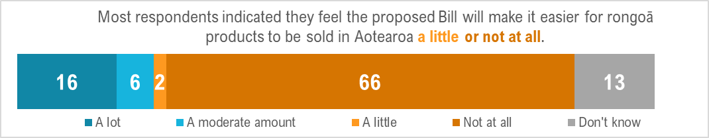

* About a quarter of respondents (22/103) indicated they feel the proposed Bill will make it easier for rongoā products to be sold in Aotearoa a lot or a moderate amount.
* Most respondents (68/103) indicated they feel the proposed Bill will make it easier for rongoā products to be sold in Aotearoa a little or not at all.

### Ease of export

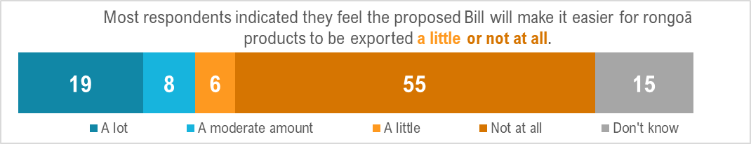

* About a quarter of respondents (27/103) indicated they feel the proposed Bill will make it easier for rongoā products to be exported a lot or a moderate amount.
* Most respondents (61/103) indicated they feel the proposed Bill will make it easier for rongoā products to be exported a little or not at all.

## Products under the Bill

### Using products

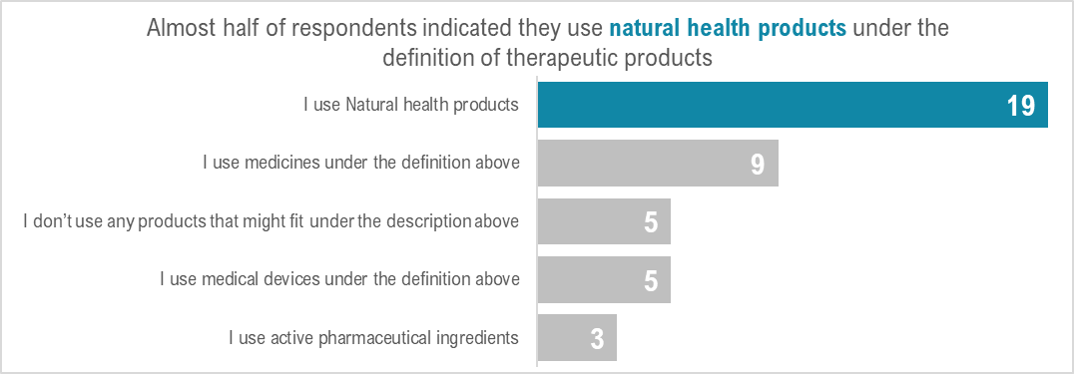

* Almost half of respondents (19/41) indicated they use natural health products under the definition of therapeutic products.
* About a quarter of respondents (9/41) indicated they use medicines under the definition of therapeutic products.
* Few respondents (5/41) indicated they use medical devices under the definition of therapeutic products.
* Very few respondents (3/41) indicated they use active pharmaceutical ingredients under the definition of therapeutic products.
* Few respondents (5/41) indicated they don’t use any products that might fit under the definition of therapeutic products.

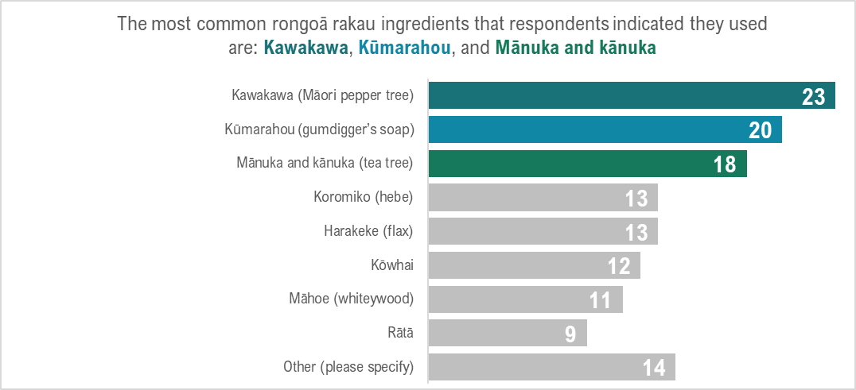

* The most common rongoā rakau ingredients that respondents indicated they used are:
* Kawakawa
* Kūmarahou
* Mānuka and kānuka.
* The most common other natural health products that respondents indicated they used are:
* Wai Māori
* Oils (such as olive oil, jojoba oil, almond oil, coconut oil)
* Minerals, including salts.

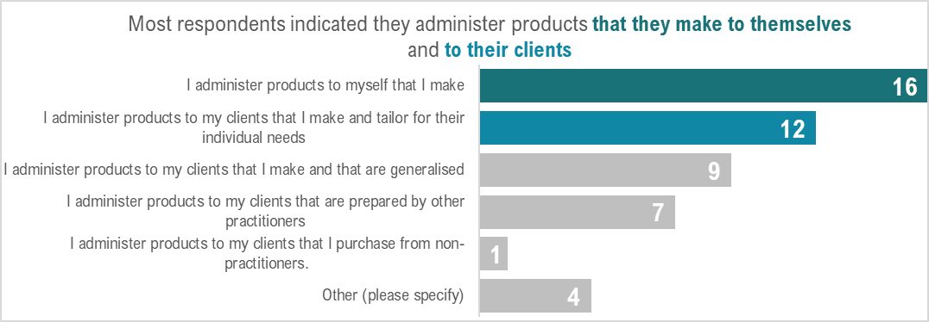

* Of the different ways to administer products, respondents indicated that they were most likely to:
  1. Administer products to themselves, that they make.
  2. Administer products to their clients that they make and tailor to their individual needs.

### Making products

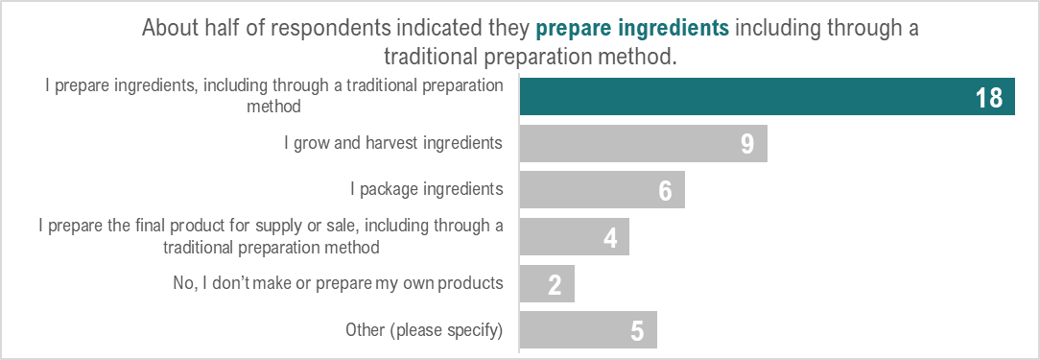

* About half of respondents (18/34) indicated they prepare ingredients, including through a traditional preparation method.
* About a quarter of respondents (9/34) indicated they grow and harvest ingredients.
* A few respondents (6/34) indicated they package ingredients.
* About half of respondents (13/25) indicated they definitely will make their own products if the Bill were to pass as it currently stands.
* About a quarter of respondents (8/25) indicated they were unsure if they would make their own products if the Bill were to pass as it currently stands.
* A few respondents (3/25) indicated they were a lot less likely to make their own products if the Bill were to pass as it currently stands.

### Supplying products

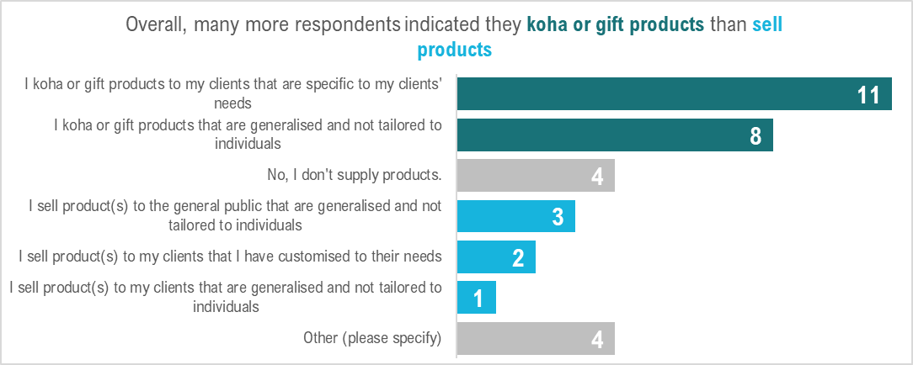

Overall, many more respondents indicated they koha or gift products than sell products.

* More than a few respondents (11/28) indicated they koha or gift products to their clients that are specific to their clients' needs.
* About a quarter of respondents (8/28) indicated they koha or gift products that are generalised and not tailored to individuals.
* A few respondents (4/28) indicated they sell products to the general public or their clients that are generalised and not tailored to individuals
* Very few respondents (2/28) indicated they sell products to their clients that are that are specific to their clients' need.



* The vast majority of respondents (17/20) indicated they do not import or export products.

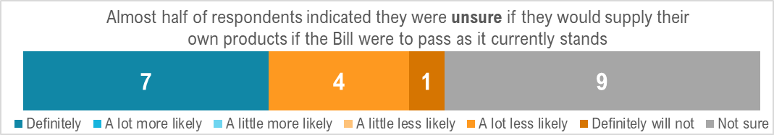

* About a third of respondents (7/21) indicated they definitely will supply their own products if the Bill were to pass as it currently stands.
* About a quarter of respondents (5/21) indicated they are a lot less likely to or definitely will not supply their own products if the Bill were to pass as it currently stands.
* Almost half of respondents (9/21) indicated they were unsure if they would supply their own products if the Bill were to pass as it currently stands.

## Training, reputation, endorsement

Overall, most respondents indicated they came to practice rongoā through pathways outside formal accreditation.

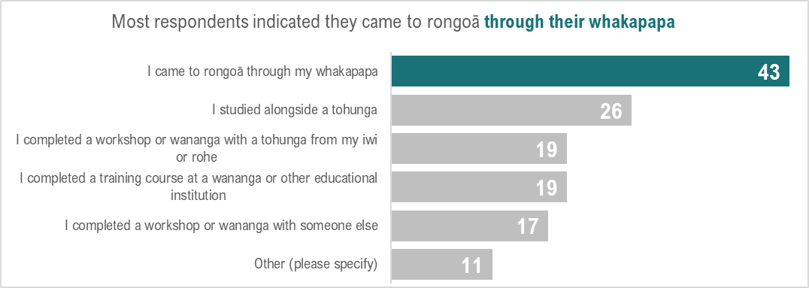

* The majority of respondents (43/61) indicated they came to rongoā through their whakapapa.
* Almost half of respondents (26/61) indicated they studied alongside a tohunga.
* More than a few respondents indicated they completed some kind training, including a training course at a wananga or educational institution (19/61), a workshop or wananga with a tohunga from their iwi or rohe (19/61), or a workshop or wananga with someone else (17/61).

Overall, most respondents indicated the definition of “fit and proper person” makes little or no sense in a mātauranga Māori context.

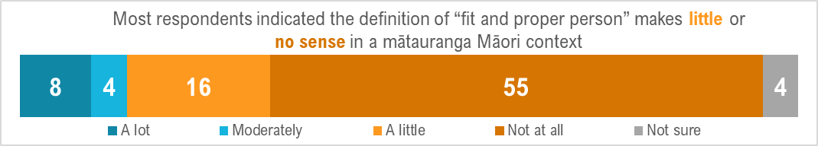

* The majority of respondents (71/87) indicated the definition of “fit and proper person” makes little or no sense in a mātauranga Māori context.
* Few respondents (8/87) indicated the definition of “fit and proper person” makes a lot of sense in a mātauranga Māori context.

Overall, many more respondents indicated that they thought it was more appropriate to receive endorsement to practice rongoā from their iwi/hapū/whānau (58/148) or local tohunga (49/148) than a Regulator (2/148), educational institution (6/148) or a national rongoā peak body (17/148) (note: respondents could select multiple options, with a total of 148 selections made).

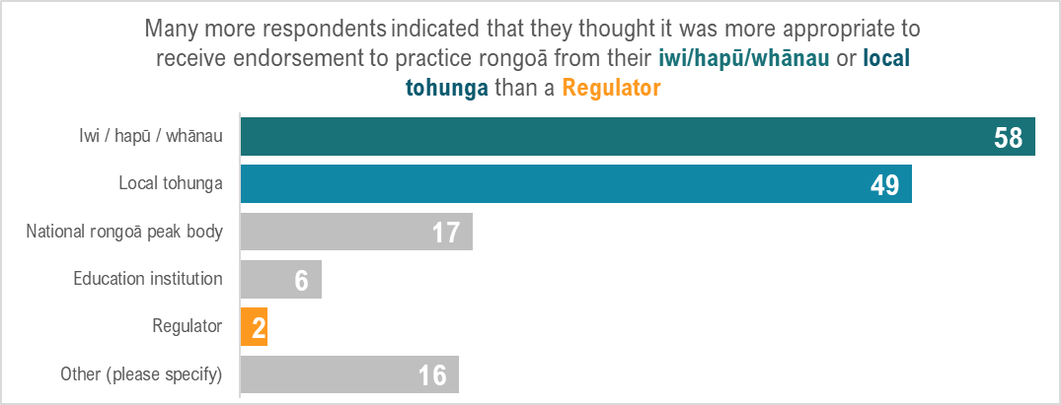

## Licensing

Overall, respondents had mixed understanding of what they would need a license for if the Bill were to pass as it currently stands.

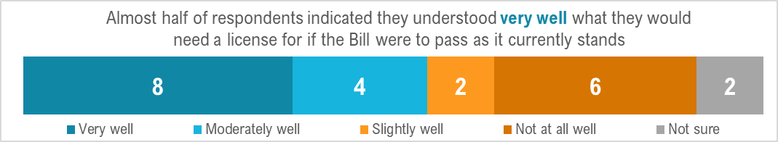

* Almost half of respondents (8/22) indicated they understood very well what they would need a license for if the Bill were to pass as it currently stands.
* About a quarter of respondents (6/22) indicated they did not understand at all well what they would need a license for if the Bill were to pass as it currently stands.

Overall, respondents had mixed awareness of whether they will need a license to practice if the Bill were to pass as it currently stands.

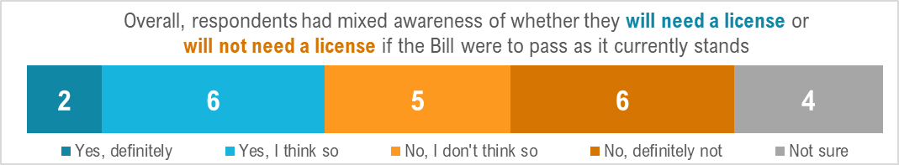

* About a quarter of respondents (6/23) indicated they think they will need a license to practice if the Bill were to pass as it currently stands.
* About a quarter of respondents (5/23) indicated they don’t think they will need a license to practice if the Bill were to pass as it currently stands.
* About a quarter of respondents (6/23) indicated they definitely won’t need a license to practice if the Bill were to pass as it currently stands.
* More than a few respondents (4/23) indicated they were unsure if they will need a license to practice if the Bill were to pass as it currently stands.

## Health benefit claims

Overall, the vast majority of respondents always tell their clients about the potential health benefits of rongoā products they use or supply.

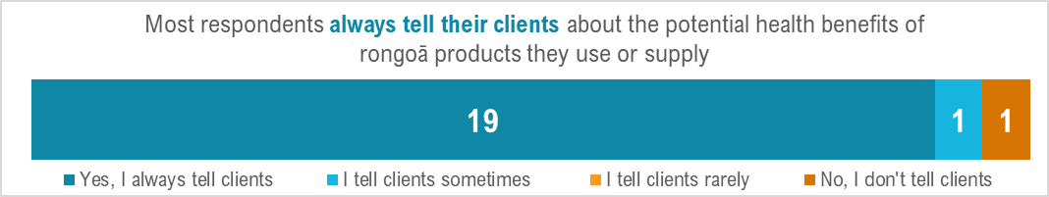

* Almost all of respondents (19/21) indicated they always tell their clients about the potential health benefits of rongoā products they use or supply.
* Very few respondents (1/21) indicated they do not tell their clients about the potential health benefits of rongoā products they use or supply.

Overall, the majority of respondents are very confident that mātauranga Māori supports the health claims they make.

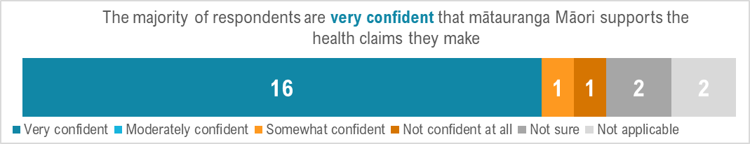

* Most respondents (16/22) indicated they are very confident that mātauranga Māori supports the health claims they make.
* Very few respondents (3/22) indicated they are not at all confident or not sure that mātauranga Māori supports the health claims they make.

## Search and entry

Overall, most of respondents do not believe requiring a search warrant or consent is appropriate to enter and search premises.

* Most respondents (13/20) indicated they do not believe requiring a search warrant or consent is appropriate to enter and search premises.
* About a quarter of respondents (5/20) indicated they believe requiring a search warrant and consent is appropriate to enter and search premises.

## Overall

Overall, most respondents expressed a generally negative view of the Bill and the process. This feedback was overwhelming and is detailed throughout the body of this report.

Rongoā should be managed for and by Māori because it is of Māori. To allow Government and legislative oversight will place our knowledge sovereignty at risk.

“I feel that the Therapeutic Products Bill as it currently stands is not good for Māori under Te Tiriti o Waitangi and tino rangatiratanga. It does not protect our taonga that belongs to us in which we have absolute sovereignty over our healing. It's like bringing back the Tohunga Suppression Act again.”

“I feel the Therapeutic Products Bill is an overreach and an attempted abuse of power. I feel that this proposed TPB is disempowering Māori from utilising ancient knowledge and practices and that government has no authority over taonga tuku iho. Governments responsibility is to protect our mātauranga not dictate how and when we use it.”

“It does not take into account te ao Māori perspective as it is structured in a way that does not respect the Crown-Māori relationship. Why is this even included in this Bill. There is no reflection of Māori as partners in this Bill from the very structure of having a Bill that rongoā Māori is added to.”

“I feel that the therapeutic products Bill is taking away our right to exercise Kaitiakitanga. Rongoā should be under the umbrella of Māori guardianship. You can't call it rongoā if the appropriate tikanga/kawa is not applied.”

“I believe it does not protect rongoā Māori and in fact hinders our rights as Māori to appropriately utilise our own IP which the crown does not own. Rongoā is steeped in te ao Māori knowledge which has supported our whānau for thousands of years throughout the South Pacific, voyaging, pre- and post-colonisation. Rongoā is our natural inherited right pre-determined by our Tīpuna and is not to control by the crown. Our rongoā also helped and treated the Pākehā that arrived in Aotearoa New Zealand.”

“It’s about power, control, and money. [It] takes away the rights of those who are appointed kaitiaki of rongoā and also Te Tiriti of Waitangi article 1 and 2. The longer-term plan suggests that regulation is part and parcel of how the three Members of Parliament at the time namely Sir Peter Buck, Sir Apirana Ngata and Sir James Carrol regulated the health laws so that Māori are regulated to conform to health and hygiene in homes, in public which overturns our tikanga rights that we are hygienic and health conscious when making rongoā, when selling products overseas, etc. Tohunga have been operating clinics for a long time and there is not one clinic that I entered that has hygiene failures rather they are conscious of how their clinics are kept due to being in organisation that keep them accountable. For those who operate at home I have not seen tohunga's home that are less then hygienic. This Bill removes the rights of our traditional practices of health and hygiene, being taught by the best to uphold our rongoā practices to be professional due to the practices of tikanga taught by tūpuna and kaiako of rongoā. TWOA have standards as like Te Raukawa that are written in their teaching manuals which uphold sanity, hygiene, safety, and health standards. To regulate our standards is to take away our tikanga practices and continue to be indoctrinated by the powers that be the government of the day and Manatū Hauora has to be seen to consult Māori community through all mediums of communication, emails, social media, zoom due to time limits. This is another fast and furious process that has restricted Māori to time [unreasonable] limits once again.”

“It will restrict what we are able to do as Practitioners.”

“This Bill criminalises rongoā Māori. It fails to actively recognise and protect rongoā Māori. It breaches Te Tiriti in that it obstructs Māori rights to tino rangatiratanga over taonga tuku iho / rongoā as guaranteed in Article Two of Te Tiriti. The process used to develop and inform the drafting of the Bill is dishonest and circumvents the Parliamentary Select Committee submission process. With regard to rongoā, this Bill assumes the premise that rongoā presents a risk to the New Zealand public that warrants legislative protection. Despite producing no evidence to the support this notion and contrary to lived experience and lack of statistical evidence of actual harm. The greatest risk to the health and safety of rongoā consumers is Crown intervention in a practice that they have no knowledge, experience, or appreciation for. This Bill gives competitive advantage to the larger players in the natural health products industry through their ability to more easily afford compliance costs imposed on rongoā practitioners under this Bill. In summary this Bill and the conduct of the Crown in the development process is dishonest, disrespectful, and unlawful and will likely result in an urgent application hearing to the Waitangi Tribunal. This Bill perpetuates the oppression of Māori ways of knowing, doing and being.”

“The mauri is not tika. It is a Western construct over the top of mātauranga rongoā because of the narrow therapy product brief. It has the Regulator in the place of power that has the real possibility to be punitive. 1907 is a clear example of legislation for the perceived protection of others which sent an entire healing system underground because of judgments and perceptions that were incorrect. That legislation was repealed 55 years later yet 116 years on we are still living the repercussions of the intergenerational trauma that our whakapapa line experienced knowingly or unknowingly. It’s all the unseen damage. The fear that we are automatically wrong, and our practice undervalued yet that is further from the truth.”

“It makes me pouri and pukuriri that rongoā Māori has been "lumped" together with everything else and not protected in accordance with Te Tiriti.”

“I have no trust or confidence in the TPB. It does not work for rongoā Māori as governed by Māori! Rongoā Māori deserves its own Bill.”

“Disappointed and scared about the future of our rongoā Māori, and rongoā getting exploited and used overseas!!”

“I feel that it’s taking the mana motuhake of rongoā Māori away from the tangata whenua that use and need it the most. It is minimising the cultural aspect of natural health. If people are allowed to export our rongoā overseas - how is that maintaining the mauri of the rakau? How is it protecting our rakau here in Aotearoa? It is not sustainable practice.”

“Rongoā Māori is a sacred practice that has been passed down through our lineage and intrinsically woven into our Māori culture. Te ao Māori and te ao Pākehā are two different worlds. How can the proposed legislation, legislate that which can never be legislated. Rongoā Māori does not fit into a mainstream colonised perspective. All issues that require addressing issues in relation to rongoā Māori should be addressed by rongoā Māori practitioners only. Not Doctors or nurse or health professionals. Not by kaupapa Māori Agencies that follow a mainstream directive. Not by Governments or iwi or but only by recognised rongoā Māori practitioners who understand the true value of rongoā in relation to te ao Māori.”

“Deeply concerned that government is involved in determining our best practices when it comes to harvest, preparation, and distribution of rongoā.”

“Indigenous knowledge and traditional practices play a crucial role in the health and well-being of native people, and it is essential that these practices are preserved and passed down from generation to generation. The regulation of natural health products under the Therapeutic Products Bill threatens to undermine this preservation by taking away the rights of native people and further perpetuating the colonisation of their culture and traditions. Furthermore, the regulation of natural health products under the bill is excessive and unnecessary, especially considering that these products are generally considered to be lower risk than traditional medicines and medical devices. The stricter regulations imposed on natural health products may limit their accessibility and availability, affecting the people who rely on these products for their health and well-being. The regulation of these products under the Therapeutic Products Bill may impact the cultural identity of native people, who have relied on these products for centuries to maintain their health and well-being. It is important that cultural heritage is respected and preserved. One of the main concerns is that the regulation of natural health products, particularly indigenous knowledge in medicine, is another form of colonisation. This is reminiscent of the Tohunga Suppressions Act, which was enacted to suppress Māori spiritual and cultural practices.”

“I feel very uncomfortable with the idea that I could be find. I am inspiring practitioner. I am worried that rongoā and mātauranga Māori will be monetised and stolen by corporations.”

“Just as the tohunga suppression act, suppressed our rongoā Māori- this will do the same. Current health model didn't work for myself, my whānau or those of my community. I feel they want to take away the very thing that is making Māori healthier.”

“Witch hunting creates biases based on one-sided unethical, unsafe, big business dangerous approach to health that has no understanding of keeping a healthy homeostasis that uses natural laws and ancient, proven by time and science. Outlawing and creating clauses so only the select prescribers can offer simple, cheap, obtainable remedies is a blatant shifting power out of our people's affordability and accessibility.”

“How do I feel? Kei te hiakai ahau, he taniwha i roto i a tatou, e ngau ana, e ngau ana, ka tapahia tona mahunga, ka horoia e ona kikokiko te whenua hei whangai i ngā rākau.”

### Positive feedback

Of respondents, 8 of 170 expressed a generally positive view in the ‘overall’ section. However, the same respondents still maintained concerns around the role of the Bill and the details within it.

Overall, their feelings towards the proposed Bill are:

“I’m encouraged that rongoā Māori will be given its rightful place within this kaupapa.”

“I think it’s great that rongoā is finally being recognised as a medicinal approach.”

“It gives people the choice to choose how, who, what, where and why they receive Rongoā.”

“Fantastic. I think it’s a win win for New Zealand not only for those that practice in this field but for all of our country.”

“Should stay.”

“Good.”

“It gives people a choice, the right to choose how, who, what and where they receive their natural products from.”

“I agree there are some areas that need accountability. Although people will tend to learn which practitioners know their stuff. The issues arising are far less than with medical allopathic medicine that can have far more side effects, drug dependency etc.”

However, amongst this group, there was still discussion around whether rongoā required legislation:

“It is our sovereignty our birth right. LORE should be adequate to protect rongoā. I don’t require legal protection so why should rongoā.”

“It will become self-regulating. This is a hapū jurisdiction not a crown one. It is up to each hapū to regulate within their rohe.”

Around fit and proper person:

“They have been appropriately recruited, trained and risk assessed from culturally appropriate experts and Māori organisations that endorses their practice as safe and whānau centred that underpins overall wellbeing.”

“Someone with history in practicing rongoā.“

“Intention, knowing their craft, whakapapa of practice/verification of competency and results from those you have treated.“

“I think judgment is all good but if this is going to help someone improve theirs and their whānau life plus that of others and those practicing rongoā should hold the respect of mātauranga Māori already.“

“Experience, who they were trained by, the client results, how long they have practised, how regularly they practice for some.”

General statements included:

“This kaupapa needs to be Māori Led always which will ensure the integrity is always preserved but will positively impact on ALL that embrace an holistic, physical, spiritual, approach to wellbeing and understanding our role as kaitiaki to Papatūānuku.”

“I believe this will be passed regardless as is now systemised in the government especially with ACC (Accident Compensation Corporation). It’s painful for me to say that! They have appointed a cabinet minister just for ACC it isn’t under general health portfolio. The Government will regulate it alongside pharmaceutical companies. Our rongoā can heal, support people to better health and living, money cannot be made off healthy people. Our rongoā will be diluted in its capability and strength to help others and could be used to keep the unwell just as they are- feeling ok but not in great health where they do not need for dis-ease. should be a daily maintenance for the self once you have overcome dis-ease. I do not see this happening when this hill passes. Rongoā vibrates at a high level in its natural form and in turn does the same with people. When it’s diluted you dilute the people, their whakaaro and intentions.”

“This will be wonderful for our country and its journey on reconnecting and revitalising our Māori culture.”

“Rongoā does not belong under the regulation of crown jurisdiction. It is Māori taonga under hapū jurisdiction.”

One Kaiako and one practitioner noted their concerns around the current legislative environment:

“Systemic processes that do not follow kawa or tikanga; certification of our practices when it should be based on whakapapa - who taught you who were your teachers/tohunga/kaitiaki; verification of competency through whakapapa practice, tikanga and kawa and tūroro those you have helped. Not been seeing on an even par or equal to other practitioners/services such as physios, osteopaths, chiropractors, counsellors, psychologists etc - we are limited in these areas as is perceived by our current system as to not having the skills or knowledge to work in these fields, which also reflects in the cost and frequency of appointments for our practice compared to the above.”

“Often once regulations come in the regulatory body will determine registrations, up skilling to their requirements, etc. all of which costs more and more money.”

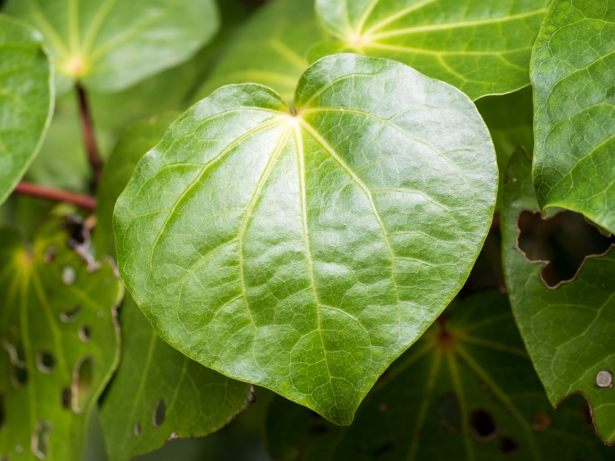

1. In this report rongoā refers to rongoā Maori.
2. The period to gather feedback from Māori was tied to the original closing date of submissions on the Bill of 7 February. The timeframe was extended to 15 February and subsequently extended to 5 March 2023.
3. Wikaira E. Harwood M. Pihama L. 2020. Traditional Indigenous Healing: What Was, Is, and Will be Rongoā Māori. 9th Biennial International Indigenous Research Conference 2020.
4. Ministry of Health. 2021. Review of Ministry of Health Funded Rongoā Services. Ministry of Health: Wellington, N.Z <https://www.health.govt.nz/publication/review-ministry-health-funded-rongoa-sector>
5. <https://www.health.govt.nz/our-work/populations/maori-health/rongoa-maori-traditional-maori-healing>
6. The Bill provides for regulation of controlled activities on manufacturing, supply, export and clinical trials, market authorisation, restrictions on product claims, cost recovery power and regulations to impose fees and levies to fund the costs of administering the Bill, and a range of compliances and enforcement powers.
7. The period to gather feedback from Māori was tied to the original closing date of submissions on the Bill of 7 February. The timeframe was extended to 15 February and then was subsequently extended to to 5 March 2023.
8. Excludes Ministry, any other government attendees, and Weaving Insights attendees/facilitators.
9. At least 60 attendees.
10. Wikaira E. Harwood M. Pihama L. 2020. Traditional Indigenous Healing: What Was, Is, and Will be Rongoā Māori. 9th Biennial International Indigenous Research Conference 2020.
11. Ministry of Health. 2021. Review of Ministry of Health Funded Rongoā Services. Ministry of Health: Wellington, N.Z https://www.health.govt.nz/publication/review-ministry-health-funded-rongoa-sector
12. https://www.health.govt.nz/our-work/populations/maori-health/rongoa-maori-traditional-maori-healing
13. The distinction here is illustrative only.
14. Their term. Allopathic medicine refers to science-based modern medicine – focussed on cures and medical intervention.
15. Implicitly, active protection was raised – however this was very much viewed as falling within article 2 and thereby we do not reproduce the crossover here.
16. This sentiment of someone ‘watching the watcher’ also came up in terms of the proposed Regulator: a number of participants were sceptical that the proposed Regulator would comply with Te Tiriti unless held accountable externally somehow.
17. Programme of work Te Pae Tawhiti, led by Te Puni Kōkiri looking at realising benefits for the Country, and at Government’s role in relation to mātauranga Māori.
18. Which was strengthened by the Quackery Prevention Act 1908. The two pieces of legislation can be read together in this way.
19. We note that access to rongoā is itself changing over time.
20. Whakamaua: Māori Health Action Plan 2020 – 2025.
21. One participant stated that the standards were ‘quashed and amalgamated.’
22. We have redacted potentially identifying information here.
23. Excludes Ministry, any other government attendees, and Weaving Insights attendees/facilitators.
24. At least 60 attendees.