Mana Tangata
Treating Everyone with Dignity
Lessons for the Aotearoa New Zealand Health System

April 2023

Acknowledgements
Produced by Tokona Te Raki for the Ministry of Health
Contributors:
Dr Eruera Tarena
Adrienne Anderson
Luc Shorter
Dr Jessica Berentson-Shaw
Megan Salole
Citation: Tarena E, Anderson A, Shorter L, et al. 2023. Ao Mai te Rā: the Anti-Racism Kaupapa Summary Paper – Lessons for the Aotearoa New Zealand Health System. Wellington: Ministry of Health.
Published in April 2023 by the Ministry of Health
PO Box 5013, Wellington 6140, New Zealand
HP 8709
This document is available at health.govt.nz
This work is licensed under the Creative Commons Attribution 4.0 International licence. In essence, you are free to: share ie, copy and redistribute the material in any medium or format; adapt ie, remix, transform and build upon the material. You must give appropriate credit, provide a link to the licence and indicate if changes were made.

Contents
Mana Tangata in Aotearoa: What is Our Vision, Why Are We Not There, and What We Can Do? 1
The vision 1
Who is this document for? 1
How can you use this document? 1
Context for this work 2
Differentiating equity and equality 3
Introduction 4
Overcoming Health Inequity: A Shared Desire 5
Understanding and Explaining the Problem of Racism, the Barriers to Equity and Wellness 5
Our health system – taking the universal ‘one size fits all’ approach 9
Cause 9
What is set in motion 9
Effects 9
Interpersonal Vs Systemic Racism 12
Critical shifts in mindsets to counter racism 12
The solution 14
Te Tiriti o Waitangi as a powerful anti-racist tool 14
An Aotearoa where we all thrive – Mana Tangata 18

Mana Tangata in Aotearoa: What is Our Vision, Why Are We Not There, and What We Can Do?

The vision
In 2040, 200 years after the signing of Te Tiriti, Aotearoa is celebrating its greatest achievement – everyone regardless of culture, background, identity, or race, is valued and honoured for who we are, and our needs are met. Our shared humanity and appreciation of our unique and complementary strengths unite us. Together we reshaped and redesigned our systems for equity so that all groups including Māori and Pasifika thrive in learning, earning, health and wellbeing. Our health system is driven by values unique to Aotearoa and Māori as our indigenous leaders – values like manaakitanga, whanaungatanga and kaitiakitanga. By 2040 Aotearoa is a place where all people live their best life and are treated with mana and dignity. We co-created this future by honouring and enacting the Māori intent of Te Tiriti o Waitangi – to unify and strengthen our nation.

Who is this document for?
People working in public health systems who care about equity, equality, justice and the wellbeing of people in New Zealand, and have their hands on some of the levers in the system, if not individually then collectively. People with power to make change in all our lives.

How can you use this document?
This document is designed to build an understanding of the role of racism in driving inequity, and to bring people together around some shared and deeper understandings of racism, especially how it plays out in our health system. It can be used as a guide on how to shift people’s mindsets and deepen understanding about the ways to overcome racism and build better systems to overcome inequity.
Three things it is important to understand:
- Racial health inequities are caused by systemic racism. We cannot advance health equity without addressing the root cause of inequity – racism.
- Interpersonal racism is unacceptable and systemic racism causes harm on a societal scale. We need to shift our mindsets around how systemic racism works as this is the change that will make the biggest difference to outcomes.
- Racism and racial health inequity are global problems but our superpower is Te Tiriti o Waitangi. An authentic commitment to Te Tiriti is how we address systemic racism and realise the potential of an equitable health system where all people are valued and everyone gets what they need.

Four actions organisations can take:
- Increase awareness of the human impacts of racism and the benefits of anti-racism so people believe in the change.
- Incorporate anti-racism into organisational strategies, planning and accountability documents so that it is embedded, and creates the conditions for anti-racist culture change.
- Train people to identify and counter systemic racism so they create anti-racist practices.
- Create anti-racism reporting tools to shine the spotlight on what needs to change and build evidence of what works to support the movement.

Four actions people can take:
- Be critically conscious. Critically reflect, examine and accept your power and privilege and commit to change. Understand that your power and privilege are resources that can be used for good.
- Be a champion for anti-racism action. Increase awareness of the im- pacts of racism on health and wellbeing, and the benefits of anti-racism practice to achieve health equity.
- Be a good anti-racism ally. Take responsibility for educating yourself. Use your power and privilege to drive individual and organisational change.
- Be prepared to share power and do things differently. Naming racism and strategising against it are important first steps. Push through the discomfort and be courageous.

Context for this work
Ao Mai te Rā: the Anti-Racism Kaupapa is a Ministry of Health initiative to support the way the health system understands, reacts and responds to racism in health.

This document summarises the stage one literature review (the review) that examines the evolution of racism and anti-racism with a focus on Aotearoa and the health sector. It tells the story of how racism has evolved and what we can do to eradicate it.

The review was completed as part of Ao Mai te Rā by researchers from the University of Canterbury and Tokona te Raki.

Differentiating equity and equality
Equity - recognises that people with different levels of advantage require different approaches and resources to get equitable health outcomes and enjoy full and healthy lives. To achieve this, it must be considered as a structural or systemic concept inclusive of power, resources, strategies, conditions, habits and outcomes, and an understanding of unique human differences.

Equality - recognises that everyone gets the same things in order to enjoy full and healthy lives. Equality only works if everyone starts from the same place and needs the same things.

Introduction
No matter our background, Māori or tauiwi (non-Māori), most of us want to live in an Aotearoa where we are valued for who we are, where our needs are met and we all have the opportunity to thrive. Achieving health equity and supporting the wellbeing of all people is a shared desire for the majority of New Zealanders. To right long-standing injustices experienced by Māori, Pacific peoples and communities of colour is the right thing to do. Meeting all people’s needs will also unlock the strength and leadership within those communities who don't have the opportunities they need to thrive, and be of benefit to all of us.

Conquering health inequity means we must address the role racism has played in creating and sustaining disadvantage for our communities. It also requires us to understand how racism operates as a system – and how it structures opportunity based on race or ethnicity. Ultimately, racism hurts all of us, and we are all better off without it. In our past, exclusion and assimilation policies have structurally disadvantaged some groups while also advantaging others. Like the code that is used to programme a computer’s operating system, racism can be so embedded in the many policies and practices that shape the lives of our communities today, that it is invisible to many people so they do not understand the role racism continues to play in maintaining inequality and shutting Māori, Pasifika and Immigrant communities out.

However it can be made visible and those systems can be reprogrammed.

One barrier to helping people see how racism is programmed in our health system, is that today racism is often painted as unconscious and between individuals. We talk about people being racist, but do not explain how a system or policy can be racist, even when it isn’t intended to be.

Our conversations and explanations need to focus more on the racist structures and systems that negatively impact Māori, Pacific peoples and communities of colour. If we cannot see how racism is hard coded into the system then it’s easy to blame individuals (deficit theorising) for “failing” or “not being good enough” or “not working hard enough” when they do not thrive. We fail to see the barriers that have been put up to prevent them thriving, we also cannot see that what some communities need to flourish is different from what we have in place now. As our population becomes older and more ethnically diverse, we need to ensure everyone gets what they need to overcome the inequity which impacts us all.

To address growing health inequities, we must identify and remove existing racist policies and practices in our health system that are barriers to Māori leadership and inclusion, and replace them with solutions that will ultimately benefit Māori and non-Māori alike. When everyone gets what they need, we all prosper.

Honouring Te Tiriti o Waitangi is one powerful tool we can use to help reprogramme our health system to ensure all people are included, all people’s needs are met, and all people are supported to thrive.
A Te Tiriti-based future is one where we embrace our shared fate with smart solutions and open hearts for the betterment of all who call Aotearoa home.

Overcoming Health Inequity: A Shared Desire
Achieving health equity and supporting the wellbeing of all people, is a shared desire for many in Aotearoa. For many people working within our public structures and systems, this desire is highly motivating. People within these systems have the power collectively to act – to create systems that overcome inequity within our communities.

First, we must understand how racism programmed into our health system is driving continued injustice and poor outcomes for particular communities, especially Māori and Pacific peoples. Then we must understand how we can use our influence to reprogramme these systems to achieve the outcomes that work best for everyone.

Understanding and Explaining the Problem of Racism, the Barriers to Equity and Wellness

Racial inequities are caused by systemic racism. Everyone getting what they need (advancing equity) means addressing the root cause of inequity – systemic racism.

One way of understanding systemic racism is to think of cities that are designed around cars – without much thought given to people riding bikes, walking, or using wheelchairs. Everything about the road has been designed and built for people driving their vehicles, with their ability to safely and efficiently move from A to B in mind.

Others, such as people riding bikes, have a different experience. Their safety and needs have generally not been figured into the design. They are vulnerable and they feel it from the moment they move onto the road, navigating a space that was not built for them. There is little room for error and, if something goes wrong, the consequences can be serious.

Systemic racism is like this. Being part of the dominant group is like being a person driving a car, and not being part of that group is like being a person riding a bike or walking. Driving a car does not make people anti those who ride or walk, however, it is important to recognise that people driving benefit more from the way the system currently works. And eventually most people, including those driving cars, experience problems when our streets are not designed for everyone.

When we look at initiatives to correct inequities in systems, this metaphor continues to hold lessons for us. Most of the cycle lanes developed over the years have been designed as an afterthought rather than included from the start and may not deliver the intended safety and usability benefits. In terms of the system, this has been the case across sectors (eg, health, education and justice) for many decades.

More recently, there has been a growing recognition that involving different groups in the design of our cities, from the beginning, delivers benefits for everyone. It results in
spaces that are more beautiful, more usable, more accessible and more enjoyable for all. The process to get there, though, comes with challenges. Small concessions of space on our streets can lead to driver frustration as they learn to share the space in new and different ways.

Perhaps most significantly, achieving real change requires that a critical mass of drivers support and buy into a vision of an inclusive future. Cyclists won't get it on their own.
Similarly, building an anti-racist system needs the same support –those who benefit from the status quo must be part of championing a new way of doing things and sharing space with diverse voices.

People working in our public structures and systems can overcome systemic racism.

Colonisation and racism in Aotearoa have always been linked. Aotearoa has a history of exclusion and assimilation policies which have structurally disadvantaged Māori (taking the land, language, and culture away from tāngata whenua) and disproportionately impacted and excluded Pacific peoples and communities of colour. Whilst the purpose of these policies was to attain and protect colonial wealth, the racist ideas that depicted Māori, Pacific peoples and communities of colour as ‘inferior’, have outlived the policies themselves. We all have a role to play in preventing, identifying and countering systemic racism in our public structures and systems.

The following diagram draws upon the work of Ibram X. Kendi to create a visual chain showing how racism driven through our systems and structures works to harm people, from the ideas and policies that support it to the visible actions and real-world outcomes it creates.
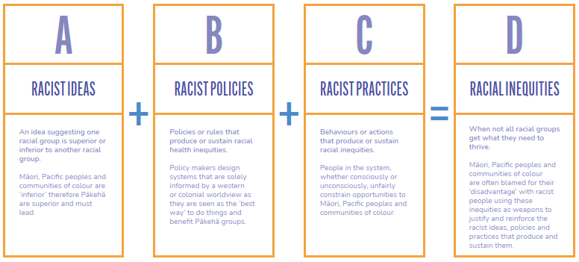

“Te piko o te māhuri, tērā te tupu o te rākau.”

THE WAY IN WHICH THE YOUNG SAPLING IS NURTURED (BENT), DETERMINES HOW THE TREE WILL GROW.

Much like the growth of a tree, how a system is set up will impact how it grows. If there are issues in its foundations, then those will have persistent negative impacts on the system throughout time. In the context of health, racist ideas, policies, and practices are the flaws in the system that will continue to produce inequity if not addressed.

Our health system – taking the universal ‘one size fits all’ approach

Cause
Traditionally, health services are driven by a universal ’one size fits all’ approach. Māori, Pacific peoples and communities of colour may be acknowledged as a stakeholder but have had limited data and decision-making power to influence the types of services they need and how they are provided. Poorer health outcomes are blamed on whānau, or attributed to genetics or socio-economic status rather than the accessibility and quality of services they receive.

What is set in motion
Health strategies, specific to Māori and Pacific peoples, often suffer from a lack of proper resourcing and support. Māori, Pacific peoples and persons of colour working in mainstream health also feel isolated and overwhelmed by being expected to repair the damage caused by racist policies and practices. Their frustration at the lack of progress and at times culturally unsafe work environments results in more Māori, Pacific peoples and persons of colour feeling burnt out and exiting the organisation.

Historically, Māori and Pacific health services have struggled due to under investment and short-term, low-trust, high-compliance funding approaches that make them unsustainable, shrinking the pool of by Māori for Māori or by Pacific for Pacific services available to whānau.

Effects
The end result is that whānau do not encounter a health system that is tailored to meet their needs. The prejudicial attitudes of some health practitioners has led to many Māori and Pacific peoples not receiving access to prevention and early detection services that they not only deserve, but also require to improve health outcomes. As a result, many Māori and Pacific peoples report ending up dissatisfied with their interactions with their primary care provider, feeling they haven’t been listened to, are not given the information they require to make informed decisions and believe they have not been treated with dignity and respect. This results in fewer Māori choosing to seek out medical assistance and advice as is evidenced in the substantively lower numbers of wahine presenting for breast and cervical screening.
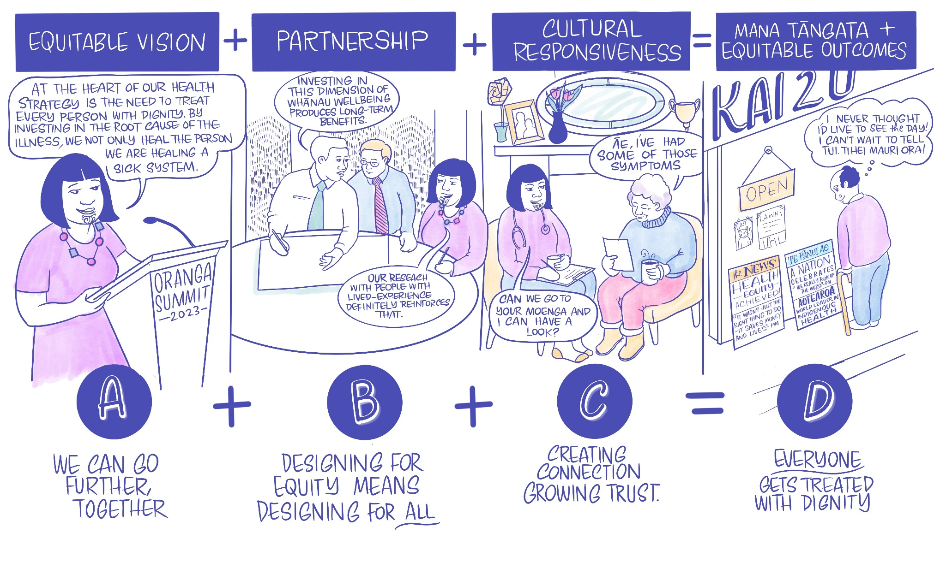

Many of us need to shift our mindsets around how racism works, and what it looks like in order to create the conditions for systemic racism to be overcome.

Part of what makes racism within institutions so durable is the mindset that
racism is primarily an interpersonal behaviour perpetrated by individuals (e.g., verbal racial abuse). While interpersonal racism is highly damaging, systemic racism can be far more damaging at a group, community and population level. A sole focus on interpersonal and individual level racism could be why racial inequities are so pervasive and hard to change. Systemic racism enables people to promote racist ideas at a societal level and protect racist policies at an institutional level. This is what creates the conditions for racist behaviours and actions to flourish.

Research shows that racism is embedded in the stories, systems and policies that impact our everyday lives, and can be enacted by people without racist intent when they use, adhere to or seek to maintain existing systems, policies and practices with racism hard coded into them. This type of unconscious bias ultimately sustains racism by enabling people to maintain an innocence or ignorance.

It ignores the role of both interpersonal AND systemic racism, and therefore provides no clear pathway for anti-racist action at an institutional level.

Interpersonal Vs Systemic Racism
Racism is a systemic issue that needs a systemic solution that counters the policies and ideas that create and maintain health inequity in Aotearoa. However, simply talking about systemic racism and enacting new policies to overcome it alone will not be enough. Narratives and the science of mindset shifts, are also key to deepening our understanding about systemic racism and building empathy and support for efforts to address racial health inequity.

Interpersonal | Systemic
Tend to be more explicit and more visible, easier to name | Less visible to those not impacted by racism or racial health inequity
Socially unacceptable in many cases | Socially acceptable and often taken for granted as the ‘norm‘
Isolated and often ‘accidental’ acts of individuals | A structured system supported by racist ideas (societal), policies (institutional) and practices (personal) that each reinforce the other
Portrayed as not organised or premeditated, often reactive | A set of interacting and comprehensive policies and practices that actively hold racial inequities in place across time at a community and population level

Critical shifts in mindsets to counter racism
Tackling racism and health inequity can feel like a daunting and impossible task but shifting our mindset is a key part of breaking this problem into solvable chunks. By raising our gaze to see how racism is coded into our health system and how it operates (and its relationship with other intersecting systems ie education, justice) we can make the problem concrete and changeable. Acknowledging systemic racism as the cause of racial inequity unlocks our power to counter and remove it. This is where we can harness the transformational power of Te Tiriti o Waitangi as a tool for anti-racism.

From | To
Racism is an action perpetrated by racist individuals | Racism is a structured system where racist ideas, policies, and practices structure opportunity and outcomes to benefit some and disadvantage others
There is only ‘one way’ of doing things | Innovation means we can tailor solutions to meet different needs so everyone has their needs met
Racism is a ‘them’ problem that doesn’t impact me | Racism is an ‘us’ problem that hurts us all. We share the same fate and anti-racism can ensure we go further together
Inequity is inevitable because some of us work harder than others | The purpose of racism is to produce and sustain racial inequity. Equity will only be possible when we truly prioritise values of fairness and justice to ensure everyone’s needs are met so they can live their best lives

In Aotearoa our superpower is Te Tiriti o Waitangi. An authentic commitment to Te Tiriti is how we address systemic racism and realise the potential of a unified and equitable Aotearoa (a country where all people are valued and everyone gets what they need).

Te Tiriti, and honouring the Māori intent of it, is one powerful tool we can use to help reprogramme our systems to ensure all people are included, their different needs are met, and they overcome inequality and inequity. A Te Tiriti-based future is one where we embrace our shared fate with smart solutions and open hearts for the betterment of all who call Aotearoa home.

The scale of this challenge can seem overwhelming but we already have examples of transformational change that have worked before. A concrete example of tailoring approaches to meet different needs has been the radical impact Kura Kaupapa (Māori-Medium Education) has had on improving Māori education outcomes. The establishment of a Māori-medium pathway in the 1980s provided a by Māori for Māori approach to meeting Māori needs as Māori – an expression of tino rangatiratanga and the enactment of Te Tiriti. The data shows Māori in Kura Kaupapa are more likely to achieve National Certificate of Educational Achievement, stay in education and progress further.

The creation of Māori-medium education is an example of the concrete changes needed in values, approaches and mindsets. Scaling up Kura Kaupapa and extending Māori knowledge, learning and leadership honed within the Kura Kaupapa model across education spaces would have even wider benefits. If a Māori education pathway can advance equity, a Māori health pathway can achieve the same benefits.

The solution

Te Tiriti o Waitangi as a powerful anti-racist tool
Policy and decision-makers wove racism through the tapestry of our nation. It has been here for so long we struggle to see the patterns because we have never seen another way. Racism and inequity however, are not inevitable and another way is possible. Eradicating racial inequity requires a systemic approach that targets and replaces racist ideas, policies and practices with anti-racist ideas, policies and practices.

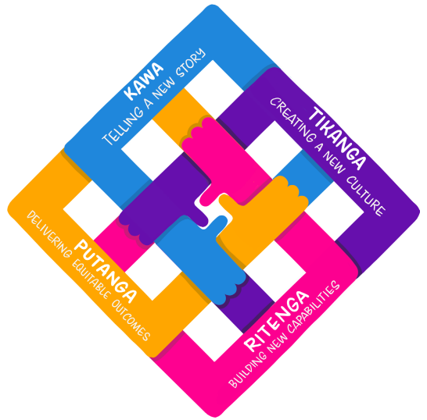
Honouring Te Tiriti is the tool we can use to remove the racist legacy of the past to weave a new pattern to take us forward.

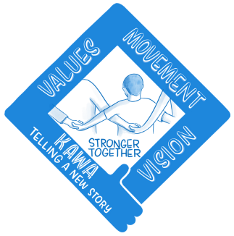

Telling a new story of who we are as a nation opens our hearts and minds to love and care for one another in a way that embraces our shared humanity – mana tangata. Placing Te Tiriti at the heart of our national identity unites those divided by history and fosters the aroha and respect needed to grow the whanaungatanga between communities. Building a new narrative shifts mindsets and invites us to be part of shaping a better future where we are all stronger together.

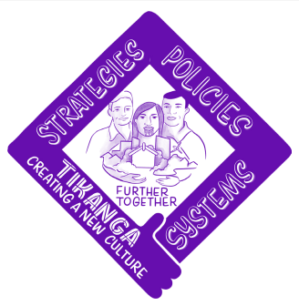

Creating a new culture helps us to redesign our institutions so everyone’s needs can be met. We can create policies that tailor solutions for the different needs of all our communities so we all gain. We need to create the environment to support anti-racism so life becomes fairer for all, we get more value out of the money we spend, and there is more to go around. Creating a new culture centred on trust ensures our institutions will achieve more for us all.

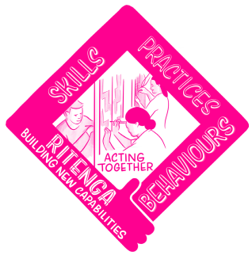

Building new capabilities helps us transform our practice. We need to ensure people have the skills to embed anti-racism into their everyday actions and behaviours to create an equitable society. Building anti-racist practices centred on dignity and understanding creates a nation where everyone gets what they need.

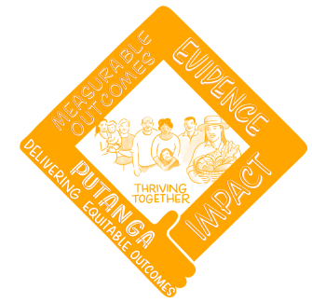

We need data and evidence to identify racist policies and practices so we can remove them. We need to connect those who haven’t experienced racism with those that have so they understand the toxic impact it has. Finally, we need to build and share evidence of what works to support anti-racism movements to grow and spread.

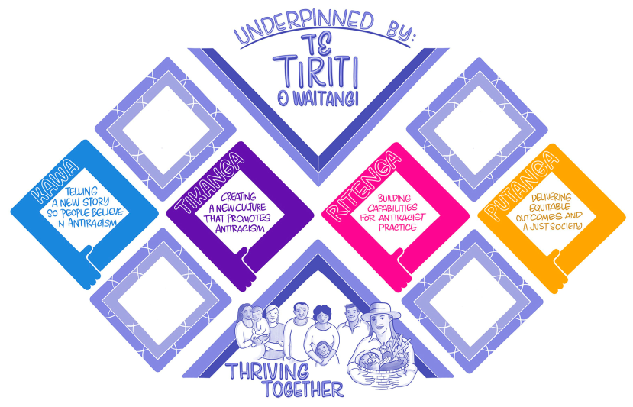

An Aotearoa where we all thrive – Mana Tangata
No-one is born racist but racism has been woven into many of the ideas, policies and practices that create fertile grounds for racism to thrive. Te Tiriti is the tool with which we can remove racism and reweave the tapestry of our nation to create an Aotearoa where everyone is treated with dignity, where racist ideas no longer divide and rank us, where racist policies no longer block us, and where racist practices no longer dehumanise us.

HE TANGATA KĒ KOUTOU, HE TANGATA KĒ MĀTOU,
ENGARI I TĒNEI WĀ, TĀTOU, TĀTOU E.

Examples include: The Native Land Acts of 1862 and 1865 that converted customary lands to individual title to be on-sold, the 1920 White New Zealand Policy which enabled officials to prevent Indians and other non-British subjects from entering Aotearoa, and the 1974-76 Dawn Raids which lead to the unfair treatment and deportation of Pacific peoples believed to be overstayers.
Ibram X. Kendi, Be Antiracist: A Journal for Awareness, Reflection, and Action. One World, 2020, pp.19.
Tokona te Raki. He Awa Ara Rau - A Journey of Many Paths: The Journey of our Rangatahi Māori Through Our education System. Christchurch, Tokona te Raki, 2019.

