SMARTPHONE-BASED PROBLEM GAMBLING EVALUATION AND TECHNOLOGY TESTING INITIATIVE (‘SPGETTI’) FEASIBILITY STUDY

SUMMARY REPORT

APRIL 2016

Key messages:
- In a small feasibility study, a smartphone app developed by University of Auckland researchers delivered automated problem gambling harm minimisation messages linked to the phones’ location-tracking capabilities when close to pokie machine venues.
- The app can also send automated alerts to problem gambling treatment services counsellors, loved ones and others by agreement with clients.
- In focus groups of clients from all priority population groups (specifically, Māori and people of Pacific and Asian ethnic groups) and problem gambling counsellors this concept was welcomed.
- Enabling people with gambling problems to receive personally tailored harm minimisation messages ‘just in time’ and ‘at the right place’ has potential to help them avoid gambling harm.
- This potential is to be tested in a randomised controlled trial undertaken by the University of Auckland researchers.
Sample mock screen shots of messages that could be sent to clients, counsellors or whanau
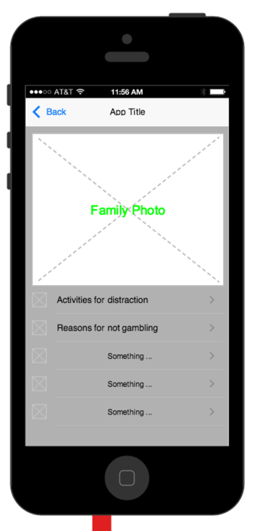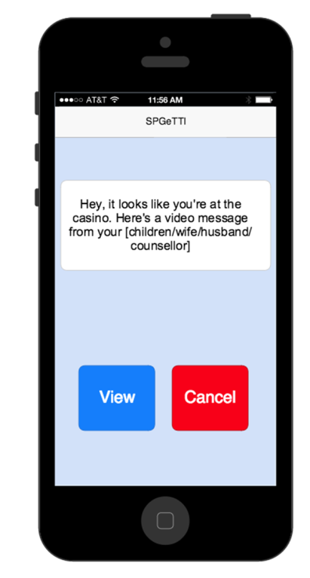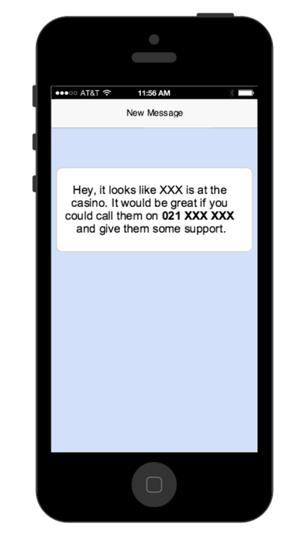

BACKGROUND
Smartphones are increasingly widely used and may have potential as a tool to support people with a gambling problem with electronic gaming machines (“pokies”).
The SPGETTI (Smartphone-based Problem Gambling Evaluation and Technology Testing Initiative) study, led by researchers at the University of Auckland’s National Institute for Health Innovation and Centre for Addiction Research, developed and tested a novel smartphone application (“app”) to see if it was a feasible way to provide additional support to people who seek help from treatment services.
The app is designed to enable people with gambling problems to receive harm minimisation messages ‘just in time’ and ‘at the right place’ to help them avoid gambling harm. These messages can be presented in different languages and tailored to individual need. If the client agrees, the app can also be designed to automatically send a message to their counsellor to make them aware that the client is near a pokie venue and may need acute support.

METHODS
The study consisted of two parts: the first part involved developing and field testing the prototype app for reliability, coverage and use with different smartphone operating systems to accurately locate and alert people when they are in close proximity to venues with pokie machines.
The second part involved assessing client and counsellor interest in, and acceptability of, the app. This was done through focus group discussions with people with gambling problems and service counsellors. Separate focus groups were held for Māori, Pacific and Asian people, led by facilitators of the same ethnic group.
Findings were that the prototype app was reliable and sufficiently accurate to be considered as a potentially useful platform for interacting with people with gambling problems as proposed. The results from the second part were that a smart phone-based support tool was welcomed by both problem gambling counsellors and clients from all priority population groups (specifically, Māori and people of Pacific and Asian ethnic groups).
However, some concerns were noted that need to be incorporated into further development of the app including: privacy and confidentiality, ownership of data, and the hypothetical potential to trigger gambling in some situations. These concerns were not regarded as insurmountable problems. Ideas for future development from the focus groups were supporting venue exclusion arrangements and blocking access to bank accounts and/or credit cards if the client wishes to have this.

CONCLUSIONS
This study found that the use of a smartphone-based app with location-tracking capability and harm minimisation messages is both technically feasible and broadly acceptable to a range of people with significant gambling problems, including those in priority population groups, and to counselling service providers.
On this basis further work is now underway at the University of Auckland to incorporate the key learning from this study in a randomised controlled trial testing the effectiveness of the app as a support tool in problem gambling treatment services.

