Suicide Facts

Deaths and intentional self-harm hospitalisations

2012

Citation: Ministry of Health. 2015. *Suicide Facts: Deaths and intentional self-harm hospitalisations 2012*. Wellington: Ministry of Health.

Published in May 2015  
by the Ministry of Health  
PO Box 5013, Wellington 6145, New Zealand

ISBN: 978-0-478-44805-4 (online)  
HP 6165

This document is available at www.health.govt.nz



### CCBY This work is licensed under the Creative Commons Attribution 4.0 International licence. In essence, you are free to: share ie, copy and redistribute the material in any medium or format; adapt ie, remix, transform and build upon the material. You must give appropriate credit, provide a link to the licence and indicate if changes were made.

Contents

Key points vii

Suicide 2012 vii

Intentional self-harm hospitalisations 2012 viii

Introduction 1

Overview 1

Suicide deaths 2

Intentional self-harm hospitalisations 3

Data presentation 4

Suicide deaths in 2012 6

Age 8

Ethnicity 15

Deprivation 22

Urban and rural suicide rates 24

District health board region 26

Methods of suicide 29

International comparisons 34

Intentional self-harm hospitalisations in 2012 36

Overview 36

Sex 37

Age 38

Ethnicity 41

Deprivation 48

District health board regions 50

References 54

Appendices 55

Appendix 1: Technical notes 55

Appendix 2: Definitions 57

Appendix 3: Further tables 62

Further information 64

List of Tables

Table 1: Suicide deaths and age-standardised rates, by sex, 2003–2012 6

Table 2: Suicide deaths, age-specific rates and suicides as a percentage of all deaths, by five-year age group and sex, 2012 10

Table 3: Age-specific suicide rates, by life-stage age group, 2012 11

Table 4: Youth suicide age-specific rates, ages 15–24 years, by sex, 2003–2012 12

Table 5: Suicide deaths, by ethnicity, life-stage group and sex, 2012 15

Table 6: Suicide deaths and age-standardised rates, Māori and non-Māori, by sex, 2003–2012 17

Table 7: Youth suicide deaths and age-specific rates, Māori and non-Māori, by sex, 2003–2012 20

Table 8: Suicide deaths and age-standardised rates, by deprivation quintile and sex, 2012 22

Table 9: Suicide deaths and rates, by urban/rural profile, life-stage age group and sex, 2012 25

Table 10: Suicide age-standardised deaths, by DHB regions, 2008–2012 27

Table 11: Methods used for suicide deaths, 2003–2012 30

Table 12: Intentional self-harm hospitalisation numbers and age-standardised rates, by sex, 2003–2012 37

Table 13: Intentional self-harm hospitalisation numbers and rates, by sex and five-year age group, 2012 38

Table 14: Youth intentional self-harm hospitalisation numbers and age-specific rates, by sex, 2003–2012 39

Table 15: Intentional self-harm hospitalisation numbers and rates, by ethnicity and sex, 2008–2012 42

Table 16: Intentional self-harm hospitalisations, by ethnicity, life-stage age group and sex, 2012 43

Table 17: Youth intentional self-harm hospitalisation numbers and age-specific rates, Māori and non-Māori, by sex, 2003–2012 47

Table 18: Intentional self-harm hospitalisation numbers and age-standardised rates, by deprivation quintile and sex, 2012 48

Table 19: Intentional self-harm hospitalisation age-standardised rates, by DHB of domicile and sex, 2010–2012 50

Table A1: Intentional self-harm categories and ICD-10-AM codes 57

Table A2: The WHO World Standard Population 58

Table A3: Intentional self-harm short-stay emergency department hospitalisations, by DHB of domicile, 2003–2012 62

Table A4: Intentional self-harm hospitalisations within two days of a previous intentional self-harm hospitalisation, by DHB of domicile, 2003–2012 63

List of Figures

Figure 1: Suicide age-standardised rates, 1948–2012 7

Figure 2: Suicide age-standardised rates, by sex, 1948–2012 7

Figure 3: Suicide as a percentage of all deaths, by age group and sex, 2012 8

Figure 4: Age-specific suicide rates, by five-year age group and sex, 2012 9

Figure 5: Age-specific suicide rates, by life-stage age group, 1948–2012 11

Figure 6: Age-specific suicide rates for youth, ages 15–24 years, by sex, 1948–2012 12

Figure 7: Age-specific suicide rates, ages 25–44 years, by sex, 1948–2012 13

Figure 8: Age-specific suicide rates, ages 45–64 years, by sex, 1948–2012 14

Figure 9: Age-specific suicide rates, ages 65 years and over, by sex, 1948–2012 14

Figure 10: Suicide rates, by ethnic group, 2008–2012 16

Figure 11: Age-standardised suicide rates, Māori and non-Māori, 2003–2012 18

Figure 12: Age-standardised suicide rates, Māori and non-Māori, by sex, 2003–2012 18

Figure 13: Youth age-specific suicide rates, by ethnic group, 2003–2012 21

Figure 14: Youth age-specific suicide rates, by ethnic group and sex, 2003–2012 21

Figure 15: Age-standardised suicide rates, by deprivation quintile, 2012 23

Figure 16: Age-standardised suicide rates, by deprivation quintile and sex, 2012 23

Figure 17: Suicides by deprivation quintile and life-stage age group, 2012 24

Figure 18: Suicide rates, by urban/rural profile and sex, 2012 24

Figure 19: Suicide rates, by urban/rural profile and life-stage age group, 2012 25

Figure 20: Age-standardised suicide rates, by DHB regions, 2008–2012 28

Figure 21: Youth age-specific suicide rates, by DHB regions, 2008–2012 28

Figure 22: Comparison of DHB region suicide rates with the national rate, 2008–2012 29

Figure 23: Methods used for suicide deaths, by sex, 2012 31

Figure 24: Methods used for suicide deaths, 2003–2012 31

Figure 25: Methods used for suicide deaths, by sex and life-stage age group, 2012 33

Figure 26: Suicide age-standardised rates for OECD countries, by sex 34

Figure 27: Youth (15–24 years) suicide age-specific rates for OECD countries, by sex 35

Figure 28: Intentional self-harm hospitalisation age-standardised rates, 2003–2012 36

Figure 29: Intentional self-harm hospitalisation age-standardised rates, by sex, 2003–2012 37

Figure 30: Intentional self-harm hospitalisation age-specific rates, by age group and sex, 2012 39

Figure 31: Youth (15–24 years) intentional self-harm hospitalisation age-specific rates, by sex, 2003–2012 40

Figure 32: Intentional self-harm hospitalisation age-standardised rates, by ethnic group, 2008–2012 42

Figure 33: Intentional self-harm hospitalisation age-standardised rates, Māori and non-Māori, 2003–2012 44

Figure 34: Intentional self-harm hospitalisation age-standardised rates for Māori and non-Māori, by sex, 2003–2012 45

Figure 35: Youth intentional self-harm hospitalisation age-specific rates, by ethnic group, 2003–2012 46

Figure 36: Youth intentional self-harm hospitalisation age-specific rates, by ethnic group and sex, 2003–2012 46

Figure 37: Intentional self-harm hospitalisation age-standardised rates, by deprivation quintile and sex, 2012 49

Figure 38: Intentional self-harm hospitalisation age-standardised rates, by DHB, 2010–2012 51

Figure 39: Comparison of DHB region intentional self-harm hospitalisation rates with national rate, 2010–2012 51

Figure 40: Intentional self-harm hospitalisation age-standardised rates for males, by DHB and ethnic group, 2010–2012 (aggregated data) 52

Figure 41: Intentional self-harm hospitalisation age-standardised rates for females, by DHB and ethnic group, 2010–2012 (aggregated data) 53

# Key points

## Suicide 2012

#### Overview

* A total of 549 people died by suicide in New Zealand in 2012. Almost 75% of these suicides were male.
* The age-standardised suicide rate decreased by 19.5% from the peak rate of 15.1 deaths per 100,000 population in 1998 to 12.2 deaths per 100,000 population in 2012.

#### Sex

* There were 404 male suicides (18.1 per 100,000 males) and 145 female suicides (6.4 per 100,000 females) in 2012.
* For every female suicide, there were 2.8 male suicides.
* Since 1948, the suicide rate for females has remained relatively stable. The male suicide rate for 2012 was 24.3% lower than its highest rate in 1995.

#### Age

* The highest rate of suicide in 2012 was in the youth age group (15–24 years) at 23.4 per 100,000 youths.
* Suicide rates decreased with age: the suicide rate for adults aged 25–44 years was 15.8 per 100,000 adults in that age group; the rate decreased to 12.9 per 100,000 adults aged  
  45–64 years.
* Adults aged 65 years and over had the lowest suicide rate (9.3 per 100,000 adults aged 65+ years).

#### Youth (15–24 years)

* In 2012, there were 107 male and 43 female youth suicides (32.3 and 13.8 per 100,000 males and females respectively).
* The Māori youth suicide rate was 2.8 times the non-Māori youth rate (48.0 per 100,000 Māori youths compared with 17.3 per 100,000 non-Māori youths).
* Over the 10 years from 2003 to 2012, Māori youth suicide rates have been at least 1.7 times the non-Māori youth suicide rates.

#### Ethnicity

* There were 120 Māori and 429 non-Māori suicide deaths in 2012.
* Māori had an age-standardised suicide rate of 17.8 per 100,000 Māori, compared with the non-Māori rate of 10.6 per 100,000 non-Māori.
* There were 30 suicide deaths among Pacific people and 23 among Asian people.
* Over the 10 years from 2003 to 2012, Māori suicide rates have been at least 1.2 times non-Māori suicide rates.

#### Deprivation

* In 2012, the suicide rate was highest among those who resided in deprivation quintile 4 and lowest in quintile 1 (14.0 per 100,000 quintile 4 population compared with 6.6 per 100,000 quintile 1 population).
* Suicide rates in both quintile 1 and 2 were significantly lower than suicide rates for those residing in quintiles 3–5.

#### Urban/rural profile

* The suicide rate was 14.6 per 100,000 population in rural areas and 12.0 per 100,000 population in urban areas.

#### District health board (DHB) region

* Based on aggregated data for the five-year period 2008–2012, Bay of Plenty, South Canterbury and Southern DHBs had significantly higher suicide rates than the national rate.
* Waitemata, Auckland and Capital & Coast DHB regions had significantly lower suicide rates than the national rate.

## Intentional self-harm hospitalisations 2012

#### Overview

* There were 3031 intentional self-harm hospitalisations in New Zealand in 2012. Two-thirds of these were female.
* Over the 10-year period 2003–2012, the rate of self-harm hospitalisations decreased by 11.5% from 80.3 per 100,000 population in 2003 to 71.0 per 100,000 population in 2012.

#### Sex

* In 2012, the female rate of intentional self-harm hospitalisation was more than twice the male rate (96.1 per 100,000 females compared with 46.4 per 100,000 males).
* Between 2003 and 2012, the female rate of intentional self-harm hospitalisation remained at least 1.7 times the male rate.

#### Age

* In 2012, the highest rate of intentional self-harm hospitalisations for both males and females was in the 15–19 years age group (103.1 per 100,000 15–19 years males and 279.5 per 100,000 15–19 years females).
* Female rates were significantly higher than male rates for all five-year age groups except in those aged 75+ years, where they were significantly lower.

#### Youth (15–24 years)

* Youth accounted for 34.7% (1052) of all intentional self-harm hospitalisations in 2012.
* The female rate of intentional self-harm hospitalisations was 2.4 times the male rate (233.7 per 100,000 females and 98.4 per 100,000 males).

#### Ethnicity

* In 2012, Māori accounted for nearly 20% (563) of all intentional self-harm hospitalisations.
* The age-standardised rate for Māori was 85.0 per 100,000 Māori compared with 68.0 per 100,000 non-Māori.
* There were 101 intentional self-harm hospitalisations of Pacific people and 97 of Asian people.

#### Deprivation

* In 2012, intentional self-harm hospitalisation rates generally increased with deprivation; the highest rate was in those residing in deprivation quintile 4 and the lowest in quintile 1 (90.9 per 100,000 quintile 4 population compared with 49.6 per 100,000 quintile 1 population).
* For both males and females, rates in the least deprived quintile (1) were significantly lower than rates in more deprived quintiles (3–5).

#### District health board (DHB) region

* Based on aggregated data from 2010–2012, eight DHBS had significantly higher rates of intentional self-harm hospitalisations than the national rate in 2012. Wairarapa DHB region had the highest age-standardised rate of intentional self-harm hospitalisations (169.0 per 100,000 population).
* Auckland, Counties Manukau, Hawke’s Bay and MidCentral DHB regions had significantly lower rates of intentional self-harm hospitalisations than the national rate.

# Introduction

Suicide and suicidal behaviours continue to be a major public health issue in New Zealand. Every year more than 500 New Zealanders take their lives and there are over 2,500 admissions[1] to hospital for serious self-harm. These are not just numbers; they may be our friends, our neighbours, our work colleagues or our family members. Every suicide or act of intentional self-harm is an indication of profound emotional distress. The impact on family, friends and communities can be devastating, far reaching and long lasting. But suicide is preventable.

The purpose of this report is to present numbers, trends and demographic profiles of people who die by suicide or seriously harm themselves. Understanding this data is important for policy makers, clinicians and others who work to prevent suicide and intentional self-harm.

It is important to recognise that the motivation for intentional self-harm varies, and therefore hospitalisation data for self-harm is not a measure of suicide attempts.

Although this report provides statistical suicide and intentional self-harm hospitalisation data, it does not attempt to explain causes of suicidal behaviour or causes of changes to suicide or intentional self-harm hospitalisation rates. Nor does it discuss measures to reduce suicide or intentional self-harm.

Numerous factors influence a person’s decision to take their own life or to self-harm. The number of suicides and self-harm hospitalisations can also vary considerably from year to year. It is therefore difficult to quantify the precise effect that programmes such as suicide prevention-related initiatives and significant events, for instance the 2010 and 2011 earthquakes in the Canterbury region, have on suicide and suicidal behaviour.

Suicide prevention in New Zealand is guided by the *New Zealand* *Suicide Prevention Strategy 2006–2016* (Associate Minister of Health 2006) and the *New Zealand* *Suicide Prevention Action Plan 2013–2016* (Ministry of Health 2013). *Suicide Facts* and other annual data updates assist in monitoring and evaluating the progress and success of implementing the strategy and action plan.

## Overview

This report presents suicide data by sex, age (including in specific regard to youth aged  
15–24 years), ethnicity, deprivation quintile, district health board (DHB) region of domicile and urban/rural profile. It also provides some international comparisons.

Intentional self-harm hospitalisation data is presented by sex, age (including in specific regard to youth aged 15–24 years), ethnicity, deprivation quintile and DHB region of domicile. Definitions of these terms are provided in Appendix 2: Definitions.

The online tables that accompany this report provide the underlying data for some graphs presented in the report as well as time-series data.

## Suicide deaths

### Data sources

All New Zealand suicide data in this report was extracted from the [Ministry of Health’s Mortality Collection](http://www.health.govt.nz/nz-health-statistics/national-collections-and-surveys/collections/mortality-collection) (MORT) on 1 October 2014. The data for other Organisation for Economic Co‑operation and Development (OECD) countries was sourced from the OECD.

MORT contains data on all deaths registered in New Zealand. Death and stillbirth registration data is sent electronically to MORT monthly from Births, Deaths, Marriages and Citizenship. In addition, the Ministry receives medical certificates of causes of death (completed by certifying doctors) from funeral directors, as well as coronial findings relating to deaths from Coronial Services of New Zealand (Ministry of Justice). Each death is then assigned an underlying cause of death code by the Ministry of Health, using the International Statistical Classification of Diseases and Related Health Problems, 10th Revision, Australian Modification (ICD-10-AM), sixth Edition (National Centre for Classification in Health 2008).

### Classification of a suicide death

In New Zealand, a death is only officially classified as suicide by the coroner on completion of the coroner’s inquiry. In some cases, an inquest may be heard several years after the death, particularly if there are factors relating to the death that need to be investigated first (for example, a death in custody). Consequently, a provisional suicide classification may be made before the coroner reaches a verdict.

The 2012 suicide data used in this report is provisional. There were 14 deaths registered in 2012 that were still subject to coroners’ findings with no provisional cause of death assigned to them at the time of data extraction (1 October 2014). Although these deaths are not included in this report, some may later be classified as suicide. For this reason, the number of provisionally classified deaths from suicide in 2012 presented in this report may differ slightly from the number, for the same year, presented in future reports, when the data has been finalised. The Ministry will release the final data in the publication *Mortality and Demographic Data 2012*.

The suicide data in this report is based on deaths that were registered in 2012 with Births, Deaths, Marriages and Citizenship. While most deaths are registered in the year in which the death occurred, a few deaths (approximately 2%) are registered in later years.

### Comparisons with other statistical publications on suicide

The number of suicide deaths in this report differs from the number released by the Chief Coroner. The Chief Coroner’s data includes all deaths initially identified at the coroner’s office as self-inflicted. However, only those deaths determined as ‘intentional’ after investigation will receive a final verdict of suicide. Some deaths provisionally coded as suicide may later be determined not to be suicide.

The Ministry reports on those deaths determined to be suicide after a completed coronial process or those provisionally coded as intentionally self-inflicted deaths before the final coroner’s verdict. Furthermore, the Chief Coroner’s data relates to years ending 30 June rather than the calendar years used in this report.

The Office of the Director of Mental Health releases an annual report that contains some statistics on suicide that are not included in this report:   
www.health.govt.nz/publication/office-director-mental-health-annual-report-2013

The data-filtering methods used in this report mean that the hospital data in this publication cannot be compared with versions of this series preceding the 2006 report.

## Intentional self-harm hospitalisations

### Data source

Intentional self-harm hospitalisation data presented in this report was extracted from the Ministry’s [National Minimum Dataset](http://www.health.govt.nz/publication/national-minimum-dataset-hospital-events-data-dictionary) (NMDS) on 1 October 2014. The NMDS is a national collection of public and private hospital discharge information, including clinical information, for inpatients and day patients.

The NMDS is used for policy formation, performance monitoring, research and review. It provides statistical information, reports and analyses of trends in delivering hospital inpatient and day patient health services both nationally and on a provider basis. It is also used for funding purposes.

Data has been submitted electronically in an agreed format by public hospitals since 1993.

### Data exclusions

For data comparability purposes, the total number of self-harm hospitalisations excludes two categories of patients:

1. Patients discharged from an emergency department after a length of stay of one day or less (Appendix 3, Table A3). It is evident from Table A3 that these events were reported very differently across the individual DHBs between 2003 and 2012.

2. Patients admitted for an intentional self-harm incident within two days of a previous intentional self-harm hospitalisation (Appendix 3, Table A4). It is not unusual for patients to be transferred between hospitals after an intentional self-harm event. DHBs record these transfers as new admissions. Such admissions usually occur within two days of a previous hospitalisation discharge, thereby artificially inflating the numbers of recorded admissions.

These exclusions allow the best possible identification of real trends in intentional self-harm behaviour within the New Zealand population, as well as optimal regional comparisons given that DHBs differ in admission practices, which results in differences in the data reported. The Ministry is endeavouring to address inconsistencies in data collection; however, filtering cannot completely eliminate differences caused by different methods of managing patients and keeping records.

Therefore the intentional self-harm hospitalisations data in this report does not represent the total number of people receiving hospital treatment for intentional self-harm or treatment events. Even once consistency issues between DHBs have been addressed, the total extent of intentional self-harm will still be difficult to capture because many people who intentionally self-harm do not seek hospital treatment.

It is important to note that hospitalisations for intentional self-harm represent individual events of self-harm rather than individual people; that is, a single person can contribute multiple unique intentional self-harm events to the data set or be hospitalised more than once for the same self-harm event.

## Data presentation

### Numbers and rates

Data is presented primarily as numbers and rates. Two rates are presented: age-specific and age-standardised. Age-specific rates are calculated to measure the frequency of suicide or self-harm hospitalisation for specific age groups (eg, five-year age group and life-stage age group). Age-standardised rates are calculated to measure the frequency of suicide or self-harm hospitalisations in a group and are adjusted to take account of differences in age distribution of the population over time or between groups.

Rates for specific groups (eg, Māori, residents of quintile 3, females, and populations in DHB regions) are calculated using the best available population for that specific group. More information about populations used in this report can be found in Appendix 1: Technical notes.

All percentage calculations comparing numbers or rates between years have been undertaken using the raw data. Due to rounding, this may mean the resultant information is slightly different to any calculations based on tabular data supplied in this report.

### Time trends

#### Publication

Suicide data is presented either from 1948 to 2012 (comparable data first became available in 1948) or from 2003 to 2012 (to provide a 10-year time trend). Where Asian age-standardised rates are presented, the data is restricted to 2008 to 2012.

Intentional self-harm hospitalisation data is presented from 2003 to 2012 to provide a 10-year time trend.

#### Online tables

The accompanying suicide tables include data from 1948 to 2012 for major breakdowns and from 1996 to 2012 for Māori and non-Māori breakdowns. Intentional self-harm hospitalisation data is presented from 1996 to 2012. Hospitalisation data can only be compared consistently back to 1996 because of changes in the recording and reporting of ethnicity data from July 1995.

### District health board region

Age-standardised rates were calculated for each district health board (DHB) region of domicile.

The suicide data for DHB regions was aggregated over five years (2008–2012), and the intentional self-harm hospitalisation data was aggregated over three years (2010–2012) since rates can vary considerably from year to year for each DHB.

When interpreting regional differences in hospitalisation rates for intentional self-harm among DHBs, it should be noted that DHBs differ in their reporting and patient management practices.

The figures also provide 99% confidence intervals to aid interpretation. Where a DHB region’s confidence interval crosses the national rate, this means that the DHB region’s suicide or intentional self-harm hospitalisation rate was not statistically significantly different from the national rate. Previous versions of *Suicide Facts* presented information on Southland and Otago DHBs. In 2010, these merged to form Southern DHB, therefore *Suicide Facts 2012* presents information for Southern DHB.

# Suicide deaths in 2012

A total of 549 people died in New Zealand by suicide in 2012. This equates to an age-standardised rate of 12.2 suicide deaths per 100,000 population (Table 1).

Comparable data first became available in 1948. Since then, the suicide rate for the whole population reached its highest in 1998. The rate generally declined between 1998 and 2012, decreasing overall by 19.5% (Figure 1).

### Sex

In 2012, a total of 404 males and 145 females died by suicide, which equates to rates of 18.1 deaths per 100,000 male population and 6.4 deaths per 100,000 female population.

Since records began in 1948, the female rate has remained relatively unchanged, but the male rate has fluctuated. In 2012, the male rate was 24.3% lower than its highest rate in 1995. Over time, the male suicide rate has been consistently higher than the female suicide rate; in 2012, there were 2.8 male suicides for every female suicide (Table 1, Figure 2).

### Groups with high suicide rates

In 2012 markedly higher rates of suicide were recorded in males, particularly youth (aged 15–24 years) and those aged 40–44 years, and Māori (compared with non-Māori). Māori males and Māori youth showed especially high suicide rates. Further data for these groups is presented in later sections of this report.

Table 1: Suicide deaths and age-standardised rates, by sex, 2003–2012

|  |  |  |  |  |  |  |  |
| --- | --- | --- | --- | --- | --- | --- | --- |
| **Year** | **Male** | | **Female** | | **Total** | | **Sex rate ratio (Male:Female)** |
| **Number** | **Rate** | **Number** | **Rate** | **Number** | **Rate** |
| 2003 | 376 | 18.4 | 141 | 6.6 | 517 | 12.4 | 2.8 |
| 2004 | 379 | 18.6 | 109 | 5.2 | 488 | 11.7 | 3.6 |
| 2005 | 380 | 18.6 | 131 | 6.0 | 511 | 12.2 | 3.1 |
| 2006 | 388 | 18.6 | 138 | 6.3 | 526 | 12.2 | 3.0 |
| 2007 | 371 | 17.4 | 116 | 5.0 | 487 | 11.0 | 3.5 |
| 2008 | 381 | 17.6 | 139 | 6.2 | 520 | 11.8 | 2.8 |
| 2009 | 393 | 17.9 | 117 | 5.0 | 510 | 11.3 | 3.6 |
| 2010 | 386 | 17.3 | 149 | 6.6 | 535 | 11.8 | 2.6 |
| 2011 | 377 | 17.0 | 116 | 5.1 | 493 | 10.9 | 3.4 |
| 20121 | 404 | 18.1 | 145 | 6.4 | 549 | 12.2 | 2.8 |

Source: New Zealand Mortality Collection

Note: rates are expressed per 100,000 population and age-standardised to the World Health Organization (WHO) World Standard population.

1 Provisional (see Appendix 2: Definitions).

Figure 1: Suicide age-standardised rates, 1948–2012

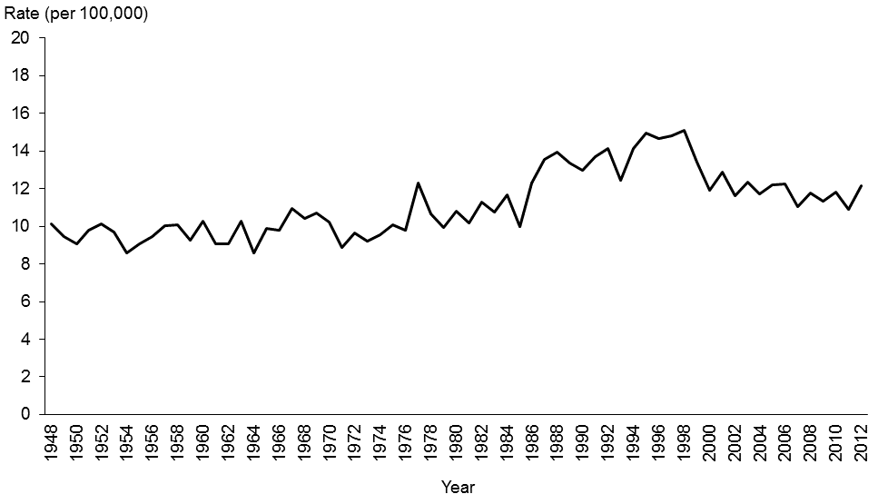

Source: New Zealand Mortality Collection

Note: rates are expressed per 100,000 population and age-standardised to the WHO World Standard population.

Figure 2: Suicide age-standardised rates, by sex, 1948–2012

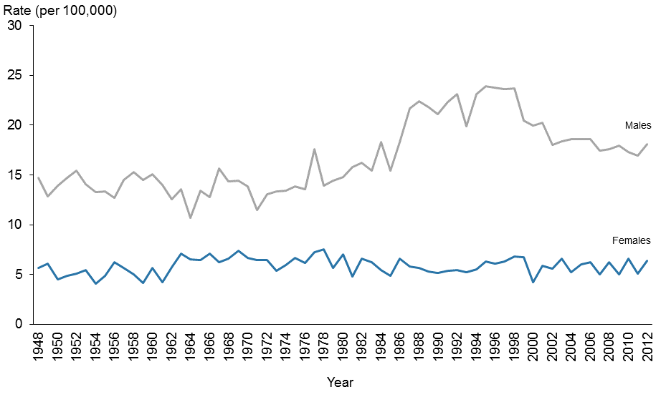

Source: New Zealand Mortality Collection

Note: rates are expressed per 100,000 population and age-standardised to the WHO World Standard population.

## Age

This section focuses on suicides by five-year age groups for 2012 and broader life-stage age groups to show trends over time.

Suicide accounted for 1.8% of all deaths in 2012. Suicide was the cause of death for about 45% of males and females aged 15–19 years. Approximately one in three deaths in males and females aged 5–24 years were due to suicide in 2012 (Figure 3).

Figure 3: Suicide as a percentage of all deaths, by age group and sex, 2012

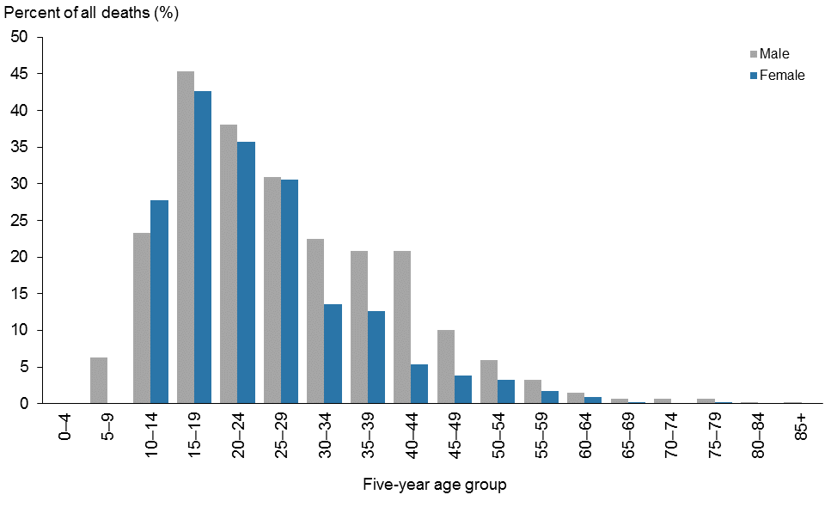

Source: New Zealand Mortality Collection

### Suicide by five-year age group

Males had higher rates of suicide than females for every age group. The highest rates for males were for those aged 15–19 and 40–44 years. The highest rate for females was in those aged  
15–19 years (Figure 4, Table 2).

Figure 4: Age-specific suicide rates, by five-year age group and sex, 2012

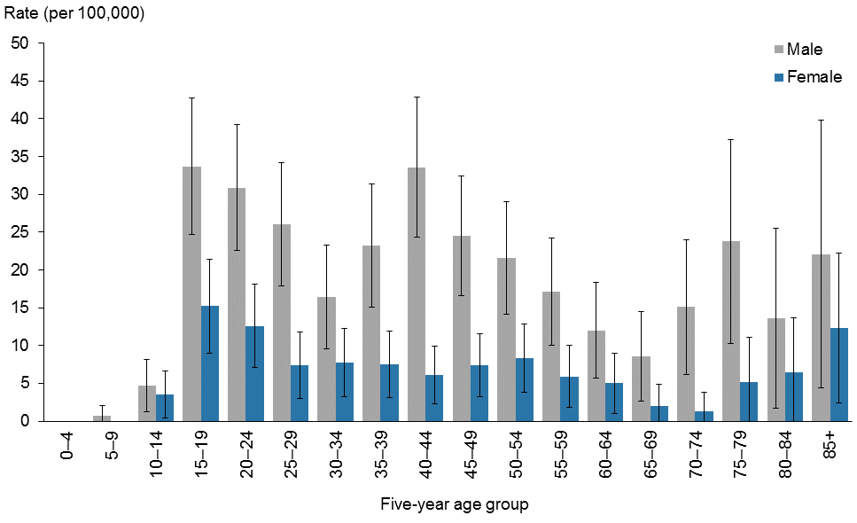

Source: New Zealand Mortality Collection

Notes:

Rates are expressed as deaths per 100,000 population.

95% confidence intervals.

Table 2: Suicide deaths, age-specific rates and suicides as a percentage of all deaths, by five-year age group and sex, 2012

|  |  |  |  |  |  |  |  |  |  |
| --- | --- | --- | --- | --- | --- | --- | --- | --- | --- |
| **Age group (years)** | **Male** | | | **Female** | | | **Total** | | |
| **Number** | **Rate** | **% of all deaths** | **Number** | **Rate** | **% of all deaths** | **Number** | **Rate** | **% of all deaths** |
| 0–4 | 0 | 0.0 | 0.0 | 0 | 0.0 | 0.0 | 0 | 0.0 | 0.0 |
| 5–9 | 1 | 0.7 | 6.3 | 0 | 0.0 | 0.0 | 1 | 0.3 | 3.3 |
| 10–14 | 7 | 4.7 | 23.3 | 5 | 3.5 | 27.8 | 12 | 4.2 | 25.0 |
| 15–19 | 54 | 33.7 | 45.4 | 23 | 15.2 | 42.6 | 77 | 24.7 | 44.5 |
| 20–24 | 53 | 30.9 | 38.1 | 20 | 12.6 | 35.7 | 73 | 22.1 | 37.4 |
| 25–29 | 39 | 26.0 | 31.0 | 11 | 7.4 | 30.6 | 50 | 16.7 | 30.9 |
| 30–34 | 22 | 16.4 | 22.4 | 11 | 7.7 | 13.6 | 33 | 11.9 | 18.4 |
| 35–39 | 31 | 23.2 | 20.8 | 11 | 7.5 | 12.6 | 42 | 15.0 | 17.8 |
| 40–44 | 50 | 33.6 | 20.8 | 10 | 6.1 | 5.4 | 60 | 19.2 | 14.1 |
| 45–49 | 37 | 24.5 | 10.1 | 12 | 7.4 | 3.9 | 49 | 15.6 | 7.2 |
| 50–54 | 32 | 21.6 | 6.0 | 13 | 8.3 | 3.2 | 45 | 14.8 | 4.8 |
| 55–59 | 22 | 17.1 | 3.2 | 8 | 5.9 | 1.8 | 30 | 11.4 | 2.6 |
| 60–64 | 14 | 12.0 | 1.5 | 6 | 5.0 | 0.9 | 20 | 8.4 | 1.2 |
| 65–69 | 8 | 8.6 | 0.6 | 2 | 2.0 | 0.2 | 10 | 5.2 | 0.5 |
| 70–74 | 11 | 15.1 | 0.7 | 1 | 1.3 | 0.1 | 12 | 7.9 | 0.4 |
| 75–79 | 12 | 23.8 | 0.6 | 3 | 5.2 | 0.2 | 15 | 13.8 | 0.4 |
| 80–84 | 5 | 13.6 | 0.2 | 3 | 6.4 | 0.1 | 8 | 9.6 | 0.2 |
| 85+ | 6 | 22.1 | 0.1 | 6 | 12.3 | 0.1 | 12 | 15.9 | 0.1 |
| Total | 404 | 18.1 | 2.7 | 145 | 6.4 | 1.0 | 549 | 12.2 | 1.8 |

Source: New Zealand Mortality Collection

Notes:

Rates are expressed as deaths per 100,000 population.

Percentages are calculated using provisional 2012 mortality data.

### Suicide by life-stage age group

This section focuses on suicide deaths by four life-stage age groups: 15–24 years (youth), 25–44 years, 45–64 years and 65 years and over.

In 2012, the suicide rate decreased with age. Youth (15–24 years) had the highest suicide rate of 23.4 per 100,000 population, and those aged 65 years and over had the lowest suicide rate represented at 9.3 per 100,000 population (Table 3).

New Zealand’s suicide rates by life-stage group have varied over time. In 1948, the differences between the four life-stage age groups were distinct, with the suicide rate increasing with age. By the early 1990s, this trend had almost reversed, with youth showing the highest rates of suicide and those aged 65 years and over having the lowest rates. In more recent years, those aged 65 years and over have continued to show the lowest rates, while rates for those aged between 25 and 64 years have started to converge (Figure 5).

Table 3: Age-specific suicide rates, by life-stage age group, 2012

|  |  |  |  |  |  |  |
| --- | --- | --- | --- | --- | --- | --- |
| **Age group (years)** | **Male** | | **Female** | | **Total** | |
| **Number** | **Rate** | **Number** | **Rate** | **Number** | **Rate** |
| 15–24 | 107 | 32.3 | 43 | 13.8 | 150 | 23.4 |
| 25–44 | 142 | 25.0 | 43 | 7.1 | 185 | 15.8 |
| 45–64 | 105 | 19.3 | 39 | 6.8 | 144 | 12.9 |
| 65+ | 42 | 15.0 | 15 | 4.5 | 57 | 9.3 |

Source: New Zealand Mortality Collection

Note: rates are expressed as deaths per 100,000 population.

Figure 5: Age-specific suicide rates, by life-stage age group, 1948–2012

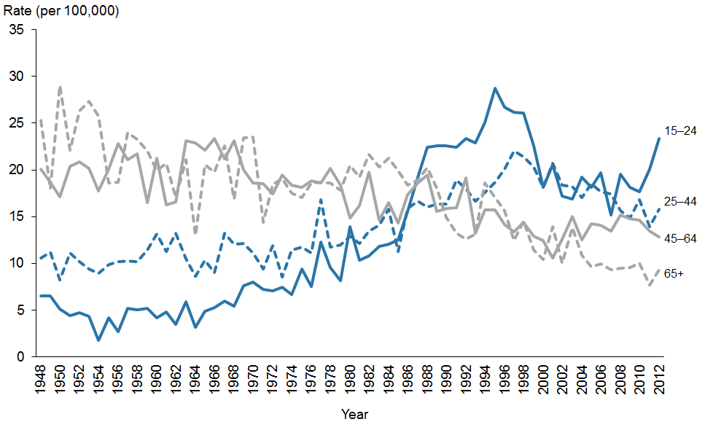

Source: New Zealand Mortality Collection

Notes:

Rates are expressed as deaths per 100,000 population.

Rates have not been provided for the 0–4 and 5–14 years age groups because the small number of deaths by suicide in these age groups makes it difficult to draw meaningful conclusions about changes over time.

#### Youth aged 15–24 years

In 2012, the youth suicide rate was 23.4 deaths per 100,000 population aged 15–24 years (Table 3). Rates were significantly higher among male youth than female youth; in 2012, the male youth suicide rate was nearly 2.3 times that of the female youth suicide rate (32.3 per 100,000 males compared with 13.8 per 100,000 females) (Table 4).

Suicide was the most common cause of death for youth (150 deaths), accounting for over one-third of all youth deaths in 2012 (37.4% of all male youth deaths and 31.9% of female youth deaths).[2] The next most common cause of death for this age group was motor vehicle accidents (70 deaths). This equates to youth mortality rates of 23.4 per 100,000 for suicide and 10.9 per 100,000 for motor vehicle accidents.

The youth suicide rate has decreased since its peak in 1995. In 2012, the youth rate was 18.6% lower than in 1995 (Figure 5).

Male youth suicide rates began to rise noticeably in the early 1970s, then rose sharply from the mid-1980s, reaching a peak of 44.1 suicides per 100,000 population in 1995. Since then, the rate has trended downwards; the 2012 rate was 26.7% lower than the peak in 1995. Female youth suicide rates also showed a general increase over time and peaked in 1996. The rates have remained variable since then (Figure 6).

Table 4: Youth suicide age-specific rates, ages 15–24 years, by sex, 2003–2012

|  |  |  |  |  |  |  |
| --- | --- | --- | --- | --- | --- | --- |
| **Year** | **Male** | | **Female** | | **Total** | |
| **Number** | **Rate** | **Number** | **Rate** | **Number** | **Rate** |
| 2003 | 66 | 22.5 | 31 | 11.0 | 97 | 16.9 |
| 2004 | 83 | 27.7 | 30 | 10.5 | 113 | 19.3 |
| 2005 | 84 | 27.6 | 24 | 8.2 | 108 | 18.1 |
| 2006 | 95 | 31.1 | 24 | 8.0 | 119 | 19.7 |
| 2007 | 70 | 22.5 | 23 | 7.6 | 93 | 15.2 |
| 2008 | 83 | 26.4 | 38 | 12.5 | 121 | 19.5 |
| 2009 | 93 | 29.0 | 21 | 6.8 | 114 | 18.1 |
| 2010 | 79 | 24.1 | 34 | 10.9 | 113 | 17.7 |
| 2011 | 96 | 29.0 | 33 | 10.6 | 129 | 20.1 |
| 20121 | 107 | 32.3 | 43 | 13.8 | 150 | 23.4 |

Source: New Zealand Mortality Collection

Notes: rates are expressed as deaths per 100,000 population.

1 Provisional (see Appendix 2: Definitions).

Figure 6: Age-specific suicide rates for youth, ages 15–24 years, by sex, 1948–2012

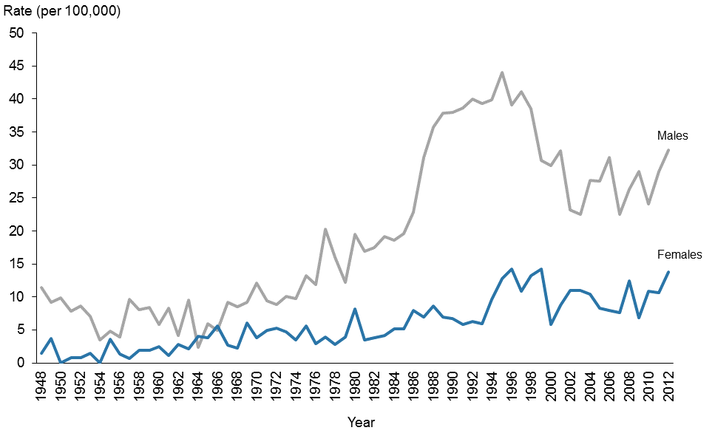

Source: New Zealand Mortality Collection

Note: rates are expressed as deaths per 100,000 population.

#### Adults aged 25–44 years

In 2012, the suicide rate for adults aged 25–44 years was 15.8 per 100,000 population in this age group. The male rate was 25.0 per 100,000 males in this age group, which was 3.5 times the female rate of 7.1 per 100,000 (Table 3).

Since the peak in 1997, suicide rates for males aged 25–44 years have fallen by 29.3%. In contrast, the female rate has remained relatively constant since official records began in 1948 (Figure 7).

Figure 7: Age-specific suicide rates, ages 25–44 years, by sex, 1948–2012

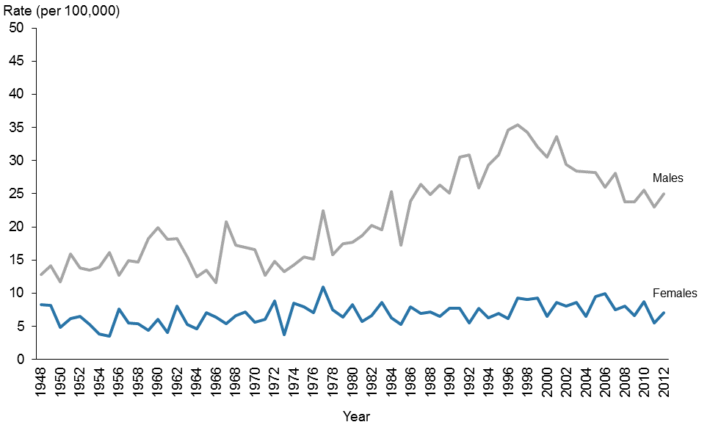

Source: New Zealand Mortality Collection

Note: rates are expressed as deaths per 100,000 population.

#### Adults aged 45–64 years

In 2012, the suicide rate for adults aged 45–64 years was 12.9 per 100,000 population in this age group. The male and female rates were 19.3 and 6.8 per 100,000 population in this age group respectively (Table 3).

Over time, suicide rates for males aged 45–64 years have remained variable, although an overall downward trend is evident with a decrease of 35.4% between 1948 and 2012.

Female rates for this age group were variable between 1948 and 1994, after which rates were more stable (Figure 8).

Figure 8: Age-specific suicide rates, ages 45–64 years, by sex, 1948–2012

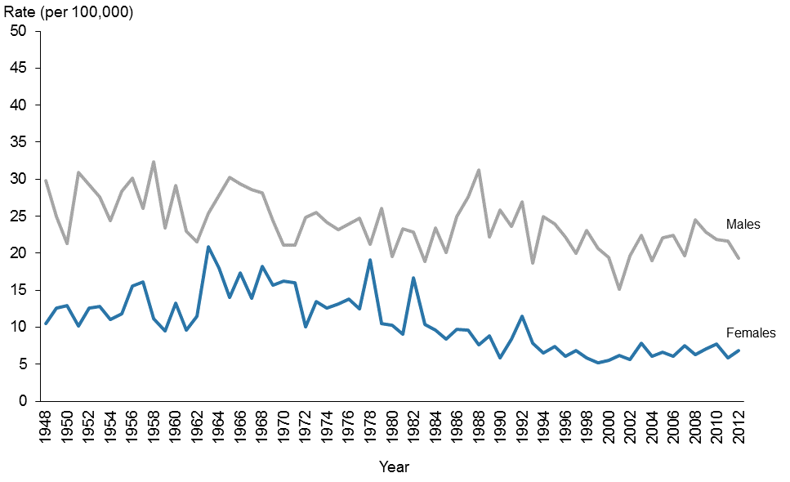

Source: New Zealand Mortality Collection

Note: rates are expressed as deaths per 100,000 population.

#### Adults aged 65 years and over

In 2012, the suicide rate for those aged 65 years and over was the lowest of the four life-stage age groups, with 9.3 per 100,000 population in this age group (Table 3). The rate has decreased by 67.9% since its highest rate in 1950 (Figure 5). The 2012 male and female rates were 15.0 and 4.5 per 100,000 population in this age group respectively (Table 3).

The male rate was variable between 1948 and 2012, although a substantial downward trend was evident with a decrease of 71.3% from the peak rate in 1950. The female rate also showed a downward trend, falling by 75.5% between 1967 (when it peaked) and 2012 (Figure 9).

Figure 9: Age-specific suicide rates, ages 65 years and over, by sex, 1948–2012

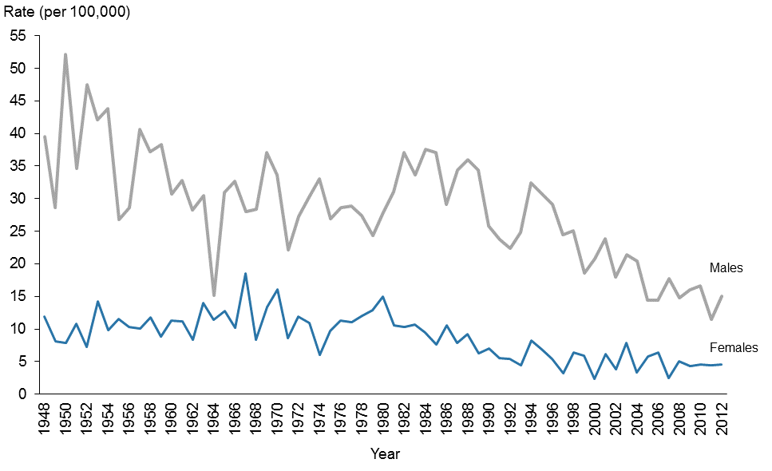

Source: New Zealand Mortality Collection

Note: rates are expressed as deaths per 100,000 population.

## Ethnicity

### Overview

There were 120 Māori suicides in 2012, accounting for 21.9% of all suicide deaths (17.8 per 100,000 population). There were 429 non-Māori suicide deaths (10.6 per 100,000 population).

Non-Māori suicides comprised 30 Pacific people, 23 Asian and 376 European & Other (Table 5). There were 287 European & Other male suicides and 89 female suicides in 2012. There were 20 male and 10 female suicide deaths among Pacific people and 14 male and 9 female suicide deaths among Asian people in 2012.

It is difficult to draw conclusions about changes in suicide rates over time for different ethnic groups; not only are the numbers of suicides in certain ethnic groups small, but also the population of Asian people in New Zealand increased markedly between 1996 and 2012. Age‑standardised rates for the ethnic group breakdown of Māori, Pacific peoples, Asian and European & Other were calculated for the five years 2008–2012. The small number of Pacific peoples and Asian suicides means rates are variable, and any trends should be interpreted cautiously (Figure 10).

Table 5: Suicide deaths, by ethnicity, life-stage group and sex, 2012

|  |  |  |  |  |  |  |  |  |
| --- | --- | --- | --- | --- | --- | --- | --- | --- |
| **Ethnicity** | **Sex** | **Life-stage age group** | | | | | | **Rate** |
| **<15** | **15–24** | **25–44** | **45–64** | **65+** | **Total** |
| Māori | Male | 6 | 37 | 30 | 9 | 1 | 83 |  |
| Female | 3 | 24 | 9 | 1 | 0 | 37 |  |
| Total | 9 | 61 | 39 | 10 | 1 | 120 | 17.8 |
| Pacific peoples | Male | 0 | 7 | 7 | 5 | 1 | 20 |  |
| Female | 2 | 6 | 1 | 1 | 0 | 10 |  |
| Total | 2 | 13 | 8 | 6 | 1 | 30 | 10.2 |
| Asian | Male | 0 | 4 | 5 | 5 | 0 | 14 |  |
| Female | 0 | 2 | 1 | 4 | 2 | 9 |  |
| Total | 0 | 6 | 6 | 9 | 2 | 23 | 4.2 |
| European & Other | Male | 2 | 59 | 100 | 86 | 40 | 287 |  |
| Female | 0 | 11 | 32 | 33 | 13 | 89 |  |
| Total | 2 | 70 | 132 | 119 | 53 | 376 | 12.0 |
| All ethnicities | Male | 8 | 107 | 142 | 105 | 42 | 404 |  |
| Female | 5 | 43 | 43 | 39 | 15 | 145 |  |
| Total | 13 | 150 | 185 | 144 | 57 | 549 | 12.2 |

Source: New Zealand Mortality Collection

Note: rates are expressed per 100,000 population and are age-standardised to the WHO World Standard population.

Figure 10: Suicide rates, by ethnic group, 2008–2012

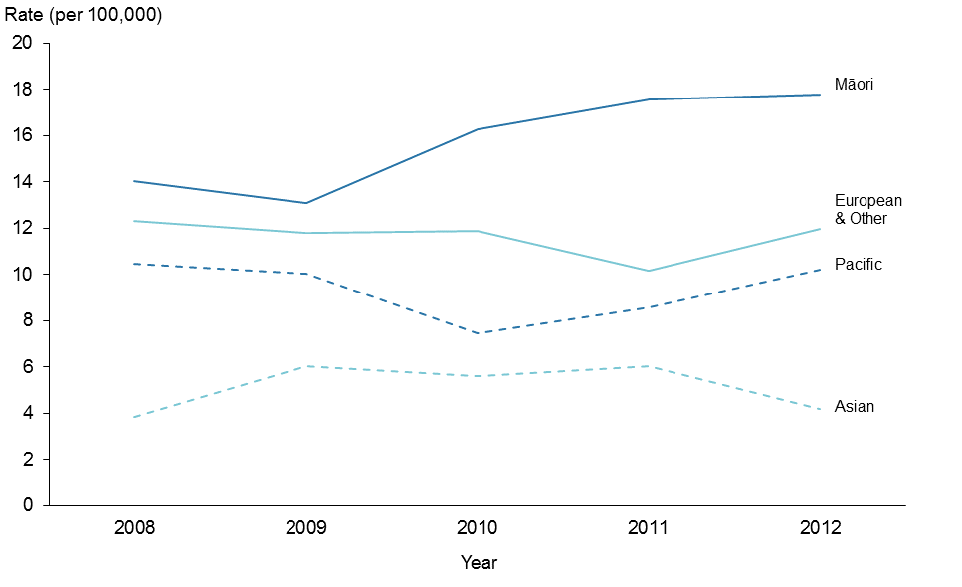

Source: New Zealand Mortality Collection

Note: rates are expressed per 100,000 population and are age-standardised to the WHO World Standard population.

### Māori and non-Māori comparison

In 2012, the age-standardised suicide rate for Māori was 1.7 times higher than that for non-Māori (17.8 per 100,000 Māori population compared with 10.6 per 100,000 non-Māori population) (Table 6).

Over the 10-year period from 2003 to 2012, Māori suicide rates were variable but were at least 1.2 times the suicide rate for non-Māori. The non-Māori suicide rates were generally stable over the same period (Figure 11).

#### Sex

The rate of suicide for Māori males was 25.6 per 100,000 population in 2012, compared with 16.3 per 100,000 for non-Māori males. The rate ratio of Māori male suicides to non-Māori male suicides was 1.6 to 1. Māori females had double the suicide rate for non-Māori females in 2012 (10.5 per 100,000 compared with 5.2 per 100,000) (Table 6).

Between 2003 and 2012, Māori male suicide rates were highly variable, while Māori female suicide rates trended upward slightly. Non-Māori male and female suicide rates were relatively stable (Figure 12).

Table 6: Suicide deaths and age-standardised rates, Māori and non-Māori, by sex, 2003–2012

|  |  |  |  |  |  |  |  |  |  |  |  |  |  |  |  |
| --- | --- | --- | --- | --- | --- | --- | --- | --- | --- | --- | --- | --- | --- | --- | --- |
| **Year** | **Māori** | | | | | | **Non-Māori** | | | | | | **Rate ratio** | | |
| **Male** | | **Female** | | **Total** | | **Male** | | **Female** | | **Total** | | **Māori:non-Māori** | | |
| **Number** | **Rate** | **Number** | **Rate** | **Number** | **Rate** | **Number** | **Rate** | **Number** | **Rate** | **Number** | **Rate** | **Male** | **Female** | **Total** |
| 2003 | 67 | 22.7 | 20 | 6.4 | 87 | 14.2 | 309 | 17.0 | 121 | 6.4 | 430 | 11.6 | 1.3 | 1.0 | 1.2 |
| 2004 | 82 | 29.0 | 27 | 8.4 | 109 | 18.3 | 297 | 16.5 | 82 | 4.5 | 379 | 10.4 | 1.8 | 1.9 | 1.8 |
| 2005 | 78 | 26.9 | 26 | 8.3 | 104 | 17.2 | 302 | 16.8 | 105 | 5.4 | 407 | 11.0 | 1.6 | 1.5 | 1.6 |
| 2006 | 75 | 25.9 | 33 | 10.7 | 108 | 18.0 | 313 | 17.0 | 105 | 5.3 | 418 | 11.0 | 1.5 | 2.0 | 1.6 |
| 2007 | 74 | 25.9 | 23 | 7.3 | 97 | 16.1 | 297 | 15.7 | 93 | 4.4 | 390 | 9.9 | 1.6 | 1.6 | 1.6 |
| 2008 | 56 | 19.8 | 31 | 8.9 | 87 | 14.0 | 325 | 17.0 | 108 | 5.4 | 433 | 11.1 | 1.2 | 1.6 | 1.3 |
| 2009 | 58 | 19.3 | 25 | 7.4 | 83 | 13.1 | 335 | 17.4 | 92 | 4.4 | 427 | 10.7 | 1.1 | 1.7 | 1.2 |
| 2010 | 74 | 23.9 | 32 | 9.4 | 106 | 16.3 | 312 | 15.7 | 117 | 5.9 | 429 | 10.7 | 1.5 | 1.6 | 1.5 |
| 2011 | 82 | 26.3 | 32 | 9.5 | 114 | 17.5 | 295 | 14.9 | 84 | 4.0 | 379 | 9.4 | 1.8 | 2.4 | 1.9 |
| 20121 | 83 | 25.6 | 37 | 10.5 | 120 | 17.8 | 321 | 16.3 | 108 | 5.2 | 429 | 10.6 | 1.6 | 2.0 | 1.7 |

Source: New Zealand Mortality Collection

Notes: rates are expressed per 100,000 population and are age-standardised to the WHO World Standard population.

1 Provisional

Figure 11: Age-standardised suicide rates, Māori and non-Māori, 2003–2012

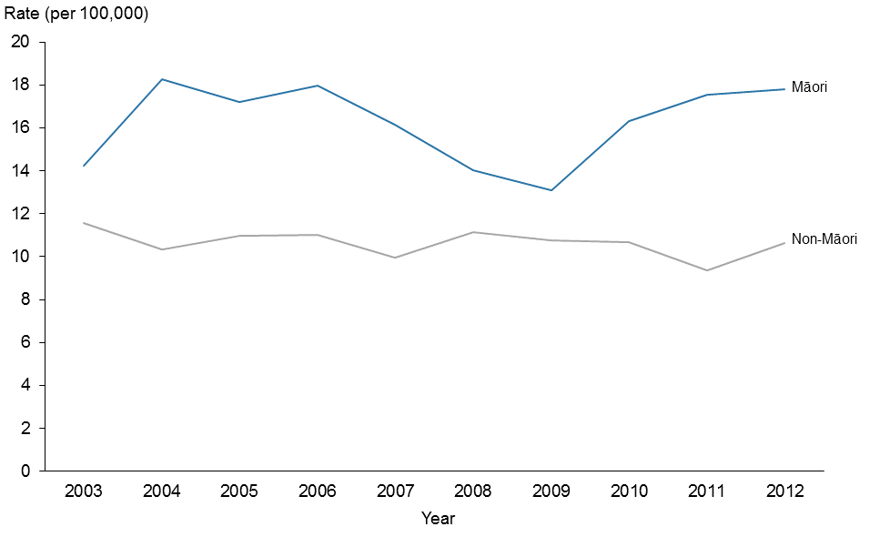

Source: New Zealand Mortality Collection

Note: rates are expressed per 100,000 population and are age-standardised to the WHO World Standard population.

Figure 12: Age-standardised suicide rates, Māori and non-Māori, by sex, 2003–2012

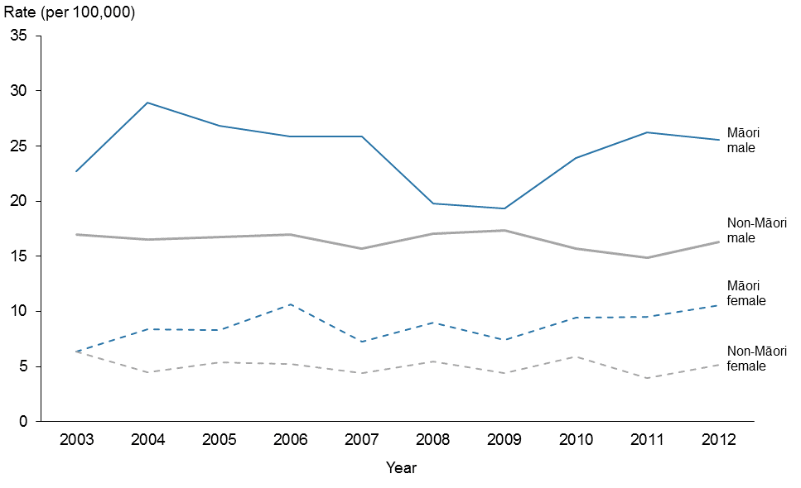

Source: New Zealand Mortality Collection

Note: rates are expressed per 100,000 population and are age-standardised to the WHO World Standard population.

#### Māori and non-Māori comparison among youth (15–24 years)

In 2012, the Māori youth suicide rate was 2.8 times the rate for non-Māori youth (48.0 per 100,000 Māori youth population compared with 17.3 per 100,000 non-Māori youth population) (Table 7). This is the greatest difference between Māori and non-Māori youth in the 10 years from 2003.

Over those 10 years, total Māori youth suicide rates were consistently higher (at least 1.7 times) than total non-Māori youth suicide rates (Figure 13). By sex, Māori male and female suicide rates were also consistently higher than non-Māori male and female suicide rates respectively over the same period (Figure 14).

Table 7: Youth suicide deaths and age-specific rates, Māori and non-Māori, by sex, 2003–2012

|  |  |  |  |  |  |  |  |  |  |  |  |  |  |  |  |
| --- | --- | --- | --- | --- | --- | --- | --- | --- | --- | --- | --- | --- | --- | --- | --- |
| **Year** | **Māori** | | | | | | **Non-Māori** | | | | | | **Rate ratio** | | |
| **Male** | | **Female** | | **Total** | | **Male** | | **Female** | | **Total** | | **Māori:non-Māori** | | |
| **Number** | **Rate** | **Number** | **Rate** | **Number** | **Rate** | **Number** | **Rate** | **Number** | **Rate** | **Number** | **Rate** | **Male** | **Female** | **Total** |
| 2003 | 20 | 37.1 | 11 | 20.2 | 31 | 28.6 | 46 | 19.3 | 20 | 8.8 | 66 | 14.2 | 1.9 | 2.3 | 2.0 |
| 2004 | 28 | 50.5 | 13 | 23.3 | 41 | 36.9 | 55 | 22.5 | 17 | 7.3 | 72 | 15.1 | 2.2 | 3.2 | 2.4 |
| 2005 | 29 | 50.5 | 10 | 17.4 | 39 | 34.0 | 55 | 22.2 | 14 | 6.0 | 69 | 14.3 | 2.3 | 2.9 | 2.4 |
| 2006 | 29 | 50.6 | 8 | 13.5 | 37 | 31.8 | 66 | 26.6 | 16 | 6.6 | 82 | 16.8 | 1.9 | 2.0 | 1.9 |
| 2007 | 23 | 39.5 | 10 | 16.8 | 33 | 28.1 | 47 | 18.6 | 13 | 5.3 | 60 | 12.1 | 2.1 | 3.2 | 2.3 |
| 2008 | 17 | 28.6 | 18 | 30.0 | 35 | 29.3 | 66 | 25.8 | 20 | 8.2 | 86 | 17.2 | 1.1 | 3.7 | 1.7 |
| 2009 | 24 | 39.2 | 11 | 18.1 | 35 | 28.7 | 69 | 26.6 | 10 | 4.1 | 79 | 15.6 | 1.5 | 4.5 | 1.8 |
| 2010 | 29 | 46.1 | 15 | 24.3 | 44 | 35.3 | 50 | 18.9 | 19 | 7.6 | 69 | 13.4 | 2.4 | 3.2 | 2.6 |
| 2011 | 33 | 51.5 | 16 | 25.7 | 49 | 38.8 | 63 | 23.6 | 17 | 6.8 | 80 | 15.5 | 2.2 | 3.8 | 2.5 |
| 20121 | 37 | 57.2 | 24 | 38.4 | 61 | 48.0 | 70 | 26.2 | 19 | 7.7 | 89 | 17.3 | 2.2 | 5.0 | 2.8 |

Source: New Zealand Mortality Collection

Notes: rates are expressed as deaths per 100,000 population.

1 Provisional

Figure 13: Youth age-specific suicide rates, by ethnic group, 2003–2012

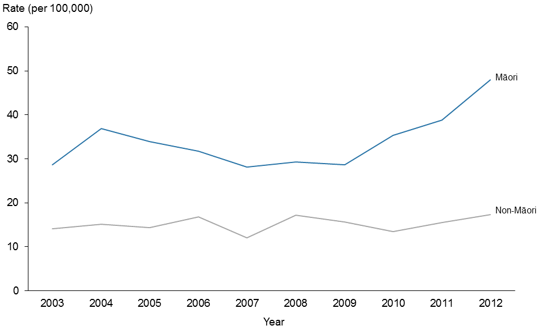

Source: New Zealand Mortality Collection

Note: rates are expressed as deaths per 100,000 population.

Figure 14: Youth age-specific suicide rates, by ethnic group and sex, 2003–2012

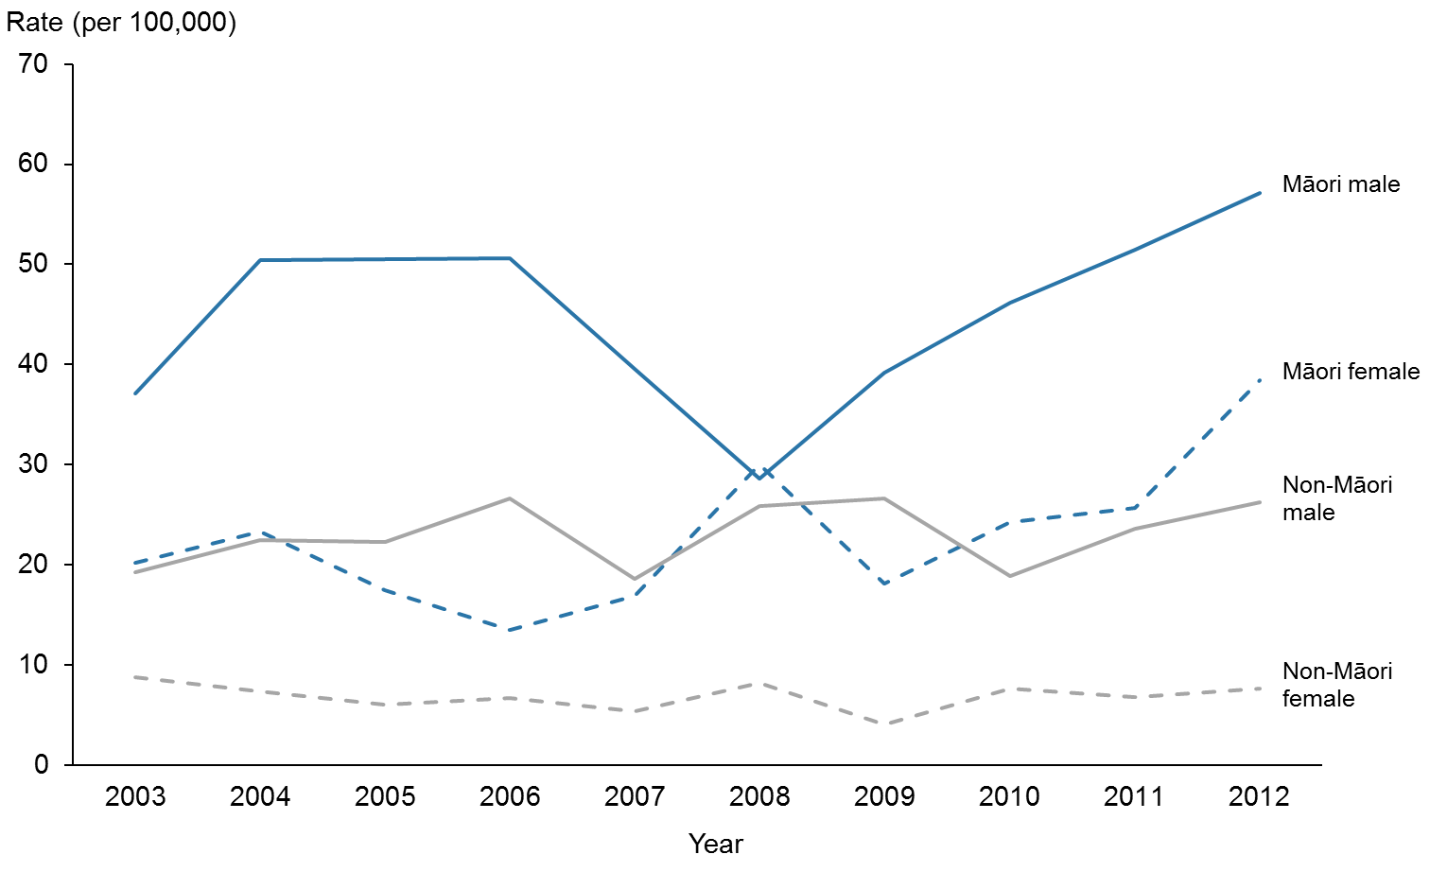

Source: New Zealand Mortality Collection

Note: rates are expressed as deaths per 100,000 population.

## Deprivation

Deprivation quintiles are used to represent the level of deprivation of the area of residence. Deprivation quintile 1 represents the least deprived and quintile 5 represents the most deprived, according to the New Zealand Deprivation Index 2006 (NZDep 2006).

In 2012, the suicide rate was highest among those who resided in deprivation quintile 4 (16.2 per 100,000), followed by quintile 3 (15.0 per 100,000). The lowest suicide rate was seen among those who resided in the least deprived quintile, quintile 1 (6.6 per 100,000) (Table 8). Suicide rates in both quintiles 1 and 2 were significantly lower than suicide rates in quintiles 3–5 (Figure 15).

When separated by sex for each deprivation quintile, female suicide rates increased with the level of deprivation. Male suicide rates were the highest in quintiles 3 and 4, which were both significantly higher than the male suicide rates in quintiles 1 and 2 (Figure 16).

The relationship between deprivation level and suicide is more apparent in the youth population when suicides by life-stage age group are presented by deprivation quintile. For youth aged  
15–24 years, there were at least 3.5 times the number of suicides in deprivation quintiles 3–5 compared with quintiles 1 and 2. The same trend was not seen in older age groups (Figure 17).

Table 8: Suicide deaths and age-standardised rates, by deprivation quintile and sex, 2012

|  |  |  |  |  |  |  |
| --- | --- | --- | --- | --- | --- | --- |
| **Deprivation quintile** | **Male** | | **Female** | | **Total** | |
| **Number** | **Rate** | **Number** | **Rate** | **Number** | **Rate** |
| 1 (least deprived) | 47 | 10.1 | 14 | 3.0 | 61 | 6.6 |
| 2 | 68 | 14.7 | 18 | 4.1 | 86 | 9.3 |
| 3 | 104 | 23.4 | 32 | 6.6 | 136 | 15.0 |
| 4 | 102 | 24.1 | 39 | 8.7 | 141 | 16.2 |
| 5 (most deprived) | 82 | 19.1 | 41 | 8.9 | 123 | 13.8 |

Source: New Zealand Mortality Collection

Notes:

Rates are expressed per 100,000 population and are age-standardised to the WHO World Standard population.

There were two suicide deaths unable to be assigned a deprivation score.

Figure 15: Age-standardised suicide rates, by deprivation quintile, 2012

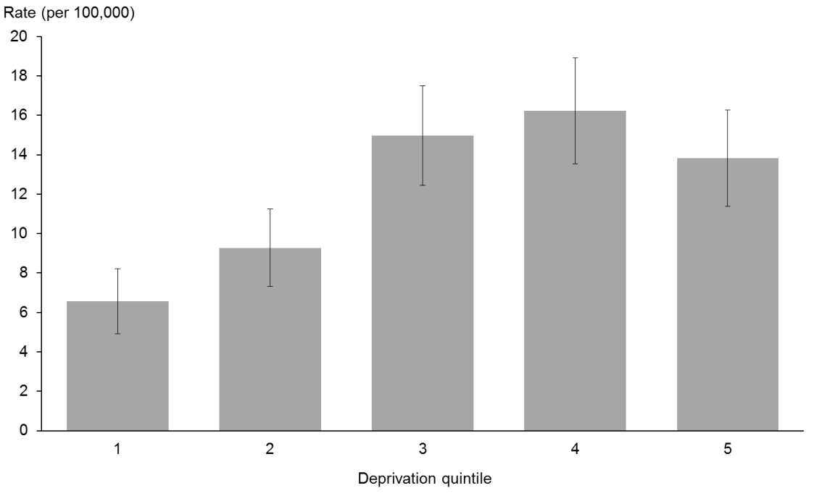

Source: New Zealand Mortality Collection

Note: rates are expressed per 100,000 population and age-standardised to the WHO World Standard population.

Figure 16: Age-standardised suicide rates, by deprivation quintile and sex, 2012

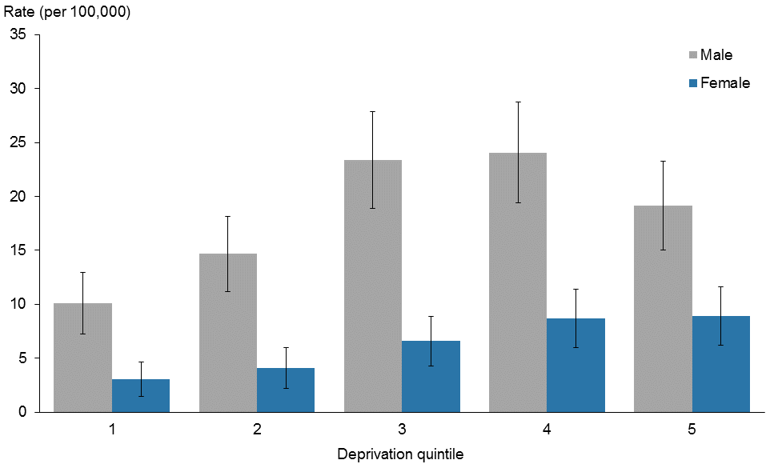

Source: New Zealand Mortality Collection

Note: rates are expressed per 100,000 population and age-standardised to the WHO World Standard population.

Figure 17: Suicides by deprivation quintile and life-stage age group, 2012

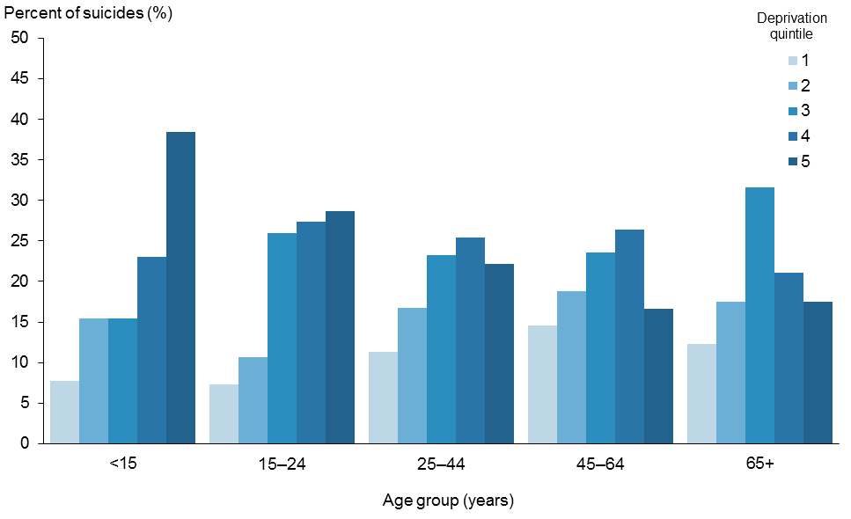

Source: New Zealand Mortality Collection

Note: rates are expressed per 100,000 population and age-standardised to the WHO World Standard population.

## Urban and rural suicide rates

The suicide rate for those residing in rural areas was 14.6 per 100,000 population compared with 12.0 per 100,000 population for those living in urban areas. This difference was not statistically significant. In all, 15.8% of people who died by suicide lived in rural areas.

### Sex

In both rural and urban areas, males had a significantly higher rate of suicide than females. For males and females, the suicide rate was higher in rural areas than urban areas. Neither of these differences was statistically significant (Figure 18).

Figure 18: Suicide rates, by urban/rural profile and sex, 2012

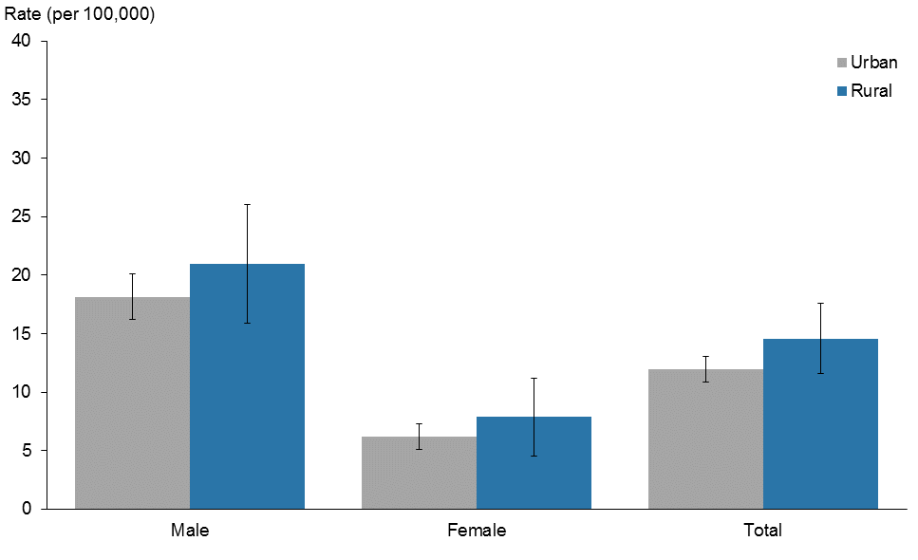

Source: New Zealand Mortality Collection

Note: rates are expressed per 100,000 population and age-standardised to the WHO World Standard population.

### Life-stage age group

The highest rate of suicide was seen in the 15–24 years life-stage age group in both rural and urban areas. The rural rates of suicide were higher than the urban rates for all life-stage age groups except for those aged 65 years and over (Figure 19).

The life-stage age group with the highest rural rate of suicide was males aged 15–24 years (29.1 per 100,000), although this was not significantly different from any of the male rural rates for other age groups, or from the urban rate for males aged 15–24 years (Table 9).

Figure 19: Suicide rates, by urban/rural profile and life-stage age group, 2012

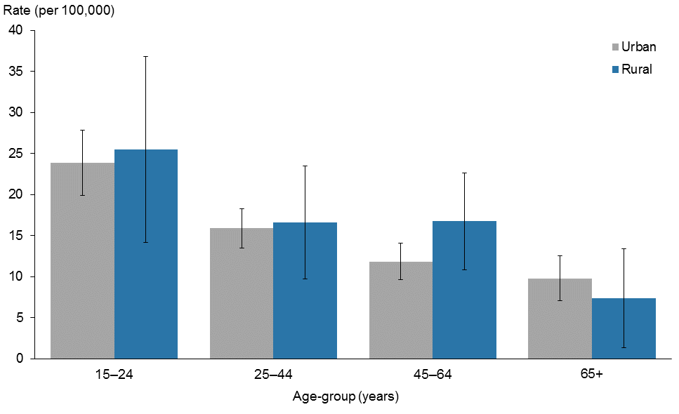

Source: New Zealand Mortality Collection

Note: rates are expressed per 100,000 population and age-standardised to the WHO World Standard population.

Table 9: Suicide deaths and rates, by urban/rural profile, life-stage age group and sex, 2012

|  |  |  |  |  |  |  |  |  |  |  |  |  |
| --- | --- | --- | --- | --- | --- | --- | --- | --- | --- | --- | --- | --- |
|  | **Number** | | | | | | **Rate** | | | | | |
| **Life-stage age group** | | | | | | **Life-stage age group** | | | | | |
| **5–14** | **15–24** | **25–44** | **45–64** | **65+** | **Total** | **5–14** | **15–24** | **25–44** | **45–64** | **65+** | **Total** |
| **Urban** |  |  |  |  |  |  |  |  |  |  |  |  |
| Male | 4 | 96 | 124 | 77 | 36 | 337 | 1.6 | 34.5 | 26.0 | 17.2 | 15.4 | 18.1 |
| Female | 4 | 36 | 35 | 33 | 15 | 123 | 1.6 | 13.1 | 6.7 | 6.8 | 5.2 | 6.2 |
| Total | 8 | 132 | 159 | 110 | 51 | 460 | 1.6 | 23.9 | 15.9 | 11.8 | 9.8 | 12.0 |
| **Rural** |  |  |  |  |  |  |  |  |  |  |  |  |
| Male | 4 | 11 | 17 | 27 | 6 | 65 | 8.4 | 29.1 | 24.0 | 27.0 | 13.7 | 20.8 |
| Female | 1 | 7 | 7 | 6 | 0 | 21 | 2.2 | 21.4 | 9.5 | 6.2 | 0.0 | 7.8 |
| Total | 5 | 18 | 24 | 33 | 6 | 86 | 5.4 | 25.5 | 16.6 | 16.7 | 7.3 | 14.4 |
| **Total** | **13** | **150** | **183** | **143** | **57** | **546** | **2.0** | **23.4** | **15.8** | **12.9** | **9.3** | **12.2** |

Source: New Zealand Mortality Collection

Notes:

There were three suicide deaths whose meshblock was unable to be assigned an urban/rural classification.

Rates are age-specific, expressed as deaths per 100,000 population. The total suicide rate is expressed per 100,000 population and age-standardised to the WHO World Standard population.

## District health board region

This section presents the rates of suicide, aggregated over a five-year period (2008–2012), for each DHB. Rates have been aggregated as some DHBs have a very small number of suicide deaths each year. Raw numbers are not presented as the size of the population varies widely across DHBs and comparing raw numbers of suicide deaths across DHBs can be misleading.

The average number of suicides per DHB over the period 2008–2012 can be found in the online tables that accompany this report.

### All ages

For this period, the national suicide rate was 11.6 deaths per 100,000 population (Table 10). Three DHB regions had significantly higher suicide rates than the national suicide rate: Bay of Plenty, South Canterbury and Southern, and three had significantly lower suicide rates than the national rate: Waitemata, Auckland and Capital & Coast DHB regions (Figures 20 and 22).

### Youth (15–24 years)

The national youth suicide rate was 19.8 suicides per 100,000 youth population (Table 10). South Canterbury DHB was the only DHB region with a significantly higher youth suicide rate than the national youth suicide rate. Waitemata and Capital & Coast DHBs had significantly lower suicide rates than the national youth suicide rate (Figures 21 and 22).

Table 10: Suicide age-standardised deaths, by DHB regions, 2008–2012

|  |  |  |  |  |
| --- | --- | --- | --- | --- |
| **DHB region** | **Total rate1** | **CI** | **Youth rate2** | **CI** |
| Northland | 13.7 | (10.1–17.3) | 29.8 | (15.5–44.1) |
| Waitemata | 9.4 | (7.9–10.9) | 13.7 | (8.8–18.6) |
| Auckland | 8.9 | (7.3–10.5) | 14.6 | (9.4–19.8) |
| Counties Manukau | 10.2 | (8.5–11.9) | 22.2 | (16.0–28.4) |
| Waikato | 11.6 | (9.6–13.6) | 19.3 | (12.4–26.2) |
| Lakes | 16.1 | (11.4–20.8) | 27.6 | (11.3–43.9) |
| Bay of Plenty | 14.9 | (11.7–18.1) | 30.1 | (17.7–42.5) |
| Tairawhiti | 17.7 | (10.3–25.1) | 40.3 | (11.5–69.1) |
| Hawke’s Bay | 14.8 | (11.2–18.4) | 26.0 | (12.9–39.1) |
| Taranaki | 13.4 | (9.4–17.4) | 15.5 | (3.4–27.6) |
| MidCentral | 14.8 | (11.4–18.2) | 26.4 | (14.9–37.9) |
| Whanganui | 15.3 | (9.5–21.1) | 18.6 | (1.6–35.6) |
| Capital & Coast | 7.8 | (6.0–9.6) | 12.2 | (6.2–18.2) |
| Hutt Valley | 10.8 | (7.7–13.9) | 18.6 | (7.6–29.6) |
| Wairarapa | 20.0 | (10.8–29.2) | 38.9 | (5.5–72.3) |
| Nelson Marlborough | 11.0 | (7.9–14.1) | 14.9 | (3.8–26.0) |
| West Coast | 11.6 | (4.9–18.3) | 0.0 |  |
| Canterbury | 11.8 | (10.1–13.5) | 17.3 | (11.7–22.9) |
| South Canterbury | 20.6 | (13.0–28.2) | 60.8 | (25.8–95.8) |
| Southern | 14.3 | (11.8–16.8) | 21.2 | (13.6–28.8) |
| National | 11.6 | (11.0–12.2) | 19.8 | (17.8–21.8) |

Source: New Zealand Mortality Collection

Notes:

Rates were calculated based on the total number of suicides between 2008 and 2012. The denominator population for the national suicide rate is the aggregated estimated national resident population for 2008–2012.

Confidence intervals (CI) are for 99% confidence.

1 Rates are expressed per 100,000 population and age-standardised to the WHO World Standard population.

2 Rates are age-specific, expressed as deaths per 100,000 population.

Figure 20: Age-standardised suicide rates, by DHB regions, 2008–2012

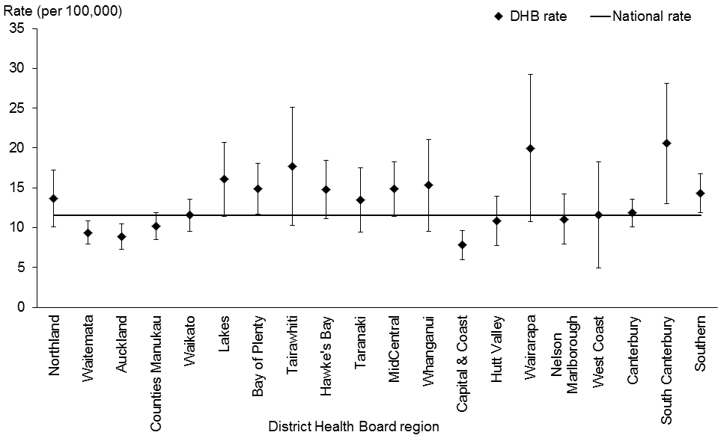

Source: New Zealand Mortality Collection

Notes:

Rates are expressed per 100,000 population and age-standardised to the WHO World Standard population.

Confidence intervals are for 99% confidence.

If a DHB region’s confidence interval does not cross the national suicide rate, the DHB rate is either statistically significantly higher or lower than the national rate.

Figure 21: Youth age-specific suicide rates, by DHB regions, 2008–2012

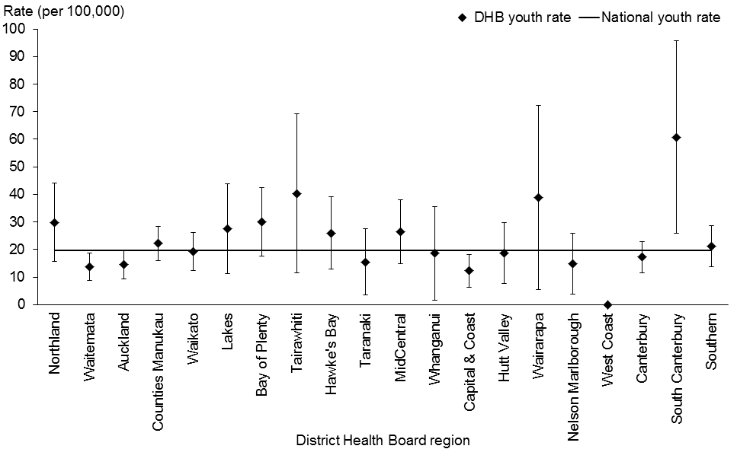

Source: New Zealand Mortality Collection

Notes:

Rates are age-specific, expressed as deaths per 100,000 population.

Confidence intervals are for 99% confidence.

If a DHB region’s confidence interval does not cross the national suicide rate, the DHB rate is either statistically significantly higher or lower than the national rate.

Figure 22: Comparison of DHB region suicide rates with the national rate, 2008–2012

Figure 22: Comparison of DHB region suicide rates with the national rate, 2008–2012

Source: New Zealand Mortality Collection

Notes:

Suicide rates for all ages are expressed per 100,000 population and age-standardised to the WHO World Standard population.

Youth rates are age-specific, expressed as deaths per 100,000 population.

## Methods of suicide

In 2012, hanging, strangulation and suffocation as a group was the most common method[3] of suicide, being used in 62.8% of all suicide deaths. Poisoning by solids and liquids was the second most common method, which was used in 10.6% of suicides, followed by poisoning by firearms and explosives (8.4%) and gases and vapours (8.2%) (Table 11).

Hanging, strangulation and suffocation was the most common method of suicide for both males and females (63.4% and 61.4% respectively). The second most common method of suicide was firearms and explosives for males (10.9%) and poisoning by solids and liquids for females (22.8%) (Figure 23).

Between 2003 and 2012, there was an increase in the proportion of suicide deaths by hanging, strangulation and suffocation from 47.8% in 2003 to 62.8% in 2012. Over the same period, suicides from poisoning by gases and vapours decreased from 20.1% to 8.2%. The use of all other methods of suicide remained relatively stable over this time period (Table 11, Figure 24).

Table 11: Methods used for suicide deaths, 2003–2012

|  |  |  |  |  |  |  |  |  |  |  |  |  |  |  |
| --- | --- | --- | --- | --- | --- | --- | --- | --- | --- | --- | --- | --- | --- | --- |
| **Year** | **Poisoning – solids and liquids** | | **Poisoning – gases and vapours** | | **Hanging, strangulation and suffocation** | | **Submersion (drowning)** | | **Firearms and explosives** | | **Other2** | | **Total** | |
| **Number** | **%** | **Number** | **%** | **Number** | **%** | **Number** | **%** | **Number** | **%** | **Number** | **%** | **Number** | **%** |
| 2003 | 58 | 11.2 | 104 | 20.1 | 247 | 47.8 | 14 | 2.7 | 41 | 7.9 | 53 | 10.3 | 517 | 100.0 |
| 2004 | 47 | 9.6 | 93 | 19.1 | 268 | 54.9 | 12 | 2.5 | 38 | 7.8 | 30 | 6.1 | 488 | 100.0 |
| 2005 | 50 | 9.8 | 110 | 21.5 | 255 | 49.9 | 13 | 2.5 | 44 | 8.6 | 39 | 7.6 | 511 | 100.0 |
| 2006 | 49 | 9.3 | 87 | 16.5 | 286 | 54.4 | 9 | 1.7 | 50 | 9.5 | 45 | 8.6 | 526 | 100.0 |
| 2007 | 44 | 9.0 | 67 | 13.8 | 282 | 57.9 | 11 | 2.3 | 47 | 9.7 | 36 | 7.4 | 487 | 100.0 |
| 2008 | 56 | 10.8 | 75 | 14.4 | 289 | 55.6 | 8 | 1.5 | 43 | 8.3 | 49 | 9.4 | 520 | 100.0 |
| 2009 | 56 | 11.0 | 50 | 9.8 | 304 | 59.6 | 5 | 1.0 | 53 | 10.4 | 42 | 8.2 | 510 | 100.0 |
| 2010 | 67 | 12.5 | 60 | 11.2 | 317 | 59.3 | 9 | 1.7 | 42 | 7.9 | 40 | 7.5 | 535 | 100.0 |
| 2011 | 58 | 11.8 | 47 | 9.5 | 301 | 61.1 | 14 | 2.8 | 36 | 7.3 | 37 | 7.5 | 493 | 100.0 |
| 20121 | 58 | 10.6 | 45 | 8.2 | 345 | 62.8 | 5 | 0.9 | 46 | 8.4 | 50 | 9.1 | 549 | 100.0 |

Source: New Zealand Mortality Collection

Notes:

1 Provisional data.

2 See Appendix 2: Definitions for information about the methods included in the ‘Other’ category.

Figure 23: Methods used for suicide deaths, by sex, 2012

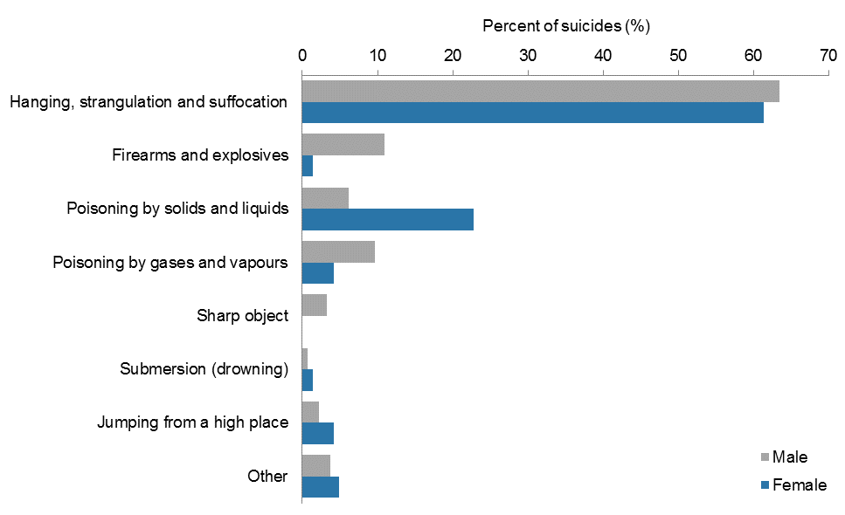

Source: New Zealand Mortality Collection

Note: see Appendix 2: Definitions for information about the methods included in the ‘Other’ category.

Figure 24: Methods used for suicide deaths, 2003–2012

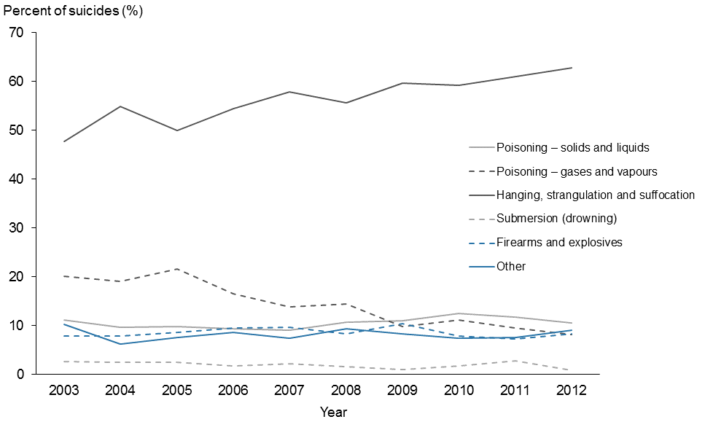

Source: New Zealand Mortality Collection

Note: see Appendix 2: Definitions for information about the methods included in the ‘Other’ category.

### Methods of suicide by life-stage age group

Hanging, strangulation and suffocation collectively was the predominant method used for suicide by both male and females in all life-stage age groups in 2012 (Figure 25).

Youth were more likely to die by hanging, strangulation and suffocation than older people – use of these suicide methods decreased with age for both sexes, especially for females (Figure 25).

Poisonings generally increased with age, particularly for female suicides. With increasing age, the proportion of females who used poisoning by solid and liquids to commit suicide increased to nearly the same proportion as hanging, strangulation and suffocation (Figure 25).

A greater proportion of males aged 45 years and over used firearms and explosives compared with those aged less than 45 years. Males were generally more likely to employ firearms and explosives than females (Figure 25).

Figure 25: Methods used for suicide deaths, by sex and life-stage age group, 2012

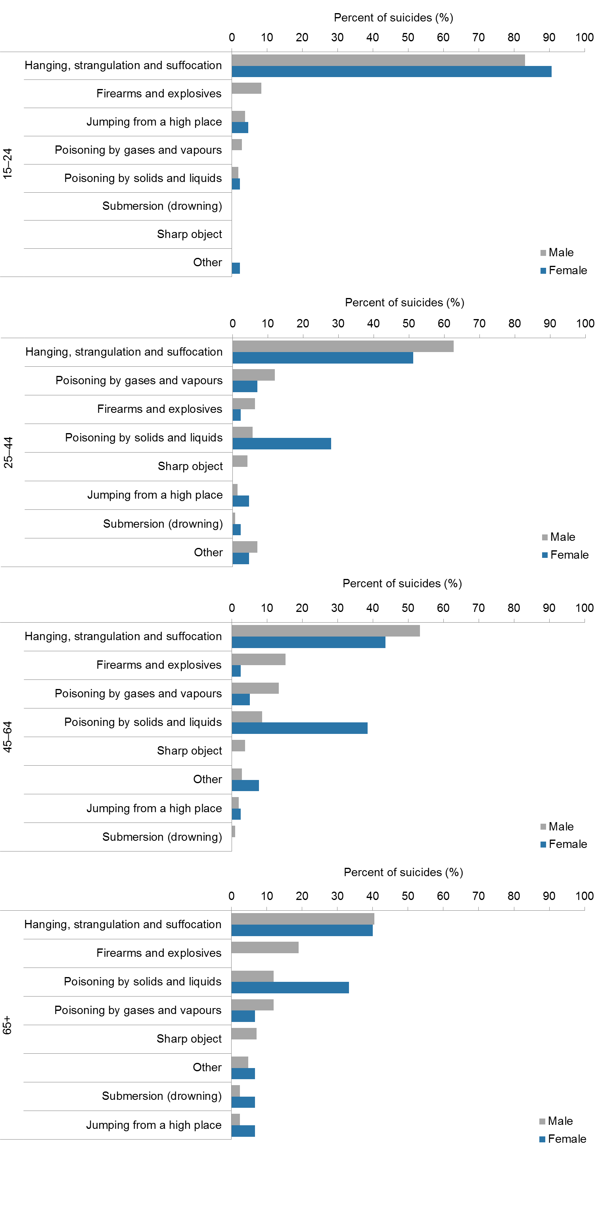

Source: New Zealand Mortality Collection

Note: see Appendix 2: Definitions for information about the methods included in the ‘Other’ category.

## International comparisons

This section compares New Zealand suicide rates with those from other countries in the Organisation for Economic Co-operation and Development (OECD). The countries presented in this report were members of the OECD in 2012. In general, OECD countries are considered to produce reliable data collections and have similar economic statuses to New Zealand, and so their health and social statistics are often used for comparison with New Zealand’s health and social statistics.

A cautious approach is recommended when comparing international suicide statistics because many factors affect the recording and classification of suicide in different countries, including the level of proof required for a verdict of suicide; the stigma associated with suicide; the religion, social class or occupation of suicide victims; and confidentiality (Andriessen 2006). As a result, deaths classified as suicide in some countries may be classified as accidental or of undetermined intent in others.

The international figures cited here (except New Zealand) are the latest available from the OECD and cover various years. Therefore New Zealand rates for 2012 are compared with data from earlier years for some countries in which different social and/or economic conditions may have applied.

### Sex

New Zealand suicide rates for both the male and female populations are slightly above the median for the OECD countries presented. All OECD countries had higher suicide rates for males than females (Figure 26).

Figure 26: Suicide age-standardised rates for OECD countries, by sex

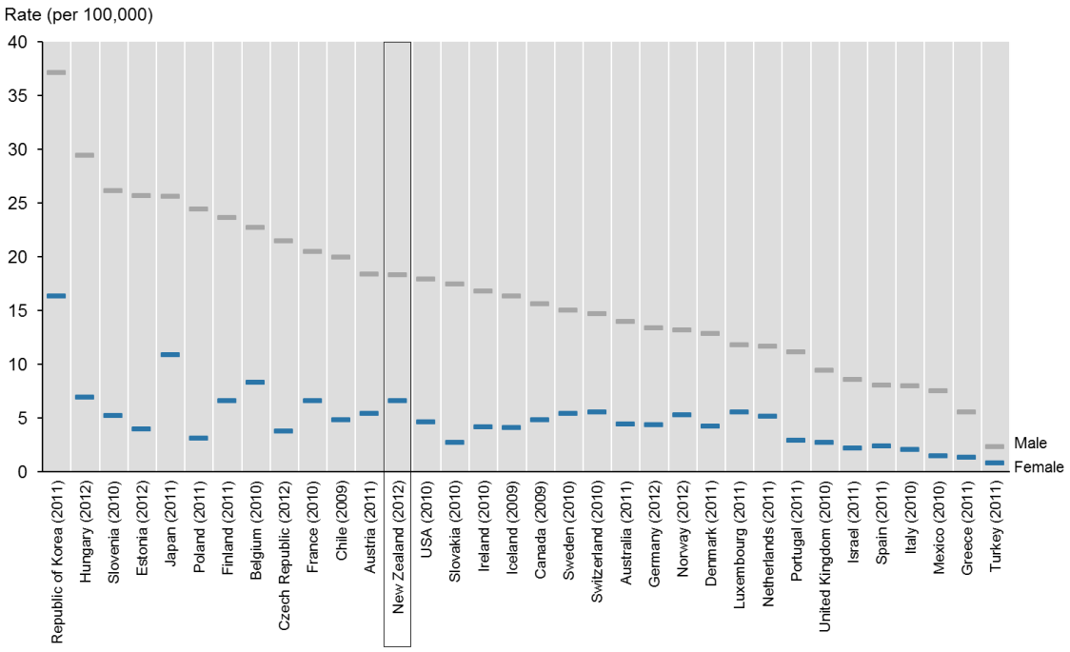

Source: OECD (nd)

Note: rates are expressed per 100,000 population and age standardised to the WHO World Standard population.

### Youth aged 15–24 years

New Zealand male and female suicide rates were the highest of the OECD countries covered in this report. The New Zealand male youth suicide rate (2012) was 32.3 per 100,000 male youth population, followed by Finland (2011) with 26.4 suicides per 100,000 population (Figure 27). New Zealand’s female youth suicide rate (2012) was 13.8 suicides per 100,000 female youth population, followed by the Republic of Korea (2011) with 11.0 per 100,000 population (Figure 27).

Figure 27: Youth (15–24 years) suicide age-specific rates for OECD countries, by sex

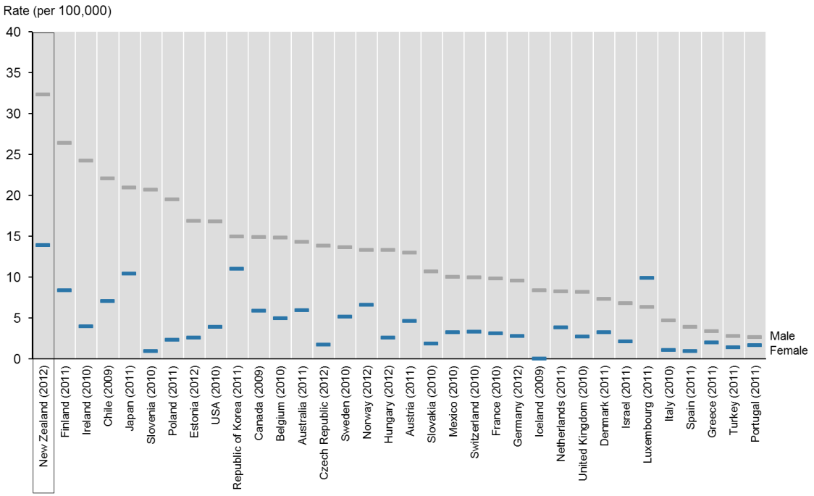

Source: OECD (nd)

Note: rates are age-specific, expressed as deaths per 100,000 population.

# Intentional self-harm hospitalisations in 2012

This section presents data on intentional self-harm hospitalisations by sex, age, ethnicity, deprivation and DHB region of domicile.

The motivation for intentional self-harm varies; note that data on hospitalisations for intentional self-harm does not provide a measure of suicide attempts. To allow the best possible identification of trends, approximately 60% of all 2012 self-harm hospitalisations data has been excluded from this analysis (due to inconsistencies in the way DHBs report data). For more information about the exclusions, see the Introduction and tables A3 and A4 in Appendix 3: Further tables.

## Overview

Over the 10-year period 2003–2012, the rate of intentional self-harm hospitalisations decreased by 11.5% from 80.3 per 100,000 in 2003 to 71.0 per 100,000 population in 2012 (Figure 28, Table 12).

The actual number of self-harm hospitalisations decreased from 3141 in 2003 to 3031 in 2012 (Table 12). Caution is advised when interpreting the decline in self-harm hospitalisations as this decline could have been caused by changes in clinical practices and administration instead of real change in behaviour.

Figure 28: Intentional self-harm hospitalisation age-standardised rates, 2003–2012

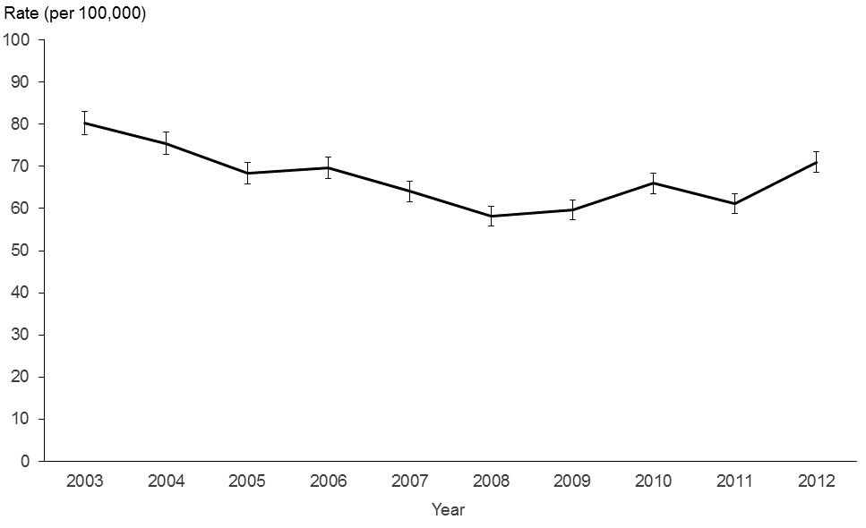

Source: New Zealand National Minimum Dataset

Note: rates are expressed per 100,000 population and age-standardised to the WHO World Standard population.

## Sex

In 2012, the female rate of hospitalisation for intentional self-harm was more than twice the male rate (96.1 per 100,000 females compared with 46.4 per 100,000 males) (Table 12).

Over the 10 years from 2003 to 2012, the female rate of intentional self-harm hospitalisation was more variable than the male rate but remained at least 1.7 times greater than the male rate (Figure 29). It is well documented that females are more likely to be hospitalised for intentional self-harm than males (Berry and Harrison 2006).

Table 12: Intentional self-harm hospitalisation numbers and age-standardised rates, by sex, 2003–2012

|  |  |  |  |  |  |  |  |
| --- | --- | --- | --- | --- | --- | --- | --- |
| **Year** | **Male** | | **Female** | | **Total** | | **Sex rate ratio (F:M)** |
| **Number** | **Rate** | **Number** | **Rate** | **Number** | **Rate** |
| 2003 | 1048 | 54.3 | 2093 | 106.0 | 3141 | 80.3 | 2.0 |
| 2004 | 982 | 50.1 | 2018 | 100.7 | 3000 | 75.5 | 2.0 |
| 2005 | 953 | 48.0 | 1790 | 88.7 | 2743 | 68.3 | 1.8 |
| 2006 | 991 | 48.8 | 1878 | 90.2 | 2869 | 69.6 | 1.8 |
| 2007 | 940 | 45.6 | 1746 | 82.4 | 2686 | 64.0 | 1.8 |
| 2008 | 877 | 41.9 | 1591 | 74.5 | 2468 | 58.2 | 1.8 |
| 2009 | 947 | 44.6 | 1592 | 74.7 | 2539 | 59.6 | 1.7 |
| 2010 | 990 | 46.1 | 1835 | 85.9 | 2825 | 66.0 | 1.9 |
| 2011 | 940 | 43.2 | 1708 | 79.0 | 2648 | 61.1 | 1.8 |
| 2012 | 1011 | 46.4 | 2020 | 96.1 | 3031 | 71.0 | 2.1 |

Source: New Zealand National Minimum Dataset

Note: rates are expressed per 100,000 population and age-standardised to the WHO World Standard population.

Figure 29: Intentional self-harm hospitalisation age-standardised rates, by sex, 2003–2012

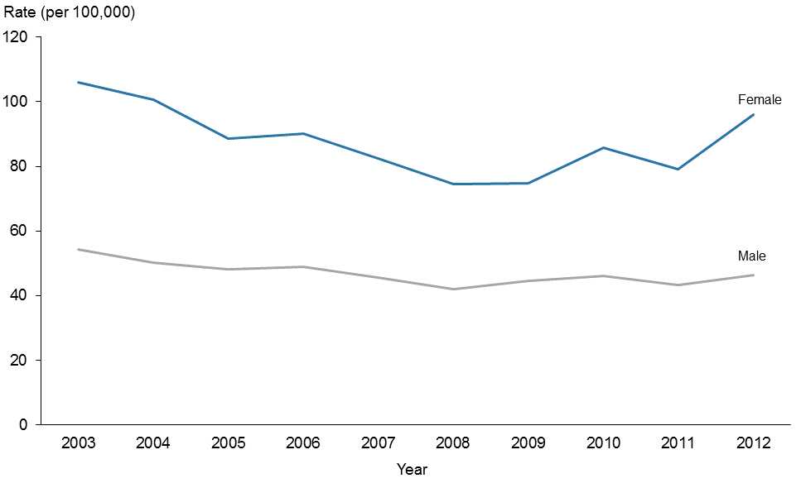

Source: New Zealand National Minimum Dataset

Note: rates are expressed per 100,000 population and age-standardised to the WHO World Standard population.

## Age

This section discusses intentional self-harm hospitalisations by five-year age groups and then focuses specifically on the group youth aged 15–24 years.

### All ages

In 2012, the 15–19 year age group had the highest rate of intentional self-harm hospitalisations for both males (103.1 per 100,000 population) and females (279.5 per 100,000 population) (Table 13).

Female rates of intentional self-harm hospitalisation were significantly higher than male rates for each five-year age group between the ages of 10 and 74 years. In those aged 75 years and over, male rates were significantly higher than female rates (Figure 30). The lowest male rates of intentional self-harm hospitalisations were in those aged 10–14 years followed by 65–69 years. In females, the lowest rates of intentional self-harm hospitalisations were in those aged 70–74 years (Table 13).

Table 13: Intentional self-harm hospitalisation numbers and rates, by sex and five-year age group, 2012

|  |  |  |  |  |  |  |
| --- | --- | --- | --- | --- | --- | --- |
| **Age group (years)** | **Male** | | **Female** | | **Total** | |
| **Number** | **Rate** | **Number** | **Rate** | **Number** | **Rate** |
| 10–14 | 17 | 11.5 | 121 | 85.8 | 138 | 47.8 |
| 15–19 | 165 | 103.1 | 423 | 279.5 | 588 | 188.8 |
| 20–24 | 161 | 93.9 | 303 | 190.2 | 464 | 140.3 |
| 25–29 | 78 | 52.0 | 202 | 135.7 | 280 | 93.7 |
| 30–34 | 88 | 65.4 | 141 | 98.3 | 229 | 82.4 |
| 35–39 | 80 | 59.9 | 156 | 106.3 | 236 | 84.2 |
| 40–44 | 96 | 64.5 | 189 | 115.4 | 285 | 91.1 |
| 45–49 | 96 | 63.5 | 149 | 91.8 | 245 | 78.1 |
| 50–54 | 72 | 48.6 | 122 | 77.8 | 194 | 63.6 |
| 55–59 | 53 | 41.1 | 67 | 49.7 | 120 | 45.5 |
| 60–64 | 33 | 28.3 | 57 | 47.1 | 90 | 37.9 |
| 65–69 | 14 | 15.0 | 28 | 28.6 | 42 | 21.9 |
| 70–74 | 11 | 15.1 | 20 | 25.2 | 31 | 20.4 |
| 75–79 | 14 | 27.8 | 15 | 25.8 | 29 | 26.8 |
| 80–84 | 16 | 43.5 | 13 | 27.8 | 29 | 34.7 |
| 85+ | 17 | 62.7 | 14 | 28.8 | 31 | 41.0 |
| Total | 1011 | 46.4 | 2020 | 96.1 | 3031 | 71.0 |

Source: New Zealand National Minimum Dataset

Notes:

The rates for five-year age groups in this table are age-specific rates, expressed as deaths per 100,000 population.

The total rates are expressed per 100,000 population and age-standardised to the WHO World Standard population.

There were no intentional self-harm hospitalisations in the 0–4 years or 5–9 years age groups.

Figure 30: Intentional self-harm hospitalisation age-specific rates, by age group and sex, 2012

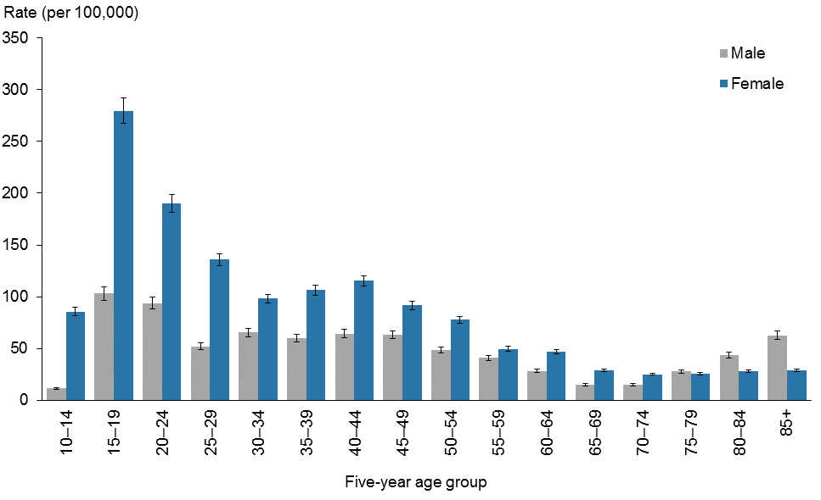

Source: New Zealand National Minimum Dataset

Note: rates are age-specific, expressed as deaths per 100,000 population.

### Youth (15–24 years)

In 2012, the female rate of intentional self-harm hospitalisations was 2.4 times the male rate (233.7 and 98.4 per 100,000 female and male populations respectively) (Table 14).

Over the 10-year period of 2003–2012, youth hospitalisation rates for intentional self-harm varied. Female rates were consistently at least 2.1 times greater than males. The rates in 2012 were the highest during this period (Figure 31).

Table 14: Youth intentional self-harm hospitalisation numbers and age-specific rates, by sex, 2003–2012

|  |  |  |  |  |  |  |  |
| --- | --- | --- | --- | --- | --- | --- | --- |
| **Year** | **Male** | | **Female** | | **Total** | | **Sex rate ratio (F:M)** |
| **Number** | **Rate** | **Number** | **Rate** | **Number** | **Rate** |
| 2003 | 275 | 93.9 | 622 | 221.2 | 897 | 156.2 | 2.4 |
| 2004 | 278 | 92.7 | 580 | 202.1 | 858 | 146.2 | 2.2 |
| 2005 | 224 | 73.5 | 503 | 172.8 | 727 | 122.0 | 2.3 |
| 2006 | 247 | 80.9 | 573 | 191.1 | 820 | 135.5 | 2.4 |
| 2007 | 219 | 70.5 | 520 | 171.6 | 739 | 120.4 | 2.4 |
| 2008 | 214 | 68.0 | 485 | 159.0 | 699 | 112.8 | 2.3 |
| 2009 | 240 | 74.8 | 489 | 159.0 | 729 | 116.0 | 2.1 |
| 2010 | 262 | 80.0 | 565 | 181.7 | 827 | 129.6 | 2.3 |
| 2011 | 262 | 79.1 | 572 | 183.3 | 834 | 129.7 | 2.3 |
| 2012 | 326 | 98.4 | 726 | 233.7 | 1052 | 163.8 | 2.4 |

Source: New Zealand National Minimum Dataset

Note: rates are expressed as deaths per 100,000 population.

Figure 31: Youth (15–24 years) intentional self-harm hospitalisation age-specific rates, by sex, 2003–2012

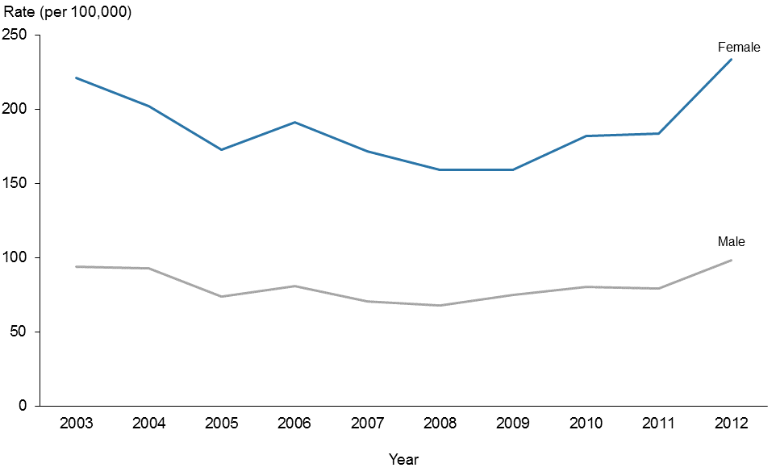

Source: New Zealand National Minimum Dataset

Note: rates are expressed as deaths per 100,000 population.

## Ethnicity

Rates of intentional self-harm hospitalisations in 2012 for each ethnic group are as follows:

a) Māori – 85.0 per 100,000 population

b) Pacific peoples – 34.0 per 100,000 population

c) European & Other – 82.8 per 100,000 population

d) Asian – 18.0 per 100,000 population (Table 15).

Over the five-year period of 2008–2012, Māori rates of hospitalisations for intentional self-harm were the highest followed by European & Other. During this period, Māori rates were at least more than twice those of the Pacific peoples and Asian populations (Figure 32).

### Māori

In 2012, there were 563 intentional self-harm hospitalisations of Māori (18.6% of total intentional self-harm hospitalisations) (Table 15). The most common age group for both Māori males and females to be hospitalised for intentional self-harm was youth (15–24 years) closely followed by the 25–44 years age group. There were 88 hospitalisations for male youth, equating to 136.0 per 100,000 population, and 138 hospitalisations for female youth, equating to 221.0 per 100,000 population (Table 16).

### Pacific peoples

In 2012, there were 101 Pacific people hospitalised for intentional self-harm (3.3% of total intentional self-harm hospitalisations), equating to an age-standardised rate of 34.0 per 100,000 Pacific population (Table 15). Half of these were in youths aged 15–24 years (Table 16).

### Asian

In 2012, there were 97 intentional self-harm hospitalisations of Asian people (3.2% of total intentional self-harm hospitalisations), equating to an age-standardised rate of 18.0 per 100,000 Asian population (Table 15). Youth (15–24 years) accounted for nearly 30% of all Asian intentional self-harm hospitalisations (Table 16).

### European & Other

There were 2270 intentional self-harm hospitalisations for people of ethnicities classified as ‘European & Other’ in 2012 (74.9% of total intentional self-harm hospitalisations). Females accounted for 68.0% of intentional self-harm hospitalisations in this group (Table 15).

Youth (15–24 years) were the most common age group to be hospitalised for intentional self-harm (198 males and 549 females) (Table 16).

Table 15: Intentional self-harm hospitalisation numbers and rates, by ethnicity and sex, 2008–2012

|  |  |  |  |  |  |  |  |  |  |
| --- | --- | --- | --- | --- | --- | --- | --- | --- | --- |
| **Sex** | **Year** | **Māori** | | **Pacific peoples** | | **Asian** | | **European & Other** | |
| **Number** | **Rate** | **Number** | **Rate** | **Number** | **Rate** | **Number** | **Rate** |
| Male | 2008 | 152 | 52.3 | 47 | 35.1 | 33 | 16.0 | 645 | 44.1 |
|  | 2009 | 176 | 59.7 | 35 | 27.0 | 36 | 15.7 | 700 | 48.6 |
|  | 2010 | 223 | 75.2 | 46 | 32.2 | 34 | 13.6 | 687 | 47.0 |
|  | 2011 | 186 | 59.8 | 35 | 24.5 | 23 | 8.9 | 696 | 47.2 |
|  | 2012 | 204 | 64.0 | 50 | 34.0 | 31 | 11.2 | 726 | 49.6 |
| Female | 2008 | 262 | 79.8 | 36 | 26.2 | 51 | 21.0 | 1242 | 88.8 |
|  | 2009 | 281 | 83.7 | 42 | 29.7 | 51 | 19.4 | 1219 | 87.7 |
|  | 2010 | 312 | 92.5 | 50 | 34.8 | 65 | 25.6 | 1409 | 102.6 |
|  | 2011 | 277 | 82.6 | 57 | 39.5 | 56 | 21.2 | 1318 | 95.6 |
|  | 2012 | 359 | 105.4 | 51 | 34.0 | 66 | 24.6 | 1544 | 117.2 |
| Total | 2008 | 414 | 66.3 | 83 | 30.6 | 84 | 18.4 | 1887 | 66.2 |
|  | 2009 | 457 | 71.6 | 77 | 28.2 | 87 | 17.4 | 1919 | 68.0 |
|  | 2010 | 535 | 83.6 | 96 | 33.5 | 99 | 19.7 | 2096 | 74.6 |
|  | 2011 | 463 | 71.5 | 92 | 32.1 | 79 | 15.2 | 2014 | 71.1 |
|  | 2012 | 563 | 85.0 | 101 | 34.0 | 97 | 18.0 | 2270 | 82.8 |

Source: New Zealand National Minimum Dataset

Notes:

Rates are expressed per 100,000 population and age-standardised to the WHO World Standard population.

Numbers and rates for 1996–2012 are presented in the online tables for Māori, Pacific peoples and European & Other.

Figure 32: Intentional self-harm hospitalisation age-standardised rates, by ethnic group, 2008–2012

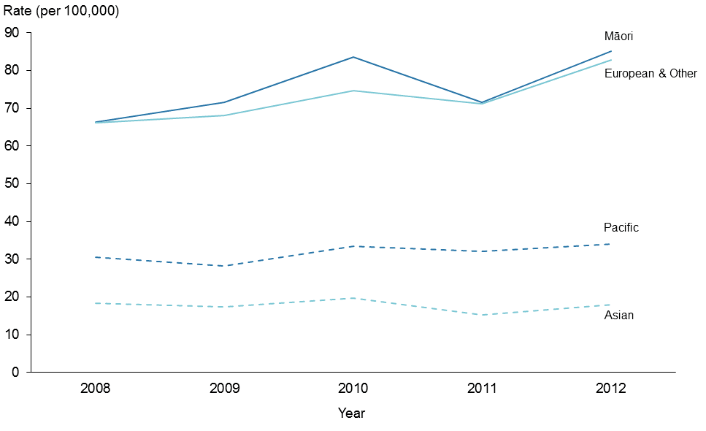

Source: New Zealand National Minimum Dataset

Note: rates are expressed per 100,000 population and age-standardised to the WHO World Standard population.

Table 16: Intentional self-harm hospitalisations, by ethnicity, life-stage age group and sex, 2012

|  |  |  |  |  |  |  |  |
| --- | --- | --- | --- | --- | --- | --- | --- |
| **Ethnicity** | **Sex** | **Life-stage age group (years)** | | | | | **Total** |
| **<15** | **15–24** | **25–44** | **45–64** | **65+** |
| Māori | Male | 7 | 88 | 78 | 31 | 0 | 204 |
| Female | 44 | 138 | 129 | 46 | 2 | 359 |
| Total | 51 | 226 | 207 | 77 | 2 | 563 |
| Pacific peoples | Male | 2 | 30 | 14 | 3 | 1 | 50 |
| Female | 7 | 20 | 19 | 5 | 0 | 51 |
| Total | 9 | 50 | 33 | 8 | 1 | 101 |
| Asian | Male | 0 | 10 | 12 | 7 | 2 | 31 |
| Female | 3 | 19 | 32 | 6 | 6 | 66 |
| Total | 3 | 29 | 44 | 13 | 8 | 97 |
| European & Other | Male | 8 | 198 | 238 | 213 | 69 | 726 |
| Female | 67 | 549 | 508 | 338 | 82 | 1544 |
| Total | 75 | 747 | 746 | 551 | 151 | 2270 |
| All ethnicities | Male | 17 | 326 | 342 | 254 | 72 | 1011 |
| Female | 121 | 726 | 688 | 395 | 90 | 2020 |
| Total | 138 | 1052 | 1030 | 649 | 162 | 3031 |

Source: New Zealand National Minimum Dataset

### Māori and non-Māori comparison

In 2012, the Māori rate of intentional self-harm hospitalisations was 25% higher than the non‑Māori rate (85.0 per 100,000 and 68.0 per 100,000, respectively). This difference was statistically significant.

Between 2003 and 2012, rates for Māori were variable and showed no real trend. Rates for non-Māori showed a general downward trend (Figure 33).

Figure 33: Intentional self-harm hospitalisation age-standardised rates, Māori and non-Māori, 2003–2012

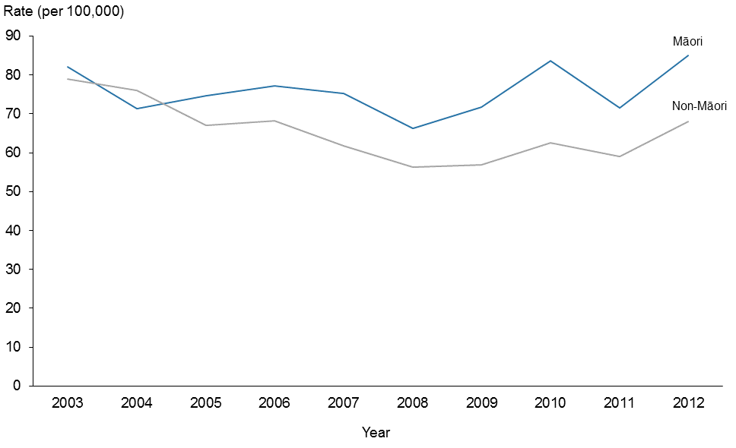

Source: New Zealand National Minimum Dataset

Note: rates are expressed per 100,000 population and age-standardised to the WHO World Standard population.

#### Sex

The rates for male Māori and non-Māori intentional self-harm hospitalisations continued to be lower than the rates for female Māori and non-Māori in 2012.

Between 2003 and 2012, rates for non-Māori males showed a downward trend and were significantly lower than Māori male rates. Māori male rates remained variable.

Non-Māori female rates for intentional self-harm hospitalisations showed a downward trend between 2003 and 2008, after which rates increased. The rate for Māori females was more variable throughout the whole period (Figure 34).

Figure 34: Intentional self-harm hospitalisation age-standardised rates for Māori and non-Māori, by sex, 2003–2012

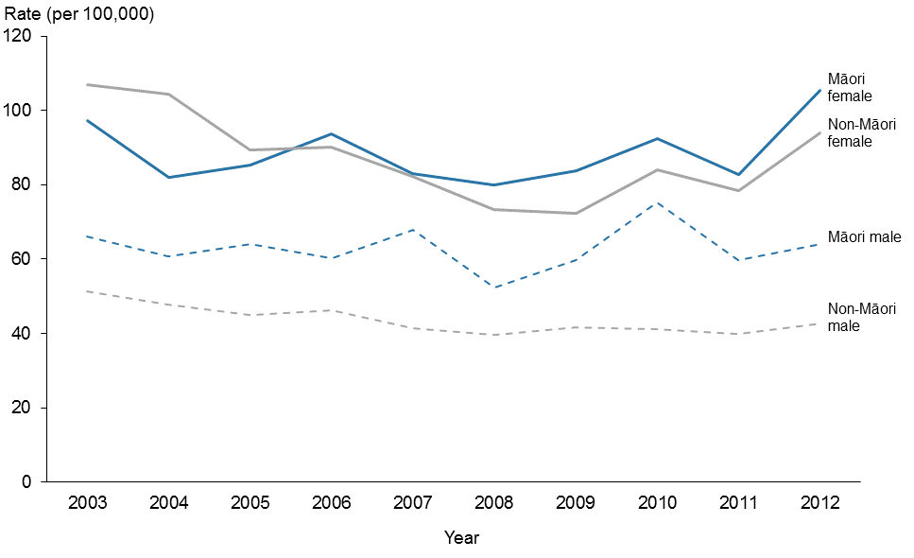

Source: New Zealand National Minimum Dataset

Note: rates are expressed per 100,000 population and age-standardised to the WHO World Standard population.

#### Youth (15–24 years)

In 2012, both Māori and non-Māori youth self-harm hospitalisation rates were the highest recorded in the 10 years from 2003 to 2012. The difference between Māori and non-Māori youth rates in 2012 was not statistically significant (Figure 35, Table 17).

Between 2003 and 2012, Māori male youth rates of intentional self-harm hospitalisation were at least 1.4 times the non-Māori male youth rate. In contrast, the ethnic disparity was less defined for female youth (Figure 36).

Figure 35: Youth intentional self-harm hospitalisation age-specific rates, by ethnic group, 2003–2012

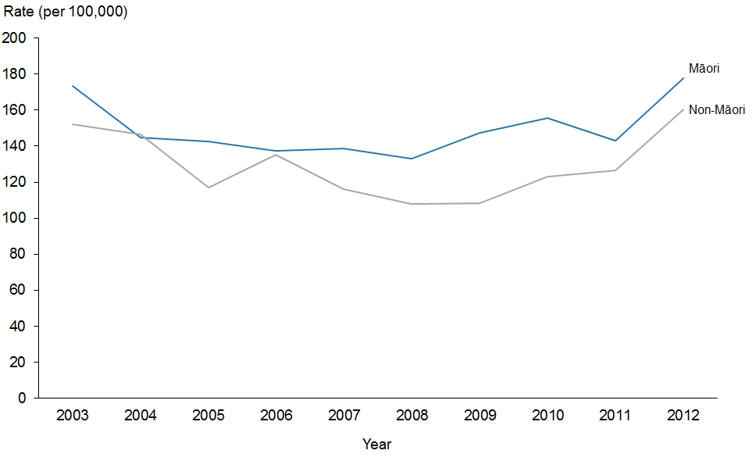

Source: New Zealand National Minimum Dataset

Note: rates are expressed as deaths per 100,000 population.

Figure 36: Youth intentional self-harm hospitalisation age-specific rates, by ethnic group and sex, 2003–2012

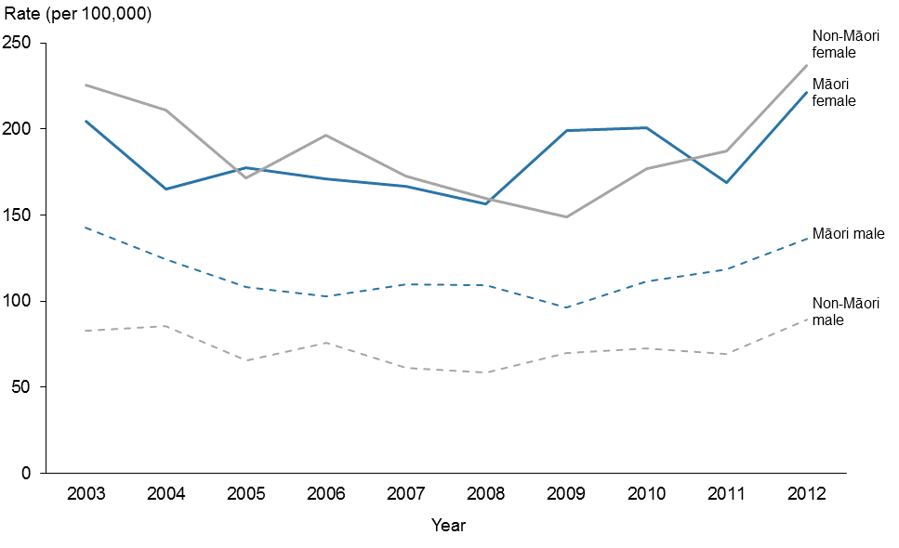

Source: New Zealand National Minimum Dataset

Note: rates are expressed as deaths per 100,000 population.

Table 17: Youth intentional self-harm hospitalisation numbers and age-specific rates, Māori and non-Māori, by sex, 2003–2012

|  |  |  |  |  |  |  |  |  |  |  |  |  |
| --- | --- | --- | --- | --- | --- | --- | --- | --- | --- | --- | --- | --- |
| **Year** | **Māori** | | | | | | **Non-Māori** | | | | | |
| **Male** | | **Female** | | **Total** | | **Male** | | **Female** | | **Total** | |
| **Number** | **Rate** | **Number** | **Rate** | **Number** | **Rate** | **Number** | **Rate** | **Number** | **Rate** | **Number** | **Rate** |
| 2003 | 77 | 142.7 | 111 | 204.2 | 188 | 173.6 | 198 | 82.9 | 511 | 225.2 | 709 | 152.2 |
| 2004 | 69 | 124.3 | 92 | 165.1 | 161 | 144.8 | 209 | 85.5 | 488 | 211.0 | 697 | 146.5 |
| 2005 | 62 | 107.9 | 102 | 177.6 | 164 | 142.8 | 162 | 65.5 | 401 | 171.6 | 563 | 117.1 |
| 2006 | 59 | 102.9 | 101 | 170.8 | 160 | 137.4 | 188 | 75.7 | 472 | 196.1 | 660 | 135.0 |
| 2007 | 64 | 110.0 | 99 | 166.8 | 163 | 138.7 | 155 | 61.4 | 421 | 172.7 | 576 | 116.1 |
| 2008 | 65 | 109.2 | 94 | 156.7 | 159 | 133.0 | 149 | 58.4 | 391 | 159.6 | 540 | 107.9 |
| 2009 | 59 | 96.4 | 121 | 199.0 | 180 | 147.5 | 181 | 69.7 | 368 | 149.1 | 549 | 108.4 |
| 2010 | 70 | 111.4 | 124 | 200.9 | 194 | 155.7 | 192 | 72.6 | 441 | 176.9 | 633 | 123.2 |
| 2011 | 76 | 118.5 | 105 | 168.6 | 181 | 143.2 | 185 | 69.3 | 468 | 187.4 | 653 | 126.3 |
| 2012 | 88 | 136.0 | 138 | 221.0 | 226 | 177.7 | 238 | 89.2 | 588 | 236.8 | 826 | 160.4 |

Source: New Zealand National Minimum Dataset

Note: rates are expressed as deaths per 100,000 population.

## Deprivation

Deprivation quintiles are used to represent the level of deprivation of the area of residence. Deprivation quintile 1 represents the least deprived areas, and quintile 5 represents the most deprived areas, according to the 2006 New Zealand Deprivation Index (NZDep 2006).

In 2012, the highest rate of intentional self-harm hospitalisations was among those residing in deprivation quintile 4. The rate in quintile 4 was 1.8 times the rate for those in quintile 1 (90.9 per 100,000 population compared with 49.6 per 100,000 population) (Table 18).

For males, the rates for quintiles 3–5 were significantly higher than the rates for quintiles 1 and 2. The rate in quintile 4 was 2.5 times the rate in the least deprived quintile (66.0 per 100,000 population compared with 26.8 per 100,000 population).

In 2012, the female intentional self-harm hospitalisations rate was highest in quintile 4 (116.3 per 100,000 population); this rate was 1.6 times higher than the rate in the least deprived quintile (quintile 1, at 73.3 per 100,000 population) (Table 18). Female rates in the three most deprived quintiles (3–5) were significantly higher than female rates in the least deprived quintile (Figure 37).

Table 18: Intentional self-harm hospitalisation numbers and age-standardised rates, by deprivation quintile and sex, 2012

|  |  |  |  |  |  |  |
| --- | --- | --- | --- | --- | --- | --- |
| **Deprivation quintile** | **Male** | | **Female** | | **Total** | |
| **Number** | **Rate** | **Number** | **Rate** | **Number** | **Rate** |
| 1 (least) | 117 | 26.8 | 287 | 73.3 | 404 | 49.6 |
| 2 | 137 | 31.9 | 345 | 87.1 | 482 | 58.6 |
| 3 | 193 | 44.7 | 427 | 102.6 | 620 | 73.3 |
| 4 | 284 | 66.0 | 494 | 116.3 | 778 | 90.9 |
| 5 (most) | 270 | 63.1 | 462 | 107.3 | 732 | 85.7 |

Source: New Zealand National Minimum Dataset

Note: rates are expressed per 100,000 population and age-standardised to the WHO World Standard population.

Figure 37: Intentional self-harm hospitalisation age-standardised rates, by deprivation quintile and sex, 2012

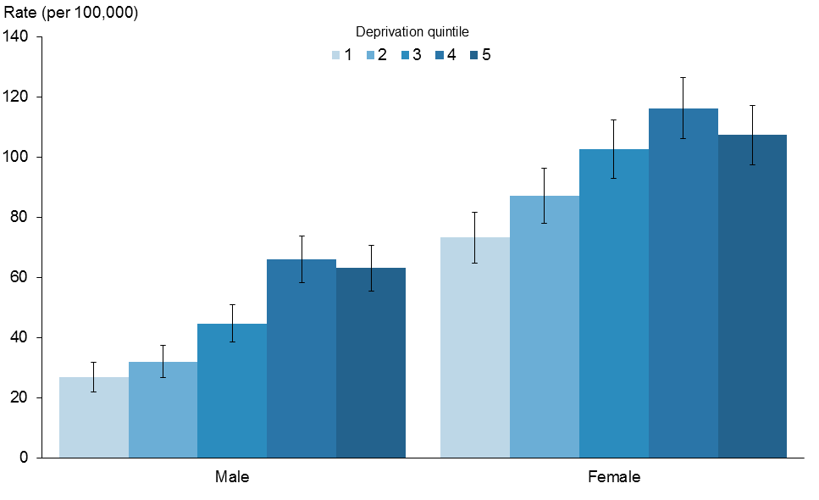

Source: New Zealand National Minimum Dataset

Note: rates are expressed per 100,000 population and age-standardised to the WHO World Standard population.

## District health board regions

In this section, data for district health board (DHB) regions has been aggregated over three years (2010–2012) because intentional self-harm hospitalisation rates can vary considerably from year to year.

The national rate was 66.0 intentional self-harm hospitalisations per 100,000 population over the three years from 2010 to 2012.

Eight DHB regions had significantly higher rates for intentional self-harm hospitalisation than the national rate, with Wairarapa having a notably higher than all other DHB regions (169.0 per 100,000 population).

Auckland, Counties Manukau, Hawke’s Bay and MidCentral DHB regions had significantly lower rates than the national rate (Table 19, Figures 38 and 39).

Table 19: Intentional self-harm hospitalisation age-standardised rates, by DHB of domicile and sex, 2010–2012

|  |  |  |  |  |  |  |
| --- | --- | --- | --- | --- | --- | --- |
| **DHB region** | **Sex** | | | | | |
| **Male** | | **Female** | | **Total** | |
| **Rate** | **CI** | **Rate** | **CI** | **Rate** | **CI** |
| Northland | 68.7 | (53.5–83.9) | 114.6 | (95.5–133.7) | 91.7 | (79.5–103.9) |
| Waitemata | 48.5 | (42.2–54.8) | 85.6 | (77.3–93.9) | 67.0 | (61.8–72.2) |
| Auckland | 30.0 | (24.8–35.2) | 36.8 | (30.9–42.7) | 33.3 | (29.4–37.2) |
| Counties Manukau | 25.7 | (20.8–30.6) | 34.4 | (28.9–39.9) | 29.9 | (26.3–33.5) |
| Waikato | 49.1 | (41.2–57.0) | 80.7 | (70.6–90.8) | 64.9 | (58.5–71.3) |
| Lakes | 60.6 | (44.0–77.2) | 79.1 | (59.9–98.3) | 69.9 | (57.2–82.6) |
| Bay of Plenty | 62.1 | (50.0–74.2) | 120.5 | (103.9–137.1) | 91.2 | (80.9–101.5) |
| Tairawhiti | 50.6 | (27.5–73.7) | 94.3 | (62.9–125.7) | 72.7 | (53.2–92.2) |
| Hawke’s Bay | 39.4 | (28.5–50.3) | 43.4 | (32.2–54.6) | 41.4 | (33.6–49.2) |
| Taranaki | 57.8 | (41.9–73.7) | 99.7 | (78.6–120.8) | 78.3 | (65.2–91.4) |
| MidCentral | 32.1 | (22.5–41.7) | 70.9 | (56.8–85.0) | 51.6 | (43.1–60.1) |
| Whanganui | 61.0 | (39.8–82.2) | 67.9 | (45.1–90.7) | 64.2 | (48.7–79.7) |
| Capital & Coast | 51.5 | (42.8–60.2) | 146.6 | (132.1–161.1) | 100.0 | (91.5–108.5) |
| Hutt Valley | 57.0 | (43.6–70.4) | 123.1 | (103.5–142.7) | 90.3 | (78.4–102.2) |
| Wairarapa | 97.2 | (62.8–131.6) | 242.1 | (185.4–298.8) | 169.0 | (136.0–202.0) |
| Nelson Marlborough | 47.7 | (35.2–60.2) | 190.7 | (163.2–218.2) | 116.4 | (101.7–131.1) |
| West Coast | 75.5 | (42.6–108.4) | 155.2 | (106.0–204.4) | 114.9 | (85.5–144.3) |
| Canterbury | 38.6 | (32.8–44.4) | 86.6 | (77.6–95.6) | 62.2 | (56.9–67.5) |
| South Canterbury | 59.8 | (36.6–83.0) | 102.0 | (71.3–132.7) | 81.0 | (61.7–100.3) |
| Southern | 57.6 | (48.5–66.7) | 121.3 | (107.9–134.7) | 89.4 | (81.3–97.5) |
| National | 45.2 | (40.0–50.4 | 87.0 | (81.0–93.0) | 66.0 | (62.0–70.0) |

Source: New Zealand National Minimum Dataset

Notes:

Rates are expressed per 100,000 population and age-standardised to the WHO World Standard population.

Rates were calculated based on the total number of intentional self-harm hospitalisations between 2010 and 2012. For the national rate, the denominator population is the aggregated estimated resident population for 2010–2012.

Confidence intervals (CI) are for 99% confidence (lower limit–upper limit).

Figure 38: Intentional self-harm hospitalisation age-standardised rates, by DHB,  
2010–2012

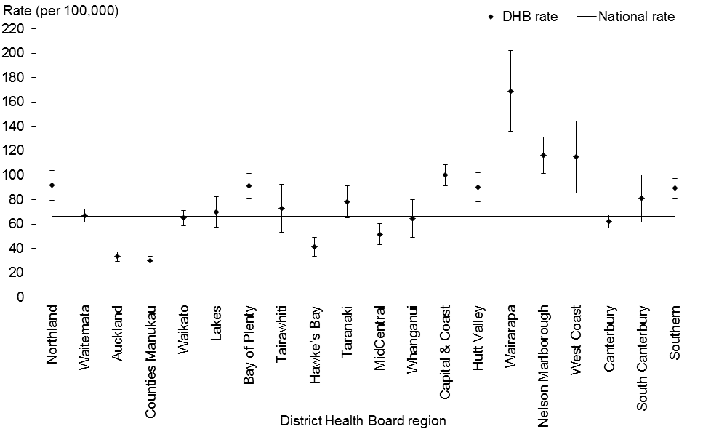

Source: New Zealand National Minimum Dataset

Note: rates are expressed per 100,000 population and age-standardised to the WHO World Standard population.

Figure 39: Comparison of DHB region intentional self-harm hospitalisation rates with national rate, 2010–2012

Figure 39: Comparison of DHB region intentional self-harm hospitalisation rates with national rate, 2010–2012

Notes:

Intentional self-harm hospitalisation rates for all ages are expressed per 100,000 population and age-standardised to the WHO World Standard population.

Youth rates are age-specific, expressed as intentional self-harm hospitalisations per 100,000 population.

### Māori and non-Māori comparison

There was considerable variation between DHB regions for Māori and non-Māori rates of intentional self-harm hospitalisations over the period 2010–2012.

Among Māori, the highest rates were in the Waitemata DHB region for males and the Wairarapa DHB region for females. The highest non-Māori rates for both males and females were seen in the Wairarapa DHB region (Figures 40 and 41). However, when the DHB region data is broken down into population subgroups, the numbers in some subgroups (for example, Māori males) are small and therefore should be treated with caution.

Figure 40: Intentional self-harm hospitalisation age-standardised rates for males, by DHB and ethnic group, 2010–2012 (aggregated data)

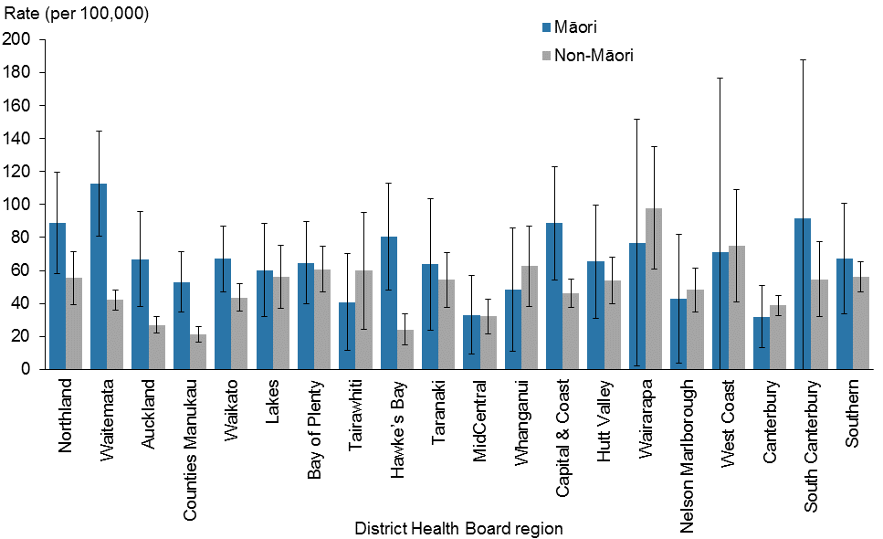

Source: New Zealand National Minimum Dataset

Note: rates are expressed per 100,000 population and age-standardised to the WHO World Standard population.

Figure 41: Intentional self-harm hospitalisation age-standardised rates for females, by DHB and ethnic group, 2010–2012 (aggregated data)

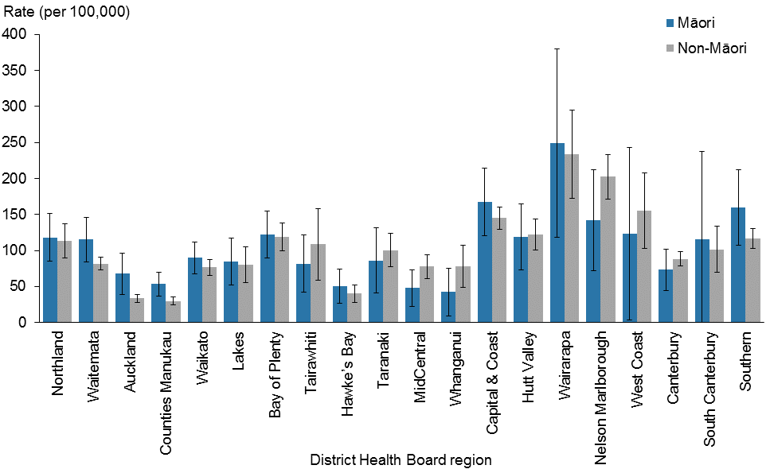

Source: New Zealand National Minimum Dataset

Note: rates are expressed per 100,000 population and age-standardised to the WHO World Standard population.

# References

Ahmad O, Boschi-Pinto C, Lopez AD, et al. 2001. *Age Standardization of Rates: A new WHO standard*. GPE discussion paper series no. 31. Geneva: World Health Organization.   
URL: [www.who.int/healthinfo/paper31.pdf](http://www.who.int/healthinfo/paper31.pdf) (accessed 8 December 2012).

Ajwani S, Blakely T, Robson B, et al. 2003. *Decades of Disparity: Ethnic mortality trends in New Zealand 1980*–*1999.* Wellington: Ministry of Health and University of Otago.

Andriessen K. 2006. Do we need to be cautious in evaluating suicide statistics? *European Journal of Public Health* 16(4): 445–7.

Associate Minister of Health. 2006. *New Zealand Suicide Prevention Strategy* *2006–2016*. Wellington: Ministry of Health.

Benzeval M, Judge K, Shouls S. 2001. Understanding the relationship between income and health: how much can be gleaned from cross-sectional data? *Social Policy and Administration* 35: 376–96.

Berry J, Harrison J. 2006. Hospital separations due to injury and poisoning, Australia 2001–02. *Injury Research and Statistics Series Number 26*. Adelaide: Australian Institute of Health and Welfare.

Blakely T. 2002. *The New Zealand Census – Mortality Study: Socioeconomic inequalities and adult mortality 1991–94*. Wellington: Ministry of Health.

Ministry of Health. 2004. *Ethnicity Data Protocols for the Health and Disability Sector*. Wellington: Ministry of Health.

Ministry of Health. 2013. *New Zealand Suicide Prevention Action Plan 2013–2016*. Wellington: Ministry of Health.

National Centre for Classification in Health. 2002. *The International Statistical Classification of Diseases and Related Health Problems, 9th Revision, Clinical Modification (ICD-9-CM)*. Sydney: National Centre for Classification in Health.

National Centre for Classification in Health. 2008. *The International Statistical Classification of Diseases and Related Health Problems, 10th Revision, Australian Modification (ICD-10–AM)*. Sydney: National Centre for Classification in Health.

OECD. nd. Organisation for Economic Co-operation and Development StatExtracts. URL <http://stats.oecd.org/index.aspx?DataSetCode=HEALTH_STAT> (accessed 26 February 2015).

Salmond C, Crampton P, Atkinson J. 2007. *NZDep2006 Index of Deprivation User’s Manual*. Wellington: Department of Public Health, University of Otago.

Statistics New Zealand. 2014. *Serious Injury Outcome Indicators: 2000–13*. Wellington: Statistics New Zealand. URL: [www.stats.govt.nz/browse_for_stats/health/injuries/serious-injury-outcome-indicators-2000–11.aspx](http://www.stats.govt.nz/browse_for_stats/health/injuries/serious-injury-outcome-indicators-2000-11.aspx) (accessed 26 February 2015).

Waterhouse J, Muir C, Correa P, et al (eds). 1976. *Cancer Incidence in Five Continents, Vol III.* IARC Scientific Publications No. 15. Lyon, France: International Agency for Research on Cancer.

White P, Gunston J, Salmond C, et al. 2008. *Atlas of Socioeconomic Deprivation in New Zealand: NZDep2006*. Wellington: Ministry of Health.

# Appendices

## Appendix 1: Technical notes

### Data

#### Population denominator

Population analysis was based on the estimated resident population of New Zealand by sex, age, ethnic group, district health board (DHB) (for total population) and rural/urban status as calculated by Statistics New Zealand.

Asian and Pacific populations, deprivation populations and DHB populations by ethnic group were sourced from Ministry of Health projected populations supplied by Statistics New Zealand.

The suicide and intentional self-harm hospitalisation rates presented in this report and the last six years’ reports will differ from those given in editions of *Suicide Facts* preceding the 2006 report as data from 2005 or earlier used different population denominators (the only exception to this is the deprivation data and data for Pacific people, for which population projections were used).

#### Small numbers and rates

Caution is advised when interpreting rates derived from small numbers as they may fluctuate markedly over time. This may apply to both small numbers of cases and/or small population groups.

#### International comparisons

New Zealand data is for 2012 whereas all other countries’ data is for years between 2009 and 2012.

A cautious approach is recommended when comparing international suicide statistics because many factors affect the recording and classification of suicide in different countries, including the level of proof required for a verdict; the stigma associated with suicide; the religion, social class or occupation of victims; and confidentiality (Andriessen 2006). As a result, deaths that are classified as suicide in some countries may be classified as accidental or of undetermined intent in others.

Furthermore, statistical measures, such as confidence intervals, cannot account for these differences. Providing such statistical measures may create a false sense of confidence in the recording of differences. Confidence intervals have therefore been excluded from the section on international comparisons in this report. The data used in this report to make international comparisons is the most recent data available from the Organisation for Economic Co-operation and Development (OECD).

### Serious injury outcome indicators reports

Statistics New Zealand produces the annual serious injury outcome indicators reports (see Statistics New Zealand 2013). These reports monitor numbers and rates of suicide death. The information for the reports is sourced from the New Zealand Mortality Collection (MORT) and is therefore broadly comparable with the information published in *Suicide Facts*. MORT is a dynamic database, and any small discrepancies in data between it and *Suicide Facts* are due to updates to database records.

The serious injury outcome indicators reports also present data on ‘Serious non-fatal intentional self-harm injury’. These indicators cover only a subset of the self-harm hospitalisation data held within *Suicide Facts* and therefore cannot be directly compared.

For more information and access to the serious injury outcome indicators technical report for 2014, please see the Statistics New Zealand webpage: www.stats.govt.nz/browse_for_stats/health/injuries/serious-injury-outcome-tech-report-2014.aspx

If you require further information relating to the methodology, classifications and processes used, and how they differ between publications, please contact: [data-enquiries@moh.govt.nz](mailto:data-enquiries@moh.govt.nz)

## Appendix 2: Definitions

### Intentional self-harm codes and definitions

For the years 2000–2012, *The International Statistical Classification of Diseases and Related Health Problems, 10th Revision, Australian Modification (ICD-10-AM)* codes used for mortality and hospitalisation data were X60–X84: Intentional self-harm (National Centre for Classification in Health 2008) (Table A1).

Before the year 2000, the codes used were E950–E959: Suicide and self-inflicted injury from *The International Statistical Classification of Diseases and Related Health Problems, 9th Revision, Clinical Modification (ICD-9-CM)* (National Centre for Classification in Health 2002). Code E959 was excluded from pre-2000 hospitalisation data in this report because it covers ‘late effects’ and hence is not relevant to current episodes.

Table A1: Intentional self-harm categories and ICD-10-AM codes

| **Category** | **ICD-10-AM code** | **ICD-10-AM code description** |
| --- | --- | --- |
| Poisoning by solids and liquids | X60 | Intentional self-poisoning by and exposure to nonopioid analgesics, antipyretics and antirheumatics |
| X61 | Intentional self-poisoning by and exposure to antiepileptic, sedative-hypnotic, antiparkinsonism and psychotropic drugs, not elsewhere classified |
| X62 | Intentional self-poisoning by and exposure to narcotics and psychodysleptics [hallucinogens], not elsewhere classified |
| X63 | Intentional self-poisoning by and exposure to other drugs acting on the autonomic nervous system |
| X64 | Intentional self-poisoning by and exposure to other and unspecified drugs, medicaments and biological substances |
| X65 | Intentional self-poisoning by and exposure to alcohol |
| X68 | Intentional self-poisoning by and exposure to pesticides |
| X69 | Intentional self-poisoning by and exposure to other and unspecified chemicals and noxious substances |
| Poisoning by gases and vapours | X66 | Intentional self-poisoning by and exposure to organic solvents and halogenated hydrocarbons and their vapours |
| X67 | Intentional self-poisoning by and exposure to other gases and vapours |
| Hanging, strangulation and suffocation | X70 | Intentional self-harm by hanging, strangulation and suffocation |
| Submersion (drowning) | X71 | Intentional self-harm by drowning and submersion |
| Firearms and explosives | X72 | Intentional self-harm by handgun discharge |
| X74 | Intentional self-harm by other and unspecified firearm discharge |
| X75 | Intentional self-harm by explosive material |
| Sharp object | X78 | Intentional self-harm by sharp object |
| Jumping from a high place | X80 | Intentional self-harm by jumping from a high place |
| Other | X76 | Intentional self-harm by smoke, fire and flames |
|  | X77 | Intentional self-harm by steam, hot vapours and hot objects |
|  | X79 | Intentional self-harm by blunt object |
|  | X81 | Intentional self-harm by jumping or lying before moving object |
|  | X82 | Intentional self-harm by crashing of motor vehicle |
|  | X83 | Intentional self-harm by other specified means |
|  | X84 | Intentional self-harm by unspecified means |

Note: in Table 11 and Figure 24, ‘sharp object’ and ‘jumping from a high place’ were grouped into ‘Other’.

### Analytical methods definitions

#### Age-specific rates

An age-specific rate measures the frequency with which an event occurs relative to the number of people in a defined age group. In *Suicide Facts*, age-specific rates are given in both five-year age groups and life-stage age groups.

#### Age-standardised rates and rate ratios

Anage-standardised rate is a rate that has been adjusted to take account of differences in the age distribution of the population over time or between different groups (for example, different ethnic groups). An age-standardised rate ratio is the ratio of two groups’ rates, taking into account differences in the groups’ size and age structure.

This report has used the WHO standard world population in determining direct age-standardised rates and rate ratios (Table A2) (Ahmad et al 2001).

Table A2: The WHO World Standard Population

|  |  |
| --- | --- |
| **Age group (years)** | **Population** |
| 0–4 | 8860 |
| 5–9 | 8690 |
| 10–14 | 8600 |
| 15–19 | 8470 |
| 20–24 | 8220 |
| 25–29 | 7930 |
| 30–34 | 7610 |
| 35–39 | 7150 |
| 40–44 | 6590 |
| 45–49 | 6040 |
| 50–54 | 5370 |
| 55–59 | 4550 |
| 60–64 | 3720 |
| 65–69 | 2960 |
| 70–74 | 2210 |
| 75–79 | 1520 |
| 80–84 | 910 |
| 85+ | 635 |
| Total | 100,035 |

Source: Waterhouse et al 1976.

#### Confidence intervals and statistical significance

The confidence intervals in this report have been calculated for age-standardised rates at the 95% level, except for rates for DHB data, which have been calculated at the 99% level.

A confidence interval is a range of values used to describe the uncertainty around a single value (such as an age-standardised rate). Confidence intervals describe how different the estimate could have been if chance had led to a different set of data. Confidence intervals are calculated with a stated probability, typically 95% (which would indicate that there is a 95% chance that the true value lies within the confidence intervals).

Confidence intervals can assist in comparing rates between different groups. If two confidence intervals do not overlap, then it is reasonable to assume that any difference between the two groups being compared is not due to chance. If they do overlap, it is not possible to draw any conclusion about the significance of any difference between the two groups being compared.

#### Numbers, rates and ratios

The number of suicide deaths refers to the number of people who have died by suicide. The numberofintentional self-harm hospitalisations refers to the number of discharges from hospital with an intentional self-harm code on the patient’s record.

The rate of suicide or intentional self-harm hospitalisations refers to the frequency with which these events occur relative to the number of people in a defined population and a defined time period.

The rate ratio refers to the frequency with which these events are reported in one population group compared with other groups.

### Other definitions

#### Admission

The process by which a person becomes a resident in a health care facility. For the purposes of the Ministry of Health’s national collections, health care users who receive assessment and/or treatment for three hours or more, or who have a general anaesthetic are to be admitted. This also applies to health care users of Emergency Departments. ‘Assessment/treatment’ is clinical assessment, treatment, therapy, advice, diagnostic or investigatory procedures from a nurse or doctor or other health professional.

#### Deprivation

Deprivation has been associated with various adverse health outcomes. From the social inequalities literature, it is evident that those who are most deprived generally experience poorer health (Benzeval et al 2001; White et al 2008). Suicide mortality and hospitalisation rates for intentional self-harm are presented in this report by deprivation quintile according to the New Zealand Deprivation Index 2006 (NZDep2006) (Salmond et al 2007).

The New Zealand Deprivation Index is a measure of socioeconomic status calculated for small geographic areas. The calculation uses a range of variables from the 2006 Census of Population and Dwellings that represent nine dimensions of social deprivation. The Deprivation Index is calculated at the level of meshblocks (the smallest geographical units that Statistics New Zealand uses to collect and measure statistical data, containing a median of 90 people), and the Ministry of Health maps these meshblocks to domicile codes, which are built up to the relevant geographic scale using weighted average census (usually resident population) counts.

The nine variables (proportions in small areas) in the index, by decreasing weight, are:

1. income: people aged 18–64 years[4] receiving a means-tested benefit

2. income: people living in an equivalised[5] household whose income is below a certain threshold

3. home ownership: people not living in their own home

4. support: people aged under 65 years living in a single-parent family

5. employment: people aged 18–64 years who are unemployed

6. qualifications: people aged 18–64 years with no qualifications

7. living space: people living in an equivalised household below a bedroom occupancy threshold

8. communication: people with no access to a telephone

9. transport: people with no access to a car.

Further information is available from www.health.govt.nz (search for ‘NZDep2006 Index of Deprivation’).

#### Ethnicity

There are different methods for outputting ethnicity data. This report uses ‘prioritised ethnicity’, where each person represented in the data is allocated to a single ethnic group using the priority system Māori > Pacific peoples > Asian > European/Other (Ministry of Health 2004). The aim of prioritisation is to ensure that, where it is necessary to assign people to a single ethnic group, ethnic groups that are small or important in terms of policy are not swamped by the European ethnic group (Ministry of Health 2004). This is a more robust method of dealing with the low rate of multiple ethnicities in health-sector data.

This report uses two ethnic classifications for analysing suicides and intentional self-harm hospitalisations. The first comprises Māori, Pacific peoples, Asian and European & Other and the second divides the population into Māori and non-Māori.

Before 1996, the concept of ethnicity was based on biological race (that is, percentage of blood), as recorded on death registration forms, and on a sociocultural concept (that is, cultural affiliation) as defined in the census. Since September 1995, death certificates have included a question comparable with the self-identified ethnicity question in the 1996 Census, which allows a person to have multiple ethnic identities. New Zealand Census Mortality Study (NZCMS) adjustors can be applied to mortality counts from 1996 to 1999 (Blakely 2002). This process adjusts data to allow for an undercount of Māori and Pacific peoples. The NZCMS adjustors are not used in this report. From 2000 onwards, comparisons across all ethnic groups have been possible because adjustors are not necessary. For further discussion on inconsistencies in ethnicity collection, refer to *Decades of Disparity* (Ajwani et al 2003).

#### Provisional data

The label ‘provisional’ relates to information that is not final; that is, it is subject to change. See the subsection Classification of a suicide death in the Introduction for more information.

#### Urban/rural profile

This report includes a classification of deaths by the urban/rural profile of the person committing suicide. The address recorded on the person’s death certificate is used to determine whether the person’s place of residence was urban or rural. Statistics New Zealand has developed an experimental urban/rural profile, which was used to allocate a profile to people committing suicide for the data in this report. For more information on urban/rural profiles, see: [www.stats.govt.nz/browse_for_stats/people_and_communities/geographic-areas/urban-rural-profile-update.aspx](http://www.stats.govt.nz/browse_for_stats/people_and_communities/geographic-areas/urban-rural-profile-update.aspx)

## Appendix 3: Further tables

Table A3: Intentional self-harm short-stay emergency department hospitalisations, by DHB of domicile, 2003–2012

|  |  |  |  |  |  |  |  |  |  |  |
| --- | --- | --- | --- | --- | --- | --- | --- | --- | --- | --- |
| **DHB of domicile** | **Year of discharge** | | | | | | | | | |
| **2003** | **2004** | **2005** | **2006** | **2007** | **2008** | **2009** | **2010** | **2011** | **2012** |
| Northland | 38 | 43 | 55 | 73 | 65 | 63 | 79 | 88 | 78 | 104 |
| Waitemata | 380 | 320 | 310 | 369 | 422 | 468 | 433 | 387 | 368 | 474 |
| Auckland | 383 | 444 | 419 | 489 | 462 | 518 | 497 | 531 | 463 | 555 |
| Counties Manukau | 376 | 373 | 451 | 436 | 468 | 505 | 481 | 546 | 568 | 625 |
| Waikato | 184 | 203 | 224 | 245 | 71 | 148 | 248 | 310 | 368 | 356 |
| Lakes | 39 | 56 | 59 | 53 | 53 | 75 | 59 | 53 | 82 | 92 |
| Bay of Plenty | 13 | 12 | 5 | 22 | 70 | 91 | 94 | 92 | 118 | 122 |
| Tairawhiti | 0 | 0 | 0 | 0 | 0 | 0 | 2 | 8 | 4 | 6 |
| Taranaki | 24 | 7 | 1 | 0 | 0 | 25 | 62 | 76 | 63 | 73 |
| Hawke’s Bay | 0 | 0 | 0 | 43 | 67 | 88 | 150 | 175 | 174 | 176 |
| MidCentral | 0 | 19 | 114 | 131 | 181 | 177 | 190 | 192 | 182 | 200 |
| Whanganui | 12 | 13 | 11 | 16 | 18 | 44 | 89 | 77 | 80 | 84 |
| Capital & Coast | 1 | 3 | 2 | 7 | 1 | 20 | 215 | 317 | 250 | 226 |
| Hutt Valley | 0 | 0 | 0 | 0 | 0 | 0 | 0 | 0 | 32 | 56 |
| Wairarapa | 0 | 0 | 0 | 0 | 0 | 0 | 0 | 1 | 6 | 16 |
| Nelson Marlborough | 0 | 0 | 0 | 0 | 0 | 18 | 50 | 64 | 69 | 92 |
| West Coast | 14 | 9 | 23 | 3 | 4 | 0 | 1 | 0 | 2 | 2 |
| Canterbury | 508 | 408 | 443 | 519 | 427 | 514 | 497 | 566 | 559 | 507 |
| South Canterbury | 0 | 1 | 0 | 0 | 0 | 0 | 0 | 0 | 0 | 0 |
| Southern | 105 | 155 | 137 | 139 | 152 | 131 | 154 | 175 | 166 | 276 |
| Overseas and undefined | 8 | 15 | 12 | 4 | 2 | 10 | 11 | 7 | 11 | 12 |
| Total | 2085 | 2081 | 2266 | 2549 | 2463 | 2895 | 3312 | 3665 | 3643 | 4054 |

Source: New Zealand National Minimum Dataset

Notes:

‘Short stay’ is defined as a stay of one day or less in an emergency department.

In 2010 Southland and Otago DHBs merged to form Southern DHB. Data for Southern DHB is an aggregate of Southland and Otago DHB data for the years 2003─2009.

Table A4: Intentional self-harm hospitalisations within two days of a previous intentional self-harm hospitalisation, by DHB of domicile, 2003–2012

|  |  |  |  |  |  |  |  |  |  |  |
| --- | --- | --- | --- | --- | --- | --- | --- | --- | --- | --- |
| **DHB of domicile** | **Year of discharge** | | | | | | | | | |
| **2003** | **2004** | **2005** | **2006** | **2007** | **2008** | **2009** | **2010** | **2011** | **2012** |
| Northland | 16 | 20 | 15 | 8 | 13 | 11 | 12 | 23 | 12 | 13 |
| Waitemata | 44 | 58 | 34 | 45 | 45 | 43 | 32 | 49 | 33 | 55 |
| Auckland | 32 | 27 | 19 | 16 | 16 | 23 | 31 | 30 | 16 | 39 |
| Counties Manukau | 9 | 11 | 10 | 10 | 15 | 13 | 5 | 3 | 10 | 9 |
| Waikato | 34 | 41 | 51 | 28 | 31 | 27 | 43 | 31 | 24 | 41 |
| Lakes | 10 | 6 | 3 | 6 | 11 | 7 | 9 | 9 | 6 | 10 |
| Bay of Plenty | 14 | 23 | 20 | 10 | 21 | 21 | 19 | 27 | 21 | 53 |
| Tairawhiti | 4 | 3 | 5 | 2 | 7 | 3 | 6 | 5 | 4 | 6 |
| Taranaki | 14 | 17 | 20 | 25 | 19 | 18 | 16 | 21 | 11 | 20 |
| Hawke’s Bay | 5 | 2 | 1 | 8 | 1 | 4 | 0 | 4 | 4 | 0 |
| MidCentral | 19 | 21 | 11 | 15 | 11 | 9 | 5 | 12 | 2 | 8 |
| Whanganui | 1 | 0 | 1 | 0 | 5 | 1 | 0 | 3 | 4 | 4 |
| Capital & Coast | 14 | 14 | 7 | 8 | 12 | 10 | 15 | 50 | 24 | 27 |
| Hutt Valley | 32 | 12 | 9 | 10 | 16 | 5 | 9 | 17 | 10 | 24 |
| Wairarapa | 7 | 2 | 0 | 2 | 1 | 8 | 0 | 3 | 3 | 6 |
| Nelson Marlborough | 5 | 5 | 5 | 8 | 7 | 3 | 8 | 7 | 8 | 31 |
| West Coast | 19 | 10 | 14 | 9 | 10 | 9 | 7 | 7 | 4 | 2 |
| Canterbury | 82 | 82 | 57 | 50 | 29 | 15 | 14 | 23 | 12 | 28 |
| South Canterbury | 12 | 6 | 3 | 6 | 3 | 1 | 2 | 2 | 4 | 1 |
| Southern | 13 | 15 | 15 | 15 | 22 | 12 | 35 | 50 | 65 | 65 |
| Overseas and undefined | 2 | 0 | 2 | 1 | 1 | 0 | 1 | 1 | 2 | 1 |
| Total | 388 | 375 | 302 | 282 | 296 | 243 | 269 | 377 | 279 | 443 |

Source: New Zealand National Minimum Dataset

Notes:

This data is displayed using the DHB of domicile rather than the DHB agency as many hospitalisations within two days of discharge take place in different DHBs.

This data excludes short-stay emergency department hospitalisations.

In 2010 Southland and Otago DHBs merged to form Southern DHB. Data for Southern DHB is an aggregate of Southland and Otago DHB data for the years 2003─2009.

# Further information

### General information about suicide prevention

To find out more about suicide and suicide prevention (including information about the *New Zealand Suicide Prevention Strategy 2006–2016*, Associate Minister of Health 2006*)*, see the Ministry of Health’s suicide prevention webpage  
([www.health.govt.nz/our-work/mental-health-and-addictions/suicide-prevention](http://www.health.govt.nz/our-work/mental-health-and-addictions/suicide-prevention)).

### Statistics

A set of online tables accompanies this document and provides underlying data for some graphs presented in the document, as well as time-series data.

For health data, including suicide statistics, contact:

Analytical Services

National Collections and Reporting

National Health Board

Ministry of Health

PO Box 5013

Wellington

Phone: (04) 496 2000

Fax: (04) 816 2898

Email: data-[enquiries@moh.govt.nz](mailto:enquiries@moh.govt.nz)

Website: [www.health.govt.nz](http://www.health.govt.nz)

### Earlier copies of this publication

To download copies of *Suicide Facts* for previous years, see the Ministry of Health webpage (www.health.govt.nz/nz-health-statistics/health-statistics-and-data-sets/suicide-facts-deaths-and-intentional-self-harm-hospitalisations-series).

1. See Appendix 2: Definitions for an explanation of the term ‘admission’.
2. These percentages have been calculated from unpublished provisional New Zealand Mortality Collection 2012 data.
3. See Table A1 in Appendix 2: Definitions for the ICD-10-AM codes linked to each method. There is possibly some ambiguity as to the codes used to distinguish between poisoning methods.
4. The upper age boundary of 65 years has been increased from the NZDep2001 value of 60 years to better reflect societal norms.
5. Equivalisation is a method used to control the range of possible household compositions.