Social, Emotional and Behavioural Difficulties in New Zealand Children
Technical Report

Citation: Ministry of Health. 2018. Social, Emotional and Behavioural Difficulties in New Zealand Children: Technical Report. Wellington: Ministry of Health.
Published in May 2018
by the Ministry of Health
PO Box 5013, Wellington 6140, New Zealand
ISBN 978-1-98-853940-9 (online)
HP 6761
This document is available at health.govt.nz
This work is licensed under the Creative Commons Attribution 4.0 International licence. In essence, you are free to: share ie, copy and redistribute the material in any medium or format; adapt ie, remix, transform and build upon the material. You must give appropriate credit, provide a link to the licence and indicate if changes were made.

Foreword
I am pleased to present this report, which describes social, emotional and behavioural functioning of children and youth in New Zealand. It explores differences in functioning across age, sex, ethnicity, and neighbourhood deprivation.

The report is based on data collected in the years 2012/13, 2014/15 and 2015/16 as part of the New Zealand Health Survey. More than 10,400 parents or caregivers of children and youth aged 3–14 years participated in the survey over these three years.

A special thank you goes out to the many thousands of New Zealanders who gave their time to take part in the survey. The information they have provided is critical for understanding and monitoring the health of New Zealand children.

I hope you find this report of interest.

Stephen McKernan
Acting Director-General of Health
Ministry of Health

Acknowledgements
The New Zealand Health Survey relies on the support and enthusiasm of many individuals, including the survey participants and the surveyors who worked so diligently to collect the data.

The New Zealand Health Survey is developed by the Health Survey team in the Health and Disability Intelligence Group, Ministry of Health. It is conducted by CBG Health Research Ltd.

This report was written by Linda Pannekoek. Thank you to all who provided input and review.

Contents
Foreword iii
Acknowledgements iv
Summary viii
Introduction 1
Methods 3
Data sources 3
Using the SDQ to measure social, emotional and behavioural functioning 4
Adjusted rate ratios 5
Interpretation notes 6
Findings 7
Prevalence of ‘concerning’ SDQ scores in children aged 3–14 years 7
Prevalence of ‘concerning’ SDQ scores by age 10
Prevalence of ‘concerning’ SDQ scores by sex 13
Prevalence of ‘concerning’ SDQ scores by ethnicity 16
Differences in prevalence across ethnic groups by age group and sex 22
Prevalence of ‘concerning’ SDQ scores by neighbourhood deprivation 23
Conclusions 27
References 28
Appendix 1: Technical details of analysis in this report 30
Appendix 2: Thresholds for SDQ scores 32
Appendix 3: Modelling the data 33

List of tables
Table 1: Estimated prevalence of ‘concerning’ total difficulties scores on SDQ 7
Table 2: Estimated prevalence of ‘concerning’ subscale scores on SDQ 8
Table 3: Subscale difficulties in children with a ‘concerning’ SDQ total difficulties score 10
Table 4: Adjusted rate ratios comparing ‘concerning’ SDQ scores across age groups 10
Table 5: Mean SDQ scores by age group 11
Table 6: Adjusted rate ratios comparing ‘concerning’ SDQ scores for boys and girls 14
Table 7: Mean SDQ scores by sex 14
Table 8: Mean SDQ scores on the emotional symptoms subscale by sex and age group 16
Table 9: Adjusted rate ratios and rates for ‘concerning’ SDQ scores among Māori and non-Māori children 16
Table 10: Mean SDQ scores for Māori and non-Māori children 17
Table 11: Adjusted rate ratios and rates for ‘concerning’ SDQ scores among Pacific and non-Pacific children 18
Table 12: Mean SDQ scores for Pacific and non-Pacific children 19
Table 13: Adjusted rate ratios and rates for ‘concerning’ SDQ scores among Asian and non-Asian children 20
Table 14: Mean SDQ scores for Asian and non-Asian children 21
Table 15: Rates of children not born in New Zealand, and length of time in New Zealand by ethnic group 22
Table 16: Adjusted rate ratios comparing ‘concerning’ SDQ scores for children living in the most and least deprived areas 24
Table 17: Mean SDQ scores by neighbourhood deprivation 25
Table A2.1: Range indicating ‘borderline’ scores for preschool and school age SDQ 32
Table A2.2: Thresholds for ‘concerning’ scores for preschool and school age SDQ 32
Table A3.1: Linear regression output 33

List of figures
Figure 1: Summary of differences in prevalence of SDQ scores based on age, sex, ethnicity and neighbourhood deprivation ix
Figure 2: Patterns of ‘concerning’ SDQ subscale scores in children aged 3–14 years 9
Figure 3: Adjusted prevalence of ‘concerning’ SDQ scores by age group 11
Figure 4: Distribution of scores on the hyperactivity subscale by age group 12
Figure 5: Distribution of scores on the emotional symptoms subscale by age group 13
Figure 6: Adjusted rate ratios comparing ‘concerning’ SDQ scores for boys and girls across age groups 15
Figure 7. Adjusted prevalence of ‘concerning’ SDQ scores for Māori and non-Māori children 17
Figure 8. Adjusted prevalence of ‘concerning’ SDQ scores for Pacific and non-Pacific children 19
Figure 9: Distribution of scores on the hyperactivity subscale for Pacific and non-Pacific children 20
Figure 10. Adjusted prevalence of ‘concerning’ SDQ scores for Asian and non-Asian children 21
Figure 11: Distribution of scores on the hyperactivity subscale for Māori and non-Māori children by sex 23
Figure 12: Adjusted prevalence of ‘concerning’ SDQ scores by neighbourhood deprivation 24
Figure 13: Distribution of scores on the hyperactivity subscale by neighbourhood deprivation 25
Figure 14: Prevalence of complex and uniform SDQ difficulties by neighbourhood deprivation 26

Summary
This report presents a picture of social, emotional and behavioural functioning of New Zealand children and youth aged 3–14 years. Data were collected from parents using the Strengths and Difficulties Questionnaire (SDQ), as part of the New Zealand Health Survey (the Health Survey) in 2012/13, 2014/15 and 2015/16.
The SDQ assesses children on a range of positive and negative behaviours that are related to emotions, peer interactions, hyperactivity and conduct. Children with healthy development display the majority of the positive behaviours and few of the negative behaviours assessed. These children are better equipped to meet life’s challenges. They also learn better, get along better with others, have positive relationships with their families, friends and others (eg, teachers) and contribute to their community in ways that are appropriate for their age. Healthy development provides a foundation for positive mental health and wellbeing, now and into the future.
Parent responses to the SDQ in the Health Survey indicated that the majority of children aged 3–14 years were developing well, without any substantial social, emotional or behavioural problems. However, approximately 8% of children in this age range displayed significant levels of difficulty according to their parents’ report on the SDQ. The proportion of children experiencing difficulties and the nature of their difficulties differed by age group, sex, ethnicity, and neighbourhood deprivation. These group differences are summarised in Figure 1.
The prevalence of difficulties based on the overall SDQ (emotional, peer, hyperactivity and conduct combined) differed across subgroups. Difficulties were:
- more likely for boys compared with girls
- more likely for older compared with younger primary school children
- more likely for Māori compared with non-Māori children
- more likely for children living in the most socioeconomically deprived areas compared with the least
- comparable in prevalence for Pacific and non-Pacific children
- less likely for Asian compared with non-Asian children.
The particular areas in which children were likely to experience difficulties differed by subgroup. Girls were more likely than boys to experience difficulties that are emotional in nature. Boys on the other hand were more likely than girls to have peer, hyperactivity and conduct problems. Children aged
10–14 had higher rates of emotional symptoms than those aged 5–9 years.
Parents of Māori and non-Māori children reported comparable rates of emotional symptoms. For the other areas, Māori children typically had higher rates of difficulties compared with non-Māori children. Pacific children typically had lower rates of hyperactivity compared with non-Pacific children, and higher rates of difficulties related to emotions, peer interactions and conduct. The rate of peer problems was comparable for Asian and non-Asian children, while Asian children typically had lower rates for the other areas assessed by the SDQ compared with non-Asian children.
Children from families living in the most socioeconomically deprived areas had higher rates of difficulties than those living in least deprived areas for all aspects of development assessed by the SDQ. Hyperactivity was an exception, with comparable rates reported for children living in the most and the least deprived areas.
The findings presented in this report have a number of policy implications. While for all groups the majority of children were developing well, certain groups of children experienced a higher rate of emotional or behavioural difficulties. Also, the nature of these difficulties was somewhat different across groups. Higher rates of difficulties were reported by parents of older children, which may be preventable through early identification and intervention. Child-focused initiatives that develop children’s skills in building relationships, regulating their emotions and coping with stress may help to improve children’s outcomes across a range of areas, including mental health and education. Findings provide an indication of the proportion of New Zealand children experiencing difficulties, which could inform service planning.
Figure 1: Summary of differences in prevalence of SDQ scores based on age, sex, ethnicity and neighbourhood deprivation
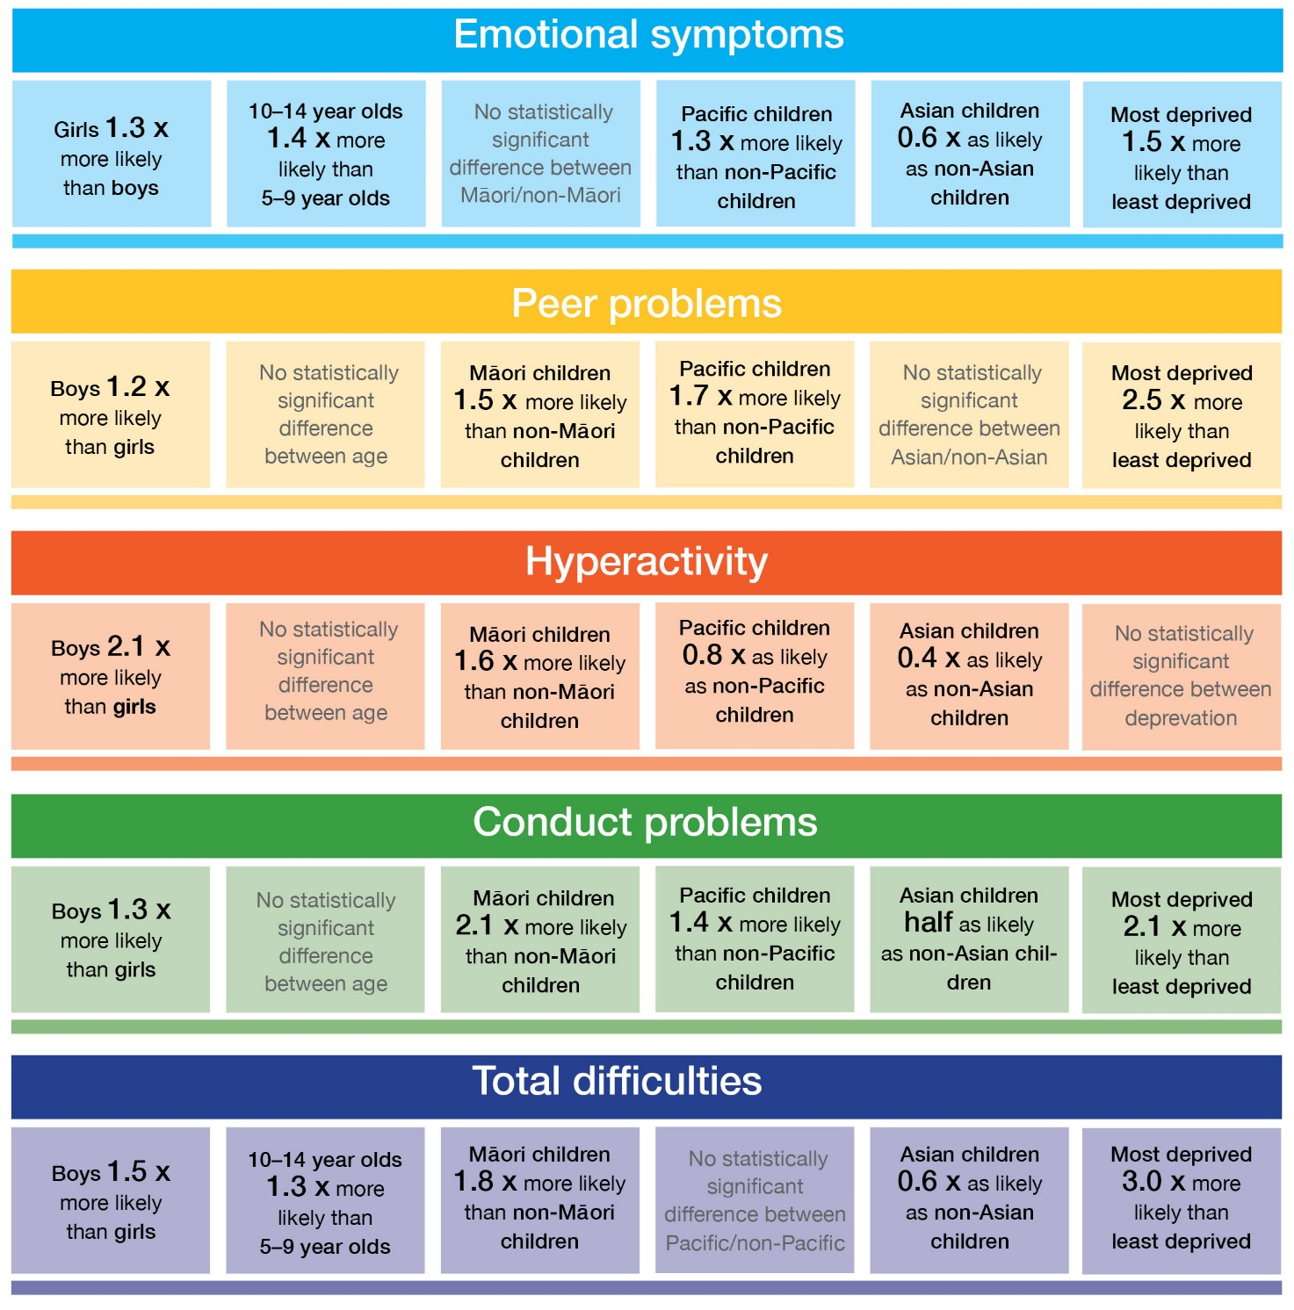
Note: This figure presents Adjusted Rate Ratios (ARRs), adjusted for the demographic factors described in the Methods section. ARRs for age compare children 5–9 years to children 10–14 years, as these age groups have identical SDQ items and thresholds.

How to read the figure

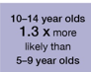
For total difficulties (the sum of scores on the SDQ), 10–14 year old children were 1.3 times more likely to have a ‘concerning’ score than 5–9 year old children.

Introduction
‘There is no health without mental health.’ World Health Organization (WHO 2005)

The WHO acknowledges that physical and mental health and wellbeing are closely related (Prince et al 2007). Good mental health has important implications for a person’s entire life course. Childhood mental health addresses their social, emotional and behavioural wellbeing, and is equally integral to children’s development as physical health. It supports children’s ability to grow into healthy adults leading fulfilling lives and contributing socially and economically to society (Hawkins et al 2012).

As children develop, they learn to manage feelings and relationships, regulate behaviour, and develop an understanding of responsibilities. This is a complex process, and almost all children struggle at times, particularly during certain stages of development. It is a normal part of growing up. A wide range of factors influences a child’s feelings and behaviours, including their temperament, culture, relationships, health, tiredness, family circumstances, and life experiences. This complexity can make it difficult to determine whether a child’s behaviour or feelings fall within the normal range, or whether the child may need some additional support.

For most children, social, emotional or behavioural difficulties are temporary. The difficulties often resolve as the child develops further, and can be addressed through guidance and support from family and carers. If social, emotional or behavioural problems continue or worsen, the child may have an underlying developmental delay or disorder (eg, an autism spectrum disorder) or a greater risk of developing some types of mental disorder (eg, conduct disorder, depression) either in childhood or later in life.

Many New Zealand adolescents experience poor mental health (Fergusson and Horwood 2001; Fleming et al 2014). Mental disorders are the largest contributor to disability in young people aged 10–24 years (Whiteford et al 2015). Approximately a quarter of participants in both the Christchurch Health and Development Study and the Dunedin Multidisciplinary Study met the criteria for at least one mental disorder at the age of 15 years, based on the standard criteria for the classification of mental disorders, DSM-III-R (McGee et al 1996; Fergusson and Horwood 2001).

Evidence indicates that early intervention in response to difficulties experienced by a child can reduce the risk or severity of certain types of mental disorder later in childhood, adolescence or adulthood and improve developmental, emotional, academic and social outcomes. The earlier the intervention, the greater those improvements are (Manning 2017). For services to respond early and promote positive outcomes, it is important to adequately identify children who may be at greater risk or already show signs of social, emotional or behavioural difficulties.

In New Zealand there are various initiatives that help identify social, emotional and behavioural concerns. The Strengths and Difficulties Questionnaire (SDQ, Goodman 1997), a brief multiple choice questionnaire asking parents about their child’s behaviour, is often used for this purpose. For example, the SDQ is used in the Incredible Years programme (led by the Ministries of Health and Education), the B4 School Check (Ministry of Health), the Gateway Assessments (for health and education needs – Ministries of Health and Education), and the Social Workers in Schools service (Ministry of Social Development).

The SDQ has also been used in population surveys, including the New Zealand Health Survey (the Health Survey) and the Youth 2000 series (in 2001, 2007 and 2012), as well as the Growing up in New Zealand study, a longitudinal study of children’s health, education, cultural influences and community life. Information from this range of surveys provides insights into the developmental health of New Zealand children. The results from the Health Survey are particularly useful because they provide information that is representative of the entire New Zealand child population 3–14 years of age, in contrast to data from programmes, which typically focus on a particular subgroup of the population (eg, a specific age, demographic, or children who are known to experience difficulties). The Health Survey also has enough statistical power to provide insights for specific population subgroups. This report explores the social, emotional and behavioural functioning of New Zealand children across age, sex, ethnicity and socioeconomic deprivation.

The SDQ is used only as an initial screening tool, and cannot be used to make a formal diagnosis.

Methods

Data sources
This report is based on data from the Health Survey. The Health Survey collects a wealth of information on the health and wellbeing of New Zealanders. The New Zealanders it surveys are people of all ages who are usually resident in New Zealand. It includes people living in permanent dwellings, aged-care facilities and student accommodation, but not those living in institutions (such as prisons and long-term hospital care), the homeless, short-term visitors and tourists.

The Health Survey is designed to yield an annual sample size of approximately 14,000 adults and 5,000 children. Households are randomly selected to participate in the survey. Subsequently, one adult (aged 15 years or over) and one child (aged from birth to 14 years, if any in the household) are selected at random from the household. Child interviews are conducted with a guardian/primary caregiver of the child; that is, a person who has day-to-day responsibility for the care of the child.

The Health Survey has two parts:
1. a core part that contains mostly the same survey questions each year, covering a set range of topics,
2. modules that vary year by year, to examine specific topics in more depth.

The SDQ was part of the Developmental Health and Wellbeing module that featured in the Health Survey for children in the years 2012/13, 2014/15 and 2015/16. The content of this module is described in the content guide for the child questionnaire, which can be found on the Ministry of Health’s website (Ministry of Health 2016a).

Most of the Health Survey is administered through face-to-face interviewing, but the SDQ was self-completed by parents using Computer-Assisted Personal Interviewing (CAPI) software. For more details about the Health Survey methodology, go to the Ministry of Health’s website (Ministry of Health 2016b).

For this report, data from the 2012/13, 2014/15 and 2015/16 Health Survey years were pooled, providing a larger sample size (responses for a total of 10,457 children). This approach allowed for more detailed analyses for specific population groups. The sample size, demographics and findings were comparable for each survey year. Where this report presents the estimated number of children in the New Zealand population that the findings apply to, the number represents the yearly average over the three years of data.

Using the SDQ to measure social, emotional and behavioural functioning
The SDQ is a questionnaire that asks parents about their child’s positive and negative behaviours and emotions (Goodman 1997). It is widely used to screen for behavioural and emotional difficulties both in New Zealand and internationally. The questionnaire is reliable and comprehensive, and research has confirmed it is suitable for use in New Zealand (Pannekoek et al, submitted). It includes questions focusing on children’s strengths as well as their difficulties, which increases its acceptability among parents.

The SDQ is a screening tool; and can only provide an initial indication of whether a child displays symptoms of a level of severity that merits more detailed assessment and/or clinical attention. If parents have a poor understanding of what normal development is for the child’s age, the SDQ may identify some children as having difficulties when they actually do not have any (Cox et al 2010). However, asking parents about their child’s behaviour has advantages, as it involves family and whānau members in recognising and managing any difficulties. Identifying children who based on parents’ responses are most likely to be at risk of substantial difficulties before referring them for clinical assessment is time and cost effective. This allows for screening at a population level, ensuring all children at risk can be assessed, not only those in a specific target population.

The SDQ is made up of five subscales, which contain five statements (items) each (see www.sdqinfo.com). Each subscale refers to a different set of behaviours: emotional symptoms, peer interactions, hyperactivity, conduct, and prosocial behaviour. The questionnaire is designed to screen children aged 2–17 years. To ensure that the SDQ assesses developmentally appropriate behaviours, different versions are available for those aged 2–4 years (preschool SDQ) and 4–17 years (school age SDQ). The main difference between the two versions concerns the wording of two items of the conduct problems subscale. In the Health Survey, parents of children aged 3–4 years completed the preschool SDQ, and parents of children aged 5–14 years the school age SDQ.

When completing the SDQ, parents are asked to consider the child’s behaviour over the past six months or the current school year. Parents mark each statement as ‘Not true’, ‘Somewhat true’ or ‘Certainly true’, which are scored 0–2 respectively. For each subscale, scores are summed across the five statements, resulting in a subscale range of 0–10. The emotion, peer, hyperactivity and conduct subscale scores are summed to produce a total difficulties score (range 0–40). Higher scores suggest more difficulties.

A child’s score on the SDQ is used to predict how likely they are to have a social, emotional and/or behavioural problem in the clinical range; low, medium – referred to as a ‘borderline’ SDQ score, or high – referred to as a ‘concerning’ SDQ score. A child with a ‘concerning’ total difficulties score is recommended to undergo a more thorough clinical assessment, and is likely to benefit from some kind of service intervention. The thresholds for each of the three categories (see Appendix 2) were defined by a large study in the United Kingdom, based on the relative level of mental health in the child population (Youth in Mind 2014).

For the school age SDQ the thresholds were based on an estimated 80% of children in the normal range, 10% in the ‘borderline’ range, and 10% in the ‘concerning’ range. For the preschool version of the SDQ, they were based on an estimated 12% of children in the ‘borderline’ range, and 8% in the ‘concerning’ range. The prevalence of difficulties in other western countries may differ somewhat from that in the United Kingdom. Nevertheless, the same SDQ thresholds have been used internationally to identify children who may have an underlying behavioural or mental health problem, including in New Zealand.
The items that make up the prosocial subscale, which is not included in the total difficulties score, do not measure a distinct construct (Pannekoek et al, submitted; Giner Torréns & Kärtner 2017), but a range of positive behaviours that are not necessarily strongly related. Taking two items of the pro-social subscale as an example, a child may be good at sharing (item 1), but not be considerate of other people’s feelings (item 2). Scores on this subscale can be influenced by parents’ willingness to agree with positively worded questions resulting in bias (McAloney-Kocaman &McPherson 2017). As it is hard to draw conclusions based on the prosocial subscale, it was not used for this report. The subscale may nevertheless be useful in a clinical setting to identify areas of strength which can be built upon, or to provide some broad measure of childhood resilience.

A child who does not experience any difficulties does not necessarily have good mental health. Being mentally healthy is much more than being free of anxiety, emotional symptoms or other psychological issues. For a review on positive mental health and wellbeing in children, the reader is referred to a review by Kvalsvig et al (2016). Future work in this area, with a focus on resilience, is needed.

Adjusted rate ratios
This report presents adjusted rate ratios (ARRs) to compare the prevalence of difficulties in different groups. A rate ratio reveals how many times larger or smaller the rate is for the group of interest compared with the reference group. A rate ratio above 1 means the indicator is more likely in the group of interest than in the reference group; a rate ratio below 1 means the indicator is less likely in the group of interest. For example, when comparing the most and least deprived quintiles of neighbourhood deprivation, an ARR of 2.95 for the total difficulties score means that the most deprived quintile is 2.95 times more likely to have a ‘concerning’ SDQ score than the least deprived quintile.

To analyse differences by ethnicity, this report compares each ethnic group with children in all other ethnic groups. This helps to answer the question, ‘Does each ethnic group differ from other children in New Zealand for this outcome?’

This report presents ARRs for the following comparisons:
- three age groups (3–4 years, 5–9 years and 10–14 years)
- boys and girls
- Māori and non-Māori
- Pacific and non-Pacific
- Asian and non-Asian
- children living in the most and least socioeconomically deprived areas.

Further details of the analysis can be found in Appendix 1.

Interpretation notes
When interpreting the findings in this report, keep in mind the following points.
- Behaviours assessed by the SDQ are ranked along a continuum from no difficulties to more evident difficulties. The defined thresholds (cut-off scores) help identify those children most at risk of experiencing substantial difficulties – those with ‘concerning’ scores. This report presents rates of children scoring above the threshold, and compares these rates across subgroups. However, this does not mean that a child scoring below the threshold will not experience any difficulties or that a child scoring just above the threshold will always experience substantial difficulties. In fact, these two children may not differ considerably in the difficulties they experience, in their needs and/or their outcomes. Acknowledging the limits of using set thresholds, the distribution of scores along the continuum and mean scores are also presented in this report.
- Scores on the SDQ reflect parents’ perceptions of their child’s behaviour. Perceptions are influenced by a range of factors, including social norms, expectations and cultural values and perspectives.
- Although differences between groups are discussed in this report (eg, boys compared with girls), it needs to be acknowledged that considerable differences also exist within groups.
- The SDQ can only be used as an initial screening tool, and not to make a formal diagnosis.

Based on the SDQ, the likelihood of a child experiencing difficulties is assessed for four aspects of development (subscales):
- emotions
- peer relationships
- hyperactivity
- conduct
The total difficulties score is the sum of the four subscale scores.

SDQ scores are classified as:
- unlikely to have difficulties
- borderline: medium likelihood of difficulties
- concerning: high likelihood of difficulties.
However, difficulties experienced vary alongside a continuum of severity.

Findings

Prevalence of ‘concerning’ SDQ scores in children aged 3–14 years

Fifteen percent of children had a ‘borderline’ or ‘concerning’ total SDQ score
About 8.0% of children aged 3–14 years had a ‘concerning’ SDQ total difficulties score, which equates to an estimated 57,000 children in the New Zealand population (see Table 1). A further 7.0% (an estimated 50,000 children) had a ‘borderline’ total difficulties score.

Table 1: Estimated prevalence of ‘concerning’ total difficulties scores on SDQ
Characteristics | Percentage (95% CI)
 | Total | Boys | Girls | Estimated number of children
Total sample | 8.0 (7.4–8.7) | 9.4 (8.3–10.6) | 6.6 (5.7–7.5) | 57,000 (52,000–62,000)
Age (years)
3–4 | 10.2 (8.3–12.0) | 11.4 (8.6–14.1) | 9.0 (6.3–11.7) | 12,000 (9,000–14,000)
5–9 | 6.9 (6.0–7.8) | 8.0 (6.7–9.3) | 5.7 (4.5–6.9) | 21,000 (18,000–24,000)
10–14 | 8.4 (7.2–9.6) | 10.3 (8.4–12.2) | 6.5 (5.1–7.8) | 24,000 (21,000–28,000)
Ethnicity
Māori | 12.0 (10.5–13.4) | 13.7 (11.6–15.9) | 10.1 (8.2–12.0) | 22,000 (19,000–24,000)
Pacific | 10.0 (8.0–12.0) | 11.9 (9.2–14.6) | 8.0 (5.5–10.5) | 9,000 (7,000–11,000)
Asian | 4.9 (3.4–6.3) | 5.9 (3.5–8.3) | n<30 | 4,000 (3,000–5,000)
European/other | 7.5 (6.7–8.3) | 8.8 (7.5–10.2) | 6.0 (4.9–7.1) | 38,000 (34,000–43,000)
Deprivation
Quintile 1  (least deprived areas) | 3.7 (2.3–5.0) | 4.0 (2.2–5.9) | 3.2 (1.2–5.3) | 5,000 (3,000–7,000)
Quintile 2 | 6.5 (4.7–8.3) | 7.7 (4.8–9.4) | 5.2 (3.0–7.5) | 9,000 (7,000–12,000)
Quintile 3 | 7.4 (5.7–9.1) | 8.7 (6.1–11.3) | 6.0 (4.3–7.8) | 10,000 (8,000–12,000)
Quintile 4 | 9.6 (7.9–11.3) | 11.5 (8.8–14.2) | 7.6 (5.6–9.6) | 13,000 (10,000–15,000)
Quintile 5  (most deprived areas) | 12.4 (10.8–13.9) | 14.8 (12.3–17.3) | 10.0 (8.1–11.8) | 20,000 (18,000–23,000)
Note. Thresholds for children aged 3–4 years olds are different from those for children aged 5 years and over.

The SDQ total difficulties score is the sum of the scores for the subscales. The subscale scores can tell us more about the nature of children’s difficulties. The difficulties most often reported by parents on the SDQ were peer problems, while hyperactivity was reported least frequently (see Table 2).

Table 2: Estimated prevalence of ‘concerning’ subscale scores on SDQ
Characteristics | Percentage (95% CI)
 | Emotional symptoms | Peer problems | Hyperactivity | Conduct problems
Total sample | 9.7 (8.9–10.4) | 13.7 (12.7–14.6) | 8.5 (7.8–9.2) | 10.3 (9.5–11.1)
Age (years)
3–4 | 11.1 (8.9–13.3)* | 13.8 (11.7–15.9) | 7.3 (5.8–8.9) | 10.5 (8.7–12.3)*
5–9 | 7.8 (6.8–8.9) | 13.1 (11.8–14.4) | 8.2 (7.2–9.1) | 10.1 (8.9–11.2)
10–14 | 11.1 (9.7–12.4) | 14.2 (13.0–15.4) | 9.4 (8.0–10.8) | 10.4 (9.1–11.8)
Sex
Boys | 8.5 (7.4–9.7) | 15.0 (13.7–16.3) | 11.5 (10.3–12.6) | 11.6 (10.4–12.8)
Girls | 10.9 (9.7–12.1) | 12.2 (11.1–13.4) | 5.4 (4.7–6.2) | 8.9 (7.9–9.9)
Ethnicity
Māori | 11.0 (9.6–12.3) | 17.8 (15.9–19.7) | 11.8 (10.4–13.3) | 16.7 (14.8–18.6)
Pacific | 12.0 (9.9–14.0) | 21.1 (18.6–23.7) | 6.6 (5.2–8.1) | 13.5 (11.4–15.7)
Asian | 6.5 (4.8–8.2) | 12.9 (10.4–15.4) | 3.6 (2.5–4.7) | 5.6 (3.9–7.3)
European/other | 9.7 (8.7–10.6) | 11.4 (10.4–12.4) | 8.7 (7.7–9.6) | 9.3 (8.3–10.2)
Deprivation
Quintile 1  (least deprived areas) | 7.3 (5.2–9.5) | 6.8 (4.9–8.6) | 7.5 (5.3–9.6) | 5.3 (3.6–7.0)
Quintile 2 | 8.9 (7.0–10.9) | 11.5 (9.6–13.3) | 6.9 (5.3–8.6) | 7.1 (5.4–8.8)
Quintile 3 | 9.3 (7.6–11.0) | 12.4 (10.3–14.5) | 8.4 (6.9–9.9) | 10.3 (8.3–12.2)
Quintile 4 | 11.0 (9.5–12.6) | 16.0 (14.0–18.0) | 9.4 (7.8–11.0) | 12.2 (10.1–14.3)
Quintile 5  (most deprived areas) | 11.5 (10.2–12.9) | 20.6 (18.7–22.4) | 10.2 (8.6–11.8) | 16.0 (13.5–17.7)
* Thresholds for children aged 3–4 years olds are different from those for children aged 5 years and over.

Over one in four children had a ‘concerning’ score for at least one subscale
Just over one in four children (27.9%, 95% confidence interval (CI) 26.7–29.1) had a score reflecting a concern for at least one of the four SDQ subscales (see Figure 2). Including ‘borderline’ SDQ scores, 45.5% of children (95% CI 44.3–46.8) were in this category.

Of the children with one or more ‘concerning’ subscale scores, 71.2% (95% CI 69.0–73.4) did not have a ‘concerning’ total difficulties SDQ score. The majority of these children experienced difficulties according to only one SDQ subscale (85.1%, 95% CI 82.9–87.2), most commonly peer problems (42.9% of those with no ‘concerning’ total difficulties score, 95% CI 39.9–45.9).

An estimated 57,000 children (95% CI 52,000–62,000) had a ‘concerning’ total difficulties score (8.0%).
An estimated 199,000 children (95% CI 195,000–202,000) had at least one ‘concerning’ subscale score (27.9%).

Referral for further assessment of potential difficulties is typically based on the total difficulties score. These results show that based on this criterion for referral, a large proportion of children with a ‘concerning’ score in a particular area may be missing out on the support they need.

Figure 2: Patterns of ‘concerning’ SDQ subscale scores in children aged 3–14 years
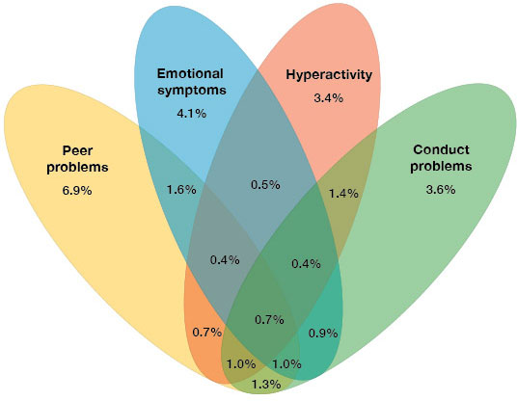
Note: The percentages in the figure add up to 27.9%, which is the proportion of children experiencing difficulties in one or more areas assessed by the SDQ. Areas of overlap show the proportion of children with ‘concerning’ scores for multiple subscales. For example 1.3% of children had a ‘concerning’ score on the peer and conduct problems subscales, but not the hyperactivity and emotional symptoms subscales.

Many children experienced behavioural difficulties in multiple areas
Children with a ‘concerning’ total difficulties score on average had 2.4 ‘concerning’ subscales (95% CI 2.3–2.5). Preschool children (3–4 years) were more likely to experience difficulties according to a single subscale only compared with children in the older age groups (see Table 3). This could, however, be related to the different thresholds that are in place for the youngest age group.
Table 3: Subscale difficulties in children with a ‘concerning’ SDQ total difficulties score
Number of ‘concerning’ subscales | % (95% CI)  total sample | % (95% CI)  3–4 years | % (95% CI)  5–9 years | % (95% CI)  10–14 years
1 | 13.0 (10.2–15.8) | 24.5 (16.1–32.9) | 11.8 (7.6–16.0) | 8.7 (5.7–11.6)
2 | 43.6 (38.7–48.5) | 41.3 (32.5–50.1) | 34.3 (27.6–41.0) | 52.6 (45.3–60.0)
3 | 34.7 (30.1–39.3) | 29.6 (19.4–39.9) | 44.0 (36.6–51.5) | 29.0 (22.4–35.6)
4 | 8.7 (6.3–11.1) | 4.5 (0.0–9.0) | 9.8 (5.5–14.2) | 9.7 (5.7–13.7)

Knowing that many children experience difficulties in more than one area of development is important, as research has found that children with comorbid difficulties or disorders generally experience greater levels of impairment and poorer outcomes over the long term (eg, Armstrong et al 2015). They require more complex interventions that may cover multiple domains of service provision. Problems children experience in one area are often related to their functioning in other areas at an older age (Croft et al 2015). As such, if social, emotional or behavioural difficulties are identified and adequately addressed at an early age, the effect of those difficulties on other areas of behavioural and developmental functioning may be reduced.

Prevalence of ‘concerning’ SDQ scores by age

Children in early to middle primary school years were least likely to have a ‘concerning’ SDQ score
After adjusting for differences in sex, ethnicity and neighbourhood deprivation, rates of ‘concerning’ SDQ scores differed across age groups (see Table 4 and Figure 3):
- Parents of children aged 5–9 years reported the lowest rate of ‘concerning’ total difficulties scores:
- Children aged 3–4 years were 1.45 times more likely to have a ‘concerning’ total difficulties score than children aged 5–9 years.
- Children aged 10–14 years were 1.27 times more likely to have a ‘concerning’ total difficulties score than children aged 5–9 years.
- The rates of ‘concerning’ scores for peer and conduct problems were comparable across age groups.
- Children aged 3–4 years and 10–14 years were 1.40 times more likely than those aged 5–9 years to have a ‘concerning’ emotional symptoms scores.
- Children aged 10–14 years had rates of ‘concerning’ scores on the hyperactivity subscale that were 1.28 times higher than those of children aged 3–4 years.
Table 4: Adjusted rate ratios comparing ‘concerning’ SDQ scores across age groups
 | ARR (95% CI)
 | 3–4 vs 5–9 years | 3–4 vs 10–14 years | 5–9 vs 10–14 years
Total difficulties | 1.45 (1.12–1.79) * | 1.15 (0.88–1.41) | 0.79 (0.64–0.94) *
Emotional symptoms | 1.40 (1.05–1.75) * | 0.98 (0.76–1.19) | 0.70 (0.57–0.83) *
Peer problems | 1.02 (0.85–1.19) | 0.91 (0.76–1.06) | 0.89 (0.78–1.01)
Hyperactivity | 0.91 (0.69–1.13) | 0.78 (0.58–0.99) * | 0.86 (0.69–1.02)
Conduct problems | 1.02 (0.82–1.23) | 0.95 (0.74–1.16) | 0.93 (0.76–1.09)
Note: Rate ratios are adjusted for sex, neighbourhood deprivation, and ethnicity.
* Statistically significant difference in rate.
Figure 3: Adjusted prevalence of ‘concerning’ SDQ scores by age group
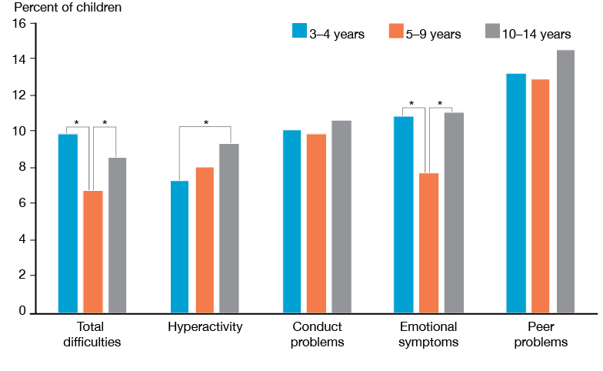
Note: Percentages are adjusted for differences in sex, neighbourhood deprivation and ethnicity.
* Statistically significant difference between age groups.

The comparison of rates across age groups is based on scores being above or below a set threshold. Services use these thresholds to decide whether to refer a child for further assessment, as they help identify children who are most likely to experience substantial difficulties. Besides rates of scores above the threshold (yes or no), the full range of scores (0–10 for each subscale) provides additional insights. While one group of children may experience the most severe difficulties, another group may have higher SDQ scores on average, meaning more children experience some level of difficulty.

The following section reports mean scores. Linear regression analysis was used to explore group differences in SDQ mean scores. The detailed output of this analysis can be found in Appendix 3. A recent study confirmed that it is possible to compare SDQ mean scores across the three age groups (Pannekoek et al, submitted). However, it is important to use caution when comparing conduct problem scores across age groups, as two items of this subscale are different for children aged 3–4 years (preschool version).

In line with the lower rate of ‘concerning’ total difficulties scores, children aged 5-9 years had the lowest mean score for the total SDQ (see Table 5). For the (1) hyperactivity and (2) emotional symptoms subscales the pattern of age group differences was different when looking at mean scores rather than rates of ‘concerning’ scores.

Table 5: Mean SDQ scores by age group
Age (years) | Mean score (95% CI)
 | Total difficulties | Emotional symptoms | Peer problems | Hyperactivity | Conduct problems
3–4 | 8.38 (8.09–8.66) | 1.40 (1.31–1.49) | 1.63 (1.54–1.72) | 3.29 (3.17–3.42) | 2.06 (1.95–2.16)
5–9 | 7.65 (7.46–7.85) | 1.57 (1.50–1.64) | 1.55 (1.49–1.62) | 3.09 (3.00–3.18) | 1.44 (1.38–1.49)
10–14 | 8.02 (7.80–8.23) | 1.92 (1.84–2.00) | 1.70 (1.63–1.77) | 3.02 (2.92–3.12) | 1.38 (1.31–1.44)
Note: Estimates are unadjusted.

(1) For the hyperactivity subscale, children aged 3–4 years had higher mean scores compared with the two older age groups (Table 5), despite having lower rates of hyperactivity scores above the threshold for ‘concerning’. Regression analysis, adjusting for sex, ethnicity and neighbourhood deprivation, confirmed that preschool children had a higher hyperactivity mean score (see Appendix 3). As Figure 4 shows, preschool children had mid-range scores more often than older children. Because the data only reflect one point in time, we do not know whether the children with a mid-range score were on a path to more concerning levels of hyperactivity at older ages. It is possible that children with a ‘borderline’ score may benefit from relatively minor initiatives to prevent the development of more substantial difficulties.

While substantial difficulties with hyperactivity were less prevalent in preschool children, children at preschool age were more likely to display some level of hyperactivity behaviour compared with school age children.
Figure 4: Distribution of scores on the hyperactivity subscale by age group
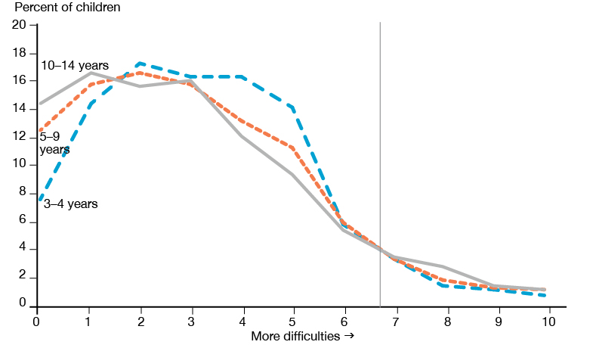
Note: Rates are unadjusted.

How to read the Figure
Each subscale has a range of possible scores of 0–10. Taking hyperactivity as an example, a score of 0 indicates no difficulties with hyperactivity behaviours, while a score of 10 suggests substantial difficulties. For each possible score, the percentage of children with that score is indicated in the figure. The percentages across the scores 0-10 add up to 100% (for each age group). For example, looking at the far left of the figure, 7.7% of 3–4 year olds had a score of 0 on the hyperactivity subscale, 12.6% of 5–9 year olds and 14.6% of 10–14 year olds. The vertical line indicates the threshold for ‘concerning’ for all age groups. A child with a score to the right of this line is considered to have a ‘concerning’ score for hyperactivity.

(2) For the emotional symptoms subscale, children aged 5–9 years had a higher mean score than those aged 3–4 years, and children aged 10–14 years had a higher mean score than those aged 5–9 years (Table 5, Figure 5). Regression analysis confirmed that scores on average were higher for older age groups. This pattern differs from that for the rate ratios (Table 4), where those aged 5–9 years had the lowest rate of ‘concerning’ scores for the emotional symptoms subscale.
This discrepancy is a result of the thresholds used. The threshold for concern with regards to emotional symptoms is lower for children aged 3–4 years (a subscale score of 4 and over) compared with that for older age groups (a subscale score of 5 and over). If the threshold for older children was also used for preschool children, only 5.2% (95% CI 3.6–6.7) of children aged 3–4 years would be classified as having a ‘concerning’ score rather than 11.1% (95% CI 8.9–13.3). For preschool children, the targeted rate of 8% of children being identified falls between the two thresholds.
Mean scores on the emotional symptoms subscale were higher for older children.

Figure 5: Distribution of scores on the emotional symptoms subscale by age group 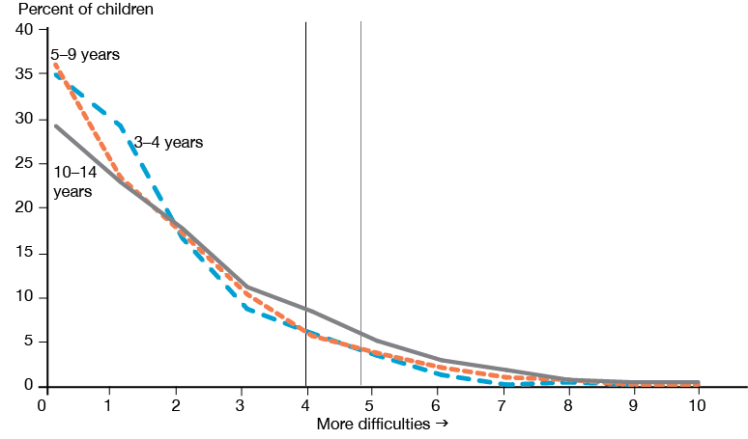
Note: Rates are unadjusted. For each age group, the percentages for each score (0–10) on the emotional symptoms subscale add up to 100%. The vertical lines indicate the thresholds, black for 3–4 year olds, grey for children 5+ years.

Prevalence of ‘concerning’ SDQ scores by sex

Boys were more likely than girls to have a ‘concerning’ SDQ score
An estimated 34,000 boys (9.4%) and 23,000 girls (6.6%) in the New Zealand child population aged 3-14 years had a SDQ total difficulties score indicating concern, meeting the criteria for referral for more detailed assessment.

After adjusting for differences in age, ethnicity and neighbourhood deprivation, rates of ‘concerning’ SDQ scores differed between boys and girls (see Table 6).
- Boys were 1.46 times more likely than girls to have a ‘concerning’ total difficulties score.
- Boys had higher rates of ‘concerning’ scores for conduct, peer and hyperactivity problems than girls.
- Girls were 1.26 times more likely than boys to have a ‘concerning’ score for emotional symptoms.
- For both boys and girls, peer problems were the most common, with rates of 15.0% and 12.2% respectively (see Table 2).

The higher rate of conduct problems reported by parents for boys than girls is in line with a tendency for boys to show their problems through externalising behaviours, causing behavioural difficulties that are primarily directed outward (Chaplin & Aldao 2013). On the other hand, the higher rate of emotional problems for girls is consistent with the tendency for girls to express their problems more through internalising behaviours such as anxiety and sadness (Chaplin & Aldao 2013).
Table 6: Adjusted rate ratios comparing ‘concerning’ SDQ scores for boys and girls
 | ARR (95% CI)
 | Boys vs girls | Boys vs girls adjusted for  problems in other SDQ areas
Total difficulties | 1.46 (1.18–1.74) *
Emotional symptoms | 0.79 (0.65–0.94) * | 0.69 (0.57–0.80) *
Peer problems | 1.24 (1.10–1.38) * | 1.18 (1.06–1.30) *
Hyperactivity | 2.12 (1.76–2.48) * | 1.96 (1.65–2.27) *
Conduct problems | 1.32 (1.11–1.53) * | 1.12 (0.96–1.30) *
Note: Rate ratios are adjusted for age group, neighbourhood deprivation, and ethnicity.
*Statistically significant sex difference in rate.

One in ten children (9.9%, see Figure 2) experienced difficulties across multiple SDQ subscales. If there is a relationship between difficulties in the different areas assessed by the SDQ, sex differences in the rate of ‘concerning’ scores on one subscale could result in sex differences on another. When accounting for this in the analysis, sex differences for conduct problems were no longer statistically significant (Table 6). This was mainly due to sex differences in hyperactivity:
- Hyperactivity behaviours were more strongly related to conduct problems in boys than girls, suggesting boys more often experienced the two problems together.
- Hyperactivity behaviours were more common in boys than girls.

The higher prevalence of conduct problems in boys was largely because they had a more complex pattern of problems across multiple areas. It is possible that through intervention in response to hyperactivity problems in particular, sex differences in the rate of conduct problems may be reduced. Note that although this analysis demonstrated an association between hyperactivity and conduct problems, it is not possible to draw any conclusions with regards to cause and effect.

Consistent with the pattern for ‘concerning’ scores, mean scores were higher for boys than girls for total difficulties, peer problems, hyperactivity and conduct problems. Girls had a higher mean score than boys for emotional symptoms (Table 7). These sex differences were confirmed with linear regression analysis, adjusting for age group, ethnicity and neighbourhood deprivation (see Appendix 3).
Table 7: Mean SDQ scores by sex
 | Mean score (95% CI)
 | Boys | Girls
Total difficulties | 8.38 (8.18-8.57)* | 7.44 (7.23-7.65)
Emotional symptoms | 1.58 (1.51-1.65)* | 1.80 (1.72-1.87)
Peer problems | 1.72 (1.65-1.78)* | 1.53 (1.47-1.59)
Hyperactivity | 3.47 (3.39-3.56)* | 2.70 (2.62-2.79)
Conduct problems | 1.60 (1.55-1.66)* | 1.41 (1.36-1.47)
Note: Estimates are unadjusted.
* Statistically significant difference in mean score between boys and girls in linear regression analysis.

Although scores for boys and girls differed on all SDQ subscales in the overall sample, these differences were not consistent across all age groups (Figure 6). Already for children in their preschool years, parent reports indicated sex differences for hyperactivity and peer problems. Boys had higher rates of hyperactivity across all age groups.

Figure 6: Adjusted rate ratios comparing ‘concerning’ SDQ scores for boys and girls across age groups
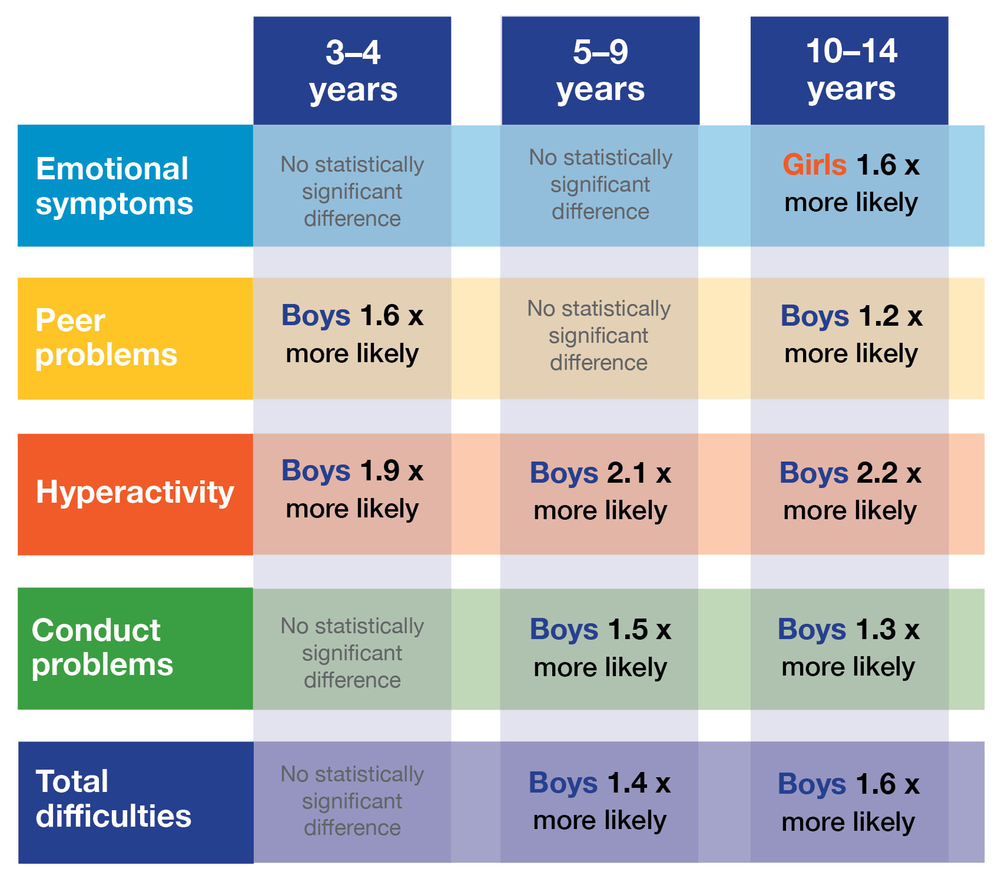
Note: Rate ratios are adjusted for neighbourhood deprivation and ethnicity. For example, for total difficulties on the SDQ there was no statistically significant sex difference for 3–4 year olds, while for 5–9 year olds boys were 1.4 times more likely to have a ‘concerning’ score than girls, and for 10–14 this was 1.6 times more likely for boys.

Rates of peer problems were higher for boys than girls for the age groups of 3–4 and 10–14 years, with no sex differences for 5–9 year olds. Sex differences in peer problems over the preschool period may be related to language development. Girls typically develop language skills at an earlier age than boys (eg, Bornstein et al 2004). Research has linked lower levels of language skills with poorer peer relationships, and this relationship is stronger for boys than for girls (Stowe et al 1999). Previous work has linked low vocabulary at age 2 and 4 to peer problems on the SDQ at 4 years of age (Bretherton et al 2014).

Sex differences for emotional symptoms were statistically significant only for children aged 10–14 years, with higher rates for girls. For both boys and girls, emotional symptom scores were higher for older age groups (see Table 8). However, this difference by age was larger for girls than boys, particularly when comparing 5–9 and 10–14 year olds. Emotional regulation is usually more unstable over the transition from late childhood to early adolescence. This is related to factors such as the onset of puberty, changing relationships with parents and peers and the move to high school, which result in changing expectations and insecurity (Sabatier et al 2017). Findings show that the impact of such changes on emotions may be stronger for 10–14 years old girls than boys. Other factors that are likely to play a role are differences in how boys and girls respond to the changes, express their emotions and seek support, as well as differences in parents’ recognition of emotional problems in teenage girls compared with boys (Chaplin & Aldao 2013).

Table 8: Mean SDQ scores on the emotional symptoms subscale by sex and age group
 | Mean score (95% CI)
 | 3–4 years | 5–9 years | 10–14 years
Boys | 1.31 (1.18–1.44) | 1.54 (1.44–1.64) | 1.73 (1.62–1.84)
Girls | 1.48 (1.33–1.64) | 1.61 (1.51–1.70) | 2.12 (2.00–2.24)
Note: Estimates are unadjusted.

Prevalence of ‘concerning’ SDQ scores by ethnicity

Māori children were more likely than non-Māori children to have a ‘concerning’ SDQ score
An estimated 22,000 (12.0%) Māori children in the New Zealand population had a SDQ total difficulties score indicating concern, meeting the criteria for referral for further assessment.

After adjusting for age and sex differences, rates of ‘concerning’ SDQ scores differed for Māori and non-Māori children (see Table 9, Figure 7).
- Māori children were 1.79 times more likely than non-Māori children to have a ‘concerning’ total difficulties score.
- Māori and non-Māori children had comparable rates of emotional symptoms.
- Māori children had higher rates of peer, hyperactivity and conduct problems than non-Māori children.
- After removing the effect of ‘concerning’ scores on the other subscales, all differences between Māori and non-Māori children remained. This suggests that differences between Māori and non-Māori children in rates of ‘concerning’ scores for one subscale were not responsible for differences in rates for another subscale.

Table 9: Adjusted rate ratios and rates for ‘concerning’ SDQ scores among Māori and non-Māori children
 | ARR (95% CI) | Percentage (95% CI)
 | Māori vs non-Māori | Māori | non-Māori
Total difficulties | 1.79 (1.50–2.07) * | 11.97 (10.50-13.43) | 6.70 (5.97-7.63)
Emotional symptoms | 1.19 (1.00–1.38) ) | 10.97 (9.59-12.34) | 9.24 (8.33-10.16)
Peer problems | 1.46 (1.28–1.63) * | 17.84 (16.00-19.68) | 12.25 (11.26-13.24)
Hyperactivity | 1.63 (1.34–1.91) * | 11.95 (10.46-13.44) | 7.35 (6.52-8.69)
Conduct problems | 2.08 (1.75–2.40) * | 16.75 (14.88-18.62) | 8.07 (7.22-8.92)
Note: Rate ratios and percentages are adjusted for age group and sex.
* Statistically significant difference in rate.

Figure 7. Adjusted prevalence of ‘concerning’ SDQ scores for Māori and non-Māori children
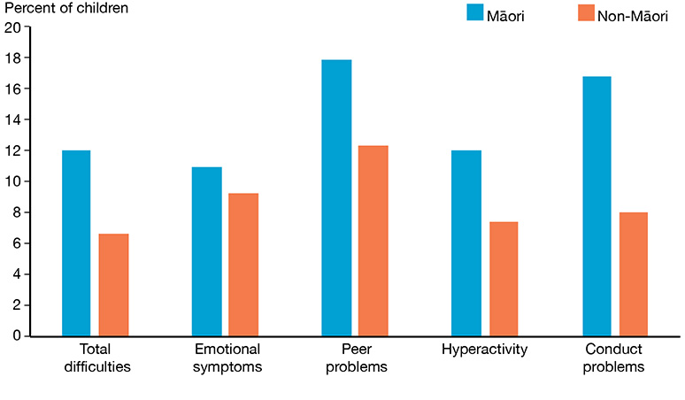
Note: Rates are adjusted for age group and sex. Estimates for Māori children differ slightly from those presented in Table 1 and 2 as the estimates in these tables are unadjusted.

Māori children had higher mean scores than non-Māori children for all subscales (Table 10). Regression analysis confirmed that after adjusting for sex and age differences Māori children on average had higher scores on the SDQ, indicating that their parents reported more difficulties. This is consistent with the ARRs in Table 9. One exception was the emotional symptoms subscale. Even though rates of ‘concerning’ scores for the emotional symptoms scale were comparable for Māori and non-Māori children, Māori children had a significantly higher mean subscale score (M = 1.87) than non-Māori children (M = 1.62). The reason for this difference is that Māori children had lower rates of scores indicating no difficulties, and higher rates of ‘borderline’ scores (just below the threshold) compared with non-Māori children.

While rates of substantial difficulties with emotions were comparable for Māori and non-Māori children, Māori children were more likely to display some level of emotional symptoms.

Table 10: Mean SDQ scores for Māori and non-Māori children
 | Mean score (95% CI)
 | Māori | Non-Māori
Total difficulties | 9.34 (9.08-9.60) * | 7.43 (7.27-7.60)
Emotional symptoms | 1.87 (1.79-1.95) * | 1.62 (1.57-1.68)
Peer problems | 1.94 (1.85-2.03) * | 1.52 (1.46-1.57)
Hyperactivity | 3.62 (3.51-3.72) * | 2.92 (2.85-2.99)
Conduct problems | 1.91 (1.83-2.00) * | 1.37 (1.33-1.42)
Note: Estimates are unadjusted.
* Statistically significant difference in mean score between Māori and non-Māori in linear regression analysis.

A previous study that looked at the SDQ in 4 and 5 year old children based on Before School Checks in 2011 also found higher rates of difficulties for Māori children compared with their peers (Kersten 2014). Like the Health Survey (see Table 2), this study found the highest rates of difficulties for Māori children on the conduct and peer problems subscales.

The SDQ is based on parents’ reports, and parents may differ in their views of what behaviours are part of normal development. Cultural expectations of age-appropriate and inappropriate behaviours may vary. The study by Kersten (2014) also assessed the 4 and 5 year old children using interviews by trained nurses, which also suggested that Māori children had higher rates of behavioural or emotional difficulties requiring referral than the wider population. This is consistent with what is seen for adults. In New Zealand population surveys, Māori adults were more likely than non-Māori adults to report mental health difficulties (Baxter et al 2006, Ministry of Health 2016c). Culturally appropriate intervention at an early age may help to reduce ethnic disparities in mental health.

Pacific children were more likely than non-Pacific children to have ‘concerning’ SDQ scores for emotional, peer and conduct problems
An estimated 9,000 (10.0%) Pacific children in the New Zealand population had a SDQ total difficulties score indicating concern, meeting the criteria for referral for further assessment.

After adjusting for age and sex differences, rates of ‘concerning’ scores differed for Pacific and non-Pacific children for the SDQ subscales, but not the total difficulties score (see Table 11, Figure 8).
- Pacific and non-Pacific children had comparable rates of ‘concerning’ total difficulties scores.
- Pacific children had higher rates of conduct and peer problems than non-Pacific children.
- Pacific children had higher rates of emotional symptoms than non-Pacific children; however, this difference disappeared after adjusting for differences in peer problems (ARR 1.08, 95% CI 0.87–1.29).
- Pacific children had lower rates of hyperactivity than non-Pacific children.
- With the exception of emotional symptoms, differences between Pacific and non-Pacific children remained after removing the effect of ‘concerning’ scores on the other subscales. This suggests that differences in rates of ‘concerning’ scores on other subscales were not responsible for differences in rates for the peer, hyperactivity and conduct subscales.

Table 11: Adjusted rate ratios and rates for ‘concerning’ SDQ scores among Pacific and non-Pacific children
 | ARR (95% CI) | Percentage (95% CI)
 | Pacific vs non-Pacific | Pacific | Non-Pacific
Total difficulties | 1.27 (0.99–1.56) ) | 9.91 (7.97-11.85) | 7.78 (7.05-8.50)
Emotional symptoms | 1.27 (1.04–1.51) * | 11.93 (9.95-13.91) | 9.36 (8.55-10.18)
Peer problems | 1.67 (1.45–1.89) * | 21.11 (18.57-23.66) | 12.63 (11.70-13.55)
Hyperactivity | 0.76 (0.59–0.92) * | 6.63 (5.19-8.07) | 8.78 (8.03-9.53)
Conduct problems | 1.38 (1.12–1.63) * | 13.52 (11.36-15.68) | 9.82 (8.99-10.65)
Note: Rate ratios and percentages are adjusted for age group and sex.
* Statistically significant difference in rate.

Figure 8. Adjusted prevalence of ‘concerning’ SDQ scores for Pacific and non-Pacific children
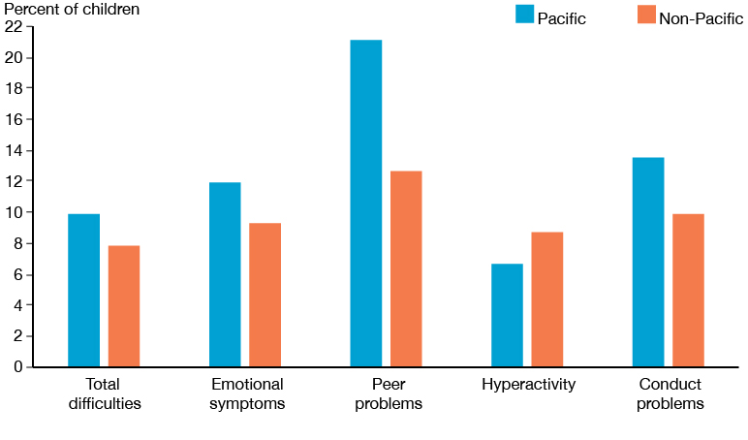
Note: Rates are adjusted for age group and sex. Estimates for Pacific children differ slightly from those presented in Table 1 and Table 2 as the estimates in these tables are unadjusted.

For the emotional symptoms, peer problems and conduct problems subscales, Pacific children had higher mean scores than non-Pacific children (Table 12), consistent with the higher rates of ‘concerning’ scores (see Table 11). Regression analysis confirmed that Pacific children had higher scores on average for these three subscales, suggesting they experienced more difficulties than non-Pacific children. Like for the Māori population, these findings are consistent with higher rates of mental health difficulties reported by Pacific adults in the Health Survey compared with non-Pacific adults (Ministry of Health 2016c).

Table 12: Mean SDQ scores for Pacific and non-Pacific children
 | Mean score (95% CI)
 | Pacific | Non-Pacific
Total difficulties | 9.09 (8.78-9.39) * | 7.75 (7.62-7.89)
Emotional symptoms | 1.86 (1.74-1.98) * | 1.66 (1.61-1.71)
Peer problems | 2.16 (2.05-2.27) * | 1.55 (1.50-1.60)
Hyperactivity | 3.28 (3.13-3.42) * | 3.07 (3.01-3.13)
Conduct problems | 1.79 (1.67-1.91) * | 1.47 (1.43-1.51)
Note: Estimates are unadjusted.
* Statistically significant difference in mean score between Pacific and non-Pacific children in linear regression analysis.

For the hyperactivity subscale and total difficulties score, the pattern of differences between Pacific and non-Pacific children was different for mean scores than for rates of ‘concerning’ scores. Pacific children had higher total difficulties and hyperactivity mean scores than non-Pacific children (Table 12), despite comparable and lower rates of ‘concerning’ SDQ scores respectively. As Figure 9 shows, compared with non-Pacific children, fewer Pacific children had scores suggesting no hyperactivity problems (score of 0). More Pacific than non-Pacific children had scores in the range below the threshold for ‘concerning’ (a score of 2–6). Scores in this range indicate a child is experiencing some difficulties, from very minor to of ‘borderline’ concern (a score of 6). While rates of substantial difficulties with hyperactivity as assessed by the SDQ were comparable for Pacific and non-Pacific children, Pacific children were more likely to display some level of hyperactivity. The differences between Pacific and non-Pacific children for the total difficulties score followed a similar pattern.

Figure 9: Distribution of scores on the hyperactivity subscale for Pacific and non-Pacific children
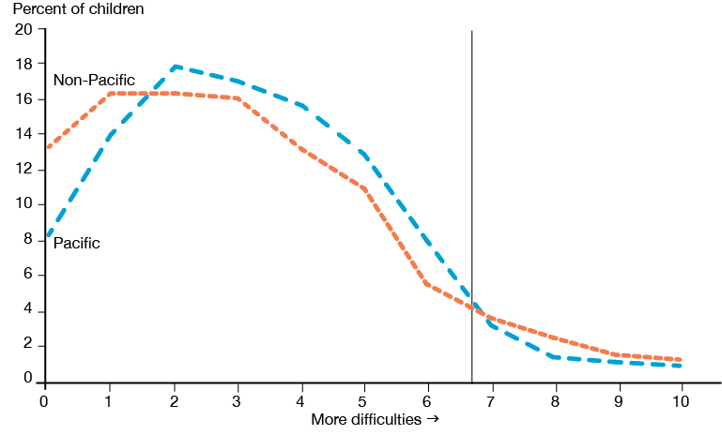
Note: Rates are unadjusted. For each group the percentages for each score (0–10) add up to 100%. Vertical line indicates the threshold for the hyperactivity subscale.

Asian children were less likely than non-Asian children to have a ‘concerning’ SDQ score
An estimated 4,000 (4.9%) Asian children in the New Zealand population had a SDQ total difficulties score indicating concern, meeting the criteria for referral for further assessment.

After adjusting for age and sex differences, rates of ‘concerning’ SDQ scores differed for Asian and non-Asian children (see Table 13, Figure 10).
- Asian children were almost half as likely as non-Asian children to have a ‘concerning’ total difficulties SDQ score.
- Asian children had lower rates of hyperactivity, conduct problems and emotional symptoms than non-Asian children.
- Asian and non-Asian children had comparable rates of peer problems.
- After removing the effect of ‘concerning’ scores on the other subscales, all differences between Asian and non-Asian children remained, suggesting that differences in rates of ‘concerning’ scores for one subscale could not explain differences in rates for another subscale.

Table 13: Adjusted rate ratios and rates for ‘concerning’ SDQ scores among Asian and non-Asian children
 | ARR (95% CI) | Percentage (95% CI)
 | Asian vs non-Asian | Asian | Non-Asian
Total difficulties | 0.57 (0.39–0.75)* | 4.84 (3.38-6.29) | 8.46 (7.72-9.19)
Emotional symptoms | 0.64 (0.46–0.82)* | 6.49 (4.80-8.18) | 10.09 (9.25-10.94)
Peer problems | 0.94 (0.75–1.12) ) | 12.93 (10.51-15.35) | 13.77 (12.77-14.76)
Hyperactivity | 0.40 (0.27–0.53)* | 3.64 (2.57-4.71) | 9.14 (8.33-9.94)
Conduct problems | 0.52 (0.36–0.68)* | 5.65 (3.95-7.34) | 10.87 (10.04-11.70)
Note: Rate ratios and percentages are adjusted for age group and sex.
* Statistically significant difference in rate.

Figure 10. Adjusted prevalence of ‘concerning’ SDQ scores for Asian and non-Asian children
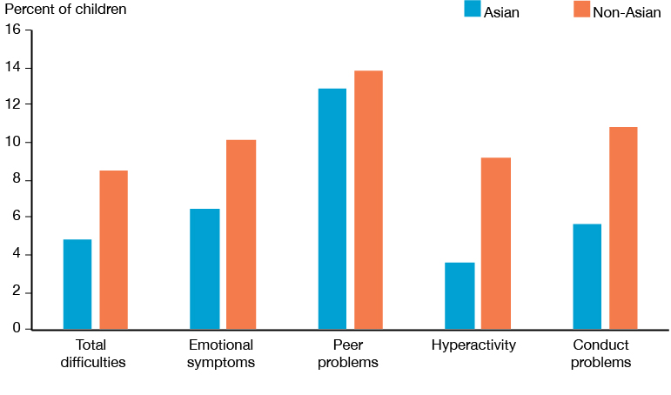
Note: Rates are adjusted for age group and sex. Estimates for Asian children differ slightly from those presented in Table 1 and Table 2 as the estimates in these tables are unadjusted.
The pattern of differences in rates (Table 13) was consistent with by the pattern of differences between Asian and non-Asian children in mean scores (Table 14). Regression analysis confirmed that Asian children on average had lower scores than non-Asian children for all subscales, with the exception of the peer problems subscale. This indicates that based on their parents’ report on the SDQ, Asian children displayed fewer problem behaviours related to emotions, hyperactivity and conduct. For the peer problems subscale, mean scores were comparable for Asian and non-Asian children, in line with the rate ratio for this subscale.

Table 14: Mean SDQ scores for Asian and non-Asian children
 | Mean score (95% CI)
 | Asian | Non-Asian
Total difficulties | 7.10 (6.76-7.45) * | 8.02 (7.87-8.17)
Emotional symptoms | 1.43 (1.31-1.54) * | 1.72 (1.67-1.77)
Peer problems | 1.69 (1.59-1.79) ) | 1.62 (1.56-1.67)
Hyperactivity | 2.67 (2.51-2.83) * | 3.15 (3.09-3.22)
Conduct problems | 1.32 (1.21-1.42) * | 1.54 (1.49-1.58)
Note: Estimates are unadjusted.
* Statistically significant difference in mean score between Asian and non-Asian children in linear regression analysis.

A few factors may play a role in the lower rates of ‘concerning’ scores on the SDQ for Asian children compared with non-Asian children. There is evidence that individuals from Asian cultures have lower rates of mental health service use than other ethnic groups (Chow & Mulder 2017). Lower levels of service use may reflect better mental health in the Asian population, but could also be related to cultural or immigration factors (Chow & Mulder 2017). The rate of Asian children participating in the Health Survey who were born overseas (36.2%, 95% CI 32.4–39.9) was higher than that of non-Asian children (8.1%, 95% CI 7.1–9.0). Also, Asian children who were born overseas had on average been in the country for fewer years compared with children from other ethnic groups who were born overseas (see Table 15). Limited proficiency in the English language, limited exposure to the New Zealand education and health systems or other migration related reasons could have influenced parents’ ratings on the SDQ (see also Ho et al 2003).
Table 15: Rates of children not born in New Zealand, and length of time in New Zealand by ethnic group
 | Estimate (95% CI)
 | Māori | Pacific | Asian
Not NZ born (%) | 2.90  (2.11–3.69) | 10.31  (8.36–12.25) | 36.15  (32.40–39.91)
0–5 years in NZ¹ (%) | 52.97  (36.64–69.30) | 43.39  (31.90–54.88) | 63.92  (58.04–69.80)
Mean time in NZ¹ (years) | 5.51  (4.21–6.80) | 6.45  (5.55–7.36) | 4.78  (4.32–5.24)
Note: The time in New Zealand is a broad estimate based on year of arrival in New Zealand and year of administration of the Health Survey.
¹ Of children born outside of New Zealand.

Differences in prevalence across ethnic groups by age group and sex
Differences between ethnic groups in rates of ‘concerning’ scores were consistent across age groups. Already for preschool children, rates of parent reported problem behaviours differed by ethnic group.
Differences in the rates of ‘concerning’ scores across ethnic groups were also largely across sex. One exception was the hyperactivity subscale, where sex differences in the rate of ‘concerning’ scores differed for Māori and non-Māori children.

Differences between Māori and non-Māori children in rates of ‘concerning’ hyperactivity behaviours were present for boys only.

Sex differences were larger within the Māori child population compared to the non- Māori child population. After adjusting for differences in age:
- Māori boys were 2.85 times (95% CI 2.16–3.55) more likely than Māori girls to have a ‘concerning’ hyperactivity score.
- Non-Māori boys were 1.81 times (95% CI 1.45–2.18) more likely than non-Māori girls to have a ‘concerning’ hyperactivity score.

Differences between Māori and non-Māori children in hyperactivity rates were only present for boys. After adjusting for differences in age:
- Māori boys were 1.87 times (95% CI 1.49–2.24) more likely to have a score above the threshold for hyperactivity than non-Māori boys.
- Māori and non-Māori girls had comparable rates of ‘concerning’ hyperactivity scores (ARR 1.18, 95% CI .88–1.48).

Māori boys had a higher rate of ‘concerning’ scores for hyperactivity (17.5%, 95% CI 14.9–20.1) than Māori girls (6.1%, 95% CI 4.8–7.4), and non-Māori boys and girls (9.4% and 5.2% respectively) (see Figure 11).

Figure 11: Distribution of scores on the hyperactivity subscale for Māori and non-Māori children by sex
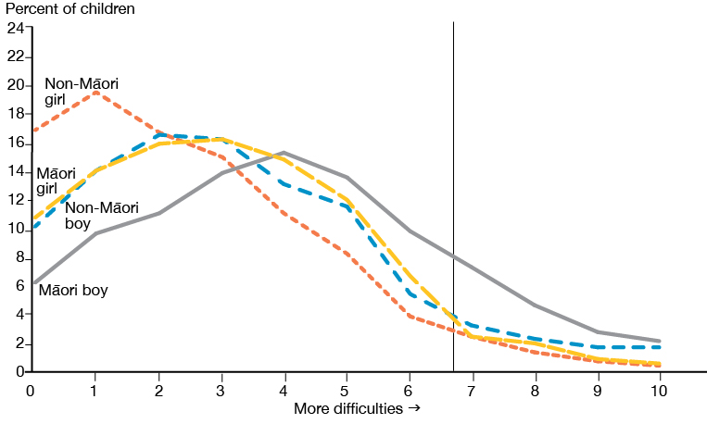
Note: Rates are unadjusted. For each group the percentages for each score (0–10) add up to 100%. Vertical line indicates the threshold for the hyperactivity subscale.

Prevalence of ‘concerning’ SDQ scores by neighbourhood deprivation

Children living in more deprived areas were more likely to have a ‘concerning’ SDQ score
An estimated 20,000 children (12.4%) living in the most socioeconomically deprived areas in New Zealand (quintile 5) had a SDQ total difficulties score indicating concern, meeting the criteria for referral for further assessment. This compares to 5,000 children (3.7%) in the least deprived areas (quintile 1).

After adjusting for differences in age, sex and ethnicity, rates of ‘concerning’ scores for children living in the most deprived areas differed from the rates for children in the least deprived areas (see Table 16).
- Children living in the most deprived areas were three times more likely to have a ‘concerning’ total difficulties score on the SDQ than those living in the least deprived areas.
- Children living in the most deprived areas had higher rates of peer problems, emotional symptoms and conduct problems than children living in the least deprived areas.
- Children living in the most and least deprived areas had comparable rates of ‘concerning’ scores for the hyperactivity subscale.
- After removing the effect of ‘concerning’ scores on the other subscales, differences between children living in the most and least deprived areas remained for the peer and conduct problems subscales. This suggests that differences in rates of ‘concerning’ scores for peer and conduct problems could not be explained by differences in rates for other subscales.

Differences in rates of emotional symptoms between children living in the most and least deprived areas were no longer statistically significant after accounting for differences on the other three subscales. This is similar to what was found when comparing Pacific and non-Pacific children. Differences across deprivation or ethnicity were typically smaller for emotional symptoms than for other subscales (and not statistically significant when comparing Māori and non-Māori children). The differences that were seen appeared to be largely related to ‘concerning’ scores on the other subscales. It is not possible to identify cause and effect from this analysis. However, it seems that higher rates of emotional symptoms experienced by some groups are related to other difficulties experienced by children in these groups.

Figure 12 presents the rates of scores above the threshold for all neighbourhood deprivation quintiles. The pattern of more difficulties in areas of higher deprivation was consistent across age groups and sex.

Table 16: Adjusted rate ratios comparing ‘concerning’ SDQ scores for children living in the most and least deprived areas
 | ARR (95% CI)
 | Quintile 5 vs Quintile 1
Total difficulties | 2.95 (1.79–4.11) *
Emotional symptoms | 1.49 (1.03–1.95) *
Peer problems | 2.50 (1.74–3.26) *
Hyperactivity | 1.38 (0.95–1.81) )
Conduct problems | 2.28 (1.42–3.14)*
Note: Rate ratios are adjusted for age group, sex and ethnicity.
* Statistically significant difference in rate.

Figure 12: Adjusted prevalence of ‘concerning’ SDQ scores by neighbourhood deprivation
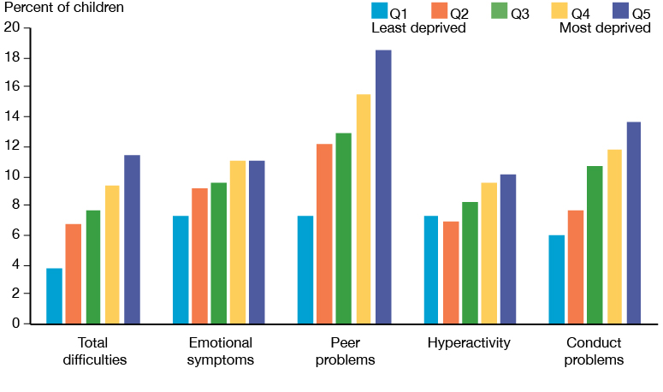
Note: Rates are adjusted for age group, sex and ethnicity.

The pattern of higher rates of difficulties for children living in areas of higher deprivation (Table 16) was consistent with higher mean scores for children living in more deprived areas (Table 17). Regression analysis confirmed that children living in the more deprived areas on average had higher SDQ scores than children living in the less deprived areas, after adjusting for age, sex and ethnicity. Mean scores were also higher for children living in the most compared to the least deprived areas for the hyperactivity subscale, despite the comparable rate of ‘concerning’ scores for this subscale. Similar to the findings for Pacific children, children living in the more deprived areas were less likely to have no or few difficulties than children living in the less deprived areas (see Figure 13).

Table 17: Mean SDQ scores by neighbourhood deprivation
 | Mean score (standard deviation)
 | Quintile 1 | Quintile 2 | Quintile 3 | Quintile 4 | Quintile 5
Total difficulties | 6.49 (0.16) | 7.23 (0.19) | 7.59 (0.19) | 8.55 (0.16) | 9.48 (0.13)
Emotional symptoms | 1.45 (0.07) | 1.63 (0.07) | 1.65 (0.05) | 1.81 (0.05) | 1.86 (0.04)
Peer problems | 1.13 (0.06) | 1.43 (0.05) | 1.49 (0.06) | 1.82 (0.05) | 2.16 (0.05)
Hyperactivity | 2.74 (0.08) | 2.83 (0.07) | 3.00 (0.07) | 3.28 (0.07) | 3.55 (0.05)
Conduct problems | 1.17 (0.04) | 1.34 (0.04) | 1.44 (0.05) | 1.63 (0.05) | 1.90 (0.05)
Note: Estimates are unadjusted. Standard deviations are presented instead of 95% confidence intervals, which are available upon request

Figure 13: Distribution of scores on the hyperactivity subscale by neighbourhood deprivation
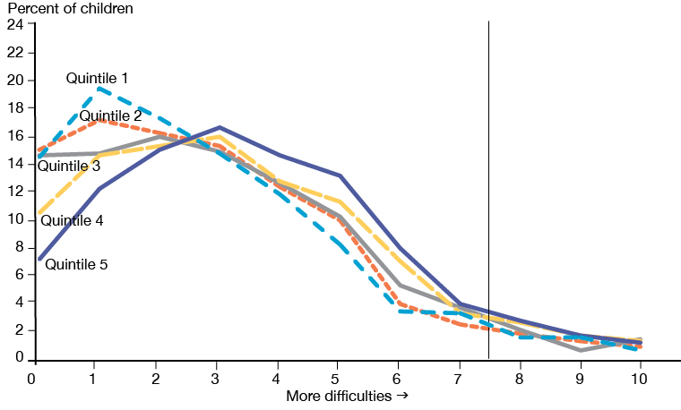
Note: Rates are unadjusted. For each group the percentages for each score (0–10) add up to 100%. The vertical line indicates the threshold for the hyperactivity subscale.
Compared to children living in the less deprived areas, children living in more deprived areas more often experienced problems across multiple areas assessed by the SDQ (see Figure 14). For example, of the children in the least deprived areas with at least one ‘concerning’ subscale score, 26% had multiple ‘concerning’ subscales. For children in the most deprived areas this was 39%.

The difficulties experienced by children in the more deprived areas were more likely to be complex.

Figure 14: Prevalence of complex and uniform SDQ difficulties by neighbourhood deprivation
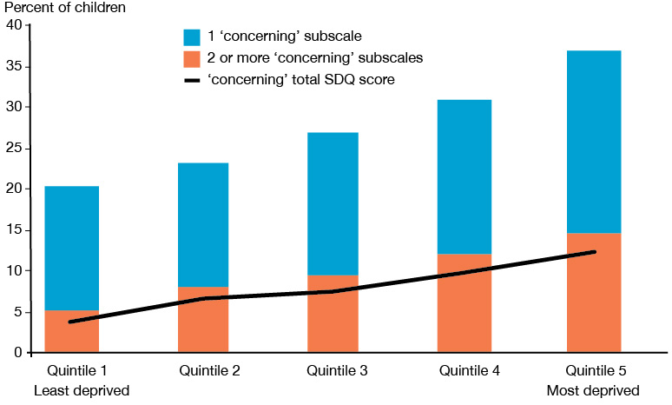
Note: Not all children with ‘concerning’ subscale scores had a ‘concerning’ total difficulties score. For each quintile there were children with multiple ‘concerning’ subscales who did not have a ‘concerning’ total difficulties score, and conversely children with a ‘concerning total difficulties score and only a single ‘concerning’ subscale.

Conclusions
The findings presented in this report illustrate that the majority of New Zealand children aged 3–14 years are developing well, without significant social, emotional and/or behavioural problems. However, about 8.0% of children were found to exhibit substantial difficulties based on the SDQ total difficulties score. This equates to an estimated 57,000 children. The prevalence and nature of difficulties differed across subgroups. These children may be at risk of poorer social, behavioural and mental health outcomes later in life.

The SDQ can only be used for an initial screen and not to make a formal diagnosis. To make sure no children are missed, screening questionnaires like the SDQ are designed to identify more children as at risk than the true prevalence of difficulties that require attention. As a result, the actual number of children with substantial difficulties is likely to be smaller than the number reported as at risk in this report. In short, the Health Survey results provide estimates of the number of children who could benefit from further clinical assessment.

The findings highlight that it is possible to detect social, emotional and behavioural difficulties, which may be indicative of an underlying mental health problem, at an early age. Being able to do so is important as it provides opportunities to intervene.

Early intervention in response to difficulties can reduce the risk or severity of certain types of mental disorders later in childhood, adolescence or adulthood and improve children’s developmental, emotional, academic and social outcomes. The earlier the intervention occurs, the greater those improvements are (Manning 2017).

For the SDQ to contribute to better outcomes in mental health and wellbeing, it is essential that adequate referral processes for further assessment are in place, as well as effective, culturally appropriate initiatives to support positive development. Child development is influenced by a complex combination of multiple factors. Further work is required on the identification of key risk factors for social, emotional and behavioural difficulties in the New Zealand context. It is important that such work also focuses on factors that contribute to positive mental health and wellbeing, such as resilience.

In short, a share of New Zealand children requires additional support for their developmental and mental health. The SDQ can help identify at risk children early, providing a key opportunity to reduce negative outcomes, and improve children’s wellbeing in the long-term. Initiatives to support children showing signs of difficulty throughout the primary school years could help them to achieve their full potential.

References
Armstrong D, Lycett K, Hiscock H, et al. 2015. Longitudinal associations between internalizing and externalizing comorbidities and functional outcomes for children with ADHD. Child Psychiatry & Human Development 46(5): 736–48.
Baxter J, Kokaua J, Wells JE, et al. 2006. Ethnic comparisons of the 12-month prevalence of mental disorders and treatment contact in Te Rau Hinengaro: the New Zealand Mental Health Survey. Australian and New Zealand Journal of Psychiatry 40(10): 905–13.
Bornstein MH, Hahn CS, Haynes OM. 2004. Specific and general language performance across early childhood: Stability and gender considerations. First Language 24(3): 267–304.
Bretherton L, Prior M, Bavin E, et al. 2014. Developing relationships between language and behaviour in preschool children from the Early Language in Victoria Study: implications for intervention. Emotional and Behavioural Difficulties 19(1): 7–27.
Chaplin TM, Aldao A. 2013. Gender differences in emotion expression in children: a meta-analytic review. Psychological Bulletin 139(4): 735–65.
Chow CS, Mulder RT. 2017. Mental health service use by Asians: a New Zealand census. The New Zealand Medical Journal 130(1461): 35.
Cox JE, Huntington N, Saada A. et al. 2010. Developmental screening and parents’ written comments: an added dimension to the Parents’ Evaluation of Developmental Status questionnaire. Pediatrics 126(Supplement 3): S170–S176.
Croft S, Stride C, Maughan B, et al. 2015. Validity of the strengths and difficulties questionnaire in preschool-aged children. Pediatrics 135(5): e1210–e1219.
Fergusson DM, Horwood LJ. 2001. The Christchurch Health and Development Study: review of findings on child and adolescent mental health. Australian and New Zealand Journal of Psychiatry 35(3): 287–96.
Fleming TM, Clark T, Denny S, et al. 2014. Stability and change in the mental health of New Zealand secondary school students 2007–2012: Results from the national adolescent health surveys. Australian & New Zealand Journal of Psychiatry 48(5): 472–80.
Giner Torréns, M, Kärtner J. 2017. Psychometric properties of the early prosocial behaviour questionnaire. European Journal of Developmental Psychology 14(5): 618–27.
Goodman R. 1997. The Strengths and Difficulties Questionnaire: a research note. Journal of Child Psychology and Psychiatry 38: 581–6.
Hawkins M, Villagonzalo K-A, Sanson A, et al. 2012. Associations between positive development in late adolescence and social, health, and behavioral outcomes in young adulthood. Journal of Adult Development 19: 88–99. DOI: 10.1007/s10804-011-9137-8 (accessed 30 June 2017).
Ho E, Au S, Bedford C, Cooper J. 2003. Mental Health Issues for Asians in New Zealand: A literature review. Wellington: Prepared for Mental Health Commission.
Kersten P, Vandal A, McPherson K, et al. 2014. A Validation and Norming Study of the Strengths and Difficulties Questionnaire in the New Zealand Context. Final report.
Kvalsvig A, D’Souza A, Duncanson M, et al. 2016. Pathways to Child Health, Development and Wellbeing: Optimal environments for orchids and dandelions. An overview of the evidence. Wellington: Ministry of Health.
Manning. 2017. Addressing developmental challenges to improve the wellbeing of children. In S Garvis, D Pendergast, Health and Wellbeing in Childhood (2nd ed, pp 39-56). Cambridge: Cambridge University Press.
McAloney-Kocaman K, McPherson K. 2017. Factor Structure and Reliability of the Parent–Informant Strengths and Difficulties Questionnaire in a Scottish Preschool Sample. Early Education and Development 28(3): 368–76.
McGee R, Feehan M, Williams S. 1996. Mental health. In PA Silva, WR Stanton (eds). From Child to Adult: The Dunedin Multidisciplinary Health and Development Study. Auckland, Oxford University Press: 150–62.
Ministry of Health. 2016a. Content Guide 2015/16: New Zealand Health Survey. Wellington: Ministry of Health. www.health.govt.nz/publication/content-guide-2015-16-new-zealand-health-survey
Ministry of Health. 2016b. Methodology Report 2015/16: New Zealand Health Survey. Wellington: Ministry of Health. https://www.health.govt.nz/publication/methodology-report-2015-16-new-zealand-health-survey
Ministry of Health. 2016c. Annual Update of Key Results 2015/16: New Zealand Health Survey. Wellington: Ministry of Health. https://www.health.govt.nz/publication/annual-update-key-results-2015-16-new-zealand-health-survey
Pannekoek et al. Submitted. Psychometric properties of the Strengths and Difficulties Questionnaire in a multi-ethnic population of pre- and primary school-aged children.
Prince M, Patel V, Saxena S, et al. 2007. No health without mental health. Lancet 370: 859–77. DOI: 10.1016/S0140-6736(07)61238-0.
Sabatier C, Cervantes DR, Torres MM, et al. 2017. Emotion Regulation in Children and Adolescents. Psicología desde el Caribe 34(1).
Shortland E. 1856. Traditions and Superstitions of the New Zealanders. London: Longman, Brown, Green, Longmans & Roberts.
Stowe RM, Arnold DH, Ortiz C. 1999. Gender differences in the relationship of language development to disruptive behavior and peer relationships in preschoolers. Journal of Applied Developmental Psychology 20(4): 521–36.
Tsiantis J, Smith M, Dragonas T, et al. 2000. Early mental health promotion in children through primary health care services: a multi-centre implementation. International Journal of Mental Health Promotion 2(3): 5–17.
Whiteford HA, Ferrari AJ, Degenhardt L, et al. 2015. The global burden of mental, neurological and substance use disorders: an analysis from the Global Burden of Disease Study 2010. PloS one 10(2): e0116820.
WHO. 2005. Mental Health: Facing the challenges, building solutions. Report from the WHO European Ministerial Conference. Copenhagen, Denmark: WHO Regional Office for Europe.
Youth in Mind. 2014. SDQ: information for researchers and professionals about the Strengths and Difficulties Questionnaires. Retrieved from http://www.sdqinfo.com/.

Appendix 1: Technical details of analysis in this report
This section provides some key points for interpreting survey results presented in this report. For more details about the Health Survey methodology, see the Methodology Report 2015/16: New Zealand Health Survey (Ministry of Health 2016b).

Representative population
All results in this report are weighted so that they are representative of the total child population aged 3–14 years in New Zealand.

Calculation of proportions
To estimate the proportion of the population who belong to a particular group (eg, the proportion of the child population of 3–14 year olds who had a ‘concerning’ score on the SDQ, 8.0%), this analysis has divided the sum of the weights for that group (eg, children 3–14 years with a ‘concerning’ SDQ score) by the sum of the weights of all respondents in the population of interest (eg, all children 3–14 years with a response for the SDQ). Proportions are not presented if the number of children concerned in the sample was smaller than 30.

Calculation of totals (counts)
To estimate totals (eg, an estimated 57,000 children aged 3–14 years had a ‘concerning’ score on the SDQ), this analysis has multiplied the sum, over all respondents, of the weight by the variable of interest. To account for the aggregation of data over three years, it has then divided this value by three to provide a yearly average.

Statistical significance
Statistical significance is measured at the 5% significance level (that is, p-value is less than 0.05). All differences reported in the text are statistically significant unless stated otherwise.

Total response ethnicity
This report uses total response ethnicity to define ethnic groups. Total response ethnicity classifies a person in all the ethnic groups they identify with. This means that statistics for individual people can appear in more than one ethnic group. Ethnicity in this report reflects the ethnicity of the child as the parent has reported it. In some cases the parent responding to the Health Survey may identify with an ethnicity or set of ethnicities that is different from that of their child.

Neighbourhood deprivation
The neighbourhood deprivation measure used is the New Zealand Index of Deprivation 2013. This is reported in quintiles 1 to 5, or most deprived (quintile 1) versus least deprived (quintile 5) areas.

Rate ratios – adjustments
The rate ratios were adjusted for demographic factors that may influence (ie, confound) the comparison, as follows.
- When comparing age groups, rate ratios were adjusted for sex, ethnic group (prioritised ethnicity) and neighbourhood deprivation (NZDep2013 quintiles).
- When comparing boys and girls, rate ratios were adjusted for age group, ethnic group (prioritised ethnicity) and neighbourhood deprivation (NZDep2013 quintiles).
- For ethnic comparisons where data on boys and girls were combined, rate ratios are adjusted for age group and sex.
- Comparisons of children living in the most and the least deprived neighbourhoods were adjusted for age group, sex and ethnic group.

This report has not adjusted ethnic rate ratios for neighbourhood deprivation because deprivation is one of the key mechanisms contributing to differences in health status between ethnic groups. Ethnicity is one factor that is linked to a person’s level of socioeconomic deprivation, which in turn affects their health status.

Regression analysis
The report uses regression analysis to estimate the relationship between variables. Using this method several variables can be modelled and analysed at the same time. The focus is on the relationship between a dependent variable (eg, a total difficulties score above the threshold) and one or more independent variables (eg, age group, sex, ethnicity and neighbourhood deprivation). ARRs, based on the rate of children scoring above the SDQ threshold for specific groups, were calculated with logistic regression analysis. Linear regression analysis was used to calculate the relationships between demographic variables and the full range of scores on the SDQ scales. Technical results of the linear regression analysis are available on request.

Rounding
Data tables present prevalence estimates in percentages rounded to one decimal place. In some cases, this rounding results in prevalence estimates that do not add up to 100%. ARRs are rounded to two decimal places. Estimates concerning the actual number of children concerned are rounded to the nearest 1,000 children. Calculations used unrounded values.

Appendix 2: Thresholds for SDQ scores
Table A2.1: Range indicating ‘borderline’ scores for preschool and school age SDQ
 | Cut-off 3–4 y | Cut-off 5+
Total difficulties | 13–15 | 14–16
Emotional symptoms | 3 | 4
Peer problems | 3 | 3
Hyperactivity | 6 | 6
Conduct problems | 4 | 3
Note: These cut-off scores are published on the SDQ website: http://www.sdqinfo.com/py/sdqinfo/c0.py

Table A2.2: Thresholds for ‘concerning’ scores for preschool and school age SDQ
 | Cut-off 3–4 y | Cut-off 5+
Total difficulties | >15 | >16
Emotional symptoms | >3 | >4
Peer problems | >3 | >3
Hyperactivity | >6 | >6
Conduct problems | >4 | >3
Note: These cut-off scores are published on the SDQ website: http://www.sdqinfo.com/py/sdqinfo/c0.py

Appendix 3: Modelling the data
A linear regression model was fitted to the respondent-level data from the Health Survey to better understand the variation in SDQ scores across the population groups. In separate models, the dependent variable was the total SDQ difficulties score and the four SDQ subscale scores. The explanatory variables were age group, sex, ethnicity, and neighbourhood deprivation (NZDep2013 quintiles).

Table A3.1: Linear regression output
Variable |  | Levels | β coefficient | 95% CI lower | 95% CI upper | P
Total difficulties score  (range 0–40) | Age group | 3–4 | .19 | -.16 | .54 | .29
 |  | 5–9 | -.46 | -.74 | -.18 | <.001
 |  | 10–14 | Reference
 | Sex | Boys | .98 | .68 | 1.27 | <.0001
 |  | Girls | Reference
 | Ethnicity | Māori | 1.91 | 1.60 | 2.23 | <.0001
 |  | Non-Māori | Reference
 |  | Pacific | 1.31 | 1.00 | 1.63 | <.0001
 |  | Non-Pacific | Reference
 |  | Asian | -.92 | -1.29 | -.56 | <.0001
 |  | Non-Asian | Reference
 | Deprivation | Quintile 5 | 2.32 | 1.88 | 2.75 | <.0001
 |  | Quintile 4 | 1.71 | 1.24 | 2.18 | <.0001
 |  | Quintile 3 | .95 | .47 | 1.44 | <.001
 |  | Quintile 2 | .69 | .20 | 1.17 | <.01
 |  | Quintile 1 | Reference
Emotional problems score  (range 0–10) | Age group | 3–4 | -.55 | -.66 | -.43 | <.0001
 |  | 5–9 | -.36 | -.46 | -.26 | <.0001
 |  | 10–14 | Reference
 | Sex | Boys | -.21 | -.32 | -.10 | <.001
 |  | Girls | Reference
 | Ethnicity | Māori | .25 | .15 | .36 | <.0001
 |  | Non- Māori | Reference
 |  | Pacific | .21 | .08 | .33 | <.001
 |  | Non-Pacific | Reference
 |  | Asian | -.28 | -.40 | -.16 | <.0001
 |  | Non-Asian | Reference
 | Deprivation | Quintile 5 | .36 | .18 | .53 | <.0001
 |  | Quintile 4 | .35 | .17 | .54 | <.001
 |  | Quintile 3 | .21 | .04 | .39 | .02
 |  | Quintile 2 | .20 | .01 | .39 | .04
 |  | Quintile 1 | Reference
Peer problems score  (range 0–10) | Age group | 3–4 | -.14 | -.24 | -.03 | <.01
 |  | 5–9 | -.18 | -.26 | -.09 | <.0001
 |  | 10–14 | Reference
 | Sex | Boys | .20 | .12 | .28 | <.0001
 |  | Girls | Reference
 | Ethnicity | Māori | .43 | .33 | .53 | <.0001
 |  | Non-Māori | Reference
 |  | Pacific | .61 | .50 | .72 | <.0001
 |  | Non-Pacific | Reference
 |  | Asian | .07 | -.03 | .18 | .17
 |  | Non-Asian | Reference
 | Deprivation | Quintile 5 | .83 | .67 | .98 | <.0001
 |  | Quintile 4 | .58 | .43 | .73 | <.0001
 |  | Quintile 3 | .32 | .16 | .48 | <.001
 |  | Quintile 2 | .28 | .14 | .41 | <.0001
 |  | Quintile 1 | Reference
Hyperactivity problems score  (range 0–10) | Age group | 3–4 | .23 | .06 | .41 | .01
 |  | 5–9 | .04 | -.09 | .17 | .53
 |  | 10–14 | Reference
 | Sex | Boys | .78 | .67 | .90 | <.0001
 |  | Girls | Reference
 | Ethnicity | Māori | .70 | .58 | .82 | <.0001
 |  | Non-Māori | Reference
 |  | Pacific | .20 | .05 | .35 | <.01
 |  | Non-Pacific | Reference
 |  | Asian | -.48 | -.66 | -.31 | <.0001
 |  | Non-Asian | Reference
 | Deprivation | Quintile 5 | .63 | .43 | .84 | <.0001
 |  | Quintile 4 | .45 | .24 | .65 | <.0001
 |  | Quintile 3 | .21 | .00 | .43 | .05
 |  | Quintile 2 | .08 | -.15 | .31 | .50
 |  | Quintile 1 | Reference
Conduct problems score  (range 0–10) | Age group* | 3–4 | .64 | .51 | .76 | <.0001
 |  | 5–9 | .04 | -.05 | .13 | .39
 |  | 10–14 | Reference
 | Sex | Boys | .20 | .12 | .29 | <.0001
 |  | Girls | Reference
 | Ethnicity | Māori | .53 | .42 | .63 | <.0001
 |  | Non-Māori | Reference
 |  | Pacific | .30 | .18 | .42 | <.0001
 |  | Non-Pacific | Reference
 |  | Asian | -.24 | -.34 | -.13 | <.0001
 |  | Non-Asian | Reference
 | Deprivation | Quintile 5 | .50 | .35 | .65 | <.0001
 |  | Quintile 4 | .33 | .18 | .48 | <.0001
 |  | Quintile 3 | .21 | .08 | .34 | .01
 |  | Quintile 2 | .14 | .00 | .27 | .05
 |  | Quintile 1 | Reference
* As two items of the SDQ conduct problems subscale differ in the preschool and school age SDQ, caution is required when comparing conduct problem scores across age groups.

For approximately 7 percent of children the Health Survey was completed by a primary caregiver other than their mother or father. For the sake of readability, the rest of this report uses the term ‘parents’ to encompass all caregivers.
For positively worded statements the scoring is reversed, where a score of 0 is given for ‘Certainly true’ and 2 for ‘Not true’.
Boys on average had .46 ‘concerning’ subscales (95% CI .43–.50), while for girls this was .37 (95% CI .35–.40).
Except when ethnicity is a control variable in regression analysis, in which case ethnicity is prioritised.

