Smoking Status of Daily Vapers
New Zealand Health Survey:
2017/18 to 2021/22

Acknowledgements
The New Zealand Health Survey relies on the support and enthusiasm of many individuals, including the survey participants and the surveyors who worked so diligently to collect the data.
This report was prepared by the Health Surveys team, Evidence, Research and Analytics, Manatū Hauora (Ministry of Health).
Thank you to everyone who provided input and review, including Ope Ōpiki, Public Health Agency, Manatū Hauora.
Citation: Ministry of Health. 2023. Smoking Status of Daily Vapers. Wellington: Ministry of Health.
Published in June 2023 by the Ministry of Health
PO Box 5013, Wellington 6140, New Zealand
ISBN 978-1-991075-29-1 (online)
HP 8775
This document is available at health.govt.nz
This work is licensed under the Creative Commons Attribution 4.0 International licence. In essence, you are free to: share ie, copy and redistribute the material in any medium or format; adapt ie, remix, transform and build upon the material. You must give appropriate credit, provide a link to the licence and indicate if changes were made.

Contents
Key findings 1
Introduction 2
Trends in smoking and vaping 4
Trends in daily vaping 5
Smoking status of daily vapers 7
Smoking status of daily vapers – trends 7
Smoking status of daily vapers by age group 9
Smoking status of daily vapers by ethnic group 10
Methods 12
Data source 12
Sample size 12
Analysis 13
References 15

List of Figures
Figure 1: Smoking and vaping in people aged 15 and older, 2011/12 to 2021/22 4
Figure 2: Smoking and vaping in people aged 18–24, 2011/12 to 2021/22 5
Figure 3: Daily vaping in people aged 15 or older, by age group, 2017/18 to 2021/22 6
Figure 4: Daily vaping in people aged 15 and older, by smoking status, 2017/18 to 2021/22 8
Figure 5: Daily vaping in people aged 15 and older, by smoking status, 2017/18 to 2021/22 8
Figure 6: Daily vaping in people aged 15 and older, by smoking status and age group, pooled data for 2020/21 and 2021/22 10
Figure 7: Daily vaping in people aged 15 and older, by smoking status and ethnic group (total response), pooled data for 2020/21 and 2021/22 11

List of Tables
Table 1: Daily vaping in people aged 15 or older, 2017/18 to 2021/22 5
Table 2: Daily vaping in people aged 15 and older, by smoking status and age group, pooled data for 2020/21 and 2021/22 9
Table 3: Daily vaping in people aged 15 and older, by smoking status and ethnic group (total response), pooled data for 2020/21 and 2021/22 11
Table 4: Data collection period, sample size and response rate, 2017/18 to 2021/22 12

Key findings
- In 2021/22, 1 in 12 people aged 15 or older (8.3%) were daily vapers (346,000 people). This is a large increase since 2019/20, when about 1 in 30 people (3.5%) were daily vapers (144,000 people).
- Young people aged 18–24 had the highest rate of daily vaping in 2021/22 (22.9%), up from 5.0% in 2019/20.
- The majority of daily vapers aged 15 or older were either ex-smokers or current smokers. In 2021/22, 56% of daily vapers were ex-smokers and 22% were current smokers (that is, dual users).
- A relatively small, but increasing, proportion of daily vapers are people who have never been smokers. In 2021/22, 18% of daily vapers were never-smokers, up from 7% in 2017/18.
- The smoking status of daily vapers varies by age. Among daily vapers aged 25 or older, nearly all were ex-smokers (64%) or current smokers (26%).
- Among daily vapers aged 18–24, 33% were ex-smokers, 21% were current smokers (that is, dual users), and 37% were never-smokers (based on pooled data for 2020/21 and 2021/22).
- Estimates for young people aged 15–17 are based on small numbers and should be interpreted with caution. Based on pooled data for 2020/21 and 2021/22, 1 in 14 young people aged 15–17 (6.9%) were daily vapers. Of these, 76% were never-smokers, 18% were ex-smokers and 6% were current smokers. This age group accounted for 4% of all daily vapers.
- In all ethnic groups, about half of daily vapers were ex-smokers. The proportion of daily vapers who were also current smokers (that is, dual users) was: Māori (28%), Pacific (35%), Asian (14%), European/Other (23%). The proportion of daily vapers who were never-smokers was: Māori (16%), Pacific (12%), Asian (28%) and European/Other (18%).

Introduction
Smoking is a leading cause of potentially avoidable health loss in Aotearoa New Zealand and globally. In 2019, smoking accounted for 9.6% of all illness and premature mortality in New Zealand. This included about 4,800 deaths from tobacco smoking and 350 deaths from second-hand smoking (Global Burden of Disease 2023).

In 2011, the Government set a goal for Smokefree 2025. In 2021, the Smokefree Aotearoa 2025 Action Plan was launched to accelerate progress towards a smokefree future (Ministry of Health 2021). The goal of the Action Plan is to reduce daily smoking prevalence to less than 5% for all population groups in New Zealand by 2025. The Action Plan has 3 main outcomes: eliminate inequities in smoking rates and smoking-related illnesses, create a smokefree generation by increasing the number of children and young people who remain smokefree, and increasing the number of people who successfully quit smoking.

Vaping products have the potential to contribute to the Smokefree 2025 goal by helping smokers quit or reduce the number of cigarettes they smoke. However, it is important that children, young people and non-smokers do not vape because vaping does have risks (although it is significantly safer than smoking). Vaping refers to the use of an electronic device that heats a liquid turning it into an aerosol (vapour) which the user inhales.

The New Zealand Health Survey is a key tool for monitoring smoking and vaping among people aged 15 and older. Data from the survey shows that smoking rates are declining, while vaping rates are increasing. Since 2019/20 increases in vaping have exceeded declines in smoking, especially among young people. This suggests that some people who have never smoked are taking up vaping.

The main purpose of this report is to determine the smoking status (current smoker, ex-smoker, never-smoker) of daily vapers. The report includes the following:
- trends in smoking (2011/12 to 2021/22) and vaping (2017/18 to 2021/22)
- trends in daily vaping by smoking status (2017/18 to 2021/22)
- daily vaping by smoking status for population subgroups (2020/21 and 2021/22 combined).

Things to consider when interpreting results
Keep these factors in mind when interpreting findings in this report.

Sample sizes
The sample refers to both the total sample size (denominator) and the number of people vaping or smoking (numerator). While the total sample sizes for the 2017/18 and 2018/19 surveys were at usual levels (about 13,500 people aged 15 or older), rates of vaping were low during these years. Vaping rates have increased in the last few years, but the total sample sizes for surveys from 2019/20 to 2021/22 were reduced due to COVID-19 (see Table 4 in the Methods section).

The sample size (numerator and/or denominator) limited our analysis. For example, it was not possible to analyse annual trends in the smoking status of daily vapers for population subgroups. To understand patterns by age and ethnic group, we pooled data across the last 2 survey years (2020/21 and 2021/22).

Reliability of results
All survey estimates have a margin of error. We use 95% confidence intervals to indicate the uncertainty in an estimate due to collecting data from only a sample of the population. Wider confidence intervals indicate less precise estimates due to smaller numbers in a sample and/or higher variation within a sample.

A difference over time or between population subgroups is statistically significant if the 95% confidence intervals do not overlap. In tables, the 95% confidence intervals are shown in parentheses after the point estimate. In charts, the 95% confidence intervals are represented by error bars.

We also use the relative standard error (RSE) to indicate data quality. The RSE is a measure of the size of the standard error relative to the estimate. If the RSE is over 30%, estimates are flagged in tables and graphs to recommend caution when interpreting these estimates.

Results are for people aged 15 and older
Data on smoking and vaping is collected as part of the New Zealand Health Survey 'adult' questionnaire, which is for people aged 15 and older. It is illegal to sell tobacco and vapes to people under 18, so results for young people aged 15–17 are reported separately where possible. We recommend caution when interpreting this data as the very small group means results have lower reliability.

Some 2021/22 results were collected by video interview
The survey is usually conducted as a face-to-face interview in the respondent’s home. However, in 2021/22 about one-third of interviews were completed by video due to COVID-19 restrictions. The video interview replicated the in-person interview as much as possible and is of high quality in the context of the COVID-19 pandemic. Analysis of data by survey mode (face-to-face and video) showed no difference for most key indicators. If there was a difference, it was small relative to sampling errors.

Data on smoking and vaping is self-reported
Data on smoking and vaping is self-reported. People may over-report good behaviours or under-report risky behaviours based on what they consider socially desirable. Every effort is made to minimise misreporting in the New Zealand Health Survey, including using highly trained interviewers to conduct in-person interviews.

Trends in smoking and vaping
This section summarises key trends in smoking and vaping to provide some context for the new analysis in this report. Most data in this section is published in the Annual Data Explorer 2021/22 (Ministry of Health 2022a).

The New Zealand Health Survey has collected data on smoking in people aged 15 or older annually since 2011/12. Questions on vaping were first asked in 2015/16 as part of a tobacco use module, and these questions were added to the annual survey in 2017/18. The prevalence of daily vaping was very low in 2015/16 (0.9%), so this report focuses on data since 2017/18.

Figure 1 shows trends in the prevalence of smoking and vaping in people aged 15 and older. The prevalence of smoking (current and daily) has been declining since 2011/12, with a greater rate of decline over the last 2 survey years. The prevalence of vaping has been increasing since 2017/18, with more rapid increases over the last 2 survey years. In 2021/22, the prevalence of current vaping was higher than the prevalence of current smoking for the first time, although the difference was not statistically significant.

Figure 1: Smoking and vaping in people aged 15 and older, 2011/12 to 2021/22
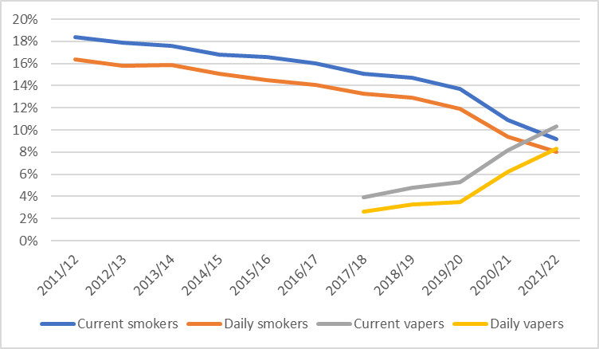
Note: current = at least monthly (includes daily)

Vaping rates are highest in young people aged 18–24. Vaping rates in this age group have increased rapidly over the last 2 survey years, with increases greatly exceeding declines in smoking (Figure 2). The prevalence of vaping in this age group began to exceed the prevalence of smoking in about 2019/20.
Figure 2: Smoking and vaping in people aged 18–24, 2011/12 to 2021/22
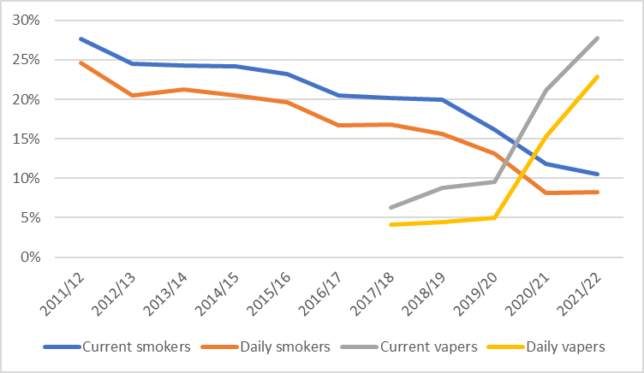
Note: current = at least monthly (includes daily)

Trends in daily vaping
This report focuses on daily vaping because it is more likely to reflect addiction than current vaping, which includes non-daily vaping (that is, weekly or monthly). In the most recent (2021/22) New Zealand Health Survey, 1 in 12 people (8.3%) aged 15 or older were daily vapers (equivalent to 346,000 people). This is a large increase since 2019/20, when about 1 in 30 people (3.5%) were daily vapers (144,000 people).

Table 1: Daily vaping in people aged 15 or older, 2017/18 to 2021/22
Survey year | Prevalence (95% CI) | Estimated number (95% CI)
2017/18 | 2.6% (2.3–3.0%) | 103,000 (91,000–116,000)
2018/19 | 3.3% (2.9–3.6%) | 131,000 (116,000–145,000)
2019/20 | 3.5% (3.0–4.1%) | 144,000 (124,000–164,000)
2020/21 | 6.2% (5.5–7.0%) | 258,000 (228,000–289,000)
2021/22 | 8.3% (7.1–9.7%) | 346,000 (295,000–397,000)

As shown in Figure 3, the prevalence of vaping has increased in all age groups, with the largest absolute increase in those aged 18–24 (from 5.0% in 2019/20 to 22.9% in 2021/22). Note that size of the age groups varies so the prevalence does not reflect the estimated number of daily vapers in each age group. For example, daily vapers aged 18–24 accounted for 30% of all daily vapers in 2021/22, whereas daily vapers aged 15–17 accounted for 4%.
Figure 3: Daily vaping in people aged 15 or older, by age group, 2017/18 to 2021/22
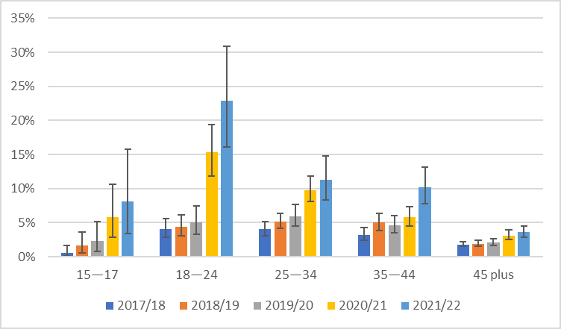
Note: RSE over 30% for those aged 15–17 (all years except 2020/21)

Smoking status of daily vapers
The main purpose of this report is to look at the smoking status of daily vapers. Daily vapers were assigned to one of the following smoking status groups.
- Current smokers – people who have smoked more than 100 cigarettes in their lifetime and now smoke at least monthly. This group is predominantly made up of daily smokers, but also includes some people who smoke less often (weekly or monthly).
- Ex-smokers – people who have smoked more than 100 cigarettes in their lifetime and stopped smoking more than one month ago.
- Never-smokers – people who have never tried smoking (not even a puff) or tried smoking but smoked fewer than 100 cigarettes in their lifetime.
- Others – people who have smoked more than 100 cigarettes in their lifetime but smoke less than monthly (so are not considered current smokers), and people who quit smoking in the last month (so are not considered ex-smokers due to their risk of relapse). This is a small group, so results are not shown in tables and graphs.

Smoking status of daily vapers – trends
Figure 4 shows trends in daily vaping by smoking status. The percentage of people aged 15 and older who were both a daily vaper and current smoker (that is, a dual user) was relatively stable across years. The percentage of people who were a daily vaper and an ex-smoker increased steadily, from 0.9% in 2017/18 to 4.7% in 2021/22. The percentage of people who were a daily vaper and a never-smoker was very low (0.2–0.3%) up until 2019/20, but then increased to 1.5% in 2021/22 (63,000 people).

Figure 4: Daily vaping in people aged 15 and older, by smoking status, 2017/18 to 2021/22
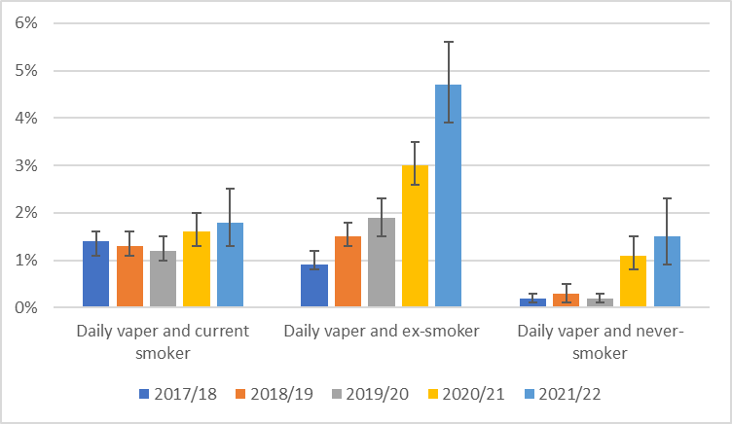

Figure 5 shows the same data, but as a stacked bar chart. This is useful to show overall trends in daily vaping by smoking status, but take into account the 95% confidence intervals in the previous graph when interpreting results.

Figure 5: Daily vaping in people aged 15 and older, by smoking status, 2017/18 to 2021/22
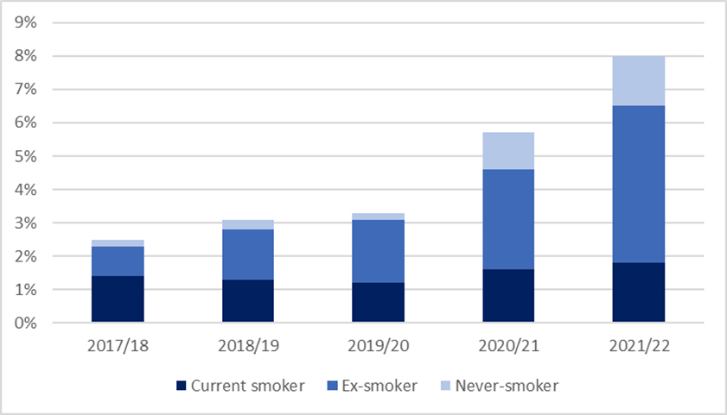
Note: excludes the Other smoking group, so percentages do not sum to daily vaping estimates published in the Annual Data Explorer 2021/22 (Ministry of Health 2022a)

The majority of daily vapers are either ex-smokers or current smokers, although the mix has changed over time. In 2017/18 there was an estimated 103,000 daily vapers. Of these, 52% were current smokers, 36% were ex-smokers and 7% were never-smokers. In 2021/22, there was an estimated 346,000 daily vapers. Of these, 56% were ex-smokers, 22% were current smokers, and 18% were never-smokers.

Smoking status of daily vapers by age group
The sample size was not sufficient to provide annual estimates of daily vaping by smoking status and age group. Therefore, data from the most recent 2 survey years (2020/21 and 2021/22) was pooled to boost the sample size and provide a more reliable estimate. However, even with pooled data some age and/or smoking status groups have wide 95% confidence intervals.

The percentage of people who were both a daily vaper and current smoker (that is, a dual user) was highest in those aged 18–24, followed by 25–34. The percentage of people who were a daily vaper and an ex-smoker was highest in those aged 18–44. The percentage of people who were a daily vaper and a never-smoker was highest in those aged 18–24, followed by 15–17. People aged under 25 years accounted for three-quarters of all daily vapers who had never smoked.

Table 2: Daily vaping in people aged 15 and older, by smoking status and age group, pooled data for 2020/21 and 2021/22
 | 15–17 | 18–24 | 25–34 | 35–44 | 45+ | All 15+
Daily vaper | 6.9%  (4.0-11.1%) | 19.1%  (15.0-23.8%) | 10.6%  (8.8-12.5%) | 8.0%  (6.6-9.7%) | 3.4%  (2.8-3.9%) | 7.3%  (6.6-8.0%)
Daily vaper and current smoker | 0.4%  (0.0-1.5%)† | 4.0%  (2.5-6.1%) | 2.9%  (2.1-4.0%) | 1.6%  (1.1-2.3%) | 1.0%  (0.7-1.3%) | 1.7%  (1.4-2.0%)
Daily vaper and  ex-smoker | 1.2%  (0.3-3.1%)† | 6.3%  (4.1-9.1%) | 6.2%  (4.8-7.8%) | 6.0%  (4.6-7.6%) | 2.1%  (1.7-2.6%) | 3.9%  (3.4-4.4%)
Daily vaper and  never-smoker | 5.3%  (2.5-9.6%) | 7.0%  (4.3-10.6%) | 1.0%  (0.5-1.6%) | 0.3%  (0.1-0.6%)† | 0.1%  (0.0-0.4%)† | 1.3%  (1.0-1.7%)
Note: excludes the Other smoking group, so the subcategories may not sum to daily vapers
† RSE over 30%.

Figure 6 shows the same data, but as a stacked bar graph. This is useful to show patterns by age group, but take into account the 95% confidence intervals and quality flags († interpret with caution) in the previous table when interpreting results in this graph.

Figure 6: Daily vaping in people aged 15 and older, by smoking status and age group, pooled data for 2020/21 and 2021/22
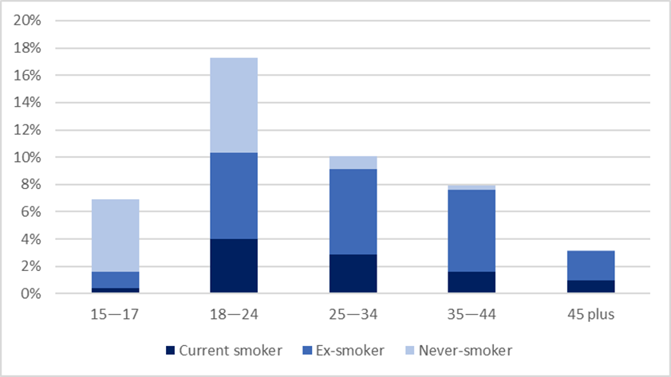
Notes: results for the Other smoking group are not shown; RSE over 30% for current and ex-smokers aged 15–17 years and never-smokers aged 35–44 and 45+

Among daily vapers aged 25 or older, nearly all were ex-smokers (64%) or current smokers (26%). Among daily vapers aged 18–24, just over half were either ex-smokers (33%) or current smokers (21%), 9% were in the other smoking group (people who smoke less than monthly or quit smoking in the past month), and 37% were never-smokers.

Results for the 15–17 age group have lower reliability and we recommend caution in interpretation. Based on pooled data from the last 2 survey years (2020/21 and 2021/22), about 1 in 14 people aged 15–17 (6.9%) were daily vapers. Of these, 76% were never-smokers, 18% were ex-smokers and 6% were current smokers (that is, dual users). This age group accounted for 4% of all daily vapers.

Smoking status of daily vapers by ethnic group
The sample size was not sufficient to provide reliable annual estimates of daily vaping by smoking status and ethnic group. Therefore, data from the most recent 2 survey years (2020/21 and 2021/22) was pooled to boost the sample size and provide a more reliable estimate. However, even with pooled data the 95% confidence intervals are wide for some smoking status and/or ethnic groups.

The percentage of people who were both a daily vaper and current smoker (that is, a dual user) was highest in Māori and Pacific peoples. The percentage of people who were a daily vaper and an ex-smoker was also highest in Māori and Pacific peoples. There was no significant difference by ethnic group in the percentage of people who were a daily vaper and a never-smoker.
Table 3: Daily vaping in people aged 15 and older, by smoking status and ethnic group (total response), pooled data for 2020/21 and 2021/22
 | Māori | Pacific | Asian | European/  Other | All
Daily vaper | 15.1%  (13.1-17.2%) | 12.7%  (9.0-17.2%) | 4.8%  (3.5-6.4%) | 7.0%  (6.3-7.8%) | 7.3%  (6.6-8.0%)
Daily vaper and current smoker | 4.3%  (3.1-5.8%) | 4.5%  (2.4-7.7%) | 0.7%  (0.3-1.4%)† | 1.6%  (1.3-2.0%) | 1.7%  (1.4-2.0%)
Daily vaper and  ex-smoker | 7.7%  (6.2-9.4%) | 6.1%  (3.2-10.4%) | 2.6%  (1.7-3.6%) | 3.7%  (3.1-4.3%) | 3.9%  (3.4-4.4%)
Daily vaper and  never-smoker | 2.4%  (1.5-3.5%) | 1.5%  (0.8-2.7%)† | 1.3%  (0.5-2.9%)† | 1.3%  (0.9-1.8%) | 1.3%  (1.0-1.7%)
Note: excludes the Other smoking group, so the subcategories may not sum to daily vapers
† RSE over 30%.

Figure 7 shows the same data, but as a stacked bar graph. Take into account the 95% confidence intervals in the previous table when interpreting results in this graph.

Figure 7: Daily vaping in people aged 15 and older, by smoking status and ethnic group (total response), pooled data for 2020/21 and 2021/22
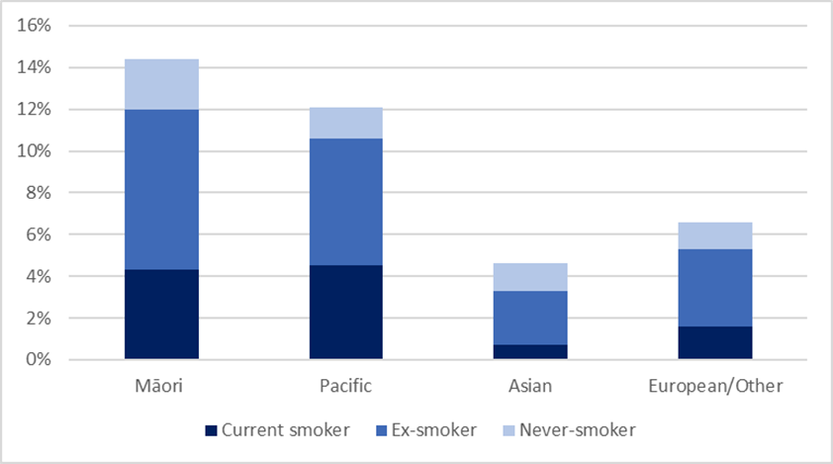
Notes: results for the Other smoking group are not shown; RSE over 30% for Asian smokers and never-smokers

In all ethnic groups, about half of daily vapers were ex-smokers. The proportion of daily vapers who were also current smokers (that is, dual users) was: Māori (28%), Pacific (35%), Asian (14%), European/Other (23%). The proportion of daily vapers who were never-smokers was: Māori (16%), Pacific (12%), Asian (28%) and European/Other (18%).

Methods

Data source
The data in this report was collected as part of the New Zealand Health Survey, which is a population-based survey commissioned by the Ministry of Health. The survey is an annual, nationally representative, household survey of the 'usually resident' population of all ages living in private dwellings, aged-care facilities and student accommodation (99% of the eligible population). The survey includes different content for adults (15+ years) and children (0–14 years). For more information about the survey see the latest Methodology Report (Ministry of Health 2022b).

The New Zealand Health Survey has been measuring the prevalence of smoking in people aged 15 or older annually since 2011/12. Questions on vaping were first asked in 2015/16 as part of a tobacco use module and these questions were introduced into the annual survey in 2017/18. See the latest Questionnaires and Content Guide for the questions on vaping and smoking (Ministry of Health 2022c).

Sample size
Table 4 shows the data collection period, sample size and response rate for the last 5 survey years (since vaping was part of the annual survey). Data collection generally occurs from July to June, but there is always a period of ‘mop-up’ so there is some overlap between data collection periods.

Table 4: Data collection period, sample size and response rate, 2017/18 to 2021/22
Survey year | Data collection period | Sample size | Response rate
2017/18 | July 2017 to October 2018 | 13,869 | 80%
2018/19 | July 2018 to August 2019 | 13,752 | 80%
2019/20 | July 2019 to March 2020 | 9,699 | 75%
2020/21 | September 2020 to August 2021 | 9,709 | 77%
2021/22 | July 2021 to July 2022 | 4,434 | 56%

Impact of COVID-19
COVID-19 impacted on surveys from 2019/20 onwards. The main disruptions to data collection are summarised below, with more information available in the methodology report for each survey year.
- 2019/20 – data was collected from July 2019 to March 2020, then stopped just before the first national lockdown.
- 2020/21 – data collection started slightly late but continued for 12 months (from September 2020 to August 2021). Data collection was paused at times due to regional outbreaks.
- 2021/22 – data was collected from July 2021 to July 2022, but paused at times due to national or regional lockdowns. Data collection was slower than usual due to workforce issues. About one-third of surveys were conducted by virtual interview (see below for more information).

Disruptions to data collection resulted in smaller sample sizes for the last 3 survey years, especially for 2021/22 (see Table 4). The main impact of smaller sample sizes is increased sampling errors associated with estimates. Sampling errors are used to calculate the 95% confidence intervals, meaning these are wider than usual. Wider 95% confidence intervals indicate lower quality data, and differences over time and between groups have to be larger to reach statistical significance.

COVID-19 disruptions also affected response rates, with slight declines in 2019/20 and 2020/21. The response rate for 2021/22 was much lower than in pre-COVID years, but is still relatively high by international standards. Also, the survey weights largely adjust for differences in coverage and non-response.

The survey is usually conducted as a face-to-face interview in the respondent’s home. However, in 2021/22 about one-third of interviews (33% of adult and 35% of child) were completed by video due to COVID-19 restrictions. The video interview replicated the in-person interview as much as possible and is of high quality in the context of the COVID-19 pandemic. Most other countries suspended data collection or conducted their surveys by telephone interview or online.
The move to video interviews was a rapid response to COVID-19 restrictions and could not be tested in advance. To investigate possible mode effects, we compared results for key indicators by interview type (face-to-face or video). For most indicators, there was no difference between the 2 survey types. If there was a difference, it was not substantial in comparison to the sampling errors for the indicator.

Analysis

Survey weights
Survey weights were used in all analyses so that estimates are representative of the usually resident adult population of New Zealand. The survey weights account for the unequal probability of selection (eg, oversampling of some population groups) and differential non-response.

Ethnicity
Survey respondents were asked which ethnic group or groups they identify with. This analysis uses the total response classification of ethnicity. This means that people who reported more than one ethnic group are counted once in each group they reported. Results are output for the following 4 ethnic groups: Māori, Pacific, Asian and European/Other.

Reliability of results
All survey estimates have a margin of error. We use 95% confidence intervals to indicate the uncertainty in an estimate due to collecting data from only a sample of the population. Take care when interpreting estimates with wide confidence intervals. Wider confidence intervals indicate less precise estimates due to smaller numbers in a sample and/or higher variation within a sample.

We also use the relative standard error (RSE) to indicate data quality. The RSE is a measure of the size of the standard error relative to the estimate. If the RSE is over 30%, estimates are flagged in tables and graphs to recommend caution when interpreting these estimates.

Statistical significance
When 95% confidence intervals do not overlap, it means the difference over time or between groups is statistically significant. In this report, all differences reported in the text are statistically significant unless otherwise stated.

Note that a key factor influencing tests for statistical significance is the sample size. This means that for smaller population subgroups (for example, young people aged 15–17, Pacific peoples) the difference needed for statistical significance is much larger than for other population subgroups and the population overall.

References
Global Burden of Disease Collaborative Network. 2023. Global Burden of Disease Study 2019 Results. Seattle, WA: Institute for Health Metrics and Evaluation. URL: vizhub.healthdata.org/gbd-compare/ (accessed 15 March 2023).
Ministry of Health. 2021. Smokefree Aotearoa 2025 Action Plan - Auahi Kore Aotearoa Mahere Rautaki 2025. URL: www.health.govt.nz/publication/smokefree-aotearoa-2025-action-plan-auahi-kore-aotearoa-mahere-rautaki-2025
Ministry of Health. 2022a. Annual Data Explorer 2021/22: New Zealand Health Survey [Data File]. URL: minhealthnz.shinyapps.io/nz-health-survey-2021-22-annual-data-explorer/
Ministry of Health. 2022b. Methodology Report 2021/22 New Zealand Health Survey. URL: www.health.govt.nz/publication/methodology-report-2021-22-new-zealand-health-survey
Ministry of Health. 2022c. Questionnaires and Content Guide 2021/22: New Zealand Health Survey. URL: www.health.govt.nz/publication/questionnaires-and-content-guide-2021-22-new-zealand-health-survey

