SMARTPHONE-BASED PROBLEM GAMBLING EVALUATION AND TECHNOLOGY TESTING INITIATIVE (‘SPGETTI’) FEASIBILITY STUDY

FINAL REPORT

March 2016

Prepared for: Prepared by:
The New Zealand Ministry of Health Professor Chris Bullen
National Institute for Health Innovation (NIHI)
& Centre for Addiction Research (CFAR)
Faculty of Medical and Health

Acknowledgments:
The authors wish to thank the problem gambling practitioners and clients who participated in the focus groups. Without their generosity this project would not have been possible. We also thank the Ministry of Health (Minimising Gambling Team, Mental Health Service Improvement, Sector Capability and Implementation) at the New Zealand Ministry of Health who commissioned this work.

Contact details:
Professor Chris Bullen, Director, National Institute for Health Innovation (NIHI)
School of Population Health, Faculty of Medical and Health Sciences
University of Auckland
Private Bag 92019, Auckland, New Zealand
Phone: +64 9 3737 599 Email: c.bullen@auckland.ac.nz

Ministry of Health Disclaimer:
This report was prepared under contract to the New Zealand Ministry of Health. The copyright in this article is owned by the Crown and administered by the Ministry. The views of the authors do not necessarily represent the views or policy of the New Zealand Ministry of Health. The Ministry makes no warranty, express or implied, nor assumes any liability of responsibility for use of or reliance on the contents of this report.

Suggested citation:
Bullen C, Rossen F, Newcombe D, Whittaker R, Strydom J (2015). Smartphone-based Problem Gambling Evaluation and Technology Testing Initiative (‘SPGETTI’) Feasibility Study: Final Report. National Institute for Health Innovation & Centre for Addiction Research. Prepared for the Ministry of Health. Auckland, New Zealand: Auckland UniServices Limited, The University of Auckland.

Permissions:
Reports from Auckland UniServices Limited should only be used for the purposes for which they were commissioned. If it is proposed to use a report prepared by Auckland UniServices Limited for a different purpose or in a different context from that intended at the time of commissioning the work, then UniServices should be consulted to verify whether the report is being correctly interpreted. In particular it is requested that, where quoted, conclusions given in UniServices reports should be stated in full.

CONTENTS
EXECUTIVE SUMMARY ii
LAY SUMMARY iv
INTRODUCTION & BACKGROUND 1
PHASE ONE: Technical Assessment and Field Studies 6
1.1 Aims and Objectives 6
1.2 Methods 6
1.3 Results 7
PHASE TWO: Focus Group DISCUSSIOns 9
1.4 Aims and Objectives 9
1.5 Methods 9
1.6 Ethics 12
1.7 Results 12
DISCUSSION 61
1.8 Issues for consideration for future problem gambling research 63
1.9 Strengths and limitations 64
Conclusions 65
REFERENCES 66
APPENDICES 68
Appendix A Participant Information Sheets and Consent Forms 69
Appendix B Semi-structured interview schedule 78
Appendix C Mobile-phone Screenshots 82

EXECUTIVE SUMMARY
This report presents results from the SPGETTI (Smartphone-based Problem Gambling Evaluation and Technology Testing Initiative) study. The aim of the study was to test the feasibility of a smartphone application that supports people with a gambling problem who are seeing counsellors and accessing services to receive ‘just in time’ and ‘at the right place’ support, specifically to avoid relapse and remain abstinent from harmful gambling on Electronic Gambling Machines (EGMs or more colloquially, ‘pokies’). Key research questions we sought to address in this project were:
- What is the technical feasibility of a smartphone-based intervention for reducing problem gambling harm?
- How acceptable will such an intervention be to people with problem gambling?
Methods
This study consisted of two phases. The first phase was a technical assessment of the reliability, coverage and use of different mobile phone operating systems. We also piloted the application in the field. The second phase involved assessing end-user interest and acceptability, through focus group discussions with problem gambling practitioners and individuals with experience of problem gambling (recruited through our partner organisations in the problem gambling sector).
Results
Technical assessment - The basic system we prototyped was reliable and sufficiently accurate to be considered, with further refinement, as a potentially useful intervention. Focus groups – Our analysis of participant responses indicates that in the main the concept of a support tool readily available and using technology was supported by both problem gambling practitioners and consumers from all priority population groups (specifically Māori and people of Pacific and Asian ethnic groups). Some concerns were noted that would need to be addressed in any further refinement of this idea. These included privacy, confidentiality and ownership of data; and, the hypothetical potential to trigger gambling in some situations. Ideas for additional features and future development from the focus groups were ‘alerts’ for host responsibility and/or security at a gambling venue; and blocking access to bank accounts and/or credit cards. An issue related to the conduct of the research project was the difficulty experienced in recruiting sufficient numbers of participants in all the focus groups.
Conclusions
We conclude from this small feasibility study that the use of a smartphone-based app with location-tracking capability is both technically feasible and broadly acceptable in principle to a range of people with significant gambling problems, including those in priority population groups (Māori, Pacific and Asian peoples). On this basis we consider that a second stage of development is needed, to incorporate the key learning from this study, including refinement of content and intensive testing with end-users through an interactive approach to development; leading to a trial of its efficacy as a support tool.

LAY SUMMARY
Smartphones are widely used and may help support people with a gambling problem and who are trying to get on top of their problem to avoid places with pokie machines and to handle urges to gamble in ways that are harmful to them and their Whanau.
We developed and tested a new smartphone app that could be used in this way. We also asked groups of people who have been getting help or counselling people from problem gambling helping organisations about what they thought of the idea.
We found most people, especially people who have a gambling problem, supported the idea –they thought it would be good as it can reach people wherever they are and just in time if they are feeling tempted to gamble again. But they thought it would be best if used as an add-on to counselling support rather than just stand alone. Some people had concerns about privacy, that it could be turned off if people really wanted to, or that many people who have a problem with gambling can’t afford a smartphone or the dataplan that is needed to make it work. But overall, we found most people in all major New Zealand ethnic groups thought it was a good idea to develop and test further.

INTRODUCTION & BACKGROUND
Problem gambling is characterized by persistent and recurrent maladaptive gambling behaviour (American Psychiatric Association, 2003). It is common, with a lifetime prevalence of 1% to 2% (Shaffer & Hall, 2001) and is associated with significant morbidity (Crockford & el-Guebaly, 1998; Potenza, Kosten, & Rounsaville, 2001).
In New Zealand problem gambling is a significant public health issue. The prevalence of problem gambling and changes in prevalence over time in New Zealand have been difficult to estimate because the available studies differ in regard to screening instruments, methodology, response rate and sample size. The most robust recent data come from the New Zealand National Gambling Study, that estimated that in 2012 0.7% of adults in New Zealand (approximately 24,000 people) were current problem gamblers and a further 1.8% (60,000 people) were moderate-risk gamblers as defined by he Problem Gambling Severity Index (PGSI).(Abbott et al., 2014). The 2010, 2012 and 2014 Health and Lifestyle Surveys have found broadly similar results (Ministry of Health, 2014).
Problem gambling is associated with widespread negative economic, social and health effects (e.g. Abbott & Volberg, 2000; Abbott & Volberg, 1991; Ministry of Health, 2009). In particular, problem gambling has been associated with financial hardship, bankruptcy, crime and incarceration, anxiety and depression, suicidality, substance use/abuse, disruption to employment/study, breakdown of family units, child neglect, and disruption to the family and community of which the problem gambler is a member (Abbott et al., 2012; Brown & Raeburn, 2001; Productivity Commission, 1999, 2010; Rankine & Haign, 2003; Sobrun-Maharaj, Rossen, & Wong, 2012; Welte, Barnes, Wieczorek, Tidwell, & Parker, 2004). The National Gambling Study estimated that gambling had caused stress or anxiety for 1.4% of all adults at least sometimes in the year before the study but in problem gamblers the corresponding figure was 85.3%(Abbott et al, 2014).
The ripple effects to others have also been estimated: the 2011/12 NZ Health Survey estimated 3% of adults were affected by ‘someone else’s gambling’ (Ministry of Health, 2014). In the 2006/07 NZ Health Survey 53% of the adults who reported experiencing problems due to someone’s gambling reported that EGMs were at least one of the forms of gambling involved, and 33% named casino machines (Ministry of Health, 2010).
There are marked ethnic differences in problem gambling harm: Māori and Pacific peoples are more likely to suffer gambling harm from their own gambling or someone else’s than people in other ethnic groups: in the 2006/07 NZ Health Survey Māori had over five times the risk of being a problem gambler compared to people who were not of Māori or Pacific ethnicity after controlling for cofounders. (Ministry of Health,2010). Approximately 1 in 16 Māori and Pacific males and 1 in 24 Māori and Pacific females were either moderate-risk or problem gamblers. There is substantial evidence that Māori and Pacific people, and those who live in neighbourhoods with higher levels of deprivation are disproportionately affected by problem gambling (Abbott et al., 2012; Abbott & Volberg, 2000; Abbott & Volberg, 1991; Ministry of Health, 2009; Rossen, Tse, & Vaidya, 2009). There appear to be high risks of gambling harm among Asian peoples but this varies significantly by specific Asian population group and gender. Asian males (like Māori and Pacific males) are far more likely to be moderate-risk gamblers or problem gamblers than European/Other males.
Electronic Gambling Machines (EGMs) are the activity most frequently associated with problem gambling and gambling related harm (Abbott & Volberg, 2000; Abbott & Volberg, 1991; Ministry of Health, 2008, 2009, 2014).
In the field of addiction, the chief therapeutic goal is abstinence. However, maintaining abstinence is difficult, in part due to exposure to cues that trigger relapse. Research in Europe found around one third of people with problem gambling relapsed within a few months of intervention (Echeburúa, Fernández-Montalvo, & Báez, 2000). Abnormal cue reactivity is a central feature of all addictions, including problem gambling, and is associated with increased activity in motivation to engage in the behaviour. In people with problem gambling, direct presentation of gambling cues has been found to trigger gambling activity in around half (Grant & Kim, 2001), with men reporting a greater likelihood to gamble secondary to gambling sensory stimuli (billboards, advertisements, sights, sounds, hearing people talk about gambling) and women more often reporting emotional cues (Grant & Kim, 2001). Identifying cues and triggers for gambling is therefore an essential aspect of relapse prevention in the treatment of problem gambling (Ladouceur et al., 2003; Tavares, Zilberman, & el-Guebaly, 2005).
The advent of the personal smartphone has created unprecedented opportunities to intervene in this situation. With their large number of built-in sensors, smartphones can record quality data without need for additional devices. Smartphones have enabled the integration of geospatial information - data on a person’s location that can be linked to information about the surrounding contextual environment (such as the location of pokie machines) – with SMS or app-based interventions that may have potential to assist people with a problem gambling disorder and who are seeking help from services to resist cue-induced relapse ‘just in time’ and ‘in the right place’.
Smartphones can be programmed to collect data on their position (latitude and longitude) via their internal Global Positioning System (GPS) chip, and to identify if in proximity to a predefined location, such as gambling machines. Being able to utilize location services using mobile apps to locate a device to a building-specific level is good, but may not be good enough. Wi-Fi network access points can be used to create virtual “fingerprints” from radio signals found inside buildings and machine learning techniques used to detect the location of a user within a building. The phone’s magnetometer can be used to determine the direction the device is facing, the accelerometer can be used to detect whether the person holding the device is walking and Bluetooth can be used to help determine the device’s location. Together, recent research has found the ability to detect location of free-living individuals using smartphones to have around 90% accuracy (Trinh & Gatica-Perez, 2014).
Regularly updated data on New Zealand gambling machine location addresses are obtainable from the Department of Internal Affairs website. These addresses can be geo-coded. Geospatial software such as ArcGIS Network AnalystTM can then be used to help the processing of the spatial data and calculation of a distance between the person with a smart phone and a gambling machine.
According to a survey conducted in January/February 2014, 59% of New Zealanders currently own a smartphone (Research New Zealand, 2014). Ownership levels are expected to grow strongly reaching 90% penetration in 2018. Mobile devices have transitioned from being used primarily for voice and text to more sophisticated multi-functional usage based on their mobile media capabilities. The NZMDU survey found that 44% of New Zealand smartphone users mainly use them to regularly engage with mobile media, 61% to access social networking via an app or via an internet site at least once a month while other activities becoming more common include job search (36% at least once in every six months), house buying (29%) and car purchase (29%). As smartphone functionality improves it is predicted they will shortly become the preferred device over laptops/PC’s and tablets. (Research New Zealand, 2014).
Smartphone ownership was substantially more common among Māori and Pacific people (70%) than Europeans (55%) and Māori and Pacific users were more likely to use them more often than a year ago (59%) compared to Europeans (46%) (Research New Zealand, 2014). As tools for intervention they appear to cross cultural divides: in our own research we found the use of a mobile intervention programme for smoking cessation based on SMS messages was as effective for Māori as for non-Maori (Bramley et al, 2005).
The use of smartphones for problem gambling interventions is not unique. The Problem Gambling Institute of Ontario (PGIO) developed the Mobile Monitor Your Gambling & Urges (MYGU) app (http://www.problemgambling.ca/gambling-help/mygu-getmobile/). The app promotes self-awareness of gambling behaviours; ie., it gathers information about gambling behaviours and reports back to the gambler the date and time they experienced an urge to gamble, triggers for urges to gamble, activities they do instead of gambling, wins and losses when they gambled, feelings and consequences if they gambled or didn’t gamble. The app also complements counselling sessions and provides information to therapists. iPromises is an iPhone addiction recovery app (http://ipromises.org/) with trigger alerts, a visual journal, and a directory of phone numbers for support anywhere in the US, Canada, and some international offices. Users can add friends and share meetings, track progress and challenges, and get a daily positive message. It also enables them to track any setbacks, issues or achievements. To date, approximately 5,000 people have downloaded this app. Cost2Play, is an app that helps people to understand the long-term costs involved in popular casino games: slots, blackjack and roulette. It calculates all losses, to highlight that even small individual losses can add up.
These apps have limited use in New Zealand’s unique sociocultural setting but they do provide helpful points of reference for our proposed intervention.
Our research uses as a starting point existing models of intervention for relapse prevention, then adds a level of sophistication with real-time targeting and personalisation that has not yet been investigated in the gambling addictions field.
Our approach is innovative in that it harnesses widely available and affordable smartphone technology used in everyday social and commercial transactions as a vehicle for ‘smart’ theoretically-based, targeted personalised interventions that interact in a contemporaneous way (“just in time”) with the environment, to support the counselling from service providers and change potentially harmful gambling behaviour.
There are challenges with this technology: the geo-location capture period must be long enough to acquire the information via satellites; direct line of sight to the sky is ideal, but if indoors some smartphone chips can improve signal accuracy by integrating the limited GPS data with cell phone triangulation and orbital data to map satellite locations. External Wi-Fi triangulation may provide additional position information, as can cellphone accelerometer data. Studies have shown a more than 90% accuracy within 20m of a known point (Trinh & Gatica-Perez, 2014). On a practical note, smartphones can only record data continuously if efficient systems for battery consumption are put in place.

PHASE ONE: Technical Assessment and Field Studies

Aims and Objectives
This part of the study involved developing and testing the technical feasibility of the proposed smartphone-based EGM relapse prevention intervention. Specifically, we sought to develop and test systems that would be feasible to operate from standard smartphones utilising their in-built geolocation attributes and other functions (e.g. alerts, SMS messaging to people with problem gambling and their counsellors).

Methods
The smartphone application makes use of GPS coordinates in order to detect a person’s location. The coordinates are then compared to a database of predefined locations of gambling industry venues. The mobile application sends the GPS data to a server via an Application Programming Interface (API). The server holds the location data in a database and uses an algorithm to decide whether a message should be sent to a person. The algorithm includes factors like accuracy of the GPS reading, the distance from the location, the speed at which the person moves and the amount of time the person is spending in alert area. Messages are delivered as smartphone notifications instead of SMS.
Figure 1: Diagrammatic overview of prototype application development
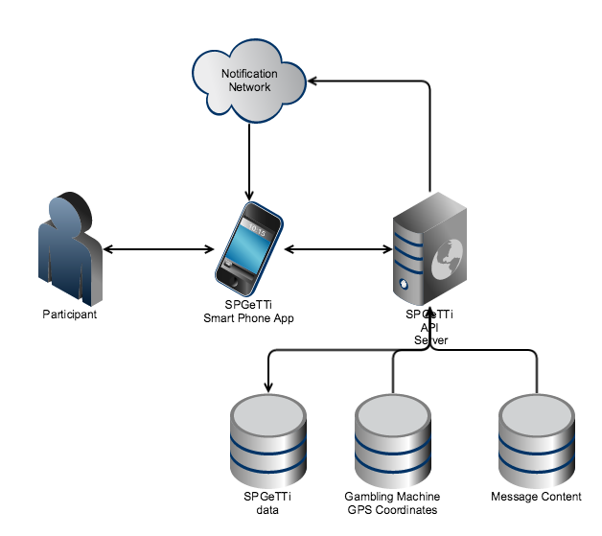

We field tested the prototype app using hybrid technology that allows application to other operating systems (such as Windows mobile) and others in future, loading it onto six Android and Apple (IOS) smartphones held by the participants (University staff members who volunteered). They reported back on their experience as they moved in and out of proximity to known gambling venues.

Results
All components of the architecture were successfully developed, including the mobile application, the API server and the database. The scope of the system was limited to geo-location functionality and messaging. Other content and functionality will be explored in future phases.
Accuracy: The accuracy of the GPS location is very dependent on the signal strength from satellites and whether the person’s phone is powered on or not. GPS coordinates from satellites can be accurate to within a couple of meters, whereas location information from cell-towers could be out by a few 100 meters. We noted that signal density and spatial accuracy is a real issue that needs to be taken into account in further developments of the app, for example in defining the ‘hot zone’ to accommodate variations in signal density.
Proximity: Instead of performing a distance calculation between every coordinate received and every pre-defined gambling venue, we generated boundary coordinates for gambling venues. This allows simple database lookups to be undertaken automatically to determine whether a person is within a certain range of a registered electronic gambling machine location. It also reduces the amount of processing and resources needed on the server.
Movement: We made use of the speed factor to prevent sending messages to people while they are moving, as it is unlikely that they are actively gambling and more likely that they are just moving past a known venue. The smart phone application sends location data, based on the speed at which the person moves. The faster a person moves the less frequent the application sends the GPS coordinates and vice-versa.
Duration: We made provision for the amount of time a person spends within a zone that contains gambling machines. For example, there are many places that offer more services than just gambling so we have had to consider what is a reasonable maximum duration spent at a particular venue before a message is triggered.
Refinement: We are constantly re-factoring the algorithm as we get more test results and feedback and will continue to do so in the future.

PHASE TWO: Focus Group DISCUSSIOns

Aims and Objectives
The main aim for this phase of the research was to elicit the acceptability and utility of a smartphone-based app to people with problem gambling from the priority population groups (Māori, Pacific and Asian). In the focus groups we sought to elicit participants’ views of possible components and actions that could occur when proximity to a gambling site is imminent with regard to appropriateness and potential effects. New ideas were sought and discussed, and issues such as timing, language and tone of messages and possible adverse effects of the intervention were also addressed.

Methods
A series of qualitative focus group discussions were conducted with problem gambling practitioners and individuals with experience of problem gambling (consumers). These groups aimed to explore the acceptability and utility amongst this population with regard to the potential for a smartphone-based ‘App’ to provide substantial support for those experiencing/addressing problem gambling.

    - Recruitment and Sample
Problem Gambling Practitioners: An invitation to participate in a focus group discussion for this project was extended to practitioners via the researchers networks with problem gambling treatment providers. Representation was sought across Māori, Pacific, Asian and Mainstream services with a balance of male and female also being obtained. To accommodate practitioners’ availability, two separate discussions were held; the first group consisted of six participants and the second group had a total of four participants.
Individuals with Experience of Problem Gambling (Consumers): Consumers were recruited through problem gambling treatment providers in Auckland. Information on the study (a flyer and the Participant Information Sheet) were displayed in reception areas and/or provided to clients by practitioners. Clients who were interested in participating were able to complete a short form indicating their interest and contact details. This form could be returned to reception, or the client could contact the research team directly.
In total, fifty-six people participated across eight focus group discussions: two with problem gambling practitioners; and, six with individuals with experience of problem gambling (consumers). A diverse range of participants was sought, with separate focus group discussions being held with Practitioners, and Māori, Pacific, Asian and European/Other consumers. Table 1 provides a summary of the ethnic composition of the focus groups. With regard to gender, in the Practitioner groups, 60% participants were female and 40% were male, whereas in the consumer groups 20% were female and 80% were male, a gender mix that is characteristic of people with problem gambling especially in Māori, Pacific and Asian population groups.

Table 1: Overview of focus group composition
Participant Type | Ethnicity | Number of Focus Groups | Number of Participants
Practitioner | Mixed | 2 | 10
Consumer | Māori | 1 | 8
 | Pacific | 1 | 12
 | Asian – Korean | 1 | 4
 | Asian – Chinese | 1 | 10
 | European / Other | 2 | 12
TOTAL |  | 8 | 56

Inclusion and Exclusion Criteria
Individuals were eligible for inclusion in the focus group discussions if they fulfilled the following criteria:
- Problem gambling practitioners:
  - Were currently working as a problem gambling practitioner.
- Individuals with experience of problem gambling (Consumers):
  - Were aged 18 years or older;
  - Were experienced moderate risk or problem gambling;
  - Were of Māori, Pacific, Asian or European/Other ethnicity;
  - Were willing and able to provide informed consent to participate in the study.
Individuals were excluded from the focus group discussions if they fulfilled any of the following criteria:
Individuals with experience of Problem Gambling (Consumers):
- There was evidence of severe psychiatric illness or cognitive impairment that would affect their ability to participate in the study;
- There was evidence that they were at immediate risk of causing harm to themselves or others.

    - Procedures
The focus group discussions were led by experienced facilitators who were ethnically matched with participants. Informed consent was gained from each participant (see Appendix A for copies of the Participant Information Sheets and Consent Forms). Each discussion was audio recorded, transcribed and translated into English by research assistants (where applicable), and supplemented with notes recorded during the interviews. At the conclusion of each group, participants were provided with a $20 supermarket voucher as an expression of gratitude for their participation.

    - Measures
Each focus group discussion was guided by a semi-structured interview schedule (see Appendix B) that was developed by the research team in accordance with the key aims and research questions. A series of mock smartphone screenshots (see Appendix C) were used in conjunction with the interview schedule to elicit discussion in relation to a number of scenarios.

    - Data Analysis
The transcribed qualitative data were analysed for key themes using the general inductive method (Thomas, 2003). This approach to thematic data analysis enables themes, clusters and categories to be identified.

In this project, patterns of views and experiences were formed through analysis of direct quotes, which were then used to form overall themes and a comprehensive picture of participants’ views and experiences. The research team sought to ensure methodological rigour by a ‘consistency check’ of the analysis: other members of the research team reviewed the data and, in line with the approach recommended by Patton, agreed on key themes by consensus (Patton, 1990).

Ethics
Ethical approval for this project was obtained on 22nd December 2014 through the expedited review pathway for the Central Health and Disability Ethics Committee (HDEC): ethics reference number 14/CEN/213.

Results
The following section presents results from the analysis of focus group discussions. Key themes have been outlined and when apparent, convergence or divergence between categories such as type of participant (problem gambling practitioner vs consumer) and different ethnicities have been noted. Participant quotes have been used to illustrate themes and categories.

Table 2. Key themes
Key themes | Comments
Use of pervasive mobile technology | Strong support for use of mobile phone technology from providers and consumers
Self-determination | Divergence between providers and consumers regarding automated messages to others: all focus groups considered these would be helpful; providers felt these would detract from consumers need to build self-determination
Personalisation/ customisation of messages | General support for personalised messages that were tailored for language, stage of recovery, likely risky times of day - but support for video messages from family members limited, especially if a poor relationship existed.
Consequences of relapse | Strong support for messages about potential for adverse consequences of relapse
Concerns | In common were: Privacy, confidentiality, and ownership of data; that the phone could be turned off, the hypothetical potential for the app to trigger gambling in some situations, the availability of smartphones and cost of mobile data by poorer people There was divergence between providers and some consumers in some areas: Asian consumers group felt messages about proximity of EGMs could act as triggers to relapse as did providers. Other groups were not so concerned.
    - Initial Response to the Concept
Most of the focus groups began with a general discussion on whether or not participants thought a mobile phone ‘App’ to help reduce or stop gambling could be useful, and if they thought people would be interested in using this type of ‘App’. While some people found it hard to confidently answer this question without knowing the parameters of such an ‘App’, an overall positive response was received by practitioners and participants in the European/Other focus group:
“…it is a useful app, it is good to have that app on a phone that our clients can have access to” (PFG1Part3)
“Well my view, yes, because I use them a lot and the family and friends I know of would use them as well…” (PFG1Part 1)
“Yeah, I think it could potentially be helpful. I mean just as another tool. So for me, when I was going through it, my partner says like, “Okay, go and see a counsellor.” And first of all I was like, “No, I don’t want to, I don’t need to see a counsellor.” And so maybe having something that you can do as a first step even, as well as a, oh I guess at any stage, but as a first step so you’re not, yeah, so just to get you in just to start you off maybe. Yeah, I think it could be a… Less intrusive…” (EurO1Part1)

Participants in the Korean and Chinese groups had somewhat mixed views. While they generally thought that an ‘App’ could be helpful, they also highlighted that the effectiveness of an App would depend on issues such as individuals being motivated to stop gambling and committed to using the ‘App’, and that the ‘App’ should be automated so that it was not reliant on an individual activating it:
“I also think it may work. We all carry our smart phones 24/7 and it’s always there. It could be loneliness that triggers someone to gamble yet there is no one around to talk him/her out of it. If the application can be that, to divert his/her mind every time from gambling…though I don’t really know how the application works…that will definitely help the person.” (KORPartM3)
“I am not really sure what exactly you have in mind about the application. But generally, people choose to use the app or not. When the options are given, the person who is willing to use it will go ahead but those who are not willing or not motivated would not use the application. In my opinion, having the option to decide, really doesn’t work at the end.” (KORPartM2)
“Many people will say that they want to stop gambling and download the App. After a while, they may delete the App when they relapse. They may repeatedly download and delete the App…” (ChiPart8)

Some participants in the practitioner and Chinese focus groups emphasised the importance of keeping up with technology, especially as many gambling industries have adopted use of smart-phone technologies. They felt that an ‘App’ to help prevent gambling problems would be an appropriate use of smart-phone technology:
“So yeah, because it is the way of the future, or, it’s just going to, need to go there somewhere along the lines. So yes, I believe that it will [be useful]… ” (PFG1Part 1)
“…some application to help problem gambling in their mobile phone will be really good, because the gambling industry push that area and so someone has to address in the same way kind of thing.” (PFG1Part 4)
“And that’s kind of the reverse of what’s happening already with, I think around Australia where the, where the people who, the people who provide the gambling, the bookies or whatever, can actually track people and their smartphones and say, “Hey you’re walking past our establishment, pop in for a gamble.” So it’s kind of, how far do you take that, I guess, yeah. Anyway.” (PFG2Part 1)
“…in reality, I think the app for gambling is developing faster than the app to prevent from problem gambling.” (ChiPart10)

    - Scenario Number One
The first scenario that was discussed with participants related to the message presented in Appendix C: “It looks like you’re at the casino. Would you like to contact ‘Bob’ and get some support?” Actions/responses included ’Call’, ‘Send Message’, ‘Email’, and ‘Cancel’.
Overall, participants in the practitioner, Korean, Pacific and European/Other focus groups were positive about this type of message. People tended to think that this type of feature could assist with: facilitating access to support networks; assisting people to pause/reflect on their choices to gamble - a chance to think about the consequences rather than automatically follow the urge to gamble; reminding individuals that the ‘App’ is there and can help in this type of situation. For example:
“Yeah, I actually like it, because we had a group session yesterday and we were talking about a support group and sharing one another’s numbers. And if somebody happened to go into a pokie venue, if they could text Bob or someone, and then Bob would text them back and say, “Do you need, do you want to have a coffee with me or something,” or like something like that. Yeah, so that’s awesome, I think it would be great.” (PFG1Part2)
“Yeah, I think it will be a good idea too. It will just give a client another second thought whether they’re going in or not, yeah.” (PFG1Part5)
“There is a saying that ‘casinos are the worst form of organised gangs’. It just forces people to be there even though there is no physical threatening whatsoever…. If there is some kind of reminder that makes you realise ‘You’re in it again’, that may be helpful.” (KORPartM3)
“Yeah, I thought also that if something pops up, it automatically puts something in your brain that you’re in a place where you shouldn’t be, so you’re starting to think, whether you throw the phone away or whether you answer it or whether you cancel it, is up to you, but at least if something popped up which will trigger whatever in your head… I think this is going to make you aware… Other than somebody tapping them on the shoulder, that’s the next best thing, I think.” (EurO2Part4)
“I think it’s a good idea.” (PacificPart7)

Some members of the practitioner focus group and all members of the Chinese focus group were concerned about the potential for this type of message to act as a trigger for gambling and/or alert people to the location of a gambling venue. For instance:
“…the other side of the coin, that if this machine remind them too often, like at the moment I’m not on the urge, but now I’m approaching a pokie machine… So some way that the app should be, make them forget about excitement gambling, down the road gradually. But if it is to remind them too often… If they don’t think but they receive this text message, they think about that.” (PFG1Part 4)
“…there’s one particular community within South Auckland that has got fifteen pokie venues just on one lane. And so if it says, “You’re within ten feet of fifteen pokie venues,” that might not be so good for somebody that is really on the edge. They’ll be like, “Wow, there’s like fifteen pokie venues.”“ (PFG1Part2)
“There are pros and cons. If you are a gambler, when you are walking on a street, you may not know whether there is any gambling venue around there, this Application may help you to identify the nearest gambling venue.” (ChiPart5)
“I think one of the cons will be if I am a gambler, I may be near Sky City or another gambling venue where I am having my meal, I may not have the thought of gambling. With this App that sends the message of reminder, it may trigger my thought of gambling. It is just like when someone tries to discourage you by repeating telling you to smoking or drinking, in a prolonged period it will become like a reminder instead, it will become a negative effect.” (ChiPart8)
“I am just like anyone, it is easy to find a gambling venue in Auckland but it is hard to find a pokie bar in small town, I will find this App helping me to locate a pokie bar.” (ChiPart3)

Some members of the Chinese and European/Other focus groups expressed a preference for the message to be automated. They felt it would be more useful if the ‘App’ was able to automatically contact the designated support person and/or notify them that the individual was at a gambling venue:
“I think that it will be more effective if there is a function that has automatic dialling to a supporter instead of a reminder message when a gambler is near a gambling venue… Yes. If I have decided to stop gambling, I will decide who to put as third party reminder. As GPS does not need Wi-Fi, a text can be sent out to the third party and he can then give a call to me to ask whether I am near a gambling venue.” (ChiPart8)
“Needs to be sent to your wife or your partner or your counsellor and they can see, they can call you and go, “Hey, I know where you are, get home.” Or something like that. Because if it was just up to the person, when you’ve got the blinkers on, doesn’t matter sometimes… You’ve already got excited and about to gamble. It’s very hard to get unexcited and leave.” (EurO2Part2)
“I think it would be quite good if you could put in the message, I think the best thing would be for you to get a message and for it to go straight to someone who you designate as well. But I think it would be a good idea to actually put in the message where you are, because quite often when you go out for a beer, you’ll tell whoever, I don’t know, your partner or whatever, you’ll say, I’m going to wherever for a beer. And then they get a message saying that you’re there then that’s okay. “He’s at New World by the Lotto shop,” or something. Yeah, he’s gone to the supermarket. But if it comes up and says he’s at the casino…” (EurO2Part5)

Some members of the European/Other focus group suggested that the ‘cancel’ option should be removed as this made it too easy to ignore the message:
“I was just going to say, is that, yeah, I don’t know if it would be better or not if that cancel button is gone. I know you can just sort of turn your phone off too, but I just thought looking down and seeing that that’s just way too easy just to… you can just turn the phone off as well, but I just thought maybe if you eliminate that, just makes your task just a little bit more…” (EurO2Part9)

The European/Other focus group also thought that it would be important for the location feature of the ‘App’ to be accurate enough to distinguish between problematic (e.g. a casino gambling floor) and non-problematic locations/venues (e.g. a supermarket with a Lotto outlet).
“I mean sometimes like you might just be in a supermarket and it thinks you’re in the Lotto shop… you just got your shopping list out and then it’s like, “Contact blah, blah, ‘cause you’re in a Lotto shop.” And you’re like, “I’m just buying some potatoes.” (EurO1Part1)
“That’s the other thing you’d say that if it’s going to go off when you walk into a Lotto shop or something like that. Like you go into the supermarket and do your shopping or you’re walking down the street, I’ll go into the diary, I’ll get a can of Coke and a pie and next minute it goes off with, you know. Next minute, as you said, the partner sees the phone and you’ve got, God he’s got, been into five different places today, he’s been…” (EurO2Part3)

This also has implications for the customisation/personalisation of the ‘App’ with regard to each individual’s problem modes/activities:
“Well I think that the app should have options that you can, at the start as you register, for Lotto shops, just pokie venues, TAB, casino. If you’re at risk of all you’ll obviously have them all ticked. If you’re just a pokies, maybe, I mean that could be something just for… at the supermarket, Pac ‘n Save, because every shop, every supermarket can have a Lotto. So that should be an option maybe. ” (EurO2Part8)

While the Pacific group were supportive of a message like the one presented in this scenario, they suggested that the message could be improved by simplifying it and adopting/including elements of religion to educate and help people:
“It’s good but not good enough in my view… I use the example in the Bible. I’m a Christian, so I use it… I’m using his example, “Come home. Jane, come home?” And if Jane has the training in the Bible that to be honest and sincere whatever she does do the right thing, then if she doesn’t come she knows if I go home, it reminds her what her mother has been doing all her life, do the right thing, and though you don’t come home, you know what mum wants. “Jane, do the right thing.”” (PacificPart1)

A number of participants in the practitioners, Māori and European/Other focus groups thought that the timing of this message would be important. They felt it would be most beneficial if a message could be received when an urge was first identified (i.e. before entering or arriving at a gambling venue) or immediately upon entry to a venue.
“Yeah, I quite like that, that message is good, but I would like the message to come when they identify the urge, not when they’re in the casino” (PFG1Part3)
“Even when you walk inside the door… the smartphone can tell you ‘No. We’ve got poker machines in here. Keep out.’” (MāoriPart4)
“I mean I think if someone’s going to do it, they’re going to do it, but I also think… sometimes too is that, just that distraction, you sort of like go, “Oh shit, reality check.” But I just sort of think is it sort of too late sort of once they’re on the machine or whatever they’re doing, so it’s often that timeframe is, will be quite hard… five minutes and you walk in the door of the casino, I mean you’re already at the machine in five minutes and it’s already, you’re playing, you’re playing it out really.” (EurO2Part4)
“The problem is when you’re at that point your mind’s kind of made up and it doesn’t matter what. It almost needs, that message needs to go, be sent, when you get near a place for someone to call you.” (EurO2Part2)

Practitioners also suggested that delivery of messages could be tailored for times of high-risk (e.g. a day/time that has been identified as high-risk or a trigger).
“Something that’s automatically almost and even possibly something, ‘cause a lot of our people know, and I’m an ex-gambler myself, that there are certain triggers of certain time of the day, so sometimes that could also, like maybe they know twelve o’clock is a trigger for them. Twelve o’clock it just reminds them, “Oh just remember it’s twelve o’clock, but are you okay, be in contact with somebody,” or something like that.” (PFG1Part1)

    - Scenario Number Two
The second scenario that was presented to participants for discussion was
“Hey, it looks like you’re at the casino. Here’s a video message from your children / wife / husband / counsellor.”
Actions/responses included ‘View’ and ‘Cancel’ (as per the screenshot presented in Appendix C). Overall, practitioners, Māori, Korean, European/Other and Chinese participants thought that receiving a message from someone who was important to them could be a powerful and helpful feature which would help people to pause and reconsider their actions:
“Yeah, it depends, I suppose, depends on the person, but I think that would be an interesting, I think it would be definitely getting them to pause and if they get that, especially if they’ve been there longer, I would say that would be a better one.” (PFG1Part 1)
“…because they would know the severity of the gambling themselves, so they would be punching in like at this point of time, “Yeah, I’m going to select my children, my husband, and this person.” So it comes in those stages. So depending on how long it’s going to be there, the first stop is the children’s going to call first, then maybe husband, and the last one is the counsellor.” (PFG1Part 3)
“If I were addicted to gambling and it had become a habit, that means even if I want to stop gambling, I am at a casino without thinking. But if I get these messages, I think it will be a big help…Yes, I think this would work instantly to curb the urge to gamble, like a trigger? I think it will be a big help” (KORPartM1)
“It must be helpful and especially watching the children’s video message must be so powerful.” (KORPartM3)
“I think it is helpful, it is a good idea.” (ChiPart10)
“I think you have to have quite a range of messages, because personally I think that would work for a lot of people. In early recovery that certainly would’ve worked for me… Would’ve worked for me, no question about that.” (EurO2Part10)
“I think anything in this world today is going to help, to what it was twenty years ago. So any message, any phone message, any TV advert, any signs on the road, all sorts of things, is going to help to deter people doing what they’re doing, try to. ” (EurO2Part4)

The need for messages to be personal and remind the individual of the consequences of their gambling, particularly the impacts of gambling on family and children, was emphasised by some members of the Pacific and Māori focus groups:
“It would be more personal. Like, “Hey, we are hungry.” More it’s actually, “Hey, we are your children,” something like that. Or something like, “Hey, have you paid your power bill?” “Hey, have you…” Something is alerting, an alert, something go to your… Yeah, “Have you get, have you paid the mortgage, have you…” If this a dad say, and she kept reminding, “Have you paid the mortgage, have you paid our mortgage?” (PacificPart2)
“Someone who, that specific somebody that makes you think ‘oh my gosh, I can’t go there now’ I’ll just go home you know” (MāoriPart1)
“Yeah if it was my grandkids then actually delivered a message then yeah that would sort of, if it had them saying ‘Nana, stop spending money on the pokies’ that would, that would” (MāoriPart7)

One suggestion that emerged from the Māori, Korean, and European/Other groups was the removal of the ‘cancel’ button. As per the some of the comments in relation to the first scenario, participants thought that it would be more effective if any choice was removed as to whether or not they viewed the message:
“I think it would be better to delete the ‘cancel’ button. So that he or she must see the video.” (KORPartM1)
“The only reason I say that is because the message is giving me a choice. Don’t give us a choice… Yeah no choice about it, in such a way that you are given… ok let’s talk to XXX, but that’s amongst the gamblers I’ve seen, you don’t give them a choice. You state it, and they do it. There’s no choice about it… But if it was given in such a way, like where you’re not gonna get assaulted but you grin and you listen anyway, that would be nice, but that I would just go cancel cos it’s given me a choice and I’ve decided I’m just not gonna listen” (MāoriPart1)
“I think you’ve got to take the complication out of it. Like how you said you’ve got all your options [‘View’ and ‘Cancel’] and that, you should either choose, “No, I don’t want it.” Or if you choose, “Yes, I want it,” then, I think someone said before, it just comes up and starts, away it goes. So I think if you’re interested in it, and if it comes up it’s probably going to have more an effect than if you’re not interested in it and it asks you to play, you’re never going to say yes, sort of thing… It just vibrates in your phone or something and you take it from there and there it is. Whereas if you’re not interested in it then you’re probably never going to push view, if it asks you you’re never going to say yes…” (EurO2Part5)
“And if it did go to that, why have you got the cancel button? Why are you giving the gambler the choice?” (EurO2Part7)

While most participants were positive about this scenario (as outlined above), a number of reservations were also expressed. A few people in the European/Other group strongly felt that the effort of setting up a video message(s) would be prohibitive and put them off using the ‘App’:
“I mean it’s a lot of prep… Bit more of a commitment thing… I think as well I would be, I would be more off put, I think that’s too much. It’s like, the idea of an app, like more of like a small support, rather than, I think if I got a video, if I had to do video messages, like record them so they can go on the thing and stuff, I would just give up before that happened ‘cause I’d be like… Yeah, for you to even set up the app and it sort of seems like, once you’ve done all of that, then it’s a lot of time and stuff.” (EurO1Part2)
“For me, no. For me, that there, would discourage me from putting the app on my phone… Yep. That there takes a hell of a lot more time and it takes a hell of a lot more planning that some people wouldn’t buy into and some people just wouldn’t care about. So you’d get to that stage and they’re, “Fuck it, I’m not going to have it.” Oh, “Stuff it, I’m not going to…” (general laughter) You know what I mean? So for me, that there is adding a level of sophistication that, so what…” (EurO2Part7)

Some practitioners emphasised the need to consider the message content (e.g. supportive vs confrontational) and who the message is from, as family members can be a trigger for gambling – especially if the relationship is under strain. This was reinforced by the European/Other group who also suggested that messages from family could induce feelings of guilt and be a trigger for gambling – although they also thought that a message from family could be helpful when things are going well. For instance:
“Because I don’t want, I know that family member, already they have a really bad relationship may trigger, okay, [they will then] turn the machine [phone] completely off.” (PFG1Part 4)
“…where you’ve got a history of antagonism and threatening to leave and all of that kind of thing, I’m not sure that it would be appropriate in all cases… Sort of when you’re trying to work with people to deal with a gambling problem at the same time they’re trying to keep their family or their marriage together or their partnership, they, there’s often a lot of guilt and is it a good idea to kind of reinforce the guilt by having that sort of message from the family?... Having family support is great, but it’s not always the case. And so having the family kind of put a message on like that, I’d say yes but with some caution about it.” (PFG2Part 4)
“If you’re in a really bad space and to see that, you know the damage you’re doing to your family sort of stuff, on the back of the mind, because you’re just … showing you that, just make you more sad. ” (EurO2Part8)
“Yeah, I mean it all depends on what sort of day you’ve had as well. As you say, it could be the last thing that… The last straw, you’ve got to shift that and all of a sudden you’re going to have a beer and then put some money in and something like that comes up, as I say, it could be the last thing.” (EurO2Part3)
“Already feel guilty enough, it might make you go, “Oh God, that’s…”… But it might be a good idea if they’re not in that risky scene, like if you’re doing well and everything’s going fine, it’ll be like a little reminder message of why I’m doing what I’m doing. Could work down the line.“ (EurO1Part1)

Moreover, some members of the Chinese and European/Other groups felt that if someone wants to gamble, a message or notification from the ‘App’ would not be enough to stop them from gambling – there needs to be a strong level of commitment and self-determination on the individuals part with regard to stopping gambling:
“In my situation, if I have decided to go to casino, I will definitely go. To me, such App is not helpful. For instance, if I receive a call from my wife or friend, I will be annoyed by it. I may answer the call, switch off the mobile and continue to gamble. It will not have any effect on me.” (ChiPart2)
“Just like what I have mentioned earlier, it depends whether if you are addicted to gambling or wanted to control your own gambling behaviour. The most important factor is yourself. I believe that this App is useful, especially towards those who wants to self-control their behaviours. As I told you earlier, I have lost a great amount of money, but I do not want to leave, no matter who calls me it is not going to work, the same goes with using the App.” (ChiPart4)
“Yeah, I think, everything we’ve talked about so far, we talk about taking responsibility a lot here. So if you’re actually going to have it, decide you want to do something about it, so it’s going to happen. If you don’t want it then don’t have it, but if you do want to take responsibility then know if you go where you’re not meant to be then your wife is going to get a message, and be in the shit. (general laughter) So I think it’s quite a good deterrent if you do it that way. Just, yeah like no mucking around, just you’re there, you’ve done it, someone’s going to be told… Yeah. For me that would be quite a big deterrent.” (EurO2Part5)

    - Scenario Number Three
Participants were shown the following message
“Hey, it looks like XXX is at the casino. It would be great if you could call them on 021… and give them some support”.
Participants were asked for their views on a message like this being automatically sent to a designated support person if they had entered and remained in a gambling venue for more than 15 minutes (see Appendix C for the screenshot of this message). The Chinese, European/Other and Pacific groups thought that a message like this could be helpful as it would provide a distraction from or interrupt a gambling session. They also thought the knowledge that someone would be notified if they go gambling could act as a deterrent and prevent them from entering a gambling venue.
“I think this idea could work. I used to have severe gambling problems, no matter if its sports betting or going into Skycity. Now I am still engaged with these activities, and also playing pokie machines – but I still can control it… If I was being reminded, saying “I have played for 15 minutes, it’s almost time [to leave]” – it is okay. Following the idea you have presented means that I cannot go into that place anymore because when I enter I would receive a call… Hence I thought the initial idea is quite good.” (ChiPart4)
“That’s what it should do for mine. Straight off the bat, it’s going to happen… Just get it done, yeah. No mucking round… The consequences are still there and worse though aren’t they, even if you go gambling at two o’clock in the morning and you get a call from your mum at seven o’clock in the morning saying, “What the hell happened last night?” That’s going to be in your head next time you go in, at the thought. It doesn’t get around the fact that you can’t lie to her, can you, once it’s done it’s done.” (EurO2Part5)
“Embarrass people…” (PacificPart6)

Practitioners had a somewhat different view, overall they thought that while social support is important and useful, the automated nature of this message would not be helpful therapeutically, as it takes away control from the individual and places it with a third party. They felt it would be better if the message was self-driven and the individual was given an option/prompt to initiate contact with a support person themselves (as per Scenarios One and Two).
“I think that’s something, my position is that some, some way it should be initiated there by the gambler… Something like that, actually if someone, the gambler take action to protect himself and they got a respond from their supporters, that, they get more kind of confidence or that kind of thing. It’s not automatic kind of thing… One thing I really avoid if it’s possible, is that too much automated kind of thing eliminates the people’s engagement, human engagement or take a lead on their behaviour kind of thing.” (PFG1Part 4)

The role of self-determination and the need for an individual to be committed to addressing their gambling was also raised by some members of the practitioner, Korean and European/Other groups in response to this scenario:
“Yeah, it’s fraught with assumptions and it’s fraught with the idea that another person will influence them. And in my experience, when the person wants to do it, they do it. Yeah, it’s like, I don’t, I’m not sure that’s that helpful…Yeah, more self-control. In the end, another person isn’t actually going to influence them that much if they really want to do it.” (PFG2Part 4)
“Whether a person enters a casino or not is up to him/herself. I don’t think any other people’s opinion would affect the person, since he/she is the sole decision maker. This wouldn’t be much help.” (KORPartM3)
“If that happened to me [the contact person failed to call them], I could see myself using that as an excuse to gamble… I’m just saying I would use that as an excuse to gamble. It’s not a valid excuse. I mean it’s nothing to do with my mum [contact person]” (EurO2Part2)

Participants in the practitioner, Korean, European/Other groups also highlighted some concerns around how a situation like this could impact on inter-personal dynamics: privacy, the importance of choosing the ‘correct’ support person, potential for changes in the power dynamics of a relationship, and the potential for a support person to suffer significant burden. Some quotes that illustrate these issues include:
“To be honest, if I’m the person who got this message I feel very uncomfortable. It looks like somebody’s watching at me and every time have no privacy.” (PFG2Part 2)
“There’s, I just have questions around it, it could work, it could work but I’m having questions around even the person, the power of the people that are texting to the other, to the person who’s the client. It’s like, “Well hey, you’re in the casino,” how would you text that person? It kind of, yeah, and how that all, the dynamics around all that working is kind of a grey area for me, yeah.” (PFG2Part 1)
“Even if I choose one of my friends, there is no guarantee my friend may betray me and disclose my privacy and blame me to others on my going to a casino.” (KORPartM1)
“The motive behind this is great but the person who is getting this message is really important. I guess it all depends on the relationship between the user and the person of contact but I think, actions taken by the person who gets the message determines the change in the user’s mind… As there could be diverse opinions and reactions from different people, I think the match should be planned beforehand considering the user’s personalities and types. And also monitoring the relationship between them would be needed... It doesn’t necessarily have to be a family member but people whom the user feels most comfortable with will be preferable… not to harm any relationships…” (KORPartM2)
“Puts a lot of onus on that other person then too, doesn’t it? A lot of onus on them to give you that call, but if they didn’t, I mean after a while, you get four or five of those… it kind of ruins that, whatever goes on in the mind of a gambler.”” (EurO2Part1)
“Yeah, yeah. I don’t know, I think it’s putting a lot of onus on somebody.” (EurO2Part7)

    - Scenario Number Four
Participants were asked to imagine a scenario whereby someone had walked past a gambling venue and then received the following message
“Well done for not stopping at the casino! Great work!”
(see Appendix C for the screenshot of this message). Views on the potential for this type of message to be useful were mixed. Overall, Practitioners and most members of the Korean, Chinese, Māori and Pacific groups thought that messages with a theme of positive reinforcement would be helpful. For instance:
“Positive…one of the biggest triggers for my clients is the environment. They’re driving past, particularly if they know where every pokie bar is, they know, all sorts of things they get triggered by… That could be used as part of the environment in a positive way, it’s a positive message and it is reminding, it’s focusing them on the positive things about, “Well done, you can do this,” or whatever the message is, which is a positive thing during the day of all these kind of environmental stimuli to actually go in. So if they’re kind of sitting there and thinking, “Oh…” As most gamblers will, “Oh there’s a bar,” or something. Some of them start to, in the end they start to ignore it altogether, but it could be, on their journey, it could be a very positive tool, I think.” (PFG2Part 4)
“Well it would depend on who it is… it would depend on how they accept acknowledgements. Some are verbal acknowledgements, some are hugs and, depending on what type of acknowledgement they actually accept and that they’re comfortable with. So if someone likes the gratitude, being told, being acknowledged for something verbally, I think that will do well for them. For somebody who doesn’t like things like that, then it won’t.” (PFG1Part 1)
“It seems nice. People like being complimented. This is a positive compliment. No matter how old you are, we are all happy to hear positive responses.” (KORPartM1)
“This text message idea is good. At least you would feel a little happier when you see it.” (ChiPart2)
“That would be so… yeah, that, that, yeah would actually, for me, that would be good because I’m not the one to think much of myself at all, but to have something like that, like ‘aw, congratulations, awesome job’ you know ‘ you passed the casino’ or the sky tower and umm, it’s like aw sweet!... Yup. It’s like wow, you’d be jumping up and down because you did something good.” (MāoriPart3)
“It’s a good message. Don’t stop at the casino.” (PacificPart10)

The Chinese group also suggested that positive messages could involve/be from family etc:
“For me, I think everyone would have someone significant to them. Setting in this significant person’s photo [would be useful].” (ChiPart10)
“So meaning at this kind of situation, it can show a short video of encouragement and praise from the family.” (ChiPart7)

Conversely, European/Other participants were negative about this type of message. They felt it would be annoying and patronising and did not think it would be helpful:
“I wouldn’t like that… Because if you’re just walking down in town, you walk past the casino because it’s like a block worth of space and if I was walking, I feel like that’s a bit patronising, like, “No, I was just walking.”” (EurO1Part2)
“That would annoy me… That would just do my fucken head in. [general laughter]” (EurO2Part7)
“It would annoy me too.” (EurO2Part5)

Practitioners suggested that the statement could be improved by making it neutral from gambling. They felt that referring to gambling could alert people to the location of a gambling venue (that they may not have been aware of) and/or remind people of gambling in general which could then act as a trigger:
“I would look at it, I’m thinking this message could also, there’s a negative side to it. If I’ve got my smartphone and I’m in an area that I don’t know very well, it actually alerts me that, of something that… Yeah, “There’s a casino?” (general laughter) “Oh thank you for telling me smartphone. Let’s go back.” So of course there’s always that … if I’m in a new suburb, I don’t even know where the casinos are, it actually tells me, so it’s alerted me again that, yeah, there’s one there.” (PFG1Part 3)
“… if we can delete, “…for not stopping at casino,” and put in, “Well done, Bob, great work.” ‘Cause I think reminding about casino will have him come back” (PFG1Part 6)
“I have rung clients when I’m doing follow-ups, say a three-month follow-up and say, “Have you, just following up, how you doing with your gambling?” And they’ve said, “I haven’t thought of it until you’ve rung, now you’ve put it in my mind,” kind of thing. So it could be a trigger in a way” (PFG2Part 1)

Similar issues were also raised by participants in the Māori, Korean, Chinese and European/Other consumer groups:
“I have this clinging worry that a user may not realise that he/she was near a casino yet the message from the application may ‘inform’ that he/she is near a casino.” (KORPartF)
“But it could also work in a different way – that is instead of making the person feeling encouraged, but can also be a system that informs him/her that there’s a gambling venue nearby in which he/she was not aware before. So when this message suddenly pops-up the person might go:”Ah, how could I pass by this place and never realize that it’s there?” and then he/she goes to the gambling venue. Then what?” (ChiPart7)
“But there’s a downfall on that too, like on that app because like we’re all recovering gamblers, and it’s more or less like for me personally, I find it hard still. And umm, well stops me at the moment is my kōtiro (girls) and umm, it’s the kai for them, and then having them something like this going, beeping off, like on my tablet beeping off going ‘You’re 5 metres from a casino,’ and it’s gonna be like… ‘aw, I’m only 5 metres!’ you’re 1 minute away from the casino, from Sky Tower, ‘Aw yeah! Sweet, I’m in’ so… So it can help you, but in the same way you’ve got that disadvantage which is, it’s gonna go… it’s gonna put you back on that track where you’ll go ‘Yeah, sweet, I can go in, it’s down there and I’m this far away from it.’” (MāoriPart3)
“Like, “What, I passed a casino?”… And I think more keeping it in the positives, like… reminder of what you’re not doing, sort of keeping it more on what you are doing”” (EurO1Part1)
“Yeah, yeah, “Oh I better turn around.”… Yeah, exactly, yeah for those more hidden places, if you wanted to do that, then yeah… Yeah the whole like thing, and sometimes you forget that, you don’t spend, well especially I find the least, the longer it’s been since I’ve had a bet the less I think all the time about it. And I don’t want a reminder, ‘cause it’s, that’s not cool and it’s not great. Like I did dumb things and stuff like that and when I’m just walking down the road I don’t necessarily want like someone just telling me like, “Remember you, remember…”” (EurO1Part2)
“For me, that would be going, “Oh, did I just walk past them, oh yes, I did, there’s a casino here.”” (EurO2Part7)

    - Scenario Number Five
The final scenario that was presented in the focus group discussions consisted of two screens, the first of which had a ‘button’ that was labelled “I have an urge”. It was explained to participants that someone could use this if they were having strong urges or cravings to gamble and that this would then activate the second screen which would contain personalised information (e.g. alternative activities, reasons for not gambling, contact numbers, photos of family, empowering messages) that could assist when someone was feeling at-risk of gambling (as per the screenshots presented in Appendix C). Participants in the practitioners, Korean, Chinese, European/Other and Pacific groups thought that a screen like this, where someone could access personalised information when feeling at-risk of gambling, would be helpful:
“Yeah, because what we’re trying to do is put a space in there, in a way, and then… about what’s important here… Yeah, once again, I think it would be, it has to be used at the right time, but I think it could be a very beneficial tool, ‘cause it could fit in very well with their philosophy of change, if you like. So you’re kind of reinforcing but it’s a thing that goes in with everything else, kind of slots in with your strategy and, yeah.” (PFG2Part 1)
“When I have an urge, it depends on what may appear when I select the option. If it is something that I like for an example, badminton, where and when I can find a badminton game, it will help me more.” (ChiPart8)
“Alert of activities near me will help me to re-direct my attention.” (ChiPart1)
“Talk and have a cup of tea, or, and a biscuit. It’s a good place for a pizza. Go to the pizza place and eat together and be happy, enjoy with drinks…” (PacificPart6)
“…the reason I do like it is because it’s like once you do make a choice, like even calling up or whatever, then it’s sort of like the battle’s half won already. That’s what I felt like anyway. And so it sort of seems like it could be positive as well. But on this one, I was looking at the, and maybe not even, like it’s, like it is, it could be something more like a power button or something so it’s more empowering for you. Instead of a choice, it’s like, you feel something and you push it and then something good comes up.” (EurO1Part2)
“Holiday to Tahiti’s going down the drain… I think something to make you feel guilty, because I know after I gamble you feel really, really guilty. So if you can find a way of getting that feeling at that time, it would be quite powerful.” (EurO2Part5)
“I think the urge thing is okay because, for me, when I’ve got an urge I can be reasoned with” (EurO2Part2)

Some members of the Chinese group also suggested that a function to plan and limit the amount of money or time spent gambling could be incorporated into this part of the App:
“If the person has strong urge (of gambling), the App can include the “action plan” such as showing the amount of money to being that he has planned beforehand. There can also be an alarm (to indicate the limited time spent). Since he wants to go (gambling), he should set himself some limits… Yes, in planning about how much cash to bring, how long would I be there, and what kind of reminders to remind me.” (ChiPart7)
“I think both ways are good. Firstly, if I thought of going [to gamble], and there’s a reminder that says ‘do not bring cards’, ‘bring XX amount of cash’ – this can be a good idea. Secondly, as one of the members have shared – if I felt the urge to go [to gamble], by pressing a button, and there showed some of the suggestions on the alternative activities that I can do can help in distracting my attention.” (ChiPart2)

Some practitioners and members of the Korean, Chinese, and European/Other groups indicated while this function could be useful, when someone has a strong urge, they may not be in the right frame of mind to use the App and/or this function of the App. For instance:
“I think the people on that urge they are really under strong stress, which means that their mind is not clear…in some way I believe that kind of reason for not gambling kind of required, they don’t want to think about, at the moment it’s on that kind of urge, this huge stress, but in some way human touch would be, but it, depending on people’s situation, it may, it may be necessary or it’s good…”(PFG1Part 4)
“When you think about it, an urge cannot be detected by the application. So when a person feels an urge he/she would need to access the app but I really doubt that is likely. The choice is given to a user and that is rather daunting… When a person addicted to gambling, he/she does it because he/she really likes it. Personally, if I really like doing something, I don’t even look at my phone… People don’t like to be bothered when they do what they love to do. I still think if the application has an option to choose then, it wouldn’t be helpful for a user, who can’t control him/herself.” (KORPartM2)
“It will be more helpful if the App only appears under certain circumstances. If I need to select it by myself, I don’t think I will use it. If (the alert appears when I am near a gambling venue) and facing an urge and I can select a message to remind me of my family, it may be more helpful. If it needs me to select when I am facing an urge, it is not helpful.” (ChiPart8)
“I don’t know if I would ever press that. I mean that doesn’t mean that lots of people wouldn’t, but that, to me goes back more to like the phoneless thing, like I don’t, I don’t necessarily always want to really like take the action myself, I suppose. ‘Cause I mean my best way is just saying, “Not right now,” to myself. And I think if I press ‘I have the urge’ and I go through all that stuff, like it’s, it leaves me in the, I don’t know. I don’t know. I mean lots of people obviously would, I just, I don’t know if I would press it myself. Doesn’t mean I wouldn’t use other features of the app, but I don’t know I’d ever press that button when I had an urge. I might do it another time to see what happened. ” (EurO1Part2)

Participants in the practitioner groups also emphasised the need for the content and wording of the message/screen to be personalised to ensure it was appropriate and meaningful.
“I think, if there was a panic button like this, but it would have to be tailor-made for that person, in how it would look like. Even the word urge. (laughter)… Yeah, it would probably be the wording too that would help. Like, “I need help.” “Help” or even just the word help (PFG1Part 1)
“So I think I go back again to what you’re saying from the beginning, so if it’s tailor-made for that person who is actually wanting to manage their gambling on themselves, that’s really pivotal for that person. That they’re working closely with that counsellor who’s specifically knowing, whether it’s Pacific or what area they’re coming from, that all these things have got to be tailor-made around, so when they hit that panic button, who do they go to, ‘cause the triggers are coming from within.” (PFG1Part 3)
“Just one comment, it mentioned about the family photo, and I do find that some people they don’t have family or they’re quite distant from their family, no emotional attachment, so…[would need an option for an image of something meaningful to them]” (PFG2Part2)

    - Access to Smartphones, Data and Phone Credit
Practitioners thought that access to smart-phones varied amongst clients with gambling problems. Whilst it was more common amongst Asian clients, they generally thought that clients from lower socio-economic backgrounds would not have access to smartphones and may also have limited access to credit for cell-phone services.
“Very common [for Asian clients to have a smartphone]”. (PFG1Part 4)
“But if I look at the clients I work with, I don’t see them putting their, having phones that are a smartphone. So they would have very basic phones that they would receive calls on or texts on, just this is basing on the clients that I work with.” (PFG1Part 3)
“Yeah, I think that would be the same for the Māori team as well, is that a lot of the clients that we work with have very, some of them don’t even have phones. Some of them have just the real basic ones.” (PFG1Part 2)
“…depends on whether the clients got the smartphone. I found, because I work on the Shore, I found not every got smartphone, they still use very old, the simple, yeah, mobile, cell phone.“ (PFG2Part 2)

One practitioner suggested that where possible, it would be helpful if resources included in the App were free (e.g. 0800 helplines etc):
“Yeah and they might not have credit, so they’ve got to be, either accept the charges at the other end or 0800, ‘cause otherwise the panic buttons, they’ll probably panic that they’ve got no credit.” (PFG1Part 2)

Potential cost barriers were also raised in some of the consumer groups. In particular, participants in the Māori and Pacific groups felt that people with gambling problems would struggle to afford a smartphone:
“Affordable… if someone else wants to buy it [smartphone], you know, it has to be affordable, in their budget, it’s no use selling something that’s… $2000… no one will buy it. If you bring it down to $1500, or even a thousand… There’s phone’s out there that people can tell, Vodafone, I noticed the other day I went into Vodafone right, their cheapest, aw their dearest phone is $1250. And that’s got everything on it… For those people who can afford phones, you know, flash phones like that it’s alright. I’ve got an old Nokia” (MāoriPart4)
“I haven’t got any phone like that because it’s too much expensive” (PacificPart5)
“No. We can’t afford to buy…“ (PacificPart7)
“The other thing to me, I don’t know how to use any phone. Anything about a phone I have nothing idea about it. If I drive the car a lot, if I go in my car, break down on the motorway, I’ll walk, I walk to the petrol station to ring home on my own line.” (PacificPart10)

However, practitioners also thought that cost barriers will disappear with time and that access to smartphones will improve as technology becomes more affordable. For example:
“And I think that more people will have mobile phone later on, the cost, as time goes more people will have that mobile phone” (PFG1Part 4)
“I’d say that technology is going to get cheaper, as it is there’s always something rolling out all the time. So that barrier will slowly disappear I’d say. You can almost pick up a phone for zero now, even some of the smartphones on certain little, small little things. So I’m sure it will change.” (PFG1Part 1)

The Korean, Chinese and Pacific groups all suggested that some form of corporate or government sponsorship or support could assist with access to smartphones (or similar technology):
“I have a question. This application only works with people who actually have smartphones, what if they don’t use smart phones? The government wouldn’t provide smart phones to those people who don’t have them… But perhaps they could develop a small gadget like a pager, and lend them to those ones who don’t have smart phones.” (KORPartF)
“How can we get a phone, how? Can you help us or the companies help us?“ (PacificPart7)
“So, it’s important to have big companies’ support. For examples they can look for health related associations or using free Wi-Fi that doesn’t need password… Of course it will be a problem. Those types of gamblers mostly have financial problem. When you are gambling, you feel that you are lacking of money. If you have money, many will not want to chase back the losses. When a person is heavily gambling, every bill at home is an expense (burden).” (ChiPart4)

When asked how they would feel about an App like this using some data, most participants thought it would be okay as long as it was not excessive:
“I think most people will not mind. As long as you like an App, no one will bother about the amount of data used… If it can make use of GPS, most people use GPS nowadays and hence will be able to locate many places.” (ChiPart5)
“It depends on lifestyles of users. How comfortable they are with using data… there are different conditions using data here. Perhaps GPS wouldn’t take up much data but Youtube videos and certain apps will take up a chunk of data. And that could be sensitive for some people.” (KORPartM3)
“I have unlimited data, but if I didn’t it would definitely [ be an issue], ‘cause I used to only have 1GB or whatever and I don’t, they must lie about how much you use, because I never used it for hardly, like I was hardly on the Internet and it would just run out so quickly. ” (EurO1Part1)
“Yeah that’s a point really, ‘cause if it costs you like half your allowance in a month, or even a quarter, you’d probably go like, “Whoa,” it might be one of the first things to go.” (EurO1Part2)
“And the other thing is how much data’s it going to suck up, because you need the location on your phone, don’t you, and it just chews it up. I don’t even have my location on anymore, because it just, battery would be dead in a day.” (EurO2Part8)
“…spend so much per week, how much money and value… in relation to what you spend on gambling? I charge my phone every day, it’s really not going to be a worry for me. But I could see it could be for some people. ” (EurO2Part1)

    - Concerns about Privacy
Participants were asked if they thought people would have any concerns around privacy when using an App like this. Most practitioners felt that it’s fairly normal to be tracked by all sorts of Apps and that privacy concerns would not be a major factor for people with problem gambling as long as the conditions were clear when they signed-up/registered.
“…if people have got a smartphone they are usually being tracked whatever it is that they do, so they know that… So people, that tracking thing is very much in, it’s out there. So if someone’s agreed to this kind of app, they will know what that tracking means” (PFG2Part3)
“Right now most of those apps do it now. If you want them, you have to agree with it. So it sort of takes that away from you, you have no choice if that’s what you want. But then again, if they want this that’s what will go with it, it’ll be a standard and that could be a deterrent at the same time, “Oh I don’t want that machine to tell me, to keep an eye on me.” But we know that you can’t go nowhere in this entire world now that you don’t get caught on one camera somewhere. You leave a footprint somewhere. So yeah, I think that would be the only downfall is that, if they don’t want that then yeah, and again, it’ll probably be where they are in their treatment.” (PFG1Part 1)
“Actually there is quite a number of free application for calling or checking kind of thing, but before they download they will ask, “You will be,” kind of thing, one, two, three, four, “Do you agree on that?”” (PFG1Part4)

Conversely, one practitioner and a number of participants in the consumer focus groups raised some concerns around privacy.
“… I know a lot of my clients are really touchy around people knowing what they’re doing and where they’re going… with gamblers when I have, when I’m working with them and their partners, their partners are trying to track them all the time. I know that’s a general statement, but a lot of times the partners really want to know where they are. And a lot of time the person who’s gambling starts to get really angry about being in a fish bowl. And they get, yeah they kind of get really angry, frustrated that they can’t live their lives without someone knowing where they are. So there’s that kind of, yeah.” (PFG2Part1)
“That may entail a lot of debate. Some users may think since they are being tracked, they would not want to use it… That’s the very reason why the person may not download the application. Perhaps he or she may want to be protected and then that’s fine, but those who don’t, they would not use the application.” (KORPartF)

In particular, Chinese and European/Other participants discussed that there is a need for the App to be discreet and protect privacy; alerts and notifications would should be delivered in such a way that their meaning is not obvious to others (e.g. a spouse or employer) that may see them.
“It needs to consider how the message is being set up that only the user can recognise the meaning of the message that others may not be able to understand.” (ChiPart4)
“Because like with my phone I don’t allow anyone location and all that sort of, with the whole privacy thing. But it would be still nice to have something that can work even if you like… Yes, and, especially when it starts, when they start like wanting to access everything… So if it was just, yeah I think privacy is quite, getting, becoming quite important for people.” (EurO1Part1)
“Maybe if a partner knows that you’ve got it on your phone and then they look through your phone all the time seeing if you’ve got these notifications…”(EurO2Part2)
“Well will your employer want to know that you’ve got an app on your phone that’s, and using it for gambling, do you know what I mean? That’s a privacy issue. And would your next partner necessarily want that as well.” (EurO2Part1)

      - Storage and Privacy of Data
Practitioners queried the ownership of the data that would be collected by the App and who can use that data once it has been collected. They also enquired about what would happen to an individual’s data if they decided to stop using the App – can they choose to delete/remove their data?
“And so when they withdraw their kind of application, automatically what kind of thing should it be deleted, as a confidentiality kind of thing, some way, confidentiality with problem gamblers very important.” (PFG1Part 4)
“…it also comes back to what XXX was saying, is how long does that information sit in there, can we delete it when we need to, so it doesn’t get any further.” (PFG1Part 1)
“So again, how can you, can you build that into it and do people know when they’re signing up for it? And how long do you sign up for? Can you cancel the app and get out of it, and is your data, the Internet keeps everything forever anyway, so, but how can you stop a university from pulling that metadata in and looking at it? You probably can’t actually. So once you signed up for it, it’s going to probably be there forever. People would need to know that.” (PFG2Part 3)

Some practitioners and participants in the Chinese and European/Other groups enquired about the privacy and confidentiality of data that would be collected via the App, in particular, they were concerned about the potential for other parties (e.g. commercial companies and governmental agencies) to access and share data.
“…we do screens and that sort of thing, and I guess the screening could get onto an app or something. The next step would be link, where’s that going to link to? We have a CLIC system here where things get linked, as you know, to the Ministry of Health, so I can see some big privacy issues, in the future, so there’s some scary stuff that could develop.” (PFG2Part 1)
“Need to consider this [confidentiality] in software development. There is a need to protect the data well. Anyway, this is a common problem for mobile phone use.” (ChiPart4)
“The real problem that comes across is the data sharing between governmental agencies. That would be my major concern in regards to signing up for this app. I don’t want EQC, I don’t want Ministry of Education, I don’t want the Ministry of Justice, I don’t want all these people having access through the Ministry of Health to my stuff… No, and data sharing’s happening all the time within these agencies now and if they want it, they can get it straightaway. And I think that could be the major prohibitive…” (EurO2Part7)
“Especially, a lot of my job we do analytic, so like we use data, like the sort of data that would be collected by an app like this or location settings on a phone. And we use it to predict what people will do and things like that, I mean it’s very simple, you don’t have to, we, you get the data, I mean I don’t know what you did, because you’re just a number in the sequence, but I can say that what someone, like what a group, an age group did and that kind of, it’s used and companies more and more are starting to use it because it’s a really easy way to sort of know your customer and personalise your, I think it’s, it will, even though it’s the government or the health, or, you know, a not-for-profit, that information one day will be used. And, ‘cause I mean it’s worth something, but it’s, like not everyone’s okay with that. ‘Cause it’s kind of freaky if you think about it.” (EurO1Part1)
“I’d just like to say, yeah, I’m beginning to feel worried about how that firewall issue of sharing data is only going to increase. Inland Revenue are spending up to two million dollars on their next computer, they’re going to be finding out every little thing about us, in every monetary sense, and other lifestyle senses that they possibly can. It’ll be interesting to see if there could be an app that could be linked to GPS in order to do what it’s meant to do, but would be totally anonymous as to where it goes to.” (EurO2Part1)
“Is the app going to be designed that the, oh a lot of apps that you agree to that you never read those terms and conditions, it’s actually been kept, the information’s being tracked and the University of Auckland can see all the people’s… There might be certain people, some scientist can read and see that fifty million dollars cash just went out in a two-year period, so I don’t know, people’s privacy… Well I just thought, it’s getting more talked about, I mean, yeah. I’m not a big worrier of it, but it does make you wonder what will happen ten years down the track with all this data that’s being collected that people don’t actually realise it’s happening.” (EurO2Part8)

    - Social Networking and Accessing the App Through Other Devices
Participants were asked if they thought it would be useful for the App to have the ability to connect with Facebook or other social networking sites. Some practitioners thought that this feature could be useful for some people as long as privacy concerns were addressed and that it was clearly stipulated in the setup process (i.e. people were able to opt in or out of this feature during set-up). They emphasised that the App should not automatically link to social networking due to concerns about privacy and digital footprints (where information remains available indefinitely).
“Only as an option, because sometimes, depending on, most times as a gambler it doesn’t, only a small amount of people would know it, what really went on. And they don’t want to really push it out too far, especially in terms of the shame and that the community knows that you did this, did that. So again, as an option.” (PFG1Part 1)
“In some way, kind of, because every society, especially in Asian community, there’s a really strong stigma. And then okay I used to be a problem gambler and then I stopped gambling quite a long time, but it’s connect data, social media. The social media still hold my information being a gambler. I think that’s really dangerous. At the moment, in my country there is some business that clean up all the, my personal electronic data in social media, that they are a business, they are the people, because when I was young and I made some stupid comments on somebody, but still there and then when they apply for the good job, and the company are, “Oh…”… Actually I really hesitate that it be connect to other social media which this group never had a control over it.” (PFG1Part 4)

Other practitioners and many consumers were not convinced that linking the App with social networking would be a useful feature. In general, participants said they would not be likely to use this function due to privacy concerns. For example:
“I would think it would have to be really clearly stipulated about, yeah how that’s disseminated and I would really hate to see those links on Facebook and that kind of thing, just because it’s out and it’s everywhere and not everybody would…”(PFG2Part 3)
“Yeah, once it starts going out into Facebook and that it becomes public doesn’t it, we might as well say that.” (PFG2Part 1)
“I personally wouldn’t be into it, because I’ve only just started on Facebook just ‘cause I had to with the course I’m in. But otherwise I’m not into that. Twitter’s probably better, but I wouldn’t do that either, because I don’t want everyone to see.” (EurO1Part1)
“No, I don’t think it’s a good idea, for the sake of privacy.” (KORPartM2)
“I think that gambling has a negative connotation and hence linking with own profile may… I don’t think there is a need to link up them up.”(ChiPart1)
“Social Media is more public, privacy may be violated if it is linked with social media as others may know more of you (including problem gambling).”(ChiPart5)

A number of participants in the Chinese and European/Other groups identified one positive outcome of the App connecting with social networking sites – the potential for accessing support from people in a similar situation (e.g. a support group of people with gambling problems):
“But we don’t wish that certain things to be “promoted” in WeChat… It can be linked with other activities in the social media… Say for instance in this period of time I have severe gambling issue, and then I decided to not have anything to do with gambling – that is to say that I want to stop having this kind of lifestyle, and I need to separate myself with anything that relates to gambling. There is no need to have competition in between friends, which is different from getting over drugs – such as giving out a medal for not touching drugs for a period of time. Having encouragement from others is different.”(ChiPart4)
“…I was thinking it might work, or might be good if it was like a, they’ve got different settings for groups. So if you had like a secret group or closed group, which they can tap into, that’s more, so you can still keep your privacy, potentially, I think. I’m not too sure… Yeah. Yeah, no one else can see it [secret/closed group], so it’s more, which could work as another support…” (EurO1Part1)

The Chinese group talked about the potential negatives of connecting with other people with gambling problems – they felt there was a danger that people might be triggered to gamble by someone else in the group:
“This is probably unnecessary, because this App targeted at and designed for those who have gambling problems. Hence, this works like an intervention for problem gambling. So if we include everyone together [PGs] just like what this person is saying, it might have negative effects. ”(ChiPart10)

Participants were asked if they thought it would be helpful to be able to access the App through other devices (e.g. PC, tablet). While not overly important, the general response was that it would be good to be able to access the App via other devices as long as privacy was protected (e.g. login and password required). Some practitioners also thought that their clients might struggle with other devices, such as computers:
“It’s useful if they’re the only ones that can log, they have to log into it obviously before, depending on if it sits on the machine itself or sit in the cloud, all the info. The only time that they can, most times if they’ve got all the information and it’s sitting on the cloud then they can access it anywhere.” (PFG1Part 1)
“The phone’s really little, for someone with eyesight like mine it’s easier to read it on a bigger screen. Most phones have pins and passwords, so you lose your phone, people can’t access it because it’s locked. So, and that’s the same with most devices, so again it’s kind of talking about those kinds of things, I think.” (PFG2Part 3)
“I guess if it’s password protected and that the phone, whether you put it on your computer or leave it on your phone is neither here nor there, but I really see it also as a tool, a small tool that people, they carry round with them and they have, I think people carry their phones around just about all day. And I know they have access to laptops, but it just seems to be a handy thing. But either or, for me it’s, as long as the privacy of the client, for us, the way we work, at the moment is, privacy is paramount for the client. So, and gamblers, as you know, are really, there’s a lot of shame around it and they’re very protective of themselves.” (PFG2Part 1)
“Yeah, so I’m just putting a measure on that with our clients today, they still can’t work their way around the computer.” (PFG1Part 3)
“Perhaps such as smart watches would be ok but other than that, I don’t see any need.” (KORPartF)
“You just need to download into different devices with a single user account...Is it possible to set on iPad and when you are bored, it can link you up with WeChat to chat with friends? It may work… TV screen is bigger than mobile’s hence clearer. ”(ChiPart4)
“I guess, like Instagram, you can go on your computer as well, I guess that kind of thing, yeah. Not like necessarily really important, but I guess.” (EurO1Part2)
“I don’t think the take up would be that high.” (EurO2Part7)

Māori and Pacific did not appear to discuss this topic.

    - Customisation / Personalisation of the App
Participants highlighted a number of design features that they thought it would be important for users to have the ability to customise. Key themes have been outlined below along with illustrative quotes.

      - General Customisation
Chinese participants thought that the App would need to allow customisation in general. For example:
“I hope this App can be individualized according to each one’s needs and not with fixed functions or procedure.” (ChiPart1)
“Functions must be determined by individuals. More options will be better and distractions can be helpful.” (ChiPart5)

Participants from the European/Other group had mixed views on the need for general customisation – some thought the ability to customise would be important, while others thought that customisation would entail too much effort and that this could be prohibitive and put people off using the App.
“Yeah, ‘cause if there’s more options then it’s more likely that one of the options will suit more people kind of thing. Like someone might be into writing the journal, someone else might be into having a little notification when they walk past and that kind of thing.” (EurO1Part2)
“Yeah, you could almost, like we’re talking about all this, this could all be, it could just be quite simple. Just a message may be enough. And then if you want to message to someone else then you can do that as well. The simpler it is, maybe the easier… Just like download it and then it’s there and it will just do its own thing and you, like you’ll probably, you’d forget about it after a while, that you even had it.” (EurO2Part5)
“The old KISS syndrome, Keep It Simple Stupid.” (EurO2Part3)
“…because I think the message has to be tailor-made, I agree with you there. I think the more connected you are to yourself, like XXX said, a photo of yourself, because that’s the only person you’ve got answer to. So I think it’s quite huge. ” (EurO2Part10)

      - Triggers for Gambling
Some practitioners suggested that the ability to insert and have the App recognise personalised triggers for gambling (e.g. time of day/week, certain locations etc) as well as ‘safe times’ (e.g. time of day/week, certain locations etc) could be beneficial.
“What are your triggers, what time of the day, what day? Payday’s one of the key things for people and they just have to put it in the system, so payday’s this, what time. And certain urges during the day come up certain times. Midnight used to be one of mine.” (PFG1Part 1)

      - Language of Choice
There was general agreement across all of the focus groups that the App should be available in multiple languages and that the user should be able to select their language of choice:
“As long as they’ve got the option to be able to switch to whatever language. The only reason why they probably wouldn’t do it in their own language is sometimes you have to push so many letters just to say one word. Wherein English you can cut it down to text speak, you can’t do that with other languages.” (PFG1Part 1)
“English words can be misinterpreted therefore it is absolutely necessary to have it in Korean” (KORPartM1)
“If a language is a problem, then users often don’t use the application.” (KORPartF)
“It will be better if you have a choice. You may not be able to read English. Some can only read Chinese. It will be better with choices.” (ChiPart5)
“I reckon you should be given that choice, you should it on the app, where you can get the choice of language you want.” (MāoriPart3)
“Yep, both [English and Pacific language].” (PacificPart10)
“Yes, of course, different cultures, absolutely.” (EurO2Part1)

The Māori group also suggested incorporating terminology and phrases that were meaningful to each individual.
“And the types of words that you’re used to like ‘get the hell out!’” (MāoriPart4)
“Yeah, said by someone who you really respect their words.” (MāoriPart2)

Some members of the European/Other group also discussed not using ‘txt speak’ or at least making it optional as to whether or not it is used:
“The only thing I would think is if it used shortened words like ur, u-r, and stuff like that, to me that like drives me mad and I would not be, I would just get irritated by it. It’s just like a pedantic thing of my own. But yeah, if that was a thing, I would rather be able to choose full English... Yeah, like no ur, u-r and, yeah like that sort of thing, ‘cause that really drives me mad… Yeah, ‘cause if you wanted, if you were going to do language options then you could do like text speak as one of your options, but some, when they’re trying to be like, I think there’s like a, the drinking ad or something on the TV and they’re trying to be like cool with the kids and they do that sort of stuff, and I’m like, oh, that just puts me off. Not that I drink a lot, but, you know.” (EurO1Part2)
“Me too. Yeah, but at the same time, keeping it like everyday lingo. I don’t think you have to be all proper, but yeah definitely…” (EurO1Part1)

      - Motivating Factors, Goals and Needs, Severity of Problem and Stage of Recovery
Most participants in the practitioners, Māori, Chinese and European/Other groups thought that it would be helpful if messages and could be personalised to suit issues such as each person’s motivating factors, goals and needs, and severity of problem.
“…because they would know the severity of the gambling themselves, so they would be punching in like at this point of time, “Yeah, I’m going to select my children, my husband, and this person.” So it comes in those stages. So depending on how long it’s going to be there, the first stop is the children’s going to call first, then maybe husband, and the last one is the counsellor.” (PFG1Part 3)
“It could be, again depending on the situation of the person already, how financially well off they are, versus somebody who’s on the benefit. They’re different, they’ve got different values at that time. So if it was money-wise, for somebody who’s on a low income, “Congratulations, your rent is, you’re doing well with your rent, it’s up to date all the time.” Something along those lines. It could be rent, it could be that sort of thing. Versus somebody who is well off to do, I don’t know, I know one said “I was able to increase my business by a million dollars.” So again the values in, it all changes for the person.” (PFG1Part 1)
“I meant individual can decide on what messages can be helpful to you and pre-set it in the App and to be use in time of need.” (ChiPart4)
“The message has to appeal to me [general agreement]. So the message would have to say, “For what you are doing, what harm are you causing?” Because then I actually have to take ownership and I have to think about it. If it’s saying, “Hey, you’re in the casino.” Yep, so what? But if it’s actually appealing to my sense of self, I would have to do something about it. So the message would have to be focused on me doing something about it.” (EurO2Part7)

The Māori group felt that voice recordings of tamariki and mokupuna would be particularly powerful at motivating parents to stop gambling.
“You get to, or close to the casino or the pokies or all that, and it comes up and you hear your… Yeah, your tamariki’s voices ‘Mum, don’t go in there’… ‘Mum, we love you… ‘Mum you can do it’ and it’s like ‘Oooh, I can go in?’ Nah’” (MāoriPart3)
‘Don’t spend our money’… ‘Mum think of my lunch tomorrow’” (MāoriPart7)
“…recording about the children or the mokos you know that’s really, really awesome… Really tell their feelings to their parent, you know ‘Mum and Dad don’t do this, we need milk, we need bread, think of our lunch’ and think ‘we need socks’ things like that, and that would really awaken a parent and if some parent don’t wake up well they’ve got a problem… So having that app, reminder from the mokopuna or the child that you truly love, cos there’s always one child in the family or maybe two you know that you’re so close to, and having their voice be on the phone on the data and saying you know ‘Nana, please think of me, my schooling, my socks, we need some bread’ you know that will be so touching you know and some that doesn’t wake up and turn off the phone, they’re just ‘bang’ you know having that voice, and it will awaken a lot of mothers and that are, that are at the pokie machines.” (MāoriPart6)

There was general agreement amongst practitioners that an ‘App’ like this would be more appropriate for those who have already received some counselling and are wanting to self-manage their gambling – not those who have just started addressing gambling issues:
“It would be very interesting to see, you probably wouldn’t put, give this sort of app to somebody who’s just started counselling or just started talking to somebody, because again, they wouldn’t be ready for this. It would be somebody who’s already gone through a certain stage or period of time working with somebody… If you get too strong in the very beginning, then they’re gone pretty fast.” (PFG1Part 1)
“…it’s got to be self-help. They’ve got to have reached a place in their journey where they want to manage, it’s going to be like a follow-up for them. So I think the smartphone app is going to be good, because it’s them managing that they carry on and keep away from it, rather than something that’s put in and they’re still going through counselling or…” (PFG1Part 3)
“Yeah, something early on, it wouldn’t perhaps be so useful I don’t think.” (PFG2Part4)
“That’s what tends to happen [ambivalence about stopping gambling disappears] the longer people are in therapy, yeah. A lot of times, not all the time, but yeah, definitely. So the further they into their recovery, then maybe something like this would become more useful, more appropriate?” (PFG2Part1)

They also thought that it would be important for the App to be able to tailor messages and notifications based on each individual’s stage of recovery. Some practitioners proposed that the App incorporate the ‘wheel of change’ to regularly gauge where someone was in recovery and match the type of motivational messages that would be appropriate. For instance:
“And it [the message] could still be the, also on how long have they not gambled could be a good time, part as well, where they are in their treatment. Are they at the end or, it would be if somebody, be very good for somebody who has not been gambling for sometime, just reminding them that you’ve done a good job, keep on going…And again, it would be like what we said in the beginning, the level of severity of those, who they believe that will actually, they just need that little bit of a tap. Not a whack. (laughter)” (PFG1Part 1)
“I think that’s the matter is that we measure many times the severity, the continuum kind of, application should be well matched where the clients are, kind of thing, otherwise mismatch kind of thing. (PFG1Part 4)
“I think you can probably follow the Wheel of Change in a way, so I wouldn’t have the same message for everyone. There are people who are kind of leading change, there are people who are trying to put things into action, and there are people who are maintaining change, and so I wouldn’t have the same message for each person. And I wouldn’t have the same message for two people that were at the change thing. Yeah, I wouldn’t, because they, they might, at the behavioural change, because they’ve got different things that motivate them…So, yeah, it’s getting the right kind of message, later on it’s, it’s more, it can be more positive and, “Well done, you’re keeping, you’re maintaining change.” So yeah, I think it would be different messages at different times.” (PFG2Part 1)
“I really like what XXX said before about the Wheel of Change and people at different stages. And I think if you were going to be sending motivational messages it would be good to have some way to, if you were working with them as the counsellor or if they can self-identify where they are on that wheel so that messages are tailored to that, because again they might be moving backwards and forwards around that, so it’s not necessarily a progression around it, it could be going back and needing different stuff. So if there was going to be a technological way that that could get connected up.” (PFG2Part 3)

The need for the App to recognise the stage of recovery and employ messages that were appropriate for that stage was reinforced by the Korean focus group:
“After a certain period, when a user no longer thinks about gambling, yet the application always repeats the same pattern of activities, then it might counter act on a user by ‘pushing’ him/her to gamble again… If there is an option to change the frequency of reminders…” (KORPartF)

    - Miscellaneous Topics of Discussion
A number of issues were raised throughout the focus group discussions which do not fit within the themes or topic areas already discussed. These have been outlined in the following section.

      - Reliance on assistance from third parties
As outlined previously, a number of the scenarios presented to participants involved a nominated third party (e.g. a friend or spouse) who would be alerted in certain situations (e.g. when the individual has entered a gambling venue and requires assistance). Some practitioners and participants from the European/Other and Korean focus groups thought that people could begin to rely on an immediate response from their support person which may be unrealistic.
“I think the panic button idea is, whether they can, if they have response from their community, what people they designate, they will probably feel happy or feel okay the person pay attention to me kind of thing, make you slow down. And actually I think that as a last resort they push button, could be helpful really, I support that idea…The thing is, this kind of thing, instant, spontaneous kind of thing, simultaneous requires someone to respond instant and is at the other end there is kind of need or some kind of availability at the other end, very important as well.” (PFG1Part 4)

They proposed that guidance could be included around other options that would be more likely to give a timely response (e.g. a Gambling Helpline) and that the App could contact secondary supports if no response was received from the primary support person within a certain timeframe. For example:
“Yeah, the moment they hit that panic button they’d want it, they want to be acknowledged immediately, that would be the only downside. When they push panic, they want it now, not five minutes later, not an hour later or half an hour later, I think that will be the downside… Yeah, somebody that they can talk immediately [referring to Gambling Helpline or similar], ‘cause yeah that’s when they’ll, as I said, that would be the only downside, if they push it, they’re waiting for something or whatever, and it’s not happening.” (PFG1Part 1)
“It would be better to send the message [Scenario #3 “Hey, it looks like XXX is at the casino. It would be great if you could call them on 021… and give them some support”] to the one person then if there is no response, on to the second person and so on.” (KORPartF)
“Maybe it should default to the gambling helpline if that other person doesn’t ring back in say a certain time.” (EurO2Part5)
“It doesn’t have to be someone you know though. There’s no reason that couldn’t be the gambling 0800 number… Yeah. Doesn’t have to be someone you personally know... Maybe it should default to the gambling helpline if that other person doesn’t ring back in say a certain time.” (EurO2Part5)

      - Facilitation of peer support networks
A number of practitioners thought that the ‘App’ could be a useful tool for facilitating peer support (in addition to the role of generic social networking sites, such as Facebook, that were discussed in Section 1.7.9). They thought it could be used to connect individuals with a network of peers who are experiencing problems with gambling, thus providing support or help. They also specified that users would need to be able to adjust the settings as required (i.e. they should be able to opt in or out as necessary).
“The thing is, right now is, I know, I didn’t, I don’t use it but some application actually give texts to people who have some kind of connection. What I mean is that some group of people, peer support group, when I up at the casino, if they say yes, that text goes to all the group, people in the group, peer support group. “I’m getting into danger,” kind of thing and they can support, something like that… Actually, I think, I’d prefer it the way that they complete the treatment and after that they meet once a month, something like that and that they create their own group, support group, to stay away from gambling,” (PFG1Part 4)
“I think we’re all saying is that as long it [messages to/from a peer support group] was set up well, where they can, and tailor-make it for themselves, then I don’t think it will become an issue, because they’re the ones who’ve set it up the way they want to see it.” (PFG1Part 1)
“So they can have the access to update if it changes.” (PFG1Part 3)

      - Self-control and empowerment vs enforcement
Throughout the discussion with practitioners, a recurring theme emerged. There was general agreement amongst practitioners that if messages or ‘functions’ of the App could be self-driven (i.e. instigated by an individual) this would be consistent with a more empowering approach to recovery. They felt it would be more therapeutic if the App was able to encourage self-control rather than ‘enforcing’ behaviours.
“as a counsellor, the most significant indication of improvement is that self-control kind of thing, and I think that’s, I think that we need to encourage them to be able to do that. Even though this application should be something that includes their self-control and positive reinforcement kind of thing… but the thing is that’s, it’s an automatic message that someone at the end of the call, call, all kind of thing, yes they, as a support, that’s good, but actually at the end of the day, they are the people who have control themselves kind of thing. We need to encourage the person to be…” (PFG1Part 4)
“Only a supportive tool, not something that just takes over anyone’s control.” (PFG1Part 1)
“…definitely find that the more people do things for themselves the more empowering it is, yeah.” (PFG2Part 1)
“If at a certain point the person’s decided they can stop, it has to be them that stop. The other person, anyone else, the social pressure thing of getting them in by other people and situations isn’t, it’s another kind of role. But people, other people stopping them in the sense that you have to instil people’s internal, change their internal thinking, doing, for them to stop. I don’t think the third party thing is actually that… Yeah, so we’re working with people to change their, what they used to call the, I don’t know if it’s still around, their internal locus of control and all of that. But we’re working for them to make their decisions that are positive for them and have tools, internal tools.” (PFG2Part 4)

It is interesting that these views contrast somewhat with earlier comments (see Sections 1.7.2 and 1.7.3 – commentary relating to scenarios one and two) from consumers who expressed interest in the App being more directive and removing choices associated with actions (e.g. ‘cancel’ buttons).

      - Positive reinforcement
Overall, practitioners proposed that it would be good to give generic positive reinforcement and/or incentives (for example a message, access to bonus features, a free App or game), to those who have been gamble free for some time.
“I really support that idea that gamble-free days, how many days, and when they reach fifty days gamble-free, they receive some kind of … I don’t know what kind of thing. But actually some way, one hundred days and one year kind of thing, gamble-free… Something acknowledgement, some kind of positive reinforcement should be given kind of thing. Even they can download another free application for fun kind of thing. “You are entitled to, because you are free away, free from gambling for…”” (PFG1Part 4)
“…in a sense that you could have, the casino has all these reward points and things. You could have on an app a reward, like a reward thing. “You have been so-and-so gamble free,” and you work out with this person that okay I’m going to go to dinner or I’m going to do this. So it comes up, “Reward, well done.” So they’re looking at their rewards, which is quite powerful in a sense, because a lot of, as you know, a lot of the people that I deal with, they’re getting these things through the mail, “Have a free, get a free jug, get this, get that.” So it could be helping them to somehow reward themselves.” (PFG2Part 1)
“Yeah, positive reinforcement, even to the extent of having something like, I don’t know what, they used to have years ago on, with the A&D field they used to have these books with touch stones or something in them. And they look, every day they looked through the, a page in the book and it was a, sort of like an inspirational kind of life and a reinforcing message of some sort. I just wondered whether something more being available along that line of thing, in that if people feel good about themselves, they’re more likely to not gamble.” (PFG2Part4)

The potential for positive reinforcement was also raised in the Korean focus group (see quote below) and was discussed in relation to Scenario number four (see Section 1.7.5).
“Technically speaking, we check our phones now and then. So, on the main screen, if we could put something inspirational, not necessarily about gambling, but something that would make us to be better person like family related pictures or writings. So we could look at it and remind ourselves that life would be better. That will be helpful.” (KORPartF)

      - Sharing information from the App with other people
Participants were asked if they thought it would be useful to enable other support people (e.g. their counsellor, a family member) to access information that had been logged by the App. Most practitioners thought it would be useful if the App could share data with them to keep them informed of a client’s progress as this would enable them to provide feedback and positive reinforcement to their clients. In particular, they thought it would be useful to be able to see client information such as scores on problem gambling screens and the number of days gamble free.
“And some way kind of follow up with the counsellor, call them, the counsellor be informed and then, “Oh I just received text that you stay away from gambling for thirty days, I really congratulate you,” kind of thing.” (PFG1Part 4)
“Yes, I agree, because we’re doing it anyway with our self-care plans. So when we sit with a client, they sit together, we see it, what they’ve put in place as a goal. So they also choose whether it’s thirty days or sixty days or ninety days. So they take the copy away for themselves because that’s what they’re going to be working on. We keep a hard copy. So after that length of time when they come back, that’s when we give the affirmation, “Well done, you’ve done it,” or something has changed. So to me that on that smartphone app would be about the same thing, but now it’s electronic. So both the counsellor and the client has it, so that message going both ways could be really good.” (PFG1Part 3)
“…who would be the people to get the information when they’re doing this, the key people. So yeah, probably the counsellor would be a key person as soon as they do their screenings, just automatically texts it off, so that we can help monitor it… And of course, the information that is shared, the only thing I’d probably as counsellor be interested in knowing was scoring, their scores if that’s part of that… Yeah, if there are screens and when they, if they hit certain milestones. And of course automated if we were one of the people that needs automatically contacted when they’re in that sort of dire straights, but that sort of sharing of information, that would probably be the only thing I’d be interested in looking at. ” (PFG1Part 1)

One counsellor commented that the automatic sharing of information would need to be considered; they thought it may be therapeutically helpful if client is given control over what is shared (see similar comments in section 1.7.11.3 - ‘Self-control and Empowerment vs Enforcement’):
“Some way gambler themselves need to have control over it, even though they, let’s say they have kind of follow-up contract, one, three, six month, kind of, they will send the kind of improvement. But actually the thing, the person should have some kind of control, that’s my thought.” (PFG1Part 4)

Some participants in the European/Other focus group thought that it could be useful to link with their counsellor through a video-link in the App and/or to share information recorded by the App with their counsellor in a face-to-face session etc.
“There’s some pretty good… software too, or like live videos. So you can just have a quick video feed with your counsellor.” (EurOPart1)
“Yeah that could be cool, that would work, yeah. And also like if someone was into doing daily blogs about, or a journal, about how it’s going, that could be done through the app. ‘Cause I think yeah the more people can become engaged with it, or things to become engaged in would be, it’d work well.” (EurOPart1)

Other participants in the European/Other group didn’t think it would be useful to share the information from the App with a counsellor etc. They felt that the App was there to support them and that a function like this would begin to resemble ‘Big Brother’. For instance:
“I think this group and other groups work on honesty. I mean it’s like, I’m starting to feel like I’m wearing a bracelet… Yeah, I know this is just early days in terms of what this… but I think if I can’t sit down in front of [my counsellor] and tell him I’ve been gambling then I don’t belong in this room. You don’t belong in yourself, do you know what I mean? Okay, so do we say to gamblers, “Well yes, of course we must here.” But hey, if they don’t take responsibility to step over the line, then man it’s, even then in Gamblers Anonymous you’ve got to have the person willing to stop. If they’re not willing to stop that then I’m not sure how we can help... and therefore if we take away our personal honestly and integrity and say, “Yeah, check my phone.” Then I think it’s a little bit like he doesn’t trust me and therefore as a counsellor why would I trust him?” (EurO2Part1)
“I don’t think your counsellor’s got time to look it up though, basically. Honestly again, and like you’ve said, it’s the relationship… They don’t actually give a stuff of what we do, I don’t believe. That’s not fair I’ve said it, but they care about our wellbeing and all of that in general sense, but if we go out and have a splurge, they’ll say you need to learn from it and this how you do it and don’t do it and prevent it.” (EurO2Part1)

Practitioners and consumers also commented on sharing information from the App with other support people (i.e. not their counsellor). Practitioners’ views centred around three issues: The confidentiality and privacy of information that is shared with support people would need to be considered - how do you ensure that those third parties are respectful?; What is the timeframe that third parties will receive notifications/requests for support for? Would this be reviewed periodically?; and, It may not be therapeutically productive to have family involved / able to access information – this can lead to a ‘policing’ situation which is not helpful for recovery. Example quotes include:
“Yeah, I think it comes back to what you were saying earlier, who does it contact, if it, in thirty days, and again they would have set it up themselves, “Yeah, in thirty days, these are the people I would like it to contact, my counsellor, my mum,” whoever else, an email saying, “Guess what, dah, dah, has done thirty days.” And then it will be up to us to contact them. “Yeah, thanks, your machine has told us that you’ve done thirty days, congratulations, can I take you out for lunch.”” (PFG1Part 1)
“Well there are risks, if you talk about a third person, if you talk about a third person, it might be a friend of theirs or something, a text, and they’re sitting at a restaurant or something and, “Oh this is, oh God this is the second one tonight, this is Joe and I’m going to…” “Oh Joe, Joe…” And it’s kind of like, yeah.” (PFG2Part 1)
“Yeah, it’d have to be, and it’d have to be certainly obviously agreed, obviously agreed by the person. And I’m not sure what timeframe there would be. Whether the person would have a chance to actually say, “Look, I’ve signed up for six months or so, it’s not going to happen for the rest of my life.” Well once that number is in the system and they’re tracked, who’s going to guarantee they’re not going to be tracked for the rest of their life? There’s a whole lot of things around that. ” (PFG2Part 1)
“Yeah, so the other issue is around working with significant others to take on a role of detachment. So this kind of linking in with the person and being the, it kind of goes against it in a way… Yes, it actually is counter to how we work with significant others on the whole, or I am, anyway… Definitely not in the role of policing or telling, following the person…” (PFG2Part 4)
“Most of them, I would say a big majority of my clients do not want family or significant other involvement. They may down the track, but, and not always, most times they don’t. They want to work on it on their own.” (PFG2Part 1)

While some members of the Chinese and European/Other focus groups thought that the social pressure that would result from family/friends/support people being able to view information from the App could act as a deterrent from gambling, others indicated that they would not want support people to have access to information.
“I think this is necessary. Reason being when I have gambling problem I would often times be alone – I prefer to go to the casino alone, or with one friend. I don’t like to go with too many people, because it will affect my judgment or me, I suppose. However, if my friends or family knew about these messages, I would try to control myself a little.” (ChiPart10)
“I think it is best to communicate with close friends and families. Relatives and wife may be possible. Avoid friends that you like to hang out with and the ones that go to casino… I would say I would not wish, for instance, my friends to know. I would not want my wife and parents to know, because if they keep on reminding you every now and then – you would feel annoyed.” (ChiPart2)
“If they felt like, I mean I would happily give people access to that if they felt like looking at it would make them feel better, if that’s what does it, makes them like have more confidence, or like feel a bit lighter about the, I don’t know… I don’t think I’d really mind, I mean, especially, I mean that would probably be better actually for me because again it would give me like more, it would be more likely that I, if I went to the high risk place and I stayed there for a long time or whatever, that if they saw it, that’s another thing. And also I suppose, a good thing to have, you could be like, if location settings were turned off on your phone, there could just be like a note in like a log or whatever, like, “Location settings got turned off for four hours,”… Yeah, ‘cause then to someone else would go, “Oh, why was that?” I mean you could have a fully legitimate reason, ‘cause sometimes you do do things like that. But then it also could be like what, and maybe get the conversation going because I’m, you’re not necessarily going to come out and tell them if you had a bet, but maybe you wouldn’t lie about it if they asked, kind of thing, yeah.” (EurOPart2)

      - Therapeutic relationship with human beings (counsellors) versus an ‘App’
A small number of practitioners highlighted that while an App would be able to provide support for recovery, it wouldn’t be able to provide the in-depth examination of underlying issues that contribute to why someone is gambling:
“…there are some triggers in gambling that are actually quite deep in people. And so for young people to use kind of this kind of technology and think that they’re going to be cured from gambling, get away from the kind of face-to-face contact or a deeper kind of level of exploring their issues, that’s where I’m a little bit unsure about how effective it will be. For me though, a workbook or something that people refer to day-to-day and they, and it’s a way of, a behavioural change but it’s not the be-all and end-all of ending a gambling addiction… I think there can be recovery, there can be the cases that are, it can be used for like that. We did some texting at Gambling Helpline that seemed to be quite beneficial to a client… Yeah, whereas I feel a lot of my clients are looking superficially on the surface, responding to day-to-day things, responding to advertising, but not really getting used to actually being reflective.” (PFG2Part 1)

This view was supported by members of the Korean group who suggested that while an App could be a valuable source of ‘social support’, face-to-face was very important and an App couldn’t replace that function.
“In my opinion, gambling is an illness and makes people weak… Since people are weak, they go back to gambling. So if this application could play a role of a friend, a partner and talk to a user for a certain period of time… Like a friend who really doesn’t exist but in the cyber space, someone whom a user could talk to.” (KORPartM3)
“I think the application is not the best method. For a therapy, it’s best to see a professional face to face.” (KORPartM2)

      - Cultural implications
The Importance of culture in the therapeutic process was discussed by practitioners who emphasised the need for an App to be culturally appropriate.
“Or if we’ve got a Māori focus group, we talk about rakau, like just going outside and just going to get a rakau and doing some exercises with it. We’ve also got that as one of our sessions too, is learning mau rakau. So it’s also getting in touch with things Māori for them as well.” (PFG1Part 2)
“And I also think it would have to be culturally sensitive as well.” (PFG2Part 1)
“I would say maybe use other people’s positive or successful examples. Rather than say that person directly, yeah just not… to the gambler. Instead it, generalise it, or use other people’s examples. Yeah that make them feel they are not targeted, yeah. Yeah, maybe more welcoming in that way… Yeah, instead of saying the details of that person, about me for example. Yeah, it’s more, sounds more acceptable, for some cultures.” (PFG2Part2)

The role of gambling in Pacific communities was also raised by practitioners who discussed the pressure for people to gamble as a way to raise money to meet cultural commitments. They felt that this could impact support networks and dictate who people could include as a support person in the App etc.
“…for our Pacific people, this entirety of just what we talked about, I’m thinking, because with us, talatalanoa is a big thing for us, talanoa, korero. So even the thought of us having all these things, “I have an urge,” I’m thinking about at the moment we’re running two programmes for our elderly care in the community. And today the, the key topic today was the, on your faith, spirituality of a person. And if that collapses what does it do to the other parts of your, the holistic model. So for me when I see that, talking from the Pacific context, is we’ve got to talk about, we’ve got to have people that we talk about safely, because the big thing for us is the shame. Shame factor, and a lot of these urges are going to be brought up by commitments that we have to our village and to our people and to, so how then do we deal with these urges, because what’s happening is that there’s a big commitment coming. “I need to give four thousand dollars for my family, so it’s driving me to go and find the closest casino somewhere to go and get money.” So yeah, I’m just holding that, I’m thinking about that. “I have an urge. I can’t go back and talk to my support people and, my Pacific team won’t support me on this.” But this is the conversation that we’re having right now for our Pacific people as to how do we deal with that when that, when they’re coming to that self-care place and then they are hit with a trigger that causes them to go there, how then do they look for that support?” (PFG1Part 3)
“Yeah, because Pacific communities put in a lot of tithing, eh, and they’re quite large amounts.” (PFG1Part 2)

Similar views were expressed in relation to Asian cultures and the need to ‘keep face’ and how that might impact the way in which the App was used. For example, males/fathers may struggle with feelings of shame if they receive messages from their spouse or children.
“Asian people, with their face, face is really important, saving face. So I’m not sure how that would work with an Asian person having someone saying, “Hey…” (PFG2Part1) … “Especially if the gambler’s a male. The father and the husband, if the video from the children and the wife or mother, what they’re going to think about, how they’re going to feel. They’ll totally feel shameful, feel very down. And not only Asian, I find some Muslims got the same feelings about, they quite care about their image, reputation in the community. They care a lot about that.” (PFG2Part2)

Some practitioners and participants from the Korean group thought that an App like this would be most appropriate for younger people. One counsellor thought that as young people can be more focused on the ‘now’ and want ‘instant solutions’, an App might be more attractive than an ongoing commitment to counselling.
“So I was just saying smartphone, for our people it’s going to be more the younger clients that we would steer…” (PFG1Part 3)
“I can see young people doing it, yeah definitely.” (PFG2Part4)
“And so for young people to use kind of this kind of technology and think that they’re going to be cured from gambling, get away from the kind of face-to-face contact or a deeper kind of level of exploring their issues, that’s where I’m a little bit unsure about how effective it will be… I’m finding with young people that I work with who are doing sports betting. It’s kind of very attractive, very quick, but there’s kind of this very superficial level of, it doesn’t allow them to get deeper into their, into what they’re doing. In fact it becomes a part, a problem in their lives, because everything becomes now.” (PFG2Part1)

Some members of the Korean and Chinese groups also reinforced that the App would be more useful for younger people - an older participant (60+ years) indicated that smartphones were not really relevant to him and that host-responsibility and face-to-face counselling services would be more useful:
“Honestly, I am not really interested in smartphones… Even though gamblers really want to stop, nobody could advise on that. If we really want to help gambler, then (instead of providing this application) the casino needs to be more active to identify problem gambling addicts and to provide them with services person-to-person.” (KORPartM1)
“In my opinion, text message might not be as useful for younger individuals” (ChiPart7)

      - Potential for cellphone ‘addiction’ and crossover with gambling via the internet / smartphones / PCs
One practitioner raised the issue of dependence on cellphones and that use of an App like this could lead to gambling being replaced by a smartphone ‘addiction’.
“I’m not sure if this is the right time to say or not, but actually the thing is that quite a good number of people have a problem with [smartphones]. And that my question is it can be a kind of replacement for gambling addiction kind of thing.” (PFG1Part 4)

This led to a discussion about the similarities between an App and online gambling. One counsellor thought this could raise difficulties for people who have an addiction to online gambling and one countered that online did not seem like a very prevalent issue amongst clients. They also raised the issue of internet gambling via a PC and that for some people they would be seeking help for gambling through a medium that is similar to the one they use to access gambling. On the other hand – they thought that if people use their phones for gambling then there is potential to use an App on their phones to prevent gambling.
“…I guess the only thing about it would be the similarity to online gambling, that people can do online gambling through their phones. I guess I could see that that would maybe not be so helpful to those people in that it would trigger them to think, “Okay, so what do I do, do I try the thing to stop or do I, I’ve got another one here that says I can go, let’s go…” (PFG2Part4)
“…but I notice and so far, I sometimes ask question about online gambling, but it sounds like only one person, one client told me that she played online games and so for... So that’s my experience.” (PFG2Part2)

An interesting concept that was raised by practitioners and participants in the Māori, Chinese and European/Other focus groups was the potential for the App to detect if a gambling App (e.g. Lotto, TAB or online casino etc) was opened. They thought it would be useful if it could then be triggered in the same way as proximity to a physical EGM to begin sending notifications/messages and/or block the gambling App/website.
Definitely, yep [it be useful for this App to be triggered by online gambling Apps]. Yep, definitely... Yeah, it’s like very similar to the casino with the thing coming up, in a way. It’s a little bit different, but yeah, straightaway, I think that would be really helpful.” (PFG2Part1)
“Yeah. It needs a pop-up block… Yeah you know when you open your app and it pops up, and it has little gambling games and in the corner you can push the x, like really needs that… cos sometimes you might press cancel but you push the thing at the same time, and it’ll come up and the app says ‘well done’ and then [machine sounds, OTHERs laugh] you know?” (MāoriPart5)
“Currently many gambling can be done through Apps. Such as Baccarat, roulette and dice on web cam, it can be played by smartphone… You can play that anywhere even when you are watching TV programme with your family, you can play on your mobile phone. It is hard to prevent. If this gambling prevention App can be linked to such gambling App and they must be downloaded at the same time and can set reminder, then it will be more effective… I will like to add that the programme aims to prevent problem gambling. Some of us may prefer casino or pokie bars but there are some who gamble online. I have a friend who works in foreign exchange department; he has the habit of gambling online while working. Since he won USD230, 000 online, his mobile phone has never left his hand. There is no reminder from anyone or time limit. It will probably be effective if this App can be linked to gambling Apps that can set regular reminders. ” (ChiPart10)
“It is possible for the App to be programmed to be automatically tied with some gambling companies such as you can set your computer to block certain sites. When you enter the site, you may not be able to enter or a message may appear. However, if you want this and gambling Apps to be downloaded at the same time, the gambling companies will not agree. “ (ChiPart4)
“The only other thing is like, I mean this is going to help for venues but it doesn’t help people who are at home gambling online, if poker’s online or TAB apps on their phone. Could this also override apps like TAB on your phone? … I think it should be part of this app, if they’re trying to open other apps or bet overseas, TAB Aussie or something like that.” (EurO2Part5)

On a similar topic, the Māori group also thought the App could be useful with limiting gambling on modes, such as Lotto and Instant Kiwi (which they noted were now widely available – e.g. at supermarkets and dairies).
“Will this app, like, be too, like for umm, Lotto and scratchies? … Cos that’s still gambling…Cos boy, I’m bad for scratchies…” (MāoriPart3)

      - Potential for the App to access bank accounts & credit cards to limit access to money

Participants were asked if they thought it would be a helpful feature for the App to freeze access to their bank accounts and/or credit cards upon detecting that they had been at a gambling venue for a specified time. Responses were mixed - some people thought this would be helpful while others were less keen. Some practitioners felt that the ability of the App to escalate so that it would cut-off access to bank accounts & credit cards if someone remained in a venue could be a very useful feature (as long as this was clearly specified during setting-up/registration procedures).
“It would be a good idea, but very interesting, because again, it would be at their control, obviously, that they’ve actually put that in.” (PFG1Part 1)
“If we could it would be a good idea… It would be an interesting idea, definitely.” (PFG1Part 1)
“I believe it can work, it can work if they, of course again the permission. And I keep going back to the setting up, this person who’s setting themselves up is putting every measure in place to manage themselves. So they will select my banker will freeze my account if I’ve gone over four hundred dollars.” (PFG1Part 3)

One person in the Pacific focus group thought that a system that could limit the amount of money you spent could be useful, however they suggested that EGMs ‘lock you out’ after you reach a certain amount.
“Yeah, I wish the casino recognise once you spend a hundred dollars and then cut you off from anywhere to play, any machines. And that’s the only, what they done, they doesn’t really mean much or solve the problems gambling, with some words, so if the machine, say, you recognise you spend a hundred dollars in any casino and then that’s it, cut you off. Whenever you put your money in, it rejects that, go home. Something like that.” (PacificPart2)

Most participants in the European/Other group thought that some method of blocking access to money/accounts or EGMS in ‘danger zones’ (i.e. within a venue or at an ATM that they designate as dangerous) would be a useful feature.
“I was thinking before actually, you could, I don’t know whether you could, but it would be useful to programme in like dangerous ATMs. So if there’s an ATM, I know at Beck’s Bar there’s an ATM about twenty metres down the road. If you got a message when you were there, that’s probably a good time to get it.” (EurO2Part5)
“But you know, there’s nothing, say if you can sign up for this app, you’re at the casino, all of a sudden you can’t use your card for twenty minutes… For me, if I’m going to go gamble, sometimes yeah, you plan, but one of the things that makes me gamble is having access to the money when I want to have access to it. And if I don’t have access to it, I have to sit on my hands and I have to think and it’s like, “Oh man, I’m going to have another cigarette, come on twenty minutes, come on twenty minutes, come on twenty minutes.” Might reconsider. So it’s that instantaneous reaction, driving home, had a shit day, bored, straight in there, “Oh yeah, can I have a pint and give us a hundred bucks please.” “Shit I’ve lost that, can I have another hundred bucks, please.” That’s what this would be useful for, because all of a sudden, if they got this block on it, can’t have access to my money. You know what I mean, and I have to wait.” (EurO2Part7)
“Well ASB are doing that now, so yeah… You can access your card or lock it from your phone, ASB can.” (EurO2Part3)
“But you can limit the damage... Yeah, just think of examples where that, whatever’s in the wallet is my gambling stake, but as soon as that’s gone that’s when the damage really starts to kick in because you’ve got access to it, if you want it.” (EurO2Part1)

A number of participants had some reservations about this type of feature. Some practitioners felt that people would manage to get access to money somehow and that it was a punitive action with aspects of ‘Big Brother’. The proposed the following alternative options: Include a strategy in the App to take a certain amount of money with them (e.g. to the casino); and, Link the App to the pre-commit Action Cards at the casino.
“Well cutting off access to money is one of the tools we use anyway. Self-barring themselves from their bank accounts and leaving their cards at home and doing that, which a lot of people do, not having access to money. I guess I’d see that as being the decision making thing. But if they decided they wanted to keep it, but to just go with so much, again it’s that, can you stop, I mean realistically, yeah. And they will get money from somewhere, if they want it. So they’ll just go out the door and go down the road and sell their watch. If they didn’t have access to money, if they were that, if they were in that way, so I don’t know whether it would be that helpful.” (PFG2Part4)
“There’s something, once about, once again there’s something about cutting off money for people that kind of gets into me as like big brother….Yeah. I don’t believe in cutting off people’s bank accounts either. I would much rather them have their, in their strategy on their app that they’re only going to take this amount and even if that started flashing at a certain point in time if they were in the casino. Or if the app, if the app could somehow start flashing, in a sense that, yeah, just at certain points, it might just help people to refocus on, “Yeah well actually…” Yeah, I don’t know whether that can happen, whether that’s possible.” (PFG2Part1)
“I mean there’s some inbuilt things at the casino as well around pre-commitments, so maybe that could be part of it, because they can actually load up a pre-commitment if they’re using the Action Card, so that could be an option in their app…Yeah, so are, you are, you’re making a choice to do this and then they have to click yes. And again, it could have been something that they’ve discussed with their counsellor at another session that when they get to this point something else will happen, if they get this then what’s their strategy around maybe not clicking on yes or, I don’t know.” (PFG2Part3)

Some Māori, Korean and European/Other participants did not think that this feature was useful. The Korean and European/Other group expressed concerns about privacy, with Korean participants noting that cash withdrawals are normally made away from the casino to avoid alerting IRD etc. It was proposed that the feature could be useful if it was modified / combined with other features (e.g. to keep track of withdrawals for gambling and to notify a support person if they have withdrawn a certain amount of money). Māori, Korean and European/Other participants noted the potential to be left without funds for legitimate purchases (e.g. food, transport) immediately after a gambling session.
“Involving banks with the issue may cause privacy related issues. And also if the account is blocked then how would that unblocked under what conditions? More considerations are needed here... For example, you have been blocked but you don’t have enough money to take taxi back home.” (KORPartM2)
“If a user withdraws money from a casino, then there could be issues with IRD and banks so normally people go to the bank teller and withdraw cash or use ATM.” (KORPartM1)
“GPS sound very effective but people who go to a casino usually withdraw a lot of money which is more than what other people normally carry. So if a user withdraws more than a limit, the message should be sent to the user and the person of contact regarding when and where, how much money has been withdrawn… Perhaps sending the message to other members of family would be helpful as well. Then a family member would contact the user and speak him/her out of it.” (KORPartF)
“I’d be pissed off!... Pissed off… actually past the pissed off stage… But the only thing with that thing too, is when you do that, if you did that umm where it locks you, when you go to do shopping – if you’ve got the money there – but if you go and do the shopping and you go and swipe your card, and then you find out it’s because your cards blocked… that’s the only problem of having blocked with something like the machine, like pokie machines or the casinos and that… Mmm, but when, like if you’ve got cash on your card you’ve gotta use your card to get your cash out to be able to play these? And like if it’s blocked, like if you wanted to go to a dairy to get something to eat, you can’t use it because it’s blocked. And then it costs you money at the bank to unblock it” (MāoriPart3)
“At, at like at the like if it was to happen at the time, I’d be like ‘boom! boom’ I’d be like [wrestles with the phone] that, that’s real for me... Yeah, but what I feel like, with this thing is I’ll stop by not using too much money at once, and am amping to… It could get annoying for me, cos I buy a lot of food at once, and what if the app goes off when I spend that much money, it’s gonna be like ‘Aaargh this is annoying.’ It’s just like those annoying pop-up things, and you’re not even gambling. And you’re at a supermarket buying some cokes and drink and it goes ‘dooot dooot! you’re spending too much, too much money, you must be gambling.’ Yeah so…” (MāoriPart5)
“But I don’t know if, it seems like a real privacy thing. Like I don’t know how happy, just because like, not that I don’t trust the government, I mean they have access to everything, mostly, anyway, but it’s, that’s pretty invasive that they can shut down your bank account. And then also like what kind of other situations do you end up in then, if you’re trying to do it in the middle of the night, then you can’t get home. I just, it feels like… I think. I mean for me. I can understand the idea of like declining gambling transactions when you’re trying to quit, but I don’t know if an app, having access to your bank account and being able to close the bank account off completely for a couple of hours is really, I don’t know.” (EurO1Part2)

      - Potential for the App to notify host responsibility or security at a venue
Participants were also asked if they though it would useful for the App to contact host responsibility and/or security at a venue to notify them that they were on the premises and required assistance. Practitioners were divided on whether or not this would be a helpful feature – some thought it could be a useful tool, while others saw it as punitive and taking control away from the individual. For example:
“Probably, the first one would be [cutting off money], but then, the host responsibility of that area would be contacted immediately. That would be the first one probably.” (PFG1Part 1)
“Sometimes, really interesting but actually I don’t know how it can be implemented, but let’s say someone exclude themselves already from the Sky City, or exclude from pokie bar, and they were getting into, stay there for a certain period of time. Something need to, with their permission, third party or host responsibility team or kind of thing, could be very interesting... But it requires so many kind of deterrent kind of thing, all kind of thing, privacy act all kind of thing, but depending on severity of the problem gamblers, I think that something can be useful. But they can turn off the mobile phone before they go into, but anyway, it’s not just, but actually depending on the severity, the measurement should be kind of thing, with their permission, with a kind of consent.” (PFG1Part 4)
“Or, “In five minutes host responsibility will be coming,” or security. ‘Cause we’ve got heaps of clients that do that, eh, do self-exclusion and then they go back into the casino, sneak in and they get caught.” (PFG1Part 2)
“…The host responsibility team will call security and remove me from the premises if I’ve been here for more than five hours. So they’ve actually selected all these things based on what they know for themselves as extreme and the other end, and they’ve actually done that.” (PFG1Part 3)
“I guess the end result and that’s kind of like big brother in a big way. So I’m, for me I think just how far do we go and how much does this technology start creating control over people’s lives? …Yeah, I’m glad you used that word punitive, because it’s starting to feel like, a little bit like that for me. And also control. I mean one of the things we work on, I think, with gamblers is how to help them regain some control and some resilience to the urge. If we’re kind of, how far do we go before we start pissing them off and they become totally, the cure is worse than the thing?... So I guess for me as a counsellor, now it’s starting to get into my personal ethics around client rights and getting into kind of citizens’ rights, if you like, and big brother stuff, yeah.” (PFG2Part 1)
“I wouldn’t do that, I don’t think we can collude with the casino to that extent, do you? …Well you’d be pushed to do it in bars and pokie parlours, they’d just tell you where to get off… And the, yeah the privacy thing for the person. I mean they might agree with it at the time, but then later on, I mean it’s a little bit punitive, isn’t it?... And you wouldn’t know how the, what the personality of the person in the bar or the casino was going to be like and how they would, how they‘re going to approach. They might have some authoritarian hang up. “What have we got here then? Get out, you’ve been here long enough, come on, off you go, move along.”” (PFG2Part 4)

Overall, participants in the Chinese and European/Other group thought that this could be a useful feature, especially if some sort of anonymity could be maintained. Chinese participants also discussed how the App could fulfil a function similar to that of the pre-commit cards.
“What happens nowadays is that when you have self-excluded from Skycity, you could still enter the Casino a few times before being caught – and this is the truth. Then you may try out in Hamilton or Christchurch. However, you would know that you could not self-exclude from pokie machines. Hence, everyone can cooperate to help this person to self-exclude… In 2003 and 2004, there was a system of pre-paid card but you were not allowed to pre-determine the maximum amount, you could top up any number of times and amount. You were only allowed to cash out your winning at the counter which create some barriers.” (ChiPart3)
“I agree to some of the opinions raised… However, there could be one benefit in terms of letting others know about the situation that I am in. For an example, I am located near to a gambling venue, I might be gambling; however, it can help to alert the people around me to help me, because I might need help and that I don’t even realize it. That is to say having someone to help me might be helpful… Is it possible that you will need to login to this App before you can enter the gambling venue and start gambling? The App must be active in the mobile to be used in anytime. This must be implemented in the entire gambling business. For instance, I will need to login before I can gamble on the pokie machine or in a casino.“ (ChiPart1)
“See if this was combined with banning, you know that thing, self-exclusion and that app came and said, “Well done for not stopping at the casino, by the way the manager of the casino has been alerted to the fact that you’ve approached the premises.” Like it’s, “Whoa,” that’s (unintelligible, 0:38:42.1) it actually tells you that, the pub more likely because that’s where most machine gamblers are rather than the casino. But that pub is alerted to the fact that you’re not allowed on a licence premise, you’re not allowed in the casino section of licence premises. And it could say, “They will be alerted.”… So when they’re scanning their thirty-five people, whether they know me in the face, ah that name comes up, because I’ve got that on my phone. You know that, you see what I’m saying?” (EurO2Part1)
“See, I wouldn’t want my name. If it was going to go down that road I’d say, “Please check your records for banned people, suspicion of banned person on premise.”” (EurO2Part7)

Some members of the European/Other group were not so keen on the idea. They thought it was more the individual’s responsibility to not gamble and were not keen on strangers (i.e. venue staff) being notified.
“Yeah, ‘we’re busy [venue staff] and we’re doing our work’, like if you can’t, ‘cause it is personal responsibility. If I can’t handle not, just having a, one bet like a normal person it’s my responsibility not to bet, not someone else’s. I mean it’s nice if they want to help but making them, like bringing them into it is a bit mean, I think... ‘Cause only you can stop yourself, no one else can and so it’s, I mean it’s good, it’s good to have support and stuff like that, but yeah... Though I think that text thing is good if you can pre-set it to like a person, that that’s the appropriate person for it to go to. But it’s just when it then starts involving random strangers and then it’s like is that always appropriate?” (EurO1Part2)
“Yeah that’s a good point actually, keeping it as your own responsibility and like, and between you and your counsellor.” (EurO1Part1)

      - Limitations of the App
A number of potential limitations of the App were raised throughout the focus group discussions. The Korean, Chinese and European/Other groups raised the issue of accuracy of the GPS and that ideally it would be able to distinguish between being in a venue vs nearby – this would minimise fatigue on participants and/or support people (e.g. receiving unnecessary messages that could act as triggers). The Māori group also identified that some venues are not solely gambling venues (e.g. a pub or restaurant with gambling room; Sky Tower vs casino) and that ideally the App would be able to distinguish between these.
“That’s right. The reminder should only be sent when the gambler is in the gambling venue and not just nearby… I would like to imagine it as a perfect system and it can locate where you are precisely.” (ChiPart8)
“Then the boundary has to be set within 2 to 3 metres as the drinking and gambling areas are separated in a bar… You have to be within 2 to 3 metres for it to work.” (ChiPart4)
“… on deciding on the distance when the App alerts you of a gambling venue, it has to be a safe distance that gambler will not be able to easily find that place… It is important to decide on the distance and boundary (of the gambling venues for the App to send alert). ” (ChiPart2)
“But the only trouble is if I’m taking my girls into the Sky Tower and then all of a sudden the damn thing goes off, I’d be like ‘Aw, I’m only in here taking them on a trip, and they’re too young to go up to go up to the casino… Just the gambling areas you know? If it could be certain places, it’d be awesome… Yeah, yeah I know Fortuna is, yeah. But still if you can do it in such a way where the casino area itself, where you actually do the gambling, instead of the eating areas? Fortuna would be a place where you can go to, I realise it’s an eating place inside the gambling area, that you shouldn’t be allowed in, because it’s on the area itself, on the floor, but to take the whole building where you’re gambling.” (MāoriPart3)
“Cos I’m looking at the fact that they’re, they’re talking about going shopping with the kids, and this things gonna go off, but there might be gaming places next door, but you were in doing the shopping for the kids, so just to, cos if we put it to the areas where the actual gambling is, cos if all the pubs shut you out of just the gambling area, you tell them that you can have a drink, and I know for a fact that that does happen” (MāoriPart1)
“What about… what about these, these places that they have restaurants. Alright there’s a restaurant in Manukau right? It has pokie machines. But if you’re in there having a meal… And you spent $80…” (MāoriPart4)
“So would that app would that come up the minute you’re inside, ‘cause if I walked down Riccarton Road, you could walk a hundred metres and you see, bloody, a venue, a venue and a venue. Do I have to walk inside the venue before it will sound alarm bells, think that I’m there or will it, that’s… Yeah, ‘cause you’re driving, there’s just so many there, going past Lotto shops. That’s what I thought when it… Yeah that’s what I’d, yeah, so like XXX said, I would say inside the venue for two minutes or five minutes or something then maybe that pops up, that’s just a thought, because I still go to bars and have a beer and I don’t need that message to be sent to someone because I’m not gambling.” (EurO2Part8)

Participants from the practitioner, Chinese and Māori groups said that if someone really wants to gamble, they will just ignore the App and/or its notifications (similar to reactions to pop-ups on EGMs), or turn the App and/or their phone off. Some practitioners and Māori participants thought it would be good if people were unable to turn their phone off when in a ‘hot-zone’? For example:
“I was thinking, yes they will turn off, they will try and turn off their phones, maybe the app will not allow them to. It stays on, it will stay on, disables their turn off button…It will stay on, you cannot turn it off…And it turns automatically on as soon as you go anywhere near it.” (PFG1Part 1)
“But thinking about the messages that come up on pokie machines anyway that say, “You’ve been here for a while, do you want to keep going?” or something like that. They just, they tell me they just ignore them. So would it be the same, is my thought. The only thing is that it’s a person’s, that they identify with and that they’ve set up. If they’ve set that up for themselves maybe it would be good. But just a little thought about the messages that are, and the, all the messages in the place, they’re not going to turn, they don’t get turned off by those messages. They just walk in and just, they don’t exist.” (PFG2Part4)
“They might just ignore it and turn off the mobile, not even bring their mobile, they know.” (PFG2Part2)
“I agree. Like you mentioned previously, the smartphone may ring continuously when you are near a pokie machine, you may get agitated and will have thoughts of deleting the App… If there are multiple messages from the App, you may get frustrated and delete the App in the end.” (ChiPart7)

    - Closing Response to the Concept
At the end of each discussion, participants were asked the same question that was asked at the beginning of the discussion – did they think that a mobile phone ‘App’ to help reduce or stop gambling could be useful, and do think that people would be interested in using this type of ‘App’.
Overall, a positive response was received from all the groups. Some practitioners specified the following caveats:
- The App should not replace person-to-person contact;
- The App should include positive reinforcement;
- The App should ‘do no harm’; and,
- We should not reinvent the wheel (look at other Apps and see what has been done in this area already).
“Mm, yes. Yes, in actual fact, my thoughts now it’s even more intensified, but yes it would be an awesome app to have… Cause sometimes if we, like human beings, we think about it, we think we’ll always remember it, but the moment it goes in it’s gone. So somewhere where they can, ‘cause we all walk around with this, I’ve got my diary in this, I’ve got everything in this piece of machinery. So if they had everything in there again, designed to take care of them in that aspect and just remind them, I think it could do quite well. Small little things. This app’s going to be powerful. “ (PFG1Part1)
“Yeah, I think so. “ (PFG1Part4)
“I think anything that is going to assist people and if, and it’s available to them at a reasonable cost and all of that, and they choose to use it, absolutely.” (PFG2Part4)
“For me, is that new app is, takes some time for people to get feedback about, so improvement or feedback is quite important. Yeah. And I don’t know whether my client would like to use it or not. Like I quite agree with what Jenny said, it’s like, positive reinforcement, yeah, direction, could be very important. Yeah and self-rewarding as Colin said, make people feel good about themselves, even though they got a gambling problem, so that motivate them to change their gambling is top important thing, whatever technology they’re going to be in, is very important.” (PFG2Part2)
“The only thing for me is that underlying… to do no harm, so just whatever it is, that that’s built into it implicitly… I’m aware that there are gambling health apps outside of New Zealand and so what I would like to know is how they have been, well I don’t need to know the nuts and bolts of how they’ve been developed, but how they’ve been assessed and what can we learn from that. So I don’t think it is about reinventing the wheel, I think the wheel’s been invented, to some degree. So how it’s been evaluated, the outcomes of all of that kind of thing. So, for me, that’s an important thing to have some knowledge around it from.” (PFG2Part3)

All members of the Māori FG were positive about the App and the extra support it could provide. They also felt it was a high priority and the sooner it was developed the better for everyone trying to prevent gambling harm.
“Aw definitely [OTHERs agree] ” (MāoriPart5)
“It’ll help other people… It will help other people who’re in the same situation as us who wanna get off it … It’d make you feel really great if you’re, you know, if you can get one person to stop gambling” (MāoriPart4)
“That’d be awesome… Yeah, exactly. Especially for supporters like XXX and I, it’ll be awesome to use it when supporting so our whānau can say ‘that’s it, no more’” (MāoriPart1)
“Must say for me at home, I don’t really have that support… That’s why I find it so hard, so for some ways, I don’t really have any support. So I’m pretty much doing it on my own. I’d say yeah, I know I can ring up here [service] if I want to and to, for example speak to [staff who were at the FG] and them or [other staff members] umm it’s like… for me, I like to try and do things on my own first, be that independent, but this, having something like that for me, the app, yeah it will really help. Especially if I have to see [staff] face all the time (laughter) I know I’ll have a reason for not cancelling! (more laughter)” (MāoriPart3)
“Yeah cos sometimes those bloody, those machines can be manipulative, you know the machine in your pocket actually keep on buzzing, doot doot doot, and that sucks, man you’re so bloody determined to beat the machine, but if yo’ got that bloody hōhā thing in your pocket just reminds you and gives you a hint to look at it, just remind you‘Nah, let’s go, let’s give it up’sure enough it might” (MāoriPart2)
“Just hurry up!” (MāoriPart3)
“Tell them that it’s not allowed, it’s not allowed to be 2 or 3 years down the track, cos for some of us it’s gonna be too long” (MāoriPart7)
“It’s for the future generation, I mean that’s what we’re trying to do anyway… go through the same thing” (MāoriPart1)
“It’s up there [priority], it’s up there with the liquor licence. As you know, this is South Auckland. We’ve got so many liquor outlets it’s not surprising. You know, we were, I help out with the local board at the Ōtahūhū and Mangere local board, and did you know there are 102 outlets that sell alcohol in Mangere and Ōtahūhū district. 102 outlets. That’s amazing” (MāoriPart4)

All members of the Korean group were positive about the usefulness of an App as long as privacy concerns were addressed and the App was able to be personalised / tailored so that the options available suited and improved the effectiveness for each person.
“No matter how much money is invested, if this application works for each individual who uses it, then it will be fine…” (KORPartM2)
“I think if we had this application earlier, it might have helped people greatly. I wish they develop the application ASAP... I am glad to see that this government start looking after problem gamblers.” (KORPartM3)
“I thought about this GPS connection on the application but this should be seriously reconsidered. Since it directly tackles privacy issues. And sending messages to a contact person, that also involves privacy issues on both sides. I guess it would be helpful for those who have control over gambling but to others, it would not do much… I think having lots of options actually customizes for a user then we could always think of other functions that would work.” (KORPartF)

All members of the Chinese group were positive about the potential for the App to be useful and suggested that clients who attend Problem Gambling Foundations Asian Family Services should have to download the App.
“Actually this App’s purpose is to provide individuals who gamble sufficient information or encouragement for themselves. There are two struggles, one is an individual’s urge to gamble, and the other is the effects of his /her environment or the support from the family. Then it is up to the person to judge. If, for instance, this App helped you to overcome your gambling urge, then it is considered as a success.” (ChiPart4)
“Definitely it can be useful… Is it possible for this App to have a warning alert if you spend too long time on a gambling website? That will work… I just need it to be linked to a few popular and reliable (gambling Apps) and to be reminded after playing for half an hour or an hour. This will help me… people like us who have problem gambling, when we come to Asian Family Services for counselling, make it mandatory for us to download the App before we can re-enter to the casino. I think this will be a good reminder (to be in control of gambling behaviour) and feasible for government to intervene… Government can put some pressure on SkyCity.“ (ChiPart2)
“To certain extent, it will be helpful.“ (ChiPart3)
“If this App is funded by government of gambling society, there can be more functions and more links to other information on gambling and exclusion.“ (ChiPart5)

Participants in the European/Other focus group also thought that an App like this could be helpful.
“Yeah, I do, I do actually think it could be helpful for some people. For a lot of people, as another tool. I kind of think the more tools in people’s tool belts the best, is better. For me I like, it was good having the, in reality, one-on-one, but that could lead to that or some people might just get a lot from it. Yeah, I think it could be good.” (EurO1Part1)
“I think the same, yeah another option to have and might not work for everyone, but not everything works for everyone, so you take what you can kind of thing and try and work it out.” (EurO1Part2)
“As long as it is user-friendly and as long as it is simple, really simple. The more complicated it is, the less likely I’d be using it.” (EurO2Part7)
“Anything will help. It’s like we give bracelets out, we give balloons out, we give this out, we give that out, anything’s helpful. So, and technology today has helped us I reckon. Yep and technology on the phone is going to be helpful.” (EurO2Part4)
“I think the urge thing is okay because, for me, when I’ve got an urge I can be reasoned with, but once I’ve made the decision and my brain snaps, and my brain’s not going through the logic centre, doesn’t matter who talks to me or what happens. Unless I get knocked out, punched in the face that’ll stopped me gambling, but that’s about it… Yeah, so I can keep it almost to the urge stage, but for me personally that wouldn’t help... But I can certainly see it working for people that are in the early stages of recovery, where perhaps they were really open to things. Certainly every gambler’s different. Their brain works differently. And they have different urges, different. And some people can stop in the middle of a session, but I can’t, but some people can, after the damage is too much.” (EurO2Part2)

Views of the Pacific focus group to this item cannot be determined as there were no responses to this question.

DISCUSSION
In the first phase of the research all components of the architecture were successfully developed, including the mobile application, the API server and the database. The scope of the system was limited to geo-location functionality and messaging. We conclude that while content and functionality will require further exploration in future phases, the use of a smartphone-based app with location-tracking capability is technically feasible.
Our analysis of data collected from the focus group discussions (phase two of the research) with problem gambling practitioners and individuals with experience of problem gambling (consumers) demonstrate that overall, the concept was enthusiastically supported by both problem gambling practitioners and consumers. The concept of a support tool that was readily available (i.e. accessibility was not limited by factors such as time of day or location) and utilised up-to-date technology was generally supported.
Reservations about the proposed smartphone-based intervention centred on two issues: privacy confidentiality, and ownership of data; and, the potential for the App to trigger gambling in some situations. While many of the concerns around privacy, confidentiality, and ownership of data could be readily addressed through the incorporation of privacy statements that would require acknowledgement when signing-up to the App and design considerations (e.g. use of passwords to access the App), concerns around ownership of data and data sharing are more complex.
It should be noted that a number of participants voiced specific concern around the potential for data to be shared amongst entities such as governmental departments.
Some participants expressed concern about the potential for the App to act as a trigger for gambling in certain situations. For example, concerns were raised that notifications/messages from the App could alert a user to the proximity/location of a gambling venue and/or trigger them to think about gambling at a time when they were occupied with other tasks.
A number of notable divergences and convergences emerged from the data, including:
- Practitioners and consumers: Differences between practitioners and consumers around the ideal level of self-determination were evident, perhaps based on ideological principles of therapy and issues such as self-empowerment/efficacy. While many practitioners believed that all actions should be driven by App users (e.g. sending a text message to a support person should require their input/approval) a number of consumers felt that automated features (i.e. automatically sending a text message to a support person in pre-approved situations) would be most useful. In-fact, many consumers felt that providing a choice to ‘cancel’ an action would severely undermine the effectiveness of the App.
- Ethnicity: Pacific participants expressed a strong desire for the App to incorporate religion and Māori (particularly wahine [women]) emphasised the power of incorporating images, videos, or voice messages from Whanau [family], especially mokopuna [grandchildren]. Some differences were also noted in the availability of smartphones to different population groups. While most participants did not perceive a financial barrier to smartphone ownership, some participants in the Pacific group indicated that smartphones were not affordable for them.
- Customisation: Views on whether or not the App should incorporate functions to allow customisation/personalisation were somewhat mixed. Most consumers supported the view that ideally an App would be customisable for issues such as problem gambling mode/activity, triggers (e.g. time of day/week), language, stage of recovery, actions that would result from proximity to a gambling venue, privacy settings (sharing or data with nominated support people), and inclusion of personalised information (e.g. photos, messages from significant others). Conversely, some consumers strongly felt that customisation procedures would be cumbersome and could inhibit their motivation to use the App. These consumers proposed that customisation be optional and that the app have ‘standard’ settings that would negate the need for extensive input prior to use.
A number of ideas for additional features / future development also emerged from the focus groups. There was some interest in the development of functions that under specified conditions would:
- ‘Alert’ host responsibility and/or security at a gambling venue; and,
- Block access to bank accounts and/or credit cards.
The ability of the App to incorporate a wide range of gambling activities (e.g. TABs, Lotto shops), rather than just EGMs, was also seen as desirable by most participants. Particular interest was also expressed in relation to online gambling and/or gambling Apps – participants thought it would be very helpful if the App was able to detect and block the use of gambling-related websites and Apps.

Issues for consideration for future problem gambling research
A major challenge in addiction research in general, but especially in the field of problem gambling, is the recruitment and retention of participants (Toneatto, 2005). While we found it relatively easy to recruit participants for the practitioner and Asian focus group discussions, engaging participants for the other groups were not so straightforward – even with the strong support of practitioners and intervention agencies.
One reason may be ‘oversaturation’ of the European/Other problem gambling population with research at this point in time. A second possible explanation is that many people with problem gambling disorder face additional challenges due to comorbidities, debt and other flow-on effects of their disorder – meaning their capacity to attend meetings reliably may be limited. Thirdly, there may be a reluctance to take part in research due to a perceived stigma attached to such involvement - being the subject of research may be seen, incorrectly, as an index of severity.
Another consideration is that smartphone ownership and use in people who use EGMs and have problem gambling is unknown.

Strengths and limitations
A major strength of this project was the use of ethnic focus groups to collect views/perspectives from participants.
A further strength was the ethnic matching of focus group facilitators/researchers with participants. This helped engender trust and a sense of safety, and therefore the openness with which participants were able to discuss the scenarios.
Limitations of the study included the composition of the Pacific focus group which consisted of older Pacific people, most of whom had limited experience in the use of mobile phone technology let alone smartphones.
Furthermore, participants were recruited exclusively through problem gambling intervention agencies or support groups. It is possible these people may differ in their views and in other ways to people who have not sought formal assistance for problem gambling. However, the use of the app should be seen as an adjunct to enhance existing service provision, so has been developed for use in people similar to those who took part in this study.

Conclusions
We conclude that the use of a smartphone-based app with location-tracking capability is both technically feasible and broadly acceptable in principle to a range of people with problem gambling disorder, including those in priority population groups. On this basis we consider that further development is needed that incorporates the key findings from this study, including refinement of content and intensive testing with end-users through an interactive approach to development, estimates smartphone ownership and use by people who use EGMs, and ultimately a clinical trial.

REFERENCES
Abbott, M., Bellringer, M., Vandal, A., Hodgins, D., Palmer Du Preez, K., Landon, J., . . . Feigin, V. (2012). Effectiveness of problem gambling brief telephone interventions: A randomised controlled trial. Auckland, New Zealand: Auckland University of Technology (AUT).
Abbott, M., & Volberg, R. (2000). Taking the pulse on gambling and problem gambling in New Zealand: Phase One of the 1999 National Prevalence Survey. Report number three of the New Zealand Gaming Survey. Wellington: Department of Internal Affairs.
Abbott, M., & Volberg, R. A. (1991). Gambling and problem gambling in New Zealand (Research Series 12) Wellington: Department of Internal Affairs.
Abbott, M., Bellringer, M., Garrett,N., Mundy-McPherson,S. (2014). New Zealand 2012 National Gambling Study: Gambling Harm And Problem Gambling Report Number 2. Auckland, New Zealand: Auckland University of Technology (AUT).
Bramley D, Riddell T, Whittaker R, et al. Smoking cessation using mobile phone text messaging is as effective in Maori as non-Maori. N Z Med J. 2005;118:U1494.
Brown, R., & Raeburn, J. (2001). Gambling, harm and health. Two perspectives on ways to minimise harm and maximise health regard to gambling in New Zealand. Auckland: The Problem Gambling Committee of New Zealand and the Gambling Studies Institute of New Zealand.
Crockford, D. N., & el-Guebaly, N. (1998). Psychiatric comorbidity in pathological gambling: a critical review. Canadian Journal of Psychiatry, 43(1), 43-50.
Echeburúa, E., Fernández-Montalvo, J., & Báez, C. (2000). Relapse prevention in the treatment of slot-machine pathological gambling: Long-term outcome. Behavior Therapy, 31(2), 351-364.
Grant, J. E., & Kim, S. W. (2001). Demographic and clinical features of 131 adult pathological gamblers. Journal of Clinical Psychiatry, 62(12), 957-962.
Ladouceur, R., Sylvain, C., Boutin, C., Lachance, S., Doucet, C., & Leblond, J. (2003). Group therapy for pathological gamblers: A cognitive approach. Behaviour Research and Therapy, 41(5), 587-596.
Ministry of Health. (2006). Problem gambling in New Zealand: Analysis of the 2002/03 New Zealand Health Survey. Wellington: Ministry of Health.
Ministry of Health. (2008). Problem Gambling Intervention Services in New Zealand: 2007 service-user statistics. Wellington: Ministry of Health.
Ministry of Health. (2009). A Focus on Problem Gambling: Results of the 2006/07 New Zealand Health Survey. Wellington: Ministry of Health.
Ministry of Health. (2014). Intervention client data. Retrieved from http://www.health.govt.nz/our-work/mental-health-and-addictions/problem-gambling/service-user-data/intervention-client-data
Patton Patton, M. Q. (1990). Qualitative evaluation and research methods. Newbury Park, CA: Sage.
Potenza, M. N., Kosten, T. R., & Rounsaville, B. J. (2001). Pathological gambling. The Journal of the American Medical Association, 286(141-144)
Productivity Commission. (1999). Australia’s gambling industries. Report No. 10. Ausinfo, Canberra:
Productivity Commission. (2010). Gambling. Report no. 50. Canberra:
Rankine, J., & Haign, D. (2003). Social impacts of gambling in Manukau City. Report prepared for Manukau City Council.:
Rossen, F. V., Tse, S., & Vaidya, R. (2009). New Zealand Asian & Youth Gambling: A Secondary Analysis of Data from the Health Sponsorship Council 2006/07 Gaming and Betting Attitudes Survey. Centre for Gambling Studies. Prepared for the Ministry of Health. Auckland UniServices Limited, The University of Auckland:
Shaffer, H. J., & Hall, M. N. (2001). Updating and refining prevalence estimates of disordered gambling behaviour in the United States and Canada. Canadian Journal of Public Health, 92(3), 168-172.
Sobrun-Maharaj, A., Rossen, F., & Wong, A. S. (2012). The Impact of Gambling and Problem Gambling on Asian Families and Communities in New Zealand. Auckland, New Zealand: University of Auckland.
Tavares, H., Zilberman, M. L., & el-Guebaly, N. (2005). Comparison of craving between pathological gamblers and alcoholics. Alcoholism: Clinical and Experimental Research, 29(8), 1427-1431.
Trinh, M., & Gatica-Perez, D. (2014). The place of our lives: Visiting patterns and automatic labelling from longitudinal smartphone data. IEEE Transactions on Mobile Computing, 13(3), 638-648.
Welte, J. W., Barnes, G. M., Wieczorek, W. F., Tidwell, M. O., & Parker, J. C. (2004). Risk factors for pathological gambling. Addictive Behaviors, 29, 323-335.
Thomas, D. (2003). A general inductive approach for qualitative data analysis. Auckland: University of Auckland.

APPENDICES

- Participant Information Sheets and Consent Forms

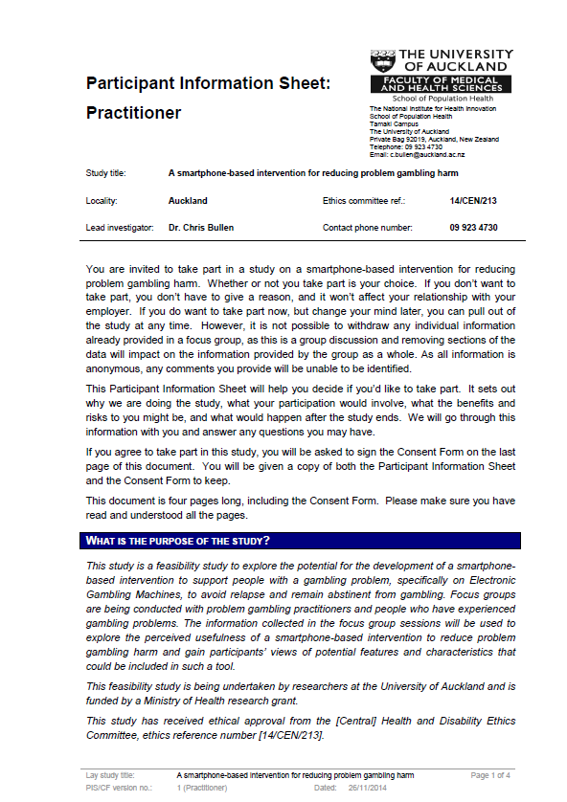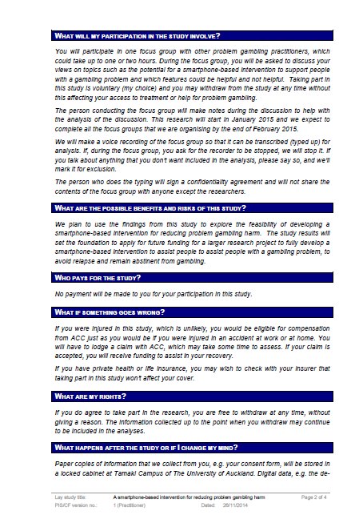
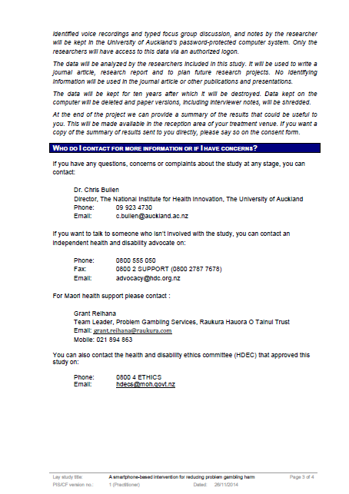
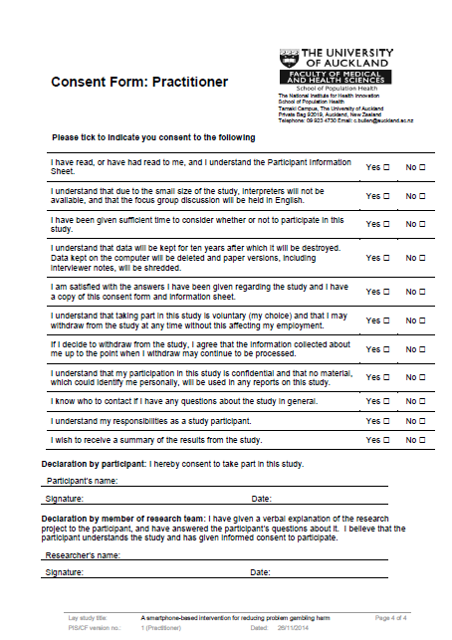
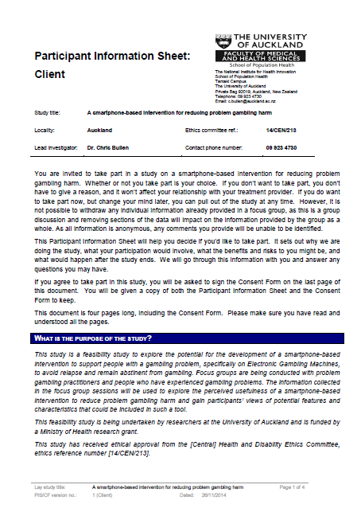
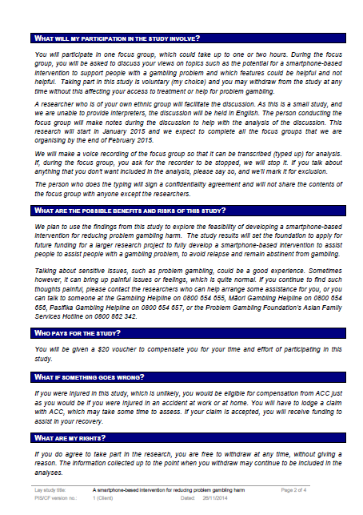
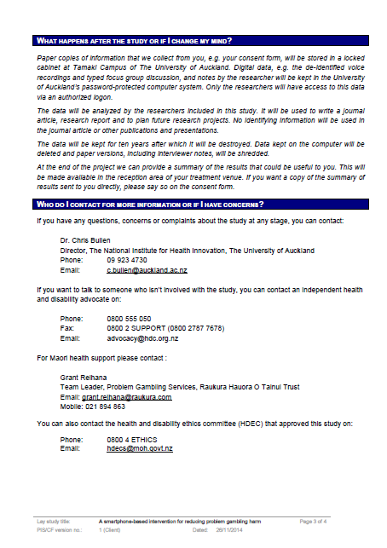
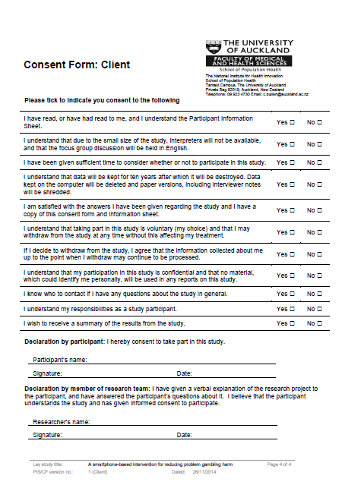
- Semi-structured interview schedule

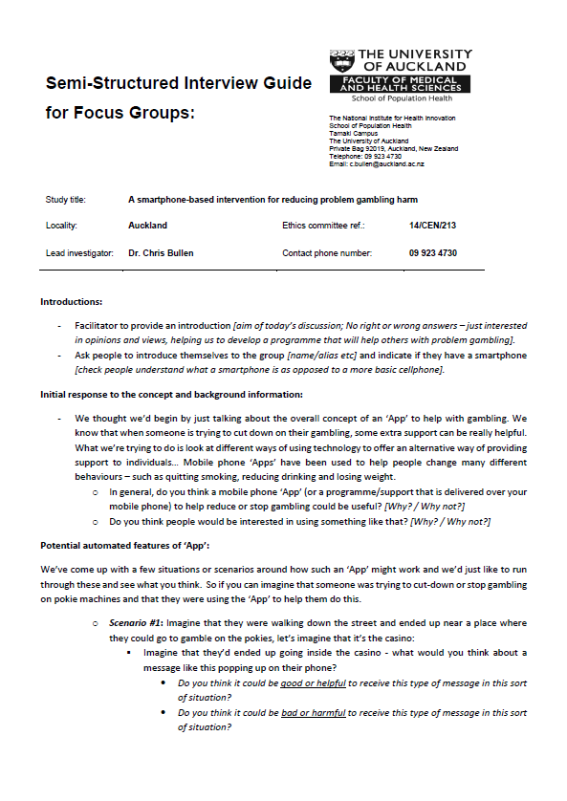
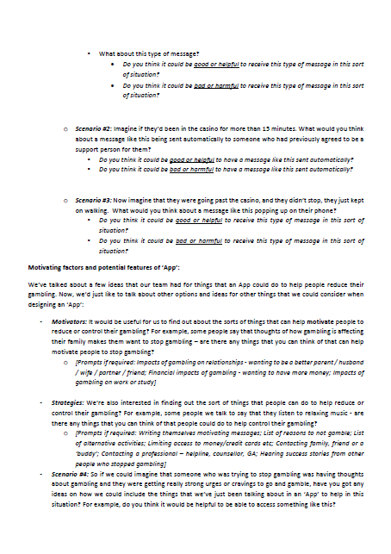
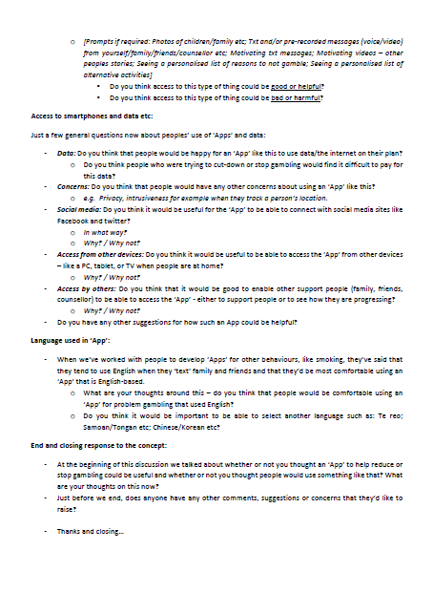
- Mobile-phone Screenshots
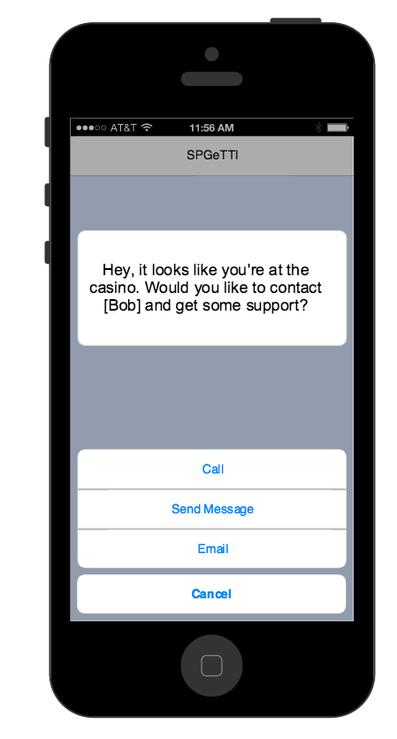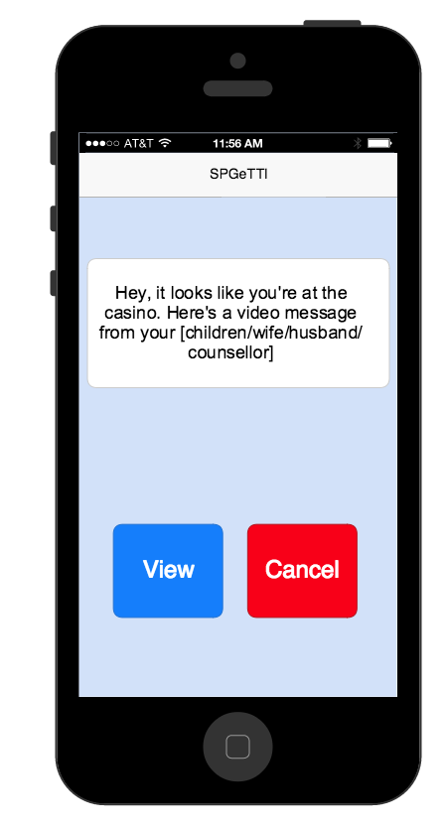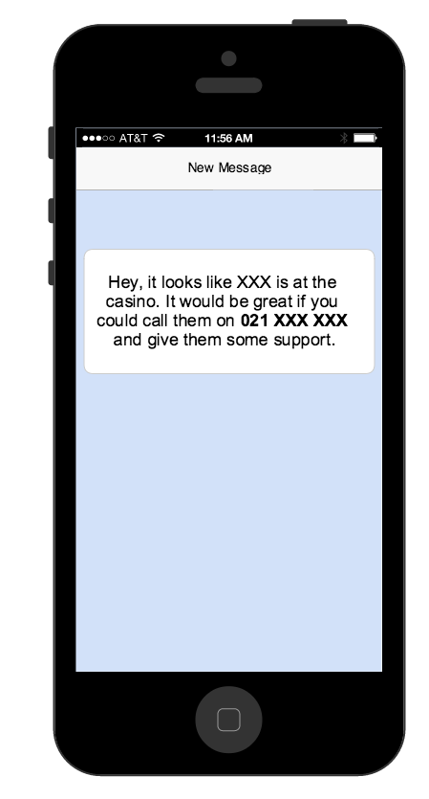
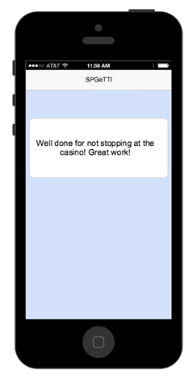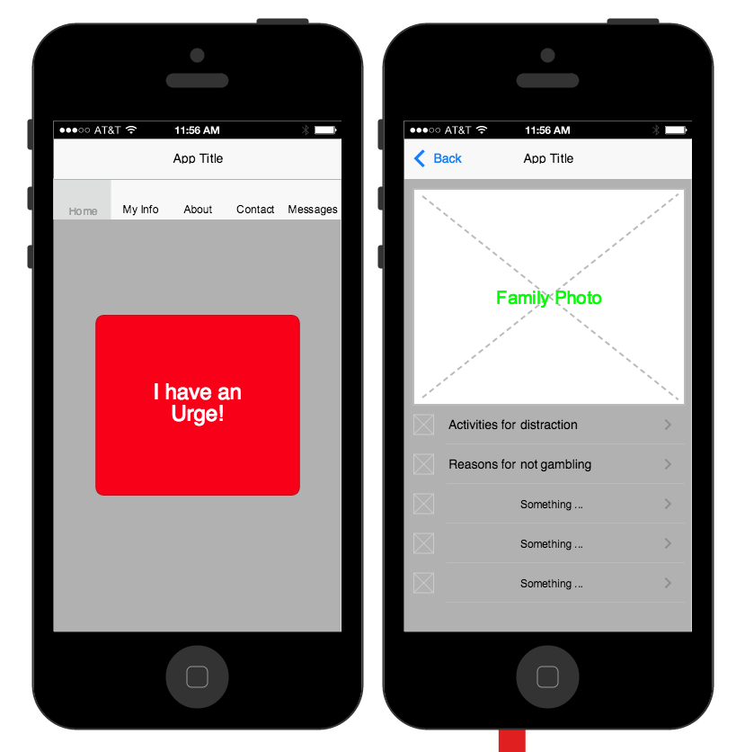

Key for focus group codes: PFG# = Practitioner Focus Group (focus group number); KOR = Korean; Chi = Chinese; Māori = Māori; EurO# = European / Other (focus group number); Pacific = Pacific; Part# = Participant number. So for example, PFG1Part2 = Practitioner Focus Group (first group), Participant number 2

