Sexual Orientation
Findings from the
2014/15 New Zealand Health Survey
2019

Acknowledgements
The New Zealand Health Survey would not have been possible without the support and enthusiasm of many individuals, including the many thousands of New Zealanders who gave their time to participate in it and the interviewers who worked so diligently to collect the data. Thank you for your generosity.
This data brief was written by Nigel Dickson (University of Otago), Bridget Murphy (Ministry of Health), Peter Saxton (University of Auckland), Jennie Connor (University of Otago), Antoinette Righarts (University of Otago) and Melanie Duncan (Ministry of Health). The data analysis was undertaken by Barry Gribben (CBG Health Research), Thomas Zhang (CBG Health Research) and James Stanley (University of Otago).
Citation: Ministry of Health. 2019. Sexual Orientation: Findings from the 2014/15 New Zealand Health Survey. Wellington: Ministry of Health.
Published in November 2019 by the Ministry of Health
PO Box 5013, Wellington 6140, New Zealand
ISBN 978-1-98-859750-8 (online)
HP 7285
This document is available at health.govt.nz
This work is licensed under the Creative Commons Attribution 4.0 International licence. In essence, you are free to: share ie, copy and redistribute the material in any medium or format; adapt ie, remix, transform and build upon the material. You must give appropriate credit, provide a link to the licence and indicate if changes were made.

Contents
Summary v
Introduction 1
Sexual identity 2
Same-gender sex 5
Same-gender sex in lifetime 5
Had sexual partner of the same gender in the five years preceding the survey 8
Sexual attraction 9
Sexual attraction in lifetime 9
Sexual attraction in the 12 months preceding the survey 12
Interpretation notes 13
Overview of survey methodology 15
References 17

List of Figures
Figure 1: Sexual identity by age group and gender 2
Figure 2: Sexual identity, by ethnic group and gender 3
Figure 3: Same-gender sex in lifetime, by age group and gender 6
Figure 4: Same-gender sex in lifetime, by ethnic group and gender 7
Figure 5: Had a sexual partner of the same gender in the five years preceding the survey, by age group and gender 8
Figure 6: Sexual attraction in lifetime, by age group and gender 10
Figure 7: Sexual attraction in lifetime, by ethnic group and gender 11
Figure 8: Sexual attraction in 12 months preceding the survey, by age group and gender 12

List of Tables
Table 1: Participation in the Sexual and Reproductive Health module of the New Zealand Health Survey, by ethnicity 16

Summary
This report describes sexual diversity in New Zealand with regard to gender, age, ethnicity and neighbourhood deprivation patterns.

As part of the Ministry of Health’s commitment to achieving equity in health outcomes for all New Zealanders, it is important for us to understand the inequity that exists. Internationally and in New Zealand, there are clear inequities in the health of rainbow communities, including gay, lesbian and bisexual people.

These inequities, and particularly those related to mental health, are considered to be a consequence of the stressors that Rainbow New Zealanders experience, including discrimination from families/whānau, health services and people in society in general.

Key findings include:
- 97% of men and 95% of women identified themselves as heterosexual or straight
- 2.3% of men and 3.7% women identified themselves as lesbian, gay or bisexual
- men were less likely to identify as bisexual than women (1.0% and 2.6% respectively)
- men were less likely to have ever had sex with another man than women with another woman (4.2% and 6.5% respectively)
- men were less likely to have ever been sexually attracted to both men and women than women to both men and women (4.6% and 16% respectively)
- women’s sexual orientation varied by age, whereas men’s did not
- younger women were more likely to identify as bisexual, have had same-gender sexual partners and have been sexually attracted to both men and women than older women.

Introduction
Sexual orientation has three primary dimensions: how adults identify their sexuality, who they have sexual contact with and who they are attracted to (Laumann et al 1994). Individuals may be attracted to and have experiences with one or more genders on a continuum, and may have experienced same-gender attraction and/or contact but identify as heterosexual.

Internationally and in New Zealand, there are clear inequities in the health of sexual minority groups (Skegg et al 2003; Fergusson et al 2005; Psutka et al 2013; Dickson et al 2015; Gonzales et al 2016). These inequities, and particularly those related to mental health, are considered to be a consequence of the stressors that sexual minority adults experience due to discrimination from families/whānau, health services and people in society in general. As part of the Ministry of Health’s commitment to achieving equity in health outcomes for all New Zealanders, it is important for us to understand disadvantaged populations (Ministry of Health 2018).

While certain dimensions of sexual orientation have been examined in the national Youth2000 health surveys, the Dunedin Multidisciplinary Health and Development Study and the Christchurch Health and Development Study cohort studies, there have been no comprehensive national surveys of sexual orientation across a wide age range (Fergusson et al 2005; Lucassen et al 2014; Dickson et al 2016).

To fill this gap, the Ministry of Health included questions on all three dimensions of sexual orientation in the Sexual and Reproductive Health module of the 2014/15 New Zealand Health Survey (the survey). This report presents key findings about sexual orientation by gender, age group, ethnicity and neighbourhood deprivation at the time of the survey interview.

You can find more information and results from the survey, including statistics on heterosexual orientation and data tables in the data explorer, online at https://www.health.govt.nz/publication/sexual-and-reproductive-health-2014-15-new-zealand-health-survey

Sexual identity
This section sets out responses to the survey question ‘Which of the following options best describes how you think of yourself? Heterosexual or straight, Gay or lesbian, Bisexual, Other?’.

Three percent of adults identified as lesbian, gay or bisexual
- 2.3% of men and 3.7% women identified themselves as lesbian, gay or bisexual.
- The percentage of men who identified as gay (1.3%) was similar to the percentage of women who identified as gay or lesbian (1.1%).

Younger women were more likely to identify as bisexual than older women
The percentage of women identifying as bisexual decreased as age increased, ranging from 5.0% of 16–24-year-olds to 0% of 65–74-year-olds. The percentage of women identifying as gay or lesbian did not differ by age. Among men, there was no clear pattern in sexual identity corresponding to age (Figure 1).

Figure 1: Sexual identity by age group and gender
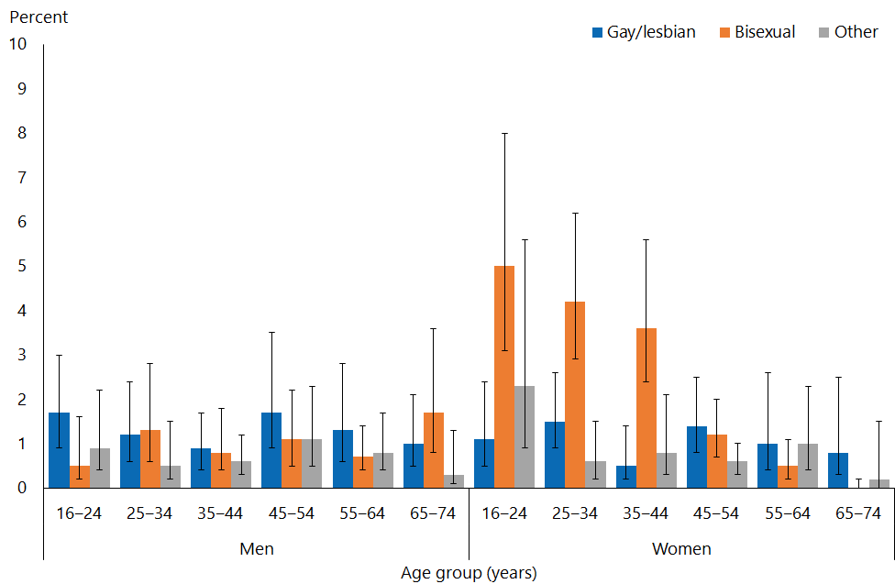
Note: Excluding heterosexual/straight adults, so that the smaller values can be seen on the vertical scale.

Māori men more likely to identify as ‘other‘ sexual identity than non-Māori men
- The percentage of men who identified as ‘other’ varied by ethnic group: 1.9% of Māori, 1.4% of Asian, 0.5% of European/Other and 0.4% of Pacific (Figure 2).
- After adjusting for age, Māori men were 3.3 times as likely to identify as ‘other’ sexual identity than non-Māori men, and Asian men were 2.2 times as likely to do so as non-Asian men.
- The percentage of women who identified as heterosexual or straight varied by ethnic group. It was highest in Asian women (97%) and lowest in Māori women (92%).

Figure 2: Sexual identity, by ethnic group and gender
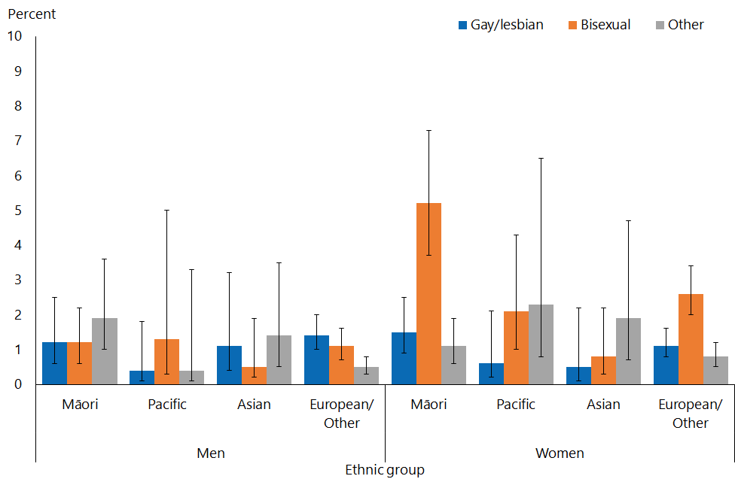
Note: Excluding heterosexual/straight adults, so that the smaller values can be seen on the vertical scale.
Adults who reported more than one ethnic group are counted once in each group reported. This means that the total number of responses for all ethnic groups can be greater than the total number of adults who stated their ethnicities.

Men living in the most deprived neighbourhoods were more likely to identify as bisexual than men in the least deprived neighbourhoods
- A higher percentage of men living in the most deprived neighbourhoods identified as bisexual (1.5%) than men living in the least deprived neighbourhoods (0.4%).
- After adjusting for age and ethnicity, men living in the most deprived neighbourhoods were 4.2 times as likely as those living in the least deprived neighbourhoods to identify as bisexual.
- Men living in the most deprived neighbourhoods were less likely to identify as heterosexual (96%) than men in the least deprived neighbourhoods (99%).
- After adjusting for age and ethnicity, men living in the most deprived neighbourhoods were 0.95 times as likely as those living in the least deprived neighbourhoods to identify as heterosexual.

Same-gender sex

Same-gender sex in lifetime
The survey asked men and women slightly different questions about their sexual experiences:
- Men were asked: ‘Have you ever had sex with a male? That is, oral or anal sex or any other genital contact intended to achieve orgasm?’
- Women were asked: ‘Have you ever had sex with a female? That is, oral sex or any other genital contact intended to achieve orgasm?’

In both cases, the question specified that it was asking respondents about the sex they had had since turning 13 years old, to avoid causing distress from what respondents may have considered a probing question about child sexual abuse. Respondents may have interpreted the terms ‘male’ and ‘female’ as either sex or gender.

Women were more likely to have had sex with other women, than men with other men
Having ever had sex with a same-gender partner was more common among women (6.5%) than men (4.2%) (Figure 3).

Younger women were more likely than older women to have ever had sex with another woman
For women, having ever had sex with a woman was most common in those under 45 years, after which age it became progressively and markedly less common (Figure 3).

For men, there was no clear pattern in ever having had sex with a man by age.

Figure 3: Same-gender sex in lifetime, by age group and gender
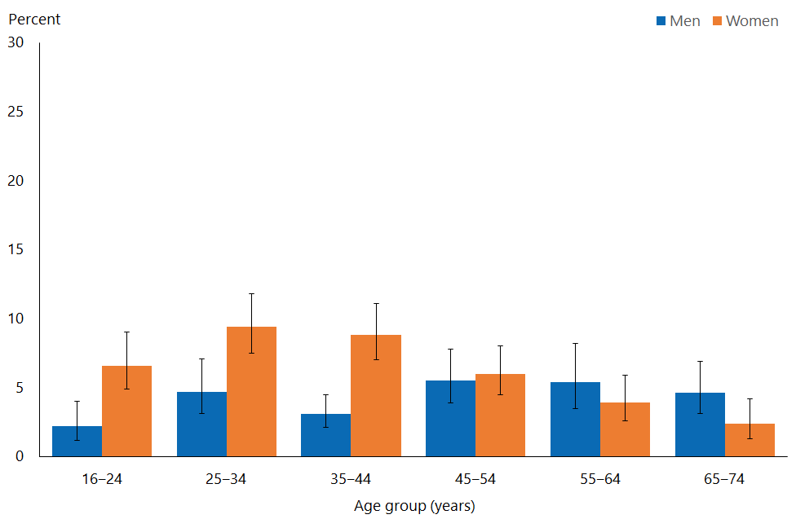

Māori and European/Other women were most likely to have ever had sex with another woman
The percentage of women who had had sex with another woman varied by ethnic group:
- 10.1% of Māori
- 7.4% of European/Other
- 2.7% of Pacific
- 1.8% of Asian women.

The percentage of men who had had sex with another man also varied by ethnic group:
- 4.9% of European/Other
- 4.3% of Māori
- 2.4% of Pacific
- 1.8% of Asian men.

Figure 4: Same-gender sex in lifetime, by ethnic group and gender
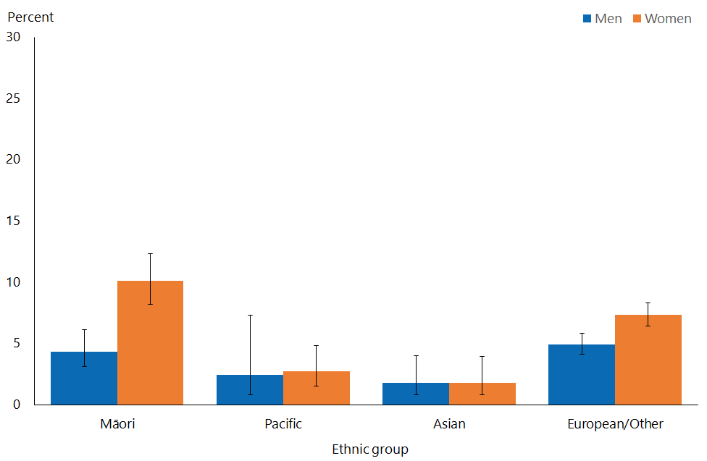
Note: Adults who reported more than one ethnic group are counted once in each group reported. This means that the total number of responses for all ethnic groups can be greater than the total number of adults who stated their ethnicities.

Women living in the most deprived neighbourhoods were more likely to have ever had sex with another woman
The percentage of women who have ever had sex with another women was higher in the most deprived neighbourhoods (7.6%) than in the least deprived neighbourhoods (4.5%). After adjusting for age and ethnicity, women living in the most deprived neighbourhoods were 2.4 times as likely as those in the least deprived neighbourhoods to have ever had sex with a woman.

Among men, there was no clear pattern in having ever had sex with another man by level of neighbourhood deprivation.

Had sexual partner of the same gender in the five years preceding the survey
The survey asked men about how many males they had had sex with in the five years preceding the survey, and women the equivalent question. These questions were used to derive the ‘Had a sexual partner of the same gender in the five years preceding the survey’ indicator. Respondents may have interpreted the terms ‘male’ and ‘female’ as either sex or gender.

Around one in 35 adults had a same-gender sexual partner in the last five years
Having had a same-gender sexual partner in the last five years was experienced by a similar percentage of men (2.6%) and women (3.2%) aged 16–74 years.

For women, having had a same-gender sexual partner in the last five years was most common in those aged under 35, but there was no clear pattern by age for men.

Figure 5: Had a sexual partner of the same gender in the five years preceding the survey, by age group and gender
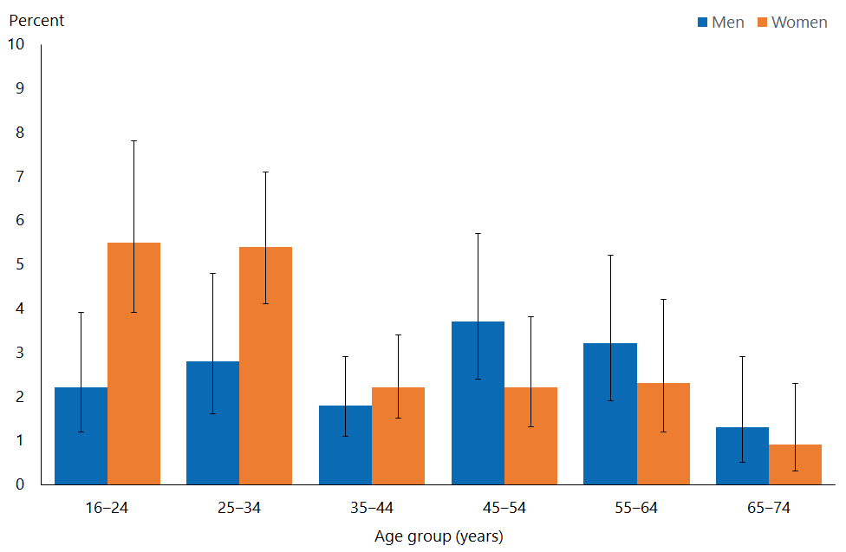

You can find more results about same-gender sexual partners in the five years preceding the survey online at https://www.health.govt.nz/publication/sexual-and-reproductive-health-2014-15-new-zealand-health-survey

Sexual attraction
The survey asked men, ‘What best describes who you have ever felt sexually attracted to? I have felt sexually attracted:
1. Only to females, never to males.
2. More often to females and at least once to a male.
3. About equally often to females and males.
4. More often to males and at least once to a female.
5. Only to males, never to females.
6. I have never felt sexually attracted to anyone at all.’

The response options ‘More often to females and at least once to a male’, ‘About equally often to females and males’, and ‘More often to males and at least once to a female’ were combined into one group (ie, men who reported that they were attracted to both males and females).

The survey asked women the equivalent questions, and categories were similarly combined.

Respondents may have interpreted ‘male’ and ‘female’ as sex or gender.

Sexual attraction in lifetime

Less than 2% of adults have only ever been attracted to adults of the same gender
- 1.6% of women and 0.8% of men have only been attracted to same-gender adults (Figure 6).
- 4.6% of men and 16% of women have experienced attraction to both men and women.
- 93% of men have only ever been attracted to women, and 82% of women have only ever been attracted to men.
- Some adults (0.5% of men and 1.8% of women) have never felt sexually attracted to anyone. Among women, those aged 16–24 years (4.1%) were more likely to report this than older women (less than 1.5%).

Younger women more likely than older women to have ever been attracted to both men and women
For women, lifetime attraction to both men and women was most frequent in those aged 25–44 years (23%). Less than 10% of women aged 55 years and over had ever been attracted to both men and women.

For men, lifetime sexual attraction was similar across age groups (Figure 6).

Figure 6: Sexual attraction in lifetime, by age group and gender
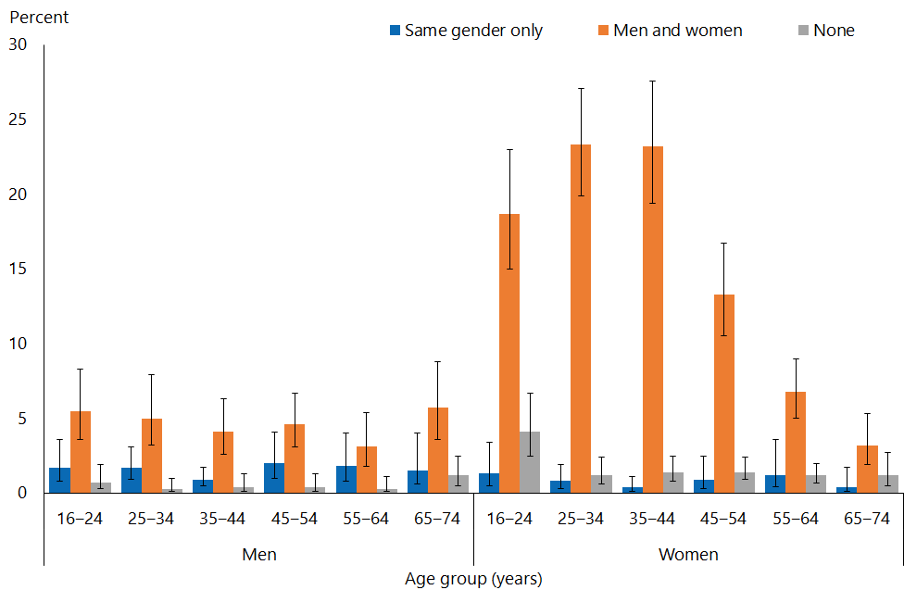
Note: Excluding ‘women only’ for men and the equivalent for women, so that the smaller values can be seen on the vertical scale.

Pacific and Asian women were less likely to have been sexually attracted to both women and men than non-Pacific and non-Asian women
Among women, the percentage who have experienced attraction to both women and men varied by ethnicity:
- 20% of Māori women
- 18% of European/Other women
- 7.6% of Pacific women
- 5.6% of Asian women.

After adjusting for age, Pacific women were 0.4 times as likely to ever have experienced sexual attraction to both women and men as non-Pacific women, and Asian women 0.25 times as likely as non-Asian women.

Figure 7: Sexual attraction in lifetime, by ethnic group and gender
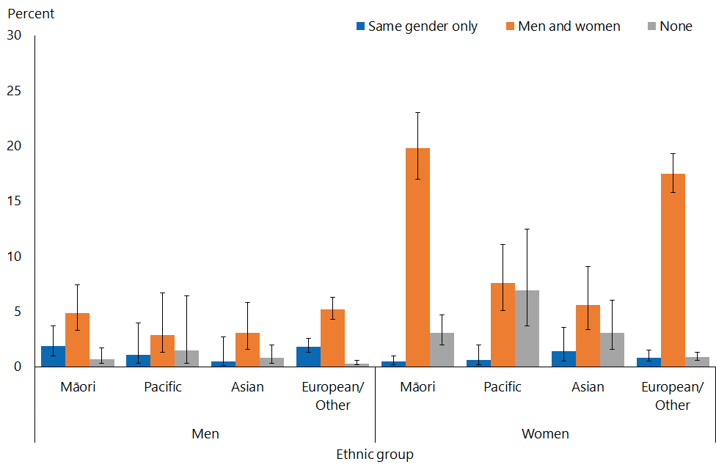
Note: Excluding ‘women only’ for men and the equivalent for women, so that the smaller values can be seen on the vertical scale.
Adults who reported more than one ethnic group are counted once in each group reported. This means that the total number of responses for all ethnic groups can be greater than the total number of adults who stated their ethnicities.

Men living in the most deprived neighbourhoods were more likely to report attraction to both men and women
Among men living in the most deprived neighbourhoods 4.9% have been attracted to both males and females, compared with 3.4% in the least deprived neighbourhoods.

After adjusting for age and ethnicity, men living in the most deprived neighbourhoods were almost twice as likely to have ever been attracted to both men and women as those living in the least deprived areas.

Among women, there was no pattern in attraction for both men and women by neighbourhood deprivation.

Sexual attraction in the 12 months preceding the survey
In addition to the cumulative lifetime sexual attraction statistics, a more current picture of sexual attraction patterns in the last 12 months is presented below.

2.4% of men and 7.4% of women had experienced attraction to both men and women. 1.9% of men and 1.2% of women were only attracted to the same gender in the last 12 months.

Men were more likely (95%) to have been exclusively heterosexually attracted than women (84%) in the last 12 months.

No sexual attraction in the last 12 months was more common among women (7.5%) than men (1.2%).

Women aged 16–24 years were more likely have been attracted to both men and women in the last year than older women
Attraction to both men and women in the last year was most common among women aged 16–24 years (13.5%), and declined with increasing age. There was no clear pattern in same-gender sexual attraction in the last 12 months by age for men (Figure 8).

Figure 8: Sexual attraction in 12 months preceding the survey, by age group and gender
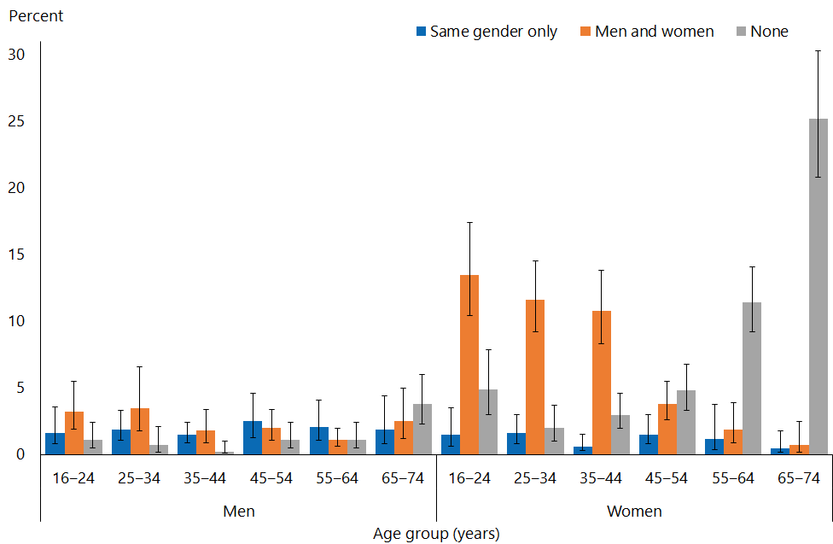
Note: Excluding ‘women only’ for men and the equivalent for women, so that the smaller values can be seen on the vertical scale.

You can find more results about same-gender sexual attraction in the 12 months preceding the survey online at https://www.health.govt.nz/publication/sexual-and-reproductive-health-2014-15-new-zealand-health-survey

Interpretation notes
This section provides some key points for interpreting the survey results presented in this report. For more details about the survey methodology, see the Methodology Report 2014/15: New Zealand Health Survey (Ministry of Health 2015b) and Sexual and Reproductive Health Indicator Interpretation Guide 2014/15: New Zealand Health Survey (Ministry of Health 2019).

Statistical significance
Unless otherwise specified, the results discussed in this report only refer to differences that are statistically significant at the 5 percent level (ie, those with a p-value of less than 0.05). ‘Statistically significant’ means that the difference between the sample groups is likely to reflect real differences in the population groups, rather than being caused by chance. A statistically significant difference does not necessarily mean the difference between the population groups is meaningful.

Confidence intervals
We use 95% confidence intervals to show the statistical precision of the estimates. Wider confidence intervals indicate less precise estimates than narrow intervals, caused by higher variation with a sample and/or smaller numbers in a sample. Confidence intervals generally agree with statistical significance. When confidence intervals for two estimates don't overlap, there is a statistically significant difference between the estimates. However, the opposite may not always be true.

Comparing population subgroups
This report uses adjusted ratios to test if the prevalence of indicators is statistically significantly different between groups. We have adjusted these ratios for demographic factors that may be influencing the comparison, such as age, gender and ethnicity. The adjusted ratio indicates whether the results are less or more likely in the group of interest than the comparison group. A ratio of less than 1 indicates that the result is less likely and a ratio greater than 1 indicates that it is more likely.

The survey uses the New Zealand Index of Deprivation 2013 (NZDep2013) to measure neighbourhood deprivation. The survey groups neighbourhoods into five quintiles (the label ‘quintile 1’ applies to neighbourhoods with the lowest levels of deprivation, and ‘quintile 5’ to those with the highest). Indicators are reported for each quintile. The adjusted ratios for deprivation compare the highest and lowest deprivation areas, after adjusting for age, ethnic group, gender and the pattern across all five quintiles.

Gender
Gender is self-defined by respondents in the survey. For some people their gender is not the same as their biological sex at birth. Respondents were asked if they were male or female, and while what these options meant was open to the respondent’s interpretation, gender-diverse options (eg, ‘gender non-conforming’ or ‘other’) were not available. The Ministry of Health acknowledges the need to improve data collection in this area, and is considering implementing the statistical standard for gender identity in future surveys (Statistics New Zealand 2015).

Non-sampling error
The survey results may underestimate or overestimate some indicators because the data is self-reported. The accuracy of a person’s memory may vary depending on many factors, including social norms, the importance of the event being recalled, the individual’s age at the time and the period of time that has passed since the event occurred.

Overview of survey methodology
This section gives a brief overview of the survey methodology for the New Zealand Health Survey.

How were people selected for the survey?
The 2014/15 results refer to the sample selected for the period July 2014–June 2015. The survey has a multi-stage sampling design that involves randomly selecting a sample of small geographic areas, households within the selected areas and individuals within the selected households. One adult aged 15 years or older and one child aged 14 years or younger (if there were any) were chosen at random from each selected household. Adults aged 16–74 years who had completed the 2014/15 survey were invited to participate in the Sexual and Reproductive Health module. Further details are available in The New Zealand Health Survey: Sample design, years 1–3 (2011–2013) (Ministry of Health 2011).

How was data collected?
Professional surveyors from CBG Health Research Ltd collected data in respondents’ homes. For the core part of the survey, data was collected through a face-to-face interview. However, participants completed the Sexual and Reproductive Health module by themselves, directly entering responses into a program run on a tablet computer. Surveyors provided minimal assistance, and reiterated that they would not be able to see the answers. Respondents could answer ‘Don’t know’ or ‘Choose not to answer’ to any question. If they chose either of those options for the question about having ever had sex with someone of a different sex, then they were not asked to complete the rest of the survey module.

How many people took part?
11,993 adults aged 16–74 years completed the core 2014/15 survey and were eligible for the Sexual and Reproductive Health module. This report is based on the responses from 10,198 adults (or 87% of eligible respondents). Some eligible respondents were not included in the final data set for the following reasons.
- 668 respondents (5.6% of those who were eligible) did not start the module, either because they refused or because of English language and/or cognitive difficulties.
- 991 respondents (6.5% of eligible respondents) started the module but stopped before the end of the module.
- 123 respondents (1.2% of eligible respondents) completed the module but their records were discarded because at least half of their responses were ‘Don’t know’ or ‘Choose not to answer’.

Of the people who completed the Sexual and Reproductive Health module, 4,358 gave their gender as male and 5,840 as female. The table below summarises the 10,198 survey respondents by ethnic group.

Table 1: Participation in the Sexual and Reproductive Health module of the New Zealand Health Survey, by ethnicity
Ethnic group | Number
Māori | 2,460
Pacific | 619
Asian | 814
European/Other | 7,542
Note: Adults who reported more than one ethnic group are counted once in each group reported. This means that the total number of responses for all ethnic groups can be greater than the total number of adults who stated their ethnicities.

Survey weights
The Sexual and Reproductive Health data set was weighted so that the responding sample represented the New Zealand ‘usually resident’ population in that year, using external population benchmarks (age, sex, ethnicity and neighbourhood deprivation) and demographic and behavioural benchmarks (eg, educational level and hazardous drinking). After an initial selection weight was calculated, it was adjusted for those who did not complete the module (for any reason). This should have minimised the impact of any differences in the characteristics of people who did or did not participate in the Sexual and Reproductive Health module. For more detail about the survey methodology, refer to the Methodology Report 2014/15 (Ministry of Health 2015b).

Additional information
See also the following documents:
- The New Zealand Health Survey: Sample design years 1–3 (2011–2013) (Ministry of Health 2011). Note, despite the report title being 2011-13, this sample design was used for the 2014/15 Health Survey
- Methodology Report 2014/15: New Zealand Health Survey (Ministry of Health 2015b)
- Content Guide 2014/15: New Zealand Health Survey (Ministry of Health 2015a)
- Questionnaires for the New Zealand Health Survey 2014/15 (Ministry of Health 2016a; Ministry of Heath 2016b)
- Sexual and Reproductive Health Indicator Interpretation Guide 2014/15: New Zealand Health Survey (Ministry of Health 2019).

References
Dickson N, Lee B, Foster T, et al. 2015. The first 30 years of HIV in New Zealand: review of the epidemiology. New Zealand Medical Journal 128(1426): 31–48.
Dickson NP, Righarts A, van Roode T, et al. 2016. Do reports of age and circumstances of first intercourse differ in a birth cohort when asked seventeen years apart? Journal of Sex Research 53(3): 321–30.
Fergusson DM, Horwood LJ, Ridder EM, et al. 2005. Sexual orientation and mental health in a birth cohort of young adults. Psychological Medicine 35(7): 971–81.
Gonzales G, Przedworski J, Henning-Smith C. 2016. Comparison of health and health risk factors between lesbian, gay, and bisexual adults and heterosexual adults in the United States: Results From the National Health Interview Survey. JAMA Internal Medicine 176(9): 1344–51.
Laumann EO, Gagnon JH, Michael RT, et al. 1994. The Social Organization of Sexuality: Sexual practices in the United States. Chicago: University of Chicago Press.
Lucassen MFG, Clark TC, Moselen E, et al. 2014. Youth’12 The Health and Wellbeing of Secondary School Students in New Zealand: Results for young adults attracted to the same sex or both sexes. Auckland: University of Auckland.
Ministry of Health. 2011. The New Zealand Health Survey: Sample design, years 1–3 (2011–2013). Wellington: Ministry of Health.
Ministry of Health. 2015a. Content Guide 2014/15: New Zealand Health Survey. Wellington: Ministry of Health.
Ministry of Health. 2015b. Methodology Report 2014/15: New Zealand Health Survey. Wellington: Ministry of Health.
Ministry of Health. 2016a. Adult Sexual Reproductive Health Module (Year 4). Wellington: Ministry of Health.
Ministry of Health. 2016b. New Zealand Health Survey Adult Questionnaire (Year 4). Wellington: Ministry of Health.
Ministry of Health. 2018. Achieving Equity in Health Outcomes: Highlights of important national and international papers. Wellington: Ministry of Health.
Ministry of Health. 2019. Sexual and Reproductive Health Indicator Interpretation Guide 2014/15: New Zealand Health Survey. Wellington: Ministry of Health.
Priebe G, Svedin CG. 2013. Operationalization of three dimensions of sexual orientation in a national survey of late adolescents. Journal of Sex Research 50(8): 727–38.
Psutka R, Dickson N, Azariah S, et al. 2013. Enhanced surveillance of infectious syphilis in New Zealand sexual health clinics. International Journal of STD & AIDS 24(10): 791–8.
Skegg K, Nada-Raja S, Dickson, N, et al. 2003. Sexual orientation and self-harm in men and women. American Journal of Psychiatry 160(3): 541–6.
Statistics New Zealand. 2015. Statistical Standard for Gender Identity. Wellington: Statistics New Zealand.

Rainbow is an inclusive term used to refer to anyone with a diverse sex, gender identity or sexual orientation.
The ‘other’ category includes adults who did not see themselves as fitting into the heterosexual or straight, bisexual, gay or lesbian categories, such as takatāpui.
‘Sex’ and ‘gender’ are related but different concepts (Statistics New Zealand 2015).
‘Sex’ and ‘gender’ are related but different concepts (Statistics New Zealand 2015).
‘Sex’ and ‘gender’ are related but different concepts (Statistics New Zealand 2015).

