Ngā mahi kaikiri i te tau 2011/12, i te tau 2016/17 me te tau 2020/21

Racial Discrimination 2011/12, 2016/17 and 2020/21
New Zealand Health Survey

Ngā mihi
E hāpaitia ana te New Zealand Health Survey e te tautoko me te ngākau hihiri o te takitini, pērā i ngā kaiwhakautu me ngā kairangahau nā rātou ngā tatauranga i āta kohikohi mai nei. Tēnā koutou katoa.
He mea whakawhanake te New Zealand Health Survey e te rōpū Health Surveys i roto i te tari o Evidence, Research and Analytics ki te Manatū Hauora. He mea whakahaere nā Reach Aotearoa (arā, ko CBG Health Research Ltd te ingoa o mua), he kaiwhakarato rangahau hauora tūmatanui motuhake ki Tāmaki Makaurau.
He mea whakarite tēnei pūrongo nā te rōpū o Evidence, Research and Analytics i runga i te tautoko o Te Pou Hauora Māori me te rōpū o Pacific Health ki te Manatū Hauora.
Kei te mihi mātou ki Te Whare Wānanga o Otāgo mō ngā tāpaenga kōrero e pā ana ki tō rātou tātaringa o ngā tatauranga mō ngā mahi kaikiri.
He mihi anō ki ngā tāngata katoa i whāngai, i arotake hoki i te pūrongo nei.

Acknowledgements
The New Zealand Health Survey relies on the support and enthusiasm of many individuals, including the survey participants and the surveyors who worked so diligently to collect the data. Thank you to all.
The New Zealand Health Survey is developed by the Health Surveys team in the Evidence, Research and Analytics group, Manatū Hauora — Ministry of Health. It is conducted by Reach Aotearoa (formerly known as CBG Health Research Ltd), an Auckland-based independent public health research provider.
This report was prepared by the Evidence, Research and Analytics group with support from the Māori Health Directorate and Pacific Health team within Manatū Hauora.
We would like to thank the University of Otago for providing advice based on its previous analysis of the racial discrimination data.
Thank you to all who provided input and review.
Citation: Ministry of Health. 2023. Racial Discrimination 2011/12, 2016/17 and 2020/21: New Zealand Health Survey. Wellington: Ministry of Health.
Published in June 2023 by the Ministry of Health
PO Box 5013, Wellington 6140, New Zealand
ISBN 978-1-991075-30-7 (online)
HP 8787
This document is available at health.govt.nz
This work is licensed under the Creative Commons Attribution 4.0 International licence. In essence, you are free to: share ie, copy and redistribute the material in any medium or format; adapt ie, remix, transform and build upon the material. You must give appropriate credit, provide a link to the licence and indicate if changes were made.

Ngā kōrero o roto | Contents
Ngā kitenga matua | Key points 1
Te Kaupapa | Purpose 2
He kupu whakataki | Introduction 3
Things to consider when interpreting the results 4
He whakarāpopoto o ngā kitenge | Summary of findings 7
Māori, Pacific and Asian adults had the highest rates of racial discrimination 7
Some groups experienced increases in racial discrimination over time 8
Verbal abuse was the most common type of racial discrimination experienced 10
Racial discrimination is associated with poor health outcomes and unmet need 13
Ngā tikanga rangahau | Methodology 16
Source data 16
Sample sizes 16
Impact of COVID-19 on the 2020/21 survey collection 16
Comparisons by ethnic group 17
Comparability with previously published data 17
How we treated non-response 18
How we treated ‘not applicable’ responses 18
Confidentiality and reliability of estimates 18
Confidence intervals 18
Ngā tohutoro | References 20
Āpitihanga A: Ngā pātai a te wāhanga o te Rangahau Hauora o Aotearoa 2020/21 e pā ana ki ngā mahi kaikiri | Appendix A: Racial discrimination module questions, New Zealand Health Survey 2020/21 22

Ngā tatau | List of Figures
Figure 1: Racial discrimination indicators from the NZHS 4
Figure 2: Experience of racial discrimination in the past 12 months, by ethnic group and gender, 2020/21 (percentages) 8
Figure 3: Experience of racial discrimination in the past 12 months, by ethnic group, 2011/12, 2016/17 and 2020/21 (percentages) 9
Figure 4: Experience of ethnically motivated unfair treatment in the past 12 months, 2011/12, 2016/17 and 2020/21 (percentages) 12
Figure 5: Experience of ethnically motivated personal attack in the past 12 months, 2011/12, 2016/17 and 2020/21 (percentages) 12

Ngā tūtohi | List of Tables
Table 1: Experience of racial discrimination in the past 12 months and in lifetime, by ethnic group, 2020/21 (percentages) 7
Table 2: Experience of racial discrimination in the past 12 months, by type of discrimination and ethnic group, 2020/21 (percentages) 10
Table 3: Experience of racial discrimination in lifetime, by type of discrimination and ethnic group, 2020/21 (percentages) 11
Table 4: Experience of psychological distress, by ethnic group, and experience of racial discrimination in past 12 months, 2020/21 (percentages) 14
Table 5: Good, very good or excellent self-rated health, by ethnic group and experience of racial discrimination in past 12 months, 2020/21 (percentages) 14
Table 6: Unmet need for primary health care, by ethnic group, and experience of racial discrimination in past 12 months, 2020/21 (percentages) 15
Table 7: Sample sizes for NZHS in 2011/12, 2016/17 and 2020/21, by ethnic group 16

Ngā kitenga matua |
Key points
- The New Zealand Health Survey included questions on racial discrimination in 2011/12, 2016/17 and 2020/21.
- Māori, Pacific and Asian adults are more likely than non-Māori, non-Pacific, non-Asian (non-MPA) adults to experience racial discrimination. In the 12 months before the 2020/21 survey, 13.8% of Māori, 9.5% of Pacific, 12.3% of Asian and 4.8% of non-MPA adults experienced racial discrimination.
- The proportion of Māori who experienced racial discrimination in the past 12 months increased from 10.8% in 2011/12 to 13.8% in 2020/21. In particular, the proportion of Māori women who experienced racial discrimination in the past 12 months increased, from 9.7% in 2011/12 to 16.8% in 2020/21.
- Verbal abuse was the most common type of racial discrimination that all ethnic groups experienced in the 12 months before the 2020/21 survey (9.0% of Māori, 6.4% of Pacific, 9.9% of Asian and 3.6% of non-MPA adults).
- Unfair treatment by a health professional was the second-most common type of discrimination experienced in the past 12 months for both Māori (3.8%) and Pacific (2.6%) adults.
- Unfair treatment at work or refusal of a job was the second-most common type of discrimination experienced in the past 12 months for Asian (2.4%) and non-MPA (1.0%) adults.
- Racial discrimination is associated with higher rates of psychological distress, lower rates of good/very good/excellent self-rated health, and higher rates of unmet need for primary health care.

Te kaupapa |
Purpose
This report has been prepared to present the key results from a racial discrimination module that has been included in the New Zealand Health Survey (NZHS) in some years.

Addressing racial discrimination is critical to upholding our obligations under Te Tiriti o Waitangi, and essential to achieving health equity. As kaitiaki of the system, Manatū Hauora — Ministry of Health (the Ministry) has an important role to play in creating an environment where all people can access the health care they need without fear of racial discrimination. The Ministry has outlined a commitment to addressing racism and discrimination. Ao Mai te Rā: The Anti-Racism Kaupapa (Ministry of Health 2022a) is a Ministry initiative that aims to support the health sector to understand and respond to racism in health. The Ministry’s commitment to addressing racism and discrimination is reflected as outcomes in Whakamaua: Māori Health Action Plan (Ministry of Health 2020b), Ola Manuia: Pacific Health and Wellbeing Action Plan (Ministry of Health 2020a), New Zealand Cancer Action Plan (Ministry of Health 2019) and Kia Manawanui Aotearoa (Ministry of Health 2021a).

Eliminating all forms of racism is critical to achieving health equity and the vision of pae ora — healthy futures for all New Zealanders (Ministry of Health 2022b). This report includes high-level information about different forms of racial discrimination, including the experience of ethnically motivated unfair treatment by a health professional.

He kupu whakataki |
Introduction
Racism is an important determinant of health that contributes to health inequities (Harris et al 2018).

Ao Mai te Rā uses the following working definition of racism:

Racism comprises racial prejudice and societal power and manifests in different ways. It results in the unequal distribution of power, privilege, resources and opportunity to produce outcomes that chronically favour, privilege and benefit one group over another. All forms of racism are harmful, and its effects are distinct and not felt equally. (Ministry of Health 2022b, p3)

Racism appears in different forms (Jones 2000; Talamaivao et al 2020), including the following.
- Internalised racism: The acceptance and internalisation of oppressive or dominant values, beliefs, attitudes and stereotypes about one’s own race (Jones 2000; Pheterson 1986; Pyke 2010; Watts-Jones 2002). It occurs within an individual.
- Interpersonal racism: When individuals interact with others and their personal racial prejudice affects how they act and behave (overtly, covertly, conscious, unconscious, implicit, explicit) towards racialised ‘others’. It occurs between individuals (Watts-Jones 2002).
- Institutional racism: Policies, practices and laws that, intentionally or not, exclude and foster the unequal distribution of power and privilege. It determines differential access to goods, services and the opportunities of society based on race. It occurs within an institution or system (Watts-Jones 2002).
- Structural racism: The cumulative impact of multiple institutions that fosters racial inequity through mutually reinforcing policies, practices, and laws (that is, housing, employment, education, etc). It occurs among institutions or systems and is a feature of the social, economic and political systems in which we all exist (Watts-Jones 2002).

Data is a necessary lever for change and helps to uncover the visible, tangible impacts and consequences of racism on health outcomes and the achievement of health equity (McMeeking et al 2022; Williams and McMeeking 2022). This report presents information on how adults in New Zealand experience racial discrimination, including through ethnically motivated personal attack (physical or verbal), and unfair treatment in health care, employment or housing. Figure 1 presents the full list of indicators available. Data is available on people’s experience of racial discrimination over 2 time periods: in the 12 months before the survey and over their lifetime. See the methodology section for information about the survey questions used to create these indicators.

Data comes from the NZHS racial discrimination modules from 2011/12, 2016/17 and 2020/21. Adults aged 15 years and over completed these modules.

Figure 1: Racial discrimination indicators from the NZHS
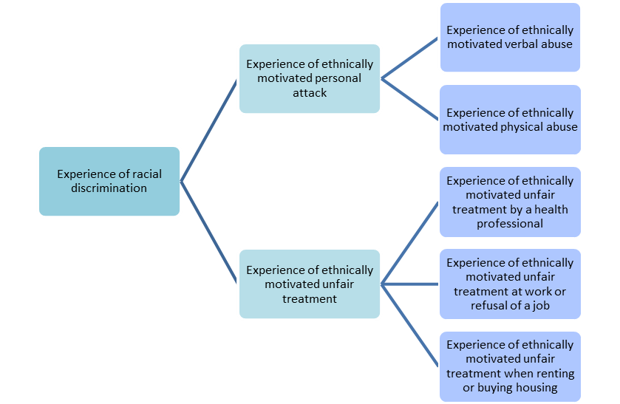

This report presents racial discrimination indicators by ethnic group, including Māori, Pacific, Asian and non-Māori, non-Pacific, non-Asian (non-MPA) adults. People belonging to the Māori, Pacific and Asian ethnic groups have been counted in each ethnic group they identify with. The group ‘non-MPA’ represents people belonging to the European, Middle Eastern/Latin American/African (MELAA) and/or Other ethnic groups who don’t also identify as Māori, Pacific or Asian (ie, people who are non-Māori and non-Pacific and non-Asian).

Things to consider when interpreting the results
There are a number of things to be aware of when interpreting the findings in this report.

Possible under-reporting of racial discrimination
The data in this report comes from self-reported experiences of racial discrimination. This may underestimate experience of racial discrimination, particularly for Māori, Pacific and Asian adults (Harris et al 2019).

The survey results may under-report experiences of racial discrimination for the following reasons.
- The data covers experiences of only some forms of racial discrimination, and it mostly reflects experiences of interpersonal discrimination (Harris et al 2006).
- The questions ask about unfair treatment in some settings (health care, employment and housing), but not others such as education and shops (Harris et al 2006). The questions also don’t cover racial discrimination experienced through digital communication such as social media.
- People may be reluctant to disclose their experiences of racial discrimination and may provide socially acceptable responses (Gee et al 2007; Harris et al 2012; Lewis et al 2015).
- People may interpret similar experiences in different ways (Karlsen and Nazroo 2002). They also may not consciously recognise that they have experienced racial discrimination (Harris et al 2012; Krieger et al 2010).
- Recall bias may affect the data, particularly where respondents report on their lifetime experience of racial discrimination (Harris et al 2012).
- The questions only cover racial discrimination that people experienced in New Zealand.

The questions do not ask about other forms of discrimination that people may have experienced. They do not capture information on experience of discrimination for multiple social markers of difference (eg, disability, gender, sexuality, religion).

The questions don’t measure the intensity of the experience. They provide limited information on how frequently people experienced racial discrimination over time (Harris et al 2006).

The NZHS data is cross-sectional (ie, taken at one period in time). This limits our ability to comment on causality (Harris et al 2019).

Other things to be aware of when interpreting the data
Be careful when comparing results from this report with reports that use a different data source because definitions and methods may differ. The data presented in this report may also differ from previous publications that used NZHS data. See the methodology section for more information.

Ethnicity data is presented at an aggregated level for the groups Māori, Pacific, Asian and non-MPA. There is considerable diversity within each of these groups, and people may have different contexts such as their place of birth, how recently they immigrated, what languages they speak and the strength of their accent.

The non-MPA group includes people belonging to the MELAA and Other ethnic groups who do not also belong to one or more of the Māori, Pacific and Asian ethnic groups. People within the non-MPA group are likely to have diverse experiences of racial discrimination. Small sample sizes for the MELAA group and changes to the method of data collection over time limit the information that we can provide for this group. The report includes a small amount of information for the MELAA group for 2020/21, but this data has wide confidence intervals and should be used with caution.

Data for the 2020/21 NZHS was collected between September 2020 and August 2021. COVID-19 restrictions affected this data collection. The main impact is that the sample size for 2020/21 was smaller than usual. As a result of the smaller sample sizes, the confidence intervals around point estimates are wider than usual. See the methodology section for more information.

Take care when interpreting estimates with wide confidence intervals. In particular, the small sample size for the Pacific and Asian ethnic groups and wide confidence intervals limit conclusions that can be drawn from the data.

He whakarāpopoto o ngā kitenge |
Summary of findings

Māori, Pacific and Asian adults had the highest rates of racial discrimination
Around one in 14 adults (7.4%) experienced racial discrimination in the past 12 months, according to the 2020/21 NZHS. This equates to around 305,000 people. More than one in 5 adults (22.6%), or around 935,000 people, have experienced racial discrimination in their lifetime.

Māori, Pacific and Asian adults had higher rates of racial discrimination than non-MPA adults in 2011/12, 2016/17 and 2020/21. In 2020/21, Māori had the highest rate of racial discrimination in the past 12 months (13.8%), followed by Asian (12.3%), Pacific (9.5%) and non-MPA (4.8%) adults (Table 1). More than one in 3 Māori (37.6%) and Asian (35.3%) adults experienced racial discrimination over their lifetime, compared with more than one in 4 Pacific (28.7%) and nearly one in 6 non-MPA (16.2%) adults.

Table 1: Experience of racial discrimination in the past 12 months and in lifetime, by ethnic group, 2020/21 (percentages)
 | Māori | Pacific | Asian | Non-MPA
Time period | % (95% CI) | % (95% CI) | % (95% CI) | % (95% CI)
Past 12 months | 13.8 (11.8–16.0) | 9.5 (6.9–12.6) | 12.3 (10.0–15.0) | 4.8 (4.1–5.6)
Lifetime | 37.6 (34.2–41.0) | 28.7 (23.9–33.8) | 35.3 (31.2–39.5) | 16.2 (14.9–17.4)
Note: CI = confidence interval.

In 2020/21, Māori, Pacific and Asian adults were more likely than non-MPA adults to experience racial discrimination in the past 12 months. Māori adults were 2.5 times, Pacific adults 1.7 times and Asian adults 2.3 times as likely as non-MPA adults to experience racial discrimination in the past 12 months, after adjusting for differences in age and gender.

Māori women had high rates of racial discrimination
Māori women had a high rate of racial discrimination in 2020/21 compared with Māori men and women from other ethnic groups (Figure 2). More than one in 6 Māori women (16.8%) experienced racial discrimination in the 12 months before the 2020/21 survey, compared with 10.9% of Pacific women, 13.3% of Asian women and 4.7% of non-MPA women. Māori women had a higher rate of racial discrimination than Māori men. Among Māori men, 10.7% experienced racial discrimination in the past 12 months, compared with 7.7% of Pacific men, 11.5% of Asian men and 4.9% of non-MPA men.

After adjusting for differences in age, Māori women were 3.1 times as likely, Pacific women 2.0 times as likely and Asian women 2.4 times as likely as non-MPA women to experience racial discrimination in the past 12 months. Māori men were 2.0 times as likely, Pacific men 1.4 times as likely and Asian men 2.1 times as likely as non-MPA men to experience racial discrimination in the past 12 months.

Figure 2: Experience of racial discrimination in the past 12 months, by ethnic group and gender, 2020/21 (percentages)
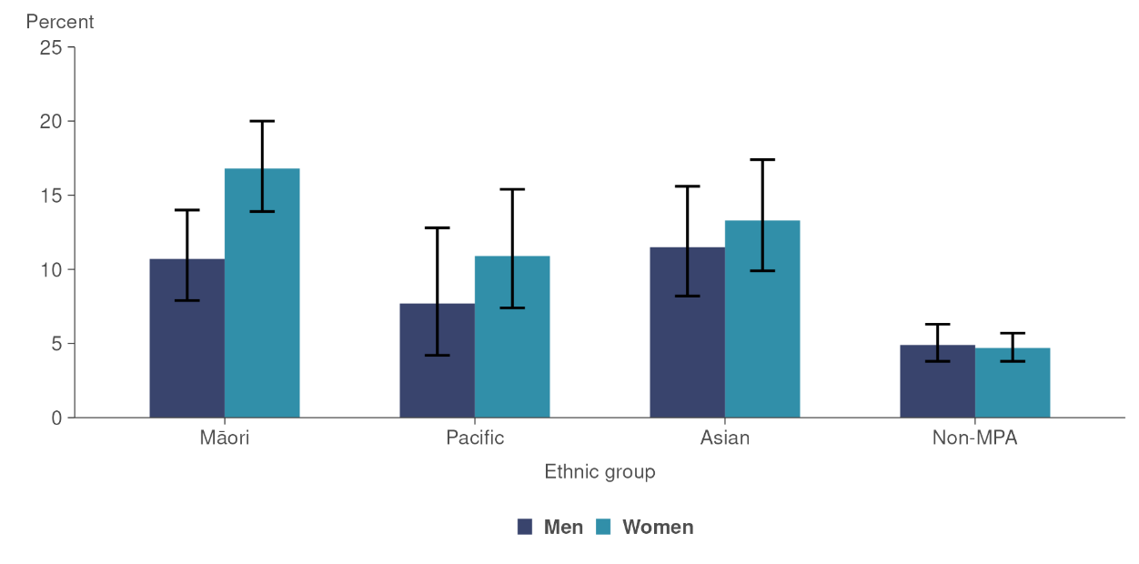

Some groups experienced increases in racial discrimination over time
The proportion of adults who experienced racial discrimination increased from 2011/12 to 2020/21. Experience of racial discrimination in the past 12 months increased from 5.9% in 2011/12 to 7.4% in 2020/21. Lifetime experience of racial discrimination increased from 16.1% to 22.6% over the same period.

Figure 3: Experience of racial discrimination in the past 12 months, by ethnic group, 2011/12, 2016/17 and 2020/21 (percentages)
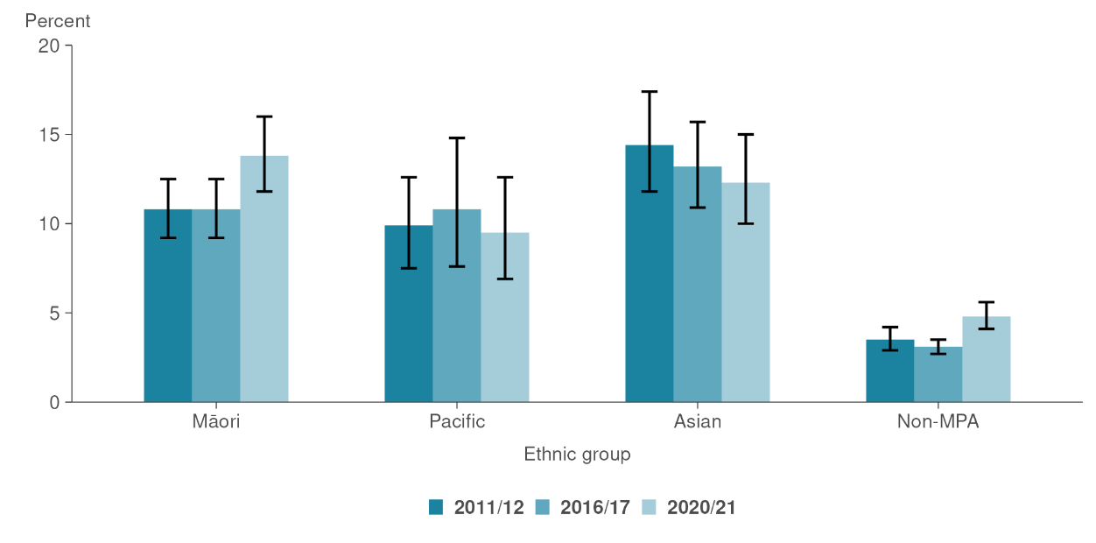
The proportion of Māori who experienced racial discrimination in the past 12 months increased from 10.8% in 2011/12 to 13.8% in 2020/21 (Figure 3). In particular, the proportion of Māori women who experienced racial discrimination in the past 12 months increased from 9.7% in 2011/12 to 16.8% in 2020/21. The lifetime prevalence of racial discrimination also increased for Māori, rising from 27.4% in 2011/12 to 37.6% in 2020/21.

Pacific experiences of racial discrimination in the past 12 months did not change significantly from 2011/12 (9.9%) to 2020/21 (9.5%). However, lifetime prevalence of racial discrimination increased from 21.5% in 2011/12 to 28.7% in 2020/21.

Asian adults experienced a small decrease in racial discrimination in the past 12 months, from 14.4% in 2011/12 to 12.3% in 2020/21, but the change was not statistically significant. Lifetime prevalence of racial discrimination increased from 31.9% to 35.3% over this time for Asian adults, but again this difference was not statistically significant.

For non-MPA adults, experiences of racial discrimination increased from 2011/12 to 2020/21. Over this time, 12-month prevalence increased from 3.5% to 4.8% and lifetime prevalence from 11.3% to 16.2%. Within the non-MPA group, adults belonging to MELAA ethnic groups had a 12-month prevalence of racial discrimination of 21.9% (95% confidence interval of 13.8%–31.8%) and a lifetime prevalence of 33.9% (95% confidence interval of 24.6%–44.3%) in 2020/21. Take care when interpreting these statistics because they have wide confidence intervals. We cannot compare rates of racial discrimination for MELAA groups over time because the sample size is small and the method of data collection has changed.

Verbal abuse was the most common type of racial discrimination experienced
Table 2 shows experiences of racial discrimination in the past 12 months, while Table 3 shows experiences over the lifetime. Ethnically motivated verbal abuse was the most common type of racial discrimination that adults in all ethnic groups experienced in 2020/21, both in the past 12 months and over their lifetime.

Unfair treatment by a health professional was the second-most common type of racial discrimination experienced in the past 12 months for both Māori (3.8%) and Pacific (2.6%) adults. Unfair treatment at work or refusal of a job was the second-most common type of discrimination experienced in the past 12 months for Asian (2.4%) and non-MPA (1.0%) adults.

Table 2: Experience of racial discrimination in the past 12 months, by type of discrimination and ethnic group, 2020/21 (percentages)
 | Māori | Pacific | Asian | Non-MPA
Type of racial discrimination* | % (95% CI) | % (95% CI) | % (95% CI) | % (95% CI)
Experience of personal attack | 9.2 (7.4–11.3) | 6.4 (4.3–9.1) | 9.9 (7.7–12.6) | 3.7 (3.0–4.4)
Physical abuse | 1.7 (1.0–2.6) | 0.7† (0.2–1.7) | 0.5† (0.1–1.8) | 0.3† (0.2–0.6)
Verbal abuse | 9.0 (7.2–11.1) | 6.4 (4.3–9.1) | 9.9 (7.6–12.6) | 3.6 (3.0–4.3)
Experience of unfair treatment | 7.0 (5.5–8.7) | 4.4 (2.8–6.6) | 4.2 (2.8–6.1) | 1.7 (1.3–2.2)
Unfair treatment by a health professional | 3.8 (2.5–5.4) | 2.6 (1.4–4.5) | 1.3† (0.5–2.7) | 0.6 (0.4–0.9)
Unfair treatment at work or refusal of a job | 2.8 (1.9–3.9) | 1.5† (0.7–2.7) | 2.4 (1.5–3.7) | 1.0 (0.7–1.4)
Unfair treatment when renting or buying housing | 1.9 (1.3–2.8) | 1.7† (0.7–3.5) | 1.7† (0.7–3.2) | 0.2† (0.1–0.5)
Notes: CI = confidence interval.
* People may experience more than one type of racial discrimination so percentages for specific types of racial discrimination combined do not sum to the total in each category.
† Interpret with caution as the relative standard error (the size of the standard error relative to the result) is over 30%.

Table 3: Experience of racial discrimination in lifetime, by type of discrimination and ethnic group, 2020/21 (percentages)
Type of racial discrimination* | Māori | Pacific | Asian | Non-MPA
 | % (95% CI) | % (95% CI) | % (95% CI) | % (95% CI)
Experience of personal attack | 29.9 (26.9–33.1) | 19.8 (15.6–24.6) | 29.2 (25.1–33.5) | 13.9 (12.7–15.1)
Physical abuse | 7.2 (5.9–8.7) | 4.5 (2.5–7.3) | 3.7 (2.3–5.7) | 2.6 (2.1–3.2)
Verbal abuse | 29.1 (26.0–32.2) | 19.5 (15.3–24.2) | 28.8 (24.7–33.2) | 13.2 (12.0–14.5)
Experience of unfair treatment | 18.6 (16.3–21.0) | 15.0 (11.6–19.0) | 14.1 (11.5–16.9) | 5.2 (4.5–5.9)
Unfair treatment by a health professional | 8.3 (6.7–10.3) | 6.4 (4.2–9.4) | 2.7 (1.5–4.4) | 1.8 (1.4–2.3)
Unfair treatment at work or refusal of a job | 8.1 (6.6–9.8) | 8.6 (6.0–11.9) | 10.3 (8.3–12.7) | 3.1 (2.6–3.7)
Unfair treatment when renting or buying housing | 8.8 (7.2–10.5) | 5.8 (3.8–8.6) | 4.9 (3.3–6.9) | 1.0 (0.6–1.4)
Notes: CI = confidence interval.
* People may experience more than one type of racial discrimination so percentages for specific types of racial discrimination do not sum to the total in each category.

Ethnically motivated unfair treatment
In this report, ethnically motivated unfair treatment includes unfair treatment by a health professional, unfair treatment at work or refusal of a job, and unfair treatment when renting or buying housing. In 2020/21, 7.0% of Māori, 4.4% of Pacific, 4.2% of Asian and 1.7% of non-MPA adults experienced unfair treatment on the basis of ethnicity in the past 12 months (Figure 4). This represents an increase in the rate of unfair treatment for Māori and for non-MPA since 2011/12.

After adjusting for differences in age and gender, Māori were 3.5 times as likely, and Pacific and Asian adults 2.2 times as likely as non-MPA adults to experience unfair treatment in the past 12 months on the basis of ethnicity.

Figure 4: Experience of ethnically motivated unfair treatment in the past 12 months, 2011/12, 2016/17 and 2020/21 (percentages)
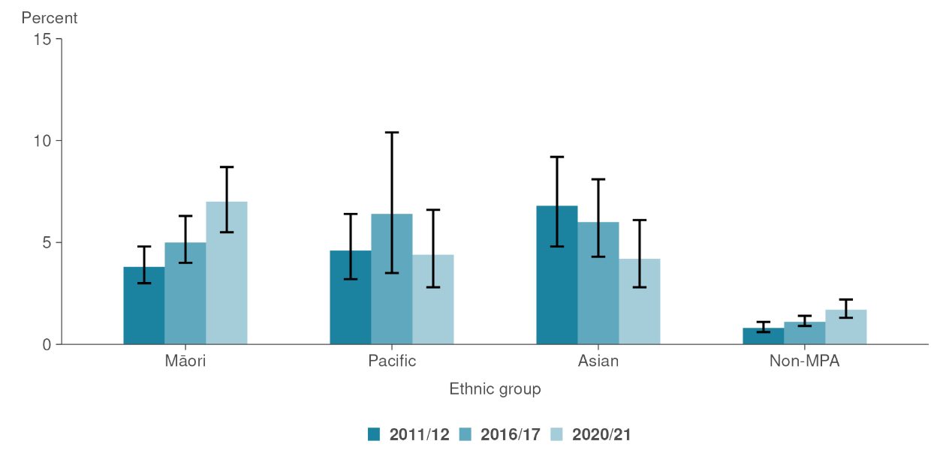

Ethnically motivated personal attack
In the 12 months before the 2020/21 survey, 9.2% of Māori, 6.4% of Pacific, 9.9% of Asian and 3.7% of non-MPA adults experienced ethnically motivated personal attacks (including verbal or physical abuse) (Figure 5). Verbal abuse was the most common type of ethnically motivated personal attack experienced by all ethnic groups. Over this period, 9.0% of Māori, 6.4% of Pacific, 9.9% of Asian and 3.6% of non-MPA adults experienced ethnically motivated verbal abuse.

Figure 5: Experience of ethnically motivated personal attack in the past 12 months, 2011/12, 2016/17 and 2020/21 (percentages)
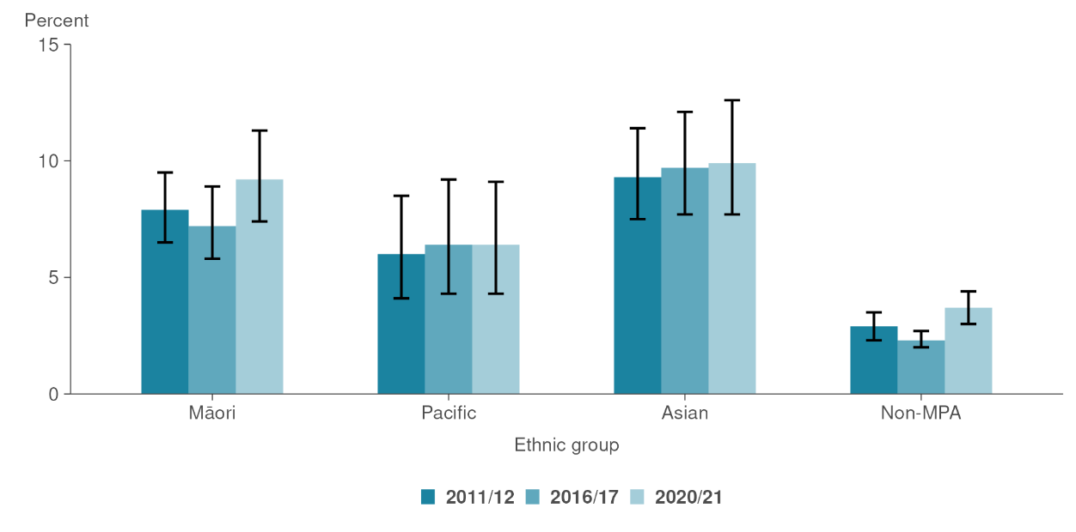
Māori and Asian adults were more likely than non-MPA adults to experience an ethnically motivated personal attack in the 12 months before the 2020/21 survey, after adjusting for age and gender differences between the groups. Māori adults were 2.2 times and Asian adults 2.3 times as likely as non-MPA adults to experience an ethnically motivated personal attack. Pacific adults were 1.5 times as likely as non-MPA adults to experience an ethnically motivated personal attack, but the difference was not statistically significant.

Racial discrimination is associated with poor health outcomes and unmet need
Note: This section shows associations between racial discrimination and health outcomes. It does not show that one causes the other.

The results in this section show key health outcomes and barriers to accessing health services for people who had experienced racial discrimination in the past 12 months. These figures only show associations between health outcomes and discrimination rather than cause-and-effect relationships, and other factors may contribute to the differences. For example, we don’t know from the data whether people experienced psychological distress as a result of experiencing racial discrimination. Note that in some cases below, the differences are not statistically significant.

Psychological distress
People who experienced racial discrimination in the past 12 months had a higher rate of psychological distress (17.1%) than people who had not experienced racial discrimination (8.9%). After adjusting for differences in age and gender, people who experienced discrimination in the past 12 months were 1.7 times as likely as people who hadn’t experienced discrimination to experience psychological distress.

Table 4 shows the rate of psychological distress for people who experienced racial discrimination in the past 12 months, compared with those who did not experience racial discrimination. Māori, Pacific and non-MPA adults who experienced racial discrimination had a higher rate of psychological distress than people who did not experience racial discrimination.

Table 4: Experience of psychological distress, by ethnic group, and experience of racial discrimination in past 12 months, 2020/21 (percentages)
Experienced racial discrimination in past 12 months | Percentage experiencing psychological distress
 | Māori | Pacific | Asian | Non-MPA
 | % (95% CI) | % (95% CI) | % (95% CI) | % (95% CI)
Yes | 23.9% (17.1–31.9) | 35.9% (19.9–54.6) | 6.7%† (2.9–13.0) | 17.5% (12.8–23.1)
No | 14.6% (12.0–17.5) | 14.0% (10.1–18.5) | 6.9% (4.9–9.5) | 7.9% (6.9–9.0)
Notes: CI = confidence interval.
† Interpret with caution as the relative standard error (the size of the standard error relative to the result) is over 30%.

Self-rated health
People who experienced racial discrimination in the past 12 months had a lower rate of good, very good or excellent self-rated health (79.5%) than people who did not experience racial discrimination (88.8%). After adjusting for differences in age and gender, people who experienced discrimination in the past 12 months were 0.9 times as likely as people who hadn’t experienced discrimination to have good, very good or excellent self-rated health.

Table 5 shows the rate of good, very good or excellent self-rated health for people who experienced racial discrimination and those who did not experience racial discrimination in the past 12 months. Māori, Pacific and non-MPA adults who experienced racial discrimination had a lower rate of good, very good or excellent self-rated health than people who did not experience racial discrimination. For the Asian ethnic group, the rate of good, very good or excellent self-rated health was similar for people who experienced racial discrimination and those who did not.

Table 5: Good, very good or excellent self-rated health, by ethnic group and experience of racial discrimination in past 12 months, 2020/21 (percentages)
Experienced racial discrimination in past 12 months | Percentage with good, very good or excellent self-rated health
 | Māori | Pacific | Asian | Non-MPA
 | % (95% CI) | % (95% CI) | % (95% CI) | % (95% CI)
Yes | 68.4% (60.7–75.5) | 63.5% (48.9–76.5) | 89.5% (82.1–94.6) | 81.8% (74.1–88.0)
No | 84.3% (82.0–86.4) | 83.8% (79.2–87.8) | 90.4% (87.6–92.7) | 89.9% (89.1–90.6)
Note: CI = confidence interval.

Unmet need for primary health care
Racial discrimination may act as a barrier to accessing health care (Harris et al 2019). People who had experienced racial discrimination in the past 12 months had a higher rate of unmet need for primary health care in the past 12 months (41.9%) than people who did not experience racial discrimination (26.7%). After adjusting for differences in age and gender, people who experienced discrimination in the past 12 months were 1.5 times as likely as people who hadn’t experienced discrimination to have an unmet need for primary health care.

Table 6 shows the rate of unmet need for primary health care for people who experienced racial discrimination in the past 12 months, compared with those who did not experience racial discrimination. Adults in all ethnic groups who experienced racial discrimination had a higher rate of unmet need for primary health care than people who did not experience racial discrimination.

Table 6: Unmet need for primary health care, by ethnic group, and experience of racial discrimination in past 12 months, 2020/21 (percentages)
Experienced racial discrimination in past 12 months | Percentage with unmet need for primary health care
 | Māori | Pacific | Asian | Non-MPA
 | % (95% CI) | % (95% CI) | % (95% CI) | % (95% CI)
Yes | 52.7% (42.9–62.3) | 51.4% (33.6–68.9) | 30.7% (20.2–42.9) | 40.9% (32.8–49.3)
No | 32.0% (29.2–35.0) | 30.1% (25.8–34.7) | 19.9% (16.9–23.1) | 26.7% (25.0–28.5)
Note: CI = confidence interval.

Ngā tikanga rangahau |
Methodology

Source data
The data in this report was collected as part of the NZHS racial discrimination module. This module was attached to the adult questionnaire in 2011/12, 2016/17 and 2020/21. The questions are shown in Appendix A. See the NZHS questionnaire and content guide for more information about survey modules and questions.

Sample sizes
Table 7 shows the sample sizes for the NZHS in 2011/12, 2016/17 and 2020/21 by the ethnic group categories used in this report.

Table 7: Sample sizes for NZHS in 2011/12, 2016/17 and 2020/21, by ethnic group
 |  | Year
Ethnic group | 2011/12 | 2016/17 | 2020/21
Māori | 2,586 | 2,747 | 1,927
Pacific | 960 | 843 | 606
Asian | 931 | 1,318 | 1,068
Non-MPA | 8,256 | 8,851 | 6,246

Impact of COVID-19 on the 2020/21 survey collection
Interviews for the 2020/21 NZHS took place between September 2020 and August 2021. COVID-19 had a significant impact on the data collection for this survey. Data was not collected during COVID-19 Alert Levels 3 or 4, or when there was uncertainty about potential community outbreaks. Data collection was most disrupted in Auckland.

The main impact of COVID-19 disruptions for the 2020/21 survey year is that the sample size is smaller than usual. The adult sample for 2020/21 is about 69% of the size of the usual sample (compared with pre-COVID-19 years from 2011/12 to 2018/19). As a result of the smaller sample sizes, the confidence intervals around point estimates are wider than usual. The smaller sample size may also mean that more subgroup statistics are suppressed. See the NZHS Methodology Report 2020/21 for more information (Ministry of Health 2021b).

Comparisons by ethnic group
Ethnicity data in this analysis represents the ethnic group or groups the respondent self-identifies with. Data is classified according to the Ethnicity New Zealand Standard Classification 2005. Data for Māori, Pacific and Asian groups is shown at ‘level 1’ of the ethnicity classification, while the non-MPA group is an aggregation of level 1 ethnic groups.

This analysis is based on the total response method of classifying ethnicity, except for the non-MPA group. People belonging to the Māori, Pacific or Asian ethnic groups have been counted in each ethnic group they identify with. The non-MPA group includes people who belong to the European, Middle Eastern/Latin American/African (MELAA) and/or Other ethnic groups, excluding people who also belong to the Māori, Pacific and/or Asian ethnic groups. In other words the non-MPA group represents the non-Māori, non-Pacific and non-Asian group. For example, someone who belongs to the Māori and Pacific ethnic groups would be included in the results for both ethnic groups. Someone who belongs to the Māori and European ethnic group would only be included in the results for the Māori ethnic group. This differs from the regular NZHS outputs where people are counted in each ethnic group they belong to, including the European/Other group.

Comparability with previously published data
These results may differ from previously published results. Updated population data has been used to recalculate NZHS results from 2011/12 to 2019/20. See the NZHS Methodology Report 2020/21 for more information (Ministry of Health 2021b). The way we treated partial non-response and adjusted for non-response may differ from previous releases (see the next section for more information). In addition, comparison with the non-MPA group differs from previous publications on this topic.

How we treated non-response
In this analysis, we have treated partial non-response to the questions in the following ways.
- Where the respondent has indicated they have experienced racial discrimination, we have categorised them as experiencing discrimination even if they haven’t responded to other questions. For example, if someone indicated they had experienced verbal abuse but they didn’t answer the questions about unfair treatment, we have categorised them as having experienced discrimination.
- Where the respondent answered ‘no’ to all questions about experience of personal attacks and unfair treatment, we have categorised them as not having experienced racial discrimination in the specified time-period.
- Where the respondent has answered ‘no’ to some questions and hasn’t answered others, we have treated this as non-response.

We made an adjustment to account for non-response to the discrimination questions using the standard NZHS method of adjusting for item non-response. See the NZHS Methodology Report 2020/21 for more information (Ministry of Health 2021b). The way we treated non-response in this analysis may differ from previously published analyses.

How we treated ‘not applicable’ responses
In 2016/17 and 2020/21, the questions about unfair treatment included a response option of ‘not applicable’. The 2011/12 survey did not include this response option. To carry out time-series analyses, we combined the ‘not applicable’ responses with responses of ‘no’.

Confidentiality and reliability of estimates
To ensure the survey data presented is reliable and to protect the respondents’ confidentiality, this report presents data only when at least 30 people are in the denominator (the population group being analysed).

Confidence intervals
These results include 95% confidence intervals to represent the uncertainty due to selecting a sample to estimate values for the entire population. When confidence intervals do not overlap, it can be concluded that the estimates differ significantly. However, when they do overlap, it is still possible that there is a significant difference. See the NZHS Methodology Report 2020/21 for more information (Ministry of Health 2021b).

Care should be taken when interpreting estimates with wide confidence intervals. Wider confidence intervals indicate less precise estimates than narrow intervals, caused by higher variation with a sample and/or smaller numbers in a sample.

Ngā tohutoro |
References
Gee GC, Spencer MS, Chen J, et al. 2007. A nationwide study of discrimination and chronic health conditions among Asian Americans. American Journal of Public Health 97(7): 1275–82.

Harris R, Tobias M, Jeffreys M, et al. 2006. Racism and health: the relationship between experience of racial discrimination and health in New Zealand. Social Science & Medicine 63(6): 1428–41.

Harris R, Cormack D, Tobias M, et al. 2012. The pervasive effects of racism: experiences of racial discrimination in New Zealand over time and associations with multiple health domains. Social Science & Medicine 74(3): 408–15.

Harris RB, Cormack DM, Stanley J. 2019. Experience of racism and associations with unmet need and healthcare satisfaction: the 2011/12 adult New Zealand Health Survey. Australian and New Zealand Journal of Public Health 43(1): 75–80.

Harris RB, Stanley J, Cormack DM. 2018. Racism and health in New Zealand: prevalence over time and associations between recent experience of racism and health and wellbeing measures using national survey data. PLoS One 13(5): e0196476.

Jones CP. 2000. Levels of racism: a theoretic framework and a gardener’s tale. American Journal of Public Health 90(8): 1212–5.

Karlsen S, Nazroo J. 2002. Relation between racial discrimination, social class, and health among ethnic minority groups. American Journal of Public Health 92(4): 624–30.

Krieger N, Carney D, Lancaster K, et al. 2010. Combining explicit and implicit measures of racial discrimination in health research. American Journal of Public Health 100(8): 1485–92.

Lewis TT, Cogburn CD, Williams DR. 2015. Self-reported experiences of discrimination and health: scientific advances, ongoing controversies, and emerging issues. Annual Review of Clinical Psychology 11: 407–40.

McMeeking S, Tarena E, Williams M, et al. 2022. Whiria te Muka Tangata: Anti-Racism Systems Change. A preliminary model for the Aotearoa New Zealand health system. Wellington: Ministry of Health.

Ministry of Health. 2019. New Zealand Cancer Action Plan 2019–2029 — Te Mahere mō te Mate Pukupuku o Aotearoa 2019–2029. Revised January 2020 Wellington: Ministry of Health.

Ministry of Health. 2020a. Ola Manuia: Pacific Health and Wellbeing Action Plan 2020–2025. Wellington: Ministry of Health. URL: www.health.govt.nz/publication/ola-manuia-pacific-health-and-wellbeing-action-plan-2020-2025 (accessed 12 May 2023).

Ministry of Health. 2020b. Whakamaua: Māori Health Action Plan 2020–2025. Wellington: Ministry of Health. URL: www.health.govt.nz/system/files/documents/publications/whakamaua-maori-health-action-plan-2020-2025-2.pdf (accessed 12 May 2023).

Ministry of Health. 2021a. Kia Manawanui Aotearoa: Long-term pathway to mental wellbeing. Wellington: Ministry of Health.

Ministry of Health. 2021b. Methodology Report 2020/21: New Zealand Health Survey. Wellington: Ministry of Health. URL: www.health.govt.nz/system/files/documents/publications/methodology-report-2020-21-new-zealand-health-survey-dec21.pdf (accessed 12 May 2023).

Ministry of Health. 2022a. Ao Mai te Rā | The Anti-Racism Kaupapa. URL: www.health.govt.nz/our-work/populations/maori-health/ao-mai-te-ra-anti-racism-kaupapa (accessed 30 March 2023).

Ministry of Health. 2022b. Position Statement and Working Definitions for Racism and Anti-racism in the Health System in Aotearoa New Zealand. Wellington: Ministry of Health. URL: www.health.govt.nz/publication/position-statement-and-working-definitions-racism-and-anti-racism-health-system-aotearoa-new-zealand (accessed 30 March 2023).

Pheterson G. 1986. Alliances between women: overcoming internalized oppression and internalized domination. Signs 12(1): 146–60.

Pyke KD. 2010. What is internalized racial oppression and why don’t we study it? Acknowledging racism’s hidden injuries. Sociological Perspectives 53(4): 551–72. DOI: 10.1525/sop.2010.53.4.551 (accessed 12 May 2023).

Talamaivao N, Harris R, Cormack D, et al. 2020. Racism and health in Aotearoa New Zealand: a systematic review of quantitative studies. New Zealand Medical Journal (Online) 133(1,521): 55–65.

Watts-Jones D. 2002. Healing internalized racism: the role of a within-group sanctuary among people of African descent. Family Process 41(4): 591–601.

Williams M, McMeeking S. 2022. Best Practice Approaches to Addressing Racism: Lessons for the Aotearoa New Zealand Health System (Stage Two Literature Review). Wellington: Ministry of Health.

Āpitihanga A: Ngā pātai a te wāhanga o te Rangahau Hauora o Aotearoa 2020/21 e pā ana ki ngā mahi kaikiri |
Appendix A: Racial discrimination module questions, New Zealand Health Survey 2020/21
The analysis in this report is based on the following questions from the racial discrimination module of the New Zealand Health Survey (NZHS) adult questionnaire. The questions are copied from the 2020/21 module. The 2016/17 questionnaire had minor differences in response categories for the first 2 questions. For more information, see: www.health.govt.nz/nz-health-statistics/national-collections-and-surveys/surveys/new-zealand-health-survey?mega=Health%20statistics&title=NZ%20Health%20Survey#2020-21.

R5.10 Have you ever been a victim of an ethnically motivated attack (verbal or physical abuse to you or your property) in New Zealand?
[Select all that apply]

1 Yes, verbal – within the past 12 months
2 Yes, verbal – more than 12 months ago
3 Yes, physical – within the past 12 months
4 Yes, physical – more than 12 months ago
5 No
.K Don’t know
.R Refused

R5.11 Have you ever been treated unfairly (for example, kept waiting or treated differently) by a health professional (that is, a doctor, nurse, dentist etc.) because of your ethnicity in New Zealand?
[Select all that apply]

1 Yes, within the past 12 months
2 Yes, more than 12 months ago
3 No
4 Not applicable – have never tried to visit a health professional in New Zealand
.K Don’t know
.R Refused

R5.12 Have you ever been treated unfairly at work or been refused a job because of your ethnicity in New Zealand?
[Select all that apply]

1 Yes, within the past 12 months
2 Yes, more than 12 months ago
3 No
4 Not applicable – have never had a job or tried to find a job in New Zealand
.K Don’t know
.R Refused

R5.13 Have you ever been treated unfairly when renting or buying housing because of your ethnicity in New Zealand?
[Select all that apply]

1 Yes, within the past 12 months
2 Yes, more than 12 months ago
3 No
4 Not applicable – have never tried to rent or buy a house in New Zealand
.K Don’t know
.R Refused

In this report, ‘racial discrimination’ includes experience of personal attack (physical or verbal), and experience of unfair treatment in health care, employment or housing.
In this report, racial discrimination includes experience of ethnically motivated personal attack (physical or verbal), and experience of unfair treatment in health care, employment or housing.
The difference over time or between groups is statistically significant if the confidence intervals do not overlap. Sometimes, even when 2 confidence intervals overlap, the difference between these groups can be statistically significant. Unless specifically stated otherwise, where the text states 2 rates differ, we have carried out a statistical test to confirm that the finding is statistically significant.
In this report, ‘psychological distress’ means having a high or very high level of psychological distress, with a score of 12 or more on the 10-question Kessler Psychological Distress Scale (K10). Where people have these levels of psychological distress, it is highly or very highly probable that they also have an anxiety or depressive disorder.
Unmet need for primary health care includes any unmet need in the past 12 months (unable to get an appointment at usual medical centre within 24 hours, unmet need for GP services due to cost or transport, unmet need for after-hours services due to cost or transport).
New Zealand Health Survey: www.health.govt.nz/nz-health-statistics/national-collections-and-surveys/surveys/new-zealand-health-survey?mega=Health%20statistics&title=NZ%20Health%20Survey (accessed 12 May 2023).
Ethnicity New Zealand Standard Classification 2005 V2.1.0: http://aria.stats.govt.nz/aria/?_ga=2.99316702.1191826017.1659388995-392480606.1646960786#ClassificationView:uri=http://stats.govt.nz/cms/ClassificationVersion/YVqOcFHSlguKkT17 (accessed 12 May 2023).
For Annual New Zealand Health Survey outputs, see www.health.govt.nz/nz-health-statistics/national-collections-and-surveys/surveys/new-zealand-health-survey?mega=Health%20statistics&title=NZ%20Health%20Survey#2021_22 (accessed 12 May 2023).

