Progress on Gambling Harm Reduction 2010 to 2017
Outcomes report – New Zealand Strategy to Prevent and Minimise Gambling Harm

Acknowledgements
The Ministry of Health thanks the members of the external Gambling Outcomes Advisory Group (comprising researchers, industry, and harm minimisation providers) for their comments on the initial draft.
Report prepared by:
Dr John Wren, Senior Research Advisor, Addictions, Mental Health and Addiction Directorate, Ministry of Health.
Citation: Ministry of Health. 2019. Progress on Gambling Harm Reduction 2010 to 2017: Outcomes report – New Zealand Strategy to Prevent and Minimise Gambling Harm. Wellington: Ministry of Health.
Published in March 2019 by the Ministry of Health
PO Box 5013, Wellington 6140, New Zealand
ISBN 978-1-98-856816-4 (online)
HP 6967
This document is available at health.govt.nz
This work is licensed under the Creative Commons Attribution 4.0 International licence. In essence, you are free to: share ie, copy and redistribute the material in any medium or format; adapt ie, remix, transform and build upon the material. You must give appropriate credit, provide a link to the licence and indicate if changes were made.

Contents
Executive summary 1
Progress on strategic goal 2
Conclusion – review and reinvigoration of activities is suggested to reduce harm 5
Introduction 6
The 2013 baseline report 7
Independent updates on gambling prevalence and associated harm 7
Section 1: Progress on the strategic goal 11
The sector working together 11
Independent assessment of progress – more work is needed 13
Harm reduction 14
Suggested explanations for the plateauing in harmful gambling levels 18
Section 2: Key outcomes 19
Objective 1: There is a reduction in gambling harm-related inequities 19
Objective 2: Māori have healthier futures, through the prevention and minimisation of gambling harm 24
Conclusion: Objectives 1 and 2 29
Section 3: Enabling people and communities – objectives 3, 5 and 7 31
Aware Communities and Supportive Communities 32
Conclusion: Objectives 5, 7 and 11 35
Section 4: Services are accessible, raise awareness and reduce harm – objectives 8–10 36
Objective 8: Promoting safe and safer gambling environment design 37
Objectives 9 and 10: Services raise awareness and are accessible 41
Conclusion: Objectives 8–10 45
Section 5: System supports change – objectives 4, 6 and 11 46
Objective 4: Promoting gambling harm minimisation policies 47
Objective 6: Developing a skilled workforce 50
Objective 11: Developing an evidence base to underpin activities 51
Conclusion: Objectives 4, 6, 11 53
Summary and conclusion 55
Summary 55
Conclusion – review and reinvigoration of activities is suggested to reduce harm further 58
References 59
Appendix 1: Gambling expenditure 2009/10–2016/17 62

List of Figures
Figure 1: Logic model grouping the integrated objectives of the Strategy to Prevent and Minimise Gambling Harm 10
Figure 2: Percentage of gambling participation in the total population, 2010–2016 Health and Lifestyles Surveys 14
Figure 3: Percentage of past-year gambling participation by number of activities, 1985–2012 National Gambling Study 15
Figure 4: Percentage of gambling harm by PGSI low-risk to problem gambling behaviour scores, 2010–2016 Health and Lifestyle Surveys 15
Figure 5: Estimates of risky gambling behaviour in total New Zealand 2014 population from pooled results of the combined 2012–2016 Health and Lifestyles Surveys 16
Figure 6: Distribution of class 4 (pokie) venues by socioeconomic deprivation area (venue counts by year and socioeconomic deprivation area), as at June 2012–2018 21
Figure 7: Absolute and relative inequalities in gambling harm experience over time between New Zealand ethnic groups, 2010–2016 HLS 22
Figure 8: Clients by ethnicity assisted over time by main type of intervention (all interventions and excluding brief interventions), 2004/05–2015/16 28
Figure 9: Implementer ratings of the safer environment programme outcomes 40
Figure A1: Total actual gambling expenditure 62
Figure A2: Total inflation adjusted gambling expenditure 63
Figure A3: Total inflation adjusted expenditure per capita 63

List of Tables
Table 1: Results of meta-analysis of results from Health and Lifestyles Surveys 2012, 2014, 2016 of gambling activity and associated risk of harm in the 2014 New Zealand population by PGSI level 17
Table 2: Number of New Zealand gamblers by PGSI category, 2010–2016 18
Table 3: Predictors for those who report contact with gambling problem services 26
Table 4: Forms of gambling most frequently identified as potentially more harmful, 2010 and 2016 Health and Lifestyles Surveys 43
Table 5: Service recognition by all respondents and those with risky gambling behaviour, 2016 HLS 44
Table 6: Actions and outcomes associated with promoting workplace and organisation policy development and implementation 48
Table 7: Actions and outcomes associated with local government policy 49
Table 8: Actions and outcomes associated with alternative funding sources 50

Executive summary
This report focuses on what has been achieved in the prevention and minimisation of gambling harm over the calendar period 2010 to 2017.
Since 1 July 2004, the Ministry of Health (the Ministry) has been responsible for developing and implementing the ‘integrated problem gambling strategy focused on public health’ that is described in section 317 of the Gambling Act 2003 (the Act).

The current integrated Strategy to Prevent and Minimise Gambling Harm 2016/17 to 2018/19 (the Strategy) implements the Ministry’s response to its responsibility. The Strategy comprises the Ministry’s strategic framework for the prevention and minimisation of gambling harm, a three-year service plan giving effect to the strategic framework, and the levy rate and Ministry budget. The strategy builds on previous iterations going back to 2004.

Outcomes reporting against the objectives and activities set out in the Strategy is one of the actions in the service plan. A baseline report published in 2013 is available on the Ministry’s gambling webpage: www.health.govt.nz/publication/outcomes-framework-preventing-and-minimising-gambling-harm-baseline-report

This new outcomes report is an evolution of the approach set out in the 2013 outcomes report, and is an update on the progress made since the 2013 report. The period 2010–2013 has been added to the report to provide some context and make it easier to monitor change over time.

This new report brings together a range of information that has been published in a number of independent research reports, national gambling survey data, time-series analysis of population-level survey data collected through the Health Promotion Agency’s Health and Lifestyles Survey (HLS) from 2010–2016, agency contract monitoring reports and administrative data on service use.

The report is organised into five sections that comprise groupings of the 11 strategic objectives. The sections are:
1 Progress on the strategic goal – sector working together to reduce harm
2 Key outcomes – reduction in harm inequalities and Māori have healthier futures
3 Enabling people and communities
4 Services are accessible, raise awareness and reduce harm
5 System supports change.

In each section, outcomes measures for the time period are reported in the form of summary statistics. The focus is on what has or has not changed over the 2010–2017 period, and a brief commentary presents an interpretation, discussion and conclusion about what the statistics indicate and implications for service design and delivery.

In the analysis, the emphasis is on reporting measures showing what has changed (been achieved) in terms of the key outcomes as a result of activities, rather than on reporting what has been done and every possible indicator of change. The indicators that have been used are from reliable data sources and are directly related to activities undertaken and the key outcomes sought as expressed through the strategy objectives.

Progress on strategic goal
Over the 2010–2017 period the Strategy’s strategic goal has been:
Government, the gambling sector, communities and families/whānau working together to prevent and minimise gambling harm, and to reduce related health inequities.

In outcomes reporting terms, this goal has three aspects that represent discrete outcomes:
1 The gambling sector is working together
2 Gambling harm has been minimised
3 Gambling-harm-related inequities have been reduced.

The sector working together is a work in progress
The 2018 independent needs assessment of the gambling sector by the Sapere Research Group commented that:
‘There are many opportunities to learn from best practice within New Zealand and create pilot service models to address service gaps. Work is needed to improve inter-sectoral relationships and make best use of the skills available within the industry as a whole to support those harmed by gambling.’
(Rook et al 2018).

Areas the assessment identified where the sector as a whole could work better together include:
- improving host responsibility practices aimed at identifying risky gambling behaviour and encouraging those at risk to seek help
- enabling more effective and efficient voluntary multi-venue exclusion practices
- relocating non-casino gambling machines (ie, ‘pokies’) away from the most socioeconomically deprived areas
- improving the flow of the distribution of the proceeds of gambling to the community groups in the areas in greatest need of support.

Gambling harm levels have reduced substantially compared with 25 years ago, however, they have remained substantively unchanged since 2012
From the Health Promotion Agency’s 2016 Health and Lifestyles Survey (Thimasarn-Anwar et al 2017), and the National Gambling Study (Abbott et al 2018), the data and associated discussion highlight that gambling harm in the total population in 2016, as measured by the Problem Gambling Severity Index (PGSI), is at the lowest level in 25 years. In the last five to seven years, however, the level of PGSI gambling harm in the overall population, as measured by the HLS and NGS, has remained relatively stable. Meta-analysis of the survey results for 2010–2016 indicates that, based on the 2014 New Zealand population, in the previous 12 months approximately:
- 0.5% of the population (23,500 people) report levels of gambling behaviour and harm associated with problem gambling risk
- 1.5% of the population (60,440 people) report levels of gambling behaviour and harm associated with moderate gambling risk
- 3.1% of the population (167,888 people) report levels of gambling behaviour and harm associated with low to mild gambling risk
- 65.3% of the population (2,460,000 people) report levels of gambling behaviour and harm associated with no/non-problem gambling risk
- 29.9% of the population report not gambling.

Some public health researchers question the use of the PGSI as the key measure of gambling harm, arguing that a quality of life years lost (QALY) measure should be used. Using QALYs, the 2017 Measuring the Burden of Gambling Harm in New Zealand study suggests that the harm experienced through high-risk gambling behaviour is perceived as of the same order of magnitude as high alcohol consumption and other health issues such anxiety and depression (Browne et al 2017). In addition, the authors argue that cumulatively the harm from gambling ‘is close to twice that of drug use disorders, bipolar affective disorder, eating disorders and schizophrenia combined’.

Absolute levels of inequalities have reduced between population groups since 2010, however, relative inequalities remain
Data and analysis show that inequalities between population groups by age, socioeconomic deprivation, gender and ethnicity have reduced in absolute terms in the period 2010–17. However, in relative terms disparities in exposure to gambling and experience of gambling-related harm remain.

Many of the high-risk population groups reside disproportionately in neighbourhoods categorised in the three highest levels of deprivation. These neighbourhoods typically have high concentrations of gambling venues and outlets. In New Zealand this includes electronic gaming machines in pubs and clubs, and track and sports betting venues (TABs). Living in close proximity to gambling venues has been shown to be associated with higher levels of problem gambling (Tu et al 2014).

Work to promote aware, enabled and resilient communities and safer gambling environments has progressed
A range of activities over the 2010–2017 period have been aimed at promoting community awareness, resiliency and safer gambling environments.

The outcomes show that the activities have maintained a good level of awareness of the harm arising from gambling and what can be done to minimise it. In the population overall, the data shows that awareness is generally high: about 70% recognise the signs of risky gambling and what can be done to address the behaviour. However, the most recent levels reported in 2016 are lower than those in earlier years. Of interest and concern is that levels of awareness of key services such as free face-to-face counselling are relatively low (at approximately 30%) among at-risk gamblers, although awareness of the key free telephone helpline service is higher. Activities in the policy area have enabled people to engage in local decisions about gambling activities in their communities (Kolandai-Matchett et al 2018a).

Among the challenges are that, due to their design and method of delivery, many of the initiatives are local, specific and short term in nature, as well as resource intensive for the provider and funder. These characteristics typically mean the long-term impacts may be minimal and are not necessarily scalable nationwide. However, Kolandai-Matchett et al (2018a) have argued that these types of initiatives are important in promoting ‘social sustainability’ and ‘could function in a positively reinforcing loop to strengthen programme effectiveness’ overall. As such, the initiatives are well aligned with a comprehensive public health approach to preventing and minimising gambling harm.

System change enablers have progressed
System change enablers are activities aimed at assisting communities and service providers to have information resources, training and a research evidence base that inform the design and delivery of effective services and enable local communities to engage in harm minimisation activities.

Activities over the 2010–2017 period include: developing new training resources for the gambling industry on host responsibility; the Ministry expressing to service providers its ongoing expectations about the professionalisation of the harm minimisation workforce; supporting policy engagement activities by harm minimisation service providers; and commissioning a broad range of research and evaluation services.

The outcomes reported indicate that more needs to be done to promote understanding of the benefits of workforce professionalisation and to overcome the barriers to it identified in Sapere’s 2018 gambling needs assessment (Rook et al 2018). Similarly, while resources have been developed to support the gambling industry, the 2016 HLS results indicate that there is considerable room for improvement by the gambling industry in the host responsibility area. New research and evaluation knowledge has been acquired that has informed policy and operational thinking. Studies such as the National Gambling Study and the Measuring the Burden of Gambling Harm in New Zealand study are internationally significant, and the HLS gambling module is integral to regularly monitoring change over time in the level of gambling activity and harm in the New Zealand population.

Conclusion – review and reinvigoration of activities is suggested to reduce harm
Overall, the outcomes to date show progress has been made in reducing gambling harm and inequities in New Zealand. However, since approximately 2012 the downward movement in gambling harm has plateaued.

Progress has also been made across all of the 11 objectives set out in the Ministry’s integrated strategies. However, in a number of the areas challenges to further progress have been identified.

A range of research-based explanations may help to account for these outcomes. Research has shown that reaching a plateau in harm reduction is not unique to New Zealand.

These results imply that the current harm reduction activities should be reviewed and reinvigorated if the aim is to further reduce gambling harm.

Introduction
This report has evolved from earlier gambling outcomes frameworks dating back to 2007.
Since 1 July 2004, the Ministry of Health (the Ministry) has been responsible for developing and implementing the ‘integrated problem gambling strategy focused on public health’ that is described in section 317 of the Gambling Act 2003 (the Act). Over time, a number of strategy documents and service plans have been developed and implemented. Each has had the overall goal of:
Government, the gambling sector, communities and families/whānau working together to prevent and minimise gambling harm, and to reduce related health inequities.

As part of the efforts to achieve this goal, the Act includes requirements for the Ministry to have:
- measures to promote public health by preventing and minimising the harm from gambling
- services to treat and assist problem gamblers and their families and whānau
- independent scientific research associated with gambling, including, for example, longitudinal research on the social and economic impacts of gambling, particularly the impacts of gambling on different cultural groups
- evaluation.

In 2007 the Ministry began work on developing an outcomes framework for reporting on progress against the overall goal set for the Ministry by the legislation, and associated objectives set out in a series of Ministry gambling harm reduction strategy documents. In 2010 an outcomes framework was incorporated into Preventing and Minimising Gambling Harm: Six-year strategic plan 2010/11–2015/16 (Health 2010).

Since the publication of that plan, a range of independent research reports and the results from national surveys have been published. These publications included a wide range indicators such as the prevalence of gambling harm in the New Zealand population, attitudes towards gambling, the viewing of gambling harm messages, and the use of gambling harm reduction services.

The 2013 baseline report
In 2013, the Ministry published the Outcomes Framework for Preventing and Minimising Gambling Harm – Baseline Report (KPMG 2013) (the baseline report). It presented an analysis of an initial set of 65 indicators measuring progress on the 11 gambling harm minimisation objectives set out in the Preventing and Minimising Gambling Harm: Six-year strategic plan 2010/11–2015/16. The baseline report covered the period from 2006–2012.

Independent updates on gambling prevalence and associated harm
Since the publication of the baseline report in 2013, a suite of comprehensive population level survey reports on the incidence and prevalence of gambling and gambling harm has been published by the Health Promotion Agency (HPA) and the Auckland University of Technology (AUT) Gambling and Addictions Research Centre. These large independent surveys, funded from the gambling research budget, collect a wealth of information about gambling behaviour and the harm experienced by gamblers and their affected others. The surveys and associated analyses fundamentally inform this outcomes report. These surveys are outlined below.

Health and Lifestyles Survey (HLS)
Every two years the HPA undertakes a large survey of New Zealanders’ health and lifestyle behaviour, including gambling. The survey provides a regular update of the incidence of gambling behaviour and associated harm in New Zealand. For the results of the most recent (2016) survey, which includes a time-series analysis, go to: www. hpa.org.nz/research-library/research-publications/new-zealanders-participation-in- gambling-results-from-the-2016-health-and-lifestyles-survey

National Gambling Study (NGS)
Beginning in 2012, the NGS is a longitudinal cohort study of gamblers in New Zealand. The study, using an in-depth survey approach, has focused on following a group of New Zealanders over time to study their gambling behaviour. The study has resulted in the publication of a suite of detailed reports on the patterns of self-reported gambling behaviour, reasons for the behaviour, and the harm occurring to the gambler and affected others from the gambling behaviour. For the reports from the study, go to: www.health.govt.nz/our-work/mental-health-and-addictions/gambling/gambling-research-and-evaluation/key-information-sources-gambling-harm-and-service-utilisation/national-gambling-study-understanding-gambling-behaviour

Administrative data used in this report
Additional administrative gambling statistics from government agencies have been sourced from the Department of Internal Affairs (DIA) and from the Ministry’s client intervention gambling services data. Summary statistics and analysis of the administrative data are publicly available. The sources are outlined below.

Department of Internal Affairs gaming statistics
The DIA routinely collects and publishes data from the gambling sector on the numbers and types of gambling societies licensed to operate gaming machines at approved venues. Annual expenditure statistics on the four main types of gambling are available. The DIA has produced a range of analyses about the distribution and use of gaming machines in the population. For the DIA data, go to: www.dia.govt.nz/ Resource-material-Information-We-Provide-Gaming-Statistics

Ministry of Health gambling harm statistics
The Ministry routinely collects data on gambling service use. Regular updates are provided by service providers on the number of clients who have received problem gambling treatment services. Their reports include a range of variables such as gender, ethnicity, territorial region and primary source of gambling harm by gambling mode. For summary statistics on service use over time, go to: www.health.govt.nz/ our-work/mental-health-and-addictions/gambling/service-user-data/intervention- client-data

Progress on achieving the objectives of the Strategy to Prevent and Minimise Gambling Harm
Collectively, the above body of resources provides the opportunity to monitor progress on changes in exposure to gambling activities, gambling behaviour, the harm occurring from gambling activity over time, and outcomes from a range of other gambling harm minimisation activities. This report collates some of this material with a focus on monitoring progress against the Ministry’s strategic plan and associated service plans for preventing and minimising gambling harm.

This outcomes report focuses on what has changed since 2010, and the KPMG baseline report. Where earlier robust and comparable data is available on the incidence and prevalence of gambling harm, it has been incorporated into this report. Figure 1 presents a logic model, grouping the objectives that have driven the Ministry’s programme of work over 2010–2018. The logic model builds on and refines the various outcomes frameworks that have evolved since 2007.

Based on the logic model groupings, the report is organised into the following five sections, which group the 11 strategic objectives:
1 Progress on the strategic goal – sector working together to reduce harm
2 Key outcomes – reduction in harm inequalities and Māori have healthier futures
3 Enabling people and communities
4 Services are accessible, raise awareness and reduce harm
5 System supports change.

In each section, outcomes measures in the form of summary statistics for the time period are reported. Brief commentary presenting an interpretation, discussion and conclusion about what the statistics indicate is provided.

Figure 1: Logic model grouping the integrated objectives of the Strategy to Prevent and Minimise Gambling Harm
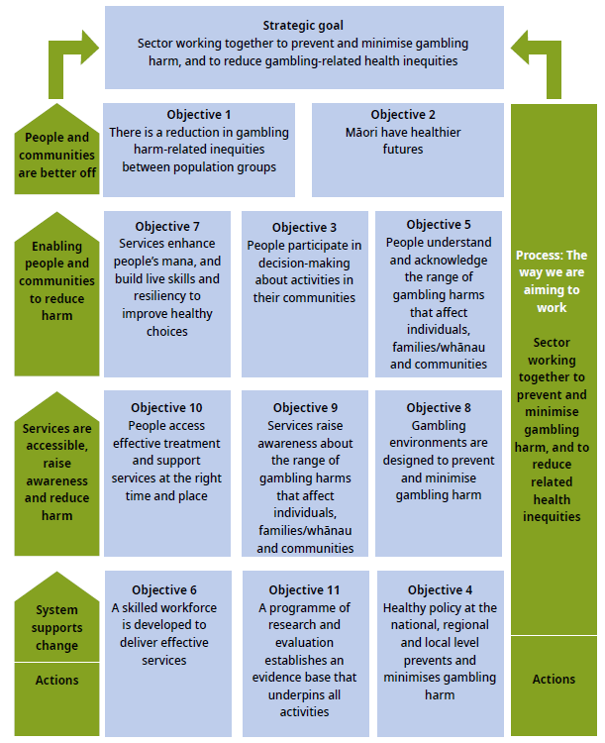

The Ministry welcomes feedback on this report. Send any comments, including questions, to gamblingharm@moh.govt.nz

Section 1:
Progress on the strategic goal
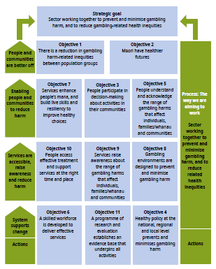
The strategic gambling harm reduction goal for the Ministry is set in legislation, with the overall goal of: Government, the gambling sector, communities and families/whānau working together to prevent and minimise gambling harm, and to reduce related health inequities.
In outcomes thinking terms, this goal has three key components:
1 Gambling sector working together
2 Harm minimisation
3 Reducing gambling-harm-related inequities.

The sector working together
The gambling sector is described in the legislation as including commercial and non-commercial gambling operators. Among these operators are the New Zealand Racing Board, the New Zealand Lotteries Commission, member associations such as Clubs New Zealand and Hospitality New Zealand, operators of gambling venues (including publicans and operators of retail outlets), providers of services to prevent and minimise gambling harm, and gambling researchers.

Ministry of Health activities
Since 1 July 2004, the Ministry of Health has been responsible for developing and implementing the ‘integrated problem gambling strategy focused on public health’ that is described in section 317 of the Gambling Act 2003.

The Act states that the strategy must include:
- measures to promote public health by preventing and minimising the harm from gambling
- services to treat and assist problem gamblers and their families and whānau
- independent scientific research associated with gambling, including (for example) longitudinal research on the social and economic impacts of gambling, particularly the impacts of gambling on different cultural groups
- evaluation.

The Act defines a problem gambler as a person whose gambling causes harm or may cause harm. The definition of ‘harm’ in section 4 is that it:
(a) means harm or distress of any kind arising from, or caused or exacerbated by, a person’s gambling; and
(b) includes personal, social, or economic harm suffered –
(i) by the person; or
(ii) by the person’s spouse, civil union partner, de facto partner, family, whānau, or wider community; or
(iii) in the workplace; or
(iv) by society at large.

The Ministry receives funding through Vote Health to develop and implement the strategy. The Crown then recovers the cost of this appropriation through a ‘problem gambling levy’ paid by the main gambling operators.

In working with the sector, the Ministry has been guided by the following key principles:
- reflect the relationship between the Crown and Māori under Te Tiriti o Waitangi (the Treaty of Waitangi) and, in particular, apply the principles of partnership, participation and protection
- achieve health equity
- maintain a comprehensive range of public health services based on the World Health Organization’s Ottawa Charter for Health Promotion and New Zealand models of health (particularly Māori models, such as Pae Ora, Te Pae Mahutonga and Te Whare Tapa Whā)
- fund services that prevent and minimise gambling harm for priority populations
- ensure culturally accessible and responsive services
- ensure links between public health and intervention services
- maintain a focus on healthy futures for Māori
- maintain a focus on improving health outcomes for Pacific peoples
- ensure services are evidence-based, effective and sustainable
- develop the workforce
- apply an intersectoral approach
- strengthen communities.

Department of Internal Affairs
The Department of Internal Affairs is the main gambling regulator and the main policy advisor to the Government on gambling regulatory issues. DIA administers the Act and its regulations, issues licences for gambling activities, ensures compliance with the legislation and publishes statistical and other information concerning gambling. DIA’s role includes key regulatory aspects of gambling harm prevention and minimisation.

Other sector partners
Other partners are formed by the gambling industry, the gambling harm minimisation service providers and associated infrastructure support.

Independent assessment of progress – more work is needed
Since 2004, the Ministry has developed a strategic framework that provides context for three-year service plans. From time to time, the actions of the Ministry in implementing the service plans and associated levy setting have been challenged in the New Zealand courts by both the gambling industry and, in 2014, a service provider. These occurrences signify the inherent tensions that can emerge and have limited the procurement of new services as the legal processes are followed.

In its 2018 gambling needs assessment, which included undertaking independent interviews with members of the sector, the Sapere Research Group noted there are tensions within the sector due to the competing perspectives. It found that:
‘There are many opportunities to learn from best practice within New Zealand and create pilot service models to address service gaps. Work is needed to improve inter-sectoral relationships and make best use of the skills available within the industry as a whole to support those harmed by gambling.’
(Rook et al 2018)

Areas where the sector as a whole could work better together include:
- improving host responsibility practices that are aimed at identifying risky gambling behaviour and encouraging those at risk to seek help
- enabling more effective and efficient voluntary multi-venue exclusion practices
- relocating non-casino gambling machines (ie, ‘pokies’) away from the most socioeconomically deprived areas
- improving the flow of the distribution of the proceeds of gambling to the community groups in areas in greatest need of support.

Harm reduction
Data from the HLS shows that gambling participation in some form in the total population has declined slowly and steadily since the peak of 90% in the early 1990s to the current level of approximately 70–75% in 2016. These figures represent the proportion of New Zealanders who report gambling at least once in the last 12 months (HLS 2016 and NGS Wave 4 reports). Since 2012 the levels of risky gambling behaviour in the total population has plateaued at approximately 5% (see Figure 2).

Data from the HLS and NGS also shows this decline extends to a drop in participation in terms of the number of gambling activities people participate in: participation in four or more gambling activities has declined and the percentage of those reporting that they have not gambled in the last 12 months has increased (Abbott et al 2014) (see Figure 3). Appendix 1 presents additional data showing how, at the population level and after adjusting for inflation, expenditure on a range of types of gambling has also plateaued – with the exception of Lotto in the most recent period (see Figure A3).

Figure 2: Percentage of gambling participation in the total population, 2010–2016 Health and Lifestyles Surveys
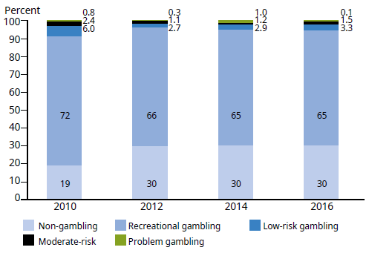

Figure 3: Percentage of past-year gambling participation by number of activities, 1985–2012 National Gambling Study
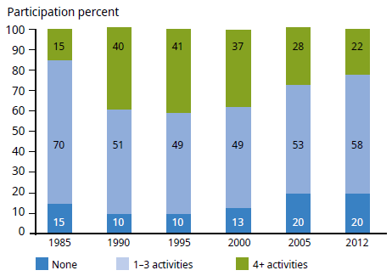

However, while overall gambling participation has declined over the long term, ‘problem gambling’ and ‘low-risk’ and ‘moderate-risk’ gambling levels, as measured by the Problem Gambling Severity Index (PGSI), have remained relatively constant in the last five to six years.

Figure 4 shows that for the period 2012–2016, the HLS has found the prevalence of risky gambling behaviour and associated levels of harm, as measured by the PGSI, has remained at approximately 5% in the total New Zealand population over 15 years of age.

Figure 4: Percentage of gambling harm by PGSI low-risk to problem gambling behaviour scores, 2010–2016 Health and Lifestyle Surveys
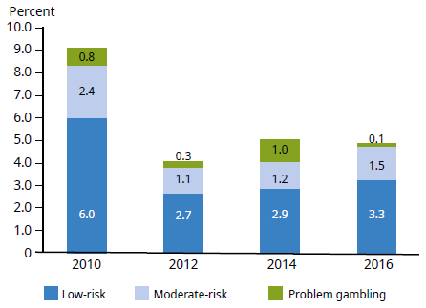

Estimates of gambling harm in New Zealand
As already indicated, the most accurate estimates of gambling harm in New Zealand, using the PGSI scores come from the HLS and NGS, and both show that in 2016 approximately 5% of the New Zealand population (191,000 people) participate in at least low-risk gambling behaviour. Of these, 0.5% (37,000 people) fit the clinical definition of a ‘problem gambler’.

The data on harmful gambling from individual surveys has a wide statistical variability (see Table 1), which makes it hard to be precise about the level of harm occurring in the population. To produce more accurate estimates of the level of harm for this outcomes report, the Ministry commissioned the HPA to undertake a statistical meta- analysis that pools all the data from these surveys into one data set based on the size of the New Zealand population in 2014. Figure 5 shows the results of the pooled data set of 9,009 survey respondents over 15 years of age in the three Health and Lifestyles Surveys from 2012–2016.

Figure 5: Estimates of risky gambling behaviour in total New Zealand 2014 population from pooled results of the combined 2012–2016 Health and Lifestyles Surveys
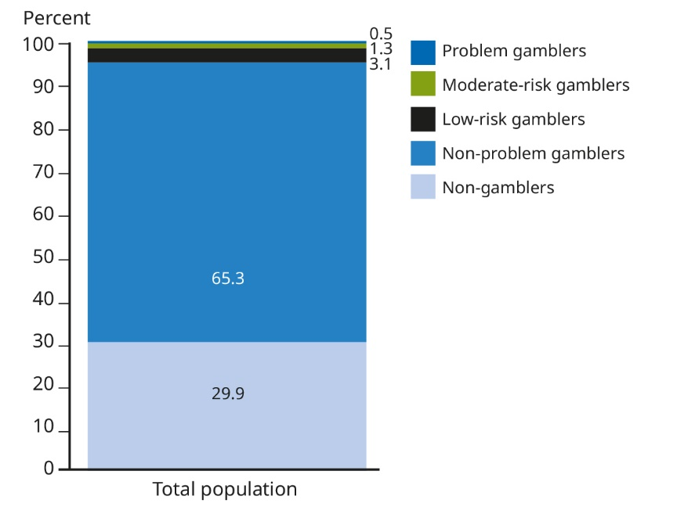
Source: Meta-analysis of HPA HLS Survey for 2012, 2014, 2016. (Pooled survey population n=9,009 weighted for 2014 population). December 2017. HPA and Ministry of Health.

Table 1 presents the same numbers in more detail, with the addition of 95% statistical confidence intervals and breakdown by a range of population characteristics.

Table 1: Results of meta-analysis of results from Health and Lifestyles Surveys 2012, 2014, 2016 of gambling activity and associated risk of harm in the 2014 New Zealand population by PGSI level
Percentage of total population, point estimate (95% confidence interval).
Pooled sample (n) = 9,009
PGSI category / population group | Non-gambler | Non-problem gambler | Low-risk gambler | Moderate-risk gambler | Problem gambler
Total population | 29.9  (28.3–31.4) | 65.3  (63.7–66.8) | 3.1  (2.6–3.5) | 1.3  (0.9–1.7) | 0.5  (0.1–1.3)
Female | 30.2  (28.3–32.2) | 66.0  (64.0–67.9) | 2.8  (2.2–3.4) | 0.9  (1.4–2.4) | 0.7  (0–1.4)
Male | 29.4  (27.3–31.6) | 64.5  (62.2–66.8) | 3.4  (2.6–4.2) | 1.8  (1.1–2.5) | 0.9  (0.2–2.7)
Age 15–17 years | 74.8  (66.2–83.5) | 24.0  (15.4–32.6) | 1.2  (0.0–4.5) | 0  (0–1.7) | 0  (0–1.7)
Age 18–24 years | 39.6  (34.2–44.9) | 54.5  (49.2–59.7) | 3.4  (1.8–5.7) | 2  (0.5–5.2) | 0.6  (0.1–1.7)
Age 25–44 years | 28.8  (26.4–31.2) | 65.2  (62.6–67.8) | 3.3  (2.5–4.1) | 1.6  (1.1–2.2) | 1.1  (0.1–4.0)
Age 45–64 years | 21.8  (19.7–23.9) | 73.2  (71.0–75.4) | 3.5  (2.5–4.4) | 1.3  (0.8–1.9) | 0.2  (0.1–0.5)
Age 65 plus years | 27.8  (24.9–30.8) | 69.4  (66.4–72.4) | 2.2  (1.4–2.9) | 0.6  (0.3–1.1) | 0  (0–0.1)
Māori | 26.7  (23.8–29.7) | 64.7  (61.6–67.9) | 5.2  (3.8–6.6) | 2.7  (1.7–3.7) | 0.6  (0.3–1.0)
Non-Māori | 30.3  (28.6–32.1) | 65.3  (63.6–67.1) | 2.7  (2.2–3.3) | 1.4  (3.3–1.0) | 1.0  (0.4–1.9)
Pacific | 36.6  (32.8–40.5) | 55.0  (51.0–59.1) | 5.1  (3.2–6.9) | 2.3  (1.4–3.3) | 1.0  (0.4–1.9)
Non-Pacific | 29.4  (27.7–31.1) | 66.0  (64.3–67.6) | 2.9  (2.4–3.4) | 1.3  (0.9–1.6) | 0.5  (0.1–1.4)
Asian | 46.2  (41.3–51.2) | 48.0  (43.1–52.9) | 3.2  (1.6–5.8) | 2.2  (0.6–5.5) | 0.5  (0.1–1.5)
Non-Asian | 27.4  (25.8–29.1) | 67.8  (66.2–69.5) | 3.0  (2.5–3.5) | 1.2  (0.9–1.5) | 0.5  (0.1–1.5)
NZDep Index
1 Least deprived | 26.0  (22.1–29.8) | 71.4  (67.5–75.3) | 2.3  (1.1–3.5) | 0.2  (0–0.7) | 0.1  (0–0.5)
2 | 28.3  (25.1–31.6) | 67.2  (63.7–70.7) | 3.1  (2.0–4.3) | 1.3  (0.4–3.0) | 0.1  (0–0.2)
3 | 30.0  (25.9–34.1) | 65.6  (61.5–69.7) | 2.5  (1.6–3.4) | 1.7  (1.0–2.4) | 0.2  (0.1–0.6)
4 | 34.2  (30.7–37.7) | 60.5  (57.0–63.9) | 3.4  (2.3–4.5) | 1.5  (0.8–2.2) | 0.4  (0.1–1.2)
5 Most deprived | 31.3  (27.9–34.7) | 60.9  (57.4–64.3) | 4.0  (3.0–4.9) | 2.0  (1.2–2.9) | 1.9  (0.2–6.9)

Table 2 translates the percentage data in Table 1 into the number of people in the population in various years.

Table 2: Number of New Zealand gamblers by PGSI category, 2010–2016
 | Non-gamblers | Non-problem gamblers | Low-risk gamblers | Moderate-risk gamblers | Problem gamblers
2010 | 644,000  (529,000–760,000) | 2,485,000  (2,363,000–2,606,000) | 205,000  (152,000–259,000) | 81,000  (50,000–  112,000) | 27,000  (13,000–  49,000)
2012 | 1,057,000  (960,000–1,154,000) | 2,281,000  (2,191,000–2,371,000) | 95,000  (67,000–  123,000) | 37,000  (20,000–  54,000) | 9,000  (4,000–  18,000)
2014 | 1,069,000  (954,000–1,184,000) | 2,347,00  (2,233,000–2,460,000) | 106,000  (71,000–  140,000) | 42,000  (23,000–  61,000) | 37,000  (6,000–  123,000)
2016 | 1,121,000  (1,034,000–1,207,000) | 2,466,000  (2,376,000–2,556,000) | 125,000  (98,000–  152,000) | 55,000  (31,000–  80,000) | 6,000  (3,000–  11,000)
Source: Table 5-3, HLS 2016.

Suggested explanations for the plateauing in harmful gambling levels
The New Zealand pattern of reduction in the level of population gambling participation, and relative stability in the level of risky gambling behaviour in recent years, has also been observed in Sweden and Victoria, Australia. This pattern poses the public health policy and research challenge of identifying the factors that explain why the levels of harm persist despite declining gambling participation in the population overall.

Possible reasons for the observed plateau effect have been discussed by Abbott (2017a, 2017b) in the context of gambling availability and adaptation theory. Abbott has suggested that the plateauing effect may be the result of:
- high levels of relapse in risky gambling behaviour in the at-risk gambling population, which means that over time this pool of people is unchanging and will continue to grow in absolute population numbers even though in relative terms the ratio of ‘problem gambling’ prevalence remains relatively stable
- the effect of new migrants and a new young population in the New Zealand population who are newly exposed to readily available gambling products and consequently go on to experience harm
- the development and promotion of new gambling products, which invite new gambling participation and associated onset of harm in new population groups (Abbott et al 2018). Examples include new Lotteries products, and the convergence of gambling and gaming.

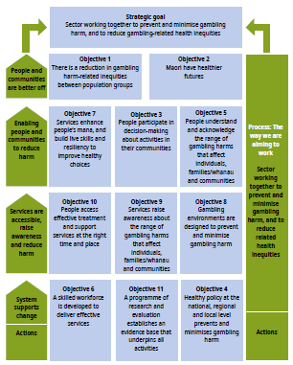
Section 2:
Key outcomes
This section reports on the following two key objectives in the Ministry’s integrated strategy and service since 2010:
- Objective 1: There is a reduction in gambling-harm-related inequities
- Objective 2: Māori have healthier futures, through the prevention and minimisation of gambling harm.

Objective 1: There is a reduction in gambling harm-related inequities
This objective is about keeping a focus on reducing differences in levels of gambling harm among different population groups and in the determinants of gambling harm. It is a population health approach that targets at-risk groups, including Māori, Pacific peoples, some segments of the Asian population and people living in areas of higher socioeconomic deprivation.

Over time, this objective has seen shifts in emphasis between inequality and inequity. In the health research literature, the two terms have different meanings; consequently outcomes reporting needs to reflect these differences.

Health inequality versus inequity
Health inequality and inequity are not the same. Where there are differences in health experience between population groups – for example, on average females live longer than males – these are usually referred to in the health literature as a ‘health inequality’. Where the differences are large, they are referred to as a health ‘disparity’. The presence of a health disparity may indicate the existence of a health ‘inequity’. The concept of inequity is often associated with ‘fairness’. The presence of an inequity does not necessarily indicate ‘unfairness’, depending on the cause of the inequity and the size of the disparity. In health, an inequity is considered to exist where the presence of the disparity is attributed to social, cultural and economic factors rather than biomedical ones.

Well-recognised inequalities in health, including gambling behaviour, often occur between groups because of a range of socioeconomic, cultural and biological factors. The most common factors are:
- sex
- age
- socioeconomic deprivation
- ethnicity
- education.

Evidence for the presence of inequalities and inequities in gambling harm between different New Zealand population groups over time
Gambling research studies have demonstrated the presence of inequalities and inequities in gambling harm in the New Zealand population and internationally (Canale et al 2017; Kolandai-Matchett et al 2017; Rintoul et al 2013; Tu et al 2014; van der Maas 2016). Researchers at the AUT Gambling and Addictions Research Centre reported in 2014 that both the 1990 New Zealand gambling harm survey and the 2012 NGS showed that Māori and Pacific peoples had much higher problem gambling prevalence rates than people of other ethnicities (Abbott et al 2014).

The NGS results show that males, young adults, people who lack formal educational qualifications, unemployed people, people living in neighbourhoods with high socioeconomic deprivation, and people belonging to non-Christian religions or non- traditional Christian churches also were at higher risk. Males, young adults, and low- income and non-married people were almost universally found to have elevated rates of problem gambling prevalence (Abbott et al 2014b; Abbott et al 2015; Calado et al 2017). Similar results have been found in the HLS.

Odds ratio analysis and tests for statistical difference of several years of HLS results by a range of gambling predictors, population groups of interest (eg, ethnicity, gender, socioeconomic deprivation) and time have shown that, compared with the European/Other group on predictors of moderate-risk/problem gambling:
- the Asian group’s risk is greatest at 9.5 times higher (p ≤ 0.05)
- Māori are the group at second greatest risk, at 4.7 times higher (p ≤ 0.001)
- the risk of Pacific peoples is 2.4 times higher (no statistically significant difference).

However, when examined by predictors of low-risk gambling, the risk structure changes considerably:
- the risk for Pacific peoples is 3.54 times higher (p ≤ 0.001)
- the Asian group’s risk is second highest, at 2.07 (no statistically significant difference)
- the risk for Māori is 1.93 times higher (p ≤ 0.05) (Thimasarn-Anwar et al 2017).

In addition, in terms of overall gambling service use, the HLS analysis suggests the Asian population group underuse the services compared with the other ethnic groups. The odds ratios for ‘predictors for those who contact gambling problem services’ are 0.31 for Asian, 1.21 for Pacific peoples and 3.14 for Māori. Of these odds ratios, the Māori results were statistically significantly different at p ≤ 0.01.

Figure 6 shows data illustrating statistically significant differences over the last seven years in the location of class 4 electronic gambling machine (EGM) venues by area based on the level of socioeconomic deprivation. Approximately 50% of all EGM venues (ie, pokie machine venues, which research has shown are the source of the highest risk of harmful gambling activity) are clustered in geographic areas representing the three most socioeconomically deprived populations (ie, poorest areas of the country). In economic terms, these are the groups who can least afford the financial losses from gambling, who experience the lowest returns from gambling proceeds to their communities, and who can least afford the health harm arising from risky gambling activity (Rook et al 2018).

Figure 6: Distribution of class 4 (pokie) venues by socioeconomic deprivation area (venue counts by year and socioeconomic deprivation area), as at June 2012–2018
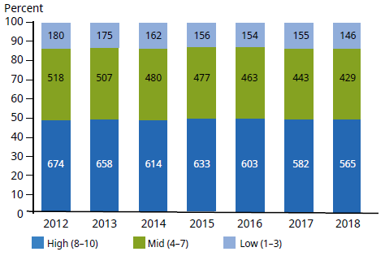
Source: Data from Department of Internal Affairs; census area analysis by Ministry of Health (August 2018).

Discussion: Evidence indicates that absolute inequality has reduced but gambling harm inequities remain
Health inequities between Māori and non-Māori and between Pacific peoples and non-Pacific peoples have been present for a long time in New Zealand. Inequities between socioeconomic groups are also not new. Evidence from the New Zealand Burden of Diseases, Injuries and Risk Factors Study (Health 2016) has shown that while absolute levels of health inequality and inequity have reduced in population groups over time, the relative levels of inequality and inequity between population groups remain. Figure 7, using data from the New Zealand Health and Lifestyles Survey, illustrates that the same pattern also appears to apply to gambling harm. When comparing the 2010 HLS results for each ethnic group with the results from years 2012, 2014 and 2016, we can see that for each group (Māori in particular), the absolute level of harm has fallen (for an example of the comparison, see the red circles, which show where the numbers in each PGSI category have substantially decreased between 2010 and 2016). However, a comparison of the groups over time shows that, while the relative inequality between the ethnic groups has reduced, the position of Māori and Pacific ethnic groups in relation to the European/Other group remains the same (see the green circle in Figure 7 for the comparison).

Figure 7: Absolute and relative inequalities in gambling harm experience over time between New Zealand ethnic groups, 2010–2016 HLS
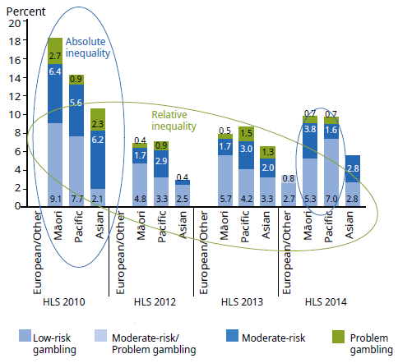

Challenges to addressing gambling harm inequalities and inequities
The World Health Organization defines equity as a ‘fair opportunity for everyone to attain their full health potential regardless of demographic, social, economic or geographic strata’. This definition relates both to health status and to the social determinants of health. Inequities are inequalities that are judged to be unfair – that is, both unacceptable and avoidable.

Inequities are not random, and they are typically due to structural factors present in the society and local community and are not explainable by biomedical differences between population groups. This means their causes are often complex and multifaceted and are outside the scope of the health system to address on its own. For example, income inequality (poverty) has been shown to be strongly associated with differences in health outcomes, including gambling (Canale et al 2017; Kolandai- Matchett et al 2017; Rintoul et al 2013; Tu et al 2014; van der Maas 2016).

Many of the high-risk gambling population groups reside disproportionately in high-deprivation neighbourhoods. These neighbourhoods typically have high concentrations of gambling venues and outlets. In New Zealand this includes EGMs in pubs and clubs, and track and sports betting venues (TABs) (Allen+Clarke 2015). Living in close proximity to gambling venues is associated with higher levels of problem gambling (Ministry of Health 2008).

Recently, researchers at the AUT Gambling and Addictions Research Centre have argued that:
Most of the high risk groups contain proportionately more people who are disadvantaged in other ways. For some groups such as new migrants or international students while having low levels of overall gambling participation, when they do gamble it is done in a highly risky way. This may reflect limited prior gambling experience or less gambling opportunities. It seems likely that heightened vulnerability and low prior gambling experience, combined with high exposure to hazardous forms of gambling, contributes to elevated rates of problem gambling in these groups. This may somewhat explain the persistence of problem gambling disparities and the plateauing of problem gambling prevalence rates when gambling participation reduces (Abbott et al 2018).

Objective 2: Māori have healthier futures, through the prevention and minimisation of gambling harm
Over the last two service plans years the Ministry has committed in its service plans to a focus on reducing differences in levels of gambling harm and in the determinants of gambling harm for Māori. Objective 2 aligns with Objective1, and is supported by all the other objectives in the Strategy to Prevent and Minimise Gambling Harm 2016/17 to 2018/19 (the Strategy). Consequently, there is some overlap in the reporting of outcome measures.

In 2013, an editorial in the New Zealand Medical Journal observed that:
Māori experience higher exposures to risk factors for poor health, more injury, more disability and poorer outcomes when they interact with health services ...
Underlying the reported results ... are entrenched systemic drivers of disparities and poor outcomes for Māori. These include social and environmental drivers, health system factors, health professional behaviours and institutional resistance to innovation ...
The determinants of Māori health outcomes ... include low incomes, poor housing, inadequate education, erratic employment and racism.
The impacts are complex and intergenerational ... We use them to address ‘confounding’ although in the real world they are ‘compounding’ ... (Carr 2013)

Gambling research and the HLS results have shown that harmful gambling behaviour is often associated with other risky drug, tobacco and alcohol behaviours, as well as with the experience of a range of harms such as violence, financial and mental stress and relationship breakdowns (Abbott et al 2018; Thimasarn-Anwar et al 2017). A new approach to measuring gambling harm by Browne et al (2017) suggests that the harm experienced through high-risk gambling behaviour is perceived as of the same order of magnitude as high alcohol consumption and other health issues such as anxiety and depression. Browne et al (2017) have argued that the cumulative harm from gambling ‘is close to twice that of drug use disorders, bipolar affective disorder, eating disorders and schizophrenia combined’.

In this context of overlapping addictive behaviour and harm consequences, the last two Ministry service plans have promoted healthier futures for Māori through a focus on:
- enabling services by Māori for Māori
- raising awareness through social marketing campaigns of what risky gambling behaviour looks like, and the services available to help people
- increasing service provider awareness of gambling inequalities through health literacy
- using screening tools by service providers to identify the presence of other risky addictive behaviours such as tobacco, alcohol and drug use as part of minimising the harm of risky gambling behaviour
- developing and trialling targeted interventions such as ‘Sorted Whānau’, which was designed to support Māori and Pacific peoples specifically. This intervention aims to improve family and whānau financial capability by raising awareness of the financial risks of gambling, and providing tools to better manage risks.

Factors related to use of gambling support services
Analysis of the 2016 HLS results shows that self-reported use of gambling services is related to age, ethnicity, level of socioeconomic deprivation, education level and PGSI score.

The odds ratios in Table 3 show that use of the Ministry’s gambling treatment services was statistically associated with a range of independent factors:
- being Māori (3.14 times higher than European/Other)
- being highly educated (2.69 times higher among those with a postgraduate
- education compared with those holding no educational qualification)
- having a higher PGSI score (2.46 times higher compared with non-problem gamblers)
- living in a high-deprivation area (2.19 times higher compared with those in low- deprivation areas)
- being over 45 years of age (those in younger age groups much less likely to use services).

These self-reported levels of service use suggest that Māori and those in high-deprivation areas are using services at levels one might expect to see given the high level of harm associated with these population groups. However, Table 3 also suggests that Asian people and those under 25 years of age are reporting service use at a lower level than one might expect.

Table 3: Predictors for those who report contact with gambling problem services
 | Proportion (95% confidence interval of proportion) | Odds ratio (95% confidence interval of odds ratio)
Overall | 3.2% (2.5–3.9)
Age
15–17 years | 0.9% (0.0–2.7) | 0.16** (0.08–0.32)
18–24 years | 1.2% (0.0–2.6) | 0.19 (0.02–1.62)
25–44 years | 3.1% (2.0–4.2) | 0.63* (0.40–0.98)
45+ years | 4.0% (2.9–5.0) | Reference
Ethnicity
Māori | 7.3% (4.1–10.6) | 3.14** (1.66–5.93)
Pacific | 3.6% (1.4–5.8) | 1.21 (0.58–2.52)
Asian | 1.1% (0.1–2.0) | 0.31 (0.09–1.07)
European/Other | 2.8% (1.9–3.6) | Reference
Socioeconomic deprivation
Low | 2.0% (1.1–2.9) | Reference
Mid | 3.3% (2.0–4.6) | 1.79 (0.96–3.33)
High | 4.3% (3.0–5.6) | 2.19* (1.14–4.22)
Education
None | 3.4% (1.9–4.9) | Reference
Secondary | 2.9% (1.8–4.0) | 1.48 (0.78–2.83)
Trade/Certificate/Other | 2.7% (1.5–3.8) | 1.02 (0.49–2.12)
Undergraduate | 3.2% (1.7–4.6) | 1.95 (0.87–7.6)
Postgraduate | 4.5% (2.0–7.1) | 2.69* (1.10–6.61)
PGSI
Non-gamblers | 2.7% (1.6–3.8) | 1.09 (0.62–1.91)
Non-problem gamblers | 3.0% (2.3–3.8) | Reference
Some-risk gamblers | 8.2% (3.0–13.4) | 2.46* (1.16–5.23)
Base: All respondents (n = 3,854); * p < 0.05, ** p < 0.01, *** p < 0.001; outcome variable: had used a gambling support service (1= yes, 0= no).

Current service use is substantively lower than could be expected
Given the estimated levels of gambling harm in the population, current levels of service use in the population as a whole are substantively lower than could be expected given the current estimates of risky gambling prevalence.

Analysis of Ministry gambling service administrative data shows that of the approximately 5,900 gamblers who sought treatment in 2016:
- 44% identified as European/Other
- 31% identified as Māori
- 14% identified as Pacific peoples
- 11% identified as East-Asian
- 60% were men
- average age was 42 years.

In addition, of the approximately 2,050 who were screened for co-existing problematic alcohol and drug use, 45% were identified as having a co-existing issue.

Figure 8 presents two graphs showing Ministry gambling service administrative data of actual service use over the last seven years, first for ‘all interventions’ and then ‘excluding brief interventions’, by ethnic group and year.

In terms of overall service use over the last seven years, approximately 10,000+ clients (including family and affected others) are seen every year by gambling harm intervention services. Of these, approximately 4,000 are for brief interventions. This level of absolute numbers seeking treatment suggests there is substantive underuse of services at the overall population level. This is because the current prevalence estimates of the number of ‘problem gamblers’ (0.5%) and ‘moderate-risk gamblers’ (1.5%) in the total New Zealand population over 15 years of age equate in absolute numbers to approximately 23,000 and 60,000 people respectively (Thimasarn-Anwar et al 2017). This suggests that at the moderate gambling risk level in the total population, service use is at approximately 16% of those in the moderate-risk and problem categories. These relatively low levels of service use have been reported before in New Zealand and found internationally (Bellringer et al 2008; Hing et al 2011).

Figure 8: Clients by ethnicity assisted over time by main type of intervention (all interventions and excluding brief interventions), 2004/05–2015/16
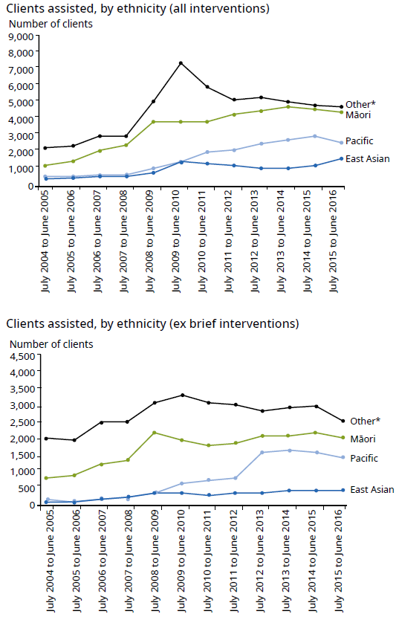
* Includes New Zealand European and ethnic groups not otherwise specified. For further details of the ethnicity categories used, please read the Ethnicity Data Protocols for the Health and Disability Sector.
Source: Ministry of Health Gambling Data, www.health.govt.nz/our-work/mental-health-and-addictions/problem-gambling/service-user-data/intervention-client-data

Māori use of services
Figure 8 also shows that people in the Māori and European/Other ethnic groups are using services at approximately the same level. This level of actual service use is expected given the proportion of Māori in the population is approximately one-fifth of the total population, while the levels of gambling harm experienced by Māori are three to four times higher than European/Other. This suggests a ratio of approximately four Māori presenting compared with one European/Other would be appropriate given the lower harm levels for the European/Other population group. Incidentally, this ratio is similar to the odds ratio presented in Table 3 on self-reported service use.

This outcome is the same as that reported in the 2013 KPMG baseline report, which found Māori were accessing services ‘approximately equivalent’ to their proportion of risky gambling behaviour and harm (KPMG 2013).

The number of Asian ethnic presentations to services is low
The dark-blue line in Figure 8 shows the number of Asian ethnic presentations is approximately 1,000 people per year. This finding is in contrast to the Māori service use levels, and is substantively lower than what might be expected compared with the prevalence estimates of risky gambling behaviour in the Asian population and the proportion of Asian people in the total New Zealand population.

Service use by Pacific peoples
Table 4 and Figure 8 show that the level of service use by Pacific peoples is approximately halfway between Māori and Asian levels.

Conclusion: Objectives 1 and 2
The outcomes reported indicate that since 2010 gambling harm inequalities for Māori have reduced in absolute and relative terms. However, the data also shows that inequalities remain between population groups.

The service use data presented suggests Māori are using services at appropriate levels given the harm experienced, and this has remained unchanged since the 2013 KPMG baseline report.

However, when comparing the overall service use data against the estimated numbers of moderate-risk and problem gamblers in the population, the data indicates that services are not being used at the levels expected in terms of the numbers of people in the population, and in particular in the Asian population. This indicates further work is required to improve the uptake of services.

Improving health services for Māori tends to benefit other population groups
Health service research has shown that Māori reports of their experiences with a wide range of government agency services are highly consistent over time, and that improving the health service experience for Māori also tends to improve service experience for other population groups (Williams and Cram 2012). Māori typically describe their experiences with mainstream health services in terms of being difficult to access, unresponsive and alien to the lived experience and value systems of those who do not share the dominant ‘mainstream’ world view represented in many government services. In the health context, barriers have been broadly grouped as social, cultural, economic and geographical (Williams and Cram 2012).

Williams and Cram (2012) note there is a substantive body of evidence about what works in health promotion areas such as alcohol, smoking, violence, and Māori women’s health services, which can be used to inform design in other areas of health service delivery. The evidence clearly shows that effective programmes interweave current scientific knowledge of and best practice in health promotion and agency service delivery with:
- a Māori world view of health
- a meaningful partnership approach where the needs of both parties are met
- recognition of the aspirations of Māori for self-determination and development
- success measured in relation to not only health outcome and in the short term (less than three years), but also participation, engagement and wider aspirations for social, cultural and economic development in the long term
- appropriate resourcing (financial and people) for the task. This is likely to mean funding has to be at levels higher than mainstream programmes, given that many of the issues being addressed are long-standing and interventions are starting from a position of significant gaps in community and workforce resiliency, capability and resourcing (Williams and Cram 2012).

The general health services research also suggests service delivery benefits, and associated health outcomes, are likely to be achieved through adopting a stronger consumer focus in the design and delivery of services.

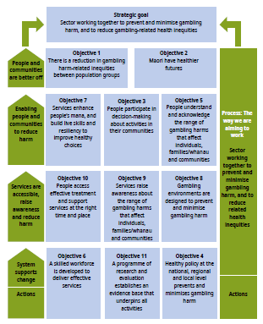
Section 3:
Enabling people and communities – objectives 3, 5 and 7
This section reports on objectives 3, 5 and 7 of the Ministry’s integrated strategy and service plan over the period 2010–2017:
- Objective 3: People participate in decision-making about activities that prevent and minimise gambling harm in their communities
- Objective 5: People understand the range of gambling harms that affect individuals, families/whānau and communities
- Objective 7: People have the life skills and resilience to make healthy choices.

These three objectives are aimed at building awareness at individual and community levels of the range of harms that can arise from risky gambling behaviour, and at providing services that help build their resiliency to those harms.

To achieve these objectives, a suite of public health interventions has been commissioned since 2010 from public health providers under the programmes Aware Communities and Supportive Communities. These work programmes are outlined below, along with some examples of their results. Evidence for what has changed over time is presented where available.

Aware Communities and Supportive Communities
Since 2010, the Aware Communities and Supportive Communities programmes of work have involved commissioning a suite of public-health-oriented activities focused on building local community-level awareness of gambling harm, fostering community action and fostering the resiliency of people in communities to gambling harm.

In the Ministry’s service specifications, resilient and supportive communities are defined as those that are aware of the harm that arises from risky gambling and have some capacity to prevent and minimise the gambling harm in the locality. Community action differs from standard mass-market media or education campaigns by focusing on requiring the community to be involved in designing and delivering the programme. Research has shown that where communities are engaged with interventions, the interventions tend to be more effective (Williams et al 2012).

The programmes of work have targeted the general population and at-risk communities who are disproportionately affected by gambling harms; these communities include people living in socioeconomically deprived areas, Māori and Pacific peoples and new immigrants. Since 2010, activities undertaken by harm minimisation providers under contract to the Ministry include:
- community stakeholder engagement
- engaging with at-risk communities
- working with youth
- approaches to reach the mass population.

The following sections summarise each of these activities and discuss the outcomes achieved.

Community stakeholder engagement
Community stakeholder engagement (eg, engaging with local community health and social services, community groups, media organisations) includes activities such as:
- health and social service employees learning how gambling harms are interrelated with other addictive behaviours – in particular, drug and alcohol use, family violence, financial loss and poor mental health
- participating in other public health events – for example, participating in events focused on family violence to raise awareness of gambling as a potential source of such harm
- engaging with media channels to raise awareness of the harm associated with even low- to moderate-risk gambling behaviour and its effects on family and whānau
- delivering presentations to tertiary students in public health to raise awareness of the links between gambling harm and other health issues.

Analysis of programme monitoring reports and independent evaluation (Kolandai- Matchett et al 2018a) shows that these types of activities:
- raise awareness among community stakeholders of the links between gambling and other health experiences and social and cultural development and wellbeing
- foster relationships between public health programmes that help to build sustainability and value for money of discrete programmes
- enhance the capacity of new health care professionals about health comorbidity effects and the importance of treating the ‘whole’ person
- build informed and trusted relationships with media personnel for future local activities.

At-risk communities – raising awareness and increasing resiliency
Community action approaches in at-risk communities acknowledge that to reach people in these communities, gambling harm reduction messages and interventions are best delivered where they are seen as directly relevant to them and are supported by, or support, other health and wellbeing interventions.

For example, since 2015, the Sorted Whānau initiative has been developed in partnership between Raukura Hauora O Tainui, the Commission for Financial Capability and Malatest International. The intervention aims to reduce gambling harm by building financial/budgeting awareness and capability of participants from Māori and Pacific communities. It is premised on the view that financial literacy education may be more effective than traditional budgeting assistance at increasing understanding of the financial harm from gambling, improve financial decision- making and longer-term behaviour change for problem gamblers and those affected by problem gambling.

Interim evaluation results indicate a very positive response to the intervention by participants, and shows substantive increased awareness about the financial impact of gambling on them and their family/whānau budget, and changes in behaviour around financial management and associated gambling behaviour (Malatest International et al 2018). In terms of community resiliency, a very important evaluation finding has been that participants share their new knowledge with up to 20 other family/whānau others who then are benefiting from the intervention.

Other examples of community action approaches include:
- using culturally specific media (such as ethnic language radio and newspapers) and culturally significant meeting places (such as churches, marae, sports events) to deliver harm minimisation messages to at risk communities
- delivering public health activities at significant community events
- reframing and translating existing mainstream resources to better reflect, including challenge where appropriate, culturally held philosophies and understandings about gambling.

Independent evaluative analysis of contract monitoring reports indicates that these activities have been effective in:
- enhancing awareness of gambling as a source of harm in at risk communities
- establishing relationships between community groups and agencies that enable gambling harm services to be utilised and messaging understood (Kolandai- Matchett et al 2018a).

Youth and mass reach activities respectively
Activities targeting youth are limited, and where they have occurred they are typically integrated with other youth focussed public health interventions such as mental health, parenting support, or youth development.
Examples include:
- education programmes for parents where parental restriction / monitoring of gambling activity is promoted
- supporting a range of youth group activities that incorporate gambling harm messages.

These activities aim to foster the building of youth resiliency to gambling harm and to be agents for change in their own family’s/whānau/communities.

Mass reach approaches include general public awareness campaigns such as Choice Not Chance, which is general population web-based intervention that includes information about gambling harm, the probability of winning from playing pokie machines and where to seek help.

In other mass market activities, gambling harm minimisation providers participate in media interviews, contribute to talkback radio, engage in social media and raise gambling issues in other mass media (examples of issues are the new Lotto ‘instant win’ gambling products that have significant increased risk associated with them due to their design elements; and changes in local government gambling licensing policy). Data is presented in the next section about how successful some of these activities has been in raising awareness of gambling harm and the services available in the population.

Conclusion: Objectives 5, 7 and 11
Programme activities can be seen to have raised awareness among communities who received interventions about gambling harm issues and the services available to minimise harm, and enabled people to engage in local decisions about gambling activities in their communities (Kolandai-Matchett et al 2018a).

Among the challenges are that, due to the nature of their design and delivery, many of the initiatives are local, specific and short term, as well as resource intensive for the provider and funder. These characteristics typically mean the long-term impacts may be minimal and are not necessarily scalable nationwide. However, Kolandai- Matchett et al (2018a) have argued that these types of initiatives are important in promoting ‘social sustainability’ and ‘could function in a positively reinforcing loop to strengthen programme effectiveness’ overall. As such, they are well aligned with a comprehensive public health approach to preventing and minimising gambling harm and the associated activities outlined in the next section, which reports on outcomes associated with objectives 8 to 10.

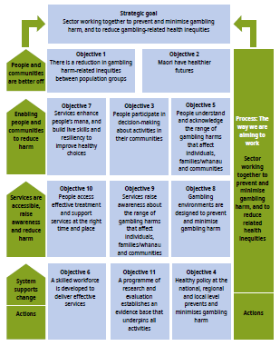
Section 4:
Services are accessible, raise awareness and reduce harm – objectives 8–10
This section reports on the following three objectives in the Ministry’s integrated strategy and service since 2010:
- Objective 8: Gambling environments are designed to prevent and minimise gambling harm
- Objective 9: Services raise awareness of gambling harm
- Objective 10: Accessible, responsive and effective services are developed and maintained.

Objective 8 recognises that some of the most effective ways to minimise and prevent gambling harm target the source of the harm through, for example:
- influencing the regulation of the design of electronic gaming machines (ie, pokies), such as by using pop-up warning messages, placing limits on expenditure and limits on wins, and making it compulsory to take breaks between gaming sessions
- promoting changes to the venue environment that limit access to automated teller machines, increase lighting, and screen machines from general public view
- introducing gambling host responsibility programmes aimed at training venue staff to recognise harmful gambling behaviour and equipping them to intervene, and using signage about where to seek help
- facilitating the use of voluntary gambler venue exclusion orders.

Research indicates these types of interventions are effective. However, introducing them is often a particular challenge where industry is resistant to them and sees them as an added cost barrier to their legitimate business (Kolandai-Matchett et al 2015).

Objective 9 acknowledges that families and whānau of gamblers with risky behaviour are often the most severely affected by the gambling. Children living with adults who are exposed to risky gambling are likely to both experience harm and develop risky gambling behaviour themselves. Helping those affected by gambling to recognise the risky behaviour, and know how to address it and where they can seek help is important to minimise gambling harm.

Objective 10 focuses on harm minimisation service delivery.

Objective 8: Promoting safe and safer gambling environment design
The terms ‘safe’ and ‘safer’ describe two broad and separate programmes of work the Ministry is involved with that are aimed at enabling a wide range of initiatives designed to deliver on objectives 8 and 9. The Ministry uses ‘safe’ in its service specifications with gambling harm minimisation providers. It uses ‘safer’ in relation to a programme of work with the HPA and DIA to help deliver on these two objectives.

Ministry initiatives under these two broad programmes involve working with:
- the DIA as the regulator to monitor and promote safer gaming machine design, and safer gambling venue design, practice and regulation. An example of activity in this area is the Ministry’s work with the DIA and the wider gambling sector on the design and delivery of a multi-venue exclusion process
- the HPA to support the gambling sector by providing it with, for example, tools to implement host responsibility programmes; and raise general population and venue awareness of risky gambling behaviour and where to get help
- enabling gambling harm minimisation providers to undertake activities at the local level to influence local government decision-making about local gambling policies, and raising general awareness of the signs of risky gambling behaviour and harm, and the services that are available to assist people.

The achievements, challenges and outcomes from this broad range of activities over
the last five to seven years are summarised below.

Activities: Safe and safer gambling environments
The Gambling Act 2003 (sections 308–310) requires casinos and class 4 venues (non- casino gaming machines – ie, pokies) to:
- develop policies to identify problem gamblers
- display notices about gambling harm
- identify harmful gambling behaviour
- offer advice or information about problem gambling and self-exclusion procedures to potential problem gamblers
- issue exclusion orders to a venue for a term of up to two years for self-identified problem gamblers, and remove self-excluded individuals who enter premises.

To help gambling providers meet their responsibilities, a range of activities has been undertaken since 2010 including:
- the Ministry funding key gambling harm minimisation providers to work with local venue operators to develop and implement host responsibility policies and practices, and encouraging gambling venues to refer patrons experiencing gambling harm to their treatment services and for venue exclusion as appropriate
- the HPA being funded to work with DIA and class 4 societies to develop resources giving information on safer environments, and deliver training to venues and their staff
- DIA staff visiting venues as part of their compliance activities, holding regional public meetings where issues such as gambling host responsibility are discussed with the gambling industry
- introducing a working group with gambling sector representatives focused on developing a national multi-venue self-exclusion (MVE) process, and introducing a national MVE administrative service
- the Ministry monitoring the development of new technologies such as online databases to support the administration of MVE exclusion orders, and the use of photo frame and other software and video technology to identify excluders entering gambling premises, as a way of promoting the efficiency and effectiveness of the MVE process.

Outcomes from activities promoting safe or safer gambling environments
An evaluation review of early programme activities in the period 2010–2013 (Kolandai-Matchett et al 2016), subsequent ongoing contract reporting activity by the Ministry, and DIA workshop feedback, have shown that:
- relationships at the local level have been established between harm minimisation providers and venues
- through resources developed and training delivered, harm minimisation providers have gained a greater understanding of the venue context, and training has been tailored to different gambling environments
- knowledge about venue marketing strategies has grown
- there has been growth in venue understanding of their host responsibilities and implementation of MVE processes and some venues are willing to collaborate
- increased growth in the use of MVE as a treatment tool
- the activities have facilitated on-going discussion in the sector about the value, merit and functioning of the MVE process as a harm minimisation tool
- there has been a growth in venue development and implementation of host responsibility policies and practices, and staff knowledge of gambling harm minimisation.

For example, recent regional workshops held by the DIA and HPA in 2017/18 engaged with around 370 people from clubs, venues, societies, and service providers. Feedback shows these workshops provided the opportunity for connection between DIA and others in the gambling system as a whole. Attendees from pubs, clubs, societies, and service providers were able to discuss their roles and perspectives on the gambling system.

Challenges in promoting safe/safer gambling environments
While a number of activities have been undertaken, considerable challenges remain. The following figure shows the results of a small survey of implementers of the safer environment programme, which is the programme aimed at gambling providers, about their thoughts on the programme. The figure shows that while progress has been made across a number of factors there is room for considerable improvement. Since this result, further work has been done to improve the programme, and a more detailed evaluation plan is being discussed for the new service period commencing 2019/20.

Figure 9: Implementer ratings of the safer environment programme outcomes
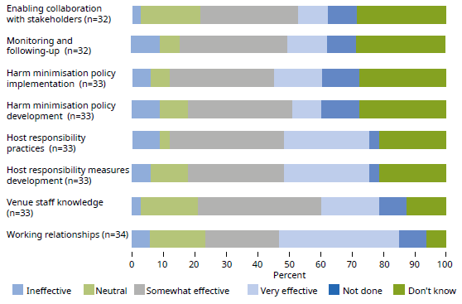
Source: Kolandai-Matchett et al 2016

Results from the 2016 HLS show that of the 495 pokie player respondents, none reported that staff had handed out leaflets on gambling support services, and only 0.3% reported staff had spoken to them about their gambling.

In addition, while 66% noticed advertising about getting help for gambling problems, 57% ignored the advertising as they saw it as not relevant to them. Only 2% saw the information and thought about changing their behaviour.

In terms of respondents’ knowledge of venue operator responsibilities to minimise gambling harm, 76% thought that venues should do something. However, only 35% of respondents knew that venues had a legal responsibility around harm minimisation.

Other evaluation activities by Kolandai-Matchett et al (2016), the Ministry’s ongoing monitoring of harm minimisation provider reports, and DIA regulatory activity have shown that:
- some societies and venues resist sharing information on the grounds of ‘commercial sensitivity’ and the sense of being monitored
- some venues see awareness-raising materials as unimportant and are reluctant to make them available
- receiving additional host responsibility training is seen as unnecessary
- the MVE process is seen as complex, time-consuming and costly, particularly where there are large numbers of exclusion orders to administer and monitor. Some venue staff see MVE as ‘not my job’
- the trialling of new technologies such as photo frames and facial recognition has raised questions about individual rights and privacy of information. However, the use of such technology is seen, particularly by industry, as important to streamline the MVE process and harm minimisation providers see it as a useful way of improving the effectiveness of MVE as a clinical tool. This is because facial recognition technology makes it easier for venue operators to identify self- excluders as part of their host responsibility process, and for treatment providers to help excluders
- a review of the working of the MVE process suggests there is evidence of overuse of MVE exclusion orders by treatment providers, which is impeding the effectiveness and efficiency of MVE process as a whole.

Objectives 9 and 10: Services raise awareness and are accessible

Activities: Services raise awareness
Gambling harm minimisation providers, including the HPA, are contracted to undertake a range of public health activities aimed at raising awareness of the services available and to deliver services in more accessible ways. Significant national initiatives over the last five years include:
- the ‘Choice Not Chance’ campaign run by the HPA (www.choicenotchance.org.nz)
- the ‘Pause the Pokies’ campaign promoted by the Problem Gambling Foundation during Gambling Harm Awareness Week (www.facebook.com/PausethePokies) and some other service providers
- the Problem Gambling Foundation’s establishment of new service providers such Asian Family Services (www.asianfamilyservices.nz) and Mapu Maia for Pacific peoples (www.pgf.nz/mapu-maia.html)
- the Salvation Army’s establishment of the national multi-venue exclusion administration service
- the delivery of internationally significant research on the burden of gambling harm in terms of loss of health quality of life and in the context of harm from drug, alcohol and tobacco use (Browne et al 2017).

Activities: Promoting accessible services
Funding has established a toll-free helpline, which is seen as an important first point of call for help, particularly where local face-to-face services are not readily available. However, access to face-to-face services is integral to delivering effective clinical- orientated help and support.

The Ministry in recent years has been emphasising the development of workforce capability to deliver appropriate services (note that Objective 6 focuses on developing a skilled workforce – see Section 5). The promotion of the use of simple but effective screening tools is seen as another way of both raising awareness and promoting the use of non-specialist addiction treatment services among people experiencing gambling harm who, for a range of reasons, may not wish to go to a specialist service (Hing et al 2011).

Outcomes: Services raise awareness about harm and the services available, however, there is room for improvement in the free specialist support services available

Awareness of harm
Research has shown that the most harmful forms of gambling are the continuous type such as pokie machines (Abbott 2006). New Zealand gambling surveys have also consistently shown pokies are the most commonly named source of gambling harm (Abbott et al 2018; Abbott et al 2014a; Allan and Clarke 2015; Rossen et al 2017; Tu and Puthipiroj 2017).

In the context of the research evidence about the source of harm, the results from the most recent (2016) HLS show that over 90% of all respondents (a total of 3,854 people) were able to correctly identify three items from a list of five known early signs of risky gambling behaviour.

In addition, 78% of respondents were able to identify a range of forms of gambling they thought were potentially more harmful than others. Table 4 compares the forms of potentially harmful gambling that respondents identified in the 2010 HLS and the 2016 HLS. It shows that in 2016, 68% of respondents identified pokies in pubs and clubs as the most frequent source of harm, followed by various forms of Lotto tickets at 57% and then pokies in casinos at 48%. These results can be seen as reflecting positive levels of awareness among the population and among gamblers in particular. However, they also show that, for the most harmful forms of gambling, the levels of awareness are statistically significantly lower in 2016 compared with 2010 (although the 2016 results are the same as those in the 2014 HLS). The one exception is that awareness of the potential for harm from mobile phone or app games for money has increased from 31% to 39% over the same period.

Table 4: Forms of gambling most frequently identified as potentially more harmful, 2010 and 2016 Health and Lifestyles Surveys
Form of gambling | 2010  (%) | 2016  (%) | Statistically significant difference
Gaming machines or pokies at a pub or club | 69 | 60 | Yes
Lotto, Keno, Strike, Powerball, Instant Kiwi or scratch tickets | 66 | 57 | Yes
Gaming machines or pokies at a casino | 58 | 48 | Yes
Internet games, such as online poker for money | 44 | 40 | No
Mobile phone or app games for money | 31 | 39 | Yes
Betting on horse or dog races | 40 | 33 | No
Betting on sports events | 28 | 27 | No
Table games at casinos | 33 | 23 | Yes
Gaming or casino evening / Raffle ticket for fundraising | 24 | 19 | No
Bullseye/Play3 ticket | 17 | 15 | No
Housie/Bingo | 21 | 15 | No
Bets with family or friends: card games/sweepstakes | 17 | 14 | No
Source: Adapted from Thimasarn-Anwar et al 2018.

Analysis of these results shows that awareness of the sources of gambling harm is positively related to the amount of gambling activity undertaken by respondents, and their ethnicity. The highest rates of awareness were at 84% in the Māori and European/Other population groups, compared with Pacific peoples at 75% and Asians at 69%.

Awareness of services
While the 2016 HLS results show that at 78% there is good awareness in the general population, particularly among gamblers, of the forms of harmful gambling. However, this did not translate into knowledge about how to get help or the range of services (including free counselling) that are available. Furthermore, there has been a large decline in knowledge over time about the services available.

In 2006/07, 71% of survey respondents reported they knew what to do to help a friend or family member about their risky gambling behaviour. This dropped to 62% in 2010, and further dropped to 56% of all survey respondents in the 2016 survey.

When the 2016 HLS respondents were asked to identify the strategies or actions they could take to assist a risky gambler, the 56% of respondents (2,149 people) who said they knew what they could do identified 20 different actions. The most common of these actions were:
- 55% said they would talk to the person gambling too much
- 34% they would tell the person to get help or seek professional advice
- 26% would be supportive or listen to the person
- 25% would call a helpline or direct the person to do so.

All other actions were identified by less than 10% of respondents.

In terms of service awareness in the general population, 84% of all respondents to the 2016 HLS had heard of a least one service. However, this finding is somewhat misleading as closer analysis of the results, as reported in Table 5, indicates a concerning level of lack of awareness of key services such as support groups and free counselling and treatment services for gamblers and affected others. For example, only approximately 30% of all respondents and low-risk gamblers were aware of these services, and less than half of moderate-risk and problem gamblers were aware. On the positive side, awareness of the 0800 helpline service was high.

Table 5: Service recognition by all respondents and those with risky gambling behaviour, 2016 HLS
Type of service | Percentage (%) of responses
 | All respondents | Low-risk gambler (PGSI) | Moderate-risk or problem gambler (PGSI)
0800 helpline | 65 | 70 | 81
Gamblers Anonymous | 35 | 42 | 58
Support groups | 34 | 31 | 43
Free counselling or treatment service | 31 | 34 | 45
Salvation Army | 28 | 22 | 38
Help from a general practitioner or health professional | 21 | 26 | 31
Citizens Advice Bureau | 18 | 18 | 22
Internet site | 16 | 14 | 32
Paid/private treatment | 15 | 17 | 22
Māori health service | 13 | 12 | 12
Church or community leader | 13 | 7 | 12
Text a helpline service | 12 | 15 | 13
Pacific health service | 8.4 | 8 | 3.8
Asian health service | 5 | 4.1 | 1
Source: Adapted from Thimasarn-Anwar et al 2018.

Conclusion: Objectives 8–10
The outcomes presented above suggest that there is good recognition of gambling harm at a general population level, as well as good awareness of what can be done to help and the services available. However, there is room for improvement in promoting the specific counselling and support services available for gamblers with risky behaviour and affected others. In addition, while the general level of awareness is high, it has slowly declined over the last five years. In summary, the results suggest the need to look at the design and delivery of advertising with a view to increasing awareness in general and in particular in the at-risk gambling population.

These results could also help explain why services are not being used at levels that could be expected given the level of risky behaviour and harm occurring in the population, as reported in Section 1. Other possible explanations for these results include:
- significant cultural pressures mean gambling is not seen as a risky behaviour among at-risk population groups
- there is significant social stigma attached to the use of services
- health providers may not recognise gambling harm when gamblers are presenting for other addiction or health conditions
- changes in gambling availability and types of activity (for example, convergence of gaming and gambling and the development of more addictive forms of Lotto games) are causing changes in awareness of harm and appropriateness of services
- more needs to be done to promote front-facing services at the local level.

Options for improving service use could include:
- improving the marketing of the services available
- modifying the telephone helpline service to be more proactive about referral
- developing, trialling and evaluating new self-help options (eg, online help, mobile apps) for gamblers and affected others as a lead to accessing professional services for gambling problems.

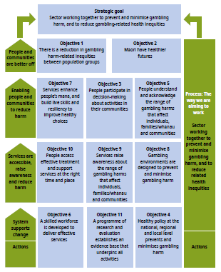
Section 5:
System supports change – objectives 4, 6 and 11
This section reports on the following three objectives in the Ministry’s integrated strategy and service since 2010:
- Objective 4: Health policy at the national, regional and local level prevents and minimises gambling harm
- Objective 6: A skilled workforce is developed to deliver effective services
- Objective 11: A programme of research and evaluation establishes an evidence base that underpins all activities.

Objective 4 recognises that policy settings at the national and local government level are important enablers of change and action to minimise gambling harm. Providing advice to other government agencies, local government and communities on harm minimisation policy tools, the research available and frameworks for action is a core function of the Ministry’s integrated public health approach to gambling harm prevention and minimisation.

Objective 6 supports objectives 8–10 on the delivery of services. It also reflects the intent to develop a skilled workforce in line with the public health workforce development plan, Te Uru Kahikatea 2017–2026.

Objective 11 is about enabling the supply of a body of research and evaluation information to contribute to policy and operational decision-making and activities in a way that is timely, relevant and cost-effective.

Objective 4: Promoting gambling harm minimisation policies

Activities and outcomes
Since 2010 the Ministry, through its service contracts, has encouraged service providers to undertake a range of policy information activities in three areas:
- workplace and organisational policies
- local government policies around EGMs
- non-gambling fundraising policy.

The focus on workplace policies aims to increase workplace and organisational awareness of risky gambling behaviour among employees and/or clients, and their voluntary adoption of harm minimisation practices. Action on local government policies on EGMs aims to influence local government to adopt stronger harm minimisation policies such as stronger targets around ‘sinking-lid’ limits. Non-gambling fundraising policy is about encouraging organisations to look at alternative methods of fundraising other than through gambling activities or the proceeds of others’ gambling, and to encourage discussion about the ethics of accepting funding generated through the proceeds of harmful (although legal) gambling.

Workplace and organisational policies
Examples of activities and outcomes associated with action in the workplace and organisational area since 2010 are highlighted in Table 6. These activities targeted a range of workplaces and organisations, including social service providers, corrections facilities, sports groups, banks, prisons, mental health services, other alcohol and drug services, mental health services and community groups and local services where internet access may be available.

Table 6: Actions and outcomes associated with promoting workplace and organisation policy development and implementation
Activities | Outcome
Modified an existing Work Well toolkit to include problem gambling  Developed and delivered a presentation that was specific to their local contact to introduce the toolkit  Identified and worked with several organisations each reporting period eg, whānau or collectives | Organisations recognised the value of the Work Well toolkit  Raised awareness among workplaces and organisations of the impact of gambling harm on their employees, clients, community and organisation  Adoption of policies that support the minimisation of gambling harm for employees and clients  Some organisations appointed in-house champions to lead the development and implementation of tailored policies  Toolkit welcomed by stakeholder due to its simplicity and capacity to function as an education resource  Toolkit reproduced for other organisations and community groups
Engaged in discussions with staff and managers of a range of organisations, and provided resources | Raised awareness of gambling harm among staff and clients  Gambling harm added to other drug and alcohol harm reduction policies
Provided incentives – special awards/certificates acknowledging local businesses/organisations that develop and implement gambling harm reduction policies | Motivated some organisations to include gambling within organisation harm reduction policies

An evaluation of some of these activities has highlighted a range of challenges health promoters working in this area face, including:
- getting organisations to recognise gambling as a problem and as relevant to them
- resistance to change due to preconceived ideas about the issues and the degree of responsibility a workplace or organisation might have – with a view of gambling as a personal issue rather a ‘public’ or ‘health’ issue
- assuming that existing health-related policies were adequate to gambling and other addiction issues
- a view that the issue is not a priority and that action is another cost burden for workplaces and organisations (Kolandai-Matchett et al 2018b).

Local government policies
Health promotion activity aimed at influencing local government policy is well- established practice across a broad range of health issues. Activities generally focus on two audiences: council staff and councillors; and the general public. Examples of activities undertaken since 2010 are highlighted in Table 7.

Table 7: Actions and outcomes associated with local government policy
Activities | Outcome
Made presentations and provided policy submission workshops to local groups and organisations  Collaborated with other problem gambling providers, district health boards and local agencies  Made written submissions and oral presentations to district councils  Encouraged other agencies and groups to make submissions | Local organisations made written or oral submissions to local councils  Submissions often resulted in positive class 4 policy changes – that is, either retaining or changing:  - sinking lid policies  - gambling machine caps  - relocation policies
Led a campaign to increase the number of submissions made by Māori communities  Created and distributed a regional profile of all Auckland district health boards, outlining their commitment to reducing gambling-related harm | Raised awareness of gambling harm for Māori  Resource well received by regional partners and demonstrated the interconnected nature of harm being inflicted on Māori communities  Communities supported and enabled to make submissions to councils
Organised a mayoral debate, which included gambling policies as a topic | Raised awareness of issue with a range stakeholder audiences
Source: Adapted from Kolandai-Matchett et al (2018b).

An evaluation of some of these activities has highlighted a range of challenges health promoters working in this area face, including:
- councillors rejecting or weakening a ‘sinking lid’ policy in spite of substantive lobbying and community involvement in favour of strengthening the policy
- perceptions that gambling revenue is a way of boosting local economic development and funding community groups, countering the perceptions of gambling harm
- vested interests by councillors in gambling activities
- lack of transparency and consistency regarding the timing of local government reviews of their gambling policies (Kolandai-Matchett et al 2018b).

Promoting alternative fundraising policies
Alternative funding policy activities are about enabling community groups, sports clubs and church groups to think about and potentially have a policy of seeking funding sources other than from the proceeds of gambling.

Notable successes are outlined in Table 8. However, these successes are the exceptions. Health promoters report that finding alternative funding sources (such as food sales, garage sales, cultural events) requires substantive effort and those sources have their own regulatory challenges for organisers (Kolandai-Matchett et al 2018b).

Table 8: Actions and outcomes associated with alternative funding sources
Activities | Outcome
Developed and maintain an alternative funding database | Database shared via Hāpai Te Hauora website and distributed to stakeholders including hapū and iwi
Worked with a branch of Māori Women’s Welfare League to raise awareness of gambling harm | League recognised the issue and has adopted a policy of not applying for casino gambling proceeds to support its activities
Source: Adapted from Kolandai-Matchett et al (2018b).

Objective 6: Developing a skilled workforce

Activities and outcomes
For the Ministry, a workforce that has both capability and capacity is essential to the delivery of timely and effective services. Another aspect of developing a skilled workforce has been the Ministry’s efforts over the last three years to promote
‘professionalisation’ among harm minimisation service providers through encouraging clinical registration with Dapaanz and achieving public health competencies in problem gambling service delivery.

To facilitate the development of a skilled workforce, the Ministry has contracted Abacus to deliver nationwide training to gambling harm minimisation providers. Regional training forums, held twice a year, are seen as adding value to the workforce through providing inspiration and ideas (Rook et al 2018).

The 2018 gambling harm minimisation needs assessment by Sapere also found general support for a shift to greater professionalisation of the workforce, with 44% of the workforce survey respondents in favour and only 7% against. However, the remaining 49% of responses indicated they had no opinion, didn’t know, or didn’t understand the question (Rook et al 2018). Further analysis by Sapere suggested that professionalisation is a concept that gains support from approximately half of the workforce, while the other half do not understand it. From a practical point of view, the regional forums for the provider workforce support collegial working and sharing of best practice. Some reasons against professional registration seem to be the workload involved, the lack of remuneration or recognition for doing it and difficulties in actually achieving it (Rook et al 2018).

Objective 11: Developing an evidence base to underpin activities
The Gambling Act 2003 requires ‘independent scientific research and evaluation’. Objective 11 of the Ministry’s Strategy sets outs its direction for implementing the requirement. The Strategy indicates the Ministry’s priorities for research and evaluation services over time. The services are intended to inform policy and service development by government agencies, and appropriate activities in the sector.

Since 2010 the Ministry has commissioned a broad range of research and evaluation services. The following are some significant investments and highlights.
- National Gambling Study: The NGS is a longitudinal cohort survey that provides insights into changes in gamblers’ gambling behaviour over time. The AUT Gambling and Addictions Research Centre, in partnership with the National Research Bureau, has held the contracts for this work.
- The NGS started in 2012 with a randomly selected national sample of 6,251 people aged 18 years and older living in private households, who were interviewed face to face with computer assistance. Participants remaining in the study have been re-interviewed in 2013, 2014 and 2015. Therefore, four waves of data have been collected over time.
- Survey questionnaires include questions on leisure activities and gambling participation, past gambling and recent gambling behaviour change, problem gambling, life events, attitudes towards gambling, mental health, substance use/misuse, health conditions, social connectedness, level of deprivation and demographics.
- The results of the work have been publicly released in a suite of six major reports, and can be accessed via both the Ministry’s and AUT’s websites.
- Health and Lifestyles Survey gambling module: The HLS is undertaken every two years by the HPA. It is a nationally representative, face-to-face, in-home survey that monitors health behaviours and attitudes of New Zealanders aged 15 years and over. The HLS collects information to inform the HPA’s main programme areas, including minimising gambling harm.
- In 2016, the gambling questions in the HLS were designed to be comparable with the 2006/07 Gaming and Betting Activities Survey, a benchmark survey carried out to inform the development of a national health promotion programme aimed at reducing gambling harm. The majority of the 2016 gambling section questions, which have provided the most recent data available at time of writing of this outcomes report, were also comparable with those in the 2008, 2010, 2012 and 2014 surveys.
- The results of the 2016 survey were publicly released in 2018 (Thimasarn-Anwar et al 2018). They included a range of time-series analyses, which have been used to significantly inform this outcomes report.
- Pacific Islands Families Study – gambling: The Pacific Islands Families study by AUT has been following a cohort of Pacific children since the year 2000. The purpose of the prospective study is to determine the pathways leading to optimal health, development and social outcomes for Pacific children and their families. In 2006, 2009 and 2014 significant gambling questions were added to the study, obtained from mothers and fathers in 2006 and mothers and children in 2009 and 2014. The youth, now aged 17 years, are currently being re-interviewed so that further gambling-related analyses can be conducted.
- Effectiveness of problem gambling interventions in a service setting: A pragmatic randomised clinical trial: The aim of this clinical trial by AUT is to examine how effective two forms of treatment are with or without added text message support, and which treatment approaches are best suited to particular client groups (based on age, gender, ethnicity and problem severity). The two treatments being trialled are: 1) motivational interviewing plus workbook plus follow-up motivational telephone support; and 2) cognitive behavioural therapy plus exposure therapy. Each treatment includes investigating the efficacy of the treatments for relapse prevention. The trial is being conducted in collaboration with the Salvation Army Addiction Services – Gambling (Oasis). It has been running for some years and is due for completion in 2020.
- International Think Tank on Gambling Research, Policy and Practice: AUT has convened the Think Tank every two years in New Zealand, usually every two years since 2004. The Think Tank is an international network of researchers, policy makers, service providers and interested others collaborating to advance understanding of gambling and to reduce gambling-related harm. It receives significant funding from the Ministry and provides a significant opportunity for sharing knowledge about gambling harm minimisation research and policy internationally.
- A mixed methods analysis of gambling harm for women in New Zealand: This AUT research aims to identify and explore the context, issues and factors influencing gambling practices and gambling harm for women in New Zealand. The aim is to identify promising avenues for policy and practice to reduce gambling harm for women, and to identify areas where further research is needed.
- An evaluation of the Partners for Change Outcome Management System (PCOMS) in a gambling treatment setting: This research by AUT is an exploratory mixed-methods evaluation of the use of PCOMS and its potential within a national gambling treatment service in New Zealand. PCOMS is a system for collecting and using client feedback on their counselling experiences to improve outcomes by engaging with the client feedback. It comprises two scales of four items each: the Outcome Rating Scale and the Session Rating Scale.
- Hawke’s Bay Multi-venue Exclusion Process Trial and Evaluation: This is a process and impact evaluation, by Malatest International, of a multi-venue exclusion process for Māori and Pacific gamblers and their whānau and aiga in Hawke’s Bay.
- Sorted Whānau Financial Capability Trial and Evaluation: This project, by Malatest International, extends the original Sorted Whānau – Building Financial Capability pilot to include a larger group of providers and their clients.
- Development and trial of a clinical smartphone-based problem gambling app (SPGeTTI): This project by Auckland University, which has been running over several years, has developed and is trialling a smart mobile phone app for the clinical treatment of problem gamblers.
- Measuring the Burden of Gambling Harm in New Zealand: The Ministry engaged Central Queensland University’s Experimental Gambling Research Laboratory and the AUT Gambling and Addictions Research Centre to develop a framework and a methodology for understanding and measuring gambling-related harm in the New Zealand population. The project systematically investigated gambling-related harm in New Zealand, and assessed the aggregate ‘burden of harm’ caused by gambling with reference to different levels of problem gambling and other comparable conditions. The approach used the standard measures methodology of quality of life years, which have been used to measure the health loss associated with a wide range of health conditions internationally in global burden of disease studies.

Conclusion: Objectives 4, 6, 11

Objective 4 – Promoting gambling harm minimisation policies
Over 2010/17 the Ministry has contracted a range of service providers to undertake gambling policy development and implementation with workplaces, organisations and local government. Contract monitoring and an independent evaluation show that providers have developed a range of resources enabling workplaces, organisations and community groups to engage with gambling policy development and decision-making. Providers have also directly engaged with local government decision-makers on gambling policy. The greatest success has been achieved with local government.

However, useful innovations have also been delivered in changing workplace policy and fundraising policy, which can serve as models for others to follow in New Zealand and internationally (Kolandai-Matchett et al 2018b). Independent evaluation has also suggested that providers face significant challenges in undertaking policy work and that they would benefit from:
- assistance in raising awareness, particularly at the local government level and in the workplace, of the harm arising from risky gambling behaviour not only to the individual gambler but also to affected others
- greater public discussion about the ethics of accepting money from the proceeds of gambling, and discussion of alternative sources of funding for community groups
- up-to-date research-based guidelines on what effective local government policy could look like – such as the ‘sinking lid’ policy setting (Kolandai-Matchett et al 2018b).

Objective 6: Developing a skilled workforce
Developing a skilled workforce remains a work in progress for harm minimisation providers. Sapere (Rook et al 2018) have suggested that thinking about the workforce should include thinking beyond harm minimisation service providers. For example, all gambling venues are required to train staff in problem gambling awareness to identify problem gamblers and offer support. This legal requirement applies equally to the high street TAB, the local bowling club and the SkyCity casino. The gambling venues and their workforce are the most obvious touchpoint for problem gamblers,

yet data from successive Health and Lifestyles Surveys shows the large majority of people who play EGMs do not interact with venue staff (Tu and Puthipiroj 2017). This finding suggests there is plenty of room for improvement.

Objective 11: Developing an evidence base to underpin activities
The overall research and evaluation programme has provided a sound research and evaluation base to inform policy development, operational decision-making and practice. The results of the NGS and HLS in particular are routinely cited and used by agencies and the major harm minimisation service providers in their public information dissemination activities and work with local government, communities and organisations. Major studies such as the Measuring the Burden of Gambling Harm in New Zealand have provided impetus for new ways of thinking about the harm caused by gambling, as well as a wider health context for thinking about the priority attached to gambling harm minimisation compared with other health issues. The NGS is an internationally important study in that it provides long-term insight into individual-level changes in gambling behaviour over time and the reasons for them.

Summary and conclusion

Summary
Since 1 July 2004, the Ministry has been responsible for developing and implementing the ‘integrated problem gambling strategy focused on public health’ that is described in section 317 of the Gambling Act 2003.

This report has substantively focused on what has been achieved in the prevention and minimisation of gambling harm in the 2010–2017 period.

The current integrated Strategy outlines the Ministry’s response to its responsibility under the Act. The Strategy comprises the Ministry’s strategic framework for the prevention and minimisation of gambling harm, a three-year service plan giving effect to the strategic framework, and the levy rate and Ministry budget.

Outcomes reporting against the objectives and activities set out in the Strategy is one of the actions in the service plan. A baseline report was published in 2013 and is available on the Ministry’s gambling webpage: www.health.govt.nz/publication/ outcomes-framework-preventing-and-minimising-gambling-harm-baseline-report

This new outcomes report is an evolution of the approach set out in 2013 baseline report, and is an update on the progress made since the baseline report. It brings together a range of information drawn from published and independent research and evaluation reports, official government agency administrative data and reports, and contract outcomes monitoring reports. References to key sources of information have been provided.

Gambling harm levels have reduced substantially compared with 25 years ago, however, they have remained substantively unchanged over the last five years
Data from the most recent HLS (Thimasarn-Anwar et al 2017) and the National Gambling Study (Abbott et al 2018) highlights that gambling harm as measured by the Problem Gambling Severity Index (PGSI) is at the lowest level in 25 years. However, in the last five to seven years the level of PGSI gambling harm in the overall population, as measured by the HLS and the NGS, has remained relatively stable. Meta-analysis of the HLS results for 2010–2016 indicates that, based on the 2014 New Zealand population, in the previous 12 months approximately:
- 0.5% (23,500 people) report levels of gambling behaviour and harm associated with problem gambling risk
- 1.5% of the population (60,440 people) report levels of gambling behaviour and harm associated with moderate gambling risk
- 3.1% of the population (167,888 people) report levels of gambling behaviour and harm associated with low to mild gambling risk
- 65.3% of the population (2,460,000 people) report levels of gambling behaviour and harm associated with no/non-problem gambling risk
- 29.9% of the population report not gambling.

Some public health researchers question the use of the PGSI as the key measure of gambling harm of the prevalence of rate for problem and risky gambling, and a proxy for associated gambling harm, arguing that a QALY measure should be used. Using QALYs, the 2017 Measuring the Burden of Gambling Harm in New Zealand study (Browne et al 2017) found that the total burden of harms occurring to gamblers is greater than common health conditions (such as diabetes and arthritis) and approaches the level of burden of anxiety and depressive disorders.

Absolute levels of inequalities have reduced between population groups, however, relative inequalities remain
The data and analysis presented in Section 2 show that inequalities between population groups by age, socioeconomic deprivation, gender and ethnicity have reduced in absolute terms in the period 2010–2017. However, in relative terms disparities in exposure to gambling and experience of gambling-related harm remain.

Many of the high-risk population groups reside disproportionately in neighbourhoods with high socioeconomic deprivation. These neighbourhoods typically have high concentrations of gambling venues and outlets. In New Zealand, this includes EGMs in pubs and clubs, and TABs (Allen+Clarke 2015). Living in close proximity to gambling venues has been shown to be associated with higher levels of problem gambling (Ministry of Health 2008).

Aware, enabled and resilient communities, safer environments
Sections 3 and 4 outlined a range of activities undertaken over the 2010–17 period that have been aimed at promoting community awareness, resiliency and safer gambling environments. The outcomes reported show that the activities have maintained a good level of awareness about the harm arising from gambling and what can be done to minimise it. Activities in the policy area have enabled people to engage in local decisions about gambling activities in their communities (Kolandai- Matchett et al 2018a). In the population overall, the data shows that awareness is generally high: about 70% recognise the signs of risky gambling and what can be done to address the behaviour. However, the current levels reported in 2016 are lower than levels in earlier years. Of interest and concern is that awareness of key services such as free face–to-face counselling is relatively low (at approximately 30%) among at-risk gamblers, although awareness of the key free telephone helpline service is higher.

Among the challenges are that, due to their design and method of delivery, many of the initiatives are local, specific and short term in nature, as well as resource intensive for the provider and funder. These characteristics typically mean the long-term impacts may be minimal and are not necessarily scalable nationwide. However, Kolandai-Matchett et al (2018a) have argued that these types of initiatives are important in promoting ‘social sustainability’ and ‘could function in a positively reinforcing loop to strengthen programme effectiveness’ overall. As such, the initiatives are well aligned with a comprehensive public health approach to preventing and minimising gambling harm.

System change enablers
System change enablers are activities aimed at assisting communities and service providers to have information resources, training and a research evidence base to deliver effective services and engage in harm minimisation activities in their local communities.

Activities over the 2010–2017 period include: developing new training resources for the gambling industry on host responsibility; the Ministry expressing to service providers its ongoing expectations about the professionalisation of the harm minimisation workforce; supporting policy engagement activities by harm minimisation service providers; and commissioning a broad range of research and evaluation services.

The outcomes reported indicate that more needs to be done to promote understanding of the benefits of workforce professionalisation and to overcome the barriers identified in Sapere’s 2018 gambling needs assessment (Rook et al 2018). Similarly, while resources have been developed to support the gambling industry, the 2016 HLS results indicate that there is considerable room for improvement by the gambling industry in the host responsibility area. New research and evaluation knowledge has been acquired that has informed policy and operational thinking. Studies such as the NGS and the Measuring the Burden of Gambling Harm study are internationally significant, and the HLS gambling module is integral to regularly monitoring change over time in the level of gambling activity and harm in the New Zealand population.

Conclusion – review and reinvigoration of activities is suggested to reduce harm further
Overall, the outcomes presented in this report show progress has been made in reducing gambling harm and inequalities in New Zealand. However, since approximately 2012 the downward movement in harm levels has plateaued. A range of research-based explanations for these outcomes has been identified and presented. Research has shown that the plateauing in harm reduction is not unique to New Zealand.

Progress has also been made across all of the 11 objectives set out in the Ministry’s integrated Strategy in a number of the areas, although challenges to further progress have been identified.

These results imply that the current harm reduction activities should be reviewed and reinvigorated if the aim is to further reduce levels of gambling harm and inequities.

References
Abbott M. 2006. Do EGMs and problem gambling go together like a horse and carriage? Gambling Research: Journal of the National Association for Gambling Studies (Australia) 18(1): 7–38.
Abbott M, Bellringer M, Garrett N. 2018. New Zealand National Gambling Study: Wave 4 (2015). Report number 6. Auckland: Auckland University of Technology, Gambling and Addictions Research Centre.
Abbott M. 2017a. Gambling and gambling harm in New Zealand: a 28-year case study. International Journal of Mental Health and Addiction 15(1221).
Abbott MW. 2017b. Beyond Reno: a critical commentary on Hancock and Smith. International Journal of Mental Health and Addiction.
Abbott M, Bellringer M, Garrett N, et al. 2014. New Zealand 2012 National Gambling Study: Gambling harm and problem gambling: Report 2. Wellington: Gambling and Addictions Research Centre, National Institute for Public Health and Mental Health Research, AUT University.
Abbott M, Bellringer M, Garrett N, et al. 2014. New Zealand 2012 National Gambling Study: Gambling Harm and Problem Gambling: Report 2. Wellington: Gambling and Addictions Research Centre, National Institute for Public Health and Mental Health Research, AUT University.
Abbott M, Bellringer M, Garrett N, et al. 2015. New Zealand National Gambling Study: Wave 2 (2013). Report Number 4: Auckland University of Technology.
Allen+Clarke. 2015. Informing the 2015 gambling harm needs assessment: Final report for the Ministry of Health. Wellington.
Bellringer M, Pulford J, Abbott M, et al. 2008. Problem Gambling: Barriers to help seeking behaviours. Auckland: AUT Gambling Research Centre.
Browne M, Bellringer M, Greer N, et al. 2017. Measuring the Burden of Gambling Harm in New Zealand. Auckland: Central Queensland University and Auckland University of Technology.
Calado F, Alexandre J, Griffiths MD. 2017. Prevalence of Adolescent Problem Gambling: A Systematic Review of Recent Research. Journal of Gambling Studies 33(2): 397–424.
Canale N, Vieno A, Lenzi M, et al. 2017. Income Inequality and Adolescent Gambling Severity: Findings from a Large-Scale Italian Representative Survey. Frontiers in Psychology 8: 1318.
Carr J. 2013. Māori health. What next? NZ Medical Journal 126(1379): 6–7.
Health Promotion Agency. 2015. 2014 Health and Lifestyles Survey. Wellington: Health Promotion Agency Research and Evaluation Unit.
Hing N, Nuske E, Gainsbury S. 2011. Gamblers At-risk and Their Help-seeking Behaviour. Lismore NSW: Centre for Gambling Education and Research, School of Tourism and Hospitality Management, Southern Cross University.
Kolandai-Matchett K, Bellringer M, Landon J, et al. 2015. Evaluation of Problem Gambling Interventions and Public Health Services: A review of literature. Auckland: Auckland University of Technology, Gambling and Addictions Research Centre.
Kolandai-Matchett K, Bellringer M, Landon J, et al. 2016. Working with gambling venues to enable safer gambling environments: lessons learned from a problem gambling public health intervention in New Zealand. In Many Ways to Help. Melbourne: Victorian Responsible Gambling Foundation.
Kolandai-Matchett K, Langham E, Bellringer M, et al. 2017. How gambling harms experienced by Pacific people in New Zealand amplify when they are culture-related. Asian Journal of Gambling Issues and Public Health 7(1): 5.
Kolandai-Matchett K, Bellringer M, Landon J, et al. 2018a. A process evaluation of the ‘Aware’ and ‘Supportive Communities’ gambling harm-minimisation programmes in New Zealand. European Journal of Public Health 28(2): 369–76.
Kolandai-Matchett K, Landon J, Bellringer M, et al. 2018b. A national public health programme on gambling policy development in New Zealand: insights from a process evaluation. Harm Reduction Journal 15: 11.
KPMG. 2013. Outcomes Framework for Preventing and Minimising Gambling Harm – Baseline Report. Wellington: Ministry of Health.
Malatest International, Raukura Hauora O Tainui, Commission for Financial Capability. 2018. June 2018 Interim Report: The extension of the Sorted Whānau Financial Capability pilot. Wellington: Malatest International.
Ministry of Health. 2010. Preventing and Minimising Gambling Harm: Six-year strategic plan 2010/11–2015/16. Wellington: Ministry of Health.
Ministry of Health. 2016. Health Loss in New Zealand 1990–2013: A report from the New Zealand Burden of Diseases, Injuries and Risk Factors Study. Wellington: Ministry of Health.
Rintoul AC, Livingstone C, Mellor AP, et al. 2013. Modelling vulnerability to gambling related harm: how disadvantage predicts gambling losses. Addiction Research & Theory 21(4): 329–38.
Rook H, Rippon R, Pauls R, et al. 2018. Gambling Harm Reduction Needs Assessment. Wellington: Sapere Research Group.
Rossen F, Walker C, Berry S, et al. 2017. Parental Gambling in New Zealand Families: Evidence from Growing Up in New Zealand. Auckland: Auckland University.
Thimasarn-Anwar T, Squire H, Trowland H, et al. 2018. Gambling Report: Results from the 2016 Health and Lifestyles Survey. Wellington: Health Promotion Agency.
Thimasarn-Anwar T, Squire H, Trowland H, et al. 2017. Gambling Report: Results from the 2016 Health and Lifestyles Survey. Wellington: Health Promotion Agency Research and Evaluation Unit..
Tu D, Gray RJ, Walton DK. 2014. Household experience of gambling-related harm by socio-economic deprivation in New Zealand: increases in inequality between 2008 and 2012. International Gambling Studies 14(2): 330–44.
Tu D, Puthipiroj P. 2017. New Zealanders’ Participation in Gambling: Results from the 2014 Health and Lifestyles Survey. Wellington: Health Promotion Agency Research and Evaluation Unit.
van der Maas M. 2016. Problem gambling, anxiety and poverty: an examination of the relationship between poor mental health and gambling problems across socio-economic status. International Gambling Studies 16(2): 281–95.
Williams L, Cram F. 2012. What Works for Māori: Synthesis of selected literature. Prepared for the Department of Corrections. Wellington: Department of Corrections.
Williams RJ, West BL, Simpson RI. 2012. Prevention of Problem Gambling: A comprehensive review of the evidence and identified best practices. Ontario: University of Lethbridge.

Appendix 1:
Gambling expenditure 2009/10–2016/17
As Figures A1 to A3 show, gambling expenditure from 2009/10–2016/17 is relatively stable, growing from $2.1 billion to $2.3 billion over from 2009/10–2016/17. However, recent years have seen some changes in expenditure by type of gambling activity. Specifically expenditure has increased on New Zealand Lotteries and decreased on non-casino gaming machines.

Figure A1: Total actual gambling expenditure
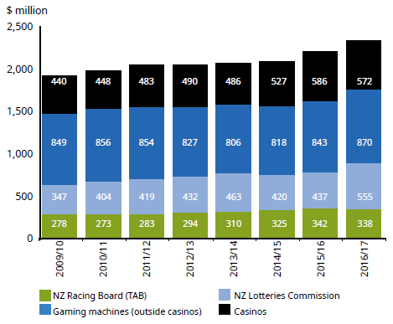

Figure A2: Total inflation adjusted gambling expenditure
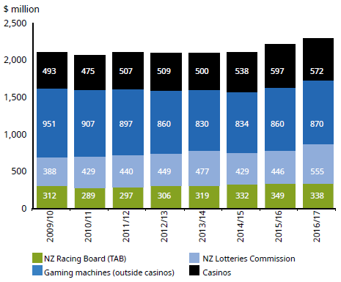

Figure A3: Total inflation adjusted expenditure per capita
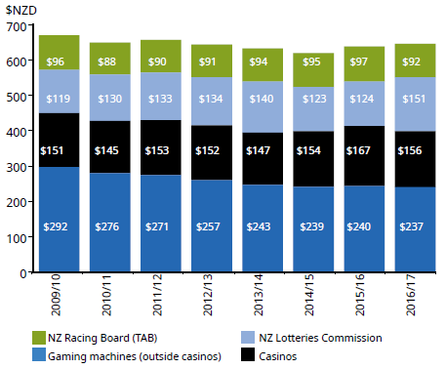

An odds ratio is a statistical measure of association between an exposure and an outcome – in this case the outcomes of gambling behaviour, harm and the other variables of interest, such as service use. The odds ratio provides an estimate of the size of the outcome for a given amount of exposure to the event causing the outcome. It is one way for researchers to make direct statistical comparisons between population groups.
www.who.int/gender-equity-rights/understanding/equity-definition/en/ accessed 17 June 2015.
The three signs of a gambler’s risky behaviour that respondents most commonly identified were: they go back to the pub to try to win back last night’s losses; their gambling sometimes causes them stress; and they don’t want anyone else to know they are gambling.

