Primary Care Ethnicity Data Audit Toolkit
A toolkit for assessing
ethnicity data quality
2021

Acknowledgements
This toolkit was developed as part of a Ministry of Health-funded project in 2013. The following authored the original version of this toolkit; Melissa McLeod and Donna Cormack from Te Rōpū Rangahau Hauora a Eru Pōmare, University of Otago, Wellington. The following contributed to the development of the toolkit: Papaarangi Reid, Peter Sandiford, Dale Bramley, Graeme Lindsay, Lannes Johnson, Lance Norman and Sue Crengle, Sue Crengle, Pat Neuwelt, Barbara Christie, Carolyn Eves, Ricci Harris, Tony Jackson, Lynn McBain, Keri Ratima, Bridget Robson and Peter Sandiford. The toolkit has been updated to align with the HISO 10001: 2017 Ethnicity Data Protocols.
Citation: Ministry of Health. 2021. Primary Care Ethnicity Data Audit Toolkit. Wellington: Ministry of Health.
Published in December 2021 by the Ministry of Health
PO Box 5013, Wellington 6140, New Zealand
ISBN 978-1-99-110008-5 (online)
HP 8010
This document is available at health.govt.nz
This work is licensed under the Creative Commons Attribution 4.0 International licence. In essence, you are free to: share ie, copy and redistribute the material in any medium or format; adapt ie, remix, transform and build upon the material. You must give appropriate credit, provide a link to the licence and indicate if changes were made.

Contents
Introduction 1
The Primary Care Ethnicity Data Audit Toolkit 2
Associated performance reporting requirements 2
How often should we complete this audit? 3
Resources 4
Ethnicity Data Protocols 4
Stats NZ statistical standard for ethnicity 4
Overview of the audit process 5
Stage 1: Systems compliance audit checklists 6
Who should complete this stage of the audit? 6
What will I need to complete the checklists? 6
How will compliance be scored? 7
How do these tools help the practice? 7
Stage 2: Staff survey 11
Who should complete this stage of the audit? 11
What will I need to complete the staff survey stage? 11
How should I mark the surveys? 12
How do I feed back the results of the survey to staff? 12
Forms and guide 12
Stage 3: Ethnicity data quality audit 26
Who should complete this stage of the audit? 26
What will I need to complete the data ethnicity quality audit? 27
How does this activity help your practice? 27
Instructions and patient form 27
Related articles 35

List of Figures
Figure 1: Information from PMS 29
Figure 2: Fresh data from patient 29
Figure 3: Example of reducing more than six ethnicities 30

Introduction
New Zealand is recognised as a world leader in our ability to analyse health data by ethnicity.

In the last decade, there has been a rapid shift in primary care from a system that did not record ethnicity routinely to one with near complete ethnicity data recording. We have moved from non-standardised collection of data to a process of collecting, recording and output of ethnicity data governed by Stats NZ’s Statistical Standard, Ethnicity V1.0.0 (statistical standard) and the HISO 10001:2017 Ethnicity Data Protocols (Ethnicity Data Protocols). This transition has been an important step in our evolving ability to monitor and report key health indicators by ethnicity.

The Ethnicity Data Protocols have been updated to address the move in the health and disability sector to electronic collection and storage of data. The Ethnicity Data Protocols define both the appropriate processes for confirmation or correction of ethnicity where existing data is held for a respondent and an appropriate frequency for collecting ethnicity data. The updated Ethnicity Data Protocols support a transition from the previous minimum requirements of recording up to three ethnicities at level 2 classification to recording up to six ethnicities at level 4 classification. This reflects the requirement for information systems to capture the greater population diversity and improved granularity of information to plan, fund and monitor health services.

The Primary Care Ethnicity Data Audit Toolkit (EDAT) has been updated in alignment with the HISO 10001:2017 Ethnicity Data Protocols. The EDAT provides a resource for both assessing the quality of ethnicity data in New Zealand primary health care settings and supporting ethnicity data quality improvement. In the New Zealand primary health care context, the purposes of ethnicity data collection include:
- guiding implementation of individual care plans and interventions (eg, risk assessment tools)
- supporting clinical audit and quality improvement activities in general practice
- measuring and monitoring population health (including health risk factors, incidence, outcomes, and experiences of care)
- monitoring policy and service performance, effectiveness, and equity at a broader system level
- planning for population priorities
- targeting funding and allocation of resources.

The Primary Care Ethnicity Data Audit Toolkit
The EDAT encompasses three practice-administered tools to assess the quality of ethnicity data and systems for data collection, recording and output within primary health care settings. It provides your practice with guidance on quality improvement activities and:
- an option for benchmarking how well your practice is currently complying with the current health and disability sector standard HISO 10001 2017 Ethnicity Data Protocols (Protocols)
- information on the current minimum standards for collecting, recording and outputting ethnicity data within the health and disability sector
- further information and links to useful resources to guide quality improvement in your practice
- assistance to assess primary health care ethnicity data against the standard for the health and disability sector, outlined in the Ethnicity Data Protocols and, more broadly, against current best practice.

The EDAT is designed to stand alone. We anticipate that it will complement and support other quality improvement activities as part of broader quality improvement cycles in practices.

Associated performance reporting requirements
A Public Health Organisation is required to provide regular performance reports as part of the Ministry’s DHB Performance Measures, see Better population health outcomes supported by primary health care PH02. Improving the quality of ethnicity data collection in PHO and NHI registers.

In addition, in the National Enrolment Service and Capitation Based Funding, business rule #3.3 – Date of Birth, Ethnicity and Gender Validation states that an enrolled person’s ethnicity information must be validated and synchronised with the NHI.

How often should we complete this audit?
There are three stages to the ethnicity data audit. The first time your practice undertakes the comprehensive audit, you should complete all three stages in the order they are presented. How often you need to conduct future audits will be dictated by the extent of issues identified at each stage of the first audit. However, a comprehensive audit should be actioned every three years.

Where the process identifies an issue within any audit stage, you should undertake quality improvement activities, staff training, and bring your procedures into alignment with the Ethnicity Data Protocols. You should repeat any relevant stages of the audit within 12 months.

Resources
The following key resources required when actioning a stage of the audit process. They are referred to at various points within this document.

Ethnicity Data Protocols
Describes the standard procedures for collecting, recording, and using data on the ethnicity of people treated by or working in the New Zealand health and disability sector.
- HISO 10001:2017 Ethnicity Data Protocols
- Ethnicity classification list: This contains a quick reference table of Ethnicity classifications listing:
- descriptions in alphabetic order along with their classification code
- classification codes in numeric order along with their description.

Stats NZ statistical standard for ethnicity
The statistical standard for ethnicity was developed to ensure that ethnicity is collected consistently for all surveys and administrative collections.
- Stats NZ statistical standard for ethnicity v1.0.0
- Ethnicity New Zealand Standard Classifications 2005 v2.1.0: This coding tool was developed by Stats NZ and provides a function to search for an ethnicity classification at any of the four levels.
- Ethnicity New Zealand Concordances: This link provides the mapping between Ethnicity New Zealand Standard Classifications V2.0.0 to V2.1.0 and V1.0.0. These should be used by implementers to apply the necessary changes to map existing data and to update to the most recently published ethnicity codes.

Overview of the audit process

Stage 1:
Systems compliance audit checklists
The systems compliance audit checklists allow you to assess whether your practice is collecting, recording and outputting ethnicity data in compliance with the Ethnicity Data Protocols.

Who should complete this stage of the audit?
Someone who has a good understanding of your practice’s processes and policies for managing ethnicity data should complete the checklist.

What will I need to complete the checklists?
You will need:
      - a copy of your practice’s written protocols or policies relating to ethnicity data. Where these are unwritten, obtain the assistance of somebody within the practice with an understanding of how your practice manages ethnicity data. This may be somebody in charge of handling patient enrolment data collection, recording patient ethnicity data in the practice management system (PMS) and reporting to the primary health organisation (PHO) or other organisation
      - a copy of the HISO 10001:2017 Ethnicity Data Protocols
      - access to the Ethnicity code tables from either:
        - the Ministry of Health, Ethnicity code table
        - the coding tools provided by Stats NZ:
          - Ethnicity New Zealand Standard Classifications 2005 v2.1.0
          - Ethnicity New Zealand Concordances.

How will compliance be scored?
Compliance will be assessed for each of the specific standards for (a) collecting, (b) recording, and (c) outputting ethnicity data outlined in the Ethnicity Data Protocols. Compliance is either met (YES) or not met (NO). A score will be calculated for compliance in collecting, recording and outputting based on the number of YES responses. This will allow your practice to better identify specific areas for improvement.

How do these tools help the practice?
The checklists measure compliance with the Ethnicity Data Protocols. Your practice needs to address the areas where it does not comply. A list of useful links and resources is provided within this document, to assist you with quality improvements and support you to fully align with the Ethnicity Data Protocols.

Primary Care Ethnicity Data Audit Toolkit

Stage 1: Ethnicity data systems compliance audit checklist
Date:
Completed by:

 | Compliance question | Response
Is your practice policy for collecting ethnicity data compliant with the current Ethnicity Data Protocols for the health sector? | Does your practice collect ethnicity data from all enrolled patients (for example for all age groups and funding sources)? | Yes | No
 | Are less than 2 percent of your practice management system (PMS) records for enrolled patients coded as having missing or ‘not stated’ ethnicity response fields? (This will require you to run a query in your PMS.) | Yes | No
 | Does your practice registration/enrolment form contain the standard ethnicity question, ethnicity response list in order) and ability to collect multiple other ethnicities* as outlined in the current Ethnicity Data Protocols? | Yes | No
 | Does your practice allow all respondents to self-identify their ethnicity, regardless of how ethnicity is collected (for example, face to face, on a paper form, electronically, by telephone)? (Note: This excludes situations where ethnicity must be collected from next of kin.) | Yes | No
 | When collecting ethnicity data for children (including for the pre-enrolment of newborns), does your practice provide the parent or caregiver with the standard ethnicity question** to complete for the child until the child is of an age to complete it themselves? | Yes | No
 | When a patient is unable to complete the ethnicity question through incapacity, does your practice provide his or her next of kin with the standard ethnicity question to complete, or, if no next of kin is available, does the practice wait until the respondent is able to self-identify their ethnicity? | Yes | No
 | In cases where ethnicity data is collected by asking the patient verbally (for example, over the phone), does your practice require staff to:  1. state to the patient/consumer that they would like to collect ethnicity  2. explain that the patient may choose more than one ethnicity  3. read out to the patient/consumer all the categories, in the order they appear in the standard ethnicity question outlined in the current ethnicity data protocols, and  4. record all the patient’s responses? | Yes | No
Is your practice policy for recording ethnicity data compliant with the current Ethnicity Data Protocols for the health sector? | Does your practice only use the standard codes, as outlined in the current Ethnicity Data Protocols for recording ethnicity? | Yes | No
 | Does your practice store ethnicity data in the PMS at level 4 of the standard classification system?  (see Resources for links to level 4 classifications) | Yes | No
 | For ethnicities that are written on the form by respondents, does your practice match the response with the level 4 ethnicity codes and then record the response in the PMS at level 4? | Yes | No
 | Is your practice able to record and store up to six ethnicities for an individual? | Yes | No
 | Where a patient supplies more responses than can be recorded in your PMS, does your practice use  - the method determined by Stats NZ (Appendix A of the Ethnicity Data Protocols) to reduce the number of ethnicities where six may be recorded  or  - where systems are not able to record six ethnicities do you prioritise responses according to the standard list provided in the current Ethnicity Data Protocols and record these at level 4? (See section 5.5.2 of the Ethnicity Data Protocols) | Yes | No
Is your practice policy for the output of ethnicity data compliant with the current Ethnicity Data Protocols for the health sector? | Where your practice outputs data to the primary health care organisation, are you able to deliver up to six ethnicities per patient? | Yes | No
 | In the analysis and reporting of ethnicity data, does your practice use one of the recommended methods (total response, prioritised or sole/combination) for the output of multiple ethnicities?*** | Yes | No
 | In the analysis and reporting of ethnicity data, does your practice describe the method it uses for the output of multiple ethnicities (eg, total, prioritised or sole/combination)?*** | Yes | No
* The standard ethnicity question for the health and disability sector is the Stats NZ ethnicity question used in the most recent census. See HISO 10001:2017 Ethnicity Data Protocols, 3.2: Standard ethnicity question (Ministry of Health 2017) for the standard question, categories, formatting and layout requirements.
** See HISO 10001:2017 Ethnicity Data Protocols, 3.3.4 c) Proxy response in the Ethnicity Data Protocols for information on collecting ethnicity details for children/newborns.
*** Total response, prioritised and sole/combination are different methods for outputting multiple ethnicities.
- Total response counts each person once in each ethnic group they identify with.
- Prioritisation assigns a person who identifies with more than one ethnic group to a single mutually exclusive category based on an established priority order.
- Sole/combination assigns individuals to either a sole ethnicity group (if they only identify with one ethnicity) or a combination category (for example, European/Māori) if they identify with more than one ethnic.

Compliance score
Category | Score | Action
Collection | /7 | If score is less than 7, action is required
Recording | /5 | If score is less than 5, action is required
Output | /3 | If score is less than 3, action is required
Total | /15 | If score is less than 15, action is required

Stage 2:
Staff survey
This stage of the audit allows you to assess your staff’s understanding and current processes for collecting and recording ethnicity data and identify specific staff training needs.

Who should complete this stage of the audit?
The person who completed stage 1 should run this stage of the audit. This person will be responsible for distributing and marking the staff surveys, reporting back to staff and identifying training needs.

All staff involved in collecting and/or recording patient ethnicity data should complete the staff survey. This will likely include most of the non-clinical staff and some clinical staff.

What will I need to complete the staff survey stage?
You will need:
      - printed copies (or an electronic version) of the Staff survey form: How are we doing? for each participating staff member
      - a copy of the Rapid assessment sheet for staff surveys (see pages 11–13) and the Detailed guide for staff survey responses (see pages 17–21)
      - a copy of the HISO 10001:2017 Ethnicity Data Protocols
      - a copy of the Ethnicity code tables from either:
        - the Ministry of Health, Ethnicity code table
        - the coding tools provided by Stats NZ
          - Ethnicity New Zealand Standard Classifications 2005 v2.1.0
          - Ethnicity New Zealand Concordances.

How should I mark the surveys?
Use the Rapid assessment sheet for staff survey and the Detailed guidance for staff survey response to review the completed staff surveys, and to identify any issues that require attention. The detailed guidance document provides a brief explanation of ideal responses, corrective actions and useful resources.

Mark each staff survey separately, to identify issues that need attention for individual staff members. It may also be worth reviewing all completed staff surveys to identify issues that have arisen for more than one participant and therefore may need to be addressed at the practice level (for example, through group training).

In smaller practices, it may help to use external support with reviewing and addressing issues identified in the survey, particularly where an individual is responsible for both completing the survey and reviewing it. Support may be available from your PHO.

How do I feed back the results of the survey to staff?
The results of the survey should be discussed with all staff in the practice (for example, during a staff meeting). It is important that you base any feedback given in a group setting on an overall picture of the survey responses, and do not identify any particular individual’s survey response.

Where you identify an issue with a single member of staff, you should discuss it with them confidentially, and agree on a plan of action. This process may also be a good opportunity to gather feedback from staff on the audit process itself. In your feedback to staff, you should include:
- include any issues identified
- the plan for addressing the issues
- the proposed date of review.

Forms and guide
The forms for the staff survey follow:
- Staff survey form: How are we doing?
- Rapid assessment sheet for staff surveys
- Detailed guidance for staff survey responses

A copy of each of these forms follows. These forms are also available on the Ministry of Health’s website from the hyperlink provided with the relevant checklist in the bullet list above.

Primary Care Ethnicity Data Audit Toolkit

Stage 2: Staff survey form: How are we doing?
Please take a few minutes to fill out this survey on collecting and recording ethnicity data in our practice. This survey is part of a wider audit process we are undertaking that aims to improve the quality of our practice processes for ethnicity data collection, recording and outputting.

For the following questions, please tick the one box that is the closest to your response.

Training
1. | Have you received any training on how to collect or record ethnicity data in primary care?
 | Yes, in the last  12 months | Yes, but not in the last 12 months | No | N/A
2, | How often are you involved in collecting ethnicity data from patients or recording ethnicity data in the practice management system (PMS)?
 | Frequently (on most  days I am working) | Occasionally  (once a week) | Infrequently  (once a month or less) | N/A
3. | Do you consider that you understand why ethnicity data is collected in primary care?
 | Yes | No | Not sure | N/A
4. | Are you comfortable collecting ethnicity data from patients?
 | Yes | No | Not sure | N/A

What do you do?
5. | How often do you check patient ethnicity details for patients enrolled in your practice?
 | On initial patient enrolment/registration and regularly (at least three-yearly) thereafter |  | On initial patient enrolment/registration and irregularly thereafter, or at intervals greater than three years apart | On initial patient enrolment/registration only or not sure |  | N/A
6, | Are there times when you guess a patient’s ethnicity rather than asking the patient to self-identify?
 | Yes  See below |  | No  Go to question 7 | N/A  Go to question 7
 | Why do you decide/guess a patient’s ethnicity?
7. | Do you have a list of codes or search function available to help you record a patient’s ethnicity?
 | Yes |  | No | Not sure |  | N/A
8. | Do you ever make up a new code to record an ethnicity?
 | Yes |  | No | Not sure |  | N/A
9. | Which code would you record in your PMS where a patient provided each of the following responses to the ethnicity question? (Feel free to refer to any resources that you would normally use when coding ethnicity.)
 | Written-in response of ‘New Zealander’ code
 | Written-in response of ‘Fijian-Indian’ code
 | Written-in response of ‘Cook Islander’ code
 | Blank (where patient not immediately contactable) code
 | Declined to provide ethnicity code
10. | Are you able to record up to six ethnicities for a patient in your PMS?
 | Yes | If YES, where a patient provides more than six ethnicities, how do you decide which six are recorded in the PMS? Please explain.
 | No | If NO, where a patient provides more ethnicities than you can record, how do you decide which ethnicities are recorded in the PMS? Please explain.

What do you think?
11, | Have you experienced any difficulties with collecting ethnicity data from patients/consumers or recording ethnicity data in the PMS? If yes, please explain.
12, | Is there anything that would make it easier for you to collect or record ethnicity data from patients/consumers? If yes, please explain.

Additional feedback
Please share any additional comments.

Personal information
Given name: |  | Family name:
Practice name:
Position:
Date:

Thank you for taking the time to fill out this survey. We rely on your feedback to help improve our systems. Your input is greatly appreciated.

Primary Care Ethnicity Data Audit Toolkit

Stage 2: Rapid assessment sheet for staff surveys
This rapid assessment sheet can be used to mark completed staff surveys. Any answers that require follow-up actions shaded in orange. Where an answer is assessed as ‘needs attention’, refer to the Detailed guidance on staff survey responses for corrective actions and useful resources.

Each staff survey should be marked separately to identify issues that relate to individual staff members. It may also be worth reviewing staff surveys collectively, to identify issues that have arisen for more than one participant.

Name of staff survey participant:
Date:

Training
1. | Have you received any training on how to collect or record ethnicity data in primary care?
 | Ideal | Pass | Needs attention
 | Yes, in the last  12 months | Yes, but not in the last 12 months | No | N/A
2, | How often are you involved in collecting ethnicity data from patients or recording ethnicity data in the practice management system (PMS)?
 | Highest priority
 | Frequently (on most  days I am working) | Occasionally  (once a week) | Infrequently  (once a month or less) | N/A
3. | Do you consider that you understand why ethnicity data is collected in primary care?
 | Ideal | Needs attention | Needs attention
 | Yes | No | Not sure | N/A
4. | Are you comfortable collecting ethnicity data from patients?
 | Ideal | Needs attention | Needs attention
 | Yes | No | Not sure | N/A

What do you do?
5. | How often do you check patient ethnicity details for patients enrolled in your practice?
 | Pass | Needs attention | Needs attention
 | On initial patient enrolment/registration  and regularly (at least three-yearly) thereafter | On initial patient enrolment/registration and irregularly thereafter, or at intervals greater than three-years apart | On initial patient enrolment/registration only or not sure |  | N/A
6, | Are there times when you guess a patient’s ethnicity rather than asking the patient to self-identify?
 | Needs attention | Ideal
 | Yes | No | N/A
7. | Do you have a list of codes available or search function to help you record a patient’s ethnicity?
 | Ideal | Needs attention | Needs attention
 | Yes | No | Not sure |  | N/A
8. | Do you ever make up a new code to record an ethnicity?
 | Needs attention | Ideal | Needs attention
 | Yes | No | Not sure |  | N/A
9. | Which code would you record in your practice management system where a patient provided each of the following responses to the ethnicity question?
 | Patient provided response |  |  | Short description | Code
 | Written-in response of ‘New Zealander’ |  |  | New Zealander | 61118
 | Written-in response of ‘Fijian-Indian’ |  |  | Fijian Indian | 43112
 | Written-in response of ‘Cook Islander’ |  |  | Cook Island Māori | 32100
 | Blank (where patient not immediately contactable) |  |  | Not stated code | 99999
 | Declined to provide ethnicity |  |  | Refused to answer | 95555
10. | Are you able to record up to six ethnicities for an individual in your PMS?
 | Ideal | Needs attention
 | Yes | No
 | If YES, where a patient provides more than six ethnicities, how do you decide which six are recorded in the PMS? Please explain.
A correct response must include a statement that covers the following points.
Where more than six ethnicities are provided by the patient, those selected to be recorded are to be based on the random manual reduction method outlined in the HISO 10001:2017 Ethnicity Data Protocols, Appendix A.
The response may also include reference to:
- the IT software we use reduces the number of ethnicities recorded to six based on the StatsNZ random reduction method
- removing codes that would be assigned to a level 1 residual code
- mapping all level 4 codes to level 1
- retaining responses that have only one level 4 ethnicity code mapping to a level 1 code
- where more than one ethnicity is assigned to the same level 1 code randomly selecting one of the level 1 categories having more than one level 4 ethnicity and then randomly selecting one of the level 4 codes from that category to retain. Continue doing this until only six level 4 codes remain.
- a minimum of six ethnicities being entered into the PMS where the number of ethnicities identified by the patient is greater than six.
An incorrect response may refer to:
- asking the patient to rank their own ethnicities, or picking up to six they most strongly identify with
- a staff member choosing which ethnicities are entered based on anything other than the random method described above.
If NO, where a patient provides more ethnicities than you can record, how do you decide which ethnicities are recorded in the PMS? Please explain.
Where six ethnicities cannot be collected, the prioritisation method outlined in the Ethnicity Data Protocols should be used rather than the Stats NZ random reduction method. If, in their response to this question, a staff member indicates that they made a decision according to some other process, their answer may need attention.
A correct response must include a statement to the following effect.
- Prioritisation of level 2 ethnicity is based upon the priority list provided in the Ethnicity Data Protocols.
The response may also include reference to:
- prioritisation occurring at code levels 1 or 2
- a minimum of three ethnicities being entered onto the PMS where the number of ethnicities identified by the patient is greater than three
- prioritisation of level 2 ethnicity being based upon the priority list provided in the Ethnicity Data Protocols.
An incorrect response may refer to:
- asking the patient to rank their own ethnicities, or picking the one, two or three they most strongly identify with
- a staff member choosing which ethnicities are entered based upon anything other than the Protocol priority list.

Primary Care Ethnicity Data Audit Toolkit

Stage 2: Detailed guidance for staff survey responses
The following is an assessment guide against which the staff surveys can be reviewed. This guide provides more detailed advice on the survey responses than the Rapid assessment sheet. Where attention is required, this detailed guide identifies corrective actions for each of the staff survey questions.

Staff training is available through the online ethnicity training course on the hospital’s eLearning platform or the Ministry of Health’s eLearning platform. This training provides an understanding of what ethnicity is, why it is collected, the rules for collecting and recording ethnicity data and how to deal with difficult situations or questions.

Training
The first four survey questions relate to staff training, and staff’s understanding of and comfort with collecting ethnicity data. These questions may assist in identifying which individual staff members need further training, as well as identifying wider training needs. Where you identify issues with training, recommended actions are as follows.

Recommended actions:
- Consider individual staff training using the online ethnicity training course provided on the Ministry of Health’s eLearning platform or if your practice has access to a hospital’s eLearning platform.
- Consider conducting group staff training sessions (this could be undertaken as part of existing staff meetings or training).
- Consider including staff training on correct processes for ethnicity data collection in induction processes for new staff.
- Consider providing staff with resources and support to collect ethnicity data.

      - Have you received any training on how to collect or record ethnicity data in primary care?
Ideally, staff will have received training in collecting ethnicity data from patients/consumers, and your practice will have a process in place for ensuring new staff are appropriately trained.

      - How often are you involved in collecting ethnicity data from patients or recording ethnicity data in the practice management system (PMS)?
This question may be useful if it is necessary to prioritise staff training. When planning training and refresher courses, prioritise those staff who are collecting and recording ethnicity data regularly.

      - Do you understand why ethnicity data is collected in primary care?
When planning training and refresher courses, prioritise those staff who do not feel they understand fully why ethnicity data is collected. Evidence suggests that understanding why ethnicity data is collected in health settings helps improve data collection.

      - Are you comfortable collecting ethnicity data from patients/consumers?
When planning training and refresher courses, prioritise those staff who are not comfortable collecting ethnicity data from patients. Staff who have received training and who feel well supported to collect ethnicity data are likely to be more comfortable in undertaking this task and do it accurately. The online ethnicity training course aims to make staff feel more comfortable about asking the ethnicity question and dealing with difficult questions or responses.

What do you do?
      - How often do you check patient ethnicity details for patients enrolled in your practice?
Ethnicity data needs to be up to date. Ideally the process of updating it should be at planned intervals. An irregular or opportunistic collection will not result in updated details for all individuals. Therefore, collecting ethnicity data at planned intervals using the protocol collection methods is the preferred practice.

Recommended action:
- The practice should establish a policy for confirming and updating patients’ ethnicity details. This may be done in conjunction with updating other patient details but must be completed using the standard ethnicity question and in accordance with the Ethnicity Data Protocols.

      - Are there times when you guess a patient’s ethnicity rather than asking the patient to self-identify?
Where patients are able to self-identify, staff must not guess the patient’s ethnicity or complete the question on the patient’s behalf.

Recommended action:
- Where a staff member guesses a patient’s ethnicity, explore the reasons for this in order to identify:
- if there is a training/awareness issue (for example, staff not knowing the appropriate procedure)
- a systems/process issue (for example, staff being aware of expected practice but being influenced by other barriers, such as workload pressures).

      - Do you have a list of codes or search engines available to help you record a patient’s ethnicity?
A patient’s ethnicity must be recorded at level 4. At times, staff will need to identify the correct codes to use for ethnic categories they may be less familiar with. Also, at times patients will provide a written response that is more detailed than level 4, and staff will need to aggregate up to the correct level 4 code.
If the system is not capable of recording at level 4, then the staff member will need to identify the correct codes using the ethnicity classification level that the practice is using at the time of the survey. Please note that all systems are to move to collecting information at level 4.

Recommended actions:
- Provide training to assist staff to understand the process for correctly identifying the relevant level 4 codes (or the level the practice is using at the time of the survey). Information on the process for coding ethnicity is outlined in the Ethnicity Data Protocols.
- The tools to be able to identify the codes are listed in the Resources section above.

      - Do you ever make up a new code to record a patient’s ethnicity?
Your PMS must record ethnicity details using the standard numeric code and corresponding text description outlined in the Ethnicity Data Protocols. Practices must not develop their own codes/descriptions or modify the standard codes/ descriptions, as this will impact on the quality and standardisation, and therefore the usefulness, of the data.

Recommended actions:
- Where a staff member makes up new codes, explore the reasons for this action to identify if there is a training/awareness issue (for example, the staff member does not know the appropriate procedure for coding ethnicity) or a systems/process issue (for example, the PMS contains incorrect codes).
- The practice should address any issues through appropriate training or a system change, as relevant.

      - Which code would you record in your practice management system where a patient provided each of the following responses to the ethnicity question?
Patient provided response | Short description | Code
Written-in response of ‘New Zealander’ | New Zealander | 61118
Written-in response of ‘Fijian-Indian’ | Fijian Indian code | 43112
Written-in response of ‘Rarotongan’ | Cook Island Māori code | 32100
Blank (where patient not immediately contactable) | Not stated code | 99999
Declined to provide ethnicity | Refused to answer | 95555
If the system is not capable of recording at level 4, then the staff member will need to identify the correct codes using the ethnicity classification level that the practice is using at the time of the survey.

Recommended action:
- Provide training to help staff understand the process for correctly identifying the relevant level 4 codes (or the level the practice is using at the time of the survey). Information on the process for coding ethnicity is outlined in HISO 10001:2017 Ethnicity Data Protocols.

      - Are you able to record up to six ethnicities for a patient in your system?
Your PMS should be able to record up to six ethnicities for an individual patient, using the standard numeric code and corresponding text description outlined in the Ethnicity Data Protocols.

If YES, where a patient provides more than six ethnicities, how do you decide which six are recorded in the PMS? Please explain.
The reduction of more than six ethnicities provided by the patient should be based on the random manual reduction method outlined in HISO 10001:2017 Ethnicity Data Protocols, Appendix A.

Recommended actions:
(for an incorrect response, or a partially correct response)
- Provide training to help staff understand the process for correctly prioritising ethnicity data, where more than six responses are provided. Information on how to manually reduce the number of responses using the random method can be found in HISO 10001:2017 Ethnicity Data Protocols, Appendix A.
- The coding tools listed in the Resource section above should be used to help find appropriate codes. These should be used wherever possible to ensure consistent coding by all collectors.

If NO, where a patient provides more ethnicities than can be recorded in your PMS, how do you decide which is recorded in the PMS? Please explain.
Your PMS should be able to record up to six ethnicities for an individual patient, using the standard numeric code and corresponding text description outlined in the Ethnicity Data Protocols.

Recommended action:
(If the system is not able to collect up to six ethnicities)
- The practice should address this through a system change to ensure that all IT systems are able to record up to six ethnicities.
As an interim measure, prioritisation can be used to identify which ethnicity should be recorded where the system cannot record up to six ethnicities. The correct process for the prioritisation of ethnicities is outlined in section HISO 10001:2017 Ethnicity Data Protocols, section 5.5.2 Prioritised output.

Recommended actions:
(For an incorrect or partially correct response by staff member to reducing the number of ethnicities)
- Provide training to help staff understand the process for correctly prioritising ethnicity data, where more responses are provided than can be recorded by the IT system. Information on how to prioritise at level 2 is provided in HISO 10001:2017 Ethnicity Data Protocols, section 5.5.2 Prioritised output.
- The coding tools listed in the Resources section above should be used to help find appropriate codes. These should be used wherever possible to ensure consistent coding by all collectors.

What do you think?
      - Have you experienced any difficulties with collecting ethnicity data from patients/consumers or recording ethnicity data in your PMS? If yes, please explain.
Research has identified a number of barriers around collecting and inputting ethnicity data in health care settings. These include: a lack of understanding about why ethnicity data is being collected; a lack of knowledge or understanding about how to collect ethnicity data correctly; a lack of accessible and ongoing training; issues with the IT systems used in health institutions (for example, systems not having the right codes, or not making it easy to record multiple ethnicities); high staff turnover; and concern about offending people.

Recommended actions:
- The practice should identify whether staff difficulties with collecting ethnicity data relate to training or to practice systems or processes and address these as appropriate.
- The staff should complete the online ethnicity training course which aims to make staff feel more comfortable about asking the ethnicity question and dealing with difficult questions or responses.

      - Is there anything that would make it easier for you to collect and record ethnicity data from patients/consumers? If yes, please explain.
Research has identified a number of things that facilitate collecting and inputting ethnicity data in health care settings, such as online training tools and training resources to support changes (for example, changes to standard code sets).

Recommended actions:
- Where staff identify something that would make it easier for them to collect and record data, assess whether the suggested solution is appropriate and potentially useful to all staff. Staff are more likely to accept a particular solution if they identified it for themselves.
- You should not implement proposed solutions if they result in a collection process that does not comply with the Ethnicity Data Protocols.
- The manager should report back to staff on their reasons for adopting (or not) solutions identified by staff.

Stage 3:
Ethnicity data quality audit
The purpose of this stage is to assess the quality of ethnicity data currently held in the practice management system (PMS) against a ‘fresh’ collection of self-identified patient ethnicity data using the supplied audit form.
Complete this activity after completing stages 1 and 2. This stage involves collecting information from practice patients and should be handled in accordance with your practice policies on information privacy and relevant legal requirements including the Health Information Privacy Code 2020.

Who should complete this stage of the audit?
This activity is likely to involve more than one member of staff to complete this stage of the audit. It is likely to involve front reception staff because you will need to collect ethnicity details from all enrolled/registered patients as they arrive during the audit timeframe. The assessment of data quality will require somebody with knowledge of how to access patient ethnicity details on the electronic record in the PMS and an understanding of how to correctly code write-in responses and prioritise ethnicities where a patient has identified more than six ethnic groups.

What will I need to complete the data ethnicity quality audit?
You will need:
      - printed copies of the audit question form containing the most recent ethnicity question (see section HISO 10001:2017 Ethnicity Data Protocols, section 3.2 Standard ethnicity question), for all patients for whom you will collect ‘fresh’ ethnicity information
      - a copy of Instructions for completing the data quality audit and the Patient data collection form (see pages 26–33 of this document)
      - access to the PMS
      - a copy of the Ethnicity Data Protocols
      - a copy of the Ethnicity code tables from either:
        - the Ministry of Health, Ethnicity code table
        - the coding tools provided by Stats NZ
          - Ethnicity New Zealand Standard Classifications 2005 v2.1.0
          - Ethnicity New Zealand Concordances.

How does this activity help your practice?
Use of this tool will give your practice a greater understanding of how closely ethnicity data on your PMS reflects current self-identified ethnicity data. It will then help you to identify recommended actions to improve the quality of ethnicity data.

Instructions and patient form
The following are included to support your practice completing the ethnicity data quality audit stage:
- instructions for the ethnicity data quality audit
- patient data collection form.

The Patient data collection form is available on the Ministry of Health’s website from the hyperlink provided at the bullet.

Primary Care Ethnicity Data Audit Toolkit

Stage 3: Instructions for completing the ethnicity data quality audit
Follow the instructions and complete the audit steps in the order listed below.

Part 1: Collecting and recording data
Ask all enrolled/registered patients that come into the practice for an appointment to provide their ethnicities details in the appropriate Patient data collection form (see page 33). Continue this activity until you have 100 completed forms.

When undertaking this process, follow these guidelines.
- Collect a proxy response (from a caregiver) for enrolled/registered children.
- Exclude drop-in, casual or new patients, and patients who are seriously unwell or otherwise unable to complete the form.
- Ensure that the patient self-identifies their ethnicity (or that their caregiver does so, in the case of children).
- Ensure that you comply with your practice’s policies on information, the Privacy Act 2020, the Health Information Privacy Code 2020 and the HISO 10064:2017 Health Information Governance Guidelines.
- Store collected data securely.
- Other patient details may be updated at the same time (for example, address, phone numbers or next-of-kin details).
- If your practice has multiple practitioners, aim to undertake the data quality audit on a day or days when the largest numbers of staff are working, to capture the greatest range of patients.

Part 2: Analysing data
The lower part of the patient data collection form contains a section to help you undertake the data audit.

Step 1
For each patient, find the appropriate entry on the practice management system (PMS), and in the space provided on the patient data collection form (under ‘Office use only’, ‘PMS’), note their ethnicity details as recorded on the PMS. For example, if the patient’s ethnicity is recorded on the PMS as Māori and NZ European, you would enter these as per the following example.

Figure 1: Information from PMS
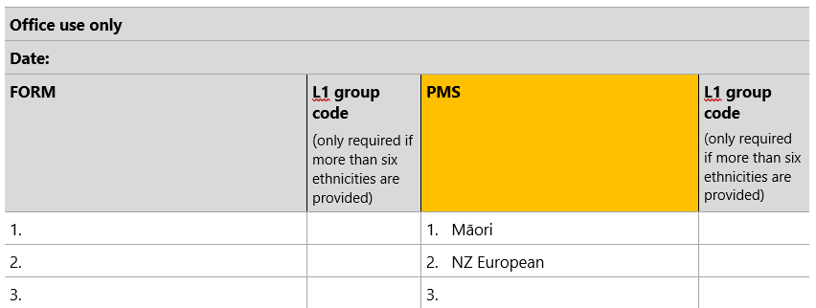

Step 2
In the space provided on the form (under ‘Office use only’, ‘Form’), note the self-identified ethnicity details as collected on the upper section of the audit form.

For example, if the same patient as above only selected ‘Māori’ on their audit form, you would enter this as below.

Figure 2: Fresh data from patient
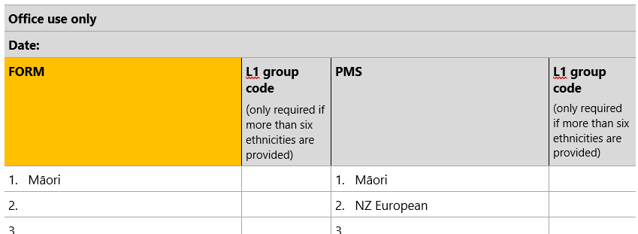

Able to record six ethnicities in the PMS system
When a PMS system is able to record up to six ethnicities and more than six ethnicities are recorded on the form, the Stats NZ’s random method of reduction is used to reduce the number of ethnicities on the form to six. There are only six level 1 categories and this method ensures each level 1 group code provided on the form is represented in the PMS. When performing the audit:
- check that no residual ethnicity codes are recorded in the system
- identify level 1 group codes for each ethnicity on the form
- check that all level 1 group codes of the ethnicities recorded on the form are represented in the PMS record.

Figure 3: Example of reducing more than six ethnicities
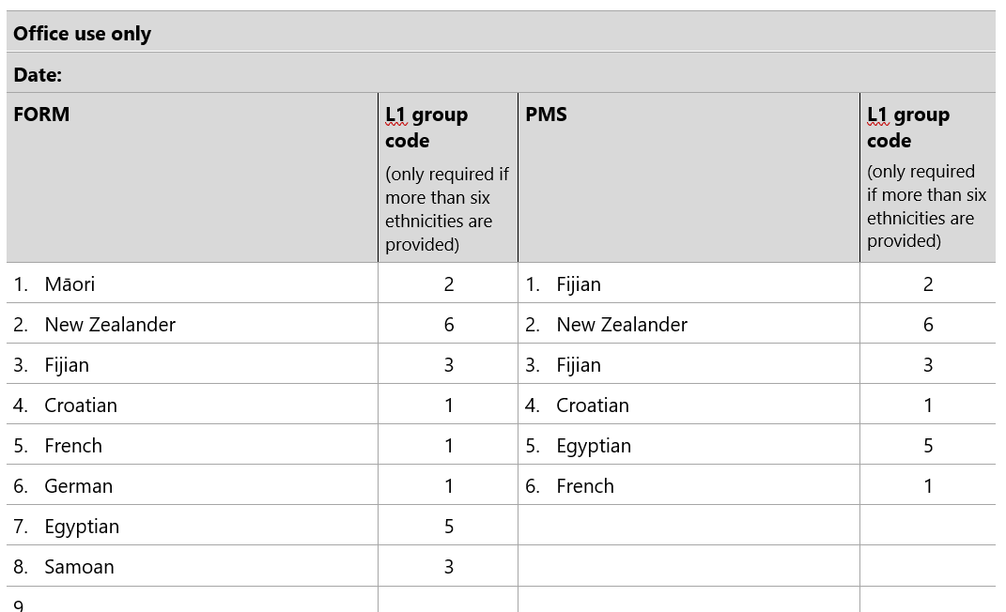

In the example above, there are two level 1 categories with more than one response:
- Croatian, French, and German all map to level 1, ethnic group code 1 European
- Samoan and Fijian both map to level 1, ethnic group code 3 Pacific peoples.

Ethnicities from these two groups have been randomly removed, but the record has retained at least one ethnicity from each ethnic group.

Unable to record up to six ethnicities in the PMS system
If your PMS system is unable to record up to six ethnicities, note this on the form and follow the Prioritised output method to reduce the number of ethnicities to the required amount that can be recorded in your system. See HISO 10001:2017 Ethnicity Data Protocols, section 5.5.2 Prioritised output.

Step 3
For each audit form, identify the level of match between the two records of ethnicity, as follows (use only one grade per form).

Match (M) | All ethnicities identified by the patient on the audit form match with those recorded for that patient in your PMS. (Note: the order in which they are recorded does not need to match). For example:  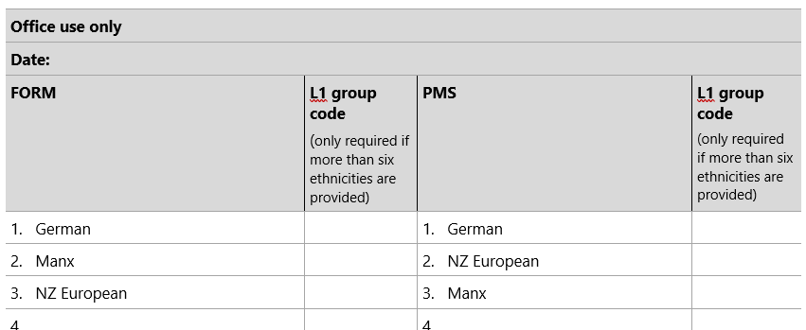  When a PMS system is able to record up to six ethnicities and more than six ethnicities are recorded on the form, only six ethnicities recorded in the PMS need to match provided they represent all level 1 categories of the ethnicities recorded on the form. For example:  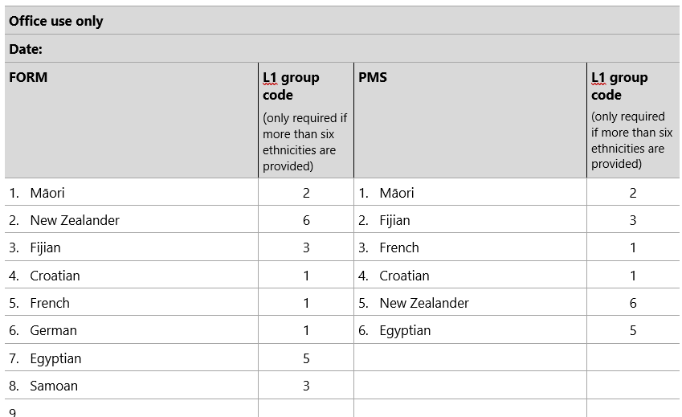  The above example is a Match because all level 1 ethnicity categories on the patient form are represented in the PMS and no residual categories are retained.  An example of less than six ethnicities provided and a system that is only able to capture three ethnicities:  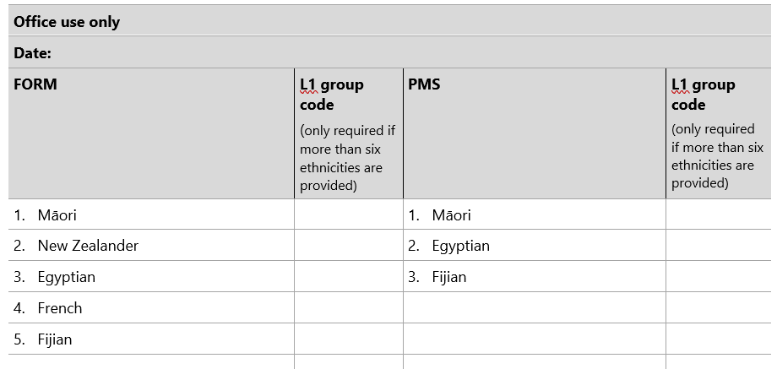  The previous example is a Match because the ethnicities with the highest priority score are represented in the PMS.
Partial match (PM) |  | This is only relevant for patients with multiple ethnicities recorded. It applies where some but not all the ethnicities match, regardless of the order.  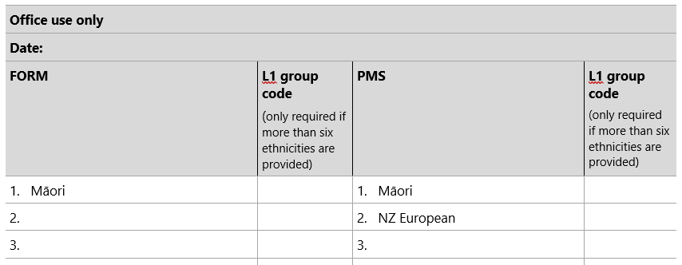  This includes those responses where the number of ethnicities recorded on the patient form exceeds six and the number of ethnicities recorded in the PMS has not been correctly reduced to six.  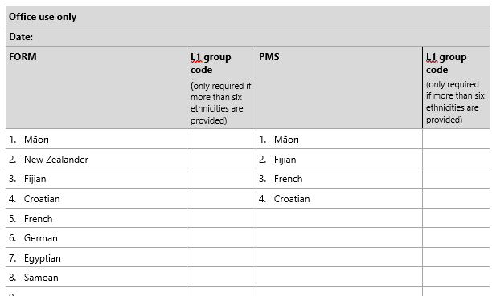
Total mismatch (TMM) |  | None of the ethnicities identified by the patient on the audit form match with those recorded for that patient in your PAS.  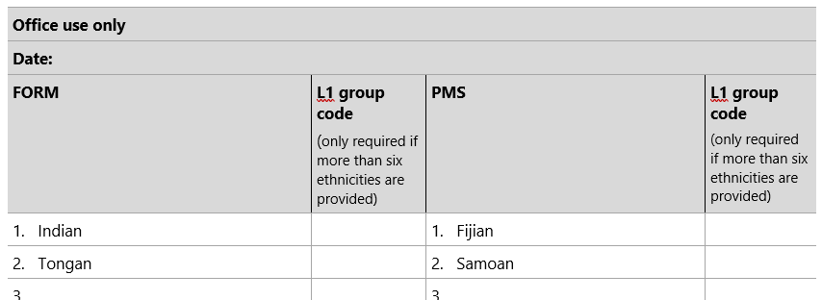

Step 4
Record the level of match on the bottom of each audit form by circling either M, PM or TMM. For example, a partial match is recorded as:
M | PM | TMM

Step 5
Once all forms are completed and you have identified the level of match for each, complete the table below.
 | Number of forms | Percentage of total forms*
Match (M) |  | %
Partial match (PM) |  | %
Total mismatch (TMM) |  | %
Total (M+PM+TMM) |  | –
* Percentage = number of M, PM or TMM forms divided by total number of forms, times 100. For example, if a total of 100 forms were completed, and 60 of them had ethnicity details that matched: (60/100) x 100 = 60 percent.

Part 4: Taking action
It is expected that all practices will record a small percentage of mismatched (or partially matched) ethnicity data, which may result from changes in ethnicity identification by patients. However, a large level of mismatch may indicate collection or recording issues that need to be addressed.

Percentage of match | Action required
Level of match (M) is greater than 90 percent | The practice should ensure that patient ethnicity is updated at regular intervals and repeat the ethnicity data quality audit within a period of no more than three years.
Level of match (M) is between 70 and 90 percent | The practice should:  - review its collection and recording systems (using stages 1 and 2 of the audit)  - immediately begin a process of updating patient ethnicity details (consistently with the Ethnicity Data Protocols)  - ensure that patient ethnicity records are updated at regular intervals  - provide staff training as required  - repeat the data quality audit process in 12 months’ time.
Level of match (M) is below 70 percent | The practice should:  - consider undertaking a more thorough ethnicity data audit, perhaps drawing on outside expertise  - review its collection and recording systems (using stages 1 and 2 of the audit)  - immediately begin a process of updating patient ethnicity details (consistently with the Protocols)  - ensure that patient ethnicity records are updated at regular intervals  - provide staff training  - repeat the three stages of the audit process in 12 months’ time.

Primary Care Ethnicity Data Audit Toolkit

Stage 3: Patient data collection form
We are currently updating our patient details and would appreciate if you would answer the following questions.
Full name:
Date of birth: |  | / |  | /

Which ethnic group do you belong to? Mark the space or spaces that apply to you.
New Zealand European
Māori
Samoan
Cook Island Māori
Tongan
Niuean
Chinese
Indian
Other (such as Dutch, Japanese, Tokelauan). Please state:

Office use only
Date:
FORM |  | L1 group code  (only required if more than six ethnicities are provided) | PMS | L1 group code  (only required if more than six ethnicities are provided)
1. |  |  | 1.
2. |  |  | 2.
3. |  |  | 3.
4. |  |  | 4.
5. |  |  | 5.
6. |  |  | 6.
7.
8.
9.
10.

M | PM | TMM

Related articles
Cormack D. 2010. The Politics and Practice of Counting: Ethnicity in official statistics in Aotearoa/New Zealand. Wellington: Te Rōpū Rangahau Hauora a Eru Pōmare. URL: www.otago.ac.nz/wellington/otago600095.pdf (accessed 22 September 2021).
Cormack D, McLeod M. 2010. Improving and Maintaining Quality in Ethnicity Data Collections in the Health and Disability Sector. Wellington: Te Rōpū Rangahau Hauora a Eru Pōmare. URL: www.otago.ac.nz/wellington/otago600098.pdf (accessed 22 September 2021).
Disney G, Teng A, Atkinson J, et al. 2017. Changing ethnic inequalities in mortality in New Zealand over 30 years: Linked cohort studies with 68.9 million person-years of follow-up. Population Health Metrics 15(1): 15. DOI: https://dx.doi.org/10.1186/s12963-017-0132-6 (accessed 21 September 2021).
Gurney JK, Scott N, Thompson G, et al. 2018. New Zealand's Revised Ethnicity Data Protocols must not become a Shelved Document: A challenge from Hei Āhuru Mōwai. NZMJ 131(1470): 104–6.
Ministry of Health. 2020. He Korowai Oranga. URL: www.health.govt.nz/our-work/populations/maori-health/he-korowai-oranga (accessed 21 September 2021).
Neuwelt P, Crengle S, Cormack D, et al. 2014. General practice ethnicity data: Evaluation of a tool. J Prim Health Care 6(1): 49–55.
Rumball-Smith J, Sarfati D. 2011. Improvement in the accuracy of hospital ethnicity data. NZMJ 124(1340): 96–97.
Salvetto M, Cormack D, Bartholomew K. 2018. The use of audit to improve ethnicity data quality in primary care: Experience from New Zealand. European Journal of Public Health 28 (suppl_1). DOI: 10.1093/eurpub/cky047.032 (accessed 21 September 2021).

Our data, our sovereignty, our future
Te Mana Raraunga, Māori Data Sovereignty Network was established to advocate for Māori rights and interests in data to be protected as the world moves into an increasingly open data environment. See https://www.temanararaunga.maori.nz/.

Related quality improvement materials
Information and resources for CORNERSTONE, the accreditation programme for general practices, are available on The Royal New Zealand College of General Practitioners website: www.rnzcgp.org.nz/cornerstone-general-practice-accreditation.

