Pressure Injuries in Aged Residential Care
1 January 2016 to 31 March 2017

Citation: Ministry of Health. 2018. Pressure Injuries in Aged Residential Care: 1 January 2016 to 31 March 2017. Wellington: Ministry of Health.
Published in November 2018 by the Ministry of Health
PO Box 5013, Wellington 6140, New Zealand
ISBN 978-1-98-853990-4 (online)
HP 6925
This document is available at health.govt.nz

This work is licensed under the Creative Commons Attribution 4.0 International licence. In essence, you are free to: share ie, copy and redistribute the material in any medium or format; adapt ie, remix, transform and build upon the material. You must give appropriate credit, provide a link to the licence and indicate if changes were made.

Contents
Introduction 1
Audit method 2
Limitations 3
Number and severity of pressure injuries 4
The residents 5
Residents with multiple injuries 6
Where the injury was acquired 7
Practice areas 8
Pressure injury severity by practice area 9
Auditor comments 10
Practice area 1: Policy/guidelines 10
Practice area 2: Internal audit programme 10
Practice area 3: Meeting minutes 11
Practice area 4: Adverse event reporting 11
Practice area 5: Equipment availability 12
Practice area 6: Annual training programme 12
Practice area 7: Staff knowledge and understanding 13
Summary 14
Points for future consideration 15

List of figures
Figure 1: Pressure injury severity 4
Figure 2: Assessed level of care 5
Figure 3: Multiple injuries and assessed level of care 6
Figure 4: Facility acquired versus non-facility acquired pressure injuries 7
Figure 5: Number of aged residential care providers where practice areas were demonstrated at time of audit 8
Figure 6: PIPM strategies and pressure injury severity 9

Introduction
Pressure injuries are a major cause of preventable harm for health services, with approximately 55,000 people in New Zealand suffering from a pressure injury every year.

Pressure injuries are known to reduce the quality of life for those with an injury and include human cost such as constant pain, loss of function and mobility, distress and anxiety, prolonged hospital stays and even death.

The National Pressure Ulcer Advisory Panel (NPUAP) defines a pressure injury, as:
localized damage to the skin and/or underlying soft tissue usually over a bony prominence or related to a medical or other device. The injury can present as intact skin or an open ulcer and may be painful. The injury occurs as a result of intense and or prolonged pressure or pressure in combination with shear. The tolerance of soft tissue for pressure and shear may also be affected by microclimate, nutrition, perfusion, co-morbidities and condition of the soft tissue.

The Ministry of Health (the Ministry), the Health Quality & Safety Commission New Zealand (HQSC) and the Accident Compensation Corporation (ACC) have been working collaboratively since late 2014 on strategies that will support pressure injury prevention and management within the health sector.

HealthCERT, a group within the Ministry, are responsible for ensuring health services provide safe and reasonable levels of care. HealthCERT developed two programmes of work on pressure injuries in the aged residential care setting:
- a focus on pressure injuries stage 3 and above reported to HealthCERT as section 31 notifications
- a requirement for auditors to review pressure injury prevention and management as part of the certification audit process.

The aim of these initiatives was to raise the profile of pressure injury prevention and management (PIPM) within the aged residential care sector.

This report considers the information gathered by auditing agencies as part of the certification process. The information represents audits completed between 1 January 2016 and 31 March 2017.

Audit method
Designated auditing agencies (DAA) audit aged residential care providers in accordance with the Designated Auditing Agency Handbook (the handbook).

The auditors use a sampling methodology as prescribed in the handbook to gather evidence, using these methods:
- interviews – with residents, relatives, personnel (managers, staff members) and other health professionals
- a document review – including policies, clinical records, reports, forms
- observation – where the auditor reviews a provider’s practices on the day of audit.

On the audit day, auditors used these methods to:
- indicate the number of residents with pressure injuries and the severity of the injury
- consider whether the provider was implementing PIPM against seven defined practice areas:
- Policy/guidelines – Providers should have one or more policies relating to maintaining skin integrity and wound care. The policies should include aspects of assessment, care planning and evaluation and may include references to or use of interRAI data.
- Internal audit programme – This may include audit of pressure injury risk assessment and care planning, wound management and/or clinical file review.
- Meeting minutes – Reference to pressure injury may be recorded in one or more meetings, for example, quality meetings and/or staff meetings.
- Adverse event reporting – Facility acquired pressure injuries should be reported through the incident management system.
- Equipment availability – The provider must demonstrate access to appropriate resources and equipment to prevent and manage pressure injuries.
- Annual training programmes – A range of training is offered within the provider, including on topics such as maintaining skin integrity (which may include the SSKIN bundle of care and/or PIPM).
- Staff knowledge and understanding – The auditors could corroborate that staff understand PIPM, including risk assessment, event reporting and treatment of pressure injuries.

There are an estimated 659 certified aged residential care providers in New Zealand, and 528 providers were audited between 1 January 2016 and 31 March 2017 (the breadth of data included in this report).

Limitations
There are some key limitations to the information presented in this report:
- The audit is based on sampling principles, that is, the auditors did not interview all staff, and they did not review all available documents.
- The number of pressure injuries (and their severity) is based on document review not on a skin inspection of every resident in every audited facility.
- A number of different auditors were involved in this process, and therefore the results will include a degree of variation in approach to data collection and interpretation.
- The audit is substantially based on a qualitative analysis of auditor commentary.
- The sample of providers and residents is not representative, and no weighting has been made for difference in size or type of facility or resident health needs.

Number and severity of pressure injuries
The audit identified the following data on pressure injuries in aged residential care.
- 299 of the 528 providers audited had pressure injuries at the time of audit.
- The 299 providers had 821 pressure injuries.
- The majority of pressure injuries (413) were at stage 2 severity.
- 196 injuries were stage 3 or above.

The severity of pressure injuries has been classified into the following six stages.
- Stage 1 pressure injury: Non-blanchable erythema
- Stage 2 pressure injury: Partial thickness skin loss
- Stage 3 pressure injury: Full thickness skin loss
- Stage 4 pressure injury: Full thickness tissue loss
- Unstageable pressure injury: Depth unknown
- Suspected deep tissue injury’: Depth unknown.

Figure 1 shows the severity of the pressure injuries present in the 299 aged residential care providers that had pressure injuries at the time of audit.

Figure 1: Pressure injury severity
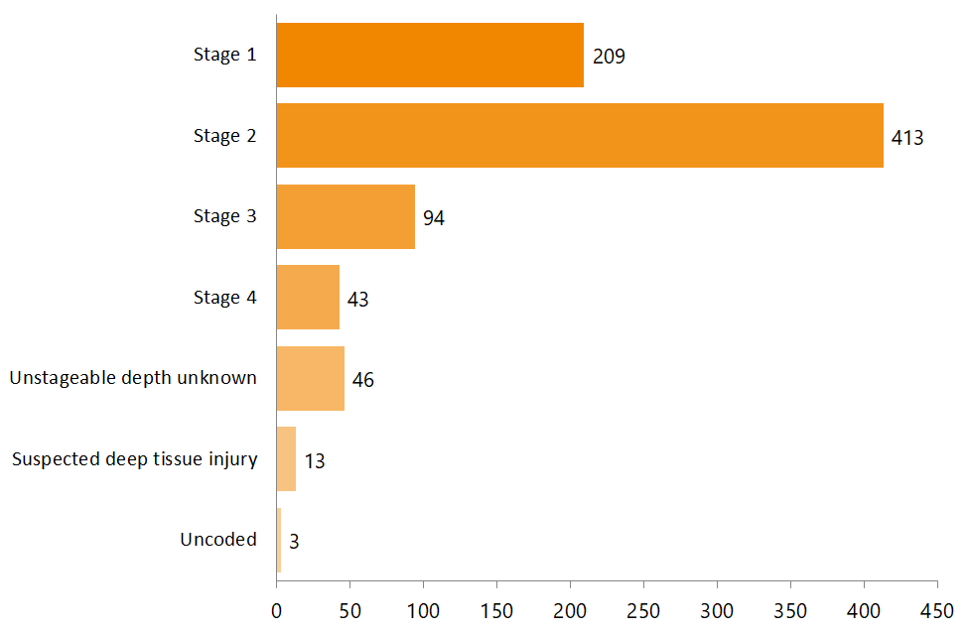

The residents
The auditors recorded the assessed level of care of the residents with pressure injuries in the aged residential care providers. The level of care means the degree/type of care each resident has been assessed as needing. As shown in Figure 2:
- 782 residents accounted for the 821 pressure injuries
- 775 of these residents had their level of care recorded
- 608 were receiving hospital-level care.

Figure 2: Assessed level of care
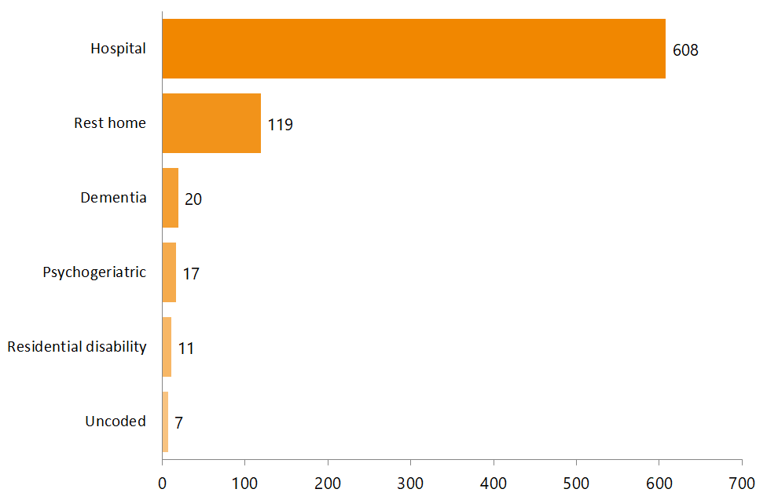

Residents with multiple injuries
Among the 782 residents who had pressure injuries, 33 had more than one pressure injury.
- 28 residents had two injuries.
- 4 residents had three injuries.
- 1 resident had four injuries.

The level of care was reported for 32 of the 33 residents who had more than one pressure injury.

As shown in Figure 3 below, 25 of the residents who had more than one pressure injury had been assessed as requiring hospital level care.

Figure 3: Multiple injuries and assessed level of care
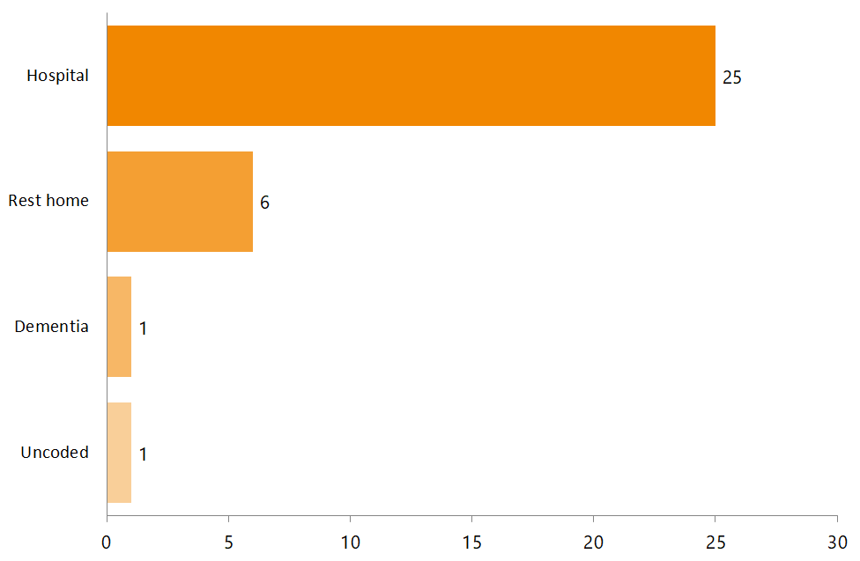

Where the injury was acquired
Auditors reviewed a range of documents to ascertain whether the pressure injury was facility acquired or non-facility acquired.

As shown in Figure 4 below, the majority of injuries (610) were facility acquired.

Figure 4: Facility acquired versus non-facility acquired pressure injuries
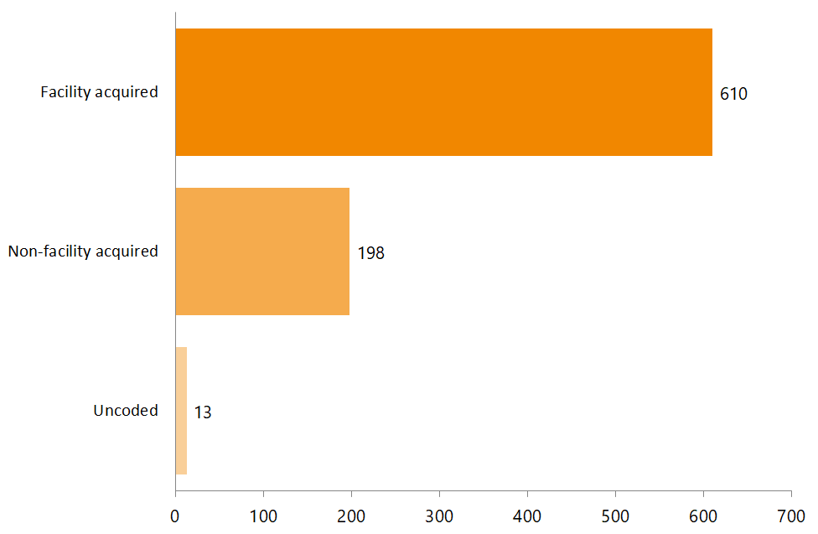

Practice areas
The auditors were asked to review evidence of PIPM activity across seven practice areas:
- policy/guidelines
- internal audit programme
- meeting minutes
- adverse event reporting
- equipment availability
- annual training programme
- staff knowledge and understanding of PIPM strategies.

Note: The auditors were not required to record the extent of the PIPM activity in any instance, only that activity was demonstrated (ie, ‘yes/no’).

The majority of providers could demonstrate PIPM practices, with 96 percent of providers demonstrating a level of PIPM activity in the practice areas of: policy/ guidelines, equipment availability, and staff knowledge and understanding of PIPM strategies, as shown in Figure 5 below.

At the other extreme, 11 percent of the 528 providers audited had no evidence of PIPM activity in the practice areas of internal audit programme and adverse event reporting.

Figure 5: Number of aged residential care providers where practice areas were demonstrated at time of audit
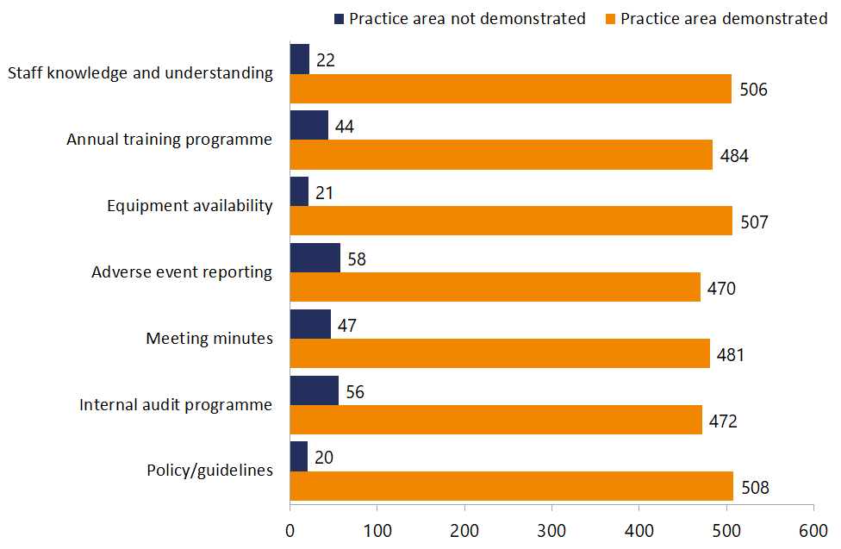

Pressure injury severity by practice area
Figure 6 compares the severity of the pressure injury with the absence or presence of PIPM strategies. Where PIPM was present, the auditors observed no variation in pressure injury severity across the practice areas, with 76 percent of pressure injuries at stages 1 and 2 and 24 percent at stage 3 and above consistently across all seven practice areas.

By comparison, where PIPM was absent, the auditors noted some variation in pressure injury severity across the practice areas. For example, 75 percent of all pressure injuries in providers where policy/guidelines practices were absent were stages 1 and 2 and 25 percent were stage 3 or above, while 69 percent of pressure injuries in providers where equipment was not available were at stages 1 and 2 and 31 percent were stage 3 and above.

The finding that more severe pressure injuries were apparent where equipment was not available suggests a potential area for quality improvement. However, it should be noted that only 21 providers (of 528) were identified as not having equipment available.

Figure 6: PIPM strategies and pressure injury severity
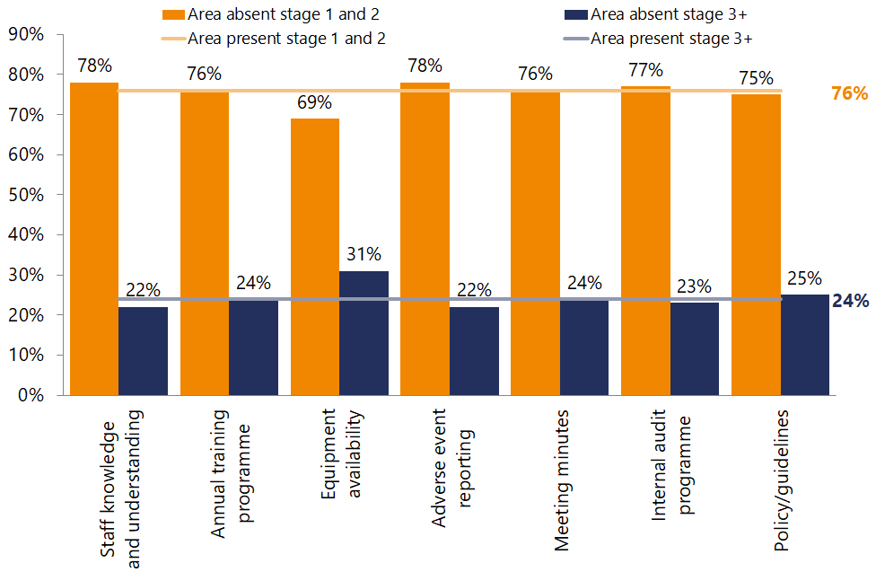

Auditor comments
The following is based on the auditors’ ‘yes/no’ responses to specific questions and free-text comments. The auditors were invited to include comments against each practice area. This was not a requirement, and no guidance was provided as to the type of commentary sought. Their comments were analysed and coded.

Practice area 1: Policy/guidelines
In total, 508 of the 528 providers were found to have a policy (and/or guidelines) in place supporting PIPM. Comments indicated that seven providers were in the process of drafting, reviewing or updating their policy.

Auditors commented on policy improvements needed at nine providers, with comments ranging from: ‘not current’, ‘needs more input’, ‘have not been updated’, ‘does not reflect best practice’ to ‘focuses more on treatment than prevention’.

Practice area 2: Internal audit programme
A total of 472 of the 528 providers had an internal audit programme that included pressure injury monitoring. The auditors commented on the audit programme content and, to a lesser extent, compliance, frequency of auditing and corrective action plans.

The areas commonly being internally audited by providers were pressure injury monitoring, wound management and care plans. The auditors did not comment on the detail of each internal audit. The auditors identified 21 providers as being in the process of developing, scheduling or updating their internal audit programme, and 13 of these had their internal audit programme scheduled but not yet implemented. The inclusion of pressure injury monitoring in the providers internal audit programme was not always considered worthwhile if pressure injury numbers were low, with one auditor commenting ‘… the numbers of pressure injuries is very low in this service, and integration into the internal audit system would not provide additional worthwhile information.’ Providers predominantly conducted internal audits on a six-monthly basis.

Practice area 3: Meeting minutes
The auditors found that 481 of the 528 providers had meetings that included discussions on pressure injuries. The auditors commented on the type of meetings held and the topics discussed. Their comments were based on sighting meeting minutes and/or on verbal feedback from staff.

Pressure injuries were discussed across a range of meeting types. The most commonly reported types were: staff meetings, clinical meetings and quality meetings. Among all providers, approximately one-third had staff meetings, clinical meetings and/or quality meetings that included discussions about pressure injuries, wound management and/or skin integrity. Depending on the meeting type, frequency ranged from daily through to twice monthly. The level of discussion at these meetings was not collected at audit.

Practice area 4: Adverse event reporting
A total of 470 of the 528 providers used an adverse event reporting approach to report pressure injuries. The auditors commented on the type of reporting used, whether pressure injury was a dedicated clinical indicator and adequacy of pressure injury reporting. Their comments were based on sighted adverse event reports, policy content and/or staff feedback.

Comments indicated that 63 providers included pressure injuries in a benchmarking programme. The auditors commented that some providers said they did not have pressure injuries as a dedicated clinical indicator because there was an ‘insufficient number of pressure injuries’ to justify it.

In 29 cases, the auditors identified areas for improvement, including: a lack of reporting of pressure injuries and pressure injuries exceeding the benchmark. Four providers were in the process of reviewing or updating their approach to include (or better include) pressure injury reporting.

Practice area 5: Equipment availability
In total, 507 of the 528 providers reported using equipment to prevent and manage pressure injuries. Auditor comments focused on equipment type and availability, equipment quality, appropriate use of equipment and areas for improvement. The most common equipment used by providers was the pressure relieving mattress, with types including alternating air mattress, ripple mattress, dynamic mattress and posture temp mattress. The next most commonly mentioned piece of equipment was small pressure relieving equipment, including cushions. The auditors only commented briefly on the quality of the equipment, flagging it as either ‘being appropriate’ or ‘meets best practice’.

The auditors commented on the incorrect use of equipment and/or lack of equipment by four providers. This included a dynamic mattresses being set at the wrong weight, a lack of appropriate equipment while residents were seated and not accessing pressure-relieving mattresses for residents with existing pressure injuries.

Practice area 6: Annual training programme
A total of 484 providers offered PIPM-related training opportunities to staff. The auditors’ comments indicated training topics included dedicated pressure injury courses, wound care and skin integrity training, with some courses covering all three topics. In all, 222 providers were identified as offering pressure injury specific training to a range of staff, including registered nurses, managers and care staff.

In most instances, the training provider was not identified, rather the auditors noted training as: ‘in-house’, ‘in-service’ and ‘external training opportunities’. The auditors identified 16 providers as offering self-directed learning (including online training). Other approaches included toolbox talks and education at staff meetings. There were no reports of opportunistic training conducted in response to an existing incident/injury, such as learning from adverse event reporting and analysis.

The auditors’ comments on training frequency included specific training dates (suggesting one-off training days) or generalised comments such as ‘ongoing’ or ‘regular’. ‘Mandatory’ training was reported for six providers. This included compulsory education days and mandatory annual in-service training topics. Attendance levels were commented on for 13 providers. Mixed attendance levels were reported, from ‘low’ to ‘good’ to ‘all staff attending’.

Practice area 7: Staff knowledge and understanding
All staff interviewed at 506 providers were aware of PIPM, including risk assessment, adverse event reporting and treatment of any pressure injuries. The auditors interviewed a range of staff, including care staff, registered nurses, clinical leaders and managers / team leaders.

The auditors mentioned two strategies used by providers to support the oversight of pressure injuries and wound care management: a ‘wound care champion’ and ‘pressure injury registers’. The wound care champion was described as the person who carried out the internal audits, viewed all wounds, oversaw wound management and provided regular wound care training. Pressure injury registers were implemented to help monitor the number, type and progress of pressure injuries.

There were no specific references to understanding the bundle of care approach to maintaining skin integrity (SSKIN), pain management or use of pro re nata (PRN) – as needed – medication.

Summary
The purpose of this work was to raise the profile of PIPM in the aged residential care sector by auditing the evidence (documentation) to demonstrate implementation of PIPM across seven defined practice areas. The audit also reported on the number of pressure injuries identified in documentation as being treated on the day of audit.

Audits were completed at 528 aged care providers out of 659 certified at that time. During the period 1 January 2016 to 31 March 2017, a total of 821 pressure injuries were reported. These were reported in 299 of the 528 providers.
- The majority of pressure injuries were stage 2 (413 of 818 that were coded).
- There were 196 (of 818 that were coded) injuries at stage 3 and above.
- In all, 782 residents accounted for 821 injuries. The majority of residents with a pressure injury (608 of the 775 that were coded) were receiving hospital-level care.
- Among the residents who had pressure injuries (782), 33 had more than one injury – 28 residents had two injuries, four had three injuries, and one resident had four injuries.
- There were 198 injuries (of the 808 that were coded) reported as being non-facility acquired.

No correlations could be found between implementation of the seven practice areas and the number of pressure injuries in aged residential care providers. Based on the results of this audit work, it is therefore not possible to say that a greater number of pressure injuries would result from not implementing the seven practice areas. However, the following factors did emerge.
- Generally, aged residential care providers have looked to implement pressure injury prevention and management strategies that align to the seven practice areas.
- Based on the audit data obtained, there are indications that the absence of pressure relieving equipment might contribute to the severity of pressure injuries, with a higher percentage of pressure injuries at stage 3 and above. (Note: The auditors identified only 21 providers (of 528) as lacking suitable equipment.)
- The practice areas of: meeting minutes (481 of 528), internal audit programme (472 of 528), adverse event reporting (470 of 528) and annual training programmes (484 of 528) have the lowest attainment rates of those audited in this study. These areas could benefit from targeting in the future.

Points for future consideration
It is recognised that PIPM is an area for ongoing focus in aged-related residential care (as it is in hospital and community care settings).

Evidence shows most pressure injuries are preventable – early identification of people at risk and subsequent effective management needs to be a high priority for all care providers to reduce significant harm to this group of people.

There are key actions that are recognised and promoted globally to reduce the risk and impact of pressure injuries. For example, the SSKIN bundle of care provides a useful approach to ensure that no prevention element is missed.

The five-step SSKIN approach covers:
- Surface – Provide a supportive and pressure-relieving surface for the patient to rest on.
- Skin inspection – Undertake regular checks for discolouration and pain on bony prominences (such as hips and heels) and under or around medical devices.
- Keep moving – Encourage the patient to change position often.
- Incontinence – Make sure the patient’s skin remains dry and clean.
- Nutrition – Support the patient to eat healthily and drink plenty of fluids.

Significant work is ongoing to create resources to support best-practice prevention and management in all health settings, including aged residential care. Additional research, including on use of the SSKIN bundle of care in the New Zealand context is an area for future work. The ongoing challenge is to embed this systematically at the clinical practice level to ensure harm is avoided and patients receive the best preventive care.

An excellent starting point for all health professionals, carers and people giving and receiving care is the Guiding Principles for Pressure Injury Prevention and Management in New Zealand.

Some other useful resources can be found can be found on the New Zealand Wound Care Society’s website (www.nzwcs.org.nz/resources/stop-pi-day).

Appropriate and consistent measurement is essential if health care providers are to continue to improve the way they manage the incidence and prevalence of pressure injuries. Pressure injuries are a reportable event. All severe pressure injuries at stage 3 and above need to be investigated and managed in accordance with local policy and reported to the relevant agency. The HQSC has prepared national guidance, which, although focused on in hospital measurement, is valid across all care settings. Further details can be found on the HQSC website (www.hqsc.govt.nz/our-programmes/pressure-injury-prevention/).

KPMG report prepared for the Health Quality & Safety Commission New Zealand, Ministry of Health and Accident Compensation Corporation, available on the Health Quality & Safety Commission website: www.hqsc.govt.nz/our-programmes/other-topics/publications-and-resources/publication/2362/
NPUAP. 2016. National Pressure Ulcer Advisory Panel (NPUAP) announces a change in terminology from pressure ulcer to pressure injury and updates the stages of pressure injury. URL: www.npuap.org/national-pressure-ulcer-advisory-panel-npuap-announces-a-change-in-terminology-from-pressure-ulcer-to-pressure-injury-and-updates-the-stages-of-pressure-injury/ (accessed 11 July 2018).
S31 (5) of the Health and Disability Services (Safety) Act 2001 requires a person certified to provide health care services of any kind to give written notice of any incident that may be putting at risk the health of people receiving services.
A care package or ‘bundle’ that is organised around the five factors of SSKIN: Skin, Support Surfaces, Keep Moving, Incontinence, Nutrition.
The NPUAP/EPUAP pressure injury classification system provides a consistent and accurate means by which the severity of a pressure injury can be communicated and documented. (See NPUAP Pressure Injury Stages. URL: www.npuap.org/resources/educational-and-clinical-resources/npuap-pressure-injury-stages/ (accessed 12 July 2018).
A facility-acquired pressure injury is one that has occurred since admission to the aged residential care provider.
Thirteen injuries were not coded at audit as to where they were acquired.
‘Staff meetings’ includes ‘facility meetings’.
‘Clinical meetings’ is inclusive of registered nurse (RN) and enrolled nurse (EN) meetings.
Wound care courses may have covered pressure injury, but this could not be determined from the data.
Informal meetings on topics related to a specific job.
See: https://improvement.nhs.uk/resources/Using-SSKIN-to-manage-and-prevent-pressure-damage/
ACC. 2017. Guiding Principles for Pressure Injury Prevention and Management in New Zealand. Wellington: Clinical Services, Accident Compensation Corporation. URL: www.acc.co.nz/assets/provider/acc7758-pressure-injury-prevention.pdf (accessed 12 July 2018).

