Pregnancy Planning
Findings from the
2014/15 New Zealand Health Survey
2019

Acknowledgements
The New Zealand Health Survey would not have been possible without the support and enthusiasm of many individuals, including the many thousands of New Zealanders who gave their time to participate in it and the interviewers who worked so diligently to collect the data. Thank you for your generosity.
This data brief was written by Nigel Dickson (University of Otago), Bridget Murphy (Ministry of Health), Jennie Connor (University of Otago), Antoinette Righarts (University of Otago) and Peter Saxton (University of Auckland). The data analysis was undertaken by Barry Gribben (CBG Health Research), Thomas Zhang (CBG Health Research) and James Stanley (University of Otago).
Citation: Ministry of Health. 2019. Pregnancy Planning: Findings from the 2014/15 New Zealand Health Survey. Wellington: Ministry of Health.
Published in November 2019 by the Ministry of Health
PO Box 5013, Wellington 6140, New Zealand
ISBN 978-1-98-859702-7 (online)
HP 7174
This document is available at health.govt.nz
This work is licensed under the Creative Commons Attribution 4.0 International licence. In essence, you are free to: share ie, copy and redistribute the material in any medium or format; adapt ie, remix, transform and build upon the material. You must give appropriate credit, provide a link to the licence and indicate if changes were made.

Contents
Summary v
Introduction 1
Pregnant in the last five years 3
Pregnancy planning status 5
Folic acid supplementation in preparation for pregnancy 8
Healthier eating in preparation for pregnancy 11
Interpretation notes 13
Overview of survey methodology 15
References 18
Appendix 1: The LMUP questions 20

List of Figures
Figure 1: Pregnant in the five years preceding survey (among women 16–44 years old), by age group 3
Figure 2: Pregnant in the five years preceding survey (among women 16–44 years old), by ethnic group 4
Figure 3: Pregnancy planning (among women 16–44 years old, pregnant at the time of survey or in preceding five years), by age group 6
Figure 4: Pregnancy planning (among women 16–44 years old, pregnant at the time of survey or in preceding five years), by ethnic group 7
Figure 5: Took folic acid in preparation for pregnancy (among women 16–44 years old, pregnant at the time of survey or in preceding five years), by age group 9
Figure 6: Took folic acid in preparation for pregnancy (among women 16–44 years old, pregnant at the time of survey or in preceding five years), by ethnic group 10
Figure 7: Healthier eating in preparation for pregnancy (among women 16–44 years old, pregnant at the time of survey or in preceding five years), by age group 12

List of Tables
Table 1: Participation in the Sexual and Reproductive Health module of the New Zealand Health Survey, by ethnicity 16

Summary
This report describes the degree to which women planned their most recent pregnancy, based on their answers to questions about contraceptive use, timing, intention, desire for a baby, partner discussion, and pre-conceptual preparations. Unplanned pregnancies can result in adverse health outcomes for pregnant women and children.

The differences in degree of pregnancy planning are examined with regard to age, ethnicity, and neighbourhood deprivation, for women who were pregnant in the five years preceding the survey. The most recent pregnancy in the last five years could be current at the time of the survey, or have ended in a birth, miscarriage, stillbirth or abortion.

Key findings include:
- One in three women aged 16–44 years had been pregnant in the last five years.
- Just over half of all women’s most recent pregnancies were planned (54%); nearly one-third were ambivalent (32%); and the remaining 14% were unplanned.
- Younger women were less likely to have been engaging in behaviours to prepare for pregnancy before their most recent pregnancy than older women. Māori women and Pacific women were less likely to have been engaging in behaviours to prepare for pregnancy before their most recent pregnancy, compared to non-Māori women, and non-Pacific women.
- Nearly half of women surveyed reported having taken folic acid tablets/ supplements before their most recent pregnancy in the last five years; however, this occurred among only about one-fifth of those aged 16–24. Pacific and Māori women were less likely to report having taken folic acid tablets/supplements prior to their most recent pregnancy in the last five years than non-Pacific and non-Māori women.
- One-third of women reported having eaten more healthily prior to their most recent pregnancy; this was more commonly reported by older women. Women living in the most deprived neighbourhoods were less likely to report this than those living in the least deprived neighbourhoods.

Introduction
Women having unplanned pregnancies risk more obstetric complications and poorer mental health, and children born from these pregnancies have been shown to have a lower birthweight, experience poorer mental and physical health during childhood and do less well in cognitive tests (Mohllajee et al 2007; Gipson et al 2008; Lanzi et al 2009; Shah et al 2011; Carson et al 2013).

The Health Committee Inquiry into improving child health identified high-quality health promotion in the area of sexual and reproductive health as a way of improving the health and wellbeing of future generations (Health Committee 2013). Making lifestyle changes prior to pregnancy, including taking folic acid supplements, stopping or cutting down on drinking alcohol, and eating more healthily, can improve the outcome of pregnancies.

The Ministry of Health recommends that women take one folic acid tablet daily when planning for pregnancy and for the first 12 weeks of pregnancy, to reduce the risk of neural tube defects, such as spina bifida. The Ministry also recommends taking iodine throughout pregnancy and while breastfeeding.

Drinking alcohol during pregnancy increases the risks of complications, including miscarriage, stillbirth, prematurity and fetal alcohol spectrum disorder (FASD, an umbrella term used to describe a range of effects on the baby after being exposed to alcohol in the womb). The Ministry recommends that women do not drink alcohol when planning a pregnancy or while pregnant. There is no known safe level of alcohol consumption during pregnancy.

The Growing Up in New Zealand longitudinal study of women enrolled when 28 weeks pregnant in Auckland, Counties Manukau and Waikato District Health Board regions (Morton et al 2010) examined pregnancy planning status. Sixty percent of women surveyed responded positively to the one planning question, ‘Was this pregnancy planned?’. Hohmann-Marriott (2018) estimated that 53% of pregnancies in New Zealand were unplanned in 2008, after combining these Growing Up in New Zealand results with the estimated number of abortions and miscarriages.

Recognition of the complexity of pregnancy planning status has led to the development of more sophisticated approaches than a single dichotomous question. The London Measure of Unplanned Pregnancy (LMUP) is a multi-item instrument developed for the third British National Survey of Sexual Attitudes and Lifestyles (Natsal-3), and comprises six questions, covering contraceptive use, timing of motherhood, intention to become pregnant, desire for a baby, discussion with a partner and preconceptual preparations (Bacharach and Newcomer 1999; Barrett and Wellings 2002).

The Ministry of Health included the six LMUP questions in the Sexual and Reproductive Health module of the 2014/15 New Zealand Health Survey (the survey). This report presents key findings about pregnancy planning by ethnicity, age group and neighbourhood deprivation at the time of the survey interview.

You can find more information and results from the survey, including data tables in the data explorer, online at https://www.health.govt.nz/publication/sexual-and-reproductive-health-2014-15-new-zealand-health-survey

Pregnant in the last five years
The survey asked women: ‘Can we just check, have you been pregnant in the last five years?’.

One-third of women aged 16–44 years reported having been pregnant in the last five years, and half of women aged 25–34 years
- 33% of women aged 16–44 years reported having had one or more pregnancies in the last five years.
- 18% of women aged 16–24 reported a pregnancy in the last five years. This compared to 49% of women aged 25–34 years and 32% of women aged 35–44 years (Figure 1).

Figure 1: Pregnant in the five years preceding survey (among women 16–44 years old), by age group
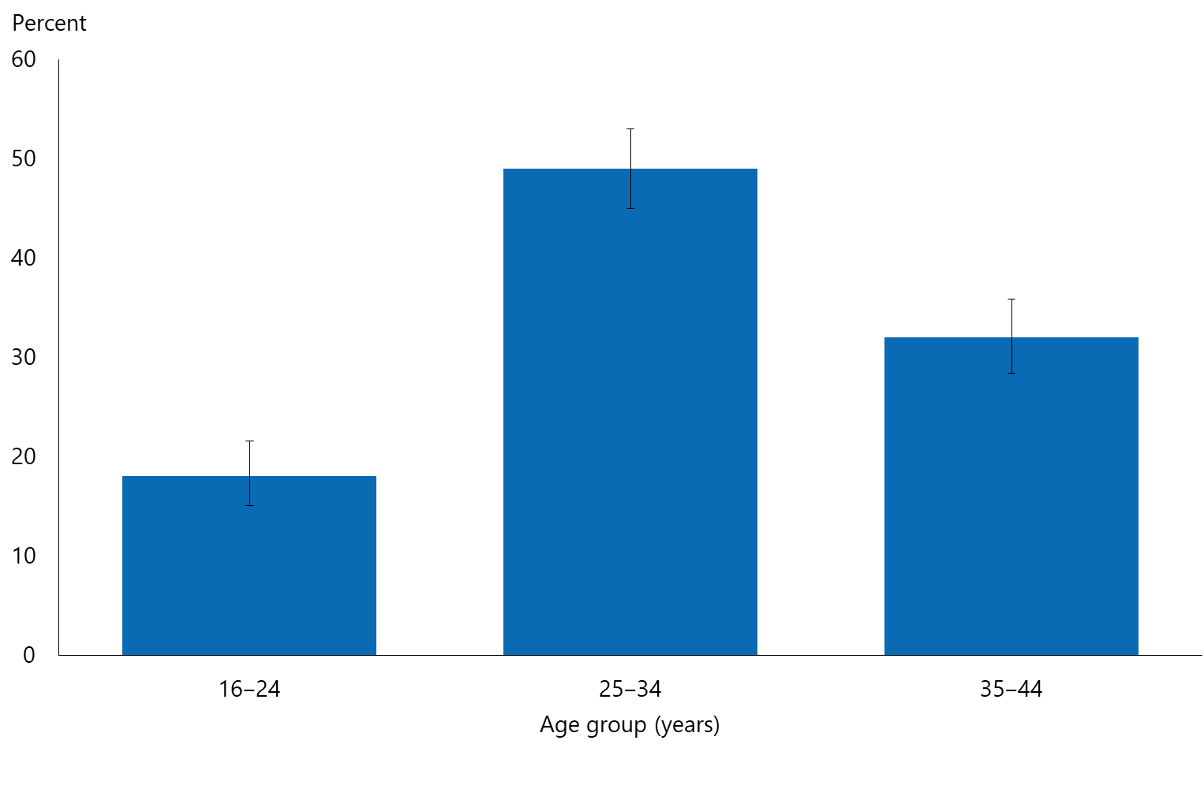

Māori women were most likely to report being pregnant in the last five years
- The percentage of women who reported having had a pregnancy in the last five years varied by ethnicity: it was highest for Māori women (43%) and lowest for Asian women (25%) (Figure 2).
- After adjustment for age, Māori women were 1.4 times as likely to report having had a pregnancy in the past five years as non-Māori; Asian women were 0.7 times as likely as non-Asian women to have done so.
Figure 2: Pregnant in the five years preceding survey (among women 16–44 years old), by ethnic group
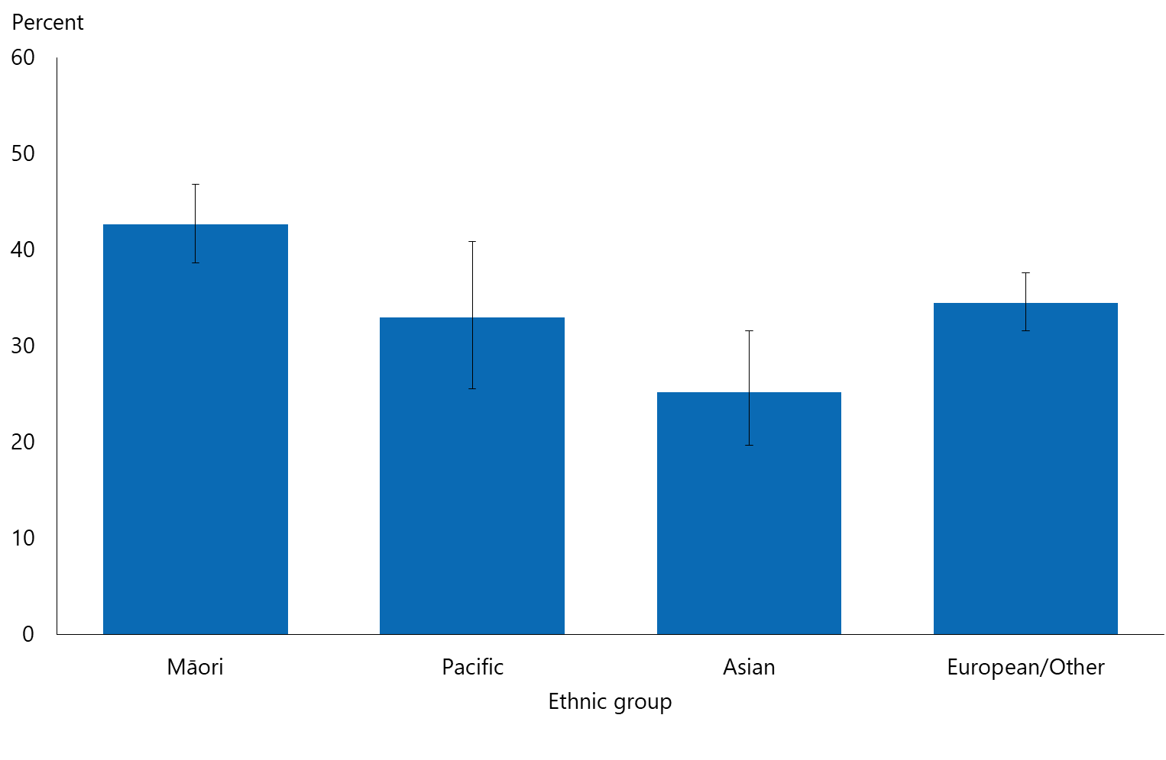
Note: Women who reported more than one ethnic group are counted once in each group reported. This means that the total number of responses for all ethnic groups can be greater than the total number women who stated their ethnicities.
- There was no consistent pattern in the percentage of women who reported having had had a pregnancy in the last five years by level of neighbourhood deprivation.

Pregnancy planning status
The survey asked women who had been pregnant in the last five years the LMUP questions (Barrett et al 2004). This includes women who were pregnant at the time of the survey, as well as those who had full term pregnancies, abortions, miscarriages or stillbirths.

The LMUP questions measure how planned a pregnancy was by asking about behaviour and opinions prior to the pregnancy (Barrett et al 2004). The answers are combined to rate a pregnancy as either planned, ambivalent, or unplanned. The last LMUP question asks about behaviours that a woman might have done to get healthier before the pregnancy began, and this analysis looks at two of them.

Older women were more likely to report having planned their most recent pregnancy than younger women
- Overall, 54% of the most recent pregnancies in the last five years were scored as planned and 14% as unplanned; 32% were scored as ‘ambivalent’.
- Women aged 35–44 years were the most likely to have their most recent pregnancies scored as planned (69%) and least likely for them to be scored as unplanned (8.9%) (Figure 3). Women aged 16–24 years were least likely to have engaged in pregnancy-planning behaviour: for this age group, 20% of pregnancies were scored as planned and 30% as unplanned.

Figure 3: Pregnancy planning (among women 16–44 years old, pregnant at the time of survey or in preceding five years), by age group
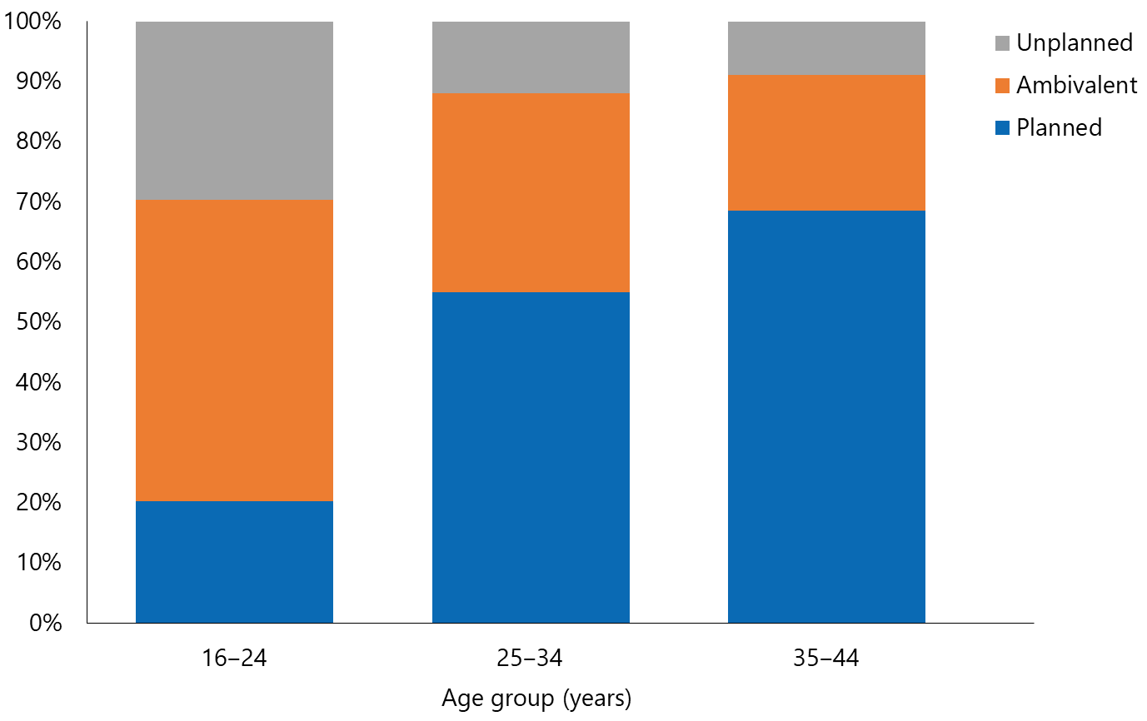
Note: The London Measure of Unplanned Pregnancy is made up of six questions about: contraceptive use, timing of motherhood, intention to become pregnant, desire for a baby, discussion with a partner, and preconceptual preparations. Each question is scored 0–2, and the total score has been grouped with 0–3 being classified as unplanned, 4–9 as ambivalent, and 10–12 as planned.

Māori women were least likely to report having planned their most recent pregnancy
The percentage of women who reported having planned their current or most recent pregnancy varied by ethnic group:
- 30% of Māori women
- 40% of Pacific women
- 56% of European/Other women
- 69% of Asian women.

After adjusting for age differences, Māori women were 0.6 times as likely as non-Māori women to report having planned their most recent pregnancy. Asian women were 1.3 times as likely to report having planned their most recent pregnancy, and Pacific women were 0.8 times as likely as non-Pacific women to have done so.

Māori women were 1.7 times as likely to make an ‘ambivalent’ report about planning their most recent pregnancy as non-Māori women; Pacific women were 1.5 times as likely as non-Pacific women to have done so; and Asian women were 0.6 times as likely as non-Asian women to have done so.

Figure 4: Pregnancy planning (among women 16–44 years old, pregnant at the time of survey or in preceding five years), by ethnic group
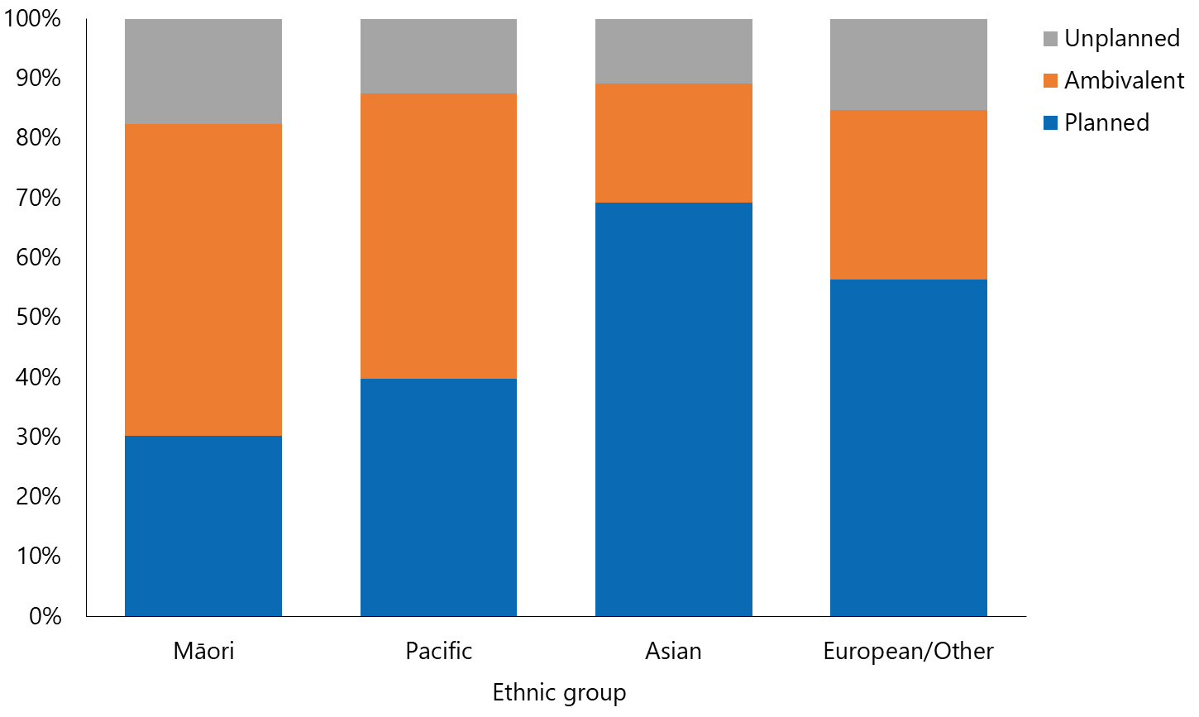
Note: The London Measure of Unplanned Pregnancy is made up of six questions about: contraceptive use, timing of motherhood, intention to become pregnant, desire for a baby, discussion with a partner, and preconceptual preparations. Each question is scored 0–2, and the total score has been grouped with 0–3 being classified as unplanned, 4–9 as ambivalent, and 10–12 as planned.
Women who reported more than one ethnic group are counted once in each group reported. This means that the total number of responses for all ethnic groups can be greater than the total number of women who stated their ethnicities.

There was no consistent relationship between reported pregnancy planning status in the last five years and neighbourhood deprivation.

Folic acid supplementation in preparation for pregnancy
The last LMUP question (Barrett et al 2004) in the survey asked women:
‘Before you became pregnant, did you do anything to improve your health in preparation for pregnancy?
1. Took folic acid tablets/supplements
2. Stopped or cut down smoking
3. Stopped or cut down drinking alcohol
4. Ate more healthily
5. Sought medical/health advice
6. Took some other action
7. I did not do any of the above before my pregnancy.’

This section focuses on the first item in that list: taking folic acid tablets/supplements.

About half of the women surveyed reported having taken folic acid supplements before their most recent pregnancy; this was more common among older women
Overall, 48% of women reported having taken folic acid tablets/supplements in preparation for their most recent pregnancy in the last five years:
- 21% of women aged 16–24 years
- about half (47%) of women aged 25–34 years
- 63% of women aged 35–44 years.

Figure 5: Took folic acid in preparation for pregnancy (among women 16–44 years old, pregnant at the time of survey or in preceding five years), by age group
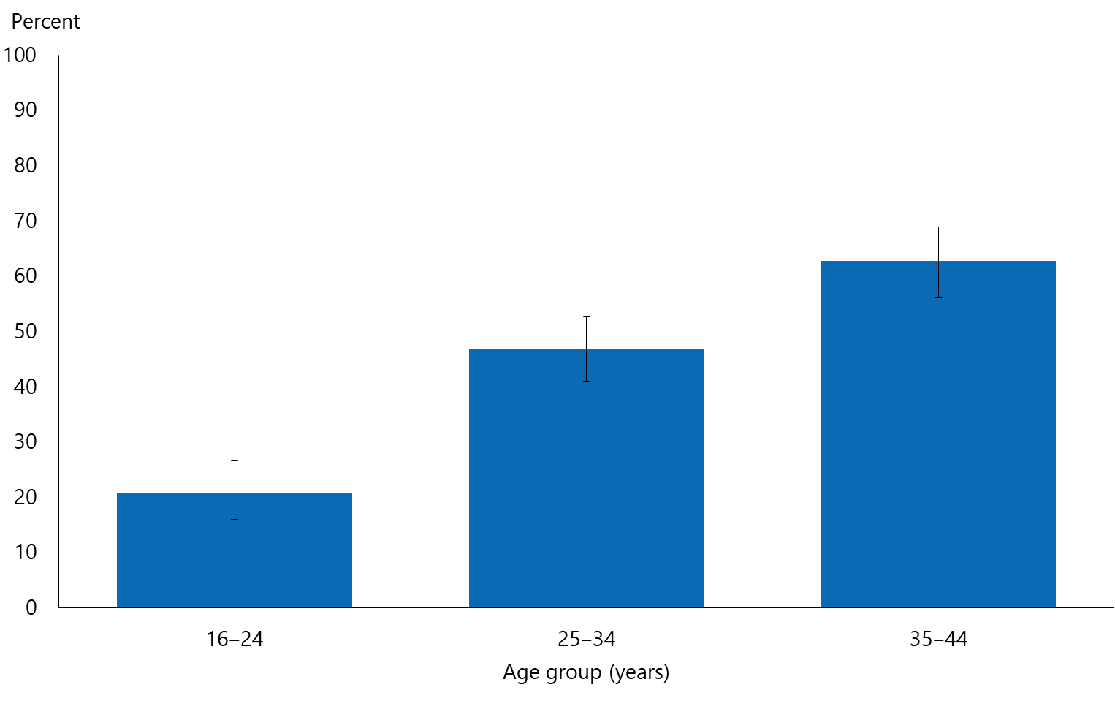

Māori and Pacific women were less likely to report having taken folic acid supplements prior to their most recent pregnancy
- Fewer Māori (34%) and Pacific (31%) women reported having taken folic acid tablets/supplements in preparation for their most recent pregnancy in the last five years than Asian women (54%) and European/other women (50%) (Figure 6).
- After adjustment for age, Māori women were 0.8 times as likely to report having taken folic acid tablets/supplements prior to their most recent pregnancy in the last five years as non-Māori women, and Pacific women 0.7 times as likely as non-Pacific women to have done so.

Figure 6: Took folic acid in preparation for pregnancy (among women 16–44 years old, pregnant at the time of survey or in preceding five years), by ethnic group
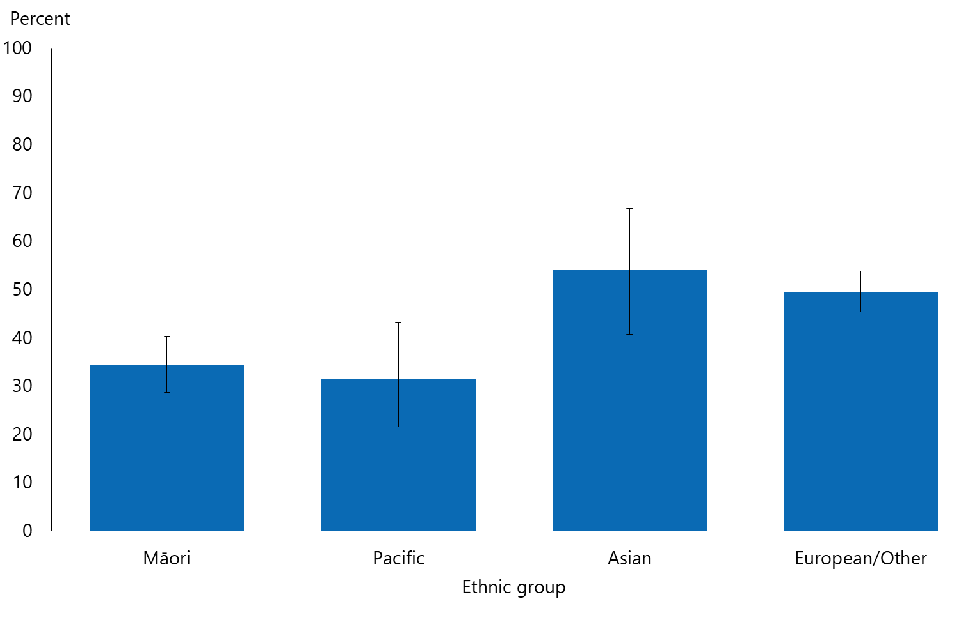
Note: Women who reported more than one ethnic group are counted once in each group reported. This means that the total number of responses for all ethnic groups can be greater than the total number of women who stated their ethnicities.

The percentage of women reporting having taken folic acid tablets/supplements prior to their most recent pregnancy did not differ by neighbourhood deprivation, after adjustment for age and ethnicity.

Healthier eating in preparation for pregnancy
The last LMUP question in the survey asked women:
‘Before you became pregnant, did you do anything to improve your health in preparation for pregnancy?
1. Took folic acid tablets/supplements
2. Stopped or cut down smoking
3. Stopped or cut down drinking alcohol
4. Ate more healthily
5. Sought medical/health advice
6. Took some other action
7. I did not do any of the above before my pregnancy.’

This section focuses on the fourth item in that list: eating more healthily.

One-third of women reported having eaten more healthily prior to their most recent pregnancy
Overall, 33% of women reported having eaten more healthily in preparation for their most recent pregnancy in the last five years:
- 16% of women aged 16–24 years
- 32% of women aged 25–34 years
- 42% of women aged 35–44 years (Figure 7).

Figure 7: Healthier eating in preparation for pregnancy (among women 16–44 years old, pregnant at the time of survey or in preceding five years), by age group
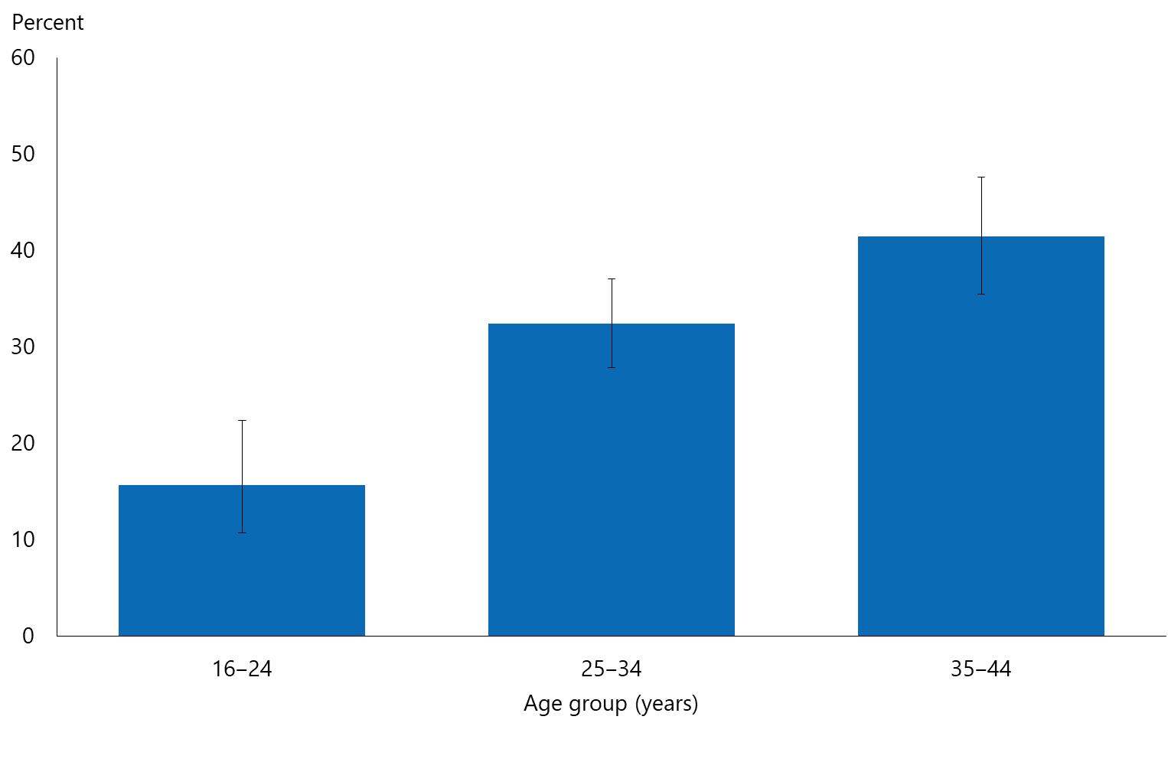

- Reports of having eaten more healthily in preparation for their most recent pregnancy were most common among Asian women (39%) and least common among Māori (30%) women. 33% of Pacific women and 32% of European/other women reported having done so.
- After adjustment for age, there were no differences in women’s reporting they had eaten more healthily in preparation for their most recent pregnancy by ethnicity.

Women living in the most deprived neighbourhoods were less likely to report having eaten more healthily in preparation for their most recent pregnancy than those living in the least deprived neighbourhoods
- One-quarter of women living in the most deprived neighbourhoods reported having eaten more healthily in preparation for their most recent pregnancy, compared with around 39% of women living in the least deprived neighbourhoods.
- After adjusting for age and ethnicity, women living in the most deprived areas were 0.6 times less likely to report having eaten more healthily in preparation for their most recent pregnancy than those living in the least deprived neighbourhoods.

Interpretation notes
This section provides some key points for interpreting the survey results presented in this report. For more details about the survey methodology, see the Methodology Report 2014/15: New Zealand Health Survey (Ministry of Health 2015b) and Sexual and Reproductive Health Indicator Interpretation Guide 2014/15: New Zealand Health Survey (Ministry of Health 2019).

Statistical significance
Unless otherwise specified, the results discussed in this report only refer to differences that are statistically significant at the 5% level (ie, those with a p-value of less than 0.05). ‘Statistically significant’ means that the difference between the sample groups is likely to reflect real differences in the population groups, rather than being caused by chance. A statistically significant difference does not necessarily mean the difference between the population groups is meaningful.

Confidence intervals
We use 95% confidence intervals to show the statistical precision of the estimates. Wider confidence intervals indicate less precise estimates than narrow intervals, caused by higher variation with a sample and/or smaller numbers in a sample. Confidence intervals generally agree with statistical significance. When confidence intervals for two estimates don't overlap, there is a statistically significant difference between the estimates. However, the opposite may not always be true.

Comparing population subgroups
This report uses adjusted ratios to test if the prevalence of indicators is statistically significantly different between groups. We have adjusted these ratios for demographic factors that may be influencing the comparison, such as age, gender and ethnicity. The adjusted ratio indicates whether the results are less or more likely in the group of interest than the comparison group. A ratio of less than 1 indicates that the result is less likely and a ratio greater than 1 indicates that it is more likely.

The survey uses the New Zealand Index of Deprivation 2013 (NZDep2013) to measure neighbourhood deprivation. The survey groups neighbourhoods into five quintiles (the label ‘quintile 1’ applies to neighbourhoods with the lowest levels of deprivation, and ‘quintile 5’ to those with the highest). Indicators are reported for each quintile. The adjusted ratios for deprivation compare the highest and lowest deprivation areas, after adjusting for age, ethnic group, gender and the pattern across all five quintiles.

Gender
Gender is self-defined by respondents in the survey. For some people their gender is not the same as their biological sex at birth. Respondents were asked if they were male or female, and while what these options meant was open to the respondent’s interpretation, gender-diverse options (eg, ‘gender non-conforming’ or ‘other’) were not available. The Ministry of Health acknowledges the need to improve data collection in this area, and is considering implementing the statistical standard for gender identity in future surveys (Statistics New Zealand 2015).

Non-sampling error
The survey results may underestimate or overestimate some indicators because the data is self-reported. The accuracy of a person’s memory may vary depending on many factors, including social norms, the importance of the event being recalled, the individual’s age at the time and the period of time that has passed since the event occurred.

Overview of survey methodology
This section gives a brief overview of the survey methodology for the New Zealand Health Survey.

How were people selected for the survey?
The 2014/15 results refer to the sample selected for the period July 2014–June 2015. The survey has a multi-stage sampling design that involves randomly selecting a sample of small geographic areas, households within the selected areas and individuals within the selected households. One adult aged 15 years or older and one child aged 14 years or younger (if there were any) were chosen at random from each selected household. Adults aged 16–74 years who had completed the 2014/15 survey were invited to participate in the Sexual and Reproductive Health module. Further details are available in The New Zealand Health Survey: Sample design, years 1–3 (2011–2013) (Ministry of Health 2011).

How was data collected?
Professional surveyors from CBG Health Research Ltd collected data in respondents’ homes. For the core part of the survey, data was collected through a face-to-face interview. However, participants completed the Sexual and Reproductive Health module by themselves, directly entering responses into a program run on a tablet computer. Surveyors provided minimal assistance, and reiterated that they would not be able to see the answers. Respondents could answer ‘Don’t know’ or ‘Choose not to answer’ to any question. If they chose either of those options for the question about having ever had sex with someone of a different sex, then they were not asked to complete the rest of the survey module.

How many people took part?
11,993 adults aged 16–74 years completed the core 2014/15 survey and were eligible for the Sexual and Reproductive Health module. This report is based on the responses from 10,198 adults (or 87% of eligible respondents). Some eligible respondents were not included in the final data set for the following reasons.
- 668 respondents (5.6% of those who were eligible) did not start the module, either because they refused or because of English language and/or cognitive difficulties.
- 991 respondents (6.5% of eligible respondents) started the module but stopped before the end of the module.
- 123 respondents (1.2% of eligible respondents) completed the module but their records were discarded because at least half of their responses were ‘Don’t know’ or ‘Choose not to answer’.

Of the people who completed the Sexual and Reproductive Health module, 4,358 gave their gender as male and 5,840 as female. The table below summarises the 10,198 survey respondents by ethnic group.

Table 1: Participation in the Sexual and Reproductive Health module of the New Zealand Health Survey, by ethnicity
Ethnic group | Number
Māori | 2,460
Pacific | 619
Asian | 814
European/Other | 7,542
Note: Adults who reported more than one ethnic group are counted once in each group reported. This means that the total number of responses for all ethnic groups can be greater than the total number of adults who stated their ethnicities.

Survey weights
The Sexual and Reproductive Health data set was weighted so that the responding sample represented the New Zealand ‘usually resident’ population in that year, using external population benchmarks (age, sex, ethnicity and neighbourhood deprivation) and demographic and behavioural benchmarks (eg, educational level and hazardous drinking). After an initial selection weight was calculated, it was adjusted for those who did not complete the module (for any reason). This should have minimised the impact of any differences in the characteristics of people who did or did not participate in the Sexual and Reproductive Health module. For more detail about the survey methodology, refer to the Methodology Report 2014/15 (Ministry of Health 2015b).

Additional information
See also the following documents:
- The New Zealand Health Survey: Sample design years 1–3 (2011–2013) (Ministry of Health 2011). Note: despite the report title being 2011-13, this sample design was used for the 2014/15 Health Survey
- Methodology Report 2014/15: New Zealand Health Survey (Ministry of Health 2015b)
- Content Guide 2014/15: New Zealand Health Survey (Ministry of Health 2015a)
- Questionnaires for the New Zealand Health Survey 2014/15 (Ministry of Health 2016a; Ministry of Heath 2016b)
- Sexual and Reproductive Health Indicator Interpretation Guide 2014/15: New Zealand Health Survey (Ministry of Health 2019).

References
Bacharach CA, Newcomer S. 1999. Intended pregnancies and unintended pregnancies: distinct categories or opposite ends of a continuum? Family Planning Perspectives 31(5): 251–2.
Barrett G, Smith S, Wellings K. 2004. Conceptualisation, development, and evaluation of a measure of unplanned pregnancy. Journal of Epidemiology and Community Health 58(5): 426–33.
Barrett G, Wellings K. 2002. What is a ‘planned’ pregnancy? Empirical data from a British study. Social Science & Medicine 55(4): 495–57.
Carson C, Redshaw M, Sacker A, et al. 2013. Effects of pregnancy planning, fertility, and assisted reproductive treatment on child behavioral problems at 5 and 7 years: evidence from the Millennium Cohort Study. Fertility and Sterility 99(2): 456–63.
Gipson JD, Koenig MA, Hindin MJ. 2008. The effects of unintended pregnancy on infant, child, and parental health: a review of the literature. Studies in Family Planning 39(1): 18–38.
Health Committee. 2013. Inquiry into Improving Child Health Outcomes and Preventing Child Abuse, with a Focus from Preconception until Three Years of Age: Report of the Health Committee. Wellington: New Zealand House of Representatives.
HealthEd. 2017. Eating for Healthy Pregnant Women/Ngā Kai Totika mā te Wahine Hapū. Christchurch: HealthEd.
Hohmann-Marriott BE. 2018. Unplanned pregnancies in New Zealand. Australian and New Zealand Journal of Obstetrics and Gynaecology 58(2): 247–50.
Lanzi RG, Bert SC, Jacobs BK, et al. 2009. Depression among a sample of first-time adolescent and adult mothers. Journal of Child and Adolescent Psychiatric Nursing 22(4): 194–202.
Ministry of Health. 2011. The New Zealand Health Survey: Sample design, years 1–3 (2011–2013). Wellington: Ministry of Health.
Ministry of Health. 2015a. Content Guide 2014/15: New Zealand Health Survey. Wellington: Ministry of Health.
Ministry of Health. 2015b. Methodology Report 2014/15: New Zealand Health Survey. Wellington: Ministry of Health.
Ministry of Health. 2016a. Adult Sexual Reproductive Health Module (Year 4). Wellington: Ministry of Health.
Ministry of Health. 2016b. New Zealand Health Survey Adult Questionnaire (Year 4). Wellington: Ministry of Health.
Mohllajee AP, Curtis KM, Morrow B, et al. 2007. Pregnancy intention and its relationship to birth and maternal outcomes. Obstetrics and Gynecology 109(3): 678–86.
Morton SMB, Atatoa Carr PE, Grant CC, et al. 2012. Growing Up in New Zealand: A longitudinal study of New Zealand children and their families. Report 2: Now we are born. Auckland: Growing Up in New Zealand.
Shah PS, Balkhair T, Ohlsson A, et al. 2011. Intention to become pregnant and low birth weight and preterm birth: a systematic review. Maternal and Child Health Journal 15(2): 205–16.
Statistics New Zealand. 2015a. Births Tables. URL: http://archive.stats.govt.nz/browse_for_stats/population/births/births-tables.aspx (accessed 26 February 2019).
Statistics New Zealand. 2015b. Statistical standard for gender identity. Wellington: Statistics New Zealand.

Appendix 1:
The LMUP questions
A total score of 0–3 is classified as ‘unplanned’, 4–9 as ‘ambivalent’ and 10–12 as ‘planned’.

1) In the month that I became pregnant ...
2 I/we were not using contraception
1 I/we were using contraception, but not on every occasion
1 I/we always used contraception, but knew that the method had failed (ie, broke, moved, came off, came out, not worked, etc) at least once
0 I/we always used contraception

2) In terms of becoming a mother (first time or again), I feel that my pregnancy happened at the ...
2 right time
1 ok, but not quite right time
0 wrong time

3) Just before I became pregnant ...
2 I intended to get pregnant
1 my intentions kept changing
0 I did not intend to get pregnant

4) Just before I became pregnant ...
2 I wanted to have a baby
1 I had mixed feelings about having a baby
0 I did not want to have a baby

5) Before I became pregnant ...
2 my partner and I had agreed that we would like me to be pregnant
1 my partner and I had discussed having children together, but hadn’t agreed for me to get pregnant
0 we never discussed having children together

6) Before you became pregnant, did you do anything to improve your health in preparation for pregnancy?
- took folic acid
- stopped or cut down smoking
- stopped or cut down drinking alcohol
- ate more healthily
- sought medical/health advice
- took some other action, please describe ____________________________
- I did not do any of the above before my pregnancy

1 = 1 action
2 = 2 or more actions

The lower rates of pregnancies in the last five years among Pacific women (35%) in comparison to Māori women (44%) were unexpected. The total fertility rates calculated from the 2013 New Zealand Census data show a higher lifetime fertility for Pacific women (2.73 children) in comparison to Māori women (2.49 children) (Statistics New Zealand 2015).
The appendix lists out the questions and the scoring methodology.

