COVID-19 PCR Testing Backlog

Rapid Review

4 May 2022

Allen + Clarke has been independently certified as compliant with ISO9001:2015 Quality Management Systems

CONTENTS

Acknowledgements 1
Executive Summary 2

1. Introduction 7
1.1. Context 7
1.2. Purpose and Scope 9
1.3. Approach 9
2. Laboratory Capacity 10
2.1. COVID-19 laboratories 10
2.2. Capacity 11
2.3. National capacity 13
2.4. Increasing capacity 14
2.5. Reporting of capacity 15
3. Operational Management 18
3.1. Planning 18
3.2. Reporting 38
4. Organisational Design 41
5. Conclusion 43
6. Recommendations 44

Annex 1 – Abbreviations and Terminology 45

Acknowledgements
The review team recognises the substantial efforts of individuals involved in the COVID-19 response. At the time of the review, laboratory and Ministry of Health staff have been in an operational response setting for two years, and under particular strain since the Delta outbreak began in August 2021. We would like to thank all the people that contributed to this review for their time and input in a short space of time.

Citation: Allen + Clarke. 2022. COVID-19 PCR Testing Backlog: Rapid review. Wellington: Ministry of Health.
Published in June 2022 by the Ministry of Health
PO Box 5013, Wellington 6140, New Zealand
ISBN 978-1-99-110055-9 (online)
This document is available at health.govt.nz
This work is licensed under the Creative Commons Attribution 4.0 International licence. In essence, you are free to: share ie, copy and redistribute the material in any medium or format; adapt ie, remix, transform and build upon the material. You must give appropriate credit, provide a link to the licence and indicate if changes were made.

Executive Summary

Context
Since the beginning of the Delta outbreak in August 2021, laboratories undertaking COVID-19 testing and the Ministry of Health (the Ministry) Directorate coordinating the health system response have been under considerable strain. This strain built on close to 18 months of operational response and significant workloads starting in March 2020. As the Delta outbreak waned in late 2021, Omicron was identified as a new variant of concern and New Zealand began to adapt its response plan accordingly. The Government’s three-phase Omicron response set out a staged approach of changes to testing, contact tracing, and isolation requirements, gradually moving from PCR testing as the primary methodology to Rapid Antigen Tests (RATs) primarily in Phase 3.
As part of response planning, the Ministry’s Testing and Supply Group in the COVID-19 Health Response Directorate worked with laboratories to understand existing capacity for PCR testing and support plans to increase capacity. A goal of 60,000 tests per day nationally was identified and efforts were undertaken to achieve this by the end of March 2022, including by procuring additional equipment. Regular reporting of capacity indicated to decision makers that laboratories were on track to achieving this level of capacity. However, there were issues with the definition of capacity that led to misinterpretation of the system’s ability to respond to a surge in Omicron cases.
The first case of community transmission of Omicron in New Zealand was reported on 18 January 2022. Demand for testing, the proportion of positive tests, and case numbers began to increase rapidly. By the middle of February 2022, some laboratories were becoming overwhelmed, and a backlog of PCR tests began to build. By 1 March 2022, a backlog of 32,000 samples older than five days had built up that laboratories advised would be destroyed due to their reduced clinical relevance and/or viability. However, as New Zealand had shifted to Phase 3 of the Omicron response, laboratories were able to free up capacity and processed the backlog by mid-March 2022.
In this context, Allen + Clarke was commissioned by the Ministry in March 2022 to undertake an independent rapid review of the circumstances leading to the backlog of PCR testing and the apparent gap between the system’s forecast capacity and its actual ability to respond to the Omicron surge.

Findings
The review found the following contributing factors leading to the backlog of PCR testing and the misinterpretation of the system’s ability to respond to the Omicron surge.
Laboratory Capacity
- Inconsistency in the definition of capacity, together with insufficient caution in how capacity was reported to decision makers, created a risk of overstating estimated capacity. Clarity on the factors that affect capacity, in particular when pooling of samples is no longer viable, could have built a better picture of capacity and encouraged more direct and active monitoring of risks of exceeding capacity.
- The reporting of capacity as a national figure provided the impression that demand surges could readily, and always, be addressed by free capacity in other laboratories. However, IT interconnectivity and other logistical issues mean that capacity could only be shifted between laboratories as a planned process before samples are collected. Reporting has therefore overestimated useable capacity
- In the absence of signalling from the Ministry on expected standing capacity, laboratories have not had the incentives to develop their capacity, except in a responsive manner. Though efforts were initiated in late 2021 to build to a national capacity of 60,000 pooled tests per day by end of March 2022 this would not have prevented the issues that occurred due to rapidly rising positivity rates in mid-February.
- Formal reporting of capacity to the Director-General of Health and Ministers relied on pooled sample numbers and did not signal a period where demand for testing exceeded single test capacity, despite modelling predicting this. By the time clarity on single test capacity was provided to Ministers, the backlog had already accumulated. This left the Director-General and Ministers with limited ability to anticipate or plan for a period where demand may exceed capacity.
Planning
- While the 3-Phase Omicron Response Plan was designed on the assumption that PCR capacity would be reduced, the significance of increasing positivity rates was either not fully appreciated by the Ministry or was not effectively communicated to decision makers. As a result, the length of time for Phase 2 was extended to 10 days, double the period initially considered appropriate to maintain PCR capacity, through gradual shift to RATs, despite the rising positivity rate.
- It does not appear that the Testing and Supply Group successfully conveyed the significance of positivity rates as an advance indicator of PCR capacity. While the positivity rate was discussed at regular Public Health Risk Assessments (PHRAs) to inform advice on transition between Omicron phases, it was not explicitly included as a critical factor for shifting between phases.
- While modelling was initiated in late January 2022, it appears that positivity rates were used to forecast demand only and were not used to forecast capacity or the point when pooling of samples is no longer viable. Even then, the positivity rates used in the modelling are significantly understated and do not reflect the messaging from laboratories. As a result, the modelling did not use laboratory capacity in any meaningful way to inform decisions around triggers to transition through Phases.
- Opportunities to learn from international experience were substantial, particularly in relation to the speed at which positivity rates increase and the impact on pooling. It is not apparent how these insights were incorporated into testing modelling, planning, or reporting.
- Without a forecast date when PCR testing capacity would be exceeded, there was no deadline by when RAT roll-out was required. There was lack of confidence in system readiness which meant the PCR backlog kept growing despite laboratories calling for an earlier shift to Phase 3.
- The limitations of the data readily available to the Ministry were not explicitly recognised and their impact on planning does not seem to have been fully understood. There is no evidence of efforts to improve data availability, in particular access to leading indicators of demand for testing as opposed to testing complete.
Reporting
- The Testing and Supply Group were of the impression that the significant amount of reporting they produced was being absorbed and correctly interpreted. This created a false sense of comfort that decision makers would action information if needed.
- On the contrary, due to the overwhelming amount of information provided, and it not being reported formally with clear action items, key messages were lost, and opportunities were missed.
Organisational Design
- The Ministry has been in a constant response mode since the beginning of the Delta outbreak with little time to take stock or provide a break for staff. The Laboratory Testing team has struggled to maintain and increase its capacity throughout the pandemic, leading to significant strain on subject matter experts.
- There is a structural disconnect within the Testing and Supply Group between demand for testing (managed by the Testing Operations team) and testing capacity (managed by the Laboratory Testing team). Combined with a lack of planning capacity and capability, this resulted in a reactive approach to engaging with laboratories.
- Despite best efforts, there was a high risk of missed opportunities and insufficient management and reporting capacity that ultimately led to a disconnect in understanding of the situation with decision makers.

Conclusion
The backlog in PCR testing that emerged in February 2022 should have been and was to some degree predictable. The Ministry’s testing modelling did forecast single test capacity being exceeded and modelled scenarios that forecast PCR testing capacity with pooling, would also be exceeded.
However, there were deficiencies in the COVID-19 testing system design and operational management that meant that testing strategy objectives were not met because risks to those objectives were not adequately managed or communicated.
The core causal factors were:
- insufficient capacity and capability to develop forward looking testing plans aligned with the broader pandemic management strategies
- inadequate highlighting, monitoring, notification and/or escalation of potential or actual risks and consequences in formal reporting, including that provided to the Director-General and Ministers
- inability to feed information from laboratories and other external sources into Ministry communication channels in ways that contextualised the information and conveyed its significance for PCR testing capacity.
There were a series of other factors identified that while not causal, were in some cases more minor contributory factors, or resulted in opportunities to avoid the backlog occurring being missed or meant that the testing system worked in a less optimal way. These included:
- a lack of contractual levers to enable the Ministry to manage COVID-19 testing centrally and maximise the benefit from the laboratory network
- a laboratory network with commercial incentives that did not always lead to the early flagging of emerging issues
- a reactive and arms-length approach to working with laboratories to encourage collaboration in the absence of contractual levers.
As a result, a disconnect emerged in the knowledge and understanding of the COVID-19 Directorate and the laboratories relative to the Director-General and Ministers, which led to them being unprepared for the PCR backlog that eventuated.

Recommendations
In order to avoid similar circumstances emerging in the future, and to take advantage of the lessons available from this experience, the following recommendations are made.
- Review the resourcing model of the COVID-19 Testing and Supply Group to address any capacity deficits and enable the Group to manage current workload and transition away from operational surge settings.
- Develop a clear testing plan that determines the role of PCR testing and other modalities going forward, as well as providing clarity about the roles and expectations of the laboratories.
- As part of the strategic planning (recommendation 2), address how COVID-19 testing transitions to a business-as-usual laboratory testing regime.
- Determine the level of standing PCR testing infrastructure required for future variants or pathogens and where this infrastructure should be maintained as part of the strategic planning (refer to recommendations 2 and 3). In the absence of guidance from the Ministry, some laboratories have signalled they may need to reduce their PCR capacity, including mothballing equipment and reducing staffing.
- Review the approach to contracting laboratory services to facilitate greater transparency and national coordination in a pandemic. The health systems reforms and transition to new entities (Health NZ, Māori Health Authority, and the Public Health Agency) provides an opportunity to consider how laboratory services can best support clinical and public health outcomes.
- Consider greater interoperability of information technology platforms so that the data that is generated from laboratory testing can be better used for surveillance and public health outcomes as a part of any review of laboratory services.
- Consider how the Ministry and Health NZ can achieve more integrated ways of operating with laboratories when planning for managing the ongoing testing requirements of COVID-19, and in planning undertaken for future pandemic readiness.
- Ensure there are clear, formal governance arrangements in place between the Ministry and/or Health NZ and laboratories that enable sufficient centralised planning and management of testing in Aotearoa New Zealand’s pandemic approach.
- Consider options to strengthen the Chief Testing Adviser position and shape the role so the Ministry and/or Health NZ is able to better leverage their subject matter expertise and insights across testing planning, modelling and reporting.
- Introduction
  - Context
Since mid-August 2021, New Zealand’s medical diagnostic laboratories have been under considerable strain. The Delta outbreak of COVID-19 saw increasing demand for PCR testing, particularly in the Northern region, leading to longer turn-around times (TAT) and the need to rely on laboratory PCR testing capacity (lab capacity) from across the country to process tests. In addition to testing mandates for certain categories of workers, testing associated with crossing the Auckland region border kept demand at high levels throughout the Delta outbreak. Following an initial peak in demand for testing in August, including a day where close to 50,000 samples were tested, demand then remained between 20-30,000 tests per day between early October and late December 2021. Laboratories were, however, able to cope with this demand through pooling of samples and by making use of available lab capacity in other parts of the country.
In October 2021, the COVID-19 Testing Technical Advisory Group (CT-TAG) produced A Rapid Review of COVID-19 Testing in Aotearoa New Zealand that recommended, amongst other things, “a clearly articulated and communicated future-focussed COVID-19 testing strategy to assist planning; strengthening the leadership in the testing space within the Ministry of Health; and the creation of a dedicated testing approach to facilitate innovation and the implementation of new tests and testing strategies in a timely fashion.”
In November 2021, the Ministry of Health (the Ministry) set a goal for national baseline testing capacity of 60,000 samples per day and preparations were made by laboratories and the Ministry to work towards this. On 26 November 2021, the Omicron variant of COVID-19 was named a variant of concern by the World Health Organization.
In December 2021, as the Delta outbreak was waning, Omicron outbreaks across the world saw rapid surges in positivity rates and demand for testing surged globally. The first case of Omicron in New Zealand was detected in a Managed Isolation Facility in Christchurch on 16 December 2021 and case numbers at the border rapidly increased. The first community transmission of Omicron occurred on 18 January 2022, and by the end of the month Omicron was the dominant variant in New Zealand.
On 26 January, the government announced a three-phase public health response to Omicron. The triggers for each phase relied on total numbers of positive cases. Each phase saw an increasing usage of Rapid Antigen Tests (RAT), with Phase 3 shifting to RATs as the primary COVID-19 testing modality.
Over the first half of February 2022, case numbers steadily increased but demand for testing remained manageable around a 7-day moving average of 20,000 tests per day. Pooling of samples was still possible given low but rising positivity rates. From 14 February 2022, the 7-day moving average demand for testing rose sharply reaching 36,000 test per day in less than a week. Over the same period, the 7-day average positivity rates doubled from 3% to 6% and continued to rise from there, reaching 18% by the end of the month. Laboratories were no longer able to pool samples due to the high positivity rates and could not rely on sharing workload with other regions as the outbreak had spread, placing demand on all laboratories and regions across Aotearoa, New Zealand. Figure 1. below shows the 7-day average demand and throughput of samples and the positivity rate between 1 August 2021 and 1 March 2022.

Figure 1
Seven-day average PCR Samples Registered and Processed and Positivity Rate (01/08/21 - 01/03/22)
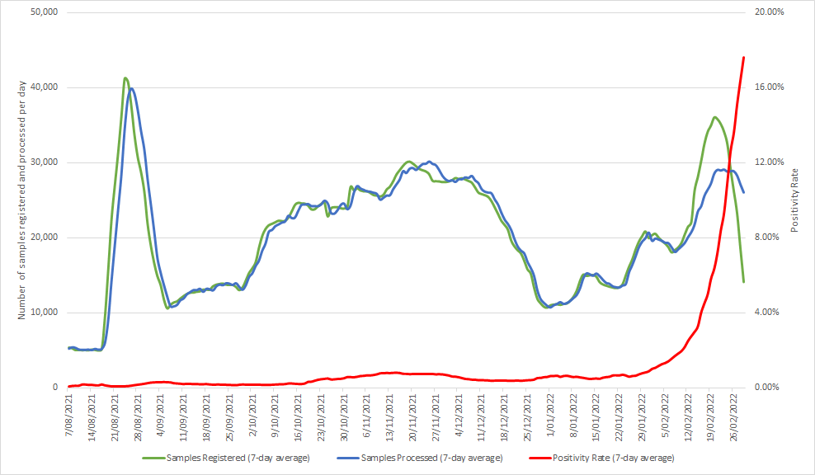

As a result, TAT increased steadily with the number of tests outstanding by more than 48 hours reaching 82,000 on 27 February 2022. By 1 March 2022, there were 32,000 samples older than five days that laboratories advised were likely to be discarded due to their diminishing clinical viability. However, the capacity that had been freed up by shifting to Phase 3 of the Omicron response, with the widespread use of RATs rather than PCR testing, enabled laboratories to clear the backlog by the middle of March 2022.
  - Purpose and Scope
The purpose of this review is to analyse the circumstances related to the backlog in the laboratory network that led to significant delays in COVID-19 PCR testing. It focuses on the actions and activities undertaken to calculate the capacity of the laboratories in response to the anticipated growth of COVID-19 cases in the community, that resulted in increased testing demands in February 2022. In particular, the review examines the current and future system capacity to manage COVID-19 testing.
To this end the scope of the review is the:
- effectiveness of the design methodology for projecting lab network capacity (including approach to collecting, collating, and analysing the information relevant to the projected estimates)
- potential impacts of demand estimates based on real-time data and its extrapolation
- effectiveness of risk reporting and monitoring, i.e., timeliness and effectiveness of risk reporting; documented processes of active monitoring and appropriate escalation; appropriate action-oriented governance oversight
- identifying factors contributing to the overestimation of the predicted capacity, including the magnitude of their impact (both individually and collectively)
- timeliness and appropriateness of actions taken to prevent the impact of overwhelming the lab network, including any factors that affected the success of these actions
- other actions and extraneous factors that affected or that could have been taken to prevent the severely reduced lab capacity.
  - Approach
Allen + Clarke was commissioned by the Ministry to undertake an independent review into the events leading up to the PCR testing backlog.
The review was undertaken between 8-25 March 2022. It relied on a comprehensive review of documentation together with interviews of staff of the Ministry of Health, laboratories and laboratory networks, and primary care. The review took an ‘audit-light’ approach, seeking to correlate any facts stated in interviews with documentary evidence. In total 45 interviews were undertaken with 57 individual stakeholders and more than 700 documents were reviewed. A list of stakeholders interviewed is provided in Annex 2 to this report.
- Laboratory Capacity
  - COVID-19 laboratories
The National Laboratory Network Group
New Zealand’s medical diagnostic laboratory services are provided by a mix of laboratories owned and operated by District Health Boards (DHBs) and private laboratories that contract to DHBs. The number of these laboratories undertaking nasopharyngeal COVID-19 PCR testing has varied over time as different laboratories have invested in molecular technology in response to the ongoing need for PCR testing since the pandemic began. As of March 2022, 14 of these laboratories are able to undertake COVID-19 PCR testing. In 2020, an informal National Laboratory Network Group (the Network) was established comprised of the laboratories that undertake PCR testing for COVID-19. The Network engages with the Ministry’s Testing and Supply Group in the COVID-19 Directorate through regular update calls that ranged from daily to weekly depending on both the phase of the pandemic response and the demand for testing.
Throughout the pandemic, the laboratories have operated under a letter of agreement with the Ministry setting out a fixed price per test, invoiced directly to the Ministry based on the number of tests completed and reported to the national Clinical Data Repository (CDR). The letter of agreement does not set out any expectations of capacity availability nor does it provide any contractual levers to the Ministry for management of COVID-19 testing from a national perspective. Unable to enforce compliance, the Ministry’s relationship with the Network has therefore been reactive and relied on good will to influence capacity planning.
Other laboratories and testing
ESR has played a key role in supporting national health intelligence throughout the pandemic, including developing and undertaking genomic sequencing and wastewater testing for COVID-19. ESR also has some capacity for testing of samples but this is primarily as an overflow rather than being a primary testing laboratory. ESR has been included in the regular calls between the Network and the Ministry’s Testing and Supply Group.
The IANZ accreditation requirements of having medical microbiologists on staff sets a high barrier to entry for laboratories not already undertaking medical diagnostic testing. This is despite having non-medical microbiologists on staff. While IANZ relaxed the certification requirements for laboratory assistants, enabling the laboratories in the Network to increase their staffing, there does not appear to have been any consideration of how to reduce the barriers to entry for other laboratories. Nevertheless, the Ministry did enter into a contract with Hill Laboratories in October 2021 for additional capacity. However, without any guaranteed volumes of samples and no incentives for the laboratories in the Network to share samples except when they are facing capacity issues, the commercial viability for other laboratories to support New Zealand’s COVID-19 response is limited.
The Ministry also has a contract for saliva PCR testing with APHG, the major provider of community medical diagnostic testing services in New Zealand. There have also been ongoing discussions with Rako Science for saliva testing, including planning for a border testing regime for the Reconnecting New Zealand programme. This, however, did not proceed due to the changes in border settings. Though there are questions as to whether saliva testing could have played a greater role in New Zealand’s COVID-19 response, this is not discussed any further as it is out of scope of this review and the saliva testing programme did not directly contribute to the backlog.
The Northern Region
In the Northern Region (Northland and Auckland), the laboratories have formed a sub-network and undertaken some joint planning. This includes an early agreement that the DHB owned laboratories would process the samples collected at Community Testing Centres (CTCs) and the commercial laboratory, Labtests, would process the samples collected by primary care providers. This has mostly worked well from a planning and logistics perspective. At various points in time, all laboratories have shifted samples either within the region or to other regions as demand has surged, particularly throughout the Delta outbreak.
The Northern Region Health Coordination Centre (NRHCC) also interfaces with both the laboratories and the Ministry. However, while the laboratories engage with the Testing and Supply Group, NRHCC’s relationship to the Ministry is through the Incident Management Team (IMT) of the COVID-19 Directorate. The NRHCC also engages directly with the Director General of Health and, on occasion, Ministers. The lack of clear governance arrangements between laboratories, DHBS, NRHCC, and the Ministry and the multiple lines of communication have, at times, caused confusion, mixed messaging, and delay in communication.
  - Capacity
Defining capacity
The definition of capacity to undertake PCR testing has varied over time. For this review, we will define capacity in relation the equipment, reagents, roster, and staffing available at any time as:
- single test capacity being the number of tests from an individual sample a laboratory can undertake per day
- pooled capacity being the number of tests a laboratory can undertake in a day based on the number of samples it can process in pools, typically ranging from 1:3 to 1:8
- surge capacity being the number of pooled tests a laboratory can undertake based on increasing rosters and staffing for a defined period of time, typically being up to 7 days.
However, the Ministry and the Network have used the terminology of “Baseline capacity” interchangeably for single test capacity and pooled capacity. In addition, there has not always been consistency of terminology between all the labs and the Ministry.
Weekly Reporting
On a weekly basis, laboratories have reported their capacity figures to the Ministry but this has often included a mix of single test capacity and pooled capacity depending on the interpretation of individual labs. It was only in January 2022 that the Ministry sent out an additional special request to laboratories to confirm their:
- “Baseline Capacity 1:1 (No Pooling)”
- “Baseline Capacity with BAU pooling”, including their average pooling ratio
- “Max surge capacity”
The variability in definition, and usage of the “Baseline” terminology has led to some confusion in what capacity has existed for nasopharyngeal PCR testing at any given time. While this did not cause significant issues in previous outbreaks as the rate of positive samples remained low and allowed pooling of samples to continue, this was not the case in the context of an Omicron outbreak. From a 7-day moving average positivity rate at or below 1% through to the end of January 2022, the positivity rate rapidly increased to 2% on 9 February, reaching 5% (the level by when pooling is considered no longer viable) nationally on 18 February, and continuing to rapidly increase from there. The Northern Region reached 5% positivity as early as 12 February 2022. From an Omicron outbreak planning and management perspective it would therefore have been better to distinguish between single and pooled capacity and what leading indicators were available to identify when pooling would no longer be possible.
Intraweek variability
The weekly reporting from laboratories to the Ministry captures a snapshot of laboratory capacity on a given day. Laboratories typically reported that the figures were based on a scenario where there were no machinery, reagent, or staffing issues, except in specific circumstances where a machine may have been out of service for example. The reporting did not capture variability in rosters across the week. Many laboratories have reduced shifts or rosters on weekends or public holidays for example such that the average daily capacity across a week is typically lower than that reported to the Ministry. This is evidenced in the pattern of testing completed on weekends being lower than that that on weekdays. The reporting to the Ministry therefore provided an overly optimistic impression of capacity.
Significance
It appears that the COVID-19 Testing and Supply Group assumed a greater understanding of all the parties involved in providing and receiving reporting on capacity and therefore did not exercise sufficient caution in how it reported capacity, or build a true picture of how capacity was evolving over time.
This created a risk of misunderstanding through an overstated estimation or understanding of capacity based on the inclusion of pooling and no discounting of capacity for when pooling would no longer be viable.
If there had been greater (and earlier) clarity in reporting regarding the factors that affect capacity, in particular when pooling is no longer viable, a better picture of capacity could have been built, and this might have empowered or encouraged more direct and active monitoring with a consequent flagging of risks of exceeding capacity earlier.
  - National capacity
IT interconnectivity
Based on the reporting from laboratories outlined above, the Testing and Supply Group reported a total national capacity figure based on adding up all individual laboratory capacities. Conceptualising capacity as additive assumes there is an ability to shift samples seamlessly between laboratories so that variations in demand across regions can be leveraged to maintain throughput. In the current Network this, however, is not currently possible.
All the laboratories, both publicly and commercially owned, operate as individual commercial entities and with a variety of laboratory information systems (LIS) that have varying levels of inter-operability. Depending on their location, they are also connected to a regional CDR that provides access to clinical data for DHBs and primary care. COVID-19 test results are reported to both the national CDR for national oversight and management of the pandemic, and to regional CDRs for local patient management. Until early March 2022, there was no ability for labs to report test results to another region’s CDR unless specific IT interconnectivity had been established locally to allow for that.
Electronic-order registration of samples
Further, the national electronic ordering system for COVID-19 testing that was developed by the Ministry to expedite processing, registers a sample into a specific laboratory’s LIS at the point of collection. The national electronic ordering system is used by community testing centres (CTC) and a small selection of primary care practices in the Auckland region. Once a sample is registered in an LIS, the laboratory considers it has clinical duty of care for it as per IANZ registration. In addition, there is a significant amount of manual activity required to de-register a sample from an LIS and then re-register it in another laboratory’s LIS. When samples have been diverted to other laboratories regionally or nationally, this has been a planned process of redirecting a CTC in the electronic ordering system overnight to a different laboratory so that the samples collected the following day are registered into that laboratory’s LIS. While the Ministry has facilitated shifting samples after they have been registered into an LIS on a handful of occasions, this has typically led to additional delays in processing due to the time-consuming nature of de-registering and then re-registering samples, and the time required for transportation of samples. Also, during the Omicron outbreak, the willingness and ability of other laboratories to accept samples from another region was constrained due to their own actual or predicted increasing local demand.
Significance
A national capacity figure provided the impression that demand surges can readily, and always, be addressed by free capacity in other laboratories.
Reporting has therefore overestimated useable capacity.
It would have been more accurate and useful to identify and report capacity at a regional level or within existing sub-networks of laboratories (i.e., laboratories that share an LIS or have taken steps to be able to share data).
  - Increasing capacity
Incentives for investment
As also highlighted in a rapid review of testing undertaken in October 2021, there continues to be limited information available on future stages of the pandemic response on which to base planning. This is largely due to the operational focus of the response and the heavy workload on staff in the COVID-19 Directorate (see Section 4). Consequently, laboratories have not had any guidance on what capacity they should build to for most of the pandemic. Their investments have therefore been reactively driven by testing volume rather than pro-actively planned. As a result, the amount of investment has varied across the laboratories with some investing early and systematically and others only responsively as demand grew through the Delta outbreak. There is a view across many laboratories that COVID-19 has generated substantial profits and that without strategic direction from the Ministry, and due to the lack of contractual levers to incentivise investment, some providers have not sufficiently reinvested profits in improving laboratory capacity and conditions.
Efforts to increase capacity
In November 2021, a national capacity target of 60,000 PCR tests per day was identified based on modelling completed by Te Pūnaha Matatini and an assumption of a 2% positivity rate. It was not made clear whether the target included any pooling but given pooling is a common practice at 2% positivity it was assumed that it did. The Ministry communicated that target to laboratories in December 2021 and requested projections of laboratory capacity aiming to meet the 60,000 tests per day by the of end March 2022. A number of laboratories were already going through procurement processes or expanding premises to accommodate additional equipment, but most of the additional capacity was not scheduled to come online until the first three months of 2022. The Ministry also offered to purchase equipment for laboratories to aid in increasing capacity, which was taken up by a selection of laboratories. However, given the timeframes for procurement, shipping, commissioning, and certification none of that equipment was operational before the latter half of February. In parallel, the Ministry engaged with ESR in late November on setting up a dedicated national testing facility to increase capacity. A proposal was put forward in December that would have seen capacity of 2-4,000 additional tests per day from late March. However, this did not progress at that time as it required further work and consideration as part of wider system changes.
Future PCR capacity
Since the transition to Phase 3 and the reliance on Rapid Antigen Testing (RAT) as the primary diagnostic tool, the PCR throughput has fallen dramatically, and the Network capacity is not being used. There is growing concern in the Network about idle equipment and staff. Without a direction from the Ministry on the future capacity requirements for PCR testing, there is a risk that laboratories will begin to dismantle their capacity, including mothballing equipment and reducing staffing.

Significance
The lack of signalling by the Ministry of expected capacity to build to or maintain has not created the incentives for laboratories to build to a centrally determined capacity.
Efforts to identify and then build testing capacity were responsive and only late in the overall management of the pandemic.
As it transpires, the capacity building aimed at achieving 60,000 pooled tests per day by the end of March, would have been both too little, as positivity rates rose quickly above 2%, and too late, as the Omicron peak hit New Zealand in mid-February.
There is now a need to determine what standing capacity Aotearoa New Zealand needs for pandemic management, including the potential for further Omicron outbreaks or new variants of concern, to secure the capacity that has been built and avoid losing accumulated knowledge.
  - Reporting of capacity
Formal reporting
There is a substantial amount of information, including on capacity, that is routinely shared across the Ministry and, by the Ministry, with Ministers’ offices. However, it is typically provided with limited or no commentary and without specific flagging of issues (see Section 3.2.) Between November 2021 and February 2022, there have also been a number of formal reports sent to the Director General of Health and Ministers that provided an opportunity for formally reporting on capacity. Due to the variable usage of the “Baseline” capacity terminology, these have been prone to misunderstanding and opportunities to highlight potential issues were missed. These reports include:
- a review by the Department of the Prime Minister and Cabinet (DPMC) in early December 2021 that outlined current Baseline capacity of 23,590 tests per day and an expectation of a Baseline capacity of 40,000 test per day from mid-December, increasing to 60,000 tests per day by the end of the March 2022. The figures provided by the Ministry to DPMC included both nasopharyngeal and saliva testing and reflected the pooled capacity
- a Health Report in mid-December 2021 updating Ministers on capacity stating that further to clarification with labs, the current capacity had increased to 32,980 tests per day and that initial projections were encouraging in terms of reaching the substantial uplift in capacity outlined in the DPMC review. These were still pooled capacity figures. The Health Report also indicated that the Ministry would provide further updates through regular dashboards
- an update by DPMC on their earlier review in late December 2021 that stated the Ministry would meet or exceed its target of 40,000 test per day by the end of December, and 60,000 by the end of March 2022. The Minister’s response to this update flagged concerns that the figures stated might be based on pooling, noted the need to adhere to definitions, and requested a further update
- a Health Report in late January 2022 outlining a testing plan for an Omicron outbreak reported that current baseline capacity was 58,539 tests per day and that the baseline without pooling was 29,337. It also stated the Ministry was working towards a baseline capacity of 60,000 per day by the end of March 2022, but did not specify whether this was pooled or not
- a final update by DPMC on their review in mid-February that noted the Ministry had provided two definitions for baseline capacity being baseline capacity with “BAU pooling” and baseline capacity “1:1 (no pooling)” – i.e., single test capacity. It noted that at the beginning of February the single test capacity was 29,337 tests per day, forecast to increase to 40,485 by the end of March 2022. It also noted that given the high prevalence of COVID-19 in the community capacity would be reduced to the single test capacity.
Significance
By the time the final update by DPMC was received and acknowledged by Ministers, the PCR backlog in the Northern Region was already growing.
Despite modelling of PCR test capacity and demand that started in late January 2022 showing a period where demand would be above capacity, this was never formally reported in any memos or reports that we have sighted.
A modelling dashboard was provided weekly from 30 January 2022 (and with occasional updates in between) but without contextual information or any recommendations.
The first mention of a PCR testing backlog, or any risk thereof, was in a memorandum to the Director General on 20 February 2022 noting that laboratories would not process samples older than 5 days and outlining a communications plan around this decision
By then there were already 32,000 samples sitting in a backlog of more than 48-hour TAT.

- Operational Management
  - Planning
    - Introduction
Planning to match PCR testing capacity and protocols with the public health settings and demands of the COVID-19 pandemic was an ongoing and iterative activity for the Testing and Supply Group, relative to the stage of the pandemic and the public health settings.
Early signals of potential laboratory capacity issues were highlighted during the Delta outbreak, which offered important lessons for preparations for future outbreaks including the Omicron outbreak.
October 2021 Rapid Review of COVID-19 Testing
A Rapid Review of COVID-19 Testing in Aotearoa New Zealand was undertaken by the COVID-19 Testing Technical Advisory Group (CT-TAG) and was published on 4 October 2021. Included in the Terms of Reference was the requirement to identify opportunities to ensure ongoing sustainable and fit for purpose COVID-19 testing within New Zealand, including testing modalities not currently in use.
The review noted the use of sample pooling by multiple laboratories in Aotearoa New Zealand, and the important efficiency benefits that it offered. However, the review also noted that the “methodology is only useful in low prevalence settings.”
Delta Testing Statistics and Lessons Learnt
Following the identification of a positive COVID-19 case in Auckland on 17 August 2021, the government announced that the country would move to Level 4. A series of locations of interest were subsequently published. Test demand instantly increased from approximately 5,000 per day and spiked at more than 40,000 tests per day. Test volumes stayed at more than 20,000 per day from 18 to 31 August 2021. The demand spike eased as the effects of the Level 4 restrictions began to have their desired effect. Daily testing remained at more than 10,000 per day for the next 3 months, and between 20,000 to 30,000 for the majority of that time.
Laboratories responded to the extraordinary demands of the Delta outbreak by working collaboratively and making operating decisions that provided a surge in capacity for PCR testing. In this context, surging means increasing operating hours, which also included asking staff to work longer hours. In this way they were able to cope with heightened demand. As demand for testing was primarily in the Northern Region, laboratories were also able to plan the redirection of samples to other regions to balance capacity.
Having to sustain this form of surge capacity was demanding and took its toll on the laboratory staff. In late 2021, laboratories were communicating with the Testing and Supply Group to share what they had learned from the Delta outbreak in the hopes that it would inform planning for future outbreaks. Key messages from laboratories included:
- PCR testing capacity was finite and meeting outbreak demand through PCR testing was dependent on sample pooling
- sample pooling is not sustainable and becomes increasingly less efficient as positivity rates increase
- when sample pooling is no longer viable due to increased positivity rates during an outbreak, laboratory PCR testing capacity will reduce dramatically and other testing modalities such as Rapid Antigen Testing (RAT) will need to be introduced, testing will need to be prioritised and aligned with the appropriate modality, and public health settings and communications will need to be adjusted to manage testing demand.
The significance of the lessons learnt from the Delta outbreak, the communications between the laboratories and the Ministry, and the findings of the October 2021 Rapid Review of COVID-19 testing, is that there was a clear understanding within the Testing and Supply Group that PCR testing that involved sample pooling would become less available as the proportion of positive results from the tests completed increased (positivity rate).
    - Testing Strategy and Planning
During the final quarter of 2021, the Testing and Supply Group was also developing plans to support and enable the proposed transition to the COVID-19 Protection Framework (CPF). The new framework involved settings that included the easing of restrictions on public activities under the traffic light system and as a result, there was an expectation that demand for tests would also increase.
Testing Strategy Framework
In November 2021 the Testing Strategy Framework was drafted. The Framework considered three scenarios that might reasonably be expected to occur during the next phase of the COVID-19 pandemic, broadly based around the prevalence of COVID-19 cases. It considered the implications of the prevalence of cases from different perspectives, including the implications for laboratory workload and the likely setting under the proposed traffic light system (CPF), and sought to align the testing aim for each scenario.
A separate testing approach for each scenario was then envisaged, in which testing modalities and prioritisation of groups for testing could be calibrated to reflect testing demand and capacity.
In order to leverage the lessons from the Delta outbreak and best prepare for further outbreaks or increased cases, (and the prospect of the “Spreading” and “Unsustainable” scenarios), the COVID-19 Testing and Supply Group undertook further planning and continued to focus on:
- increasing PCR testing capacity
- the staged introduction of additional testing modalities, most notably RATs
- prioritisation of who would be tested, and the modality used, in order to balance demand and capacity.
Initiatives to increase capacity were commenced. These involved working with laboratories to identify opportunities to scale operations, with the Ministry also exploring options around how they might support those efforts through procurement, logistics or other means. The Ministry also investigated options to bring additional laboratories with PCR testing capabilities into the laboratory network and support the standing up of new PCR testing capacity. (Refer to Section 2.4).
Concurrent with efforts to increase PCR testing capacity, the Ministry also sought to increase its supply of RATs and developed plans for the prioritised distribution of the RATs. Further, the Ministry developed protocols for the prioritisation of cohorts for testing and the alignment with the designated testing modality. General principles for the order of prioritisation were proposed as follows:
- those that are symptomatic and are at highest risk should be given highest priority
- other symptomatic testing and those most likely to have been exposed (including close contacts) are given medium priority
- routine, asymptomatic surveillance testing is a lower priority.
3-Phase Testing Strategy
Through December 2021 and January 2022, the testing plan continued to evolve, particularly in response to the emergence of the Omicron variant, particularly as it had spread to Australia by early December 2021.
With the risk of a further Delta outbreak and later the prospect of an Omicron outbreak, the three scenarios contained in the testing framework were reframed as phases. Accordingly, the testing plan evolved to become based on a 3-phased approach.
Each of the phases involved a graduated response to increased testing demand. The testing modalities used, and the testing settings (prioritised testing) were intended to enable the CPF objectives to be met, while preserving the PCR testing capacity for its most effective use.
From a testing system perspective, the critical trigger for the need to transition to the next phase of the graduated response, was the increasing proximity of testing demand surpassing PCR testing capacity. Accordingly, as demand was anticipated to increase, RATs would be progressively used to test an increasing number of cohorts, preserving the PCR testing capacity for those cohorts of the highest priority.
Having an accurate understanding of current demand relative to the level of current capacity was therefore important. For planning purposes, being able to accurately predict the intersection between those two factors was crucial.
Testing, Tracing, Isolation and Quarantine (TTIQ)
The testing strategy was only one component of the broader COVID-19 Testing, Tracing, Isolation and Quarantine (TTIQ) Public Health Model for Omicron. The testing strategy therefore needed to be aligned with the other TTIQ streams. The move to the CPF and the 3-phased approach therefore meant that the approaches to each of the TTIQ streams need to be factored in and aligned in order to determine the settings for each phase and, importantly, the timing and transitions to the next phase.
Accordingly, testing considerations about the triggers and duration of each of the phases considered the requirements and implications for each of the TTIQ streams, and an approach was configured as a result. The COVID-19 Testing and Supply Group provided input into these considerations, including advice regarding a shorter duration or possible complete omission of Phase 2. Given that the availability of the laboratory network PCR testing capacity was underpinning their rationale for the phase timings, it would appear that the significance of their advice may not have been fully appreciated, or other considerations were given greater weight.
Significance
The 3-Phase Testing Strategy was developed to enable increasing testing demand to be met in a graduated manner. The strategy was designed on an assumption that PCR capacity would reduce dramatically when pooling samples was no longer efficient due to increased positivity levels.
However, the significance of the positivity rate and the risk posed by a sudden and dramatic reduction in PCR testing capacity was either not fully appreciated by Testing and Supply or was not communicated effectively to decision makers.
As a result, the length of time for Phase 2 was extended to 10 days, double the period initially considered appropriate to maintain PCR capacity, through gradual shift to RATs, despite the rising positivity rate curve.
Despite the significance of this issue, the COVID-19 Testing and Supply Group did not elect to pursue this matter further or relitigate the merits of the shorter phases further.
    - Risk Management
The approach taken to develop the testing plan reflects the Testing and Supply Group’s understanding of the risk that demand in an outbreak would likely exceed PCR testing capacity.
PCR Testing Capacity Critical Dependencies & Critical Success Factors
Through engagement with the laboratories, the COVID-19 Testing and Supply Group were able to confirm that maintaining PCR testing capacity was dependent on:
- the availability of suitably qualified laboratory staff
- the supply of reagents
- the availability of platforms and equipment.
In addition, the Group confirmed that PCR capacity that includes sample pooling, is dependent on low positivity rates.
The Group understood that in an outbreak, high levels of positivity would reduce the availability of sample pooling and ultimately render it unavailable as a testing methodology. They understood this would have the effect of reducing the national laboratory network PCR testing capacity by approximately half.
The COVID-19 Testing and Supply Group identified that the main elements of the Testing Strategy could be applied to mitigate this risk. Therefore, they continued efforts to increase PCR testing capacity, increase and secure the availability of RAT supply, and promote prioritisation of testing to manage demand.
The potential success of the Testing Strategy was dependent on the timely movement between the three phases. In fact, timing of the shifts between the phases was a critical success factor underpinning the Strategy.
Given the volume, intensity and pace of the workload, and the evolving nature of the pandemic, the COVID-19 Testing and Supply Group did not undertake a formal risk assessment that included a rigorous analysis of the impacts. As a result, there was no detailed documented analysis of the likely impacts if PCR testing with sample pooling was rendered unavailable and the transition to the next phase was not initiated in a timely way.
Had this analysis been undertaken it may have led to earlier and wider discussion and consideration of impacts such as:
- PCR testing capacity is reduced by half when positivity thresholds are breached
- unmet testing demand results in the emergence and growth of sample backlogs
- sample viability diminishes with age
- clinical practice is to discard untested samples no longer considered viable.
Bringing these impacts to the surface via a rigorous risk assessment may have served to highlight the significance of the need to get the timing of the transitions right. They may have also served to:
- create the right level of focus on the timing considerations
- accord the appropriate level of weight to testing requirements and risks when determining the phase thresholds and transition triggers
- accord options and priorities different weightings when aligning the broader strategic approach in the TTIQ strategy
- create the appropriate sense of urgency and lead to a greater focus on agility and timing rather than such a heavy focus on increasing PCR testing capacity
- show modelling that forecasted testing demand exceeding single test capacity in a different light.
Significance
It does not appear that the COVID-19 Testing and Supply Group successfully conveyed the significance of positivity rates as an advance indicator of continued PCR testing capacity with sample pooling. In fact, the positivity rate in an Omicron outbreak is a critical risk indicator.
A more rigorous risk assessment and impact analysis, including the impacts of specified positivity rates on pooling capacity, and the positivity rate at which pooling is no longer available would have supported messaging and raised the profile of positivity rates as a key risk indicator in planning considerations.
If it had been recognised as a critical risk indicator, it could have been used to provide early/advance warnings of the impending reduction of PCR testing capacity by 50%.
If the Omicron response phases had been calibrated to the positivity rates, positivity rates could have served as the triggers to transition to the subsequent phases of the Strategy.
In addition, a more nuanced appreciation and analysis of the positivity rates would have had implications for the Ministry’s testing modelling, reporting, planning and readiness.
    - Testing Modelling
Modelling scenarios that considered testing capacity and demand was only started recently. We heard it was difficult to get support from suitably capable teams across the Ministry and the Testing and Supply Group therefore resorted to best efforts with internal capability. A weekly dashboard was provided within an information pack comprising a significant amount of wider reporting (see Section 3.2)
Testing Modelling 30 January 2022
From late January 2022, weekly testing modelling was undertaken with a summative report distributed to internal stakeholders. The modelling on 30 January 2022 forecasted that testing demand would exceed PCR testing capacity from 2 February 2022 and peak at 160,000 tests a day. The modelling included a range of assumptions, implications and omissions.
- The modelling assumes the transition to Phase 2 will be 2 February 2022 and the transition to Phase 3 will be 17 February 2022. Phase 2 is therefore modelled to be 15 days in duration, compared with earlier thinking and advice that Phase 2 should be a short transition, around 5 days, or possibly consider moving directly from Phase 1 to Phase 3.
- The positivity rate is not modelled or depicted in the graph, so there is no depiction of the relationality with PCR testing capacity.
- The assumptions explain that positivity rates are projected to “increase incrementally from 0.5% to 30% at its peak”.
- The PCR Test Capacity vs Demand graph notes that “as positivity rates peak the single testing capacity figure will become the key metric of PCR testing capacity.”
- While it is not explicitly stated, the modelling appears to imply that PCR testing capacity with sample pooling will be viable and available until positivity rates reach 30%. This is at odds with the Australian experience of Omicron and with the views expressed by the laboratories of pooling becoming unavailable when positivity rates are at much lower thresholds.

Figure 2
PCR Test Capacity vs Demand, Testing Modelling - 30 January 2022
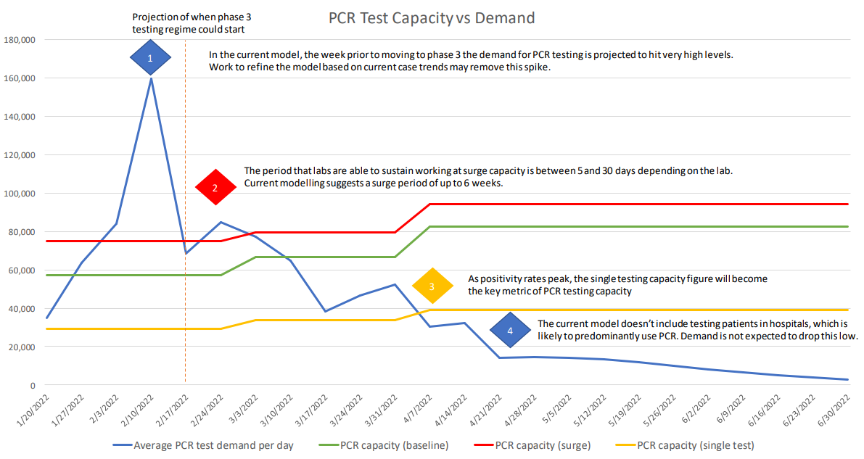

Key features of the modelling to note are:
- the model provides no indication of when positivity rates are expected to peak. The graph shows PCR capacity (baseline), which includes sample pooling, as being fully available until 30 June 2022, regardless of increases in positivity rates
- in addition, whether it is intentional or not, the model is forecasting a sample backlog of more than 80,000 samples in a single day with PCR baseline capacity exceeded each day for more than a fortnight from 31 January 2022. The backlog is not referred to or explained in any notes or commentary in the report
- the model does not appear to be consistent with the Testing Strategy Framework or rationale. The transition to Phase 3 appears to be too late to protect PCR testing capacity. The increased utilisation of RATs does not appear to be initiated early enough to avoid a backlog occurring.
Testing Modelling 4 February 2022
The modelling for the following week (report dated 4 February 2022) adjusted the assumptions. Most notably, testing demand was considerably lower with demand pushed out by a further 2 weeks. The dates for phase transitions were adjusted to 10 February for Phase 2 and 24 February for Phase 3.

Figure 3
PCR Test Capacity vs Demand, Testing Modelling - 4 February 2022
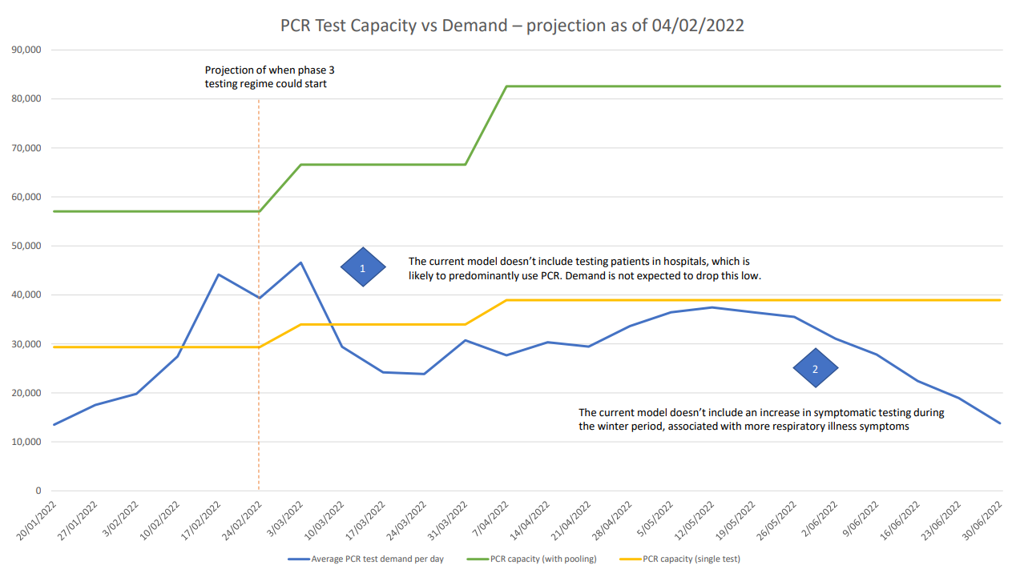

Key features of the modelling to note are:
- PCR testing demand is modelled to exceed PCR single test capacity from 10 February until 7 March 2022
- the positivity rate assumed in the model increases from 1-4% over this period
- the commentary notes that “PCR testing is forecast to rapidly increase as case numbers grow, prior to the phase 3 change of symptomatic and close contact rapid antigen testing.”
- the model depicts that PCR baseline capacity (with sample pooling) continues to be available without interruption until 30 June 2022. In fact, the model shows PCR capacity (with pooling) increasing as new capacity comes online
- the commentary in the section “Next Steps” notes an intention to “Review with labs viability of pooling as positivity rate increase.”
Testing Modelling 11 February 2022
The modelling for the report dated 11 February 2022 recalibrated the forecasting of testing demand. The modelling assumed that Phase 2 would commence on 17 February 2022 and Phase 3 would commence on 3 March 2022, both one week later than the previous week’s modelling assumptions.

Figure 4
PCR Test Capacity vs Demand, Testing Modelling - 11 February 2022
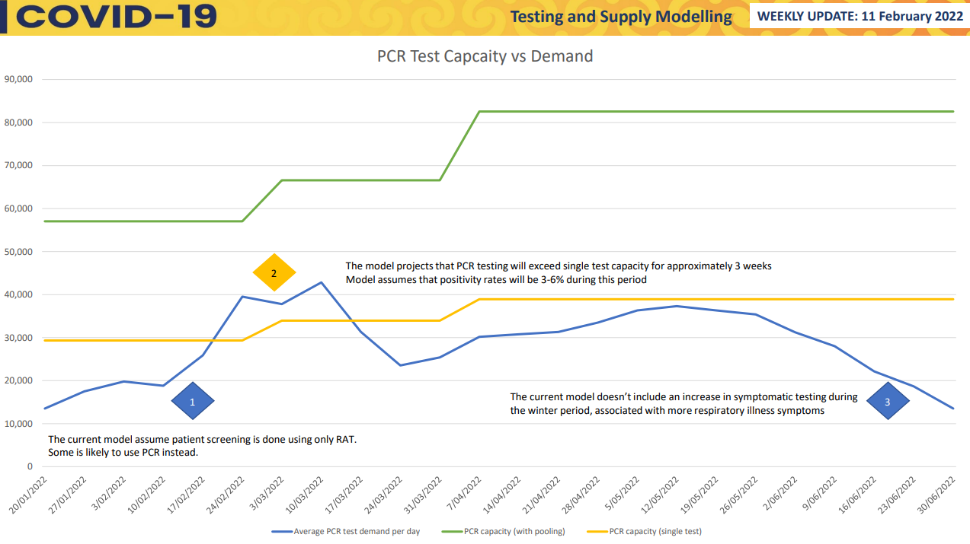

Key features of the modelling to note are:
- the commentary notes that the positivity rate used in the previous week’s model was 1% compared with the actual positivity rate of 1.4%. This is a 40% variance in modelling an Omicron outbreak
- the positivity rate forecast/assumed this week is 3%
- the positivity rate is still not graphed
- the model predicts a 3-week period where demand will exceed PCR single test capacity.
- over the same 3-week period the model assumed/predicted that the positivity rate will increase from 3% to 6%
- there is no update in the assumptions or commentary to indicate the outcomes of the previous weeks intention to review pooling viability as positivity increases
- the commentary in the section “Next Steps” still notes an intention to “Review with labs viability of pooling as positivity rate increase.”
- the model still depicts PCR capacity with baseline pooling being fully available and uninterrupted until 30 June 2022.
Testing Modelling 12 February 2022
On 12 February 2022 further modelling is undertaken that includes an additional scenario to that reported on 11 February 2022. Key aspects of this model include:
- this model assumes that the positivity rate is 1.4% on 10 February and increased to 30% by 31 March
- the model assumes Phase 3 will commence on 24 February, one week earlier than the model of 11 February
- the model illustrates that demand will exceed single test capacity immediately in Phase 2 from 11 February and remains above single test capacity until 7 April
- the model illustrates PCR capacity with pooling being exceeded from 12 February until 5 March
- despite the assumption that positivity rates will reach the forecasted peak of 30% on 31 March, the graph gives no indication that PCR capacity with pooling will be compromised or not available.

Figure 5
PCR Test Capacity vs Demand, Testing Modelling - 12 February 2022 (note the date is wrong in the document)
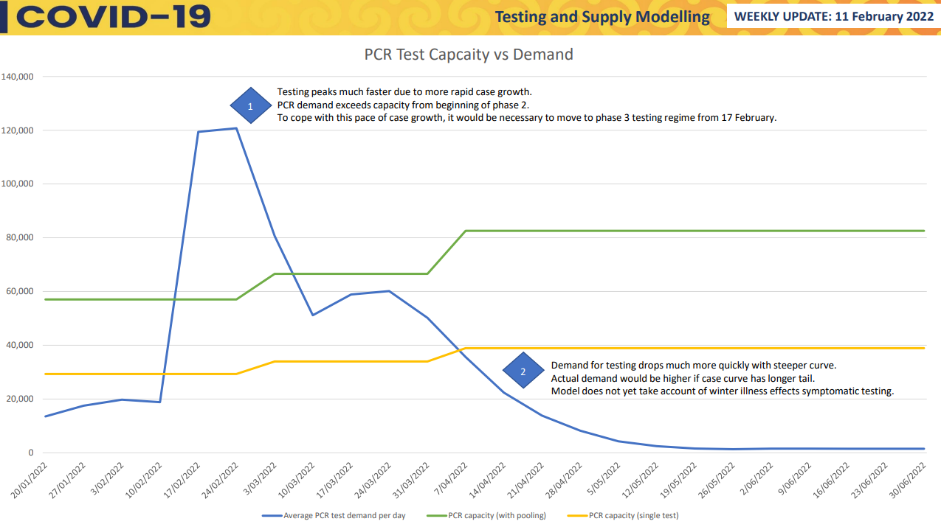

Testing Modelling 13 February 2022
On 13 February 2022 a further scenario is modelled, including a scenario of 10,000 new cases per day which is modelled to occur on 17 March. Other key points to note:
- the positivity rate is forecast to only reach 5% by 24 February, 9% by 3 March and 25% by 17 March
- the model assumes that Phase 3 commences on 3 March 2022
- single test capacity is exceeded for a brief period
- the model assumes that PCR capacity with pooling is available and uninterrupted throughout this period.

Figure 6
PCR Test Capacity vs Demand, Testing Modelling 13 February 2022
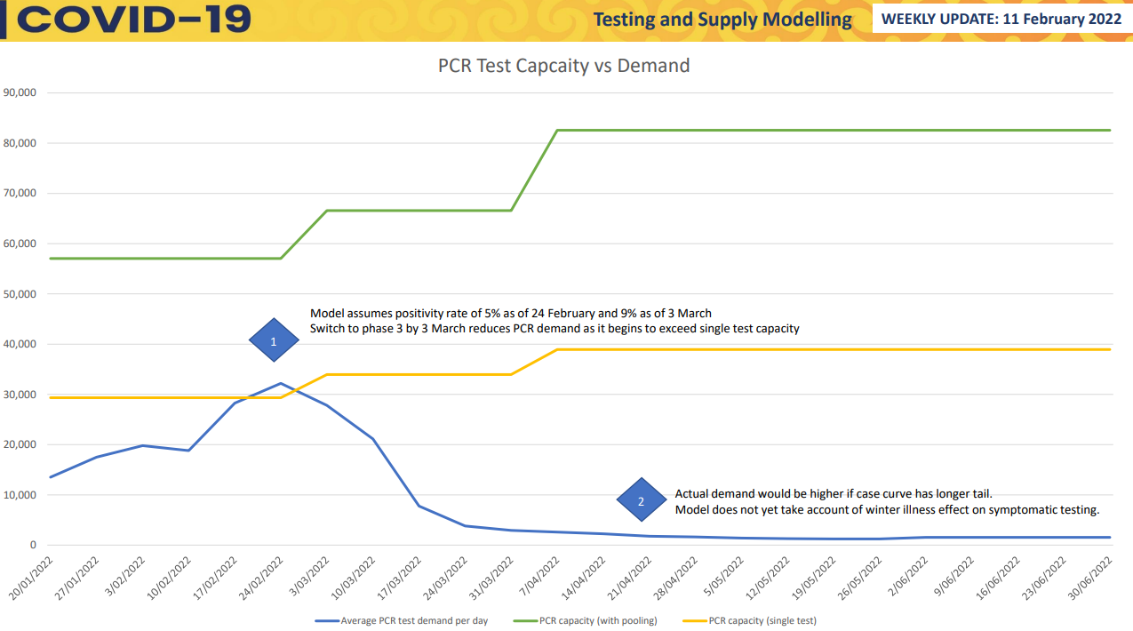

Testing Modelling 18 February 2022
The modelling for the report dated 18 February 2022 includes two models. Model 1 predicts a 10,000 case per day peak which is projected to occur on 24 March 2022.

Figure 7
PCR Test Capacity vs Demand, Testing Modelling - 18 February 2022

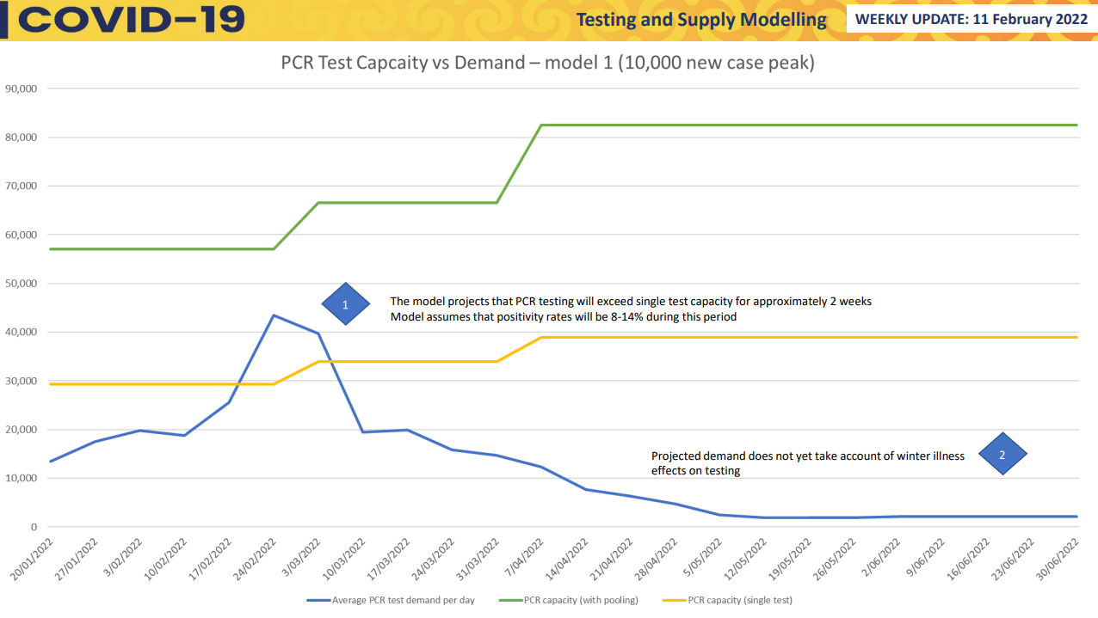

Key features of the modelling to note are:
- the model assumed a positivity rate for the previous week of 3% compared with an actual positivity rate of 4.2%. This is an under-estimation variance of 40%
- the positivity rate is forecast to peak at 25% on 24 March 2022
- The model forecasts demand to exceed single test capacity for approximately 2 weeks
- during that period positivity rates are forecasted at between 8 and 14%
- PCR test capacity with pooling is not indicated to be impacted or interrupted in any way.
Model 2 is based on an assumption that case numbers will peak at 25,000 per day. That peak is assumed to occur on 7 April 2022.

Figure 8
PCR Test Demand vs Capacity, Testing Modelling, Model 2 - 18 February 2022

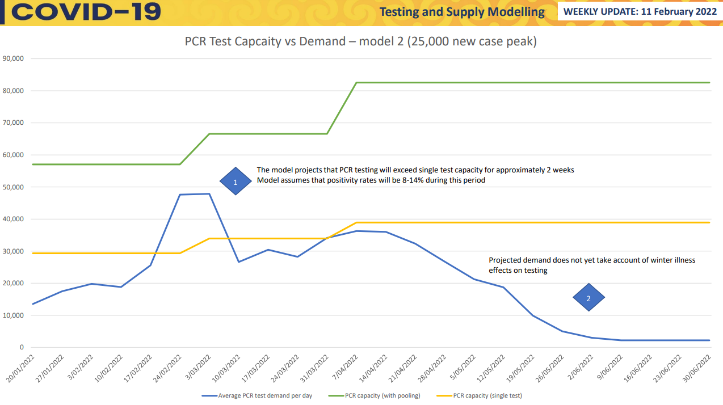

Other points to note are:
- the model predicts testing demand will peak at approximately 48,000 samples
- the model predicts that PCR single testing capacity will be exceeded from 18 February, for just over 2 weeks
- the positivity rates are assumed for that period are 8-14%
- there is no update or projection regarding the availability of PCR capacity with pooling, however the modelling continues to imply that PCR capacity with pooling continues to be available.
Testing Modelling 25 February 2022
The modelling for the report dated 25 February 2022 is based on a single scenario.
- The model is based on a peak of 25,000 cases per day with that peak occurring on 17 March 2022.
- The models from the previous week assumed the positivity rate would be 8% (rolling 7-day average). The actual positivity rate was 10% (rolling 7-day average).
- The model uses actual demand figures from 20 January to 10 February.
- The model commentary notes that “PCR testing demand has exceeded single test capacity over the past one to two weeks, leading to a backlog in samples to be tested.”
- The model does not include any indication that PCR capacity with pooling is not available. The graph continues to create the impression that demand is manageable within PCR capacity (with pooling) thresholds.
- There is no reference to the laboratories having ceased PCR testing with sample pooling because positivity levels have breached thresholds that render pooling no longer effective or efficient as a testing methodology.

Figure 9
PCR Test Capacity vs Demand, Testing Modelling - 25 February 2022
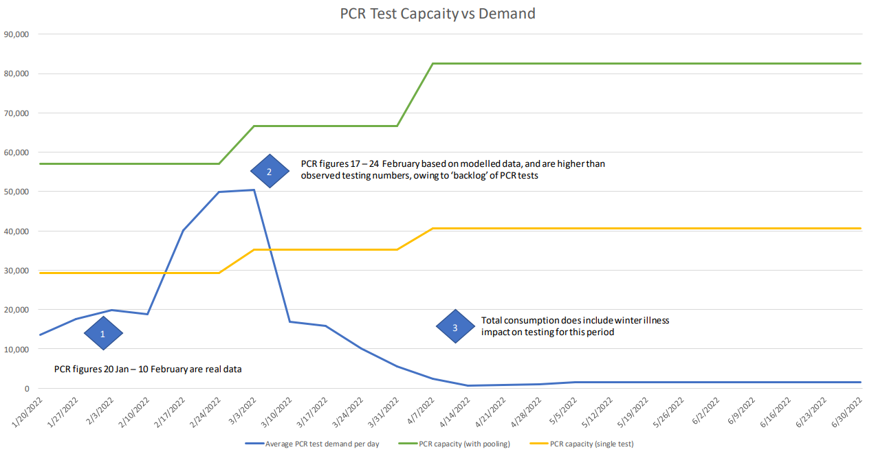

Testing Modelling 4 March 2022
A further model was developed on 4 March, immediately prior to this review commencing. The model uses real data of PCR testing between 20 January and 3 March 2022 and depicts demand remaining below single test capacity throughout this period despite the backlog that is known to have occurred. This demonstrates the lack of understanding in difference between demand for testing and throughput. The actual figures represent tests completed as reported by laboratories (i.e., the throughput) as opposed to the number of samples that were collected (i.e., demand) which is known to have surpassed single test capacity.
Figure 10
PCR Test Capacity vs Demand, Testing Modelling - 4 March 2022
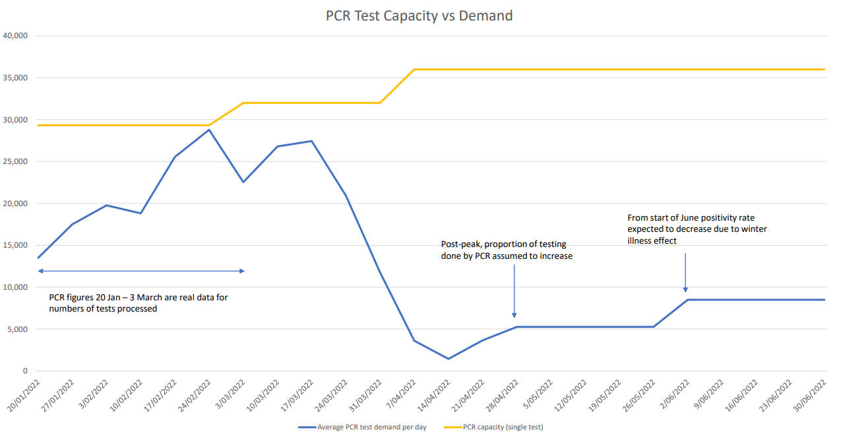

Significance
The modelling appears to be using the positivity rates to forecast testing demand only.
The modelling is not using positivity rates to forecast testing capacity and the points in time that the reduction or loss of sample pooling will be experienced.
Where positivity rates are used in the model, the rates applied are consistently too low (understated by at least 20-40%).
The modelling showed no update of assumptions to reflect messaging from laboratories about positivity rates and the impacts on capacity. Laboratories claim to have advised the Ministry about the impact on pooling at the rates of 3%, 5% and 10%.
The modelling contained no signal in either the commentary or the graphs as to when pooling capacity would drop from consistently 58,000+ shown in the graphs to the single test capacity of just under 30,000.
As a result (of the issues above), the modelling is not using laboratory capacity in any meaningful way to inform decisions around the triggers to transition to either Phase 2, or to Phase 3 of the Omicron response.
It does not appear that the modelling was appropriately sensitised to the risks posed to PCR testing capacity by positivity rates.
    - International Experiences of Omicron
One of the key advantages that Aotearoa New Zealand has been able to benefit from is that we have experienced many aspects of the pandemic after other countries and jurisdictions. This was also the case with Omicron.
The modelling undertaken by the Ministry did take advantage of this opportunity and consider analysis of the Omicron outbreak experiences in Singapore and in Australia.
However, the under appreciation of the value that positivity rates offered as an indicator meant that the analysis does not appear to have focused on how effective positivity rates had been as a forecaster of the reducing efficiency and viability of sample pooling in PCR testing.
As is now well known, PCR testing capacity was overrun in Queensland, New South Wales and Victoria during their respective Omicron outbreaks. These outbreaks all commenced in early December 2021 and PCR testing capacity with pooling had been rendered inefficient by the beginning of January 2022.
The experiences of each of these states and of Australia at a national level offered two key lessons:
- the points at which positivity rates impacted on sample pooling
- the rates at which positivity increased during an outbreak.
This information would have been invaluable in supporting staff to determine the appropriate staging of the phases of the Testing Strategy in New Zealand.
Members of the laboratory network monitored developments in Australia, and many were in direct contact with their Australian colleagues and counterparts to understand the implications of the outbreak for the PCR testing approaches. It was clear to the laboratories that once in the community, Omicron would spread quickly, and testing demand would spike. It was also apparent that positivity rates would increase rapidly, and sample pooling would be impacted quickly.
As a result, a number of the laboratories began planning for sample pooling impacts at different positivity rates. Most laboratories advised they expected sample pooling to be impacted when positivity rates reached 5-10%.
The Australian experience indicates that nationally, and in each of the three eastern seaboard states, that positivity rates exceeded the 10% threshold well within a month of the first case of community transmission.

Table 1
Australian Omicron Outbreaks - Time to 10% Positivity Rate
State | First Community Transmission | Days taken until Positivity Rate >10% | Positivity Rate at that point (%)
NSW | 3 Dec 2021 | 27 days | 12.58
VIC | 8 Dec 2022 | 24 days | 14.8%
QLD | 13 Dec 2022 | 21 Days | 10.56

The significance of these lessons is that they support the views the COVID-19 Testing and Supply Group held early in their planning. Their initial thinking and planning indicated that a three phased approach would be adopted based on a first phase of between 10-20 days, followed by Phase 2 which lasted for approximately 5 days and then the final transition to Phase 3. Their thinking at one stage considered moving directly from Phase 1 to Phase 3 (see Section 3.1.2). However, subsequent iterations of the testing plan moved away from this approach.
In Australia, once the positivity rates reach 3-5% they tripled within a week. Each daily increase in the positivity rate was significant, meaning that in the Aotearoa New Zealand context, daily monitoring would have been warranted if Phase 2 and Phase 3 testing plans were going to be activated on time. The rate of increase in positivity rates experienced in the Australian states also highlights the potential risk of unmet testing demand and the growth of a backlog if other modalities and demand management strategies are not in place and activated.
Significance
The opportunities to learn from the international experiences of testing during an Omicron outbreak were substantial, particularly in respect of positivity rates and the impacts on sample pooling.
Of significance was the rate at which pooling was severely impacted and PCR testing capacity was drastically reduced. For example, on 26 December 2021 New South Wales could only process 97,241 tests compared with PCR testing capacity of well over 150,000 tests during the Delta outbreak in September 2021.
The reduction in PCR testing capacity was due to the unavailability of pooling due to the prevalence of positive results. The positivity rate was 5.8%.
Another key insight available from the Australian experience was the speed at which positivity rates increased. In NSW the positivity rate moved from 1.7 to 5.8 in less than a week.
It is not apparent how these insights were incorporated into the testing modelling, planning or reporting. Certainly, it would have been beneficial to model projections of the positivity rate and, critically when it would likely exceed 5%.
    - Ability to move to RAT
Regulatory approval
Under the COVID-19 Public Health Response (Point-of-care Tests) Order 2021 the import, manufacture, supply, sale, and use of point-of-care tests is prohibited unless exempted by the Director-General of Health. In June 2021, three RATs were reviewed and approved by ESR for potential use under future settings. Recognising the shifting environment and the new testing strategies being developed in late 2021 (see Section 3.1.2), a Principal Advisor joined the Ministry’s Laboratory Testing team in November 2021 to develop and administer a regulatory review and approval process for additional RATs. While the Ministry was able to increase the number of RATs available through the Director-General’s exemption, there are still limitations on which tests are available to New Zealand and a significant and growing backlog of applications.
Procurement
In December 2021, New Zealand had a supply of approximately 2 million RATs on hand with a few additional orders being placed. By the end of the month, a decision was made to ramp up the procurement of RATs and by the end of January 2022 there was approximately 160 million RATs on order. However, the majority were due for delivery in mid- to late-April with a known gap in supply for February. Through strategic procurement efforts, some of these gaps were able to be filled and by 18 February 2022 there was an estimated 7.5 million RATs available in the system with a further 23.2 million expected by the end of the month.
System readiness
A significant programme of work was underway by Testing and Supply to prepare the system to move to RAT testing. This included workstreams on data and digital for RAT reporting, communications, and coordination with DHBs and CTCs on the provision of RATs to the public. A Phase 3 readiness summary from Testing and Supply dated 20 February noted that most of the action required for Phase 3 were between 1 – 5 days away from being complete. Nevertheless, a progressive shift to RATs at CTCs began in recognition that laboratory capacity had already been exceeded. While we have heard differing views across the Ministry about readiness to move, the documentation does not provide certainty to confirm whether this would have been feasible and did not provide decision makers with the confidence this was possible.
Significance
The lack of a forecast date when PCR testing capacity would be exceeded did not provide a sufficient impetus to get the RAT roll-out ready.
The lack of confidence in system readiness meant the PCR backlog kept growing despite laboratories calling for an earlier shift to Phase 3.
    - Data availability
Indicators available
The ability of the Testing and Supply Group to use data for improved planning is limited by the nature of the data indicators available. Specifically, there is a reliance on tests completed, which is a lagging indicator, as this is the only data that Testing and Supply readily has access to through the national CDR. While changes in the moving average test completed or the positivity rate can provide an indication of potential changes in demand, it is not a substitute for the number of samples taken. Of particular concern is that we heard there is no data available on a regular basis of samples collected at CTCs without a manual process of asking each CTC to report back. Further, samples collected by primary care are even more difficult to predict.
There was also no requirement or incentive for laboratories to pro-actively report accumulating backlog of samples. It was not until 21 February that the Ministry began requesting a count of samples awaiting registration or processing.
Disconnect
This disconnect between the true demand for testing – i.e., samples collected by CTCs and primary care – and planning for capacity – has emphasised the difficulty in planning. In the context of the public health messaging of seeking a test if unwell or as a result of being a contact of a case, there was always a significant risk that demand would exceed capacity. As identified in Section 3.1.4 and below in Section 3.2, this disconnect was not explicitly recognised and throughput (i.e., tests completed) was often presented as demand.
Significance
Data limitations were not explicitly recognised and their impact on planning does not seem to have been fully understood. There is no evidence of efforts to improve data availability.
Planning efforts were always limited in their ability to accurately reflect demand for testing.
  - Reporting
Daily and Weekly Reporting Suite
The COVID-19 Testing and Supply Group prepared an extensive suite of reports that included a range of daily and weekly operational reports. These reports included:
- Daily Laboratory Operations Report
- Daily Sitrep
- COVID-19 Laboratory Testing Dashboard
- PCR Testing Capacity Weekly Dashboard
- Border Workforce Register (BWTR) Testing Dashboard
- Weekly Testing Modelling Report (as discussed in Section 3.1.4).
In addition, the group was producing and distributing reports relating to the RAT rollout and other ad hoc reports. Each Friday a weekly reporting package was also distributed to a range of internal stakeholders, that was also accompanied by the Weekly Talking Points for the Deputy Chief Executive (DCE).
Monitoring, Forecasting and Reporting
A critical role of operational reporting is to report on key issues, progress and indicators. Much of the operational reporting did in fact provide targeted and useful information however, there is a question about whether there should have been a greater level of reporting focus on positivity rates. For instance, positivity rates do not feature in the PCR Testing Capacity Weekly Dashboard Report. Given it is a key determinant in the ongoing availability of sample pooling, and its value as a predictor of unavailability, that is surprising.
The COVID-19 Testing and Supply Group were monitoring laboratory testing turn-around times against a KPI of 80% tested within 24 hours, which was prudent and sensible. However, they did not elect to either monitor or report on the quantity of aged samples (that is the age in days of samples collected but not yet tested), until after a backlog had developed.
The modelling and forecasting did not seek to predict the point in time when positivity rates would reach levels to render sample pooling unavailable. There is no reporting that shows PCR Baseline Capacity reducing in any material way. As a result, the reporting appeared to adopt more of a reactive stance rather than a proactive anticipatory one. The PCR Testing Capacity Weekly Dashboard Report continued to show PCR Baseline Capacity as fully available until after it was no longer available.
Report logic and information presentation
Having reviewed the reporting, our assessment is that the reporting was not always intuitive and some of the labels and the way that information was presented, were at risk of misinterpretation. The PCR Testing Capacity Weekly Dashboard Report uses the term “baseline capacity”. As noted in Section 2.2, there was variability and inconsistency in the use of the “baseline capacity” terminology, but it was mostly understood to include sample pooling. Accordingly, the COVID-19 Testing and Supply Group was expecting baseline capacity to reduce when pooling was no longer viable. This is perhaps counter-intuitive with readers possibly expecting that the baseline level is the non-variable component of capacity.
Notwithstanding the labelling issues, the Daily Test and 30-Day Projection graph contained in the PCR Testing Capacity Weekly Dashboard Report only shows the “baseline capacity” figure and does not highlight single test capacity. Again, this created the opportunity for someone to misinterpret the data and assume that baseline capacity refers to the minimum level of capacity. It also presents the daily throughput of testing as “demand” not recognising that this does not represent the volume of samples collected and therefore does not signal any potential backlogs.

Figure 11
Graph from PCR Testing Capacity Weekly Dashboard Report - 4 February 2022
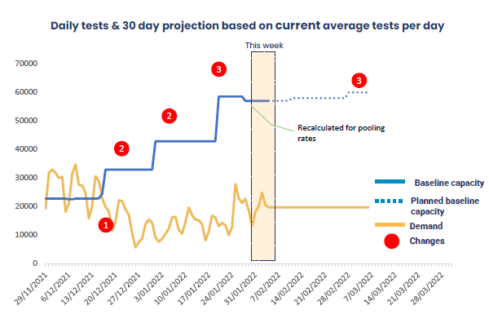
While the graph in the Weekly Dashboard was eventually updated to represent single testing capacity as of 18 February, as is now known this was too late as the backlog had already built up.
Reporting Analysis and Commentary
A number of the reports included useful information however, the reports were not always delivered with significant contextual information, critical analysis or a call for action. The reporting style of the COVID-19 Testing and Supply Group appears to assume its audience had the requisite background knowledge and understanding to interpret the reports and recognise the significance of what was being reported. It also doesn’t recognise the significant non-COVID workload of some of the audience, such as the Director-General or Ministers who have significant other portfolios to attend to. This is perhaps reflective of the capacity limitations of the group in such a demanding environment.
As a result, or in addition to this, the COVID-19 Testing and Supply Group relied heavily on verbal communication to provide context or convey information. This approach also assumed that the audience had the requisite background to the issues communicated and that they passed on that information effectively. For example, for the updates provided at the Daily IMT it was assumed that information passed on was being interpreted correctly, being noted, and actioned appropriately.
Significance
The Testing and Supply Group produced a significant amount of reporting and were of the impression the information was being correctly interpreted. This created a false sense of comfort that decision makers would action information if needed.
On the contrary, as critical information was not always reported formally with clear action items, key messages were lost, and opportunities were missed.

- Organisational Design
Laboratory Testing Team Capacity
While the Testing and Supply Group is relatively large and well resourced, the Laboratory Testing team within the Group is significantly under resourced at only 3.1 Full Time Equivalent (FTE) staff. The role of the team is split between managing the relationship with laboratories and reporting on testing complete and developing and running the regulatory process for approval of other testing technologies (e.g., Rapid Antigen Tests). The National Laboratory Network Group is large with diverse players and internal dynamics that requires significant coordination. The lack of contractual levers to incentivise behaviour frustrates the ability of the Ministry to manage the Network productively, meaning the Ministry has resorted instead to a facilitation and support role. For example, the Ministry has often taken the lead on coordinating reagent supplies for laboratories despite the laboratories having the contractual arrangements with the suppliers.
In this role, the Ministry has therefore played a critical role throughout the pandemic and especially since the beginning of the Delta outbreak in August 2021 ensuring New Zealand’s testing programme was able to proceed without supply issues. As a result, the team has been very operationally focussed and responsive rather than having any time for strategic or business continuity planning. While some work was started on business continuity planning in early August 2021, the Delta outbreak forced the team to pivot back to operational response. The effort required to coordinate the laboratories since then has not slowed and the team has been under severe strain throughout. This has led to the team being a transactor of data rather than a team that can interrogate data from laboratories to plan ahead and identify and effectively communicate emerging risks.
Organisational Structure of the Testing and Supply Group
The structure of the Testing and Supply Group emphasises the disconnect between demand for testing (i.e., samples collected) and delivery of testing. The Testing Operations team manages the relationship of the Ministry with CTCs, represents the Testing and Supply Group at daily IMT meetings, and provides input into Public Health Risk Assessments. While there is good collaboration between the Testing Operations and Laboratory Testing teams, the split creates a disconnect in the overall management of testing. It is also worth noting that the Testing Operations team has three times as many FTEs as Laboratory Testing.
Further, while a Chief Testing Adviser was recruited to the Ministry in December 2021, the position does not sit in the Testing and Supply Group and has not been able to be fully leveraged in supporting the management and coordination of laboratories.
Expectations of Testing and Supply Group
There have also been questions raised about the expectations of the Laboratory Testing team in relation to any strategic planning function. Testing plans and testing strategies have, at various points, been developed by the Testing and Supply Group. However, these have been developed based on a laboratory view of testing rather than a higher-level policy or strategic view of pandemic management.
Planning capability in COVID-19 Directorate
We heard that the lack of strategic planning is due to a lack of planning capability across all the groups in the Directorate. The work of the Testing and Supply Group has been highly operationally focussed and reactionary due to the lack of planning. There would have been benefit in having dedicated capability across the groups but centrally coordinated to develop forward looking strategic plans and ‘playbooks’ for future outbreaks and phases in management of the pandemic. Without this, the Ministry has always been on the back foot in responding to events.

Significance
The Laboratory Testing team has been in a constant response mode since the beginning of the Delta outbreak with little time to take stock or provide a break for staff.
The structural disconnect and lack of planning capacity and capability resulted in a reactive rather than proactive approach to engaging with laboratories.
Despite best efforts, there was a high risk of missed opportunities and insufficient management and reporting capacity that ultimately led to a disconnect in understanding of the situation with decision makers.

- Conclusion
The backlog in PCR testing that emerged in February 2022 should have been and was to some degree predictable. The Ministry’s testing modelling did forecast single test capacity being exceeded and modelled scenarios that forecast PCR testing capacity with pooling, would also be exceeded.
However, there were deficiencies in the COVID-19 testing system design and operational management that meant that testing strategy objectives were not met because risks to those objectives were not adequately managed or communicated.
The core causal factors were:
- insufficient capacity and capability to develop forward looking testing plans aligned with the broader pandemic management strategies
- inadequate highlighting, monitoring, notification and/or escalation of potential or actual risks and consequences in formal reporting, including that provided to the Director-General and Ministers
- inability to feed information from laboratories and other external sources into Ministry communication channels in ways that contextualised the information and conveyed its significance for PCR testing capacity.
There were a series of other factors identified that while not causal, were in some cases more minor contributory factors, or resulted in opportunities to avoid the backlog occurring being missed or meant that the testing system worked in a less optimal way. These included:
- a lack of contractual levers to enable the Ministry to manage COVID-19 testing centrally and maximise the benefit from the laboratory network
- a laboratory network with commercial incentives that did not always lead to the early flagging of emerging issues
- a reactive approach to working with laboratories relying on good will to encourage collaboration in the absence of contractual levers.
As a result, a disconnect emerged in the knowledge and understanding of the COVID-19 Directorate and the laboratories relative to the Director-General and Ministers, which led to them being unprepared for the PCR backlog that eventuated.
- Recommendations
In order to avoid similar circumstances emerging in the future, and to take advantage of the lessons available from this experience, the following recommendations are made.
- Review the resourcing model of the COVID-19 Testing and Supply Group to address any capacity deficits and enable the Group to manage current workload and transition away from operational surge settings.
- Develop a clear testing plan that determines the role of PCR testing and other modalities going forward, as well as providing clarity about the roles and expectations of the laboratories.
- As part of the strategic planning (recommendation 2), address how COVID-19 testing transitions to a business-as-usual laboratory testing regime.
- Determine the level of standing PCR testing infrastructure required for future variants or pathogens and where this infrastructure should be maintained as part of the strategic planning (refer to recommendations 2 and 3). In the absence of guidance from the Ministry, some laboratories have signalled they may need to reduce their PCR capacity, including mothballing equipment and reducing staffing.
- Review the approach to contracting laboratory services to facilitate greater transparency and national coordination in a pandemic. The health systems reforms and transition to new entities (Health NZ, Māori Health Authority, and the Public Health Agency) provides an opportunity to consider how laboratory services can best support clinical and public health outcomes.
- Consider greater interoperability of information technology platforms so that the data that is generated from laboratory testing can be better used for surveillance and public health outcomes as a part of any review of laboratory services.
- Consider how the Ministry and Health NZ can achieve more integrated ways of operating with laboratories when planning for managing the ongoing testing requirements of COVID-19, and in planning undertaken for future pandemic readiness.
- Ensure there are clear, formal governance arrangements in place between the Ministry and/or Health NZ and laboratories that enable sufficient centralised planning and management of testing in Aotearoa New Zealand’s pandemic approach.
- Consider options to strengthen the Chief Testing Adviser position and shape the role so the Ministry and/or Health NZ is able to better leverage their subject matter expertise and insights across testing planning, modelling and reporting.

Annex 1 – Abbreviations and Terminology

Abbreviations
CDR | Clinical Data Repository
CTC | Community Testing Centre
CPF | COVID-19 Protection Framework
CT-TAG | COVID-19 Testing Technical Advisory Group
DPMC | Department of the Prime Minister and Cabinet
ESR | The Institute of Environmental Science and Research
FTE | Full Time Equivalent
IMT | Incident Management Team
IAMZ | International Accreditation New Zealand
LIS | Laboratory Information system
NRHCC | Northern Region Health Coordination Centre
RAT | Rapid Antigen Test
TTIQ | Testing, Tracing, Isolation, and Quarantine
TAT | Turn-Around Time

Terminology
- Eclair Clinical Data Repository: Eclair acts as a repository for all COVID-19 test results, both positive and negative, from all health laboratory testing facilities in New Zealand. Eclair was created by ESR and Sysmex New Zealand as a collaborative project to streamline vital data.
- Nasopharyngeal PCR test: The nasopharyngeal collection method collects a sample from the nasopharynx, which is the upper part of the throat behind the nose. PCR test results are usually ready within 2-5days, depending on demand.
- Rapid Antigen Test (RAT): The RAT sample is generally taken with a front of nose swab. Tests can be carried out under supervision (done by a healthcare professional), or you can do it yourself. RAT results are available in about 15 to 20 minutes.
- Reagents: Reagents are substances or compounds added to samples to test if a reaction occurs. Reagents differ between the various types of testing equipment/machinery. An example of a reagent is the Aptima™ SARS-CoV-2 assay.
- Sample pooling: Sample pooling is the practice of combining samples from multiple people and testing them as a group. Laboratories in New Zealand have typically pooled COVID-19 samples in ratios of 1:3 (three samples in a single test), 1:5, or 1:8. If a pool of samples tests positive, each of the samples must then be individually tested such that a 1:5 pool that tests positive results in six individual tests being undertaken (the original pooled test and single tests for each of the five samples). When the proportion of samples that test positive is low, pooling is an effective strategy to increase the number of samples that can be processed for a given equipment, reagent, and staffing profile. However, when positivity rates (the portion of samples taken that test positive) increase, pooling is less efficient and ultimately no longer a viable strategy as the number of repeat tests grows.
- Turn-Around Times: The time taken from a sample being registered in a laboratory to the notification of the test result. This may also be measured in the time from sample collection to notification of result.

Sample pooling is the practice of combining samples from multiple people and testing them as a group. Laboratories in New Zealand have typically pooled COVID-19 samples in ratios of 1:3 (three samples in a single test), 1:5, or 1:8. If a pool of samples tests positive, each of the samples must then be individually tested such that a 1:5 pool that tests positive results in six individual tests being undertaken (the original pooled test and single tests for each of the five samples). When the proportion of samples that test positive is low, pooling is an effective strategy to increase the number of samples that can be processed for a given equipment, reagent, and staffing profile. However, when positivity rates (the portion of samples taken that test positive) increase, pooling is less efficient and ultimately no longer a viable strategy as the number of repeat tests grows.
Rapid Review of COVID-19 Testing in Aotearoa New Zealand, COVID-19 Testing Technical Advisory Group, 4 October 2021 (https://www.beehive.govt.nz/sites/default/files/2021-10/COVID-19%20Testing%20Rapid%20Review%20Report.pdf)
A Rapid Review of COVID-19 Testing in Aotearoa New Zealand, COVID-19 Testing Technical Advisory Group, page 11
Using MoH figures on single test capacity and baseline capacity including sample pooling.

