Office of the Director of Mental Health and Addiction Services Annual Report 2017

Disclaimer
The purpose of this publication is to inform discussion about mental health and addiction services and outcomes in New Zealand, and to assist in policy development.
This publication reports information provided by district health boards and non-governmental organisations via the Programme for the Integration of Mental Health Data (PRIMHD). It is important to note that, because PRIMHD is a dynamic collection, it was necessary to wait some time before publishing a record of the information contained in that collection. This means that it is less likely that the information will need to be amended after publication (see Appendix 1).
Although every care has been taken in preparing this document, the Ministry of Health cannot accept legal liability for any errors, omissions or damages resulting from reliance on the information it contains.
A note on the cover
‘Beating Hearts’ by Paul Holmes
Paul has been making artworks since he started attending Vincents Art Workshop (Vincents) in 2015. Paul says coming to Vincents has got him out of the house and out of his comfort zone. He has entered the IHC Art Awards for the last four years and has regularly exhibited in group shows at Vincents and the St James Theatre. ‘This artwork is called “Beating Hearts” because everyone’s heart beats in a different way’.
Vincents Art Workshop is a community art space in Wellington established in 1985. A number of people who attend the workshop have had experience of mental health services or have a disability, and all people are welcome. Vincents models the philosophy of inclusion and celebrates the development of creative potential and growth. vincents.co.nz
Citation: Ministry of Health. 2019. Office of the Director of Mental Health and Addiction Services: Annual Report 2017. Wellington: Ministry of Health.
Published in February 2019 by the Ministry of Health
PO Box 5013, Wellington 6140, New Zealand
ISBN 978-1-98-856843-0 (print)
ISBN 978-1-98-856844-7 (online)
HP 6999
This document is available at health.govt.nz
This work is licensed under the Creative Commons Attribution 4.0 International licence. In essence, you are free to: share ie, copy and redistribute the material in any medium or format; adapt ie, remix, transform and build upon the material. You must give appropriate credit, provide a link to the licence and indicate if changes were made.

Foreword
Tēnā koutou.

Nau mai ki tēnei tekau mā toru o ngā Rīpoata ā Tau a te Āpiha Kaitohu Tari Hauora Hinengaro mō te Manatū Hauora. Kei tēnei tūnga te mana whakaruruhau kia tika ai te tiaki i te hunga e whai nei i te oranga hinengaro me te waranga. I a tau ka pānuitia tēnei rīpoata kia mārama ai te kaitiakitanga me te takohanga o te āpiha nei ki te katoa.

Welcome to the thirteenth annual report of the Office of the Director of Mental Health and Addiction Services (formerly Office of the Director of Mental Health). This report presents information and statistics that serve as indicators of the quality of our specialist mental health services. It is vital to actively monitor these services to ensure that New Zealanders receive quality care in a timely fashion.

The Government recognises that mental health contributes to many different aspects of our daily lives. We aim to ensure that anyone experiencing mental health illness or addiction can access the right services, which are responsive to their needs. The mental health system acknowledges the importance of balancing good clinical practices with the rights outlined in and the protections offered by legislation in order to grow and maintain individuals’ wellbeing and dignity.

Over the year of 2017, one of the key changes within our work was the introduction of legislation for those experiencing severe substance use and addictive behaviours. The Substance Addiction (Compulsory Assessment and Treatment) Act 2017 (the Substance Addiction Act) replaced the Alcoholism and Drug Addiction Act 1966. To reflect the additional work resulting from the legislation change, our team name has been amended; I took on the role of Director of Addiction Services and our responsibilities to mental health broadened to incorporate addiction services.

The Ministry of Health oversaw changes and growth in the mental health system in 2017. You will read about some of the activities our team participated in throughout 2017, data that indicates the performance of district health boards (DHBs) and information about specialist mental health and addiction services. With this report, we want to increase the visibility of care provided by the mental health care facilities and develop public understanding of what our work means for mental health and addiction services within New Zealand.

This report can only provide a snapshot of service provision at mental health care facilities – some measures described in the report may alter over time, even within the time it takes to publish the report. In addition to the analysis provided in the body of the report, you can find caveats in the appendices, which explain changes to data over time. Because the Substance Addiction Act came into effect in February 2018, this report will incorporate only 2017 data under the Alcoholism and Drug Addiction Act 1966.

The Office of the Director of Mental Health and Addiction Services will continue to improve the processes around administering the Mental Health (Compulsory Assessment and Treatment) Act 1992 (the Mental Health Act), and the Substance Addiction Act. We work to make a meaningful contribution to the changing landscape of the mental health and addictions sector in New Zealand and to improve wellbeing outcomes for New Zealanders.

In 2017, I advertised three new principal clinical supervisor positions for our team: Māori mental health, clinical psychologist and addictions specialist. Peta Ruha, Emma Sutich and Klare Braye accepted the respective positions and joined us in 2018. I am confident that their experience and clinical knowledge will improve our administration of the Acts we engage with, help us develop better stakeholder relationships and broaden our understanding of approaches to better mental health and addiction services in New Zealand. I look forward to our continued work together.

Noho ora mai

Dr John Crawshaw
Director of Mental Health
Director of Addiction Services

Contents
Foreword iii
Executive summary xiii
Further reading xiv
The New Zealand Mental Health and Addictions KPI Programme xiv
Other PRIMHD publications xiv
Introduction 1
Objectives 1
Structure of this report 1
Context 2
The Ministry of Health 2
Mental health and addictions care in New Zealand: Continually evolving 2
The Mental Health and Addiction Inquiry 3
Looking forward 4
Addiction treatment services: developing models of care 4
Specialist mental health and addiction services 5
The Mental Health Act 7
Administration of the Mental Health Act 7
Protecting the rights of people subject to compulsory treatment 8
Activities for 2017 11
Mental health and addictions sector relationships 11
Cross-government relationships 11
Relationship with the Department of Corrections 12
Relationship with the New Zealand Police 12
Victims of crime interagency working group 12
Nova Trust 12
Social initiatives 13
The Prime Minister’s Youth Mental Health Project 13
Response to Christchurch earthquake 2011 14
Response to Kaikoura earthquake 2016 14
Fixated Threat Assessment Centre pilot 15
Let’s get real 15
Equally Well 16
Strategies for suicide prevention in New Zealand 17
LifeKeepers 17
Waka Hourua 17
Human Rights and the Mental Health Act: Action 9(d) of the Disability Action Plan 2014–2018 18
Guidelines 19
Special patient guidelines 19
Night safety procedures 19
Section 65 of the Land Transport Act 1998 20
Appointment of statutory roles 21
District inspectors under the Mental Health Act 21
District inspectors under the Substance Addiction Act 21
Directors of Area Addiction Services under the Substance Addiction Act 21
Approval of opioid substitution treatment services 21
Office of the Auditor-General performance audit 22
Ensuring service quality 24
Specialist mental health and addiction services 24
Consumer experience 24
Survey results 25
Waiting times 25
Transition (discharge) plans 26
Use of the Mental Health Act 29
The Mental Health Act process 29
2017 statistics 30
Compulsory assessment and treatment by district health board 31
Compulsory treatment by age and sex 33
Māori and the Mental Health Act 35
Family/whānau consultation and the Mental Health Act 41
Seclusion 45
Changes in seclusion use 47
Seclusion in New Zealand mental health services 49
Seclusion by district health board 50
Seclusion and ethnicity 52
Seclusion in forensic units 54
Forensic mental health services 56
Special and restricted patients 56
Forensic mental health services 57
Extended forensic care (EFC) special patients 58
Short-term forensic care (SFC) special patients 58
Sex, age and ethnicity of special patients 60
Decisions regarding leave and change of legal status for special and restricted patients 62
Mental health and addiction adverse event reporting 64
Deaths reported to the Office of the Director of Mental Health and Addiction Services 64
Adverse events reported to the Health Quality & Safety Commission 65
Adverse events reported by district health board-funded mental health and addiction services 65
Death by suicide 67
Specialist treatment regimes 72
Opioid substitution treatment 72
The Alcoholism and Drug Addiction Act 1966 77
Electroconvulsive therapy 78
References 86
Appendix 1: Key databases and caveats 89
The Programme for the Integration of Mental Health Data 89
The Alcohol and Drug Outcomes Measure 90
Appendix 2: Additional statistics 92
The Mental Health Review Tribunal 92
Ministry of Justice statistics 94
Seclusion statistics incorporating outlier data 95
Appendix 3: Special and restricted patients 97
The insanity defence 97
Section 23 of the Crimes Act 1961: Insanity 97
Appendix 4: Developments in mental health and addiction reporting and improvement 99
Updated National Adverse Events Reporting Policy 2017 99
National mental health and addiction quality improvement programme 100
Suicide Mortality Review Committee 101

List of Figures
Figure 1: Number of people engaging with specialist services each year, 2011–2017 6
Figure 2: Percentage of service users accessing only community services, 1 January to 31 December 2017 6
Figure 3: Responses to the statement ‘I would recommend this service to friends and family if they needed similar care or treatment’, 1 January to 31 December 2017 25
Figure 4: Percentage of people seen by mental health services within three weeks (left) and within eight weeks (right), 1 January to 31 December 2017 26
Figure 5: Percentage of people seen by addiction services within three weeks (left) and within eight weeks (right), 1 January to 31 December 2017 26
Figure 6: Percentage of service users with a transition plan, by DHB, 1 January to 31 December 2017 27
Figure 7: Percentage of service users with a transition/wellness plan, 1 January to 31 December 2017 28
Figure 8: Average number of people per 100,000 on a given day* subject to a community treatment order (section 29 of the Mental Health Act), by DHB, 1 January to 31 December 2017 32
Figure 9: Average number of people per 100,000 on a given day* subject to an inpatient treatment order (section 30 of the Mental Health Act), by DHB, 1 January to 31 December 2017 33
Figure 10: Rate of people per 100,000 subject to compulsory treatment order applications (including extensions), by age group, 2004–2017 34
Figure 11: Rate of people per 100,000 subject to compulsory treatment order applications (including extensions), by sex, 2004–2017 34
Figure 12: Rate ratio of Māori to non-Māori subject to a community treatment order (section 29) under the Mental Health Act, by DHB, 1 January to 31 December 2017 38
Figure 13: Rate ratio of Māori to non-Māori subject to an inpatient treatment order (section 30) under the Mental Health Act, by DHB, 1 January to 31 December 2017 39
Figure 14: Age-standardised rates of Māori and non-Māori subject to community and inpatient treatment orders (sections 29 and 30 respectively) under the Mental Health Act, by sex, 1 January to 31 December 2017 40
Figure 15: Length of time spent subject to community and inpatient treatment orders (sections 29 and 30) under the Mental Health Act for Māori and non-Māori, 2009–2015 41
Figure 16: Average national percentage of family/whānau consultation for particular assessment/treatment events, 1 January to 31 December 2017 44
Figure 17: Average percentage of family/whānau consultation across all assessment/ treatment events, by DHB, 1 January to 31 December 2017 44
Figure 18: Reasons for not consulting family/whānau, 1 January to 31 December 2017 45
Figure 19: Number of people secluded in adult inpatient services nationally, 2007–2017 48
Figure 20: Total number of seclusion hours in adult inpatient services nationally, 2007–2017 48
Figure 21: Number of people secluded across all inpatient services (adult, forensic, intellectual disability, and youth), by age group, 1 January to 31 December 2017 49
Figure 22: Number of seclusion events across all inpatient services (adult, forensic, intellectual disability, and youth), by duration of event, 1 January to 31 December 2017 50
Figure 23: Number of people secluded in adult inpatient services per 100,000, by DHB, 1 January to 31 December 2017 51
Figure 24: Number of seclusion events in adult inpatient services per 100,000, by DHB, 1 January to 31 December 2017 51
Figure 25: Seclusion indicators for adult inpatient services, Māori and non-Māori, 1 January to 31 December 2017 52
Figure 26: Percentage of people spending time in seclusion in adult inpatient services, Māori and non-Māori males and females, 1 January to 31 December 2017 53
Figure 27: Number of Māori and non-Māori aged 20–64 years secluded in adult inpatient services, 2007–2017 53
Figure 28: Total number of special patients, by DHB, 1 January to 31 December 2017 58
Figure 29: Percentage of extended forensic care and short-term forensic care legal statuses, by DHB, 1 January to 31 December 2017 59
Figure 30: Total number of special patients, by age group, 1 January to 31 December 2017 60
Figure 31: Total number of special patients, by ethnicity, 1 January to 31 December 2017 61
Figure 32: Total number of special patients, by ethnicity and special patient type, 1 January to 31 December 2017 61
Figure 33: Age-standardised rate of suicide, by service use, people aged 10–64 years, 2001–2015 69
Figure 34: Age-specific rate of suicide, by age-group, sex and service use, people aged 10–64 years, 2015 70
Figure 35: Number of opioid substitution treatment clients, by age-group, 2008–2017 73
Figure 36: Number of people receiving opioid substitution treatment from a specialist service, general practice or prison service, 2008–2017 74
Figure 37: Percentage of people receiving opioid substitution treatment from specialist services and general practice, by DHB, 1 January to 31 December 2017 75
Figure 38: Percentage of withdrawals from opioid substitution treatment programmes, by reason (voluntary, involuntary or death), 2008–2017 76
Figure 39: Number of people prescribed Suboxone, 2008–2017 76
Figure 40: Number of people treated with ECT per 100,000 service user population, 2005–2017 80
Figure 41: Rates of people treated with ECT, by DHB of domicile, 1 January to 31 December 2017 82
Figure 42: Number of people treated with ECT, by age group and sex, 1 January to 31 December 2017 85

List of Tables
Table 1: Number of completed section 95 inquiry reports received by the Director of Mental Health, 2003–2017 9
Table 2: Average number of people per 100,000 per month required to undergo assessment under sections 11, 13 and 14(4) of the Mental Health Act, by DHB, 1 January to 31 December 2017 31
Table 3: Average number of people per 100,000 on a given day* subject to sections 29, 30 and 31 of the Mental Health Act, by DHB, 1 January to 31 December 2017 32
Table 4: Age-standardised rates of Māori and non-Māori subject to community and inpatient treatment orders (sections 29 and 30 respectively) under the Mental Health Act, by sex, 1 January to 31 December 2017 40
Table 5: Seclusion data for people with intellectual disabilities, by DHB and events for the period 1 January to 31 December 2017 55
Table 6: Seclusion data for people with intellectual disabilities, by DHB and seclusion hours for the period 1 January to 31 December 2017 55
Table 7: Seclusion indicators for forensic mental health services, by DHB, 1 January to 31 December 2017 56
Table 8: Total number of special patients, by type and DHB, 1 January to 31 December 2017 59
Table 9: Number of section 50 long leave, revocation and reclassification applications sent to the Minister of Health for special patients and restricted patients, 1 January to 31 December 2017 63
Table 10: Outcomes of reportable death notifications under section 132 of the Mental Health Act, 1 January to 31 December 2017 65
Table 11: Adverse events (relating to mental health behaviour) reported by DHBs to the Health Quality & Safety Commission, 1 January to 31 December 2017 66
Table 12: Mental health adverse events reported to the Health Quality & Safety Commission, by DHB, 1 January to 31 December 2017 66
Table 13: Number and age-standardised rate of suicide, by service use, people aged 10–64 years, 2015 68
Table 14: Number and age-standardised rate of suicide, by service use and sex, people aged 10–64 years, 2015 69
Table 15: Number and age-specific rate of suicide, by age-group, sex and service use, people aged 10–64 years, 2015 70
Table 16: Number and age-standardised rate of suicide and deaths of undetermined intent, by ethnicity and service use, people aged 10–64 years, 2015 71
Table 17: Number of applications for detention and committal under the ADA Act, by application outcome, 2004–2017 77
Table 18: Number of granted orders for detention and committal, under the ADA Act, 2004–2017 78
Table 19: ECT therapy indicators, by DHB of domicile, 1 January to 31 December 2017 81
Table 20: Indicators for situations in which ECT was not consented to, by DHB of service, 1 January to 31 December 2017 83
Table 21: Number of people treated with ECT, by age group and sex, 1 January to 31 December 2017 84
Table 22: Number of people treated with ECT, by ethnicity, 1 January to 31 December 2017 85
Table A1: Rate ratio Māori to non-Māori subject to a compulsory treatment order (section 29) under the Mental Health Act, by DHB, 2013–2017 90
Table A2: Outcome of the Mental Health Act applications received by the Mental Health Review Tribunal, 1 July 2016 to 30 June 2017 92
Table A3: Results of inquiries under section 79 of the Mental Health Act held by the Mental Health Review Tribunal, 1 July 2016 to 30 June 2017 92
Table A4: Ethnicity of people who identified their ethnicity in Mental Health Review Tribunal applications, 1 July 2016 to 30 June 2017 93
Table A5: Sex of people making Mental Health Review Tribunal applications, 1 July 2016 to 30 June 2017 93
Table A6: Applications for compulsory treatment orders (or extensions), 2004–2017 94
Table A7: Types of compulsory treatment orders made on granted applications, 2004–2017 95

Kaore i hangaia te kupenga hei hopu ika anake,
engari i hangaia kia oioi i roto i te nekeneke o te tai.
The net is not fashioned purely to catch fish,
but also to be flexible so that it may flow with the tide.
A whakataukī from Ngāti Rangiteaorere o Te Arawa

Executive summary
- In the 2017 calendar year, a record number of people accessed specialist mental health and addiction services. Most accessed services in the community.
- In 2017, consumer satisfaction with mental health and addiction services was rated at 83 percent.
- In 2017, a small proportion of all service users received compulsory assessment and/or treatment under the Mental Health (Compulsory Assessment and Treatment) Act 1992 (the Mental Health Act).
- Māori are over-represented under the Mental Health Act. Reducing the disparity in mental health outcomes for Māori is a priority action for the Ministry of Health and district health boards (DHBs).
- In 2017, the use of seclusion in adult mental health inpatient units appeared to have increased following a seven-year decline. Most services in New Zealand that use seclusion had entered a re-planning phase, in which they began to refine and refocus seclusion reduction initiatives. Māori continued to be over-represented in the seclusion figures.
- In 2017, 265 people received electroconvulsive therapy (ECT) in mental health services. Females were more likely to receive ECT than males, and older people were more likely to receive ECT than younger people.
- In 2015, a total of 525 people died by suicide. Mental disorders are one of the factors that can increase the likelihood of suicidal behaviour.

Further reading

The New Zealand Mental Health and Addictions KPI Programme
The New Zealand Mental Health and Addictions Key Performance Indicators (KPI) programme is a provider-led initiative designed to support quality and performance improvement across the mental health and addiction sector. Further information on the KPI programme can be found at www.mhakpi.health.nz

Other PRIMHD publications
The Ministry of Health publishes additional information provided to PRIMHD on mental health and addiction service use. Further information on these publications can be found at www.health.govt.nz/publications

Introduction

Objectives
The objectives of this report are to:
- provide information about specific clinical activities that must be reported to the Director of Mental Health under the Mental Health Act
- contribute to improving the standards of care and treatment for people with mental illness by actively monitoring services against targets and performance indicators set by the Ministry of Health (the Ministry)
- inform mental health service users, their families/whānau, service providers and members of the public about the role, function and activities of the Office of the Director of Mental Health and Addiction Services
- report on the activities of statutory officers under the Mental Health Act (such as District Inspectors and the Mental Health Review Tribunal)
- report on the implementation of the Substance Addiction (Compulsory Assessment and Treatment) Act 2017 (the Substance Addiction Act) in the addiction treatment sector.

Structure of this report
This report is divided into three main sections. ‘Context’ provides an overview of the legislative and service delivery contexts in which the Office of the Director of Mental Health and Addiction Services (the Office) operates. ‘Activities for 2017’ describes the work carried out by the Office in 2017. ‘Ensuring service quality’ provides statistical information that covers the use of the Mental Health Act, seclusion, reportable deaths and specialist care regimes (such as ECT and alcohol and drug services) during the reporting period.

Context

The Ministry of Health
The Ministry improves, promotes and protects the mental health and addiction and independence of New Zealanders by:
- providing whole-of-sector leadership of the New Zealand health and disability system
- advising the Minister of Health and the Government on mental health and addiction issues and priorities
- directly purchasing a range of important national mental health and addiction services
- providing health-sector information and payment services.

Different teams within the Ministry are responsible for leading and supporting mental health and addiction services. Prior to the restructure in 2018, the Protection, Regulation and Assurance business unit monitored the quality of mental health and addiction services, and the safety of compulsory mental health and addictions treatment. The Service Commissioning business unit supported the implementation of mental health and addictions policies, pay equity, and DHB funding, monitoring, and planning. Clinical and policy leaders collaborated with the Strategy and Policy business unit to advise the Government on and implement mental health policies.

In 2018, the Mental Health Directorate was established; bringing together the respective mental health and addiction teams, including the Office, Addictions, Policy, Programme Coordinators and Managers, to name a few.

Mental health and addictions care in New Zealand: Continually evolving
Over the last 50 years, mental health and addiction services have moved from an institutional model of care to a recovery model of care. Compulsory inpatient treatment has largely given way to voluntary engagement with services in community settings. Mental health and addiction services care in New Zealand is continually evolving.

A focus on recovery will also emphasise the value of the peer support workforce. The peer support workforce works alongside treatment counsellors, adding value by demonstrating empathy for life experience and recovery relevant to the service user. This workforce can also provide outreach and community education; inform people about options and solutions; support people to stay in treatment; and be part of a support network through continuing care.

Investment into mental health and addiction has resulted in the establishment of a wide range of community, kaupapa Māori, specialist and acute services. Ring-fenced funding for mental health and addiction services has increased from $1.1 billion in 2008/09 to approximately $1.4 billion in 2016/17. The Ministry has led and assisted in many cross-agency initiatives that seek to improve population-level mental health and addiction outcomes.

Despite these achievements, the sector faces new and shifting challenges. In 2017, the number of people accessing specialist mental health and addiction services again increased. This increase is consistent with international trends and has occurred in the context of population growth, improved non-governmental organisation (NGO) reporting, growing social awareness and increasingly open discussion of mental health issues, as promoted by initiatives such as the National Telehealth Service for mental health 1737, and Like Minds, Like Mine. Although it is encouraging to see that more New Zealanders are seeking and receiving specialist mental health care, services are experiencing increasing pressure.

We know that mental health outcomes continue to be inequitable in New Zealand. Māori, Pacific peoples, people with disabilities, people of the rainbow community, and refugees (among others) disproportionately experience mental health challenges.

In addition, we know that there is a group of New Zealanders with moderate mental health needs who are not easily managed in primary care but who do not meet the threshold for specialist care. This can result in their needs not being fully met and further affecting their wellbeing.

We also know that mental health can be affected and helped by more than the health sector alone. Because mental health is multifaceted, we as a Ministry must work together with agencies, departments, and organisations to understand how to improve the mental health and wellbeing of New Zealanders from different angles.

The Mental Health and Addiction Inquiry
On 23 January 2018, the Government announced details of the Mental Health and Addiction Inquiry (the Inquiry). The purpose of the Inquiry is to identify unmet needs and make recommendations for a better mental health and addiction system for New Zealand. The Inquiry looked at how to prevent mental health and addiction problems, intervene early and respond better to people in need, and promote wellbeing.

The Inquiry met with individuals and groups, including people with mental health and addiction challenges, their families and whānau, service providers, advocates, organisations, institutions and experts. It received 5,500 submissions, conducted 400 meetings (including 26 public meetings, which collectively drew an audience of over 2,000 people).

Former Health and Disability Commissioner, Professor Ron Paterson chaired the Inquiry. The Chair and members were responsible for conducting the Inquiry within terms of reference set by the Government. The Ministry welcomes the Inquiry and acknowledges the importance of its independence.

Looking forward
The Government and the Ministry are committed to providing high-quality mental health and addiction services to all New Zealanders.

The Ministry continues to engage with members of the public, DHBs, other government agencies and NGOs throughout the health sector to understand the issues for those whose mental health and addiction needs are not currently well supported and improve New Zealanders’ mental health and wellbeing.

It is important to recognise that mental health is multifaceted, requiring engagement and open communication between agencies.

Addiction treatment services:
developing models of care
The four DHB regions (Northern, Midland, Central, and South Island) are to be congratulated for their work in recent years, developing regional models of care for addiction treatment services. Such models of care have been informed by various reviews of withdrawal management services; requirements for residential treatment; and the commencement of the Substance Addiction Act (see the later section on implementation).

Models of care can be thought of as complex systems, offering multiple options for a person’s progression through the health system. Each model is dynamic and integrated, supporting and reinforcing prevention with treatment and recovery. Local and national data help regulate such systems of care by providing a valuable source of insight and knowledge, which is integral to delivering appropriate treatment services and clinical practices and consumer satisfaction. This feedback helps to inform actions and decisions to shape change and future development.

Since 1 July 2015, the Ministry has required DHBs to report information gathered through the Alcohol and Drug Outcome Measure (ADOM) tool. In 2017, collection of this data was variable: three DHBs were exempt for a variety of technical reasons, and a further three had limited collections of data. The Office intends to press all services to collect and report on ADOM data and demonstrate how they are using such data to drive service improvements.

In developing a Substance Addiction Act model of care for Northern Region (2017), the Northern Region Alliance noted that:
The model of care is structured in line with the ‘service user journey’. The model describes the key stages of the Substance Addiction Act response, from the point of referral to the point at which a person is discharged from the Act. Continuing care (treatment and support) options post discharge are part of the model of care and are also described in detail.

Here, the model of care is explicitly about the ‘service user journey’. While there are many aims for having an explicit model of care, the main one should be to articulate what the service user (and their family/whānau) can expect to happen throughout their care.

This requires the health sector to consider working in partnership and strengthening relationships with service practitioners and users: whether these be other health services, such as mental health and primary health care, agencies such as the Department of Corrections and Housing New Zealand, or with NGOs providing basic needs, such as shelter, food and health care access.

In light of the Substance Addiction Act legislation, DHBs must be mindful of the concept of ‘mana-enhancing’ services. Services will need to consider a person’s guardianship while that person is being cared for under the Substance Addiction Act and in terms of continuing care. They will also need to consider the mana of the person’s family and whānau.

It is a significant development in New Zealand that Parliament has established a health law that recognises the concept of mana enhancement. While the Substance Addiction Act is concerned with a small number of patients in the addictions treatment sector, there will be practice and service implications for the entire health sector in delivering mana-enhancing health services.

Specialist mental health and addiction services
In 2017, specialist mental health and addiction services engaged with 176,310 people (3.6 percent of the New Zealand population). Within this figure, 124,698 clients saw mental health services only, 16,627 clients saw both mental health and addiction services, and 34,985 clients saw addiction services only.

Figure 1 shows that the number of people engaging with specialist services gradually increased from 143,208 people in 2011 to 176,310 people in 2017. The rise could be due to several variables, including greater accuracy in capturing data, the growing New Zealand population, improved visibility of and access to services, and stronger referral relationships between providers.

Figure 1: Number of people engaging with specialist services each year, 2011–2017
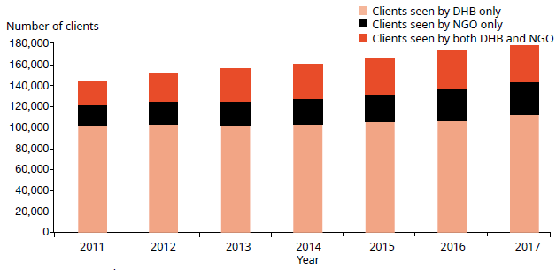
Source: PRIMHD data

Most people access mental health and addiction services in the community. In 2017:
- 92 percent of specialist service users accessed only community mental health and addiction services
- less than 1 percent accessed only inpatient services
- the remaining 8 percent accessed a mixture of inpatient and community services (see Figure 2).

The proportion of people who received treatment only in the community increased by 6 percent between 2002 (when it was 86 percent) and 2017.

Figure 2: Percentage of service users accessing only community services, 1 January to 31 December 2017
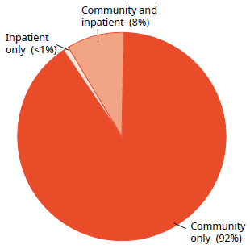
Note: Includes NGOs.
Source: PRIMHD data as at 15 August 2018

The Mental Health Act
The Mental Health Act defines the circumstances in which people may be subject to compulsory mental health assessment and treatment. It provides a framework for balancing personal rights with public interests when a person poses a serious danger to themselves or others due to mental illness.

The long title of the Act states that its purpose is to:
redefine the circumstances in which and the conditions under which persons may be subjected to compulsory psychiatric assessment and treatment, to define the rights of such persons and to provide better protection for those rights, and generally to reform and consolidate the law relating to the assessment and treatment of persons suffering from mental disorder.

The ‘Ensuring service quality’ section of this report provides data on the use of the Mental Health Act.

Administration of the Mental Health Act
The chief statutory officer under the Mental Health Act is the Director of Mental Health, appointed under section 91 of that Act. The Director is responsible for the general administration of the Mental Health Act under the direction of the Minister of Health and Director-General of Health. The Director is also the Chief Advisor, Mental Health, and is responsible for advising the Minister of Health on mental health issues. The Director’s functions and powers under the Mental Health Act allow the Ministry to provide guidance to mental health services.

In each DHB, the Director-General of Health appoints a Director of Area Mental Health Services (DAMHS) under section 92 of the Act. The DAMHS is a senior mental health clinician responsible for administering the Mental Health Act within their DHB area. They must report to the Director of Mental Health every three months (quarter) regarding the exercise of their powers, duties and functions under the Mental Health Act (Ministry of Health 2012a).

Each DAMHS must appoint responsible clinicians and assign them to lead the treatment of every person subject to compulsory assessment or treatment (Ministry of Health 2012a). The DAMHS also appoint competent health practitioners as ‘duly authorised officers’ to respond to people experiencing mental illness in the community who are in need of intervention. Duly authorised officers are required to provide general advice and assistance in response to requests from members of the public and the New Zealand Police. If a duly authorised officer believes that a person may be mentally disordered, are considered a danger to themselves or other people, and may benefit from a compulsory assessment, the Mental Health Act grants powers to the officer to arrange for a medical examination (Ministry of Health 2012c).

Protecting the rights of people subject to compulsory treatment

District inspectors
Although, under the Mental Health Act, the Ministry expects each DAMHS to protect the rights of people in their area, the Mental Health Act also provides for independent monitoring mechanisms. The Minister appoints qualified lawyers as district inspectors to protect people’s rights under section 94 of the Mental Health Act.

District inspectors protect specific rights and investigate alleged breaches of rights under the Mental Health Act, address concerns of family/whānau and monitor service compliance with the Mental Health Act process.

The Mental Health Act requires district inspectors to report to the DAMHS in their area within 14 days of inspecting a mental health service. It also requires them to report monthly to the Director of Mental Health (the Director) on the exercise of their powers, duties and functions. These reports provide the Director with an overview of mental health services and any arising problems.

The Office’s responsibilities in relation to district inspectors include:
- coordinating the appointment and reappointment of district inspectors
- managing district inspector remuneration
- receiving and responding to monthly reports from district inspectors
- organising twice-yearly national meetings of district inspectors
- facilitating inquiries under section 95 of the Mental Health Act
- implementing the findings of section 95 inquiries.

As at 31 December 2017, there were 35 district inspectors throughout New Zealand. A list of current district inspectors is available on the Ministry of Health’s website (health.govt.nz) under Mental Health District Inspectors.

Section 95 inquiries
The Director will occasionally require a district inspector to carry out an inquiry under section 95 of the Mental Health Act (Ministry of Health 2012b). Such inquiries generally focus on systemic issues across one or more mental health services. They typically result in the district inspector making specific recommendations about the mental health services and/or their system.

The Director considers the recommendations, and acts on any that have implications for the Ministry or the mental health sector. The Director later audits the DHB’s implementation of the recommendations.

The inquiry process is not completed until the Director considers that the DHB concerned and, if appropriate, the Ministry and all other DHBs have satisfactorily implemented the recommendations.

No section 95 inquiries were completed during 2017. Table 1 shows the number of completed section 95 inquiry reports received by the Director of Mental Health between 2003 and 2017.

Table 1: Number of completed section 95 inquiry reports received by the Director of Mental Health, 2003–2017
2003 | 2004 | 2005 | 2006 | 2007 | 2008 | 2009 | 2010 | 2011 | 2012 | 2013 | 2014 | 2015 | 2016 | 2017
1 | 2 | 1 | 4 | 1 | 1 | 3 | 2 | 1 | 1 | 0 | 0 | 1 | 2 | 0
Source: Office of the Director of Mental Health and Addiction Services records

The New Zealand Mental Health Review Tribunal
The New Zealand Mental Health Review Tribunal (the Tribunal) is a specialist independent tribunal empowered by law to review compulsory treatment orders, special patient orders and restricted patient orders. If a person disagrees with their treatment under the Mental Health Act, they can apply to the Tribunal for an examination of their condition and whether it is necessary to continue compulsory treatment. Where the Tribunal considers it appropriate, it may release the person from compulsory treatment status.

The Tribunal comprises three members, one of whom must be a lawyer, one a psychiatrist and one a community member. A number of deputy members are also appointed to each position, to act where a particular member is not available.

A selection of the Tribunal’s published cases is available online (see www.nzlii.org/nz/ cases/NZMHRT). The Tribunal carefully anonymises these cases to respect the privacy of the individuals and family/whānau involved. The intention of publication is to improve public understanding of both the Tribunal’s work and mental health law and practices.

The main function of the Tribunal is to review the condition of people in accordance with sections 79 and 80 of the Mental Health Act. Section 79 relates to people who are subject to ordinary compulsory treatment orders, and section 80 relates to the status of special patients. During the year ending 30 June 2017, the Tribunal heard 69 cases of contested treatment orders. In six cases (8.7 percent), a person was deemed fit to be released from compulsory status.

The Tribunal has a number of other functions under the Mental Health Act, including reviewing the condition of restricted patients (section 81), considering complaints when people are dissatisfied with the outcome of a district inspector’s investigation (section 75) and appointing psychiatrists authorised to carry out second opinions under the Mental Health Act (sections 59–61).

Under section 80 of the Mental Health Act, the Tribunal makes recommendations relating to special patients to the Minister of Health or the Attorney-General, who determine whether there should be a change to the patients’ legal status.

The Tribunal may also investigate a complaint if the complainant is dissatisfied with a district inspector’s investigation. If the Tribunal decides a complaint has substance, it must report the matter to the relevant DAMHS, with appropriate recommendations. The DAMHS must then take all necessary steps to remedy the matter.

For more information about the Tribunal’s activities for the year ending 30 June 2017, see Appendix 2: Additional statistics.

Activities for 2017

Mental health and addictions sector relationships
Each year, the Director of Mental Health visits the different DHBs’ mental health and addictions services. These visits give the Director an opportunity to engage with the services and understand the types of challenges that local mental health and addictions services face, while offering Ministry support and oversight.

The Office also maintains collaborative relationships with many parts of the mental health and addictions sector, attending and presenting at a large number of mental health and addictions sector meetings each year.

Cross-government relationships
The Office maintains strong relationships with other government agencies, working to support good clinical practices and person-centred services for people with mental health and addiction problems.

In 2017, the Office worked with a number of agencies on a wide range of projects, including but not limited to:
- the Youth Crime Action Plan
- the Disability Action Plan
- Traumatic Brain Injury Strategy and Action Plan
- Treatment Foster Care workshop series
- High and Complex Needs Unit governance board
- Intervention and Support project board with Department of Corrections
- Restraint and Seclusion Advisory Group/Guidelines
- the Veteran Rehabilitation Strategy
- Missing Persons project
- All Right? campaign
- Greater Christchurch psychosocial governance
- Fixated Threat Assessment Centre pilot
- the Oranga Tamariki Ministry for Children (Oranga Tamariki) model of care
- the Oranga Tamariki Gateway Assessments project and direct purchasing trial
- Taking action on fetal alcohol spectrum disorder: 2016–2019: An action plan
- improving cross-sector responses for children and youth in crisis
- the New Zealand Police-led gap analysis project
- the child wellbeing work programme.

Relationship with the Department of Corrections
The Ministry works closely with the Department of Corrections to improve health services for people detained in prisons. Offenders often have complex mental health needs that may require more intensive support than Corrections health services can give as providers of primary health care. Regional forensic psychiatry services support Corrections to access and treat offenders with complex mental health needs. Offenders may be transferred to a secure forensic mental health facility for treatment in a therapeutic environment.

Relationship with the New Zealand Police
Mental health services need to see people who come to the attention of police promptly because of possible mental health problems. Police often provide the initial response to events involving people whose mental illness may render them a danger to themselves or others. Therefore, it is important for police and mental health services to maintain collaborative relationships. During 2017, the Office continued to work with New Zealand Police to ensure that police responded appropriately to people with mental illness and their families/whānau.

Victims of crime interagency working group
Forensic mental health services have a dual role to both facilitate special patients’ rehabilitative journeys and protect members of the public, including registered victims of the special patients’ offending. The Ministry works with the Ministry of Justice; New Zealand Police; Oranga Tamariki; Department of Corrections; Ministry of Business, Innovation and Employment; Ministry of Social Development; Accident Compensation Corporation (ACC) and WorkSafe New Zealand on the victims of crime interagency working group.

Nova Trust
The Substance Addiction Act requires patients to reside at a treatment centre in order to receive compulsory treatment and other related services. Core constituents of this Act are to restore a person’s severely diminished capacity (as a result of their alcohol or substance use) while engaging in mana-enhancing practice for that individual. Nova Trust are the first ‘approved provider’ who have developed a designated nine- bed unit, called Nova Supported Treatment and Recovery (Nova STAR), to respond to the Act’s requirements. At the unit, among other things, Nova STAR will deliver medical care and oversight, cognitive assessments, remediation interventions, occupational therapy support, harm reduction and relapse prevention input.

Social initiatives
Budget 2017 planned a $100 million cross-agency contingency to trial 17 new, evidence-based mental health initiatives. The Office played a role in developing these initiatives and coordinating proposals from different services in order to identify what was most needed to improve the mental health services, particularly when engaging communities.

The Prime Minister’s Youth Mental Health Project
The Prime Minister’s Youth Mental Health Project (the Project) began in 2012, launching 26 initiatives and six key outcomes for youth mental health. It was a four-year cross-agency programme focusing on prevention and early intervention for youth aged 12 to 19 years with, or at risk of, mental health problems. The six outcomes were:
- greater knowledge of what works to improve youth mental health
- increased resilience among youth
- better access to timely and appropriate treatment and follow-up
- more support in schools, communities and health services
- early identification of mild to moderate mental health issues in youth
- better access to appropriate information for youth and their families and whānau.

In December 2016, the government’s Social Policy Evaluation and Research Unit (Superu), which focused on improving the lives of families and whānau, published The Prime Minister’s Youth Mental Health Project: Summative evaluation report (Superu 2016). This evaluation report assessed the Project progress towards its intended outcomes. The evaluation found key improvements, such as increased service capacity and access for youth. By 2016, the Project had successfully implemented all 26 initiatives in its portfolio and has reached over 180,000 youth.

The evaluation also highlighted areas needing improvement, data gaps and limitations, and the need for better coordination of initiatives amongst local services.

The Ministry took the lead on the Project, working alongside the Department of the Prime Minister and Cabinet, The Treasury, Ministry of Education, Ministry of Social Development, Ministry for Pacific Peoples and Te Puni Kōkiri. The Project has worked well to identify the needs of youth mental health and facilitate action on its initiatives. It has encouraged further cross-agency work in other areas of youth mental health, including youth with fetal alcohol syndrome.

Response to Christchurch earthquake 2011
Since the Christchurch earthquakes, the Ministry has partnered with local and central government agencies and organisations to improve support services for Cantabrians, particularly in relation to psychosocial wellbeing. The Ministry is responsible for coordinating the provision of psychosocial support and providing the required health services by funding, planning, and contracting services.

The Ministry helped develop a psychosocial governance committee; a package of targeted supports; a boost in the number of primary and community mental health services, information services and workforce wellbeing support; and extended the successful All Right? mental health and wellbeing promotion campaign.

A $28 million programme will be implemented over the next three years, aiming to allocate one mental health worker to every 500 primary- and intermediate-aged school children in Canterbury. The children will receive specialist support that is individualised to their needs, and it is hoped that children will in future feel more comfortable asking for help.

Response to Kaikoura earthquake 2016
In 2017, the Ministry approved $3.76 million to assist Kaikoura and Marlborough after the earthquake in November 2016. The budget was used to provide free or subsidised GP visits until May, increase mental health services, hire additional health practitioners (including mental health experts) and pay for the balance of the Kaikoura Health Te Hā o Te Ora health centre. Further, the All Right? campaign was extended to include the Marlborough region.

The Ministry provided oversight of the Psychosocial Recovery Plan for 2017 by establishing a cross-sectoral psychosocial steering group. The Psychosocial Recovery Plan was developed to deliver a comprehensive and coordinated approach to addressing psychosocial needs in the recovery phase of the Kaikoura earthquake. This may include providing basic, universal services and security; community and family supports; focussed supports; and specialist services. The steering group promotes and monitors the psychosocial recovery and wellbeing of the people of the Hurunui and Kaikoura districts; identifies gaps and, where possible, solutions; and provides advice and guidance to other components of the plan.

Fixated Threat Assessment Centre pilot
Research conducted in 2014 found that, of 102 New Zealand’s Members of Parliament (MPs) surveyed, 87 percent report various forms of harassment, stalking, threats and attacks (Dr Every-Palmer et al 2015). The researchers suggested the establishment of a New Zealand Fixated Threat Assessment Centre (FTAC).

In 2017, the Office, in conjunction with Capital & Coast DHB, New Zealand Police and Parliamentary Services, commenced the FTAC pilot. The pilot aims to test whether or not this mechanism can reliably identify and manage potential fixated and threatening behaviour of people who are presenting as a risk to people in public office.

FTAC uses a prevention framework, which involves a focus on the underlying causes of behaviour by looking beyond single incidents, and engages mental health services or other interventions earlier. International research has found that there is a high rate of mental health problems among people whose fixated behaviour is posing a risk to themselves or others. Often it is the fixated person themselves who experiences the most harm. Therefore, an important aspect of the FTAC is early engagement with mental health services if necessary, to ensure that the person is offered the help they need. In May 2018, the pilot was extended until 28 December 2018.

Let’s get real
In 2008, the Ministry developed Let’s get real; a knowledge, skills, values and attitudes framework for anyone working in mental health and addiction services. Let’s get real aims to strengthen the way in which health services are able to support people and families and whānau experiencing mental health and addiction, regardless of what health service they are accessing. Services, education providers and professional bodies can use the framework to identify the essential knowledge and skills required in the workforce. Since its inception, Te Pou o te Whakaaro Nui (Te Pou), a national centre for addiction, disability and mental health workforce development, has provided ongoing support to organisations using Let’s get real in developing appropriate tools and resources.

In 2017, Te Pou led a refresh of Let’s get real. This refresh has been a priority of the Mental Health and Addiction Workforce Action Plan 2017–2021 (see Ministry of Health 2018b). The refresh process included an e-survey, focus groups and a draft framework for consultation. The feedback and results were published in Let’s get real (2018) and are available for organisations to use. You can read more about Let’s get real at: www.tepou.co.nz/initiatives/lets-get-real/107

Equally Well
Service users of specialist mental health and addiction services have higher rates of premature mortality, two-thirds of which are a result of preventable and treatable physical health issues (Cunningham et al 2014). Following an evidence review conducted by Te Pou, a consensus position paper coordinated by Te Pou (in consultation with other organisations), and a hui, the Equally Well collaboration formally commenced in 2014. More than 120 organisations formally endorsed the consensus position paper, committing to actions in their spheres of influence.

Equally Well is a collaborative group of organisations and individuals with a common goal of reducing physical health disparities of those who experience mental health and addiction conditions. The collaborative comprises a diverse range of stakeholders, including service users, family and whānau, psychiatrists, general practitioners, support workers, pharmacists, public health physicians, academics, funders and planners, policymakers, and more.

The Ministry has included actions to address the Equally Well goal in the New Zealand Diabetes Strategy (Living Well with Diabetes: 2015–2020 – see Ministry of Health 2015a) and the updated Cardiovascular Disease Risk Assessment and Management for Primary Care guide (Ministry of Health 2018a). For the past three years, the Ministry has been conducting an evidence review to inform the update of primary health care guidance on the risk assessment and management of cardiovascular disease.

Mental health was a priority area in the literature review and as a result of the greater risk and under-management of cardiovascular disease in people with mental health and addiction issues. The updated guidance reminds clinicians that the current risk assessment algorithms that are available will underestimate the risks for this patient population.

In 2017, the Ministry launched a five-year quality improvement programme for mental health and addiction services, led by the Health Quality and Safety Commission New Zealand (HQSC). Maximising the physical health of people with mental health and addiction problems is one of the five priority areas of quality improvement. The HQSC will be setting out their action plan in this area early in 2019.

The Office will be working to support the rest of the Ministry to address this health inequity and to provide leadership to the mental health and addiction sector to maximise the physical health of people with mental health and addiction problems.

Strategies for suicide prevention in New Zealand
As the New Zealand Suicide Prevention Strategy 2006–2016 (see Associate Minister of Health 2006) was nearing its end, the Ministry developed a draft suicide prevention strategy on behalf of and with input from other government agencies. A Strategy to Prevent Suicide in New Zealand: Draft for public consultation (Ministry of Health 2017a) was publicly consulted on between 12 April and 26 June 2017.

During the public consultation period, over 300 people attended 15 public consultation meetings around the country, and almost 500 substantive submissions were received. Copies of the submissions received and a draft summary of the submissions will inform the way forward for suicide prevention and have been provided to the Mental Health and Addiction Inquiry.

LifeKeepers
In September 2017, LifeKeepers, a suicide prevention training programme, was officially launched. LifeKeepers was created by Le Va, and is funded by the Ministry. LifeKeepers combines evidence-based practices with local knowledge and experience to provide a community-focused, clinically safe and culturally responsive programme.

LifeKeepers is designed for people who work in communities and frontline roles and is available nationwide and free of charge to New Zealand adults who are likely to interact with people at risk of suicide.

Waka Hourua
In 2014, the Ministry contracted Te Rau Matatini, the national centre for Māori Health, Māori workforce development and excellence, and Le Va to establish a national Māori and Pacific community suicide prevention programme called Waka Hourua. The aim of Waka Hourua is to build the capacity and capability of Māori and Pacific communities to prevent suicide.

Governance for Waka Hourua is provided by the Waka Hourua Leadership Group. The Ministry, including the Office, is represented as observatory members on this group.

The work of Waka Hourua continued throughout 2017.

Human Rights and the Mental Health Act: Action 9(d) of the Disability Action Plan 2014–2018
In partnership with Balance Aotearoa, the Office led Action 9(d) of the Disability Action Plan 2014–2018 (see Office for Disability Issues 2015), to ‘explore how the Mental Health (Compulsory Assessment and Treatment) Act 1992 relates to the New Zealand Bill of Rights Act 1990 and the CRPD (the Convention on the Rights of Persons with Disabilities)’. This project was developed in response to the United Nations Committee on the Rights of Persons with Disabilities’ concerns over the Mental Health Act’s compliance with the CRPD.

In February 2017, a discussion document was released to consult targeted populations who have been directly involved with the Mental Health Act; service users/tangata whaiora (people seeking wellness), family/whānau, clinicians and services, academics and researchers, agencies and organisations involved with the health sector. The discussion document gathered comprehensive perspectives and knowledge in order to understand the breadth of the Mental Health Act’s impact on those affected by it.

Action 9(d) was completed and the findings were reported back to Ministers in July 2017. The key issues and concerns raised as a result of Action 9(d) are as follows:
- The Mental Health Act is inconsistent with our human rights obligations under the CRPD and the Bill of Rights Act 1990.
- There needs to be increased recognition of the views and preferences of service users/tangata whaiora.
- There must be informed consent.
- Service users need greater choice in treatment options – not just medication.
- There is a lack of access to early intervention services.
- There is conflict between a ‘recovery model’ of mental health and the culture of risk avoidance/management.
- Services need to improve family/whānau consultation.
- We need to strengthen cultural responsiveness, competency and assessment, including kaupapa Māori approaches.
- There must be greater priority given to reducing and eliminating seclusion and restraint.

The findings will inform existing work programmes as well as new work to ensure the rights of service users/tangata whaiora are promoted. The work will involve ongoing engagement with service users/tangata whaiora, the health sector, independent monitoring agencies and other organisations.

You can read more about the summary of submissions on the Mental Health Act and human rights at the Ministry of Health’s webpage Mental Health and human rights – an assessment: health.govt.nz/our-work/mental-health-and-addictions/mental-health/mental-health-and-human-rights-assessment

Guidelines

Special patient guidelines
In 2017, the Ministry released Special Patients and Restricted Patients: Guidelines for Regional Forensic Mental Health Services (Ministry of Health 2017b). The guidelines are intended to support forensic mental health services to work effectively with the Office in treating special and restricted patients under part 4 of the Mental Health Act. More specifically, they aim to:
- provide clarity and reduce frustration for forensic mental health services by facilitating the smooth processing of requests from those services
- establish a commitment from the Office to process requests within defined timeframes
- provide transparency around the processes that need to be undertaken when seeking leave or considering a change of status for special patients.

More information about special, and restricted patients can be found on page 56 of this report.

Night safety procedures
During 2017, the Office worked to develop the Night Safety Procedures: Transitional Guideline (Ministry of Health 2018c). Night safety procedures include locking a patient in their bedroom overnight for safety purposes. Such a practice has been ruled as having no therapeutic function and constitutes a use of force.

While only two DHB forensic services use night safety procedures, and only in their medium secure inpatient units, the night safety guidelines from 1995 are considered no longer fit for purpose or aligned with a human rights approach to mental health care. It is anticipated that night safety procedures will be eliminated by 30 December 2022.

Section 65 of the Land Transport Act 1998
During 2017, the Ministry worked together with the New Zealand Transport Agency (NZTA), Matua Raḵi (the national centre for addiction workforce development), dapaanz (the association representing the professional interests of practitioners working in addiction treatment) and the Ministry of Transport to update the standard operating procedures (SOPs) for section 65 of the Land Transport Act 1998 (the LTA).

Section 65 of the LTA provides for the mandatory disqualification of drivers’ licences and assessment for repeat offenders. That is, people who have driven repeatedly whilst inebriated and are convicted by the courts may undergo an indefinite disqualification of their licence. To reinstate their licence, they must attend an assessment centre and undergo an assessment of how well they are managing their substance use or addictive behaviour issues. The assessment centres send copies of the reports to NZTA, who may or may not reinstate the person’s licence, depending on the assessment centres’ recommendations.

The SOPs provide a framework for assessing a person’s alcohol and other drug use in relation to the risk of them re-offending because of impaired driving. These SOPs can be found on the Ministry’s website at: health.govt.nz/publication/assessing-fitness-drive-people-sentenced-under-section-65-land-transport-act-1998-standard-operating.

The Director-General of Health approves assessment centres. Establishments and individuals applying to be an approved assessment centre must demonstrate that they are competent in assessing alcohol and other drug problems. The applicant for approval must:
- hold full registration as a registered alcohol and drug practitioner with the dapaanz or be a Fellow of the Australasian Chapter of Addiction Medicine of The Royal Australasian College of Physicians
- have at least three years supervised experience working as a practitioner in the assessment and treatment of addictive behaviours
- hold a qualification equivalent to or greater than the New Zealand Qualifications Framework level 7 qualification related to assessing and/or treating addictive behaviours, particularly substance use disorders.

The rationale for requiring minimum criteria to become an assessment centre are:
- to ensure that clients receive an honest and accurate reflection of their readiness to have their licence reinstated
- if the client came back through the courts for driving under the influence, assessment centres must be able to provide evidence supporting their decision to have that client’s licence reinstated.

Appointment of statutory roles

District inspectors under the Mental Health Act
District inspectors are appointed under section 94 of the Mental Health Act. As mentioned earlier, they uphold the rights of patients who are subject to compulsory assessment and treatment under the Mental Health Act. District inspectors hold office for a three-year term. In 2017, an appointment round for district inspectors was held as all 33 warrants were due to expire in June 2017. The appointment round saw 35 recommended district inspectors being appointed by the Minister of Health.

District inspectors under the Substance Addiction Act
District inspectors are also appointed under section 90 of the Substance Addiction Act. These inspectors perform similar duties in that they uphold the rights of patients who are subject to compulsory assessment and treatment under the Substance Addiction Act. They too hold office for a three-year term. In 2017, the Minister of Health appointed all 10 recommended district inspectors. In 2018, a further seven district inspectors were appointed.

Directors of Area Addiction Services under the Substance Addiction Act
Director of Area Addiction Services (area directors) are appointed under section 89 of the Substance Addiction Act. Area directors are experienced addiction treatment professionals who hold a senior role within a DHB addiction treatment service. Their primary statutory obligations are the administration and clinical oversight of the Substance Addiction Act within their region.

There is no requirement for an area director to be appointed for each DHB. In 2017, the Director of Addiction Services appointed nine area directors. A Gazette notice states each appointee and the areas for which they are responsible.

Approval of opioid substitution treatment services
The Ministry invests in opioid substitution treatment (OST) to ensure people with opioid dependence have access to a comprehensive treatment package that provides them with the opportunity to recover their health and wellbeing.

The Director of Mental Health, acting under delegated authority from the Minister of Health, designates specialist services and lead clinicians to provide treatment with controlled drugs to people who are dependent on controlled drugs, pursuant to Section 24(7)(b) of the Misuse of Drugs Act 1975. A Gazette notice will specify the service and lead clinician, and any conditions attached to the approval, including the expiry of that Gazette notice (usually every three years). On 31 December 2017, the Gazette notices of 18 services and lead clinicians were due to expire, all of whom reapplied.

The Ministry has worked closely with providers and services throughout New Zealand, across all the processes involved with designating specialist services and lead clinicians, as well as guidelines issued to OST. Notably, the National Association of Opioid Treatment Providers (NAOTP) has provided invaluable leadership, advice and support to OST services.

Further information about OST services can be found in this report under ‘Specialist treatment regimes: Opioid substitution treatment’ on page 70 or on the Ministry’s website.

Office of the Auditor-General performance audit
In May 2017, the Office of the Auditor-General (the OAG) carried out a performance audit, the results of which contributed to their report Mental Health: Effectiveness of the planning to discharge people from hospital (OAG 2017).

The performance audit focused on the relatively few people who are most unwell with mental health problems and require a high level of care, including care in an inpatient unit. The audit considered whether:
- planning for these people’s discharge from an inpatient unit to community care was completed as intended
- the needs identified by discharge planning were followed up after discharge
- discharge planning was helping to improve outcomes for people with acute mental health problems.

The audit covered a cohort of 20,000 people aged 20–64 years who had at least one acute mental health admission to a hospital during the four years from 2011/12 to 2014/15. The audit did not include primary mental health services; services for children, youth and older people; forensic mental health services; or those who only accessed addiction services or community mental health services. Various techniques were used, including data analysis, 110 case file reviews, 150 interviews, a survey of DHB staff and a workshop with Canterbury DHB staff. The final report also drew on stories submitted to the People’s Mental Health Report (Elliott 2017).

The OAG report recognised that there are pressures on parts of the mental health system and support services that demand urgent attention and, potentially, innovative solutions. The report made a set of recommendations regarding discharge planning. It recommended that DHBs:
1. urgently find ways for inpatient and community mental health teams to work together more effectively to prepare and implement discharge plans, ensuring that all relevant people (the person to be discharged, family, other carers and all service providers) are appropriately involved and informed
2. help staff by improving the guidance and tools to support discharge planning (including information systems) so that the necessary information can be accessed and compiled efficiently
3. regularly review the standard of discharge planning and follow-up work to identify issues and make improvements.

The report further recommended that the Ministry and DHBs:
4. quickly make improvements to how they use information to monitor and report on outcomes for mental health service users
5. use the information from this monitoring to identify issues and make service improvements.

Ensuring service quality
As a sector, we are working to get better mental health and addiction care to more people sooner. Central government, DHBs, NGOs, Crown entities, international bodies (such as the United Nations and the World Health Organization (WHO)) and independent watchdogs (such the Office of the Ombudsman and district inspectors) collaborate to achieve this goal.

Actively monitoring the performance of DHBs and NGOs and gathering their feedback and data is vital to ensuring service quality and safety. The Ministry – and the wider government – sets goals and targets for the health sector that are aimed at improving outcomes for the people who use mental health services. Reporting from the health sector is integral to this process, as it allows the Ministry to measure progress against these goals.

This section presents statistics on multiple mental health indicators concerned with general mental health service use, as well as compulsory care under the Mental Health Act.

Statistics cover consumer satisfaction, waiting times, transition plans, the Mental Health Act, Māori and the Mental Health Act, family/whānau consultation and the Mental Health Act, seclusion in inpatient units, special patients, serious adverse events, ECT, OST and the Alcoholism and Drug Addiction Act 1966.

Specialist mental health and addiction services

Consumer experience
Since 2006, the Ministry has conducted national consumer satisfaction surveys for mental health and addiction service users as one measurement of DHB service quality and consumer outcomes. Survey participants have received treatment from specialist mental health and addiction community services in DHBs around New Zealand.

In 2006, half the DHBs in New Zealand participated in the survey, providing a total of 596 respondents. In 2015, there was a shift in method from paper-based survey to the Mārama electronic real-time survey, developed by CBG Health Research for the Health and Disability Commissioner. In the 2017/18 financial year, the paper-based survey was discontinued completely. Mārama, which is collated on a calendar-year basis, had 15 DHBs participating in real-time surveys, with 5,177 responses in the 2017 calendar year.

Survey results
In the 2017 calendar year, 83 percent of those surveyed agreed or strongly agreed that they ‘would recommend this service to friends and family if they needed similar care or treatment’ (see Figure 3).

Figure 3: Responses to the statement ‘I would recommend this service to friends and family if they needed similar care or treatment’, 1 January to 31 December 2017
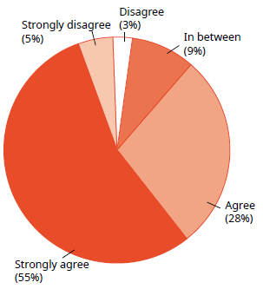
Source: Mārama real-time feedback system, 2017 calendar year

Previous annual reports published the results of the paper-based National Mental Health Consumer Satisfaction Survey. However, that survey has been phased out since the Mārama real-time feedback system was established, and the questions have changed. The new questions may be described in the 2018 annual report.

Waiting times
Waiting times are a measure of how long new clients wait to be seen by mental health and addiction services. New clients are defined as people who have not accessed mental health or addiction services in the past year. Waiting time is reflected as the length of time from the day mental health and addiction services receive a referral to the day the person first receives a service.

A sector-wide target for DHBs specified that mental health or addiction services should see 80 percent of people referred for services within three weeks, and 95 percent within eight weeks. Some referrals must be seen within 48 hours. In the 2017 calendar year, 47.2 percent of people new to mental health services were seen within 48 hours.

DHB-provided services saw 78 percent of all mental health service clients within three weeks and 93 percent within eight weeks (see Figure 4). Combined, DHB and NGO addiction services saw 82 percent of clients within three weeks and 94 percent within eight weeks (see Figure 5).

Figure 4: Percentage of people seen by mental health services within three weeks (left) and within eight weeks (right), 1 January to 31 December 2017
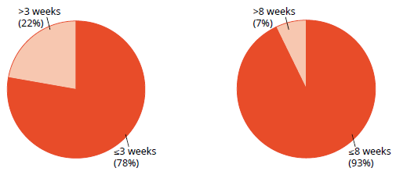
Source: PRIMHD data as at 18 June 2018

Figure 5: Percentage of people seen by addiction services within three weeks (left) and within eight weeks (right), 1 January to 31 December 2017
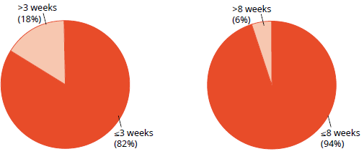
Source: PRIMHD data as at 18 June 2018

Transition (discharge) plans
In 2014, the Ministry introduced a target of ensuring at least 95 percent of all people who have used mental health and addiction services have a transition (discharge) plan. Transition planning aims to ensure that:
- service provision is matched as closely as possible to the needs of individuals and is delivered by the most appropriate services
- individuals and their families/whānau are the key decision-makers regarding the services they receive
- care is delivered across a dynamic continuum of specialist- and primary-health- care-level services and decisions are based on the needs and wishes of individuals and their families/whānau (not service boundaries)
- processes are in place to identify and respond early should individuals experience a reemergence of a mental health or alcohol and other drugs (AOD) concern.

Following the 2016 Office of the Auditor General audit, the Ministry is required to report on the number of transition plans at discharge from inpatient services. The 95 percent goal is an important measure to support work being undertaken by the HQSC to improve mental health and addiction services. This work has a particular focus on improving service transitions.

Figure 6 shows the percentage of all service users with a transition plan as at 31 December 2017, but only by DHB. In 2017, the reporting requirements for transition plans changed. Further, DHBs have different reporting systems, and some DHBs work with NGOs to streamline care and reintegration for the service user. For these reasons, it has not been feasible to collect all the transition plan data from the DHBs yet. Moreover, this means that Figure 6 is likely an underestimation of how many service users are receiving transition plans upon discharge into the community.

Figure 6: Percentage of service users with a transition plan, by DHB, 1 January to 31 December 2017
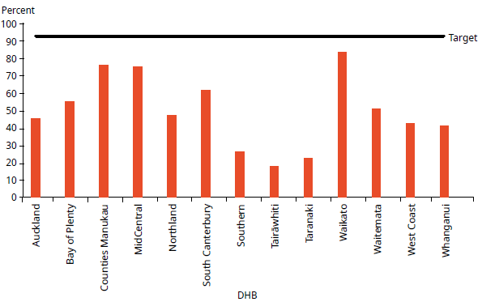
Note: DHBs that did not collect data are not included in this figure. The measures definition changed to include all adults from 1 July 2017. DHBs are working to improve their methods for gathering these data.
Source: DHB quarterly reporting data

PRIMHD also captures supplementary consumer records (SCRs), which can be seen in Figure 7. The SCRs identify and monitor the changing social and environmental factors that can affect a service user’s journey. The variables measured include accommodation, employment, education and training status and presence of a transition/wellness plan for an individual. Similar to a transition plan, a wellness plan is personalised to monitor and maintain a service user’s wellbeing while they are receiving mental health and addiction services.

Figure 7 displays the percentage of all service users with a transition/wellness plan in place in 2017, as reported by DHBs or NGOs.

Figure 7: Percentage of service users with a transition/wellness plan, 1 January to 31 December 2017
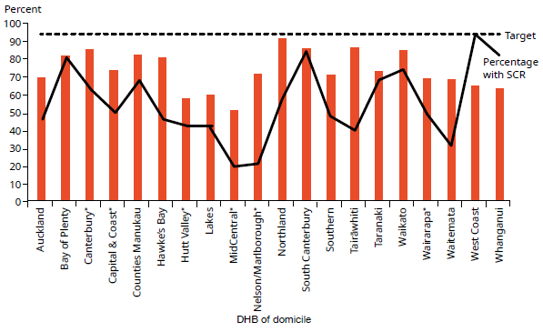
Notes: The measure definition changed to include all adults from 1 July 2017. DHBs are working to improve their methods for gathering this data. MidCentral, Capital & Coast, Hutt Valley, Canterbury, Wairarapa and Nelson Marlborough DHBs did not collect transition plan data (*); the SCR volumes relate to NGO submitted data.
Source: PRIMHD data as at 12 October 2018

The SCR percentage varies across DHBs relative to the percentage of transition plans because the collection is relatively new and not all people have transition plans.

Use of the Mental Health Act
The Mental Health Act defines the circumstances under which people may be subject to compulsory mental health assessment and treatment. In summary, in 2017:
- 10,286 people (approximately 5.8 percent of specialist mental health and addiction service users) were subject to the Mental Health Act11 on the last day of 2017, approximately 5,284 people were subject to either compulsory assessment or compulsory treatment under the Mental Health Act
- use of the Mental Health Act varied across DHBs
- males were more likely to be subject to the Mental Health Act than females
- people aged 25–34 years were the most likely to be subject to compulsory treatment, and people over 65 years of age were the least likely
- Māori were more likely to be assessed or treated under the Mental Health Act than non-Māori.

The Mental Health Act process
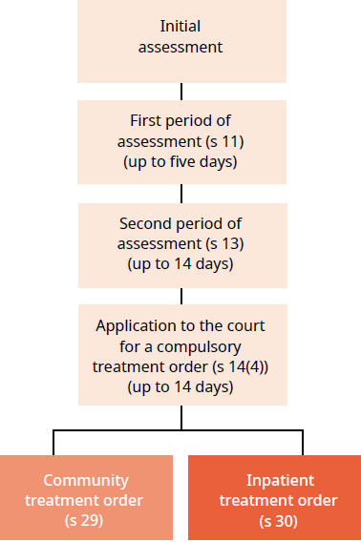
The compulsory assessment and treatment process begins with a referral and an initial assessment by a psychiatrist. If the psychiatrist believes a person fits the statutory criteria, the person will become subject to the Act and will receive further assessment accordingly.

Compulsory assessment
Compulsory assessment can take place in either a community or a hospital setting. There are two periods of compulsory assessment, during which a person’s clinician may release them from assessment at any time.

During the assessment period, a person is obliged to receive treatment as prescribed by their responsible clinician. The first period (section 11 of the Mental Health Act) is for up to five days. The second period (section 13) can last up to 14 days.

Following the first two assessment periods, a person’s responsible clinician can make an application to the Family or District Court (section 14(4)) to place the person on a compulsory treatment order.

At any time during the compulsory assessment process, the person (or someone acting on their behalf) can request a judicial review of their condition to determine whether it is appropriate that they continue to be assessed under the Mental Health Act. A judicial review consists of a hearing in the District Court. Based on information provided by clinicians, a judge will decide whether the person should continue to be compulsorily assessed.

During 2017, approximately 1,257 applications for compulsory treatment orders were considered under section 16 (review of patient’s condition by Judge) of the Mental Health Act. Of this total, an order for release from compulsory status was issued in 31 cases (4 percent of the applications that proceeded to hearings).

Compulsory treatment
There are two types of compulsory treatment orders. One is for treatment in the community (a section 29 order) and the other is for treatment in an inpatient unit (a section 30 order). A person’s responsible clinician can convert an inpatient treatment order into a community treatment order at any time. A responsible clinician may also grant a person leave from the inpatient unit for treatment in the community for up to three months (section 31).

Most people subject to compulsory treatment access that treatment in the community (approximately 87 percent in 2017).

2017 statistics
On the last day of 2017, a total of 5,284 people were subject to either compulsory assessment or compulsory treatment.

In New Zealand in each month of 2017, on average, the assessment provisions of the Mental Health Act were applied as follows.
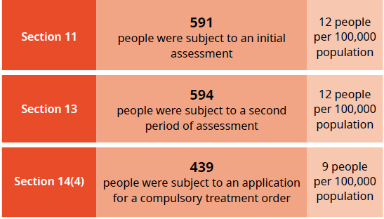

In New Zealand on a given day in 2017, on average, the treatment provisions of the Mental Health Act were applied as follows.
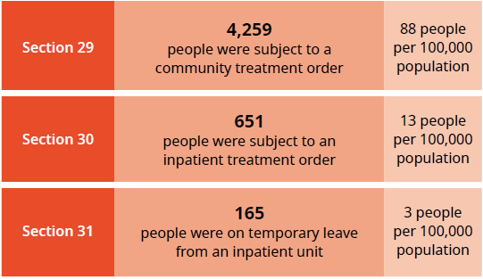

Compulsory assessment and treatment by district health board
Table 2 shows the average number of people per month in 2017 who were required to undergo assessment under the Mental Health Act, by DHB. Table 3 shows the average number of people subject to a compulsory treatment order on a given day in 2017, by DHB. Following those tables, Figures 8 and 9 present the average number of people subject to a compulsory treatment order on a given day, but focus specifically on community treatment orders (Figure 8) and inpatient treatment orders (Figure 9).

Table 2: Average number of people per 100,000 per month required to undergo assessment under sections 11, 13 and 14(4) of the Mental Health Act, by DHB, 1 January to 31 December 2017

DHB | s 11 | s 13 | s 14(4) |  | DHB | s 11 | s 13 | s 14(4)
Auckland | 14 | 16 | 11 |  | Northland | 16 | 18 | 15
Bay of Plenty | 13 | 10 | 5 |  | South Canterbury | 5 | 4 | 4
Canterbury | 11 | 11 | 9 |  | Southern | 12 | 9 | 6
Capital & Coast | 13 | 15 | 11 |  | Tairāwhiti | 9 | 10 | 7
Counties Manukau | 10 | 12 | 9 |  | Taranaki | 13 | 9 | 5
Hawke’s Bay | 13 | 10 | 7 |  | Waikato | 18 | 17 | 11
Hutt Valley | 17 | 14 | 7 |  | Wairarapa | 7 | 3 | 6
Lakes | 11 | 9 | 5 |  | Waitemata | 10 | 11 | 9
MidCentral | 15 | 13 | 13 |  | West Coast | 13 | 12 | 6
Nelson Marlborough | 9 | 9 | 13 |  | Whanganui | 11 | 9 | 6
 |  |  |  |  | National average | 12 | 12 | 9
Source: PRIMHD data, extracted on 17 August 2018, except Southern DHB and s14(4) for Auckland DHB, which submitted data manually
Table 3: Average number of people per 100,000 on a given day* subject to sections 29, 30 and 31 of the Mental Health Act, by DHB, 1 January to 31 December 2017
DHB | s 29 | s 30 | s 31 |  | DHB | s 29 | s 30 | s 31
Auckland | 104 | 9 | 1 |  | Northland | 161 | 16 | 2
Bay of Plenty | 42 | 16 | 7 |  | South Canterbury | 70 | 3 | 2
Canterbury | 65 | 19 | 7 |  | Southern | 76 | 9 | 3
Capital & Coast | 119 | 26 | 3 |  | Tairāwhiti | 151 | 7 | 2
Counties Manukau | 91 | 10 | 1 |  | Taranaki | 74 | 4 | 3
Hawke’s Bay | 160 | 17 | 16 |  | Waikato | 125 | 15 | 4
Hutt Valley | 60 | 7 | 1 |  | Wairarapa | 73 | – | –
Lakes | 124 | 6 | 5 |  | Waitemata | 70 | 12 | 2
MidCentral | 75 | 21 | 1 |  | West Coast | 86 | 4 | 1
Nelson Marlborough | 62 | 11 | – |  | Whanganui | 94 | 21 | 3
 |  |  |  |  | National average | 88 | 13 | 3
Note: * ‘On a given day’ is the average of the last day of each month.
Source: PRIMHD data, extracted on 17 August 2018, except Southern DHB, which submitted data manually

Figure 8: Average number of people per 100,000 on a given day* subject to a community treatment order (section 29 of the Mental Health Act), by DHB, 1 January to 31 December 2017
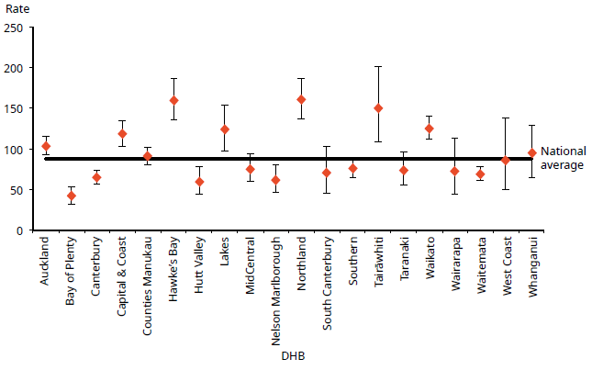
Notes: * ‘On a given day’ is the average of the last day of each month.
Confidence intervals (for 99 percent confidence) have been used to aid interpretation. Where a DHB region’s confidence interval crosses the national average, this means the DHB’s rate was not statistically significantly different from the national average.
Source: PRIMHD data, extracted on 17 August 2018, except Southern DHB, which submitted data manually

Figure 9: Average number of people per 100,000 on a given day* subject to an inpatient treatment order (section 30 of the Mental Health Act), by DHB, 1 January to 31 December 2017
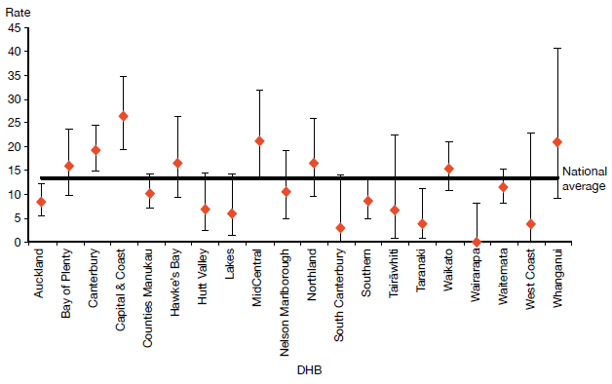
Notes: * ‘On a given day’ is the average of the last day of each month.
Confidence intervals (for 99 percent confidence) have been used to aid interpretation. Where a DHB region’s confidence interval crosses the national average, this means the DHB’s rate was not statistically significantly different from the national average.
Source: PRIMHD data, extracted on 17 August 2018, except Southern DHB, which submitted data manually

Compulsory treatment by age and sex
During 2017:
- people aged 25–34 years were the most likely to be subject to a compulsory treatment order (160 per 100,000), and people over 65 years of age were the least likely (55 per 100,000) (see Figure 10)
- males were 1.5 times more likely to be subject to a compulsory treatment order (107 per 100,000) than females (72 per 100,000) (see Figure 11).

Figure 10: Rate of people per 100,000 subject to compulsory treatment order applications (including extensions), by age group, 2004–2017
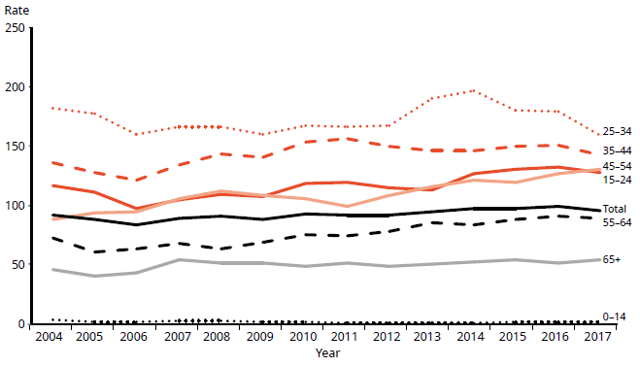
Note: This system uses data entered into the case management system (CMS). The CMS is a live operational database. Figures are subject to minor changes at any time.
Source: Ministry of Justice Integrated Sector Intelligence System as at 12 June 2018

Figure 11: Rate of people per 100,000 subject to compulsory treatment order applications (including extensions), by sex, 2004–2017
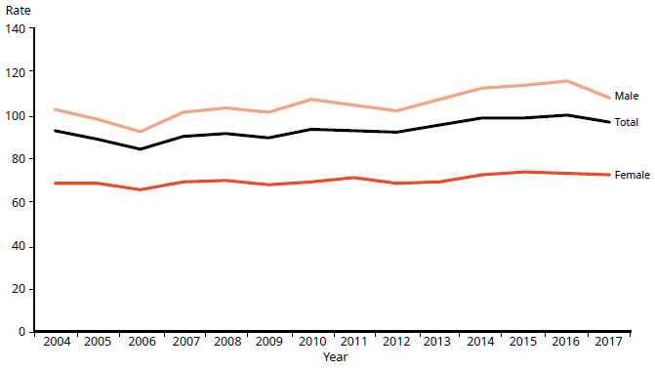
Source: Ministry of Justice Integrated Sector Intelligence System as at 12 June 2018

Māori and the Mental Health Act
This section presents statistics on Māori subject to community treatment orders and inpatient treatment orders (sections 29 and 30 respectively of the Mental Health Act) in 2017. These statistics underline the need for the mental health sector to engage in meaningful actions to address the disparity of mental health outcomes for Māori in New Zealand.

In summary, in 2017:
- Māori were 3.9 times more likely than non-Māori to be subject to a community treatment order and 3.4 times more likely to be subject to an inpatient treatment order
- Māori males were the population group most likely to be subject to community and inpatient treatment orders (compared with non-Māori males and Māori and non-Māori females)
- the ratio of Māori to non-Māori subject to community and inpatient treatment orders varied by DHB
- on average, Māori and non-Māori remained on community and inpatient treatment orders for similar periods of time.

The high rate of Māori subject to compulsory treatment orders
The high rate of Māori subject to compulsory treatment orders is a complex issue. Māori make up approximately 16 percent of New Zealand’s population, yet they account for 28 percent of all mental health service users.

The national mental health prevalence study, Te Rau Hinengaro (Oakley Browne et al 2006), showed that Māori experience the highest levels of mental health disorder overall. They are also more likely to experience serious disorders and co-morbidities than non-Māori.

In 2017, Māori access rates to services exceeded those of other groups (6.4 percent of Māori accessed mental health services in 2017, compared with 3.1 percent of non-Māori). These higher access rates are likely to be a contributing factor to higher rates of Māori under compulsory treatment orders.

Other demographic features relevant to the high rate of Māori service users include the youthfulness of the Māori population and the disproportionate representation of Māori in low socioeconomic groups. In 2017, approximately half of the total Māori service user population were under 25 years of age, compared with 30 percent of non-Māori service users.

Further, 52 percent of Māori service users under a community treatment order (ie, living in the community; section 29) live in the most deprived deciles (8–10), and 78 percent live in the higher deprived deciles (6–10). This compares with 32 percent and 61 percent, respectively, for non-Māori service users under a community treatment order.

Analysis has shown that these demographic factors do not completely account for the high rate of Māori with serious mental illness (ie, if Māori had the same age structure and level of socioeconomic privilege as people in other groups, their rates of mental disorder would still be higher) (Oakley Browne et al. 2006).

Other factors involved in the disparity
Elder and Tapsell (2013) emphasise that we need to understand more about Māori experiences with the Mental Health Act and why Māori are over-represented in compulsory treatment. They suggested that the following are important questions for the sector to consider.
- Are Māori receiving differential treatment in the mental health system?
- How can we build a more culturally competent workforce and reduce cultural bias in formulations of mental illness?

Are Māori receiving differential treatment in the mental health system?
- Are whānau of tangata whaiora being sufficiently engaged by mental health services?

Māori experiences of the Mental Health Act and acute mental health care
In June 2015, Te Rau Matatini facilitated a one-day hui with 10 tangata whaiora to better understand Māori experiences of the Mental Health Act and acute mental health care (Baker 2015).

Some tangata whaiora described using the Mental Health Act as a ‘bargaining tool’ to appease clinicians and more quickly gain release from the inpatient service in which they were receiving treatment. Others described the Mental Health Act as providing a ‘false sense of security’ in terms of access to medication. Participants also talked of:
- not understanding the compulsory assessment and treatment process
- experiencing the opposite of what clinicians advised was going to happen under the Mental Health Act
- experiencing overt discrimination in the community, such as disproportionately harsh treatment by Police and refusal of accommodation and employment, due to the stigma that continues to surround compulsory treatment orders
- struggling to be released from the Mental Health Act.

With regard to acute mental health care, tangata whaiora described its restrictive and disempowering nature, and their sense that the treatment they received was more closely aligned with the clinicians’ needs than their own. It is clear that the sector needs to actively address these issues in order to make mental health care for Māori as empowering an experience as possible.

At the hui, tangata whaiora identified a number of solutions to improve Māori experiences of mental health care, including:
- a holistic approach to service provision, incorporating tīkanga Māori (Māori customs), te reo Māori (Māori language), mātauranga Māori (Māori knowledge) and increased whānau involvement
- the provision of acute mental health care in alternative, less restrictive environments
- the formation of a national body of Māori with lived experience of mental health care to improve advocacy for tangata whaiora, increase representation of Māori consumer advisors in mental health services and influence policy and decision-making.

Māori and compulsory treatment orders, by district health board
Figures 12 and 13 show variation across New Zealand in terms of the disparities between Māori and non-Māori subject to compulsory treatment orders in 2017. With regard to community treatment orders, the Māori to non-Māori rate ratio ranged from 1.9:1 (in West Coast DHB) to 5:1 (in Counties Manukau DHB). With regard to inpatient treatment orders, the rate ratio ranged from 0:1 (in South Canterbury and Wairarapa DHBs) to 5:1 (in Waikato DHB).

These numbers are difficult to interpret, because it is hard to define an ideal rate ratio for a given population or DHB; likewise, the proportions of populations across DHBs vary greatly. However, for comparative purposes, a line of no difference has been included in the figures. The figures emphasise that we need in-depth, area-specific knowledge to understand the particular disparities around the country and what could be done at a local level to address them.

Figure 12: Rate ratio of Māori to non-Māori subject to a community treatment order (section 29) under the Mental Health Act, by DHB, 1 January to 31 December 2017
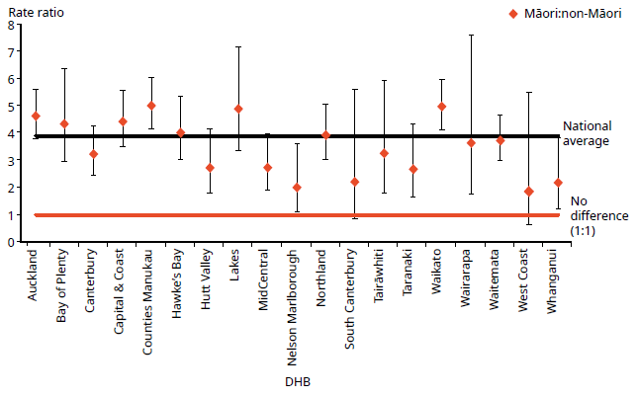
Notes: Rates per 100,000 are age standardised to account for differences in the population structures of the DHBs.
Confidence intervals (for 99 percent confidence) have been used to aid interpretation. Where a DHB region’s confidence interval crosses the national average, this means the DHB’s rate was not statistically significantly different from the national average.
Because Southern DHB submitted data manually, the rate ratio for Southern DHB was not able to be represented in the above graph. The (non-age-standardised) rate ratio for Southern DHB was 2.3.
Source: PRIMHD data, extracted on 17 August 2018, except for Southern DHB, which submitted data manually

Figure 13: Rate ratio of Māori to non-Māori subject to an inpatient treatment order (section 30) under the Mental Health Act, by DHB, 1 January to 31 December 2017
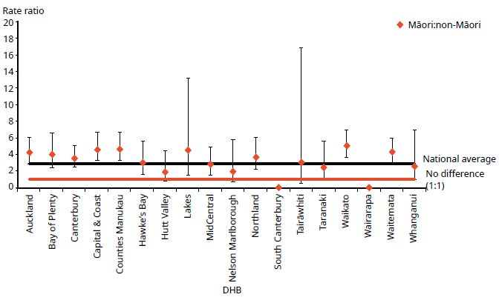
Notes: Rates per 100,000 are age standardised to account for differences in the population structures of the DHBs.
Confidence intervals (for 99 percent confidence) have been used to aid interpretation. Where a DHB region’s confidence interval crosses the national average, this means the DHB’s rate was not statistically significantly different from the national average.
Because Southern DHB submitted data manually, the rate ratio for Southern DHB was not able to be represented in the above graph. Further, because of the small population of West Coast DHB, their rates are volatile, and error bars of the resulting calculations are large, therefore, data has been omitted from the graph so as not to skew the overall results. The (non-age-standardised) rate ratios for Southern and West Coast DHB was 2.6 and 3.6, respectively.
Source: PRIMHD data, extracted on 17 August 2018, except for Southern DHB, which submitted data manually

Sex, ethnicity and compulsory treatment
In 2017, Māori males were the population group most likely to be subject to community and inpatient treatment orders. In particular, in 2017, Māori males were four times more likely to be subject to a community treatment order (section 29) than non-Māori males.

Table 4 and Figure 14 present information on age-standardised rates of community and inpatient treatment orders by sex and ethnicity.

Table 4: Age-standardised rates of Māori and non-Māori subject to community and inpatient treatment orders (sections 29 and 30 respectively) under the Mental Health Act, by sex, 1 January to 31 December 2017
 | Community treatment orders |  | Inpatient treatment orders
 | Male | Female | Male | Female
Māori | 468.2 | 217 | 144.5 | 72.4
Non-Māori | 113.4 | 59.2 | 35.9 | 24
Rate ratio Māori : non-Māori | 4.1:1 | 3.7:1 | 4:1 | 3:1
Note: Rates per 100,000 are age-standardised. Source: PRIMHD data, extracted on 17 August 2018.

Figure 14: Age-standardised rates of Māori and non-Māori subject to community and inpatient treatment orders (sections 29 and 30 respectively) under the Mental Health Act, by sex, 1 January to 31 December 2017
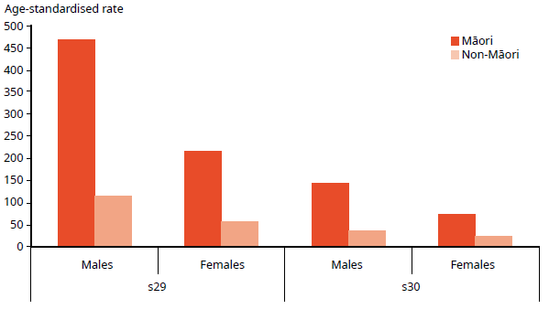
Note: Rates per 100,000 are age-standardised (ASR).
Source: PRIMHD data, extracted on 17 August 2018

Length of time spent subject to compulsory treatment orders
On average, Māori and non-Māori remain on compulsory treatment orders for a similar amount of time (see Figure 15). For community treatment orders commenced between 2009 and 2015, 80 percent of Māori and 81 percent of non-Māori were subject to the order for less than a year. For inpatient treatment orders commenced between 2009 and 2015, 96 percent of Māori and 97 percent of non-Māori were subject to the order for less than a year.

Figure 15: Length of time spent subject to community and inpatient treatment orders (sections 29 and 30) under the Mental Health Act for Māori and non-Māori,
2009–2015
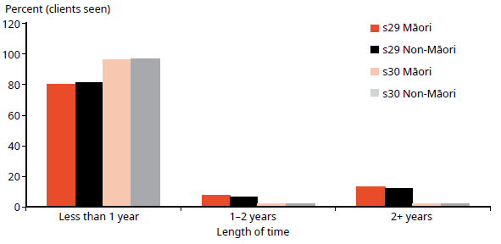
Note: The data refers to treatment orders started between 2009 and 2015. 2015 is the most recent year referred to in this figure, as this analysis requires at least two years to have elapsed to determine the number of people who have remained on a treatment order for two or more years.
Source: PRIMHD data, extracted on 17 August 2018

Future focus
Reducing the disparity of Māori mental health outcomes continues to be a priority for the Ministry (Ministry of Health 2012e). Publishing data on the rate of Māori subject to compulsory treatment is just one aspect of what needs to be a wider conversation around Māori over-representation in compulsory assessment and treatment under the Mental Health Act.

The Office will continue to work alongside DHBs and other Ministry and government groups to ensure that the best possible mental health outcomes are being sought for Māori in New Zealand.

Family/whānau consultation and the Mental Health Act
In 1999, Parliament made an amendment to the Mental Health Act that required clinicians to consult family/whānau at particular junctures of a person’s compulsory assessment and treatment under the Mental Health Act. Section 7A of the Act requires a mental health service to consult unless it is deemed not reasonably practicable, or not in the interests of the person being assessed or receiving the treatment.

In summary, in 2017:
- on average nationally, 60 percent of families/whānau were consulted about Mental Health Act assessment/treatment events
- of all the steps in the Mental Health Act treatment process, family/whānau were most likely to be consulted at a person’s certificate for further assessment (section 12)
- family/whānau consultation varied by DHB
- the most common reason family/whānau were not consulted was that service providers deemed consultation not reasonably practicable in the particular circumstance.

Purpose of family/whānau consultation
The purpose of family/whānau consultation is to:
- strengthen family/whānau involvement in the compulsory assessment and treatment process
- enhance the family/whānau contribution to the person’s care
- address family/whānau concerns about information sharing and treatment options
- facilitate ongoing family/whānau involvement in Mental Health Act processes, such as clinical reviews of treatment or Court hearings (Ministry of Health 2012d).

In 2006, the Ministry published a review of section 7A of the Mental Health Act, following concerns that mental health services were not carrying out the required consultation adequately (Ministry of Health 2006). The review made a number of recommendations, including:
- revision of the relevant section in Guidelines to the Mental Health Act (Ministry of Health 2012d)
- better training and resources for clinicians
- development of information and opportunities to involve family/whānau in the compulsory assessment and treatment process
- the establishment of nationwide reporting on section 7A consultation.

This is the fourth year that national data on the application of section 7A has been included in this report. We have included it in the hope that its publication will emphasise the importance of family/whānau consultation, bring greater transparency and accountability to DHB efforts to involve family/whānau, and further encourage a culture of family/whānau involvement in mental health treatment.

Definition of family/whānau
Definitions and understandings of family/whānau vary and are informed by different cultural backgrounds and practices. Almost always, the most important perspective for defining family/whānau is that of the person. Therefore, family/whānau is not limited to blood ties but may include partners, friends and others in a person’s wider support network (Ministry of Health 2012d).

District health board reporting of family/whānau consultation
The Ministry requires DHBs to report on family/whānau consultation across five different assessment/treatment events in the Mental Health Act process. These events are listed below.

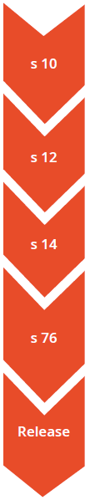 | Preliminary assessment  The clinician makes a preliminary assessment, including as to whether the person should undergo the initial five-day period of assessment under s 11.  Further assessment  After an initial assessment period of five days, the clinician decides whether the person should undergo a further two-week period of assessment under s 13.  Final assessment  After the second period of assessment, the clinician decides whether the person should be placed on either a community treatment order or an inpatient treatment order.  Review  If a person has been placed on a compulsory treatment order, the clinician conducts a review no later than three months after it was put in place to see whether it should remain. Thereafter, the clinician reviews the order at intervals no longer than six months.  Release  If at any time while the compulsory treatment order is in place, the clinician considers that the person no longer requires compulsory treatment, they can direct release with immediate effect.

Across all DHBs in 2017, the highest rate of family/whānau consultation occurred during the person’s certificate for further assessment (section 12 – 68 percent).

Figure 16 shows the percentage of cases in which family/whānau consultation occurred at this and other points in the assessment/treatment process in 2017.

Figure 16: Average national percentage of family/whānau consultation for particular assessment/treatment events, 1 January to 31 December 2017
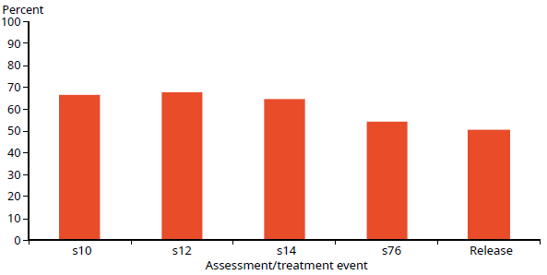
Note: Waitemata DHB does not record section 7A family/whānau consultation data.
Source: Office of the Director of Mental Health and Addiction Services records

Nationally during 2017, the average percentage of cases in which family/whānau consultation occurred across all assessment/treatment events was 60 percent (see Figure 17). West Coast DHB had the highest rate of consultation, at 100 percent, and Canterbury DHB had the lowest, at 29 percent.

Figure 17: Average percentage of family/whānau consultation across all assessment/ treatment events, by DHB, 1 January to 31 December 2017
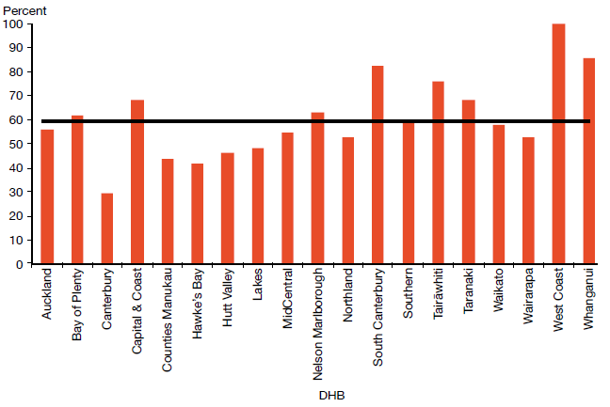
Note: Waitemata DHB does not record section 7A family/whānau consultation data.
Source: Office of the Director of Mental Health and Addiction Services records

Reasons for not consulting family/whānau
During 2017, the most common reason DHBs gave for not arranging family/whānau consultation was that it was not reasonably practicable (60 percent). This was followed by ‘not in the best interests of the person’ (6 percent), ‘no for another reason’ (6 percent), and ‘don’t know’ (28 percent) (see Figure 18).

Figure 18: Reasons for not consulting family/whānau, 1 January to 31 December 2017
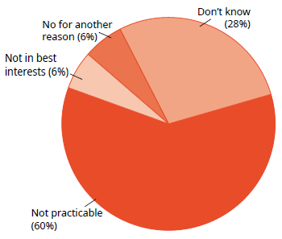
Note: Waitemata DHB does not record section 7A family/whānau consultation data.
Source: Office of the Director of Mental Health and Addiction Services records

Seclusion
Standards New Zealand (2008a) defines seclusion as a situation ‘Where a consumer is placed alone in a room or area, at any time and for any duration, from which they cannot freely exit’ (page 30). Seclusion should be an uncommon event, and services should use it only when there is an imminent risk of danger to the individual or others and no other safe and effective alternative is possible.

In March 2018, the HQSC in partnership with Te Pou launched a national collaborative project called ‘Zero Seclusion: towards the elimination of seclusion by 2020. In collaboration with DHBs, service providers and tangata whaiora, the zero seclusion project takes a recovery approach that encompasses a strong focus on the role of consumers, families, and whānau. The project uses quality improvement methods to test and implement evidence-based strategies to reduce and eliminate the use of seclusion.

It should be reiterated that the data presented in this annual report is drawn from the 2017 calendar year, which preceded the announcement of the zero seclusion project. Therefore, in this report we present seclusion data that will help inform the zero seclusion project.

Adult inpatient services are distinct from forensic services, youth services, intellectual disability services and services for older people. Patients can receive treatment under a different service to that of their legal status. The Ministry is working to capture seclusion clearly, though it overlaps between legal status and service.

For this report, the mental health services’ seclusion data (ie, adult inpatient services) includes seclusion data of patients who have a legal status under the Mental Health Act but are treated within the Regional Intellectual Disability Secure Services (RIDSS). The reason for this is because seclusion reported under the Intellectual Disability (Compulsory Care and Rehabilitation) Act 2003 (IDCC&R Act), is reported by statute only (ie, by legal status), not by the service.

The following seclusion data has purposely excluded an outlier – a high proportion of Capital & Coast DHB’s recorded seclusion hours pertain to a single client due to the method the DHB was using to record its data (Capital & Coast DHB has now changed its method for collecting seclusion data to record much of the time outside seclusion). For this reason, Capital & Coast DHB’s 2017 data is not directly comparable with its data from previous years. This change is being closely monitored by the Director of Mental Health and the Office of the Ombudsman. For more information about this outlier data, please see Appendix 2: Additional statistics.

In summary, in adult inpatient services in 2017:
- the total number of people who experienced seclusion while receiving mental health treatment in an adult inpatient service has decreased by 28 percent since 2009
- the total number of hours spent in seclusion has decreased by 59 percent since 2009
- although the number of clients decreased by 3 percent in 2017, the number of hours spent in seclusion increased by 8 percent
- males were twice as likely as females to have spent time in seclusion in 2017
- people aged 20–24 years were more likely to have spent time in seclusion than those in any other age group
- Māori were more likely than non-Māori to have been secluded, have greater numbers per 100,000 population of seclusion events, and of greater average duration
- the number of seclusion events per 1,000 inpatient bed nights was 6.3.

The Health and Disability Services (Restraint Minimisation and Safe Practices) Standards came into effect on 1 June 2009 (Standards New Zealand 2008b). Their intent is to ‘reduce the use of restraint in all its forms and to encourage the use of least restrictive practices’. In addition, reducing (and eventually eliminating) seclusion is one of the goals of the Ministry’s service development plan Rising to the Challenge (Ministry of Health 2012e).

Section 71 of the Mental Health Act relates to seclusion. It states that seclusion can only occur where, and for as long as, it is necessary for the care or treatment of the person, or for the protection of other people.

Seclusion rooms must be designated by the relevant DAMHS and can be used only with the authority of a person’s responsible clinician. Clinicians must record the duration and circumstances of each episode of seclusion in a register that must be available for district inspectors to review. Seclusion should never be used for discipline, coercion, staff convenience, or as a substitute for adequate levels of staff or active treatment.

The Ministry’s revised guidelines on seclusion (Ministry of Health 2010) identify best practice methods for using seclusion in mental health inpatient units. These guidelines aim to progressively decrease and limit the use of seclusion.

Te Pou supports the national direction set by the Ministry for seclusion reduction using evidence-based information, such as the ‘Six Core Strategies’ of the National Technical Assistance Centre (Huckshorn 2005). Te Pou works with DHBs to support their local initiatives. Further information, statistics and stories about emerging good practice can be found on the website for Te Pou (tepou.co.nz).

Changes in seclusion use
Most services in New Zealand, having successfully employed best-practice strategies to reduce their use of seclusion, are working through a re-planning phase in which they are refining and refocusing seclusion reduction initiatives. In addition, since 2009, efforts have focused on improving the way seclusion is reported; this may partially explain the general steadying of seclusion rates.

Figures 19 and 20 show a decrease in the number of people secluded in adult inpatient services, and in the total number of seclusion hours since 2007.

Between 2009, when the seclusion reduction policy was introduced, and 2017, the total number of people secluded in adult inpatient services nationally decreased by 28 percent. The total number of seclusion hours for people in adult inpatient services nationally decreased by 59 percent.

Between 2016 and 2017, while the total number of people who were secluded decreased by 3 percent, the number of events increased by 6 percent and the hours spent in seclusion increased by 8 percent.

The reduction (and eventual elimination) of seclusion will require strong local leadership and resourcing, evidence-based seclusion reduction initiatives, ongoing workforce development and significant organisational commitment. The Office will continue to provide national leadership in this area by publishing new guidance on restrictive practices and introducing a monitoring regime for night safety procedures.

Figure 19: Number of people secluded in adult inpatient services nationally,
2007–2017
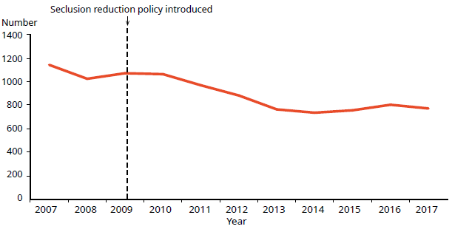
Note: This data also includes patients with a legal status under the Mental Health Act, but are treated in RIDSS.
Source: Office of the Director of Mental Health annual reports 2007–2016 and PRIMHD data for 2017, extracted on 17 August 2018; Southern DHB supplied data manually; excludes forensic data

Figure 20: Total number of seclusion hours in adult inpatient services nationally, 2007–2017
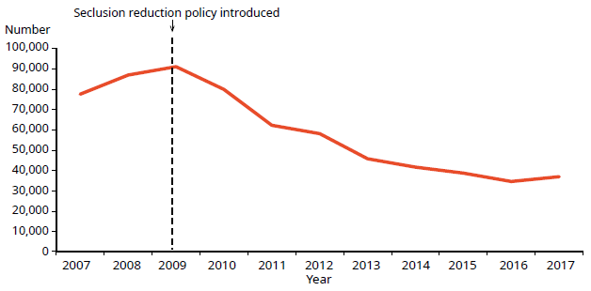
Note: This data also includes patients with a legal status under the Mental Health Act, but are treated in RIDSS.
Source: Office of the Director of Mental Health annual reports 2007–2016 and PRIMHD data for 2017, extracted on 17 August 2018; Southern DHB supplied data manually; excludes forensic data

Seclusion in New Zealand mental health services
Between 1 January and 31 December 2017, New Zealand adult mental health services (excluding forensic and other regional rehabilitation services) accommodated 8,910 people for a total of 241,830 bed nights. Of these people, 775 (8.7 percent) were secluded at some stage during the reporting period.

People who were secluded were often secluded more than once (on average two times). Therefore, the number of seclusion events in adult inpatient services (1,527) was higher than the number of people secluded.

New to this report is the number of seclusion events per 1,000 bed nights in adult inpatient units. The number of seclusion events is measured against the number of accrued mental health care days/nights in an adult inpatient unit. During 2017, the number of seclusion events per 1,000 bed nights in inpatient units was 6.3. This means that – nationally and on average – for every 1,000 bed nights a person spent in an inpatient unit, the person would have had 6.3 seclusion events.

Across all inpatient services, including forensic, intellectual disability and youth services, 977 people experienced at least one seclusion event. Of those secluded, 70 percent were male and 30 percent were female. The most common age group for those secluded was 20–24 years (see Figure 21). A total of 98 young people (aged 19 years and under) were secluded during the 2017 year in 285 seclusion events.

Figure 21: Number of people secluded across all inpatient services (adult, forensic, intellectual disability, and youth), by age group, 1 January to 31 December 2017
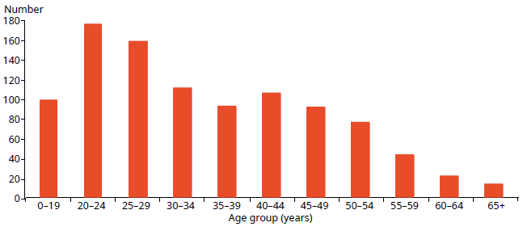
Note: This data also includes patients with a legal status under the Mental Health Act, but are treated in RIDSS.
Source: PRIMHD data, extracted on 17 August 2018; Southern DHB supplied data manually
The length of time spent in seclusion varied considerably. Most seclusion events (76 percent) lasted for less than 24 hours. Some (12 percent) lasted for longer than 48 hours. Figure 22 shows the number of seclusion events by duration of the event for the 2017 calendar year.

Figure 22: Number of seclusion events across all inpatient services (adult, forensic, intellectual disability, and youth), by duration of event, 1 January to 31 December 2017
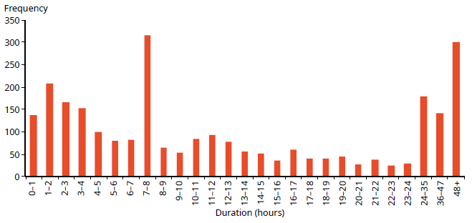
Note: This data also includes patients with a legal status under the Mental Health Act, but are treated in RIDSS.
Source: PRIMHD data, extracted on 17 August 2018; Southern DHB supplied data manually

Seclusion by district health board
All DHBs except for Wairarapa DHB (which has no mental health inpatient service) use seclusion. In 2017, the national average number of people secluded in adult inpatient services per 100,000 population was 27.2, and the average number of seclusion events per 100,000 population was 55.1.

As Figures 23 and 24 show, seclusion data varied widely across DHBs in 2017. Such variation is likely to be due to a number of factors, including:
- differences in seclusion practice
- geographical variations in the prevalence and acuity of mental illness
- ward design factors, such as the availability of intensive care and low-stimulus facilities
- staff numbers, experience and training
- use of sedating psychotropic medication
- the frequent or prolonged seclusion of a small number of people, distorting seclusion figures over the 12-month period.

Because it is difficult to measure and adjust for these factors, the Ministry recommends comparing an individual DHB’s performance over time in addition to considering the adjusted comparisons between DHBs in this report.

Figure 23: Number of people secluded in adult inpatient services per 100,000, by DHB, 1 January to 31 December 2017
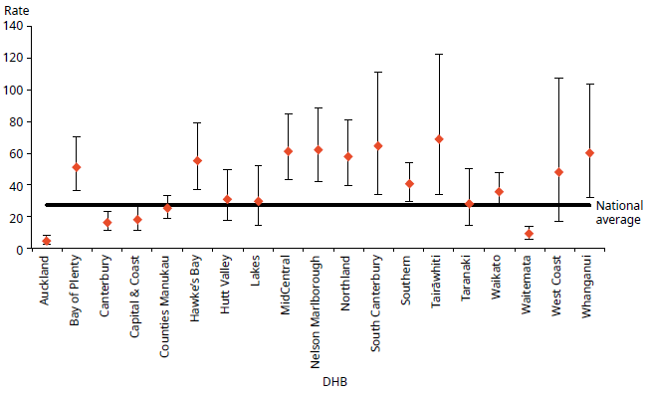
Notes: Confidence intervals (for 99 percent confidence) have been used to aid interpretation. Where a DHB region’s confidence interval crosses the national average, this means the DHB’s rate was not statistically significantly different from the national average.
This data also includes patients with a legal status under the Mental Health Act, but are treated in RIDSS.
Source: PRIMHD data, extracted on 17 August 2018; Southern DHB supplied data manually

Figure 24: Number of seclusion events in adult inpatient services per 100,000, by DHB, 1 January to 31 December 2017
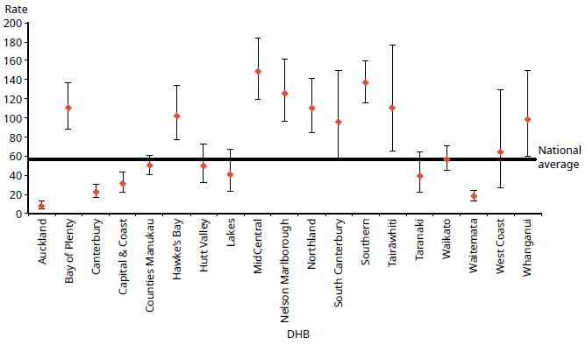
Notes: Confidence intervals (for 99 percent confidence) have been used to aid interpretation. Where a DHB region’s confidence interval crosses the national average, this means the DHB’s rate was not statistically significantly different to the national average.
This data also includes patients with a legal status under the Mental Health Act, but are treated in RIDSS.
Source: PRIMHD data, extracted on 17 August 2018; Southern DHB supplied data manually

Seclusion and ethnicity
In 2017, Māori were 4.5 times more likely to be secluded in adult inpatient services than people from other ethnic groups. Of those secluded in adult inpatient services during 2017, 41 percent were Māori.

Figure 25 shows seclusion indicators for Māori and non-Māori during 2017. Māori were secluded at a rate of 82.2 people per 100,000, and non-Māori at a rate of 18.5 people per 100,000 population.

Reducing and eventually eliminating the use of seclusion for Māori is a priority action in Rising to the Challenge (Ministry of Health 2012e) supported by Te Pou. Information on initiatives and strategies for reducing the use of seclusion with Māori can be found on the website for Te Pou (tepou.co.nz).

Figure 25: Seclusion indicators for adult inpatient services, Māori and non-Māori, 1 January to 31 December 2017
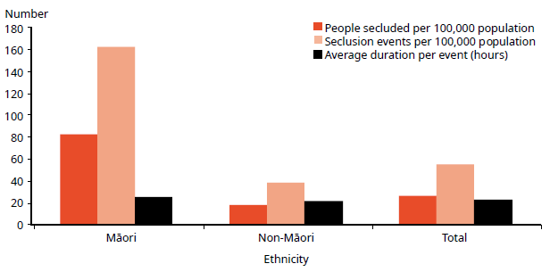
Note: This data also includes patients with a legal status under the Mental Health Act, but are treated in RIDSS.
Source: PRIMHD data, extracted on 17 August 2018; Southern DHB supplied data manually

Figure 26 shows the percentage of Māori and non-Māori male and female service users secluded in adult services in 2017. This figure indicates that a greater proportion of Māori were secluded than non-Māori, and that across ethnicities males were more likely to be secluded (11 percent) than females (6 percent).

Figure 26: Percentage of people spending time in seclusion in adult inpatient services, Māori and non-Māori males and females, 1 January to 31 December 2017
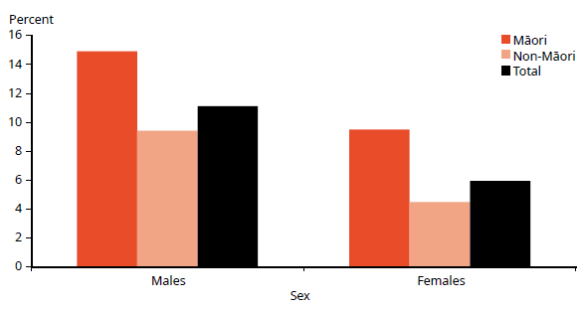
Note: This data also includes patients with a legal status under the Mental Health Act, but are treated in RIDSS.
Source: PRIMHD data, extracted on 17 August 2018; Southern DHB supplied data manually

Figure 27 shows the number of Māori and non-Māori aged 20–64 years secluded in adult inpatient services from 2007 to 2017. Nationally over this time, the number of people secluded decreased by 32 percent. The number of people secluded who identified as Māori decreased by 17 percent over the same time.

Figure 27: Number of Māori and non-Māori aged 20–64 years secluded in adult inpatient services, 2007–2017
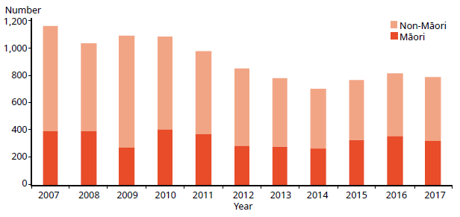
Note: This data also includes patients with a legal status under the Mental Health Act, but are treated in RIDSS.
Source: PRIMHD data, extracted on 17 August 2018; Southern DHB supplied data manually

Seclusion in forensic units
Five DHBs provide specialist inpatient forensic services: Canterbury, Capital & Coast, Southern, Waikato and Waitemata. There is a smaller inpatient forensic service in Whanganui. These services provide mental health treatment in a secure environment for prisoners with mental disorders and for people defined as special or restricted patients under the Mental Health Act.

These forensic services also provide care for people (care recipients or special care recipients) under the IDCC&R Act. We report on seclusion data for those under the IDCC&R Act separate to patients under the Mental Health Act to have a better understanding of the use of seclusion for each group (see below).

To reiterate, the seclusion data presented for intellectual disabilities is specific to care recipients with a legal status under the IDCC&R Act. The seclusion data of mental health services includes patients who have a legal status under the Mental Health Act, but receive treatment from RIDSS. This data will be built upon and reported on separately in future Office of the Director of Mental Health and Addiction Services annual reports.

Seclusion in forensic intellectual disability units
The aforementioned DHB forensic services provide specialist secure intellectual disability forensic services known as RIDSS. RIDSS provide secure beds for people subject to compulsory care orders under the IDCC&R Act, or other appropriate legal mandates. RIDSS services vary in bed configuration and numbers. Some beds are provided within existing forensic mental health infrastructure; others are provided in purpose-built facilities. Some RIDSS also have ’step-down’ facilities, which are medium secure ‘cottages’ intended to provide a more home-like environment as care recipients move towards a transition to the community.

Data collection
Care recipients under the IDCC&R Act can also be subject to seclusion. Because they often receive treatment in a forensic mental health service, seclusion indicators relevant to these service users are sometimes reported via PRIMHD and are indistinguishable from forensic mental health service user seclusion data. The Office is actively working with Disability Support Services and DHBs to report IDCC&R Act seclusion data separately from forensic mental health data in PRIMHD. The data for this report was done both manually for some DHBs and extracted from PRIMHD for other DHBs.

The numbers of beds across RIDSS services around the country vary greatly. A small group of care recipients currently in secure care have not made significant rehabilitative gains towards transitioning to community placement. These clients have intellectual disabilities and/or mental health conditions of such severity that they have already been subject to long-term hospital-level care (10.5 years on average, with a range from 6 to 20 years), and it is highly likely they will continue to require long-term secure care and more restrictive practices. This is reflected in the data provided in Tables 5, 6 and 7.

Table 5: Seclusion data for people with intellectual disabilities, by DHB and events for the period 1 January to 31 December 2017
DHB | Total number of beds | Number of people | Number of events | Median number of events per person | Average number of events per person | Average  number of events per number of beds
Canterbury | 8 | 9 | 117 | 6 | 13 | 15
Capital & Coast | 32 | 9 | 28 | 2 | 3 | 0.8
Southern | 11 | 12 | 64 | 1 | 5 | 6
Waikato | 3 | 1 | 11 | 11 | 11 | 4
Waitemata | 12 | 8 | 338 | 6 | 42 | 28
Note: This data only presents seclusion data for care recipients with a legal status under the IDCC&R Act.
Source: All DHB data supplied manually

Table 6: Seclusion data for people with intellectual disabilities, by DHB and seclusion hours for the period 1 January to 31 December 2017
DHB | Total seclusion hours (hours) | Median duration of seclusion events (hours:minutes) | Average duration of seclusion events (hours:minutes)
Canterbury | 622 | 3:31 | 5:19
Capital & Coast | 182 | 3:05 | 6:30
Southern | 254 | 2:20 | 3:58
Waikato | 120 | 2:45 | 10:55
Waitemata | 3,166 | 7:29 | 9:22
Note: This data only presents seclusion data for care recipients with a legal status under the IDCC&R Act.
Source: All DHB data supplied manually

Table 7 presents seclusion indicators for forensic mental health services for the 2017 calendar year. These indicators cannot be compared with adult service indicators because they do not reflect the same client base. The rates of seclusion for the relatively small group of people in the care of forensic mental health services can be affected by individuals who were secluded significantly more often or for longer than others.

Table 7: Seclusion indicators for forensic mental health services, by DHB, 1 January to 31 December 2017
DHB | Clients  secluded | Number of events | Total  hours | Average duration per client (hours)
Canterbury | 15 | 77 | 1,941 | 25.2
Capital & Coast | 7 | 46 | 921 | 20.0
Southern | 6 | 35 | 1,764 | 50.4
Waikato | 18 | 33 | 1,943 | 58.9
Waitemata | 38 | 158 | 4,777 | 30.2
Whanganui | 1 | 1 | 96 | 96.3
Total | 83 | 350 | 11,442 | 32.7
Notes: The sum of the total clients does not match the total reported because two clients were seen by both Waikato and Waitemata DHBs.
Clients are aged 20–64 years. Clients are mental health services only.
Source: PRIMHD data extracted on 17 August 2018; Southern DHB supplied data manually

Forensic mental health services

Special and restricted patients
New Zealand legislation specifically allows for people who have been charged with or convicted of an offence and meet certain criteria in terms of their mental illness to be treated for that condition in hospital. Treating mental illness is an important step towards helping an individual address the reasons for their offending. In doing so, they can reduce their chances of re-offending and significantly improve their wellbeing.

The terms ‘special patient’ and ‘restricted patient’ refer to mentally ill offenders detained in a forensic mental health service under specific legislative provisions.

Special patients include:
- people charged with, or convicted of, a criminal offence and remanded to a hospital for a psychiatric report
- remanded or sentenced prisoners transferred from prison to a hospital
- defendants found not guilty by reason of insanity (see Appendix 3: Special and restricted patients)
- defendants who are unfit to stand trial
- people who have been convicted of a criminal offence and both sentenced to a term of imprisonment and placed under a compulsory treatment order.

Restricted patients are people detained by a court order because they pose a danger to others. Restricted patients are generally subject to the same leave provisions as the provisions that apply to special patients.

Forensic mental health services
Forensic mental health services are responsible for the care and treatment of special patients and restricted patients within the legislative framework of the Mental Health Act and the Criminal Procedure (Mentally Impaired Persons) Act 2003 (the CP (MIP) Act).

When managing special patients, forensic mental health services are required to balance the rights, treatment and rehabilitative needs of the individual patient against the safety of the public and the concerns of any victims.

The clinical management of special patients lies with the patient’s responsible clinician. However, leave and change of legal status require consideration and approval by the Director of Mental Health, and (depending on the legal status of the patient) the Minister of Health and/or the Attorney-General. This level of decision- making reflects the seriousness of special patients’ status and the need to ensure that a wide range of factors are considered when making decisions about such patients.

Special and restricted patients are detained in the care of one of five regional forensic psychiatry services throughout New Zealand under the jurisdiction of Waitemata, Waikato, Capital & Coast, Canterbury and Southern DHBs. These services develop management plans to progressively reintegrate people into the community as treatment improves their mental health.

During 2017, there were 378 people with special patient status. On any given day, there were approximately 196 people with special patient status.

Figure 28: Total number of special patients, by DHB, 1 January to 31 December 2017
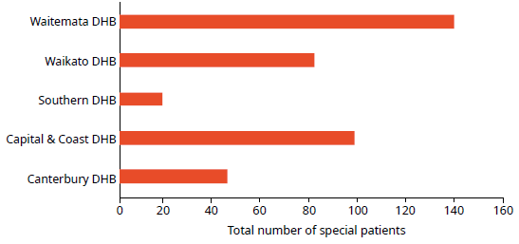
Source: PRIMHD collection, extracted on 14 August 2018

Extended forensic care (EFC) special patients
‘EFC special patients’ refers to patients who have been detained in a forensic mental health service. These special patients have been found not guilty by reason of insanity or unfit to stand trial and have been remanded to one of the five forensic mental health facilities in New Zealand under section 24(2)(a) of the CP (MIP) Act.

Also included in these statistics are patients subject to a restricted patient order (section 55 of the Mental Health Act). In 2017, there were a total of 139 EFC special patients.

EFC special patients are categorised primarily by a severe psychiatric disorder that significantly influenced a crime that they committed, such that the person had little understanding of the nature of the act (see Appendix 3: Special and restricted patients for a description of the insanity defence). Restricted patients pose a danger to themselves and other people such that they are detained to a forensic mental health service. Restricted patients are subject to the same provisions as special patients, though they may not have necessarily committed a crime to be detained under special patient status. They may have also been transferred from prison or previously had a special patient status that was changed when their sentence ended.

Short-term forensic care (SFC) special patients
‘SFC special patients’ refers to patients transferred to a forensic mental health service from prison for compulsory mental health assessment and treatment (including those under a ‘hybrid order’). In 2017, there were a total of 254 SFC special patients.

Once a person has been sentenced to a term of imprisonment, any compulsory mental health treatment order relating to them ceases to have effect. Remand prisoners may remain on a pre-existing compulsory treatment order, but it is unlawful to enforce compulsory treatment in the prison environment.

If a mentally disordered prisoner requires compulsory assessment and/or treatment, section 45 of the Mental Health Act provides for their transfer to hospital. Section 46 allows for voluntary admission to hospital with the approval of the prison superintendent. Services must notify the Director of Mental Health of all such admissions. On advice from services, the Director can direct the person’s return to prison under section 47 of the Mental Health Act.

Table 8: Total number of special patients, by type and DHB, 1 January to 31 December 2017
Forensic services | EFC special patients | SFC special patients | Total special patients
Canterbury DHB | 15 | 30 | 45
Capital & Coast DHB | 38 | 62 | 98
Southern DHB | 11 | 7 | 18
Waikato DHB | 29 | 59 | 81
Waitemata DHB | 46 | 96 | 139
Notes: Some people will be counted as special patients against more than one DHB if they received treatment with more than one DHB. This means the total of this data is higher than the national total.
Certain special patient orders enable a Court to direct treatment outside a regional forensic service – this data has been excluded due to low numbers and to protect patient confidentiality.
Source: PRIMHD collection, extracted on 14 August 2018

Figure 29: Percentage of extended forensic care and short-term forensic care legal statuses, by DHB, 1 January to 31 December 2017
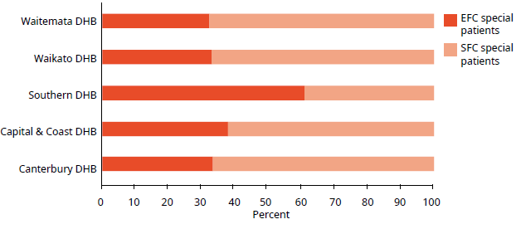
Note: Unlike previous data in this section, the data used in this figure is based on a count of legal statuses rather than people. One special patient may have many legal statuses in a period, which could be in different categories, but each special patient legal status can only be in one category – EFC or SFC. Please use caution when comparing the legal status counts with the counts of people with legal statuses.
Source: PRIMHD collection, extracted on 14 August 2018

The CP (MIP) Act allows the Court to sentence a convicted offender to a term of imprisonment while also ordering their detention in hospital as a special patient (if mentally disordered). These orders are referred to as hybrid orders because they combine aspects of compulsory treatment and imprisonment.

Sex, age and ethnicity of special patients
In 2017, most people subject to a special patient legal status were male (86 percent). Special patients were seven times more likely to be male than female (14 percent). The most common age group for special patients was 25–29 years old (see Figure 30).

Figure 30: Total number of special patients, by age group, 1 January to 31 December 2017
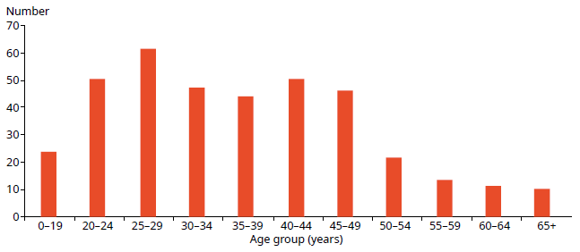
Source: PRIMHD collection, extracted on 14 August 2018

As Figure 31 indicates, in 2017 the highest proportion of people subject to a special patient order were Māori (51 percent). However, the largest proportion of EFC special patients (those remanded to a forensic health facility) had an ethnicity classification of ‘other’, at 43 percent. Māori special patients made up 40 percent of EFC special patients and 58 percent of SFC special patients (see Figure 32). This difference in proportion is likely to reflect the high proportion of Māori in the prison population.

Figure 31: Total number of special patients, by ethnicity, 1 January to 31 December 2017
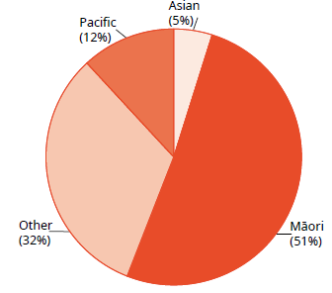
Source: PRIMHD collection, extracted on 14 August 2018

Figure 32: Total number of special patients, by ethnicity and special patient type, 1 January to 31 December 2017
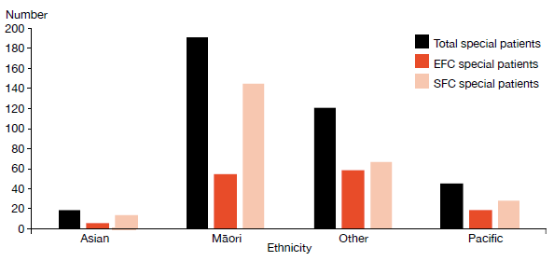
Note: A patient may be represented in one or more categories in this graph.
Source: PRIMHD collection, extracted on 14 August 2018

Decisions regarding leave and change of legal status for special and restricted patients
The Director of Mental Health has a central role in managing special patients and restricted patients. The Director must be notified of the admission, discharge or transfer of special and restricted patients, and certain incidents involving these people (section 43 of the Mental Health Act). The Director may direct the transfer of such patients between DHBs under section 49 of the Mental Health Act or grant leave for any period not exceeding seven days for certain special and restricted patients (section 52).

Leave is an important part of a special patient’s rehabilitation and occurs in a carefully stepped manner. Patients usually begin by having walks on the hospital grounds escorted by forensic service staff. If appropriate, patients progress to unescorted ground leave and then to escorted and unescorted community leave. This leave is typically used to attend appointments, work, rehabilitation programmes or to visit family. After increasing periods of successful unescorted leave, it may be appropriate for some individuals to progress to a less secure settings. Individuals may move to an open hospital unit and eventually reside in the community, often in supported accommodation or with family. It is important to note that not all special patients will be eligible for leave, and that there is no requirement for progression towards less secure conditions if this is not supported by risk assessment or progress.

The Minister of Health grants periods of leave over seven days (section 50), which are available to certain categories of special patients. The Director briefs the Minister of Health when requests for leave are made. Initial ministerial section 50 leave is usually granted for a period of six months, with the possibility of a further application for ministerial leave for a period of 12 months.

While on leave, special patients are subject to leave conditions and regular monitoring by their treating team. If a special patient breaches their leave conditions or their mental state requires their return to hospital, leave may be revoked. If the patient is subject to a further 12 month ministerial long leave, the Director may recommend the Minister revokes leave.

Special patients are subject to a high degree of oversight and are not able to exit forensic services or travel overseas without permission. During 2015, the Ministry developed guidance on special patient safety (including public safety) and security. This work included a national incident process to be followed by health services and New Zealand Police, as well as updated guidance on actions that forensic services and the Ministry should take when a special patient becomes absent without leave. The Ministry also updated its guidance on preventing special patients from travelling overseas without permission. Part of this work involved putting border alerts in place for any special patient granted unescorted leave in the community.

Special patients found not guilty by reason of insanity may be considered for a change of legal status if it is determined that their detention as a special patient is no longer necessary to safeguard the interests of the person or the public. This will usually occur after the person has been living successfully in the community on ministerial long leave for several years. Services send applications for changes of legal status to the Director of Mental Health. After careful consideration, the Director makes a recommendation to the Minister about a person’s legal status.

Following a change of legal status, former special patients continue to be supported in the community by mental health services. Many remain under compulsory mental health treatment orders for an extended period of time. For further information about the management of special patients, refer to Special Patients and Restricted Patients: Guidelines for Regional Forensic Mental Health Services (Ministry of Health 2017b).

Table 9 shows the numbers of section 50 long leave, revocation and reclassification applications processed by the Office during 2017.

Table 9: Number of section 50 long leave, revocation and reclassification applications sent to the Minister of Health for special patients and restricted patients, 1 January to 31 December 2017
Type of request | Number
Initial ministerial section 50 leave applications | 13
Initial ministerial section 50 leave applications not approved | 0
Ministerial section 50 leave revocations | 2
Further ministerial section 50 leave applications | 13
Further ministerial section 50 applications not approved | 0
Change of legal status applications approved | 9
Change of legal status applications not approved | 0
Total | 37
Note: Numbers do not include the number of applications that were withdrawn before the Minister of Health received them.
Source: Office of the Director of Mental Health and Addiction Services records

Mental health and addiction adverse event reporting
There are two major national reporting mechanisms for adverse events relating to mental health and addiction.
1. DHBs are required to notify the Director of Mental Health of the death of any person or special patient under the Mental Health Act.
2. DHBs are required to report all Severity Assessment Code (SAC) 1 or 2 rated adverse events to the HQSC in line with the National Adverse Events Reporting Policy. Mental health and addiction services that are not funded by DHBs are encouraged but not required to report adverse events to the HQSC. (Due to small numbers, this data is not reported here.)

Please note, deaths of people subject to the Mental Health Act may be reported to both agencies where the death meets the SAC1 criteria.

Deaths reported to the Office of the Director of Mental Health and Addiction Services
Section 132 of the Mental Health Act requires the Director of Mental Health to be notified within 14 days of the death of any person or special patient under the Mental Health Act. Such a notification must identify the apparent cause of death.

If the circumstances surrounding a death cause concern, the relevant DHB may initiate an inquiry. The Director of Mental Health can also initiate an investigation under section 95 of the Mental Health Act and, in rare cases, the Minister or Director-General of Health can initiate an inquiry under section 72 of the New Zealand Public Health and Disability Act 2000. The Director of Mental Health works to ensure that DHBs follow up on recommendations.

In 2017, the Director of Mental Health received 59 death notifications related to people under the Mental Health Act (see Table 10). Of these, 16 related to people who were reported to have died by suspected suicide. The remaining 43 reportedly died by other means, including natural causes and illnesses unrelated to mental health status.

Table 10: Outcomes of reportable death notifications under section 132 of the Mental Health Act, 1 January to 31 December 2017
Reportable death outcome | Number
Suspected suicide | 16
Other deaths | 43
Total | 59
Source: Office of the Director of Mental Health and Addiction Services records

Adverse events reported to the Health Quality & Safety Commission
Adverse event reporting encourages health and disability services to identify and review the events with the aim of preventing similar occurrences in the future and help ensure better and safer health care for New Zealanders.

In New Zealand, adverse events have been reported publically since 2006. Since reporting began, the number of adverse events reported by DHBs has increased. This is not necessarily because the frequency of adverse events has increased; we consider that DHBs have improved their reporting systems and cultures, reflecting a stronger culture of transparency and commitment to learning.

The reporting of adverse events is one part of a broader safety framework within New Zealand to ensure health care is as safe as possible.

Adverse events reported by district health board-funded mental health and addiction services
Table 11 provides a breakdown of the types of adverse events relating to mental health behaviour reported by DHBs to the HQSC during 2017; Table 12 shows the number of events reported for each DHB.

Our ability to compare reports year to year is limited because the definition of adverse events has changed, as have the parameters around service-user contact before an adverse event. Initially, the adverse events reporting requirements were defined as events that had occurred within seven days of contact with a service. In the New Zealand Health and Disability Services – National Reportable Events Policy 2012 (HQSC 2012), DHB mental health and addiction services voluntarily amended this criterion to include cases that had occurred within 28 days of contact with the service, allowing lessons to be learned from a wider set of events. Some providers have taken this even further and now report serious adverse events for any current community mental health service user, irrespective of time since their last contact with the service.
It is also important to note that comparisons between individual DHBs are not straightforward. As noted above, high numbers can indicate a good reporting culture rather than a higher number of adverse events than other DHBs. DHBs that provide larger and more complex or regional mental health services may also report a higher number of adverse events.

Table 11: Adverse events (relating to mental health behaviour) reported by DHBs to the Health Quality & Safety Commission, 1 January to 31 December 2017
Type of event | Outpatient | Inpatient | On approved leave | Total
Suspected suicide | 164 | 10 | 2 | 176
Serious self-harm | 7 | 6 | 0 | 13
Serious adverse behaviour | 8 | 6 | 0 | 14
Total | 179 | 22 | 2 | 203
Source: HQSC adverse event data, 2018

Table 12: Mental health adverse events reported to the Health Quality & Safety Commission, by DHB, 1 January to 31 December 2017

DHB | Number of events |  | DHB | Number of events
Auckland | 16 |  | Northland | 7
Bay of Plenty | 11 |  | South Canterbury | 4
Canterbury | 34 |  | Southern | 17
Capital & Coast | 12 |  | Tairāwhiti | 2
Counties Manukau | 10 |  | Taranaki | 2
Hawke’s Bay | 10 |  | Waikato | 8
Hutt Valley | 5 |  | Wairarapa | 3
Lakes | 4 |  | Waitemata | 18
MidCentral | 24 |  | West Coast | 3
Nelson Marlborough | 5 |  | Whanganui | 8
 |  |  | New Zealand total | 203
Source: HQSC adverse event data, 2018

Please see Appendix 4: Developments in mental health and addiction reporting and improvement for an update from the HQSC on recent initiatives.

Death by suicide
Suicide is a serious concern for New Zealand. Around 500 New Zealanders die by suicide every year. Suicide affects the lives of many – whānau, families, friends, colleagues and communities.

This section provides a brief overview of suicide deaths and deaths of undetermined intent, with a particular focus on people who had contact with specialist mental health services (including services treating people with alcohol and other drugs (AOD) addiction) in the year before their death. People with no history of mental health service use in the year before their death are referred to as ‘non-service users’ here, although we acknowledge that some non-service users may have used mental health or AOD services at some earlier time in their lives. This overview uses data from 2015 as it can take several years for a coroner’s investigation into a suicide to be completed.

In summary, in 2015:
- 525 people died by suicide. A further 17 deaths of undetermined intent were recorded in the mortality database
- approximately 42 percent of those who died by suicide or undetermined intent (among those aged 10–64 years) were mental health service users
- mental disorders are one of the factors that can increase the likelihood of suicidal behaviour
- males were more likely to die by suicide than females.

Prevalence of suicide in the population
At the time the data was extracted, there were 525 suicides recorded in the mortality database for 2015. A further 17 deaths of undetermined intent were recorded and are included in this report. Of this initial total of 542 deaths, 66 involved people aged 65 years and over. The following discussion excludes these deaths.

Table 13 sets out statistics on the remaining 476 deaths. Of these 476 people, 201 (42 percent) had had contact with specialist mental health services in the year before death.

Suicide has no single cause – it is usually the end result of interactions between many different factors that impact different people in different ways. Mental disorders (in particular, mood disorders, substance-use disorders and antisocial behaviours) are one set of factors that can increase the likelihood of suicidal behaviour (Beautrais et al 2005).

Table 13: Number and age-standardised rate of suicide, by service use, people aged 10–64 years, 2015
 | Number | Age-standardised rateª
Deaths due to intentional self-harm
Service users^{b} | 196 | 125.1
Non-service users | 265 | 6.7
Total | 461 | 11.7
Deaths of undetermined intent
Service users | 5 | 3.1
Non-service users | 10 | 0.2
Total | 15 | 0.4
Total deaths
Service users | 201 | 128.3
Non-service users | 275 | 6.9
Total | 476 | 11.5
Notes:
a Age-standardised rate is per 100,000, standardised to the World Health Organization (WHO) standard population aged 0–64 years.
b Service user denominator excludes service users of unknown age.
Source: Ministry of Health mortality database data, extracted on 28 June 2018

Changes in number of suicides over time
Figure 33 shows the changes in the rates of suicide by service users and non-service users between 2001 and 2015.

Figure 33: Age-standardised rate of suicide, by service use, people aged 10–64 years, 2001–2015
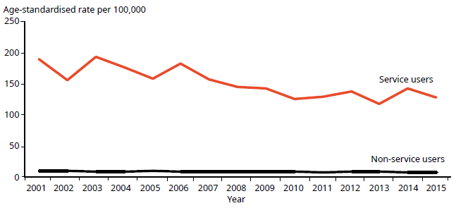
Notes: Age-standardised rate is per 100,000, standardised to the WHO standard population aged
0–64 years.
The service user population is much smaller than the non-service user population and will therefore produce rates more prone to fluctuation from year to year.
Source: Ministry of Health mortality database data, extracted on 28 June 2018

Sex and age in relation to suicide
As Table 14 and Figure 34 show, 2.6 times more males than females died by suicide in 2015. Of the service users who died by suicide in 2015, 28 percent were female and 72 percent were male.

When considering these numbers, it is important to note that these age-specific rates are highly variable over time because they are derived from a small service-user population.

Table 14: Number and age-standardised rate of suicide, by service use and sex, people aged 10–64 years, 2015
Sex | Service users |  | Non-service users |  | Total
 | Number | ASR | Number | ASR | Number | ASR
Males | 137 | 164.4 | 207 | 10.5 | 344 | 16.8
Females | 64 | 85.8 | 68 | 3.5 | 132 | 6.4
Total | 201 | 128.3 | 275 | 6.9 | 476 | 11.5
Notes: ASR = Age-standardised rate.
Includes deaths of undetermined intent. Age-standardised rate is per 100,000, standardised to the WHO standard population aged 0–64 years.
Service user denominator excludes service users of unknown age.
Source: Ministry of Health mortality database data, extracted on 28 June 2018

Figure 34: Age-specific rate of suicide, by age-group, sex and service use, people aged 10–64 years, 2015
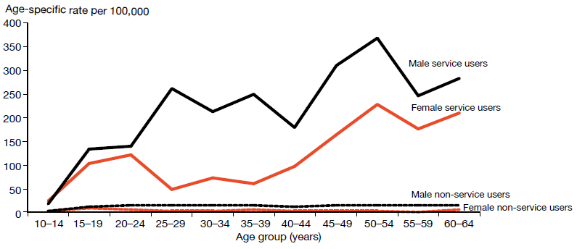
Source: Ministry of Health mortality database data, extracted on 28 June 2018

As Table 15 shows, the rate of suicide among female service users was highest for those aged 50–54 years, at 227.9 per 100,000. The rate of suicide among male service users was also highest for those aged 50–54 years, at 369.3 per 100,000.

For female non-service users, the rate of suicide was highest in those aged 15–19 years, at 9.8 per 100,000 ASR. For male non-service users, the rate of suicide was highest in those aged 20–24 years, at 15.6 per 100,000 ASR.

Table 15: Number and age-specific rate of suicide, by age-group, sex and service use, people aged 10–64 years, 2015
Age band (years) | Service users |  |  |  | Non-service users
 | Female |  | Male |  | Female |  | Male
 | Number | ASR | Number | ASR | Number | ASR | Number | ASR
10–14 | 1 | 22.7 | 1 | 17.2 | 3 | 2.2 | 4 | 2.8
15–19 | 11 | 103.6 | 12 | 133.1 | 14 | 9.8 | 20 | 12.9
20–24 | 8 | 120.4 | 12 | 138.6 | 10 | 6.4 | 26 | 15.6
25–29 | 3 | 48.8 | 20 | 262.2 | 5 | 3.3 | 22 | 14.8
30–34 | 4 | 73.6 | 14 | 213.8 | 5 | 3.5 | 20 | 15.1
35–39 | 3 | 59.2 | 15 | 248.3 | 6 | 4.3 | 18 | 14.4
40–44 | 5 | 97.1 | 11 | 178.5 | 6 | 3.8 | 18 | 12.8
45–49 | 8 | 164.2 | 18 | 309.1 | 5 | 3.2 | 22 | 15.2
50–54 | 10 | 227.9 | 18 | 369.3 | 6 | 3.7 | 21 | 14.1
55–59 | 6 | 176.3 | 9 | 245.4 | 1 | 0.7 | 20 | 14.7
60–64 | 5 | 210.7 | 7 | 283.9 | 7 | 5.5 | 16 | 13.4
Notes: ASR = Age-specific rate.
Includes deaths of undetermined intent.
Source: Ministry of Health mortality database data, extracted on 28 June 2018

Ethnicity and suicide
As Table 16 indicates, among people using mental health services in 2015, the age-standardised rate of suicide was higher for Māori (111.9 per 100,000 service users) than for Pacific peoples (81 per 100,000 service users). The age-standardised rate of suicide for those in the ‘Other’ category was 138.4 per 100,000 service users. The suicide rate for Māori non-service users was higher than for all non-Māori non-service users. (Note: the suicide rate for Pacific peoples is highly variable over time.)

Table 16: Number and age-standardised rate of suicide and deaths of undetermined intent, by ethnicity and service use, people aged 10–64 years, 2015
Ethnicity | Service users |  | Non-service users |  | Total
 | Number of deaths | ASR | Number of deaths | ASR | Number of deaths | ASR
Māori | 50 | 111.9 | 72 | 12.8 | 122 | 23.2
Pacific | 7 | 81 | 17 | 6.4 | 24 | 9.9
Other | 144 | 138.4 | 186 | 5.6 | 330 | 9.9
Total | 201 | 128.3 | 275 | 6.9 | 476 | 11.5
Note: ASR = Age-standardised rate.
Source: Ministry of Health mortality database data, extracted on 28 June 2018

Service users who died by suicide during 2015
Of the 201 service users who died by suicide in 2015, one died while an inpatient, six died within a week of being discharged and 53 died within 12 months of discharge.

An overview of service users dying by suicide, 2001–2015
From 2001 to 2015, 2,615 service users died by suicide. Of this total, 50 service users (nearly 2 percent) died while inpatients, 171 (nearly 7 percent) died within a week of being discharged and 768 (nearly 29 percent) died within 12 months of discharge.

Of the 2,615 service user suicides, 2,577 people had received treatment from a specialist service community team in the 12 months before their death, and 614 had received treatment from a specialist AOD team in the 12 months before their death.

Specialist treatment regimes

Opioid substitution treatment
Opioid substitution treatment (OST) is a service that prescribes opioids, such as methadone and buprenorphine with naloxone (Suboxone), as a substitute for illicit opioids. It is a well-established treatment that ensures that people with opioid dependence have access to comprehensive services to support them in their recovery. One of the key priorities of OST is to improve the physical and psychological health and wellbeing of the people who use opioids.

In 2017:
- 5,538 people received OST
- 80 percent of these people were New Zealand European, 14 percent were Māori, 1 percent were Pacific peoples and 5 percent were of another ethnicity
- approximately 28 percent of people receiving OST were being treated by a GP in a shared-care arrangement.

The Director of Mental Health is responsible for approving qualified practitioners to prescribe controlled drugs for the treatment of drug dependence under section 24 of the Misuse of Drugs Act 1975. For this purpose, the Director undertakes regular site visits, focusing on building relationships and improving service quality.

In 2016, the Office authorised medical practitioners to prescribe controlled drugs for addiction treatment to include nurse practitioners, registered nurse prescribers working in mental health and pharmacist prescribers. The benefits include greater availability and flexibility of prescribers for treating addiction and more timely access.

Service improvements
The Specialist Opioid Substitution Treatment (OST) Service Audit and Review Tool sets out clinical audit requirements to ensure best treatment and services for clients and their family/whānau (see Ministry of Health 2014b). The Ministry audits services based on indicators from two key documents:
- New Zealand Practice Guidelines for Opioid Substitution Treatment (Ministry of Health 2014a)
- National Guidelines: Interim methadone prescribing (Ministry of Health 2007).

The Ministry has initiated a rolling programme of OST service audits to support ongoing quality improvement. All services were expected have completed an audit by July 2018.

To ensure the best possible health outcomes for service users, the health sector must place greater emphasis on managing coexisting medical and mental health problems and focus on integrating primary and specialist health services (Ministry of Health 2012e).

The ageing population of opioid substitution treatment clients
OST clients are an ageing population; those over 45 years of age are the most likely to be receiving treatment. In 2017, 61.1 percent of clients were over 45 years old, with only two services nationally having less than 50 percent of their clients over that age (see Figure 35).

Figure 35: Number of opioid substitution treatment clients, by age-group, 2008–2017
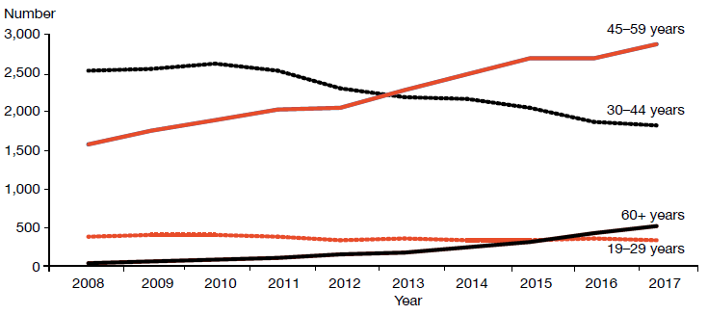
Source: Data provided by OST services in six-monthly reports

Shared care with general practice
Specialist addiction services and primary health care teams provide OST services in New Zealand. Transferring care to a shared-care arrangement with primary health care offers a lot of benefits, including allowing specialist services to focus on those with the highest need and normalising the treatment process. Ensuring that services are delivered seamlessly across providers will be an important focus in the future.

Corrections opioid substitution treatment shared care model
When a person receiving OST goes to prison, the Department of Corrections ensures that the person continues to receive OST services, including psychosocial support and treatment from specialist services. Figure 36 presents a comparison of the number of people receiving OST from a specialist service, general practice or prison service between 2008 and 2017.

Figure 36: Number of people receiving opioid substitution treatment from a specialist service, general practice or prison service, 2008–2017
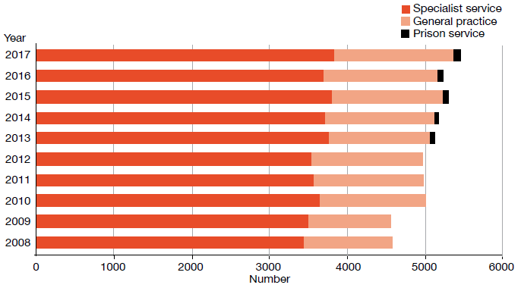
Source: Data provided by OST services in six-monthly reports

Since 2008, the number of clients accessing OST services typically increased by 70–150 clients per year. Between 2016 and 2017, the number of clients accessing OST services increased by 224.

In 2017, 17 DHBs and one primary health organisation delivered OST services, thereby providing national coverage. The Ministry’s target for service provision is 50:50 between primary and specialist health care services. Nationwide, general practice currently delivers approximately 28 percent of OST, while specialist services deliver approximately 71 percent. Figure 37 presents the percentage of people receiving OST from specialist services and general practice by DHB in 2017.

Figure 37: Percentage of people receiving opioid substitution treatment from specialist services and general practice, by DHB, 1 January to 31 December 2017
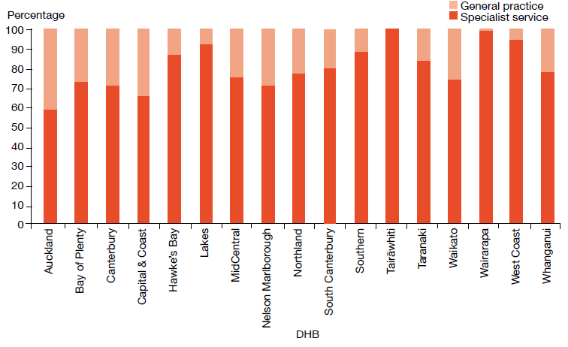
Source: Data provided by OST services in six-monthly reports

Entry to and exit from opioid substitution treatment
OST is built on a model of recovery. It aims to assist people to stay well by building support structures that help them define and achieve their goals. We can track an individual’s entry into, involvement in and exit from OST to monitor their recovery.

At the end of 2017, there were 310 voluntary withdrawals from OST (81 percent of all withdrawals during 2017). This is less than the previous year’s figure. During 2017, there were 27 involuntary withdrawals (7 percent of all withdrawals). Involuntary withdrawals are generally a result of behaviour that may have jeopardised the safety of the individual or others. The number of involuntary withdrawals has increased over the last two years (in 2016, there were 18; in 2015, there were 10), although this remains low compared with numbers before 2014 (see Figure 38).

The remaining withdrawals during 2017 were due to service user deaths (48 people receiving OST from specialist treatment services died from a range of causes). This figure is lower than the previous year’s. Of the 48 deaths, only three were likely a result of overdose. When a client dies of a suspected overdose, the Ministry requires services to conduct an incident review and report on it to the Director of Mental Health.

Figure 38: Percentage of withdrawals from opioid substitution treatment programmes, by reason (voluntary, involuntary or death), 2008–2017
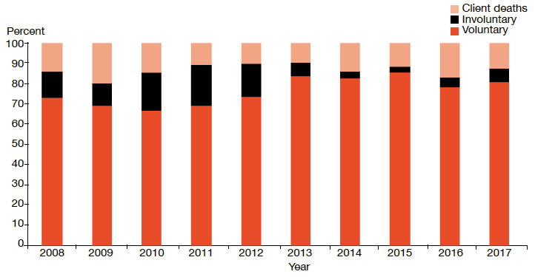
Source: Data provided by OST services in six-monthly reports

Methadone and Suboxone prescribing
Since July 2012, PHARMAC has funded Suboxone for OST. Since then, there has been a steady increase in the number of people prescribed this opioid medicine. Suboxone lowers the risk of drug diversion, and its misuse is lower than that associated with methadone. In addition, Suboxone can be given in cumulative doses that last several days, which allows for a greater level of normality for clients, rather than the daily dosing regimen that is required with methadone.

Figure 39: Number of people prescribed Suboxone, 2008–2017
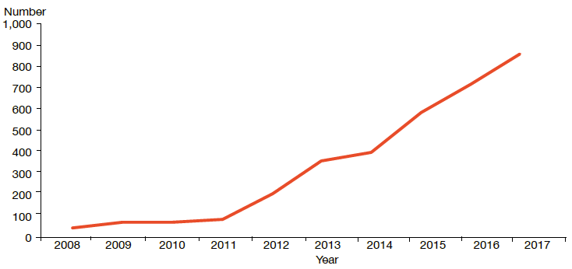
Source: Data provided by OST services in six-monthly reports

The Alcoholism and Drug Addiction Act 1966
The Alcoholism and Drug Addiction Act 1966 (the ADA Act) provides for people with severe substance dependence to receive compulsory detention and treatment for up to two years at certified institutions.

In 2017:
- the Family Court granted 16 orders for either detention or committal under the ADA Act
- four of the granted orders were for voluntary detention (under section 8), and 12 were for involuntary committal (under section 9).

Section 8 of the ADA Act allows a person who is dependent on alcohol or another drug to voluntarily apply to the Family Court for detention in a specified institution certified under the ADA Act. Section 9 of the ADA Act applies when another person (such as a relative or the Police) makes an application to the Family Court for the person to be committed to a specified institution certified under the ADA Act. Section 9 applications must be accompanied by two medical certificates.

Table 17 details the outcomes of applications under the ADA Act to the Family Court since 2004, when the Ministry of Justice began to publish statistics on the use of the Act. Table 18 shows the number of orders granted for detention under section 8 and for committal under section 9 of the ADA Act since 2004.

Table 17: Number of applications for detention and committal under the ADA Act, by application outcome, 2004–2017
2004 | 2005 | 2006 | 2007 | 2008 | 2009 | 2010 | 2011 | 2012 | 2013 | 2014 | 2015 | 2016 | 2017
Applications granted or granted with consent
72 | 79 | 77 | 71 | 75 | 71 | 69 | 74 | 72 | 74 | 64 | 59 | 45 | 16
Applications dismissed or struck out
5 | 3 | 4 | 1 | 2 | 3 | 3 | 1 | 2 | 3 | 4 | 2 | 1 | 4
Applications withdrawn, lapsed or discontinued
3 | 9 | 2 | 6 | 1 | 4 | 9 | 5 | 9 | 9 | 7 | 2 | 3 | 3
Total applications for s 8 and s 9 orders
80 | 91 | 83 | 78 | 78 | 78 | 81 | 80 | 83 | 86 | 75 | 63 | 49 | 23
Notes: The table presents applications that were disposed at the time of data extraction at 14 June 2018.
The case management system (CMS) is a live operational database. Figures are subject to minor changes at any time.
Source: Ministry of Justice CMS

Table 18: Number of granted orders for detention and committal, under the ADA Act, 2004–2017
Year |  |  | Number (and percentage) of section 8 applications granted for detention |  |  | Number (and percentage) of section 9 applications granted for committal | Total number of applications granted
2004 |  | 44 (92%) |  |  | 28 (85%) |  | 72
2005 |  | 49 (96%) |  |  | 30 (79%) |  | 79
2006 |  | 60 (98%) |  |  | 17 (77%) |  | 77
2007 |  | 52 (100%) |  |  | 19 (76%) |  | 71
2008 |  | 63 (98%) |  |  | 12 (86%) |  | 75
2009 |  | 49 (98%) |  |  | 22 (81%) |  | 71
2010 |  | 55 (96%) |  |  | 14 (58%) |  | 69
2011 |  | 59 (97%) |  |  | 15 (75%) |  | 74
2012 |  | 61 (97%) |  |  | 11 (58%) |  | 72
2013 |  | 58 (94%) |  |  | 16 (64%) |  | 74
2014 | 50 (94%) |  |  | 14 (64%) |  |  | 64
2015 | 36 (100%) |  |  | 23 (85%) |  |  | 59
2016 | 24 (100%) |  |  | 21 (81%) |  |  | 45
2017 | 4 (67%) |  |  | 12 (71%) |  |  | 16
Notes: The table presents applications that were disposed at the time of data extraction on 14 June 2018.
The case management system (CMS) is a live operational database. Figures are subject to minor changes at any time.
Source: Ministry of Justice CMS

In October 2009, the Prime Minister announced a review of the ADA Act as part of a range of initiatives to reduce harm from methamphetamine. The New Zealand Law Commission released its report Compulsory Treatment for Substance Dependence: A review of the Alcoholism and Drug Addiction Act 1966 in October 2012 (New Zealand Law Commission 2012).

In 2012, Parliament introduced a Bill to repeal and replace the ADA Act. The Substance Addiction (Compulsory Assessment and Treatment) Bill was introduced to Parliament in December 2015 and came into force in February 2018. For more information on the Substance Addiction Act, see page 21 of this report.

Electroconvulsive therapy
ECT is a therapeutic procedure in which a brief pulse of electricity is delivered to a person’s brain in order to produce a seizure. It can be an effective treatment for various types of mental illness, including depressive illness, mania, catatonia and other serious neuropsychiatric conditions. It is often effective as a last resort in cases where medication is contraindicated or is not relieving symptoms sufficiently. It can only be given with the consent of the person receiving it, other than in certain carefully defined circumstances.

In 2017:
- 265 people received ECT (5.5 people per 100,000)
- services administered a total of 2,914 treatments of ECT
- those treated received an average of 11 administrations of ECT over the year
- females were more likely to receive ECT than males
- older people were more likely to receive ECT than younger people.

Medical staff administer ECT under anaesthesia in an operating theatre, making use of muscle relaxants. The person who has received ECT wakes unable to recall the details of the procedure. The most common side effects of ECT are confusion, disorientation and memory loss. Confusion and disorientation typically clear within an hour, but memory loss can be persistent and in some cases even permanent (American Psychiatric Association 2001; Ministry of Health 2004).

Significant advances have been made in improving ECT techniques and reducing side effects over the last 20 years. Despite these improvements, ECT remains a controversial treatment. In 2003, in response to petition 1999/30 of Anna de Jonge and others regarding ECT, the Health Committee recommended that an independent review be carried out on the safety and efficacy of ECT and the adequacy of regulatory controls on its use in New Zealand. The review concluded that ECT continues to have a place as a treatment option for consumers of mental health services in New Zealand, and that banning its use would deprive some seriously ill people of a potentially effective and sometimes life-saving means of treatment (Ministry of Health 2004).

In 2009, the Ministry created a consumer resource on ECT as part of the Government response to the 2004 independent review (Ministry of Health 2009).

Changes in the use of ECT over time
The number of people treated with ECT in New Zealand has remained relatively stable since 2006. Around 200 to 300 people receive the treatment each year. Although the rate of people treated with ECT had been declining for some years, it has increased since the 2015 calendar year (Figure 40).

Figure 40: Number of people treated with ECT per 100,000 service user population, 2005–2017
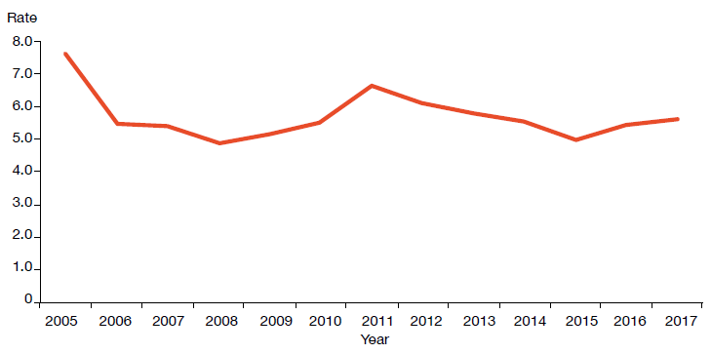
Source: PRIMHD data, extracted on 14 August 2018, except for Nelson Marlborough, Southern, and Whanganui DHBs, which submitted data manually

During the year ending 31 December 2017, a total of 265 people received ECT and 2,914 treatments were administered, representing a mean of 11 treatments per person (see Table 19).

Table 19: ECT therapy indicators, by DHB of domicile, 1 January to 31 December 2017
DHB of domicile |  | Number of people treated with ECT |  | Number of  treatments | Mean number of treatments per person (range)
Auckland | 23 |  | 298 |  | 13 (2–52)
Bay of Plenty | 17 |  | 256 |  | 15 (3–52)
Canterbury | 21 |  | 198 |  | 9 (1–45)
Capital & Coast | 21 |  | 190 |  | 9 (1–30)
Counties Manukau | 23 |  | 214 |  | 9 (1–16)
Hawke’s Bay | 12 |  | 46 |  | 4 (1–12)
Hutt Valley | 12 |  | 142 |  | 12 (1–31)
Lakes | 9 |  | 102 |  | 11 (1–28)
MidCentral | 7 |  | 46 |  | 7 (3–11)
Nelson Marlborough | 8 |  | 66 |  | 8 (3–17)
Northland |  | 14 |  | 183 | 13 (1–30)
South Canterbury |  | – |  | – | –
Southern |  | 38 |  | 451 | 12 (1–58)
Tairāwhiti |  | 1 |  | 6 | 6 (6–6)
Taranaki |  | 2 |  | 7 | 4 (1–6)
Waikato |  | 36 |  | 413 | 11 (1–47)
Wairarapa |  | 1 |  | 1 | 1 (1–1)
Waitemata |  | 22 |  | 275 | 13 (2–31)
West Coast |  | 1 |  | 7 | 7 (7–7)
Whanganui |  | 1 |  | 13 | 13 (13–13)
New Zealand total |  | 265 |  | 2,914 | 11 (1–58)
Notes: In 2017, 24 people were treated out of area, as follows:
- Auckland DHB saw one person from Bay of Plenty DHB, two people from Counties Manukau DHB and one from Waitemata DHB
- Bay of Plenty DHB saw one person from Tairāwhiti DHB
- Canterbury DHB saw one person from West Coast DHB
- Capital & Coast DHB saw six people from Hutt Valley DHB
- Counties Manukau DHB saw one person from Auckland DHB
- Hutt Valley DHB saw two people from Capital & Coast DHB and one from Wairarapa DHB
- Lakes DHB saw one person from Taranaki DHB, one person from Waikato DHB and one person from Waitemata DHB
- MidCentral DHB saw one person from Hutt Valley DHB, one from Taranaki DHB and one from Whanganui DHB
- Southern DHB saw one person from Northland DHB
- Waikato DHB saw one person from Auckland DHB.
If a person was seen while living in two DHB areas, they were counted under each DHB. The New Zealand total of 265 is a unique count and not a sum of this column in the table, as the New Zealand total excludes one individual who was treated by more than one DHB.
Source: PRIMHD data, extracted on 14 August 2018, except for Nelson Marlborough, Southern and Whanganui DHBs, which submitted data manually

The national rate of people receiving ECT treatment in 2017 was 5.5 per 100,000. Figure 41 presents the rate of people treated with ECT by DHB of domicile. As Figure 41 shows, the rate of ECT treatments varies regionally. Several factors contribute to this. First, regions with smaller populations are more vulnerable to annual variations (according to the needs of the population at any given time). In addition, people receiving continuous or maintenance treatment will typically receive more treatments in a year than those treated with an acute course. ECT is indicated in older people more often than in younger adults because older people are more likely to have associated medical problems contraindicating medication. Finally, populations in some DHBs have better access to ECT services than others.

Figure 41: Rates of people treated with ECT, by DHB of domicile, 1 January to 31 December 2017
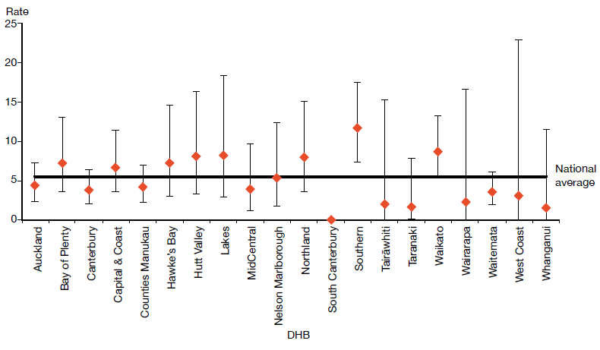
Notes: As the numbers of people receiving ECT by DHB are so small, it is difficult to make meaningful comparisons between DHBs using rates per 100,000 population.
Confidence intervals (for 99 percent confidence) have been used to aid interpretation. Where a DHB region’s confidence interval crosses the national average, this means the DHB’s rate was not statistically significantly different to the national average.
Source: PRIMHD data, extracted on 14 August 2018, except for Nelson Marlborough, Southern and Whanganui DHBs, which submitted data manually

Consent to treatment
Section 60 of the Mental Health Act describes the process required for obtaining consent for ECT – obtaining either the consent of the person themselves or a second opinion from a psychiatrist appointed by the Mental Health Review Tribunal. In the latter case, the psychiatrist must consider the treatment to be in the interests of the person.

This process allows for the treatment of people too unwell to consent to treatment. Clinicians should decide whether ECT is in the interests of the person after discussing the options with family/whānau and considering any relevant advance directives the person has made.
During 2017, six people were treated with ECT who retained decision-making capacity and refused consent. The total number of ECT treatments not able to be consented increased from 954 in 2016 to 1,137 in 2017, which may be attributable to focused efforts by the Office during 2015 to improve reporting on non-consensual ECT. Table 20 shows the number of treatments administered without consent during 2017.

Table 20: Indicators for situations in which ECT was not consented to, by DHB of service, 1 January to 31 December 2017
DHB of service | Number of people given ECT who did not have the capacity to consent | Number of administrations not able to be consented to | Number of people given ECT who had capacity and refused consent
Auckland | 18 | 212 | 0
Bay of Plenty | 5 | 51 | 0
Canterbury | 16 | 167 | 2
Capital & Coast | 4 | 26 | 0
Counties Manukau | 8 | 52 | 0
Hawke’s Bay | 0 | 0 | 0
Hutt Valley | 4 | 24 | 3
Lakes | 0 | 0 | 0
MidCentral | 3 | 32 | 0
Nelson Marlborough | 0 | 0 | 0
Northland | 7 | 68 | 0
South Canterbury | 0 | 0 | 0
Southern | 17 | 234 | 1
Tairāwhiti | 0 | 0 | 0
Taranaki | 0 | 0 | 0
Waikato | 14 | 173 | 0
Wairarapa | – | – | –
Waitemata | 10 | 98 | 0
West Coast | – | – | –
Whanganui | – | – | –
New Zealand | 106 | 1,137 | 6
Notes: The data in this table cannot be reliably compared with the data in Table 17, as it relates to DHB of service rather than DHB of domicile.
A dash (–) indicates the DHB does not perform ECT. In this case, the DHB sends people to other DHBs for treatment.
Source: Manual data from DHBs (the Ministry of Health is currently unable to provide this data from PRIMHD)

Age and sex of patients treated with electroconvulsive therapy
Table 21 and Figure 42 present information on the age and sex of people treated with ECT in 2017. For this data, age group was determined by the individual’s age at the beginning of the reporting period. The majority of people (66 percent) treated with ECT were over 50 years old in 2017.

In 2017, of the 265 people who received ECT treatment, 168 (almost 63 percent) were female and 97 (almost 37 percent) were male. The main reason for the sex difference is that more females present to mental health services with depressive disorders. This ratio is similar to that reported in other countries.

Table 21: Number of people treated with ECT, by age group and sex, 1 January to 31 December 2017
Age group | Female | Male | Total
15–19 | 3 | 1 | 4
20–24 | 5 | 8 | 13
25–29 | 6 | 8 | 14
30–34 | 6 | 4 | 10
35–39 | 15 | 3 | 18
40–44 | 9 | 6 | 15
45–49 | 12 | 5 | 17
50–54 | 22 | 8 | 30
55–59 | 11 | 16 | 27
60–64 | 18 | 12 | 30
65–69 | 28 | 8 | 36
70–74 | 13 | 6 | 19
75–79 | 13 | 6 | 19
80–84 | 3 | 4 | 7
85–89 | 3 | 2 | 5
90–95 | 1 | 0 | 1
Total | 168 | 97 | 265
Source: PRIMHD data, extracted on 14 August 2018, except for Nelson Marlborough, Southern and Whanganui DHBs, which submitted data manually

Figure 42: Number of people treated with ECT, by age group and sex, 1 January to 31 December 2017
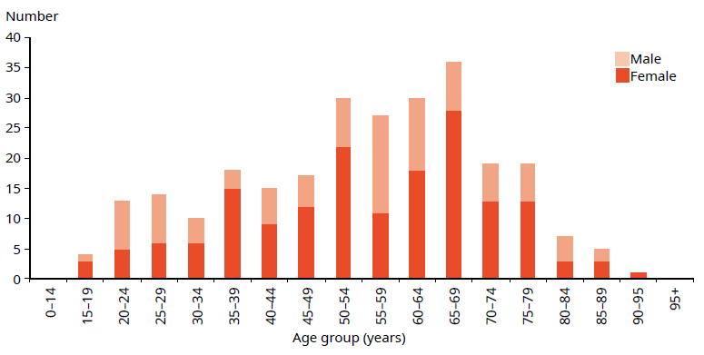
Source: PRIMHD data, extracted on 14 August 2018, except for Nelson Marlborough, Southern and Whanganui DHBs, which submitted data manually

Ethnicity of people treated with electroconvulsive therapy
Table 22 suggests that Asian, Māori and Pacific peoples are less likely to receive ECT than those of other ethnicities. However, the numbers involved are so small that it is not statistically appropriate to compare the percentages of people receiving ECT in each ethnic group with the proportion of each ethnic group in the total population of New Zealand.

Table 22: Number of people treated with ECT, by ethnicity, 1 January to 31 December 2017
Ethnicity | Number
Asian | 14
Māori | 28
Pacific | 11
Other | 212
Total | 265
Source: PRIMHD data, extracted on 14 August 2018, except for Nelson Marlborough, Southern and Whanganui DHBs, which submitted data manually

References
American Psychiatric Association. 2001. The Practice of ECT: A task force report (2nd ed). Washington, DC: American Psychiatric Association.
Associate Minister of Health. 2006. New Zealand Suicide Prevention Strategy
2006–2016. Wellington: Ministry of Health.
Baker M. 2015. He Kai i nga Rangatira: He korero o nga whānau whaiora. Wellington: Te Rau Matatini Ltd.
Beautrais AL, Collings SCD, Ehrhardt P, et al. 2005. Suicide Prevention: A review of evidence of risk and protective factors, and points of effective intervention. Wellington: Ministry of Health.
Cunningham R, Sarfati D, Peterson D, et al. 2014. Premature mortality in adults using New Zealand psychiatric services. New Zealand Medical Journal 127(1394): 31–41.
Elder H, Tapsell R. 2013. Māori and the Mental Health Act. In J Dawson and K Gledhill (eds). New Zealand’s Mental Health Act in Practice. Wellington: Victoria University Press.
Elliott M. 2017. The People’s Mental Health Report: A crowdfunded and crowdsourced story- based inquiry into the public mental health system in Aotearoa New Zealand. Wellington: ActionStation Aotearoa. URL: www.peoplesmentalhealthreport.com (accessed 30 November 2018).
Every-Palmer S, Barry-Walsh J, Pathé M. 2015. Harassment, stalking, threats and attacks targeting New Zealand politicians: A mental health issue. Australian & New Zealand Journal of Psychiatry 49(7): 634–41.
HQSC. 2012. New Zealand Health and Disability Services – National Reportable Events Policy 2012. Wellington: Health Quality & Safety Commission New Zealand.
Huckshorn KA. 2005. Six Core Strategies to Reduce the Use of Seclusion and Restraint Planning Tool. Alexandria, VA: National Association of State Mental Health Program Directors.
Ministry of Health. 2004. Use of Electroconvulsive Therapy (ECT) in New Zealand: A review of efficacy, safety, and regulatory controls. Wellington: Ministry of Health.
Ministry of Health. 2006. Review of the Application of Section 7A of the Mental Health (Compulsory Assessment and Treatment) Act 1992. Wellington: Ministry of Health.
Ministry of Health. 2007. National Guidelines: Interim methadone prescribing. Wellington: Ministry of Health.
Ministry of Health. 2009. Electroconvulsive Therapy (ECT) in New Zealand: What you and your family and whānau need to know. Wellington: Ministry of Health.
Ministry of Health. 2010. Seclusion under the Mental Health (Compulsory Assessment and Treatment) Act 1992. Wellington: Ministry of Health.
Ministry of Health. 2012a. Guidelines for the Role and Function of Directors of Area Mental Health Services. Wellington: Ministry of Health.
Ministry of Health. 2012b. Guidelines for the Role and Function of District Inspectors Appointed under the Mental Health (Compulsory Assessment and Treatment) Act 1992. Wellington: Ministry of Health.
Ministry of Health. 2012c. Guidelines for the Role and Function of Duly Authorised Officers under the Mental Health Act 1992. Wellington: Ministry of Health.
Ministry of Health. 2012d. Guidelines to the Mental Health (Compulsory Assessment and Treatment) Act 1992. Wellington: Ministry of Health.
Ministry of Health. 2012e. Rising to the Challenge: The Mental Health and Addiction Service Development Plan 2012–2017. Wellington: Ministry of Health.
Ministry of Health. 2013a. New Zealand Suicide Prevention Action Plan 2013–2016. Wellington: Ministry of Health. URL: www.health.govt.nz/publication/new-zealand-suicide-prevention-action-plan-2013-2016 (accessed 6 December 2018).
Ministry of Health. 2013b. PRIMHD: Mental health data. URL: www.health.govt.nz/nz-health-statistics/national-collections-and-surveys/collections/primhd-mental-health-data (accessed 8 September 2017).
Ministry of Health. 2014a. New Zealand Practice Guidelines for Opioid Substitution Treatment. Wellington: Ministry of Health.
Ministry of Health. 2014b. Specialist Opioid Substitution Treatment (OST) Service Audit and Review Tool. Wellington: Ministry of Health. URL: www.health.govt.nz/publication/specialist-opioid-substitution-treatment-ost-service-audit-and-review-tool (accessed 5 December 2018).
Ministry of Health. 2015a. Living Well with Diabetes: A plan for people at high risk of or living with diabetes 2015–2020. Wellington: Ministry of Health.
Ministry of Health. 2015b. Suicide Facts: Deaths and intentional self-harm hospitalisations 2012. Wellington: Ministry of Health.
Ministry of Health. 2017a. A Strategy to Prevent Suicide in New Zealand: Draft for public consultation. Wellington: Ministry of Health.
Ministry of Health. 2017b. Special Patients and Restricted Patients: Guidelines for Regional Forensic Mental Health Services. Wellington: Ministry of Health. URL: www.health.govt.nz/ publication/special-patients-and-restricted-patients-guidelines-regional-forensic-mental-health-services (accessed 3 December 2018).
Ministry of Health. 2018a. Cardiovascular Disease Risk Assessment and Management for Primary Care. Wellington: Ministry of Health.
Ministry of Health. 2018b. Mental Health and Addiction Workforce Action Plan 2017–2021 (2nd edn). Wellington: Ministry of Health. URL: www.health.govt.nz/publication/mental-health- and-addiction-workforce-action-plan-2017-2021 (accessed 3 December 2018).
Ministry of Health. 2018c. Night Safety Procedures: Transitional Guideline. Wellington: Ministry of Health. URL: www.health.govt.nz/publication/night-safety-procedures- transitional-guideline (accessed 3 December 2018).
New Zealand Law Commission. 2010. Mental Impairment Decision-making and the Insanity Defence. Wellington: New Zealand Law Commission.
New Zealand Law Commission. 2012. Compulsory Treatment for Substance Dependence: A review of the Alcoholism and Drug Addiction Act 1966. Wellington: New Zealand Law Commission.
OAG. 2017. Mental Health: Effectiveness of the planning to discharge people from hospital. Wellington: Office of the Auditor-General. URL: www.oag.govt.nz/2017/mental-health/docs/mental-health.pdf/view (accessed 3 December 2018).
Oakley Browne MA, Wells JE, Scott KM (eds). 2006. Te Rau Hinengaro: The New Zealand Mental Health Survey. Wellington: Ministry of Health.
Office for Disability Issues. 2015. Disability Action Plan 2014–2018: Update 2015: Cross-government priorities to improve disabled people’s ability to participate and contribute to New Zealand. Wellington: Office for Disability Issues. URL: www.odi.govt.nz/nz-disability-strategy/disability-action-plan/disability-action-plan-2014-2018-update-2015/ (accessed 3 December 2018).
Standards New Zealand. 2008a. Health and Disability Services (General) Standard. Wellington: Standards Council.
Standards New Zealand. 2008b. Health and Disability Services (Restraint Minimisation and Safe Practices) Standards. Wellington: Standards Council.
Simon RJ, Ahn-Redding H. 2006. The Insanity Defense, the World Over. Lanham, Maryland: Rowman & Littlefield.
Suicide Mortality Review Committee. 2016a. Ngā Rāhui Hau Kura: Suicide Mortality Review Committee Feasibility Study 2014–15. Wellington: Suicide Mortality Review Committee. URL: www.hqsc.govt.nz/our-programmes/mrc/sumrc/publications-and-resources/publication/2471 (accessed 5 December 2018).
Suicide Mortality Review Committee. 2016b. Ngā Rāhui Hau Kura: Suicide Mortality Review Committee Feasibility Study 2014–15. Report to the Ministry of Health, 31 May 2016. Wellington: Suicide Mortality Review Committee. URL: www.hqsc.govt.nz/our- programmes/mrc/sumrc/publications-and-resources/publication/2471 (accessed 5 December 2018).
Superu. 2016. The Prime Minister’s Youth Mental Health Project: Summative evaluation report. Wellington: Social Policy Evaluation and Research Unit. URL: http://superu.govt.nz/ymh (accessed 30 November 2018).
Te Pou o Te Whakaaro Nui. 2014. Auckland: Te Pou.

Appendix 1: Key databases and caveats

The Programme for the Integration of Mental Health Data
The Programme for the Integration of Mental Health Data, or PRIMHD (pronounced ‘primed’), is the Ministry of Health’s (the Ministry’s) national collection for mental health and addiction service activity and outcome data for mental health consumers. PRIMHD data is used to report on what services are being provided, who is providing the services, and what outcomes are being achieved for health consumers across New Zealand’s mental health sector. These reports enable mental health and addiction service providers to carry out better service planning and decision-making at the local, regional and national levels (Ministry of Health 2013b). PRIMHD reports are invaluable for facilitating important conversations and debates about mental health issues in New Zealand.

In 2008, it became mandatory for district health boards (DHBs) to report to PRIMHD. In addition, from this date, an increasing number of non-governmental organisations (NGOs) began reporting to the PRIMHD database. As of December 2017, 204 NGOs were reporting to PRIMHD.

Because of both its recent introduction and the enormous complexities of creating and maintaining a national data collection, the following caveats need to be kept in mind when reviewing statistics generated using PRIMHD data.
- Shifts or patterns in the data after 2008 may reflect the gradual adaptation of service providers to the PRIMHD system, in addition to, or instead of, any trend in mental health service use or consumer outcomes.
- PRIMHD is a living data collection that continues to be revised and updated as data reporting processes are improved. For this reason, previously published data may be liable to amendments.
- Statistical variance between services may reflect different models of practice and different consumer populations. However, inter-service variance may also result from differences in data entry processes and information management.
- To function as a national collection, PRIMHD requires integration with a wide range of person management systems across hundreds of unique service providers. As the services adjust to PRIMHD, it is expected that the quality of the data will improve.
- The quality and accuracy of statistical reporting relies on consistent, correct and timely data entry by the services that report to PRIMHD. The Ministry is actively engaged in an ongoing project to review and improve the data quality of PRIMHD. This project is considered a priority given the importance of mental health data in providing information about mental health consumption and outcomes, and in generating conversations and public debate about how to improve mental health care for New Zealanders.
- To demonstrate how data can vary over time, Table A1 presents the rate ratio of Māori to non-Māori subject to a compulsory treatment order (section 29) under the Mental Health Act, by DHB, from 2013 to 2017.

Table A1: Rate ratio Māori to non-Māori subject to a compulsory treatment order (section 29) under the Mental Health Act, by DHB, 2013–2017

Year | Rate ratio (Māori:non-Māori)
 | 2013 | 2014 | 2015 | 2016 | 2017
Annual reports | 2.9 | 2.9 | 3.6 | 3.6 | 3.9
Retrospective extraction | 3.9 | 3.9 | 4.0 | 3.9 | 3.9
Source: PRIMHD data, extracted on 27 September 2018

Taken from the 2013 to the 2017 annual reports, it appears the rate ratio between Māori and non-Māori has increased by 1 point. However, because PRIMHD is changeable and data are being improved constantly, this could result in the difference of the rate ratio between what was extracted in previous reports compared with what is seen for those periods now.

Further, legal status reporting and most PRIMHD reporting prioritises the ethnicity recorded for the National Health Index (NHI) rather than the ethnicity recorded against the person at the time of an event. If people have subsequently recorded Māori as an additional ethnicity on their NHI when previously they just recorded New Zealand European, they will be recorded as Māori on all ethnicity reports extracted after that change was made. This happens constantly as people engage more with health services and more information is collected. In 2017, ethnicity was taken from primary health organisation (PHO) records and combined with the NHI – resulting in approximately 10,000 additional Māori nationwide.

The Alcohol and Drug Outcomes Measure
In July 2015, the Alcohol and Drug Outcome Measure (ADOM) was mandated for use in community outpatient settings. It is a validated, New Zealand-designed outcome, measuring alcohol and other drug use, lifestyle and wellbeing, and recovery satisfaction.

In 2017, there was a noticeable increase in the uptake of ADOM and aggregated reports using ADOM data. Of the 20 DHBs required to use and report on ADOM in community settings, 15 (75 percent) are now reporting to PRIMHD, and 85 percent of the NGOs are also doing so. These organisations comprise over 220 teams.

Aggregated reports of the Te Pou o te Whakaaro Nui (Te Pou) website have been well received, and statistics have been used in presentations, at conferences and anecdotally for local service improvement around New Zealand.

The end of 2017 saw discussion around using ADOM in peer support and translating ADOM into other languages, both to be followed up on in 2018.

Appendix 2:
Additional statistics

The Mental Health Review Tribunal
During the year ended 30 June 2017, the Mental Health Review Tribunal (the Tribunal) received 139 applications under the Mental Health (Compulsory Assessment and Treatment) Act 1992 (the Mental Health Act). Table A2 presents the types of applications received (by governing section of the Act) and the outcomes of these applications.

Table A2: Outcome of the Mental Health Act applications received by the Mental Health Review Tribunal, 1 July 2016 to 30 June 2017
Outcome | Section  79 | Section  80 | Section  81 | Section  75 | Total
Deemed ineligible | 11 | 0 | 0 | 0 | 11
Withdrawn | 55 | 4 | 0 | 0 | 59
Held over to the next report year | 6 | 0 | 0 | 0 | 6
Heard in the report year | 60 | 3 | 0 | 0 | 63
Total | 132 | 7 | 0 | 0 | 139
Source: Annual report of the Mental Health Review Tribunal, 1 July 2016 to 30 June 2017

During the year ended 30 June 2017, the Tribunal heard 62 applications under section 79 of the Mental Health Act. Table A3 presents the results of those cases.

Table A3: Results of inquiries under section 79 of the Mental Health Act held by the Mental Health Review Tribunal, 1 July 2016 to 30 June 2017
Result | Number
Not fit to be released from compulsory status | 63
Fit to be released from compulsory status | 6
Total | 69

Source: Annual report of the Mental Health Review Tribunal, 1 July 2016 to 30 June 2017

Table A4 shows the ethnicity of the 115 people for whom ethnicity was identified in an application to the Tribunal in the year ended 30 June 2017.

Table A4: Ethnicity of people who identified their ethnicity in Mental Health Review Tribunal applications, 1 July 2016 to 30 June 2017
Ethnicity | Number | Percent
New Zealand European | 81 | 58%
Māori | 26 | 19%
Pacific | 8 | 6%
Asian | 3 | 2%
Other | 10 | 7%
Unknown | 11 | 8%
Total | 139 | 100%
Source: Annual report of the Mental Health Review Tribunal, 1 July 2016 to 30 June 2017

Of the 139 Mental Health Act applications the Tribunal received during the year ended 30 June 2017, 84 (60 percent) were from males and 55 (40 percent) from females. Table A5 presents these figures broken down by application subject.

Table A5: Sex of people making Mental Health Review Tribunal applications, 1 July 2016 to 30 June 2017
Subject of application | Total number (percentage) | Sex | Number
Community treatment order | 111 (80%) | Female | 44
 |  | Male | 67
Inpatient treatment order | 21 (15%) | Female | 11
 |  | Male | 10
Special patient order | 7 (5%) | Female | 0
 |  | Male | 7
Restricted person order | 0 (0%) | Female | 0
 |  | Male | 0
Source: Annual report of the Mental Health Review Tribunal, 1 July 2016 to 30 June 2017

Ministry of Justice statistics
Table A6 presents data on applications for a compulsory treatment order from 2004 to 2017. Table A7 shows the types of orders granted over the same period.

Table A6: Applications for compulsory treatment orders (or extensions), 2004–2017
Year | Number of applications for a CTO, or extension to a CTO | Number of applications granted or granted with consent | Number of applications dismissed or struck out | Number of applications withdrawn, lapsed or discontinued | Number of applications transferred to the High Court
2004 | 4,443 | 3,863 | 100 | 460 | 0
2005 | 4,298 | 3,682 | 100 | 520 | 0
2006 | 4,254 | 3,643 | 109 | 515 | 1
2007 | 4,535 | 3,916 | 99 | 542 | 0
2008 | 4,633 | 3,969 | 103 | 485 | 0
2009 | 4,562 | 4,038 | 54 | 494 | 0
2010 | 4,783 | 4,156 | 74 | 523 | 1
2011 | 4,781 | 4,215 | 70 | 516 | 0
2012 | 4,885 | 4,343 | 71 | 443 | 0
2013 | 5,062 | 4,607 | 68 | 411 | 0
2014 | 5,227 | 4,632 | 47 | 575 | 0
2015 | 5,368 | 4,748 | 52 | 550 | 0
2016 | 5,601 | 4,924 | 70 | 544 | 0
Notes: The table presents applications that had been processed at the time of data extraction on 12 June 2018. The year is determined by the final outcome date.
CTO = Compulsory treatment order.
The case management system (CMS) is a live operational database. Figures are subject to minor changes at any time.
Source: Ministry of Justice Integrated Sector Intelligence System, which uses data entered into the CMS

Table A7: Types of compulsory treatment orders made on granted applications, 2004–2017
Year | Number of granted applications for orders | Number of compulsory community treatment orders (or extension) | Number of compulsory inpatient treatment orders (or extension) | Number of orders recorded as both compulsory community and inpatient treatment orders (or extension) | Number of applications where type of order was not recorded
2004 | 3,863 | 1,831 | 1,533 | 119 | 368
2005 | 3,682 | 1,576 | 1,438 | 93 | 565
2006 | 3,643 | 1,614 | 1,384 | 91 | 540
2007 | 3,916 | 1,714 | 1,336 | 118 | 724
2008 | 3,969 | 1,841 | 1,431 | 120 | 564
2009 | 4,038 | 2,085 | 1,564 | 106 | 268
2010 | 4,156 | 2,253 | 1,625 | 111 | 158
2011 | 4,215 | 2,255 | 1,677 | 90 | 185
2012 | 4,343 | 2,436 | 1,684 | 80 | 139
2013 | 4,607 | 2,639 | 1,766 | 72 | 129
2014 | 4,632 | 2,659 | 1,784 | 83 | 105
2015 | 4,748 | 2,801 | 1,789 | 68 | 89
2016 | 4,924 | 2,894 | 1,722 | 66 | 239
2017 | 4,937 | 2,609 | 1,690 | 55 | 581
Notes: The table presents applications that had been processed at the time of data extraction on 12 June 2018. The year is determined by the final outcome date.
Where more than one type of order is shown, it is likely to be because new orders are being linked to a previous application in the case management system (CMS). The CMS is a live operational database. Figures are subject to minor changes at any time.
Source: Ministry of Justice Integrated Sector Intelligence System, which uses data entered into the CMS

Seclusion statistics incorporating outlier data
The Ministry and DHBs continue to develop and refine their data collection and analysis in order to reflect their services more accurately. Between these groups, however, methodologies often differ, making it challenging to provide comparable datasets. In 2017, Capital & Coast DHB adjusted the way it recorded seclusion to include time outside seclusion. As a result, a high proportion of Capital & Coast DHB hours for the 2017 year pertains to a single client, such that the data is considered an outlier.

Incorporating outlier data in the national statistics would skew the data and create a different picture of mental health services. To highlight how influential this discrepancy is, we present some of the data that includes the outlier below.

These cases are closely monitored by the Director of Mental Health and the Office of the Ombudsman.

To summarise, in adult inpatient services in 2017:
- the total number of hours spent in seclusion has decreased by 56 percent since 2009
- the number of hours spent in seclusion has increased by 16 percent
- the number of seclusion events increased by 46 percent, and the national average number of seclusion events per 100,000 population was 76
- between 1 January and 31 December 2017, adult mental health services (excluding forensic and other regional rehabilitation services) accommodated 8,911 people for a total of 242,195 bed nights. Of these people, 77660 (8.7 percent) were secluded at some time during the reporting period
- people who were secluded were often secluded more than once (on average
- 2.8 times). Therefore, the number of seclusion events in adult inpatient services (2,163) was higher than the number of people secluded
- most seclusion events (80 percent) lasted for less than 24 hours. Some (9 percent) lasted for longer than 48 hours
- Māori were 4.4 times more likely to be secluded in adult inpatient services that people from other ethnic groups
- the number of seclusion events per 1,000 bed nights was 8.8.

Appendix 3: Special and restricted patients

The insanity defence

Section 23 of the Crimes Act 1961: Insanity
1. Every one shall be presumed to be sane at the time of doing or omitting any act until the contrary is proved.
2. No person shall be convicted of an offence by reason of an act done or omitted by him or her when labouring under natural imbecility or disease of the mind to such an extent as to render him or her incapable –
a. of understanding the nature and quality of the act or omission; or
b. of knowing that the act or omission was morally wrong, having regard to the commonly accepted standards of right and wrong.

In New Zealand legislation, the insanity defence comes under Section 23 of the Crimes Act 1961. As explained in the New Zealand Law Commissions’ report Mental Impairment Decision-making and the Insanity Defence (2010), the insanity defence draws connection to the M’Naghten Rule. The M’Naghten Rule is a test that is used to determine whether or not a person accused of a crime should be held criminally responsible given their sanity at the time.

Under the insanity defence, the person who committed an offence would have had no understanding of the nature of the offence and/or that, at the time the offence was made, they could not recognise the morality behind the offence. Several countries, including Canada, the United States, Argentina, Italy, Hungary, China and Nigeria, share similar legislation (Simon and Ahn-Redding 2006). In New Zealand legislation, the insanity defence pertains to the Criminal Procedure (Mentally Impaired Persons) Act 2003, the Intellectual Disability (Compulsory Care and Rehabilitation) Act 2003 and the Mental Health (Compulsory Assessment and Treatment) Act 1992.

For more information about the Insanity Defence, we recommend reading Mental Impairment Decision-making and the Insanity Defence (New Zealand Law Commission 2010).

Special patient legal status types
Act | Section | Special patient type
CP (MIP) Act | Section 38(2)(c) | SFC
CP (MIP) Act | Section 24(2)(a) (Unfit to stand trial) | EFC
CP(MIP) Act | Section 24(2)(a) (Found to be insane) | EFC
CP (MIP) Act | Section 44(1) | SFC
CP (MIP) Act | Section 34(1)(a)(i) | SFC
CP (MIP) Act | Section 23 | SFC
CP (MIP) Act | Section 35 | SFC
MH (CAT) Act | Section 55, Restricted | EFC
MH (CAT) Act | Special Patient, Sections 45 and 11 | SFC
MH (CAT) Act | Sections 45 and 13 | SFC
MH (CAT) Act | Section 46 | SFC
MH (CAT) Act | Sections 45 and 30 Extension | SFC
MH (CAT) Act | Sections 45 and 14 | SFC
MH (CAT) Act | Sections 45 and 30 | SFC
MH (CAT) Act | Sections 45 and 15(1) | SFC
MH (CAT) Act | Sections 45 and 15(2) | SFC
MH (CAT) Act = Mental Health (Compulsory Assessment and Treatment) Act
CP (MIP) Act = Criminal Procedure (Mentally Impaired Persons) Act
SFC = short forensic care
EFC = extended forensic care

Appendix 4: Developments in mental health and addiction reporting and improvement

Updated National Adverse Events Reporting Policy 2017
The Health Quality & Safety Commission New Zealand’s (HQSC’s) Adverse Events Learning Programme continues to focus on learning from reviews of adverse events, including those in mental health and addiction services. Following broad consultation, the HQSC released the updated National Adverse Events Reporting Policy on 1 July 2017 (the 2017 Policy), with a number of associated guidance documents and resources.

The 2017 Policy supports a shift to see adverse events within mental health and addiction services follow the same reporting and review processes as non-mental health and addiction events. Since 2013, adverse events relating to users of mental health and addiction services funded by district health boards (DHBs) have been reported to the HQSC, in line with the policy, but publicly reported by the Office of the Director of Mental Health and Addiction Services (the Office). Historically, most adverse events occurring in mental health and addiction services were reviewed using the London Protocol, as this methodology was deemed by the mental health sector to be more suitable than the root cause analysis approach more commonly used in the wider health and disability sector.

The 2017 Policy removed separate reporting and review processes specific to mental health and addiction services. It allows for the use of a broader range of review methodologies, including those more suited to mental health and addiction services. The HQSC is working with the Office to determine how the learnings from these reviews will be reported and shared in the future. In the meantime, numbers of events will continue to be shared through the Office’s annual reports, and learnings from reviews will be shared through the HQSC’s Open Book reports and other learning forums.

National mental health and addiction quality improvement programme
On 1 July 2017, the Minister of Health launched a new five-year national mental health and addiction quality improvement programme, led by the HQSC. This programme will see the HQSC work with consumers, their families/whānau and service providers to continue to improve the quality of mental health and addiction services in New Zealand.

The programme will use improvement science to test evidence-based changes and interventions locally, to measure the impact of these changes and, if they are successful, to work with other services to implement the changes more widely. It will focus on five priority areas.
1. Minimising restrictive care
2. Improving medication management and prescribing
3. Improving service transitions
4. Maximising the physical health of people with mental health and addiction problems
5. Learning from serious adverse events and consumer experience.

As well as leading this work, the HQSC will support leadership in the health sector to deliver quality improvement initiatives and to build quality improvement capability within mental health and addiction services.

Suicide Mortality Review Committee
Suicide is a major cause of death in New Zealand and the most common cause of death for young people. In September 2013, the Ministry of Health contracted the HQSC to trial a suicide mortality review, an action set out in the New Zealand Suicide Prevention Action Plan 2013–16 (Ministry of Health 2013a). This resulted in the HQSC establishing the Suicide Mortality Review Committee (SuMRC) and the Suicide Mortality Review Feasibility Study. The HQSC published the resulting reports, including recommendations, in May 2016 (Suicide Mortality Review Committee 2016a and b).

Following the successful SuMRC trial, the Minister of Health announced in July 2017 that SuMRC will receive funding for ongoing work. The SuMRC will provide vital knowledge about factors and patterns of suicide to guide new suicide prevention activities and reinforce and strengthen existing activities.

Data from 2015 is used because it can take over two years for a coroner’s investigation into a suicide to be completed.
More information on the Ministry’s work in the areas of mental health and addictions can be found at www.health.govt.nz/our-work/mental-health-and-addictions.
More information about the ADOM can be found in Appendix 1.
Source: Programme for the Integration of Mental Health Data (PRIMHD) as at 15 August 2018.
Source: PRIMHD data as at 15 August 2018.
Source: PRIMHD data as at 15 August 2018.
Between 2011 and 2017, the total New Zealand population increased by approximately 10 percent.
Te Pou o Te Whakaaro Nui 2014.
Some DHBs submitted responses to the paper-based survey before it was discontinued as well as the real-time survey.
Mārama real-time feedback system, 2017 calendar year.
Mental Health Act sections 11, 13, 14(4), 15(1), 15(2), 29, 30 and 31
Source: Ministry of Justice Integrated Sector Intelligence System as at 12 June 2018; this system uses data entered into the case management system (CMS). The CMS is a live operational database. Figures are subject to minor changes at any time.
Source: PRIMHD data, extracted on 7 June 2018.
Source: PRIMHD data, extracted on 17 August 2018, except for data from Southern and Auckland DHBs, which submitted data manually.
Source: PRIMHD data, extracted on 17 August 2018, except for data from Southern DHB, which submitted data manually. ‘On a given day’ is the average of the last day of each month.
Source: Ministry of Justice Integrated Sector Intelligence System as at 12 June 2018; this system uses data entered into the case management system (CMS). The CMS is a live operational database. Figures are subject to minor changes at any time.
This is a specific action outlined in Rising to the Challenge (Ministry of Health 2012e). In addition, the number of Māori subject to section 29 of the Mental Health Act is now an indicator in the Māori health plans that the Ministry requires every DHB to produce.
These ratios are based on the age-standardised rates of the Māori and non-Māori populations. See Appendix 1: Key databases and caveats for a time-series extraction and analysis of the rate ratio between Māori and non-Māori under section 29 of the Mental Health Act.
Source: PRIMHD data, extracted on 15 August 2018. This applies to both voluntary service users and those treated under the Mental Health Act.
Source: PRIMHD data, extracted on 15 August 2018.
Source: PRIMHD data, extracted on 15 August 2018.
Source: PRIMHD data, extracted on 17 August 2018. Deprivation deciles are ranked 1 to 10, where 1 represents areas with the least deprived scores and 10 the areas with the most deprived scores.
The Ministry’s leadership of Action 9(d) of the Disability Action Plan 2014–18, to ‘explore how the Mental Health (Compulsory Assessment and Treatment) Act 1992 relates to the New Zealand Bill of Rights Act 1990 and the CRPD (the Convention on the Rights of Persons with Disabilities)’ is expected to contribute in a meaningful way to this conversation.
Adult mental health services generally care for people aged 20–64 years. Adult inpatient services are distinct from forensic services, youth services, intellectual disability services and services for older people. Additionally, this data includes patients with a legal status under the Mental Health Act, but are treated in RIDSS.
Note: see Appendix 2 for further details about the outlier data.
We are comparing with 2009 because that is the year when seclusion reduction policies were introduced.
For 2017, bed nights are measured by team types that provide seclusion. In previous years, this was measured by acute and sub-acute bed nights. Excludes outlier data.
Source: PRIMHD data, extracted on 17 August 2018; except Southern DHB, which submitted data manually. Excludes outlier data.
Source: PRIMHD data, extracted on 17 August 2018; excludes forensic and outlier data.
Source: PRIMHD data, extracted on 17 August 2018; except Southern DHB, which submitted data manually; excludes the outlier data.
Of the 98 young people spending time in seclusion, 37 were in the country’s specialist facilities for children and young people (in Christchurch, Auckland and Wellington). Of the 285 seclusion events, 104 occurred in those specialist facilities.
If a person in Wairarapa DHB requires admission to mental health inpatient services, they are transported to Hutt Valley or MidCentral DHB, and the seclusion statistics relating to these service users appear on the corresponding DHB’s database.
The Whanganui inpatient unit comes under the Capital & Coast DHB’s forensic services.
More details about the legislative provisions used to define special and restricted patient status for this report are included in Appendix 3: Special and restricted patients.
As per section 2(1) of the Mental Health Act. For the purposes of this report, the data does not include people subject to section 191(2)(a) of the Armed Forces Discipline Act 1971 or section 136(5)(a) of the IDCC&R Act.
There is also a smaller inpatient forensic service in Whanganui that operates under the Capital & Coast DHB’s forensic services. Additionally, in some circumstances, certain special patient orders can enable a Court to direct treatment outside a regional forensic service.
Counts of people with a special patient legal status code current on 30 June 2016.
’Other’ refers to any ethnicity not otherwise specified in the data presented. This report uses prioritised ethnicity according to the ethnicity code tables on the Ministry’s website (www.health.govt.nz/nz-health-statistics/data-references/code-tables/common-code-tables/ethnicity-code-tables).
SAC is a numerical rating that defines the severity of an adverse event and, as a consequence, the required level of reporting and investigation to be undertaken for that event.
See: www.hqsc.govt.nz/our-programmes/adverse-events/publications-and-resources/ publication/2933/
Any suicides or suspected suicides under the Mental Health Act also come under the serious adverse event reporting requirements of the HQSC.
In New Zealand, a death is only officially classified as suicide by the coroner on completion of the coroner’s inquiry. Only those deaths determined as ‘intentionally self-inflicted’ after the inquiry will receive a final verdict of suicide. A coronial inquiry is unlikely to occur within a calendar year of an event occurring, therefore, when a death appears to be self-inflicted but the intent has not yet been determined, it is called a ‘suspected suicide’.
Reports published before the HQSC’s first publication in 2010 were produced by the Quality Improvement Committee.
For more detailed information regarding deaths by suicide, please refer to Understanding Suicide in New Zealand available on the Ministry of Health’s website.
Ministry of Health mortality database data, extracted on 28 June 2018.
Suicide is a death where evidence shows that the person deliberately brought about their own death as determined by coronial ruling. Death by undetermined intent is determined by a coroner in circumstances where intent was not determined or there was not enough information obtained about likely intent
These numbers are subject to change. The mortality database is a dynamic collection, and changes can be made even after the data is considered nominally final.
This is because in the Central and Southern regions, older people’s mental health treatment was provided by health services for older people rather than mental health services and was not necessarily recorded in PRIMHD. Each year, deaths of children under 10 years of age are also excluded because ‘undetermined intent’ deaths in this age group are unlikely to be caused by suicide. The data was drawn from information provided to the Ministry’s national mortality database and PRIMHD.
This figure is determined from the number of people who had an inpatient activity on the day they died; PRIMHD cannot determine the number of people who died at an inpatient unit. In addition to capturing suicide deaths that occurred in inpatient facilities, this figure may also capture: - people who received care in an inpatient facility, were discharged and died by suicide in the community later that day - people who attempted suicide in the community and later died in hospital - people who died by suicide in the community while on leave from an inpatient facility. Note that these figures should not be compared with those of previous annual reports, as the definitions for ‘inpatient’ and ‘community service user’ have been updated.
Excluding those who received treatment on the day of their death.
Excluding those who received treatment on the day of their death and those who died within a week of being discharged from an inpatient service.
Includes deaths of undetermined intent.
Data provided by OST services in six-monthly reports.
PHARMAC is the New Zealand government agency that decides which pharmaceuticals to publicly fund in New Zealand.
The table presents data by DHB of domicile; that is, the area where a person lives. This takes account of the fact that some DHBs do not perform ECT and the people who live in such DHB areas are referred to other DHBs for ECT treatment. Other ECT statistics are presented by DHB of service.
This psychiatrist must be independent of the person’s clinical team.
Refer to the Guidelines to the Mental Health (Compulsory Assessment and Treatment) Act 1992 (Ministry of Health 2012d).
Adult mental health services generally care for people aged 20–64 years. Adult inpatient services are distinct from forensic services, youth services, intellectual disability services and services for older people. Additionally, this data includes patients with a legal status under the Mental Health Act, but are treated in RIDSS.
For 2017, bed nights are measured by team types that provide seclusion. In previous years, bed nights were measured by acute and subacute bed nights.
Source: PRIMHD data, extracted on 17 August 2018; except Southern DHB, which submitted data manually.
See: www.hqsc.govt.nz/our-programmes/adverse-events/national-adverse-events-policy
The London Protocol revised and updated the original ‘Protocol for the Investigation and Analysis of Clinical Incidents’ and outlines a process of incident investigation and analysis develop in a research context and adapted for practical use by risk managers and others trained in incident investigation. For more details, see: www.imperial.ac.uk/media/imperial-college/medicine/surgery-cancer/pstrc/londonprotocol_e.pdf
Based on IHI. 2003. The Breakthrough Series: IHI’s Collaborative Model for Achieving Breakthrough Improvement. IHI Innovation Series white paper. Boston: Institute for Healthcare Improvement. (Available at: www.ihi.org/resources/Pages/IHIWhitePapers/TheBreakthroughSeriesIHIsCollaborativeModelforAchievingBreakthroughImprovement.aspx).
The wording of these five priority areas may be amended when the mental health and addictions quality improvement programme is finalised, but the topic themes will remain the same.

