Methodology Report 2017/18

New Zealand Health Survey

**Authors**

This report was written by Deepa Weerasekera and Chloe Lynch (Ministry of Health), Robert Clark (Statistics Adding Value) and Barry Gribben, Carol Boustead and Neil Tee (CBG Health Research Ltd).

Citation: Ministry of Health. 2019. *Methodology Report 2017/18:  
New Zealand Health Survey*. Wellington: Ministry of Health.

Published in January 2019 by the Ministry of Health  
PO Box 5013, Wellington 6140, New Zealand

ISBN 978-1-98-856836-2 (online)  
HP 7005



This document is available at health.govt.nz

|  |  |
| --- | --- |
| **CCBY** | This work is licensed under the Creative Commons Attribution 4.0 International licence. In essence, you are free to: share ie, copy and redistribute the material in any medium or format; adapt ie, remix, transform and build upon the material. You must give appropriate credit, provide a link to the licence and indicate if changes were made. |

Contents

Section 1: Introduction 1

Background 2

Section 2: Survey content 3

Core content 3

Section 3: Survey population and sample design 5

Target and survey population 5

Sample design 6

Section 4: Data collection 9

Pilot study 9

Enumeration 9

Invitation to participate 10

Visit pattern 10

Interview duration 11

Respondent feedback 11

Audio recording 11

Interviewer training 12

Objective measurements 12

Section 5: Response and coverage rates 14

Calculating the response rate 14

Coverage rate 15

Section 6: Data processing 17

Capturing and coding 17

Securing information 17

Checking and editing 17

Missing data due to non-response 18

Creating derived variables 18

Section 7: Weighting 21

Calculating selection weights 22

Calibration of selection weights 23

Jackknife replicate weights 25

Weights for measurement data 26

Section 8: Analysis methods 27

Estimating proportions, totals and means 27

Comparing population groups 29

Confidence intervals and statistical tests 31

Time trends 32

Section 9: New Zealand Health Survey 2017/18 34

2017/18 module topics 34

Data collection 34

Response rates 36

Coverage rates 37

Final weights 40

Sample sizes 40

Section 10: Errors in previously published statistics 43

Years 1 to 6 child indicator – Television watching 43

References 44

Appendix: 2006/07 New Zealand Health Survey 46

2006/07 New Zealand Health Survey 46

List of Figures

Figure 1: Proportion of households agreeing to first interview, by number of visits, 2017/18 35

Figure 2: Response rates (%) for adults and children, 2011/12–2017/18 36

Figure 3: Coverage rates (%) for adults and children, 2011/12–2017/18 37

Figure 4: Coverage rates (%) for Māori, Pacific and Asian groups, 2011/12–2017/18 38

Figure 5: Coverage rates (%) by NZDep2013 quintiles, 2011/12–2017/18 38

Figure 6: Coverage rates (%) for total population, by age group and sex, 2017/18 39

Figure 7: Coverage rates (%) for Māori, by age group and sex, 2017/18 39

List of Tables

Table 1: Core content of the New Zealand Health Survey 2017/18 4

Table 2: New Zealand Health Survey module topics, 2017/18 34

Table 3: Number of survey respondents, by quarter, 2017/18 35

Table 4: Final weights, 2017/18 40

Table 5: Sample sizes and population counts for children and adults, by sex, 2017/18 40

Table 6: Sample sizes and population counts for children and adults, by ethnic group, 2017/18 41

Table 7: Sample sizes and population counts, by age group, 2017/18 41

Table 8: Sample sizes and population counts, by NZDep2013 quintile, 2017/18 42

# Section 1: Introduction

The New Zealand Health Survey (NZHS) is an important data collection tool that is used to monitor population health and provide supporting evidence for health policy and strategy development. The Health and Disability Intelligence group, within the Ministry of Health’s (the Ministry’s) Health System Improvement and Innovation business unit, is responsible for designing, analysing and reporting on the NZHS. The NZHS field activities are contracted out to a specialist survey provider, CBG Health Research Ltd (CBG).

The NZHS collects information that cannot be obtained more effectively or efficiently through other means, such as by analyses of hospital administrative records, disease registries or epidemiological research. The NZHS is the best source of information at a population level for most of the topics it covers.

NZHSs have also been conducted in 1992/93, 1996/97, 2002/03 and 2006/07. In addition, separate stand-alone surveys on specific subjects have been conducted once every three or four years as part of the wider health survey programme. These surveys covered adult and child nutrition; tobacco, alcohol and drug use; mental health; and oral health. From July 2011, all of the above surveys were integrated into a single NZHS, which is now in continuous operation.

From 2013 onwards, a number of key outputs from the NZHS became Tier 1 statistics (a portfolio of the most important official statistics, essential to understanding how well New Zealand is performing in different aspects of national concern). For the 2017/18 year, the eight Tier 1 statistics from the NZHS are: smoking (current), past-year (alcohol) drinking, hazardous (alcohol) drinking, obesity, unmet need for a general practitioner (GP) due to cost, unfilled prescription due to cost, self-rated health and mental health status (psychological distress).

This NZHS methodology report outlines the procedures and protocols followed to ensure the NZHS produces the high-quality and robust data expected of official statistics (Statistics New Zealand 2007). The information from the continuous NZHS specific to the current 2017/18 year (datacollected between July 2017 and June 2018) is included in Section 9 of this report. The corresponding information for years 2011/12 to 2016/17 of the NZHS can be found in the previous methodology reports.[1]

## Background

As a signatory to the *Protocols for Official Statistics* (Statistics New Zealand 1998), the Ministry employs best-practice survey techniques to produce high-quality information from the NZHS. It uses standard frameworks and classifications, with validated questions where possible, so that NZHS data can be integrated with data from other sources.

### Goal

The goal of the continuous NZHS is to support the formulation and evaluation of health policy by providing timely, reliable and relevant health information. This information covers population health; health risk and protective factors; and health service utilisation.

### Objectives

To achieve this goal, a number of specific objectives have been identified. The *Content Guide 2017/18: New Zealand Health Survey* contains further information on these objectives (Ministry of Health 2018).

### Features of the survey

The NZHS has been carefully designed to minimise the impact on survey respondents. Features for this purpose include:

* selecting only one eligible adult and one eligible child per dwelling
* using well-tested and proven questionnaires
* using professional, trained interviewers to conduct the interviews
* making an appointment to conduct each interview at a time that suits the respondent and their family
* having the option of using a proxy respondent where would-be respondents living in private dwellings have severe ill health or cognitive disability.

The New Zealand Health and Disability Multi-region Ethics Committee (MEC) approved the NZHS 2017/18 (MEC reference: MEC/10/10/103).

# Section 2: Survey content

The NZHS comprises a set of core questions combined with a flexible programme of rotating topic modules. The questionnaire is administered (face to face and computer assisted) to adults aged 15 years and older, as well as to children aged 0–14 years, generally through their primary caregiver, who acts as a proxy respondent.

Over previous years, the content of NZHSs has remained similar so that data can be compared over time. The current NZHS maintains continuity with the previous surveys by including a set of core questions in both the adult and child questionnaires. The module topics change every 12 months.

Cognitive testing is undertaken to ensure the questions are understood as intended and response options are appropriate.

For more detail on the rationale of topic inclusion, cognitive testing and the content of the questionnaires, see the *Content Guide 2017/18* (Ministry of Health 2018).

## Core content

Most of the core questions for both adults and children are drawn from the main topic areas included in the 2006/07 NZHS and the 2011/12 NZHS. Topic areas include long-term conditions; health status and development; health behaviours; health service utilisation and patient experience; sociodemographics; and anthropometry. Table 1 summarises the topics included in the core content of the 2017/18 NZHS. See the *Content Guide 2017/18* (Ministry of Health 2018) for the module topics of each survey year between 2011/12 and 2017/18.

Table 1: Core content of the New Zealand Health Survey 2017/18

|  |  |  |  |
| --- | --- | --- | --- |
| **Topic area** | | **Topics** | |
| **Children** | | | |
| Long-term conditions | Asthma, eczema, diabetes, rheumatic heart disease, mental health conditions | | |
| Health status and development | General health | | |
| Health behaviours | Breastfeeding, nutrition, physical activity, child’s misbehaviour, sleep, tooth brushing | | |
| Health service utilisation and patient experience | Primary health care provider use, GPs, nurses, medical specialists, dental health care workers, other health care workers, hospital use, prescriptions | | |
| Sociodemographics | Child: sex, age, ethnicity, language, country of birth  Primary caregiver/proxy respondent: relationship to child, age, education, income and income sources, employment status, household characteristics | | |
| Anthropometry | Height, weight and waist circumference measurements | | |
| **Adults** | | |
| Long-term conditions (self‑reported) | Heart disease, stroke, diabetes, asthma, arthritis, mental health conditions, chronic pain, high blood pressure, high blood cholesterol | |
| Health status | General health (physical and mental health), psychological distress | |
| Health behaviours | Physical activity, tobacco smoking, electronic cigarette use, vegetable and fruit intake, alcohol use, drug use, sleep, tooth brushing | |
| Health service utilisation and patient experience | Primary health care provider use, GPs, nurses, medical specialists, oral health care professionals, other health care professionals, hospital use, prescriptions | |
| Sociodemographics | Sex, age, ethnicity, language, country of birth, sexual identity, education, income and income sources, employment status, medical insurance, household characteristics | |
| Anthropometry | Height, weight and waist circumference measurements | |

# Section 3: Survey population and sample design

This section describes the target population, the survey population and the sample design for the NZHS.

## Target and survey population

The **target population** is the population the survey aims to represent. The **survey population** is the population that was covered in the survey.

### Target population

The target population for the NZHS is the New Zealand ‘usually resident’ population of all ages, including those living in non-private accommodation.

The target population is approximately 3.9 million adults (aged 15 years and over) and 0.9 million children (aged from birth to 14 years), according to the Statistics New Zealand Census population figures for 2013.

Previously (2006/07 and earlier), the NZHS included only people living in private accommodation. The target population for the current NZHS includes people living in some type of non-private accommodation to improve coverage of older people in an ageing population.

### Survey population

Approximately 99 percent of the New Zealand usually resident population of all ages is eligible to participate in the NZHS. For practical reasons, a small proportion of the target population is excluded from the survey population. The following are excluded from the survey population:

* most types of non-private dwellings (prisons, hospitals, hospices, dementia care units and hospital-level care in aged-care facilities)
* households located on islands other than the North Island, South Island and Waiheke Island.

Included in the survey population are people living in aged-care facilities (rest homes) and those temporarily living away from their household in student accommodation (university hostels and boarding schools).

## Sample design

The sample design for the NZHS has been developed by the National Institute for Applied Statistics Research Australia (NIASRA), University of Wollongong, Australia.

The sample design used in the current year, 2017/18, is the same design that was used in years 2015/16 and 2016/17, but it is slightly different from the design used between 2011/12 and 2014/15. The main changes made in 2015/16 are listed below.

* The first-stage selection units are now Statistics New Zealand’s household survey frame primary sampling units (PSUs) rather than census meshblocks used in the previous four years. PSUs are groupings of one or more meshblocks. There have also been some associated changes to the selection probabilities and the number of dwellings selected from each PSU.
* PSUs are now selected using the Statistics New Zealand coordinated selection facility to manage overlap across many government surveys and to minimise the NZHS revisiting the same households.
* PSUs selected for the area component (defined below under Sample selection) of the sample are now surveyed in two different quarters of the same calendar year, but in different reporting years (eg, 2016/17 and 2017/18). Different households are surveyed in these two different quarters.

For more detail on the current sample design, see *Sample Design from 2015/16: New Zealand Health Survey* (Ministry of Health 2016), and of the sample design used prior to 2015/16, see Clark et al (2013) and *The New Zealand Health Survey: Sample design, years 1–3 (2011–2013)* (Ministry of Health 2011).

### Sample selection

The NZHS has a multi-stage, stratified, probability-proportional-to-size (PPS) sampling design. The survey is designed to yield an annual sample size of approximately 14,000 adults and 5,000 children.

A dual-frame approach has been used, whereby respondents are selected from an area-based sample and a list-based electoral roll sample. The aim of this approach is to increase the sample sizes for Māori, Pacific and Asian ethnic groups.

#### Area-based sample

Statistics New Zealand’s PSUs form the basis of the area-based sample. Th~~e~~ area-based sample is targeted at the ethnic groups of interest by assigning higher probabilities of selection to areas (PSUs) in which these groups are more concentrated.

A three-stage selection process is used to achieve the area-based sample.

First, a sample of PSUs is selected within each district health board (DHB) area. The PSUs are selected with PPS, where the size measure is based on the counts of occupied dwellings from the 2013 Census. This means that larger PSUs have a higher chance of being selected in the sample. The size measures are modified using a targeting factor to give higher probabilities of selection to PSUs where more Pacific or Asian people live, again based on the 2013 Census.

Second, a list of households is compiled for each selected PSU. A systematic sample of approximately 21 households is selected from this list by choosing a random start point and selecting every *k*th household. The skip *k* is calculated by the census occupied-dwellings count divided by 21.

Third, one adult (aged 15 years or over) and one child (aged from birth to 14 years, if any in the household) are selected at random from each selected household.

Aged-care facilities in the selected PSUs are included in the area-based sample by first dividing them into ‘accommodation units’, typically consisting of an individual or couple living together in the facility. Accommodation units are then treated as households in the sampling process, although at most, five accommodation units are selected from a single facility.

Students living away from home in university hostels and boarding schools are eligible to be selected via their family’s house if they still consider this to be their home. If selected, arrangements are made to survey them either when they are next at home or at their student accommodation.

#### Electoral roll sample

The electoral roll is another sampling frame used to increase the sample size of the Māori ethnic group. The electoral roll is used to select a sample of addresses where a person has self-identified as having Māori ancestry. A copy of the electoral roll is obtained quarterly for this purpose.

Stratified three-stage sampling is used to select the sample from the electoral roll.

The first stage involves selecting a sample of PSUs within each stratum (DHB area), with probability proportional to the number of addresses on the electoral roll containing at least one person who has self-identified as having Māori ancestry. The sample of PSUs is selected so that it does not overlap with the sample of PSUs for the area-based sample.

The second stage involves selecting a systematic sample of 14 addresses (from the list of households where any person has self-identified as having Māori ancestry) from each selected PSU, or all addresses if there are fewer than 14 addresses in a selected PSU.

In the third stage, one adult (aged 15 years or over) and one child (aged from birth to 14 years, if any in the household) are selected at random from each selected address.

The electoral roll is used to increase the recruitment rate of Māori into the sample. However, the process of contacting households and selecting an adult and child is exactly the same as for the area-based sample. In particular, the adult and child (if any in the household) randomly selected into the sample can be Māori or non-Māori. This approach ensures that probabilities of selection can be correctly calculated for all respondents.

# Section 4: Data collection

CBG collect the data for the NZHS. The CBG interview team consists of approximately 35 professional social research interviewers.

Interviews are conducted in respondents’ homes, with the interviewer entering responses directly into a laptop computer using The Survey System’s Computer Assisted Personal Interviewing (CAPI) software.

For the 2017/18 surveys, adult respondents were also invited to complete some sections of the interview by themselves using the laptop computer. ‘Show-cards’ with predetermined response categories were also used to assist respondents where appropriate. Electronic show-cards were introduced in 2017/18 where respondents viewed the show-cards on a tablet instead of paper and these automatically changed as the question changed. Images were used in the show-cards for the patient experience questions to improve respondent engagement.

## Pilot study

A pilot study was carried out with 150 respondents from seven PSUs in Northland, Auckland, Hamilton, Bay of Plenty, Hawke’s Bay and Wellington before the main data collection for the 2017/18 NZHS. Respondents were randomly selected following the usual respondent selection protocols. In order to test the adult module adequately, it was decided to oversample adult respondents. To achieve this oversample, in some households only an adult was selected (eg, a child was not also selected). Upon conclusion of the fieldwork, 121 adult and 29 child interviews had been completed. As a result of the pilot study, a number of questions were deleted from the adult survey in order to ensure the survey duration remained comparable with previous years. See the *Content Guide 2017/18* (Ministry of Health 2018) for more information about the purpose and results of the pilot study.

## Enumeration

CBG pre-selects households from PSUs selected for the survey using the New Zealand Post address database (Postal Address File), which is obtained quarterly. Each area PSU that an interviewer visits is re‑enumerated in order to record new dwellings built and those removed since the last census enumeration and release of the New Zealand Post address list. The details of new households are entered into CBG’s Sample Manager software while the interviewer is in the field, allowing these households to be included in the random selection process for that PSU.

## Invitation to participate

The NZHS is voluntary, relying on the goodwill of respondents, and consent is obtained without coercion or inducement. CBG posts each selected household an invitation letter from the Ministry, along with an information pamphlet about the NZHS. Interviewers take copies of the information pamphlet in 11 languages when they subsequently visit households to seek people’s agreement to participate in the survey.

One adult and one child (if any in the household) are randomly selected from each selected household to take part in the survey, using CBG’s Sample Manager software. Respondents are asked to sign an electronic consent form and are given a copy of the consent form to keep. The consent form requires the respondent to confirm that they have read and understood the information pamphlet and that they know that they can ask questions at any time and can contact CBG or the Ministry for further information. The consent form also states that:

* the respondent can stop the interview at any time and they don’t have to answer every question
* their participation is confidential and no identifiable information will be used in any reports
* their answers are protected by the Privacy Act 1993.

The consent form also includes a request for an interpreter if required (in any of a range of different languages). The respondent may elect a friend or family member (aged 15 years or over) to act as their interpreter during the survey, or CBG will arrange a professional interpreter. Attempts are also made to match respondents and interviewers by ethnicity and sex when requested.

Where a selected adult respondent is unable to provide consent themselves, a legal guardian is permitted to consent to and complete the survey on the respondent’s behalf, if the legal guardian agrees to participate.

Child interviews are conducted with a guardian/primary caregiver of the child; that is, a person who has day-to-day responsibility for the care of the child.

All respondents for the NZHS are given a thank you card and a small token of appreciation, such as a pen or fridge magnet, at the conclusion of the interview. The thank you card contains a list of health and community organisations, with freephone contact details, that respondents can use if they would like to discuss any issues raised by their participation in the NZHS or if they need advice on a health issue.

## Visit pattern

Interviewers make up to 10 visits to each selected household at different times of the day and on different days of the week before recording that the household is a ‘non-contact’. Visits are recorded as unique events only if they are made at least two hours apart.

Interviewers space their visits over two to three months. During the first month in which the PSU is being surveyed, the interviewer will make up to six visits to each selected household in that PSU. If contact with the household is not established during this first month, the interviewer pauses their visits for three to four weeks before attempting two more visits. After this, if contact is still not established, the interviewer pauses their visits for a further three to four weeks before attempting a final two visits. This procedure helps the interviewer contact not only people who are temporarily away but also those who are busy with work, family or friends when their household is first approached.

## Interview duration

The mean duration of the adult survey in 2017/18 was 40 minutes, with the core questions (including measurements) taking 31 minutes and the module taking 9 minutes to complete. The mean duration of the child survey in 2017/18 was 20 minutes, with the core questions taking 17 minutes (including measurements) and the module taking 3 minutes to complete. These timings exclude the time spent by the interviewer engaging with the household, completing the consent process and disengaging/packing up at the end of the survey. The time to complete these background tasks averages around 10 minutes per household.

## Respondent feedback

CBG conducts audit calls with around 15 percent of all respondents and at least one household per PSU. The audit calls are to ensure that survey protocols have been followed correctly and to ascertain the respondent’s satisfaction with the survey process. Respondents are left with feedback postcards, which they can use to send feedback directly to CBG, anonymously if they choose. Feedback is also encouraged via the survey helpline and email.

## Audio recording

Audio recording of interviews was introduced in 2017/18 for quality control purposes. This helps ensure that all interviewers conduct the interviews in a consistent and impartial manner. If a respondent consents to parts of their survey being recorded, the program records random or pre-determined questions.

## Interviewer training

Interviewers take part in annual training that prepares them to deliver the new modular content of the survey, as well as ongoing training courses run by CBG on how to conduct interviews. In 2017/18, CBG redesigned and expanded their cultural competency training as an interactive eLearning module. Interviewers will complete the course annually.

## Objective measurements

All respondents aged two years and over have their height and weight measurements taken by the interviewer at the end of the survey. Those aged five years and over also have their waist circumference measured. Pregnant women are excluded from having any measurements taken.

In the 2012/13 NZHS, laser height measurement was introduced. The measuring device consists of a professional laser meter (Precaster HANS CA770) mounted to a rigid headboard, which the interviewer holds against the corner of a wall or door. The headboard is lowered until it reaches the respondent’s head, at which point the laser is activated to take a measurement (the respondent has no shoes on). The laser design was trialled and refined in early 2012 before being used for the NZHS from July 2012. The laser meter replaced traditional stadiometers, which were used in the 2011/12 NZHS.

Weight is measured with electronic weighing scales (Tanita HD-351). Respondents are required to empty their pockets as well as remove their shoes and any bulky clothing that could produce an inaccurate reading.

Waist circumference is measured using an anthropometric measuring tape (Lufkin W606PM). The measurement is taken over one layer of clothing at the midpoint between the lowest palpable rib and the top of the hip bone.

Height, weight and waist circumference measurements are each taken at least twice each survey. If there is more than a 1 percent variation between the first and second measurements, then a third measurement is taken for accuracy. To align with international standards, the final height, weight and waist measurements used for analysis are calculated for each respondent by taking the mean of the two closest measurements.

Blood pressure measurement for adults was also included in the NZHS from 2012/13. This measurement was cycled-out for the 2017/18 survey year to allow more time for the questionnaire portion of the survey. The blood pressure measurement will be reintroduced for the 2018/19 year.

Respondents are left with a measurement card, which details the readings taken on the day of the survey.

Several techniques are used to ensure the quality of the objective measurement equipment. Interviewers report faulty equipment to CBG management, and replacements are supplied immediately. Equipment is also checked by CBG management at least twice every year in the field.

Additionally the equipment is checked and recalibrated at the time of the annual module change training, where:

* the electronic weighting scales are recalibrated by a manufacturer-approved agent
* the lasers are checked against a known fixed height to ensure they are measuring correctly and are still programmed to the correct settings.

Interviewers are retrained annually and must pass a recertification assessment to ensure they maintain the required skill levels.

# Section 5: Response and coverage rates

The response rate is a measure of how many people who were selected to take part in the survey actually participated. A high response rate means that the survey results are more representative of the New Zealand population.

In 2017/18, the final weighted response rate was 80 percent for adults and 79 percent for children.

For more details on the response rates for 2017/18, see Section 9.

The response rate is an important measure of the quality of a survey. Methods used to maximise response rates include:

* giving interviewers initial and ongoing training and development
* supporting and assessing interviewers in the field
* using well-designed call pattern processes, allowing for up to 10 calls to potential respondents at different times of the week and day
* revisiting ‘closed’ PSUs during a mop-up phase at the end of each quarter, whereby un-contacted households are revisited (up to 10 times overall) and attempts are made to complete interviews with selected respondent who were unable to take part when originally selected.

## Calculating the response rate

The NZHS calculates a weighted response rate. The weight of each household reflects the probability of the household being selected into the sample; thus the weighted response rate describes the survey’s success in terms of achieving the cooperation of the population being measured.

For adults, the response rate calculation classifies all selected households into the following four groups.

1. Ineligibles (eg, vacant sections, vacant dwellings and non-residential dwellings).

2. Eligible responding (interview conducted, respondent confirmed to be eligible for the survey).

3. Eligible non-responding (interview not conducted but enough information collected to indicate that the household did contain an eligible adult; almost all refusals were in this category).

4. Unknown eligibility (eg, non-contacts and refusals who provided insufficient information to determine eligibility).

The response rate is calculated as follows:

Calculation of response rate

The justification for using this calculation method is that a proportion of the unknowns is likely to have been eligible if contact could have been made. This proportion of the unknowns is therefore treated as eligible non-responding.

The estimated number of unknown eligibles is calculated as follows:

estimated number of unknown eligibles calculation

The response rate for children is calculated using the same approach as for adults, but ‘eligible’ means the household contained at least one child and the definition of ‘responding’ is that a child interview was conducted.

## Coverage rate

The coverage rate is an alternative measure related to survey response and shows the extent to which a population has been involved in a survey. It provides information on the discrepancy between the responding sample (weighted by selection weight) and the population. It encompasses the impact of non-response rates but also incorporates other factors, such as being excluded or missed from the sample frame. For example, dwellings that have just been built may not be included in the sample frame, in this way contributing to under-coverage.

The coverage rate is defined as the ratio of the sum of the selection weights for the survey respondents to the known external population size.

Unlike the response rate, the coverage rate can be calculated without making any assumption about how many households with unknown eligibility were in fact eligible. Moreover, the coverage rate can usually be broken down in more detail than the response rate, including by individual characteristics. However, definitional or operational differences between the survey scope and the external population size (eg, differing definitions of usual residence) will affect the coverage rate. As a result, the response rate is generally used as the primary measure of the survey’s quality. Some information on the coverage rate is included here to provide more detail on response, particularly response by ethnicity and age group.

The coverage rate also represents the factor by which the calibrated weighting process adjusts selection weights in order to force agreement with calibration benchmarks (see Section 7 for more on calibration).

For details on the coverage rates in 2017/18, see Section 9.

# Section 6: Data processing

## Capturing and coding

Questionnaire responses are entered directly on interviewers’ laptops using CAPI software.

Most questions have single-response options or require discrete numerical responses, such as age at the time of a specific event or the number of visits to a specific medical professional. However, a number of questions allow for multiple responses. For these questions, all responses are retained, with each response shown as a separate variable on the data file.

In addition, a number of questions in the questionnaire offer an ‘other’ category, where respondents can specify non-standard responses. Each ‘other’ category response is recorded (in free text).

Ethnicity is self-defined, and respondents are able to report their affiliation with more than one ethnic group using the Statistics New Zealand standard ethnicity question. Responses to the ethnicity question are coded to level 4 of the 2005 standard ethnicity classification.

## Securing information

Any information collected in the survey that could be used to identify individuals is treated as strictly confidential. Data are transferred daily from interviewers’ laptops to CBG by a secure internet upload facility. The Ministry accesses the data through the CBG website using a secure login username and password.

The names and addresses of people and households that participate in the survey are not stored with response data. Unit record data are stored in a secure area and are only accessible on a restricted basis.

## Checking and editing

CBG and the Ministry both routinely check and edit the data throughout the field period of the NZHS. In addition, the final unit record data sets provided to the Ministry are edited for range and logic. Any inconsistencies found are remedied by returning to the interviewer and, if necessary, the respondent for clarification and correction.

In 2017/18, enhanced data cleaning was introduced by CBG. Previously, where a respondent decided to go back in the survey and change their response to an earlier question, any responses that were no longer on a valid logic path were retained in the data set. This resulted in extra cleaning being required at the analysis stage to manually remove these responses. In response to this issue, CBG worked with the survey software provider to develop on-the-fly automatic cleaning of survey responses which were no longer on a valid logic route.

## Missing data due to non-response

Unit non-response is where no response is obtained from the selected household or person; for example, if the household is unable to be contacted or declines to participate. Item non-response is where the respondent does not provide an answer to some (but not all) questions asked on the questionnaire, usually because they don’t know or refuse to answer.

Unit non-response is adjusted for in the calculation of weights, as described in Section 7. Weighting is also used to adjust for non-response to the measurement phase of the interview.

Almost all questions have less than 1 percent item non-responses. The questions with the most item non-responses in the 2017/18 NZHS are:

* personal income and household income (7.6 percent and 15.0 percent non-responses respectively)
* sexual identity (5.9 percent non-responses)
* questions that ask for the cost of the respondent’s last GP visit (4.6 percent non-responses).

Where a respondent does not provide their date of birth or their age in years, age is imputed as the midpoint of the age group they have provided. No other imputation is used to deal with item non-responses.

## Creating derived variables

A number of derived variables are created on the NZHS data set. Many of the derived variables, such as body mass index (BMI), Alcohol Use Disorders Identification Test (AUDIT) and level of psychological distress (K10), are based on commonly used or standard definitions to enable comparison with other data sources and countries. Other derived variables, such as a summary indicator of physical activity level that incorporates information on the intensity, duration and frequency of physical activity, are developed specifically for the NZHS.

See the Annual Data Explorers for more detailed information on all the indicators used in the NZHS annual reports.

### Outliers

Respondents with height and weight measurements that lead to a calculated BMI of less than 10 or greater than 80 are treated as non-respondents to the measurement phase of the interview.

Respondents who report more than 112 hours of physical activity per week (an average of 16 hours per day) are excluded from the derived summary measure of physical activity.

### Ethnicity

Ethnic group variables are derived using the concept of **total response ethnicity** (Statistics New Zealand 2005). This means that respondents can appear in, and contribute to the published statistics for, more than one ethnic group.

NZHS reports generally provide statistics for the following four ethnic groups: Māori, Pacific peoples, Asian and European/Other. The ‘Other’ ethnic group (comprising mainly Middle-Eastern, Latin-American and African ethnicities) has been combined with European to avoid problems with small sample sizes.

Respondents who don’t know or refuse to state their ethnicity are included as European/Other, as are those who answer ‘New Zealander’.

The ethnicity data are collected using a standard Statistics New Zealand ethnicity question that provides eight checkboxes for the most common ethnic groups in New Zealand and up to three text responses for other ethnic group options. The ethnicity coding was improved in 2015/16. The ‘other’ ethnicity text response options have been coded to level 4 of the Ethnicity New Zealand Standard Classification 2005 since 2015/16. This is likely to have had a small effect on the time series, for example, increasing the size of the Asian ethnic group. It is unlikely to have affected responses relating to Māori ethnicity because Māori is listed as an ethnicity in the eight checkboxes for the most common ethnic groups.

### Neighbourhood deprivation

Neighbourhood deprivation refers to the New Zealand Index of Deprivation 2013 (NZDep2013), developed by researchers at the University of Otago (Atkinson et al 2014). NZDep2013 measures the level of socioeconomic deprivation for each neighbourhood (meshblock) according to a combination of the following 2013 Census variables: income, benefit receipt, transport (access to car), household crowding, home ownership, employment status, qualifications, support (sole-parent families) and access to the internet.

NZHS reports generally use NZDep2013 quintiles, where quintile 1 represents the 20 percent of small areas with the lowest levels of deprivation (the least deprived areas) and quintile 5 represents the 20 percent of small areas with the highest level of deprivation (the most deprived areas).

A small number of meshblocks do not have a value for NZDep2013. If any of these meshblocks are selected in the NZHS, the respondents are assigned to quintile 3 (ie, the middle quintile) for weighting and analysis purposes.

# Section 7: Weighting

Weighting of survey data ensures the estimates calculated from these data are representative of the target population.

Most national surveys have complex sample designs whereby different groups have different chances of being selected in the survey. These complex designs are used for a variety of purposes, in particular to:

* reduce interviewer travel costs by ensuring the sample is geographically clustered
* ensure all regions of interest, including small regions, have a sufficient sample size for adequate estimates to be made
* ensure important sub-populations, in particular Māori, Pacific and Asian ethnic groups, have a sufficient sample size for adequate estimates to be made.

To ensure no group is under- or over-represented in estimates from a survey, a method of calculating estimates that reflects the sample design must be used. Estimation weights are used to achieve this aim.

A weight is calculated for every respondent, and these weights are used in calculating estimates of population totals (counts), averages and proportions. Typically, members of groups that have a lower chance of selection are assigned a higher weight so that these groups are not under-represented in estimates. Conversely, groups with a higher chance of selection receive lower weights. Also, groups that have a lower response rate (eg, young men) are usually assigned a higher weight so that these groups are correctly represented in all estimates from the survey.

The NZHS uses the calibrated weighting method to:

* reflect the probabilities of selecting each respondent
* make use of external population benchmarks (typically based on the population census) to correct for any discrepancies between the sample and the population benchmarks; this improves the precision of estimates and reduces bias due to non-response.

Data from each calendar quarter of the NZHS data set are weighted separately to population benchmarks for that quarter. This means that each quarter’s data can be used to produce valid population estimates.

## Calculating selection weights

The first step in producing calibrated weights is to calculate a selection probability (and hence selection weight) for each respondent. It is crucial to calculate selection weights correctly to avoid bias in the final calibrated estimators.

Selection weights for the area-based sample and the electoral roll sample are calculated in different ways.

### Area-based sample

* The probability of a PSU *i* being selected in the area-based sample (A) is written as *Ai*. The values of *Ai* are greater than 0 for all PSUs in the survey population.
* The probability of a dwelling being selected from a selected PSU *i* in the area sample is 1/*kAi*, where *kAi* is a skip assigned to each PSU on the frame.
* The probability of any particular adult being selected from a selected dwelling *j* in a selected PSU *i* is then 1/*Nij*(adult), where *Nij*(adult) is the number of adults in the dwelling. Similarly, the probability of any particular child (if any in the household) being selected is 1/*Nij*(child), where *Nij*(child) is the number of children in the dwelling.

### Electoral roll sample

* The probability of a PSU *i* being selected in the electoral roll sample (R) is written as *Ri*. The values of *Ri* are 0 for some PSUs (those with fewer than five households with residents who registered Māori descent on the electoral roll snapshot used in the sample design for that year).
* Dwellings are eligible for selection in the electoral roll sample if they have at least one adult registered as being of Māori descent in the electoral roll snapshot extracted for the enumeration quarter. (*Eij*= 1 if PSU *i* has ***Ri***> 0 and dwelling *j* in this PSU is eligible; *Eij*= 0 otherwise.)
* A skip *kRi* is assigned to each PSU and applied to eligible dwellings. The probability of an eligible dwelling being selected from PSU *i* in the electoral roll sample is 1/*kRi*, where *kRi* is a skip assigned to each PSU on the frame.
* The probability of any particular adult being selected in the electoral roll sample from a selected dwelling *j* in a selected PSU *i* is then 1/*Nij*(adult), and the probability of any particular child (if any in the household) being selected is 1/*Nij*(child).

### Combined sample

The electoral roll sample and the area-based sample are selected according to the probabilities calculated using the above methods. The two samples of PSUs do not overlap. The complete NZHS sample is defined as the union of the two samples. The probability of selecting any adult in dwelling *j* in PSU *i* in the combined sample is therefore:

(1) 

Similarly, the probability of selecting any child in dwelling *j* in PSU *i* in the combined sample is:

(2) 

The selection weights for adults and children are given by the reciprocal (inverse) of the above:

(3) 

(4) 

For the purposes of calculating weights, values of *Nij(adult*) or *Nij(child)* greater than 5 are truncated to 5. This affects only a small proportion of households (approximately 1%) and is designed to reduce the variability of weights in order to avoid instability in weighted statistics.

## Calibration of selection weights

Calibrated weights are calculated by combining the selection weights and population benchmark information obtained externally from the survey. The NZHS uses counts from Statistics New Zealand’s estimated resident population for each calendar quarter, broken down by age, sex, ethnicity and socioeconomic position, as its benchmark population.

Calibrated weights are calculated to achieve two requirements.

1. The weights should be close to the inverse of the probability of selecting each respondent.

2. The weights are calibrated to the known population counts for a range of sub-populations (eg, age-by-sex-by-ethnicity categories). This means that the sum of the weights for respondents in the sub-population must equal exactly the known benchmark for the sub‑population size.

Requirement 1 ensures that estimates have low bias, while requirement 2 improves the precision of estimates and achieves consistency between the survey estimates and external benchmark information. The calibrated weights are calculated in such a way as to minimise a measure of the distance between the calibrated weights and the inverse selection probabilities, provided that requirement 2 above is satisfied.

A number of distance measures are in common use. A chi-square distance function (case 1 in Deville and Särndal 1992) is used for calibrating the NZHS weights, which corresponds to generalised regression estimation (also known as GREG). This distance function is slightly modified to force weights to lie within certain bounds, with the aim of avoiding extreme weights.

The inverse selection probability is sometimes called the initial weight. The final, calibrated weights are sometimes expressed as: final weight = initial weight * g-weight. The ‘g-weight’ indicates the factor by which calibration has changed the initial weight.

### Population benchmarks

The following population benchmarks are used in the NZHS weighting:

* age group (0–4, 5–9, 10–14, 15–19, 20–24, 25–29, 30–34, 35–39, 40–44, 45–49,  
  50–54, 55–59, 60–64, 65–74, 75+ years) by sex (male, female) for all people
* age group (0–4, 5–9, 10–14, 15–29, 30–34, 35–39, 40–44, 45–49, 50–54, 55–64, 65+ years) bysex (male, female) for all Māori
* adult population by Pacific and non-Pacific peoples
* adult population by Asian and non-Asian
* total population by NZDep2013 quintile.

Age, sex, ethnicity (Māori, Pacific peoples, Asian, using self-identified total ethnicity) and socioeconomic position (NZDep2013) are included because these variables are related to many health conditions and to non-response, and they are a key output classification for the survey.

Quarterly calibration means that benchmarks are less detailed than would be possible if annual data sets were weighted. In particular, broader age groups are used for the Māori population benchmarks.

### Benchmarks for the Māori population

Quarterly benchmarks for the Māori population are constructed for the NZHS by projecting forward the annual (mid-year) population estimates for Māori released by Statistics New Zealand.

Using the Māori population estimates and total population estimates as at 30 June, the proportion of the total population who are Māori is calculated for each five-year age-by-sex group. Then these proportions are applied to quarterly total population estimates, by age and sex, for the subsequent four quarters.

For example, the proportion of each age-by-sex group who are Māori as at 30 June 2011 is used to construct estimates of the Māori population by age and sex in each of the quarters ending 30 September 2011, 31 December 2011, 31 March 2012 and 30 June 2012.

### Benchmarks for the Pacific and Asian populations

Quarterly benchmarks for the adult Pacific and Asian populations are derived from Statistics New Zealand’s Household Labour Force Survey. This large national survey of 15,000 households per quarter achieves a very high response rate (close to 90 percent).

The Household Labour Force Survey publishes quarterly estimates of the working-age (aged 15 years and over) Pacific and Asian populations. From these estimates, the proportions of the adult population who are Pacific and Asian are obtained for each quarter. Some of the quarter-to-quarter variation in these proportions is smoothed out by applying a moving average over the quarterly figures. The final smoothed proportions are applied to the total adult benchmark for the corresponding quarter to give quarterly benchmarks for Pacific and Asian adults.

### Benchmarks for the NZDep2013 quintiles

Benchmarks for the quintiles of NZDep2013 are derived by dividing the latest total population figures (of all age groups) into five groups of equal size.

The calibration for the 2011/12 and 2012/13 surveys used benchmarks for the New Zealand Index of Deprivation 2006 (NZDep2006) based on 2006 Census data, while the surveys from 2013/14 onwards have used NZDep2013.

### Calibrating software and bounding of weights

The GREGWT SAS macro, developed by the Australian Bureau of Statistics, is used to calculate the calibrated weights. The input weights are the selection weights, first rescaled to sum to the overall population benchmark. Final weights are constrained to be less than or equal to the smaller of 2.5 times the input weight and 1625.

## Jackknife replicate weights

The NZHS uses the delete-a-group jackknife method (Kott 2001) to calculate standard errors for survey estimates.

One hundred jackknife replicate weights are produced for every respondent in the survey, in addition to the final calibrated weight. Each replicate weight corresponds to removing a group of PSUs from the sample and re-weighting the remaining sample. This is achieved using exactly the same approach that was used to construct the weights for the full sample, including calibration to the same population benchmarks.

For any weighted estimate calculated from the survey, 100 jackknife replicate estimates can also be calculated using the 100 jackknife weights. The standard error of the full sample estimate is based on the variation in the replicate estimates.

Prior to 2015/16, the assignment of meshblocks to jackknife replicate groups was done independently in separate years (survey years). With the introduction of PSUs in 2015/16 survey design, some PSUs in the area sample of one survey year were reused in the following survey year as well (see also *Sample Design* under Section 3). Therefore, a given PSU is assigned to the same jackknife replicate group in each of the two consecutive years with repeat PSUs. This ensures that the resulting jackknife weights appropriately take into account the clustering of the sample when calculating jackknife variances for:

* differences of estimates between consecutive years (with repeat PSUs)
* estimates from pooled data across years.

A number of statistical analysis packages, including SAS, Stata and R, can calculate standard errors using jackknife weights.

## Weights for measurement data

An additional set of estimation weights (and corresponding jackknife replicate weights) has been created specifically for analysing the measurements collected from respondents as part of the core NZHS interview. Height and weight measurements are obtained from around 95 percent of eligible adult and 90 percent of eligible child respondents. Because variables derived from height and weight are key outputs from the survey, it is useful to have this additional set of estimation weights to compensate for the non-response to these items.

The extra set of weights is calculated for the subset of respondents who have their height and weight measured. Creating these estimation weights follows exactly the same process as for the full sample. This consistent approach ensures that any bias due to lower participation in the measurement phase of the survey for particular demographic subgroups (such as age groups or ethnic groups) is accounted for in the final estimates for the survey.

These estimation weights are also used for analysis involving waist and blood pressure measurements. Waist and blood pressure measurements are obtained from almost all respondents who have had their height and weight measured.

# Section 8: Analysis methods

## Estimating proportions, totals and means

Most statistics published in NZHS reports are proportions, totals or means, that is, survey estimates of:

* the proportion (or percentage) of people with a particular characteristic, such as a specific health condition, behaviour or outcome (in epidemiology, the proportion of a population who have a disease or health condition at a specific period of time is called the prevalence of the disease or condition).
* the total number of people with a particular characteristic
* the mean per person of some numeric quantity.

A description of the calculation method for each of these types of statistics follows. References to weights here mean the final calibrated weights discussed in Section 7.

### Adjusting for item non-response

Before calculating proportions, totals or means for a particular variable, an adjustment is made to the final weights to account for respondents who answered with ‘don’t know’ or ‘refused’ to the relevant question or questions.

The adjustment increases the final weights of the respondents who answered the question, to represent the final weights of the respondents who answered ‘don’t know’ or ‘refused’. This is carried out within cells defined by sex and age group (10-year age groups for adults and five-year age groups for children), therefore making use of some information on what type of respondents are more likely to be item non-respondents to the variable. Then the item non-respondents can be safely left out of the calculation of proportions, totals or means for the variable.

The adjustment is most important for totals to ensure that item non-response does not lead to underestimating the number of people who have a particular condition or behaviour. The effect will usually be very small for proportions and means; that is, proportions and means using the adjusted weights will be very similar to those using the final calibrated weights.

The adjustment is done ‘on the fly’ in the sense that the item-specific weights are created and used for estimating but are not kept on the survey data set.

### Calculating proportions

The proportion of the population who belong to a particular group (eg, the proportion of the population who have diabetes) is estimated by calculating the sum of the weights of the respondents in the group divided by the sum of the weights of all respondents.

The proportion of people in a population group who belong to a subgroup (eg, the proportion of Māori who have diabetes) is estimated by calculating the sum of the weights of the respondents in the subgroup (Māori who have diabetes) divided by the sum of the weights of the respondents in the population group (Māori).

### Calculating totals

Estimates of totals are given by calculating the sum, over all the respondents, of the weight multiplied by the variable of interest. For example, the estimate of the total number of people with diabetes in the whole population would be given by the sum, over all respondents, of the weight multiplied by a binary variable indicating which respondents have diabetes. This is equivalent to the sum of the weights of the respondents who have diabetes in the population.

### Calculating means

Estimates of population averages, such as the average number of visits to a GP, are determined by calculating the sum, over all respondents, of the weight multiplied by the variable of interest divided by the sum of the weights.

Sometimes the average within a group is of interest; for example, the average number of visits to a GP by males. The estimate is given by calculating the sum over respondents in the group, of the weight multiplied by the variable of interest, divided by the sum of the weights of the respondents in the group.

### Suppression of small sample sizes

Small samples can affect both the reliability and the confidentiality of results. Problems with reliability arise when the sample becomes too small to adequately represent the population from which it has been drawn. Problems with confidentiality can arise when it becomes possible to identify an individual, usually someone in a subgroup of the population within a small geographical area.

To ensure the survey data presented are reliable and the respondents’ confidentiality is protected, data have only been presented when there are at least 30 people in the denominator (the population group being analysed). Care has been taken to ensure that no respondent can be identified in the results.

## Comparing population groups

### Age standardisation

NZHS reports mainly focus on presenting crude (unadjusted) estimates of the proportion or mean in the total population by age group (age-specific rates or means).

However, age is an important determinant of health, so population groups with different age structures (such as men and women, whose age structures differ due to women’s longer life expectancy) may have different rates or means due to these age differences. This means that comparisons of crude rates or means over time and between groups may be misleading if the age structure differs between the groups being compared.

One approach to making more meaningful comparisons between groups is to compare age-specific rates or means. Alternatively it can be useful to summarise a set of age-specific rates or means for a group into a single age-independent measure. This is achieved by a process called **age standardisation**.

Age standardisation in NZHS reports is performed by **direct standardisation** using the World Health Organization (WHO) world population age distribution (Ahmad et al 2000). The direct method calculates an age-standardised rate, which is a weighted average of the age‑specific rates, for each of the population groups to be compared. The weights applied represent the relative age distribution of the WHO population. This provides a single summary rate for each of the population groups being compared that reflects the rate that would have been expected if the group had had an age distribution identical to the WHO population.

The age-standardised rate (ASR) is given by:

ASR = ∑ri (ni/∑ ni),

where *ni* is the population in the *i*th age group of the standard population and *ri* is the rate in the *i*th age group from the survey.

Age-standardised rates are provided in some tables to help make comparisons by sex, ethnic group and neighbourhood deprivation (NZDep2013) and between survey years.

Results for children are age-standardised to the population younger than 15 years, and results for adults are age-standardised to the population aged 15 years and over.

The same approach is used to age-standardised estimates of means.

#### Adjusted rate ratios

NZHS reports also present comparisons between population groups as **rate ratios**; that is, as the ratio of the estimated proportions having the characteristic of interest in the two groups.

Rate ratios are used for comparing:

* men and women
* Māori and non-Māori (for the total population, men and women)
* Pacific and non-Pacific (for the total population, men and women)
* Asian and non-Asian (for the total population, men and women)
* people living in the most and least socioeconomically deprived areas.

In keeping with the use of total response ethnicity to present statistics by ethnic group, ethnic comparisons are presented such that Māori are compared with non-Māori, Pacific with non-Pacific and Asian with non-Asian. For this purpose, all respondents who identified as Māori are included in the Māori group; all other respondents are included in the non-Māori group. Similar groups are formed for Pacific and Asian ethnic groups.

Rate ratios can be interpreted in the following way.

* A value of 1 shows that there is no difference between the group of interest (eg, men) and the reference group (eg, women).
* A value higher than 1 shows that the proportion is higher for the group of interest than for the reference group.
* A value lower than 1 shows that the proportion is lower for the group of interest than for the reference group.

The rate ratios presented in NZHS reports are adjusted for differences in demographic factors between the groups being compared that may be influencing (confounding) the comparison. The adjustments are as follows.

* The sex comparison is adjusted for age.
* The ethnic comparisons are adjusted for age and sex.
* The deprivation comparison is adjusted for age, sex and ethnic group.

Adjusting for potential confounding factors makes comparisons more accurate and meaningful because the adjustment removes the effect of these confounding factors.

In the above comparisons, the comparison across neighbourhood deprivation is adjusted for ethnicity as well as age and sex. However, ethnic comparisons are adjusted for age and sex only; not for neighbourhood deprivation. This approach is used because ethnicity confounds the association between deprivation and health outcomes. By contrast, deprivation is only a mediator, not a confounder, of the association between ethnicity and health outcomes; that is, deprivation is on the path that links ethnicity to health outcomes. So, if ethnic comparisons were adjusted for deprivation, the analyses would not reflect the full independent effect of ethnicity but only that portion of the ethnic effect that is not mediated by the socioeconomic position of deprivation.

Adjusted rate ratios are calculated using the **predictive margins** approach of Korn and Graubard (1999), which Bieler et al (2010) call **model-adjusted risk ratios**. In this method:

* a logistic regression model is fitted to the data. The variable defining the groups to be compared, and the adjustment variables, are explanatory variables in the model
* the parameters of the fitted model are used to estimate the proportion with the characteristic of interest as if all the respondents belong to the group of interest (eg, are all male), but otherwise each respondent keeps their own values for the adjustment variables in the model (eg, age). That is, the proportion being estimated is for a hypothetical population of men who have the same age distribution as the full sample
* in the same way, the parameters of the fitted model are used to estimate the proportion with the characteristic of interest as if all the respondents belong to the comparison group of interest (eg, are all female), but otherwise each respondent keeps their own values for the adjustment variables in the model (eg, age). That is, the proportion being estimated is for a hypothetical population of women who have the same age distribution as the full sample
* once the model-adjusted proportions for the group of interest (eg, men) and the comparison group (eg, women) have been estimated in this way, their ratio can be calculated.

In the neighbourhood deprivation comparisons, the rate ratio refers to the **relative index of inequality** (Hayes and Barry 2002). This measure is used instead of simply comparing the most deprived quintile with the least deprived quintile. It is calculated by first using data from all quintiles to calculate a line of best fit (linear regression line), adjusted for age group, sex and ethnic group. The points on the regression line corresponding to the most and least deprived areas are used to calculate the rate ratio that is presented in the reports. This method has the advantage of using data from all the NZDep2013 quintiles to give an overall test for trend (gradient) by neighbourhood deprivation rather than only using the data from quintiles 1 and 5.

While total response ethnicity is used to report ethnic group statistics in the NZHS reports, a prioritised ethnicity variable is used when adjusting for ethnicity in the regression model underlying the relative index of inequality. Using prioritised ethnicity in the model simplifies the modelling process and gives results similar to including total response ethnicity variables in the model. The priority ordering of ethnic groups used is: Māori, Pacific peoples, Asian, European/Other.

## Confidence intervals and statistical tests

Ninety-five percent confidence intervals are used in NZHS reports to represent the sampling error associated with the statistics; that is, the uncertainty due to selecting a sample to estimate values for the entire population. A 95 percent confidence interval for a statistic is constructed in such a way that, under a hypothetical scenario where selecting the sample could be repeated many times, 95 percent of the confidence intervals constructed in this way would contain the true population value.

### Calculating confidence intervals

In most cases, confidence intervals presented in NZHS reports are calculated using the usual normal approximation. The upper and lower limits of the 95 percent confidence interval are found by:

estimate ± 1.96 x standard error of the estimate

However, confidence intervals based on the normal approximation sometimes do not work well when estimating small proportions. In these cases, the symmetrical behaviour of these normal confidence intervals can be unrealistic and can even lead to confidence intervals containing negative values.

The Korn and Graubard (1998) method is used to calculate more appropriate confidence intervals where:

* the prevalence estimate is less than 5 percent or greater than 95 percent
* the lower confidence interval limit from the normal approximation results in a value less than 0 percent
* the upper confidence interval limit from the normal approximation results in a value greater than 100 percent.

In any of these circumstances, the Korn and Graubard confidence intervals can and should be asymmetrical.

Confidence intervals for percentiles (eg, medians) are calculated using the Woodruff (1952) method.

### Tests for statistically significant differences

Some analysts assess whether two estimates differ significantly by seeing whether their confidence intervals overlap or not. This procedure is known to be overly conservative, resulting in a substantial degrading of statistical power, with some significant differences incorrectly assessed as insignificant.

When confidence intervals do not overlap, it can be concluded that the estimates differ significantly. However, when they do overlap, it is still possible that there is a significant difference. In this case, a *t*-test is used to correctly test the statistical significance of differences between NZHS estimates.

## Time trends

Where possible, the results of indicators presented in the current report are compared with the corresponding results from the previous years of the continuous NZHS (from 2011/12 onwards) and from the 2006/07 NZHS, to examine whether an indicator shows an increase or a decrease. This is referred to as ‘time trends’ in the annual report.

Testing the statistical significance of changes over time is based on age-standardised statistics.

# Section 9: New Zealand Health Survey 2017/18

This section provides some field-related data specific to the data collection and analysis of the NZHS in 2017/18. The Appendix contains some information on a past NZHS carried out in 2006/07.

## 2017/18 module topics

Table 2 outlines the NZHS module topics for 2017/18.

Table 2: New Zealand Health Survey module topics, 2017/18

|  |  |
| --- | --- |
| **Adult module topics** | **Child module topics** |
| Health service utilisation and patient experience  Understanding health and health care | Health service utilisation and patient experience |

For details on the questionnaires used in the 2017/18 NZHS, see the Ministry webpage: www.health.govt.nz/publication/questionnaires-and-content-guide-2017-18-new-zealand-health-survey

## Data collection

In 2017/18 of the continuous NZHS, 1 July 2017 to 30 June 2018, a total of 13,869 adults and 4,723 children took part in the survey. Table 3 shows the number of respondents selected in each quarter of 2017/18.

Table 3: Number of survey respondents, by quarter, 2017/18

|  |  |  |  |  |  |
| --- | --- | --- | --- | --- | --- |
|  | **Adults** | |  | **Children** | |
| **Number** | **Percentage of total respondents** |  | **Number** | **Percentage of total respondents** |
| Quarter 1 (July–September 2017) | 3,465 | 25 |  | 1,220 | 26 |
| Quarter 2 (October–December 2017) | 3,460 | 25 |  | 1,159 | 24 |
| Quarter 3 (January–March 2018) | 3,548 | 26 |  | 1,213 | 26 |
| Quarter 4 (April–June 2018) | 3,396 | 24 |  | 1,131 | 24 |
| **Total (July 2017–June 2018)** | **13,869** | **100** |  | **4,723** | **100** |

### Visit pattern

The visit pattern used in the NZHS, as described in Section 4, is an important part of achieving a high response rate. In 2017/18, interviewers followed a proven visit approach, including visiting PSUs at different times and on different days depending on the area where they were working. For about 90 percent of households, the first (or only) interview took place within seven visits (Figure 1).

Figure 1: Proportion of households agreeing to first interview, by number of visits, 2017/18

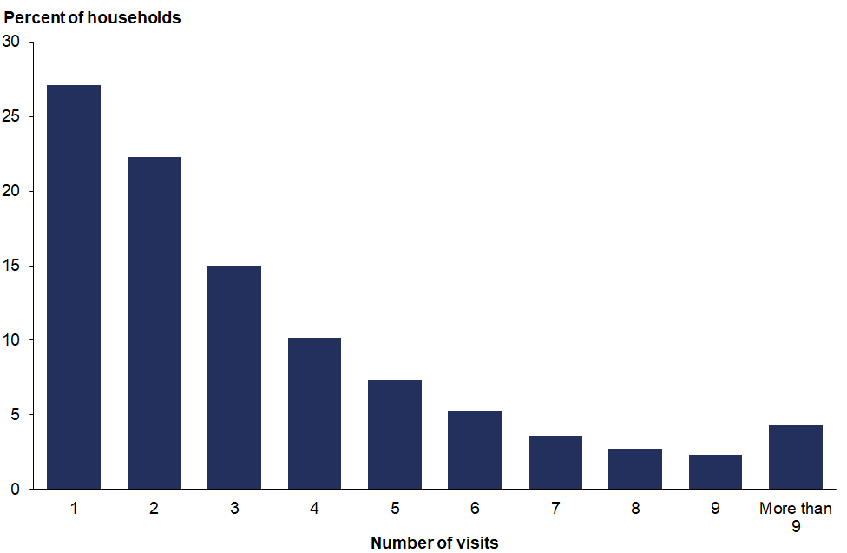

## Response rates

The NZHS is well received by the public: the weighted response rate in 2017/18 was 80 percent for adults and 79 percent for children. Figure 2 shows the time trend of response rates of adults and children from 2011/12 to the current survey year, 2017/18.

Figure 2: Response rates (%) for adults and children, 2011/12–2017/18

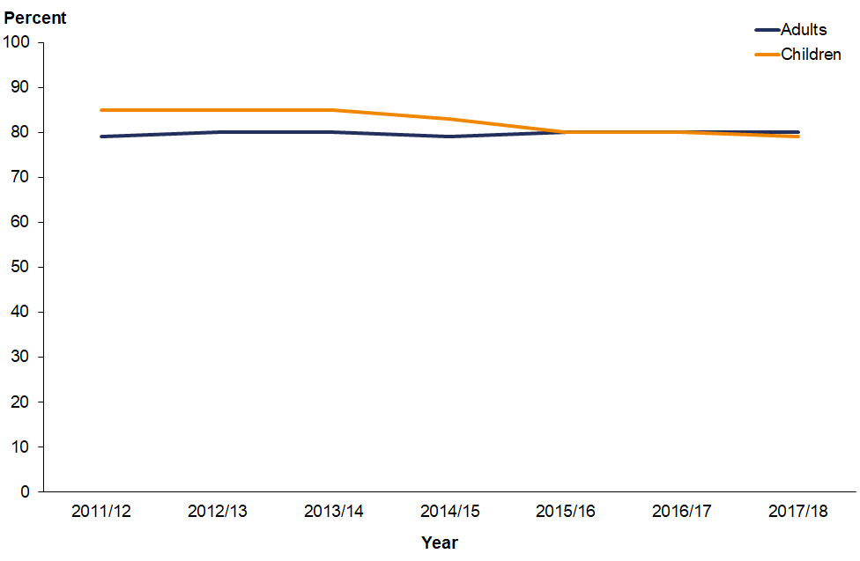

## Coverage rates

In 2017/18, the coverage rates were 61 percent for adults and 74 percent for children. Figure 3 shows the time trend of coverage rates of adults and children from 2011/12 to the current survey year, 2017/18.

Figure 3: Coverage rates (%) for adults and children, 2011/12–2017/18

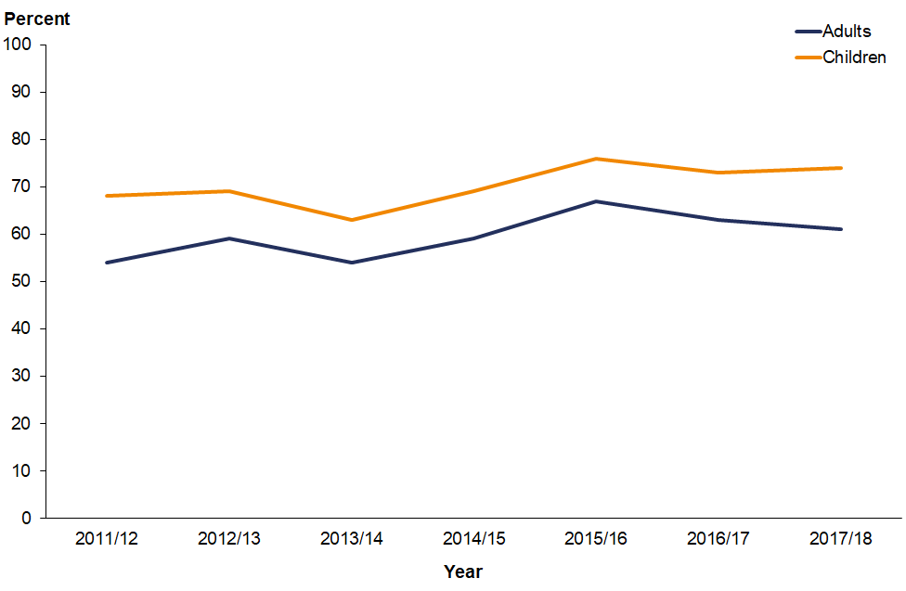

Figure 3 clearly shows that the coverage rates are high for children in all the years.

In 2017/18, the coverage rates were 65 percent for Māori, 65 percent for Pacific peoples and 70 percent for Asian peoples. Figure 4 shows the time trend of coverage rates for Māori, Pacific and Asian ethnic groups from 2011/12 to the current survey year, 2017/18.

Figure 4: Coverage rates (%) for Māori, Pacific and Asian groups, 2011/12–2017/18

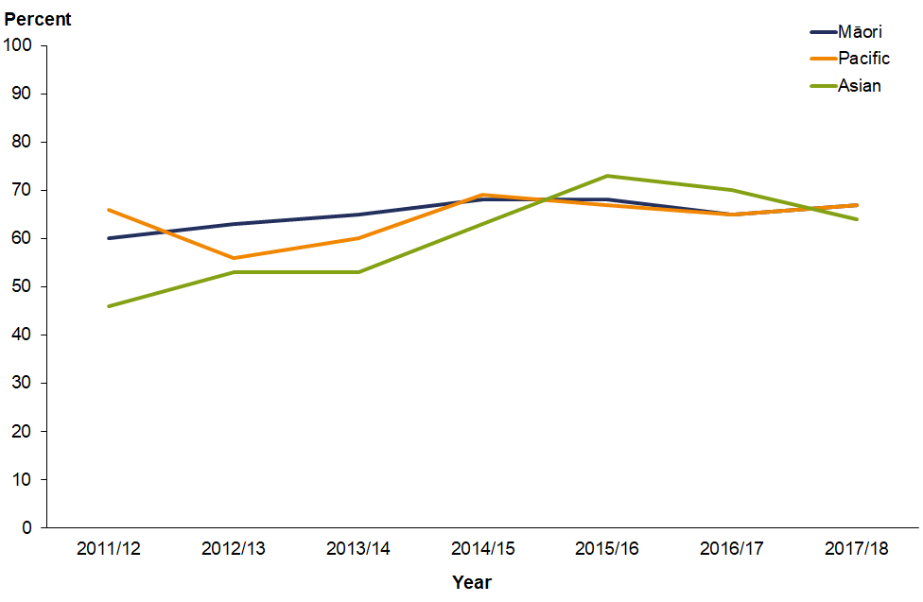

As Figure 4 shows, the coverage rates are not very different for Māori, Pacific and Asian groups.

In 2017/18, the coverage rates for neighbourhood deprivation quintiles were 64 percent (Q1), 67 percent (Q2), 68 percent (Q3), 63 percent (Q4) and 63 percent (Q5). Figure 5 shows the time trend figures for Q1 to Q5 from 2011/12 to the current survey year, 2017/18.

Figure 5: Coverage rates (%) by NZDep2013 quintiles, 2011/12–2017/18

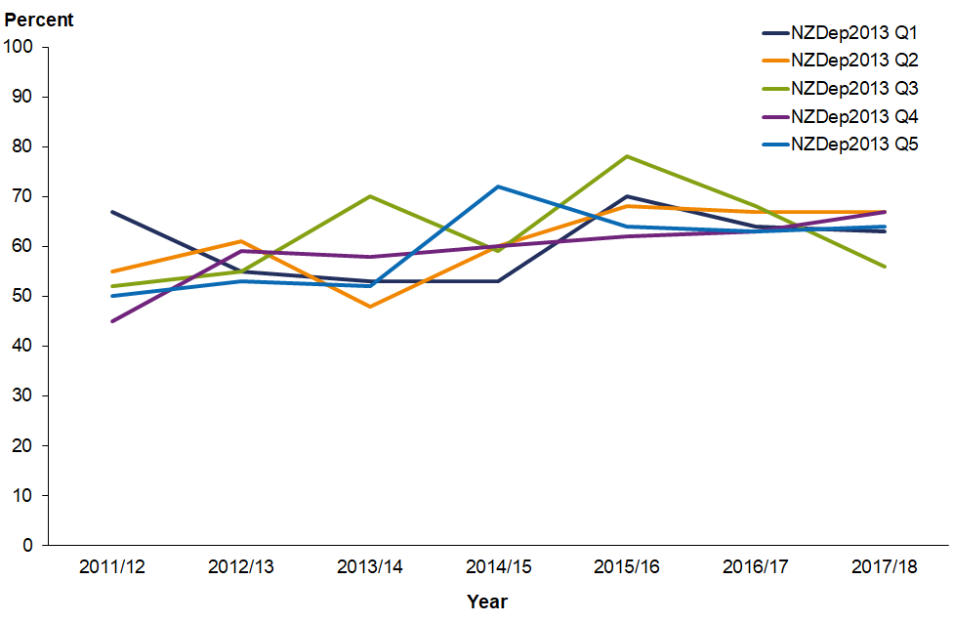

Figures 6 and 7 show the coverage rates by age and sex for 2017/18 for the total population and Māori respectively.

Figure 6: Coverage rates (%) for total population, by age group and sex, 2017/18

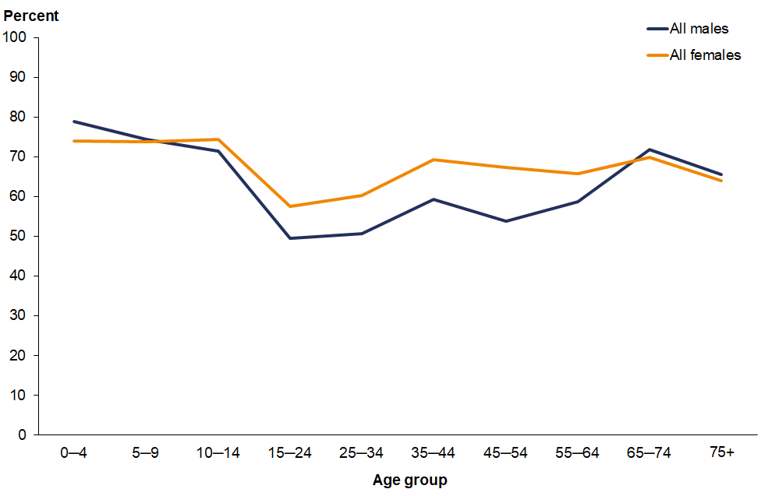

Figure 7: Coverage rates (%) for Māori, by age group and sex, 2017/18

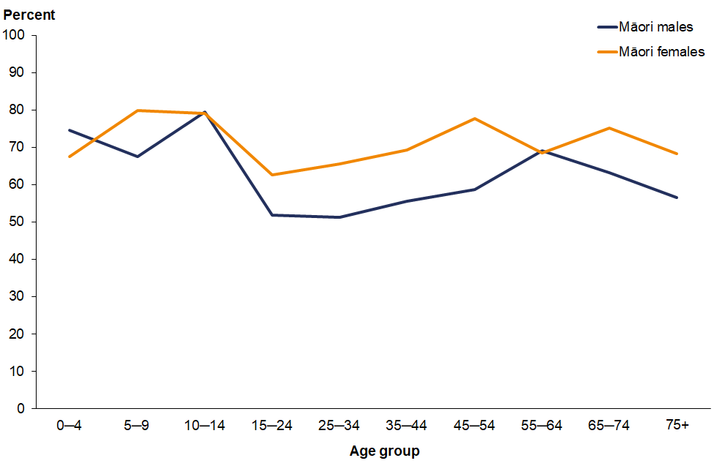

## Final weights

Section 7 has explained how the calibrated weights were calculated. Table 4 gives basic descriptive information on the final weights calculated for the 2017/18 survey.

The g-weights are the ratios of the final weights to the initial selection weights. The mean g‑weight is approximately 1.7 which can be considered as reasonable. This means the calibrated weights, which were calculated using population benchmark information, have changed the initial selection weight by an average factor of 1.7.

Table 4: Final weights, 2017/18

|  |  |
| --- | --- |
|  | **Final weight** |
| Minimum | 22 |
| Median | 209 |
| 90th percentile | 582 |
| 95th percentile | 760 |
| 99th percentile | 1,207 |
| Maximum | 1,625 |
| Coefficient of variation (CV%) | 84.5 |
| Approximate design effect due to weighting (1 + CV2) | 1.7 |

## Sample sizes

Tables 5–8 show the 2017/18 NZHS sample sizes and the total ‘usually resident’ population counts, by sex, ethnicity, age and NZDep2013 quintile.

Table 5: Sample sizes and population counts for children and adults, by sex, 2017/18

|  |  |  |  |  |
| --- | --- | --- | --- | --- |
| **Population group** | **Sex** | **Interviews** | **Measurements* (2+ years)** | **Population count** |
| Children (0–14 years) | Boys | 2,467 | 1,873 | 482,720 |
| Girls | 2,256 | 1,693 | 458,313 |
| **Total** | **4,723** | **3,566** | **941,033** |
| Adults (15 years and over) | Men | 5,988 | 5,703 | 1,910,015 |
| Women | 7,881 | 7,120 | 2,003,760 |
| **Total** | **13,869** | **12,823** | **3,913,775** |

Note: * These numbers are based on the number of respondents with valid height and weight measurements, and they exclude 218 pregnant women, who are not eligible to be measured.

Table 6: Sample sizes and population counts for children and adults, by ethnic group, 2017/18

|  |  |  |  |  |
| --- | --- | --- | --- | --- |
| **Ethnic group (total response)** | **Population group** | **Interviews** | **Measurements* (2+ years)** | **Population count** |
| European/Other | Children | 3,232 | 2,487 | 675,076 |
| Adults | 10,434 | 9,680 | 2,986,694 |
| Māori | Children | 1,722 | 1,288 | 239,458 |
| Adults | 2,856 | 2,590 | 496,155 |
| Pacific | Children | 710 | 513 | 128,429 |
| Adults | 921 | 832 | 247,750 |
| Asian | Children | 637 | 452 | 133,281 |
| Adults | 1,319 | 1,240 | 525,750 |

Note: * These numbers are based on the number of respondents with valid height and weight measurements, and they exclude 218 pregnant women, who are not eligible to be measured.

Table 7: Sample sizes and population counts, by age group, 2017/18

|  |  |  |  |
| --- | --- | --- | --- |
| **Age group (years)** | **Interviews** | **Measurements* (2+ years)** | **Population count** |
| 0–4 | 1,660 | 758 | 306,165 |
| 5–9 | 1,496 | 1,381 | 327,492 |
| 10–14 | 1,567 | 1,427 | 307,375 |
| 15–24 | 1,562 | 1,455 | 673,470 |
| 25–34 | 2,280 | 2,072 | 699,273 |
| 35–44 | 2,236 | 2,090 | 586,380 |
| 45–54 | 2,146 | 2,028 | 637,745 |
| 55–64 | 2,200 | 2,040 | 578,827 |
| 65–74 | 1,979 | 1,838 | 426,585 |
| 75 and over | 1,466 | 1,300 | 311,495 |

Note: * These numbers are based on the number of respondents with valid height and weight measurements, and they exclude 218 pregnant women, who are not eligible to be measured.

Table 8: Sample sizes and population counts, by NZDep2013 quintile, 2017/18

|  |  |  |  |  |
| --- | --- | --- | --- | --- |
| **NZDep2013 quintile** | **Population group** | **Interviews** | **Measurements* (2+ years)** | **Population count** |
| Quintile 1 (least deprived neighbourhoods) | Children | 608 | 473 | 181,218 |
| Adults | 1,901 | 1,763 | 788,744 |
| Quintile 2 | Children | 739 | 576 | 175,791 |
| Adults | 2,230 | 2,091 | 795,170 |
| Quintile 3 | Children | 777 | 608 | 182,636 |
| Adults | 2,431 | 2,283 | 788,326 |
| Quintile 4 | Children | 1,072 | 796 | 174,848 |
| Adults | 3,367 | 3,102 | 796,113 |
| Quintile 5 (most deprived neighbourhoods) | Children | 1,527 | 1,113 | 226,539 |
| Adults | 3,940 | 3,584 | 744,422 |

Note: * These numbers are based on the number of respondents with valid height and weight measurements, and they exclude 218 pregnant women, who are not eligible to be measured.

# Section 10: Errors in previously published statistics

This section notifies NZHS users about errors in the statistics published in previous annual reports or in the Annual Data Explorers. These errors occurred as a result of independent events at different stages of the survey process, which are explained below. Removal of the data or revisions to the data and statistics have been made in the current publication.

## Years 1 to 6 child indicator – Television watching

The definition of the child television watching indicator reported in years 1–6 of the NZHS was inaccurate. Television watching is defined for children (aged 2–14 years) as watching two or more hours of television per day (averaged over a week). However, it was discovered that the code of the software program mistakenly recorded one and a half hours or more of television watching per day rather than two or more hours per day.

The television watching indicator has been removed from the Annual Data Explorer for Year 7 (current year) and going forward. This is because, over the years and as technology has developed, there has been more focus on the child screen watching indicators. The child screen watching indicators capture not only television watching but also other screen time activities (not including time spent looking at screens at school or for homework) and so, are more relevant than television watching alone.

# References

Ahmad O, Boschi-Pinto C, Lopez A, et al. 2000. *Age-standardization of Rates: A new WHO standard*. Geneva: World Health Organization.

Atkinson J, Salmond C, Crampton P. 2014. *NZDep2013 Index of Deprivation*. Wellington: Department of Public Health, University of Otago.

Bieler GS, Brown GG, Williams RL, et al. 2010. Estimating model-adjusted risks, risk differences, and risk ratios from complex survey data. *American Journal of Epidemiology* 171: 618–23.

Clark RG, Templeton R, McNicholas A. 2013. Developing the design of a continuous national health survey for New Zealand. *Population Health Metrics* 11(1): 25. URL: [www.pophealthmetrics.com/content/11/1/25](http://www.pophealthmetrics.com/content/11/1/25) (accessed 29 October 2015).

Cole TJ, Bellizzi MC, Flegal KM, et al. 2000. Establishing a standard definition for child overweight and obesity worldwide: international survey. *British Medical Journal* 320(7244): 1240.

Cole TJ, Flegal KM, Nicholls D, et al. 2007. Body mass index cut offs to define thinness in children and adolescents: international survey. *British Medical Journal* 335(7612): 194.

Cole TJ, Lobstein T. 2012. Extended international (IOTF) body mass index cut-offs for thinness, overweight and obesity. *Pediatric Obesity* 7(4): 284–94.

Deville JC, Särndal CE. 1992. Calibration estimators in survey sampling. *Journal of the American Statistical Association* 87: 376–82.

Hayes L, Barry G. 2002. Sampling variability of the Kunst-Mackenbach relative index of inequality. *Journal of Epidemiology and Community Health* 56: 762–5.

Korn EL, Graubard BI. 1998. Confidence intervals for proportions with small expected number of positive counts estimated from survey data. *Survey Methodology*  
24(2): 193–201.

Korn EL, Graubard BI. 1999. *Analysis of Health Surveys*. New York: Wiley.

Kott PS. 2001. The delete-a-group jackknife. *Journal of Official Statistics* 17(4): 521–6.

Ministry of Health. 2008. *A Portrait of Health: Key results of the 2006/07 New Zealand Health Survey.* Wellington: Ministry of Health.

Ministry of Health. 2011. *The New Zealand Health Survey: Sample design, years 1–3 (2011–2013).* Wellington: Ministry of Health. URL: [www.health.govt.nz/publication/new-zealand-health-survey-sample-design-years-1-3-2011-2013](http://www.health.govt.nz/publication/new-zealand-health-survey-sample-design-years-1-3-2011-2013) (accessed 3 November 2016).

Ministry of Health. 2016. *Sample Design from 2015/16: New Zealand Health Survey.* Wellington: Ministry of Health.

Ministry of Health. 2018. *Content Guide 2017/18: New Zealand Health Survey.* Wellington: Ministry of Health.

Statistics New Zealand. 1998. *Protocols for Official Statistics.* Wellington: Statistics New Zealand.

Statistics New Zealand. 2005. *Understanding and Working with Ethnicity Data: A technical paper.* Wellington: Statistics New Zealand.

Statistics New Zealand. 2007. *Principles and Protocols for Producers of Tier 1 Statistics.* Wellington: Statistics New Zealand. URL: [www.statisphere.govt.nz/tier1-statistics/principles-protocols.aspx](http://www.statisphere.govt.nz/tier1-statistics/principles-protocols.aspx) (accessed 2 November 2016).

Woodruff RS. 1952. Confidence intervals for medians and other position measures. *Journal of the American Statistical Association* 47: 635–46.

# Appendix: 2006/07 New Zealand Health Survey

To determine any changes in the prevalence of indicators over time, the Annual Data Explorer, published on the Ministry’s website: www.health.govt.nz, shows results comparing the current NZHS with the NZHS survey conducted in 2006/07. This appendix gives a brief description of that 2006/07 survey.

## 2006/07 New Zealand Health Survey

The target population for the 2006/07 NZHS was the usually resident civilian population of all ages living in permanent private dwellings in New Zealand. An area-based frame of Statistics New Zealand meshblocks was used as the sample frame. Māori, Pacific and Asian peoples were oversampled.

Data were collected from October 2006 to the end of November 2007 using computer-assisted, face-to-face interviewing. The total response rate for the survey was 68 percent for adults and 71 percent for children. A total of 12,488 adults and 4,921 children took part in the survey. The survey included 11,632 European/Other peoples, 5,143 Māori, 1,831 Pacific peoples and 2,255 Asian peoples of all ages.

For full details on the methodology of the 2006/07 NZHS, see *A Portrait of Health: Key results of the 2006/07 New Zealand Health Survey* (Ministry of Health 2008).

1. See www.health.govt.nz/nz-health-statistics/national-collections-and-surveys/surveys/current-recent-surveys/new-zealand-health-survey