Non-volitional Sex
Findings from the
2014/15 New Zealand Health Survey
2019

Acknowledgements
The New Zealand Health Survey would not have been possible without the support and enthusiasm of many individuals, including the many thousands of New Zealanders who gave their time to participate in it and the interviewers who worked so diligently to collect the data. Thank you for your generosity.
This data brief was written by Nigel Dickson (University of Otago), Bridget Murphy (Ministry of Health), Jennie Connor (University of Otago), Antoinette Righarts (University of Otago) and Peter Saxton (University of Auckland). The data analysis was undertaken by Barry Gribben (CBG Health Research), Thomas Zhang (CBG Health Research) and James Stanley (University of Otago).
Citation: Ministry of Health. 2019. Non-volitional Sex: Findings from the 2014/15 New Zealand Heath Survey. Wellington: Ministry of Health.
Published in November 2019 by the Ministry of Health
PO Box 5013, Wellington 6140, New Zealand
ISBN 978-1-98-859748-5 (online)
HP 7272
This document is available at health.govt.nz
This work is licensed under the Creative Commons Attribution 4.0 International licence. In essence, you are free to: share ie, copy and redistribute the material in any medium or format; adapt ie, remix, transform and build upon the material. You must give appropriate credit, provide a link to the licence and indicate if changes were made.

Contents
Key findings iv
Introduction 1
Experience of non-volitional sex 2
Interpretation notes 7
Overview of survey methodology 9
References 12

List of Figures
Figure 1: Experience of non-volitional sex in lifetime, by age group and gender 2
Figure 2: Experience of non-volitional sex in lifetime, by ethnicity and gender 3
Figure 3: Median age at most recent non-volitional sex, by age group and gender 4
Figure 4: Relationship to perpetrator of most recent non-volitional sex, by gender 5
Figure 5: Relationship to perpetrator of most recent non-volitional sex among women, by ethnicity 6

List of Tables
Table 1: Participation in the Sexual and Reproductive Health module of the New Zealand Health Survey, by ethnicity 10

Key findings
Key findings include the following.
- Sex against an individual’s will after the age of 13, referred to in this document as non-volitional sex, has been experienced by many more women (one in nine) than men (one in 30) aged 16–74 years; over half of these experiences occurred when the people concerned were teenagers.
- Māori men and women were more likely to have experienced non-volitional sex than non-Māori, and Asian women were less likely than non-Asian women to have experienced it.
- Women currently living in the most deprived areas were more likely than those in the least deprived areas to have experienced non-volitional sex.
- Women and men mostly knew the perpetrator of their most recent experience of non-volitional sex, either as a former or current intimate partner (34 percent of women, 16 percent of men), a family member or friend (26 percent of women, 31 percent of men), or as an acquaintance (22 percent of women, 28 percent of men).
- Among Māori and Pacific women, the most recent perpetrator was more likely to have been a family member or friend than it was for non-Māori and non-Pacific women.

Introduction
Having sexual experiences against one’s will, referred to as non-volitional sex violates an individual’s rights to choose when and with whom to have sex, and what behaviours to engage in (Kalmuss 2004). People of all ages can experience non-volitional sex as a single event or as part of a pattern of victimisation lasting for months or years. Violence might be involved in non-volitional sex, and that can add to broad-ranging consequences, which include long-term mental, physical, sexual and reproductive health effects (Macdowall et al 2013). These factors, and the associated economic and social costs, make non-volitional sex a serious public health issue (Garca-Moreno and Watts 2011).
A number of research projects both in New Zealand and internationally have shown that women experience sexual violence relatively commonly, and particularly when they are young (Fanslow and Robinson 2004, Fleming et al 2007). Victims were more likely to report current poor physical and mental health than those who had not experienced sexual violence.
The New Zealand Crime and Safety Survey (NZCASS) undertaken in 2006, 2009 and 2014 found that around one-quarter of women (24 percent) and 6 percent of men had experienced some degree of sexual victimisation, including distressing sexual touching, attempted or completed forced sex or other sexual violence (New Zealand Family Violence Clearinghouse 2017). The definition of completed non-volitional sex used in this data brief is similar to that of ‘completed forced sex’ in the NZCASS. One in nine women (11 percent) and 1.7 percent of men have experienced completed forced sex, according to the 2014 NZCASS (Ministry of Justice 2015). This data also suggested that the incidence of what could be classified as sexual offences among adults dropped from 3.9 percent (317,000 events) in 2005 to 2.1 percent (186,000 events) in 2013; in the latter year 2.9 percent of women experienced such victimisation, and 1.1 percent of men.
The Ministry of Health included questions on non-volitional sex since the age of 13 years in the Sexual and Reproductive Health module of its national 2014/15 New Zealand Health Survey (the survey).
After defining ‘having sex’ as having vaginal, oral or anal sex or genital contact, the survey asked participants ‘Since the age of 13, has anyone tried to make you have sex with them, against your will?’ A follow-up question asked ‘Since the age of 13, has anyone actually made you have sex with them, against your will?’ Those who said ‘Yes’ to both questions were considered to have experienced non-volitional sex. The survey then asked those people who had experienced non-volitional sex how old they had been when it last happened, and their relationship with the perpetrator. It did not ask the sex of the perpetrator.
The survey questions originated from the 2010 British National Survey of Sexual Attitudes and Lifestyles, which avoided the term ‘rape’, as research has found that term to be highly subjective, to imply possible legal ramifications in the minds of participants, and to be likely to lead to under-reporting (Koss 1993).
You can find more information and results from the survey, including data tables in the data explorer, online at https://www.health.govt.nz/publication/sexual-and-reproductive-health-2014-15-new-zealand-health-survey

Experience of non-volitional sex

One in nine women and one in 30 men had ever experienced non-volitional sex
- 3.1 percent of men and 11 percent of women aged 16–74 years had experienced non-volitional sex since the age of 13 years, equivalent to around 50,000 men and 186,000 women.
- Among men, there was no clear pattern of experiencing non-volitional sex by age at survey interview (Figure 1), although rates were marginally higher in the 45–54-year age group. Note that percentages reported by the youngest and oldest men should be treated cautiously in view of the relatively small numbers.
- Among women, the percentage who had reported experiencing non-volitional sex was highest among those aged 45–54 years (Figure 1), and the rate was lower among both those older and younger. Non-volitional sex is more likely to occur in the future for young people, meaning the median age will rise over time.

Figure 1: Experience of non-volitional sex in lifetime, by age group and gender
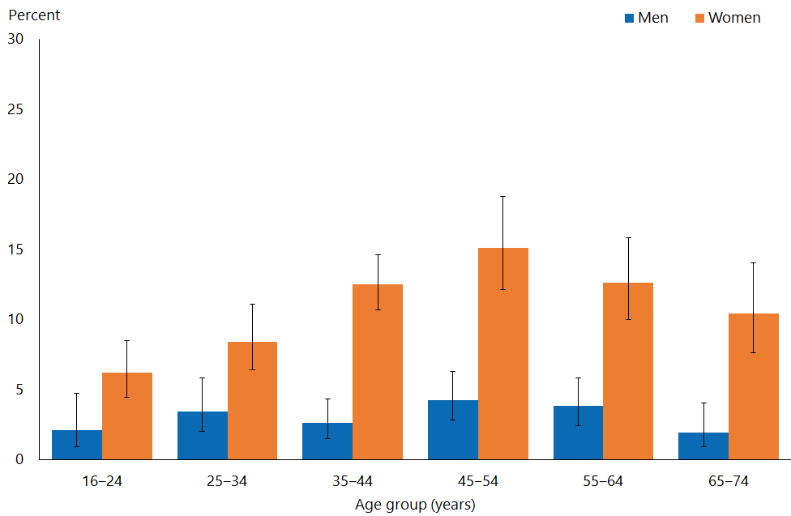

- Among men, those of European/Other ethnicity were the least likely to have experienced non-volitional sex (Figure 2); however, the percentage reported by Pacific and Asian men should be treated cautiously in view of the relatively small numbers.
- After adjustment for age, Māori men were twice as likely to have experienced non-volitional sex as non-Māori men.
- Māori women and women of European/Other ethnicity were most likely to have experienced non-volitional sex, and Asian women were the least likely.
- After adjustment for age, Māori women were 1.6 times as likely to have experienced non-volitional sex as non-Māori; Asian women were 0.3 times as likely to have experienced it as non-Asian women.

Figure 2: Experience of non-volitional sex in lifetime, by ethnicity and gender
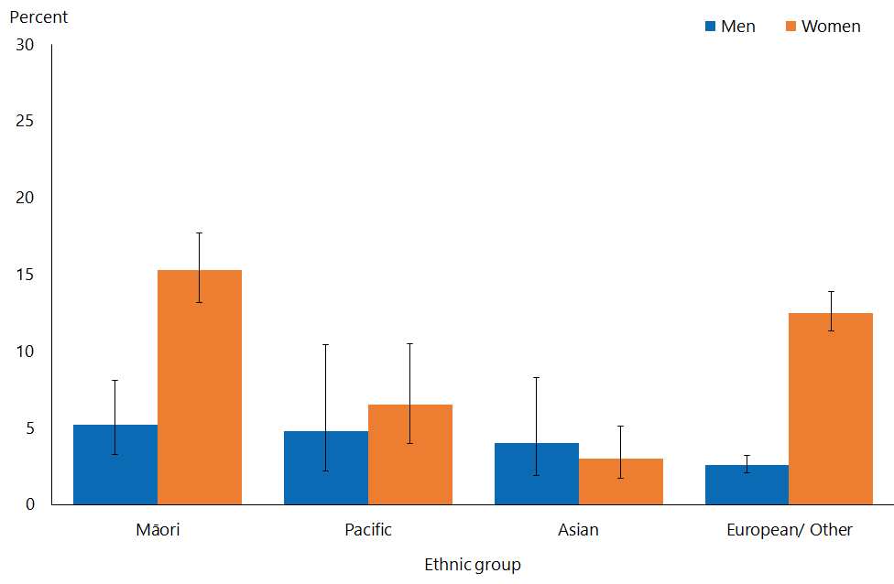
Note: Adults who reported more than one ethnic group are counted once in each group reported. This means that the total number of responses for all ethnic groups can be greater than the total number of adults who stated their ethnicities.

- Among women, there was a clear pattern for those living in the more deprived areas to have experienced more non-volitional sex; for men, there was a less consistent pattern.
- After adjustment for age and ethnicity, women living in the most deprived areas were 2.2 times as likely to have experienced non-volitional sex as those living in the least deprived areas.

Most non-volitional sex was experienced by young people
- The median ages for the only or most recent episode of non-volitional sex were 15 years for men and 18 years for women; this means that non-volitional sex is a problem concentrated at a young age.
- The median age for the only or most recent episode changed little by age group (Figure 3).

Figure 3: Median age at most recent non-volitional sex, by age group and gender
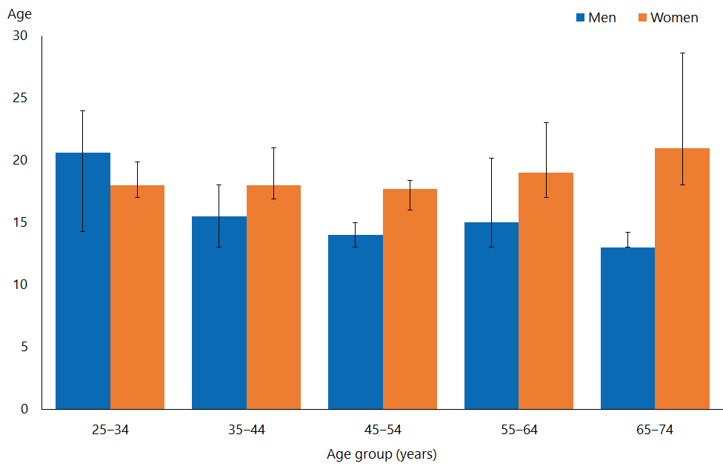
Note: The figure does not display median ages for the age groups 16–24 years (although eTables do). They could be misleading, as non-volitional sex is more likely to occur in the future for young people, meaning the median age will rise over time.

- Among men, the median age of the most recent episode of non-volitional sex was 14 years for Māori and Pacific men and those of European/other ethnicity, and 19 years for Asian men. Among women, it was lowest for Pacific women (15 years), slightly older for Māori women (16 years), 18 years for women of European/other ethnicity and highest for Asian women (20 years).
- There was no pattern for the median age of the most recent episode of non-volitional sex by level of neighbourhood deprivation.

The most recent non-volitional sex for women was perpetrated by an intimate partner (former or current) in one in three cases
- Among women, the perpetrator of the most recent episode of non-volitional sex was most commonly a former or current intimate partner (34 percent) (Figure 4). The numbers are too small to examine how this varied by age.
- Among men, the perpetrator of the most recent episode of non-volitional sex was most commonly either a family member/friend (31 percent), or an acquaintance (28 percent) (Figure 4). The numbers are too small to examine how this varied by age.

Figure 4: Relationship to perpetrator of most recent non-volitional sex, by gender
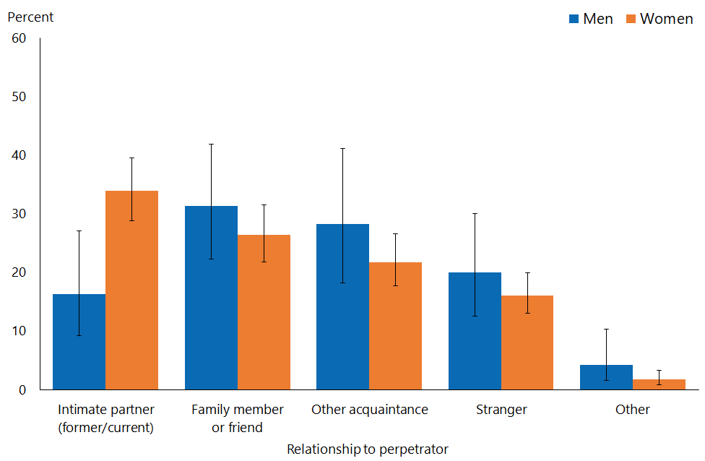

- Among men, the numbers were too small to reliably analyse by relationship with the most recent perpetrator for most ethnic groups.
- Women of Asian and European/other ethnicity most commonly reported that the perpetrator of their most recent episode of non-volitional sex was a former or current intimate partner, while for Māori and Pacific women it was most likely to have been a family member or friend.

Figure 5: Relationship to perpetrator of most recent non-volitional sex among women, by ethnicity
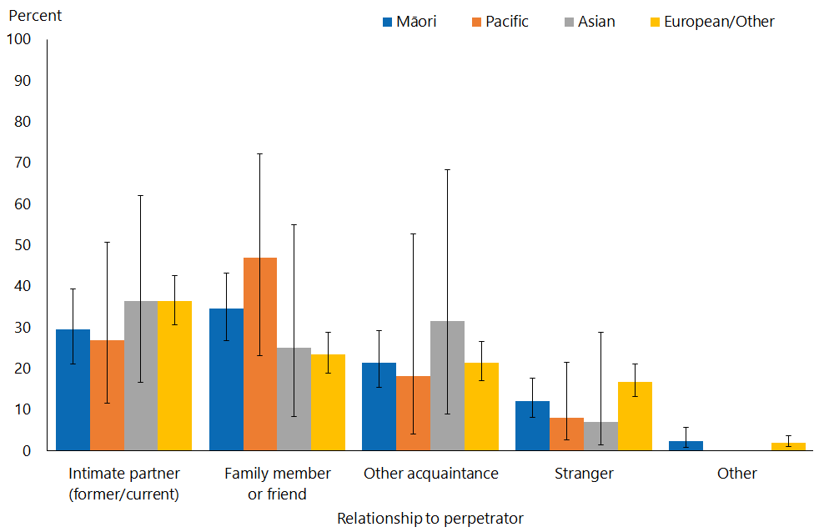
Note: Adults who reported more than one ethnic group are counted once in each group reported. This means that the total number of responses for all ethnic groups can be greater than the total number of adults who stated their ethnicities.

- After adjustment for age, the most recent perpetrator for Māori women was 1.5 times as likely to have been a family member or friend as it was for non-Māori women. The most recent perpetrator for Pacific women was twice as likely to have been a family member or friend as it was for non-Pacific women.
- Among women, there were no clear or consistent patterns in terms of relationships with the most recent perpetrator by neighbourhood level of deprivation, before and after adjusting for age and ethnicity.
- Among men, small numbers prevented reliable examination of the type of perpetrator by neighbourhood deprivation.

Interpretation notes
This section provides some key points for interpreting the survey results presented in this report. For more details about the survey methodology, see the Methodology Report 2014/15: New Zealand Health Survey (Ministry of Health 2015b) and Sexual and Reproductive Health Indicator Interpretation Guide 2014/15: New Zealand Health Survey (Ministry of Health 2019).

Statistical significance
Unless otherwise specified, the results discussed in this report only refer to differences that are statistically significant at the 5 percent level (ie, those with a p-value of less than 0.05). ‘Statistically significant’ means that the difference between the sample groups is likely to reflect real differences in the population groups, rather than being caused by chance. A statistically significant difference does not necessarily mean the difference between the population groups is meaningful.

Confidence intervals
We use 95% confidence intervals to show the statistical precision of the estimates. Wider confidence intervals indicate less precise estimates than narrow intervals, caused by higher variation with a sample and/or smaller numbers in a sample. Confidence intervals generally agree with statistical significance. When confidence intervals for two estimates don't overlap, there is a statistically significant difference between the estimates. However, the opposite may not always be true.

Comparing population subgroups
This report uses adjusted ratios to test if the prevalence of indicators is statistically significantly different between groups. We have adjusted these ratios for demographic factors that may be influencing the comparison, such as age, gender and ethnicity. The adjusted ratio indicates whether the results are less or more likely in the group of interest than the comparison group. A ratio of less than 1 indicates that the result is less likely and a ratio greater than 1 indicates that it is more likely.

The survey uses the New Zealand Index of Deprivation 2013 (NZDep2013) to measure neighbourhood deprivation. The survey groups neighbourhoods into five quintiles (the label ‘quintile 1’ applies to neighbourhoods with the lowest levels of deprivation, and ‘quintile 5’ to those with the highest). Indicators are reported for each quintile. The adjusted ratios for deprivation compare the highest and lowest deprivation areas, after adjusting for age, ethnic group, gender and the pattern across all five quintiles.

Gender
Gender is self-defined by respondents in the survey. For some people their gender is not the same as their biological sex at birth. Respondents were asked if they were male or female, and while what these options meant was open to the respondent’s interpretation, gender-diverse options (eg, ‘gender non-conforming’ or ‘other’) were not available. The Ministry of Health acknowledges the need to improve data collection in this area, and is considering implementing the statistical standard for gender identity in future surveys (Statistics New Zealand 2015).

Non-sampling error
The survey results may underestimate or overestimate some indicators because the data is self-reported. The accuracy of a person’s memory may vary depending on many factors, including social norms, the importance of the event being recalled, the individual’s age at the time and the period of time that has passed since the event occurred.

Overview of survey methodology
This section gives a brief overview of the survey methodology for the New Zealand Health Survey.

How were people selected for the survey?
The 2014/15 results refer to the sample selected for the period July 2014–June 2015. The survey has a multi-stage sampling design that involves randomly selecting a sample of small geographic areas, households within the selected areas and individuals within the selected households. One adult aged 15 years or older and one child aged 14 years or younger (if there were any) were chosen at random from each selected household. Adults aged 16–74 years who had completed the 2014/15 survey were invited to participate in the Sexual and Reproductive Health module. Further details are available in The New Zealand Health Survey: Sample design, years 1–3 (2011–2013) (Ministry of Health 2011).

How was data collected?
Professional surveyors from CBG Health Research Ltd collected data in respondents’ homes. For the core part of the survey, data was collected through a face-to-face interview. However, participants completed the Sexual and Reproductive Health module by themselves, directly entering responses into a program run on a tablet computer. Surveyors provided minimal assistance, and reiterated that they would not be able to see the answers. Respondents could answer ‘Don’t know’ or ‘Choose not to answer’ to any question. If they chose either of those options for the question about having ever had sex with someone of a different sex, then they were not asked to complete the rest of the survey module.

How many people took part?
11,993 adults aged 16–74 years completed the core 2014/15 survey and were eligible for the Sexual and Reproductive Health module. This report is based on the responses from 10,198 adults (or 87 percent of eligible respondents). Some eligible respondents were not included in the final data set for the following reasons.
- 668 respondents (5.6 percent of those who were eligible) did not start the module, either because they refused or because of English language and/or cognitive difficulties.
- 991 respondents (6.5 percent of eligible respondents) started the module but stopped before the end of the module.
- 123 respondents (1.2 percent of eligible respondents) completed the module but their records were discarded because at least half of their responses were ‘Don’t know’ or ‘Choose not to answer’.

Of the people who completed the Sexual and Reproductive Health module, 4,358 gave their gender as male and 5,840 as female. The table below summarises the 10,198 survey respondents by ethnic group.

Table 1: Participation in the Sexual and Reproductive Health module of the New Zealand Health Survey, by ethnicity
Ethnic group | Number
Māori | 2,460
Pacific | 619
Asian | 814
European/Other | 7,542
Note: Adults who reported more than one ethnic group are counted once in each group reported. This means that the total number of responses for all ethnic groups can be greater than the total number of adults who stated their ethnicities.

Survey weights
The Sexual and Reproductive Health data set was weighted so that the responding sample represented the New Zealand ‘usually resident’ population in that year, using external population benchmarks (age, sex, ethnicity and neighbourhood deprivation) and demographic and behavioural benchmarks (eg, educational level and hazardous drinking). After an initial selection weight was calculated, it was adjusted for those who did not complete the module (for any reason). This should have minimised the impact of any differences in the characteristics of people who did or did not participate in the Sexual and Reproductive Health module. For more detail about the survey methodology, refer to the Methodology Report 2014/15 (Ministry of Health 2015b).

Additional information
See also the following documents:
- The New Zealand Health Survey: Sample design years 1–3 (2011–2013) (Ministry of Health 2011). Note, despite the report title being 2011–13, this sample design was used for the 2014/15 Health Survey
- Methodology Report 2014/15: New Zealand Health Survey (Ministry of Health 2015b)
- Content Guide 2014/15: New Zealand Health Survey (Ministry of Health 2015a)
- Questionnaires for the New Zealand Health Survey 2014/15 (Ministry of Health 2016a; Ministry of Heath 2016b)
- Sexual and Reproductive Health Indicator Interpretation Guide 2014/15: New Zealand Health Survey (Ministry of Health 2019).

References
Fanslow J, Robinson E. 2004. Violence against women in New Zealand: prevalence and health consequences. New Zealand Medical Journal 117(1206): 1173.
Fleming TM, Watson PD, Robinson E, et al. 2007. Violence and New Zealand Young People: Findings of Youth2000 – A National Secondary School Youth Health and Wellbeing Survey. Auckland: University of Auckland.
Garca-Moreno C, Watts C. 2011. Violence against women: an urgent public health priority. Bulletin of the World Health Organization 89(1): 2.
Kalmuss D. 2004. Non-volitional sex and sexual health. Archives of Sexual Behavior 33(3): 197–209.
Koss M. 1993. Detecting the scope of rape: a review of prevalence research methods. Journal of Interpersonal Violence 8: 198–222.
Macdowall W, Gibson LJ, Tanton C, et al. 2013. Lifetime prevalence, associated factors, and circumstances of non-volitional sex in women and men in Britain: findings from the third National Survey of Sexual Attitudes and Lifestyles (Natsal-3). Lancet 382(9907): 1845–55.
Ministry of Health. 2011. The New Zealand Health Survey: Sample design, years 1–3 (2011–2013). Wellington: Ministry of Health.
Ministry of Health. 2015a. Content Guide 2014/15: New Zealand Health Survey. Wellington: Ministry of Health.
Ministry of Health. 2015b. Methodology Report 2014/15: New Zealand Health Survey. Wellington: Ministry of Health.
Ministry of Health. 2016a. Adult Sexual and Reproductive Health Module (Year 4). Wellington: Ministry of Health.
Ministry of Health. 2016b. New Zealand Health Survey Adult Questionnaire (Year 4). Wellington: Ministry of Health.
Ministry of Health. 2019. Sexual and Reproductive Health Indicator Interpretation Guide 2014/15: New Zealand Health Survey. Wellington: Ministry of Health.
Ministry of Justice. 2015. 2014 New Zealand Crime and Safety Survey: Main findings. Wellington: Ministry of Justice.
New Zealand Family Violence Clearinghouse, University of Auckland. 2017. Data Summary 5: Adult Sexual Violence. Auckland: University of Auckland.
Statistics New Zealand. 2015. Statistical Standard for Gender Identity. Wellington: Statistics New Zealand.

Statistical comparison between ethnic groups adjusted for age cannot be undertaken on the medians.

