annual report 2016

National Maternity Monitoring Group

Cover Photo courtesy of Whakawhetū.
Thank you also to the many families who generously provided photos for this publication.

Abbreviations used in this report
DHB District Health Board
LMC Lead Maternity Carer
MQSP Maternity Quality and Safety Programme
MQI Maternity Quality Initiative
NMMG National Maternity Monitoring Group
PHO Primary Health Organisation
PMMRC Perinatal and Maternal Mortality Review Committee

Disclaimer
This publication informs discussion and assists New Zealand’s maternity policy development. The opinions expressed in the publication do not necessarily reflect the views of the Ministry of Health. All care has been taken in the production of this publication. Data was accurate at the time of release, but may be subject to change over time as more information is received. It is advisable to check the current status of figures with the National Maternity Monitoring Group before quoting or using them in further analysis. The National Maternity Monitoring Group makes no warranty, expressed or implied, nor assumes any legal liability or responsibility for the accuracy, correctness, completeness or use of the information or data in this publication. Further, the National Maternity Monitoring Group shall not be liable for any loss or damage arising directly or indirectly from the information or data presented in this publication. The National Maternity Monitoring Group welcomes comments and suggestions about this publication.

Contents

Chair’s message 4
About the National Maternity Monitoring Group 5
NMMG members 6
An overview of the NMMG’s recommendations for 2016 8
The Fourth Annual Report of the NMMG 9
People powered 10
Connect with and support the involvement of consumers in DHBs’ Maternity Quality and Safety Programmes 10
Closer to home 12
Investigate access to, and provision and use of rural and primary maternity facilities for women. 12
Investigate access to Anti-D following a sensitising event 17
Investigate increases in perineal trauma 19
Value and high performance 20
Monitor implementation of DHB MQSPs 20
Review key sector publications including the Report on Maternity 23
Support the ratification of national maternity clinical guidelines 24
Monitor the outcomes of the work undertaken by the Maternity Ultrasound Advisory Group 26
Smart system 28
Review the New Zealand Maternity Clinical Indicators data and monitor DHB responses to variations 28
The NMMG going for wards 34
Acknowledgements 35
Appendix 1: 36
Terms of Reference for the National Maternity Monitoring Group 36

Chair’s message
It has been an honour to serve as the first National Maternity Monitoring Group (NMMG) Chair. During this time, we have seen the implementation of the Maternity Quality Initiative and, through this, a wide range of national and local maternity- focused quality improvement initiatives have been implemented. It is encouraging to see the effort with which maternity sector stakeholders have approached maternity quality improvements since 2013.

As in previous years, in 2015/16 the maternity sector has completed a wide range of evidence-informed and data-driven improvements to investigate causes of poorer maternity outcomes and to implement systems, processes and programmes to improve on these outcomes and support world class services that are high performing, valued and smart. Together, these initiatives and the frameworks that support them are making a substantial contribution to improvements in women’s experience of pregnancy, birth and motherhood.

The refreshed New Zealand Health Strategy places a strong quality lens on the maternity sector. The NMMG’s multidisciplinary approach is well-suited to supporting cross- sector and integrated quality initiatives particularly under the Closer to Home, Value and High Performance and Smart Systems themes. Our working style also strongly supports the One Team theme as we continue to collaborate closely with other sector advisors in maternity care, including the Perinatal and Maternal Mortality Review Committee and the Maternity Ultrasound Advisory Group.

30 June 2016 marks the end of the first term of the NMMG. It is also the term-end for four sitting members of the NMMG: Bev Lawton, Elaine Langton, Margret Norris and myself. On behalf of the NMMG, I would like to thank outgoing members for their commitment to improving maternity in New Zealand and the valuable contributions they have each made during their time on the NMMG. I would also like to thank the remaining sitting members of the NMMG: it is not possible to develop an effective, quality-focused group without strong support from all members.

I wish the new NMMG all the best for the next three years.

Norma Campbell

About the National Maternity Monitoring Group
The NMMG was established in 2012 by the Ministry of Health as part of the Maternity Quality Initiative (MQI). This year (2015/16) is our fourth full year of operation.

The New Zealand Maternity Standards (2011) consist of three high-level strategic statements to guide the planning, funding, provision and monitoring of maternity services in New Zealand:
- Standard 1: Maternity services provide safe, high-quality services that are nationally consistent and achieve optimal health outcomes for mothers and babies
- Standard 2: Maternity services ensure a woman-centred approach that acknowledges pregnancy and childbirth as a normal life stage, and
- Standard 3: All women have access to a nationally consistent, comprehensive range of maternity services that are funded and provided appropriately to ensure there are no financial barriers to access for eligible women.

These high-level statements are accompanied by specific audit criteria and measurements of these criteria. One of the criteria is that a national monitoring group be established to oversee the maternity system and the implementation of the New Zealand Maternity Standards. Ultimately, the NMMG acts as a strategic advisor to the Ministry of Health on areas for improvement in the maternity sector, provides advice to district health boards (DHBs) on priorities for local improvement and provides a national overview of the quality and safety of New Zealand’s maternity services.

During 2015/16, the NMMG’s work was also guided by the development of the refreshed New Zealand Health Strategy. The New Zealand Health Strategy outlines a high-level direction for New Zealand’s health system to 2026. It is accompanied by a Roadmap of Actions, many of which have a focus on our maternity system, our pregnant women and our babies.

Together, the Maternity Quality Initiative, the Maternity Standards and the New Zealand Health Strategy with the Roadmap provide guidance on how the NMMG and maternity stakeholders can work together in the future to ensure that women and babies live well, stay well and get well if they are sick.

NMMG members
Norma Campbell (Chair)
Norma is a Midwifery Advisor (Quality and Sector Liaison) for the New Zealand College of Midwives and during the course of this year her role with the College has moved to part time as she has now taken on the 0.5 FTE role of Executive Director of the Midwifery and Maternity Providers Organisation (MMPO). She has been a member of the International Confederation of Midwives Council for the past nine years. Norma has been involved in a number of expert advisory groups and multidisciplinary work on clinical guidelines. Norma has been involved in developing and supporting the Maternity Quality Initiative nationally and supporting the MQSPs in DHBs since their inception.
John Tait (Vice-Chair)
John is a consultant obstetrician and gynaecologist, and New Zealand Vice President of the Royal Australian and New Zealand College of Obstetricians and Gynaecologists (RANZCOG). He is the Chief Medical Officer at Capital and Coast DHB and continues to practise in the public sector in gynaecology. John has been involved in a number of expert advisory groups including developing and supporting the MQSP.
Rose Swindells
Rose is a mother with a passion for community development. She is an Adult Literacy tutor, antenatal education facilitator and involved with Playcentre. Rose served as a consumer member on the Capital and Coast DHB Maternity Quality panel before joining the NMMG and sees her work in this area as part of the wider system which aims for women to feel empowered, knowledgeable, calm and confident in their birth experience.
Elaine Langton
Elaine is a specialist anaesthetist and, until recently, was the Clinical Leader of Obstetric Anaesthesia at Capital and Coast DHB. She is a member of the New Zealand Society of Anaesthetists and a fellow of the Australian and New Zealand College of Anaesthetists. She has specialised in obstetric anaesthesia for more than 20 years and has represented obstetric anaesthesia on a number of maternity advisory groups. Elaine is also currently involved in the Severe Acute Maternal Morbidity research project, which is reviewing near-miss maternity events.
Frank Bloomfield
Frank is a neonatal paediatrician at National Women’s Health, Auckland City Hospital, Director of the Liggins Institute and Professor of Neonatology at the University of Auckland. He is currently the President of the Perinatal Society of Australia and New Zealand, a corresponding member of the New Zealand Paediatric and Child Health Division Committee of the Royal Australasian College of Physicians and Council member of the Perinatal Research Society (USA). Frank also is part of a large research group investigating perinatal care at the Liggins Institute, University of Auckland. He contributed to the Working Group on Maternity Standards.
Judith McAra-Couper
Judith is Chair of the Midwifery Council and the Head of Midwifery at Auckland University of Technology. Judith is an Associate Professor and Director of the Centre for Midwifery and Women’s Health Research and is involved in a number of research projects including maternal mental health, sustainability of midwifery practice and place of birth. Judith regularly works for the World Health Organisation in Bangladesh in midwifery education. She has worked in Counties Manukau Health for many years and continues to be involved in this community.

Margret Norris
Margret is the Midwifery Leader for Bay of Plenty DHB. She has had various roles in the midwifery profession as an employed midwife working in the DHB and as a lead maternity carer (LMC) midwife working in the rural areas. To maintain her clinical competencies, she supports the maternity services, has a small caseload and also does weekend cover for local LMC Midwives. As part of her role, Margret is the Perinatal and Maternal Mortality Review Committee (PMMRC) coordinator for the Bay of Plenty DHB, and the Chair for the local MQSP Governance Group.
Rachael McEwing
Rachael works at Christchurch Women’s Hospital and in a private practice for Christchurch Radiology Group, almost exclusively in Obstetric and Gynaecology imaging. She is a Fellow of the Royal Australian and New Zealand College of Radiologists and an advisor to the National Screening Unit on first trimester screening. Rachael is a member of the Maternity Ultrasound Advisory Group and the New Zealand Fetal Maternal Medicine Governance Board.
Bev Lawton
Bev is the Director of the Women’s Health Research Centre and an Associate Professor at the University of Otago. She is Ngati Porou and a member of Te Ohu Rata O Aotearoa (Māori Medical Practitioners Association) and Te Akoranga a Maui (Māori faculty of the Royal New Zealand College of General Practitioners). Bev is currently involved in a number of projects looking at maternal and child outcomes.
Bronwen Pelvin (ex officio)
Bronwen is the Ministry of Health’s Principal Advisor on Maternity. A midwife with more than 40 years of experience, Bronwen has worked as a domiciliary midwife, a community-based LMC, a core midwife and a maternity manager. She worked as the national Midwifery Advisor for the New Zealand College of Midwives and was also the Professional Midwifery Advisor for Nelson Marlborough DHB before moving into her current role in 2008. A major focus of her work in the Ministry of Health has been the development of the Maternity Quality Initiative and its implementation.
Sue Belgrave (ex officio)
Sue is the current Chair of the Perinatal and Maternal Mortality Review Committee (PMMRC). She is a consultant obstetrician and gynaecologist at North Shore and National Women’s Hospitals and Clinical Director of Obstetrics for Waitemata DHB. She is a local coordinator at Waitemata DHB for the PMMRC and is an advisor on ultrasound in Obstetrics and Gynaecology. Sue is also a RANZCOG training supervisor.
Allen + Clarke (Secretariat)
Allen + Clarke provides a wide range of secretariat and policy services required to support the effective administration and management of the NMMG. It also specialises in delivering core policy services, programme development, implementation and review, evaluation and regulatory analysis. Its clients include a wide range of central and local government agencies, professional bodies, and NGOs in New Zealand and abroad.

An overview of the NMMG’s recommendations for 2016
A number of things need to happen to ensure the continued improvement of maternity services in New Zealand. Many of these items reflect and will support the achievement of specific actions within the New Zealand Health Strategy. Below, we outline those areas in which we expect to see action from key maternity stakeholders.
- Connecting and supporting consumer members: all DHBs should support the effective engagement of at least two consumer members in their MQSP governance arrangements. DHBs should ensure that mechanisms to involve a range of consumer perspectives in the substantive design and monitoring of maternity services exist.
- Other national groups and committees involved in maternity quality improvement: we expect all such groups to be working collaboratively and in a coordinated manner to ensure that identified recommendations are implemented.
- New Zealand Maternity Clinical Indicator data: following six years of data with limited positive change in maternity outcomes, the Ministry, DHBs and professional colleges should consider barriers that may be adversely affecting improvements in maternity outcomes.
- Primary maternity facilities: we expect the Ministry of Health to establish a group to investigate normal birth and to focus on understanding the factors influencing place of birth decisions made by women and their health care providers.
- Consistency in the quality of first trimester care: DHBs must consider innovative service delivery that inspires women to engage with maternity services in a timely manner. We also recommend that that the Ministry of Health appoint a practising general practitioner to the NMMG. Health practitioners should still ensure that they are well-informed about what should be covered in an evidence-informed early pregnancy consultation.
- Anti-D: DHBs should have comprehensive guidelines on the administration of Anti-D immunoglobulin, including processes to ensure that all Rh D negative women receive the appropriate dose when required (including prophylactically).
- Perineal trauma: DHBs should continue to closely monitor and observe third and fourth-degree tearing with a focus on improving clinical practice.
- The refreshed New Zealand Health Strategy: all DHBs should use the New Zealand Health Strategy and Roadmap of Actions to guide investment in child and maternal health.

The Fourth Annual Report of the NMMG
Over the following pages, we describe our work for 2015/16. We explain why we have chosen to focus on specific topics, our findings and areas for further improvement. We also share examples of good practice and useful statistics.

In line with our brief to oversee the New Zealand Maternity Standards, the NMMG met four times in 2015/16. We discussed the implementation of our work programme and our priorities to improve the quality, safety and experience of maternity care in New Zealand, improve health and equity for women and babies, and support best value for public health system resources. Our work programme for 2015/16 is described below.

Following publication of the refreshed New Zealand Health Strategy, we considered our work programme and were pleased to note considerable alignment between our work and the New Zealand Health Strategy’s priorities. As such, we have presented our 2015/16 report in the same themes as the refreshed Strategy.

The NMMG’s 2015/16 priorities for investigation
- Investigate consistency in the quality of first trimester antenatal care
- Investigate access to, provision and use of rural and primary maternity facilities for women
- Investigate access to Anti-D after a sensitising event for Rh negative women, and
- Investigate the increase in perineal trauma and variability within and between DHBs.

The NMMG’s 2015/16 priorities for monitoring
- Monitor the involvement of consumer members in DHBs’ MQSPs
- Review the outcomes of work undertaken by the Maternity Ultrasound Advisory Group
- Support the ratification of new national maternity clinical guidelines and monitor the implementation of existing guidelines
- Review the New Zealand Clinical Indicators data and monitor DHBs’ responses to variations
- Monitor DHBs’ implementation of their local MQSPs (including maintaining a focus on maternal mental health and variation in gestation at time of birth), and
- Review key maternity sector publications including the Ministry of Health’s Report on Maternity.

People powered

Connect with and support the involvement of consumers in DHBs’ Maternity Quality and Safety Programmes
Our focus for 2015/16 was to connect with and support the involvement of maternity consumer members in DHB MQSP governance arrangements particularly as MQSPs are further embedded into broader DHB quality frameworks.
Ensuring women’s experience is recognised and feeds into service design and delivery is critical to developing effective and responsive services that both inform and involve women
in their care. DHB MQSP consumer members need to be involved in discussions and decision- making at every level of the maternity sector, including actively contributing to MQSP direction setting, monitoring and reporting. To do this effectively, DHB MQSP consumer members must be able to gather information and support from their communities. Members need adequate guidance and support from the DHB to ensure that they can fulfil their role effectively.
The NMMG recognises the importance of engaged consumers. We recommended that our membership expand to include two consumer members, including one Māori consumer.

What we have done this year and our findings
We reviewed the findings of the 2014 Maternity Consumer Survey.
Survey results show that women were generally satisfied with the services provided in New Zealand’s maternity sector. They felt informed, listened to and able to easily access the care they needed. We were pleased to learn that maternity services are valued; however, it was concerning that women with disabilities generally felt less satisfied with their overall care and with the care received from hospital or birthing unit staff after the birth of their babies compared to other groups. In light of this, DHBs may wish to review policies/processes for postnatal support for women with disabilities.
The Maternity Consumer Survey also identifies a number of aspects of care that could be improved. We support these priorities for improvement, especially ensuring that all women know who will care for them should their LMC be unavailable and that more post-natal support is provided to women immediately after birth if they require this.
We reviewed each DHB’s governance structure to determine consumer participation in MQSP governance arrangements.
Consumer members, especially those who can put forward the views of priority maternity populations (including Māori, Pacific and mothers aged 20 years and under), play a critical role in ensuring that services are appropriate and acceptable to women. In 2015, we recommended that DHBs have more than one consumer member involved in MQSP governance arrangements. We were pleased to learn that almost all DHBs have at least two (and in a number of cases, three) consumer members involved in MQSP governance arrangements.

The changes we expect to see next
DHB MQSPs are best supported by having two consumer members involved in governance arrangements. Consumer members themselves must have, or be supported to have, networks through a variety of organisations in the community to gain information if needed. As we noted last year, we encourage those remaining DHBs with only one consumer member to appoint and retain at least two consumer members to MQSP governance arrangements as soon as possible. DHBs must also continue to support consumer members’ effective engagement in all aspects of governance.
Maternity data indicates that different population groups may experience different maternity outcomes. As such, we expect DHBs to identify high-risk populations and consider how best to connect with them to improve maternity outcomes. DHBs should consider mechanisms to involve a wide range of consumer perspectives in substantive design and monitoring of maternity services. This includes engaging women with disabilities, young women aged 20 years and younger, and Māori and Pacific women. We expect DHBs to consider the women having babies in their area and ensure that their views are represented in discussions about maternity care.

Examples of good practice
Counties-Manukau Health established a 13-member maternity consumer panel to provide advice and feedback on maternity service design, direction, service accessibility and effectiveness in meeting women’s needs. The panel contributes to testing resources including social media initiatives on early engagement with an LMC, developing content on DHB pregnancy services, advising on engaging women to participate in research, and supporting the drafting of the DHB’s MQSP Annual Report.
Creative connection with women who have experienced adverse maternity outcomes has resulted in a positive initiative in Taranaki DHB. Women approached the DHB to seek pre-birth tours of its maternity facilities for women who have had a previous traumatic birth or who are fearful of childbirth.
The Taranaki DHB has created a Supa Suga advertisement targeted towards Māori and Pasifika women to promote proactive health care at the early stages of pregnancy. The advertisement uses a woman-centred approach to encourage expecting mothers to contact an LMC early on, to monitor the health of themselves and their baby, and to adopt healthy nutrition and lifestyle habits. It emphasises the importance of nutrition, self-care and planning.
The Lakes DHB has also set up an 0800 LAKES BABY number to easily connect women to a midwife in their first trimester.

Closer to home

Investigate access to, and provision and use of rural and primary maternity facilities for women.
Our focus for 2015/16 was to investigate availability and use of, and accessibility to, primary maternity services and facilities particularly for women living in rural areas. Birthing at primary maternity facilities enables women to have babies where they can receive appropriate maternity care and the support they need, as close to home as possible. Facilities need to be modern and supported by LMCs and ensure timely access to obstetric services during labour and birth should these be needed.

What we have done this year and our findings

We investigated data on the number of births at primary birthing units by DHB.
Almost all DHBs provide primary maternity facilities (see Figure 1). Almost all of these births were spontaneous vaginal births.

Figure 1: Location of primary maternity facilities
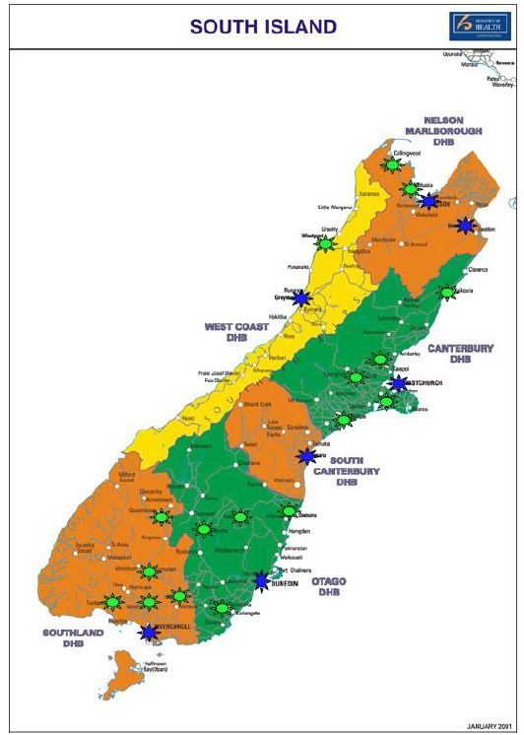
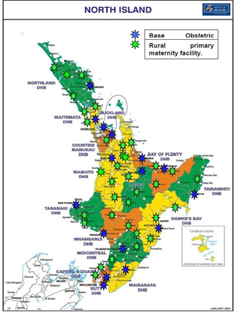
Building on our work from 2015, we found that the number of women birthing at primary birthing units has declined since 2009 from 6,696 births in 2009 to 5,218 births in 2013 (representing a decline from 11 percent to nine percent of total births). Most DHBs recorded a decline in the number of women birthing at individual primary maternity facilities. The reasons for these changes are not currently well-understood and the NMMG reviewed limited information describing the number of women who plan to birth at a primary facility compared to where they actually birth.

Supporting birth at primary maternity facilities requires adequate and appropriate access to secondary and tertiary maternity services when these are needed. In support of this, we wrote to the Ministry of Health indicating our support for multi-disciplinary emergency obstetric skills courses and training.

The changes we expect to see next

The NMMG supports strengthening primary maternity services including timely, equitable access to community-based primary maternity care particularly for women living in rural New Zealand. We continue to support the Ministry’s efforts to promote normal birth and to better understand women’s preferences about place of birth. Much remains unknown. Issues to further explore are:
- Influencers on women’s preferences regarding place of birth
- Location of primary birthing facilities, staffing levels, and use/occupancy rates
- Access to primary maternity facilities in rural and remote areas
- Integration of primary birthing facilities into DHB management and quality frameworks
- Closing data gaps (for example, in-labour and post-natal transfer rates between type of facility, number of LMCs working in remote and rural primary birthing facilities, etc.), and
- The guidance DHBs require to maintain and manage primary birthing units within the MQSP framework.

Much important work remains to be done. The NMMG looks forward to considerable progress being made by the Ministry of Health in this area in 2016/17.

Investigate consistency in the quality of first trimester antenatal care
Our focus for 2015/16 was to continue investigating consistency in the quality of first trimester care to ensure that all health practitioners providing publicly funded services to women use evidence-informed early pregnancy care.
Approximately 60 percent of women who give birth see a GP (who claims a non-LMC first trimester module from Section 88) in their first trimester of pregnancy. Provision of early pregnancy care in general practice varies by DHB, parity, maternal age and ethnicity. A high- quality health system relies on full use of health practitioners’ skills and training so that appropriate care is delivered. Specifications for first trimester care are well-described in the Section 88 Primary Maternity Notice. We have uncovered the extent of the variation in the type of care received at an early pregnancy consultation, and some uncertainty about consumer and practitioner expectations.

What we have done this year and our findings
We monitored the timeliness of women registering with an LMC within the first 12 weeks of pregnancy and reviewed the development of DHB initiatives that meet the care needs of women, including those who are not accessing early pregnancy care in a timely manner.
The number of women registering with an LMC in the first 12 weeks of pregnancy continues to increase in almost all DHBs (see graph below). DHB efforts to improve timely engagement have been driving these increases which is encouraging; however, significant variation between DHBs persists. DHBs with lower engagement rates must continue to focus on this and consider how to support services that encourage women to engage in a timely manner.
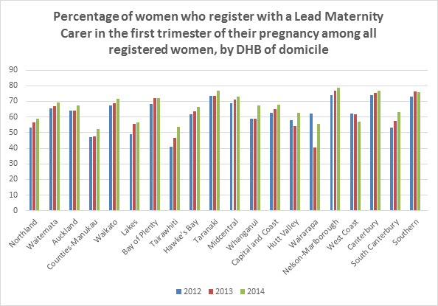

Source: Ministry of Health. 2016. New Zealand Maternity Clinical Indicators 2014. Wellington: Ministry of Health.
We discussed the quality aspects of care and ongoing education in general practice regarding early pregnancy care.
Our correspondence and investigation this year raised the extent of the range of quality of early pregnancy care delivered in a primary setting and the ongoing post-registration education required to provide care in the first trimester. We heard that section 88 funding for a first early pregnancy consult is paid as one payment. We were advised that the range of services undertaken in general practice may depend on how soon after visiting a GP registration with an LMC occurs. For example, a GP may do a full check if referral is likely to take some time (such as in a remote or rural area) or do very little if registration is likely to be sooner (so as to avoid duplication of the full registration consultation that an LMC would undertake). This timing results in considerable variability in type of care (not necessarily the quality of care) that women might receive from a non-LMC but the payment is the same regardless.

It is important that general practice and LMCs work together and share information about the care provided to individual women antenatally and up to six weeks after birth. General practice, obstetricians and LMC midwives should ensure written information about care previously given is provided when a woman is transferred between practitioners. For example, general practice could provide women with information to share with their LMC even if the woman has yet to decide who that might be. This would assist the LMC with any significant past medical or obstetric history. Alternatively, general practice could share doctors’ contact details with LMCs to facilitate transfer of any relevant information by phone or secure email. Electronic transfer of such information would be ideal but, in many primary care settings, LMC midwives still do not have the capability to send or receive such messages because there has been no support to achieve this for them.

We were informed that general practice is increasingly making referrals to obstetricians and gynaecologists for women’s health issues and that numbers of vocationally registered GPs qualified in women’s health is increasing; however, we were also informed that the knowledge around women’s health issues (and pregnancy specifically) is varied in general practice.

As part of our considerations on the quality of first trimester care, we considered a model estimating antenatal transmission of hepatitis B. We found that hepatitis B is routinely screened for in antenatal blood screening and that the number of cases predicted by the model is accurate.

The changes we expect to see next
We will complete further investigation into the accessibility of LMCs, timeframe between first consultation and LMC registration, and awareness of these timeframes within general practice. To support our work, we recommend that the Ministry of Health appoint a GP who currently provides non- LMC and/or LMC services to the NMMG.

All health practitioners providing publicly funded services to pregnant women need to ensure that they are well-informed about what should be covered in an evidence-informed early pregnancy consultation. The service expectations are clearly set out in the Section 88 Primary Maternity Services Notice. All health practitioners must follow these requirements if claiming for pregnancy care payments. We will ensure the Royal New Zealand College of General Practitioners is informed of our findings and the expectations of the publicly funded Section 88 Notice so they can share these with members.

We will continue to monitor the timeliness of women registering with an LMC within the first 12 weeks of pregnancy.

The NMMG expects to maintain communication with the Ministry of Health in relation to its discussions about in-service education options to ensure evidence informs all first trimester consultations.les of good practice

Examples of good practice

Counties-Manukau Health has developed a first contact pregnancy pack for women. This pack is given to all women on their first contact with a health professional (including a GP, LMC, hospital outpatients, etc.). The pack includes written information and weblinks about a wide range of maternity advice. A card for health practitioners was also created to support early pregnancy discussions about smoking cessation, immunisation during pregnancy, weight gain and first trimester antenatal screening. PHOs in the Counties Manukau also have appointed champions to support maternity care in a primary care setting.

South Canterbury DHB has also developed a consumer-focused trimester-related pregnancy information packs which contain a range of information about pregnancy care relevant to the trimester.

Investigate access to Anti-D following a sensitising event

At the request of the Ministry of Health our focus for 2015/16 was to investigate Rh D negative women’s access to Anti-D immunoglobulin during pregnancy and post-partum.

Anti-D immunoglobulin is given to pregnant Rh D negative women to prevent immunisation to Anti-D and the development of rhesus disease in babies. The New Zealand Blood Service provides detailed guidance on the use of Anti-D in the Use of Rh D immunoglobulin during pregnancy and the post-partum period guideline). Timely access to Anti-D immunoglobulin is critical for preventing rhesus disease and ensuring babies’ health should a sensitising event occur.

What we have done this year and our findings

We investigated the number of women requiring intrauterine transfusion for Anti-D antibody mediated fetal anaemia and the number of babies needing postnatal transfusion.

From 2010 to 2015, 44 women required intrauterine transfusion for Anti-D antibody mediated fetal anaemia. National data on the number of babies requiring postnatal transfusion is not collated but estimates provided to the NMMG indicate that up to 30 babies may be affected each year. While further data is required to confirm the burden of rhesus disease, current estimates are concerning given that rhesus disease can be effectively prevented by the provision of Anti-D.

We wrote to DHBs requesting information about women’s access Anti-D immunoglobulin and assessed responses against the New Zealand Blood Service’s guideline.

Some DHBs have comprehensive guidelines covering indications for Anti-D immunoglobulin use, advice on screening and routine antenatal and postnatal use, assessment of feto-maternal haemorrhage size, Anti-D dose, route of administration and processes for seeking informed consent and managing decline of treatment. Where other DHBs do not appear to provide advice on all of these issues, we noticed the following gaps:
- Lack of guidance covering situations when Anti-D has been offered but is declined
- Limited information about route of administration
- Uncertainty about the use of Kleihauer tests to determine the size of feto- maternal haemorrhage and Anti-D dose, and
- DHB guidelines that are out-of-date or due for review or which do not reference the New Zealand Blood Service guidelines.

The changes we expect to see next

Further information on intra-uterine transfusion rates and incidence of rhesus disease would provide better understanding of the differences between New Zealand rates and those in Australia (where Anti-D immunoglobulin is offered prophylactically between 28 and 32 weeks).

We expect all DHBs to have comprehensive guidelines on the administration of Anti-D immunoglobulin, including processes to ensure that all Rh D negative women receive the appropriate dose when required (including prophylactically). This includes the use of Kleihauer testing as a means to assess dosage and ensuring that women receive patient information about Anti-D immunisation, rhesus disease and prevention to support informed consent.

Investigate increases in perineal trauma
Our focus for 2015/16 was to investigate increases in the degree of damage to the lower genital tract at birth following our review of the New Zealand Maternity Clinical Indicators data.
The 2009-2014 New Zealand Maternity Clinical Indicators data shows that, nationally, rates of intact lower genital tract at birth are decreasing and that the degree of damage to the lower genital tract appears to be increasing. Significant damage to the lower genital tract is debilitating for women. It is important that DHBs recognise this trend, explore reasons for it and implement quality improvement initiatives focused on diagnosis and management.
What we have done this year and our findings
We considered the New Zealand Maternity Clinical Indicators data for indicators 6-9 and observed an apparent increase in lower genital tract damage. Following this, we sought information from DHB Clinical Directors about potential drivers for the apparent increase in perineal trauma and the diagnosis and management of severe tearing.
Possible reasons for the apparent increase in perineal trauma include:
- Changes in babies’ presentation including larger babies and more occipito-posterior births
- Increased awareness of the significance of third and fourth degree perineal tears, and better training in recognition and management resulting in improved assessment of the perineum and increased diagnosis of severe tearing, and
- Improved reporting.
We were encouraged to hear about initiatives to better diagnose and manage third and fourth degree perineal tears. The presence of third and fourth-degree tears is an indicator of the quality of labour care received. While improved diagnosis, management and reporting of
third and fourth degree tears may account for some of the apparent increase (rather than poor clinical practice), it is important that DHBs continue to investigate instances of significant tearing and how this might be reduced. The NMMG is confident that DHBs will continue to appropriately identify and manage perineal trauma. A number of DHBs are also conducting audits to further investigate trends in genital tract damage and we look forward to hearing about the results of this in 2016/17.
Examples of good practice
Perineal care as a key quality initiative in Waikato DHB’s MQSP. Its comprehensive perineal care programme contains the following elements:
- obstetric and physiotherapy guidelines on the management of third and fourth degree perineal tears
- postnatal patient debriefs on diagnosis and management of perineal tearing (including the provision of patient information, pain relief/other medication and ACC forms)
- referral to physiotherapy services before and following discharge and a six-week follow up check with a women’s health physiotherapist, and
- referral to clinic for subsequent pregnancy.

Value and high performance

Monitor implementation of DHB MQSPs
Our focus for 2015/16 was to review each DHB’s MQSP Annual Report and provide feedback to DHBs to support identification, implementation and achievement of strategic goals and objectives.
In 2015/16, the Ministry of Health moved DHB MQSP funding to a new contracting model as it embedded and expanded the MQSP and sought to enhance the impact of the MQI. The new contracting model reflected the different stages of maturity of each DHB’s MQSP at the time, with different DHBs allocated to different contract tiers. The NMMG adapted its monitoring role in response to these changes, including providing advice on DHB placement within contract tiers.

What we have done this year and our findings

We concentrated monitoring efforts on “emerging” DHBs to support advancement to more connected and integrated local MQSPs.

We encouraged “establishing” and “excelling” DHBs to further embed existing programmes into long-term, organisation-wide quality frameworks while retaining strong clinical leadership and management support.

West Coast DHB has made significant progress. Its plan provides a clear pathway to move to the established tier and describes its governance structure, relationships, audit activity and risk management activities well. Quality improvement activities are identified, measurable, timed and allocated to a responsible person. An active coordinator is in place. We are confident that the West Coast DHB’s planned work will result in progress to the established tier.

Southern DHB has slowly progressed the development of its MQSP. We are pleased that the MQSP coordinator role has now been filled and hope that this appointment will act as a catalyst for the DHB to now develop its understanding of Southern DHB’s pregnant population before it prepares a focused, integrated MQSP. We encourage DHB leadership and clinical staff to further support the development and implementation of a satisfactory and achievable MQSP. We expect that the DHB will provide a comprehensive report on its progress and we note that progression to the established tier requires both continued and sustained leadership and effort. Achievement in this area will ensure that women in the Southern region access high-quality maternity care.

Other DHB MQSPs continue to evolve: some DHBs are implementing increasingly sophisticated and integrated MQSPs while others continue to work hard towards embedding effective programmes of work to improve maternity outcomes. We remain concerned about the level of engagement that DHBs have with LMCs in some areas. It is important that DHBs consider how best to engage with LMCs, the community and primary care (including general practice) during implementation of MQSPs.

We wrote to Health Workforce New Zealand about midwifery and obstetric workforce recruitment and retention at DHBs and are pleased that the Maternity Strategic Advisory Group has been established to investigate maternity workforce issues. We will continue to review the activities of this group and monitor outcomes.

We reviewed each DHB’s 2015/16 MQSP Annual Report to determine how they align work to improve the quality of maternity services within broader quality initiatives and to determine the extent to which DHBs have progressed toward achieving identified strategic objectives.

We found that future priorities for DHB MQSPs are generally well-identified and are well aligned with the priorities identified by the NMMG. Most DHBs appear to have held discussions to embed the MQSP into their wider quality work and ‘business as usual’ practise, which is encouraging and will support progression through the tiers. One potential area of improvement for reporting is better balance between local and national priorities. For example, some DHBs demonstrated a strong focus on national priorities without revealing as much about their local performance and focus. Others did not link strongly to national priorities in their MQSP reports. Finally, where DHBs have successfully implemented and integrated performance initiatives, evaluation processes should be clearly included to ensure good measurement of performance.

We sought information from DHBs about integrated pathways for maternal mental health.
All DHBs have a documented integrated pathway describing how women can access mental health services during pregnancy and for up to one year after birth. Coordination between primary care, DHBs and service providers is an integral component to the successful implementation of these pathways as is service availability. Having a pathway alone does not guarantee access to care when women require it: we are concerned to hear that often mental health cases must be severe before women can be referred to or access services. We were also concerned to hear of situations in which an LMC midwife may not know about these pathways, or how to access or support access to these pathways.

Examples of good practice
We met with Taranaki DHB and were impressed with its description of the implementation of its maternal mental health pathway. This pathway appears to be well-coordinated, women- focused and holistic. Some of the factors critical to successful implementation are that it is:
- women-centred (including the ability for women to self-refer to mental health services for triaged assessment and the provision of opportunities to visit maternity facilities and meet staff pre-birth should a woman be concerned about birth or be experiencing mental health or addiction issues)
- coordinated and engages with a wide range of service providers involved in maternal mental health care (including primary care, well child services, and representatives of all DHB departments involved in maternity services or caring for mothers and babies – including mental health services)
- DHB-wide: all-department meetings are held to discuss maternal mental health issues
- consistently applying a standardised screening tool (in this case, the Edinburgh Postnatal Depression Scale), which has included health practitioner training, and
- providing ongoing leadership: the establishment of a pathway and appointment of dedicated FTE is only the first step.

The changes we expect to see next
We expect all “established” DHBs to be planning how and preparing for movement into the “excelling” tier. This pathway should be described in the MQSP Annual Report.
We encourage the Ministry of Health to support promotion of Taranaki DHB’s implementation of its maternal mental health pathway as it demonstrates a good approach on how to embed the mental health as a core maternity service. We expect all DHBs to continue to monitor the implementation of maternal mental health pathways.
We expect that all DHB MQSP coordinators continue to be supported with dedicated time to complete their coordination role rather than fitting this important work around other clinical or administrative roles.

Review key sector publications including the Report on Maternity

Our focus for 2015/16 was to review key maternity sector publications and accompanying data tables to provide advice on the findings and possible priorities for future action.

Reviewing key sector publications and providing advice on the findings of these reports is one of the key functions of the NMMG and one of the ways in which we contribute to continuous systems improvement. We have previously reviewed each Report on Maternity and provided advice on possible improvements: we expect to continue to do this.

What we have done this year and our findings

We reviewed the Ministry of Health’s Report on Maternity 2014.

The 2014 Report on Maternity and the accompanying data tables continue to provide a wide range of useful clinical, statistical and demographic information about maternity care in New Zealand.

We requested advice from the Ministry of Health about the process and timing needed to develop a high-quality data set and to develop and publish the Report on Maternity, the annual New Zealand Maternity Clinical Indicators reports and the accompanying data tables.

Timely publication of robust data is critical to understanding maternity care outcomes and developing responsive quality improvement initiatives. Previous reports have been published long after the close of the calendar year (for example, the 2013 Maternity Clinical Indicators data was released in September 2015, more than 20 months after year-end). We sought further explanation from the Ministry and now have a better understanding of the timing and process required to develop robust reports.

Key sector reports like the Report on Maternity and the clinical indicator data draw information from a range of different datasets (including LMC claim data, public hospital discharge data and primary maternity unit discharge data). The Ministry receives this data at different timeframes: overall, a minimum of eight months following the close of the calendar year is needed to be sure that data is complete. Data must then go through quality processes in order to be presented accurately. The NMMG encouraged the Ministry to continue its appropriate and robust processes.

We were pleased to see that the Ministry has published the 2014 Maternity Clinical Indicators report in a more timely manner.

The changes we expect to see next
We expect the publication of robust reports to continue and that timeliness will improve. All reports should be published within 15 months of the close of the previous calendar year. The Ministry of Health should also publish provisional (and potentially incomplete) data to enable maternity stakeholders to access more timely information. We will continue to monitor this.
We also expect that DHBs are reviewing the same key sector reports and considering how the recommendations apply to services provided in their areas. For example, we expect DHBs to be reporting on the Clinical Indicator results each year.

Support the ratification of national maternity clinical guidelines

Our focus for 2015/16 was to ensure that national evidence-informed clinical guidance is appraised and ratified using the AGREE II Instrument and algorithm. We also monitored implementation of existing guidelines.
National maternity clinical guidelines are a key component of the maternity sector. They set standards based on the latest clinical evidence or best practice and enable consistency in clinical maternity practice nationally. Guidelines do not replace the autonomy of clinical decision-makers or the need to seek a woman’s informed consent.
We know of work undertaken by special interest multidisciplinary groups which may provide such guidance to the sector (or conversely which may result in less robust advice) and which may be rolled out without being formally appraised or ratified. The establishment of a formal process to appraise and ratify such work is critical to ensuring that evidence-based guidance supports effective and informed clinical decisions.

What we have done this year and our findings

The NMMG and the Ministry of Health developed a formal process to appraise and ratify externally developed guidelines.

Any external organisation that is developing guidelines can request that the Ministry of Health review the draft material and the development process before recommending endorsement (or not) as a national guideline. The NMMG can also request that the Ministry consider draft guidance material for endorsement. The NMMG provides comment on the Ministry’s recommendation for endorsement. Detailed advice about the process and the AGREE II Instrument is available at: http://www.health.govt.nz/our-work/life-stages/maternity-services/national- maternity-clinical-guidance/external-maternity-clinical-guidance No draft guidelines were presented to the NMMG for ratification in 2015/16.

We discussed the currency of a number of maternity-related guidelines and sought feedback on anticipated review timeframes and processes.

We were pleased to hear that the Ministry is provided updated advice on nutrition for pregnant and breastfeeding women through its new Eating and Activity Guidelines Series and will ensure that nutrition advice for pregnant and breastfeeding women is evidence-informed. We were advised that Australian systematic reviews of dietary guidance (including advice
for pregnant and breastfeeding women) in 2013 have recommended similar nutrition advice as is contained in New Zealand’s current guideline. We look forward to reviewing the new guidance once the systematic review is completed and decisions regarding changes to the current guideline are made (expected in 2018).

We are aware that work is being undertaken to compile a guideline on hypertension in pregnancy. We expect to see this completed as soon as possible and expect to see this implemented by the sector.

The changes we expect to see next

The NMMG looks forward to fulfilling our role in considering recommendations on endorsement (or otherwise). We encourage those who have been working on clinical guidance through a multidisciplinary approach to ensure that they are familiar with the AGREE II Instrument requirements. We expect to see increased use by guideline developers of the AGREE II Instrument and adapted algorithm.

We recommend that the Ministry of Health develop at least one new maternity-focused guideline per annum. The maternity sector requires guidance on the diagnosis and management of hypertension and pre-eclampsia in pregnancy (as noted in our 2015 report). The NMMG recommends that the Ministry of Health progress this work as a matter of priority. Other priority topics include the care of women with breech presentation.

The NMMG will maintain a monitoring focus on the implementation of existing national guidelines including the Screening, Diagnosis and Management of Gestational Diabetes in New Zealand and the Referral Guidelines. We note that the Referral Guidelines are due to be updated by December 2017 to ensure that they reflect current evidence and best practice. We support this work. The National Consensus Guideline for the Treatment of Postpartum Haemorrhage is also due for revision in 2016: this should be completed in a timely manner.

Monitor the outcomes of the work undertaken by the Maternity Ultrasound Advisory Group
Our focus for 2015/16 was to monitor the outcomes of the Maternity Ultrasound Advisory Group in its work to advise the Ministry on key issues in supply, utilisation and quality of publicly-funded primary maternity ultrasound services and pathways.
Best practice antenatal care for a woman who has no complications during pregnancy, is low- risk, engages with health services in the first trimester of pregnancy, and carries her baby to term involves referral for two screening-based ultrasounds:
- A first trimester ultrasound optimally performed at around 12 weeks for dating, identification of twin pregnancy, early anatomy assessment and screening for chromosomal anomaly (if consented to by the woman), and
- An anatomy ultrasound optimally performed at 19+ weeks for detailed assessment of fetal anatomy.
Previously, we have highlighted the rising primary maternity ultrasound rates in New Zealand and variability in access and quality. In 2015/16, we co-opted a College of Radiology member to help us to explore possible reasons for rising ultrasound numbers and found a number of interrelated factors that may be contributing to the rising rates. We have previously recommended that there be a review of maternity ultrasound use and women’s expectations in relation to the number of scans they receive. Health professionals have asked the NMMG to assist in determining steps to reduce this often unnecessary investigation (unless clinically indicated).

What we have done this year and our findings
We supported the establishment of a group to consider and advise the Ministry on key issues in supply, utilisation and quality of publicly- funded primary maternity ultrasound services and pathways.
The NMMG supports the important work undertaken by the Maternity Ultrasound Advisory Group, including its work to:
- investigate equitable access to ultrasound services (including barriers to access)
- understand the drivers and clinical appropriateness of the current volumes and types of publicly funded primary maternity ultrasounds
- consider the quality of services and primary maternity ultrasound referral pathways
- identify areas for further investigation or audit, and
- develop national standards for primary maternity ultrasounds.
Our support has included representative membership: Rachel McEwing sits on the Group as the NMMG’s representative. The NMMG provided the Advisory Group with information on combined screening, the quality of nuchal translucency ultrasounds and non-invasive prenatal testing (NIPT), which we collected during our consideration of this issue.

We are especially interested in the work that the Maternity Ultrasound Advisory Group is doing to explore the use of dating scans before 12 weeks as this was an area that we had noted was increasing with no evidence in very early pregnancy to support such a scan. Given the importance of ultrasound to effective maternity care, the NMMG has formally requested updates from the Maternity Ultrasound Advisory Group so we can keep abreast of its discussions and monitor their recommendations.

We requested that the New Zealand Maternal Fetal Medicine Network update its statement on the use of NIPT, which it has done.

The changes we expect to see next

We are pleased to note significant progress in this area. We look forward to the Maternity Ultrasound Advisory Group’s report back in 2016 and to hearing the results of its work, particularly its advice regarding the clarification of the quality frameworks that surround primary maternity ultrasounds.

Smart system

Review the New Zealand Maternity Clinical Indicators data and monitor DHB responses to variations

Our focus for 2015/16 was to review the New Zealand Maternity Clinical Indicators report provides advice on to DHBs and the Ministry of Health on trends and variances.

The New Zealand Maternity Clinical Indicators are nationally standardised benchmarked maternity data. Maternity sector stakeholders rely on this data to consider whether the New Zealand Maternity Standards are being met. In 2015/16, the Ministry released data for 2013 and 2014, making data available for both the period prior to the implementation of the Maternity Quality Initiative and the period immediately after implementation.

What we have done this year and our findings

We reviewed the Maternity Clinical Indicator data set to determine national trends and identify instances where DHBs continue to record significant and consistent variation from the national average and shared our findings with each DHB. We also raised concerns about the timeliness of the national data to support the work being undertaken in the DHBs.

⬆ | Rates of registration with an LMC in the first trimester of pregnancy continue to  increase.
⬇ | The number of standard primiparae who have a spontaneous vaginal birth continues to fall as intervention rates (including induction of labour, instrumental birth and caesarean section) continue to increase.
⬇ | Standard primiparae are less likely to have an intact genital tract following birth compared to women birthing in 2009. More episiotomies are being performed and more third and fourth degree tears are being diagnosed.
⬇ | The number of women having a general anaesthetic for caesarean section has decreased as has the number of women requiring blood transfusion with caesarean section; however, blood transfusion rates for vaginal birth appear to be increasing.
⬇ | Serious adverse maternal outcomes appear to be decreasing: fewer women had eclampsia at birth admission, a peripartum hysterectomy or needed admission to ICU and ventilation.
⬆ | Women’s BMI is increasing: 8.8 percent of mothers had a BMI over 35 in 2014.
⬇ | Some baby outcomes remain stable or are improving (including pre-term birth and fewer small babies at term). Other baby outcomes appear to be worsening including the number of term babies requiring respiratory support.

Considerable care is needed when assessing possible relationships between this data and the impact of the Maternity Quality Initiative and DHB MQSPs. DHBs have implemented a significant range of quality improvement initiatives and a lag between the implementation of initiatives and improvements in maternity outcomes is expected in the first few years post-implementation. Significant change (including culture change and evidence-based improvements to clinical practice) can take time to produce results; however, the NMMG expects to see improvement (or credible reasons for trend) in the 2015 data.

Recent Maternity Clinical Indicator data also clearly shows that maternity outcomes continue to vary significantly between DHBs and between facilities within DHB areas. This is a concerning and persistent trend across all Indicators. We sought feedback from DHBs about local variances and were reassured somewhat that DHBs are aware of where performance improvements are required (and where they are performing well). Most DHBs are also putting in place a range of initiatives to investigate variance or implement quality improvement initiatives to address areas of concern. The NMMG supports DHBs to use up-to-date data to explore apparent trends and respond to findings. The NMMG will also continue to monitor this data and work with DHBs on any issues relating to quality.

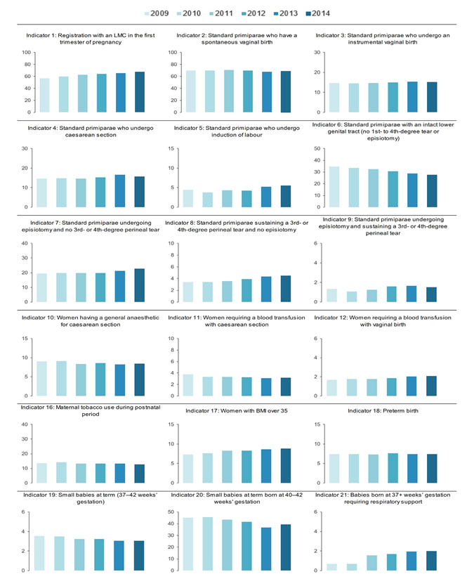
Figure 2: New Zealand Maternity Clinical Indicator rates by year 2009-2014.

Source: Ministry of Health. 2016. New Zealand Maternity Clinical Indicators 2014. Wellington: Ministry of Health. http://www.health.govt.nz/publication/new-zealand-maternity-clinical-indicators-2014

This year, we specifically investigated the trends shown for perineal trauma (Indicators 6-9). Our findings are discussed on page 19.

We reviewed national and local rates of induction of labour and elective caesarean birth by gestational age and maternal age and ethnicity for births at 37⁰ to 38⁶ weeks and provided this information to each DHB. We also sought information about the range of services that DHBs offer to women in support of vaginal birth after a previous caesarean (VBAC).

We were encouraged to see that, at a national level, rates of elective caesarean birth are declining and there has been a small but positive shift in the timing of planned early birth (i.e., it is broadly occurring at later gestational ages compared to when we assessed this using 2011 data).

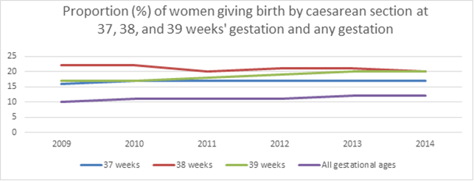

Source data provided by Ministry of Health.

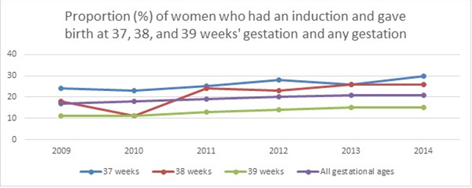
Source data provided by Ministry of Health.

We note that the Royal Australian and New Zealand College of Obstetricians and Gynaecologists recommends that planned early birth in women without additional risks should be carried out at approximately 39 weeks gestation due to the increased risk of respiratory morbidity, surfactant deficiency and pulmonary hypertension for babies born before 39 weeks gestation. We understand that a number of factors impact on the timing of planned early birth but the main drivers should be clinical factors (rather than theatre time or access to anaesthesiology).

VBAC is an important birth option for women who have had a previous uncomplicated lower segment caesarean section if the current pregnancy is uncomplicated. We were pleased to note that, of the DHBs that responded to our questions, all provide decision-making support to women during consideration of VBAC. This includes specialist-led clinics, access to obstetric advice, and provision of patient information on VBAC.

We provided advice to the Ministry of Health on progressing a national framework and clinical pathway for the assessment of babies for whom there are concerns about fetal growth. Accurate tracking and measuring of growth and gestational age supports accurate assessment of babies’ health. Some facilities use Fenton charts; others use the GROW system or an alternative chart. There is now consensus to use the GROW system.

We met with Ministry of Health officials to discuss maternity coding processes within DHBs, including processes for identifying and correcting errors.

We were encouraged to hear that the Ministry of Health is implementing the eighth edition of the ICD-10. Implementation includes an upgrade to in-house training for DHB coding staff. We were also pleased to note that several DHBs have identified clinical coding as a quality improvement area and are implementing new programmes of work to address identified quality issues. The NMMG continues to support strong communication between MQSP coordinators and maternity care professionals regarding coding decisions.

The changes we expect to see next

We encourage the Ministry of Health to release the 2015 Maternity Clinical Indicators dataset as soon as possible in 2016. When this is released, the NMMG will consider the dataset and correspond with DHBs about intended actions to take as a result of the new data. We expect DHBs to continue to review the Maternity Clinical Indicators data and use this to guide quality improvement initiatives, including reporting on this work and its impact in their MQSP Annual Reports.

The NMMG will meet with the Expert Working Group annually to discuss trends, consider the impact of the Maternity Quality Initiative on maternity outcomes and assess proposed or required changes to the Clinical Indicators, including addition or removal of individual Indicators.

We encourage DHBs to review births that have been initiated earlier than 39 weeks to determine if organisational factors are a contributory factor to that timing and to then consider initiatives to optimise the timing of birth for these babies.

The NMMG going for wards
Supporting the achievement of the refreshed New Zealand Health Strategy is an important focus of the NMMG’s work. Our work programme for 2016/17 includes eight priority areas for monitoring and two priority areas for further investigation. Completion of our work programme will further support a maternity system that provides the best care for women and their babies and supports them to live well, stay well and get well.

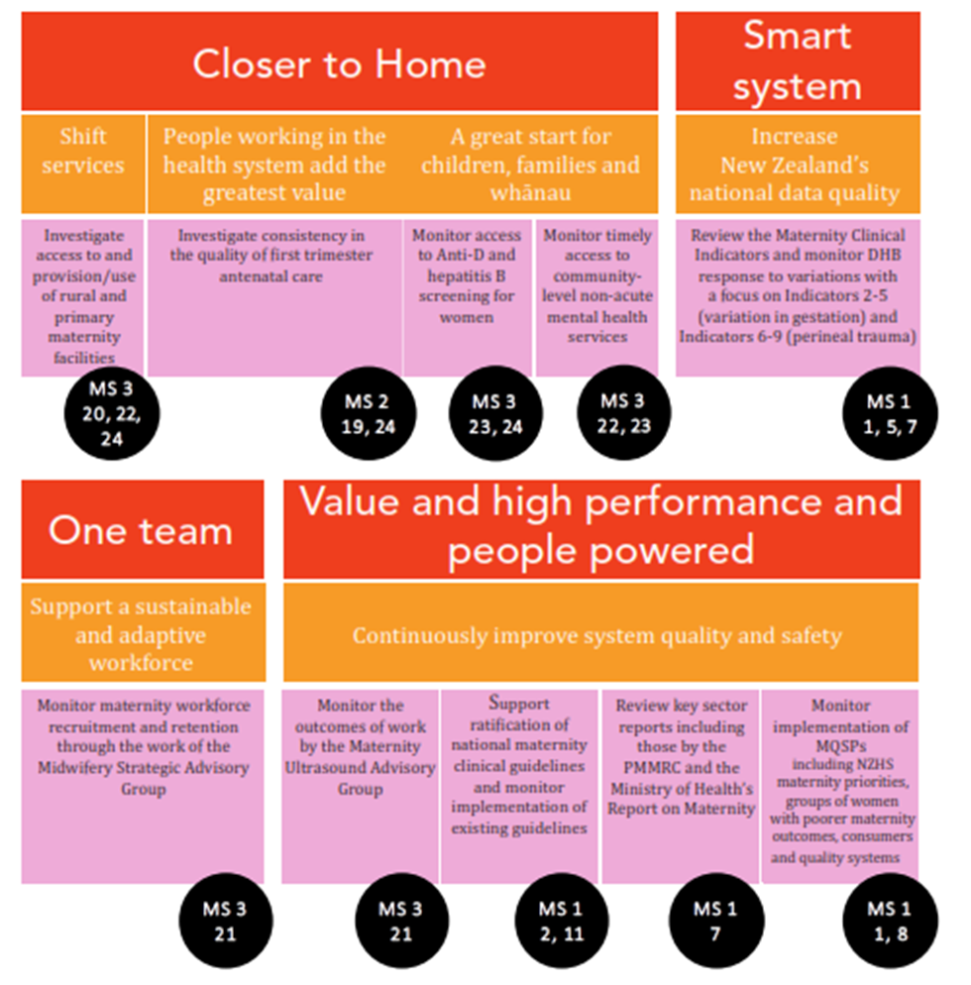
The diagram (below) describes the core components of our 2016/17 work programme. We will also produce an annual report.

Acknowledgements
As with previous years, the NMMG has appreciated the responsiveness of maternity sector stakeholders to our enquiries. Timely provision of detailed information has helped us further explore key issues, draw linkages across issues affecting maternity care where different agencies are involved, and identify other potential priorities for investigation or monitoring.

The NMMG would like to thank the following groups and individuals for their contribution to our work this year:
- The consumers who engaged so openly both with the National Maternity Monitoring Group and district health boards, so that we could all better understand the perspectives of pregnant women, women who are birthing and women postnatally
- The professionals within the maternity sector who worked so hard to provide us with detailed information
- Staff at the Ministry of Health for their ongoing support of the NMMG’s work
- The Minister of Health and the Director-General of Health for ongoing commitment both to the National Maternity Monitoring Group and the maternity sector
- All involved in the delivery of the Maternity Quality and Safety Programme - seeing collaboration between professionals and consumers has been particularly encouraging, and
- Chief Executive Officers and other district health board staff throughout New Zealand who have taken responsibility for providing such timely and robust responses to questions from the National Maternity Monitoring Group.

We could not do this important work without your support.

We look forward to working with you all again as the new NMMG continues our programme of work in 2016/17.

Appendix 1:

Terms of Reference for the National Maternity Monitoring Group

Introduction

1. This document sets out the:
a. roles and responsibilities of the National Maternity Monitoring Group b. work programme and reporting requirements
c. composition of the National Maternity Monitoring Group
d. terms and conditions of appointment.

Background

2. The New Zealand Maternity Standards (Ministry of Health 2011) consist of three high- level strategic statements to guide the planning, funding, provision and monitoring of maternity services:
a. Standard 1: Maternity services provide safe, high-quality services that are
nationally consistent and achieve optimal health outcomes for mothers and babies
b. Standard 2: Maternity services ensure a woman-centred approach that acknowledges pregnancy and childbirth as a normal life stage
c. Standard 3: All women have access to a nationally consistent, comprehensive range of maternity services that are funded and provided appropriately to ensure there are no financial barriers to access for eligible women.

3. These high-level statements are accompanied by specific audit criteria and measurements of these criteria. One of the criteria is that a National Monitoring Group be established to oversee the maternity system and the implementation of the Standards.

Role of the National Maternity Monitoring Group

4. The role of the National Maternity Monitoring Group is to oversee the New Zealand maternity system and to provide strategic advice to the Ministry of Health on priorities for improvement.

5. Standard 1 of the New Zealand Maternity Standards states “a National Monitoring Group, consisting of a small number of clinical sector experts and consumer representatives … provides oversight and review of national maternity standards, analysis and reporting. The National Monitoring Group provides advice to the Ministry on priorities for national improvement based on the national maternity report, nationally standardised benchmarked data, the audited reports from DHB service specifications, Maternity Referral Guidelines, and the Primary Maternity Services Notice 2007”.

6. Standard 1 sets out audit criteria, applicable at the national level, to which the Ministry of Health and the professional colleges are accountable to. These additionally inform the role of the National Maternity Monitoring Group.

7. The National Maternity Monitoring Group is not a decision making body. While it may provide recommendations to the Ministry of Health, responsibility for decision making and implementation rests with the Ministry of Health and/or other relevant participants in the maternity system.

Responsibilities and reporting requirements of the National Maternity Monitoring Group

8. The National Maternity Monitoring Group will meet at least four times per annum, and will undertake other communication as necessary to deliver the agreed work programme.

9. The National Maternity Monitoring Group is responsible for identifying priorities for action or investigation, and agreeing a 12-month work programme with the Ministry of Health at the beginning of each year of operation.

10. The work programme may include but is not limited to:
a. providing expert advice on data released through the New Zealand Maternity Clinical Indicators, national maternity consumer surveys and the New Zealand Maternity Report, which are published from time to time by the Ministry of Health
b. contributing to the review of the New Zealand Maternity Clinical Indicators at a minimum of three-year intervals and providing advice on the modification, addition or withdrawal of any indicators
c. identifying priorities for national clinical guidelines / guidance for maternity including recommendations on best clinical practice, and providing advice on how these should be developed and implemented
d. reviewing reports of the Perinatal and Maternal Mortality
Review Committee (PMMRC), identifying the implications for the maternity system of the findings of the PMMRC and providing advice on system response to these findings
e. reviewing and assessing the annual reports produced by each
DHB as part of its Maternity Quality and Safety Programme.
f. reviewing and assessing other maternity reports produced or commissioned by the Ministry of Health, DHBs, professional colleges, consumer groups or other stakeholders as requested from time to time.

11. The National Maternity Monitoring Group may be asked to provide advice on any other matters related to the quality and safety of maternity care and services by the Ministry of Health from time to time.

12. The National Maternity Monitoring Group will produce an Annual Report by a date negotiated with the Ministry of Health detailing:

a. Work carried out, conclusions reached and recommendations made during the
previous year
b. Its priorities and work programme for the following year.

Relationship of the National Maternity Monitoring Group to the Perinatal and Maternal Mortality Review Commission

13. The Perinatal and Maternal Mortality Review Committee (PMMRC) is a Mortality Review Committee, appointed under section 59E of the New Zealand Public Health and Disability Act 2000 by the Health Quality and Safety Commission.

14. The PMMRC considers maternal and perinatal mortality, and other morbidity as directed by the Minister in writing. It prepares an Annual Report, which includes its advice and recommendations.

15. In providing its advice, the National Maternity Monitoring Group will take account of the findings on maternal and perinatal mortality and morbidity by the PMMRC set out in its Annual Report.

16. Where the PMMRC recommends specific action by maternity system stakeholders, the National Maternity Monitoring Group will advise the Ministry on an appropriate response to these recommendations.

17. The National Maternity Monitoring Group will meet at least once annually with the
PMMRC.

Composition of the National Maternity Monitoring Group

18. The National Maternity Monitoring Group will have a maximum of 8 members, not including ex-officio members from the Health Quality and Safety Commission and Ministry of Health.

19. Composition of the National Maternity Monitoring Group will balance requirements for:
a. expertise necessary to analyse different sources of information on the maternity
system and make recommendations based on this analysis b. perspectives of key stakeholders in the maternity system.

20. The National Maternity Monitoring Group will include the following skill sets or expertise:
a. expertise in epidemiological research and analysis of health data/statistics
b. experience and expertise in midwifery care
c. experience and expertise in specialist medical maternity care d. experience and expertise in specialist neonatal care
e. expertise in Māori health f. expertise in Pacific health
g. experience and expertise in representing a consumer perspective on maternity issues.

21. All members of the National Maternity Monitoring Group will have basic skills and confidence in working with and interpreting health data.

22. The Ministry will seek nominations from relevant organisations and professional colleges, including the Health Quality and Safety Commission. The Ministry reserves the right to appoint more than one member from an organisation or college or to appoint members not officially nominated by an organisation or college, in order to ensure the balance of skills and expertise outlined in 20 a) to f ).

23. Members of the National Maternity Monitoring Group will share a commitment to working collaboratively and constructively to oversee the national maternity system.

24. The National Maternity Monitoring Group may identify that additional skills or expertise in a particular field or specialty is required to deliver aspects of the agreed work programme. The National Maternity Monitoring Group may seek additional (co-opted) members to fill skill gaps. This will be done in agreement with the Ministry of Health.

25. At least one representative of the Ministry of Health will attend meetings in an ex-officio
capacity.

Term of the National Maternity Monitoring Group

26. The National Maternity Monitoring Group will operate until the end of June 2016 unless otherwise notified by the Director General of Health.

Decision-making

27. Decisions within the National Maternity Monitoring Group are to be made by consensus.
Members are expected to work as far as is possible to achieve consensus. Dissenting
views of members can be noted for the record.

Appointment process

28. The Director General of Health will appoint members to the National Maternity
Monitoring Group.

29. Membership of the National Maternity Monitoring Group will be for a period of three years to June 2016.

30. A Chair and Vice Chair will be elected by the members of the National Maternity Monitoring Group for a term of one year and may be re- elected.

31. Co-opted appointments may be proposed by the National Maternity
Monitoring Group and will be made by the Director General of Health.

32. Any member of the National Maternity Monitoring Group may at any time resign as a member by advising the Ministry of Health in writing.

33. The Director General of Health may choose to fill vacancies should resignations occur.

Support for the National Maternity Monitoring Group

34. The Ministry of Health will arrange provision of the secretariat function for the National Maternity Monitoring Group. This may be externally procured. This includes distribution of agendas and recording of the minutes. Agendas and any associated papers will be circulated at least five days prior to meetings. Minutes will be circulated no later than a fortnight following the meeting date.

Meeting arrangements

35. Meetings will normally be held in Wellington. Rooms and refreshments will be provided
for the meetings.

Payment of meeting fees and travel costs

36. A fee of $325.00 (exclusive of GST) will be paid for attendance at face-to-face meetings and is based upon a full day meeting including travel time. Other work carried out as part of the National Maternity Monitoring Group will be reimbursed on a pro rata basis at the rate of $325.00 per day (exclusive of GST).

37. Public servant/state servants/employees of Crown bodies are not paid for meetings of the National Maternity Monitoring Group. A public servant/state servant/employee of a Crown body should not retain both the fee and their ordinary pay where the duties of the outside organisation are undertaken during ordinary department or Crown body hours.

38. Payment of meeting and other fees will be in accordance with the latest Cabinet circular on fees and guidelines for appointments for statutory bodies, which can be found at: http://www.dpmc.govt.nz/sites/all/files/circulars/coc-12-06.pdf

39. Travel to meetings and, if necessary, flights and accommodation will be arranged. Meal expenses (without alcohol) will also be paid, but other hotel charges including phone calls and items from the ‘mini bar’ will not be paid. Any additional travel expenses incurred will be reimbursed, including taxis, mileage (at the rate of 0.62c per km, GST not applicable) and parking. A valid receipt must accompany claims for expenses.

Conflicts of interest

40. Members of the National Maternity Monitoring Group should document their conflicts of interests and identify any conflict of interest prior to a discussion of a particular
issue. The National Maternity Monitoring Group will then decide what part the member may take in any relevant discussion, and will identify whether the conflict needs to
be escalated to the Ministry of Health for consideration. Guidance can be found in the document ‘Conflict of Interest Protocol for Ministry of Health Advisory Committees’.

Confidentiality

41. The National Maternity Monitoring Group will maintain confidentiality of agenda material, documents and other matters forwarded to them unless otherwise specified.

42. Members of the National Maternity Monitoring Group are not to represent themselves as agents of the Ministry of Health, and by reason of their membership of the National Maternity Monitoring Group, are not permitted to speak on behalf of the National Maternity Monitoring Group or the Ministry of Health.

43. If a member receives a media request or enquiry relating to the work of the National Maternity Monitoring Group, they must inform the Ministry of Health including the Ministry’s Health Communications Manager. Any media communication will be via the Ministry of Health.

If you have any enquiries about this report, or wish to contact the National Maternity Monitoring Group, please contact the NMMG Secretariat:

Email: nmmg@allenandclarke.co.nz
Phone: +64 4 550 5705
Fax: +64 4 890 7301
PO Box 10730, Wellington 6143,
New Zealand

Ministry of Health. 2011. New Zealand Maternity Standards. Wellington: Ministry of Health.
Minister of Health. 2016. New Zealand Health Strategy: Roadmap of Actions 2016. Wellington: Ministry of Health.

