Night Safety Procedures
Transitional Guideline

Disclaimer
While every care has been taken in the preparation of the information in this document, users are reminded that the Ministry of Health cannot accept legal liability for any errors or omissions or damages resulting from reliance on the information contained in this document.
Citation: Ministry of Health. 2018. Night Safety Procedures: Transitional Guideline. Wellington: Ministry of Health.
Published in February 2018
by the Ministry of Health
PO Box 5013, Wellington 6140, New Zealand
ISBN 978-1-98-853950-8 (online)
HP 6784
This document is available at health.govt.nz
This work is licensed under the Creative Commons Attribution 4.0 International licence. In essence, you are free to: share ie, copy and redistribute the material in any medium or format; adapt ie, remix, transform and build upon the material. You must give appropriate credit, provide a link to the licence and indicate if changes were made.

Preface
Night safety procedures is the practice of locking a patient in their bedroom overnight for the purposes of safety. This practice is based on a 1995 Ministry of Health document Night Safety Procedures.

The procedure, as it is currently constructed, is no longer fit for purpose and the Ministry of Health is working towards a phasing out of its use. As I have been advised that it is not immediately possible to stop using night safety procedures, we need to ensure patients receive adequate standards of care and monitoring and that practice is consistent with current expectations. This transitional guideline is being issued with that in mind.

Dr John Crawshaw
Director of Mental Health

Contents
Preface iii
Introduction 1
Purpose of this document 1
Context 2
Statement of principle 3
Outcomes and criteria 4
Outcomes 4
Background 4
Rights 5
Regulations: The Health and Disability Standards 5
Employment standards: Health and Safety at Work Act 2015 5
Outcome 1 6
Outcome 2 6
Outcome 3 7
Appendix 1: Relevant international and domestic legal/regulatory frameworks (overview) 8
Human rights treaties 8
New Zealand legislation 9

Introduction
Patients under the Mental Health (Compulsory Assessment and Treatment) Act 1992 (the Mental Health Act) are subject to a range of restrictions. It is imperative that patients receive adequate standards of care and monitoring and that services provided do not breach their rights. Care must be provided in the least restrictive environment whilst being proportionate to the assessed risks.

A night safety procedure is the practice of locking a patient in their bedroom overnight for the purposes of safety. The practice has no therapeutic function and constitutes (at the very least).a form of environmental restraint.

Night safety procedures have been based on a 1995 Ministry of Health document Night Safety Procedures. Reducing and eventually eliminating the use of seclusion and restraint is a priority action in Rising to the Challenge, the Mental Health Addiction Services Action Plan 2012–2017. In line with that direction, the Ministry of Health is working towards phasing out the use of night safety procedures and, as such, the Ministry’s 1995 Night Safety Procedures document is no longer fit for purpose.

In regions where night safety procedures are still in use, it has been reported that they are considered an essential component to providing a safe environment. Reasons cited include issues with building design and lines of vision, staffing levels, and the level of risk that patients present with.

Purpose of this document
The Ministry is issuing these transitional guidelines to assist Directors of Area Mental Health Services (DAMHS), and others in mental health and secure disability services, who continue to use night safety procedures to work towards eventual elimination. This transitional guideline replaces the Night Safety Procedures document issued in June 1995 by the Ministry of Health.

While this guideline is developed primarily in relation to the use of night safety procedures for patients under the Mental Health Act, in some instances these practices are in use in intellectual disability hospital level secure services. For this reason the transitional guideline will also apply to hospital level secure services under the Intellectual Disability (Compulsory Care and Rehabilitation) Act 2003 (ID(CC&R) Act).

Context
This practice guideline should be read within the context of the following legislation:
- Mental Health (Compulsory Assessment and Treatment) Act 1992
- Criminal Procedure (Mentally Impaired Persons) Act 2003
- Health and Safety at Work Act 2015
- Intellectual Disability Compulsory Care and Rehabilitation Act 2003.

This practice guideline reflects the requirements of the:
- Health and Disability Services (Restraint Minimisation and Safe Practice) Standards (NZS 8134.2:2008).
- Health and Safety at Work (General Risk and Workplace Management) Regulations 2016.

This document is intended to complement the following guidelines, accessible from the Ministry of Health’s website, www.health.govt.nz:
- Guidelines to the Mental Health (Compulsory Assessment and Treatment) Act 1992
- Guidelines for Forensic Mental Health Services
- A Guide to the Intellectual Disability (Compulsory Care and Rehabilitation) Act 2003.

Statement of principle
1. Locking a patient in their room is a restrictive practice, and constitutes a use of force. The use of all restrictive practices, including night safety procedures, must be justified on an individual basis and must be for the shortest time possible. Restrictive practices must be guided by ethical principles that include acting for the patient’s beneficence, avoiding harm to the patient, avoiding harm to self and others, and respecting the dignity of the patient. Blanket use of night safety procedures in forensic units is unacceptable.

2. Like seclusion, the decision to use night safety procedures is based on a duty of care. Night safety procedures should only be required for the management of risk to patients. They should only be used when no other safe and effective intervention is possible. Night safety procedures should not occur as part of a routine admission or therapeutic procedure, or be administered as discipline, or as a replacement for adequate levels of staff or resources.

3. Forensic services may legitimately need to restrict a person’s movement at night for the purposes of safety by locking the door to their room. Services may also require the restriction of movement at night. Examples of this may include patients only being able to access certain parts of the units but not others (eg, the communal lounges). This a form of environmental restraint and should be recorded and monitored as such.

4. Services should work to address the environmental issues that drive the use of night safety procedures, such as building design and lines of vision.

Outcomes and criteria

Outcomes
There are three outcomes intended by this document. The accompanying criteria outline the requirements that services must meet to comply with this practice guidance.
1. The use of night safety procedures will be eliminated from practice by 30 December 2022. Future services will not use night safety procedures.
2. Rights of patients and staff are recognised and protected.
3. The Ministry of Health maintains oversight of the current use of night safety procedures.

Background
Providing for safety and order may reasonably require the use of restrictive practices and this may take different forms. The Mental Health Act and the ID(CC&R) Act provide wide discretionary powers for the use of restrictive practices.

The powers for providing compulsory assessment and treatment under the Mental Health Act and compulsory care under the ID(CC&R) Act should be read consistently with the rights in the New Zealand Bill of Rights Act 1990 (NZBORA) and the Code of Health and Disability Services Consumers’ Rights 1996 as far as possible.

Rights
The rights of people detained in mental health and hospital level secure disability facilities in New Zealand are set out in a range of international standards and guidelines in New Zealand law and policy (refer Appendix). Unauthorised restriction on a patients’ rights could be considered unlawful. Additionally, minimum rights and entitlements are set out in law which apply to all employees.

The Mental Health Act incorporates a number of patients’ rights; it has inbuilt protection of the rights of patients and proposed patients as does the ID(CC&R) Act. These rights supplement the rights affirmed in the NZBORA and the rights enjoyed by all health service patients under the Health and Disability Services Consumers’ Code of Rights (Code of Rights).

New Zealand has a number of mechanisms in place to ensure the protection of every person’s rights. Mental health services are required to demonstrate their respect for these rights through a number of monitoring mechanisms, including District Inspectors and the National Preventive Mechanisms under the Optional Protocol on the Convention Against Torture (OPCAT). Torture and other cruel, inhuman or degrading treatment or punishment is absolutely prohibited under New Zealand and international law.

Regulations: The Health and Disability Standards
The use of restraint and seclusion in mental health services is governed by the Health and Disability Services (Restraint Minimisation and Safe Practice) Standards (NZS 8134.2:2008) (Standards).

The Standards reflect best practice and require that services demonstrate that the use of restraint is actively minimised. They also state that practice must be guided by ethical principles that include acting for the patient’s beneficence, avoiding harm to the patient, avoiding harm to self and others, and respecting the dignity of the patient and the patient’s human rights. The 2008 Standard excludes night safety procedures from its scope. However, current best practice reflects that night safety procedures should not be used unless they can be justified on an individual basis. The 2008 Standard is currently being reviewed to ensure it does reflect best practice.

Employment standards: Health and Safety at Work Act 2015
The Health and Safety at Work Act 2015 provides a legislative framework to secure the health and safety of workers and workplaces.

A key aspect of the Act is the creation of a new duty holder, known as a Person Conducting a Business or Undertaking (PCBU). The Act covers Crown organisations, including district health boards. PCBUs have primary responsibility (‘primary duty of care’) for the health and safety of their workers and any other workers they influence or direct. The PCBU is also responsible for the health and safety of other people at risk from its work, including patients. The Health and Safety at Work Act creates offences relating to breaches of health and safety duties.

Outcome 1
The use of night safety procedures will be eliminated from practice by 30 December 2022. Future services will not use night safety procedures.

Criteria
To achieve these outcomes services will meet the following criteria:
1.1 Services will consider future options to avoid the use of night safety procedures.
1.2 Services will consider whether additional education or training need is required to assist staff in providing care in the least restrictive environment, proportionate to the assessed risks.

Outcome 2
Rights of patients and staff are recognised and protected.

Criteria
To achieve these outcomes services will meet the following criteria:
2.1 Services only utilise night safety procedures when indicated following assessment on an individual basis.
2.2 Night safety procedures are only used after alternative less restrictive interventions have been considered or attempted or deemed inappropriate.
2.3 Demonstrate an appropriate balance between the rights of patients and of staff and other patients.
2.4 The use of night safety procedures are evaluated in collaboration with the patient.
2.5 Night safety procedures are discussed by the multidisciplinary team and approved by the responsible clinician.

Quality
Services conduct regular reviews of all night safety procedures to determine:
2.6 the extent of night safety and any trends
2.7 the organisation’s progress in reducing night safety
2.8 adverse outcomes
2.9 service provider compliance with policies and procedures
2.10 whether night safety is necessary, safe, of an appropriate duration, and appropriate in light of patient and service provider feedback and current accepted practice
2.11 whether changes to policy procedures or guidelines are required.

Outcome 3
The Ministry of Health maintains oversight of the current use of night safety procedures.

Criteria
3.1 To achieve these outcomes services will meet the following criteria.

Reporting
3.2 Policies for the use of night safety procedures and a plan for phasing out their use are provided to the Director of Mental Health for review. Policies should address:
a) the indications for use of a night safety procedure
b) approval of night safety procedures
c) consent processes
d) frequency of review
e) observation and care standards
f) criteria for ending the use of night safety procedures
g) policy for recording night safety procedures (including whether consent was obtained or not)
h) services will report their use of night safety procedures to the Director of Mental Health quarterly via DAMHS reporting, beginning with the quarter beginning 1 April 2018 (this will be added to the Ministry’s quarterly reporting template as an interim reporting mechanism. Developments are underway to improve seclusion reporting for ID secure units and DHBs will be kept informed).
3.3 Quarterly reporting will include:
a) number of individuals subject to a night safety procedure, number of times per individual (in nights) and total number of patients on the ward
b) the indications for the use of night safety procedures
c) approval procedures
d) monitoring mechanisms
e) details of consent, including whether it was given, the date and how long it applies for
f) sufficient detail to provide an accurate account of:
i. the indication for use
ii. the intervention
iii. the duration
iv. the outcome
v. the alternatives attempted.

Appendix 1: Relevant international and domestic legal/regulatory frameworks (overview)

Human rights treaties
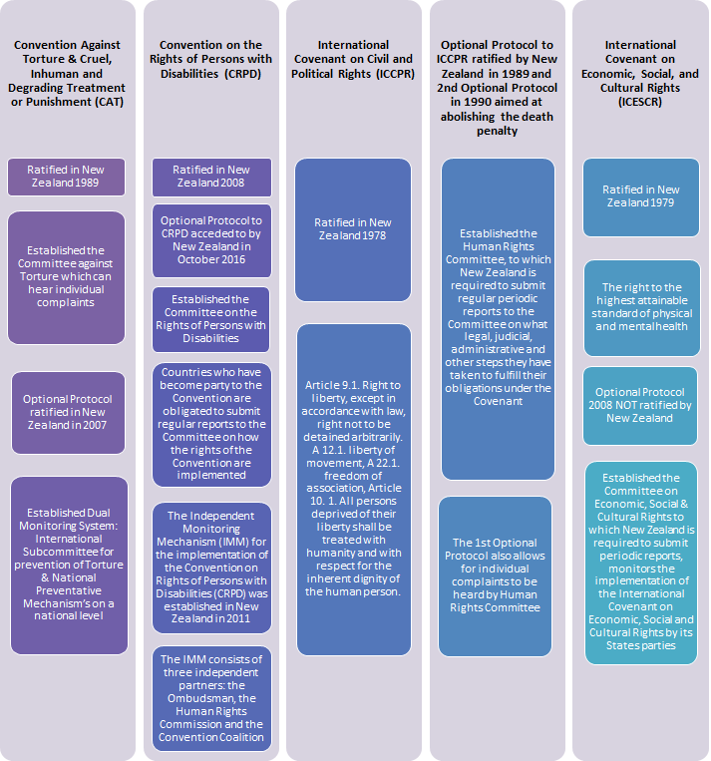

New Zealand legislation
