Ngā Wānanga Pae Ora
Summary Report: Engagement for the development of Pae Tū: Hauora Māori Strategy
2023

Acknowledgements
This report was commissioned by Manatū Hauora following Ngā Wānanga Pae Ora 2023 and was produced on behalf of Manatū Hauora by ThinkPlace WāhiWhakaaro.
Citation: Manatū Hauora. 2023. Ngā Wānanga Pae Ora Summary Report: Engagement for the development of Pae Tū: Hauora Māori Strategy. Wellington: Ministry of Health.
Published in September 2023 by the Ministry of Health
PO Box 5013, Wellington 6140, New Zealand
ISBN 978-1-991075-56-7 (online)
HP 8829
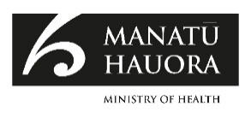
This document is available at health.govt.nz
This work is licensed under the Creative Commons Attribution 4.0 International licence. In essence, you are free to: share ie, copy and redistribute the material in any medium or format; adapt ie, remix, transform and build upon the material. You must give appropriate credit, provide a link to the licence and indicate if changes were made.

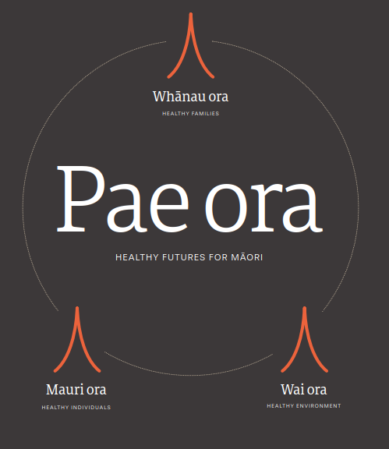

Foreword
E rere atu ana ngā tai o mihi ki ngā kanohi kitea me ngā reo kārangaranga i tae atu rā ki Ngā Wānanga Pae Ora. Nā rātou i whakatakoto te tūāpapa o ngā rautaki hauora a te pūnaha hauora, whaikaha hoki. Nā rātou hoki ō rātou iwi, ō rātou hapū, me ō rātou whānau i whakakanohi mai. Nei au ka whakakōrero i ngā whare o te Manatū Hauora me Te Aka Whai Ora ki te mihi atu ki a rātou katoa.

The past three years have seen significant gains for Māori health in Aotearoa. In July 2020, the Associate Minister of Health, Hon Peeni Henare, released Whakamaua: Māori Health Action Plan 2020-2025. On 1 July 2022, the Pae Ora (Healthy Futures) Act 2022
entered into force, strengthening the Crown’s commitment to Te Tiriti o Waitangi and establishing new entities and functions for Māori health.

A sharp focus is in place to secure the vision of pae ora and to steer our pathway towards it. It is critical that iwi, Māori communities and the Māori health and disability sector have regular opportunities to connect, share their aspirations, and collectively carve out the future we want for our mokopuna. As part of Whakamaua, we have committed to providing these opportunities each year.

Ngā Wānanga Pae Ora 2023 provided a space for Māori to come together and reflect on our progress to date with the health reforms, the challenges and opportunities we face, and to confirm the strategic direction and priorities for change for hauora Māori.

This report shines a light on the engagement we did to develop Pae Tū: Hauora Māori Strategy and to shape the hauora Māori priorities for other population strategies required under the Pae Ora Act 2022. As you’ll see within, we’ve heard from a wide range of people, and their views build on the kōrero we’ve received from previous engagements, including Hui Whakaoranga 2021 and engagement for Whakamaua: Māori Health Action Plan.

Their hopes and aspirations for their own health, and that of their whānau and communities, have become the foundations upon which we all build. So, in acknowledging the Pae Ora strategies, it’s important we recognise the significant contributions from our communities, whānau, hapū, iwi, health sector groups, and community organisations in setting the direction ahead. Ka nui te mihi ki a rātou katoa.

The insights we gathered are a taonga and we hope the people who gathered to wānanga across Aotearoa will see their voices reflected in this report and in the Pae Ora strategies.

John Whaanga
Deputy Director-General, Māori Health Manatū Hauora

Contents
Foreword iv
Foundations 1
Introduction 3
How we engaged 4
Summary of the key wānanga themes 7
Pae Tū Hauora Māori Strategy 10
Day one wānanga 10
Reflections over the past two years 11
Biggest shifts and impacts 13
Looking ahead towards a future in the new health system 15
Women, rural and disabled people’s health strategies 18
Day two wānanga 18
Women’s Health 20
Defining ‘pae ora’ for wāhine Māori 20
Wāhine Māori empathy map themes 21
Wāhine Māori persona 22
Desired system shifts for wāhine Māori 23
Rural Health 24
Defining ‘pae ora’ for rural Māori 24
Rural Māori empathy map themes 25
Rural Māori persona 26
Desired system shifts for rural Māori 27
Health of disabled people 28
Defining ‘pae ora’ for tāngata whaikaha Māori 28
Empathy map themes for tāngata whaikaha Māori 29
Tangata whaikaha Māori persona 30
Desired system shifts for tāngata whaikaha Māori 31
Shared aspirations 32
Priority areas for action 33
Conclusion 34

Foundations
The following timeline outlines the foundations that have led us to where we are on our journey to pae ora. This includes the strategies, action plans, key engagements, and reports that have influenced this journey.

The intersecting takarangi spiral represents a traversing of the past, present, and future, joining them together as we move into te ao mārama; pae ora.

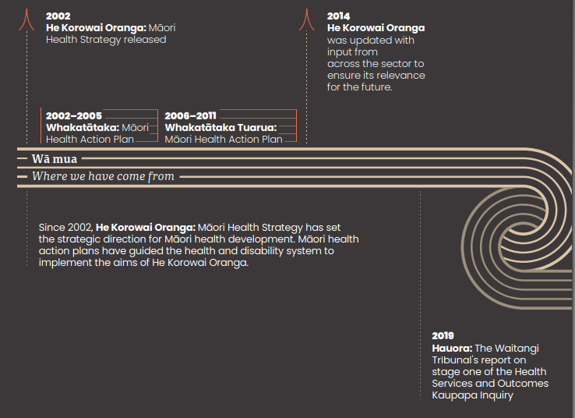

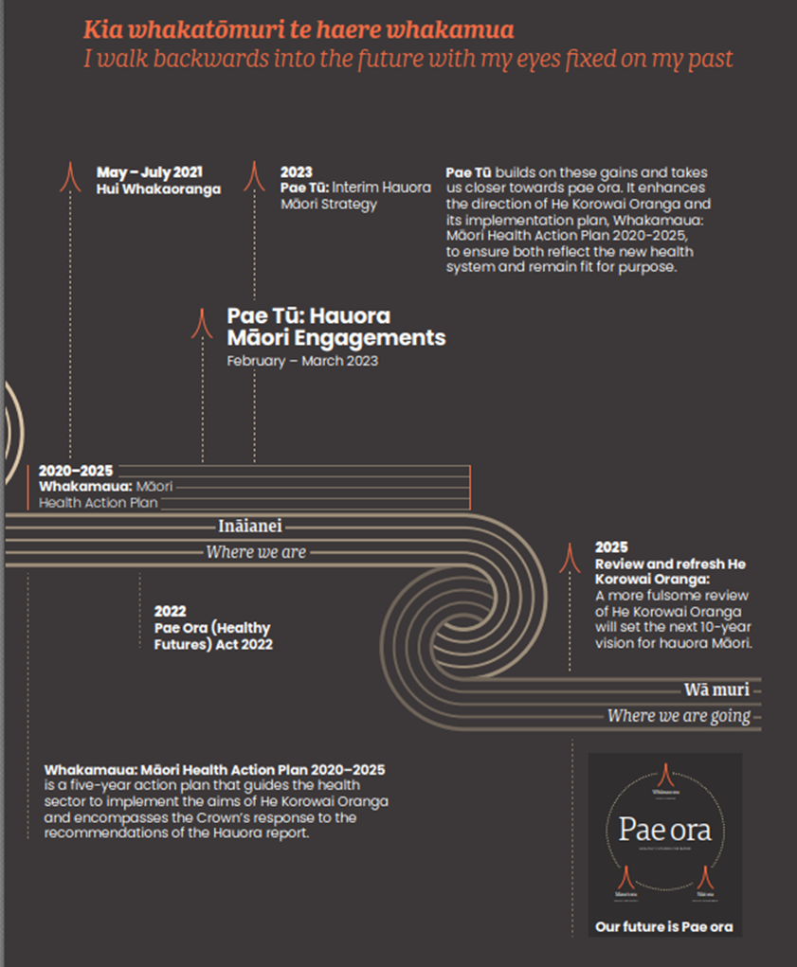

Introduction
Earlier this year, four Ngā Wānanga Pae Ora were held across Aotearoa. The purpose of each wānanga was to explore and inform important strategies required under the Pae Ora (Healthy Futures) Act 2022 to set the strategic direction for the health system.

The Pae Ora Act requires the Minister of Health to determine six specified strategies from 1 July 2023, including a Hauora Māori Strategy. These are key mechanisms for government to set expectations for how health entities and the wider health sector can collaborate and work together to achieve pae ora. The strategies will inform the next iteration of the Government Policy Statement (GPS) and the New Zealand Health Plan (Te Pae Tata).

Manatū Hauora and Te Aka Whai Ora have worked together to develop Pae Tū: Hauora Māori Strategy, which guides the sector to uphold Te Tiriti o Waitangi and achieve Māori health equity. This is an interim step ahead of a full review and refresh of He Korowai Oranga, which will take place when the foundations of the new system are further embedded and Whakamaua: Māori Health Action Plan 2020-2025 is fully implemented.

The intent of this document is to provide an overview of the Māori engagement that guided the creation of Pae Tū: Hauora Māori Strategy. Engaging with Māori and
those working across the health sector was essential in order to more fully understand the impacts of the health reforms, and to confirm the priorities for change.

The engagements were a chance to learn what is happening on the ground, learn from those directly impacted or experiencing the change, get a deeper sense of what is generally concerning for Māori whānau when trying to achieve or maintain hauora, and hear their aspirations for their whānau and mokopuna.

‘There is hope for Māori voice, there is hope for Māori action,
there is hope for Māori rongoā’
Hui Whakaoranga 2021, Waitangi

How we engaged

Designing the engagements
Four wānanga were held by Manatū Hauora and Te Aka Whai Ora to provide an opportunity for Māori and the health and disability sector to shape and contribute to the development of Pae Tū: Hauora Māori Strategy and other Pae Ora strategies. The wānanga, held in Whangārei, Kirikiriroa (Hamilton), Te Whanganui-a-Tara (Wellington), and Ōtepoti (Dunedin) in February and March 2023, were designed to hear whakaaro about prevailing issues in Māori health and potential priority areas for action.

The wānanga were designed and conducted so that participants could feel safe, supported, and able to express their culture.

Methodology
The style of engagement was different from past events in that we took a co-design approach.

On day one, we reflected on the progress made, the challenges still ahead, and our overarching priorities for hauora Māori.

On day two, we focused on the shifts needed to achieve pae ora for wāhine, tāngata whaikaha, and whānau living rurally to inform the Women’s Health Strategy, Health of Disabled People Strategy, and Rural Health Strategy. We explored how we might...
- better understand what whānau and communities need and want for their health and wellbeing
- reflect and respond to those needs and aspirations in the Pae Ora strategies
- define Pae Ora from a lived experience point of view, looking beyond traditional, narrow definitions of health and wellbeing
- identify solutions to system problems that hold inequity in place and prevent us from reaching pae ora.

Live illustrators
To preserve the themes and flavour of each event, a group of expert illustrators called the League of Live Illustrators captured the essence of the proceedings visually.

The illustrations are used throughout this report.

Key groups represented at the wānanga
- 20% Health service kaimahi
- 18% Kaupapa Māori provider kaimahi
- 12% Iwi/hapū/marae
- 12% Whānau/consumer
- 10% Government funded agencies

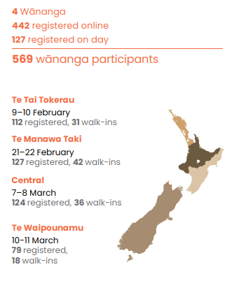

The main tools we used in the day two workshops

Empathy mapping
Empathy mapping is a collaborative process used to unpack and articulate the realities of individuals, whānau, and/or communities.

The process of empathy mapping explores what people see, hear, feel, think, say, and do in certain contexts. It enables us to better understand and deeply empathise with what it is that whānau and community:
- need and want from the health system
- see as the biggest challenges and pain points
- see as strengths, gains and ‘bright spots’.

Personas
Personas are fictional characters that are informed by real human experiences.

Good user personas are meaningful descriptions — not just a list of demographics and a fake name that allows researchers to simply make assumptions. They can be created using research and observations of users, which is analysed and then depicted in the form of a person’s profile. Alternatively, they can be created by users themselves.

Systems change frameworks
What we do is just as important as how we do it.

Systems change is about advancing equity by shifting the conditions that hold a problem in place.
- It is useful to apply in solving complex problems within systems.
- It allows us to recognise the many dimensions to a system and the various pieces that influence it.
- It recognises that no single solution will create system shifts.
- Its application increases our odds for success through focusing on the issues driving the problem (root cause) rather than the symptoms.

Exploring where we are now and where we want to be across the six condition areas (policies, practices, resource flows, relationships, power dynamics, and mental models) enables us to define problems and address them respectively.

- The Systems Change Model used in the wānanga was adapted by Healthy Families: https://www.healthyfamiliesnz.org/creating-change

Summary of the key wānanga themes
Kōrero at each hui varied according to local context and participants’ interests. Common key themes emerged. Across the motu, participants envisioned a health and disability system that respects, includes, and is guided by kaupapa, mātauranga, and te ao Māori as the way to achieve pae ora – healthy futures for Māori. Participants expressed a ‘cautious optimism’ about the health and disability reforms, describing it as a once in a lifetime opportunity for change.

We heard that the progress we have made under Whakamaua and through the introduction of the Pae Ora Act has instilled hope and optimism among Māori that hauora Māori aspirations will be realised. Māori have high expectations that the recent reforms, coupled with evidence of successful Māori and community-led solutions, greater visibility of mātauranga Māori in the health system, and commitments to addressing racism and discrimination, will lead to sustained system-wide transformation.

However, for most Māori, the impacts of the health reforms have yet to be sufficiently seen or felt, and long-standing challenges such as access to safe and responsive healthcare, discrimination, and unmet needs continue to pose barriers to health equity.
Tino rangatiratanga and mana motuhake
The health system must recognise tino rangatiratanga and support Māori to have control over their own wellbeing and the wellbeing of their whānau.
“Enabling mana motuhake and reasserting rangatiratanga to whānau, hapu, and iwi.”
Recognise the importance of the environment and whānau wellbeing for health
Māori health and wellbeing is interconnected with whānau (whānau ora) and environmental wellbeing (wai ora).
“When my whānau thrive, I thrive.”
Access to a culturally safe health system
Whānau want access to rongoā and tikanga practices and culturally safe mainstream health services. The health system needs to build cultural safety in the non-Māori workforce and accountability and consequences for underperformance and racism.
“For the health system to be more culturally safe [we need] more kaimahi Māori who are able to work in a Māori way, not just clinical [and] non-Māori kaimahi to be less judgmental.”
Accessible and responsive healthcare services, especially for rural communities
Accessibility and responsiveness of health services remain an urgent priority, especially for Māori living in rural areas. For many Māori, basic health needs are still not being met.
“Access to health care is becoming more difficult. The change to a more centralised public health system has not changed currently severe staff shortages and staff stress.”
Strategic direction is sound, but it needs to flow into real change for many whānau
The strategic direction for Māori health is sound, and some progress has been made with the reforms, but this has yet to flow through to real change for many whānau.
“A focus towards Te Ao Māori solutions. Change is happening. It is not fast, but we are hopeful.”
Build on the gains of COVID-19
The health system needs to build on the gains of the Covid-19 example by turning learnings into action (collaboration, iwi/hapū collective action, devolution of resources).
“COVID-19 allowed Māori to lead response and Māori providers were treated as professionals.”
Commission health services with and for Māori, working across agencies to optimise resource
The way agencies commission services and supports can be a key lever for change; the approach needs to be relational, grounded in outcomes that matter to whānau, local needs, and evidence of what works.
“It’s not just about money. You can throw money at the problem but if the system keeps putting up barriers, it won’t change.”
Boost investments in kaupapa Māori solutions. Invest in capability and capacity
Māori need greater access to kaupapa Māori primary and community healthcare. There needs to be sustained investment in Māori providers to increase their reach and performance.
“Give Māori the investment and trust their determination of its prioritisation.”
Address racism
Despite some action and positive steps to call out racism in the health system, racism is still prevalent and experienced by whānau and Māori health workers. We must shift from acknowledging the problem to collective action at every system level.
“The discussion around racism, discrimination and prejudice needs to acknowledge racism is systems of power...”
Encourage, foster, and grow diverse Māori leadership
Greater Māori leadership and decision making is a key enabler for change.
Encourage, foster, and grow diverse Māori leadership at all system levels, including but not limited to, rangatahi, wāhine, and tāngata whaikaha.
“Nurture future leaders to sit around the tēpu to be actively involved and included.”
Attract, develop, retain, and protect a Māori workforce
We need to attract, develop, and retain Māori workers. This will help to build a workforce that reflects the community it serves and help protect mātauranga throughout the system.
“Māori voice is heard and listened to. Māori workforce is well trained, well paid and respected.”
“Ensure Māori representation is maintained in the health system and workforce.”
Enhance cross-sector collaboration based on outcomes that matter to whānau
Enhance cross-sector collaboration, action, and investment to share and optimise resourcing so that whānau have their holistic needs met and are supported to thrive.
Greater investment in the early years of mokopuna should be a core focus.
“Socio-economic determinants are multi-sectoral impacts. Move as one.”
“We need one hauora body across education, housing and health.”
Data sovereignty and monitoring that our whānau can trust
Monitoring and accountability are critical and should be based on outcomes that matter to whānau (going beyond clinical indicators). This requires trusted data to be collected and shared with Māori to enable informed decision-making.
“Indigenise a feedback-informed process, based in mātauranga Māori.”
“Measure Māori success not Māori deficit.”

Pae Tū Hauora Māori Strategy

Day one wānanga
We wanted to ensure everyone had an equal opportunity to share their whakaaro. This was facilitated through smaller group reflections and discussions.

The first day of each of the four wānanga was focused on the Pae Tū Hauora Māori Strategy, and the day was split into three activity sessions:
- Reflections over the past two years
We asked...
- what are you seeing, hearing, and feeling in the health system that’s different?
- where are the biggest wins or shifts?
- what hasn’t shifted that should’ve by now?
- what’s your level of optimism for the future health system?
- The biggest shifts and impacts
We asked participants to...
Take the top two themes determined from questions 1 & 2 in the first wānanga session and map the themes against shifts and impacts to identify:
- which have had the biggest impact on Māori communities and whānau?
- which made the most significant shifts in the health system?
- Looking ahead towards a future in the new health system
We asked...
What needs to start, stop, be modified or enhanced across six priority areas:
- Enabling an anti-racist health system
- Growing Māori leadership and decision-making
- Building an active monitoring and learning system
- Collectively addressing social determinants
- Commissioning for pae ora
- Other areas that should be considered

Reflections over the past two years
We captured what participants had seen, heard, and felt that had been different over the previous two years. We also captured what people felt optimistic about. Here is a summary of those reflections from across the regional participants.

Te Tai Tokerau Regional Wānanga
Whangārei, 9–10 February

- Whānau are hopeful that the recent reforms will lead to significant improvements in Māori health.
- Workforce challenges are growing – retention, fatigue, understaffing, and tokenism were commonly raised.
- Ensuring access to culturally safe and relevant health services is still a top priority.
- The financial and mental health strain on whānau is concerning.

“I’m hugely optimistic about the future of Māori health. The recent changes enable us to have greater determination with equity being a core focus.”

Te Manawa Taki Regional Wānanga
Kirikiriroa Hamilton, 21-22 February

- There is much greater emphasis on Te Tiriti, equity, mātauranga Māori, and te reo Māori compared to three years ago.
- Māori providers are much more visible, proactive, collectivising, and leading.
- Through the COVID-19 response, Māori demonstrated an ability to care for all.
- Māori are taking ownership of their hauora and not tolerating racism any more.

“Hapū, iwi, and marae increasingly playing a significant role, particularly through emergency responses. This should be our model going forward.”

Central Region Wānanga
Te Whanganui-a-Tara Wellington, 7–8 March

- Challenges with accessibility, and lack of cultural capability in primary health services is a concern.
- The establishment of Te Aka Whai Ora has whānau feeling hopeful, optimistic, and excited.
- Commissioning needs to be reconsidered so that it is whānau-driven.
- The iwi and community-led responses to COVID-19 showed adaptability and effectiveness. Iwi and communities should be given this opportunity more.

“A genuine focus on te ao Māori solutions and the opportunity to make more moemoea a reality.”

Te Waipounamu Regional Wānanga
Ōtepoti Dunedin, 10-11 March

- New structures won’t create change – new mindsets and practices will. Seeing a lot of the same people in leadership roles in the new structure is concerning.
- Workforce recruitment and retention is challenging in the South Island due to the geographical spread.
- The cost of living is heavily impacting whānau in the South. Access issues for remote rural whānau are still a concern.
- Iwi and Māori provider leadership is growing and more powerful than ever.

“Kia tere! Get more runs on the board.”

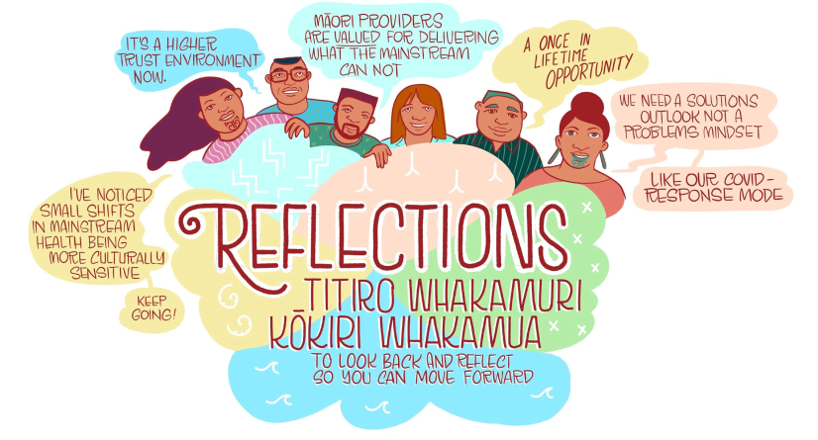

Biggest shifts and impacts
Once the groups had considered the reflection themes, they explored the biggest shifts that had occurred and also the biggest impacts for whānau. Here are some of those big shifts and impacts by region.

Te Tai Tokerau Regional Wānanga
Whangārei, 9–10 February

- Mana whenua are more active in the health system, reasserting tino rangatiratanga for whānau, hapū, and iwi.
- The system seems to want to work differently and more inclusively with Māori and to lift the voice of whānau.
- COVID-19 and the reforms have exposed systemic racism but reinforced the systems’ Te Tiriti obligations and the need to address Māori health equity.
- Recognition of te ao Māori solutions to address wider determinants in health.

“Biggest wins are legislation that includes Te Tiriti and establishing a Māori authority … but how does this translate at the grassroots?”

Te Manawa Taki Regional Wānanga
Kirikiriroa Hamilton, 21-22 February

- Increasing Māori power and leadership in the health system.
- Iwi Māori Partnership Boards and Te Aka Whai Ora have been put in place to enable change.
- There are more opportunities for Māori to design, deliver, and monitor using mātauranga.
- Strong commitments and momentum to amplify whānau voice in the health system.

“Actions speak louder than words for our whānau.”

Central Region Wānanga
Te Whanganui-a-Tara Wellington, 7–8 March

- The passing of the Pae Ora Act and the establishment of new entities.
- Māori providers are being acknowledged for what they have always done.
- Acknowledgement of the importance of the Māori workforce and leadership.
- Increase of whānau voice and engagement being valued and heard.
- Digitisation and flexibility of Māori provider service provision, e.g. telehealth.

“Māori providers being reflected and acknowledged for what they have always done.”

Te Waipounamu Regional Wānanga
Ōtepoti Dunedin, 10-11 March

- New structures and wider health reforms are leading to dedicated funding and more Māori in the workforce and greater inclusion of tangata whaikaha and rainbow communities.
- Greater voice and decision-making at the local level, e.g. COVID-19 initiatives.
- Mātauranga Māori in action, e.g. rongoā, te reo, Māori-led and iwi-driven approaches.
- New and expanded ways of working, e.g. digital improvements and cross-sector work to tackle social determinants.

“Māori providers have emerged as leaders and experts in great health provision.”

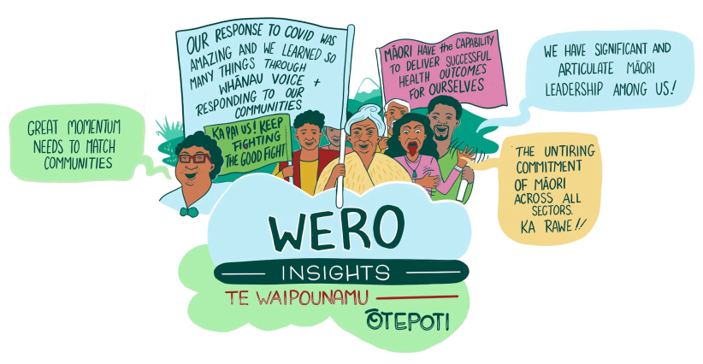

Looking ahead towards a future in the new health system
Here are some participants’ thoughts about what we should focus on, stop, or modify going forward; these were consistent across the regional wānanga and have been summarised into key themes.

Addressing racism
- Increase awareness of the multiple factors that uphold and perpetuate systemic racism.
- More Māori in leadership roles, amplified whānau voice, and more education are all important levers to address racism.
- Call out racism when it occurs.
- Provide opportunities to educate and champion anti-racism through investing in practical and joined up approaches and tools that will contribute to tangible culture change.
- Strengthen collective accountability across the health system through having clearly articulated anti-racism strategies, equity-specific metrics, and a focus on ongoing monitoring to embed change.

“Many people have shifted and are more accommodating, but there are still shocking examples of racism.”

Māori Leadership
- Retain, recruit and develop diverse Māori leaders.
- Enhance whānau voice at all levels and support community succession planning.
- Ensure we have the right Māori participation – some will sit outside of health.
- Enable rangatahi pathways into health careers and embed Te Tiriti in decision- making.
- Share power and ensure Māori have decision-making positions. Encourage, foster, and grow Māori leaders, especially rangatahi and wāhine.
- Give more power to the community.
- Ensure greater support for emerging Māori leaders.
• Greater diversity in Māori leadership needed.

Building an active monitoring and learning system
- Reporting and monitoring of outcomes and measures should be oranga- focused, underpinned by a te ao Māori lens, and informed by whānau and community voice.
- Build on opportunities to share data and learning insights with community and contribute to a broader evidence base for Māori.
- Data should be visible, usable, and tailored to the needs of specific Māori communities.
• Identify and showcase data and insights that promote Māori-led success and leadership in the system.

Addressing broader determinants in health
- Increase investment in prevention and early intervention.
- Learn from iwi and Māori providers that already integrate services, building on the experience of COVID-19.
- Resource Māori solutions. Enable integrated contracts.
- Strengthen cross-government collaboration, strengthen cross-sector action, and ensure agencies are working together.
• Invest in education and social wellbeing in a way that values Māori ways of doing things and considers intersectionality.

“Hapū, iwi, and marae [are] increasingly playing a significant role, particularly through emergency responses. This should be the model going forward.”

Commissioning for pae ora
- Build strong relationships with Māori communities and providers with a focus on early and ongoing engagement.
- Design and develop high-trust commissioning models that are adaptable and supported by flexible contracting arrangements.
- Scale up and embed pilot programmes and initiatives that have been informed by, and have the support of, whānau, hapū, iwi, and hapori Māori.
- Pursue locally driven solutions grounded in mātauranga Māori and make a tangible difference for Māori.
- Make sure localities and iwi-Māori partnership boards are well supported to determine need.
- Normalise the Māori worldview in decision- making, delivery, and practice.
- Ensure there is adequate funding for Māori service providers, which accurately reflects the mahi they do.
- Think and plan intergenerationally, focused on the next 50 to 100 years.
- A strong focus on prevention and innovation and to showcase what works.
- Strengthen the recruitment and development process for the Māori health workforce.
- Enhance mātauranga Māori capability in the workforce and providers.
- Invest in innovation.

“Hugely optimistic about the future of health for Māori. The recent changes enable us to have greater determination with equity being a focus.”

“To achieve pae ora we need to look at our communities.
What do they want and need to succeed?”
Hui Whakaoranga 2021, Virtual hui

Women, rural and disabled people’s health strategies
Combined insights from the design sprints

Day two wānanga
The sessions were designed to ensure everyone could share their whakaaro equally and help paint a picture of the current state, while emphasising the future priorities for three population-specific Pae Ora Strategies:
- Women’s health
- Rural health
- The health of disabled people

The second day of each wānanga was split into three activities:

Empathy mapping and personas
Participants...
- imagined themselves as a whānau member/ someone in their community
- completed an empathy map capturing what that person would, see/hear, think/feel, and say/do in their lives
- themed findings then considered their biggest bright spots, painpoints, needs, and wants.

Defining ‘pae ora’
Then participants...
- discussed and captured what pae ora looks and feels like across its three dimensions, considering it from the perspective of the persona they just developed
2. themed the shared whakaaro for each dimension.

Desired system shifts
Participants chose...

one of six system conditions to focus on, i.e. policies, practices, resource flows, relationships, power dynamics, and mental models.
Then...
- considered where the system is now versus where it needs to be across each condition area
- prioritised the top two
- mapped these against the “from” and “to” pyramids.

Women’s Health
The Women’s Health Strategy, published in July 2023, sets the direction for improving the health and wellbeing of women over the next 10 years. It is one of six population strategies required under the Pae Ora Act. Its aim is for all women to live longer in good health, have improved wellbeing and quality of life, and be part of healthy, and resilient whānau and communities, within healthy environments that sustain their health and wellbeing. This is the first time that Aotearoa New Zealand has had a Women’s Health Strategy.

The Women’s Health Strategy was developed by Manatū Hauora and informed by a wide range of evidence and engagements, including engagement with Māori as part of Ngā Wānanga Pae Ora 2023.

Defining ‘pae ora’ for wāhine Māori
Participants shared what pae ora means to them and identified key themes. This is a summary of the definitions they created.

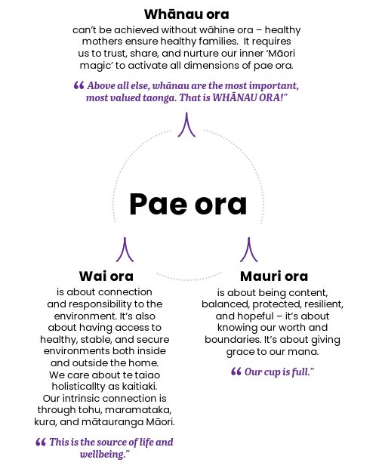

Wāhine Māori empathy map themes

Women experience pain points & challenges...
- A really full plate: wāhine are filling lots of roles and responsibilities and putting others first.
- The system isn’t designed for wāhine: wāhine feel invisible, disempowered, judged, unseen, unheard, and like the system doesn’t care.
- Compounding racism, sexism, and discrimination of Māori women’s experience ‘leaves a residue on their body and wairua’.
- Multiple forms of mamae and trauma that are cumulative and intergenerational.

There are bright spots & strengths...
- Mana wāhine: valuing the strength, power, courage, and resilience of wāhine, including their mātauranga.
- Wāhine nourish many: giving, caring, advocating for whānau, uplifting, aroha, te whakapono.

Women need...
- empowerment, time, space, and resources to have what they need, make choices, and live their dreams
- a village, anchors and support networks - ‘Who can I reach out to? Who understands what I’m going through?’
- te ao Māori identity and connections
• connection and care for Papatūānuku.

Women want...
- locally-led, whānau, iwi, and Māori designed and led supports
- whānau centred, holistic supports that provide safe places and address access barriers (cost, short appointments, long waits)
- investment in services and supports for wāhine, e.g. kaupapa Māori services, Māori kaimahi such as midwives
- te ao Māori practices and approaches to services and supports - the ability for mātauranga to flourish.

Wāhine Māori persona
Participants were taken through an empathy mapping activity where they were asked to picture a loved one or a group in their communities that fit the description of the focus population and visualise what they see/hear around them, feel/think about their community and the health system, and say/do in the context of their health and wellbeing.

These evolved into illustrated personas that represented real stories and experiences from participants and their communities. The personas reflect the examples and language shared directly by participants. The example below is one of many developed in the women’s health design sprint.

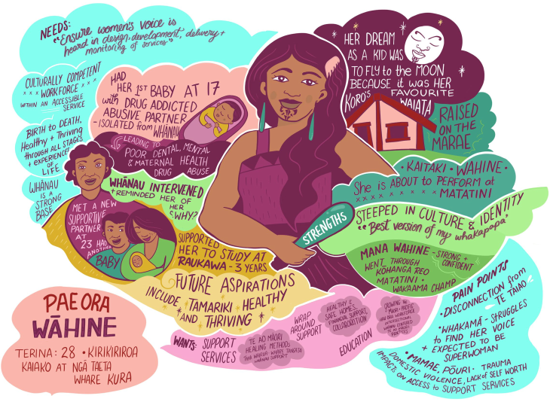

Terina, raised on a marae in a small Kirikiriroa community, represents the strength and resilience of wāhine Māori. Her future aspiration for her tamariki is to see them healthy and thriving. Terina has a strong sense of cultural identity and connectedness which supported her through some tough challenges in life. She struggles to find her voice and is expected to be superwoman. She wants to be able to access culturally competent health services, and traditional healing.

Desired system shifts for wāhine Māori

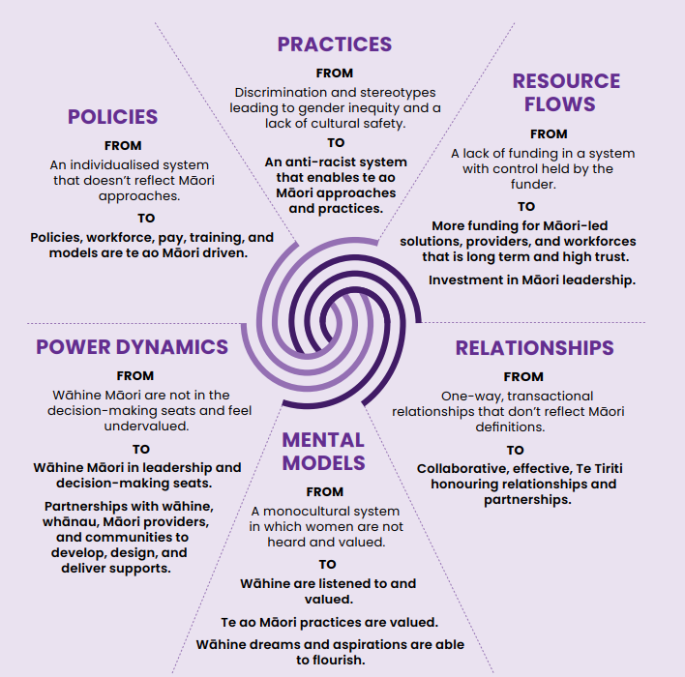

Adapted from the Waters of System Change Model by FSG: https://www.fsg.org/resource/water_of_systems_change/

For a more detailed explanation of the model, see page 6.

Rural Health
The Rural Health Strategy, published in July 2023, sets the direction for improving the health and wellbeing of rural communities over the next 10 years. It is one of six population strategies required under the Pae Ora Act. Its aim is for all people living in rural communities to live long and healthy lives, supported by a health system that meets the varied needs of these communities and draws on the strengths and knowledge of rural communities to achieve pae ora – healthy futures for all.

This is the first time that Aotearoa New Zealand has had a Rural Health Strategy. It recognises that rural communities’ health needs are often under-served, particularly in relation to accessing health services, especially for remote communities and rural Māori. The Rural Health Strategy was developed by Manatū Hauora and informed by a wide range of evidence and engagements, including engagement with Māori as part of Ngā Wānanga Pae Ora 2023.

Defining ‘pae ora’ for rural Māori
Participants shared what pae ora means to them and identified key themes. This is a summary of the definitions they created.

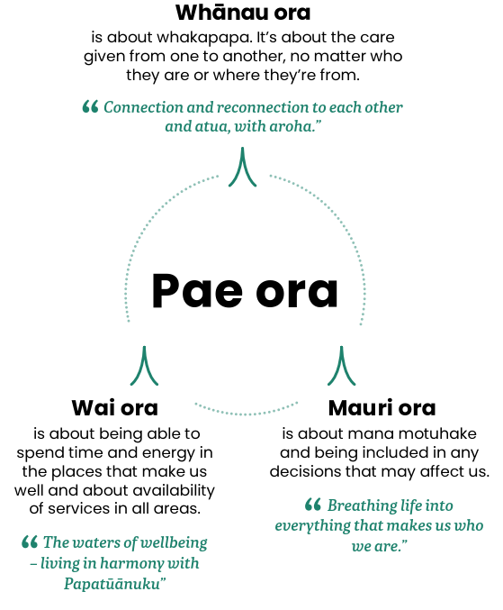

Rural Māori empathy map themes

Our rural whānau experience pain points & challenges...
- Rural communities tend to seek help when their symptoms are severe and their need is acute.
- Rural whānau feel invisible in the system. When they do interact, they feel disrespected (e.g. automated appointments) and undermined (e.g. discrediting rongoā).
- Services and supports are often piecemeal and don’t reflect holistic needs.
- Rural whānau with chronic health conditions, disabilities, and single parents are carrying significant burden.

There are bright spots & strengths...
- Rural whānau are hugely resourceful and resilient.
- Rural communities look out for one another and share resources.
- To live rurally means whānau have greater access to te taiao and are more equipped to be self-sufficient.
• Rural whānau just “get on with it.”

Rural whānau need...
- primary, preventative healthcare services that utilise advanced medicine and cutting-edge technology
- greater flexibility and devolved approaches to support providers to proactively deliver to whānau needs
- intergenerational, whānau-centred services that are delivered through kaiawhina workforce who are trusted by their communities.

Rural whānau want...
- to be able to fully participate in their community and to experience mana motuhake (self-determination)
- to live in a society that centres design and delivery around inclusion and social connectivity/cohesion and celebrates te ao Māori solutions, whānau, rangatahi, and tamariki potential
- to build on natural protective factors, like the ‘aroha’ of the community
- strong interpersonal relationships with health providers.

Rural Māori persona
Participants were taken through an empathy mapping activity where they were asked to picture a loved one or a group in their communities that fit the description of the focus population and visualise what they see/hear around them, feel/think about their community and the health system, and say/do in the context of their health and wellbeing.

These evolved into illustrated personas that represented real stories and experiences from participants and their communities. The personas reflect the examples and language shared directly by participants. The example below is one of many developed in the rural health design sprint.

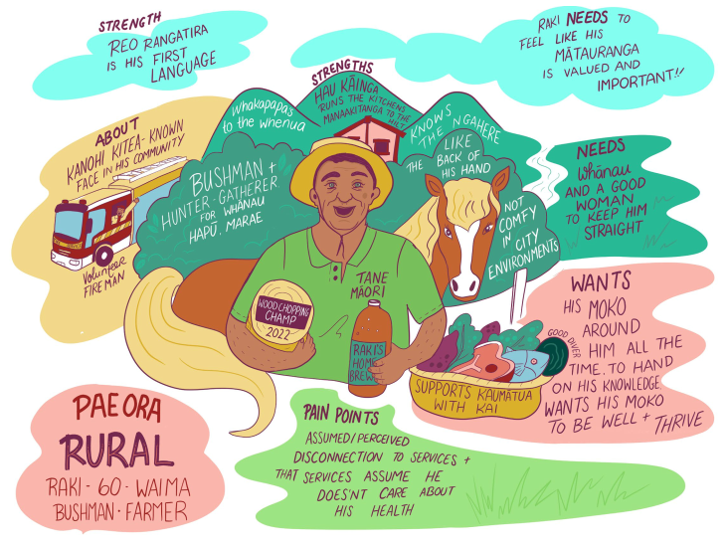

Raki, hau kāinga from Waimā, is a rangatira in his community with strong connections to his whenua, the ngahere, and his mokopuna. He enjoys providing for and serving his community. Raki needs the health system to respect his mātauranga and trust that he cares about his own wellbeing.

Desired system shifts for rural Māori

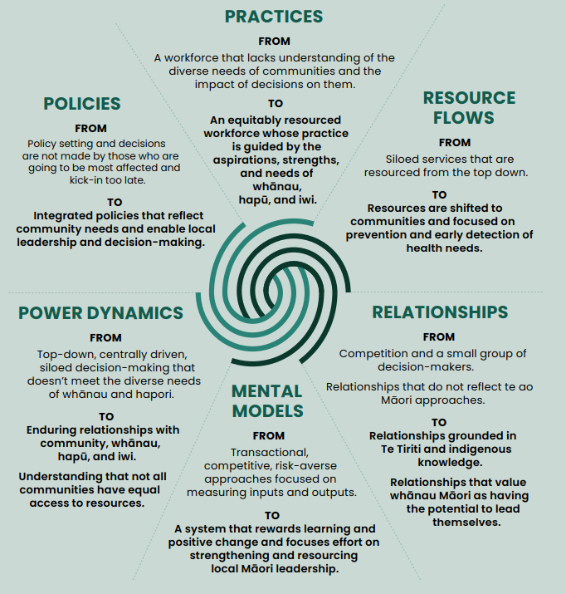

Adapted from the Waters of System Change Model by FSG: https://www.fsg.org/resource/water_of_systems_change/

For a more detailed explanation of the model, see page 6.

Health of disabled people
The Provisional Health of Disabled People Strategy, published in July 2023, sets the direction and long-term priorities for the new health system to move towards
achieving equity in disabled people’s health and wellbeing outcomes over the next 10 years. It is one of six population strategies required under the Pae Ora Act. Its vision is to achieve pae ora for disabled people and their whānau in Aotearoa New Zealand. This is a future in which all disabled people and their whānau live long, fulfilling and more independent lives in good health.

The provisional strategy provides a framework to guide health entities to improve health outcomes for disabled people and their whānau. The Rural Health Strategy was developed by Manatū Hauora based on face-to-face, online and written engagement with disabled people and their whānau, including as part of Ngā Wānanga Pae Ora 2023. The strategy has been published in a provisional form to enable further targeted engagement with the disability community and shaping of priorities.

Defining ‘pae ora’ for tāngata whaikaha Māori
Participants shared what pae ora means to them and identified key themes. This is a summary of the definitions they created.

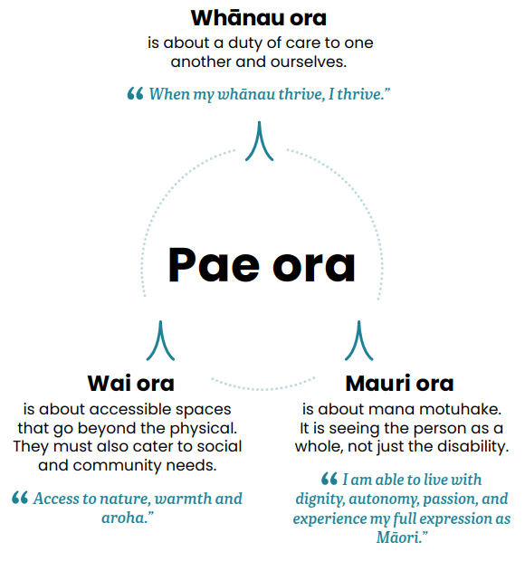

Empathy map themes for tāngata whaikaha Māori

Tāngata whaikaha Māori experience painpoints & challenges...
- Tāngata whaikaha and their whānau are often left carrying a significant emotional, physical, and economic burden.
- Experiences of racism, discrimination, and ableism in the system.
- Tāngata whaikaha are often left to struggle with managing and resourcing their conditions on their own, needing to go between government agencies for help, and struggling to find adequate resource.

There are bright spots & strengths...
- Tāngata whaikaha and their whānau find strength in each other.
- Tāngata Whaikaha and their whānau are amazing navigators as a result of having to work across an extremely complex and siloed health system.
- Tāngata whaikaha are resilient and resourceful.

Tāngata whaikaha Māori need...
- more kaupapa Māori services as they have the greatest flexibility and empathy in responding to their holistic needs and are a preferable option for many whānau
- more resource to support them to be well
- services to work together and provide seamless care and support
- for the health system to get its systems right.

Tāngata whaikaha Māori want...
- to be seen, heard, and accommodated in ways that reflect disabled people’s unique situations and circumstances
- the system to work in a holistic, humanising way
- to be respected, their dignity to be maintained, and their mana upheld.

Tangata whaikaha Māori persona
Participants were taken through an empathy mapping activity where they were asked to picture a loved one or a group in their communities that fit the description of the focus population and visualise what they see/hear around them, feel/think about their community and the health system, and say/do in the context of their health and wellbeing.

These evolved into illustrated personas that represented real stories and experiences from their community. The personas reflect the examples and language shared directly by participants. The example below is one of many developed in the tāngata whaikaha Māori design sprint.

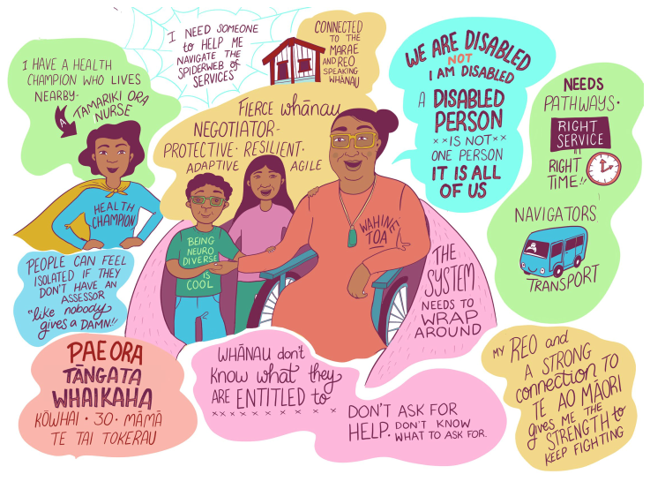

Kōwhai from Te Tai Tokerau finds strength in her whānau and her connection to te ao Māori. Her disability is not part of her identity but her disability can be challenging at times. Kōwhai is adept at navigating the complex health systems with the support of her whānau and local health workers. Despite this, she doesn’t always receive the supports she is entitled to. She wants to be able to access quality health services, where and when she needs them in a way that upholds her cultural values and integrity.

Desired system shifts for tāngata whaikaha Māori

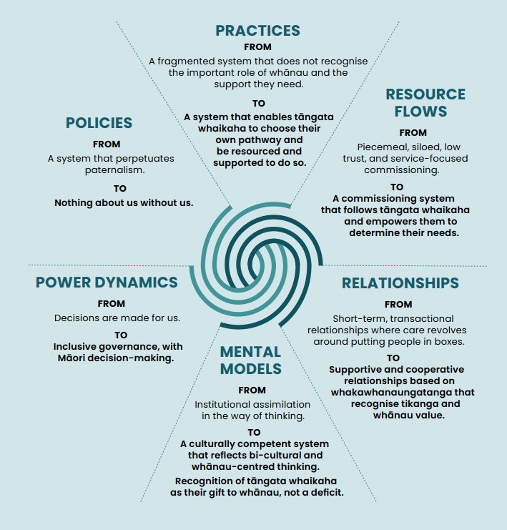

Adapted from the Waters of System Change Model by FSG: https://www.fsg.org/resource/water_of_systems_change/

For a more detailed explanation of the model, see page 6.

Shared aspirations
We tested the foundations that are set out in Whakamaua. Throughout the engagements we found that they still reflected the aspirations of our people. These outcomes will continue to guide us.

Outcome 1
Iwi, hapū, whānau, and Māori communities can exercise their authority to improve their health and wellbeing.

Outcome 2
The health and disability system is fair and sustainable and delivers more equitable outcomes for Māori.

Outcome 3
The health and disability system addresses racism and discrimination in all its forms.

Outcome 4
The inclusion and protection of mātauranga Māori throughout the health and disability system.

Priority areas for action
We heard that to achieve these outcomes, we need to accelerate effort in these five areas.

Priority 1
Enabling whānau, hapū, iwi, and Māori community leadership, decision-making, and governance at all levels.

Priority 2
Strengthening whole-of-government commitment to Māori health.

Priority 3
Growing the Māori health workforce and sector to match community needs.

Priority 4
Enabling culturally safe, whānau-centred, and preventative primary health care.

Priority 5
Accountability for system performance for Māori health.

Conclusion
E ngā manawa tītī, e ngā ngākau titikaha ka mihi anō ki a koutou i whai wāhi atu ki ā tātou mahi. Nō mātou te whiwhi i rongo mātou i ō koutou whakaaro me ō koutou hiahia mō te anamata o te pūnaha hauora kia ora ai, kia tōnui ai te iwi.

Throughout this engagement, Manatū Hauora and Te Aka Whai Ora received honest, challenging, and intelligent thoughts about what needs to change for Māori to live
healthy, independent lives. What was said and the solutions offered gave us an even deeper understanding of what needs to change to meet the hauora needs and aspirations of Māori.

The Pae Ora strategies, including Pae Tū: Hauora Māori Strategy, were launched in July 2023 and respond to what we heard through these engagements.

Pae Tū: Hauora Māori Strategy specifically builds on the gains of He Korowai Oranga and Whakamaua: Māori Health Action Plan 2020 - 2025. This is in recognition of the strong support we heard to keep going with the strategic direction of He Korowai Oranga. We also heard support for the four high-level outcomes of Whakamaua and agreement to keep them as the foundation of Pae Tū. So that is what we did.

This feedback has also shaped the strategies for women’s health, rural health, and the health of disabled people. Nā reira, ka nui te mihi, thank you to everyone who contributed.

From here, Whakamaua remains the implementation plan for us to complete. All its actions are well underway. Pae Tū takes its place as our interim strategy to align with the overall Pae Ora direction. It will guide us until Manatū Hauora and Te Aka Whai Ora refresh He Korowai Oranga in 2025.

Manatū Hauora and Te Aka Whai Ora thank you for sharing your insights, experiences, and whakaaro to better understand Māori health challenges and opportunities as we all seize our hoe (paddle) to propel our waka forward.

Pae Tū
‘Pae Tū’ is a karanga to the health system. It calls us to stand together as one in our commitment to achieving health equity, upholding Te Tiriti o Waitangi, and delivering better health outcomes for Māori.

Pae Tū also alludes to the whakataukī, ‘Pai tū, pai hinga’, which encourages people to give something a go without fear of failure.

Likewise, we are charging ahead, embracing the challenges and opportunities before us, and giving everything we’ve got to achieve our vision.

You can read Pae Tū here

