New Zealand Maternity Clinical Indicators

2017

Citation: Ministry of Health. 2019. *New Zealand Maternity Clinical Indicators 2017*. Wellington: Ministry of Health.

Published in May 2019 by the Ministry of Health  
PO Box 5013, Wellington 6140, New Zealand

ISBN 978-1-98-856880-5 (online)  
HP 7116



This document is available at health.govt.nz

|  |  |
| --- | --- |
| **CCBY** | This work is licensed under the Creative Commons Attribution 4.0 International licence. In essence, you are free to: share ie, copy and redistribute the material in any medium or format; adapt ie, remix, transform and build upon the material. You must give appropriate credit, provide a link to the licence and indicate if changes were made. |

Contents

Executive summary xi

Introduction 1

What is a clinical indicator? 1

What are the New Zealand Maternity Clinical Indicators? 1

Background 2

Overview 3

About the data 5

Data integrity 6

Interpretation notes 6

Notes on national data 8

Standard primiparae 8

Women registered with a lead maternity carer 10

All women giving birth 10

Babies 10

International comparisons 10

Indicator 1: Registration with a lead maternity carer 14

Rationale and purpose 14

Notes on 2017 data 14

Indicator 1: Registration with a lead maternity carer in the first trimester of pregnancy, 2017 15

Indicators 2 to 5: Type of birth 18

Rationale and purpose 18

Notes on 2017 data 19

Indicator 2: Spontaneous vaginal birth among standard primiparae, 2017 20

Indicator 3: Instrumental vaginal birth among standard primiparae, 2017 23

Indicator 4: Caesarean section among standard primiparae, 2017 26

Indicator 5: Induction of labour among standard primiparae, 2017 29

Indicators 6 to 9: Damage to the lower genital tract 32

Rationale and purpose 32

Notes on 2017 data 33

Indicator 6: Intact lower genital tract among standard primiparae giving birth vaginally, 2017 34

Indicator 7: Episiotomy and no third- or fourth-degree tear among standard primiparae giving birth vaginally, 2017 37

Indicator 8: Third- or fourth-degree tear and no episiotomy among standard primiparae giving birth vaginally, 2017 40

Indicator 9: Episiotomy and third- or fourth-degree tear among standard primiparae giving birth vaginally, 2017 43

Indicator 10: General anaesthetic for women giving birth by caesarean section 46

Rationale and purpose 46

Notes on 2017 data 46

Indicator 10: General anaesthetic for women giving birth by caesarean section, 2017 47

Indicators 11 and 12: Blood transfusion during birth admission 50

Rationale and purpose 50

Notes on 2017 data 50

Indicator 11: Blood transfusion during birth admission for caesarean section delivery, 2017 51

Indicator 12: Blood transfusion during birth admission for vaginal birth, 2017 54

Indicators 13 to 15: Severe maternal morbidity 57

Rationale and purpose 57

Eclampsia (indicator 13) 57

Peripartum hysterectomy (indicator 14) 58

Mechanical ventilation (indicator 15) 58

Notes on 2017 data 58

Indicator 13: Diagnosis of eclampsia during birth admission, 2017 59

Indicator 14: Peripartum hysterectomy, 2017 61

Indicator 15: Mechanical ventilation during pregnancy or postnatal period, 2017 63

Indicator 16: Maternal tobacco use during postnatal period 65

Rationale and purpose 65

Notes on 2017 data 65

Indicator 16: Maternal tobacco use during postnatal period, 2017 66

Indicator 17: Preterm birth 69

Rationale and purpose 69

Notes on 2017 data 70

Indicator 17: Preterm births, 2017 70

Indicators 18 and 19: Small for gestational age at term 73

Rationale and purpose 73

Small babies at term (indicator 18) 73

Small babies at term born at 40–42 weeks’ gestation (indicator 19) 74

Notes on 2017 data 74

Indicator 18: Small babies at term (37–42 weeks’ gestation), 2017 75

Indicator 19: Small babies at term born at 40–42 weeks’ gestation, 2017 78

Indicator 20: Term babies requiring respiratory support 81

Rationale and purpose 81

Notes on 2017 data 81

Indicator 20: Babies born at 37+ weeks’ gestation requiring respiratory support, 2017 82

References 85

Appendices 87

Appendix 1: National Maternity Collection 87

Appendix 2: Technical notes 89

Appendix 3: Catchment areas 96

List of figures

Figure 1: Number of standard primiparae as a proportion of women giving birth for the first time and of all women giving birth in 2017, by place of birth, age group, ethnic group, deprivation quintile and district health board of residence 9

Figure 2: New Zealand Maternity Clinical Indicator rates by year, 2009–2017 13

Figure 3: Percentage of women who register with a lead maternity carer in the first trimester of their pregnancy among all registered women giving birth, by district health board of residence, 2017 15

Figure 4: Percentage of women who register with a lead maternity carer in the first trimester of their pregnancy among all registered women giving birth, by facility of birth (secondary and tertiary facilities), 2017 15

Figure 5: Percentage of spontaneous vaginal births among standard primiparae, by district health board of residence, 2017 20

Figure 6: Percentage of spontaneous vaginal births among standard primiparae, by facility of birth (secondary and tertiary facilities), 2017 20

Figure 7: Percentage of instrumental vaginal births among standard primiparae, by district health board of residence, 2017 23

Figure 8: Percentage of instrumental vaginal births among standard primiparae, by facility of birth (secondary and tertiary facilities), 2017 23

Figure 9: Percentage of caesarean section deliveries among standard primiparae, by district health board of residence, 2017 26

Figure 10: Percentage of caesarean section deliveries among standard primiparae, by facility of birth (secondary and tertiary facilities), 2017 26

Figure 11: Percentage of inductions of labour among standard primiparae, by district health board of residence, 2017 29

Figure 12: Percentage of inductions of labour among standard primiparae, by facility of birth (secondary and tertiary facilities), 2017 29

Figure 13: Percentage of standard primiparae giving birth vaginally with intact lower genital tract, by district health board of residence, 2017 34

Figure 14: Percentage of standard primiparae giving birth vaginally with intact lower genital tract, by facility of birth (secondary and tertiary facilities), 2017 34

Figure 15: Percentage of standard primiparae giving birth vaginally and undergoing episiotomy without third- or fourth-degree tear, by district health board of residence, 2017 37

Figure 16: Percentage of standard primiparae giving birth vaginally and undergoing episiotomy without third- or fourth-degree tear, by facility of birth (secondary and tertiary facilities), 2017 37

Figure 17: Percentage of standard primiparae giving birth vaginally sustaining a third- or fourth-degree tear and not undergoing episiotomy, by district health board of residence, 2017 40

Figure 18: Percentage of standard primiparae giving birth vaginally sustaining a third- or fourth-degree tear and not undergoing episiotomy, by facility of birth (secondary and tertiary facilities), 2017 40

Figure 19: Percentage of standard primiparae giving birth vaginally undergoing episiotomy and sustaining a third- or fourth-degree tear, by district health board of residence, 2017 43

Figure 20: Percentage of standard primiparae giving birth vaginally undergoing episiotomy and sustaining a third- or fourth-degree tear, by facility of birth (secondary and tertiary facilities), 2017 43

Figure 21: Percentage of women undergoing a caesarean section under general anaesthetic, by district health board of residence, 2017 47

Figure 22: Percentage of women undergoing a caesarean section under general anaesthetic, by facility of birth (secondary and tertiary facilities), 2017 47

Figure 23: Percentage of women giving birth by caesarean section and undergoing blood transfusion during birth admission, by district health board of residence, 2017 51

Figure 24: Percentage of women giving birth by caesarean section and undergoing blood transfusion during birth admission, by facility of birth (secondary and tertiary facilities), 2017 51

Figure 25: Percentage of women giving birth vaginally and undergoing blood transfusion during birth admission, by district health board of residence, 2017 54

Figure 26: Percentage of women giving birth vaginally and undergoing blood transfusion during birth admission, by facility of birth (secondary and tertiary facilities), 2017 54

Figure 27: Percentage of women identified as smokers during postnatal period (two weeks after birth), by district health board of residence, 2017 66

Figure 28: Percentage of women identified as smokers during postnatal period (two weeks after birth), by facility of birth (secondary and tertiary facilities), 2017 66

Figure 29: Percentage of preterm births, by district health board of residence, 2017 70

Figure 30: Percentage of preterm births, by facility of birth (secondary and tertiary facilities), 2017 70

Figure 31: Percentage of small babies at term (37–42 weeks’ gestation), by district health board of residence, 2017 75

Figure 32: Percentage 0f small babies at term (37–42 weeks’ gestation), by facility of birth (secondary and tertiary facilities), 2017 75

Figure 33: Percentage of small babies at term born at 40–42 weeks’ gestation, by district health board of residence, 2017 78

Figure 34: Percentage of small babies at term born at 40–42 weeks’ gestation, by facility of birth (secondary and tertiary facilities), 2017 78

Figure 35: Percentage of babies born at 37+ weeks’ gestation requiring respiratory support, by district health board of residence, 2017 82

Figure 36: Percentage of babies born at 37+ weeks’ gestation requiring respiratory support, by facility of birth (secondary and tertiary facilities), 2017 82

Figure A1: Maternity facilities in New Zealand by DHB and facility type (2009–2017) 98

List of tORDables

Table 1: New Zealand Maternity Clinical Indicators 3

Table 2: New Zealand Maternity Clinical Indicator national rates by year, 2009–2017 11

Table 3: Number and percentage of women who register with a lead maternity carer in the first trimester of their pregnancy among all registered women, by district health board of residence, 2017 16

Table 4: Number and percentage of women who register with a lead maternity carer in the first trimester of their pregnancy among all registered women, by facility of birth, 2017 17

Table 5: Number and percentage of spontaneous vaginal births among standard primiparae, by district health board of residence, 2017 21

Table 6: Number and percentage of spontaneous vaginal births among standard primiparae, by place of birth, 2017 22

Table 7: Number and percentage of instrumental vaginal births among standard primiparae, by district health board of residence, 2017 24

Table 8: Number and percentage of instrumental vaginal births among standard primiparae, by place of birth, 2017 25

Table 9: Number and percentage of deliveries by caesarean section among standard primiparae, by district health board of residence, 2017 27

Table 10: Number and percentage of deliveries by caesarean section among standard primiparae, by place of birth, 2017 28

Table 11: Number and percentage of inductions of labour among standard primiparae, by district health board of residence, 2017 30

Table 12: Number and percentage of inductions of labour among standard primiparae, by facility of birth (secondary and tertiary facilities), 2017 31

Table 13: Number and percentage of standard primiparae giving birth vaginally with intact lower genital tract, by district health board of residence, 2017 35

Table 14: Number and percentage of standard primiparae giving birth vaginally with intact lower genital tract, by facility of birth (secondary and tertiary facilities), 2017 36

Table 15: Number and percentage of standard primiparae giving birth vaginally and undergoing episiotomy without third- or fourth-degree tear, by district health board of residence, 2017 38

Table 16: Number and percentage of standard primiparae giving birth vaginally and undergoing episiotomy without third- or fourth-degree tear, by facility of birth (secondary and tertiary facilities), 2017 39

Table 17: Number and percentage of standard primiparae giving birth vaginally sustaining a third- or fourth-degree tear and not undergoing episiotomy, by district health board of residence, 2017 41

Table 18: Number and percentage of standard primiparae giving birth vaginally sustaining a third- or fourth-degree tear and not undergoing episiotomy, by facility of birth (secondary and tertiary facilities), 2017 42

Table 19: Number and percentage of standard primiparae giving birth vaginally undergoing episiotomy and sustaining a third- or fourth-degree tear, by district health board of residence, 2017 44

Table 20: Number and percentage of standard primiparae giving birth vaginally undergoing episiotomy and sustaining a third- or fourth-degree tear, by facility of birth (secondary and tertiary facilities), 2017 45

Table 21: Number and percentage of women undergoing a caesarean section under general anaesthetic, by district health board of residence, 2017 48

Table 22: Number and percentage of women undergoing a caesarean section under general anaesthetic, by facility of birth (secondary and tertiary facilities), 2017 49

Table 23: Number and percentage of women giving birth by caesarean section and undergoing blood transfusion during birth admission, by district health board of residence, 2017 52

Table 24: Number and percentage of women giving birth by caesarean section and undergoing blood transfusion during birth admission, by facility of birth (secondary and tertiary facilities), 2017 53

Table 25: Number and percentage of women giving birth vaginally and undergoing blood transfusion during birth admission, by district health board of residence, 2017 55

Table 26: Number and percentage of women giving birth vaginally and undergoing blood transfusion during birth admission, by facility of birth (secondary and tertiary facilities), 2017 56

Table 27: Number and percentage of women diagnosed with eclampsia during birth admission, by district health board of residence, 2017 59

Table 28: Number and percentage of women diagnosed with eclampsia during birth admission, by facility of birth (secondary and tertiary facilities), 2017 60

Table 29: Number and percentage of women having a peripartum hysterectomy, by district health board of residence, 2017 61

Table 30: Number and percentage of women having a peripartum hysterectomy, by facility of birth (secondary and tertiary facilities), 2017 62

Table 31: Number and percentage of women admitted to an intensive care unit and requiring over 24 hours of mechanical ventilation any time during the pregnancy or postnatal period, by district health board of residence, 2017 63

Table 32: Number and percentage of women admitted to an intensive care unit and requiring over 24 hours of mechanical ventilation any time during the pregnancy or postnatal period, by facility of birth (secondary and tertiary facilities), 2017 64

Table 33: Number and percentage of women identified as smokers during postnatal period (two weeks after birth), by district health board of residence, 2017 67

Table 34: Number and percentage of women identified as smokers during postnatal period (two weeks after birth), by facility of birth (secondary and tertiary facilities), 2017 68

Table 35: Number and percentage of preterm births, by district health board of residence, 2017 71

Table 36: Number and percentage of preterm births, by facility of birth (secondary and tertiary facilities), 2017 72

Table 37: Number and percentage of small babies at term (37–42 weeks’ gestation), by district health board of residence, 2017 76

Table 38: Number and percentage of small babies at term (37–42 weeks’ gestation), by facility of birth (secondary and tertiary facilities), 2017 77

Table 39: Number and percentage of small babies at term born at 40–42 weeks’ gestation, by district health board of residence, 2017 79

Table 40: Number and percentage of small babies at term born at 40–42 weeks’ gestation, by facility of birth (secondary and tertiary facilities), 2017 80

Table 41: Number and percentage of babies born at 37+ weeks’ gestation requiring respiratory support, by district health board of residence, 2017 83

Table 42: Number and percentage of babies born at 37+ weeks’ gestation requiring respiratory support, by facility of birth (secondary and tertiary facilities), 2017 84

Table A1: Singleton birth exclusion criteria 90

Table A2: Cephalic presentation exclusion criteria 90

Table A3: Duration of pregnancy (gestation exclusion criteria) 90

Table A4: Obstetric complications exclusion criteria 91

Table A5: Delivery type codes 91

Table A6: Excluded delivery procedure codes 92

Table A7: Induction procedure codes 92

Table A8: Episiotomy and/or perineal tear codes 93

Table A9: General anaesthetic procedure code 93

Table A10: Blood transfusion procedure codes 93

Table A11: Eclampsia codes 94

Table A12: Peripartum hysterectomy codes 94

Table A13: 10th centile birthweight for male and female babies according to gestational age 94

# Executive summary

The New Zealand Maternity Clinical Indicators provide information on a series of maternity outcomes which relate to optimal health outcomes for women and their babies. For this report, as with previous reports in this series, the ‘standard primipara’definition is used to identify a group of women who are considered to be ‘low risk’, for whom rates of intervention and outcomes should be similar between units and regions. Of the 20 indicators covered in this report:

* one applies to women who registered with a lead maternity carer (LMC)
* eight apply to standard primiparae
* seven apply to all women giving birth in New Zealand
* four apply to all babies born in New Zealand.

This is the ninth report in the New Zealand Maternity Clinical Indicators series. It presents data on women giving birth, and babies born in the 2017 calendar year.

From 2009 to 2017, there was:

* an increase in the proportion of women who registered with an LMC in the first trimester of pregnancy, but variation between regions persists
* a decrease in the proportion of standard primiparae who had a spontaneous vaginal birth, and continued variation between regions
* an increase in the proportion of standard primiparae who had an instrumental birth or a caesarean section
* an increase in the proportion of standard primiparae who had an induction of labour
* a decrease in the proportion of standard primiparae who had an intact perineum and an increase in the proportion who had an episiotomy and/or a third- or fourth-degree tear, and continued variation between regions
* a decrease in the proportion of women who required a blood transfusion with a caesarean section, and an increase for women who required a blood transfusion with a vaginal birth
* a decrease in the proportion of women who smoked during the postnatal period
* a decrease in the proportion of term (37–42 weeks’ gestation) babies who were born small
* a decrease in the proportion of small babies at term (37–42 weeks’ gestation) who were born at 40–42 weeks’ gestation
* an increase in the proportion of babies born at term who required respiratory support.

As the eight previous reports demonstrated, reported interventions and outcomes for women and babies vary between district health boards (DHBs) and between individual secondary and tertiary facilities. These findings merit further investigation of data quality and integrity as well as variations in local clinical practice management.

Since 2012, DHBs and maternity stakeholders have used national benchmarked data in their local maternity quality and safety programmes to identify areas warranting further investigation at a local level. Using the data in this report, DHBs and local maternity stakeholders can expand the scope of their investigations and view trends over a nine-year period.

# Introduction

## What is a clinical indicator?

A clinical indicator is a measure of the clinical management and outcome of health care received by an individual. For each clinical indicator, there should be evidence that confirms the underlying causal relationship between a particular process or intervention and a health outcome (WHA 2007). Clinical indicators can enable the quality of care and services to be measured and compared, by describing a performance or health outcome that should occur, and then evaluating whether it has occurred, in a standardised format that enables comparison between services or sites (Mainz 2003).

## What are the New Zealand Maternity Clinical Indicators?

The New Zealand Maternity Clinical Indicators show key maternity outcomes for each DHB region and maternity facility.

The purpose of the New Zealand Maternity Clinical Indicators is to:

* highlight areas where quality and safety could be improved at a national level
* support quality improvement by helping DHBs to identify focus areas for local clinical review of maternity services
* provide a broader picture of maternity outcomes in New Zealand than that obtainable from maternal and perinatal mortality data alone
* provide standardised (benchmarked) data allowing DHBs to evaluate their maternity services over time and against the national average
* improve national consistency and quality in maternity data reporting.

The New Zealand Maternity Clinical Indicators are evidence-based and cover a range of procedures and outcomes for women and their babies. Where possible, the New Zealand Maternity Clinical Indicators are aligned with international maternity indicators to enable international comparison.

The Ministry of Health develops and publishes the New Zealand Maternity Clinical Indicators with support from the National Maternity Monitoring Group and the New Zealand Maternity Clinical Indicators Expert Working Group.

It is an expectation of the New Zealand Maternity Standards that the New Zealand Maternity Clinical Indicators are reviewed approximately every three years. In the major review undertaken in 2016, the Expert Working Group recommended deletion of ‘BMI over 35’ (formerly Indicator 17) because it does not meet the description of a clinical indicator. ‘BMI over 35’ is a demographic descriptor, and is currently presented in the Report on Maternity series.

## Background

In 2010 the Minister of Health directed the Ministry of Health to develop a national quality and safety programme for maternity services, encompassing standards and clinical indicators.

The New Zealand Maternity Clinical Indicators are the result of collaboration between the Ministry of Health and maternity stakeholders representing consumer, midwifery, obstetric, general practice, paediatric and anaesthetic perspectives. In 2011 an expert working group established a set of 12 maternity clinical indicators that the Ministry of Health could measure using the available data collections at that time.

Since then, data collections and data quality have improved. In 2013, the National Maternity Monitoring Group reviewed the original indicator set and recommended a range of changes to improve the quality, completeness and scope of the Maternity Clinical Indicators. The original expert working group further reviewed and developed these proposed changes to ensure the Maternity Clinical Indicators retained their objectives.

The Ministry of Health implemented the changes in two phases:

* improving the quality and completeness of the original 12 indicators and introducing three new indicators in *New Zealand Maternity Clinical Indicators 2012*
* expanding the methodology to count outcomes for women giving birth outside a maternity facility more accurately and introducing six new indicators in *New Zealand Clinical Indicators 2013*.

This report, *New Zealand Maternity Clinical Indicators 2017*, presents data on the 20 indicators included in the 2016 report. The report covers births in the 2017 calendar year.

In early 2015, the Minister of Health committed to the continuation of the Maternity Quality Initiative, under which the Ministry of Health has committed to continued annual publication of clinical indicators. The next review of the New Zealand Maternity Clinical Indicators will occur prior to the development of the report on 2018 data.

## Overview

This report presents the fifth year of reporting on the revised indicators, and the ninth edition in the *New Zealand Maternity Clinical Indicators* series (see Table 1 for a list of indicators presented in this publication). The 20 indicators presented in this report are the same as those presented in the 2016 report, with no changes to criteria and methods. The Ministry of Health developed the indicators in partnership with the New Zealand Maternity Clinical Indicators Expert Working Group.

Table 1: New Zealand Maternity Clinical Indicators

| **Population** | **Indicator** | | **Numerator** | **Denominator** |
| --- | --- | --- | --- | --- |
| Women registered with an LMC | 1 | Registration with an LMC in the first trimester of pregnancy | Total number of women who register with an LMC in the first trimester of their pregnancy | Total number of women who register with an LMC |
| Standard primiparae | 2 | Standard primiparae who have a spontaneous vaginal birth | Total number of standard primiparae who have a spontaneous vaginal birth at a maternity facility | Total number of standard primiparae |
| 3 | Standard primiparae who undergo an instrumental vaginal birth | Total number of standard primiparae who undergo an instrumental vaginal birth | Total number of standard primiparae |
| 4 | Standard primiparae who undergo caesarean section | Total number of standard primiparae who undergo caesarean section | Total number of standard primiparae |
| 5 | Standard primiparae who undergo induction of labour | Total number of standard primiparae who undergo induction of labour | Total number of standard primiparae |
| 6 | Standard primiparae with an intact lower genital tract (no 1st- to 4th-degree tear or episiotomy) | Total number of standard primiparae with an intact lower genital tract with vaginal birth | Total number of standard primiparae who give birth vaginally |
| 7 | Standard primiparae undergoing episiotomy and no 3rd- or 4th-degree perineal tear | Total number of standard primiparae undergoing episiotomy and no 3rd- or 4th-degree perineal tear with vaginal birth | Total number of standard primiparae who give birth vaginally |
| 8 | Standard primiparae sustaining a 3rd- or 4th-degree perineal tear and no episiotomy | Total number of standard primiparae sustaining a 3rd- or 4th-degree perineal tear and no episiotomy with vaginal birth | Total number of standard primiparae who give birth vaginally |
| 9 | Standard primiparae undergoing episiotomy and sustaining a 3rd- or 4th-degree perineal tear | Total number of standard primiparae undergoing episiotomy and sustaining a 3rd- or 4th-degree perineal tear with vaginal birth | Total number of standard primiparae who give birth vaginally |
| Women giving birth | 10 | Women having a general anaesthetic for caesarean section | Total number of women having a general anaesthetic for caesarean section | Total number of women who undergo caesarean section |
| 11 | Women requiring a blood transfusion with caesarean section | Total number of women requiring a blood transfusion with caesarean section | Total number of women who undergo caesarean section |
| 12 | Women requiring a blood transfusion with vaginal birth | Total number of women requiring a blood transfusion with vaginal birth | Total number of women who give birth vaginally |
| 13 | Diagnosis of eclampsia at birth admission | Total number of women diagnosed with eclampsia during birth admission | Total number of women giving birth |
| 14 | Women having a peripartum hysterectomy | Total number of women having an abdominal hysterectomy within 6 weeks after birth | Total number of women giving birth |
| 15 | Women admitted to an intensive care unit (ICU) and requiring ventilation during the pregnancy or postnatal period | Total number of women admitted to ICU and requiring over 24 hours of mechanical ventilation during admission any time during the pregnancy or postnatal period | Total number of women giving birth |
| 16 | Maternal tobacco use during postnatal period | Total number of women identified as smokers at 2 weeks after birth | Total number of women with smoking status at 2 weeks after birth reported |
| Live-born babies | 17 | Preterm birth | Total number of babies born under 37 weeks’ gestation | Total number of babies born (live births) |
| 18 | Small babies at term (37–42 weeks’ gestation) | Total number of babies born at 37–42 weeks’ gestation with birthweight under the 10th centile for their gestation | Total number of babies born at 37–42 weeks’ gestation |
| 19 | Small babies at term born at 40–42 weeks’ gestation | Total number of babies born at 40–42 weeks’ gestation with birthweight under the 10th centile for their gestation | Total number of babies born at 37–42 weeks’ gestation with birthweight under the 10th centile for their gestation |
| 20 | Babies born at 37+ weeks’ gestation requiring respiratory support | Total number of babies born at 37+ weeks’ gestation requiring over 4 hours of respiratory support | Total number of babies born at 37+ weeks’ gestation |

The Ministry of Health has produced a set of online tables to accompany this report and published it on its website ([www.health.govt.nz/publication/new-zealand-maternity-clinical-indicators-](http://www.health.govt.nz/publication/new-zealand-maternity-clinical-indicators-2014)2017). These tables present numbers and rates by:

* indicator, ethnic group and DHB of residence, 2009–2017
* indicator and facility of birth (primary, secondary and tertiary), 2009–2017
* gestation in weeks for indicator 18, 2009–2017.

Maps showing rates for each indicator by DHB of residence will be available on the Health Quality & Safety Commission’s Atlas of Healthcare Variation ([www.hqsc.govt.nz/atlas](http://www.hqsc.govt.nz/atlas)). The Atlas displays easy-to-use maps, graphs, tables and commentaries that highlight variations by geographic area in the provision and use of specific health services and health outcomes.

## About the data

We extracted data for these indicators from all pregnancies and live-born babies recorded on the National Maternity Collection (MAT) on 17 August 2018. We extracted additional hospital event data for each pregnancy and live-born baby recorded on MAT from the National Minimum Dataset (NMDS).

We have excluded records of babies born at a gestational age of less than 20 weeks and the corresponding records for their mothers from this analysis. We have made all efforts to ensure that the data presented does not include duplicate events. We have counted women giving birth at home as having a spontaneous vaginal birth without an episiotomy.

We identified standard primiparae using maternal age, gestational age and parity sourced from MAT, and clinical codes sourced from the current birth event, from antenatal events corresponding to the pregnancy, and from a search of historical maternity events held in the NMDS. See ‘Appendix 2: Technical notes’ for more detail on definitions and code ranges.

The data presented in this report primarily pertains to women recorded as having given birth and babies live-born in 2017 from MAT. We have re-extracted data from births occurring from 2009 to 2017 using the same methods and criteria to provide an up-to-date time-series view.

As the definitions and data sources used in this report have been revised and may differ from previously published reports in this series, you should not compare the data this edition presents to the data in previous reports. See the accompanying spreadsheets for time-series analysis.

## Data integrity

We have compiled this report from data supplied by DHBs and LMCs. District health boards and facilities are individually responsible for ensuring the completeness and quality of data they supply to national collections. Lead maternity carers are contractually responsible for ensuring the accuracy of data they supply on claims for payment. We have applied data quality management at several points in the collection, extraction and reporting of the data presented here. However, errors can occur. Contact the Ministry of Health if you have concerns regarding any of the data or analyses presented here.

## Interpretation notes

We present data in this report in two ways:

* by DHB of residence: we intend this data to provide DHBs with information relevant to their usually resident population
* by place of birth: we intend this data to allow monitoring of trends over time at the facility level. We present data for births in secondary and tertiary facilities graphically in the body of this document, and data for births in primary and private facilities and home births in the accompanying online tables.

### Numbers and rates

We present rates as raw percentages. We have not standardised rates by age or ethnicity; we have chosen denominators togroup women into clinically similar cohorts that would be expected to experience similar birth outcomes (eg, standard primiparae).

Differences in rates by ethnicity or socioeconomic group could be an area of focus for analysis at the DHB level. Some rates reflect small numbers of events; treat them with caution.

### Figures

We have presented graphs showing rates by DHB of residence and secondary/tertiary facility of birth for each indicator, except indicators 13–15 due to very small numbers. We have displayed the median, as well as the 25th and 75th percentiles, on the graphs to help compare rates between DHBs and facilities. The following diagram explains some components of the graphs presented in this report.

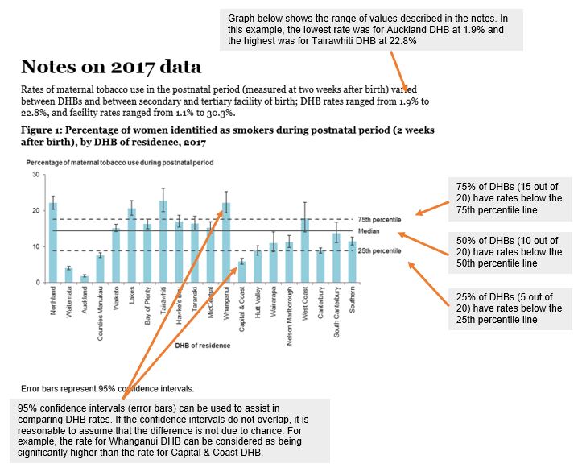

# Notes on national data

This section highlights how clinical indicator rates at a national level have changed from 2009 to 2017. See Table 2 for a summary of results, and Figure 2 for a graph showing rates for each indicator from 2009 to 2017. This figure is also available by DHB and by secondary or tertiary facility in the accompanying online tables. We present the following analysis by the population considered.

## Standard primiparae

A ‘standard primipara’ is a woman expected to have an uncomplicated pregnancy; intervention and complication rates for such women should be low and consistent across hospitals and DHBs. Comparing data about standard primiparae (rather than all women giving birth) controls for differences in case mix and increases the validity of inter-hospital comparisons of maternity care (adapted from Australian Council on Healthcare Standards 2008, p 29).

For the purposes of this publication, we consider approximately 15 percent of women giving birth in New Zealand to be standard primiparae. These women are a subset of the general maternity population and so are not representative of birthing women in New Zealand.

Standard primiparae in this publication are women aged 20–34 years old at the time of giving birth who are giving birth for the first time (parity = 0)[1] at term (37–41 weeks’ gestation) where the outcome of the birth is a singleton baby, the presentation is cephalic and there have been no recorded obstetric complications that are indications for specific obstetric interventions.

Standard primiparae as a proportion of women giving birth varied across DHBs in 2017, ranging from 13.0 percent (Tairāwhiti DHB) to 16.7 percent (Auckland DHB). The highest proportion (26.9 percent) of standard primiparous women were aged between 20 and 24 years old. A higher proportion of standard primiparous women identified as Asian (22.0 percent for Indian and 21.2 percent for other Asian); 12.2 percent identified as Pacific people and 11.0 percent as Māori. About 12.8 percent of women giving birth at home were standard primiparae, while 15.4 percent of women who gave birth at a maternity facility were standard primiparae (Figure 1).

From 2009 to 2017, there was a statistically significant increase in the proportion of standard primiparae who had:

* an instrumental vaginal birth (indicator 3)
* a caesarean section (indicator 4)
* an induction of labour (indicator 5)
* an episiotomy without third- or fourth-degree perineal tear (indicator 7)
* a third- or fourth-degree tear and no episiotomy (indicator 8)
* an episiotomy and a third- or fourth-degree tear (indicator 9).

Conversely, there was a significant decrease in the proportion of standard primiparae who had:

* a spontaneous vaginal birth (indicator 2)
* an intact lower genital tract (indicator 6).

Figure 1: Number of standard primiparae as a proportion of women giving birth for the first time and of all women giving birth in 2017, by place of birth, age group, ethnic group, deprivation quintile and district health board of residence

Figure 1: Number of standard primiparae as a proportion of women giving birth for the first time and of all women giving birth in 2017, by place of birth, age group, ethnic group, deprivation quintile and district health board of residence

Note: The number by each bar is the proportion of women who were standard primiparae.

Deprivation quintiles are based on the characteristics of the neighbourhood in which a person resides. Approximately equal numbers of the total New Zealand population reside in areas associated with each of the five deprivation quintiles.

## Women registered with a lead maternity carer

The vast majority of women giving birth in New Zealand first register with a lead maternity carer (LMC) for their primary maternity care. This increased from 82 percent of women giving birth in 2009 to 92 percent of women giving birth in 2017.

Women are registering increasingly earlier with LMCs; there was a statistically significant increase in women registering within the first trimester of pregnancy (<13 weeks) from 2009 to 2017.

## All women giving birth

Among all women giving birth, there was a statistically significant increase from 2009 to 2017 in the proportion requiring a blood transfusion with a vaginal birth (indicator 12).

In contrast, there was a significant decrease from 2009 to 2017 in the proportion of women:

* having a general anaesthetic for caesarean section (indicator 10)
* requiring a blood transfusion with a caesarean section (indicator 11)
* who smoked during the postnatal period (indicator 16).

## Babies

From 2009 to 2017, there was a significant decrease in the proportion of:

* term (37–42 weeks’ gestation) babies who were born small
* small babies at term (37–42 weeks’ gestation) who were born at 40–42 weeks’ gestation.

The proportion of term babies requiring respiratory support increased significantly from 2009 to 2017.

## International comparisons

International comparisons are often problematic, due to differing methodology, definitions and availability of national data. When compared to Australia, New Zealand appears to have markedly lower rates of obstetric intervention, including among women at low risk of complications, although definitions of low risk differ between the two countries. Rates for other indicators among the total birthing population in New Zealand, including rates of general anaesthetic for caesarean section (indicator 10) and maternal tobacco use (indicator 16), appear similar to their Australian equivalents.

Table 2: New Zealand Maternity Clinical Indicator national rates by year, 2009–2017

| **Indicator** | | **2009** | | **2010** | | **2011** | | **2012** | | **2013** | | **2014** | | **2015** | | **2016** | | **2017** | | **From 2009 to 2017 (p-value)1** | |
| --- | --- | --- | --- | --- | --- | --- | --- | --- | --- | --- | --- | --- | --- | --- | --- | --- | --- | --- | --- | --- | --- |
| **Women registered with an LMC** | | | | | | | | | | | | | | | | | | | | | |
|  | Registration with an LMC in the first trimester of pregnancy (%) | 57.6 | 59.9 | | 62.8 | | 64.0 | | 65.4 | | 67.8 | | 70.0 | | 71.9 | | 72.3 | |  | | (<0.001) |
| **Standard primiparae** | | | | | | | | | | | | | | | | | | | | | |
| 2 | Standard primiparae who have a spontaneous vaginal birth (%) | 69.7 | 69.9 | | 70.0 | | 69.8 | | 67.7 | | 68.9 | | 68.7 | | 67.6 | | 65.1 | |  | | (<0.000) |
| 3 | Standard primiparae who undergo an instrumental vaginal birth (%) | 14.8 | 14.6 | | 14.9 | | 14.9 | | 15.3 | | 15.2 | | 16.3 | | 16.1 | | 16.3 | |  | | (<0.000) |
| 4 | Standard primiparae who undergo caesarean section (%) | 14.6 | 14.7 | | 14.5 | | 15.1 | | 16.5 | | 15.5 | | 14.9 | | 16.2 | | 17.6 | |  | | (0.000) |
| 5 | Standard primiparae who undergo induction of labour (%) | 4.4 | 3.8 | | 4.4 | | 4.2 | | 5.2 | | 5.6 | | 5.7 | | 6.3 | | 7.6 | |  | | (<0.000) |
| 6 | Standard primiparae with an intact lower genital tract (no 1st- to 4th-degree tear or episiotomy) (%) | 34.6 | 33.3 | | 32.2 | | 30.3 | | 28.9 | | 27.6 | | 28.2 | | 27.7 | | 27.7 | |  | | (<0.000) |
| 7 | Standard primiparae undergoing episiotomy and no 3rd- or 4th-degree perineal tear (%) | 19.6 | 19.9 | | 19.9 | | 19.7 | | 21.0 | | 22.7 | | 22.2 | | 23.0 | | 24.5 | |  | | (<0.000) |
| 8 | Standard primiparae sustaining a 3rd- or 4th-degree perineal tear and no episiotomy (%) | 3.4 | 3.4 | | 3.5 | | 3.9 | | 4.3 | | 4.5 | | 4.4 | | 4.2 | | 4.4 | |  | | (<0.000) |
| 9 | Standard primiparae undergoing episiotomy and sustaining a 3rd- or 4th-degree perineal tear (%) | 1.3 | 1.1 | | 1.3 | | 1.6 | | 1.6 | | 1.5 | | 1.5 | | 1.9 | | 1.7 | |  | | (<0.000) |
| **Women giving birth** | | | | | | | | | | | | | | | | | | | | | |
| 10 | Women having a general anaesthetic for caesarean section (%) | 9.0 | 9.1 | | 8.4 | | 8.6 | | 8.3 | | 8.4 | | 8.8 | | 8.5 | | 8.2 | |  | | (0.011) |
| 11 | Women requiring a blood transfusion with caesarean section (%) | 3.8 | 3.3 | | 3.3 | | 3.2 | | 3.1 | | 3.2 | | 2.9 | | 2.9 | | 3.1 | |  | | (<0.000) |
| 12 | Women requiring a blood transfusion with vaginal birth (%) | 1.7 | 1.8 | | 1.8 | | 1.9 | | 2.0 | | 2.1 | | 2.0 | | 2.0 | | 2.2 | |  | | (<0.000) |
| 13 | Women with eclampsia at birth admission (numerator)2 | 27 | 22 | | 17 | | 12 | | 17 | | 18 | | 26 | | 28 | | 17 | |  | | N/A |
| 14 | Women having a peripartum hysterectomy (numerator)2 | 51 | 29 | | 39 | | 49 | | 21 | | 37 | | 30 | | 25 | | 29 | |  | | N/A |
| 15 | Women admitted to an ICU and requiring ventilation during the pregnancy or postnatal period (numerator)2 | 19 | 18 | | 21 | | 12 | | 17 | | 13 | | 16 | | 9 | | 11 | |  | | N/A |
| 16 | Maternal tobacco use during postnatal period (%) | 13.7 | 14.4 | | 13.4 | | 13.3 | | 13.2 | | 12.8 | | 12.0 | | 11.7 | | 10.5 | |  | | (<0.000) |
| **Babies** | | | | | | | | | | | | | | | | | | | | | |
| 17 | Preterm birth (%) | 7.4 | 7.4 | | 7.3 | | 7.6 | | 7.4 | | 7.4 | | 7.3 | | 7.5 | | 7.5 | | – | | (0.485) |
| 18 | Small babies at term (37–42 weeks’ gestation) (%) | 3.5 | 3.5 | | 3.2 | | 3.2 | | 3.0 | | 3.0 | | 3.1 | | 2.9 | | 2.9 | |  | | (<0.000) |
| 19 | Small babies at term born at 40–42 weeks’ gestation (%) | 45.4 | 45.5 | | 43.4 | | 41.4 | | 36.9 | | 39.3 | | 38.4 | | 35.8 | | 31.9 | |  | | (<0.000) |
| 20 | Babies born at 37+ weeks’ gestation requiring respiratory support | 0.7 | 0.7 | | 1.6 | | 1.7 | | 1.9 | | 2.0 | | 1.9 | | 2.0 | | 2.0 | |  | | (<0.000) |

1 Shows whether there was a statistically significant increase (), or decrease (), or no statistically significant change (–) in rates from 2009 to 2017. Statistical significance was derived using a chi-squared test for trend in proportions, at a 95% significance level for all indicators, except indicators 13–15 due to small numbers.

2 Rates are not presented due to small numbers for these indicators. The numbers presented are the numerator values each year for the indicator.

Figure 2: New Zealand Maternity Clinical Indicator rates by year, 2009–2017

graphs showing the maternity clinical indicator rates by year

Figure 2: New Zealand Maternity Clinical Indicator rates by year, 2009–2017

Note: Indicators 13–15 (showing severe maternal morbidity) are not presented as graphs due to very small numbers (see Table 2).

# Indicator 1: Registration with a lead maternity carer

## Rationale and purpose

The Perinatal and Maternal Mortality Review Committee (2017), the National Maternity Monitoring Group (2013) and the Health Select Committee Inquiry into improving child health outcomes and preventing child abuse with a focus on preconception to three years of age (2013) all recommend early engagement with maternity care. The National Institute for Health and Care Excellence (2008) recommends that antenatal care be started in the first trimester, and ideally by 10 weeks’ gestation.

Early engagement with an LMC enables opportunities for screening, education and referral, and begins the primary maternity continuity of care relationship between a woman and her LMC. The National Maternity Monitoring Group recommended in their 2013 annual report that DHBs develop new ways to improve access to LMC services in the first trimester, and profiled a range of activities DHBs were already undertaking to this end.

This indicator monitors the number of women who registered with an LMC in the first trimester of their pregnancy, out of all women who gave birth and had an LMC providing their primary maternity care.[2] This indicator supports national and local monitoring of the effectiveness of activities to improve timely registration with an LMC.

## Notes on 2017 data

Rates of registration with an LMC in the first trimester varied between DHBs and between secondary and tertiary facility of birth; rates by DHB of residence ranged from 56.1 percent to 81.4 percent, and rates by facility of birth ranged from 50.3 percent to 85.3 percent. Initiatives in this area, such as a video Counties Manukau DHB produced specifically for Pacific women, are expected to increase the rate of women engaging with an LMC in the first trimester of their pregnancy.

## Indicator 1: Registration with a lead maternity carer in the first trimester of pregnancy, 2017

Figure 3: Percentage of women who register with a lead maternity carer in the first trimester of their pregnancy among all registered women giving birth, by district health board of residence, 2017

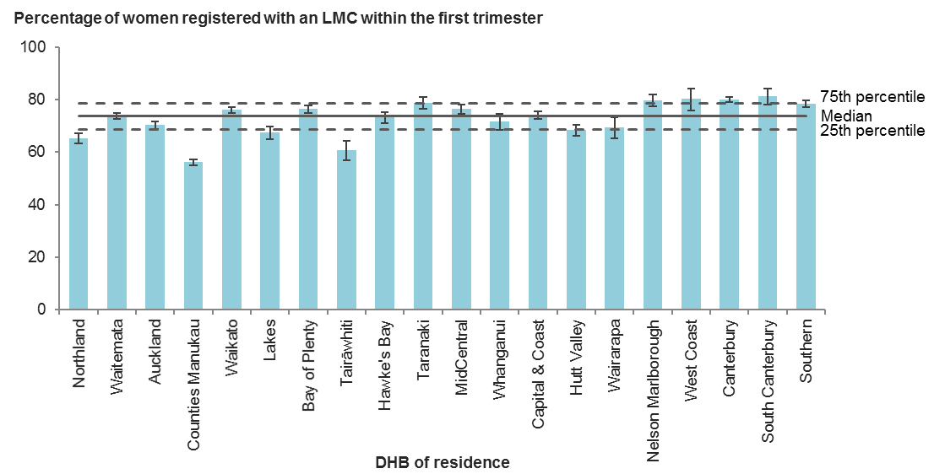

Error bars represent 95% confidence intervals.

Figure 4: Percentage of women who register with a lead maternity carer in the first trimester of their pregnancy among all registered women giving birth, by facility of birth (secondary and tertiary facilities), 2017

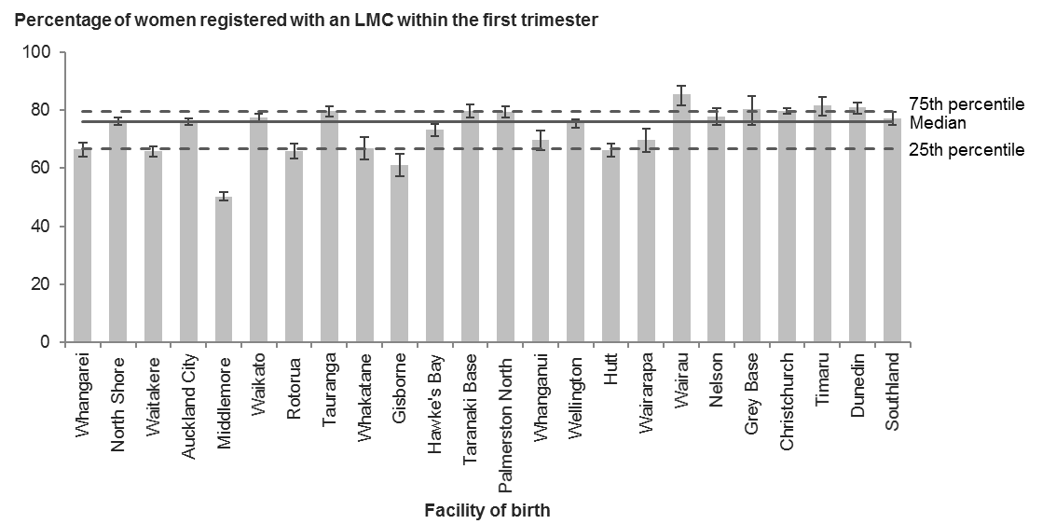

Error bars represent 95% confidence intervals.

Table 3: Number and percentage of women who register with a lead maternity carer in the first trimester of their pregnancy among all registered women, by district health board of residence, 2017

|  |  |  |  |
| --- | --- | --- | --- |
| **DHB of residence** | **Registered within the first trimester of pregnancy** | **All registered women** | **Rate (%)** |
| Northland | 1,361 | 2,084 | 65.3 |
| Waitemata | 5,442 | 7,382 | 73.7 |
| Auckland | 3,078 | 4,379 | 70.3 |
| Counties Manukau | 3,610 | 6,431 | 56.1 |
| Waikato | 3,936 | 5,172 | 76.1 |
| Lakes | 1,041 | 1,543 | 67.5 |
| Bay of Plenty | 2,352 | 3,079 | 76.4 |
| Tairāwhiti | 420 | 693 | 60.6 |
| Hawke’s Bay | 1,459 | 1,995 | 73.1 |
| Taranaki | 1,098 | 1,394 | 78.8 |
| MidCentral | 1,584 | 2,075 | 76.3 |
| Whanganui | 574 | 801 | 71.7 |
| Capital & Coast | 2,428 | 3,281 | 74.0 |
| Hutt Valley | 1,259 | 1,842 | 68.3 |
| Wairarapa | 362 | 521 | 69.5 |
| Nelson Marlborough | 1,083 | 1,357 | 79.8 |
| West Coast | 284 | 354 | 80.2 |
| Canterbury | 5,089 | 6,362 | 80.0 |
| South Canterbury | 513 | 630 | 81.4 |
| Southern | 2,682 | 3,418 | 78.5 |
| Unknown | 151 | 269 | – |
| **New Zealand** | **39,806** | **55,062** | **72.3** |

Table 4: Number and percentage of women who register with a lead maternity carer in the first trimester of their pregnancy among all registered women, by facility of birth, 2017

|  |  |  |  |
| --- | --- | --- | --- |
| **Place of birth** | **Registered within the first trimester of pregnancy** | **All registered women** | **Rate (%)** |
| Whangarei | 962 | 1,448 | 66.4 |
| North Shore | 2,904 | 3,814 | 76.1 |
| Waitakere | 1,732 | 2,631 | 65.8 |
| Auckland City | 4,115 | 5,419 | 75.9 |
| Middlemore | 2,375 | 4,721 | 50.3 |
| Waikato | 2,662 | 3,439 | 77.4 |
| Rotorua | 854 | 1,296 | 65.9 |
| Tauranga | 1,519 | 1,907 | 79.7 |
| Whakatane | 410 | 612 | 67.0 |
| Gisborne | 391 | 640 | 61.1 |
| Hawke’s Bay | 1,367 | 1,868 | 73.2 |
| Taranaki Base | 983 | 1,234 | 79.7 |
| Palmerston North | 1,411 | 1,778 | 79.4 |
| Whanganui | 493 | 707 | 69.7 |
| Wellington | 2,257 | 2,993 | 75.4 |
| Hutt | 1,159 | 1,752 | 66.2 |
| Wairarapa | 332 | 476 | 69.7 |
| Wairau | 349 | 409 | 85.3 |
| Nelson | 647 | 831 | 77.9 |
| Grey Base | 201 | 250 | 80.4 |
| Christchurch | 4,139 | 5,192 | 79.7 |
| Timaru | 478 | 586 | 81.6 |
| Dunedin | 1,344 | 1,663 | 80.8 |
| Southland | 951 | 1,231 | 77.3 |
| **All secondary and tertiary facilities** | **34,035** | **46,897** | **72.6** |
| **All primary facilities** | **3,993** | **5,659** | **70.6** |
| **All home births** | **1,492** | **1,986** | **75.1** |
| **New Zealand1** | **39,806** | **55,062** | **72.3** |

1 Includes women where birth location was unspecified.

# Indicators 2 to 5: Type of birth

## Rationale and purpose

Indicators 2 to 5 present data on types of birth among standard primiparae. They compare rates of spontaneous vaginal birth and rates of medical interventions in a low-risk population.[3] Their purpose is to encourage maternity service providers to review the appropriateness of these interventions among low-risk women, with the aims of supporting normal birth, improving maternal experience of maternity care, reducing maternal and perinatal morbidity, and supporting value for money for the health system. The following sections describe the rationale and purpose of the specific indicators.

### Spontaneous vaginal birth (indicator 2)

This indicator measures the proportion of women having a spontaneous (non-instrumental) vaginal birth in a low-risk population. This measure includes births for which labour was augmented or induced. Maternity service providers should review, evaluate and make necessary changes to clinical practice aimed at supporting women to achieve a spontaneous vaginal birth, and may wish to consider further local measures that exclude other birth interventions.

### Instrumental vaginal birth (indicator 3)

This indicator measures the use of instrumental interventions; that is, vacuum (ventouse) and forceps. The use of instruments is associated with both short-term and long-term complications for the woman and the baby, some of which can be serious. Maternity service providers should use instrumental interventions judiciously (AIHW 2013). If a maternity service provider’s rates of intervention are significantly higher than its peer group at a national level, it should examine the use of instrumental birth alongside other indicators that instrumental birth may affect, including maternal and perinatal morbidity.

### Caesarean section (indicator 4)

The purpose of this indicator is to encourage maternity service providers to evaluate whether they performed caesarean sections on the right women at the right place and at the right time, and to reduce the harm associated with potentially avoidable caesarean sections among low-risk women. Caesarean birth is safer now than in the past and serious complications are uncommon, particularly for healthy women, but a small risk of serious morbidity and mortality for both the woman and the baby remains, and a primary caesarean section can complicate a subsequent pregnancy (AIHW 2013). If a provider’s caesarean section rates are significantly different from their peer group at a national level, it should examine its use of caesarean sections among low-risk women.

### Induction of labour (indicator 5)

The purpose of this indicator is to benchmark rates of induction of labour in a low-risk population. Induction of labour is associated with risk of fetal distress, uterine hyper-stimulation and postpartum haemorrhage, and can be the start of a cascade of further medical interventions (AIHW 2013). Maternity service providers should use this indicator in further investigation of their policies and practices with respect to inducing labour in low-risk women. If a provider’s rates of induction of labour are significantly higher than its peer group at a national level, it should review the appropriateness of inductions in this group as well as examine the results of other indicators that can be affected by induction, such as caesarean section and postpartum haemorrhage.

## Notes on 2017 data

Rates of spontaneous vaginal birth among standard primiparae varied notably between DHBs and between secondary and tertiary facilities in 2017; DHB rates ranged from 56.5 percent to 78.7 percent and facility rates ranged from 45.9 percent to 83.3 percent. This variation merits further urgent investigation, as it represents significant variation in clinical practice among a clinically comparable cohort.

Rates of instrumental vaginal birth ranged from 6.9 percent to 32.0 percent between facilities. Caesarean section rates also varied by facility, from 8.3 percent to 27.1 percent, and by DHB, from 7.4 percent to 22.8 percent. These variations indicate an urgent need for the relevant DHBs to identify the standard primiparae who had inductions of labour or operative births and undertake multidisciplinary audit to determine whether the interventions were evidence based. District health boards not already reviewing caesarean sections among low-risk women should do so.

Standard primiparae are unlikely to have indications for induction of labour, so rates of induction for this group should be low. District health boards and facilities with rates significantly above the national median should investigate reasons for high induction rates.

## Indicator 2: Spontaneous vaginal birth among standard primiparae, 2017

Figure 5: Percentage of spontaneous vaginal births among standard primiparae, by district health board of residence, 2017

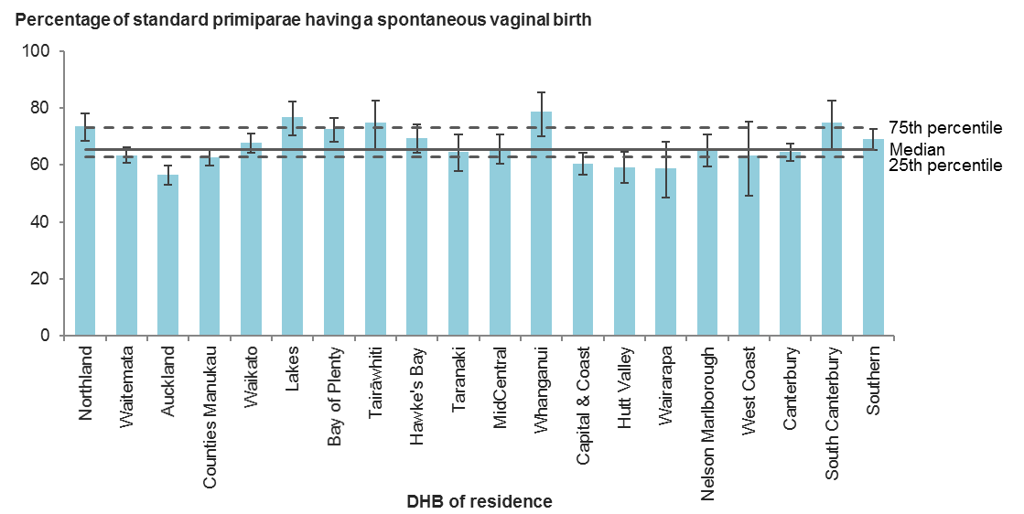

Error bars represent 95% confidence intervals.

Figure 6: Percentage of spontaneous vaginal births among standard primiparae, by facility of birth (secondary and tertiary facilities), 2017

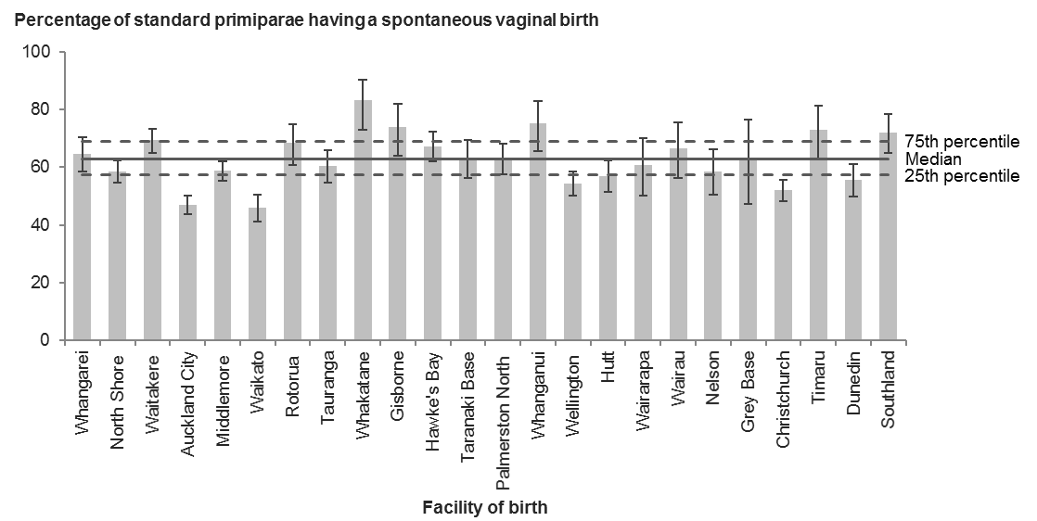

Error bars represent 95% confidence intervals.

Table 5: Number and percentage of spontaneous vaginal births among standard primiparae, by district health board of residence, 2017

|  |  |  |  |
| --- | --- | --- | --- |
| **DHB of residence** | **Spontaneous vaginal births** | **Standard primiparae** | **Rate (%)** |
| Northland | 244 | 332 | 73.5 |
| Waitemata | 752 | 1,185 | 63.5 |
| Auckland | 491 | 869 | 56.5 |
| Counties Manukau | 750 | 1,198 | 62.6 |
| Waikato | 521 | 769 | 67.8 |
| Lakes | 152 | 198 | 76.8 |
| Bay of Plenty | 337 | 465 | 72.5 |
| Tairāwhiti | 72 | 96 | 75.0 |
| Hawke’s Bay | 230 | 331 | 69.5 |
| Taranaki | 137 | 212 | 64.6 |
| MidCentral | 216 | 328 | 65.9 |
| Whanganui | 85 | 108 | 78.7 |
| Capital & Coast | 366 | 605 | 60.5 |
| Hutt Valley | 183 | 309 | 59.2 |
| Wairarapa | 54 | 92 | 58.7 |
| Nelson Marlborough | 171 | 262 | 65.3 |
| West Coast | 31 | 49 | 63.3 |
| Canterbury | 631 | 979 | 64.5 |
| South Canterbury | 72 | 96 | 75.0 |
| Southern | 405 | 587 | 69.0 |
| Unknown | 12 | 16 | – |
| **New Zealand** | **5,912** | **9,086** | **65.1** |

Table 6: Number and percentage of spontaneous vaginal births among standard primiparae, by place of birth, 2017

|  |  |  |  |
| --- | --- | --- | --- |
| **Place of birth** | **Spontaneous vaginal births** | **Standard primiparae** | **Rate (%)** |
| Whangarei | 158 | 244 | 64.8 |
| North Shore | 352 | 601 | 58.6 |
| Waitakere | 316 | 456 | 69.3 |
| Auckland City | 447 | 950 | 47.1 |
| Middlemore | 525 | 894 | 58.7 |
| Waikato | 202 | 440 | 45.9 |
| Rotorua | 110 | 161 | 68.3 |
| Tauranga | 178 | 295 | 60.3 |
| Whakatane | 60 | 72 | 83.3 |
| Gisborne | 68 | 92 | 73.9 |
| Hawke’s Bay | 208 | 309 | 67.3 |
| Taranaki Base | 126 | 200 | 63.0 |
| Palmerston North | 189 | 300 | 63.0 |
| Whanganui | 70 | 93 | 75.3 |
| Wellington | 284 | 522 | 54.4 |
| Hutt | 174 | 305 | 57.0 |
| Wairarapa | 54 | 89 | 60.7 |
| Wairau | 58 | 87 | 66.7 |
| Nelson | 89 | 152 | 58.6 |
| Grey Base | 24 | 38 | 63.2 |
| Christchurch | 380 | 731 | 52.0 |
| Timaru | 65 | 89 | 73.0 |
| Dunedin | 168 | 302 | 55.6 |
| Southland | 121 | 168 | 72.0 |
| **All secondary and tertiary facilities** | **4,426** | **7,590** | **58.3** |
| **All primary facilities** | **1,225** | **1,235** | **99.2** |
| **All home births** | **261** | **261** | **100.0** |
| **New Zealand1** | **5,912** | **9,086** | **65.1** |

1 Includes women where birth location was unspecified.

## Indicator 3: Instrumental vaginal birth among standard primiparae, 2017

Figure 7: Percentage of instrumental vaginal births among standard primiparae, by district health board of residence, 2017

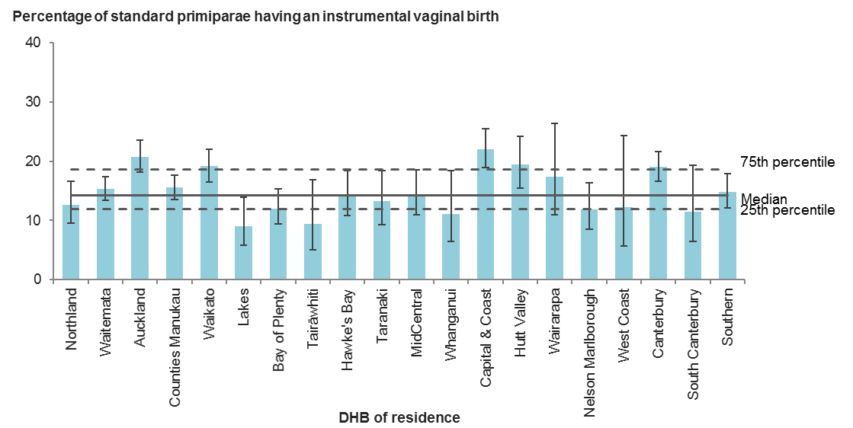

Error bars represent 95% confidence intervals.

Figure 8: Percentage of instrumental vaginal births among standard primiparae, by facility of birth (secondary and tertiary facilities), 2017

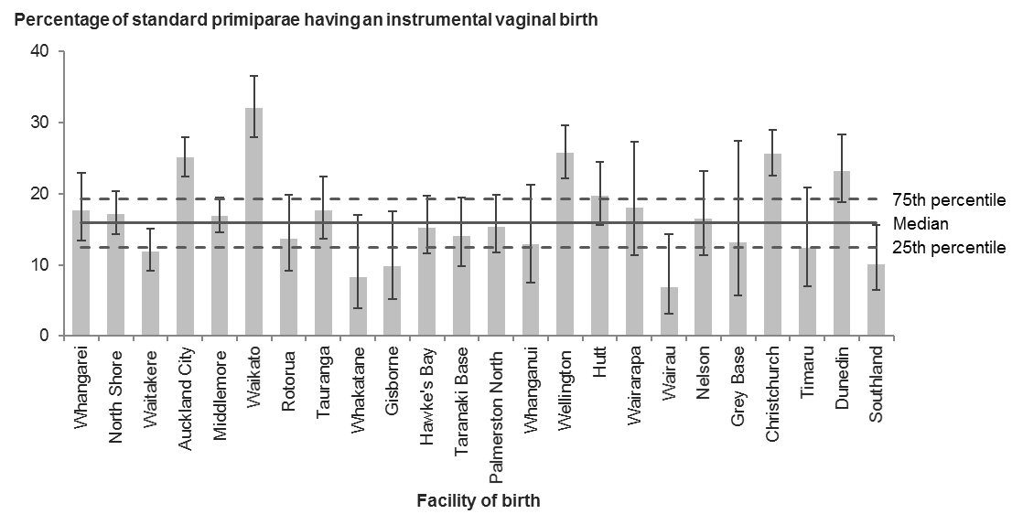

Error bars represent 95% confidence intervals.

Table 7: Number and percentage of instrumental vaginal births among standard primiparae, by district health board of residence, 2017

| **DHB of residence** | **Instrumental vaginal births** | **Standard primiparae** | **Rate (%)** |
| --- | --- | --- | --- |
| Northland | 42 | 332 | 12.7 |
| Waitemata | 181 | 1,185 | 15.3 |
| Auckland | 180 | 869 | 20.7 |
| Counties Manukau | 186 | 1,198 | 15.5 |
| Waikato | 147 | 769 | 19.1 |
| Lakes | 18 | 198 | 9.1 |
| Bay of Plenty | 56 | 465 | 12.0 |
| Tairāwhiti | 9 | 96 | 9.4 |
| Hawke’s Bay | 47 | 331 | 14.2 |
| Taranaki | 28 | 212 | 13.2 |
| MidCentral | 47 | 328 | 14.3 |
| Whanganui | 12 | 108 | 11.1 |
| Capital & Coast | 133 | 605 | 22.0 |
| Hutt Valley | 60 | 309 | 19.4 |
| Wairarapa | 16 | 92 | 17.4 |
| Nelson Marlborough | 31 | 262 | 11.8 |
| West Coast | 6 | 49 | 12.2 |
| Canterbury | 186 | 979 | 19.0 |
| South Canterbury | 11 | 96 | 11.5 |
| Southern | 87 | 587 | 14.8 |
| Unknown | 2 | 16 | – |
| **New Zealand** | **1,485** | **9,086** | **16.3** |

Table 8: Number and percentage of instrumental vaginal births among standard primiparae, by place of birth, 2017

|  |  |  |  |
| --- | --- | --- | --- |
| **Place of birth** | **Instrumental vaginal births** | **Standard primiparae** | **Rate (%)** |
| Whangarei | 43 | 244 | 17.6 |
| North Shore | 103 | 601 | 17.1 |
| Waitakere | 54 | 456 | 11.8 |
| Auckland City | 238 | 950 | 25.1 |
| Middlemore | 151 | 894 | 16.9 |
| Waikato | 141 | 440 | 32.0 |
| Rotorua | 22 | 161 | 13.7 |
| Tauranga | 52 | 295 | 17.6 |
| Whakatane | 6 | 72 | 8.3 |
| Gisborne | 9 | 92 | 9.8 |
| Hawke’s Bay | 47 | 309 | 15.2 |
| Taranaki Base | 28 | 200 | 14.0 |
| Palmerston North | 46 | 300 | 15.3 |
| Whanganui | 12 | 93 | 12.9 |
| Wellington | 134 | 522 | 25.7 |
| Hutt | 60 | 305 | 19.7 |
| Wairarapa | 16 | 89 | 18.0 |
| Wairau | 6 | 87 | 6.9 |
| Nelson | 25 | 152 | 16.4 |
| Grey Base | 5 | 38 | 13.2 |
| Christchurch | 187 | 731 | 25.6 |
| Timaru | 11 | 89 | 12.4 |
| Dunedin | 70 | 302 | 23.2 |
| Southland | 17 | 168 | 10.1 |
| **All secondary and tertiary facilities** | **1,483** | **7,590** | **19.5** |
| **All primary facilities** | **2** | **1,235** | **0.2** |
| **All home births** | **0** | **261** | **0.0** |
| **New Zealand1** | **1,485** | **9,086** | **16.3** |

1 Includes women where birth location was unspecified.

## Indicator 4: Caesarean section among standard primiparae, 2017

Figure 9: Percentage of caesarean section deliveries among standard primiparae, by district health board of residence, 2017

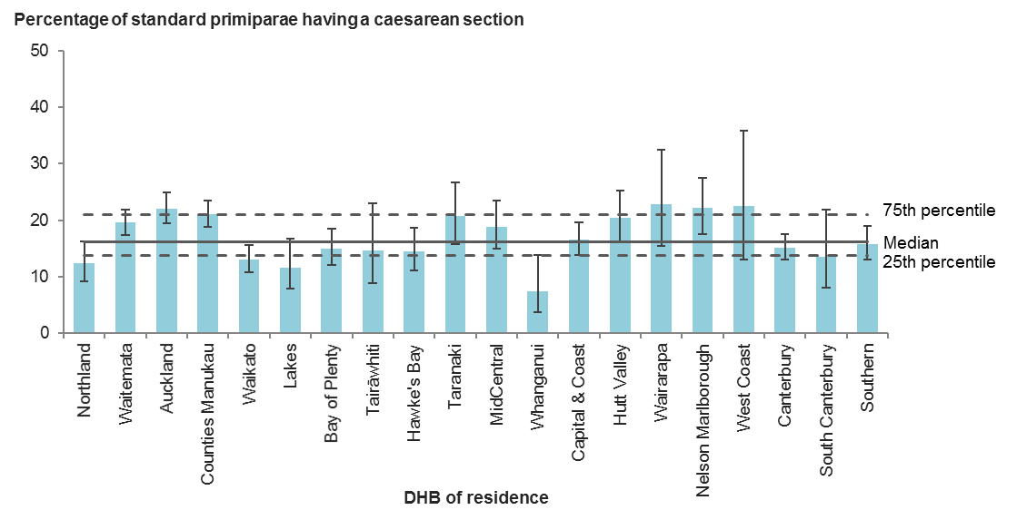

Error bars represent 95% confidence intervals.

Figure 10: Percentage of caesarean section deliveries among standard primiparae, by facility of birth (secondary and tertiary facilities), 2017

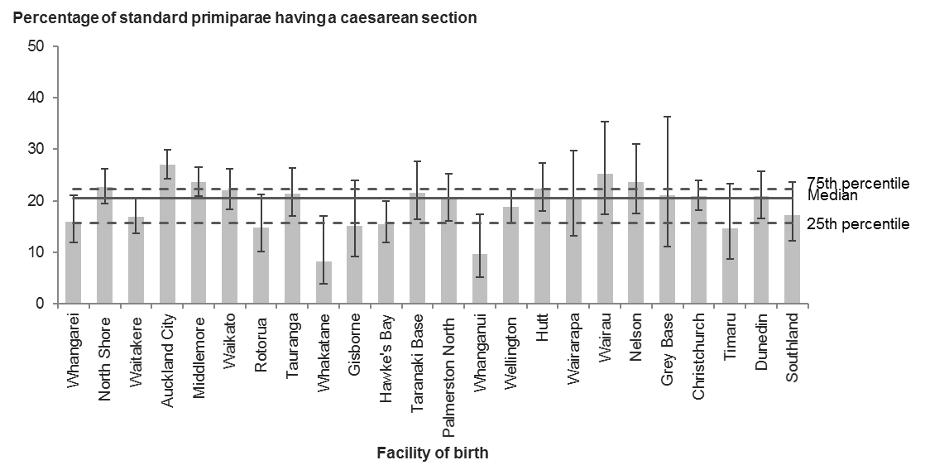

Error bars represent 95% confidence intervals.

Table 9: Number and percentage of deliveries by caesarean section among standard primiparae, by district health board of residence, 2017

|  |  |  |  |
| --- | --- | --- | --- |
| **DHB of residence** | **Caesarean sections** | **Standard primiparae** | **Rate (%)** |
| Northland | 41 | 332 | 12.3 |
| Waitemata | 232 | 1,185 | 19.6 |
| Auckland | 192 | 869 | 22.1 |
| Counties Manukau | 252 | 1,198 | 21.0 |
| Waikato | 100 | 769 | 13.0 |
| Lakes | 23 | 198 | 11.6 |
| Bay of Plenty | 70 | 465 | 15.1 |
| Tairāwhiti | 14 | 96 | 14.6 |
| Hawke’s Bay | 48 | 331 | 14.5 |
| Taranaki | 44 | 212 | 20.8 |
| MidCentral | 62 | 328 | 18.9 |
| Whanganui | 8 | 108 | 7.4 |
| Capital & Coast | 100 | 605 | 16.5 |
| Hutt Valley | 63 | 309 | 20.4 |
| Wairarapa | 21 | 92 | 22.8 |
| Nelson Marlborough | 58 | 262 | 22.1 |
| West Coast | 11 | 49 | 22.4 |
| Canterbury | 148 | 979 | 15.1 |
| South Canterbury | 13 | 96 | 13.5 |
| Southern | 93 | 587 | 15.8 |
| Unknown | 2 | 16 | – |
| **New Zealand** | **1,595** | **9,086** | **17.6** |

Table 10: Number and percentage of deliveries by caesarean section among standard primiparae, by place of birth, 2017

|  |  |  |  |
| --- | --- | --- | --- |
| **Place of birth** | **Caesarean sections** | **Standard primiparae** | **Rate (%)** |
| Whangarei | 39 | 244 | 16.0 |
| North Shore | 136 | 601 | 22.6 |
| Waitakere | 77 | 456 | 16.9 |
| Auckland City | 257 | 950 | 27.1 |
| Middlemore | 211 | 894 | 23.6 |
| Waikato | 97 | 440 | 22.0 |
| Rotorua | 24 | 161 | 14.9 |
| Tauranga | 63 | 295 | 21.4 |
| Whakatane | 6 | 72 | 8.3 |
| Gisborne | 14 | 92 | 15.2 |
| Hawke’s Bay | 48 | 309 | 15.5 |
| Taranaki Base | 43 | 200 | 21.5 |
| Palmerston North | 61 | 300 | 20.3 |
| Whanganui | 9 | 93 | 9.7 |
| Wellington | 98 | 522 | 18.8 |
| Hutt | 68 | 305 | 22.3 |
| Wairarapa | 18 | 89 | 20.2 |
| Wairau | 22 | 87 | 25.3 |
| Nelson | 36 | 152 | 23.7 |
| Grey Base | 8 | 38 | 21.1 |
| Christchurch | 153 | 731 | 20.9 |
| Timaru | 13 | 89 | 14.6 |
| Dunedin | 63 | 302 | 20.9 |
| Southland | 29 | 168 | 17.3 |
| **All secondary and tertiary facilities** | **1,593** | **7,590** | **21.0** |
| **All primary facilities** | **2** | **1,235** | **0.2** |
| **All home births** | **0** | **261** | **0.0** |
| **New Zealand1** | **1,595** | **9,086** | **17.6** |

1 Includes women where birth location was unspecified.

## Indicator 5: Induction of labour among standard primiparae, 2017

Figure 11: Percentage of inductions of labour among standard primiparae, by district health board of residence, 2017

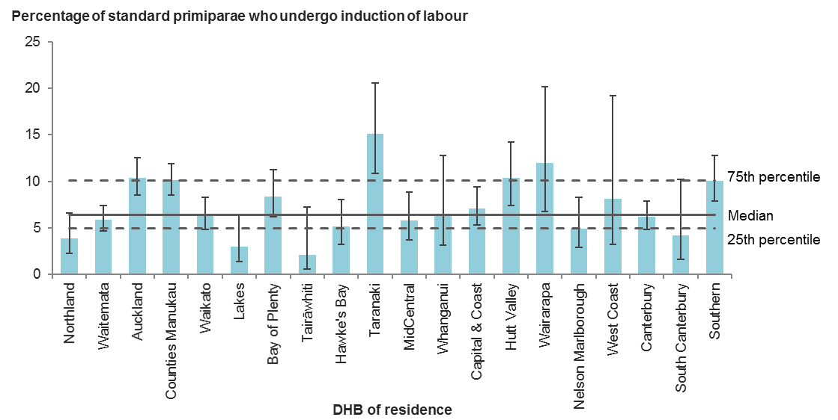

Error bars represent 95% confidence intervals.

Figure 12: Percentage of inductions of labour among standard primiparae, by facility of birth (secondary and tertiary facilities), 2017

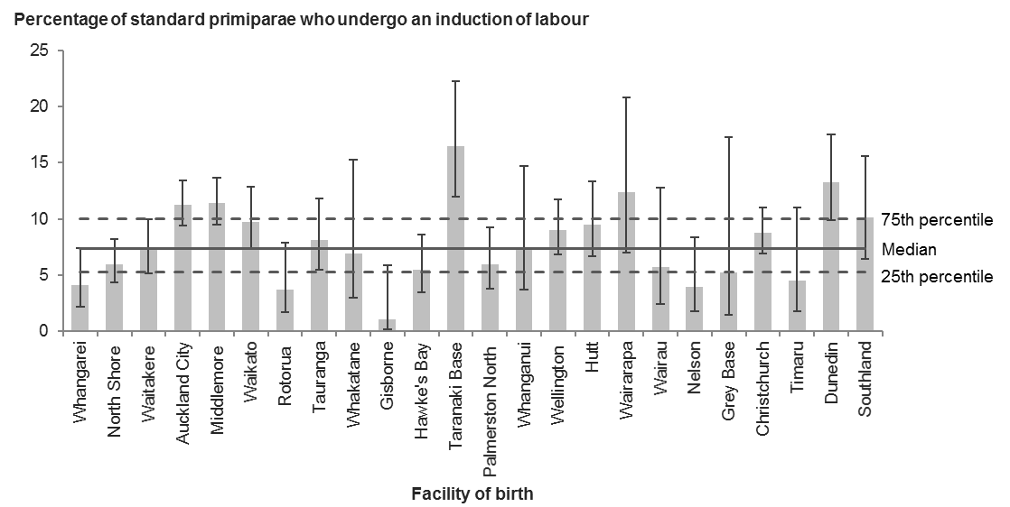

Error bars represent 95% confidence intervals.

Table 11: Number and percentage of inductions of labour among standard primiparae, by district health board of residence, 2017

|  |  |  |  |
| --- | --- | --- | --- |
| **DHB of residence** | **Inductions of labour** | **Standard primiparae** | **Rate (%)** |
| Northland | 13 | 332 | 3.9 |
| Waitemata | 70 | 1,185 | 5.9 |
| Auckland | 90 | 869 | 10.4 |
| Counties Manukau | 121 | 1,198 | 10.1 |
| Waikato | 49 | 769 | 6.4 |
| Lakes | 6 | 198 | 3.0 |
| Bay of Plenty | 39 | 465 | 8.4 |
| Tairāwhiti | 2 | 96 | 2.1 |
| Hawke’s Bay | 17 | 331 | 5.1 |
| Taranaki | 32 | 212 | 15.1 |
| MidCentral | 19 | 328 | 5.8 |
| Whanganui | 7 | 108 | 6.5 |
| Capital & Coast | 43 | 605 | 7.1 |
| Hutt Valley | 32 | 309 | 10.4 |
| Wairarapa | 11 | 92 | 12.0 |
| Nelson Marlborough | 13 | 262 | 5.0 |
| West Coast | 4 | 49 | 8.2 |
| Canterbury | 61 | 979 | 6.2 |
| South Canterbury | 4 | 96 | 4.2 |
| Southern | 59 | 587 | 10.1 |
| Unknown | 1 | 16 | – |
| **New Zealand** | **693** | **9,086** | **7.6** |

Table 12: Number and percentage of inductions of labour among standard primiparae, by facility of birth (secondary and tertiary facilities), 2017

|  |  |  |  |
| --- | --- | --- | --- |
| **Place of birth** | **Inductions of labour** | **Standard primiparae** | **Rate (%)** |
| Whangarei | 10 | 244 | 4.1 |
| North Shore | 36 | 601 | 6.0 |
| Waitakere | 33 | 456 | 7.2 |
| Auckland City | 107 | 950 | 11.3 |
| Middlemore | 102 | 894 | 11.4 |
| Waikato | 43 | 440 | 9.8 |
| Rotorua | 6 | 161 | 3.7 |
| Tauranga | 24 | 295 | 8.1 |
| Whakatane | 5 | 72 | 6.9 |
| Gisborne | 1 | 92 | 1.1 |
| Hawke’s Bay | 17 | 309 | 5.5 |
| Taranaki Base | 33 | 200 | 16.5 |
| Palmerston North | 18 | 300 | 6.0 |
| Whanganui | 7 | 93 | 7.5 |
| Wellington | 47 | 522 | 9.0 |
| Hutt | 29 | 305 | 9.5 |
| Wairarapa | 11 | 89 | 12.4 |
| Wairau | 5 | 87 | 5.7 |
| Nelson | 6 | 152 | 3.9 |
| Grey Base | 2 | 38 | 5.3 |
| Christchurch | 64 | 731 | 8.8 |
| Timaru | 4 | 89 | 4.5 |
| Dunedin | 40 | 302 | 13.2 |
| Southland | 17 | 168 | 10.1 |
| **All secondary and tertiary facilities** | **667** | **7,590** | **8.8** |
| **All primary facilities** | **26** | **1,235** | **2.1** |
| **All home births** | **0** | **261** | **0.0** |
| **New Zealand1** | **693** | **9,086** | **7.6** |

1 Includes women where birth location was unspecified.

# Indicators 6 to 9: Damage to the lower genital tract

## Rationale and purpose

Indicators 6 to 9 cover the degree of damage to the lower genital tract from vaginal birth among standard primiparae. Perineal trauma remains one of the most common complications of childbirth, and is thought to affect between 60 percent and 85 percent of women who give birth vaginally (WHA 2007). Reasons for perineal trauma are varied, and may reflect either maternal or neonatal issues. Perineal damage can cause women pain and longer-term morbidity. The aim of these indicators is to reduce such trauma and its associated maternal morbidity. This may improve maternal satisfaction and mother−infant bonding by reducing maternal pain and discomfort. The following sections describe the rationale and purpose of the specific indicators.

### Intact lower genital tract (indicator 6)

The four categories of perineal tear classification enable a standardised description of perineal damage. Assessing and identifying degrees of perineal damage remains a complex process. A classification of first or second degree does not necessarily reflect the level of pain or long-term morbidity a woman experiences. This indicator provides a concise measure of all perineal trauma, and is intended to encourage further investigation to determine how maternity service providers can improve rates of intact lower genital tract.

### Episiotomy (indicator 7)

This indicator aims to encourage further investigation among maternity service providers to ensure that they assess risks to the woman and infant appropriately before undertaking an episiotomy. Meta-analysis of randomised controlled trials confirms that judicious use of episiotomy is better practice than routine use of episiotomy (AIHW 2013). If a provider’s rates of episiotomy, particularly among low-risk women, are significantly higher than its peer group at a national level, it should examine these results. Providers should also consider their rates alongside other indicators that can be affected by episiotomies, such as third-degree tears, postpartum haemorrhage, infection and maternal admission to high-dependency units or intensive care units (ICUs), to ascertain whether there is any correlation.

### Third- and fourth-degree tears (with and without episiotomy) (indicators 8 and 9)

The aim of these indicators is to encourage maternity service providers to consider the rate of tears in conjunction with episiotomy rates, and to undertake further investigation of labour management if rates are significantly different from their peer group at a national level. Labour management may include birth position, the use of induction, instrumental delivery and management of second-stage labour.

## Notes on 2017 data

Rates of intact lower genital tract after vaginal birth among standard primiparae ranged from 15.5 percent to 48.0 percent across DHBs, and from 6.8 percent to 47.0 percent across secondary and tertiary facilities. This regional variation suggests that we should investigate both data integrity and local clinical practice. Rates of intact lower genital tract appear to have decreased over time since 2009. We need to further investigate the causes of this, including through review of coding practices, particularly given there has been no statistically significant increase in the rates of instrumental birth among the same population over this time.

Rates of episiotomy without third- or fourth-degree tear also varied, from 4.9 percent to 41.1 percent across DHBs, and from 5.1 percent to 49.2 percent across secondary and tertiary facilities. Facilities and DHBs with rates significantly above the median should investigate the reasons for these differences, which could include review of the clinical indications given in specific cases, education and policy review, and identification of the discipline and number of practitioners performing episiotomies.

All DHBs should undertake more detailed local analysis of the relationship between rates of intact perineum, episiotomies and third- and fourth-degree tears.

## Indicator 6: Intact lower genital tract among standard primiparae giving birth vaginally, 2017

Figure 13: Percentage of standard primiparae giving birth vaginally with intact lower genital tract, by district health board of residence, 2017

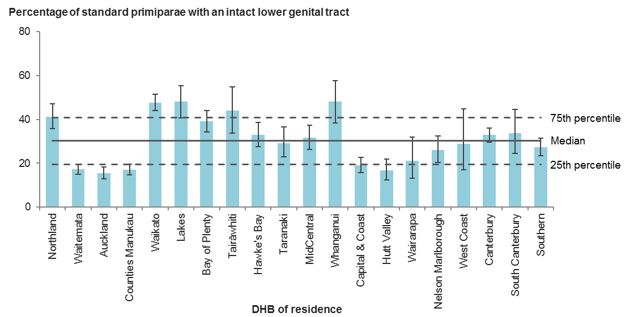

Error bars represent 95% confidence intervals.

Figure 14: Percentage of standard primiparae giving birth vaginally with intact lower genital tract, by facility of birth (secondary and tertiary facilities), 2017

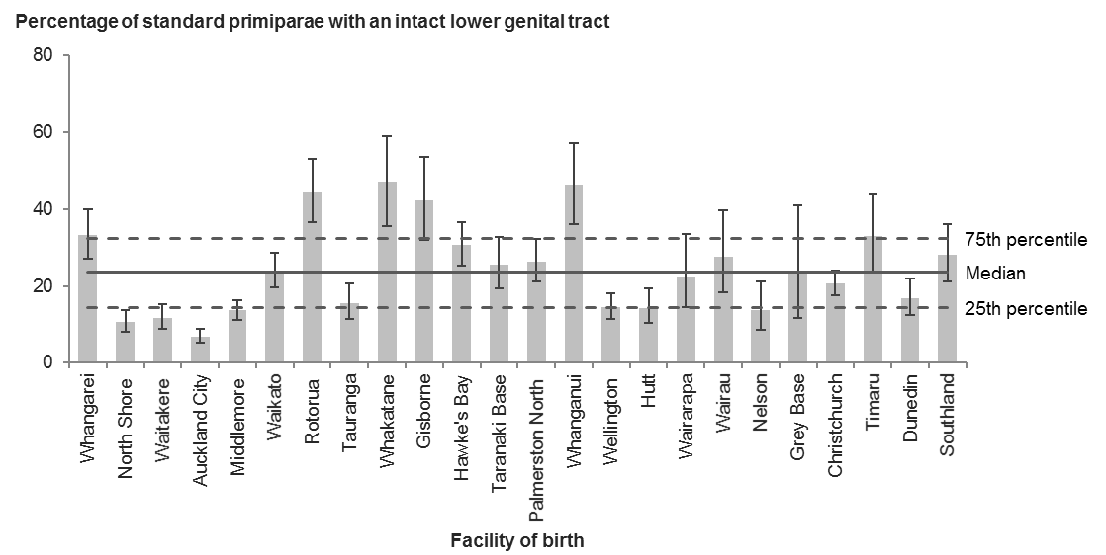

Error bars represent 95% confidence intervals.

Table 13: Number and percentage of standard primiparae giving birth vaginally with intact lower genital tract, by district health board of residence, 2017

|  |  |  |  |
| --- | --- | --- | --- |
| **DHB of residence** | **Intact lower genital tract** | **Standard primiparae giving birth vaginally** | **Rate (%)** |
| Northland | 120 | 291 | 41.2 |
| Waitemata | 164 | 953 | 17.2 |
| Auckland | 105 | 677 | 15.5 |
| Counties Manukau | 161 | 946 | 17.0 |
| Waikato | 319 | 669 | 47.7 |
| Lakes | 84 | 175 | 48.0 |
| Bay of Plenty | 154 | 395 | 39.0 |
| Tairāwhiti | 36 | 82 | 43.9 |
| Hawke’s Bay | 93 | 283 | 32.9 |
| Taranaki | 49 | 168 | 29.2 |
| MidCentral | 84 | 266 | 31.6 |
| Whanganui | 48 | 100 | 48.0 |
| Capital & Coast | 96 | 505 | 19.0 |
| Hutt Valley | 41 | 246 | 16.7 |
| Wairarapa | 15 | 71 | 21.1 |
| Nelson Marlborough | 53 | 204 | 26.0 |
| West Coast | 11 | 38 | 28.9 |
| Canterbury | 273 | 831 | 32.9 |
| South Canterbury | 28 | 83 | 33.7 |
| Southern | 135 | 494 | 27.3 |
| Unknown | 9 | 14 | – |
| **New Zealand** | **2,078** | **7,491** | **27.7** |

Table 14: Number and percentage of standard primiparae giving birth vaginally with intact lower genital tract, by facility of birth (secondary and tertiary facilities), 2017

|  |  |  |  |
| --- | --- | --- | --- |
| **Place of birth** | **Intact lower genital tract** | **Standard primiparae giving birth vaginally** | **Rate (%)** |
| Whangarei | 68 | 205 | 33.2 |
| North Shore | 49 | 465 | 10.5 |
| Waitakere | 44 | 379 | 11.6 |
| Auckland City | 47 | 693 | 6.8 |
| Middlemore | 93 | 683 | 13.6 |
| Waikato | 82 | 343 | 23.9 |
| Rotorua | 61 | 137 | 44.5 |
| Tauranga | 36 | 232 | 15.5 |
| Whakatane | 31 | 66 | 47.0 |
| Gisborne | 33 | 78 | 42.3 |
| Hawke’s Bay | 80 | 261 | 30.7 |
| Taranaki Base | 40 | 157 | 25.5 |
| Palmerston North | 63 | 239 | 26.4 |
| Whanganui | 39 | 84 | 46.4 |
| Wellington | 61 | 424 | 14.4 |
| Hutt | 34 | 237 | 14.3 |
| Wairarapa | 16 | 71 | 22.5 |
| Wairau | 18 | 65 | 27.7 |
| Nelson | 16 | 116 | 13.8 |
| Grey Base | 7 | 30 | 23.3 |
| Christchurch | 119 | 578 | 20.6 |
| Timaru | 25 | 76 | 32.9 |
| Dunedin | 40 | 239 | 16.7 |
| Southland | 39 | 139 | 28.1 |
| **All secondary and tertiary facilities** | **1,141** | **5,997** | **19.0** |
| **All primary facilities** | **710** | **1,233** | **57.6** |
| **All home births1** | **227** | **261** | **87.0** |
| **New Zealand2** | **2,078** | **7,491** | **27.7** |

1 The numerator is derived by subtracting the number of women who were admitted to a maternity facility with a diagnosis of perineal tear within three days of giving birth from the total number of women who gave birth at home. Women who received care for perineal trauma from non-maternity facilities may be included in the numerator. Therefore, the presented rate may be higher than the true rate.

2 Includes women where birth location was unspecified.

## Indicator 7: Episiotomy and no third- or fourth-degree tear among standard primiparae giving birth vaginally, 2017

Figure 15: Percentage of standard primiparae giving birth vaginally and undergoing episiotomy without third- or fourth-degree tear, by district health board of residence, 2017

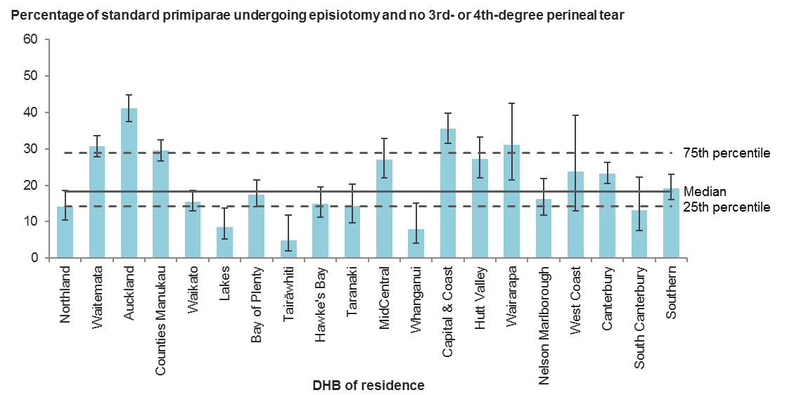

Error bars represent 95% confidence intervals.

Figure 16: Percentage of standard primiparae giving birth vaginally and undergoing episiotomy without third- or fourth-degree tear, by facility of birth (secondary and tertiary facilities), 2017

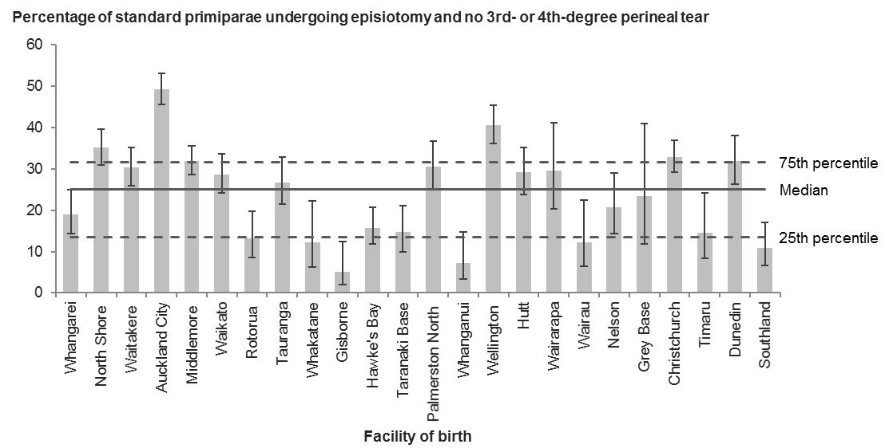

Error bars represent 95% confidence intervals.

Table 15: Number and percentage of standard primiparae giving birth vaginally and undergoing episiotomy without third- or fourth-degree tear, by district health board of residence, 2017

|  |  |  |  |
| --- | --- | --- | --- |
| **DHB of residence** | **Episiotomy without 3rd- or 4th-degree tear** | **Standard primiparae giving birth vaginally** | **Rate (%)** |
| Northland | 41 | 291 | 14.1 |
| Waitemata | 292 | 953 | 30.6 |
| Auckland | 278 | 677 | 41.1 |
| Counties Manukau | 279 | 946 | 29.5 |
| Waikato | 104 | 669 | 15.5 |
| Lakes | 15 | 175 | 8.6 |
| Bay of Plenty | 69 | 395 | 17.5 |
| Tairāwhiti | 4 | 82 | 4.9 |
| Hawke’s Bay | 42 | 283 | 14.8 |
| Taranaki | 24 | 168 | 14.3 |
| MidCentral | 72 | 266 | 27.1 |
| Whanganui | 8 | 100 | 8.0 |
| Capital & Coast | 179 | 505 | 35.4 |
| Hutt Valley | 67 | 246 | 27.2 |
| Wairarapa | 22 | 71 | 31.0 |
| Nelson Marlborough | 33 | 204 | 16.2 |
| West Coast | 9 | 38 | 23.7 |
| Canterbury | 193 | 831 | 23.2 |
| South Canterbury | 11 | 83 | 13.3 |
| Southern | 95 | 494 | 19.2 |
| Unknown | 1 | 14 | – |
| **New Zealand** | **1,838** | **7,491** | **24.5** |

Table 16: Number and percentage of standard primiparae giving birth vaginally and undergoing episiotomy without third- or fourth-degree tear, by facility of birth (secondary and tertiary facilities), 2017

|  |  |  |  |
| --- | --- | --- | --- |
| **Place of birth** | **Episiotomy without 3rd- or 4th-degree tear** | **Standard primiparae giving birth vaginally** | **Rate (%)** |
| Whangarei | 39 | 205 | 19.0 |
| North Shore | 163 | 465 | 35.1 |
| Waitakere | 115 | 379 | 30.3 |
| Auckland City | 341 | 693 | 49.2 |
| Middlemore | 218 | 683 | 31.9 |
| Waikato | 98 | 343 | 28.6 |
| Rotorua | 18 | 137 | 13.1 |
| Tauranga | 62 | 232 | 26.7 |
| Whakatane | 8 | 66 | 12.1 |
| Gisborne | 4 | 78 | 5.1 |
| Hawke’s Bay | 41 | 261 | 15.7 |
| Taranaki Base | 23 | 157 | 14.6 |
| Palmerston North | 73 | 239 | 30.5 |
| Whanganui | 6 | 84 | 7.1 |
| Wellington | 172 | 424 | 40.6 |
| Hutt | 69 | 237 | 29.1 |
| Wairarapa | 21 | 71 | 29.6 |
| Wairau | 8 | 65 | 12.3 |
| Nelson | 24 | 116 | 20.7 |
| Grey Base | 7 | 30 | 23.3 |
| Christchurch | 190 | 578 | 32.9 |
| Timaru | 11 | 76 | 14.5 |
| Dunedin | 76 | 239 | 31.8 |
| Southland | 15 | 139 | 10.8 |
| **All secondary and tertiary facilities** | **1,802** | **5,997** | **30.0** |
| **All primary facilities** | **36** | **1,233** | **2.9** |
| **All home births1** | **0** | **261** | **0.0** |
| **New Zealand2** | **1,838** | **7,491** | **24.5** |

1 For the purposes of this indicator, all women giving birth at home are counted as having had a spontaneous vaginal birth without an episiotomy. The rate presented may not reflect the true rate due to this assumption.

2 Includes women where birth location was unspecified.

## Indicator 8: Third- or fourth-degree tear and no episiotomy among standard primiparae giving birth vaginally, 2017

Figure 17: Percentage of standard primiparae giving birth vaginally sustaining a third- or fourth-degree tear and not undergoing episiotomy, by district health board of residence, 2017

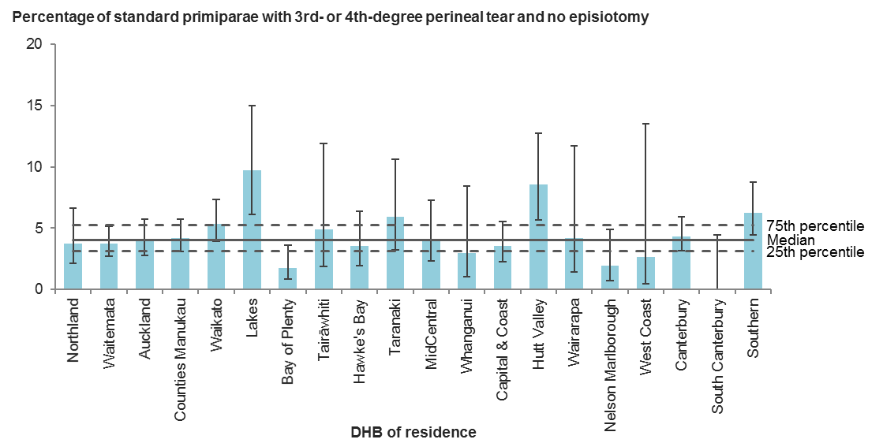

Error bars represent 95% confidence intervals.

Figure 18: Percentage of standard primiparae giving birth vaginally sustaining a third- or fourth-degree tear and not undergoing episiotomy, by facility of birth (secondary and tertiary facilities), 2017

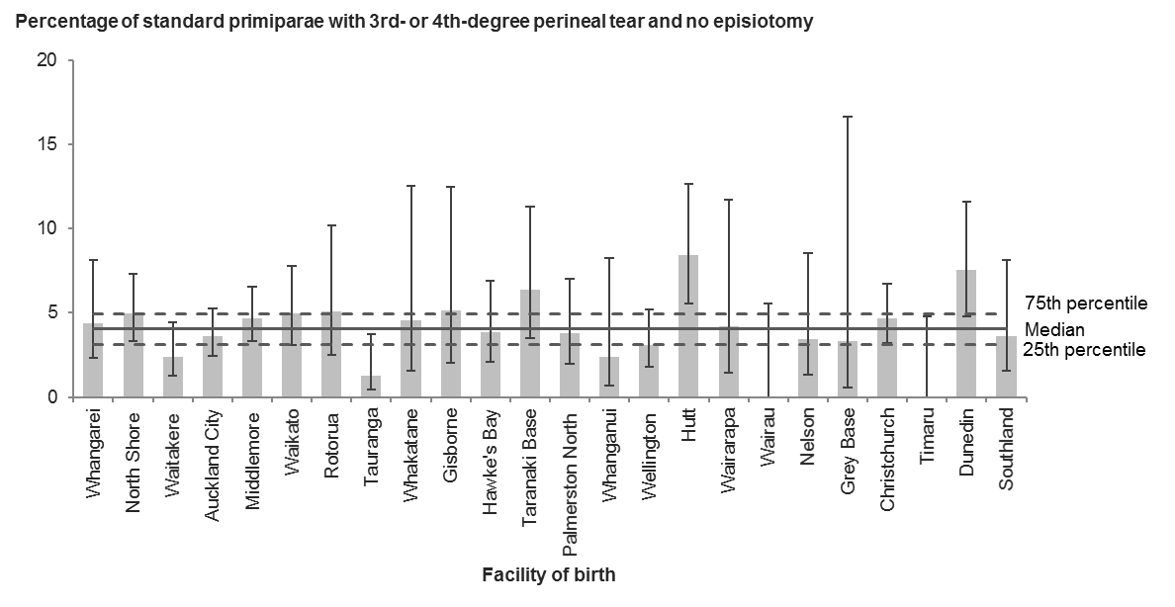

Error bars represent 95% confidence intervals.

Table 17: Number and percentage of standard primiparae giving birth vaginally sustaining a third- or fourth-degree tear and not undergoing episiotomy, by district health board of residence, 2017

|  |  |  |  |
| --- | --- | --- | --- |
| **DHB of residence** | **3rd- or 4th-degree tear without episiotomy** | **Standard primiparae giving birth vaginally** | **Rate (%)** |
| Northland | 11 | 291 | 3.8 |
| Waitemata | 36 | 953 | 3.8 |
| Auckland | 27 | 677 | 4.0 |
| Counties Manukau | 40 | 946 | 4.2 |
| Waikato | 36 | 669 | 5.4 |
| Lakes | 17 | 175 | 9.7 |
| Bay of Plenty | 7 | 395 | 1.8 |
| Tairāwhiti | 4 | 82 | 4.9 |
| Hawke’s Bay | 10 | 283 | 3.5 |
| Taranaki | 10 | 168 | 6.0 |
| MidCentral | 11 | 266 | 4.1 |
| Whanganui | 3 | 100 | 3.0 |
| Capital & Coast | 18 | 505 | 3.6 |
| Hutt Valley | 21 | 246 | 8.5 |
| Wairarapa | 3 | 71 | 4.2 |
| Nelson Marlborough | 4 | 204 | 2.0 |
| West Coast | 1 | 38 | 2.6 |
| Canterbury | 36 | 831 | 4.3 |
| South Canterbury | 0 | 83 | 0.0 |
| Southern | 31 | 494 | 6.3 |
| Unknown | 0 | 14 | – |
| **New Zealand** | **326** | **7,491** | **4.4** |

Table 18: Number and percentage of standard primiparae giving birth vaginally sustaining a third- or fourth-degree tear and not undergoing episiotomy, by facility of birth (secondary and tertiary facilities), 2017

|  |  |  |  |
| --- | --- | --- | --- |
| **Place of birth** | **3rd- or 4th-degree tear without episiotomy** | **Standard primiparae giving birth vaginally** | **Rate (%)** |
| Whangarei | 9 | 205 | 4.4 |
| North Shore | 23 | 465 | 4.9 |
| Waitakere | 9 | 379 | 2.4 |
| Auckland City | 25 | 693 | 3.6 |
| Middlemore | 32 | 683 | 4.7 |
| Waikato | 17 | 343 | 5.0 |
| Rotorua | 7 | 137 | 5.1 |
| Tauranga | 3 | 232 | 1.3 |
| Whakatane | 3 | 66 | 4.5 |
| Gisborne | 4 | 78 | 5.1 |
| Hawke’s Bay | 10 | 261 | 3.8 |
| Taranaki Base | 10 | 157 | 6.4 |
| Palmerston North | 9 | 239 | 3.8 |
| Whanganui | 2 | 84 | 2.4 |
| Wellington | 13 | 424 | 3.1 |
| Hutt | 20 | 237 | 8.4 |
| Wairarapa | 3 | 71 | 4.2 |
| Wairau | 0 | 65 | 0.0 |
| Nelson | 4 | 116 | 3.4 |
| Grey Base | 1 | 30 | 3.3 |
| Christchurch | 27 | 578 | 4.7 |
| Timaru | 0 | 76 | 0.0 |
| Dunedin | 18 | 239 | 7.5 |
| Southland | 5 | 139 | 3.6 |
| **All secondary and tertiary facilities** | **254** | **5,997** | **4.2** |
| **All primary facilities** | **63** | **1,233** | **5.1** |
| **All home births** | **9** | **261** | **3.4** |
| **New Zealand1** | **326** | **7,491** | **4.4** |

1 Includes women where birth location was unspecified.

## Indicator 9: Episiotomy and third- or fourth-degree tear among standard primiparae giving birth vaginally, 2017

Figure 19: Percentage of standard primiparae giving birth vaginally undergoing episiotomy and sustaining a third- or fourth-degree tear, by district health board of residence, 2017

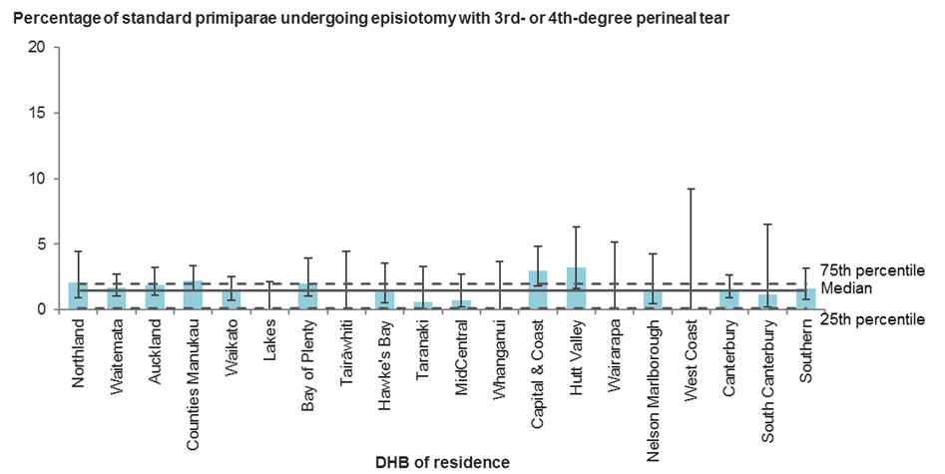

Error bars represent 95% confidence intervals.

Figure 20: Percentage of standard primiparae giving birth vaginally undergoing episiotomy and sustaining a third- or fourth-degree tear, by facility of birth (secondary and tertiary facilities), 2017

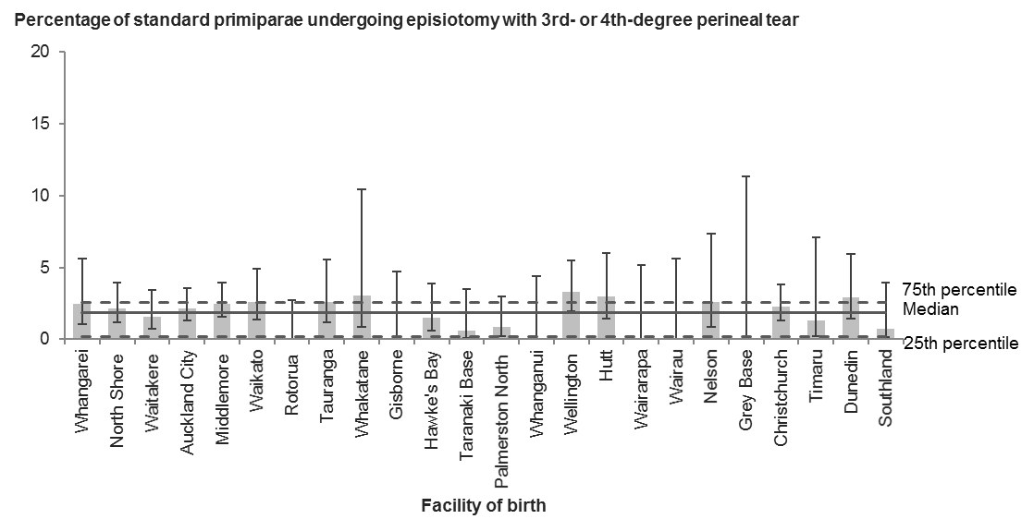

Error bars represent 95% confidence intervals.

Table 19: Number and percentage of standard primiparae giving birth vaginally undergoing episiotomy and sustaining a third- or fourth-degree tear, by district health board of residence, 2017

|  |  |  |  |
| --- | --- | --- | --- |
| **DHB of residence** | **Episiotomy with 3rd- or 4th-degree tear** | **Standard primiparae giving birth vaginally** | **Rate (%)** |
| Northland | 6 | 291 | 2.1 |
| Waitemata | 16 | 953 | 1.7 |
| Auckland | 13 | 677 | 1.9 |
| Counties Manukau | 21 | 946 | 2.2 |
| Waikato | 9 | 669 | 1.3 |
| Lakes | 0 | 175 | 0.0 |
| Bay of Plenty | 8 | 395 | 2.0 |
| Tairāwhiti | 0 | 82 | 0.0 |
| Hawke’s Bay | 4 | 283 | 1.4 |
| Taranaki | 1 | 168 | 0.6 |
| MidCentral | 2 | 266 | 0.8 |
| Whanganui | 0 | 100 | 0.0 |
| Capital & Coast | 15 | 505 | 3.0 |
| Hutt Valley | 8 | 246 | 3.3 |
| Wairarapa | 0 | 71 | 0.0 |
| Nelson Marlborough | 3 | 204 | 1.5 |
| West Coast | 0 | 38 | 0.0 |
| Canterbury | 13 | 831 | 1.6 |
| South Canterbury | 1 | 83 | 1.2 |
| Southern | 8 | 494 | 1.6 |
| Unknown | 0 | 14 | – |
| **New Zealand** | **128** | **7,491** | **1.7** |

Table 20: Number and percentage of standard primiparae giving birth vaginally undergoing episiotomy and sustaining a third- or fourth-degree tear, by facility of birth (secondary and tertiary facilities), 2017

|  |  |  |  |
| --- | --- | --- | --- |
| **Place of birth** | **Episiotomy with 3rd- or 4th-degree tear** | **Standard primiparae giving birth vaginally** | **Rate (%)** |
| Whangarei | 5 | 205 | 2.4 |
| North Shore | 10 | 465 | 2.2 |
| Waitakere | 6 | 379 | 1.6 |
| Auckland City | 15 | 693 | 2.2 |
| Middlemore | 17 | 683 | 2.5 |
| Waikato | 9 | 343 | 2.6 |
| Rotorua | 0 | 137 | 0.0 |
| Tauranga | 6 | 232 | 2.6 |
| Whakatane | 2 | 66 | 3.0 |
| Gisborne | 0 | 78 | 0.0 |
| Hawke’s Bay | 4 | 261 | 1.5 |
| Taranaki Base | 1 | 157 | 0.6 |
| Palmerston North | 2 | 239 | 0.8 |
| Whanganui | 0 | 84 | 0.0 |
| Wellington | 14 | 424 | 3.3 |
| Hutt | 7 | 237 | 3.0 |
| Wairarapa | 0 | 71 | 0.0 |
| Wairau | 0 | 65 | 0.0 |
| Nelson | 3 | 116 | 2.6 |
| Grey Base | 0 | 30 | 0.0 |
| Christchurch | 13 | 578 | 2.2 |
| Timaru | 1 | 76 | 1.3 |
| Dunedin | 7 | 239 | 2.9 |
| Southland | 1 | 139 | 0.7 |
| **All secondary and tertiary facilities** | **123** | **5,997** | **2.1** |
| **All primary facilities** | **5** | **1,233** | **0.4** |
| **All home births** | **0** | **261** | **0.0** |
| **New Zealand1** | **128** | **7,491** | **1.7** |

1 Includes women where birth location was unspecified.

# Indicator 10: General anaesthetic for women giving birth by caesarean section

## Rationale and purpose

Although the risks of general anaesthetic for caesarean section have reduced greatly in recent decades, regional anaesthetic is still safer than general anaesthetic because it results in less maternal and neonatal morbidity (Australian Council on Healthcare Standards 2008, p 474).

Maternity service providers will continue to perform a proportion of caesarean sections under general anaesthetic because of factors such as patient preference, as well as in some high-risk cases (such as if a woman has pre-eclampsia) when only general anaesthetic can be used. Providers are more likely to use general anaesthetic when they do caesarean sections urgently; factors affecting this can include the configuration and organisation of obstetric and anaesthetic services (for example, whether a specialist anaesthetist is on site) and the level of antenatal care a woman has received.

The objective of this indicator is to encourage services that have higher-than-average rates of general anaesthetic for caesarean sections to undertake further investigation to determine the causes of these higher rates and evaluate whether they are justified.

## Notes on 2017 data

Rates of general anaesthetic use in caesarean section deliveries ranged from 5.1 percent to 13.1 percent across DHBs, and from 3.8 percent to 13.6 percent across secondary and tertiary facilities. These rates are based on small numbers, so caution must be used when making comparisons.

Maternity service providers that are outliers in terms of these figures should review their rates of general anaesthetic for caesarean sections and consider the impact of the ratio between emergency and elective caesarean section rates. Providers should further investigate the reasons for higher rates of general anaesthetic for emergency caesarean sections, to ensure their practice represents the best possible quality of care for women and their babies.

## Indicator 10: General anaesthetic for women giving birth by caesarean section, 2017

Figure 21: Percentage of women undergoing a caesarean section under general anaesthetic, by district health board of residence, 2017

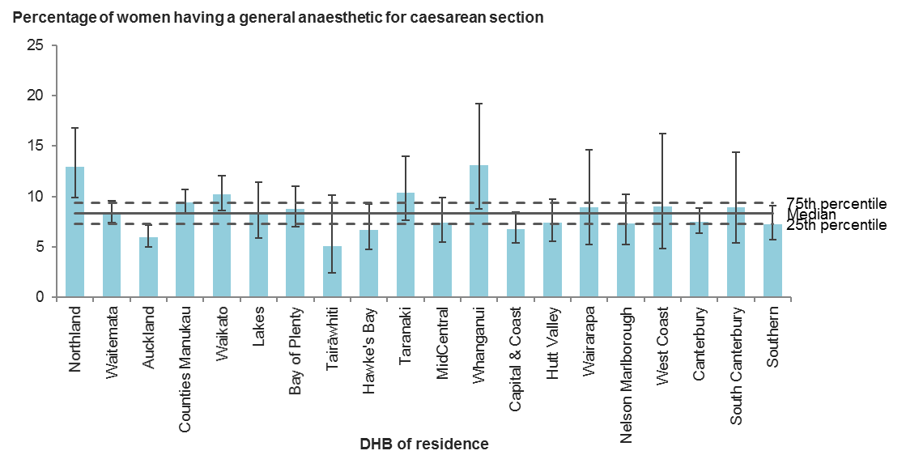

Error bars represent 95% confidence intervals.

Figure 22: Percentage of women undergoing a caesarean section under general anaesthetic, by facility of birth (secondary and tertiary facilities), 2017

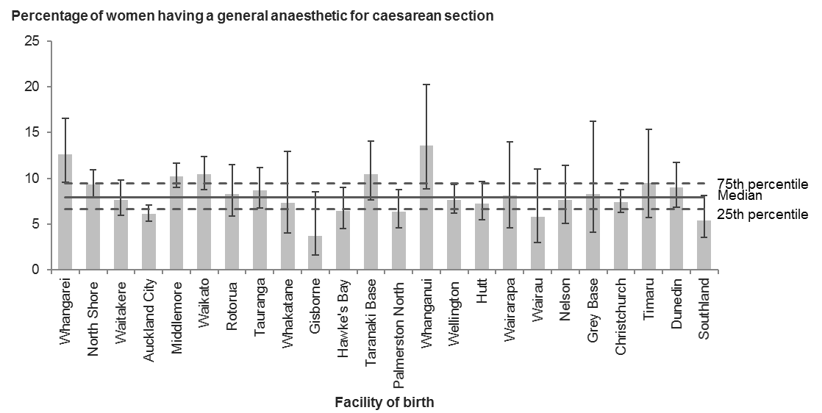

Error bars represent 95% confidence intervals.

Table 21: Number and percentage of women undergoing a caesarean section under general anaesthetic, by district health board of residence, 2017

|  |  |  |  |
| --- | --- | --- | --- |
| **DHB of residence** | **Caesarean sections under general anaesthetic** | **All caesarean sections** | **Rate (%)** |
| Northland | 48 | 370 | 13.0 |
| Waitemata | 209 | 2,487 | 8.4 |
| Auckland | 116 | 1,931 | 6.0 |
| Counties Manukau | 224 | 2,369 | 9.5 |
| Waikato | 118 | 1,156 | 10.2 |
| Lakes | 32 | 388 | 8.2 |
| Bay of Plenty | 68 | 772 | 8.8 |
| Tairāwhiti | 7 | 138 | 5.1 |
| Hawke’s Bay | 33 | 493 | 6.7 |
| Taranaki | 37 | 357 | 10.4 |
| MidCentral | 42 | 567 | 7.4 |
| Whanganui | 21 | 160 | 13.1 |
| Capital & Coast | 70 | 1,031 | 6.8 |
| Hutt Valley | 46 | 623 | 7.4 |
| Wairarapa | 13 | 146 | 8.9 |
| Nelson Marlborough | 31 | 423 | 7.3 |
| West Coast | 9 | 100 | 9.0 |
| Canterbury | 129 | 1,715 | 7.5 |
| South Canterbury | 14 | 157 | 8.9 |
| Southern | 66 | 912 | 7.2 |
| Unknown | 2 | 15 | – |
| **New Zealand** | **1,335** | **16,310** | **8.2** |

Table 22: Number and percentage of women undergoing a caesarean section under general anaesthetic, by facility of birth (secondary and tertiary facilities), 2017

|  |  |  |  |
| --- | --- | --- | --- |
| **Place of birth** | **Caesarean sections under general anaesthetic** | **All caesarean sections** | **Rate (%)** |
| Whangarei | 44 | 348 | 12.6 |
| North Shore | 136 | 1,458 | 9.3 |
| Waitakere | 56 | 728 | 7.7 |
| Auckland City | 165 | 2,688 | 6.1 |
| Middlemore | 205 | 2,001 | 10.2 |
| Waikato | 120 | 1,148 | 10.5 |
| Rotorua | 31 | 375 | 8.3 |
| Tauranga | 54 | 620 | 8.7 |
| Whakatane | 10 | 137 | 7.3 |
| Gisborne | 5 | 133 | 3.8 |
| Hawke’s Bay | 31 | 482 | 6.4 |
| Taranaki Base | 36 | 345 | 10.4 |
| Palmerston North | 35 | 549 | 6.4 |
| Whanganui | 19 | 140 | 13.6 |
| Wellington | 86 | 1,129 | 7.6 |
| Hutt | 44 | 605 | 7.3 |
| Wairarapa | 11 | 135 | 8.1 |
| Wairau | 8 | 138 | 5.8 |
| Nelson | 21 | 274 | 7.7 |
| Grey Base | 7 | 84 | 8.3 |
| Christchurch | 128 | 1,724 | 7.4 |
| Timaru | 14 | 147 | 9.5 |
| Dunedin | 48 | 531 | 9.0 |
| Southland | 21 | 386 | 5.4 |
| **All secondary and tertiary facilities** | **1,335** | **16,305** | **8.2** |
| **All primary facilities** | **0** | **4** | **0.0** |
| **All home births** | **0** | **0** | **0.0** |
| **New Zealand1** | **1,335** | **16,310** | **8.2** |

1 Includes women where birth location was unspecified.

# Indicators 11 and 12: Blood transfusion during birth admission

## Rationale and purpose

These indicators look at the way maternity providers handle excessive blood loss in women who have just given birth, also known as postpartum haemorrhage. According to the Australian Council on Healthcare Standards (2008), ‘postpartum haemorrhage (PPH) is a potentially life-threatening complication of birth that occurs in about 3−5% of vaginal births [and globally] remains a leading cause of maternal morbidity and mortality’ (p 480). Excessive blood loss is often defined as an amount in excess of 1000 mL, although accuracy of measurement at this level is questionable, especially as the blood loss is often cumulative. A different and (some suggest) more objective measure is whether there is a requirement for blood transfusion due to excessive blood loss during or following birth. This measurement is also not without difficulties; for example, decisions to perform blood transfusions depend on individual levels of patient tolerance, and some patients refuse a transfusion for religious or other beliefs. However, as a broad measure of excessive blood loss and potential long-term morbidity due to that blood loss, this indicator is a useful measure of severe, life-threatening PPH.

This indicator aims to provide maternity service providers with an indicator of significant blood loss that will stimulate further investigation of clinical management and intervention. All maternity service providers should be familiar with the national consensus guideline for treatment of PPH (Ministry of Health 2013).

## Notes on 2017 data

District health boards should investigate the reasons behind the greater variation in rates of blood transfusion with caesarean section and vaginal birth. They need to consider the impact of high elective caesarean section rates on any differences between rates for elective and emergency caesarean sections. Because these indicators are markers for PPH and for management of anaemia, the focus should be on understanding and addressing the underlying causes of bleeding.

## Indicator 11: Blood transfusion during birth admission for caesarean section delivery, 2017

Figure 23: Percentage of women giving birth by caesarean section and undergoing blood transfusion during birth admission, by district health board of residence, 2017

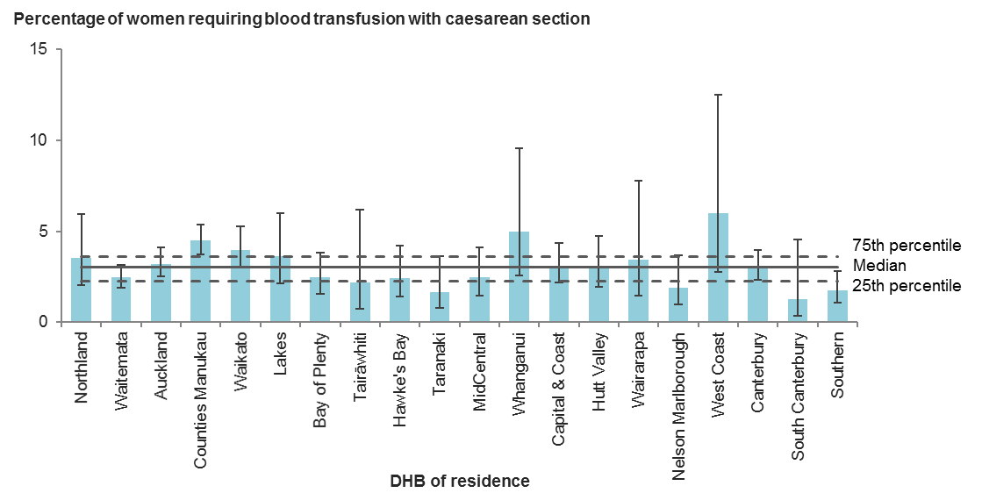

Error bars represent 95% confidence intervals.

Figure 24: Percentage of women giving birth by caesarean section and undergoing blood transfusion during birth admission, by facility of birth (secondary and tertiary facilities), 2017

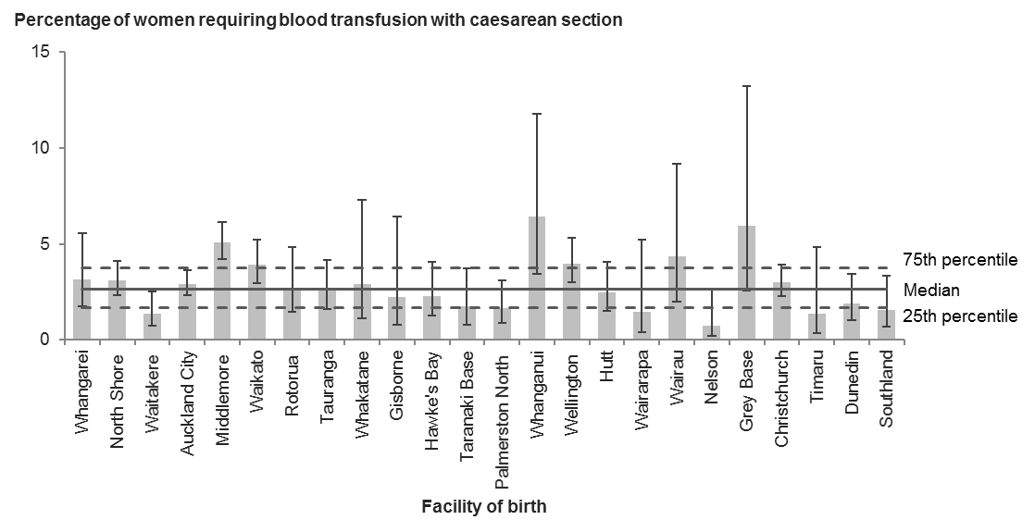

Error bars represent 95% confidence intervals.

Table 23: Number and percentage of women giving birth by caesarean section and undergoing blood transfusion during birth admission, by district health board of residence, 2017

|  |  |  |  |
| --- | --- | --- | --- |
| **DHB of residence** | **Caesarean sections with blood transfusion** | **All caesarean sections** | **Rate (%)** |
| Northland | 13 | 370 | 3.5 |
| Waitemata | 61 | 2,487 | 2.5 |
| Auckland | 62 | 1,931 | 3.2 |
| Counties Manukau | 106 | 2,369 | 4.5 |
| Waikato | 46 | 1,156 | 4.0 |
| Lakes | 14 | 388 | 3.6 |
| Bay of Plenty | 19 | 772 | 2.5 |
| Tairāwhiti | 3 | 138 | 2.2 |
| Hawke’s Bay | 12 | 493 | 2.4 |
| Taranaki | 6 | 357 | 1.7 |
| MidCentral | 14 | 567 | 2.5 |
| Whanganui | 8 | 160 | 5.0 |
| Capital & Coast | 32 | 1,031 | 3.1 |
| Hutt Valley | 19 | 623 | 3.0 |
| Wairarapa | 5 | 146 | 3.4 |
| Nelson Marlborough | 8 | 423 | 1.9 |
| West Coast | 6 | 100 | 6.0 |
| Canterbury | 52 | 1,715 | 3.0 |
| South Canterbury | 2 | 157 | 1.3 |
| Southern | 16 | 912 | 1.8 |
| Unknown | 0 | 15 | – |
| **New Zealand** | **504** | **16,310** | **3.1** |

Table 24: Number and percentage of women giving birth by caesarean section and undergoing blood transfusion during birth admission, by facility of birth (secondary and tertiary facilities), 2017

|  |  |  |  |
| --- | --- | --- | --- |
| **Place of birth** | **Caesarean sections with blood transfusion** | **All caesarean sections** | **Rate (%)** |
| Whangarei | 11 | 348 | 3.2 |
| North Shore | 45 | 1,458 | 3.1 |
| Waitakere | 10 | 728 | 1.4 |
| Auckland City | 78 | 2,688 | 2.9 |
| Middlemore | 102 | 2,001 | 5.1 |
| Waikato | 45 | 1,148 | 3.9 |
| Rotorua | 10 | 375 | 2.7 |
| Tauranga | 16 | 620 | 2.6 |
| Whakatane | 4 | 137 | 2.9 |
| Gisborne | 3 | 133 | 2.3 |
| Hawke’s Bay | 11 | 482 | 2.3 |
| Taranaki Base | 6 | 345 | 1.7 |
| Palmerston North | 9 | 549 | 1.6 |
| Whanganui | 9 | 140 | 6.4 |
| Wellington | 45 | 1,129 | 4.0 |
| Hutt | 15 | 605 | 2.5 |
| Wairarapa | 2 | 135 | 1.5 |
| Wairau | 6 | 138 | 4.3 |
| Nelson | 2 | 274 | 0.7 |
| Grey Base | 5 | 84 | 6.0 |
| Christchurch | 52 | 1,724 | 3.0 |
| Timaru | 2 | 147 | 1.4 |
| Dunedin | 10 | 531 | 1.9 |
| Southland | 6 | 386 | 1.6 |
| **All secondary and tertiary facilities** | **504** | **16,305** | **3.1** |
| **All primary facilities** | **0** | **4** | **0.0** |
| **All home births** | **0** | **0** | **0.0** |
| **New Zealand1** | **504** | **16,310** | **3.1** |

1 Includes women where birth location was unspecified.

## Indicator 12: Blood transfusion during birth admission for vaginal birth, 2017

Figure 25: Percentage of women giving birth vaginally and undergoing blood transfusion during birth admission, by district health board of residence, 2017

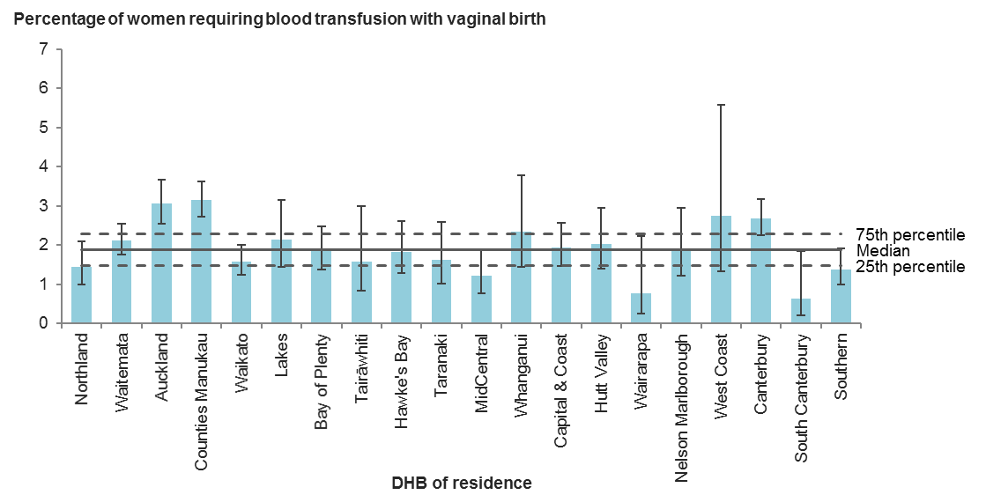

Error bars represent 95% confidence intervals.

Figure 26: Percentage of women giving birth vaginally and undergoing blood transfusion during birth admission, by facility of birth (secondary and tertiary facilities), 2017

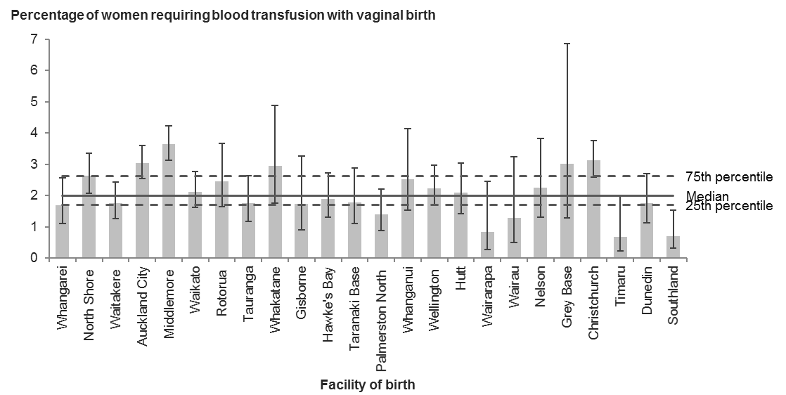

Error bars represent 95% confidence intervals.

Table 25: Number and percentage of women giving birth vaginally and undergoing blood transfusion during birth admission, by district health board of residence, 2017

|  |  |  |  |
| --- | --- | --- | --- |
| **DHB of residence** | **Vaginal births with blood transfusion** | **All vaginal births** | **Rate (%)** |
| Northland | 27 | 1,872 | 1.4 |
| Waitemata | 111 | 5,231 | 2.1 |
| Auckland | 113 | 3,698 | 3.1 |
| Counties Manukau | 186 | 5,904 | 3.2 |
| Waikato | 66 | 4,161 | 1.6 |
| Lakes | 25 | 1,166 | 2.1 |
| Bay of Plenty | 43 | 2,327 | 1.8 |
| Tairāwhiti | 9 | 566 | 1.6 |
| Hawke’s Bay | 30 | 1,637 | 1.8 |
| Taranaki | 17 | 1,044 | 1.6 |
| MidCentral | 19 | 1,566 | 1.2 |
| Whanganui | 16 | 683 | 2.3 |
| Capital & Coast | 48 | 2,461 | 2.0 |
| Hutt Valley | 27 | 1,327 | 2.0 |
| Wairarapa | 3 | 390 | 0.8 |
| Nelson Marlborough | 19 | 999 | 1.9 |
| West Coast | 7 | 254 | 2.8 |
| Canterbury | 125 | 4,679 | 2.7 |
| South Canterbury | 3 | 475 | 0.6 |
| Southern | 35 | 2,525 | 1.4 |
| Unknown | 7 | 373 | – |
| **New Zealand** | **936** | **43,338** | **2.2** |

Table 26: Number and percentage of women giving birth vaginally and undergoing blood transfusion during birth admission, by facility of birth (secondary and tertiary facilities), 2017

|  |  |  |  |
| --- | --- | --- | --- |
| **Place of birth** | **Vaginal births with blood transfusion** | **All vaginal births** | **Rate (%)** |
| Whangarei | 21 | 1,240 | 1.7 |
| North Shore | 66 | 2,493 | 2.6 |
| Waitakere | 35 | 1,991 | 1.8 |
| Auckland City | 125 | 4,111 | 3.0 |
| Middlemore | 162 | 4,443 | 3.6 |
| Waikato | 51 | 2,402 | 2.1 |
| Rotorua | 23 | 933 | 2.5 |
| Tauranga | 23 | 1,302 | 1.8 |
| Whakatane | 14 | 475 | 2.9 |
| Gisborne | 9 | 517 | 1.7 |
| Hawke’s Bay | 28 | 1,473 | 1.9 |
| Taranaki Base | 16 | 895 | 1.8 |
| Palmerston North | 18 | 1,287 | 1.4 |
| Whanganui | 15 | 593 | 2.5 |
| Wellington | 47 | 2,100 | 2.2 |
| Hutt | 26 | 1,242 | 2.1 |
| Wairarapa | 3 | 353 | 0.8 |
| Wairau | 4 | 312 | 1.3 |
| Nelson | 13 | 577 | 2.3 |
| Grey Base | 5 | 166 | 3.0 |
| Christchurch | 109 | 3,493 | 3.1 |
| Timaru | 3 | 440 | 0.7 |
| Dunedin | 20 | 1,140 | 1.8 |
| Southland | 6 | 853 | 0.7 |
| **All secondary and tertiary facilities** | **842** | **34,831** | **2.4** |
| **All primary facilities** | **54** | **5,882** | **0.9** |
| **All home births** | **25** | **1,992** | **1.3** |
| **New Zealand1** | **936** | **43,338** | **2.2** |

1 Includes women where birth location was unspecified.

# Indicators 13 to 15: Severe maternal morbidity

## Rationale and purpose

Maternity systems have long monitored maternal mortality as an indicator of their safety and quality. However, the number of maternal deaths in any given year is low. The impact of severe morbidity is significant and long term, of high personal cost to a woman and her family and of high financial cost to the health system. Monitoring severe morbidity allows a view of a larger (but still limited) set of cases that might provide a broader picture of the true impact of adverse outcomes in maternity in New Zealand and allow individual units to benchmark whether their rates of severe morbidity are consistent with those in other units. Cases of severe maternal morbidity should be subject to local multidisciplinary review for quality improvement purposes.

## Eclampsia (indicator 13)

Pre-eclampsia is a disorder of pregnancy characterised by [high blood pressure](http://en.wikipedia.org/wiki/Hypertension) and [protein in the urine](http://en.wikipedia.org/wiki/Proteinuria). Pre-eclampsia affects between 2 percent and 8 percent of pregnancies worldwide. Eclampsia is a serious complication of pre-eclampsia and results in high rates of perinatal and maternal morbidity and mortality (WHO 2011). Eclampsia is considered preventable through early detection and management of pre‑eclampsia. The purpose of this indicator is to drive local investigation, including case review, into the appropriate diagnosis and management of pre-eclampsia with a view to decreasing the incidence of eclampsia.

## Peripartum hysterectomy (indicator 14)

Peripartum hysterectomy is a surgical intervention usually only performed to save a woman’s life, and usually when uncontrollable obstetric haemorrhage or extensive uterine rupture complicates birth. It is a marker of severe maternal morbidity, and may indicate the failure of upstream interventions to prevent and manage antecedents such as haemorrhage or prolonged obstructed labour. The purpose of this indicator is to drive local investigation including case review to reduce the need for this significant surgery.

## Mechanical ventilation (indicator 15)

Mechanical ventilation for greater than 24 hours of a pregnant or postpartum woman is a marker of severe maternal morbidity that does not distinguish by cause. It denotes a high degree of severity, and its measurement is more sensitive than measurement of intensive/special care unit admissions, as it is not dependent on local layout of facilities. The purpose of this indicator is to drive local investigation including case review of the reasons for mechanical ventilation of a pregnant or postpartum woman to identify opportunities to prevent or reduce severe maternal and perinatal morbidity.

## Notes on 2017 data

Of women giving birth in 2017:

* 17 were diagnosed with eclampsia during the birth admission
* 29 had a peripartum hysterectomy
* 11 were admitted to an ICU and required over 24 hours of mechanical ventilation at some time during their pregnancy or postnatal period.

District health boards with cases pertaining to these indicators should investigate each case to confirm the accuracy of the data and to determine whether there were opportunities for prevention.

## Indicator 13: Diagnosis of eclampsia during birth admission, 2017

Table 27: Number and percentage of women diagnosed with eclampsia during birth admission, by district health board of residence, 2017

|  |  |  |
| --- | --- | --- |
| **DHB of residence** | **Diagnosis of eclampsia during birth admission** | **All women giving birth** |
| Northland | 0 | 2,242 |
| Waitemata | 1 | 7,718 |
| Auckland | 2 | 5,629 |
| Counties Manukau | 4 | 8,273 |
| Waikato | 1 | 5,317 |
| Lakes | 1 | 1,554 |
| Bay of Plenty | 2 | 3,099 |
| Tairāwhiti | 0 | 704 |
| Hawke’s Bay | 1 | 2,130 |
| Taranaki | 0 | 1,401 |
| MidCentral | 1 | 2,133 |
| Whanganui | 0 | 843 |
| Capital & Coast | 1 | 3,492 |
| Hutt Valley | 0 | 1,950 |
| Wairarapa | 0 | 536 |
| Nelson Marlborough | 0 | 1,422 |
| West Coast | 0 | 354 |
| Canterbury | 3 | 6,394 |
| South Canterbury | 0 | 632 |
| Southern | 0 | 3,437 |
| Unknown | 0 | 388 |
| **New Zealand** | **17** | **59,648** |

Table 28: Number and percentage of women diagnosed with eclampsia during birth admission, by facility of birth (secondary and tertiary facilities), 2017

|  |  |  |
| --- | --- | --- |
| **Place of birth** | **Diagnosis of eclampsia during birth admission** | **All women giving birth** |
| Whangarei | 0 | 1,588 |
| North Shore | 2 | 3,951 |
| Waitakere | 0 | 2,719 |
| Auckland City | 2 | 6,799 |
| Middlemore | 3 | 6,444 |
| Waikato | 1 | 3,550 |
| Rotorua | 1 | 1,308 |
| Tauranga | 1 | 1,922 |
| Whakatane | 1 | 612 |
| Gisborne | 0 | 650 |
| Hawke’s Bay | 1 | 1,955 |
| Taranaki Base | 0 | 1,240 |
| Palmerston North | 1 | 1,836 |
| Whanganui | 0 | 733 |
| Wellington | 1 | 3,229 |
| Hutt | 0 | 1,847 |
| Wairarapa | 0 | 488 |
| Wairau | 0 | 450 |
| Nelson | 0 | 851 |
| Grey Base | 0 | 250 |
| Christchurch | 3 | 5,217 |
| Timaru | 0 | 587 |
| Dunedin | 0 | 1,671 |
| Southland | 0 | 1,239 |
| **All secondary and tertiary facilities** | **17** | **51,136** |
| **All primary facilities** | **0** | **5,886** |
| **All home births** | **0** | **1,992** |
| **New Zealand1** | **17** | **59,648** |

1 Includes women where birth location was unspecified.

## Indicator 14: Peripartum hysterectomy, 2017

Table 29: Number and percentage of women having a peripartum hysterectomy, by district health board of residence, 2017

|  |  |  |
| --- | --- | --- |
| **DHB of residence** | **Peripartum hysterectomy** | **All women giving birth** |
| Northland | 1 | 2,242 |
| Waitemata | 3 | 7,718 |
| Auckland | 3 | 5,629 |
| Counties Manukau | 6 | 8,273 |
| Waikato | 2 | 5,317 |
| Lakes | 1 | 1,554 |
| Bay of Plenty | 0 | 3,099 |
| Tairāwhiti | 1 | 704 |
| Hawke’s Bay | 2 | 2,130 |
| Taranaki | 1 | 1,401 |
| MidCentral | 0 | 2,133 |
| Whanganui | 1 | 843 |
| Capital & Coast | 2 | 3,492 |
| Hutt Valley | 0 | 1,950 |
| Wairarapa | 0 | 536 |
| Nelson Marlborough | 0 | 1,422 |
| West Coast | 0 | 354 |
| Canterbury | 2 | 6,394 |
| South Canterbury | 1 | 632 |
| Southern | 3 | 3,437 |
| Unknown | 0 | 388 |
| **New Zealand** | **29** | **59,648** |

Table 30: Number and percentage of women having a peripartum hysterectomy, by facility of birth (secondary and tertiary facilities), 2017

|  |  |  |
| --- | --- | --- |
| **Place of birth** | **Peripartum hysterectomy** | **All women giving birth** |
| Whangarei | 1 | 1,588 |
| North Shore | 1 | 3,951 |
| Waitakere | 1 | 2,719 |
| Auckland City | 7 | 6,799 |
| Middlemore | 4 | 6,444 |
| Waikato | 2 | 3,550 |
| Rotorua | 0 | 1,308 |
| Tauranga | 0 | 1,922 |
| Whakatane | 0 | 612 |
| Gisborne | 1 | 650 |
| Hawke’s Bay | 2 | 1,955 |
| Taranaki Base | 1 | 1,240 |
| Palmerston North | 0 | 1,836 |
| Whanganui | 1 | 733 |
| Wellington | 2 | 3,229 |
| Hutt | 0 | 1,847 |
| Wairarapa | 0 | 488 |
| Wairau | 0 | 450 |
| Nelson | 0 | 851 |
| Grey Base | 0 | 250 |
| Christchurch | 2 | 5,217 |
| Timaru | 1 | 587 |
| Dunedin | 2 | 1,671 |
| Southland | 1 | 1,239 |
| **All secondary and tertiary facilities** | **29** | **51,136** |
| **All primary facilities** | **0** | **5,886** |
| **All home births** | **0** | **1,992** |
| **New Zealand1** | **29** | **59,648** |

1 Includes women where birth location was unspecified.

## Indicator 15: Mechanical ventilation during pregnancy or postnatal period, 2017

Table 31: Number and percentage of women admitted to an intensive care unit and requiring over 24 hours of mechanical ventilation any time during the pregnancy or postnatal period, by district health board of residence, 2017

|  |  |  |
| --- | --- | --- |
| **DHB of residence** | **ICU admission with over 24 hours of mechanical ventilation** | **All women giving birth** |
| Northland | 0 | 2,242 |
| Waitemata | 2 | 7,718 |
| Auckland | 3 | 5,629 |
| Counties Manukau | 1 | 8,273 |
| Waikato | 1 | 5,317 |
| Lakes | 0 | 1,554 |
| Bay of Plenty | 0 | 3,099 |
| Tairāwhiti | 0 | 704 |
| Hawke’s Bay | 0 | 2,130 |
| Taranaki | 0 | 1,401 |
| MidCentral | 0 | 2,133 |
| Whanganui | 1 | 843 |
| Capital & Coast | 0 | 3,492 |
| Hutt Valley | 0 | 1,950 |
| Wairarapa | 0 | 536 |
| Nelson Marlborough | 0 | 1,422 |
| West Coast | 0 | 354 |
| Canterbury | 2 | 6,394 |
| South Canterbury | 1 | 632 |
| Southern | 0 | 3,437 |
| Unknown | 0 | 388 |
| **New Zealand** | **11** | **59,648** |

Table 32: Number and percentage of women admitted to an intensive care unit and requiring over 24 hours of mechanical ventilation any time during the pregnancy or postnatal period, by facility of birth (secondary and tertiary facilities), 2017

|  |  |  |
| --- | --- | --- |
| **Place of birth** | **ICU admission with over 24 hours of mechanical ventilation** | **All women giving birth** |
| Whangarei | 0 | 1,588 |
| North Shore | 2 | 3,951 |
| Waitakere | 0 | 2,719 |
| Auckland City | 2 | 6,799 |
| Middlemore | 0 | 6,444 |
| Waikato | 0 | 3,550 |
| Rotorua | 0 | 1,308 |
| Tauranga | 0 | 1,922 |
| Whakatane | 0 | 612 |
| Gisborne | 0 | 650 |
| Hawke’s Bay | 0 | 1,955 |
| Taranaki Base | 0 | 1,240 |
| Palmerston North | 0 | 1,836 |
| Whanganui | 1 | 733 |
| Wellington | 0 | 3,229 |
| Hutt | 0 | 1,847 |
| Wairarapa | 0 | 488 |
| Wairau | 0 | 450 |
| Nelson | 0 | 851 |
| Grey Base | 0 | 250 |
| Christchurch | 2 | 5,217 |
| Timaru | 1 | 587 |
| Dunedin | 0 | 1,671 |
| Southland | 0 | 1,239 |
| **All secondary and tertiary facilities** | **8** | **51,136** |
| **All primary facilities** | **0** | **5,886** |
| **All home births** | **2** | **1,992** |
| **New Zealand1** | **11** | **59,648** |

1 Includes women where birth location was unspecified.

# Indicator 16: Maternal tobacco use during postnatal period

## Rationale and purpose

Smoking during pregnancy leads to increased carbon monoxide concentration in the blood of both the woman and her baby, resulting in reduced oxygen and nourishment available to the baby. This increases the risk of babies being born with a low birthweight and increases the risk of neonatal mortality, sudden and unexpected death in infancy and long-term respiratory problems for the child (The Quit Group 2004).

This indicator monitors maternal tobacco use at two weeks postnatal, which potentially identifies the number of women who have continued to smoke during pregnancy and following the birth as well as those who have re-commenced smoking following the birth. We can use this indicator to identify how we can support women and families to stop smoking.

Improving rates against this indicator will require providers to ensure they offer coordinated tobacco cessation support during pregnancy and into the postnatal period that meets the needs of local populations. It will require tobacco cessation services to work closely with LMCs and DHB maternity services.

## Notes on 2017 data

Rates of maternal tobacco use in the postnatal period (measured at two weeks after birth) varied between DHBs and between secondary and tertiary facility of birth; DHB rates ranged from 1.9 percent to 22.8 percent, and facility rates ranged from 1.1 percent to 30.3 percent. District health boards and facilities with higher rates should undertake further investigation into their provision of appropriate smoking cessation services and development of new initiatives to support smoking cessation among pregnant and postpartum women, particularly among population groups known to have high rates of tobacco use.

This indicator currently presents tobacco use information from women registered with an LMC or a DHB primary maternity service. Completeness of this data varies between DHBs. In 2017, completeness ranged from 59 percent to 97 percent of all women giving birth. Data completeness was over 90 percent for 15 of the 20 DHBs.

## Indicator 16: Maternal tobacco use during postnatal period, 2017

Figure 27: Percentage of women identified as smokers during postnatal period (two weeks after birth), by district health board of residence, 2017

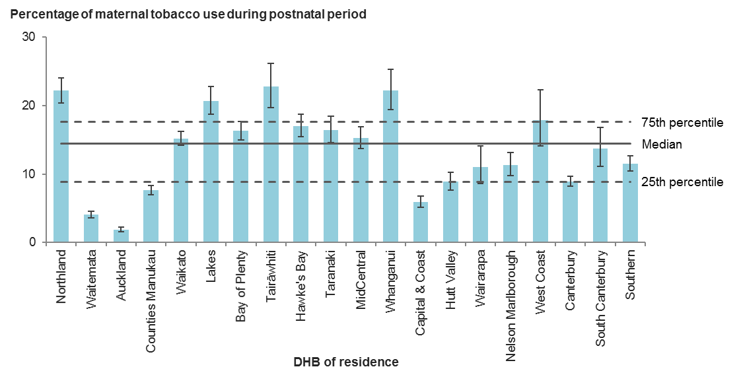

Error bars represent 95% confidence intervals.

Figure 28: Percentage of women identified as smokers during postnatal period (two weeks after birth), by facility of birth (secondary and tertiary facilities), 2017

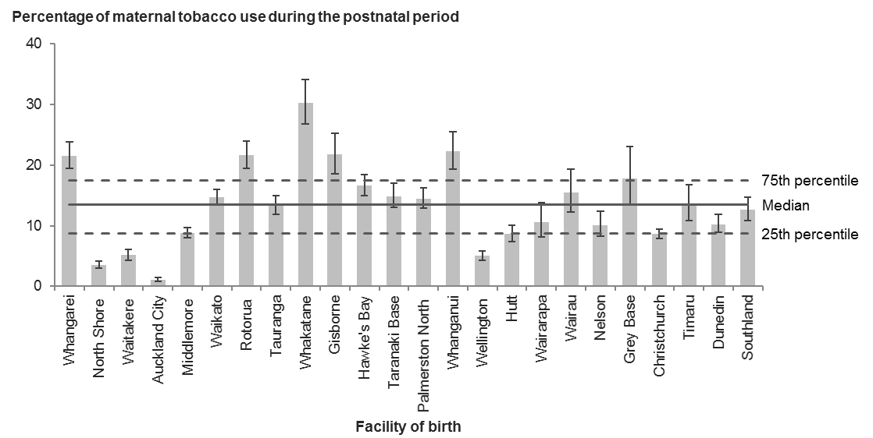

Error bars represent 95% confidence intervals.

Table 33: Number and percentage of women identified as smokers during postnatal period (two weeks after birth), by district health board of residence, 2017

|  |  |  |  |
| --- | --- | --- | --- |
| **DHB of residence** | **Women identified as smokers at 2 weeks after birth** | **All women with reported smoking status at 2 weeks after birth** | **Rate (%)** |
| Northland | 445 | 2,009 | 22.2 |
| Waitemata | 294 | 7,258 | 4.1 |
| Auckland | 97 | 5,173 | 1.9 |
| Counties Manukau | 454 | 5,967 | 7.6 |
| Waikato | 758 | 5,003 | 15.2 |
| Lakes | 308 | 1,491 | 20.7 |
| Bay of Plenty | 488 | 3,000 | 16.3 |
| Tairāwhiti | 147 | 646 | 22.8 |
| Hawke’s Bay | 338 | 1,987 | 17.0 |
| Taranaki | 225 | 1,373 | 16.4 |
| MidCentral | 301 | 1,976 | 15.2 |
| Whanganui | 169 | 763 | 22.1 |
| Capital & Coast | 192 | 3,253 | 5.9 |
| Hutt Valley | 159 | 1,794 | 8.9 |
| Wairarapa | 55 | 498 | 11.0 |
| Nelson Marlborough | 150 | 1,324 | 11.3 |
| West Coast | 60 | 337 | 17.8 |
| Canterbury | 555 | 6,208 | 8.9 |
| South Canterbury | 76 | 556 | 13.7 |
| Southern | 379 | 3,294 | 11.5 |
| Unknown | 31 | 250 | – |
| **New Zealand** | **5,681** | **54,160** | **10.5** |

Table 34: Number and percentage of women identified as smokers during postnatal period (two weeks after birth), by facility of birth (secondary and tertiary facilities), 2017

|  |  |  |  |
| --- | --- | --- | --- |
| **Place of birth** | **Women identified as smokers at 2 weeks after birth** | **All women with reported smoking status at 2 weeks after birth** | **Rate (%)** |
| Whangarei | 302 | 1,402 | 21.5 |
| North Shore | 132 | 3,725 | 3.5 |
| Waitakere | 130 | 2,532 | 5.1 |
| Auckland City | 71 | 6,328 | 1.1 |
| Middlemore | 377 | 4,262 | 8.8 |
| Waikato | 481 | 3,278 | 14.7 |
| Rotorua | 272 | 1,262 | 21.6 |
| Tauranga | 250 | 1,872 | 13.4 |
| Whakatane | 181 | 598 | 30.3 |
| Gisborne | 130 | 599 | 21.7 |
| Hawke’s Bay | 306 | 1,843 | 16.6 |
| Taranaki Base | 181 | 1,217 | 14.9 |
| Palmerston North | 246 | 1,700 | 14.5 |
| Whanganui | 151 | 679 | 22.2 |
| Wellington | 148 | 2,934 | 5.0 |
| Hutt | 148 | 1,707 | 8.7 |
| Wairarapa | 49 | 462 | 10.6 |
| Wairau | 62 | 401 | 15.5 |
| Nelson | 82 | 810 | 10.1 |
| Grey Base | 43 | 242 | 17.8 |
| Christchurch | 440 | 5,068 | 8.7 |
| Timaru | 70 | 518 | 13.5 |
| Dunedin | 166 | 1,619 | 10.3 |
| Southland | 149 | 1,175 | 12.7 |
| **All secondary and tertiary facilities** | **4,567** | **46,233** | **9.9** |
| **All primary facilities** | **831** | **5,493** | **15.1** |
| **All home births** | **186** | **1,944** | **9.6** |
| **New Zealand1** | **5,681** | **54,160** | **10.5** |

1 Includes women where birth location was unspecified.

# Indicator 17: Preterm birth

## Rationale and purpose

Preterm birth is a significant contributor to perinatal mortality and neonatal morbidity, especially for babies born under 32 weeks’ gestation. Preterm birth is among the top causes of death in infants worldwide (WHO 2013).

Preterm birth may have a number of consequences, including:

* higher neonatal mortality and morbidity
* long-term effects on babies, such as poorer neurodevelopmental and educational outcomes, more hospital admissions and increased general disease burden in childhood
* greater use of health resources
* long-term effects on disease risk through to adulthood, such as hypertension and diabetes.

Spontaneous onset of labour, premature rupture of membranes, antepartum haemorrhage, multiple pregnancy and pregnancy-induced hypertension are the most common causes of preterm birth.

Management of maternal hypertension and tobacco use may reduce rates of early preterm birth. Clinical decision-making regarding timing of induction and elective caesarean section affects rates of late preterm birth.

Recent investigation by the National Maternity Monitoring Group found that rates of preterm birth at 34 and 35 weeks’ gestation remained fairly constant over the four years from 2008 to 2011. However, preterm births at 36 weeks’ gestation have increased. This may represent changes in planned preterm births. The National Maternity Monitoring Group recommends that all DHBs should audit preterm births in their region; particularly births at 34, 35 and 36 weeks (National Maternity Monitoring Group 2015, pp 28–30).

## Notes on 2017 data

Overall rates of preterm birth (< 37 weeks’ gestation) varied between DHBs, ranging from 6.6 percent to 9.3 percent, and varied more widely between secondary and tertiary facilities, ranging from 4.3 percent to 12.0 percent. The latter variation is likely to reflect clinical decision-making on place of birth for women in preterm labour and at risk of iatrogenic preterm birth.

## Indicator 17: Preterm births, 2017

Figure 29: Percentage of preterm births, by district health board of residence, 2017

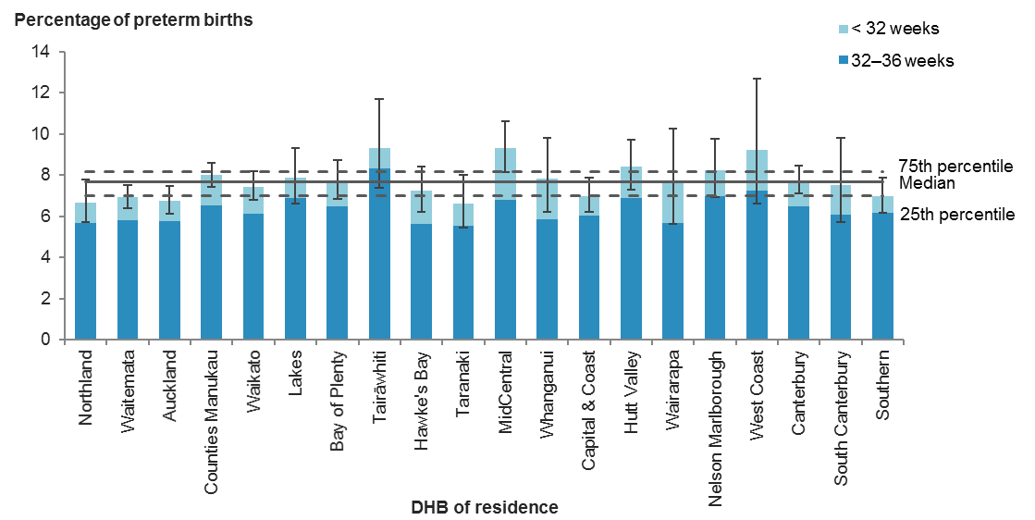

Error bars represent 95% confidence intervals.

Figure 30: Percentage of preterm births, by facility of birth (secondary and tertiary facilities), 2017

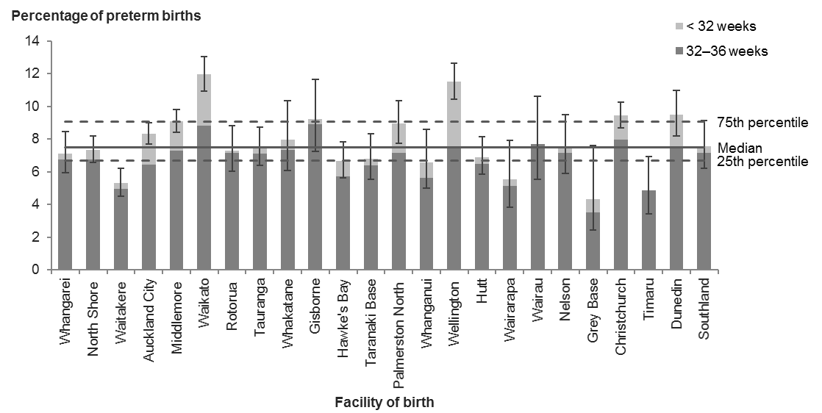

Error bars represent 95% confidence intervals.

Table 35: Number and percentage of preterm births, by district health board of residence, 2017

|  |  |  |  |  |  |
| --- | --- | --- | --- | --- | --- |
| **DHB of residence** | **Babies born under 37 weeks’ gestation** | | | **All babies born (live births)** | **Rate (%)** |
| **<32 weeks** | **32–36 weeks** | **Total** |
| Northland | 22 | 127 | 149 | 2,232 | 6.7 |
| Waitemata | 85 | 452 | 537 | 7,762 | 6.9 |
| Auckland | 56 | 328 | 384 | 5,670 | 6.8 |
| Counties Manukau | 123 | 547 | 670 | 8,365 | 8.0 |
| Waikato | 72 | 329 | 401 | 5,382 | 7.5 |
| Lakes | 15 | 108 | 123 | 1,563 | 7.9 |
| Bay of Plenty | 39 | 203 | 242 | 3,132 | 7.7 |
| Tairāwhiti | 7 | 59 | 66 | 709 | 9.3 |
| Hawke’s Bay | 35 | 120 | 155 | 2,136 | 7.3 |
| Taranaki | 15 | 79 | 94 | 1,421 | 6.6 |
| MidCentral | 54 | 146 | 200 | 2,145 | 9.3 |
| Whanganui | 17 | 50 | 67 | 856 | 7.8 |
| Capital & Coast | 33 | 212 | 245 | 3,502 | 7.0 |
| Hutt Valley | 30 | 135 | 165 | 1,958 | 8.4 |
| Wairarapa | 10 | 29 | 39 | 511 | 7.6 |
| Nelson Marlborough | 18 | 99 | 117 | 1,421 | 8.2 |
| West Coast | 7 | 26 | 33 | 358 | 9.2 |
| Canterbury | 82 | 418 | 500 | 6,440 | 7.8 |
| South Canterbury | 9 | 39 | 48 | 639 | 7.5 |
| Southern | 28 | 214 | 242 | 3,460 | 7.0 |
| Unknown | 7 | 8 | 15 | 352 | – |
| **New Zealand** | **764** | **3,728** | **4,492** | **60,014** | **7.5** |

Table 36: Number and percentage of preterm births, by facility of birth (secondary and tertiary facilities), 2017

|  |  |  |  |  |  |
| --- | --- | --- | --- | --- | --- |
| **Place of birth** | **Babies born under 37 weeks’ gestation** | | | **All babies born (live births)** | **Rate (%)** |
| **< 32 weeks** | **32–36 weeks** | **Total** |
| Whangarei | 6 | 108 | 114 | 1,603 | 7.1 |
| North Shore | 23 | 270 | 293 | 3,996 | 7.3 |
| Waitakere | 9 | 137 | 146 | 2,751 | 5.3 |
| Auckland City | 132 | 445 | 577 | 6,914 | 8.3 |
| Middlemore | 117 | 478 | 595 | 6,550 | 9.1 |
| Waikato | 114 | 319 | 433 | 3,621 | 12.0 |
| Rotorua | 2 | 95 | 97 | 1,327 | 7.3 |
| Tauranga | 7 | 139 | 146 | 1,954 | 7.5 |
| Whakatane | 4 | 46 | 50 | 627 | 8.0 |
| Gisborne | 2 | 59 | 61 | 662 | 9.2 |
| Hawke’s Bay | 19 | 113 | 132 | 1,980 | 6.7 |
| Taranaki Base | 5 | 80 | 85 | 1,250 | 6.8 |
| Palmerston North | 33 | 134 | 167 | 1,866 | 8.9 |
| Whanganui | 7 | 42 | 49 | 744 | 6.6 |
| Wellington | 128 | 248 | 376 | 3,270 | 11.5 |
| Hutt | 8 | 121 | 129 | 1,869 | 6.9 |
| Wairarapa | 2 | 25 | 27 | 487 | 5.5 |
| Wairau | 0 | 33 | 33 | 428 | 7.7 |
| Nelson | 3 | 59 | 62 | 825 | 7.5 |
| Grey Base | 2 | 9 | 11 | 254 | 4.3 |
| Christchurch | 79 | 418 | 497 | 5,258 | 9.5 |
| Timaru | 0 | 29 | 29 | 594 | 4.9 |
| Dunedin | 33 | 127 | 160 | 1,687 | 9.5 |
| Southland | 5 | 90 | 95 | 1,259 | 7.5 |
| **All secondary and tertiary facilities** | **740** | **3,624** | **4,364** | **51,776** | **8.4** |
| **All primary facilities** | **8** | **49** | **57** | **5,795** | **1.0** |
| **All home births** | **6** | **43** | **49** | **1,990** | **2.5** |
| **New Zealand1** | **764** | **3,728** | **4,492** | **60,014** | **7.5** |

1 Includes babies without a birth location recorded.

# Indicators 18 and 19: Small for gestational age at term

## Rationale and purpose

Infants who are born small for gestational age (SGA) are at increased risk of neonatal morbidity and mortality, reduced growth through childhood, lower childhood neurodevelopmental scores, reduced educational attainment and increased lifetime risk for impaired glucose tolerance, including type 2 diabetes, and cardiovascular disease (Arcangeli et al 2012; Lawn et al 2014).

Placental disease (including that associated with pre-eclampsia) and smoking are common causes of poor fetal growth leading to SGA babies. Appropriate management of women at increased risk of SGA (those with a past history of SGA, hypertension or obesity, and those who smoke) may reduce the risk. Timely detection of poor fetal growth in those women with or without risk factors for SGA may reduce the risk of stillbirth by presenting the opportunity for enhanced surveillance and iatrogenic preterm birth.

## Small babies at term (indicator 18)

This indicator measures the proportion of all babies born at term gestation who are small for their gestational age. This is defined as less than the 10th percentile for birthweight on the INTERGROWTH-21 growth charts for gestational ages 37 to 42 weeks. INTERGROWTH-21, an international consortium on issues concerning fetal growth, developed and published these growth standards, using the same methodology as the World Health Organization childhood growth standards ([www.health.govt.nz/system/files/documents/pages/factsheet-2-growth-charts-well-child.pdf](http://www.health.govt.nz/system/files/documents/pages/factsheet-2-growth-charts-well-child.pdf)) recommended for use in New Zealand. The percentage of babies within New Zealand that fall above or below a given percentile on these charts will be different from the equivalent percentages on New Zealand population charts and from customised centile charts which are widely used in New Zealand.

There is extensive evidence for maternal factors leading to SGA, including smoking, hypertension, pre-eclampsia, poorly controlled diabetes, obesity and poor nutrition. We intend this indicator to drive multidisciplinary review of the prevention and management of poor fetal growth at a population level, with the potential for reducing risk of SGA, morbidity from SGA, and stillbirth.

## Small babies at term born at 40–42 weeks’ gestation (indicator 19)

This indicator measures the proportion of SGA babies at term gestation (37–42 weeks) who were born at 40–42 weeks’ gestation.

This indicator is intended to drive review of the identification and management of poor fetal growth at term. Evidence/best practice recommends the expedited birth of babies identified as SGA once they reach term, and ideally before 40 weeks; therefore, this indicator represents the proportion of unrecognised or sub-optimally managed cases.

## Notes on 2017 data

Of all babies born at 37–42 weeks’ gestation, the proportion of SGA babies was generally low, but varied two-fold across the DHBs, ranging from 1.7 percent to 4.1 percent, and from 1.6 percent to 3.9 percent across secondary and tertiary facilities.

Of all SGA babies who were born at 37–42 weeks’ gestation, the proportion of those who were born at 40–42 weeks’ gestation varied widely, from 10.0 percent to 50.0 percent between DHBs, and from 0.0 percent to 75.0 percent across secondary and tertiary facilities. These rates were based on small numbers (in both numerators and denominators); we advise caution when making comparisons.

Nevertheless, DHBs with high rates of SGA babies born at 40–42 weeks’ gestation should consider whether investigation may lead to earlier detection of babies at significantly increased risk of stillbirth and perinatal compromise.

## Indicator 18: Small babies at term (37–42 weeks’ gestation), 2017

Figure 31: Percentage of small babies at term (37–42 weeks’ gestation), by district health board of residence, 2017

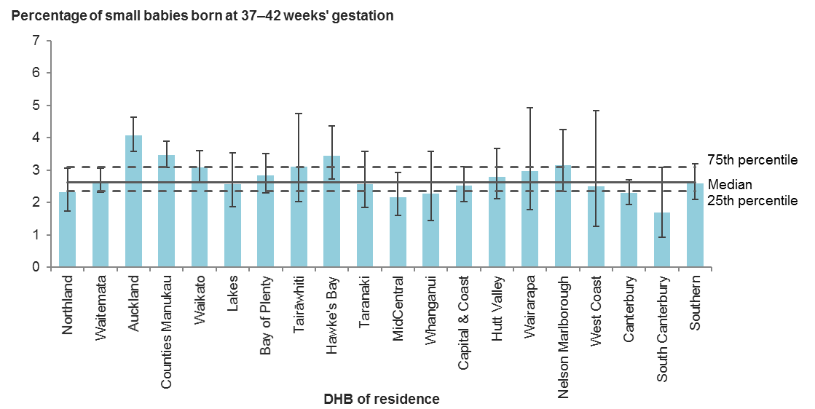

Error bars represent 95% confidence intervals.

Figure 32: Percentage 0f small babies at term (37–42 weeks’ gestation), by facility of birth (secondary and tertiary facilities), 2017

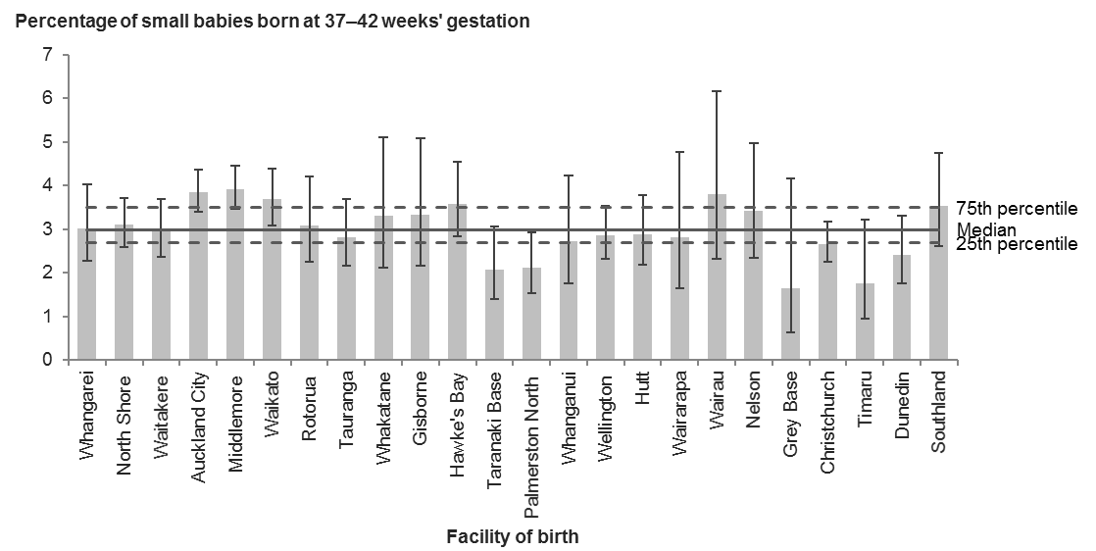

Error bars represent 95% confidence intervals.

Table 37: Number and percentage of small babies at term (37–42 weeks’ gestation), by district health board of residence, 2017

|  |  |  |  |
| --- | --- | --- | --- |
| **DHB of residence** | **Babies born at 37–42 weeks’ gestation with birthweight under the 10th centile for their gestation** | **Babies born at 37–42 weeks’ gestation** | **Rate (%)** |
| Northland | 48 | 2,075 | 2.3 |
| Waitemata | 192 | 7,210 | 2.7 |
| Auckland | 215 | 5,274 | 4.1 |
| Counties Manukau | 266 | 7,665 | 3.5 |
| Waikato | 153 | 4,947 | 3.1 |
| Lakes | 37 | 1,434 | 2.6 |
| Bay of Plenty | 82 | 2,879 | 2.8 |
| Tairāwhiti | 20 | 643 | 3.1 |
| Hawke’s Bay | 68 | 1,969 | 3.5 |
| Taranaki | 34 | 1,320 | 2.6 |
| MidCentral | 42 | 1,937 | 2.2 |
| Whanganui | 18 | 788 | 2.3 |
| Capital & Coast | 82 | 3,252 | 2.5 |
| Hutt Valley | 50 | 1,790 | 2.8 |
| Wairarapa | 14 | 471 | 3.0 |
| Nelson Marlborough | 41 | 1,299 | 3.2 |
| West Coast | 8 | 321 | 2.5 |
| Canterbury | 136 | 5,918 | 2.3 |
| South Canterbury | 10 | 591 | 1.7 |
| Southern | 83 | 3,212 | 2.6 |
| Unknown | 1 | 277 | – |
| **New Zealand** | **1,600** | **55,272** | **2.9** |

Table 38: Number and percentage of small babies at term (37–42 weeks’ gestation), by facility of birth (secondary and tertiary facilities), 2017

|  |  |  |  |
| --- | --- | --- | --- |
| **Place of birth** | **Babies born at 37–42 weeks’ gestation with birthweight under the 10th centile for their gestation** | **Babies born at 37–42 weeks’ gestation** | **Rate (%)** |
| Whangarei | 45 | 1,488 | 3.0 |
| North Shore | 115 | 3,701 | 3.1 |
| Waitakere | 77 | 2,600 | 3.0 |
| Auckland City | 244 | 6,328 | 3.9 |
| Middlemore | 233 | 5,933 | 3.9 |
| Waikato | 117 | 3,175 | 3.7 |
| Rotorua | 38 | 1,229 | 3.1 |
| Tauranga | 51 | 1,804 | 2.8 |
| Whakatane | 19 | 575 | 3.3 |
| Gisborne | 20 | 601 | 3.3 |
| Hawke’s Bay | 66 | 1,840 | 3.6 |
| Taranaki Base | 24 | 1,160 | 2.1 |
| Palmerston North | 36 | 1,695 | 2.1 |
| Whanganui | 19 | 694 | 2.7 |
| Wellington | 83 | 2,890 | 2.9 |
| Hutt | 50 | 1,738 | 2.9 |
| Wairarapa | 13 | 460 | 2.8 |
| Wairau | 15 | 395 | 3.8 |
| Nelson | 26 | 760 | 3.4 |
| Grey Base | 4 | 243 | 1.6 |
| Christchurch | 127 | 4,759 | 2.7 |
| Timaru | 10 | 565 | 1.8 |
| Dunedin | 37 | 1,527 | 2.4 |
| Southland | 41 | 1,163 | 3.5 |
| **All secondary and tertiary facilities** | **1,510** | **47,323** | **3.2** |
| **All primary facilities** | **88** | **5,712** | **1.5** |
| **All home births** | **2** | **1,872** | **0.1** |
| **New Zealand1** | **1,600** | **55,272** | **2.9** |

1 Includes babies where birth location was unspecified.

## Indicator 19: Small babies at term born at 40–42 weeks’ gestation, 2017

Figure 33: Percentage of small babies at term born at 40–42 weeks’ gestation, by district health board of residence, 2017

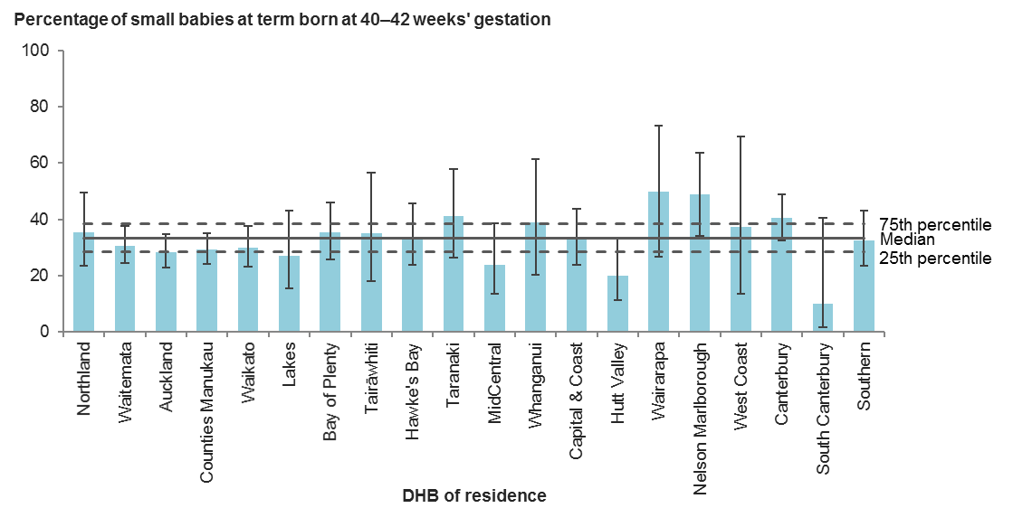

Error bars represent 95% confidence intervals.

Figure 34: Percentage of small babies at term born at 40–42 weeks’ gestation, by facility of birth (secondary and tertiary facilities), 2017

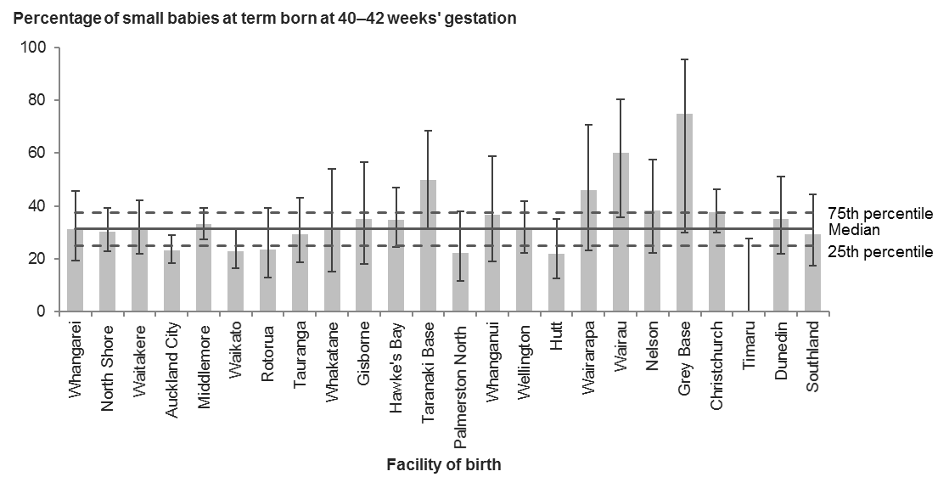

Error bars represent 95% confidence intervals.

Table 39: Number and percentage of small babies at term born at 40–42 weeks’ gestation, by district health board of residence, 2017

|  |  |  |  |
| --- | --- | --- | --- |
| **DHB of residence** | **Babies born at 40–42 weeks’ gestation with birthweight under the 10th centile for their gestation** | **Babies born at 37–42 weeks’ gestation with birthweight under the 10th centile for their gestation** | **Rate (%)** |
| Northland | 17 | 48 | 35.4 |
| Waitemata | 59 | 192 | 30.7 |
| Auckland | 61 | 215 | 28.4 |
| Counties Manukau | 78 | 266 | 29.3 |
| Waikato | 46 | 153 | 30.1 |
| Lakes | 10 | 37 | 27.0 |
| Bay of Plenty | 29 | 82 | 35.4 |
| Tairāwhiti | 7 | 20 | 35.0 |
| Hawke’s Bay | 23 | 68 | 33.8 |
| Taranaki | 14 | 34 | 41.2 |
| MidCentral | 10 | 42 | 23.8 |
| Whanganui | 7 | 18 | 38.9 |
| Capital & Coast | 27 | 82 | 32.9 |
| Hutt Valley | 10 | 50 | 20.0 |
| Wairarapa | 7 | 14 | 50.0 |
| Nelson Marlborough | 20 | 41 | 48.8 |
| West Coast | 3 | 8 | 37.5 |
| Canterbury | 55 | 136 | 40.4 |
| South Canterbury | 1 | 10 | 10.0 |
| Southern | 27 | 83 | 32.5 |
| Unknown | 0 | 1 | – |
| **New Zealand** | **511** | **1,600** | **31.9** |

Table 40: Number and percentage of small babies at term born at 40–42 weeks’ gestation, by facility of birth (secondary and tertiary facilities), 2017

|  |  |  |  |
| --- | --- | --- | --- |
| **Place of birth** | **Babies born at 40–42 weeks’ gestation with birthweight under the 10th centile for their gestation** | **Babies born at 37–42 weeks’ gestation with birthweight under the 10th centile for their gestation** | **Rate (%)** |
| Whangarei | 14 | 45 | 31.1 |
| North Shore | 35 | 115 | 30.4 |
| Waitakere | 24 | 77 | 31.2 |
| Auckland City | 57 | 244 | 23.4 |
| Middlemore | 77 | 233 | 33.0 |
| Waikato | 27 | 117 | 23.1 |
| Rotorua | 9 | 38 | 23.7 |
| Tauranga | 15 | 51 | 29.4 |
| Whakatane | 6 | 19 | 31.6 |
| Gisborne | 7 | 20 | 35.0 |
| Hawke’s Bay | 23 | 66 | 34.8 |
| Taranaki Base | 12 | 24 | 50.0 |
| Palmerston North | 8 | 36 | 22.2 |
| Whanganui | 7 | 19 | 36.8 |
| Wellington | 26 | 83 | 31.3 |
| Hutt | 11 | 50 | 22.0 |
| Wairarapa | 6 | 13 | 46.2 |
| Wairau | 9 | 15 | 60.0 |
| Nelson | 10 | 26 | 38.5 |
| Grey Base | 3 | 4 | 75.0 |
| Christchurch | 48 | 127 | 37.8 |
| Timaru | 0 | 10 | 0.0 |
| Dunedin | 13 | 37 | 35.1 |
| Southland | 12 | 41 | 29.3 |
| **All secondary and tertiary facilities** | **459** | **1,510** | **30.4** |
| **All primary facilities** | **52** | **88** | **59.1** |
| **All home births** | **0** | **2** | **0.0** |
| **New Zealand1** | **511** | **1,600** | **31.9** |

1 Includes babies where birth location was unspecified.

# Indicator 20: Term babies requiring respiratory support

## Rationale and purpose

Respiratory support for a baby born at term is a marker of severe morbidity that does not distinguish by cause and denotes a high degree of severity. It is a more specific measure of severity than measurement of neonatal intensive/special care unit admissions, as it is not dependent on variations in local layout of facilities and in admission practices. The underlying factors driving the need for respiratory support at term may be more amenable than those driving respiratory support of the preterm infant, where prematurity is the largest driver. Respiratory support in this indicator includes both mechanical and non-invasive ventilation where the sum of both is greater than four hours.

The purpose of this indicator is to drive local investigation, including case review, of the reasons for the need for respiratory support of term babies, to help providers identify opportunities to prevent or reduce perinatal morbidity.

Data presented for this indicator may reflect variation in reporting practices regarding respiratory support for babies. District health boards should address this locally; all DHBs should ensure the data they report to the national collections is accurate and complete.

## Notes on 2017 data

There was considerable variation in the rate of babies born at term (37+ weeks’ gestation) requiring respiratory support, ranging from 0.6 percent to 3.6 percent across the DHBs, and from 0.4 percent to 4.3 percent across secondary and tertiary facilities. This warrants further investigation at the local level.

## Indicator 20: Babies born at 37+ weeks’ gestation requiring respiratory support, 2017

Figure 35: Percentage of babies born at 37+ weeks’ gestation requiring respiratory support, by district health board of residence, 2017

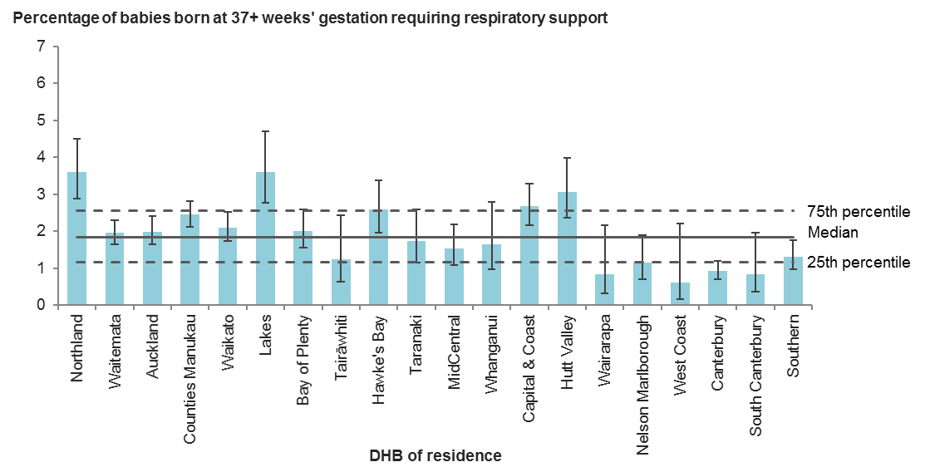

Error bars represent 95% confidence intervals.

Figure 36: Percentage of babies born at 37+ weeks’ gestation requiring respiratory support, by facility of birth (secondary and tertiary facilities), 2017

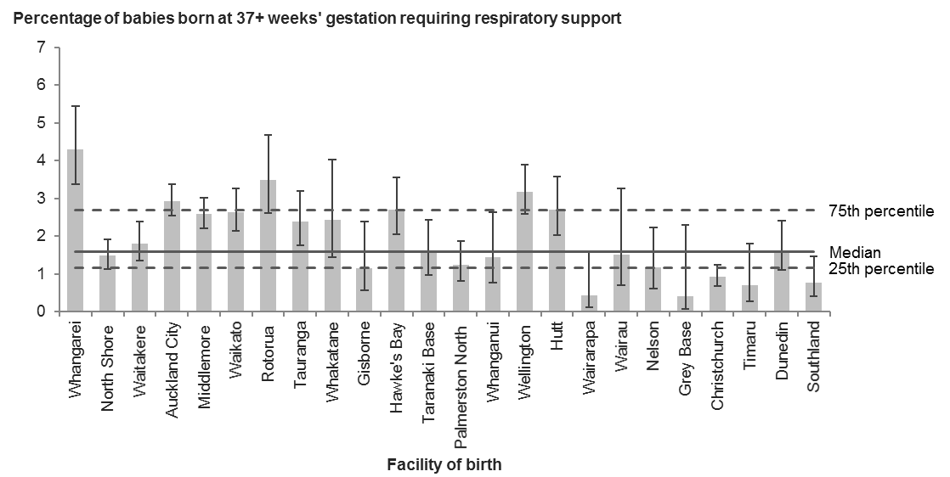

Error bars represent 95% confidence intervals.

Table 41: Number and percentage of babies born at 37+ weeks’ gestation requiring respiratory support, by district health board of residence, 2017

|  |  |  |  |
| --- | --- | --- | --- |
| **DHB of residence** | **Babies born at 37+ weeks’ gestation requiring over 4 hours of respiratory support** | **Babies born at 37+ weeks’ gestation** | **Rate (%)** |
| Northland | 75 | 2,082 | 3.6 |
| Waitemata | 141 | 7,222 | 2.0 |
| Auckland | 105 | 5,280 | 2.0 |
| Counties Manukau | 188 | 7,672 | 2.5 |
| Waikato | 104 | 4,970 | 2.1 |
| Lakes | 52 | 1,440 | 3.6 |
| Bay of Plenty | 58 | 2,888 | 2.0 |
| Tairāwhiti | 8 | 643 | 1.2 |
| Hawke’s Bay | 51 | 1,974 | 2.6 |
| Taranaki | 23 | 1,324 | 1.7 |
| MidCentral | 30 | 1,945 | 1.5 |
| Whanganui | 13 | 789 | 1.6 |
| Capital & Coast | 87 | 3,255 | 2.7 |
| Hutt Valley | 55 | 1,791 | 3.1 |
| Wairarapa | 4 | 472 | 0.8 |
| Nelson Marlborough | 15 | 1,302 | 1.2 |
| West Coast | 2 | 325 | 0.6 |
| Canterbury | 55 | 5,933 | 0.9 |
| South Canterbury | 5 | 591 | 0.8 |
| Southern | 42 | 3,218 | 1.3 |
| Unknown | 3 | 284 | – |
| **New Zealand** | **1,116** | **55,400** | **2.0** |

Table 42: Number and percentage of babies born at 37+ weeks’ gestation requiring respiratory support, by facility of birth (secondary and tertiary facilities), 2017

|  |  |  |  |
| --- | --- | --- | --- |
| **Place of birth** | **Babies born at 37+ weeks’ gestation requiring over 4 hours of respiratory support** | **Babies born at 37+ weeks’ gestation** | **Rate (%)** |
| Whangarei | 64 | 1,489 | 4.3 |
| North Shore | 55 | 3,703 | 1.5 |
| Waitakere | 47 | 2,603 | 1.8 |
| Auckland City | 186 | 6,332 | 2.9 |
| Middlemore | 154 | 5,937 | 2.6 |
| Waikato | 84 | 3,180 | 2.6 |
| Rotorua | 43 | 1,229 | 3.5 |
| Tauranga | 43 | 1,806 | 2.4 |
| Whakatane | 14 | 577 | 2.4 |
| Gisborne | 7 | 601 | 1.2 |
| Hawke’s Bay | 50 | 1,843 | 2.7 |
| Taranaki Base | 18 | 1,162 | 1.5 |
| Palmerston North | 21 | 1,699 | 1.2 |
| Whanganui | 10 | 695 | 1.4 |
| Wellington | 92 | 2,892 | 3.2 |
| Hutt | 47 | 1,739 | 2.7 |
| Wairarapa | 2 | 460 | 0.4 |
| Wairau | 6 | 395 | 1.5 |
| Nelson | 9 | 761 | 1.2 |
| Grey Base | 1 | 243 | 0.4 |
| Christchurch | 44 | 4,759 | 0.9 |
| Timaru | 4 | 565 | 0.7 |
| Dunedin | 25 | 1,527 | 1.6 |
| Southland | 9 | 1,164 | 0.8 |
| **All secondary and tertiary facilities** | **1,035** | **47,361** | **2.2** |
| **All primary facilities** | **64** | **5,730** | **1.1** |
| **All home births** | **13** | **1,931** | **0.7** |
| **New Zealand1** | **1,116** | **55,400** | **2.0** |

1 Includes babies where birth location was unspecified.

# References

AIHW National Perinatal Epidemiology and Statistics Unit and AIHW. 2013. *National core maternity indicators. Cat. no. PER 58*. Canberra: Australian Institute of Health and Welfare. URL: [www.aihw.gov.au/reports/mothers-babies/national-core-maternity-indicators/contents/table-of-contents](https://www.aihw.gov.au/reports/mothers-babies/national-core-maternity-indicators/contents/table-of-contents) (accessed 12 April 2019).

Arcangeli T, Thilaganathan B, Hooper R, et al. 2012. Neurodevelopmental delay in small babies at term: a systematic review. *Ultrasound in Obstetrics and Gynecology* 40: 267–75.

Australian Council on Healthcare Standards. 2008. *Australasian Clinical Indicator Report: 2001–2008: Determining the potential to improve quality of care: 10th edition*. Ultimo, NSW: Australian Council on Healthcare Standards. URL: [www.achs.org.au/media/88679/clinical_indicator_report_2006_2013.pdf](https://www.achs.org.au/media/88679/clinical_indicator_report_2006_2013.pdf) (accessed 12 April 2019).

Health Select Committee. 2013. *Inquiry into improving child health outcomes and preventing child abuse, with a focus from preconception until three years of age*. Wellington: New Zealand House of Representatives. URL: www.parliament.nz/en-nz/pb/sc/documents/reports/50DBSCH_SCR6007_1/inquiry-into-improving-child-health-outcomes-and-preventing (accessed 11 April 2019).

Lawn JE, Blencowe H, Oza S, et al. 2014. Every newborn: progress, priorities, and potential beyond survival. *Lancet* 384: 189–205.

Leddy MA, Power ML, Schulkin J. 2008. The impact of maternal obesity on maternal and fetal health. *Reviews in Obstetrics and Gynecology* 1(4): 170–8.

Mainz J. 2003. Defining and classifying clinical indicators for quality improvement. *International Journal for Quality in Health Care* 15(6): 523–30. DOI: <http://dx.doi.org/10.1093/intqhc/mzg081> (accessed 12 April 2019).

Ministry of Health. (nd). New Zealand Maternity Clinical Indicators – Series. URL: www.health.govt.nz/nz-health-statistics/health-statistics-and-data-sets/new-zealand-maternity-clinical-indicators-series (accessed 12 April 2019).

Ministry of Health. 2012. *Guidelines for Consultation with Obstetric and Related Medical Services (Referral Guidelines)*. Wellington: Ministry of Health. URL: [www.health.govt.nz/publication/guidelines-consultation-obstetric-and-related-medical-services-referral-guidelines](https://www.health.govt.nz/publication/guidelines-consultation-obstetric-and-related-medical-services-referral-guidelines) (accessed 12 April 2019).

Ministry of Health. 2013. *National Consensus Guideline for Treatment of Postpartum Haemorrhage*. Wellington: Ministry of Health. URL: [www.health.govt.nz/publication/national-consensus-guideline-treatment-postpartum-haemorrhage](https://www.health.govt.nz/publication/national-consensus-guideline-treatment-postpartum-haemorrhage) (accessed 12 April 2019).

Ministry of Health. 2015. *Report on Maternity 2015*. Wellington: Ministry of Health. URL: [www.health.govt.nz/publication/report-maternity-2015](http://www.health.govt.nz/publication/report-maternity-2015) (accessed 12 April 2019).

National Maternity Monitoring Group. 2013. *Annual Report 2013*. Wellington: National Maternity Monitoring Group. URL: [www.health.govt.nz/publication/national-maternity-monitoring-group-annual-report-2013](http://www.health.govt.nz/publication/national-maternity-monitoring-group-annual-report-2013) (accessed 12 April 2019).

National Maternity Monitoring Group. 2015. *Annual Report 2015*. Wellington: National Maternity Monitoring Group. URL: [www.health.govt.nz/system/files/documents/publications/national-maternity-monitoring-group-annual-report-2015-dec15.pdf](http://www.health.govt.nz/system/files/documents/publications/national-maternity-monitoring-group-annual-report-2015-dec15.pdf) (accessed 12 April 2019).

Newcombe RG. 1998. Two-sided confidence intervals for the single proportion: Comparison of seven methods. *Statistics in Medicine* 17: 857–72.

NICE. 2008. *Antenatal Care for Uncomplicated Pregnancies. NICE Guideline C62*. London: National Institute for Health and Care Excellence. URL: www.nice.org.uk/guidance/CG62/chapter/Introduction (accessed 11 April 2019).

Perinatal and Maternal Mortality Review Committee. 2015. *Eleventh Annual Report of the Perinatal and Maternal Mortality Review Committee: Reporting mortality 2015*. Wellington: Health Quality & Safety Commission. URL: <https://www.hqsc.govt.nz/assets/PMMRC/Publications/2017_PMMRC_Eleventh_Annual_Report.pdf> (accessed 15 April 2019).

The Quit Group. 2004. Smoking and Pregnancy. URL: <https://quit.org.nz/reasons-to-quit/smoking-and-pregnancy> (accessed 11 April 2019).

Villar J, Ismail LC, Victora CG, et al. 2014. International standards for newborn weight, length, and head circumference by gestational age and sex: the Newborn Cross-Sectional Study of the INTERGROWTH-21st Project. *Lancet* 384(9946): 857–68. DOI: http://dx.doi.org/10.1016/S0140-6736(14)60932-6 (accessed 12 April 2019).

WHA. 2007. *Findings from the Core Maternity Indicators Project Funded by the Australian Council on Safety and Quality in Health Care and Sponsored by the Department of Health, Western Australia*. Turner, ACT: Women’s Hospitals Australasia.

WHO. 2011. *Recommendations for Prevention and Treatment of Pre-eclampsia and Eclampsia*. Geneva: World Health Organization. URL: [www.who.int/reproductivehealth/publications/maternal_perinatal_health/9789241548335/en/](https://www.who.int/reproductivehealth/publications/maternal_perinatal_health/9789241548335/en/) (accessed 12 April 2019).

WHO. 2018. Preterm Birth Factsheet. URL: [www.who.int/mediacentre/factsheets/fs363/en/index.html](http://www.who.int/mediacentre/factsheets/fs363/en/index.html) (accessed 12 April 2019).

# Appendices

## Appendix 1: National Maternity Collection

The Ministry of Health’s National Maternity Collection (MAT) provides statistical, demographic and clinical information about selected publicly funded maternity services up to nine months before and three months after a birth. It collates data about each pregnancy that results in birth and each live-born baby separately from:

* inpatient and day-patient health event data during pregnancy, birth and the postnatal period for women giving birth and their babies, sourced from the National Minimum Dataset (NMDS)
* lead maternity carer (LMC) claim forms for primary maternity services provided under the Primary Maternity Services Notice 2007
* primary maternity services provided by DHBs to women who do not have a midwife LMC.[4]

The Ministry of Health collects these sources for administrative purposes (including the funding of maternity services). The collection does not contain details of stillborn babies. The Mortality Collection includes information about stillbirths. Refer to the data dictionary ([www.health.govt.nz/publication/national-maternity-collection-data-dictionary](http://www.health.govt.nz/publication/national-maternity-collection-data-dictionary)) for more information on the data held in MAT.

### National Minimum Dataset

The NMDS stores administrative information routinely collected for all publicly funded inpatients of a New Zealand maternity facility (hospitals and birthing units). This information contains a large amount of demographic and clinical data, including data on diagnoses and the procedures used. The NMDS assigns information standardised codes that are internationally comparable. The classification system used is the International Statistical Classification of Diseases and Related Health Problems, 10th Revision, Australian Modification. This system is designed for the classification of morbidity and mortality information for statistical, epidemiological and clinical purposes. Refer to the data dictionary ([www.health.govt.nz/publication/national-minimum-dataset-hospital-events-data-dictionary](http://www.health.govt.nz/publication/national-minimum-dataset-hospital-events-data-dictionary)) for more information on the data held in the NMDS.

### Lead maternity carer claims data

The LMC claims data set contains information on women and babies who access primary maternity services provided under Section 88 of the New Zealand Public Health and Disability Act 2000. The Ministry of Health receives information through LMC claim forms; this information includes all women registered with an LMC. This represented 92 percent of all women giving birth in 2017. Data sourced from LMC claim forms includes details on registration with an LMC, as well as other antenatal and postnatal factors (eg, parity, smoking status and breastfeeding status).

### District health board-funded primary maternity services data

Collection of this data set is under way. This data set contains information (similar to LMC claims data) on women who access DHB primary maternity services, including DHB caseload midwives, DHB primary midwifery teams and shared care arrangements.

The extent of primary maternity services DHBs are providing varies significantly by DHB, ranging from DHBs that do not currently provide any primary maternity services to DHBs that provide primary maternity services to at least one-quarter of their women giving birth. Not all DHBs that provide primary maternity services have provided data to MAT.[5]

Once complete, this data set will increase the scope of information the Ministry holds on women (and their babies) who access primary maternity services.

## Appendix 2: Technical notes

### Obtaining the data

This publication uses the National Maternity Collection (MAT) as the primary source for identifying all women giving birth and live-born babies. We extracted variables used to identify the women and babies from MAT, as well as the following variables: delivery date, place of birth, age, ethnicity, smoking status, parity, primary maternity care provider, gestation and birthweight.

The National Maternity Collection primarily sources parity and smoking status data from LMC claim forms, with additional data from some DHB primary maternity services. This data is therefore only available for women registered with an LMC or with a DHB primary maternity service (95 percent of women giving birth in 2017).

Indicators 2 to 12 and 20 require additional information that is not available in MAT. Therefore, we identified and extracted hospital events occurring during the pregnancy and postnatal period for these women and their babies from the National Minimum Dataset (NMDS).

The NMDS codes hospital events using the International Statistical Classification of Diseases and Related Health Problems, Tenth Revision, Australian Modification (ICD‑10-AM) for diagnoses codes and uses the Australian Classification of Health Interventions (ACHI) for procedure codes. Both ICD-10-AM and ACHI are from the Independent Hospital Pricing Authority, Australia. NMDS is based on the 6th edition for hospital discharges up to 30 June 2014 and the 8th edition for hospital discharges from 1 July 2014 onwards. The next section provides the relevant clinical and procedure codes.

### Clinical codes and definitions

**Standard primiparae:** a group of women considered to be clinically comparable and expected to require low levels of obstetric intervention. This report defines standard primiparae as women recorded in MAT who meet all of the following criteria:

* gave birth at a maternity facility or had a home birth[6]
* are aged between 20 and 34 years (inclusive) at birth
* are pregnant with a single baby presenting in labour in cephalic position (see Tables A1 and A2)
* have no known prior pregnancy of 20 weeks and over gestation
* give birth to a live or stillborn baby at term gestation: between 37 and 41 weeks inclusive (based on gestational age recorded for the baby and exclusion criteria in Table A3)
* have no recorded obstetric complications in the present pregnancy that are indications for specific obstetric interventions (see Table A4).

Table A1: Singleton birth exclusion criteria

|  |  |
| --- | --- |
| **Clinical code** | **Description** |
| O300–O309 | Multiple gestation |
| O318 | Other complications specific to multiple gestation |
| O325 | Maternal care for multiple gestation |
| O632 | Delayed delivery of second twin, triplet, etc |
| O840–O849* | Multiple delivery |
| Z372–Z377 | Outcome of delivery − twins or multiple |

* Introduced in the 8th edition of ICD-10-AM.

Table A2: Cephalic presentation exclusion criteria

|  |  |
| --- | --- |
| **Clinical code** | **Description** |
| 9047000 | Spontaneous breech delivery |
| 9047001 | Assisted breech delivery |
| 9047002 | Assisted breech delivery with forceps to after-coming head |
| 9047003 | Breech extraction |
| 9047004 | Breech extraction with forceps to after-coming head |
| O640−O649 | Labour and delivery affected by malposition and malpresentation of fetus |

Table A3: Duration of pregnancy (gestation exclusion criteria)

|  |  |
| --- | --- |
| **Clinical code** | **Description** |
| O090−O095 | Duration of pregnancy under 37 weeks |
| O48 | Prolonged pregnancy |
| O601 | Preterm labour and delivery |

Table A4: Obstetric complications exclusion criteria

|  |  |
| --- | --- |
| **Clinical code** | **Description** |
| O10−O16 | Hypertension, proteinuria, pre-eclampsia, eclampsia |
| O240−O249 | Diabetes mellitus in pregnancy |
| O360, O361, O363, O364, O365 | Known or suspected fetal problems |
| O411, O420−O429 | Infection of the amniotic sac/membranes or premature rupture of membranes |
| O450–O459, O460−O469, O48 | Premature separation of placenta, antepartum haemorrhage, prolonged pregnancy |

**Spontaneous vaginal birth:** the birth of a baby without obstetric intervention (ie, without caesarean section, forceps or vacuum (ventouse)), identified by the presence of a spontaneous vaginal birth clinical code with no concurrent instrumental/caesarean section code (see Table A5). Spontaneous vaginal births may include births where labour has been induced or augmented. We counted women giving birth at home as having had a spontaneous vaginal birth.

Table A5: Delivery type codes

|  |  |
| --- | --- |
| **Clinical code** | **Description** |
| O80 | Single spontaneous delivery |
| O81 | Single delivery by forceps and vacuum extractor |
| O82 | Single delivery by caesarean section |
| O83* | Other assisted single delivery |
| O840* | Multiple delivery, all spontaneous |
| O841* | Multiple delivery, all by forceps and vacuum extractor |
| O842* | Multiple delivery, all by caesarean section |
| O848* | Other multiple delivery |
| O849* | Multiple delivery, unspecified |
| 9046700 | Spontaneous vertex delivery |
| 9046800−9046804 | Forceps delivery |
| 9046900 | Vacuum extraction with delivery |
| 1652000−1652003 | Caesarean section |

* Introduced in the 8th edition of ICD-10-AM.

**Instrumental vaginal birth:** a vaginal birth requiring instrumental assistance with no concurrent clinical code indicating a caesarean section. Interventions include forceps and/or vacuum (ventouse) extraction (see Table A5). Instrumental vaginal births do not include failed attempts at forceps or vacuum extraction (see Table A6).

Table A6: Excluded delivery procedure codes

|  |  |
| --- | --- |
| **Clinical code** | **Description** |
| 9046805 | Failed forceps |
| 9046901 | Failed vacuum extraction |

**Caesarean section:** an operative birth through an abdominal incision. This definition includes emergency and elective, lower segment and classical caesarean sections, and it is identified by the presence of any caesarean section clinical code (see Table A5).

**Induction of labour:** an intervention to stimulate the onset of labour by pharmacological or other means, identified by induction of labour clinical codes (see Table A7).

Table A7: Induction procedure codes

|  |  |
| --- | --- |
| **Clinical code** | **Description** |
| 9046500 | Medical induction of labour, oxytocin |
| 9046501 | Medical induction of labour, prostaglandin |
| 9046502 | Other medical induction of labour |
| 9046503 | Surgical induction of labour by artificial rupture of membranes |
| 9046504 | Other surgical induction of labour |
| 9046505 | Medical and surgical induction of labour |

**Intact lower genital tract:** identified by an absence of clinical codes indicating an episiotomy or a tear of any degree (first to fourth, and including ‘was unspecified’ degree) (see Table A8).

**Episiotomy:** an incision of the perineal tissue surrounding the vagina at the time of birth to facilitate delivery, identified by the presence of an episiotomy clinical code (see Table A8). We counted women giving birth at home as having had a spontaneous vaginal birth without an episiotomy.

**Third- and fourth-degree tear:** a third- or fourth-degree perineal laceration during birth, identified by the presence of a third- or fourth-degree tear clinical code (see Table A8) in a hospital admission within three days after birth.

Table A8: Episiotomy and/or perineal tear codes

|  |  |
| --- | --- |
| **Clinical code** | **Description** |
| 9047200 | Episiotomy |
| O700 | First-degree perineal laceration during delivery |
| O701 | Second-degree perineal laceration during delivery |
| O702 | Third-degree perineal laceration during delivery |
| O703 | Fourth-degree perineal laceration during delivery |
| O709 | Perineal laceration during delivery, was unspecified |
| 9048100 | Suture of first or second degree tear of perineum |
| 1657300 | Suture of third or fourth degree tear of perineum |

**General anaesthetic for a caesarean section birth:** identified by the presence of a general anaesthetic clinical code (see Table A9) and a caesarean section clinical code (see Table A5).

Table A9: General anaesthetic procedure code

|  |  |
| --- | --- |
| **Clinical code** | **Description** |
| 92514XX | General anaesthesia |

**Blood transfusion during birth admission:** identified by clinical codes for selected blood transfusion procedures (see Table A10) in a hospital admission within three days after birth.

Table A10: Blood transfusion procedure codes

|  |  |
| --- | --- |
| **Clinical code** | **Description** |
| 1370601 | Administration of whole blood |
| 1370602 | Administration of packed cells |
| 1370603 | Administration of platelets |
| 9206000 | Administration of autologous blood |
| 9206200 | Administration of other serum |
| 9206300 | Administration of blood expander |
| 9206400 | Administration of other blood product |

**Diagnosis of eclampsia at birth admission:** identified by the presence of an eclampsia clinical code (see Table A11) during birth admission.

Table A11: Eclampsia codes

|  |  |
| --- | --- |
| **Clinical code** | **Description** |
| O150 | Eclampsia in pregnancy |
| O151 | Eclampsia in labour |
| O152 | Eclampsia in the puerperium |
| O159 | Eclampsia, was unspecified as to time period |

**Diagnosis of peripartum hysterectomy:** identified by the presence of an abdominal hysterectomy clinical code (see Table A12) in a hospital admission within six weeks after birth.

Table A12: Peripartum hysterectomy codes

|  |  |
| --- | --- |
| **Clinical code** | **Description** |
| 3565300 | Subtotal abdominal hysterectomy |
| 3565301 | Total abdominal hysterectomy |
| 3565304 | Total abdominal hysterectomy with removal of adnexa |

**Mechanical ventilation required during pregnancy or postnatal period:** identified by any hospital admission during the pregnancy or postnatal period where the woman was in an intensive care unit and required more than 24 hours of mechanical ventilation.

**First trimester registration with an LMC:** applicable where date of registration with an LMC is within the first 12 completed weeks of pregnancy, based on the woman’s estimated date of delivery reported at registration.

**Preterm birth:** the birth of a live-born baby between 20 weeks 0 days and 36 weeks 6 days gestation.

**Small for gestational age:** applies to babies born with birthweight below the 10th percentile for their gestational age, based on smoothed centile tables for birthweight according to gestational age from the INTERGROWTH-21st project (see Table A13).

Table A13: 10th centile birthweight for male and female babies according to gestational age

|  |  |  |
| --- | --- | --- |
| **Gestational age (weeks)** | **Male (kg)** | **Female (kg)** |
| 37 | 2.38 | 2.33 |
| 38 | 2.57 | 2.50 |
| 39 | 2.73 | 2.65 |
| 40 | 2.88 | 2.78 |
| 41 | 3.01 | 2.89 |
| 42 | 3.12 | 2.98 |

Source: Villar et al 2014.

**Respiratory support during birth admission:** applies to a baby requiring over four hours of mechanical ventilation or of continuous positive airway pressure during a hospital admission within three days after birth.

### Other technical notes

**Facility graphs:** all facility graphs in this report present maternity events occurring in secondary and tertiary maternity facilities (hospitals) only, while DHB graphs present maternity events by DHB of residence and include births at all maternity facilities (including primary facilities). The aim of this is to enable the comparison of births for which clinicians have access to similar clinical facilities and interventions. The accompanying online tables provide data for individual primary facilities. Take care when making comparisons, because many primary units deal with only a small number of maternity events, meaning that in many cases differences between rates will not be statistically significant.

**Presentation of confidence intervals:** the error bars on the charts in this document represent 95 percent confidence intervals for the sample proportion, which have been calculated using the Wilson score (see Newcombe 1998).

**Southern DHB data:** in May 2010, Otago and Southland DHBs were merged into a single entity, Southern DHB, which began reporting to the Ministry of Health National Collections in 2011. This report includes all relevant data under ‘Southern DHB’.

**Christchurch and Christchurch Women’s data:** from 1 July 2009 maternity events that had previously been reported as occurring in Christchurch Women’s Hospital were reported as occurring in Christchurch Hospital. This change represents a change in the way the data is reported, rather than a change in patient care. For the purposes of this report, we have summed Christchurch Women’s Hospital and Christchurch Hospital events.

## Appendix 3: Catchment areas

The primary, secondary and tertiary maternity facilities that reported births between 2009 and 2017 are listed by DHB region (of location) in the table below. Figure A1 presents their geographical locations.

| **DHB** | **Tertiary facility1** | **Secondary facility2** | **Primary facility3** |
| --- | --- | --- | --- |
| Northland | Auckland City | Whangarei | Bay of Islands  Dargaville (closed)  Hokianga Health  Kaitaia |
| Waitemata | North Shore  Waitakere | Helensville  Warkworth  Wellsford |
| Auckland |  | Birthcare Auckland |
| Counties Manukau | Middlemore |  | Botany Downs  Papakura  Pukekohe |
| Waikato | Waikato |  | Birthcare Huntly  Matariki (closed)  Pohlen Trust  Rhoda Read (closed)  River Ridge  Taumaranui  Te Awamutu  Te Kuiti  Thames  Tokoroa  Waihi  Waterford |
| Lakes | Rotorua | Taupo |
| Bay of Plenty | Tauranga  Whakatane | Bethlehem  Murupara  Ōpotiki |
| Tairāwhiti | Gisborne | Ngati Porou Hauora |
| Taranaki | Taranaki Base | Elizabeth R (closed)  Hawera |
| Hawke’s Bay | Wellington | Hawke’s Bay Regional | Wairoa |
| MidCentral | Palmerston North | Dannevirke  Horowhenua  Te Papaioea |
| Whanganui | Whanganui | Otaihape  Waimarino |
| Capital & Coast |  | Kapiti  Kenepuru |
| Hutt Valley |  | Hutt |  |
| Wairarapa | Wairarapa |  |
| Nelson Marlborough | Wairau  Nelson | Golden Bay  Motueka |
| West Coast | Christchurch | Grey Base | Buller  Reefton |
| Canterbury |  | Akaroa (closed)  Ashburton  Burwood (closed)  Darfield  Kaikoura  Lincoln  Rangiora  St George’s  Waikari (closed) |
| South Canterbury | Timaru |  |
| Southern | Dunedin  Southland | Charlotte Jean  Clutha  Dunstan (closed)  Gore  Lakes District  Lumsden  Maniototo (closed)  Ōamaru  Tuatapere  Winton |

1 A facility that provides a multidisciplinary specialist team for women and babies with complex or rare maternity needs; for example, babies with major fetal disorders requiring prenatal diagnostic and fetal therapy services, or women with obstetric histories that significantly increase the risks during pregnancy, labour and delivery (for example, those who have already had two placental abruptions). This includes neonatal intensive care units.

2 A facility that provides additional care during the antenatal, labour and birth, and postnatal periods for women and babies who experience complications and who have a clinical need for either specialist consultation or transfer.

3 A facility that does not have inpatient secondary maternity services or 24-hour on-site availability of specialist obstetricians, paediatricians and anaesthetists. This includes birthing units.

Note: Several facilities that have closed remain listed on this table. This is because while these facilities are currently closed, births still occurred there between 2009 and 2017.

Figure A1: Maternity facilities in New Zealand by DHB and facility type (2009–2017)

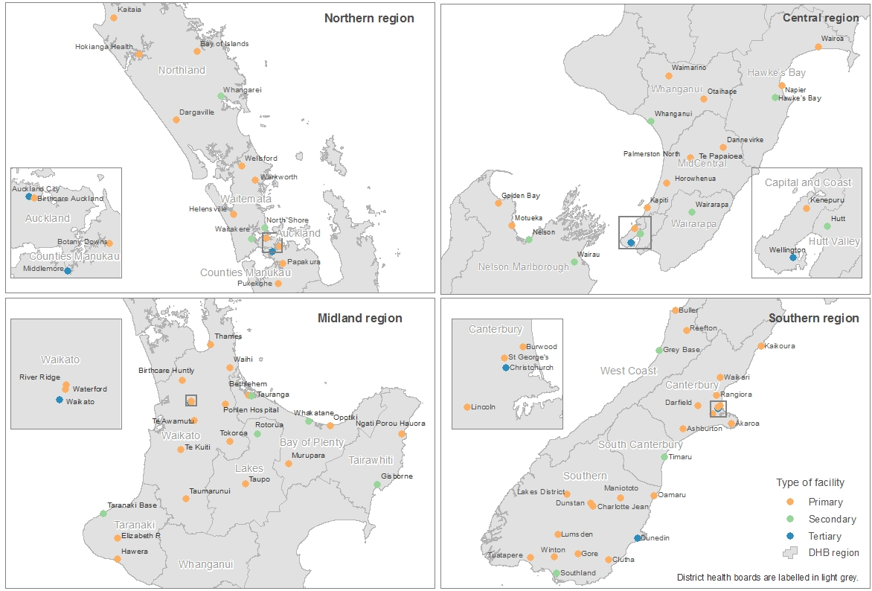

1. The proportion of women giving birth for the first time (parity = 0) is approximately 40 percent (ranging from 33 percent to 47 percent by DHB of residence). This proportion is lower among women giving birth at home, as 19 percent of women giving birth at home were having their first baby (ranging from 12 percent to 27 percent of home births by DHB of residence).
2. Women who register with a DHB primary maternity service are not counted in this indicator.
3. Some indicators do not sum to 100 percent due to missing data codes for some events.
4. Collection of this data set (from 2014 onwards) is under way, but still incomplete. We have included data currently available in MAT in this publication.
5. From 2009 to 2015, approximately 87 percent of women giving birth registered to receive primary maternity care with an LMC, and 8 percent registered to receive care from a DHB primary maternity service. Provision of care was unknown for 5 percent of women giving birth. We expect that most of these women received care from the respective DHB primary maternity services (not yet reporting), but some may not have received any primary maternity care (Ministry of Health 2015).
6. Place of birth is designated as ‘home’ if there was an LMC claim for home birth supplies and no corresponding record for a birth at a maternity facility.