National Syphilis Action Plan
An action plan to stop the syphilis epidemic in New Zealand
2019

Citation: Ministry of Health. 2019. National Syphilis Action Plan: An action plan to stop the syphilis epidemic in New Zealand. Wellington: Ministry of Health.
Published in June 2019 by the Ministry of Health
PO Box 5013, Wellington 6140, New Zealand
ISBN 978-1-98-856876-8 (online)
HP 7108
This document is available at health.govt.nz
This work is licensed under the Creative Commons Attribution 4.0 International licence. In essence, you are free to: share ie, copy and redistribute the material in any medium or format; adapt ie, remix, transform and build upon the material. You must give appropriate credit, provide a link to the licence and indicate if changes were made.

Contents
Introduction 1
Understanding the epidemic 1
Equity 4
The big picture 4
Aim and goals 4
National and regional response needed 5
Action areas 6
Action area 1: Primary prevention and health promotion 6
Action area 2: Testing and management 7
Action area 3: Preventing congenital syphilis 10
Action area 4: Surveillance 11
References 12

List of Figures
Figure 1: Infectious syphilis cases by sex and sexual behaviour, 2013–2018 2
Figure 2: Infectious syphilis by District Health Board, number of cases, 2013–2018* 3

Introduction
Syphilis incidence has been increasing in New Zealand since 2012 to the point that we now have a syphilis epidemic. Provisional data from the Institute of Environmental Science and Research Ltd (ESR) indicates that the number of syphilis cases reported in 2018 is more than double the number of cases reported in 2015. In 2018, New Zealand had 543 cases of syphilis – 454 in males and 89 in females.

It is also highly concerning that we are now seeing cases of congenital syphilis in New Zealand – a completely preventable condition. There were four reported cases of congenital syphilis in 2017 and five in 2018 compared to one case in 2016. Prior to 2016, cases of congenital syphilis were very rare in New Zealand.

Understanding the epidemic
Understanding the epidemiology of the syphilis epidemic is vital to target actions to the populations in greatest need. Men who have sex with men (MSM) remain the group most affected by syphilis. However, over recent years the demographics of those affected by syphilis have become increasingly diverse, including a steady increase in cases contracted through heterosexual sex among both males and females (see Figure 1).

Figure 1: Infectious syphilis cases by sex and sexual behaviour, 2013–2018
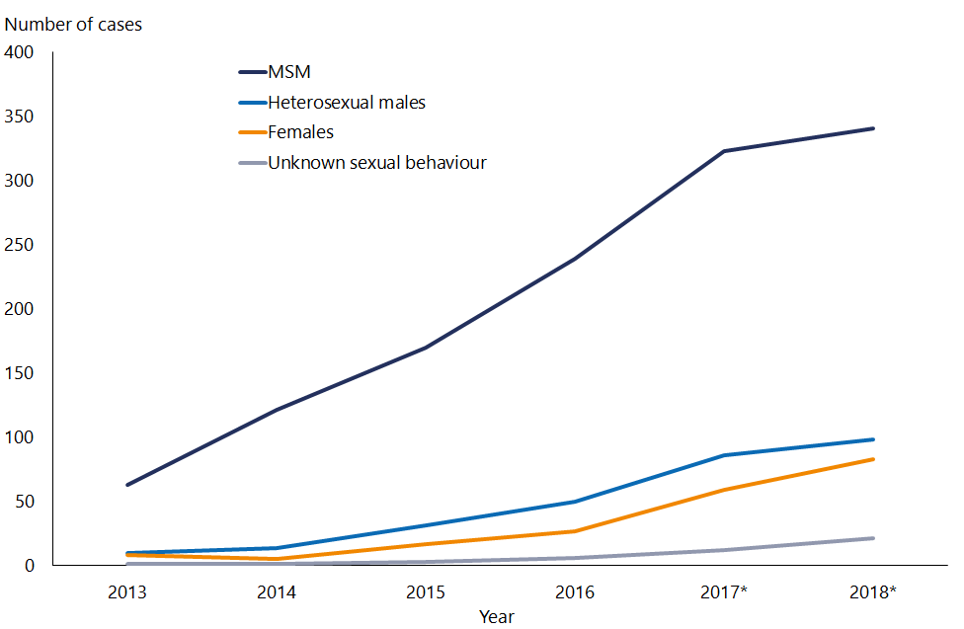
Data source: Enhanced surveillance of infectious syphilis and STI Surveillance, ESR.
Note:
1. Data for 2017 and 2018 provisional.
2. MSM – men who report they have sex with men.
3. Heterosexual males refers to males who report only having sex with females.
4. Females includes females who have sex with males and females.
5. Unknown sexual behaviour – includes transgender where sex is unknown.

Rates of syphilis in New Zealand now show marked ethnic inequities. In particular, the number of cases of syphilis among Māori women has increased markedly, from five cases reported in 2016 to 28 cases in 2017 and 37 cases reported in 2018. As a result, Māori women now account for the highest proportion of cases of syphilis in women in New Zealand (45 percent of cases in 2018 compared to 19 percent in 2016). Prior to 2017, over half of syphilis cases were in New Zealand European women. Addressing this increasing inequity needs to be a priority in the response to syphilis.

In terms of age and gender, in 2017 the highest number of cases was reported in males aged 20–39 years, particularly those in the 25–29 age group.

In terms of district health board (DHB) district or region, most of the syphilis cases occurred in the Auckland region DHBs (Auckland, Counties Manukau and Waitemata DHBs), followed by the DHBs in the Wellington region (Hutt Valley and Capital & Coast DHBs) (see Figure 2).

Figure 2: Infectious syphilis by District Health Board, number of cases, 2013–2018*
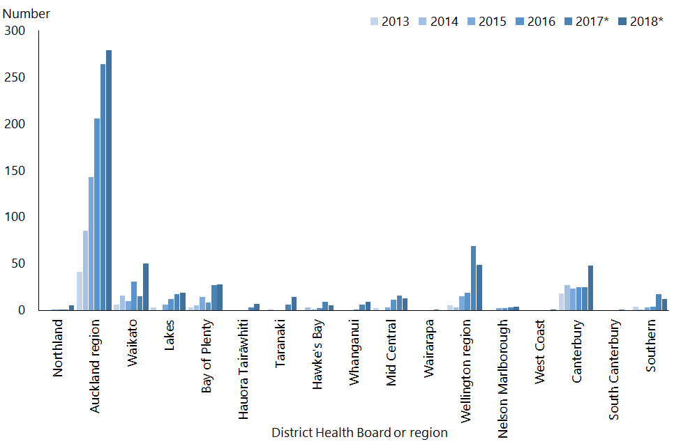
Data source: Enhanced surveillance of infectious syphilis and STI Surveillance: Syphilis, ESR
* Data for 2017 and 2018 provisional.

Based on currently available data, the populations most impacted by syphilis are:
- men who have sex with men – around 70% of reported cases
- Māori females – accounting for the largest number of cases among females in 2018
- Asian and Māori males – accounting for a high proportion of cases relative to their population size
- pregnant women – who are a priority population for preventing congenital syphilis, with Māori pregnant women disproportionately impacted
- people who are incarcerated and those who are recently released from prison – based on anecdotal evidence from sexual health clinicians
- drug users, particularly methamphetamine users – based on anecdotal evidence from sexual health clinicians.

For further epidemiology, go to the ESR website: https://surv.esr.cri.nz/surveillance/annual_sti.php

Based on the priority populations we have identified above, the priority settings for providing health care to address the syphilis epidemic are:
- sexual health services
- non-governmental organisation providers of sexual and reproductive health services
- Māori health providers
- primary care
- maternity care
- prisons and probation programmes
- drug and alcohol services
- mental health services
- emergency departments – which provide an opportunity to engage with those who don’t access other health care services.

Equity
The largest number of syphilis cases among women are in Māori women – these inequities are unacceptable. The response to syphilis needs to be grounded in, and driven by, Te Tiriti o Waitangi (Treaty of Waitangi) principles with a key focus on decreasing inequities. As such, it is expected that the focus of all actions will include decreasing the impact of syphilis on Māori and improving equity.

The big picture
As well as an increase in syphilis, we are seeing an increase in other sexually transmitted infections (STIs) in New Zealand. Work to address syphilis fits within a broader context of decreasing the transmission of STIs generally and improving access to sexual and reproductive health services in New Zealand, particularly for Māori. The Sustainability Development Goals set out this focus. Notably, one of the targets under Goal Three (good health and wellbeing) is:
By 2030, ensure universal access to sexual and reproductive health-care services, including for family planning, information and education, and the integration of reproductive health into national strategies and programmes.

The Ministry of Health is currently finalising a 5-year Sexual and Reproductive Health Action Plan. We envisage that this National Syphilis Action Plan (action plan) will align and link in with broader Sexual and Reproductive Health Action Plan to improve sexual and reproductive health in New Zealand.

Aim and goals
The aim of this action plan is to guide a coordinated and systematic response to interrupt ongoing transmission of infectious syphilis and to prevent congenital syphilis. Responding effectively to the syphilis epidemic requires taking the right balance of short- and long-term actions.

Once the rates of syphilis start to decrease, we will need to review ongoing STI control actions and consider how to better identify and respond to outbreaks in the future.

In responding to the syphilis epidemic now, the overall goals are to:
      - stop the increase in syphilis
      - eliminate ethnic inequities in syphilis
      - eliminate congenital syphilis
      - reduce morbidity associated with syphilis by improving testing and treatment
      - ensure New Zealand has high-quality syphilis surveillance.

National and regional response needed
Effectively responding to the syphilis epidemic requires a combination of national and regional actions. It is important that work is undertaken at a regional level in partnership with communities to increase testing and management. With this approach, the solutions developed will be appropriate for the populations within each region.

The Ministry of Health, along with other national organisations, will lead national actions. District health boards, public health units and specialist sexual health services are expected to work collaboratively with other key stakeholders in their regions to ensure a regional response meets the specific needs of their communities. With this in mind, DHBs will have to develop and deliver local responses using existing contracts or through reprioritising DHB funding.

Action areas
Priority actions have been identified under four key action areas, with the aim of covering the full spectrum of syphilis prevention and care:
      - prevention and health promotion
      - testing and management
      - antenatal care
      - surveillance and monitoring.

Each action falls into one of the following timeframes, starting from March 2019:
- short term: immediate actions to complete by mid 2019
- medium term: actions to complete within one to two years
- long term: actions to complete within three to five years.

This action plan identifies lead agencies for the national actions. The lead agency is responsible for leading the action and engaging with other agencies for input as required. We expect that DHBs will develop regional actions collaboratively and prioritise them to meet the needs of each region.

The plan will be reviewed annually to ensure actions are being delivered.

Action area 1: Primary prevention and health promotion
Strengthening primary prevention by promoting a safe sex culture is a vital component of sustainably addressing the increase in syphilis cases. This includes improving knowledge and awareness of syphilis, promoting condom use and promoting regular testing for STIs.

To date, prevention strategies have focussed on MSM. Given the current increase in syphilis and cases of congenital syphilis, these strategies must include increasing awareness of syphilis among women of childbearing age, with a focus on Māori women.

Increasing public awareness
National actions | Timeline | Lead
Identify options and channels for national social marketing campaign to promote condom use and regular STI testing among priority populations. | Medium term | Ministry of Health
Promote condom use and regular STI testing among MSM. | Ongoing | New Zealand AIDS Foundation (NZAF)
Promote STI screening for people who are on pre-exposure prophylaxis (PrEP). | Ongoing | NZAF
Promote STI testing through dating and hook-up apps used by MSM and explore other options for engaging with apps for health promotion. | Ongoing | Body Positive and Ministry of Health
Work with Ministry of Education to ensure high-quality sexuality education in schools, linking in with the Sexual and Reproductive Health Action Plan. | Long term | Ministry of Health
Regularly review surveillance data to ensure that awareness raising activities are targeted appropriately. | Medium term | Ministry of Health
Regional actions | Timeline | Lead
Work locally with communities to increase awareness of STIs among high-risk groups and increase awareness of where to access condoms freely or on prescription, considering impact of actions on equity. | Medium term | District Health Boards
Create safe-sex supporting environments by ensuring condoms are available in sex-on-site premises. | Ongoing | District Health Boards

Action area 2: Testing and management
Increasing testing coverage is crucial to interrupt the spread of syphilis and to reduce the risk of long-term effects from undiagnosed syphilis. Syphilis can be hard to diagnose, as it can present in many different ways, including with no symptoms.

This action area needs to address four key aspects:
      - increasing availability of and ensuring equitable access to syphilis testing
      - increasing health professional awareness and understanding of syphilis so that they consider syphilis as a diagnosis, test for it and manage it appropriately
      - improving contact tracing
      - ensuring availability of specialist sexual health advice and care.

Increasing availability of and ensuring equitable access to testing
National actions | Timeline | Lead
Work with Department of Corrections to consider including syphilis and other STI screening in prison health checks. | Medium term | Ministry of Health
Provide free point-of-care testing for syphilis for MSM at NZAF testing centres and outreach testing services. | Ongoing | NZAF
Investigate options around the use of point-of-care tests. | Medium term | Ministry of Health
Increase awareness among health professionals on eligibility for testing for non-resident pregnant women. | Short term | Ministry of Health
Regional actions | Timeline | Lead
Work locally with high-risk and high-need populations who may benefit from community testing and develop targeted strategies to address this issue, with a focus on decreasing inequities. | As per regional priorities | District Health Boards
Investigate options for opportunistic screening in priority settings according to local need, such as mental health and addiction services. | As per regional priorities | District Health Boards
Consider developing or piloting innovative solutions, such as:  - electronic health information system prompts for primary care screening of priority populations  - text-based STI check reminder  - emerging testing technologies and models of testing such as computer assisted self-interview  - screening in emergency departments  - quality improvement initiatives to include syphilis in STI screening tests. | Long term | District Health Boards

Access to affordable and appropriate health care remains an issue for a number of New Zealanders, with 28 percent reporting an unmet need for primary health care in the 2017 New Zealand Health Survey (Ministry of Health 2017). Māori women are most likely to experience unmet need for health care, with 43 percent reporting barriers to accessing primary care. Work is needed to improve access to primary care in order to address the increase in syphilis and the disproportionately high rates of syphilis among Māori women. Other work programmes within the Ministry of Health are addressing this need as part of Government’s focus on primary care.

Syphilis education for health professionals
National actions | Timeline | Lead
Produce podcast on syphilis diagnosis and management targeted at primary care. | Short term | Ministry of Health
Make syphilis information, including case definitions and case report forms, easily accessible online. | Short term | Ministry of Health
Produce national messages for primary care.  Key messages will include:  - screen appropriately and recognise signs  - STI screen is not complete without syphilis (and HIV) test  - management of syphilis includes a proper conversation about partner notification or contact tracing  - syphilis is a notifiable condition and completing case notification is a legal requirement.  The key messages could also provide a link to podcasts and other resources. | Short term | Ministry of Health
Provide guidelines and information on clinical management of syphilis for primary care. | Ongoing | New Zealand Sexual Health Society (NZSHS)
Increase awareness among mental health and addiction service workers that their clients are high risk and that they need to consider screening for syphilis. | Medium term | Ministry of Health
Engage with other medical speciality bodies for targeted messaging relevant to their professions (eg, rheumatology, neurology, ophthalmology). | Medium term | Ministry of Health
Identify opportunities to include more comprehensive sexual health, STI or syphilis education and training for medical and nursing students. | Long term | Ministry of Health
Regional actions | Timeline | Lead
Communicate locally with primary care (including midwifery) outlining local management and referral pathways. | Short term | District Health Boards

Contact tracing
National actions | Timeline | Lead
Provide guidance and expectations on contact tracing for positive syphilis case, including access to information. | Short term | Ministry of Health
Include information on online resources available for patients and their partners on the Ministry of Health website. | Short term | Ministry of Health
Identify options for online contact tracing as an additional approach to person-to-person contact tracing. | Medium term | Ministry of Health
Regional action
Ensure contact tracing is appropriately resourced. | As per regional priorities | District Health Boards

Availability of specialist sexual health advice and care
National actions | Timeline | Lead
Ensure DHBs are aware of increase in syphilis and the requirement to provide appropriate sexual health services. | Short term | Ministry of Health
Ensure syphilis management pathways are consistent across all regions, including timely access to advice and pathways for management of complicated syphilis. | Medium term | Ministry of Health
Regional actions | Timeline | Lead
Resource sexual health services appropriately. | As per regional priorities | District Health Boards
Put management pathways in place for complicated syphilis. | As per regional priorities | District Health Boards

Action area 3: Preventing congenital syphilis
Congenital syphilis can be prevented through antenatal testing and appropriate treatment of syphilis during pregnancy. Most cases of congenital syphilis in 2017 and 2018 received no antenatal care and presented to health services either in labour or in the week before labour. In some cases, positive antenatal syphilis tests were incorrectly managed or followed up.

Because congenital syphilis disproportionately impacts Māori women, it is vital to develop actions that meet this group’s needs.

Antenatal care
National actions | Timeline | Lead
Review congenital syphilis cases to identify system issues that can be addressed and share results with relevant workforce. | Ongoing | Ministry of Health
Support the development of maternal syphilis guidelines by the New Zealand Sexual Health Society to:  - provide guidance on re-testing for syphilis during pregnancy  - ensure consistency in syphilis management pathways in each region. | Medium term | Ministry of Health and NZSHS
Provide advice to midwives with update on syphilis and key practice points. | Short term | NZCOM
Develop educational resources, eg, a podcast, on syphilis for midwives. | Medium term | NZCOM
Regional action | Timeline | Lead
Ensure that local management and referral pathways are shared with lead maternity carers. | As per regional priorities | Regional leads

Action area 4: Surveillance
Ready access to high-quality surveillance data will improve understanding of at-risk populations, improve planning and evaluation of prevention and control activities and also supply data for ongoing monitoring of the syphilis epidemic in New Zealand.

In 2017, syphilis became a notifiable disease under the Health (Protection) Amendment Act 2016. It is a Section C disease, meaning it has to be notified without any identifiable patient information. ESR has developed an automated notification system for Section C diseases, but the system is not yet fully operational due to information technology difficulties. An interim solution went live on 1 November 2018, while the full system is anticipated to be operational during 2020. The Ministry of Health and ESR are working together to ensure the interim solution is effective in collecting the information needed for surveillance.

Up until November 2018, syphilis surveillance had relied on sentinel surveillance from sexual health and family planning clinics. Because the sentinel surveillance system did not capture cases of syphilis that general practitioners diagnose and manage, it may have underestimated the true burden of syphilis in New Zealand. As a result, caution is needed when comparing syphilis data before and after November 2018.

High-quality surveillance data available
National actions | Timeline | Lead
Develop monitoring framework for the delivery of the national syphilis action plan. | Short term | Ministry of Health
Work with ESR to resolve automated STI notification system issues. | Medium term | Ministry of Health and ESR
Until fully automated system is operational, work with ESR to make syphilis surveillance data accessible and fit for purpose. | Short term | Ministry of Health and ESR
Ensure timely delivery of fit for purpose STI annual reports. | Ongoing | Ministry of Health and ESR
Review options for including strain typing to monitor transmission networks and association with complications, eg, ocular or neurosyphilis. | Medium term | Ministry of Health and ESR
Undertake a broader review of STI surveillance system. | Medium term | Ministry of Health and ESR
Regional actions | Timeline | Lead
Monitor local trends and at-risk groups. | Ongoing | District Health Boards

References
Porta M (ed). 2014. A Dictionary of Epidemiology. Oxford: Oxford University Press.
Ministry of Health. 2017. Annual Data Explorer 2016/17: New Zealand Health Survey [Data File]. URL: https://www.health.govt.nz/nz-health-statistics/national-collections-and-surveys/surveys/new-zealand-health-survey#2016-17.

An epidemic is defined as ‘the occurrence in a community or region of cases of an illness, specific health-related behaviour, or other health-related events clearly in excess of normal expectancy’ (Porta 2014).
Recent data from the New Zealand Health Survey indicates that over half (57 percent) of people who had at least two sexual partners in the previous year didn’t use a condom every time they had sex.
www.health.govt.nz/about-ministry/what-we-do/work-programme-2018

