National SUDI Prevention Programme
National Safe Sleep Device Quality Specification Guidelines
2019

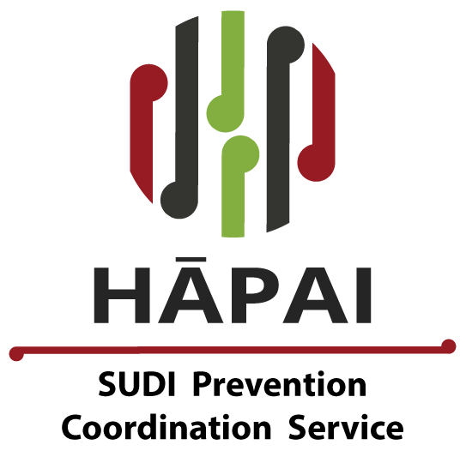

Citation: Ministry of Health. 2019. National SUDI Prevention Programme: National Safe Sleep Device Quality Specification Guidelines. Wellington: Ministry of Health.
Published in April 2019 by the Ministry of Health
PO Box 5013, Wellington 6140, New Zealand
ISBN 978-1-98-856875-1 (online)
HP 7097
This document is available at health.govt.nz
This work is licensed under the Creative Commons Attribution 4.0 International licence. In essence, you are free to: share ie, copy and redistribute the material in any medium or format; adapt ie, remix, transform and build upon the material. You must give appropriate credit, provide a link to the licence and indicate if changes were made.

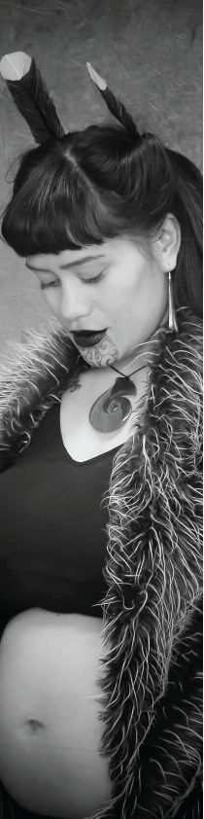 | Karakia – Mihi  He hōnore, he korōria ki te Atua  He maungarongo ki runga i te mata o te whenua  He whakaaro pai ki ngā tāngata katoa  Āmine  Arohaina ngā tēina me ngā tuākana E wehi ana ki te Atua  Whakahōnoretia te Kīngi Māori o te Motu!  Kīngi Tūheitia Pōtatau Te Wherowhero te tuawhitu  E noho nei i runga i te ahurewa tapu o ōna tīpuna. Paimārire  He aha te mea nui o tēnei ao?  Māku e ki atu – he tangata, he tangata, he tangata Kia whakataurangitia te whakaaro nui kia eke  ki runga i te manaaki i ā tātou tamariki mokopuna  Atu ki ō tātou mokopuna kare anō kia whānau mai  In honour and Glory to God  Peace reign throughout the land  Goodwill to all Mankind  Amen  Love to the young and elder siblings  Acknowledging the greatness of our God  Honouring and acknowledging our Māori King!  King Tūheitia Pōtatau Te Wherowhero  Residing on the sacred threshold of his ancestors. Paimārire  What is the greatest statement that we can share in our world?  Allow me to say that it is people, it is people, it is people  To vary our thinking that we may converge  On focusing on caring for our children and grandchildren  And also those of our unborn grandchildren yet to come.

Foreword
Tēnā koutou e whai nei i te oranga o ā tātau pēpi nei.

Having been long involved in New Zealand efforts to reduce infant death from sudden infant death syndrome (SIDS) and then sudden unexpected death in infancy (SUDI), I very much welcome the formal involvement of the Ministry of Health in the rollout of the National SUDI Prevention Programme (NSPP). We have come a long way from the early development of a ‘safer sleep environment’ with wahakura on the East Coast, with ‘safe sleep’ principles of that region then informing the emergence of other safe sleep devices such as the waikawa and the Pēpi-Pod®. But it was the ‘Change for our Children’ scaling up of Pēpi-Pod® production following the Canterbury earthquakes that laid the base for safe sleep programmes in District Health Board (DHB) regions which then led to the establishment of the NSPP in 2017.

While we celebrate the community development of wahakura programmes and the voluntary participation of DHBs in safe sleep programmes, we must all be excited that the Ministry of Health has come on board to roll out the NSPP. Professor Ed Mitchell, Stephanie Cowan and I estimated that the NSPP has covered approximately a quarter of mothers and babies with significant SUDI risk so there is a way to go yet.

Bed sharing after smoking in pregnancy is the primary combination of risks for SUDI in this country and this remains a significant issue in the Māori community. While the NSPP will prioritise funding for the purchase of safe sleep devices such as wahakura and Pēpi-Pods®, we should be aware that smoking in pregnancy requires the full attention of all health professionals. If that sounds like an emergency, let’s be clear – it is. As we make safe sleeping environments the norm in New Zealand, SUDI deaths will hopefully fall. Hopefully too a time will come when SUDI mortality continues to reduce as ways to address smoking in pregnancy are strengthened.

This is an exciting journey. The NSPP is delivered across all 20 DHB regions and directly supports up to 8,500 families and whānau with an elevated risk of SUDI each year. Moving from a community-based and voluntary DHB activity to a well-funded and well-planned national programme with Ministry of Health support will be a more effective way to work towards reaching the ambitious goal of the NSPP: to reduce the SUDI rate from 0.7 in every 1,000 New Zealand babies born (1.59 for every 1,000 Māori) to 0.1 in every 1,000 births by 2025.

This is no small feat and I commend everyone involved.

Professor David Tipene-Leach, MNZM

Acknowledgements
The Ministry of Health, District Health Boards and Hāpai Te Hauora would like to acknowledge the National SUDI Prevention Programme Expert Advisory Group for their direction, advice and overall revision of the national safe sleep device quality guidelines (guidelines).
Amanda Malu  CEO, Royal NZ Plunket Trust  Associate Professor Dr Beverley Lawton  University of Otago Women’s Health Research Centre  Dr Christine McIntosh  Counties Manukau District Health Board GP Liaison Child Health  Primary & Integrated Care  Professor Dr David Tipene-Leach  Eastern Institute of Technology SUDI academic expert  Professor Edwin Mitchell  University of Auckland SUDI academic expert  Estelle Mulligan  Counties Manukau District Health Board safe sleep coordinator and midwife  Professor Hayden McRobbie  Tobacco control expert | Dr Janine Ryland  Ministry of Health, Clinical Advisor Child and Youth Health  Dr Justine Mesui  Pacific general practitioner  Dr Lance O’Sullivan  Māori general practitioner  Associate Professor Dr Marewa Glover  Massey University tobacco control expert (resigned June 2018)  Dr Pat Tuohy  Ministry of Health, Chief Advisor Child and Youth Health  Paula Snowden  CEO, Problem Gambling Foundation NZ  Puti Baker  Ngā Maia ki Tamaki Makaurau, Māori midwife

Glossary
Safe sleep device | Pēpi-Pod®, wahakura, cot or bassinet and the contents of that space: blankets, sheets, mattresses, toys, etc.
Safe sleep environment | Area on which the safe sleep device is placed, or where cot or bassinet is located, free of hazards such as blind cords, curtains, power points, heaters, pets and other children.
Safe sleep position | Position baby is placed for sleep – that is, on their back, with feet to bottom of cot.
Bed sharing | Direct bed sharing by sharing the same sleep surface –that is, baby is in bed with another person. Being in a Pēpi-Pod® or wahakura on a bed is different as these babies are in their own sleep space.

Contents
Karakia – Mihi iii
Foreword iv
Acknowledgements v
Glossary v
Introduction 1
Purpose 1
Challenge 2
Objective 2
Access 2
Overview 2
Wahakura 3
Wānanga wahakura 3
Pēpi-Pod® 4
Baby Box 5
Design and construction of the Pēpi-Pod® and wahakura 6
Regional design and construction differences 7
Bassinets 9
Other sleeping devices 10
Appendix 1: Safety standards and regulations for safe sleep devices 11
Safe sleep device standards 11
Websites with information on regulations and safety standards 11
Risk assessment of heavy metals in wahakura 12
Appendix 2: Summary of guidelines for weaving a wahakura 13
Appendix 3: Cleaning and disinfecting a Pēpi-Pod® 15
Cleaning 15
Disinfecting 15
Appendix 4: Regional differences in the design and style of wahakura 18
Northern region 18
Midland and Central regions 19

List of figures
Figure 1: Wahakura 3
Figure 2: Pēpi-Pod® 4
Figure 3: Cassandra Moar presenting Prime Minister the Rt Hon Jacinda Ardern with a wahakura 18

List of tables
Table 1: Essential features of a safe sleep device to prevent SUDI 7
Table 2: Recommended guidelines for the Pēpi-Pod® and wahakura from different regions 8
Table 3: Summary of wahakura weaving guidelines 13
Table 4: How to make 0.1% hypochlorite solution 16
Table 5: How to make 0.5% hypochlorite solution [for use with Pēpi-Pod® 17

Introduction
The National Safe Sleep Device Quality Specification Guidelines (guidelines) bring together information covering a range of safe sleep devices (SSDs). SSDs include portable sleep spaces that can be used on a bed, or next to the parents’ sleeping surface. Providers of SSDs that are distributed through the Ministry of Health funded National SUDI Prevention programme (NSPP) are expected to supply and distribute them to vulnerable families and whānau and in a way that is consistent with these guidelines. However, SSD providers should not rely on these guidelines as a complete guide for ensuring safe sleep environments for babies.

These guidelines are a living document. They set out the minimum levels of product specifications (eg, fit for purpose, safe, reliable) that SSDs are expected to meet.

The guidelines will support SSD providers, and health and social service practitioners in choosing and using the most appropriate SSDs for eligible whānau as they are guided through the NSPP service pathway.

Purpose
The purpose of these guidelines is to provide a reference source for ensuring that SSDs meet key safety requirements (see Appendix 1: Safety standards and regulations for safe sleep devices) that, together with addressing other key modifiable SUDI risk factors, will protect infants from harm during sleep. They provide DHBs, the health sector and the public with guidance on what is required to ensure SSDs are safe and are used reliably.

The guidelines do not go into detail about safety requirements for all types of SSDs available. However, they support the view that once baby is too large for an in-bed capable SSD or is able to roll over, baby should be placed in a cot to sleep. Because babies remain vulnerable to SUDI until they are approximately 12 months old, parents and caregivers are encouraged to continue with safe sleep practices throughout baby’s first year.

Challenge
The challenge these guidelines help to address is to protect infants against the risk of injury and death associated with supplying and using potentially unsafe SSDs. As infants spend considerable periods of time sleeping, SSDs must have clear and purposeful safety criteria that apply in a wide variety of environments. Families and whānau also need information, and education about how to make sure every sleep for baby is a safe sleep. In this way, families and whānau will have the knowledge they need to use a SSD reliably in the home or when visiting and travelling.

Objective
The objective of these guidelines is to provide DHBs, the sector and the public with minimum safety specifications for SSDs to ensure they are safe and reliable.

Currently Pēpi-Pods® supplied to DHBs meet voluntary SSD safety requirements. Pēpi-Pod® requirements have been established by service provider, Change for our Children. Key people involved in producing the wahakura requirements include Professor David Tipene-Leach and Nanny Whaipooti Hitchiner.

Access
For up-to-date information on who to contact in each DHB district about accessing SSDs for the most vulnerable families and whānau and about what SSD support is available, go to: http://sudinationalcoordination.co.nz/safe-sleep-coordinators

Overview
The guidelines describe the different types of SSDs used in Aotearoa New Zealand:
- wahakura
- Pēpi-Pod®
- Baby Box
- bassinets
- other SSDs – cots, cribs and portacots.

They also address design and construction issues related to wahakura and Pēpi-Pods®.

Wahakura
The wahakura (Figure 1) is a flax-woven in-bed capable SSD that enables families and whānau to keep baby close, including during sleep.

Wahakura were introduced in the mid-2000s to address the SUDI rate among Māori infants, which was approximately six times higher than the rate for non-Māori infants, and to change the nature of bed sharing in a way that is culturally appropriate to Māori mothers. Wahakura as an SSD were piloted in Gisborne in 2006 and Hawke’s Bay in 2007.

Wahakura are a taonga (prized resource), which are embedded in Māori tikanga (customs) and the values of marae (traditional community complexes). The marae is the essence of what connects Māori to their whakapapa (genealogy). Wahakura raranga (plaiting) and whiri (braiding) weaving techniques must combine to produce stiff, rigid or taut sides that will prevent collapsing, ensure a flat base and provide overall strength that guarantees baby’s safety.

Wānanga wahakura
Wahakura weaving is taught to whānau to help meet the demand for SSDs in Māori communities. Teaching whānau how to weave wahakura in a traditional setting using traditional methods, together with promoting safe sleep messages, has resulted in Māori safe sleep alternatives to bed sharing of adults and infants. (See Appendix 2 for a summary of guidelines for weaving a wahakura.)

Figure 1: Wahakura
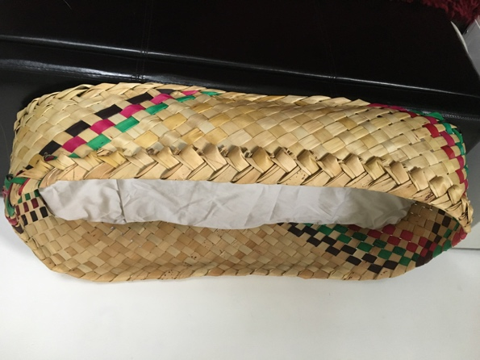
Source: David Tipene-Leach (25 May 2018)

Pēpi-Pod®
The Pēpi Pod® (Figure 2) is an in-bed capable infant bed, made from polypropylene, a food-grade plastic, and fitted with mattress and bedding. The SSD is part of a programme of education to protect infants against accidental suffocation during sleep. The term Pēpi-Pod® is a registered trademark with the Intellectual Property Office of New Zealand.

In 2010, the SSD was introduced to families and whānau for concept testing and served as an emergency response during the Canterbury earthquakes of 2011. Pēpi-Pods® are offered by Change for our Children Limited to families and whānau of babies at increased risk of accidental suffocation. (See Appendix 3 for information on cleaning and disinfecting a Pēpi-Pod®.)

A wahakura or a Pēpi-Pod® provides a ‘zone of protection’ against accidental suffocation, particularly when adults and infants are bed sharing and where the mother smoked during pregnancy. Bringing the SSD into the parental bed also enhances the valued sense of closeness that bed sharing provides. It improves safety by decoupling the high-risk combination of smoke exposure during pregnancy and direct bed sharing.

Figure 2: Pēpi-Pod®
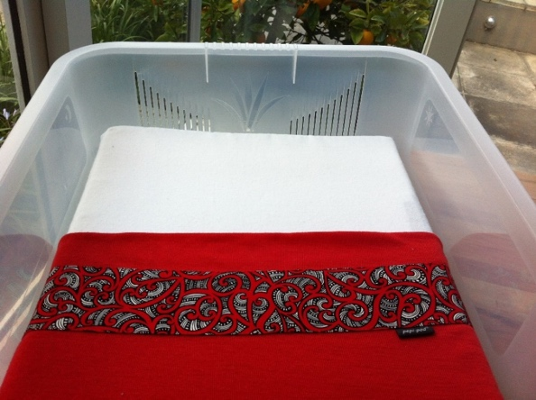
Source: Change for our Children, www.changeforourchildren.nz/pepi_pod_programme/windows_upgrade

Baby Box
The Baby Box is a concept developed in Finland and was originally introduced to support the reduction of infant mortality by providing essential items such as baby clothes, shawls, play mats, bedding, books etc.

In 2015, a charity called Baby Start New Zealand was set up to provide Baby Boxes to the New Zealand market. Baby Boxes are made from reinforced cardboard (as well as the essential items referred to above) and comes with a mattress and bedding, which can serve as a SSD. The Baby Box is not an ‘in-bed capable’ device. When baby is placed in a Baby Box, the SSD should be placed on the floor. The primary focus of a Baby Box is not as a safe sleep device but a total care package to support a family or whānau following the birth of a new baby.

Design and construction of the Pēpi-Pod® and wahakura
Portable SSDs offer a safety solution while a baby is developmentally vulnerable and when other infant bed options may not be available or suitable. Accordingly, these guidelines reflect the developmental needs of infants as well as the physical attributes of a device if ‘in-bed capable’ devices are to be useful in preventing SUDI. Two of the main considerations in the acceptability of the original Pēpi-Pod® were:
- the height of the sides, which needs to make it easy for parents and caregivers to offer a comforting touch and to observe and respond to baby
- the width of the pods, because if the Pēpi-Pod® is too narrow, baby will not be able to fit in it throughout the vulnerable age and if it is too wide, it will not fit in the adult bed so will not be useful for safe bed-sharing.

Table 1 describes generic physical features important to the effective use of an ‘in-bed capable’ safe sleep device. The dimensions it gives do not apply to wahakura. However, the intent – consistent with the first bullet point above – is to ensure that caregivers are able to reach over the edge to comfort baby in the wahakura. If the sides are too high, this is not feasible.

Table 1: Essential features of a safe sleep device to prevent SUDI
Context | The safe sleep device needs to be usable as an infant sleeping space in all situations and locations that are known to increase the risk of SUDI
Features | Portable  Low-sided (15 cm sides)  Rigid construction  Firm sides (not padded or soft)  Compact  Size (40 cm wide x 72 cm long x 15 cm deep)  Supplied with mattress and bedding  For young infants (unable to roll)  Comes with ‘rules’ of protection  Supplied as a health intervention  Recipient invited to help spread safe sleep knowledge and practice | Can be easily carried with baby sleeping in it  Enables easy comforting with loving touch  No assembly required (so no risk from assembly errors)  Reduced suffocation risk  Can be placed in the parental bed  To last babies through the 4–5 months of increased risk  To ensure snug fit and be ‘ready to go’  Not for older babies, or babies who can roll  Safe sleep and infant health principles built-in  Not ‘furniture’ as such. Primary purpose is protection against sudden infant death  Peer education role integrated into supply
For use | In any situation, where a baby is not sleeping in a traditional baby bed | For example, when sleeping in, or on, an adult bed, or on a couch; for use as a ‘day’ bed, when visiting, travelling, out and about, and where a makeshift bed is needed
 | As a complete system for settling and sleep in the vulnerable first months | For example, when no other infant bed is available
Position | Baby lies flat and level in the ISSD (not inclined) | To avoid positional changes from propping or slipping
Source: Mitchell EA, Cowan S, Tipene-Leach D. 2016. The recent fall in post perinatal mortality in New Zealand and the Safe Sleep programme. Acta Paediatrica 105(11): 1312–20. doi:10.1111/apa.13494.

Regional design and construction differences
Across Aotearoa New Zealand, the style of wahakura differs. The differences are fluid and in most cases are specific to the individual weaver, iwi, whānau and hapū (sub-tribe). As mātauranga (knowledge) Māori and weaving practices likewise vary, it is important to respect and retain the different iwi (tribal) practices that sit within a wider knowledge base.

These guidelines do not limit weavers’ artistry, creativity and individual styles, or the body of knowledge unique to wahakura by region, or a ‘one size fits all’ model. Instead, Table 2 draws on weaving values, wahakura construction specifications and practices from Pēpi-Pod® supplier Change for our Children and from experts in the Northern, Midland and Central regions on wahakura in its various forms (see Appendix 4 for more information on regional differences).

It is reasonable to accept a range of wahakura dimensions, allowing for variations in the size of the SSD and in the thickness of the mattress, provided that the:
wahakura does not exceed the minimum and maximum dimensions indicated in Table 2.

Table 2: Recommended guidelines for the Pēpi-Pod® and wahakura from different regions
 | Base width | Height  of sides | Mattress size(s) | Additional resources given with safe sleep device*
Pēpi-Pod® | 40 cm wide x 72 cm long | 15 cm deep – low sides | Firm mattress 40 cm wide x 72 cm long | Includes mattress, bedding and ‘rules of protection’
Northern region wahakura | 40 cm wide x 72 cm long | 15 cm deep – low sides | Firm mattress 40 cm wide x 72 cm long | PEPE message**
Midland region wahakura | 36 cm wide x 70 cm long approximately | 20–25 cm deep | Mattress well fitted to base of wahakura  20–25 mm depth of mattress (sponge rubber)
Central region wahakura | 34 cm wide x 70 cm long  40 cm wide x 70 cm long | 16–24 cm deep  16–22 cm high | Mattress well fitted to base of wahakura
Notes:
* See Change for our Children, www.changeforourchildren.nz/safe_start_programme/baby_essentials_online and www.changeforourchildren.nz/safe_start_programme/tool_kit
** PEPE message: Place baby in their own baby bed in the same room as their parent or caregiver. Eliminate smoking in pregnancy and protect baby with a smokefree whānau, whare (house) and waka (car). Position baby flat on their back to sleep – face clear of bedding. Encourage and support breastfeeding and gentle handling of baby.

Bassinets
One recommendation for SUDI prevention is to provide baby, from birth to 12 months of age, with their own bed in the same room as the parent(s) or caregiver(s).

This age range covers the period of greatest risk for SUDI, as the peak incidence occurs at one to two months, and 80 percent occurs before five months.

Having baby sleep in a bassinet offers the benefits of providing:
- a convenient way to share a room with baby
- a safe sleep space for baby
- convenience and ease for night feeding
- peace of mind.

Bassinets are most commonly designed to work with either fixed legs or casters. Obvious differences from wahakura and Pēpi-Pod® are that bassinets do not provide ‘in-bed capability’ and they take up additional space in the bedroom of the parent(s) or caregiver(s). Many families and whānau use bassinets before using a cot or crib. It is important to note that, when baby can push up or roll over, it is time to transition to a cot (see the next section).

A wide variety of makes and models of bassinets is available. Unlike cots, cribs and portacots, the Commerce Commission has not set mandatory safety standards for these products or their mattresses. Importantly, however, all SSDs should take into account basic safety guidelines to ensure the safest possible sleep for baby and to reduce the incidence of SUDI where possible. In particular, the device should:
- have a mattress that fits flush to all of its edges
- have a firm flat mattress, no more than 40 millimetres thick as it could be a suffocation hazard
- have blankets firmly tucked under the mattress
- have no pillows or bumper-pads
- have no soft toys or extra blankets
- be placed away from windows, curtains and any hanging objects.

Other sleeping devices
Cots, cribs and portacots all have mandatory safety standards. The major difference between the three is that the portacot can fold down and is portable. Portacots come with a safety warning that they are not intended for long-term use and infants should not be left unattended when placed in a portacot. Specific safety concerns are the risks that baby might:
- accidentally release locking devices so that the sides of the portacot collapses
- suffer strangulation or asphyxiation by getting their neck trapped if one or more of the locking devices fail, with the sides forming a ‘V’ shaped clamp
- suffocate if their head gets trapped between the mattress and sides of the portacot, if both are made of non-breathable material.

Important safety measures include:
- checking there are no footholds and the portacot is sufficiently deep that baby cannot fall out of the cot
- testing the parts to ensure there are no small components that baby might swallow.

Most modern cots have two height settings for the base of the cot. The high base, which involves less bending for adults, is used when baby is quite small, while the lower base is for when baby becomes more mobile.

The safety standards apply only to household cots. The few exclusions to these regulations are hospital cots, bassinets, antique cots and collectible cots. New cots should be manufactured under the New Zealand and Australian mandatory safety standards (see the websites in Appendix 1). Buyers should check that a cot is displaying a safety standards sticker so they know it complies with those standards.

Second-hand cots must also meet certain requirements. Some are that the cot must have:
- a minimum depth of 600 mm from mattress base to the lowest point on any side or end
- no horizontal or diagonal bars or fixtures that will allow baby to climb up the sides of a cot
- a permanent warning and information label on the mattress base
- no more than 20 mm of space between all the bars and all sides of the mattress sides
- space between the vertical bars of between 50 and 95 millimetres
- no protrusions (eg construction nuts or bolts or a corner) that measure more than 5 millimetres.

It is always advisable for health professionals to reinforce safe sleep advice and practice with families and whānau. With a cot in particular, families and whānau should place it in a flat, safe place in the room, away from windows, curtains or any potential hazards.

Appendix 1: Safety standards and regulations for safe sleep devices

Safe sleep device standards
For full details of all of the regulation requirements for cots, go to www.standards.co.nz.

Websites with information on regulations and safety standards
Standards New Zealand is a business unit within the Ministry of Business, Innovation and Employment. It manages the development of standards to: improve the quality of goods and services; support trade and commerce; and promote safety health and welfare. Specific SSD standards on its website are:
- https://shop.standards.govt.nz/catalog/2172%3A2013%28AS%7CNZS%29/view Standard AS/NZS 2172:2013: Cots for household use – Safety requirements
- https://shop.standards.govt.nz/default.htm?action=touchstoneRef&mod=catalog&pid=2195:2010(AS|NZS) AS/NZS 2195:2010: Folding cots – Safety requirements.

The Commerce Commission is New Zealand’s competition enforcement and regulatory agency. It gives details on legislation and provides consumer information on the supply of goods and services. For more information, go to: www.comcom.govt.nz

Risk assessment of heavy metals in wahakura
Another area of concern for safety has been the potential for baby to be exposed to contaminant elements (heavy metals) in flax-woven wahakura. Wahakura were therefore tested for their accumulated levels of contaminant elements.

Contaminant elements are not absorbed through the skin to any great extent, particularly from a solid matrix such as flax. However, infants frequently ‘mouth’ items in their immediate environment. This was considered to be the most plausible route of contaminant element exposure for infants from wahakura.

Sections from different parts of the wahakura were excised and extracted with simulated salivary fluid. This testing found that, in all cases, the mean concentrations of saliva-soluble contaminant elements in the wahakura flax are within the range of concentrations potentially present in other food and drinking-water sources for infants.

Given that the amounts of food and water consumed by infants will be much greater than the amount of flax they may potentially mouth, the levels of contaminant elements detected in wahakura are highly unlikely to represent a health concern.

Appendix 2: Summary of guidelines for weaving a wahakura
Table 3 summarises instructions for weaving a wahakura, which includes information from Professor David Tipene-Leach’s wahakura guidelines.

Table 3: Summary of wahakura weaving guidelines
Use whāriki flax and boil it.
Make the base size approximately 35 centimetres (14 inches) wide by 70 centimetres (28 inches) long.
Use approximately 24 strips each side of three whiri plaits to make the base.
Lock off before weaving the sides.
Make the sides approximately 20–25 centimetres (8–10 inches) high.
Use strong, thick whiri to finish at the top.

A few weavers have worked with Professor David Tipene-Leach and Nanny Whaipooti Hitchiner to develop these guidelines, and most tend to follow the dimensions and weaving processes. But, like most artisans or artists, they are innovative, practical and creative so, even with the guidelines, individual styles and identifiable trademark weaving are evident in the finished wahakura.

Professor Tipene-Leach’s resource provides instructions on how to care for and maintain wahakura. It also provides the following specifications and guidelines.
      - Your wahakura should be made by an expert weaver. It should have a flat bottom, reasonably firm sides and a top edge strong enough to allow you to pick it up (without baby in it).
      - Your wahakura is not designed to be a carry-cot. It is for sleeping only; do not put handles on the wahakura.
      - It should have a thin 20–25 millimetre mattress (eg, sponge rubber from Para Rubber) with a cotton cover. Both mattress and cover are easily washable.
      - If the wahakura is soiled, wash it with a wet cloth and mild household detergent. Bleach will kill any mould. Dry with a towel and leave it in the sun.
      - Watch out for worn and weakened spots in the walls of the wahakura, or split flax that might create a sharp edge to catch you or baby on.

In an additional initiative, Hauora Tairāwhiti (previously known as Tairāwhiti District Health) is supporting the development of the Kairaranga Wahakura network or roopu (group) for Te Tairāwhiti. Within that, a Kaunihera (governance group/council) of representative ‘expert weavers’ will help guide and advise Hauora Tairāwhiti on the quality and safety of wahakura, as well as an agreed pricing schedule.

Appendix 3: Cleaning and disinfecting a Pēpi-Pod®
Cleaning and disinfecting a Pēpi-Pod® are two different but important processes.

Cleaning
Cleaning is a process that uses soap or detergent with water to remove visibly contaminated surfaces (ie, soil and grease). Cleaning does not remove or kill micro-organisms. It is possible that something may look clean but still spreads illness.

To make cleaning as thorough as possible:
- use hot water and change it often – detergent works best in hot water, but will not work if the water is dirty
- use a clean cloth and change the cloth at the end of each day. Cloths can be washed with detergent in hot water, boiled, or soaked in a suitable disinfectant and thoroughly dried each day
- use different cloths for different cleaning jobs – colour-code the cloths so you have separate cloths.

Disinfecting
Disinfection is a process that uses chemicals to remove unseen dirt and kill micro-organisms. Disinfectants should be used on surfaces and areas where faeces and mucus are most likely to be found, and where blood or vomit could be.

Disinfectants
Disinfectants kill bacteria and viruses or other organisms that can cause illness. To work properly, they must be used after the area or item has been thoroughly cleaned with soap or detergent and water.

Disinfectants used on most surfaces and items are chemicals that must be wiped on and left for a time to work. The length of time will depend on the strength of the disinfectant. The disinfectant should be left for as long as possible in areas where viruses and bacteria are most likely to be found (eg, toilet and bathrooms).

While a range of disinfectants are available, many are not very effective. Household bleach is one of the most effective and cheapest disinfectants to use. Bleaches contain hypochlorite, the chemical that kills bacteria and viruses. However, bleaches such as Janola, White Magic and other supermarket bleaches are sold in different strengths. The strength of the bleach is written on the label. You will need a disinfectant that has at least 2 percent hypochlorite.

Using bleach as a disinfectant
Different strengths of bleach are needed in different situations, depending on the amount of risk. The following tables will help you to decide how much water you should add to bleach to make a disinfectant or find the right strength (either 0.1% or 0.5% hypochlorite solution).

Making 0.5 percent sodium hypochlorite solution is considered appropriate for high-risk areas. These are areas where there have been spills of blood or vomit, or where there is likely to be body fluids.

Making a 0.1% or 0.5% hypochlorite solution
Follow the instructions in Table 4 to make a 0.1% hypochlorite solution using bleach containing different concentrations of hypochlorite.

Table 4: How to make 0.1% hypochlorite solution
Strength of bleach |  | Quantity of bleach | Quantity of  water | Total volume of diluted solution
%  hypochlorite | g/100 ml hypochlorite
0.5%¹ | 0.5 g/100 ml | 50 ml | 450 ml | 500 ml
2% | 2 g/100 ml | 25 ml | 475 ml | 500 ml
3% | 3 g/100 ml | 10 ml | 290 ml | 300 ml
4% | 4 g/100 ml | 10 ml | 390 ml | 400 ml
5% | 5 g/100 ml | 10 ml | 490 ml | 500 ml

Follow the instructions in Table 5 to make a 0.5% hypochlorite solution using bleach containing different concentrations of hypochlorite. Recently 0.5% hypochlorite solution has become available for use undiluted (straight from the bottle). Check for a manufacturer’s assurance that the concentration will not vary significantly or reduce over time to less than 0.5%.

Table 5: How to make 0.5% hypochlorite solution [for use with Pēpi-Pod®]
Strength of bleach |  | Quantity of bleach | Quantity of  water | Total volume of diluted solution
%  hypochlorite | g/100 ml hypochlorite
0.5% | 0.5 g/100 ml | Use undiluted | Nil | Use undiluted
2% | 2 g/100 ml | 100 ml | 300 ml | 400 ml
3% | 3 g/100 ml | 50 ml | 250 ml | 300 ml
4% | 4 g/100 ml | 50 ml | 350 ml | 400 ml
5% | 5 g/100 ml | 50 ml | 450 ml | 500 ml

To increase the amount of solution made, double (or triple) the amount of bleach and water added.

Caution: Hypochlorite solutions lose strength so prepare enough for each day or store unused dilutions in a cool dark place.
- The strength of the bleach will be on the label. This is the undiluted strength, before you mix it with water.
- A fresh solution of bleach should be prepared each day. It must be protected from light and heat or it will not work well.
- Read the label to see how it should be used and follow the instructions. Be aware of allergies to bleach and wear gloves if you need to.
- Use bleach carefully. It cannot be mixed with other chemicals.
- Where there have been spills of blood or other body fluids, the most effective way to disinfect is to leave the bleach on the surface for 30 minutes. If this cannot be done, wear gloves and wipe up the spillage using a cloth soaked in bleach solution made for high-risk situations, and then throw away the cloth.
- Wipe over the area again using another cloth soaked in the bleach solution. Then clean the area with water and detergent.
- Store bleach safely away from children in a secure, locked cupboard. Try to buy bleach in containers with child-resistant caps. If the bleach is to be transferred to another container, transfer information on the label also.

Do not allow children to play with empty bleach containers.

Appendix 4: Regional differences in the design and style of wahakura

Northern region
Cassandra Moar (Figure 3), a renowned weaver from the North, has created her own set of weaving quality specifications. Her expertise extends to teaching wahakura weaving to both hapū māmā (pregnant mothers) and health professionals. The wider recognition of wahakura as a cultural alternative for Māori to sleep their babies safely has also increased the demand exponentially. A number of DHBs in the Northern region have secured contracts with Cassandra Moar to help provide wahakura weaving and related child wellbeing education across their communities.

Figure 3: Cassandra Moar presenting Prime Minister the Rt Hon Jacinda Ardern with a wahakura
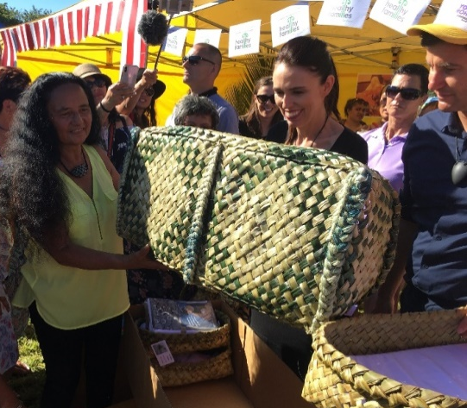
Source: Hāpai Te Hauora (2018)

Cassandra Moar has customised the process so that the wahakura can fit a standard Pēpi-Pod® mattress (360 mm wide x 700 mm long at the base) and the walls are high enough (25 cm high) to safeguard the structure of the wahakura when bed sharing.

Midland and Central regions
A number of expert weavers and collectives of weavers work within the Midland and Central regions. The previous safe sleep programme supported the development of wahakura guidelines by Nanny Whaipooti Hitchiner (Nukutere Weavers Collective, Te Tairāwhiti), Professor David Tipene-Leach and other stalwart advocates of the wahakura. The resource provides information on:
- how to use a wahakura
- why to use one
- how to weave one – with a summary of instructions
- how to make the mattress – pillow-slip style.

Primarily babies of mothers who smoke in pregnancy, coupled with whānau who infant bed share and including Māori, Pacific and Teen Parents.
Hāpai te Hauora. Digital resources. URL: http://sudinationalcoordination.co.nz/digital-resources
Change for our Children. Baby essentials online. URL: www.changeforourchildren.nz/safe_start_programme/baby_essentials_online
Change for our Children. Tool kit. URL: www.changeforourchildren.nz/safe_start_programme/tool_kit
Baddock SA, Tipene-Leach D, Williams SM, et al. 2017. Wahakura versus bassinet for safe infant sleep: a randomized trial. Pediatrics 139.
An ‘in-bed capable device’ is a device such as a wahakura or Pēpi-Pod® where baby can sleep and that can be placed in a bed safely with another person.
CYMRC. 2017. Sudden Unexpected Death in Infancy (SUDI): Special report. Wellington: Child and Youth Mortality Review Committee Te Roopu Arotake Auau Mate o te Hunga Tamariki, Taiohi. Mitchell E, Blair P. 2012. SIDS prevention: 3000 lives saved but we can do better. New Zealand Medical Journal 125(1359).
Consumer Reports. Bassinet buying guide. URL: https://www.consumerreports.org/cro/bassinets/buying-guide/index.htm
Following extraction of the flax material, simulated salivary fluid was analysed for silver, arsenic, bismuth, cadmium, copper, mercury, molybdenum, lead, antimony and tin.
USEPA. 2011. Exposure Factors Handbook: 2011 edition. EPA/600/R-090/52F. Washington DC: United States Environmental Protection Agency.
Tipene-Leach D. 2007. The wahakura: the safe bed-sharing project. URL: www.manageme.org.nz/assets/Uploads/W-Wahakura-book-Sudden-Infant-Death-Syndrome-instructions.pdf
Kairaranga Wahakura network or roopu (group) for Te Tairāwhiti, Wahakura Aotearoa.
Tipene-Leach D. 2007. The wahakura: the safe bed-sharing project. URL: www.manageme.org.nz/assets/Uploads/W-Wahakura-book-Sudden-Infant-Death-Syndrome-instructions.pdf

