Annual
Report
2015

National
Maternity Monitoring Group

Abbreviations used in this report
DHB District Health Board

LMC Lead Maternity Carer (who may be a midwife, a general practitioner or a specialist obstetrician)

MQI Maternity Quality Initiative

MQSP Maternity Quality and Safety Programme

NGO Non-Government Organisation

NMMG National Maternity Monitoring Group

PHO Primary Health Organisation

PMMRC Perinatal and Maternal Mortality Review Committee

RANZCOG The Royal Australian and New Zealand College of Obstetricians and Gynaecologists

Disclaimer
This publication informs discussion and assists New Zealand’s maternity care policy development. The opinions expressed in the publication do not necessarily reflect the official views of the Ministry of Health.

All care has been taken in the production of this publication. The data was deemed to be accurate at the time of release, but may be subject to slight changes over time as more information is received. It is advisable to check the current status of figures given here with the National Maternity Monitoring Group before quoting or using them in further analysis.

The National Maternity Monitoring Group makes no warranty, expressed or implied, nor assumes any legal liability or responsibility for the accuracy, correctness, completeness or use of the information or data in this publication. Further, the National Maternity Monitoring Group shall not be liable for any loss or damage arising directly or indirectly from the information or data presented in this publication.

The National Maternity Monitoring Group welcomes comments and suggestions about this publication.

National Maternity Monitoring Group

2

Contents

Chair’s message 4
About the National Maternity Monitoring Group 5
Background 5
NMMG members 6
An overview of the NMMG’s recommendations 8
The Third Annual Report of the NMMG 10
Registration with a Lead Maternity Carer 11
National variability in access to and quality of primary maternity ultrasounds 16
Rural and primary maternity facilities and services 19
Good example of supporting rural maternity facilities 22
National maternity clinical guidelines 23
Clinical coding 25
Good example of identifying and responding to clinical coding issues 26
The NMMG’s six monitoring priorities during 2014/15 27
Variation in gestation at birth 28
National consistency in the provision of coordinated maternal mental health services 30
Connecting and supporting consumer members of the MQSP 32
The New Zealand Maternity Clinical Indicators 34
The Ministry of Health’s Report on Maternity, 2012 38
DHB MQSP Annual Reports 39
The NMMG going forward 42
Acknowledgements 43
Appendix 1: Terms of Reference for the NMMG 2013-16 44

4 National Maternity Monitoring Group
Chair’s message

In 2014/15, New Zealand’s maternity sector has completed a large work programme focused on improving the quality of our maternity services. Within maternity, there is a
momentum developing to implement quality improvement initiatives. In the past year, the National Maternity Monitoring Group has continued to build on our previous achievements and, together with all maternity stakeholders, we appear to be starting to have a real, demonstrable and positive impact. The response that the Group has had from e sector to its requests has been appreciated as it further informs all of our work in this area as we aim to continuously improve maternity services for women and their babies.

The National Maternity Monitoring Group has continued to play a key part in this work, meeting quarterly to discuss a wide range of issues pertinent to the achievement of New Zealand’s Maternity Standards. We have continued to review national data as it becomes available and ask hard questions of district health boards and others involved in maternity care in New Zealand. Supporting quality
improvement against the New Zealand Maternity Standards continues to drive all of our activities.

We are very pleased that the Ministry of Health, with the support of the Minister of Health, is continuing and expanding the Maternity Quality Initiative. We believe that the priorities for action build on the good work completed to date but also place added emphasis on areas in which further improvements can be made. We fully support seamless flow for women between primary care, the community maternity service and maternity facility service provision. We expect district health boards to be able to show support and understanding to assist all healthcare providers.

We are excited that the Ministry of Health has decided to continue supporting the good work being undertaken by district health boards through the local Maternity Quality and Safety Programmes. We look forward to continuing to support these programmes.

We have reviewed our work programme from the past two years and have decided to strengthen our monitoring role while also continuing to ask challenging questions in specific work areas that we consider need further attention. This will continue to involve all providers delivering maternity care in New Zealand and, most of all, we look forward to continuing our positive, collaborative relationship with the Ministry of Health, maternity providers and consumers as we all continue to work towards the betterment of maternity care for mothers, babies and families.

Norma Campbell

National Maternity Monitoring Group
4

About the National Maternity Monitoring Group

The National Maternity Monitoring Group (the NMMG) was established in 2012 by the Ministry of Health. Our remit is to oversee the maternity system in general and, more specifically, the implementation of the New Zealand Maternity Standards (2011).

Ultimately, the NMMG acts as a strategic adviser to the Ministry of Health on areas for improvement in the maternity sector. We provide a national overview of the quality and safety of New Zealand’s maternity services. The year 2014/15 is our third full year.

Background
The NMMG was created as part of the Maternity Quality Initiative (MQI) launched in 2009. The MQI was made up of:
- a new national Maternity Quality and Safety Programme (MQSP), including maternity standards and clinical indicators
- revision of the Guidelines for Consultation with Obstetric and Related Medical Services (the Referral Guidelines), which set out processes for transfer of care including in an emergency
- a new standardised, electronic maternity information management system to improve communication and the sharing of health information among health practitioners, and
- improved maternity information systems and analysis so that there is better reporting and monitoring of maternity services.

The New Zealand Maternity Standards consist of three high-level strategic statements to guide the planning, funding, provision and monitoring of maternity services in
New Zealand:
- Standard 1: Maternity services provide safe, high-quality services that are nationally consistent and achieve optimal health outcomes for mothers and babies
- Standard 2: Maternity services ensure a woman-centred approach that acknowledges pregnancy and childbirth as a normal life stage, and
- Standard 3: All women have access to a nationally consistent, comprehensive range of maternity services that are funded and provided appropriately to ensure there are no financial barriers to access for eligible women.

These high-level statements are accompanied by specific audit criteria and measurements for these criteria. One of the criteria is that a national monitoring group be established to oversee the maternity system and the implementation of the New Zealand Maternity Standards. The NMMG’s role is to provide advice to the Ministry of Health on priorities for national improvement and to provide advice to district health boards (DHBs) on priorities for local improvement.

NMMG members

Norma Campbell (Chair)
Norma is a Midwifery Advisor - Quality and Sector Liaison for the New Zealand College of Midwives and has been a member of the International Confederation of Midwives Council for the past seven years. She has been involved in a number of expert advisory groups including being the Chair of the National Breastfeeding Advisory Committee. Norma has been involved in developing and supporting the MQI nationally and supporting the MQSPs in DHBs.

John Tait (Vice-Chair)
John is a consultant obstetrician and gynaecologist and New Zealand Vice President of the Royal Australian and New Zealand College of Obstetricians and Gynaecologists (RANZCOG). He is also the Executive Director Clinical Surgery, Women and Children’s Directorate at Capital and Coast DHB. He works in public obstetric practice and privately in gynaecology and reproductive medicine. John has been involved in a number of expert advisory groups including developing and supporting the MQSP.

Frank Bloomfield
Frank is a neonatal paediatrician at National Women’s Health, Auckland City Hospital, Director of the Liggins Institute and Professor of Neonatology at the University of Auckland. He currently is President of the Perinatal Society of Australia and New Zealand and a corresponding member of the New Zealand Paediatric and Child Health Division Committee of the Royal Australasian College of Physicians. Frank also is part of a large research group investigating perinatal care at the Liggins Institute, University of Auckland. He contributed to the Working Group on Maternity Standards.

Elaine Langton
Elaine is a specialist anaesthetist and, until recently, was the Clinical Leader of Obstetric Anaesthesia at Capital and Coast DHB. She is a member of the
New Zealand Society of Anaesthetists and a fellow of the Australian and New Zealand College of Anaesthetists. She has specialised in obstetric
anaesthesia for more than 20 years and has represented obstetric anaesthesia on a number of maternity advisory groups. Elaine is also currently involved in the Severe Acute Maternal Morbidity research project, which is reviewing near- miss maternity events.

Beverley Lawton
Beverley is the Director of the Women’s Health Research Centre and an Associate Professor at the University of Otago. She is Ngati Porou and a member of Te Ohu Rata O Aotearoa (Māori Medical Practitioners Association) and Te Akoranga a Maui (Māori faculty of the Royal New Zealand College of General Practitioners). Beverley is currently leading the national Severe Acute Maternal Morbidity research project, which is reviewing near-miss maternity events.

Judith McAra-Couper
Judith is Chair of the Midwifery Council and the Head of Midwifery at Auckland University of Technology. Judith is an Associate Professor and Director of the centre for Midwifery and Women’s Health Research and is involved in a number of research projects including maternal mental health, sustainability of midwifery practice and place of birth. Judith regularly works for the World Health Organisation in Bangladesh in midwifery education. She has worked in Counties Manukau Health for many years and continues to be involved in this community.

Rachael McEwing
Rachael works at Christchurch Women's Hospital and in a private practice for Christchurch Radiology Group, almost exclusively in Obstetric and Gynaecology imaging. She is a Fellow of the Royal Australian and New Zealand College of Radiologists and an advisor to the National Screening Unit on first trimester screening.

Margret Norris
Margret is the Midwifery Leader for Bay of Plenty DHB. She has held various roles in the midwifery profession as an employed midwife working in the DHB and as a lead maternity carer (LMC) midwife working in the rural areas. To maintain her clinical competences she supports the maternity services, has a small caseload and also does weekend cover for local LMC Midwives. Margret is also the Perinatal and Maternal Mortality Review Committee (PMMRC) coordinator for Bay of Plenty DHB.

Rose Swindells
Rose is a mother with a passion for community development. Before having children she managed community centres in Wellington and family learning projects at historic sites in London. Since she has become a mother, Rose has enjoyed using her community networking and advocacy skills as a Consumer Representative on the Capital and Coast DHB’s Maternity Quality and Safety Panel.

Sue Belgrave (ex officio)
Sue is the current Chair of the PMMRC. She is a consultant obstetrician and gynaecologist at North Shore and National Women’s Hospitals and Clinical Director of Obstetrics for Waitemata DHB. She is a RANZCOG training supervisor and is the Chair of the Auckland training committee. Sue is a local coordinator at Waitemata DHB for the PMMRC and is an advisor on ultrasound in Obstetrics and Gynaecology.

Bronwen Pelvin (ex officio)
Bronwen is the Ministry of Health’s Principal Advisor on Maternity. A midwife with more than 30 years of experience, Bronwen has worked as a domiciliary midwife, a community-based LMC, a core midwife and a maternity manager. She worked as the national Midwifery Advisor for the New Zealand College of Midwives and was also the Professional Midwifery Advisor for Nelson Marlborough DHB before moving into her current role. A major focus of her work in the Ministry of Health has been the development of the MQI and its implementation.

Allen + Clarke (secretariat)
Allen + Clarke provides a wide range of secretariat and policy services required to support the effective administration and management of the NMMG. It also specialises in delivering core policy services, programme development, implementation and review, evaluation and regulatory analysis. Its clients include a wide range of central and local government agencies, professional bodies and non-government organisations (NGOs) in New Zealand and abroad.

An overview of the
NMMG’s recommendations

There are a number of things that need to happen to ensure the continued improvement of maternity services in New Zealand. Below, we outline those areas in which we expect to see action from key maternity stakeholders.

- Consistency in the quality of first trimester care: all health practitioners providing publicly funded services to women must ensure that they provide evidence-informed early pregnancy care.
- Registration with an LMC: DHBs must understand the needs of their pregnant populations and apply this understanding to the development of initiatives that meet the needs of women, including those who are not accessing care in a timely manner.
- Access to and quality of primary maternity ultrasounds: we support efforts to understand and act on the rising number of primary maternity ultrasounds and we support clarification of the quality frameworks that surround maternity ultrasounds.
- Rural and primary maternity facilities and services: we support the Ministry’s commitment to strengthen these maternity services including more timely and more equitable access to community-based primary maternity care and services particularly for women who live in rural New Zealand.
- National maternity guidelines: we expect to see increased use by guideline developers of the AGREE II Instrument and adapted algorithm before submitting guidelines to the NMMG for appraisal and ratification.
- Clinical coding: we expect DHBs, through the MQSPs, to ensure that there is better communication between midwives, medical staff and clinical coders. DHBs need to ensure that there are processes to review the quality of data locally and to identify instances of coding error and the reasons for this.
- Variation in gestation at birth: we expect DHBs to continue to monitor variation in gestation and to consider impact of healthcare provider on timing of birth and evidence for these decisions.
- Maternal mental health: we expect PHOs, DHBs and NGOs to work together to develop integrated pathways for maternal mental health (extending from conception to one year post-birth) and expect all DHBs to include a formal maternal mental health pathway in their next MQSP Annual Report.
- Connecting and supporting consumer members of the MQSP: all DHBs must have more than one consumer member involved in the MQSP governance structure and must provide adequate guidance and support to consumer members to network with the wider consumer voice in each DHB.
- New Zealand Clinical Indicators: we expect DHBs to continue to review the Maternity Clinical Indicators data and to use this data to guide quality improvement initiatives including reporting this work in their Annual Reports.
- DHB MQSP Annual Reports: we expect DHBs to produce easy-to-read annual reports which are available to the public. These should demonstrate a clear programme of work aligned to the local MQSP’s strategic objectives including achievements against these objectives.

Finally, as the MQI and the MQSP move into an established phase, we expect all DHBs to continue to develop and enhance local MQSPs. ‘Emerging’ DHBs must progress an MQSP that effectively uses data and delivers a joined-up programme of quality initiatives. We encourage ‘Established’ DHBs to move towards an excelling programme. ‘Excelling’ DHBs should continue the excellent work previous completed as they further embed maternity quality into long-term, organisation wide, strategic quality frameworks to improve outcomes for women and their babies.

The Third Annual Report of the NMMG

Over the following pages, we outline our work in 2014/15.
In line with our brief to oversee the New Zealand Maternity Standards, the NMMG’s 2014/15 work programme focused on providing strategic advice on matters related to improving quality, safety and experience of maternity care in New Zealand, improving health and equity for women and babies and supporting best value for public health system resources. In 2014/15, we met four times to discuss the implementation of our work programme and our priorities.

Our priority investigative workstreams for 2014/15 were:

- Timing of registration with an LMC which was expanded to look at the first antenatal assessment and the quality of this assessment by the health professional involved
- National variability in access to and quality of primary maternity ultrasounds
- Rural and primary maternity services and facilities
- National maternity clinical guidelines, and
- Clinical coding.

In this report, we describe our work, explain why we have chosen to focus on specific topics, our findings and areas for further improvement. We also share examples of good practice and useful statistics.

National Maternity Monitoring Group

10

Registration with a Lead Maternity Carer

Our focus for 2014/15 was to explore the quality of first trimester antenatal care, including how each DHB supports women to access this care and timely access to registration with an LMC.

Supporting early access to high-quality maternity care enables sharing of information with women and baseline health assessment early in pregnancy. Public health messages can also be conveyed at this early stage. For this to occur, women themselves need to understand the importance of registering with an LMC early and to experience and see value in doing so for the health of both themselves and their baby.

In 2014, we recommended that focus continue on first trimester registration with an LMC. We expected to see clear outcomes from relevant initiatives and that the specific cultural needs of DHB populations are recognised in the way that information is conveyed to women.

What we’ve done this year and our findings

We monitored DHBs’ rates of registration with an LMC within the first 12 weeks of pregnancy.

Enrolment with an LMC in the first trimester of pregnancy has increased in all DHBs since 2008. Rates of very late registration (after 26 weeks of gestation) are also falling; however, there are striking differences in registration before 12 weeks gestation by ethnicity, age and/or deprivation quintile. For example, young Pacific women living in high deprivation areas have significantly lower rates of registration than other groups. We note that DHBs generally describe their pregnant populations well in their MQSP Annual Reports. We are less sure about how DHBs then use their knowledge of the pregnant population to determine strategies and initiatives to encourage timely registration among groups with lower rates of registration.

Figure 1: Percentage of women registered with an LMC prior to birth by trimester of registration, age group, ethnic group and deprivation quintile of residence, 2012
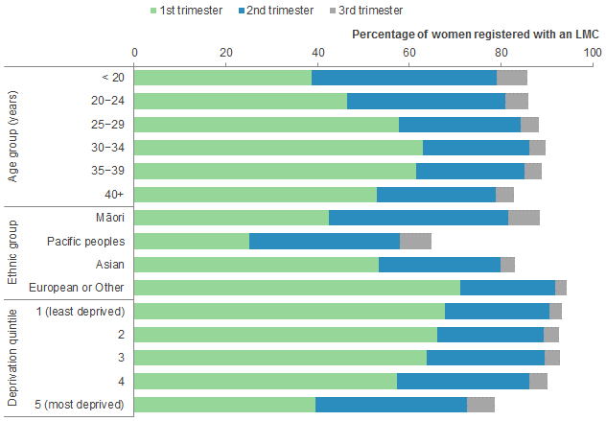

Source: Ministry of Health. 2015. Report on Maternity, 2012. Wellington: MOH.
Note: The denominator used to calculate percentages is the number of women giving birth for that demographic group.

We reviewed data on the number of women who visit a non-LMC Section 88 claimant for early pregnancy care.

Approximately 60 percent of women who give birth see a non- LMC Section 88 claimant for at least some early pregnancy care (for example, diagnosis of pregnancy by a general practitioner or a practice nurse). Access varies by DHB,
by parity, by maternal age and by ethnicity. We were pleased to hear that a first trimester non-LMC contact appears to have a positive impact on timely LMC registration, with 81 percent of women who have a first trimester non-LMC contact claim registering with an LMC in the first trimester. These women also appear to register slightly earlier than those who did not have a non-LMC contact (mean registration at 11.5 weeks compared to registration at 12.6 weeks).

We investigated national consistency in the quality of first trimester antenatal care.

As first trimester registration rates with LMCs continue to increase, we have shifted our attention to investigating the quality of care that pregnant women receive in the first trimester regardless of whether care is delivered by an LMC, a general practitioner, a practice nurse or another health practitioner. Specifications for first trimester maternity care are well described in the section 88 Primary Maternity Services Notice1. To start our investigation into the quality of first trimester care, we:
  - requested advice on how professional colleges support quality in early pregnancy consultations, including those who provide non-LMC first trimester consultations
  - discussed the Ministry of Health’s Integrated Performance and Incentive Framework and audits of the Section 88 Primary Maternity Services Notice claims data, and
  - provided information to each PHO about the number of women presenting for a non- LMC first trimester consultation (through non-LMC section 88 claims data) and requested information about the early pregnancy care that they provide and the education that their providers receive to remain updated with latest evidence.

We heard there may be variation in the type of care received at an early pregnancy consultation. Care ranges from a full early pregnancy assessment and provision of advice and information to women to diagnosis of pregnancy and the provision of advice about engaging with an LMC only. We also heard that care may be provided by practice nurses as well as (or instead of) general practitioners. Finally, we were told about a software initiative designed to support general practitioners and practice nurses to deliver early pregnancy care and developed in response to an identified gap in understanding about the expectations of this care.

We considered whether general practitioners and practice nurses had sufficient access to available post-registration education to maintain a current, evidence-based understanding of early pregnancy care and assessment.

We are concerned about the apparently limited availability of post-registration education for health practitioners working in primary care in relation to women’s health generally and maternity specifically. We discussed the importance of up-to-date knowledge about women’s health issues for general practitioners including understanding what is required when they see a woman for a first trimester visit and the current evidence that supports that care and advice.

We discussed the post-registration education currently funded by Health Workforce New Zealand including the Postgraduate Certificate in Women’s Health and the
Postgraduate Diploma in Obstetrics and Gynaecology. We understand these are not well- utilised yet were reassured to hear that options for education of general practitioners and practice nurses in women’s health and maternity care is also being discussed by Health Workforce New Zealand.

1 This is available at: http://www.health.govt.nz/publication/section-88-primary-maternity-services-notice-2007.

The changes we expect to see next

We will continue to monitor the timeliness of women registering with an LMC within the first 12 weeks of pregnancy.

Our correspondence this year has raised awareness of the quality aspects of care and ongoing education and updates required to provide care in the first trimester – particularly the absence of this for general practice teams. In 2015/16, the NMMG will continue to investigate how best to measure the quality dimensions of first trimester antenatal assessments.

All health practitioners providing publicly funded services to pregnant women need to ensure that they are well-informed about what should be covered in an evidence- informed early pregnancy consultation. The service expectations are set out in the Section 88 Primary Maternity Services Notice. All health practitioners must follow these requirements if claiming for pregnancy care payments.

We will maintain communication with Health Workforce New Zealand in relation to their discussions about education options to ensure evidence informs all first trimester consultations.

Good examples of promoting timely LMC registration

Good examples of
connection between disciplines

National variability
in access to and quality of primary maternity ultrasounds

Our focus for 2014/15 was to further explore ways to support the delivery of high-quality primary maternity ultrasounds throughout pregnancy.

Best practice antenatal care for a woman who has no complications of pregnancy, is low risk, engages with health services in the first trimester of pregnancy, and carries her baby to term involves referral for two screening-based ultrasounds:

- a first trimester ultrasound optimally performed at around 12 weeks for dating, identification of twin pregnancy, early anatomy assessment and screening for chromosomal anomaly(if consented to by the woman), and
- an anatomy ultrasound optimally performed at 19+ weeks for detailed assessment of fetal anatomy.

In 2013/14, we reviewed primary maternity ultrasound claims data held by the Ministry of Health and found that the average total number of ultrasounds for women who had a live birth or stillbirth was 3.4. The most common number of ultrasounds received was three. This has increased over time. We recommended that more effort was needed from professionals who order primary maternity ultrasounds, the Ministry of Health and DHBs to understand and act on the rising number of ultrasounds. Specific recommendations included that:

- the Ministry of Health conduct a quality audit and investigation into the rising numbers of ultrasounds being claimed for under the Section 88 Primary Maternity Services Notice
- we co-opt a College of Radiology member onto the NMMG for one year to provide specialist advice as part of the NMMG
- the Ministry of Health consider how best to fund ultrasounds so that universal access to a funded maternity service for women includes no co-payments for clinically indicated scans and ensures no potential practitioner incentive to request more scans
- DHBs work with consumer networks through the MQSP to ensure that women are fully informed about the referral reason for scans
- DHBs and the professional colleges prioritise primary maternity ultrasounds as an area to jointly review the evidence in relation to scans and the indications for ordering them, and
- professional colleges provide clinical leadership by discussing if professional standards are being followed in relation to requests for primary maternity ultrasounds, and the factors driving the increase in scans and whether these are based on evidence.

In 2014/15, we continued our investigations into national variability in equity of access to primary maternity ultrasounds including cost for women, timing and quality. We are pleased to note significant progress in this area.

What we’ve done this year and our findings

We co-opted a radiologist (Rachael McEwing) onto the NMMG to provide specialist knowledge while we uncover the reasons for increasing numbers of primary maternity ultrasounds.

We sought information from the professional colleges, DHBs and PHOs about ultrasound utilisation.

Our investigations indicate that a higher than expected number of primary maternity ultrasounds are continuing to be performed despite the NMMG raising issues with the sector. We remain concerned by this. Specific issues arising because of this increase include:
  - lack of equity of women's access to primary maternity ultrasounds (driven by variable co-payments and limited services in some regions)
  - concerns that some primary maternity ultrasounds are being performed without clinical indication (i.e., six-week dating scans) or insufficient time being allocated to perform thorough anatomy ultrasounds, and
  - the lack of national standards to guide clinical pathways for primary maternity ultrasounds.

We recommended that the Ministry of Health convene a multidisciplinary working group to consider primary maternity ultrasound quality assurance and access issues.

A multidisciplinary maternity ultrasound working group should develop an evidence-based guideline that describes the expected standards for publicly funded primary maternity scans in relation to timing of screening ultrasounds, referral for primary maternity ultrasounds, undertaking primary maternity ultrasounds, reporting on scans and follow-up (i.e., a guideline that reflects professional standards and evidence and which covers the complete clinical pathway from referrer to scan to follow up). We also recommended that this group provide expert advice to the Ministry of Health as it conducts a financial audit of primary maternity ultrasounds claimed under the Section 88 Primary Maternity Services Notice.

Next Steps

As in 2013/14, there is much work to be done and we look forward to supporting the Maternity Ultrasound Advisory Group in its work and its monitoring responsibilities. We also expect to retain a representative of the College of Radiology on the NMMG until June 2016.

Good examples of investigating obstetric ultrasound

Auckland DHB, Counties-Manukau Health, Northland and Waitemata DHBs

Rural and primary
maternity facilities and services

Our focus for 2014/15 was to consider the provision of primary maternity services and facilities, particularly accessibility to these services for women living in rural areas.

Approximately ten percent of New Zealand women birth at primary maternity facilities, with many of these maternity units located in rural areas. We were interested in whether pregnant women in rural areas access maternity services locally and receive continuity of care from local LMCs and, in cases where primary maternity facilities are available, the utilisation rates. The range of services women may access at local community facilities includes:

  - labour, birth and support after birth including establishing breastfeeding and early parenting support at the community maternity unit
  - pregnancy and parenting classes, and
  - pregnancy care from an LMC (including consultation with the obstetric service if required) and possibly birthing in a secondary or tertiary maternity hospital.

What we’ve done this year and our findings

We discussed trends in birthing at primary maternity facilities.

The Crown Funding Agreement requires DHBs to support and maintain primary maternity facilities, particularly if these are already established and are servicing a population of women who live over one hour from a secondary or tertiary maternity service. We are concerned that some primary maternity facilities are under-utilised, which can result in DHBs conducting reviews and subsequently closing units. These facilities (whether urban or rural) are especially vulnerable during DHB service spend evaluations.

From discussions with the sector, it seems that community units need to be modern and supported by LMCs to ensure that they are used by their populations. Reasons for choosing not to birth in primary community units are complex. More investigation is needed into whether facility quality and perceptions regarding timely access to obstetric care are the main reasons for under-utilisation or whether other drivers exist.

Figure 2: Distribution of women giving birth at a maternity facility, by type of facility, age group, ethnic group and deprivation quintile of residence, 2012

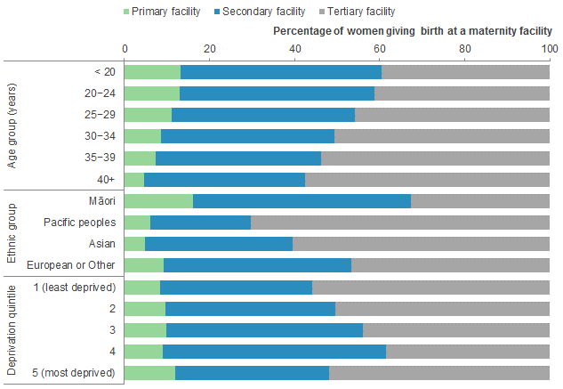

Source: Ministry of Health. 2015. Report on Maternity, 2012. Wellington: MOH.

Note: The denominator used for calculating percentages is the number of women giving birth at a maternity facility for each demographic group.

Figure 3: Distribution of women giving birth at a maternity facility, by type of facility and DHB of residence, 2012

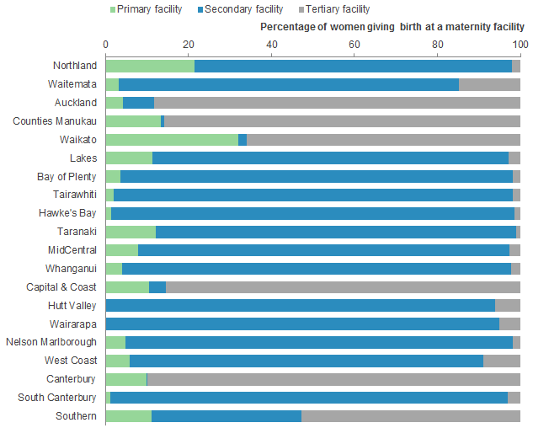

Source: Ministry of Health. 2015. Report on Maternity, 2012. Wellington: MOH.

Note: The denominator used for calculating percentages is the number of women residing in each DHB region who gave birth at a maternity facility. Some DHBs do not have primary maternity units. Homebirths are excluded.

We recommended that the Ministry of Health host a national forum to discuss issues facing rural and primary maternity services and facilities. We asked that invitations be extended to consumers, NGOs that provide primary maternity facilities, maternity health practitioners including LMCs, practice nurses and general practitioners, obstetricians, DHBs and the NMMG.

The changes we expect to see next

The NMMG acknowledges the support that this workstream has received from the Ministry of Health through its commitment to proceed with a national forum and through the MQI priorities for 2015/16 – 2017/18 (which include a focus on strengthening maternity services with more timely access and more equitable access to community-based primary maternity care and services). We look forward to following the progress made in this area.

We are also mindful of the workforce issues facing LMCs and other health practitioners working in rural areas. A number of issues, including access to emergency care, location of the birthing population and remote areas, have come to the attention of the NMMG as we have been exploring this area. We will continue to monitor the progress of work in this area, especially following-up on the outcomes of the Ministry’s national forum to determine our role in this work.

We would like to further explore the establishment and delivery of multidisciplinary emergency response education with the relevant Colleges, ambulance services and Health Workforce New Zealand.

Good example of
supporting rural maternity facilities

West Coast DHB

National maternity clinical guidelines

Our focus for 2014/15 was to support the Ministry of Health to develop a process through which robust, evidence-based maternity-related guidelines can be ratified into national guidelines.

National maternity clinical guidelines are a key component of the maternity sector. They set standards based on the latest clinical evidence or best practice and enable consistency in clinical maternity practice nationally. We are aware
of work undertaken by special interest multidisciplinary groups (often led by the Colleges) which may provide such guidance to the sector (or conversely which may result in less robust advice) and which
may be rolled out without being formally appraised or ratified. The NMMG determined that it is important to establish a formal process to appraise and ratify such work (or not, if a robust and transparent process had not been followed).

What we’ve done this year and our findings

We recommended that all clinical guidelines not developed by the Ministry of Health be appraised and ratified using a framework based on the Appraisal of Guidelines for Research and Evaluation II (AGREE II) Instrument before it can become national guidance in maternity.

The developed framework focuses on ensuring that a robust, evidence-based, collaborative, practical and multidisciplinary approach is used to develop national guidelines.

We asked the Ministry of Health to consider using the AGREE II Instrument as a ratification tool and to seek feedback from the sector on its use, which the sector supported.

We recommended that the Ministry of Health publish the AGREE II Instrument and algorithm on its website, advise the sector of the ratification process and approach any groups that have developed draft guidelines so that appraisal and ratification can be completed.

The changes we expect to see next

Effective development and implementation of national guidelines requires engagement with both guideline developers and the sector to ensure that the suggested process is workable. The NMMG looks forward to fulfilling our role in considering draft guidelines for ratification to national guidance. We encourage those who have been working on clinical guidelines through a multidisciplinary approach to become familiar with the AGREE II Instrument requirements.

The NMMG advised the Ministry of Health during 2014/15 that it supported the development of a national guideline on the management of pregnancy-related hypertension and pre-eclampsia. We look forward to this work proceeding.
Pregnancy-related hypertension and pre-eclampsia are common and potentially serious conditions for both women and their babies. A guideline will provide advice on the prevention, diagnosis and management of these conditions.

We will maintain a monitoring focus on several existing national guidelines including DHBs’ implementation of the Screening, Diagnosis and Management of Gestational Diabetes in New Zealand: a clinical practice guideline and the Guidelines for Consultation with Obstetric and Related Medical Services (Referral Guidelines). The NMMG notes that the Referral Guidelines are due to be updated by December 2017 to ensure that they reflect current evidence and best practice. We support this work.

Clinical coding

Our focus for 2014/15 was to support efforts to ensure that maternity data collected from DHBs by the Ministry of Health is nationally consistent and accurate.

The NMMG received advice from DHBs and through the MQSP on concerns about data quality specifically relating to the standard of coding. Accurate data informs much of the work that the whole sector does and specifically when the Ministry’s Report on Maternity and New Zealand Maternity Clinical Indicators are produced. Previously, we noted that clinical coders appeared to be under-supported. In 2014, we recommended that the Ministry of Health and DHBs consider the support provided to clinical coders so that there is confidence in the national maternity data.

What we’ve done this year and our findings

We met with Ministry of Health staff to discuss coding practice and quality improvement initiatives and the concerns that have been raised with us.

We arranged for an NMMG member to work alongside the Principal Advisor (Maternity). A meeting with the Ministry of Health was arranged to discuss data coding concerns, communications between coders and maternity clinicians and to inquire about ongoing education, support and guidelines for maternity coding. We wanted to be confident about DHB-level data quality. We found that a number of different stakeholders are responsible for ensuring quality maternity data. DHB coding staff have training on and work to the International Statistical Classification of Diseases and Related Health Problems 10th Revision (Australian Modification). The Ministry of Health’s National Collections and Reporting team are then responsible for ensuring the quality of data that is entered into the data collections. As DHB coders work across a number of health areas, we encourage coding teams, MQSP coordinators and maternity clinical leaders to develop and maintain relationships to ensure queries about maternity data anomalies are jointly reviewed. We also note that all clinicians working in maternity need to ensure they enter the correct information into women’s records as they too have a role to support coders. DHBs must ensure that entering such information is easily facilitated as part of the clinical work flow as this encourages accuracy.

The changes we expect to see next

This workstream has encouraged all DHB MQSP Coordinators and maternity clinical leaders to provide support for DHB coding teams, to work together and to have regular reviews of the quality of data coded locally to identify instances of coding error. Proactive management of such issues is then required. We note this is now occurring in some DHBs and encourage all DHBs to move toward a proactive approach. Management of identified issues includes providing support to maternity clinical coders, regular local review of data to detect issues and working closely so that there is clear understanding between all clinicians in maternity about the need to maintain quality of this data and what would further enable this to occur.

The NMMG will continue to review the Ministry’s annual Report on Maternity, the Clinical Indicator Report and the MQSP Reports from a data monitoring perspective.

Good example of
identifying and responding to clinical coding issues

Taranaki DHB

2015 Annual Report 27
The NMMG’s six monitoring priorities during 2014/15

The NMMG has an important role to oversee the New Zealand maternity system, to monitor the implementation of the New Zealand Maternity Standards and to advise on priorities for improvement arising from this work.

Our 2014/15 work programme focused on monitoring the following six aspects of New Zealand's maternity system:
- Variation in gestation at birth
- National consistency in the provision of coordinated maternal mental health services
- Connecting and supporting maternity consumer members of the MQSP
- The New Zealand Maternity Clinical Indicators
- The Ministry of Health's annual Report on Maternity, and

DHB MQSP Annual Reports.

National Maternity Monitoring

Group

27

Variation in gestation at birth

Our focus for 2014/15 was to monitor national variation in gestation at birth including considering the impact of healthcare provider-determined time of delivery on variation in gestation.

Research shows that worldwide there have been increases in planned early birth
(370 to 386 weeks gestation). Prolonging pregnancy to 40 weeks generally results in better neonatal outcomes and less health resource used with each week gained in gestational age. Previously we have provided DHBs with data on the gestation at time of induction of labour and elective caesarean section and have recommended that DHBs monitor these rates, particularly noting the gestation of babies when either of these birth modes are planned.
We also asked that stakeholders use consistent terminology relating to planned early-term birth.

What we’ve done this year and our findings

We reviewed rates of induction of labour and elective caesarean birth, identified that mothers of different ethnic groups and ages experience differing rates of elective caesarean sections and inductions of labour and discussed what DHBs and health professionals considered as possible reasons for these differences.

Specifically, we reviewed 2009-2012 data on gestational age, maternal age, ethnicity and mode of birth at 370 to 386 weeks gestation (i.e., early-term birth). Key findings are that:
- European and Middle Eastern, Latin American and African women have higher rates of elective caesarean sections than Māori, Pacific or Asian women.
- There are differences based on ethnicity and maternal age when elective caesareans and inductions of labour are performed: Pacific and Māori women tend to have elective caesarean sections when they are younger; other ethnicities have them when they are older.
- More inductions are performed at 37 weeks gestation compared to other gestational ages.

We were pleased to see that most DHBs are auditing and reviewing data on variation in gestation at birth (including rates of early inductions and caesarean section) and conducting relevant quality improvement activities where indicated. We expect this work to continue. We expect those DHBs that have not yet initiated a review process to do so in the coming year and that all DHBs will report on this work in their MQSP Annual Reports (particularly where it has influenced changes to practice and information for women).

We provided advice to the Ministry of Health on sector discussion about appropriate national guidance to measure and plot fetal growth in pregnancy to identify small for gestational age/suspected intra-uterine growth restriction babies.

We noted that there is a need for multidisciplinary education on fundal height measurement and recording methods and, if a baby is considered to be small for gestational age, ensuring that adequate clinical pathways
exist. Gestation Related Optimum Weight (GROW) is one software tool designed to assess fetal growth.
The NMMG is aware that while these charts have been used in some jurisdictions, high quality evidence for their use in New Zealand is currently lacking. There is variation in the extent of their use beyond the indications that this tool was developed for. We are concerned about the level of variation in application and implementation of these tools (and others) given
the potential risks faced by babies and mothers by incorrect interpretation or use.

The changes we expect to see next

We will continue to monitor variation in gestation with an emphasis on further exploring whether there is a relationship between planned early-term birth, maternal age and ethnicity. We expect that all DHBs will continue to carefully monitor rates of inductions of labour and elective caesarean sections and that they will provide advice to the NMMG on their findings and any relevant quality improvement initiatives.

We will continue to provide advice to the Ministry of Health on progressing a national framework and clinical pathway for the assessment of babies for whom there are concerns about fetal growth. This must be equitable for all women and babies and must have quality assurance frameworks surrounding it.

National consistency in the provision of coordinated maternal mental health services

Our focus for 2014/15 was to continue to support better knowledge for women and the maternity sector of mental health service availability, timeliness of access and integration between maternity and mental health services.

Maternal mental health has been a focus of our work programme since we began. A number of reports have identified either the lack of availability or lack of clear information for women about accessing mental health services during and after pregnancy. Women with existing mental health issues are particularly at risk of escalation during pregnancy and postnatally. Suicide remains a leading cause of maternal mortality.

The NMMG has previously noted that all DHBs are required, under the DHB Service Coverage Schedule, to provide perinatal and maternal mental health services. In our 2014 Annual Report, we recommended that all DHBs must include a formal maternal mental health referral pathway between primary care, secondary care, maternity and paediatric services in their 2014/15 MQSP Annual Report.

What we’ve done this year and our findings

We wrote to each DHB advising of the importance of integrated maternal mental health services and requesting advice about service prioritisation and maternal mental health referral pathways between primary care, secondary care, maternity and paediatric services.

We were encouraged to hear about initiatives that support improved priority access to mental health care for mothers in some DHBs. This included:
- establishment of multidisciplinary strategic advisory groups to develop and oversee initiatives
- development of clearer regional maternal mental health pathways
- development of mental health service directories for maternity providers and, importantly,
- changes to practices to support easier and more timely access to referred services (such as enabling LMCs or women themselves to refer into services or the appointment of a dedicated staff member to manage maternal mental health referrals).

The changes we expect to see next

We were disappointed by how few DHBs appear to have integrated frameworks for maternal mental health care. The NMMG appreciates how complex and resource- intensive this can be but it is critical for women who have mental health concerns and their health care providers to know where to access care and support. We expect each DHB to work with PHOs, general practice and NGOs that provide mental health services to draft a formal maternal mental health referral pathway. This pathway extends from conception until the child is one year old. We will continue to monitor how women access maternal mental health services through reviews of MQSP Annual Reports. We will write to the Chief Executives of those DHBs who appear to have done no work in this area to date to inquire what their DHB plan to do in this area of service provision.

Connecting and supporting consumer members
of the MQSP

Our focus for 2014/15 was to ensure that consumer members are an integral part of DHB MQSPs and that consumer members are aware of the support available to them to undertake their roles and be involved in decision making through the MQSP.

Consumer members need to be involved in discussions and decision-making at every level of the maternity sector. To be effective, DHB MQSP consumer members must have a mechanism that is developed within the MQSP to gather information and support from their communities and from organisations aligned to the maternity sector. In 2014, we noted that DHBs and the Ministry of Health have a role in addressing support for consumers including role clarification, financial reimbursement, access to their community, proper mechanisms to report into the MQSP and opportunities to connect at the national level.

What we’ve done this year and our findings

We attended and spoke at the August 2014 and May 2015 MQSP Consumer Forum events.

In August 2014, we were impressed with the level of commitment and enthusiasm shown by the DHB MQSP consumer members. We came away with an enhanced understanding of consumer member experiences across DHBs. MQSP consumer members have knowledge and experience of the maternity sector and passion for improving it. We were disappointed that many of those participating had been given little information on the MQSP, their roles on governance groups and the support available to them. We strongly support the continued involvement of consumer members in DHB MQSPs at a governance level and the continuation of the consumer members’ annual forum (hosted by the Ministry of Health).
The information gathered at this forum should also be shared with MQSP Coordinators and Governance groups in all DHBs.

In May 2015, we were disappointed to hear that some consumer members continue to feel isolated, are unsure of the scope of their roles within the MQSP and that some have resigned from the role. Support for consumer members varies between DHBs. We were heartened that, overall, consumer members of DHB MQSPs noted that tokenism of the consumer role is reducing with a genuine level of engagement in most DHBs.

We heard that MQSP consumer members have been very active in some DHBs at promoting a range of methods for the MQSP to connect and engage with a wide range of consumers. We support these efforts to network, share information and to learn from each other.

We continued to monitor the appointment of MQSP consumer members at each DHB and note that most DHBs now have two consumer members on their governance groups.

The changes we expect to see next

We encourage all DHB MQSP consumer members and the Health Quality and Safety Commission to attend the next MQSP Consumer Forum.

We consider that DHB MQSPs are best supported by having two consumer members involved in governance arrangements. We encourage DHBs to appoint at least two consumer members as soon as possible (if they have not already done so) and to then support them to network with the wider community in relation to the work of the DHB’s MQSP.

As in 2014, we expect DHBs to provide adequate guidance and support to consumer members regarding the scope of the consumer member role, and available administrative and financial support. We expect MQSP consumer members to work closely with the MQSP Coordinator and be involved in setting the direction of the DHB’s MQSP. Members are supported to actively contribute to DHB MQSP Annual Reports and responses to NMMG requests as the next phase of the MQSP is embedded.

The New Zealand
Maternity Clinical Indicators

Our focus for 2014/15 was to review and contribute advice to the Ministry of Health and DHBs on the New Zealand Maternity Clinical Indicators.

The Maternity Clinical Indicators are New Zealand’s nationally standardised benchmarked maternity data. Four reports discussing the Maternity Clinical Indicators have now been released: 2009, 2010, 2011 and 2012. The 2012 publication created a four-year baseline dataset for the Indicators covering the time period immediately before the implementation of local DHB MQSPs.

What we’ve done this year and our findings

We reviewed the 2009-2012 National Maternity Clinical Indicator data set for Indicators 2-12 to determine where DHBs record significant and consistent variances from the national average and/or trends that may require further investigation or the implementation of a quality improvement activity.

The 2009-2012 data clearly shows that maternity services delivery and outcomes vary between DHBs and between facilities within DHB areas. The NMMG wanted to hear what work was happening in each DHB to review the Indicators where rates were significantly different from other areas. We wrote to all DHBs to highlight Indicators where there was variance in rates relative to the national mean and asked them to advise of their investigations and responses to the data. One of the specific areas which has considerable variation was the rate of lower genital tract injury.

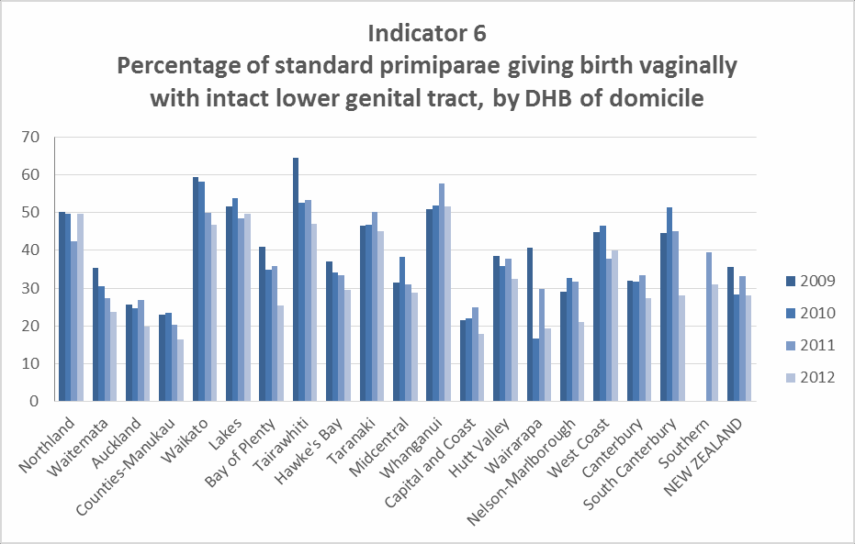
Sourced from the New Zealand Maternity Clinical Indicators dataset 2009-12.

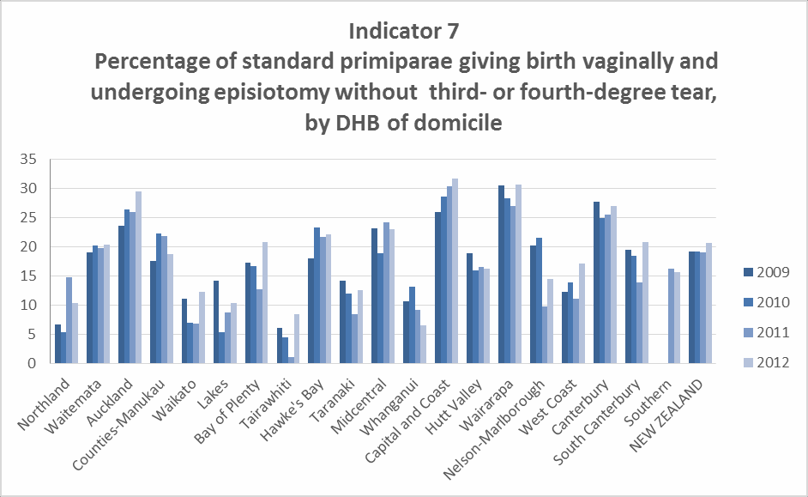
Sourced from the New Zealand Maternity Clinical Indicators dataset 2009-12.

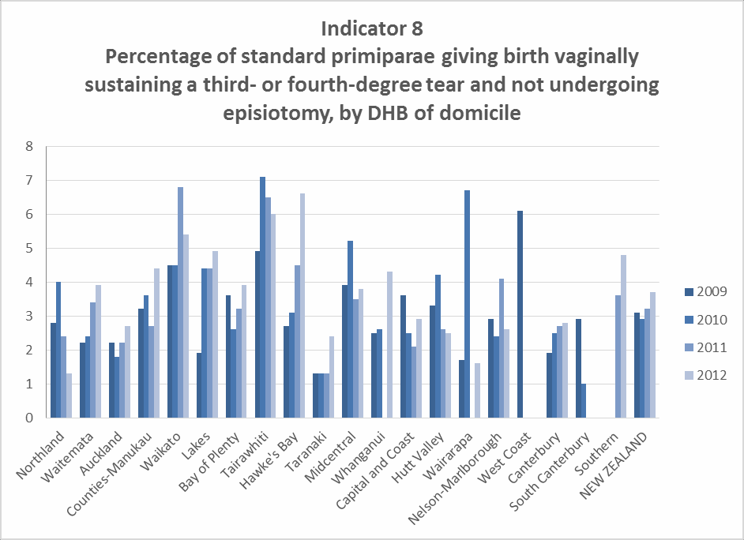
Sourced from the New Zealand Maternity Clinical Indicators dataset 2009-12.

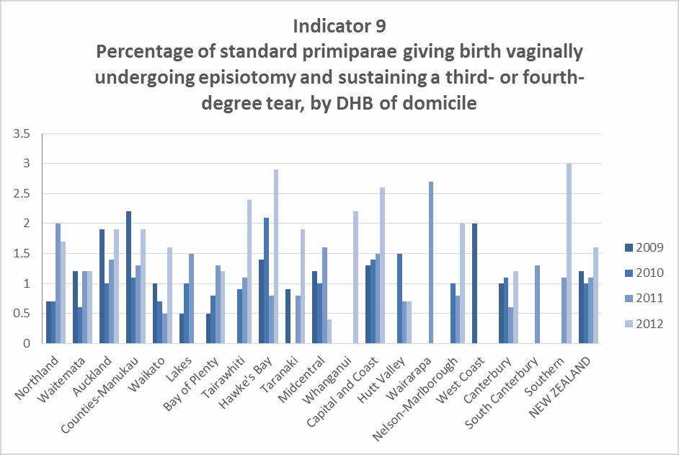

Sourced from the New Zealand Maternity Clinical Indicators dataset 2009-12.

We shared our findings with each DHB and requested advice on the trends and issues.

We were pleased with the considerable effort put into responses by DHBs. It is especially encouraging to see the way in which DHBs use the Maternity Clinical Indicator findings to undertake investigative initiatives such as clinical audits to determine why rates are higher than average as well as implement increased education opportunities and quality improvement activities to support changes to outcomes.

We heard about different practices undertaken by DHBs to share and discuss Clinical Indicator data with maternity stakeholders, including the use of multidisciplinary investigation meetings to share best practice, identify areas for improvement and make recommendations for future practice and shared learning.

The Maternity Clinical Indicators dataset is a good basis from which to determine possible priorities for maternity quality improvement initiatives. Enhancing some or adding further indicators would improve the overall picture (as noted in our 2014 Annual Report).

We supported the Clinical Indicators Expert Working Group’s advice to the Ministry of Health to expand the 2013 Maternity Clinical Indicators to include six new indicators relating to maternal health and neonatal outcomes. We also supported further enhancements to analytical function by providing for further ethnicity analysis, presentation of median, 25th and 75th percentile lines, and analysis by PHO.

The changes we expect to see next

The NMMG encourages the Ministry of Health to release the reviewed 2013 and 2014 Maternity Clinical Indicators datasets as soon as possible. When these are released, the NMMG will consider the datasets and correspond with DHBs about any actions that they intend to take as a result of having this data. We also expect that DHB MQSP Annual Reports will include information about the clinical indicators and each DHB’s responses to these.

The Ministry of Health’s
Report on Maternity, 2012

Our focus for 2014/15 was to review the Ministry of Health’s
Report on Maternity, 2012 and to give advice for future reports.

The Ministry of Health’s Report on Maternity, 2012 presents health statistics on pregnancy and childbirth for women who gave birth in New Zealand in 2012. It presents annual health statistics about women giving birth, their pregnancy and child-birth experience and the characteristics of live-born babies born in New Zealand. We have previously provided advice to the Ministry of Health on possible improvements to the Report. We expect to continue to do this.

What we’ve done this year and our findings

We provided advice to the Ministry of Health on the Report on Maternity, 2012 and acknowledged our support, in the interests of timely data release, for the production of online data tables for 2013 and then a full report for 2014.

The Report on Maternity, 2012 is sound, with a well-developed methodology based on trusted statistical, demographic and clinical information. It provides useful information about pregnancy and birth in New Zealand. We found the accompanying data tables to be of particular use; however, the time lag between the presented data and the Report’s publication date may mean that the content does not
necessarily reflect issues affecting maternity care nationally or at DHB-level today (particularly given the strong focus that maternity care has been given nationally through the MQI). Timeliness of such data for DHBs to consider as part of the development of their MQSP is important. As a result we consider that these reports should become more reflective of current practices and outcomes for women and their babies and be easy to ready by consumers.

The changes we expect to see next

The NMMG would like the Ministry of Health to consider whether the ethnic groups can be further separated within the data tables, particularly the ‘other’ and Asian ethnicity categories. We also would like it to consider presenting more information by DHB to increase the Report on Maternity’s utility for both DHBs and the NMMG.

DHB MQSP Annual Reports

Our focus for 2014/15 was to review the MQSP Annual Reports produced by each DHB and provide guidance and feedback to each DHB to support identification, implementation and achievement of strategic goals and objectives.

The MQSP has now been operating for three years. A key part of the NMMG’s work is to monitor the MQSP in every DHB and provide advice on priorities for local improvement based on each DHB’s MQSP Annual Report. It is particularly important to give feedback to DHBs, and support those who are not delivering the MQSP at an acceptable level especially as the MQSP is moving out of the implementation phase and into an embedded quality improvement phase. We have previously recommended that work to improve the quality of maternity services be aligned with wider quality initiatives at the DHB level. We also note there has been an evaluation of the MQSP during 2015. This evaluation provided the Ministry of Health and the NMMG with a focus for ongoing monitoring and advice to DHBs.

What we’ve done this year and our findings

We reviewed DHB service priorities for 2012/13 and 2013/14 to consider the level of progress made by each DHB and the extent to which DHBs have taken on board and implemented any recommendations/feedback provided by the NMMG.

We found that there is considerable variation in both the complexity and ambition of individual DHB MQSPs. DHB MQSPs over the past three years have ranged from complex programmes of work with clearly aligned strategic objectives embedded into broader DHB quality frameworks through to MQSPs based on ad-hoc, individual quality activities within maternity services alone. This remained the case in 2014/15. The level of progress made in achieving maternity quality goals also varies: some DHBs continued with simple programmes still focused on establishing a local MQSP; others have moved forward substantially and have implemented advanced programmes of improvement initiatives.

The content and presentation of the MQSP Annual Reports also varied significantly. We were impressed with the quality of more reports this year compared to last year. We are disappointed that some DHBs do not seem to have moved forward as much as we would have liked with their programme of work (or indeed how it is presented in their MQSP Annual Report). The NMMG expects the MQSP Annual Reports to demonstrate a clear programme of work aligned to the local MQSP’s strategic objectives, include achievements against strategic activities and be easy to read.

We are pleased that most DHBs have implemented activities focused on improving the timeliness of registration with an LMC, assessing variation in gestation at birth and providing better support for MQSP consumer members. We were disappointed that many DHBs have not responded with a programme of work in relation to maternal mental health pathways as requested by NMMG in 2013.

We are pleased to note that the majority of DHBs have made their MQSP Annual Reports publicly available as recommended in the NMMG’s 2014 Annual Report; however, a significant number of DHBs have not yet published these reports online. Having access to information about maternity quality initiatives is a key way for all stakeholders to understand the quality process required to improve maternity care and to assess how progress to achieve improvements is tracking.

We participated in the evaluation of the MQSP by providing feedback to the evaluators on how the MQSP has widened the scope and visibility of maternity quality activities and encouraged local and regional quality improvement activities. We also provided advice to the Ministry of Health about ongoing priorities for the MQI.

The NMMG supports the Ministry of Health’s decision to embed and expand the MQSP. We were also pleased to hear the evaluators’ views that the MQSP is resulting in improvements to maternity care. We support the Ministry’s proposed refocusing of the MQI work programme.
We expect to further assist the Ministry by providing advice in relation to key projects within the MQI over the next three years.
The new approach will support all DHBs as they work towards achieving the
New Zealand Maternity Standards and the
maternity targets. We recommend that those involved in MQSP in each DHB read the Evaluation Report and use this to determine whether they have to strengthen aspects of their own programme.

We met with two DHBs to discuss the support they may require to advance their MQSPs.

We found these visits to be a useful forum to discuss our concerns and hear from those involved in the MQSP as well as leadership and management external to MQSP but which may be an influencer of the programme in the relevant DHB. We have reviewed each of these DHBs’ 2014/15 MQSP Annual Reports and will provide feedback.

The changes we expect to see next

We will review each DHB’s 2014/15 MQSP Annual Report. We look forward to hearing how DHBs have aligned work to improve the quality of maternity services within broader quality initiatives. We expect DHBs to clearly articulate strategic objectives and detail progress made against these each year with an overall view of demonstrating progress. Our review findings will be discussed in the NMMG’s 2016 Annual Report.

We will provide advice to the Ministry of Health to support its negotiations with each DHB including advice on allocation to one of the three contract tiers identified following the MQSP Review (i.e., placement in an “emerging”, “established” or “excelling” tier). Funding is the same for all MQSP, whatever tier they have been assigned to however, given that the MQSP has now been operating for three years, we consider that ideally no DHB should be in the “emerging” category. Any “emerging” DHB must progress an established and effective MQSP. We expect to concentrate our monitoring effort on these “emerging” DHBs by providing support and guidance. We will also monitor other DHBs but our focus will differ: we expect to encourage the “established” DHBs to move to “excelling”. “Excelling” DHBs will be encouraged to further embed programmes into long-term, organisation-wide quality frameworks while retaining strong clinical leadership and management support. To do this, we will closely review each DHB’s MQSP Annual Report and provide advice to the Ministry about DHB achievement and placement within the contract tiers.

We expect that all DHB MQSP coordinators continue to be supported with dedicated time to complete their coordination role rather than fitting this important work around other clinical or administrative roles.

The NMMG has previously advised that MQSP Annual Reports must be made available online. We reiterate this.

.

The NMMG going forward

The NMMG’s 2015/16 work programme includes six monitoring priorities and four priority areas for further investigation.

Priorities for monitoring
- Monitor the involvement of maternity consumer members in DHBs’ MQSPs.
- Review the outcomes of work undertaken by the Maternity Ultrasound Advisory Group.
- Support the ratification of national maternity clinical guidelines and implementation of existing guidelines.
- Review the New Zealand Clinical Indicators data and monitor DHBs’ responses to variations.
- Monitor DHBs’ implementation of their local MQSPs (including maintaining a focus on maternal mental health and variation in gestation at birth).
- Review key maternity sector publications including the Ministry of Health’s Report on Maternity.

Priorities for investigation
- Investigate consistency in the quality of first trimester antenatal care.
- Investigate access to, provision and use of rural and primary maternity facilities for women.
- Investigate access to Anti-D after a sensitising event for Rh negative women.
- Investigate the increase in perineal trauma and variability within and between DHBs.

The NMMG will also produce an annual report.

Acknowledgements

The maternity sector has continued to build on the tremendous energy put into improving quality, care and outcomes over the past three years. We have seen ample evidence demonstrating this through DHB engagement with and responses to NMMG requests. The NMMG would like to thank the following groups and individuals for their contribution to our work this year:

  - the consumers who engaged so openly both with the NMMG and DHBs so that we could all better understand the perspectives of pregnant women
  - the professionals within the maternity sector who worked so hard to provide us with detailed information on maternity care in their DHBs
  - staff at the Ministry of Health for their openness and transparency when dealing with all the members and secretariat of the NMMG
  - the Minister of Health and the Director-General of Health for ongoing commitment both to the NMMG and the maternity sector, and
  - all involved in the delivery of the MQSP - seeing collaboration between professionals and consumers has been particularly encouraging.

We could not do this important work without your support.

We look forward to working with you all again as our work continues into 2015/16.

Appendix 1:
Terms of Reference for the NMMG 2013-16

Introduction

- This document sets out the:
roles and responsibilities of the National Maternity Monitoring Group; work programme and reporting requirements;
composition of the National Maternity Monitoring Group, and terms and conditions of appointment.

Background

- The New Zealand Maternity Standards (Ministry of Health 2011) consist of three high-level strategic statements to guide the planning, funding, provision and monitoring of maternity services:
Standard 1: Maternity services provide safe, high quality services that are nationally consistent and achieve optimal health outcomes for mothers and babies;
Standard 2: Maternity services ensure a woman-centred approach that acknowledges pregnancy and childbirth as a normal life stage, and
Standard 3: All women have access to a nationally consistent, comprehensive range of maternity services that are funded and provided appropriately to ensure there are no financial barriers to access for eligible women.
- These high-level statements are accompanied by specific audit criteria and measurements of these criteria. One of the criteria is that a National Monitoring Group be established to oversee the maternity system and the implementation of the Standards.

Role of the National Maternity Monitoring Group

- The role of the National Maternity Monitoring Group is to oversee the New Zealand maternity system and to provide strategic advice to the Ministry of Health on priorities for improvement.
- Standard 1 of the New Zealand Maternity Standards states “a National Monitoring Group, consisting of a small number of clinical sector experts and consumer representatives … provides oversight and review of national maternity standards, analysis and reporting. The National Monitoring Group provides advice to the Ministry on priorities for national improvement based on the national maternity report, nationally standardised benchmarked data, the audited reports from DHB service specifications, Maternity Referral Guidelines, and the Primary Maternity Services Notice 2007”.

- Standard 1 sets out audit criteria, applicable at the national level, to which the Ministry of Health and the professional colleges are accountable to. These additionally inform the role of the National Maternity Monitoring Group.
- The National Maternity Monitoring Group is not a decision-making body. While it may provide recommendations to the Ministry of Health, responsibility for decision- making and implementation rests with the Ministry of Health and/or other relevant participants in the maternity system.

Responsibilities and reporting requirements of the National Maternity Monitoring Group

- The National Maternity Monitoring Group will meet at least four times per annum, and will undertake other communication as necessary to deliver the agreed work programme.
- The National Maternity Monitoring Group is responsible for identifying priorities for action or investigation, and agreeing a 12-month work programme with the Ministry of Health at the beginning of each year of operation.
- The work programme may include but is not limited to:
Providing expert advice on data released through the New Zealand Maternity Clinical Indicators, national maternity consumer surveys and the New Zealand Maternity Report, which are published from time to time by the Ministry of Health.
Contributing to the review of the New Zealand Maternity Clinical Indicators at a minimum of three-year intervals and providing advice on the modification, addition or withdrawal of any indicators.
Identifying priorities for national clinical guidelines / guidance for maternity including recommendations on best clinical practice, and providing advice on how these should be developed and implemented.
Reviewing reports of the Perinatal and Maternal Mortality Review Committee (PMMRC), identifying the implications for the maternity system of the findings of the PMMRC and providing advice on system response to these findings.
Reviewing and assessing the annual reports produced by each DHB as part of its Maternity Quality and Safety Programme.
Reviewing and assessing other maternity reports produced or commissioned by the Ministry of Health, DHBs, professional colleges, consumer groups or other stakeholders as requested from time to time.
- The National Maternity Monitoring Group may be asked to provide advice on any other matters related to the quality and safety of maternity care and services by the Ministry of Health from time to time.
- The National Maternity Monitoring Group will produce an Annual Report by a date negotiated with the Ministry of Health detailing:
Work carried out, conclusions reached and recommendations made during the previous year.
Its priorities and work programme for the following year.

Relationship of the National Maternity Monitoring Group to the Perinatal and Maternal Mortality Review Commission
- The Perinatal and Maternal Mortality Review Committee (PMMRC) is a Mortality Review Committee, appointed under section 59E of the New Zealand Public Health and Disability Act 2000 by the Health Quality and Safety Commission.
- The PMMRC considers maternal and perinatal mortality, and other morbidity as directed by the Minister in writing. It prepares an Annual Report, which includes its advice and recommendations.
- In providing its advice, the National Maternity Monitoring Group will take account of the findings on maternal and perinatal mortality and morbidity by the PMMRC set out in its Annual Report.
- Where the PMMRC recommends specific action by maternity system stakeholders, the National Maternity Monitoring Group will advise the Ministry on an appropriate response to these recommendations.
- The National Maternity Monitoring Group will meet at least once annually with the PMMRC.

Composition of the National Maternity Monitoring Group

- The National Maternity Monitoring Group will have a maximum of eight members, not including ex-officio members from the Health Quality and Safety Commission and Ministry of Health.
- Composition of the National Maternity Monitoring Group will balance requirements for:
Expertise necessary to analyse different sources of information on the maternity system and make recommendations based on this analysis.
Perspectives of key stakeholders in the maternity system.
- The National Maternity Monitoring Group will include the following skill sets or expertise:
Expertise in epidemiological research and analysis of health data/statistics.
Experience and expertise in midwifery care.
Experience and expertise in specialist medical maternity care.
Experience and expertise in specialist neonatal care.
Expertise in Māori health. Expertise in Pacific health.
Experience and expertise in representing a consumer perspective on maternity issues.
- All members of the National Maternity Monitoring Group will have basic skills and confidence in working with and interpreting health data.
- The Ministry will seek nominations from relevant organisations and professional colleges, including the Health Quality and Safety Commission. The Ministry reserves the right to appoint more than one member from an organisation or college or to

appoint members not officially nominated by an organisation or college, in order to ensure the balance of skills and expertise outlined in 20 a) to f).
- Members of the National Maternity Monitoring Group will share a commitment to working collaboratively and constructively to oversee the national maternity system.
- The National Maternity Monitoring Group may identify that additional skills or expertise in a particular field or specialty is required to deliver aspects of the agreed work programme. The National Maternity Monitoring Group may seek additional (co- opted) members to fill skill gaps. This will be done in agreement with the Ministry of Health.
- At least one representative of the Ministry of Health will attend meetings in an ex- officio capacity.

Term of the National Maternity Monitoring Group

- The National Maternity Monitoring Group will operate until the end of June 2016 unless otherwise notified by the Director General of Health.

Decision-making

- Decisions within the National Maternity Monitoring Group are to be made by consensus. Members are expected to work as far as is possible to achieve consensus. Dissenting views of members can be noted for the record. Appointment process
- The Director General of Health will appoint members to the National Maternity Monitoring Group.
- Membership of the National Maternity Monitoring Group will be for a period of three years to June 2016.
- A Chair and Vice Chair will be elected by the members of the National Maternity Monitoring Group for a term of one year and may be re-elected.
- Co-opted appointments may be proposed by the National Maternity Monitoring Group and will be made by the Director General of Health.
- Any member of the National Maternity Monitoring Group may at any time resign as a member by advising the Ministry of Health in writing.
- The Director General of Health may choose to fill vacancies should resignations occur.

Support for the National Maternity Monitoring Group

- The Ministry of Health will arrange provision of the secretariat function for the National Maternity Monitoring Group. This may be externally procured. This includes distribution of agendas and recording of the minutes. Agendas and any associated papers will be circulated at least five days prior to meetings. Minutes will be circulated no later than a fortnight following the meeting date.

Meeting arrangements

35. Meetings will normally be held in Wellington. Rooms and refreshments will be provided for the meetings.

Payment of meeting fees and travel costs

- A fee of $325.00 (exclusive of GST) will be paid for attendance at face-to-face meetings and is based upon a full day meeting including travel time. Other work carried out as part of the National Maternity Monitoring Group will be reimbursed on a pro rata basis at the rate of $325.00 per day (exclusive of GST).
- Public servant/state servants/employees of Crown bodies are not paid for meetings of the National Maternity Monitoring Group. A public servant/state servant/employee of a Crown body should not retain both the fee and their ordinary pay where the duties of the outside organisation are undertaken during ordinary department or Crown body hours.
- Payment of meeting and other fees will be in accordance with the latest Cabinet circular on fees and guidelines for appointments for statutory bodies, which can be found at: http://www.dpmc.govt.nz/sites/ all/files/circulars/coc-12-06.pdf
- Travel to meetings and, if necessary, flights and accommodation will be arranged. Meal expenses (without alcohol) will also be paid, but other hotel charges including phone calls and items from the ‘mini bar’ will not be paid. Any additional travel expenses incurred will be reimbursed, including taxis, mileage (at the rate of 0.62c per km, GST not applicable) and parking. A valid receipt must accompany claims for expenses.

Conflicts of interest

- Members of the National Maternity Monitoring Group should document their conflicts of interests and identify any conflict of interest prior to a discussion of a particular issue. The National Maternity Monitoring Group will then decide what part the member may take in any relevant discussion, and will identify whether the conflict needs to be escalated to the Ministry of Health for consideration. Guidance can be found in the document ‘Conflict of Interest Protocol for Ministry of Health Advisory Committees’.

Confidentiality

- The National Maternity Monitoring Group will maintain confidentiality of agenda material, documents and other matters forwarded to them unless otherwise specified.
- Members of the National Maternity Monitoring Group are not to represent themselves as agents of the Ministry of Health, and by reason of their membership of the National Maternity Monitoring Group, are not permitted to speak on behalf of the National Maternity Monitoring Group or the Ministry of Health.
- If a member receives a media request or enquiry relating to the work of the National Maternity Monitoring Group, they must inform the Ministry of Health including the Ministry’s Health Communications Manager. Any media communication will be via the Ministry of Health.

If you have any enquiries about this report, or wish to contact the NMMG, please contact the NMMG Secretariat on:
Email: nmmg@allenandclarke.co.nz Phone: 04 550 5705

