**NEW ZEALAND NATIONAL GAMBLING STUDY: WAVE 3 (2014) - REPORT NUMBER 5**

This research is the third year of the New Zealand National Gambling Study (NGS), with the same people (adults aged 18 years and older) interviewed annually in 2012, 2013 and 2014. It provides results from the 2014 survey, as well as some changes from 2013 to 2014. In 2014, 3,115 of the original 6,251 participants were re-interviewed. The research is nationally representative, meaning that the research findings can be scaled up to the New Zealand adult population.

**Gambling participation in 2014**

In 2014, 77% of the population (about 2,542,000 people) took part in at least one gambling activity in the previous year. The most popular form of gambling was Lotto with 60% playing at least once in the past year (about 1,981,000 people) and 32% playing monthly (about 1,056,000 people). One in seven people (14%) had gambled on a pokie machine (electronic gaming machine) in the past year and one in 29 people (3.5%) had gambled monthly on pokies. People were more likely to gamble on pub pokies than on pokies in a club or casino. Less than one percent of the population (about 29,700 people) gambled on overseas internet gambling in the past year.

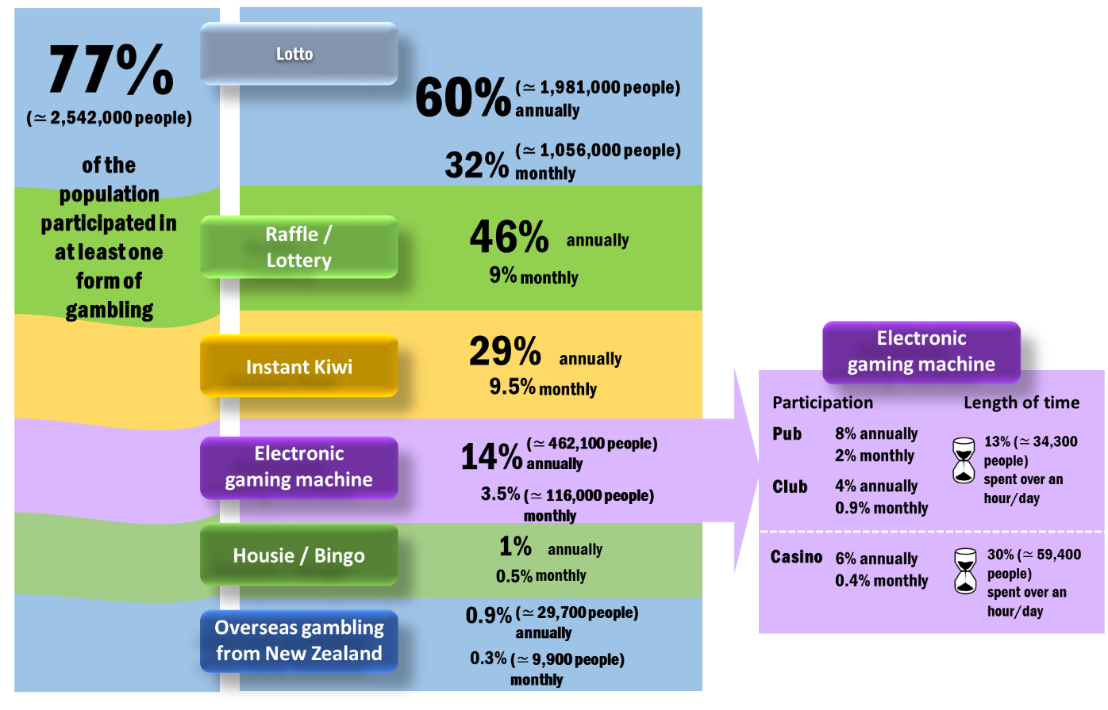

**At-risk and problem gambling in 2014**

In 2014, 0.3% of the adult population were problem gamblers (about 7,000 to 17,000 people), 1.5% were moderate-risk gamblers (about 49,500 people), 5.0% were low-risk gamblers (about 165,000 people) and 70% were non-problem gamblers. Māori and Pacific adults were more likely to develop problems (low-risk, moderate-risk and problem gambler) than European/Other New Zealanders. Asian people were also at slightly higher risk.

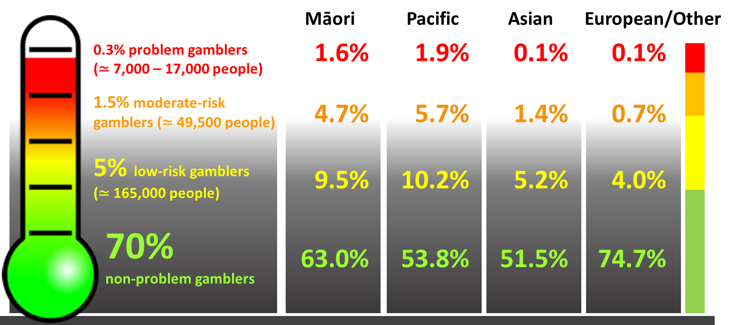

**Changes in gambling risk level from 2013 to 2014**

People in the at-risk groups were the most likely to change over time in their level of risky gambling. The non-problem and non-gambling groups were the least likely to change risk level.





**Incidence and relapse**

The incidence, or new cases, of problem gambling from 2013 to 2014 was 0.18%. This means that about 6,000 people became ‘new’ problem gamblers in 2014. About 32,000 people (1.0%) became moderate-risk gamblers. But, substantial proportions of these so called ‘new’ problem gamblers (21%) and moderate-risk (15%) had in fact relapsed from being problem or moderate-risk gamblers in the past.

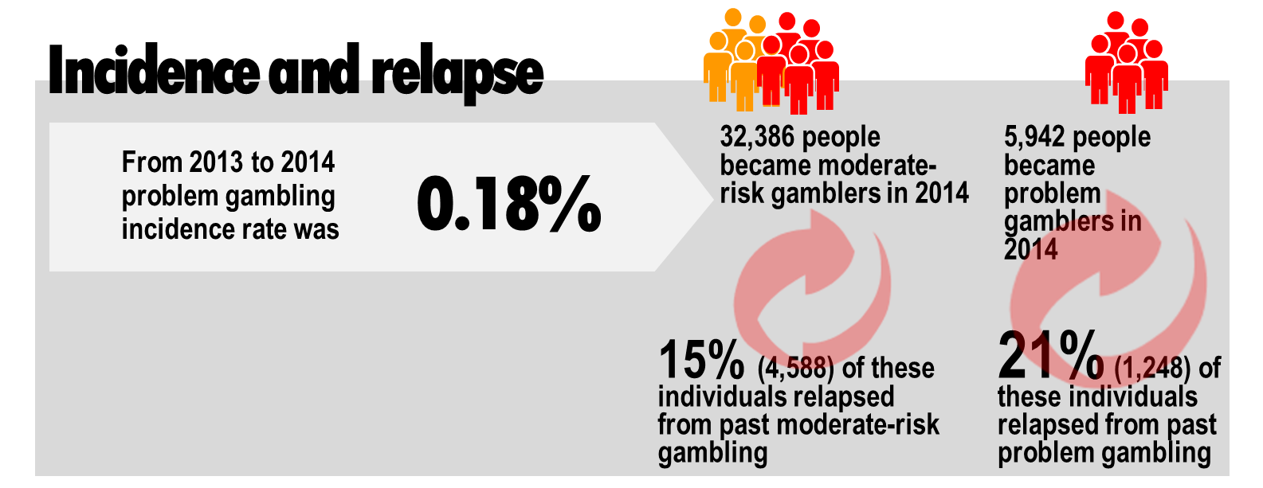

**Factors for moving towards risky gambling or remaining at risk**

Predictors (risk) factors for moving towards risky gambling included higher gambling frequency or expenditure, casino or pub pokie machine gambling, having a lower quality of life, experiencing significant life events, having higher levels of mental distress and using cannabis. Protective factors were gambling with other people, having a higher household income and not using illegal drugs.

Risk factors for remaining at risk included frequent gambling, and gambling on certain activities.

Ethnicity was associated with both moving towards risk gambling and remaining at risk for gambling problems.

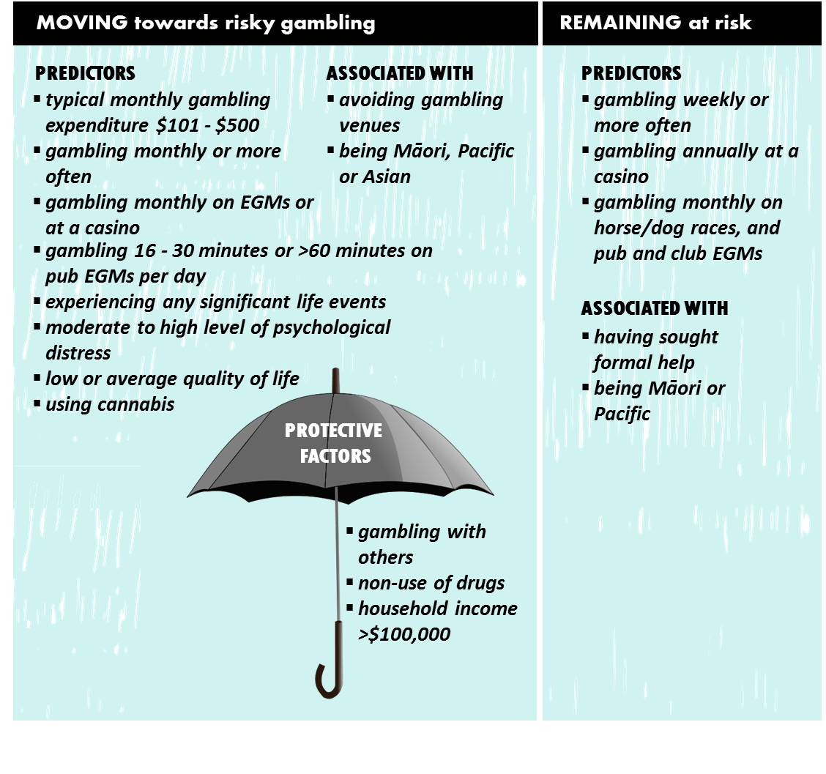

The research was conducted by the Auckland University of Technology, Gambling and Addictions Research Centre and was funded by the Ministry of Health. The principal researchers were Professor Max Abbott, Dr Maria Bellringer, Dr Nick Garrett and Dr Stuart Mundy-McPherson.