Mortality and Demographic Data

2012

Copyright

The copyright owner of this publication is the Ministry of Health, which is part of the New Zealand Crown.

The Ministry of Health permits the reproduction of material from this publication without prior notification, provided that all the following conditions are met.

* The content is not distorted or changed.
* The information is not sold.
* The material is not used to promote or endorse any product or service.
* The material is not used in an inappropriate or misleading context, having regard to the nature of the material.
* Any relevant disclaimers, qualifications or caveats included in the publication are reproduced.
* The New Zealand Ministry of Health is acknowledged as the source.

Disclaimer

The purpose of this publication is to inform discussion and assist policy development. The opinions expressed in the publication do not necessarily reflect the official views of the Ministry of Health.

All care has been taken in the production of this publication; the data was considered to be accurate at the time of publication, but may be subject to slight changes over time as further information is received. It is advisable to check the current status of figures given here with the Ministry of Health before quoting or using them in further analysis.

The Ministry of Health makes no warranty, expressed or implied, nor assumes any legal liability or responsibility for the accuracy, correctness, completeness or use of the information or data in this publication. Further, the Ministry of Health will not be liable for any loss or damage arising directly or indirectly from the information or data presented in this publication.

Citation: Ministry of Health. 2015. *Mortality and Demographic Data 2012*. Wellington: Ministry of Health.

Published in November 2015  
by the Ministry of Health  
PO Box 5013, Wellington 6145, New Zealand

ISBN: 978-0-947491-08-6 (online)  
HP 6276

This document is available at health.govt.nz



### CCBY This work is licensed under the Creative Commons Attribution 4.0 International licence. In essence, you are free to: share, ie, copy and redistribute the material in any medium or format; adapt, ie, remix, transform and build upon the material. You must give appropriate credit, provide a link to the licence and indicate if changes were made.

# Acknowledgements

Many people have assisted in the production of this publication. In particular, the Ministry of Health thanks the peer reviewers for their valuable contribution.

The Ministry of Health would also like to thank the following organisations:

* Department of Internal Affairs, Births, Deaths and Marriages
* Ministry of Justice, coroners and the Coronial Services Unit
* Land Transport New Zealand
* Water Safety New Zealand
* district health boards.

Contents

Acknowledgements iii

Introduction 1

Late data 1

Ethnicity data and analysis 3

Statistical notes 3

Further mortality data 4

Mortality 2012: Quick facts 5

Number of deaths 5

Age-standardised rates 5

Selected causes of mortality 2012 5

Mortality in New Zealand 6

Overview of mortality statistics 6

Selected causes of mortality 12

Mortality by region 14

Selected trends 20

All cancers 21

Lung cancer 26

Female breast cancer 29

Prostate cancer 32

Malignant melanoma of the skin 35

Cervical cancer 38

Ischaemic heart disease 41

Cerebrovascular disease 46

Diabetes mellitus 51

Motor vehicle accidents 55

Suicide 60

Maternal mortality 65

Further mortality-related information 68

Accompanying online tables 68

Ministry of Health publications 68

Publications by other organisations 68

Population data used for calculating rates 69

Additional data available from the Ministry of Health 69

Explanatory notes 71

Mortality 71

Population 73

Ethnicity 74

Statistical notes 75

References 77

List of tables

Table 1: Mortality rates, by age group, sex and ethnicity, 2012 7

Table 2: Number of deaths and mortality rates, by sex, 1980–2012 8

Table 3: Mortality rates from selected causes, by sex and ethnicity, 2012 12

Table 4: Number of deaths and mortality rates from all cancers, by sex, 1980–2012 22

Table 5: Age distribution of deaths from all cancers, percentages and rates, by ethnicity and sex, 2012 23

Table 6: Number of deaths and mortality rates from lung cancer, by sex, 1980–2012 27

Table 7: Age distribution of deaths from lung cancer, percentages and rates, by ethnicity and sex, 2012 28

Table 8: Number of deaths and mortality rates from breast cancer in females,  
1980–2012 30

Table 9: Age distribution of deaths from breast cancer in females, percentages and rates, by ethnicity, 2012 31

Table 10: Number of deaths and mortality rates from prostate cancer, 1980–2012 33

Table 11: Age distribution of deaths from prostate cancer in males, percentages and rates, by ethnicity, 2012 34

Table 12: Number of deaths and mortality rates from malignant melanoma of the skin, by sex, 1980–2012 36

Table 13: Age distribution of deaths from malignant melanoma of the skin, percentages and rates, by ethnicity and sex, 2012 37

Table 14: Number of deaths and mortality rates from cervical cancer, 1980–2012 39

Table 15: Age distribution of deaths from cervical cancer, percentages and rates, by ethnicity, 2012 40

Table 16: Number of deaths and mortality rates from ischaemic heart disease, by sex, 1980–2012 42

Table 17: Age distribution of deaths from ischaemic heart disease, percentages and rates, by ethnicity and sex, 2012 43

Table 18: Number of deaths and mortality rates from cerebrovascular disease, by sex, 1980–2012 47

Table 19: Age distribution of deaths from cerebrovascular disease, percentages and rates, by ethnicity and sex, 2012 48

Table 20: Number of deaths and mortality rates from diabetes mellitus, by sex,  
1980–2012 52

Table 21: Age distribution of deaths from diabetes mellitus, percentages and rates, by ethnicity and sex, 2012 53

Table 22: Number of deaths and mortality rates from motor vehicle accidents, by sex, 1980–2012 56

Table 23: Age distribution of deaths from motor vehicle accidents, percentages and rates, by ethnicity and sex, 2012 57

Table 24: Number of deaths and mortality rates from suicide, by sex, 1980–2012 61

Table 25: Age distribution of deaths from suicide, percentages and rates, by ethnicity and sex, 2012 62

Table 26: Number of maternal deaths and maternal mortality rates, 1980–2012 66

Table 27: Maternal deaths by underlying cause, 2008–2012 67

Table 28: Mortality data available from the Ministry of Health 70

Table 29: Codes used to define amenable mortality 72

Table 30: The WHO World Standard Population 76

List of figures

Figure 1: Stages of processing cause of death data in New Zealand 2

Figure 2: Number of deaths and mortality rates, by sex, 1950–2012 6

Figure 3: Mortality rates, by sex and ethnicity, 1996–2012 9

Figure 4: Mortality rates for the five major causes of mortality, 1980–2012 10

Figure 5: Age at death, rates by ethnicity, 2012 10

Figure 6: Amenable mortality rates per 100,000 people aged 0–74 years, by sex and ethnicity, 2000–2012 11

Figure 7: Mortality rates, by DHB region, total population, 2012 14

Figure 8: Mortality rates, by DHB region, Māori population, 2012 15

Figure 9: Mortality rates, by DHB region, non-Māori population, 2012 16

Figure 10: Comparison of DHB region mortality rates for Māori and non-Māori, 2012 18

Figure 11: Number of deaths and mortality rates from all cancers, by sex, 1950–2012 21

Figure 12: Mortality rates from all cancers, by sex and ethnicity, 1996–2012 24

Figure 13: Mortality rates from all cancers, by DHB region, total population, 2012 25

Figure 14: Number of deaths mortality rates from lung cancer, by sex, 1950–2012 26

Figure 15: Mortality rates from lung cancer, by sex and ethnicity, 1996–2012 28

Figure 16: Number of deaths and mortality rates from breast cancer in females,  
1950–2012 29

Figure 17: Mortality rates from breast cancer in females, by ethnicity, 1996–2012 31

Figure 18: Number of deaths and mortality rates from prostate cancer, 1950–2012 32

Figure 19: Mortality rates from prostate cancer, by ethnicity, 1996–2012 34

Figure 20: Number of deaths and mortality rates from malignant melanoma of the skin, by sex, 1950–2012 35

Figure 21: Number of deaths and mortality rates from cervical cancer, 1950–2012 38

Figure 22: Mortality rates from cervical cancer, by ethnicity, 1996–2012 40

Figure 23: Number of deaths and mortality rates from ischaemic heart disease, by sex, 1950–2012 41

Figure 24: Mortality rates from ischaemic heart disease, by sex and ethnicity, 1996–2012 43

Figure 25: Mortality rates from acute myocardial infarction (ICD I21) and chronic ischaemic heart disease (ICD I25), by sex and ethnicity, 2012 44

Figure 26: Mortality rates from ischaemic heart disease, by DHB region, total population, 2012 45

Figure 27: Number of deaths and mortality rates from cerebrovascular disease, by sex, 1950–2012 46

Figure 28: Number of deaths and mortality rates from cerebrovascular disease, by sex and ethnicity, 1996–2012 48

Figure 29: Mortality rates from cerebrovascular disease, by specific disease classification and sex, 2012 49

Figure 30: Mortality rates from cerebrovascular disease, by DHB region, total population, 2012 50

Figure 31: Number of deaths and mortality rates from diabetes mellitus, by sex,  
1950–2012 51

Figure 32: Mortality rates from diabetes mellitus, by sex and ethnicity, 1996–2012 53

Figure 33: Mortality rates from diabetes mellitus, by diabetes type and sex, 2012 54

Figure 34: Number of deaths and mortality rates from motor vehicle accidents, by sex, 1950–2012 55

Figure 35: Mortality rates from motor vehicle accidents, by sex and ethnicity, 1996–2012 58

Figure 36: Mortality and hospitalisation rates from motor vehicle accidents, and ratio of hospitalisation rate to mortality rate, 1996–2012 59

Figure 37: Number of deaths and mortality rates from suicide, by sex, 1950–2012 60

Figure 38: Mortality rates from suicide, by sex and ethnicity, 1996–2012 62

Figure 39: Male mortality and hospitalisation rates from intentional self-harm, and ratio of hospitalisation rate to mortality rate, 1996–2012 63

Figure 40: Female mortality and hospitalisation rates from intentional self-harm, and ratio of hospitalisation rate to mortality rate, 1996–2012 64

Figure 41: Number of maternal deaths and maternal mortality rates, 1950–2012 65

# Introduction

*Mortality and Demographic Data 2012* presents data on the underlying cause of each death registered in New Zealand in the 2012 calendar year. The causes of death were coded to the International Statistical Classification of Diseases and Related Health Problems, Tenth Revision, Australian Modification, Sixth Edition (ICD-10-AM). In this publication, the abbreviation ICD is used to refer to the ICD-10-AM coding system (National Centre for Classification in Health 2008).

Underlying cause of death, as defined by the World Health Organization (WHO), is ‘(a) the disease or injury which initiated the train of morbid events leading directly to death, or (b) the circumstances of the accident or violence which produced the fatal injury’ (WHO 1979).

The three main sources of information for mortality data are:

* certificates of cause of death from doctors and coroners
* post-mortem reports
* death registration forms, which are usually completed by a funeral director.

Figure 1 illustrates the stages of processing cause of death data in New Zealand.

## Late data

At the time of publication of this document, the Ministry of Health was unable to assign specific ICD codes to a small number of deaths due to the extended length of time that some coronial inquiries take. These deaths are included in the statistics under the ICD codes R99 (‘other ill-defined and unspecified causes of mortality’) and X59 (‘exposure to unspecified factor’). Because the Ministry of Health Mortality Collection is a dynamic database, the Ministry will update the records for these deaths with specific underlying cause of death codes once it receives coroners’ findings. This means there may be small differences between later extracts of mortality data and data contained in this publication.

The data for this publication was extracted on 11 March 2015. At that time, the deaths of one infant (aged under one year) and six adults were provisionally coded to underlying causes R99 and X59, and the deaths of six infants, four children (aged 1–14 years), 12 youths (aged 15–24 years) and 102 adults (aged 25 years and over) were provisionally coded to other causes. Coronial inquiries had not been completed for these deaths.

Figure 1: Stages of processing cause of death data in New Zealand

Figure 1: Stages of processing cause of death data in New Zealand

## Ethnicity data and analysis

Two ethnic groupings are used in the *Mortality and Demographic Data* publication: Māori and non-Māori. The Māori population includes everyone who was identified as Māori, and the non‑Māori population includes everyone else.

Because of changes in the Births, Deaths, Marriages and Relationships Registration Act 1995 that came into force in September 1995, Māori and non-Māori rates from 1996 onwards are not comparable with earlier data. For this reason, the ethnicity trend data in this publication covers a smaller range (ie, 1996 to 2012) than that of the total population data (see ‘Ethnicity’ within this document’s ‘Explanatory notes’ for a discussion of ethnicity coding).

## Statistical notes

In this publication, numbers are generally presented to one decimal place. However, calculations are made from the full string (ie, all the numbers after the decimal place), thereby providing more precise reporting.

### Age-specific and age-standardised rates

This publication uses age-specific and age-standardised rates.

Age-specific mortality rates represent the number of deaths in relation to the population size of a particular age group. The number of deaths within an age group is divided by the population of that age group and then multiplied by 100,000.

Age-standardised rates account for differences in population structure, and can be used to compare groups with different age structures (eg, males and females, or Māori and non-Māori) and data from different years. In the present publication, the population structure used is the WHO World Standard Population, and age-standardised rates are per 100,000 population (see ‘Statistical notes’ within ‘Explanatory notes’).

### Confidence intervals

Where appropriate, confidence intervals have been calculated at the 95% or 99% level to aid the interpretation of mortality incidence (Keyfitz 1966). A confidence interval is a range of values used to illustrate the uncertainty around a single value (such as an age-standardised rate). Confidence intervals are calculated with a stated probability; for example 95% (which would indicate that there is a 95% chance that the true value lies within the confidence interval).

Note that Māori populations have lower numbers relative to the total population. This can result in greater variance (and thus larger confidence intervals) when calculating age-standardised rates. Any precise calculations made in the present publication (such as percentage differences between ethnic mortality rates) must be interpreted with this caveat in mind.

## Further mortality data

Statistical mortality data tables are available online in Excel format alongside this *Mortality and Demographic Data 2012* publication at: [www.health.govt.nz/publication/mortality-2012-online-tables](http://www.health.govt.nz/publication/mortality-2012-online-tables). The tables published on this page contain mortality data for the complete range of ICD-10-AM classifications, in sex and five-year age groupings. The data is grouped at national, regional and ethnic group (Māori, Pacific, Asian and non-Māori) level.

Other Ministry of Health publications contain further mortality-related data. These include publications on fetal and infant deaths, suicide, and cancer incidence and mortality.

More detailed information on numbers and rates of live births and on fetal, neonatal and post-neonatal deaths is published in the annual publication series [*Fetal and Infant Deaths*](http://www.health.govt.nz/nz-health-statistics/health-statistics-and-data-sets/fetal-and-infant-deaths-series)(www.health.govt.nz/nz-health-statistics/health-statistics-and-data-sets/fetal-and-infant-deaths-series).

Information on hospitalisations and mortality from suicide can be found in [*Suicide Facts: Deaths and intentional self-harm hospitalisations*](http://www.health.govt.nz/nz-health-statistics/health-statistics-and-data-sets/suicide-facts-deaths-and-intentional-self-harm-hospitalisations-series)(www.health.govt.nz/nz-health-statistics/health-statistics-and-data-sets/suicide-facts-deaths-and-intentional-self-harm-hospitalisations-series).

Information on cancer registrations and mortality can be found in [*Cancer: New Registrations and Deaths*](http://www.health.govt.nz/nz-health-statistics/health-statistics-and-data-sets/cancer-new-registrations-and-deaths-series)(www.health.govt.nz/nz-health-statistics/health-statistics-and-data-sets/cancer-new-registrations-and-deaths-series).

For a complete listing of other mortality-related data, see ‘Further mortality-related information’.

# Mortality 2012: Quick facts

## Number of deaths

|  |  |  |  |
| --- | --- | --- | --- |
|  | **2012 mortality** | | |
| **Male** | **Female** | **Total** |
| Māori | 1643 | 1421 | 3064 |
| Non-Māori | 13,505 | 13,708 | 27,213 |
| Total | 15,148 | 15,129 | 30,277 |

## Age-standardised rates

|  |  |  |  |
| --- | --- | --- | --- |
|  | **2012 mortality rates** | | |
| **Male** | **Female** | **Total** |
| Māori | 743.3 | 567.6 | 649.3 |
| Non-Māori | 425.1 | 305.9 | 362.0 |
| Total | 463.0 | 332.7 | 393.6 |

Note: rates per 100,000 population, age-standardised to WHO World Standard Population.

## Selected causes of mortality 2012

|  |  |  |  |  |  |  |  |  |  |
| --- | --- | --- | --- | --- | --- | --- | --- | --- | --- |
| **Condition** | **Total deaths** | **Percentage of deaths by sex** | | **Māori rate** | | **Non-Māori rate** | | **Total rate** | |
| **Male** | **Female** | **Male** | **Female** | **Male** | **Female** | **Male** | **Female** |
| All cancer | 8905 | 53.2 | 46.8 | 209.5 | 192.5 | 135.9 | 101.1 | 143.4 | 109.0 |
| Lung cancer‡ | 1628 | 54.7 | 45.3 | 65.4 | 66.4 | 23.9 | 15.7 | 27.1 | 19.7 |
| Female breast cancer | 617 | … | 100.0 | … | 26.5 | … | 16.9 | … | 17.7 |
| Prostate cancer | 607 | 100.0 | … | 18.1 | … | 16.4 | … | 17.0 | … |
| Melanoma of the skin | 354 | 62.7 | 37.3 | 0.9 | 0.8 | 7.2 | 3.8 | 6.8 | 3.6 |
| Cervical cancer | 56 | … | 100.0 | … | 3.7 | … | 1.6 | … | 1.8 |
| Ischaemic heart disease | 5339 | 55.3 | 44.7 | 140.3 | 77.2 | 78.5 | 40.0 | 85.2 | 43.8 |
| Cerebrovascular disease | 2612 | 37.1 | 62.9 | 30.3 | 31.7 | 25.7 | 28.4 | 27.1 | 29.6 |
| Diabetes mellitus | 807 | 53.3 | 46.7 | 48.3 | 33.8 | 9.9 | 6.6 | 12.8 | 8.6 |
| Suicide | 550 | 73.5 | 26.5 | 25.3 | 10.5 | 16.3 | 5.2 | 18.5 | 6.4 |
| Motor vehicle accidents | 347 | 73.5 | 26.5 | 22.4 | 6.3 | 9.3 | 3.2 | 11.3 | 3.7 |

Note: rates per 100,000 population, age-standardised to WHO World Standard Population.

‡ Includes cancer of the trachea, bronchus and lung.

... = Not applicable.

# Mortality in New Zealand

This section presents an overview of national mortality statistics in 2012, describes trends in mortality over time and examines selected major causes of mortality in 2012.

## Overview of mortality statistics

There were 30,277 deaths registered in New Zealand in 2012. The number of deaths generally increased over time (Figure 2). This trend is not surprising bearing in mind that the total population of New Zealand increased at the same time. A more useful measure of mortality is the age-standardised mortality rate, allowing comparisons to be made over time and between differing groups.[[1]](#footnote-1) From 1950 to 2012, the mortality rate showed a strong downward trend when adjusted for age. In 2012 there were 393.6 deaths per 100,000 population.

Figure 2: Number of deaths and mortality rates, by sex, 1950–2012

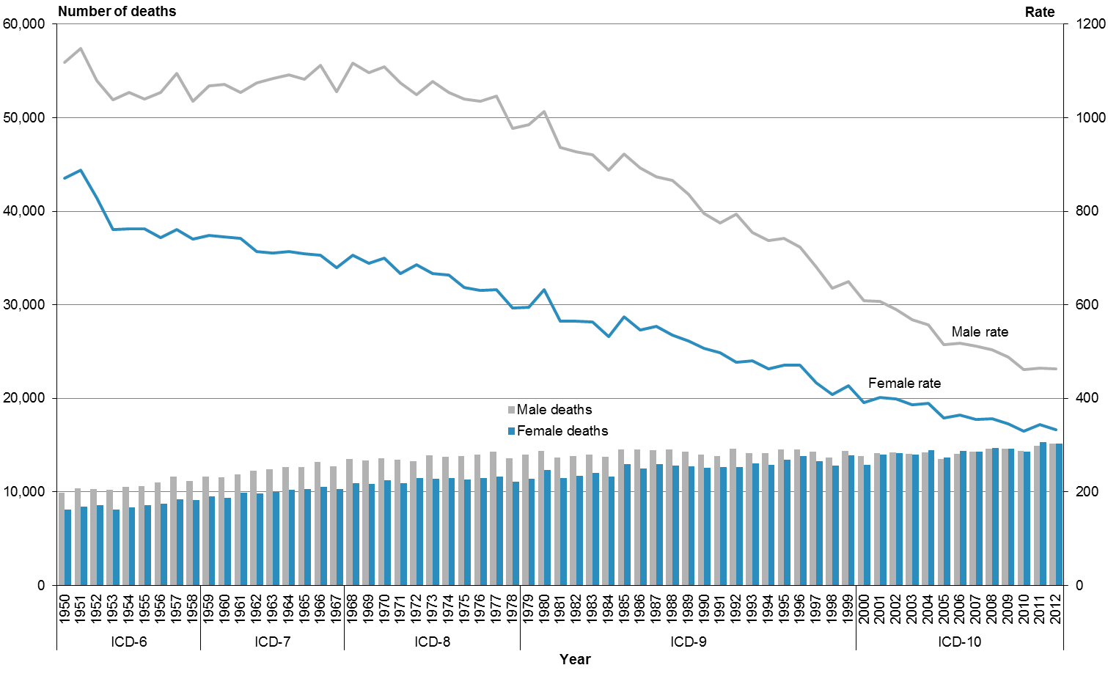

Note: rates per 100,000 population, age-standardised to WHO World Standard Population.

In 2012, there were equivalent numbers of male and female deaths (15,148 male deaths and 15,129 female deaths). However, the age-standardised rates showed a different trend; the male rate was 1.4 times higher than the female rate (463.0 deaths per 100,000 males compared to 332.7 per 100,000 females). This disparity is due to the differing age distributions of male and female deaths. Male mortality occurred more frequently in the younger age groups compared to female mortality (see definition of age-standardised rates in ‘[Statistical notes](#_Statistical_notes)’).

Māori accounted for one in every ten deaths in 2012 (1643 males and 1421 females). The mortality rate for Māori was 1.8 times the non-Māori rate (649.3 and 362.0 deaths per 100,000 population respectively). Across all age and ethnic groups, males had higher mortality rates than females in 2012 (Table 1).

Table 1: Mortality rates, by age group, sex and ethnicity, 2012

|  |  |  |  |  |  |  |  |  |
| --- | --- | --- | --- | --- | --- | --- | --- | --- |
|  | **Age-specific rate by age group (years)** | | | | | | | **Age-standardised rate** |
| **<1** | **1–14** | **15–24** | **25–44** | **45–64** | **65–74** | **75+** |
| **Māori population** |  |  |  |  |  |  |  |  |
| Male | 640.3 | 32.3 | 125.2 | 214.7 | 956.2 | 3132.4 | 8936.2 | 743.3 |
| Female | 589.0 | 22.8 | 64.1 | 97.7 | 674.6 | 2728.0 | 7376.0 | 567.6 |
| Total | 615.3 | 27.7 | 95.2 | 152.5 | 807.5 | 2917.4 | 8038.3 | 649.3 |
| **Non-Māori population** |  |  |  |  |  |  |  |  |
| Male | 478.9 | 14.3 | 66.4 | 90.9 | 413.0 | 1685.3 | 7387.7 | 425.1 |
| Female | 376.8 | 12.3 | 28.2 | 58.8 | 279.7 | 1040.6 | 6842.2 | 305.9 |
| Total | 428.9 | 13.3 | 48.0 | 74.5 | 344.8 | 1353.5 | 7075.2 | 362.0 |
| **Total population** |  |  |  |  |  |  |  |  |
| Male | 523.1 | 18.6 | 81.5 | 111.8 | 466.8 | 1785.6 | 7671.7 | 463.0 |
| Female | 434.6 | 14.8 | 35.7 | 65.1 | 320.5 | 1162.7 | 7035.5 | 332.7 |
| Total | 479.8 | 16.7 | 58.9 | 87.4 | 391.6 | 1464.7 | 7306.6 | 393.6 |

Notes:

Age-specific rates are per 100,000 population in each age group.

Age-standardised rates are per 100,000 population, age-standardised to WHO World Standard Population.

The mortality rate for both males and females declined steadily between 1980 and 2012; rates halved over this time (Table 2). In 2012, the male mortality rate was 54.3% lower than in 1980, and the female rate was 47.4% lower.

Table 2: Number of deaths and mortality rates, by sex, 1980–2012

|  |  |  |  |  |  |  |
| --- | --- | --- | --- | --- | --- | --- |
| **Year** | **Male** | | **Female** | | **Total** | |
| **No.** | **Rate** | **No.** | **Rate** | **No.** | **Rate** |
| 1980 | 14,338 | 1013.6 | 12,350 | 633.1 | 26,688 | 795.1 |
| 1981 | 13,672 | 935.8 | 11,475 | 564.4 | 25,147 | 726.2 |
| 1982 | 13,834 | 927.2 | 11,713 | 564.8 | 25,547 | 721.4 |
| 1983 | 13,986 | 920.0 | 12,021 | 562.9 | 26,007 | 717.2 |
| 1984 | 13,773 | 888.6 | 11,610 | 531.4 | 25,383 | 685.5 |
| 1985 | 14,534 | 922.4 | 12,950 | 575.1 | 27,484 | 725.7 |
| 1986 | 14,533 | 892.1 | 12,519 | 545.6 | 27,052 | 698.1 |
| 1987 | 14,472 | 873.4 | 12,958 | 554.3 | 27,430 | 694.5 |
| 1988 | 14,567 | 865.8 | 12,840 | 535.7 | 27,407 | 681.7 |
| 1989 | 14,332 | 836.3 | 12,712 | 522.2 | 27,044 | 661.3 |
| 1990 | 13,967 | 795.7 | 12,557 | 506.2 | 26,524 | 633.9 |
| 1991 | 13,810 | 775.6 | 12,680 | 497.3 | 26,490 | 620.3 |
| 1992 | 14,573 | 793.1 | 12,679 | 476.9 | 27,252 | 615.9 |
| 1993 | 14,178 | 755.3 | 13,031 | 480.8 | 27,209 | 601.1 |
| 1994 | 14,169 | 738.0 | 12,924 | 463.1 | 27,093 | 583.1 |
| 1995 | 14,528 | 742.3 | 13,428 | 471.4 | 27,956 | 589.6 |
| 1996 | 14,523 | 723.8 | 13,856 | 471.3 | 28,379 | 581.8 |
| 1997 | 14,297 | 680.1 | 13,315 | 433.9 | 27,612 | 542.9 |
| 1998 | 13,661 | 635.0 | 12,796 | 408.0 | 26,457 | 508.5 |
| 1999 | 14,348 | 649.3 | 13,876 | 427.5 | 28,224 | 526.0 |
| 2000 | 13,817 | 609.2 | 12,906 | 391.1 | 26,723 | 487.6 |
| 2001 | 14,166 | 606.7 | 13,968 | 402.4 | 28,134 | 493.0 |
| 2002 | 14,195 | 590.4 | 14,164 | 398.7 | 28,360 | 484.0 |
| 2003 | 14,066 | 568.6 | 13,995 | 385.8 | 28,061 | 467.7 |
| 2004 | 14,201 | 556.8 | 14,435 | 388.8 | 28,636 | 464.3 |
| 2005 | 13,494 | 514.8 | 13,647 | 357.8 | 27,141 | 429.9 |
| 2006 | 14,023 | 518.0 | 14,366 | 364.9 | 28,389 | 434.9 |
| 2007 | 14,333 | 511.8 | 14,268 | 355.3 | 28,601 | 427.2 |
| 2008 | 14,591 | 503.7 | 14,721 | 356.9 | 29,312 | 424.8 |
| 2009 | 14,615 | 488.5 | 14,589 | 346.0 | 29,204 | 412.1 |
| 2010 | 14,337 | 461.9 | 14,304 | 330.2 | 28,641 | 391.6 |
| 2011 | 14,941 | 464.4 | 15,348 | 343.2 | 30,289 | 400.4 |
| 2012 | 15,148 | 463.0 | 15,129 | 332.7 | 30,277 | 393.6 |

Note: rates per 100,000 population, age-standardised to WHO World Standard Population.

From 1996 to 2012, Māori males consistently had the highest mortality rate (Figure 3). In 2012, the mortality rate for Māori males was 1.7 times the non-Māori male rate. Among females, the rate for Māori was 1.9 times the rate for non-Māori.

Between 1996 and 2012, age-standardised mortality rates for all groups decreased. Males experienced a slightly greater decrease compared to females over this time. From 2011 to 2012, Māori males were the only group to show an increase in their mortality rate.

Figure 3: Mortality rates, by sex and ethnicity, 1996–2012

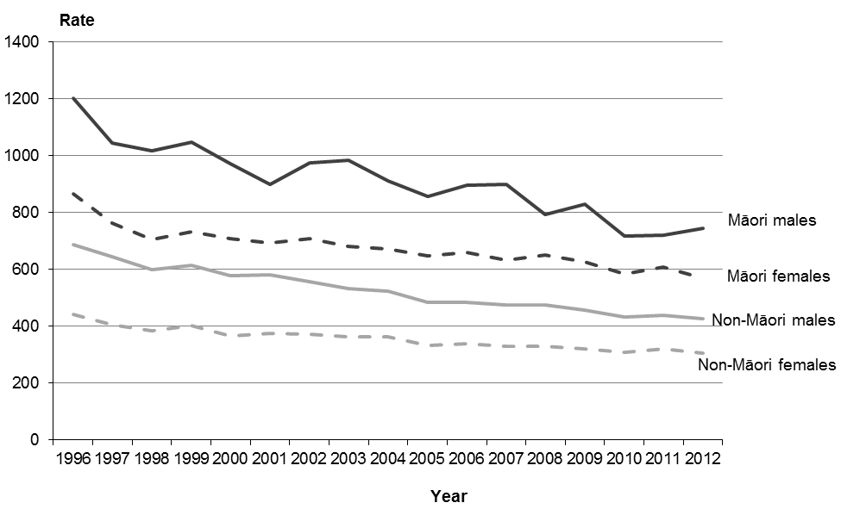

Notes: rates per 100,000 population, age-standardised to WHO World Standard Population.

From 1980 to 2012 the five major causes of death were cancer, ischaemic heart disease, cerebrovascular disease, chronic lower respiratory disease and other forms of heart disease. In 2012, these five major causes accounted for two thirds (65.9%) of all deaths. Cancer accounted for 29.4% of deaths, ischaemic heart disease accounted for 17.6%, and the remaining three together accounted for 18.9% (Figure 4).

Between 1980 and 2012, mortality rates for all five major causes decreased. Specifically:

* ischaemic heart disease and cerebrovascular disease rates decreased by more than two-thirds (71.0% and 68.8% respectively)
* rates for chronic lower respiratory diseases and other forms of heart disease halved (declining by 53.3% and 50.0% respectively)
* the rate for cancer decreased by 23.6%.

Figure 4: Mortality rates for the five major causes of mortality, 1980–2012

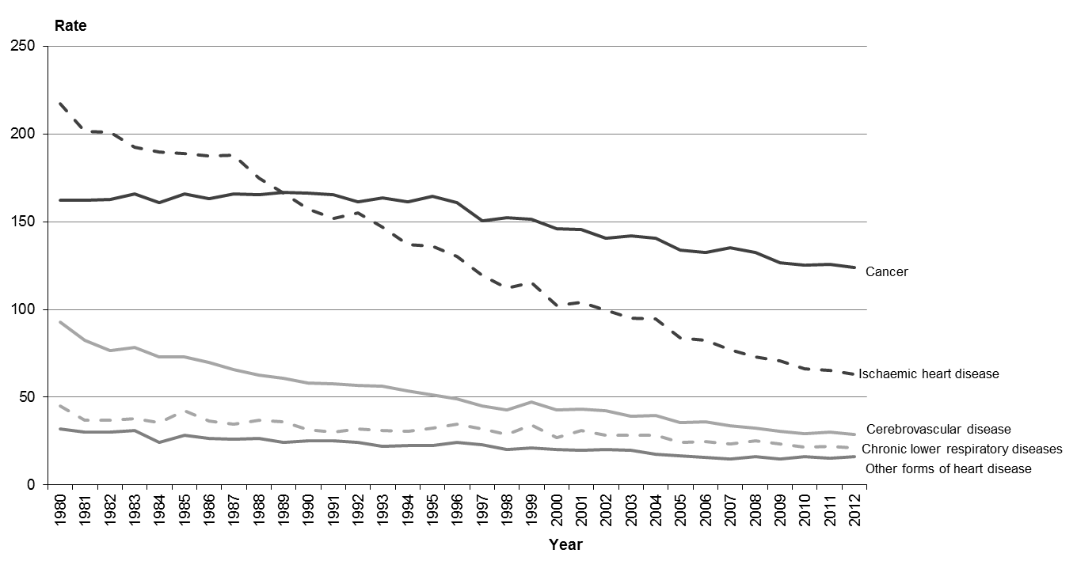

Note: rates per 100,000 population, age-standardised to WHO World Standard Population.

Māori had higher age-specific mortality rates than non-Māori for all five-year age groups under 85 years (Figure 5). Across each of these age groups, the mortality rate for the Māori population ranged from 1.4 to 3.2 times that of the non-Māori population. This ethnic disparity was greatest in those aged 10–14 years, where the Māori rate was more than three times that of the non-Māori rate. For those aged 85 years and over Māori and non-Māori mortality rates were comparable.

Figure 5: Age at death, rates by ethnicity, 2012

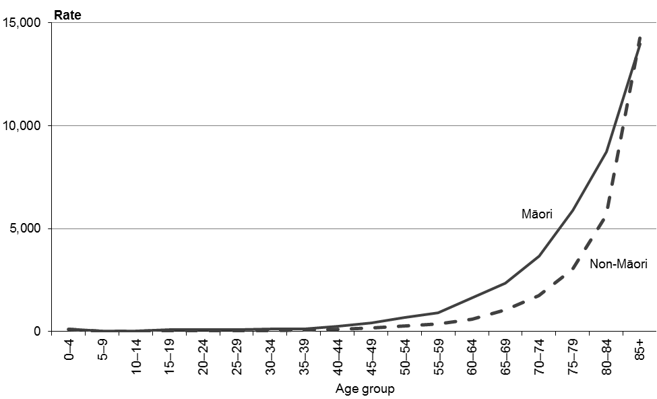

Note: rates per 100,000 population in each age group.

The term ‘amenable mortality’ refers to potentially preventable deaths that might have been prevented if health services had been delivered more effectively or if patients had accessed services earlier (either in primary care or in hospital). Amenable mortality includes deaths from some types of infection and cancer; maternal, perinatal and infant conditions/complications; injuries; and a range of chronic disorders (see ‘Amenable mortality’ within ‘Explanatory notes’ for further information). Figure 6 shows amenable mortality rates for Māori and non-Māori by sex from 2000 to 2012.

From 2000 to 2012 New Zealand’s amenable mortality rate decreased across all groups. Over this time, the rate for Māori was between 2.4 and 2.9 times the rate for non-Māori. For both ethnic groups the amenable mortality rate was higher for males than for females.

Figure 6: Amenable mortality rates per 100,000 people aged 0–74 years, by sex and ethnicity, 2000–2012

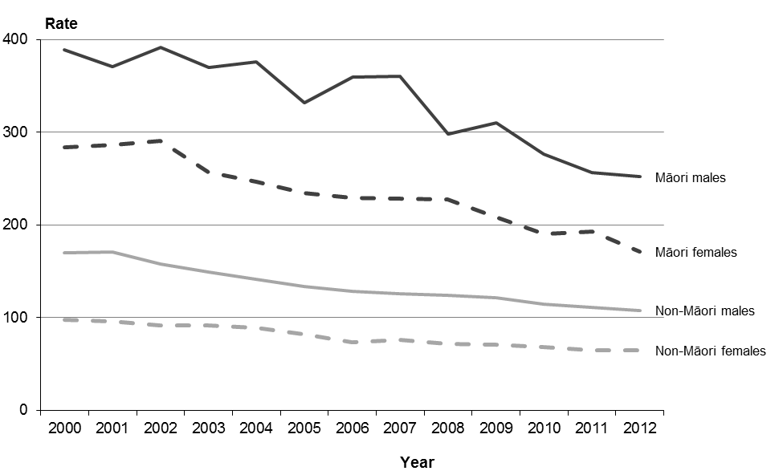

Note: rates per 100,000 population, age-standardised to WHO World Standard Population aged 0–74 years.

## Selected causes of mortality

Table 3 shows age-standardised mortality rates for selected causes of death for Māori, non-Māori and the total population in 2012.

Table 3: Mortality rates from selected causes, by sex and ethnicity, 2012

|  |  |  |  |  |  |  |  |  |  |  |
| --- | --- | --- | --- | --- | --- | --- | --- | --- | --- | --- |
| **ICD code** | **Cause of death** | **Māori population** | | | **Non-Māori population** | | | **Total population** | | |
| **Male** | **Female** | **Total** | **Male** | **Female** | **Total** | **Male** | **Female** | **Total** |
| C00–C96, D45–D47 | Total cancer | 209.5 | 192.5 | 199.4 | 135.9 | 101.1 | 116.5 | 143.4 | 109.0 | 124.0 |
| C33–C34 | Lung cancer\* | 65.4 | 66.4 | 65.7 | 23.9 | 15.7 | 19.5 | 27.1 | 19.7 | 23.1 |
| C50 | Breast cancer | 0.0 | 26.5 | 14.5 | 0.0 | 16.9 | 8.9 | 0.0 | 17.7 | 9.4 |
| C61 | Prostate cancer | 18.1 | … | … | 16.4 | … | … | 17.0 | … | … |
| C43 | Melanoma of the skin | 0.9 | 0.8 | 0.8 | 7.2 | 3.8 | 5.4 | 6.8 | 3.6 | 5.1 |
| C53 | Cervical cancer | … | 3.7 | … | … | 1.6 | … | … | 1.8 | … |
| I00–I99 | Diseases of the circulatory system | 239.1 | 164.9 | 199.3 | 132.7 | 90.6 | 111.0 | 144.6 | 98.7 | 120.7 |
| I05–I09 | Chronic rheumatic heart disease | 3.7 | 6.6 | 5.3 | 1.2 | 1.4 | 1.3 | 1.5 | 1.8 | 1.7 |
| I10–I15 | Hypertensive disease | 11.8 | 10.5 | 11.2 | 3.5 | 3.2 | 3.4 | 4.2 | 3.7 | 4.0 |
| I20–I25 | Ischaemic heart disease | 140.3 | 77.2 | 106.2 | 78.5 | 40.0 | 58.0 | 85.2 | 43.8 | 63.0 |
| I30–I52 | Other forms of heart disease§ | 42.7 | 27.2 | 34.3 | 15.8 | 12.3 | 14.1 | 18.3 | 13.8 | 16.0 |
| I60–I69 | Cerebrovascular disease | 30.3 | 31.7 | 31.2 | 25.7 | 28.4 | 27.7 | 27.1 | 29.6 | 29.0 |
| J40–J47 | Chronic lower respiratory diseases | 52.7 | 53.7 | 53.0 | 21.2 | 16.5 | 18.3 | 23.8 | 19.1 | 20.9 |
| J40–J44 | COPD‡ | 45.7 | 46.2 | 45.8 | 19.8 | 14.6 | 16.7 | 22.0 | 16.8 | 18.8 |
| E10–E14 | Diabetes mellitus | 48.3 | 33.8 | 40.6 | 9.9 | 6.6 | 8.1 | 12.8 | 8.6 | 10.6 |
| X60–X84 | Suicide | 25.3 | 10.5 | 17.6 | 16.3 | 5.2 | 10.6 | 18.5 | 6.4 | 12.3 |
| V00–V99 | Transport accidents | 28.2 | 6.3 | 16.8 | 10.9 | 3.6 | 7.2 | 13.6 | 4.0 | 8.7 |
| V02–V89≠ | Motor vehicle accidents | 22.4 | 6.3 | 14.1 | 9.3 | 3.2 | 6.2 | 11.3 | 3.7 | 7.4 |
| F00–F09 | Organic, including symptomatic, mental disorders~ | 8.4 | 10.8 | 10.0 | 10.6 | 12.8 | 12.1 | 11.0 | 13.1 | 12.5 |
| J09–J18 | Pneumonia and influenza | 11.6 | 8.7 | 10.0 | 7.6 | 6.8 | 7.2 | 8.3 | 7.2 | 7.7 |
| Q00–Q99 | Congenital anomalies | 3.5 | 2.6 | 3.0 | 4.9 | 2.8 | 3.9 | 4.5 | 3.0 | 3.7 |
| X85–Y09 | Assault | 4.3 | 1.0 | 2.6 | 0.8 | 1.2 | 1.0 | 1.4 | 1.2 | 1.3 |
|  | **All causes of death** | **743.3** | **567.6** | **649.3** | **425.1** | **305.9** | **362.0** | **463.0** | **332.7** | **393.6** |

Note: rates per 100,000 population, age-standardised to WHO World Standard Population.

\* Includes cancer of the trachea, bronchus and lung.

‡ Chronic obstructive pulmonary disease.

§ Includes pericardial diseases, valve disorders, myocarditis, cardiomyopathy, conduction disorders, cardiac arrest and heart failure, but excludes chronic rheumatic heart disease.

≠ Selected codes from the V02–V89 range.

~ Includes dementia, amnesic syndrome, delirium and other mental disorders due to brain damage and dysfunction and to physical disease.

... = Not applicable.

The highest mortality rates in the total population in 2012 were from cancer and diseases of the circulatory system (of which ischaemic heart disease and cerebrovascular disease were the top two causes).

The highest mortality rates in the Māori population in 2012 were from cancer and diseases of the circulatory system (of which ischaemic heart disease and chronic lower respiratory diseases were the top two causes).

Lung cancer was the leading cause of cancer death for Māori males, non-Māori males and Māori females in 2012; breast cancer was the leading cause of cancer death for non-Māori females.

### Sex-based differences in mortality

Table 3 shows that mortality rates for males were generally higher than for females in 2012. For example, males had a mortality rate:

* for all causes that was 1.4 times the rate for females
* from transport accidents that was more than three times the female rate
* from suicide that was nearly three times the female rate
* from ischaemic heart disease and melanoma that was nearly twice the female rate
* from diabetes, congenital anomalies and lung cancer that was almost 1.5 times the female rate.

Female mortality rates were higher than the equivalent male rates for cerebrovascular disease; organic, including symptomatic, mental disorders; and chronic rheumatic heart disease.

### Ethnicity-based differences in mortality

In 2012, Māori had a total mortality rate that was 1.8 times the rate for non-Māori (the age-standardised rates were 649.3 and 362.0 respectively).

Māori had higher mortality rates than non-Māori for most of the causes shown in Table 3, except for melanoma and congenital anomalies.

In 2012, the two largest differences between mortality rates for Māori and non-Māori were for:

* diabetes mellitus, where the rate for Māori was five times that for non-Māori (the age-standardised rates were 40.6 and 8.1 respectively)
* chronic rheumatic heart disease, where the rate for Māori was four times that for non-Māori (the age-standardised rates were 5.3 and 1.3 respectively).

In addition, Māori had mortality rates for lung cancer and hypertensive diseases that were more than three times the equivalent non-Māori rate. Māori rates for chronic lower respiratory diseases (including chronic obstructive pulmonary disease), assault, transport accidents, cervical cancer and other forms of heart disease were at least twice the equivalent non-Māori rates.

Note that the percentages and rates discussed here present a snapshot from 2012. Mortality rates for Māori tend to vary more widely than those for non-Māori, due to the lower number of deaths they are based on. It is useful, whenever possible, to examine the pattern of their incidence over several years. This helps to determine whether the mortality figures for a particular year and condition are a statistical spike or representative of the general trend.

Selected causes of death, broken down by sex and ethnicity, are discussed further in ‘Selected trends’.

## Mortality by region

This section presents mortality data by district health board (DHB) region of residence by age-standardised rate. Note that the populations used in this section are different to the populations used in the remainder of the publication. This means that some results in this section differ very slightly from those given in other sections (see ‘Population’ within ‘Explanatory notes’).

### Total population

Figure 7 presents the mortality rate and the 99% confidence intervals for each DHB region for 2012. Four DHB regions had mortality rates that were significantly lower than the national rate: Waitemata, Nelson Marlborough, Auckland and Capital & Coast. Five had mortality rates that were significantly higher than the national rate: Tairāwhiti, Whanganui, Lakes, Northland and South Canterbury. The remaining DHB regions had rates with 99% confidence limits that overlapped with the New Zealand mortality rate, meaning they were not significantly different from the national rate (see ‘Confidence intervals’ within ‘Explanatory notes’).

Figure 7: Mortality rates, by DHB region, total population, 2012

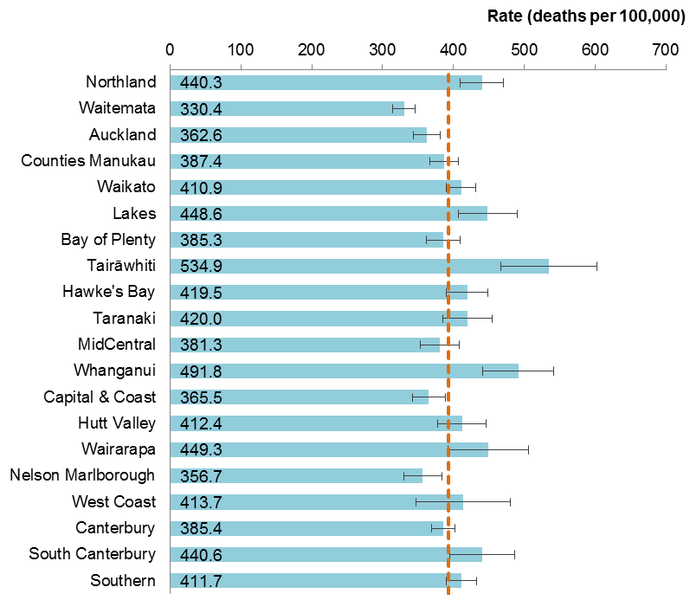

Notes:

The dashed vertical line is the national rate.

Rates per 100,000 population, age-standardised to WHO World Standard Population; 99% confidence intervals.

### Māori and non-Māori mortality by DHB region

Figure 8 shows mortality rates by DHB region of residence for Māori in 2012 compared with the national mortality rate for Māori.

All five DHBs in the South Island (South Canterbury, West Coast, Nelson Marlborough, Southern and Canterbury) had a mortality rate for Māori that was significantly lower than the national rate. No DHB had a rate that was significantly higher than the national rate. South Canterbury DHB had the lowest Māori mortality rate (249.7 deaths per 100,000). Whanganui and Wairarapa DHBs had the highest Māori mortality rates (827.0 and 822.1 deaths per 100,000 respectively).

The rates for some DHBs have very wide confidence intervals, due to low mortality numbers (eg, South Canterbury (7) and West Coast (10)). Rates for these DHBs should be interpreted with caution.

Figure 8: Mortality rates, by DHB region, Māori population, 2012

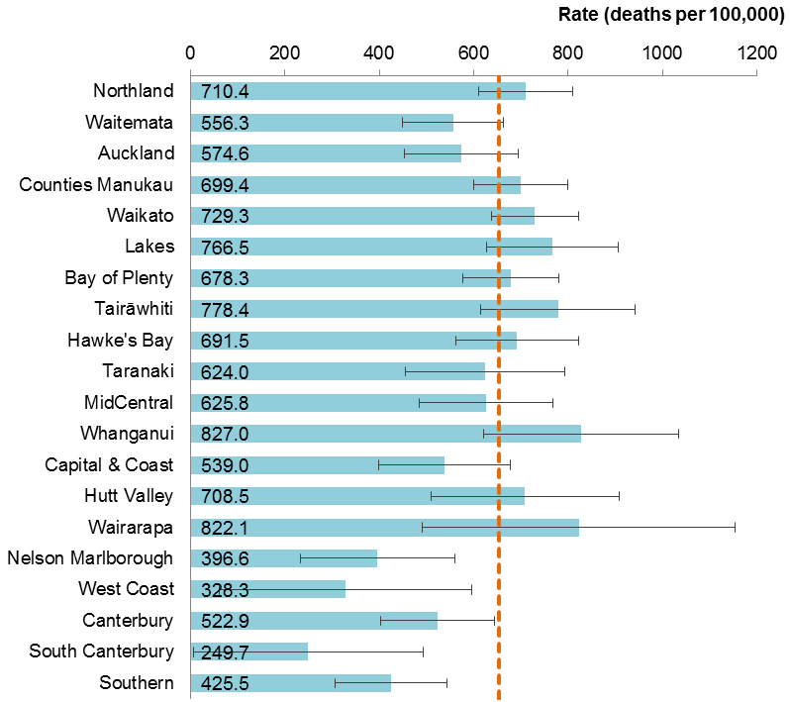

Notes:

The dashed vertical line is the national rate for Māori.

Rates per 100,000 Māori population, age-standardised to WHO World Standard Population; 99% confidence intervals.

Figure 9 shows mortality rates by DHB region for non-Māori in 2012 compared with the rate for all non-Māori.

Six DHB regions had a mortality rate for non-Māori that was significantly different from the national rate; three were higher (South Canterbury, Whanganui and Southern) and three were lower (Waitemata, Bay of Plenty and Auckland).

The DHB regions with the highest mortality rates for the non-Māori population were South Canterbury (446.6 deaths per 100,000), Whanganui (433.4 per 100,000) and Tairāwhiti (433.0 per 100,000). The DHB region with the lowest non-Māori mortality rate was Waitemata (316.1 per 100,000).

Figure 9: Mortality rates, by DHB region, non-Māori population, 2012

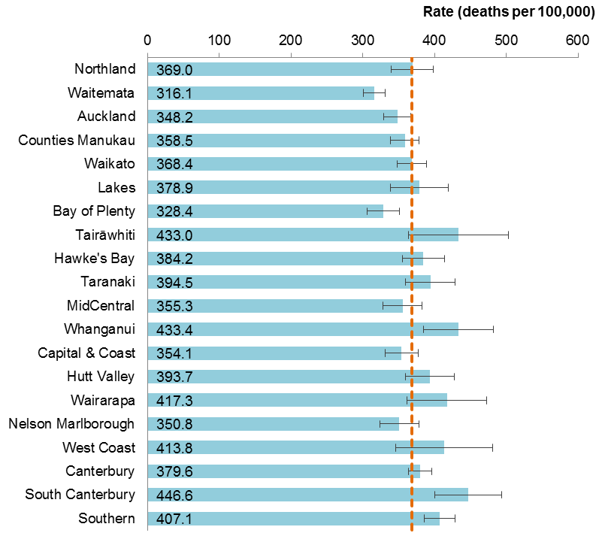

Notes:

The dashed vertical line is the national rate for non-Māori.

Rates per 100,000 non-Māori population, age-standardised to WHO World Standard Population; 99% confidence intervals.

Figure 10 combines the same information as Figures 8 and 9 in map form. The different shades shown on the maps distinguish ranges in DHB rates, lighter shades represent lower rates and darker shades represent higher rates. Mortality rates for Māori were generally higher than the corresponding rates for non-Māori, particularly in the North Island.

Some factors that influence regional mortality rates have not been adjusted for in the data presented. They include:

* demographic factors (such as sex, ethnicity, deprivation and socioeconomic status)
* geographic factors (such as the average distance travelled to access health services)
* population risk factors (such as smoking rates, obesity rates, diabetes rates, mix of occupations and occupational mortality rates, and population health literacy).

For example, different regions have different proportions of Māori in their populations, and Māori exhibit higher rates of mortality. Similarly, smoking and obesity rates are known to be higher among people living in more deprived areas (Ministry of Health 2012), and some DHBs have a relatively higher proportion of such areas. This data cannot be used to assess the quality of care being provided by DHBs to their populations.

Figure 10: Comparison of DHB region mortality rates for Māori and non-Māori, 2012

C:\Users\emwoods\AppData\Local\Microsoft\Windows\INetCache\Content.Word\DHBMortalityRates_Maori2012updated.emf

C:\Users\emwoods\AppData\Local\Microsoft\Windows\INetCache\Content.Word\DHBMortalityRates_nonMaori2012updated.emf

Note: rates per 100,000 population, age-standardised to WHO World Standard Population.

# Selected trends

This section examines mortality statistics for several conditions in greater depth. These analyses, while addressing the most salient conditions, are not intended to be a definitive account of the mortality and health issues facing the New Zealand population.

Conditions covered in this section are:

* all cancers (malignant neoplasm)
* lung cancer (malignant neoplasm of the trachea, bronchus and lung)
* female breast cancer (malignant neoplasm of the female breast)
* prostate cancer (malignant neoplasm of the prostate)
* melanoma of the skin (malignant melanoma of the skin)
* cervical cancer (malignant neoplasm of the cervix uteri)
* ischaemic heart disease (angina pectoris, myocardial infarction and other forms of acute and chronic ischaemic heart disease)
* cerebrovascular disease (cerebral haemorrhage (subarachnoid, intracerebral and other non-traumatic), cerebral infarction, occlusion and stenosis of precerebral and cerebral arteries and other cerebrovascular diseases)
* diabetes mellitus, Type 1 (insulin dependent) and Type 2 (adult onset diabetes)
* motor vehicle accidents (accidents associated with motorised land transport)
* suicide (intentional self-harm)
* maternal mortality (direct and indirect obstetric deaths).

## All cancers

Cancer, or malignant neoplasm (an abnormal growth of tissue), is a general term that covers a large number of diseases. This section is concerned with the total mortality impact of all cancers. Collectively, cancers are a major cause of mortality in the New Zealand population. In this report, data for all cancers combined includes ICD codes C00–C96 and D45–D47.

Cancer was the leading cause of death for both males and females in 2012. There were 8905 deaths from cancer in this year (4735 males and 4170 females). For males the most common cancer deaths were from lung cancer, colorectal cancer, prostate and pancreatic cancer, and melanoma. For females the most common cancer deaths were from lung, colorectal, breast, pancreatic and ovarian cancer.

Figure 11 shows how the numbers and mortality rates from cancer changed from 1950 to 2012. Although the number of deaths increased steadily for both males and females, matching the general rise in population, the rate shows a different trend.

The rate for males showed a general increase, with a peak in 1985 and then a gradual decline to below the levels seen in the 1950s. The female rate showed more stability, reaching its highest level in 1990 and its lowest level in 2012.

Figure 11: Number of deaths and mortality rates from all cancers, by sex, 1950–2012

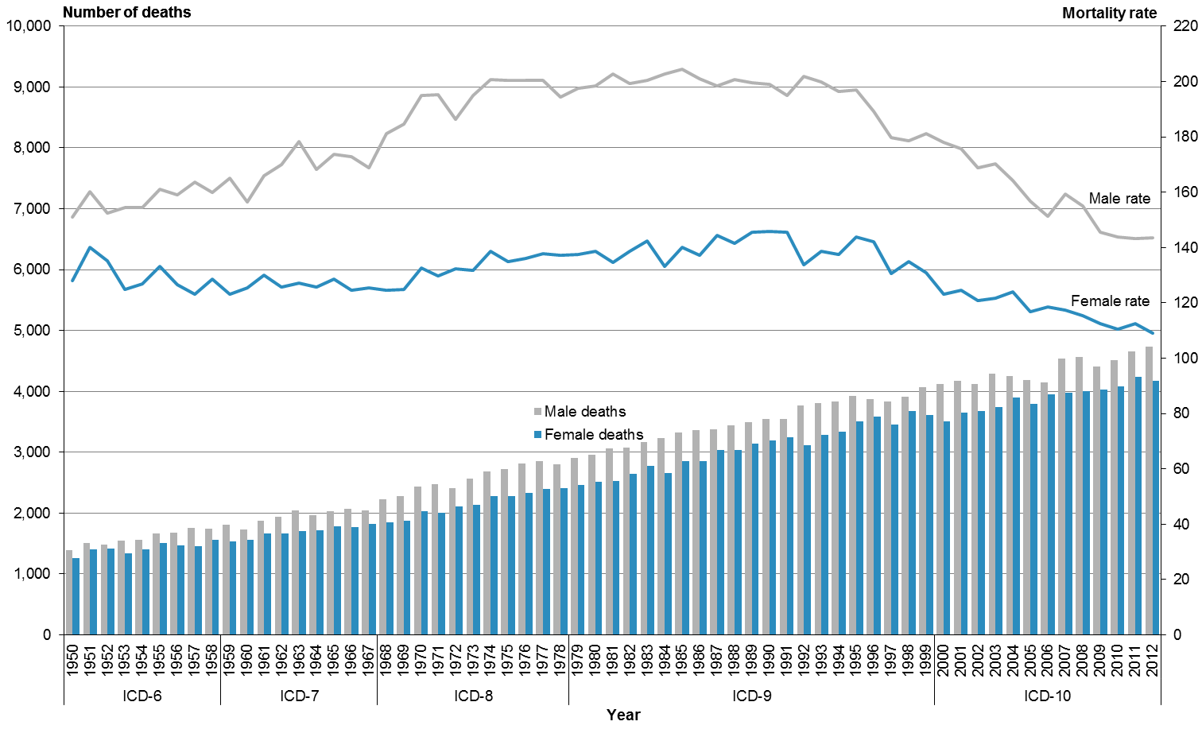

Note: rates per 100,000 population, age-standardised to WHO World Standard Population.

In 2012 the cancer mortality rate for males was 1.3 times the female rate. Males consistently had a higher mortality rate than females from 1980 to 2012 (Table 4). Mortality rates generally declined over this time; the rate for males in 2012 was 27.7% lower than the equivalent rate in 1980, and the female rate was 21.3% lower.

Table 4: Number of deaths and mortality rates from all cancers, by sex, 1980–2012

|  |  |  |  |  |  |  |
| --- | --- | --- | --- | --- | --- | --- |
| **Year** | **Male** | | **Female** | | **Total** | |
| **No.** | **Rate** | **No.** | **Rate** | **No.** | **Rate** |
| 1980 | 2952 | 198.4 | 2513 | 138.5 | 5465 | 162.3 |
| 1981 | 3061 | 202.6 | 2527 | 134.6 | 5588 | 162.2 |
| 1982 | 3076 | 199.3 | 2647 | 138.7 | 5723 | 162.6 |
| 1983 | 3166 | 200.4 | 2771 | 142.3 | 5937 | 165.7 |
| 1984 | 3237 | 202.7 | 2651 | 133.1 | 5888 | 160.8 |
| 1985 | 3318 | 204.5 | 2849 | 140.2 | 6167 | 165.6 |
| 1986 | 3364 | 200.9 | 2857 | 137.2 | 6221 | 163.1 |
| 1987 | 3375 | 198.5 | 3035 | 144.3 | 6410 | 165.8 |
| 1988 | 3444 | 200.6 | 3037 | 141.5 | 6481 | 165.2 |
| 1989 | 3492 | 199.6 | 3139 | 145.6 | 6631 | 166.9 |
| 1990 | 3548 | 199.0 | 3198 | 145.7 | 6746 | 166.2 |
| 1991 | 3541 | 195.1 | 3251 | 145.4 | 6792 | 165.2 |
| 1992 | 3771 | 201.7 | 3110 | 133.8 | 6881 | 161.5 |
| 1993 | 3812 | 199.8 | 3282 | 138.6 | 7094 | 163.4 |
| 1994 | 3834 | 196.3 | 3332 | 137.6 | 7166 | 161.3 |
| 1995 | 3918 | 196.9 | 3504 | 143.8 | 7422 | 164.5 |
| 1996 | 3872 | 189.3 | 3589 | 142.1 | 7461 | 160.8 |
| 1997 | 3834 | 179.6 | 3448 | 130.7 | 7282 | 150.6 |
| 1998 | 3911 | 178.5 | 3671 | 134.9 | 7582 | 152.4 |
| 1999 | 4063 | 181.3 | 3611 | 130.7 | 7674 | 151.4 |
| 2000 | 4120 | 178.1 | 3500 | 123.2 | 7620 | 146.1 |
| 2001 | 4166 | 175.7 | 3644 | 124.6 | 7810 | 145.5 |
| 2002 | 4125 | 168.9 | 3675 | 120.9 | 7800 | 140.7 |
| 2003 | 4292 | 170.1 | 3735 | 121.7 | 8027 | 141.8 |
| 2004 | 4246 | 164.1 | 3899 | 124.1 | 8145 | 140.7 |
| 2005 | 4184 | 156.6 | 3787 | 116.9 | 7971 | 133.6 |
| 2006 | 4144 | 151.3 | 3950 | 118.5 | 8094 | 132.4 |
| 2007 | 4539 | 159.4 | 3980 | 117.3 | 8519 | 135.1 |
| 2008 | 4561 | 154.9 | 4005 | 115.3 | 8566 | 132.3 |
| 2009 | 4402 | 145.4 | 4035 | 112.6 | 8437 | 126.8 |
| 2010 | 4511 | 143.9 | 4082 | 110.6 | 8593 | 125.2 |
| 2011 | 4650 | 143.3 | 4241 | 112.6 | 8891 | 125.9 |
| 2012 | 4735 | 143.4 | 4170 | 109.0 | 8905 | 124.0 |

Note: rates per 100,000 population, age-standardised to WHO World Standard Population.

In 2012, the mortality rate from all cancers for Māori was 199.4 deaths per 100,000 Māori. For non-Māori the mortality rate was 116.5 deaths per 100,000 non-Māori.

The distribution of cancer-related deaths was skewed toward the 65 years and over age group. However, a large proportion of cancer-related deaths also occurred in the 45–64 years age band. Cancer deaths were relatively rare in people aged under 45 years (Table 5).

Table 5: Age distribution of deaths from all cancers, percentages and rates, by ethnicity and sex, 2012

|  |  |  |  |  |  |  |  |  |  |  |  |  |
| --- | --- | --- | --- | --- | --- | --- | --- | --- | --- | --- | --- | --- |
| **Age group (years)** | **Percentage** | | | | | | **Age-specific mortality rate** | | | | | |
| **Māori** | | | **Non-Māori** | | | **Māori** | | | **Non-Māori** | | |
| **Male** | **Female** | **Total** | **Male** | **Female** | **Total** | **Male** | **Female** | **Total** | **Male** | **Female** | **Total** |
| <25 | 2.0 | 1.6 | 1.8 | 0.5 | 0.5 | 0.5 | 4.9 | 4.5 | 4.7 | 3.3 | 3.0 | 3.2 |
| 25–44 | 5.2 | 5.1 | 5.1 | 2.0 | 3.8 | 2.8 | 29.2 | 28.1 | 28.6 | 17.2 | 27.4 | 22.5 |
| 45–64 | 36.1 | 42.8 | 39.6 | 19.7 | 22.6 | 21.0 | 282.1 | 335.7 | 310.4 | 173.3 | 161.9 | 167.5 |
| 65+ | 56.7 | 50.5 | 53.4 | 77.9 | 73.1 | 75.7 | 1597.4 | 1349.2 | 1462.0 | 1261.3 | 861.3 | 1045.1 |

Note: rates per 100,000 population.

Compared with non-Māori, a greater proportion of Māori deaths occurred in the youngest three age groups (almost half of Māori cancer deaths occurred in those aged less than 65; for non‑Māori this figure was 24.3%).

Between 1996 and 2012, the Māori population had a consistently higher rate of cancer deaths than the non-Māori population. Māori males had a higher rate than Māori females in every year except 2008 (Figure 12).

There was a significant difference in cancer mortality rates between non-Māori males and non-Māori females between 1996 and 2012 (using 95% confidence intervals).[[2]](#footnote-2) The difference between the rates for Māori males and Māori females was not significant in 2012.

In 2012, the rate of cancer deaths for Māori males was 1.5 times that for non-Māori males. The rate for Māori females was 1.9 times that for non-Māori females.

Figure 12: Mortality rates from all cancers, by sex and ethnicity, 1996–2012

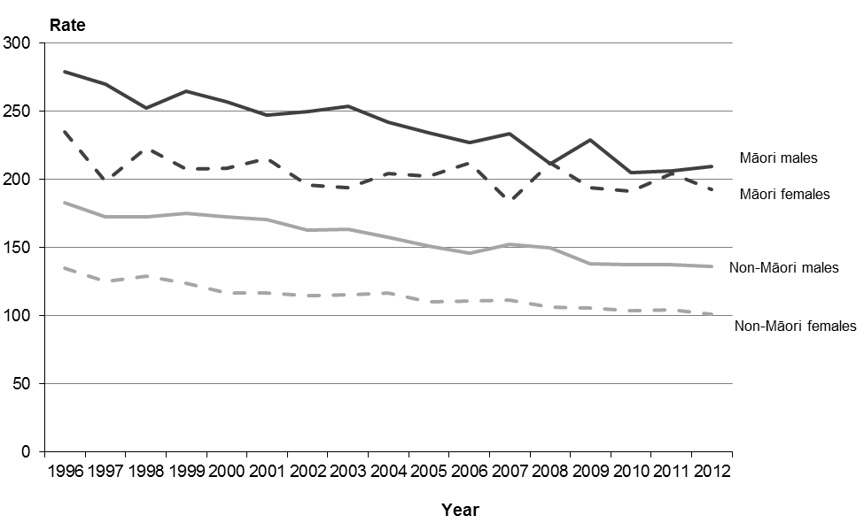

Note: rates per 100,000 population, age-standardised to WHO World Standard Population.

Figure 13 shows cancer mortality rates by DHB region for the total population in 2012. One DHB (Southern) showed a rate that was significantly above the national rate; two DHBs had rates that were significantly lower (Auckland and Waitemata). All other DHBs had rates that were not significantly different to the New Zealand rate.

Figure 13: Mortality rates from all cancers, by DHB region, total population, 2012

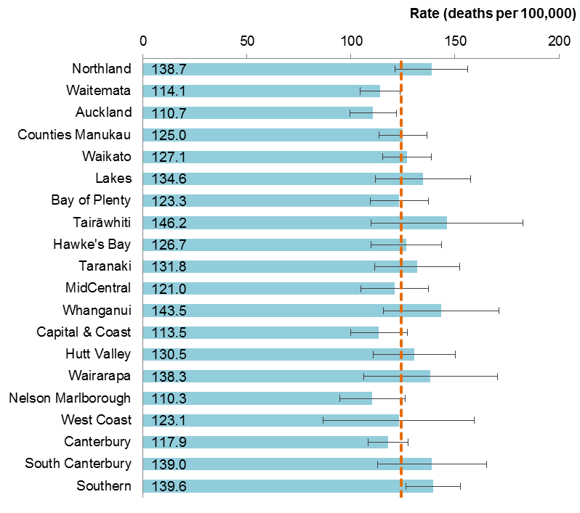

Notes:

The dashed vertical line is the national rate.

Rates per 100,000 population, age-standardised to WHO World Standard Population; 99% confidence intervals.

## Lung cancer

This section covers ICD codes C33 and C34 (C33: malignant neoplasm of trachea; C34: malignant neoplasm of bronchus and lung). In this publication, these conditions are collectively referred to as lung cancer.

Lung cancer was the leading cause of cancer death in 2012, accounting for 18.3% of cancer deaths (1628 deaths). The majority of those who died from lung cancer were males (54.7%). In 2012, the mortality rate for males was higher than the female rate (27.1 deaths per 100,000 males compared to 19.7 deaths per 100,000 females).

Figure 14 shows trends in numbers and rates of death from lung cancer for both males and females from 1950 to 2012. Mortality rates for males peaked in the mid-1980s and then showed a strong downward trend. Female rates showed a general upward trend from 1950 before stabilising in the 1990s.

Figure 14: Number of deaths mortality rates from lung cancer, by sex, 1950–2012

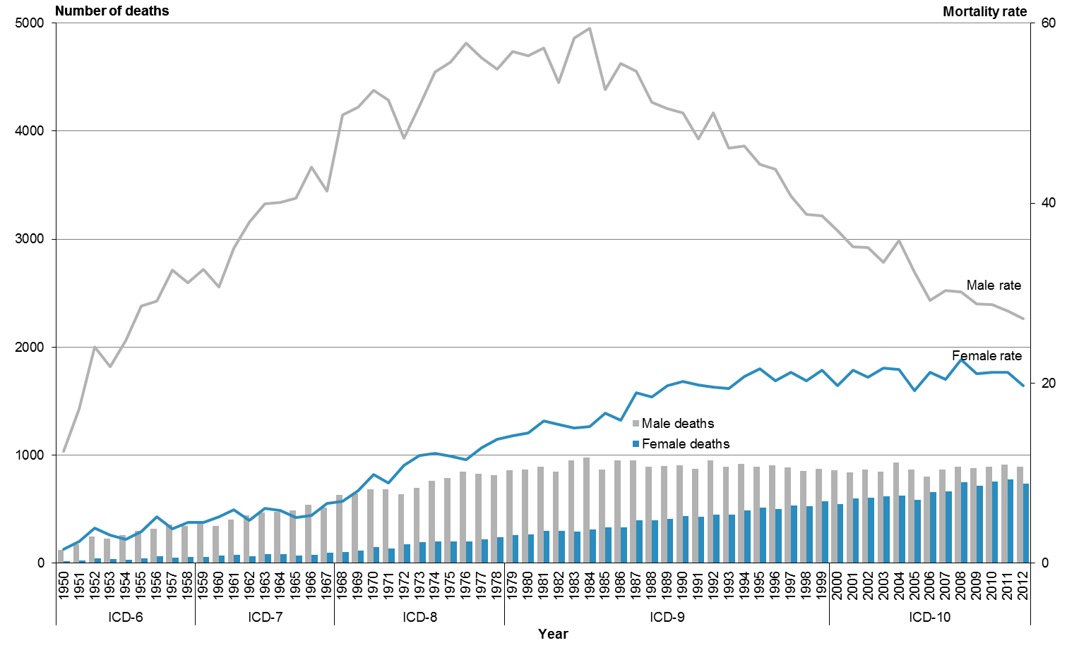

Note: rates per 100,000 population, age-standardised to WHO World Standard Population.

Table 6 shows deaths from lung cancer from 1980 to 2012. The mortality rate for males declined by more than half over this time (51.9%), while the rate for females showed the opposite trend, increasing by 36.2%. The number of male deaths in 2012 was comparable to the number of male deaths in 1980. For females, the number of deaths in 2012 was almost three times the number of deaths in 1980.

Table 6: Number of deaths and mortality rates from lung cancer, by sex, 1980–2012

|  |  |  |  |  |  |  |
| --- | --- | --- | --- | --- | --- | --- |
| **Year** | **Male** | | **Female** | | **Total** | |
| **No.** | **Rate** | **No.** | **Rate** | **No.** | **Rate** |
| 1980 | 868 | 56.4 | 265 | 14.5 | 1133 | 32.8 |
| 1981 | 889 | 57.3 | 298 | 15.8 | 1187 | 33.8 |
| 1982 | 844 | 53.4 | 298 | 15.4 | 1142 | 31.7 |
| 1983 | 948 | 58.3 | 291 | 15.0 | 1239 | 34.0 |
| 1984 | 975 | 59.4 | 307 | 15.2 | 1282 | 34.4 |
| 1985 | 866 | 52.6 | 331 | 16.6 | 1197 | 31.9 |
| 1986 | 949 | 55.5 | 329 | 15.9 | 1278 | 33.1 |
| 1987 | 950 | 54.7 | 396 | 18.9 | 1346 | 34.5 |
| 1988 | 892 | 51.2 | 395 | 18.4 | 1287 | 32.7 |
| 1989 | 896 | 50.5 | 411 | 19.7 | 1307 | 32.9 |
| 1990 | 903 | 50.0 | 433 | 20.2 | 1336 | 33.0 |
| 1991 | 869 | 47.1 | 427 | 19.8 | 1296 | 31.6 |
| 1992 | 947 | 50.0 | 445 | 19.5 | 1392 | 32.5 |
| 1993 | 892 | 46.1 | 444 | 19.4 | 1336 | 30.9 |
| 1994 | 919 | 46.3 | 484 | 20.7 | 1403 | 31.7 |
| 1995 | 892 | 44.3 | 514 | 21.6 | 1406 | 31.5 |
| 1996 | 904 | 43.8 | 502 | 20.2 | 1406 | 30.5 |
| 1997 | 882 | 40.8 | 530 | 21.2 | 1412 | 29.6 |
| 1998 | 855 | 38.8 | 526 | 20.2 | 1381 | 28.1 |
| 1999 | 874 | 38.6 | 569 | 21.4 | 1443 | 28.8 |
| 2000 | 860 | 37.0 | 546 | 19.7 | 1406 | 27.3 |
| 2001 | 841 | 35.1 | 594 | 21.4 | 1435 | 27.3 |
| 2002 | 866 | 35.1 | 605 | 20.7 | 1471 | 26.9 |
| 2003 | 848 | 33.4 | 618 | 21.6 | 1466 | 26.6 |
| 2004 | 929 | 35.9 | 626 | 21.5 | 1555 | 27.8 |
| 2005 | 864 | 32.3 | 587 | 19.2 | 1451 | 25.0 |
| 2006 | 798 | 29.2 | 659 | 21.2 | 1457 | 24.7 |
| 2007 | 864 | 30.3 | 664 | 20.4 | 1528 | 24.7 |
| 2008 | 889 | 30.1 | 745 | 22.6 | 1634 | 25.7 |
| 2009 | 876 | 28.8 | 717 | 21.0 | 1593 | 24.4 |
| 2010 | 893 | 28.7 | 757 | 21.2 | 1650 | 24.6 |
| 2011 | 909 | 28.0 | 773 | 21.2 | 1682 | 24.2 |
| 2012 | 891 | 27.1 | 737 | 19.7 | 1628 | 23.1 |

Note: rates per 100,000 population, age-standardised to WHO World Standard Population.

The great majority of lung cancer deaths occurred in those aged 45 years and over (Table 7). Among Māori, a greater percentage of deaths occurred in those aged 45–64 years (the percentage for this age group was almost twice that of the equivalent non-Māori percentage), and the Māori age-specific rate was 3.6 times that of non-Māori. In the 65 years and over age group, the Māori rate was three times that of non-Māori.

Table 7: Age distribution of deaths from lung cancer, percentages and rates, by ethnicity and sex, 2012

|  |  |  |  |  |  |  |  |  |  |  |  |  |
| --- | --- | --- | --- | --- | --- | --- | --- | --- | --- | --- | --- | --- |
| **Age group (years)** | **Percentage** | | | | | | **Age-specific rate** | | | | | |
| **Māori** | | | **Non-Māori** | | | **Māori** | | | **Non-Māori** | | |
| **Male** | **Female** | **Total** | **Male** | **Female** | **Total** | **Male** | **Female** | **Total** | **Male** | **Female** | **Total** |
| <25 | 0.0 | 0.0 | 0.0 | 0.0 | 0.0 | 0.0 | 0.0 | 0.0 | 0.0 | 0.0 | 0.0 | 0.0 |
| 25–44 | 2.9 | 1.8 | 2.3 | 1.1 | 1.4 | 1.2 | 5.1 | 3.4 | 4.2 | 1.6 | 1.6 | 1.6 |
| 45–64 | 35.7 | 41.7 | 39.0 | 21.8 | 20.7 | 21.4 | 88.7 | 110.8 | 100.4 | 33.6 | 23.1 | 28.2 |
| 65+ | 61.4 | 56.5 | 58.8 | 77.1 | 77.9 | 77.4 | 549.5 | 512.7 | 529.2 | 218.5 | 142.0 | 177.1 |

Note: rates per 100,000 population.

In 2012, the mortality rate from lung cancer for Māori was 65.7 deaths per 100,000. The mortality rate for non-Māori was 19.5 deaths per 100,000.

The mortality rate from lung cancer in Māori males was 2.7 times that for non-Māori males in 2012 (Figure 15). The rate for Māori females was more than four times that for non-Māori females.

Between 1996 and 2012, mortality rates for Māori males and females from lung cancer were higher than the equivalent non-Māori rates. During this period, the mortality rate for Māori males from lung cancer decreased by 38.5%, while the Māori female rate showed no obvious trend.

Figure 15: Mortality rates from lung cancer, by sex and ethnicity, 1996–2012

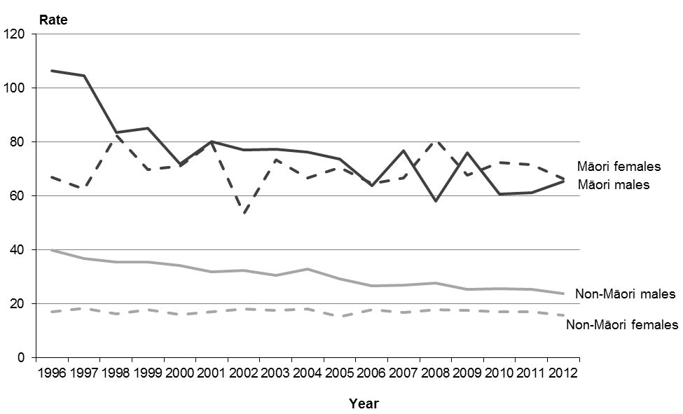

Note: rates per 100,000 population, age-standardised to WHO World Standard Population.

## Female breast cancer

Breast cancer was the third leading cause of cancer death among females in 2012 after lung and colorectal cancer.[[3]](#footnote-3) National breast screening commenced at the end of 1998 for women aged 50–69 years; from July 2008 the minimum screening age was lowered to 45.[[4]](#footnote-4)

This section covers ICD code C50 (malignant neoplasm of breast).

A total of 617 females died from breast cancer in 2012; this accounted for 14.8% of female deaths from cancer.

Although the number of deaths due to breast cancer increased between 1950 and 2012, when adjusted for age and the change in population, the rate showed a general downward trend after the mid-1980s (Figure 16). The mortality rate for 2012 (17.7 deaths per 100,000 females) was the lowest over the entire period.

Figure 16: Number of deaths and mortality rates from breast cancer in females, 1950–2012

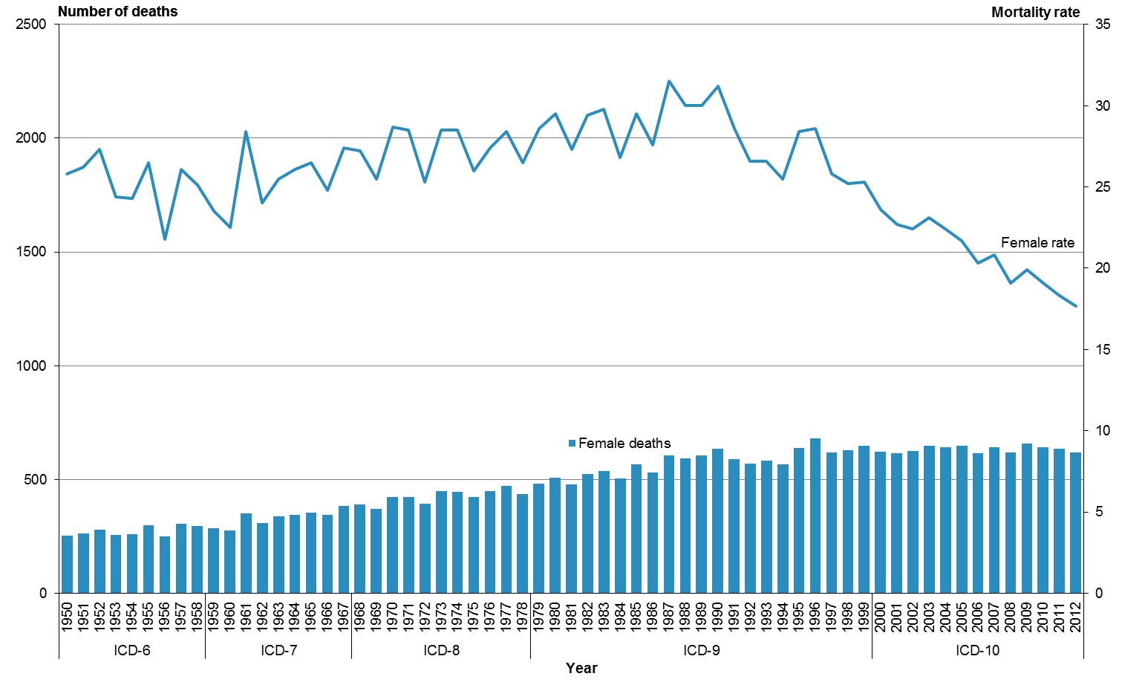

Note: rates per 100,000 female population, age-standardised to WHO World Standard Population.

From 1980 to 2012 the number of female deaths increased, reaching a peak in 1996 before stabilising. Over this time the mortality rate for females from breast cancer decreased by 40.1% (Table 8).

Table 8: Number of deaths and mortality rates from breast cancer in females, 1980–2012

|  |  |  |
| --- | --- | --- |
| **Year** | **No.** | **Rate** |
| 1980 | 509 | 29.5 |
| 1981 | 478 | 27.3 |
| 1982 | 524 | 29.4 |
| 1983 | 537 | 29.8 |
| 1984 | 504 | 26.8 |
| 1985 | 565 | 29.5 |
| 1986 | 529 | 27.6 |
| 1987 | 607 | 31.5 |
| 1988 | 593 | 30.0 |
| 1989 | 605 | 30.0 |
| 1990 | 635 | 31.2 |
| 1991 | 588 | 28.6 |
| 1992 | 569 | 26.6 |
| 1993 | 584 | 26.6 |
| 1994 | 567 | 25.5 |
| 1995 | 638 | 28.4 |
| 1996 | 681 | 28.6 |
| 1997 | 620 | 25.8 |
| 1998 | 629 | 25.2 |
| 1999 | 647 | 25.3 |
| 2000 | 622 | 23.6 |
| 2001 | 615 | 22.7 |
| 2002 | 625 | 22.4 |
| 2003 | 647 | 23.1 |
| 2004 | 642 | 22.4 |
| 2005 | 648 | 21.7 |
| 2006 | 614 | 20.3 |
| 2007 | 643 | 20.8 |
| 2008 | 618 | 19.1 |
| 2009 | 658 | 19.9 |
| 2010 | 641 | 19.1 |
| 2011 | 636 | 18.3 |
| 2012 | 617 | 17.7 |

Note: rates per 100,000 female population, age-standardised to WHO World Standard Population.

For Māori, the highest proportion of deaths from breast cancer was in women aged 45–64 years; this age group accounted for 60.3% of Māori deaths from breast cancer. For non-Māori women, the highest proportion was in women aged 65 and over; accounting for 57.2% of non-Māori breast cancer deaths (Table 9).

Table 9: Age distribution of deaths from breast cancer in females, percentages and rates, by ethnicity, 2012

|  |  |  |  |  |
| --- | --- | --- | --- | --- |
| **Age group (years)** | **Percentage** | | **Age-specific rate** | |
| **Māori female** | **Non-Māori female** | **Māori female** | **Non-Māori female** |
| <25 | 0.0 | 0.0 | 0.0 | 0.0 |
| 25–44 | 9.6 | 7.9 | 7.9 | 8.4 |
| 45–64 | 60.3 | 34.9 | 69.7 | 37.1 |
| 65+ | 30.1 | 57.2 | 118.7 | 99.7 |

Note: rates per 100,000 population.

In 2012, Māori females had a breast cancer mortality rate that was 1.6 times the non-Māori rate (Figure 17). There were 26.5 deaths per 100,000 Māori females, compared to 16.9 deaths per 100,000 non-Māori females.

For most years from 1996 to 2012, Māori rates were significantly higher than non-Māori rates (using 95% confidence intervals).[[5]](#footnote-5) The Māori mortality rate for breast cancer shows greater variability than that of non-Māori. This may be partially explained by the lower number of Māori deaths (73 in 2012). There was no significant change in breast cancer death rates among Māori between 1996 and 2012. For non-Māori females, the mortality rate for 2012 was significantly lower than the 1996 rate.

Figure 17: Mortality rates from breast cancer in females, by ethnicity, 1996–2012

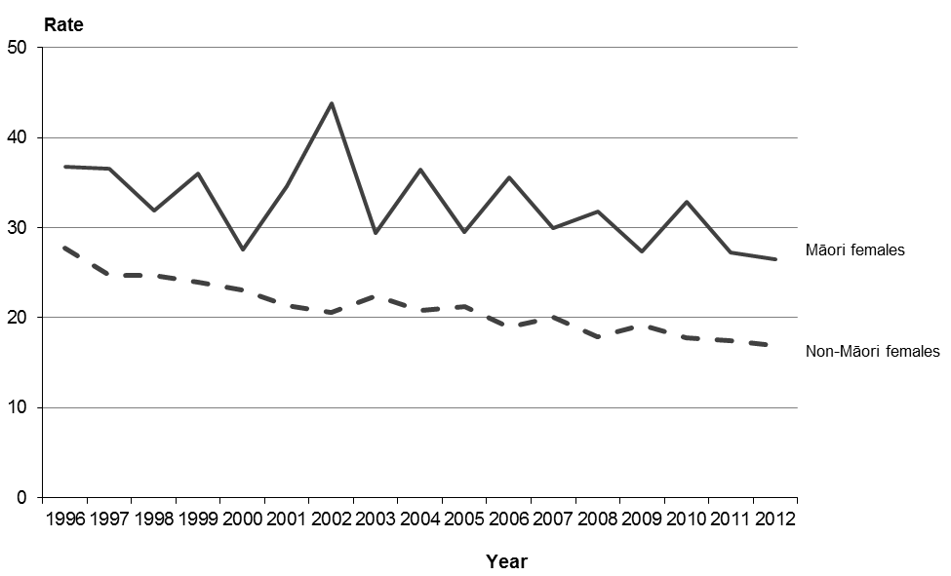

Note: rates per 100,000 female population, age-standardised to WHO World Standard Population.

## Prostate cancer

Prostate cancer was the most common cancer registered for males in 2012,[[6]](#footnote-6) and was also the third leading cause of male cancer death. This section covers ICD code C61 (malignant neoplasm of prostate).

There were 607 deaths from prostate cancer in 2012 (an age-standardised rate of 17.0 deaths per 100,000 male population), accounting for 12.8% of total male cancer deaths.

Between 1950 and 2012 mortality rates from prostate cancer showed an overall increase until a peak in 1995 (Figure 18). Thereafter, rates showed a downward trend. The 2012 rate was similar to rates in the 1950s. Over that time, the number of deaths from prostate cancer steadily increased to a reach a peak in 2008 before stabilising.

Figure 18: Number of deaths and mortality rates from prostate cancer, 1950–2012

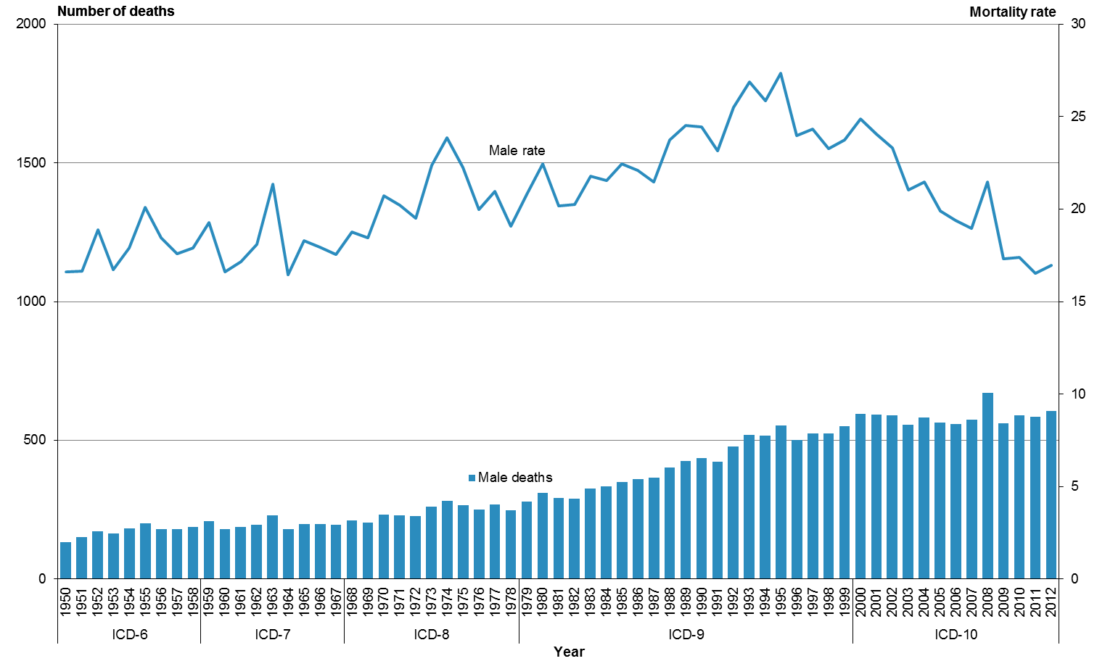

Note: rates per 100,000 male population, age-standardised to WHO World Standard Population.

Table 10 shows numbers and mortality rates for prostate cancer deaths between 1980 and 2012. Over this time the mortality rate declined by 24.4%.

Table 10: Number of deaths and mortality rates from prostate cancer, 1980–2012

|  |  |  |
| --- | --- | --- |
| **Year** | **No.** | **Rate** |
| 1980 | 311 | 22.4 |
| 1981 | 293 | 20.2 |
| 1982 | 289 | 20.3 |
| 1983 | 325 | 21.8 |
| 1984 | 335 | 21.5 |
| 1985 | 351 | 22.5 |
| 1986 | 360 | 22.1 |
| 1987 | 365 | 21.5 |
| 1988 | 402 | 23.7 |
| 1989 | 425 | 24.5 |
| 1990 | 436 | 24.5 |
| 1991 | 423 | 23.1 |
| 1992 | 478 | 25.5 |
| 1993 | 520 | 26.9 |
| 1994 | 517 | 25.8 |
| 1995 | 554 | 27.3 |
| 1996 | 502 | 24.0 |
| 1997 | 525 | 24.3 |
| 1998 | 524 | 23.3 |
| 1999 | 552 | 23.8 |
| 2000 | 594 | 24.9 |
| 2001 | 592 | 24.1 |
| 2002 | 591 | 23.3 |
| 2003 | 556 | 21.0 |
| 2004 | 583 | 21.5 |
| 2005 | 564 | 19.9 |
| 2006 | 559 | 19.4 |
| 2007 | 574 | 19.0 |
| 2008 | 670 | 21.5 |
| 2009 | 562 | 17.3 |
| 2010 | 589 | 17.4 |
| 2011 | 585 | 16.5 |
| 2012 | 607 | 17.0 |

Note: rates per 100,000 male population, age-standardised to WHO World Standard Population.

Prostate cancer mortality in 2012 primarily occurred in the 65 and over age group, for both Māori and non-Māori (Table 11). The distribution of deaths for this particular cancer was more skewed toward the older age group than it was for cancer deaths as a whole.

Table 11: Age distribution of deaths from prostate cancer in males, percentages and rates, by ethnicity, 2012

|  |  |  |  |  |
| --- | --- | --- | --- | --- |
| **Age group (years)** | **Percentage** | | **Age-specific rate** | |
| **Māori male** | **Non-Māori male** | **Māori male** | **Non-Māori male** |
| <25 | 0.0 | 0.0 | 0.0 | 0.0 |
| 25–44 | 0.0 | 0.0 | 0.0 | 0.0 |
| 45–64 | 15.6 | 6.8 | 8.9 | 8.0 |
| 65+ | 84.4 | 93.2 | 172.5 | 202.2 |

Note: rates per 100,000 male population.

In 2012 the mortality rate for Māori from prostate cancer was marginally higher (10.6% higher) than the rate for non-Māori (Figure 19). There were 18.1 deaths per 100,000 Māori males, compared to 16.4 deaths per 100,000 non-Māori males.

Between 1996 and 2012, the mortality rate for Māori was highly variable; the 1996 rate was not significantly different to the 2012 rate (using 95% confidence intervals).[[7]](#footnote-7) Over this time period there was an overall decrease in the mortality rate for prostate cancer in non-Māori; the 2012 rate was significantly lower than the 1996 rate.

Figure 19: Mortality rates from prostate cancer, by ethnicity, 1996–2012

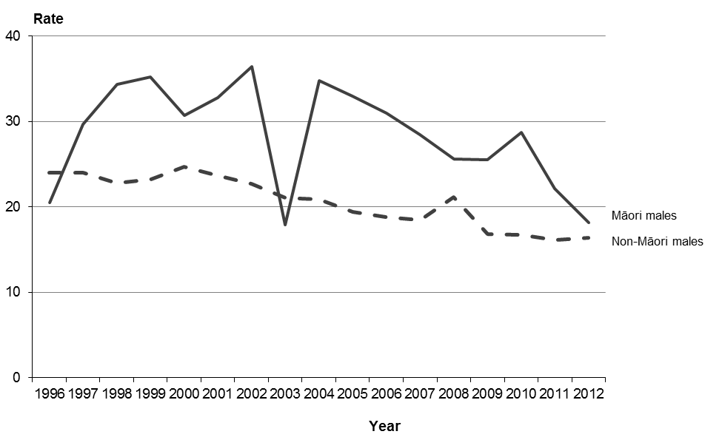

Note: rates per 100,000 male population, age-standardised to WHO World Standard Population.

## Malignant melanoma of the skin

This section covers ICD code C43 (malignant melanoma of skin). Malignant melanoma of the skin was the fifth leading cause of cancer deaths for males and the seventh leading cause for females in 2012.

There were 354 deaths from malignant melanoma of the skin in 2012, representing 4.0% of total cancer deaths. Almost two-thirds of those who died from this condition (62.7%) were males.

Melanoma mortality rates increased for both males and females from 1950 to the late 1970s. From then on, male rates continued to increase, while female rates remained fairly stable, ranging from 2.8 to 4.0 deaths per 100,000. In 2012 the rate for males was almost twice the female rate (Figure 20).

Figure 20: Number of deaths and mortality rates from malignant melanoma of the skin, by sex, 1950–2012

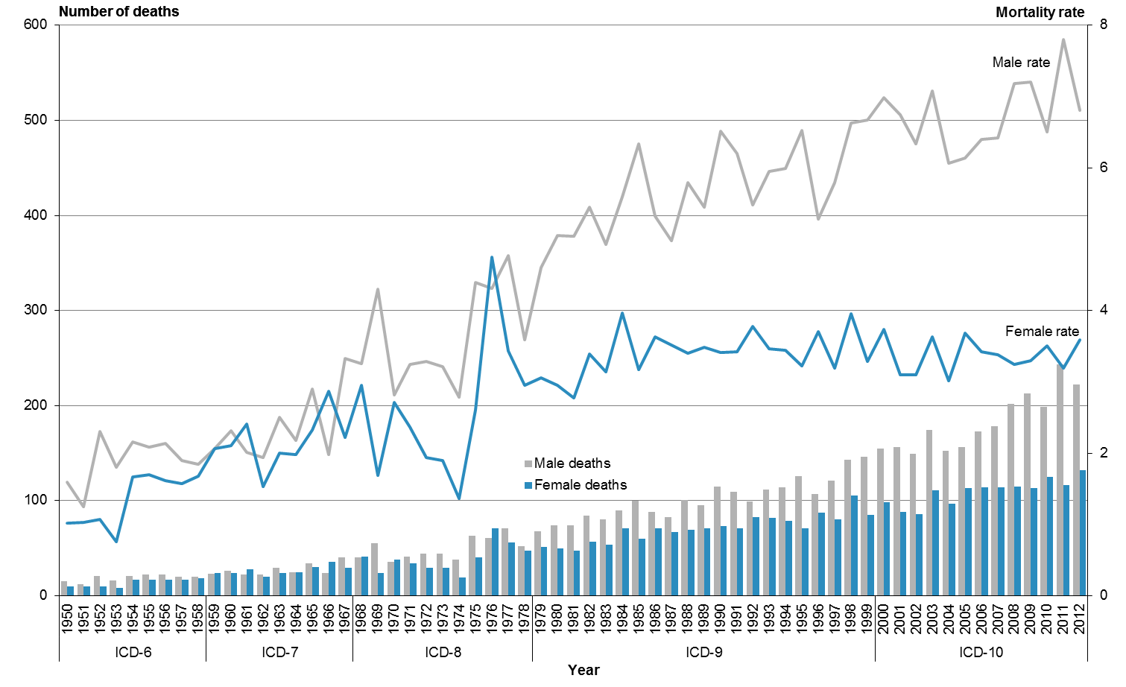

Note: rates per 100,000 population, age-standardised to WHO World Standard Population.

From 1980 to 2012 the mortality rate from melanoma increased by 34.7% for males and 21.7% for females (Table 12). The number of male deaths from melanoma in 2012 was three times the number of deaths in 1980. For females, the number of deaths in 2012 was 2.6 times the number of deaths in 1980.

Table 12: Number of deaths and mortality rates from malignant melanoma of the skin, by sex, 1980–2012

|  |  |  |  |  |  |  |
| --- | --- | --- | --- | --- | --- | --- |
| **Year** | **Male** | | **Female** | | **Total** | |
| **No.** | **Rate** | **No.** | **Rate** | **No.** | **Rate** |
| 1980 | 74 | 5.1 | 50 | 2.9 | 124 | 3.9 |
| 1981 | 74 | 5.0 | 47 | 2.8 | 121 | 3.8 |
| 1982 | 84 | 5.5 | 57 | 3.4 | 141 | 4.3 |
| 1983 | 80 | 4.9 | 54 | 3.1 | 134 | 4.0 |
| 1984 | 90 | 5.6 | 71 | 4.0 | 161 | 4.7 |
| 1985 | 100 | 6.3 | 60 | 3.2 | 160 | 4.6 |
| 1986 | 88 | 5.3 | 71 | 3.6 | 159 | 4.4 |
| 1987 | 83 | 5.0 | 67 | 3.5 | 150 | 4.2 |
| 1988 | 101 | 5.8 | 69 | 3.4 | 170 | 4.5 |
| 1989 | 95 | 5.5 | 71 | 3.5 | 166 | 4.4 |
| 1990 | 115 | 6.5 | 73 | 3.4 | 188 | 4.9 |
| 1991 | 109 | 6.2 | 71 | 3.4 | 180 | 4.7 |
| 1992 | 99 | 5.5 | 83 | 3.8 | 182 | 4.5 |
| 1993 | 112 | 6.0 | 82 | 3.5 | 194 | 4.6 |
| 1994 | 114 | 6.0 | 79 | 3.4 | 193 | 4.6 |
| 1995 | 126 | 6.5 | 71 | 3.2 | 197 | 4.6 |
| 1996 | 107 | 5.3 | 87 | 3.7 | 194 | 4.4 |
| 1997 | 121 | 5.8 | 80 | 3.2 | 201 | 4.3 |
| 1998 | 143 | 6.6 | 105 | 4.0 | 248 | 5.2 |
| 1999 | 146 | 6.7 | 85 | 3.3 | 231 | 4.8 |
| 2000 | 155 | 7.0 | 98 | 3.7 | 253 | 5.2 |
| 2001 | 156 | 6.7 | 88 | 3.1 | 244 | 4.7 |
| 2002 | 149 | 6.3 | 86 | 3.1 | 235 | 4.6 |
| 2003 | 174 | 7.1 | 111 | 3.6 | 285 | 5.2 |
| 2004 | 152 | 6.1 | 97 | 3.0 | 249 | 4.4 |
| 2005 | 156 | 6.1 | 113 | 3.7 | 269 | 4.8 |
| 2006 | 173 | 6.4 | 114 | 3.4 | 287 | 4.7 |
| 2007 | 178 | 6.4 | 114 | 3.4 | 292 | 4.8 |
| 2008 | 202 | 7.2 | 115 | 3.2 | 317 | 5.1 |
| 2009 | 213 | 7.2 | 113 | 3.3 | 326 | 5.1 |
| 2010 | 199 | 6.5 | 125 | 3.5 | 324 | 4.9 |
| 2011 | 243 | 7.8 | 116 | 3.2 | 359 | 5.3 |
| 2012 | 222 | 6.8 | 132 | 3.6 | 354 | 5.1 |

Note: rates per 100,000 population, age-standardised to WHO World Standard Population.

Melanoma is uncommon among Māori. In 2012 there were three Māori deaths from melanoma of the skin, or 0.8 deaths per 100,000 Māori. Non-Māori had a mortality rate of 5.4 deaths per 100,000 in the same year.

Table 13: Age distribution of deaths from malignant melanoma of the skin, percentages and rates, by ethnicity and sex, 2012

|  |  |  |  |  |  |  |  |  |  |  |  |  |
| --- | --- | --- | --- | --- | --- | --- | --- | --- | --- | --- | --- | --- |
| **Age group (years)** | **Percentage** | | | | | | **Age-specific rate** | | | | | |
| **Māori** | | | **Non-Māori** | | | **Māori** | | | **Non-Māori** | | |
| **Male** | **Female** | **Total** | **Male** | **Female** | **Total** | **Male** | **Female** | **Total** | **Male** | **Female** | **Total** |
| <25 | 0.0 | 0.0 | 0.0 | 0.0 | 0.0 | 0.0 | 0.0 | 0.0 | 0.0 | 0.0 | 0.0 | 0.0 |
| 25–44 | 0.0 | 0.0 | 0.0 | 2.3 | 9.2 | 4.8 | 0.0 | 0.0 | 0.0 | 1.0 | 2.3 | 1.7 |
| 45–64 | 0.0 | 50.0 | 33.3 | 23.1 | 28.5 | 25.1 | 0.0 | 1.6 | 0.8 | 10.4 | 7.2 | 8.8 |
| 65+ | 100.0 | 50.0 | 66.7 | 74.7 | 62.3 | 70.1 | 6.4 | 5.4 | 5.8 | 62.3 | 26.0 | 42.6 |

Note: rates per 100,000 population.

## Cervical cancer

This section covers ICD code C53 (malignant neoplasm of cervix uteri). There were 56 deaths from cervical cancer in 2012, accounting for 1.3% of total female cancer deaths.

From 1950 to 2012, the mortality rate from cervical cancer declined by almost 80% from 8.1 to 1.8 deaths per 100,000 females (Figure 21).

Figure 21: Number of deaths and mortality rates from cervical cancer, 1950–2012

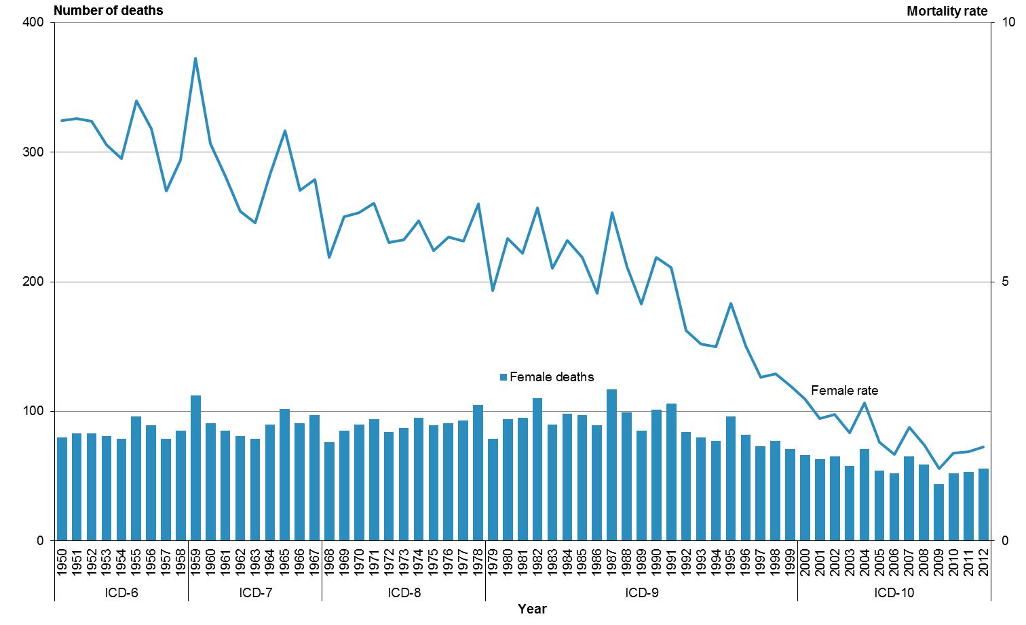

Note: rates per 100,000 female population, age-standardised to WHO World Standard Population

Between 1980 and 2012, the number of women dying from cervical cancer decreased by 40.4% (Table 14). One factor in this decrease seen may have been the establishment of the National Cervical Screening Programme in 1991.[[8]](#footnote-8)

Table 14: Number of deaths and mortality rates from cervical cancer, 1980–2012

|  |  |  |
| --- | --- | --- |
| **Year** | **No.** | **Rate** |
| 1980 | 94 | 5.8 |
| 1981 | 95 | 5.5 |
| 1982 | 110 | 6.4 |
| 1983 | 90 | 5.3 |
| 1984 | 98 | 5.8 |
| 1985 | 97 | 5.5 |
| 1986 | 89 | 4.8 |
| 1987 | 117 | 6.3 |
| 1988 | 99 | 5.3 |
| 1989 | 85 | 4.6 |
| 1990 | 101 | 5.5 |
| 1991 | 106 | 5.3 |
| 1992 | 84 | 4.1 |
| 1993 | 80 | 3.8 |
| 1994 | 77 | 3.7 |
| 1995 | 96 | 4.6 |
| 1996 | 82 | 3.8 |
| 1997 | 73 | 3.2 |
| 1998 | 77 | 3.2 |
| 1999 | 71 | 3.0 |
| 2000 | 66 | 2.7 |
| 2001 | 63 | 2.4 |
| 2002 | 65 | 2.4 |
| 2003 | 58 | 2.1 |
| 2004 | 71 | 2.7 |
| 2005 | 54 | 1.9 |
| 2006 | 52 | 1.7 |
| 2007 | 65 | 2.2 |
| 2008 | 59 | 1.9 |
| 2009 | 44 | 1.4 |
| 2010 | 52 | 1.7 |
| 2011 | 53 | 1.7 |
| 2012 | 56 | 1.8 |

Note: rates per 100,000 female population, age-standardised to WHO World Standard Population.

In 2012, the majority (90.9%) of Māori deaths from cervical cancer were females under 65 years (Table 15). The corresponding proportion for non-Māori was 55.6%.

Table 15: Age distribution of deaths from cervical cancer, percentages and rates, by ethnicity, 2012

|  |  |  |  |  |
| --- | --- | --- | --- | --- |
| **Age group (years)** | **Percentage** | | **Age-specific rate** | |
| **Māori female** | **Non-Māori female** | **Māori female** | **Non-Māori female** |
| <25 | 0.0 | 0.0 | 0.0 | 0.0 |
| 25–44 | 27.3 | 17.8 | 3.4 | 1.6 |
| 45–64 | 63.6 | 37.8 | 11.1 | 3.3 |
| 65+ | 9.1 | 44.4 | 5.4 | 6.4 |

Note: rates per 100,000 female population.

Māori accounted for one-fifth (19.6%) of cervical cancer deaths in 2012. The mortality rate for Māori was 2.4 times the non-Māori rate: there were 3.7 deaths per 100,000 Māori females compared with 1.6 deaths per 100,000 non-Māori females.

There was a significant decrease in cervical cancer mortality rates for both Māori and non-Māori women between 1996 and 2012. The mortality rate for Māori decreased by 71.4% over this time, while the rate for non-Māori decreased by 46.0% (Figure 22). Note that the Māori numbers were low (eg, only 11 deaths in 2012).

Figure 22: Mortality rates from cervical cancer, by ethnicity, 1996–2012

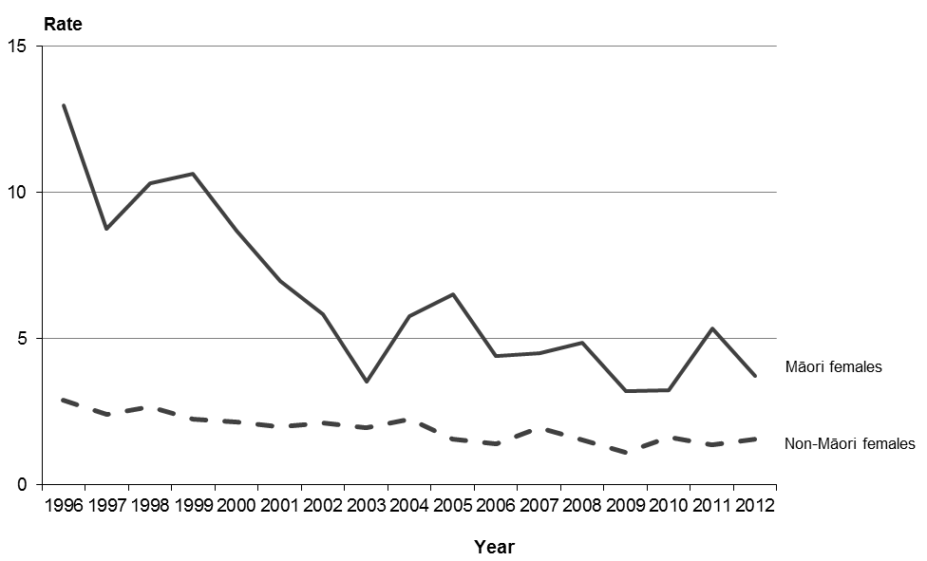

Note: rates per 100,000 female population, age-standardised to WHO World Standard Population.

## Ischaemic heart disease

Ischaemic (or coronary) heart disease is a condition in which fatty deposits accumulate in the cells lining the wall of the coronary arteries – a process called atherosclerosis. The progressive narrowing and hardening of the arteries over time results in an inability to provide adequate oxygen to the heart muscle (called ischaemia). This can cause damage to the heart muscle or, in more severe cases, lead to myocardial infarction (a heart attack). This section covers ICD codes I20–I25.

Ischaemic heart disease was the second leading cause of death after cancer in 2012, accounting for 5339 deaths (17.6% of all deaths). Males accounted for 55.3% of these deaths.

Mortality rates from ischaemic heart disease for males and females in 2012 were the lowest they have been since 1950 (Figure 23). From 1950, males consistently had a higher mortality rate than females, although this gap became less marked after its peak in the late 1960s and early 1970s.

Figure 23: Number of deaths and mortality rates from ischaemic heart disease, by sex, 1950–2012

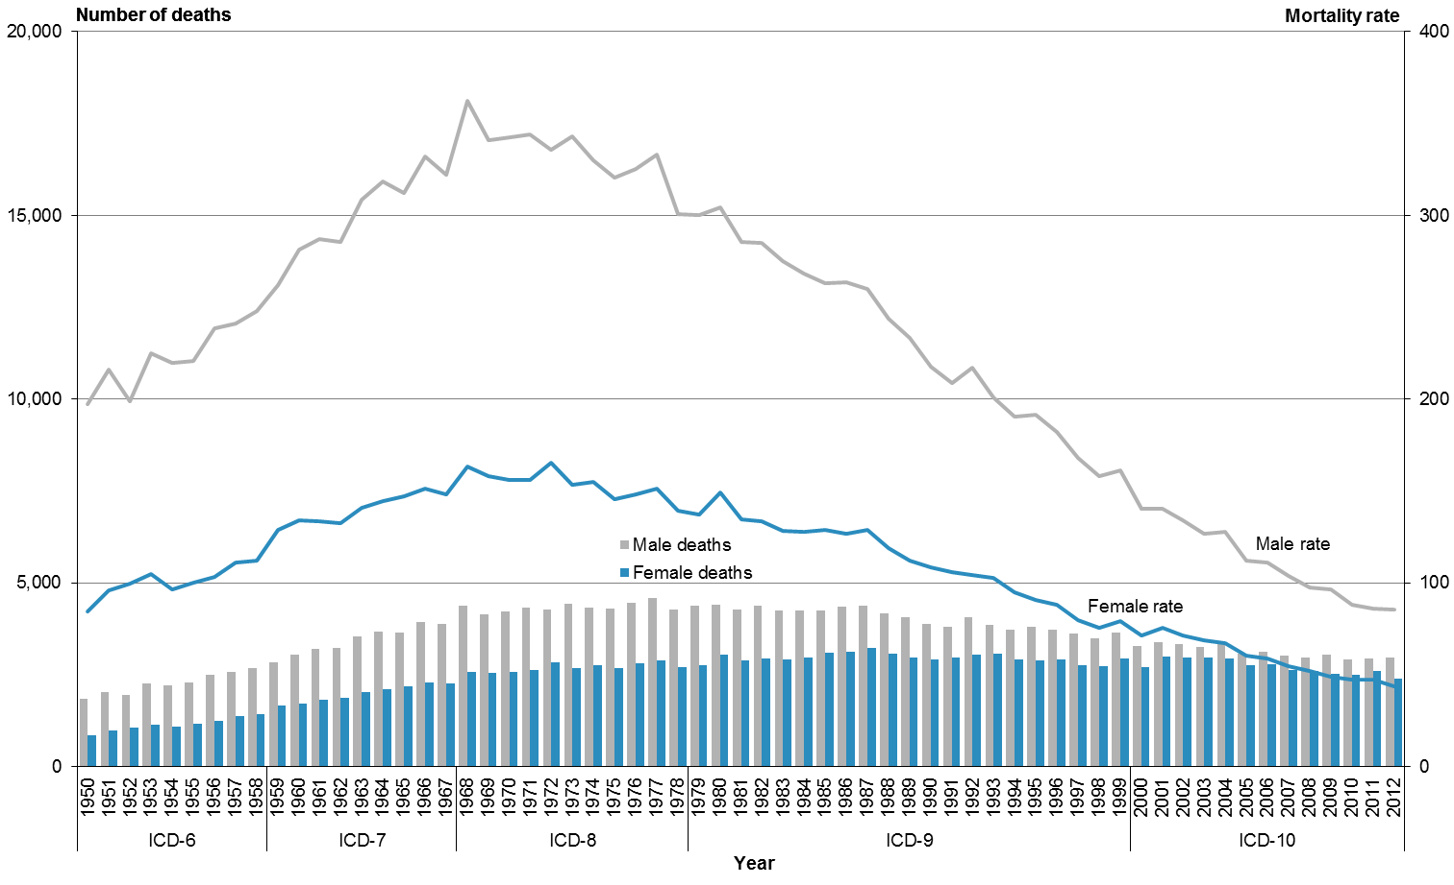

Note: rates per 100,000 population, age-standardised to WHO World Standard Population.

From 1980 to 2012 the mortality rate from ischaemic heart disease declined by 71.0% (Table 16). The male mortality rate was consistently higher than the female rate over this time: it was approximately twice the equivalent female rate for most of the period. In 2012 the male rate was 1.9 times the female rate.

Table 16: Number of deaths and mortality rates from ischaemic heart disease, by sex, 1980–2012

|  |  |  |  |  |  |  |
| --- | --- | --- | --- | --- | --- | --- |
| **Year** | **Male** | | **Female** | | **Total** | |
| **No.** | **Rate** | **No.** | **Rate** | **No.** | **Rate** |
| 1980 | 4413 | 304.4 | 3046 | 149.2 | 7459 | 217.4 |
| 1981 | 4259 | 285.3 | 2883 | 134.7 | 7142 | 201.6 |
| 1982 | 4362 | 285.0 | 2939 | 133.6 | 7301 | 200.9 |
| 1983 | 4241 | 274.8 | 2904 | 128.3 | 7145 | 192.6 |
| 1984 | 4245 | 268.2 | 2951 | 127.5 | 7196 | 189.6 |
| 1985 | 4234 | 262.9 | 3106 | 128.8 | 7340 | 188.8 |
| 1986 | 4346 | 263.4 | 3109 | 126.6 | 7455 | 187.4 |
| 1987 | 4379 | 260.1 | 3235 | 128.7 | 7614 | 187.8 |
| 1988 | 4173 | 243.4 | 3079 | 118.8 | 7252 | 174.9 |
| 1989 | 4071 | 233.4 | 2964 | 111.9 | 7035 | 166.3 |
| 1990 | 3884 | 217.5 | 2923 | 108.4 | 6807 | 157.3 |
| 1991 | 3789 | 208.6 | 2954 | 105.8 | 6743 | 151.7 |
| 1992 | 4064 | 217.3 | 3034 | 104.0 | 7098 | 155.1 |
| 1993 | 3842 | 201.0 | 3056 | 102.7 | 6898 | 146.7 |
| 1994 | 3718 | 190.5 | 2901 | 94.9 | 6619 | 137.2 |
| 1995 | 3810 | 191.2 | 2887 | 90.8 | 6697 | 135.9 |
| 1996 | 3729 | 182.0 | 2904 | 87.8 | 6633 | 130.1 |
| 1997 | 3614 | 168.0 | 2755 | 79.9 | 6369 | 119.4 |
| 1998 | 3479 | 158.1 | 2724 | 75.3 | 6203 | 112.3 |
| 1999 | 3646 | 160.9 | 2925 | 79.2 | 6571 | 115.6 |
| 2000 | 3269 | 140.3 | 2704 | 71.2 | 5973 | 102.2 |
| 2001 | 3389 | 140.2 | 2982 | 75.2 | 6371 | 104.1 |
| 2002 | 3333 | 134.2 | 2954 | 71.4 | 6287 | 99.8 |
| 2003 | 3243 | 126.7 | 2953 | 68.4 | 6196 | 94.9 |
| 2004 | 3366 | 127.6 | 2947 | 67.0 | 6313 | 94.4 |
| 2005 | 3057 | 111.8 | 2750 | 60.5 | 5807 | 83.9 |
| 2006 | 3133 | 110.9 | 2779 | 58.6 | 5912 | 82.5 |
| 2007 | 3015 | 103.4 | 2619 | 54.4 | 5634 | 77.2 |
| 2008 | 2960 | 97.4 | 2594 | 51.9 | 5554 | 72.9 |
| 2009 | 3039 | 96.6 | 2514 | 48.6 | 5553 | 70.7 |
| 2010 | 2900 | 88.0 | 2489 | 47.5 | 5389 | 66.3 |
| 2011 | 2934 | 85.9 | 2600 | 47.3 | 5534 | 65.4 |
| 2012 | 2952 | 85.2 | 2387 | 43.8 | 5339 | 63.0 |

Note: rates per 100,000 population, age-standardised to WHO World Standard Population.

In 2012, the mortality rate from ischaemic heart disease for Māori was 106.2 deaths per 100,000. The rate for non-Māori was 58.0 deaths per 100,000.

In 2012, the majority of ischaemic heart disease deaths occurred in the 65 years and over age group (which accounted for 81.3% of male deaths and 93.9% of female deaths from this condition). Māori deaths from ischaemic heart disease tended to occur at a younger age than non-Māori: 40.2% of Māori deaths from this condition occurred in those aged under 65 years, compared to 10.5% of non-Māori deaths (Table 17).

Table 17: Age distribution of deaths from ischaemic heart disease, percentages and rates, by ethnicity and sex, 2012

|  |  |  |  |  |  |  |  |  |  |  |  |  |
| --- | --- | --- | --- | --- | --- | --- | --- | --- | --- | --- | --- | --- |
| **Age group (years)** | **Percentage** | | | | | | **Age-specific rate** | | | | | |
| **Māori** | | | **Non-Māori** | | | **Māori** | | | **Non-Māori** | | |
| **Male** | **Female** | **Total** | **Male** | **Female** | **Total** | **Male** | **Female** | **Total** | **Male** | **Female** | **Total** |
| <25 | 0.0 | 0.0 | 0.0 | 0.0 | 0.0 | 0.0 | 0.0 | 0.0 | 0.0 | 0.0 | 0.2 | 0.1 |
| 25–44 | 4.2 | 1.7 | 3.2 | 1.2 | 0.5 | 0.9 | 15.2 | 3.4 | 8.9 | 6.8 | 2.1 | 4.4 |
| 45–64 | 41.1 | 30.3 | 37.0 | 14.6 | 3.4 | 9.5 | 209.3 | 85.5 | 143.9 | 79.6 | 14.8 | 46.5 |
| 65+ | 54.7 | 68.0 | 59.8 | 84.2 | 96.0 | 89.5 | 1003.2 | 653.0 | 812.9 | 846.3 | 679.7 | 756.2 |

Note: rates per 100,000 population.

Of the four groups represented in Figure 24, the Māori male population had the highest rate of ischaemic heart disease deaths in 2012. This rate was 1.8 times the rate for non-Māori males. The rate for Māori females was 1.9 times the rate for non-Māori females.

Between 1996 and 2012, the rate for Māori males was consistently higher than rates for all other groups shown in Figure 24. The rate for Māori males was also the only rate that increased between 2011 and 2012.

Figure 24: Mortality rates from ischaemic heart disease, by sex and ethnicity, 1996–2012

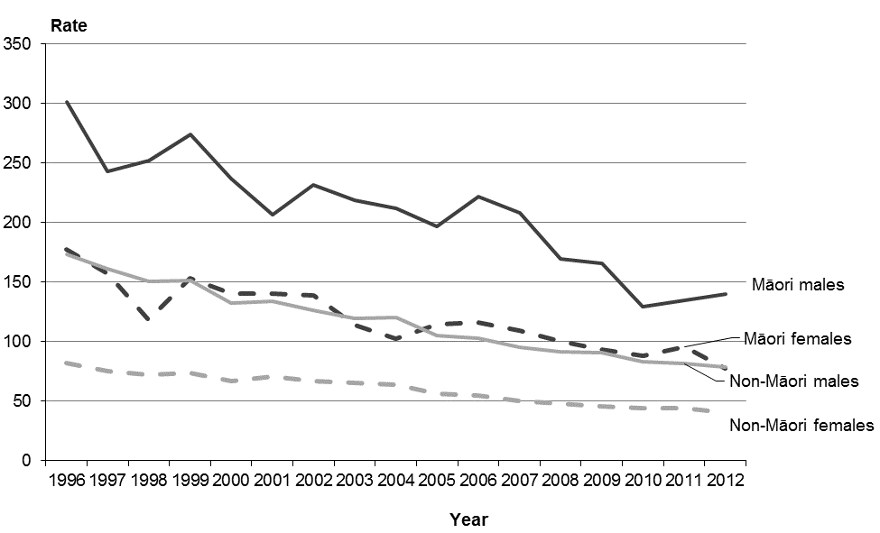

Note: rates per 100,000 population, age-standardised to WHO World Standard Population.

The five conditions that make up the ischaemic heart disease ICD classification grouping for mortality coding are:

* I20 angina pectoris
* I21 acute myocardial infarction
* I22 subsequent myocardial infarction
* I24 other acute ischaemic heart diseases
* I25 chronic ischaemic heart disease.

Of these conditions, acute myocardial infarction (I21) and chronic ischaemic heart disease (I25) together account for the majority of the ischaemic heart disease deaths reported for 2012 (98.7%). Chronic ischaemic heart disease alone was responsible for 53.7%.

Figure 25 compares age-standardised mortality rates, by ethnicity and sex, from acute myocardial infarction and chronic ischaemic heart disease in 2012. The figure suggests the pattern of mortality incidence for these two conditions is generally similar. Males had a higher age-standardised mortality rate (within the ethnic groups) for both conditions.

Figure 25: Mortality rates from acute myocardial infarction (ICD I21) and chronic ischaemic heart disease (ICD I25), by sex and ethnicity, 2012

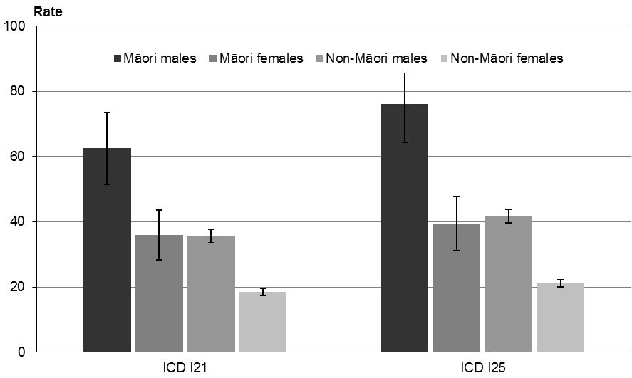

Note: rates per 100,000 population, age-standardised to WHO World Standard Population; 95% confidence intervals.

Three DHB regions (Tairāwhiti, Whanganui and Hawke’s Bay) had an ischaemic heart disease death rate that was significantly higher than the national rate (Figure 26). Two DHBs had a rate that was significantly lower (Waitemata and Auckland).

Figure 26: Mortality rates from ischaemic heart disease, by DHB region, total population, 2012

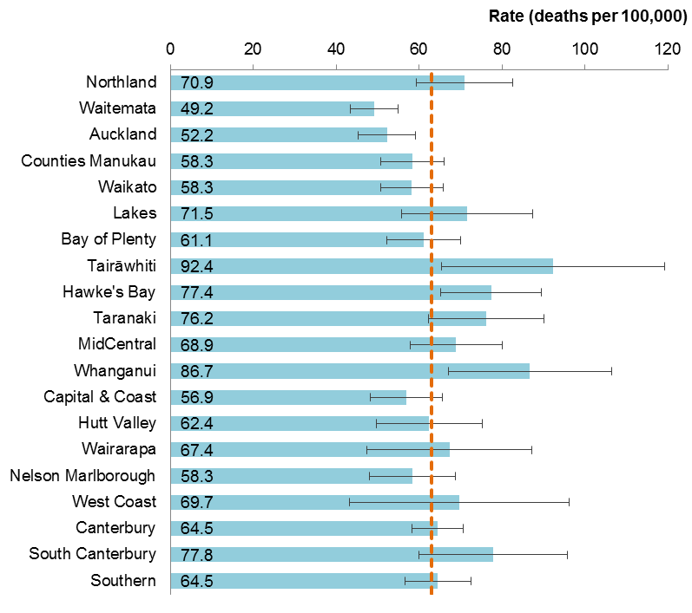

Notes:

The dashed vertical line is the national rate.

Rates per 100,000 population, age-standardised to WHO World Standard Population; 99% confidence intervals.

## Cerebrovascular disease

Cerebrovascular disease is a general term that encompasses a variety of diseases affecting the arteries that supply the brain. This condition is commonly associated with stroke (ie, the sudden death of brain cells due to lack of oxygen when the blood flow to part of the brain is impaired by blockage or rupture of an artery in the brain). A stroke is sometimes called a cerebrovascular accident. Risk factors associated with the narrowing of the arteries (atherosclerosis) that characterises cerebrovascular disease include high blood cholesterol level, high blood pressure, smoking, diabetes and a family history of atherosclerotic disease. Atherosclerosis also occurs with ageing. This section covers ICD codes I60–I69.

Cerebrovascular disease was the third leading cause of death in the total population in 2012, after cancer and ischaemic heart disease.

There were 2612 deaths from cerebrovascular disease in 2012, the majority of which (62.9%) were females.

For each year between 1950 and 2012 there were more female deaths from cerebrovascular disease compared to males (Figure 27). Mortality rates from cerebrovascular disease were similar, and sharply declined for both males and females from the early 1970s to 2012.

Figure 27: Number of deaths and mortality rates from cerebrovascular disease, by sex, 1950–2012

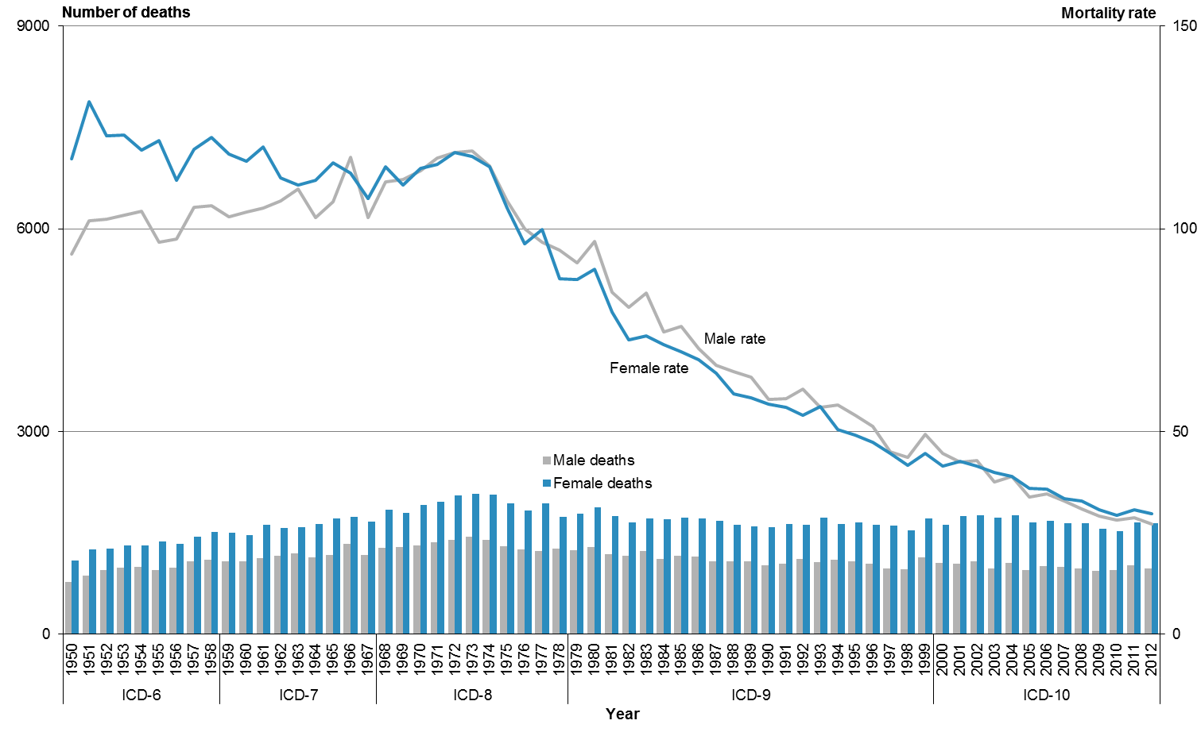

Note: rates per 100,000 population, age-standardised to WHO World Standard Population.

In 2012 the mortality rate from cerebrovascular disease for males was 72.0% lower than it was in 1980, and the rate for females was 67.1% lower (Table 18). Males and females had similar annual mortality rates over this period.

Table 18: Number of deaths and mortality rates from cerebrovascular disease, by sex, 1980–2012

|  |  |  |  |  |  |  |
| --- | --- | --- | --- | --- | --- | --- |
| **Year** | **Male** | | **Female** | | **Total** | |
| **No.** | **Rate** | **No.** | **Rate** | **No.** | **Rate** |
| 1980 | 1288 | 96.8 | 1870 | 90.0 | 3158 | 92.8 |
| 1981 | 1175 | 84.4 | 1745 | 79.4 | 2920 | 82.3 |
| 1982 | 1155 | 80.7 | 1651 | 72.6 | 2806 | 76.6 |
| 1983 | 1229 | 84.1 | 1708 | 73.5 | 2937 | 78.2 |
| 1984 | 1108 | 74.5 | 1703 | 71.4 | 2811 | 73.0 |
| 1985 | 1160 | 76.0 | 1723 | 69.7 | 2883 | 72.9 |
| 1986 | 1145 | 70.5 | 1710 | 67.7 | 2855 | 69.8 |
| 1987 | 1076 | 66.3 | 1675 | 64.4 | 2751 | 65.8 |
| 1988 | 1077 | 64.8 | 1616 | 59.2 | 2693 | 62.5 |
| 1989 | 1072 | 63.3 | 1597 | 58.3 | 2669 | 60.8 |
| 1990 | 1021 | 57.9 | 1579 | 56.6 | 2600 | 57.9 |
| 1991 | 1036 | 58.1 | 1624 | 56.0 | 2660 | 57.6 |
| 1992 | 1113 | 60.5 | 1621 | 54.0 | 2734 | 56.8 |
| 1993 | 1061 | 55.9 | 1727 | 56.0 | 2788 | 56.4 |
| 1994 | 1096 | 56.6 | 1631 | 50.4 | 2727 | 53.4 |
| 1995 | 1070 | 53.9 | 1645 | 49.0 | 2715 | 51.5 |
| 1996 | 1045 | 51.3 | 1614 | 47.2 | 2659 | 49.1 |
| 1997 | 966 | 44.9 | 1600 | 44.5 | 2566 | 45.1 |
| 1998 | 960 | 43.5 | 1532 | 41.6 | 2492 | 42.7 |
| 1999 | 1129 | 49.3 | 1706 | 44.5 | 2835 | 47.0 |
| 2000 | 1048 | 44.6 | 1620 | 41.4 | 2668 | 42.9 |
| 2001 | 1036 | 42.4 | 1748 | 42.7 | 2784 | 43.1 |
| 2002 | 1078 | 42.7 | 1751 | 41.3 | 2829 | 42.3 |
| 2003 | 969 | 37.4 | 1723 | 39.8 | 2692 | 39.3 |
| 2004 | 1050 | 38.8 | 1756 | 38.9 | 2806 | 39.4 |
| 2005 | 940 | 33.7 | 1647 | 36.0 | 2587 | 35.5 |
| 2006 | 1000 | 34.6 | 1673 | 35.8 | 2673 | 35.8 |
| 2007 | 987 | 32.9 | 1638 | 33.4 | 2625 | 33.7 |
| 2008 | 970 | 30.9 | 1641 | 32.9 | 2611 | 32.4 |
| 2009 | 937 | 29.0 | 1551 | 30.7 | 2488 | 30.4 |
| 2010 | 945 | 28.1 | 1522 | 29.2 | 2467 | 29.1 |
| 2011 | 1012 | 28.7 | 1653 | 30.6 | 2665 | 30.2 |
| 2012 | 969 | 27.1 | 1643 | 29.6 | 2612 | 29.0 |

Note: rates per 100,000 population, age-standardised to WHO World Standard Population.

Among non-Māori, 94.0% of deaths from cerebrovascular disease occurred in those aged 65 years and over in 2012 (Table 19). Among Māori, a greater proportion of deaths occurred in younger age groups; 34.4% of Māori deaths from this condition occurred below the age of 65. The equivalent figure for non-Māori was 6.0%.

Table 19: Age distribution of deaths from cerebrovascular disease, percentages and rates, by ethnicity and sex, 2012

|  |  |  |  |  |  |  |  |  |  |  |  |  |
| --- | --- | --- | --- | --- | --- | --- | --- | --- | --- | --- | --- | --- |
| **Age group (years)** | **Percentage** | | | | | | **Age-specific rate** | | | | | |
| **Māori** | | | **Non-Māori** | | | **Māori** | | | **Non-Māori** | | |
| **Male** | **Female** | **Total** | **Male** | **Female** | **Total** | **Male** | **Female** | **Total** | **Male** | **Female** | **Total** |
| <25 | 1.7 | 1.4 | 1.5 | 0.0 | 0.0 | 0.0 | 0.5 | 0.6 | 0.6 | 0.0 | 0.0 | 0.0 |
| 25–44 | 3.4 | 6.9 | 5.3 | 1.2 | 0.9 | 1.0 | 2.5 | 5.6 | 4.2 | 2.3 | 2.7 | 2.5 |
| 45–64 | 37.3 | 19.4 | 27.5 | 7.5 | 3.5 | 5.0 | 39.0 | 22.2 | 30.1 | 13.9 | 10.7 | 12.3 |
| 65+ | 57.6 | 72.2 | 65.6 | 91.3 | 95.6 | 94.0 | 217.3 | 280.6 | 251.5 | 313.5 | 481.3 | 404.3 |

Note: rates per 100,000 population.

In 2012, Māori had a mortality rate from cerebrovascular disease of 31.2 deaths per 100,000. The mortality rate for non-Māori was 27.7 deaths per 100,000.

Of the four population groups shown in Figure 28, Māori females had the highest age-standardised mortality rate for cerebrovascular disease in 2012, followed by Māori males. From 1996 to 2012, the rate for all groups decreased. In particular, the rate for Māori males and non-Māori males declined by 49%. The disparity between Māori and non-Māori rates appears to be narrowing over time.

Figure 28: Number of deaths and mortality rates from cerebrovascular disease, by sex and ethnicity, 1996–2012

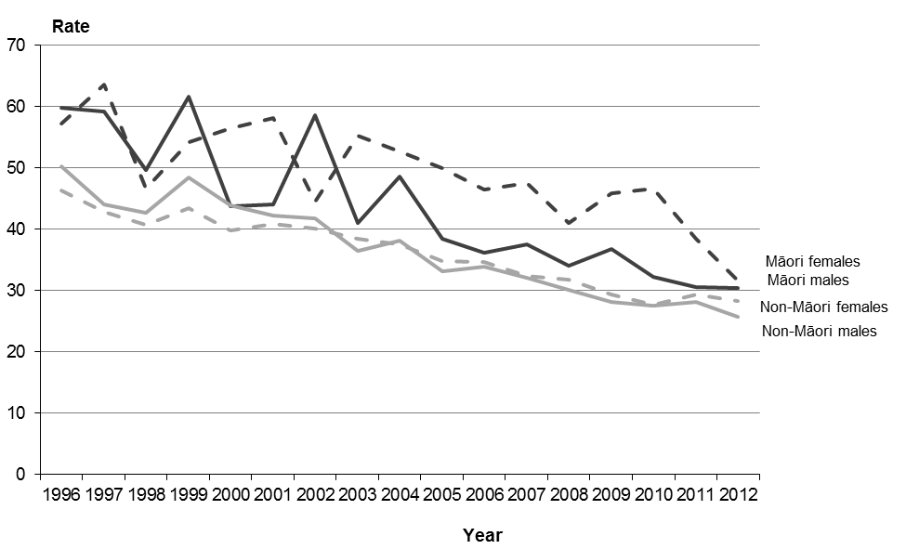

Note: rates per 100,000 population, age-standardised to WHO World Standard Population.

The seven codes that make up the cerebrovascular disease ICD classification grouping for mortality coding are:

* I60 subarachnoid haemorrhage
* I61 intracerebral haemorrhage
* I62 other non-traumatic intracranial haemorrhage
* I63 cerebral infarction
* I64 stroke, not specified as haemorrhage or infarction
* I67 other cerebrovascular diseases
* I69 sequelae[[9]](#footnote-9) of cerebrovascular disease.

‘Stroke, not specified as haemorrhage or infarction’ (I64) accounted for 40.4% of cerebrovascular disease-related mortality in 2012. The three other major causes of cerebrovascular disease-related mortality in 2012 were:

* I69 sequelae of cerebrovascular disease (17.3%)
* I63 cerebral infarction (15.2%)
* I61 intracerebral haemorrhage (12.6%).

Together, these four conditions accounted for the majority (85.5%) of mortality from cerebrovascular disease in 2012.

Females had significantly higher rates of mortality from stroke (I64) and subarachnoid haemorrhage (I60) in 2012 (Figure 29).

Figure 29: Mortality rates from cerebrovascular disease, by specific disease classification and sex, 2012

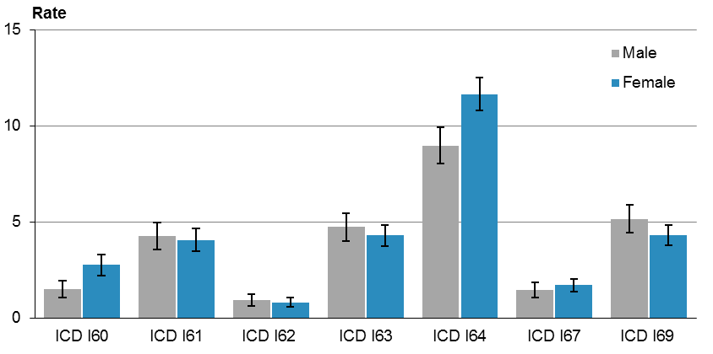

Note: rates per 100,000 population, age-standardised to WHO World Standard Population; 95% confidence intervals.

Figure 30 shows cerebrovascular disease mortality rates by DHB region of residence for the total population in 2012. Northland DHB had a rate that was significantly lower than the national rate. All other DHB regions had rates that were not significantly different to the national rate.

Figure 30: Mortality rates from cerebrovascular disease, by DHB region, total population, 2012

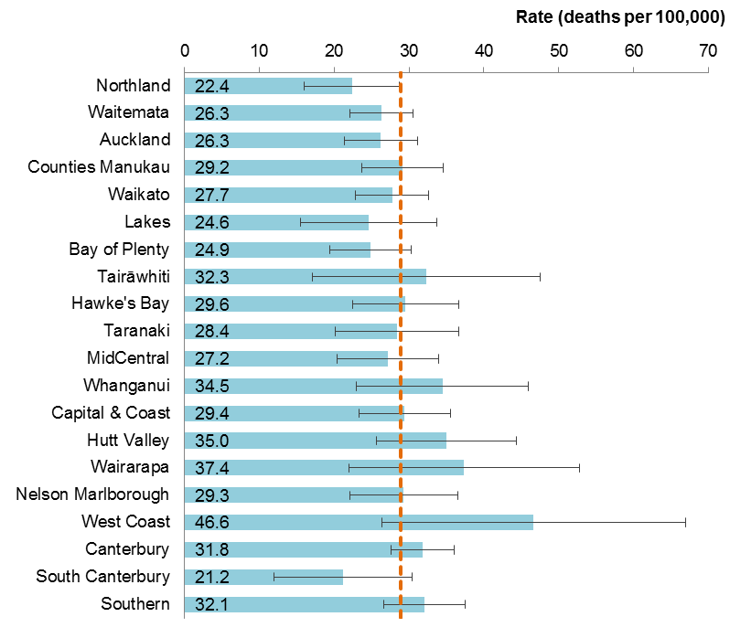

Notes:

The dashed vertical line is the national rate.

Rates per 100,000 population, age-standardised to WHO World Standard Population; 99% confidence intervals.

## Diabetes mellitus

This section covers ICD codes E10–E14. Diabetes mellitus, commonly known as diabetes, is a chronic disease associated with abnormally high levels of glucose in the blood (hyperglycaemia). There are two main types of diabetes: Type 1 (insulin-dependent diabetes mellitus) and Type 2 (adult-onset diabetes). Type 2 diabetes is much more common than Type 1.

A person with Type 1 diabetes does not produce sufficient insulin – they might make only a little, or none at all. Type 1 diabetes usually starts in the teenage years or when puberty begins, although onset can occur later in life.

A person with Type 2 diabetes produces insulin, but the cells upon which the insulin should act are not sufficiently sensitive to its action. Type 2 diabetes commonly starts later in life (typically in people over 30 years of age). Common risk factors include: genetic predisposition (eg, ethnicity or a family history of Type 2 diabetes), obesity and lack of exercise. It is associated with lower socioeconomic status. People suffering from Type 2 diabetes can become insulin-dependent as the disease progresses.

Diabetes can lead to other health conditions, including kidney failure, eye disease, foot ulceration and heart disease.

There were 807 deaths from diabetes mellitus in 2012. Males accounted for 53.3% of these.

From 1950 to the late 1960s the mortality rate from diabetes mellitus for males was generally lower than that for females (Figure 31). From 1970 to 2012 the male rate was consistently higher than the female rate. In 2012 the male rate was 1.5 times the female rate.

Figure 31: Number of deaths and mortality rates from diabetes mellitus, by sex, 1950–2012

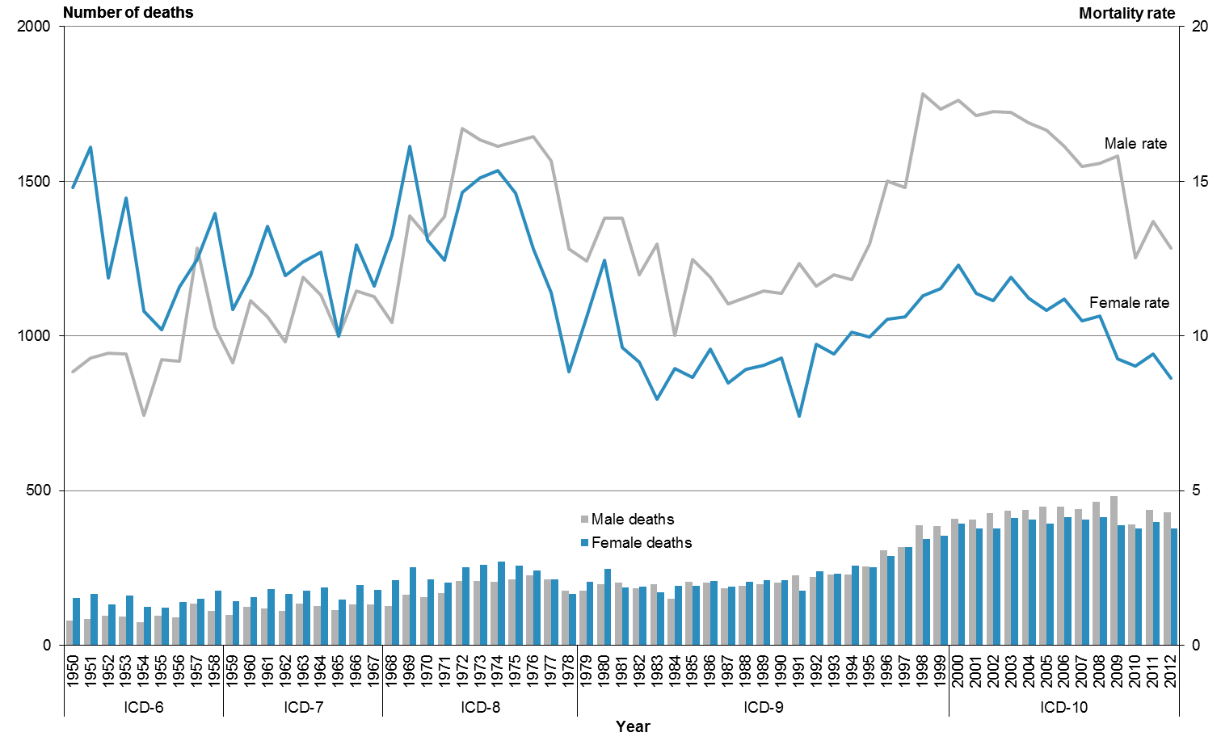

Note: rates per 100,000 population, age-standardised to WHO World Standard Population.

While the total number of deaths from diabetes mellitus peaked in 2008, the mortality rate has generally been declining since 2000 (Table 20). In 2012, the mortality rate for females was 8.6 deaths per 100,000, and for males it was 12.8 deaths per 100,000.

Table 20: Number of deaths and mortality rates from diabetes mellitus, by sex, 1980–2012

|  |  |  |  |  |  |  |
| --- | --- | --- | --- | --- | --- | --- |
| **Year** | **Male** | | **Female** | | **Total** | |
| **No.** | **Rate** | **No.** | **Rate** | **No.** | **Rate** |
| 1980 | 198 | 13.8 | 248 | 12.4 | 446 | 13.1 |
| 1981 | 201 | 13.8 | 187 | 9.6 | 388 | 11.2 |
| 1982 | 184 | 12.0 | 190 | 9.2 | 374 | 10.4 |
| 1983 | 197 | 13.0 | 172 | 8.0 | 369 | 10.1 |
| 1984 | 149 | 10.0 | 192 | 8.9 | 341 | 9.2 |
| 1985 | 204 | 12.5 | 193 | 8.7 | 397 | 10.3 |
| 1986 | 202 | 11.9 | 207 | 9.6 | 409 | 10.5 |
| 1987 | 184 | 11.0 | 189 | 8.5 | 373 | 9.6 |
| 1988 | 192 | 11.3 | 205 | 8.9 | 397 | 10.0 |
| 1989 | 196 | 11.5 | 209 | 9.0 | 405 | 10.0 |
| 1990 | 203 | 11.4 | 211 | 9.3 | 414 | 10.1 |
| 1991 | 226 | 12.3 | 177 | 7.4 | 403 | 9.6 |
| 1992 | 220 | 11.6 | 238 | 9.7 | 458 | 10.5 |
| 1993 | 228 | 12.0 | 231 | 9.4 | 459 | 10.6 |
| 1994 | 228 | 11.8 | 258 | 10.1 | 486 | 10.7 |
| 1995 | 255 | 13.0 | 253 | 10.0 | 508 | 11.2 |
| 1996 | 306 | 15.0 | 289 | 10.5 | 595 | 12.4 |
| 1997 | 316 | 14.8 | 317 | 10.6 | 633 | 12.5 |
| 1998 | 387 | 17.8 | 343 | 11.3 | 730 | 14.2 |
| 1999 | 385 | 17.3 | 355 | 11.5 | 740 | 14.1 |
| 2000 | 408 | 17.6 | 394 | 12.3 | 802 | 14.6 |
| 2001 | 405 | 17.1 | 377 | 11.4 | 782 | 13.9 |
| 2002 | 427 | 17.2 | 378 | 11.1 | 805 | 13.8 |
| 2003 | 436 | 17.2 | 411 | 11.9 | 847 | 14.3 |
| 2004 | 438 | 16.9 | 405 | 11.2 | 843 | 13.7 |
| 2005 | 447 | 16.7 | 392 | 10.8 | 839 | 13.4 |
| 2006 | 447 | 16.1 | 413 | 11.2 | 860 | 13.4 |
| 2007 | 440 | 15.5 | 407 | 10.5 | 847 | 12.9 |
| 2008 | 463 | 15.6 | 414 | 10.6 | 877 | 12.9 |
| 2009 | 482 | 15.8 | 387 | 9.3 | 869 | 12.3 |
| 2010 | 391 | 12.5 | 377 | 9.0 | 768 | 10.7 |
| 2011 | 438 | 13.7 | 397 | 9.4 | 835 | 11.5 |
| 2012 | 430 | 12.8 | 377 | 8.6 | 807 | 10.6 |

Note: rates per 100,000 population, age-standardised to WHO World Standard Population.

Diabetes mortality in 2012 was largely confined to those aged 45 years and older. Only a small proportion of deaths occurred below this age (Table 21). Within the Māori population, a greater proportion of deaths from diabetes occurred in the 45–64-year age group than in the equivalent age group within the non-Māori population (41.6% of deaths occurred in this age group for Māori compared to 13.7% for non-Māori).

Table 21: Age distribution of deaths from diabetes mellitus, percentages and rates, by ethnicity and sex, 2012

|  |  |  |  |  |  |  |  |  |  |  |  |  |
| --- | --- | --- | --- | --- | --- | --- | --- | --- | --- | --- | --- | --- |
| **Age group (years)** | **Percentage** | | | | | | **Age-specific rate** | | | | | |
| **Māori** | | | **Non-Māori** | | | **Māori** | | | **Non-Māori** | | |
| **Male** | **Female** | **Total** | **Male** | **Female** | **Total** | **Male** | **Female** | **Total** | **Male** | **Female** | **Total** |
| <25 | 0.0 | 0.0 | 0.0 | 0.6 | 0.0 | 0.3 | 0.0 | 0.0 | 0.0 | 0.3 | 0.0 | 0.2 |
| 25–44 | 2.9 | 2.4 | 2.7 | 0.6 | 1.4 | 1.0 | 3.8 | 2.2 | 3.0 | 0.4 | 0.8 | 0.6 |
| 45–64 | 43.7 | 39.0 | 41.6 | 16.2 | 10.8 | 13.7 | 79.8 | 50.7 | 64.4 | 10.8 | 6.3 | 8.5 |
| 65+ | 53.4 | 58.5 | 55.7 | 82.6 | 87.8 | 85.0 | 351.4 | 259.0 | 301.2 | 101.9 | 83.0 | 91.7 |

Note: rates per 100,000 population.

Of the four population groups represented in Figure 32, Māori males had the highest age-standardised mortality rate for diabetes mellitus, followed by Māori females. The age-standardised rate for Māori was five times the rate for non-Māori in 2012 (Māori had a mortality rate of 40.6 deaths per 100,000, compared with 8.1 deaths per 100,000 non-Māori).

Figure 32: Mortality rates from diabetes mellitus, by sex and ethnicity, 1996–2012

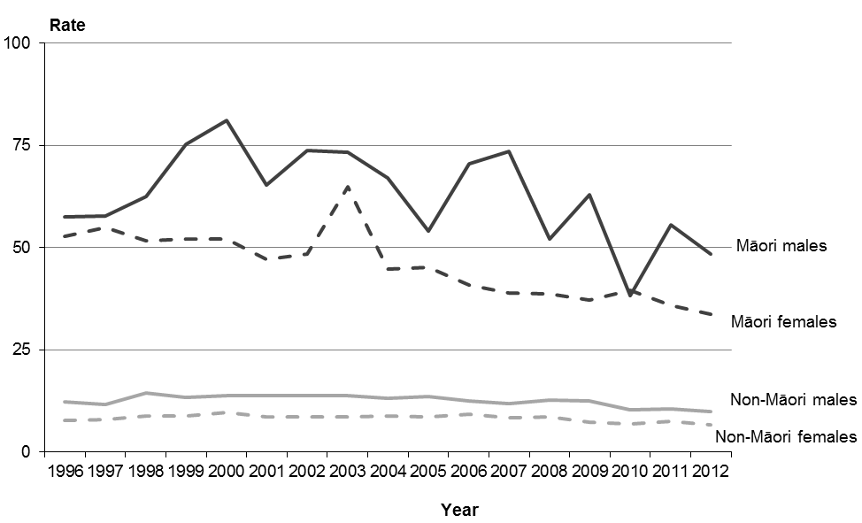

Note: rates per 100,000 population, age-standardised to WHO World Standard Population.

The four codes that make up the diabetes mellitus ICD classification grouping are:

* E10 Type 1 diabetes mellitus
* E11 Type 2 diabetes mellitus
* E13 other specified diabetes mellitus
* E14 unspecified diabetes mellitus.

Type 2 diabetes mellitus (E11) accounted for the majority (94.5%) of diabetes mortality in 2012. Very few deaths (7) were classified as unspecified diabetes mellitus (E14). There were no deaths classified as other specified diabetes mellitus (E13) in 2012.

Figure 33 shows mortality rates for Type 1 (E10) and Type 2 (E11) diabetes mellitus by sex in 2012. Males had a significantly higher rate of Type 2 diabetes mortality than females.

Figure 33: Mortality rates from diabetes mellitus, by diabetes type and sex, 2012

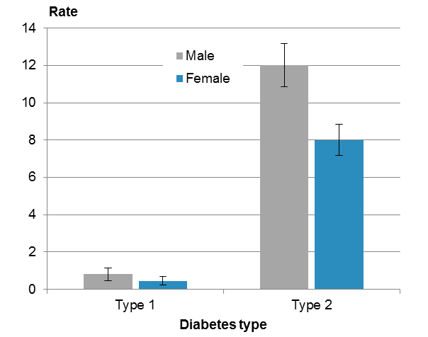

Note: rates per 100,000 population, age-standardised to WHO World Standard Population; 95% confidence intervals.

## Motor vehicle accidents

The classification ‘motor vehicle accidents’ primarily covers accidents associated with motorised transport (both on-road and off-road), including cars, two- or three-wheeler vehicles and heavy transport vehicles. It also includes pedestrians or cyclists involved in accidents with motor vehicles. The classification excludes road traffic accidents that did not include some form of motorised transport; for example, a collision between a pedestrian and a pedal cyclist, or a collision between a pedal cyclist and a railway train. It also excludes accidents involving watercraft and aircraft. The ICD codes from the V02–V89 range discussed here therefore exclude those that do not meet these criteria.

Motor vehicle accidents are a major cause of mortality in New Zealand and other industrialised countries. The first recorded motor vehicle accident fatality in New Zealand was in Christchurch in 1908. For most of the 20th century, the motor vehicle accident rate rose in concert with the increasing number of vehicles on New Zealand roads. Since the late 1980s this trend has reversed, and there has been a steady decline in deaths from motor vehicle accidents. This decline may be related to a variety of factors, including a greater societal awareness of the dangers of drink driving, excessive speed and driver fatigue; a rise in seatbelt use; better trauma treatment; and the increasing safety of roads and modern motor vehicles. The open road speed limit in New Zealand has varied over the years from 80 km/h (set in 1948 and again in 1974) to 100 km/h (the current limit, set in 1985). Blood alcohol and breath testing procedures were introduced in New Zealand in 1969, and seatbelt use became compulsory in 1975. Speed cameras were introduced in 1993.

Mortality rates from motor vehicle accidents peaked in the 1970s and generally declined from this point forward (Figure 34). In 2011 mortality rates were the lowest of all years shown for both sexes (9.8 deaths per 100,000 for males and 3.3 deaths per 100,000 for females). In 2012 the mortality rate was 11.3 deaths per 100,000 for males and 3.7 per 100,000 for females.

Figure 34: Number of deaths and mortality rates from motor vehicle accidents, by sex, 1950–2012

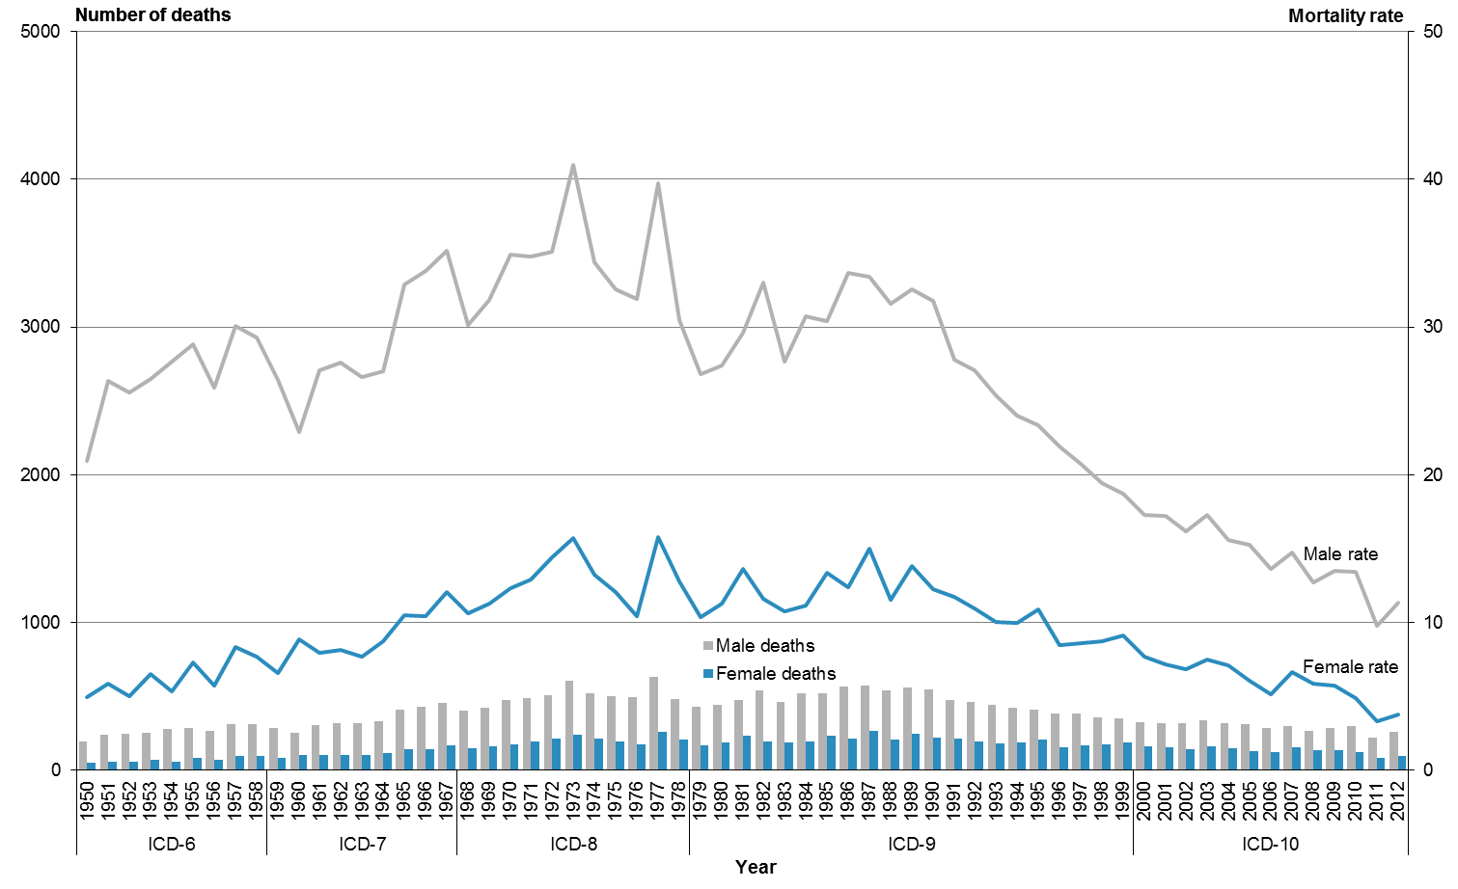

Note: rates per 100,000 population, age-standardised to WHO World Standard Population.

From 1980 to 2012 the rate of motor vehicle accident deaths declined by around two-thirds (58.7% among males and 66.8% among females) (Table 22). Males had a consistently higher rate of motor vehicle accident deaths over this time; in 2012 the male rate was three times the female rate.

Table 22: Number of deaths and mortality rates from motor vehicle accidents, by sex, 1980–2012

|  |  |  |  |  |  |  |
| --- | --- | --- | --- | --- | --- | --- |
| **Year** | **Male** | | **Female** | | **Total** | |
| **No.** | **Rate** | **No.** | **Rate** | **No.** | **Rate** |
| 1980 | 438 | 27.4 | 184 | 11.3 | 622 | 19.3 |
| 1981 | 476 | 29.6 | 231 | 13.6 | 707 | 21.6 |
| 1982 | 538 | 33.0 | 192 | 11.6 | 730 | 22.2 |
| 1983 | 461 | 27.6 | 186 | 10.8 | 647 | 19.2 |
| 1984 | 517 | 30.8 | 193 | 11.1 | 710 | 21.0 |
| 1985 | 516 | 30.4 | 231 | 13.4 | 747 | 21.8 |
| 1986 | 567 | 33.7 | 215 | 12.4 | 782 | 23.0 |
| 1987 | 570 | 33.4 | 265 | 15.0 | 835 | 24.2 |
| 1988 | 537 | 31.6 | 206 | 11.5 | 743 | 21.5 |
| 1989 | 557 | 32.5 | 242 | 13.8 | 799 | 23.1 |
| 1990 | 545 | 31.7 | 219 | 12.2 | 764 | 22.0 |
| 1991 | 471 | 27.8 | 210 | 11.7 | 681 | 19.7 |
| 1992 | 462 | 27.1 | 194 | 10.9 | 656 | 18.8 |
| 1993 | 438 | 25.3 | 179 | 10.0 | 617 | 17.6 |
| 1994 | 419 | 24.0 | 183 | 10.0 | 602 | 16.9 |
| 1995 | 407 | 23.4 | 205 | 10.9 | 612 | 17.1 |
| 1996 | 381 | 21.9 | 156 | 8.5 | 537 | 15.1 |
| 1997 | 383 | 20.8 | 167 | 8.6 | 550 | 14.5 |
| 1998 | 358 | 19.4 | 171 | 8.7 | 529 | 14.0 |
| 1999 | 349 | 18.7 | 184 | 9.1 | 533 | 13.8 |
| 2000 | 322 | 17.3 | 157 | 7.7 | 479 | 12.5 |
| 2001 | 318 | 17.2 | 151 | 7.2 | 469 | 12.1 |
| 2002 | 314 | 16.2 | 142 | 6.8 | 456 | 11.4 |
| 2003 | 336 | 17.2 | 158 | 7.4 | 494 | 12.3 |
| 2004 | 314 | 15.6 | 149 | 7.1 | 463 | 11.2 |
| 2005 | 307 | 15.2 | 127 | 6.0 | 434 | 10.6 |
| 2006 | 283 | 13.6 | 120 | 5.1 | 403 | 9.2 |
| 2007 | 300 | 14.7 | 150 | 6.6 | 450 | 10.6 |
| 2008 | 261 | 12.7 | 135 | 5.8 | 396 | 9.2 |
| 2009 | 286 | 13.5 | 134 | 5.7 | 420 | 9.5 |
| 2010 | 296 | 13.4 | 120 | 4.9 | 416 | 9.1 |
| 2011 | 221 | 9.8 | 84 | 3.3 | 305 | 6.5 |
| 2012 | 255 | 11.3 | 92 | 3.7 | 347 | 7.4 |

Note: rates per 100,000 population, age-standardised to WHO World Standard Population.

Motor vehicle accident deaths within the Māori population were more common in the younger age groups in 2012 (Table 23). More than two-thirds of Māori deaths (69.3%) occurred in those below the age of 45, compared to 51.0% of non-Māori deaths.

Māori had higher age-specific rates of motor vehicle accident deaths than non-Māori in all age groups. Māori aged 25–44 and 45–64 years had mortality rates that were approximately three times higher than the corresponding non-Māori rates in 2012.

Table 23: Age distribution of deaths from motor vehicle accidents, percentages and rates, by ethnicity and sex, 2012

|  |  |  |  |  |  |  |  |  |  |  |  |  |
| --- | --- | --- | --- | --- | --- | --- | --- | --- | --- | --- | --- | --- |
| **Age group (years)** | **Percentage** | | | | | | **Age-specific rate** | | | | | |
| **Māori** | | | **Non-Māori** | | | **Māori** | | | **Non-Māori** | | |
| **Male** | **Female** | **Total** | **Male** | **Female** | **Total** | **Male** | **Female** | **Total** | **Male** | **Female** | **Total** |
| <25 | 33.8 | 25.0 | 31.8 | 27.3 | 25.0 | 26.6 | 12.5 | 2.8 | 7.8 | 8.4 | 3.2 | 5.9 |
| 25–44 | 32.4 | 55.0 | 37.5 | 27.8 | 15.3 | 24.3 | 27.9 | 12.3 | 19.7 | 10.7 | 2.1 | 6.3 |
| 45–64 | 25.0 | 10.0 | 21.6 | 20.9 | 20.8 | 20.8 | 30.2 | 3.2 | 15.9 | 8.0 | 2.9 | 5.4 |
| 65+ | 8.8 | 10.0 | 9.1 | 24.1 | 38.9 | 28.2 | 38.3 | 10.8 | 23.4 | 17.0 | 9.0 | 12.6 |

Note: rates per 100,000 population.

Māori had a motor vehicle accident mortality rate more than twice that of non-Māori in 2012 (14.1 deaths per 100,000, compared with 6.2 deaths per 100,000 non-Māori).

For all groups shown in Figure 35, mortality rates were significantly lower in 2012 compared with 1996 (using 95% confidence intervals).[[10]](#footnote-10) Of rates for these groups, the rate for Māori males showed the biggest decline, decreasing by 38.4% over this time.

In 2012, the mortality rate for Māori males was 2.4 times the rate for non-Māori males. For females, the Māori rate was twice the non-Māori rate.

Figure 35: Mortality rates from motor vehicle accidents, by sex and ethnicity, 1996–2012

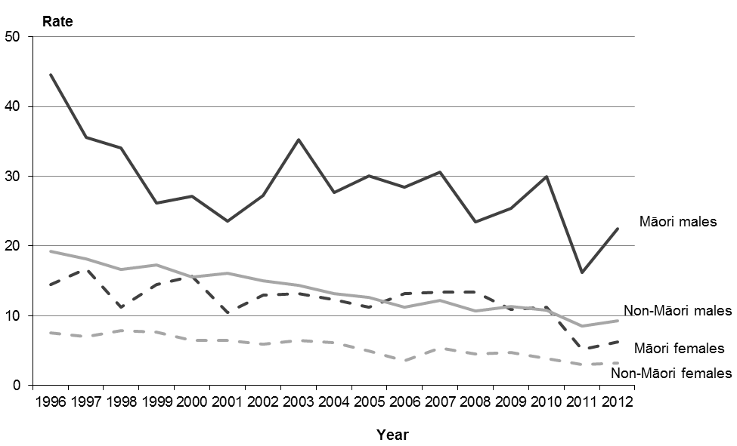

Note: rates per 100,000 population, age-standardised to WHO World Standard Population.

Figure 36 shows the rate of hospitalisations alongside the mortality rate from motor vehicle accidents between 1996 and 2012. Both the hospitalisation and the mortality rates showed a significant decline over this period. The motor vehicle accident mortality rate fell from 15.1 per 100,000 total population in 1996 to 7.4 per 100,000 in 2012. The hospitalisation rate fell from 236.6 per 100,000 total population in 1996 to 148.3 per 100,000 in 2012.

The ratio line shows how many motor vehicle hospitalisation incidents occurred for every mortality incident over these years. In 2012, for example, there were 20 motor vehicle accident-related hospitalisations for every death. The general upward trend of the ratio line suggests that people injured in a motor vehicle accident were less likely to die over this time period.

Figure 36: Mortality and hospitalisation rates from motor vehicle accidents, and ratio of hospitalisation rate to mortality rate, 1996–2012

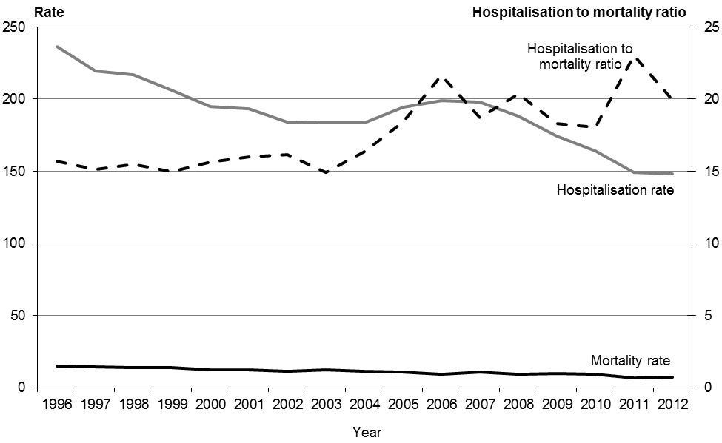

Notes:

Rates per 100,000 population, age-standardised to WHO World Standard Population.

In the interests of making the data comparable between DHBs, the hospitalisation data used to produce this figure excludes short-stay emergency department events.[[11]](#footnote-11)

Some events will have been included in both the hospitalisation and the mortality count, taking into account people who were injured then subsequently died in hospital.

## Suicide

The ICD codes X60–X84 covers acts of intentional self-harm. Mortality from intentional self-harm is commonly referred to as suicide. This section provides an overview of suicide mortality; for a more detailed analysis see the Ministry of Health publication series *Suicide Facts: Deaths and Intentional Self-harm Hospitalisations*.[[12]](#footnote-12)The numbers presented here are taken from the final data for 2012 suicide mortality, and so differ slightly from the provisional data in the 2012 *Suicide Facts* publication.

In 2012, 550 suicides occurred in New Zealand, as determined following coronial investigation. Males made up three-quarters (73.5%) of these deaths.

After 1950, the male suicide rate reached a peak in 1995, then declined to a rate of 18.5 deaths per 100,000 males in 2012 (Figure 37). The female rate remained relatively stable between 1950 and 2012. In 2012 the rate for females was 6.4 deaths per 100,000.

Figure 37: Number of deaths and mortality rates from suicide, by sex, 1950–2012

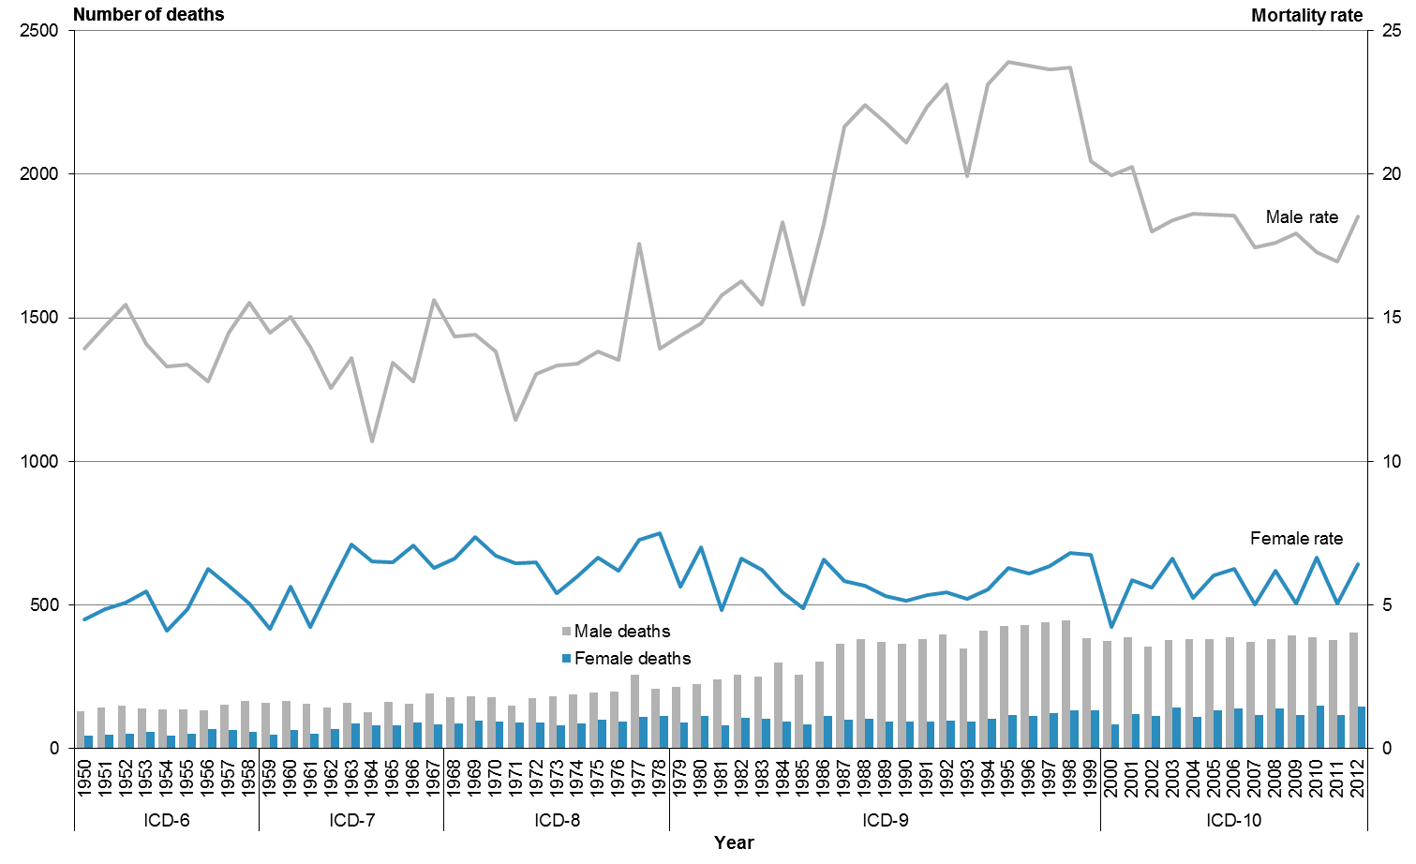

Note: rates per 100,000 population, age-standardised to WHO World Standard Population.

Between 1980 and 2012 the male suicide rate was consistently higher than the female rate (Table 24). The biggest disparity occurred in 2000, when the male rate was more than 4.5 times the female rate. In 2012 the male rate was almost three times the female rate.

Table 24: Number of deaths and mortality rates from suicide, by sex, 1980–2012

|  |  |  |  |  |  |  |
| --- | --- | --- | --- | --- | --- | --- |
| **Year** | **Male** | | **Female** | | **Total** | |
| **No.** | **Rate** | **No.** | **Rate** | **No.** | **Rate** |
| 1980 | 225 | 14.8 | 112 | 7.0 | 337 | 10.8 |
| 1981 | 241 | 15.8 | 79 | 4.8 | 320 | 10.2 |
| 1982 | 257 | 16.3 | 107 | 6.6 | 364 | 11.3 |
| 1983 | 250 | 15.5 | 102 | 6.2 | 352 | 10.7 |
| 1984 | 297 | 18.3 | 92 | 5.4 | 389 | 11.7 |
| 1985 | 255 | 15.5 | 83 | 4.9 | 338 | 10.0 |
| 1986 | 301 | 18.3 | 113 | 6.6 | 414 | 12.3 |
| 1987 | 363 | 21.7 | 100 | 5.8 | 463 | 13.6 |
| 1988 | 381 | 22.4 | 103 | 5.7 | 484 | 13.9 |
| 1989 | 372 | 21.8 | 93 | 5.3 | 465 | 13.4 |
| 1990 | 363 | 21.1 | 92 | 5.1 | 455 | 13.0 |
| 1991 | 380 | 22.3 | 94 | 5.4 | 474 | 13.7 |
| 1992 | 397 | 23.1 | 96 | 5.4 | 493 | 14.1 |
| 1993 | 349 | 19.9 | 94 | 5.2 | 443 | 12.5 |
| 1994 | 409 | 23.1 | 103 | 5.5 | 512 | 14.1 |
| 1995 | 427 | 23.9 | 116 | 6.3 | 543 | 15.0 |
| 1996 | 428 | 23.8 | 112 | 6.1 | 540 | 14.7 |
| 1997 | 440 | 23.7 | 121 | 6.3 | 561 | 14.8 |
| 1998 | 445 | 23.7 | 132 | 6.8 | 577 | 15.1 |
| 1999 | 385 | 20.4 | 131 | 6.8 | 516 | 13.4 |
| 2000 | 375 | 20.0 | 83 | 4.2 | 458 | 11.9 |
| 2001 | 388 | 20.3 | 119 | 5.9 | 507 | 12.9 |
| 2002 | 353 | 18.0 | 113 | 5.6 | 466 | 11.6 |
| 2003 | 376 | 18.4 | 141 | 6.6 | 517 | 12.4 |
| 2004 | 379 | 18.6 | 109 | 5.2 | 488 | 11.7 |
| 2005 | 380 | 18.6 | 131 | 6.0 | 511 | 12.2 |
| 2006 | 388 | 18.6 | 138 | 6.3 | 526 | 12.2 |
| 2007 | 371 | 17.4 | 116 | 5.0 | 487 | 11.0 |
| 2008 | 381 | 17.6 | 139 | 6.2 | 520 | 11.8 |
| 2009 | 393 | 17.9 | 117 | 5.0 | 510 | 11.3 |
| 2010 | 386 | 17.3 | 149 | 6.6 | 535 | 11.8 |
| 2011 | 377 | 17.0 | 116 | 5.1 | 493 | 10.9 |
| 2012 | 404 | 18.5 | 146 | 6.4 | 550 | 12.3 |

Note: rates per 100,000 population, age-standardised to WHO World Standard Population.

In 2012, a high proportion of Māori suicide deaths occurred in the younger age groups. More than half of all Māori suicide deaths (58.0%) were among those aged 5–24 years. The proportion in the equivalent age-group for non-Māori was 21.1%. Conversely, a higher proportion of non-Māori suicide deaths occurred among those aged 65 and over, compared with the equivalent Māori age group (13.2% for non-Māori and 0.8% for Māori).

While Māori had higher age-specific mortality rates from suicide in the younger age groups (those aged less than 45 years), rates for Māori aged 45 years and over were lower than the corresponding rates for non-Māori. Table 25 shows the 2012 percentage distribution of deaths and age-specific mortality rates from suicide for five age groupings for Māori and non-Māori.

Table 25: Age distribution of deaths from suicide, percentages and rates, by ethnicity and sex, 2012

|  |  |  |  |  |  |  |  |  |  |  |  |  |
| --- | --- | --- | --- | --- | --- | --- | --- | --- | --- | --- | --- | --- |
| **Age group (years)** | **Percentage** | | | | | | **Age-specific rate** | | | | | |
| **Māori** | | | **Non-Māori** | | | **Māori** | | | **Non-Māori** | | |
| **Male** | **Female** | **Total** | **Male** | **Female** | **Total** | **Male** | **Female** | **Total** | **Male** | **Female** | **Total** |
| 5–14 | 6.1 | 8.1 | 6.7 | 0.6 | 1.8 | 0.9 | 6.8 | 4.3 | 5.6 | 0.9 | 0.9 | 0.9 |
| 15–24 | 45.1 | 64.9 | 51.3 | 21.4 | 16.5 | 20.2 | 57.2 | 38.4 | 48.0 | 25.9 | 7.3 | 16.9 |
| 25–44 | 36.6 | 24.3 | 32.8 | 34.8 | 31.2 | 33.9 | 38.1 | 10.1 | 23.2 | 22.9 | 6.6 | 14.6 |
| 45–64 | 11.0 | 2.7 | 8.4 | 30.1 | 36.7 | 31.8 | 16.0 | 1.6 | 8.4 | 19.9 | 7.8 | 13.7 |
| 65+ | 1.2 | 0.0 | 0.8 | 13.0 | 13.8 | 13.2 | 6.4 | 0.0 | 2.9 | 15.8 | 4.8 | 9.9 |

Note: rates per 100,000 population.

In 2012, Māori had a mortality rate from suicide of 17.6 deaths per 100,000, compared with 10.6 deaths per 100,000 non-Māori.

Compared with their female counterparts, both Māori males and non-Māori males had significantly higher mortality rates in 2012 (Figure 38).[[13]](#footnote-13)

Figure 38: Mortality rates from suicide, by sex and ethnicity, 1996–2012

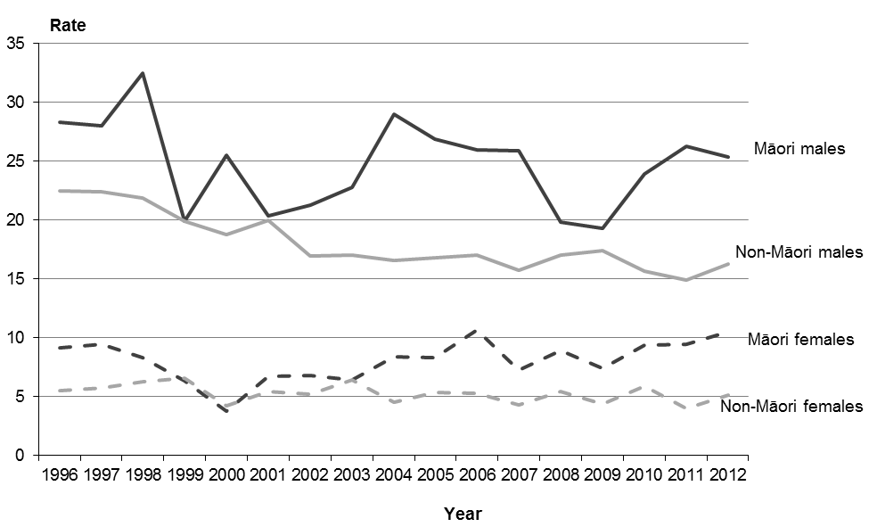

Note: rates per 100,000 population, age-standardised to WHO World Standard Population.

Figures 39 and 40 show the rate of intentional self-harm hospitalisations alongside the mortality rate for suicide between 1996 and 2012 for males and females. Note that the hospitalisation figures exclude short-stay emergency department data, in line with the methodology used for motor vehicle accident hospitalisations in this publication and in line with that used in the *Suicide Facts* publication series.

There is a distinct difference between males and females in regard to intentional self-harm hospitalisation rates relative to suicide mortality rates. Males have a lower ratio of hospitalisations to deaths than females.

Figure 39: Male mortality and hospitalisation rates from intentional self-harm, and ratio of hospitalisation rate to mortality rate, 1996–2012

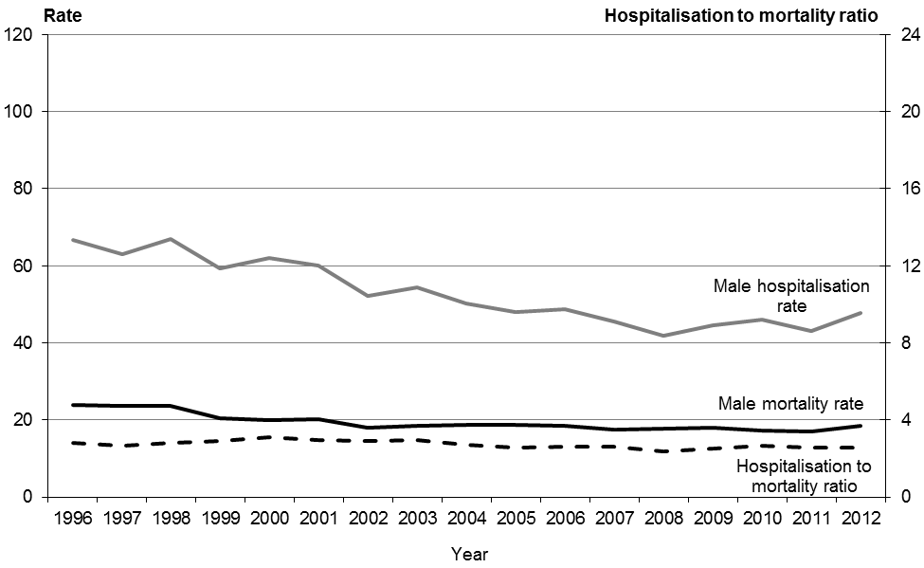

Note: rates per 100,000 population, age-standardised to WHO World Standard Population.

Figure 40: Female mortality and hospitalisation rates from intentional self-harm, and ratio of hospitalisation rate to mortality rate, 1996–2012

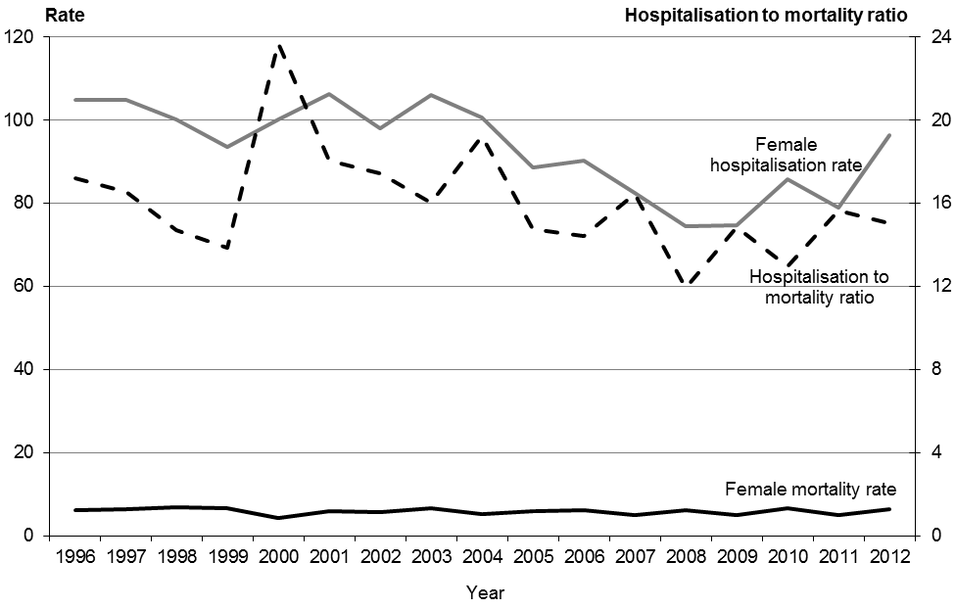

Note: rates per 100,000 population, age-standardised to WHO World Standard Population.

## Maternal mortality

According to the WHO a maternal death is ‘the death of a woman while pregnant or within 42 days of termination of pregnancy, irrespective of the duration and site of the pregnancy, from any cause related to or aggravated by the pregnancy or its management but not from accidental or incidental causes’ (WHO 2004).

The WHO categorises maternal deaths into two groups:

1. Direct obstetric deaths: those resulting from obstetric complications of the pregnant state (pregnancy, labour or puerperium), from interventions, omissions, incorrect treatment, or from a chain of events resulting from any of the above.

2. Indirect obstetric deaths: those resulting from previous existing disease or disease that developed during pregnancy and was not due to direct obstetric causes but that was aggravated by the physiologic effects of pregnancy.

These definitions exclude maternal deaths occurring 42 days after the termination (end) of pregnancy. This section covers ICD codes O00-O95, O98-O99.

The number of maternal deaths in New Zealand each year is relatively small, so annual maternal death rates may vary substantially. Caution is advised when comparing rates over time.

A total of seven maternal deaths occurred in 2012, equating to a rate of 11.3 deaths per 100,000 live births.

The number and rate of maternal deaths decreased markedly from the 1950s to the late 1970s (Figure 41). There were 52 deaths in 1950 (105.2 deaths per 100,000 live births) compared to six deaths in 1979 (11.5 deaths per 100,000). From the late 1970s the decline in the rate of maternal deaths slowed and became more stable compared to previous years.

Figure 41: Number of maternal deaths and maternal mortality rates, 1950–2012

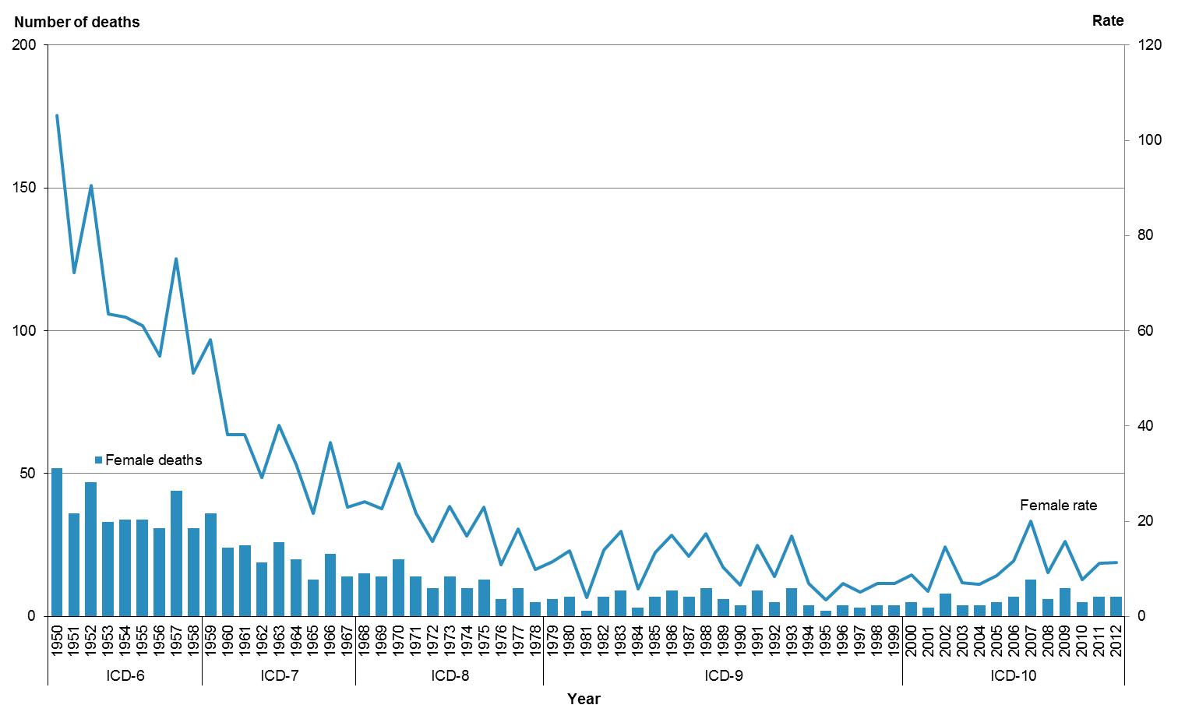

Note: rates per 100,000 live births.

From 1980 to 2012 the number of maternal deaths ranged between two (in both 1981 and 1995) and 13 (in 2007) (Table 26). The highest rate of maternal deaths over this period was 20.0 deaths per 100,000 live births in 2007. The lowest rate was 3.5 deaths per 100,000 live births in 1995.

Table 26: Number of maternal deaths and maternal mortality rates, 1980–2012

|  |  |  |  |  |  |  |
| --- | --- | --- | --- | --- | --- | --- |
| **Year** | **Direct** | | **Indirect** | | **Total** | |
| **Number** | **Rate** | **Number** | **Rate** | **Number** | **Rate** |
| 1980 | 7 | 13.8 | 0 | 0.0 | 7 | 13.8 |
| 1981 | 2 | 3.9 | 0 | 0.0 | 2 | 3.9 |
| 1982 | 7 | 14.0 | 0 | 0.0 | 7 | 14.0 |
| 1983 | 7 | 13.9 | 2 | 4.0 | 9 | 17.8 |
| 1984 | 3 | 5.8 | 0 | 0.0 | 3 | 5.8 |
| 1985 | 6 | 11.6 | 1 | 1.9 | 7 | 13.5 |
| 1986 | 6 | 11.4 | 3 | 5.7 | 9 | 17.0 |
| 1987 | 4 | 7.2 | 3 | 5.4 | 7 | 12.7 |
| 1988 | 5 | 8.7 | 5 | 8.7 | 10 | 17.4 |
| 1989 | 4 | 6.9 | 2 | 3.4 | 6 | 10.3 |
| 1990 | 3 | 5.0 | 1 | 1.7 | 4 | 6.6 |
| 1991 | 7 | 11.7 | 2 | 3.3 | 9 | 15.0 |
| 1992 | 2 | 3.4 | 3 | 5.1 | 5 | 8.4 |
| 1993 | 6 | 10.2 | 4 | 6.8 | 10 | 17.0 |
| 1994 | 4 | 7.0 | 0 | 0.0 | 4 | 7.0 |
| 1995 | 2 | 3.5 | 0 | 0.0 | 2 | 3.5 |
| 1996 | 4 | 7.0 | 0 | 0.0 | 4 | 7.0 |
| 1997 | 2 | 3.5 | 1 | 1.7 | 3 | 5.2 |
| 1998 | 1 | 1.7 | 3 | 5.2 | 4 | 6.9 |
| 1999 | 3 | 5.2 | 1 | 1.7 | 4 | 7.0 |
| 2000 | 2 | 3.5 | 3 | 5.3 | 5 | 8.8 |
| 2001 | 0 | 0.0 | 3 | 5.3 | 3 | 5.3 |
| 2002 | 4 | 7.3 | 4 | 7.3 | 8 | 14.7 |
| 2003 | 3 | 5.3 | 1 | 1.8 | 4 | 7.1 |
| 2004 | 1 | 1.7 | 3 | 5.1 | 4 | 6.8 |
| 2005 | 3 | 5.1 | 2 | 3.4 | 5 | 8.5 |
| 2006 | 4 | 6.6 | 3 | 5.0 | 7 | 11.6 |
| 2007 | 7 | 10.7 | 6 | 9.2 | 13 | 20.0 |
| 2008 | 3 | 4.6 | 3 | 4.6 | 6 | 9.2 |
| 2009 | 5 | 7.9 | 5 | 7.9 | 10 | 15.8 |
| 2010 | 2 | 3.1 | 3 | 4.6 | 5 | 7.7 |
| 2011 | 2 | 3.2 | 5 | 8.0 | 7 | 11.3 |
| 2012 | 2 | 3.2 | 5 | 8.1 | 7 | 11.3 |

Note: rates per 100,000 live births.

From 2008 to 2012, indirect maternal deaths accounted for 60% of all maternal deaths (Table 27). Of the 21 women who died of an indirect maternal cause between 2008 and 2012, the majority died as a result of diseases of the circulatory system (8 women) and diseases of the respiratory system complicating pregnancy, childbirth and the puerperium (7 women). The remaining women died as a result of either:

* endocrine, nutritional and metabolic diseases
* mental disorders and diseases of the nervous system
* diseases of the skin and subcutaneous tissue, or
* other specified diseases and conditions complicating pregnancy, childbirth and the puerperium.

Direct maternal deaths made up the remaining 40%. Of the 14 women who died of a direct maternal cause, five women died as a result of an obstetric embolism.

Table 27: Maternal deaths by underlying cause, 2008–2012

|  |  |  |  |  |  |  |  |
| --- | --- | --- | --- | --- | --- | --- | --- |
| **Underlying cause of death by ICD 3‑character code** | **2008** | **2009** | **2010** | **2011** | **2012** | **2008–2012** | |
| **Number** | | | | | **Number** | **Percent** |
| **Direct maternal deaths (O00–O95)** | **3** | **5** | **2** | **2** | **2** | **14** | **40.0** |
| Pre-existing hypertension complicating pregnancy, childbirth and the puerperium (O10) | – | – | – | 1 | – | 1 | 2.9 |
| Gestational (pregnancy-induced) hypertension with significant proteinuria (O14) | 1 | 1 | – | – | – | 2 | 5.7 |
| Maternal care for other conditions predominantly related to pregnancy (O26) | – | – | 1 | – | – | 1 | 2.9 |
| Other disorders of amniotic fluid and membranes (O41) | – | – | – | – | 1 | 1 | 2.9 |
| Placental disorders (O43) | 1 | – | – | – | – | 1 | 2.9 |
| Other obstetric trauma (O71) | – | 1 | – | – | – | 1 | 2.9 |
| Other complications of labour and delivery, not elsewhere classified (O75) | – | – | 1 | – | – | 1 | 2.9 |
| Venous complications in the puerperium (O87) | – | – | – | 1 | – | 1 | 2.9 |
| Obstetric embolism (O88) | 1 | 3 | – | – | 1 | 5 | 14.3 |
| **Indirect maternal deaths (O98–O99)** | **3** | **5** | **3** | **5** | **5** | **21** | **60.0** |
| Other maternal diseases classifiable elsewhere but complicating pregnancy, childbirth and the puerperium (O99) | 3 | 5 | 3 | 5 | 5 | 21 | 60.0 |
| **Total maternal deaths** | **6** | **10** | **5** | **7** | **7** | **35** | **100.0** |
| Live births | 65,333 | 63,285 | 64,699 | 62,174 | 62,035 | – | – |

# Further mortality-related information

## Accompanying online tables

Statistical mortality data tables are available online in Excel format alongside the *Mortality and Demographic Data* publication at: www.health.govt.nz/nz-health-statistics/health-statistics-and-data-sets/mortality-and-demographic-data-series

The tables published on this page contain mortality data for the complete range of ICD-10-AM classifications, in sex and five-year age groupings. The data is grouped at national, regional and ethnic group level.

## Ministry of Health publications

Further detailed information may be found in the following Ministry of Health publications:

* Further detailed information on numbers and rates of live births, and fetal, neonatal and post-neonatal deaths, is published in the annual series *Fetal and Infant Deaths*  
  (www.health.govt.nz/nz-health-statistics/health-statistics-and-data-sets/fetal-and-infant-deaths-series).
* Further information on cancer incidence and mortality can be found in the annual series *Cancer: New registrations and deaths*(www.health.govt.nz/nz-health-statistics/health-statistics-and-data-sets/cancer-new-registrations-and-deaths-series).
* Information on hospitalisations and mortality from intentional self-harm can be found in the annual series *Suicide Facts: Deaths and intentional self-harm hospitalisations*  
  (www.health.govt.nz/nz-health-statistics/health-statistics-and-data-sets/suicide-facts-deaths-and-intentional-self-harm-hospitalisations-series). Suicide prevention information can be found at [www.health.govt.nz/our-work/mental-health-and-addictions/working-prevent-suicide](http://www.health.govt.nz/our-work/mental-health-and-addictions/working-prevent-suicide)

These publications, and others produced by the Ministry of Health, can be found through www.health.govt.nz/nz-health-statistics/health-statistics-and-data-sets

## Publications by other organisations

### Serious injury outcome indicator reports

Statistics New Zealand produces annual serious injury outcome indicator reports. These reports include numbers and rates of death from suicide, assault and motor vehicle traffic crashes (MVTC). The information for these reports is also sourced from the New Zealand Mortality Collection, and is therefore broadly comparable with the information published in *Mortality and Demographic Data*.However, the Mortality Collection is a dynamic database; any small discrepancies in data between the two publications are therefore likely to be due to updates to records in the database over time.

The serious injury outcome indicator reports also present data on ‘serious non-fatal intentional self-harm injury’ and ‘serious non-fatal MVTC injury’. These indicators cover only a subset of the self-harm hospitalisation data and motor vehicle accidents data analysed in this publication, and therefore cannot be directly compared.

For more information and access to the serious injury outcome indicator reports[see](file:///C:\Users\JADAM\AppData\Local\Downloaded%20documents\see) [www.stats.govt.nz/browse\_for\_stats/health/injuries/serious-injury-outcome-indicators-reports.aspx](http://www.stats.govt.nz/browse_for_stats/health/injuries/serious-injury-outcome-indicators-reports.aspx)

For further information relating to the methodology, classifications and processes used to produce this publication, and how they differ between publications, contact data-enquiries@moh.govt.nz

## Population data used for calculating rates

For population and other demographic data, contact the Ministry of Health (email: [data-enquiries@moh.govt.nz](mailto:data-enquiries@moh.govt.nz)) or Statistics New Zealand ([www.stats.govt.nz](http://www.stats.govt.nz) or email: info@stats.govt.nz).

## Additional data available from the Ministry of Health

The Ministry of Health collects and records the information presented in Table 28 for all deaths in New Zealand. For a full listing of available fields, refer to the Mortality Collection Data Dictionary (available at: www.health.govt.nz/publication/mortality-collection-data-dictionary).

You may require information not included in this report or in the accompanying online tables. The Ministry of Health is able to produce customised data extracts tailored to your needs. These may incur a charge (at Official Information Act rates). If you require additional data or analysis, contact:

Analytical Services

Ministry of Health

PO Box 5013

Wellington, 6145

New Zealand

Phone (04) 496 2000

Fax (04) 816 2898

Email: [data-enquiries@moh.govt.nz](mailto:data-enquiries@moh.govt.nz)

or visit: www.health.govt.nz

The Ministry of Health welcomes comments and suggestions about this publication.

Table 28: Mortality data available from the Ministry of Health

| **Item** | **Notes** |
| --- | --- |
| 1 Health care user number | Also known as National Health Index number. Restricted access. |
| 2 Domicile code | Based on Statistics New Zealand Standard Area Unit code used for the 2006 Census. |
| 3 Sex | Male, female, indeterminate. |
| 4 Ethnicity | Based on Statistics New Zealand Standard Classification 1996 (Level 2); for example, NZ Māori, NZ European or Pākeha, Other European, Samoan, Chinese and so on. Up to three ethnicities are recorded and prioritised. |
| 5 Age | Age in days, weeks, months or years, as applicable. |
| 6 Date of birth | Day, month, year. |
| 7 Country of birth | From Statistics New Zealand Standard Country Code list, 1986. |
| 8 Time deceased was in New Zealand | Number of years in New Zealand if not born in New Zealand. |
| 9 Date of death | Day, month, year. |
| 10 Year of registration | Year in which the death was registered. |
| 11 Place died | Place of death as recorded on the death registration. |
| 12 Underlying cause of death | Codes from ICD-10-AM from 2000 onwards. |
| 13 Selected contributing disease or condition | Codes from ICD-10-AM for selected conditions that contributed to death but were not the underlying cause of death (eg, diabetes mellitus, drug abuse and injuries) from 2000 onwards. |
| 14 Mesh block | Statistics New Zealand’s smallest area unit code, based on deceased’s residential address, from 2003 onwards. Restricted access. |
| 15 Cot death indicator | Sudden infant death syndrome indicator. |
| 16 Maternal death indicator | Indicates whether the death is the death of a woman while pregnant or within 42 days of termination of pregnancy, irrespective of the duration and the site of the pregnancy, from any cause related to or aggravated by the pregnancy or its management, but not from accidental or incidental causes. |
| 17 Pregnancy-related indicator | Indicates if a woman died while pregnant or within 42 days of termination of pregnancy, irrespective of the cause of death. |
| 18 Post-mortem code | Indicates whether a post-mortem was performed and/or used in classification by the Ministry of Health. |
| 19 Death certifier code | Certified by doctor, or coroner with/without inquest, coroner’s interim report. |
| 20 Death information source code | Code indicating the most accurate source of the information used to classify the underlying cause of death; for example, Births, Deaths and Marriages, Coronial Services, Land Transport New Zealand, Water Safety New Zealand. |
| 21 Comments | Free text field for additional comments relating to the death (eg, may include details of accidents or time sequence of conditions). Restricted access. |
| 22 Occupation | Text description of deceased’s usual occupation (or former occupation, if retired). Collected since 1998. |
| 23 Work-related indicator | Recorded if the cause of death was known to be due to an accident while at work from 2000 onwards. |
| 24 Alcohol-involved indicator | Records if alcohol consumption preceded death, when reported from 2000 onwards. Only recorded for deaths certified by a coroner. |
| 25 Blood alcohol level | Recorded in mg/100 mL blood, when reported from 2000 onwards. Only recorded for deaths certified by a coroner. |
| 26 Birthweight | Weight at birth in grams. Recorded when known for deaths of infants less than one year of age and for stillbirths. |
| 27 Gestation | Gestation (in weeks) of infant at birth. Recorded when known for deaths of infants less than one year of age and for stillbirths. |

# Explanatory notes

## Mortality

### Deaths

Every death occurring in New Zealand must be registered with Births, Deaths and Marriages. Deaths should be registered within three working days of burial or cremation, although the law does not impose any limit on the time after which a death may not be registered.

This information, along with stillbirth registration data, is supplied to the Ministry of Health. The Ministry of Health then matches death and stillbirth registrations from the Registry with individuals’ National Health Index numbers. This combined information comprises the death registration data held in the National Mortality Collection (MORT).

The statistics in this publication relate to registrations during the year 2012, rather than the actual number of deaths during the year 2012.

### Causes of death

The ICD-10-AM was used to classify causes of death throughout this report (National Centre for Classification in Health 2008). The WHO regularly revises the ICD publication, and issues updates in the form of new revisions; for example, ICD-10 is the Tenth Revision.

If more than one cause is entered on a medical certificate, the Mortality Collection follows WHO mortality rules and guidelines (as specified in ICD-10) for identifying the underlying cause of death. This is largely determined from the statement of the certifying doctor or coroner, but reference is also made to post-mortem reports received, and cancer registrations. On some occasions, coded hospital inpatient event summaries are compared with entries on the medical certificate in order to obtain more specific information. Information is also obtained from letters to certifying doctors and medical records departments, from data supplied by Land Transport New Zealand and Water Safety New Zealand, from the internet and from Coronial Services.

When a death is due to an external cause, such as an accident, the external cause and not the resulting injury is coded as the underlying cause of death. For example, if a death is due to a head injury as a result of a motor vehicle crash, the motor vehicle crash will be coded as the cause of death. Sites and types of injuries are coded as contributing causes, if reported.

### Amenable mortality

The ICD-10-AM codes used to define amenable mortality in this publication are shown in the following table.

Table 29: Codes used to define amenable mortality

|  |  |  |  |
| --- | --- | --- | --- |
| **Group** | **Condition** | **ICD-10-AM code(s)** | **Notes** |
| Infections | Pulmonary tuberculosis | A15–A16 |  |
| Meningococcal disease | A39 |  |
| Pneumococcal disease | A40.3, G00.1, J13 |  |
| HIV/AIDS | B20–B24 |  |
| Cancers | Stomach cancer | C16 |  |
| Rectal cancer | C19–C21 |  |
| Bone and cartilage cancer | C40–C41 |  |
| Melanoma of skin | C43 |  |
| Female breast cancer | C50 | Females only |
| Cervical cancer | C53 |  |
| Prostate cancer | C61 |  |
| Testis cancer | C62 |  |
| Thyroid cancer | C73 |  |
| Hodgkin lymphoma | C81 |  |
| Acute lymphoblastic leukaemia | C91.0 | Ages 0–44 years |
| Maternal and infant | Complications of pregnancy | O00–O96, O98–O99 |  |
| Complications of perinatal period | P01–P03, P05–P94 |  |
| Cardiac septal defect | Q21 |  |
| Chronic disorders | Diabetes | E10–E14 |  |
| Valvular heart disease | I01, I05–I09, I33–I37 |  |
| Hypertensive diseases | I10–I13 |  |
| Coronary disease | I20–I25 |  |
| Pulmonary embolism | I26 |  |
| Heart failure | I50 |  |
| Cerebrovascular diseases | I60–I69 |  |
| COPD | J40–J44 |  |
| Asthma | J45–J46 |  |
| Peptic ulcer disease | K25–K27 |  |
| Cholelithiasis | K80 |  |
| Renal failure | N17–N19 |  |
| Injuries | Land transport accidents excluding trains | V01–V04, V06–V14, V16–V24, V26–V34, V36–V44, V46–V54, V56–V64, V66–V74, V76–V79, V80.0–V80.5, V80.7–V80.9, V82–V86, V87.0–V87.5, V87.7–V87.9, V88.0–V88.5, V88.7–V88.9, V89, V98–V99 | Include V00 if using ICD-10-AM-VI (from 2008 onwards) |
| Accidental falls on same level | W00–W08, W18 |  |
| Fire | X00–X09 |  |
| Suicide | X60–X84 |  |
| Treatment injury | Y60–Y82 |  |

### Cancer mortality

In the third edition of the International Classification of Diseases for Oncology (ICD-O), the range of neoplasms considered to be malignant was expanded. Specifically, polycythaemia vera, myelodysplastic syndromes and chronic myeloproliferative disorders are considered to be malignant in the third edition of ICD-O, whereas in the second edition these diseases were considered to be of uncertain behaviour. The ICD-10 codes for these additional malignancies are in the range D45–D47. This change took effect from 2003. *Mortality and Demographic Data 2004* was the first publication in this series to include the D45–D47 range in cancer analyses.

### Motor vehicle accident deaths

The ICD 10 AM codes used to define motor vehicle accident deaths in this publication are:  
V02–V04, V09.0–V09.3, V12–V14, V19.0–V19.2, V19.4–V19.6, V20–V79, V80.3–V80.5, V81.0–V81.1, V82.0–V82.1, V83.0–V83.3, V84.0–V84.3, V85.0–V85.3, V86.0–V87.8,  
V88.0–V88.8, V89.0, V89.2 and V89.9.

### Maternal mortality

The ICD-10-AM codes used to define maternal mortality in this publication are O00–O95: direct obstetric deaths and O98–O99: indirect obstetric deaths. This is in line with the WHO definition.

In addition to the summarised maternal mortality data in this publication, the Perinatal and Maternal Mortality Review committee within the Health Quality and Safety Commission publishes more detailed maternal mortality information in their annual report: see [www.hqsc.govt.nz/our-programmes/mrc/pmmrc/publications-and-resources/publication/2123/](http://www.hqsc.govt.nz/our-programmes/mrc/pmmrc/publications-and-resources/publication/2123/)

### Domicile

In general, the domicile code of the deceased is classified according to the usual residence at time of death. The domicile code used for health collections is the four-digit Health Domicile Code originally created by Statistics New Zealand from its six-digit Census Area Unit Code. In 2012, the Health Domicile Code used was based on the 2006 Census Area Unit Code.

## Population

### Changes to estimating the population in New Zealand

Statistics New Zealand produces national population estimates based on the concept of the ‘usually resident population’ (since 1991). Previously, both national and subnational estimates were based on the ‘de facto population’ concept, which included all people in New Zealand at a given time, including overseas visitors, and excluded New Zealanders temporarily overseas on Census night. Statistics New Zealand considers that the resident population concept produces a more accurate estimate.

The most significant outcome of this change is that the resulting demographic indices are slightly lower. This is because of a smaller numerator (because registrations of births, deaths and marriages of overseas visitors while in New Zealand are excluded) and a bigger denominator (due to the slightly larger population estimates).

### Population data used

The populations used to calculate rates in this report are available online in Excel format alongside this publication.

Mortality rates for 2012 were calculated using the following population data sets supplied by Statistics New Zealand:

* estimated resident population by age and sex, mean year ended 31 December 2012
* estimated resident population for Māori and non-Māori by age and sex, mean year ended 31 December 2012\*
* estimated resident population by age, sex and DHB as at 30 June 2012.

Populations used were updated with 2013 Census results except for those marked with an asterisk (\*), which were based on 2006 Census results.

Maternal mortality rates were calculated using the number of live-born babies registered with Births, Deaths and Marriages in each calendar year.

Rates presented for years prior to 2012 are as published in the ‘Mortality and Demographic Data’ series. They were calculated using the estimated resident population available at the time of release, and have not been recalculated for this report.

## Ethnicity

Ethnicity data for deaths mainly come from Births, Deaths and Marriages. Ethnicity data is provided to funeral directors by family members or others assisting with the death registration and recorded on the BDM28 *Notification of Death for Registration* form.

Ethnicity data for the New Zealand population is based on prioritised ethnicity. Changes in ethnicity recording came into effect in September 1995. Previously, ethnicity had been based on ancestry, with only one ethnic group ascribed to each individual (the ‘sole ethnic origin’ concept). The 1995 changes introduced the self-identified ethnicity model, which allows an individual to choose multiple ethnicities based on their preferences or self-concept. Multiple selected ethnicities are then prioritised into a hierarchy.

The system recognises the following key characteristics of ethnicity.

* Ethnicity is self-perceived, so people should identify their own ethnic affiliation whenever feasible.
* A person can belong to more than one ethnic group.
* The ethnicities with which a person identifies can change over time or in different contexts.

Ethnicity is a social construct of group affiliation and identity. The present Ministry of Health statistical standard for ethnicity states that ‘ethnicity is the ethnic group or groups that people identify with or feel they belong to’. Thus, ethnicity is self-perceived, complex and multidimensional.

This definition is based on the work of Anthony Smith (Smith 1986).

### Prioritisation

In this publication, all individuals who identified as Māori (including those who identified with more than one ethnic group) are presented as Māori. All other individuals are presented as non-Māori, including those with no recorded ethnicity (Ministry of Health 2004). The aim of prioritisation is to ensure that when it is necessary to assign people to a single ethnic group, ethnic groups that are small or important in terms of policy are not swamped by the European ethnic group. This method is also a more robust method of dealing with the low rate of multiple ethnicities in health sector data.

Further information on ethnicity data protocols for the health and disability sector is available at www.health.govt.nz/publication/ethnicity-data-protocols-health-and-disability-sector

## Statistical notes

### Age-specific rates

An age-specific rate is the rate at which a particular event (eg, death or disease incidence) occurs in each age group of a population as some unit of the population-at-risk or person-years-at-risk.

An age-specific rate is simply the crude rate for the specific age group. For example, to calculate the age-specific rate of a disease for people aged 45–49, the total number of cases in the age group is divided by the population in that age group and multiplied by a constant (a unit of population: 100,000 in this publication). This process produces death rates showing the number of deaths per 100,000 population in each age group in a particular year (Borman 1995).

### Age-standardised rates

Age-standardised death rates adjust for differences in age distribution of the populations being compared. Age-standardised rates are artificially created figures that allow comparisons to be made with differing groups; they should only be compared with other adjusted rates that have been computed using the same ‘standard’ population.

Age-standardised rates are calculated by multiplying age-specific rates by a standard population. The standard population used in these calculations is the WHO World Standard Population (Table 30). The WHO World Standard Population is a widely used New Zealand and international standard.

Different population standards will produce different mortality rates, different rankings for causes of death and different confidence intervals. For example, comparing the WHO standard population used in this publication and a Māori population shows that the all-cause mortality rate for Māori is higher using the WHO standard, and that the relative rankings of some causes of Māori death (eg, deaths from external causes) are lower (Robson et al 2007).

Further information on age-specific and age-standardised rates can be found in the Ministry of Health/Public Health Commission document *Standardising Rates of Disease*: see www.health.govt.nz/publication/standardising-rates-disease

Table 30: The WHO World Standard Population

|  |  |
| --- | --- |
| **Age group** | **Population** |
| 0–4 | 8860 |
| 5–9 | 8690 |
| 10–14 | 8600 |
| 15–19 | 8470 |
| 20–24 | 8220 |
| 25–29 | 7930 |
| 30–34 | 7610 |
| 35–39 | 7150 |
| 40–44 | 6590 |
| 45–49 | 6040 |
| 50–54 | 5370 |
| 55–59 | 4550 |
| 60–64 | 3720 |
| 65–69 | 2960 |
| 70–74 | 2210 |
| 75–79 | 1520 |
| 80–84 | 910 |
| 85+ | 635 |
| Total | 100,035 |

Source: Waterhouse et al 1976

### Confidence intervals

Confidence intervals have been calculated for age-standardised rates at the 95% or 99% level using the method presented in Keyfitz (1966).

A confidence interval is a range of values used to describe the uncertainty around a single value (such as an age-standardised rate). It is used to estimate the true value in a population, such as the underlying or true rate. Confidence intervals are calculated with a stated probability; for example 95% (which would indicate that there is a 95% chance that the true value lies within the confidence interval).

Confidence intervals may assist in comparing rates over time or between different groups. If two confidence intervals do not overlap, then it is reasonable to assume that the difference is not due to chance. If two confidence intervals do overlap, it would only be possible to make any conclusion about the significance of any difference between the rates by conducting a statistical test of difference.

Note that the use of a standardised population such as the WHO World Standard Population tends to produce wider Māori confidence intervals than the use of a Māori-specific population.

# References

Ahmad O, Boschi-Pinto C, Lopez A, et al. 2001. *Age Standardization of Rates: A new WHO standard*.GPE Discussion Paper Series: No. 31. Geneva: World Health Organization.

Borman B. 1995. *Standardising Rates of Disease*.Wellington: Public Health Commission.

Keyfitz N. 1966. Sampling variance of standardized mortality rates. *Human Biology* 38: 309–17.

Ministry of Health. 2004. *Ethnicity Data Protocols for the Health and Disability Sector*. Wellington: Ministry of Health.

Ministry of Health. 2012. *The Health of New Zealand Adults 2011/12: Key findings for the New Zealand Health Survey*. Wellington: Ministry of Health.

National Centre for Classification in Health. 2008. *The International Statistical Classification of Diseases and Related Health Problems, Tenth Revision, Australian Modification, Sixth Edition (ICD-10-AM)*. Sydney: National Centre for Classification in Health.

Robson B, Purdie G, Cram F, et al. 2007. Age standardisation – an indigenous standard? *Emerging Themes in Epidemiology* 4(3).

Smith A. 1986. *The Ethnic Origins of Nations*.Oxford: Blackwell Publishers Ltd.

Statistics New Zealand. 2014a. *Serious Injury Outcome Indicators – Technical Report 2014*.Wellington: Statistics New Zealand.

Statistics New Zealand. 2014b. *Serious Injury Outcome Indicators: 2000–13*.Wellington: Statistics New Zealand.

Waterhouse J, Muir C, Correa P, et al (eds). 1976. *Cancer Incidence in Five Continents, Vol III*. IARC Scientific Publications No. 15. Lyon, France: International Agency for Research on Cancer.

WHO. 1979. *Medical Certification of Cause of Death: Instruction for physicians on use of international form of medical certificate of cause of death*. Geneva: World Health Organization.

WHO. 2004. *International Classification of Diseases (ICD), Tenth Revision*. Geneva: World Health Organization.

1. For information on age-standardised rates see ‘Statistical notes’. [↑](#footnote-ref-1)
2. Confidence intervals were calculated for all rates, although they are not shown in Figure 12. For more information on confidence intervals, see ‘Statistical notes’. [↑](#footnote-ref-2)
3. This section discusses cancer of the female breast; breast cancer can occur in males but is rare (there was one male death in 2012). [↑](#footnote-ref-3)
4. For further information on the BreastScreen Aotearoa programme, see the National Screening Unit’s website: www.nsu.govt.nz [↑](#footnote-ref-4)
5. Confidence intervals were calculated for all rates, although they are not shown in Figure 17. For more information on confidence intervals, see “Confidence intervals’ within ‘Statistical notes’. [↑](#footnote-ref-5)
6. See the publication series Cancer: New Registrations and Deaths at  
   [www.health.govt.nz/nz-health-statistics/health-statistics-and-data-sets/cancer-new-registrations-and-deaths-series](http://www.health.govt.nz/nz-health-statistics/health-statistics-and-data-sets/cancer-new-registrations-and-deaths-series) [↑](#footnote-ref-6)
7. Confidence intervals were calculated for all rates, although they are not shown in Figure 19. For more information on confidence intervals, see ‘Confidence intervals’ within ‘Statistical notes’. [↑](#footnote-ref-7)
8. For further information on the National Cervical Screening Programme, see the [National Screening Unit](http://www.nsu.govt.nz/current-nsu-programmes/national-cervical-screening-programme.aspx)‘s website: www.nsu.govt.nz [↑](#footnote-ref-8)
9. The term ‘sequelae’ refers to conditions that follow as a consequence of a disease. [↑](#footnote-ref-9)
10. Confidence intervals were calculated for all rates, although they are not shown in Figure 35. For more information on confidence intervals, see ‘Confidence intervals’ within ‘Statistical notes’. [↑](#footnote-ref-10)
11. For further information see the short-stay emergency department data factsheet: www.health.govt.nz/publication/factsheet-short-stay-emergency-department-events [↑](#footnote-ref-11)
12. www.health.govt.nz/nz-health-statistics/health-statistics-and-data-sets/suicide-facts-deaths-and-intentional-self-harm-hospitalisations-series [↑](#footnote-ref-12)
13. Confidence intervals were calculated for all rates, although they are not shown in Figure 38. For more information on confidence intervals, see ‘Confidence intervals’ within ‘Statistical notes’. [↑](#footnote-ref-13)