Mental Health and Addiction Year in Review
For the financial year
1 July 2020 – 30 June 2021

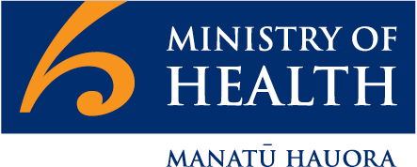
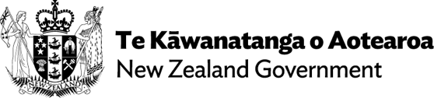

Citation: Ministry of Health. 2021.
Mental Health and Addiction Year in Review
Wellington: Ministry of Health.
Published in November 2021 by the Ministry of Health PO Box 5013, Wellington 6140, New Zealand
ISBN 978-1-99-100790-2 (online)
HP 7963
This document is available at health.govt.nz
This work is licensed under the Creative Commons Attribution 4.0 International licence. In essence, you are free to: share ie, copy and redistribute the material in any medium or format; adapt
ie, remix, transform and build upon the material. You must give appropriate credit, provide a link to the licence and indicate if changes were made.

Foreword
From the Deputy Director-General Mental Health and Addiction

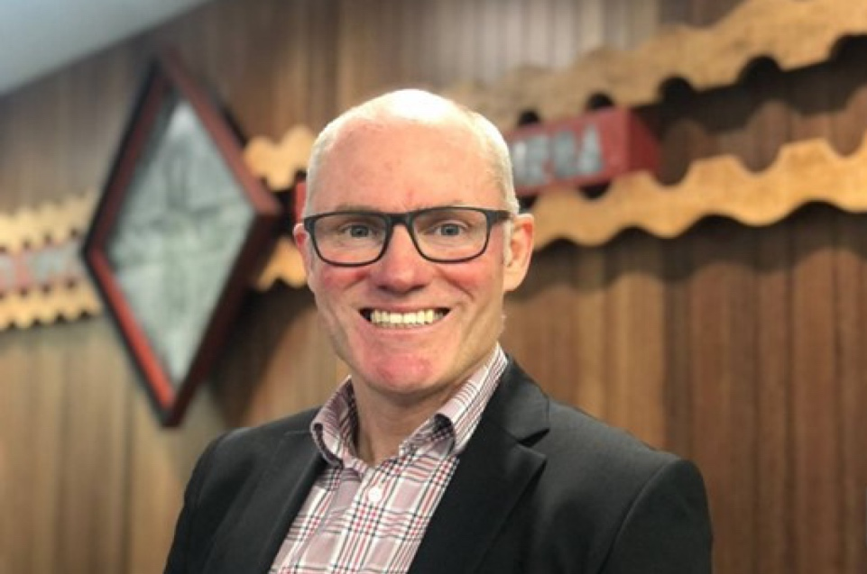

Kia ora koutou. Welcome to the Year in Review, a report we have compiled to showcase some of this past financial year’s highlights and major changes and to provide some general context around our wider work programme.
This covers the 12-month period from 1 July 2020 to 30 June 2021. While I wasn’t in the Deputy Director-General role during this time, I was on the senior leadership team of the Mental Health and Addiction directorate in the Ministry of Health. It’s fair to say this
period saw a significant amount of change as we continued work to transform the mental health and addiction sector.
Looking back, there’s a lot of positive change happening, and I’m pleased to see some
big pieces like our Access and Choice programme are coming together and starting to produce excellent outcomes for
New Zealanders. But it’s also important to face up to the challenges that remain. Alongside the Year in Review, we are publishing a
wide range of different reports to ensure transparency about the performance of the mental health and addiction system and services. These reports provide insight into issues like the continued use of seclusion and wait times for service users. While these aren’t new problems, new solutions are being worked on and new services are being stood up, so there’s a wider story to tell and context to provide.
There has no doubt been COVID-19-related impacts on our sector’s progress, with many services needing to pivot to join the wider health and psychosocial response. Kia Kaha, Kia Māia, Kia Ora Aotearoa: COVID-19 Psychosocial and Mental Wellbeing Plan has made a difference and I’m proud of our sector’s contribution. We are working hard behind the scenes to increase vaccination rates in the mental health and addiction service user community. The response to COVID-19 will continue to pose resourcing challenges into the future for the sector, but it is my view we must not lose focus or the momentum we have in transforming mental health and addiction care in this country.

We know right now the mental health and addiction system isn’t where it needs to be. We know about many of the pressures,
the shortages and the inequities. In 2020/21 we made genuine progress against this.
As it stands today more than 11,000 people are being seen every month by health improvement practitioners and health coaches in around 237 general practice clinics across New Zealand – and the access will continue to grow as this phased rollout ramps up. New kaupapa Māori services and Pacific services are also being stood up and we have contracted rainbow competency training to help health professionals to better cater to the needs of some of our most vulnerable communities.
The transformation stems from He Ara Oranga: Report of the Government Inquiry into Mental Health and Addiction, published in 2018. The Government’s response to He Ara Oranga guides our work, and our directorate has been busy with its implementation.
This year we saw significant opportunities continue to open up for New Zealanders to contribute to shaping the future state of our mental health and addiction services. We have completed engagement on gambling harm reduction and launched a consultation on repealing and replacing the Mental Health (Compulsory Assessment and Treatment) Act 1992 and work has begun on a framework to set out the core components of a contemporary mental health and addiction system and services.
We welcomed a new and vitally important voice to our senior leadership team in the form of lived experience. The Lived Experience group amplifies the voices of New Zealand’s lived experience communities and brings a wealth of knowledge and experience to our directorate’s governance, planning, policy and service development decisions.
I was also proud to see the launch of Kia Manawanui Aotearoa: Long-term pathway to mental wellbeing in September. While this event fell outside the financial year, much of
the hard work to create this strategy was done during it. Kia Manawanui represents the first time all of government has come together to address the determinants of mental wellbeing, and it also elevates the contribution of whānau and a community-led approach.
This is an acknowledgement mental wellbeing is an issue for everyone to care about and that the wellbeing challenges we face as a nation are bigger than any individual, any
non-governmental organisation (NGO), any ministry or any government.
I know this will be the sort of ownership and oversight the mental health and addiction sector will be pleased to see. As a former mental health nurse myself, what sometimes feels like a lifetime ago, I know how important this sort of support and recognition is for those on the frontlines.
With that in mind, I want to thank everyone in the sector. It’s been a huge year with COVID-19 and all of the other additional workforce and capacity pressures on the health system. My hope is the work detailed in this report will
give you heart that change and progress is happening at pace, and that momentum will not be lost.
Finally, I want to also give my thanks to my predecessor Toni Gutschlag for everything she did in leading mental health and addiction through some incredibly challenging times.
Also, our first Director of the Suicide Prevention Office Carla na Nagara, who finished up this year – thank you for all you did in setting up the Suicide Prevention Office for success.

Ngā mihi nui

Philip Grady
Deputy Director-General, Mental Health and Addiction

Contents

Foreword i
Mental health and addiction services offered 2
Psychosocial and wellbeing response to COVID-19 4
Primary and community wellbeing 5
Expanding access and choice Supporting children and young people Rainbow young people
Tertiary student wellbeing Maternal mental health
Fit-for-purpose legislation 11
Focusing on lived experience 13
Workforce development 14
Specialist services 16
Suicide prevention 18
Alcohol & other drugs & reducing gambling harm 20
Pregnancy and Parenting Service
Primary and community alcohol and other drugs services Waikato Alcohol and Other Drug Treatment Court
Te Ara Oranga
Sector reporting 23

Mental health and addiction services offered

as at June 30 2021

11
12

In all regions
- Mental Health and Addiction (MHA) crisis service development and capability planning
- MHA crisis support FTE
- Increased funding for specialist alcohol
and other drug (AOD) services
- Youth telehealth and web chat support
- Expanded telehealth, digital and online support options
- Aoake te Rā, bereaved by suicide service (online)
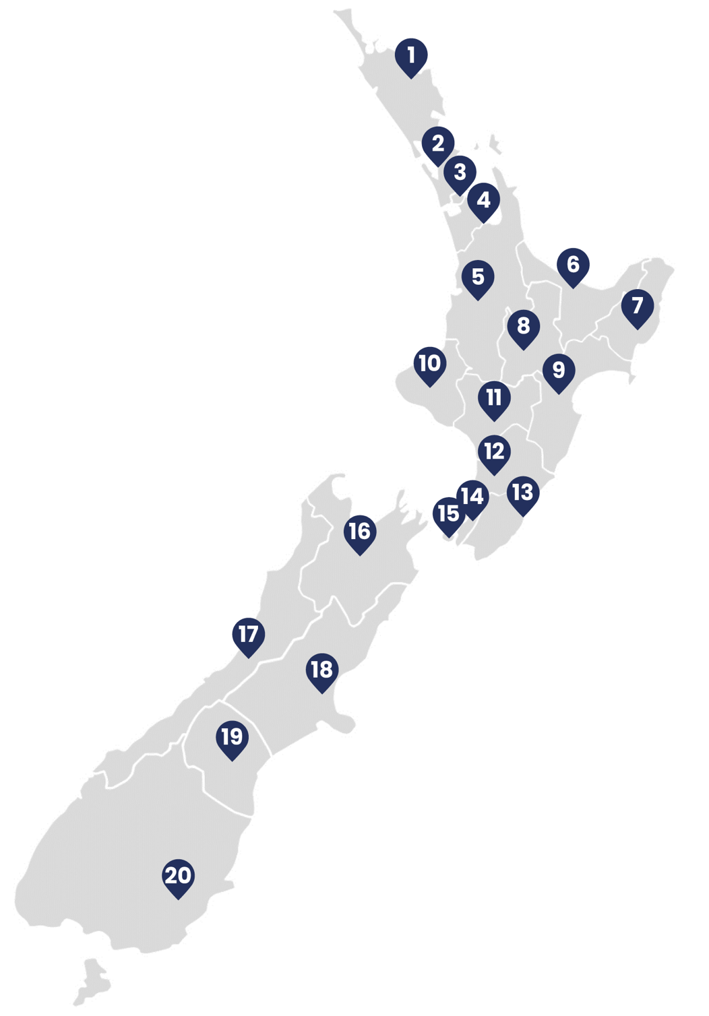

Northland
- Integrated primary MHA services
- Te Ara Oranga
- Youth primary MHA service

Waitematā
- Integrated primary MHA services
- Pacific primary MHA service
- Youth primary MHA service
- Additional adult forensic MHA prison in-reach services

Auckland
- Integrated primary MHA services
- Youth primary MHA service
- Pacific primary MHA service
- Community AOD initiative (Haven Café)
- Additional youth MHA forensic community FTE

Counties Manukau
  - Integrated primary MHA services
  - Youth primary MHA service
  - Pacific primary MHA service
  - Māori primary MHA service

Waikato
    - Integrated primary MHA services
    - Youth primary MHA service
    - Māori primary MHA service
    - Pacific primary MHA service
    - Additional adult forensic MHA prison in-reach services
    - Additional youth MHA forensic community FTE
    - Additional AOD clinical FTE

Bay of Plenty
    - AOD Pregnancy and Parenting pilot site
    - Additional AOD specialist service
    - Youth primary MHA service (Eastern BoP)

Tairāwhiti
    - Māori primary MHA service
    - Additional AOD specialist service

Lakes
    - Integrated primary MHA services
    - Youth primary MHA services
    - Māori primary MHA service
    - Additional AOD specialist service

Hawke’s Bay
    - Integrated primary MHA services
    - Additional AOD residential care beds
    - Māori primary MHA service

Taranaki
    - Integrated primary MHA services
    - Additional AOD specialist service
- Acute Drug Harm Fund initiative
- Community AOD initiative
- Māori primary MHA service

Whanganui
- Integrated primary MHA services
- AOD Pregnancy and Parenting pilot site
- Māori primary MHA service

MidCentral
- Integrated primary MHA service
- Youth primary MHA service

Wairarapa
- Integrated primary MHA services
- Youth primary MHA services
- Piki Pilot

Hutt Valley
- Integrated primary MHA services
- Youth primary MHA services
- Pacific primary MHA services
- Acute Drug Harm Discretionary Fund
- Piki pilot

Capital and Coast
- Integrated primary MHA services
- Youth primary MHA services
- Pacific primary MHA services
- Additional adult forensic MHA prison in-reach services
- Additional youth MHA forensic community FTE
- Additional adult forensic community FTE
- Piki pilot

Nelson Marlborough
- Integrated primary MHA services
- Acute Drug Harm Discretionary Fund
- Withdrawal management service

West Coast
- Youth primary MHA services
- Withdrawal management service

Canterbury
- Integrated primary MHA services
- Youth primary MHA services
- Pacific primary MHA service
- Māori primary MHA service
- Mana Ake
- Additional adult forensic MHA prison in-reach services
- Additional youth and adult MHA forensic community FTE
- Withdrawal management service

South Canterbury
- Youth primary MHA services
- Withdrawal management service

Southern
- Integrated primary MHA services
- Youth primary MHA services
- Māori primary MHA service
- Additional adult forensic MHA prison in-reach services
- Additional youth and adult MHA forensic community FTE
- Withdrawal management service

Psychosocial and wellbeing response to COVID-19

Supporting mental health and wellbeing is a key part of New Zealand’s response to
COVID-19. We have built on the foundations in place from the Government’s response to He Ara Oranga: Report of the Government Inquiry into Mental Health and Addiction, the investment from the 2019 Wellbeing Budget, and the additional $15 million investment for mental wellbeing support specifically for the COVID-19 response.
Our psychosocial responses to COVID-19, in line with Kia Kaha, Kia Māia, Kia Ora Aotearoa: COVID-19 Psychosocial and Mental Wellbeing Plan, have focused on ensuring people are aware of how they can look after themselves and others and that help is available if they need it. Kia Kaha, developed by the Ministry of Health in consultation with stakeholders, provides a framework to guide collective efforts to support mental wellbeing at national, regional and local levels. While it is focused on supporting individuals, whānau and communities to respond, recover, adapt and thrive in the context of COVID-19, it also sits within the Ministry’s longer-term work to transform New Zealand’s approach to mental wellbeing.
COVID-19 and associated restrictions continue to cause disruption, stress and uncertainty
in people’s lives. Experience from other significant events suggests that while the onset of effects on people’s mental wellbeing following a significant event like a pandemic may be delayed, the consequences can be
wide-reaching and continue for a number of years. Supporting people’s mental wellbeing will continue to be a vital part of New Zealand’s response to COVID-19.
Over the year, we supported a range of wellbeing supports for
New Zealanders, including by:
- increasing capacity for phone- based counselling through ‘Need to talk? 1737’ and the ‘Struggle Got
Real?’ campaign to encourage calls to 1737
- supporting and promoting a range of digital tools to help people manage their own wellbeing (Mentemia, Staying on Track and Melon)
- promoting the campaign ‘Getting Through Together’ – a national mental health and wellbeing campaign led by the team
at All Right? aimed at helping New Zealanders get through COVID-19 together
- facilitating a wide range of free and online Whakatau Mai wellbeing sessions offered in real-time,
helping to safely support individuals’ wellbeing from the comfort of their own space.

Primary and community wellbeing

Expanding access and choice

The 2019 Wellbeing Budget saw
$455 million phased over four years invested in the national rollout of the initiative ‘Expanding Access to and Choice of Primary Mental Health and Addiction Support’.
This programme focuses on developing primary mental health and addiction services across
a range of settings, including kaupapa Māori, Pacific and youth-specific services, as well as expanding the services accessible through general practice teams. The focus is on:
  - recognising and responding to distress early
  - increasing access and equity of access
  - providing services in places and ways that work best for the people and whānau they are serving
  - focusing on strengths and equipping people and whānau to manage their own wellbeing with support when they need it for as long as they need it
  - holistic services that recognise that distress occurs within a cultural social and economic context
  - improving outcomes and equity of outcomes.
Over the last year, services within this programme have supported tens of thousands of people. The programme will continue to grow over the next three years. While COVID-19 has presented some challenges, including the need for many providers to pivot their services and direct their attention to the wider health response, we remain on track to meet the target of 325,000 people accessing these new services annually by the end of 2023/24. During 2020/21, these services had a combined value of $61.9 million.

Numbers of priority groups accessing these services
Almost
300

people were using the Kaupapa Māori services in June 2021

More than
480

people accessed Pacific services in June 2021

More than
790

790 young people were seen through these services in June 2021

Health coaches and support workers in general practice
Health coaches and support workers including health improvement practitioners (HIPs)
are core components of this programme, providing mental wellbeing support in the community. In the last financial year, we contracted more than 345 mental health practitioners to provide these new services based in general practice sites.
These health workers use their own experience, combined with training, to partner with people, supporting them to build the skills, knowledge and confidence to manage their health and wellbeing. Many health coaches and support workers bring lived experience of mental health or addiction issues to their work, as well as relevant cultural perspectives and other life experiences.
Below are some relevant figures for these services over the last year.

Feedback from people accessing these services

‘In my experience of anxiety/ depression everything is overwhelming. It was calming to make a plan and [gain] some control. If the doctor just gives medication, it doesn’t work for
a while, what can you do in the interim? It addressed all issues that I was having, not just health.’

‘After the first appointment, it was such a relief to have a plan and some actions that might help me. I was feeling so overwhelmed and to be able to make
a plan with the HIP was calming.’

All*
20

District health boards with contracted services

General practice sites delivering services

‘In the first session the HIP recommended a psychologist, who has been great. The second session was focused on wellness tools and I went away to spend some time implementing them. And then I checked back to discuss how it was going. The HIP also helped arrange for me to see the practice nurse – it was great that they can link to other services.’
237

Almost
152,000

sessions provided
11,000

‘The methodology is a brilliant way to get people support that GPs would struggle to provide. I hope this is an opportunity to change the way mental health is dealt with.’
people seen per month (as of June 2021)

* Four of these are in the establishment phase, and are yet to commence service delivery.

Recognition of procurement practices
A highlight this year was the procurement process we ran for new kaupapa Māori primary mental health and addiction services. This process used an approach that was brand new in New Zealand. In response to feedback from Māori that government procurement processes can often result in low levels of success for Māori providers, and particularly small providers, we developed a process that was more user-friendly and culturally aligned for Māori organisations of all sizes, while remaining robust and compliant.

The Ministry won three awards for this approach at the CIPS Australia & New Zealand Excellence in Procurement Awards 2021: Best Initiative to Deliver Social Value through Procurement, Best Public Procurement Project and Overall Winner.

Supporting children and young people
Mana Ake
Mana Ake is a holistic mental health programme that provides mental wellbeing support to primary and intermediate school-aged children across Canterbury and Kaikōura. It also provides advice, guidance and support for schools, teachers and whānau.
As at 30 June 2021, Mana Ake had supported over 9,000 children either individually or in group programmes.
Schools play an important role in supporting mental health and wellbeing for children and young people. A number of school-based mental wellbeing initiatives are currently under way. We work closely with the Ministry of Education on mental wellbeing initiatives for children and young people in schools.

School based health services
Around 96,000 students in almost 300 decile 1–5 secondary schools can now access mental health support through school based health services, which places nurses in schools. This initiative offers students one-on-one conversations with a nurse to support their mental health and connect them to other support services if they require them.
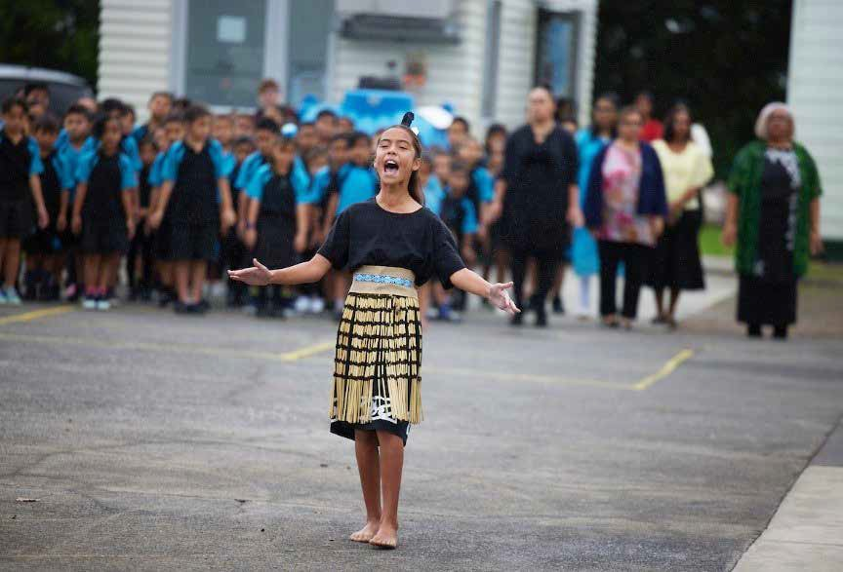
In April 2021, the Health Minister announced at Homai School (pictured) that local co-design of tailored Mana Ake services would begin in five additional DHB areas: Northland, Counties Manukau, Lakes, Bay of Plenty and West Coast. Co-design plans are due at the end of 2021 from each of these areas, with the aim of commencing service delivery in 2022.

Rainbow young people
The Ministry of Health has recently invested in expanded mental wellbeing supports for rainbow young people. This group is more likely to experience poorer mental health and wellbeing, discrimination, harassment and bullying than the general population.
RainbowYOUTH and InsideOUT Kōaro received funding for primary mental health and addiction services for rainbow young people.

InsideOUT will:
- increase its services to an additional 100 schools per year
- expand existing services/supports in schools in Wellington, Wairarapa, Auckland, Manawatū, Bay of Plenty, Taranaki, Canterbury, Otago and Southland
- establish new services/supports in schools in the West Coast, Nelson/ Tasman, Marlborough, Waikato, Gisborne,
Whanganui, Napier/Hastings and Northland.

RainbowYOUTH will:
- expand the existing RainbowYOUTH peer support (service) in Auckland, Northland, Dunedin, Taranaki and nationwide (through virtual channels).

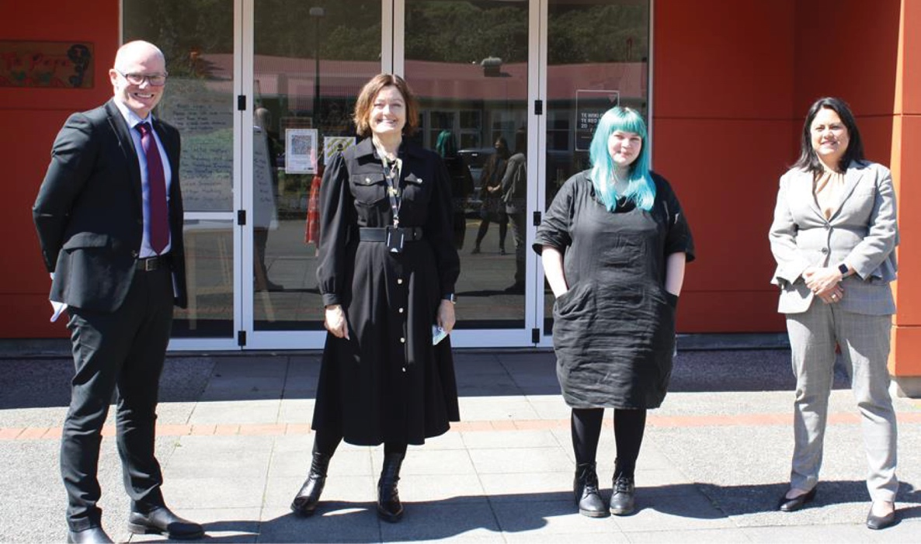
InsideOUT Kōaro has launched a new service to provide rainbow and takatāpui competency training for the mental health and addiction workforce in Aotearoa. This service will make it easier for rainbow and takatāpui service users to access safe and inclusive care for mental health and addiction challenges. Left to right: Philip Grady, Karla Bergquist (Managing Director of InsideOUT Kōaro), Tabby Besley, and Associate Minister of Health, Hon Dr Ayesha Verrall.

Tertiary student wellbeing
As part of the Ministry of Education’s Budget 2020 Student and Educator Wellbeing Package,
$25 million was made available over four years to expand mental health and wellbeing services for tertiary education students. This initiative builds on current service provision across tertiary education institutes.
Funding is phased. $2 million is available in year one (2020/21), increasing to $10 million annually from year four. The number and reach of services will expand as funding increases over the next three years.
Māori and Pacific learners were identified as priority populations for year one. Because the greatest proportion of Māori and Pacific learners are enrolled in wānanga and Te Pūkenga (New Zealand Institute of Skills and Technology) subsidiaries, these institutions were targeted for funding in the first year.
The Ministry of Health and Te Pūkenga signed a contract for services in April 2021 and the Ministry also commenced discussions with three wānanga to consider how best to distribute funding to provide additional supports to their learners.

Maternal mental health
This year, we continued our foundational work to strengthen maternal mental health services. We undertook a stocktake of
services district health boards (DHBs) provide, to understand what is working well and identify gaps. While the Access and Choice programme has increased the community support available to everyone, there is still a need for support for mothers and their whānau. We will use the findings of the stocktake to inform the way maternal mental health services are delivered in the future.

Piki
Piki, launched in February 2019, is an innovative primary mental health service that aims to improve access to mental health and wellbeing support for young people aged 18 to 25 years in the Greater Wellington area who are experiencing mild to moderate levels of distress. As at 30 June 2021, Piki had supported nearly 7,000 young people. Piki has been extended for a further
18 months to December 2022.

Fit-for-purpose legislation

He Ara Oranga recommended repealing and replacing the Mental Health (Compulsory Assessment and Treatment) Act 1992 (the Mental Health Act), because it has not kept pace
with the shift towards a recovery and wellbeing approach to care, and has never been comprehensively reviewed. The Government accepted this recommendation in full.
Since 2019, we have been working on immediate, short-term improvements under the current legislation, alongside work to understand which issues we need to be address when we create new mental health legislation for New Zealand.

Improving service user experiences under the current Mental Health Act
In September 2020, we published a range of new guidelines for clinical staff, district inspectors and anyone else working within the legal or clinical framework of the Mental Health Act.
The guidelines help to clarify how people should administer the Act, particularly in regard to:
- the growing influence of rights-based approaches, and how we can better promote such approaches within the parameters of the current Act
- the need to give greater emphasis to our obligations under Te Tiriti o Waitangi
- the impact of He Ara Oranga and feedback from people with lived experience and
their families and whānau on how they experience the current administration of the Mental Health Act.
Education and training are under way to help embed these changes.

Amendments to the current Mental Health Act to better protect people’s rights and improve safety
The Mental Health (Compulsory Assessment and Treatment) Amendment Bill was introduced in March 2021 and gained Royal assent at the end of October 2021.
It makes four key changes to the Mental Health Act to improve the protection of individual rights, ensure the safety of patients and the public and enable more effective application of the Act:
  - eliminating indefinite treatment orders
  - minimising the risk of harm to patients and the public during transport of forensic patients who are ‘special patients’ as defined under the Act
  - addressing technical drafting issues that will improve the administrative efficiency of the Act
  - removing the sunset date for technical amendments and audiovisual link amendments made by the COVID-19 Response (Further Management Measures) Legislation Act 2020.
All of these changes came into force on 30 October 2021, except the elimination of
indefinite compulsory treatment orders, which will come into effect by Order in Council or two years following the date of Royal assent. This timeframe is to ensure there is sufficient time for implementation.

Repealing and replacing the Mental Health Act
Our new guidelines for administration of the current Mental Health Act, and the Mental Health (Compulsory Assessment and Treatment) Amendment Bill, represent short-term improvements to the current legislation. As a long-term solution, the Government is planning a full repeal and replacement of the current Act: it approved principles to guide development of new mental health legislation in 2019. We have been preparing for this process, including by reviewing previous related consultations, academic research and international examples to understand the key issues and potential options.
We developed a public discussion document in consultation with a targeted group of stakeholders, including people in the mental health and addiction sector, people with lived experience, academia and government agencies. The discussion document sets out the key topics that we need to consider in the development of new legislation. Cabinet approved this document at the beginning of October 2021.
Public consultation will run for three months to 28 January 2022.

Focusing on lived experience

He Ara Oranga recognised that people with lived experience and their whānau hold critical knowledge as experts, leaders, advocates, service providers, and service users.
Several of He Ara Oranga’s recommendations focused on improving the ways people with lived experience can meaningfully engage with mental health and addiction governance, planning, policy and service development decisions.
We established our Lived Experience group in February this year, and the Programme Director of this group is part of the Mental Health and Addiction directorate’s senior leadership team.
The Lived Experience group has been working closely with people with lived experience to bring them into the directorate’s work at all levels, ensuring that the Ministry understands and makes use of the expertise and knowledge of people with lived experience.
The group is active across the Ministry of Health, demonstrating how the lived experience voice can enhance Ministry stewardship.

Workforce development

A sustainable, diverse and skilled mental health and addiction workforce is essential to transforming our approach to mental wellbeing. The 2019 Wellbeing Budget included funding to increase the number of people working in the sector and build the skills and capability of the existing workforce.
There is an ongoing focus on developing Māori and Pacific mental health and addiction workforces. Over the year, work to this end has included:
  - more than doubling the capacity of cultural competency programmes by creating more than 800 new places to help ensure Māori and Pacific people receive culturally appropriate support
  - creating 46 new bursaries for Māori students pursuing a career in mental health and addiction
  - creating 30 new scholarships for Pacific students pursuing a career in mental health and addiction.
We work closely with national mental health and addiction workforce development centres as key partners for developing Māori and Pacific workforces. These include Te Rau Ora, which leads Māori workforce development activities, and Le Va, which leads Pacific workforce development activities.
Whāraurau, which leads workforce development for the infant, child and adolescent mental health and alcohol and other drugs (AOD) sectors, is also a key partner.
Rainbow competency training for mental health and addiction professionals started in the final quarter of this year. The training will support professionals to better understand and address the needs of the rainbow community.
Primary mental health and
addiction nurse credentialling
programme
This year the primary mental health and addiction nurse credentialling programme celebrated the 500th nurse enrolment. The programme is designed to help nurses not working in specialist mental health and addiction roles to develop their knowledge and skills and build their confidence in providing support to people with mental health and addiction needs. About three-quarters of nurses undertaking the training work in general practices. Others work in a variety of primary health care-focused nursing roles, including for Corrections, iwi and Māori providers, schools and the New Zealand Defence Force. They include public health, youth health and district nurses.

The following information summarises initiatives
in the area of workforce development

Growing existing workforces
Over
100

additional New Entry to Specialist Practice places each year for
nurses, social workers and occupational therapists to practice in mental health and addiction

1

Upskilling existing workforces
Over
70

new training places for post-graduate study in 2021 in specialist
practice areas including leadership; cognitive behavioural therapy; and infant, child and
adolescent mental health and addiction

Developing new workforces
200
Over
200

places for HIP training and over 200 places for health coach training for
positions within integrated
primary services
46

New programme to support nurse practitioners and
enrolled nurses with a substantive mental health and addiction role into employment with health providers

8

additional clinical psychology internships each year, bringing total supported internships to 20

new places in 2021 for primary care nurses to achieve credentialling in mental health and addiction
800

new places for Māori and Pacific cultural competence training each year
new bursaries each year for Māori students pursuing a career in mental health and addiction
30

new scholarships each year for Pacific students pursuing a career in mental health and addiction

Specialist services

While we are working to expand access and choice in the context of primary and community mental wellbeing services, it is critical that people who need more specialist support have timely access to high-quality care. Similarly, it is important that people who are experiencing distress have access to timely and appropriate crisis supports.
There has been pressure on specialist mental health and addiction services, including crisis services, for some time – and dedicated professionals in this area are working hard
to meet the needs of their communities. We are undertaking a range of initiatives to help address these pressures.

Crisis services
We are working with DHBs to improve mental health and addiction crisis support services, by supporting the enhancement of existing crisis response services and implementing a community-based integrated crisis and peer support pilot.
This financial year, the Ministry invested
$1.39 million to introduce 10.7 new mental health and addiction crisis support full-time equivalent roles across all 20 DHBs. These roles are intended to support the implementation of DHBs’ crisis plans and enhance service provision. They will also help to enhance responses where people present in crisis.
In line with some of the key shifts He Ara Oranga called for, we are developing a pilot of a community-based peer-led crisis centre in Hawke’s Bay DHB.
Te Tāwharau, meaning ‘shelter’, is a mental wellbeing service integrated with NZ Police and social service support.
The facility will provide crisis respite, emergency mental health services and home-based treatment services. These
services are currently all operating in separate locations, with the peer support operating as part of the emergency mental health service. Services will be fully co-located in early 2022. Te Tāwharau has received positive feedback on its peer support workers from tāngata whaiora in the community and other DHB staff.

Access to specialist services
We continue to see increases in the number of people accessing specialist mental health
services. This is likely due to population growth, improved visibility and access to services and stronger referral relationships between health providers, as well as improvements in data reporting.

The Office of the Director of Mental Health and Addiction Services’ Regulatory Report contains further information and statistics on people receiving care under the Mental Health Act and the Substance Addiction (Compulsory Assessment and Treatment) Act 2017.

The following table shows client numbers between 2018 and 2021.
Total child and youth clients  (aged 0–19 years) | 2018/19 | 2019/20 | 2020/21*
 | 49,634 | 49,764 | 50,694
Total adult clients  (aged 20–64 years) | 115,610 | 119,050 | 119,253
Total older clients  (aged 65+) | 14,188 | 14,774 | 14,817
Total clients | 179,432 | 183,588 | 184,764
* 12 months to end of Q2 of 2020/21

Wait times for people seeking specialist mental health support
The Ministry of Health measures wait times new clients experience from referral until their first face-to-face contact (defining ‘new client’ as a person specialist mental health services have not seen for at least a year).
For this purpose, the Ministry uses the Programme for the Integration of Mental Health Data (PRIMHD). This data, used to measure performance, is regularly published on our website.

This is not averaged data. The first contact may entail engagement; assessment; safety planning; and a range of short-term
interventions including cognitive, behavioural and supportive strategies and (potentially) medication.

The following table shows wait times by age group over 2019–2021.
 | Within 48 hours |  | Within 3 weeks |  | Within 8 weeks
Age | 2019/20 | 2020/21 | 2019/20 | 2020/21 | 2019/20 | 2020/21
0–19 years | 35% | 37% | 67% | 67% | 85% | 90%
20–64 years | 59% | 60% | 82% | 85% | 93% | 96%
65+ | 44% | 42% | 83% | 86% | 95% | 98%

Suicide prevention

The Ministry of Health established the Suicide Prevention Office in November 2019 in response to He Ara Oranga. The Office leads suicide prevention work and delivers a nationally coordinated approach to the implementation of Every Life Matters – He Tapu te Oranga o ia Tangata: Suicide Prevention Strategy 2019–2029 and Suicide Prevention Action Plan 2019–2024 for Aotearoa New Zealand.
Suicide is always a tragedy; we know Aotearoa’s suicide rates need to come down.
We also know that there is no single factor that can predict a person’s vulnerability to suicide. We all have a part to play to ensure New Zealanders can thrive and live their lives in communities where people reach out and support each other; where there are services that people in mental distress can access; and where care is taken to ensure their welfare is supported to give them every opportunity to thrive. When a suicide does occur, we need to make sure whānau and friends can access the right support for them in a way that is culturally appropriate and within easy reach.
There is so much good work happening in this area in communities across Aotearoa, especially in the areas of Māori and Pasifika wellbeing intervention and support. This last year, suicide prevention initiatives and programmes received accelerated funding through Budget 2019.

Carla na Nagara, Director of the Suicide Prevention Office, with Tau Faaeteete, Zeal Education. Zeal Education is a recipient of the Pasifika Suicide Prevention Community Fund, administered by Le Va. The funding is being used to develop and run suicide prevention mentoring groups in Auckland and Wellington. The groups run for 10 weeks each term, with approximately 10–30 Pasifika young people attending each group.

Evaluation work
In May 2020, the Suicide Prevention Office conducted a review of New Zealand’s suicide prevention sector. It released its final findings in October 2020: Sector Voices: A review of the suicide prevention sector on behalf of the Suicide Prevention Office.

Provider funding
A number of national and community organisations received funding for mental wellbeing and suicide prevention initiatives over the past year, either through national partners (Te Rau Ora and Le Va) that manage Māori and Pacific suicide prevention community funds or directly through other suicide prevention programmes the Suicide Prevention Office funds.
The majority of these funds were targeted at building the capacity of whānau, hapū and iwi to prevent suicide and respond effectively when necessary. Similarly, the Office supported Pacific providers to build capacity in this area.
This year we implemented a new national suicide postvention service, Aoake ta Rā, which provides free support nationally for whānau and friends bereaved by suicide.

Suicide prevention coordinators
Suicide prevention and postvention coordinators are in place in DHBs across the motu. Additional funding this year has enabled suicide prevention coordinators to increase their emphasis on providing
postvention support specifically for Māori, who are overrepresented in suicide statistics.

Māori Expert Reference Panel
The Māori Expert Reference Panel has provided valuable guidance to the Suicide Prevention Office and has supported a steady waka for the mahi.
During the last year, the Māori Expert Reference Panel has been integral to providing the Suicide Prevention Office with strategic advice, support and guidance on matters relating to Māori suicide prevention and implementation of He Tapu te Oranga.
Towards the end of 2020, Sir Mason Durie stepped down from his position of Chair. Hinemoa Elder replaced him in May 2021.
Current members are:
- Dr Hinemoa Elder
- Dean Rangihuna
- Tricia Walsh
- Dr Waikaremoana Waitoki
- Mapihi Raharuhi
- Kirsty Maxwell-Crawford

Alcohol & other drugs & reducing gambling harm

Alcohol and other drug services and service users, and gambling services and service users, have had to adjust to the challenges of COVID-19. Those challenges have related to technology, including familiarity, access and
data allowances for both people accessing services and the workforce; communication lines to and across the sector; and an increased need
to focus on meeting people’s basic needs for food and shelter before being able to provide support for specific addiction issues.

Pregnancy and Parenting Service
The Pregnancy and Parenting Service (PPS) is an intensive engagement and harm reduction service that aims to reduce risk and improve outcomes for parents who are experiencing the harms of substance use, have infants under the age of three or are pregnant, and are marginalised or poorly connected to health and social services.
The service currently operates at six sites: Waitematā (the original site, where the service has been running for over 15 years); Tairāwhiti, Hawke’s Bay and Northland (all funded through Budget 2016); and Eastern Bay of Plenty and Whanganui (funded through Budget 2019).
We have completed an outcomes evaluation of the service at Tairāwhiti, Hawke’s Bay and Northland; this will be available publicly soon.
The evaluation showed that the PPS made a positive difference for many clients and their whānau, including improved wellbeing, reductions in addiction, improved child outcomes and reduction in risk for children.
The Eastern Bay of Plenty and Whanganui sites opened their doors in March and April 2021 respectively. Both DHBs have partnered with kaupapa Māori organisations to develop PPSs that are driven by mātauranga Māori. Each will provide support to 100 parents/ mātua and their whānau.

Primary and community alcohol and other drugs services
Budget 2019 invested $14 million over four years in primary and community AOD services. This funding increases incrementally, with a further $1 million in sustainable funding available each year until the 2022/23 financial year. Alongside the two initiatives outlined below, we have contracted services in Counties and South Canterbury so far.

Peer support
Taranaki DHB received funding for two peer support services – one for people experiencing AOD harm themselves, and one for affected family and others. The latter is an existing peer support service called Families Overcoming Addiction, which supports whānau and friends of those with AOD issues.
Between April 2020, when the service commenced, and the end of June 2021: 86
people attended the weekly
New Plymouth Families Overcoming Addiction group sessions
5
people attended the monthly Stratford
Families Overcoming Addiction group
sessions, which started in mid-May 2021
68
whānau groups were supported via one-on-one sessions with a peer support facilitator.

During this period there were 58 New Plymouth group sessions, 2 Stratford group sessions and 346 one-on-one peer support sessions. The launch of the peer support service for those experiencing AOD harm themselves was delayed; it will occur by the end of this calendar year.

Haven Recovery Café
Haven Recovery Café, run by Odyssey House on Auckland’s Karangahape Road, is a drop- in support space for people with AOD needs. It has been consistently receiving around 600 drop-ins each weekend; approximately 400 individuals accessed support from the café in 2020/21.
The café estimates that, between May 2020 and 1 July 2021, it received more than 20,000 drop-ins.

Waikato Alcohol and Other Drug Treatment Court
The Waikato Alcohol and Other Drug Treatment Court, Te Whare Whakapiki Wairua ki Kirikiriroa, opened on 12 June 2021. The court is a joint initiative involving many organisations, including Waikato DHB, the Ministry of Health, the Ministry of Justice, local iwi and health service providers.
Alcohol and other drug treatment courts provide an important and effective alternative pathway to imprisonment for people experiencing addiction. An important aspect of each court is making sure it accurately reflects the needs and opportunities of the local community. At Te Whare Whakapiki Wairua ki Kirikiriroa, Waikato-Tainui appoint a Pou Oranga to support the Court to embed tikanga and connect with local iwi, marae and kaupapa Māori services. The Pou
Oranga works alongside the whānau support expert, whose role is to provide support to participants and their whānau.

Te Ara Oranga
Te Ara Oranga, the methamphetamine harm reduction programme, based in Northland, is an innovative, integrated model of health care, community and policing designed to reduce the supply and demand for methamphetamine. It is not a single treatment programme but rather a system entailing Police prevention and enforcement activities; community support; and various health services, including AOD treatment programmes, screening and brief intervention, support from Pou Whānau connectors as well as employment support.
Budget 2019 provided $4 million over four years to fund the programme. Between July 2019 and the end of June 2021, Te Ara Oranga supported almost 1,500 people.

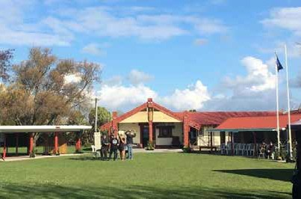
Te Whare Whakapiki Wairua ki Kirikiriroa (Waikato Alcohol and Other Drug Treatment Court) at Hukanui Marae.

Sector reporting

On the Mental Health and Addiction section of the Ministry of Health website, you can find statistics and data relating to the mental health and addiction system, including information about specialist services, the Access and Choice programme and suicide. Specifically, you can find:
  - information on access to specialist services
  - information on transition (discharge) planning
  - information on wait times
  - suicide statistics
  - The Office of the Director of Mental Health and Addiction Services’ Regulatory Report 2020.
A number of other organisations collect and publish information relating to the performance of the mental health and addiction system.

Department of the Prime Minister and Cabinet Implementation Unit
The Department of the Prime Minister and Cabinet (DPMC)’s Implementation Unit carried out a mid-term review of the 2019 mental health and addiction package. The report is available on DPMC’s website.

Mental Health and Wellbeing Commission
The Mental Health and Wellbeing Commission provides system-level oversight of mental health and wellbeing in New Zealand. It became an independent Crown entity in February 2021. The Commission’s Board is chaired by Hayden Wano. The board members are Professor Sunny Collings, Kevin Hague, Taimi Allan, Dr Jemaima Tiatia-Seath, and Alexander El Amanni. Information about the Commission’s work is available on their website.

Te Pou
Te Pou is the national workforce centre for mental health, addiction and disability. It runs a consumer satisfaction survey for tāngata whai ora and whānau to find out about their experience of the services they receive in the DHB and NGO non-governmental organisation mental health and addiction sector. Te Pou publishes results of this survey on its website.

Chief Coroner
The Chief Coroner releases national suspected suicide statistics each year. These are available on the Coronial Services’ website.

Te Kawanatanga o Aotearoa

