Ministry of Health

Output Plan

2018/19

Contents
About this output plan 4
Delivering priorities for the sector and Ministry 4
A. Medium-term Government priorities: 4
B. Immediate system priorities: 4
C. Other supporting priorities 4
D. Core work of the Ministry 5
E. Lifting core capability of the Ministry/response to the Performance Improvement Framework 5
Work programmes for associate ministers 6
Overview of our programmes 6
Current reviews and inquiries 7
Reporting against this output plan 8
Signed statements 8
System context 9
Coalition agreement on the health and disability system 9
Ministerial delegations 10
Overview of the vote 11
Progressing our priorities 12
Portfolio, programme and project management approach 12
Summary diagrams – output plan deliverables 13
A. Government priorities 19
Priority 1: Mental health and addictions 19
Priority 2: Primary health care 19
Priority 3: Child wellbeing 20
Priority 4: Achieving equity in health outcomes 21
B. System priorities 22
Priority 1: Improving DHB performance 22
Priority 2: Drinking-water regulation 22
Priority 3: Maternity care 23
Priority 4: Planned care 24
Priority 5: Capital asset management 24
C. Supporting priorities 25
Māori health 25
Pacific health 26
Health of older people/aged care 26
Anti-microbial resistance 27
Bowel screening 28
Budget 2019 29
National Health Information Platform 29
Disability support system transformation 30
National data collection transformation 30
Non-communicable disease prevention and management 30
Pay equity/industrial relations 31
Appropriations funding review 32
Sector operations transformation 32
Supporting the Health and Disability System Review 33
National health and disability workforce strategy 33
Organ donation agency 34
Medicinal cannabis agency 34
Long-term system planning for ambulance 35
D. Core work/functions of the Ministry 36
E. Responding to the Performance Improvement Framework review 37
Focus area descriptions 38
Focus area 1: Systems and processes 38
Focus area 2: Sustainable health system and performance story 38
Focus area 3: Clarity, execution and measurement of our strategy 38
Focus area 4: Analytics, insights and the voice of the customer 38
Focus area 5: Governance, leadership and stewardship 38
Focus area 6: Relationships and ways of working 38
Focus area 7: Culture and capability 39
Key performance improvement activities for 2017/18 39
Conclusion 40
Appendix One: Hon Associate Minister of Health Salesa work programme 41
Appendix Two: Hon Associate Minister of Health Genter work programme 44

About this output plan
This output plan (the plan) is a performance agreement between the Minister of Health (the Minister) and the Director-General of Health, and includes the work programme for the Associate Ministers of Health. It covers the financial year ending 30 June 2019.
The plan is designed to show the Ministry of Health’s (the Ministry’s) commitment to deliver a range of ‘outputs’ to the Minister and Associate Ministers of Health, encompassing:
- a portfolio of strategic priorities including medium-term flagship priorities that the Government has identified for the health and disability sector
- other supporting priorities projects currently being undertaken
- the delivery of the Ministry’s core functions, with accompanying key performance measures
- our performance improvement work programme to lift our core capabilities to address the findings of the 2017 Performance Improvement Framework (PIF) review.
The plan is designed to demonstrate that New Zealanders will have access to strongly and strategically provided public health services which are well funded by the Government and that will deliver high-quality health outcomes.

Delivering priorities for the sector and Ministry
We have organised our priorities into a number of distinct clusters as shown below. These priority programmes will help to deliver on the Government’s goals of a strong public health care system and improved and more equitable health outcomes for New Zealanders.

Medium-term Government priorities:
- mental health
- primary health care
- child wellbeing
- achieving equity.

Immediate system priorities:
- improving DHB performance
- drinking-water regulation
- maternity care
- planned care
- capital asset management.
- Other supporting priorities
The Ministry is mindful that work in other areas needs to be delivered to support the Government priorities and the five immediate system priorities, as well as contributing to improved outcomes for New Zealanders. These supporting priorities are:
- improving Māori health outcomes
- refreshing Pacific health strategic priorities
- delivering better outcomes for people requiring aged care
- minimising the threat of antimicrobial resistance to humans
- implementing the National Bowel Screening Programme (NBSP) to reduce the mortality rate from bowel cancer
- delivering a successful Budget package for 2019/20
- progressing a National Health Information Platform
- transforming disability support services (DSS)
- transforming national data collection
- improving non-communicable disease prevention and management
- extending pay equity to relevant health workers and achieving the Government’s industrial relations objectives
- reviewing the Appropriations of Vote Health including Vote structure and performance measures
- improving payments and information processes through sector operations transformation
- supporting the Health and Disability System Review
- developing a national health and disability workforce strategy 2018-2030
- legislating to allow NZ Blood Service to take on organ donation functions
- establishing a regulatory scheme and agency for medicinal cannabis use
- implementing a long-term system plan for the air ambulance service.
Contributions to the supporting priorities will be approached in the same way as for the Government and system priorities. It is acknowledged that during the year changes in circumstances may create risks to the achievement of this work programme. For example we may be asked to do work on emerging issues. If necessary, the Ministry will reprioritise the output plan in consultation with Ministers.
- Core work of the Ministry
In addition to the delivery of the strategic work programme above, the Ministry will maintain a strong focus on delivering our core functions, including delivery of:
- policy advice
- ministerial servicing
- regulatory and enforcement services
- sector payment services
- sector planning and performance, including commissioning (including national health services, disability support services and public health)
- health sector information systems.
The standards to which these outputs above will be delivered are described on page 36.
- Lifting core capability of the Ministry/response to the Performance Improvement Framework
The Ministry’s response to the PIF review undertaken in 2016/17 aims to lift the core capability of the Ministry to ensure it can:
- deliver on government priorities (programme and project delivery)
- execute organisational improvement initiatives (distilling PIF recommendations into immediate actions and a 6–12 month improvement work programme)
- plan and run the business more effectively, which includes development of this plan and the Ministry’s wider work programme.
The performance improvement programme is under development, and will be finalised after second-tier structure changes are completed.
The improvement programme is grouped into seven focus areas that were identified as needing immediate attention:
- systems and processes
- sustainable health system and a clear performance story
- clarity, execution and measurement of our strategy
- analytics, insights and the voice of the customer
- governance, leadership and stewardship
- relationships and ways of working
- culture and capability.

Work programmes for associate ministers
Additional work programmes to support associate ministers are included as appendices.

Overview of our programmes
The diagram below illustrates the linkages between the priorities above and the system shifts the health and disability system needs to make.
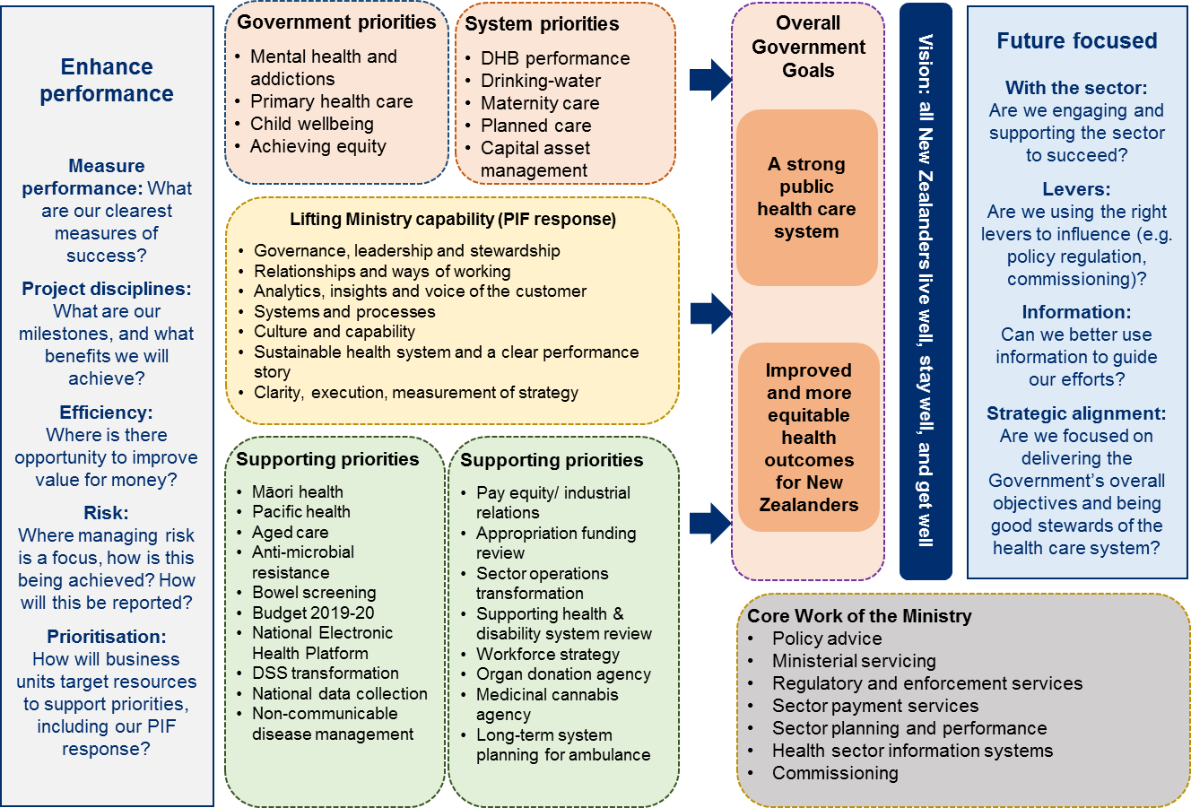

In all our work we will address the Government’s Treaty of Waitangi obligation to improve Māori health outcomes.

Current reviews and inquiries
There are several reviews and inquiries underway currently or imminently that will inform our work programme over the next year and beyond. This includes the overarching Health and Disability System Review announced by the Minister in May 2018. This work will require resourcing and substantial input and support from the Ministry and we will be working to identify what these needs might be.
A brief description of the review scope and deliverables of this review, along with work being undertaken by the Ministry on other reviews and inquiries, are shown below.
Current health sector reviews and inquiries
Review of the New Zealand Health and Disability Sector
- The Review will provide a report to the Government, including recommendations, on:
  - A sustainable and forward-looking Health and Disability System that is well placed to respond to future needs of all New Zealanders and which:
    - Is designed to achieve better health and wellness outcomes for all New Zealanders.
    - Ensures improvements in health outcomes of Māori and other population groups.
    - Has reduced barriers to access to both health and disability services to achieve equitable outcomes for all parts of the population.
    - Improves the quality, effectiveness and efficiency of the Health and Disability System, including institutional, funding and governance arrangements.
  - How the recommendations could be implemented.
Deliverables
- The Review will provide an interim report by the end of August 2019 and a final report by 31 March 2020.

Other reviews and inquiries underway or imminent, and responses to recent reviews
- Inquiry into Mental Health and Addiction (reporting October 2018).
- Bowel Cancer Screening Review (reported July 2018).
- Waitangi Tribunal Health Services and Outcomes Kaupapa Inquiry (WAI 2575) (stage 1 Primary Health Care – it is expected the Waitangi Tribunal will produce its Stage One report in quarter three, 2018/19).
- Productivity Commission report (response to this).
- Water regulation/‘Three waters’ in response to the Havelock North Water Inquiry.
- Working intersectorally with other Government agencies and Crown entities, to deliver a “wellness approach’ to the delivery of services.

Reporting against this output plan
The Director-General will provide the Minister with four-monthly progress reports against this plan. The reports will include:
- relevant updates on changes and developments to the priorities agreed in this output plan and contained in the Minister’s letter of expectation
- an explanation of and commentary on any variances from achieving the deliverables in this plan
- proposed actions to correct any negative variances of performance
- any other information sought by the Minister.
The reports will be provided to the Minister by the following dates:
Period | Due
1st progress report | Thursday 29 November 2018
2nd progress report | Friday 5 April 2019
Year-end report | Wednesday 7 August 2019

Signed statements

Hon Dr David Clark Dr Ashley Bloomfield
Minister of Health Director-General of Health

Date: Date:

System context
The health and disability system is generally serving New Zealanders well. However, the system faces enduring challenges, in particular:
- some population groups, including Māori and Pacific peoples, continue to experience disproportionately poorer health outcomes
- life expectancy is increasing faster than health expectancy (the time spent in good health), resulting in more people spending longer in poor health.
The system also faces immediate challenges of meeting increasing service demand and maintaining assets within constrained funding and workforce. As a result, we are seeing:
- declining financial results: combined DHB financial deficits for 2017/18 were around $240 million
- variable performance against expectations: for example, DHB performance against the previous health target for electives waiting time expectations is slipping, and there is widespread concern about pressure on mental health services
- a capital assets that are under pressure: there is an increasing need to invest in our infrastructure, including our physical equipment, property and IT systems. DHBs have signalled that around 19 percent of their building and facility assets are in poor or very poor condition. The cost of remediating legacy infrastructure issues, and investing in modern facilities to accommodate growth, is in excess of $10 billion over the next 10 years.
Strong and effective system leadership is needed to understand and address these short and long term challenges. This will ensure that the health system meets this Government’s expectations and is seen to deliver strong and strategic public provision of well-funded health services for all New Zealanders.
The PIF review of the Ministry, released in December 2017, identified significant weaknesses in the Ministry’s capability, including its system leadership. The review outlined the significant challenge ahead for the Ministry in building its capability, improving its culture and fulfilling its sector leadership role. In particular, it identified that the Ministry must strengthen its relationships with the sector and the central agencies if it is to give effect to its system leadership role.
The Ministry is also an important player in a range of cross-Government initiatives. We will continue to collaborate with other government agencies and the sector to improve health outcomes and strengthen our organisation.

Coalition agreement on the health and disability system
Improving the health and disability system is high on the agenda of this Government and a number of significant commitments have been agreed between coalition and confidence and supply partners for this financial year and beyond.
The Coalition Agreement between Labour and NZ First sets out the following health priorities that are reflected in the activities of this plan:
- re-establish the Mental Health Commission
- annual free health check for seniors including an eye-check as part of the SuperGold Card
- free visits to doctors for all under 14s
- progressively increase the age for free breast screening to 74.
The Confidence and Supply Agreement with the Green Party sets out the following health priorities that are reflected in the activities of this plan:
- ensure everyone has access to timely and high quality mental health services, including free counselling for those under 25 years
- increase funding for alcohol and drug addiction services
- ensure drug use is treated as a health issue
- have a referendum on legalising the personal use of cannabis at, or by, the 2020 general election.
In addition to the above, the following health deliverables were committed to in the Speech from the Throne:
- restore funding to the health system to allow access for all
- invest in the health system to provide the highest levels of care, support and treatment, wherever people live in New Zealand
- place a real focus on primary health e.g. GP fee subsidies will be increased to reduce fees by $10 a visit, and the longer term funding system will be reviewed to ensure doctor visits remain affordable
- make medicinal cannabis available for people with terminal illnesses or in chronic pain
- increase resources for frontline health workers, including more nurses in schools to make it easier for young people and others with mental health problems to get the help they need.
Initial scoping will be undertaken in regard to the above activities.

Ministerial delegations
The Associate Ministers of Health are the Hon Jenny Salesa (NZ Labour Party) and Hon Julie Anne Genter (Green Party). The Ministers’ delegated areas of responsibility are set out below.
Associate Minister: Hon Jenny Salesa
- Māori health
- Pacific health
- Health Promotion Agency
- tobacco control
- problem gambling
- health of older people/aged care
- family violence
- healthy school environments.
Associate Minister: Hon Julie Anne Genter
- disability support services – Ministry of Health funded for under 65 year-olds
- women’s health including breast and cervical screening
- sexual health
- population health
- climate change and health.

Overview of the vote
Vote Health ($18.225 billion in 2018/19) is the primary source of funding for New Zealand's health and disability system (ACC is the other major source of public funding). It is a significant investment for the Crown, typically making up around a fifth of government expenditure. The services funded are intended to support all New Zealanders to achieve the best possible health and wellbeing. The vote comprises the following key elements:
- $13,236 million (72.6 percent of the vote) is provided to 20 district health boards (DHBs) for services to meet the needs of each district's population, taking into account regional considerations, government priorities, and the strategic direction set for the health sector. Among the many services provided or funded by DHBs are: hospital care; most aged care, mental health, and primary care services; the combined pharmaceuticals budget; and some public health services.
- $2,926 million (16.1 percent of the vote) funds health and disability services, funded at a national level, and managed by the Ministry of Health, comprising:
  - national disability support services ($1,269 million or 7.0 percent of the vote)
  - public health service purchasing ($423 million or 2.3 percent of the vote)
  - national elective services ($364 million or 2.0 percent of the vote)
  - primary health care strategy ($266 million or 1.5 percent of the vote)
  - national maternity services ($181 million or 1.0 percent of the vote)
  - national emergency services ($130 million or 0.7 percent of the vote)
  - national child health services ($89 million or 0.5 percent of the vote)
  - national personal health services ($78 million or 0.4 percent of the vote)
  - national mental health services ($68 million or 0.4 percent of the vote)
  - other national services ($58 million or 0.3 percent of the vote).
$783 million (4.3% of the vote) is for the support, oversight, governance and development of the health and disability sectors, consisting of:
- Ministry of Health operating costs ($207 million or 1.1 percent of the vote)
- supporting equitable pay ($348 million or 1.9 percent of the vote)
- Health workforce training and development ($187 million or 1.0 percent of the vote)
- monitoring and protecting health and disability consumer interests ($30 million or 0.2 percent of the vote)
- provider development ($24 million or 0.2 percent of the vote)
- other expenses ($11 million or 0.1 percent of the vote).
$27 million (or 0.1 percent of the vote) for other expenses including $24 million for provider development.
$1.253 million (6.9 percent of the vote) for capital investment, consisting of:
- sector capital investment ($1,090 million or 6.0 percent of the vote)
- equity support for DHBs ($139 million or 0.7 percent of the vote)
- residential care loans ($15 million or 0.1 percent of the vote)
- Ministry of Health capital expenditure ($9 million or 0.1 percent of the vote).
Vote Health Estimates of Appropriations link:
https://treasury.govt.nz/publications/estimates/vote-health-health-sector-estimates-2018-2019

Progressing our priorities
The Ministry has identified clear priorities for the organisation that we intend to focus delivery of our work around over the next financial year. These are outlined above on page 4.
Our priorities and deliverables are grouped by:
- Government priorities
- Immediate system priorities
- Other supporting priorities
- Core work of the Ministry
- Our PIF work programme.
Additional work programmes to support associate ministers are included as appendices.
The diagrams that follow summarise our priorities and key deliverables for 2018/19.
The sections that follow the diagrams provide the details for the priorities and deliverables.

Portfolio, programme and project management approach
To ensure for the appropriate governance is in place to deliver on the priorities, a programme and project approach through the Enterprise Portfolio Management Office (EPMO), is being adopted to provide appropriate mobilisation and oversight of key work programmes. Clear terms of reference and measures of success are being scoped and established for all portfolios, programmes and projects. This work will be supplemented by improving our performance measures in the Estimates of Appropriation through a full review of the structure and performance measures in the Vote.

Summary diagrams – output plan deliverables
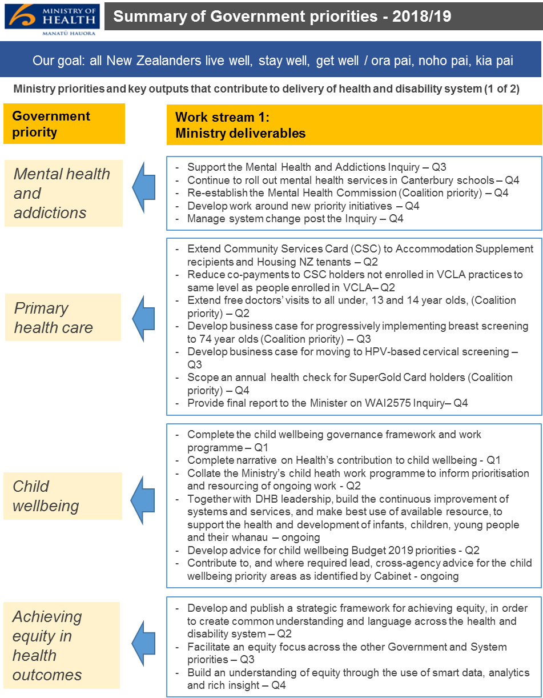

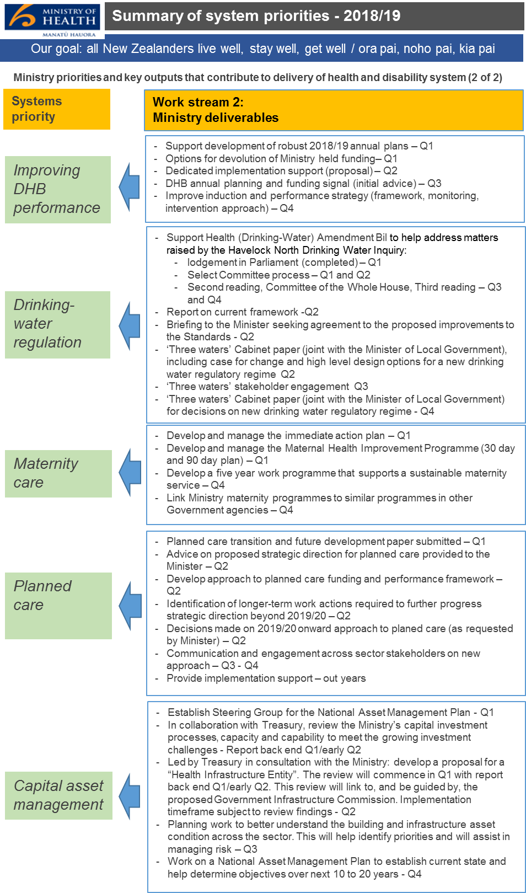
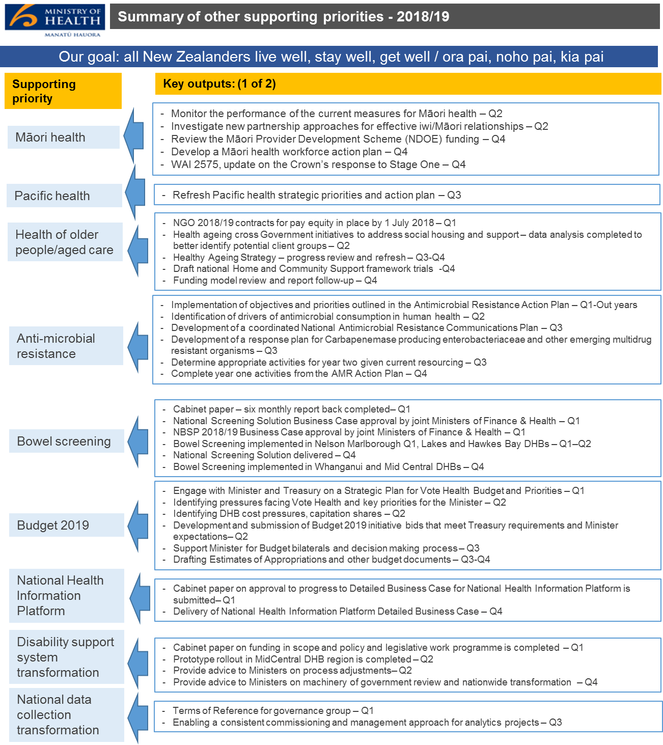

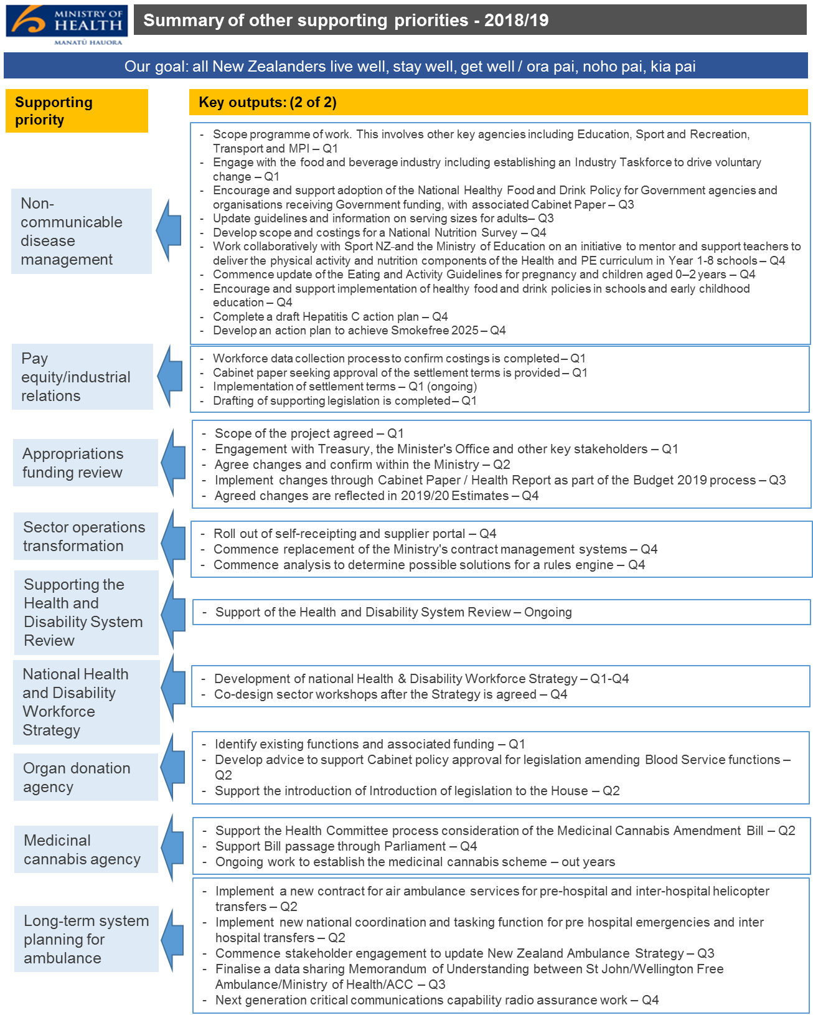

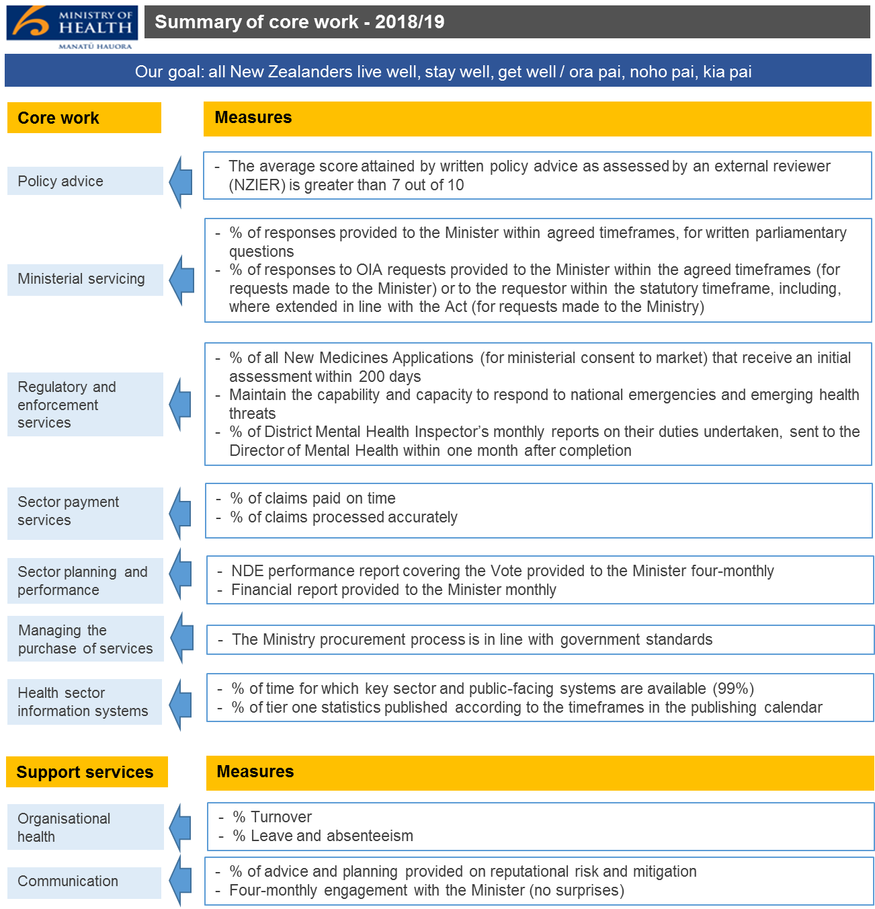

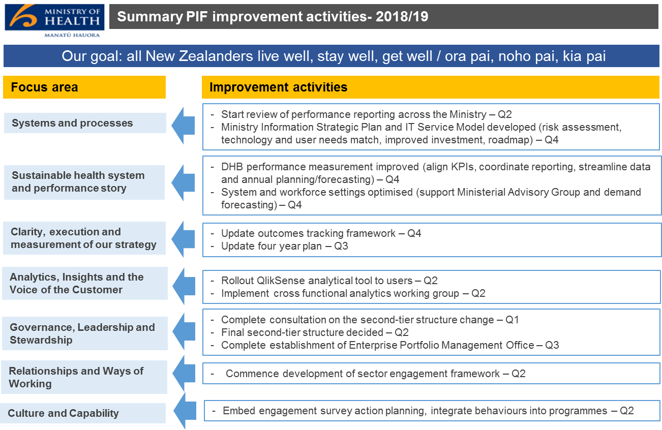

Government priorities

Priority 1: Mental health and addictions
Description:
This programme of work will put in place the arrangements (structures, functions and processes) that will enable a joined up approach to improving mental health and addiction outcomes. This will support leadership of the cross-agency programme as well as the Ministry’s programme. The intended outcomes of this work are:
  - ensuring collective ownership of the vision, strategy and change programme for improving mental health outcomes (at both population and individual levels)
  - coordinating effort and investment across the health, social, justice and education sectors with a focus on those areas that are most likely to improve mental health outcomes (at both population and individual levels)
  - improving mental health and wellbeing, more equitable mental health outcomes and less pressure on the health, social and justice systems.
The immediate objective is to progress and implement this programme to enable a collective response to the recommendations that arise from the Inquiry into Mental Health and Addiction.
Key activities to achieve results:
Activity | Quarter due
Support the Inquiry into the Mental Health and Addiction (including formulation of the response, implementation of Government decisions) | Q3
Continue to roll out mental health services in Canterbury schools | Q4
Re-establish the Mental Health Commission (Coalition priority) | Q4
Develop work around new priority initiatives | Q4
Manage system change post the Inquiry | Q4

Priority 2: Primary health care
Description:
The Ministry is preparing to progress the package of Budget 2018 initiatives that will reduce costs for New Zealanders to visit their GP and improve access to general practice. There are two main tranches to this work:
- implementing primary care initiatives
- supporting the primary care WAI2575 Inquiry.
Key activities to achieve results:
Activity | Quarter due
Extend Community Services Card (CSC) to Accommodation Supplement recipients and Housing NZ tenants | Q2
Reduce co-payments to CSC holders not enrolled in Very Low Cost Access (VCLA) practices to same level as people enrolled in VCLA | Q2
Extend free doctors’ visits to all under, 13 and 14 year olds, (Coalition priority) | Q2
Develop business case for progressively implementing free breast screening to 74 year olds (Coalition priority) | Q3
Develop business case for moving to HPV-based cervical screening | Q3
Scope an annual health check for SuperGold card holders (Coalition priority) | Q4
Provide a final report to the Minister on progress of the WAI2575 inquiry | Q4

Priority 3: Child wellbeing
Description:
Child wellbeing is a priority work programme for Government, the Ministry and DHBs, which includes contributing to the development and delivery of New Zealand’s first Child Wellbeing Strategy.
This work is being overseen by the Prime Minister in her role as the Minister for Child Poverty Reduction and Minister Martin in her role as Minister for Children, and is supported by the Department of the Prime Minister and Cabinet (DPMC). Cabinet has agreed the cross-government work led by DPMC is to progress in 16 focus areas, with six identified as requiring an immediate policy focus.
Of these cross-agency priority work streams, two have Ministry leadership:
  - ensuring children experience optimal development in their first 1000 days: safe and positive pregnancy, birth and parenting (in partnership with the Ministry of Social Development (MSD)
  - supporting children’s mental wellbeing.
The Ministry is also likely to lead the potential priority area on cross-cutting data and measurement, in partnership with the Ministry of Education.
We have internal governance to oversee the Ministry-wide maternity, infant, child and youth programme of work, in the context of both reprioritising where required to support the six focus areas agreed by Cabinet, and delivering nationally-funded services and a policy work programme that continues to improve the health and development of children and their whānau.
We have established a sector Health Leaders Advisory Group on Child Wellbeing. The groups is focused on strengthening partnerships between DHB and the Ministry as we work together to improve our services for children and their whānau. Working together, we are actively improving the health and wellbeing of infants, children and youth and their whānau, with a particular focus on improving outcomes for Māori, Pacific people, and people living in high deprivation areas.
Key activities to achieve results:
Activity | Quarter due
Complete the child wellbeing governance framework and work programme | Q1
Complete narrative on Health’s contribution to child wellbeing | Q1
Collate the Ministry’s child heath work programme to inform prioritisation and resourcing of ongoing work | Q2
Together with DHB leadership, build the continuous improvement of systems and services, and make best use of available resource, to support the health and development of infants, children, young people and their whānau | Ongoing
Develop advice for child wellbeing Budget 2019 priorities | Q2
Contribute to, and where required lead, cross-agency advice for the child wellbeing priority areas as identified by Cabinet | Ongoing

Priority 4: Achieving equity in health outcomes
Description:
A key priority is achieving equitable health outcomes for all New Zealanders, particularly for Māori, Pacific people and low-socioeconomic groups. The goal is to enable the health system to deliver the same high-quality health outcomes for all people to reach their full health potential no matter where they live, what they have or who they are.
At this stage however the key themes for action are:
  - giving the most vulnerable children the best start in life
  - equipping New Zealanders, particularly Māori, Pacific peoples and low-socioeconomic groups, with the right information and support to manage their own health and wellbeing (and that of their whānau)
  - achieving a decline in preventing deaths, disease due to risk factors such as smoking
  - ensuring people have faster access and high quality services when they need them most
  - increasing confidence that communities have services that work for their unique needs close to home
  - enabling best practice to be followed, and enabling the most able health practitioners to continue to serve communities and ensure sustainable service provision for the future.
Key activities to achieve results:
Activity | Quarter due
Develop and publish a strategic framework for achieving equity, in order to create common understanding and language across the health and disability system | Q2
Facilitate an equity focus across the other Government and system priorities | Q3
Build an understanding of equity through the use of smart data, analytics and rich insight | Q4

System priorities

Priority 1: Improving DHB performance
Description:
The Ministry is undertaking a programme of work, in close consultation with DHBs and Treasury, to support enhanced capability and performance across the health and disability system.
We aim to strengthen the current DHB performance regime to better understand the quality of health and disability services and the system shifts that will be required to improve health outcomes. This includes development of a framework for early intervention when issues arise.
An improved monitoring and intervention regime is expected to deliver:
  - improved equity and access
  - improved patient experience
  - reduced avoidable harm
  - improved efficiency and cost effectiveness.
Key activities to achieve results:
Activity | Quarter due
Support development of robust 2018/19 annual plans | Q1
Options for devolution of Ministry held funding | Q1
Dedicated implementation support (proposal) | Q2
DHB annual planning and funding signal (initial advice) | Q3
Improve induction and performance strategy (framework, monitoring, intervention approach) | Q4

Priority 2: Drinking-water regulation
Description:
The Ministry is leading the cross-government response to the Havelock North Drinking Water Inquiry, which is likely to result in fundamental changes to how drinking water is managed and regulated. Any fundamental changes to the drinking water regime will take several years to design and implement. Consequently, the Ministry’s work programme comprises two components:
- in the long-term, developing a new drinking-water regulatory regime integrated with the wider three waters regulatory system
- in the short-term, continuing to improve the safety of drinking-water (within the limits of the current framework) until the new regulatory regime is in place.
To achieve these objectives, the Ministry is advancing work (in addition to business as usual work) to:
  - Make immediate improvements to how drinking water is being provided and regulated necessary to address any immediate threats to public health posed in the current regime. Part of this work is to progress the Health (Drinking Water) Amendment Bill, which will see that the current regulatory regime and institutional arrangements for drinking-water are improved to help address matters raised by the Havelock North Drinking Water Inquiry.
  - Advise government on a more effective approach (over the longer term) to ensuring drinking water safety, which is expected to result in changes to regulatory settings and their administration and stewardship. This longer-term work is being undertaken as part of the cross-government ‘three waters’ review, led by the Department of Internal Affairs, as many of the issues around how drinking-water is managed and regulated extend across all of the ‘three waters’ services – drinking-water, wastewater and storm water).
Key activities to achieve results:
Activity | Quarter due
Support Health (Drinking-Water) Amendment Bill to help address matters raised by the Havelock North Drinking Water Inquiry:  - lodgement in Parliament (completed)  - Select Committee process  - Second reading, Committee of the Whole House, third reading | Q1  Q1 and Q2  Q3 and Q4
Report on current framework | Q2
Briefing to the Minister seeking agreement to the proposed improvements to the Drinking-Water Standards | Q2
‘Three waters’ Cabinet paper (joint with the Minister of Local Government), including case for change and high level design options for a new drinking water regulatory regime | Q2
‘Three waters’ stakeholder engagement | Q3
‘Three waters’ Cabinet paper (joint with the Minister of Local Government) for decisions on new drinking water regulatory regime | Q4

Priority 3: Maternity care
Description:
The Ministry is working with the New Zealand College of Midwives and the broader whole-of-maternity system to develop a more equitable and sustainable service, and address longstanding workforce issues, with both short and longer term options to deliver on outcomes and address workforce challenges. This work will link with the child wellbeing strategy and the review of primary health care (above), which will also explicitly consider maternity issues.
Key activities to achieve results:
Activity | Quarter due
Develop and manage the immediate action plan | Q1
Develop and manage the Maternal Health Improvement Programme (30 day and 90 day plan) | Q1
Develop a five year work programme that supports a sustainable maternity service | Q4
Link Ministry maternity programmes to similar programmes in other Government agencies | Q4

Priority 4: Planned care
Description:
The Ministry is progressing work, in partnership with a sector advisory group, to refresh the approach to planned care. This work will consider and recommend options to address current challenges while retaining a core focus on access, equity and quality of care for patients.
The current policy, funding and performance framework will be revised to make sure it supports a stronger focus on patient outcomes, makes the best use of constrained resources, and enables contemporary models of care.
Key activities to achieve results:
Activity | Quarter due
Planned care transition and future development paper submitted | Q1
Advice on proposed strategic direction for planned care provided to the Minister | Q2
Develop approach to planned care services funding and performance framework | Q2
Identification of longer-term work actions required to further progress strategic direction beyond 2019/20 | Q2
Decisions made on 2019/20 onward approach to electives (as requested by Minister) | Q2
Communication and engagement across sector stakeholders on new approach | Q3 – Q4
Provide implementation support | Out years

Priority 5: Capital asset management
Description:
The health and disability system must maintain capital assets that are of sufficient standard and are fit-for-purpose in order to enable the delivery of high quality service to New Zealanders.
DHBs own most of the buildings and land used to deliver hospital level care in New Zealand. There are hundreds of individual buildings with a total floor area in excess of two million square meters.
The current state of DHB assets is mixed. DHBs have identified investment needs of $14 billion over the next ten years (of which $9.2 billion requires Crown funding). However, there is some uncertainty on these figures, as they reflect high-level estimates of potential future projects that have not been fully scoped nor subject to the Better Business Case process.
The key drivers of investment need are:
  - facility remediation required due to age or condition of facilities
  - significant demographic growth, particularly in the northern region.
Key activities to achieve results:
Activity | Quarter due
Establish the Steering Group for the National Asset Management Plan | Q1
In collaboration with Treasury, review the Ministry’s capital investment processes, capacity and capability to meet the growing investment challenges. Report back end Q1/early Q2 | Q2
Led by Treasury in consultation with the Ministry: develop a proposal for a Health Infrastructure Entity. The review will commence in Q1 with report back at the end of Q1/early Q2. This review will link to, and be guided by, the proposed Government Infrastructure Commission. Implementation timeframe subject to review findings | Q2
Planning work to better understand the building and infrastructure asset condition across the sector. This will help identify priorities and will assist in managing risk | Q3
Work on a National Asset Management Plan to establish current state and help determine objectives over next 10 to 20 years | Q4

Supporting priorities

Māori health
Description:
Te Tiriti o Waitangi determines the Government’s obligation to address and improve Māori health outcomes. This is implemented by acknowledging the Treaty principles of partnership, participation and protection to support Māori aspirations and to achieve Pae Ora (healthy futures).
Key activities to achieve results:
Theme | Activity | Quarter due
Measuring Māori health | Monitor the performance of the current measures for Māori health | Q2
Resetting the Crown/Māori relationships in health | Investigate new partnership approaches for effective Iwi/Māori relationships | Q2
Investing in Māori health | Review the Māori Provider Development Scheme (NDE) funding | Q4
Building the Māori health workforce | Develop a Māori health workforce action plan | Q4
Responding to WAI 2575 Health Services and Outcomes Kaupapa Inquiry | Update on the Crown’s response to Stage One | Q4

Pacific health
Description:
Supporting system performance, participation and leadership for Pacific people across all levels of the health system.
The focus of the refresh will be to support health sector providers to connect with services addressing the wider determinants of health. In particular, the quality and tenure of housing, employment/income stability, stable family relationships/family violence prevalence and education.
Key activities to achieve results:
Activity | Quarter due
Refresh Pacific health strategic priorities and action plan | Q3

Health of older people/aged care
Description:
The Ministry has several initiatives, in partnership with other agencies, to deliver better outcomes for those requiring aged care:
  - Home and Community Support - Future Models of Care: The Ministry, in partnership with DHBs, is developing a national framework to guide future commissioning and delivery of home and community support services for older New Zealanders. Framework design is targeted for draft completion in Q1, for trialling with a selection of DHBs leading into their 2019/20 commissioning rounds.
  - Review of the Funding Model for Aged Residential Care (ARC): DHBs, the Ministry and ARC providers are part way through a review of the current funding model for ARC. The aim is to ensure that the funding model is appropriate to meet the growing demand and quality expectations of future older New Zealanders for residential care in a fiscally sustainable way.
  - Continued implementation of pay equity and in-between travel settlement agreements: The Ministry continues to be involved in the implementation of these settlements, including aiming for full devolution of additional funding from 1 July 2019.
  - NZ Superannuation reform work programme: As part of overall welfare reform, MSD is undertaking a significant programme of work on Superannuation reform. This will include elements relevant to the health sector including review of unit of entitlement and supplementary assistance. Both are related to health through their contribution to aged care services.
Other work over the next financial year regarding aged care will include:
  - review of contracting arrangements with four NGO’s: Determining whether or not or how we continue to work with NGO's to receive sector advice on aged care policy
  - healthy ageing: cross government initiatives to address social, housing and support needs of vulnerable older New Zealanders
  - Healthy Ageing Strategy: a review of progress and refresh of priority actions is due to be undertaken in 2018/19.
Key activities to achieve results:
Activity | Quarter due
NGO 2018/19 contracts for pay equity in place by 1 July 2018 | Q1
Healthy ageing cross government initiatives to address social housing and support - data analysis completed to better identify potential client groups | Q2
Healthy Ageing Strategy - progress review and refresh | Q3-Q4
Draft national Home and Community Support framework trials | Q4
Funding model review and report follow up | Q4

Anti-microbial resistance
Description:
We are working with the Ministry for Primary Industries (MPI) and key stakeholders to minimise the threat of antimicrobial resistance (AMR) to humans, animals and agriculture through a 'one health' approach. MPI and the Ministry have worked with stakeholders to develop the New Zealand Antimicrobial Resistance Action Plan.
To implement the action plan, an AMR project group across the Ministry and MPI, the New Zealand AMR Action Plan Governance Group (NZAMRGG), and an advisory group (Health Antimicrobial Resistance Coordination Group (HARC)) have been established.
Current objectives for the financial year include:
  - improve awareness and understanding of AMR through effective communication, education and training
  - strengthen the knowledge and evidence base about AMR through surveillance and research
  - improve infection prevention and control measures across human health and animal care settings to prevent infection and transmission of micro-organisms
  - optimise antimicrobial stewardship – the use of antimicrobial medicines in human health, animal health and agriculture, including by maintaining and enhancing the regulation of animal and agriculture antimicrobials
  - establish and support clear governance, collaboration and investment arrangements for a sustainable approach to countering AMR.
Key activities to achieve results:
Activity | Quarter due
Implementation of objectives and priorities outlined in the AMR Action Plan: 2017–2022 | Q1-Out years
Identification of drivers of antimicrobial consumption in human health | Q2
Development of a coordinated National AMR Communications Plan | Q3
Development of a response plan for Carbapenemase producing enterobacteriaceae and other emerging multidrug resistant organisms | Q3
Determine appropriate activities for year two and provide these recommendations to the Minister | Q3
Complete year one activities from the AMR Action Plan | Q4

Bowel screening
Description:
This work involves implementing the National Bowel Screening Programme (NBSP) across New Zealand by 30 June 2021. Once fully implemented, the NBSP will have an eligible population of around 700,000 men and women aged 60–74, who will be invited for free bowel cancer screening during every two-year period (a screening round). The first year at full capacity will result in approximately:
  - 380,000 people being invited to participate
  - 236,000 people returning a completed faecal immunochemical test (FIT) kit (based on 62 percent participation)
  - 9,000 people having a colonoscopy
  - 500-700 cancers detected annually during early rounds.
The primary objective of bowel screening is to reduce the mortality rate from bowel cancer by diagnosing and treating bowel cancer at an early, curable stage. Cancer diagnosed at an earlier stage is associated with lower treatment costs compared to the cost of treating more advanced cancer. An additional objective is to identify and remove precancerous advanced adenomas from the bowel before they become cancerous, which can, over time, lead to a reduction in bowel cancer incidence.
Key activities to achieve results:
Activity | Quarter due
Cabinet paper – six monthly report back completed | Q1
National Screening Solution Business Case approval by joint Ministers of Finance and Health | Q1
NBSP 2018/19 Business Case approval by joint Ministers of Finance and Health | Q1
Bowel Screening implemented in Nelson and Marlborough (Q1), Hawkes Bay DHBs (Q2) | Q1–Q2
National Screening Solution delivered | Q4
Bowel screening implemented in Whanganui and Mid Central DHBs | Q4

Budget 2019
Description:
Work is currently being scoped to support the Minister to deliver a Budget 2019 package, and build on Budget 2018. This is occurring alongside the final stages of the wrap up of Budget 2018 information.
Budget 2019 has been signalled by the Minister of Finance, as ‘the wellbeing budget’, which means a broadening of the process to accommodate wider measures of social goods than the present cost-benefit analysis approach. The Ministry is working with the Minister to identify the priorities for investment to support this approach.
In addition, workforce pressures facing the Vote are likely to have a strong influence on the choices available to the Minister. This is likely to make options to manage expenditure better, or reprioritise options, a key element of the process.
Key activities to achieve results:
Activity | Quarter due
Engage with Minister and Treasury on a strategic plan for Vote Health Budget and priorities | Q1
Identification of pressures facing Vote Health and key priorities for the Minister | Q2
Identifying DHB cost pressures, capitation shares | Q2
Development and submission of Budget 2019 initiative bids that meet Treasury requirements and Minister expectations | Q2
Support Minister for Budget bilaterals and decision making process | Q3
Drafting Estimates of Appropriations and other Budget documents | Q3–Q4

National Health Information Platform
Description:
We are developing a detailed business case for investment in a National Health Information Platform capability.
The National Health Information Platform will deliver some of the key enablers that will bring together health information from the health sector so it can be accessed by New Zealanders, health care providers, planners and those who can help provide initiative models of care in the future. Providing consistent health and wellness information that can be accessed by those that need it brings the opportunity to use information to fundamentally transform how we improve equity and wellbeing through all of society.
Key activities to achieve results:
Activity | Quarter due
Submit Cabinet paper on approval to progress detailed business case for the National Health Information Platform | Q1
Deliver National Health Information Platform detailed business case | Q4

Disability support system transformation
Description:
This work includes co-designing a prototype of a transformed disability support system in MidCentral DHB, determining funding in scope, supporting a machinery of government review and developing policy and legislative work programme and advice on a nationwide transformation.
The objectives are to give disabled people and their whānau more options and decision making authority about their support and lives, improve their outcomes, and to create a more cost-effective disability support system.
Key activities to achieve results:
Activity | Quarter due
Complete Cabinet paper on funding in scope and policy and legislative work programme | Q1
Complete prototype rollout in MidCentral DHB region | Q2
Provide advice to Ministers on process adjustments | Q2
Provide advice to Ministers on machinery of government review and nationwide transformation | Q4

National data collection transformation
Description:
Work includes establishing cross-Ministry governance arrangements for analytics, putting appropriate governance and resourcing in place, demonstrating progress and serving internal customers in priority areas.
Work will also include developing an operating model that includes customer insights, a focus on data, filling technology and capability gaps and setting the Ministry on a path to transformation. This will include incorporating technological advances and working collaboratively with DHBs and other sector agencies to transform the efficiency and effectiveness of the Ministry’s analytics.
Key activities to achieve results:
Activity | Quarter due
Develop agreed Terms of Reference for governance group | Q1
Enable a consistent commissioning and management approach for analytics projects | Q3

Non-communicable disease prevention and management
Description:
Non-communicable diseases share common risk factors including tobacco use, alcohol misuse, poor nutrition and lack of exercise. These risk factors can lead to long-term conditions such as cancer, diabetes, cardiovascular disease, chronic respiratory diseases, mental health conditions and musculoskeletal disorders. Long-term conditions cause an estimated 88 percent of health loss in New Zealand. They are major contributors to inequitable health outcomes, particularly for population groups such as Pacific peoples, Māori and those living in high deprivation areas.
This supporting priority also includes development of a national Hepatitis C action plan. Hepatitis C is a communicable disease and the work programme is managed by the long-term conditions team at the Ministry.
Key activities to achieve results:
Activity | Quarter due
Scope programme of work. This involves other key agencies including Education, Sport NZ, Transport and MPI | Q1
Engage with the food and beverage industry including establishing an industry taskforce to drive voluntary change | Q1
Encourage and support adoption of the National Healthy Food and Drink Policy for Government agencies and organisations receiving Government funding, with associated Cabinet paper | Q3
Update guidelines and information on serving sizes for adults | Q3
Develop scope and costings for a National Nutrition Survey | Q4
Work collaboratively with Sport NZ and the Ministry of Education on an initiative to mentor and support teachers to deliver the physical activity and nutrition components of the Health and PE curriculum in year 1–8 schools | Q4
Commence update of the Eating and Activity Guidelines for pregnancy and children aged 0–2 years | Q4
Encourage and support implementation of healthy food and drink policies in schools and early childhood education | Q4
Complete a draft national Hepatitis C action plan | Q4
Develop an action plan to achieve Smokefree 2025 | Q4

Pay equity/industrial relations
Description:
This work includes extending pay equity to mental health workers.
The objective is to reach, and successfully implement an out of court settlement to the union legal claim that mental health support staff wage rates should be increased to the rates payable to care and support workers under the Terranonva pay equity settlement.
Key activities to achieve results:
Activity | Quarter due
Complete workforce data collection process to confirm costings | Q1
Complete Cabinet paper seeking approval of the settlement terms | Q1
Implementation of settlement terms | Q1 (ongoing)
Complete drafting of supporting legislation | Q1

Appropriations funding review
Description:
Past feedback from Treasury indicates that the Vote Health appropriations could be improved. The Ministry is undertaking an internal review of appropriations to address this feedback including review of non-financial information (performance measures, scope statements, what is intended to be achieved) and financial information (expenditure allocation). The review may also result in structural changes to the current set up of appropriations depending on the scale of changes and appetite for change.
The objectives are to have appropriation information that represents what the Government receives for its investment in Vote Health. This should tell the story of the Ministry's strategic objectives and inform how we will know if we are delivering on the performance measures set on the funding we receive.
Key activities to achieve results:
Activity | Quarter due
Agree scope of the project | Q1
Engage with Treasury, the Minister's office and other key stakeholders | Q1
Agree changes and confirm within the Ministry | Q2
Implement changes through Cabinet paper/health report as part of the Budget 2019 process | Q3
Reflect agreed changes in the 2019/20 Estimates | Q4

Sector operations transformation
Description:
Work includes a $9.8 million four-year (to 2020/21) programme of incremental and manageable change to improve the customer experience through faster, more timely and more accurate payments and information, the use of payments and provider information to support policy and health outcomes and the integrity of health sector payments and services, the efficiency, resilience and agility of processes and enabling technology.
The focus over the next financial year will be to develop a self-receipting and supplier portal to enable online approval for payments, commence replacement of the Ministry’s contract management systems and commencement of analysis to determine possible solutions for a rules engine that will increase integrity over payments.
Key activities to achieve results:
Activity | Quarter due
Roll out of self-receipting and supplier portal | Q4
Commence replacement of the Ministry's contract management systems | Q4
Commence analysis to determine possible solutions for a rules engine | Q4

Supporting the Health and Disability System Review
Description:
The Ministry is building its capability in assessing New Zealand's health system policy settings, considering the evidence and international practice to better understand our strengths and weaknesses and how we can further optimise system performance to improve health outcomes.
An initial overview will produce descriptions and indicative assessments that can be used to inform a range of users, from the public and health practitioners to agencies and reviews, both formal and informal. The work will grow over time into an ongoing programme of stewardship work that will both inform and be informed by, the independent review of the health and disability system.
Key activities to achieve results:
Activity | Quarter due
Support the Health and Disability System Review | Ongoing

National health and disability workforce strategy
Description:
Health Workforce New Zealand (HWNZ) has begun initial background work on the development of a national health and disability workforce strategy 2018–2030.
The rationale is that a long term strategy is needed to ensure alignment between workforce and wider health system priorities and planning, which provides the framework for workforce decision-making nationally, regionally and locally, and help to address current and forecast workforce challenges. It is intended to be an active, participatory process with the sector.
There is sector support for co-design of a national workforce strategy that will be a comprehensive ‘living’ document, incorporating priorities and actions that will be updated and reviewed annually.
HWNZ will run national workshops to partner with all parts of the sector to develop a long-term workforce strategy.
The timing for undertaking this work is to be confirmed with the Minister as part of the Health and Disability Workforce Strategy development.
Key activities to achieve results:
Activity | Quarter due
Develop national Health and Disability Workforce Strategy | Q1–Q4
Co-design sector workshops after the Strategy is agreed | Q4

Organ donation agency
Description:
Work includes implementation of elements of the national strategy to increase deceased organ donation and transplantation.
Initial steps involve legislating to allow the New Zealand Blood Service to take on organ donation functions.
At the same time we are identifying what functions and funding currently sit with the Auckland DHB.
Key activities to achieve results:
Activity | Quarter due
Identify existing functions and associated funding | Q1
Develop advice to support Cabinet policy approval for legislation amending Blood Service functions | Q2
Support the introduction of legislation to the House | Q2

Medicinal cannabis agency
Description:
The Government, as part of its 100-day commitments, introduced legislation to improve access to medicinal cannabis. The Bill will:
  - allow Government to make regulations to set quality standards for medicinal cannabis products
  - provide an exception to the offence, and a defence to the charge of possessing and using illicit cannabis for people who have a terminal illness, and
  - remove cannabidiol (CBD) from the Misuse of Drugs Act, so that it is no longer a controlled drug.
The Bill is a key component in establishing a medicinal cannabis scheme. The scheme aims to provide a greater supply of quality medicinal cannabis products by enabling domestic cultivation and manufacture.
Over the next financial year the Ministry will be supporting the passage of the Bill through Parliament, establishing the medicinal cannabis scheme, and setting up an agency to operationalise it.
Setting up the agency has financial implications and additional funding is required (but not yet identified).
New funding will require Cabinet approval or met through reprioritisation of Vote Health baselines.
Key activities to achieve results:
Activity | Quarter due
Support the Health Committee process consideration of the Medicinal Cannabis Amendment Bill | Q2
Support Bill passage through Parliament | Q4
Ongoing work to establish the medicinal cannabis scheme | Out years

Long-term system planning for ambulance
Description:
The National Ambulance Sector Office (NASO) is a joint ACC and Ministry of Health business unit. It is responsible for the purchase of New Zealand’s emergency ambulance services including air, road and communications.
NASO’s major focus for 2018/19 will be implementing a reconfigured national helicopter air ambulance service. This is the first stage of a 10-year plan to improve the safety, quality, and coordination of New Zealand’s air ambulance service.
The 10-year plan, supported by Cabinet, will incrementally improve New Zealand’s air ambulance service across helicopter and fixed wing services. It will integrate air ambulance services across the wider health system. This will contribute to reducing the variation in clinical outcomes across New Zealand.
A reconfigured air ambulance model is expected to be in place from 1 November 2018. The first round of procurement includes the purchase of pre-hospital and inter-hospital helicopter transfers and the implementation of a new coordination and tasking function. The second round is planned for three to four years’ time.
The New Zealand Ambulance Strategy expires in 2020. This will be updated over the next 12 months by the NASO.
Key activities to achieve results:
Activity | Quarter due
Implement a new contract for air ambulance services for pre-hospital and inter-hospital helicopter transfers | Q2
Implement new national coordination and tasking function for pre hospital emergencies and inter hospital transfers | Q2
Commence stakeholder engagement to update New Zealand Ambulance Strategy | Q3
Finalise a data sharing Memorandum of Understanding between St John/Wellington Free Ambulance/Ministry of Health/ACC | Q3
Next generation critical communications capability radio assurance work | Q4

Core work/functions of the Ministry
While the Ministry and sector have clear strategic priorities and supporting work programmes to deliver over the 2018/19 financial year, the Ministry will continue to deliver on its core functions. These are critical functions for maintaining confidence in the department and ensuring its key customer – the Minister of Health, is well serviced by his Ministry and also includes the Ministry’s role to monitor population health and system performance. Key to this is access to robust data to monitor health outcomes over time. This includes the publication of analysis and datasets from the annual New Zealand Health Survey, national collections and other sources.
These core services and their respective performance targets are set out in the table that follows.
Core services | Measures
Policy advice | The average score attained by written policy advice as assessed by an external reviewer (NZIER) is greater than 7 out of 10 (assessed annually)
Ministerial servicing | % of responses provided to the Minister within agreed timeframes, for written parliamentary questions
 | % of responses to OIA requests provided to the Minister within the agreed timeframes (for requests made to the Minister) or to the requestor within the statutory timeframe, including, where extended in line with the Act (for requests made to the Ministry)
Regulatory end enforcement services | % of New Medicines Applications (for ministerial consent to market) that receive an initial assessment within 200 days
 | Maintain the capability and capacity to respond to national emergencies and emerging health threats
 | % of District Mental Health Inspector’s monthly reports on their duties undertaken, sent to the Director of Mental Health within one month after completion
 | Note: We propose a more complete set of regulatory measures as part of our core functions reporting. This will include a heightened focus on delivery of the Havelock North Inquiry
Payment services | 98% of claims paid on time
 | 95% of claims processed accurately
Sector planning and performance | NDE performance report covering the Vote provided to the Minister four-monthly  Financial report provided to the Minister monthly
Managing the purchase of services | The Ministry procurement process is in line with government standards
Health sector information systems | Key sector and public-facing systems are available 99% of the time
 | 100% of tier-one statistics are published according to the timeframes in the publishing calendar
Key support service measures are outlined in the table below.
Support service | Measure
Organisational health | % turnover
 | % leave and absenteeism
Communication | % of advice and planning provided on reputational risk and mitigation
 | Four-monthly engagement with the Minister (no surprises)

Responding to the Performance Improvement Framework review
The Ministry of Health’s recent PIF review signals a number of areas where the Ministry must lift its performance and capability to:
  - more effectively undertake the Ministry’s unique role as steward of the health and disability system
  - fulfil its responsibility for the overall management and development of the system
  - ensure the sector is supported by the information and systems it needs to improve health outcomes for New Zealanders
  - operate effectively to advise the Government on system performance and health and disability issues.
The PIF review outlines the significant challenges ahead of the Ministry, but in doing so, provides a clear path forward to improve our performance.
The PIF review speaks to many of the core underpinnings of the Ministry as an organisation. This includes improving its leadership, culture and governance, as well as clarifying its stewardship role in a highly-devolved system. In particular, the PIF review identifies an urgent need to strengthen relationships with the sector if the Ministry is to reassert its unique role of system steward. We are committed to improving our performance in these areas.
Crucial to this is robust system architecture that functions well and produces the information we require. The Ministry and our sector partners are operating with ageing systems and technology. This prolongs the need for inefficient, manual processes; limits our ability to share information across the sector and to enable consumers to access their information; and prevents us from capitalising on technological advances. Moving to a more digitally-enabled health system will require significant effort and investment in key systems to enable integration, fit-for-purpose customer relationship management (CRM) capability, and open application programming interfaces (APIs).
The Ministry has put in place an immediate response to the findings of the PIF review, focusing first on improving our core functions and aligning our work to our strategic priorities.
The Ministry is currently carrying out a second-tier structure review. Once this review is completed, the Director-General anticipates finalising the performance improvement plan, with clear accountabilities and deliverables assigned to the second-tier leaders.

Focus area descriptions

Focus area 1: Systems and processes
The PIF review outlined the need to upgrade the Ministry’s legacy systems and processes to support more efficient operations. Fit-for-purpose, well-functioning system architecture is a crucial enabler for our ability to steward, our analytical capability and a sustainable, high-performing health system. Our first focus is on improving our core business. Our longer-term work programme will be grounded in optimising our operating model and developing a strategic plan to prioritise investment in both national systems and Ministry systems.

Focus area 2: Sustainable health system and performance story
The PIF review found that the Ministry needs to do more to understand how the health system is performing, where the pressures are and to use these insights to inform a sustainable growth path for the system. Critical to addressing this will be addressing the Ministry’s and wider system’s fragmented and ageing technology assets. Our immediate focus is on working with DHBs to lift and better measure their performance (one of our system priorities), while also investigating new measures to drive system performance. This will form the basis for improving our understanding of and reporting on system performance, forecasting system demand and workforce requirements.

Focus area 3: Clarity, execution and measurement of our strategy
The PIF review observed that the Ministry needs to take a more deliberate approach to implementing the New Zealand Health Strategy. We interpret this more broadly as needing to better articulate the outcomes we are seeking to achieve across the health system in a way that can be measured effectively.

Focus area 4: Analytics, insights and the voice of the customer
The PIF review addresses the need to develop the Ministry’s analytical capability and to use customer insights to inform decision-making. This shift will take time, but we have begun to develop an analytical operating model and tools to support this.
We are using the portfolio of strategic priorities to test new ways of integrating analytics into our work. We will continue developing the tools, models and capabilities to strengthen this work over the next 12 months.

Focus area 5: Governance, leadership and stewardship
The PIF review emphasised the need for the Ministry to demonstrate leadership across the system, including making better use of the Ministry’s levers to drive performance. Our immediate focus is on improving internal governance to support the strategic priorities, while also taking initial steps to strengthen our stewardship role. This will form the basis of our longer-term focus on becoming a more active system steward. Crucial to this is ensuring we have well-functioning and fit-for-purpose leadership structure.

Focus area 6: Relationships and ways of working
The PIF review emphasised an urgent need to work more collaboratively with sector stakeholders. We have committed to a new engagement model to deliver on the Government’s priorities and address immediate system issues. This model has been tested with and is supported by sector representatives, and we will continue to refine and embed this new way of working with our partners.

Focus area 7: Culture and capability
The PIF review noted a need to focus on organisational culture, values and behaviour, including in relation to developing leadership and talent within the organisation. The Ministry has developed and begun to implement a ‘People Plan’ in response to the Review’s findings. The Plan provides a 12 month focus on improving the culture, leadership and capabilities of the Ministry.

Key performance improvement activities for 2017/18
Focus area | Activity | Quarter due
1. Systems and processes | Start review of performance reporting across the Ministry | Q2
 | Ministry Information System Strategic Plan and IT Service Model developed (risk assessment, technology and user needs match, improved investment, roadmap) | Q4
2. Sustainable health system and performance story | DHB performance measurement improved (align KPIs, coordinate reporting, streamline data and annual planning/forecasting) | Q4
 | System and workforce settings optimised (support Ministerial Advisory Group and demand forecasting) | Q4
3. Clarity, execution and measurement of our strategy | Update outcomes tracking framework | Q4
 | Update four year plan | Q3
4. Analytics, insights and voice of the consumer | Rollout QlikSense analytical tool to users | Q2
 | Implement cross functional analytics working group | Q2
5. Governance and leadership | Complete consultation on the second-tier structure change | Q1
 | Final second-tier structure decided – implementation commenced | Q2
 | Complete establishment of Enterprise Portfolio Management Office | Q3
6. Relationships and ways of working | Commence development of sector engagement framework | Q2
7. Culture and capability | Embed engagement survey action planning, integrate behaviours into programmes | Q2

Conclusion
This plan provides a comprehensive outline of the areas the Government and the Ministry plans to focus its efforts over the 2018/19 financial year to improve the health and disability sector.
We see this plan as a living document and we expect some outputs will change throughout the course of the year as we adapt our work based on the findings of reviews and inquiries underway across the health and disability system.
Where such instances occur, any changes will be agreed with Ministers, either as part of the regular performance reporting process, or when decisions are made.
We are looking forward to working with Ministers to deliver on these priorities and we will remain ready and agile to meet any new priorities Ministers wishes us to pursue.

Appendix One: Hon Associate Minister of Health Salesa work programme
Vision: Delivering improved health outcomes that are equitable for all, particularly Māori, Pacific, young children and older people.
How we are going to deliver on our priorities to achieve the vision | 2018 key deliverables | 2019 key deliverables | Progress by 2020 | Vision
Improving access to and the delivery of health services, so that they are responsive to and deliver better outcomes for Māori. | - Begin a process to develop a Māori health action plan, by:  - building client insights to understand how well the health system is currently meeting the needs of Māori  - responding to the WAI2575 Health Services and Outcomes Kaupapa Inquiry, looking particularly at primary care  - monitoring the performance of current measures for Māori health  - investigating new partnership approaches for effective iwi/Māori relationships, as part of resetting Crown/Māori relationships in health  - identifying actions to build the Māori health workforce  - Lead the review of the Māori Provider Development Fund | - Complete a Māori health action plan and begin implementation, supported by:  - measurable outcomes in all key documents, in particular DHB accountability measures for 2019/20, alongside the Minister of Health  - Continue to respond to the WAI2575 Inquiry  - Implement decisions on Māori Provider Development Fund | - The health system is responsive to the needs of Māori  - The health system has made significant gains in its approaches to achieving equitable outcomes for Māori  - Māori providers have the capacity and capability to deliver high quality services | Improving access to and the delivery of health services, so that they are responsive to and deliver better outcomes for Māori.
Supporting system performance, participation and leadership for Pacific across all levels of the health system | - Develop new Pacific health strategic priorities and action plan  - Support the development of measurable outcomes for Pacific population groups in key documents (ie. DHB accountability, funding and service contracts, policies and services)  - Lead the review of the Pacific Provider Development Fund  - Examine the capacity and capability of Pacific health leadership across the health system  - Budget 2019 proposal to support implementation of Ala Mo’ui | - Launch the new Pacific Health Strategic Priorities and Action Plan  - Implement measurable outcome settings in all key documents, in particular DHB accountability measures for 2019/20, alongside the Minister of Health  - Implement recommendations following the PPDF review  - Review the Pacific Health workforce pipeline and funding streams | - Health system is responsive to the needs of Pacific peoples  - Health system is working towards achieving equitable outcomes for Pacific peoples  - Increased visibility of Pacific health representation across the health system  - Pacific providers are sustainable, and have the capacity and capability to deliver high quality services  - Pacific are supported into (and across) the workforce pipeline (from secondary school, tertiary, post-grad, adult learners etc) | Supporting system performance, participation and leadership for Pacific across all levels of the health system
Set the strategic direction to achieve Smokefree 2025. | - Develop a plan of action to achieve Smokefree 2025  - Seek Cabinet agreement on policy positions for the regulation of vaping and smokeless tobacco products  - Issue drafting instructions for the Smokefree Environments (vaping and smokeless tobacco products) Amendment Bill  - Develop a public campaign to increase awareness of vaping as a harm reduction tool  - Consult on voluntary vaping product safety standards  - Budget 2019 proposal for health support (smoking, alcohol and other addictions, aum, PA, mental wellbeing | - Introduce the Smokefree Environments (vaping and smokeless tobacco products) Amendment Bill  - Consult on tailored packaging requirements and health warnings for vaping and smokeless tobacco products  - Amendment Bill passed in the House  - Implement the new regulations under Smokefree Environments Act  - Develop product safety standards for smokeless tobacco products | - Improved quit rates for Māori, Pacific and young people in particular  - Improved quit rates for Māori pregnant woman  - Regulations for vaping and other technologies are fit for purpose  - Industry meets vaping product safety standards | Prevalence rate of smoking in New Zealand is below 5% for all population groups.
Improve child wellbeing, by changing the food and drink environments in education settings (from ECE through to Secondary school) | - Revise and/or develop a suite of guidance, information and tools to support healthy food and drink policies in schools and early childhood education (ECEs). Audiences will include parents, whānau, communities and schools/ECEs  - Identify opportunities to promote, support and encourage schools and ECEs to adopt and implement healthy food and drink policies  - Identify and implement monitoring approach | - Implement a suite of tools to support parents, whānau, communities and schools/ECE to create healthy food and drink environments  - Support education actions to promote, support and encourage schools and ECEs to adopt and implement healthy food and drink policies | - Improved food and drink environments in education settings  - Parents, whānau, communities and schools are supported to make healthier choices  - Improved school attendance, focus and concentration, educational attainment and outcomes  - Improved physical and mental health and wellbeing | Children and young people have improved health and educational outcomes.
Work in partnership with agencies and communities to build age-friendly environments that support healthy ageing.  Support the delivery of high-quality home support, community health and residential care services for older people. | - Continue to implement the Healthy Ageing Strategy, progressing the 48 actions committed for the first two years  - Prepare for a second Healthy Ageing Strategy action plan  - Scope a free annual health check for seniors  - Provide advice on proposals for an Aged Care Commissioner and Commission  - Embed pay-equity and in-between travel settlement  - Review Aged Residential Care Funding Models  - Explore packages of support and models of care to improve home and community support services delivered to older people  - Develop priority actions to improve workforce training, recruitment and retention  - Support the development of a cross-government work programme designed to obtain better results for older people across health, social and housing sectors | - Complete a second Healthy Ageing Strategy action plan  - Implement new models and support packages of home and community support services  - Implement actions to improve workforce training, recruitment and retention  - Implement changes to aged residential care funding, alongside the Minister of Health | - The health, social and housing sectors work together to improve healthy life expectancy, and prevent further decline for people with long-term health conditions and disabilities  - The health system supports older people to manage their conditions and access quality services in a timely manner | Older people live well, age well and have a respectful end of life in age-friendly communities

Appendix Two: Hon Associate Minister of Health Genter work programme
Area of focus/Delegation | Actions we can deliver in 2018/19 | Actions we can make further progress on in 2018/19 | Potential new actions we can scope in 2018/19
Climate change and health | Environmental Health Action Plan Discussion Document - Q2  Green and More Environmentally Friendly Health Care Report (emphasis on DHBs and sustainability) - Q2  DHB climate change stocktake reports  Climate change working group established to advise the Ministry on DHBs and sustainability  Heat Health Plan Guideline - Q2  Massey University is maintaining Climate Change Environmental Health Indicators - Q1-Q4  Participation in all of Government climate change groups - Q1-Q4  ESR is examining adaptation strategies for the environmental health impacts of climate change - Q4 | The effects of climate change on population health in New Zealand: indicators of vulnerable populations  Green and More Environmentally Friendly Health: review of DHB initiatives and further updates of report - Q4  Green and More Environmentally Friendly Health: sustainable procurement  Revision of the Healthcare Waste Standard (to include waste minimisation such as recycling options) | Scoping climate change and health action plan  Opportunities for work with other agencies, eg, EECA, MBIE, MfE, (particularly around procurement)  The effects of climate change on wellbeing, particularly food and nutrition  The interface between health and the environment and how sustainability can be managed within the health sector  Establishment of a Climate Change / Sustainability Working Group within the Ministry of Health
Population health (built environment) | Transport collaboration (2018/19)  The Ministry is working with the Ministry of Transport and NZTA to improve health through urban design and healthy, environmentally friendly and safe transport options 2018/19 work includes:  2WALKandCYCLE conference. The theme of the 2018 2WALK&CYCLE conference is 'moving towards healthy communities’  Transport Knowledge hub events on:  - how infrastructure can increase social equity and how to prioritise urban design which encourages healthier transport options  - Massey University’s Environmental Health Indicators  Healthy Families NZ and enhancing active transport focus - Q1-Q4  A briefing on the next Healthy Families NZ evaluation - Q1–Q2  Develop and implement the Healthy Homes Initiative (HHI) cross-agency implementation plan to strengthen the effectiveness of HHIs and maximise their contribution to improving child wellbeing and equity of health outcomes - Q2-Q4  Commission and completion of an outcomes evaluation of the HHI - Q2-Q4  DHB-owned Public Health Units (PHUs) are supported to continue providing services that contribute to environments which reduce the impact of lifestyle related chronic diseases, promote overall population health and wellbeing, and mitigate the impact of climate change - Q4 | Cross agency response to the Global Action Plan on Physical Activity  Sport NZ and the Ministry of Health are leading the development of a New Zealand response to the Global Action Plan on physical activity, which was launched by the World Health Organization on 4 June 2018  Transport collaboration (ongoing)  Presence on the Ministry of Transport’s National Road Safety Committee  Ministry of Health adopting the NZTA’s environmentally friendly vehicle procurement and safe driving principles  Input into the second Government Policy Statement on Land Transport  Working with NZTA on the Urban Cycleways Programme  Integrate injury prevention/safety into the HHIs - Q3  Work closer with DHBs and their PHUs to ensure that public health services in their regions are aligned to the priorities of their populations - Q4 | Scope opportunities to test new, and strengthen existing, prototypes that help establish a sustainable supply of housing-related interventions to create warm, dry healthy homes for HHI families - Q4  Scope opportunities to strengthen social and physical environments that impact on population health - Q4
Disability support services | DSS System Transformation rollout MidCentral prototype - Q2  Options re Family Funded Care - Q1-Q2  Progress Disability Action Plan actions on improving health for people with an intellectual disability; options re safeguarding against non-therapeutic sterilisation - Q1-Q2  Government department and ministerial consultation on draft Government response to UN Convention on Rights of Persons with Disabilities - Q1 | Trial supported decision making as part of MidCentral prototype - Q2-Q4  Implementing service development for the one high needs client - Q2  Implementation of changes to the Carer Support Subsidy - Q1-Q4 Input into MSD led FFC cabinet paper and public consultation - Q1 | Scope policy options re Tourettes - Q2
Women’s health | Work with the maternity sector to develop a five year sustainable maternity work programme to develop a more equitable and accessible maternity service - Q1-Q2  - This includes consumer feedback and priorities reset - Q2  - Supporting change programme to be implemented in partnership with sector - Q4  Implement LMC budget packages - Q2  The updated Mesh Report for Medsafe’s website - Q1  The Mesh Round Table group meets to discuss and progress issues associated with surgical mesh - Q1  The Ministry and the Endometriosis Taskforce provide referral guidelines to local clinical pathways - Q2  Prepare business case for extending the age range for breast screening to 74 - Q2  Prepare business case for HPV screening - Q2 | Implement priority actions in the five year work programme - Q3-4  - Includes agreeing the sustainable commissioning model for implementation in 2020/21. Sustainable model identified in Q2, implementation impacts Q3, final implementation by Q1 202/21 | Scope and implement direction-setting decisions to initiate and drive system changes  Consider Government’s response to Mental Health & Addiction Inquiry report recommendations applying a Perinatal and Infant Mental Health lens - Q4
Sexual health | Publish and launch the Sexual and Reproductive Health Plan (SRHAP) - Q3  Establish joint work programme with Ministry of Education to respond to recommendations from Education Review Office Report on the teaching of Sexuality Education - Q4  Establish contracts in all DHBs to reduce Cost Barriers to Contraception for Low Income Women - Q3  Provide Ministry and health sector input into abortion law reform proposals - Q1  Contract for GAPPS/GOSS survey in time for Big Gay Out 2019 - Q1  Develop educational resources for primary care on syphilis and other STI management - Q2 | Work with your and Minister Clark’s office to develop proposals on actions/areas in the SRHAP that could be included in the Minister’s letter of expectations to DHBs - Q3  Work with Education sector to identify effective models for delivery of sexuality education - Q4  Establish contracts for primary care training for contraceptive consultation and long acting reversible contraceptive procedures - Q3  Support cross government work to mitigate impact of pornography on sexual development.  Develop co-ordinated national and regional response to reduce incidence of syphilis, with health sector partners - Q3 | Scope plan to implement more effective models for delivery of sexuality education and sexual health promotion - Q4  Scope widening current scope of practice for key NGOs to enable response to STI outbreaks in high risk populations - Q3  Scope potential changes to DHB  abortions services to align with  proposed changes to abortion legislation - Q4  Support cross-government work to mitigate the impact of pornography on sexual  development - Q4
Rainbow health  gender-affirming surgery | We are developing policy advice for the ongoing delivery of gender-affirmation surgery including the provision and funding mechanism - Q2  We are progressing a staged review of the current waiting list to meet commitment to deliver a maximum of three males to female and one female to male surgery every two years - Q1  We are also developing advice on the potential banning of gay conversion therapy  We are consulting on new data collection standards for the National Health index to improve data collection on sex, sexuality and gender identity | We are working in partnership with sector stakeholders to develop a sustainable service arrangement for the ‘package of care’ (including access criteria, service specifications for pre and post-operative and contracting of surgical activities that supports patients to access genital surgery - Q2–Q4  We are working to ensure that there are suitable gender affirming care pathways. This will be a longer term piece of work | There may be an opportunity to develop new guidelines for gender affirming care as part of the pathways of care work. The guidelines would provide guidance for individuals and their families, medical professionals and DHBs

The $207 million excludes mental health.

