Methodology Report 2022/23

New Zealand Health Survey

2023

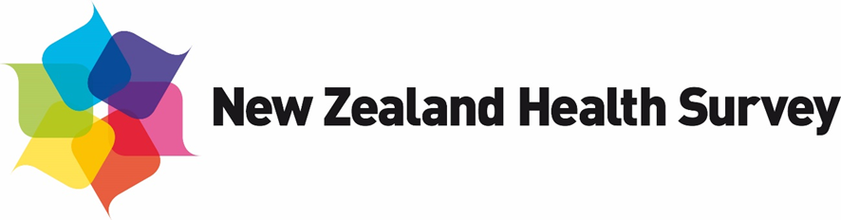

**Acknowledgements**

This report was originally written by Deepa Weerasekera, Steven Johnston, Maria Turley, Robert Clark (Statistics Adding Value) and Barry Gribben, Carol Boustead Gibb and Neil Tee (Reach Aotearoa).

This version of the report was updated by the Health Surveys team in the Evidence, Research and Analytics group of Manatū Hauora | the Ministry of Health. Additional content was provided by Robert Clark (Statistics Adding Value) and Neil Tee (Reach Aotearoa).

Citation: Ministry of Health. 2023. *Methodology Report 2022/23: New Zealand Health Survey*. Wellington: Ministry of Health.

Published in December 2023 by the Ministry of Health  
PO Box 5013, Wellington 6140, New Zealand

ISBN 978-1-991075-64-2 (online)  
HP 9058



This document is available at health.govt.nz

|  |  |
| --- | --- |
| CCBY | This work is licensed under the Creative Commons Attribution 4.0 International licence. In essence, you are free to: share ie, copy and redistribute the material in any medium or format; adapt ie, remix, transform and build upon the material. You must give appropriate credit, provide a link to the licence and indicate if changes were made. |

Contents

Introduction 1

Background 2

Survey content 3

Core content 3

Survey population and sample design 5

Target and survey population 5

Sample design 6

Data collection 9

Interviews 9

Objective measurements 10

Field work 12

Response and coverage rates 16

Calculating the response rate 17

Coverage rate 18

Data processing 19

Capturing and coding 19

Securing information 19

Checking and editing 19

Missing data due to non-response 20

Creating derived variables 21

Weighting 24

Calculating selection weights 25

Calibration of selection weights 26

Jackknife replicate weights 29

Weights for measurement data 29

Analysis methods 31

Estimating proportions, totals and means 31

Comparing population groups 33

Confidence intervals and statistical tests 36

Time trends 37

New Zealand Health Survey 2022/23 38

2022/23 module topics 38

Data collection 38

Impact of data collection disruptions 39

Response rates 40

Coverage rates 40

Final weights 43

Sample sizes 44

Changes in previously published statistics 46

References 47

List of figures

Figure 1: Proportion of households agreeing to first interview, by number of visits, 2022/23 15

Figure 2: Response rates for adults and children, 2011/12 to 2022/23 40

Figure 3: Coverage rates for adults and children, 2011/12 to 2022/23 41

Figure 4: Coverage rates for Māori, Pacific peoples and Asian ethnic groups, 2011/12 to 2022/23 41

Figure 5: Coverage rates by New Zealand Index of Deprivation quintiles, 2011/12 to 2022/23 42

Figure 6: Coverage rates for total population, by age group and gender, 2022/23 42

Figure 7: Coverage rates for Māori, by age group and gender, 2022/23 43

List of tables

Table 1: New Zealand Health Survey 2022/23 core content 3

Table 2: Sample size and response rates, 2011/12–2022/23 16

Table 3: Questions with item non-response for more than 3% of respondents, 2022/23 21

Table 4: New Zealand Health Survey 2022/23 module topics 38

Table 5: Number of survey respondents by quarter, 2022/23 39

Table 6: Final weights 2022/23 43

Table 7: Sample sizes and population counts for children and adults, by gender, 2022/23 44

Table 8: Sample sizes and population counts for children and adults, by total response ethnicity, 2022/23 44

Table 9: Sample sizes and population counts, by age, 2022/23 44

Table 10: Sample sizes and population counts, by NZDep2018 quintile, 2022/23 45

Table 11: Sample sizes and population counts (adults), by disability status and gender, 2022/23 45

# Introduction

The New Zealand Health Survey (NZHS) is an important data collection tool that is used to monitor population health and provide supporting evidence for health policy and strategy development. The Evidence, Research and Analytics group, within the Manatū Hauora/Ministry of Health’s Evidence, Research and Innovation directorate, is responsible for designing, analysing and reporting on the NZHS. The NZHS field activities are contracted out to a specialist survey provider, Reach Aotearoa, formerly known as CBG Health Research.

The NZHS collects information that cannot be obtained more effectively or efficiently through other means, such as by analyses of hospital administrative records, disease registries or epidemiological research. The NZHS is the best source of information at a population level for most of the topics it covers.

Before 2011, the Ministry conducted New Zealand Health Surveys every three or four years (1992/93, 1996/97, 2002/03 and 2006/07). The wider survey programme included separate surveys on specific subjects (eg, nutrition; tobacco, alcohol and drug use; mental health; and oral health) at varying frequencies. In July 2011, all of these surveys were integrated into a single NZHS, which is now in continuous annual operation.

From 2013 onwards, a number of key outputs from the NZHS became Tier 1 statistics (a portfolio the government maintains of the most important official statistics, essential to understanding how well New Zealand is performing in different aspects of national concern). These are: smoking (current), past-year (alcohol) drinking, hazardous (alcohol) drinking, obesity, unmet need for a general practitioner (GP) due to cost, unfilled prescription due to cost, self-rated health, and mental health status (psychological distress).

This NZHS methodology report outlines the procedures and protocols followed to ensure that the NZHS produces the high-quality and robust data expected of official statistics (Stats NZ 2007). The information from the continuous NZHS specific to the 2022/23 year (data collected from July 2022 to July 2023) is included in the ‘New Zealand Health Survey 2022/23’ section of this report. Due to workforce issues and ongoing disruptions to data collection related to the COVID-19 pandemic and Cyclone Gabrielle, the sample size for 2022/23 is smaller than those for pre-COVID years (until 2018/19). The corresponding information for years 2011/12 to 2021/22 of the NZHS can be found in previous methodology reports.[1]

## Background

As a signatory to the *Protocols for Official Statistics* (Stats NZ 1998), the Ministry employs best-practice survey techniques to produce high-quality information from the NZHS. It uses standard frameworks and classifications, with validated questions where possible, so that NZHS data can be integrated with data from other sources.

### Goal

The goal for the NZHS was reviewed in 2019 as part of a project to ensure the survey remains fit for purpose for the future. The refreshed goal is to monitor and research the health and wellbeing of New Zealanders, including how people experience their own health and health services. The information covers population health, health risk and protective factors, as well as health service utilisation.

### Objectives

To achieve this goal, four high-level objectives have been identified for the NZHS. These are to:

1. provide an evidence base to inform health system funding, policy, programmes and advocacy with a focus on long-term priorities
2. monitor and research population health status and the prevalence of key health behaviours and risk factors
3. monitor barriers to access and use of health care services, including health service user experience
4. enable robust statistical analysis to be carried out and links to other data collections to be made, to address wider information needs.

### Features of the survey

The NZHS has been carefully designed to minimise impact on survey respondents. Features for this purpose include:

* selecting only one eligible adult and one eligible child per dwelling
* using well-tested and proven questions
* using professional, trained interviewers to conduct the interviews
* making an appointment to conduct each interview at a time that suits the respondent and their family
* having the option of using a proxy respondent where would-be respondents living in private dwellings have severe ill health or cognitive disability
* having the option of computer-assisted video interviewing (CAVI) when it was not possible to do a computer-assisted personal interview (CAPI).

The New Zealand Health and Disability Multi-region Ethics Committee (MEC) approved the 2022/23 NZHS (MEC reference: MEC/10/10/103).

# Survey content

The NZHS comprises core questions and measurements that are repeated every year, combined with a series of modules that usually change every 12 months.

For details on the rationale of topic inclusion, cognitive testing, and the content of the questionnaires, see the *Content Guide* 2022/23 (Ministry of Health 2023b).

## Core content

Most of the core content for both adults and children is drawn from the main topic areas included in the 2006/07 and 2011/12 NZHS. Topic areas include long-term conditions, health status and development, health behaviours and risk factors, health service utilisation and barriers to accessing health care, sociodemographic and health measurements. Table 1 summarises the topics included in the core content of the 2022/23 NZHS. See the *Content Guide 2022/23* (Ministry of Health 2023b) for the module topics of each survey year between 2011/12 and 2022/23.

Table 1: New Zealand Health Survey 2022/23 core content

| **Domain** | **Topics** |
| --- | --- |
| **Children** | |
| Long-term health conditions | Asthma, eczema, developmental disorders, attention deficit hyperactivity disorder, autism spectrum disorder |
| Health status | Parent-rated health |
| Health behaviours and risk factors | Nutrition, physical activity, screen time, sleep, tooth brushing, child discipline |
| Health care services: utilisation and barriers | General practitioners (GPs), nurses, specialist doctors, emergency departments (EDs), prescriptions, dental health care workers |
| Sociodemographics | Child: gender, age, ethnicity, country of birth, health insurance, Household: housing, household income, household composition (age, gender, and the relationship between all household members), household food security  Primary caregiver: education and employment status |
| Health measurements | Height, weight, waist circumference |
| **Adults** | |
| Long-term health conditions | Heart disease, stroke, high cholesterol, high blood pressure, diabetes, asthma, arthritis, chronic pain, psychological distress |
| Health status | General health (physical and mental health), functional difficulties (disability status), life satisfaction, family wellbeing, loneliness |
| Health behaviours and risk factors | Tobacco smoking, electronic cigarette use, alcohol use, drug use, nutrition, physical activity, sleep, tooth brushing |
| Health care services: utilisation and barriers | General practitioners, nurses, specialist doctors, EDs, prescriptions, dental health care workers |
| Sociodemographics | Adult: sex, gender, age, ethnicity, sexual identity, languages spoken, country of birth, education, personal income and income sources, employment status, health insurance  Household: housing, household income, household composition (age, gender, and the relationship between all household members) |
| Health measurements | Height, weight, waist circumference, measured blood pressure |

Notes: Health measurements (including measured blood pressure) were not collected in the 2021/22 NZHS due to COVID-19 restrictions. Blood pressure was not measured in the 2017/18 and 2022/23 surveys due to a lack of time.

# Survey population and sample design

This section describes the target population, the survey population and the sample design for the NZHS.

## Target and survey population

The **target population** is the population the survey aims to represent. The **survey population** is the population that was covered in the survey.

### Target population

The target population for the NZHS is the New Zealand ‘usually resident’ population of all ages, including those living in non-private accommodation.

The target population is approximately 4.2 million adults (aged 15 years and over) and 0.96 million children (aged from birth to 14 years), according to the Stats NZ estimated resident population as at 30 September 2022 (Stats NZ 2023).

The NZHS previously (in 2006/07 and earlier) included only people living in private accommodation. The target population for the current NZHS includes people living in some types of non-private accommodation, to improve coverage of older people.

### Survey population

Approximately 99% of the New Zealand ‘usually resident’ population of all ages is eligible to participate in the NZHS. For practical reasons, a small proportion of the target population is excluded from the survey population. People in this category include:

* those in most types of non-private dwellings (prisons, hospitals, hospices, dementia care units and hospital-level care in aged-care facilities)
* non-New Zealand diplomats, diplomatic staff and their dependants
* people who usually live in a household but are currently away and will not return within the next four weeks (except students based in hostels and boarding schools)
* people in households located on islands other than the North Island, South Island and Waiheke Island.

Included in the survey population are:

* usual residents who live in aged-care facilities (rest homes)
* students who live away for at least four weeks from their household in student accommodation (university hostels and boarding schools)
* usual residents who live in a household, but are away for less than four weeks
* children under shared care arrangements if they spend:
* at least four days per week in the current household
* equal time in the current household and somewhere else, and they are present in the household on the day of recruitment
* overseas visitors who intend to stay in New Zealand for more than 12 months.

## Sample design

The sample design for the NZHS was developed by the National Institute for Applied Statistics Research Australia, University of Wollongong, Australia.

The sample design used in the current year is the same design used for the years 2015/16 to 2021/22, but it is slightly different from the design used for the years 2011/12 to 2014/15. The main changes made in 2015/16 were as follows:

* The first-stage selection units are now Stats NZ’s household survey frame primary sampling units (PSUs) rather than the census meshblocks used in the first four years of continuous survey. PSUs are groupings of one or more meshblocks. There have also been some associated changes to the selection probabilities and the number of dwellings selected from each PSU.
* PSUs are now selected using the Stats NZ coordinated selection facility to manage overlap across many government surveys and to minimise the NZHS revisiting the same households.
* PSUs selected for the area component (defined below under ‘Sample selection’) of the sample are now surveyed in two different quarters of the same calendar year, but in different reporting years, such as 2020/21 and 2021/22. Different households are surveyed in these two different quarters.

For more detail on the current sample design, see *Sample Design from 2015/16: New Zealand Health Survey* (Ministry of Health 2016), and for detail on the sample design used prior to 2015/16, see Clark et al (2013) and *The New Zealand Health Survey: Sample design, years 1–3 (2011–2013)* (Ministry of Health 2011).

### Sample selection

The NZHS has a multi-stage, stratified, probability-proportional-to-size (PPS) sampling design. The survey is designed to yield an annual sample size of approximately 14,000 adults and 5,000 children in a normal year (without disruption to data collection due to COVID-19 pandemic).

A dual-frame approach has been used, whereby respondents are selected from an area-based sample and a list-based electoral roll sample. The aim of this approach is to increase the sample sizes for Māori, Pacific peoples and Asian ethnic groups.

#### Area-based sample

Stats NZ’s PSUs form the basis of the area-based sample. The area-based sample is targeted at the ethnic groups of interest by assigning higher probabilities of selection to areas (PSUs) in which these groups are more concentrated.

A three-stage selection process is used to achieve the area-based sample.

* First, a sample of PSUs is selected within each district health board (DHB) area. The PSUs are selected with PPS, where the size measure is based on the counts of occupied dwellings from the 2018 Census. This means that larger PSUs have a higher chance of being selected in the sample. The size measures are modified using a targeting factor to give higher probabilities of selection to PSUs where more Pacific or Asian people live, also based on the 2018 Census.
* Second, a list of households is compiled for each selected PSU. A systematic sample of approximately 21 households is selected from this list by choosing a random start point and selecting every *k*th household. The skip *k* is calculated by the 2018 Census occupied-dwellings count divided by 21.
* Third, one adult (aged 15 years or over) and one child (aged from birth to 14 years, if any in the household) are selected at random from each selected household.

Aged-care facilities in the selected PSUs are included in the area-based sample by first dividing them into ‘accommodation units’, typically consisting of an individual or couple living together in the facility. Accommodation units are then treated as households in the sampling process, although, at most, five accommodation units are selected from a single facility.

Students living away from home in university hostels and boarding schools are eligible to be selected via their family’s house if they still consider this to be their home. If selected, arrangements are made to survey them either when they are next at home or at their student accommodation.

#### Electoral roll sample

The electoral roll provides another sampling frame, used to increase the sample size of the Māori ethnic group. The electoral roll is used to select a sample of addresses where a person has self-identified as having Māori ancestry. A copy of the electoral roll is obtained quarterly for this purpose.

Stratified three-stage sampling is used to select the sample from the electoral roll.

* The first stage involves selecting a sample of PSUs within each stratum (DHB area), with probability proportional to the number of addresses on the electoral roll containing at least one person who has self-identified as having Māori ancestry. The sample of PSUs is selected so that it does not overlap with the sample of PSUs for the area-based sample.
* The second stage involves selecting a systematic sample of 14 addresses (from the list of households where any person has self-identified as having Māori ancestry) from each selected PSU, or all addresses if there are fewer than 14 addresses in a selected PSU.
* In the third stage, one adult (aged 15 years or over) and one child (aged from birth to 14 years, if there are any children in the household) are selected at random from each selected address.

The process of contacting households and selecting an adult and child is exactly the same for the electoral roll sample as for the area-based sample. The adult and child (if there are any children in the household) randomly selected into the sample can be Māori or non-Māori. This approach ensures that probabilities of selection can be correctly calculated for all respondents.

# 

# Data collection

Reach Aotearoa collects data for the NZHS. Approximately 76 professional interviewers worked on the 2022/23 survey.

The NZHS is a household survey with data usually collected face-to-face in the respondents' home, using a combination of interviews and objective measurements (for example, height and weight).

## Interviews

Over 97% of adult and child surveys for the 2022/23 NZHS were collected face-to-face or using computer-assisted personal interviewing (CAPI). For CAPI, the interviewer enters responses directly into a laptop, using the Askia survey platform. Data for some sensitive questions is collected via computer-assisted self-interviewing (CASI), whereby adult respondents enter their responses directly into a tablet computer.

Approximately, 3% of the interviews for the 2022/23 NZHS were conducted via CAVI – see Computer-assisted video interviewing below. Objective health measurements (height, weight and waist) were collected in the 2022/23 NZHS, but blood pressure measurements were not taken due to a lack of time.

'Showcards' with predetermined response options are used to help respondents where appropriate. Since 2017/18, electronic showcards on a tablet computer have been used help improve respondent engagement and the accuracy of their responses. The options displayed on the electronic showcards automatically change as the survey progresses.

### Computer-assisted video interviewing

In response to COVID-19 restrictions in 2020, Reach Aotearoa developed a virtual interviewing system, which enables CAVI. The CAVI system provides a secure, private online ‘room’ where an interviewer and respondent can meet to complete the survey together, in a way that closely resembles an in-person interview. The system features an integrated video call component and a large survey window. The respondent can view the showcards on the screen and complete the CASI questions themselves. Video interviewing was offered to respondents who were apprehensive about having an interviewer in their home or where the household did not pass the COVID-19 doorstep screener – see ‘COVID-19 protocols’ to follow.

In the 2022/23 NZHS, 167 (2%) adult interviews and 57 (3%) child interviews were conducted using CAVI.

### Interviewer training

Interviewers participate in annual training for new module content and receive ongoing training and support during the year, in the form of individualised and group learning. In-field assessments are also conducted by field managers at regular intervals during the survey year. Interviewers are retrained annually and must pass a recertification assessment to ensure they maintain the required skill levels.

## Objective measurements

Objective measurements are usually taken at the end of the interview component of the survey. All respondents aged two years and over are invited to have their height and weight measured, respondents aged five years and over are invited to have their waist circumference measured, and adults aged 15 years and over are invited to have their blood pressure measured. Respondents may decline to provide some or all measurements. Pregnant women are excluded from the measurement component of the survey.

Respondents are given a measurement card, detailing the readings taken on the day of the survey. The card also includes details about where to go for further information or advice.

### Anthropometric measurements

Anthropometric measurements (height, weight and waist circumference) are part of the core NZHS. These measurements were not taken in 2021/22 due to COVID-19 restrictions but were reintroduced in 2022/23.

Height, weight and waist circumference measurements are taken at least twice for each respondent. If there is a variation of more than 1 percent between the first and second measurements, a third measurement is taken for accuracy. The final height, weight and waist measurements are calculated for each respondent by taking the mean of the two closest measurements.

#### Height

Laser height measurement was introduced with the 2012/13 NZHS. The laser design was trialled and refined before being introduced. It replaced the traditional stadiometers used in the 2011/12 NZHS and nutrition surveys. The professional measuring device, a Precaster HANS CX100, consists of a laser meter mounted to a rigid headboard that the interviewer holds against a wall or a closed door. The headboard is lowered until it reaches the respondent’s head, activating the laser to take a measurement to the nearest 0.1 centimetre. Respondents are asked to remove their shoes before their height is measured.

#### Weight

Weight is measured to the nearest 0.1 kilogram, using professional electronic weighing scales (Tanita HD-351), which can take a maximum of 200 kilograms. Respondents are asked to empty their pockets and remove their shoes and any bulky clothing before their weight is measured.

#### Waist circumference

Waist circumference is measured to the nearest 0.1 centimetre, using an anthropometric measuring tape (Lufkin® W606PM). Measurements are taken over one layer of clothing, at the midpoint between the lowest palpable rib and the top of the hip bone.

### Blood pressure

Blood pressure measurement for adults was introduced into the NZHS in 2012/13. It has been included most years except the following:

* 2017/18 – to allow more time for the questionnaire portion of the survey
* 2021/22 – no measurements due to COVID-19 restrictions
* 2022/23 – to allow more time for the questionnaire portion of the survey.

If the respondent consents, interviewers obtain a blood pressure measurement, using an OMRON HEM-907, a portable electronic sphygmomanometer with four cuff sizes. A fabric cuff is wrapped around the respondent’s upper left arm, just above the elbow. Within the cuff is a plastic bladder connected by a tube to the main device. As the bladder inflates, the device detects the respondent’s blood pressure. The device is programmed to take three readings, with a 1-minute pause between each.

The final systolic and diastolic measurements used for analysis are calculated for each respondent by taking the mean of the second and third measurements. The first reading is not used, to minimise the impact of any increase in blood pressure caused by taking measurements.

### Equipment checks

Several techniques are used to ensure the quality of the objective measurement equipment. If interviewers report faulty equipment, replacements are supplied immediately. Reach managers carry out in-field checks of equipment a minimum of once a year. These checks include:

* a visual check of equipment for damage/cleanliness (to ensure, for example, that blood pressure cuffs are in good condition, blood pressure tubes and connectors are sound and weighing scales have all four feet)
* a check that the laser and blood pressure devices are still programmed with the correct settings.

At the time of the annual module change, the equipment is checked and recalibrated as follows.

* The electronic weighting scales and blood pressure monitors are recalibrated by a manufacturer-approved agent.
* The lasers are checked against a known fixed height to ensure they are measuring correctly and are still programmed to the correct settings.

Interviewers undergo retraining on the process for collecting measurements at the time of each annual module change. They must pass a certification assessment before being permitted to deliver the survey in the field. The assessment is administered by Reach managers and includes an assessment of the interviewer’s ability to measure children.

## Field work

### COVID-19 protocols

To ensure the safety of respondents and interviewers in relation to COVID-19, the 2022/23 survey included the measures of:

* interviewer training
* training on infection control
* physical distancing
* cleaning and sanitising of equipment and hands
* interviewer and household wellbeing checks
* record keeping.

#### Interviewer wellbeing checks

For part of the 2022/23 year, interviewers were required to complete a daily self-assessment to check whether they or anyone in their household had any COVID-like symptoms or whether anyone in their household was self-isolating or awaiting a COVID-19 test result. Interviewers also took their temperature daily using an in-ear thermometer. If they failed any part of this assessment, they were not permitted to go into the field. This measure was phased out in September 2022.

#### On the doorstep

Once contact was made at a sampled address, the interviewer ensured they maintained a distance of at least 1 metre during the recruitment process. After a respondent had been selected, a COVID-19 screener was administered to identify whether anyone in the household was at increased risk from contracting COVID-19.

* Is anyone in your household currently unwell and have symptoms similar to COVID-19? This includes fever, coughing, sore throat, and sneezing.
* Is anyone in your household self-isolating? For example, because they have travelled back from overseas recently or had been in contact with someone who had COVID-19.
* Is anyone in your household currently employed in a role where they may come in contact with COVID-19? For example, working at official quarantine facilities, or employed to work on aircrafts that come from overseas.

If the respondent screened negative to all three questions, the survey proceeded face-to-face if the respondent was comfortable with the interviewer being in their home, otherwise a video interview was offered. Other precautions included the use of disposable masks if physical distancing was not possible inside the residence.

If the respondent screened positive to any of the three screening questions, then a face-to-face interview was not permitted. In this situation, the respondent had the option to reschedule the interview to a later date (at least two weeks in the future) or complete the survey via a video interview. If they opted for a video interview, the interviewer provided a login card with information on how to access the survey, and they agreed a time with the respondent.

### Pilot study

Before the main data collection for the 2022/23 NZHS, a pilot study involving 100 respondents was carried out from 18 April to 1 May 2022. Due to uncertainty regarding COVID-19 restrictions, interviews for the pilot were conducted exclusively using CAVI. Participants were recruited from the panel of previous NZHS respondents who had consented to be involved in further research. Quotas were used to ensure the sample contained good representation by age, gender and ethnicity. A total of 72 adult and 28 child interviews were completed in this pilot study. See the *Content Guide 2022/23* (Ministry of Health 2023b) for more information about the purpose and results of the pilot study.

### Enumeration

Reach Aotearoa pre-selects households from PSUs selected for the survey using the New Zealand Post address database, obtained quarterly. Each area PSU is re-enumerated by the interviewer when they first visit, to ensure accuracy of both new dwellings and those removed (since the previous census). New household details are entered into Reach Aotearoa’s Sample Manager software while the interviewer is in the field, making those households eligible for random selection process within its PSU.

### Invitation to participate

The NZHS is voluntary, relying on the goodwill of respondents, and interviewers obtain consent for participation without coercion or inducement. Reach Aotearoa posts each selected household an invitation letter from the Ministry, along with an information pamphlet. Interviewers take copies of the information pamphlet in 11 different languages when they subsequently visit households seeking people’s agreement to participate in the survey.

Using Reach Aotearoa’s Sample Manager software, one adult and one child (if any in the household) are randomly selected from each selected household to take part in the survey. Respondents are asked to sign an electronic consent form and are given a copy to keep. The consent form requires the respondent to confirm they have read and understood the information pamphlet, that they can ask questions at any time and that they can contact Reach Aotearoa or the Ministry for more information.

The consent form also informs respondents:

* of their right to request an interpreter if required (in a range of 10 different languages)
* that they can stop the interview at any time
* that they do not have to answer every question
* that their participation is confidential, and no identifiable information will be used in any reports
* that their answers are protected by the Privacy Act 2020.

Where a selected adult respondent is unable to provide consent themselves, a welfare guardian, or someone who holds enduring power of attorney for the respondent’s personal care and welfare, is permitted to consent to and complete the survey on the respondent’s behalf.

Child interviews are conducted with a guardian or primary caregiver of the child; that is, a person who has day-to-day responsibility for the care of the child.

All respondents for the NZHS are given a thank you card and a small token of appreciation, such as a pen or fridge magnet, at the conclusion of the interview. A list of health and community organisations is also included should respondents wish to discuss their participation, or if they need advice on a health issue.

### Visit pattern

In attempting to make contact, interviewers visit each selected household, on different days and at different times of the day. Interviewers can visit as many times as they deem necessary; however, a household will only be recorded as a ‘non-contact’ once 8 unsuccessful visits have been made. Visits are recorded as separate events only if they are made at least two hours apart.

Interviewers space their PSU visits over a period of two to three months and are required to complete a call-back regime that meets the following minimum criteria.

* Contact attempted on at least three different days
* At least one attempt:
* before noon
* between noon and 6 pm
* after 6 pm
* on the weekend.

Interviewers will typically stagger their visits across the collection period, which helps with contacting people who might be away temporarily or who are otherwise engaged when their household is first approached.

The visit pattern used in the NZHS is an important part of achieving a high response rate. For about 94% of households in the 2022/23 survey, the first (or only) interview took place within nine visits (Figure 1).

Figure 1: Proportion of households agreeing to first interview, by number of visits, 2022/23

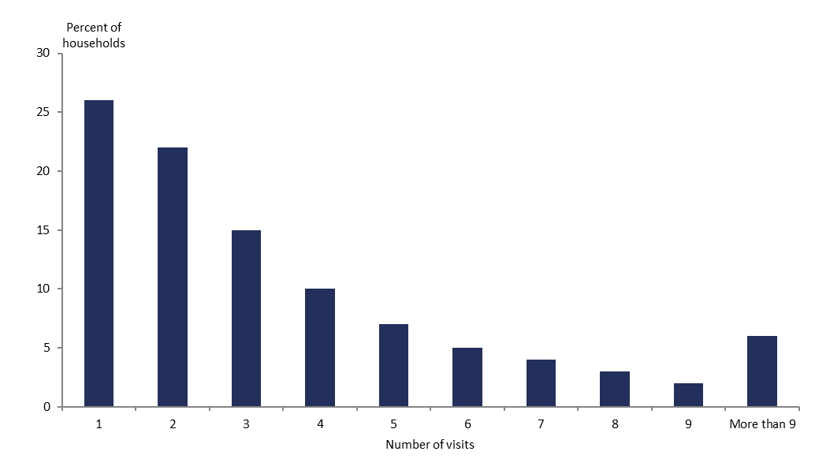

### Interview duration

The mean duration of the adult survey in 2022/23 was 39 minutes, comprising 31 minutes for the core questions and 8 minutes for the modules. The mean duration of the child survey in 2022/23 was 22 minutes, comprising 14 minutes for the core questions and 8 minutes for the modules. Time taken for the interviewer to engage with the household to complete the consent process and pack away at the end of the survey (an average of 10 minutes) is not included in these durations.

### Respondent feedback

To ensure survey protocols have been followed correctly and to ascertain respondents’ satisfaction with the survey process, Reach Aotearoa conducts audit calls with at least 15% of all respondents and at least two households per PSU. Interviewers leave postcards with respondents, which they can use to send feedback (anonymously if they choose) directly to Reach Aotearoa. Feedback is also encouraged via the survey helpline and email.

### Audio recording

Audio recording of interviews was introduced in the 2017/18 NZHS as a part of quality control. Audio recording helps to ensure that interviews are conducted in a consistent and impartial manner. Upon respondent consent, random or pre-determined questions are recorded.

# Response and coverage rates

The response rate is a measure of how many people who were selected to take part in the survey actually participated. The higher the response rate, the more representative the survey results are of the New Zealand population. Table 2 shows the response rate and sample size for adults and children from 2011/12 to the current survey year, 2022/23.

In the 2022/23 NZHS, the final weighted response rate was 71% for adults and 67% for children.

For more details on the response rates for 2022/23, see the ‘New Zealand Health Survey 2022/23’ section.

Response rate is an important measure of the quality of a survey. Methods used to maximise response rates in the NZHS include:

* giving interviewers initial and ongoing training and development
* supporting and assessing interviewers in the field
* using well-designed call pattern processes, allowing for up to 8 calls to potential respondents at different times of the week and day
* revisiting ‘closed’ PSUs at the end of each quarter – non-contact households are revisited (up to 8 times overall) and attempts made to complete interviews with selected respondents who were unable to take part when they were originally selected.

Table 2: Sample size and response rates, 2011/12–2022/23

| **Year** | **Adult Sample Size** | **Child Sample Size** | **Adult Response Rate** | **Child Response Rate** |
| --- | --- | --- | --- | --- |
| 2011/12 | 12,370 | 4,478 | 79% | 85% |
| 2012/13 | 13,009 | 4,485 | 80% | 85% |
| 2013/14 | 13,309 | 4,699 | 80% | 85% |
| 2014/15 | 13,497 | 4,754 | 79% | 83% |
| 2015/16 | 13,781 | 4,721 | 80% | 80% |
| 2016/17 | 13,598 | 4,668 | 80% | 80% |
| 2017/18 | 13,869 | 4,723 | 80% | 79% |
| 2018/19 | 13,572 | 4,503 | 80% | 79% |
| 2019/20 | 9,699 | 3,290 | 75% | 74% |
| 2020/21 | 9,709 | 2,954 | 77% | 74% |
| 2021/22 | 4,434 | 1,323 | 56% | 53% |
| 2022/23 | 6,799 | 2,029 | 71% | 67% |

## Calculating the response rate

The NZHS calculates a weighted response rate. The weight of each household reflects the probability of the household being selected into the sample; the weighted response rate describes the survey’s success in terms of achieving the cooperation of the population being measured.

For adults, the response rate calculation classifies all selected households into the four groups of:

1. ineligible (such as vacant sections, vacant dwellings and non-residential dwellings)
2. eligible responding (interview conducted; respondent confirmed to be eligible for the survey)
3. eligible non-responding (interview not conducted but enough information collected to indicate that the household did contain an eligible adult; almost all refusals were in this category)
4. unknown eligibility (such as non-contacts and refusals who provided insufficient information to determine eligibility).

The response rate is calculated as follows:

The response rate is the number of eligible people responding divided by the number of eligible people responding plus the number of eligible people not responding and the estimated number of eligible people from the unknowns. That number is multiplied by 100 for the rate.

The justification for using this calculation method is that a proportion of the unknowns is likely to have been eligible if contact could have been made. This proportion of the unknowns is therefore treated as eligible non-responding.

The estimated number of unknown eligibles is calculated as follows:

The estimated number of eligibles from the unknowns is calculated by adding the number of eligible people responding to the number of eligible people not responding, then dividing that number by the total number of eligible responding people, non-responding eligible people and the ineligible people. That number is multiplied by the number of unknowns to yield the estimated number of eligibles from the unknowns.

The response rate for children is calculated using the same approach as for adults, but ‘eligible’ means the household contained at least one child, and the definition of ‘responding’ is that a child interview was conducted.

## Coverage rate

The coverage rate is an alternative measure related to survey response and shows the extent to which a population has been involved in a survey. It provides information on the discrepancy between the responding sample (weighted by selection weight) and the population. It encompasses the impact of non-response rates and also incorporates other factors, such as being excluded or missed from the sample frame. For example, dwellings that have just been built may not be included in the sample frame, in this way contributing to under-coverage.

The coverage rate is defined as the ratio of the sum of the selection weights for the survey respondents to the known external population size.

Unlike the response rate, the coverage rate can be calculated without making any assumption about how many households with unknown eligibility were in fact eligible. Moreover, the coverage rate can usually be broken down in more detail than the response rate, including by individual characteristics. However, definitional or operational differences between the survey scope and the external population size (such as differing definitions of usual residence) will affect the coverage rate. As a result, the response rate is generally used as the primary measure of the survey’s quality. Some information on the coverage rate is included to provide more detail on response, particularly response by ethnicity and age group.

The coverage rate also represents the factor by which the calibrated weighting process adjusts selection weights to force agreement with calibration benchmarks (see the ‘Weighting’ section for more on calibration).

For details on the coverage rates in 2022/23, see the ‘New Zealand Health Survey 2022/23’ section.

# Data processing

## Capturing and coding

Questionnaire responses are entered directly on interviewers’ laptops using computer assisted software.

Most questions have single-response options or require discrete numerical responses, such as age at the time of a specific event or the number of visits to a specific medical professional. However, a number of questions allow for multiple responses. For these questions, all responses are retained, with each response shown as a separate variable on the data file.

A number of questions offer a category called ‘other’, where respondents can specify non-standard responses. Each ‘other’ category response is recorded (in free text).

Ethnicity is self-defined, and respondents can report their affiliation with more than one ethnic group, using the Stats NZ standard ethnicity question. Responses to the ethnicity question are coded to level 4 of the *Ethnicity New Zealand Standard Classification 2005* (Stats NZ 2005).

## Securing information

Any information collected in the survey that could be used to identify individuals is treated as strictly confidential. Data is transferred daily from interviewers’ laptops to Reach Aotearoa by a secure internet upload facility. The Ministry accesses the data through the Reach Aotearoa website using a secure username and password login.

The names and addresses of people and households that participate in the survey are not stored with response data. Unit record data are stored in a secure area and are only accessible on a restricted basis.

## Checking and editing

The electronic questionnaire contains built-in edits, including ‘hard’ and ‘soft’ edits. Hard edits prevent impossible responses being entered, such as the year of arrival in New Zealand being earlier than the date of birth. These responses must be changed before the interviewer can proceed to the next question. Soft edits check for unlikely responses, such as inconsistency between responses or values that are unusually high or low. For example, if the response to A3.12a (hours of sleep per day) is less than 4 hours, the interviewer is prompted to verify the answer with respondent. Interviewers may suppress these soft edits and proceed to the next question without changing the response.

Reach Aotearoa and the Ministry routinely check and edit the data throughout the field period of the NZHS. In addition, the final unit record data sets provided to the Ministry are edited for range and logic. Any inconsistencies found are remedied by returning to the interviewer and, if necessary, the respondent for clarification and correction.

In 2018/19, enhanced data cleaning was introduced by Reach Aotearoa. Previously, where a respondent decided to go back in the survey and change their response to an earlier question, any responses that were no longer on a valid logic path were retained in the data set. This resulted in extra cleaning being required at the analysis stage to manually remove these responses. To resolve this issue, Reach Aotearoa worked with the survey software provider to develop on-the-fly automatic cleaning of survey responses that were no longer on a valid logic route.

## Missing data due to non-response

The term ‘unit non-response’ refers to the situation in which no response is obtained from the selected household or person; for example, if the household is unable to be contacted or declines to participate. ‘Item non-response’ refers to the situation in which a respondent does not provide an answer to some (but not all) questions asked on the questionnaire, usually because they do not know the answer or refuse to answer.

Unit non-response is adjusted for in the calculation of weights, as described in the ‘Weighting’ section. Weighting is also used to adjust for non-response to the measurement phase of the interview.

Table 3 shows questions where more than 3% of respondents either didn’t know the answer or refused to answer the question (item non-response). In the 2022/23 NZHS, 13 adult questions had item non-response of 3% or more, and 8 child questions had ‘item non-response’ of 3% or more

Height measurements were obtained from 87% of eligible adult and 76% of eligible child respondents. Weight measurements were obtained from 86% of eligible adult and 76% of eligible child respondents. Waist measurements were obtained from 85% of eligible adult and 75% of eligible child respondents.

Table 3: Questions with item non-response for more than 3% of respondents, 2022/23

| **Question** | **% non-response** |
| --- | --- |
| **Adults** |  |
| Household income | 24% |
| Personal income | 18% |
| Self-reported weight | 13% |
| Self-reported height | 12% |
| Type of arthritis | 11% |
| Type of arthritis affecting respondent the most | 7% |
| Reason for unmet need for mental health and addiction services | 6% |
| Amount charged for last GP visit | 6% |
| House ownership | 5% |
| Age in years | 5% |
| Medical insurance type | 5% |
| Highest qualification | 4% |
| House in family trust | 4% |
| **Children** |  |
| Household income | 23% |
| Reason for unmet need for mental health and addiction services | 10% |
| House ownership | 6% |
| Age when child given drink/food other than breast milk | 5% |
| Treatment for autism spectrum disorder | 5% |
| Age when child stopped being breastfed | 4% |
| Highest qualification of primary caregiver | 4% |
| Use of online resources to get information on mental health support | 3% |

Where a respondent does not provide their date of birth or their age in years, age is imputed as the midpoint of the age group they have provided. No other imputation is used to deal with item non-responses.

## Creating derived variables

A number of derived variables are created on the NZHS data set. Many of these, such as Alcohol Use Disorders Identification Test (AUDIT), and level of psychological distress (K10), are based on commonly used or standard definitions to enable comparison with other data sources and countries.

See the *Annual Data Explorer 2022/23* for more detailed information on all the indicators used in the NZHS (Ministry of Health 2023a).

### Ethnicity

Ethnic group variables are derived using the concept of **total response ethnicity** (Stats NZ 2005). This means that respondents can appear in, and contribute to, the published statistics for more than one ethnic group.

NZHS reports generally provide statistics for the following four groups: Māori, Pacific peoples, Asian and European/Other. The group ‘Other’ (comprising mainly Middle-Eastern, Latin-American and African ethnicities) has been combined with European to avoid problems with small sample sizes.

Respondents who do not know or refuse to state their ethnicity are included as European/Other, as are those who identify themselves as ‘New Zealander’.

The ethnicity data is collected using a standard Stats NZ ethnicity question that provides eight checkboxes for the most common ethnic groups in New Zealand, and up to three text responses for other ethnic group options. The ethnicity coding was improved in 2014/15. The Other ethnicity text response options have been coded to level 4 of the *Ethnicity New Zealand Standard Classification 2005* (Stats NZ 2005) since 2017/18. This is likely to have had a small effect on the time series; for example, increasing the size of the Asian ethnic group. It is unlikely to have affected responses relating to Māori ethnicity, because Māori is listed as an ethnicity in the eight checkboxes for the most common ethnic groups.

### Neighbourhood deprivation

Neighbourhood deprivation refers to the New Zealand Index of Deprivation 2018 (NZDep2018), developed by researchers at the University of Otago (Atkinson et al 2019). NZDep2018 measures the level of socioeconomic deprivation for each neighbourhood (Statistical Area 1, SA1) according to a combination of the following 2018 Census variables: household income, benefit receipt, household crowding, home ownership, employment status, qualifications, single-parent families, living in a home with dampness/mould and access to the internet. An earlier version of NZDep (NZDep2013) was used between NZHS years 2014/15 and 2018/19, and NZDep2006 was used before NZHS 2014/15.

NZHS reports generally use NZDep2018 quintiles, where quintile 1 represents the 20% of small areas with the lowest levels of deprivation (the least deprived areas) and quintile 5 represents the 20% of small areas with the highest level of deprivation (the most deprived areas).

A small number of areas do not have a value for NZDep2018. If any of these areas are selected in the NZHS, the respondents are assigned to quintile 3 (the middle quintile) for weighting and analysis purposes.

### Disability status

The 2022/23 NZHS results are presented by disability status for both adults and children. Different question sets are used for adults and children to identify disability status. The question set used to identify disabled adults in the NZHS Annual Data Explorer is known as the Washington Group Short Set (WG-SS). This question set has been included in the NZHS since 2018/19.

Using the WG-SS, disabled adults are those who have at least a lot of difficulty seeing or hearing (even with glasses or hearing aids), walking or climbing stairs, remembering or concentrating, self-care, or communicating. The six domains included in the WG-SS were chosen because they were found to be the ones that identified a majority of people at risk of being restricted in their independent participation in society.

The WG-SS should not be used to produce estimates of disability prevalence or to investigate levels of need for services or environmental change. To meet these and other data needs, a disability-specific survey, with a more extensive question set, would be required. The population identified as disabled using the WG-SS is considerably smaller than the population identified by disability-specific surveys. One of the limitations is that no WG-SS question fully captures mental health impairments.

The question set used to identify disabled children (aged 5–14 years) in the NZHS is known as the Washington Group / UNICEF Child Functioning Module (CFM). This question set was included in the NZHS for the first time in 2022/23.

Using the CFM, disabled children (aged 5 to 14 years) are those who have at least a lot of difficulty with seeing or hearing (even with glasses or hearing aids), walking, self-care, communicating, learning, remembering, concentrating, accepting change, controlling their own behaviour or making friends, or if they have anxiety, or depression.

For more information on the WG-SS, WG-SS Enhanced and CFM, please see the Washington Group on Disability Statistics website at: [www.washingtongroup-disability.com](http://www.washingtongroup-disability.com)

A small number of people have not been assigned a disability status due to responses of ‘don’t know’ or ‘refused’ to the disability questions. As a result, the estimated number of disabled and non-disabled people shown in the Annual Data Explorer may not add to the total population count.

# Weighting

Weighting of survey data ensures the estimates calculated from this data are representative of the target population.

Most national surveys have complex sample designs whereby different groups have different chances of being selected in the survey. These complex designs are used for a variety of purposes; in particular, to:

* reduce interviewer travel costs by ensuring the sample is geographically clustered
* ensure all regions of interest, including small regions, have a sufficient sample size for adequate estimates to be made
* ensure important sub-populations – in particular, Māori, Pacific peoples and Asian ethnic groups – have a sufficient sample size for adequate estimates to be made.

To ensure no group is under- or over-represented in estimates from a survey, a method of calculating estimates that reflects the sample design must be used. Estimation weights are used to achieve this aim.

A weight is calculated for every respondent, and these weights are used in calculating estimates of population totals (counts), averages and proportions. Typically, members of groups that have a lower chance of selection are assigned a higher weight so that these groups are not under-represented in estimates. Conversely, groups with a higher chance of selection receive lower weights. Also, groups that have a lower response rate (such as young men) are usually assigned a higher weight so that these groups are correctly represented in all estimates from the survey.

The NZHS uses the calibrated weighting method to:

* reflect the probabilities of selecting each respondent
* make use of external population benchmarks (typically based on the population census) to correct any discrepancies between the sample and the population benchmarks; this improves the precision of estimates and reduces bias due to non-response.

NZHS weights are usually calculated for respondents in each survey quarter separately and are calibrated to population benchmarks for the corresponding calendar quarter. Data for the four quarters of the survey year is combined to produce annual survey statistics, and the weights are divided by four so that the combined annual sample represents the target population.

In 2022/23, data collection was attempted for the sample of households selected in the first two quarters of the survey year and part of the sample of households selected in the third quarter. The proportion of the sample attempted in the third quarter varied by DHB, and this has been taken into account in the calculation of the selection weights. Due to smaller achieved sample sizes this year, the respondents from all three quarters have been combined for weighting purposes and calibrated to the averages of the quarterly population benchmarks.

## Calculating selection weights

The first step in producing calibrated weights is to calculate a selection probability (and hence selection weight) for each respondent. It is crucial to calculate selection weights correctly to avoid bias in the final calibrated estimators.

Selection weights for the area-based sample and the electoral roll sample are calculated in different ways, as follows.

### Area-based sample

* The probability of a PSU *i* being selected in the area-based sample (A) is written as *Ai*. The values of *Ai* are greater than 0 for all PSUs in the survey population.
* The probability of a dwelling being selected from a selected PSU *i* in the area sample is 1/*kAi*, where *kAi* is a skip assigned to each PSU on the frame.
* The probability of any particular adult being selected from a selected dwelling *j* in a selected PSU *i* is then 1/*Nij*(adult), where *Nij*(adult) is the number of adults in the dwelling. Similarly, the probability of any particular child (if any in the household) being selected is 1/*Nij*(child), where *Nij*(child) is the number of children in the dwelling.

### Electoral roll sample

* The probability of a PSU *i* being selected in the electoral roll sample (R) is written as *Ri*. The values of *Ri* are 0 for some PSUs (those with fewer than five households with residents who registered Māori descent on the electoral roll snapshot used in the sample design for that year).
* Dwellings are eligible for selection in the electoral roll sample if they have at least one adult registered as being of Māori descent in the electoral roll snapshot extracted for the enumeration quarter. (*Eij*= 1 if PSU *i* has *Ri* > 0 and dwelling *j* in this PSU is eligible; *Eij*= 0 otherwise.)
* A skip *kRi* is assigned to each PSU and applied to eligible dwellings. The probability of an eligible dwelling being selected from PSU *i* in the electoral roll sample is 1/*kRi*, where *kRi* is a skip assigned to each PSU on the frame.
* The probability of any particular adult being selected in the electoral roll sample from a selected dwelling *j* in a selected PSU *i* is then 1/*Nij*(adult), and the probability of any particular child (if any in the household) being selected is 1/*Nij*(child).

### Combined sample

The electoral roll sample and the area-based sample are selected according to the probabilities calculated using the above methods. The two samples of PSUs do not overlap. The complete NZHS sample is defined as the union of the two samples. The probability of selecting any adult in dwelling *j* in PSU *i* in the combined sample is therefore:

(1)



Similarly, the probability of selecting any child in dwelling *j* in PSU *i* in the combined sample is:

(2)



The selection weights for adults and children are given by the reciprocal (inverse) of the above:

(3)



(4)



For the purposes of calculating weights, values of *Nij(adult*) or *Nij(child)* greater than five are truncated to five. This affects only a small proportion of households (approximately 1%) and is designed to reduce the variability of weights to avoid instability in weighted statistics.

## Calibration of selection weights

Calibrated weights are calculated by combining the selection weights and population benchmark information obtained externally from the survey. The NZHS uses counts from Stats NZ’s estimated resident population for each calendar quarter, broken down by age, sex, ethnicity and socioeconomic position, as its benchmark population.

Calibrated weights are calculated to achieve two specific requirements.

A. The weights should be close to the inverse of the probability of selecting each respondent.

B. The weights are calibrated to the known population counts for a range of sub-populations (such as age-by-sex-by-ethnicity categories). This means that the sum of the weights for respondents in the sub-population must equal exactly the known benchmark for the sub-population size.

Requirement A ensures that estimates have low bias; requirement B improves the precision of estimates and achieves consistency between the survey estimates and external benchmark information. The calibrated weights are calculated in such a way as to minimise a measure of the distance between the calibrated weights and the inverse selection probabilities, provided that requirement B above is satisfied.

A number of distance measures are in common use. A chi-square distance function (case 1 in Deville and Särndal 1992) is used for calibrating the NZHS weights, which corresponds to generalised regression estimation (also known as GREG). This distance function is slightly modified to force weights to lie within certain bounds, with the aim of avoiding extreme weights. For details on the weighting in 2022/23, see the ‘New Zealand Health Survey 2022/23’ section.

The inverse selection probability is sometimes called the initial weight. The final, calibrated weights are sometimes expressed as: final weight = initial weight * g-weight. The ‘g-weight’ indicates the factor by which calibration has changed the initial weight.

### Population benchmarks

The following population benchmarks are used in the NZHS weighting.

* Age group (0–4, 5–9, 10–14, 15–19, 20–24, 25–29, 30–34, 35–39, 40–44, 45–49,  
  50–54, 55–59, 60–64, 65–74, 75+ years) by sex (male, female) for all people in the target population
* Age group (0–4, 5–9, 10–14, 15–29, 30–34, 35–39, 40–44, 45–49, 50–54, 55–64, 65+ years) bysex (male, female) for all Māori
* Adult population by Pacific peoples and non-Pacific peoples
* Adult population by Asian and non-Asian
* Total population by NZDep2018 quintile.

Age, sex, ethnicity (Māori, Pacific peoples, Asian, using self-identified total ethnicity) and socioeconomic position (NZDep2018) are included because these variables are related to many health conditions and to non-response, and they are a key output classification for the survey.

### Benchmarks for the total population

Quarterly benchmarks for the total population are Stats NZ’s population estimates as at the end of each calendar quarter.

### Benchmarks for the Māori population

Quarterly benchmarks for the Māori population are constructed for the NZHS by projecting forward the annual (mid-year) population estimates for Māori released by Stats NZ.

Using the Māori population estimates and total population estimates as at 30 June, the proportion of the total population who are Māori is calculated for each five-year age-by-sex group. Then these proportions are applied to quarterly total population estimates, by age and sex, for the subsequent four quarters. For example, the proportion of each age-by-sex group who are Māori as at 30 June 2022 is used to construct estimates of the Māori population by age and sex in each of the quarters ending 30 September 2022, 31 December 2022 and 31 March 2023.

### Benchmarks for the Pacific and Asian populations

Annual population estimates are not available for the Pacific and Asian populations in New Zealand, and so quarterly benchmarks for the adult Pacific and Asian populations are derived from Stats NZ’s Household Labour Force Survey. This large national survey of around 15,000 households per quarter achieves a high response rate, with a target of 90%.

The Household Labour Force Survey publishes quarterly estimates of the working-age (aged 15 years and over) Pacific and Asian populations. From these estimates, the proportions of the adult population who are Pacific peoples and Asian are obtained for each quarter. Some of the quarter-to-quarter variation in these proportions is smoothed out by applying a moving average over the quarterly figures. The final smoothed proportions are applied to the total adult benchmark for the corresponding quarter to give quarterly benchmarks for Pacific and Asian adults.

### Benchmarks for the NZDep2018 quintiles

Benchmarks for the quintiles of NZDep2018 are derived by dividing the latest total population figures (of all age groups) into five groups of equal size.

The calibration for the 2011/12 and 2012/13 surveys used benchmarks from the New Zealand Index of Deprivation 2006 (NZDep2006) based on 2006 Census data. The surveys conducted between 2013/14 and 2018/19 used NZDep2013 based on 2013 Census data, while NZDep2018 was used for surveys from 2019/20 to 2022/23.

### Calibration by sex

For the first time, in 2022/23, the NZHS included three response options for sex and gender. The adult questionnaire asked about the respondent’s sex at birth (‘male’, ‘female’, ‘another term’) and gender (‘male’, ‘female’, ‘another gender’). The child questionnaire asked about the child’s gender (‘male’, ‘female’, ‘another gender’).

However, Stats NZ population statistics are only available for the binary sex categories ‘male’ and ‘female’.

Following advice from Stats NZ, calibration of the NZHS weights has been carried out using respondent data on sex at birth for adults and gender for children, where non-binary responses have been replaced with imputed binary values of ‘male’ or ‘female’. This imputation was only done for the purposes of calibrating the survey weights. All outputs in the Annual Data Explorer are presented by gender as specified by the respondent or their parent/caregiver.

The following imputation methods were used.

* For children with another gender, randomly assign to male or female for weighting purposes.
* For adults with sex at birth specified as ‘another term’ and gender of male or female, assign to male or female based on gender for weighting purposes.
* For adults with sex at birth specified as ‘another term’ and gender specified as ‘another gender’, randomly assign to male or female for weighting purposes.

### Calibrating software and bounding of weights

Calibrated weights were calculated in R using the ‘survey’ package developed by Thomas Lumley.[2] The input weights are the selection weights, first rescaled to sum to the overall population benchmark. Final weights are constrained to be less than or equal to 2.5 times the input weight.

## Jackknife replicate weights

The NZHS uses the delete-a-group jackknife method (Kott 2001) to calculate standard errors for survey estimates.

One hundred jackknife replicate weights are produced for every respondent in the survey, in addition to the final calibrated weight. Each replicate weight corresponds to removing a group of PSUs from the sample and reweighting the remaining sample. This is achieved using exactly the same approach that was used to construct the weights for the full sample, including calibration to the same population benchmarks.

For any weighted estimate calculated from the survey, 100 jackknife replicate estimates can also be calculated using the 100 jackknife weights. The standard error of the full sample estimate is based on the variation in the replicate estimates.

Prior to 2015/16, the assignment of meshblocks to jackknife replicate groups was done independently in separate survey years. With the introduction of PSUs in the 2015/16 sample design, PSUs in the area sample of one survey year are usually reused in the following survey year as well (see also ‘Sample design’ in the ‘Survey population and sample design’ section). Therefore, a given PSU is assigned to the same jackknife replicate group in each of the two consecutive years that it is used in. This ensures that the resulting jackknife weights appropriately take into account the clustering of the sample when calculating jackknife variances for:

* differences of estimates between consecutive years (with repeat PSUs)
* estimates from pooled data across years.

A number of statistical analysis packages, including SAS, Stata and R, can calculate standard errors using jackknife weights.

## Weights for measurement data

An additional set of estimation weights (and corresponding jackknife replicate weights) has been created specifically for analysing the measurements collected from respondents as part of the core NZHS interview. Height and weight measurements are obtained from around 86% of eligible adult and 76% of eligible child respondents. Because variables derived from height and weight are key outputs from the survey, it is useful to have this additional set of estimation weights to compensate for the non-response to these items.

The extra set of weights is calculated for the subset of respondents who have their height and weight measured. Creating these estimation weights follows the same process as for the full sample. This consistent approach ensures that any bias due to lower participation in the measurement phase of the survey for particular demographic subgroups (such as age groups or ethnic groups) is accounted for in the final estimates for the survey.

These estimation weights are also used for analysis involving waist measurements. Waist measurements are obtained from nearly all respondents who have had their height and weight measured.

# Analysis methods

## Estimating proportions, totals and means

Most statistics published in NZHS reports are proportions, totals or means; that is, survey estimates of:

* the proportion (or percentage) of people with a particular characteristic, such as a specific health condition, behaviour or outcome
* the total number of people with a particular characteristic
* the mean per person of some numeric quantity.

A description of the calculation method for each of these types of statistics follows. References to weights mean the final calibrated weights discussed in the ‘Weighting’ section.

### Adjusting for item non-response

Before calculating proportions, totals or means for a particular variable, an adjustment is made to the final weights to account for respondents who answered with ‘don’t know’ or ‘refused’ to the relevant question or questions.

The adjustment increases the final weights of the respondents who answered the question, to represent the final weights of the respondents who answered ‘don’t know’ or ‘refused’. This is carried out within cells defined by gender and age group (10-year age groups for adults and five-year age groups for children), therefore making use of some information on what type of respondents are more likely to be item non-respondents to the variable. Then the item non-respondents can be safely left out of the calculation of proportions, totals or means for the variable.

The adjustment is most important for totals to ensure that item non-response does not lead to underestimating the number of people who have a particular condition or behaviour. The effect will usually be very small for proportions and means; that is, proportions and means using the adjusted weights will be very similar to those using the final calibrated weights.

The adjustment is done ‘on the fly’ in the sense that the item-specific weights are created and used for estimating but are not kept on the survey data set.

### Calculating proportions

The proportion of the population who belong to a particular group (such as the proportion of the population who have diabetes) is estimated by calculating the sum of the weights of the respondents in the group divided by the sum of the weights of all respondents.

The proportion of people in a population group who belong to a subgroup (such as the proportion of Māori who have diabetes) is estimated by calculating the sum of the weights of the respondents in the subgroup (Māori who have diabetes) divided by the sum of the weights of the respondents in the population group (Māori).

### Calculating totals

Estimates of totals are given by calculating the sum, over all the respondents, of the weight multiplied by the variable of interest. For example, the estimate of the total number of people with diabetes in the whole population would be given by the sum, over all respondents, of the weight multiplied by a binary variable indicating which respondents have diabetes. This is equivalent to the sum of the weights of the respondents who have diabetes in the population.

### Calculating means

Estimates of population averages are determined by calculating the sum, over all respondents, of the weight multiplied by the variable of interest divided by the sum of the weights. For example, the average number of males visiting a GP. The estimate is given by calculating the sum, over respondents in the group, of the weight multiplied by the variable of interest, divided by the sum of the weights of the respondents in the group.

### Suppression of small sample sizes

Small samples can affect both the reliability and the confidentiality of results. Problems with reliability arise when the sample becomes too small to adequately represent the population from which it has been drawn. Problems with confidentiality can arise when it becomes possible to identify an individual; usually someone in a subgroup of the population within a small geographical area.

To ensure the survey data presented is reliable and the respondents’ confidentiality is protected, proportions have only been estimated when there are at least 30 people in the denominator (the population group being analysed).

The relative standard error (the standard error expressed as a proportion of the estimate, or RSE) is another indicator of data quality. Data was suppressed when the RSE was over 100% which indicates very poor-quality data. Estimates with an RSE of over 30% are moderate quality and have been flagged to indicate that they should be interpreted with caution.

## Comparing population groups

### Age standardisation

NZHS reports mainly focus on presenting crude (unadjusted) estimates of the proportion or mean in the total population by age group (age-specific rates or means). However, age is an important determinant of health, so population groups with different age structures (such as men and women, whose age structures differ due to women’s longer life expectancy) may have different rates or means due to these age differences. This means that comparisons of crude rates or means over time and between groups may be misleading if the age structure differs between the groups being compared.

One approach to making more meaningful comparisons between groups is to compare age-specific rates or means. Alternatively, it can be useful to summarise a set of age-specific rates or means for a group into a single age-independent measure. This is achieved by a process called **age standardisation**.

Age standardisation in NZHS reports is performed by **direct standardisation** using the World Health Organization (WHO) world population age distribution: *Age‑standardization of Rates: A new WHO standard* (Ahmad et al 2000). The direct method calculates an age-standardised rate (ASR), which is a weighted average of the age-specific rates, for each of the population groups to be compared. The weights applied represent the relative age distribution of the WHO population. This provides a single summary rate for each of the population groups being compared that reflects the rate that would have been expected if the group had had an age distribution identical to the WHO population.

The ASR is given by:

ASR = åri (ni/å ni),

where *ni* is the population in the *i*th age group of the standard population and *ri* is the rate in the *i*th age group from the survey.

Age-standardised rates are provided in some tables to help make comparisons by gender, ethnic group and neighbourhood deprivation and between survey years.

Results for children are age-standardised to the population younger than 15 years, and results for adults are age-standardised to the population aged 15 years and over.

The same approach is used to age-standardised estimates of means.

#### Adjusted rate ratios

NZHS reports also present comparisons between population groups as **rate ratios**; that is, as the ratio of the estimated proportions having the characteristic of interest in the two groups.

Rate ratios are used for comparing:

* men and women
* Māori and non-Māori (for the total population, men and women)
* Pacific peoples and non-Pacific peoples (for the total population, men and women)
* Asian and non-Asian (for the total population, men and women)
* people living in the most and least socioeconomically deprived areas
* disabled and non-disabled (for the total population).

In keeping with the use of total response ethnicity to present statistics by ethnic group, ethnic comparisons are presented such that Māori are compared with non-Māori, Pacific peoples with non-Pacific peoples and Asian with non-Asian. For this purpose, all respondents who identified as Māori are included in the Māori group; all other respondents are included in the non-Māori group. Similar groups are formed for Pacific peoples and Asian ethnic groups.

Rate ratios can be interpreted in the following ways.

* A value of 1 shows that there is no difference between the group of interest (for example, women) and the reference group (for example, men).
* A value higher than 1 shows that the proportion is higher for the group of interest than for the reference group.
* A value lower than 1 shows that the proportion is lower for the group of interest than for the reference group.

The rate ratios presented in NZHS reports are adjusted for differences in demographic factors between the groups being compared that may be influencing (confounding) the comparison. The adjustments are as follows.

* The gender comparison is adjusted for age.
* The ethnic comparisons are adjusted for age and gender.
* The deprivation comparison is adjusted for age, gender and ethnic group.

Adjusting for potential confounding factors makes comparisons more accurate and meaningful because the adjustment removes the effect of these confounding factors.

In the above comparisons, the comparison across neighbourhood deprivation is adjusted for ethnicity as well as age and gender. However, ethnicity comparisons are adjusted for age and gender but not for neighbourhood deprivation. This approach is used because ethnicity confounds the association between deprivation and health outcomes. By contrast, deprivation is only a mediator, not a confounder, of the association between ethnicity and health outcomes; that is, deprivation is on the path that links ethnicity to health outcomes. So, if ethnic comparisons were adjusted for deprivation, the analyses would not reflect the full independent effect of ethnicity but only that portion of the ethnicity effect that is not mediated by the socioeconomic position of deprivation.

Adjusted rate ratios are calculated using the **predictive margins** approach of Korn and Graubard (1999), which Bieler et al (2010) call **model-adjusted risk ratios**. In this method:

* a logistic regression model is fitted to the data. The variable defining the groups to be compared, and the adjustment variables, are explanatory variables in the model
* the parameters of the fitted model are used to estimate the proportion with the characteristic of interest as if all the respondents belong to the group of interest (such as all male), but otherwise each respondent keeps their own values for the adjustment variables in the model (such as age). That is, the proportion being estimated is for a hypothetical population of men who have the same age distribution as the full sample
* in the same way, the parameters of the fitted model are used to estimate the proportion with the characteristic of interest as if all the respondents belong to the comparison group of interest (such as total females), but otherwise each respondent keeps their own values for the adjustment variables in the model (such as age). That is, the proportion being estimated is for a hypothetical population of women who have the same age distribution as the full sample
* once the model-adjusted proportions for the group of interest (men) and the comparison group (women) have been estimated in this way, their ratio can be calculated.

In the neighbourhood deprivation comparisons, the rate ratio refers to the **relative index of inequality** (Hayes and Barry 2002). This measure is used instead of simply comparing the most deprived quintile with the least deprived quintile. It is calculated by first using data from all quintiles to calculate a line of best fit (linear regression line), adjusted for age group, gender and ethnic group. The points on the regression line corresponding to the most and least deprived areas are used to calculate the rate ratio that is presented in the reports. This method has the advantage of using data from all the NZDep2018 quintiles to give an overall test for trend (gradient) by neighbourhood deprivation rather than only using the data from quintiles 1 and 5.

While total response ethnicity is used to report ethnic group statistics in the NZHS reports, a prioritised ethnicity variable is used when adjusting for ethnicity in the regression model underlying the relative index of inequality. Using prioritised ethnicity in the model simplifies the modelling process and gives results similar to including total response ethnicity variables in the model. The priority ordering of ethnic groups used is as follows: Māori, Pacific peoples, Asian, European/Other.

## 

## Confidence intervals and statistical tests

Ninety-five percent confidence intervals are used in NZHS reports to represent the sampling error associated with the statistics; that is, the uncertainty due to selecting a sample to estimate values for the entire population. A 95% confidence interval for a statistic is constructed in such a way that, under a hypothetical scenario where selecting the sample could be repeated many times, 95% of the confidence intervals constructed in this way would contain the true population value.

### Calculating confidence intervals

NZHS statistics that are estimates of means or totals (population counts) are calculated using the usual normal approximation. The upper and lower limits of the 95% confidence interval are found by:

estimate ± 1.96 x standard error of the estimate

However, most NZHS statistics are estimates of proportions. Confidence intervals based on the normal approximation sometimes do not work well for these statistics. For example, when estimating very small (close to 0%) or very large (close to 100%) proportions, the symmetric behaviour of normal confidence intervals can be unrealistic and can even lead to confidence intervals containing negative values or values greater than 100%.

Instead, the Korn and Graubard (1998) method is used to calculate better confidence intervals for proportions. For very small or very large proportions, this method produces asymmetric confidence intervals which still have appropriate statistical properties but stay within the limits of 0% and 100%. For proportions further away from 0% or 100%, the method will produce confidence intervals almost identical to the normal approximation method.

Confidence intervals for percentiles such as medians are calculated using the Woodruff (1952) method.

### Tests for statistically significant differences

Some analysts assess whether two estimates differ significantly by seeing whether their confidence intervals overlap or not. This procedure is known to be overly conservative, resulting in a substantial degrading of statistical power, with some significant differences incorrectly assessed as insignificant.

When confidence intervals do not overlap, it can be concluded that the estimates differ significantly. However, when they do overlap, it is still possible that there is a significant difference. In this case, a *t*-test is used to correctly test the statistical significance of differences between NZHS estimates.

## Time trends

Where possible, the results of indicators presented in the Annual Data Explorer are compared with the corresponding results from the previous years of the continuous NZHS (from 2011/12 onwards). This is referred to as ‘time trends’.

Testing the statistical significance of changes over time is based on age-standardised statistics to adjust for changes in the age structure of the population over time.

# 

# New Zealand Health Survey 2022/23

This section provides some field-related information specific to the data collection and analysis of the 2022/23 NZHS.

## 2022/23 module topics

Table 4 outlines the NZHS 2022/23 module topics.

Table 4: New Zealand Health Survey 2022/23 module topics

|  |  |
| --- | --- |
| **Child module topics** | **Adult module topics** |
| Behavioural and developmental problems  Functional difficulties (CFM)[3] | Mental health and substance use  Extra questions on functional difficulties (WG-SS Enhanced) |

For details about the questionnaires used in the 2022/23 NZHS, see *Content Guide 2022/23: New Zealand Health Survey* (Ministry of Health 2023b).

## Data collection

A NZHS survey year usually refers to the sample drawn from July to June, in four calendar quarters (that is, July to September, October to December, January to March and April to June). Data collection for each quarter usually occurs during the calendar quarter, with some 'mop-up' at the end of the quarter.

Ongoing disruptions from the COVID-19 pandemic and Cyclone Gabrielle had a significant impact on data collection by quarter for the 2022/23 survey as only three quarters were opened, and there was a slightly lower response rate. Data collection continued to be slower than a normal year (see ‘Impact of data collection disruptions*’* below).

As a result of partial data collection in the third quarter and not collecting data for the sample for in the fourth quarter, the sample size for the 2022/23 NZHS is smaller than usual, with a total of 6,799 adults and 2,029 children – about half the size and less than half the size respectively of the samples sizes for the surveys conducted before COVID-19.

Table 5 shows the number of respondents in each calendar quarter, as well as the data collection dates.

Table 5: Number of survey respondents by quarter, 2022/23

|  |  |  |  |  |  |
| --- | --- | --- | --- | --- | --- |
|  | **Adults** | |  | **Children** | |
| **Number** | **Percentage of total respondents** |  | **Number** | **Percentage of total respondents** |
| Quarter 1  (11 July 2022–26 May 2023) | 2,943 | 43 |  | 853 | 42 |
| Quarter 2  (14 November 2022–17 July 2023) | 2,972 | 44 |  | 908 | 45 |
| Quarter 3  (19 April 2023–19 July 2023) | 884 | 13 |  | 268 | 13 |
| Quarter 4  (not started due to COVID-19 and Cycle Gabrielle related disruptions) | – | – |  | – | – |
| **Total (July 2022–July 2023)** | **6,799** | **100** |  | **2,029** | **100** |

## Impact of data collection disruptions

The 2022/23 NZHS data collection began at the usual time of year but suffered ongoing disruptions, related to the COVID-19 pandemic and Cyclone Gabrielle.

One result of these disruptions for the 2022/23 survey year is a smaller sample size. The adult sample for 2022/23 is around half the size of the usual sample, and the child sample is less than half the size of the usual sample (compared with pre-COVID-19 years from 2011/12 to 2018/19). As a result of the smaller sample sizes, the confidence intervals around point estimates are wider than usual.

The smaller sample size means that some subgroup statistics were suppressed because the subgroups had fewer than 30 respondents or the relative standard error (RSE) was more than 100% (see ‘Suppression of small sample sizes’ in ‘Analysis methods’ above). Also, some results in the Annual Data Explorer are flagged as 'e’ because the RSE is 31–100%, indicating that the estimates are less precise and should be interpreted with caution.

The desired mode of data collection for the NZHS is a face-to-face interview in the respondent’s home. In the 2022/23 NZHS, about 3% of the survey respondents were interviewed via CAVI instead of a face-to-face survey. These CAVI interviews were done when a specific household preferred not to have the interviewer in the house because of COVID-19 risks. The method replicated the in-person experience as much as possible and included a video call with the interviewer that involved all the same showcards and visual guides as the in-person version.

For more information about how CAVI interviewing has been used in the NZHS, see *Methodology Report 2021/22* (Ministry of Health 2022).

Another impact of the ongoing data collection disruptions was the lower response rates (weighted) for 2022/23 compared with pre-COVID years (See the ‘Response rates’ section below), however response rates for 2022/23 recovered significantly compared with 2021/22. The main factors underpinning the lower response rate in 2022/23 included:

* difficulty in making contact with respondents,
* interviewer workforce shortages,
* reluctance from the general public to participate in the survey,
* inability to access certain areas due to Cyclone Gabrielle.

## Response rates

The 2022/23 weighted response rate was 71% for adults and 67% for children.

Figure 2 shows the time trend of response rates of adults and children from 2011/12 to the current survey year, 2022/23.

Figure 2: Response rates for adults and children, 2011/12 to 2022/23

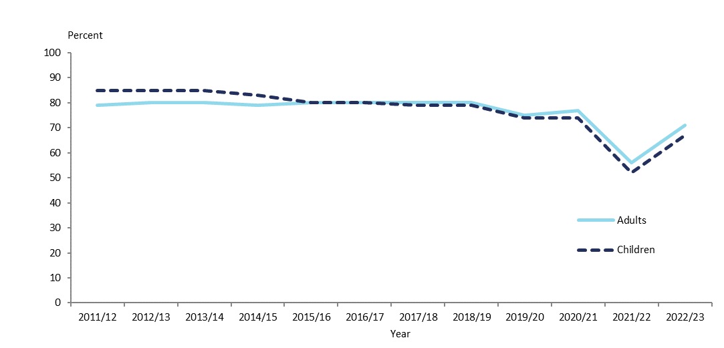

## Coverage rates

A coverage rate records the extent to which a population has been involved in a survey. It provides information on the discrepancy between the responding sample (weighted by selection weight) and the population. The coverage rate is defined as the ratio of the sum of the selection weights for the survey respondents to the known external population size.

In 2022/23, the coverage rates were 52% for adults and 56% for children. Figure 3 shows the time trend of coverage rates of adults and children from 2011/12 to the current survey year, 2022/23.

Figure 3: Coverage rates for adults and children, 2011/12 to 2022/23

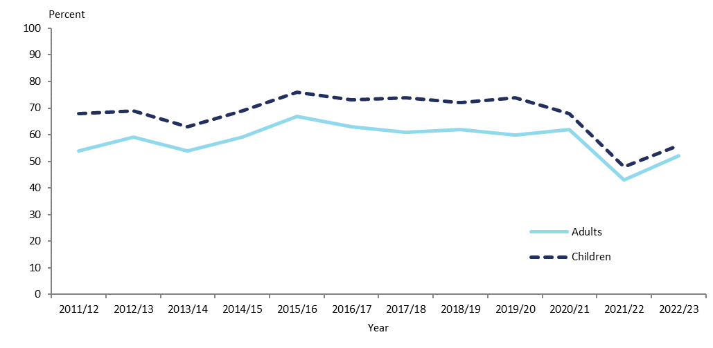

Figure 3 shows that coverage rates for children have been higher compared to adults across all years since 2011/12, although the gap has closed in recent years.

In 2022/23, the coverage rates were 44% for Māori, 55% for Pacific peoples and 60% for Asian people. Figure 4 shows the time trend of coverage rates for the Māori, Pacific peoples and Asian ethnic groups from 2011/12 to the current survey year, 2022/23.

Figure 4: Coverage rates for Māori, Pacific peoples and Asian ethnic groups, 2011/12 to 2022/23

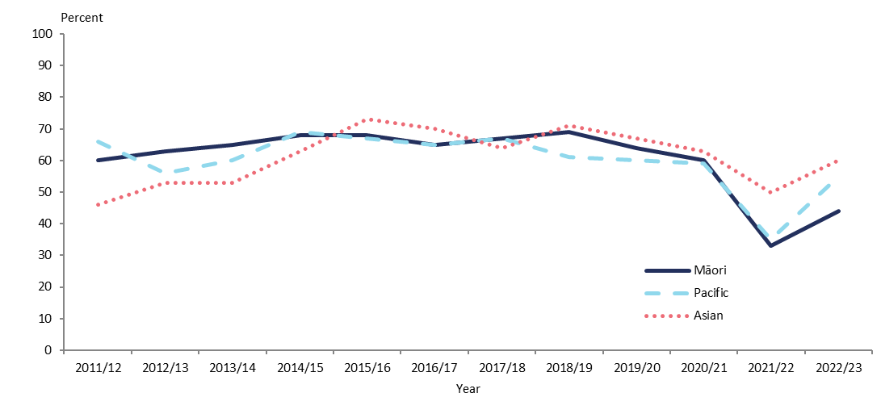

In 2022/23, the coverage rates for quintiles of neighbourhood deprivation were: 58% (NZDep quintile 1), 57% (NZDep quintile 2), 53% (NZDep quintile 3), 48% (NZDep quintile 4) and 49% (NZDep quintile 5). Figure 5 shows the time trend figures for NZDep quintile 1 to NZDep quintile 5 from 2011/12 to the current survey year, 2022/23.

Figure 5: Coverage rates by New Zealand Index of Deprivation quintiles, 2011/12 to 2022/23

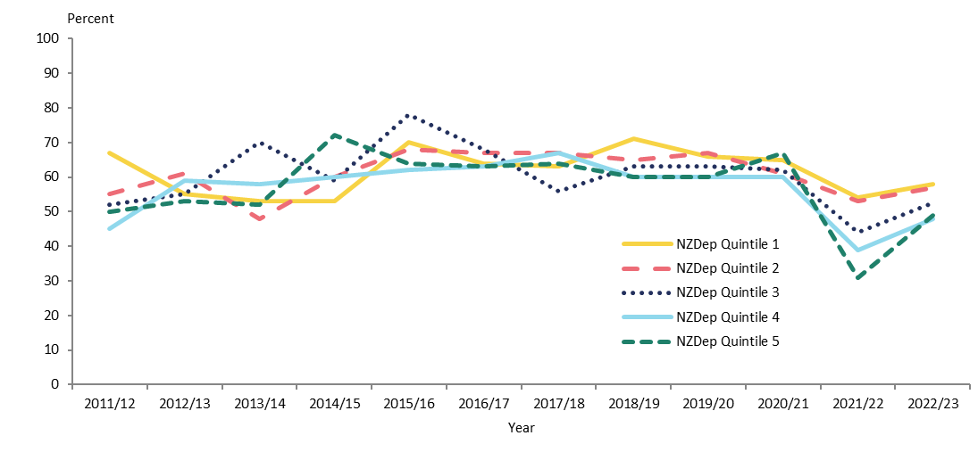

Figure 6 and Figure 7 show the coverage rates by age group and gender for 2022/23 for the total population and Māori respectively.

Figure 6: Coverage rates for total population, by age group and gender, 2022/23

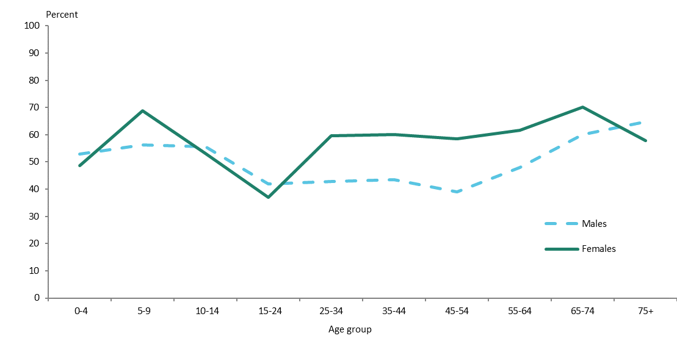

Figure 7: Coverage rates for Māori, by age group and gender, 2022/23

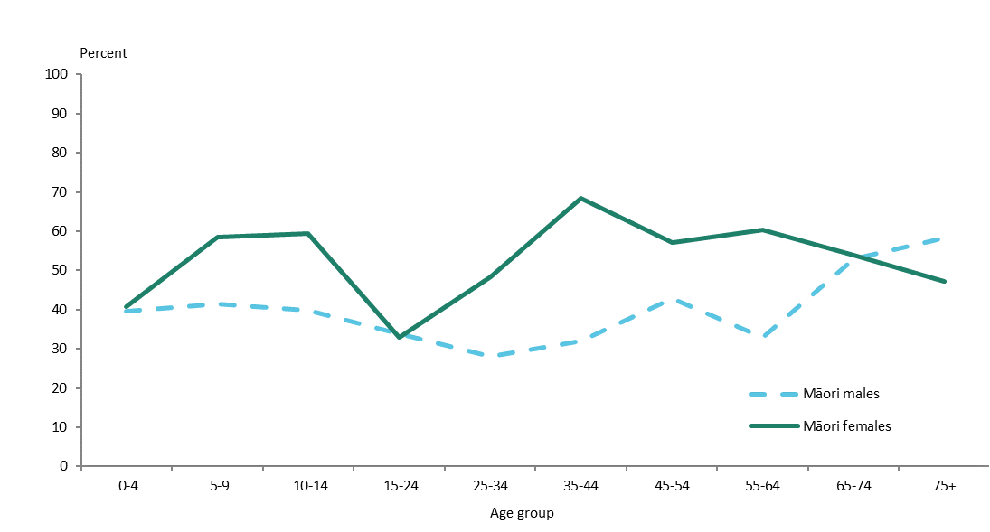

## Final weights

The section on weighting has explained how the calibrated weights were calculated. Table 6 gives basic descriptive information on the final weights calculated for the 2022/23 survey.

The g-weights are the ratios of the final weights to the initial selection weights. The mean g-weight is 2.0, which can be considered as reasonable. This means the calibrated weights, which were calculated using population benchmark information, have changed the initial selection weight by an average factor of 2.0.

Table 6: Final weights 2022/23

|  |  |
| --- | --- |
|  | **Final weight** |
| Minimum | 56 |
| Median | 426 |
| 90th percentile | 1,179 |
| 95th percentile | 1,597 |
| 99th percentile | 2,690 |
| Maximum | 5,000 |
| Coefficient of variation (CV%) | 89 |
| Approximate design effect due to weighting (1 + CV2) | 1.8 |

## 

## Sample sizes

Table 7 to Table 11 show the 2022/23 NZHS sample sizes and the total ‘usually resident’ population counts, by gender, ethnicity, age, NZDep2018 quintile and disability status.

Table 7: Sample sizes and population counts for children and adults, by gender, 2022/23

|  |  |  |  |
| --- | --- | --- | --- |
| **Population group** | **Gender** | **Interviews** | **Population count** |
| Children | Boys | 1,018 | 494,797 |
| (0–14 years) | Girls | 1,011 | 469,960 |
|  | **Total** | **2,029** | **964,757** |
| Adults | Men | 2,766 | 2,060,337 |
| (15 years and over) | Women | 4,012 | 2,117,537 |
|  | Another gender | 21 | 21,436 |
|  | **Total** | **6,799** | **4,199,310** |

Table 8: Sample sizes and population counts for children and adults, by total response ethnicity, 2022/23

|  |  |  |  |
| --- | --- | --- | --- |
| **Ethnic group** | **Population group** | **Interviews** | **Population count** |
| **(total response)** |
| European/Other | Children | 1,313 | 621,594 |
| Adults | 5,108 | 3,104,291 |
| Māori | Children | 657 | 267,780 |
| Adults | 1,292 | 630,383 |
| Pacific peoples | Children | 309 | 155,330 |
| Adults | 447 | 279,667 |
| Asian | Children | 407 | 200,692 |
| Adults | 847 | 636,000 |

Table 9: Sample sizes and population counts, by age, 2022/23

| **Age group (years)** | **Interviews** | **Population count** |
| --- | --- | --- |
| 0–4 | 630 | 302,140 |
| 5–9 | 663 | 321,593 |
| 10–14 | 736 | 341,023 |
| 15–24 | 576 | 645,383 |
| 25–34 | 1,093 | 747,923 |
| 35–44 | 1,056 | 677,870 |
| 45–54 | 970 | 648,200 |
| 55–64 | 1,153 | 626,687 |
| 65–74 | 1,071 | 482,423 |
| 75 and over | 880 | 370,823 |

Table 10: Sample sizes and population counts, by NZDep2018 quintile, 2022/23

|  |  |  |  |
| --- | --- | --- | --- |
| **NZDep2018 quintile** | **Population group** | **Interviews** | **Population count** |
| Quintile 1 | Children | 183 | 187,267 |
| (least deprived neighbourhoods) | Adults | 620 | 845,546 |
| Quintile 2 | Children | 275 | 174,150 |
| Adults | 986 | 858,663 |
| Quintile 3 | Children | 377 | 194,633 |
| Adults | 1,364 | 838,180 |
| Quintile 4 | Children | 525 | 191,697 |
| Adults | 1,763 | 841,116 |
| Quintile 5 | Children | 669 | 217,009 |
| (most deprived neighbourhoods) | Adults | 2,066 | 815,805 |

Table 11: Sample sizes and population counts (adults), by disability status and gender, 2022/23

|  |  |  |  |
| --- | --- | --- | --- |
| **Disability status** | **Gender** | **Interviews** | **Population count** |
| Disabled | Children (5+) | 203 | 90,227 |
| Adults | 813 | 388,579 |
| Non-disabled | Total children (5+) | 1,167 | 558,458 |
| Total adults | 5,963 | 3,798,111 |

# Changes in previously published statistics

This section notifies NZHS users about errors or changes in the statistics published in previous annual reports or in the *Annual Data Explorers*. These errors may have occurred as a result of independent events at different stages of the survey process, which are explained below. Any revisions to the data have been made in the current Annual Data Explorer.

An error was corrected in the 2022/23 Annual Data Explorer for the 2021/22 statistics. Some households were assigned to the wrong New Zealand Index of Deprivation (NZDep) decile. The NZDep is used to calculate the survey weights for all analyses, so the error affected all the 2021/22 statistics. However, the impact was relatively small and the revised statistics were almost all within the margin of error of the original statistics. For more information, see the Ministry of Health website:[4]

An error was corrected in the 2022/23 Annual Data Explorer for the child indicator on unmet need for mental health support. The indicator for previous years was incorrectly calculated for children aged 0-14 years, rather than 2-14 years. Please use the figures in the 2022/23 data explorer going forward.

# References

Ahmad O, Boschi-Pinto C, Lopez A, et al. 2000. *Age-standardization of Rates: A new WHO standard*. Geneva: World Health Organization (WHO).

Atkinson J, Salmond C, Crampton P. 2019. *NZDep2018 Index of Deprivation*. Interim Research Report, December 2019, Wellington: Department of Public Health, University of Otago.

Bieler GS, Brown GG, Williams RL, et al. 2010. Estimating model-adjusted risks, risk differences, and risk ratios from complex survey data. *American Journal of Epidemiology* 171: 618–23.

Clark RG, Templeton R, McNicholas A. 2013. Developing the design of a continuous national health survey for New Zealand. *Population Health Metrics* 11(1): 25. URL: [www.pophealthmetrics.com/content/11/1/25](http://www.pophealthmetrics.com/content/11/1/25) (accessed 01 October 2022).

Deville JC, Särndal CE. 1992. Calibration estimators in survey sampling. *Journal of the American Statistical Association* 87: 376–82.

Hayes L, Barry G. 2002. Sampling variability of the Kunst-Mackenbach relative index of inequality. *Journal of Epidemiology and Community Health* 56: 762–5.

Korn EL, Graubard BI. 1998. Confidence intervals for proportions with small expected number of positive counts estimated from survey data. *Survey Methodology*  
24(2): 193–201.

Korn EL, Graubard BI. 1999. *Analysis of Health Surveys*. New York: Wiley.

Kott PS. 2001. The delete-a-group jackknife. *Journal of Official Statistics* 17(4): 521–6.

Ministry of Health. 2011. *The New Zealand Health Survey: Sample design, years 1–3 (2011–2013)*. Wellington: Ministry of Health. URL: [www.health.govt.nz/publication/new-zealand-health-survey-sample-design-years-1-3-2011-2013](http://www.health.govt.nz/publication/new-zealand-health-survey-sample-design-years-1-3-2011-2013) (accessed 11 October 2022).

Ministry of Health. 2016. *Sample Design from 2015/16: New Zealand Health Survey*.Wellington: Ministry of Health. URL: [www.health.govt.nz/publication/sample-design-2015-16-new-zealand-health-survey](http://www.health.govt.nz/publication/sample-design-2015-16-new-zealand-health-survey) (accessed 11 October 2022).

Ministry of Health. 2022. *Methodology Report 2021/22: New Zealand Health Survey*. Wellington: Ministry of Health. URL: [www.health.govt.nz/publication/methodology-report-2021-22-new-zealand-health-survey](https://www.health.govt.nz/publication/methodology-report-2021-22-new-zealand-health-survey) (accessed 9 November 2023).

Ministry of Health. 2023a. *Annual Data Explorer 2022/23: New Zealand Health Survey*. Wellington: Ministry of Health. URL: [www.health.govt.nz/publication/annual-update-key-results-2022-23-new-zealand-health-survey](http://www.health.govt.nz/publication/annual-update-key-results-2022-23-new-zealand-health-survey) (accessed 26 October 2023).

Ministry of Health. 2023b. *Content Guide 2022/23: New Zealand Health Survey*. Wellington: Ministry of Health. URL: [www.health.govt.nz/publication/content-guide-2022-23-new-zealand-health-survey](http://www.health.govt.nz/publication/content-guide-2022-23-new-zealand-health-survey) (accessed 26 October 2023).

Stats NZ. 1998. *Protocols for Official Statistics*. Wellington: Stats NZ.

Stats NZ. 2005. *Ethnicity New Zealand Standard Classification 2005*. Wellington: Stats NZ.

Stats NZ. 2007. *Principles and Protocols for Producers of Tier 1 Statistics.* Wellington: Stats NZ. URL: <http://archive.stats.govt.nz/about_us/who-we-are/home-statisphere/tier-1/principles-protocols.aspx#gsc.tab=0> (accessed 27 October 2020).

Stats NZ. 2023. Estimated resident population by age and sex (1991+) (Qrtly Mar/Jun/Sep/Dec) – Infoshare table reference DPE054AA*.* URL: http://infoshare.stats.govt.nz (accessed 18 July 2023).

Woodruff RS. 1952. Confidence intervals for medians and other position measures. *Journal of the American Statistical Association* 47: 635–46.

1. See the New Zealand Health Survey webpage on the Ministry of Health website at: www.health.govt.nz/nz-health-statistics/national-collections-and-surveys/surveys/current-recent-surveys/new-zealand-health-survey
2. Available from the webpage Survey: Analysis of Complex Survey Samples on The Comprehensive R Archive Network website at URL: <https://cran.r-project.org/web/packages/survey/index.html> (accessed 9 November 2023).
3. The functional difficulties module questions used for children in the 2018/19, 2019/20 and 2020/21 surveys (WG-SS) did not work well to identify disabled children. In 2022/23, a different set of module questions (CFM) was used. This set of questions is better at identifying disabled children, and these questions are likely to become core questions.
4. See the corrections to the 2021/22 New Zealand Health Survey data webpage on the Ministry of Health website at [www.health.govt.nz/nz-health-statistics/surveys/corrections-made-2021-22-new-zealand-health-survey-data](https://www.health.govt.nz/nz-health-statistics/surveys/corrections-made-2021-22-new-zealand-health-survey-data)