Methodology Report 2020/21

New Zealand Health Survey

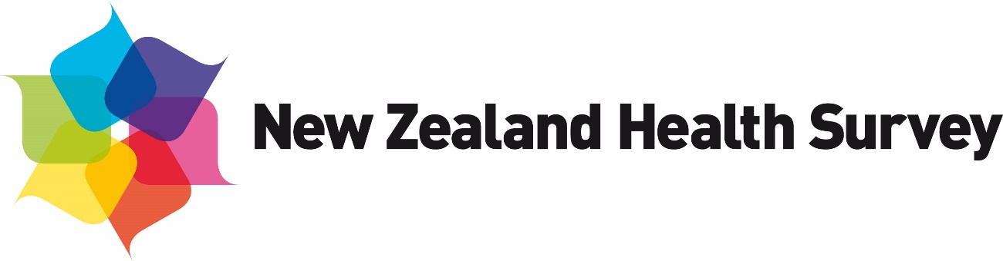

### Authors

This report was originally written by Deepa Weerasekera, Steven Johnston, Maria Turley and Chloe Lynch (Ministry of Health), Robert Clark (Statistics Adding Value) and Barry Gribben, Carol Boustead Gibb and Neil Tee (CBG Research).

This version of the report was updated by the Health Surveys team in the Health and Disability Intelligence Group, Ministry of Health. Contributors include Aloka Bhattacharya, Melanie Duncan and Maria Turley.

Citation: Ministry of Health. 2021. *Methodology Report 2020/21: New Zealand Health Survey*. Wellington: Ministry of Health.

Published in December 2021 by the Ministry of Health  
PO Box 5013, Wellington 6140, New Zealand

ISBN 978-1-99-100794-0 (online)  
HP 7994



This document is available at [health.govt.nz](http://www.health.govt.nz)

|  |  |
| --- | --- |
| **CCBY** | This work is licensed under the Creative Commons Attribution 4.0 International licence. In essence, you are free to: share ie, copy and redistribute the material in any medium or format; adapt ie, remix, transform and build upon the material. You must give appropriate credit, provide a link to the licence and indicate if changes were made. |

Contents

Introduction 1

Background 2

Survey content 3

Core content 3

Survey population and sample design 5

Target and survey population 5

Sample design 6

Data collection 9

Interviews 9

Objective measurements 10

Field work 12

Response and coverage rates 17

Calculating the response rate 18

Coverage rate 19

Data processing 20

Capturing and coding 20

Securing information 20

Checking and editing 21

Missing data due to non-response 21

Creating derived variables 22

Weighting 25

Calculating selection weights 26

Calibration of selection weights 27

Jackknife replicate weights 29

Weights for measurement data 30

Analysis methods 31

Estimating proportions, totals and means 31

Comparing population groups 33

Confidence intervals and statistical tests 36

Time trends 37

New Zealand Health Survey 2020/21 38

2020/21 module topics 38

Data collection 38

Impact of COVID‑19 disruptions 39

Response rates 40

Coverage rates 41

Final weights 44

Sample sizes 44

Changes in previously published statistics 47

Population data changes 47

References 48

List of Tables

Table 1: New Zealand Health Survey 2020/21 core content 4

Table 2: Questions with missing data for more than 1 percent of respondents (adults) 22

Table 3: New Zealand Health Survey 2020/21 module topics 38

Table 4: Number of survey respondents by quarter, 2020/21 39

Table 5: Final weights 2020/21 44

Table 6: Sample sizes and population counts for children and adults, by gender, 2020/21 44

Table 7: Sample sizes and population counts for children and adults, by total response ethnicity, 2020/21 45

Table 8: Sample sizes and population counts, by age, 2020/21 45

Table 9: Sample sizes and population counts, by NZDep2018 quintile, 2020/21 46

Table 10: Sample sizes and population counts (adults), by disability status and gender, 2020/21 46

List of Figures

Figure 1: Proportion of households agreeing to first interview, by number of visits, 2020/21 15

Figure 2: Response rates for adults and children, 2011/12 to 2020/21 40

Figure 3: Coverage rates for adults and children, 2011/12 to 2020/21 41

Figure 4: Coverage rates for Māori, Pacific peoples and Asian ethnic groups, 2011/12 to 2020/21 42

Figure 5: Coverage rates by New Zealand Index of Deprivation quintiles, 2011/12 to 2020/21 42

Figure 6: Coverage rates for total population, by age group and gender, 2020/21 43

Figure 7: Coverage rates for Māori, by age group and gender, 2020/21 43

# Introduction

The New Zealand Health Survey (NZHS) is an important data collection tool that is used to monitor population health and provide supporting evidence for health policy and strategy development. The Health and Disability Intelligence group, within the Ministry of Health’s Health System Improvement and Innovation business unit, is responsible for designing, analysing and reporting on the NZHS. The NZHS field activities are contracted out to a specialist survey provider, CBG Health Research Ltd (CBG).

The NZHS collects information that cannot be obtained more effectively or efficiently through other means, such as by analyses of hospital administrative records, disease registries or epidemiological research. The NZHS is the best source of information at a population level for most of the topics it covers.

Before 2011, the Ministry conducted New Zealand Health Surveys (in the years 1992/93, 1996/97, 2002/03 and 2006/07) and additional, separate stand-alone surveys on specific subjects (adult and child nutrition; tobacco, alcohol and drug use; mental health; and oral health) once every three or four years. In July 2011, all of these surveys were integrated into a single NZHS, which is now in continuous annual operation.

From 2013 onwards, a number of key outputs from the NZHS became Tier 1 statistics (a portfolio the government maintains of the most important official statistics, essential to understanding how well New Zealand is performing in different aspects of national concern). For the 2019/20 year, the eight Tier 1 statistics from the NZHS are: smoking (current), past-year (alcohol) drinking, hazardous (alcohol) drinking, obesity, unmet need for a general practitioner (GP) due to cost, unfilled prescription due to cost, self-rated health and mental health status (psychological distress).

This NZHS methodology report outlines the procedures and protocols followed to ensure that the NZHS produces the high-quality and robust data expected of official statistics (Statistics New Zealand 2007). The information from the continuous NZHS specific to the 2020/21 year (data collected from September 2020 to August 2021) is included in the ‘New Zealand Health Survey 2020/21’ section of this report. Due to COVID-19 restrictions, the sample size for 2020/21 is smaller than those for other years. The corresponding information for years 2011/12 to 2019/20 of the NZHS can be found in previous methodology reports.[1]

## Background

As a signatory to the *Protocols for Official Statistics* (Statistics New Zealand 1998), the Ministry employs best-practice survey techniques to produce high-quality information from the NZHS. It uses standard frameworks and classifications, with validated questions where possible, so that NZHS data can be integrated with data from other sources.

### Goal

The goal for the NZHS was reviewed in 2019 as part of a project to ensure the survey remains fit for purpose for the future. The refreshed goal is to monitor and research the health and wellbeing of New Zealanders, including how people experience their own health and health services. The information covers population health, health risk and protective factors, as well as health service utilisation.

### Objectives

To achieve this goal, four high-level objectives have been identified for the NZHS. These are to:

* + - * 1. provide an evidence base to inform health system funding, policy, programmes and advocacy with a focus on long-term priorities
        2. monitor and research population health status and the prevalence of key health behaviours and risk factors
        3. monitor barriers to access and use of health care services, including health service user experience
        4. enable robust statistical analysis to be carried out and links to other data collections to be made, to address wider information needs.

### Features of the survey

The NZHS has been carefully designed to minimise impact on survey respondents. Features for this purpose include:

* selecting only one eligible adult and one eligible child per dwelling
* using well-tested and proven questions
* using professional, trained interviewers to conduct the interviews
* making an appointment to conduct each interview at a time that suits the respondent and their family
* having the option of using a proxy respondent where would-be respondents living in private dwellings have severe ill health or cognitive disability.

The New Zealand Health and Disability Multi-region Ethics Committee (MEC) approved the 2020/21NZHS (MEC reference: MEC/10/10/103).

# Survey content

The NZHS comprises a set of core questions combined with a flexible programme of rotating topic modules. The questionnaire is administered (face to face and computer assisted) to adults aged 15 years and older, as well as to children aged 0–14 years, generally through their primary caregiver, who acts as a proxy respondent.

The current NZHS maintains continuity with the previous surveys by including a set of core questions in both the adult and child questionnaires. The module topics usually change every 12 months.

For details on the rationale of topic inclusion, cognitive testing, and the content of the questionnaires, see the *Content Guide* 2020/21(Ministry of Health 2021b).

## Core content

Most of the core questions for both adults and children are drawn from the main topic areas included in the 2006/07 and 2011/12 NZHSs. Topic areas include long-term conditions, health status and development, health behaviours, health service utilisation and patient experience, sociodemographic and health measurements. Table 1 summarises the topics included in the core content of the 2020/21NZHS. See the *Content Guide* 2020/21(Ministry of Health 2021b) for the module topics of each survey year between 2011/12 and 2020/21.

Table 1: New Zealand Health Survey 2020/21 core content

| **Domain** | **Topics** | |
| --- | --- | --- |
| **Children** | | |
| Health conditions | Asthma, eczema, mental health and developmental disorders (depression, anxiety, ADHD, autism spectrum disorder) | |
| Health status | Parent-rated health | |
| Health behaviours and risk factors | Nutrition, physical activity, screen time, sleep, teeth brushing, child discipline | |
| Health care services: utilisation, barriers and patient experience | GPs, nurses, after hours, medical specialists, allied health (for example, dentists, pharmacists), emergency department, hospitals, prescriptions | |
| Sociodemographics | Child: Gender, age, ethnicity, country of birth, health insurance, Household: Housing, household income, household composition (relationship to and age and gender of every member of household)  Primary caregiver: Education and employment status | |
| Health measurements | Height, weight, waist circumference | |
| **Adults** | |
| Health conditions | Heart disease, stroke, high cholesterol, high blood pressure, diabetes, asthma, arthritis, chronic pain, mental health conditions (psychological distress, depression, anxiety, bipolar disorder) |
| Health status | General health (physical and mental health), functional difficulties (disability status) |
| Health behaviours and risk factors | Tobacco smoking, electronic cigarette use, alcohol use, drug use, nutrition, physical activity, sleep, teeth brushing |
| Health care services: utilisation, barriers and patient experience | GPs, nurses, after hours, medical specialists, allied health (for example, dentists, pharmacists), emergency department, hospitals, prescriptions |
| Sociodemographics | Adult: Gender, age, ethnicity, sexual identity, languages spoken, country of birth, education, personal income and income sources, employment status, health insurance  Household: Housing, household income, household composition (relationship to and age and gender of every member of household) |
| Health measurements | Height, weight, waist circumference, blood pressure |

# Survey population and sample design

This section describes the target population, the survey population and the sample design for the NZHS.

## Target and survey population

The **target population** is the population the survey aims to represent. The **survey population** is the population that was covered in the survey.

### Target population

The target population for the NZHS is the New Zealand ‘usually resident’ population of all ages, including those living in non-private accommodation.

The target population is approximately 4.1 million adults (aged 15 years and over) and 0.97 million children (aged from birth to 14 years), according to the Statistics New Zealand estimated resident population as of September 2020 (Stats NZ 2021).

The NZHS previously (in 2006/07 and earlier) included only people living in private accommodation. The target population for the current NZHS includes people living in some types of non-private accommodation, to improve coverage of older people.

### Survey population

Approximately 99 percent of the New Zealand ‘usually resident’ population of all ages is eligible to participate in the NZHS. For practical reasons, a small proportion of the target population is excluded from the survey population. People in this category include:

* those in most types of non-private dwellings (prisons, hospitals, hospices, dementia care units and hospital-level care in aged-care facilities)
* non-New Zealand diplomats, diplomatic staff and their dependants
* people who usually live in a household but are currently away and will not return within the next four weeks (except students based in hostels and boarding schools)
* people in households located on islands other than the North Island, South Island and Waiheke Island.

Included in the survey population are:

* usual residents who live in aged-care facilities (rest homes)
* students who live away for at least four weeks from their household in student accommodation (university hostels and boarding schools)
* usual residents who live in a household, but are away for less than four weeks
* children under shared care arrangements if they spend:
* at least four days per week in the current household
* equal time in the current household and somewhere else, and they are present in the household on the day of recruitment
* overseas visitors who intend to stay in New Zealand for more than 12 months.

## Sample design

The sample design for the NZHS was developed by the National Institute for Applied Statistics Research Australia, University of Wollongong, Australia.

The sample design used in the current year is the same design used for the years 2015/16 to 2019/20, but it is slightly different from the design used for the years 2011/12 to 2014/15. The main changes made in 2015/16 are as follows:

* The first-stage selection units are now Statistics New Zealand’s household survey frame primary sampling units (PSUs) rather than the census meshblocks used in the previous four years. PSUs are groupings of one or more meshblocks. There have also been some associated changes to the selection probabilities and the number of dwellings selected from each PSU.
* PSUs are now selected using the Statistics New Zealand coordinated selection facility to manage overlap across many government surveys and to minimise the NZHS revisiting the same households.
* PSUs selected for the area component (defined below under ‘Sample selection’) of the sample are now surveyed in two different quarters of the same calendar year, but in different reporting years, such as 2018/19 and 2019/20. Different households are surveyed in these two different quarters.

For more detail on the current sample design, see *Sample Design from 2015/16: New Zealand Health Survey* (Ministry of Health 2016), and for detail on the sample design used prior to 2015/16, see Clark et al (2013) and *The New Zealand Health Survey: Sample design, years 1–3 (2011–2013)* (Ministry of Health 2011).

### Sample selection

The NZHS has a multi-stage, stratified, probability-proportional-to-size (PPS) sampling design. The survey is designed to yield an annual sample size of approximately 14,000 adults and 5,000 children.

A dual-frame approach has been used, whereby respondents are selected from an area-based sample and a list-based electoral roll sample. The aim of this approach is to increase the sample sizes for Māori, Pacific peoples and Asian ethnic groups.

#### Area-based sample

Statistics New Zealand’s PSUs form the basis of the area-based sample. The area-based sample is targeted at the ethnic groups of interest by assigning higher probabilities of selection to areas (PSUs) in which these groups are more concentrated.

A three-stage selection process is used to achieve the area-based sample.

* First, a sample of PSUs is selected within each district health board (DHB) area. The PSUs are selected with PPS, where the size measure is based on the counts of occupied dwellings from the 2018 Census. This means that larger PSUs have a higher chance of being selected in the sample. The size measures are modified using a targeting factor to give higher probabilities of selection to PSUs where more Pacific or Asian people live, also based on the 2018 Census.
* Second, a list of households is compiled for each selected PSU. A systematic sample of approximately 21 households is selected from this list by choosing a random start point and selecting every *k*th household. The skip *k* is calculated by the 2018 Census occupied-dwellings count divided by 21.
* Third, one adult (aged 15 years or over) and one child (aged from birth to 14 years, if any in the household) are selected at random from each selected household.

Aged-care facilities in the selected PSUs are included in the area-based sample by first dividing them into ‘accommodation units’, typically consisting of an individual or couple living together in the facility. Accommodation units are then treated as households in the sampling process, although, at most, five accommodation units are selected from a single facility.

Students living away from home in university hostels and boarding schools are eligible to be selected via their family’s house if they still consider this to be their home. If selected, arrangements are made to survey them either when they are next at home or at their student accommodation.

#### Electoral roll sample

The electoral roll provides another sampling frame, used to increase the sample size of the Māori ethnic group. The electoral roll is used to select a sample of addresses where a person has self-identified as having Māori ancestry. A copy of the electoral roll is obtained quarterly for this purpose.

Stratified three-stage sampling is used to select the sample from the electoral roll.

* The first stage involves selecting a sample of PSUs within each stratum (DHB area), with probability proportional to the number of addresses on the electoral roll containing at least one person who has self-identified as having Māori ancestry. The sample of PSUs is selected so that it does not overlap with the sample of PSUs for the area-based sample.
* The second stage involves selecting a systematic sample of 14 addresses (from the list of households where any person has self-identified as having Māori ancestry) from each selected PSU, or all addresses if there are fewer than 14 addresses in a selected PSU.
* In the third stage, one adult (aged 15 years or over) and one child (aged from birth to 14 years, if there are any children in the household) are selected at random from each selected address.

The process of contacting households and selecting an adult and child is exactly the same for the electoral roll sample as for the area-based sample. The adult and child (if there are any children in the household) randomly selected into the sample can be Māori or non-Māori. This approach ensures that probabilities of selection can be correctly calculated for all respondents.

# Data collection

CBG collects data for the NZHS. The CBG interview team comprises approximately 40 professional public policy interviewers.

The NZHS is a household survey with data collected in the respondents’ home, using a combination of interviews and objective measurements (for example, height and weight).

Due to COVID-19 restrictions, a small number of interviews for the 2020/21 NZHS were conducted via computer-assisted video interviewing (CAVI) – see ‘Computer-assisted video interviewing (CAVI)’ below.

The 2020/21 NZHS does not collect any data from people during COVID-19 alert levels 3 or 4 – see ‘New Zealand Health Survey 2020/21’ at the end of this report.

## Interviews

Most data for the NZHS is collected via computer-assisted personal interviewing (CAPI). For CAPI, the interviewer enters responses directly into a laptop, using the survey system’s CAPI software. Data for some sensitive questions is collected via computer-assisted self-interviewing (CASI), whereby adult respondents enter their responses directly into a tablet computer.

‘Showcards’ with predetermined response options are used to help respondents where appropriate. Since 2017/18, electronic showcards on a tablet computer have been used help improve respondent engagement and the accuracy of their responses. The options displayed on the electronic showcards automatically change as the survey progresses.

### Computer-assisted video interviewing (CAVI)

In response to COVID-19 restrictions, CBG developed a virtual interviewing system, which enables computer-assisted video interviewing (CAVI). The CAVI system provides a secure, private online ‘room’ where an interviewer and respondent can meet to complete the survey together, in a way that closely resembles an in-person interview. The system features an integrated video call component and a large survey window. The respondent can view the showcards on the screen and complete the CASI questions themselves. Video interviewing was offered to respondents who were apprehensive about having an interviewer in their home or where the household did not pass the COVID-19 doorstep screener – see ‘COVID-19 protocols’ to follow. In the 2020/21 NZHS, 31 adult interviews and 9 child interviews were conducted using CAVI.

### Interviewer training

Interviewers participate in annual training for new modular content and receive ongoing training and support during the year, in the form of individualised and group learning. In-field assessments are also conducted by field managers at regular intervals during the survey year. Interviewers are retrained annually and must pass a recertification assessment to ensure they maintain the required skill levels.

## Objective measurements

Objective measures are taken during the face-to-face interview at the end of the interview component of the survey. All respondents aged two years and over are invited to have their height and weight measured, respondents aged five years and over are invited to have their waist circumference measured, and adults aged 15 years and over are invited to have their blood pressure measured. Respondents may decline to provide any or all of these measurements. Pregnant women are excluded from the measurement component of the survey.

For the 2020/21 NZHS, height and weight measurements were not taken for some respondents who were uncomfortable being physically close to the interviewer.

Height, weight and waist circumference measurements are taken at least twice for each respondent. If there is a variation of more than 1 percent between the first and second measurements, a third measurement is taken for accuracy. The final height, weight and waist measurements used for analysis are calculated for each respondent by taking the mean of the two closest measurements.

Respondents are given a measurement card, detailing the readings taken on the day of the survey. The card also includes details about where to go for further information or advice.

### Height

Laser height measurement was introduced with the 2012/13 NZHS. The laser design was trialled and refined before being introduced. It replaced the traditional stadiometers used in the 2011/12 NZHS and nutrition surveys. The professional measuring device, a Precaster HANS CA770, consists of a laser meter mounted to a rigid headboard that the interviewer holds against a wall or a closed door. The headboard is lowered until it reaches the respondent’s head, activating the laser to take a measurement to the nearest 0.1 centimetre. Respondents are asked to remove their shoes before their height is measured.

### Weight

Weight is measured to the nearest 0.1 kilogram, using professional electronic weighing scales (Tanita HD-351), which can take a maximum of 200 kilograms. Respondents are asked to empty their pockets and remove their shoes and any bulky clothing before their weight is measured.

### Waist circumference

Waist circumference is measured to the nearest 0.1 centimetre, using an anthropometric measuring tape (Lufkin® W606PM). Measurements are taken over one layer of clothing, at the midpoint between the lowest palpable rib and the top of the hip bone.

### Blood pressure

Blood pressure measurement for adults was introduced into the annual core content of the NZHS in 2012/13. It was removed during the 2017/18 survey year (to allow more time for the questionnaire portion of the survey) and reintroduced in 2018/19.

If the respondent consents, interviewers obtain a blood pressure measurement, using an OMRON HEM-907, a portable electronic sphygmomanometer with three cuff sizes. A fabric cuff is wrapped around the respondent’s upper left arm, just above the elbow. Within the cuff is a plastic bladder connected by a tube to the main device. As the bladder inflates, the device detects the respondent’s blood pressure. The device is programmed to take three readings, with a 1-minute pause between each. The final systolic and diastolic measurements used for analysis are calculated for each respondent by taking the mean of the second and third measurements. The first reading is not used, to minimise the impact of any increase in blood pressure caused by taking measurements.

### Equipment checks

Several techniques are used to ensure the quality of the objective measurement equipment. If interviewers report faulty equipment, replacements are supplied immediately. CBG managers carry out in-field checks of equipment at least twice a year. These checks include:

* a visual check of equipment for damage/cleanliness (to ensure, for example, that blood pressure cuffs are in good condition, blood pressure tubes and connectors are sound and weighing scales have all four feet)
* a check that the laser and blood pressure devices are still programmed with the correct settings.

At the time of the annual module change, the equipment is checked and recalibrated as follows.

* The electronic weighting scales and blood pressure monitors are recalibrated by a manufacturer-approved agent.
* The lasers are checked against a known fixed height to ensure they are measuring correctly and are still programmed to the correct settings.

Interviewers undergo retraining on the process for collecting measurements at the time of each annual module change. They must pass a certification assessment before being permitted to deliver the survey in the field. The assessment is administered by a nurse and includes an assessment of the interviewer’s ability to measure children.

## Field work

### COVID-19 protocols

To ensure the safety of respondents and interviewers in relation to COVID-19, the 2020/21 survey introduced the measures of:

* interviewer training
* training on infection control
* physical distancing
* cleaning and sanitising of equipment and hands
* interviewer and household wellbeing checks
* record keeping.

#### Interviewer wellbeing checks

Interviewers had to complete a daily self-assessment, which checked whether they or anyone in their household had any COVID-like symptoms or whether anyone in their household was self-isolating or awaiting a COVID-19 test result. Interviewers also took their temperature daily using an in-ear thermometer. If they failed this assessment, they were not permitted to go into the field.

#### On the doorstep

Once contact was made at a sampled address, the interviewer ensured they maintained a distance of at least 1 metre during the recruitment process. After a respondent had been selected, a COVID-19 screener was administered to identify whether anyone in the household was at increased risk from contracting COVID-19. The screener included the first three questions listed below for the 2020/21 survey year, with the fourth question added in July 2021.

* Is anyone in your household currently unwell and have symptoms similar to COVID-19? This includes fever, coughing, sore throat, and sneezing.
* Is anyone in your household self-isolating? For example, because they have travelled back from overseas recently or had been in contact with someone who had COVID-19.
* Is anyone in your household currently employed in a role where they may come in contact with COVID-19? For example, working at official quarantine facilities, or employed to work on aircrafts that come from overseas.
* Has anyone in your household been at a ‘location of interest’ either in New Zealand or overseas in the past 14 days? A location of interest is a place known to be visited by someone confirmed to have COVID-19. Anyone who has visited the same location at certain times is asked by Ministry of Health to follow additional directions to prevent the spread of COVID-19.

If the respondent screened negative to all four questions, the survey proceeded face to face if the respondent was comfortable with the interviewer being in their home, otherwise a video interview was offered. Other precautions included the use of disposable masks if physical distancing was not possible inside the residence. Some measurements (waist circumference and blood pressure) were not made during alert level 2.

If the respondent screened positive to any of the four screening questions, then a face-to-face interview was not permitted. In this situation, the respondent had the option to reschedule the interview to a later date (at least two weeks in the future) or complete the survey via a video interview. If they opted for a video interview, the interviewer provided a login card with information on how to access the survey, and they agreed a time with the respondent.

### Pilot study

Before the main data collection for the 2020/21 NZHS, a pilot study was carried out with 110 respondents from nine PSUs in Auckland, West Coast and Oamaru. A total of 91 adult and 19 child interviews were completed in this pilot study. As a result of the pilot, some minor changes were made to the survey questions. See the *Content Guide* 2020/21 (Ministry of Health 2021b) for more information about the purpose and results of the pilot study.

### Enumeration

CBG pre-selects households from PSUs selected for the survey using the New Zealand Post address database, obtained quarterly. Each area PSU is re‑enumerated by the interviewer when they first visit, to ensure accuracy of both new dwellings and those removed (since the previous Census). New household details are entered into CBG’s Sample Manager software while the interviewer is in the field, making those households eligible for random selection process within its PSU.

### Invitation to participate

The NZHS is voluntary, relying on the goodwill of respondents, and interviewers obtain consent for participation without coercion or inducement. CBG posts each selected household an invitation letter from the Ministry, along with an information pamphlet. Interviewers take copies of the information pamphlet in 11 different languages when they subsequently visit households seeking people’s agreement to participate in the survey.

Using CBG’s Sample Manager software, one adult and one child (if any in the household) are randomly selected from each selected household to take part in the survey. Respondents are asked to sign an electronic consent form and are given a copy to keep. The consent form requires the respondent to confirm they have read and understood the information pamphlet, that they can ask questions at any time and that they can contact CBG or the Ministry for more information.

The consent form also informs respondents:

* of their right to request an interpreter if required (in a range of 10 different languages)
* that they can stop the interview at any time
* that they do not have to answer every question
* that their participation is confidential, and no identifiable information will be used in any reports
* that their answers are protected by the Privacy Act 1993.

Where a selected adult respondent is unable to provide consent themselves, a welfare guardian, or someone who holds enduring power of attorney for the respondent’s personal care and welfare, is permitted to consent to and complete the survey on the respondent’s behalf.

Child interviews are conducted with a guardian or primary caregiver of the child; that is, a person who has day-to-day responsibility for the care of the child.

All respondents for the NZHS are given a thank you card and a small token of appreciation, such as a pen or fridge magnet, at the conclusion of the interview. A list of health and community organisations is also included should respondents wish to discuss their participation, or if they need advice on a health issue.

### Visit pattern

In attempting to make contact, interviewers visit each selected household, on different days and at different times of the day. Interviewers can visit as many times as they deem necessary, however, a household will only be recorded as a ‘non-contact’ once 10 unsuccessful visits have been made. Visits are recorded as separate events only if they are made at least two hours apart.

Interviewers space their PSU visits over a two- to three-month period. During the first month, the interviewer will make up to six visits to each selected household within the PSU. If contact with a selected household is not established during that time, the interviewer suspends visiting that household for three or four weeks before attempting twice more. If contact is still not established, the interviewer suspends visiting for another three or four weeks before their final two attempts. This process helps the interviewer contact people who might be away temporarily or who are otherwise engaged when their household is first approached.

The visit pattern used in the NZHS is an important part of achieving a high response rate. In the 2020/21 NZHS, interviewers followed a proven visit approach that had been used in previous years, visiting PSUs at different times and on different days depending on the area. For about 93 percent of households, the first (or only) interview took place within nine visits (Figure 1).

Figure 1: Proportion of households agreeing to first interview, by number of visits, 2020/21

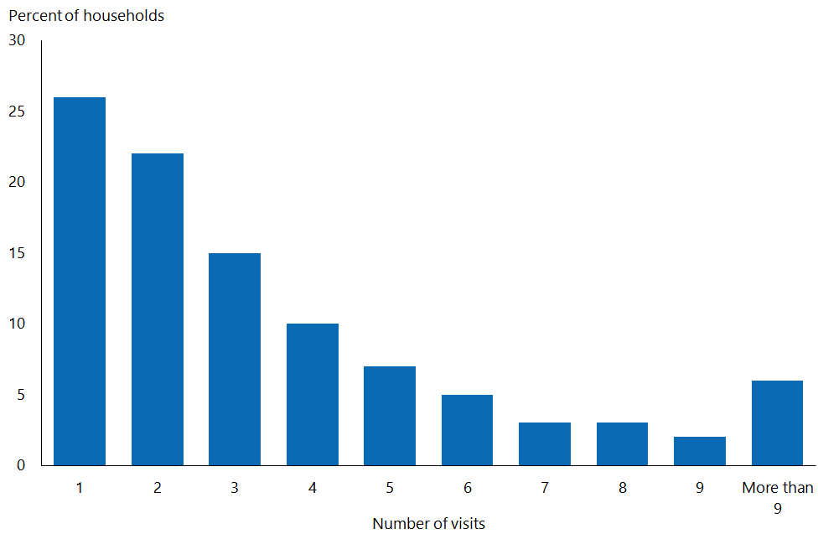

### Interview duration

The mean duration of the adult survey in 2020/21 was 43 minutes, comprising 38 minutes for the core questions (including measurements) and 5 minutes for the modules. The mean duration of the child survey in 2020/21 was 23 minutes, comprising 19 minutes for the core questions (including measurements) and 4 minutes for the modules. Time taken for the interviewer to engage with the household, to complete the consent process and to pack away at the end of the survey (an average of 10 minutes) is not included in these durations.

### Respondent feedback

To ensure survey protocols have been followed correctly and to ascertain respondents’ satisfaction with the survey process, CBG conducts audit calls with at least 15 percent of all respondents and at least two households per PSU. Interviewers leave postcards with respondents, which they can use to send feedback (anonymously if they choose) directly to CBG. Feedback is also encouraged via the survey helpline and email.

### Audio recording

Audio recording of interviews was introduced in the 2017/18 NZHS as a part of quality control. Audio recording helps to ensure that interviews are conducted in a consistent and impartial manner. Upon respondent consent, random or pre-determined questions are recorded.

# Response and coverage rates

The response rate is a measure of how many people who were selected to take part in the survey actually participated. The higher the response rate, the more representative the survey results are of the New Zealand population.

In 2020/21, the final weighted response rate was 77 percent for adults and 74 percent for children.

For more details on the response rates for 2020/21, see the ‘New Zealand Health Survey 2020/21’ section.

Response rate is an important measure of the quality of a survey. Methods used to maximise response rates in the NZHS include:

* giving interviewers initial and ongoing training and development
* supporting and assessing interviewers in the field
* using well-designed call pattern processes, allowing for up to 10 calls to potential respondents at different times of the week and day
* revisiting ‘closed’ PSUs at the end of each quarter – non-contact households are revisited (up to 10 times overall) and attempts made to complete interviews with selected respondents who were unable to take part when they were originally selected.

## Calculating the response rate

The NZHS calculates a weighted response rate. The weight of each household reflects the probability of the household being selected into the sample; the weighted response rate describes the survey’s success in terms of achieving the cooperation of the population being measured.

For adults, the response rate calculation classifies all selected households into the four groups of:

* + - * 1. ineligible (such as vacant sections, vacant dwellings and non-residential dwellings)
        2. eligible responding (interview conducted; respondent confirmed to be eligible for the survey)
        3. eligible non-responding (interview not conducted but enough information collected to indicate that the household did contain an eligible adult; almost all refusals were in this category)
        4. unknown eligibility (such as non-contacts and refusals who provided insufficient information to determine eligibility).

The response rate is calculated as follows:

The response rate is the number of eligible people responding divided by the number of eligible people responding plus the number of eligible people not responding and the estimated number of eligible people from the unknowns. That number is multiplied by 100 for the rate.

The justification for using this calculation method is that a proportion of the unknowns is likely to have been eligible if contact could have been made. This proportion of the unknowns is therefore treated as eligible non-responding.

The estimated number of unknown eligibles is calculated as follows:

The estimated number of eligibles from the unknowns is calculated by adding the number of eligible people responding to the number of eligible people not responding, then dividing that number by the total number of eligible responding people, non-responding eligible people and the ineligible people. That number is multiplied by the number of unknowns to yield the estimated number of eligibles from the unknowns.

The response rate for children is calculated using the same approach as for adults, but ‘eligible’ means the household contained at least one child, and the definition of ‘responding’ is that a child interview was conducted.

## Coverage rate

The coverage rate is an alternative measure related to survey response and shows the extent to which a population has been involved in a survey. It provides information on the discrepancy between the responding sample (weighted by selection weight) and the population. It encompasses the impact of non-response rates and also incorporates other factors, such as being excluded or missed from the sample frame. For example, dwellings that have just been built may not be included in the sample frame, in this way contributing to under-coverage.

The coverage rate is defined as the ratio of the sum of the selection weights for the survey respondents to the known external population size.

Unlike the response rate, the coverage rate can be calculated without making any assumption about how many households with unknown eligibility were in fact eligible. Moreover, the coverage rate can usually be broken down in more detail than the response rate, including by individual characteristics. However, definitional or operational differences between the survey scope and the external population size (such as differing definitions of usual residence) will affect the coverage rate. As a result, the response rate is generally used as the primary measure of the survey’s quality. Some information on the coverage rate is included to provide more detail on response, particularly response by ethnicity and age group.

The coverage rate also represents the factor by which the calibrated weighting process adjusts selection weights to force agreement with calibration benchmarks (see the ‘Weighting’ section for more on calibration).

For details on the coverage rates in 2020/21, see the ‘New Zealand Health Survey 2020/21’ section.

# Data processing

## Capturing and coding

Questionnaire responses are entered directly on interviewers’ laptops using CAPI software.

Most questions have single-response options or require discrete numerical responses, such as age at the time of a specific event or the number of visits to a specific medical professional. However, a number of questions allow for multiple responses. For these questions, all responses are retained, with each response shown as a separate variable on the data file.

In addition, a number of questions in the questionnaire offer a category called ‘other’, where respondents can specify non-standard responses. Each ‘other’ category response is recorded (in free text).

Ethnicity is self-defined, and respondents are able to report their affiliation with more than one ethnic group using the Statistics New Zealand standard ethnicity question. Responses to the ethnicity question are coded to level 4 of the *Ethnicity New Zealand Standard Classification 2005* (Statistics New Zealand 2005a).

## Securing information

Any information collected in the survey that could be used to identify individuals is treated as strictly confidential. Data is transferred daily from interviewers’ laptops to CBG by a secure internet upload facility. The Ministry accesses the data through the CBG website using a secure username and password login.

The names and addresses of people and households that participate in the survey are not stored with response data. Unit record data are stored in a secure area and are only accessible on a restricted basis.

## Checking and editing

CBG and the Ministry routinely check and edit the data throughout the field period of the NZHS. In addition, the final unit record data sets provided to the Ministry are edited for range and logic. Any inconsistencies found are remedied by returning to the interviewer and, if necessary, the respondent for clarification and correction.

In 2018/19, enhanced data cleaning was introduced by CBG. Previously, where a respondent decided to go back in the survey and change their response to an earlier question, any responses that were no longer on a valid logic path were retained in the data set. This resulted in extra cleaning being required at the analysis stage to manually remove these responses. To resolve this issue, CBG worked with the survey software provider to develop on-the-fly automatic cleaning of survey responses that were no longer on a valid logic route.

## Missing data due to non-response

The term ‘unit non-response’ refers to the situation in which no response is obtained from the selected household or person; for example, if the household is unable to be contacted or declines to participate. ‘Item non-response’ refers to the situation in which a respondent does not provide an answer to some (but not all) questions asked on the questionnaire, usually because they do not know the answer or refuse to answer.

Unit non-response is adjusted for in the calculation of weights, as described in the ‘Weighting’ section. Weighting is also used to adjust for non-response to the measurement phase of the interview.

For adults in the 2020/21 NZHS, 12 questions have more than 1 percent ‘item non‑response’ (see Table 2). For children, 15 questions have more than 1 percent ‘item non‑response’.

Table 2: Questions with missing data for more than 1 percent of respondents (adults)

|  |  |
| --- | --- |
| **Question** | **Percent non-response** |
| Household income | 18% |
| Blood pressure measurement | 18% |
| Country of birth | 13% |
| Personal income | 11% |
| Type of arthritis affecting most | 9% |
| Age in years | 9% |
| Type of health insurance | 6% |
| Emergency department visit due to unmet need | 5% |
| Likeliness of having a COVID-19 vaccine when offered | 4% |
| Emergency department visit about own health | 3% |
| Family trust | 3% |
| House ownership | 2% |

Where a respondent does not provide their date of birth or their age in years, age is imputed as the midpoint of the age group they have provided. No other imputation is used to deal with item non-responses.

### Questions about dental health care worker visits

Approximately 400 adult respondents from the first quarter of the NZHS 2020/21 were mistakenly not asked questions A2.95 and A2.95a during their interview due to a programming error. These respondents were recontacted when the issue was discovered. All but 136 were successfully recontacted, and their answers were added to the data. The two questions were:

A2.95 Which of the following statements best describes the regularity of your consultations with a dental health care worker?

A2.95a In the last 12 months, have you avoided going to a dental health care worker because of the cost?

## Creating derived variables

A number of derived variables are created on the NZHS data set. Many of these, such as body mass index (BMI), Alcohol Use Disorders Identification Test (AUDIT) and level of psychological distress (K10), are based on commonly used or standard definitions to enable comparison with other data sources and countries. Other derived variables are developed specifically for the NZHS, such as a summary indicator of physical activity level that incorporates information on the intensity, duration and frequency of a person’s physical activity.

See the *Annual Data Explorer* for more detailed information on all the indicators used in the NZHS ([www.health.govt.nz/publication/annual-update-key-results-2020-21-new-zealand-health-survey](http://www.health.govt.nz/publication/annual-update-key-results-2020-21-new-zealand-health-survey)).

### Outliers

Respondents with height and weight measurements that lead to a calculated BMI of less than 10 or greater than 80 are considered outliers and treated as non-respondents to the measurement phase of the interview.

Respondents who report more than 112 hours of physical activity per week (an average of 16 hours per day) are excluded from the derived summary measure of physical activity.

### Ethnicity

Ethnic group variables are derived using the concept of **total response ethnicity** (Statistics New Zealand 2005a). This means that respondents can appear in, and contribute to, the published statistics for more than one ethnic group.

NZHS reports generally provide statistics for the following four ethnic groups: Māori, Pacific peoples, Asian and European/Other. The ethnic group Other (comprising mainly Middle-Eastern, Latin-American and African ethnicities) has been combined with European to avoid problems with small sample sizes.

Respondents who do not know or refuse to state their ethnicity are included as European/Other, as are those who identify themselves as ‘New Zealander’.

The ethnicity data is collected using a standard Statistics New Zealand ethnicity question that provides eight checkboxes for the most common ethnic groups in New Zealand, and up to three text responses for other ethnic group options. The ethnicity coding was improved in 2015/16. The Other ethnicity text response options have been coded to level 4 of the *Ethnicity New Zealand Standard Classification 2005* (Statistics New Zealand 2005a) since 2015/16. This is likely to have had a small effect on the time series; for example, increasing the size of the Asian ethnic group. It is unlikely to have affected responses relating to Māori ethnicity, because Māori is listed as an ethnicity in the eight checkboxes for the most common ethnic groups.

### Neighbourhood deprivation

Neighbourhood deprivation refers to the New Zealand Index of Deprivation 2018 (NZDep2018), developed by researchers at the University of Otago (Atkinson et al 2019). NZDep2018 measures the level of socioeconomic deprivation for each neighbourhood (meshblock) according to a combination of the following 2013 Census variables: income, benefit receipt, transport (access to car), household crowding, home ownership, employment status, qualifications, support (sole-parent families) and access to the internet. The older version of NZDep2018 (NZDep2013) was used between NZHS years 2014/15 and 2018/19, and NZDep2006 was used prior to NZHS 2014/15.

NZHS reports generally use NZDep2018 quintiles, where quintile 1 represents the 20 percent of small areas with the lowest levels of deprivation (the least deprived areas) and quintile 5 represents the 20 percent of small areas with the highest level of deprivation (the most deprived areas).

A small number of meshblocks do not have a value for NZDep2018. If any of these meshblocks are selected in the NZHS, the respondents are assigned to quintile 3 (the middle quintile) for weighting and analysis purposes.

### Disability status

The question set used to identify disabled people in the NZHS is known as the Washington Group Short Set (WGSS) and has been included in the NZHS since 2018/19. Using the WGSS, disabled people are those who have at least a lot of difficulty seeing or hearing (even with glasses or hearing aids), walking or climbing stairs, remembering or concentrating, self-care, or communicating. The six domains included in the WGSS were chosen because they were found to be the ones that identified a majority of people at risk of being restricted in their independent participation in society.

The WGSS should not be used to produce estimates of disability prevalence or to investigate levels of need for services or environmental change. To meet these and other data needs, a disability-specific survey, with a more extensive question set, would be required. The population identified as disabled using the WGSS is considerably smaller than the population identified by disability-specific surveys. One of the limitations is that no WGSS question fully captures mental health impairments.

For more information, please see [www.washingtongroup-disability.com](http://www.washingtongroup-disability.com).

NZHS results by disability status are presented for adults but not for children. The number of children in one survey year of the NZHS who are identified as disabled by the WGSS is too small to allow robust conclusions to be drawn.

# Weighting

Weighting of survey data ensures the estimates calculated from this data are representative of the target population.

Most national surveys have complex sample designs whereby different groups have different chances of being selected in the survey. These complex designs are used for a variety of purposes; in particular, to:

* reduce interviewer travel costs by ensuring the sample is geographically clustered
* ensure all regions of interest, including small regions, have a sufficient sample size for adequate estimates to be made
* ensure important sub-populations – in particular, Māori, Pacific peoples and Asian ethnic groups – have a sufficient sample size for adequate estimates to be made.

To ensure no group is under- or over-represented in estimates from a survey, a method of calculating estimates that reflects the sample design must be used. Estimation weights are used to achieve this aim.

A weight is calculated for every respondent, and these weights are used in calculating estimates of population totals (counts), averages and proportions. Typically, members of groups that have a lower chance of selection are assigned a higher weight so that these groups are not under-represented in estimates. Conversely, groups with a higher chance of selection receive lower weights. Also, groups that have a lower response rate (such as young men) are usually assigned a higher weight so that these groups are correctly represented in all estimates from the survey.

The NZHS uses the calibrated weighting method to:

* reflect the probabilities of selecting each respondent
* make use of external population benchmarks (typically based on the population census) to correct any discrepancies between the sample and the population benchmarks; this improves the precision of estimates and reduces bias due to non-response.

Data from each calendar quarter of the NZHS data set are weighted separately to population benchmarks for that quarter. This means that each quarter’s data can be used to produce valid population estimates.

## Calculating selection weights

The first step in producing calibrated weights is to calculate a selection probability (and hence selection weight) for each respondent. It is crucial to calculate selection weights correctly to avoid bias in the final calibrated estimators.

Selection weights for the area-based sample and the electoral roll sample are calculated in different ways, as follows.

### Area-based sample

* The probability of a PSU *i* being selected in the area-based sample (A) is written as *Ai*. The values of *Ai* are greater than 0 for all PSUs in the survey population.
* The probability of a dwelling being selected from a selected PSU *i* in the area sample is 1/*kAi*, where *kAi* is a skip assigned to each PSU on the frame.
* The probability of any particular adult being selected from a selected dwelling *j* in a selected PSU *i* is then 1/*Nij*(adult), where *Nij*(adult) is the number of adults in the dwelling. Similarly, the probability of any particular child (if any in the household) being selected is 1/*Nij*(child), where *Nij*(child) is the number of children in the dwelling.

### Electoral roll sample

* The probability of a PSU *i* being selected in the electoral roll sample (R) is written as *Ri*. The values of *Ri* are 0 for some PSUs (those with fewer than five households with residents who registered Māori descent on the electoral roll snapshot used in the sample design for that year).
* Dwellings are eligible for selection in the electoral roll sample if they have at least one adult registered as being of Māori descent in the electoral roll snapshot extracted for the enumeration quarter. (*Eij*= 1 if PSU *i* has *Ri* > 0 and dwelling *j* in this PSU is eligible; *Eij*= 0 otherwise.)
* A skip *kRi* is assigned to each PSU and applied to eligible dwellings. The probability of an eligible dwelling being selected from PSU *i* in the electoral roll sample is 1/*kRi*, where *kRi* is a skip assigned to each PSU on the frame.
* The probability of any particular adult being selected in the electoral roll sample from a selected dwelling *j* in a selected PSU *i* is then 1/*Nij*(adult), and the probability of any particular child (if any in the household) being selected is 1/*Nij*(child).

### Combined sample

The electoral roll sample and the area-based sample are selected according to the probabilities calculated using the above methods. The two samples of PSUs do not overlap. The complete NZHS sample is defined as the union of the two samples. The probability of selecting any adult in dwelling *j* in PSU *i* in the combined sample is therefore:

(1) 

Similarly, the probability of selecting any child in dwelling *j* in PSU *i* in the combined sample is:

(2) 

The selection weights for adults and children are given by the reciprocal (inverse) of the above:

(3) 

(4) 

For the purposes of calculating weights, values of *Nij(adult*) or *Nij(child)* greater than five are truncated to five. This affects only a small proportion of households (approximately 1 percent) and is designed to reduce the variability of weights to avoid instability in weighted statistics.

## Calibration of selection weights

Calibrated weights are calculated by combining the selection weights and population benchmark information obtained externally from the survey. The NZHS uses counts from Statistics New Zealand’s estimated resident population for each calendar quarter, broken down by age, gender, ethnicity and socioeconomic position, as its benchmark population.

Calibrated weights are calculated to achieve two specific requirements.

A. The weights should be close to the inverse of the probability of selecting each respondent.

B. The weights are calibrated to the known population counts for a range of sub-populations (such as age-by- gender -by-ethnicity categories). This means that the sum of the weights for respondents in the sub-population must equal exactly the known benchmark for the sub-population size.

Requirement A ensures that estimates have low bias; requirement B improves the precision of estimates and achieves consistency between the survey estimates and external benchmark information. The calibrated weights are calculated in such a way as to minimise a measure of the distance between the calibrated weights and the inverse selection probabilities, provided that requirement B above is satisfied.

A number of distance measures are in common use. A chi-square distance function (case 1 in Deville and Särndal 1992) is used for calibrating the NZHS weights, which corresponds to generalised regression estimation (also known as GREG). This distance function is slightly modified to force weights to lie within certain bounds, with the aim of avoiding extreme weights.

The inverse selection probability is sometimes called the initial weight. The final, calibrated weights are sometimes expressed as: final weight = initial weight * g-weight. The ‘g-weight’ indicates the factor by which calibration has changed the initial weight.

### Population benchmarks

The following population benchmarks are used in the NZHS weighting.

* Age group (0–4, 5–9, 10–14, 15–19, 20–24, 25–29, 30–34, 35–39, 40–44, 45–49,  
  50–54, 55–59, 60–64, 65–74, 75+ years) by gender (male, female) for all people
* Age group (0–4, 5–9, 10–14, 15–29, 30–34, 35–39, 40–44, 45–49, 50–54, 55–64, 65+ years) bygender (male, female) for all Māori
* Adult population by Pacific peoples and non-Pacific peoples
* Adult population by Asian and non-Asian
* Total population by NZDep2018 quintile.

Age, gender, ethnicity (Māori, Pacific peoples, Asian, using self-identified total ethnicity) and socioeconomic position (NZDep2018) are included because these variables are related to many health conditions and to non-response, and they are a key output classification for the survey.

Quarterly calibration means that benchmarks are less detailed than would be possible if annual data sets were weighted. In particular, broader age groups are used for the Māori population benchmarks.

### Benchmarks for the Māori population

Quarterly benchmarks for the Māori population are constructed for the NZHS by projecting forward the annual (mid-year) population estimates for Māori released by Statistics New Zealand.

Using the Māori population estimates and total population estimates as at 30 June, the proportion of the total population who are Māori is calculated for each five-year age-by- gender group. Then these proportions are applied to quarterly total population estimates, by age and gender, for the subsequent four quarters. For example, the proportion of each age-by- gender group who are Māori as at 30 June 2020 is used to construct estimates of the Māori population by age and gender in each of the quarters ending 30 September 2020, 31 December 2020, 31 March 2021 and 30 June 2021.

### Benchmarks for the Pacific and Asian populations

Quarterly benchmarks for the adult Pacific and Asian populations are derived from Statistics New Zealand’s Household Labour Force Survey. This large national survey of 15,000 households per quarter achieves a very high response rate (close to 90 percent).

The Household Labour Force Survey publishes quarterly estimates of the working-age (aged 15 years and over) Pacific and Asian populations. From these estimates, the proportions of the adult population who are Pacific peoples and Asian are obtained for each quarter. Some of the quarter-to-quarter variation in these proportions is smoothed out by applying a moving average over the quarterly figures. The final smoothed proportions are applied to the total adult benchmark for the corresponding quarter to give quarterly benchmarks for Pacific and Asian adults.

### Benchmarks for the NZDep2018 quintiles

Benchmarks for the quintiles of NZDep2018 are derived by dividing the latest total population figures (of all age groups) into five groups of equal size.

The calibration for the 2011/12 and 2012/13 surveys used benchmarks from the New Zealand Index of Deprivation 2006 (NZDep2006) based on 2006 Statistics New Zealand Census data. The surveys conducted between 2013/14 and 2018/19 used NZDep2013 based on 2013 Census data, while the 2019/20 and 2020/21 surveys used NZDep2018.

### Calibrating software and bounding of weights

The GREGWT SAS macro, developed by the Australian Bureau of Statistics, is used to calculate the calibrated weights. The input weights are the selection weights, first rescaled to sum to the overall population benchmark. Final weights are constrained to be less than or equal to the smaller of 2.5 times the input weight and 1625.

## Jackknife replicate weights

The NZHS uses the delete-a-group jackknife method (Kott 2001) to calculate standard errors for survey estimates.

One hundred jackknife replicate weights are produced for every respondent in the survey, in addition to the final calibrated weight. Each replicate weight corresponds to removing a group of PSUs from the sample and reweighting the remaining sample. This is achieved using exactly the same approach that was used to construct the weights for the full sample, including calibration to the same population benchmarks.

For any weighted estimate calculated from the survey, 100 jackknife replicate estimates can also be calculated using the 100 jackknife weights. The standard error of the full sample estimate is based on the variation in the replicate estimates.

Prior to 2015/16, the assignment of meshblocks to jackknife replicate groups was done independently in separate survey years. With the introduction of PSUs in 2015/16 survey design, some PSUs in the area sample of one survey year were reused in the following survey year as well (see also ‘Sample design’ in the ‘Survey population and sample design’ section). Therefore, a given PSU is assigned to the same jackknife replicate group in each of the two consecutive years with repeat PSUs. This ensures that the resulting jackknife weights appropriately take into account the clustering of the sample when calculating jackknife variances for:

* differences of estimates between consecutive years (with repeat PSUs)
* estimates from pooled data across years.

A number of statistical analysis packages, including SAS, Stata and R, can calculate standard errors using jackknife weights.

## Weights for measurement data

An additional set of estimation weights (and corresponding jackknife replicate weights) has been created specifically for analysing the measurements collected from respondents as part of the core NZHS interview. Height and weight measurements are obtained from around 87 percent of eligible adult and 81 percent of eligible child respondents (2–14 years old). Because variables derived from height and weight are key outputs from the survey, it is useful to have this additional set of estimation weights to compensate for non-responses to these items.

The extra set of weights is calculated for the subset of respondents who have their height and weight measured. Creating these estimation weights follows exactly the same process as for the full sample. This consistent approach ensures that any bias due to lower participation in the measurement phase of the survey for particular demographic subgroups (such as age groups or ethnic groups) is accounted for in the final estimates for the survey.

These estimation weights are also used for analysis involving waist and blood pressure measurements. Waist and blood pressure measurements are obtained from almost all respondents who have had their height and weight measured.

# Analysis methods

## Estimating proportions, totals and means

Most statistics published in NZHS reports are proportions, totals or means; that is, survey estimates of:

* the proportion (or percentage) of people with a particular characteristic, such as a specific health condition, behaviour or outcome
* the total number of people with a particular characteristic
* the mean per person of some numeric quantity.

A description of the calculation method for each of these types of statistics follows. References to weights mean the final calibrated weights discussed in the ‘Weighting’ section.

### Adjusting for item non-response

Before calculating proportions, totals or means for a particular variable, an adjustment is made to the final weights to account for respondents who answered with ‘don’t know’ or ‘refused’ to the relevant question or questions.

The adjustment increases the final weights of the respondents who answered the question, to represent the final weights of the respondents who answered ‘don’t know’ or ‘refused’. This is carried out within cells defined by gender and age group (10-year age groups for adults and five-year age groups for children), therefore making use of some information on what type of respondents are more likely to be item non-respondents to the variable. Then the item non-respondents can be safely left out of the calculation of proportions, totals or means for the variable.

The adjustment is most important for totals to ensure that item non-response does not lead to underestimating the number of people who have a particular condition or behaviour. The effect will usually be very small for proportions and means; that is, proportions and means using the adjusted weights will be very similar to those using the final calibrated weights.

The adjustment is done ‘on the fly’ in the sense that the item-specific weights are created and used for estimating but are not kept on the survey data set.

### Calculating proportions

The proportion of the population who belong to a particular group (such as the proportion of the population who have diabetes) is estimated by calculating the sum of the weights of the respondents in the group divided by the sum of the weights of all respondents.

The proportion of people in a population group who belong to a subgroup (such as the proportion of Māori who have diabetes) is estimated by calculating the sum of the weights of the respondents in the subgroup (Māori who have diabetes) divided by the sum of the weights of the respondents in the population group (Māori).

### Calculating totals

Estimates of totals are given by calculating the sum, over all the respondents, of the weight multiplied by the variable of interest. For example, the estimate of the total number of people with diabetes in the whole population would be given by the sum, over all respondents, of the weight multiplied by a binary variable indicating which respondents have diabetes. This is equivalent to the sum of the weights of the respondents who have diabetes in the population.

### Calculating means

Estimates of population averages are determined by calculating the sum, over all respondents, of the weight multiplied by the variable of interest divided by the sum of the weights. For example, the average number of males visiting a GP. The estimate is given by calculating the sum, over respondents in the group, of the weight multiplied by the variable of interest, divided by the sum of the weights of the respondents in the group.

### Suppression of small sample sizes

Small samples can affect both the reliability and the confidentiality of results. Problems with reliability arise when the sample becomes too small to adequately represent the population from which it has been drawn. Problems with confidentiality can arise when it becomes possible to identify an individual; usually someone in a subgroup of the population within a small geographical area.

To ensure the survey data presented is reliable and the respondents’ confidentiality is protected, data have only been presented when there are at least 30 people in the denominator (the population group being analysed). Care has been taken to ensure that no respondent can be identified in the results.

## Comparing population groups

### Age standardisation

NZHS reports mainly focus on presenting crude (unadjusted) estimates of the proportion or mean in the total population by age group (age-specific rates or means). However, age is an important determinant of health, so population groups with different age structures (such as men and women, whose age structures differ due to women’s longer life expectancy) may have different rates or means due to these age differences. This means that comparisons of crude rates or means over time and between groups may be misleading if the age structure differs between the groups being compared.

One approach to making more meaningful comparisons between groups is to compare age-specific rates or means. Alternatively, it can be useful to summarise a set of age-specific rates or means for a group into a single age-independent measure. This is achieved by a process called **age standardisation**.

Age standardisation in NZHS reports is performed by **direct standardisation** using the World Health Organization (WHO) world population age distribution: *Age‑standardization of Rates: A new WHO standard* (Ahmad et al 2000). The direct method calculates an age-standardised rate (ASR), which is a weighted average of the age-specific rates, for each of the population groups to be compared. The weights applied represent the relative age distribution of the WHO population. This provides a single summary rate for each of the population groups being compared that reflects the rate that would have been expected if the group had had an age distribution identical to the WHO population.

The ASR is given by:

ASR = ∑ri (ni/∑ ni),

where *ni* is the population in the *i*th age group of the standard population and *ri* is the rate in the *i*th age group from the survey.

Age-standardised rates are provided in some tables to help make comparisons by gender, ethnic group and neighbourhood deprivation and between survey years.

Results for children are age-standardised to the population younger than 15 years, and results for adults are age-standardised to the population aged 15 years and over.

The same approach is used to age-standardised estimates of means.

#### Adjusted rate ratios

NZHS reports also present comparisons between population groups as **rate ratios**; that is, as the ratio of the estimated proportions having the characteristic of interest in the two groups.

Rate ratios are used for comparing:

* men and women
* Māori and non-Māori (for the total population, men and women)
* Pacific peoples and non-Pacific peoples (for the total population, men and women)
* Asian and non-Asian (for the total population, men and women)
* people living in the most and least socioeconomically deprived areas
* disabled and non-disabled (for the total population).

In keeping with the use of total response ethnicity to present statistics by ethnic group, ethnic comparisons are presented such that Māori are compared with non-Māori, Pacific peoples with non-Pacific peoples and Asian with non-Asian. For this purpose, all respondents who identified as Māori are included in the Māori group; all other respondents are included in the non-Māori group. Similar groups are formed for Pacific peoples and Asian ethnic groups.

Rate ratios can be interpreted in the following ways.

* A value of 1 shows that there is no difference between the group of interest (for example, women) and the reference group (for example, men).
* A value higher than 1 shows that the proportion is higher for the group of interest than for the reference group.
* A value lower than 1 shows that the proportion is lower for the group of interest than for the reference group.

The rate ratios presented in NZHS reports are adjusted for differences in demographic factors between the groups being compared that may be influencing (confounding) the comparison. The adjustments are as follows.

* The gender comparison is adjusted for age.
* The ethnic comparisons are adjusted for age and gender.
* The deprivation comparison is adjusted for age, gender and ethnic group.

Adjusting for potential confounding factors makes comparisons more accurate and meaningful because the adjustment removes the effect of these confounding factors.

In the above comparisons, the comparison across neighbourhood deprivation is adjusted for ethnicity as well as age and gender. However, ethnicity comparisons are adjusted for age and gender but not for neighbourhood deprivation. This approach is used because ethnicity confounds the association between deprivation and health outcomes. By contrast, deprivation is only a mediator, not a confounder, of the association between ethnicity and health outcomes; that is, deprivation is on the path that links ethnicity to health outcomes. So, if ethnic comparisons were adjusted for deprivation, the analyses would not reflect the full independent effect of ethnicity but only that portion of the ethnicity effect that is not mediated by the socioeconomic position of deprivation.

Adjusted rate ratios are calculated using the **predictive margins** approach of Korn and Graubard (1999), which Bieler et al (2010) call **model-adjusted risk ratios**. In this method:

* a logistic regression model is fitted to the data. The variable defining the groups to be compared, and the adjustment variables, are explanatory variables in the model
* the parameters of the fitted model are used to estimate the proportion with the characteristic of interest as if all the respondents belong to the group of interest (such as all male), but otherwise each respondent keeps their own values for the adjustment variables in the model (such as age). That is, the proportion being estimated is for a hypothetical population of men who have the same age distribution as the full sample
* in the same way, the parameters of the fitted model are used to estimate the proportion with the characteristic of interest as if all the respondents belong to the comparison group of interest (such as total females), but otherwise each respondent keeps their own values for the adjustment variables in the model (such as age). That is, the proportion being estimated is for a hypothetical population of women who have the same age distribution as the full sample
* once the model-adjusted proportions for the group of interest (men) and the comparison group (women) have been estimated in this way, their ratio can be calculated.

In the neighbourhood deprivation comparisons, the rate ratio refers to the **relative index of inequality** (Hayes and Barry 2002). This measure is used instead of simply comparing the most deprived quintile with the least deprived quintile. It is calculated by first using data from all quintiles to calculate a line of best fit (linear regression line), adjusted for age group, gender and ethnic group. The points on the regression line corresponding to the most and least deprived areas are used to calculate the rate ratio that is presented in the reports. This method has the advantage of using data from all the NZDep2018 quintiles to give an overall test for trend (gradient) by neighbourhood deprivation rather than only using the data from quintiles 1 and 5.

While total response ethnicity is used to report ethnic group statistics in the NZHS reports, a prioritised ethnicity variable is used when adjusting for ethnicity in the regression model underlying the relative index of inequality. Using prioritised ethnicity in the model simplifies the modelling process and gives results similar to including total response ethnicity variables in the model. The priority ordering of ethnic groups used is as follows: Māori, Pacific peoples, Asian, European/Other.

## Confidence intervals and statistical tests

Ninety-five percent confidence intervals are used in NZHS reports to represent the sampling error associated with the statistics; that is, the uncertainty due to selecting a sample to estimate values for the entire population. A 95 percent confidence interval for a statistic is constructed in such a way that, under a hypothetical scenario where selecting the sample could be repeated many times, 95 percent of the confidence intervals constructed in this way would contain the true population value.

### Calculating confidence intervals

In most cases, confidence intervals presented in NZHS reports are calculated using the usual normal approximation. The upper and lower limits of the 95 percent confidence interval are found by:

estimate ± 1.96 x standard error of the estimate

However, confidence intervals based on the normal approximation sometimes do not work well when estimating small proportions. In these cases, the symmetrical behaviour of these normal confidence intervals can be unrealistic and can even lead to confidence intervals containing negative values.

The Korn and Graubard (1998) method is used to calculate more appropriate confidence intervals where:

* the prevalence estimate is less than 5 percent or greater than 95 percent
* the lower confidence interval limit from the normal approximation results in a value less than 0 percent
* the upper confidence interval limit from the normal approximation results in a value greater than 100 percent.

In any of these circumstances, the Korn and Graubard confidence intervals can and should be asymmetrical.

Confidence intervals for percentiles such as medians are calculated using the Woodruff (1952) method.

### Tests for statistically significant differences

Some analysts assess whether two estimates differ significantly by seeing whether their confidence intervals overlap or not. This procedure is known to be overly conservative, resulting in a substantial degrading of statistical power, with some significant differences incorrectly assessed as insignificant.

When confidence intervals do not overlap, it can be concluded that the estimates differ significantly. However, when they do overlap, it is still possible that there is a significant difference. In this case, a *t*-test is used to correctly test the statistical significance of differences between NZHS estimates.

## Time trends

Where possible, the results of indicators presented in the current report are compared with the corresponding results from the previous years of the continuous NZHS (from 2011/12 onwards). This is referred to as ‘time trends’ in the annual report.

Testing the statistical significance of changes over time is based on age-standardised statistics to make it comparable with different age structures of the population over time.

# New Zealand Health Survey 2020/21

This section provides some field-related information specific to the data collection and analysis of the 2020/21 NZHS.

## 2020/21 module topics

Table 3 outlines the NZHS 2020/21 module topics.

Table 3: New Zealand Health Survey 2020/21 module topics

|  |  |
| --- | --- |
| **Adult module topics** | **Child module topics** |
| Racial discrimination  COVID-19 | COVID-19  Child development  Functional difficulties  Household food security |

For details about the questionnaires used in the 2020/21 NZHS, see *Content Guide 2020/21: New Zealand Health Survey* (Ministry of Health 2021b).

## Data collection

A NZHS survey year refers to the sample drawn from July to June, in four calendar quarters (that is, July to September, October to December, January to March and April to June). Data collection for each quarter usually occurs during the calendar quarter, with some ‘mop-up’ at the end of the quarter.

However, COVID-19 had a significant impact on data collection by quarter for the 2020/21 survey. Data collection for the first quarter started late and continued for longer than usual. This pattern continued for the second and third quarters, with more overlap than usual. Although the intention was to catch up by the end of the survey year, this was not possible due to ongoing disruptions and it was necessary to not collect data in the fourth quarter.

As a result of not collecting data in the fourth quarter, the sample size for the 2020/21 NZHS is smaller than usual, with a total of 9,709 adults and 2,954 children. Table 4 shows the number of respondents in each calendar quarter, as well as the data collection dates.

Table 4: Number of survey respondents by quarter, 2020/21

|  |  |  |  |  |  |
| --- | --- | --- | --- | --- | --- |
|  | **Adults** | |  | **Children** | |
| **Number** | **Percentage of total respondents** |  | **Number** | **Percentage of total respondents** |
| Quarter 1 (September 2020–February 2021) | 3,379 | 35 |  | 1,061 | 36 |
| Quarter 2 (November 2020–June 2021) | 3,429 | 35 |  | 1,033 | 35 |
| Quarter 3 (February 2021–August 2021) | 2,901 | 30 |  | 860 | 29 |
| Quarter 4 (not collected) | ~~–~~ | ~~–~~ |  | ~~–~~ | ~~–~~ |
| **Total (September 2020–August 2021)** | **9,709** | **100** |  | **2,954** | **100** |

The NZHS did not collect data in regions that were in COVID-19 alert levels 3 or 4 or when there was uncertainty about potential community outbreaks. Data collection was most disrupted in the Auckland region due to the restrictions in that region from:

* 14–17 February 2021 across the Auckland region due to COVID-19 alert level 3
* 17–23 February 2021 in South and East Auckland due to new community cases of COVID-19 in the region linked to the previous outbreak
* 28 February to 7 March 2021 across the Auckland region due to COVID-19 alert level 3.

## Impact of COVID‑19 disruptions

The main impact of COVID-19 disruptions for the 2020/21 survey year is a smaller sample size. The adult sample for 2020/21 is about 69 percent of the size of the usual sample, and the child sample is 74 percent of the size of the usual sample (compared with pre-COVID-19 years from 2011/12 to 2018/19). As a result of the smaller sample sizes, the confidence intervals around point estimates are wider than usual. The smaller sample size may also mean that more subgroup statistics will be suppressed, where subgroups of the population have fewer than 30 respondents (see ‘Suppression of small sample sizes‘ in the ‘Analysis methods‘ section above).

Another impact of COVID-19 disruptions is the lower response rates for 2020/21 compared with previous years (See the ‘Response rates’ section below). This is mainly due to data collection being suspended abruptly when the entire country went into its second COVID-19 alert level 4 in mid-August 2021, before the ‘mop-up’ had been completed.

## Response rates

The NZHS is well received by the public. The 2020/21 weighted response rate was 77 percent for adults and 74 percent for children. The weighted adult response rate was about 2 percentage point higher in 2020/21 than in 2019/20, whereas the child response rate was very similar to that of the previous year. The figures in the last two years are lower compared with the previous years due to data collection being suspended abruptly due to COVID-19 restrictions. Figure 2 shows the time trend of response rates of adults and children from 2011/12 to the current survey year, 2020/21.

Figure 2: Response rates for adults and children, 2011/12 to 2020/21

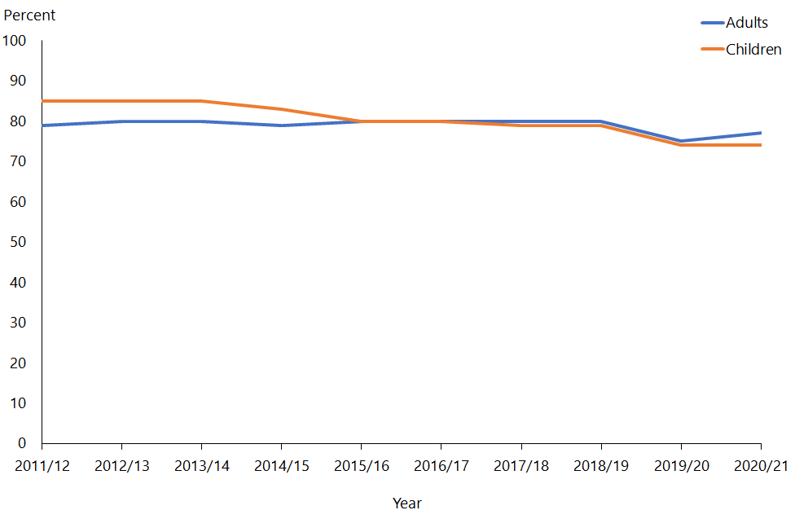

## Coverage rates

In 2020/21, the coverage rates were 62 percent for adults and 68 percent for children. Figure 3 shows the time trend of coverage rates of adults and children from 2011/12 to the current survey year, 2020/21.

Figure 3: Coverage rates for adults and children, 2011/12 to 2020/21

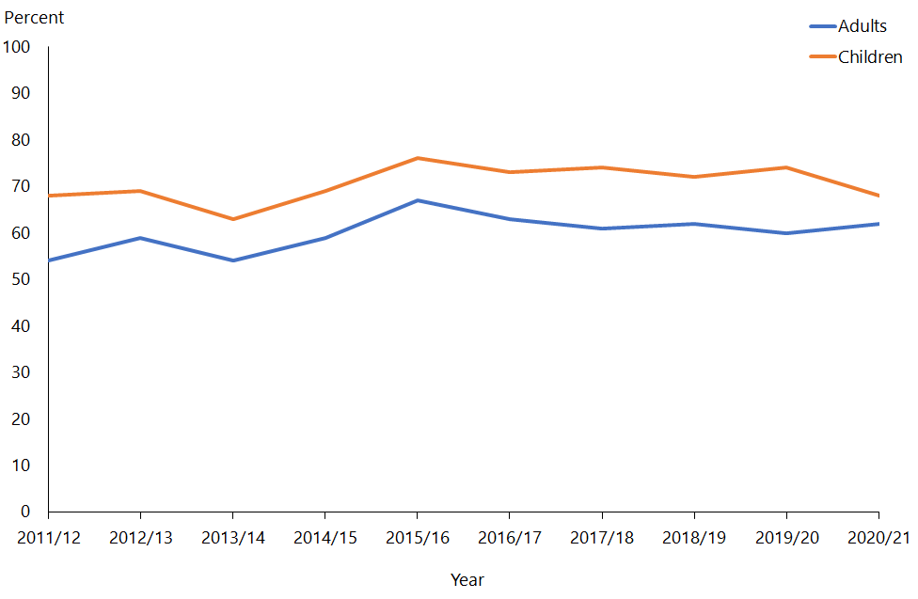

Figure 3 clearly shows that coverage rates for children have been high across all years since 2011/12.

In 2020/21, the coverage rates were 60 percent for Māori, 59 percent for Pacific peoples and 63 percent for Asian people. Figure 4 shows the time trend of coverage rates for the Māori, Pacific peoples and Asian ethnic groups from 2011/12 to the current survey year, 2020/21.

Figure 4: Coverage rates for Māori, Pacific peoples and Asian ethnic groups, 2011/12 to 2020/21

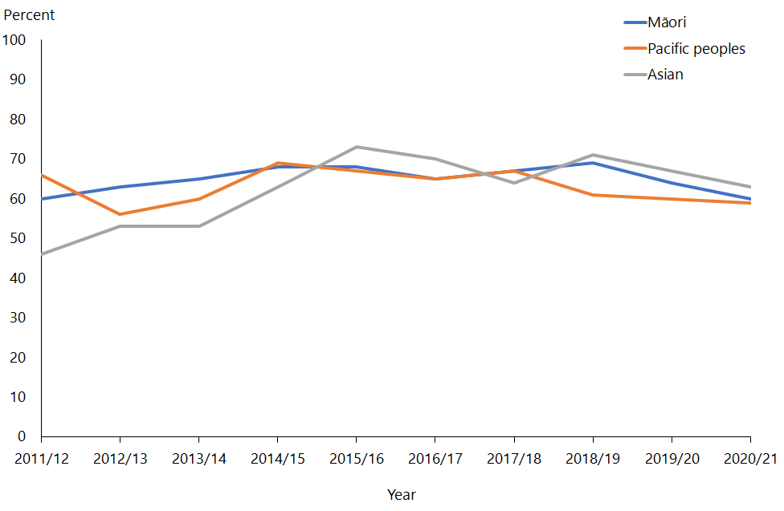

In 2020/21, the coverage rates for neighbourhood deprivation quintiles were: 65 percent (NZDep quintile 1), 61 percent (NZDep quintile 2), 62 percent (NZDep quintile 3) and 60 percent (NZDep quintile 4) and 67 percent (NZDep quintile 5). Figure 5 shows the time trend figures for NZDep quintile 1 to NZDep quintile 5 from 2011/12 to the current survey year, 2020/21.

Figure 5: Coverage rates by New Zealand Index of Deprivation quintiles, 2011/12 to 2020/21

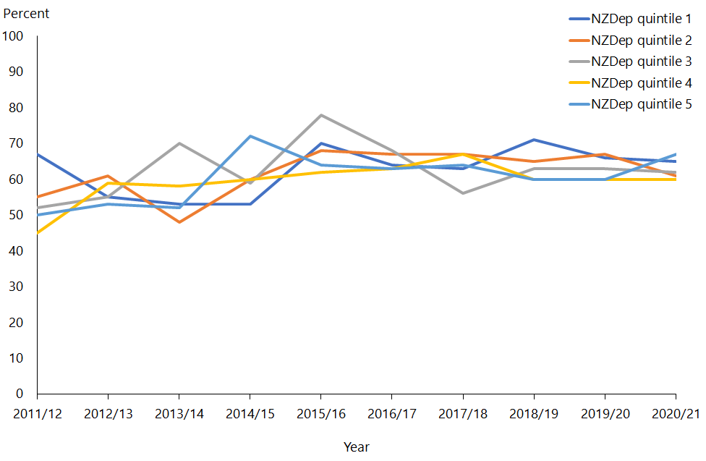

Figure 6 and Figure 7 show the coverage rates by age group and gender for 2020/21 for the total population and Māori respectively.

Figure 6: Coverage rates for total population, by age group and gender, 2020/21

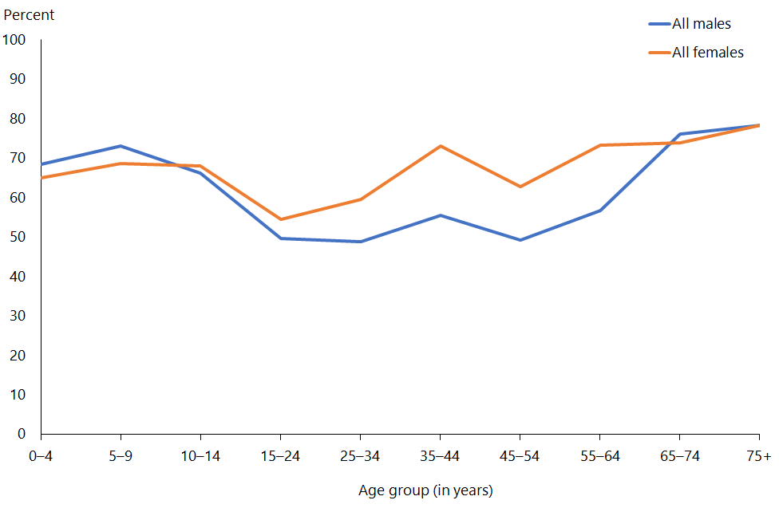

Figure 7: Coverage rates for Māori, by age group and gender, 2020/21

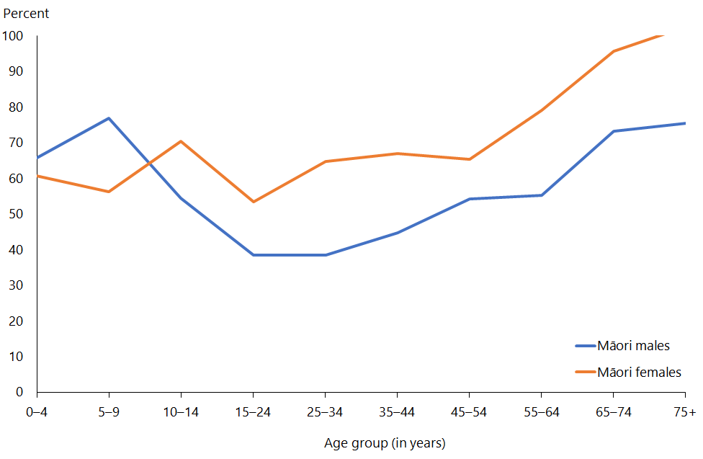

## Final weights

The section on weighting has explained how the calibrated weights were calculated. Table 5 gives basic descriptive information on the final weights calculated for the 2020/21 survey.

The g-weights are the ratios of the final weights to the initial selection weights. The mean g-weight is approximately 1.6, which can be considered as reasonable. This means the calibrated weights, which were calculated using population benchmark information, have changed the initial selection weight by an average factor of 1.6.

Table 5: Final weights 2020/21

|  |  |
| --- | --- |
|  | **Final weight** |
| Minimum | 16 |
| Median | 302 |
| 90th percentile | 820 |
| 95th percentile | 1,070 |
| 99th percentile | 1,822 |
| Maximum | 2,167 |
| Coefficient of variation (CV%) | 84.8 |
| Approximate design effect due to weighting (1 + CV2) | 1.7 |

## Sample sizes

Table 6Table 10 show the 2020/21 NZHS sample sizes and the total ‘usually resident’ population counts, by gender, ethnicity, age, NZDep2018 quintile and disability status.

Table 6: Sample sizes and population counts for children and adults, by gender, 2020/21

|  |  |  |  |  |
| --- | --- | --- | --- | --- |
| **Population group** | **Gender** | **Interviews** | **Measurements* (2+ years)** | **Population count** |
| Children (0–14 years) | Boys | 1,557 | 1,064 | 496,673 |
| Girls | 1,397 | 978 | 470,390 |
| **Total** | **2,954** | **2,042** | **967,063** |
| Adults (15 years and over) | Men | 4,126 | 3,734 | 2,038,163 |
| Women | 5,583 | 4,728 | 2,100,993 |
| **Total** | **9,709** | **8,462** | **4,139,156** |

* These numbers are based on the number of respondents with valid height and weight measurements, and they exclude 140 pregnant women who were not eligible to be measured.

Table 7: Sample sizes and population counts for children and adults, by total response ethnicity, 2020/21

|  |  |  |  |  |
| --- | --- | --- | --- | --- |
| **Ethnic group (total response)** | **Population group** | **Interviews** | **Measurements* (2+ years)** | **Population count** |
| European/Other | Children | 1,998 | 1,410 | 671,302 |
| Adults | 7,371 | 6,450 | 3,076,003 |
| Māori | Children | 1,034 | 694 | 177,659 |
| Adults | 1,927 | 1,661 | 592,896 |
| Pacific peoples | Children | 429 | 276 | 127,774 |
| Adults | 606 | 524 | 278,667 |
| Asian | Children | 485 | 324 | 167,265 |
| Adults | 1,068 | 925 | 633,667 |

* These numbers are based on the number of respondents with valid height and weight measurements, and they exclude 140 pregnant women who were not eligible to be measured.

Table 8: Sample sizes and population counts, by age, 2020/21

|  |  |  |  |
| --- | --- | --- | --- |
| **Age group (years)** | **Interviews** | **Measurements* (2+ years)** | **Population count** |
| 0–4 | 1,000 | 419 | 305,043 |
| 5–9 | 966 | 819 | 326,817 |
| 10–14 | 988 | 804 | 335,203 |
| 15–24 | 932 | 841 | 651,773 |
| 25–34 | 1,502 | 1,284 | 757,383 |
| 35–44 | 1,503 | 1,307 | 648,210 |
| 45–54 | 1,410 | 1,253 | 655,850 |
| 55–64 | 1,627 | 1,434 | 619,900 |
| 65–74 | 1,513 | 1,328 | 466,977 |
| 75 and over | 1,222 | 1,015 | 339,103 |

* These numbers are based on the number of respondents with valid height and weight measurements, and they exclude 140 pregnant women who were not eligible to be measured.

Table 9: Sample sizes and population counts, by NZDep2018 quintile, 2020/21

|  |  |  |  |  |
| --- | --- | --- | --- | --- |
| **NZDep2018 quintile** | **Population group** | **Interviews** | **Measurements* (2+ years)** | **Population count** |
| Quintile 1 (least deprived neighbourhoods) | Children | 414 | 328 | 200,020 |
| Adults | 1,437 | 1,276 | 821,224 |
| Quintile 2 | Children | 488 | 321 | 182,927 |
| Adults | 1,639 | 1,422 | 838,317 |
| Quintile 3 | Children | 482 | 317 | 181,527 |
| Adults | 1,714 | 1,482 | 839,717 |
| Quintile 4 | Children | 621 | 440 | 177,055 |
| Adults | 2,203 | 1,923 | 844,189 |
| Quintile 5 (most deprived neighbourhoods) | Children | 949 | 636 | 225,533 |
| Adults | 2,716 | 2,359 | 795,711 |

* These numbers are based on the number of respondents with valid height and weight measurements, and they exclude 140 pregnant women who were not eligible to be measured.

Table 10: Sample sizes and population counts (adults), by disability status and gender, 2020/21

|  |  |  |  |
| --- | --- | --- | --- |
| **Disability status** | **Gender** | **Interviews** | **Population count** |
| Disabled | Men | 426 | 159,016 |
| Women | 723 | 208,848 |
| Non-disabled | Men | 3,687 | 1,872,530 |
| Women | 4,842 | 1,886,117 |

# Changes in previously published statistics

This section notifies NZHS users about errors in the statistics published in previous annual reports or in the *Annual Data Explorers*. These errors occurred as a result of independent events at different stages of the survey process, which are explained below. Removal of the data or revisions to the data and statistics have been made in the current publication.

## Population data changes

Updated population data has been used to recalculate results from the NZHS from 2011/12 to 2019/20. This means that some results in the 2020/21 Annual Data Explorer will be different to those that have been previously published. The impact on prevalence is negligible, but the estimated numbers of people are slightly larger, particularly for Māori.

The Ministry of Health has also taken this opportunity to implement an improved calculation method, and a small amount of the change in the results can be attributed to these calculation improvements.

# References

Ahmad O, Boschi-Pinto C, Lopez A, et al. 2000. *Age-standardization of Rates: A new WHO standard*. Geneva: World Health Organization.

Atkinson J, Salmond C, Crampton P. 2019. *NZDep2018 Index of Deprivation*. Interim Research Report, December 2019, Wellington: Department of Public Health, University of Otago.

Bieler GS, Brown GG, Williams RL, et al. 2010. Estimating model-adjusted risks, risk differences, and risk ratios from complex survey data. *American Journal of Epidemiology* 171: 618–23.

Clark RG, Templeton R, McNicholas A. 2013. Developing the design of a continuous national health survey for New Zealand. *Population Health Metrics* 11(1): 25. URL: [www.pophealthmetrics.com/content/11/1/25](http://www.pophealthmetrics.com/content/11/1/25) (accessed 27 October 2020).

Deville JC, Särndal CE. 1992. Calibration estimators in survey sampling. *Journal of the American Statistical Association* 87: 376–82.

Hayes L, Barry G. 2002. Sampling variability of the Kunst-Mackenbach relative index of inequality. *Journal of Epidemiology and Community Health* 56: 762–5.

Korn EL, Graubard BI. 1998. Confidence intervals for proportions with small expected number of positive counts estimated from survey data. *Survey Methodology*  
24(2): 193–201.

Korn EL, Graubard BI. 1999. *Analysis of Health Surveys*. New York: Wiley.

Kott PS. 2001. The delete-a-group jackknife. *Journal of Official Statistics* 17(4): 521–6.

Ministry of Health. 2008. *A Portrait of Health: Key results of the 2006/07 New Zealand Health Survey*.Wellington: Ministry of Health. URL: [www.moh.govt.nz/NoteBook/nbbooks.nsf/0/9FF50018D90C43D3CC2574640009AE76/$file/portrait-of-health-june08.pdf](http://www.moh.govt.nz/NoteBook/nbbooks.nsf/0/9FF50018D90C43D3CC2574640009AE76/$file/portrait-of-health-june08.pdf) (accessed 28 October 2020).

Ministry of Health. 2011. *The New Zealand Health Survey: Sample design, years 1–3 (2011–2013)*. Wellington: Ministry of Health. URL: [www.health.govt.nz/publication/new-zealand-health-survey-sample-design-years-1-3-2011-2013](http://www.health.govt.nz/publication/new-zealand-health-survey-sample-design-years-1-3-2011-2013) (accessed 27 October 2020).

Ministry of Health. 2016. *Sample Design from 2015/16: New Zealand Health Survey*.Wellington: Ministry of Health. URL: [www.health.govt.nz/publication/sample-design-2015-16-new-zealand-health-survey](http://www.health.govt.nz/publication/sample-design-2015-16-new-zealand-health-survey) (accessed 27 October 2020).

Ministry of Health. 2021a. *Annual Data Explorer 2020/21: New Zealand Health Survey*. URL: <https://www.health.govt.nz/publication/annual-update-key-results-2020-21-new-zealand-health-survey> (accessed 1 December 2021).

Ministry of Health. 2021b. *Content Guide 2020/21: New Zealand Health Survey*. URL: [www.health.govt.nz/publication/content-guide-2020-21-new-zealand-health-survey](http://www.health.govt.nz/publication/content-guide-2020-21-new-zealand-health-survey) (accessed 1 December 2021).

Statistics New Zealand. 1998. *Protocols for Official Statistics*. Wellington: Statistics New Zealand.

Statistics New Zealand. 2005a. *Ethnicity New Zealand Standard Classification 2005*. Wellington: Statistics New Zealand.

Statistics New Zealand. 2007. *Principles and Protocols for Producers of Tier 1 Statistics.* Wellington: Statistics New Zealand. URL: <http://archive.stats.govt.nz/about_us/who-we-are/home-statisphere/tier-1/principles-protocols.aspx#gsc.tab=0> (accessed 27 October 2020).

Stats NZ. 2021. Estimated resident population by age and sex (1991+) (Annual-Sep), at September 2020 – Infoshare table reference DPE057AA*.* URL: http://infoshare.stats.govt.nz (accessed 19 October 2021).

Woodruff RS. 1952. Confidence intervals for medians and other position measures. *Journal of the American Statistical Association* 47: 635–46.

1. See the New Zealand Health Survey webpage on the Ministry of Health website at: www.health.govt.nz/nz-health-statistics/national-collections-and-surveys/surveys/current-recent-surveys/new-zealand-health-survey