Maternal Fetal Medicine – He Rongoā Mā Te Kukune

Action Plan – Te Ahunga Matua
Delivering safe, sustainable maternal fetal medicine services to women and babies in Aotearoa New Zealand

Acknowledgements – Ngā mihi
The Ministry of Health would like to thank members of the Maternal Fetal Medicine (MFM) Improvement Advisory Group for their valuable contribution to this improvement action plan for MFM services in Aotearoa New Zealand.
Particular thanks go to consumer representatives who provided valuable insights into aspects of MFM care that are important to women and whānau experiencing the service.
Citation: Ministry of Health. 2021. Maternal Fetal Medicine – He Rongoā Mā Te Kukune: Action Plan – Te Ahunga Matua. Wellington: Ministry of Health.
Published in July 2021 by the Ministry of Health
PO Box 5013, Wellington 6140, New Zealand
ISBN 978-1-99-100723-0 (online)
HP 7713
This document is available at health.govt.nz
This work is licensed under the Creative Commons Attribution 4.0 International licence. In essence, you are free to: share ie, copy and redistribute the material in any medium or format; adapt ie, remix, transform and build upon the material. You must give appropriate credit, provide a link to the licence and indicate if changes were made.

Contents
About maternal fetal medicine – Ngā Whakamahuki ā He Rongoā Mā Te Kukune 1
Maternity care 1
Maternal fetal medicine 1
The case for change – Te Urunga kit e Toiora 4
Current MFM service configuration 4
MFM service scope 5
MFM specialist workforce 6
Reporting of MFM activity 8
Referral pathways 11
Shared care 14
MFM and Māori 14
The MFM service model – Te Herenga Tuira 17
MFM goal 17
MFM outcomes and objectives 17
Achieving equity in MFM 18
MFM as a national service 19
The model of care for MFM 24
The MFM Action Plan – Te Ahunga Matua 34
Improvement framework 34
Priority 1: The MFM service model enables high-quality clinical care and outcomes 36
Priority 2: High-quality, nationally consistent data informs MFM service planning 38
Priority 3: MFM services are cohesive and well integrated with other services 39
Priority 4: All women receive timely and equitable access to MFM care 41
Priority 5: All women and whānau experience MFM care that meets their needs 43
System enablers 45
Measures of MFM service effectiveness 46
Implementation 47
Post-implementation evaluation 47
Appendix 1 : Referral guidance for maternal assessment 49
Appendix 2 : Referral guidance for fetal assessment 51
Appendix 3 : Referral guidance for fetal procedures 53
Appendix 4 : Abbreviations 54
References 55

List of Figures
Figure 1: The pyramid of maternity care 2
Figure 2: Catchment areas for the maternal fetal medicine regional hubs 5
Figure 3: MFM attendances by provider, 2015/16 to 2018/19 10
Figure 4: Referral flows to regional maternal fetal medicine hubs, 2017/18 13
Figure 5: Number of MFM women per 10,000 live births by DHB of domicile and MFM hub, 2017/18 13
Figure 6: A history of inequity 15
Figure 7: Number of maternal fetal medicine assessments per 10,000 live births, by ethnicity (average over 2013–2017) 16
Figure 8: MFM outcomes and service objectives 17
Figure 9: Partners in equity in MFM 19
Figure 10: The proposed national service structure for MFM 21
Figure 11: Service configuration for MFM 22
Figure 12: Essential criteria for an MFM provider 23
Figure 13: Summary of the MFM referral process 29
Figure 14: Maternal fetal medicine improvement framework 35

List of Tables
Table 1: Size of the maternal fetal medicine specialist workforce, by MFM provider, 2020 7
Table 2: Outpatient attendances reported against the three MFM purchase unit codes, 2017/18 to 2018/19 9
Table 3: Likely admissions for a fetal procedure, 2014/15 to 2016/17 11
Table 4: Pae ora principles for the maternal fetal medicine model of care 25
Table 5: Members of a maternal fetal medicine multidisciplinary team 30
Table 6: Shared care responsibilities 33
Table 7: Action areas for Priority 1 37
Table 8: Action areas for Priority 2 39
Table 9: Action areas for Priority 3 40
Table 10: Action areas for Priority 4 42
Table 11: Action areas for Priority 5 43
Table 12: System enablers 45
Table 13: Measures of effectiveness of MFM services 46

About maternal fetal medicine – Ngā Whakamahuki ā He Rongoā Mā Te Kukune

Maternity care
In Aotearoa New Zealand, maternity care is funded by the Ministry of Health (the Ministry) and provided by district health boards (DHBs) and community-based clinicians. Providers of maternity care may be community- or DHB-based midwives, public or private obstetricians or, in some cases, general practitioners (GPs).

Women have the right to choose who they engage as their lead maternity carer (LMC). Professional colleges and the Ministry provide guidelines about referral and appropriate care for women with high-risk pregnancies (Ministry of Health 2012a).

Maternity services are organised around community-based care, supported by secondary, tertiary and quaternary hospital services. Aotearoa New Zealand has six tertiary obstetric providers (Auckland, Counties Manukau, Waikato, Capital & Coast, Canterbury and Southern DHBs). All providers support women with relatively complex maternity and obstetric needs.

In 2018, the Ministry partnered with the Maternal Fetal Medicine (MFM) sector to address a range of issues in impacting care for women with high-risk pregnancies. Maternity experts across the health sector led the development of a five-year work programme. As women who need the most care often receive the least care, the focus of the work programme is on birthing at the right time in the right place and with the right care, regardless of where women live. Improving responsiveness to Māori and increasing access to services for Pacific peoples are priorities.

Maternal fetal medicine
MFM is a sub-specialty of obstetrics and maternity care for women where the pregnancy is considered highly complex (because of either a maternal condition or a fetal condition or abnormality). The service provides assessment, diagnosis and management, which includes advanced fetal therapies or procedures where indicated.

MFM is part of a pyramid of maternity care (Figure 1), which may involve shared care across one or more of the tiers. Most women will be under the care of primary maternity service providers. However, some women will necessarily be under the care of a secondary or tertiary obstetric service, which may include shared care with the community LMC and or GP.
The MFM service is at the top of the pyramid of maternity care. Regional hubs provide MFM care, while others in the pyramid make referrals to one of these hubs for complex fetal or maternal therapies. This approach influences the service configuration for MFM care, which is based around supra-regional and quaternary care that extends across DHB regions.

Figure 1: The pyramid of maternity care
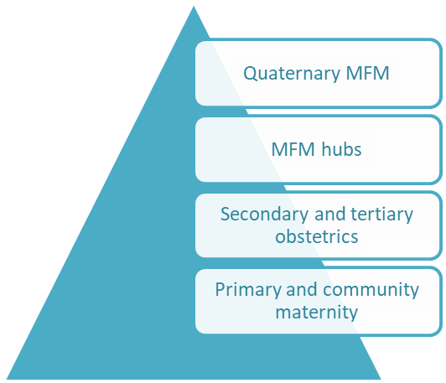
Most complex
Least complex
Complexity and
degree of risk

When women are referred to MFM, they have an increased chance of obtaining an accurate antenatal diagnosis. MFM services also improve outcomes for women and babies by providing advanced clinical expertise to determine diagnoses, counselling and care for complex maternal and fetal conditions.

MFM services can prevent maternal, fetal or neonatal deaths, or reduce the impact of some fetal conditions through appropriately timed interventions (Tan et al 2012). In other cases, the value of the service will be that it provides an early diagnosis of fetal abnormality, allowing the family to decide whether to proceed with the pregnancy or not.

Despite recent advances in ultrasound technology, which rarely misses structural abnormalities, it is not possible to diagnose some fetal conditions during pregnancy. Because of this limitation, diagnoses can be incomplete, it can be difficult to predict the severity and progression of disease, and information about the neonatal outcome may be limited. Sometimes a suspected diagnosis will not be confirmed until birth or later. In this situation, care involves much time and counselling to provide for the range of possible outcomes for the live-born baby. Services may also need to coordinate with other disciplines such as genetics or paediatric specialties. Discussion at a fetal medicine multidisciplinary meeting is invaluable in such cases.

An estimated 6 percent of births (about 3,500 births) are considered complex enough to need a referral to an MFM sub-specialist each year (Babu and Pasula 2013; Bacino 2017). In some cases, the condition will be time-critical, requiring assessment, diagnosis and treatment within one to two days to prevent death or disability. Other cases, while less urgent, may involve significant anxiety for parents who have been advised there may be an abnormality affecting their baby. Delays in access to care can be very stressful in these circumstances.

The case for change – Te Urunga kit e Toiora

Current MFM service configuration
Aotearoa New Zealand’s MFM services have historically been configured into three regional ‘hubs’, including an Auckland-based quaternary service for highly complex pregnancies and some fetal procedures. The services are vulnerable because of the low number and limited locations of MFM sub-specialists. In response, in 2014 the Ministry provided funding for the New Zealand Maternal Fetal Medicine Network (NZMFMN), so that it could provide clinical leadership, develop clinical practice recommendations and coordinate some MFM improvement activities (see https://www.healthpoint.co.nz/public/new-zealand-maternal-fetal-medicine-network).

As one of its outputs, NZMFMN has developed four formal criteria for designating an MFM hub (NZMFMN 2014). That is, the hub must:
      - have sub-specialists with a Certificate in Maternal Fetal Medicine (CMFM) or obstetricians and gynaecologists with a Diploma of Diagnostic Ultrasound (DDU) leading the unit
      - belong to a DHB that offers paediatric surgery services and Level 3 neonatal services
      - have access to genetic services and perinatal pathology services
      - be a recognised regional provider of maternal fetal medicine services.

Auckland, Capital & Coast and Canterbury DHBs have been ‘recognised’ as MFM hubs.

Figure 2 shows the hub boundaries. The Auckland DHB hub covers the Northern and Midland regions (excluding Taranaki DHB); the Capital & Coast DHB hub covers the Central region, as well as Taranaki and Nelson Marlborough DHBs; and the Canterbury DHB hub covers the South Island (excluding Nelson Marlborough DHB).

In addition to the recognised regional hubs, Counties Manukau DHB provides some elements of an MFM service to its local population that has complex health needs.

Auckland DHB continues to be the quaternary provider for complex maternal conditions and some fetal therapies.

Figure 2: Catchment areas for the maternal fetal medicine regional hubs

The criteria for an MFM hub describe the requirement for clinical expertise and some critical relationships, but does not consider other elements of a safe, sustainable service. There is also no established mechanism for designating another DHB as a clinically appropriate provider of MFM care.

MFM service scope
MFM services are those provided to women and babies with the following conditions (NZMFMN 2015):
      - major fetal abnormalities
      - fetal intrauterine transfusions for rhesus incompatibility
      - fetal cardiac anomalies that are ‘duct dependent’
      - provision of multi-fetal reduction
      - complex multiple pregnancy
      - severe (early onset) fetal growth restriction
      - major maternal cardiac disease
      - major liver disease in pregnancy.
While provided by specialists with an MFM sub-specialty certificate, the service has two distinct disciplines:
      - fetal medicine – a possible or confirmed fetal abnormality requiring an expert sub-specialist opinion and sometimes treatments (conditions 1–6 above)
      - maternal medicine – women with a very high-risk pregnancy because of a medical condition that may be made more complex because of the pregnancy (conditions 7–8 above).

In Aotearoa New Zealand many maternal medicine conditions are currently managed within secondary or tertiary DHB obstetric units. Women with a pregnancy that involves a fetal abnormality are more likely to be referred to an MFM hub for assessment, diagnosis or advice.

Lack of clarity about who should be referred to MFM may have negative effects. In some cases, women who should see an MFM sub-specialist may not be referred. Alternatively, some women may be referred who do not need to be, and experience greater anxiety about the potential outcome as a result.

MFM specialist workforce
MFM services are led by specialist obstetricians with a formal sub-specialty MFM qualification: either the CMFM, which they gain through the Royal Australian and New Zealand College of Obstetricians and Gynaecologists (RANZCOG), or an international equivalent. As at September 2019, all three MFM hubs and Counties Manukau DHB had at least one CMFM sub-specialist, but Auckland DHB has a shortage, with 1.5 full-time equivalent (FTE) vacant.

Other members of the core MFM specialist team are obstetricians with a DDU and obstetric physicians. Obstetricians with a special interest in MFM support the core MFM team. Table 1 describes the core MFM specialist workforce for each provider in terms of both FTEs and number of people.

Table 1: Size of the maternal fetal medicine specialist workforce, by MFM provider, 2020
Provider | CMFM sub-specialist |  | Obstetric physician |  | Obstetrician with DDU
 | FTE | People | FTE | People | FTE | People
Auckland | 6.1 | 6 | 3.7 | 7 | 0.86 | 6
Canterbury | 1.0 | 1 | 0.9 | 2 | 1.0 | 1
Capital & Coast | 0.92 | 1 |  |  | 2.0 | 2
Counties Manukau | 1.25 | 2 | 0.1 | 1 | 1.0 | 2
Total | 9.27 | 10 | 4.7 | 10 | 4.86 | 11
Note: Workforce data is as at January 2020. Capital & Coast DHB has one senior medical officer (SMO) who is about to complete a CMFM and who will work 0.8 FTE when qualified, and another SMO who is about to complete a DDU who will work 0.1 FTE in MFM when qualified. The Capital & Coast SMO with CMFM also has a DDU qualification. Auckland DHB also has one CMFM trainee.

The CMFM workforce is considered highly vulnerable, for the following reasons.
- MFM training uptake – returning trainees are the most effective source of future MFM sub-specialists, but only limited numbers of them take up MFM training. A concern is that MFM sub-specialty training will not attract new candidates.
- Covering leave – the two DHBs with only one MFM sub-specialist are not able to cover periods of leave with another MFM sub-specialist. Instead, other members of the multidisciplinary team cover the sub-specialist’s leave.
- Maintaining competency – because practitioners perform only a few advanced fetal procedures, they may have difficulty completing enough procedures to meet credentialling requirements.
- Burn-out – providing MFM care can be extremely stressful, including where it involves discussion with highly anxious families about fetal abnormality and the management options.

The MFM service relies heavily on recruitment of specialists from overseas (three of the current specialists are overseas trained). RANZCOG has accredited Auckland, Canterbury, Capital & Coast and Counties Manukau DHBs for MFM sub-specialty training.

Others in the MFM workforce
The wider MFM team includes obstetricians with a DDU, obstetric physicians, obstetricians with an MFM interest, MFM midwives and sonographers.

To be part of the MFM team, the following qualifications and experience is required:
- DDU-qualified obstetricians need enhanced skills and expertise to provide high-risk maternity care, diagnose maternal and fetal conditions, and triage and manage cases of moderate complexity.
- obstetric physicians need specific expertise and experience in managing medical conditions in pregnancy (either pre-existing or pregnancy-related), along with a Certificate of Obstetric Medicine or equivalent recognition
- MFM midwives need a relevant postgraduate qualification.
- Sonographers need a relevant postgraduate qualification.

The MFM workforce has a close working relationship with other service providers, including general obstetricians, LMCs, anaesthetists, neonatologists, radiologists, geneticists, paediatric surgeons and paediatric cardiologists.

The MFM workforce is small, specialised and largely dependent on overseas recruitment. Staff members are vulnerable because of the nature of the work, difficulty in providing specialised CMFM leave cover, and the small number of fetal procedures that they perform each year, which limits their opportunities to maintain competency.

Reporting of MFM activity
Provider reporting on maternity care is collated into the National Maternity Collection (MAT), which provides statistical, demographic and clinical information about selected publicly funded maternity services up to nine months before and three months after birth. MAT contains data on primary maternity services as well as data on inpatient and day-patient health events.

Providers also report on hospital care for maternity services into the:
- National Non-Admitted Patient Collection (NNPAC) – for outpatient activity
- National Minimum Dataset (NMDS) – for inpatient activity.

MFM care is primarily an outpatient-based assessment service, with a small number of admitted fetal procedures. MFM is not a discrete, standalone service; it is reported as part of the broader obstetric service.

Outpatients
Outpatient activity is reported into NNPAC at a specialty level, which is not clinically coded. There are three dedicated MFM purchase unit codes. MFM may also be reported against general obstetric purchase units; if so, this activity is not identifiable as MFM activity.

The four MFM providers report activity inconsistently against these three PUCs. Table 2 shows all activity reported against these three PUCs by host/provider DHB.
- Auckland DHB primarily reports against ‘W03008 – maternity foetal medicine clinics’ but also reports a small number of women against ‘W03007 – Rhesus clinics’.
- Canterbury, Capital & Coast and Counties Manukau DHBs report MFM activity against ‘W03009 – foetal medicine/anomalies clinics’.
- Capital & Coast DHB also reports activity against ‘W03008 – maternity foetal medicine clinics’. The DHB has confirmed this activity involves complex obstetrics rather than MFM.
- Counties Manukau DHB began using ‘W03009 – foetal medicine/anomalies clinics’ in October 2018. Before then, it reported MFM activity in other PUCs.
- Southern DHB also reports a small number of women each year against ‘W03008 – maternity foetal medicine clinics’.

Table 2: Outpatient attendances reported against the three MFM purchase unit codes, 2017/18 to 2018/19
Reporting DHB | Purchase unit | Women |  | Visits
 |  | 2017/18 | 2018/19 | 2017/18 | 2018/19
Auckland | Total | 1,779 | 1,833 | 3,139 | 3,659
 | W03008 Maternity foetal medicine clinics | 1,763 | 1,826 | 3,083 | 3,628
 | W03007 Rhesus clinics | 16 | 7 | 56 | 31
Capital & Coast | Total | 1,846 | 2,027 | 4,688 | 5,991
 | W03009 Foetal medicine/anomalies clinics | 490 | 496 | 925 | 1,924
 | W03008 Maternity foetal medicine clinics | 1,356 | 1,531 | 3,763 | 4,067
Canterbury | W03009 Foetal medicine/anomalies clinics | 618 | 1,120 | 1,519 | 2,894
Counties Manukau | W03009 Foetal medicine/anomalies clinics | 19 | 382 | 30 | 701
Southern | W03008 Maternity foetal medicine clinics | 76 | 80 | 190 | 183
Total MFM purchase unit codes |  | 4,338 | 5,442 | 9,566 | 13,428
Total MFM (excluding non-MFM activity) |  | 2,906 | 3,831 | 5,613 | 9,178
Note: Data extracted from NNPAC on 6 August 2019. Women are ‘counted’ if the activity is the first occurrence during a financial year. One woman might be counted once in one year and again in the second year if a pregnancy and attendance cross financial years. Capital & Coast DHB activity includes non-MFM activity reported against the ‘Maternity foetal medicine clinics’ PUC. Southern DHB activity is included but is not provided by an MFM sub-specialist. Non-MFM activity that is excluded is Capital & Coast and Southern maternity medicine clinics.

Figure 3 shows solely MFM attendances (excluding complex obstetrics reported against the MFM PUCs) for each of the past four financial years (July to June) for each MFM provider.

Figure 3: MFM attendances by provider, 2015/16 to 2018/19
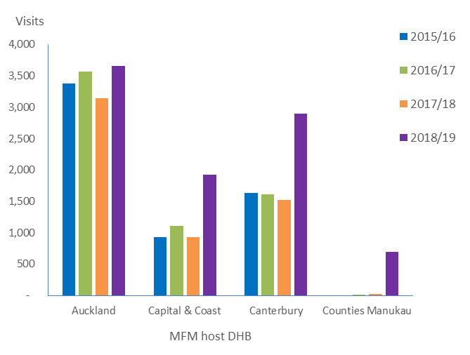
Source: Data extracted from NMDS on 6 August 2019 for PUC W03007, W03008 and W03009. Capital & Coast activity excludes W03008. Counties Manukau DHB activity increased due to a reporting change.

A new MFM health specialty code was introduced in 2018 for use in NNPAC to support classification of clinical documentation. With MFM providers using this code (P39), it will possible to identify MFM outpatient consultations more reliably.

Inpatients
Procedures for inpatients are clinically coded, which enables more detailed analysis of diagnosis and treatment provided. MFM-related admissions may be identified through primary diagnosis, International Classification of Diseases (ICD)-10 clinical procedure code or diagnostic related group (DRG) code. For example:
- maternal care for rhesus isoimmunisation is a primary diagnosis classification
- intrauterine fetal intravascular blood transfusion is an ICD-10 code
- selective fetoscopic laser photocoagulation (SFLP) for twin-to-twin transfusion syndrome (TTTS) is a DRG classification.

These codes may have been used with general obstetric classifications (such as spontaneous or caesarean delivery or therapeutic amniocentesis) so an MFM query cannot be developed based on only one of the three code types. Instead a complex manual analysis is required.

A manual analysis of data extracted from the NMDS identified that approximately 40 women are admitted for a fetal procedure each financial year, primarily to Auckland DHB (Table 3).

Table 3: Likely admissions for a fetal procedure, 2014/15 to 2016/17
Conditions | 2014/15 | 2015/16 | 2016/17
Intrauterine fetal transfusion | 8 | 11 | 13
Fetal reduction | 4 | 6 | 4
SFLP for TTTS | 7 | 10 | 4
Drainage of fetal fluid cavity | 3 | 3 | 1
Amnioinfusion | 0 | 0 | 1
Care for rhesus or other isoimmunisation | 9 | 13 | 6
Maternity care for fetal abnormality | 12 | 8 | 13
Complications specific to multiple gestation | 2 | 1 | 0
Polyhydramnios | 8 | 9 | 0
Total likely admissions for a fetal procedure | 53 | 61 | 42
Note: Data extracted from NMDS on 20 November 2017. Includes day case procedures and activity reported to NMDS but excludes outpatient (non-admitted) procedures and activity reported to NNPAC. Some fetal procedures may not be identifiable, and data excludes admissions under an MFM sub-specialist’s care for a maternal condition affecting pregnancy.

Inconsistent reporting of MFM activity in outpatients and inpatients makes it difficult to reliably report on current service provision and service costs. It is not possible to use reported activity to project service demand or workforce requirements. In addition, the information that is available on MFM does not easily allow an understanding of the service or its clinical outcomes.

Referral pathways
To achieve the best possible outcomes, women with complex maternal conditions or suspected fetal abnormality need access to a specialist with the right level of expertise. MFM services also need to have effective processes for managing referrals to meet quality and timeliness standards.

DHB maternity service specifications describe minimum requirements for maternity care, including MFM, in Aotearoa New Zealand. However, these do not describe expectations about how a DHB obstetric or MFM service manages planned assessment, such as by setting referral processing standards or timeframes for assessments.

To access MFM care, which is a predominantly planned service, a woman needs a referral from a health practitioner to the MFM hub. Each of the MFM hubs accepts referrals directly (rather than through a central booking office) and triage occurs daily (weekdays only). Although MFM is a tertiary-level service, MFM hubs usually accept referrals from all maternity providers, including GPs and community LMCs. Referrals may be electronic or on paper.

The health services directory website Healthpoint hosts an MFM section that provides information on how to refer to the service. This includes information such as phone and fax numbers, website and referral forms. The MFM section does not include information on referral to an MFM sub-specialist at Counties Manukau DHB but a page in a separate section has advice on how to access its MFM midwifery service.

The following tools support maternity referral, but do not guide referral to an MFM sub-specialist, are not extensive, or have not been widely disseminated.
- Guidelines for Consultation with Obstetric and Related Medical Services (Referral Guidelines) are well established and LMCs use them to guide decisions about referral to secondary or tertiary services (Ministry of Health 2012a). These Referral Guidelines do not make recommendations about referral to MFM.
- The Perinatal and Maternal Mortality Review Committee (PMMRC) has produced practice points in some areas to help with referring and managing a range of conditions appropriately. These practice points go a step beyond the maternity guidelines but do not differentiate between tertiary-level obstetric care and MFM care (PMMRC 2018a).
- Canterbury HealthPathways has a community pathway for fetal medicine referrals, but the pathway contains less information than is on the Healthpoint page on Canterbury DHB’s MFM services.
- The MFM section on Healthpoint’s website contains guidelines and practice recommendations for a range of conditions that support appropriate, evidence-based clinical management of complex pregnancies and fetal abnormalities. Depending on the subject, MFM sub-specialists or secondary obstetricians might use these resources.
- NZMFMN developed algorithm referral pathways for three non-fetal abnormality conditions, but these have not been finalised.

An analysis of MFM outpatient assessment data provides more information about current use of referral pathways for MFM. Figure 4, which compares where women are accessing MFM care with where babies are born, indicates that access rates differ across providers with Auckland DHB seeing a higher proportion of women in their catchment than the other two providers.

Figure 4: Referral flows to regional maternal fetal medicine hubs, 2017/18
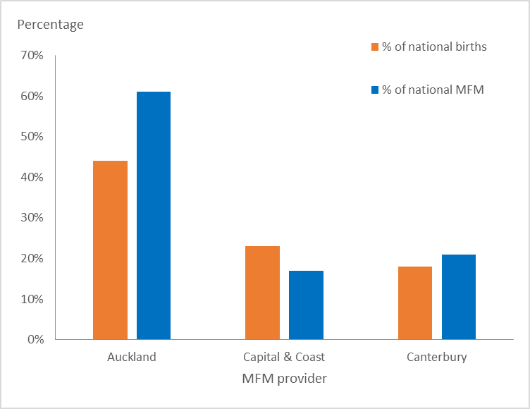
Source: Birth data – Report on Maternity 2017: accompanying tables, published 11 April 2019. National MFM extracted from NMDS on 6 August 2019. Birth data includes Counties Manukau DHB births; MFM data for Auckand excludes MFM that Counties Manukau DHB provides.

An alternative way of assessing access is to consider the number of women attending MFM care per 10,000 live births from within the DHB of domicile. This analysis confirms the referral pattern that women from outside of an MFM hub are less likely to be assessed in an MFM clinic (Figure 5).

Figure 5: Number of MFM women per 10,000 live births by DHB of domicile and MFM hub, 2017/18
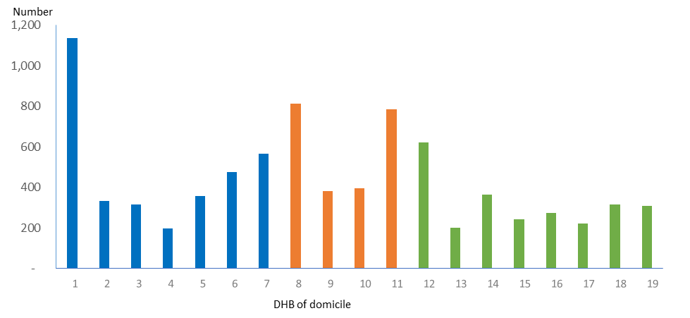
Blue: | Auckland provider | Orange: | Canterbury provider | Green: | Capital & Coast provider
1 | Auckland | 8 | Canterbury | 12 | Capital & Coast
2 | Bay of Plenty | 9 | South Canterbury | 13 | Hawke’s Bay
3 | Lakes | 10 | Southern | 14 | Hutt Valley
4 | Northland | 11 | West Coast | 15 | MidCentral
5 | Tairāwhiti |  |  | 16 | Nelson Marlborough
6 | Waikato |  |  | 17 | Taranaki
7 | Waitematā |  |  | 18 | Wairarapa
 |  |  |  | 19 | Whanganui
Source: Birth data – Report on Maternity 2017: accompanying tables, published 11 April 2019. National MFM extracted from NMDS on 6 August 2019. Counties Manukau MFM activity and births have been excluded because of incomplete data.

Based on the available information, it appears that MFM is primarily provided to women who live in, or close to, an MFM regional hub. Further work is required to understand referral pathways to MFM from regional DHBs.

Shared care
Shared care is an essential component of MFM and enables MFM services to provide woman-centred care. Depending on the complexity of the pregnancy and ongoing needs, the clinical responsibility for care may be transferred but clinicians that initiate referral and that are responsible for subsequent care must be kept fully informed and engaged.

Of particular importance in shared care is for all involved to have an understanding of individual roles and responsibilities, along with systems in place for effective communication between providers and with women.

Documented shared care process and responsibilities will help to reduce potentially avoidable perinatal and maternal deaths. The PMMRC’s Twelfth Annual Report (PMMRC 2018b) has identified contributor factors as:
- organisational and/or management factors (such as lack of policies, inadequate staff numbers, delays)
- personnel factors (such as failure of communication between staff)
- barriers to access and/or engagement with care (such as cultural barriers, infrequent care or late booking).

MFM services need systems to support effective communication and provision of clearly described roles and responsibilities to optimise a safe model of shared care.

MFM and Māori
Internationally, New Zealand rates well in terms of overall population health. Despite this, Māori continue to experience poorer health outcomes than other New Zealanders.

Social determinant indicators published by the Ministry show that Māori are more likely to live in the most economically deprived communities, have less schooling and be unemployed or receiving income support. Māori also are more likely than non-Māori to experience discrimination, including by health professionals (Ministry of Health 2015).

In a review of national and international papers assessing health equity, the Ministry has identified this inequity as a long-standing and challenging area to address (Ministry of Health 2018) (Figure 6).

Figure 6: A history of inequity
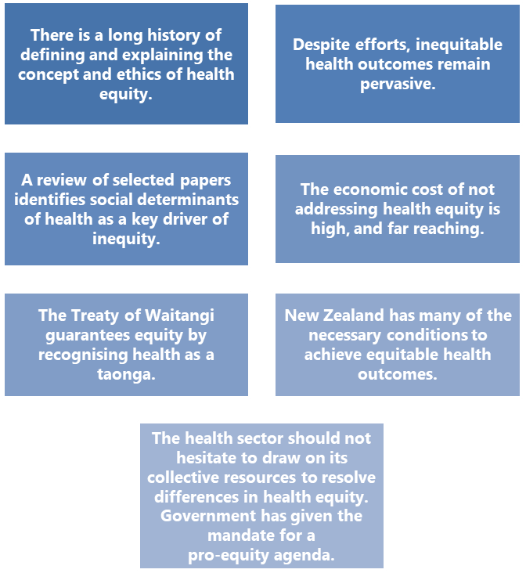
Source: Ministry of Health (2018).

Within maternity care, PMMRC has reported that outcomes for Māori (as well as Pacific and Indian) mothers and babies are inequitable. Māori mothers experience inequity in access to antenatal care and are less likely to be registered with an LMC in the first trimester, and a resuscitation attempt is less likely for Māori babies born alive at
23–26 weeks’ gestation (PMMRC 2018b).

Figure 7 shows that Māori women are 2.3 times and Pacific women 1.5 times less likely to attend an MFM assessment than women of ‘Other’ ethnicities. Distance and cost are known barriers to accessing health services, particularly for people living in communities with high socioeconomic deprivation. The further away women live from the MFM service, the more likely it is that some women and whānau experience barriers to MFM assessment.

Figure 7: Number of maternal fetal medicine assessments per 10,000 live births, by ethnicity (average over 2013–2017)
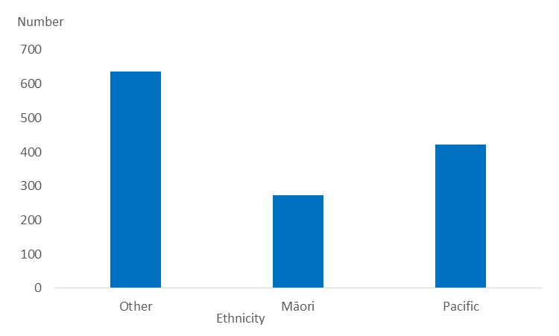
Source: Birth data – Report on Maternity 2017: accompanying tables, published 11 April 2019. National MFM extracted from NMDS on 6 August 2019. (Average of births and women attending MFM over four years.)

Cultural and socioeconomic influences are likely to contribute to inequity in access to MFM. Health practitioners can compound inequity in deciding whether to offer Māori an MFM assessment (which clinical guidelines or care pathways could address and improve) and service configuration can compound inequity if Māori are likely to accept the offer of referral (which culturally responsive hospital administrative processes could address and improve).

The Treaty of Waitangi makes it a constitutional requirement to achieve health equity for Māori, and to protect and promote the health of Māori. This requirement includes equity in providing maternity services.

The MFM service model – Te Herenga Tuira
The service model for MFM aims to provide a framework that enables MFM services to achieve the following goal, outcomes and service objectives for women, babies and whānau.

MFM goal
All mothers and babies achieve the best possible outcomes, through high-quality MFM assessment and treatment provided by expert practitioners.

MFM outcomes and objectives
Figure 8: MFM outcomes and service objectives
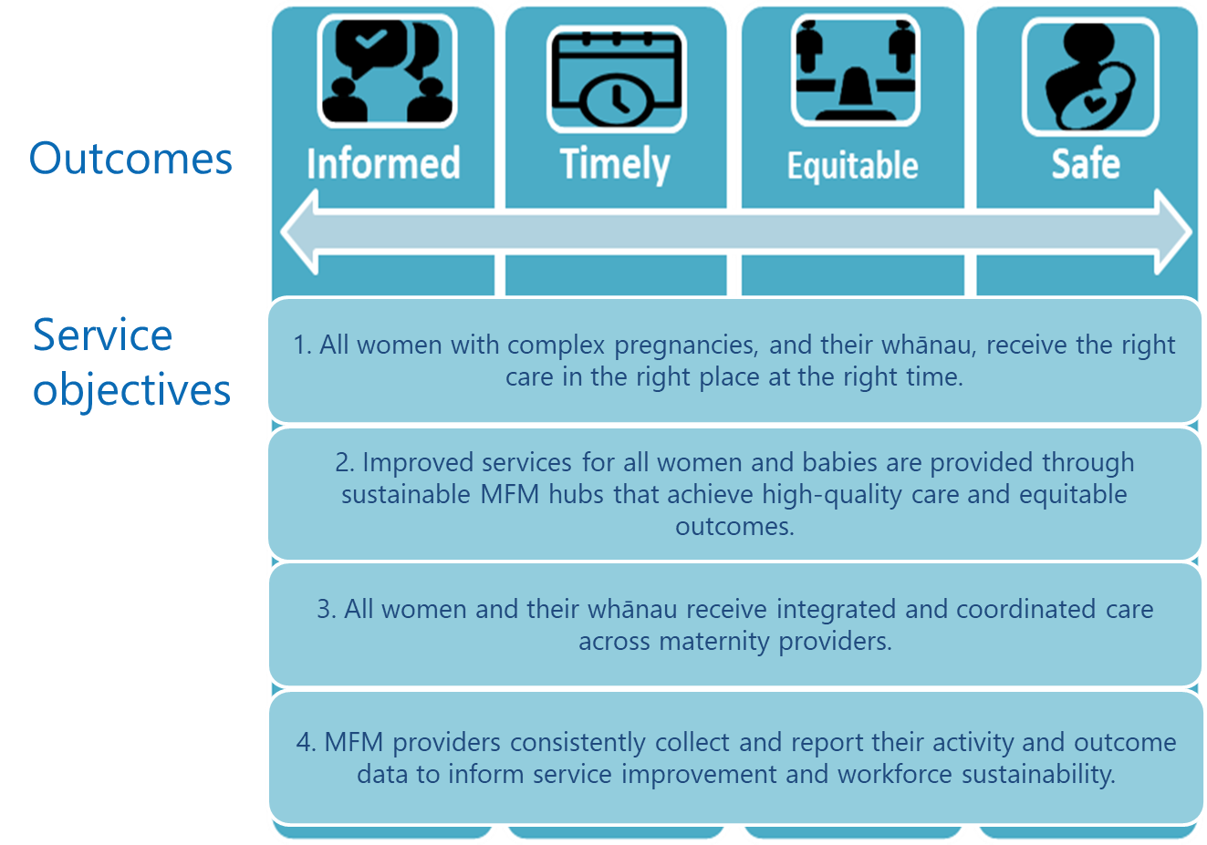

Achieving equity in MFM
In Aotearoa New Zealand, people have differences in health that are not only avoidable but also unfair and unjust. Equity recognises that people who differ in their levels of advantage require different approaches and resources to get equitable health outcomes (Ministry of Health 2019).

Te Tiriti o Waitangi (the Treaty of Waitangi) requires the Crown to protect and promote the health and wellbeing of Māori, including by responding to Māori health aspirations and meeting Māori health needs. To meet this obligation, DHBs and MFM providers need to work in partnership with iwi to support tangata whenua-informed processes, actions and decision-making (Figure 9).

All regulated health professional groups have developed statements on being culturally competent and providing culturally safe care (Medical Council of New Zealand 2019; Midwifery Council of New Zealand 2011; Nursing Council of New Zealand 2011).

The MFM Action Plan recognises the importance of culturally competent care in ensuring all women and whānau are able to achieve their best possible outcomes. The MFM Action Plan focuses on providing a safe and accessible service but acknowledges that addressing equity requires culturally safe maternity services across Aotearoa New Zealand, provided by culturally competent teams. Key aspects of this work are to recognise the power relationships between participants in health care interactions; to focus on the patient’s experiences to improve the quality of care; and to ensure all women receive access to the right services in the right place.

To provide culturally competent care, it is necessary to consider barriers to accessing MFM services within individual DHBs and take remedial actions that support whānau to travel to an MFM hub for care if required (Ministry of Health 2019). Where systems have structures and processes that were designed in the past, they need to redesign those structures and processes to overcome the attitudes and policies of that earlier time. Some key priorities Māori stakeholders identified in the Ministry of Health’s (2019) equity report include:
- advancing the aspirations of iwi and Māori
- creating a space to meaningfully address racism and discrimination
- creating responsive organisations that meet minimum standards for a focus on equity
- ensuring that leaders and managers take responsibility for addressing equity
- ensuring that decision-making takes place as close to communities as possible
- ensuring that actions to address inequities are timely, effective and pragmatic
- increasing responsible reporting over time through better use of data and analytics.

Figure 9: Partners in equity in MFM
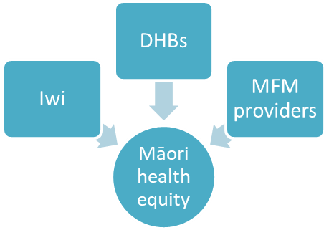

MFM as a national service
MFM will be provided as a national service through a ‘hub and spoke’ model, under national leadership and with multiple providers. We see this model as the most appropriate to support a nationally consistent and collaborative service while maintaining services in at least three centres to facilitate equitable access for all women and whānau.

Service leadership and governance
An MFM national leadership group will be formed to provide direction, oversight and monitoring of the service. This group will have governance rather than operational responsibilities, while operational leadership and responsibility within DHBs will remain unchanged.

A strong and focused leadership group, with the support of effective national clinical leadership and diversely representative membership, is the most appropriate mechanism to lead change at a national level and across DHBs. The leadership group will have legitimacy as a commissioned group with defined membership, terms of reference, goals and authority and accountability for overseeing progress against the Action Plan and ensuring MFM services achieve the service goal, outcomes and objectives.

Terms of reference for the group will be developed outlining the specific roles and responsibilities of the national leadership group. They will also specify a diverse membership, so that interested stakeholder groups have representative oversight of the service. As well as having clinical representatives, membership will include consumers and Māori to ensure the Action Plan delivers patient-centred, culturally safe and equitable care. The national leadership group will be resourced in terms of leadership, consumer participation and administrative or secretariat support. Accountability will be to the Ministry, as funder.

DHBs that are MFM providers will be responsible for ensuring the safety and sustainability of their hub and MFM workforce, based on the advice of the MFM national leadership group.

The Ministry, through the National Services and Maternity teams, will support implementation of changes recommended by the national leadership group, where required. This may be done by setting expectations, undertaking non-financial reporting and/or intervening directly where appropriate.

MFM national service team
The MFM national service team will sit within one of the three MFM hubs, appointed through a selective procurement process. At first it will have three funded positions, two of which will be funded on an ongoing basis.

A National Clinical Director (NCD) will be appointed from one of the MFM providers. The National Clinical Director will be an obstetrician who can demonstrate leadership and the ability to build consensus across a range of disciplines.

The National Clinical Director will provide clinical leadership for the service and will have a significant role in facilitating the development and implementation of improvement actions, policies, protocols and standards of MFM care. This role will be 0.4 FTE until the Action Plan is delivered and the hubs have a sustainable workforce; it will then move to 0.2 FTE on an ongoing basis.

The national service team host DHB will also have funding for two positions that focus on supporting the National Clinical Director in their leadership role and implementing the MFM Action Plan. These positions are:
      - a programme manager – a fixed-term position of at least 0.6 FTE, which will continue until the Action Plan is delivered and the hubs have a sustainable workforce
      - an MFM administrator – a permanent position of at least 0.4 FTE.

An operational group will support the National Clinical Director and programme manager. It will work with them to progress development of policies, protocols and standards for MFM care in line with the Action Plan, with the aim of achieving the service goal, outcomes and objectives. The operational group will include consumer and Māori health advisors so that it considers all relevant perspectives.

To participate in the operational group or the national leadership group, members will need to have the support of their employing DHB.

Figure 10 presents the proposed national service leadership structure for MFM.

Figure 10: The proposed national service structure for MFM
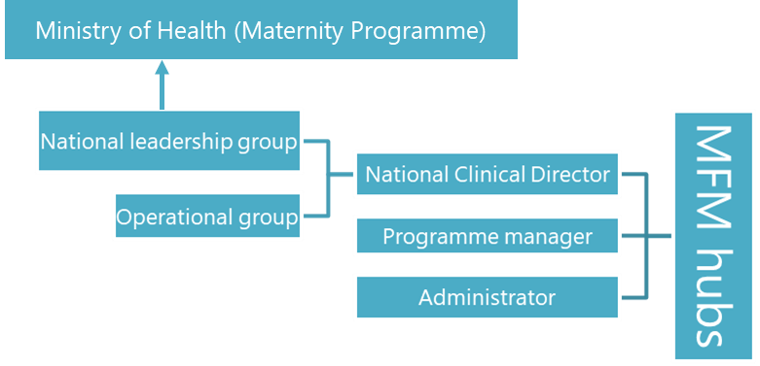

Location of MFM services
MFM services will continue to be provided through three regional MFM hubs located in Auckland, Wellington and Christchurch. Each hub provides MFM services to the DHBs from within its region (with some exceptions).
- The North MFM hub is situated in Auckland DHB. This hub will provide MFM care to the DHBs in the Northern and Midland regions (excluding Taranaki DHB, which refers to the Central MFM hub in Wellington).
- The Counties Manukau MFM provider will partner with the North MFM hub to provide MFM services to its local population, while referring complex cases to the North MFM hub.
- The Central MFM hub is situated in Capital & Coast DHB. This hub will provide MFM care to the Central region DHBs, and to Taranaki and Nelson Marlborough DHBs.
- The South MFM hub is situated in Canterbury DHB. This hub will provide MFM care to the South Island DHBs (excluding Nelson Marlborough DHB, which refers to the Central MFM hub in Wellington).

The quaternary MFM service is, and will continue to be, provided in Auckland through the North MFM hub. This service includes advanced maternal and fetal medicine assessments and fetal procedures.

Other DHBs will continue to provide obstetric services, with Southern and Waikato DHBs providing tertiary obstetric services for women with complex pregnancies.

Nelson Marlborough and Taranaki DHBs together with the MFM hubs should review and confirm which MFM hub will be the referral centre for these DHBs, taking into account where important related services are provided.

Figure 11: Service configuration for MFM
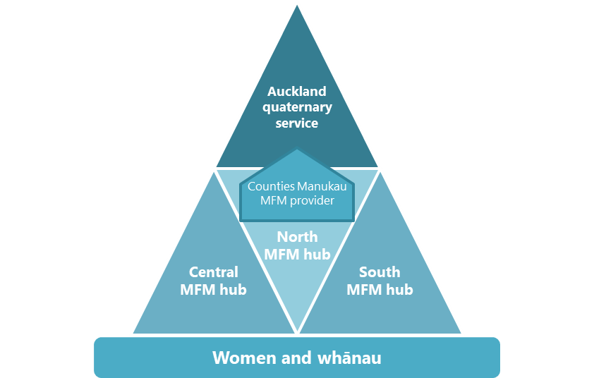

Requirements for MFM hubs
The decisions about the number and location of hubs are based on the ability of the MFM providers to meet service requirements that are essential to providing safe, sustainable and high-quality MFM care.

An MFM hub must have at least one CMFM sub-specialist in the short term and meet other requirements as follows.
- Core MFM – core MFM staff must be employed within the service.
- Essential on site – other services that have essential interdependencies with MFM must be on site with the MFM hub; without these support services, MFM services cannot provide care safely.
- Readily accessible – the MFM hub must have ready access to other services that have significant interdependencies with its services, contributing to the quality and effectiveness of MFM care.

The number of MFM hubs that Aotearoa New Zealand needs, based on population needs and workforce capacity, is unlikely to change in the near future. However, if an additional hub is seen as necessary in the future, the new MFM hub would need to demonstrate it can meet all essential criteria and requirements (Figure 12). The national leadership group will be responsible for confirming whether a new MFM hub is endorsed. Ministry accountability documents will describe MFM hub requirements.

Figure 12: Essential criteria for an MFM provider
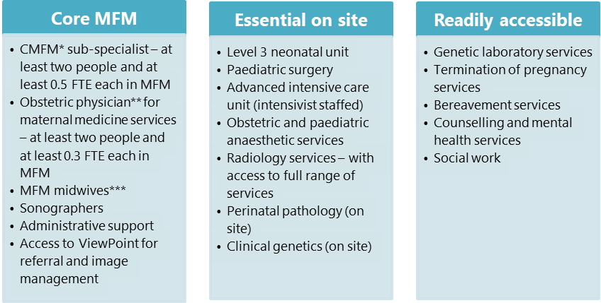Notes: * CMFM or equivalent international qualification
** Obstetric physician with Certificate of Obstetric Medicine (or recognition as such)
*** MFM midwives with appropriate postgraduate qualification

The core MFM workforce
Many areas of the MFM workforce have shortages or challenges, including in relation to CMFM sub-specialists and sonographers. Working as a sole practitioner in any role is not sustainable, especially for a prolonged period.

We have set a timeframe of three years for an MFM hub to achieve the staffing levels identified as ‘core MFM’ for MFM providers. If it does not already have these staff in place, the DHB should be working to develop the required capability.

Collaboration between hubs to support a national MFM service
Given the MFM workforce is so small, a provider will on occasion be unable to meet the requirements for the hub workforce we have identified above. MFM hubs will need to have appropriate workforce support and succession plans in place to minimise gaps in service.

To prevent a workforce shortage from adversely affecting women, MFM DHBs will need to have an escalation plan to maintain safe care for women.

In most cases, a hub may manage short-term leave of a CMFM sub-specialist internally, arranging for a DDU-qualified obstetrician to cover fetal medicine services with supervision or support from another MFM hub.

In other cases, an MFM hub may experience a vacancy or long-term gap in CMFM sub-specialist cover, when maintaining service coverage will be of particular importance. Here hubs will need to consider what role other members of the multidisciplinary team can fill within their scope of practice, and how they will support women and whānau to travel for care, if this is required. The National Clinical Director will have an important role in confirming requirements for clinically appropriate short- and long-term service coverage.

Developing the core MFM workforce
Each MFM hub will develop a workforce plan for the development and succession of staff of each discipline in the MFM team. Development should consider requirements to keep staff up to date in evidence-based MFM treatment and to meet any procedural skill credentialing requirements. Increasing workforce diversity should also be part of any workforce development plan for MFM services as an important way of improving equity.

In addition, the plan should consider staffing requirements for a sustainable service as and when service activity levels change. The national leadership group will have a role in identifying workforce vulnerability so that appropriate remedial plans can be developed in partnership with the DHBs, professional colleges and the Ministry.

The National Clinical Director will facilitate, with appropriate project and administrative support, a training and/or education programme. A further requirement will be to engage with RANZCOG to attract and support additional CMFM trainees. This focus will address the need for at least two further MFM sub-specialists to meet the minimum requirements in Capital & Coast and Canterbury DHBs and to permit succession planning.

The model of care for MFM

Pae ora principles
The model of care for MFM is framed around pae ora principles of care. Key elements of the model of care are that MFM:
- provides assessment, diagnosis and treatment
- takes a multidisciplinary team approach to care
- is woman- and whānau-centred, involving shared care between community, secondary and specialist providers.

Table 4: Pae ora principles for the maternal fetal medicine model of care
Woman-centred and equitable | MFM services empower women and whānau and give them time to make informed choices about care and treatment options and take their preferences into account.  MFM services recognise the needs of women and whānau, and appropriately use services such as the National Travel Assistance (NTA) scheme to ensure access is fair and equitable.  Social media and digital platforms connect women and whānau to expert advice and information that will increase health literacy.
Integrated and coordinated | Care is integrated and coordinated across providers and settings to ensure continuity and promote wellness.  MFM services are well connected to referrers so that women receive the right care in the right place.
High-quality, safe and sustainable | MFM services use continuous quality improvement so that women and whānau receive safe, high-quality care.  The MFM team works collegially across hubs to support each other.  MFM services use technology to manage and monitor MFM care, improving equity and outcomes.

Referral pathways

Women who should be offered referral to MFM
MFM includes both maternal and fetal medicine. Health professionals need to take a range of factors into account when considering whether to refer a woman to the MFM service. These factors include the condition or diagnosis, the severity or risk associated with the pregnancy or delivery, the experience or expertise of general obstetricians, and the woman’s preferences (based on an informed decision).

All women with complex pregnancies should receive high-quality care from expert maternity carers who treat a sufficient number of cases to maintain clinical expertise. At the same time, women should, where possible, receive care as close to home as clinically appropriate.

Defining ‘scope’ for MFM is just a first step. Referral pathways and guidelines to improve standardisation and facilitate timely referral to an MFM hub are required. MFM services must also provide LMCs and tertiary obstetricians with information to enable them to manage conditions within their scope. Providers should develop these pathways and guidelines using a multidisciplinary approach that involves a range of referring disciplines, as well as Māori and other consumers.

Maternal conditions requiring MFM input into care
Maternal conditions requiring MFM expertise should be referred to the appropriate MFM provider. Failure to refer may contribute to poor outcomes.

A small number of conditions are always be high risk and will always necessitate MFM input. For many other conditions, the need for referral may depend on either the severity of the condition or the presence of co-morbidities. Some conditions, such as maternal diabetes, would not normally require an MFM sub-specialist, but may in some circumstances.

For women with some conditions, developing individualised care plans through a multidisciplinary team approach will improve outcomes and support care closer to home. For example, women with mechanical prosthetic heart valves or some other cardiac or valve conditions could have anticoagulation therapy managed in an MFM centre, following a care plan jointly developed with the quaternary MFM service.

If an MFM hub does not have an obstetric physician or an MFM sub-specialist is not available to care for a woman with a complex medical condition, referral to North MFM (quaternary) hub is recommended.

For guidance on where to refer women with conditions that complicate pregnancy, see ‎Appendix 1.

Fetal conditions requiring MFM assessment
To identify a potential anomaly at ultrasound, health professionals are likely to need to consult with an MFM sub-specialist. Some conditions are time-critical and need urgent referral and treatment. Many other conditions may be less urgent but are still likely to result in a high degree of anxiety for women and whānau.

General guidance is that any ultrasound that is a ‘departure from normal’ (including conditions such as ventriculomegaly and talipes that may indicate other conditions) should prompt a referral to a secondary obstetric service, which may refer to or discuss with the MFM service. Referrals triaged by the MFM service may result in advice only or an assessment.

Where the MFM service provides advice, clinical responsibility remains with the referrer. If MFM accepts a referral and conducts an assessment, care may transfer to the MFM provider, or it may involve shared care between the MFM provider and the referrer, depending on the condition and the experience or expertise of the local obstetric provider. If care is transferred to the MFM provider, the provider needs to have strong links with primary maternity care who will provide post-delivery care.

For guidance on referral for MFM assessment, and options for shared care, see ‎Appendix 2.

Fetal procedures
Some cases require a fetal (in-utero) procedure. MFM hubs providing fetal procedures, such as in-utero transfusions or shunt insertions, must have an appropriately qualified CMFM sub-specialist available. If none is available, a hub should refer women to another hub because evidence links clinical outcomes to both procedural volume (Hui et al 2016) and operator experience (Papanna et al 2011).

Some therapies require specific skills or equipment or have such a small volume that they should only be provided in the Auckland quaternary MFM service or be referred to Brisbane, as part of a trans-Tasman agreement. In these circumstances the assessing MFM hub will liaise with the quaternary MFM service to facilitate referral and application for funding under the High Cost Treatment Pool.

For situations where referral to the quaternary MFM service is required, guidance is needed to clarify the appropriate approach and timing. The guidance will determine whether:
- assessment can be undertaken using telehealth and remote viewing of images
- referral and transfer should occur immediately to avoid adverse outcomes
- referral and transfer delivery and post-delivery care are required – relocation to Auckland should be at least four weeks ahead of the expected delivery date.

When care is shared between MFM hubs or an MFM hub and another specialist service (eg, the National Paediatric and Congenital Cardiac Service (NPCCS)), roles and responsibilities for communication and management need to be clearly defined.

For guidance on referral of women requiring a fetal procedure, see ‎Appendix 3.

Clinical pathways, guidelines and practice recommendations
Clinical pathways (or guidelines and practice recommendations) are required to provide guidance to clinicians so that women with complex pregnancies can receive the best care in the right place and at the right time. These translate the information on ‘who should be referred to MFM’ into practical tools or guidance to inform referral behaviours.

If clinical pathways are to be of benefit, they need to be readily accessible, customised for the local DHB environment and incorporated into existing systems.

Primary care professionals in most DHB regions are using Canterbury Community Health Pathways. Canterbury is also developing Health Pathways for hospital specialists to use for management and/or referral from a secondary specialist to tertiary or sub-specialist care.

For maternity services, the Referral Guidelines are the main mechanism to guide referral.

Once developed, MFM referral pathways need to be incorporated into these existing systems, such as Health Pathways or AGREE II. The MFM web portal also needs to be updated to provide access to them.

The quality framework of the MFM service should include auditing services for their adherence to referral pathways and guidelines. The national leadership group would be responsible for providing appropriate feedback on practice variation.

The referral process
Figure 13 summarises the process for referral to MFM. The process is similar for both fetal and maternal referrals but they have different ‘triggers’. The trigger for a fetal referral will usually be an abnormal scan result, whereas for maternal referrals it will usually be when pregnancy is confirmed in a woman with a pre-existing complex medical condition. Either the LMC or the woman’s managing specialist (eg, cardiologist) may initiate these referrals.

If the woman is within the MFM hub’s host DHB catchment, the LMC may refer directly to MFM. The triaging specialist will decide whether a general obstetric or an MFM assessment is required.

Obstetricians may conduct their review and/or assessment by non-contact (a specialist-to-specialist plan of care) or telehealth (specialist assessment of a patient via a video link) if clinically appropriate and the MFM sub-specialist has appropriate access to clinical information and images. Because telehealth is becoming an increasingly useful way of providing assessments following referral, it will be important to provide access to the required technology to support this option.

Figure 13: Summary of the MFM referral process
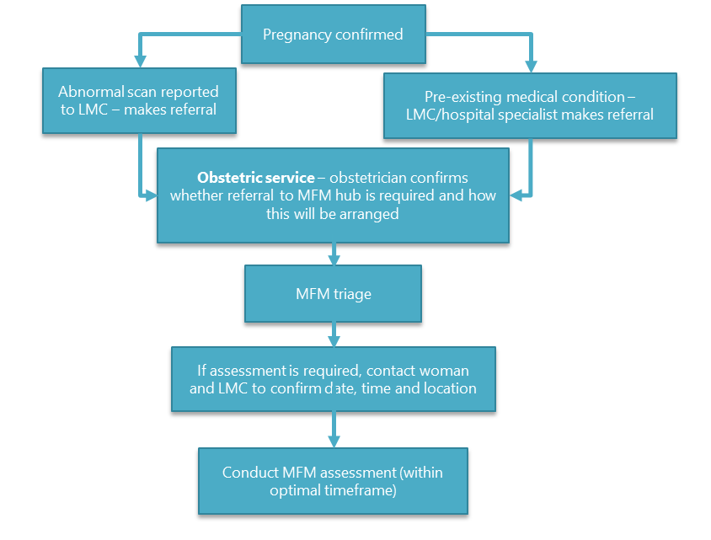
Note: Obstetric services will have local arrangements for how referral from LMC to the service occurs to ensure appropriate continuity of care for women. Within an MFM hub, the referral may be direct to an MFM sub-specialist rather than through a general obstetrician.

Referral timeframes
The potential risk associated with the maternal condition, pregnancy or fetal abnormality will determine the urgency of the consultation, but all cases require rapid referral, triage and communication. The agreed standards for referral triage and assessment are that:
      - 90 percent of referrals to MFM will occur within two working days of identifying the pregnancy, medical problem or abnormal scan
      - 80 percent of referrals will be triaged and the woman will be advised of the next step (which may include face-to-face or telehealth booking) within two working days of receiving the referral
      - all referrals triaged as ‘urgent’ will be offered an assessment that occurs within five working days of receiving the referral
      - all referrals triaged as ‘non-urgent’ will be offered an assessment that occurs within three weeks of receiving the referral, or in the optimal timeframe, based on the condition and the stage of pregnancy.

Updated accountability documents will contain standards (including expected referral process, communication and re-prioritisation), and MFM providers will be required to collect data and report on timeliness of referral processing. Providers will give this information to the national leadership group, which will oversee achievement against agreed service measures and will work with MFM hubs to address any variation that this monitoring identifies.

MFM multidisciplinary team
A multidisciplinary team provides MFM care. The team is based around the core MFM team and involves other team members (see Table 5), who may vary depending on the individual clinical situation and whether the team is providing a fetal or maternal assessment.

Table 5: Members of a maternal fetal medicine multidisciplinary team
Core MFM team | CMFM sub-specialists  Obstetric physicians  MFM midwives | Sonographers  Administrative staff
Other potential members of the multidisciplinary team | LMCs  Core (DHB) midwives  Obstetricians  Obstetricians with DDU  Neonatologists  Radiologists  Anaesthetists (obstetric and paediatric)  Nurses (neonatal, etc)  Geneticists/genetic counsellors  Laboratory technicians | Perinatal pathologists  Paediatric surgeons  Paediatric cardiologists  Bereavement counsellors  Psychosocial counsellors  Social workers  Palliative care  Specialist physicians and surgeons  General practitioners  Ethicists

Multidisciplinary meetings
A multidisciplinary meeting framework will be developed to better support shared decision-making and planning of care for women with complex pregnancies, using the well-established model of cancer multidisciplinary meetings (Ministry of Health 2012b).

MFM multidisciplinary meetings will provide input into treatment plans for the more complex situations where a decision is required on the most appropriate management plan for a woman or where care may be shared across DHBs and MFM hubs. Contributors to an MFM multidisciplinary meeting may include neonatologists, geneticists, anaesthetists, paediatric surgeons and other specialists (eg, cardiologists).

Support for women and whānau
A key aspect of the model of care is supporting women and whānau. Being faced with a potential abnormality identified on ultrasound can be a highly stressful event for women. It is essential that women and their whānau receive both emotional and practical support. The following are some of the important areas of support that we have identified for women and whānau.

Communication – ‘knowing’ helps allay anxiety while ‘uncertainty’ increases it. Maintaining the connection with the LMC is an important communication link as women may feel uncomfortable asking the specialist questions or may need time to digest the information provided. The LMC can help women and whānau to understand medical information, be available for follow-up questions and act as an interface with the specialist.

Health literacy – ‘information is power’ and increasing health literacy will help women feel more in control and will contribute to improved outcomes. Services can provide information in a range of media and languages to meet a wide range of needs. This information needs to be culturally relevant, use plain language and meet the needs of all health care users.

Peer support – connection to non-governmental organisations, such as Sands, Women’s Health Action Trust and Multiples NZ, provides women and whānau with opportunities to access support from peers, especially for those experiencing a complex pregnancy or the loss of a baby.

Bereavement care and counselling – many women under the care of MFM services will face difficult decisions or bereavement. Development of bereavement services is required across all of maternity care but is particularly relevant in MFM. Strategies to improve bereavement care need to take into account the specific needs and considerations of Māori, including recognition of the need for whānau members to stay with the tūpāpaku (the deceased’s body) from death to burial.

Cultural support – to meet cultural needs, MFM services need to take a holistic approach. For Māori, culturally appropriate care includes pae ora and three interconnected elements of Mauri Ora (healthy individuals), Whānau Ora (healthy families) and Wai Ora (healthy environments). Some practical approaches include encouraging whānau participation, for example through Karakia, providing Hunga-Atawhai (non-clinical navigators) to assist whānau and providing a whānau space.

Travel assistance – many women who need to attend an MFM hub may also be faced with the challenge of attending an appointment at an unfamiliar hospital several hundred kilometres from home. To avoid making travel an obstacle that prevents women from accessing health care, referring DHBs should have good processes in place to register a woman for assistance under the NTA scheme and should adopt a case-by-case approach to deciding on the appropriate support for people on the margins of eligibility. They should have flexible processes for providing petrol vouchers or approving NTA for people travelling shorter distances. DHBs that do not allow LMCs to refer for NTA or that restrict NTA to minimum entitlements will need to consider how this may restrict access to important services and contribute to inequitable outcomes.

Shared care
In Aotearoa New Zealand the recommended model of care is that if delivery is planned to occur:
- in one of the regional MFM hubs, the lead clinician will be an MFM-based specialist and/or midwife
- locally in the woman’s home DHB or hospital, the LMC will remain the lead clinician, with MFM input as required.

Following birth, if the baby requires neonatal intensive care, then shared care arrangements and responsibilities need to be developed and documented for appropriate postnatal care.

In the case of maternal medicine, where a woman has a condition that results in pregnancy-related risk, it may be sufficient for the local specialists and the LMC to provide ongoing care, with planned MFM input from time to time. However, where the risk to the mother is high, transfer of care may be necessary to achieve the best outcome.

The Royal Women’s Hospital in Victoria, Australia has produced guidelines for shared maternity care (Royal Women’s Hospital 2015). Table 6 sets out key roles and responsibilities it has identified for effective shared care adapted to the Aotearoa New Zealand context. Services need to review these and develop them into locally agreed protocols on roles and responsibilities that everyone is aware of.

Good communication is an essential component of shared care. The development of the Aotearoa New Zealand model of shared care for MFM will need to include expectations for communication between members of the team.

Table 6: Shared care responsibilities
MFM hub responsibilities | LMC and obstetric service responsibilities
Notify referrer, LMC and woman of appointment details.  Notify referrer and LMC if the woman does not attend the appointment.  Develop the shared care plan and update it as required.  Notify the referrer and LMC of the outcome of all hospital visits.  Ensure the woman has information about her pregnancy, treatment and plans.  Ensure hospital appointments are negotiated with the woman to find a suitable time. | Notify the MFM hub if the woman doesn’t attend planned visits.  Contact the woman if she doesn’t attend MFM hub or LMC appointments or has a poor attendance history.  Work with the woman to understand barriers to attendance and agree plans to support access.  Keep contact details up to date.  Manage identified elements of the care plan.  Act as a navigator to facilitate access to MFM care if required.  Interpret information so it can be understood.
Shared responsibilities | Women and whānau responsibilities
Participate in multidisciplinary teams and multidisciplinary meetings that relate to the woman’s care.  Update health records with test and scan results.  Make all results and new clinical information available to all shared care partners (particularly if they don’t have access to a shared health record).  Review investigations ordered in a timely way and follow up abnormal results. | Agree appointments with both LMC and MFM hub in line with the maternity plan.  Attend appointments or agree alternative dates and times if unable to attend.  Ask questions or seek information if unsure of any aspect of the plan.
Source: Adapted from Royal Women’s Hospital (2015).

The MFM Action Plan – Te Ahunga Matua

Improvement framework
The MFM Action Plan supports implementation of the MFM model of care to achieve the service goal, outcomes and objectives. The National Clinical Director and the national service team will lead the delivery of the Action Plan, with the support of an operational group and MFM hubs. They may use workshops and learning sessions to gain input and insight from Māori and consumer groups, and to share information across DHBs.

Figure 14 sets out the improvement framework, including the service goal, outcomes and objectives, along with the five priorities of the Action Plan and the improvement outcomes for each one. The following sections then describe each of these priorities in more detail, including the action areas to address them. The action areas identify leads for individual actions, and an action tracker will be used to assess progress. The Ministry and the national leadership group will develop timeframes for each priority area to allow progress to be monitored.

The national leadership group will escalate any issues that arise for Ministry and DHB intervention.

Figure 14: Maternal fetal medicine improvement framework
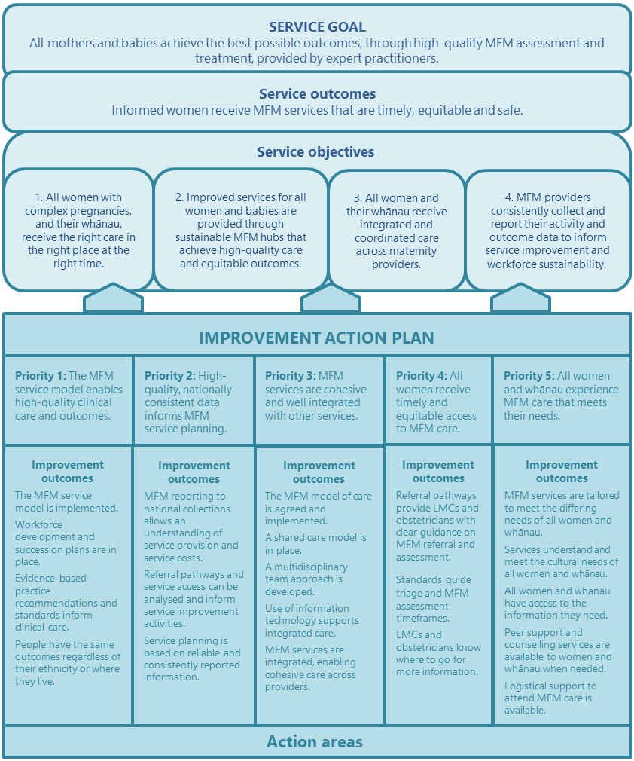

Priority 1: The MFM service model enables high-quality clinical care and outcomes

Why this needs to happen
MFM is a highly specialised area, with a small and vulnerable workforce; two of the regional providers of MFM have only a single sub-specialist.

Criteria for MFM providers must include the broad requirements for a safe and sustainable service that provides high-quality clinical care and equitable outcomes.

Improvement outcomes
      - The MFM service model is implemented.
      - Workforce development and succession plans are in place.
      - Evidence-based practice recommendations and standards inform clinical care.
      - People have the same outcomes regardless of their ethnicity or where they live.

Table 7: Action areas for Priority 1
Action areas | Leads
The MFM service model is implemented  Establish the national leadership group, with terms of reference that describe membership, purpose and responsibilities.  Appoint the national service team and resources, use a selective procurement process for the National Clinical Director and collaborate with the relevant host DHB for other team members.  Define the service specification, roles and responsibilities with input from the national leadership group.  Update Ministry accountability documents to describe essential elements of a safe and sustainable MFM service, including identified hub requirements and process for formal recognition or endorsement of any new providers that can meet the described requirements.  Formalise the agreed location and configuration of MFM hubs and providers by:  1. confirming hubs and the areas they serve – specifically, reviewing pathways for Taranaki and Nelson Marlborough DHBs to ensure these arrangements contribute to best access and outcomes  2. confirming the hub configuration and putting in place agreements for service arrangements between Auckland and Counties Manukau DHBs. | Ministry  MFM hubs
Workforce development and succession plans are in place  Create a workforce development and succession plan for each MFM hub that:  - identifies workforce requirements across the multidisciplinary team to achieve a sustainable MFM team  - includes a training plan to develop the team to fill critical workforce gaps and support team members to work at the top of their scope of practice  - includes a continuing medical education programme so that team members maintain clinical currency within their scope of practice, including procedural competence  - includes a recruitment plan to maintain or grow the CMFM, obstetric physician, sonography and MFM midwifery workforces  - considers opportunities to increase workforce diversity.  Develop and agree on collaboration arrangements to support practitioners working in isolation and to ensure service continuity. | MFM hubs
Evidence-based practice recommendations and standards inform clinical care  Review practice (guidelines) recommendations and update them based on current evidence.  Develop and implement standards for providing MFM care, and for sharing clinical information and images between carers.  Consider recommendations from the Health and Disability Commissioner and PMMRC in reviewing processes and protocols to ensure organisational policies do not contribute to negative health outcomes.  Conduct clinical audits of outcomes and referral pathways, and embed a research culture in practice. | NCD/ operations group  MFM hubs
People have the same outcomes regardless of their ethnicity or where they live  Consider the specific needs of at-risk populations to facilitate their timely and appropriate access to care.  Use outcome metrics to inform service improvement activities and performance actions. | NCD/  operations group  NLG

Priority 2: High-quality, nationally consistent data informs MFM service planning

Why this needs to happen
Reporting of MFM activity in outpatient and inpatient settings is inconsistent, no reliable information is available on who is, and who is not, accessing MFM care.

MFM data does not allow benchmarking between providers to ensure the service is appropriately planned and resourced.

Improvement outcomes
      - MFM reporting to national collections allows an understanding of service provision and service costs.
      - Referral pathways and service access can be analysed and inform service improvement activities.
      - Service planning is based on reliable and consistently reported information.

Table 8: Action areas for Priority 2
Action areas | Leads
MFM reporting to national collections allows an understanding of service provision and service costs  Standardise reporting of MFM activity to allow reliable assessment of the size, scope and location of services.  - DHBs use the MFM health specialty code when reporting in NNPAC.  - Reach agreement to use the MFM health specialty code in NMDS.  - Review purchase units for MFM to ensure they adequately define the service activity.  Agree on MFM reporting conventions and review DHB activity mapping to align with the reporting requirements.  Include a review of MFM pricing (inpatient and outpatient) in the work programme of the National Pricing Programme so that host DHBs are able to appropriately fund and resource the service. | Ministry  MFM hubs  NLG  NCD
Referral pathways and service access can be analysed and inform service improvement activities  Develop reports that allow analyses of MFM activity, referral pathways and whether services achieve identified service standards.  Use reports to understand referral pathways so interventions can be targeted to improve access.  Agree on and monitor outcome and quality measures.  - Use metrics that consider maternity outcomes for populations where there is a known inequity – particularly Māori, Pacific and Indian women and babies. | NCD  NLG  MFM hubs
Service planning is based on reliable and consistently reported information  Review activity and waiting time and access indicators to ensure there is sufficient capacity to meet demand.  - Where an MFM hub comes under pressure through increased demand or reduced capacity, the host DHB works with the national leadership group to develop and agree service plans to keep the service safe and sustainable. | MFM hubs  NLG

Priority 3: MFM services are cohesive and well integrated with other services

Why this needs to happen
Woman-centred MFM services need to be well integrated so that all women have the best opportunity to access the right services, in the right place. The involvement of the LMC is vital to continuity of care, and as a role to advocate for and share information with women.

Improvement outcomes
      - The MFM model of care is agreed and implemented.
      - A shared care model is in place.
      - A multidisciplinary team approach is developed.
      - Use of information technology supports integrated care.
      - MFM services are integrated, enabling cohesive care across providers.

Table 9: Action areas for Priority 3
Action areas | Leads
The MFM model of care is agreed and implemented  Implement the MFM hubs model of care to support an integrated, cohesive service to women, regardless of where they live.  Develop referral pathways through a partnership approach with referrers, consumers and Māori, and implement them to enable women to access MFM when they need to.  Describe the role of members of the multidisciplinary team to clarify how the team will support integrated care for women.  Contribute to training and development of LMCs and other maternity providers so that all providers have a consistent understanding of the MFM model of care. | NLG  NCD/ operations group  MFM hubs
A shared care model is in place  Develop an Aotearoa New Zealand MFM model of shared care in partnership with referrers, consumers and Māori and implement it.  Describe responsibilities for the MFM hub, neonatal intensive care unit staff (when involved following delivery), the LMC, the woman and whānau and any shared responsibilities.  Socialise the model of shared care with stakeholders so that all are aware of their roles.  Support access to training to upskill shared care teams in MFM.  Provide guidance on the opportunities for shared care and where to transfer care. Include this guidance in the Referral Guidelines. | NCD/ operations group  MFM hubs
A multidisciplinary team approach is developed  Review Ministry guidance for multidisciplinary meetings and adapt it to describe the model of delivering a multidisciplinary meeting process in MFM. The goals of this action are to:  - improve treatment planning because health professionals consider the full range of therapeutic options, with improved outcomes  - improve equity of outcomes for women and babies  - increase continuity of care and reduce duplication of services  - have better coordinated and integrated services  - improve communication between care providers, as clear lines of responsibility are developed between members of the multidisciplinary team  - use time and resources more efficiently. | NLG  NCD/ operations group  MFM hubs
Use of information technology supports integrated care  Coordinate MFM care across providers, making the best possible use of technology.  Put in place telehealth options for providing care to support remote clinical assessment.  Explore options for shared access to electronic health records across regions so that all MFM clinicians have access to the same health information, images and results. | MFM hubs
MFM services are integrated, enabling cohesive care across providers  Develop a clinician information website that hosts information on the MFM service, model of care and the service goal, outcomes and objectives.  Develop and implement a communications plan aimed at clinicians working with women with complex pregnancies across all disciplines, to make them aware of the website.  Describe and implement arrangements for how MFM hubs will collaborate to deliver cohesive MFM services across hubs, particularly when management sits with one DHB and delivery is planned at another centre or where more than one clinical specialty is involved in the care of a woman and baby, such as where the NPCCS is involved. | NCD/ operations group  MFM hubs

Priority 4: All women receive timely and equitable access to MFM care

Why this needs to happen
Inappropriate variation in MFM referral and uptake impacts health outcomes. Access to MFM services is an equity issue, with Maori and Pacific women less likely to be referred to MFM and less likely to attend an MFM appointment following referral.

Improvement outcomes
      - Referral pathways provide LMCs and obstetricians with clear guidance on MFM referral and assessment.
      - Standards guide triage and MFM assessment timeframes.
      - LMCs and obstetricians know where to go for more information.

Table 10: Action areas for Priority 4
Action areas | Leads
Referral pathways provide LMCs and obstetricians with clear guidance on MFM referral and assessment  Endorse and publish guidelines for maternal assessment, fetal assessment and fetal procedures.  Review health pathways for MFM referral where these exist. Where they are not already available, develop and implement them, using a partnership approach with referrers, consumers and Māori.  Contribute to guidelines or practice recommendations updates.  Undertake audits that assess whether referrals vary or deviate from the agreed pathways, from ethnicity and geographical perspectives, and agree on remedial actions where required. | NLG  NCD/ operations group  MFM hubs
Standards guide triage and MFM assessment timeframes  Agree on service standards for:  - timeliness and quality expectations for receiving, triaging and booking referrals for MFM care  - expectations for referrals from non-DHB specialists.  Review and update hub referral management processes to align them with the agreed service standards.  Update service specifications or operational policy framework and service coverage schedule for maternity care to include requirements for managing non-urgent referrals to MFM care, and reprioritising referrals when a clinical situation changes.  Provide information to LMCs on referral timeliness standards. | NLG  NCD/ operations group  MFM hubs  Ministry
LMCs and obstetricians know where to go for more information  Include referral pathways in existing DHB and Community Health Pathways and into DHB regional referral sites, such as Health Navigator, Healthpoint and HealthPathways.  On the MFM website, include practice recommendations, clinical guidelines specific to MFM and links to general referral guidance documents, such as the Ultrasound Guidelines and maternity Referral Guidelines. | NCD/ operations group  MFM hubs

Priority 5: All women and whānau experience MFM care that meets their needs

Why this needs to happen
Women with high-risk pregnancies can experience high levels of anxiety and stress. Information, communication and access to support services are vital to supporting women and whānau.

Improvement outcomes
      - MFM services are tailored to meet the differing needs of all women and whānau.
      - Services understand and meet the cultural needs of all women and whānau.
      - All women and whānau have access to the information they need.
      - Peer support and counselling services are available to women and whānau when needed.
      - Logistical support to attend MFM care is provided and barriers to travel and/or relocation are minimised.

Table 11: Action areas for Priority 5
Action areas | Leads
MFM services are tailored to meet the differing needs of all women and whānau  Review referral management processes, in partnership with consumers and Māori, so that they take a woman-centred approach to MFM scheduling and communication.  - With a consumer council, review letters for their content and formatting to ensure they are consumer friendly.  - Implement standards for acknowledging receipt and notification of triage outcomes so that women know what the next step is.  - Make patient-focused booking the standard in all MFM centres, either through a phone call to negotiate an appointment or through an ‘invitation to contact’.  - Develop DNA protocols that support attendance.  Consider introducing outreach services within DHB spokes when the MFM workforce is at a level that would enable this. | MFM hubs  NCD/ operations group
The cultural needs of all women and whānau are met  Include consumer and Māori health advisors on the national leadership group, who can provide feedback on changes required.  Establish a vision of pae ora – healthy futures for women and babies for all MFM services  Recognise and respond to differing needs of some groups to ensure the same outcomes in all protocols and practice recommendations,  Require staff to undertake cultural competency training and development and provide culturally safe care.  Actively support whānau to be involved in consultation and care.  Review and redesign booking information, including appointment letters, so that it is easy to understand. | Ministry  NLG  MFM hubs
All women and whānau have access to the information they need  Establish an information platform in Health Navigator as one mechanism for women and whānau to access the information they need.  Review and regularly update consumer information from a health literacy perspective and based on Rauemi Atawhai principles, which provide best practice advice for developing health education resources (Ministry of Health 2012c).  Develop information on complex medical conditions in plain language that contributes to increased health literacy.  Make information available in multiple languages. | NLG  MFM hubs  NCD/ operations group
Peer support and counselling services are available to all women and whānau when needed  Connect women who experience, or expect to experience, a bereavement to counselling services or non-governmental organisations that can provide peer support and access to counselling from people with similar experiences.  Include information in Health Navigator about support services that are available in regions to support women and whānau.  Adopt core standards for bereavement care that provide wrap-around support for women and whānau experiencing fetal or neonatal loss.  Provide MFM personnel with education and training to help them to deliver compassionate bereavement care.  Ensure DHB facilities provide a suitable physical environment to give grieving families the privacy and comfort they need.  Provide bereavement care that meets the cultural, religious, ethnic and social values of whānau. | MFM hubs
Logistical support to attend MFM care is provided  Ensure logistical support to attend MFM care is available to all women and whānau when they need it.  Encourage referring centres to consider the NTA scheme and other support systems they provide to women as a way of reducing barriers to travel.  Provide referring DHBs with data to demonstrate inequity where monitoring indicates this.  Provide hub staff with the information and training they need to be familiar with the eligibility criteria for the NTA scheme and advocate for women and whānau. | MFM hubs  All DHBs

System enablers
System enablers are activities that can be applied across all areas of the plan or system to support achieving the objectives and priorities. Table 12 summarises the role of system enablers in implementing the Action Plan and what each one requires to be effective.

Table 12: System enablers
Area | How it supports the Action Plan | Requirements
Leadership | Clinical leadership will support achievement of the service objectives, in line with the Action Plan.  A national leadership group will oversee the quality and effectiveness of the service.  Planning and performance will be oriented to drive improved equity in access and outcomes. | For the leadership model to be effective, DHBs (both providers of MFM and those providing secondary obstetric care) need to have robust maternity services and workforces in place to support achievement of standards and performance indicators endorsed by the national leadership group.
Workforce | All members of the MFM workforce will strive to support women to receive the best possible care.  Primary and secondary maternity providers will contribute to the development of improvement resources that will support women to access MFM care in the right place, at the right time. | To develop an MFM workforce, DHBs, professional colleges and the Ministry must take a long-term view of requirements for a sustainable workforce, including how to support sub-specialist training.  MFM care also depends on a sustainable workforce in other key positions such as sonography.  Developing a culturally diverse workforce will require a system wide change that should be a focus for the Ministry and the wider health system.
Information technology | Telehealth technology will support improved equity of access to MFM services and timely clinical decision-making. It will also facilitate communication with women and lead maternity carers.  Technology will support treatment teams to collect outcome data, allowing evaluation of the service for its quality and effectiveness. | DHBs will need to consider how to best integrate the ViewPoint system that MFM services use with other DHB systems such as the electronic clinical record and the patient management system.  Technology to support shared care, including regional and national shared records, is needed to develop a national Health Information Platform (nHIP). The nHIP will enable real-time clinical decision support and data-driven health care, as well as empowering patients to self-manage their health.

Measures of MFM service effectiveness
Part of implementing the Action Plan will involve developing measures of the effectiveness of MFM services in meeting the outcomes and service objectives. These measures will use multiple sources of information, including national collections and MFM hub data, clinical audit and questionnaires (both online and face-to-face interview, depending on participants and requirements).

Table 13: Measures of effectiveness of MFM services
Area | Measure | Data source | Baseline | Goal
Timeliness | Referrals received within two working days of the pregnancy, medical problem or abnormal scan being identified. | MFM hub system | TBD | 90%
 | Referrals triaged and the woman advised of the next step within two working days of receiving the referral. | MFM hub system | TBD | 80%
 | Referrals triaged as ‘urgent’ are offered an appointment that will occur within five working days of receiving the referral. | MFM hub system | TBD | 100%
 | Referrals triaged as ‘non-urgent’ are offered an appointment that will occur within three weeks (21 days) of receiving the referral (excludes referrals where the optimal timeframe depends on the condition or stage of pregnancy). | MFM hub system | TBD | 100%
Access | The number of first MFM assessments (face-to-face or non-contact) provided per 10,000 live births by DHB region. | NNPAC | TBD | TBD
 | The number of first MFM assessments (face-to-face or non-contact) compared with DHB’s forecast or planned assessments. | NNPAC | TBD | +/–5%
 | The number of MFM assessments offered and declined. | MFM hub system | TBD | TBD
 | Did not attend rates. | NNPAC | TBD | TBD
Equity | The number of first MFM assessments (face-to-face or non-contact) provided per 10,000 live births by ethnicity. | NNPAC | TBD | TBD
 | The number of MFM assessments offered and declined by ethnicity. | MFM hub system | TBD | TBD
 | Did not attend rates by ethnicity. | NNPAC | TBD | TBD
Quality | Quality indicators will be developed to understand a range of factors influencing quality and outcomes (all patients and by ethnicity), for example:  - discussion at multidisciplinary meetings  - late referral. | NMDS  Clinical audit  MFM hub systems | TBD | TBD
Experience | How referrers (LMCs and obstetricians) rate their experience of MFM services in terms of:  - ease of contact  - shared care arrangements  - communication. | Survey | TBD | TBD
 | How women and whānau rate their experience of MFM services in terms of:  - communication  - partnership  - coordination  - physical and emotional needs  - satisfaction with access. | Survey/ interview | TBD | TBD
Note: Timeliness measures can be reported from National Patient Flow if the scope of this collection is expanded to include MFM – health specialty code P39. TBD = to be decided.

Implementation
The National Clinical Director will lead the implementation of the MFM Action Plan, with the support of the programme manager, the Ministry and the operational group. The national leadership group and the Ministry will provide oversight.

An action tracker will be jointly developed to identify progress against each action, which the national leadership group will monitor. The National Clinical Director will provide quarterly reports to the Ministry and national leadership group outlining progress, challenges and risks. An escalation process will be in place to progress actions where required through Ministry accountability arrangements.

Post-implementation evaluation

Process evaluation
The first stage of the review of implementation is a process evaluation that will assess the extent to which MFM services have implemented the agreed service model. The Ministry, in consultation with the national leadership group, will develop evaluation questions to understand how and where services provide MFM.

The process evaluation will provide an opportunity to adjust or revise any components of the service model or Action Plan that are considered to be operating ineffectively.

Summative evaluation
Following implementation, a summative evaluation will be completed, to see whether MFM providers have achieved the stated outcomes, particularly quality improvements and equity. The planned timing of the summative evaluation will be two years after the service model is fully implemented.

This evaluation will consider the measures of benefit that are developed for the service under Priority 2. It should include an assessment of how women and whānau experience the service, clinical outcomes and service effectiveness.

        - : Referral guidance for maternal assessment
Area | Condition | Referral guidance
Cancer | Advanced malignancy | Refer to MFM hub.
Cardiac – congenital | Complex congenital heart disease with or without pulmonary hypertension | Refer to MFM hub, which will:  - liaise with NPCCS  - consider referral to North MFM quaternary service.
Cardiac – valve | Mechanical heart valves or cardiac valve disease with:  - a severe obstructive lesion  - severe regurgitant lesions | Refer to MFM hub, which will:  - liaise with NPCCS  - consider referral to North MFM quaternary service.
Other cardiac | Complex arrhythmias  Ischaemic heart disease | Refer to MFM hub.
 | Other cardiac conditions, including:  - systemic ventricular dysfunction (LVEF <30%, NYHA III–IV)  - Marfan syndrome with aortic dilatation  >40–45mm or aortic dilatation > in aortic disease associated with bicuspid aortic valve  - pulmonary arterial hypertension | Refer to MFM hub, which will:  - liaise with NPCCS  - consider referral to North MFM quaternary service.
Hepato-biliary | Oesophageal varices | Refer to North or South MFM hub.
 | Advanced liver disease or cirrhosis | Refer to North or South MFM hub.
Immune system or haematology | Antiphospholipid syndrome refractory to standard therapy | Refer to MFM hub.
 | Severe systemic lupus erythematosus (SLE) | Refer to MFM hub.
 | Autoimmune disease on biologics (irritable bowel disease, rheumatological conditions) | Refer to MFM hub.
 | Severe thrompocytopenia refractory to conventional therapy | Refer to MFM hub.
 | Sickle cell disease | Refer to MFM hub.
Neurological | Myasthenia gravis | Refer to MFM hub.
 | Spinal cord lesions above T6 level | Refer to MFM hub.
Pregnancy-related | Cerebral anoxia or cardiac arrest, if maternal survival and continuing pregnancy | Refer to MFM hub.
 | Severe hypertension or pre-eclampsia with a pre-viable fetus requiring consideration of termination | Refer to MFM hub.
Renal | Stage IV kidney disease, on renal replacement therapy (dialysis and/or transplant) | Refer to MFM hub.
Transplant | History of heart, lung or liver transplant | Refer to North MFM hub.
Note: LVEF = left ventricular ejection fraction. MFM = maternal fetal medicine. NPCCS = National Paediatric and Congenital Cardiac Service. NYHA = New York Heart Association classification. T6 = sixth thoracic vertebra.

        - : Referral guidance for fetal assessment
Condition | Referral guidance | Shared care
Major fetal abnormalities | Refer to local MFM hub if ultrasound shows ‘departure from normal’. | Depends on condition and availability of local obstetric expertise
Fetal cardiac anomalies | Refer to local MFM hub.  MFM will discuss with the NPCCS and determine treatment plan. | NPCCS
Duct-dependent fetal cardiac anomalies | Refer to local MFM hub, which will refer to NPCCS and the North MFM hub quaternary service.  Schedule delivery in Auckland. | MFM hub, North hub and NPCCS
Red cell antibodies | Refer to MFM if:  - Rhesus D and Rhesus c titre is >1:16  - any level of anti-Kell is present  - any other red cell antibodies considered at risk for fetal disease are present or have a titre of ≥1:32. | If stable and local specialist maternity ultrasound expertise with clear obstetric clinical leadership
Fetal and neonatal alloimmune thrombocytopenia (FNAIT) | Refer to MFM if:  - intravenous immunoglobulin is needed. | MFM hub
Multiple pregnancy requiring prenatal testing | Refer to MFM for:  - CVS  - amniocentesis. | Yes
Severe intra-uterine growth restriction (IUGR) | Refer if pregnancy is at ≤28/40 weeks.  May be managed through telehealth. | Yes
Triplets or higher-order multiple | Refer to MFM hub. | Yes
Acardiac, conjoined and monochorionic-monoamniotic twins | Refer to MFM, which may refer to North MFM quaternary service if therapeutic intervention considered. | Depends on prognosis
Dichorionic twins | Refer to MFM if significant discordance exists at ≤28/40 weeks. Do not refer if no significant discordance. | Yes
Monochorionic twins | Refer to MFM if:  - complications exist; or if scan requires expertise in identifying TTTS; or early onset IUGR discordance is present; or other complications relating to chorionicity exist  - invasive procedure (amniocentesis, CVS) is required  - significant discordance exists at ≤28/40 weeks, ie, one twin <10th percentile and/or >20% discordancy of estimated fetal weight.  MFM will refer to North MFM quaternary service if laser intervention or selective reduction is required. | Yes, depending on condition
Note: CVS = chorionic villus sampling. MFM = maternal fetal medicine. NPCCS = National Paediatric and Congenital Cardiac Service. TTTS = twin-to-twin transfusion syndrome.

        - : Referral guidance for fetal procedures
Procedure | Referral guidance
- Diagnostic ultrasound scan  - Fetal magnetic resonance imaging (MRI)  - Invasive testing (CVS and amniocentesis)  - Termination/feticide  - Selective reduction of dichorionic-diamniotic multiples  - In-utero transfusions  - Management of FNAIT  - Fetal shunt insertions | Refer to MFM hub.
- Selective reduction of monochorionic twins  - Fetoscopic laser treatment for TTTS  - Interstitial laser for some anomalies (eg, sacrococcygeal teratoma) | Refer to MFM hub.  Referral to North MFM quaternary service may be recommended.
- Ex-utero intra-partum treatment (EXIT) procedure requires input from Auckland DHB paediatric otolaryngoscopy service  - Pregnancies where the neonate may require extra corporeal membrane oxygenation (ECMO)  - Duct-dependent fetal cardiac abnormalities | Refer to MFM hub.  Referral to North MFM quaternary service may be recommended.
- In-utero spina bifida surgery and fetoscopic endoluminal tracheal occlusion (FETO) for diaphragmatic hernia are provided in Brisbane | Refer to MFM hub.  Referral to North MFM quaternary service may be recommended, and/or referral to Brisbane under High Cost Treatment Pool.
Note: CVS = chorionic villus sampling. FNAIT = fetal and neonatal alloimmune thrombocytopenia. MFM = maternal fetal medicine. TTTS = twin-to-twin transfusion syndrome.

        - : Abbreviations
Abbreviation | Description
CMFM | Certificate of Maternal Fetal Medicine
DDU | Diploma of Diagnostic Ultrasound
DHB | District health board
DRG | Diagnostic related group
FTE | Full-time equivalent
GP | General practitioner
ICD | International Classification of Diseases
LMC | Lead maternity carer
MAT | National Maternity Collection
MCIS | Maternity Clinical Information System
MFM | Maternal fetal medicine
NCD | National Clinical Director
NLG | National leadership group
NMDS | National Minimum Dataset
NNPAC | National Non-Admitted Patient Collection
NPCCS | National Paediatric and Congenital Cardiac Service
NTA | National Travel Assistance
NZMFMN | New Zealand Maternal Fetal Medicine Network
PMMRC | Perinatal and Maternal Mortality Review Committee
PUC | Purchase unit code
RANZCOG | Royal Australian and New Zealand College of Obstetricians and Gynaecologists
SFLP | Selective fetoscopic laser photocoagulation
TTTS | Twin-to-twin transfusion syndrome

References
Babu RS, Pasula S. 2013. Frequency of foetal anomalies in a tertiary centre. Journal of Clinical & Diagnostic Research 7(7): 1276–9.
Bacino CA. 2017. Birth defects: epidemiology, types and patterns. UpToDate. Retrieved from https://www.uptodate.com/contents/birth-defects-epidemiology-types-and-patterns (accessed 18 December 2020).
Hui L, Tabor A, Walker SP, et al. 2016. How to safeguard competency and training in invasive prenatal diagnosis: ‘the elephant in the room’. Ultrasound in Obstetrics & Gynecology 41(1): 8–13.
Medical Council of New Zealand. 2019. Statement on cultural competence and the provision of culturally-safe care. Wellington: Medical Council of New Zealand.
Midwifery Council of New Zealand. 2011. Statement on cultural competence for midwives. Wellington: Midwifery Council of New Zealand.
Ministry of Health. 2011. New Zealand Maternity Standards: A set of standards to guide the planning, funding and monitoring of maternity services by the Ministry of Health and District Health Boards. Wellington: Ministry of Health.
Ministry of Health. 2012a. Guidelines for Consultation with Obstetric and Related Medical Services (Referral Guidelines). Wellington: Ministry of Health.
Ministry of Health. 2012b. Guidance for Implementing High-quality Multidisciplinary Meetings. Wellington: Ministry of Health.
Ministry of Health. 2012c. Rauemi Atawhai: A guide to developing health education resources in New Zealand. Wellington: Ministry of Health.
Ministry of Health. 2015. Tatau Kahukura: Māori Health Chart Book 2015. Wellington: Ministry of Health.
Ministry of Health. 2018. Achieving Equity in Health Outcomes: Highlights of important national and international papers. Wellington: Ministry of Health.
Ministry of Health. 2019. Achieving Equity in Health Outcomes: Summary of a discovery process. Wellington: Ministry of Health.
Nursing Council of New Zealand. 2011. Guidelines for Cultural Safety, the Treaty of Waitangi and Māori Health in Nursing Education and Practice. Wellington: Nursing Council of New Zealand.
NZMFMN. 2014. New Zealand Maternal Fetal Medicine Network (NZMFMN). Retrieved from https://www.healthpoint.co.nz/public/new-zealand-maternal-fetal-medicine-network/?solo=otherList&index=0 (accessed 18 December 2020).
NZMFMN. 2015. Sustainable Maternal Fetal Medicine Services into the Future for New Zealand. Auckland: New Zealand Maternal Fetal Medicine Network.
Papanna R, Biau DJ, Lovepreet KM, et al. 2011. Use of the Learning Curve-Cumulative Summation test for quantitative and individualized assessment of competency of a surgical procedure in obstetrics and gynaecology: fetoscopic laser ablation as a model. American Journal of Obstetrics and Gynecology 204(3): 218.e1–9.
PMMRC. 2018a. PMMRC Practice Points. Wellington: Health Quality & Safety Commission. Retrieved from https://www.hqsc.govt.nz/our-programmes/mrc/pmmrc/publications-and-resources/publication/3048/ (accessed 16 December 2020).
PMMRC. 2018b. Twelfth Annual Report of the Perinatal and Maternal Mortality Review Committee: Reporting mortality 2016. Wellington: Health Quality & Safety Commission.
Royal Women’s Hospital. 2015. Guidelines for Shared Maternity Care Affiliates. Melbourne: Mercy Public Hospitals Incorporated and Western Health.
Tan WS, Guaran R, Challis D. 2012. Advances in maternal fetal medicine practice. Journal of Paediatrics and Child Health 40(11): 955–62.

