INITIAL COVID-19 MĀORI RESPONSE ACTION PLAN

Ministry of Health

COVID-19 Māori Response Action Plan

Acknowledgements
Our thanks and acknowledgement for the feedback, insights and guidance provided by a range of individuals, groups, and organisations during the COVID-19 response. This includes the Māori Reference Group, Tumu Whakarae (DHB Managers, Māori Health), and the Technical Advisory Group. We will continue to work with these groups and others as we respond to COVID-19.
Membership of the COVID-19 Māori Reference Group includes:
Bill Halkyard | Riki Niania
Chris Tooley | Tania Pritchard
Hector Matthews | Te Pora Thompson-Evans
Herewini Te Koha | Matapura Ellison
Jo Baxter | Sharlene Moata-Davis
Lance Norman | Mike Smith
Lorraine Hetaraka | Aran Culver
Lynette Stewart | Chris Kumeroa
Mata Cherrington | Ramon Pink
Suzanne Pitama | Donna Foxall
Tracey Wright | Te Puea Winiata

Citation: Ministry of Health. 2020. Initial COVID-19 Māori Response Action Plan. Wellington: Ministry of Health.
Published in April 2020 by the Ministry of Health
PO Box 5013, Wellington 6140, New Zealand
ISBN 978-1-98-859785-0 (online)
HP 7392
This document is available at health.govt.nz
This work is licensed under the Creative Commons Attribution 4.0 International licence. In essence, you are free to: share ie, copy and redistribute the material in any medium or format; adapt ie, remix, transform and build upon the material. You must give appropriate credit, provide a link to the licence and indicate if changes were made.

Contents
Acknowledgements 2
Executive summary 4
Contact details and further information 4
Introduction 5
Indigenous health inequities in New Zealand 5
Unequal distribution and exposure to the determinants of health increases risk for Māori 5
Equity for Māori is a critical feature central to the Ministry’s pandemic response 6
A commitment to Te Tiriti o Waitangi 7
Our expression of Te Tiriti 7
Our approach to achieving these goals 7
Positioning equity at the centre of the pandemic response 9
Integrating equity into decision-making 9
Pandemic response and the COVID-19 alert levels 11
COVID-19 Māori Response Action Plan objectives 13
COVID-19 Māori Response Action Plan actions 14
Section 1: Māori health specific actions 15
Section 2: Contributory actions 16
Appendix 1: COVID-19 Māori Response Action Plan 18
Appendix 2: Ministry of Health’s draft Te Tiriti o Waitangi framework 19

Executive summary
The Initial COVID-19 Māori Response Action Plan (the Plan) establishes a framework to ensure the health and wellbeing of iwi, hapū, whānau and Māori communities is protected during the COVID-19 pandemic. This Plan is a living document that will evolve and adapt to the COVID-19 response as it progresses. It sets out a strategic approach and suite of actions that the COVID-19 response can adopt to uphold Te Tiriti o Waitangi and support the achievement of Māori health equity.
The Plan is aligned with the framework and content of the COVID-19 Health and Disability System Response Plan and contributes to the various actions and activities underway to protect, prevent and manage the spread and transmission of COVID-19 within whānau, hapū, iwi and Māori communities. This approach ensures that the COVID-19 response for Māori is integrated across the broader health and disability system response. This Plan also makes an important contribution to the all-of-government response to COVID-19 in mitigating the social impact of COVID-19 on whānau, hapū, iwi and Māori communities.
The purpose of this Plan is to describe the actions that will be triggered or considered at all levels of the health and disability system to prevent and manage the spread of COVID-19. An A3 overview of the Plan is attached as Appendix 1. The Ministry of Health’s draft Te Tiriti o Waitangi framework is attached as Appendix 2.

Contact details and further information
If you have any issues and queries, please contact maorihealth@health.govt.nz.
For the latest updates and information on the COVID-19 response, please go to https://covid19.govt.nz/.

Introduction
The severe impact of the 1918–19 pandemic on Māori and the increased susceptibility of Māori to the 2009 H1N1 influenza A pandemic provide rationale to strengthen the Māori-specific response to COVID-19. It is evident from previous pandemic responses that the business-as-usual model previously used preferentially benefited non-Māori and failed to protect whānau, hapū, iwi and Māori communities from the worst outcomes. It is critical that the specific needs of Māori, particularly equity and active protection, are integral to the health and disability response to COVID-19.

Indigenous health inequities in New Zealand
Indigenous ethnic inequities in infectious diseases are marked. Māori experience higher rates of infectious diseases than other New Zealanders. One example that highlights the ethnic difference within close-contact infectious diseases was the higher rates of hospitalisations reported for Māori and Pacific peoples, compared with other New Zealanders, during the H1N1 pandemic (Māori rate ratio (RR)=3.0, 95% confidence interval (CI) 2.9–3.2; Pacific peoples RR=6.7, 95% CI 6.2–7.1).
Historically, individuals at risk of close-contact infectious diseases are generally children, pregnant women, older people, individuals with underlying chronic medical conditions and individuals with immunosuppressed disorders. For COVID-19, older people and individuals with underlying conditions are at increased risk of severe infection. Māori generally have higher rates of chronic conditions and comorbidities and, following international trends, are likely to have an increased risk of infection should a community outbreak occur.

Unequal distribution and exposure to the determinants of health increases risk for Māori
Health differences between ethnic groups is influenced by socioeconomic factors and compounded by structural inequities such as racism and discrimination. Structural inequities systematically disadvantage individuals and groups on the basis of ethnicity and social positioning (i.e. age, gender, able-ness). This results in the unequal distribution of power and resources, and differential access and exposure to the determinants of health. An increase in the incidence of close-contact infection is associated with crowded living conditions and lower socioeconomic status. The incidence of close-contact infectious diseases is higher among individuals who live in the most deprived areas. Māori and Pacific peoples are more likely than other New Zealanders to live in higher deprivation and are also likely to be living in overcrowded households or in higher-density housing conditions. The psychosocial impacts for Māori arising from public health measures, such as self-isolation, physical distancing, and general societal anxiety, is also likely to exacerbate existing mental health conditions and place increased pressure on the wider whānau unit.

Equity for Māori is a critical feature central to the Ministry’s pandemic response
Measures must be taken in a way that actively protects the health and wellbeing of whānau, hapū, iwi and Māori communities. Critically, this means that equity will be at the centre of each level of the alert system. There will be a requirement nationally and within district health boards (DHBs), as well as across other sectors, to ensure whānau, hapū, iwi and Māori communities have the resources to undertake, develop, lead and respond to public health measures to prevent and manage the spread of the virus. This will be matched with active surveillance and monitoring of COVID-19 across DHBs.
This requires the routine collection of ethnicity data and regular analysis and review of measures that are in place to ensure essential supplies are in the regions of greatest need. The ability to quickly mobilise resources to communities (and therefore whānau) is pertinent to preventing, mitigating and protecting Māori from potential COVID-19 outbreaks.
Acknowledging that Māori also bare a greater burden of chronic diseases that increase risk of more serious outcomes from infections, such as influenza, requires the Ministry and DHBs to strike an equitable balance between resources in response to COVID-19 and maintaining adequate continuity of care that is essential to maintaining and supporting Māori health and wellbeing.

A commitment to Te Tiriti o Waitangi
As a public service department, the Ministry of Health has a responsibility to contribute to the Crown meeting its obligations under Te Tiriti o Waitangi/Treaty of Waitangi. This statement confirms our commitment and provides high-level direction for how we will go about delivering on it. Additional detail on this approach is summarised in the Ministry of Health’s draft Te Tiriti o Waitangi framework, attached as Appendix 2. This position on Te Tiriti o Waitangi was endorsed by the Director-General of Health on 9 January 2020.

Our expression of Te Tiriti
The text of Te Tiriti, including the preamble and the three articles, along with the Ritenga Māori declaration, are the enduring foundation of our approach. Based on these foundations, we will strive to achieve the following four goals, each expressed in terms of mana.
- Mana whakahaere: effective and appropriate stewardship or kaitiakitanga over the health and disability system. This goes beyond the management of assets or resources.
- Mana motuhake: enabling the right for Māori to be Māori (Māori self-determination), to exercise their authority over their lives, and to live on Māori terms and according to Māori philosophies, values and practices, including tikanga Māori.
- Mana tangata: achieving equity in health and disability outcomes for Māori across the life course and contributing to Māori wellness.
- Mana Māori: enabling ritenga Māori (Māori customary rituals), which are framed by te ao Māori (the Māori world), enacted through tikanga Māori (Māori philosophy and customary practices) and encapsulated within mātauranga Māori (Māori knowledge).

Our approach to achieving these goals
The principles of Te Tiriti o Waitangi, as articulated by the Courts and the Waitangi Tribunal, provide the framework for how we will meet our obligations. These principles are applicable to the wider health and disability system, including the response to COVID-19. The principles include:
- Tino rangatiratanga, which provides for Māori self-determination and mana motuhake. This means that Māori are key decision makers in the design, delivery, and monitoring of health and disability services and the response to COVID-19.
- Equity, which requires the Crown to commit to achieving equitable health outcomes for Māori and to eliminate health disparities resulting from COVID-19. This includes the active surveillance and monitoring of Māori health to ensure a proportionate and coordinated response to health need.
- Active protection, which requires the Crown to act, to the fullest extent practicable, to protect Māori health and achieve equitable health outcomes for Māori in the response to COVID-19. This requires the Crown to implement measures to equip whānau, hapū, iwi and Māori communities with the resources to undertake and respond to public health measures to prevent and/or manage the spread of COVID-19.
- Options, which requires the Crown to provide for and properly resource kaupapa Māori health and disability services in the response to COVID-19. Furthermore, the Crown is obliged to ensure that all health and disability services are provided in a culturally appropriate way that recognises and supports the expression of hauora Māori models of care.
- Partnership, which requires the Crown and Māori to work in partnership in the governance, design, delivery, and monitoring of the response to COVID-19. This contributes to a shared responsibility for achieving health equity for Māori.
Meeting our obligations under Te Tiriti o Waitangi is necessary if we are to ensure iwi, hapū, whānau, and Māori communities and organisations are active partners in preventing and addressing the potential impacts of COVID-19. This is crucial to realising the overall aim of Pae Ora (healthy futures for Māori) under He Korowai Oranga (the Māori Health Strategy). These principles underpin all actions outlined in this Plan.

Positioning equity at the centre of the pandemic response
The Ministry of Health’s definition of equity is:
In Aotearoa New Zealand, people have differences in health that are not only avoidable but unfair and unjust. Equity recognises different people with different levels of advantage require different approaches and resources to get equitable health outcomes.
A fair health and disability system prioritises equity. The key drivers of health inequity are differential access to resources, services and opportunities on the basis of ethnicity and social positioning (eg, age, gender, able-ness) and inaction or inappropriate action in response to health need. To mitigate against inequity, the National Ethics Advisory Committee’s Getting through Together: Ethical values for a pandemic outlines two equity principles – fairness and respect.
Fairness:
- supports individuals, whānau, hapū, iwi and Māori communities to get what they are entitled to
- ensures that individuals, whānau, hapū, iwi and Māori communities get treated in an equitable manner
- minimises health and disability inequities for individuals, whānau, hapū, iwi and Māori communities
- prioritises fairly when there are limited resources for all to get the services they seek.
Respect:
- supports individuals, whānau, hapū, iwi and Māori communities to make their own decisions wherever possible
- supports those who make decisions on behalf of individuals who can’t make their own decisions
- restricts freedom as little as possible, if freedom must be restricted for the public good.

Integrating equity into decision-making
Applying an equity analysis to planning and operational activities requires the following actions:
- Identify which of the priority populations are relevant to the specified action.
- Decide on the actions to meet the needs of the identified priority populations.
- Resource and implement the actions, focusing on tailored and appropriate delivery.
- Monitor and track the results for the identified priority population group.
In addition to Te Tiriti o Waitangi principles, this approach will help us to:
- prioritise resources to improve access
- improve pathways of care
- address structural inequities for priority population groups
- ensure the active protection of priority population groups
- ensure the provision of options for priority population groups
- partner with communities to make their own decisions.

Pandemic response and the COVID-19 alert levels
New Zealand’s Pandemic Plan comprises six phases. This Plan focuses on the ‘Stamp It Out (containment and cluster control)’ and ‘Manage It (pandemic management)’ phases of the response.
New Zealand’s four-level COVID-19 alert system specifies public health and social measures to be taken against COVID-19. The measures may be updated on the basis of (i) new scientific knowledge about COVID-19 and (ii) information about the effectiveness of intervention measures in New Zealand and elsewhere.
The alert levels may be applied at a town, city, territorial local authority, regional or national level. Different parts of the country may be at different alert levels. We can move up and down alert levels. In general, the alert levels are cumulative – for example, Level 1 is a base-level response. Always prepare for the next level.
At all levels, health services, emergency services, utilities and goods transport, and other essential services, operations and staff are expected to remain up and running. Employers in those sectors must continue to meet their health and safety obligations.
The New Zealand COVID-19 alert levels (see diagram below) have implications for the implementation of this Plan.

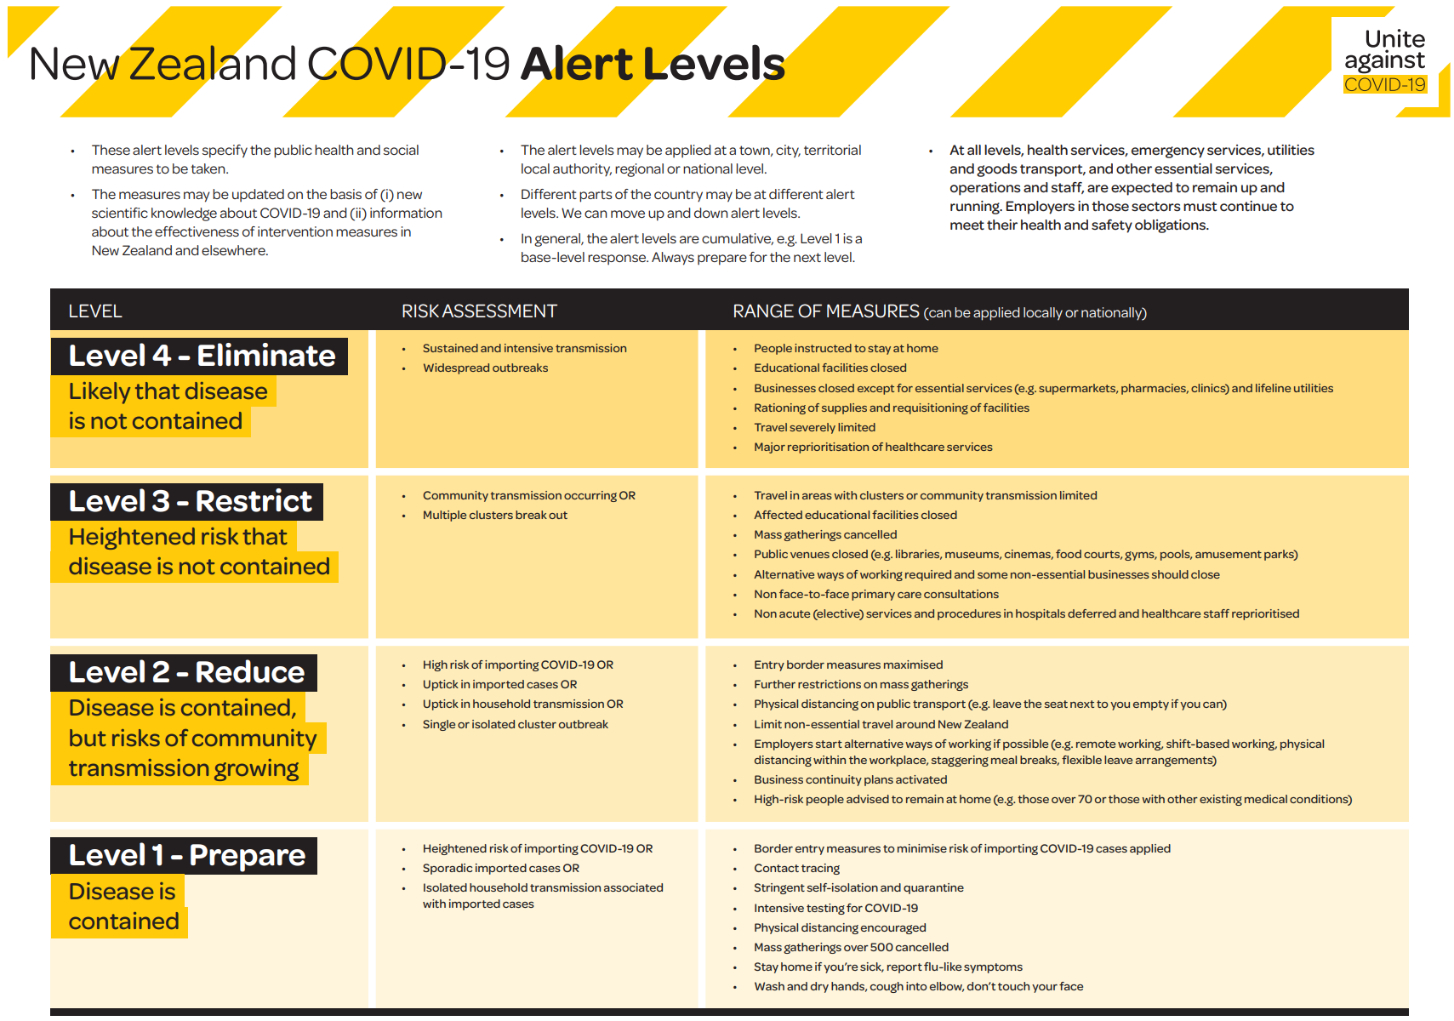

COVID-19 Māori Response Action Plan objectives
The overarching goal of the Plan is to support the Crown in meeting its obligation under Te Tiriti o Waitangi in the COVID-19 response, including to protect Māori health wellbeing and the achievement of equity. To achieve this, the Plan outlines four objectives based on the articles of Te Tiriti o Waitangi, represented in the diagram below.
Ensuring Te Tiriti and Māori health equity responsibilities are met in the exercise of kaitiakitanga and stewardship over the national COVID-19 response.
Mana Whakahaere
Ensuring Māori health equity is prioritised in the COVID-19 national response planning and implementation, including targeted information guidance and support to iwi, hapū, whānau, and Māori communities.
Mana Tangata
Enabling iwi, hapū, whānau and Māori health organisations to utilise mātauranga Māori approaches in the design and delivery of appropriate services for their people in response to COVID-19.
Mana Māori
Mana Motuhake
Ensuring iwi, hapū, whānau and Māori organisations are supported to respond directly to the increasing health and other needs of their people due to COVID-19.
The principles of tino rangatiratanga, equity, active protection, options, partnership, fairness and respect guide the types of actions needed to meet the four objectives. This approach ensures that each action will contribute to the Crown meeting its obligations under Te Tiriti o Waitangi, including the achievement of Māori health equity.
This Plan and the actions outlined will be revised and updated as new information is available. This Plan is to be read in conjunction with:
- The Guide to He Korowai Oranga: Māori Health Strategy (2014)
- New Zealand Influenza Pandemic Plan: A framework for action (2017)
- COVID-19 Health and Disability System Response Plan (2020).

COVID-19 Māori Response Action Plan actions
This Plan sits under the Māori health workstream, which is one of twelve Ministry of Health COVID-19 operational workstreams. This Plan acknowledges that Māori are a priority population group for the COVID-19 response and that actions specific to supporting whānau, hapū, iwi and Māori communities will also be delivered through other COVID-19 operational workstreams. It is expected that this Plan will also capture a broad range of COVID-19 activities targeted towards Māori but led by other workstreams.
Therefore, the actions outlined in this Plan are organised into two main sections:
- Section 1: Māori health specific actions – consists of actions designed to expand the reach and coverage of COVID-19 activities to better support whānau, hapū, iwi and Māori communities. This also includes support to Māori providers and organisations. Delivery of these actions is led by the Māori health workstream and primarily coordinated by the Māori Health Directorate within the Ministry of Health.
- Section 2: Contributory actions – consists of actions designed to specifically target support to whānau, hapū, iwi and Māori communities. Delivery of these actions is primarily coordinated and led by other COVID-19 operational workstreams. This is not an exhaustive list of actions – it is expected this list will evolve as Māori-specific actions are identified across other workstreams.
The actions outlined within each section meet one or more of the principles of Te Tiriti o Waitangi and contribute to one or more of the four objectives for this Plan. The actions have been drawn from a range of sources, including:
- the New Zealand Influenza Pandemic Plan
- the COVID-19 Health and Disability System Response Plan
- an external Māori Touchstone Group (established to advise on the COVID-19 response)
- a range of Māori stakeholders and Māori commentary on COVID-19 to date.

Section 1: Māori health specific actions
This section consists of actions designed to expand the reach and coverage of COVID-19 activities to better support whānau, hapū, iwi and Māori communities. This also includes support to Māori providers and organisations. Delivery of these actions is led by the Māori health workstream and primarily coordinated by the Māori Health Directorate within the Ministry of Health.
Action | Responsibility
Mana Motuhake – Ensuring iwi, hapū, whānau and Māori organisations are supported to respond directly to the increasing health and other needs of their people due to COVID-19.
- Provide financial assistance for Māori provider networks to enable providers to meet increased demand, including through DHB General Managers Māori (Tumu Whakarae). | Ministry of Health  DHBs
- Support the backfilling and additional workforce capacity arrangements for Māori providers. | Ministry of Health  DHBs
Mana Māori – Enabling iwi, hapū, whānau and Māori health organisations to utilise mātauranga Māori approaches in the design and delivery of appropriate services for their people in response to COVID-19.
- Establish and maintain a Māori Touchstone Group to provide advice and guidance on the Government’s response to COVID-19. | Ministry of Health
Mana Tangata – Ensuring Māori health equity is prioritised in the COVID-19 national response planning and implementation, including targeted information, guidance and support to iwi, hapū, whānau, and Māori communities.
- Support the Whanau Ora Commissioning Agencies to respond to the increased need in the community as a result of COVID-19.  - Provide packages of care, including hygiene and sanitation packs, access to food, essential supplies, warm clothing and access to quality health information. | Te Puni Kōkiri
- Develop guidelines to help Māori whānau to prepare for self-isolation, particularly when self-isolating as part of a large whānau grouping, and during Alert Level 4. | Ministry of Health
- Support Māori communities (whānau, hapū, iwi and marae and Māori organisations) to provide locally specific support for those self-isolating, unwell, or generally in need of assistance. | Ministry of Health  DHBs
- Provide financial support for whānau and Māori communities to eliminate barriers to health care. This includes payment for prescriptions and health services. | Ministry of Health
- Provide continuity of care for kuia and koroua – to keep kaumātua healthy and well (eg, food parcels, medications, resources). | Ministry of Health  DHBs
Mana Whakahaere – Ensuring Te Tiriti and Māori health equity responsibilities are met in the exercise of kaitiakitanga and stewardship over the national COVID-19 response.
- Ensure DHBs are partnering with iwi and Māori organisations in the development and delivery of COVID-19 response strategies. | Ministry of Health
- Conduct active surveillance and monitoring of COVID-19 outcomes for Māori across DHB regions. | Ministry of Health

Section 2: Contributory actions
This section consists of actions designed to specifically target support to whānau, hapū, iwi and Māori communities. Delivery of these actions is primarily coordinated and led by other Ministry of Health COVID-19 operational workstreams. This is not an exhaustive list of actions – it is expected this list will evolve as Māori-specific actions are identified across other workstreams. The actions outlined in this section are intended to be high-level and indicative. Further detail for each action can be found in the respective operational plans of each workstream.
Action | Responsibility
Mana Motuhake – Ensuring iwi, hapū, whānau and Māori organisations are supported to respond directly to the increasing health and other needs of their people due to COVID-19.
- The Mental Health & Addiction Directorate is working with Māori providers to ensure continuity of service delivery over the period of the COVID-19 response, particularly through the Alert Level System. | Ministry of Health
Mana Māori – Enabling iwi, hapū, whānau and Māori health organisations to utilise mātauranga Māori approaches in the design and delivery of appropriate services for their people in response to COVID-19.
- This includes funding a Māori-led and Māori-specific influenza vaccination programme to address equity issues, starting with Māori most at risk of COVID-19. | Ministry of Health
Mana Tangata – Ensuring Māori health equity is prioritised in the COVID-19 national response planning and implementation, including targeted information, guidance and support to iwi, hapū, whānau, and Māori communities.
- The Mental Health & Addiction Directorate has identified a range of actions to support information and guidance for Māori throughout the COVID-19 response, including:  - launching the ‘Getting through together’ campaign, which shares ways to help Kiwis cope with the stress of COVID-19  - developing and releasing a Māori-focused communications and mental health and support campaign. | Ministry of Health
- Establish and deliver mental health support services in communities with a high proportion of Māori population groups. | Ministry of Health
- Establish and activate Community-Based Assessment Centres (CBACs) in communities with a high proportion of Māori population groups. | Ministry of Health
- The Cancer Control Agency (CCA) has identified a range of key areas to focus on achieving equity for Māori cancer patients during the COVID-19 response. This activity involves working with a range of stakeholders from across the sector. Actions include:  - ensuring equitable access to treatment across the COVID-19 response, including flu vaccinations and support services  - developing a framework to assess cancer-specific impacts across key areas for all patients, with a specific focus on Māori, and looking at how these issues may be addressed or alleviated across the COVID-19 response. | Ministry of Health
Mana Whakahaere – Ensuring Te Tiriti and Māori health equity responsibilities are met in the exercise of kaitiakitanga and stewardship over the national COVID-19 response.
- Ensure actions are supported by tailored Māori communications through appropriate and trusted channels – expanding the reach and coverage of communications. | Ministry of Health
- Build in to the telehealth service a call-back mechanism to ensure all Māori whānau, hapū and iwi receive timely health advice. | Ministry of Health
- The National Health Coordination Centre (NHCC) will maintain oversight across the response to COVID-19 to ensure equity process and outcomes by utilising and maintaining a Māori lens. | Ministry of Health

Appendix 1: COVID-19 Māori Response Action Plan
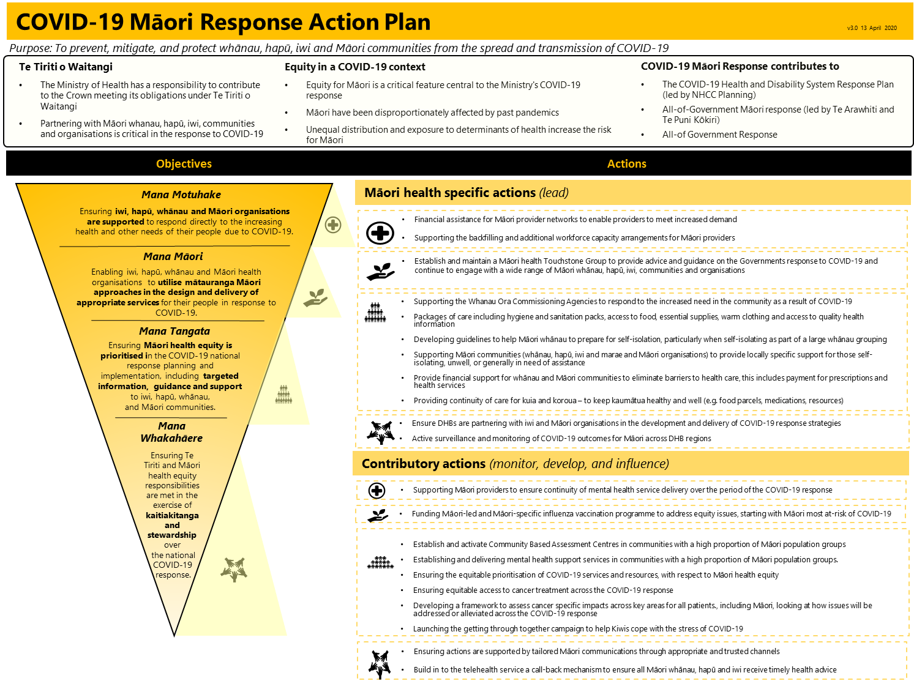

Appendix 2: Ministry of Health’s draft Te Tiriti o Waitangi framework
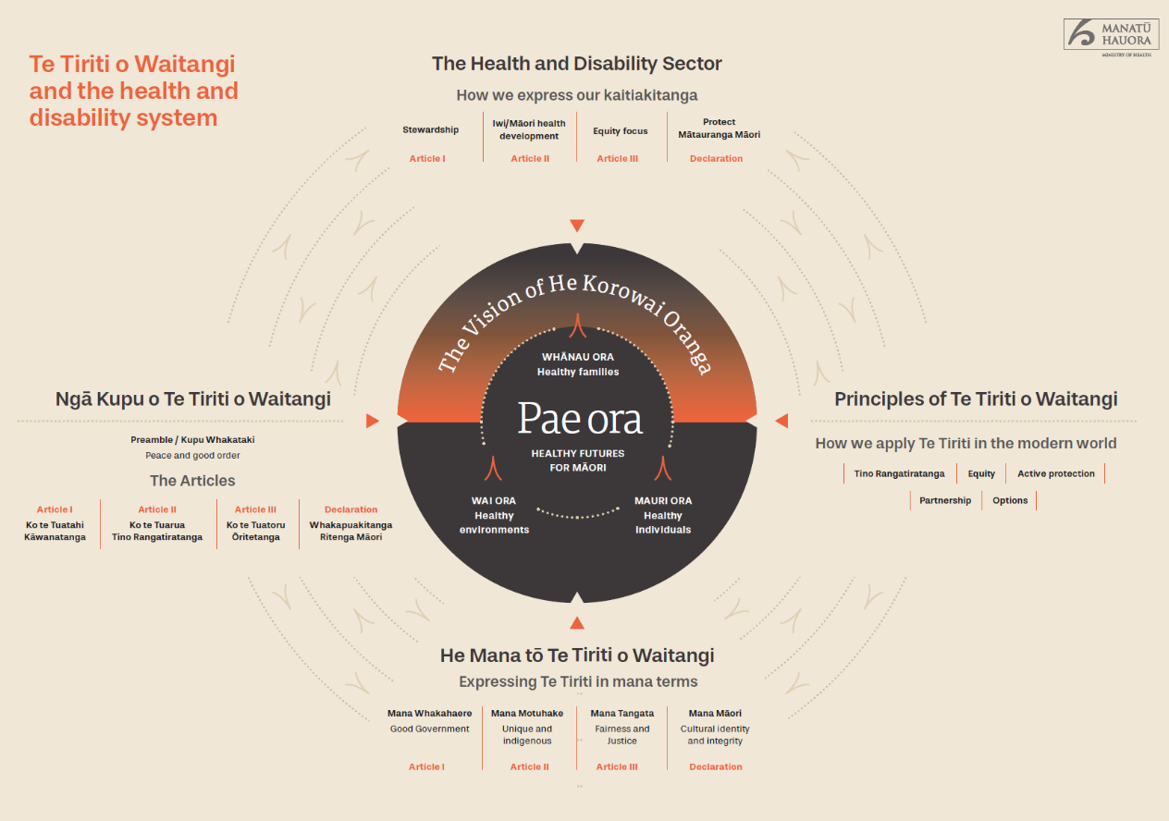

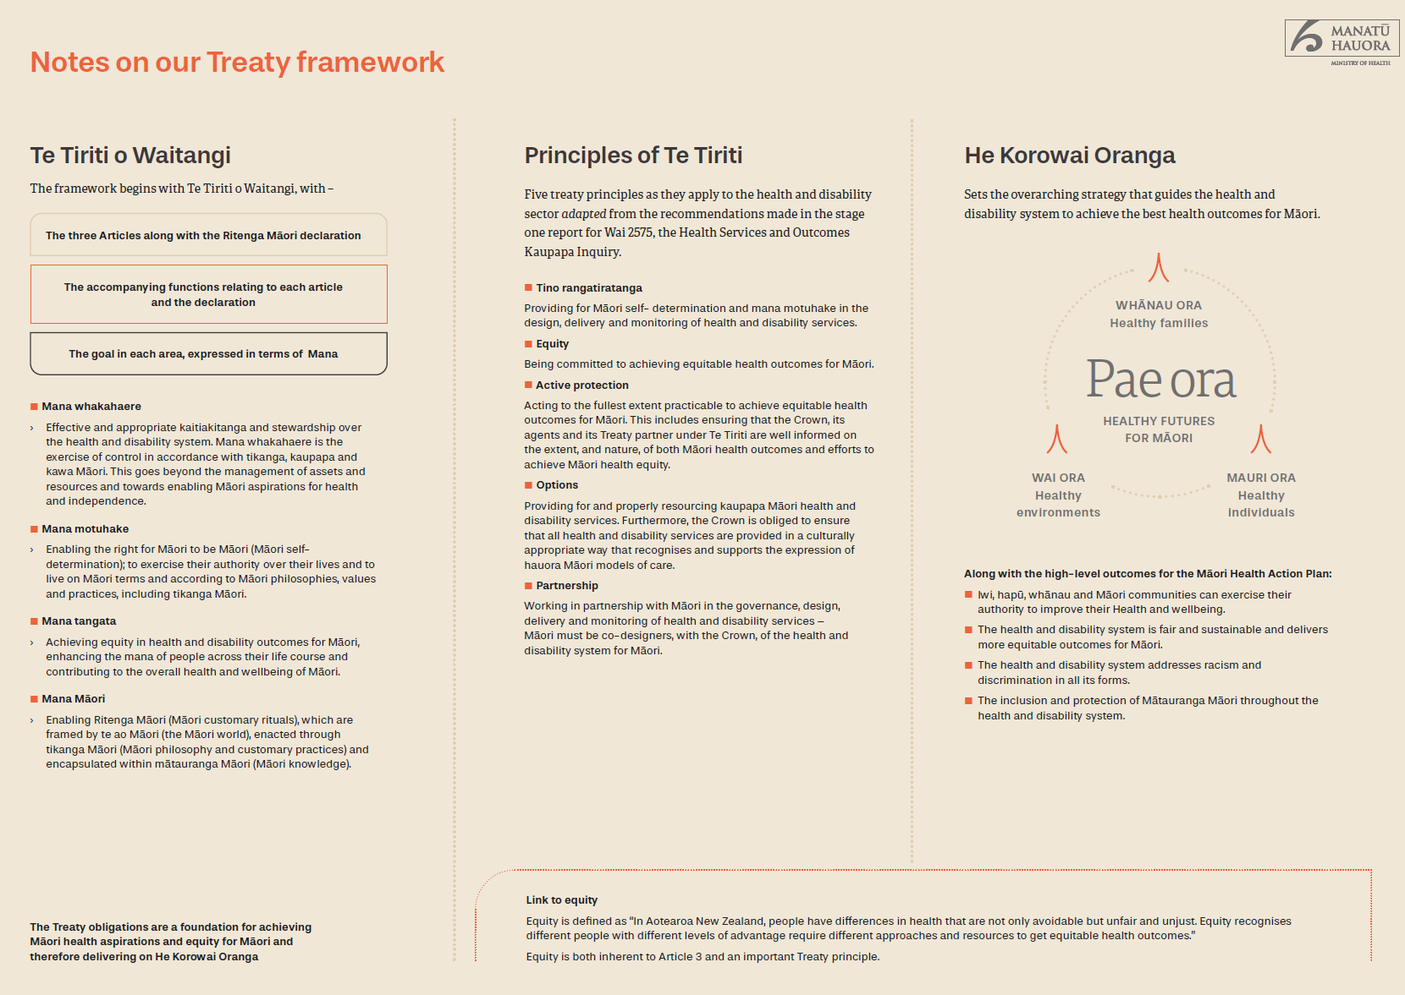

Baker, M. G., Wilson, N., Huang, Q. S., Paine, S., Lopez, L., Bandaranayake, D., Tobias, M., Mason, K., Mackereth, G. F., Jacobs, M., Thornley, C., Roberts, S., & McArthur, C. (2009). Pandemic influenza A(H1N1)v in New Zealand: the experience from April to August 2009. Euro surveillance : bulletin Europeen sur les maladies transmissibles = European communicable disease bulletin, 14(34), 19319. https://doi.org/10.2807/ese.14.34.19319-en
Further detail can be found in the Cabinet Office circular CO (19) 5: Te Tiriti o Waitangi/Treaty of Waitangi Guidance 22 October 2019.
Often referred to as the ‘fourth article’ or the ‘verbal article’.
Mana is a uniquely Māori concept that is complex and covers multiple dimensions.
This definition of equity was signed-off by the Director-General of Health, Dr Ashley Bloomfield, in March 2019.
https://www.health.govt.nz/system/files/documents/publications/influenza-pandemic-plan-framework-action-2nd-edn-aug17.pdf
https://covid19.govt.nz/assets/COVID_Alert-levels_v2.pdf

