

Independent review of  
New Zealand’s Electronic   
Health Records Strategy

Date of submission: Thursday 16 July 2015

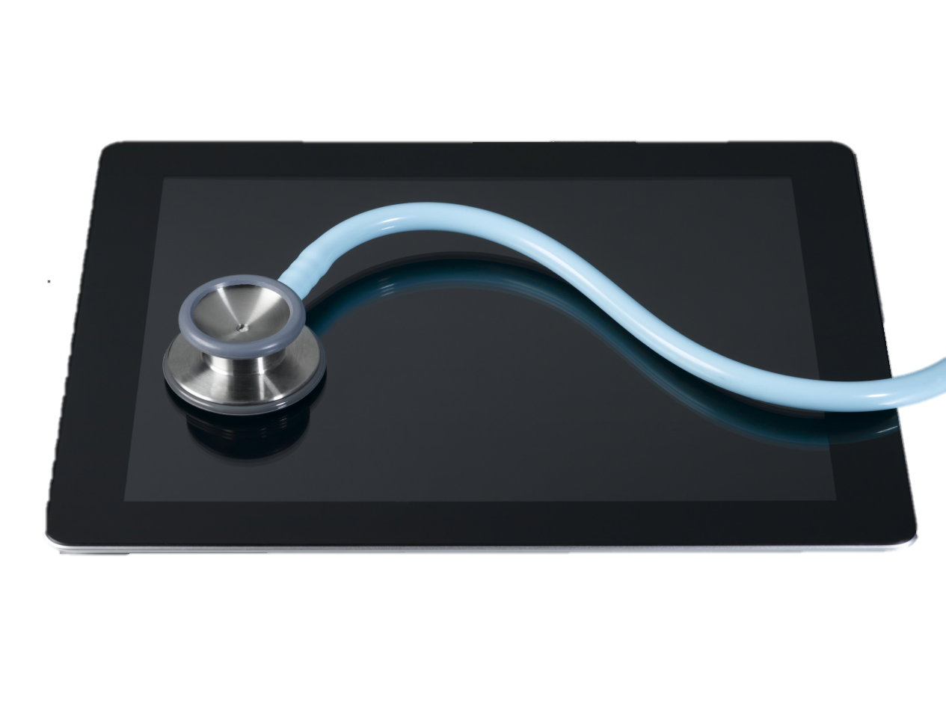

Contents

Executive summary 4

Background 8

Definitions 10

1) New Zealand Context 14

2) International Experience 22

3) Potential Benefits of a ‘Single’ EHR 32

4) ‘Optimal’ EHR Discussion 43

5) Rationale for Change 55

6) Implementation Options 62

Next Steps 68

Appendix A New Zealand Consultation 69

Appendix A New Zealand Consultation/Visits 69

Appendix B International Consultation/Visits 70

Appendix C OECD Health Statistics 71

Appendix D Preconditions for Maturity Steps 72

Appendix E EHR / EMR Maturity Scale Mappings 73

Appendix F Case Studies 74

Appendix G Stakeholder Quotes 81

Appendix H Productivity & Quality of Care 83

# Executive summary

Review Scope:

The Minister of Health has requested an independent review of New Zealand’s Electronic Health Record (EHR) policy to explore the continuum of options for delivering an EHR in New Zealand.

In the context of this review, an **Electronic Health Record (EHR)** is defined as “a longitudinal electronic record of patient health information generated by one or more encounters in any care delivery setting. In a national context, an EHR is also referred to as a **NHR (National Health Record)** in some countries.

By contrast, an **Electronic Medical Record (EMR)** is a digital version of the paper charts in a health practitioner’s office. The EMR is more specific and narrow in scope, focusing on episodic healthcare events. It is designed to support interactions in a specific setting (e.g. primary care or hospital) or for a particular type of professional (e.g. orthopaedic specialist).

The purpose of this review is to examine what might be the optimal configuration for a comprehensive EHR in New Zealand – and if this would provide incremental benefits over and above the current state.

New Zealand Sector Context:

New Zealand’s health sector costs have been rising (from 8.0% of GDP in 2004 to 9.7% in 2013). In the face of an ageing population and on-going inflation of medical costs, as well as increasing demands from the population, this trend is likely to continue.

Unfortunately, while costs and staffing levels have risen, New Zealand’s healthcare sector has experienced a drop in productivity: MBIE data indicates that health sector productivity has dropped 0.2% year-on-year since 2001 and that real GDP created per hour paid is $39 per hour – well below the New Zealand average of $48 per hour.

As Appendices C and H and outline, New Zealand appears to have a productivity gap in its hospitals – where over two thirds of our resources are consumed. Our resource intensity per hospital bed is 1 doctor and 3.6 nurses per bed, compared to an OECD average of 0.7 doctors and just 1.9 nurses per bed. Our hospital costs are over $USD 1.2m per bed against an OECD average of just over $USD 0.7m (purchasing power parity adjusted).

Since information technology is a key enabler for productivity, efficiency and quality in any sector, it would appear that healthcare IT could make a better contribution towards lifting sector performance. Other jurisdictions have made investments in healthcare IT, as well as in the ‘industrialisation’ of healthcare delivery, that have resulted in significant quality, performance and productivity improvements. Therefore there is a sound case to be made, that the ‘right’ EHR strategy for New Zealand could add material value to our healthcare delivery system.

New Zealand Health IT Landscape:

With the early investments in national systems and infrastructure, New Zealand was considered world-leading in the 1980s. With our National Health Index (NHI) and Health Provider Index (HPI), we have some of the best nation-wide registries for identifiers available in the world. Combined with our Health Information Privacy Code and the many years of experience in linking local systems to national collections, we have become proficient at getting systems to talk to each other on a point-2-point basis and with our national systems and regional solutions.

Under the guidance of the National Health IT Board, clinical information has started to become stratified into national regional and local solutions – and we have mechanisms in place to link these different repositories to create a ‘Virtual’ EHR.

In the context of this Review, ‘Virtual’ solutions are defined as systems that assemble data on demand when a user wants to look at information on the screen – typically in human-readable form (e.g. a Web screen). By contrast, a ‘Single’ or ‘physical’ EMR / EHR solution would physically store the information in a consolidated repository, all joined-up and ready. These systems support more sophisticated functionality as outlined further below.

With the ‘Virtual’ approach, our overall system landscape is still quite complex, diverse and difficult to manage. We lack ‘universality’ in terms of common systems and processes that are nation-wide. We also struggle to scale innovations out nationally and often IT is viewed as a cost burden, rather than being viewed as a strategic investment.

Nonetheless, the regional initiatives are starting to physically consolidate clinical information into regional repositories, whilst some of the national initiatives are physically consolidating information at national level. This offers a potential basis for further consolidation.

Therefore the New Zealand health IT landscape offers a sound basis to build on. We are comfortable embracing the digitization of health information, we have the ability to integrate it between different systems, and we have the ability move it about.

Most of the frustrations expressed by the sector with regard to the current IT landscape relate to the governance and the operating model of the sector. If we want to make better use of information as a strategic asset and get better value out of our IT systems, then New Zealand needs to do a better job of designing solutions end-2-end: Namely aligning our operating models, standardising processes and harmonising systems with strong clinical leadership.

International Experience:

It is worth noting that all of the mature healthcare systems have taken care to address their hospital EMRs as part of the journey towards a ‘Single’ EHR. This has typically been done out of economic necessity (to ensure high productivity in a resource intensive setting) as well as to enable better and more seamless integration with primary care and community care.

International experience also demonstrates significant benefits from a ‘Single’ EHR – both in terms of productivity, as well as in terms of quality. There is a general trend towards single / fewer vendors across advanced healthcare systems – whether they are private or public. The healthcare systems that have made the biggest advances have moved from ‘Best-of-Breed’ strategies or ‘Virtual’ EHRs towards ‘Single’ EHR strategies.

In public healthcare systems at state or national level, EHR strategies have achieved system rationalisation and harmonisation through funding mechanisms that supported increased central leadership, guidance and ability to influence. They have also focused heavily on leadership alignment, clinical governance and buy-in from practitioners.

Most importantly, they have established a clear end-2-end vision for the desired outcomes for their healthcare operating model. Failure to align the underlying operating model and IT leads to unsuccessful EHR implementations – IT must always be seen as an enabler of change, as opposed to a driver for change.

‘Optimal’ EHR for New Zealand:

The reason that high performing healthcare systems have chosen to pursue a ‘Single’ EMR or EHR implementation, is that the underlying information is machine-readable and highly consistent. This allows computer systems to use the information, interpret it and trigger off automatic tasks and workflows. Such solutions provide a higher level of EHR maturity, workflow and decision support than what is possible with ‘Virtual’ approaches.

The current ‘Virtual’ EHR approach in New Zealand has not reached its full potential, and further benefits are possible. However, more mature healthcare systems have relinquished ‘Virtual’ EHR strategies in favour of ‘Single’ EHR strategies to drive tangible increases in productivity and quality.

On a four-stage maturity scale used in this review, the ‘Virtual’ approach starts to plateau at level 2 / 3 (as discussed in Chapter 3). Appendix F provides a series of case studies from jurisdictions such as British Columbia, Denmark, Kaiser Permanente and Singapore on the impressive productivity and quality gains made, as they harmonised processes and systems towards a ‘Single’ EHR. Their benefits would be difficult to achieve with a ‘Virtual’ approach.

New Zealand is at an inflexion point for our EHR strategy: under the current approach we can continue to make some further gains. However the full benefits achieved in other healthcare systems will elude us, unless we adopt a ‘Single’ EHR strategy that is capable of reaching higher up the EHR maturity scale (level 3 & 4 for more sophisticated workflow automation & decision support) by delivering broad capabilities into the healthcare sector.

The ‘optimal’ path forward and logical next step from the current EHR strategy is to adopt a Hybrid / Best of Suite strategy for the EHR. Under such an approach, the various platforms across different healthcare settings would be rationalised down to 1-2 EMRs per setting, and a single ‘physical’ EHR repository would be introduced to join these up nationally.

This would potentially involve the following (not necessarily in sequence, but concurrently)

* Rationalising secondary care facilities (hospitals) into 1 EMR vendor per region or 2 vendors country-wide. This allows for some risk management to prevent vendor lock-in and ensuring some redundancy at a national level.
* Creating a ‘Single’ EHR that physically consolidates health information in one area, so that it can be shared across individual EMRs (via a Hub & Spoke model). This could be done nationally or regionally. Some hospital EMR packages already include this functionality in their solution – alternatively the ‘Single’ EHR could be built out of an existing Regional solution.
* Connect Primary Care and the ‘Single’ EHR via a Hub and Spoke model. This would build on the existing regional model but make it more consistent nationally, as well as adding more functionality.
* Implement Closed Loop Medicine Management. This is an area that offers the highest benefits in terms of patient safety and quality.
* Develop Consumer Portal access. This leverages the ability to serve up information from a physical repository in real-time, through digital channels to consumers. Consumer engagement around their health and wellness is key to implementing a preventative or primary care led strategy.

A significant lesson from international experience is the importance of clinical leadership. This is fundamental to driving the harmonisation of clinical processes and workflow, without which many of the benefits of an EHR are not able to be realised.

Implementation Considerations:

A ‘Single’ EHR could make a significant contribution to lifting our overall maturity and capability, if it is combined with strong design-thinking and a willingness to industrialise our healthcare delivery. However this process has to start with the design-thinking – it cannot start with technology and seek to harmonise processes after the fact.

Moving towards a ‘universal’ healthcare system requires a combination of system and process change to move ‘up and to the right’ – towards a future state with fewer systems and less process variability.

New Zealand is well positioned to move up the technology maturity curve, based on our system integration capabilities, our national and regional systems and our strong computerisation in primary care. However significant effort is required to drive the necessary harmonisation of our underlying healthcare operating model and IT approach.

We need to significantly strengthen our design thinking, clinical governance and leadership models, to achieve greater ‘unversality’ and to harmonise how we operate across the sector at a national or regional level.

To a certain extent New Zealand has progressed further up the IT maturity curve in primary care than in hospitals. Most hospitals still run dozens if not 100s of different departmental systems and niche repositories with clinical information.

All major international systems that have progressed their EHR have started their journey with a robust hospital EMR. Therefore there may be a need to play ‘catch-up’ for New Zealand’s hospitals in the pursuit of a ‘Single’ EHR.

Next Steps:

This review of the Electronic Health Record (EHR) policy for New Zealand has taken place at a point in time, when other reviews are examining our healthcare strategy, the broader sector capabilities, as well as our funding arrangements.

Given the confluence of these reviews, there is an opportunity to drive more significant rather than incremental change into our healthcare system. This would allow New Zealand to achieve more ‘universality’ with increased productivity, efficiency and effectiveness. We have a unique opportunity to take stock of our operating model, sector strategy and healthcare IT all at the same time. This affords us greater flexibility on what we do with regard to the pursuit of a ‘Single’ EHR.

The future EHR strategy must be developed in the context of our desired operating model for healthcare. If New Zealand is prepared to harmonise the variability in our clinical practices, standardise processes for efficiency gains and deliver a more seamless experience to consumers across the nation, then a ‘Single’ EHR can help accelerate this evolution.

Upon conclusion of the current reviews, it would be helpful to consider the following next steps in the evolution of our healthcare system:

1. We need to reflect more deeply on the underlying productivity and quality of our healthcare system and determine where in the sector healthcare IT investments could potentially add more value. This should flesh out what the case for investment looks like.
2. We need to reflect on what our ambitions are going to be with regard to the overall maturity of our healthcare delivery: i.e. what a ‘transformed’ healthcare system might actually look like. This would involve assembling the right ‘Think-tank’ to develop a joined-up future vision for healthcare that New Zealander’s can aspire to.
3. Subject to a sound case for change (vision and investment case), changes will need to be made, that strengthen our governance and clinical leadership capabilities in particular. We will also have to change the way we manage our funding, so that more judicious investments in IT can help shape the sector moving forward.

# Background

Context for this review:

The Minister of Health has requested an independent expert review of New Zealand’s Electronic Health Record (EHR) policy to explore the continuum of options for delivering an EHR in New Zealand.

New Zealand’s Health IT endeavours can be traced back to the early 1980s, with the development of a National Master Patient Index (NMPI, now the National Health Index, or NHI) and a National Minimum Data Set (NMDS). Our vision has always been for New Zealanders and the health professionals caring for them to have electronic access to a core set of health information.

Since 2010, the National Health IT Board has led the development of New Zealand’s current EHR policy, which seeks to balance enterprise systems and single subject systems via common information and technology standards. Information captured at the point of care can be made available to other health professionals and patients via patient and provider portals, through a range of electronic messages such as referral and discharge summaries, and on a GP to GP basis for exchanging health records.

The New Zealand standards framework has effectively shaped an ecosystem of applications and technologies that can be thought of as a ‘Virtual’ EHR. Data is spread over different systems and repositories, but can be assembled on-demand through the use of common identifiers such as the NHI and the Health Provider Index (HPI).

Historically, New Zealand’s federated governance has encouraged a ‘best-of-breed’ system landscape that is highly diverse, and resulted in health systems across the country advancing at markedly different speeds. Since 2009, the National Health IT has sought to guide the market towards better collaboration and integration in the form of a ‘managed ecosystem’: This has started to rationalise the system landscape and delivered a set of regional and national IT solutions which deliver functionality by way of a ‘Virtual’ EHR that links together diverse systems and platforms.

The Health IT Board currently has 25 active national programmes and has encouraged common platforms in each of the four regions, with a corresponding consolidation of systems. With limited funding available, the Health IT Board has had to foster relationships across the sector that encourage buy-in on the ground – particularly from clinicians – so that local solutions can emerge with a strong support base.

However the overall system landscape remains highly diverse – particularly with regard to clinical information systems inside and outside hospitals. Clinical information assets are tiered over national, regional and local systems. The four regions have adopted different approaches and the maturity of clinical information systems varies widely across DHBs. Many still view IT as a cost burden, as opposed to a strategic asset.

Correspondingly, clinical practices, workflows and operating models are highly diverse across the New Zealand healthcare sector, leading to a lack of ‘universality’.

A ‘Single’ EHR system (single, physically integrated system) is a potential next step to build on the current ‘Virtual’ EHR. Under such an approach, core EHR information would be consolidated in a single physical repository, instead of being spread across multiple disparate systems. This would offer a single view of patient information and support care coordination across the continuum. In effect, this would be deliver further consolidation of systems and solutions across the four regions.

A ‘Single’ EHR system would offer a fully integrated package that provides an integrated approach across multiple health care settings and disciplines. The implementation of such a system would enable a reduction in the variability of clinical practice and encourage greater ‘universality’ and consistency across the New Zealand healthcare system.

This review compares the EHR approach to date with the scope and potential benefits that may be delivered by a ‘Single’ EHR system as a next step. It also notes that such a step-change cannot be based on technology alone, but would require significant changes in the current operating model for the healthcare sector in New Zealand.

Key questions considered:

This Review specifically compares the current EHR approach with the scope and potential benefits that may be delivered by a ‘Single’ EHR system and provides independent advice on the options for delivering a greater level of universality through an EHR in New Zealand. The following key questions are explored:

* What aspects of the New Zealand context need to be considered in the EHR debate?
* What is the international experience and what are the outcomes of large scale healthcare systems at national / state-wide level for implementations of a ‘Single’ EHR?
* Are there potential benefits in moving the sector to a ‘Single’ EHR system?
* What is the optimal configuration for a ‘Single’ EHR in New Zealand (existing investment notwithstanding)?
* What is the analysis of the cost/benefits/risks of the current approach versus moving to a ‘Single’ EHR?
* What are the implementation options available to move towards a sustainable successful ‘Single’ EHR appropriate for the New Zealand health system?

1. What are the pros and cons of each option and on balance what is the advice on a path to a ‘Single’ EHR?
2. What are the main implementation issues with both the current approach and other possible options?

# Definitions

Key terms:

It is important to define an **Electronic Health Record (EHR),** and highlight the differences between an EHR and an **Electronic Medical Record (EMR)** (as per international definitions), as well as other terms commonly used in New Zealand, such as the **Clinical Workstation (CWS)**, the **Clinical Data Repository (CDR),** **Patient Administration Systems (PAS)** and **Practice Management Systems (PMS)**. Each of these is defined over the following paragraphs.

Another element is the difference between a **‘Virtual’** versus a **‘Single’** or **‘physical’** EMR or EHR solutions. In the context of this Review, ‘Virtual’ solutions are defined as systems that assemble data on demand – i.e. data is aggregated through software and interfaces when a user wishes to access the information, to create a joined-up view. Most frequently, this is done in a human-readable form, such as a joined-up Web-page (e.g. two medication lists displayed side by side, with one from the hospital and one from the primary care system).

By contrast, a ‘Single’ or ‘physical’ EMR / EHR solution would physically store the information in a consolidated repository, all joined-up and ready. In such an implementation, the information is also machine-readable – i.e. a computer system can use the information, interpret it and trigger off automatic tasks and workflows. The underlying information would also be highly consistent in terms of its format and data quality.

Electronic Health Record (EHR):

An **Electronic Health Record (EHR)** is commonly defined as “a longitudinal electronic record of patient health information generated by one or more encounters in any care delivery setting”.[1] It differs from an EMR in the breadth of information that it contains and ultimately the depth of functionality that it can offer. In a national context, an EHR is also referred to as **NHR (National Health Record)** in some countries.

EHRs include technology tools that can be used to provide:

* A person-centric design where everything revolves around a person and provides a 360 degree view of their health & wellness, as well as relevant clinical episodes of care.
* Support for patient tracking, administration and scheduling of a range of care-related activities - directly or indirectly via interfaces to other systems. This is fundamental to being able to coordinate care around joint-up treatment plans.

The diagram below illustrates an EHR system in a national context, and illustrates how information from various systems potentially feeds into a national EHR:

Figure 1: Visual Representation of a National EHR

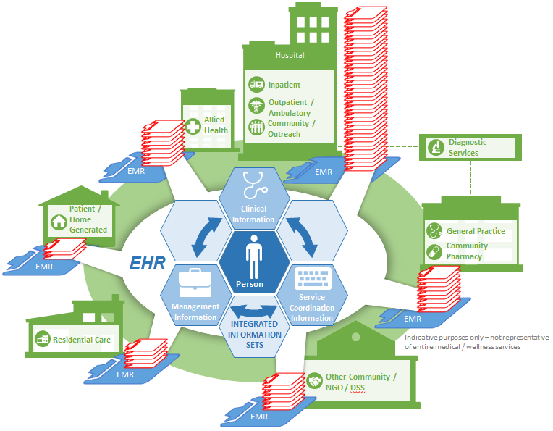

As the diagram also illustrates, EHRs include underlying connectivity to exchange information with a broad range of contributors into the EHR – either from linked EMRs or from within the EHR itself.

* The ability to capture a complete record of a patient’s encounter across the life of the patient. The EHR transcends the episodic focus on an EMR and seeks to link together a longitudinal record over the life of the person.
* The ability to capture and manage information such as patient demographics, progress notes, problems, medications, vital signs, past medical history, immunizations, laboratory data and radiology reports.
* The ability to automate and streamlines the service delivery workflow and inter-disciplinary collaboration for the delivery of care. This means that complex work order sets or treatment plans can be composed, managed and coordinated.
* Advanced functionality to interrogate and analyse datasets, in order to derive insights into population risk or medical practice.
* The ability to translate insights into action, by providing evidence-based decision support that interacts with healthcare professionals at the point-of-care, to support quality management, and better outcomes.

Electronic Medical Record (EMR):

An **Electronic Medical Record (EMR)** is a digital version of the paper charts in a health practitioner’s office. It contains the medical and treatment history of a patient for a particular healthcare setting or clinical speciality. Typically the EMR is focused on episodic healthcare events – i.e. it is designed to support interactions in a primary care setting, or a hospital setting for an allied health professional. EMRs can also be designed for specific clinical specialities – for example Orthopaedic versus Maternity Services – and provide comprehensive functionality to cover a complete episode of care with inter-disciplinary support, to coordinate care delivery.

The diagram below illustrates the functional components expected in an EMR, as defined by the Institute of Medicine:

Figure 2: Core Functionality for an EMR

Electronic communication can be between provider-provider, patient-provider, trading partners such as pharmacies, insurers, laboratory, radiology, and among team members for coordination. Electronic connectivity includes integrated medical record within a facility, within different facilities of the same healthcare system, and among different healthcare systems

**Connectivity**

A defined data set that includes medical and nursing diagnoses, a medication list, allergies, demographics, clinical narratives, and laboratory test results for access by care providers when needed

**Health Information and Data**

Administrative processes include electronic scheduling systems for hospital admissions, inpatient and outpatient procedures, and identifying eligible or potential eligible patients for clinical trials

**Administration**

A feature that manages lab test results and radiology procedures results, does results reporting and results notification, and handles multimedia support—images, waveforms, pictures, sounds

**Results Management**

Computerised clinical order management (COM) for such areas as electronic prescribing, laboratory, microbiology, pathology, ancillary, nursing, supplies. Even with little or no decision support they can still improve workflow processes by eliminating lost orders and ambiguities caused by illegible handwriting, generating related orders automatically

**Order Management**

A computerised decision support system that enhances clinical performance by providing drug alerts, other rule-based alerts, reminders, clinical guidelines and pathways. It also helps in improving drug dosing and drug selection. It can be used for chronic disease management, clinician work lists, diagnostic decision support, and automated real-time surveillance

**Decision Support**

This feature supports the reporting of patient safety and quality data, public health data, and disease registries. It makes the reporting process less labour-intensive and time-consuming

**Reporting and Population Health Mgmt**

Patient support includes patient education, family and informal caregiver education, data entered by patient, family, and/or information for patient caregivers such as home monitoring

**Patient Support**

EMRs include technology tools that can be used to provide:

* Basic connectivity and administration functionality to enable tracking of patients and exchanging of information
* A medical record that acts as a repository of patient and clinician information
* Tools to support the efficient capture and access of information
* In advanced stages, decision support capabilities to assist the delivery of care
* In advanced stages, portals and patient-engagement tools to encourage participation in their care

New Zealand Equivalents:

New Zealand has focused on some of the sub-components of a vertically integrated EMR, which are often presented by different vendors in our system landscape. The most notable of these include the following:

| NZ Terms | EMR Equivalent |
| --- | --- |
| **Patient Administration Systems (PAS)** provide the foundation for any kind of EMR. Without connectivity, an ability to integrate and an ability to track, schedule and manage patients, any higher EMR functions become very difficult. PAS solutions may be deployed for specific settings such as hospitals or primary care. |  |
| A **Practice Management System (PMS)** typically refers to the technology used by primary care and allied health professionals in their respective business. The more advanced solutions may encompass all of an EMR’s functionality, but only in the context of their setting. The more basic versions may offer little more than PAS functionality. |  |
| A **Clinical Data Repository (CDR)** provides the underlying data storage facility to actually capture and manage clinical and healthcare information. The depth and breadth of a CDR depends on the setting where it is deployed and how many different information sources are feeding into it. |  |
| A **Clinical Workstation (CWS)** refers to the front-end tool that clinicians and care providers use to actually access and capture healthcare information. These vary in sophistication, from simple note and data capture, through to more advanced order management functionality and decision support. |  |
| **Portals** provide Web access into any number of the above systems. They may be relatively simplistic and offer little more than information access, through to being highly interactive and supporting a range of functions such as appointment bookings or adding healthcare information into the CDR. It should be noted that portals are also increasingly becoming mobile enabled, reflecting the general trend of consumer preference for mobile devices. |  |

# New Zealand Context

New Zealand’s health sector challenges:

### Health expenditure and public expectations are growing at an unsustainable pace

Over the 10-year period from 2004 to 2013, New Zealand health expenditure has increased significantly. Total health expenditure rose from 8.0% to 9.7% of GDP[2], and per capita costs rose from $1,990 to $3,405.[3] The latter represents an over 70% increase.

Cost drivers include an ageing population and rising incidence of chronic disease[4] -- and these trends will continue to drive expenditure increases as:

* the percentage of New Zealanders aged 65 and over rises from 12% to 25% by 2050 and;
* chronic conditions rise four-fold among those aged 75 and over and six-fold for those aged 85 and over by 2025.[5]

In addition to these demographic cost drivers, the public has rising expectations on what health services will do to keep people alive, healthy, and well -- especially with technological advances in treatment options that are expensive.

For all of these reasons, the gap between the health services New Zealanders want and those they can afford is expected to widen in the coming decades.

### Our large and growing workforce lags in labour productivity

Increases in health service demand exist against a backdrop of declining health sector labour productivity and a growing health sector workforce.

At $39 real GDP created per hour paid, the health sector is well below the NZ average of $48. The Ministry of Business, Innovation and Employment’s *2014 Sectors Report* states that labour productivity from 2001 to 2011 experienced a 0.2% decline rate.[6]

Over the period 2002-2012, the health sector workforce increased from 154,441 to 210,141. By international standards, we have a large number of healthcare workers. NZ now has 250,300 people employed in healthcare and social assistance work.[7] Per 2010 data, NZ had 52 health and social workers per 1000 population, when comparable OECD countries range from 40-50 per 1000.[8]

### Our hospitals are resource intensive

Despite having a health strategy focused on primary care for the last decade, the lion’s-share of healthcare funding in New Zealand is still consumed by hospitals. [9]

Our hospitals are resource intensive compared with those in other OECD countries. For example, New Zealand has 1 doctor and 3.6 nurses per bed compared to an OECD average of 0.7 doctors and just 1.9 nurses per bed[10]. Our hospital costs are over $USD 1.2m per bed against an OECD average of just over $USD 0.7m (purchasing power parity adjusted)[11].

(Appendices C and H provide further details around our levels of performance in terms of quality and productivity).

The diagram below provides an overview of the ‘spend-wheel’ on our healthcare funding and illustrates where the bulk of our funding and resources are consumed:

Figure 3: Healthcare resource consumption profile:

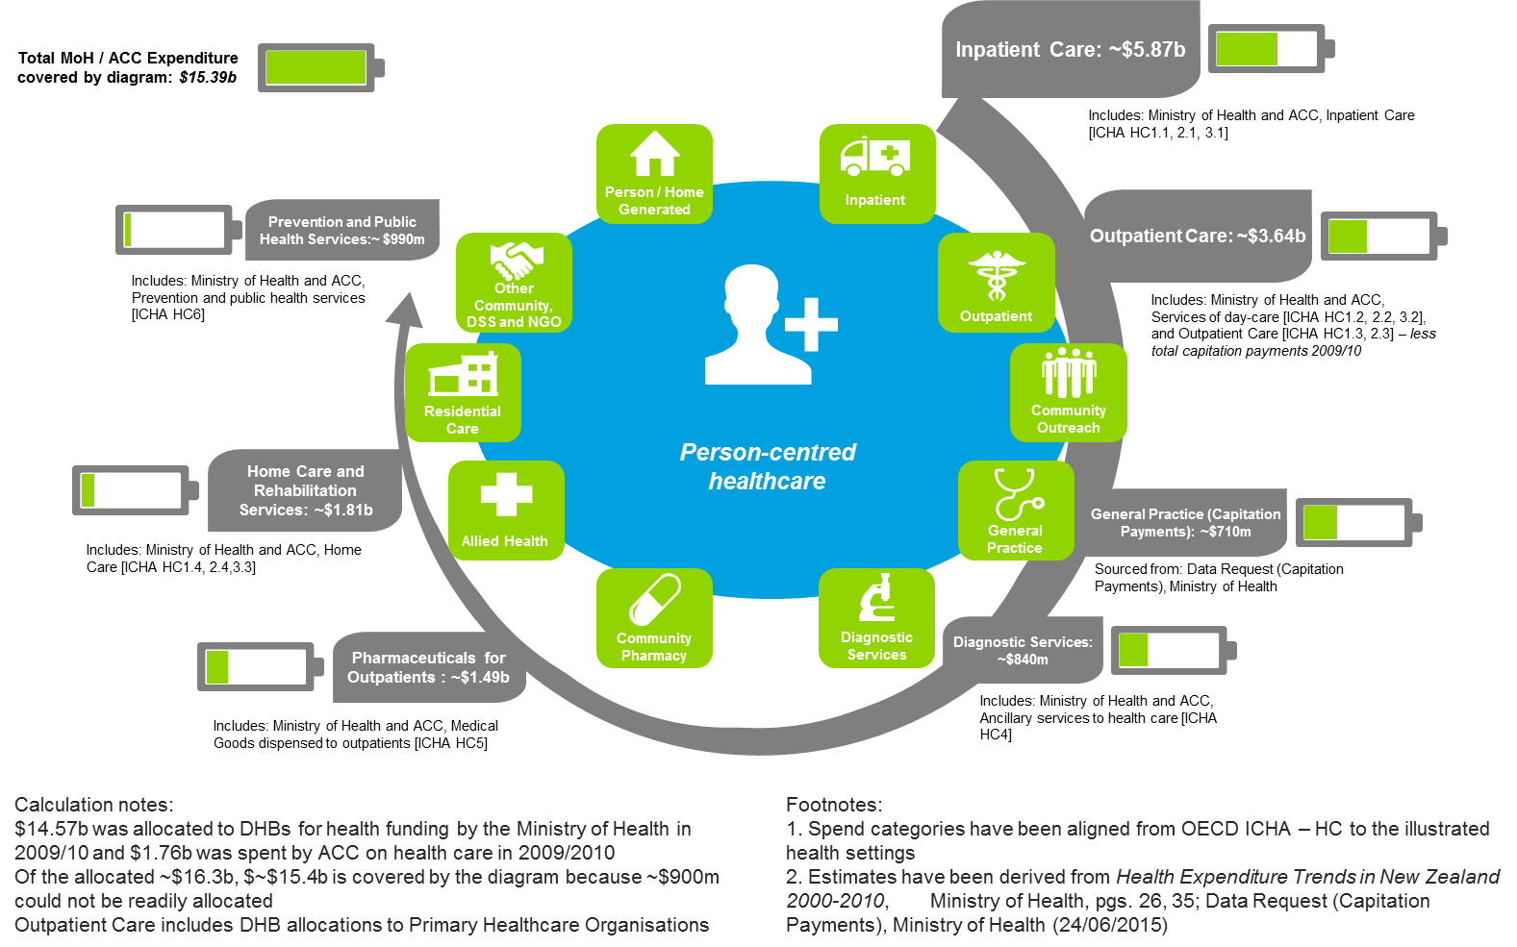

### Our primary care strategy has guided investments

Although the bulk of our funding is consumed through hospitals, New Zealand has been following a primary care based strategy, with an emphasis on keeping people well, delivering care close to their home and boosting services in the community and primary care setting.

In support of our primary care strategy much of the innovation and progress in healthcare IT has been in settings outside the traditional hospital walls. Generally speaking, hospital IT investments and innovation have lagged by comparison.

As Appendix H outlines, we have room for improvement around reducing avoidable hospital admissions through improved detection and prevention in primary care. We also have room for improvement around our hospital productivity and resource intensity.

Getting the balance right between IT investments in primary care versus hospitals is challenging: Given the discrepancy in resource intensity between different settings, any discretionary investments in IT should ideally focus on those areas that have the most material impact on the sector as a whole.

The focus on primary care over the last decade has potentially left hospital IT behind the curve. Further improvements around integrated care may be hampered, if hospital systems cannot keep up with the demands and expectations placed on them by primary care, patients and the community.

### Tactical concerns trump strategic issues

With the population-based funding approach, the twenty DHBs are largely autonomous, including control over their own spending decisions. There is a strong tendency to favour local service delivery and population needs over national needs or projects.

Because the DHB funding and planning cycles are done on an annual basis, there is also a strong desire for short-term Return on Investment (ROI) that favours ’low-hanging fruit’. Large scale reengineering or IT transformation that requires a multi-year horizon is more difficult to achieve. Many DHBs view IT as a cost-item, as opposed to a strategic asset.

Many DHBs are also concerned with their hospital operations and asset base, at the expense of taking a strategic approach to primary care and or population health management. This is a function of the capital intensive nature of their hospitals and the fact that their ability to manage deficits is largely driven by their ability to manage hospital costs.

### Innovation is difficult to scale out nationally

The federated model for our health system governance supports a culture of local independence that makes regional collaboration and national standardisation challenging.

***“We (New Zealand) are really good at creating innovation… but really bad at spreading it around”***

Senior Management at a large DHB, June 2015

Innovations from one DHB are often rejected by other DHBs in New Zealand, because they are ‘not invented here’.

Because of the diversity of practice across DHBs and the differences in their underlying system landscapes, the innovations created in one DHB on a particular vendor platform, cannot be easily replicated in other DHBs – even when they use the same technology. New Zealand health IT vendors find it difficult to deliver enhancements and support across the sector, because the implementations of their platforms are just so variable.

### Investment in healthcare IT could potentially lift sector performance

Since information technology is a key enabler for productivity, efficiency and quality in any sector, it would appear that healthcare IT could make a strong contribution towards lifting the overall performance of the sector.

Based on current evidence, the healthcare sector has an apparent productivity and efficiency gaps against other OECD countries - and against leading healthcare systems. Other jurisdictions have made investments in healthcare IT, as well as in the ‘industrialisation’ of healthcare deliver, which have driven significant quality, performance and productivity improvements. Therefore there is a sound case to be made, that the ‘right’ EHR strategy for New Zealand could add material value to our healthcare delivery system.

Health sector IT strengths:

### We have well established national information sets and registries

Through early investments in both national data collections for statistical purposes and registries for tracking patient and provider identifiers, New Zealand addressed one of the fundamental challenges that other national healthcare systems struggled with for a long time – namely to establish the base-layer for an EHR, where data could be safely communicated, exchanged and linked between different healthcare providers and their systems.

This work has benefited New Zealand in three ways:

1. We have a mechanism for uniquely identifying patients and providers across the entire continuum of care – nationally and across all settings.
2. National collections and corresponding screening systems provide us with valuable information for retrospective analysis.
3. Our progress has led to the Health Information Privacy Code and a mature, practical approach to dealing with many of the challenges that arise from the digitisation of health data.

### We have strong system integration capability

Our ‘best of breed’ approach with a ‘managed ecosystem’ allows providers to adopt the systems that best suit their unique requirements. The National Health IT Board has heavily promoted the use of information and technology standards to allow systems and information to be linked regionally and nationally into ‘Virtual’ EHRs. The Health IT Board has also fostered pilots and regional solutions that successfully demonstrate inter-operability across diverse systems.

Arguably the undesirable level of complexity and fragmentation of our IT environment has led one of our major IT strengths – strong capability for integrating disparate platforms.

With the National Health Index (NHI) and Health Provider Index (HPI), New Zealand has some of the best nation-wide registries for identifiers available in the world. Combined with our Health Information Privacy Code and the many years of experience in linking local systems to national collections, we have become proficient at getting systems to talk to each other on a point-2-point basis and with our national systems and regional solutions.

This connectivity supports a healthy volume of electronic transactions, such as eReferrals, eDischarges or GP2GP record transfers. There are, for example, 40,000 eReferrals from primary to secondary care and 20,000 GP2GP transfers each month.[12]

### Our computerisation in primary care is world leading

The pervasiveness of technology in General Practice is high, with nearly 100% computerized in some form. Although most OECD countries are catching up, our level of device penetration into primary care remains the envy of many other countries.

The average General Practice exchanges information electronically with more than 50 other healthcare provider organisations every month.[13] This means that the fundamental investments in telecommunication networks, secure communication and common identifiers have paid off. We can readily exchange information from one practice to another – at least regionally.

### Regional repositories have efficient hub and spoke configurations

The Health IT Board has encouraged the development of regional IS plans with corresponding harmonisation of systems and collaboration around clinical information. With four major regions, New Zealand now has a number of Regional Information platforms in place that replicate key data into regional repositories or provider broker services (e.g. Regional CDRs for Labs / PACs and Regional ePrescribing & Administration (ePA).

These repositories are starting to form regional hubs in a ‘hub & spoke’ configuration. This configuration is more efficient than point-2-point information flow: An updated laboratory result can be uploaded by the diagnostic services provider for all to see, as opposed to having to be sent to many different individual systems, when multiple care providers are involved.

Health sector IT challenges:

### IT governance is federated rather than national

New Zealand does not have the ‘command and control’ levers in place that have underpinned the success of private sector organisations in designing and implementing a ‘Single’ EHR solution. We have also not had mechanisms such as centralised funding / budget holding or co-investment available, to encourage participation by individual healthcare organisations in a broader plan. Such mechanisms have been commonly deployed in other public healthcare systems – whether they are state-wide or national.

The autonomy of DHBs has resulted in siloed regional IT platforms that have had mixed success because of the following:

* diversity of approaches taken
* disparate underlying technology readiness
* cultural challenges outlined earlier
* high degree of variability in underlying maturity with regard to clinical leadership, governance and existing IT asset base

***“We need a bit more of Thou Shalt Do”***

Senior Management at a large DHB, June 2015

The National Health IT Board provides guidance to DHBs, but it has limited ability to direct or to enforce direction with sanctions or rewards. This creates numerous delays for platform rationalisation or regional integration activities. Each DHB has a voice, and all participants need to come to agreement before an initiative can proceed. Given the sometimes quite different starting positions for different DHBs, this can be very challenging.

Driving any one of the regional IT initiatives or national initiatives forward is enormously time consuming and requires significant change management effort as well as strong leadership.

### The complex system environment is cumbersome and expensive

In the absence of national IT control, the National Health IT Board has moved New Zealand from an unconstrained ‘best of breed’ approach[14] towards a ‘managed eco-system’ with fewer vendors and systems - with all the integration challenges and costs that this entails. The Health IT Board’s focus on information and technology standards to support integration, as well as the on-going rationalisation of platforms, has alleviated the overall integration burden on the healthcare sector, and has reduced variability at regional level.

Through its influence and emphasis on regional planning and collaboration for IT, the Health IT Board has managed to reduce complexity. Between 2011 and 2015, the overall number of systems in each of the key work stream areas dropped by approximately 6%.[15] Nonetheless, the current ecosystem of healthcare IT vendors in New Zealand remains large and complex; with a resultant diversity of systems and practices that prevents economies of scale.

### Underinvestment in IT limits its ability to add value

The twenty DHBs have control over spending decisions, including funding for IT investments.[16] Their investment decisions affect the healthcare organisations within their geographic area.

Currently, DHB IT investment decisions have focused on infrastructure and maintaining legacy systems[17] rather than innovation. The National Health IT Board estimates that 40-70% of DHB IT investment is consumed by maintenance and infrastructure spending, which adds very little value to healthcare service delivery. The NZ target for IT investment in healthcare is set at 4% of Opex, but DHBs barely achieve 2% of Opex across the country.[18]

Against this back-drop, in particular the hospital IT asset base tends to be run-down, poorly maintained and fragile. Too often hospital clinicians have to put up with system outages in key areas, such as ED, or are unable to grade appointment referrals, because departmental systems or other systems are down.

As architectural debt around IT is accumulated, the problems with the underlying infrastructure tend to be pushed forward. Programmes such as the National Infrastructure Programme (NIP) have recognised this risk: NIP will help reduce the risk of basic hardware failures (e.g. due to equipment being over 10 years old), power failure (e.g. equipment being housed in data centres with insufficient air conditioning, redundancy and power supply) and lack of back-ups.

Reliable IT infrastructure is table-stakes when it comes to digitizing healthcare records. If clinicians cannot rely on their systems furnishing crucial information, they need to revert back to paper and other alternatives. This negates any clinical productivity gains, or quality improvements that might be possible with IT.

### Innovation limited by the sector’s ability to share and scale

***"A decade ago, Denmark & NZ led the world – now NZ is behind due to the piecemeal approach”***

Business leader in the NZ Health IT industry, June 2015

There are ‘pockets of brilliance’ dotted across New Zealand’s health system and IT landscape that demonstrate that IT can fundamentally transform health care delivery, quality, and productivity. However, these endeavours inevitably struggle to scale from a local solution to a regional and national level.

When one DHB develops a technology enhancement for an application, it cannot be readily picked up by other DHBs using the same application – even if they are willing - because of the underlying variability in each system implementation. New Zealand health IT vendors frequently see a lack of standardisation in the implementation of their platforms, making their solutions difficult to manage, expensive to support and hard to enhance through upgrades.

### Our Information Management is immature

Whilst New Zealand has focused on data management, data definitions and a Health Information Privacy Policy that guides how data is exchanged, the system-wide approach to information management is immature. Despite having unique identifiers such as the NHI and the HPI, it is very difficult to take data from multiple systems and aggregate it consistently to form a joined-up view. This can create issues in regional repositories, when for example the merger of NHI numbers or changes to a patient’s details can have unintended consequences and scramble records.

***“I have only a fraction of the management information available, that I would routinely have at my fingertips in the NHS – particularly with regard to population health and risk”***

DHB CEO, June 2015

Measuring sector KPIs like the health targets, or developing a national patient flow perspective, has been extremely challenging. This is due to the underlying variability of how data is captured across different systems through different processes, workflow and with a different context.

Although the technical means exist to link disparate data sets, the context of how data is defined, captured, manipulated, scrubbed, cleansed and aggregated is not well-managed. Without this context, it is difficult to turn data into meaningful information and insights. As a result, the health sector lacks management reporting capabilities and analytical capabilities – often put down to ‘poor data quality’.

DHBs and different sector participants do not trust (or understand) each other’s data, and more time is taken discussing the validity of statistics than thinking about their interpretation and what to do about them. The OAG has noted that it is a struggle to trace funding, outcomes, resources and effectiveness across our healthcare system - in particular in community and primary care, as noted in their qualified audit comments for DHBs.

Summing up:

Appendices C and H provide a range of comparative metrics on New Zealand’s healthcare sector cost and quality. These demonstrate that we have room for improvement with regard to productivity and quality, when compared with OECD averages and leading systems.

The metrics also demonstrate that other countries and healthcare systems that have successfully invested in healthcare IT, have reaped significant benefits from a ‘Single’ EHR. Appendix F provides a range of case studies with tangible improvements in productivity and quality. These demonstrate that judicious use of healthcare IT and more advanced EHR capabilities, can deliver significant benefits across a healthcare system. The International examples are reviewed in more detail in the next section of the report.

Based on New Zealand’s starting position, there is a case to be made that we could make significant improvements in productivity and quality across the sector – and that these could be enabled by advances in our EHR capability.

Under the guidance of the National Health IT Board, clinical information has started to become stratified into national regional and local solutions – and we have mechanisms in place to link these different repositories to create a ‘Virtual’ EHR.

However our overall system landscape is still quite complex, diverse and difficult to manage. We lack ‘universality’ in terms of common systems and processes that are nation-wide. We also struggle to scale innovations nationally and often IT is viewed as a cost burden, rather than being viewed as a strategic investment.

Nonetheless, the regional initiatives are starting to physically consolidate clinical information into regional repositories, whilst some of the national initiatives are physically consolidating information at national level. This offers a potential basis for further consolidation.

Therefore the New Zealand health IT landscape offers a sound basis to build on. We are comfortable embracing the digitization of health information, we have the ability to integrate it between different systems, and we have the ability move it about.

Most of the frustrations expressed by the sector with regard to the current IT landscape relate to the governance and the operating model of the sector. If we want to make better use of information as a strategic asset and get better value out of our IT systems, then New Zealand needs to do better job of designing solutions end-2-end: Namely aligning our operating models, standardising processes and harmonising systems with strong clinical leadership.

# International Experience

General themes in healthcare IT:

### Rising healthcare costs are shaping IT investments

Other countries also face similar challenges to New Zealand, in that healthcare costs keep rising. In developed countries, where acute care and institutional long-term care services are widely available, the use of healthcare services by adults rises with age, and per capita expenditures on health care is relatively high among older age groups.[19]

The rise is not just driven by the ageing populations, but also medical inflation, longer life expectancies, chronic long-term conditions and diseases, as well as increased consumer demand.

Facing these challenges, the general increase in the use of IT is also observed across OECD countries, as well as non OECD countries. Emerging market nations often seek to ‘leapfrog’ western countries, as they stamp entire new hospital systems, aged-care or other healthcare systems out of the ground. These new facilities tend to focus on full digitization and virtually paperless environments.

### Industrialisation of medicine is driving IT

Frequently decried as ‘cook-book’ medicine, the industrialisation of clinical care and service delivery is progressing rapidly in most developed nations. It is a function of having to decrease the variability of services, quality and outcomes, as well as needing to deliver more for less. This can take the form of strong quality management with financial sanctions – such as Joint Commission on Accreditation of Healthcare Organizations (JCAHO) accreditation increasing or reducing fee levels in the US. It can also be driven through strong clinical governance and a desire to deliver the best possible service with appropriate clinical protocols, such as at the Kaiser or Mayo clinics.

In the United States, there has been a strong shift from volume to Value-Based-Care (VBC). As delivery systems mature there typically are widespread efforts to control/reduce costs, improve outcomes, and obtain more value for money spent through different contracting arrangements.

Where Accountable Care Organisations (ACOs) have been established, there is a heavy focus on standardising clinical care and guidelines, to ensure that patients are well managed and supported with evidence based protocols. This is done across the entire healthcare continuum – from primary care through to specialist services, hospital care and long-term residential care facilities.

In integrated delivery systems, the delivery of care is not just reviewed retrospectively, but concurrently – i.e. during the process of service delivery, outliers, exceptions and reasons for variation are noted and captured. As a result, the IT systems that support the delivery of care at the coal face have become increasingly sophisticated.

The success of VBCs or ACOs to delivering integrated care depends heavily on clinical ownership and control. There has to be buy-in to the harmonisation of processes, the way that care is coordinated and the way in which the overall system is rewarded and managed. Clinical leadership and a clear system perspective are key to ensuring that healthcare professionals can play their integral role in health care delivery.[20]

To boost clinician and patient participation in such systems, designers build systems that support clinical and business resources, and bring the advanced automation and decision-support capabilities necessary for day-to-day service delivery. The resultant solutions use technology for communications and information exchange, provide robust functionality and allow both clinicians (physicians) and non-clinical staff to coordinate patient care.[21]

### Consumerisation of healthcare information

There is a general acknowledgement that EHRs need to be consumer centric with the person at the centre. Policy developers, Health Management Organisations (HMOs), Insurers and Payers, all recognised that personal involvement in healthcare delivery, participation in wellness programmes and engaged consumers are key to success.

The proliferation of Internet enabled medical devices, home health appliances, and biometric data being captured by wearable devices, means that healthcare IT systems are also being challenged with an influx of data – from many different and disparate data sources.

New technologies enabling healthcare agencies to leverage “big data” in healthcare are requiring healthcare agencies globally to reposition how they maximise the use of information. The entry of EHRs, smartphone technology, wearables and sophisticated analytics tools into patient behaviour is driving the exponential growth of healthcare data[22].

As a result, the future “core” of health information records needs to accommodate the rise in core clinical information, the rise in patient-generated information, and the importance of cross-data sets (e.g. welfare and education outcome information).

It has been estimated that there are already 15 Exabytes of health data in the world – three times the number of words that have ever been spoken.[23] Therefore EHRs are seeing a shift in the centre of gravity from provider generated data to consumer generated and captured data over time.

Hand-in-hand with the rise in consumerism, there is an increasing tendency to access information from a broad set of mobile devices. In 2014, New Zealand already went past this inflection point, where we are now adding more mobile devices connected to the Internet than stationary devices. So both portals as well as specific transactions around the EHR need to be developed with mobile access in mind, rather than just the traditional computer-based access.

Benefits of an EHR:

### Gains in productivity and efficiency

EHR systems have resulted in workforce productivity and efficiency gains for many healthcare systems overseas. They typically drive productivity gains within hospitals, but also across highly distributed settings such as pharmacy and medication management.

Benefits are primarily driven through workflow automation, better clinical decision support (diagnostic testing/screening) and improved information sharing capability. Examples include:

* In British Columbia, eHealth initiatives as part of the national Infoway programme has shown that their Picture Archiving Communication System for capturing and transmitting exam images electronically improved the efficiency of clinical decision-making by 30 to 90 minutes per week, resulting in the equivalent of 84 new full time physicians or an additional 1.2million physician consults per year.[24]
* Nearly half of physicians in a Gartner survey attribute the PACS with fewer patient transfers as it allowed more patients to be treated in rural and remote facilities without needing to be transferred to larger centres, while maintaining the same quality of care.[25]
* Recent British Columbia stakeholder interviews report as high as 10-20% reduction in exam duplication, far greater than the 2-3% national estimate.[26]
* Likewise, British Colombia implemented a centralised database for dispensing pharmaceuticals which has resulted in productivity gains for pharmacists and pharmacist technicians of 9.1% and 7.8% respectively, allowing pharmacists to spend more time with patients.[27]
* At Kaiser Permanente, HealthConnect supported increases in the efficiency and productivity of preventative screening practices. Kaiser Permanente reported a 30% increase in colon cancer screenings, an 11% increase in breast screening and a 13% improvement in cholesterol management through enhanced EHR capability.[28]
* Denmark’s National Strategy for Digitalisation in the Health Sector 2009-2012 has enhanced how hospitals leverage information to drive productivity and efficiency gains:[29]
* 92% of hospital capture and evaluate system usage statistics to influence behaviour and system enhancements, with 71% capturing medication safety statistics;
* 96% of hospitals are entering approximately 90% of their orders electronically through CPOE processes;
* 100% of hospitals indicate that their imaging departments are fully automated.

### Better clinical outcomes

Successful EHR implementations deliver better clinical outcomes. In particular mature implementations that encourage evidence-based care through decisions support, achieve more consistency and higher quality care. Hospitals with advanced EMRs report achieving a broad range of benefits from their EMR implementations. These include clinical quality, patient safety and operational efficiencies.[30]

* A December 2013 Health Service Research report found that most physicians with EHRs reported EHR use enhanced patient care overall (78 percent), helped them access a patient's chart remotely (81 percent), and alerted them to a potential medication error (65 percent) and critical lab values (62 percent). Between 30 and 50 percent of physicians reported that EHR use was associated with clinical benefits related to providing recommended care, ordering appropriate tests, and facilitating patient communication.[31]
* At Kaiser Permanente, *HealthConnect* supported the organisation to achieve better clinical outcomes. Researchers found that annual emergency room visits declined 5.5 %, annual hospitalisation declined 5.2 %.[32]
* In British Columbia, with the *Infoway* programme, PharmaNet metrics reveal that pharmacists were alerted to more than 40 million drug interactions that could lead to an Adverse Drug Event – 500,000 of these drug interactions were Level 1 Severity (clearly contraindicated in all cases).[33]
* Denmark’s *National Strategy for Digitalisation in the Health Sector 2009-2012* has delivered reductions in average stays for patients in hospital care. Health IT investments have focused on improving the capability of healthcare information sharing and clinical competence so patients can receive high-quality care in the home. At Odense University Hospital, their investments have resulted in bringing down the time patients with chronic diseases spend in hospital to an average of 2.9 days per patient (compared to the European average of approximately seven days). Readmission rates for chronic disease patients are also down by more than 50 per cent.[34]

***HealthConnect enabled Kaiser Permanente to rapidly respond to a serious medication alert affecting cardiovascular patients. Based on internal data Kaiser Permanente determined that the drug Vioxx had an increased risk of cardiovascular events before that information was published based on its own internal data. Similarly, within 90 minutes of learning of the withdrawal of Vioxx from the market, the Cleveland Clinic queried its EHR to see which patients were on the drug. Within seven hours they deactivated prescriptions and notified clinicians via e-mail. [35]***

* A Carnegie Mellon University Living Analytics Research Centre study found that enhanced EHR adoption has been accounted for a 27 per cent reduction in aggregated patient safety events, a 30 per cent decline in negative medication events, and a 25 per cent decrease in complications regarding tests, treatments or procedures.[36]

Lessons learned from system-wide EHRs:

### Start with a hospital EMR

Whether it is emerging nations such as India, China or, United Arab Emirates or Brunei, or long-standing OECD countries, the use of a single EMR in hospital systems is a well-established first step. Starting here makes economic sense, since hospital efficiency and effectiveness is a large contributor to the overall health economic outcomes for any large scale system.

Simply put, hospitals are too large a ‘squeaky wheel’ to ignore when there is overall pressure on health system productivity and throughput. Even with a primary care led strategy, healthcare systems cannot afford major productivity drains on their overall healthcare system, if hospitals are not well-run, industrialised and efficient. In the New Zealand context for example, hospital based services (inpatient & outpatients) comprise ~68% of our total public healthcare expenditure.

Hospitals with 100s of departmental EMRs (‘speciality clinical information systems’) struggle to provide a common front-door to primary and community care. They also struggle to reliably leverage any nationally available information such as medication alerts into all of these systems. This also makes it difficult for them to deliver a consistent patient experience and engage people in their personal care and follow-up activities after an acute event.

By focusing on hospitals first, other countries have taken advantage of the vendor investments in readymade solutions that have become increasingly sophisticated. They have also accelerated the level of industrialisation and harmonisation inside the hospital walls, so that the interfaces into primary care and other settings become easier.

* By 2004, both of Singapore’s two public healthcare clusters – Singapore Health Services (SingHealth) and National Health Group (NHG) – had EMR systems within the hospital setting. Singhealth had a single instance EMR system that covered the entire cluster. This meant that a clinician in any Singhealth institution has access to EMRs generated from any other Singhealth institution. Although NHG institutions had different EMR systems, they were linked through a Cluster Patient Record Sharing system. [37]
* Eastern Heath (Australia) has chosen to develop a ‘clinical core’ driven primarily from the secondary care setting.[38] A clinical governance group decides what is included in the core with consultation from relevant IT stakeholders, including vendors, to best arrive at an achievable technology solution. This core then interfaces to various primary (and ancillary/specialised) care services the person may receive care outside the core, similar to the ‘spine’ approach taken in other jurisdictions in Australia, including Queensland Health and in the UK.
* In 2006, Denmark had finished deployment of an EMR at the ten hospitals (2,525 in-patient beds) in one of Denmark’s five healthcare regions.[39]

Because of the need to support a high degree of automation and tightly integrated workflow across different treatment modalities and care professionals, hospital settings are well suited to ‘monolithic’ or integrated systems. These systems can support inpatient, outpatient or community care delivered out of a hospital setting. They provide a single physical repository for the clinical information, so that work orders, automation and task flow can readily work in real-time.

Since all the data is assembled in one place, this also allows them to develop advanced decision support and analytical capabilities to manage risk. Even complex rules that require data traditionally stored in disparate systems belonging to different specialties or clinical support services, can be fired off and served up when all the information is in one place.

Similarly, portals can serve up an integrated view of the patient in real-time to patients and external providers alike. This is particularly important for advanced Web-functionality and digital services to mobile devices. A ‘Virtual’ EMR that has to pull together data from multiple systems behind the scenes would struggle to keep up with performance and demand.

### General trend towards single/fewer vendors

Building on the push towards a single, hospital-wide EMR, many healthcare systems have built on this paradigm and moved towards a model where there is a single vendor or very few vendors for each delivery setting. Global research finds that an increasing number of healthcare systems are moving towards EHR models that operate with a single-vendor (one physical EMR) per setting – especially in the hospital. In some instances this vendor has then been used to create the full EHR with a lifetime view of the enrolled population and across both primary care and secondary care settings. For example:

* *Kaiser Permanente (USA)* based their Electronic Health Record (EHR) system *KP HealthConnect* on a single-vendor model to address challenges associated with multiple information siloes and standards[40]. Kaiser chose to implement one vendor across all of their major healthcare settings, including inpatient, outpatient, community, diagnostic support services, pharmacy and primary care. They demonstrate one of the most advanced forms of system rationalisation and process harmonisation – across multiple care settings and over 10 million members spread over 9 states with distinct healthcare reimbursement, reporting and legislative requirements.
* Similarly *Novant Health (USA)* selected a single-vendor EHR model to best meet their needs of improving the patient experience and improving operating efficiency despite being a geographically diverse organisation. [41] Novant has 343 clinics and 1,441 providers live on its electronic practice management system and 316 clinics and 1,205 providers using its electronic health record. The rollout in all 14 acute care facilities is slated for completion in 2017.[42]

In other instances a two-vendor strategy or limited vendor strategy is pursued by large scale systems. These national or state-wide healthcare systems have moved towards a rationalised ‘best in suite’ model where only 1-2 vendors are selected per setting. This retains some competitive tension and redundancy in the health IT landscape, but limits the number of interfaces and integration points that have to be developed across care settings.

The overall architecture then typically includes a single, physical national / state-wide repository that acts as the system-wide EHR to support advanced care coordination and decision support. Examples of this approach include

* *National Electronic Health Record (Singapore)* has a nationwide ‘Single’ EHR is supported via a “hub and spoke” model with interfaces from multiple EMRs.[43] The central ‘hub’ acts as a national repository for patient information. Secondary hospitals are supported by a small number of vendors and feed into the national EHR “hub”. At the same time community hospitals and GP practices have developed their capability of feeding into the national EHR and some settings have adopted a single system.[44] (e.g. aged care)
* *Health Infoway (Canada)* is implementing a federal-led, provincially-delivered programme for electronic health records.[45] Its goal is to develop a network of effective interoperable EMR solutions across Canada, linking clinics, hospitals, pharmacies and other points of care. While there are provincial differences, a plurality of provinces operate with a single vendor, especially in secondary care and provide data to the EHR. Some national level data is collected (National Dose Registry) for EHR as well.[46]

### High maturity EMRs / EHRs use a single/few vendor approach

The Health Information Management Systems Society (HIMSS) has developed a well-established maturity framework to grade the different maturity levels of EMR implementations. Different versions of the framework exist, covering both ambulatory (outpatient) as well as more hospital-centric implementations. While developed in the US and centred on hospitals, it has evolved to include various geographies e.g. UK/Europe, Asia-Pacific. The system grades implementations on a scale of 0 to 7.

Since 2005, HIMSS Analytics EMR Adoption Model (EMRAM) has tracked the adoption of EMR applications within hospitals and health systems across North America. Only 203 hospital health systems have achieved a rating of 7 out of 7 for their respective healthcare system.[47] In the US, only 38 ambulatory health systems have achieved a rating of 7 out of 7 for their respective healthcare system.[48] The overwhelming majority of these health systems achieving this rating use a single/few vendor approach. [49]

Single vendor models give organisations a clear and unambiguous mandate to execute change and align clinical pathways to new ways of working that advance the cause of healthcare:

* In 2015, Kaiser Permanente received a Stage 7 Ambulatory Award for 350 of their ambulatory clinics. This was attributed to Kaiser Permanente’s *HealthConnect* electronic record, and reflects the use of a single vendor model for EHR systems.[50]
* Seoul National University Bundang Hospital was the first Stage 7 Hospital out of North America and opted for a single vendor to deliver on their goal of being the first fully-digital general hospital.[51]
* In 2014, Ontario Shores Centre for Mental Health Sciences became the first hospital in Canada to reach HIMSS Stage 7 with a fully integrated, single-vendor EMR solution.[52]

Evidence suggests that developing a high maturity EHR with advanced capabilities can only be observed in healthcare systems with single or few vendors. Unless the overall health IT systems landscape has been deliberately reduced to fewer moving parts and a manageable number of interfaces, it is very difficult to develop and deliver advanced workflow and decision support functionality across diverse healthcare settings and users.

### Funding models are used for leverage

A key factor driving system rationalisation and harmonisation is the underlying funding and / or commercial imperative. In the case of Kaiser, market forces and a desire to be deliver the best possible care under a strong consumer brand, have allowed them to make investments and drive process and system harmonisation further, than any other healthcare system.

In state-wide or national systems, this would be impossible to achieve: They face vastly different operating models and governance challenges. Therefore public healthcare systems (state-wide or national) typically rely on co-funding, central funding or other mechanisms to encourage the different players in their system to come on board. (e.g. Canadian Infoway funded provinces to the tune of ~80% of their business case, several Australian states co-funded EMR implementation in their hospital systems for preferred vendors, Scotland provided up to ~50% co-funding).

### EHR systems must reflect the operating model

Like any IT solution, the approach taken to an EMR or EHR implementation has to reflect the business operating model that it supports – i.e. a centralised IT system would struggle to work in a federated and diverse business environment. If there is misalignment between the IT architecture and the business architecture, then ‘tissue rejection’ will lead to expensive and costly IT project failures.

Failure to change the underlying operating model leads to unsuccessful implementations. New Zealand has already seen its share of public sector IT projects face this same challenge. IT must always be seen as an enabler of change, as opposed to the sole driver for change.

Therefore the choices that any large scale healthcare system makes around its approach to the EHRs must reflect the operating model and organisational structures of the underlying healthcare system. Where IT is not reflective of the operating model, the implementations suffer at best from delays and cost overruns, at worst suffer complete failure.

* NZ has seen a number of large public sector and healthcare IT projects not meet expectations, where failure to reengineer processes, failure to align organisational leadership and disagreements around the design, have been contributing factors.
* International experience shows, that large scale systems that embark on the EHR journey, spend significant time up front on design thinking. This means developing strong leadership, alignment around a common purpose and vision, process harmonisation and clinical standardisation, before embarking on technology implementation.
* As noted by The King’s Fund Report,[53] the experience at Canterbury DHB shows that it can take a long time to achieve the necessary consensus and buy-in to a common vision for what ‘integrated care’ looks like. However once this is in place, any given healthcare system is in vastly stronger position to implement technology successfully.

### Strong clinical leadership is key

Precisely because any EHR needs to be used by clinicians and non-clinicians across a large range of care settings, it is important that there is strong buy-in to the system design and its functionality. Many of the benefits of an advanced EMR or EHR are generated out of the process redesign, clinical workflow improvements, clinical guidelines and quality controls – as opposed to automation per se. This means the clinical leadership is key to successfully designing a solution that works, that is acceptable and that delivers the desired benefits.

Particularly when large healthcare systems seek to implement an EHR (or EMR for just one setting), it becomes critical to have strong clinical leadership - regardless of which technology approach is adopted. Agreements must be reached on clinical processes so that information capture, interpretation and re-use can be standardised and harmonised (e.g. there is no reason why the first specialist consult by a paediatrician checking on a 4-year old should vary by institution or location).

Conversely clinical workflow within and across different disciplines must be harmonised. The respective roles and responsibilities for care, service delivery and care coordination protocols must be standardised, so that they can be supported with a high degree of automation through the underlying systems.

If the healthcare system cannot agree on common business rules, or common triggers for alerts and decision-support reminders, then there is little value that can be gained from the underlying EMR or EHR functionality. Therefore mature systems have all taken care, to really focus not just on the initial clinical leadership and governance required for the initial implementation, but also the on-going governance of continuous improvements:

***“We have absolute government support with an “it will be done” attitude. They brought in the right people, created a risk-tolerant environment and presented no big obstacles”***

Singaporean Director of Solutions and Architecture

* In *Singapore*, a strong government vision and effective clinical leadership has been attributed to the success of the “One Singaporean, One Health Record” connected healthcare vision. To support the central government vision as part of the National Electronic Health Record, three types of governance were put in place to both align clinicians but ensure effective decision-making capability. One of the governance structures was focused on Clinical Solutions (e.g. User Functionality, Clinical Risk. The Singaporean Government also encourages the connected health agency to be experimental and innovative in its decision-making to ensure new ways of working and new benefits can be realised.
* *Kaiser Permanente’s* vision of high-quality care enabled clinical leaders to unite practitioners, staff and users around a common purpose. The *Blue Sky Vision* gave leaders the ability to clearly articulate what healthcare would look like in the future, and then drive practitioners and staff to define how to streamline clinical processes to achieve the eHealth vision. In implementation, doctors, nurses and clinical experts worked with business leaders and experts for months to figure out what systems were needed to support the new goals for assisting patients with healthcare.[54]
* In British Columbia, eHealth initiatives have been supported by strong leadership structures with clinical experts as co-design partners. Clear and well-defined governance roles have delivered strong lines of accountability, transparency and management of risks. Decisions makers have the ability to make binding decisions and to be able to clearly define what success looks like for any eHealth initiative. Involving clinical experts in senior governance roles and as implementation leads has ensured eHealth initiatives reflect clinical practices and get clinicians to align and agree behind new ways of working.

### Privacy concerns can be addressed with governance and controls

With the advent of digitisation, information becomes more shareable, transferrable and therefore also potentially more vulnerable. Often healthcare providers raise concerns around privacy, when exploring how records might be exchanged and information shared between different parties.

In both UK and US Surveys of Health Care Consumers, results showed that one-third of persons surveyed remained concerned about privacy and security of personal information stored online.[55] As a result of consumer concerns, jurisdictions have opted to address privacy concerns when developing an EHR, regardless of which IT option is chosen. Care must be taken to differentiate from genuine concerns from vested interests.

* *Singapore’s* NEHR incorporates role based access, data, sensitivity classicisation and an override tool for clinicians to access restricted patient information in case of an emergency.
* *Canada’s Infoway* works in collaboration with privacy commissioners, health ministries and other stakeholder to ensure that privacy and security of information is upheld.

### Healthcare systems do not always get it right

Not all attempts at national health IT systems are successful. Lack of leadership, failure to capture the hearts and minds of clinicians and poor alignment around the end-2-end system design are the most common causes for having to shut down initiatives.

The UK experience with NPFIT is one of the most publicized examples. It experienced significant technical issues around the introduction of a ‘national spine’ that sought to link the many regional systems through a single backbone to create a ‘Virtual’ record at national level. Different regions pursued different plans with variable degrees of success – and ultimately clinicians started to lose faith in the system. However it should be noted that the UK has one of the lowest GP per capita ratios in Europe and is running at lower staffing and resource levels than most other European countries. The systems that have been put in place provide an unprecedented ability to seamlessly schedule appointments and to allow patients to move conveniently across the continuum of care – with a high degree of visibility.

Summing up:

It is worth noting that all of the mature healthcare systems have taken care to address their hospital EMRs as part of the journey towards a ‘Single’ EHR. This has typically been done out of economic necessity (to ensure high productivity in a resource intensive setting) as well as to enable better and more seamless integration with primary care and community care.

International experience also demonstrates significant benefits from a ‘Single’ EHR – both in terms of productivity, as well as in terms of quality. There is a general trend towards single / fewer vendors across advanced healthcare systems – whether they are private or public. The healthcare systems that have made the biggest advances, have moved from ‘Best-of-Breed’ strategies or ‘Virtual’ EHRs towards ‘Single’ EHR strategies.

In public healthcare systems at state or national level, EHR strategies have achieved system rationalisation and harmonisation through funding mechanisms that supported increased central leadership, guidance and ability to influence. They have also focused heavily on leadership alignment, clinical governance and buy-in from practitioners.

Most importantly, they have established a clear end-2-end vision for the desired outcomes for their healthcare operating model. Failure to align the underlying operating model and IT leads to unsuccessful EHR implementations – IT must always be seen as an enabler of change, as opposed to a driver for change.

Appendix F provides a series of case studies from jurisdictions such as British Columbia, Denmark, Kaiser Permanente and Singapore on the impressive productivity and quality gains made, as they harmonised processes and systems towards a ‘Single’ EHR.

# Potential Benefits of a ‘Single’ EHR

Clinical Leadership as a Prerequisite:

A significant lesson from international experience is the importance of clinical leadership. This is fundamental to driving the harmonisation of clinical processes and workflow, without which many of the benefits of an EHR are not able to be realised. A study by the NHS in the UK noted that organisations with strong clinical leadership were more successful in delivering change needed to capture EHR benefits.[56] Clinical leaders are proactive in the reception, design, development, and implementation of an EHR, and play a critical role in creating an organizational culture that allows for the efficient and accurate flow of data. Furthermore, it has also been shown that hospitals with the greatest clinician involvement in management scored 50% higher on key measures of organisational performance.[57]

Engagement with NZ DHBs confirms that clinical leadership is a key component to achieving success with any health IT transformation in New Zealand as well. In particular getting alignment around the respective roles in an integrated delivery setting, for care coordination across different disciplines, can be challenging.

Appendix G provides selected quotes from key stakeholders commenting on leadership & clinical buy-in. Appendix F provides some case studies that indicate what is possible when strong clinical alignment and care coordination is achieved in high-performing systems.

EHR Maturity Staircase:

The benefits that arise from a health system-wide implementation of a ‘Single’ EHR depend on the maturity of the underlying EHR and its functional scope. Certain benefits such as improved clinical outcomes, better care coordination and a better patient experience, come from functional ‘depth’. Other benefits such as allocative efficiency, population risk management, advanced analytics capabilities and development of a ‘learning system’, are driven by the ‘width’ of the data included in the scope of the EHR.

As outlined in international experience, the ‘Single’ EHR is typically constructed out of the same functional building blocks as an EMR – either through a single system or by integrating and linking multiple EMRs into joint-up architecture. Therefore, the underlying EMRs used in a healthcare system have a material impact on the shape and capabilities of the over-arching EHR at national or state-wide level. The correlation between EMR maturity and EHR maturity at system-wide level is illustrated in more detail in Appendix E.

The Maturity Staircase for an EHR is illustrated below and shows a series of progressive capabilities that are required to build up, in order to reach the highest level of maturity:

Figure 4: EHR Maturity Staircase

*“Practitioner-level ability to exchange patient information and track service delivery”*

*“Transactional patient information with data entry and display”*

*“Information is used to generate insights that alert practitioners to specific issues or generate workflow tasks automatically based on agreed rules”*

Patient information is reliable, accessible and accurate enough to supports rules engines that can scan for specific conditions or risks

Based on analytical insights, guidelines are developed to optimise care delivery and population risk management (e.g. diabetic screening)

Technology supports evidence based decisions and acts as ‘co-pilot’ during the day-to-day delivery of services

Risk management is supported by rules that trigger alerts, manage exceptions and drive escalations.

Multiple parties share the same data to collectively manage risks and outcomes. They collectively participate in a learning system where data and context are shared fully and openly.

Patient & Provider Identifiers are in place with Secure Networks for Information Exchange and Service Tracking / Administration.

Ability to capture core clinical & encounter data on the patient.

Results Reporting & Diagnostic Data (e.g. PACS) is made available or Medication Lists.

This may also include referral or discharge summaries.

Information and data is captured at a practitioner level, but systems and protocols are in place for service coordination between different practitioners. Workflow automation enhances productivity.

Information and ‘Work Orders’ create a workflow that guides what practitioners do (e.g. Test requests / Referrals, Prescriptions).

Practitioners receive and update task lists that tell them what is expected, based on the agreed service & collaboration protocols.

Possible with ‘Virtual’ EHRs / multiple EMRs ….. Requires single ‘Physical’ EHR / few EMRs

Breadth & depth of benefits

**Decision Support   
& Risk Management**

**Service Management   
& Collaboration**

**Clinical Information Access**

**Common Identifiers & Information Exchange**

*“Information is shared and services are coordinated real-time to trigger tasks for other healthcare workers in a collaborative process”*

Appendix E provides a mapping between these EHR capabilities at a national level and what would be required in terms of the underlying EMRs, based on the Health Information Management Systems Society (HIMSS) ratings, which scale from 0 to 7. HIMSS provides an objective maturity scale that covers hospital as well as community and primary care (ambulatory settings). They have also developed tailored assessment toolkits for different geographies around the world (e.g. Asia-Pacific versus Europe).

As the diagram also illustrates, the system-wide benefits of an EHR become much more substantial and material, as healthcare systems move up the staircase. HIMSS research describes Level 5 as a ‘glass ceiling’, after which those systems that move higher, start to reap substantial rewards.

Some of the EHR benefits are entirely achievable with a ‘Virtual’ EHR – particularly at the early stages of a healthcare system’s maturity journey. However as the functionality becomes more advanced and as the data sets become broader, virtual approaches can no longer keep up. That is why the most advanced healthcare systems have gravitated towards rationalise their platforms towards ‘Single’ EHR architectures.

At higher levels of maturity, the required level of fidelity for information to automate workflow, trigger alerts or leverage decision support, is very high. This is difficult to achieve, if the underlying source-data was captured with a ‘Virtual’ EHR through different clinical workflow, with different processes and with a different systems: There is often too much variability in the context in which data was captured, to be able to assemble it in machine readable form, so that it can drive automation or decisions support. Also performance issues make it challenging to assemble information ‘on-the-fly’ through software and then use it to drive automation or assist with decision support.

For real-time system interactions and automation, the laws of physics require the underlying health information to be stored in a single physical repository. If workflow tasks are to trigger events in real-time and drive straight-through processing, then the rules associated with those tasks as well as the assembly of the underlying information, cannot be done ‘on-the-fly’ anymore. There is too much latency in processing and network connectivity to process complex data sets which are distributed across multiple systems. Advanced decision support rules and alerts that wish to trigger in real-time across a broad array of underlying information, require the underlying data sets to be pre-assembled.

This is also one of the key drivers behind ‘monolithic’ EMR solutions being deployed in hospitals in particular. Hospitals require as much processing efficiency, workflow automation, and alert functionality in real time as possible. They tend to run tightly coupled business processes that involve many different departments and disciplines interacting with each other. If for example the nurse hand-over sheet (or mobile pad equivalent) had to look into 40 different departmental systems to check what ‘Allergies’ are noted for a patient, then it would be very difficult to automatically run a medication check.

EHR Stages and Benefits:

Each one of the EHR stages provides incremental benefits over and above what is possible with the previous stages. Unfortunately it is not possible to ‘leap-frog’ straight to Level 4 – i.e. the foundational capabilities must be in place, before the more advanced capabilities can be delivered. Each of the stages is briefly described below:

### Stage 1 - Common Identifiers & Information Exchange:

At this stage a healthcare system has established the base capabilities necessary to exchange information between healthcare practitioners in a secure and reliable manner. That means that interfaces are in place, as well as common identifiers so that communications are not misdirected. Often this early stage goes hand-in-hand with administrative harmonisation and defines common service definitions. These can then be used for both tracking as well as billing purposes. Key benefits at this stage include:

* An ability to track service utilisation and furnish management information about the overall system. Especially when this is combined with billing / costing information, there are gains to be made with regard to allocative efficiencies as well as resource optimisation.
* An ability to re-allocate resources and configure services for optimal usage and coverage. Often this starts with hospital planning, but then also extends into high-cost imaging (e.g. MRI) and diagnostic service planning and configuration.
* Visibility on billing, revenue and costs across the healthcare system. Once the activities (service definitions) and units of measure have been standardised, the healthcare system can start to track Key Performance Indicators (KPIs) to manage overall health system performance from a cost and efficiency perspective.
* For individual providers in the healthcare system, key benefits arise from the ability to better manage their scheduling and appointments. With the ability to book services and exchange basic information, providers gain administrative efficiencies, since they do not have to repeatedly enter the same data. Patients also experience an enhanced service, when they can choose booking slots at their convenience.

### Stage 2 – Clinical Information Access:

At this stage a healthcare system has established the base capabilities necessary to actually assemble a more integrated view around the patient on a single screen. That means different information such as diagnostic data, personal details of the patient and diagnostic or treatment information is accessible from one place. Having this information assembled also allows patients to start to engage in their own care and wellness activities – especially if they can contribute personally generated information into the joint-up record. Often this stage focuses on results reporting and diagnostic imaging in the first instance. Medication management with a joint-up list of medicines across the continuum of care tend to be close second. Further enrichment of the data can come from discharge summaries as well as referrals generated across the continuum of care. Key benefits at this stage include:

* An ability to capture core clinical and encounter data on the patient. This will includes personal information that is core to service delivery, as well as key information specific to a particular health service. By capturing such information once and re-using it many times, there are efficiency gains across the system and time is saved by each provider delivering services.
* By sharing clinical information electronically, it becomes possible to distribute diagnostic work across geographic boundaries (e.g. get radiographers in another city to read the scan). This helps achieve faster turnaround times on investigations and test and enhances overall resource utilisation.
* Medication management starts at Stage 2. To begin with, just a simple list of medications becomes available for reconciliation. This can support the management of drug-drug interactions as well as known allergies, to ensure safer medication and more convenience for the patient. Pharmacists can see what else has already been prescribed, as well as being proactive around medication adjustments or suggestions back to the referring physician when they have a full view of the patient’s prescriptions as well as known co-morbidities.
* The provision of discharge summaries and electronic referrals assists providers with saving time and enhances the consumer experiences (by reducing the number of times the same information is captured). Where available, a history of discharges and referrals provides a richer context when any one person is being assessed clinically. This history provides a more comprehensive picture of their overall health status and needs – which can nuance the findings and assist with managing their co-morbidities.
* The engagement of consumers in their health and wellness can potentially commence at Stage 2 as well. They can start to contribute bio-metric data captured from home health appliances or Internet enabled devices. This saves them time and reduces the number of physical consultations necessary.

### Stage 3 – Service Management & Collaboration:

At this stage a healthcare system has established a common vision and clear goals for what it seeks to achieve – typically defined as some form of integrated care. That means the various roles are agreed for the participants in the healthcare system and there are agreed protocols in place for collaborative care and service coordination. The underlying EHR solution starts to provide a rich set of transactional services that help get things done. The EHR system moves from passively providing information to actively automating key delivery processes. Work orders can be created, including complex order sets that straddle different modalities and services, so that the right tasks are allocated to the right participants. Practitioners receive and review task lists and get system support that assists them in their delivery of services. Key benefits at this stage include:

* Information is shared more real-time and forwarded in conjunction with work orders, so that practitioners can deliver the services requested of them. For example an eReferral for a specialist assessment automatically includes the pre-testing that needs to be done as well as follow-up reminders. Overall there is a less chance of patients ‘falling through the cracks’ because service requests are tracked checked up on and managed.
* At this stage in the evolution of the EHR, the health system has typically reached critical mass around a core set of information that is broad enough to be of interest to significant number of providers, as well as broad enough to actually be relevant to healthcare consumers. Typically this requires at least a full set of diagnostic data, core personal data, key hospital data, and key primary care data. If only one dataset is present, then the functionality may be too narrow to drive significant benefits.
* The EHR platform becomes capable of implementing business rules that shape what is done, how it is done and where tasks are executed across the healthcare system. Sometimes decried as ‘cook-book medicine’, this Stage shows an increasing level of industrialisation for the delivery of health and wellness services. Workflow, Order Management, Appointment Scheduling and many other routine tasks can become automated to ensure efficient and effective service delivery.
* Once Stage 3 is reached, closed-loop-medication-management becomes possible. With e-Prescribing, e-Dispensing and Intake monitored across the continuum of care, a reduction in Adverse Medical Events becomes possible. Important pharmaceutical decisions such as substitution of oral antibiotics for IV antibiotics or generic substitution can start to be applied consistently across settings. This can drive cost savings in pharmaceutical expenditure, improved patient compliance and more effective use of medications.
* Productivity gains across the healthcare system are particularly evident around diagnostic services – including imaging services, as well as the management of more expensive hospital resources. Once appointment scheduling can be automated, the interface between primary care and secondary care becomes a lot more seamless, since patients can choose appointments at their convenience, whilst still in the consult with their primary care physician.
* Patient portals can come into their own at Stage 3, because the EHR now has a sufficiently rounded perspective of the person at the centre of the healthcare system. Because the EHR is no longer passively serving up data but also providing transactional capabilities, it enables consumers to take a much more active part in their care. Long-term conditions and home-healthcare can start to be delivered in fundamentally new ways, where patients stay in their homes, rather than having to travel to service locations.

### Stage 4 – Decision Support & Risk Management:

At this stage a healthcare system starts to think about working ‘smarter’ rather than ‘harder’ and has established a vision around continuous learning and improvement. That means that health informatics standards and governance is in place to look for variability in clinical practice and to shape what ‘best practice’ or ‘evidence-based-care’ actually looks like. The consolidated EHR data provides a rich set of information on what has taken place in a person’s lifetime and what the respective outcomes were. This can be used to understand population risk, analyse the needs of the enrolled population and identify optimisation opportunities. As new patterns are discovered, these can be embedded through advanced decision-support rules into day-to-day service delivery. Real-time alerts can be generated at the point of care, to ensure clinical decisions are well-informed and to proactively schedule particular services or contact patients. Key benefits at this stage include:

* Many examples abound where consistent, repetitive adherence to clinical protocols can ensure better care and overall outcomes for conditions such as diabetes or cardio-vascular disease. At their most basic level, the alerts might just remind clinicians to run a regular Hg A1c and visual foot-checks on a regular basis for their Diabetic patients. More advanced decision support may provide an integrated risk management framework for blood pressure, cholesterol and co-factors to reduce the chance of an acute cardiac event (e.g. Predict).
* The breadth of the underlying data set and the reach of an EHR solution determine the art of the possible at this level. The more data is available, the more sophisticated the decision-support and alerting rules can be. For example a request for an angiogram may note an Iodine Allergy, as well as recent dispensing of Warfarin by the community pharmacist, which would make this investigation a high-risk proposition.
* At this stage in the evolution of a healthcare system, there is not just agreement around the key care paths across the continuum of care, but also what constitutes ‘best practice’. End-to-end care paths with agreed outcome measures and KPIs can be implemented, to fashion a learning system. This may for example involve implementing intelligent guidelines with decision-support to assist in the management of cardiac events – including the post-acute follow-up in the community (with dietary advice, patient engagement in lifestyle adjustments, on-going education and behavioural modification programmes that target the family as well).
* A common use case for EHR systems at national level, tend to be screening programmes that seek to identify key risk factors early and then encourage appropriate interventions. Examples include cervical screening, prostrate checks, colon-cancer screening, breast cancer screening, etc. In a Stage 4 system, the interventions do not just stop with the screening, but actually start with this process – i.e. they drive on-going workflow and follow-up to ensure that the identified risks are proactively managed by the overall healthcare system.

Appendix F provides a series of case studies that illustrate the very tangible benefits achieved with highly capable EHR solutions in other healthcare systems. The diagram below summarises typical benefits and provides some examples for what has been achieved in different healthcare systems at different maturity levels.

Figure 5: EHR Benefits

**Common Identifiers & Information Exchange**

*“When I use the system, it will inform me of critical events / key risks and offer me guidance on my best course of action”*

*“I am able generate work orders for individual services or combined treatment plans, and know that they will be executed”*

*“I am able to track patients through the system and exchange information to manage appointment loads & bookings”*

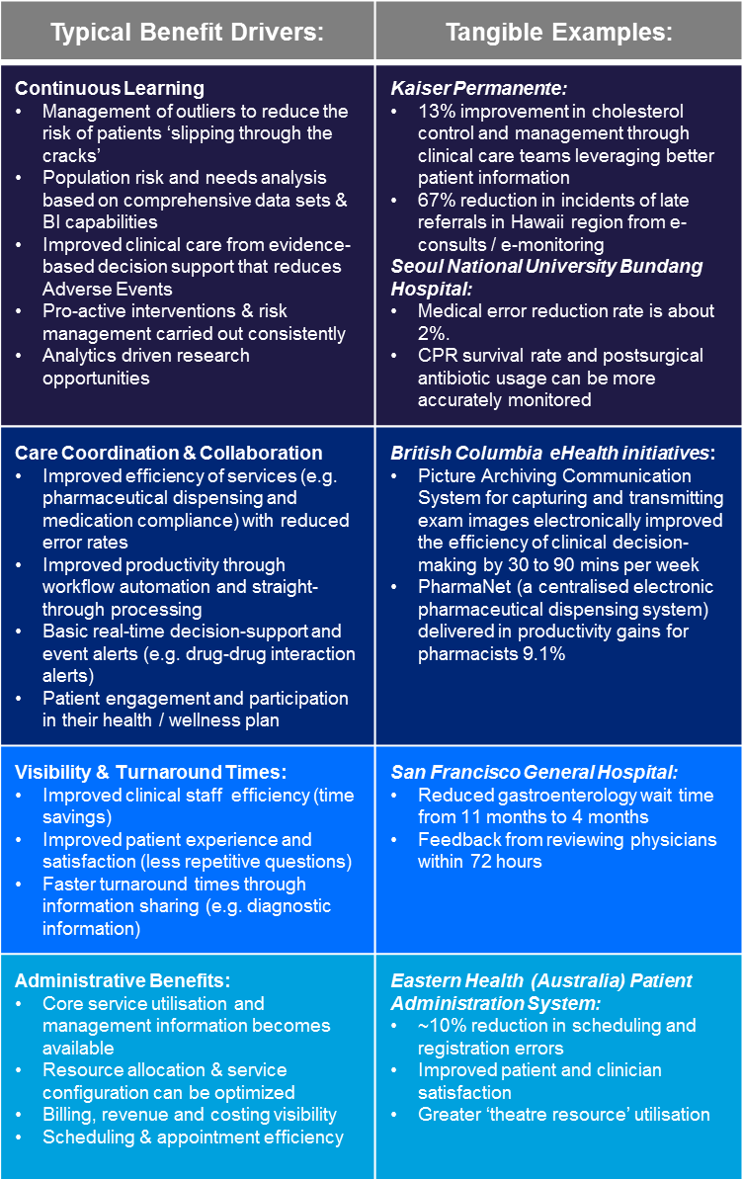

*“I am able to see all of the necessary clinical information on my screen and capture key details of my consultation”*

**Common Identifiers & Information Exchange**

**Clinical Information Access**

**Service Management & Collaboration**

**Decision Support & Risk Management**

Incremental Benefits for New Zealand:

Appendix H provides a series of data points on New Zealand’s overall health system productivity and quality. It contrasts us with OECD averages as well as with more advanced healthcare systems that have more mature EHR capabilities. The data indicates that New Zealand has room for improvement – both in terms of quality, as well as in terms of productivity across the healthcare sector.

### Quality[58] improvements by reducing variability

The current EHR strategy of New Zealand has progressed a ‘Virtual’ EHR and also introduced regional repositories that provide the foundation for a ‘Physical’ EHR. This allows us to move to Stage 2 and partially into Stage 3 for loosely coupled services, where tight integration and real-time workflow are not essential. However we have enormous variability in our implementations across these early stages (e.g. 40 different referral message types in one DHB region alone).

New Zealand does have some ‘pockets of brilliance’ where Stage 4 level functionality is available in narrow and specific domains: An example of Stage 4 capability is driving better care through advanced decision-support during patient contact in the primary care sector, whilst leveraging national data sets (e.g. the Predict tool available to primary care for managing cardiovascular risk).

However we struggle to link these up consistently at a nation-wide level. Our innovative implementations struggle with scale – they are not adopted universally across the country and even just getting one region to adopt any form of ‘best practice’ developed in another region has been extremely challenging.

The net result for our healthcare system is a high degree in variability around how care is delivered, how care pathways work and how clinical workflow operates – i.e. a lack of ‘universality’. The ePrescribing programme demonstrates how long it takes to agree a consistent level of practice, let alone roll this out on a nation-wide basis.

Unfortunately such variability can also introduce risk and makes pro-active quality management challenging. In 2014 ACC paid over $124 million for "treatment injury" (formerly medical misadventures) claims and increased the provisions for current and continuing claims to $165 million.[59]. This compares to claims costs of only $94 million in 2010.

Adverse reactions are another example. Adverse reactions reporting in New Zealand is managed by Medsafe and the Centre for Adverse Reactions (CARM). CARM receives, on average, 4000 spontaneous adverse reaction reports each year. Approximately half of these adverse reaction reports are submitted from general practice.[60]. Some studies estimate that potentially up to 2,506[61] patients die per annum in New Zealand, due to Adverse Drug Events. As we strive to make our healthcare system consistently safe and deliver higher quality outcomes, our levels of maturity.

### Productivity improvements through automation

In well-designed EHR solutions, there is a level of automation and industrialisation that adds to the overall productivity of the sector, as well as that of individual clinicians and practitioners.

As Appendix H illustrates, current evidence suggests that the healthcare sector productivity in New Zealand does have room for improvement – and that potentially our hospitals are lagging in the productivity race. Therefore higher levels of maturity – particularly within the context of a hospital-wide EMR, would generate incremental benefits as New Zealand moves up the staircase.

Although we have pockets of automation (e.g. eReferrals and eDischarges), these are not always linked up consistently – some DHBs still have to re-key the electronic referral information they receive from primary care into their departmental systems. Other DHBs cannot electronically refer patients and exchange date with others who they rely upon for service delivery (e.g. exchanging information between Waikato DHB and the Auckland DHBs).

By more consistently implementing functionality at Levels 1 & 2 across New Zealand, we would offer more seamless experience to patients, as well as achieving more end-2-end process integration and efficiency gains.

### Our benefit scorecard

The diagram below provides a scorecard for how well New Zealand’s current approach is positioned to harvest the potential benefits available from a ‘Single’ EHR. It illustrates how much of the available benefits at each level we are currently harvesting, as well as what could potentially still be harvested if we continued with the current ‘Virtual’ EHR approach (albeit with more standardisation).

Figure 6: New Zealand’s Scorecard for Benefit Capture

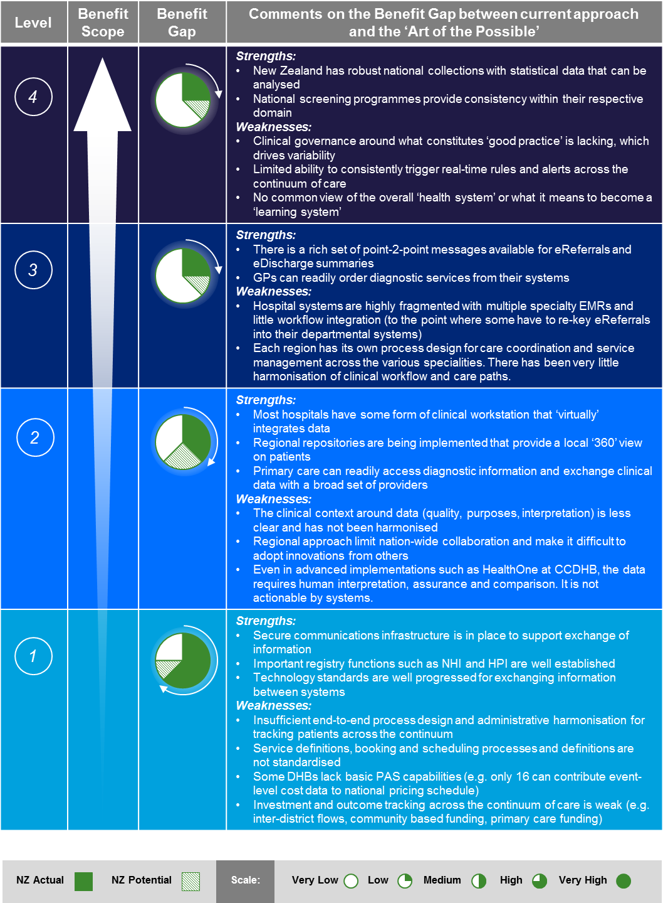As this summary illustrates, there is an emerging value-gap between what is possible and what New Zealand is able to achieve with its current approach. The current ‘Virtual’ EHR approach can capture low maturity benefits (i.e. level 1 or 2) – but is a poor fit for capturing high maturity benefits. The international experience, as outlined in chapter 2, indicates that high maturity benefits[62] are likely to be more significant and achieved through a different approach to the current EHR strategy.

Appendix D outlines some of the pre-conditions that have to be in place in order to move up each step in the maturity curve. It is important to note, that each step up the maturity scale requires significant change management – it is enabled by better IT, but cannot be successful unless changes in the healthcare operating model are made.

Summing up:

The current ‘Virtual’ EHR approach in New Zealand has not yet reached its full potential, and further benefits are possible. However, more mature healthcare systems have relinquished ‘Virtual’ EHR strategies in favour of ‘Single’ EHR strategies to reach a higher level of IT support in their healthcare delivery. This comes with tangible increases in productivity and quality.

New Zealand is at an inflexion point for our EHR strategy. Under the current approach we can continue to make some further gains. However, the full benefits achieved in other jurisdictions will elude us, unless we adopt a ‘Single’ EHR strategy that is capable of reaching higher up the EHR maturity scale and deliver deeper and broader capabilities to the healthcare sector.

# ‘Optimal’ EHR Discussion

Our Starting Position:

Health IT can ensure the timely and accurate collection and exchange of health data are likely to foster better care, and the more efficient use of resources.[63] Effective sharing of person-centric information across the continuum of care can:

* Improve collaboration between providers;
* Improve patient safety and care quality;
* Reduce the time between fundamental research and its application in a health service delivery context; and
* Increase the effectiveness and efficiency with which the health system can address the needs of individuals in a personalised way, ultimately resulting in better outcomes for the patient

The diagram below illustrates how the key elements of New Zealand’s ‘managed ecosystem’ currently interact:

Figure 7: Current New Zealand EMR / EHR Landscape

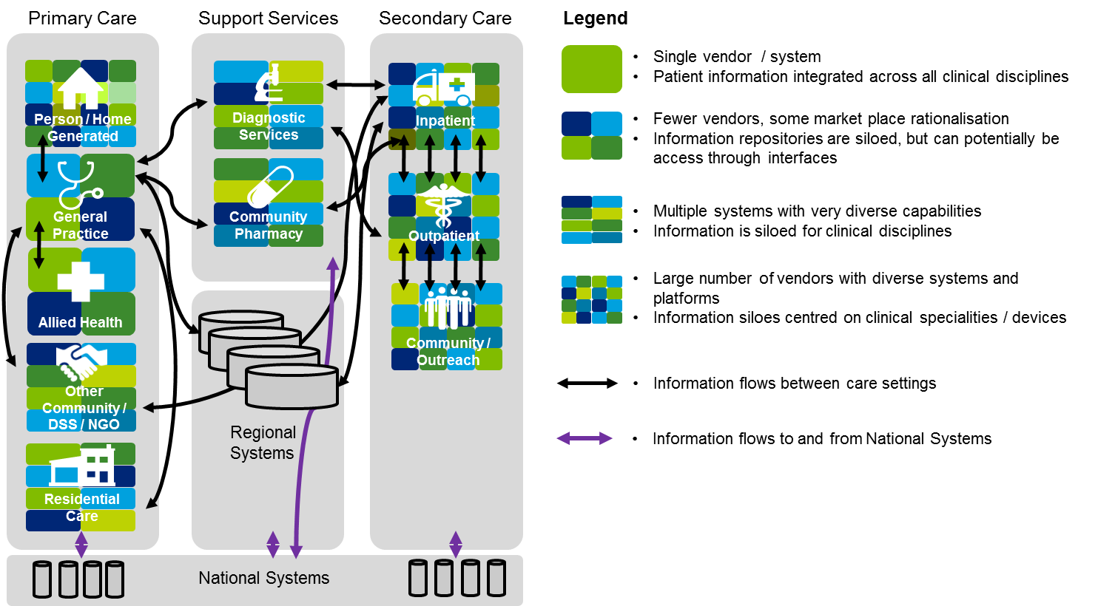

As this diagram illustrates, there is active point-2-point information flow between different practitioners across the healthcare system. With the development of regional solutions, there is more use of hub & spoke arrangements that allow information to be shared across multiple parties. These regional solutions provide a ‘physical’ information store for their underlying data, so that it is readily available on demand.

Key Highlights that are worth noting are:

* NZ has made good use of registries such as the NHI and HPI to link and aggregate data sets. National Collections and systems (e.g. NMDS, MCIS, National Screening) obtain data from a broad set of repositories – particularly for statistical purposes.
* NZ has also invested in a technology & information standards to drive integration forward, so that point-2-point communication is enabled (e.g. eReferrals, eDischarge. GP-2-GP Patient Transfer)
* The general pervasiveness of technology in GP practices is high (nearly 100% computerized in some form or other), demonstrating good progress in primary care.
* Hospitals do not have a ‘Single’ EMR and have large numbers of departmental systems. Typically the hospitals links departmental systems into a joint-up ‘Virtual’ EHR where possible, using Web-pages.
* New Zealand also has a large volume of electronic transactions between systems – for example:
  1. The average NZ general practice exchanges information electronically with more than 50 other healthcare provider organisations every month.
  2. There are over 40,000 eReferrals a month from primary to secondary care and the GP-2-GP solutions is seeing 20,000 transfers per month.
* NZ has also invested in Regional Information platforms that replicate key data into regional repositories or provider broker services (e.g. Regional CDRs for Labs / PACs and Regional ePrescribing & Administration (ePA).

Options for an EHR:

### Continuum of Choices:

Other healthcare systems have made significant investments in their respective EHR strategies and capabilities – for measurable returns. They have demonstrated that real and tangible benefits are achievable from the harmonisation of healthcare, improving care paths across the continuum of care and supporting health professionals with IT that automates and informs their day-to-day tasks.

To determine what an ‘Optimal’ EHR approach for New Zealand might look like, it is helpful to review the range of implementations carried out by other large-scale healthcare systems. These reveal a continuum of choices with two options at the extreme of the spectrum – namely a single monolithic vendor versus a Virtual / Best-of-Breed approach. In between these two options is a Hybrid approach based on a Best-of-Suite strategy.

It can be argued that the National Health IT Board has already started to move New Zealand partially toward the Best-of-Suite strategy with the focus on regional harmonisation and consolidation of IT systems. This continuum of choices is illustrated below.

Figure 8: Continuum of EHR Choices

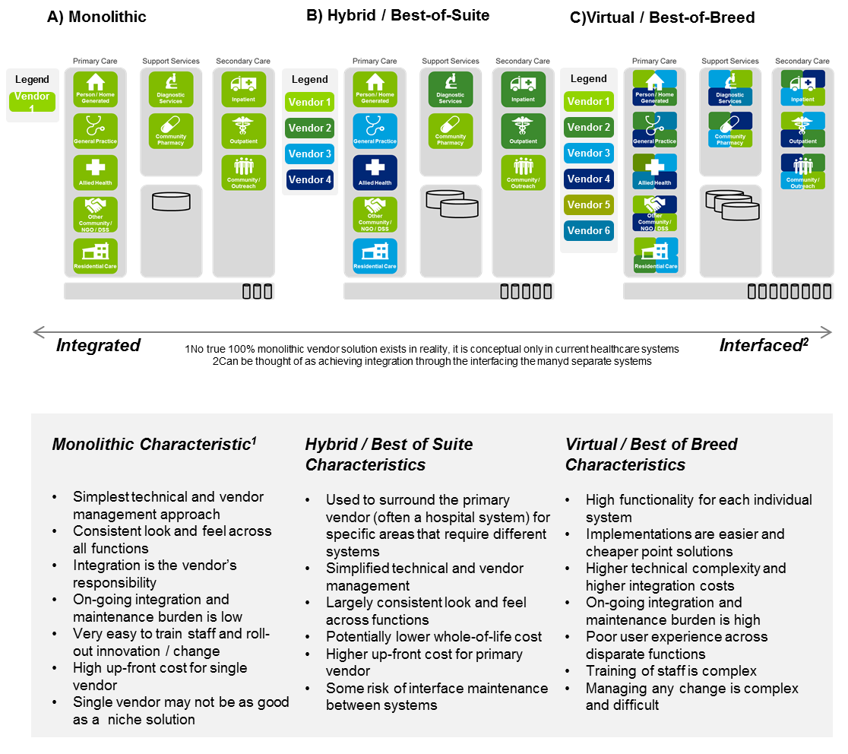

The international research shows that there are two paths towards a ‘Single’ EHR capable at performing at Level 4 of the Maturity Model: One path focuses on a single system and monolithic solution delivering the necessary functionality across the full continuum of care. Only Kaiser has taken this approach as an integrated healthcare system that encompasses multiple states and around 10 million members and ranges from secondary through to primary and long-term care.

The more frequent path, involves a rationalisation of individual EMR solutions across the continuum of care to implement a ‘best of suite’ approach, so that fewer interfaces need to be managed. In this approach, a physical repository or national CDR is added, where EHR data is physically consolidated. This effectively offers a Hybrid solution, where data is still replicated and integrated, but also consolidated in a single physical repository, so that higher level functions at Level 3 or Level 4 can be delivered. Singapore illustrates this approach, with only 1-2 vendors for hospital EMRs and Primary Care, down to just 1 vendor in certain settings such as Long-term Care.

It should be noted that under the Best of Suite paradigm, the remaining systems can be integrated via a ‘Hub & Spoke’ arrangement where they array around the physical EHR. This arrangement reduces the need for multiple point-2-point interfaces between each system and ensures that important information is published once to the master repository, but and then used many times over.

Alternatively the multiple EMRs can be integrated using a ‘Common Spine’. Under the ‘Common Spine’ approach a ‘system services bus’ is created, that allows individual EMR’s to transact with each other via a standardised middleware and integration layer (e.g. a universal appointment scheduling service, or diagnostic imaging request that works between any participating systems). This was the approach taken in the UK – albeit without rationalising the number of individual EMR solutions first. Needless to say, this technically more complex approach is more difficult, carries a higher risk and is more expensive.

Key choices facing New Zealand:

### Option A) Monolithic EHR:

This would involve a single vendor implementing their EHR solution across the continuum of care, spanning primary care, secondary care and support services. It could potentially deliver L4 capabilities across a range of settings, all linked through a single integrated system. This option could involve the selection of a single vendor to enable patient health records to be shared either nation-wide or at regional level, depending on the geographic scope.

### Option B) – Hybrid / Best-of-Suite EHR:

A Hybrid approach or Best-of-Suite strategy would rationalise the New Zealand EMR landscape down to just 1-2 vendors per setting – or even just one for specific specialities (e.g. Maternity Care). It would rationalise the number of interfaces and provide deep integration of data into a single shared repository, to potentially deliver L4 functionality across a range of healthcare settings. This option could involve the implementation of a single physical EHR either for the entire country, or just at regional level, depending on the geographic scope.

Moving to a hybrid approach would involve building on the parts of the current system that work well, and replacing others. This option would involve some of the following elements (not necessarily in sequence, but potentially in parallel):

* Refinement of the existing HealthOne solution in Canterbury - to build and extend the capabilities of HealthOne repository so that it can provide more advanced workflow and decision support capability across the different settings.
* Stronger focus on hospital level EMR rationalisation and standardisation, to reduce the complexity associated with a myriad of speciality and sub-speciality systems containing clinical information. This is potentially the approach being taken by the Northern DHBs.
* Progressive implementation of a single vendor system for hospital EMRs would typically start with Inpatient services and move ‘out’ to Outpatient services and Community Services provided by the hospitals. Modern hospital EMR solutions are capable of providing a fuller EHR that extends into primary care and other settings.
* Rationalisation and merger of regional solutions to form a common EHR. This would contain a broad set of data in a single physical repository shared across the continuum of care. It could potentially be provided through the EHR capabilities of one of the vendors chosen to deliver the hospital EMR solution.
* Rationalisation and merger of diagnostic support, imaging and pharmacy systems across the regions. Different hospital EMR vendors offer varying capabilities in these areas.

### Option C) – Current Virtual / Best-of-Breed EHR:

A continuation of the current virtual approach to the EHR would involve on-going investments in standards development, integration and interface harmonisation. It would continue to leverage the NHI and HPI to expand the available messaging services on either a point-2-point basis, or in and out of the regional repositories. This option might involve some of the following elements:

* Continuing development of ‘proofs-of-concept’ to foster innovation and encourage the use of IT for sharing information across settings.
* More emphasis on harmonising business processes and agreeing protocols for the coordination of care, over and above the on-going development of technical and information standards.
* Development of clinical standards – this would ensure that the clinical workflow can be integrated and harmonised, with corresponding governance in place to support the on-going management of agreed guidelines and care paths.
* Extensions on the current regional solutions with potential further rationalisation and consolidation at national level. This would effectively morph the strategy into Option B).

### Operating Model Choices:

Although each of these options has been described in terms of its high-level *Technology* *Approach* it is important to note that each choice implies fundamentally different approaches to health system design, process harmonisation, clinical governance and health information sharing.

The chosen options has to be based on the right operating model and structural foundations for the healthcare system. It is important to decide up front what level of ‘Universality’ is desired, since this sets the tone for what level of process and systems standardisation is desired.

The different paths to achieve a high performing healthcare system are illustrated below, as well as the key choices facing New Zealand with regard to the geographic scope of any EHR strategy:

Figure 9: EHR Operating Model Implications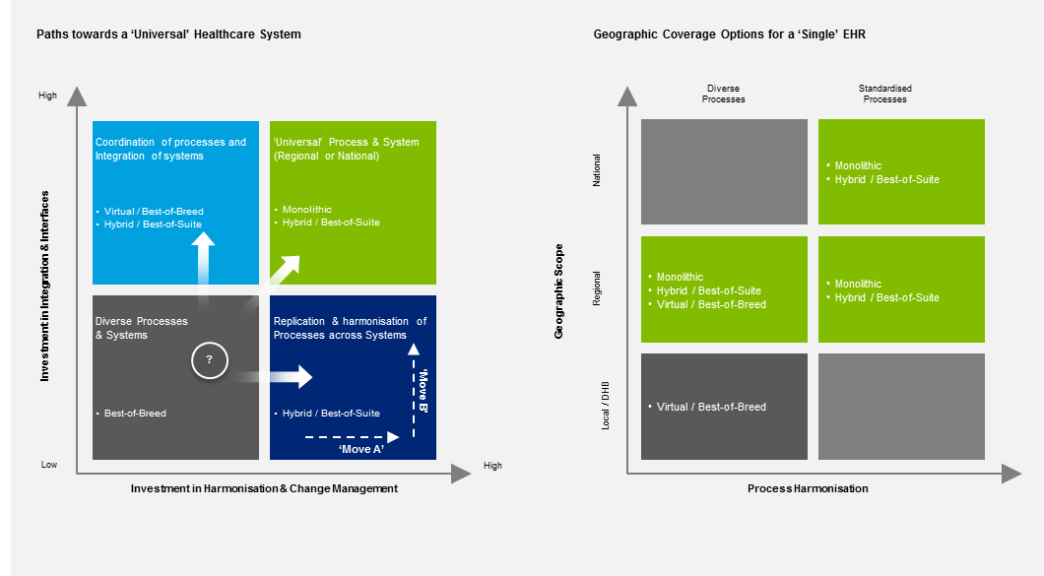

A ‘Single’ EHR could make a significant contribution to lifting our overall maturity and capability, leading to a future state with fewer systems and less process variability.

The diagram above illustrates that moving towards a ‘universal’ healthcare system requires a combination of system as well as process investments in order to move ‘up and to the right’. Moving in that general direction requires strong design-thinking and a willingness to industrialise our healthcare delivery.

One option is to spend money retrospectively after diverse IT solutions have been implemented. This approach integrates multiple systems into a ‘Virtual’ EHR that supports better coordination and integration. Under this approach, a lot of money is spent on IT as part of each implementation, if there is a lot of underlying system and process variability. Large IT investments will also be required on an on-going basis, to constantly iron out differences in the underlying processes and systems.

An alternative option is to invest in the harmonisation of the operating model first, before comitting major Capital Expenditure on IT solutions. In this model the journey commences with design-thinking – it does not start with technology – and then seeks to harmonise processes after the fact.

By harmonising processes first, before IT systems are implemented and integrated, the respective IT costs are reduced and better managed up front. This approach makes the design phase more expensive, since substantial change management and alignment is required. In theory, either road can lead to a ‘Single’ EHR, if that is the desired end-point.

Chapter 5 discusses the recommended sequence of ‘Move A’ followed by ‘Move B’ in more detail, since this would result in the most cost effective journey.

Another set of choices revolves around the geographic scope for any New Zealand EHR implementation. Options can be restricted to just one of the (20) local DHBs, to one of the (4) regions or to a single nation-wide implementation.

Based on international experience, regional or state-wide approaches pay bigger dividends for integrating care than localised implementations. Therefore some of the *Technology Configurations* would not be sensible, as represented by the grey boxes on the right side of Figure 9. If New Zealand was to embark on a ‘Single’ EHR strategy, then this would be more sensible at national / regional level, rather than at DHB level.

Option Evaluation:

### Evaluation Framework

Before discussing, what might be an ‘Optimal’ EHR approach for New Zealand, it is important to reflect on the potential evaluation criteria that should be considered.

Based on discussions with other healthcare systems and colleagues around the world, the top 10 major criteria used in making decisions were identified. The list below provides an overview of criteria that others have found useful in shaping the development of their respective healthcare system’s EHR strategy:

|  |  |
| --- | --- |
| Evaluation Criteria: | Considerations |
| Functional Maturity | Is the strategy able to provide support for the maturity and functionality desired by the healthcare system? This considers not just the depth but also breadth of functionality of the EHR. |
| Capital Expenditure | What are the anticipated costs that will be incurred through purchase & implementation, such as system integration, data migration, hardware, software, etc.? |
| Operating Expenditure | What are the anticipated costs that will be incurred through ongoing operations, such as maintenance & upgrades and on-going system enhancements? |
| Person Centricity | The ability of the strategy to offer or support a person centric electronic health record - across the entire continuum of health. This should particularly consider consumer adoption. |
| Clinical Quality & Safety | How well does the strategy support service providers’ ability to deliver high-quality care? Can it support health system outcomes for quality, access, equity etc.? |
| Productivity | Whether the strategy will enhance clinical care delivery processes and workflows. Does it enable staff to work efficiently and effectively? |
| Implementation / Change Management Effort | What is the level of effort required to implement the strategy compared to the current state? |
| Governance & Political Risk | What are the political risks at local, regional, and national level for the solution? What are the potential policy implications? |
| Leverage of Prior Investments | How well does the strategy leverage other systems that may currently exist? How well does the it support or interface with existing repositories (e.g. NHI) |
| Capturing Level 4 Benefits | What is the capability of the chosen strategy to reach level 4 on the EHR Maturity Staircase? |

### Evaluation Results

The table below provides a high-level assessment of the three options against the Evaluation Framework introduced in the previous section. Given that we are not in a formal solution evaluation process, this analysis was done at a high level and on relative merit. Choosing different evaluation criteria or placing more weight on some than others, will lead to different solutions.

|  |  |  |  |
| --- | --- | --- | --- |
| Evaluation Criteria | Option A)  Monolithic | Option B)  Hybrid / Best-of-Suite | Option C)  ‘Virtual’ Best-of-Breed |
| **Functional Maturity** |  |  |  |
| **Capital Expenditure** |  |  |  |
| **Operating Expenditure** |  |  |  |
| **Person Centricity** |  |  |  |
| **Clinical Quality & Safety** |  |  |  |
| **Productivity** |  |  |  |
| **Implementation / Change Management Effort** |  |  |  |
| **Governance & Political Risk** |  |  |  |
| **Leverage of Prior Investments** |  |  |  |
| **Capturing Level 4 Benefits** |  |  |  |

|  |  |  |  |  |  |  |  |  |  |  |
| --- | --- | --- | --- | --- | --- | --- | --- | --- | --- | --- |
| Scale: |  | very poor |  | poor |  | moderate |  | Good |  | excellent |

Based on the assessment above, the ‘optimal’ way forward from the current EHR Strategy for New Zealand, would be to pursue a Hybrid / Best-of-Suite strategy. This would build on the current investments but drive further rationalisation between the regions and further process harmonisation across regions.

Potential Future State for a ‘Single’ EHR:

Based on the assessment framework and the applied evaluation criteria, the Hybrid / Best-of-Suite option is the most optimal path forward for New Zealand. This option:

* Offers significant benefits and ‘up-side’ if New Zealand wishes to progress up the EHR Maturity staircase
* Can be eased into from the current level of fragmentation of our healthcare system and our federated governance
* Is more readily phased and offers sufficient flexibility to allow different parts of the sector to catch up, when they are in fundamentally different starting positions
* Builds on existing IT investments and infrastructure

The diagram below illustrates what the potential future for a ‘Single’ EHR New Zealand might look like, if a Hybrid / Best-of-Suite strategy were to be pursued:

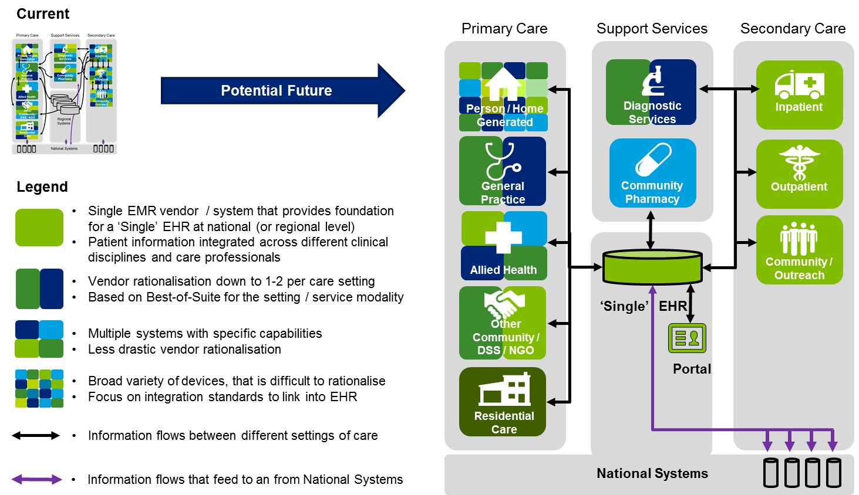Figure 10: Potential Future EHR Strategy - Hybrid / Best-of-Suite

The key changes and building blocks for moving forward with a Hybrid / Best-of-Suite strategy are noted below:

| Step | Recommended Building Bock | Comments |
| --- | --- | --- |
| **1** | **Rationalise secondary care facilities (hospitals) into 1 EMR vendor per region or 2 vendors country-wide** | * It would be prudent for New Zealand to retain two vendors in the overall architecture, in case adverse economic events outside New Zealand’s control or local service delivery issues lead to a relationship deteriorating * Focusing on hospital EMR capability would be expected to provide a significant boost to hospital productivity and resource intensity. Since hospital care consumes a significant amount of the total New Zealand healthcare budget, this could provide a substantial gain. * Starting the industrialisation process with hospital facilities, reflects international practice: Getting agreement on what reengineered processes and clinical workflows should look like is challenging enough within an institution, let alone across institutions. * Once the core hospital processes and clinical workflows have been harmonised, the interface in and out of primary care can become much more harmonised. This creates the ability to more seamlessly manage appointment bookings, scheduling and service requests to the hospital, as well as post-acute follow up in the community. * *It should be noted that the numerous departmental systems in New Zealand hospitals appear highly fragmented and offer significant consolidation opportunities.* |
| **2** | **Create a ‘Single’ EHR that physically consolidates health information** | * The advanced EMR solutions provided for hospital care are capable of serving up a universal EHR. Depending on which vendor(s) have been selected for the hospital EMR, there is the possibility of using the same repository as the ‘Hub’ in the future architecture. * Depending on the business functionality available from the selected EMR vendor, the ‘Single’ EHR, would offer functional and transactional capabilities to automate workflow and provide alerts. * Alternatively one of the existing Regional Repositories could be used as the platform for the future ‘Single’ EHR. * It would be more economical to have only one National EHR for New Zealand, rather than Regional EHRs. A single instance would offer lower on-going licencing, maintenance and integration costs. * Since the ‘Single’ EHR should have a life-time focus, it should carry comprehensive diagnostic data, patient history and encounter data for the life of a person – irrespective of where they have lived in New Zealand. * *It should be noted that the Northern Region DHBs are currently investigating a solution that would be capable of providing this.* |
| **3** | **Connect Primary Care and National Systems via a Hub and Spoke model** | * Once the repository has been established, the ‘Single’ EHR could be linked to primary care providers as well as Diagnostic Service providers – similar to the current regional set-up. * Essentially the ‘Single’ EHR would capture information once, to be used many times. It would allow multiple local EMR systems to link into the shared repository on a 'publish & subscribe' basis, so that they get alerted when data of interest is changed. * Under a ‘Hub & Spoke’ arrangement, the ‘Single’ EHR would help reduce the many point-2-point interfaces and assist with managing the on-going integration costs and overheads associated with linking systems. * The ‘Single’ EHR could also pass relevant information through to the National Systems, so that we could reduce the multiple individual interfaces that are currently in place. * *It should be noted that this approach is similar to the Canterbury DHB model and what HealthOne is seeking to achieve over time.* |
| **4** | **Implement Closed Loop Medicine Management** | * International experience shows that significant healthcare quality gains can be made through better management of pharmaceuticals and medicines. * Typically this process starts inside the hospitals to reduce the number of Adverse Medical Events resulting from prescribing / dispensing errors. Once this has been strengthened, it can be extended into primary care and the community. * Depending on the selected vendor for the hospital EMR or ‘Single’ EHR, the pharmacy management, prescribing and dispensing functionality of their platform could also be leveraged by community pharmacies. * In conjunctions with the linkage back to National Systems (e.g. the Medical Warning System alerts), the ‘Single’ EHR can support and deliver medication management specific rules and alerts. * With the integration to primary care, it now becomes possible to reengineer the supply chain for consumer convenience (e.g. delivery by courier) and to also manage adherence (e.g. comparing what was prescribed, with what was dispensed and what is taken) * *It should be noted that New Zealand appears to have significant scope for improvement with regard to our Medication Error Rate.* |
| **5** | **Develop Consumer Portal access** | * Once sufficient useful functionality becomes available (e.g. ability to consult or book appointments with a range of providers), the ‘Single’ EHR could provide services for a Consumer Portal. * Depending on the selected vendor for the hospital EMR or ‘Single’ EHR platform, a Consumer Portal will be part of the standard functionality that they provide. * The key to consumer acceptance and usefulness would be to ensure that the ‘Single’ EHR has critical mass in terms information and functionality. (E.g. updates on waiting times, available appointment slots, next steps planned in their care plan, visit or appointment reminders, etc.). * Consumer engagement is vital for health and wellness programmes, as well as any primary care led strategy that seeks to reduce morbidity or the risk of chronic conditions. * With the rapid proliferation of home health devices and mobile technologies accessing the home, this area is seeing rapid growth, where for example Kaiser Permanente has grown ‘virtual’ visits from 4.1 million to 10.5 million per annum since 2008.[64] * *It should be noted that international experience shows that poorly conceived portal can lead to consumer backlash and scepticism. They need to show a high degree of usability and also be mobile device friendly.* |

Summing up:

The ‘optimal’ path forward and logical next step from the current EHR strategy is to adopt a Hybrid / Best of Suite strategy for the EHR. Under such an approach, the various platforms across different healthcare settings would be rationalised down to 1-2 EMRs per setting, and a single ‘physical’ EHR repository would be introduced to join these up nationally.

This would potentially involve the following (not necessarily in sequence, but concurrently)

* Rationalising secondary care facilities (hospitals) into 1 EMR vendor per region or 2 vendors country-wide. This allows for some risk management to prevent vendor lock-in and ensuring some redundancy at a national level.
* Creating a ‘Single’ EHR that physically consolidates health information. This could be done nationally or regionally. Some hospital EMR packages already include this functionality in their solution – alternatively the ‘Single’ EHR could be built out of an existing Regional solution.
* Connect Primary Care and the ‘Single’ EHR via a Hub and Spoke model. This would build on the existing regional model but make it more consistent nationally, as well as adding more functionality
* Implement Closed Loop Medicine Management. This is an area that offers the highest benefits in terms of patient safety and quality.
* Develop Consumer Portal access. This leverages the ability serve up information from a physical repository in real-time, through digital channels to consumers. Consumer engagement around their health and wellness is key to implementing a preventative or primary care led strategy.

# Rationale for Change

Limitations of the Current Approach:

The current EHR strategy of progressing a ‘Virtual’ EHR has delivered some tangible technical milestones and allowed New Zealand to connect healthcare systems in ways that are envied by other countries. However in progressing our technical ability to integrate systems, New Zealand has under invested in design-thinking around process harmonisation and the standardisation of clinical workflow. This is a reflection of the lack of leadership around the overall design of our healthcare system and the federated nature of our governance structures.

The risks of ‘doing nothing’ and continuing with the current approach are centred on the challenges currently being faced by the New Zealand health and health IT systems. International experience demonstrates that continuing with a ‘Virtual’ EHR means New Zealand may struggle to:

* **Address sector productivity issues:** Productivity and efficiency benefits are primarily driven through workflow automation, better clinical decision support (diagnostic testing/screening) and improved information sharing capability. Evidence suggests that developing a high-maturity EHR with advanced capabilities is most likely to be realised in healthcare systems with single or few vendors.
* **Handle a large increase in IT system operating expenditure:** A ‘Virtual’ EHR/ best-of-breed approach results in significant complexity and cost of technology integration elements. Integrating solutions from disparate vendors will become an on-going burden and may cause previous integration work to ‘break’. Another consequence of the current approach is the lack of ‘value-add’ spend on IT systems, due to the high proportion of Opex required on infrastructure and maintaining legacy systems.
* **Construct an EHR capable of delivering better clinical outcomes:** A higher level maturity EHR requires a system capable of decision support and rule-based risk management. Higher level functions at Level 3 or Level 4 are easiest to deliver in a setting where data is consolidated in a single physical repository.

The hidden cost of poor design thinking have an adverse impact on the day-to-day tasks and activities of healthcare delivery. They include ‘deadly sins’ such as:

* **Hybrid environments that blend systems and paper** – Health practitioners may find that existing systems do not necessarily provide all the information that they require and so pen and paper continue to act as a supplement to these systems. This result in re-keying of information or the need to reference both systems and paper files. The net result is lost productivity. An example is the need to re-key eReferrals into some DHB departmental systems.
* **Requiring manual integration of information –** When using information systems, healthcare providers often need to bring together information from multiple information sources to support decision making. Often they do this manually (e.g. using Excel) or copying & pasting from one file to another. Some DHBs have dozens of different BI tools and all of them struggle to extract meaningful insights on their population health. When they are doing this in order to carry out their daily activities, productivity is lost – and decision-making is impaired.
* **Limited capabilities to share information –** Practitioners who are working in a broader context (e.g. community based providers / external research partners) often find that their systems do not cater for their need to move information across organisational boundaries. It may not be possible to E-mail ‘extracts’ safely and security and data may have to be printed out to be faxed / scanned. Alternatively clinicians move data around on USB sticks or with their personal laptops. Apart from sapping productivity, thiscreates privacy risks. An example is the clinician with patient files on their laptop that they have ‘lost’ in the staff car park, exposing the DHB to a breach.

It must be noted that these issues are NOT for IT to resolve, but require strong business leadership, clinical engagement and business engagement to be addressed. If New Zealand was to focus more strongly on end-2-end process chains and the overall alignment around the operating model for our healthcare system, then this could pay significant dividends.

The Alternatives:

Moving forward from the current approach, requires at least two directions of travel – namely a stronger focus on design thinking to improve the industrialisation of our healthcare services, as well as the pursuit of a different EHR architecture based on a Hybrid model with a ‘Single’ EHR.

As discussed in the previous chapter, these are respectively described as ‘Move A’ (Process Harmonisation) followed by ‘Move B’ (System Integration & Harmonisation):

* **Move A:** Strengthen Design Thinking and Process Harmonisation ; and
* **Move B:** Move towards a ‘Single’ EHR based on a Hybrid / Best-of-Suite Approach

As noted in the previous discussions around international experiences, as well as the pre-requisites for an EHR, a ‘Single’ EHR for New Zealand would not be feasible without underlying process harmonisation – i.e. executing both Move A and Move B.

Each of these two moves can be examined in turn for their impact on the available benefits for the New Zealand healthcare system, as well as the incremental risk that they pose. The subsequent tables provide an assessment of how much of the benefit gap between where New Zealand is at today, and what would be possible under a ‘Single’ EHR could be closed.

With regard to just executing ‘Move A’, the tables also illustrate what incremental improvements might be possible by persisting with the current approach, but focusing on just more standardisation around a ‘Virtual’ EHR.

### Move A: Strengthen Design Thinking and Process Harmonisation

| Consideration | Comments |
| --- | --- |
| **Level 1 Benefits** | New Zealand has an opportunity to close the benefit gap for ‘Administrative’ Benefits in the EHR Maturity Staircase, even with just the current technologies in place. For example:   * The FPSC solution could provide a common financial backbone for financial tracking, contract administration and funding arrangements, so that all DHBs have a consistent view on financial spending and commensurate outcomes. * However it should be noted, that the gaps cannot be fully closed, unless DHBs significantly strengthen their underlying PAS / EMR capabilities. Without strengthen these core functions, event level data is difficult to marry up with cost and outcome data. * Better end-2-end process design and definitions, would enhance the ability to track patients (e.g. National Patient Flow) and improve the quality of key system metrics (e.g. Health Targets) so that we have a consistent view on what success looks like. |
| **Level 2 Benefits** | New Zealand has an opportunity to partially reduce the benefit gaps around ‘Visibility & Turnaround Times’ in the EHR Maturity Staircase, even with just the current technologies in place. For example:   * Harmonisation of clinical work practices would serve to standardise the context under which data is captured, so that it is more reliable and useful when other practitioners wish to leverage the same data. * Especially aggregate reporting and data analysis would improve, if information management practices were more formally managed and standardised. * The 360 View of a patient in the Regional Repositories can continue to be enhanced, so that consumer access and clinical usefulness increases over time. |
| **Level 3 Benefits** | New Zealand has an opportunity to partially reduce the benefit gaps around ‘Care Coordination’ in the EHR Maturity Staircase, even with just the current technologies in place. For example:   * Adopting a standards set of care pathways at a national level, would improve equity across the regions and provide patients with more consistent outcomes. The exam question to discuss would be: ‘Why can’t Canterbury’s care paths be adopted and extended further’? * As the care paths and care coordination become formalised and standardised, it becomes possible to automate loosely coupled process chains, such as the interactions between primary care providers and the hospitals. * Consumer engagement can be taken to the next level, if patients can have a consistent service experience no matter where they are. If they are subject to a ‘post-code-lottery’ then every time they move, they would have to re-engage with some form of local portal. |
| **Level 4 Benefits** | New Zealand has an opportunity to make minor gains around ‘Continuous Learning’ in the EHR Maturity Staircase, based on the current technologies in place. For example:   * Under the current approach, insights and decision support would continue to be predominantly retrospective, since a ‘Virtual’ EHR struggles to deliver real-time decision support capabilities at the coal face. * With increased emphasis on process standards, information and data definitions in a business context and more consistent data capture, it is reasonable to assume that the underlying quality of information in the National Collections would improve. * This might create specific opportunities – such as for example in the existing Pharmhouse, where extensive data scrubbing, cleansing and manipulation is required to align the incoming data, before interpreting it. |
| **Costs** | * The costs associated with process harmonisation, standardising clinical workflow and reaching agreement on care pathways, are mostly measured in terms of people’s time. Although some capital investments might be required to accelerate key designs and to shape the overall strategy, the on-going investments would be mainly operational costs. * New Zealand would have to invest more in leadership skills, to be able to strengthen harmonisation across the sector. This investment would cover both training, as well as back-fill and time for the limited number of leaders available. * It would also require the setting up of more comprehensive and inclusive governance structures and a ‘Design Authority’ that can shape the harmonisation and the development of business rules and standards across the sector. * In addition it wold require scaling up and strengthening the existing IT governance and standards bodies, since they are already under-resourced for the body of work necessary. Once the business catches up, they would face an even heavier workload. |
| **Risks** | * The key risk to attempting standardisation is a cultural backlash by individual DHBs and or the ‘not invented here’ mentality. When local concerns trump the national good, then this can easily de-rail a process. * To manage such a risk, the approach to funding and the composition of the underlying governance structures, are important. These structures can ‘enforce’ agreed standards but also ensure the right behaviours are encouraged. * As Canterbury DHB has demonstrated, a surprising amount of alignment at regional level is possible, when Collective Leadership models are used with an emphasis on alliancing and linking together different providers across the sector. * It is worth noting, that although reputational and political risk increases with attempts at harmonisation, technology and project delivery risks reduce, because there is more certainty around IT outcomes and business results. * Therefore the net-risk profile of proceeding with process harmonisation and strengthening design thinking is likely to be equivalent to New Zealand’s current approach. |

### Move B: System Harmonisation towards a ‘Single’ EHR

| Consideration | Comments |
| --- | --- |
| **Level 1 Benefits** | New Zealand has an opportunity to close the benefit gap for ‘Administrative’ Benefits in the EHR Maturity Staircase, based on the ‘Optimal’ EHR Strategy. For example:   * The FPSC solution could provide a common financial backbone for financial tracking, contract administration and funding arrangements, so that all DHBs have a consistent view on financial spending and commensurate outcomes. * It could fully integrate with a common PAS / EMR deployed across hospitals, so that event-level cost data, resource consumption and clinical outcomes become traceable. * By virtue of having a common PAS / EMR backbone, challenges such as end-2-end tracking of resources and patients becomes much easier (e.g. National Patient Flow). |
| **Level 2 Benefits** | New Zealand has an opportunity to close the benefit gap for ‘Visibility & Turnaround Times’ Benefits in the EHR Maturity Staircase, based on the ‘Optimal’ EHR Strategy. For example:   * A ‘Single’ EHR can become the Hub for a comprehensive 360 view of patients * Clinical work practices, data definitions and information capture would be harmonised by virtue of using a common system. This would greatly enhance data quality and the comparability of information * Aggregate reporting and data analysis would be greatly enhanced, providing a much more comprehensive view on population health and risk. * The 360 View of a patient in ‘Single’ EHR can support consumer engagement not just by providing information, but also by supporting interaction. |
| **Level 3 Benefits** | New Zealand has an opportunity to close the benefit gaps around ‘Care Coordination’ in the EHR Maturity Staircase, based on the ‘Optimal’ EHR Strategy. For example:   * Standard care pathways can be deployed at national or regional level. When innovative practices emerge, they can be rapidly rolled out and adopted across all of New Zealand * With the embedded functionality attached to a ‘Single’ EHR, both loosely coupled workflow and automation of tasks in real-time become a possibility. This will enhance productivity inside the hospitals, in addition to improving the integration between primary care providers and the hospitals. * Consumer engagement can be taken to the next level, with self-service functionality delivered via a portal into the ’Single’ EHR. Apart from bringing administrative benefits (e.g. change of address), this also supports self-care and self-management, by enabling personal and home-health devices. |
| **Level 4 Benefits** | New Zealand has an opportunity to close the benefit gaps around ‘Continuous Learning’ in the EHR Maturity Staircase, based on the ‘Optimal’ EHR Strategy. For example:   * National Collections would continue to harvest rich, granular detail with a high degree of fidelity. These systems in addition to the analytical capabilities inherent in a ‘Single’ EHR will allow a detailed analysis of what is working and what is not working so well. * EHR platforms support the development of advanced decision-support rules that can be deployed for real-time interactions when clinicians and care givers use the system. This encourages evidence based decision making. * At an aggregate health system level, New Zealand would have much better visibility on the needs of its population and the health risks we are facing. Based on this insight, proactive population health management and re-deployment of limited resources become much easier than under the current approach. |
| **Costs** | * The costs for the identified work packages may actually not be a lot higher than what would be spent on individual systems anyway, when they have reached their end-of-life. * However the actual Capital Expenditure would be compressed into a much shorter timeframe and therefor still require a large lump sum up front. * A realistic assessment of the potential benefits associated with such a ‘Single’ EHR strategy as well as the likely costs would be prudent, to understand the true cost differential against the current state over an extended period of time. |
| **Risks** | * The technology risks around an EHR implementation should not be underestimated, since different platforms need to be integrated and many providers across the sector would have to make changes over a multi-year period. * The other material side of the risk equation is the change management challenge. If standardisation and harmonisation of processes has progressed well, then this substantially reduces the residual technology risk. |

Figure 11: Rationale for Change Scorecard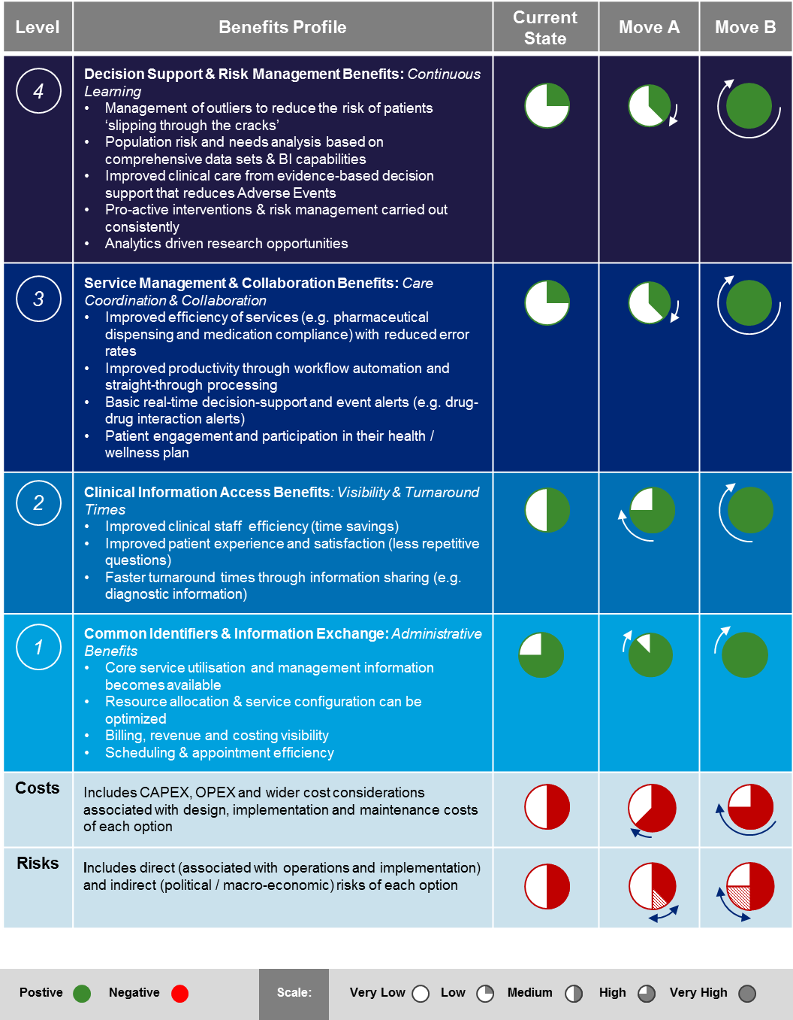

Summing up:

A ‘Single’ EHR could make a significant contribution to lifting our overall maturity and capability, if it is combined with strong design-thinking and a willingness to industrialise our healthcare delivery. However this process has to start with the design-thinking – it cannot start with technology and seek to harmonise processes after the fact.

Moving towards a ‘universal’ healthcare system requires a combination of system and process change to move ‘up and to the right’ – towards a future state with fewer systems and less process variability.

New Zealand is well positioned to move up the technology maturity curve, based on our system integration capabilities, our national and regional systems and our strong computerisation in primary care. However significant effort is required to drive the necessary harmonisation of our underlying healthcare operating model and IT approach.

We need to significantly strengthen our design thinking, clinical governance and leadership models, to be achieve greater ‘unversality’ and to harmonise how we operate across the sector at a national or regional level. Processes, clinical workflow and leadership must be aligned, before IT systems are implemented to support an end-2-end solution.

# Implementation Options

Implementing a ‘Single’ EHR in New Zealand:

**Implementation Options:**

As discussed in Chapter 4, the recommended ‘Single’ EHR strategy for New Zealand would require a number of major building blocks to be put in place. There are two fundamental paths available for industrialising a national or state-wide healthcare system:

* **Hospital-centric, moving outwards:** This approach typically starts with hospital EMR implementations and moves them up the maturity curve, before branching outwards and embracing primary care with its broader information base. It relies on institutional centres of excellence to encourage clinical leadership and buy-in.
* **Primary care-centric, moving inwards:** This approach starts with primary care and general practice. It seeks to connect the many different providers in the community first, before pushing back into the hospital environment and lifting the maturity curve. It relies more heavily on consumer engagement and broad-based support.

The diagram below illustrates the two different philosophies, noting that the former is the current Mainstream Approach:

Figure 12: 'Single' EHR Implementation Options

**Common Identifiers & Information Exchange**

**Clinical Information Access**

**Service Management & Collaboration**

**Risk Management & Decision Support**

Functional Maturity

**Horizon 1**

**Horizon 2**

**Horizon 3**

High CAPABILITY

Medium CAPABILITY

Low CAPABILITY

Secondary Care

**Primary Care**

Support Services

Breadth of Information

***Main-stream Approach:***

***Hospital Centric – moving outward***

Secondary Care

**Primary Care**

Support Services

Breadth of Information

Secondary Care

**Primary Care**

Support Services

Breadth of Information

***vs. Primary Care Centric***

***– moving inward:***

**Horizon 1**

**Horizon 2**

**Horizon 3**

Secondary Care

**Primary Care**

Support Services

Breadth of Information

Secondary Care

**Primary Care**

Support Services

Breadth of Information

Secondary Care

**Primary Care**

Support Services

**?**

Breadth of Information

Based on the international research, most major healthcare system have chosen the hospital centric approach – i.e. starting with hospital EMRs, before moving outwards into the community. Key factors that have encouraged this approach include:

* Institutional care is more expensive and offers a more tangible Return on Investment (ROI) associated with an EMR / EHR implementation;
* Achieving leadership alignment and clinical buy-in is more readily achieved within an institution as opposed to across institutions;
* Alignment with tertiary care and academic teaching institutions behind an EMR / EHR initiative, creates more clinical leadership capacity to help develop care pathways and agree on ‘best practice’ for clinical workflow;
* The ability to invest in primary care is often limited by single-practitioners / owner-operator structures, who have less capital budget available to fund large-scale change;

It should also be noted that a number of healthcare systems (e.g. Singapore) started this journey well over a decade ago. They often found themselves in a position where the level of general computerisation in primary care was relatively low. This naturally predisposed them towards focusing on hospitals first. Clearly this is NOT one factor that would be applicable in New Zealand, because our current level of IT penetration into primary care is very high.

**Recommended Path:**

To a certain extent New Zealand has progressed further up the IT maturity curve in primary care than in hospitals: The Practice Management System (PMS) landscape in New Zealand rationalised and PMS systems provide good functionality at both a clinical as well as practice management level to GPs in New Zealand.

By contrast, most hospitals still run dozens if not 100s of different departmental systems and niche repositories with clinical information. They typically tether this together into a ‘Virtual’ screen through a Web front-end and interfaces. Many hospitals have neglected their underlying Patient Administration (PAS) capability and therefore lack the ability to track and manage resource, capture event level data, and facilitate seamless appointment bookings or resource scheduling.

Given the need to play ‘catch-up’ for New Zealand’s hospitals and the fact that they seem to offer a more tangible ROI on any potential investment, the recommended approach would therefore still be the main stream approach: Namely to commence the ‘Single’ EHR journey with a more hospital centric perspective, that gradually rolls out and provides additional functionality and services back to the primary care sector.

Implementation Challenges:

The international research identified a number of Critical Success Factors (CSFs) that are important for the successful implementation of an EHR or EMR solution. Although the absence of any one CSF may not necessarily be fatal to for the drive towards a ‘Single’ EHR, it should be noted that few EHR / EMR programmes have been successful unless they paid attention to all of these factors.

The table below provides the key challenges that would have to be addressed in a New Zealand context for the implementation of a ‘Single’ EHR as per the Preferred Option.

| Critical Success Factor: | Implications for New Zealand: |
| --- | --- |
| **There must be a sound business case** | No EHR strategy or EMR implementation should be launched without a sound business case. In the New Zealand context this would involve a baseline analysis of the true cost of for the current EHR strategy and estimates for the expected costs of a ‘Single’ EHR.  The baseline analysis should also consider New Zealand’s current level of healthcare system maturity – possibly against the HIMSS framework. This framework offers an international basis for comparison and would allow us to compare ourselves against other countries (e.g. Australia’s score of 1.8 on a scale from 0 to 7)[65]  With a better understanding of the cost associated with the current EHR strategy and the results that it delivers, versus what a ‘Single’ EHR might deliver and cost, an objective assessment can be made to validate the path forward.  The business case should clearly articulate the reason why New Zealand should make investments in process harmonisation and system rationalisation to support a ‘Single’ EHR versus continuing on the current interoperability and integration path.  The business case also needs to articulate the vision for what the future of healthcare delivery should look like in New Zealand – with corresponding policy support. Without a clear and compelling need, proposed investments are unlikely to be successful. |
| **Benefits (financial and non-financial) must be specific and measurable** | Based on an objective assessment of the current healthcare system maturity, New Zealand can develop its ambitions for the future. This would mean identifying the advanced capabilities that a ‘Single’ EHR would bring over and above the current approach, so that the corresponding benefits can be described and quantified.  Where possible, current-state KPIs should be identified and measured to establish a baseline, as well as setting targets for the future-state KPIs. This will ensure that the business case and benefits can be tracked over time and that the different sector contributors can also be held to account for realising benefits within their sphere of control.  Once more detailed iterations of the business case and corresponding implementation plans are being developed, it is good practice to expand the initial ‘top-down’ business case into specific ‘bottom-up’ business cases. That way each benefit can be measured and managed, through assigned owners. |
| Clarity and brevity creates effective communications | Establishing a ‘Single’ EHR in any large scale system at national or state-wide level is as much a political challenge, as it is a people, process, technology and information challenge.  Therefore it is important to be able to communicate key principles succinctly, to be able to spell out what the implications are of the chosen path, and what it means to the stakeholders in the sector.  Communications around the proposed programme should not be over complicated by unnecessary content, conflicting information or use specialised jargon. For complex topics such as the EHR and IT systems, it does help to establish an agreed and shared understanding of key concepts with senior stakeholders.  Developing a common language that works well for senior leaders and decision-makers, is an important step in building bridges and ensuring the governance structures for a large-scale programme can work effectively. |
| Leadership is the most commonly cited ingredient for success with an EHR | It is critical that there are well-defined leadership and governance structures when implementing large-scale EHR initiatives. Gartner recommends that leadership and collaboration at all levels of the health system are a top priority during implementation of EHR systems.[66]  Deloitte’s Canadian EHR experts recommend that it is critical to allow decision-makers to have binding authority during implementation to avoid decisions being re-litigated and projects being “unwound”.[67]  It is important to properly separate management from governance and to ensure that decision-making rights in the form of a ‘Design Authority’ are inclusive of all the aspects of design that need to be addressed. By layering governance structures and management forums, it is possible to ensure that the right questions are addressed at the right table. |
| Clinicians need to be at the heart of change for implementing an EHR | Clinicians need to have confidence in proposed changes and have a sense of ownership in the ultimate solution. Gartner advises that “broad-based support is required from physicians, nursing technicians” and “input regarding every aspect of clinical care is vitally important”.[68]  A very strong collaboration between clinical professionals and management has been noted as particularly essential to the success of Kaiser Permanente’s HealthConnect system.[69].  Because of the potential depth and breadth of an EHR, the clinical input must be broader than simply consulting with doctors and nurses. It needs to include all care-givers and involve all the key stakeholders in New Zealand’s healthcare system. Canterbury DHB’s approach to engagement has shown just how far and wide this reach can go. |
| Ensure system alignment with the desired operating model | Ensuring the system aligns with the desired operating model means more than just considering the doctors and nurses.  Successful alignment requires an IT system that supports the entire health ecosystem, starting with facilitating the process around the person-centric journey through the continuum of care. Secondly, the IT system needs to align with the desired geographic scope. |
| **Stakeholder engagement, appropriate governance, and senior sponsorship by the Minster of Health and the Ministry of Finance** | It is critical that the central leadership for a given healthcare system – whether it is a country or a state - provides formal sign off and direct support for the business case. There needs to be clarity on decision rights both in terms of the funding as well as the technology.  In the New Zealand context an endeavour such as a ‘Single’ EHR would require strong support from the Minister of Health and the Minister of Finance as a minimum. The pursuit of a ‘Single’ EHR would also require strong support and leadership from the Ministry of Health – in conjunction with corresponding policy and funding.  Ultimately the implementation of a ‘Single’ EHR would transform healthcare as we know it in New Zealand and shape the system for decades to come. Therefore a very high bar is set for the level of validation necessary, before embarking on such an initiative. |
| **Ascertain a level of risk that is realistic and acceptable** | It is critical that the journey towards a ‘Single’ EHR and the healthcare transformation that this implies, are understood: All participants must enter this journey with open eyes.  Therefore a robust analysis of the key risks, how these will be mitigated and what is an acceptable level of risk, should be carried out before committing to such an initiative.  The Ministry of Health, the New Zealand public and our healthcare providers should be engaged in both the risk assessment, as well as in developing appropriate mitigation plans and tolerances. That way broad stakeholder support can be built from the ground up.  Any areas of concern or specific ‘unknowns’ should be flagged up front for further investigation and analysis as the initiative proceeds. It is good practice to keep track of risks and issues at multiple levels, so that the different layers of the governance structures can do their part in mitigating and managing risks. |

| Critical Success Factor: | Implications for New Zealand: |
| --- | --- |
| **Ensure the EHR strategy represents value for money** | During the development of an initial business case – and potentially more detailed business cases - all costs as well as the margin of certainty should be clearly documented.  Fundamentally, the move towards a ‘Single’ EHR is not just about ‘best practice’ but also about being pragmatic and affordable for New Zealand. As an inter-generational investment, it offers a huge tail of benefits, but potentially high up-front costs.  The necessary investments must objectively represent value for money not just in fiscal terms, but also in health-economic and social terms. They need to demonstrate how the ‘Single’ EHR can and will deliver measurable and tangible improvements to New Zealand. |
| **Build the capability to govern and manage the proposed initiative** | It is critical to outline how a ‘Single’ EHR programme will be managed at each stage of the programme lifecycle – from business case and inception, through to planning and execution.  Different stages and phases of EHR / EMR programmes require different governance arrangement. Therefore the governance and management capability must be built and modified along the way.  Because of the longevity of national or state-wide EHR initiatives, the succession planning around leaders in the programme and the development of future talent in the early stages of the programme is quite important.  It helps to create a broad-base of potential talent whilst at the same time ensuring as much continuity at the senior leadership level as possible. This ensures that the longevity of the vision and the purpose of the programme can be maintained over time. |

Summing up

The future EHR strategy must be developed in the context of our desired operating model for healthcare. If New Zealand is prepared to harmonise the variability in our clinical practices, standardise processes for efficiency gains and deliver a more seamless experience to consumers across the nation, then a ‘Single’ EHR can help accelerate this evolution.

A ‘Single’ EHR could make a significant contribution to lifting our overall maturity and capabilities, if it is combined with strong design-thinking and a willingness to industrialise our healthcare delivery. However this process has to start with the design-thinking – it cannot start with technology and seek to harmonise processes after the fact.

In line with the experience in other international healthcare jurisdictions, New Zealand also needs to reflect on the role that hospital EMRs have to play with regard to lifting overall productivity in the sector, and enabling better integration with primary care.

All major international systems that have progressed their EHR, started their journey with a robust hospital EMR. Therefore there may need to be some ‘catching-up’ for New Zealand’s hospitals in the pursuit of a ‘Single’ EHR.

# Next Steps

Coordination with other Reviews:

This review of the Electronic Health Record (EHR) Strategy for New Zealand has taken place at a point in time, when other reviews are examining our healthcare strategy, the broader sector capabilities as well as our funding arrangements.

Given the confluence of these reviews, there is an opportunity to drive more significant change into our healthcare system rather than incremental. This would allow New Zealand to achieve more ‘universality’ with increased productivity, efficiency and effectiveness. We have a unique opportunity to take stock of our operating model, sector strategy and healthcare IT all at the same time: This affords us greater flexibility on what we do with regard to the pursuit of a ‘Single’ EHR.

The future EHR strategy must be developed in the context of our desired operating model for healthcare. If New Zealand is prepared to harmonise the variability in our clinical practices, standardise processes for efficiency gains and deliver a more seamless experience to consumers across the nation, then a ‘Single’ EHR can help accelerate this evolution.

Potential Next Steps:

Upon conclusion of the current reviews, it would be helpful to consider the following next steps in the evolution of our healthcare system:

1. We need to reflect more deeply on the underlying productivity and quality of our healthcare system and determine where in the sector healthcare IT investments could potentially add more value. This should flesh out what the case for investment looks like.
2. We need to reflect on what our ambitions are going to be with regard to the overall maturity of our healthcare delivery: i.e. what a ‘transformed’ healthcare system might actually look like. This would involve assembling the right ‘Think-tank’ to develop a joined-up future vision for healthcare that New Zealander’s can aspire to.
3. Subject to a sound case for change (vision and investment case), changes will need to be made, that strengthen our governance and clinical leadership capabilities in particular. We will also have to change the way we manage our funding, so that more judicious investments in IT can help shape the sector moving forward.

# Appendix A New Zealand Consultation

The following New Zealand health sector stakeholders were consulted for this review:

# Appendix A New Zealand Consultation/Visits

The following New Zealand health IT system implementations were visited for this review:



# Appendix B International Consultation/Visits

The following international health sector experts & stakeholders were consulted for this review:



The following international health IT system implementations were reviewed and or visited for this report:



# Appendix C OECD Health Statistics

|  |  |  |  |  |  |  |  |  |
| --- | --- | --- | --- | --- | --- | --- | --- | --- |
| Group | Data Point | Australia | France | Germany | New Zealand | United Kingdom | United States | OECD AVERAGE |
| **Resources** | Hospital beds per 1000 population | 3.8 | 6.3 | 8.3 | **2.8** | 2.8 | 3.1 | 4.8 |
| # doctors per 1000 population | 3.3 | 3.3 | 4.0 | **2.7** | 2.8 | 2.5 | 3.2 |
| # nurses per 1000 population | 10.2 | 9.1 | 11.3 | **10.1** | 8.2 | 11.1 | 8.9 |
| # doctors per bed | 0.88 | 0.52 | 0.47 | **0.96** | 0.98 | 0.81 | 0.67 |
| # nurses per bed | 2.70 | 1.44 | 1.36 | **3.59** | 2.92 | 3.65 | 1.85 |
| **Expenditure** | Health expenditure % of GDP | 9.1 | 11.6 | 11.3 | **10.0** | 9.3 | 16.9 | 9.3 |
| Health expenditure per capita (US$ PPP) | 3996.9 | 4288.2 | 4811.2 | **3172.3** | 3289.2 | 8745.3 | 3484.1 |
| **Activities** | Hospital discharges, all causes, per 100k pop. | 17264.2 | 16765.6 | 25093.1 | **14815.8** | 14203.6 | 12549.3 | 15590.2 |
| Average Length of Stay | 5.8 | 5.6 | 9.2 | **8.2** | 7.0 | 4.8 | 7.4 |
| Hospital discharges, all causes, per capita | 0.2 | 0.2 | 0.3 | **0.1** | 0.1 | 0.1 | 0.2 |
| **Cost efficiency** | Health expenditure per discharge (US$ PPP) | 23,151 | 25,577 | 19,174 | **21,412** | 23,158 | 69,687 | 22,348 |
| Health expenditure per bed (US$ PPP) | 1,057,371 | 676,371 | 576,887 | **1,128,939** | 1,170,551 | 2,867,297 | 724,873 |
| Average Length of Stay x Discharges (per capita) | 1.00 | 0.94 | 2.31 | **1.21** | 0.99 | 0.60 | 1.16 |
| Health expenditure per hospital-day (US$ PPP) | 3,992 | 4,567 | 2,084 | **2,611** | 3,308 | 14,518 | 3,013 |
| **Resource efficiency** | Doctor & Nurses per discharge | 0.078 | 0.074 | 0.061 | **0.086** | 0.077 | 0.108 | 0.078 |

Source: [OECD-Health-Statistics-2014-Frequently-Requested-Data](http://www.oecd.org/els/health-systems/oecd-health-statistics-2014-frequently-requested-data.htm)

# Appendix D Preconditions for Maturity Steps

# Appendix E EHR / EMR Maturity Scale Mappings

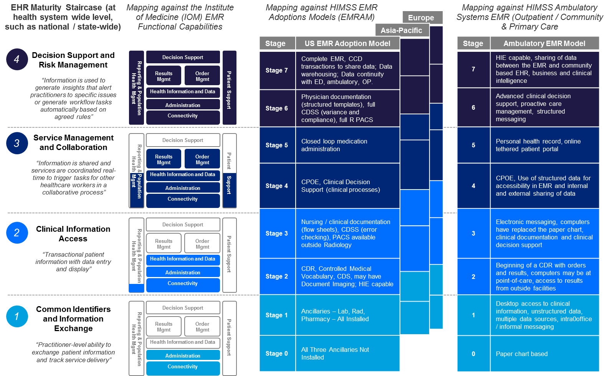

# Appendix F Case Studies

**British Columbia**

|  |  |
| --- | --- |
| Jurisdiction | Provincial |
| Population Size | 4.631 million |
| Model | eHealth initiatives / EMRs aligned to national *Infoway* programme |
| HIMSS Maturity | N/A |
| Funding | Publicly-funded healthcare |
| Benefits | Improved medical management, improved workforce productivity, better clinical outcomes |
| Cost | N/A |

In British Columba, eHealth initiatives have been developed and implemented to work towards a comprehensive electronic patient record for healthcare. British Columbia’s Ministry of Health commenced their programme of eHealth initiatives from 2005[70] to build capability and align to the federal *Canada Health Infoway* digital health programme. The Canada *Health Infoway* programme is a federal-led, provincially-delivered programme for electronic health records.[71] Its goal is to develop a network of effective interoperable EMR solutions across Canada

In April 2007, the Ministry commissioned the development of two major eHealth projects – the PLIS (Provincial Laboratory Information Solution) system and the iEHR (Interoperable Electronic Health Record) system.

Benefits from the initiatives include:

* A Picture Archiving Communication System (PACS) for capturing and transmitting exam images electronically improved the efficiency of clinical decision-making by 30 to 90 minutes per week, resulting in the equivalent of 84 new full time physicians or an additional 1.2million physician consults per year.[72] Recent British Columbia stakeholder interviews report a 10-20% reduction in exam duplication, far greater than the 2-3% national estimate.[73]
* PharmaNet, a centralised database for dispensing pharmaceuticals which has resulted in productivity gains for pharmacists and pharmacist technicians of 9.1% and 7.8% respectively.[74] PharmaNet metrics reveal that pharmacists were alerted to more than 40 million drug interactions that could lead to an Adverse Drug Event – 500,000 of these drug interactions were Level 1 Severity (clearly contraindicated in all cases).[75]

Productivity benefits include:

* Technologists reported a productivity increase 34% above that of national standards and 48% above that of the local control site.[76]
* Radiologists improved reporting and consultation efficiency by 27%, on average.[77]
* Estimates of a 10% to 20% reduction in exam duplication were reported, far greater than the 2-3% national estimate.[78]
* The new system enabled pharmacist and pharmacist assistant and technician productivity improvements valued at $66.7 million annually. The estimated increase in pharmacist capacity was the equivalent of 476 fulltime pharmacists.[79]

System-level benefits include[80]:

* Faster delivered, reliable, accurate and consistent information.
* Increased efficiency and reform through better information availability.
* Health services planned, managed and delivered in concert with patient needs.
* Savings through duplication elimination and health care directed at patient needs.
* Sustainable health care delivery by extending specialist services and skills.

Denmark:

|  |  |
| --- | --- |
| Jurisdiction | National |
| Population Size | 5.4 million |
| Model | Network of (hospital) EMRs with single national portal) |
| HIMSS Maturity | All five healthcare regions at Stage 5 HIMSS Maturity |
| Funding | Publicly-funded healthcare via national and regional health authorities |
| Benefits | Improved workforce productivity, better patient management, reduced hospital treatment times |
| Cost | N/A (due to a continuous eHealth investment programme) |

In Denmark, the national government consolidated a number of eHealth initiatives into the *National Strategy for Digitalisation in the Health Sector 2009-2012*. This strategy was designed to facilitate the adaption of EMRs within hospitals across Denmark. This strategy aimed to improve:[81]

* Digitalisation, as a tool for the employee to create quality and productivity;
* Better service and inclusion of citizens and patients;
* Stronger cooperation to create digital connectivity.

Denmark’s hospitals have an advanced network of EMRs across 43 hospitals in five healthcare regions.[82] The EMRs support clinicians with a high degree of functionality to capture and evaluate clinically relevant data into an electronic repository. Examples of the functionality include Computerised Physician Order Entry Systems (CPOE), electronic prescribing and primary care notification.[83] All EMR clinical systems are attributed at Level 5 HIMSS maturity, with acknowledgement that due to strong analytics and IT governance, there is capability to advance to Level 6/7 HIMSS maturity.[84]

The network of EMRs supports the national eHealth portal Sundhed, which enables patients and healthcare professionals to find information and communicate. Sundhed captures information from hospitals and GPs across Denmark to ensure that doctors and GPs have access to patient information in any hospital or clinic. It provides an overview with a range of information such as prescription history, laboratory test results, and data on allergies and adverse reactions.[85] Danish citizens also have access to their records on a read-only basis based on information supplied by EMRs in regions.[86]

Workforce productivity benefits include:

* In primary care, nearly all (98 per cent) use the full clinical functionality of CPOE systems;[87]
* 90 of all communication in primary care is sent as an electronic data interchange;[88]
* 92% of hospital capture and evaluate system usage statistics to influence behaviour and system enhancements, with 71% capturing medication safety statistics;
* 96% of hospitals are entering approximately 90% of their orders electronically through CPOE processes;
* 100% of hospitals indicate that their imaging departments are fully automated;
* 92% of hospital capture and evaluate system usage statistics to influence behaviour and system enhancements, with 71% capturing medication safety statistics;
* 96% of hospitals are entering approximately 90% of their orders electronically through CPOE processes;
* 100% of hospitals indicate that their imaging departments are fully automated.

Example of patient-level benefits:

* At Odense University Hospital, their investments have resulted in bringing down the time patients with chronic diseases spend in hospital to an average of 2.9 days per patient (compared to the European average of approximately seven days). Readmission rates for chronic disease patients are also down by more than 50%. [89]

Kaiser Permanente:

|  |  |
| --- | --- |
| Jurisdiction | Private healthcare provider |
| Population Size | Approx. 9 million subscribers |
| Model | Single vendor (Monolithic) EHR across different care settings |
| HIMSS Maturity | Stage 6 |
| Funding | Largely privately funded by patients |
| Benefits | Improved patient management, enhanced information sharing |
| Cost | Approximately USD$4billion[90] |

Kaiser Permanente is one of the largest integrated healthcare delivery organisations in the United States, supporting more than 9 million members across the United States. Their healthcare offerings encompass many care services, including hospital and medical care, primary care, pharmacy, laboratory, radiology and preventative care services.[91]

***“We wanted to pick a product so it didn’t matter where the patient was – inpatient, imaging, pharmacy – they received the same quality of care”[92]***

In 2002, Kaiser Permanente launched KP HealthConnect – a fully-integrated, single organisation-wide EHR system. Central to the HealthConnect vision was the notion that all clinical teams and users united around the common goal for patient-centred care, recognising the home as the hub of healthcare. Kaiser chose to implement one vendor across all of their major healthcare settings, including inpatient, outpatient, community, diagnostic support services, pharmacy and primary care – one of the most advanced forms of system rationalisation and process harmonisation. From the organisation’s perspective, it was important to have a vendor platform that “did all the integration for us” to eliminate the effect disparate IT systems were having on the organisation.[93]

*Kaiser Permanente’s* vision of high-quality care enabled clinical leaders to unite practitioners, staff and users around a common purpose. The *Blue Sky Vision* gave leaders the ability to clearly articulate what healthcare would look like in the future, and then drive practitioners and staff to define how to streamline clinical processes to achieve the eHealth vision. In implementation, doctors, nurses and clinical experts worked with business leaders and experts for months to figure out what systems were needed to support the new goals for assisting patients with healthcare.[94]

Patient care benefits from KP HealthConnect include (but are not limited to):

* 30% increase in colon cancer screenings;
* 11% increase in breast screening;
* 13% improvement in cholesterol management through enhanced EHR capability.[95]
* 76% reduction in all-cause mortality;
* 73% reduction in cardiac mortality;[96]
* Inpatient mortality reduced 8 to 10 percent per year over a four year period, peaking in the 12 month period over the winter of 2009-2010 when hospital standardized mortality ratio (HSMR) dropped 10.4% from the previous 12 months.[97]

Productivity and clinical outcomes benefits include:

* Annual emergency room visits declined 5.5 %;
* Annual hospitalisation declined 5.2 %;[98]
* Care teams in Colorado found approximately $30m in annualised cost savings.[99]

Wider benefits include:

* Improved medical data management;
* Improvements in process efficiency and reduced duplication;
* Improvements in patient satisfaction.

**Singapore**

|  |  |
| --- | --- |
| Jurisdiction | National |
| Population Size | 5.4 million |
| Model | Multiple vendor EMRs feed into national EHR[100] |
| HIMSS Maturity | Supported by a high number of hospital EMR at Stage 6 HIMSS maturity |
| Funding | Majority publicly funded |
| Benefits | Improved interoperability, better medical management |
| Cost | S$176 to launch Phase 1 of NEHR (Apr 2011)[101] |

Singapore’s *National Electronic Health Record (NEHR) is* the reflection of the Singaporean Government’s “One Singaporean, One Health Record” goal for its 5.1 million citizens. The NEHR is defined as the “longitudinal summary of healthcare profiles and a consolidated view of a patient’s current problems, medications and investigations”.[102] The NEHR is designed to meet the unique attributes of Singapore – a highly centralised population, frequent movement between regional health systems (RHS), and high levels of IT literacy.[103]

Singapore’s NEHR is supported via a hub-and-spoke model of a rationalised set of EMRs across primary and secondary healthcare settings. These interface with the central repository.[104] Secondary hospitals are supported by a small number of vendors and feed into the national EHR “hub”. At the same time community hospitals and GP practices have developed their capability of feeding into the national EHR and some settings have adopted a single cloud-based system across all regions.[105] (E.g. aged care).

Singapore’s NEHR became with the formation of the National Health Informatics Strategy in 2008, which was supported by clinical advisory groups and taskforces to provide critical clinical perspectives into system design.[106] This was then supported by the creation of goal state architecture for a national EHR, accompanied by vendor selection and development through 2010. In 2011, implementation of the system and integration with legacy systems commenced – signalling the introduction of the NEHR in Singapore.

An independent report commissioned by the Singapore Ministry of Health at the beginning of the NEHR programme quantified that approximately 65% of ongoing benefits are a result of better medication management and quality and performance management.[107]

Other benefits include:

* Greater coordination and informed decision-making;
* Improved interoperability and integration of information;
* Enhanced medical management capability;
* Reductions in medical errors and duplication.

# Appendix G Stakeholder Quotes

***"A decade ago, Denmark & NZ led the world – now NZ is behind due to the piecemeal approach”***

Business leader in the NZ Health IT industry. June 2015

"I have only a fraction of the management information available, that I would routinely have at my fingertips in the NHS – particularly with regard to population health and risk”

DHB CEO. June 2015

“We (New Zealand) are really good at creating innovation… but really bad at spreading it around”

Senior Management at a large DHB, June 2015

“We need a bit more of Thou Shalt Do”

Senior Management at a large DHB, June 2015

“We have absolute government support with an “it will be done” attitude. They brought in the right people, created a risk-tolerant environment and presented no big obstacles”

Singaporean Director of Solutions and Architecture

“If you were to draw a picture of a health ecosystem… you would see that hospitals no longer want to be integrators… This is why hospitals all over the world are moving to single vendor systems”

Business leader in the NZ Health IT industry. June 2015

“Already well past the point of doctors being able to ingest the amount of data”

Business leader in the NZ Health IT industry. June 2015

“A Kaiser-type solution (EPIC) will not work…. because Kaiser owns the primary care clinics etc…Interoperability is the only answer that is achievable”

DHB CEO. June 2015

“Their (NHITB) job is to create the road and the signage… but not to tell us what car to drive”

DHB CEO. June 2015

“Big bet putting millions into one system … would be inherently dangerous to do in a volatile environment”

DHB CEO. June 2015

“(We) need to have clear clinical leadership and governance to take any projects forward”

Senior Management at a large DHB. June 2015

“National Health IT Board needs to get more clinical people in there”

Senior Management at a large DHB. June 2015

# Appendix H Productivity & Quality of Care

*Unless otherwise specified, all currency in this section is in US$ PPP (Purchasing Power Parity). PPPs are the rates of currency conversion that eliminate the differences in price levels between countries. Using PPPs allows for a comparison of costs between countries.*

## Productivity

### Our hospitals are not as cost efficient as they could be

NZ healthcare expenditure per curative (acute) care bed-day is $4,754. The OECD average is $3,775.[108] This represents a premium of almost $1,000 per bed-day, or over 25%, when compared to the OECD average.

A bed-day (or inpatient day) is a day during which a person admitted as an inpatient is confined to a bed and in which the patient stays overnight in a hospital.[109]

The average curative care length of stay is 5.3 days, compared with the OECD average of 6.4 days. The average total inpatient care length of stay in New Zealand (across all hospitals) is 7.9 days. The OECD average is 8.3 days.[110]

It could be argued that New Zealand patients are ‘sicker’ when they get to a hospital, thereby potentially creating a higher cost. However given that our curative lengths of stay are shorter than the OECD average, this does not seem to be case.

NZ healthcare expenditure per inpatient discharge (per 100,000 population) is $23,831. The OECD average is $21,903.[111] This represents a premium of over $1,900 per discharge per 100,000 population, or 8.8%, when compared to the OECD average.

### Our healthcare labour costs is on par for primary care but higher in hospitals

*NZ general practitioner income is about the international average*

Average annual remuneration for salaried general practitioners in NZ is $102,458. The OECD average is $84,691.[112] This represents a premium of over $17,000 per annum, or over 20%, when compared to the OECD average.

The counter point to the above statistic is the average annual remuneration for self-employed general practitioners in NZ of $118,395, compared to the OECD average of $129,626.112 This represents a deficit of over $11,000, or almost -9%, when compared to the OECD average.

However, 55% of general practitioners in New Zealand are salaried – the remainder are self-employed.[113] When the remuneration averages are weighted based on employment status, the average GP remuneration in NZ is $109,630. The weighted OECD average becomes $104,911. This represents a premium of only $5,000 per annum, or over 4%, when compared to the OECD average.

*NZ specialists & hospital nurses are well remunerated and above OECD average*

Average annual remuneration for salaried specialists in NZ is $127,722. The OECD average is $106,141.[114] This represents a premium of over $21,000 per annum, or ~ 20%, when compared to the OECD average.

Average annual remuneration for salaried hospital nurses in NZ is $53,314. The OECD average is $45,315.[115] This represents a premium of about $8,000 per annum, or ~17%, when compared to the OECD average.

The labour cost differential in a hospital setting may partially explain our higher cost per average curative length of stay. This implies that productivity gains in a hospital setting would have demonstrable impact on New Zealand healthcare costs.

### Advanced EHRs / EMRs result in productivity gains

*Canada (British Columbia):*

A comprehensive EHR in British Columba has resulted in productivity benefits recorded across multiple areas.

Technologists reported a productivity increase 34% above that of national standards and 48% above that of the local control site.[116]

Radiologists improved reporting and consultation efficiency by 27%, on average.[117]

Estimates of a 10% to 20% reduction in exam duplication were reported, far greater than the 2-3% national estimate.[118]

The new system enabled pharmacist and pharmacist assistant and technician productivity improvements valued at $66.7 million annually. The estimated increase in pharmacist capacity was the equivalent of 476 fulltime pharmacists.[119]

*Denmark:*

All 24 hospitals in Denmark have an EMRAM score of Stage 5. As a country, Denmark has the highest average mean country score in Europe of 5.3.[120] Associated benefits with achieving Stage 5 include improved service efficiency, and improved productivity through workflow automation.

100% of hospitals indicate their imaging departments are fully automated. In addition, 90% of Denmark hospitals have a formal analytics programme, from which 100% can demonstrate organisation, clinical, and financial improvements.[121]

96% of Denmark hospitals are entering at least 90% of their orders electronically through computerized physician order entry processes.[122]

## Quality of Care

### NZ health indicators are mixed with regards to national health outcomes

Average life expectancy in New Zealand is 81.4 years, this compares favourably with the OECD average of 80.5 years.[123]. It should be noted that we lack many of the lifestyle hazards endemic in European countries and that our active focus on reducing smoking would be expected to drive good results.

The New Zealand infant mortality rate of 5.2 deaths per 1,000 live births compares unfavourably against the OECD average of 4.1.[124]

New Zealand mortality rates from ischemic heart disease sit at 148 deaths per 100,000 population, comparing unfavourably against the OECD average of 122.[125]

The national mortality rate from cancer of 220 deaths per 100,000 population is above the OECD average of 210.[126]

Avoidable hospital admissions in New Zealand for asthma, chronic obstructive pulmonary disease, and diabetes are all above the OECD average.[127]. This would indicate that we have further gains to make in primary care.

The New Zealand case-fatality rate in adults aged 45 and over within 30 days after admission for acute myocardial infarction (AMI) is 4.5 per 100 admissions, below the OECD average of 7.9.[128]. This would indicate that we handle these acute events well, when they happen.

### Countries with advanced EHRs have generally equal or better quality of care to NZ

*Canada:*

Life expectancy at birth in Canada is 81.5 years, virtually identical to NZ at 81.4 years.[129]

The infant mortality rate in Canada is 4.8 deaths per 1,000 live births, compared to the NZ rate of 5.2.[130]

The mortality rate from ischemic heart disease in Canada is 105 deaths per 100,000 population, compared to the NZ rate of 148.[131]

The mortality rate from cancer in Canada is215 deaths per 100,000 population, similar to the NZ rate of 220.[132]

Avoidable hospital admissions in Canada for asthma, chronic obstructive pulmonary disease, and diabetes are all below NZ levels.[133]. Their primary care appears to be more effective.

The Canadian case-fatality rate in adults aged 45 and over within 30 days after admission for AMI is 5.7 per 100 admissions, above the NZ rate of 4.5.[134].

*Denmark:*

Life expectancy at birth in Denmark is 80.4 years, lower than the life expectancy in NZ by 1 year.[135]

The infant mortality rate in Denmark is 3.5 deaths per 1,000 live births, lower than the NZ rate of 5.2.[136]

The mortality rate from ischemic heart disease in Denmark is 72 deaths per 100,000 population, far lower than the NZ rate of 148.[137]

The mortality rate from cancer in Denmark is245 deaths per 100,000 population, slightly higher than the NZ rate of 220.[138]

Avoidable hospital admissions in Denmark for asthma, chronic obstructive pulmonary disease, and diabetes are all below NZ levels.[139] Their primary care appears to be more effective.

The Danish case-fatality rate in adults aged 45 and over within 30 days after admission for AMI is 3.0 per 100 admissions, below the rate in NZ of 4.5.[140]. They appear to handle acute events even better in their hospitals.

|  |
| --- |
| Deloitte refers to one or more of Deloitte Touche Tohmatsu Limited, a UK private company limited by guarantee, and its network of member firms, each of which is a legally separate and independent entity. Please see www.deloitte.com/about for a detailed description of the legal structure of Deloitte Touche Tohmatsu Limited and its member firms.  Deloitte provides audit, tax, consulting, and financial advisory services to public and private clients spanning multiple industries. With a globally connected network of member firms in more than 150 countries and territories, Deloitte brings world-class capabilities and high-quality service to clients, delivering the insights they need to address their most complex business challenges. Deloitte’s more than 200,000 professionals are committed to becoming the standard of excellence.  Deloitte New Zealand brings together more than 1000 specialist professionals providing audit, tax, technology and systems, strategy and performance improvement, risk management, corporate finance, business recovery, forensic and accounting services. Our people are based in Auckland, Hamilton, Rotorua, Wellington, Christchurch and Dunedin, serving clients that range from New Zealand’s largest companies and public sector organisations to smaller businesses with ambition to grow. For more information about Deloitte in New Zealand, look to our website www.deloitte.co.nz  © 2015. For information, contact Deloitte Touche Tohmatsu Limited. |

1. HIMSS Definition of EHR http://www.himss.org/library/ehr/
2. World Health Organization Global Health Expenditure database (Accessed on 29 June 2015). Retrieved from http://data.worldbank.org/indicator/SH.XPD.TOTL.ZS/countries
3. Currency is Purchasing Power Parity international dollar. Sourced from World Health Organization Global Health Expenditure database (Accessed on 29 June 2015). Retrieved from http://apps.who.int/gho/data/node.country.country-NZL?lang=en
4. Briefing to the Incoming Minister of Health, The Treasury, October 2014
5. Alleviating the Burden of Chronic Conditions in New Zealand (The ABCC NZ Study): A Literature Review, 2011.
6. The New Zealand Sectors Report 2014. Ministry of Business, Innovation & Employment
7. March 2015 quarter. Household Labour Force Survey, Statistics NZ
8. Total Health and Social Employment, Density per 1000 population (head counts). OECD and CHSRF “Planning Human Resource in Healthcare” 2003
9. Includes ACC funding. Retrieved from Health Expenditure Trends in New Zealand 2009-2010, Ministry of Health
10. OECD (2014), "OECD Health Data: Health expenditure and financing: Health expenditure indicators", OECD Health Statistics (database)
11. Total Health and Social Employment, Density per 1000 population (head counts). OECD
12. National Health IT Plan Update 2013/2014, National Health IT Board
13. Clinical Messaging - the Electronic Lifeblood of the New Zealand & Australian Health Sectors. Healthlink
14. Ministry of Health Request for Quotation Review Report: Electronic Health Records (Monday 11 May 2015)
15. Deloitte analysis of Systems Landscape (October 2010 – April 2015), sourced from documents available at <https://healthitboard.health.govt.nz/our-programmes/regional-progress>, National Health IT Board
16. Note that minor funding is contributed by the NHITB Primary and Integrated Grants Fund ($11.4m) and is largely spent on feasibility studies, innovations, evaluations and development of national programmes. <https://healthitboard.health.govt.nz/system/files/documents/publications/national-health-it-plan-update-2013-14-nov13.pdf>
17. Page 26/27 of the National Health IT Plan Update 2013/14, National Health IT Board
18. Page 30 of the National Health IT Plan, September 2010, National Health IT Board
19. Global Health and Aging, 2011; National Institute on Aging
20. Preparing for the inevitable: Physician priorities in a value-based world: Perspectives from the Deloitte 2014 Survey of U.S. Physicians, Deloitte Center for Health Solutions, 2014, http://www2.deloitte.com/us/en/pages/life-sciences-and-health-care/articles/center-for-health-solutions-usphysicians-survey-health-information-technology.html.
21. Ibid
22. Deloitte Healthcare and Life Sciences Predictions 2020: A bold future?
23. McKinsey Global Institute Analysis ESG Research Report 2011 – North American Health Care Provider Market Size and Forecast
24. Gartner *British Columbia: eHealth Benefits Estimates* June 2013
25. Gartner *British Columbia: eHealth Benefits Estimates* June 2013
26. Gartner *British Columbia eHealth Benefits Estimation* *– Executive Overview* April 2013
27. Gartner *British Columbia: eHealth Benefits Estimates* June 2013
28. Connected Health: The Drive to Integrated Healthcare Delivery, Accenture. 2012
29. HIMSS Europe *Electronic Medical Record Adoption in Denmark* August 28 2014
30. The Advisory Board Company, HIMSS Analytics, Longwoods *EMR Benefits and Benefits Realisation Methods of Stage 6 and 7 Hospitals* February 2012.
31. King, Patel, Jamoom and Furukawa *Clinical Benefits of Electronic Health Record Use: National Findings* Health Services Research December 2013
32. Kaiser Permanente *Electronic Health Records Linked to Improved Care for Patients with Diabetes*. Retrieved from http://share.kaiserpermanente.org/article/electronic-health-records-linked-to-improved-care-for-patients-with-diabetes/#sthash.ISsjWTF1.dpuf
33. Gartner *British Columbia eHealth Benefits Estimation* *– Executive Overview* April 2013
34. Accenture Connected Health Global Report 2012
35. http://www.fda.gov/ola/2004/vioxx1118.html and Badgett R, Mulrow C. Using Information Technology to transfer knowledge: A medical institution steps up to the plate [editorial] Ann of Int Med 2005;142;220-221
36. Exscribe EHRs shown to improve patient safety and reduce medical errors September 2014. Retrieved from http://www.exscribe.com/orthopedic-e-news/meaningful-use/ehrs-shown-to-improve-patient-safety-and-reduce-medical-errors
37. Singapore HIT Case Study. Center for Health and Aging
38. Interview with senior management, Eastern Health, June 2015
39. Barriers to the Adoption and Use of an Electronic Medication Record, Roskilde University
40. Call with Andy Wiesenthal, Director, Deloitte USA (San Francisco) 30 May 2015.
41. Deloitte overview *Novant Health* 2014
42. Epic rollout complete at Novant clinics, Healthcare IT News. Retrieved from <http://www.healthcareitnews.com/news/epic-rollout-complete-novant-clinics>
43. Call with Chew Chiat Lee, Deloitte Public Sector Leader, SE Asia 22 June 2015,
44. For a visual reference, refer to HIMSS 12 *Lessons from Singapore: A Study in Electronic Health Records* February 23 2012
45. Catz, M., & Bayne, J. (2003). Canada Health Infoway – A pan-Canadian Approach. AMIA Annual Symposium Proceedings, 2003, 807.
46. Health Infoway Website. Retrieved from https://www.infoway-inforoute.ca/en/what-we-do/progress-in-canada/evidence-of-digital-health-adoption-and-benefits
47. HIMSS Analytics *Validated Stage 6-7 Hospitals Ambulatories 06 24 2015*
48. Ibid
49. Ibid
50. Kaiser Permanente Clinics Receive HIMSS Analytics Stage 7 Ambulatory Award January 22 2015. Retrieved from <http://share.kaiserpermanente.org/article/350-kaiser-permanente-clinics-receive-himss-analytics-stage-7-ambulatory-award/>
51. HIMSS Asia Pacific Case Studies. Retrieved from <http://www.himssanalyticsasia.org/emram/stage7caseStudySNUBH.asp>
52. HIMSS Analytics *HIMSS Analytics Stage 7 Case Study: Ontario Shores Centre for Mental Health Sciences* April 8 2015
53. Timmins N, Ham C. *The Quest for integrated health and social care: A case study in Canterbury, New Zealand* The King’s Fund 2013
54. Accenture *Connected Health Global Report* 2012
55. Deloitte *2012 Survey of US Health Care Consumers: The performance of the health care system and health care reform* and Deloitte *2010 Survey of Health Care Consumers in the United Kingdom: Behaviours, attitudes and unmet needs*
56. *National Co-ordinating Centre for NHS Service Delivery and Organisation (2006). Managing Change and Role Enactment in the Professionalised Organisation*
57. *McKinsey Quarterly (2008). A Healthier Healthcare System for the United Kingdom*
58. See appendix H for further details on quality and productivity measures
59. ‘ACC pays out $30m more for treatment injuries’. Retrieved from <http://www.stuff.co.nz/national/health/66026612/ACC-pays-out-30m-more-for-treatment-injuries>
60. Incidence, preventability, and impact of Adverse Drug Events (ADEs) and potential ADEs in hospitalized children in New Zealand: a prospective observational cohort study. Retrieved from <http://www.ncbi.nlm.nih.gov/pubmed/19301935>
61. Elizabeth Plant: Medication Safety Presentation: “How to save lives, save money and improve outcomes” at New Zealand Healthcare Summit, October 2014
62. Examples of high maturity benefits include improved efficiency of services, reduced error rates, improved patient care and risk management
63. Improving Health Sector Efficiency: The Role Of Information And Communication Technologies, OECD 2010
64. Deloitte: Connected Health: How Digital Technology is Transforming Health and Social Care
65. At Q2 2014, other country/region scores: Denmark: 5.3, US: 4.3, Canada: 2.0, Middle East: 3.1, Singapore: 5.7. Sourced from: Measurements and indicators for healthcare IT -- EMR Adoption Model Scores, Means per Segment. HIMSS (Q2, 2014)
66. Gartner *Longitudinal Electronic Health Record Systems should be Integral to Any Healthcare System* 2013
67. Engagement with Deloitte Canada 02/06/2015
68. Gartner *Longitudinal Electronic Health Record Systems should be Integral to Any Healthcare System* 2013
69. Accenture *Connected Health: Global Report* page 237
70. Provincial Laboratory Information Solution (PLIS) and Interoperable Electronic Health Record (iEHR) Project Summary August 2007
71. Catz, M., & Bayne, J. (2003). Canada Health Infoway – A pan-Canadian Approach. AMIA Annual Symposium Proceedings, 2003, 807.
72. Gartner *British Columbia: eHealth Benefits Estimates* June 2013
73. Gartner *British Columbia eHealth Benefits Estimation* *– Executive Overview* April 2013
74. Gartner *British Columbia: eHealth Benefits Estimates* June 2013
75. Gartner *British Columbia eHealth Benefits Estimation* *– Executive Overview* April 2013
76. British Columbia eHealth Benefits Estimates, Gartner, June 17th 2013
77. Ibid
78. Ibid
79. Ibid
80. Government of British Columbia Benefits of eHealth. Retrieved from http://www2.gov.bc.ca/gov/content/health/about-bc-s-health-care-system/ehealth/benefits-of-ehealth
81. Doupi, P; Renko, E; Giest, S; Dumortier, J *eHealth Strategies Country Brief: Denmark* October 2010
82. HIMSS Europe *Electronic Medical Record Adoption in Denmark* August 28, 2014, Accenture Connected Health Global Report 2012
83. Accenture Connected Health Global Report 2012
84. HIMSS Europe *Electronic Medical Record Adoption in Denmark* August 28, 2014
85. The Danish Government *Making eHealth Work: National Strategy for Digitalisation of the Danish Healthcare Sector 2013-2017*
86. MedCom - Danish National Health Network, Denmark. Retrieved from http://www.ncbi.nlm.nih.gov/pubmed/23920895
87. Accenture Connected Health Global Report 2012
88. Accenture Connected Health Global Report 2012
89. Accenture Connected Health Global Report 2012
90. The Commonwealth Fund *Kaiser Permanente: Bridging the Quality Divide with Integrated Practice, Group Accountability, and Health Information Technology* June 2009
91. The Commonwealth Fund *Kaiser Permanente: Bridging the Quality Divide with Integrated Practice, Group Accountability, and Health Information Technology* June 2009
92. Call with Andy Wiesenthal, Director, Deloitte USA (San Francisco) 30 May 2015.
93. Call with Andy Wiesenthal, Director, Deloitte USA (San Francisco) 30 May 2015.
94. Accenture Connected Health Global Report 2012
95. Accenture Connected Health Global Report 2012
96. What health systems can learn from Kaiser Permanente, Health International 2009 Number 8
97. Kaiser Permanente’s Transformation Journey, IHI International Forum – Qatar, May 2013
98. Kaiser Permanente *Electronic Health Records Linked to Improved Care for Patients with Diabetes*. Retrieved from http://share.kaiserpermanente.org/article/electronic-health-records-linked-to-improved-care-for-patients-with-diabetes/#sthash.ISsjWTF1.dpuf
99. Kaiser Permanente: Bridging the Quality Divide with Integrated Practice, Group Accountability, and Health Information Technology, The Commonwealth Fund, June 2009.
100. HIMSS Asia Pacific “Singapore hospitals win EMRAM awards from HIMSS Analytics” June 2011. Retrieved from http://www.himssanalyticsasia.org/about/pressroom-pressrelease3.asp
101. Accenture Connected Health Global Report 2012
102. Accenture Connected Health Global Report 2012
103. Call with Chew Chiat Lee, Deloitte Public Sector Leader, SE Asia 22 June 2015,
104. Call with Chew Chiat Lee, Deloitte Public Sector Leader, SE Asia 22 June 2015,
105. For a visual reference, refer to HIMSS 12 *Lessons from Singapore: A Study in Electronic Health Records* February 23 2012
106. HIMSS *Singapore’s National Electronic Health Record (NEHR) The Journey to 2012 and Beyond*
107. HIMSS *Singapore’s National Electronic Health Record (NEHR) The Journey to 2012 and Beyond*
108. Deloitte analysis based on 2013/14 data from the OECD Dataset: Health expenditure and financing, retrieved from <http://stats.oecd.org/OECDStat_Metadata/ShowMetadata.ashx?Dataset=SHA> on 9th July 2015
109. OECD Health Statistics 2015 Definitions, Sources and Methods, retrieved from <http://stats.oecd.org/wbos/fileview2.aspx?IDFile=ca8d522d-31ed-40b5-a147-4bc5eda1c97d> on 9th July 2015
110. Deloitte analysis based on 2013/14 data from the OECD Dataset: Health expenditure and financing, retrieved from <http://stats.oecd.org/OECDStat_Metadata/ShowMetadata.ashx?Dataset=SHA> on 9th July 2015
111. Ibid
112. OECD Health data 2014, OECD Dataset: Health Care Resources, retrieved from <http://stats.oecd.org/OECDStat_Metadata/ShowMetadata.ashx?Dataset=HEALTH_REAC> on 9th July 2015
113. 2014 RNZCGP Workforce Survey, The Royal New Zealand College of General Practitioners
114. OECD Health data 2014, OECD Dataset: Health Care Resources, retrieved from <http://stats.oecd.org/OECDStat_Metadata/ShowMetadata.ashx?Dataset=HEALTH_REAC> on 9th July 2015
115. Ibid
116. British Columbia eHealth Benefits Estimates, Gartner, June 17th 2013
117. Ibid
118. Ibid
119. Ibid
120. Electronic Medical Record Adoption in Denmark, HIMSS Europe, August 28th 2014
121. Ibid
122. Ibid
123. OECD Health Statistics 2015, retrieved from <http://stats.oecd.org/Index.aspx?DataSetCode=HEALTH_STAT> on 9th July 2015
124. Ibid
125. Health at a Glance 2013 – OECD Indicators. OECD
126. Ibid
127. Ibid
128. Ibid
129. OECD Health Statistics 2015, retrieved from <http://stats.oecd.org/Index.aspx?DataSetCode=HEALTH_STAT> on 9th July 2015
130. Ibid
131. Health at a Glance 2013 – OECD Indicators. OECD
132. Ibid
133. Ibid
134. Ibid
135. OECD Health Statistics 2015, retrieved from <http://stats.oecd.org/Index.aspx?DataSetCode=HEALTH_STAT> on 9th July 2015
136. Ibid
137. Health at a Glance 2013 – OECD Indicators. OECD
138. Ibid
139. Ibid
140. Ibid