Independent Review of COVID‑19 Clusters in Aged Residential Care Facilities

29 May 2020

#### Review panel members

**Tanya Jackways**, Infection Prevention and Control Practitioner

**Riana Manuel**, Chair, Te Apārangi and Manukura Hauora CEO, Te Korowai Hauora o Hauraki

**Dr Phil Wood**, Geriatrician, Waitemata DHB and Chief Advisor, Healthy Aging, Ministry of Health

**Dr Peter Moodie**, General Practitioner

**Dr John Holmes**, Public Health Physician and Honorary Clinical Senior Lecturer, Department of Preventative and Social Medicine, University of Otago

**Dr Frances Hughes**, Chair, Nurses Leadership Group, New Zealand Aged Care Association and General Manager, Oceania Health Care

# Acknowledgements

“This is not BAU, this is something ARC has to deal with. ARC has learned some lessons and forged more positive relationships with agencies … We have done a pretty good job: 1% of ARC were affected, overseas 30% or more. We should pat ourselves on our back. We have protected our residents under most difficult circumstances. It has been a journey that I’m sure each and every one of us will take something from.”

Anonymous, ARC Facility

The panel would like to acknowledge the small number of ARC facilities involved in this review as well as the generosity of staff who gave their time for further discussion.

The panel would like to thank E Tū and the New Zealand Nurses Organisation for extending the panel’s opportunity to interview additional nurses and caregivers.

The panel would also like to thank ESR for providing additional data to give a clearer description of the COVID‑19 ARC clusters.

Contents

Acknowledgements ii

Glossary iv

Executive Summary 1

Context and Purpose 1

Methodology and Sampling 1

Findings 2

Summary of Key Recommendations 3

Highly Recommended 3

Introduction 4

Background and Context to the Review 4

COVID‑19 Clusters in ARC 4

Methods 5

Limitations 5

Findings 6

Preparedness 6

IPC Policy and Procedures 6

PPE Stock 7

Previous Experience with Outbreaks 7

Ability to Isolate 7

Lockdown and COVID‑19 7

Psychosocial Environment of COVID‑19 Alert Level 4 for ARC Sector 9

ARC Provider Internal Relationships 9

Communication Channels and Relationships with External Agencies 12

Recommendations 14

Highly recommended 14

Recommended 15

Appendix A: COVID‑19 ARC Clusters in Aotearoa New Zealand 17

Appendix B: Overseas Experiences 22

# Glossary

|  |  |
| --- | --- |
| Alert Level 4 | The highest level of alert of New Zealand’s COVID‑19 four-level alert system |
| ARC | Aged Residential Care |
| ARRC agreement | Age-Related Residential Care agreement |
| Bubble | This term was used by the NZ Government to communicate the social distancing requirements of Alert Level 4. A bubble in an ARC setting is made up of all the people in the ARC facility at lockdown. This includes ARC staff and residents. |
| CDC | Centers for Disease Control and Prevention |
| COVID‑19 | Coronavirus infection 2019. For the purposes of consistency with wider NZ Government communications, this term is used to also mean SARS-CoV-2 where applicable. |
| Clusters | Defines a facility where there are 10 or more confirmed cases of COVID‑19. |
| DHB | District Health Board |
| ESR | Institute of Environmental Science and Research Te Whare Manaaki Tangata, Taiao hoki |
| GP | General Practitioner |
| HCA | Health Care Assistant |
| HCP | Health Care Personnel |
| ID | Infectious Diseases |
| IMT | Incident Management Team |
| InterRAI | International Resident Assessment Instrument |
| IPC | Infection Prevention and Control |
| Lockdown | Refers to the period of time when New Zealand was at Alert Level 4. This required ARC facilities to severely restrict and monitor the visitors, services, admissions and staff movements. |
| the Ministry | The Ministry of Health |
| NRHCC | Northern Region Coordination Centre |
| NZ | New Zealand |
| NZACA  Outbreak | New Zealand Aged Care Association  Defines a facility where there are two or more confirmed cases |
| PHO | Primary Health Organisation |
| PHU | Public Health Unit |
| PPE | Personal Protective Equipment |
| SARS-CoV-2 | The virus causing SARS-COV-2 |
| Whānau | Family or family-of-choice of an ARC resident |
| WHO | World Health Organisation |

# Executive Summary

## Context and Purpose

The COVID‑19 pandemic is a unique and unprecedented event in Aotearoa New Zealand. A huge amount of rapidly changing information and advice filtered through to the public and health sector via both formal and informal channels. Variation in opinions between ‘experts’ was highly newsworthy. International experience noted that many of the deaths attributable to COVID‑19 were older residents with multiple comorbidities, and many lived in long term care facilities. In Aotearoa New Zealand, the ARC sector consists of over 650 providers, and over 38,000 beds. This sector became very vigilant and naturally concerned about the potential impact. Much of the early clinical and pandemic planning by DHBs focused on hospital/secondary care management. Early on in Aotearoa New Zealand’s COVID‑19 response, a difference in perspective between the ARC sector and the hospital care health system became apparent. This difference was highlighted by the ARC sector wanting a negative COVID‑19 test prior to admission, in addition to the Ministry’s requirement that all admissions be placed in 14-day isolation.

Following the classification of five clusters of COVID‑19 in ARC facilities, the Director-General of Health, Dr Ashley Bloomfield, commissioned this review to quickly learn what was effective and what needs to be improved in order to avoid or better manage any similar events in the future. All the initial infections came from outside the facilities and two were associated with overseas travel. The ESR data shows three out of five facilities had staff cases first.

## Methodology and Sampling

The sample included five facilities known to have clusters of COVID‑19, an ARC facility with a contained single case of COVID‑19 and an equal number of comparable facilities (balanced for size, management, and location) without an outbreak. One ARC facility had predominantly Māori residents. Included ARC facilities were informed of the review and permission sought for interview with the panel. All interviews followed a semi-structured questionnaire and were done via Zoom video conferencing. Paired members of the panel usually met with individual staff of the facility, occasionally small groups or pairs of senior management, registered nurses, residential care assistants and senior corporate staff. A total of 12 facilities were involved. Interviews were also conducted with key staff members of the PHUs and DHBs associated with the major clusters. Limitations are noted in the Introduction section of the full report.

## Findings

Few facilities had fully comprehended the impact a probable case would have on their facility, or the impact of one member of staff becoming symptomatic with COVID‑19 (and test positive). The most notable adverse impact of a staff member’s positive test was the stand down of a high proportion of the ARC facility’s staff, and the limited prospects of backfilling these. All facilities which experienced a COVID‑19 outbreak, and more notably those with a cluster, reported a number of staff who suffered considerable stress. This stress was attributed partly to the extra vigilance and longer working hours, and partly due to considerable external pressures from community misinformation, isolation from their families, and having their accommodation threatened by fearful landlords or housemates. This was accentuated by adverse social and conventional media reporting. In addition, while some ARC staff reported COVID‑19 swab testing processes of staff was very thorough and well-managed, others reported they were left in an uncertain state: feeling pressure to decide either to continue to work or to have no contact with family. News of “silent spreaders” occupied their thoughts. A number of ARC providers reported they felt they were under pressure from all sides. Those that experienced a COVID‑19 outbreak, cited concerns for their reputation and their standing in the community. Whether they had one case or many they were all “tarred with the same brush”, which highlighted the stigmatisation of the disease and pandemic anxieties.

Amongst the difficulties reported, some ARC management and staff conveyed an increased level of camaraderie and pride at work. Staff turnover dropped during the four weeks of lockdown, as did sickness and absenteeism. ARC providers said they increased wellness initiatives for their staff, recognising the effects of the pandemic on their workload and wellbeing. In some instances, this extended to financial compensation.

Communications and resources provided to ARC providers and management were at times confusing and not always clear or consistent. Some noted a lack of available PPE leading into the pandemic contributed to an inability to practice wearing PPE in some facilities. Relationships with the local DHB infection prevention and control staff were variable. Concepts such as outbreaks, clusters, probable versus proven cases, and other epidemiological terminology, are not part of ARC provider day-to-day discourse and there needed to be better socialisation of the information. The panel found the perspectives of ARC providers and various “expert opinions” became divided. ARC facilities who experienced a COVID‑19 cluster reported they felt there was a “takeover” by PHUs and/or DHB IPC experts who had little understanding of the work required in an ARC setting. In contrast, interviewed PHU staff said they were focused on supporting ARC facilities they understood to be overwhelmed by the public health requirements to contain the spread of COVID‑19.

ARC providers and staff interviewed reported they had up-to-date IPC documentation and procedures that they had adapted for the COVID‑19 pandemic. Refresher training on hand hygiene and PPE use was undertaken. Many ARC facilities elected to encourage surgical masks be worn even if that was not required or advised by the Ministry. Several interviewees felt this was associated with minimising transmission for their ARC facility.

The effect on ARC resident’s whānau/family was noted by staff, especially just prior and in the early stages of lockdown. Prior to lockdown, several ARC facilities reported a spike in visiting whānau/family, which contributed to their decision to go into lockdown sooner than the official advice. Virtual visits using platforms such as Zoom and WhatsApp were commonplace. Visiting a resident receiving palliative care was managed on a case-by-case basis in some imaginative ways. Complaints and criticism were not common and attempts to explain and find alternatives were generally successful.

## Summary of Key Recommendations

The panel has the recommendations in two gradings: highly recommended and recommended. The recommendations included in the executive summary are those graded “highly recommended”, and have been prioritised in order of importance below. Greater detail is included in the Recommendations section of this report.

### Highly Recommended

* + - 1. Acknowledgement by the Ministry of the substantive work done by the ARC sector to prevent and manage the COVID‑19 cluster outbreaks.
      2. ARC, DHB, and PHU to develop a national outbreak management policy with leadership roles, reporting processes and communication channels, and including policy on, IPC strategies, case recognition, staff and resident management and support, supply and use of PPE, testing, screening, isolation, lockdown, and resident transfers and admissions.
      3. The development of protocols for the rapid formation of a regional ARC IMT, which includes representation and decision-making capability from both the ARC sector, PHU, DHB and relevant specialist units, and the training and practise scenarios that are undertaken to sustain this capacity on agreed occasions.
      4. Identify and provide psychosocial support for staff wellbeing during a stand down and in the period after, taking into account the unique circumstances of the individual including accommodation, whānau/family, and community.
      5. Identify and provide psychosocial support for residents’ wellbeing during and after outbreaks including alternatives to visitation during lockdown, taking into account the unique circumstances and identity of the resident.
      6. Review IPC standards and develop a national IPC strategy as it relates to the ARC sector. This should then be applied regionally and locally. This should be done with a working group consisting of representatives from the ARC sector, DHBs, and the Ministry.
      7. That protocols clarify case recognition to identify infections early and the place of surveillance during a pandemic in high risk environments.
      8. A pandemic management workbook relevant to the ARC sector is developed through collaboration between the ARC sector, PHUs, DHBs, IPC, and the Ministry.
      9. Further consideration be given to the reputational consequences for ARC facilities and stigmatisation of ARC staff, for example reconsider method for naming outbreaks.
      10. Reporting requirement to PHUs, DHBs, and others need simplification and streamlining including appropriate software, spreadsheets, and documentation to improve this.

# Introduction

## Background and Context to the Review

The COVID‑19 pandemic is a unique and unprecedented event in Aotearoa New Zealand. A huge amount of rapidly changing information and advice filtered through to the public and health sector via both formal and informal channels. Almost all deaths attributable to COVID‑19 were ARC residents.

Aotearoa New Zealand has (at the time of writing this report) five significant COVID‑19 clusters in ARC facilities; two in Christchurch, two in Auckland, and one in Waikato. ARC residents are particularly vulnerable to the complications of COVID‑19 infections.

The Ministry has prioritised action in this sector and worked closely with DHBs and the NZACA since early in the evolution of the COVID‑19 pandemic. NZACA represents over 90% of ARC providers and during this time they provided detailed proactive advice to their members, some of which were experiencing COVID‑19 clusters.

Three other reviews of ARC facilities are being completed in response to the COVID‑19 pandemic:

* + - 1. DHB Readiness Assessments: at the start of April, Director-General of Health, Dr Ashley Bloomfield, asked DHBs to systematically assess the readiness of ARC providers in their area and to provide support and assistance as necessary. DHBs looked at each ARC facility’s IPC policies and practices to ensure the safety and wellbeing of residents. This included an assessment of PPE stocks and supply.
      2. Chief Ombudsman inspection of secure ARC facilities in response to the COVID‑19 pandemic. using The Optional Protocol to the Convention against Torture to inform the inspection. The goal of the Ombudsman inspection is to provide an independent assessment of how the sector is responding to COVID‑19, including a specific focus on standards of care for those in locked facilities such as dementia care units and psychogeriatric facilities.
      3. The Auditor-General is undertaking an independent review for the public and Parliament of the Ministry’s management of PPE required for the COVID‑19 response.

Early overseas reports identified aged and frail individuals and long-term care facilities as high-risk groups. These reports highlighted other risk areas which included health care workers who worked when unwell and across multiple facilities (See Appendix B: Overseas Experiences and Table 1 in Appendix A: COVID‑19 Cases in Aotearoa New Zealand).

## COVID‑19 Clusters in ARC

In the five clusters, all the initial infections came from outside the facilities and two were associated with overseas travel. The ESR data (figures 1-5 in appendix A) shows three out of five facility’s had staff cases first. In some cases, recognition of an outbreak was relatively delayed which accelerated internal facility transmission.

* Onset dates ranged from 11 March 2020 through to 28 March 2020 with further outbreak reports ranging from 24 March 2020 through to 10 April 2020 and associated secondary cases have continued to present through to mid-May 2020.
* The clusters reflected the peak period of incidence throughout New Zealand.
* The definition of a cluster meant that it could include both residents/staff but also outside contacts. A total of 39 cases occurred in residents out of a total of 428 “beds”, with cluster size totalling 153.
* The most common vector of COVID‑19 to facilities was a staff member, although in one case the source has not been formally identified.

For details of the COVID‑19 disease and the SARS-CoV-2 virus refer to Appendix A: COVID‑19 Cases in Aotearoa New Zealand.

## Methods

In keeping with the terms of reference,[1] the sample included the five ARC facilities with COVID‑19 clusters, one ARC facility with a single case of COVID‑19, and six comparable facilities with no clusters (balanced for size, management, location). One of these facilities had predominantly Māori residents. Those on the contact list were informed of the review, and permission sought for interviews. A total of 12 facilities were involved. Interviews were also conducted with key staff members of PHUs and DHBs associated with the major clusters.

A semi-structured questionnaire was designed and used as a basis for conducting the interviews, each of which was done by video conferencing and varied in duration from 30 minutes to two hours. Each of the ARC facilities were encouraged to include staff (nursing, caregivers and support) and management in the interview process. Where possible, staff were interviewed separately from management. The panel further requested whether there would be any residents who would be available for a conversation. This offer was not taken up by any residents and is an acknowledged limitation of this report. The panel worked in pairs to conduct the interviews which were then collated into this final report.

The interviews were designed to be qualitative and sought to understand what happened during the COVID‑19 pandemic. Multiple interviews occurred within facility clusters with staff to validate findings.

## Limitations

The panel acknowledges the limitations of this review. Due to the travel restrictions of Alert Level 4 and Alert Level 3, the panel was unable to visit the ARC facilities included in this review. Whilst ARC staff and residents were provided with the opportunity to meet with the panel, the virtual nature of the review may have been a key barrier. The review panel did not interview residents or whānau/family who may have offered additional perspective. Whilst some ARC staff were interviewed, it is possible some residents and more staff would have been available for a conversation if panel members were on site.

# Findings

## Preparedness

During February and March 2020 New Zealand’s preparation for COVID‑19 focused mainly on hospital/secondary care management and the sector working on pandemic planning. The potential impact on the community and ARC sector was increasingly realised through March and April 2020; the DHB Readiness Assessments were carried out during this interval.

Whilst the review panel did not critically examine contracts, standards and pandemic plans, it was noted that alignment of these crucial agreements and process in relation to managing pandemic response was lacking. Inconsistencies between the ARRC service agreement,[2] expectations of PHU, and DHB pandemic response were noted.

### IPC Policy and Procedures

All ARC providers interviewed reported up to date and compliant infection control policies in place which were reviewed annually. While all anticipated the impact of a pandemic in general, no facilities were prepared for the impact of a positive case, let alone an outbreak/cluster. ARC facilities which were part of larger organisations had detailed pandemic plans developed prior to the Aotearoa New Zealand outbreaks.

Few ARC facilities or DHBs had ever coped with a large scale stand down of staff, as was the case for ARC facilities with clusters. Clear continuity planning for staff backfilling was limited to reduction in 20%, 40% or 50% of staff, but did not require continuity planning for up to 100% staff reduction of staff and was not stress tested. The impact on ARC residents being looked after by backfilled staff, unfamiliar to both the functioning of ARC and their individual residents, was considered by interviewees but felt a lack of involvement in the decision making process meant no reasonable alternatives were further identified.

Senior ARC staff said that they had a very good understanding of infection control and so were able to implement the plans quickly. All ARC facilities had an IPC Lead on-site. This person generally had good links to the IPC team within DHBs and were able to discuss their policies and plans as required.

*“We worked together, non-stop, in PPE. We worked out it was 64 shifts in a row with PPE.”*

ARC staff

Subsequently, it was found that the ARC facility’s preparedness, in terms of policy and procedures, did consider the magnitude of the events that could occur due to COVID‑19. However, the extent of the impact COVID‑19 had on ARC facilities far exceeded the expectation of all ARC providers, even with plans in place.

### PPE Stock

Most ARC providers had a two-week minimum supply of PPE in advance of the lockdown. Most ARC providers had access to PPE through the DHB, although there was initially some difficulty obtaining stocks from them. While all ARC providers insisted on minimum standards, most allowed staff to wear the PPE gear which made them feel safe. Clarity around why this view was held or who was being protected was unclear. The panel is of the opinion there may be a misperception that PPE was equivalent to IPC.

Through March 2020 to early April 2020, provision of PPE stocks in many ARC facilities would not have been sufficient for an outbreak, and many facilities were reliant on their regular supply of PPE, most notably masks and facial shields/goggles. These supplies were obtained from a variety of sources including commercial suppliers, DHBs, and sometimes from other ARC providers. Access to sufficient supplies was challenging. This improved following the development of a national supply chain and improved central purchasing arrangements.

### Previous Experience with Outbreaks

Most ARC providers had previous experience with outbreaks of norovirus, influenza, and/or measles. During these outbreaks, the facilities would go into lockdown. Several ARC providers noted that it was their first experience of one of a virus outbreak which prompted a review of IPC policies, best practice, and PPE supply.

A poignant quote provided to the ARC management by the whānau/family of an ARC resident who passed away during lockdown was *“our loved one died of loneliness.”*

RESIDENTS AND WHĀNAU/FAMILY

### Ability to Isolate

All interviewed ARC facilities had the ability to isolate people if required in rooms or bubbles. In some cases, isolation zones were prepared before any cases were reported, based on independent access and infrastructure. The practicality of establishing areas for isolation was linked to the age of the building. Some providers acknowledged that should an outbreak occur they could have only done what was possible. Dementia areas were particularly challenging as residents within a dementia unit are treated as one isolation bubble. Some ARC facilities reported that DHBs were inconsistent in their understanding of the challenges of applying isolation in these environments.

### Lockdown and COVID‑19

As the pandemic unfolded, all interviewed ARC providers developed detailed plans involving possible isolation of infected patients, and commenced additional staff training activities. Those facilities belonging to larger corporate organisations reported they were able to draw on their national and trans-Tasman experience and expertise.

Most ARCs instituted lockdown procedures before this was officially mandated. One ARC provider who experienced a COVID‑19 cluster waited until the official lockdown and explained they were hesitant to “jump the gun” and go against the advice of their local DHB. This was something that they regretted later.

The ARC providers and their staff felt significantly more secure in lockdown and most wished they had locked down sooner than they did.

Following lockdown, one ARC facility described how they worked from the “outside to the inside” in cleaning their facility. They first ensured the facility’s physical perimeters were cleaned and then progressively moved the cleaning process into the building. This facility highlighted that contamination came from the without, rather than from within. This provider believes this was an essential measure to contain the spread.

#### Staff

ARC providers reported they proactively worked with their staff to monitor their health status, including temperature checks, declaration of health status and PPE checks at the start of shifts. ARC providers developed resources to increase staff awareness of IPC protocol, transmission risks, and appropriate use of PPE. ARC staff interviewed separately confirmed there was an increase in and reported they were motivated to learn what would help keep the ARC residents safe.

Some ARC providers provided online training for Alert Levels 3 and 4, which included reading material. For some essential training, staff were expected to confirm they had received, read and understood the training via an emailed response. These were sent to personal emails. ARC staff were able to do this if they had time while rostered, however, otherwise this was on their own time so not necessarily paid.

#### Residents

ARC management and staff had conversations with residents to explain the ongoing pandemic, the lockdown, and what this meant for them. Residents reported feeling sad they would be unable to have visitors but understood why this was not possible. ARC staff reported residents managed well but that they were “obviously unhappy” at the loss of visiting by relatives.

All ARC providers created cohorts for meals and daily activities. One provider played the WHO video on COVID‑19 at the start of each daily activity to remind residents of the importance of lockdown. One provider held daily afternoon meetings for residents at which they would provide COVID‑19 updates.

#### Whānau and Family

Just prior to lockdown, several ARC providers reported an increase in the number of visits from whānau/family and in, some instances, this influx prompted an earlier lockdown.

In the first few days of lockdown, most ARC providers were overwhelmed by phone calls and emails from residents’ whānau/family. However, these lessened once communication channels were established.

Overall, those interviewed reported resident’s whānau/family were supportive of ARC provider’s decision to go into lockdown. Whānau/family visits were allowed if the resident was in palliative care. One ARC provider allowed a visit as the resident was experiencing severe depression. In all instances of visiting, whānau/family understood and adhered to the strict PPE and IPC measures that were in place.

## Psychosocial Environment of COVID‑19 Alert Level 4 for ARC Sector

### ARC Provider Internal Relationships

At the end of isolation, one ARC resident, who had been attended by staff in full PPE for a number of weeks said, in good humour:

*“Look, I want to see your face. Who are you? I wouldn’t recognise you in the street, yet you’ve looked after me in the shower, toilet and at bedtime.”*

ARC residents and staff

#### Relationships with Residents and Whānau/Families

In the early stages of COVID‑19 before national lockdown, relationships with some residents’ whānau/family became strained. ARC providers reported the initial strain was likely fuelled by media who were referring to “illegally locked in” whānau/family in their coverage. These articles were often published without consulting the ARC facilities they were reporting. The ARC facilities advocated for the safety of residents. Eventually, and following government announcements, whānau/family concerns decreased.

All facilities organised regular contact between residents and whānau/family. This included: setting up a regular email newsletter, increased phone access, and setting up Facebook pages and WhatsApp for their residents. All ARC providers increased their assistance in organising video calls, such as Zoom, with one ARC provider putting on an extra staff member specifically for this. One facility made a video for relatives. Some relatives were able to communicate through closed windows.

ARC staff worked particularly hard to maintain and strengthen communication between residents and whānau/family, frequently allowing consideration of visits on a case-by-case basis. Interviewees reported whānau/family have overall been quite positive about ARC providers response during Alert Level 4 and, in particular, when there were clusters.

Despite the best efforts of ARC staff, there was general feedback regarding the decline in the quality of life of residents during the lockdown. This was often attributed to the visiting restrictions.

The psychological wellbeing of residents and whānau/family in the context of a pandemic requires further consideration by ARC providers, DHBs, PHUs and the Ministry.

#### ARC Provider and Staff Members

At the start, there was tension and stress placed on ARC staff. Both management and staff described an atmosphere of fear. Initially, there was a perception that the Ministry, DHBs, and PHUs were unsure what to do and all were making high-level decisions without considering the context of the ARC sector. All interviewed felt ARC staff should have been provided prioritised access to COVID‑19 testing at a much earlier stage.

There was a significant psychological burden placed on staff. It was not uncommon to hear that staff members were threatened with eviction from their accommodation by their landlords or housemates if they continued to work for the facility. Some staff reported they were “treated like lepers in our society” and the facilities were also the subject of online attacks. One person posted on an ARC facility’s social media page that the ARC facility should be “burnt to the ground.” Staff at one facility were subject to irate neighbours due to large amount of DHB yellow laundry bags being left on the street. Neighbours abused staff on entry and exit for “exposing them to COVID‑19.” ARC staff were concerned about the effects of this type of aggression going forward.

Generally, the relationship between ARC management and staff has strengthened during the last few weeks. ARC management reported learning more about their staff and their personal life as part of their transmission risk assessments. Some ARC providers created new systems in relation to knowing their staff, where they lived and who with. Where staff members were identified as vulnerable, it was decided that they would not work near infected patients if this were to occur. In most cases where housing was an issue, ARC staff were supported with accommodation either using spare beds at the ARC facility, staying in a nearby hotel and/or a rented caravan. Some ARC providers made the decision to provide a temporary wage increase in recognition of the extra workload and risk involved in the pandemic response.

Some ARC staff worked across a number of ARC facilities, in some cases this was against their employer’s guidance and ARC staff had not always informed their employer. Uncovering this caused tension for the ARC staff and their employer(s).

Frequent communication and check-ins with ARC staff greatly impacted the perceived quality of the ARC provider’s response to COVID‑19. The majority of ARC providers established a practice of daily short meetings (in some instances twice-daily) with ARC staff.

Interviewed facilities felt the general atmosphere, once the ARC staff were reassured, was good. Across the board, staff members were quite close and part of established work environments with strong community, compassion and camaraderie. All ARC staff and management handled the situation in a professional and compassionate manner, frequently going well beyond the normal call of duty.

#### Relationships within Management and to Board / Central Office / Owner

Some ARC facility managers had regular meetings with their board, head office or regional group. These were considered essential to ensuring correct information flow and providing reassurance from the top-down. These took the form of daily briefings, presentations on policies, and/or quick check-ins. Where appropriate, meeting frequency was reduced to remain proportional to the risk of transmission. Some regional ARC providers set up short-cycle quality improvement loops to learn from their various facilities.

ARC providers found great success with solutions tailored to their local environment. One ARC provider reported that preparation for COVID‑19 was at a local community level, referring to the Iwi-based roadblocks set up by a resident to prevent road travel and prevent people from travelling in/out of the local area. The roadblocks greatly increased community awareness to the risk of COVID‑19, which simplified the work of the ARC provider in instituting lockdown and IPC measures.

ARC providers reported feeling “bombarded” by communications from the Ministry, the DHB and PHU, which were not always relevant to the ARC sector. The panel noted that during this time the Office of the Ombudsman was undertaking inspections of dementia facilitates, which added further concern for ARC sector. ARC facilities who were part of larger organisations found benefit in having a centralised office to collate the published information and resources, which were often not in concert and often a day or two late for correspondence that was sent to residents whānau/family. A few interviewees reported the delays caused by Ministry internal sign-off on needed documents was a repeated frustration.

*“The relationship between ARC and funder has improved and there has been a lot of development. We would like to see those relationships continue to be built on. We are looking after New Zealand’s greatest treasures.”*

ARC Facility staff member

#### Relationships with Local Primary Care Support and Medical Suppliers

Clinical assistance at a distance from ARC providers primary care support and usual medical suppliers worked very well, and some had software which allowed the doctors to be able to look at the case notes and nursing notes. Likewise they had electronic access to pharmacies.

ARC facilities who had primary care support as staff or through external contracts were largely unaffected by Alert Level 4 isolation. Where possible, appointments were conducted via video conferencing or telephone. Sometimes primary care professionals worked across multiple ARC facilities and some ARC facilities use multiple primary care professionals.

ARC facilities who used the local primary care support sometimes found it difficult to manage primary care support visits, in light of PPE and isolation requirements, and that sometime access to primary care was not always readily available.

ARC facilities with staff that required COVID‑19 testing had difficulty getting advice from Healthline. Lag times and provision of results was variable, and not well communicated through to the ARC facility. ARC management reported this complicated rostering and communications to their staff.

In some instances, ARC staff members were refused a test by their GP if they were asymptomatic. They were not aware that testing of asymptomatic people was discouraged in protocols from the Ministry. This was not helped by the changing advice as more information known about the virus and testing capacity increased.

### Communication Channels and Relationships with External Agencies

#### ARC Providers and DHBs

The majority of ARC providers were complimentary about their interactions with their local DHBs, who were helpful in providing PPE and kept in regular contact with ARC providers. This included brief conversations over the phone during which ARC providers were able to get advice and support on an array of issues. However, ARC providers reported there was variation in DHB response which signalled not all ARC-DHB and/or PHU relationships are strong. ARC providers observed that the personality of their DHB and/or PHU contact was very important.

One ARC provider, who had experienced a cluster, wished the DHB had offered nursing staff to help manage the extra workload in the ARC sector in light of the fact that non-acute services within the DHB had been cancelled.

*“We arrived and it was chaotic. Everyone was new. We had no idea of the work routine, nothing got documented, we couldn’t work the hoist, and all we could do was feed, keep people clean, toilet, and ready at bedtime.”*

DHB staff covering ARC shifts

ARC management spoke complimentarily about those DHBs who set up crisis units to manage the situation. Despite the initial loss of ARC staff, a number of other ARC staff members actively volunteered to work in the isolation unit and others agreed to work 12‑hour shifts so that the increased workload was covered.

Although there was significant variation in the types of responses by DHBs, their work was appreciated by the affected facilities. In addition, one of the unaffected ARC facilities was being effectively managed by the DHB due to a significant and acute loss of staff prior to the pandemic.

One DHB, when confronted with the reality that patients may have to be moved to the public hospital, rose to the occasion and became involved at a detailed level and indeed helped to find staff for specific shifts.

When decisions were made to transfer residents from certain ARC facilities, there was insufficient IPC guidance requested on appropriate IPC protocols for ARC providers and DHBs to follow. There needs to be a clear escalation process agreed by key parties (such as ARC, PHU, DHB IPC) prior to any resident being moved out of their environment. Sudden movements create stress on vulnerable groups.

#### ARC Providers and other External Services

Those ARC providers looking after COVID‑19 residents were broadly critical of their interactions with external services such as PHUs and DHB IMT teams. Many ARC providers reported they did not have access or involvement with the IMTs to allow the ability to contribute to decisions. ARC providers concerns were exacerbated by ineffective and/or inconsistent communication from the PHU, which they perceived had poor links with their local DHBs.

Once an outbreak was identified, management of staff was critical. Within 48 hours, ARC providers with a cluster reported at least 40% of their staff chose not to work because they feared infection, or because the PHU had contacted and informed the staff they were either suspected or close contacts and not to return to work. Often ARC staff received the instruction from the PHU that they were to be stood down either just prior to or in the middle of a shift. ARC facilities were generally not given prior warning, which could have assisted with staff planning. Some staff stopped working because of age or significant co-morbidities. The sudden loss of staff caused the ARC provider to turn to casual and agency staff, which also resulted in increasing the risk of infection. This period was described as “complete chaos” and was highly stressful for all concerned.

Some DHBs provided staffing support to ARC facilities. These posts were voluntary, and DHB staff who accepted these roles were assured of appropriate PPE and protocols at the ARC facility. DHB staff, ARC management, and staff highlighted that the DHB staff were not adequately briefed on what to expect when working in the ARC setting. Primarily, the differences in the way care is provided in an acute setting versus a resident’s home setting. DHB staff were not told to expect a different RN-resident ratio, different PPE, or briefed in the nature of work required. DHB staff were faced with very unfamiliar territory, processes, recordkeeping, and pharmaceutical management technology. Existing ARC staff and those familiar with old and frail people put considerable effort into educating and training the DHB staff and other replacements.

From the PHU perspective, ARC staff with multiple contacts and working at multiple facilities did complicate contract tracing. There were difficulties accessing reliable contact details, accurate rosters, details of “work bubbles” in some cases. One ARC facility reported their PHU asked ARC staff to shorten their time with residents to 15 minutes or less, which the ARC staff found an untenable option in light of their duties to taking care of residents (showering, toileting, feeding, etc).

#### ARC Providers and Media

Media reports were a significant distraction for ARC providers, who were aggrieved they were not given meaningful warning of media releases. One ARC provider was given 10 minutes warning that they were about to be named as a COVID‑19 cluster on television. The media report resulted in a storm of anxious and confused correspondence from worried whānau/family who had previously been told that everything was under control.

ARC providers that were part of a national group or chain appeared to have had greater support because their national offices fielded questions and developed communication responses which took the “heat off the facility”.

ARC providers had difficulty understanding reported size and timing of the clusters. For example, one ARC facility was reported by the PHU as having 15 cases. This ARC facility had just three residents with COVID‑19. The PHU had included all people who were suspect or confirmed cases of COVID‑19 as part of the cluster. This included household contacts of the ARC staff member. This led to a misunderstanding of the meaning of “cluster”, which had a devastating effect on the whānau/family’s confidence in the ARC providers.

# Recommendations

## Highly recommended

* + - 1. Acknowledgement by the Ministry of the substantive work done by the ARC sector to prevent and manage the COVID‑19 cluster outbreaks.
      2. ARC, DHB, and PHU to develop a national outbreak management policy with leadership roles, reporting processes and communication channels, and including policy on, IPC strategies, case recognition, staff and resident management and support, supply and use of PPE, testing, screening, isolation, lockdown, and resident transfers and admissions.
      3. The development of protocols for the rapid formation of a regional ARC IMT, which includes representation and decision-making capability from both the ARC sector, PHU, DHB and relevant specialist units, and the training and practise scenarios that are undertaken to sustain this capacity on agreed occasions.
      4. Identify and provide psychosocial support for staff wellbeing during a stand down and in the period after, taking into account the unique circumstances of the individual including accommodation, whānau/family, and community.
      5. Identify and provide psychosocial support for residents’ wellbeing during and after outbreaks including alternatives to visitation during lockdown, taking into account the unique circumstances and identity of the resident.
      6. Review IPC standards and develop a national IPC strategy as it relates to the ARC sector. This should then be applied regionally and locally. This should be done with a working group consisting of representatives from the ARC sector, DHBs, and the Ministry.

An effective IPC strategy needs to address environmental, organisational, and individual barriers to adherence. Intervention programmes need strong leadership and the involvement of staff at all levels. Infection prevention does not rely solely on a functional infection control team, but also depends on facility organisation, bed occupancy, staffing, and workload.

* + - 1. That protocols clarify case recognition to identify infections early and the place of surveillance during a pandemic in high risk environments.
      2. A pandemic management workbook relevant to the ARC sector is developed through collaboration between the ARC sector, PHUs, DHBs, IPC, and the Ministry. The workbook should include:
         1. early establishment of an ARC facility IMT, which includes representation and decision-making capability from the ARC sector, DHB, PHU, IPC and any relevant specialist units (these may be tailored depending on the nature of the outbreak)
         2. essential responsibilities of the executive management team
         3. the communication strategy, including internal communication, newsletters to whānau/family, local community, PHU, DHB, etc
         4. staffing opportunities and resources including accommodation, travel, and wellbeing support
         5. developing cohorts/bubbles within facilities (to be localised to the facility)
         6. pre-shift screening and testing thresholds for staff
         7. staff contacts, rosters, living situation, and membership of a “bubble”
         8. staff support chain, agreement about test result dissemination
         9. clear processes and procedures for when a staff member develops symptoms at home, or during a shift
         10. PPE supply, storage, and access, which reflects the perceived threat/risk
         11. better resident identification and technology to enable backfill staff to provide safe and efficient care
         12. wellbeing support for residents including technology, visiting opportunities, and end-of-life support
         13. decision point for transfer from residential facility to DHB, required briefing material, and up-to-date resident identification information
         14. decision point for DHB staffing assistance to residential facility, required briefing material, and up-to-date resident identification information
         15. routine simulation exercises for isolating units of an ARC facility and/or isolation of staff members as part of IPC plan.
      3. Further consideration be given to the reputational consequences for ARC facilities and stigmatisation of ARC staff, for example reconsider method for naming outbreaks.
      4. Reporting requirement to PHUs, DHBs, and others need simplification and streamlining including appropriate software, spreadsheet, etc documentation to improve this.

## Recommended

* + - 1. Clarify and reinforce strong communication channels between DHB, PHUs and DHB IPC teams. Work together to establish protocols for cooperative and mutually respectful alliances to manage similar situations in the future. Incident and emergency management could provide a useful framework and scenario exercises could be helpful.
      2. Explore options for familiarising the broader workforce with the aged care environment (such as through clinical rotations or supported placements) to enable a well-prepared surge workforce. Incident and emergency management could provide a useful framework and scenario exercises could be helpful.
      3. A review is undertaken as part of the national annual review of the ARRC services agreement between DHBs and ARC providers to ensure alignment and consistency with Health and Disability Services Standards (NZS 8134) and Ministry pandemic plans.
      4. Reinforce PPE supply, storage, stock management, utilisation advice and “outbreak” kits in collaboration with relevant sector representatives.
      5. Provision of support for localising pandemic planning, policies, and procedures especially standalone units.
      6. Develop pathways for de-escalation, means to avoid complacency, and acknowledgement of successes and champions.
      7. As part of the ongoing review of the Health and Disability Services Standards (NZS 8134:2008), strengthen the IPC standard or guideline, as deemed appropriate, concerning pandemic planning. This may include evidence of relationship between PHU, DHB, and IPC experts.
      8. Give consideration to timing of infection surveillance of health of residents and staff, reporting to PHU it is a notifiable disease or discussion with DHB infection control.
      9. Establish a continuous learning/quality cycle with regional networks. For smaller/standalone ARC providers, without a central office, establish local networks with assistance of DHB, to identify potential networks to link with.

# Appendix A: COVID‑19 ARC Clusters in Aotearoa New Zealand

As at 9:00am on 24 May 2020, there had been 1,154 confirmed cases of COVID‑19, 350 probable cases and 21 deaths since the first case was identified on 26 February 2020.[3] Five clusters of COVID‑19 were identified within ARC facilities by 10 April 2020, shortly before the establishment of the Independent Review.

Table 1 shows the rate of COVID‑19 is low in the population aged over 70 in Aotearoa New Zealand.

Table 1: Aged distribution of COVID‑19 cases in New Zealand[4]

This table shows the age distribution and rate per 100,000 of COVID-19 cases in NZ.
In those under 1 year old, there were 4 cases (a rate of 6.7 per 100,000). 
In 1-4 years, 18 cases (7.3). 
In 5-9, 14 cases (4.3). 
In 10-14, 46 cases (14.2).
In 15-19, 75 cases (23.8).
In 20-29, 358 cases (51.3).
In 30-39, 229 cases (35.2).
In 40-49, 220 cases, (35.4).
In 50-59, 246 cases (39.1).
In 60-69, 178 cases (34.3).
In 70+, 116 cases (22.0).

Grand total: 1504 cases and a rate of 30.6 per 100,000 people.

The Weekly COVID‑19 Report[5] for the week ending 15 May 2020 showed that five ARC clusters were associated with 153 cases linked to ARC facilities out of a total of 1,504 cases nationally at 24 May 2020 (10.2% of all cases). Table 2 shows that for the five clusters, a total of 39 residents were infected and there were 78 health care workers and 36 others associated with health care workers infected. The rate of infection in residents was considerably lower than that of health care workers or their close associates. The onset dates of the outbreak cluster cases range from 11 March 2020 until 28 March 2020 which coincides with the peak in national notifications. The timing of the onset of infection in residents, health care workers and others associated with the various facilities is shown in the Epidemic Curves[6] of Figures 1 to 5.[7],[8]

Table 2: Summary of COVID‑19 outbreak clusters related to ARC facilities

This table shows each ARC-related cluster. 

Outbreak cluster 1 had 15 cases, 3 in residents of an 87 bed facility, for a rate of 3.4 per 100 beds. It was reported on 24.3.20, with the first onset on 12.3.20 and the most recent case on 1.4.20. It was linked to international travel.

Outbreak cluster 2 had 19 cases, 5 in residents of an 89 bed facility, for a rate of 5.6 per 100 beds. It was reported on 1.4.20, with the first onset on 11.3.20 and the most recent case on 6.4.20. It was not linked to international travel.

Outbreak cluster 2 had 19 cases, 5 in residents of an 89 bed facility, for a rate of 5.6 per 100 beds. It was reported on 1.4.20, with the first onset on 11.3.20 and the most recent case on 6.4.20. It was not linked to international travel.

Outbreak cluster 3 had 56 cases, 19 in residents of an 66 bed facility, for a rate of 28.8 per 100 beds. It was reported on 4.4.20, with the first onset on 26.3.20 and the most recent case on 10.5.20. It was not linked to international travel.

Outbreak cluster 4 had 50 cases, 7 in residents of an 89 bed facility, for a rate of 7.9 per 100 beds. It was reported on 8.4.20, with the first onset on 28.3.20 and the most recent case on 9.5.20. It was not linked to international travel.

Outbreak cluster 5 had 13 cases, 5 in residents of an 97 bed facility, for a rate of 5.2 per 100 beds. It was reported on 10.4.20, with the first onset on 18.3.20 and the most recent case on 16.4.20. It was linked to international travel.

Overall, there were 153 cases linked to ARC facilities, with 39 cases in residents for an overall case rate of 9.1 cases per 100 beds.


In cluster outbreaks 2 and 3, residents appear to have been the first to show infection, but in cluster 3 a resident and a health care worker developed signs of infection simultaneously. The source(s) of their infections are unknown.

It is noteworthy that, according to the data from ESR, for three of the outbreaks, notification to the PHU was late in the outbreak. On reviewing the data in retrospect, it appears that more than half of the people had developed symptoms of illness before the outbreak was notified. This delay makes contact tracing very difficult due to people being unable to remember details and contacts many days earlier.

This can be seen in Figure 1, the outbreak cluster 1 was reported on 24 March 2020 when 13 people had been identified as being infected of the 15 cases who subsequently developed symptoms (all staff or others associated with the staff).

Figure 2 shows outbreak cluster 2 with a notification date of 1 April 2020 at which time 12 of the 19 cases (including 5residents) had become ill. The timing of the onset of first symptoms, upon which the graph is based, becomes clear when the case is investigated by the PHU. Sometimes the timings as reported may differ from their recognition by clinicians.

More detailed studies based on gathering information about the sickness experience and behaviours of individuals within the facility is required when trying to determine the risk factors for people becoming ill. Such studies require considerable resources and much planning and are not appropriate in outbreaks such as seen in the ARC facilities.

Epidemic curves for the individual facility outbreaks do not show the temporal overlap of clusters in two centres when the PHUs were each experiencing two outbreaks. These are incorporated into Figure 6. Figure 6 shows the distribution of confirmed and probable cases and the relationship of the outbreak clusters to the national picture. It can be appreciated that there would be significant workload for staff in the PHUs involved in contact tracing but also a very high demand for health care workers in the ARC facilities to replace those who were sick leave or had been put into 14 days isolation.

It is important to note that some symptoms shown in the graphs below were identified retrospectively and occurred prior to recognition of the outbreak by the PHUs.

Figure 1: Epidemic curve for COVID‑19 outbreak “Cluster 1”[9]

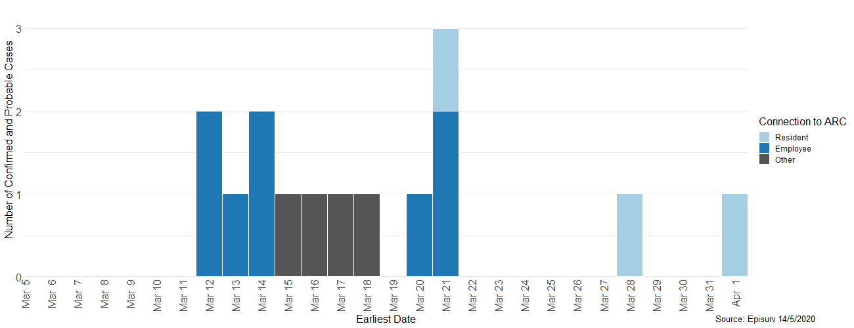

*Notification of Outbreak*

Figure 2: Epidemic curve for COVID‑19 outbreak “Cluster 2”

*Notification of Outbreak*

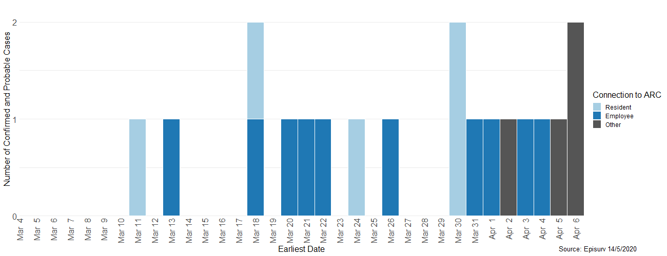

Figure 3: Epidemic curve for COVID‑19 outbreak “Cluster 3”

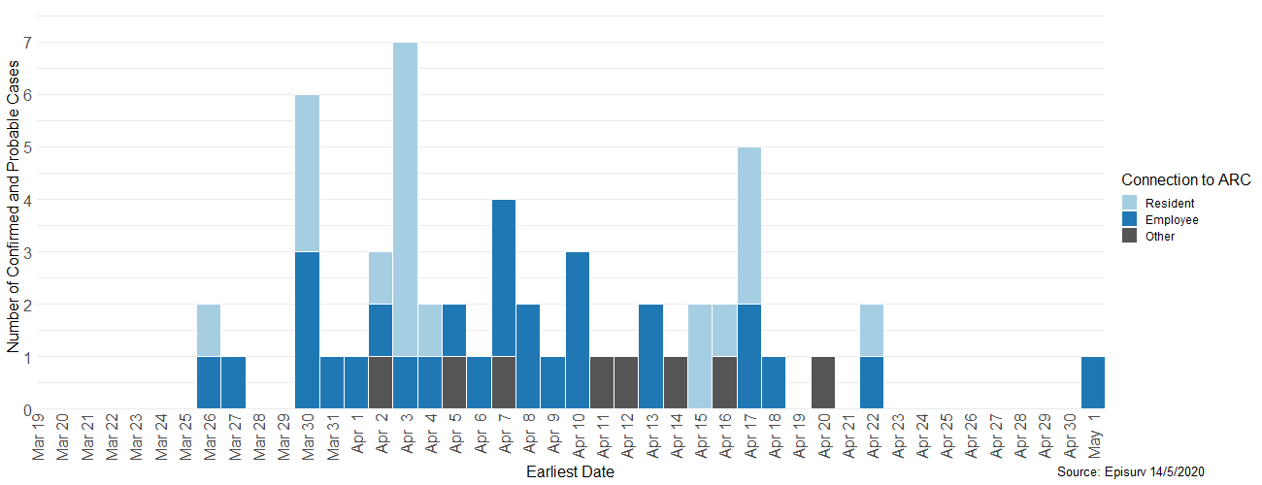

*Notification of Outbreak*

Figure 4: Epidemic curve for COVID‑19 outbreak “Cluster 4”

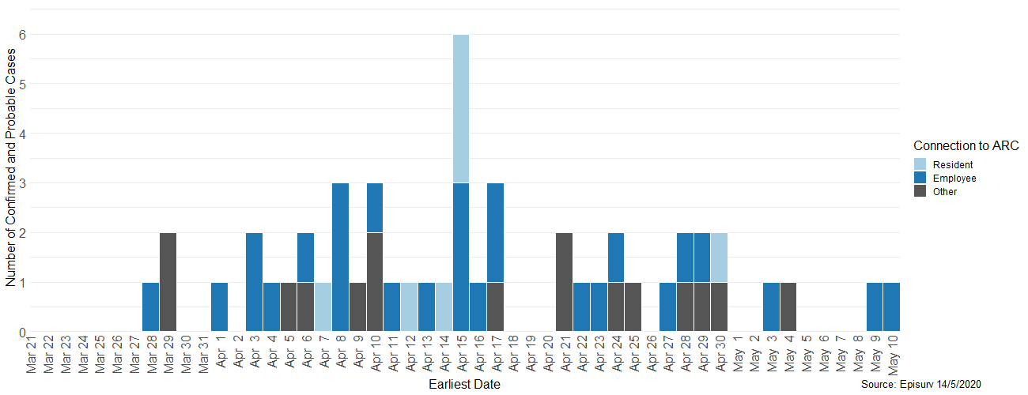

*Notification of Outbreak*

Figure 5: Epidemic curve for COVID‑19 outbreak “Cluster 5”

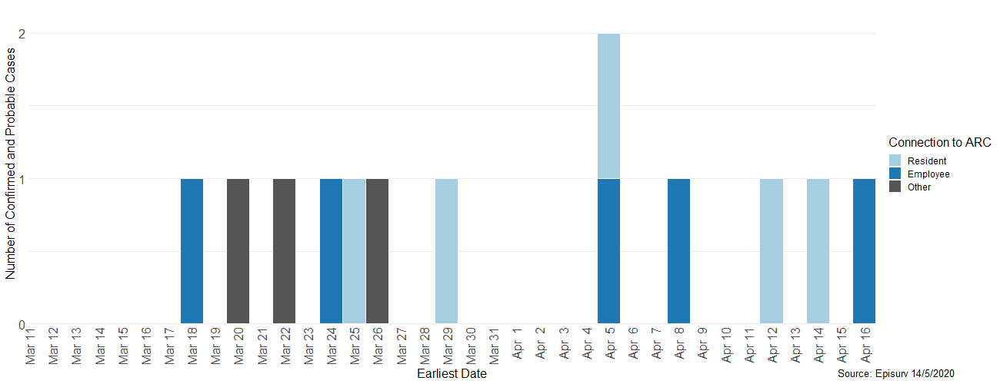

*Notification of Outbreak*

Figure 6: Covid-19 cases and outbreak clusters by ARC facility

This graph shows how the ARC facility clusters compare to the overall numbers and timeline of COVID-19 in New Zealand. It shows the beginning of border restrictions, and the movements through alert levels, with the cases for each outbreak represented against the overall totals.

# 

# Appendix B: Overseas Experiences

A report from the CDC described the experience of COVID‑19 in the United States between 12 February and 9 April 2020.[10] In that period, 315,531 COVID‑19 cases were reported to CDC, 49,370 (16%), and of those 9,282 (19%) were identified as HCP. The article concluded: “These preliminary findings highlight that whether HCP acquire infection at work or in the community, it is necessary to protect the health and safety of this essential national workforce”.

One of the first clinical reports from the United States described an outbreak of COVID‑19 cases among 89 residents in a “skilled nursing facility” in King County, Washington State.[11] This resulted from a HCP working for two shifts (26 and 28 February) whilst symptomatic and in the early stages of infection. They tested COVID‑19 positive on 1 March. On 2 March a resident in the unit became unwell and tested positive on 3 March. In all, 76 residents were tested between 10 and 26 March and 48 (64%) tested positive for COVID‑19.[12] Seventeen (35%) of these residents described typical COVID‑19 symptoms, four (8%) had atypical symptoms, and 27 (56%) reported no symptoms at all. The authors estimated the doubling time for cases in the facility to be 3.4 days (95% confidence interval [CI] 2.5 to 5.3). They concluded that there was poor correlation between symptom onset and viral shedding and recommended, “Consideration should be given to test-based strategies for identifying residents and staff with COVID‑19 infection for the purpose of excluding infected staff and cohorting residents, either in designated units within a facility or in a separate facility designated for residents with COVID‑19”.

The detection of cases of COVID‑19 in ARC facilities depends on the recognition of symptoms, but this can be difficult when many residents may have dementia, a history of strokes, or other health issues that may mask manifestations of COVID‑19 infection. All health care workers in ARC facilities need to follow the ABCD:[13]

“**Awareness** of potential key clinical differences of COVID‑19 in this population; quickly initiating appropriate **behaviours** to manage the infection clinically in ARCs;[14] implementing **containment** strategies to disrupt further spread of the virus, as well as preventive interventions in an ARC; and being knowledgeable about the **decisions** being made at the local, regional, and national level will help achieve this goal.”

The authors conclude with: “... this article is intended to help ... healthcare providers understand the ABCDs of the COVID‑19 pandemic. We recognize that the situation is fluid as new information and recommendations are released almost hourly”.

Post-containment management of ARC facilities will require a combination of medical, psychological, political and economic resources. “Until a proper management plan is drafted, ARC[15] residents are in for a lonely journey.”[16]

The American Geriatrics Society noted challenges and opportunities that will impact on the availability and expertise of the workforce in the ARC facilities.[17] These include paid leave, screening, training, and staff availability.

A study of 224 staff in Dunedin Hospital in 2008 looked at “sickness presenteeism”.[18] It found that about 50% of hospital staff had worked when unwell during the preceding 12 months. Twenty-eight percent of staff reported working when they had symptoms of influenza and 78% said they would work when they had symptoms of “common cold virus”. These symptoms are all recognised in assessing COVID‑19 and so it should not come as surprising that the HCP in Washington State worked for two shifts. The main reason given for continuing to work was: “Did not want to increase workload of others (53.5%)”. Thirty-one percent reported “There would not have been a replacement available” and 22% reported “Pressure from work” as reasons for not taking sick leave.

1. <https://www.health.govt.nz/system/files/documents/media/23_april_-_irccarc_tor_final.pdf>
2. https://www.health.govt.nz/our-work/life-stages/health-older-people/long-term-residential-care/age-related-residential-care-services-agreement
3. <https://nzcoviddashboard.esr.cri.nz\#!404> (accessed 24 May 2020). All data used in this appendix is based on an extract of data performed by ESR and provided to the panel on 24 May 2020.
4. Data extracted from the Ministry website <https://www.health.govt.nz/> (accessed 21 May 2020).
5. This report was prepared for the Ministry by ESR and is available from <https://www.esr.cri.nz/>.
6. An Epidemic curve for an outbreak shows the number of cases of a specific disease occurring at specified intervals during the entire outbreak.
7. In Figures 1 to 5 the numbers are colour-coded to show residents, staff and others.
8. All detailed data used in this report is based on an extract of data performed by ESR and provided to the panel on 18 May 2020.
9. Data from ESR extracted for period to 14 May 2020.
10. CDC COVID‑19 Response Team. 2020. Characteristics of Health Care Personnel with COVID‑19 – United States, February 12-April 9, 2020. *Morbidity and Mortality Weekly Report* 69(15), 477–481. https://doi.org/10.15585/mmwr.mm6915e6 (accessed May 2020).
11. Kimball A, Hatfield KM, Arons M, et al. 2020. Asymptomatic and Presymptomatic SARS-CoV-2 Infections in Residents of a Long-Term Care Skilled Nursing Facility – King County, Washington, March 2020. *Morbidity and Mortality Weekly Report* 69:377–381. DOI: http://dx.doi.org/10.15585/mmwr.mm6913e1 (accessed May 2020).
12. The paper refers Kimball A et al. Refer to SARS-CoV-2, but the virus had been renamed by WHO on 11 February 2020.
13. D’Adamo H, Yoshikawa T, Ouslander JG. 2020. Coronavirus Disease 2019 in Geriatrics and Long-Term Care: The ABCDs of COVID‑19. *J Am Geriatr Soc* 68(5): 912–917. *doi:10.1111/jgs.16445* (accessed May 2020).
14. Terminology has been adapted for the Aotearoa New Zealand context. Original text uses the term: “long term care” which is equivalent in Aotearoa New Zealand to ARC.
15. Terminology has been adapted for the Aotearoa New Zealand context. Original text uses the term: “nursing home” which is equivalent in Aotearoa New Zealand to ARC.
16. Boucaud-Maitre D, Roxane M, Maturin V, Villeneuve R, Tabue-Teguo TM. Post-containment management of nursing  homes: a new public health concern. [Published online ahead of print, 13 May 2020]. *Eur Geriatr Med* [Internet]. 2020 (0123456789). Available from: <https://doi.org/10.1007/s41999-020-00328-9>. This French article refers to “nursing homes” but it applies to ARC in the New Zealand context. 2020 1–2. doi:10.1007/s41999-020-00328-9 (accessed May 2020).
17. American Geriatrics Society (AGS). 2020. American Geriatrics Society Policy Brief: COVID‑19 and Nursing Homes. *J Am Geriatr Soc* 68(5): 908–11.–911. doi:10.1111/jgs.16477 (accessed May 2020).
18. Bracewell LM, Campbell DI, Faure PR, Giblin ER, Morris TA, Satterthwaite LB, Simmers DA, Ulrich CM, Holmes JD, et al. Sickness presenteeism in a New Zealand hospital. *NZ Med J* [Internet] 2010; 123(1314): 30–41. Available from: 31–42. Published 14 May 2010. http://www.nzma.org.nz/journal/123-1314/4106 (accessed May 2020).