Increasing Deceased Organ Donation and Transplantation
A National Strategy

Citation: Ministry of Health. 2017. Increasing Deceased Organ Donation and Transplantation: A national strategy. Wellington: Ministry of Health.
Published in June 2017
by the Ministry of Health
PO Box 5013, Wellington 6140, New Zealand
ISBN 978-1-98-850267-0 (print)
ISBN 978-1-98-850268-7 (online)
HP 6645
This document is available at
health.govt.nz
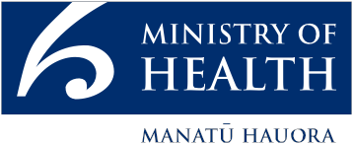
This work is licensed under the Creative Commons Attribution 4.0 International licence. In essence, you are free to: share ie, copy and redistribute the material in any medium or format; adapt ie, remix, transform and build upon the material. You must give appropriate credit, provide a link to the licence and indicate if changes were made.

Foreword
Organ transplant saves lives. For people with organ failure, a transplant is often the only option available.

But organs must be donated before they can be transplanted.

Deceased organ donation comes from generous decisions made by families and whānau of deceased donors, at a time of great sorrow.

The families’ decisions are supported by the compassion and hard work of health sector staff.

New Zealand has come a long way in increasing our organ donation and transplant rates. It is encouraging to see that our efforts to increase deceased organ donations and transplant rates have resulted in a record number of organ transplants being carried out in 2016. Despite this achievement, the Government still has ambitions to increase further.

Every organ donated and subsequently transplanted means a life saved or significantly improved. One deceased donor could gift up to seven organs, potentially saving seven lives.

This comprehensive strategy has been developed with a specific focus on increasing deceased organ donation. It is a result of wide public consultation and collaborative work with the health sector.

I am confident this strategy will help family/whānau to make the most appropriate decision based on accurate information about their loved one’s wishes and the best possible support from clinical staff. I encourage all families to have a conversation about organ donation so that their wishes are known when such a decision needs to be made.

Finally, I would like to take a moment to remember, and thank, all those who have donated organs and given the gift of life.

Hon Dr Jonathan Coleman
Minister of Health

Contents
Foreword iii
Introduction 1
Strategic priority one: Improving public awareness and media engagement about organ donation and transplantation 3
Strategic priority two: Improving New Zealand’s system of registering and sharing donation intent for individuals, families and clinicians 4
Strategic priority three: Enhancing capability and consistency through improved training 5
Strategic priority four: Increasing hospital-based capacity for deceased organ donation 6
Strategic priority five: Establish a national agency to lead the deceased organ donation and transplantation 7
Strategic priority six: Measuring progress 8
References 9

Introduction
Organ transplantation is a life-saving treatment that is often the best, or only, option for people with organ failure. A transplant can improve a person’s quality of life and life expectancy.

New Zealand’s rate of deceased organ donation is increasing as a result of the efforts and expertise of Organ Donation New Zealand (ODNZ) and ICU Link doctors and nurses. However, it is still relatively low compared with rates in other countries. New Zealand has a unique cultural make-up and provides geographical challenges to organ retrieval and transplant, but some countries have achieved significant improvements in their rate of organ donation after introducing comprehensive strategies.

This strategy is focused on increasing the donation of deceased organs, but not at any cost. Organ donation occurs in the context of human tragedy, involving grieving families/whānau at a time of great stress in an intensive care unit (ICU). Deceased organ donation relies on a decision made by family/whānau to donate a loved one’s organs for the benefit of people whom they are unlikely to ever meet.

This strategy is aimed at encouraging and making it easier for New Zealanders to make their donation wishes known to family/whānau. The strategy also aims to help family/whānau make the most appropriate decision with the best possible support and confidence. This will be achieved by enabling conversations within family/whānau, and between family/whānau and ICU staff. The decision of the family/whānau on behalf of their loved one will always be respected.

The framework of the strategy is outlined in Figure 1. It shows how the parts of the strategy fit together. At the centre is the core objective of enabling donation conversations. Alongside this are the objectives of improving clinical practice and broadening the scope of types of deceased organ donors to include more donation after circulatory death. The strategy is based on the foundations of a strong legal and ethical framework, health sector capacity and international cooperation.

The following pages summarise the strategy’s strategic priorities:
- improving public awareness and media engagement
- improving New Zealand’s system of registering and sharing donation intent
- improving training
- increasing capacity
- establishing a national agency
- measuring progress.

For further detail and discussion, please see the document: Increasing Deceased Organ Donation and Transplantation: Towards a national strategy. This document was developed by the sector working group to identify key actions to be included in the strategy.

Figure 1: Strategy framework
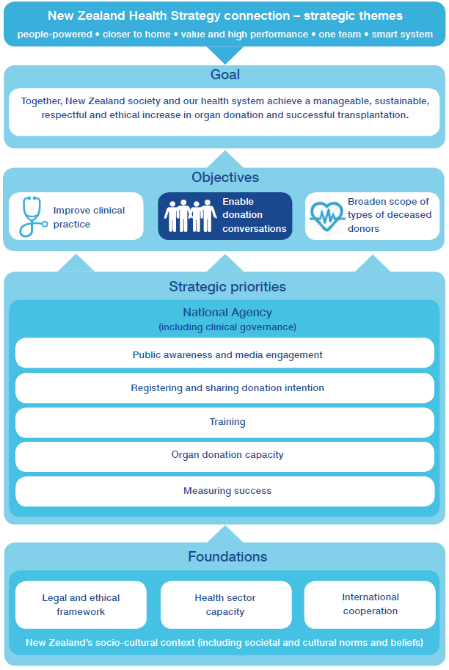

Strategic priority one

Improving public awareness and media engagement about organ donation and transplantation
There is currently no organisation with responsibility for public awareness or media engagement for deceased organ donation in New Zealand.  Public awareness campaigns improve understanding of the issues relevant to organ donation and transplantation knowledge, and this can change attitudes toward organ donation and organ donation wishes. International organ donation reform programmes include a focus on improving public awareness.  Future focus  A national agency for deceased organ donation (see strategic priority five) will be responsible for developing and implementing a public awareness and media engagement plan. This will include commissioning campaigns, managing media engagement and supporting the wider health sector to provide consistent information and messages.  Public awareness initiatives will be based on research, and will be appropriate to the needs of different audiences. This will include the development of a communication strategy for Māori and Pasifika. | - New Zealand and international research has found that while most people are in favour of organ donation, this does not always mean that they have shared their intent to donate (Li et al 2015; Ministry of Health 2016).  - Public awareness campaigns can play an important role in educating the public about organ donation and busting common myths (Li et al 2015).  - Research has found that overall, campaigns improved awareness and registration (Feeley and Moon 2009).  - Media advocacy has also been used successfully in many countries (Misterska et al 2010).

The national agency will develop a specific plan to engage with a wide range of media to help present accurate information to the public. This will include providing a single point of contact for media liaison (through to district health boards (DHBs) and clinicians).

Priority actions
- Raise public awareness and understanding of organ donation and transplantation.
- Proactively engage a wide range of media. This will include support for the health sector around communication planning.

Strategic priority two

Improving New Zealand’s system of registering and sharing donation intent for individuals, families and clinicians
Currently in New Zealand, organ donation intent is recorded through the driver licence system, but with little accompanying information.  When a person has a better understanding of organ donation, this helps them think about and communicate their donation wishes by recording those wishes in a national database. In the event of that person becoming a potential organ donor after death, the awareness that family/whānau have of their wishes can be useful in their conversations with clinical staff.  Future focus  Improvements to the way donor wishes are recorded will occur over time. This will be led by the national agency, working closely with the Ministry of Transport and the New Zealand Transport Agency (NZTA). The key principles are for donor registration to:  - provide reliable data collection on donor wishes  - be easy for clinicians and families/whānau to access  - be easy for individuals to change  - explore changes to the mandatory options  - be cost effective. | - Research indicates that family/whānau consent rates are much higher when families/whānau know that their loved one was registered as a donor (Hopkinson 2015; Stephens et al 2013).  - International experience suggests that the real value of a register is to:  - provide a focal point for raising awareness  - enable people to record their donation wishes and discuss and communicate those wishes with their family/whānau  - indicate someone’s donation wishes when they can no longer do so themselves (to families/ whānau and clinicians).

In the longer term, we are exploring the option of recording individuals’ donor information though the Electronic Health Record (which is currently in development). The system will create an online record of people’s health information, which individuals will be able to access and update.

Priority actions
- Explore other effective systems, including the Electronic Health Record (under development), to allow people to record and manage more efficiently their wishes to be organ donors.
- Provide families/whānau and clinicians in ICUs with improved access to accurate donor intent records and encourage them to consult this information.
- Enable New Zealanders to record, change and access their donor status more easily.
- Promote communication of organ donation wishes to families/whānau and friends through a public awareness campaign and social media.
- Explore options to expand the list of donor choices from ‘Yes’ and ‘No’, to include further options.

Strategic priority three

Enhancing capability and consistency through improved training
When conversations are held with the family/ whānau of potential deceased organ donors, it is important that these are conducted with sensitivity and the right information is provided to best support family/whānau to make the difficult decision of whether to donate.  For this to happen, clinicians must have high-quality training in organ donation conversations.  Future focus  The national agency will oversee and promote training in the organ donation conversation. Over time, the range of training offered will be expanded to make sure training is available to meet the different and ongoing needs of | - Organ donation is more likely to occur if the family is approached by someone trained in organ donation communication  (National Health Service Blood and Transplant 2015).  - It is estimated that only  30–50 percent of intensive care physicians have completed any organ donation conversation training  (Ernst & Young 2016).
clinicians involved in organ donation.

Training will be prioritised for those ‘on the ground’ in ICUs who are regularly involved in the process of organ donation conversations with family/whānau. Training may also be provided to emergency medicine physicians, anaesthetists and other relevant staff.

The national agency will work to improve organ donation cultural competency training specific to the New Zealand environment. This will provide the skills and information to enable culturally appropriate and respectful conversations with family/whānau.

Priority actions
- Coordinate training in organ donation conversations for clinicians and work with DHBs and professional organisations to promote and improve the uptake of training opportunities.
- Provide training to intensive care physicians, Link nurses, emergency department staff, anaesthetists and other staff involved in the organ donation process.
- Develop educational material on cultural awareness as applied to organ donation conversations with Māori and Pasifika.
- Collect data on the uptake of organ donation conversation training and its impact on service providers and consumers.

Strategic priority four

Increasing hospital-based capacity for deceased organ donation
Deceased organ donation is an uncommon event in New Zealand hospitals, but it requires a lot of time and resource when it occurs.  To have the capacity for the process of deceased organ donation, a staffed ICU bed needs to be available, and clinicians need to be available to manage the care of the potential donor and address the needs of the patient’s family/whānau.  Future focus  An expanded Link team initiative has been on trial since 2014. In the initiative four DHBs were allocated an ‘expanded’ Link nurse role with responsibility for ensuring | - ‘Funding of dedicated specialist medical and nursing roles to manage the donation process is the single most effective initiative to increase the rates of deceased organ donation.’ (Submission from public consultation)  - ‘Deceased organ donation is resource intensive, and some work is currently conducted on a “goodwill” basis.’ (Ernst & Young 2016)
that all potential deceased donors are identified. The government will continue to support this initiative.
Improving capacity to identify, manage and support deceased organ donations needs to be supported by greater knowledge sharing between clinical staff, for example, through their regular morbidity and mortality meetings.
Efforts to increase the rate of deceased organ donation need to be matched by efforts to increase the capacity for transplantation and the long-term follow-up care required by organ recipients.
Admitting patients to ICU solely to enable organ donation would mean a shift in practice, which would require additional ICU capacity. Some patients admitted to the ICU for organ donation assessment would not go on to be organ donors for a variety of reasons. This would nonetheless be resource intensive.

Priority actions
- Continue to support the expanded Link nurse roles across the deceased organ donation environment, as appropriate to regions.
- Resource specialist medical and nursing organ donation roles within ICUs, as appropriate, to enable them to champion and advocate for deceased organ donation within the DHB.
- Expand the clinical practice framework specific to organ donation following circulatory death.
- Increase knowledge-sharing around the opportunity for deceased organ donation and the organ donation system through the more effective use of morbidity and mortality meetings and wider alignment with donation audit data.
- Develop sustainable capacity for increased organ donation, retrieval, transplantation and follow-up care within national DHB planning and funding processes.

Strategic priority five

Establish a national agency to lead the deceased organ donation and transplantation
The Ministry of Health’s review and public consultation identified the need for a national agency with a comprehensive view across deceased organ donation and transplantation processes and a clear responsibility to increase donation and transplantation.  Over the past decade, ODNZ and a growing group of ICU Link nurses and doctors have achieved considerable progress in increasing donation rates and possess significant expertise in the area. This must be retained and used as a platform for further development.  There will be a national-level agency with a clear focus on | - A national agency with overall responsibility for organ donation is a key element of successful overseas systems.  - Public consultation identified that the governance of ODNZ as a business unit of a DHB, rather than a standalone entity, could be a potential impediment to reform.
increasing deceased organ donation and transplantation.
The agency will include the existing functions of ODNZ, and will be responsible for additional functions, including raising public awareness, engaging with media, improving training and developing a clinical governance framework.

Future focus
The national agency will establish a clinical governance framework to support best practice across the entire health sector. A clinical governance framework will provide a clear approach to improving the quality of service, systems and performance with an aim to increase rates of deceased organ donation and transplantation in New Zealand.

Priority actions
- Establish a national agency to lead the implementation of the strategy with a role to:
- raise the profile of deceased organ donation in the health sector and in the community
- support effective clinical governance
- work with the health sector to coordinate donation and transplantation processes
- provide expert advice and information on deceased organ and tissue donation to the sector, government, media and public.

Strategic priority six

Measuring progress
The strategy’s goal is ‘Together, New Zealand society and our health system achieve a manageable, sustainable, respectful and ethical increase in organ donation and successful transplantation.’  When we set goals, it is important to be able to measure progress against these and identify areas that still need to be improved.  Future focus  Each section of this strategy includes measures for tracking progress. The strategy’s priorities for action will be included in a high-level monitoring and evaluation framework. Tracking and monitoring progress towards achieving the strategy’s priority actions will enable the national agency to identify trends, areas of strength and opportunities for improvement.  To monitor progress against the Strategy’s goal, the national agency will collect and analyse data on process improvements. This will include a mix of performance reporting, satisfaction measures and identifying patients who have been overlooked for deceased organ donation.  The national agency will continue to improve the accuracy and frequency of donation audit performance reporting (previously ‘death audit’), which will involve sharing | - Most countries with comprehensive organ donation reform programmes have a clear national goal, supported by measurement and evaluation frameworks (Australian Organ and Tissue Authority 2014).  - A measurement framework will focus on process measures, including measuring family satisfaction, clinician perceptions and missed opportunities for identifying and exploring potential deceased organ donors.  - International comparisons suggest that significant gains in the rate of deceased organ donation have been achieved in countries where organ donation is occurring more frequently following circulatory death (Matesanz et al 2017).
regional data between DHBs. The national agency will expand the range of data collected and work with the health sector to ensure adherence to high-quality processes to enable improved outcomes.

Priority actions
- Develop and implement a measurement and reporting framework.

References
Australian Organ Tissue and Transplantation Authority. 2014. Organ and tissue donation for transplantation in Australia – 2014–2015 Strategic Plan.
Ernst & Young. 2016a. Deceased Organ Donation and Transplantation in New Zealand: Recommendations for improving practice in clinical settings and commentary on institutional arrangements. Wellington: Ministry of Health.
Ernst & Young. 2016b. Review of organ donation and transplantation: Appendum to Report on potential high level system capacity impacts from an increase in the deceased organ donation rate.
Feeley TH and Moon SI. 2009. A Meta-Analytic Review of Communication Campaigns to Promote Organ Donation. Communication Reports 22(2): 63–73. https://doi.org/10.1080/08934210903258852
Hopkinson C. 2015. Potential Donor Audit Summary report for the 12 month period 1 April 2014–31 March 2015. Bristol: National Health Service Blood and Transplant. www.odt.nhs.uk/pdf/pda_report_1415.pdf
Li AT, Wong G et al. 2015. Community-Based Interventions and Individuals’ Willingness to be a Deceased Organ Donor: Systematic Review and Meta-Analysis. Transplantation 99(12): 2634–2643. https://doi.org/10.1097/TP.0000000000000897
Ministry of Health. 2016. Discussion Paper: Public and media awareness and promotion of organ donation. Wellington: Ministry of Health.
Matesanz R, Domínguez-Gil, B et al. 2017. How Spain Reached 40 Deceased Organ Donors per Million Population. American Journal of Transplantation n/a-n/a. https://doi.org/10.1111/ajt.14104
Misterska E, Glowacki M et al. 2010. Mass-media and the transplantation crisis: the example of Poland. Medical Science Monitor 16(8).
National Health Service Blood and Transplant. 2015. Approaching the families of potential organ donors: Best practice guideline. National Health Service Blood and Transplant. www.odt.nhs.uk/pdf/family_approach_best_practice_guide.pdf
Stephens HO, Pilcher D et al. 2013. The impact of checking the Australian Organ Donor Register on family consent rates. The Medical Journal of Australia 199(8): 536–538. https://doi.org/10.5694/mja13.10146

DHBs have Link teams, which include an intensive care nurse, an operating theatre nurse and an intensive care physician. Teams are mostly involved in deceased organ donation quality assurance and education. Expanded Link teams are an extension of this existing arrangement.

