Revitalising the National HPV Immunisation Programme
with agreed outcomes from the August 2014 workshop

Citation: Ministry of Health. 2015. Revitalising the National HPV Immunisation Programme with Agreed Outcomes from the August 2014 Workshop.
Wellington: Ministry of Health.
Prepared by
Ministry of Health and collective district health board programme leads
Published in September 2015
by the Ministry of Health
PO Box 5013, Wellington 6145, New Zealand
ISBN: 978-0-478-44851-1 (online)
HP 6230
This document is available at health.govt.nz

This work is licensed under the Creative Commons Attribution 4.0 International licence. In essence, you are free to: share, ie, copy and redistribute the material in any medium or format; adapt, ie, remix, transform and build upon the material. You must give appropriate credit, provide a link to the licence and indicate if changes were made.

Contents
Commonly used abbreviations iv
Introduction 1
Background 1
Implementation to date 2
Initiation of the Programme 2
Coverage targets and achievement to date 2
The workshop 3
Increasing HPV coverage: discussion 5
The WHO GVAP objectives 5
Increasing HPV coverage: an action plan 8
Timelines 10
Appendices 11
Appendix A: WHO GVAP objectives, adapted for New Zealand 11
Appendix B: 2014 HPV coverage for 2001 birth cohort (1 January 2014–30 June 2015) 12

List of tables
Table 1: Application of the GVAP principles to the Programme 5
Table 2: Action plan principles and associated activities 9
Table 3: Timeline for achieving increased coverage in the Programme 10

List of figures
Figure 1: HPV immunisation dose three coverage by ethnicity, vaccination and eligible birth cohort, 1 January 2010–31 December 2014 3
Figure 2: Possible solutions to improve coverage discussed at the workshop 4

Commonly used abbreviations
DHB district health board
GP general practitioner
GVAP Global Vaccine Action Plan
HPV Human Papillomavirus
IMAC Immunisation Advisory Centre
NIR National Immunisation Register
NSU National Screening Unit
PHARMAC Pharmaceutical Management Agency
PHO primary health organisation
PHN public health nurse
PMS Patient Management System
PTAC Pharmacology and Therapeutics Advisory Committee
SBIP school-based immunisation programme
Tdap the adult tetanus, diphtheria and acellular pertussis vaccine
WHO World Health Organization

Introduction
In August 2014, the Ministry of Health (the Ministry) held a workshop to discuss strategies for achieving increased coverage of Human Papillomavirus (HPV) immunisation in the future.

This document outlines a plan for progressing and revitalising the HPV Immunisation Programme (the Programme) for 12-year-old girls. The plan uses the underlying principles of the Ministry’s modified four-point action plan, Plan, Engage, Promote and Monitor, and the World Health Organization (WHO)’s Global Vaccine Action Plan (GVAP).

The Ministry has adopted these plans and applied these models in order to achieve the new HPV immunisation coverage target of 75 percent for all 12-year-old girls by December 2017.

Background
HPV is responsible for a substantial burden of disease in New Zealand women, most importantly in terms of cervical cancer. The virus is highly transmissible and affects the majority of women and men at some stage in their lives. In most cases, the infection will clear spontaneously after some time. However, for a small number of people, persistent HPV infection progresses to changes in the cells and subsequently develops into cervical cancer or cancers of the throat, neck and anogenital region.

In September 2008, the Ministry launched a three-dose HPV immunisation programme for 12-year-old girls as part of the funded National Immunisation Schedule (the Schedule).

The Programme aspires to achieve herd immunity against HPV at a level that reduces the spread of the HPV infections that lead to cervical and other cancers.

Māori and Pacific women have a higher incidence of HPV-related cancers compared to New Zealand European women. From its outset, the Programme has prioritised Māori and Pacific coverage.

Since 2010, when rates of coverage could be measured, approximately 55 percent of girls in the eligible age ranges have been immunised. For herd immunity, coverage needs to be approximately 75–80 percent. The national coverage target for all other primary childhood immunisations listed on the Schedule is 95 percent. The Ministry considers this Programme should achieve similar rates of coverage.

Implementation to date

Initiation of the Programme
Internationally, HPV immunisation programmes are most commonly offered through school-based immunisation programmes (SBIPs). Since 2009, the Ministry has administered the Programme primarily to girls in school Year 8; public health nurses (PHNs) deliver it in schools. Alternatively, general practitioners (GPs), practice nurses, youth health or other health clinics (such as family planning clinics) offer the vaccine.

When the HPV SBIP was established, the Ministry implemented a ‘catch-up’ programme for a wider age range of girls, offering those in school Years 9–13 immunisation through schools or health providers. In December 2010, the school-delivery component of the catch-up programme ceased.

In Canterbury, the HPV vaccine was previously provided primarily through general practice, with a catch-up school programme in Year 10. Following a recommendation from PHARMAC’s Pharmacology and Therapeutics Advisory Committee (PTAC) Immunisation Subcommittee in February 2015, Canterbury DHB will offer HPV immunisation through the SBIP in Year 8 beginning in 2016.

Coverage targets and achievement to date
The initial coverage target was 90 percent for dose three for all 12-year-old girls by 31 December of the year in which the girl became eligible. However, DHBs considered the target to be unachievable (because, in most areas, the SBIP was new), and the Ministry revised the targets.

Up until December 2014, the revised targets for 12-year-old girls were:
- Dose one – 70 percent
- Dose two – 65 percent
- Dose three – 60 percent.

(See also Appendix B, which shows the DHB end-of-year cohorts for 2001.)

Figure 1 on the following page shows national HPV immunisation dose three coverage from 2011 to 2013 (ie, for birth cohorts 1998–2001). During this period, coverage for Pacific peoples and Asians exceeded the 60 percent target; coverage for other ethnicities and the total population remained below it.

The New Zealand Programme did not achieve the same success in reaching high coverage like Australia and the United Kingdom and, of concern for Programme leads, Figure 1 highlights that Māori and Pacific coverage had started to decrease.
Figure 1: HPV immunisation dose three coverage by ethnicity, vaccination and eligible birth cohort, 1 January 2010–31 December 2014
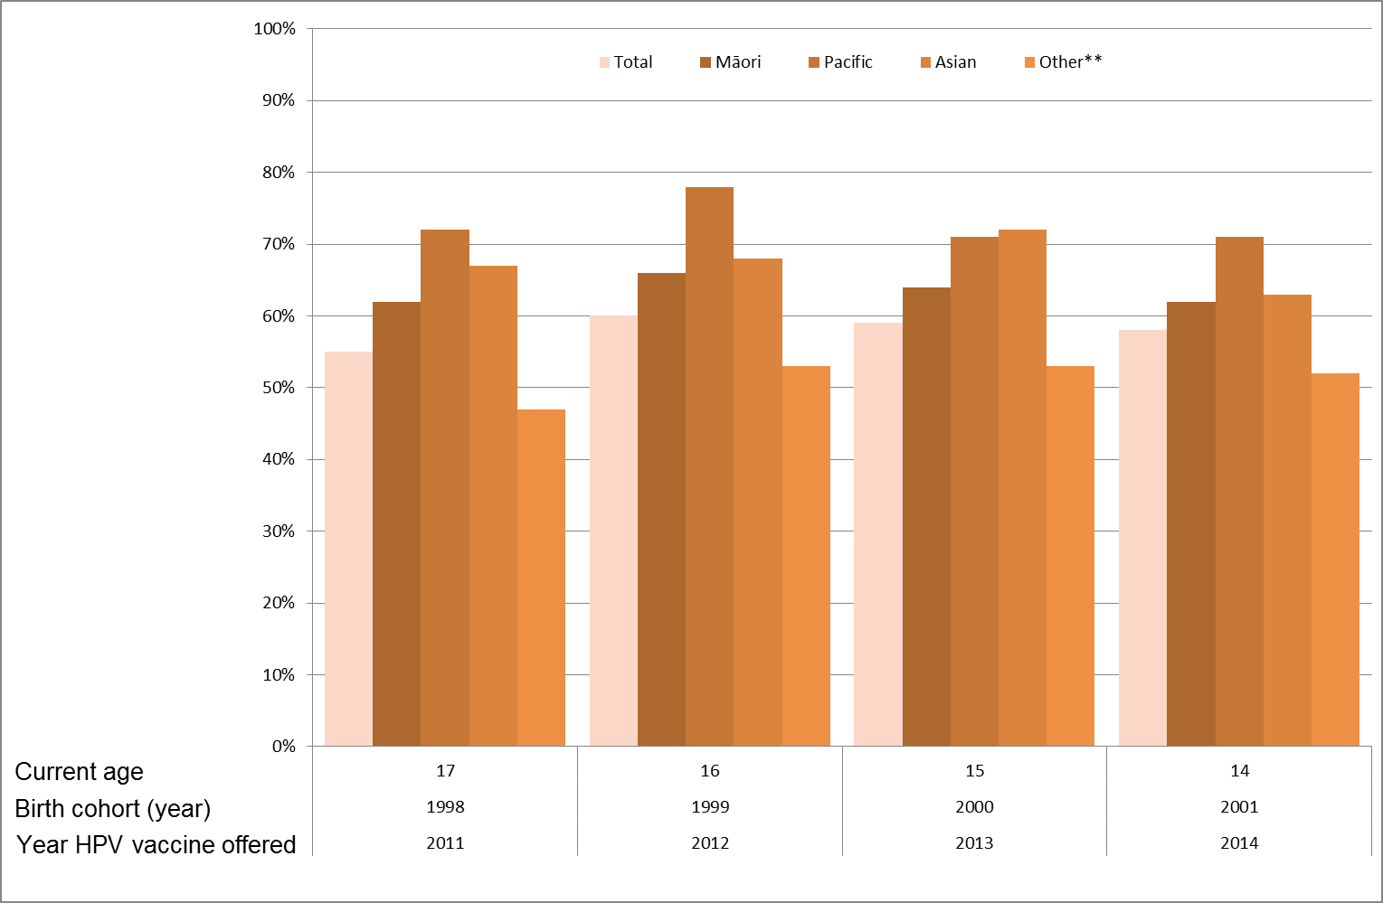
Source: Data Mart, 13 January 2015
Note: The data will be expanded during 2015 to include figures for New Zealand European and a breakdown by deprivation area.

The Ministry needs to revitalise its Programme in order to increase coverage to at least a rate that would provide herd immunity. A national workshop was agreed.

The workshop
The 2014 HPV workshop was held for DHB funding and planning managers who oversee immunisation services, PHNs, primary health organisations (PHOs), the Immunisation Advisory Centre (IMAC) and HPV immunisation programme managers. These workshop participants considered the cost-effectiveness of the Programme at current coverage levels, international approaches to HPV immunisation programmes and the questions listed below.
a) How do we de-stigmatise/normalise the Programme?
b) Should we transition the Programme to Year 7 in schools, and if so, how?
c) What are the key requirements to transitioning from a three-dose HPV schedule to a two-dose schedule?
d) Should the current 60 percent three-dose HPV target be incrementally increased to reach the recommended 75 percent coverage?

Possible solutions were suggested on how coverage could improve (see Figure 2).

Figure 2: Possible solutions to improve coverage discussed at the workshop
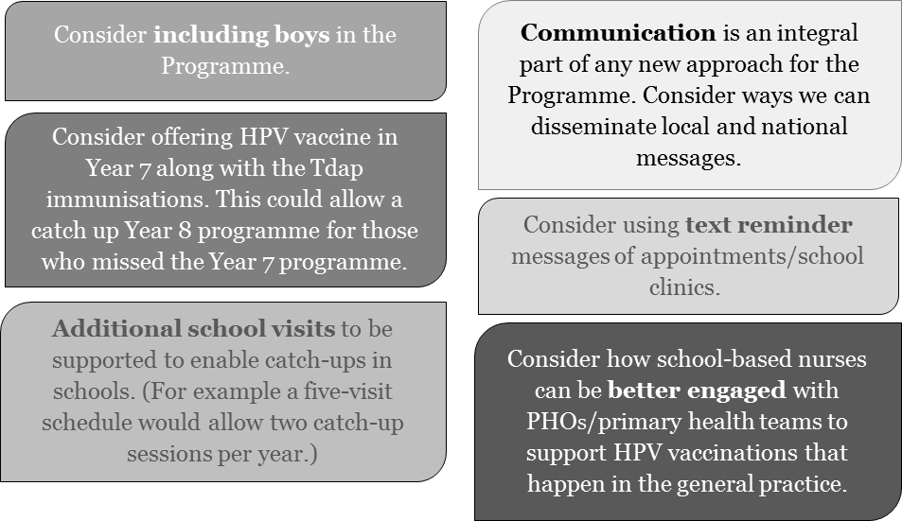

There was agreement by the workshop participants that one of the keys to increasing the HPV coverage was to incrementally increase the dose three coverage target to achieve 75 percent by 31 December 2017. DHBs and IMAC, who provided feedback, also support this change.

Increasing HPV coverage: discussion
This section sets out some of the discussion points noted above in Figure 2 for achieving increased HPV immunisation coverage in the future, using the WHO’s GVAP objectives as a framework.

The WHO GVAP objectives
As a platform for all the Ministry’s immunisation programmes, the Ministry’s Immunisation Team has adapted the six core objectives of WHO’s GVAP: ownership, shared responsibility and partnership, equity, integration, sustainability and innovation (see Appendix A, which sets out how these objectives have been adapted for New Zealand in a broader sense).

The Ministry recommends applying these objectives to the current Programme, as follows.

Table 1: Application of the GVAP principles to the Programme
Objective | Description
Ownership | All providers and the wider health sector recognise the importance of the Programme and work collectively to achieve agreed targets.
Shared responsibility and partnership | The Ministry, the National Screening Unit (NSU) and DHBs, as partners and customers, respect the role of primary health care providers and the community itself in increasing coverage, and actively look for opportunities to improve the Programme.
Equity | The Programme deliverables are fair and just; in particular for vulnerable populations such as Māori, Pacific peoples and low-income groups.
Integration | The Programme is integrated with other programmes on the Schedule in order to achieve better outcomes for young women and improve the efficiency of SBIP delivery.
Sustainability | The Programme continues to receive funding and remains a government priority.
Innovation | The Programme undergoes continuous improvement, with an aim to increase coverage rates and quality.

Using the modified WHO GVAP, the Ministry’s Immunisation Team continues to work with the NSU and DHBs to improve the HPV immunisation coverage.

A more detailed exploration of the six objectives follows.

Ownership
‘Ownership’ of immunisation programmes occurs at multiple levels. The Minister continues to support the delivery of the Schedule. In 2010, the Health Select Committee inquiry into how to improve completion rates of childhood immunisation considered that immunisation is a highly effective strategy for preventing infectious diseases throughout life. The Government, through a number of recommendations, supports timely immunisation.

In alignment with the recommendations of the 2010 Health Select Inquiry, many DHBs demonstrate ownership by providing resources for the delivery of SBIPs.

Currently there is an opportunity to expand ownership of the Programme to PHOs and general practices. This would be a way to actively involve families in the effort to ensure that girls aged 14 years complete their HPV immunisation. PHNs and general practice teams could work together to develop initiatives to engage with families to this end.

Shared responsibility and partnership
Up until 2014, there was a disconnection between the SBIP and general practice delivery of the HPV vaccine. The Programme is delivered mainly through the SBIP, but general practices were not well equipped to specifically offer the vaccine to those who declined it at school.

To date, general practice teams have not been given clear guidelines about the optimal time for recalling girls who have not received the vaccination at school. Moreover, anecdotal evidence suggests that many practices do not routinely stock the HPV vaccine. Although the SBIP notifies individual girls’ vaccine records to their GPs, in reality these records are frequently inadequate or incomplete.

There is an opportunity for the DHBs and PHOs to work collaboratively with general practice leads to re-establish best practice guidelines and more systematic approaches. DHBs who provided feedback on the draft of this document, have emphasised the need for better communication between the SBIP and general practice teams. Expanding ownership of the Programme to include general practice teams and PHNs will enable better engagement and communication.

Equity
The initial focus for the Programme was on reducing inequalities. Ethnic inequalities in cancer rates result from multiple influences, including differences in:
- underlying determinants of health
- exposure to risk and protective factors
- access to screening
- access to timely, high-quality treatment.

Māori and Pacific peoples are at increased risk of developing and dying from cervical cancer compared with the New Zealand European population. Since the start of the Programme, coverage rates for Māori and Pacific have been higher than those for New Zealand European and other ethnicities and have reached the dose three coverage target of 60 percent. These rates are positive but need to be increased or at least maintained to reduce the burden of disease for these groups and to increase herd immunity.

Immunisation providers need to re-engage with communities with low coverage, to understand their concerns and provide assurances about the vaccine. One strategy that has worked effectively in the childhood immunisation programme is the use of community immunisation champions who are willing to front local campaigns.

There is an opportunity to liaise with Whānau Ora providers, the Māori Women’s Welfare League and the Pacific Allied (Women’s) Council with a view to increasing coverage in communities with low immunisation rates.

Integration
The Programme may benefit from integration with other childhood immunisations on the Schedule. Possible options for improving integration include:
- positioning the Programme in the context of the whole Schedule, as part of an ‘immunisation across the lifespan’ approach
- offering the Programme at Year 7, to align with tetanus, diphtheria and acellular pertussis (Tdap) immunisation offered at age 11
- establishing and maintaining closer working relationships between Programme providers (SBIP), general practice teams, public health, Māori and Pacific immunisation leads and local cervical screening programmes.

Sustainability
Changing the number of doses in the Programme from three to two would be more cost effective and could help increase coverage across New Zealand. In April 2014, the WHO Strategic Advisory Group of Experts on Immunisation recommended a two-dose schedule for girls if vaccination is initiated before 15 years of age. The two doses could be delivered either in Year 7, with a six-month gap between the doses, or in Years 7 and 8; the first could be delivered alongside the Tdap vaccine.

In addition to savings in the cost of vaccine, there may be significant savings to DHBs by reducing the number of school visits.

Note: any changes to the funding and eligibility criteria for vaccines on the Schedule must be approved through PHARMAC’s assessment, prioritisation and approval processes.

DHBs who provided feedback are generally supportive of a two-dose programme.

Innovation
This section presents some ideas and questions about potential innovations in the Programme for further consideration.

One possible innovative option would be to upgrade our National Immunisation Register (NIR) to provide accurate monitoring to measure effectively against the HPV target. DHBs are local experts and know how to get the best out of their communities, health partners and IT tools.

There is potential for including boys in the Programme, as they are in Australia. Including boys in the Programme would de-stigmatise/normalise the vaccine as part of the routine childhood immunisation programme.

The current Programme appears to be cost-effective and a good use of health expenditure.
Adding boys to the Programme would deliver some extra health benefits but at very high cost and so does not appear to be cost-effective at this point in time. In order for vaccination of school-aged boys to be cost-effective in New Zealand, the vaccine would need to be supplied at very low prices and administration costs would need to be minimised.

There are opportunities for better engagement within the education sector, with a view to:
- dispelling negative myths about the safety of the vaccine
- ensuring providers have the knowledge and resources to understand parental concerns and reassure them about the safety and effectiveness of the vaccine (IMAC are currently looking into implementing an online learning module for the Programme)
- stressing the importance of vaccinating young people because they develop a stronger immune response from the vaccine compared with older people
- including education around immunisation as part of the school health curriculum.

Increasing HPV coverage: an action plan
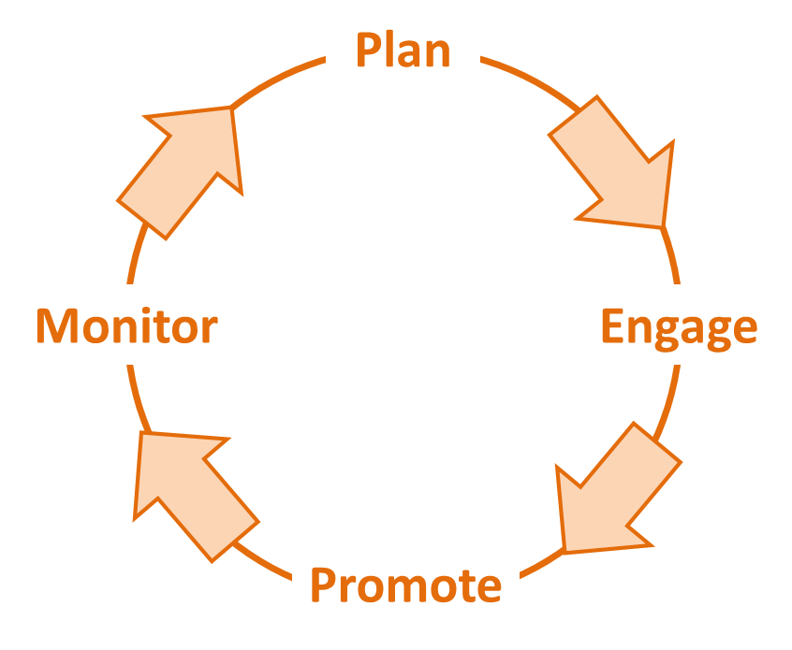
In 2012, the Ministry developed a four-point action plan to assist with achieving the immunisation health targets.

In light of the WHO objectives and ideas arising from consultation with DHBs, the Ministry has expanded and modified its four-point action plan used for the ‘Under 5s’ programme to increase HPV immunisation coverage. The action plan’s underlying principles are:
- trusting relationships with parents
- more functional relationships between SBIP and general practice teams
- better quality processes, based on the Plan, Do, Check, Act cycle
- recognising the role of the community.

The four-point action plan uses ‘Plan, Engage, Promote and Monitor’ to activate change. Its implementation within the SBIP will support a coordinated approach between school delivery and general practice to identify girls who have not been vaccinated by age 16 years. There is general support to use this plan to achieve the new HPV target of 75 percent coverage of girls fully immunised at 12 years old by 31 December 2017.

The Programme is underpinned by effective monitoring by the Programme and NIR administrators. Better liaison between SBIP, general practice teams and a network of immunisation coordinators is important to improve the Programme’s success.

The key actions will result in increased coverage, more timely HPV immunisations, more transparent and consistent delivery of immunisation services, better integration of services and better engagement between health professionals.

Table 2 sets out the principles of the plan alongside associated activities and explanations in more detail. In addition, it sets out the relevant WHO GVAP objectives that apply to each principle.

Table 2: Action plan principles and associated activities
Principle | Activity
Plan  WHO GVAP objectives 1, 2, 3, 4 and 5 | All DHBs plan to offer an HPV SBIP for girls in either school Year 7 or 8 by 1 February 2017.
 | School-based nurses and PHO staff collaborate to share methods to better engage with PHOs/general practice teams to work towards systematically delivering HPV vaccines in general practice to those girls aged 14 who are not fully vaccinated.
 | General practice teams work with nurse leads to develop a follow-up process and provide catch-up for unimmunised or incompletely immunised girls, for example an annual recall was undertaken by GPs in November/December of their 14-year-old girls not fully protected against HPV.
 | DHBs set yearly incremental milestone targets (eg, 2015 – 65%; 2016 – 70% and 2017 – 75%) for all ethnicities.
 | Plan to transition from three doses to two doses when PHARMAC approve changes to the Programme.
Engage  WHO GVAP objectives 2, 4 and 5 | DHBs encourage local health professionals and community leaders to become immunisation champions. The local cervical screening units may have champions that are keen to support the Programme.
 | School-based nurse leads notify children’s nominated GPs when parents or legal guardians indicate they wish their child to be vaccinated in general practice. When GPs receive this notification, the practice team pre-calls these girls at 12 years.
 | School-based nurse leads engage with general practice teams to develop systems to recall all unvaccinated girls in their 14th year who have not received all doses of the HPV vaccine.
 | General practice teams use practice systems to engage and enable opportunistic immunisation at each contact with the health system for all eligible girls 14 years and older.
Promote  WHO GVAP objectives 1, 2 and 4 | DHBs, in conjunction with their immunisation steering group leads, create specifically tailored promotional plans for particular local population groups. Key messages align across different promotional plans, including the cervical screening programme.
 | Promote immunisation through school newsletters, primary care, NSUs (eg, providers discuss with family members presenting for cervical smears or primary HPV screening) and youth services.
 | DHBs and PHOs promote immunisation through local media and parent groups via good news stories. Communications feature targeted messages, individual stories and shared personal experiences.
 | DHBs provide pro-immunisation resources to schools and locations relevant to the target population (eg, recreation centres, libraries, pharmacies).
 | DHBs, with support from IMAC, rebut anti-immunisation information where necessary, using pre-prepared statements making key points.
 | DHBs support GPs and nurses with good resources and training, so that they can inform parents with confidence about vaccine-preventable diseases and effectively manage parental anxiety.
Monitor  WHO GVAP objectives 2, 3, 4 and 5 | Nurse leads and general practice teams work together to address parents’ and girls’ concerns and identify access barriers for girls who do not respond within three months of a recall.
 | The Ministry develops a 14-year milestone report and shares DHB coverage information with steering groups (from 2017 identifiable individual practice, PHO and DHB information will be included in the reports).
 | The Ministry measures and reports to the WHO on coverage for girls aged 15 years.
 | The Ministry reports on coverage by ethnicity (and from 2017, by socioeconomic status).
 | The Ministry, DHBs and PHOs work together to address NIR/patient management system (PMS) interface issues before 2016/17.

Timelines
Table 3 sets out key events in the process of consultation on, and activities towards, achieving increased coverage.

Table 3: Timeline for achieving increased coverage in the Programme
Actions | How | Who | When | Support
2015 | 12-year-old HPV immunisation coverage target increases to 65% | SBIP | From February 2015 | Monitoring, quarterly data, regional teleconferences
 | General practice teams notified by SBIP of 12-year-old girls who have declined HPV vaccination at school, for follow-up by GP | SBIP, general practice teams | By December 2015
 | General practice teams recall all 14-year-old girls who are not fully immunised | General practice teams | From October 2015
2016 | 12-year-old HPV immunisation coverage target increases to 70% | SBIP | From February 2016 | Monitoring, quarterly data, regional teleconferences
 | General practice teams notified by SBIP of 12-year-old girls who have declined HPV vaccination at school, for follow-up by GP | SBIP, general practice teams | By December 2016
 | General practice teams recall all 14-year-old girls who are not fully immunised | General practice teams | From January 2016
 | Be prepared for a likely introduction of a two-dose schedule change
2017 | 12-year-old HPV immunisation coverage target increases to 75% | SBIP | From February 2017 | Monitoring, quarterly data, regional teleconferences
 | General practice teams notified by SBIP of 12-year-old girls who have declined HPV vaccination at school, for follow-up by GP | SBIP, general practice teams | By December 2017
 | General practice teams recall all 14-year-old girls who are not fully immunised | General practice teams | From January 2017
 | DHBs offer HPV immunisation through the SBIP for girls in Year 7 or 8 | DHBs | By 1 February 2017 (planned)
 | Be prepared for a likely introduction of a two-dose schedule change

Appendices

Appendix A: WHO GVAP objectives, adapted for New Zealand
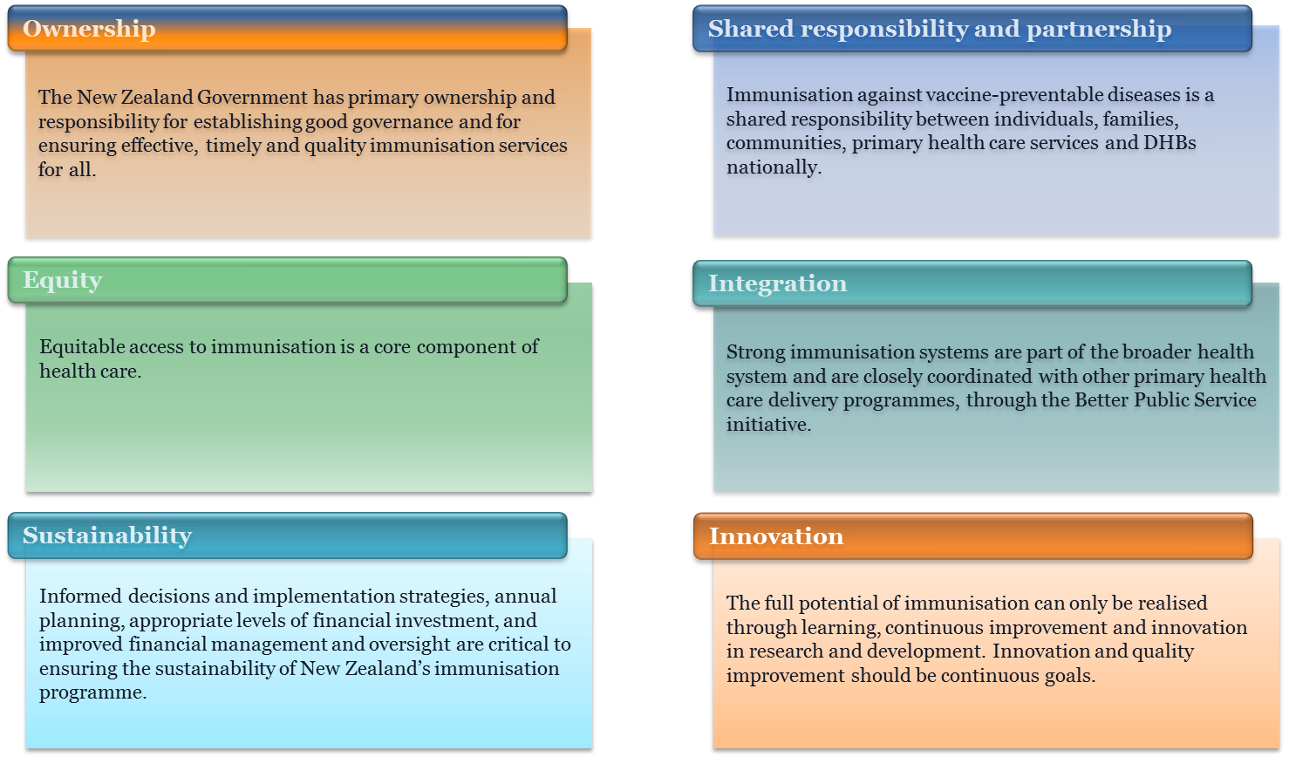

Appendix B: 2014 HPV coverage for 2001 birth cohort
(1 January 2014–30 June 2015)
HPV coverage report – June 2015 Girls turning 12 years old in 2014 [Birth Cohort: 2001]
Report run date: 07 July 2015 Period covered: 1 January 2010 to 30 June 2015
The information contained in this report has been derived from the National Immunisation Register database. While the Ministry of Health has taken all reasonable steps to ensure that the information contained within the report is accurate and complete, it accepts no liability or responsibility for the manner in which the information is subsequently used or relied on.
DHB | Vaccination | Number of HPV doses given (numerator) |  |  |  |  | Estimated eligible population* (denominator) |  |  |  |  | Immunisation coverage
 |  | Maori | Pacific | Asian | Other** | All | Maori | Pacific | Asian | Other** | All | Maori | Pacific | Asian | Other** | All
Auckland | HPV-1 Quadrivalent | 211 | 411 | 462 | 725 | 1809 | 270 | 450 | 630 | 860 | 2210 | 78% | 91% | 73% | 84% | 82%
 | HPV-2 Quadrivalent | 214 | 414 | 462 | 711 | 1801 |  |  |  |  |  | 79% | 92% | 73% | 83% | 81%
 | HPV-3 Quadrivalent | 203 | 401 | 444 | 689 | 1737 |  |  |  |  |  | 75% | 89% | 70% | 80% | 79%
Bay of Plenty | HPV-1 Quadrivalent | 434 | 20 | 36 | 431 | 921 | 570 | 30 | 30 | 810 | 1440 | 76% | 67% | 120% | 53% | 64%
 | HPV-2 Quadrivalent | 430 | 20 | 37 | 416 | 903 |  |  |  |  |  | 75% | 67% | 123% | 51% | 63%
 | HPV-3 Quadrivalent | 394 | 17 | 31 | 389 | 831 |  |  |  |  |  | 69% | 57% | 103% | 48% | 58%
Canterbury | HPV-1 Quadrivalent | 188 | 53 | 116 | 1240 | 1597 | 420 | 110 | 190 | 2290 | 3010 | 45% | 48% | 61% | 54% | 53%
 | HPV-2 Quadrivalent | 170 | 47 | 110 | 1140 | 1467 |  |  |  |  |  | 40% | 43% | 58% | 50% | 49%
 | HPV-3 Quadrivalent | 118 | 29 | 88 | 921 | 1156 |  |  |  |  |  | 28% | 26% | 46% | 40% | 38%
Capital & Coast | HPV-1 Quadrivalent | 233 | 157 | 119 | 709 | 1218 | 330 | 220 | 170 | 990 | 1700 | 71% | 71% | 70% | 72% | 72%
 | HPV-2 Quadrivalent | 227 | 151 | 118 | 693 | 1189 |  |  |  |  |  | 69% | 69% | 69% | 70% | 70%
 | HPV-3 Quadrivalent | 217 | 150 | 119 | 672 | 1158 |  |  |  |  |  | 66% | 68% | 70% | 68% | 68%
Counties Manukau | HPV-1 Quadrivalent | 668 | 972 | 433 | 633 | 2706 | 910 | 1190 | 690 | 1140 | 3930 | 73% | 82% | 63% | 56% | 69%
 | HPV-2 Quadrivalent | 650 | 955 | 448 | 648 | 2701 |  |  |  |  |  | 71% | 80% | 65% | 57% | 69%
 | HPV-3 Quadrivalent | 550 | 867 | 422 | 594 | 2433 |  |  |  |  |  | 60% | 73% | 61% | 52% | 62%
Hawke’s Bay | HPV-1 Quadrivalent | 339 | 49 | 21 | 336 | 745 | 430 | 60 | 10 | 600 | 1100 | 79% | 82% | 210% | 56% | 68%
 | HPV-2 Quadrivalent | 329 | 48 | 21 | 322 | 720 |  |  |  |  |  | 77% | 80% | 210% | 54% | 65%
 | HPV-3 Quadrivalent | 315 | 48 | 19 | 305 | 687 |  |  |  |  |  | 73% | 80% | 190% | 51% | 62%
Hutt Valley | HPV-1 Quadrivalent | 216 | 81 | 74 | 351 | 722 | 270 | 120 | 90 | 520 | 1010 | 80% | 68% | 82% | 68% | 71%
 | HPV-2 Quadrivalent | 210 | 80 | 69 | 330 | 689 |  |  |  |  |  | 78% | 67% | 77% | 63% | 68%
 | HPV-3 Quadrivalent | 203 | 76 | 73 | 334 | 686 |  |  |  |  |  | 75% | 63% | 81% | 64% | 68%
Lakes | HPV-1 Quadrivalent | 265 | 15 | 16 | 176 | 472 | 370 | 20 | 20 | 320 | 730 | 72% | 75% | 80% | 55% | 65%
 | HPV-2 Quadrivalent | 261 | 15 | 16 | 173 | 465 |  |  |  |  |  | 71% | 75% | 80% | 54% | 64%
 | HPV-3 Quadrivalent | 250 | 15 | 16 | 172 | 453 |  |  |  |  |  | 68% | 75% | 80% | 54% | 62%
MidCentral | HPV-1 Quadrivalent | 246 | 32 | 41 | 410 | 729 | 340 | 40 | 50 | 700 | 1130 | 72% | 80% | 82% | 59% | 65%
 | HPV-2 Quadrivalent | 238 | 32 | 43 | 398 | 711 |  |  |  |  |  | 70% | 80% | 86% | 57% | 63%
 | HPV-3 Quadrivalent | 226 | 32 | 42 | 377 | 677 |  |  |  |  |  | 66% | 80% | 84% | 54% | 60%
Nelson Marlborough | HPV-1 Quadrivalent | 96 | 15 | 17 | 392 | 520 | 120 | 15 | 20 | 710 | 850 | 80% | 100% | 85% | 55% | 61%
 | HPV-2 Quadrivalent | 87 | 15 | 16 | 384 | 502 |  |  |  |  |  | 73% | 100% | 80% | 54% | 59%
 | HPV-3 Quadrivalent | 84 | 15 | 16 | 359 | 474 |  |  |  |  |  | 70% | 100% | 80% | 51% | 56%
Northland | HPV-1 Quadrivalent | 398 | 23 | 14 | 274 | 709 | 530 | 30 | 30 | 580 | 1170 | 75% | 77% | 47% | 47% | 61%
 | HPV-2 Quadrivalent | 383 | 23 | 14 | 262 | 682 |  |  |  |  |  | 72% | 77% | 47% | 45% | 58%
 | HPV-3 Quadrivalent | 361 | 22 | 12 | 253 | 648 |  |  |  |  |  | 68% | 73% | 40% | 44% | 55%
South Canterbury | HPV-1 Quadrivalent | 24 | 4 | 8 | 150 | 186 | 40 | 5 | 0 | 270 | 320 | 60% | 80% | -% | 56% | 58%
 | HPV-2 Quadrivalent | 24 | 4 | 8 | 145 | 181 |  |  |  |  |  | 60% | 80% | -% | 54% | 57%
 | HPV-3 Quadrivalent | 23 | 3 | 8 | 140 | 174 |  |  |  |  |  | 58% | 60% | -% | 52% | 54%
Southern | HPV-1 Quadrivalent | 179 | 41 | 44 | 947 | 1211 | 260 | 35 | 20 | 1330 | 1660 | 69% | 117% | 220% | 71% | 73%
 | HPV-2 Quadrivalent | 176 | 42 | 42 | 933 | 1193 |  |  |  |  |  | 68% | 120% | 210% | 70% | 72%
 | HPV-3 Quadrivalent | 169 | 39 | 42 | 898 | 1148 |  |  |  |  |  | 65% | 111% | 210% | 68% | 69%
Tairāwhiti | HPV-1 Quadrivalent | 174 | 8 | 2 | 67 | 251 | 220 | 10 | 5 | 140 | 370 | 79% | 80% | 40% | 48% | 68%
 | HPV-2 Quadrivalent | 173 | 8 | 2 | 64 | 247 |  |  |  |  |  | 79% | 80% | 40% | 46% | 67%
 | HPV-3 Quadrivalent | 164 | 6 | 2 | 62 | 234 |  |  |  |  |  | 75% | 60% | 40% | 44% | 63%
Taranaki | HPV-1 Quadrivalent | 134 | 11 | 14 | 356 | 515 | 190 | 10 | 20 | 480 | 690 | 71% | 110% | 70% | 74% | 75%
 | HPV-2 Quadrivalent | 131 | 11 | 15 | 348 | 505 |  |  |  |  |  | 69% | 110% | 75% | 73% | 73%
 | HPV-3 Quadrivalent | 118 | 11 | 14 | 329 | 472 |  |  |  |  |  | 62% | 110% | 70% | 69% | 68%
Waikato | HPV-1 Quadrivalent | 549 | 73 | 100 | 880 | 1602 | 790 | 90 | 140 | 1470 | 2490 | 69% | 81% | 71% | 60% | 64%
 | HPV-2 Quadrivalent | 539 | 71 | 99 | 866 | 1575 |  |  |  |  |  | 68% | 79% | 71% | 59% | 63%
 | HPV-3 Quadrivalent | 505 | 67 | 93 | 833 | 1498 |  |  |  |  |  | 64% | 74% | 66% | 57% | 60%
Wairarapa | HPV-1 Quadrivalent | 51 | 2 | 5 | 123 | 181 | 60 | 5 | 10 | 150 | 220 | 85% | 40% | 50% | 82% | 82%
 | HPV-2 Quadrivalent | 48 | 2 | 4 | 124 | 178 |  |  |  |  |  | 80% | 40% | 40% | 83% | 81%
 | HPV-3 Quadrivalent | 46 | 2 | 2 | 114 | 164 |  |  |  |  |  | 77% | 40% | 20% | 76% | 75%
Waitemata | HPV-1 Quadrivalent | 339 | 279 | 398 | 1142 | 2158 | 530 | 380 | 660 | 2020 | 3580 | 64% | 73% | 60% | 57% | 60%
 | HPV-2 Quadrivalent | 329 | 271 | 389 | 1124 | 2113 |  |  |  |  |  | 62% | 71% | 59% | 56% | 59%
 | HPV-3 Quadrivalent | 301 | 255 | 382 | 1071 | 2009 |  |  |  |  |  | 57% | 67% | 58% | 53% | 56%
West Coast | HPV-1 Quadrivalent | 11 | 0 | 4 | 100 | 115 | 40 | 5 | 5 | 160 | 210 | 28% | 0% | 80% | 63% | 55%
 | HPV-2 Quadrivalent | 11 | 0 | 4 | 99 | 114 |  |  |  |  |  | 28% | 0% | 80% | 62% | 54%
 | HPV-3 Quadrivalent | 11 | 0 | 3 | 97 | 111 |  |  |  |  |  | 28% | 0% | 60% | 61% | 53%
Whanganui | HPV-1 Quadrivalent | 128 | 10 | 8 | 167 | 313 | 170 | 5 | 10 | 240 | 420 | 75% | 200% | 80% | 70% | 75%
 | HPV-2 Quadrivalent | 120 | 10 | 8 | 166 | 304 |  |  |  |  |  | 71% | 200% | 80% | 69% | 72%
 | HPV-3 Quadrivalent | 110 | 9 | 8 | 154 | 281 |  |  |  |  |  | 65% | 180% | 80% | 64% | 67%
Total | HPV-1 Quadrivalent | 4883 | 2256 | 1932 | 9609 | 18,680 | 6860 | 2830 | 2800 | 15,780 | 28,240 | 71% | 80% | 69% | 61% | 66%
 | HPV-2 Quadrivalent | 4750 | 2219 | 1925 | 9346 | 18,240 |  |  |  |  |  | 69% | 78% | 69% | 59% | 65%
 | HPV-3 Quadrivalent | 4368 | 2064 | 1836 | 8763 | 17,031 |  |  |  |  |  | 64% | 73% | 66% | 56% | 60%

The World Health Organization is a specialised agency of the United Nations that is concerned with international public health.
Herd immunity refers to a level of immunity within the population that is sufficient to protect both immunised and unimmunised people.
PHARMAC is the New Zealand Crown agency that decides, on behalf of DHBs, which medicines (including vaccines) and related products to subsidise for use in the community and public hospitals.
From 1 January 2015, DHBs are aiming at a 65 percent fully immunised dose three target.
Cormack D, Purdie G, Robson B. 2007. Cancer. In: Robson B, Harris R. (eds). Hauora: Māori Standards of Health IV: A study of the years 2000–2005. Wellington: Te Rōpū Rangahau Hauora a Eru Pōmare.
Blakely T, Kvizhinadze G, Karvonen T, et al. 2014. Cost-effectiveness and equity impacts of three HPV vaccination programmes for school-aged girls in New Zealand. Vaccine 2014, 32: 2645–56. URL: www.otago.ac.nz/wellington/otago068857.pdf.
Pearson A, Kvizhinadze G, Wilson N, et al. 2014. Is expanding HPV vaccination programs to include school-aged boys likely to be value-for-money: a cost-utility analysis in a country with an existing school-girl program. BMC Infections Diseases 2014, 14:351. URL: www.biomedcentral.com/content/pdf/1471-2334-14-351.pdf

