Household Food Insecurity Among Children: New Zealand Health Survey
Summary of Findings

Released 2019
Household Food Insecurity Among Children: New Zealand Health Survey: Summary of findings I

Citation: Ministry of Health. 2019. Household Food Insecurity Among Children: New Zealand Health Survey: Summary of findings. Wellington: Ministry of Health.
Published in June 2019 by the Ministry of Health PO Box 5013, Wellington 6145, New Zealand
ISBN 978-1-98-856862-1 (online)
HP 7052
This document is available at: health.govt.nz

This work is licensed under the Creative Commons Attribution 4.0 International licence. In essence, you are free to: share, ie, copy and redistribute the material in any medium or format; adapt, ie, remix, transform and build upon the material. You must give appropriate credit, provide a link to the licence and indicate if changes were made.

Contents
Introduction 1
New Zealand Health Survey and the household food security questionnaire 1
Findings 3
Income 4
Ethnicity 5
Living circumstances 6
Household composition 7
Wider circumstances 8
Of the children in food-insecure households 8
References 9

IV Household Food Insecurity Among Children: New Zealand Health Survey: Summary of findings

Introduction
Food insecurity is defined as a limited or uncertain availability of nutritionally adequate and safe foods, or limited ability to acquire personally acceptable foods that meet cultural needs in a socially acceptable way (Anderson 1990; Holben 2010; Parnell et al 2001). This means that people might not have enough to eat, might not be able to eat a varied diet and enough healthy food, or may be unable to provide food to share at social occasions. In New Zealand, food insecurity often happens because households don’t have enough money for food, although other socio-cultural factors also play a role.
Data from the New Zealand Health Survey shows that while most children live in food- secure households, almost one in five children (19%) in New Zealand lived in severely to moderately food-insecure households in 2015/16. Food insecurity in a household may not mean that individual children are food-insecure, as caregivers may shield children from the full effects of food insecurity by putting their children’s needs ahead of their own (McIntyre et al 2003).
In this brief we explore the prevalence of household food insecurity among children aged 0–14 years. We also look at the wider circumstances of these children. For example, children in food-insecure households were likely to have poorer health, poorer nutrition, and were more likely to be overweight or obese than children in food-secure households.

New Zealand Health Survey and the household food security questionnaire
A New Zealand-specific food security questionnaire was developed in the late 1990s (Parnell 2005; Parnell and Gray 2014). It consists of eight statements about:
- being able to afford to eat properly
- food running out in the household due to lack of money
- eating less because of lack of money
- eating less variety of foods because of lack of money
- relying on others to provide food and/or money for food
- making use of food grants or food banks when there is not enough money for food
- feeling stressed because of not having enough money for food
- feeling stressed because of not being able to provide the food wanted for social occasions.

The food security questionnaire was included in the child component of the New Zealand Health Survey in 2012/13, 2014/15 and 2015/161. The primary caregiver of the child responded to the statements, indicating whether this was true for the household over the past year; (1) often (2) sometimes or (3) never. Based on their responses, households were categorised as being either food-secure or food-insecure.
The findings in this brief are based on data collected through the New Zealand Health Survey in 2014/15 and 2015/16. In total, almost 9,500 primary caregivers of children aged less than 15 years completed the child component of the New Zealand Health Survey. The survey is designed so that the findings are representative of the total New Zealand child population (see Ministry of Health 2016).

1 Due to differences in analytical approach and thresholds used to categorise households into groups with different levels of food insecurity, results based on the New Zealand Health Survey and previous surveys using the food security questionnaire (eg the 1997 National Nutrition Survey and 2002 National Children’s Nutrition Survey) are not directly comparable. For more information on the New Zealand Health Survey, see health.govt.nz/nz-health-
statistics/national-collections-and-surveys/surveys/current-recent-surveys/new-zealand- health-survey

Findings
Most children in New Zealand live in households that are food-secure. However, information from the New Zealand Health Survey shows that an estimated 174,000 children (19%) below the age of 15 years lived in food-insecure households in 2015/16. Household food insecurity was more common for some subgroups of children in
New Zealand. The full report (Ministry of Health 2019) highlights that gross household income plays an important role in these group differences.
Compared to children in food-secure households, children in food-insecure households had more risk factors for health, worse health status, and their caregivers indicated more concerns with their development. These associations are consistent with those identified by previous research in New Zealand and internationally. Food insecurity, poverty, and material deprivation together are likely to contribute to these findings.
For a more detailed discussion of the findings, see the full report Household Food Insecurity Among Children: New Zealand Health Survey (Ministry of Health 2019). This covers more indicators, including primary caregiver indicators such as psychological and parenting stress.

Food insecurity is an important public policy concern because of possible negative health, development, and education consequences; and also from the perspective of the rights of children. The population-based estimates of
household food insecurity based on the New Zealand Health Survey are important to measure progress toward the Government’s programme to reduce child poverty in New Zealand. They are also relevant to the United Nations Sustainable Development Goals, which includes the goal to ‘end hunger, achieve food security and improved nutrition, and promote sustainable agriculture’ by 2030. All children should have access to enough appropriate and healthy food to eat, no matter their ethnicity or living circumstances; to help ensure they have the best possible start in life.

How to read the figures in this report
The figures in this report present the proportion of children living in food- insecure households for different groups. Purple represents the children in food-secure households, while green represents the children in food-insecure households. The numbers in the bars present the estimated number of children in each group, rounded to the nearest 1,000.
For example, the figure below presents household food insecurity for children in New Zealand with a primary caregiver receiving a benefit and those not receiving a benefit. For children with a primary caregiver on a benefit, an estimated 73,000 lived in a food-secure household, which is 44 percent of all children with a primary caregiver on a benefit. An estimated 92,000 children in this group lived in food-insecure households, which is 56 percent of children with a primary caregiver on a benefit.

Income
Household food insecurity is closely related to income. For households with a gross annual income of $50,000 or less, the proportion of children living in food-insecure households was more than 40 percent. This compares to less than 10 percent when gross household income was over $50,000.
Of children whose primary caregiver received a benefit (Jobseeker Support, Sole Parent Support and Supported Living Payments), more than 50 percent lived in food-insecure households. This compared to almost 12 percent of children in households where the primary caregiver did not receive a benefit.
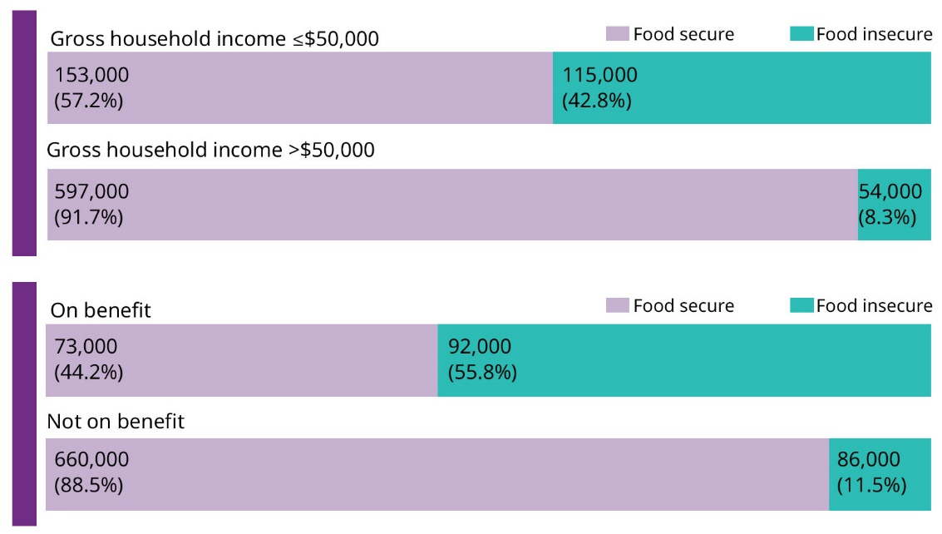

Ethnicity
The proportion of children living in food-insecure households was highest among Māori and Pacific populations. Of Pacific children, 37 percent (an estimated 46,000) lived in food-insecure households in 2015/16. For Māori children this was 29 percent (an estimated 68,000).
A lower proportion of Asian (9%) and European and other (15%) children lived in food-insecure households. However, because European and other children make up the majority of the New Zealand child population, the largest number of children (100,000) in food-insecure households were European and other.
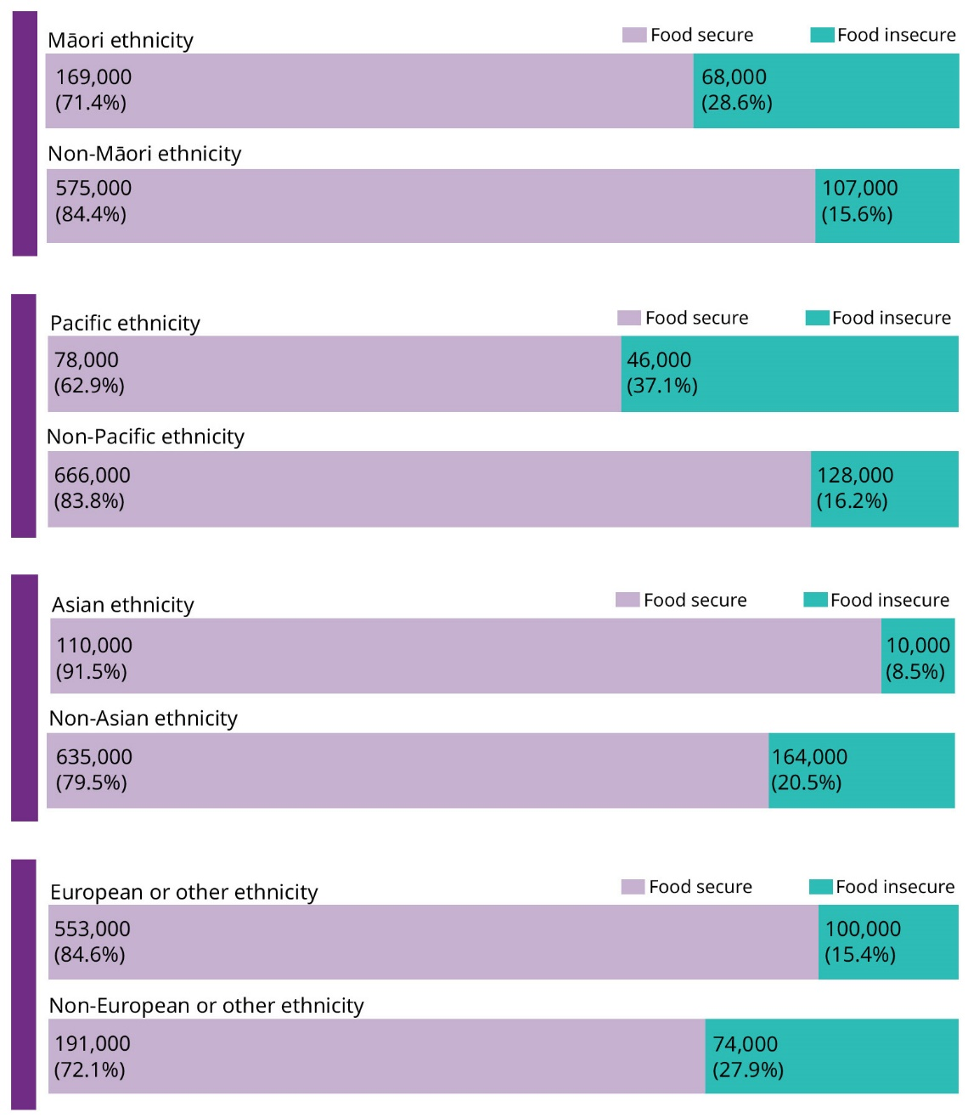

Living circumstances
A higher proportion of children lived in food-insecure households in the most deprived neighbourhoods compared to the least deprived neighbourhoods. Over one in three children (35%) in the most deprived neighbourhoods (NZDep2013 quintile 5) lived in a household that was food-insecure.
Household food insecurity was more common among children living in rented housing compared to privately-owned housing. The proportion of children living in food-insecure households was highest (53%) for children in houses rented from public landlords.
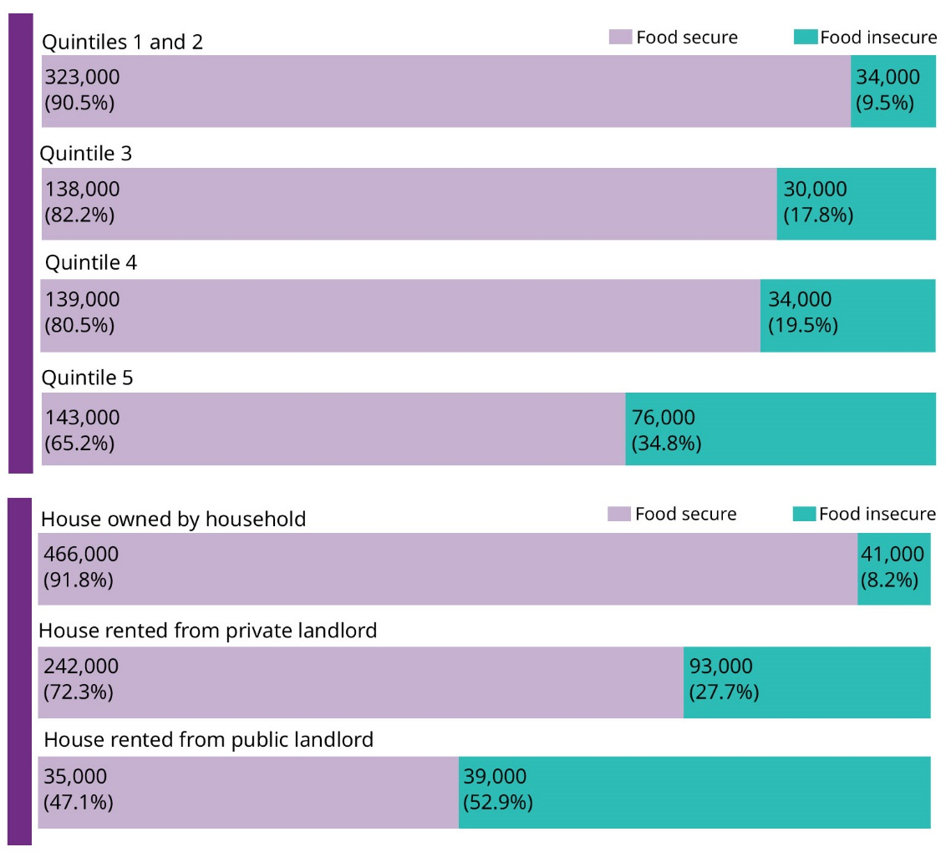

Household composition
Household food insecurity was more common in households with larger numbers of children. Of households with four or more children, 38 percent of children lived in a food-insecure household.
Households of children living with a sole-parent were more likely to be food-insecure compared to those of children living with couple-parents.
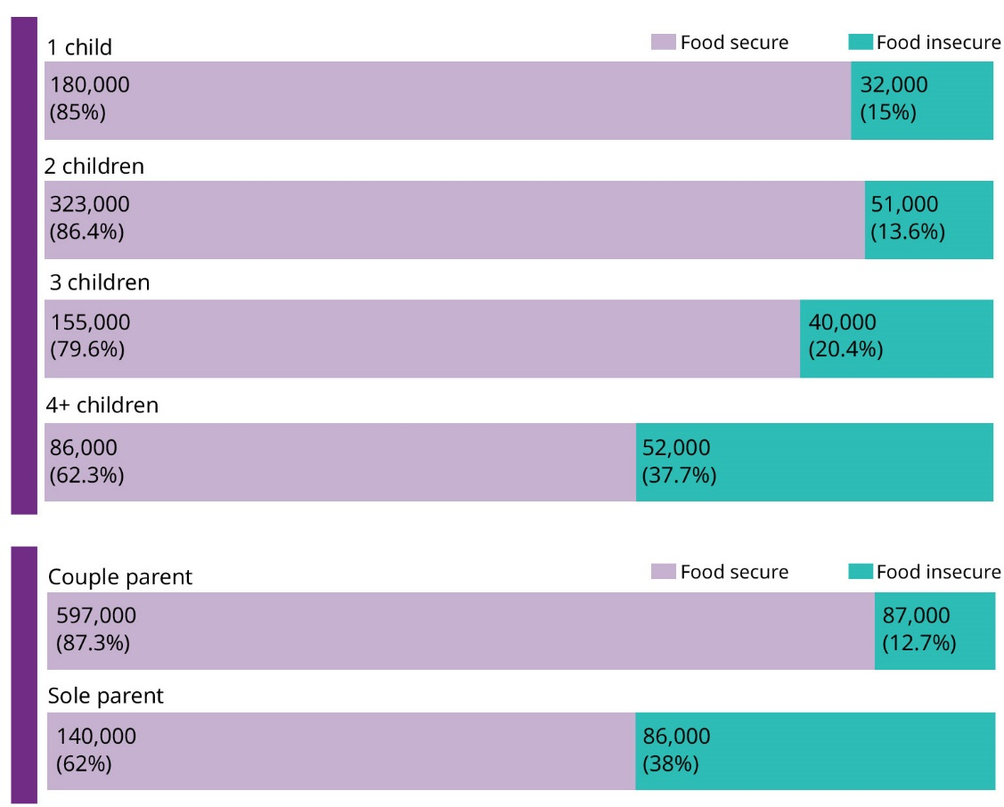

Wider circumstances
Based on New Zealand Health Survey data from 2014/15 and 2015/16 combined, we looked at the wider circumstances of children in food-insecure households. Based on this cross-sectional data we are not able to identify cause and effect. For example, our data shows that children living in food-insecure households were more likely to be obese. This does not necessarily mean that food insecurity caused obesity, it could be that food insecurity and obesity share a common cause (eg poverty or deprivation).
Food insecurity often co-occurs with a number of other risk factors. We describe the co-occurrence of food insecurity with indicators of child health and development in the following diagram.

Of the children in food-insecure households
41% had unmet needs for
primary care compared to 20%
in food-secure households
(2015/16 data only)
21% had medicated
asthma compared to 15% in food-secure households
(aged 5–14 years)
68% met the guidelines for
fruit consumption compared to 75% in food-secure households (aged 2–14 years)
46% met the guidelines for
vegetable consumption compared to 56% in food-secure households (aged 2–14 years)

27% were overweight
compared to 20% in food-secure households (aged 2–14 years)
18% were obese compared
to 9% in food-secure households
(aged 5–14 years)
12% had learning,
development or behaviour concerns based on the Parents’ Evaluation of Developmental Status compared to 5% in food-secure
households (aged 4 months to 8 years, rated by primary caregiver)
16% had a concerning
score on the Strengths and Difficulties Questionnaire, which screens for social, emotional and behavoural difficulties, compared to 6% in food-secure households
(aged 3–14 years, rated by primary caregiver)

References
Anderson SA. (1990). Core indicators of nutritional state for difficult-to-sample populations. The Journal of nutrition 120: 1559–1600.
Holben D. 2010. Position of the American Dietetic Association: Food insecurity in the United States. Journal of the American Diet Association 110: 1367–77.
McIntyre L, Patterson PB, & Mah CL. 2019. The application of ‘valence’ to the idea of household food insecurity in Canada. Social Science & Medicine, 220, 176-183
Ministry of Health. 2016. Methodology report 2015/16: New Zealand Health Survey. Wellington: Ministry of Health. URL: https://www.health.govt.nz/publication/ methodology-report-2015-16-new-zealand-health-survey
Ministry of Health. 2019. Household Food Insecurity Among Children: New Zealand Health Survey. Wellington: Ministry of Health.
Parnell W. 2005. Food security in New Zealand. Doctoral thesis. Dunedin: University of Otago.
Parnell WR, Gray AR. 2014. Development of a food security measurement tool for New Zealand households. British Journal of Nutrition 112(8): 1393–1401.
Parnell WR, Reid J, Wilson NC, et al. 2001. Food security: is New Zealand a land of plenty? New Zealand Medical Journal 114(1128): 141–5.

