Household Food Insecurity Among Children: New Zealand Health Survey
2019

Acknowledgements
The New Zealand Health Survey relies on the support and enthusiasm of many individuals, including the survey participants and the surveyors who worked so diligently to collect the data. Thank you to all.
The New Zealand Health Survey is developed by the Health Survey team in the Health and Disability Intelligence Group, Ministry of Health. It is conducted by CBG Health Research Ltd.
This report was written by Linda Pannekoek (Ministry of Health), with input from David Rea (Ministry of Social Development). Analyses were undertaken by Linda Pannekoek and James Greenwell. Thank you to all who provided input and review.
Citation: Ministry of Health. 2019. Household Food Insecurity Among Children: New Zealand Health Survey. Wellington: Ministry of Health.
Published in June 2019 by the Ministry of Health
PO Box 5013, Wellington 6140, New Zealand
ISBN 978-1-98-856832-4 (online)
HP 6996
This document is available at health.govt.nz
This work is licensed under the Creative Commons Attribution 4.0 International licence. In essence, you are free to: share ie, copy and redistribute the material in any medium or format; adapt ie, remix, transform and build upon the material. You must give appropriate credit, provide a link to the licence and indicate if changes were made.

Foreword
Food insecurity is an issue that no New Zealand family should have to worry about. Unfortunately this is not currently the case in Aotearoa/New Zealand. This report describes the prevalence of household food insecurity among our tamariki.
In 2015/16 there were just over 917,000 children aged 0–14 years in New Zealand. Most of these children lived in households that were food-secure. However, as this report indicates, for almost one in five children their household experienced severe-to-moderate food insecurity. These children may be missing out on adequate and nutritious food, the ingredients that are so essential to every aspect of their lives. This is not acceptable.

The Government has a significant political commitment to reducing child poverty and promoting child wellbeing. This report highlights the association between low socioeconomic position and household food insecurity. It shows that children in food-insecure households fare worse than children in food-secure households on indicators of health, development and access to health services. Their parents are more likely to report psychological distress and, more specifically, stress related to parenting.

The important challenges highlighted in this report require action, and will be addressed through strong cross-agency collaboration.

A special thank you goes out to the many thousands of New Zealanders who gave their time to take part in the survey. The information they have provided is critical for understanding and monitoring the health and wellbeing of New Zealand children.

Dr Ashley Bloomfield
Director-General of Health
Ministry of Health

Contents
Foreword iii
Summary ix
Key findings x
Background 1
Measuring household food insecurity in the New Zealand Health Survey 3
The prevalence of food insecurity in 2015/16 7
Almost one in five children lived in a food-insecure household 7
The share of children living in households with food insecurity was higher for some groups 9
Recent changes in the prevalence of household food insecurity among children 22
The wider circumstances of children living in households with food insecurity 25
Barriers to accessing health care were more common among children in food-insecure households 26
Fewer children in food-insecure households met the fruit and vegetable consumption guidelines 28
Fewer children in food-insecure households had a healthy weight 31
Children and caregivers in food-insecure households had lower caregiver-rated health status 34
Caregivers in food-insecure households indicated more concerns about their child’s development 35
More caregivers in food-insecure households experienced psychological distress 39
More children in food-insecure households were exposed to second-hand smoke 41
Conclusion 43
References 44
Appendices
Appendix 1: The New Zealand Health Survey 50
Appendix 2: Detail on the construction of the food insecurity index 52
Appendix 3: Definition of key variables used in the analysis 55
Appendix 4: Share of the child population in each group 2015/16 64
Appendix 5: Data tables 66

List of Figures
Figure 1: Item responses to the food security questionnaire, 2015/16 8
Figure 2: Household food insecurity among children by neighbourhood deprivation, 2015/16 11
Figure 3: Household food insecurity among children by household income, 2015/16 12
Figure 4: Household food insecurity among children with a primary caregiver receiving a means-tested benefit, 2015/16 13
Figure 5: Household food insecurity among children by housing tenure, 2015/16 15
Figure 6: Household food insecurity among Māori children, 2015/16 16
Figure 7: Household food insecurity among Pacific children, 2015/16 17
Figure 8: Household food insecurity among Asian children, 2015/16 18
Figure 9: Household food insecurity among European and other children, 2015/16 18
Figure 10: Household food insecurity among children and number of children in the household, 2015/16 20
Figure 11: Household food insecurity among children with sole and couple parents, 2015/16 21
Figure 12: Prevalence of children aged 0–14 years living in households with severe-to-moderate food insecurity, 2012/2013, 2014/2015 and 2015/16 23
Figure 13: Household food insecurity and barriers to accessing health care in the past year, 2014/15 and 2015/16 26
Figure 14A: Household food insecurity and nutrition indicators for children aged 2–4 years, 2014/15 and 2015/16 30
Figure 14B: Household food insecurity and nutrition indicators for children aged 5–9 years, 2014/15 and 2015/16 30
Figure 14C: Household food insecurity and nutrition indicators for children aged 10–14 years, 2014/15 and 2015/16 31
Figure 15A: Body size indicators by food security status for children aged
2–4 years, 2014/15 and 2015/16 32
Figure 15B: Body size indicators by food security status for children aged
5–9 years, 2014/15 and 2015/16 33
Figure 15C: Body size indicators by food security status for children aged
10–14 years, 2014/15 and 2015/16 33
Figure 16: Household food insecurity and health indicators for children and their caregivers, 2014/15 and 2015/16 34
Figure 17: Household food insecurity and concerns about child development – PEDS, 2014/15 and 2015/16 36
Figure 18: Household food insecurity and concerns about child development – SDQ, 2014/15 and 2015/16 38
Figure 19: Household food insecurity and caregiver stress indicators, 2014/15 and 2015/16 40
Figure 20: Household food insecurity and tobacco use, 2015/16 42
Figure A2.1: Probability of response selection for a specific item 53
Figure A2.2: Distribution of the food insecurity index across all children aged
0–14, 2015/16 54

List of Tables
Table 1: Food insecurity items in the child component of the New Zealand Health Survey 4
Table 2: Item responses to the food security questionnaire and summary index, 2015/16 9
Table 3: Prevalence of children living in food-insecure households, by age and sex, 2015/16 10
Table 4: Prevalence of children living in households with food insecurity, by neighbourhood deprivation, household income and benefit receipt, 2015/16 14
Table 5: Prevalence of children living in households with food insecurity, by housing tenure, 2015/16 16
Table 6: Prevalence of children living in food-insecure households, by ethnicity, 2015/16 19
Table 7: Prevalence of children living in food-insecure households, by household composition, 2015/16 21
Table 8: Prevalence of severe-to-moderate food insecurity among children aged 0–14 years, 2012/2013, 2014/2015 and 2015/16 24
Table 9: Child unmet need, indicators by food security status, 2014/15 and 2015/16 28
Table 10: Health indicators for children and their caregivers, by food security status, 2014/15 and 2015/16 35
Table 11: Child development indicators by food security status – PEDS, 2014/15 and 2015/16 37
Table 12: Child development indicators by food security status – SDQ, 2014/15 and 2015/16 38
Table 13: Caregiver stress indicators, by food security status, 2014/15 and 2015/16 41
Table 14: Tobacco use, by food security status, 2015/16 42
Table A1.1: Number of primary caregivers responding to the child component of the New Zealand Health Survey, 2012/13, 2014/15 and 2015/16 51
Table A2.1: Item response theory estimates, 2015/16 54
Table A3.1: New Zealand Health Survey variables 55
Table A4.1: Share of the child population in each group 64
Table A5.1: Vegetable consumption by food security status, 2014/15 and 2015/16 66
Table A5.2: Fruit consumption by food security status, 2014/15 and 2015/16 66
Table A5.3: Breakfast by food security status, 2014/15 and 2015/16 67
Table A5.4: Fast food by food security status, 2014/15 and 2015/16 67
Table A5.5: Fizzy drinks by food security status, 2014/15 and 2015/16 67
Table A5.6: Child body size indicators by food security status, 2014/15 and 2015/16 68
Table A5.7: Child body size indicators by food security status, 2014/15 and 2015/16 68
Table A5.8: Child body size indicators by food security status, 2014/15 and 2015/16 68
Table A5.9: Rates and rate ratios (ARR), adjusted for gross household income and number of children, 2015/16 69

Summary
In households with children, food insecurity occurs when adults or children do not have reliable access to adequate food, when caregivers feel stressed and anxious about providing food, or are forced to rely on charity or emergency assistance programmes. In New Zealand, food insecurity is largely the result of a lack of sufficient money for food, although other socio-cultural factors play a role.
New Zealand Health Survey estimates indicate that although the majority of children live in food-secure households, a share of New Zealand children do not. In 2015/16, almost one in five children (19.0%) lived in households with severe-to-moderate food insecurity.

Consistent with previous work, rates of household food insecurity were higher among certain subgroups of children, including children in households on low incomes, children in the most deprived neighbourhoods, and children of Pacific and Māori ethnicity. However, this does not mean that household food insecurity is not an issue for other subgroups. Some groups with a relatively low rate of household food insecurity made up a substantial share of all children in food-insecure households. For example, European and other children had a comparatively low prevalence of household food insecurity (15.4%). However, as a result of the size of this population (71.2% of all children identified as European and other), an estimated 57 percent of all children living in food-insecure households were European and other.

Findings based on the New Zealand Health Survey were consistent with previous research on the association of food insecurity with other indicators. Children in food-insecure households had poorer parent-rated health status, poorer nutrition, higher rates of overweight or obesity, asthma and behavioural or developmental difficulties, and experienced a range of other adverse circumstances. Parents of children in food-insecure households reported higher rates of psychological and parenting stress, as well as poorer self-rated health status. These findings represent associations, not causal relationships. Food insecurity often co-occurs with a number of risk factors, particularly those associated with other aspects of poverty and material hardship.

New Zealand children living in households with food insecurity comprise an important public policy concern. The possible adverse health, development and education consequences are relevant to the current Government’s priority of reducing child poverty. Household food insecurity is also a concern from the perspective of the rights of children. Access to adequate food, and freedom from hunger, are important components of a range of international conventions and commitments regarding human rights.

Key findings
Almost one in five children (19.0%) lived in households experiencing severe-to-moderate food insecurity in 2015/16.

In 2015/16 household food insecurity was more prevalent among children:
- living in the most deprived neighbourhoods
- in households with a lower gross income
- with a primary caregiver on the benefit
- living in publicly or privately rented housing compared to owner-occupied housing
- of Pacific and Māori ethnicity
- living with a sole parent
- living with two or more other children in the household.

Based on data from 2014/15 and 2015/16 combined, compared to children in food-secure households, children in food-insecure households were significantly more likely to:
- experience barriers to accessing health care
- not meet fruit and vegetable consumption guidelines
- eat breakfast at home for fewer than five days per week
- eat fast food and drink fizzy drinks three or more times a week
- be obese or overweight, and less likely to be a healthy weight
- have a fair or poor parent-rated health status
- have a primary caregiver who rated their own health as fair or poor
- have medicated asthma or eczema
- have a caregiver indicating concerns with development on the Parents’ Evaluation of Developmental Status questionnaire
- have a caregiver indicating social, emotional and behavioural concerns on the Strengths and Difficulties Questionnaire
- have a primary caregiver indicating stresses related to raising their child, not having someone to turn to for support or more general psychological distress
- have a primary caregiver who is a current smoker as well as live in a house where someone smoked inside.

Background
Food insecurity is defined as a limited or uncertain availability of nutritionally adequate and safe foods or limited ability to acquire personally acceptable foods that meet cultural needs in a socially acceptable way (Anderson 1990; Holben 2010; Parnell et al 2001).
The global picture of food insecurity ranges from malnutrition due to starvation as a result of food deprivation to malnutrition due to consumption of calorie-rich foods while not consuming enough vital nutrients. Both instances can lead to compromised health, morbidity and mortality.

In New Zealand, food insecurity is largely the result of a lack of sufficient money for food, although other socio-cultural factors also play a role (Bowers et al 2009; McKerchar et al 2015; Parnell et al 2016; Rush and Rusk 2009). Children living in food-insecure households tend to have poorer diets (Fram et al 2015; Parnell et al 2005), increased rates of obesity (Utter et al 2012; Widome et al 2009), poorer health status and higher rates of developmental and behavioural problems, which often also affect school performance (Shankar et al 2017; Whitaker et al 2006). Household food insecurity is an important public policy concern.

Measuring the prevalence of household food insecurity among New Zealand children is important given these concerns. In order to improve the estimation of food insecurity prevalence, a New Zealand-specific food security questionnaire was developed in the late 1990s (Parnell 2005; Parnell and Gray 2014). This questionnaire was first implemented in the 1997 National Nutrition Survey (adults). The same questionnaire was then used in the 2002 National Children’s Nutrition Survey (Parnell et al 2005). In 2012/13, 2014/15 and 2015/16, the questionnaire was used in the child component of the New Zealand Health Survey. The estimates presented in this paper use this data and build on the work by Parnell and colleagues.

A wide range of New Zealand research using other food security measures has also been conducted in recent years. This includes work using the Survey of Family, Income, and Employment (SOFIE) data (Carter et al 2010), the Youth Health and Wellbeing surveys (Utter et al 2018), the Growing Up in New Zealand Study (Schlichting et al 2018) and the Gallup World Poll (Pereira et al 2017).

Pereira’s (2017) research, using the Food Insecurity Experience Scale, found that just over 3 percent of New Zealand children under 15 years lived in households experiencing severe food insecurity, and almost 11 percent lived in households experiencing either severe or moderate food insecurity. These rates were above many Northern European countries, but similar to many of the other OECD countries surveyed.

Overall, previous research found that food insecurity affects many of New Zealand’s households and children, and that the prevalence is high among children in Pacific and Māori households, in sole parent families and large families, in low-income families, and families living in high-deprivation areas (Carter et al 2010; Ministry of Health 2003; Parnell 2005; Utter et al 2018). However, strict comparisons between the various prevalence estimates are difficult because of differences in units of measurement (eg, households or children), survey items and also thresholds used to categorise respondents into groups with different levels of food insecurity.

Measuring household food insecurity in the New Zealand Health Survey
The New Zealand Health Survey collects information on the health and wellbeing of children and adults who are usually resident in New Zealand.
The child component of the New Zealand Health Survey has two parts: a core part covering a set range of topics, and modules that vary year by year, to examine specific topics in more depth. More information about the New Zealand Health Survey can be found in Appendix 1.

The food security questionnaire that was part of the Developmental Health and Wellbeing module in 2012/13, 2014/15 and 2015/16 asked primary caregivers to respond to statements about:
- being able to afford to eat properly
- food running out in the household due to lack of money
- eating less because of lack of money
- eating less variety of foods because of lack of money
- relying on others to provide food and/or money for food
- making use of food grants or food banks when there was not enough money for food
- feeling stressed because of not having enough money for food
- feeling stressed because of not being able to provide the food wanted for social occasions.

With the exception of the first item, the responses relate to the respondents’ experience of household food insecurity in the past year. As Table 1 shows, each of these survey items relates to having sufficient resources for all members of the household, and each item uses a three-point scale by which respondents can indicate their answer.

The items were originally devised for the National Nutrition Survey in 1997 and were developed from both a review of the literature and focus group research. The focus groups aimed to ensure the statements reflected the experience of Māori, Pacific and low-income households faced with difficulties accessing appropriate food (Parnell et al 2001). The focus groups also led to the development of the introductory comments (see Table 1), to increase the acceptability of the questionnaire items.

Subsequent work by Parnell and colleagues created an aggregate index (summary index) of food insecurity using the responses to the items in the food security questionnaire. Using this summary index, household food insecurity was found to be related to poorer adult nutrition across a range of indicators (Parnell and Gray 2014). The questionnaire was also used as part of the Child Nutrition Survey in 2002.

Based on this survey, household food insecurity (the summary index) was found to be associated with adverse child nutritional indicators (Parnell 2005).

Table 1: Food insecurity items in the child component of the New Zealand Health Survey
I now want to ask you some questions about particular foods you choose, and the buying of food or gifting of food. We are interested in whether you feel you always have sufficient resources to have the food you need for yourself and the people you live with. We are not concerned with your budget, or how you spend money, but we are more interested in finding out about how people get the food that they need for their household to eat and share.

Item | Introduction by interviewer | Statement and response
I1 | First of all, we know that some people can’t afford to eat properly and we are interested in whether you think your household has enough money to eat properly. It’s what you think eating properly is – not what I think or anyone else thinks. | We can afford to eat properly  (1) always (2) sometimes (3) never
I2 | We are interested in whether you run out of basics, like bread, potatoes, etc because you do not have enough money. We are not referring to treats or special foods. | Food runs out in our household due to lack of money. How often has this been true for your household over the past year?  (1) often (2) sometimes (3) never
I3 | Now we are interested in whether a lack of money leads you to sometimes have smaller meals than you would like or whether a lack of money means there isn’t enough food for seconds or you sometimes skip meals? | We eat less because of lack of money. How often has this been true for your household over the past year?  (1) often (2) sometimes (3) never
I4 | Now we are going to talk about the variety of foods you eat. By variety, we mean the number of different kinds of food you have. | The variety of foods we are able to eat is limited by a lack of money. How often has this been true for your household over the past year?  (1) often (2) sometimes (3) never
I5 | Some people rely on support and assistance from others for supplying their regular food, and we are interested in finding out how many people fall into this group. | We rely on others to provide food and/or money for food, for our household, when we don’t have enough money. How often has this been true for your household over the past year?  (1) often (2) sometimes (3) never
I6 | Also, some people have to rely on other sources of help, such as food grants or food banks. | We make use of special food grants or food banks when we do not have enough money for food. How often has this been true for your household over the past year?  (1) often (2) sometimes (3) never
I7 | We know that some people get quite stressed and worried about providing food even though they don’t actually go without food. | I feel stressed because of not having enough money for food. How often has this been true for your household over the past year?  (1) often (2) sometimes (3) never
I8 | We recognise that for some people food and sharing with others is important, to the point that they don’t have enough food for themselves. In this question we are only interested in social situations that are gatherings within, or outside, the household. As a result people may find themselves stressed/whakamā (embarrassed) about their koha (gift) when providing food for others. | I feel stressed because I can’t provide the food I want for social occasions. How often has this been true for your household over the past year?  (1) often (2) sometimes (3) never
Note: All items allow a ‘don’t know’ and ‘refused’ response.

In this report, we present the New Zealand Health Survey estimates for both the individual items as well as a summary index. A key technical contribution of this paper is the development of an improved summary index for household food insecurity based on the food security questionnaire’s items. The summary index provides an estimate of the severity of food insecurity experienced by the household. We also developed thresholds to categorise respondents based on this summary index as either mostly to fully food-secure, moderately food-insecure or severely food-insecure.

We created the summary index of household food insecurity for each respondent using an Item Response Theory (IRT) model. Rather than each item contributing to this index equally, as with traditional scoring methods, the degree of the item’s contribution depends on: (1) how well the item discriminates between individuals with and without food insecurity, and (2) the level of severity of food insecurity assessed by each type of item response (Depaoli et al 2018). The resulting index allows a consistent comparison of different levels of food insecurity across time and between groups in the population. Appendix 2 contains more detail on the IRT analysis and the development of the thresholds.

Our analysis estimates the percentage of children who are living in households where the primary caregiver indicated the household was food-insecure. It is important to note that this may not always translate directly into what individual children experience, as there is evidence that caregivers may shield children from the full effects of food insecurity (McIntyre et al 2003).

Caregivers of children in severely food-insecure households typically responded ‘often’ to items 2–8 and ‘never’ to item 1. In this group, the ‘often’ response was selected for at least four of the eight items and, for one in four children, ‘often’ was selected for seven or all eight items. Children in households classified as moderately food-insecure had caregivers who typically responded ‘sometimes’ to the items. Half of these children did not have an ‘often’ response to any of the eight items. In the mostly to fully food-secure group were those with no indication of household food insecurity to any of the items (60.8%) and those for whom the majority of responses were ‘never’.

The categorisation of respondents into groups using thresholds is useful for comparing prevalence rates across time or between groups of the population. However, household food insecurity lies on a continuum of severity, rather than representing distinct groups. A household with a score just below the threshold for moderate food insecurity most likely does not differ substantially in terms of severity of food insecurity from a household just above this threshold. Also, the range of severity of food insecurity covered by our estimates is influenced by the content of the eight items. What the estimates tell us is that households in the severe category experience substantial food insecurity, and those in the moderate category, on average, experience food insecurity of a lesser severity.

We mostly report findings for severe-to-moderate household food insecurity, rather than for severe and moderate groups separately, to ensure enough statistical power to identify differences among groups. We tested statistical significance between groups using t-tests based on the correct variances under the complex survey design. Where we provide estimates of the number of children concerned, we have rounded them to the nearest thousand.

Adjusted rates and rate ratios (ARR) are presented comparing the prevalence of household food insecurity across the different demographic groups (see Table A5.9, Appendix 5). Adjustments are made to account for indicators that may influence (ie, confound) the group-comparison. In the case of this report, adjustments were for gross household income, number of children in the household, and the child’s age and sex. Rate ratios compare the prevalence for the group of interest (eg, primary caregiver on a benefit) and the reference group (eg, primary caregiver not on a benefit). A rate ratio above 1 means the indicator is more likely in the group of interest than in the reference group; a rate ratio below 1 means the indicator is less likely in the group of interest. For simplicity, we use the term rate for prevalence estimates. However, due to the cross-sectional nature of the data, the accurate epidemiological term is proportion.

Our findings are not directly comparable to previous work (ie, work based on the 1997 National Nutrition Survey and 2002 National Children’s Nutrition Survey), due to differences in analytical approach and the thresholds used to categorise respondents into groups with different levels of food insecurity. Recent advances have been made in IRT methodology; we were able to use the most up-to-date approach.

The prevalence of food insecurity in 2015/16

Almost one in five children lived in a food-insecure household
An estimated 19.0 percent of children lived in households experiencing severe-to-moderate food insecurity in 2015/16. A smaller proportion of children (1.6% in total) lived in households with severe food insecurity. Just over 60 percent of children (60.8%) lived in households that were fully food-secure based on the food security questionnaire (no ‘often’ or ‘sometimes’ response to any of the eight statements). For 20.2 percent of children, their primary caregiver provided some ‘often’ or ‘sometimes’ responses, but their aggregate score did not reach the threshold for moderate food insecurity.

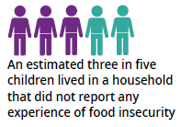
Of the eight food security items, respondents most frequently indicated that the variety of foods the household was able to eat was limited by a lack of money. Caregivers of 7.4 percent of children responded this was often the case. For an additional 23.8 percent of children the response was ‘sometimes’ (see Figure 1, Table 2). Of the children in households not classified as severely to moderately food-insecure based on the summary index, 16.0 percent of caregivers indicated that the variety of foods the household was able to eat was often (1.1%) or sometimes (14.9%) limited by a lack of money.

Figure 1: Item responses to the food security questionnaire, 2015/16
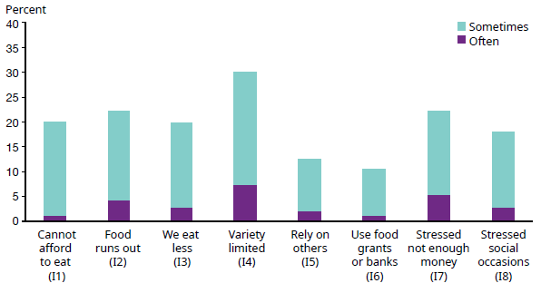

The least prevalent indicator of household food insecurity was the use of food grants or food banks. For 1.1 percent of children, the primary caregiver indicated they often made use of food grants or food banks; for just under one in ten children (9.5%) this was reported to be the case sometimes. The use of food banks or grants is associated with many factors other than need, including local availability and stigma. This means that the number of households that could have benefited from the use of food banks or grants to meet their needs may have been higher.

Food banks and grants cover a variety of different programmes run by both government and non-government organisations. For example, the Ministry of Social Development (MSD) provides Special Needs Grants for food. In June 2018, 88,000 beneficiary families with children received such grants (Perry 2018). MSD reported in 2018 that food has remained the main reason for needing hardship assistance (Ministry of Social Development 2018).

One of the main charitable organisations providing food through food banks is the Salvation Army. In 2016 they distributed 56,500 food parcels to 29,500 families or households, including those with children (Johnson 2018). Between 2016 and 2017 there was a 12 percent increase in the number of parcels distributed, after six years of relatively stable numbers (2011–2016).

Table 2: Item responses to the food security questionnaire and summary index, 2015/16
 | Severe (often) |  | Severe-to-moderate (often and sometimes)
 | % | 95% CI | % | 95% CI
Cannot afford to eat (I1) | 1.2 | 0.8–1.6 | 20.1 | 18.7–21.5
Food runs out (I2) | 4.1 | 3.4–4.8 | 22.3 | 20.9–23.8
We eat less (I3) | 2.7 | 2.2–3.3 | 19.8 | 18.4–21.3
Variety limited (I4) | 7.4 | 6.3–8.4 | 31.1 | 29.3–33.0
Rely on others (I5) | 2.0 | 1.5–2.5 | 12.5 | 11.1–13.9
Use food grants or banks (I6) | 1.1 | 0.7–1.5 | 10.5 | 9.6–11.5
Stressed not enough money (I7) | 5.2 | 4.2–6.1 | 22.3 | 20.6–24.0
Stressed social occasions (I8) | 2.8 | 2.2–3.4 | 18.0 | 16.6–19.3
Summary index of food insecurity | 1.6 | 1.2–2.1 | 19.0 | 17.5–20.4
Notes: For reporting purposes item 1 has been phrased in reverse, and the answer ‘never’ to the statement ‘we can afford to eat properly’ is included in the percentage listed for ‘often’ in the table above.
Combined severe-to-moderate estimates are presented, as later sections of the report mainly concern this group.

The share of children living in households with food insecurity was higher for some groups
In the following sections we use the summary index to look at the prevalence of severe-to-moderate food insecurity for different subgroups of children. Appendix 4 presents the share of the New Zealand child population in each of these subgroups.

There was no significant difference in the prevalence of household food insecurity for boys and girls. The proportion of younger children (0–4 years) living in households with food insecurity was not significantly different from the proportion of older children
(5–9 or 10–14 years; see Table 3).

Table 3: Prevalence of children living in food-insecure households, by age and sex, 2015/16
 | Children in households with food insecurity  (%) | 95% CI | Estimated number of children | 95% CI
Total child population | 19.0 | 17.5–20.4 | 174,000 | 161,000–188,000
Boys | 18.7 | 16.8–20.5 | 88,000 | 79,000–97,000
Girls | 19.3 | 17.3–21.3 | 86,000 | 77,000–95,000
0–4 years of age | 17.4 | 15.3–19.4 | 53,000 | 47,000–59,000
5–9 years of age | 19.5 | 17.0–21.9 | 62,000 | 54,000–70,000
10–14 years of age | 20.1 | 16.8–23.5 | 59,000 | 49,000–69,000
Note: This table presents unadjusted prevalence estimates, reflecting the actual percentage of the population affected in 2015/16.

Household food insecurity was more prevalent for children in households with a low socioeconomic position
Food insecurity is an indicator of socioeconomic distress and hardship (Denny et al 2016). Research in New Zealand and internationally indicates that food insecurity is strongly related to low income (Carter et al 2010; Smith et al 2010; Wright et al 2014). When disposable income is limited, food is one of the items that is often compromised. However, not all families experiencing economic hardship are food-insecure, and vice versa. The New Zealand Health Survey estimates show a gradient in household food insecurity by the household’s socioeconomic position based on neighbourhood deprivation (using NZDep2013), self-reported gross household income and means-tested benefit receipt.

The NZDep2013 index provides a measure of the level of socioeconomic deprivation for neighbourhoods according to a combination of 2013 Census variables (see Appendix 3 for a more detailed definition). Of children in the most deprived quintile of neighbourhoods (NZDep2013 quintile 5), more than one in three (34.8%) lived in a household reporting severe-to-moderate food insecurity (see Figure 2, Table 4). For the two least deprived quintiles of neighbourhoods (quintile 1 and 2 combined) this was fewer than one in ten children (9.5%). When considering just the children in food-insecure households, almost two-thirds lived in the two most deprived quintiles of neighbourhoods (NZDep2013 quintiles 4 and 5: 63.3%, see Figure 2).

Figure 2: Household food insecurity among children by neighbourhood deprivation, 2015/16
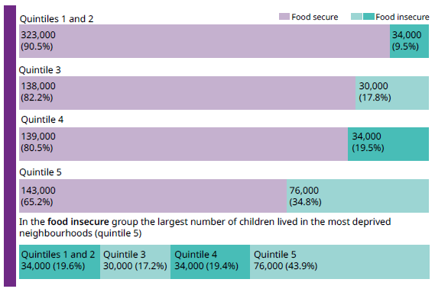
Notes: Quintiles 1 and 2 were combined, to ensure robustness of the findings (no cells with fewer than 30 observations).
See Appendix 4 for the share of the total child population in the groups being compared.

In this section of the report we compare the prevalence of household food insecurity for subgroups of children. Infographics like Figure 2 show for each subgroup the share of children in food-secure and insecure households (upper four bars, quintiles 1 and 2 to quintile 5). Some subgroups make up a larger share of the total child population than others (eg as two quintiles were combined, quintiles 1 and 2 are around twice the size of the individual quintiles 3–5). A large subgroup with a relatively low rate of food insecurity may still make up a relatively large share of the overall rate of children in food-insecure households. Hence we also present what proportion of all children in food-insecure households belongs to each of the subgroups (lowest bar, here in green).

The NZDep2013 index reflects the comparative socioeconomic positions of small areas. There is variation in the level of deprivation of individual households within the same area. Household income provides a more direct estimate of a household’s socioeconomic position. Yet many factors influence how a household’s gross income translates into disposable income, including the cost of housing.

Among children in households with a combined gross annual income in the lowest two income brackets (≤$30,000), the prevalence of household food insecurity was over 50 percent (see Table 4). This means that more than one in two of these children lived in food-insecure households. Household food insecurity also occurred in the higher income brackets, although at lower rates. Of children in food-insecure households, over two in three lived in a household with a gross income at or below $50,000 (see Figure 3).

Figure 3: Household food insecurity among children by household income, 2015/16
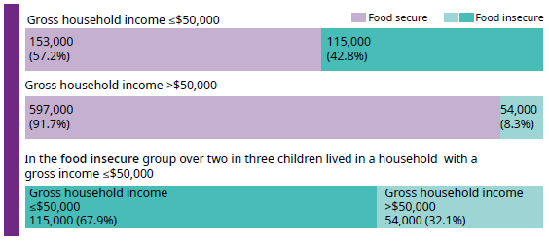
Note: See Appendix 4 for the share of the total child population in the groups being compared.

In the following section, alongside the unadjusted estimates, we also present estimates of household food insecurity adjusted for gross annual household income (see also Table 5.9 in Appendix 5). This allows us to gain insights into how much of the group differences in the prevalence of food insecurity are related to group differences in gross household income. We also adjusted these estimates for the number of children (aged less than 15) in the household to ensure that group differences were not associated with the number of dependants in the household.

Among children with a primary caregiver supported by a means-tested benefit, over one in two (55.8%) lived in a food-insecure household. This rate was significantly higher than the rate for children where the primary caregiver was not supported by such benefits (see Figure 4, Table 4). This is in line with previous findings of high rates of food insecurity among households in New Zealand relying on government benefits (Smith et al 2010). Children in households where the primary caregiver received a means-tested benefit accounted for just over half of all children with severe-to-moderate household food insecurity.

Figure 4: Household food insecurity among children with a primary caregiver receiving a means-tested benefit, 2015/16
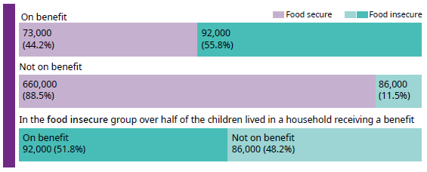
Note: See Appendix 4 for the share of the total child population in the groups being compared.

The majority (87.0%) of primary caregivers supported by a benefit reported a gross household income at or under $50,000. When comparing the prevalence of household food insecurity among children with and without primary caregivers supported by a benefit, differences remained significant after adjusting for the household’s self-reported gross income. However, differences between the two groups were reduced (ARR before and after this adjustment are respectively 4.7 and 2.0, see Appendix 5). This suggests that, as expected, household income accounted for a large portion of the difference between the two groups.

Table 4: Prevalence of children living in households with food insecurity, by neighbourhood deprivation, household income and benefit receipt, 2015/16
 | Children in households with food insecurity  (%) | 95% CI | Estimated number of children | 95% CI
Total child population | 19.0 | 17.5–20.4 | 174,000 | 161,000–188,000
NZDep2013 quintiles 1 and 2 (least deprived) | 9.5 | 7.0–12.1 | 34,000 | 25,000–43,000
NZDep2013 quintile 3 | 17.8 | 14.0–21.6 | 30,000 | 23,000–36,000
NZDep2013 quintile 4 | 19.5 | 16.2–22.9 | 34,000 | 28,000–40,000
NZDep2013 quintile 5  (most deprived) | 34.8 | 31.6–37.9 | 76,000 | 70,000–83,000
Gross household income  $1–$20,000 | 52.9 | 44.0–61.7 | 24,000 | 19,000–29,000
Gross household income  $20,001–$30,000 | 51.0 | 44.1–57.9 | 35,000 | 28,000–41,000
Gross household  $30,001–$50,000 | 37.4 | 32.0–42.8 | 55,000 | 47,000–64,000
Gross household  $50,001–$70,000 | 17.9 | 14.2–21.5 | 30,000 | 23,000–36,000
Gross household  $70,001–$100,000 | 8.0 | 4.9–11.2 | 15,000 | 9,000–21,000
Gross household  $100,001 or more | n<30
Caregiver not receiving a benefit | 11.5 | 9.8–13.2 | 86,000 | 73,000–99,000
Caregiver receiving a benefit | 55.8 | 50.9–60.7 | 92,000 | 80,000–104,000
Notes: This table presents unadjusted prevalence estimates, reflecting the actual percentage of the population affected in 2015/16.
This table does not present estimates for the response options on household income ‘loss’ or ‘zero income’, as no respondents indicated a loss, and fewer than 30 respondents indicated zero income.
See Appendix 3 for indicator definitions.

Children in food-insecure households were more likely to live in a rented house
The prevalence of household food insecurity differed by housing tenure. The rate of household food insecurity was comparatively low for children living in a house that was owned by someone in the household. Rates were significantly higher for children living in a house that was rented, particularly if it was rented from a public landlord. Among those renting from a public landlord, over one in two children (52.9%) lived in households with food insecurity (see Figure 5, Table 5).

Figure 5: Household food insecurity among children by housing tenure, 2015/16
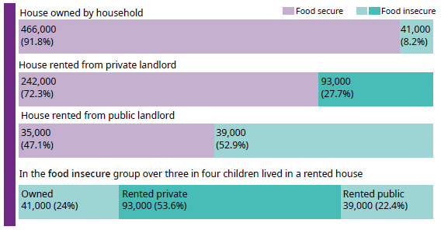
Note: See Appendix 4 for the share of the total child population in the groups being compared.

The high rates of household food insecurity among children in public housing likely occur largely because households in public housing have low incomes. Adjusting for the child’s age and sex, number of children in the household and gross household income reduced the relative differences in household food insecurity prevalence between the three groups (see Appendix 5 for ARRs).

Table 5: Prevalence of children living in households with food insecurity, by housing tenure, 2015/16
 | Children in households with food insecurity (%) | 95% CI | Estimated number of children | 95% CI
Total child population | 19.0 | 17.5–20.4 | 174,000 | 161,000–188,000
House owned by household | 8.2 | 6.5–9.9 | 41,000 | 32,000–50,000
House rented from private landlord | 27.7 | 24.6–30.8 | 93,000 | 81,000–105,000
House rented from public landlord | 52.9 | 47.2–58.7 | 39,000 | 31,000–47,000
Notes: This table presents unadjusted prevalence estimates, reflecting the actual percentage of the population affected in 2015/16.
See Appendix 3 for indicator definitions.

Household food insecurity was more prevalent among Pacific and Māori children
As documented by previous research (Bowers et al 2009; Carter et al 2010; Ministry of Health 2003; Parnell et al 2001; Te Hotu Manawa Māori 2009), there were marked differences in the prevalence of household food insecurity by ethnicity. Pacific and Māori children had the highest prevalence of household food insecurity. Differences were statistically significant for all ethnic group comparisons based on total ethnicity (eg, Māori compared to non-Māori).

Of Māori children, over one in four (28.6%) lived in food-insecure households. Conversely, of children in food-insecure households, over one in three (38.8%) children were Māori (see Figure 6, Table 6). As Māori children made up 25.7 percent of the total child population based on the New Zealand Health Survey estimates, this means Māori children were overrepresented in the food-insecure group.

Figure 6: Household food insecurity among Māori children, 2015/16
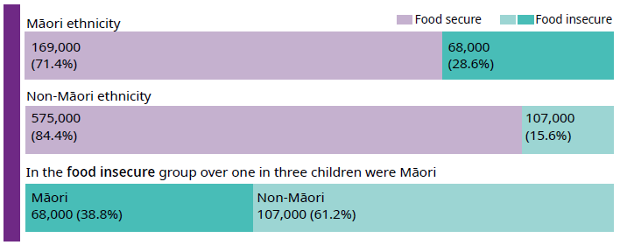
Note: See Appendix 4 for the share of the total child population in the groups being compared.

Adjusting for differences in age and sex, Māori children were 1.8 times as likely to live in food-insecure households as non-Māori children (see Appendix 5). However, after also adjusting for the household’s self-reported gross income and the number of children in the household, this difference was no longer statistically significant (ARR 1.2). This suggests that the difference in the rate of household food insecurity between Māori and non-Māori children can largely be explained by the households of Māori children being over-represented in the lower-income group, and having, on average, more children per household. This is consistent with previous research, which found that the difference in food insecurity across ethnic groups in New Zealand was partially due to underlying differences in income and family structure (Carter et al 2010).

Recent articles on findings from qualitative research on the experience of food insecurity from a Māori perspective (Beavis et al 2018; Huambachano 2018) illustrate that sharing food, which illustrates manaakitanga, was important to Māori households. It had many positive effects on hauora for both the givers and receivers. Over one in four (26.9%) Māori children lived in a household where the primary caregiver indicated they felt stressed because they couldn’t provide the food they wanted for social occasions. This compares to 14.8 percent for non-Māori children. The qualitative studies also highlighted the importance of food sovereignty, which promotes the right of nations and peoples to control their food systems, food cultures and environment. Food insecurity is a complex issue that needs to be understood in the broader economic, political, societal, historical and cultural contexts.

Figure 7: Household food insecurity among Pacific children, 2015/16
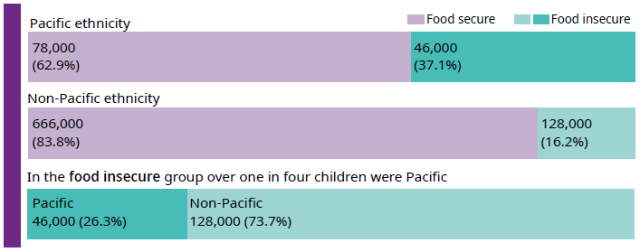
Note: See Appendix 4 for the share of the total child population in the groups being compared.

Of Pacific children, 37.1 percent lived in food-insecure households. Conversely, of children in food-insecure households, over one in four (26.3%) children were Pacific (see Figure 7, Table 6). As Pacific children made up 13.5 percent of the total child population based on the New Zealand Health Survey estimates, this means Pacific children were over-represented in the food-insecure group.

Pacific children were 2.3 times as likely to live in food-insecure households as non-Pacific children when adjusting for the child’s age and sex only. After also adjusting for the household’s self-reported gross income and the number of children in the household, this was 1.5 times as likely for Pacific children. Although the difference was still statistically significant, considering the household’s income and the number of children in the household accounted for a large share of the difference between the Pacific and non-Pacific children (see Appendix 5).

Asian and European and other children had lower rates of household food insecurity compared to non-Asian and non-European and other children respectively (see Figures 8 and 9, Table 6). However, also for these ethnic groups, controlling for the household’s income and the number of children in the household reduced the group differences (see Appendix 5). As over 70 percent of the child population identifies with the European and other ethnic group, European and other children make up a large share of the food insecure group (see Figure 9).

Figure 8: Household food insecurity among Asian children, 2015/16
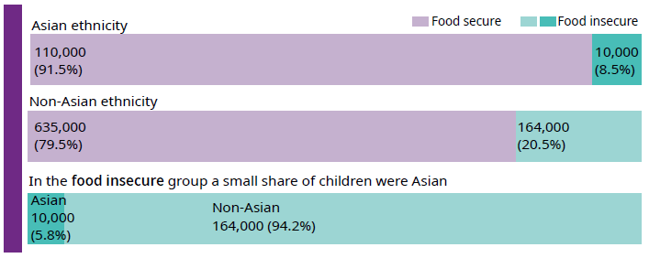
Note: See Appendix 4 for the share of the total child population in the groups being compared.

Figure 9: Household food insecurity among European and other children, 2015/16
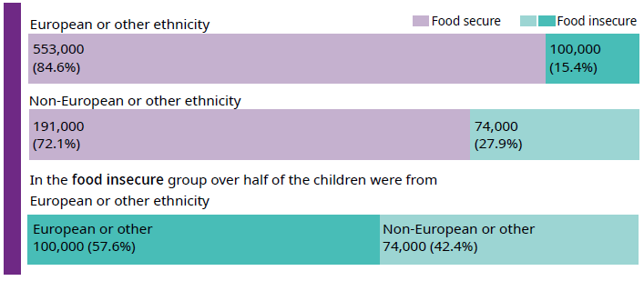
Note: See Appendix 4 for the share of the total child population in the groups being compared.

Table 6: Prevalence of children living in food-insecure households, by ethnicity, 2015/16
 | Children in households with food insecurity (%) | 95% CI | Estimated number of children | 95% CI
Total child population | 19.0 | 17.5–20.4 | 174,000 | 161,000–188,000
Māori | 28.6 | 25.4–31.7 | 68,000 | 60,000–75,000
Pacific | 37.1 | 32.5–41.6 | 46,000 | 36,000–56,000
Asian | 8.5 | 5.2–11.8 | 10,000 | 6,000–14,000
European/other | 15.4 | 13.8–16.9 | 100,000 | 89,000–112,000
Notes: This table presents unadjusted prevalence estimates, reflecting the actual percentage of the population affected in 2015/16.
This table uses the total response measure of ethnicity. Using this measure, children whose caregivers reported more than one ethnic group are counted once in each group; this means that the sum of the estimated number of children for all ethnic groups is greater than the estimated number for the total child population (174,000).

Children in sole-parent households were more likely to be food-insecure
Rates of household food insecurity were higher among children in households with more than two children. This is consistent with findings from the Child Nutrition Survey in 2002, which indicated that the prevalence of food insecurity was higher for households with more children (Ministry of Health 2003). Of children in food-insecure households, over half (52.8%) lived in households with three or more children (see Figure 10, Table 7).

Figure 10: Household food insecurity among children and number of children in the household, 2015/16
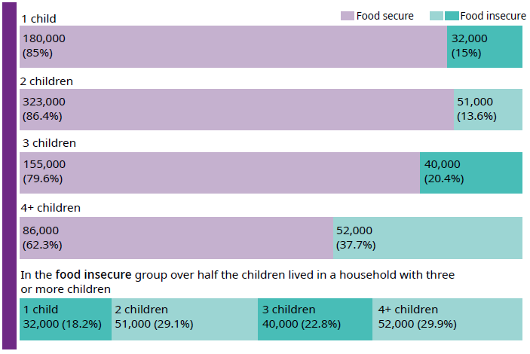
Note: See Appendix 4 for the share of the total child population in the groups being compared.

Rates of household food insecurity were also significantly higher for children living with sole parents. Of children living with sole parents, 38.0 percent lived in food-insecure households (see Figure 11, Table 7). Earlier work in New Zealand found that 37.2 percent of household with sole parents were food-insecure in 2004/05 (Carter et al 2010). However, three in four children lived in couple parent households, thereby making up a much larger share of the child population. When considering only children in food-insecure households, half lived in sole-parent households and half in couple-parent households (see Figure 11).

Figure 11: Household food insecurity among children with sole and couple parents, 2015/16
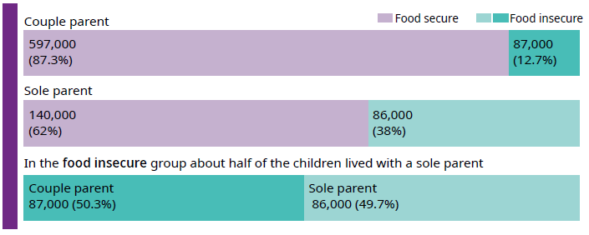
Note: See Appendix 4 for the share of the total child population in the groups being compared.

Adjusted for their age and sex, children living with sole parents were 3.1 times as likely to live in a food-insecure household as children of couple parents. After also adjusting for the number of children in the household and gross household income, this declined to children living with sole parents being 1.4 times as likely to live in a food-insecure household (see Appendix 5). Again household income was able to account for a large part of the difference in household food insecurity between groups.

Table 7: Prevalence of children living in food-insecure households, by household composition, 2015/16
 | Children in households with food insecurity (%) | 95% CI | Estimated number of children | 95% CI
Total child population | 19.0 | 17.5–20.4 | 174,000 | 161,000–188,000
Couple parent | 12.7 | 11.0–14.4 | 87,000 | 75,000–99,000
Sole parent | 38.0 | 34.1–41.8 | 86,000 | 76,000–96,000
One child in household | 15.0 | 13.0–16.9 | 32,000 | 27,000–36,000
Two children in household | 13.6 | 11.5–15.6 | 51,000 | 43,000–58,000
Three children in household | 20.4 | 16.8–24.0 | 40,000 | 32,000–47,000
Four or more children in household | 37.7 | 30.9–44.5 | 52,000 | 41,000–63,000
Note: This table presents unadjusted prevalence estimates, reflecting the actual percentage of the population affected in 2015/16.

Recent changes in the prevalence of household food insecurity among children
The New Zealand Health Survey assessed food insecurity among households with children in the years 2012/2013, 2014/2015 and 2015/2016. No data was collected on the topic in 2013/2014.
Overall, the prevalence of household food insecurity among children was lower in 2015/16 compared to 2012/2013. Severe-to-moderate food insecurity as determined by the aggregate index was 23.2 percent in 2012/13 and 19.0 percent in 2015/16, and this change was statistically significant (see Figure 12, Table 8). Across all eight items significantly fewer caregivers responded ‘often’ (or ‘never’ for I1) or ‘sometimes’ in 2015/16 compared to 2012/13.

Lower rates of caregiver-reported household food insecurity in 2015/16 compared to 2012/13 are a positive finding. However, more data points are needed to confirm whether this represents a declining trend over the longer term.

Although there are many other factors that influence the occurrence of food insecurity on a national level (eg, economic factors, employment rates), previous work has established a link between food prices and food insecurity (Gregory and Coleman-Jensen 2013, Reeves et al 2017). Each year, Otago University estimates the weekly food cost for various age groups across five cities in New Zealand, for a basic, moderate and liberal diet (Department of Human Nutrition 2018). In 2016, the estimated costs were lower than they had been in 2014, across the locations and for most age groups.

As there were no statistically significant differences between 2014/15 and 2015/16 in the aggregate food insecurity index, we combined the data for these two years for the analyses described in the following sections of the report. The resulting increase in sample size ensured robustness of our findings when looking at smaller subgroups.

Figure 12: Prevalence of children aged 0–14 years living in households with severe-to-moderate food insecurity, 2012/2013, 2014/2015 and 2015/16
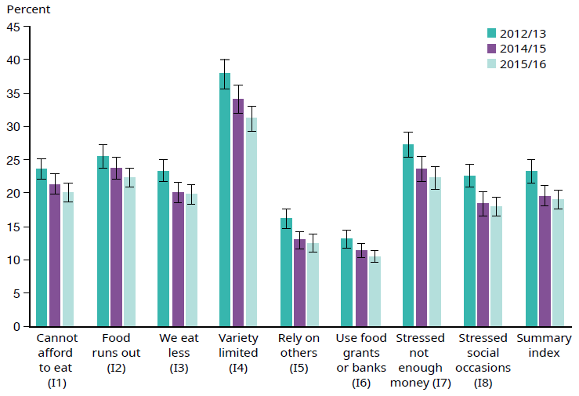

Table 8: Prevalence of severe-to-moderate food insecurity among children aged 0–14 years, 2012/2013, 2014/2015 and 2015/16
 | Often and sometimes (%) |  |  | Significance of difference between years (p value)
 | 2012/13 | 2014/15 | 2015/16 | 2012/13 and 2014/15 | 2014/15 and 2015/16 | 2012/13 and 2015/16
Cannot afford to eat (I1) | 23.6 | 21.4 | 20.1 | .04 | .23 | <.01
Food runs out (I2) | 25.6 | 23.7 | 22.3 | .13 | .22 | .01
We eat less (I3) | 23.3 | 20.1 | 19.8 | .01 | .79 | <.01
Variety limited (I4) | 37.9 | 34.0 | 31.1 | .01 | .05 | <.01
Rely on others (I5) | 16.2 | 12.9 | 12.5 | <.01 | .79 | <.01
Use food grants or banks (I6) | 13.1 | 11.4 | 10.5 | .05 | .25 | <.01
Stressed not enough money (I7) | 27.3 | 23.6 | 22.3 | .01 | .31 | <.01
Stressed social occasions (I8) | 22.6 | 18.4 | 18.0 | <.01 | .69 | <.01
Summary index of food insecurity | 23.2 | 19.6 | 19.0 | <.01 | .56 | <.01
Notes: For reporting purposes item 1 has been phrased in reverse, and the answer ‘never’ to the statement ‘we can afford to eat properly’ is included in the percentage listed for ‘often’ in the table above.
Statistically significant differences between survey years (p<.05) are shown in bold.

The wider circumstances of children living in households with food insecurity
The research literature shows that food insecurity is associated with a range of adverse circumstances, particularly those related to nutrition, physical and mental health, education and caregivers’ mental health (Ke and Ford-Jones 2015).
This may reflect a causal relationship. For example, household food insecurity may lead to poorer nutrition. However, food insecurity may also co-occur with other adverse circumstances as a result of a common cause, particularly low socioeconomic position.

Due to financial constraints households are at a heightened risk of insecure or inadequate access to food. These same households are also more likely to live in overcrowded or poor-quality housing and have lower levels of expenditure on education and recreation activities that benefit children, and are less likely to be able to afford to access primary healthcare as often as they need (Perry 2018). Importantly, many of these and other dimensions of poverty and material deprivation have adverse impacts on child and youth health and development (Howden-Chapman et al 2013).

In the following section, we document how children in food-insecure households fared compared to those in food-secure households for a range of indicators. Our cross-sectional data are not able to identify the causal impact of household food insecurity. Instead we aimed to present a picture of children living in households that experience food insecurity, irrespective of what caused the food insecurity or whether food insecurity was causally related to the indicators of interest. Hence, the differences we report are not adjusted for either demographics or other confounders such as household income. For this analysis we pooled data for the years 2014/15 and 2015/16, to increase the robustness of our estimates.

Barriers to accessing health care were more common among children in food-insecure households
As described in earlier sections, there is a strong association between household food insecurity and socioeconomic position. Households with food insecurity are likely to struggle to meet competing demands (eg, food, housing and health care) as a result of limited financial resources. For this reason, they may delay or avoid seeking health care (unmet need), which can lead to emergency department visits and compromised health status (Choi et al 2017). Compromised health may (temporarily) limit children’s ability to fully participate in schooling, potentially limiting future opportunities.

Figure 13: Household food insecurity and barriers to accessing health care in the past year, 2014/15 and 2015/16
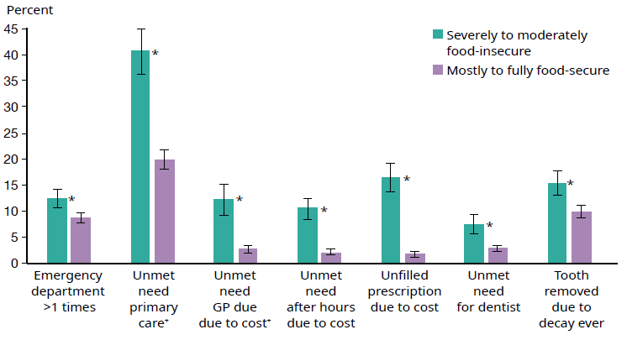
Notes: See Appendix 3 for indicator definitions.
* indicates a statistically significant difference between children in food-secure households and food-insecure households (p<.05). Estimates are unadjusted.
+ indicates data based on 2015/16 only.

Children in food-insecure households were more likely to experience barriers to accessing a range of health services compared to children in food-secure households (see Figure 13, Table 9). Unmet need for primary health care was estimated based on caregivers’ responses to the questions on barriers to accessing a general practitioner (GP), nurse or other health care worker as a result of cost, lack of transport or childcare. Just over 40 percent of children in food-insecure households had experienced at least one of these barriers in the past year, compared to almost 20 percent of children in food-secure households. Children in food-insecure households were also more likely to have visited an emergency department more than once in the past year, with a rate of 12.4 percent compared to 8.7 percent for children in food-secure households.

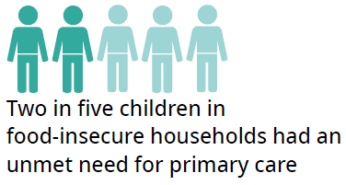
Since January 2008, the Ministry of Health has provided additional funding to encourage free GP consultations for children under six years of age. This was called the Zero Fees for Under 6s initiative. Between 2014/15 and 2015/16, this was extended to Zero Fees for Under 13s. In July 2015, 99 percent of children aged 0–5 years and 97 percent of children aged 6–12 years were enrolled at a general practice that had committed to providing free visits for children during the daytime (Ministry of Health 2015). This extension of free visits to children under 13 years resulted in a significant decrease in unmet need for GPs due to cost for children aged 6–12 years (from 8.2% in 2014/15 to 5.9% in 2015/16). To ensure this did not have an impact on our findings, estimates for unmet need for primary care and unmet need for GPs were based on responses for the year 2015/16 only.

In New Zealand basic oral health services are publicly funded for children from birth until their 18th birthday. However, barriers other than cost may play a role. Caregivers in food-insecure households reported significantly higher rates of unmet need (for any reason) for dental health care for their child (see Figure 13, Table 9). In addition, children in food-insecure households had higher rates of tooth removal as a result of decay compared to children in food-secure households. Several other studies have found an association between food insecurity and unmet dental care need and poorer dental health in both children and adults (Jamieson and Koopu 2006a; Jamieson and Koopu 2006b; Wiener et al 2018).

A recent New Zealand study has provided some evidence that a food-related initiative in schools can be effective in improving oral health. This study looked at the KickStart programme, which provides free breakfasts in New Zealand schools and kura. The Government has co-funded this programme since 2013. The study found that schools and kura enrolled with the Kickstart programme serving a higher number of breakfasts per student per week had lower rates of hospital outpatient visits for dental surgery. The provision of breakfast in schools does not only support those in poverty or experiencing food insecurity at home, but also children who do not have breakfast at home for a range of other reasons (Wilson et al 2018).

Table 9: Child unmet need, indicators by food security status, 2014/15 and 2015/16
 | Age (child) | Percentage in severely to moderately food-insecure households | Percentage in fully to mostly food-secure households | p value for difference (unadjusted)
More than one emergency department visit in past year | 0–14y | 12.4 | 8.7 | <.01
Unmet need for primary care† | 0–14y | 40.5 | 19.8 | <.01
Unmet need for GP due to cost† | 0–14y | 12.2 | 2.7 | <.01
Unmet need for after-hours care due to cost | 0–4y | 10.5 | 2.2 | <.01
Unfilled prescription due to cost | 0–14y | 16.4 | 1.8 | <.01
Unmet need for dentist | 2–14y | 7.6 | 3.0 | <.01
Tooth removed due to decay ever | 2–14y | 15.4 | 10.0 | <.01
Notes: † indicates data based on 2015/16 only.
Statistically significant differences between children in food-secure households and food-insecure households (p<.05) are shown in bold. Estimates are unadjusted.

Fewer children in food-insecure households met the fruit and vegetable consumption guidelines
There is an extensive body of research indicating that children experiencing household food insecurity have lower fruit and vegetable intake, diets higher in fat, and are at an increased risk of obesity (Fram et al 2015; Parnell and Gray 2014; Schlichting et al 2018; Smith et al 2010; Smith et al 2013; Utter et al 2012).

As there are known age-differences in the indicators related to nutrition that are covered by the New Zealand Health Survey (Ministry of Health 2017, Appendix 5), we present results for children aged 2–4 years, 5–9 years and 10–14 years separately (see Figures 14A, 14B and 14C).

For the three age groups, children living in food-insecure households were more likely to have consumed fast food or fizzy drinks three or more times in the week prior to the interview. Children in food-insecure households were also less likely to have met the guidelines for vegetable consumption, based on their average daily consumption patterns.

Children in food-insecure and food-secure households differed in terms of not meeting the guidelines for fruit consumption and eating breakfast at home for the 5–9 and 10–14 year age groups only.

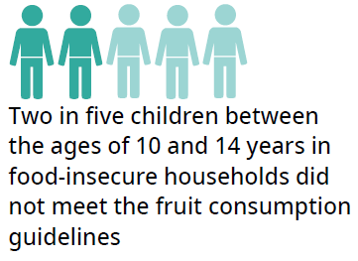
The majority of pre-schoolers (2–4 years) ate breakfast at home five or more days a week (five+ days, 94%), both in food-insecure and food-secure households. The share of children in food-insecure households having breakfast at home five+ days was significantly lower for school-aged children. For the food-secure group this was significantly lower only for
10–14 year olds (see Figures 14A, 14B and 14C). For children aged 10–14 years in food-insecure households, an estimated one in four did not eat breakfast at home five+ days a week (24.9%), compared to 13.2% for those in food-secure households. This does not mean these children did not eat breakfast at all on these days, as they may have eaten breakfast at school or in another setting.

With regards to fruit consumption, rates of not meeting the guidelines were significantly higher for children aged 10–14 years compared to those aged 2–4 years for both the food-insecure and secure groups, (see Figures 14A, 14B and 14C). Of children between the ages of 10 and 14 years, 40.3 percent did not meet the guidelines in food-insecure households and 31.5 percent in food-secure households.

Across all groups a significantly larger share of children met the guidelines for fruit compared to vegetable consumption. Particularly for children aged 5–9 years in food-insecure households this difference was large; the percentage meeting the guidelines for fruit (72.0%) was double that of the guidelines for vegetables (35.8%). Caregivers can only report on their child’s consumption patterns as far as they are aware, and may not have been able to include foods consumed by the child that were not prepared by themselves. For example, as part of the Ministry of Health-funded Fruit in School programme, children at schools with a high proportion of students from low socioeconomic communities (decile 1 and 2 and some decile 3 schools) may have received a piece of fruit or vegetable at school each day.

Figure 14A: Household food insecurity and nutrition indicators for children aged
2–4 years, 2014/15 and 2015/16
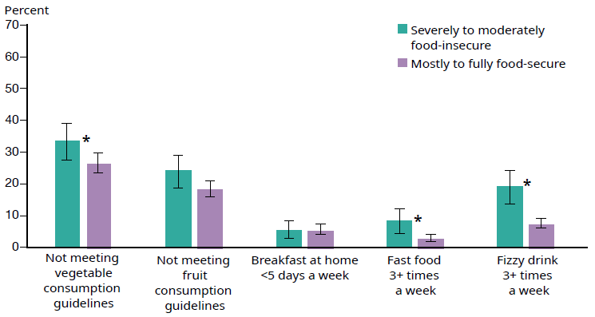
Notes: See Appendix 3 for indicator definitions and Appendix 5 for data tables.
* indicates a statistically significant difference between children in food-secure households and food-insecure households (p<.05). Estimates are unadjusted.

Figure 14B: Household food insecurity and nutrition indicators for children aged
5–9 years, 2014/15 and 2015/16
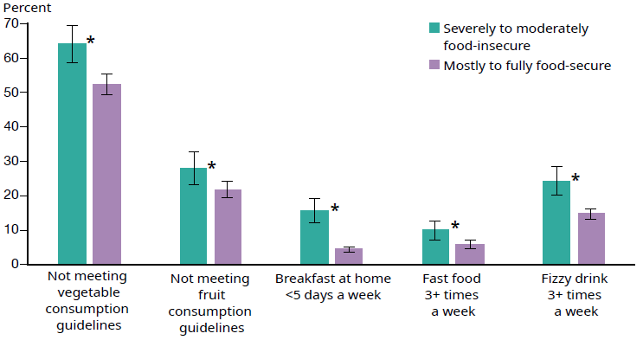
Notes: See Appendix 3 for indicator definitions and Appendix 5 for data tables.
* indicates a statistically significant difference between children in food-secure households and food-insecure households (p<.05). Estimates are unadjusted.

Figure 14C: Household food insecurity and nutrition indicators for children aged
10–14 years, 2014/15 and 2015/16
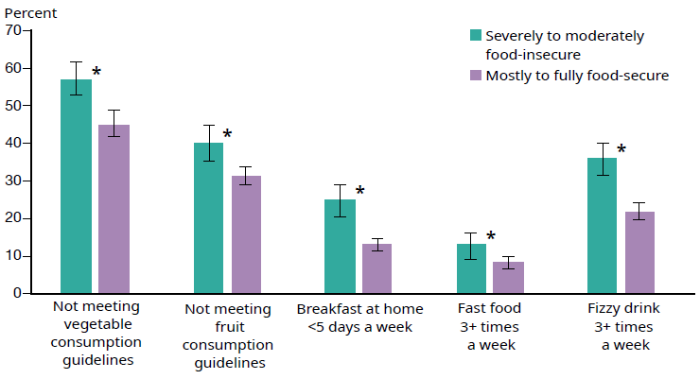
Notes: See Appendix 3 for indicator definitions and Appendix 5 for data tables.
* indicates a statistically significant difference between children in food-secure households and food-insecure households (p<.05). Estimates are unadjusted.

Fewer children in food-insecure households had a healthy weight
Evidence around the association between food insecurity and children’s body weight is mixed. Young people in New Zealand who indicated food security concerns in the Youth’12 Survey were more likely to be overweight or obese compared to their peers who did not report such concerns (Utter et al 2018). Although this is consistent with other work internationally (eg, Casey et al 2006), not all research finds an association between household food insecurity and body weight (Black et al 2017; Franklin et al 2011). The association may be stronger when asking children about their personal food insecurity rather than asking their caregiver about food insecurity in the household (Kaur et al 2015).

Explanations for the association between food insecurity and body weight are discussed in the literature. Food insecurity may put children at greater risk of being overweight due to the consumption of low-cost, easy access, energy-dense foods (Drewnowski and Specter 2004). Also susceptibility to being overweight may be a result of overeating when food is available in response to periods without sufficient food and changing eating habits (Alaimo et al 2001).

As for the nutrition indicators, body size estimates are presented for children aged
2–4 years, 5–9 years and 10–14 years separately (see Figures 15A, 15B and 15C). The estimates are based on children’s body mass index. Across the age groups, children in food-insecure households were less likely to be healthy weight and more likely to be overweight or obese compared to children in food-secure households. Around one in two children in food-insecure households were considered healthy weight. For 10–14 year old children, 50.0 percent of children were in food-insecure households and were a healthy weight compared to 61.9 percent in food-secure households. For the 5–9 and 10–14 year age groups, the rate of obesity in children in food-insecure households was twice that of children in food-secure households. Overweight rates in 10–14 year old children were similar between the food-insecure and secure groups.

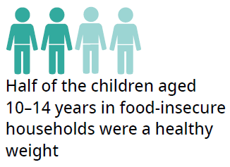
The rate of being overweight was relatively constant across age groups for children in food-insecure households. In contrast, the rate of obesity was significantly higher for older children (5–9 and 10–14 years) compared to those between 2 and 4 years in food insecure households. For children in food-secure households, the rate of obesity was significantly higher for pre-school children (2–4 years) compared to the 10–14 year age group only. This suggests that although the rate of obesity was higher for older children in the population as a whole, this increase may happen at an earlier age for children in food-insecure households.

Figure 15A: Body size indicators by food security status for children aged 2–4 years, 2014/15 and 2015/16
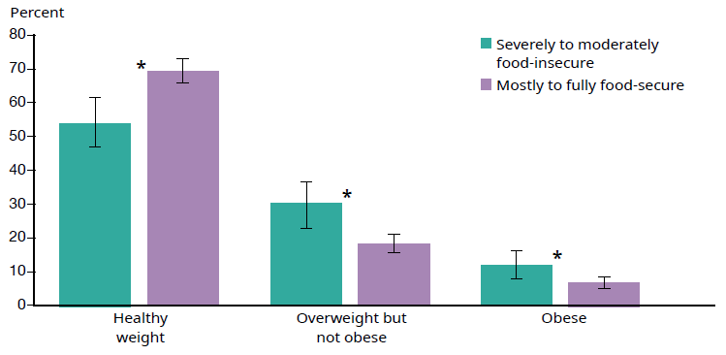
Notes: See Appendix 3 for indicator definitions and Appendix 5 for data tables.
* indicates a statistically significant difference between children in food-secure households and food-insecure households (p<.05). Estimates are unadjusted.

Figure 15B: Body size indicators by food security status for children aged 5–9 years, 2014/15 and 2015/16
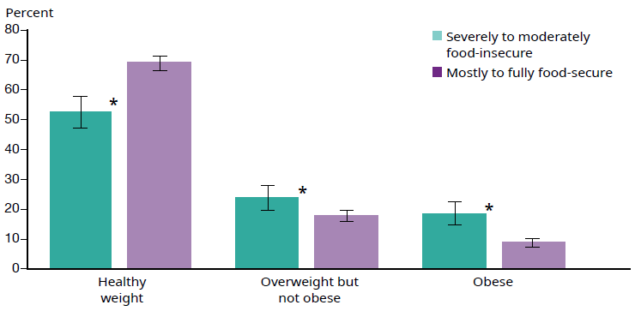
Notes: See Appendix 3 for indicator definitions and Appendix 5 for data tables.
* indicates a statistically significant difference between children in food-secure households and food-insecure households (p<.05). Estimates are unadjusted.

Figure 15C: Body size indicators by food security status for children aged 10–14 years, 2014/15 and 2015/16
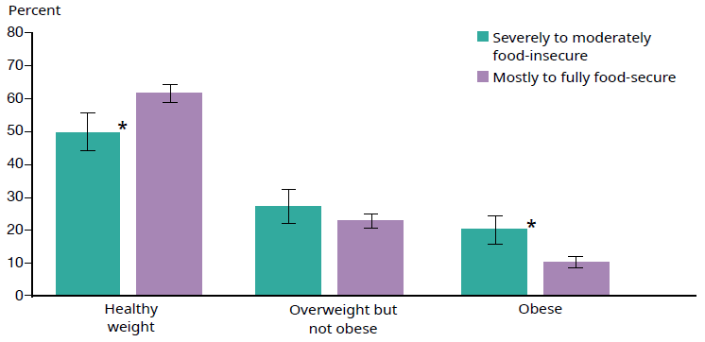
Notes: See Appendix 3 for indicator definitions and Appendix 5 for data tables.
* indicates a statistically significant difference between children in food-secure households and food-insecure households (p<.05). Estimates are unadjusted.

Children and caregivers in food-insecure households had lower caregiver-rated health status
International research indicates that children living in food-insecure households tend to have poorer health (Black et al 2017, Utter et al 2018), including higher rates of asthma (Mangini et al 2015). In a study interviewing parents of young children, parents acknowledged that adversity associated with household food insecurity was a form of toxic stress. Parents noted that trade-offs associated with food insecurity were related to their mental health and home environment. Their own frustration, anxiety, and depression related to economic hardship, in turn had a negative impact on their children’s physical health, and their social and emotional development (Knowles at al 2016).

Figure 16: Household food insecurity and health indicators for children and their caregivers, 2014/15 and 2015/16
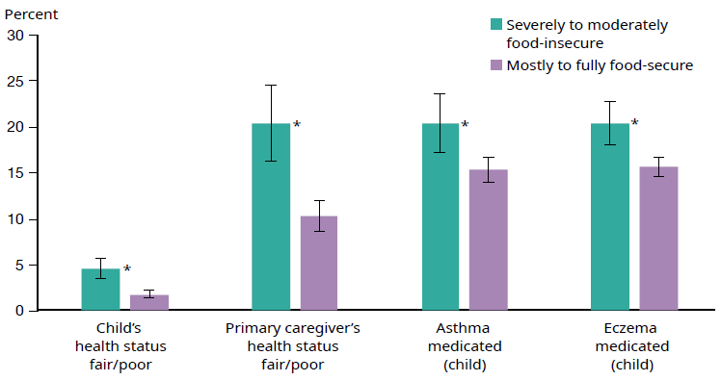
Notes: See Appendix 3 for indicator definitions.
* indicates a statistically significant difference between children in food-secure households and food-insecure households (p<.05). Estimates are unadjusted.

The majority of caregivers rated their children’s health as good, very good or excellent. More primary caregivers rated their own health as fair or poor than rated their children’s health this way. Compared to those in food-secure households, both children and caregivers in food-insecure households were more likely to be rated as having a fair or poor health status (see Figure 16, Table 10). The relative difference (unadjusted) between food-insecure households and food-secure households was more pronounced for children than for their caregivers.

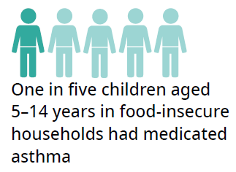
The New Zealand Health Survey also asks about some specific doctor-diagnosed health conditions. Based on this, children in food-insecure households had higher rates of medicated asthma and eczema compared to those in food-secure households (see Figure 16, Table 10).

Table 10: Health indicators for children and their caregivers, by food security status, 2014/15 and 2015/16
 | Age (child) | Percentage in severely to moderately food-insecure households | Percentage in fully to mostly food-secure households | p value for difference (unadjusted)
Child’s health status fair/poor | 0–14 | 4.6 | 1.7 | <.01
Primary caregiver’s health status fair/poor* | 0–14 | 20.5 | 10.3 | <.01
Asthma medicated (child) | 5–14 | 20.5 | 15.4 | <.01
Eczema medicated (child) | 0–14 | 20.5 | 15.7 | <.01
Notes: * indicates data based on 2015/16 only.
Statistically significant differences between children in food-secure households and food-insecure households (p<.05) are shown in bold. Estimates are unadjusted.

Caregivers in food-insecure households indicated more concerns about their child’s development
The research literature suggests a relationship between food insecurity and developmental and behavioural problems, many of which could affect school performance (Burke et al 2015; Jyoti et al 2005; Rose-Jacobs et al 2008; Shankar et al 2017; Whitaker et al 2006). Some research has found that this relationship may persist throughout adolescence (Whitsett et al 2018).

The Parents’ Evaluation of Developmental Status (PEDS) is an evidence-based screening tool asking caregivers whether they have concerns about their child’s development, health and wellbeing (Glascoe 1998). Caregivers of children aged 4 months to 8 years completed this questionnaire as part of the child developmental health and wellbeing module of the New Zealand Health Survey (see Appendix 3). Responses to each of the questions are ‘yes’, ‘no’ or ‘a little’. We present results for the share of caregivers responding ‘yes’ to the PEDS questions, indicating their concern about particular behaviours (see Figure 17, Table 11). The prevalence of caregiver concern was significantly higher for the food-insecure group for all areas that were assessed, except the child’s use of their arms and legs.

Figure 17: Household food insecurity and concerns about child development – PEDS, 2014/15 and 2015/16
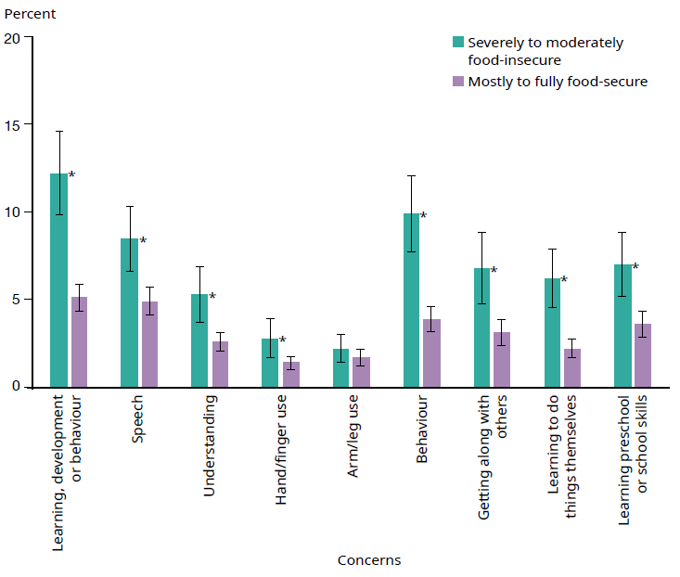
Notes: See Appendix 3 for indicator definitions.
* indicates a statistically significant difference between children in food-secure households and food-insecure households (p<.05). Estimates are unadjusted.

Table 11: Child development indicators by food security status – PEDS, 2014/15 and 2015/16
Concerns about | Child’s age | Percentage in severely to moderately food-insecure households | Percentage in fully to mostly food-secure households | p value for difference (unadjusted)
Learning, development or behaviour | 4 mths–8y | 12.2 | 5.1 | <.01
Speech | 4 mths–8y | 8.5 | 4.9 | <.01
Understanding | 4 mths–8y | 5.3 | 2.6 | <.01
Hand/finger use | 4 mths–8y | 2.8 | 1.4 | .02
Arm/leg use | 4 mths–8y | 2.2 | 1.7 | .25
Behaviour | 4 mths–8y | 9.9 | 3.9 | <.01
Getting along with others | 4 mths–8y | 6.8 | 3.1 | <.01
Learning to do things themselves | 10 mths–8y | 6.2 | 2.2 | <.01
Learning preschool or school skills | 18 mths–8y | 7.0 | 3.6 | <.01
Notes: Statistically significant differences between children in food-secure households and food-insecure households (p<.05) are shown in bold.
Estimates are unadjusted. See Appendix 3 for full items.

Another parent-completed evidence-based screening tool is the Strengths and Difficulties Questionnaire (SDQ). The SDQ can be used to assess social, emotional and behavioural functioning in children aged 2–14 years (Goodman 1997). It covers behavioural difficulties in four areas: emotional symptoms, peer problems, hyperactivity and conduct problems. Together the items make up a SDQ total difficulties score, based on which children can be categorised in groups reflecting their risk of significant difficulties; ‘no concern’, ‘borderline concern’ or ‘concern’. Children with a concerning score should be referred for further assessment and potentially a service intervention or additional support (Pannekoek et al 2018).

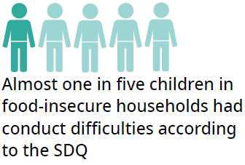
We present the SDQ results for all children aged 3–14 years combined to ensure robustness of the findings. The pattern of differences between children in food-secure and insecure households was the same across age-groups. Children living in food-insecure households had higher rates of concerning SDQ scores in all areas of behaviour assessed by the questionnaire (see Figure 18, Table 12). Overall, almost 16 percent of children in food-insecure households had a concerning SDQ score, compared to 5.8 percent in the food-secure group.

Figure 18: Household food insecurity and concerns about child development – SDQ, 2014/15 and 2015/16
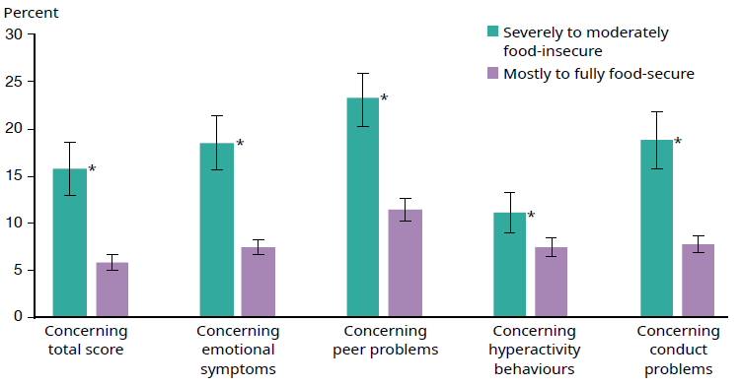
Notes: See Appendix 3 for indicator definitions.
* indicates a statistically significant difference between children in food-secure households and food-insecure households (p<.05). Estimates are unadjusted.

Table 12: Child development indicators by food security status – SDQ, 2014/15 and 2015/16
Concerning | Children’s age | Percentage in severely to moderately food-insecure households | Percentage in  fully to mostly food-secure households | p value for difference (unadjusted)
Total score | 3–14 | 15.8 | 5.8 | <.01
Emotional symptoms | 3–14 | 18.5 | 7.4 | <.01
Peer problems | 3–14 | 23.3 | 11.5 | <.01
Hyper activity behaviours | 3–14 | 11.2 | 7.4 | <.01
Conduct problems | 3–14 | 18.8 | 7.8 | <.01
Note: Statistically significant differences between children in food-secure households and food-insecure households (p<.05) are shown in bold. Estimates are unadjusted.

More caregivers in food-insecure households experienced psychological distress
Previous work has identified that caregivers in food-insecure households are more likely to experience psychological distress (Carter et al 2011) as well as parenting stress (Huang et al 2010; Knowles et al 2016).

The Kessler Psychological Distress Scale (K10) questionnaire is a widely used self-reporting measure of psychological distress that can be used to identify those in need of further assessment for anxiety and depression (Kessler 1996). Rates of psychological distress as indicated on the K10 were higher for primary caregivers in food-insecure compared to food-secure households (see Figure 19, Table 13).

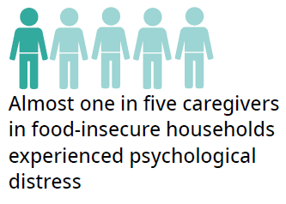
Two items in the food security questionnaire refer to stress (item 7 and 8). We wanted to rule out that the association between psychological distress on the K10 and food insecurity was a reflection of potential overlap in content of the items. Hence we also looked at the difference in the prevalence of caregivers reporting psychological distress on the K10 based on just the first statement of the food security questionnaire; ‘We can afford to eat properly’. Of caregivers responding ‘never’ or ‘sometimes’ to this statement in 2015/16, 18.2 percent (95% CI 14.1–22.2) had a K10 score indicative of psychological distress. Of those responding ‘always’ to this statement, the corresponding figure was 5.9 percent (95% CI 4.5–7.3). These rates are virtually the same as for the summary index of food insecurity (see Table 13).

Figure 19: Household food insecurity and caregiver stress indicators, 2014/15 and 2015/16
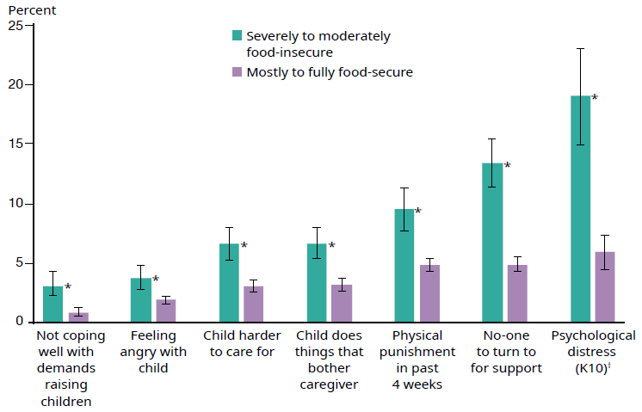
Notes: See Appendix 3 for indicator definitions.
* indicates a statistically significant difference between children in food-secure households and food-insecure households (p<.05). Estimates are unadjusted.
† indicates data based on 2015/16 only.

The New Zealand Health Survey also asked primary caregivers about stresses related to raising their child. Caregivers in food-insecure households more frequently reported experiencing stress (see Figure 19, Table 13). For example 3.0 percent of caregivers in food-insecure households indicated they were not coping very well (at all) with demands of raising children, compared to 0.9 percent of caregivers in food-secure households. Furthermore, caregivers in food-insecure households were less likely to have someone to turn to for day-to-day support with raising children.

Table 13: Caregiver stress indicators, by food security status, 2014/15 and 2015/16
 | Age (child) | Percentage in severely to moderately food-insecure households | Percentage in fully to mostly food-secure households | p value for difference (unadjusted)
Not coping well with demands raising children (not very well/ not very well at all) | 0–14 | 3.0 | 0.9 | <.01
Feeling angry with child (usually/always) | 0–14 | 3.8 | 1.9 | <.01
Finding child harder to care for (usually/always) | 0–14 | 6.6 | 3.1 | <.01
Finding child does something that bother them a lot (usually/always) | 0–14 | 6.7 | 3.2 | <.01
Having punished child physically in past four weeks | 0–14 | 9.5 | 4.8 | <.01
Not having someone to turn to for day-to-day support | 0–14 | 13.4 | 4.9 | <.01
Psychological distress (K10)† | 0–14 | 19.0 | 5.9 | <.01
Note: Statistically significant differences between children in food-secure households and food-insecure households (p<.05) are shown in bold.
Estimates are unadjusted.
† indicates data based on 2015/16 only.

More children in food-insecure households were exposed to second-hand smoke
Previous work has found food insecurity to be more common and severe in children and adults in households with smokers (Cutler-Triggs et al 2008). A study in the United States looking at young adults found that smoking prevalence was significantly higher among young adults who reported being food-insecure (Kim and Tsoh 2016).

Figure 20: Household food insecurity and tobacco use, 2015/16
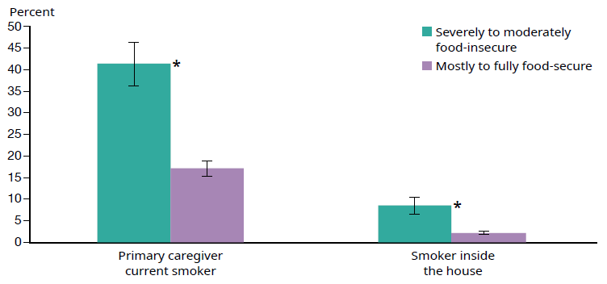
Notes: See Appendix 3 for indicator definitions.
* indicates a statistically significant difference between children in food-secure households and food-insecure households (p<.05). Estimates are unadjusted.

Children who lived in a food-insecure household in 2015/16 were significantly more likely to have a caregiver who said they were a current smoker than children living in food-secure households (see Figure 20, Table 14). Just over two in five children in food-insecure households had a caregiver reporting they smoked at least monthly. This estimate refers to the primary caregiver only; there may have been others in the households who smoked.

Children living in a household where someone smoked inside the house made up a smaller percentage. Just over 8 percent of children in food-insecure households were exposed to second-hand smoke inside the house. This was four times as likely as children in food-secure households (unadjusted).

Table 14: Tobacco use, by food security status, 2015/16
 | Age (child) | Percentage in severely to moderately food-insecure households | Percentage in fully to mostly food-secure households | p value for difference (unadjusted)
Primary caregiver current smoker | 0–14 | 41.4 | 17.0 | <.01
Smoker inside the house | 0–14 | 8.4 | 2.1 | <.01
Note: Statistically significant differences between children in food-secure households and food-insecure households (p<.05) are shown in bold. Estimates are unadjusted.

Conclusion
New Zealand Health Survey estimates presented in this report indicate that, although the majority of children live in food-secure households, a substantial share of New Zealand children do not. In 2015/16, almost one in five children (19.0%) lived in severely to moderately food-insecure households.
Children living in food-insecure households constitute an important public policy concern, both from the perspective of the rights of children and potential adverse health, development and education consequences. This report highlights that children in food-insecure households fared worse on the majority of indicators we explored. These findings were consistent with previous research, both nationally and internationally, on the association of household food insecurity with indicators of health and health behaviours, development and health service use.

Availability of population-based estimates of food insecurity is particularly important in relation to the Government’s programme to achieve a significant and sustained reduction in child poverty in New Zealand. This research suggests that household socioeconomic factors plays an important role in food insecurity. Also, access to adequate food, and freedom from hunger, are important components of a range of international conventions and commitments regarding human rights. For example, New Zealand has committed to the United Nations Sustainable Development Goals, which includes the goal to ‘end hunger, achieve food security and improved nutrition, and promote sustainable agriculture’ by 2030. This means New Zealand will contribute to the achievement of the goals through a combination of domestic action, international leadership on global policy issues and support to other countries through the New Zealand Aid Programme.

By developing an improved summary index for food insecurity from the New Zealand Health Survey, we have a method to monitor the prevalence of household food insecurity among New Zealand children. This can provide evidence over time of the success of interventions targeting child poverty. A recent report proposes the use of household food insecurity as an outcome indicator, to evaluate the success of a range of policy actions (McIntyre et al 2019).

References
Alaimo K, Olson CM, Frongillo EA. 2001. Low family income and food insufficiency in relation to overweight in US children: is there a paradox? Archives of Pediatrics and Adolescent Medicine 155(10): 1161–7.
Anderson SA. 1990. Core indicators of nutritional state for difficult-to-sample populations. The Journal of Nutrition 120: 1559–600.
Beavis BS, McKerchar C, Maaka J, et al. 2018. Exploration of Māori household experiences of food insecurity. Nutrition & Dietetics. DOI: 10.1111/1747-0080.12477.
Bernal J, Frongillo EA, Jaffe K. 2016. Food insecurity of children and shame of others knowing they are without food. Journal of Hunger and Environmental Nutrition 11(2): 180–94.
Black MM, Drennen C, Gallego N, et al. 2017. Household food insecurity is associated with children’s health and developmental risks, but not with age-specific obesity and underweight. FASEB Journal 31(1): 791–817.
Bowers S, Carter K, Gorton D, et al. 2009. Enhancing food security and physical activity for Māori, Pacific and low-income peoples. Wellington: Clinical Trials Research Unit, University of Auckland; GeoHealth Laboratory, University of Canterbury; Health Promotion and Policy Research Unit, University of Otago; Te Hotu Manawa Māori.
Burke M, Martini L, Cayir E, et al. 2015. Low and very low food security are associated with differences in emotional and behavioral problems among children and adolescents in the US. FASEB Journal 29(1 supplement): 261–4.
Carter KN, Cronin M, Blakely T, et al. 2009. Cohort profile: Survey of families, income and employment (SoFIE) and health extension (SoFIE-Health). International Journal of Epidemiology 39(3): 653–9.
Carter KN, Kruse K, Blakely T, et al. 2011. The association of food security with psychological distress in New Zealand and any gender differences. Social Science and Medicine 72(9): 1463–71.
Carter KN, Lanumata T, Kruse K, et al. 2010. What are the determinants of food insecurity in New Zealand and does this differ for males and females? Australian and New Zealand Journal of Public Health 34(6): 602–8.
Casey PH, Simpson PM, Gossett JM, et al. 2006. The association of child and household food insecurity with childhood overweight status. Pediatrics 118(5): e1406–13.
Choi SK, Fram MS, Frongillo EA. 2017. Very low food security in US households is predicted by complex patterns of health, economics, and service participation. Journal of Nutrition 147(10): 1992–2000.
Cole TJ, Bellizzi MC, Flegal KM, et al. 2000. Establishing a standard definition for child overweight and obesity worldwide: international survey. British Medical Journal 320(7244): 1240.
Cole TJ, Flegal KM, Nicholls D, et al. 2007. Body mass index cut offs to define thinness in children and adolescents: international survey. British Medical Journal 335(7612): 194.
Cole TJ, Lobstein T. 2012. Extended international (IOTF) body mass index cut-offs for thinness, overweight and obesity. Pediatric Obesity 7(4): 284–94.
Cutler-Triggs C, Fryer GE, Miyoshi TJ, et al. 2008. Increased rates and severity of child and adult food insecurity in households with adult smokers. Archives of Pediatrics and Adolescent Medicine 162(11): 1056–62.
Denny S, Lewycka S, Utter J, et al. 2016. The association between socioeconomic deprivation and secondary school students’ health: Findings from a latent class analysis of a national adolescent health survey. International Journal for Equity in Health 15(1): 757.
Depaoli S, Tiemensma J, Felt JM. 2018. Assessment of health surveys: Fitting a multidimensional graded response model. Psychology, Health and Medicine
23(S1): 13–31.
Department of Human Nutrition. 2018. Information package for users of the New Zealand estimated food costs 2018 (Food Cost Survey 2018) (L Mainvil, ed.). Department of Human Nutrition, University of Otago. Retrieved from http://hdl.handle.net/10523/8056.
Drewnowski A, Specter SE. 2004. Poverty and obesity: the role of energy density and energy costs. American Journal of Clinical Nutrition 79(1): 6–16.
Embretson SE, Reise SP. 2000. Item Response Theory for Psychologists. Lawrence Erlbaum Associates Inc, Maheah.
Fram MS, Ritchie LD, Rosen N, et al. 2015. Child experience of food insecurity is associated with child diet and physical activity. Journal of Nutrition 145(3): 499–504.
Franklin B, Jones A, Love D, et al. 2012. Exploring mediators of food insecurity and obesity: A review of recent literature. Journal of Community Health 37(1): 253–64.
Goodman R. 1997. The Strengths and Difficulties Questionnaire: a research note. Journal of Child Psychology and Psychiatry 38: 581–6.
Glascoe FP. 1998. Collaborating with parents: Using parents’ evaluation of developmental status to detect and address developmental and behavioral problems. Nashville, TN: Ellsworth and Vandermeer Press.
Gregory CA, Coleman-Jensen A. 2013. Do high food prices increase food insecurity in the United States? Applied Economic Perspectives and Policy 35(4): 679–707.
Holben D. 2010. Position of the American Dietetic Association: Food insecurity in the United States. Journal of the American Diet Association 110: 1367–77.
Howden-Chapman P, Baker MG, Bierre S. 2013. The houses children live in. Policy Quarterly 9(2): 35–9.
Hoynes H, Schanzenbach D, Almond D. 2016. Long run impacts of childhood access to the safety net. American Economic Review 106(4): 903–34.
Huambachano M. 2018. Enacting food sovereignty in Aotearoa New Zealand and Peru: Revitalizing indigenous knowledge, food practices and ecological philosophies. Agroecology and Sustainable Food Systems 42(9): 1003–28.
Huang J, Matta Oshima KM, Kim Y. 2010. Does food insecurity affect parental characteristics and child behavior? Testing mediation effects. Social Service Review 84(3): 381–401.
Jackson DB, Vaughn MG. 2017. Household food insecurity during childhood and adolescent misconduct. Preventive Medicine 96: 113–17.
Jamieson LM, Koopu PI. 2006a. Exploring factors that influence child use of dental services and toothbrushing in New Zealand. Community dentistry and oral epidemiology 34(6): 410–18.
Jamieson LM, Koopu PI. 2006b. Predictors of dental pain and general anesthetic receipt for hospital dental procedures among New Zealand children. Journal of Public Health Dentistry 66(3): 192–8.
Johnson A. 2018. State of the Nation Report. Auckland: Salvation Army.
Jones AD. 2017. Food insecurity and mental health status: A global analysis of 149 countries. American Journal of Preventive Medicine 53(2): 264–73.
Jyoti DF, Frongillo EA, Jones SJ. 2005. Food insecurity affects school children’s academic performance, weight gain, and social skills. Journal of Nutrition 135(12): 2831–9.
Kaur J, Lamb MM, Ogden CL. 2015. The association between food insecurity and obesity in children – the National Health and Nutrition Examination Survey. Journal of the Academy of Nutrition and Dietetics 115(5): 751–8.
Ke J, Ford-Jones E. 2015. Food insecurity and hunger: A review of the effects on children’s health and behaviour. Paediatric Child Health 20(2): 89–91.
Kessler RC. 1996. Kessler’s 10 Psychological Distress Scale. Boston, MA: Harvard Medical School.
Kim JE, Tsoh JY. 2016. Cigarette smoking among socioeconomically disadvantaged young adults in association with food insecurity and other factors. Preventing Chronic Disease 13 (Eod):1–10.
Knowles M, Rabinowich J, De Cuba SE, et al. 2016. ‘Do you wanna breathe or eat?’: Parent perspectives on child health consequences of food insecurity, trade-offs, and toxic stress. Maternal and Child Health Journal 20(1): 25–32.
Mangini L, Hayward M, Dong Y, et al. 2015. Household food insecurity is associated with childhood asthma. Journal of Nutrition 145: 2756–64.
Martin MS, Maddocks E, Chen Y, et al. 2016. Food insecurity and mental illness: Disproportionate impacts in the context of perceived stress and social isolation. Public Health 132: 86–91.
McCarthy TH, Danks A, Mercer J, et al. 1972. Social Security in New Zealand: Report of the Royal Commission of Inquiry. Wellington: New Zealand Government.
McIntyre L, Glanville NT, Raine KD, et al. 2003. Do low-income lone mothers compromise their nutrition to feed their children? Canadian Medical Association Journal 168(6): 686–91.
McIntyre L, Patterson PB, Mah CL. 2019. The application of ‘valence’ to the idea of household food insecurity in Canada. Social Science & Medicine 220: 176–83.
McKerchar C, Bowers S, Heta C, et al. 2015. Enhancing Māori food security using traditional kai. Global Health Promotion 22(3): 15–24.
Ministry of Health. 2003. NZ Food NZ Children: Key results of the 2002 National Children’s Nutrition Survey. Wellington: Ministry of Health. URL: health.govt.nz/system/files/documents/publications/ nzfoodnzchildren.pdf
Ministry of Health. 2015. Annual update of key results 2014/15: New Zealand Health Survey. Wellington: Ministry of Health. URL: http://www.moh.govt.nz/notebook/nbbooks.nsf/0/997AF4E3AAE9A767CC25 7F4C007DDD84/$file/annual-update-key-results-2014-15-nzhs-dec15-1.pdf
Ministry of Health. 2016a. Content guide 2015/16: New Zealand Health Survey. Wellington: Ministry of Health. URL: health.govt.nz/publication/content-guide-2015-16-new-zealand-health-survey
Ministry of Health. 2016b. Methodology Report 2015/16: New Zealand Health Survey. Wellington: Ministry of Health. URL: health.govt.nz/publication/methodology-report-2015-16-new-zealand- health-survey
Ministry of Health. 2017. Annual Data Explorer 2016/17: New Zealand Health Survey. URL: https://minhealthnz.shinyapps.io/nz-health-survey-2016-17-annual-update
Ministry of Social Development. 2018. Hardship Assistance – September 2018 quarter. URL: https://www.msd.govt.nz/about-msd-and-our-work/publications-resources/statistics/benefit/latest-quarterly-results/hardship-assistance
Moeke-Pickering T, Heitia M, Heitia S, et al. 2015. Understanding Māori food security and food sovereignty issues in Whakatane. MAI Journal – A New Zealand Journal of Indigenous Scholarship 4(1): 30–42.
Ni Mhurchu C, Gorton D, Turley M, et al. 2013. Effects of a free school breakfast programme on children’s attendance, academic achievement and short-term hunger: Results from a stepped-wedge, cluster randomised controlled trial. Journal of Epidemiology and Community Health 67(3): 257–64.
Office of Research. 2017. UNICEF Innocenti Report Card 14: Building the future: Children and the sustainable development goals in rich countries. Florence: UNICEF Office of Research – Innocenti.
Pannekoek L, et al. 2018. Psychometric properties of the Strengths and Difficulties Questionnaire in a multi-ethnic population of pre- and primary school-aged children. Unpublished Manuscript.
Parnell W. 2005. Food security in New Zealand. Doctoral thesis. Dunedin: University of Otago.
Parnell WR, Boston G, Simpson J. 2016. Food insecurity in New Zealand: Causes, consequences and cures. Paper presented at the Nutrition Society of New Zealand Annual Conference, Christchurch.
Parnell WR, Gray AR. 2014. Development of a food security measurement tool for New Zealand households. British Journal of Nutrition 112(8): 1393–401.
Parnell WR, Reid J, Wilson NC, et al. 2001. Food security: is New Zealand a land of plenty? New Zealand Medical Journal 114(1128): 141–5.
Parnell W, Wilson N, Mann J, et al. 2005. Overview of food security status in New Zealand as a predictor of nutritional outcomes. In Proceedings of the Nutrition Society of New Zealand 1–149.
Pereira AL, Handa S, Holmqvist G. 2017. Prevalence and correlates of food insecurity among children across the globe. Innocenti Working Papers No. 2017-09 (June): 1–37.
Perry B. 2018. Household Incomes in New Zealand: Trends in indicators of inequality and hardship 1982 to 2017. Wellington: Ministry of Social Development.
Raykov T, Marcoulides G. 2011. Introduction to Item Response Theory. New York: Routledge.
Reeves A, Loopstra R, Stuckler D. 2017. The growing disconnect between food prices and wages in Europe: Cross-national analysis of food deprivation and welfare regimes in twenty-one EU countries, 2004–2012. Public health nutrition 20(8): 1414–22.
Rose-Jacobs R, Black MM, Casey PH, et al. 2008. Household food insecurity: associations with at-risk infant and toddler development. Pediatrics 121(1): 65–72.
Rush E, Rusk I. 2009. Food Security for Pacific Peoples in New Zealand. Wellington: Obesity Action Coalition.
Schlichting D, Hashemi L, Grant C. 2018. Infant food security in New Zealand: A multidimensional index developed from cohort data. October: 1–15. doi: 10.20944/preprints201810.0706.v1.
Shankar P, Chung R, Frank D. 2017. Association of food insecurity with children’s behavioural, emotional and academic outcomes: a systematic review. Journal of Developmental and Behavioural Pediatrics 38(2): 135–50.
Smith C, Parnell W, Brown R. 2010. Family Food Environment: Barriers to acquiring affordable and nutritious food in New Zealand households. Wellington: Families Commission.
Smith C, Parnell WR, Brown RC, et al. 2013. Balancing the diet and the budget: Food purchasing practices of food-insecure families in New Zealand. Nutrition and Dietetics 70(4): 278–85.
Statistics New Zealand. 2005. Understanding and working with ethnicity data: A technical paper. Wellington: Statistics New Zealand.
Superu. 2018. Families and whānau status report. Wellington: Social Policy Evaluation and Research Unit.
Te Hotu Manawa Māori. 2009. He panehe toki: Food security among Māori in Aotearoa, Part 2. Wellington: Obesity Action Coalition, Te Hotu Manawa Māori.
Utter J, Denny S, Robinson E, et al. 2012. Food security concerns among young people: Impact on eating behaviors and weight status. Journal of Hunger and Environmental Nutrition 7(1): 101–11.
Utter J, Izumi BT, Denny S, et al. 2018. Rising food security concerns among New Zealand adolescents and association with health and wellbeing. Kotuitui
13(1): 29–38.
Whitaker R, Phillips S, Orzol S. 2006. Food insecurity and the risks of depression and anxiety in mothers and behavior problems in their school-aged children. Pediatrics 118(3): e859–68.
Whitsett D, Sherman MF, Kotchick BA. 2018. Household food insecurity in early adolescence and risk of subsequent behavior problems: does a connection persist over time? Journal of Pediatric Psychology 1–12.
WHO. 2011. Trade foreign policy, diplomacy and health: food security. URL: http://www.who.int/trade/glossary/story028/en/ (accessed 28 November 2018).
Widome R, Neumark-Sztainer D, Hannan PJ, et al. 2009. Eating when there is not enough to eat: Eating behaviors and perceptions of food among food-insecure youths. American Journal of Public Health 99(5): 822–8.
Wiener RC, Sambamoorthi U, Shen C, et al. 2018. Food security and unmet dental care needs in adults in the United States. Journal of Dental Hygiene 92(3).
Wilson M, Hyslop D, Vette M, et al. 2018. KickStart Breakfasts and Indicators of Child Health in Linked Administrative Data. Wellington: Ministry of Social Development, Oranga Tamariki.
Wight V, Kaushal N, Waldfogel J, et al. 2014. Understanding the link between poverty and food insecurity among children: Does the definition of poverty matter? Journal of Children and Poverty 20(1): 1–20.

Appendix 1: The New Zealand Health Survey
The New Zealand Health Survey collects information on the health and wellbeing of children and adults who are usually resident in New Zealand. The target population is people living in permanent dwellings, aged-care facilities and student accommodation. The survey excludes those living in institutions (such as prisons and long-term hospital care), the homeless, short-term visitors and tourists. Approximately 99 percent of the New Zealand usually resident population of all ages is eligible to participate in the survey. In 2015/16, the final weighted response rate was 80 percent for the child component of the survey. This response rate has been fairly consistent since 2012/13.

Each year the Ministry of Health runs the New Zealand Health Survey from 1 July to 30 June the following year. It selects the sample using a dual-frame design, with an area component covering the general population, and also an electoral roll component restricted to addresses where at least one adult has indicated Māori descent. Both components use stratified multi-stage area designs: selecting a sample of areas from each district health board, and then a sample of households from each selected area. Subsequently, one adult (aged 15 years or over) and, where relevant, one child (aged from birth to 14 years) are selected at random from the household.

The questionnaire is self-completed by adults aged 15 years and older, and primary caregivers act as proxy respondents for the child component of the survey. The survey uses a mixture of computer-assisted and in-person interviews by trained staff. The food security questionnaire was administered in-person.

The child component of the New Zealand Health Survey has two parts: a core part covering a set range of topics, and modules that vary year by year, to examine specific topics in more depth. The full child questionnaire can be found on the Ministry of Health’s website (Ministry of Health 2016a). The food security questionnaire was part of the Developmental Health and Wellbeing module that featured in the years 2012/13, 2014/15 and 2015/16.

Table A1.1 reports the number of primary caregivers who responded to the survey in each of these years. Results from the survey are weighted to ensure they reflect the target population of all children in New Zealand under 15 years of age.

Table A1.1: Number of primary caregivers responding to the child component of the New Zealand Health Survey
2012/13 | 2014/15 | 2015/16
4,485 | 4,754 | 4,721

The New Zealand Health Survey is a cross-sectional snapshot of the health of New Zealand adults and children at one point in time. We can use it to look at associations between different factors, such as health status and neighbourhood deprivation. However, it is not possible to use the survey data to analyse cause-and-effect relationships. For example, a finding of the survey that a particular condition is more common in children living in food-insecure households represents an association. However, this association does not necessarily mean the condition is caused by living in a food-insecure household.

A more in-depth description of the New Zealand Health survey methodology can be found on the Ministry of Health website (Ministry of Health 2016b).

Appendix 2: Detail on the construction of the food insecurity index
To construct an index of household food insecurity based on the categorical responses to the eight items in the New Zealand Health Survey, we used an item response theory methodology. Item response theory provides a powerful modelling approach to construct a measure of an underlying trait or phenomenon based on a questionnaire (Embretson and Reise 2000; Raykov and Marcoulides 2011). The method combines responses to all questionnaire items, and constructs an aggregate index that takes into account (i) the level of severity of the food insecurity assessed by each item, and (ii) the item’s ability to discriminate between individuals with and without food insecurity (Depaoli et al 2018). Taking such features into account results in a more accurate estimate of food insecurity than a crude sum of the scores for each statement, where each statement contributes equally.

We used the Multidimensional Item Response Theory (MIRT) package in R Version 3.3.2. To aggregate responses we used the Generalized Partial Credit Model (GPCM), which is suitable for items with more than two response options. We established the severity of food insecurity assessed by the items and their discriminatory ability based on 2015/16 data. The resulting estimates were then applied to 2012/13 and 2014/15 food security data to create the aggregate food-insecurity index for these years. This approach ensures the index is directly comparable across the years.

Our analysis indicated that the item ‘We make use of special food grants or food banks when we do not have enough money for food’ signified the most severe level of food insecurity, while the item ‘We eat less because of lack of money’ had the best discriminatory ability.

Figure A2.2 sets out the distribution of the aggregate food insecurity index across all children in 2015/16. The figure shows the household food insecurity for each percentile of children. The index score has negative values, as it represents food insecurity (negative) rather than food security (positive). Some level of food insecurity was recorded for almost 40 percent of children, with the remainder (60.8%) having no indication of food insecurity across the eight items (index score is -.19). At the most severe end (-2.06), caregivers answered ‘never’ for item 1 and ‘often’ for items 2–8. At the least severe end (-.19), caregivers answered ‘always’ for item 1 and ‘never’ for items 2–8.

As part of the analysis, we also established two thresholds for the index. This allowed us to categorise children into groups based on the severity of their household’s food insecurity: mostly to fully food-secure, moderately food-insecure and severely food-insecure. These groupings mirrored the three response options for the individual items; never, often and sometimes.

For each item, we determined the threshold as the point at which (i) the probability of respondents responding ‘sometimes’ and ‘often’ intersect (b1), and (ii) the probability of respondents responding ‘sometimes’ and ‘never’ intersect (b2). This was based on the 2015/16 data. Figure A2.1 below represents this in a hypothetical manner. The probability of selection of a specific response is presented on the y-axis. The level of food insecurity on the x-axis represents the latent construct for food insecurity based on the eight questionnaire items.

Figure A2.1: Probability of response selection for a specific item
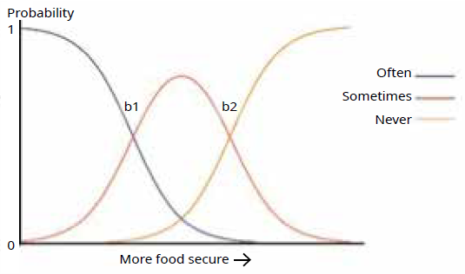
Note: The figure is not to scale. The location of ‘b1’ and ‘b2’ on the x-axis represent the item’s severity, and the slope of the graph at these points represents the item’s discriminatory ability.

To the left of ‘b1’ are respondents who had a higher probability of giving the response option ‘often’ rather than ‘sometimes’ to a particular item, based on their level of household food insecurity (index score). To the right of ‘b2’ are respondents who had a higher probability of responding ‘never’ rather than ‘sometimes’. Between ‘b1’ and ‘b2’ the most likely response was ‘sometimes’. Actual values are presented in Table A2.1.

These probabilities were averaged across the eight items, and the resulting index score of food insecurity at the intersection points was used to establish the thresholds for the overall questionnaire. Categorising households into groups with different levels of food security is useful for comparing food insecurity across different groups. However, it is important to keep in mind that the degree of food insecurity experienced by any household sits somewhere on a continuum, rather than in distinct categories.

Table A2.1: Item response theory estimates, 2015/16
Item | a | b1 | b2
1 | 3.31 | -2.38 | -1.01
2 | 4.42 | -1.77 | -0.89
3 | 5.37 | -1.89 | -0.97
4 | 3.61 | -1.56 | -0.61
5 | 3.04 | -2.11 | -1.38
6 | 2.60 | -2.45 | -1.54
7 | 4.71 | -1.66 | -0.89
8 | 3.18 | -2.02 | -1.11
Note: a is the discriminatory ability; b1 is the intersection point between the probability of the response selection of ‘often’ over ‘sometimes’; and b2 is the intersection point between the probability of response selection of ‘sometimes’ over ‘never’.

Figure A2.2 shows these thresholds for the overall questionnaire (red lines). Based on a threshold of index score smaller than -1.91, an estimated 1.6 percent of children were in households facing severe food insecurity. Approximately 19 percent of children were in households experiencing severe to moderate food insecurity (index score smaller than -1.01). Below the moderate threshold, around 19 percent of caregivers still provided an indication of food insecurity on at least one of the items (aggregate food insecurity index of larger than or equal to -1.01 and smaller than -.19).

Figure A2.2: Distribution of the food insecurity index across all children aged 0–14, 2015/16
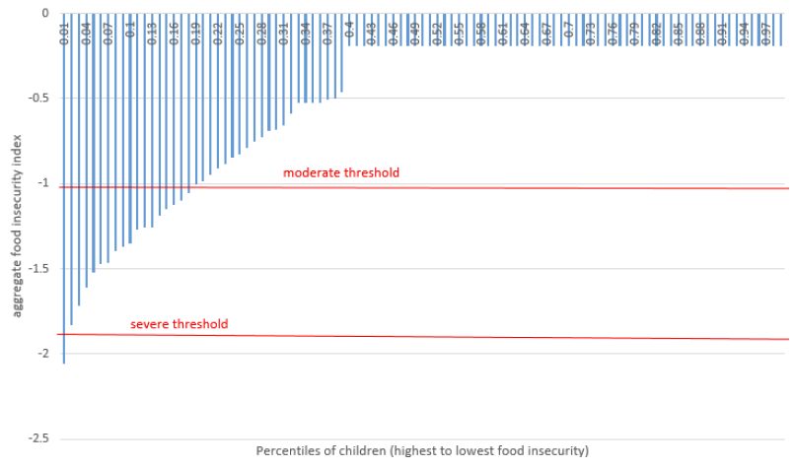

Appendix 3: Definition of key variables used in the analysis
Table A3.1: New Zealand Health Survey variables
Variable | Description | Question
Neighbourhood deprivation | Measured using the NZDep2013, which measures the level of socioeconomic deprivation for each neighbourhood according to a combination of the following 2013 Census variables: income, benefit receipt, transport (access to car), household crowding, home ownership, employment status, qualifications, sole-parent families, and access to the internet (or telephone for those 65+). Neighbourhoods are groupings of meshblocks used as primary sampling units for the survey. This report uses NZDep2013 quintiles, where quintile 1 represents the 20 percent of small areas with the lowest levels of deprivation (the least deprived areas) and quintile 5 represents the 20 percent of small areas with the highest level of deprivation (the most deprived areas). A small number of meshblocks do not have a value for NZDep2013. If a respondent in the New Zealand Health Survey selects any of these meshblocks, they are assigned to quintile 3 (ie, the middle quintile) for weighting and analysis purposes
Household income | Based on self-reported response to the household income question. In some cases there was a response to this question in both the adult and child version of the health survey. In these cases, the response to the adult questionnaire was selected | What is the total income that your household got from all sources, before tax or anything was taken out of it, in the last 12 months?  1 Loss  2 Zero income  3 $1–$20,000  4 $20,001–$30,000  5 $30,001–$50,000  6 $50,001–$70,000  7 $70,001–$100,000  8 $100,001 or more
Caregiver benefit receipt | Based on the response to a question from the adult questionnaire on sources of income. This question was only asked in the adult survey, and hence responses were only used if the primary caregiver completing the child questionnaire was also the adult questionnaire respondent. A separate set of survey weights were used to ensure the results were still representative of the New Zealand child population.  A caregiver was considered on the benefit if selecting one of the following options:  7 Jobseeker Support  8 Sole Parent Support  9 Supported Living Payment | In the last 12 months, what are all the ways that you yourself got income? Please do not count loans because they are not income.  1 Wages, salaries, commissions, bonuses etc, paid by an employer  2 Self-employment, or business you own and work in  3 Interest, dividends, rent, other investments  4 Regular payments from ACC or a private work accident insurer  5 NZ Superannuation or Veterans Pension  6 Other superannuation, pensions, annuities (other than NZ Superannuation, Veterans Pension or War Pension)  7 Jobseeker Support  8 Sole Parent Support  9 Supported Living Payment  10 Student allowance  11 Other government benefits, government income support payments, war pensions or paid parental leave  12 Other sources of income  13 No source of income during that time
Housing tenure – owned | A house was considered owned if the respondent (either in the adult or child questionnaire related to the same household) responded yes to either of these questions: ‘Do you, or anyone else who lives here hold this house/flat in a family trust’ and ‘Do you or anyone else who lives here own or partly own this dwelling, with or without a mortgage?’ | Do you or anyone else who lives here hold this house/flat in a family trust? (Yes/No)  Do you or anyone else who lives here own or partly own this dwelling, with or without a mortgage? (Yes/No)
Housing tenure – rented | If a respondent did not own the house, and responded to ‘Who owns this house/ flat?’ with ‘Private person, trust or business’, the household was considered to be rented from a private landlord. If instead one of the following response options was selected: ‘Local Authority or City Council’, ‘Housing New Zealand Corporation’ or ‘Other state-owned corporation or state owned enterprise, or government department or ministry’ the household was considered to be rented from a public landlord. | Who owns this house/flat?  1 Private person, trust or business  2 Local Authority or City Council  3 Housing New Zealand Corporation  4 Other state-owned corporation or state owned enterprise, or government department or ministry
Ethnicity | Ethnic group variables are derived using the concept of total response ethnicity (Statistics New Zealand 2005). This means that respondents can appear in, and contribute to the published statistics for more than one ethnic group. New Zealand Health Survey reports generally provide statistics for the following four ethnic groups: Māori, Pacific peoples, Asian and European/ other. The ‘other’ ethnic group (comprising mainly Middle-Eastern, Latin-American and African ethnicities) has been combined with European to avoid problems with small sample sizes. Respondents who do not know or refuse to state their ethnicity are included as European/other, as are those who answer ‘New Zealander’. | Which ethnic group or groups does [Name] belong to?  2 Māori  3 Samoan  4 Cook Island Maori  5 Tongan  6 Niuean  7 Chinese  8 Indian  77 Other [Specify]  [Three ‘Other’ ethnic groups possible]
Number of children in the household | Count of the number of children in the household aged 0–14 years on the day of the survey, as reported by the primary caregiver (source: Statistics New Zealand http://archive.stats.govt.nz/methods/ classifications-and-standards/classification-related-stats-standards/family-type/ definition.aspx)
Family structure  – sole or couple parents | We used information provided by health survey respondents about the people who are usually resident in their household, and the nature of the relationships between everyone in the house to determine whether the child lived with sole or couple parents. Statistics New Zealand’s classification rules of family types were used to derive family structure variables (source: Statistics New Zealand http://archive.stats.govt.nz/methods/ classifications-and-standards/classification-related-stats-standards/family-type/ definition.aspx)
More than one emergency department visit in past year | Defined as a child having gone to an emergency department at a public hospital about their own health more than once in the past 12 months. | In the past 12 months, how many times did [child’s name] go to an emergency department at a public hospital about their own health? (Multiple responses possible)  times
Unmet need for primary care | Defined as having experienced one or more types of unmet need for a GP, nurse or other health care worker in the past 12 months at their usual medical centre or after-hours services because of cost, transport or being unable to arrange childcare for other children. | Combination of various barriers to access questions.  Do you have a GP clinic or medical centre that you usually go to when [child’s name] is feeling unwell or is injured? (Yes/ No)  What sort of health care service is this? (A GP clinic, medical centre or family practice/A clinic that is after-hours only – not an emergency department at a public hospital/Other)  In the past 12 months, has there been a time when you wanted [child’s name] to see a GP, nurse or other health care worker at your usual medical centre within the next 24 hours, but he/she was unable to be seen? (Yes/No)  In the past 12 months, was there a time when [child’s name] had a medical problem but did not visit a GP because of cost? (Yes/No)  In the past 12 months, was there a time when [child’s name] had a medical problem but did not visit a GP because you had no transport to get there? (Yes/No)  In the past 12 months, was there a time when [child’s name] had a medical problem but did not visit a GP because you could not arrange childcare for other children? (Yes/No/Doesn’t apply)  In the past 12 months, was there a time when [child’s name] had a medical problem outside regular office hours but you did not take him/her to an after-hours medical centre because of cost? (Didn’t have a medical problem outside regular office hours/Yes, didn’t go because of cost/No)  In the past 12 months, was there a time when [child’s name] had a medical problem outside regular office hours but you did not take him/her to an after-hours medical centre because you had no transport to get there? (Yes, didn’t go because had no transport to get there/No)
Unmet need for prescription due to cost | Defined as being when parents got a prescription for their child but did not collect one or more prescription items because of cost, in the past 12 months. | In the past 12 months, was there a time when [Name] got a prescription but you did not collect one or more prescription items from the pharmacy or chemist because of cost? (Yes/ No)
Unmet need for a dentist | Defined as having had a dental problem but not being able to see a dental health care worker in the past 12 months due to any reason (not specifically cost, transport or lack of childcare). | In the last 12 months, has there been any time when [child’s name] needed to see a dental health care worker, but wasn’t able to? (Yes/No)
Tooth removed due to decay ever  (1–14 years) | Defined as having had one or more teeth removed in the child’s lifetime, due to decay, an abscess or infection. The term ‘dental health care worker’ refers to dentists and other dental health care professionals, such as dental therapists and dental hygienists, as well as dental specialists, such as orthodontists. | Have any of [child’s name] teeth been removed by a dental health care worker because of tooth decay, an abscess or infection?  Do not include teeth lost for other reasons, such as injury, crowded mouth or orthodontics (Yes/No)
Vegetable consumption meeting the guidelines  (2–14 years) | Defined as eating at least two servings of vegetables per day, and for children aged  5–14 years as eating at least three servings of vegetables per day, as recommended by the Ministry of Health. | On average, how many servings of vegetables does [child’s name] eat per day? Please include all fresh, frozen and canned vegetables. Do not include vegetable juices.  A ‘serving’ = 1 medium potato/ kumara or ½ cup cooked vegetables or 1 cup of salad vegetables. For example, 2 medium potatoes + ½ cup of peas = 3 servings.
Fruit consumption meeting the guidelines  (2–14 years) | Defined as eating at least two servings of fruit each day, as recommended by the Ministry of Health. | On average, how many servings of fruit does [child’s name] eat per day? Please include all fresh, frozen, canned and stewed fruit. Do not include fruit juice or dried fruit. A ‘serving’ = 1 medium piece or 2 small pieces of fruit or ½ cup of stewed fruit. For example, 1 apple and 2 small apricots = 2 servings.
Breakfast eaten at home <5 days  (2–14 years) | This indicator does not cover breakfast in other settings (eg, at school). | Thinking back over the past 7 days, on how many days did [child’s name] have breakfast at home? [If child was not at home in past week, ask caregiver to recall last 7 days child was at home]
Fast food three or more times a week  (2–14 years) | Defined as having eaten any food purchased from a fast-food place or takeaway shop, such as fish and chips, burgers, fried chicken or pizza, three or more times in the past week. | In the past 7 days, how many times did [child’s name] eat any food purchased from a fast food place or takeaway shop, such as fish and chips, burgers, fried chicken or pizza? This includes snacks as well as mealtimes.
Fizzy drink three or more times a week  (2–14 years) | Defined as having had a fizzy drink, such as cola or lemonade, three or more times in the past week. | In the past 7 days, how many times did [child’s name] have a fizzy drink, such as cola or lemonade? [This includes diet (artificially sweetened) and energy drinks such as ‘Powerade’ or ‘V’ but does not include powdered drinks made up with water such as cordial or ‘Raro’, or fruit juice such as ‘Just Juice’].
Body size  (2–14 years) | The following applies to all body weight indicators: body mass index (BMI) was calculated by dividing weight in kilograms by height in metres squared (kg/m²). For children aged 2–14 years, age- and sex-specific BMI cut-off points developed by the International Obesity Task Force were used to define BMI categories equivalent to those used for adults (Cole et al 2000; Cole et al 2007; Cole and Lobstein 2012). | Measured height and weight. Height is measured using a professional laser meter mounted to a rigid headboard, which the interviewer holds against the corner of a wall or door. Weight is measured with electronic weighing scales. Waist circumference is measured using an anthropometric measuring tape. The measurement is taken over one layer of clothing at the midpoint between the lowest palpable rib and the top of the hip bone.  Height, weight and waist circumference measurements are taken a minimum of twice each. If there is more than a 1 percent variation between the first and second measurements, then a third measurement is taken for accuracy. To align with international standards, the final height, weight and waist measurements used for analysis are calculated for each respondent by taking the mean of the two closest measurements
Healthy weight  (2–14 years) | Defined as a BMI equivalent to an adult BMI between 18.5 and 24.9.
Overweight (but not obese) (2–14 years) | Defined as a BMI equivalent to an adult BMI between 25.0 and 29.9.
Obese (2–14 years) | Defined as a BMI equivalent to an adult BMI of 30 (or greater).
Primary caregiver’s report of child’s health status fair/poor | Children are categorised as having fair or poor parent-rated health if the child’s parent or caregiver answered ‘fair’ or ‘poor’ to the question in the right-hand column. | In general, would you say [child’s name]’s health is: Excellent/Very good/Good/Fair/Poor?
Primary caregiver’s self-reported health status fair/poor (2015/16 only) | For this indicator, responses were used only if the adult questionnaire respondent was also the primary caregiver completing the child’s questionnaire. | In general, would you say your health is: Excellent/Very good/ Good/Fair/Poor?
Asthma medicated  (5–14 years) | Defined as the child’s parents or caregivers having ever been told by a doctor that the child has asthma, and if they now use treatments for asthma (including inhalers, medicine, tablets or pills). | Have you ever been told by a doctor that [child’s name] has asthma? (Yes/No)  What treatments does [child’s name] now have for asthma? (No treatment/inhaler/medicine, tablets or pills/something else)
Eczema medicated | Defined as the child’s parents or caregivers having ever been told by a doctor that the child has eczema, and if they now use treatments for eczema (including cream, ointment, medicine, tablets or pills). | Have you ever been told by a doctor that [child’s name] has eczema? (Yes/No)  What treatments does [child’s name] now have for eczema? (No treatment/medicine, tablets or pills/cream or ointment/ something else)
Learning, development or behaviour concerns  (4 months–8 years) | The following nine items are part of the Parent’s Evaluation of Developmental Status (Survey PEDS). | Do you have any concerns about [child’s name] learning, development, or behaviour? (No/Yes/A little)
Speech concerns  (4 months–8 years) |  | Do you have any concerns about how [child’s name] talks and makes speech sounds? (No/Yes/A little)
Understanding concerns  (4 months–8 years) |  | Do you have any concerns about how [child’s name] understands what you say? (No/Yes/A little)
Hand/finger use concerns  (4 months–8 years) |  | Do you have any concerns about how [child’s name] uses his/her hands and fingers to do things? (No/Yes/A little)
Arm/leg use concerns  (4 months–8 years) |  | Do you have any concerns about how [child’s name] uses his/her arms and legs? (No/Yes/A little)
Behaviour concerns  (4 months–8 years) |  | Do you have any concerns about how [child’s name] behaves? (No/Yes/A little)
Getting along with others concerns  (4 months–8 years) |  | Do you have any concerns about how [child’s name] gets along with others? (No/Yes/A little)
Learning to do things themselves concerns  (10 months–8 years) |  | Do you have any concerns about how [child’s name] is learning to do things for [himself/herself]? (No/Yes/A little)
Learning preschool or school skills concerns  (18 months–8 years) |  | Do you have any concerns about how [child’s name] is learning preschool or school skills? (No/Yes/A little)
Concerning total Strengths and Difficulties Questionnaire (SDQ) score (3–14 years) | The following five indicators are part of the SDQ. The total score is the sum of the scores for questions covering emotional symptoms, peer problems, hyperactivity and conduct problems. A concerning total score is a score above 15 for children aged 3 and 4 years and above 16 for children between 5 and 14 years (there are 20 questions; the range of scores is 0–40). | See Child Questionnaire (Ministry of Health 2016a)
Concerning emotional symptoms SDQ  (3–14 years) | A score above 3 for children aged 3 and 4 years and above 4 for those between 5 and 14 years olds on the emotional symptoms subscale (there are five questions; the range of scores is 0–10).
Concerning peer problems SDQ  (3–14 years) | A score above 3 for children aged 3–14 years on the peer problems subscale (there are five questions; the range of scores is 0–10).
Concerning hyperactivity SDQ (3–14 years) | A score above 6 for children aged 3–14 years on the hyperactivity subscale (there are five questions; the range of scores is 0–10).
Concerning conduct problems SDQ  (3–14 years) | A score above 4 for children aged 3 and 4 years and above 3 for those aged 5–14 years on the conduct problems subscale (there are five questions; the range of scores is 0–10).
Caregiver coping with demands raising children (not very well/not very well at all) | Based on one of five questions of the parental stress component of the Developmental health and wellbeing module in 2014/15 and 2015/16 | In general, how well do you feel you are coping with the day-to-day demands of raising children? (Very well/Well/ Somewhat well/Not very well/Not very well at all)
Caregiver feeling angry with child (usually/always) | Based on one of five questions of the parental stress component of the Developmental health and wellbeing module in 2014/15 and 2015/16. | During the past month, how often have you felt angry with [child’s name]? Never/Rarely/Sometimes/ Usually/Always
Caregiver finding child harder to care for (usually/always) | Based on one of five questions of the parental stress component of the Developmental health and wellbeing module in 2014/15 and 2015/16. | During the past month, how often have you felt [child’s name] is much harder to care for than most children the same age?  Never/Rarely/Sometimes/ Usually/Always
Caregiver finding child does things that bother them a lot (usually/always) | Based on one of five questions of the parental stress component of the Developmental health and wellbeing module in 2014/15 and 2015/16. | During the past month, how often have you felt [child’s name] does things that really bother you a lot?  Never/Rarely/Sometimes/ Usually/Always
Caregiver not having someone to turn to for day-to-day support | Based on one of five questions of the parental stress component of the Developmental health and wellbeing module in 2014/15 and 2015/16. | Is there someone that you can turn to for day-to-day emotional support with raising children? This can be any person, including your husband or wife or partner (Yes/No)
Caregiver having punished child physically in past 4 weeks (0–14 years) | Defined as a positive answer to ‘Physical punishment, such as smacking’. | Thinking back over the past 4 weeks, when [child’s name] misbehaved, which of the following, if any, have you done?  Just read out the number next to the words.  Made him/her go without something or miss out on something  Yelled at him/her  Explained why he/she should  not do it  Physical punishment, such as smacking  Told him/her off  Sent him/her to the bedroom or other place in the house  Ignored his/her behaviour  Something else [specify]  My child has not misbehaved during the past 4 weeks
Caregiver psychological distress  (K10, 2015/16 only) | Defined as high or very high levels of psychological distress according to the K10 scale (ie, a score of 12 or more) in the past four weeks. For this indicator responses were used only if the adult questionnaire respondent was also the primary caregiver completing the child questionnaire. | See Kessler 1996
Primary caregiver current smoker (2015/16 only) | Defined as having smoked at least monthly, and having smoked more than 100 cigarettes in their whole life. Data for this question were used only if the adult respondent was also the primary caregiver responding to the child questionnaire. | Have you ever smoked cigarettes or tobacco at all, even just a few puffs? Please include pipes and cigars. (Yes/No)  Have you ever smoked a total of more than 100 cigarettes in your whole life? (Yes/No)  How often do you now smoke? You don’t smoke now/At least once a day/At least once a week/ At least once a month/Less often than once a month
Smoker inside the house (2015/16 only) | An indicator of the child’s exposure to second-hand smoke inside the house | Does anyone smoke inside your house? (Yes/No)
Note: All questions also had a ‘don’t know’ and ‘refused’ response option.

Appendix 4: Share of the child population in each group 2015/16
Table A4.1: Share of the child population in each group
 | Share of population  (%) | 95% CI
Boys | 51.3 | 51.3–51.3
Girls | 48.7 | 48.7–48.7
0–4 years of age | 33.2 | 33.2–33.2
5–9 years of age | 34.8 | 34.8–34.8
10–14 years of age | 31.9 | 31.9–31.9
Māori | 25.7 | 25.7–25.7
Pacific | 13.5 | 11.3–15.6
Asian | 13.0 | 10.9–15.1
European/other | 71.2 | 68.5–73.9
NZDep2013 quintile 1 (least deprived) | 20.0 | 20.0–20.0
NZDep2013 quintile 2 | 18.9 | 18.9–18.9
NZDep2013 quintile 3 | 18.3 | 18.3–18.3
NZDep2013 quintile 4 | 18.8 | 18.8–18.8
NZDep2013 quintile 5 (most deprived) | 23.9 | 23.9–23.9
Gross household income over $50,000 | 70.9 | 69.3–72.5
Gross household income at or below $50,000 | 29.1 | 27.5–30.7
Caregiver not receiving a benefit | 81.8 | 80.3–83.4
Caregiver receiving a benefit | 18.2 | 16.6–19.7
House owned by family | 55.4 | 53.4–57.5
Renting from private landlord | 36.6 | 34.4–38.8
Renting from public landlord | 8.0 | 6.5–9.5
Couple parent | 75.1 | 73.2–77.0
Sole parent | 24.9 | 23.0–26.8
One child in household | 23.1 | 21.4–24.7
Two children in household | 40.7 | 38.6–42.7
Three children in household | 21.2 | 19.4–23.1
Four or more children in household | 15.0 | 13.3–16.8
All children | 100
Note: NZDep2013 quintiles are set up so that 20 percent of the adult population resides in each quintile. The distribution of children over the quintiles deviates somewhat from this: more children live in the most deprived quintile of neighbourhoods (24%).
This table uses the total response measure of ethnicity. Using this measure, children whose caregivers reported more than one ethnic group are counted once in each group; this means that the sum of the percentages for all ethnic groups is greater than 100 percent.

Appendix 5: Data tables

Child nutrition indicators
Table A5.1: Vegetable consumption by food security status, 2014/15 and 2015/16
 | Age  (child) | Percentage in  severely to  moderately food-insecure households | Percentage in fully  to mostly food-  secure  households | p value for group difference (unadjusted)
Not meeting vegetable consumption guidelines | 2–4 | 33.5 | 26.6 | .04
 | 5–9 | 64.2 | 52.5 | <.01
 | 10–14 | 57.6 | 45.5 | <.01
 | p value  age  difference | <.01  except 5–9 vs  10–14 ns | All <.01
Note: Statistically significant differences (p<.05) are shown in bold.

Table A5.2: Fruit consumption by food security status, 2014/15 and 2015/16
 | Age  (child) | Percentage in  severely to  moderately food-insecure households | Percentage in fully  to mostly food-  secure  households | p value for group difference (unadjusted)
Not meeting fruit consumption guidelines | 2–4 | 24.2 | 18.4 | .05
 | 5–9 | 28.0 | 22.0 | .03
 | 10–14 | 40.3 | 31.5 | <.01
 | p value  age  difference | <.01 except  2–4 vs 5–9 ns | All <.05
Note: Statistically significant differences (p < .05) are shown in bold.

Table A5.3: Breakfast by food security status, 2014/15 and 2015/16
 | Age  (child) | Percentage in  severely to  moderately food-insecure households | Percentage in fully  to mostly food-  secure  households | p value for group difference (unadjusted)
Breakfast at home <5 days per week | 2–4 | 5.5 | 5.6 | .99
 | 5–9 | 15.9 | 4.5 | <.01
 | 10–14 | 24.9 | 13.2 | <.01
 | p value  age  difference | All <.01 | <.01 except  2–4 vs 5–9 ns
Note: Statistically significant differences (p < .05) are shown in bold.

Table A5.4: Fast food by food security status, 2014/15 and 2015/16
 | Age  (child) | Percentage in  severely to  moderately food-insecure households | Percentage in fully  to mostly food-  secure  households | p value for group difference (unadjusted)
Fast food three or more times a week | 2–4 | 8.4 | 3.1 | .01
 | 5–9 | 10.0 | 5.7 | <.01
 | 10–14 | 12.8 | 8.1 | .02
 | p value  age  difference | All ns | All <.01
Note: Statistically significant differences (p<.05) are shown in bold.

Table A5.5: Fizzy drinks by food security status, 2014/15 and 2015/16
 | Age  (child) | Percentage in  severely to  moderately food-insecure households | Percentage in fully  to mostly food-  secure  households | p value for group difference (unadjusted)
Fizzy drinks 3+ times a week | 2–4 | 19.0 | 7.4 | <.01
 | 5–9 | 24.6 | 14.8 | <.01
 | 10–14 | 36.0 | 22.1 | <.01
 | p value  age  difference | All <.01 | All <.01
Note: Statistically significant differences (p<.05) are shown in bold.

Child body size indicators
Table A5.6: Child body size indicators by food security status, 2014/15 and 2015/16
 | Age  (child) | Percentage in  severely to  moderately food-insecure households | Percentage in fully  to mostly food-  secure  households | p value for group difference (unadjusted)
Obese | 2–4 | 12.2 | 7.2 | <.01
 | 5–9 | 18.8 | 9.1 | <.01
 | 10–14 | 20.3 | 10.2 | <.01
 | p value  age  difference | <.05  except 5–9 vs  10–14 ns | <.05  for 2–4 vs  10–14 only
Note: Statistically significant differences (p<.05) are shown in bold.

Table A5.7: Child body size indicators by food security status, 2014/15 and 2015/16
 | Age  (child) | Percentage in  severely to  moderately food-insecure households | Percentage in fully  to mostly food-  secure  households | p value for group difference (unadjusted)
Overweight but not obese | 2–4 | 29.7 | 18.2 | <.01
 | 5–9 | 24.4 | 18.2 | .01
 | 10–14 | 27.3 | 22.8 | .12
 | p value  age  difference | All ns | <.05 except  2–4 vs 5–9 ns
Note: Statistically significant differences (p<.05) are shown in bold.

Table A5.8: Child body size indicators by food security status, 2014/15 and 2015/16
 | Age  (child) | Percentage in  severely to  moderately food-insecure households | Percentage in fully  to mostly food-  secure  households | p value for group difference (unadjusted)
Healthy weight | 2–4 | 54.5 | 69.5 | <.01
 | 5–9 | 53.1 | 68.9 | <.01
 | 10–14 | 50.0 | 61.9 | <.01
 | p value  age  difference | All ns | <.01 except  2–4 vs 5–9 ns
Note: Statistically significant differences (p<.05) are shown in bold.

Adjusted rates and rate ratios
Table A5.9: Rates and rate ratios (ARR), adjusted for gross household income and number of children, 2015/16
 | Adjusted for age and sex |  | Adjusted for age, sex, household income and number of children in the household
 | Percentage of children in severely to moderately food-insecure households | 95% CI | Percentage of children in fully to mostly food-secure households | 95% CI
Caregiver not receiving a benefit | 12.1 | 10.8–13.5 | 14.9 | 13.2–16.6
Caregiver receiving a benefit | 56.6 | 50.9–62.2 | 29.8 | 24.5–35.0
ARR benefit vs no benefit | 4.7 | 3.9–5.4 | 2.0 | 1.6–2.4
House owned by household | 7.9 | 6.2–9.7 | 13.2 | 10.6–15.7
Renting from private landlord | 27.3 | 24.2–30.4 | 20.3 | 18.0–22.7
Renting from public landlord | 53.3 | 46.9–59.6 | 27.0 | 21.7–32.3
ARR public rental vs owned | 6.7 | 5.0–8.4 | 2.1 | 1.5–2.7
ARR public rental vs private rental | 2.0 | 1.6–2.3 | 1.3 | 1.1–1.6
ARR private rental vs owned | 3.4 | 2.6–4.3 | 1.6 | 1.2–2.0
Māori | 28.5 | 25.3–31.7 | 20.3 | 17.9–22.7
Non-Māori | 14.8 | 13.1–16.6 | 17.4 | 15.4–19.4
ARR Māori vs non-Māori | 1.8 | 1.5–2.1 | 1.2 | 1.0–1.4
Pacific | 36.1 | 31.5–40.9 | 25.2 | 21.5–28.8
Non-Pacific | 15.8 | 14.2–17.4 | 17.0 | 15.3–18.7
ARR Pacific vs non-Pacific | 2.3 | 2.0–2.6 | 1.5 | 1.2–1.7
Asian | 9.1 | 5.3–13.0 | 10.9 | 6.4–15.3
Non-Asian | 19.7 | 18.1–21.2 | 19.3 | 17.7–20.9
ARR Asian vs non-Asian | .5 | .3–.7 | .6 | .3–.8
European/other | 14.9 | 13.3–16.6 | 17.4 | 15.6–19.2
Non-European/other | 27.7 | 24.5–30.9 | 20.3 | 17.5–23.0
ARR European/other vs non-European/other | .5 | .5–.6 | .9 | .7–1.0
Sole parent | 37.5 | 33.4–41.5 | 22.5 | 19.9–25.0
Couple parent | 12.3 | 10.6–14.0 | 16.1 | 14.1–18.1
ARR sole vs couple parent | 3.1 | 2.5–3.6 | 1.4 | 1.2–1.6
One child in household | 14.6 | 12.7–16.6 | 14.5 | 12.8–16.2
Two children in household | 12.6 | 10.4–14.8 | 14.5 | 12.4–16.7
Three children in household | 19.9 | 16.3–23.5 | 18.7 | 15.3–22.0
Four or more children in household | 37.4 | 30.4–44.4 | 30.9 | 24.6–37.1
ARR four vs one children in household | 2.6 | 1.9–3.2 | 2.1 | 1.6–2.7
Note: Household income data was not available for all respondents. Only data from respondents with a household income response were used for the estimates in this table. A separate set of survey weights was used to adjust for missing income data, ensuring the estimates are representative of the overall child population.
Number of children was categorised as one, two, three, or four or more. Estimates for number of children in the household were adjusted for age, sex, and household income only.

The types of benefits included in this estimate were Jobseeker Support, Sole Parent Support and Supported Living Payments. See Appendix 3 for more detailed definitions.
Adjusted for the child’s age and sex only.
Adjusted for the child’s age and sex, number of children in the household, and the gross household income.
Public landlords include local authorities, Housing New Zealand Corporation and other state-owned corporations, state-owned enterprises, government departments or ministries.
Support, hospitality, kindness, generosity.
Holistic health, dimensions include: taha tinana (physical wellbeing), taha hinengaro (mental and emotional wellbeing), taha whānau (social wellbeing) and taha wairua (spiritual wellbeing).
The Families and Whānau Status Report 2018 (Superu 2018) presents estimates for sole and couple parents for each of the eight items. Across all items sole and couple parents differed statistically significantly in their response selection.
Estimates from the Youth Health and Wellbeing surveys show food insecurity increasing immediately prior to this period. Food insecurity was higher for young people in 2012 compared to 2007. This was based on young people’s own responses to the question: ‘Do your parents, or the people who act as your parents, ever worry about not having enough money to buy food?’ (Utter et al 2018).
No comparisons could be made with earlier years due to changes in the methods.
For approximately 7 percent of children in the survey, the primary caregiver who responded to the children’s questionnaire was not their mother or father.
The food-security questions all measured the same underlying construct (uni-dimensional data), as confirmed through principal component analysis. MIRT allowed for the use of survey weights to adjust for the sampling method of the New Zealand Health Survey.

