Hospital Ethnicity Data Audit Toolkit
A toolkit for assessing ethnicity data quality in hospitals
2021

Acknowledgements
The draft Hospital Ethnicity Data Audit Toolkit was developed as a Ministry of Health-funded project in 2015. This toolkit has been updated to align with the HISO 10001: 2017 Ethnicity Data Protocols. We acknowledge the expertise and experience of those people and organisations who contributed to the development of the toolkit. Ngā mihi nui ki a koutou katoa.
Citation: Ministry of Health. 2021. Hospital Ethnicity Data Audit Toolkit. Wellington: Ministry of Health.
Published in December 2021 by the Ministry of Health
PO Box 5013, Wellington 6140, New Zealand
ISBN 978-1-99-110007-8 (online)
HP 8009
This document is available at health.govt.nz
This work is licensed under the Creative Commons Attribution 4.0 International licence. In essence, you are free to: share ie, copy and redistribute the material in any medium or format; adapt ie, remix, transform and build upon the material. You must give appropriate credit, provide a link to the licence and indicate if changes were made.

Contents
Introduction 1
The Hospital Ethnicity Data Audit Toolkit 2
How often should we complete this audit? 2
Resources 3
Ethnicity Data Protocols 3
Stats NZ statistical standard for ethnicity 3
Overview of the audit process 4
Stage 1: Systems compliance audit checklists 5
Who should complete this stage of the audit? 5
How often should this stage be undertaken? 5
What will I need to complete the checklists? 6
How will compliance be scored? 6
How do these tools help the service? 6
Compliance checklists 7
Stage 2: Staff survey 11
Who should complete this stage of the audit? 11
What will I need to complete the staff survey stage? 11
How should I mark the surveys? 12
How do I feed back the results of the survey to staff? 12
Forms and guide 13
Stage 3: Centralised ethnicity data audit 20
Who should complete this stage of the audit? 20
What will I need to complete the centralised ethnicity data audit? 20
How does this activity help the hospital? 21
Instructions and scoring sheet 21
Stage 4: Ethnicity data quality audit 24
Who should complete this stage of the audit? 24
What will I need to complete the ethnicity data quality audit? 25
How does this activity help your hospital? 25
Instructions and patient form 25
Appendices 33
Appendix A: Detailed guidance for staff survey responses 33
Appendix B: Related articles 40

List of Figures
Figure 1: Enter PAS details 27
Figure 2: Enter self-identified ethnicities from patient data collection form 28
Figure 3: Example of more than six ethnicities 28

Introduction
Ethnicity refers to the ethnic group or groups that individuals identify with or feel that they belong to. In New Zealand, ethnicity is self-identified, and people can identify with more than one ethnic group. The Hospital Ethnicity Data Audit Toolkit (HEDAT) provides a resource for both assessing the quality of ethnicity data in New Zealand public hospital settings and supporting ethnicity data quality improvement. High-quality ethnicity data is important for developing appropriate health sector strategy and policy. In the New Zealand hospital context, the purpose of collecting ethnicity data includes:
- supporting the provision of appropriate and responsive services
- guiding implementation of individual care and support plans
- supporting clinical audit and quality improvement activities
- measuring and monitoring population health (including health risk factors, incidence, outcomes and experiences of care)
- monitoring policy and service performance, effectiveness and equity at a broader system level
- planning for population priorities
- targeting funding and allocation of resources.

The process of collecting and reporting ethnicity data in New Zealand has evolved significantly over time. Processes of collecting, reporting and outputting ethnicity data are governed by the Stats NZ statistical standard for ethnicity v1.0.0 and the Ministry of Health’s (the Ministry’s) Ethnicity Data Protocols. The Ministry first published the Ethnicity Data Protocols in 2004, with supplementary notes following in 2009. The Ministry then published a revised version, which combines these two documents, HISO 10001:2017 Ethnicity Data Protocols in September 2017 (Ministry of Health 2017). This is the current health and disability sector standard (throughout this document referred to as the ‘Ethnicity Data Protocols’). It was developed with input from a wide range of sector and government organisations.

The Ethnicity Data Protocols identify the minimum standards that apply across the health and disability sector and the requirement to use Stats NZ’s Ethnicity New Zealand Standard Classification for recording ethnicity data (see Stats NZ 2019).

The Hospital Ethnicity Data Audit Toolkit
The HEDAT encompasses four stages, with supporting tools to help you assess the quality of ethnicity data and systems for data collection, recording and outputting within your hospital settings. It provides guidance on quality improvement activities and:
- an option for benchmarking how well you are currently complying with the Ethnicity Data Protocols
- information on the current minimum standards for collecting, recording and outputting ethnicity data within the health and disability sector
- further information and links to useful resources to guide quality improvement in your organisation.

The HEDAT helps a hospital assess their ethnicity data against the standard for the health and disability sector, as outlined in the Ethnicity Data Protocols. Understanding the quality of the hospital’s ethnicity data also supports key objectives documented in He Korowai Oranga: New Zealand Māori Health Strategy (Ministry of Health 2020) and, more broadly, against current best practice.

The HEDAT is designed to stand alone. We anticipate that it will complement and support other quality improvement activities as part of broader quality improvement cycles in hospitals.

How often should we complete this audit?
The HEDAT includes audit activities that can be undertaken as stand-alone activities or as stages of a more comprehensive audit. How often you need to conduct future audits will be dictated by the extent of issues identified at each stage of the first audit. However, a comprehensive audit should be actioned every three years.

Resources
The following are key resources required when actioning a stage of the audit process. They are referred to at various points within this document.

Ethnicity Data Protocols
Describes the standard procedures for collecting, recording and using data on the ethnicity of people treated by or working in the New Zealand health and disability sector.
- HISO 10001:2017 Ethnicity Data Protocols (Ministry of Health 2017).
- Ethnicity classification list: This contains a quick reference table of Ethnicity classifications listing:
- descriptions in alphabetic order along with their classification code
- classification codes in numeric order along with their description.

Stats NZ statistical standard for ethnicity
The statistical standard for ethnicity was developed to ensure that ethnicity is collected consistently for all surveys and administrative collections.
- Stats NZ statistical standard for ethnicity v1.0.0
- Ethnicity New Zealand Standard Classifications 2005 v2.1.0: This coding tool was developed by Stats NZ and provides a function to search for an ethnicity classification at any of the four levels.
- Ethnicity New Zealand Concordances: This link provides the mapping between Ethnicity New Zealand Standard Classifications V2.0.0 to V2.1.0 and V1.0.0. These should be used by implementers to apply the necessary changes to map existing data and to update to the most recently published ethnicity codes.

Overview of the audit process

Stage 1:
Systems compliance audit checklists
The systems compliance audit checklists allow you to assess whether you are collecting, recording and outputting ethnicity data in compliance with the Ethnicity Data Protocols.

Who should complete this stage of the audit?
Each of the three checklists should be completed by a person(s) with a good understanding of processes and policies for managing ethnicity data in their area (for example, in their ward, service or department). The systems compliance audit process may be centrally coordinated by the hospital quality manager or other management staff (for example, service manager or clinical leader).

How often should this stage be undertaken?
There are potentially several different processes and IT systems being used in public hospitals to collect, record and output patient ethnicity data. At a minimum, the three systems compliance checklists should be completed once every three years as part of an overall audit process for each system (paper-based system, database or electronic system) being used to collect, record or output ethnicity data for each ward, service or department in the hospital.

If issues are identified with compliance, a plan should be actioned to bring systems up to compliance. When issues are identified, the audit should be repeated within 12 months for the relevant wards, services or departments.

What will I need to complete the checklists?
You will need:
      - a copy of any written protocols or policies relating to ethnicity data in your ward, service area or department, or, where these are unwritten, the assistance of somebody with an understanding of how your ward, service area or department manages ethnicity data (for example, somebody in charge of handling patient information)
      - a copy of your patient information form (PIF) or admission form
      - access to your patient administration system (PAS) (for the ethnicity data recording compliance checklist)
      - a copy of the HISO 10001:2017 Ethnicity Data Protocols
      - access to the Ethnicity code tables from either:
        - the Ministry of Health, Ethnicity code table
        - the coding tools provided by Stats NZ:
          - Ethnicity New Zealand Standard Classifications 2005 v2.1.0
          - Ethnicity New Zealand Concordances.

How will compliance be scored?
Compliance will be assessed for each of the specific standards for (a) collecting, (b) recording and (c) outputting ethnicity data outlined in the Ethnicity Data Protocols. Compliance is either met (YES) or not met (NO). A score will be calculated for compliance in collecting, recording and outputting based on the number of YES responses. This will allow you to better identify specific areas for improvement.

How do these tools help the service?
The checklists measure compliance with the Ethnicity Data Protocols. Your service needs to address the areas where it does not comply. A list of useful links and resources is provided within this document to assist you with quality improvements and support you to fully align with the Ethnicity Data Protocols.

Compliance checklists
The three compliance checklists are:
- Ethnicity data collection compliance checklist
- Ethnicity data recording compliance checklist
- Ethnicity data output compliance checklist.

A copy of each checklist follows. These checklists are also available on the Ministry of Health’s website from the hyperlink provided with the relevant checklist in the bullet list above.

Hospital Ethnicity Data Audit Toolkit

Stage 1: Ethnicity data collection compliance checklist
Name of ward, service or department:
Date compliance checklist was completed:
IT system being used:

 | Compliance question | Response
Is your hospital ward, service or department policy for collecting ethnicity data compliant with the current Ethnicity Data Protocols for the health sector? | Does your hospital ward, service or department collect ethnicity data from all patients or consumers (for example, all age groups)? | Yes | No
 | Does your patient information/admission form contain the current standard ethnicity question, ethnicity response list (in order) and ability to collect multiple other ethnicities* as outlined in the current Ethnicity Data Protocols? | Yes | No
 | Does your hospital ward, service or department allow all respondents to self-identify their ethnicity, regardless of how ethnicity is collected (for example, face to face, on a paper form, electronically, by telephone)? (Note: This excludes situations where ethnicity must be collected from next of kin.) | Yes | No
 | When collecting ethnicity data for children (including for newborns), does your hospital ward, service or department provide the parent or caregiver with the standard ethnicity question** to complete for the child until the child is of an age to complete it themselves? | Yes | No
 | When a patient or consumer is unable to complete the ethnicity question through incapacity, does your hospital ward, service or department provide their next of kin with the standard ethnicity question to complete, or, if no next of kin is available, do you wait until the respondent is able to self-identify their ethnicity? | Yes | No
 | In cases where ethnicity data is collected by asking the patient/ consumer verbally (for example, over the phone), does your ward, service or department require staff to:  - state to the patient/consumer that they would like to collect ethnicity  - explain that the patient/consumer may choose more than one ethnicity  - read out to the patient/consumer all the categories, in the order they appear in the standard ethnicity question outlined in the current ethnicity data protocols  - record all the patient’s/consumer’s responses? | Yes | No
* The standard ethnicity question for the health and disability sector is the Stats NZ ethnicity question used in the most recent census. See HISO 10001:2017 Ethnicity Data Protocols, 3.2: Standard ethnicity question (Ministry of Health 2017) for the standard question, categories, formatting and layout requirements.
** See HISO 10001:2017 Ethnicity Data Protocols, 3.3.4 c) Proxy response in the Ethnicity Data Protocols for information on collecting ethnicity details for children/newborns.

Collection compliance score | /6
Each correct answer is assigned a score of 1. If the combined score is less than 6, action is required.
Action(s) required:

Hospital Ethnicity Data Audit Toolkit

Stage 1: Ethnicity data recording compliance checklist
Name of ward, service or department:
Date compliance checklist was completed:
IT system being used:

 | Compliance question | Response
Is your hospital ward, service or department policy for recording ethnicity data compliant with the current Ethnicity Data Protocols for the health sector? | Does your hospital ward, service or department input and store ethnicity data in the IT system at level 4 of the standard classification?  (See Resources for links to level 4 classifications). | Yes | No
 | Is your hospital ward, service or department restricted to only using the Stats NZ Ethnicity Classification level 4 standard codes for recording ethnicity?  (See Resources for links to level 4 classifications). | Yes | No
 | For ethnicities that are written on the form by respondents, does your hospital ward, service or department match the response with the level 4 ethnicity codes and then record the response in your IT system at level 4? | Yes | No
 | Is your ward, service or department able to record and store up to six ethnicities for an individual? | Yes | No
 | Where a patient supplies more responses than can be recorded in your IT system, does your hospital ward, service or department use:  - the method determined by Stats NZ (HISO 10001:2017 Ethnicity Data Protocols, Appendix A) to reduce the number of ethnicities where six may be recorded  or  - where systems are not able to record six ethnicities, do you prioritise responses according to the standard list provided in the current Ethnicity Data Protocols and record these at level 4? (See HISO 10001:2017 Ethnicity Data Protocols section, 5.5.2 Prioritised output for more information.) | Yes | No
 | Are less than 1 percent of your records coded as having missing or ‘not stated’ ethnicity response fields on your IT system (this will require you to run a query)? | Yes | No

Recording compliance score | /6
Each correct answer is assigned a score of 1. If the combined score is less than 6, action is required.
Action(s) required:

Hospital Ethnicity Data Audit Toolkit

Stage 1: Ethnicity data output compliance checklist
Name of ward, service or department:
Date compliance checklist was completed:
IT system being used:

 | Compliance question | Response
Is your hospital ward, service or department policy for the output of ethnicity data compliant with the current Ethnicity Data Protocols for the health sector? | Where your hospital outputs data to national collections, are you able to report up to six ethnicities per patient where required? | Yes | No
 | Where the patient identifies with more than six ethnicities, do you prioritise or use the recommended reduction method for reporting into national collections according to the standard process (see Appendix A of the HISO 10001:2017 Ethnicity Data Protocols)? | Yes | No
 | Where your hospital outputs data to national collections and only three ethnicities are required, do you use the reduction method recommended by national collections to meet reporting requirements for the specific collection? | Yes | No
 | In the analysis and reporting of ethnicity data at levels 1, 2 or 3, does your hospital ward, service or department use one of the recommended methods (total response (overlapping), prioritised or sole/combination) for the output of multiple ethnicities?** | Yes | No
 | In the analysis and reporting of ethnicity data, does your hospital ward, service or department describe the method it uses for the output of multiple ethnicities (for example, total response (overlapping), prioritised or sole/combination)?** | Yes | No
** Total response, prioritised and sole/combination are different methods for outputting multiple ethnicities.
- Total response counts each person once in each ethnic group they identify with.
- Prioritisation assigns a person who identifies with more than one ethnic group to a single mutually exclusive category based on an established priority order.
- Sole/combination assigns individuals to either a sole ethnicity group (if they only identify with one ethnicity) or a combination category (for example, European/Māori) if they identify with more than one ethnic group.

Output compliance score | /5
Each correct answer is assigned a score of 1. If the combined score is less than 5, action is required.
Action(s) required:

Stage 2:
Staff survey
This stage of the audit allows you to assess your staff’s understanding and current processes for collecting and recording ethnicity data and identify specific staff training needs.

Who should complete this stage of the audit?
One individual will need to be responsible for distributing and marking the staff surveys, reporting back to staff and identifying training needs. This could be a service manager, clinical leader, or someone involved in staff training within the hospital.

Ideally, all staff involved in collecting and/or recording patient ethnicity data within the participating hospital ward, service or department should complete the staff survey. This will likely include most administrative staff and some clinical staff.

What will I need to complete the staff survey stage?
The survey can be implemented as a paper-based survey, with data collated manually. Alternatively, hospitals may wish to develop an electronic version of the survey, using the paper-based version as a template, so that they can have staff complete the survey online.

You will need:
      - printed copies (or an electronic version) of the Staff survey form: How are we doing? (see pages 15–17) for each participating staff member
      - a copy of the Rapid assessment sheet for staff surveys (see pages 18–20) and the Detailed guide for staff survey responses (see pages 34-38)
      - a copy of the HISO 10001:2017 Ethnicity Data Protocols
      - a copy of the Ethnicity code tables from either:
        - the Ministry of Health, Ethnicity code table
        - the coding tools provided by Stats NZ:
          - Ethnicity New Zealand Standard Classifications 2005 v2.1.0
          - Ethnicity New Zealand Concordances.

How should I mark the surveys?
Use the Rapid assessment sheet for staff surveys and Detailed guidance for staff survey responses to review the completed staff surveys and to identify any issues that require attention. The detailed guide provides a brief explanation of ideal responses, corrective actions and useful resources.

Mark each staff survey separately to identify issues that need attention for individual staff members. It may also be worth reviewing all completed staff surveys from this stage of the audit to identify issues that have arisen for more than one participant and therefore may need to be addressed at the ward, service or department level (for example, through group training).

In smaller wards, services or departments, it may help to use external support with reviewing and addressing issues identified in the survey, particularly where an individual is responsible for both completing the survey and reviewing it. In some cases, support may be available from your hospital, for example, Quality Managers.

How do I feed back the results of the survey to staff?
The results of the survey should be discussed with all staff in the ward, service or department (for example, during a staff meeting). It is important that you base any feedback given in a group setting on an overall picture of the survey responses and do not identify any patient’s survey response. Where you identify an issue with a single member of staff, you should discuss it with them confidentially and agree on a plan of action. This process may also be a good opportunity to gather feedback from staff on the audit process itself. In your feedback to staff, you should include:
- any issues identified
- the plan for addressing the issues
- the proposed date of review.

Forms and guide
The forms for the staff survey are:
- Staff survey form: How are we doing?
- Rapid assessment sheet for staff surveys.

A copy of each of these forms follows. These forms are also available on the Ministry of Health’s website from the hyperlink provided with the relevant checklist in the bullet list above.

Hospital Ethnicity Data Audit Toolkit

Stage 2: Staff survey form: How are we doing?
Please take a few minutes to fill out this survey on collecting and recording ethnicity data in our hospital. This survey is part of a wider audit process we are undertaking that aims to improve the quality of our hospital processes for ethnicity data collection, recording and outputting.

For the following questions, please tick the one box that is the closest to your response.

Training
1. | Have you received any training on how to collect or record ethnicity data in hospital settings?
 | Yes, in the last  12 months | Yes, but not in the last 12 months | No | N/A
2, | How often are you involved in collecting ethnicity data from patients or recording ethnicity data on hospital systems/databases?
 | Frequently (on most  days I am working) | Occasionally  (once a week) | Infrequently  (once a month or less) | N/A
3. | How often are you involved in confirming ethnicity data from patients or updating ethnicity data on hospital systems/databases?
 | Frequently (on most  days I am working) | Occasionally  (once a week) | Infrequently  (once a month or less) | N/A
4. | Do you consider that you understand why ethnicity data is collected in hospital settings?
 | Yes | No | Not sure | N/A
5. | Are you comfortable collecting ethnicity data from patients/consumers?
 | Yes | No | Not sure | N/A

What do you do?
6. | For patients already listed with ethnicity data on your hospital system/database, how often do you check your patient ethnicity data?
 | On the first encounter with our hospital ward, service or department |  | Only if ethnicity data is missing or appears incorrect | Not sure |  | N/A
7, | Are there times when you guess a patient’s ethnicity rather than asking the patient to self-identify?
 | Yes  See below |  | No  Go to question 8 | N/A  Go to question 8
 | Why do you decide/guess a patient’s ethnicity?
8. | Do you have a list of codes or search engine available to help you record a patient’s ethnicity?
 | Yes |  | No | Not sure |  | N/A
9. | Do you ever make up a new code to record an ethnicity?
 | Yes |  | No | Not sure |  | N/A
10. | Which code would you record in your system/database where a patient provided each of the following responses to the ethnicity question? (Feel free to refer to any resources that you would normally use when coding ethnicity.)
 | Written-in response of ‘New Zealander’ code
 | Written-in response of ‘Fijian-Indian’ code
 | Written-in response of ‘Rarotongan’ code
 | Blank (where patient not immediately contactable) code
 | Declined to provide ethnicity code
11. | Are you able to record up to six ethnicities for a patient in your system/database?
 | Yes | If YES, where a patient provides more than six ethnicities, how do you decide which six are recorded in the system/database? Please explain.
 | No | If NO, where a patient provides more ethnicities than you can record, how do you decide which ethnicities are recorded in the system/database? Please explain.

What do you think?
12, | Have you experienced any difficulties with collecting ethnicity data from patients/consumers or recording ethnicity data in the hospital system/database? If yes, please explain.
13, | Is there anything that would make it easier for you to collect or record ethnicity data from patients/consumers? If yes, please explain.

Additional feedback
Please share any additional comments.

Personal information
First name: |  | Last name:
Department:
Position:
IT system:
Date:

Thank you for taking the time to fill out this survey. We rely on your feedback to help us improve our systems. Your input is greatly appreciated.

Hospital Ethnicity Data Audit Toolkit

Stage 2: Rapid assessment sheet for staff surveys
This rapid assessment sheet can be used to mark completed staff surveys. Any answers that require follow-up actions are shaded in orange. Where an answer is assessed as ‘needs attention’ or ‘highest priority’, refer to the Detailed guidance for staff survey responses for corrective actions and useful resources.

Each staff survey should be marked separately to identify issues that relate to individual staff members. It may also be worth reviewing staff surveys collectively to identify issues that have arisen for more than one participant.

Name of staff survey participant:
Name of ward, service or department:
Date:

1. | Have you received any training on how to collect or record ethnicity data in hospital settings?
 | Ideal | Pass | Needs attention
 | Yes, in the last  12 months | Yes, but not in the last 12 months | No |  | N/A
2, | How often are you involved in collecting ethnicity data from patients or recording ethnicity data on hospital systems/databases?
 | Highest priority
 | Frequently (on most  days I am working) | Occasionally  (once a week) | Infrequently  (once a month or less) |  | N/A
3. | How often are you involved in confirming ethnicity data from patients or updating ethnicity data on hospital systems/databases?
 | Highest priority
 | Frequently (on most  days I am working) | Occasionally  (once a week) | Infrequently  (once a month or less) |  | N/A
4. | Do you consider that you understand why ethnicity data is collected in hospital settings?
 | Ideal | Needs attention | Needs attention
 | Yes | No | Not sure |  | N/A
5. | Are you comfortable collecting ethnicity data from patients/consumers?
 | Ideal | Needs attention | Needs attention
 | Yes | No | Not sure |  | N/A
6. | For patients already listed with ethnicity data on your hospital system/database, how often do you check your patient ethnicity data?
 | Pass | Needs attention | Needs attention
 | On the first encounter with our hospital ward, service or department | Only if ethnicity data is missing or appears incorrect | Not sure |  | N/A
7, | Are there times when you guess a patient’s ethnicity rather than asking the patient to self-identify?
 | Needs attention | Ideal
 | Yes | No | N/A
8. | Do you have a list of codes or search engine available to help you record a patient’s ethnicity?
 | Ideal | Needs attention | Needs attention
 | Yes | No | Not sure |  | N/A
9. | Do you ever make up a new code to record an ethnicity?
 | Needs attention | Ideal | Needs attention
 | Yes | No | Not sure |  | N/A
10. | Which code would you record in your system/database where a patient provided each of the following responses to the ethnicity question?
 | Patient provided response |  |  | Short description | Code
 | Written-in response of ‘New Zealander’ code |  |  | New Zealander | 61118
 | Written-in response of ‘Fijian-Indian’ code |  |  | Fijian Indian | 43112
 | Written-in response of ‘Rarotongan’ code |  |  | Cook Island Māori | 32100
 | Blank (where patient not immediately contactable) code |  |  | Not stated code | 99999
 | Declined to provide ethnicity code |  |  | Refused to answer | 95555
11. | Are you able to record up to six ethnicities for a patient in your system/database?
 | Ideal | Needs attention
 | Yes | No
 | If YES, where a patient provides more than six ethnicities, how do you decide which six are recorded in the system/database? Please explain.
A correct response must include a statement that covers the following points.
Where more than six ethnicities are provided by the patient, those selected to be recorded are to be based on the random manual reduction method outlined in the HISO 10001:2017 Ethnicity Data Protocols, Appendix A.
The response may also include reference to:
- representing every level 1 ethnic group category that is represented by patient’s ethnicities.
- removing responses that would be coded to a residual category
- retaining the responses from the level 1 categories that have just one ethnicity response belonging to them
- only applying the random method to reduce the number of responses to those level 1 categories that have more than one ethnicity response belonging to them
- a minimum of six ethnicities being entered into the IT system where the number of ethnicities identified by the patient is greater than six.
An incorrect response may refer to:
- asking the patient to rank their own ethnicities, or picking which they most strongly identify with
- a staff member choosing which ethnicities are entered based upon anything other than the Ethnicity Data Protocols random reduction method.
If NO, where a patient provides more ethnicities than you can record, how do you decide which ethnicities are recorded in the system/database? Please explain.
Where six ethnicities cannot be collected, the prioritisation method outlined in the Ethnicity Data Protocols should be used rather than the Stats NZ random reduction method. If, in their response to this question, a staff member indicates that they made a decision according to some other process, their answer may need attention.
A correct response must include a statement that covers the following points:
- Prioritisation of level 2 ethnicity is based upon the priority list provided in the Ethnicity Data Protocols.
The response may also include reference to:
- prioritisation occurring at code levels 1 or 2
- a minimum of three ethnicities being entered into the PAS when the patient has identified more than three ethnicities
- prioritisation of level 2 ethnicity being based upon the priority list provided in the Ethnicity Data Protocols.
An incorrect response may refer to:
- asking the patient to rank their own ethnicities, or picking the one, two or three they most strongly identify with
- a staff member choosing which ethnicities are entered based upon anything other than the Ethnicity Data Protocols priority list.

Stage 3:
Centralised ethnicity data audit
The purpose of this stage of the audit is to assess how well the ethnicity data policies, data collection forms and data recording practices used in your hospital aligns with the Ethnicity Data Protocols.

Who should complete this stage of the audit?
One or a number of hospital staff members should complete this stage of the audit. It is likely to involve someone working in a management, audit or quality assurance position.

What will I need to complete the centralised ethnicity data audit?
You will need:
      - printed or electronic copies of all current data collection forms used in each service within your hospital to collect patient demographic details
      - printed or electronic copies of any ethnicity data policies within the hospital
      - access to the patient administration system (PAS)
      - a print-out of the scoring sheet (see page 24).

How does this activity help the hospital?
This activity will give your hospital an understanding of how closely your processes and policies for collecting and recording data in your hospital aligns with the current Ethnicity Data Protocols and help you identify areas to target quality improvement activities.

Instructions and scoring sheet
The following will help your hospital complete the centralised ethnicity stage of their audit:
- Instructions for the centralised ethnicity data audit
- Scoring sheet for the centralised ethnicity data audit.

The scoring sheet is available on the Ministry of Health’s website from the hyperlink provided in the bullet list above.

Hospital Ethnicity Data Audit Toolkit

Stage 3: Instructions for the centralised ethnicity data audit
Follow the instructions and complete the audit steps in the order that they appear here.

Part 1: Requesting and retrieving data collection forms and policies
Send a request to all wards, services or departments for:
- a blank copy (paper-based or electronic) of any patient information forms (PIFs) or patient admission forms used to collect or record patient demographics
- a copy of any written policies, guidelines or help notes relating to ethnicity data.

When undertaking this process, please ask all wards, services or departments to:
- ensure that all forms are blank and do not contain any identifiable patient information
- indicate on the form or policy which ward, service or department it originates from (if this is not already included on the form).

Part 2: Assessing alignment with the health sector standard
To assess whether ethnicity data collection forms are in line with the Ethnicity Data Protocols, compare ethnicity questions or fields on each form with the Ethnicity Data Protocols and check specifically for whether:
- the wording of the ethnicity question matches the standard ethnicity question
- the response options match and are in the same order detailed in the Ethnicity Data Protocols
- the question allows respondents to identify with more than one ethnicity
- the form has adequate space to record multiple ethnicities under ‘Other’.

Policies, guidelines and help notes should also be assessed against the Ethnicity Data Protocols. Alternatively, the Stage 1 Compliance Checklists can be used to assess written policies, guidelines and help notes for alignment with the Ethnicity Data Protocols.

Part 3: Scoring and feedback
The accompanying form can be used to measure compliance with the ethnicity question. Forms and policies may be fully compliant (that is, completely in alignment with the Ethnicity Data Protocols), partially compliant (that is, some, but not all, aspects of the form or policy align with the Ethnicity Data Protocols) or non-compliant (that is, no aspect of the form or policy aligns with the Ethnicity Data Protocols).

It is important in any feedback given to wards, services or departments that information is given on the aspects that do not align with the Ethnicity Data Protocols to support quality improvement.

Hospitals need to provide guidance about expected actions and timeframes for remediating forms and policies.

Hospital Ethnicity Data Audit Toolkit

Stage 3: Scoring sheet for the centralised ethnicity data audit
Department/ service | Ethnicity question wording | Ethnicity response options | Multiple ethnicities | Policy, guidelines or help notes | Compliance level
Write in the name of the ward, service or department. | The wording of the ethnicity question on the PIF or admission form should match exactly the wording of the standard ethnicity question as outlined in the current HISO 10001:2017 Ethnicity Data Protocols (see section 3.2 Standard ethnicity question) | The response options provided on the PIF or admission form should match exactly the standard ethnicity question as outlined in the current HISO 10001:2017 Ethnicity Data Protocols (see section 3.2 Standard ethnicity question) | The question should allow all respondents to identify with more than one ethnicity, with no restriction on the number identified or the order. | The ethnicity data policy, guidelines or help notes should fully align with the HISO 10001:2017 Ethnicity Data Protocols. The compliance checklists in stage 1 can be used to assess this. | Record the compliance level as:  - Full (all aspects of the form or policy are completely in alignment with the Ethnicity Data Protocols)  - Partial (some aspects of the form or policy align with the Ethnicity Data Protocols but not all)  - Non-compliant (no aspect of the form or policy aligns with the Ethnicity Data Protocols).
eg, Emergency Department (ED) | Compliant | Partially compliant | Partially compliant (allows people to identify multiple ethnicities, but requests that people prioritise) | Fully compliant | Partial

Stage 4:
Ethnicity data quality audit
The purpose of this stage is to assess the quality of ethnicity data currently held in the hospital’s patient administration system against a ‘fresh’ collection of self-identified patient ethnicity data using the supplied audit form.
Complete this activity after completing stages 1, 2 and 3. Stage 4 involves the collection of information from health consumers and should be handled in accordance with your practice policies on information privacy and the Health Information Privacy Code 2020. An ethics approval may be required from your hospital’s Ethics Committee before commencing this audit activity.

Who should complete this stage of the audit?
This activity is likely to involve more than one member of staff, depending on what setting the audit is taking place in. This stage is likely to require the assistance of administrative and clerical staff, who are interacting with patients in the hospital. The comparison of ‘freshly’ collected data with that on computer records will require somebody with knowledge of how to access patient ethnicity details on the electronic record in the PAS and an understanding of how to correctly code responses and reduce ethnicities where a patient has identified more than six ethnic groups.

What will I need to complete the ethnicity data quality audit?
You will need:
      - printed copies of the audit question form containing the most recent ethnicity question (see HISO 10001:2017 Ethnicity Data Protocols section 3.2 Standard ethnicity question) for all patients for whom you will collect ‘fresh’ ethnicity information
      - a copy of Instructions for completing the ethnicity data quality audit and the Patient data collection form (see pages 27–32 of this document)
      - access to the PAS
      - a copy of the HISO 10001:2017 Ethnicity Data Protocols
      - a copy of the Ethnicity code tables from either:
        - the Ministry of Health, Ethnicity code table
        - the coding tools provided by Stats NZ:
          - Ethnicity New Zealand Standard Classifications 2005 v2.1.0
          - Ethnicity New Zealand Concordances.

How does this activity help your hospital?
Decision-makers need high-quality ethnicity data to help them understand the population they provide services for. This results in better informed planning and funding decisions. Accurate ethnicity data assists your hospital in equitable service delivery improvement planning through the design, implementation, monitoring and assessment process.

Instructions and patient form
The following are included to support your hospital completing the ethnicity quality audit stage:
- Instructions for the ethnicity data quality audit
- Patient data collection form.

The Patient data collection form is available on the Ministry of Health’s website from the hyperlink provided at the bullet above.

Hospital Ethnicity Data Audit Toolkit

Stage 4: Instructions for completing the ethnicity data quality audit
Follow the instructions and complete the audit steps in the order listed below.

Part 1: Identifying and recruiting hospital sites
Identify which outpatient and inpatient services or points of data collection will be involved in the data quality audit. You will need to approach the managers of these services to tell them about the audit and discuss suitable timeframes for undertaking the audit.

Information should be available to all staff in the services about the audit activity.

Part 2: Collecting and recording data
Over consecutive days ask all patients/consumers who present to provide their ethnicity details in the appropriate Patient data collection form (see page 33) and have the ward, service or department update the PAS patient record. Continue this activity until you have 100 completed forms.

When undertaking this process, follow these guidelines.
- Collect a proxy response (from a caregiver) for children.
- Exclude patients who are seriously unwell or otherwise unable to complete the form.
- Ensure that the patient self-identifies their ethnicity (or that their caregiver does so, in the case of children).
- Ensure that you comply with your hospital’s policies on information privacy, the Privacy Act 2020 (available from the New Zealand Legislation website), the Health Information Privacy Code 2020 and the HISO 10064:2017 Health Information Governance Guidelines.
- Store collected data securely.
- Other patient details may be updated at the same time (for example, address, phone numbers or next-of-kin details).

Part 3: Analysing data
The lower part of the Patient data collection form contains a section to help you undertake the data audit. The comparison of ‘fresh’ collected data and that on the hospital systems can be done at the end of the audit period.

Step 1
For each completed form, find the appropriate entry on the PAS. Make sure that you are looking at the ethnicity data stored in your hospital system rather than the National Health Index (NHI) ethnicity data. In the space provided on the patient data collection form (under ‘PAS’), note their ethnicity details as recorded on the PAS. For example, if the patient’s ethnicity is recorded on the hospital system/database as Māori and New Zealand European, you would enter these as per the following example.

Figure 1: Enter PAS details
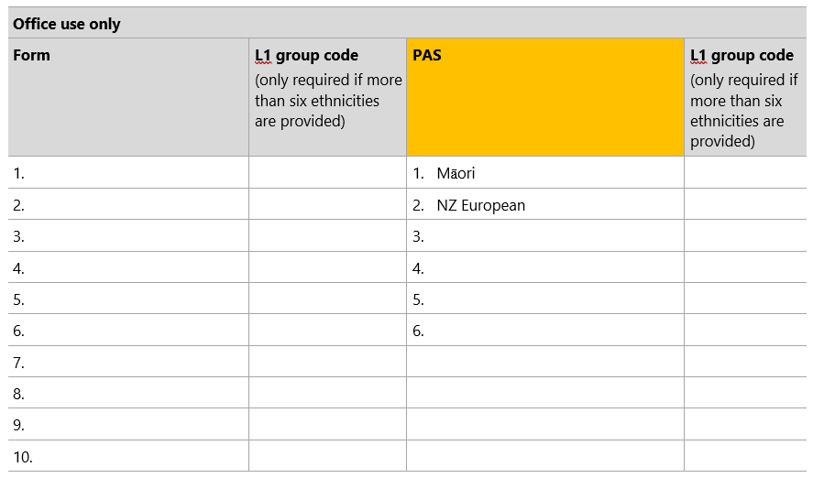

Alternatively, find the appropriate entry on the PAS and print out the sticky hospital label (if it includes ethnicity) and stick this label to the form.

Step 2
In the space provided on the patient data collection form (under ‘Form’), note the self-identified ethnicity details as collected on the upper section of the audit form. For example, if the same patient as above only selected ‘Māori’ on their audit form, you would enter this as below.

Where more than six ethnicities are identified, see Step 3.

Figure 2: Enter self-identified ethnicities from patient data collection form
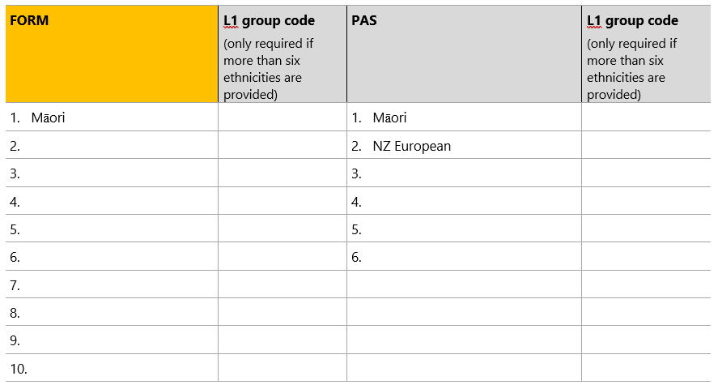

Step 3
Only required when more than six ethnicities have been provided by a patient.

Where more than six ethnicities have been recorded on the form but only six ethnicities may be recorded in the PAS, ensure that no residual ethnicity codes are recorded in the PAS and that all level 1 classifications are represented in the PAS record.

Figure 3: Example of more than six ethnicities
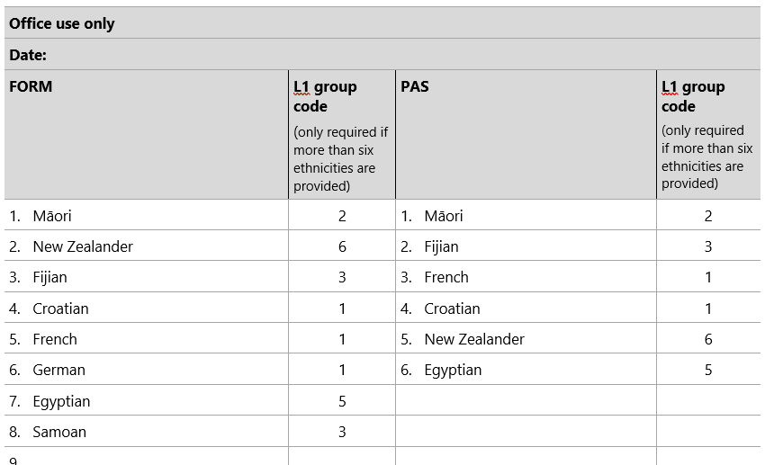

In the above example, there are two level 1 categories with more than one response:
- Croatian, French, and German all map to level 1, ethnic group code 1 European.
- Samoan and Fijian both map to level 1, ethnic group code 3 Pacific peoples.

Ethnicities from these two groups have been randomly removed, but the record has retained at least one ethnicity from each group.

Step 4
For each audit form, identify the level of match between the two records of ethnicity, as follows (use only one grade per form).

Match (M) | All ethnicities identified by the patient on the audit form match with those recorded for that patient in your PAS (Note: the order in which they are recorded does not need to match). For example:  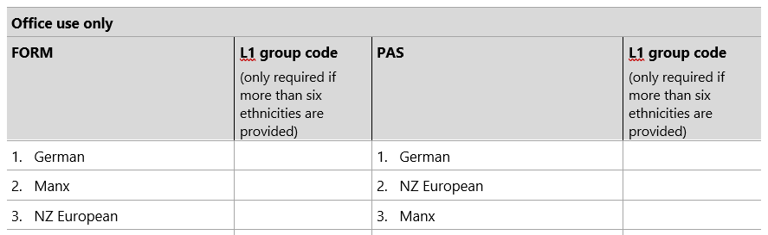  This does include those responses where the number of ethnicities recorded on the patient form exceeds six and the number of ethnicities recorded in the PAS has been correctly reduced to six. Example below:  The above example is a Match because all level 1 ethnicity categories on the patient form are represented in the PAS system/database and no residual categories are retained.
Partial match (PM) |  | This is only relevant for patients with multiple ethnicities recorded. It applies where some but not all the ethnicities match, regardless of the order.  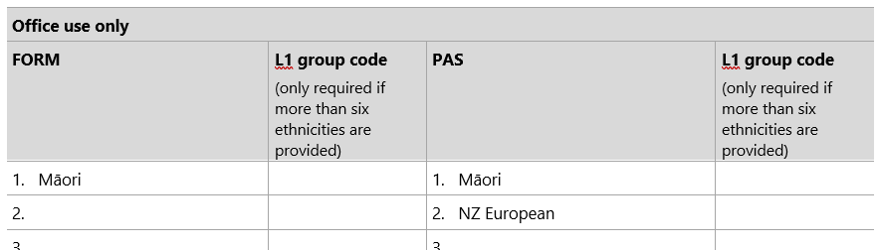  This includes those responses where the number of ethnicities recorded on the patient form exceeds six and the number of ethnicities recorded in the PAS has not been correctly reduced to six.  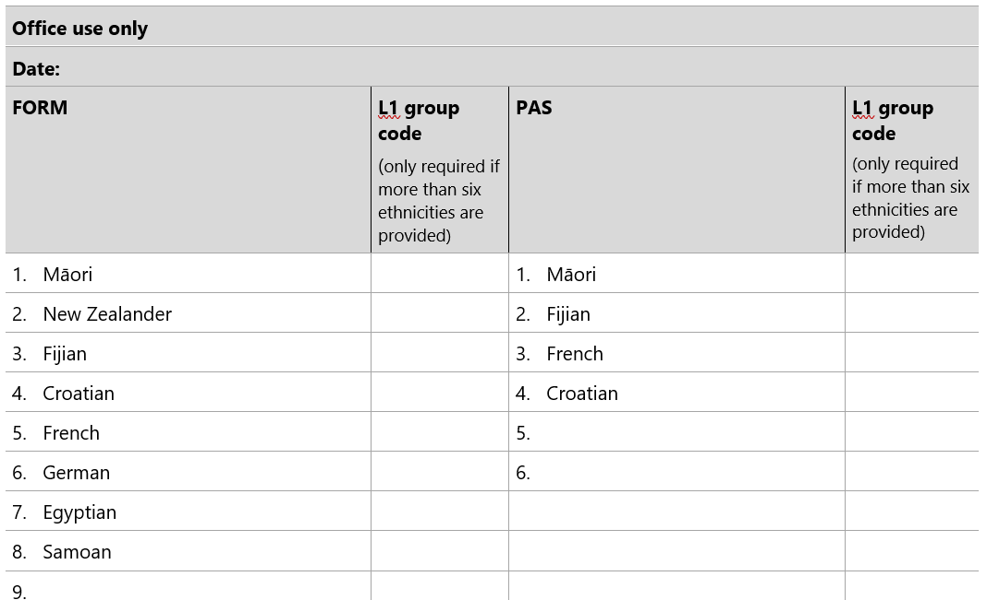
Total mismatch (TMM) |  | None of the ethnicities identified by the patient on the audit form match with those recorded for that patient in your PAS. 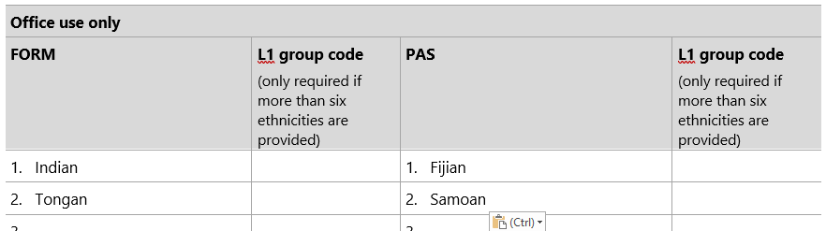

Step 5
Record the level of match on the bottom of each audit form by circling either M, PM or TMM. For example, a partial match is recorded as:
M | PM | TMM

Step 6
Once all forms are completed and you have identified the level of match for each, complete the table below.
 | Number of forms | Percentage of total forms*
Match (M) |  | %
Partial match (PM) |  | %
Total mismatch (TMM) |  | %
Total (M+PM+TMM) |  | –
* Percentage = number of M, PM or TMM forms divided by total number of forms, times 100. For example, if a total of 100 forms were completed, and 60 of them had ethnicity details that matched: (60/100) x 100 = 60 percent.

Part 4: Taking action
It is expected that all wards, services or departments will record a small percentage of mismatched (or partially matched) ethnicity data, which may result from changes in ethnicity identification by patients. However, a large level of mismatch may indicate collection or recording issues that need to be addressed.

Percentage of match | Action required
Level of match (M) is greater than 95 percent | The hospital should repeat the ethnicity data quality audit within three years.
Level of match (M) is between 85 and 95 percent | The hospital should:  - review the collection and recording systems and processes for the particular ward, service or department (using stages 1, 2 and 3 of the audit)  - ensure that patient ethnicity records are confirmed at their next encounter/contact  - provide staff training as required (refer to Online Ethnicity Training Course provided on the hospital’s eLearning platform or the Ministry of Health’s eLearning platform)  - repeat the data quality audit process in 12 months’ time.
Level of match (M) is below 85 percent | The hospital should:  - undertake a more thorough ethnicity data audit, perhaps drawing on outside expertise  - provide staff training for reviewing collection and recording systems for the particular ward, service or department (using stages 1, 2, and 3 of the audit). Refer to Online Ethnicity Training Course provided on the hospital’s eLearning platform or the Ministry of Health’s eLearning platform.)  - ensure that patient ethnicity records are confirmed at their next encounter/contact  - repeat the data quality audit process within 12 months’ time.

Hospital Ethnicity Data Audit Toolkit

Stage 4: Patient data collection form
We are currently updating our patient details and would appreciate if you would answer the following questions.
Name:
Date of birth: |  | / |  | /

Which ethnic group do you belong to? Mark the space or spaces that apply to you.
New Zealand European
Māori
Samoan
Cook Island Māori
Tongan
Niuean
Chinese
Indian
Other (such as Dutch, Japanese, Tokelauan). Please state:

Office use only |  |  | Date:
Name of ward, service or department:
FORM | L1 group code  (only required if more than six ethnicities are provided) | PAS |  | L1 group code  (only required if more than six ethnicities are provided)
1. |  | 1.
2. |  | 2.
3. |  | 3.
4. |  | 4.
5. |  | 5.
6. |  | 6.
7.
8.
9.
10.

M | PM | TMM

Appendices

Appendix A: Detailed guidance for staff survey responses
The following is an assessment guide against which the staff surveys can be reviewed. This guide provides more detailed advice on the survey responses than the rapid assessment sheet. Where attention is required, this detailed guide identifies corrective actions for each of the staff survey questions. Please note that any documentation, training and advice should align with the HISO 10001:2017 Ethnicity Data Protocols as these are the standard for health data collection, recording and reporting.

Staff training is available through the online ethnicity training course on the hospital’s eLearning platform or the Ministry of Health’s eLearning platform. This training provides an understanding of what ethnicity is, why it is collected, the rules for collecting and recording ethnicity data and how to deal with difficult situations or questions.

Training
The first five survey questions relate to staff training and staff’s understanding of and comfort with collecting ethnicity data. These questions may assist in identifying which individual staff members need further training, as well as identifying wider training needs. Where you identify issues with training, recommended actions are as follows.

Recommended actions
- Consider conducting individual staff training, using the Online Ethnicity Training Course provided on the hospital’s eLearning platform or the Ministry of Health’s eLearning platform.
- Consider conducting group staff training sessions (this could be undertaken as part of existing staff meetings or training).
- Consider including staff training on correct processes for ethnicity data collection in induction processes for new staff.
- Consider providing staff with resources and support to collect ethnicity data.

1. Have you received any training on how to collect or record ethnicity data in hospital settings?
Ideally, staff will have received training in collecting ethnicity data from patients/consumers and your hospital will have a process in place for ensuring new staff are appropriately trained.

2. How often are you involved in collecting ethnicity data from patients or recording ethnicity data on hospital systems/databases?
This question may be useful if it is necessary to prioritise staff training. When planning training and refresher courses, prioritise those staff who are collecting and recording ethnicity data regularly.

3. How often are you involved in confirming ethnicity data from patients or updating ethnicity data on hospital systems/database?
This question may be useful if it is necessary to prioritise staff training. When planning training and refresher courses, prioritise those staff who are collecting and recording ethnicity data regularly.

4. Do you understand why ethnicity data is collected in hospital settings?
When planning training and refresher courses, prioritise those staff who do not feel they understand fully why ethnicity data is collected. Evidence suggests that understanding why ethnicity data is collected in health settings helps improve data collection.

5. Are you comfortable collecting ethnicity data from patients/consumers?
When planning training and refresher courses, prioritise those staff who are not comfortable collecting ethnicity data from patients. Staff who have received training and who feel well supported to collect ethnicity data are likely to be more comfortable in undertaking this task and do it accurately. The Online Ethnicity Training course aims to make staff feel more comfortable about asking the ethnicity question and dealing with difficult questions or responses.

What do you do?

6. How often do you check the patient ethnicity details of patients who already have ethnicity data on your hospital system/database?
Ethnicity data needs to be up to date. Ideally the process of checking and updating patient details should happen regularly as part of confirming demographic details.

Recommended action
- The hospital should establish a policy for confirming and updating patients’ ethnicity details. This may be done in conjunction with updating other patient details but must be completed using the standard ethnicity question and in accordance with the HISO 10001:2017 Ethnicity Data Protocols.

7. Are there times when you guess a patient’s ethnicity rather than asking the patient to self-identify?
Where patients are able to self-identify, staff must not guess the patient’s ethnicity or complete the question on the patient’s behalf.

Recommended action
- Where a staff member guesses a patient’s ethnicity, you should explore the reasons for this in order to identify if there is a training/awareness issue (for example, staff not knowing the appropriate procedure) or a systems/process issue (for example, staff being aware of an expected practice but being influenced by other barriers, such as workload pressures).

8. Do you have a list of codes or search engines available to help you record a patient’s ethnicity?
A patient’s ethnicity must be recorded at level 4. At times, staff will need to identify the correct codes to use for ethnic categories they may be less familiar with. Also, at times, patients will provide a written response that is more detailed than level 4, and staff will need to aggregate up to the correct level 4 code.

If the system is not capable of recording at level 4, then the staff member will need to identify the correct codes, using the ethnicity classification level that the hospital is using at the time of the survey. Please note that all systems are to move to collecting at level 4.

Recommended actions
- Provide training to help staff understand the process for correctly identifying the relevant level 4 codes (or the level the hospital is using at the time of the survey). Information on the process for coding ethnicity is outlined in the HISO 10001:2017 Ethnicity Data Protocols.
- The tools to be able to identify the codes are listed in the Resources section above.

9. Do you ever make up a new code to record a patient’s ethnicity?
Your PAS/IT system must record a patient’s ethnicity using the standard numeric code and corresponding text description outlined in the Ethnicity Data Protocols. Wards, services or departments must not develop their own codes/descriptions or modify the standard codes/descriptions as this will impact on the quality and standardisation, and therefore the usefulness, of the data.

Recommended actions
- Where a staff member makes up new codes, explore the reasons for this action to identify if there is a training/awareness issue (for example, the staff member does not know the appropriate procedure for coding ethnicity) or a systems/process issue (for example, the IT system contains incorrect codes).
- The hospital should address any issues through appropriate training or a system change, as relevant.

10. Which code would you record in your system/database where a patient provided each of the following responses to the ethnicity question?
Patient provided response | Short description | Code
Written-in response of ‘New Zealander’ | New Zealander | 61118
Written-in response of ‘Fijian-Indian’ | Fijian Indian code | 43112
Written-in response of ‘Rarotongan’ | Cook Island Māori code | 32100
Blank (where patient not immediately contactable) | Not stated code | 99999
Declined to provide ethnicity | Refused to answer | 95555

If the system is not capable of recording at level 4, then the staff member will need to identify the correct codes, using the ethnicity classification level that the hospital is using at the time of the survey.

Recommended action
- Provide training to help staff understand the process for correctly identifying the relevant level 4 codes (or the level the hospital is using at the time of the survey). Information on the process for coding ethnicity is outlined in HISO 10001:2017 Ethnicity Data Protocols.

11. Are you able to record up to six ethnicities for a patient in your system/database?
Your PAS/IT system should be able to record up to six ethnicities for an individual patient, using the standard numeric code and corresponding text description outlined in the HISO 10001:2017 Ethnicity Data Protocols.

If YES, where a patient provides more than six ethnicities, how do you decide which six are recorded in the system/database? Please explain.

The reduction of more than six ethnicities provided by the patient should be based on the random manual reduction method outlined in HISO 10001:2017 Ethnicity Data Protocols, Appendix A.

Recommended actions
(For an incorrect response, or a partially correct response)
- Provide training to help staff understand the process for correctly prioritising ethnicity data where more than six responses are provided. Information on how to manually reduce the number of responses using the random method can be found in HISO 10001:2017 Ethnicity Data Protocols Appendix A.
- The coding tools listed in the Resources section above should be used to help find appropriate codes. These should be used wherever possible to ensure consistent coding by all collectors.

If NO, where a patient provides more ethnicities than can be recorded in your system/database, how do you decide which is recorded in the system/database? Please explain.

Your PAS/IT system should be able to record up to six ethnicities for an individual patient, using the standard numeric code and corresponding text description outlined in the HISO 10001:2017 Ethnicity Data Protocols.

Recommended action
(If the system is not able to collect up to six ethnicities)
- The hospital should address this through a system change to ensure that all IT systems are able to record up to six ethnicities.
As an interim measure, prioritisation can be used to identify which ethnicity should be recorded where the system cannot record up to six ethnicities. The correct process for prioritising ethnicities is outlined in HISO 10001:2017 Ethnicity Data Protocols section 5.5.2: Prioritised output.

Recommended actions
(For an incorrect or partially correct response by a staff member to reducing the number of ethnicities)
- Provide training to help staff understand the process for correctly prioritising ethnicity data, where more responses are provided than can be recorded by the IT system. Information on how to prioritise at level 2 is provided in HISO 10001:2017 Ethnicity Data Protocols section 5.5.2: Prioritised output.
- The coding tools listed in the Resources section above should be used to help find appropriate codes. These should be used wherever possible to ensure consistent coding by all collectors.

What do you think?

12. Have you experienced any difficulties with collecting ethnicity data from patients/consumers or recording ethnicity data in your system/database? If yes, please explain.
Research has identified a number of barriers around collecting and inputting ethnicity data in health care settings. These include: a lack of understanding about why ethnicity data is being collected; a lack of knowledge or understanding about how to collect ethnicity data correctly; a lack of accessible and ongoing training; issues with the IT systems used in health institutions (for example, systems not having the right codes or not making it easy to record multiple ethnicities); high staff turnover and concerns about offending people.

Recommended actions
- The hospital should identify whether staff difficulties with collecting ethnicity data relate to training or to practice systems or processes and address these as appropriate.
- The staff should complete the Online Ethnicity Training course, which provides training to make staff feel more comfortable about asking the ethnicity question and dealing with difficult questions or responses.

13. Is there anything that would make it easier for you to collect and record ethnicity data from patients/consumers? If yes, please explain.
Research has identified a number of things that facilitate collecting and inputting ethnicity data in health care settings, such as online training tools and training resources to support changes (for example, changes to standard code sets).

Recommended actions
- Where staff identify something that would make it easier for them to collect and record data, assess whether the suggested solution is appropriate and potentially useful to all staff. Staff are more likely to accept a particular solution if they identified it for themselves.
- You should not implement proposed solutions if they result in a collection process that does not comply with the Ethnicity Data Protocols.
- The manager should report back to staff on their reasons for adopting (or not) solutions identified by staff.

Appendix B: Related articles
Cormack D. 2010. The Politics and Practice of Counting: Ethnicity in official statistics in Aotearoa/New Zealand. Wellington: Te Rōpū Rangahau Hauora a Eru Pōmare. URL: www.otago.ac.nz/wellington/otago600095.pdf.
Cormack D, McLeod M. 2010. Improving and Maintaining Quality in Ethnicity Data Collections in the Health and Disability Sector. Wellington: Te Rōpū Rangahau Hauora a Eru Pōmare. URL: www.otago.ac.nz/wellington/otago600098.pdf.
Disney G, Teng A, Atkinson J, et al. 2017. Changing ethnic inequalities in mortality in New Zealand over 30 years: Linked cohort studies with 68.9 million person-years of follow-up. Population Health Metrics 15(1): 15. DOI: https://dx.doi.org/10.1186/s12963-017-0132-6 (accessed 21 September 2021).
Gurney JK, Scott N, Thompson G, et al. 2018. New Zealand’s Revised Ethnicity Data Protocols must not become a Shelved Document: A challenge from Hei Āhuru Mōwai. NZMJ 131(1470): 104–6.
Ministry of Health. 2020. He Korowai Oranga. URL: www.health.govt.nz/our-work/populations/maori-health/he-korowai-oranga.
Neuwelt P, Crengle S, Cormack D, et al. 2014. General practice ethnicity data: Evaluation of a tool. J Prim Health Care 6(1): 49–55.
Rumball-Smith J, Sarfati D. 2011. Improvement in the accuracy of hospital ethnicity data. NZMJ 124(1340): 96–97.
Salvetto M, Cormack D, Bartholomew K. 2018. The use of audit to improve ethnicity data quality in primary care: Experience from New Zealand. European Journal of Public Health 28 (suppl_1). DOI: 10.1093/eurpub/cky047.032.

