Heterosexual Sexual Behaviour
Findings from the
2014/15 New Zealand Health Survey
2019

Acknowledgements
The New Zealand Health Survey would not have been possible without the support and enthusiasm of many individuals, including the many thousands of New Zealanders who gave their time to participate in it and the interviewers who worked so diligently to collect the data. Thank you for your generosity.
This report was written by Antoinette Righarts (University of Otago), Bridget Murphy (Ministry of Health), Nigel Dickson (University of Otago), Jennie Connor (University of Otago) and Peter Saxton (University of Auckland). The data analysis was undertaken by Barry Gribben (CBG Health Research), Thomas Zhang (CBG Health Research) and James Stanley (University of Otago).
Citation: Ministry of Health. 2019. Heterosexual Sexual Behaviour: Findings from the 2014/15 New Zealand Heath Survey. Wellington: Ministry of Health.
Published in November 2019 by the Ministry of Health
PO Box 5013, Wellington 6140, New Zealand
ISBN 978-1-98-859745-4 (online)
HP 7269
This document is available at health.govt.nz
This work is licensed under the Creative Commons Attribution 4.0 International licence. In essence, you are free to: share ie, copy and redistribute the material in any medium or format; adapt ie, remix, transform and build upon the material. You must give appropriate credit, provide a link to the licence and indicate if changes were made.

Contents
Key findings v
Introduction 1
Heterosexual sex in respondents’ lifetimes 2
Types of heterosexual sex in the year preceding the survey 5
Two or more heterosexual sex partners in last year 9
Average number of heterosexual sex partners in last 12 months 13
Condom use among those who had had two or more heterosexual sex partners in the last year 19
Condom use among those who had a non-cohabiting sexual partner in the last year 21
Interpretation notes 24
Overview of survey methodology 26
References 29

List of Tables
Table 1: Participation in the Sexual and Reproductive Health module of the New Zealand Health Survey, by ethnicity 27

List of Figures
Figure 1: Heterosexual sex in respondents’ lifetimes, by age group and gender 2
Figure 2: Heterosexual sex in respondents’ lifetimes, by ethnic group and gender 3
Figure 3: Heterosexual sex in respondents’ lifetimes, by neighbourhood deprivation and gender 4
Figure 4: Type of sex in the 12 months preceding the survey (total population), by age group and gender 6
Figure 5: Number of partners in the 12 months preceding the survey (total population), by age group and gender 10
Figure 6: Number of partners in the 12 months preceding the survey (total population), by ethnic group and gender 11
Figure 7: Number of partners in the 12 months preceding the survey (total population), by neighbourhood deprivation and gender 12
Figure 8: Mean number of partners in the 12 months preceding the survey (among those who had ever had heterosexual sex), by age group and gender 14
Figure 9: Mean number of partners in the 12 months preceding the survey (among those who had ever had heterosexual sex), by ethnic group and gender 15
Figure 10: Mean number of partners in the 12 months preceding the survey (among those who had ever had heterosexual sex), by neighbourhood deprivation and gender 16
Figure 11: Median and mean number of partners in respondents’ lifetimes (among those who had ever had heterosexual sex), by age group and gender 17
Figure 12: Median and mean number of partners in respondents’ lifetimes (among those who had ever had heterosexual sex), by ethnic group and gender 18
Figure 13: Median and mean number of partners in respondents’ lifetimes (among those who had ever had heterosexual sex), by neighbourhood deprivation and gender 18
Figure 14: Condom always used with vaginal/anal sex in the 12 months preceding the survey (among those who had had multiple partners), by age and gender 20
Figure 15: Condom used at most recent vaginal/anal sex with non-cohabiting partner in the 12 months preceding the survey, by age group and gender 22
Figure 16: Condom used at most recent vaginal/anal sex with non-cohabiting partner in the 12 months preceding the survey, by ethnic group and gender 23

Key findings
This report describes heterosexual sexual activities (that is, sexual activities between men and women) in New Zealand with regard to gender, age, ethnicity and neighbourhood deprivation patterns.

Key findings include the following.
- Most adults (89 percent) had had heterosexual sex; there was minimal variation by gender, ethnicity and neighbourhood deprivation.
- In the year preceding the survey, 75 percent of men and 68 percent of women had had vaginal sex, 59 percent of men and 49 percent of women had had oral sex, and 10 percent of men and 6.8 percent of women had had anal sex.
- Men were 1.3 times as likely as women to have had two or more partners in the last year.
- 21 percent of men who had had two or more partners in the last year used a condom at the most recent time they had had sex, compared with 12 percent of women.
- Men and women aged 16–24 years were less likely to have ever had heterosexual sex, but, if they had, were more likely to have had multiple partners in the last year.
- Asian women generally said they had had lower levels of heterosexual sexual activity than non-Asian women. For example, they were 0.4 times as likely to have had multiple partners in the last year as non-Asian women; they were also 0.4 times as likely to have had anal sex in the last year, and 0.7 times as likely to have had oral sex in the last year.
- Neighbourhood deprivation was associated with numbers of partners: women from high-deprivation areas had 3.6 times, and men from those areas 2.9 times, the mean number of partners in the last year as those from the least deprived areas.

Introduction
Data on sexual behaviour is important because of its impact on the health and wellbeing of individuals and on public health. Sexual relationships are key for most adults living a happy and healthy life, and have a strong bearing on planned life-course trajectories, such as sharing a home and having children. While sexual partnerships and conduct are generally private subjects, they may be subject to social controls, and men and women are frequently held to different standards. This can cause difficulty in eliciting reliable responses to questions about sexual behaviour (Fenton et al 2001).

Sexual relationships are fundamental to individual, family and social life in all cultures (Mercer 2014), and so examining sexual health and behaviour across the whole life course is important, including in the context of our search for a better understanding of ageing.

Sexual relationships may have negative, as well as positive, consequences. Numbers of diagnoses of sexually transmitted infections (STIs) at New Zealand sexual health clinics have risen substantially since the middle 1990s, particularly in young people, and New Zealand has some of the highest rates of STI diagnosis in the OECD (Institute of Environmental Science and Research Ltd 2014).

Initiatives to control STIs depend on understanding the underlying drivers, which include the number (and sex) of people’s sexual partners, and the use of condoms. This report provides insights into potentially high-risk sexual behaviours, and hence where we could focus efforts to reduce communicable diseases (for example, by tracing gaps in sexual health education and the efficacy of outreach efforts).

The only previous national estimates of sexual behaviour in the New Zealand population are from a 1991 survey (Paul et al 1995). Since then, other studies have investigated sexual behaviour in specific groups. For example, the youth health surveys (University of Auckland Adolescent Health Research Group 2018) and the Dunedin Multidisciplinary Health and Development Study (see https://dunedinstudy.otago.ac.nz).

The Ministry of Health included questions on sex between men and women (‘heterosexual sex’), number of sexual partners, types of sexual behaviour and condom use in the Sexual and Reproductive Health module of the 2014/15 New Zealand Health Survey (‘the survey’).

This report presents key findings about heterosexual sex by gender, age group, ethnic group and neighbourhood deprivation at the time of the survey interview. The results are based on respondents’ experiences of heterosexual sex since turning age 13.

You can find more information and results from the survey, including on lifetime number of sex partners and same-gender sexual behaviour, in the data tables in the data explorer, online at https://www.health.govt.nz/publication/sexual-and-reproductive-health-2014-15-new-zealand-health-survey

Heterosexual sex in respondents’ lifetimes
This section sets out responses to the question in the survey ‘Have you ever had sex with a female, since turning 13 years old? That is vaginal sex, oral sex or anal sex’.

Heterosexual sex was defined as vaginal, oral or anal sex between a male and a female.

Almost 90 percent of New Zealanders had had heterosexual sex
- Overall, 89 percent of both men and women aged 16–74 had ever had heterosexual sex. Unsurprisingly, this figure was lowest in the age group 16–24 years (71 percent of men and 64 percent of women); it was more than 90 percent for all other age groups (Figure 1).

Figure 1: Heterosexual sex in respondents’ lifetimes, by age group and gender
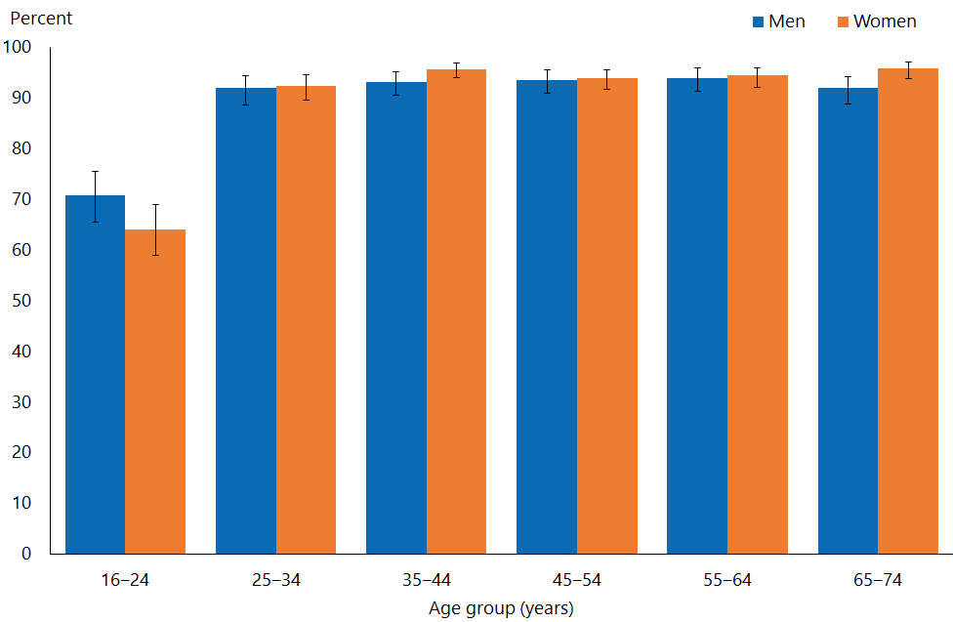

- Figure 2 shows the percentage of men and women who had ever had heterosexual sex by ethnic group. After adjusting for age, Pacific men and women were 0.9 times as likely to have ever had heterosexual sex as non-Pacific men and women. Similarly, Asian men and women were 0.9 times as likely to have ever had heterosexual sex as non-Asian men and women.

Figure 2: Heterosexual sex in respondents’ lifetimes, by ethnic group and gender
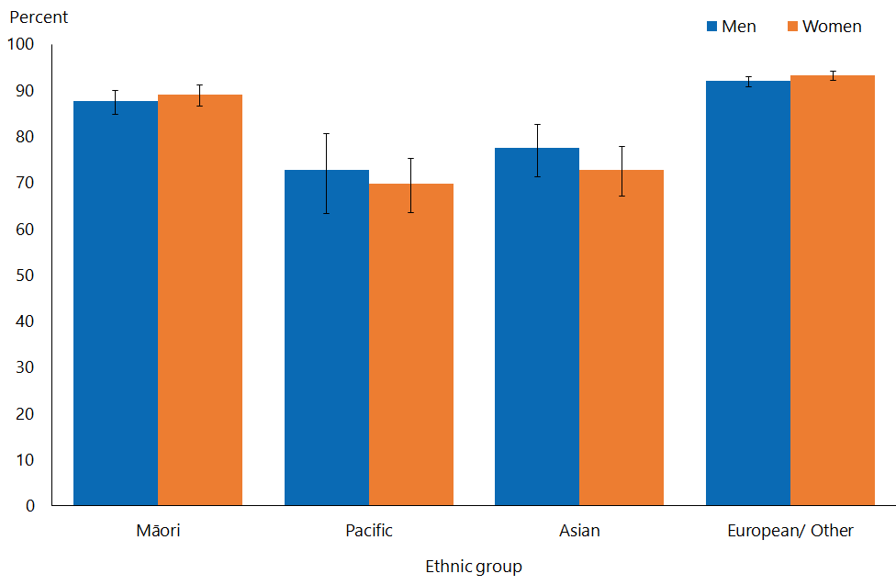
Note: Adults who reported more than one ethnic group are counted once in each group reported. This means that the total number of responses for all ethnic groups can be greater than the total number of adults who stated their ethnicities.

- Figure 3 shows percentages of men and women who had ever had heterosexual sex by neighbourhood deprivation. After adjusting for age and ethnic group, men living in the most deprived neighbourhoods were 0.9 times as likely to have ever had heterosexual sex as those living in the least.

Figure 3: Heterosexual sex in respondents’ lifetimes, by neighbourhood deprivation and gender
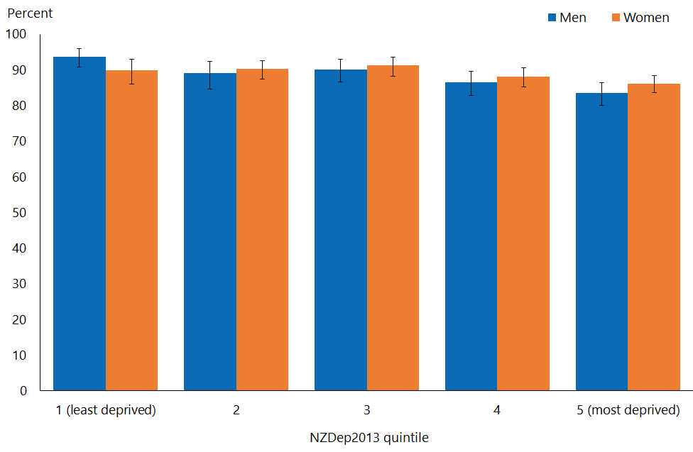

Types of heterosexual sex in the year preceding the survey
This section sets out responses to the four questions in the survey on types of heterosexual sex. For men, these questions were as follows.
- ‘When, if ever, was the last occasion you had vaginal sex with a female? Vaginal sex is a male’s penis in a female’s vagina.’
- ‘When, if ever, was the last occasion you had oral sex with a female? Oral sex is a female’s or male’s mouth on a partner’s genital area.’
- ‘When, if ever, was the last occasion you had anal sex with a female? Anal sex is a male’s penis in a partner’s anus (rectum or back passage).’
- ‘When, if ever, was the last occasion you had genital contact with a female not involving vaginal, oral, or anal sex? That is, genital contact intended to achieve orgasm, for example, stimulating by hand.’
- Answers of ‘In the last 7 days’, ‘Between 7 days and 4 weeks ago’, ‘Between 4 weeks and 6 months ago’ and ‘Between 6 months and 1 year ago’ were combined for each type of sex to arrive at numbers of respondents having had vaginal, oral or anal sex, or genital contact, in the last year.

Adults were more likely to have had vaginal sex in the last year than any other type of sex
- Overall, in the last year, 75 percent of men and 68 percent of women had had vaginal sex, 59 percent of men and 49 percent of women had had oral sex, 10 percent of men and 7 percent of women had had anal sex and 61 percent of men and 52 percent of women had genital contact.
- Sexual behaviours in the last year varied with age (Figure 4). More than 75 percent of all men aged 25–64 years, and 53 percent of men aged 65–74, had had vaginal sex in the last year. 50 percent of women aged less than 65 years and 42 percent aged 65–74 had had vaginal sex over this time. Genital contact in the last year was less common with increasing age from age 35 years for men and women; the drop was steeper for women.

Figure 4: Type of sex in the 12 months preceding the survey (total population), by age group and gender

Men were more likely to have had vaginal sex in the last year than women
- 75 percent of men had had vaginal sex in the last year, compared with 68 percent of women.
- Men were 1.1 times as likely to have had vaginal sex in the last year as women, after adjusting for age differences.
- The percentage of adults who had vaginal sex in the last year varied by ethnic group. For Māori, Pacific, Asian and European/Other men, the figures were 78, 64, 69 and 77 and percent respectively. For Māori, Pacific, Asian and European/Other women, they were 70, 57, 60 and 71 percent respectively. Pacific men and women were 0.8 times as likely as non-Pacific men and women, and Asian men and women 0.8 times as likely as non-Asian men and women, to have had vaginal sex, after adjustment for age.
- Comparing the least deprived neighbourhoods with the most deprived neighbourhoods, percentages of men who had had vaginal sex in the last year were 82 and 67 percent respectively; the equivalent figures for women were 72 and 63 percent. Men and women living in the most deprived neighbourhoods were 0.8 times as likely to have had vaginal sex as those living in the least, after adjustment for age and ethnic group.

Māori and European/Other adults were more likely to have had oral sex in the last year than Pacific and Asian adults
- The percentage of adults who had had oral sex in the last year varied by ethnic group. Figures for Māori, Pacific, Asian and European/Other men were 65, 55, 52 and 60 percent respectively. Equivalent figures for women were 56, 39, 33 and 52 percent respectively. Māori women were 1.1 times as likely to have had oral sex as non-Māori women; Pacific women were 0.7 times as likely to have had oral sex as non-Pacific women; and Asian men and women were 0.6 times as likely to have had oral sex as non-Asian men and women, after adjustment for age.
- Men were 1.2 times as likely to have had oral sex as women in the last year, after adjusting for age differences.
- Oral sex in the last year was most common among younger men and women; the percentages declined substantially after age 55 years.
- The percentage of adults who had had oral sex in the last year also varied by deprivation. Comparing the least deprived with the most deprived neighbourhoods, for men, the respective figures were 60 and 56 percent; for women, they were 52 and 47 percent. Oral sex was 0.8 times as likely among women living in the most deprived neighbourhoods as those living in the least, after adjustment for age and ethnic group.

Anal sex was the least common form of heterosexual sex
- Only 10 percent of men and 6.8 percent of women had had anal sex in the last year. Men were 1.5 times as likely to have had anal sex as women, after adjusting for age differences.
- The percentage of adults who had had anal sex in the last year varied by ethnic group. For Māori, Pacific, Asian and European/Other men, figures were 14, 14, 11 and 10 percent, respectively. For Māori, Pacific, Asian and European/Other women, figures were 10, 12, 3 and 7 percent respectively. Anal sex was 1.4 times as likely among Māori men and women as non-Māori; it was 1.4 times as likely among Pacific women as non-Pacific women; and it was 0.3 times as likely among Asian women as non-Asian women, after adjustment for age.
- The percentage of adults who had anal sex in the last year also varied by deprivation. For men, comparing the least deprived to the most deprived neighbourhoods, figures were 8 and 13 percent respectively; for women, figures were 5 and 9 percent respectively. Anal sex was 1.7 times as likely among men living in the most deprived neighbourhoods as those living in the least, after adjustment for age and ethnic group.

Genital contact not leading to intercourse in the last year was common among both men and women
- 61 percent of men and 52 percent of women had had genital contact in the last year. Men were 1.2 times as likely to have had genital contact as women after adjustment for age.
- The percentage of adults who had had genital contact in the last year varied by ethnic group. For Māori, Pacific, Asian and European/Other men, figures were 64, 48, 51 and 64 percent respectively; for Māori, Pacific, Asian and European/Other women, figures were 56, 38, 32 and 57 percent respectively.
- Genital contact was 0.8 times as likely among Pacific women as non-Pacific women, and 0.6 times as likely among Asian women as non-Asian women, after adjustment for age.
- The percentage of adults who had had genital contact in the last year also varied by deprivation. For men, comparing the least deprived to the most deprived areas, figures were 66 and 55 percent respectively; for women, they were 56 and 47 percent.
- Genital contact was 0.9 times as likely among men and women living in the most deprived neighbourhoods as those living in the least, after adjustment for age and ethnic group.

Two or more heterosexual sex partners in last year
This section sets out responses to the question in the survey ‘Altogether, in the last 12 months, how many females have you had sex with?’ Those that answered ‘don’t know’ were asked ‘Can you estimate how many females you have had sex with in the last 12 months?’. Numbers of heterosexual sex partners were grouped for this indicator as ‘None’, ‘One’ or ‘Two or more’. The term ‘multiple sex partners’ is used below to describe having had two or more heterosexual sex partners.

Men were more likely to have had multiple sex partners in the last year than women
- 13 percent of men and 9.3 percent of women had had multiple sex partners in the last year. Men were 1.3 times as likely to have had multiple partners in the last year as women, after adjusting for age differences.

Number of sex partners in the last year varied with age
- Having had multiple sex partners in the last year was most common among men and women aged under 25: figures for this age group were 30 and 23 percent respectively. The percentage of people who had had no sex partners in the past year increased steadily with age (Figure 5).

Figure 5: Number of partners in the 12 months preceding the survey (total population), by age group and gender
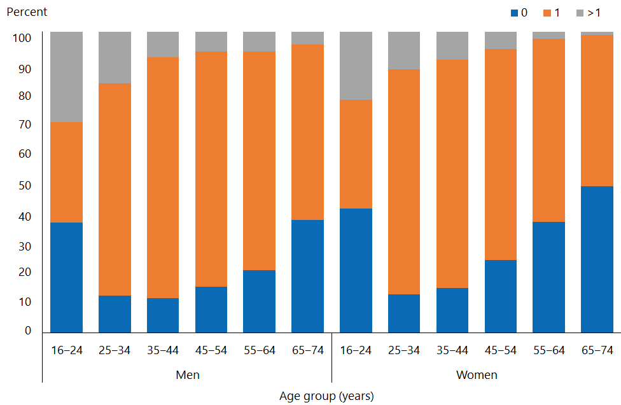

Number of sex partners in the last year varied by ethnic group
- 14 percent of Pacific men had had multiple sex partners in the last year. Māori women were 1.4 times as likely to have had multiple sex partners in the last year as non-Māori women, after adjustment for age. Asian women were 0.4 times as likely to have had multiple sex partners in the last year as non-Asian women, after adjustment for age (Figure 6).

Figure 6: Number of partners in the 12 months preceding the survey (total population), by ethnic group and gender
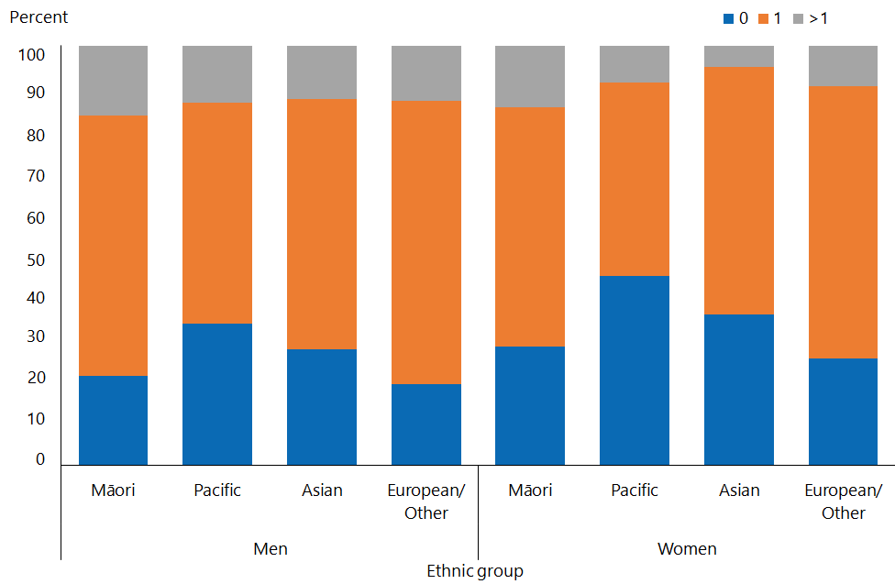
Note: Adults who reported more than one ethnic group are counted once in each group reported. This means that the total number of responses for all ethnic groups can be greater than the total number of adults who stated their ethnicities.

Number of sex partners in the last year varied by neighbourhood deprivation
- 6.8 percent of women in the least deprived areas had had multiple partners in the last year, compared with 13 percent in the most deprived areas.
- Men living in the most deprived neighbourhoods were 2.4 times as likely as those living in the least deprived neighbourhoods to have had multiple sex partners in the last year, after adjustment for age and ethnic group (Figure 7).

Figure 7: Number of partners in the 12 months preceding the survey (total population), by neighbourhood deprivation and gender
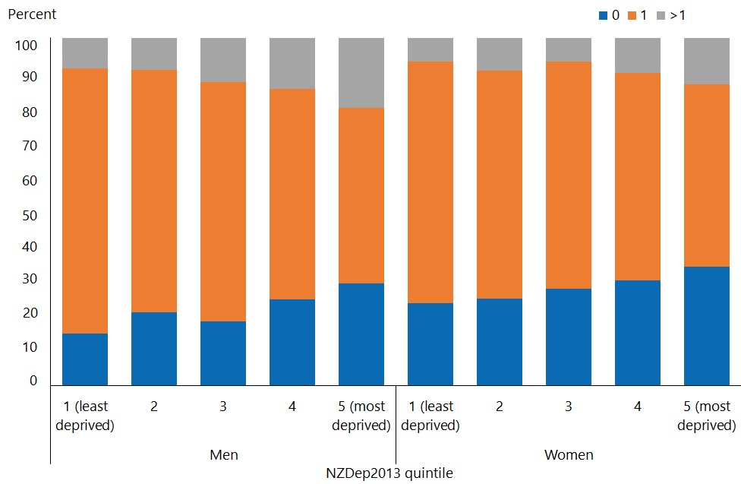

Average number of heterosexual sex partners in last 12 months
This section sets out responses to the question in the survey: ‘Altogether, in the last 12 months, how many females have you had sex with?’ Those that answered ‘don’t know’ were asked ‘Can you estimate how many females you have had sex with in the last 12 months?’.

When respondents estimated the number of partners they had had, they chose from a range. To calculate means and medians, this analysis used the midpoint of the chosen range. Where a respondent chose the last option, ‘Over 100’, we used the value ‘100’. Those who had not had a heterosexual sex partner in the last year were excluded from these calculations.

Among those who had heterosexual sex in the last year, the mean number of partners in last year dropped consistently with age, and was consistently lower for women than men
- Men aged 16–24 had 2.5 partners in the 12 months preceding the survey, decreasing to 0.8 partners for men aged 65–74. For women the number of partners decreased from 2.0 dropping to 0.6 (Figure 8).

Figure 8: Mean number of partners in the 12 months preceding the survey (among those who had ever had heterosexual sex), by age group and gender
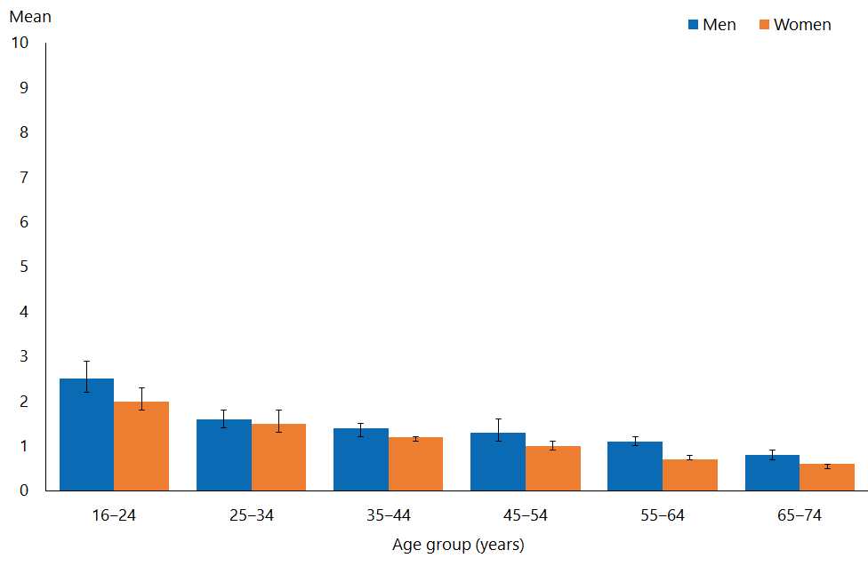

- After adjusting for age, the mean number of partners for men was 1.3 times the mean number for women.
- After adjusting for age, Māori men had 1.3 times the mean number of partners as non-Māori men; Asian women had 0.8 times the mean number of partners as non-Asian women.

Figure 9: Mean number of partners in the 12 months preceding the survey (among those who had ever had heterosexual sex), by ethnic group and gender
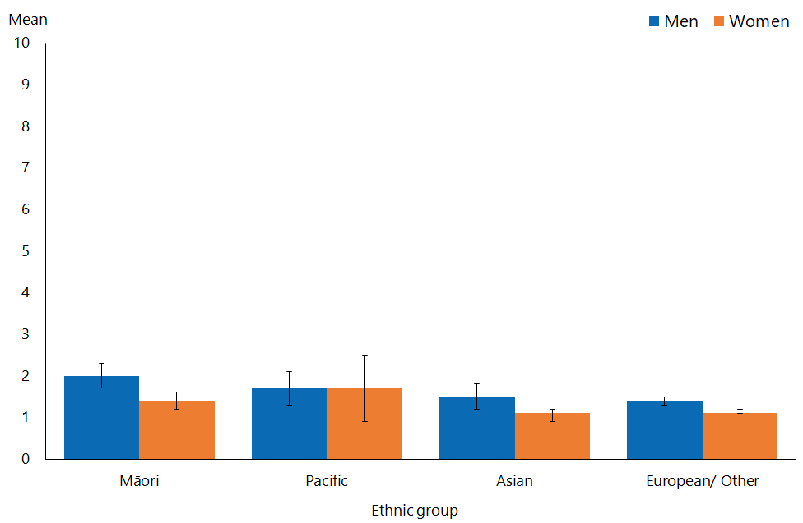
Note: Adults who reported more than one ethnic group are counted once in each group reported. This means that the total number of responses for all ethnic groups can be greater than the total number of adults who stated their ethnicities.

- Women living in the most deprived neighbourhoods had 3.6 times the mean number of partners as those living in the least deprived neighbourhoods, after adjustment for age and ethnic group. This difference for men was 2.9 times.

Figure 10: Mean number of partners in the 12 months preceding the survey (among those who had ever had heterosexual sex), by neighbourhood deprivation and gender
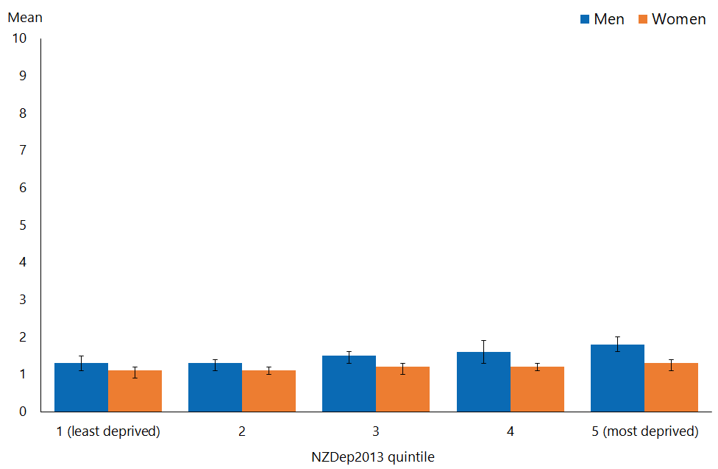

- The median number of partners in the last year for men and women in all age groups was one. The mean and median number of partners in the last year among those who had ever had heterosexual sex (not just in the last year) and the whole population are available at https://www.health.govt.nz/publication/sexual-and-reproductive-health-2014-15-new-zealand-health-survey

The lifetime median number of heterosexual sex partners peaked in the 35–44-year-old age group
- The median number of heterosexual sexual partners (among those who had ever had heterosexual sex) peaked for both men and women in the age group 35–44 years (Figure 11 i). This indicates a progressive change in sexual behaviour between those aged 65–74 years, most of whom would have been born in the 1940s, and those aged 35–44 years, who were mostly born in the 1970s. The decrease in the median in the younger age groups cannot be interpreted as a reversal of this trend, as the number of partners in the younger age groups is likely to increase with age more than in the older groups.
- The mean number of heterosexual sexual partners followed a similar pattern (Figure 11 ii), although the peak for men was in the age group 45–54 years, and for women in the age group 35–44 years. The mean was higher than the median due to a small number of people having high number of partners (resulting in a skewed distribution).
- Similar to the figures relating to numbers of partners in the last year, men had 1.7 times the mean number of partners ever as women, after adjusting for age.

Figure 11: Median and mean number of partners in respondents’ lifetimes (among those who had ever had heterosexual sex), by age group and gender
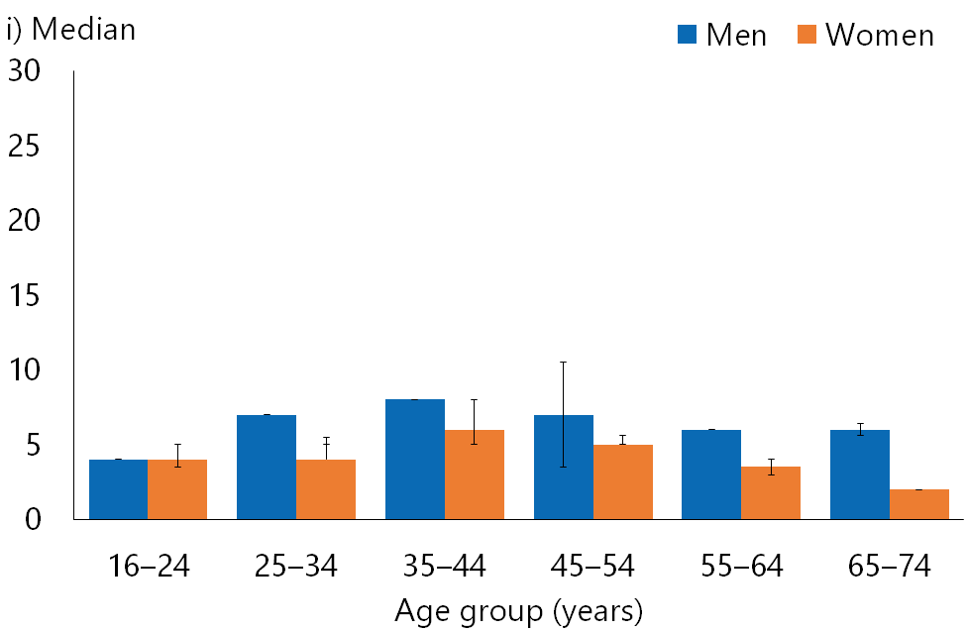 | 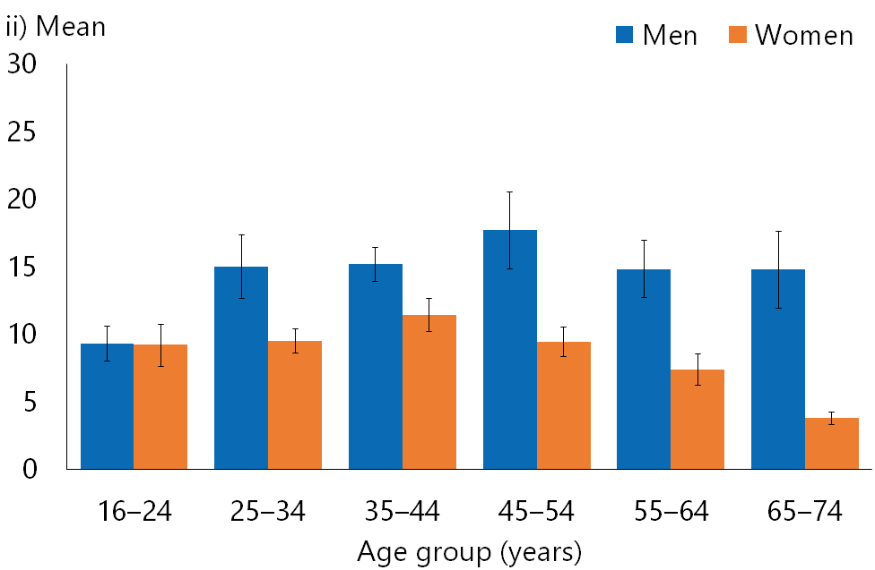
- Figure 12 shows the variation in the median and mean number of heterosexual partners ever, by ethnic group.
- After adjusting for age, Māori men and women had 1.3 times the mean number of partners as non-Māori; Pacific women had 0.7 times the mean number of partners as non-Pacific women, and Asian men and women had 0.4 times the mean number of partners as non-Asian men and women.

Figure 12: Median and mean number of partners in respondents’ lifetimes (among those who had ever had heterosexual sex), by ethnic group and gender
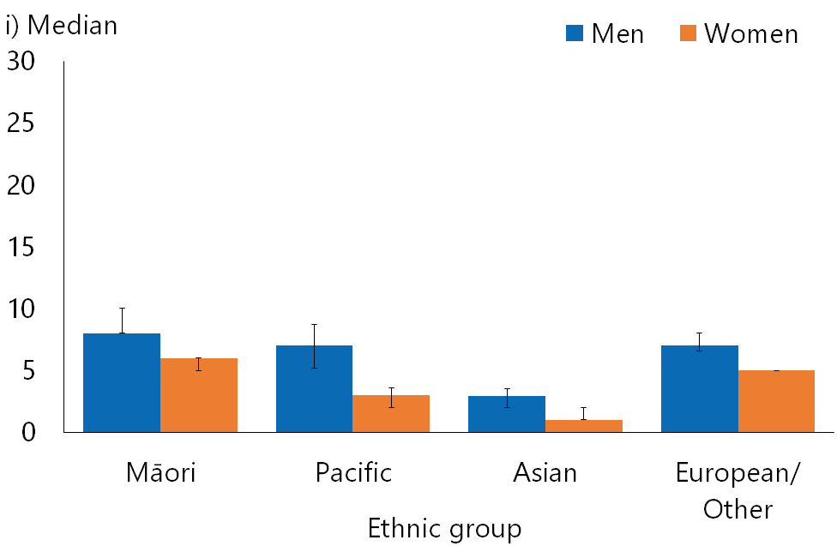 | 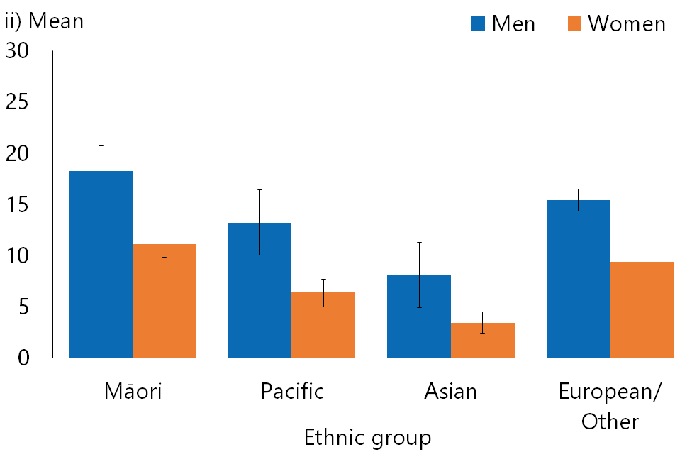
Note: Adults who reported more than one ethnic group are counted once in each group reported. This means that the total number of responses for all ethnic groups can be greater than the total number of adults who stated their ethnicities.

- Figure 13 shows the variation in median and mean number of heterosexual partners ever, by deprivation level.

Figure 13: Median and mean number of partners in respondents’ lifetimes (among those who had ever had heterosexual sex), by neighbourhood deprivation and gender
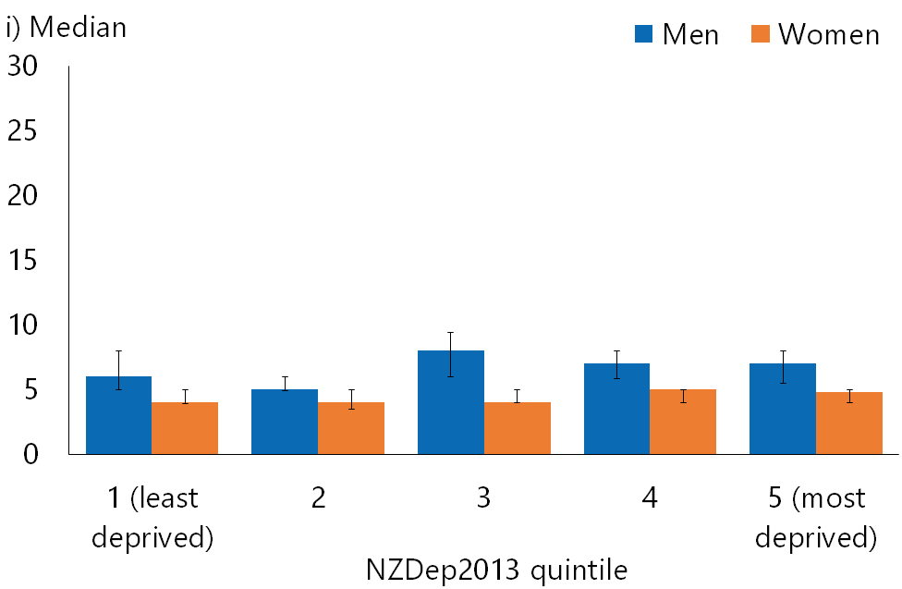 | 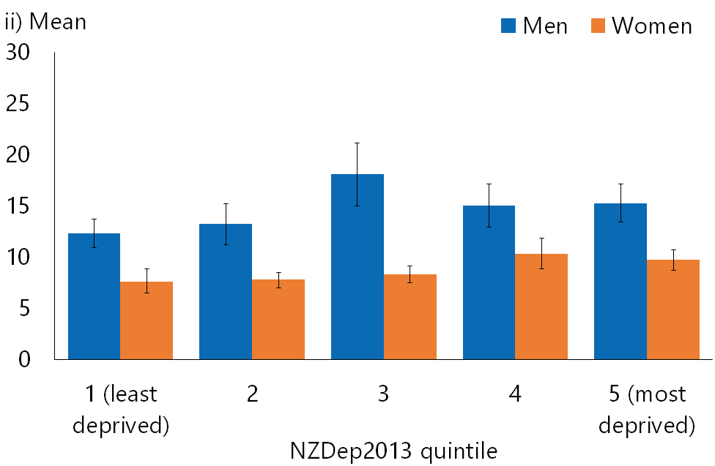

- You can find more information about median and mean number of heterosexual partners ever among the whole population, online at https://www.health.govt.nz/publication/sexual-and-reproductive-health-2014-15-new-zealand-health-survey

Condom use among those who had had two or more heterosexual sex partners in the last year
Not using condoms when having multiple sexual partners is considered a behavioural marker of STI acquisition and transmission risk. This section sets out the responses of those who had had heterosexual sex with two or more partners in the last 12 months to the question in the survey ‘In the last 12 months, if you’ve had vaginal or anal sex with a female, how often was a condom used?’. Those who did not answer ‘Every time’ were defined as not using condoms every time.

Less than one-quarter of adults who had had two or more heterosexual sex partners in the last year used condoms every time
- Among those who had had two or more heterosexual sex partners in the last year, only 12 percent of women and 21 percent of men used condoms every time they had sex in the last year.
- Among men and women, condom use was least common in those aged 35 and over; fewer than 8 percent of women said they had used a condom every time (Figure 14).

Figure 14: Condom always used with vaginal/anal sex in the 12 months preceding the survey (among those who had had multiple partners), by age and gender
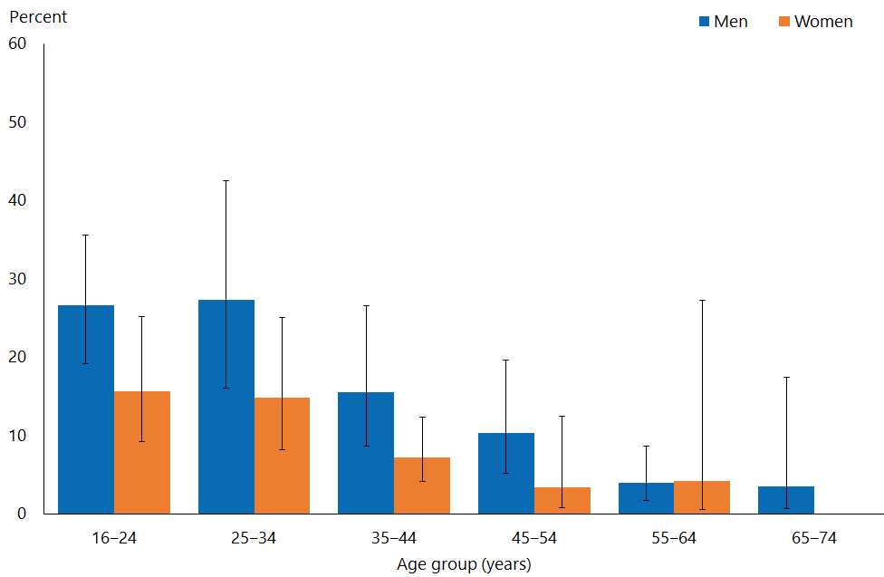

- There were no significant differences in the pattern of condom use by gender, ethnic group or neighbourhood deprivation level.

Condom use among those who had a non-cohabiting sexual partner in the last year
Non-condom use with non-cohabiting partners is also considered a key behavioural marker for STI acquisition and transmission risk.

The survey asked respondents: ‘Please start by thinking about the person you had sex with most recently, whether this was quite recently or some while ago. When was the most recent occasion you had sex with that person?’ This defined whether respondents had had sex with a partner in the last year.

They survey then asked ‘Was a condom used on that most recent occasion?’ and, if the respondent answered ‘We did not have vaginal or anal sex on that most recent occasion’, the survey asked: ‘On the most recent occasion you had vaginal or anal sex, was a condom used?’ These two questions defined whether a respondent used a condom on the most recent occasion they had sex.

The survey also asked ‘Which one of these descriptions applies best to you and that person at the time you most recently had sex?’. All answers describing the relevant relationship that were not ‘We were living together as a couple / married / in a civil partnership at the time’ were defined as indicative of a non-cohabiting sexual partner. Anyone who had at least one non-cohabiting partner in the last year was defined as having had a non-cohabiting partner; this included men and women who also had cohabiting partners in this period.

Condom use with non-cohabiting partners declined with age
- The percentage of respondents who had had sex with a non-cohabiting partner in the last year and used a condom at their most recent sexual contact declined with age, from 54 percent among men and 45 percent among women aged 16–24 to 35 percent and 20 percent respectively in those aged 45–54 (the small numbers over this age do not allow reliable estimates) (Figure 15).
- 21 percent of men and 17 percent of women had had sex with a non-cohabiting partner (either same-sex sex or heterosexual sex) in the last year.
- Overall, more men (44 percent) than women (32 percent) who had had sex with a non-cohabiting partner in the last year used a condom at the occasion of their most recent vaginal or anal sexual contact. Men were 1.4 times as likely to have used a condom in this situation as women, after adjusting for age.

Figure 15: Condom used at most recent vaginal/anal sex with non-cohabiting partner in the 12 months preceding the survey, by age group and gender
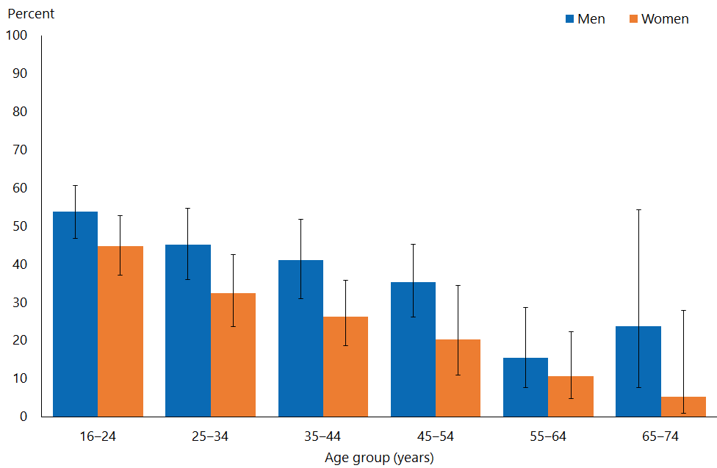

- Figure 16 shows percentages of respondents who had had sex with a non-cohabiting partner in the last year who used a condom at their most recent sexual contact, by ethnic group.
- After adjusting for age, condom use at most recent sexual contact with a non-cohabiting partner was 0.7 times as likely among Māori women than non-Māori women, and 1.5 times as likely among Asian men as non-Asian men.
- After adjustment for age and ethnic group, there was no significant variation by deprivation.

Figure 16: Condom used at most recent vaginal/anal sex with non-cohabiting partner in the 12 months preceding the survey, by ethnic group and gender
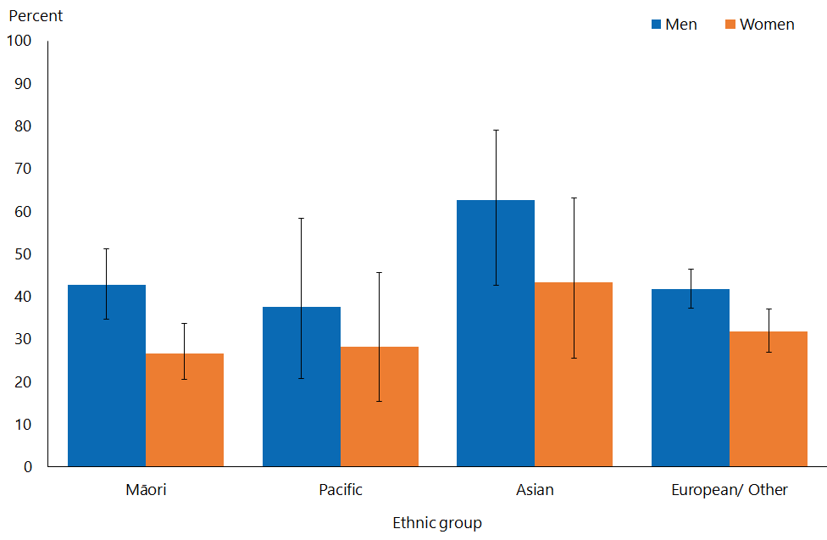
Note: Adults who reported more than one ethnic group are counted once in each group reported. This means that the total number of responses for all ethnic groups can be greater than the total number of adults who stated their ethnicities.

Interpretation notes
This section provides some key points for interpreting the survey results presented in this report. For more details about the survey methodology, see the Methodology Report 2014/15: New Zealand Health Survey (Ministry of Health 2015b) and Sexual and Reproductive Health Indicator Interpretation Guide 2014/15: New Zealand Health Survey (Ministry of Health 2019).

Statistical significance
Unless otherwise specified, the results discussed in this report only refer to differences that are statistically significant at the 5 percent level (ie, those with a p-value of less than 0.05). ‘Statistically significant’ means that the difference between the sample groups is likely to reflect real differences in the population groups, rather than being caused by chance. A statistically significant difference does not necessarily mean the difference between the population groups is meaningful.

Confidence intervals
We use 95% confidence intervals to show the statistical precision of the estimates. Wider confidence intervals indicate less precise estimates than narrow intervals, caused by higher variation with a sample and/or smaller numbers in a sample. Confidence intervals generally agree with statistical significance. When confidence intervals for two estimates don't overlap, there is a statistically significant difference between the estimates. However, the opposite may not always be true.

Comparing population subgroups
This report uses adjusted ratios to test if the prevalence of indicators is statistically significantly different between groups. We have adjusted these ratios for demographic factors that may be influencing the comparison, such as age, gender and ethnicity. The adjusted ratio indicates whether the results are less or more likely in the group of interest than the comparison group. A ratio of less than 1 indicates that the result is less likely and a ratio greater than 1 indicates that it is more likely.

The survey uses the New Zealand Index of Deprivation 2013 (NZDep2013) to measure neighbourhood deprivation. The survey groups neighbourhoods into five quintiles (the label ‘quintile 1’ applies to neighbourhoods with the lowest levels of deprivation, and ‘quintile 5’ to those with the highest). Indicators are reported for each quintile. The adjusted ratios for deprivation compare the highest and lowest deprivation areas, after adjusting for age, ethnic group, gender and the pattern across all five quintiles.

Gender
Gender is self-defined by respondents in the survey. For some people, their gender is not the same as their biological sex at birth. Respondents were asked if they were male or female, and while what these options meant was open to the respondent’s interpretation, gender-diverse options (eg, ‘gender non-conforming’ or ‘other’) were not available. The Ministry of Health acknowledges the need to improve data collection in this area, and is considering implementing the statistical standard for gender identity in future surveys (Statistics New Zealand 2015).

Non-sampling error
The survey results may underestimate or overestimate some indicators because the data is self-reported. The accuracy of a person’s memory may vary depending on many factors, including social norms, the importance of the event being recalled, the individual’s age at the time and the period of time that has passed since the event occurred.

Overview of survey methodology
This section gives a brief overview of the survey methodology for the New Zealand Health Survey.

How were people selected for the survey?
The 2014/15 results refer to the sample selected for the period July 2014–June 2015. The survey has a multi-stage sampling design that involves randomly selecting a sample of small geographic areas, households within the selected areas and individuals within the selected households. One adult aged 15 years or older and one child aged 14 years or younger (if there were any) were chosen at random from each selected household. Adults aged 16–74 years who had completed the 2014/15 survey were invited to participate in the Sexual and Reproductive Health module. Further details are available in The New Zealand Health Survey: Sample design, years 1–3 (2011–2013) (Ministry of Health 2011).

How was data collected?
Professional surveyors from CBG Health Research Ltd collected data in respondents’ homes. For the core part of the survey, data was collected through a face-to-face interview. However, participants completed the Sexual and Reproductive Health module by themselves, directly entering responses into a program run on a tablet computer. Surveyors provided minimal assistance, and reiterated that they would not be able to see the answers. Respondents could answer ‘Don’t know’ or ‘Choose not to answer’ to any question. If they chose either of those options for the question about having ever had sex with someone of a different sex, then they were not asked to complete the rest of the survey module.

How many people took part?
11,993 adults aged 16–74 years completed the core 2014/15 survey and were eligible for the Sexual and Reproductive Health module. This report is based on the responses from 10,198 adults (or 87 percent of eligible respondents). Some eligible respondents were not included in the final data set for the following reasons.
- 668 respondents (5.6 percent of those who were eligible) did not start the module, either because they refused or because of English language and/or cognitive difficulties.
- 991 respondents (6.5 percent of eligible respondents) started the module but stopped before the end of the module.
- 123 respondents (1.2 percent of eligible respondents) completed the module but their records were discarded because at least half of their responses were ‘Don’t know’ or ‘Choose not to answer’.

Of the people who completed the Sexual and Reproductive Health module, 4,358 gave their gender as male and 5,840 as female. The table below summarises the 10,198 survey respondents by ethnic group.

Table 1: Participation in the Sexual and Reproductive Health module of the New Zealand Health Survey, by ethnicity
Ethnic group | Number
Māori | 2,460
Pacific | 619
Asian | 814
European/Other | 7,542
Note: Adults who reported more than one ethnic group are counted once in each group reported. This means that the total number of responses for all ethnic groups can be greater than the total number of adults who stated their ethnicities.

Survey weights
The Sexual and Reproductive Health data set was weighted so that the responding sample represented the New Zealand ‘usually resident’ population in that year, using external population benchmarks (age, sex, ethnicity and neighbourhood deprivation) and demographic and behavioural benchmarks (eg, educational level and hazardous drinking). After an initial selection weight was calculated, it was adjusted for those who did not complete the module (for any reason). This should have minimised the impact of any differences in the characteristics of people who did or did not participate in the Sexual and Reproductive Health module. For more detail about the survey methodology, refer to the Methodology Report 2014/15 (Ministry of Health 2015b).

Additional information
See also the following documents:
- The New Zealand Health Survey: Sample design years 1–3 (2011–2013) (Ministry of Health 2011). Note, despite the report title being 2011–13, this sample design was used for the 2014/15 Health Survey
- Methodology Report 2014/15: New Zealand Health Survey (Ministry of Health 2015b)
- Content Guide 2014/15: New Zealand Health Survey (Ministry of Health 2015a)
- Questionnaires for the New Zealand Health Survey 2014/15 (Ministry of Health 2016a; Ministry of Heath 2016b)
- Sexual and Reproductive Health Indicator Interpretation Guide 2014/15: New Zealand Health Survey (Ministry of Health 2019).

References
Fenton KA, Johnson AM, McManus S, et al. 2001. Measuring sexual behaviour: methodological challenges in survey research. Sexually Transmitted Infections
77(2): 84–92.
Institute of Environmental Science and Research Ltd. 2014. Sexually Transmitted Infections in New Zealand: Annual Surveillance Report 2014. Porirua: Institute of Environmental Science and Research Ltd.
Ministry of Health. 2011. The New Zealand Health Survey: Sample design, years 1–3 (2011–2013). Wellington: Ministry of Health.
Ministry of Health. 2015a. Content Guide 2014/15: New Zealand Health Survey. Wellington: Ministry of Health.
Ministry of Health. 2015b. Methodology Report 2014/15: New Zealand Health Survey. Wellington: Ministry of Health.
Ministry of Health. 2016a. Adult Sexual Reproductive Health Module (Year 4). Wellington: Ministry of Health.
Ministry of Health. 2016b. New Zealand Health Survey Adult Questionnaire (Year 4). Wellington: Ministry of Health.
Ministry of Health. 2019. Sexual and Reproductive Health Indicator Interpretation Guide 2014/15: New Zealand Health Survey. Wellington: Ministry of Health.
Mercer CH. 2014. Sexual behaviour. Medicine (Abingdon, England : UK Ed) 42(6): 291–3.
Mitchell KR, Mercer CH, Prah P, et al. 2018. Why do men report more opposite-sex sexual partners than women? Analysis of the gender discrepancy in a British National Probability Survey. Journal of Sexual Research 56(1): 1–8.
Paul C, Dickson N, Davis PB, et al. 1995. Heterosexual behaviour and HIV risk in New Zealand: data from a national survey. Australian Journal of Public Health 19(1): 13–18.
Statistics New Zealand. 2015. Statistical Standard for Gender Identity. Wellington: Statistics New Zealand.
University of Auckland Adolescent Health Research Group. About the Youth2000 Survey Series: National youth health and wellbeing surveys. URL: https://www.fmhs.auckland.ac.nz/en/faculty/adolescent-health-research-group/youth2000-national-youth-health-survey-series.html (accessed 17 September 2019).

Heterosexual sex was defined as vaginal, oral or anal sex between a male and a female.
This question was presented to men; women were asked the same question about having sex with a ‘male’.
Heterosexual sex was defined as vaginal, oral or anal sex between a male and a female.
For women, these questions asked about types of heterosexual sex with a ‘male’.
All analyses in this report refer to the total population, regardless of whether they have ever had heterosexual sex, unless otherwise specified.
The question about genital contact not leading to intercourse was only asked of those who had ever had vaginal, anal or oral heterosexual sex; therefore, it is likely, especially for those aged 16–24 years old, that prevalence has been under-estimated.
Women were asked the same questions about ‘males’ they had had sex with.
Heterosexual sex was defined as vaginal, oral or anal sex between a male and a female.
Women were asked the same questions about ‘males’ they had had sex with.
While the mean for men and women would be expected to be the same, a higher figure for men is a consistent finding in surveys. This might be due to biased reporting (more partners are reported by men and fewer by women), or possibly under-representation of some women (such as sex workers) who have a large number of partners (Mitchell et al 2018).
Heterosexual sex was defined as vaginal, oral or anal sex between a male and a female.
Women were asked the same questions about sex with a ‘male’.
This refers to having vaginal and/or anal sex (since condom use during oral sex was not asked about) with two or more partners in the last year, and using a condom every time.
This non-cohabiting partner measure includes same-sex, as well as heterosexual, partners (data on having ever had a same-sex and/or heterosexual partner can be found here minhealthnz.shinyapps.io/nz-health-survey-2014-15-srh-data-explorer/
Non-cohabiting partners are not a homogenous group in New Zealand; some sub-groups (for example, couples in long-term relationships) are not at greater risk of STIs.
‘That most recent occasion’ refers to the most recent time respondents had sex.
‘That person’ refers to respondents’ most recent heterosexual or same-sex sex partner.

