Health and Independence Report
2015
Ministry of Health
The Director-General of Health’s Annual Report on the State of Public Health

Citation: Ministry of Health. 2015. Health and Independence Report 2015:
Ministry of Health. Wellington: Ministry of Health.
Published in October 2015
by the Ministry of Health
PO Box 5013, Wellington 6145, New Zealand
ISBN 978-0-947491-06-2 (print)
ISBN978-0-947491-07-9 (online)
HP 6279
This document is available at www.health.govt.nz
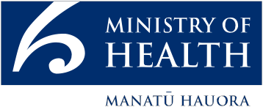

This work is licensed under the Creative Commons Attribution 4.0 International licence. In essence, you are free to: share ie, copy and redistribute the material in any medium or format; adapt ie, remix, transform and build upon the material. You must give appropriate credit, provide a link to the licence and indicate if changes were made.

Foreword
I am pleased to present my annual report on the state of public health in New Zealand.

We know that good health starts in the womb and the early years. A healthy start can improve our lifestyle and health throughout life. Indeed, today New Zealanders continue to live longer, and most of us can expect to spend more of that time in good health. However, too few New Zealanders are optimising their health by eating well, getting enough exercise, maintaining a healthy weight, reducing risky health behaviours and looking after their mental wellbeing. The reasons for these trends are complex and go well beyond the health sector.

The social, economic and physical environments in which we live, learn, work and play all influence our ability to adopt and maintain a healthy lifestyle. The communities and homes we live in, the education we receive, what we do for a living and our exposure to crime and violence all impact on our health and our ability to make healthy decisions.

This report draws on a range of information to illustrate the key health issues affecting New Zealanders. It provides an overview of the burden of disease, our health status, and the wide range of factors influencing our health and wellbeing.

While already performing well and achieving good results, the health and disability system must continually adapt to meet the changing health needs of New Zealanders. The update of the New Zealand Health Strategy will set out a new vision and road map for the health sector for the next five years.

Cross-agency collaboration is essential if we are to address the wider determinants of health, reduce the social impact of poor health and improve support for vulnerable groups. The Ministry of Health is committed to working with other public services to ensure New Zealanders live well, stay well and get well.

Chai Chuah
Director-General of Health Ministry of Health

Acknowledgements
This report was written by the Health and Disability Intelligence Group, Ministry of Health.

They would like to thank the peer reviewers and those who provided data for inclusion in the report.

Contents
Foreword iii
Acknowledgements iv
Executive summary vii
Introduction 2
How healthy are New Zealanders? 4
Leading causes of health loss 7
Looking after our health 10
Preventing ill health 15
Wider determinants of health 15
Healthy start 17
Mental health and wellbeing 21
Protecting our health 25
Early detection and treatment 25
Integrated management of long-term conditions 29
Communicable disease control 30
Meeting health system challenges 34
Improving equity for groups with poorer health outcomes 34
Protecting vulnerable groups 36
Delivering high-quality, sustainable and safe health care services 41
Summary 45
Technical notes 46
References 47

List of Tables
Table 1: Leading causes of health loss and death 7
Table 2: Ethnic breakdown of the medical and nursing workforce and the New Zealand population 35
Table 3: Outcomes of home and long-term care facility assessments undertaken in 2014/15 39

List of Figures
Figure 1: Social wellbeing indicators 4
Figure 2: Life expectancy and independent life expectancy at birth in New Zealand, 2013 6
Figure 3: Number of deaths and registrations for the top 10 causes of cancer death in New Zealand, 2012 8
Figure 4: Health loss in New Zealand (% of total Disability Adjusted Life Years) by condition, 2010 9
Figure 5: Trends in age-standardised DALY rate caused by selected health conditions, 1990–2010 10
Figure 6: Proportion of adults who are physically inactive (<30 minutes of physical activity per week) by age group, 2013/14 12
Figure 7: Prevalence of multiple risk factors among adults, 2011/12 to 2013/14 14
Figure 8: Proportion of people living in each deprivation quintile by ethnic group 16
Figure 9: Early influences on children’s health 18
Figure 10: Impact of protective and risk factors on mental health 23
Figure 11: Health loss from cardiovascular and circulatory disease that is due to lifestyle and metabolic risk factors 27
Figure 12: Weekly consultation rate for influenza-like illness in New Zealand, April 2012–August 2015 31
Figure 13: The impact of child abuse and neglect on New Zealand children 37
Figure 14: Proportion of children in the Growing up in New Zealand study exposed to individual risk factors during the ante-natal period 38
Figure 15: Hospital admissions and hip fracture rates, by age group, 2013 40
Figure 16: Amenable mortality rate per 100,000 people aged 0–74 years, by ethnic group, 2000–2012 42

Executive summary
This year’s Health and Independence Report provides an overview of the state of New Zealanders’ health, including how well the health and disability system is performing. It focuses on a number of high-profile areas for the health and disability system, such as pregnancy and early childhood, mental health and wellbeing, and vulnerable groups. The report also highlights where social sector agencies need to work together, due to the interdependence between health and social outcomes.

How healthy are New Zealanders?
New Zealanders are living longer and independent life expectancy has increased. However, independent life expectancy has not kept pace with the increase in life expectancy. This means we are spending a greater proportion of our lives, around a fifth, in poor health.

The leading causes of health loss are cancers, cardiovascular diseases, mental health disorders, musculoskeletal disorders and injuries. Mental health and musculoskeletal disorders account for a growing proportion of total health loss, as survival from cancer and cardiovascular disease improves.
We can expect
to live
4 out of 5 years of our life
in good health

Much of this health loss is due to lifestyle factors, including smoking, harmful alcohol intake, poor nutrition, and physical inactivity. While many New Zealanders look after their health, one in eight adults has an unhealthy lifestyle, reporting three or more of these risk behaviours.
Young people
are less likely
to smoke or drink hazardously than previously
Our daily smoking rate has decreased to 15 percent and is considerably lower than the average for member countries of the Organisation for Economic Co-operation and Development (OECD). However, the daily smoking rate for Māori adults remains high at 37 percent.

Fewer young people are smoking or drinking hazardously. The youth smoking rate (in those aged 15–17 years) has halved over the last seven years. Further, although a third of young adults aged 18–24 years are hazardous drinkers, this proportion has fallen by 30 percent since 2006/07.

Preventing ill health
Our health and our ability to lead a healthy lifestyle are strongly influenced by the social, economic and physical environments in which we live, learn, work and play.

The New Zealand Index of Deprivation highlights the unequal distribution of socioeconomic deprivation in New Zealand. A greater proportion of Māori and Pacific peoples live in the most socioeconomically deprived areas. Children are also over­represented in the most deprived areas as well as being more likely to live in crowded households.
Māori and Pacific
are over-represented in deprived areas

Ensuring children and young people have a healthy start to life is essential to reduce the impact of conditions such as obesity, cardiovascular disease and poor mental health on their lives. The future health of our children is shaped throughout pregnancy and childhood as their experience of both positive and negative influences grows.

The majority of mothers stop drinking alcohol either when trying to get pregnant or as soon as they become aware of their pregnancy. However, one in six women continues to drink after finding out she is pregnant.

Likewise, while support is available for pregnant women who smoke, one in eight women is smoking two weeks after the birth of her child.
1 in 6
women continue to drink after finding out that they are pregnant

A number of unhealthy behaviours are also evident among our children. One in six children aged 2–14 years has fizzy drinks three or more times a week and half watch two or more hours of TV each day. One in ten children aged 2–14 years is obese, increasing their risk of poor health outcomes.

Maternity and Well Child / Tamariki Ora services support families to adopt and maintain a healthy lifestyle. Early access to a Lead Maternity Carer (LMC) has improved for all ethnic groups, with two- thirds of pregnant women registering with an LMC by the 12th week of pregnancy.

Well Child / Tamariki Ora services are seeing more children: three-quarters of infants receive all core visits available in their first year, and 93 percent of four-year-olds have a B4 School Check. Health and wellbeing continue to be promoted once children begin school, through Health Promoting Schools and School Based Health Services.

The proportion of children who are up to date with their immunisations has increased markedly over recent years. By eight months of age, 93 percent of children are now immunised against a number of serious infectious diseases. The rates of immunisation have also increased for Māori and Pacific children as well as for those living in the most socioeconomically deprived areas.
93%
of eight-month-olds ae fully immunised

As with physical health, good mental health starts early in life. One in six mothers reports experiencing depression during pregnancy; this proportion decreases to one in nine by the time the child is nine months old.
Suicide is responsible for 1 in 3
deaths among young people
Among teenagers, one in six girls and one in eleven boys display clinically significant signs of depression. Identifying and supporting these young people is essential to help tackle New Zealand’s high youth suicide rate. Suicide accounts for a third of all deaths in those aged 15–24 years, with Māori youths particularly vulnerable.

Protecting our health
Early identification and effective management of poor health can help slow the progression of disease, improving health outcomes.

Our cervical cancer mortality rate is low compared with similar countries. However, inequities in uptake of cervical screening persist among Māori, Asian and Pacific women.

Although breast cancer screening rates have improved among Pacific women, low Māori screening uptake remains a challenge.
Equitable
access to cancer screening remains a challenge
Effective management of obesity, high blood pressure, high cholesterol and diabetes can help lower cardiovascular disease risk. Over a million adults are obese, which is three out of every ten adults. One in six adults is taking medication for high blood pressure and one in nine is taking medication for high cholesterol.

The prevalence of diabetes is increasing; 6 percent of adults have been diagnosed with this condition. Undiagnosed diabetes is also an issue, with a quarter of people with diabetes unaware of their condition.
1.1 million
New Zealanders have had their cardiovascular risk assessed in the last five years

Lifestyle factors account for 60 percent of health loss from cardiovascular disease. Initiatives supporting individuals to increase their physical activity, such as the Green Prescription scheme and smoking cessation services, are important to help people reduce their risk of cardiovascular disease.

The health target of more heart and diabetes checks is supporting earlier diagnosis of these conditions, enabling better management and a lowering of cardiovascular disease risk. Over 1.1 million people have had their cardiovascular risk assessed over the last five years. However, despite having higher levels of cardiovascular risk, a lower proportion of Māori adults have had a heart and diabetes check in the last five years.
7 out of 10
adults aged 65+ have a long-term condition
As we live longer, the proportion of people living with one or more long­ term conditions is increasing. The majority (72 percent) of adults aged 65 years and over have at least one long-term condition, while 42 percent have at least two and 18 percent at least three long-term conditions.

Although infectious diseases now have less impact on the health of the population than they did historically, their control remains a priority. The health sector is continually working to ensure New Zealand is prepared for and, where possible, protected against both domestic and international outbreaks of infectious disease.
The rheumatic fever rate has declined by
24%
The rheumatic fever rate has declined by 24 percent since targeted intervention work began. Cross-agency collaboration has been a key feature of this work. For example, agencies worked together to roll out the Healthy Homes Initiative to reduce overcrowded living conditions for those in at-risk groups.

Meeting health system challenges
The health and disability system faces a number of challenges now and in the future. Although the national picture of health is positive, there is substantial variation across different population groups. To improve health services for all New Zealanders, it is necessary to both deliver core services effectively, and to provide additional support and tailored services to those in need of them.

The population is becoming increasingly diverse. The Asian population increased by a third between the 2006 and 2013 census, to 12 percent of the total population. In addition, around 2 percent of people living in New Zealand do not speak English.
Cultural and language barriers, together with poor health literacy, increase the challenges people face when navigating the health and disability system.
The majority of New Zealanders have poor health literacy

The health and disability system, together with agencies in the wider social sector, plays a vital role in protecting vulnerable populations. Each year over 16,000 children are the victims of substantiated abuse or neglect, and eight lose their lives as a consequence of assault, neglect or maltreatment. High levels of enrolment with primary care, maternity and Well Child / Tamariki Ora services, mean health professionals can develop ongoing relationships with families. These services help identify problems early and provide support to parents before they reach crisis point.

The elderly population is growing, with 14 percent of the population aged 65 years and over. While the majority are independent, it is necessary to identify and support vulnerable older people. Over 82,000 comprehensive assessments were undertaken last year, helping identify the health and social care needs of older people.
Half
of adults aged 85+ are taking 5 or more medications
Use of multiple medications is a concern because it increases a person’s risk of adverse drug reactions. Half of adults aged 85 years and over are taking five or more medications. These adults are at greater risk of having a fall, with one in eleven adults aged 85 years and over hospitalised each year as a result of a fall.

The health and disability system faces the challenge of raising the quality and effectiveness of services within the resources available. New Zealanders are
spending less time in hospital, supporting a shift towards more community-based care. The average length of a hospital stay has decreased while the number and proportion of surgeries being undertaken as day cases have grown. Although this trend will help reduce health care costs, information on patient outcomes is needed to help maintain high-quality care.

In addition, the amenable mortality rate has fallen by 28 percent over the last 10 years, meaning that fewer people are dying of causes that could have been prevented.

However, more needs to be done to keep people out of hospital. Ambulatory sensitive hospitalisations measure the number of people who appear in hospital with conditions that could have been prevented or treated in other settings such as primary care. Despite a small decline in the rate for Māori, the ambulatory sensitive hospitalisation rate for the population as a whole has remained stable since 2010.
The amenable mortality rate has declined by 28%

The Health, Quality and Safety Commission has focused on a number of quality and safety markers through the ‘Open for better care’ patient safety campaign. This initiative has seen an increase in the proportion of older people assessed for falls in hospital, as well as improvements in hand hygiene compliance and the use of surgical safety checklists.

New Zealanders rate their health and disability system highly, with the majority of people satisfied with the care they receive in hospital and in the community. While the health and disability system adapts to meet these challenges, it must continue to deliver high-quality care to the millions of people who access the system each year.

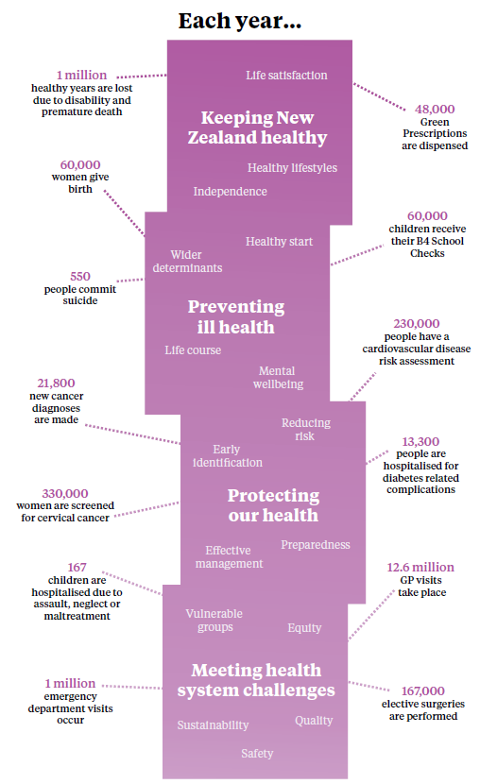

Introduction
What are the major causes of
ill health in New Zealand?
How healthy are our lifestyles and
what impact is this having on our health?
What opportunities are there to act early
to prevent or minimise future ill health?
What challenges does the
health and disability system face
and what are we doing to address these?
The Health and Independence Report is the Director-General of Health’s annual report on the state of public health in New Zealand. The report looks at: the health of New Zealanders; opportunities to improve health; and some of the challenges facing the health and disability system.

Covering such a broad topic while accurately reflecting the wealth of available information is a challenging task. While some may prefer a large reference document, we believe that most of the audience for this report would prefer a shorter, more concise overview of the health of New Zealanders. We are mindful that much of the information included here is already published in more detail elsewhere and so have chosen to present a brief snapshot of the state of health in New Zealand.

At the time of writing this report, the Ministry of Health is leading the update of the New Zealand Health Strategy. The strategy will provide a vision for the development of the health and disability system over the next 10 years.

This report provides insights into the health of New Zealanders, highlighting where we are making good progress as well as noting areas for improvement. It shows some of the changes over time and differences between population groups. We hope this information will spark your interest in particular areas. We encourage you to explore these further, using the links to additional resources included in the text.

High-profile areas covered include pregnancy and early childhood, mental health and wellbeing, and vulnerable groups. We also touch on the wider determinants of health and the social impact of poor health, demonstrating the need for health to be seen within the broader social and economic environment.

The first question this report considers is, ‘How healthy are New Zealanders?’ In answer, the first section looks at our overall health and wellbeing before summarising the leading causes of health loss and the major lifestyle factors impacting on our health.

Next, this report discusses the opportunities to prevent ill health by addressing the wider determinants of health. From a life-course perspective, it points out the importance of establishing healthy behaviours early in life. This same perspective shows how positive and negative experiences have a cumulative impact on our mental wellbeing.

The third section of the report looks at the importance of detecting and treating disease early in order to prevent or minimise future ill health. It focuses on the examples of screening for cancer and assessing the risk of cardiovascular disease. Another topic is the high prevalence of long-term conditions and the need for agencies to work together in an integrated way to support people with multiple long-term conditions.

The final section is concerned with the challenges facing the health system now and in the future. All sections of the report highlight health disparities for Māori and Pacific peoples as well as for those living in the most socioeconomically deprived areas. This section considers the barriers for these and other groups with poor health outcomes and how these can be addressed to reduce health inequalities. As this section discusses, the health sector needs to work more closely with other social sector agencies to protect vulnerable populations from harm. The final section also considers how the health and disability system is addressing the ongoing challenge of delivering effective, efficient, high-quality services within current funding constraints.

Thank you for taking the time to read this report. We hope you find it engaging and thought-provoking.

How healthy are New Zealanders?
Health, money, relationships and housing are important factors related to life satisfaction (Statistics New Zealand 2014d). Individuals who rate their health as good, have enough money to meet their everyday needs, are not lonely and have no major problems with the condition of their housing are overwhelmingly satisfied with life.

These four factors summarise a broad range of social, economic, environmental and individual factors that influence our health and are also influenced by how healthy we are.

Three out of five New Zealanders rate their health as very good or excellent (Figure 1). People who rate their health as poor are more likely to be older, be unemployed, have a low income, have low educational qualifications, be of Pacific or Māori ethnicity and/or live in rental accommodation.

Figure 1: Social wellbeing indicators
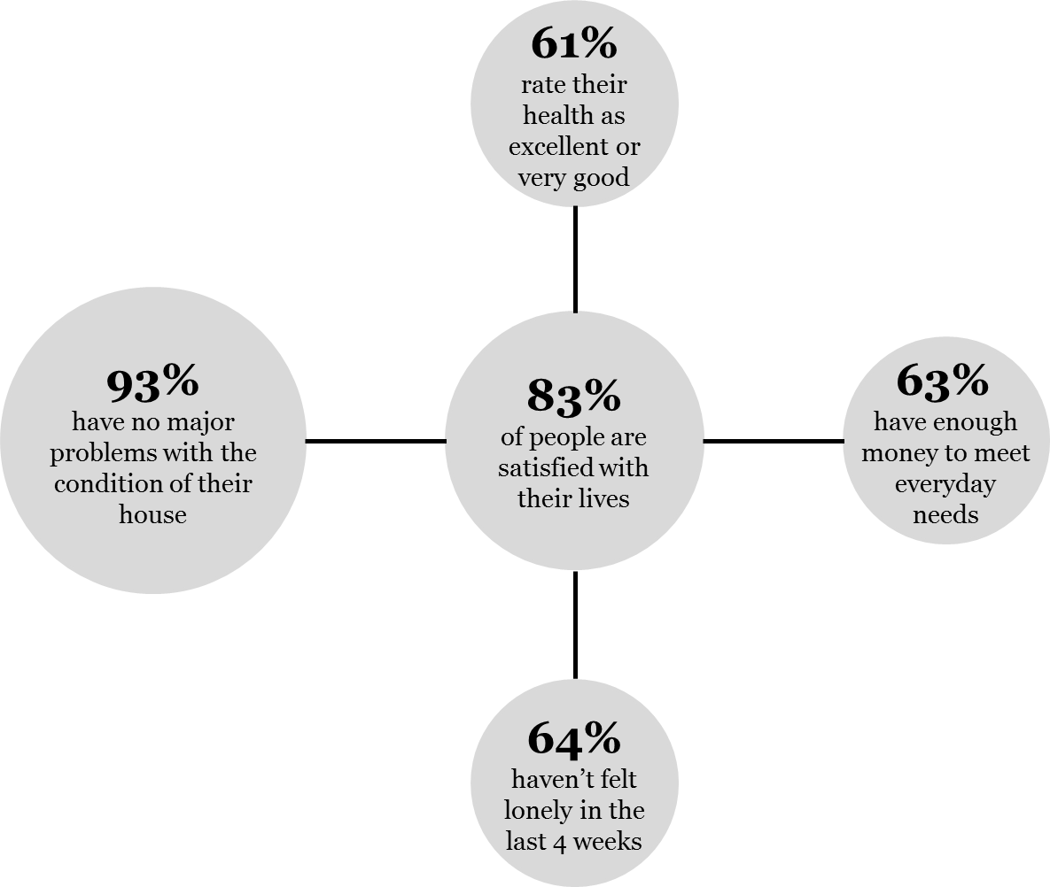
Source: 2014 General Social Survey

New Zealanders are living longer than ever before, but not all groups enjoy a long life
In 2013 life expectancy at birth was 79.5 years for males, and 83.2 years for females (Figure 2). New Zealand’s life expectancy compares well with similar countries, and is above the 2013 average among member countries of the Organisation for Economic Co-operation and Development (OECD) ( 77.8 years for males and 83.1 for females)
(OECD 2015).
Download Independent Life Expectancy in New Zealand from www.health.govt.nz

While this is good news for New Zealand as a whole, Māori and Pacific life expectancy is considerably lower than the national average. On average, Māori live seven years less than non-Māori, with Māori males having a life expectancy at birth of 73.0 years and Māori females 77.1 years (Statistics New Zealand 2014d). Pacific life expectancy is higher than the Māori rate, but is lower than the life expectancy of the total population. Pacific males have a life expectancy at birth of 74.5 years and Pacific females 78.7 years.

On average we will spend four out of five years of our life in good health
Independent life expectancy measures the average number of years we can expect to live free from functional limitations requiring assistance. Between 1996 and 2013, independent life expectancy at birth increased. However, the increase has not kept pace with the increase in life expectancy, meaning the proportion of our lives spent in poor health is increasing.

In 2013, New Zealand males could expect to live 82 percent of their life in good health, compared with 86 percent in 1996. New Zealand females in 2013 could expect to live 80 percent of their life in good health, compared with 83 percent in 1996.

While females have a higher life expectancy than males, they spend more of their life in poor health. In 2013 New Zealand females required assistance for 16.7 years of their life, compared with 14.3 years for New Zealand males (Figure 2).

Figure 2: Life expectancy and independent life expectancy at birth in New Zealand, 2013
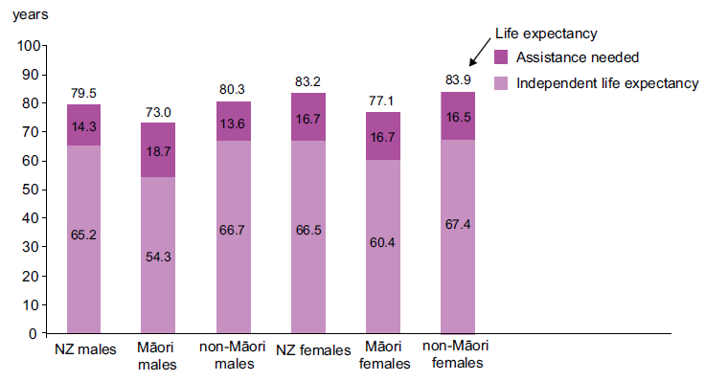
Source: Independent Life Expectancy in New Zealand, Ministry of Health

Māori males can expect to live independently for 12.4 years less than non-Māori males. Māori males also spend more of their lives in ill health, requiring assistance for an estimated 18.7 years, compared with 13.6 years for non-Māori males. This means that Māori males can expect to live only 74 percent of their lives in good health, compared with 83 percent for non-Māori males.

There is a seven-year gap in independent life expectancy at birth between Māori females (60.4 years) and non-Māori females (67.4 years). However, both will spend a similar number of years in ill health. Māori females can expect to live 78 percent of their lives in good health, compared with 80 percent for non-Māori females.

One in four New Zealanders has a disability
The number of people living with a disability has increased to around 1.1 million individuals (Statistics New Zealand 2014c). The proportion has also increased from 20 percent of New Zealanders in 2001 to 24 percent in 2013, which is partly explained by our ageing population.

Rates of disability increase with age, with 59 percent of people aged 65 years and over having at least one disability. Multiple impairments are common: over half of disabled people have more than one type of impairment. One in nine children aged 0–14 years (11 percent) has a disability; for half of them, the disability involves learning difficulties.
Find out more about the 2013 Disability Survey at www.stats.govt.nz

Māori (27 percent) and Pacific peoples (19 percent) have higher than average disability rates after adjusting for age (Statistics New Zealand 2014c).

Leading causes of health loss
The 2010 Global Burden of Disease Study uses disability adjusted life years (DALYs) to summarise both fatal and non-fatal health loss (Institute for Health Metrics and Evaluation 2013). One DALY represents the loss of one year of healthy life.

Just over a million years of healthy life are lost in New Zealand each year as a result of disability and premature death. Figure 4 summarises the conditions that are responsible for the majority of this health loss New Zealand.

Cancer is the leading cause of health loss, followed by cardiovascular disease
Cancer, cardiovascular disease, mental health disorders, musculoskeletal disorders and injuries are the leading causes of health loss (Table 1). Together these conditions account for over two-thirds of all health loss.

Sixteen percent of health loss is due to cancer. Lung, colorectal and breast cancers are the leading causes of cancer-related health loss (Institute for Health Metrics and Evaluation 2013). They are also responsible for the majority of cancer deaths (Figure 3). While the number of cancer deaths is increasing due to the ageing population, the age-standardised death rate is decreasing. In 2012 there were 124 cancer deaths per 100,000 people in New Zealand, compared with 146 per 100,000 in 2000.

In 2012 there were 21,814 new cancer registrations, which is 336 per 100,000 New Zealanders after standardising for age. While the total number of cancer registrations has increased by 23 percent since 2000, the age-standardised rate has decreased by 8 percent over the same period. Prostate cancer is responsible for the highest number of new cancer diagnoses, with 3129 new registrations in 2012. This is followed by breast (3054) and colorectal (3016) cancers.

Table 1: Leading causes of health loss and death
Leading causes of health loss  (% of total health loss) |  |  | Leading causes of death  (% of all deaths)
Cancer | 16% |  | 34% | Cardiovascular disease
Cardiovascular disease | 15% |  | 30% | Cancer
Mental health disorders | 14% |  | 9% | Respiratory disease
Musculoskeletal disorders | 14% |  | 6% | Injuries (including violence)
Injuries (including violence) | 10% |  | 4% | Diseases of the nervous system  (including Alzheimer’s)

Figure 3: Number of deaths and registrations for the top 10 causes of cancer death in New Zealand, 2012
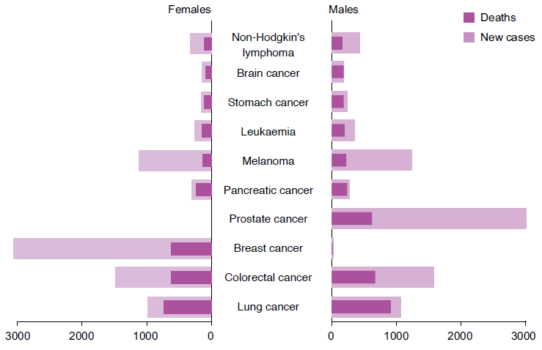
Source: New Zealand Cancer Registry and the Mortality Collection, Ministry of Health

Fifteen percent of all health loss is due to cardiovascular disease. The term ‘cardiovascular disease’ covers a range of diseases related to the circulatory system, including ischaemic heart disease (or coronary heart disease) and cerebrovascular disease (or stroke). Ischaemic heart disease is responsible for 8 percent of total health loss and stroke for 3 percent.

Cardiovascular disease is the leading cause of death in New Zealand, accounting for a third of deaths in 2012. However, the age-standardised death rate has decreased from 183 per 100,000 New Zealanders in 2000 to 118 per 100,000 in 2012.

Mental health disorders (including major depressive disorder, anxiety disorders, substance use disorders and conduct disorder) account for 14 percent of health loss. Mental health disorders are the leading cause of health loss in children aged 5–14 years and in adults aged 15–49 years. Major depressive disorders account for 4 percent of health loss, with substance use disorders responsible for 3 percent and anxiety for 2 percent.
Explore New Zealand’s data from the Global Burden of Disease Study at http://vizhub.healthdata.org/
gbd-compare
Ethnicity data area available from the 2006 New Zealand Burden of Disease Study
www.health.govt.nz
Musculoskeletal disorders include low back pain, neck pain and arthritis. Fourteen percent of health loss is due to musculoskeletal disorders, half of which is from low back pain.

Injuries, including violence, account for 10 percent of health loss. Transport injury (3 percent of total health loss), falls (3 percent) and self-harm and violence (2 percent) are the leading causes of injury- related health loss.

Figure 4: Health loss in New Zealand (% of total Disability Adjusted Life Years) by condition, 2010
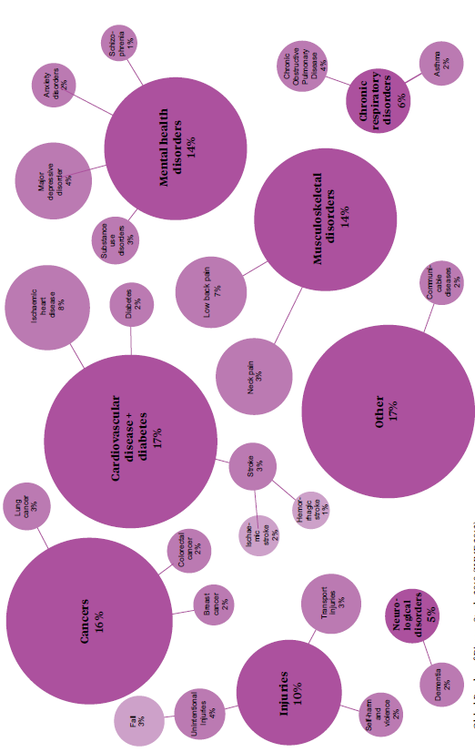
Source: Global Burden of Disease Study 2010 (IHME 2013)

Health loss has changed considerably over the last two decades
Over the last 20 years, total annual health loss in New Zealand has fallen by almost a quarter (Institute for Health Metrics and Evaluation 2013). This decline is due to a 40 percent drop in fatal health loss. Non-fatal health loss caused by disability has remained stable, and is now responsible for over half of all health loss in New Zealand.

Health loss related to cardiovascular disease has fallen steeply over the last 20 years (Figure 5). This reflects a large decline in the cardiovascular disease death rate, achieved through improved treatment and healthier lifestyles. Health loss from cancer and injury has also decreased over this period.

In contrast, health loss from mental and musculoskeletal disorders has remained stable over the last 20 years.

Figure 5: Trends in age-standardised DALY rate caused by selected health conditions, 1990–2010
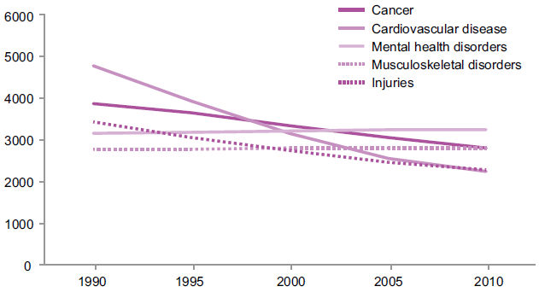
Source: Global Burden of Disease Study 2010 (IHME 2013)

Looking after our health
Much of the health loss that New Zealanders experience is due to their behaviours and risk factors that affect health, including smoking, excess alcohol intake, not maintaining a healthy weight, poor nutrition and physical inactivity. While some of this health loss is not preventable, leading a healthy lifestyle can reduce our risk of future ill health.

There are large ethnic and socioeconomic disparities in smoking
Smoking harms nearly every organ and system in the body. It is the main cause of lung cancer and chronic obstructive pulmonary disease (COPD), and a major cause of cardiovascular disease and other cancers. Almost 9 percent of total health loss in New Zealand is due to smoking.

The Government has adopted an ambitious target of achieving a smokefree New Zealand by 2025. In 2013/14, 15 percent of adults smoked daily, a fall from 18 percent in 2006/07 (Ministry of Health 2014c).

Daily smoking rates are highest in adults aged 25–34 years (22 percent). However, the youth smoking rate has halved since 2006/07.
Out of every 100 adults in New Zealand ...
15 smoke daily
16 are hazardous drinkers
59 do not eat the recommended portions of vegetables and fruit
14 are physically inactive
30 are obese, including 5 who are extremely obese

Māori adults are almost three times as likely to smoke daily as non-Māori. Thirty-seven percent of Māori adults smoke daily, with little change since 2006/07. Māori are the only ethnic group where more women than men smoke daily (38 percent compared with 36 percent).

There are strong socioeconomic disparities in smoking. Adults living in the most deprived areas are four times more likely to smoke daily than those living in the least deprived areas.

New Zealand’s smoking rate is considerably lower than the OECD average of 20 percent of adults smoking daily (OECD 2015).

Fewer young adults have a hazardous drinking pattern
Excessive or harmful use of alcohol contributes to a range of diseases, including stroke, certain cancers, cirrhosis of the liver, mental health conditions and birth defects. Alcohol-related harm also includes injuries (for example, through violence, self-harm and road traffic accidents) and social and economic harm. The net effects of alcohol consumption account for just over 3 percent of total health loss.

‘Hazardous drinking’ refers to an established drinking pattern that carries a risk of harming the drinker’s physical or mental health, or having harmful social effects on the drinker or others. Among all adults (including non-drinkers), 16 percent were hazardous drinkers in 2013/14, down from 18 percent in 2006/07. This decline is largely due to a fall in hazardous drinking among young adults. A third (33 percent) of those aged 18–24 years have a hazardous drinking pattern, down from 43 percent in 2006/07. Hazardous drinking rates in adults aged 25 years and over have not changed since 2006/07.
Find the latest results from the New Zealand Health Survey , including detailed reports on alcohol, obesity and tobacco use, at www.health.govt.nz

Poor diet accounts for one in every nine years of life lost
The foods and drinks we consume play a major role in our health and wellbeing. A healthy diet throughout life can help prevent nutritional deficiencies, protect against infection and help maintain a healthy body weight. A healthy diet also protects against and reduces the risk of avoidable chronic disease such as cardiovascular diseases, type 2 diabetes and some cancers.

Dietary risks account for 11 percent of health loss. They include consuming lower than optimal amounts of nuts, seeds, vegetables and fruit, as well as having a higher than optimal intake of energy, sodium (salt), processed meat, and saturated and trans fat.

Eating plenty of vegetables and fruit can help protect against major diseases and conditions like heart disease, stroke, high blood pressure and some cancers. The Ministry of Health recommends that adults eat at least three servings of vegetables and at least two servings of fruit per day for good health.

Two out of five adults (41 percent) meet the Ministry of Health’s guidelines for vegetable and fruit intake. This has decreased from 44 percent in 2011/12. Vegetable and fruit consumption increases with age: 32 percent of those aged 15–24 years meet the Ministry guidelines, compared with 53 percent of those aged 65–74 years.

Māori (24 percent), Pacific (27 percent) and Asian (32 percent) adults are less likely to eat the recommended portions of vegetables and fruits when compared with non-Māori, non-Pacific and non-Asian adults respectively. Adults living in the most socioeconomically deprived areas are also less likely to meet the Ministry guidelines, compared with those living in the least deprived areas.

One in seven adults is physically inactive
Physical activity helps protect against heart disease, stroke, type 2 diabetes, certain cancers, osteoarthritis and depression. It is also important for maintaining a healthy weight and for reducing the risk of and managing obesity. Low physical activity accounts for nearly 5 percent of health loss.

Figure 6: Proportion of adults who are physically inactive (<30 minutes of physical activity per week) by age group, 2013/14
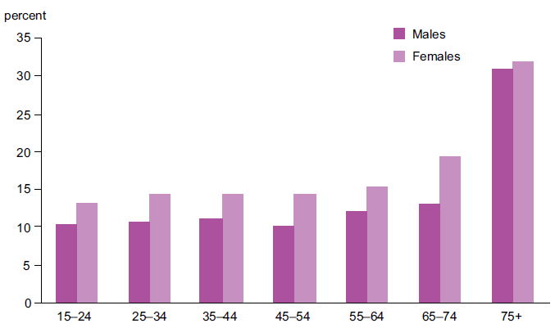
Source: New Zealand Health Survey, Ministry of Health

Half of adults (51 percent) are physically active. Males (55 percent) are more likely to be physically active than females (49 percent) (Ministry of Health 2014c).

One in seven adults (14 percent) is physically inactive, doing less than 30 minutes of physical activity per week. This is an increase from 10 percent in 2006/07.

Physical inactivity is highest in those aged 75 years and over. However, across all other adult age groups (15–74 years), around 10 percent of males and 14 percent of female are inactive (Figure 6).

Māori (16 percent), Pacific (21 percent) and Asian (20 percent) adults are more likely to be physically inactive when compared with non-Māori, non-Pacific and non-Asian adults. Adults living in the most socioeconomically deprived areas are more than twice as likely to be physically inactive compared with those living in the least deprived areas.

Obesity has increased across all age, sex and ethnic groups
Excess weight is a leading contributor to a number of health conditions, including type 2 diabetes, cardiovascular diseases, some common types of cancer (for example, colorectal), osteoarthritis, gout, sleep apnoea, reproductive disorders, gallstones and mental health conditions (especially depression). Around 9 percent of health loss in New Zealand is due to higher than optimal body mass index (BMI) (including obesity).

Over a million adults are obese, which is three out of every ten adults (Ministry of Health 2014c). A further 1.2 million adults are overweight, meaning that two-thirds of the population is overweight or obese. The adult obesity rate has tripled since the late 1970s, increasing across all age, sex and ethnic groups (Ministry of Health 2015m). We are becoming obese at a younger age, which highlights the need for a greater focus on childhood obesity. While the obesity prevalence has increased across the world, New Zealand ranks third highest in the OECD for adult obesity (OECD 2015).

Pacific adults are 2.5 times as likely to be obese as non-Pacific adults, while Māori adults are 1.8 times as likely to be obese as non-Māori. However, the majority of obese adults in New Zealand, around three-quarters, are of European/other ethnicity.

Extreme obesity – that is, having a BMI of 40 or more – can reduce life expectancy by up to 10 years. Five percent of adults, or around 163,000 New Zealanders, are extremely obese. Pacific adults are almost six times as likely to be extremely obese as non-Pacific; Māori adults are almost three times as likely to be extremely obese as non-Māori.

There are clear socioeconomic disparities in extreme obesity. Adults living in the most socioeconomically deprived areas are four times as likely to be extremely obese as those living in the least deprived areas.

One in eight adults has an unhealthy lifestyle
On its own, each of the above risk behaviours increases our chance of ill health. Further, many people have more than one risk behaviour. Evidence indicates that our risk of death increases as the number of risk behaviours increases. Adults with four risk behaviours have a health status equivalent to being 12 years older than those born in the same year who have no such behaviours (Kvaavik et al 2010).

Figure 7: Prevalence of multiple risk factors among adults, 2011/12 to 2013/14
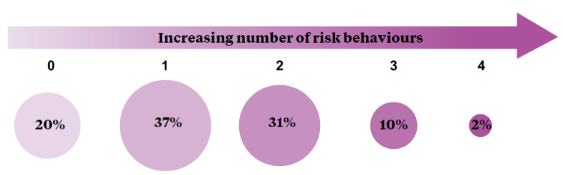
Source: New Zealand Health Survey, Ministry of Health

The following analysis looks at the proportion of adults who report risk behaviours to the New Zealand Health Survey. As it includes only a small number of risk behaviours, it provides a very simplified estimate of the proportion of the population who look after their health.

A fifth of New Zealand adults did not report any of the four risk behaviours. That is, they don’t smoke, they aren’t hazardous drinkers, they are physically active and they eat the recommended number of servings of vegetables and fruits (Figure 7). A further 37 percent have only one risk behaviour, which is most likely to be either a lack of physical activity (15 percent) or a low intake of vegetables and fruits (18 percent).

One in eight adults report an unhealthy lifestyle, with three or more risk behaviours. This is higher among males (15 percent) than females (10 percent). Younger adults are more likely to have an unhealthy lifestyle, with 17 percent of those aged 15–24 years and 16 percent of those aged 25–44 years having three or more risk behaviours.

Preventing ill health

Wider determinants of health
Our ability to adopt and maintain a healthy lifestyle is heavily influenced by the wider social, economic and physical environment. These wider determinants of health are often beyond the control of the individual, limiting our ability to reach our full health potential.

The social environment in which we live includes our family and whānau structure, social connectedness, culture, employment (see box), exposure to crime and violence as well as the level of education we achieve. Our social environment influences our health literacy, our social norms, our ability to make healthy decisions, the value we place on health and our ability to cope with life’s adversities.  The physical environment in which we live, learn, work and play also impacts on our risk of ill health.  Each year, around 180,000 claims are made to the Accident Compensation Corporation for work- related injury (Statistics New Zealand 2014b). This is the equivalent of 92 claims for every 1000 full-time employees. Agriculture and fishery workers consistently have the highest claim rate. | 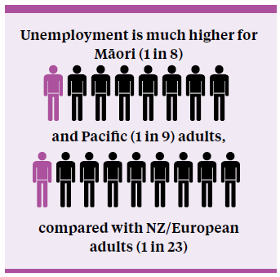  Source: Statistics NZ
Healthy Homes Initiative  The Healthy Homes Initiative systematically identifies families with children at risk of getting rheumatic fever who are living in crowded households. The initiative facilitates access to a range of interventions to reduce overcrowding.  The first of these initiatives was set up in Auckland in December 2013. In March 2015, Healthy Homes Initiatives were expanded to the regions of Northland, Waikato, Wellington, Lakes, Bay of Plenty, Hawke’s Bay and Tairāwhiti district health boards. This extension doubles the number of families who can be referred and assessed for housing interventions, to more than 3000 per year.  Across all Healthy Homes Initiatives to date, 2439 families have been referred for services, 1340 households have received assessments and developed plans, and 1065 interventions have been delivered and coordinated. |  | Living in cold, damp or overcrowded housing can directly harm our physical and mental health. Six percent of the population live in homes with major damp or mould problems (Statistics New Zealand 2015b). A higher proportion of Pacific peoples (15 percent) and Māori (14 percent) live in homes with major damp or mould problems. People living in rental properties (12 percent), single parent families (11 percent) and those with a household income of less than $30,000 per year (10 percent) are also more likely to live in homes with major damp or mould problems.
One in ten New Zealanders (10 percent) live in crowded conditions. Household crowding is linked to a number of health conditions, including rheumatic fever, meningococcal disease, respiratory infections and skin infections (for example, cellulitis), as well as higher blood pressure and increased risk of childhood injuries. Children are over-represented in crowded households: over half of crowded households have two or more children living in them.  A greater proportion of Pacific peoples live in crowded |  | 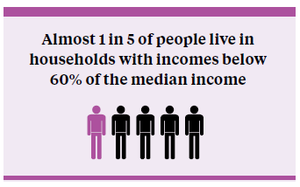  Source: Statistics NZ
conditions (38 percent), followed by Māori (20 percent) and Asians (18 percent). Only 4 percent of European and other ethnic groups live in crowded households.

There is a strong relationship between health risk factors and socioeconomic deprivation, with higher rates of smoking, obesity and alcohol use among those living in the most deprived areas. The New Zealand Index of Deprivation (NZDep2013) estimates the socioeconomic status of particular geographical areas, relative to the rest of the country. It allows us to look at the impact of deprivation on health and wider social outcomes. NZDep2013 draws together a number of indicators of deprivation relating to communication, income (see box), employment, education, home ownership, family structure, overcrowding and access to transport.

A greater proportion of Māori and Pacific peoples live in the most socioeconomically deprived areas (Figure 8). Forty percent of Māori and 54 percent of Pacific people live in the most deprived areas, compared with 11 percent of non-Maori, non-Pacific and non-Asian.

Young children and young adults are over-represented in the most deprived areas. A quarter of children aged 0–5 years (25 percent) and a quarter of young adults aged 18–24 years (25 percent) live in the most deprived areas, compared with 18 percent of those aged 25–64 years.

Figure 8: Proportion of people living in each deprivation quintile by ethnic group
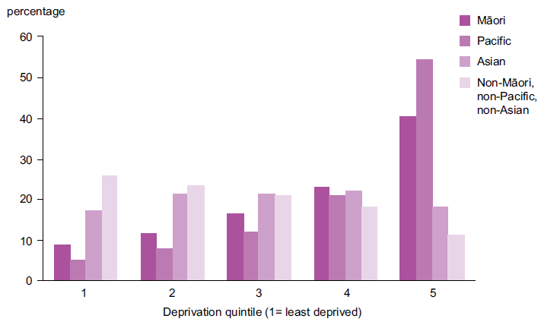
Source: NZDep2013

Healthy start

Health behaviours are established early in life
Providing children with a healthy start to life sets the foundation for their future health and wellbeing. Before they are born, and even before they are conceived, their development will be affected by the health of their parents. Although our genetic make-up helps to determine our future health, its influence is not fixed. Scientific research is developing our understanding of how our genetics and the environment interact to both increase and decrease our risk of future ill health.
Figure 9 provides a snapshot of how the impacts of both positive and negative health behaviours accumulate over the life course. These not only impact on our own health as we age, but also on the health of the next generation as we become parents.
Pregnancy and the first years of life provide an important opportunity to change negative health behaviours and establish healthier ones. Factors such as diet and exposure to alcohol, tobacco and other drugs have potential impacts on both the mother and her unborn baby. While some women will find it easy to change their lifestyle to support a healthy pregnancy, others will need greater support.

Most pregnant smokers are offered smoking cessation support
At two weeks after giving birth, the majority of mothers (87 percent) are smokefree (Ministry of Health 2015). The proportion is lower (65 percent) among Māori mothers, which reflects higher rates of smoking among Māori females. More than a third of Māori females aged 15–34 years are daily smokers (38 percent); however, this proportion has improved since 2006/07 when 46 percent were daily smokers.
The Better help for smokers to quit health target aims to increase the provision of smoking cessation advice and support to pregnant women who smoke. In the 12-month period to June 2014, the percentage of pregnant women who smoke, who are offered advice and/or support to quit has increased from 92 to 94 percent.

The majority of women stop drinking alcohol before or when aware of their pregnancy
Find out more information on what the Ministry of Health is doing to improve child health: www.health.govt.nz/our-work/life-stages/child health
The Ministry of Health advises women not to drink alcohol leading up to and during pregnancy. Alcohol exposure increases the risk of miscarriage, still birth and fetal alcohol spectrum disorder.
The majority of pregnant women stop drinking alcohol either before they get pregnant (31 percent) or as soon as they find out that they are pregnant (55 percent) (Ministry of Health 2015c). However, it can be months after conception that some women learn of their pregnancy. One in six women continues to drink after finding out she is pregnant.
The behaviour of drinking at any stage of pregnancy is linked to a range of factors including unplanned pregnancy and a woman’s established drinking patterns. The Growing Up in New Zealand study reports that 70 percent of women drank alcohol at some level before pregnancy or before becoming aware of their pregnancy (Cheung et al 2015).
Figure 9: Early influences on children’s health
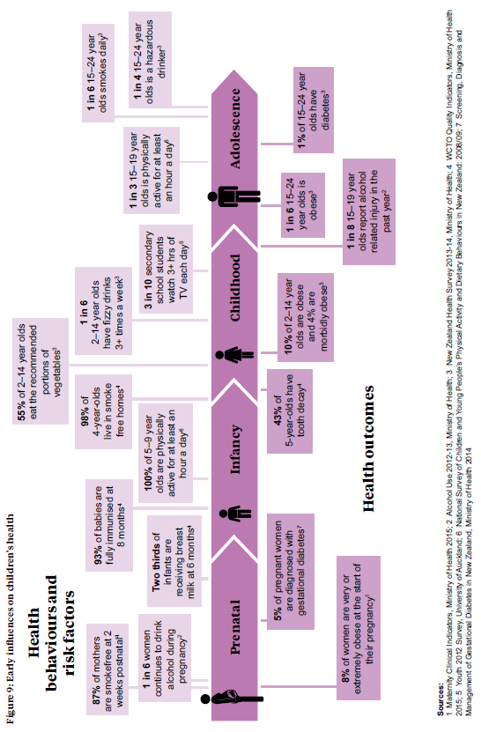

The New Zealand Health Survey asked women if they drank alcohol at any time in their most recent pregnancy. One in five women (19 percent) reported drinking alcohol during her most recent pregnancy; among women aged 15–24 years, the proportion was higher at 28 percent (Ministry of Health 2015c).

After adjusting for age, Māori mothers were twice as likely to drink at some point during pregnancy as non-Māori mothers.

Unhealthy behaviours are evident among our children
Children develop preferences and behaviours early in life, which they often carry on into adulthood. One in six children aged 2–14 years (17 percent) has fizzy drinks three or more times a week. The proportion of young children aged 2–4 years who drink three or more fizzy drinks each week has fallen significantly, from 13 percent in 2006/07 to 8.5 percent in 2013/14.

However, this figure is still too high, as highlighted by the 43 percent of five-year-olds who have dental caries (tooth decay) (Ministry of Health 2015h). Given 63 percent of Māori and 64 percent of Pacific five-year-olds having dental caries, this health issue is of particular concern for these ethnic groups.

New Zealand’s physical activity guidelines recommend that children and young people aged
5–18 years spend no more than two hours per day in front of the television, computer or games console (out of school time), in order to reduce sedentary behaviour. Half of all children currently watch two or more hours of television each day (Ministry of Health 2014c). Screen time is particularly high among children living in the most socioeconomically deprived areas, where 64 percent watch two or more hours of television each day compared with 36 percent of children living in the least deprived areas.

The Youth ’12 survey provides additional information on computer game use. Notably, one in five secondary school students plays three or more hours of computer games per day (Clark et al 2013).

Obese children are at higher risk of early signs of CVD, including high blood pressure
Poor diet and a lack of physical activity increase a person’s risk of being overweight or obese. One in ten children aged 2–14 years (10 percent) is obese, including 4 percent who are morbidly obese. This is the equivalent of 79,000 obese children, of whom 33,000 are morbidly obese (Ministry of Health 2014c).

Rates of childhood obesity are highest among Pacific children: 25 percent are obese and 12 percent morbidly obese. Pacific children are 3.2 times as likely to be obese and 3.7 times as likely to be morbidly obese as non-Pacific children.

Among Māori children, 16 percent are obese and 6 percent are morbidly obese. Māori children are almost twice as likely to be either obese or morbidly obese compared with non-Māori children.

The childhood obesity rate is much higher in children living in the most socioeconomically deprived areas. Children living in the most deprived areas are 2.5 times as likely to be obese and 4.2 times as likely to be morbidly obese compared with children living in the least deprived areas.

Obese children and young people are at a higher risk of developing diabetes and early signs of cardiovascular disease (Grant et al 2008). Previously a disease of adulthood, type 2 diabetes now accounts for a growing proportion of newly diagnosed diabetes in adolescents (Hotu et al 2004). In the 2008/09 New Zealand Adult Nutrition Survey, an estimated one in twelve of those aged 15–24 years had pre-diabetes (Coppell et al 2013).

More families are accessing maternity and Well Child /Tamariki Ora services
Ensuring good access to maternity and Well Child / Tamariki Ora (WCTO) services helps support families to give their children the best start in life. Among those women who gave birth in 2014 and registered with a Lead Maternity Carer (LMC), two-thirds (67 percent) did so within their first 12 weeks of pregnancy. This figure is up from 50 percent registered by 12 weeks in 2008 (provisional data, National Collections), indicating that early access to an LMC has improved steadily over recent years. All ethnic groups have seen an increase in early access to an LMC since 2008. However, only 40 percent of Pacific and 53 percent of Māori women who registered with a LMC did so by 12 weeks in 2014. | Healthy Families NZ  Healthy Families NZ is a large-scale initiative that brings community leadership together in a united effort to improve health. It aims to improve people’s health by working in places where they live, learn, work and play, in order to prevent chronic disease.  Healthy Families NZ is challenging communities to think differently about the underlying causes of poor health. It will support schools, workplaces, sports clubs, marae and other key community settings to change in ways that will help people make healthier choices.  Led by the Ministry of Health, the initiative will focus first on 10 locations in New Zealand. Healthy Families NZ has the potential to impact on the lives of over a million New Zealanders.  To find out more about Healthy Families NZ, visit: www. health.govt.nz/our-work/preventative-health-wellness/ healthy-families-nz

The WCTO service provides support to families until a child turns five. This includes at least five core visits in the first year and the B4 School Check at the age of four years. As at March 2015, 76 percent of infants have received all five of the core visits available in their first year and 93 percent have had their B4 School Check. A lower proportion of Māori and Pacific children receives all five core visits (67 percent and 63 percent respectively) and has their B4 School Check (85 percent and 83 percent respectively) (Ministry of Health 2015h).

Children and adolescents have access to free basic oral health services. This approach is supported by evidence that oral health status at five years of age is a good predictor of oral health in young adulthood. At September 2014, 73 percent of children were enrolled with child oral health services. Registration was lower in Māori (59 percent) and Pacific (68 percent) children (Ministry of Health 2015h).

Children are better protected against serious infectious diseases
Immunisation is one of the most effective and cost-effective interventions to protect people, especially children, from harmful infections. As well as protecting individuals, high rates of immunisation in the population can provide protection to vulnerable people who are not immunised by decreasing the incidence of infectious disease.

The Government’s Better public services health target to increase immunisation in children has resulted in a marked increase in immunisation rates among both two-year-olds and eight-month-olds. By July 2015, 93 percent of eight-month-olds and 93 percent of two-year-olds were fully immunised (Ministry of Health 2015i). This increase has been seen across all ethnic groups, with 90 percent of Māori and 95 percent of Pacific children fully immunised at eight months old.

Mental health and wellbeing
Mental health is defined as a state of wellbeing in which every individual realises their own potential, can cope with the normal stresses of life, can work productively and fruitfully, and is able to make a contribution to their community (WHO 2014). Throughout our life course we are exposed to risk and protective factors that impact on our mental health and affect our probability of developing a mental disorder. Collectively, multiple risk factors and a lack of protective factors make individuals vulnerable to moving from a mentally healthy state through varying degrees of mental illness and finally to a full-blown disorder.

Our mental health is influenced by a wide range of individual, community and social factors. These are too numerous to detail in this report. Figure 10 illustrates how these risk and protective factors accumulate over our life course and highlights their impact on mental illness.

Good mental health starts early in life
Positive early childhood experience and good parental attachment are strong protective factors for mental health. A mother’s depression during pregnancy and after birth is associated with decreased ability to bond with her newborn child (Moehler et al 2006). One in six mothers reports depression during pregnancy; this proportion decreases to one in nine by the time the child is nine months old (Morton et al 2014).

If behavioural and emotional problems in children are identified early and managed effectively, it may help reduce the risk of mental health problems in the future (Danese et al 2009). The B4 School Check uses the Strengths and Difficulties Questionnaire (SDQ) to screen for behavioural and emotional problems in four-year-olds. The vast majority of children (96 percent) have a normal SDQ score.

For around 31,000 children aged 2–14 years (3.9 percent), a doctor has diagnosed emotional and/or behavioural problems (Ministry of Health 2014c). These problems include depression, anxiety disorder, attention deficit disorder and/or attention deficit and hyperactivity disorder. Parents of Pacific children are significantly less likely to report that their child has been diagnosed with emotional and/ or behavioural problems (1.4 percent) compared with non-Pacific children.

Many adult mental health disorders begin in adolescence
In adults with a mental disorder, half had diagnosed mental illness before the age of 15 years (Jones 2013). Additionally, three out of four people who develop a substance use disorder do so by the age of 24 years (Wells et al 2007).
Find out more at: www.health.govt.nz/our-work/mental-health-and-addictions

In New Zealand, one in six teenage girls (16 percent) and one in eleven teenage boys (9 percent) report clinically significant symptoms of depression (Clark et al 2013).

Almost three in every ten teenage girls (29 percent) and one in five teenage boys (18 percent) have deliberately self-harmed in the last year (Ministry of Health 2015l). The suicide rate is highest among young adults aged 15–24 years (23 per 100,000), with suicide accounting for over a third of all deaths in this age- group.

New Zealand’s youth suicide rate is the highest in the OECD and double that of Australia (OECD 2009). Māori youths are particularly vulnerable to suicide – their rates are 2.8 times higher than those of non- Māori youths.

Figure 10: Impact of protective and risk factors on mental health
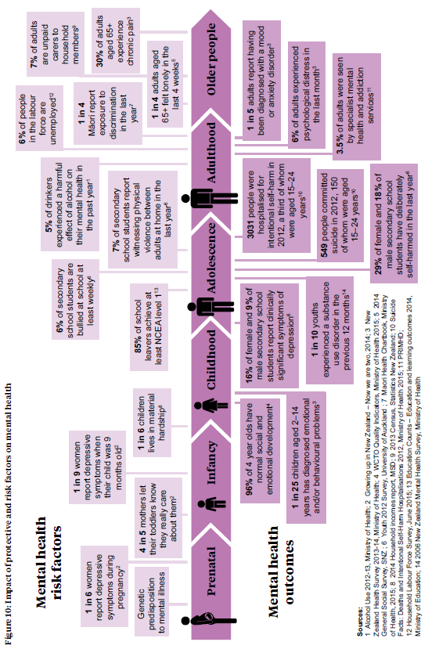

More adults are being diagnosed with mental disorders
Almost one in five adults (18 percent) report that they have been diagnosed with a mood or anxiety disorder at some time in their life, which is over a third more than in 2006/07 (Ministry of Health 2014c). This increase may have occurred because there is less social stigma around mental health disorders, with the result that more people seek help and so more mental disorders are diagnosed. Women are almost twice as likely as men to have been diagnosed with a mood and/or anxiety disorder at some time in their life.

Pacific (9 percent) and Asian (7 percent) adults are about half as likely as non-Pacific and non-Asian adults to have been diagnosed with a mood and/or anxiety disorder at some time in their life. The Māori rate is no different to that in non-Māori adults.

The 2006 Mental Health Survey identified that 12 percent of those aged 16 years and over had experienced a substance use disorder at some stage in their lives. In the previous 12 months, 3.5 percent had experienced a disorder (Wells et al 2007).

Males (5 percent), young people aged 16–24 years (9.6 percent) and those living in the most socioeconomically deprived areas (5.6 percent) were more likely to report a substance use disorder in the previous 12 months. Seven percent of Māori and four percent of Pacific adults experienced a substance use disorder in the last 12 months, compared with 3 percent of non-Māori, non-Pacific adults.

Forty percent of individuals with a substance use disorder have also experienced an anxiety disorder, while 29 percent have experienced a mood disorder, such as depression, at some time in their life (Wells et al 2007).

A total of 549 people died by suicide in New Zealand in 2012 (12 per 100,000), three-quarters of whom were male (Ministry of Health 2015l). The suicide rate has decreased by a fifth from its peak in 1998, but has remained stable over the last five years.

Protecting our health

Early detection and treatment
The earlier a disease or precursors for disease are diagnosed, the earlier treatment can start. With timely treatment and effective management, it is more likely that the progression of the disease can be delayed or even prevented. This section looks at cancer screening and cardiovascular risk assessment as examples of national programmes to increase early detection and treatment.

Cancer screening
Screening is ‘the testing of people who do not suspect they have a problem to reduce the future risk of ill health’ (Raffle et al 2013). A coordinated screening programme helps ensure better coverage and supports ongoing quality improvement. The National Screening Unit (NSU), which is part of the Ministry of Health, is responsible for coordinating national population-based screening programmes in New Zealand (NSU 2015a).

Māori women are less likely to access breast and cervical cancer screening
The target of BreastScreen Aotearoa (BSA) is that 70 percent of eligible women aged 50–69 years have a mammogram to screen for breast cancer every two years. This target was exceeded for Pacific (73 percent) and non-Māori, non-Pacific (73 percent) women, as at 30 June 2015. Improving uptake for Māori women, which is currently at 64 percent, is a key priority of BSA (Ministry of Health 2015d).

The National Cervical Screening Programme (NCSP) had a scheduled Independent Parliamentary Review in 2015 (Parliamentary Review Committee 2015).
Find more information:
visit the National Screening Unit website at www.nsu.govt.nz
or visit:
www.health.govt.nz/our-work/diseases-and-conditions/cancer-programme/bowel-cancer-programme
This review reported that between 1996 and 2012 the cervical cancer incidence reduced from 10.5 to 6.2 per 100,000 women, which makes New Zealand one of the more successful countries at reducing cervical cancer. The 2010 mortality rate from cervical cancer of 1.7 women per 100,000 women is lower than the rates in the United States of America and the United Kingdom.

The review recommended addressing participation barriers for Māori women. Overall 76 percent of eligible women aged 25–69 years received screening in the three years before June 2015. However, the rate was 63 percent for both Māori and Asian women and 73 percent for Pacific women. The NCSP coverage target of 80 percent was achieved for non-Māori, non-Pacific, non-Asian women, whose coverage was 82 percent (NSU 2015b).

The bowel screening pilot is helping inform a decision on a national bowel screening programme
The Ministry of Health is funding a four-year bowel screening pilot at Waitemata District Health Board (WDHB), which began in 2012 and was extended for two years until 2017 as part of Budget 2015. Bowel cancer causes the second-largest health loss from cancer in New Zealand (Institute for Health Metrics and Evaluation 2013). As it has identified barriers to a potential national roll-out, WDHB has made improvements to the pilot. These include ensuring equity of access for all eligible population groups, robust data management processes and ensuring an adequate number of health professionals are able to perform colonoscopies (Litmus et al 2015).

Cardiovascular risk assessment
Identifying individuals at risk of cardiovascular disease and diabetes can enable those individuals to take actions, including taking medication, to reduce their risk. The More heart and diabetes checks target aims to increase the use of cardiovascular risk assessment in primary care. By July 2015, 89 percent of the eligible population, or over 1.1 million people, had had their cardiovascular risk assessed during the previous five years (Ministry of Health 2015g). Uptake of the heart and diabetes checks is high among Pacific peoples (89 percent), but is lower among Māori (85 percent).

Lifestyle advice and medication to treat high blood pressure and cholesterol can substantially reduce the occurrence of heart disease and stroke in individuals identified as at high risk of cardiovascular disease. Cardiovascular death rates are five times higher among diabetics, but if people with diabetes achieve good glycaemic control it helps lower their risk of cardiovascular disease (Mannucci et al 2013).

Lifestyle factors account for the majority of cardiovascular-related health loss
Lifestyle factors, including dietary risks, high body mass index, physical inactivity and tobacco smoking, account for three in every five years (60 percent) of life lost to cardiovascular and circulatory disease (Institute for Health Metrics and Evaluation 2013).
Visit the Ministry of Health website for information on:
- preventative health initiatives: www.health.govt.nz/our-work/preventative-health-wellness
- the Government’s health targets: www.health.govt.nz/new-zealand-health-system/health-targets

Dietary risks are the leading cause of health loss.
They account for 28 percent of health loss related to cardiovascular and circulatory disease in particular. Dietary risks include low intake of fruits, vegetables, whole grains, seafood, omega-3 fats, nuts and seeds; and high intake of sodium, saturated fat, trans fat, sugar-sweetened drinks, red meat and processed meat.

High body mass index accounts for 14 percent of health loss from cardiovascular and circulatory disease. Physical inactivity and tobacco account for a further 10 percent and 9 percent of this loss respectively (Figure 11).

Community-based initiatives such as smoking cessation services and the Green Prescription scheme are available to help people adopt a healthy lifestyle. The Green Prescription initiative refers people at risk of preventable chronic diseases to advice on nutrition and physical activity. In 2014/15, almost 48,000 individual Green Prescriptions were issued and over 1000 families were referred to the Green Prescription’s Active Families programme.

It is now the norm for health professionals to routinely offer smokers brief advice and quit support, backed by the Better help for smokers to quit health target. Almost all smokers who are seen by a health practitioner in hospital (96 percent) are offered brief advice and quit support, as at June 2015 (Ministry of Health 2015g). Likewise in primary care, the vast majority of smokers (90 percent) have been offered brief advice and quit support in the last year, and the proportion has increased markedly from 57 percent in June 2013.

Figure 11: Health loss from cardiovascular and circulatory disease that is due to lifestyle and metabolic risk factors
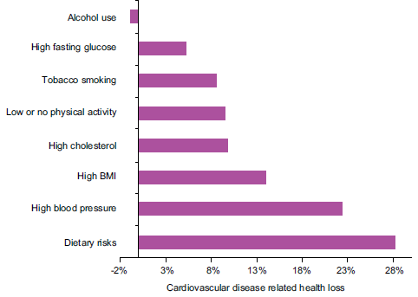
Note: Low to moderate alcohol use has a protective effect on cardiovascular disease; however, the net impact of alcohol use on the population is an estimated 4% of health loss from all causes.
Source: Global Burden of Disease Study 2010 (IHME 2013)

In 2014/15, over 14,600 smokers were referred to community-based, face-to-face smoking cessation services. Of those referred, two-thirds went on to enrol in a smoking cessation programme. Based on available information, a third of individuals who completed a smoking cessation programme were still smokefree after three months (Ministry of Health 2015a).

Up to a third of adults have high blood pressure
High blood pressure accounts for over a fifth of health loss from cardiovascular and circulatory diseases (21 percent) (Institute for Health Metrics and Evaluation 2013). Part of the New Zealand Health Survey involves measuring blood pressure and collecting information on medicated high blood pressure.

One in six adults (16 percent) has been diagnosed with and is currently taking treatment for high blood pressure (Ministry of Health 2014c). However, measurements taken on the day of the survey indicate that up to one in three adults (31 percent) may have high blood pressure (Ministry of Health 2014b).

Both Māori and Pacific adults are 1.4 times more likely than non-Māori and non-Pacific adults to have medicated high blood pressure, after adjusting for age and sex differences (Ministry of Health 2014c).

One in nine adults is currently taking medication for high cholesterol
High blood cholesterol increases a person’s risk of developing cardiovascular disease, particularly ischaemic heart disease. Higher than optimal blood cholesterol levels account for 10 percent of health loss from cardiovascular and circulatory diseases (Institute for Health Metrics and Evaluation 2013).
Out of every 100 adults in New Zealand ...
16 are taking medication for high blood pressure
11 are taking medication for high cholesterol
6 have diagnosed diabetes
2 have undiagnosed diabetes

One in nine adults (11 percent) has been diagnosed with high cholesterol and is currently taking medication for this condition, up from 8 percent in 2006/07 (Ministry of Health 2014c).

Older adults are more likely to have medicated high cholesterol, peaking at one in three adults aged 65–74 years. Similar rates of high cholesterol are seen across all ethnic groups after adjusting for age and sex.

A quarter of people with diabetes are undiagnosed
Diabetes directly accounts for 2 percent of total health loss. However, it also contributes to other conditions that lead to health loss (Institute for Health Metrics and Evaluation 2013).

Good glycaemic control is vital to help reduce the risk of diabetes-related complications including blindness and nerve damage, cardiovascular disease and kidney disease. It is important that individuals are diagnosed early and that those with pre-diabetes are supported to minimise their risk of developing diabetes.

Over a quarter of a million New Zealanders have diagnosed diabetes, which is 6 percent of the population (Ministry of Health 2015b). This diabetes rate increases with age: almost a fifth (18 percent) of adults aged 65 and over have diabetes.

The diabetes rate is highest in Pacific peoples (12 percent), followed by Indians (11 percent), Māori (8 percent) and Europeans/other (3 percent). However, as the European/other population is both numerous and older, over two-thirds of diabetics in New Zealand (68 percent) are of European/other ethnicity.

The 2008/09 New Zealand Adult Nutrition Survey found that about 2 percent of adults have undiagnosed diabetes (Coppell et al 2013). This means that about one-quarter of all people with diabetes are undiagnosed.

Furthermore, an additional one in four adults (26 percent) may have pre-diabetes, meaning their blood sugar levels are above normal but below that defined for diabetes (Coppell et al 2013). Obese adults are more likely to have pre-diabetes than adults of a healthy weight (32 percent and 20 percent respectively). The progression from pre-diabetes to type 2 diabetes can be slowed with lifestyle interventions involving weight loss, improved diet and increased physical activity (Yudkin and Montori 2014).

The rate of hospitalisations for diabetes-related complications is increasing, which will in part reflect the increasing prevalence of diabetes. In 2013/14 there were 13,301 hospitalisations for diabetes-related complications (210 per 100,000 New Zealanders). Diabetes admissions include hospitalisations for short-term and long-term complications as well as for uncontrolled diabetes.

Integrated management of long-term conditions
Long-term conditions account for over two-thirds of health loss in New Zealand (Institute for Health Metrics and Evaluation 2013). This includes health loss from mental disorders, cardiovascular disease and diabetes, respiratory disorders, musculoskeletal disorders and cancer. Many long-term conditions are more common in older people and so, as life expectancy increases, the number of people with each of these conditions is also increasing.

In addition, as people live longer, the number of people living with more than one long-term condition (multi-morbidity, sometimes called comorbidity) is likely to increase. A person with multi-morbidity has more complex care needs, creating a need for person-centred, coordinated and integrated care.

Understanding disease patterns, rather than focusing narrowly on single diseases in isolation, is becoming increasingly critical to delivering cost-effective health and disability care that meets people’s needs.

Information from the New Zealand Health Survey is used to estimate the prevalence of long-term conditions and multi-morbidity in adults aged 65 and over. The New Zealand Health Survey asks respondents whether a doctor has ever diagnosed them with: ischaemic heart disease (heart attack or angina), stroke, diabetes, asthma, arthritis or a mental health condition (depression, bipolar disorder or anxiety disorder). This report also includes information on experience of chronic pain as the majority of people reporting chronic pain have low back or neck pain.

The majority of older people have at least one long-term condition
Seven out of ten adults aged 65 years and older have at least one of the selected long-term conditions (72 percent), with arthritis and chronic pain the most common. Forty-two percent of older New Zealanders have two or more of the selected long-term conditions, and 18 percent have three or more.

The most common disease patterns are arthritis, chronic pain and anxiety/depressive disorder (2.2 percent adults aged 65 years and over), and arthritis, chronic pain and coronary heart disease (2 percent).

Communicable disease control
Improvements in the prevention and control of communicable diseases have significantly reduced their impact on the health of New Zealanders. However, control of communicable diseases remains a high priority both nationally and internationally, given emerging and re-emerging disease threats and the development of antimicrobial resistance. This section highlights some of the work underway to improve the prevention, early identification and management of communicable disease.

The rheumatic fever rate has declined since targeted intervention work began
Rheumatic fever is an autoimmune reaction to a group A streptococcal (GAS) throat infection that occurs mainly in children and young adults. Lifelong heart disease can develop from the first or recurrent attacks. In 2012, the Government committed to reducing rheumatic fever incidence by two- thirds by June 2017.

In 2014/15 there were 135 people hospitalised with rheumatic fever (3.0 per 100,000) (Ministry of Health 2015k). The latest figure represents a 24 percent drop from the baseline rate (three-year average rate for 2009/10–2011/12).

The rheumatic fever hospitalisation rate is much higher for Pacific peoples (22.5 per 100,000) and Māori (8.8 per 100,000). While the Māori rate has decreased by 36 percent from the baseline, there has been no decrease for Pacific peoples.

A multipronged approach is being used to reduce rheumatic fever, which involves:
- increasing awareness of rheumatic fever, what causes it and how to prevent it (for example, through awareness campaigns and use of a Pacific engagement service in Auckland and Wellington)
- improving access to timely and effective treatment for GAS throat infections in primary care and community settings (for example, through free drop-in clinics and school sore throat management services)
- reducing the transmission of GAS through reducing household crowding (for example, through healthy housing initiatives).

Influenza surveillance systems are used to monitor disease trends
Surveillance data are used to monitor disease trends, identify outbreaks and inform public health interventions such as immunisation programmes and public information messaging. The Ministry of Health has in place a comprehensive national surveillance programme for influenza.

Figure 12: Weekly consultation rate for influenza-like illness in New Zealand, April 2012–August 2015
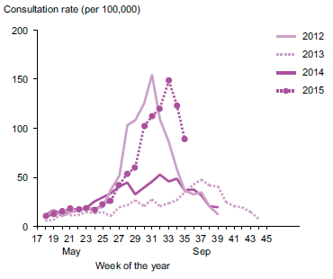

Source: ESR

Influenza activity during the 2015 New Zealand winter was within the normal range of seasonal activity. The 2015 influenza activity was moderate-high, peaking at 148.5 consultations for influenza- like illness per 100,000 people in New Zealand (ESR 2015a). This is similar to the 2012 influenza seasons (Figure 12).

Recent measles outbreaks highlight the importance of reaching the Government’s immunisation target
Measles remains the most common vaccine-preventable cause of death among children throughout the world. It is highly infectious in non-immune communities. In New Zealand we continue to have periodic outbreaks of measles, which routinely start from people who have been infected overseas.
For more information on:
- rheumatic fever and antibiotic resistance, visit: www.health.govt.nz/our-work/diseases-and-conditions
- outbreak surveillance visit: https://surv.esr.cri.nz

During 2014, 280 confirmed cases of measles were notified, compared with only 8 cases in 2013 (ESR 2015b). The majority of cases occurred in Waikato (125) and Auckland (112).

New Zealand is working towards eliminating measles by interrupting the transmission of the measles virus within the country. To eliminate measles, it is necessary to achieve and maintain 95 percent population immunity. Also essential are having sensitive surveillance systems in place to detect
and follow up potential measles cases, and access to laboratory services for confirmation and virus identification.

See the ‘Healthy start’ section for more information on the Government’s better public services health target to increase immunisation rates in children.

Collaborative working is an important part of outbreak management
Between 1 September and 28 October 2014, New Zealand experienced the largest reported outbreak of Yersinia pseudotuberculosis, when 225 confirmed cases were notified. Of these confirmed cases, 70 required hospital assessment or treatment, and some had unnecessary surgery, as symptoms mimic those of appendicitis.

Given a food source is likely to have been responsible for this outbreak, the Ministry for Primary Industries (MPI) led the outbreak response while the Ministry of Health supported the response at national and local levels. Following on from this particular experience, the Ministry of Health and MPI have developed a joint protocol for responding to foodborne illness outbreaks.

Antimicrobial resistance threatens effective prevention and treatment of infection
Modern medical practice relies on the availability of effective antimicrobials to prevent and treat infections. However, many types of bacteria are becoming resistant to the drugs most often used for treatment.

Antimicrobial resistance (AMR) threatens the ability to effectively prevent and treat a range of conditions, including some common infections. Infections caused by resistant micro-organisms are more likely to fail to respond to the antibiotics usually used. This can result in prolonged illness, higher health care expenditures and a greater risk of death.

The prevalence of methicillin/oxacillin-resistant Staphylococcus aureus (MRSA) nearly doubled between 2003 and 2014, from 12.8 to 23.8 per 100,000 people in New Zealand (Heffernan et al 2015). MRSA rates differ considerably between regions: in Tairāwhiti, Counties Manukau and Northland, the rate is more than twice the national average.

Of the 216 cases of culture-positive tuberculosis in 2013, three (1.4 percent) were multidrug-resistant tuberculosis and none was extended drug resistant (ESR 2015c).

Meeting health system challenges
The health and disability system faces a number of challenges now and in the future. Not all New Zealanders enjoy as good a level of health as they could, and access to health care doesn’t always reflect need. We must ensure all New Zealanders have the opportunities to maximise their health by providing accessible, timely and culturally appropriate health and disability services.

There is growing recognition of the need for the health and disability system to work closely with the wider social sector, in order to protect vulnerable populations from harm. Social sector agencies are identifying new ways of working, with greater collaboration and sharing of data.

The health and disability system must find ways of reducing costs while maintaining high-quality services. Reducing the time patients spend in hospital and increasing capacity in primary and community services will support longer-term sustainability as well as improving patient experience.

Improving equity for groups with poorer health outcomes
Although the national picture of health is positive, health outcomes vary substantially across different population groups. Previous sections have already highlighted a number of areas where access to services and health outcomes are worse among Māori and Pacific peoples, and for people living in more socioeconomically deprived areas.

In addition, other groups such as disabled people and those with mental illness experience poorer health outcomes than the population as a whole.
For more information download:
- Tatau Kahukura: Māori Health Chartbook 3rd edition www.health.govt.nz
- Equity of Health Care for Māori: A framework www.health.govt.nz/publication/equity-health-care-maori-framework
- ’Ala Mo’ui: Pathways to Pacific Health and Wellbeing 2014–18 www.health.govt.nz/publication/ala-mou-pathways-pacific-health-and-wellbeing-2014-2018
- A Framework for Health Literacy www.health.govt.nz/publication/framework-health-literacy

To improve health services for these populations, it is necessary to both deliver core services effectively, and to provide additional support and tailored services to those in need of them.

The population is becoming increasingly diverse, with one in four born overseas
New Zealand is becoming more ethnically diverse, as home to more than 143 different ethnic groups (Statistics New Zealand 2014a). Māori make up 15 percent of the New Zealand population, while 12 percent are Asian, 7 percent Pacific peoples and 1 percent Middle-Eastern, Latin American or African (MELAA). The ethnic groups growing most rapidly are MELAA with a 35 percent increase and Asian with a 33 percent increase between the 2006 and the 2013 censuses. A quarter of the population, over 1 million people, were born overseas.

Around 87,000 people living in New Zealand, or 2 percent of the population, do not speak English. The most common languages spoken by non-English speakers are Chinese languages (38 percent of non- English speakers), Samoan (11 percent) and Māori (10 percent).

Where health professionals are themselves ethnically and linguistically diverse, these disadvantaged communities tend to have better access to and quality of care (Ministry of Health 2014a). Currently the medical and nursing workforce includes a lower proportion of Māori and Pacific peoples than the proportion of these ethnic groups in the population as a whole (Table 2) (Ministry of Health 2015f).

Table 2: Ethnic breakdown of the medical and nursing workforce and the New Zealand population
 | Medical workforce¹ | Nursing workforce² | % of population*
European | 68% | 91% | 74%
Māori | 10% | 7% | 15%
Pacific | 3% | 3% | 7%
Chinese | 5% |  | 4%
Indian | 5% |  | 4%
* Total response ethnicity (hence numbers do not add to 100).
1 Medical Council New Zealand 2013 workforce survey.
2 Nursing Council of New Zealand End of Year Statistics as at 31 March 2015.
Source: Unpublished data from Ministry of Health (2015f)

More than half of New Zealanders have poor health literacy skills
Health literacy is the capacity to find, interpret and use health information and health services to make effective decisions for health and wellbeing. Research has shown that a person’s level of health literacy is strongly related to their health status. The majority of New Zealanders have poor health literacy skills. Māori adults fare the worst: four out of five Māori males and three out of four Māori females have poor health literacy skills; in comparison just over half of non-Māori males and females have poor health literacy skills (Ministry of Health 2010).

The Ministry of Health has developed A Framework for Health Literacy to support each level of the health and disability system to build people’s health literacy skills as well as to change the approach of the system itself so that there is less need for patients to have a high degree of health literacy (Ministry of Health 2015e).

Fewer Māori are finding cost a barrier to accessing primary care
Most New Zealanders are able to access primary health care when they need to. However, 28 percent of adults and 22 percent of children had unmet need for primary care in the last year (Ministry of Health 2014c). The most common reason for this unmet need was that people were unable to get an appointment at their usual medical centre within 24 hours (16 percent of adults and 15 percent of children).

Cost was more of a barrier to adults than children, given GP visits have a higher subsidy for young children. One in seven adults (17 percent) did not visit a GP due to cost, at some point in the last year, compared with one in twenty children (5 percent).  The number of Māori adults and children finding cost a barrier to accessing primary care has fallen. In 2012/13 25 percent of Māori adults did not visit a GP due to cost at some point in the last year. This fell to 22 percent in 2013/14. Among Māori children, the proportion fell from 9 percent to 7 percent over the same period. | Tapuaki – Pacific pregnancy and parenting education  Tapuaki is an information service aimed at increasing health literacy among pregnant Pacific mothers and their families. The Tapuaki website and app provide culturally appropriate information on pregnancy and parenting, while also linking pregnant women into maternity and Well Child / Tamariki Ora services. The service was developed to address the low proportion of Pacific mothers engaging early with a Lead Maternity Carer and their low attendance at childbirth education sessions. As well as a website, available in eight Pacific languages, the service runs pregnancy and parenting education classes tailored for Pacific mothers.  You can find out more about Tapuaki by visiting www.tapuaki.org.nz

Protecting vulnerable groups

Children at risk
The health and social sectors play a vital role in identifying, supporting and protecting vulnerable children. The Government has set a target for the public sector to halt the 10-year rise in the number of children experiencing physical abuse, and to reduce the 2011 levels by 5 per cent by 2017. The Children’s Action Plan contributes to this target as a cross-agency framework aimed at strengthening New Zealand’s approach to protecting vulnerable children.

The majority of child abuse deaths and hospitalisations are in infants
On average, eight children aged 0–14 years die each year in New Zealand as a result of injuries from assault, neglect or maltreatment (Figure 13) (Simpson et al 2014). The majority of these are children under four years old.

An additional 167 children aged 0–14 years are hospitalised each year due to assault, neglect or maltreatment (Ministry of Health 2015j). Hospitalisations for these injuries are highest in children aged less than one year and in those over 11 years of age.

Figure 13: The impact of child abuse and neglect on New Zealand children
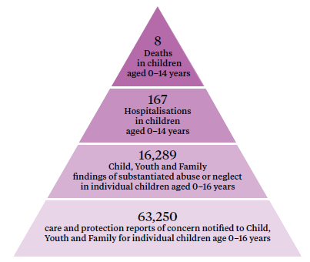
Source: National Minimum Dataset and the Mortality Collection, Ministry of Health, Child Youth and Family

Hospitalisations and deaths are the tip of the iceberg. Child, Youth and Family (CYF) reports that 63,250 children aged 0–16 years were notified to them in 2014 (care and protection reports of concern). Three-quarters of these notifications required further action, with substantiated abuse findings in 16,289 children (CYF 2015).

The health sector plays a vital role in reducing assaults on children through early identification and intervention. When a high proportion of people enrol with a primary health organisation (95 percent at 1 July 2015), as well as with maternity and Well Child / Tamariki Ora services (see page 18), health professionals can develop ongoing relationships with families. Midwives and WCTO nurses can identify parenting problems early, providing advice and support to parents before they reach crisis point.

Early life experiences are linked with health and behavioural outcomes
The Growing Up in New Zealand Study has identified a set of 12 risk factors that are linked with a child’s vulnerability to poor health, social, educational and developmental outcomes. The study found that when a child is exposed to several of these risk factors at any one time, as well as over time, they are more likely to have poor health and behavioural outcomes during the first 1000 days (three years) of development. Figure 14 summarises the proportion of children in the study who were exposed to each of these risk factors before birth (Morton et al 2014).

Over half of children in the study were exposed to at least one risk factor before birth. One in eight was exposed to four or more risk factors.

A greater proportion of children born to Māori and Pacific mothers were exposed to these risk factors before birth, compared with children born to New Zealand European mothers.

Children who were exposed to four or more risk factors, from before birth up until the age of two years, were more likely to experience chest infections and to have incomplete immunisations. If they were exposed to vulnerability risk factors, children were also more likely to have emotional and behavioural issues. Children who were exposed to four or more risk factors were seven times as likely to have an ‘abnormal’ score on the Strengths and Difficulties Questionnaire (SDQ) at the age of two years, compared with children who were exposed to no risk factors (Morton et al 2015).

Figure 14: Proportion of children in the Growing up in New Zealand study exposed to individual risk factors during the ante-natal period
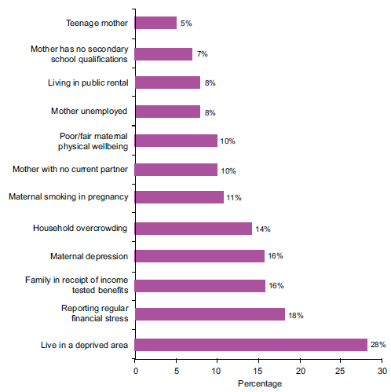
Source: Morton et al (2014)

It is important to note, however, that not all children identified as vulnerable will go on to experience poor health and behavioural outcomes. It is also not clear whether children exposed to these risk factors are at increased risk of physical or psychological abuse.
Download the:
- Child Poverty Monitor Technical Report at www.nzchildren.co.nz
- The Growing Up in New Zealand study’s two reports on vulnerability at www.growingup.co.nz

Older people
Around 14 percent of the population (650,400 people) are aged 65 years and older, and 2 percent (78,000 people) are aged 85 years and older (Statistics New Zealand 2015a). The vast majority of New Zealand residents aged 65 years and older live independently in their own homes and communities, and largely maintain physical, mental and social health well into old age. However, some older people are vulnerable to ill health and require additional support to maintain their independence.

‘Frailty’ is a term used for the subset of older people who are most vulnerable to ill health and dependency. Frail older people lack the physical and mental reserves to cope with minor adversities, often leading to a dramatic decline in wellbeing after a relatively minor event such as an infection. There is no one measure of frailty and so it is difficult to quantify accurately the number of frail individuals in the population. While not a measure of frailty, comprehensive assessments are used to help identify the health and social care needs of older adults.
To find out more on:
- the Atlas of Healthcare Variation, visit: www.hqsc.govt.nz
- the health of older people, visit: www.health.govt.nz/our-work/life-stages/health-older-people

Over 82,000 comprehensive assessments of older people were undertaken last year
Comprehensive assessments are completed for people over 65 years old who are seeking public-funded supports in both community and residential settings.36 In 2014/15, over 82,000 assessments (19,000 contact, 36,500 home care and 26,500 long-term care facility assessments) were undertaken (Table 3) (InterRAI 2015).

Table 3: Outcomes of home and long-term care facility assessments undertaken in 2014/15
 | Home care assessment | Long-term care facility assessment
Total number of assessments | 36,500 | 26,500
High or very high health instability | 10% | 6%
Severe or very severe cognitive impairment | 6% | 22%
Source: InterRAI

Ten percent of those having a home care assessment and 6 percent of those having a long-term care facility assessment were identified as having high or very high health instability. Severe or very severe cognitive impairment was identified in 6 percent of those having a home care assessment and 22 percent of those having a long-term care facility assessment.

Half of adults aged 85 and over are taking five or more long-term medications
‘Poly-pharmacy’ refers to the prescribing of multiple medications to one person, and is associated with a higher risk of adverse drug events. Approximately one in four people aged
65–74 years received five or more long-term medicines in 2014, increasing to one in two adults aged 85 and over (HQSC 2015b).

It is important that individuals taking multiple medications have their prescriptions reviewed regularly. Of those adults aged 65 years and over who were taking four or more medications, 23 percent reported that their prescriptions were not reviewed in the last year (The Commonwealth Fund 2014).

One in eleven adults aged 85+ is hospitalised due to a fall, each year
Older people are at increased risk of having a fall due to a range of factors associated with ageing, including muscle weakness, poor balance, poly-pharmacy and visual impairment. Falls can result in serious injury and loss of independence. In 2013, almost 19,000 adults aged 65 and over were admitted to hospital after having a fall. Hospital admissions due to a fall are most common in adults aged 85 years and over (93 per 1000 in 2013, Figure 15) (HQSC 2015b).

Figure 15: Hospital admissions and hip fracture rates, by age group, 2013
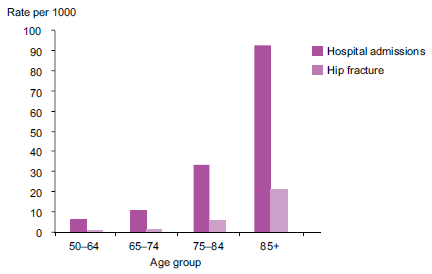
Source: HQSC (2015b)

Over 3000 adults aged 65 years and over were admitted to hospital with a hip fracture in 2013. More than half of these were in adults aged 85 years and over (21 per 1000).

Delivering high-quality, sustainable and safe health care services
The health and disability system must continue to raise the quality and effectiveness of health and disability services within available resources. Every dollar spent on health must gain the maximum possible health benefit for that investment.
Last year in New Zealand
65 million prescriptions were dispensed
25 million laboratory tests were performed
12.6 million GP visits took place
2.8 million nurse visits occurred
1.1 million people were discharged from hospital
1 million emergency department visits occurred
167,000 elective surgeries were performed

At the same time, it is important that people have a good experience of accessing the health and disability system. People want to be treated with dignity and respect. How they are treated and the support they receive can impact on their recovery and future engagement with the health system.

Source: Ministry of Health

Patients are spending less time in hospital
The average length of hospital stays can be reduced by measures such as advances in treatment technologies, more effective drugs, improved community and follow-up care, and more effective hospital administration. Shorter hospital stays are not only cost-effective; they can be better for patients’ wellbeing as well as helping reduce the risk of hospital-acquired infections.

The average length of stay for both medical and surgical procedures has fallen over the last 10 years. For medical procedures, it is 3.3 days, down from 3.7 days in 2005. For surgical procedures, the average length of stay is 4.8 days, down from 5.6 days in 2005. New Zealand’s average length of stay is similar to the OECD average, but slightly longer than in the United Kingdom, United States and Australia (OECD 2013).

The proportion of surgical procedures that are carried out as day cases has increased. Same-day surgical procedures are appropriate for less complex surgery in low-risk patients. In 2014, 58 percent of surgeries were undertaken as day cases, an increase from 52 percent in 2005.

Hospital readmission rates are often compared alongside length of stay data, to check whether the reduced length of stay is impacting on quality of care. However, there is no simple, direct link between higher readmission rates and shorter lengths of stay (HQSC 2012).

A number of factors beyond the health system impact on the risk of readmission, including age, case complexity, comorbidity and the socioeconomic environment (Rumball-Smith and Sarfati 2012). Work is underway to improve the measurement of hospital readmission rates in New Zealand.

Fewer people are dying from causes preventable by health care
This report has already highlighted the importance of prevention, early identification and effective patient management. Amenable mortality refers to deaths that might have been prevented if the condition had been prevented, if health services had been delivered more effectively or if patients had accessed services earlier.

The amenable mortality rate has decreased by 28 percent over the last 10 years, meaning that fewer people are dying from causes that could have been prevented (Figure 16). The largest decline has been seen in Māori, with the amenable mortality rate falling by a third (33 percent). However, the amenable mortality rate is still 2.6 times higher in Māori, and 2.4 times higher in Pacific peoples, compared with non-Māori, non-Pacific peoples.

Figure 16: Amenable mortality rate per 100,000 people aged 0–74 years, by ethnic group, 2000–2012
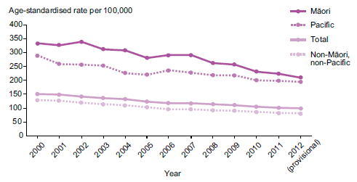
Source: National Minimum Dataset, Ministry of Health

More needs to be done to keep people out of hospital
To keep New Zealanders healthy and out of hospital, our health and disability services must support a person’s health needs before that person has to be treated in hospital. Services must take effective prevention measures, as well as delivering earlier, more convenient health care closer to home. This includes ensuring those discharged from hospital receive the right care and support to prevent readmission.

Ambulatory sensitive hospitalisations (ASH) measure the number of people who appear in hospital with conditions that could have been prevented or treated in out-of-hospital settings such as primary care.

The ASH rate did not change between 2010 and 2014, except for an 11 percent decline among Māori. However, ASH rates in Māori and Pacific peoples remain over double the rate for non-Māori/non-Pacific.

The most common conditions contributing to the ASH rates are cellulitis, gastroenteritis and dental conditions. This varies by age and ethnicity as detailed in the 2014 Health and Independence Report (Ministry of Health 2014b).

The majority of patients are satisfied with the care they receive in hospital
The adult inpatient experience survey was introduced across New Zealand last year, with early results showing high levels of patient satisfaction. The average in-patient rating was more than 8 out of 10 across all four domains of experience, which cover communication, partnership, coordination of care, and physical and emotional needs (HQSC 2015a).

The 2014 Maternity Consumer Survey reports high levels of satisfaction with the care received during pregnancy and birth and in the postnatal period. Over three-quarters (77 percent) of women were very satisfied or satisfied with the overall care received, and 80 percent were very satisfied or satisfied with the care received from their Lead Maternity Carer (Research New Zealand 2015).
To find out more on:
- international measures of health care quality, visit: www.oecd.org/els/health-systems/health-data.htm
- patient experience, visit: www.hqsc.govt.nz/our-programmes/health-quality-evaluation
- the maternity consumer survey 2014, visit: www.health.govt.nz/publication/maternity-consumer-survey-2014

The Ministry of Health and the Health Quality and Safety Commission (HQSC) are developing a patient experience survey to be used in primary care. The survey is being piloted and, once rolled out, will provide detailed information on patients’ experience of care.

Information from the 2013/14 New Zealand Health
Survey indicates that the majority of adults (80 percent) and parents of children (78 percent) who had visited their general practitioner (GP) in the previous three months reported high levels of confidence and trust in their GP (Ministry of Health 2014c). However, among parents, reported confidence and trust in their GP has fallen from 82 percent in 2012/13.

A focus on quality and safety is leading to improvements in infection control
HQSC has focused on a number of quality and safety markers through the ‘Open for better care’ patient safety campaign. These markers concentrate on four areas of harm: falls, health care associated infections, perioperative harm and medication safety.

The percentage of older people who are assessed for risk of falling has risen: 90 percent were assessed by the end of March 2015, compared with 76 percent at the same time in 2013 (HQSC 2015b). Those who are identified as ‘at risk of falling’ are also more likely to receive an individualised care plan to address those risks (91 percent at the end of March 2015).

The recorded use of the World Health Organization (WHO) surgical safety checklist reached 93 percent by the end of March 2015, compared with 71 percent at the same time in 2013. A number of process measures aimed at reducing surgical site infections have also shown improvements.

National compliance with the five moments for hand hygiene continues to improve, reaching 77 percent by March 2015.

Central line associated bacteraemia (CLAB) are blood stream infections caused by central line catheters, which are inserted into the blood vessels near the heart. CLAB can lead to longer hospital stays and associated costs. Since targeted work began, CLAB in intensive care units has fallen dramatically and is now very rare.

Summary
Many factors contribute to population health and wellbeing. Individual factors, as well as the social, economic and physical environment we live, learn, work and play in, all play a part.

Good health starts early in life. Our early years impact not only on how long we live, but also on how many years we live in good health. Improving health behaviours and minimising risk factors in children and young people will help reduce the burden of long-term conditions in the future.

Early engagement with the health system can help ensure New Zealanders have access to the right support at the right time. Improving people’s ability to navigate the health system, to become more engaged in and make informed decisions about their own health, will foster that development.

Currently too few New Zealanders are following healthy lifestyles. Improving our diets and levels of exercise and reducing a range of risky behaviours are vital. Moving a greater proportion of New Zealanders toward less risky lifestyles will reduce health loss and improve the general health of the population.

Mental wellbeing must also be seen as a fundamental aspect of a healthy lifestyle. Developing good mental health and resilience among children as well as throughout life is essential if we are to minimise the individual and social impact of poor mental health.

Early diagnosis, timely treatment and effective management are important for both mental and physical health. The health and disability system must ensure all New Zealanders have good access to effective screening and primary health care services.

As well as putting a greater focus on prevention, the health and disability system faces a number of challenges going forward. Given the increasingly diverse and ageing population, complex issues like child vulnerability and obesity, and the need to ensure the sustainability of the health and disability system, the health and disability system must think about new ways of working.

The update of the New Zealand Health Strategy will set a vision for the health and disability sector for the next 10 years. The strategy will help focus the system’s efforts as well as identifying areas where change is needed. Enablers of progress include better use of technology and sharing of information, developing trust and leadership excellence, identifying new ways of working together and enhancing cross-sector collaborations. These enablers underline a drive for innovation that will inform decision- making about the best ways to tackle New Zealand’s enduring population health challenges.

Technical notes
This report includes data from a wide range of sources, many of which are produced outside of the Ministry of Health. We have tried to ensure we only report on data where the data collection and analytical processes are robust. Footnotes are included where methodological information impacts on the interpretation of the data. We encourage you to refer to the original data source for further methodological information.

All data reported are the latest available, although the time lag between the most recent data and the present can be substantial. For example, the most recent complete mortality data are for 2012.

Where possible, we have reported on statistically significant time trends and differences between population groups, for example, by sex, age group and ethnic group.

Unless otherwise specified, total response ethnicity has been used with ethnic comparisons. Total response ethnicity classifies a person in all the ethnic groups that they identify with; this means that statistics for individual people can appear in more than one ethnic group. Where possible, we have compared ethnicity data with mutually exclusive groups, such as Māori with non-Māori.

In many comparisons, the results are adjusted or standardised for factors that may be influencing (confounding) the comparison, such as age, sex and ethnicity. Age standardisation is often used in this report to account for differences in age structure between population groups, using the WHO world population.

Selected results are presented by neighbourhood deprivation, as measured by the New Zealand Index of Deprivation 2013 (Atkinson 2014). In this report, ‘most deprived areas’ refers to quintile 5; that is, the people living in the most socioeconomically deprived 20 percent of small areas in New Zealand.

References
Atkinson J, Salmond C, Crampton P. 2014. NZDep2013 Index of Deprivation. Dunedin: University of Otago.
Cheung J, Timmins J, Wright C. 2015. Patterns and Dynamics of Alcohol Consumption during Pregnancy in a Recent New Zealand Cohort of Expectant Mothers. Wellington: Social Policy Evaluation and Research Unit.
Clark TC, Fleming T, Bullen P, et al. 2013. Youth’12 Overview: The health and wellbeing of New Zealand secondary school students in 2012. Auckland: The University of Auckland.
Coppell KJ, Mann JI, Williams SM, et al. 2013. Prevalence of diagnosed and undiagnosed diabetes and prediabetes in New Zealand: findings from the 2008/09 Adult Nutrition Survey. New Zealand Medical Journal 126(1370).
CYF. 2015. Key statistics and information for media. Wellington: Child, Youth and Family. URL: www. cyf.govt.nz/about-us/key-statistics (accessed 7 September 2015).
Danese A, Moffitt TE, Harrington H, et al. 2009. Adverse childhood experiences and adult risk factors for age-related disease: depression, inflammation, and clustering of metabolic risk markers. Archives of Pediatrics and Adolescent Medicine 163(12): 1135–43.
ESR. 2015a. Influenza Weekly Update 2015/36: 24–30 August 2015. Porirua: Institute of Environmental Science and Research Ltd.
ESR. 2015b. Notifiable Diseases in New Zealand: Annual Report 2014. Porirua: Institute of Environmental Science and Research Ltd.
ESR. 2015c. Tuberculosis in New Zealand: Annual Report 2013. Porirua: Institute of Environmental Science and Research Ltd.
Grant AM, Taungapeau FK, McAuley KA, et al. 2008. Body mass index status is effective in identifying metabolic syndrome components and insulin resistance in Pacific Island teenagers living in New Zealand. Metabolism 57(4): 511–6.
Heffernan H, Bakker S, Dyet K, et al. 2015. Annual Survey of Methicillin-resistant Staphylococcus aureus (MRSA), 2014. Porirua: Institute of Environmental Science and Research Ltd.
Hotu S, Carter B, Watson PD, et al. 2004. Increasing prevalence of type 2 diabetes in adolescents. Journal of Paediatrics and Child Health 40(4): 201–4.
HQSC. 2012. Describing the Quality of New Zealand’s Health and Disability Services. Wellington: Health Quality and Safety Commission.
HQSC. 2015a. Adult Inpatient Experience. Wellington: Health Quality and Safety Commission. URL: www.hqsc.govt.nz/our-programmes/health-quality-evaluation/projects/health-quality-and-safety-indicators/patient-experience/adult-inpatient-experience/ (accessed 13 August 2015).
HQSC. 2015b. Atlas of Healthcare Variation. Wellington: Health Quality and Safety Commission. URL: www.hqsc.govt.nz/our-programmes/health-quality-evaluation/projects/atlas-of-healthcare-variation (accessed 9 September 2015).
Institute for Health Metrics and Evaluation. 2013. GBD Compare. Seattle, WA: IHME, University of Washington. URL: http://vizhub.healthdata.org/gbd-compare (accessed 24 September 2015).
InterRAI. 2015. National interRAI Software Service.
Jones PB. 2013. Adult mental health disorders and their age at onset. British Journal of Psychiatry 202(s54): s5–s10.
Kvaavik E, Batty G, Ursin G, et al. 2010. Influence of individual and combined health behaviors on total and cause-specific mortality in men and women: the United Kingdom health and lifestyle survey. Archives of Internal Medicine 170(8): 711–8.
Litmus, et al. 2015. Interim Evaluation Report of the Bowel Screening Pilot: Screening Round One. Wellington: Ministry of Health.
Mannucci E, Dicembrini I, Lauria A, et al. 2013. Is glucose control important for prevention of cardiovascular disease in diabetes? Diabetes Care 36(Suppl 2): S259–63.
Ministry of Health. 2010. Kōrero Mārama: Health Literacy and Māori. Results from the 2006 Adult Literacy and Life Skills Survey. Wellington: Ministry of Health.
Ministry of Health. 2014a. ’Ala Mo’ui: Pathways to Pacific Health and Wellbeing 2014–2018. Wellington: Ministry of Health.
Ministry of Health. 2014b. Annual Report for the Year Ended 30 June 2014 including the Director- General of Health’s Annual Report on the State of Public Health. Wellington: Ministry of Health.
Ministry of Health. 2014c. Annual Update of Key Results 2013/14. New Zealand Health Survey. Wellington: Ministry of Health.
Ministry of Health. 2015a. 2014–15 Smoking cessation services data.
Ministry of Health. 2015b. 2014 Virtual Diabetes Register results. URL: www.health.govt.nz/our-work/ diseases-and-conditions/diabetes/about-diabetes/virtual-diabetes-register-vdr/2014-virtual-diabetes- register-results (accessed 15 September 2015).
Ministry of Health. 2015c. Alcohol Use 2012/13: New Zealand Health Survey. Wellington: Ministry of Health.
Ministry of Health. 2015d. BSA District Health Board Coverage Report: period ending 30 June 2015. Wellington: Ministry of Health.
Ministry of Health. 2015e. A Framework for Health Literacy. Wellington: Ministry of Health.
Ministry of Health. 2015f. Health of the Health Workforce 2014 to 2015 (unpublished).
Ministry of Health. 2015g. Health targets. URL: www.health.govt.nz/new-zealand-health-system/ health-targets (accessed 7 September 2015).
Ministry of Health. 2015h. Indicators for the Well Child / Tamariki Ora Quality Improvement Framework March 2015. Wellington: Ministry of Health.
Ministry of Health. 2015i. National and DHB immunisation data. URL: www.health.govt.nz/our- work/preventative-health-wellness/immunisation/immunisation-coverage/national-and-dhb- immunisation-data (accessed 31 August 2015).
Ministry of Health. 2015j. National Minimum Dataset.
Ministry of Health. 2015k. Progress on the Better Public Services rheumatic fever target. URL: www. health.govt.nz/about-ministry/what-we-do/strategic-direction/better-public-services/progress-better- public-services-rheumatic-fever-target (accessed 31 August 2015).
Ministry of Health. 2015l. Suicide Facts: Deaths and intentional self-harm hospitalisations 2012. Wellington: Ministry of Health.
Ministry of Health. 2015m. Understanding Excess Body Weight: New Zealand Health Survey. Wellington: Ministry of Health.
Moehler E, Brunner R, Wiebel A, et al. 2006. Maternal depressive symptoms in the postnatal period are associated with long-term impairment of mother–child bonding. Archives of Women’s Mental Health 9(5): 273–8.
Morton SMB, Atatoa Carr PE, et al. 2014. Growing Up in New Zealand: Vulnerability Report 1: Exploring the definition of vulnerability for children in their first 1000 days. Auckland: Growing Up in New Zealand.
Morton SMB, Atatoa Carr PE, et al. 2015. Growing Up in New Zealand: Vulnerability Report 2: Transitions in exposure to vulnerability in the first 1000 days of life. Auckland: Growing Up in New Zealand.
NSU. 2015a. National Screening Unit home page. URL: www.nsu.govt.nz (accessed 15 September 2015).
NSU. 2015b. NCSP monthly coverage June 2015. URL: www.nsu.govt.nz/system/files/page/ncsp_ monthly_coverage_jun_2015_25-69.xls (accessed 15 September 2015).
OECD. 2009. Doing Better for Children. Paris: Organisation for Economic Co-operation and Development.
OECD. 2013. Health at a Glance 2013: OECD indicators. Paris: Organisation for Economic Co-operation and Development.
OECD. 2015. OECD Health Statistics 2015. URL: http://stats.oecd.org (accessed 29 September 2015).
Parliamentary Review Committee. 2015. Report of the Parliamentary Review Committee regarding the New Zealand Cervical Screening Programme. Wellington: Ministry of Health.
Raffle A, Barratt A, Gray J. 2013. Assuring screening programmes. In C Guest, W Ricciardi, I Kawachi, et al (eds) Oxford Handbook of Public Health Practice. New York: Oxford University Press.
Research New Zealand. 2015. Maternity Consumer Survey 2014. Wellington: Ministry of Health.
Rumball-Smith J, Sarfati D. 2012. Readmission: use with caution. New Zealand Medical Journal 125(1367).
Simpson J, Obesn G, Wicken A, et al. 2014. Child Poverty Monitor 2014 Technical Report. Dunedin: NZ Child & Youth Epidemiology Service, University of Otago.
Statistics New Zealand. 2014a. 2013 Census QuickStats about culture and identity. URL: www.stats. govt.nz
Statistics New Zealand. 2014b. Injury Statistics: Work related claims: 2013. Wellington: Statistics New Zealand. URL: www.stats.govt.nz
Statistics New Zealand. 2014c. The New Zealand Disability Survey 2013. Wellington: Statistics New Zealand. URL: www.stats.govt.nz
Statistics New Zealand. 2014d. NZ Social Indicators: Life expectancy. URL: www.stats.govt.nz
Statistics New Zealand. 2015a. Estimated Resident Population at 30 June 2014. URL: www.stats.govt.nz
Statistics New Zealand. 2015b. The New Zealand General Social Survey: 2014. Wellington: Statistics New Zealand. URL: www.stats.govt.nz
The Commonwealth Fund. 2014. 2014 Commonwealth Fund International Health Policy Survey of Older Adults in 11 Countries – Article chartpack. Washington, DC: The Commonwealth Fund.
Wells JE, Baxter J, Schaaf D. 2007. Substance Use Disorders in Te Rau Hinengaro: The New Zealand Mental Health Survey. Wellington: Alcohol Advisory Council of New Zealand.
WHO. 2014. Mental Health: A state of well-being. Geneva: World Health Organization. URL: www.who. int/features/factfiles/mental_health/en/ (accessed 15 September 2015).
Yudkin JS, Montori VM. 2014. The epidemic of pre-diabetes: the medicine and the politics. British Medical Journal 349: g4485.

OECD data relate to 33 countries with similar levels of economic development to New Zealand.
Pacific life expectancy may be slightly overestimated due to incomplete mortality data on those who move to a Pacific Island country when terminally ill.
Historic information is not provided for Māori, due to methodological differences in earlier disability survey designs.
Disability is defined as an impairment that has a long-term (for more than six months) limiting effect on a person’s ability to carry out day-to-day activities.
Non-melanoma skin cancers are not registered in New Zealand.
After adjusting for changes in the size and age structure of the population over this period.
After adjusting for age and sex differences.
After adjusting for age, sex and ethnic differences.
Takes account of the reduction in cardiovascular disease and diabetes risk that is linked to low or moderate alcohol consumption.
Hazardous drinking is defined as behaviour that results in a score of 8 points or more on the Alcohol Use Disorders Identification Test (AUDIT).
After adjusting for other factors that may be influencing the results (such as age, sex and ethnic group).
Physically active is defined as undertaking at least 30 minutes of moderate-intensity physical activity at least five days per week.
After adjusting for other factors that may be influencing the results (such as age, sex and ethnic group).
Among countries that report measured obesity rates.
After adjusting for other factors that may be influencing the results (such as age, sex and ethnic group).
Vegetable and fruit consumption is used as a proxy measure for a healthy diet; however this measure is likely to overestimate the proportion of New Zealanders who have a healthy diet.
Analysis of household crowding based on census 2013 data.
Data from the Midwifery and Maternity Provider Organisation and LMC services, which represents around 80 percent of pregnant women registered with a midwife.
It is likely that alcohol consumption in pregnancy is under-reported, and women may not report alcohol consumed before they were aware of their pregnancy.
The study used the 2010 American Diabetes Association definition of pre-diabetes (HbA1c between 39 and 46 mmol/mol), which differs from the revised 2012 New Zealand criteria (HbA1c between 41 and 49 mmol/mol).
Not adjusted for age, sex and ethnicity.
Adjusted for age and sex.
These lifestyle factors also contribute to health loss from other causes including cancer, musculoskeletal disorders and respiratory disease.
Information is only available for smoking cessation services purchased by the Ministry of Health and not those directly purchased by district health boards.
High blood pressure is defined as having systolic blood pressure of 140 mmHg or higher and/or diastolic blood pressure of 90 mmHg or higher and/or currently taking medication for high blood pressure.
Based on measurements taken in a single sitting. On repeat testing, many may be found to not have high blood pressure.
After standardising for age.
The study used the 2010 American Diabetes Association definition of pre-diabetes (HbA1c between 39 and 46 mmol/mol), which differs from the revised 2012 New Zealand criteria (HbA1c between 41 and 49 mmol/mol).
The New Zealand Health Survey does not collect information on self-reported dementia because this measure is unreliable. While excluding dementia, a major cause of health loss in older people, is problematic, it is unlikely to substantively affect the results of multi-morbidity analysis because dementia prevalence is quite low except in the very old.
Chronic pain is pain that is present almost every day and lasting, or expected to last, for more than six months.
Some individuals reporting chronic pain actually have arthritis; so these two categories overlap slightly, which in turn suggests that the co-occurrence of these two conditions may be slightly overestimated.
This figure only covers hospitalisations for people’s first episode of rheumatic fever.
First episode hospitalisations.
Average annual number of deaths between 2000 and 2011.
Average annual number of admissions between 2010 and 2014.
Assessments should be undertaken every 6 months for those living in long-term care facilities.
The WHO identifies the following five moments for hand hygiene as critical to the prevention and control of infections: before touching a patient, before a procedure, after a procedure or body fluid exposure risk, after touching a patient and after touching a patient’s surroundings.

