Health of Older People Strategy
Consultation draft

Citation: Ministry of Health. 2016. Health of Older People Strategy: Consultation draft.
Wellington: Ministry of Health.
Published in July 2016
by the Ministry of Health
PO Box 5013, Wellington 6140, New Zealand
ISBN: 978-0-947515-32-4 (print)
ISBN: 978-0-947515-33-1 (online)
HP 6445
This document is available at health.govt.nz
This work is licensed under the Creative Commons Attribution 4.0 International licence. In essence, you are free to: share ie, copy and redistribute the material in any medium or format; adapt ie, remix, transform and build upon the material. You must give appropriate credit, provide a link to the licence and indicate if changes were made.

Minister’s foreword

Older New Zealanders are a large and growing proportion of our population. They deserve our best support to live healthy, independent lives and to have a respectful end of life.
I commissioned the refresh of this Strategy to follow the updated New Zealand Health Strategy, which provides a framework for the health and disability system to achieve equitable outcomes for all New Zealanders. To be able to provide for the growing number of older New Zealanders, we need to ensure our health and disability services are sustainable. We have the opportunity to embrace changes to the system and the way it operates that will improve its sustainability and add life to years, not just years to life.
This draft Strategy intends to provide a clear direction for the sector and outlines the actions needed to improve the health outcomes and independence of older people in a sustainable way. This will require an innovative and responsive system that is person centred and that appropriately supports older people to make informed choices about their health and wellbeing.
This draft Strategy has strong links to the Positive Ageing Strategy. Older people make a significant contribution to and have an integral role in our society. The Government is committed to the goals of positive ageing and a vision where older people age well and are healthy, connected, independent and respected.
A multi-faceted and coordinated approach is needed to improve the health, independence and wellbeing of our older people, particularly those who are living with long-term conditions, have high and complex health needs or are in population groups that are experiencing poorer outcomes from the health system. This will require the health and social sectors to work collaboratively and for everyone in New Zealand to recognise the important role that family, whānau and ’āiga carers play in supporting our older people in their homes and communities.
As well as enabling and supporting older people to age well, this Strategy focuses on ensuring older people have a respectful end of life. Older people need to feel safe and supported to openly discuss and plan their end-of-life care. The health system also needs to be coordinated and responsive to older people’s wishes.
The draft Strategy is the result of a highly collaborative process, involving many people and organisations with a stake in how we maintain and improve the health older people. This reflects the multiple influences on older people’s health and wellbeing, and illustrates a shared understanding, responsibility and commitment to the vision of the Strategy and to making the changes to maintain and improve the health of older people.
I would especially like to acknowledge the contribution of older people and family and whānau carers to the draft Strategy. Your input has been important as it will help to shape and improve the system and services to better respond to your needs and circumstances so that you can live well and age well, and so that your wishes are respected.
Hon Peseta Sam Lotu-Iiga
Associate Minister of Health

Director-General of Health’s foreword

With the release of the refreshed New Zealand Health Strategy, it is an appropriate time to review the Health of Older People Strategy.
The existing strategy, launched in 2002 has delivered many successes, including greater choice in long-term health care services. We can all be proud of that.
However, the social and demographic picture in our country has changed over the past 14 years. In 2002, when the current strategy was published, people 65 and older made up 11.5 percent of the New Zealand population. That figure is now 15 percent and by 2033 is expected to reach 22 per cent.
We must ensure that our health system provides the care, support and treatment that older New Zealanders need and, is sustainable. We want a health system that works for every older New Zealander. This means taking into account all the factors that impact on peoples’ health and wellbeing.
The New Zealand Health Strategy recognises the challenges and opportunities we face. Its five themes – people-powered, closer to home, one team, smart system and value and high performance – are further developed in this draft Health of Older People Strategy.
It has a strong focus on prevention and support for independence. It also recognises the importance of family, whānau and community in older people’s lives. In addition, it signals the need for Government agencies, healthcare providers and all those who make a difference to health and wellbeing to work better together. Better integrating health and social responses will help them be more responsive to New Zealanders’ needs and choices.
Following everyone’s input, this draft Strategy’s priorities are adding ‘life to years’, and a future oriented around healthy ageing, living well with long-term conditions, recovery from acute events, better support for people with high and complex needs, and ensuring people can experience a respectful end of life.
The actions outlined in the draft Strategy have been organised around the five New Zealand Health Strategy themes to make it easier to measure and review progress, performance and quality.
This draft Strategy provides us with a clear focus and vision for where we want to head. As with the New Zealand Health Strategy, the Ministry of Health will provide the leadership needed to help all the organisations involved play their part in the actions, changes and focus needed.
Leadership in this context is not about being in charge or having all the answers. Many people and organisations have been involved in developing this draft strategy: from individuals to families and whānau, carers, health professionals, service providers, government and non-governmental organisations. I’d like to thank everyone who has contributed. Your insights are vital.
So I encourage you to stay involved with this process and make a submission on this draft. Your feedback will help us to prioritise the right actions to build a manageable programme of work that gets results.
Chai Chuah
Director-General of Health

Contents
Minister’s foreword iii
Director-General of Health’s foreword iv
About this document 1
Strategy development and consultation process 2
The need for a new strategy for the health of older people 3
Strategic context 5
Taking a life course approach 7
Challenges and opportunities 8
Vision and objectives 13
Healthy ageing 14
Acute and restorative care 17
Living well with long-term conditions 20
Support for people with high and complex needs 24
Respectful end of life 27
Turning the Strategy into action 29
Action plan 31
Your feedback 43

About this document

This document sets out a draft strategy for the health and wellbeing of older people for the next 10 years. It will benefit older people, family and whānau of older people, those who work with older people, and those who plan and fund services.
This is a consultation document. The Ministry of Health is seeking your views on the direction we take and the actions we propose.
There are four parts to this document. The first part is introductory, and sets out the need for a new strategy. The second proposes an overarching direction for the system for 2016–2026. The third section is the ‘Action Plan’: it proposes a set of specific actions we want to take. The fourth part, ‘Have Your Say’, tells you about how to make a submission and make sure it reaches us in time, and includes questions to guide your submissions.
Older people are by no means a homogenous population group. We don’t become ‘old’ at any particular age or age in the same way. Ageing is only partially associated with chronological ageing and there is no ‘typical’ 65- or 75-year-old. The choices we make, our intrinsic biology and abilities, our social, environmental and economic circumstances and the activities we engage in can greatly influence the pace at which we age. Not all people will become dependent on others as they age.
This draft Strategy takes an inclusive approach. It is not limited to people with health conditions and disabilities that need treatment and management. It will benefit:
- people who are independent and competent, both physically and mentally, throughout their older years
- people with acute health conditions who need short-term support or rehabilitation to return to their previous level of independence
- people who had long-term or chronic health conditions or disabilities during their earlier adult years, and whose needs become more complex as they age
- people who develop disabilities and become dependent as they age, due to cognitive and physical decline, and conditions such as dementia
- people in the last stages of life.
The draft Strategy supports a person-centred approach. Our system and services aim to keep people in good health for longer, recognising that older people have different needs at different times. People with the highest need may be those who have the fewest resources and the least capacity to address that need.
The draft Strategy takes a preventative approach to illness and disability associated with the ageing process. It also focuses on older people who have had long-term disabilities, who may be living independently and competently in their older years. It also recognises that some people with life-long disabilities may have more unique and complex health and disability needs as they age.

Strategy development and consultation process

This draft Strategy is the result of extensive engagement with older people and their families, whānau, ’āiga and carers, aged care providers, health care professionals, professional bodies, researchers, Māori and Pacific service providers, government agencies, district health boards (DHBs), primary health organisations (PHOs) and other non-governmental organisations representing and supporting older people.
We held workshops with these key stakeholders that helped to establish the key priorities for the Strategy, along with a wide range of potential actions. We held additional focus groups with older people and carers of older people, which helped us to understand what’s important to older people, and how they currently experience and want to experience the health system. During this time, we received suggestions for the Strategy by email and through the Ministry’s website.

The image below shows the values most commonly identified in the engagement workshops regarding the ‘ultimate goal’ for the Strategy. All of the input has helped us develop this consultation document. We are now seeking your feedback on this draft Health of Older People Strategy, and encourage you to make a submission.

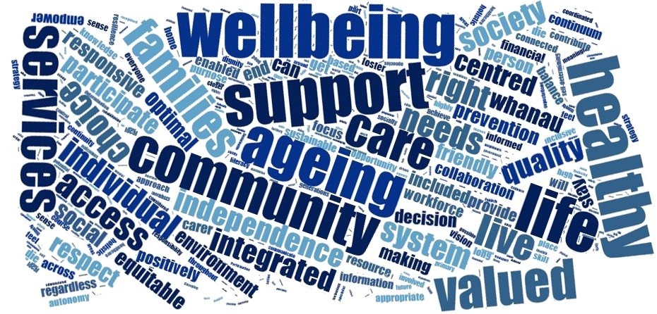

The need for a new strategy for the health of older people

Everyone is ageing and wants to age well. That New Zealanders are living longer than ever before is a major success story, and most older people are fit, healthy and active.
Older people contribute greatly to our society as family and whānau, carers, neighbours, mentors, leaders, volunteers, employees and employers, tax payers and consumers.
Remaining in good health, ageing well and being able and supported to live well with long-term conditions is critical to enable older people to continue participating and feeling valued, which in turn is important for health and wellbeing.
Building a health system that can deliver good health outcomes requires us to take stock of our achievements, challenges and opportunities, our policies, the way we currently fund and deliver care, our performance and the tools and resources we need to reach our goals.

Building on our achievements
Since the release of the 2002 Health of Older People Strategy, we have made significant improvements. We substantially implemented that Strategy’s more than 100 actions, which has led to:
- more consistent and comprehensive assessment of people’s needs for home and community support and residential care
- greater choice in long-term health care and disability support services; we are supporting more people than ever to remain in their homes for longer with long-term health conditions and disabilities
- increased funding for home and community support services (this has doubled over the last eight years) and residential care, especially for those who need it most
- a significant improvement in the quality of health care in aged residential care; and we are making improvements in home and community support services
- implementation of the Dementia Care Framework, which aims to increase people’s understanding and acceptance of dementia and to better equip primary health care services to diagnose uncomplicated dementia earlier
- a greater understanding of the factors that can help older Māori remain healthy and independent into old age
- projects to improve older people’s strength and balance; to prevent frailty, fractures and harm from falls; and to increase older people’s mental wellbeing, mobility and quality of life
- a better understanding of various risk factors for poor health, including social isolation and loneliness, certain neurological conditions, and frailty. We know more about the potential of technology to combat these issues
- better quality information on health services tailored for older people
- improved access to elective surgery, which results in greater levels of activity and independence
- improved discharge planning, aiming to strengthen connections between acute hospital services and health services in the community such as CREST and START.
Fourteen years on from the 2002 Strategy, our operating environment has changed, and our priorities continue to evolve.
The refreshed New Zealand Health Strategy has set new directions for our health system into the future. It is driving how we organise ourselves and behave, with a stronger focus on prevention, independence and wellness, people-centred services, trust, cohesion and collaboration, and integrated social responses.
We need to apply those principles to our approach for improving and maintaining older people’s health and wellbeing.
Part of this is making sure that we are getting the best value we can from our funding. As we age, we are more likely to develop long-term chronic health conditions and disabilities requiring support on a daily or regular basis.
We currently spend 42 percent of the $11,000 million health budget on people aged 65 years and older, who make up 15 percent of population. Based on population growth alone, this could rise to 50 percent of DHB expenditure by 2025/26. However, cost increases do not need to mirror demographic growth. Recently, the percentage of older people requiring some of the most expensive health services, such as acute care and aged residential care, has decreased. This indicates that older people are increasingly healthy and better supported to live well at home.
We want to maintain the positive changes we have seen over the last 14 years and improve on them in the current context.
We also want a system that is truly person-centred, supporting and empowering people to make informed choices about their health and wellbeing, and is coordinated and integrated around people’s needs and aspirations, providing high-quality services that deliver value for people.

Strategic context

The Health of Older People Strategy sits under the New Zealand Health Strategy 2016, released on 18 April 2016, which provides the overarching framework and directions for the health system. The New Zealand Health Strategy describes the future we want, identifies the culture and values that underpin this future, and sets out five strategic themes for changes we can make that will take us toward the vision:
All New Zealanders live well, stay well, get well, in a system that is people-powered, provides services closer to home, is designed for value and high performance, and works as one team in a smart system.
The Health Strategy provides the building blocks for this Health of Older People Strategy. Together, the two strategies set out how we will work toward maintaining and improving healthy ageing and independence, regardless of people’s health status, and provide better support for people with high and complex needs and at the end of life.
The New Zealand Disability Strategy 2001 also feeds into this Health of Older People Strategy. It presents a long-term plan for an inclusive society that highly values disabled people and continually enhances their full participation. This Strategy is undergoing a refresh in 2016 and will be informed by the Convention on the Rights of Persons with Disabilities, ratified in 2008. The Health of Older People Strategy is consistent with the articles of the Convention.
Government has a long-standing commitment to the vision and principles of the cross-government New Zealand Positive Ageing Strategy 2001, as reiterated in 2013 in Older New Zealanders – Healthy, Independent, Connected and Respected. Together, government agencies, including local government, are working towards a ‘vision of a society where people can age positively and where older people are highly valued and recognised as an integral part of families and communities’.
We recognise and respect the special relationship between Māori and the Crown through the principles of the Treaty of Waitangi. In the health and disability sector, this involves more support to participate in the sector and in making decisions on services. Given the poorer health experienced by Māori, this also involves delivering services that are effective for Māori. He Korowai Oranga, the Māori health strategy, guides the government’s and the health system’s approach to Māori health, in line with the Treaty, and including for the health of older people. This Strategy was last updated in 2014.
Other specific national strategies, action plans and work programmes influence the health of older people and provide guidance for services on meeting their needs. The diagram below sets out some of these, and the Action Plan section of this document includes some of their priorities and actions.
The priorities and actions under these strategies are complex and dynamic and more specific details are included alongside the Health of Older People Strategy actions. It is our intention to regularly review progress towards these actions alongside progress towards the health of older people strategic directions, to ensure we remain on track.

The Health of Older People Strategy in its government context
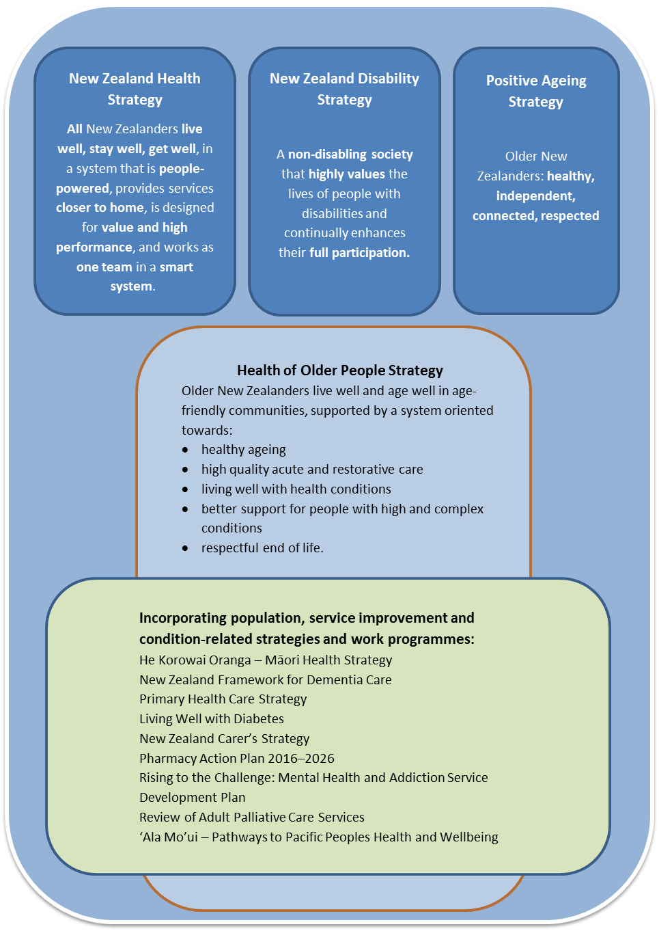

Taking a life course approach

How well we age is influenced by our genetics, our upbringing, how healthily we live in younger years and throughout our adult life and our exposure to health risks including poor housing, workplace discrimination and family violence. Also highly influential are our physical and mental capabilities; our access to resources and opportunities; our resilience including in the face of adversity; our relationships; our personal circumstances, including our occupation, level of wealth, educational attainment and gender; our potential for personal growth; and our sense of identity, security, value and wellbeing.
This Strategy applies a life course approach to achieving the aim of healthy ageing. This recognises that we age in different ways and have different needs at different times, and that our health is affected by our environment. The approach involves enhancing growth and development, preventing disease and ensuring the highest capacity possible throughout life.
‘Healthy ageing’ does not refer to the absence of disease or physical or mental ill health. The World Health Organization defines healthy ageing as ‘the process of developing and maintaining the functional ability that enables wellbeing in older age.’
Initiatives for older people that take a life course approach, promoting ‘healthy ageing’, focus on building and maintaining people’s physical and mental function and capacity, maintaining independence and preventing and delaying disease and the onset of disability. Such initiatives aim to maintain quality of life for older people who live with some degree of illness or disability requiring short or long-term care. They enable disabled people to do the things that are important to them, enhancing their participation, social connection and appropriate care and ensuring their dignity in later years.

Figure 1: A life course framework for healthy ageing
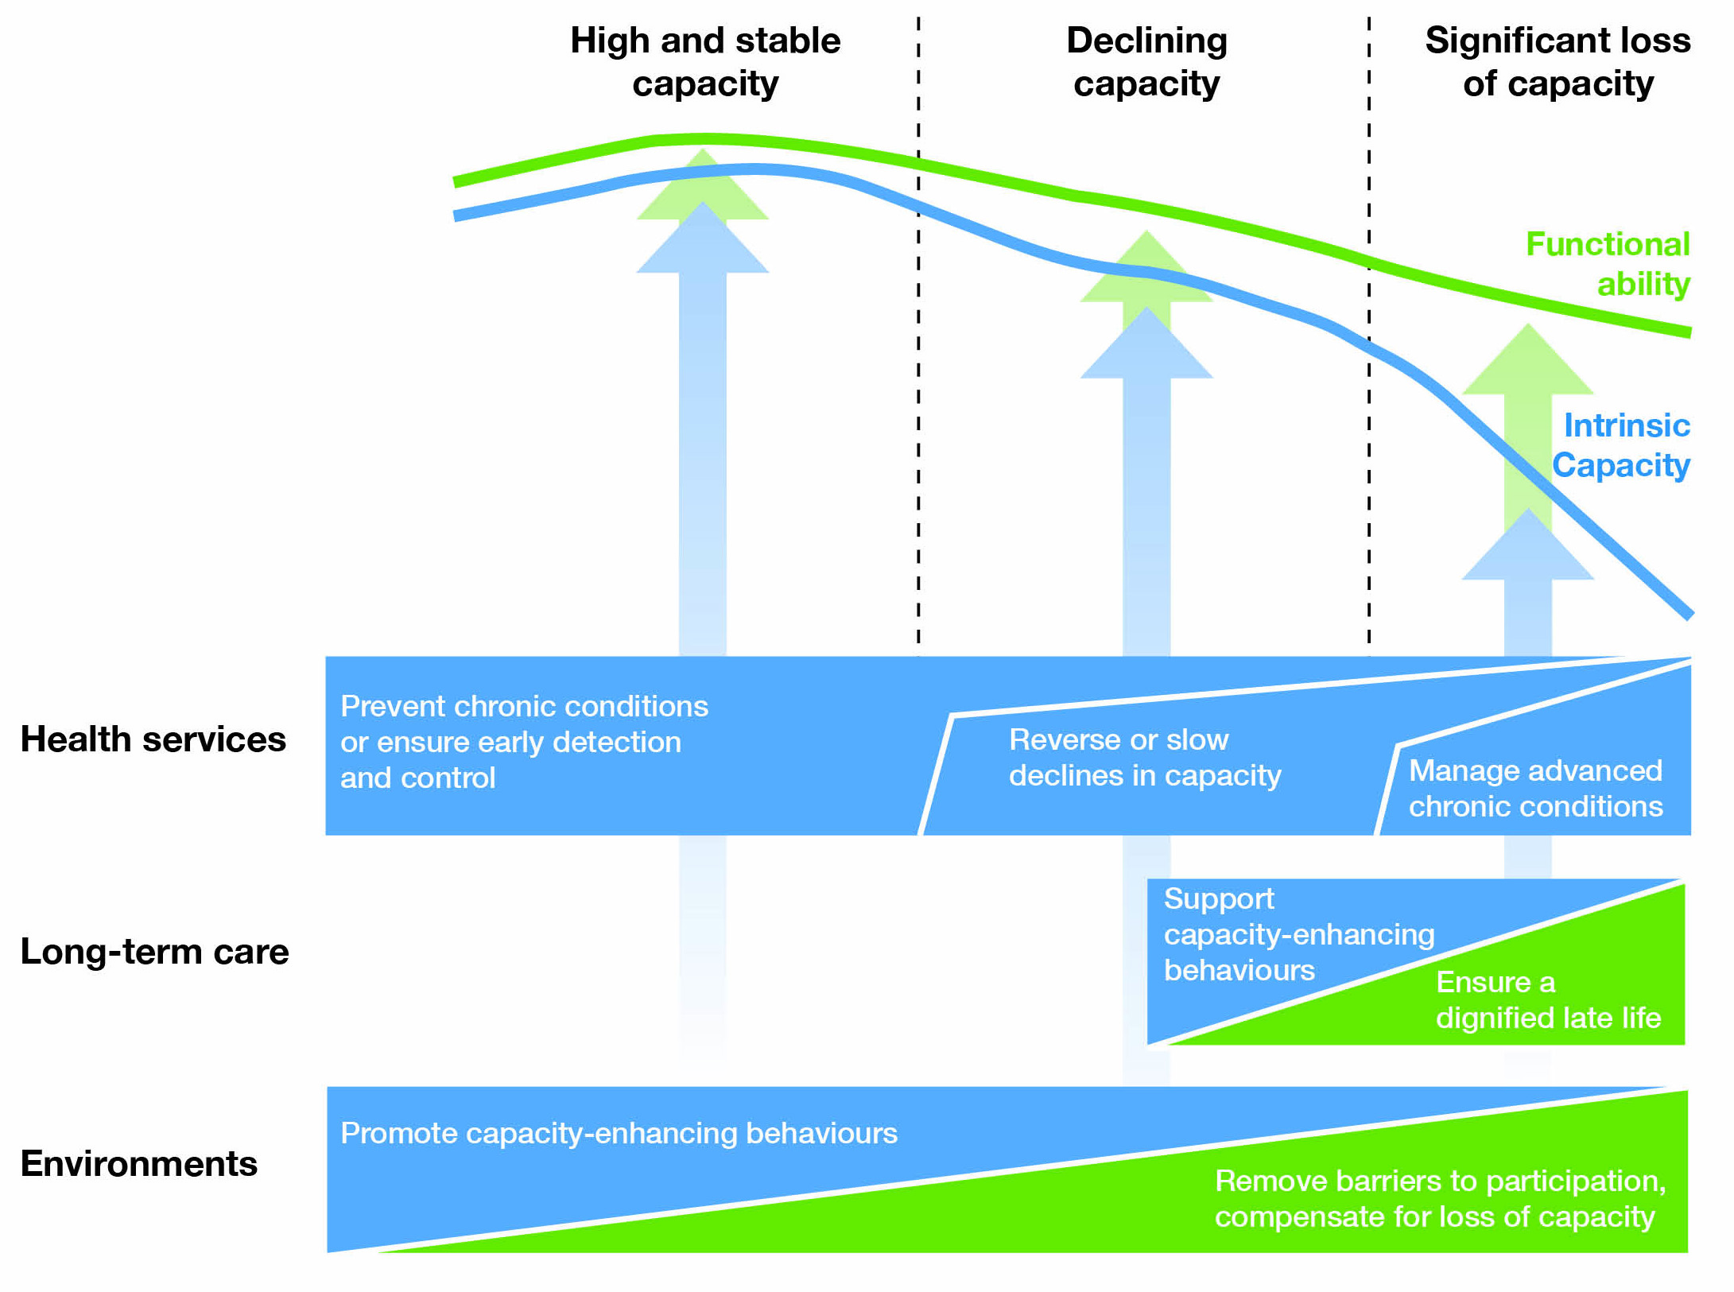
Source: World Health Organization

Challenges and opportunities

An ageing population
New Zealand’s population is ageing. There will be a substantial increase in the number of older people in the next decade. The older population will also be more diverse. The Maori population of people aged 65 years and older is projected to increase by 115 percent in the 15 years to 2026. The older Pacific population is expected to grow in number by 110 percent, and older Asian population by 203 percent in this same period.
The changing population has major policy, funding and planning implications. We need to plan well to make sure we are well equipped nationally, regionally, economically and socially. We need to have the right infrastructure in place to keep people in good health and provide for those who are not.
Figure 2: Population projections by age group with 10-year percent change
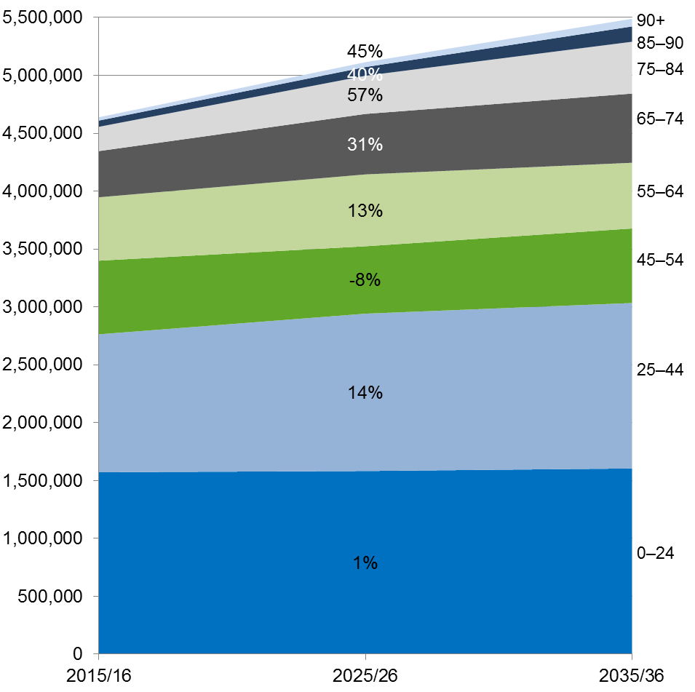
Source: Statistics New Zealand
Currently, over one in six older people are living with three or more long-term conditions. Based on existing trends, an increasingly older population will mean steadily increasing health care needs. As a population group, older people have much higher rates of long-term chronic health conditions, and disabilities requiring support on a daily or regular basis.
We are living longer, but the age to which we are likely to live in good health and without disability is not increasing at the same rate as life expectancy. At the age of 65 years, we can expect to live half of our remaining lives either free of disability or with functional limitations that we can manage without assistance.
Figure 3: Māori and non-Māori life expectancy at age 65
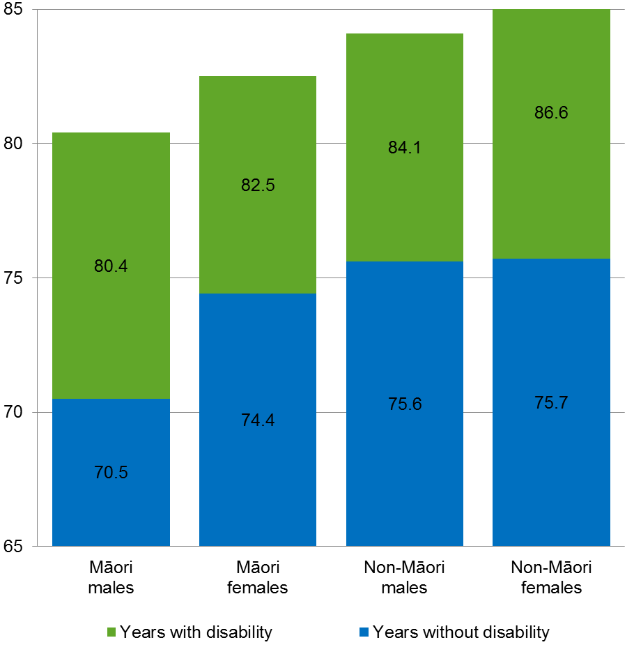
Source: Ministry of Health
This is not the same for all population groups. Māori males at age 65 can expect the shortest remaining time of living without disability or long-term illness (5.5 years on average) and the highest proportion of remaining years lived with dependency (64 percent). People with intellectual disabilities have some of the poorest health outcomes, and can develop dementia at a younger age.

Health inequities
We need to continue our efforts to reduce inequities in health, so that all population groups can enjoy good health and participate fully in family and community life. In this respect, the Ministry of Health focuses specifically on Māori, Pacific peoples, migrant and refugee communities, people with disabilities, people with long-term mental health conditions or addictions and people with low incomes, who experience persistent inequities.
Achieving equity is a core component of the ‘value and high performance’ theme. This is underpinned by the New Zealand Triple Aim Framework for a whole-of-system approach to achieving, balancing and measuring better health and equity, better value for public health system resources and improved quality, safety and experience of care.
Figure 4: New Zealand Triple Aim Framework
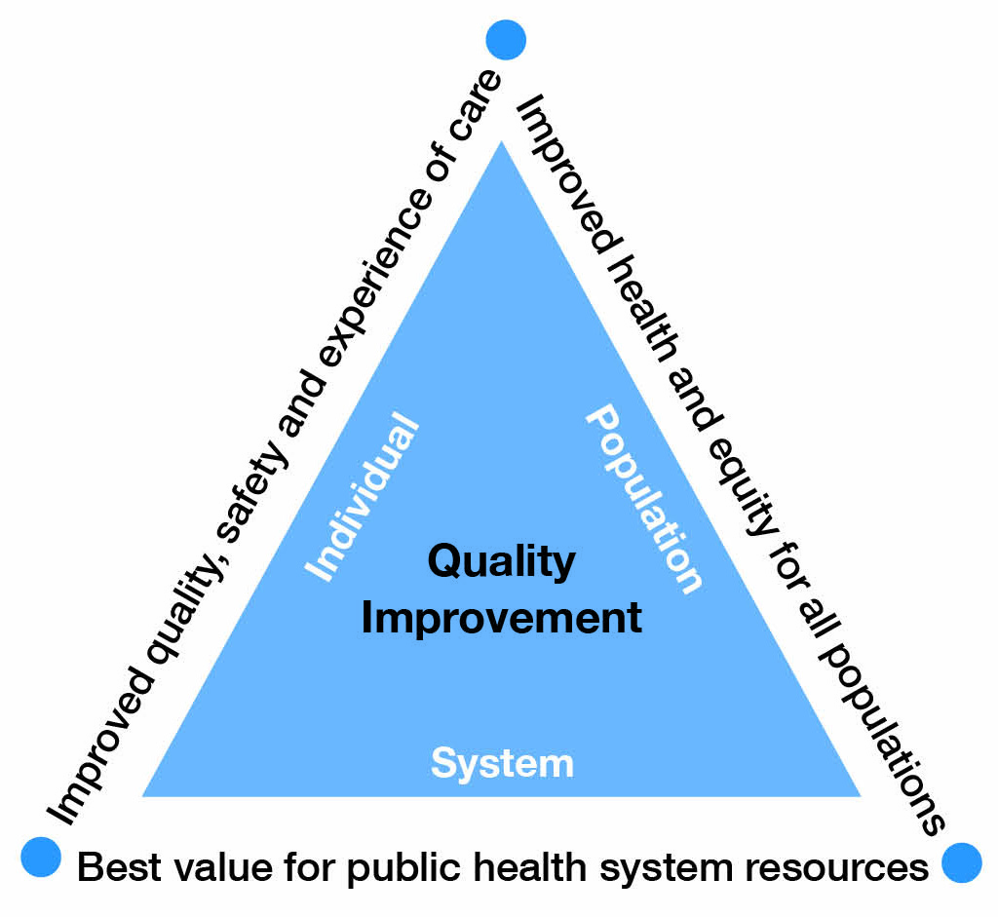
To achieve equity, we need to understand and remove the barriers that prevent groups from experiencing equitable health outcomes, and build the factors that enable equity. We need to work together with other sectors to address a range of barriers. The existing barriers we know about are infrastructural, financial and physical. Others can be difficult to articulate or identify.
We need to better understand how well our services are working for different population groups, and why problems arise. This has implications for the way that the sector conducts research, collects data and evaluates the effectiveness of services. To improve the health of different groups, we need to draw on the experience and expertise of community leaders. In this way we can inform the design of services, tailoring them to specific populations so that they are more easily available, more culturally appropriate and tailored to individual circumstances.

He Korowai Oranga
Improving the health of older Māori is a priority for this Strategy, and our approach is guided by He Korowai Oranga, the Māori Health Strategy. He Korowai Oranga has an overarching goal of pae ora, which translates to healthy futures for Māori, and comprises wai ora (healthy environments), whānau ora (healthy families) and māuri ora (healthy individuals). The Strategy aims to:
- build Māori capacity to actively contribute to their own iwi, hapū and whānau
- improve Māori participation and decision-making in the health and disability sector
- ensure that health and disability services are effective for Māori as well as all New Zealanders
- ensure that we think beyond narrow definitions of health and work across sectors to achieve a wider vision of good health for everybody.

Staying healthy and independent in older age
We have an opportunity to reinforce and accelerate the positive trends we have seen in recent years. By focusing on preventing illness and by making it easier to choose healthy options (like eating healthy food, not drinking alcohol or only drinking at low-risk levels, and undertaking regular physical activity), we can help people to avoid developing long-term health conditions or slow the development of those conditions. Most importantly, we can do this by providing universal health services and public health initiatives that cover the whole population, and having services in place to intervene early, help people to return to good health and remain independent. As part of this, we need tailored approaches for some individuals and population groups, to help them access the same level of service and enjoy the same outcomes as others.

New investment approaches
If the health system continues to fund services the way it currently does, expenditure on older people will account for 50 percent of DHB expenditure by 2025/26, up from 42 percent. It is vital that we ensure that we are getting the best value from the investments and resources across the health system and the social sector.
Currently, the Ministry of Health and other government departments are taking new ‘social investment’ approaches to funding services. These approaches provide significant opportunities for improving the health of New Zealanders in general and older New Zealanders in particular. One example of a social investment approach might be a concerted effort to reduce social isolation and loneliness, which we know have a strong relationship with poor mental and physical health outcomes and with increased problematic alcohol use.

Workforce development
The health system faces some significant workforce challenges. The health of older people workforce is itself ageing and some key workforce groups have been difficult to recruit. Forecasts show, for example, that we will have trouble maintaining the necessary number of geriatricians and some other medical specialties, as well as registered and enrolled nurses in aged care.
As people live longer with long-term conditions and complex needs, either at home or in residential care, we will increasingly need to support and develop the skills of our nursing, allied and kaiāwhina workforces. Some initiatives to sustain and grow the workforce are underway, including incentives for graduate nurses to come into the sector and programmes to support teams working together across all settings. However, these are not yet achieving significant gains. We need to be smarter in terms of the way we make use of different parts of the workforce, such as the well-qualified pharmacist and allied health workforces.
We need to prioritise attracting, retaining and making best use of the skills of all in the health workforce to meet the needs of an older population.

Families and communities
We also need to ensure that family and whānau carers receive support and information to be able to appropriately and safely care for older people. Family and whānau carers should be supported to maintain good health, and undertaking a caring role should not exacerbate any existing health conditions or disabilities.
We are starting to see the development of age-friendly communities in New Zealand. This term refers to an initiative to build communities that enable positive ageing, and healthy, respected, connected and independent older populations. The Office for Seniors has undertaken to promote the development of age-friendly communities. Many are led by older people, together with local councils and a variety of organisations, who work towards local solutions to optimise older people’s opportunities for healthy ageing, participation, security and quality of life. Age-friendly communities provide a new opportunity for developing knowledge about and skills for healthy ageing, and for the health sector to partner with older people to develop health and resilience.

Integration across the health and social sectors
Our approaches to the health and care of older people need to change at multiple levels. We need better communication between health service users and providers, to ensure that services are as effective and efficient as they can be, and to ensure that people are better able to stay well and manage their own health, and engage in the design and delivery of their services. We need to improve the abilities of families, whānau, carers and communities to support and help care for older people. The health system needs to work with other sectors to take joint action on the social, environmental and economic determinants of people’s health. Housing and transport, for example, are critical to keeping people well in their own communities.
Investment approaches present opportunities to work in more integrated and longer-term ways across the health and social sectors, for improvements in both health and social outcomes.
More collaborative approaches will make best use of those with specialist skills, such as nurse practitioners, clinical nurse specialists and all health professionals including allied, pharmacists and paramedics, to improve outcomes and enable innovative models to develop in home care, primary care and residential care. We will be better able to manage the growing need when our entire workforce is appropriately trained and working to their full scope.

Smart system
Today’s health system is a data-rich environment; that is to say, there is a tremendous volume of data that can be harvested to create a much smarter system.
The value and high performance theme of the Health Strategy places an emphasis on measuring the performance of the whole system and recommends the development of an outcomes-based approach to performance measurement. The Ministry has worked closely with the sector to co-develop a suite of system-level measures that provide a system-wide view of performance. Three of the measures: acute hospital bed days per capita, patient experience of care and amenable mortality rates, in particular, highlight significant opportunities to improve the health outcomes of older people.

We’re also able to make use of new technologies and information improvements. These technologies and improvements include initiatives that enable information to flow quickly and freely to older people themselves and to health workers, providers and families and whānau; apps that provide immediate information on an older person’s health status; and social media, which enables health professionals to better reach older people, families, whānau and carers in diverse or isolated communities and help them to more easily connect with the services and information they need. Improved information flows will also help agencies to collaborate more widely.

Vision and objectives

The workshops and discussions held prior to preparation of this draft Strategy gave us a clear picture of the values and principles we needed to focus on. We formulated the draft vision for this Strategy after careful consideration and analysis of the discussions.
The draft vision for this Strategy is that:
Older people live well, age well and have a respectful end of life in age-friendly communities.
In order to achieve this vision, we need to ensure our policies, funding, planning and service delivery:
- prioritise healthy ageing and resilience throughout people’s older years
- enable high-quality acute and restorative care, for effective rehabilitation, recovery and restoration after acute events
- ensure people can live well with long-term conditions
- better support people with high and complex needs
- provide respectful end-of-life care that caters to personal, cultural and spiritual needs.
These five outcome areas form the framework for this Strategy. We will set out to achieve our vision in these five areas within a system that, as the New Zealand Health Strategy requires, is people-powered, delivers services closer to home, is designed for value and high performance and works as one team in a smart system.

Figure 5: Strategic framework for the health of older people 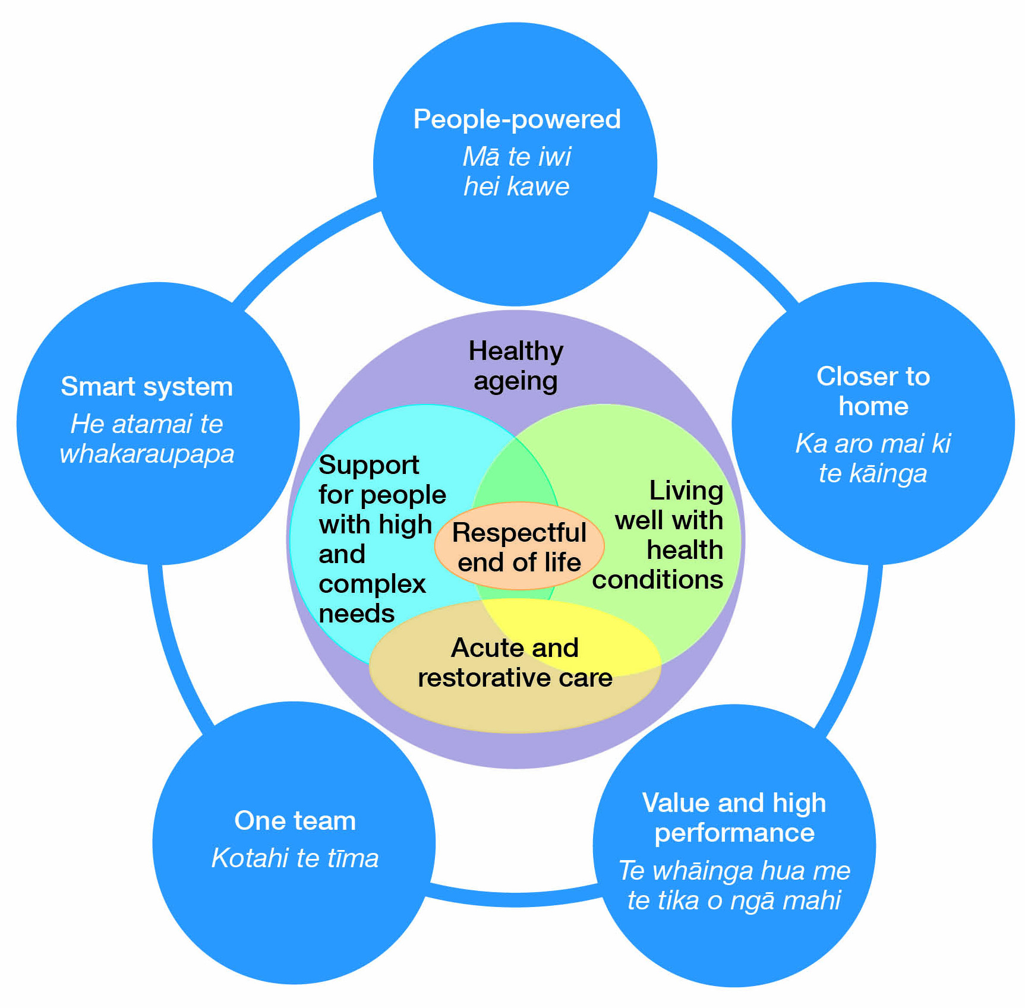

Healthy ageing

This outcome area is about:
- older people being health smart and developing and maintaining functionality that enables physical and mental wellbeing throughout older ages
- building resilience, and preventing illness and disability
- addressing the physical, social and environmental risks to healthy ageing
- achieving equity for Māori and vulnerable population groups
- growing age-friendly communities that enable older people to positively age.

Why this is important
Getting older is often perceived as a person’s inevitable decline into illness and frailty and becoming a burden on their family and whānau and society. Yet most older people are well and healthy and lead active lives.
Healthy older people make a significant contribution to our society, including as mentors, leaders, skilled workers, carers, and volunteers. They are active and engaged with the community, contributing economically, socially and intellectually to society. A healthy older population is a key feature of our commitment to positive ageing.
While there may be some loss of strength and mobility over time as we age, many of the conditions associated with ageing, such as frailty, are not inevitable. The World Health Organization estimates that more than half of the health conditions older people experience are potentially avoidable through lifestyle changes. There is increasingly clear evidence that healthy lifestyles and physical and mental resilience are determinants of health in older age.
Healthy ageing is about maximising physical and mental health and wellbeing, independence and social connectedness as people age. Healthy ageing is determined by individuals’ own physical, emotional and mental capacity, the social, economic and environmental factors that influence people’s health and wellbeing, and the strengths, exposure and vulnerabilities that accumulate over time. With the overarching goal of wellbeing, healthy ageing approaches act on the social determinants of health, the environments in which people live and can access, and actions to enhance equity.
Investing in healthy ageing has clear potential to increase the proportion of healthy, active and independent older people, prevent long-term conditions and their impacts on people’s lives and result in long-term savings to the heath system. A healthily ageing and robust population would help enable individuals to continue participating in their communities and contributing economically, socially and intellectually to a greater extent. Fewer would require acute health interventions and would be able to stably maintain themselves if they developed chronic health conditions.

Resilience
To achieve healthy ageing, we need to focus on resilience and equity. Resilient people flourish in the face of negative events, overcome stressful obstacles and recover from events that might tip a less resilient person into a state of poor health. Resilient people are more likely to age well and to avoid cognitive decline or loss of function until very late in life.
We need to increase physical activity and other healthy behaviours among older people – for example, good nutrition, not drinking alcohol or only drinking at low-risk levels, not smoking tobacco, and mentally stimulating activities that build people’s strengths and resilience. We need a strong shift of focus from treating illness and addictions to preventing them and optimising older people’s health, through healthy lifestyles and behaviours, improved strength and balance, improved oral health and improved health literacy.
Enabling people to stay active and connected community participants as they grow older is critical. There is strong evidence of the links between social isolation or loneliness and poor health outcomes. We will take action to increase awareness of this across the health system, and join with social sector agencies, community and voluntary organisations in an effort to reduce this risk factor and increase social interaction and connectedness.
We must also improve mental wellbeing among older people. Social connectedness, nutrition, physical health and activity all contribute to mental health, as does an environment that promotes older people’s sense of self-worth and value to others. We need to continue to reduce the stigma of depression and anxiety, which is still quite high among older populations, and promote the factors and supports for greater mental wellbeing. Positive psychology approaches that build people’s strengths and capabilities are another important element to building mental resilience, increasing optimism and hope and reducing the potential and impact of depression, anxiety and cognitive decline.
We know that financial security is also important for mental wellbeing and healthy ageing. Linking people with budgeting advisors and resources and programmes, such as those offered by the Commission for Financial Capability, can assist people to prepare financially for their years following retirement.
There are a number of ways in which we can minimise the harm of sensory loss and the loss of functional ability in older people. Timely recognition of emerging sight and hearing issues, for example, appropriate assessments for functional impact and better approaches to enablement can make a signficiant difference to how well people are able to live and participate in everday life and remain independent.

Healthy environments and age-friendly communities
Together with other government sectors and communities, the health system will work to improve the social, economic and physical environment factors for healthy ageing and achieve equity, removing barriers to participation. There are many opportunities to benefit long term from investments in social and environmental factors that influence health.
As well as taking joint action with partners outside the health sector on loneliness, key areas for improvement include:
- prevention, identification and reduction of elder abuse and neglect
- the quality and range of age-friendly housing for older people, with a focus on rental housing stock, which older people are increasingly likely to live in, and supported living housing options
- an increase in alternative means of transport for older drivers, especially for those who are no longer permitted to drive, to help prevent isolation and an increase in the flexibility of social services in areas where transport options are most limited
- an increase in age-friendly communities.
We will work with social housing providers to ensure that social housing is warm, safe and dry, and with others to promote options for housing that meet the needs of an ageing population. In partnership with the social and justice sector, we will work to reduce family violence and sexual violence to older people and the impacts of such violence on wellbeing.
There has been a recent surge of interest in age-friendly communities among older people and local government workers in particular. Age-friendly communities directly aim to improve social and environmental factors that also influence health – access to transport, initiatives to improve the physical environment (eg, accessible shops and dementia-friendly libraries), better housing, opportunities for civic participation and employment, improved community support and health services and positive perceptions of ageing. Health agencies will partner with older people and local governments to support the development of age-friendly communities and build networks and run initiatives that promote healthy ageing.

Our vision for healthy ageing
- Older people are physically, mentally and socially active; and healthy lifestyles and greater resilience throughout life mean that we spend more of our lives in good health and living independently.
- Everyone in the health system understands what contributes to healthy ageing, and takes part in achieving it.
- Older people are health smart, able to make informed decisions about their health and know when and how to get help early.
- All older populations are supported to age well in ways appropriate to their needs.
- Communities are age-friendly with initiatives to keep people healthy, well-connected, independent, respected and able to participate fully in their communities and with family and whānau.

Acute and restorative care

This outcome area is about:
- restoring, maintaining or adapting function after an older person has had an acute event
- coordinating care across specialities and across ACC and the health sector, to improve rehabilitation and restoration outcomes
- ensuring support is in place to reduce further hospitalisations among older people, and to recognise, minimise or manage any significant change or deterioration
- looking for ways to weave family and whānau and wider community support into recovery, especially for those with cognitive impairments such as dementia.

Why this is important
Older people are high users of hospital services, both planned and unplanned, and can be especially vulnerable to rapid deterioration.
When older people experience delayed discharge from hospital they face a slower recovery and three particular risks: too much medication, reduced physical activity (leading to loss of muscle tone and the risk of bed sores) and increased confusion. These factors in turn are strong predictors of increased length of stay, complications or death, long-term cognitive impairment, and higher costs of care. They can mean a slow recovery for the individual.
Delayed discharge from hospital that is the result of preventable factors (such as delayed access to home and community support) puts extra costs on the system. On the other hand, premature discharge can cause significant stress for family and whānau carers who feel unprepared and unsupported.
We are looking for a shift in philosophy away from simply doing things for people, to working with people to help them regain or maintain their ability to manage their day-to-day needs. Finding out an individual’s goals and motivations is a key part of developing a personalised care plan, and provides a way to recognise and respect cultural preferences.
Health services for older people currently use numerous assessment tools, and there is scope to share information from these tools, and reduce duplication. Quality assessments are central to good planning, coordination and communication, and can maximise the speed, effectiveness and durability of a person’s recovery.
Rehabilitation is an ongoing process. Family and whānau involvement should form part of any rehabilitation plan, especially where an older person returns to their own home.

Supported discharge and restorative care
‘Restorative rehabilitation’ refers to the process by which health providers assist a person to recover after an acute event. It aims to build a person’s capacity and resilience, for example through strength and balance training following a fall or fracture. Waikato DHB and Canterbury DHB make use of dedicated teams, START and CREST respectively, for this purpose. In other areas, district nursing services provide clinical care and oversight of rehabilitation – sometimes home based, sometimes in a community clinic. Studies show that using a single person to coordinate care across primary, hospital and community-based services provides a single point of contact and accountability, increases patient confidence and satisfaction, and can improve communication with family.
Emergency services in Kāpiti are trialling an ‘extended paramedic model’, in which ambulance staff (paramedics) can provide basic frontline treatment, make referrals for blood tests or other specialist tests, or make a decision not to transport someone to hospital but refer them back to their general practitioner (GP). The trial has resulted in reduced admissions, including subsequent admissions and improved patient experience, especially for older people and those with mobility problems.
Similarly, guidelines have been developed for nurses in emergency departments to assess and ‘redirect’ people coming to emergency departments back to their GP if there is no urgent need to admit them to hospital.

Quality
Quality measures in this area need to include individual outcomes; for example, can the person now dress themselves? Was the person satisfied with their recovery? Did their family and whānau feel supported to help with rehabilitation? They can also include ‘system’ measures, such as acute bed days, and contributory measures, such as whether discharge was timely and support services were in place, and whether the person was readmitted to hospital within a short time.

Integration in the health sector and across agencies
Funding for rehabilitation and recovery services is currently spread across different parts of the health, ACC and social sectors and through Veteran’s Affairs. This can lead to duplication of services, or, alternatively, gaps and delays in coordinating care: for example, a person needing home care, district nursing, nutrition advice and equipment may face four different assessments. If we can streamline assessments, standardise the use of shared care plans and routinely use multidisciplinary teams, we should be able to make any funding differences invisible to the person needing services.
Internationally, there is not a large body of consistent evidence on the best way to transition people from hospital to home. But there are promising models already in use and plenty of scope for further trials. We need to support innovation, collect data and share results to build the body of evidence and develop best-practice approaches.

Workforce
Acute care, rehabilitation and longer-term recovery and maintenance services involve a variety of different workforces. Ideally, there should be some degree of overlap between their responsibilities, to provide the workforce with greater flexibility to meet people’s needs, and potentially greater continuity of care.
Allied health staff (such as occupational and speech language therapists, dieticians and physiotherapists) offer a range of skills to support people’s rehabilitation, recovery and restoration, but access to them can be limited. Allied health staff can play important roles working directly with patients, and helping home and community support workers and family carers involved in rehabilitation.
Home and community support workers and family carers are often involved in rehabilitation. Information sharing, training and other means of support could enhance the range of activities they undertake.

Our vision for acute and restorative care
- Older people requiring urgent or planned hospital treatment benefit from best practice restorative rehabilitation strategies, discharge planning and follow-up support.
- Health, ACC, social and community services work together to support people through recovery and the return home.
- Family and whānau receive support to assist older people to recover from acute events.
- Quality measures include patient experiences as well as clinical outcomes.
- The number of people readmitted to hospital following hospital treatment reduces.

Living well with long-term conditions

This outcome area is about:
- giving individuals the tools and support they need – including guidance, information and access to technology – to manage their long-term conditions to a comfortable level, and reduce the impact of those conditions on their lives
- ensuring all health professionals and social services have the tools and support they need – including information and resources, training, models of care and technology – to detect long-term conditions at the early stages and treat, rehabilitate and manage them early
- investing in social assistance, primary and home and community services and family and whānau carers to assist older people with long-term conditions to stay well closer to home
- improving our ability to slow or stop the progress of long-term conditions towards frailty.

Why this is important
The World Health Organization has referred to long-term health conditions as ‘the health care challenge of this century’. Long-term conditions include diabetes, cardiovascular and chronic obstructive pulmonary disease, cancer, asthma, arthritis and musculoskeletal diseases, stroke, chronic pain, obesity, dementia, mental illness and addiction.
Long-term conditions can occur at any age, but become more prevalent as people get older. They are often complex, with multiple causes. They can lead to a gradual deterioration of health and mobility but can also become acute suddenly, resulting in hospitalisation and, in some cases, dependence on long-term support services or family and whānau. Some population groups tend to experience long-term conditions at earlier ages, and therefore need more targeted services.
As the graph overleaf shows, some long-term conditions are more common among older people. Currently one in six older New Zealanders are living with three or more long-term conditions. We can expect the numbers of people living with long-term conditions to increase as our population ages.
This will impact on the workload of the health and social sector workforce and will also mean that increasing numbers of people will be caring for and supporting family and whānau members.
Dementia is an increasing priority for the New Zealand health system. We expect the numbers of New Zealanders with dementia to rise to 78,000 by 2026, from an estimated 50,000 currently. Improving the Lives of People with Dementia, identifies nine action areas from the New Zealand Dementia Framework for implementation in the next three years. We need to work across the dementia sector and with people with dementia to strengthen implementation of these actions.

Figure 6: Prevalence of certain health conditions by age
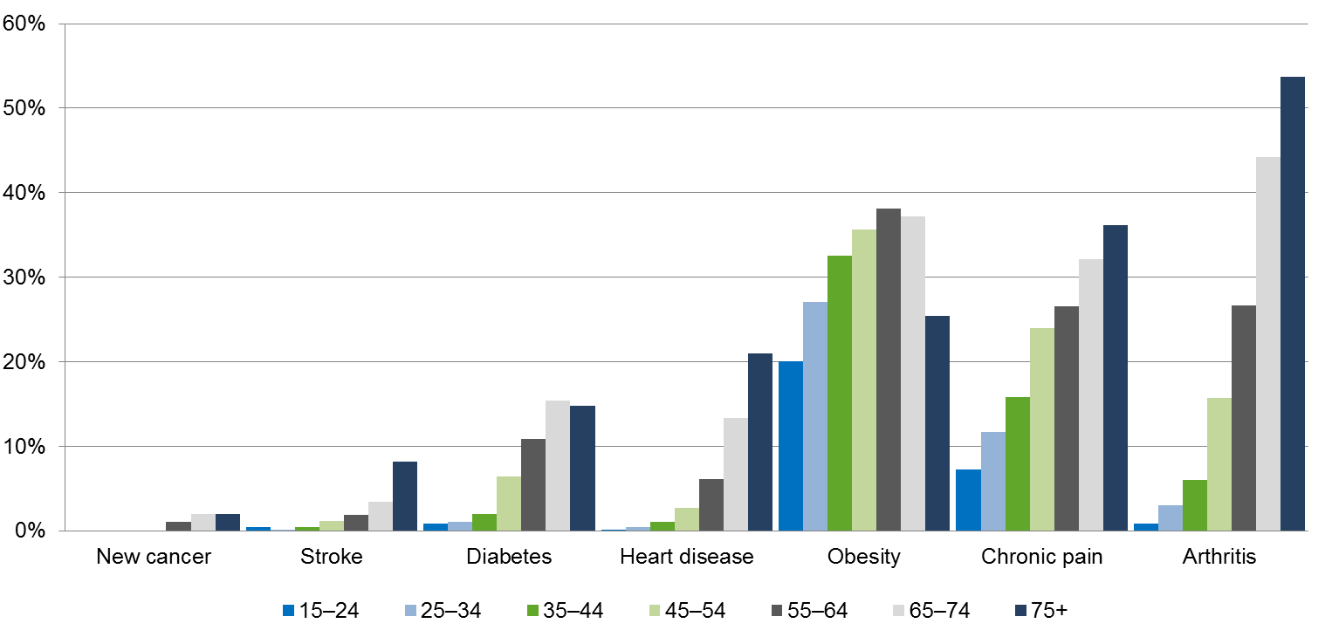

The New Zealand Health Strategy has set a goal of a health system that supports people to spend more of their lives in good health. With this in mind, we want to ensure that older people with long-term conditions retain the highest level of mental and physical function possible; that they enjoy life, and that their communities respect them.
To achieve this goal, we will take steps to improve the detection of long-term conditions, particularly where mental health and addiction issues are involved, which may mask as well as contribute to symptoms of other long-term conditions. We will help New Zealanders to become more health smart, so that they are better able to manage their conditions and get the help they need to stay well. We will improve the workforce’s ability to work in partnership with older people with long-term conditions so that they live well with their condition, and we will strengthen home and community support services so that they are better equipped to support people with long-term conditions and their family and whānau.

Prevention and detection
New Zealanders becoming more health smart is a major theme of the New Zealand Health Strategy. To create a health smart population, we need to provide individuals, as well as family and whānau and carers, with information about preventing long-term conditions. For those living with long-term conditions, we need to provide information about specific conditions, symptoms, medication and management, and the importance of healthy lifestyles. We also need to enable people to connect with groups and organisations that can help them to manage their conditions.
Long-term conditions can progress to a point where they significantly reduce an individual’s resilience. We will improve our ability to prevent and better manage long-term conditions that lead to the development of frailty. Initially, this will be through research to better understand the issue of frailty in New Zealand and the mechanisms for prevention and to reduce its severity.

Enabling technology
Technological tools such as smartphones, apps and wearable devices have many valuable applications in the area of health. They will become increasingly important as a way of allowing older people to maintain autonomy, dignity and a better quality of life, including through the ability to remain living in their own home for as long as they wish. The pace at which older people adopt such tools will vary. We need to ensure that late adopters continue to have equal access to the services they require.

Health workforce
As the proportion of older people in our society grows, the health workforce will need to become more adept at caring for older people, and more knowledgeable about what keeps older people healthy and resilient. We will expand the capability of the workforce through professional development and smarter models of working.
Primary health and home and community support services are well placed to take a greater role in the care and support of people who need assistance to remain living at home. However, in the case of home care, we could better align service models, funding methods and levels of training, to allow a greater level of involvement. At present, the home and community workforce is fragile. Jobs in this sector are generally characterised by low pay, irregular working hours and variable access to training, which contributes to high staff turnover.
We will invest in this workforce, and develop service and funding models that support a sustainable, culturally appropriate and person-centred approach to the support of older people, including people with long-term conditions.

Family and whānau
Family and whānau carers play a vital role in providing support for older people with long-term conditions. We will ensure that such carers receive the support they need. This will include training and information, as well as respite care so that they can look after their own wellbeing, particularly in relation to their mental health. Family and whānau carers should not be in a position in which they become isolated because of their caring role.

Priority populations
Long-term conditions contribute to the higher rates of illness, disability and death experienced by Māori, Pacific peoples, people on low incomes and people with disabilities. We will prioritise reducing health inequalities and other adverse outcomes for people with long-term term conditions for those agencies funding and delivering services to this group.

Our vision for living well with long-term conditions
- Improved methods of early detection and prevention mean that fewer older people are affected by long-term conditions or frailty.
- Older people with long-term conditions retain the highest level of mental and physical function possible; they enjoy life, and their communities respect them.
- Older people with long-term conditions have a range of tools and primary health care coordination and support to enable them to live well with their conditions.
- Older people with long-term conditions are ‘health smart’ and are actively self-managing their conditions to a practical and comfortable level, making living well with long-term conditions closer to home more accessible.
- The workforce that supports older people and their families to manage their long-term conditions, including the primary and wider health workforce, home and community support services and family and whānau carers, has appropriate resources, structures and training.
- Health outcomes for vulnerable older populations with long-term conditions are equitable with outcomes for the population as a whole.

Support for people with high and complex needs

This outcome area is about:
- ensuring people are in the right place to receive the care and support that most appropriately meets their needs
- individuals maintaining choice and control when they need significant support
- helping family and whānau to provide the best support they can while maintaining their own wellbeing
- coordinating, integrating and simplifying health and social services for people with high and complex needs
- having flexible home and residential care services that suit the needs of the increasingly diverse older population
- reducing avoidable visits to emergency departments and acute care among a group of potentially high users
- enabling all people with high and complex needs to easily access care and support, irrespective of their financial position
- promoting innovative models of complex care that better support older people, their family and whānau and carers.

Why this is important
Older people with high and complex needs are one of the most vulnerable groups in society. They are more likely to become ‘frail’; that is, to deteriorate markedly after an event that would otherwise have a minor effect on their health.
The number and complexity of conditions in older people with high and complex needs makes treatment and care more difficult, as conditions and treatments affect each other.
This part of the Strategy expands on the goals and actions relating to long-term conditions.

Knowledge and communication
Older people with high and complex needs need more information than usual to make choices about the care or support they want to receive; clarity of communication is vital.
Some older people with high and complex needs have lost or are losing mental capacity to fully make choices, so health care providers need to communicate with a wider group, including family and whānau and caregivers.
People with high and complex conditions have to navigate their way through more parts of the health and support system than usual; coordination of these services, including communication between services, is important.

Technology
Increasingly, technological tools such as smartphones and wearable devices are making communicating health information and monitoring health easier. Health service providers need to pay particular attention to individuals’ ability to use such devices and accommodate a range of technical literacy levels.

Services closer to home
Older people value their independence highly. They do not want to be seen as a burden on spouses, family and whānau or social services. They want to stay in their communities, and access services closer to home.

Health and social sector coordination
Older people who need to see a variety of health professionals want their individual health information to be available to all the clinicians they see, so they don’t have to repeatedly tell their story. They expect clinicians to be informed about their other treatments, conditions and current medicines they may be taking.
Health services for older people with high and complex needs can be very expensive. The more careful we are with our use of resources, the more people we can help. It is therefore very important that we design care for older people with high and complex needs with value and high performance in mind. Our approach needs to take into account the full range of influences on older people’s outcomes, including the various resources across the health and social systems, service users’ experience, service quality and the impact of services on family and whānau.
To achieve best value and high performance, district health boards need to commission services in a way that will provide older people with quality care in the right setting at a sustainable cost. If we can achieve this, we will reduce inequities in access to these services, and their effectiveness.
New Zealand’s health system needs to better support the older population groups that do not enjoy the same health as New Zealanders as a whole. These groups include Māori and Pacific peoples, disabled people and those with long-term mental health issues and alcohol and other drug addiction.
Our focus must be on removing barriers to delivering high-quality health services, within the health sector and between it and other sectors. Improving the health of vulnerable groups may involve tailoring services so that they are more accessible, available at more suitable times, or delivered in more culturally appropriate ways.
People working in teams containing a range of health specialties need to see themselves as part of one team supporting integrated care that is provided closer to home. We also need to reduce the barriers that currently prevent people from using their skills flexibly and fully.
Support workers make up a large part of the workforce for people with high and complex needs. It is important that we pay, train and value these workers as part of the integrated ‘one team’.
Beyond the formal workforce, we need to support family and whānau and others in their roles as carers of older people with high and complex needs. This support could involve health literacy education, information and training specially tailored for the carer role, and looking after the carers’ own health needs (particularly in relation to mental health).
Older people with complex needs often have comprehensive clinical assessments of their needs electronically recorded in the interRAI database. As well as people and their care provider using this information to develop care plans, the information should be a rich resource for the range of health professionals dealing with each person and for PHOs and DHBs learning about the outcomes of older people receiving support services in a location or population group.

Our vision for support for people with high and complex needs
- Older people with high and complex needs:
- have the information and freedom to make good choices about the care and support they receive
- know that health care workers understand their wishes and support needs
- are assured that information about their circumstances and their needs flows easily between health care workers
- from different ethnic groups and in rural locations have equitable access to services, and experience equitable outcomes
- move easily to and through care settings that best meet their needs
- have reduced need for acute care.
- Families and whānau have the support, information and training they need to assist older family members, and the stress of caring does not damage their own health.
- District health boards bring together data from various sources and know the value and quality of the care they provide for older people in their district. Where it is falling short, they are easily able to learn from other DHBs.

Respectful end of life

This outcome area is about:
- a respectful end of life, tailored to the physical, emotional, social and spiritual needs of an individual and their family and whānau
- making discussions of death and dying, and preparing for death and end-of-life care, more common
- making sure that people at the last stages of their life are in control of all aspects of their care as much as they’re able – from deciding on their clinical treatment to fulfilling their cultural needs
- preparing the health system for future palliative care needs.
- providing coordinated care that meets individuals’ needs
- supporting family and whānau and friends to support dying older people.

Why this is important
Death is a universal experience, and also a deeply personal one; our experience in the last stages of life can be profoundly important for us and for our loved ones.
In the last stages of life, what matters most to people is being accompanied by their loved ones, the control of symptoms and pain, good communication and well-coordinated care that doesn’t put unnecessary strain on the family and whānau. We should expect, and take steps to ensure, a respectful, high-quality palliative service at the end of life.

Planning in advance
Some people take action to protect their wishes in their final stages by delegating an enduring power of attorney and working with health professionals and others to create an advance care plan expressing their goals and wishes for treatment at the end of life. Evidence shows that advance care plans significantly improve the experience of end-of-life care; their use across clinical disciplines is an integral part of a dying person’s coordination of care.
Although advance care plans are effective, society’s discomfort with the subject of death may be compromising their effective delivery. As a society, we need to become more comfortable with conversations about death and dying; we need to see death and dying as part of life. These conversations are easier when they begin well before the end of life.
The New Zealand Health Strategy includes a commitment to supporting people and their clinicians to develop advance care plans by building on existing national and international resources and networks.
It is vital that we continue to focus on the foundational elements that underpin high-quality end-of-life care, such as shared patient information and support for advance care plans.

Future demand
As the population ages, more people will die each year. People will die at older ages, and increasingly with comorbidities, including dementia. Many will have uncomplicated deaths, but as we live longer there will be increasing numbers of people with more complex conditions requiring more specialised care.
To meet our future needs, the health system will have to take a fresh and widespread approach to palliative care. We will need to make the most of our health workforce by ensuring that the core components of end-of-life care are an integral part of everyone’s practice. We will need to support and upskill communities and family and whānau carers in providing palliative care, and we will require a sufficient specialist palliative care workforce to provide support, advice and education. The current Review of Adult Palliative Care Services focuses on these necessary changes.

Our vision for enabling a respectful end of life
- People die where they feel comfortable and safe, and are able to have their loved ones provide support. Dying older people are able to identify and articulate their fears, goals and care needs, and how they wish family and whānau and caregivers and friends to be involved in their end-of-life care. Individualised care plans, advance care planning and enduring power of attorney are much more widespread practices, and the health workforce, family and whānau and friends respect and uphold the needs and wishes of older people.
- Technology improves end-of-life care. Providers know if advance care plans are in place, routinely check whether medicines need to be reviewed, and support monitoring at home.
- Health service providers coordinate palliative care in such a way that all of those who support people dying in old age are aware of plans, and know their role in carrying them out.
- All teams are responsive to the cultural needs of different groups.
- People talk comfortably about dying and preparing for death.
- The health sector educates, supports and advises family and whānau of dying people and the health workforce in meeting the needs of people receiving end-of-life care.

Turning the Strategy into action

Building the action plan
Achieving the vision and goals set out in this Strategy will require the commitment of a vast range of players across and throughout the health and social system, working in partnership with non-governmental organisations, communities, older people and their families. It also requires that we identify the right set of actions for immediate implementation, and the longer list of actions for the remainder of the 10-year period, and that we have the right leadership and systems in place to implement those actions and keep us on course.
A set of actions have been identified to implement the Strategy, and these are presented in draft form in the following pages. The actions have been developed in discussion with older people and their representatives and with a wide array of stakeholders from across the country throughout the health and social system.
Each action has a proposed lead, who would be accountable for the action. The implementation of the actions would involve a wide variety of stakeholders from across the health and social sectors, as well as older people and their family and whānau.
Draft actions for the first two years of implementation are shown with an asterisk () in the Action Plan. A review every two years will draw from the other draft actions in determining the programme of action appropriate for the following two years.
The actions are organised under the Strategy’s goals, so that the action plan is appropriately outcome oriented in accordance with a life-course approach. There are links and inter-dependencies across the actions and common themes that will mean that some of the actions are developed and implemented together through cross- and inter-sectoral teams. These include:
- actions focused on vulnerable and high-needs population groups
- actions focused on information, tools and resources and other enablers
- actions including referral pathways and other aspects of systems for integration, which would be linked for a system-wide approach to integration.
Similarly, equity is a consideration across all actions, as is workforce.
We are seeking your feedback on this set of actions to help us make a manageable programme of action that can be delivered by the sector within available resources.
The actions published in the final Strategy document will reflect the views of many different organisations and actors in the health and other social systems gathered throughout the final consultation process.

A system of continuous improvement
Within the first months after finalising the Strategy, the Ministry of Health will develop an implementation plan with our major partners, setting out the timing, sequencing, responsibilities and resourcing required for achieving the actions.
Implementing these actions will rely on skilled leadership, solid partnerships and participation across the system. We need the Strategy to represent a shared vision for the future, and we need to work together to achieve our aims.
The health system is, and operates in, a complex and dynamic environment, and operates within a highly networked system with multiple inter-dependencies. We are limited in our ability to predict the future, and we need to be mindful and flexible, and willing to adapt in order to stay on track.
This Strategy is therefore a living document. The Ministry of Health will review it every two years. The review will look at delivery of the actions. We may need to adjust some actions, to replace them or to combine them with other initiatives, to strengthen their chance of success.
The Ministry of Health and DHBs will be primarily responsible for implementing the Strategy, and regional service plans, annual plans and annual progress reports will reflect the actions set out in the final Strategy.
The Ministry will develop systems for ensuring that our programmes and services are informed by and built around the needs and desires of the people they’re designed for.
We have a wealth of data and knowledge to inform our next steps, through our investment in interRAI and research initiatives, such as the Ageing Well Science Challenge. In addition, the development of New Zealand’s first health research strategy will help us build a more cohesive and effective health research and innovation system. We need to harness these opportunities to ensure that we make the best use of our information, and improve our understanding of ageing well.
Ultimately, we want to ensure that knowledge, information and the investment in and outcomes of research and development inform policy development and service improvement.

Action plan

Healthy ageing
Goals
- Older people are physically, mentally and socially active; and healthy lifestyles and greater resilience throughout life mean that we spend more of our lives in good health and living independently.
- Everyone in the health system understands what contributes to healthy ageing, and takes part in achieving it.
- Older people are health smart, able to make informed decisions about their health and know when and how to get help early.
- All older populations are supported to age well in ways appropriate to their needs.
- Communities are age-friendly, with initiatives to keep people healthy, well-connected, independent, respected and able to participate fully in their communities and with family and whānau.

 |  | Lead
1. Build social connectedness and wellbeing in age friendly communities
a. Establish age-friendly communities in line with the Positive Ageing Strategy. |  | Office for Seniors
b. Build strong partnerships between DHBs, Healthy Families NZ and age-friendly communities projects for effective healthy community initiatives. |  | Office for Seniors, HFNZ
c. Work across government and with local interest groups to improve access to, and coordinate assistance to socially isolated older people and develop initiatives that better address the physical and social determinants of health. |  | Ministry of Social Development, DHBs
d. Promote volunteering, networking and paid work among older people, as a means to support their self-worth and encourage social connection. |  | Non-governmental organisations
2. Increase resilience through local initiatives
a. Increase the availability of strength and balance programmes in people’s homes and community settings. |  | ACC, Health Quality & Safety Commission, Ministry of Health, DHBs
b. Expand the provision of targeted health promotion initiatives, and services to increase resilience among Māori and other vulnerable older populations who have poorer health status. |  | Government agencies
c. Review the Green Prescription programme, including the potential for other health professionals to prescribe. |  | Ministry of Health, DHBs, primary health care
3. Work across government to prevent harm, illness and disability and improve people’s safety and independence
a. Health and social sector agencies partner to share information and improve the identification of vulnerable older people, and coordinate services to better meet their needs. |  | Government agencies
b. Participate in the cross-government Ministerial Group on Family Violence and Sexual Violence Work Programme. |  | Ministry of Social Development
c. Update the 2007 Family Violence Intervention Guidelines: Elder Abuse and Neglect, and promote their uptake by a wider range of health professionals. |  | Ministry of Health
d. Work with local government to increase understanding of, and local direction of age- and disability-friendly housing models. |  | Ministry of Health, LGNZ
e. Support initiatives that maximise healthy ageing through supported housing and age-friendly communities where this will also contribute to regional economic and social development. |  | Ministry of Business and Innovation, Te Puni Kōkiri, Ministry of Health
4. Improve health literacy and communication systems
a. Strengthen the capability of provider organisations to understand the range of health literacy needs of older people, and improve the accessibility and responsiveness of services. |  | DHBs
b. Encourage services and providers to promote healthy eating, physical activity and healthy lifestyles and prevent alcohol-related harm. |  | DHBs, Health Promotion Agency
c. Enhance health promotion and service information to Māori, Pacific and other ethnic communities and priority groups to enable greater accessibility and engagement. |  | DHBs, primary health care
d. Improve the effectiveness of health literacy information distributed by health and social sector agencies. |  | Ministry of Health, Health Promotion Agency
e. Support older people’s uptake of technology for communication with health providers and their family and whānau. |  | DHBs, primary care
f. Increase the accessibility of information on healthy ageing and health and social services through govt.nz, yourhealth, SuperSeniors and links to other websites, so that people can be more ‘health smart’. |  | Government agencies
5. Improve oral health in all community and service settings
a. Develop referral pathways for optimal dental care throughout ageing and into the end of life, to maintain independence and minimise pain. |  | Ministry of Health and sector
b. Identify and promote innovative care arrangements for oral health care of people living in aged residential care. |  | Ministry of Health and sector
c. Disseminate updated information and advice on dental care to older people family, and carers in communities, and aged care organisations. |  | Ministry of Health and sector

Acute and restorative care
Goals
- Best practice restorative rehabilitation strategies, discharge planning and follow-up support are in place for older people requiring urgent or planned hospital treatment.
- Older people are supported through recovery and the return home.
- Family and whānau receive support to assist older people to recover from acute events.
- The number of people readmitted to hospital following hospital treatment reduces.

 |  | Lead
6. Support effective rehabilitation closer to home
a. Promote rehabilitation partnerships with primary care workers, allied health, nurse practitioners, pharmacists, kaiāwhina and family and whānau to support discharge planning for and ongoing rehabilitation and restoration of older people at home. |  | Ministry of Health, DHBs
7. Improve outcomes from injury prevention and treatment
a. Develop, implement and review prevention and treatment of injuries for ACC and health clients, including:  - enhancing fracture liaison services to prevent secondary injury  - implementing a national hip fracture registry  - enhancing rehabilitation services for injured older people, including through supported discharge and home and community support to achieve maximum independence and recovery closer to home  - work with local health systems to integrate prevention and rehabilitation services into existing service models. |  | Ministry of Health, ACC, Health Quality & Safety Commission and DHBs
b. Make use of big data to identify older people at risk of falls and fractures, to target and coordinate investments and interventions. |  | ACC, Ministry of Health, Health Quality & Safety Commission, DHBs
8. Reduce acute admissions
a. Support other initiatives to reduce acute admissions, for example by extending paramedic roles, improving after-hours triage for aged residential care facilities, developing acute geriatric care pathways and applying technological solutions. |  | DHBs

Living well with long-term conditions
Goals
- Improved methods of early detection and prevention mean that fewer older people are affected by long-term conditions or frailty.
- Older people with long-term conditions retain the highest level of mental and physical function possible; they enjoy life, and their communities respect them.
- Older people with long-term conditions have a range of tools and support to enable them to live well with their conditions.
- Older people with long-term conditions are ‘health smart’, and are actively self-managing their conditions to a practical and comfortable level, making living well with long-term conditions closer to home more accessible.
- The workforce that supports older people with long-term conditions, including the health workforce, home and community support services and family and whānau carers, has appropriate resources, structures and training.
- Health outcomes for vulnerable older populations with long-term conditions are equitable with outcomes for the population as a whole.

 |  | Lead
9. Ensure that those working with older people with long-term conditions have the training and support they require to deliver high-quality, person-centred care
a. Regularise and improve training of the kaiāwhina workforce in home and community support services. |  | Ministry of Health
b. Ensure undergraduate and graduate curricula support an integrated model of care that:  - enables all health professionals to work as one team  - works in partnership with older people and their family and whānau  - promotes healthy ageing and restoration  - addresses risk factors for social isolation and mental health and problematic alcohol use. |  | Ministry of Health
c. Progress training packages to enhance the capacity and capability of kaiāwhina to support people with long-term conditions and their families and whānau, as part of the Kaiāwahina Action Plan. |  | Careerforce
d. Develop a range of strategies to improve recruitment and retention of those working in aged care. |  | Ministry of Health, DHBs
e. Better utilise the allied health workforce to enhance care for older people in primary care, home care and residential care. |  | Ministry of Health, DHBs
f. Enhance workforce capability and training pathways to encourage more entry and retention of the workforce among Māori and Pacific peoples. |  | Ministry of Health
g. Improve training and information for family carers that helps them to safely and competently carry out their caring role and keep well themselves. |  | Ministry of Health
10. Enhance cross-sector, whole-of-system ways of working
a. Make better use of common points of contact across the health and social sectors to identify and support older people with mental health and alcohol and other drug problems earlier. |  | Government agencies
b. Share educational resources and good practice on effective ways to increase physical activity levels among older people with debilitating health conditions to support service improvement. |  | Providers
c. As part of the implementation of the Pharmacy Action Plan 2016 to 2020 (Ministry of Health 2016), improve medicines management and encourage better liaison across pharmacists and other health professionals including through:  - increased use of brief interventions, screening, assessment and referral in primary care, including by pharmacists  - shared examples of innovative models of care that can be adopted to support pharmacist and pharmacist prescribers’ delivery of medicines management. |  | DHBs
11. Expand and sharpen the delivery of services to tackle long-term conditions
a. Strengthen the implementation of the New Zealand Dementia Framework, and the actions specified in Improving the Lives of People with Dementia (Ministry of Health 2014). |  | DHBs
b. Encourage health, social services and communities to become more dementia-friendly. |  | Office for Seniors, Government agencies, DHBs
c. Reduce the instance of complications from diabetes, particularly for people in aged residential care in line with Living Well with Diabetes: A plan for people at high risk of or living with diabetes 2015–2020 (Ministry of Health 2015), by providing tools, resources and quality standards. |  | DHBs, primary care, providers
d. Develop commissioning and funding approaches for home and community support services that describe core aspects for national consistency, but allow for flexibility at the local and individual level. |  | Ministry of Health, DHBs
e. Use interRAI assessment data to identify quality indicators and service development opportunities including with health providers. |  | Ministry of Health, DHBs
f. Work with Māori, Pacific and other population groups to develop culturally appropriate home and community support service models. |  | DHBs, providers
g. Better coordinate and integrate rehabilitation for people recovering from a stroke by identifying improvements to business models, workforce and models of care. |  | DHBs
h. Provide community-based, early intervention programmes for people with musculoskeletal health conditions (eg, the Mobility Action Programme). |  | DHBs
i. Improve the early identification of mental illness and other conditions and addictions, such as problematic alcohol use, that can mask or contribute to other long-term conditions. |  | DHBs, primary health care
12. Inform individuals and the community so that they are better able to understand and live well with long-term conditions and get the help they need to stay well
a. Promote community support for older people with mental illness and substance misuse issues, to both reduce stigma among older people and helping them to seek treatment. |  | All
b. Ensure home and community support models of care cover advice to and support for older people to remain physically and mentally active, and strengthen skills they may have lost. |  | DHBs
13. Use new technologies to assist older people to live well with long-term conditions
a. Include health apps targeting older people with long-term conditions in the health app library currently being developed. |  | Ministry of Health
b. Promote use of tele-monitoring to monitor conditions and alleviate social isolation, especially among rural and remote locations. |  | DHBs, primary health care
c. Promote the use of assistive technology to support home-care workers to achieve good outcomes. |  | DHBs

Support for people with high and complex needs
Goals
- Older people with high and complex needs:
– have the information and freedom to make choices about the care and support they receive
– know that health professionals understand their wishes and support needs
– are assured that information about their circumstances and their needs flows easily between health professionals
– from different ethnic groups and in rural locations have equitable access to services, and experience equitable outcomes
– move easily to and through care settings that best meet their needs
– have reduced need for acute care.
- Families and whānau have the information and training they need to best assist family members and the stress of caring does not damage their own health.
- District health boards have data from various sources and know the value and quality of the care they provide for older people in their district. Where it is falling short, they are able to learn from other DHBs.

 |  | Lead
14. Reduce frailty in the community
a. Explore possibilities for a frailty identification tool to enable primary and other health professionals to identify frail older people earlier. |  | Primary health care, DHBs
b. Build responsiveness to frailty in primary health care settings and improve links to all necessary support, treatment and rehabilitation services. |  | Primary health care, DHBs
15. With service users, their families and whānau, review the quality of home and community support services and residential care in supporting people with high and complex needs and involving family and other caregivers
a. Identify models that are person-centred and needs-based and provide a choice of care that maximises independence and sustainability. |  | Ministry of Health, DHBs
b. Ensure needs assessment and care planning are culturally appropriate and meet the needs of Māori and other priority population groups. |  | DHBs
c. Promote contracting models that enable people to move freely to different care settings most suited to their need. |  | DHBs, Ministry of Health
16. Integrate funding and service delivery around the needs and aspirations of older people, to improve health outcomes of priority population groups
a. In specific locations, trial commissioning one organisation to coordinate health and support services for frail elderly people that:  - are strongly person centred and take account of family and whānau carer needs  - assist older people to meet their individual objectives  - provide timely, flexible and innovative contracting approaches to meeting the needs of specific groups, such as Māori, Pacific populations and ethnic communities  - minimise the need for the most expensive health and support services  - could include primary care, pharmacy, ambulance, home and community support, residential care and acute care services. |  | Ministry of Social Development, Ministry of Health
b. Ensure that some trials focus on population groups that currently have poorer health and social outcomes or are not well catered for in current approaches. |  | Ministry of Social Development, Ministry of Health
c. Develop referral systems for older people at risk of or experiencing social and economic isolation through their contact with primary care, aged care needs assessors, social housing, the ACC and the New Zealand Transport Agency. |  | Government agencies
d. Improve the coordination of social services to vulnerable older people across the social sector. |  | Government agencies
17. Improve the physical and mental health outcomes of older people with long-term mental illness and addiction
a. Improve access to mental health and addiction services among older people with high physical health needs, and improve integration of these services with residential care or home care services. |  | Ministry of Health, DHBs
18. Better integrate services for people living in aged residential care
a. Develop standard referral and discharge protocols between aged residential care facilities, pharmacists, primary care (including providers of after-hours services and medicines advice), ambulance and hospital services. |  | DHBs
b. Explore options for providing telephone advice and triage for aged residential care facilities, especially after hours. |  | Ministry of Health
c. Ensure systems, resources and training are in place allowing aged residential care facilities to communicate with and involve family and whānau at the point of discharge from hospital or where urgent care is needed. |  | DHBs
d. Explore options for aged residential care facilities to become providers of a wider range of services to older people, including non-residents. |  | Ministry of Health
19. Improve integration of information from assessment and care planning with acute care services, and with those responsible for advance care planning
a. Develop systems that collate relevant information and make it readily available at the point of care, as well as for planning at all levels. |  | Ministry of Health
b. Develop tools and resources for health professionals and providers to support the integration of long-term care management, acute care services and advance care planning. |  | DHBs
c. Ensure home and community support staff and, where appropriate, social workers, are able to contribute to shared care plans and interdisciplinary teams. |  | DHBs
20. Improve medicines management
a. Develop education partnerships between pharmacists and other health professionals to increase medication adherence and make better use of pharmacists’ expertise. |  | DHBs
b. Implement pharmacist-led medicines reviews for older people with high needs receiving home and community support services and those in aged residential care. |  | DHBs
c. Ensure models of care and contractual arrangements provide equitable access to medicines management services targeting people receiving high-risk medicines and/or polypharmacy, people in aged residential care and older people with complex health needs living in their own homes. |  | DHBs
21. Build the resilience and capability of family and whānau, volunteer and other community groups supporting people with high and complex needs, and those with end-of-life care needs
a. Review and improve the support for informal carers in alignment with the New Zealand Carers’ Strategy Action Plan 2014–2018, including in terms of respite care, guidance and information, and training. |  | Ministry of Health, DHBs
b. Examine options to reduce work-related barriers to informal care. |  | Government agencies

Respectful end of life
Goals
- People die where they feel comfortable and safe, and are able to have their loved ones provide support. Dying older people are able to identify and articulate their fears, goals and care needs and how they wish family, whānau, caregivers and friends to be involved in their end-of-life care. Individualised care plans, advance care planning and enduring power of attorney are much more widespread practices, and the health workforce, family and whānau and friends respect and upheld the needs and wishes of older people.
- Technology improves end-of-life care. Providers know if advance care plans are in place, routinely check whether medicines need to be reviewed, and support monitoring at home.
- Health service providers coordinate palliative care in such a way that all of those who support people dying in old age are aware of plans, and know their role in carrying them out.
- All teams are responsive to the cultural needs of different groups.
- People talk comfortably about the subject of dying and preparing for death.
- The health system educates, supports and advises family and whānau of dying people and the health workforce in meeting the needs of people receiving end-of-life care.

 |  | Lead
22. Ensure widespread and early participation in advance care planning
a. Increase public awareness about and use of advance care planning and enduring powers of attorney across the health sector, government and community agencies and amongst older people and their carers. |  | Ministry of Health, Office for Seniors
23. Build a greater palliative care workforce closer to home
a. Work with professional colleges, DHBs and training bodies to ensure that core elements of end-of-life care (such as aligning treatment with a patient’s goals, basic symptom management and psychosocial support) are an integral part of standard practice for all relevant health professionals and health care workers. |  | Ministry of Health
b. Encourage the use of new technologies to both support people in their homes and enable easy access to specialised support and advice, such as telecare, e-monitoring and assistance home technology. |  | Ministry of Health, DHBs
24. Improve the quality and effectiveness of palliative care
a. Promote the development of national standards and an outcomes framework for palliative care. |  | Ministry of Health, DHBs
b. Support the implementation of Te Ara Whakapiri: Principles and guidance for the last days of life (Ministry of Health 2015). |  | Ministry of Health, DHBs
c. Progress a national collection of patient and whānau carers’ experiences of the care provided at the end of life. |  | Ministry of Health
d. Work with the Palliative Care Advisory Panel to implement the recommendations from the Review of Adult Palliative Care Services. |  | Ministry of Health

Implementation, measurement and review
 |  |  | Lead
25. Implement the Strategy
a. With health and social sector partners, complete a Health of Older People Strategy Implementation Plan within the first three months of the Strategy’s release. |  |  |  | Ministry of Health
26. Include older people in service design, development and review and other decision-making processes
a. Work with older people to identify outcomes they wish to achieve from the services they receive and indicators of these. |  |  |  | DHBs
b. Ensure health care workers work appropriately and to their full scope with older people, through training to help realise all roles in improving older people’s health outcomes, together with family and whānau. |  |  |  | DHBs
c. Ensure there are feedback loops through which PHOs, DHBs and the wider health system can learn from patient experience, and plan for service and workforce improvement. |  |  |  | DHBs
d. Incorporate home and community support users’ experiences into Health Quality and Safety Commission-led patient experience work. |  |  |  | Health Quality & Safety Commission
e. Include representatives of older people in DHB regional forums. |  |  |  | DHBs
f. As part of the Pharmacy Action Plan 2016–2020 implementation, co-design a service model with consumers to support the development and implementation of a minor ailments and referral service. |  |  |  | DHBs
27. Establish an outcomes and measurement framework and planning and review processes
a. Develop a system to evaluate progress against the goals of the Health of Older People Strategy and support the health system to be person centred and focused on maximising healthy ageing and independence. |  |  |  | Ministry of Health
b. As part of the measurement and evaluation system, include an outcomes framework and indicators to assess, support and improve the health outcomes for older people. These indicators will form contributory measures that district alliances can monitor to help them improve on the overall health system level measures. |  |  |  | Ministry of Health
c. Regularly review the Strategy implementation progress and the prioritisation of actions. |  |  |  | Ministry of Health, DHBs
d. Publish indicators for each DHB on a regular basis. |  |  |  | Ministry of Health
e. Research the reasons for differences between DHBs’ performance on indicators, and develop strategies for lifting a DHB’s performance where its outcomes fall below average. |  |  |  | Ministry of Health
28. Improve the knowledge base
a. Implement a system to collect a minimum dataset on kaiāwhina workforce. |  |  |  | Health Workforce New Zealand
b. Increase understanding of links between loneliness and health status, and promote research into building population resilience. |  |  |  | Research agencies
c. Ensure alignment between the New Zealand Health Research Strategy, key research initiatives and centres with the identified needs of the ageing population, and that the research informs policy and service development. |  |  |  | Ministry of Health

Your feedback

How to provide feedback
You can provide feedback by:
- making a written submission using the form available from the Ministry (this form also appears below)
- making a written submission in your preferred format
- attending discussions of the Health of the Older People Strategy.
You can download the Ministry submission form at www.health.govt.nz/consultations, or complete the form online.
You can email written submissions to HOPStrategy@moh.govt.nz or mail a hard copy to:
Health of Older People Strategy Consultation
Ministry of Health
PO Box 5013, Wellington
If you are emailing your submission in PDF format, please also send us the Word document.
You can also join in online discussions about the draft Strategy at discuss.health.govt.nz The Ministry will consider discussion posts when analysing feedback.

Publishing submissions
Please note that we have updated how we will publish submissions since the initial release of our consultation documents.
We will publish all submissions on the Ministry’s website, unless you have asked us not to. If you are submitting as an individual, we will automatically remove your personal details and any identifiable information. You can also choose to have your personal details withheld if your submission is requested under the Official Information Act.

Closing date for submissions
The closing date for submissions is 7 September 2016.

Information about the person/organisation providing feedback
We encourage you to fill in this section. The information you provide will be helpful for our analysis. However, your submission will also be accepted if you don’t fill in this section.
This submission was completed by: (name)
Address: (street/box number)
(town/city)
Email:
Organisation (if applicable):
Position (if applicable):
This submission (tick one box only in this section):
comes from an individual or individuals (not on behalf of an organisation nor in their professional capacity)
is made on behalf of a group or organisation(s)
We will publish all submissions on the Ministry’s website. If you are submitting as an individual, we will automatically remove your personal details and any identifiable information.
If you do not want your submission published on the Ministry’s website, please tick this box:
Do not publish this submission
Your submission will be subject to requests made under the Official Information Act. If you want your personal details removed from your submission, please tick this box:
Remove my personal details from responses to Official Information Act requests
Please indicate which sector(s) your submission represents (you may tick more than one box in this section):
Māori Regulatory authority
Pacific Consumer
Asian District health board
Education/training provider Local government
Service provider Government
Non-governmental organisation Union
Primary health organisation Professional association
Academic/researcher Other (please specify):

Consultation questions
The following questions focus on what the Strategy is trying to achieve, expressed as vision statements, and on the actions we propose could bring about the desired changes. (Note: a vision statement is a short description of the state of the world that we want to bring about).
You don’t have to answer all the questions below. We also welcome feedback on any other matters relating to the Strategy or more generally to the health of older people.
You are welcome to include or cite supporting evidence in your submission.

Healthy ageing
1a. The draft Strategy sets out a vision for the goal of healthy ageing: see page 14 in the draft document. Do you have any comments or suggestions regarding this vision?
1b. The draft Strategy includes actions that are intended to achieve the goal of healthy ageing: see page 31 in the draft document. Do you have any comments or suggestions regarding these actions? Do you agree that the actions with an are the right actions to begin with?

Acute and restorative care
2a. The draft Strategy sets out a vision for the goal of high-quality acute and restorative care: see page 17 in the draft document. Do you have any comments or suggestions regarding this vision?
2b. The draft Strategy includes actions that are intended to achieve the goal of high-quality acute and restorative care – see page 33 in the draft document. Do you have any comments or suggestions regarding these actions? Do you agree that the actions with an are the right actions to begin with?

Living well with long-term conditions
3a. The draft Strategy sets out a vision for the goal of living well with long-term conditions: see page 20 in the draft document. Do you have any comments or suggestions regarding this vision?
3b. The draft Strategy includes actions that are intended to achieve the goal of living well with long-term conditions: see page 34 in the draft document. Do you have any comments or suggestions regarding these actions? Do you agree that the actions with an are the right actions to begin with?

Support for people with high and complex needs
4a. The draft Strategy sets out a vision for the goal of better support for people with high and complex needs: see page 24 in the draft document. Do you have any comments or suggestions regarding this vision?
4b. The draft Strategy includes actions that are intended to achieve the goal of better support for people with high and complex needs: see page 37 in the draft document. Do you have any comments or suggestions regarding these actions? Do you agree that the actions with an are the right actions to begin with?

Respectful end of life
5a. The draft Strategy sets out a vision for the goal of a respectful end of life: see page 27 in the draft document. Do you have any comments or suggestions regarding this vision?
5b. The draft Strategy includes actions that are intended to achieve the goal of a respectful end of life: see page 40 in the draft document. Do you have any comments or suggestions regarding these actions? Do you agree that the actions with an are the right actions to begin with?

Implementation, measurement and review
6 The draft Strategy includes proposals for implementing, measuring and reviewing the proposed actions: see page 41 in the draft document. Do you have any comments or suggestions regarding these proposals?

Other comments
Thank you for taking the time to provide feedback.

‘CREST’ is Canterbury DHB’s Community Rehabilitation Enablement and Support Team. ‘START’ is Waikato DHB’s Supported Transfer and Accelerated Rehabilitation Team. These teams provide intensive home-based rehabilitation following a stay in hospital or presentation to an emergency department.

